BEFORE THE FLORIDA PUBLIC SERVICE COMMISSION

In re: Petition for approval of standard offer for energy purchased from cogenerators and renewable generating facilities and standard offer contract for purchase of firm capacity and energy, by Florida Public Utilities Company. | DOCKET NO. 20190088-EQ  ORDER NO. PSC-2019-0208-PAA-EQ  ISSUED: June 3, 2019

The following Commissioners participated in the disposition of this matter:

ART GRAHAM, Chairman
JULIE I. BROWN
DONALD J. POLMANN
GARY F. CLARK
ANDREW GILES FAY

NOTICE OF PROPOSED AGENCY ACTION
ORDER APPROVING FLORIDA PUBLIC UTILITIES COMPANY’S
STANDARD OFFER CONTRACT AND SCHEDULE

BY THE COMMISSION:

NOTICE is hereby given by the Florida Public Service Commission (Commission) that the action discussed herein is preliminary in nature and will become final unless a person whose interests are substantially affected files a petition for a formal proceeding, pursuant to Rule 25-22.029, Florida Administrative Code (F.A.C.).

Section 366.91(3), Florida Statutes (F.S.), requires that each investor-owned utility (IOU) continuously offer to purchase capacity and energy from renewable energy generators and small qualifying facilities. Commission Rules 25-17.200 through 25-17.310, F.A.C., implement the statute and require each IOU to file with this Commission, by April 1 of each year, a standard offer contract based on the next avoidable fossil fueled generating unit of each technology type identified in the utility’s current Ten-Year Site Plan. On April 1, 2019, Florida Public Utilities Company (FPUC) filed its standard offer contract. FPUC’s standard offer contract filing does not reflect any changes or revisions from the filing approved by Order No. PSC-2018-0310-PAA-EQ. Accordingly, we hereby approve FPUC’s standard offer contract and schedule as filed. We have jurisdiction over this matter pursuant to Sections 366.04 through 366.055, and 366.91, F.S.

Based on the foregoing, it is

ORDERED by the Florida Public Service Commission that Florida Public Utilities Company’s standard offer contract and schedule are approved. It is further

ORDERED that the provisions of this Order, issued as proposed agency action, shall become final and effective upon the issuance of a Consummating Order unless an appropriate petition, in the form provided by Rule 28-106.201, Florida Administrative Code, is received by the Commission Clerk, 2540 Shumard Oak Boulevard, Tallahassee, Florida 32399-0850, by the close of business on the date set forth in the “Notice of Further Proceedings” attached hereto. Potential signatories should be aware that, if a timely protest is filed, Florida Public Utilities Company’s standard offer contract may subsequently be revised. It is further

ORDERED that in the event this Order becomes final, this docket shall be closed.

By ORDER of the Florida Public Service Commission this 3rd day of June, 2019.

/s/ Adam J. Teitzman
ADAM J. TEITZMAN
Commission Clerk
Florida Public Service Commission
2540 Shumard Oak Boulevard
Tallahassee, Florida 32399
(850) 413-6770
www.floridapsc.com

Copies furnished: A copy of this document is provided to the parties of record at the time of issuance and, if applicable, interested persons.

MAD

NOTICE OF FURTHER PROCEEDINGS OR JUDICIAL REVIEW

The Florida Public Service Commission is required by Section 120.569(1), Florida Statutes, to notify parties of any administrative hearing that is available under Section 120.57, Florida Statutes, as well as the procedures and time limits that apply. This notice should not be construed to mean all requests for an administrative hearing will be granted or result in the relief sought.

Mediation may be available on a case-by-case basis. If mediation is conducted, it does not affect a substantially interested person's right to a hearing.

The action proposed herein is preliminary in nature. Any person whose substantial interests are affected by the action proposed by this order may file a petition for a formal proceeding, in the form provided by Rule 28-106.201, Florida Administrative Code. This petition must be received by the Office of Commission Clerk, 2540 Shumard Oak Boulevard, Tallahassee, Florida 32399-0850, by the close of business on June 24, 2019.

In the absence of such a petition, this order shall become final and effective upon the issuance of a Consummating Order.

Any objection or protest filed in this/these docket(s) before the issuance date of this order is considered abandoned unless it satisfies the foregoing conditions and is renewed within the specified protest period.

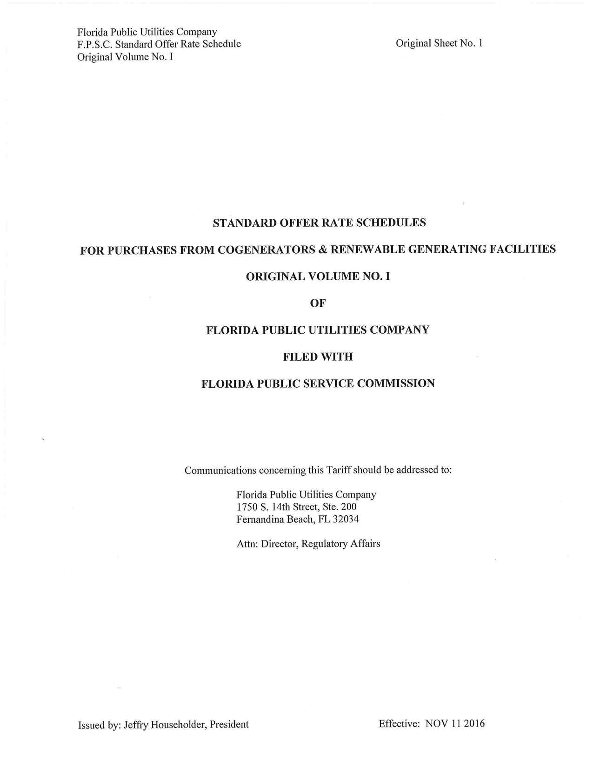

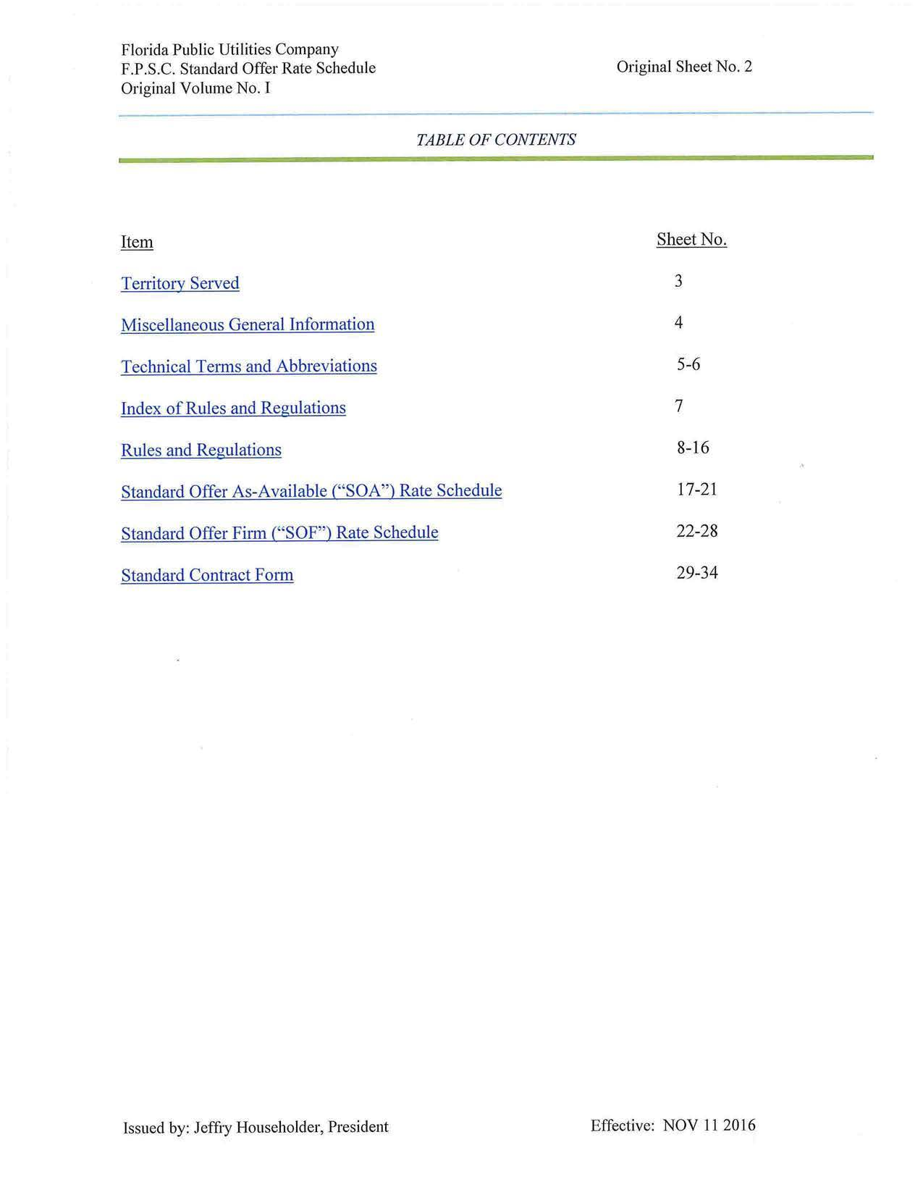
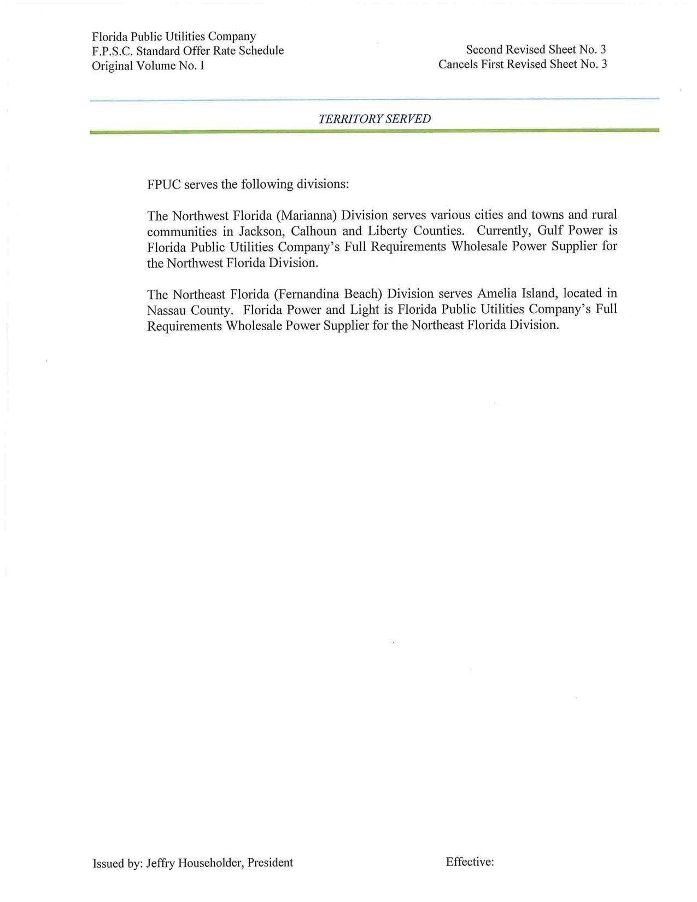
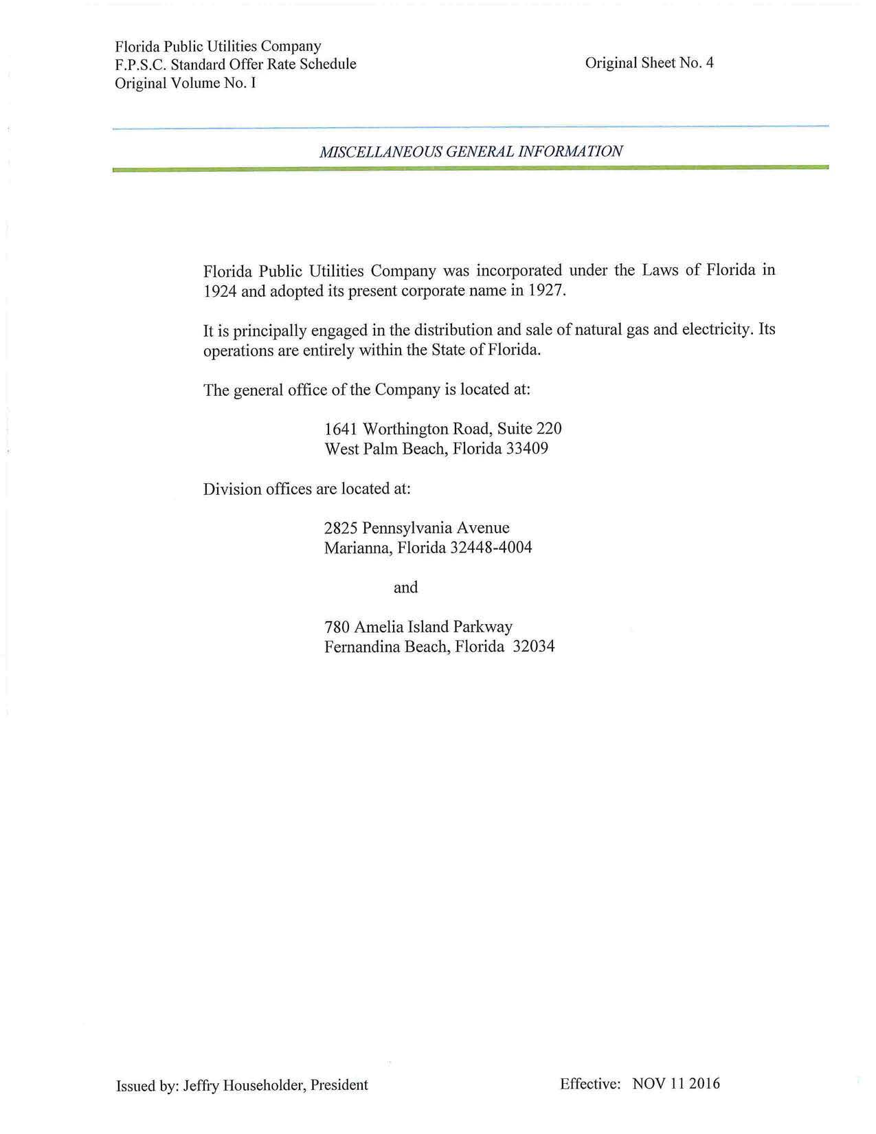
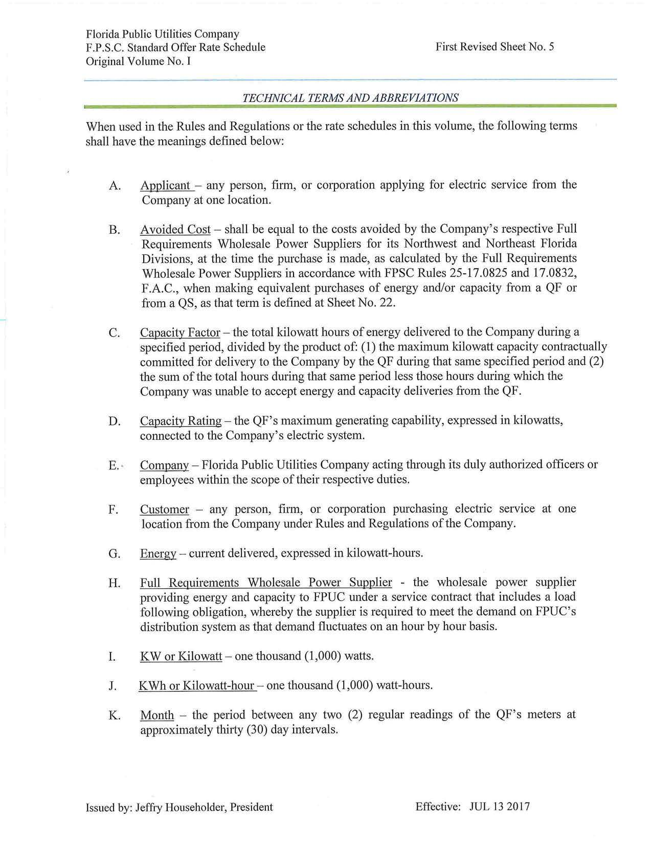
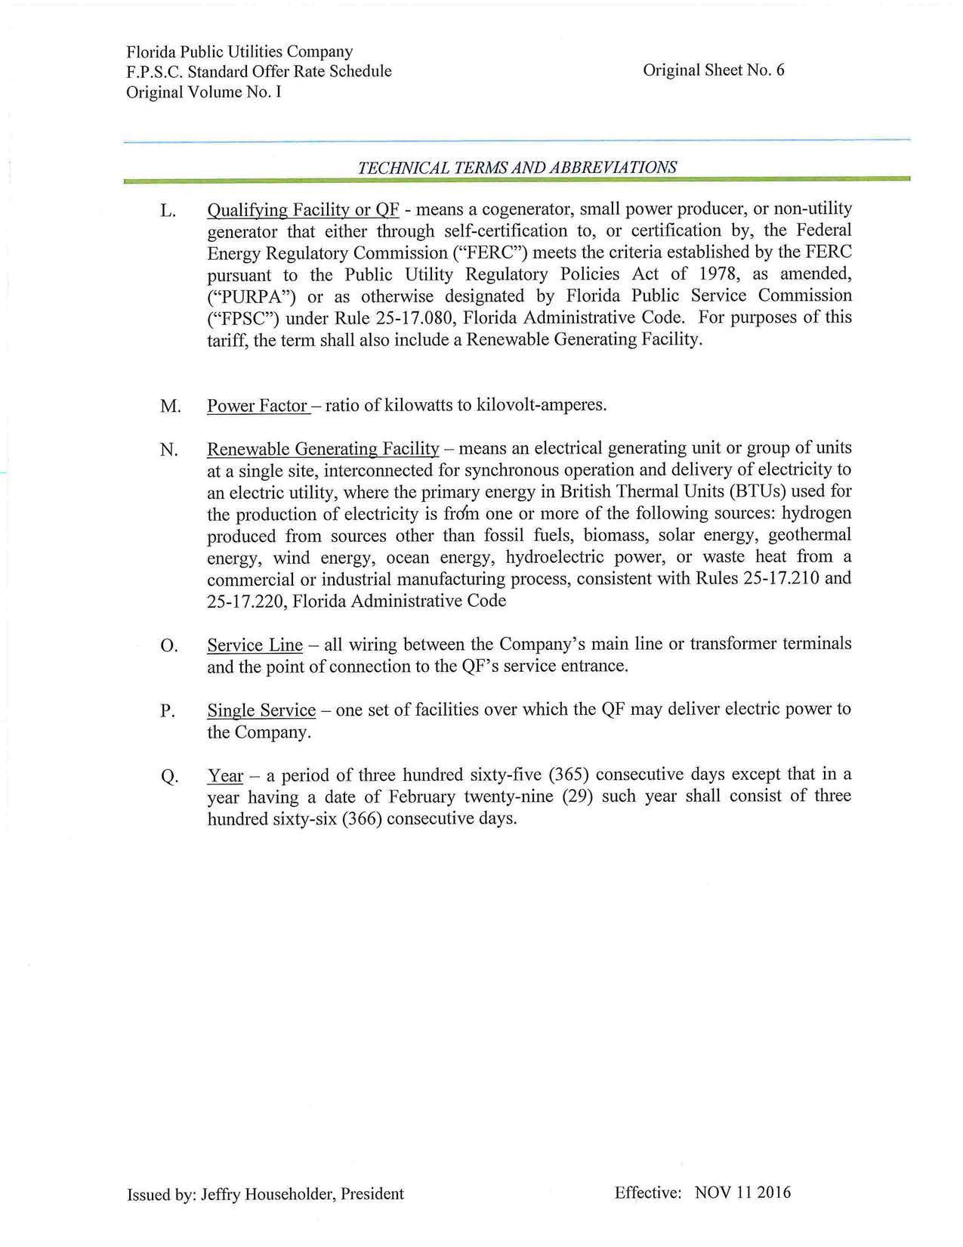
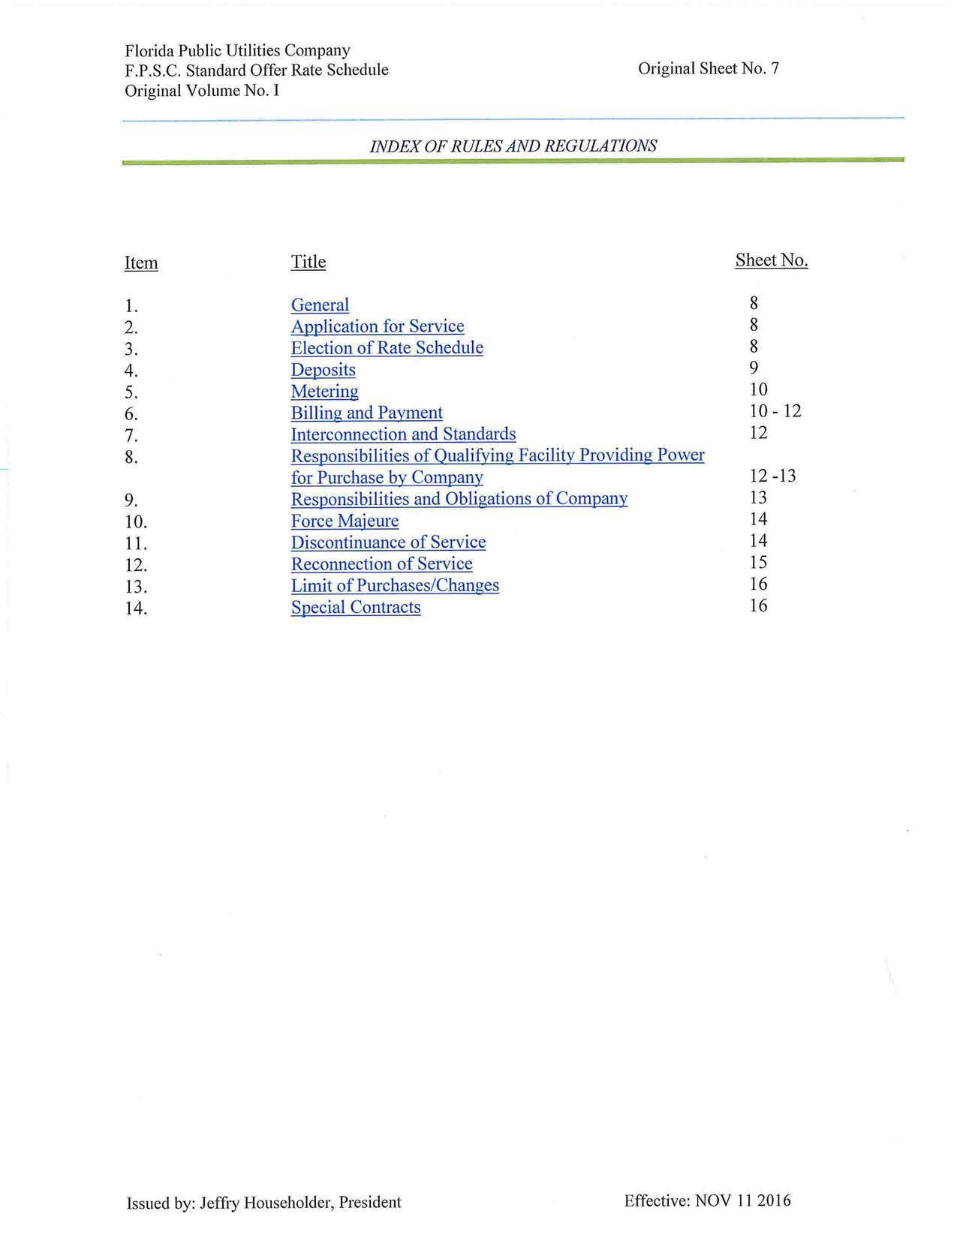
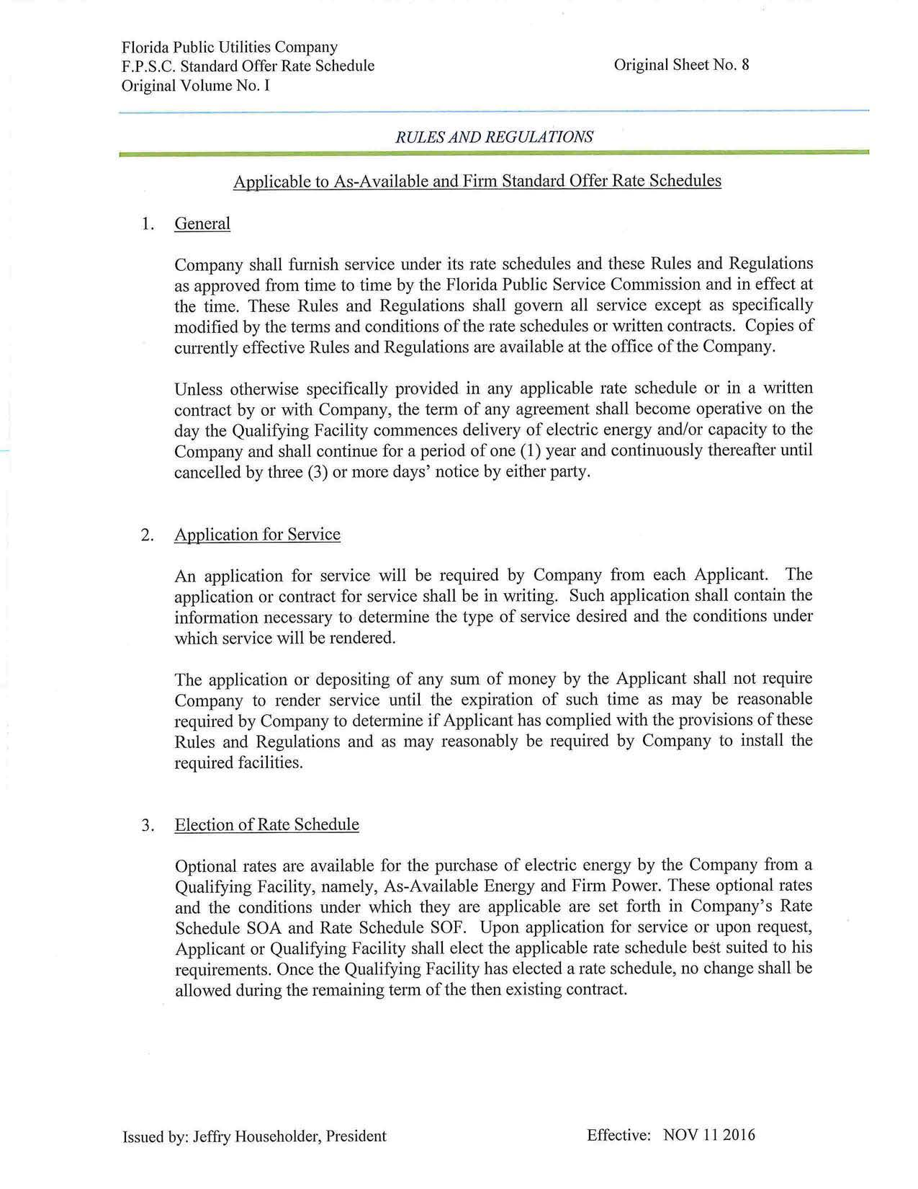
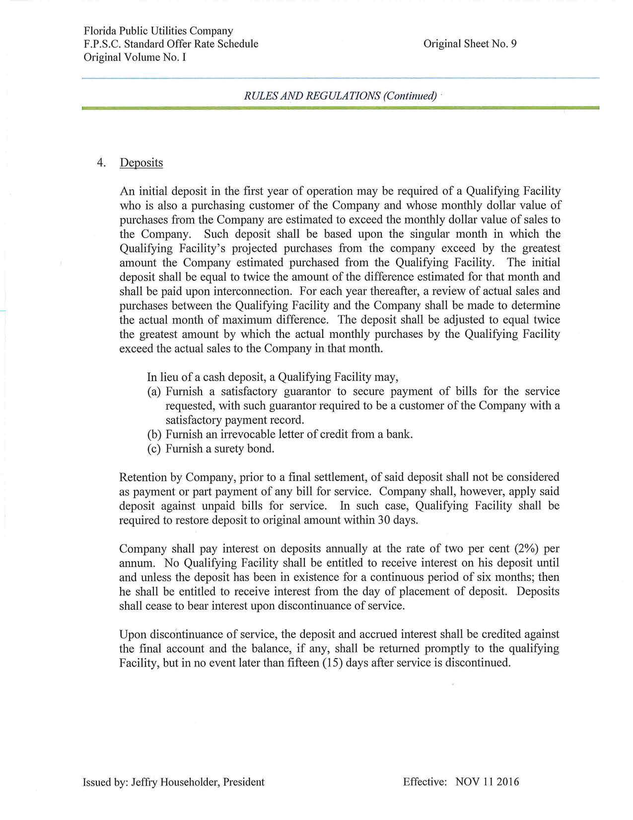
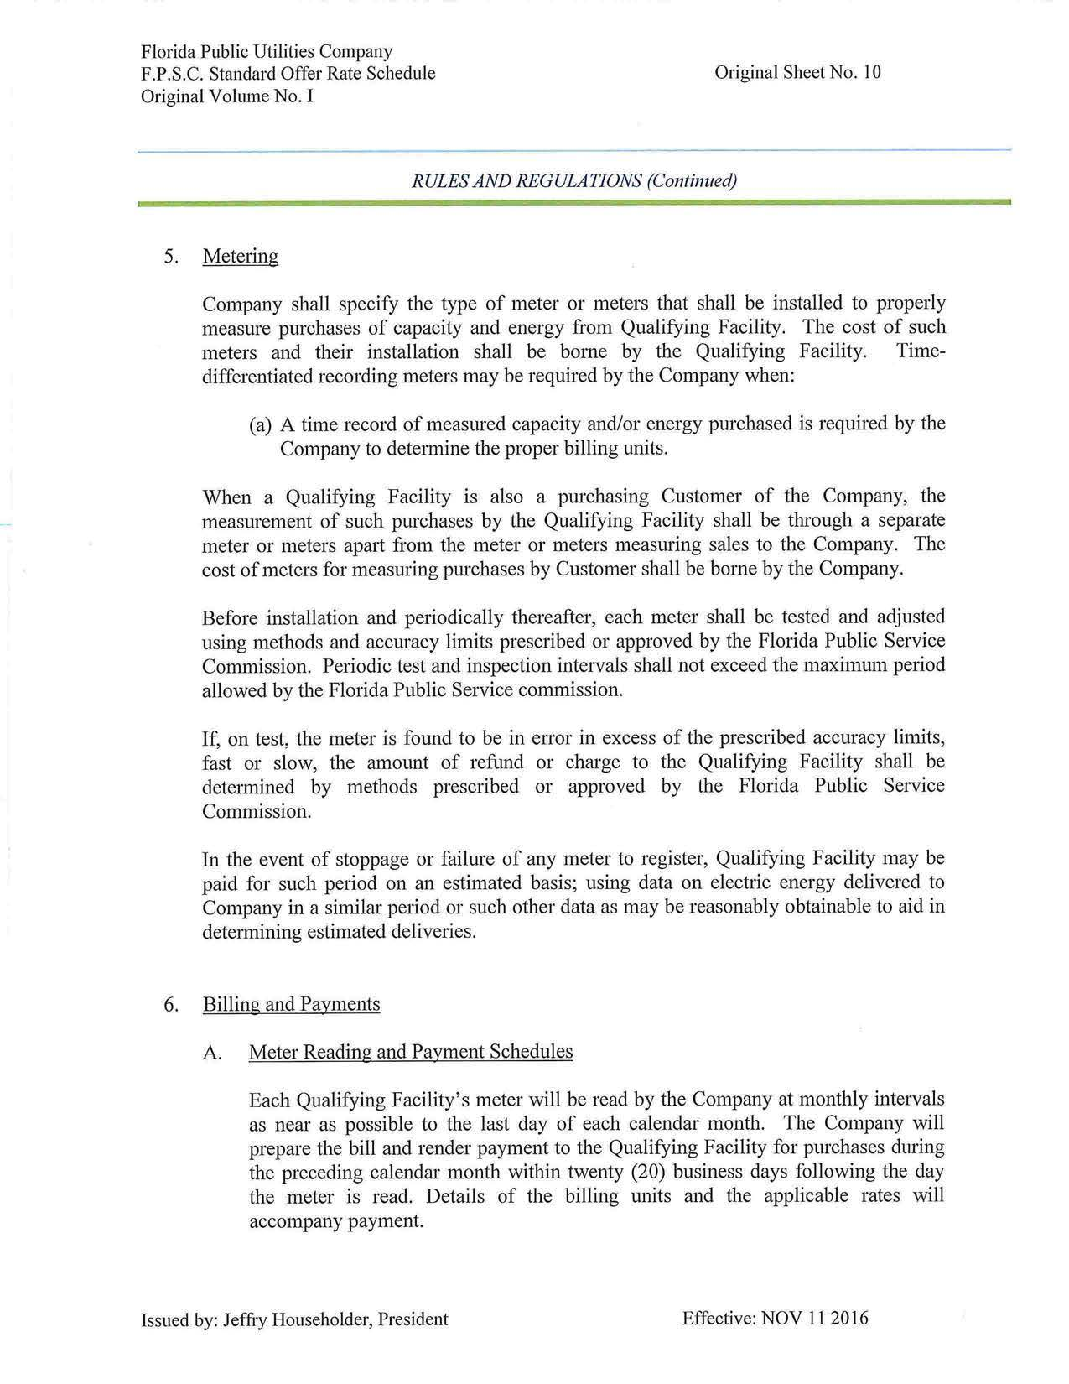
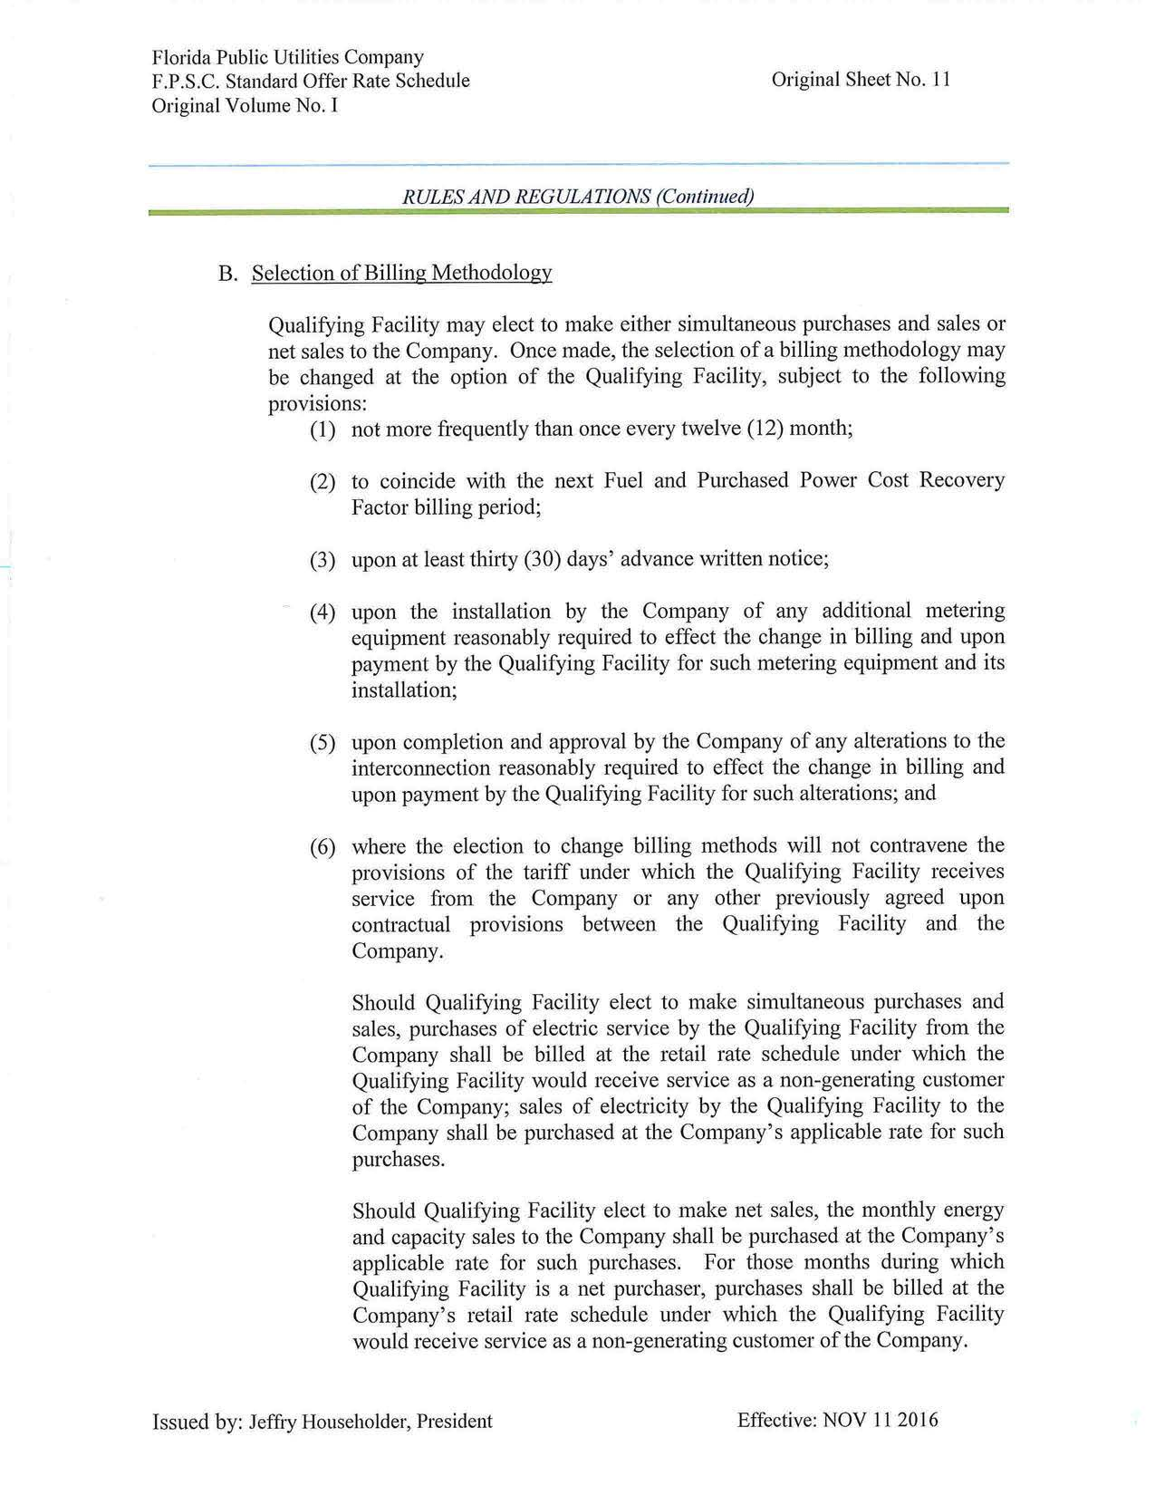
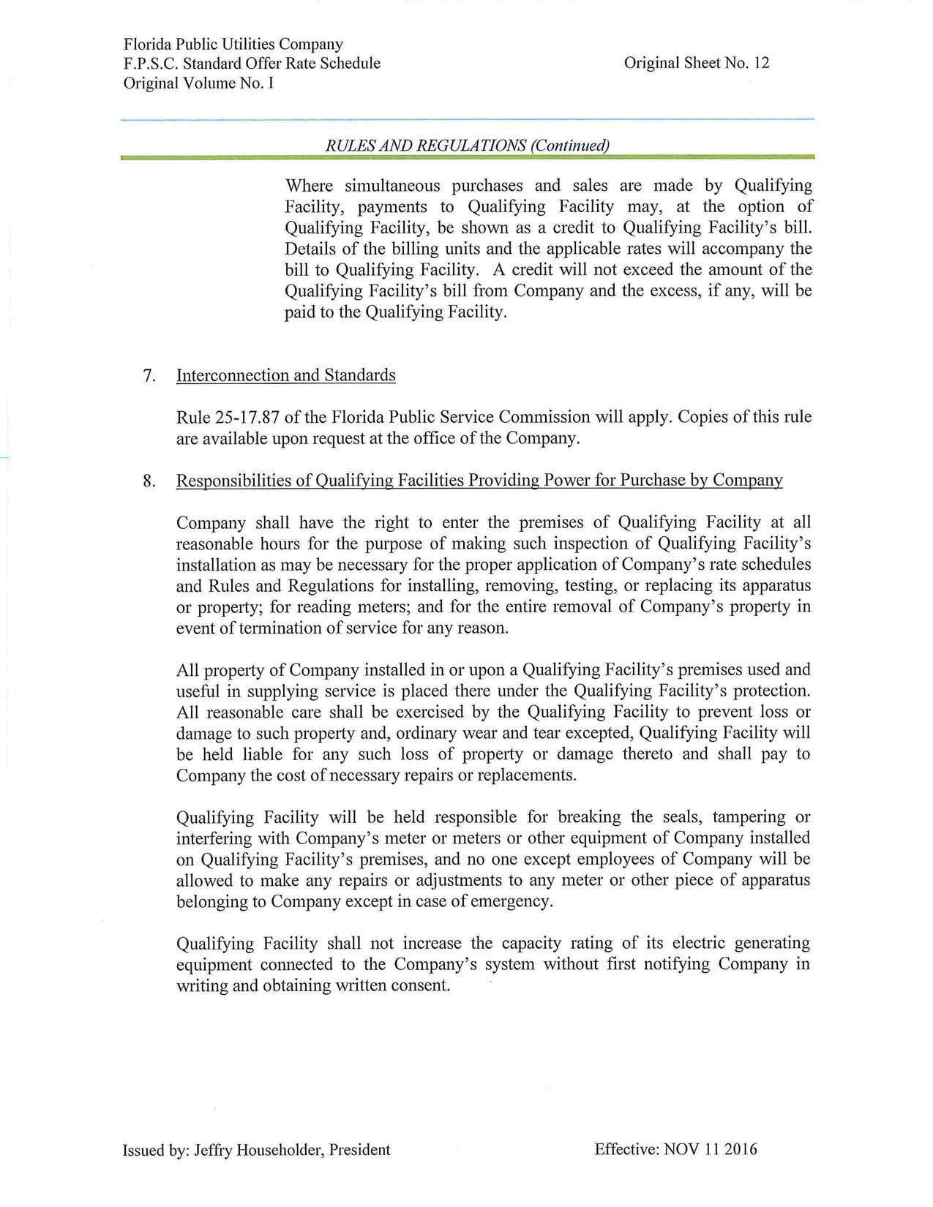
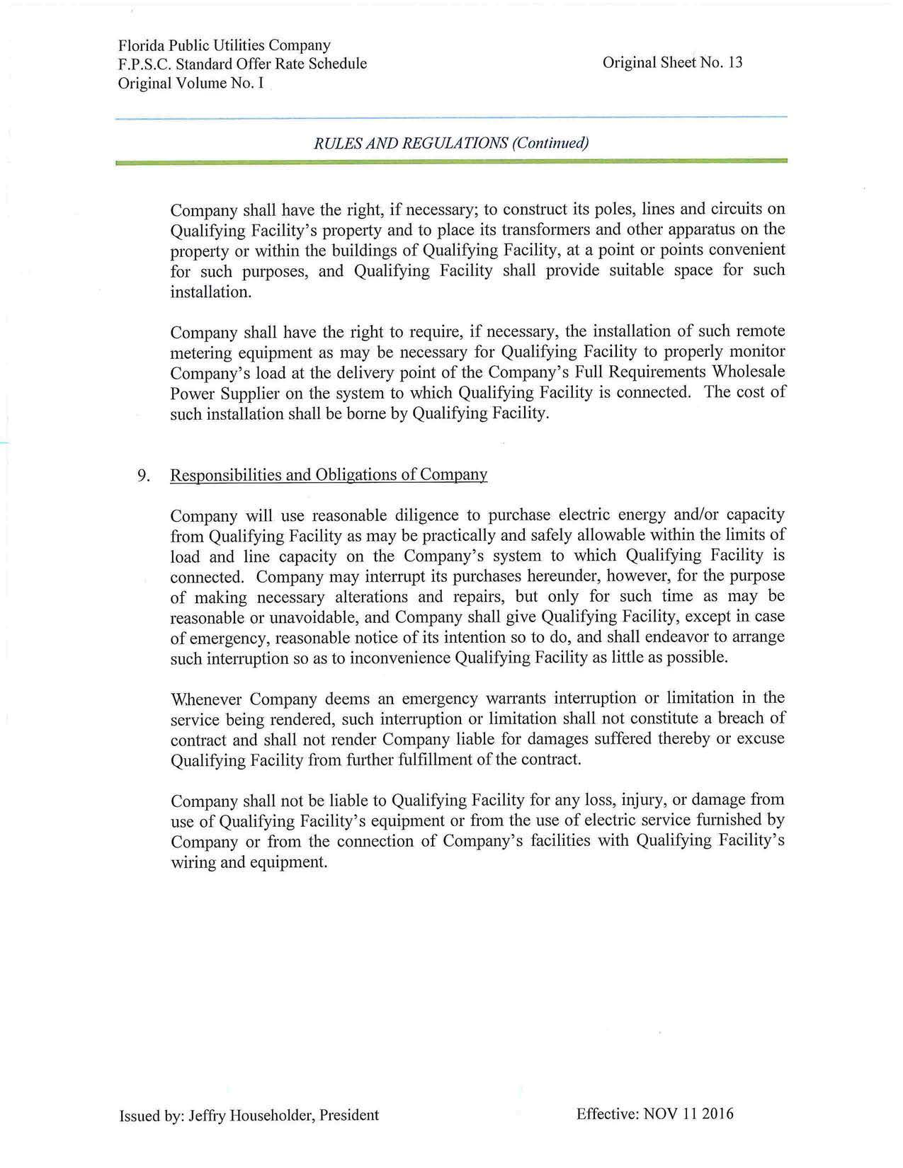
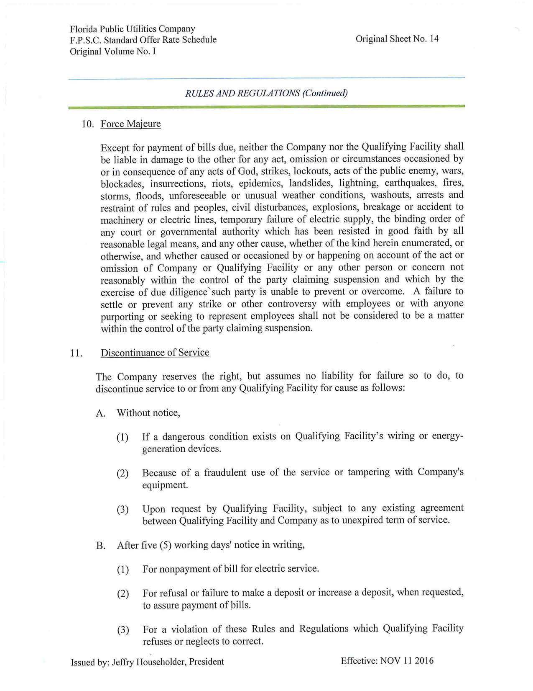
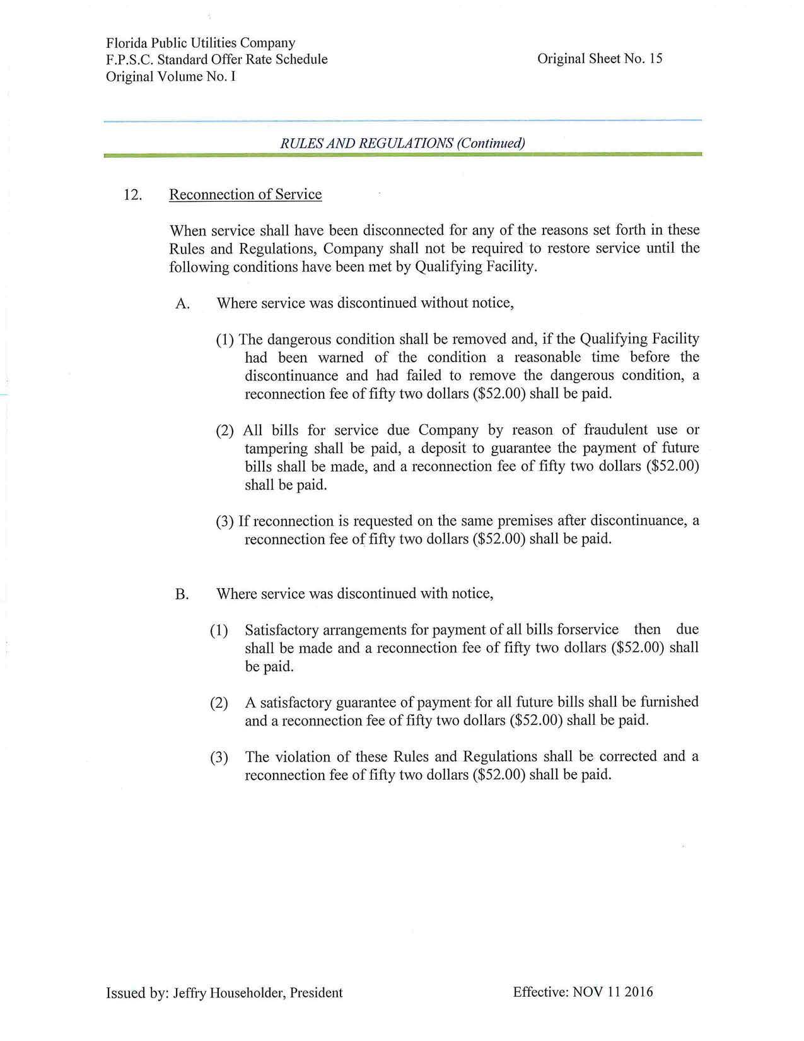
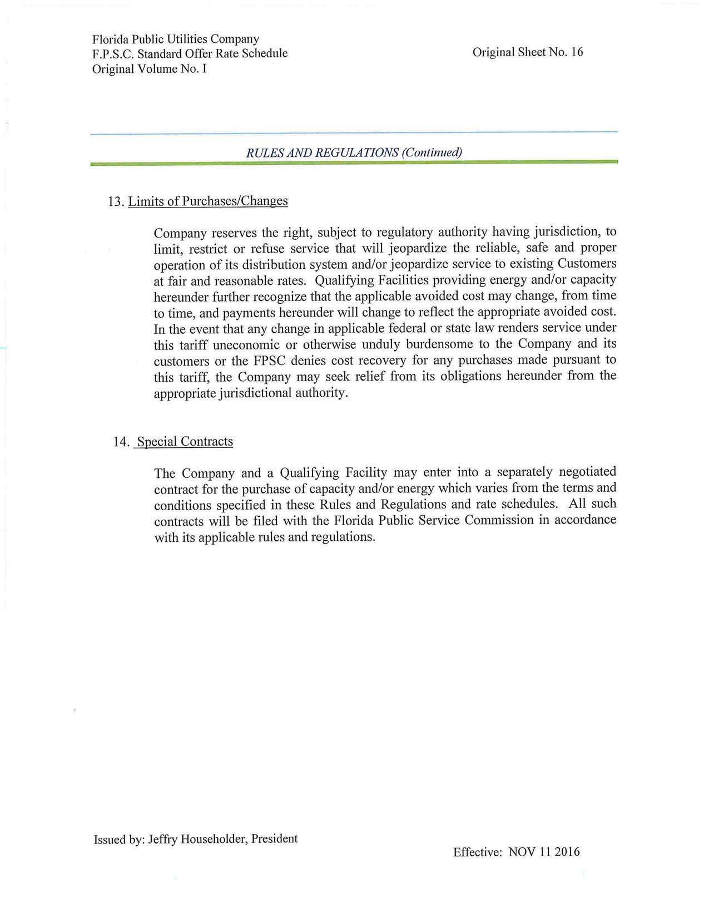
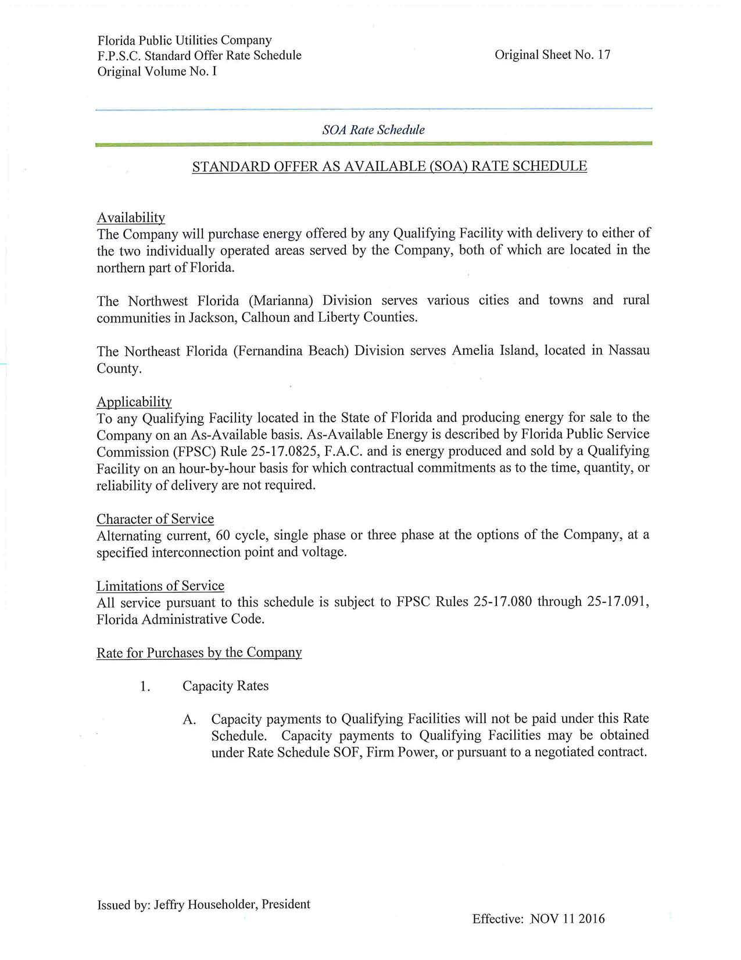
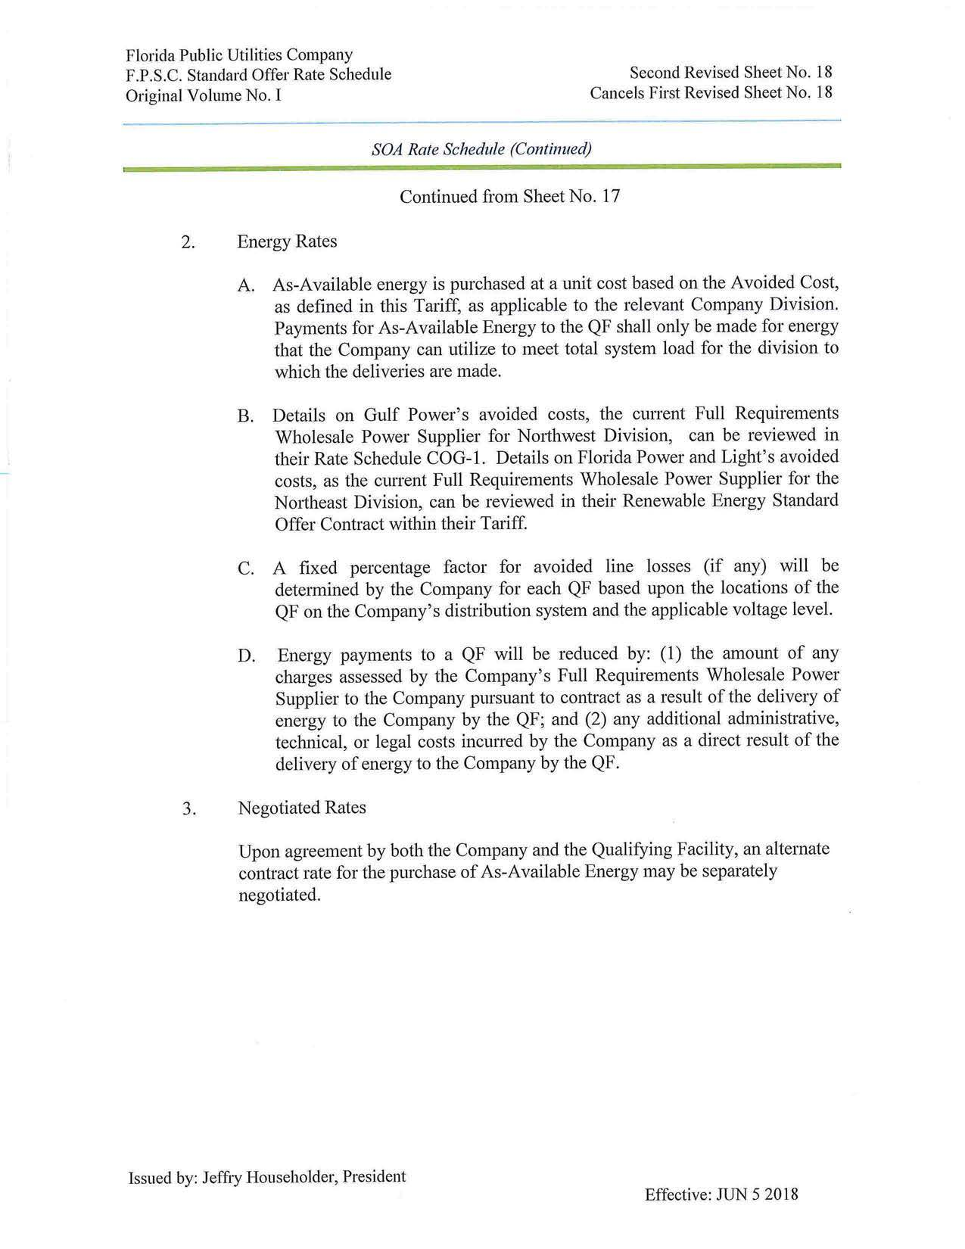
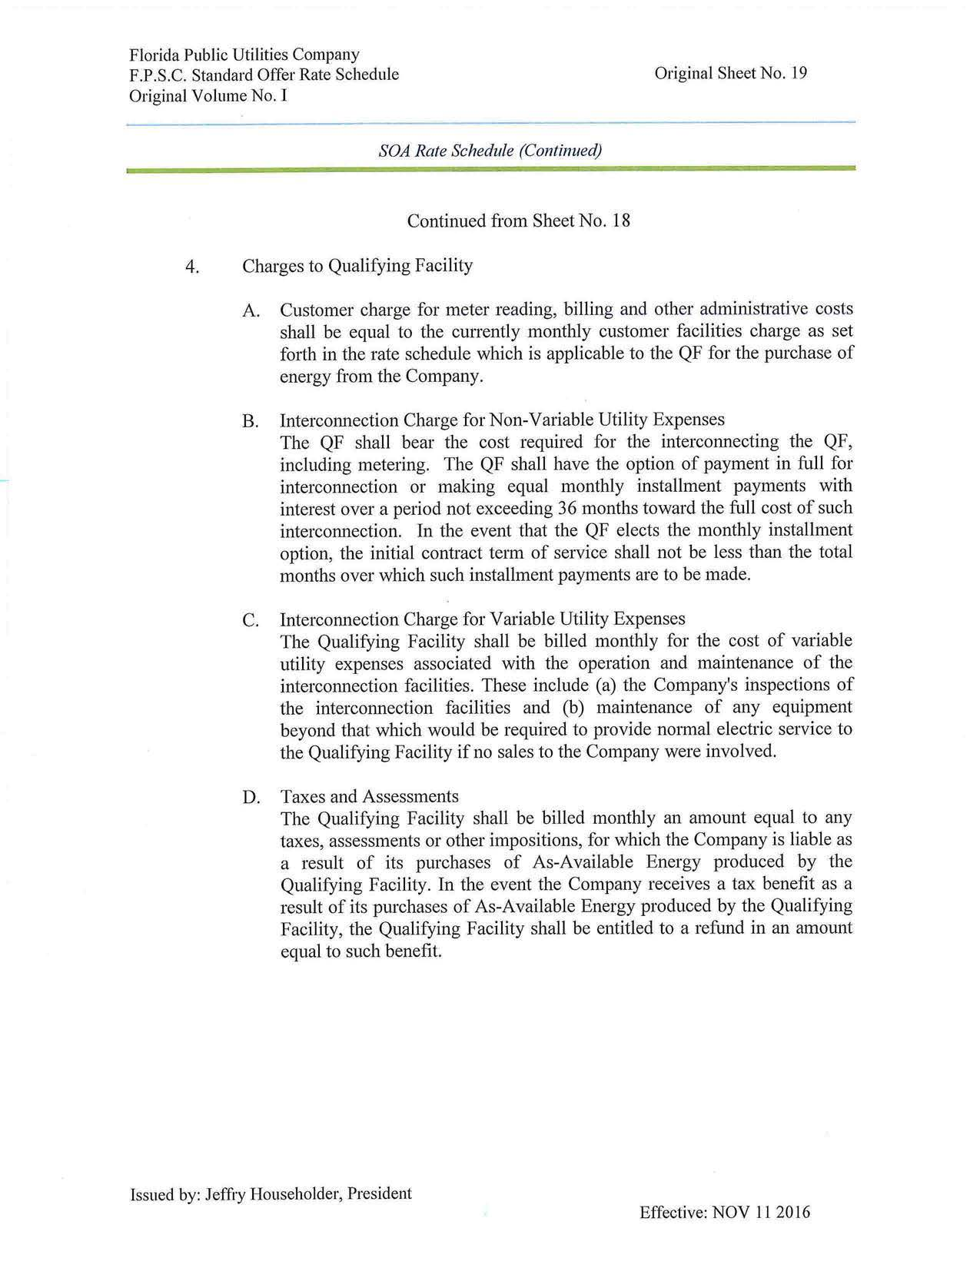
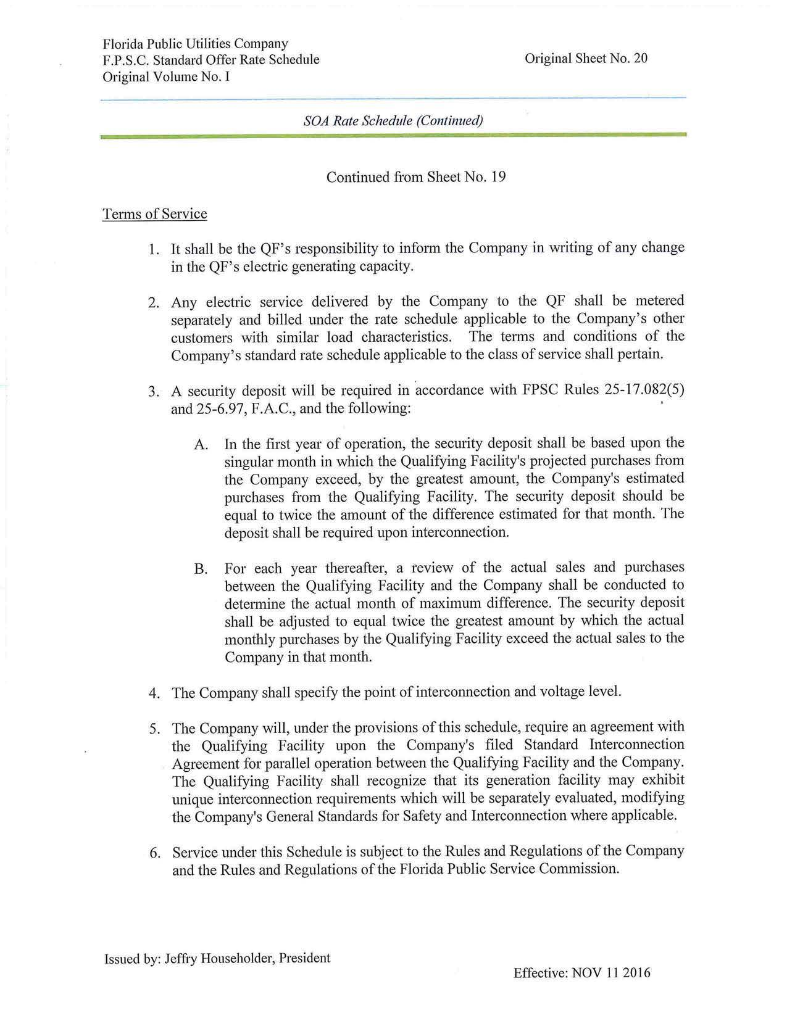
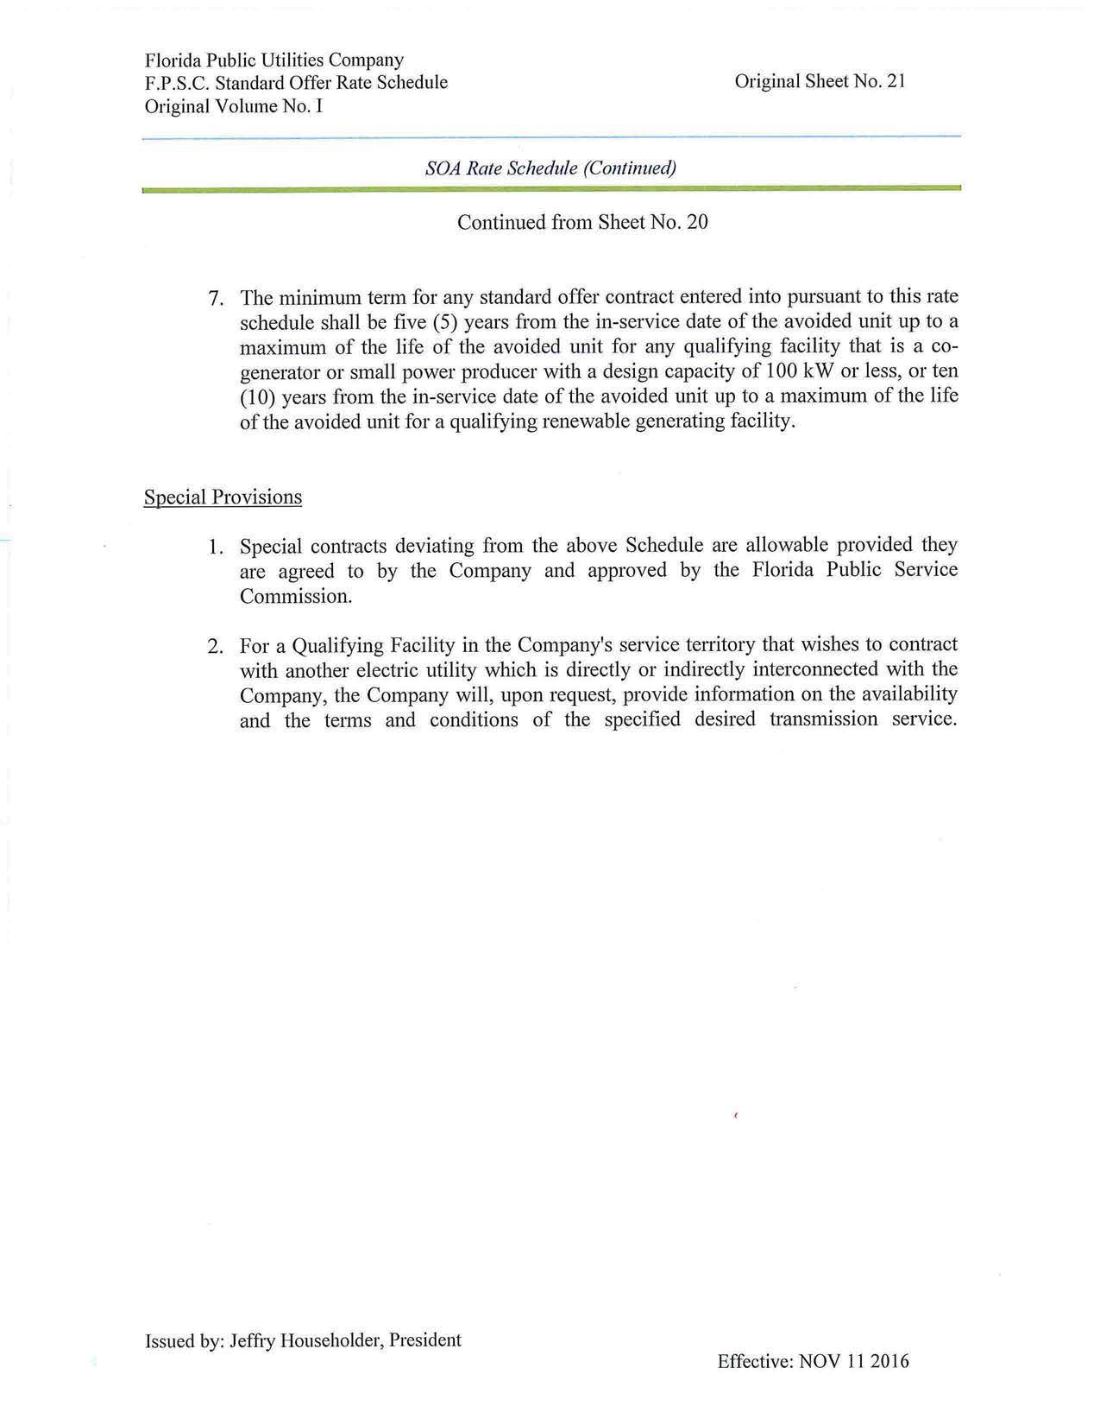
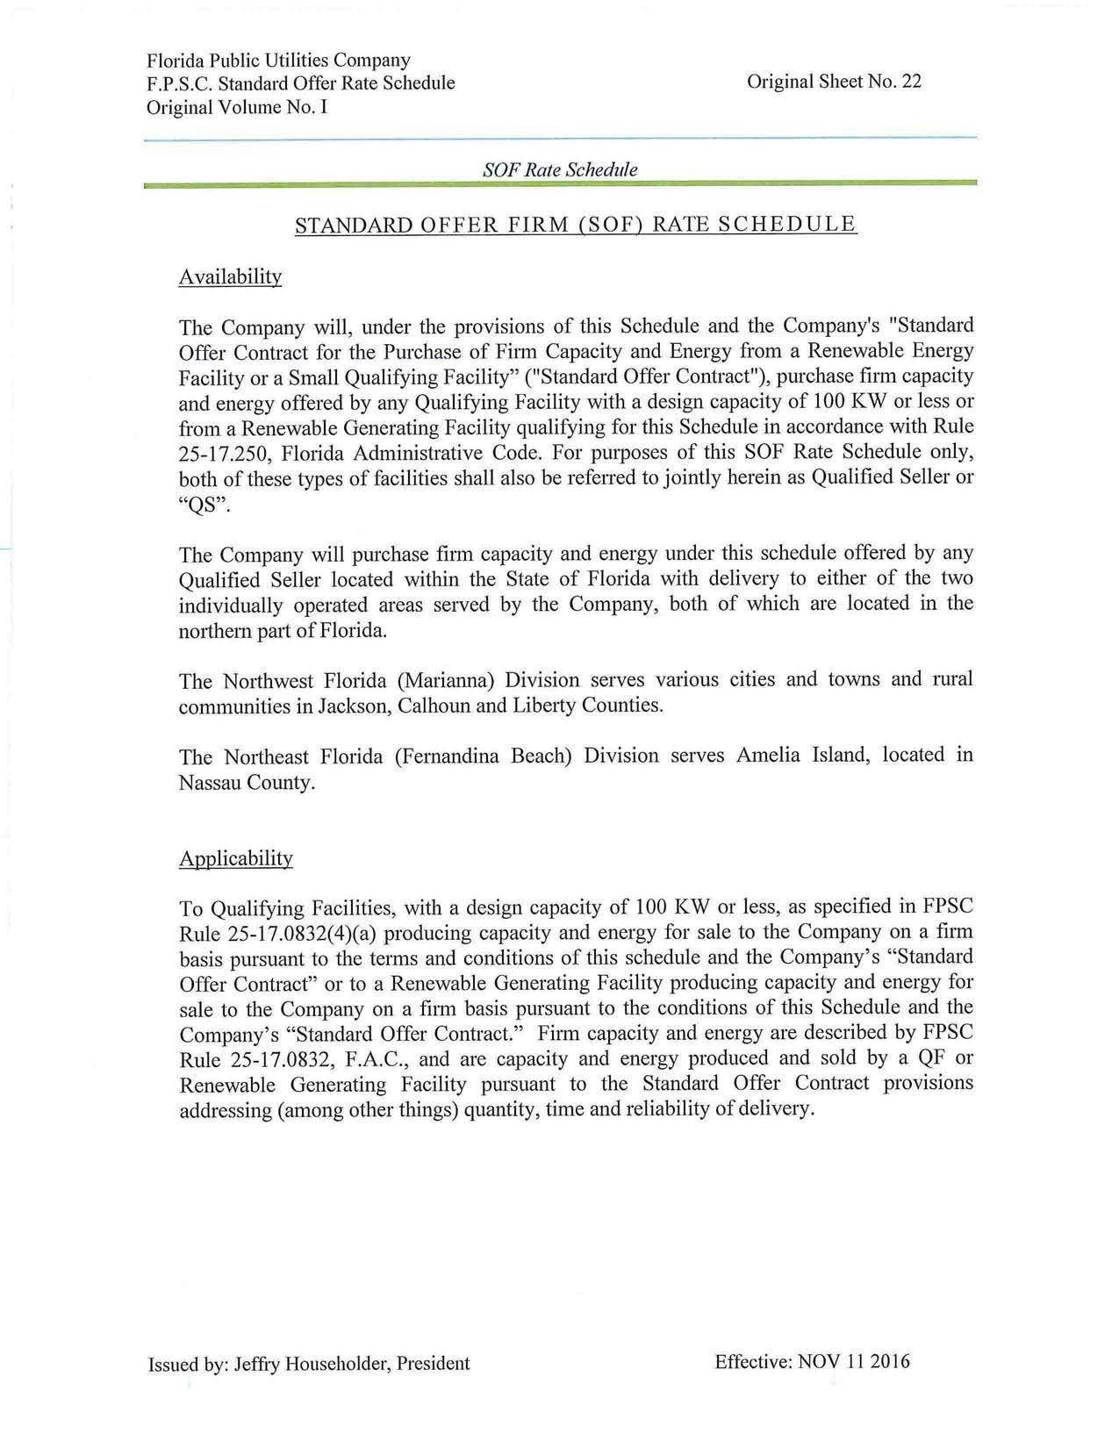
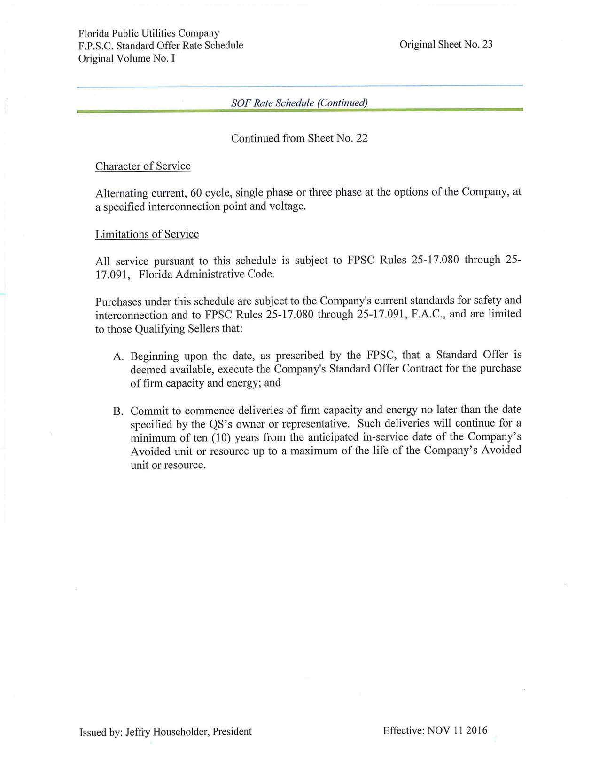
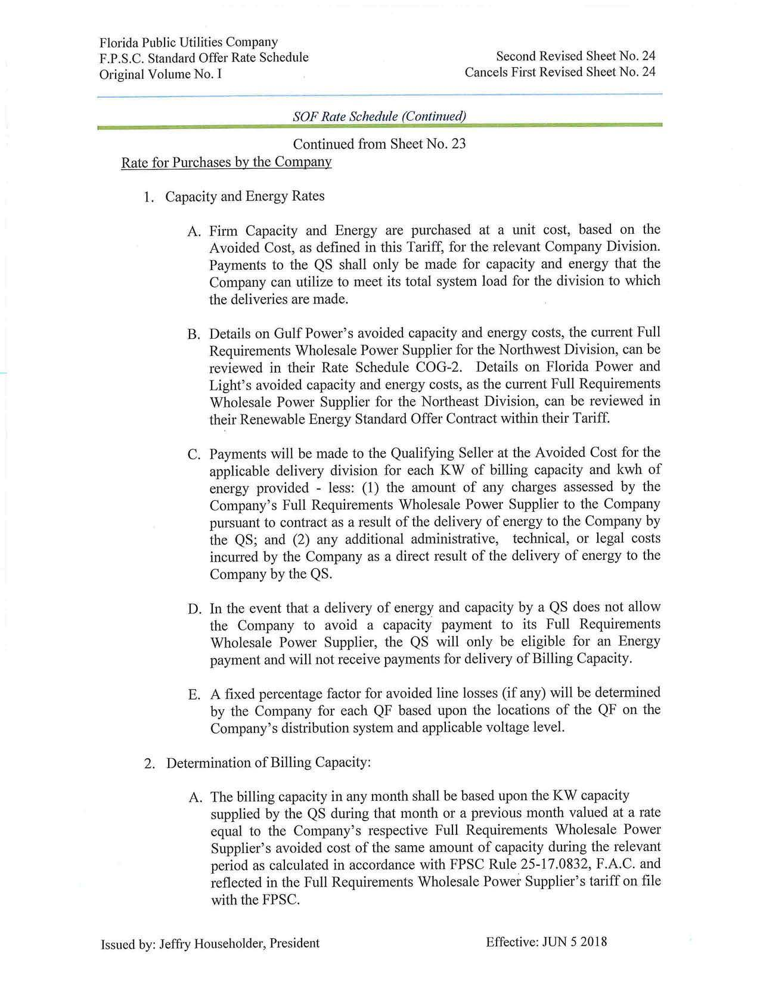
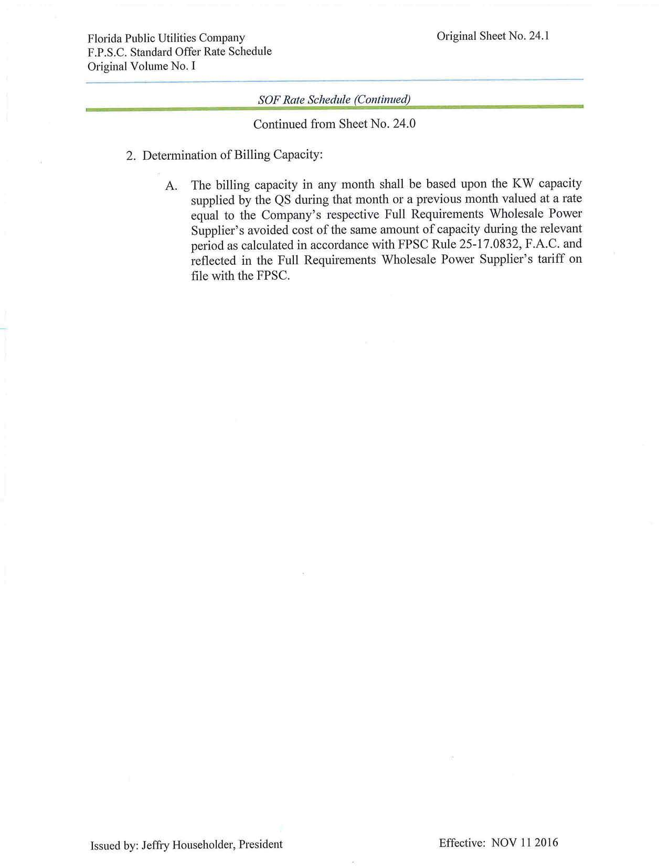
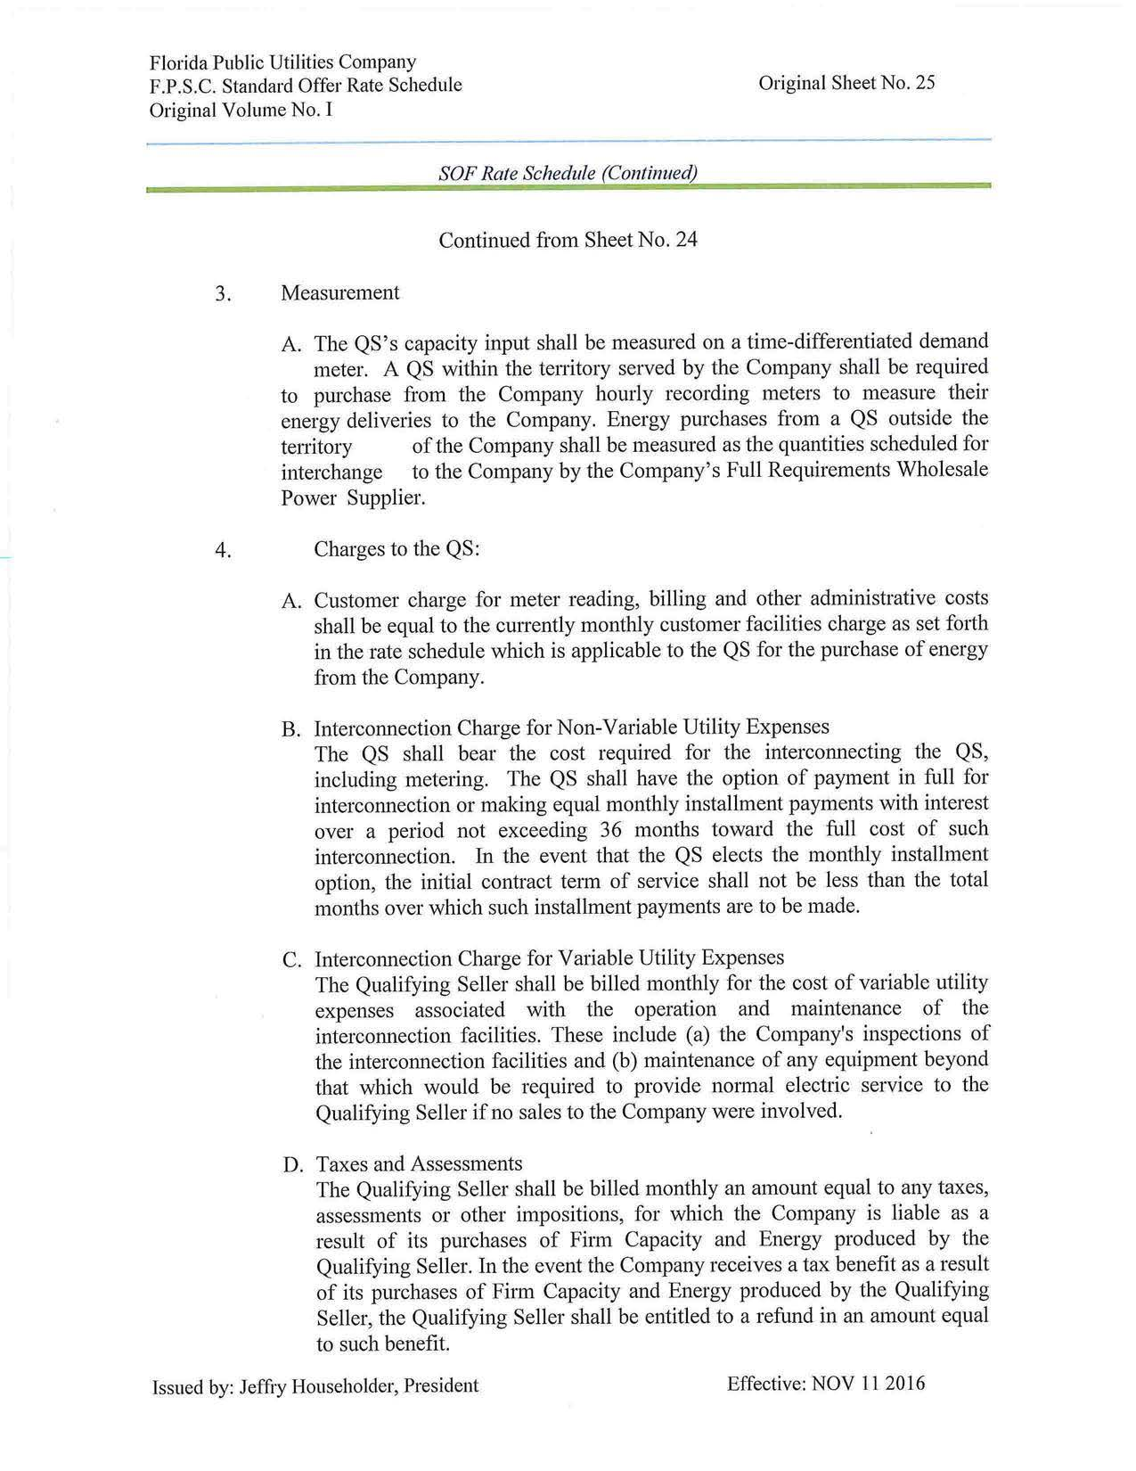
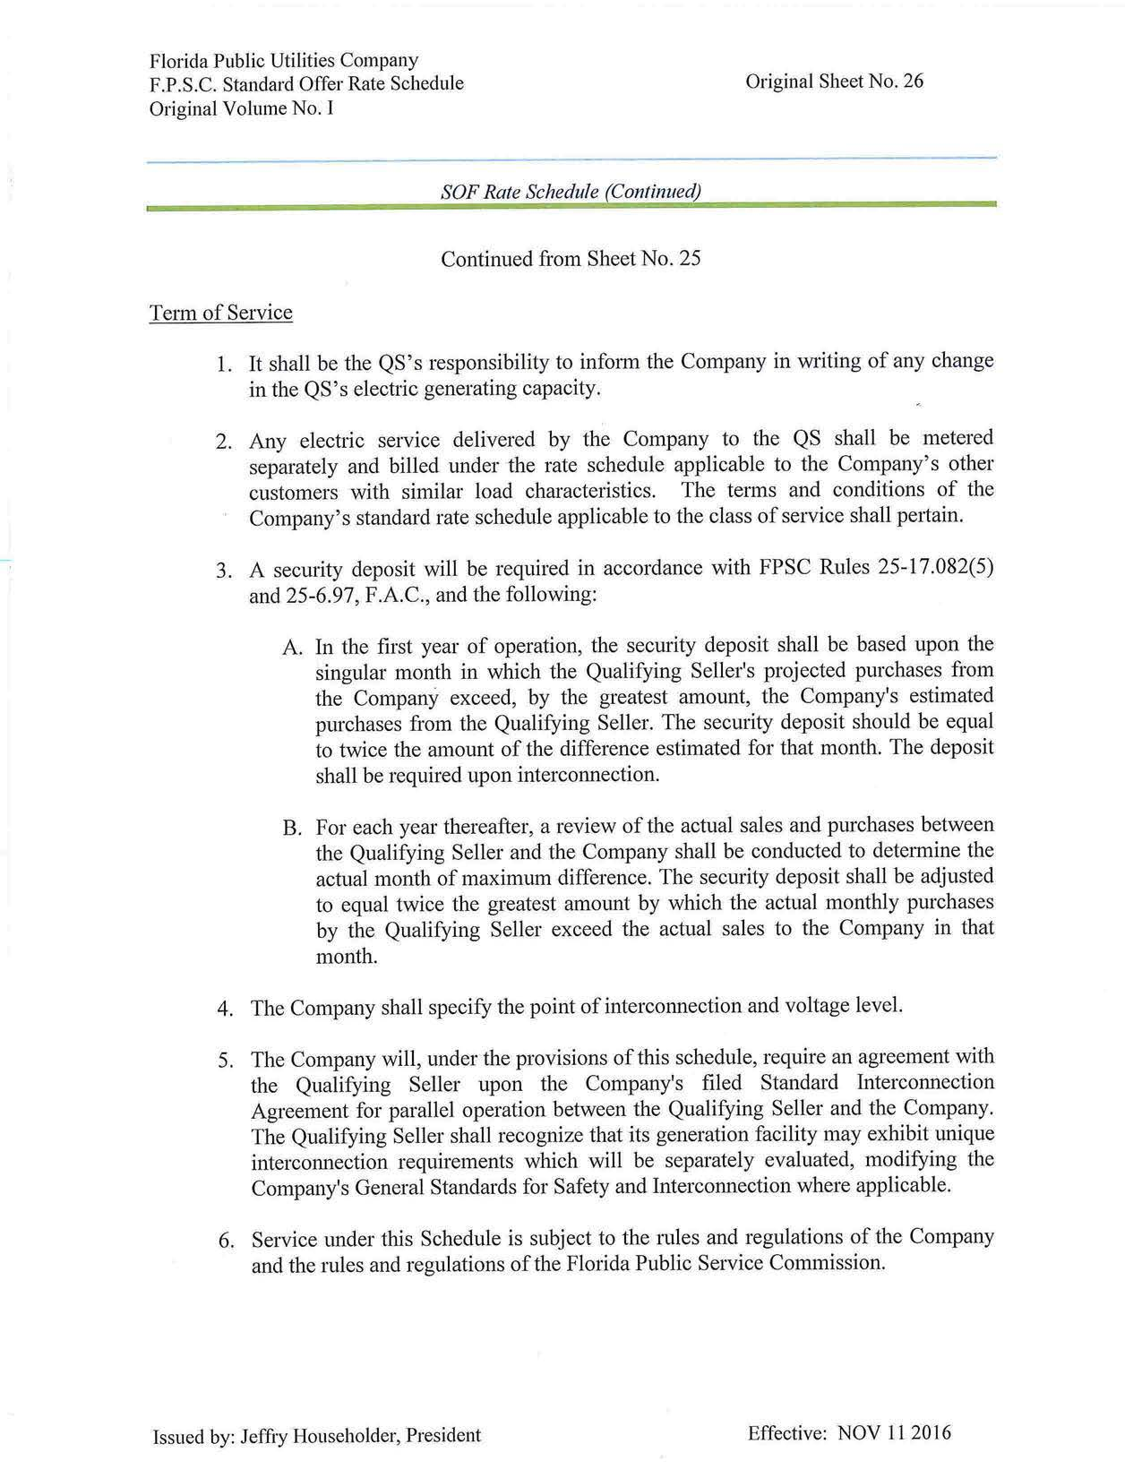
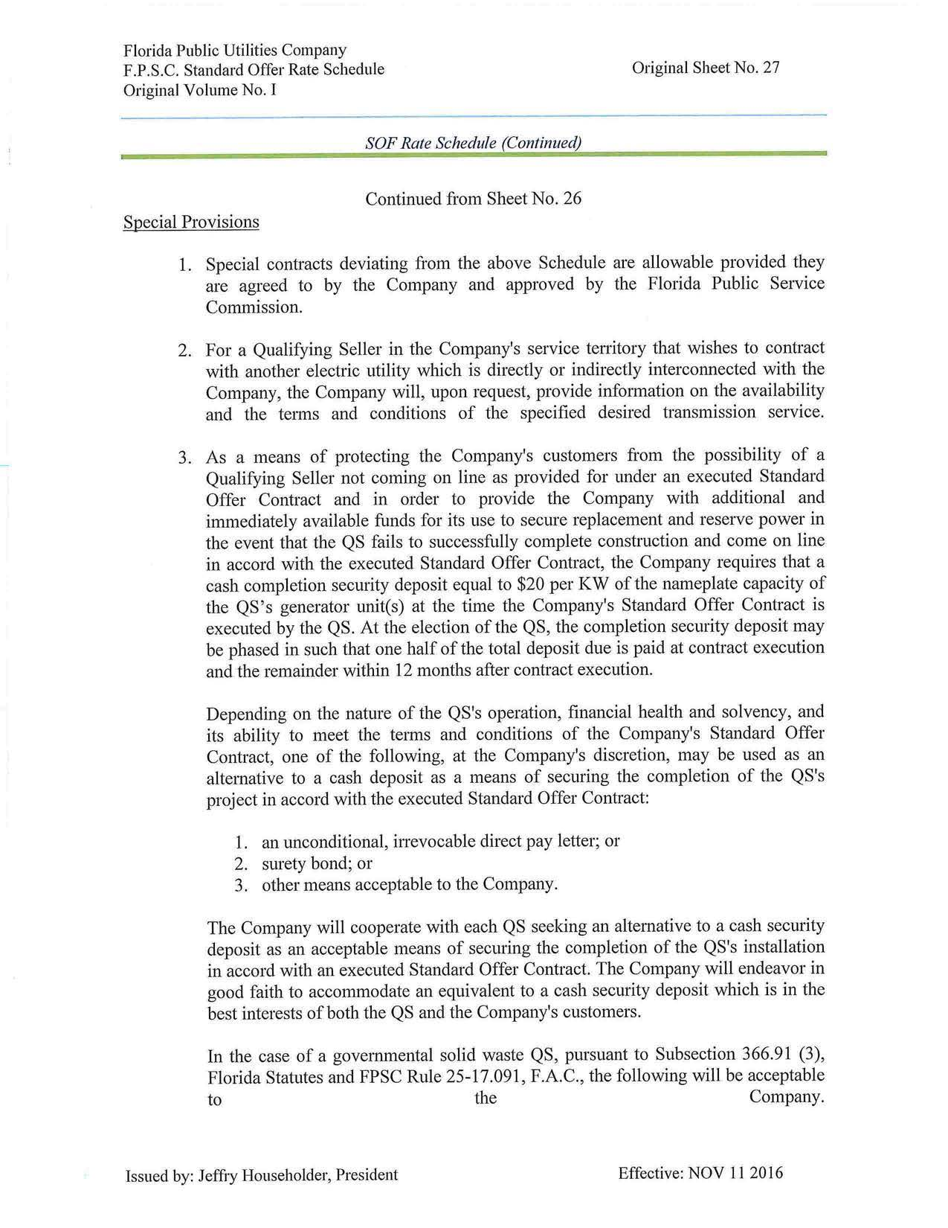
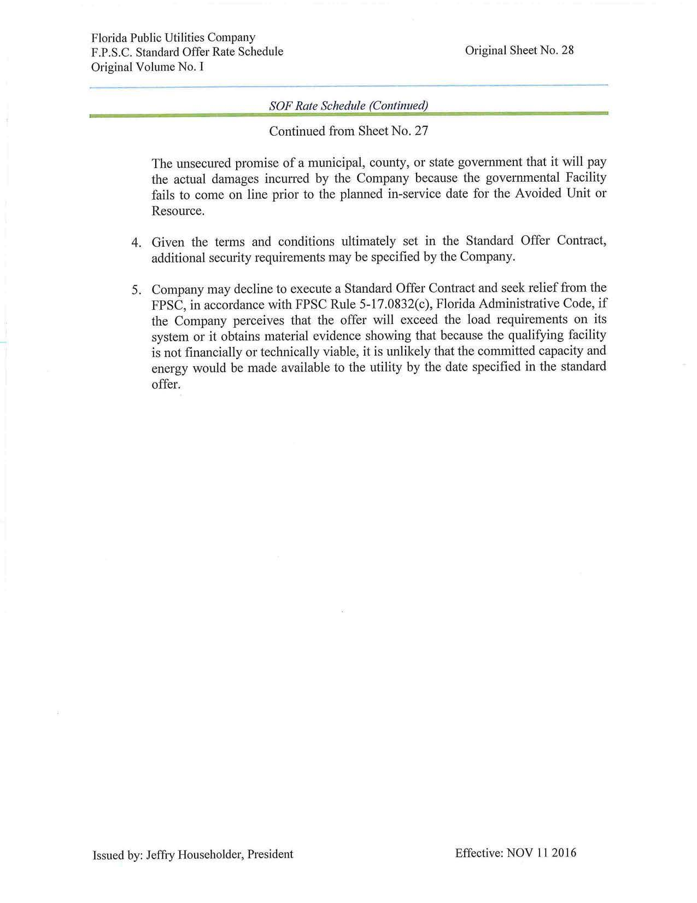
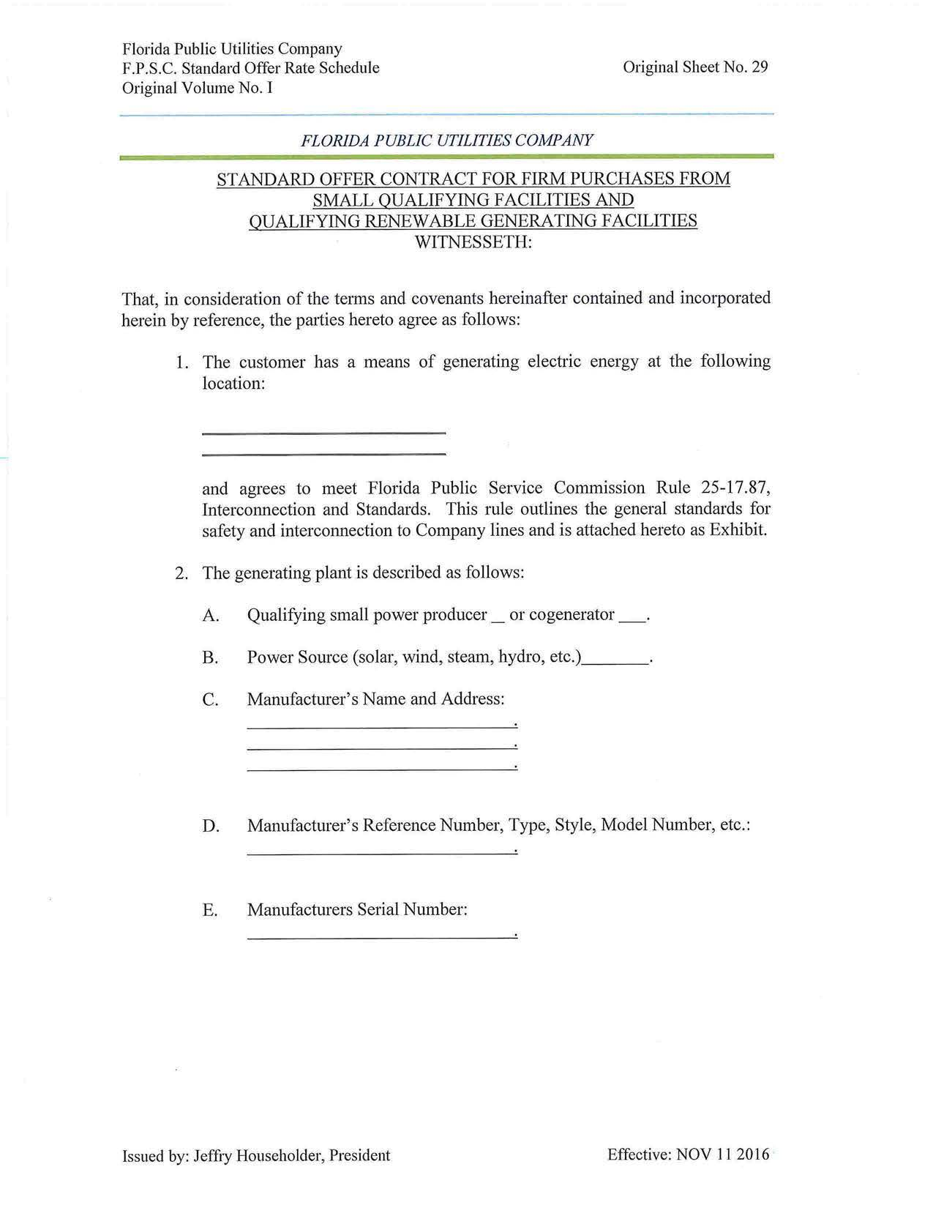
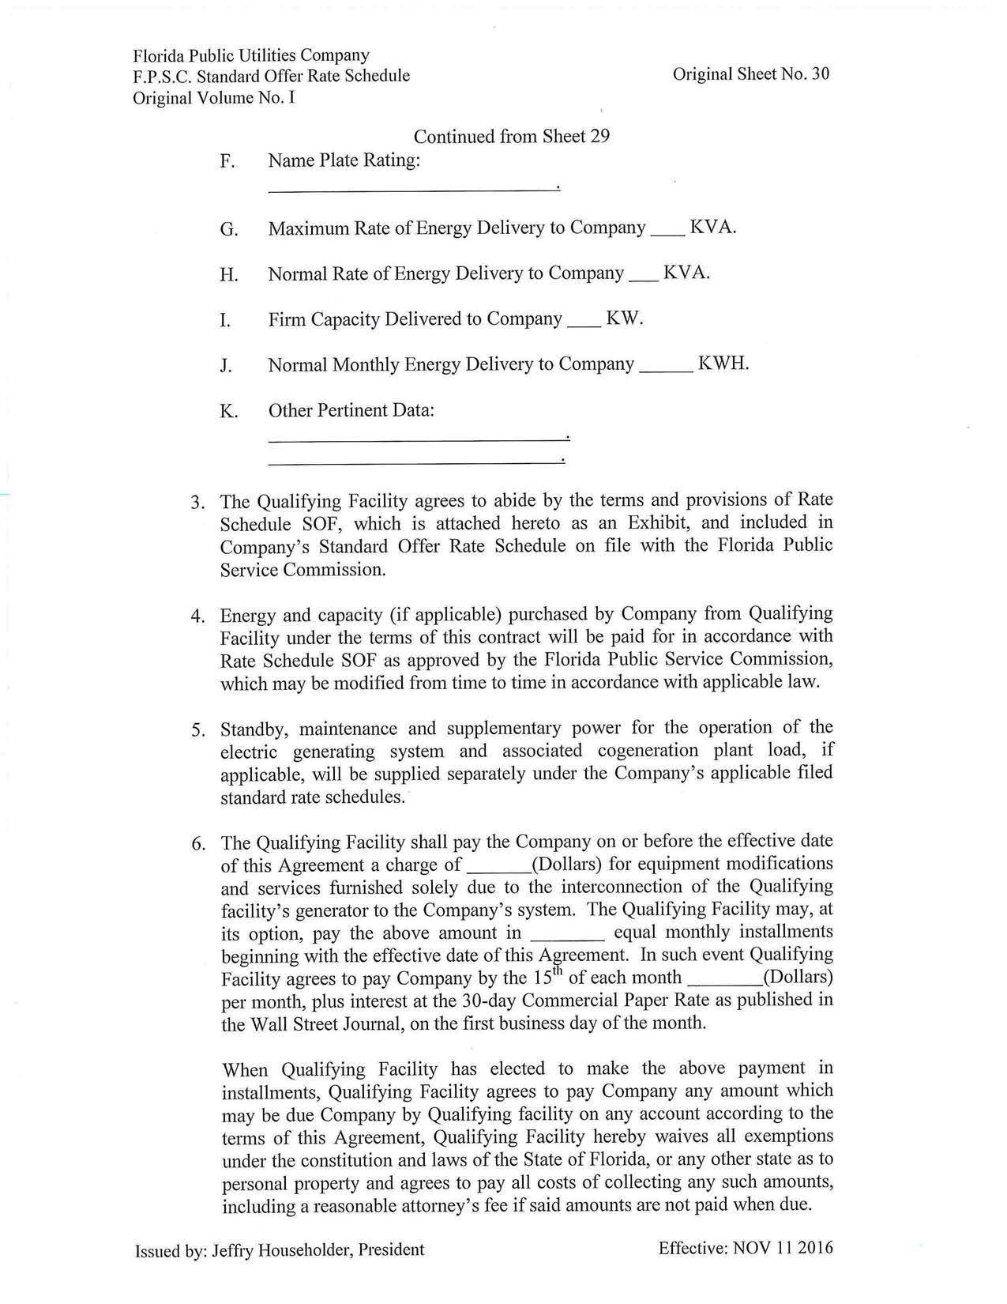
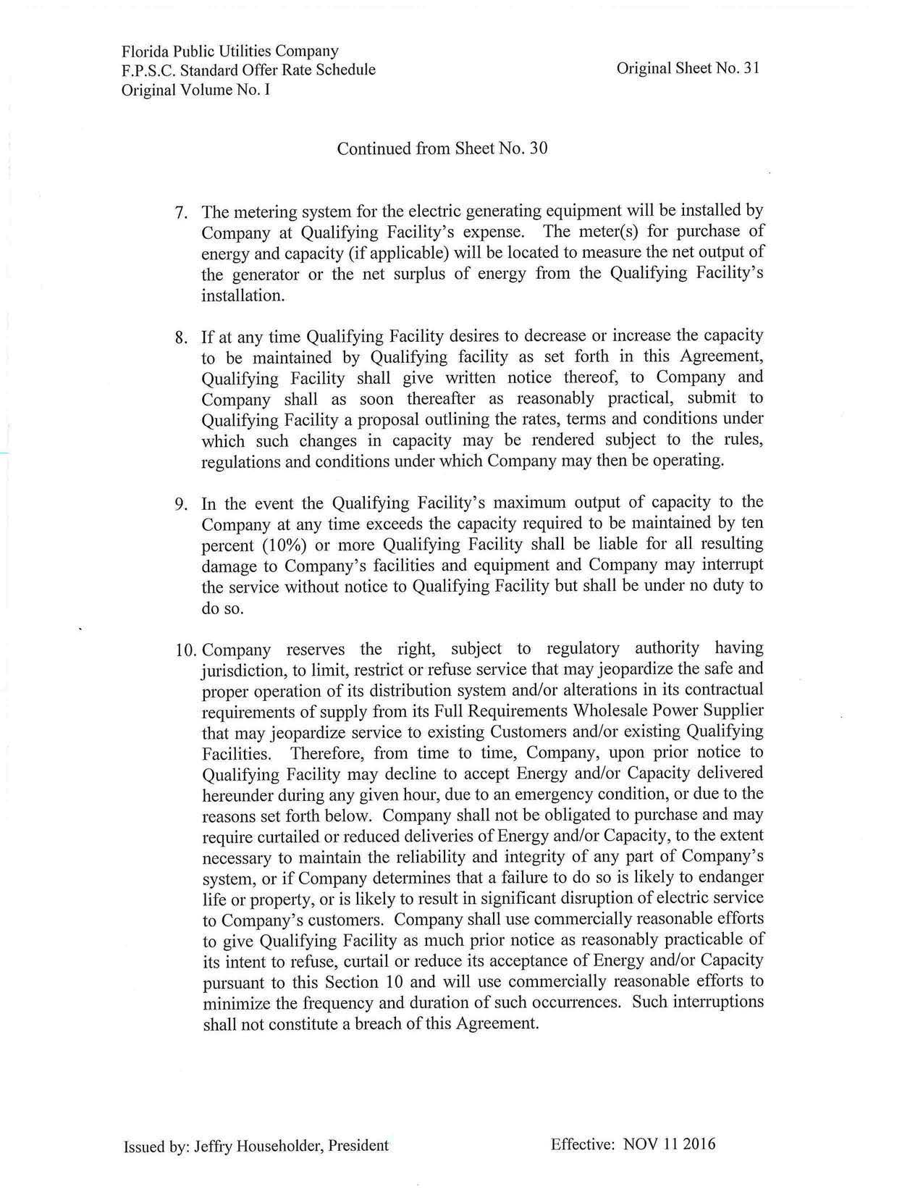
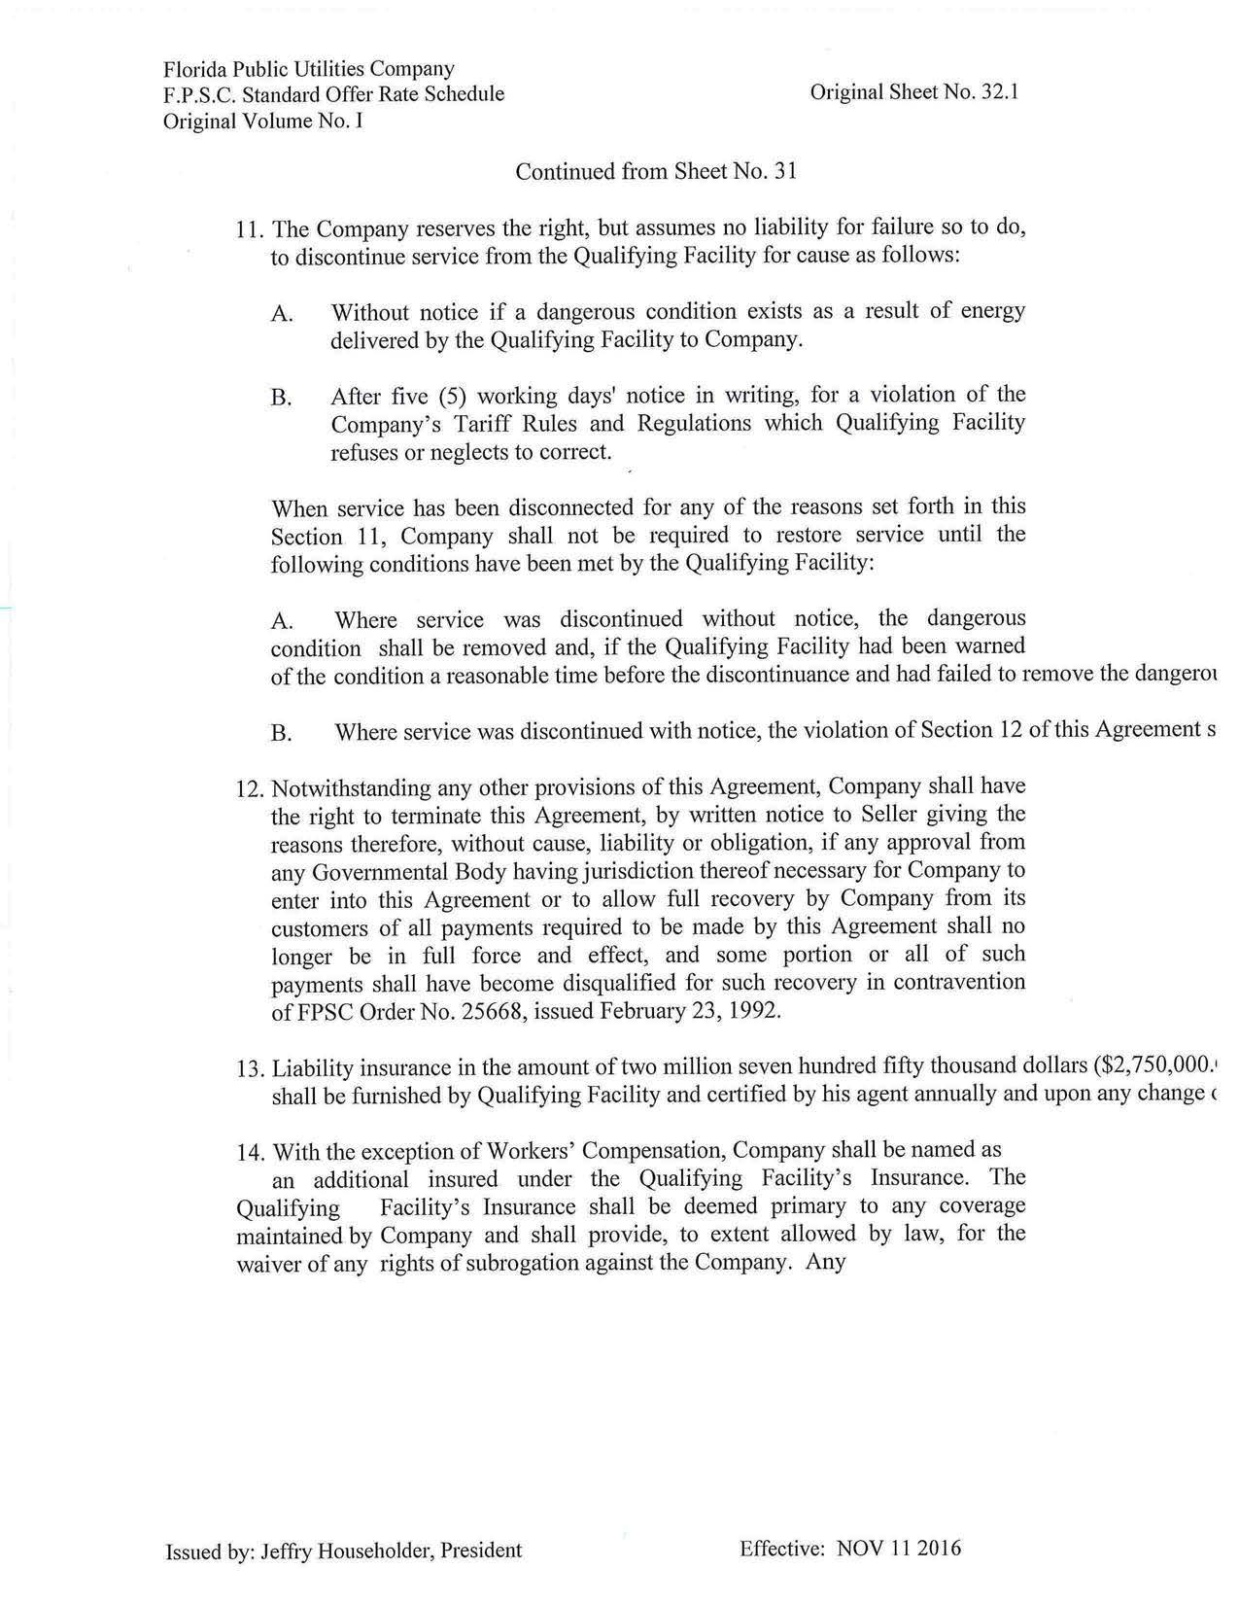
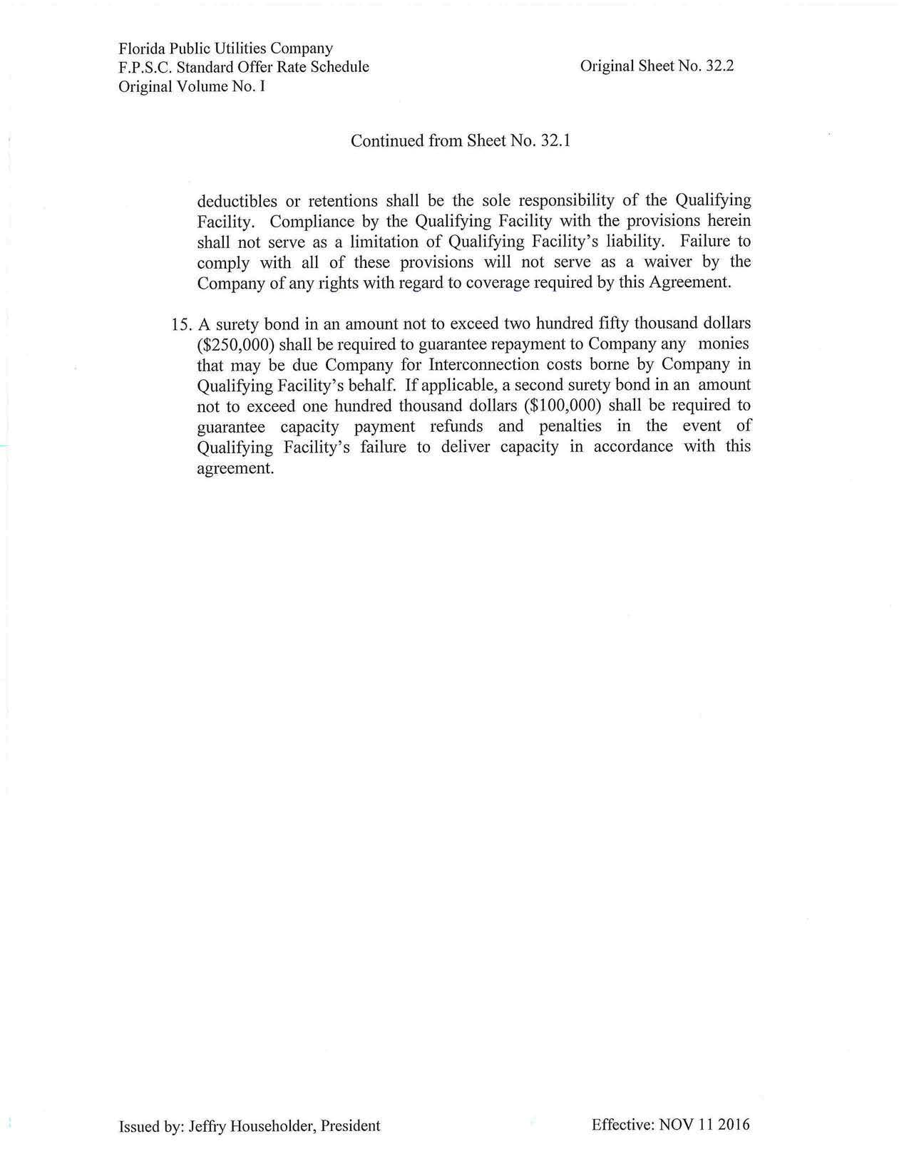
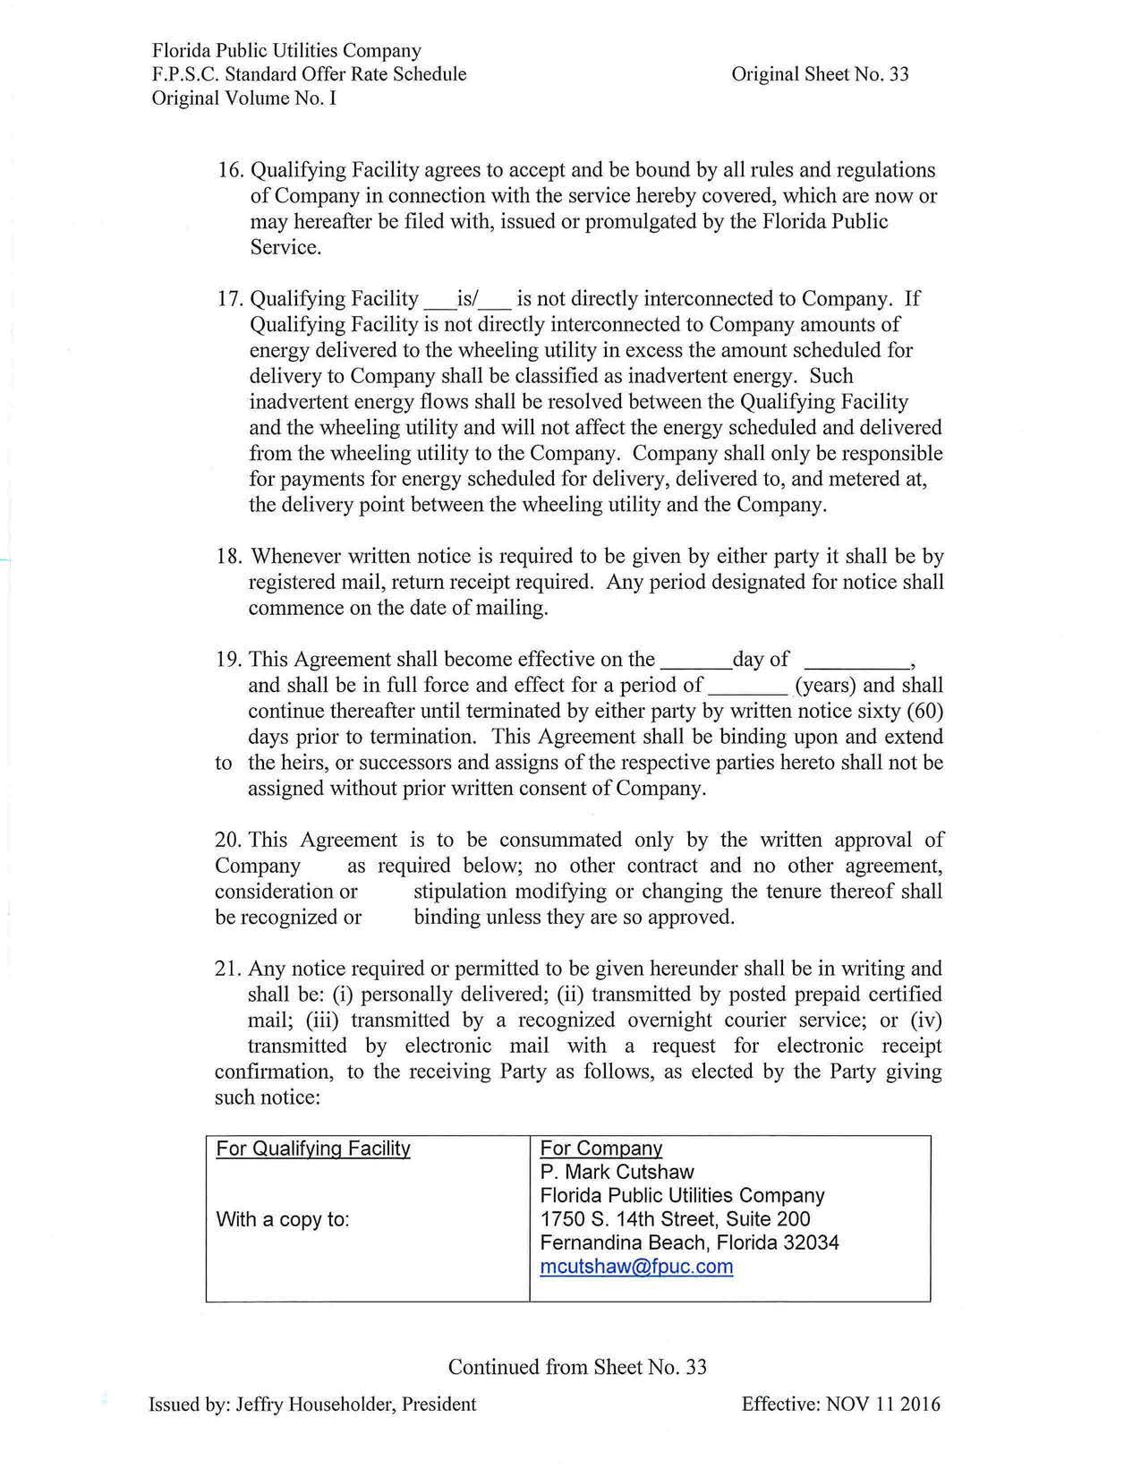
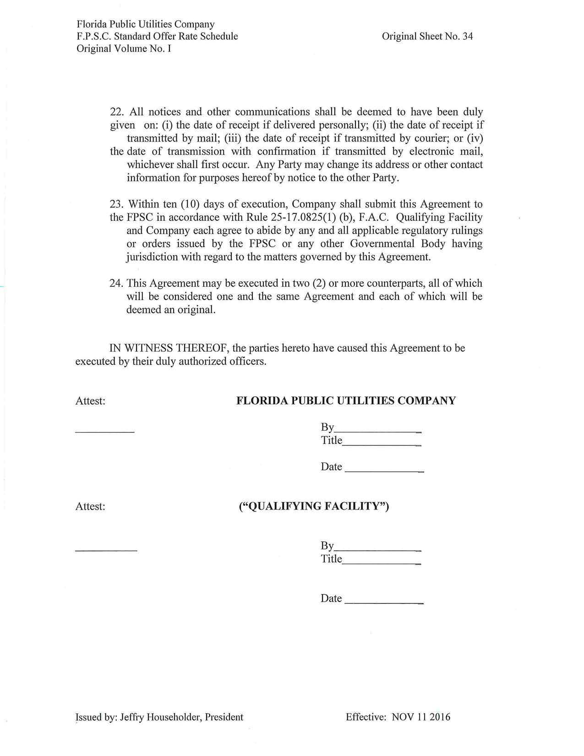

Document No. 03445-2019, filed April 1, 2019, in Docket No. 20190088-EQ.
Order No. PSC-2018-0310-PAA-EQ, issued June 12, 2018, in Docket No. 20180091-EQ, In re: Petition for approval of revisions to standard offer for energy purchased from cogenerators and renewable generating facilities and standard offer contract for purchases of firm capacity and energy, by Florida Public Utilities Company.

