BEFORE THE FLORIDA PUBLIC SERVICE COMMISSION

In re: Petition for approval of optional supplemental power services pilot program and rider, by Florida Power & Light Company. | DOCKET NO. 20190034-EI  ORDER NO. PSC-2019-0220-TRF-EI  ISSUED: June 3, 2019

The following Commissioners participated in the disposition of this matter:

ART GRAHAM, Chairman
JULIE I. BROWN
DONALD J. POLMANN
GARY F. CLARK
ANDREW GILES FAY

ORDER APPROVING PETITION FOR OPTIONAL THREE-YEAR SUPPLEMENTAL POWER SERVICES PROGRAM AND TARIFFS

BY THE COMMISSION:

Background
On January 31, 2019, Florida Power & Light Company (FPL or utility) filed a petition for approval of an optional three-year supplemental power services pilot program (OSPS pilot program) and associated tariff. The OSPS pilot program would offer customers on-site back-up generation that is installed, operated, maintained, and owned by FPL. Customers would be responsible for all costs associated with the back-up generation provided by FPL through a monthly fee. In addition, FPL requested that we establish depreciation rates applicable to its customer-sited generators.
This Commission approved a similar program for Duke Energy Florida, LLC (DEF) in 2001. DEF’s program was originally approved for a 5-year period with subsequent extensions and tariff modifications approved in 2006, 2011, and 2016.
On February 15, 2019, FPL provided a letter waiving the 60-day file and suspend provision of Section 366.06(3), Florida Statutes (F.S.), until the May 14, 2019 Agenda Conference. On February 25 and March 21, 2019, FPL responded to Commission staff’s data requests. The OSPS pilot program tariff sheets are contained in Attachments A, B, and C. Attachment A shows the OSPS tariff, Attachment B shows the residential OSPS agreement, and Attachment C shows the non-residential OSPS agreement. We have jurisdiction over this matter pursuant to Sections 366.04 and 366.06, F.S.

Decision
FPL’s petition for requesting our approval of the proposed OSPS pilot program includes provisions which protect the general body of ratepayers by making participating customers responsible for all costs associated with this optional program. The proposed tariffs would become effective 90 days after the date that we approve the program. The proposed OSPS tariff can be found in Attachments A, B, and C. Prior to the expiration of the three-year OSPS pilot program, FPL would petition this Commission regarding the future of the program.
Customers currently have the option of contracting with licensed electrical contractors or general contractors not affiliated with FPL to install on-site back-up generation. FPL stated that the process of finding a back-up generation solution could require a customer to independently research solutions, solicit offers from installers, evaluate installers, and negotiate the terms of a contract. FPL explained that customers would have significant up-front and continuing costs associated with back-up generation including the monitoring, maintenance, and repair of the equipment. Based on inquiries made by customers and conversations with customers, FPL asserted that customers are increasingly seeking back-up power solutions.

OSPS Pilot Program Overview
FPL’s proposed OSPS pilot program introduces the option of back-up power to customers that wish to avoid the associated ownership and maintenance responsibilities. Under the OSPS pilot program, FPL would be responsible for the monitoring, maintenance, and repair of the equipment located on a customer’s premises. The customers are responsible for all costs associated with this service through a monthly fee. FPL has projected that approximately 300 customers will participate in the OSPS pilot program.
FPL explained that the appropriate back-up power solution would be determined by the customer’s needs and the feasibility of system implementation. The utility would conduct an evaluation of customer requirements and of potential solutions. The utility and the customer would thereafter execute a residential or non-residential OSPS agreement that includes all the terms and conditions of the OSPS service. In addition, a customer-specific “Statement of Work” would include a description of the equipment installed, the service to be performed by FPL, and the monthly charge for the service. The agreements are included as Attachments B and C. Under the terms of the OSPS agreements, customers commit to remain in the OSPS pilot program for the specified term or otherwise compensate FPL for the net unrecovered capital and maintenance costs of the installed assets.

OSPS Equipment
FPL explained that the type of back-up generators contemplated for use will depend on each customer’s needs and is subject to change over time as technology advances. The OSPS pilot program is designed to accommodate any back-up and power conditioning technology currently available or available in the future. Currently, the types of generators contemplated for use include:
- “Whole House” residential standby generators – primarily 120/240V single-phase, stationary generators fueled by either natural gas or liquid propane, ranging from approximately 10 kilowatts (kW) to 50 kW.
- Commercial standby generators – either single-phase or three-phase stationary generators, fueled by natural gas, liquid propane, or diesel, ranging in size from 20 kW to over 60 kW. These generators are used for small-to-medium commercial applications that do not have demanding load requirements.
- Large commercial/industrial “Heavy Duty” standby generators – three-phase stationary generators typically fueled by diesel or natural gas, ranging in size from approximately 50 kW to over 2 megawatts. These generators are typically custom-built for the application and designed to meet demanding, critical load requirements.
The utility explained that, with customer approval, FPL may install additional equipment, such as interconnection, dispatch, control and/or monitoring equipment, which would enable FPL to dispatch the equipment to assist with system emergencies. The costs of such interconnection or dispatch equipment would not be included in the customer’s monthly payment and are therefore borne by the utility. The customer will always have the primary right to the power and any potential dispatch of equipment to support grid operations will not encumber the equipment’s ability to provide the service specified in the customer’s OSPS agreement.

Monthly Service Payment
FPL explained that a customer’s monthly payments will cover all costs associated with the back-up generation provided by FPL. The monthly fee is referred to as a monthly service payment in the proposed tariff. The tariff provides a formula that FPL would use to calculate the monthly fee. FPL provided work papers to show sample calculations, based on generator size, in response to Commission staff’s first data request, No. 14. The monthly fee will apply in addition to all otherwise applicable charges. The monthly fee will reflect two types of costs intended to be recovered over the term of a customer’s OSPS agreement: (1) capital costs of the installed generator and (2) on-going expenses. The two types of costs are discussed below.

Capital Costs
Each customer’s capital costs will be identified in an engineering/evaluation phase. FPL states that the capital costs under the OSPS pilot program will include the cost of the selected equipment and the cost of installation. Installation costs may include engineering, surveys, construction plans, permits, site preparation, and miscellaneous materials. Carrying costs that reflect FPL’s approved capital structure will be assessed on the total capital amount.

On-going Expenses
The projected on-going expenses recovered under the OSPS pilot program may include, but are not limited to: non-fuel operations and maintenance expenses, administrative and general expenses, depreciation expenses, and property taxes on the installed equipment. In addition, the expenses include a six percent factor to reflect a bad debt and loss reserve.
FPL explained that the utility may provide fueling services to non-residential OSPS pilot program customers in limited cases. Fuel expenses will be added to the customer’s monthly service payment and will be trued-up annually based upon actual and forecasted operating parameters and fuel costs. The utility stated that the fuel costs incurred under the OSPS pilot program will not be included in FPL’s fuel cost recovery clause filings.
In addition to annual revisions to the fuel expense, FPL stated that the monthly service payment may be adjusted by agreement of both the customer and the utility during the term of service. Reasons for modifying the monthly fee may include, but are not limited to, changes in service required by the customer, requests by the customer for supplemental equipment or services, or changes or increases in the customer’s facilities which will materially affect the operation of the utility’s equipment.
FPL proposed to include the capital costs of the OSPS pilot program in rate base and the revenues from the monthly fee will be included in base rate operating revenue (which acts as a credit when setting base rates). FPL asserts that the OSPS program is designed to have no impact on the general body of ratepayers over the life of the equipment and that the capital investment only occurs after a customer signs a long-term contract.
Table 1 shows three examples of generators with potential parameters contemplated for use under the OSPS pilot program. Numbers provided below by FPL are for illustrative purposes and actual costs are contingent on specific project requirements.
Table 1
Examples of Monthly Service Payments
Equipment Type | Capital Costs | On-going Expenses | Contract Term | Monthly Service Payment
Residential, light-duty, whole-house generator | $15,000 | $1,000/year | 10 years | $303/month
100 kW commercial heavy-duty generator | $90,000 | $2,750/year | 20 years | $1,167/month
1,000 kW industrial heavy-duty generator | $650,000 | $9,250/year | 20 years | $7,302/month
Source: FPL’s response to staff’s data request, No. 14.

OSPS Pilot Program Period
FPL requested that we approve the OSPS pilot program as a pilot program and an experimental rate for a period of three years. FPL requested that this three-year period commence 90 days after the date of our order approving the OSPS pilot program. The utility stated that the three-year period will allow FPL to gain insight into the benefits, costs, and optimal economic implementation of various customer-sited back-up power solutions and equipment configurations. During this time, FPL will determine whether the estimates and assumptions used in developing the OSPS pilot program were reasonably accurate and that if continuing the OSPS program on a permanent basis is warranted. If the utility decides against continuing the OSPS program after the pilot period expires, FPL proposed that customers taking service under the OSPS pilot program would be allowed to continue being served pursuant to and through the term of their OSPS agreement.
Upon review of the petition and materials subsequently provided by the utility, we approve FPL’s proposed OSPS pilot program and rider. We find that the approved OSPS pilot program approved herein protects the general body of ratepayers by making participating customers responsible for all costs associated with this optional program. The approved tariffs shall become effective 90 days after the issuance of our order approving the program. The proposed OSPS tariff can be found in Attachments A, B, and C, attached hereto. Prior to the expiration of the three-year OSPS pilot program, FPL shall petition this Commission regarding the future of the program.

Depreciation Parameters and Rates
In accordance with Rule 25-6.0436(3)(b), Florida Administrative Code (F.A.C.), FPL also requested our approval of two new depreciation rates. The requested depreciation rates shall be applied to four newly-established plant subaccounts. The subaccounts shall be listed under Federal Energy Regulatory Commission (FERC) Account – 371 - Installations on customers’ premises and Account – 372 - Leased property on customers’ premises.
Pursuant to Rule 25-6.0436(3)(a), F.A.C., electric utilities are required to maintain depreciation rates and accumulated depreciation reserves in accounts or subaccounts in accordance with the Uniform System of Accounts for Public Utilities and Licensees, as found in the Code of Federal Regulations, which is incorporated by reference in Rule 25-6.014(1), F.A.C. The four property subaccounts, which are based on Uniform System of Accounts prescribed for public utilities and licensees subject to the provisions of the Federal Power Act are: Account 371.6 - Light-Duty Generators; Account 371.7 - Heavy-Duty Generators; Account 372.6 - Light-Duty Generators; and Account 372.7 - Heavy-Duty Generators.
For light-duty generators and associated ancillary equipment, the utility requests approval of a 10-year average service life (ASL) and a zero percent net salvage level (NS). An annual depreciation rate of 10 percent is computed from these parameters. For heavy-duty generators and associated ancillary equipment, FPL requests approval of a 20-year ASL and a zero percent NS level. An annual depreciation rate of 5 percent is computed from these parameters.
FPL provided supporting information detailing typical life expectancies for customer-sited generators covering various levels of electric output. The information included life estimates from generator manufacturers, associated trade groups, and engineering-oriented academia. After a review of the provided materials, we find that the utility’s life proposals are well founded and approve the proposed 10- and 20-year ASL for light-duty and heavy-duty generators respectively. Further, this Commission will have future opportunities based on existing rules to evaluate FPL’s depreciation data associated with useful lives and net salvage levels and to order modifications as appropriate.
For the reasons discussed above, we approve a 10 percent annual depreciation rate for Light-Duty Generators and a 5 percent annual depreciation rate for Heavy-Duty Generators, applicable to subaccounts Account 371.6 - Light-Duty Generators; Account 371.7 - Heavy-Duty Generators; Account 372.6 - Light-Duty Generators; and Account 372.7 - Heavy-Duty Generators.
Based on the foregoing, it is

ORDERED by the Florida Public Service Commission that Florida Power & Light Company’s optional three-year supplemental power services pilot program and associated tariffs in Attachments A, B, and C are approved. It is further

ORDERED that the tariffs shall become effective 90 days after the date of our order approving the program. It is further

ORDERED that prior to the expiration of the three-year OSPS pilot program, the utility shall petition this Commission regarding the future of the program. It is further

ORDERED that we approve a 10 percent annual depreciation rate for Light-Duty Generators and a 5 percent annual depreciation rate for Heavy-Duty Generators. It is further
ORDERED that if a protest is filed within 21 days of the issuance of the order, this tariff shall remain in effect with any increase held subject to refund pending resolution of the protest. If no timely protest is filed, this docket shall be closed upon issuance of a consummating order.

By ORDER of the Florida Public Service Commission this 3rd day of June, 2019.

/s/ Adam J. Teitzman
ADAM J. TEITZMAN
Commission Clerk
Florida Public Service Commission
2540 Shumard Oak Boulevard
Tallahassee, Florida 32399
(850) 413-6770
www.floridapsc.com

Copies furnished: A copy of this document is provided to the parties of record at the time of issuance and, if applicable, interested persons.

WLT

NOTICE OF FURTHER PROCEEDINGS

The Florida Public Service Commission is required by Section 120.569(1), Florida Statutes, to notify parties of any administrative hearing or judicial review of Commission orders that is available under Sections 120.57 or 120.68, Florida Statutes, as well as the procedures and time limits that apply. This notice should not be construed to mean all requests for an administrative hearing or judicial review will be granted or result in the relief sought.

Mediation may be available on a case-by-case basis. If mediation is conducted, it does not affect a substantially interested person's right to a hearing.

The Commission's decision on this tariff is interim in nature and will become final, unless a person whose substantial interests are affected by the proposed action files a petition for a formal proceeding, in the form provided by Rule 28-106.201, Florida Administrative Code. This petition must be received by the Office of Commission Clerk, 2540 Shumard Oak Boulevard, Tallahassee, Florida 32399-0850, by the close of business on June 24, 2019.

In the absence of such a petition, this Order shall become final and effective upon the issuance of a Consummating Order.

Any objection or protest filed in this docket before the issuance date of this order is considered abandoned unless it satisfies the foregoing conditions and is renewed within the specified protest period.

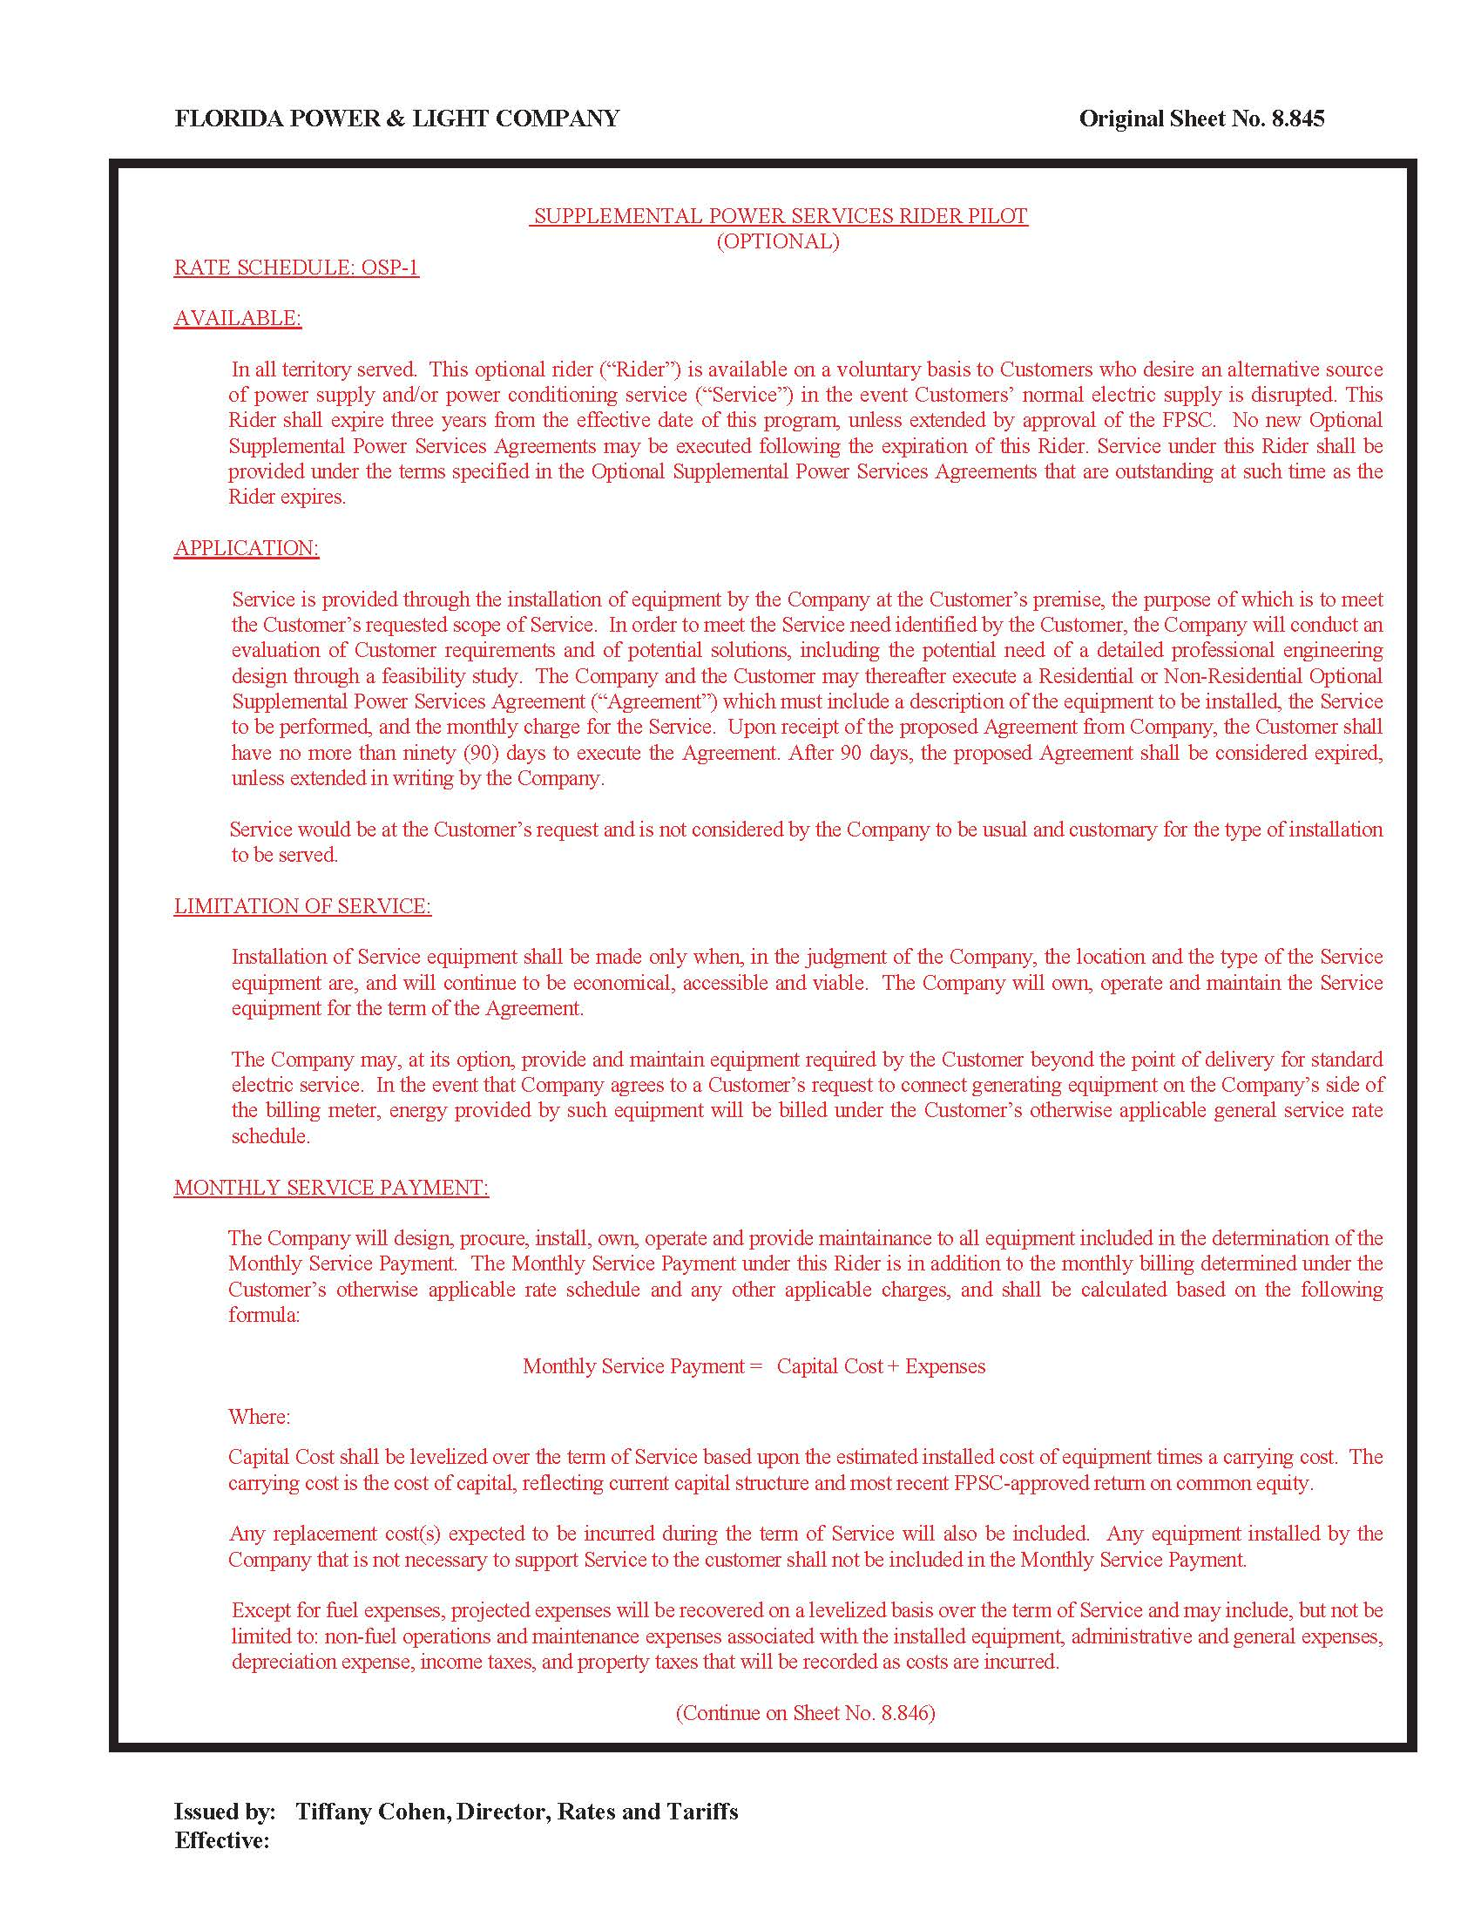

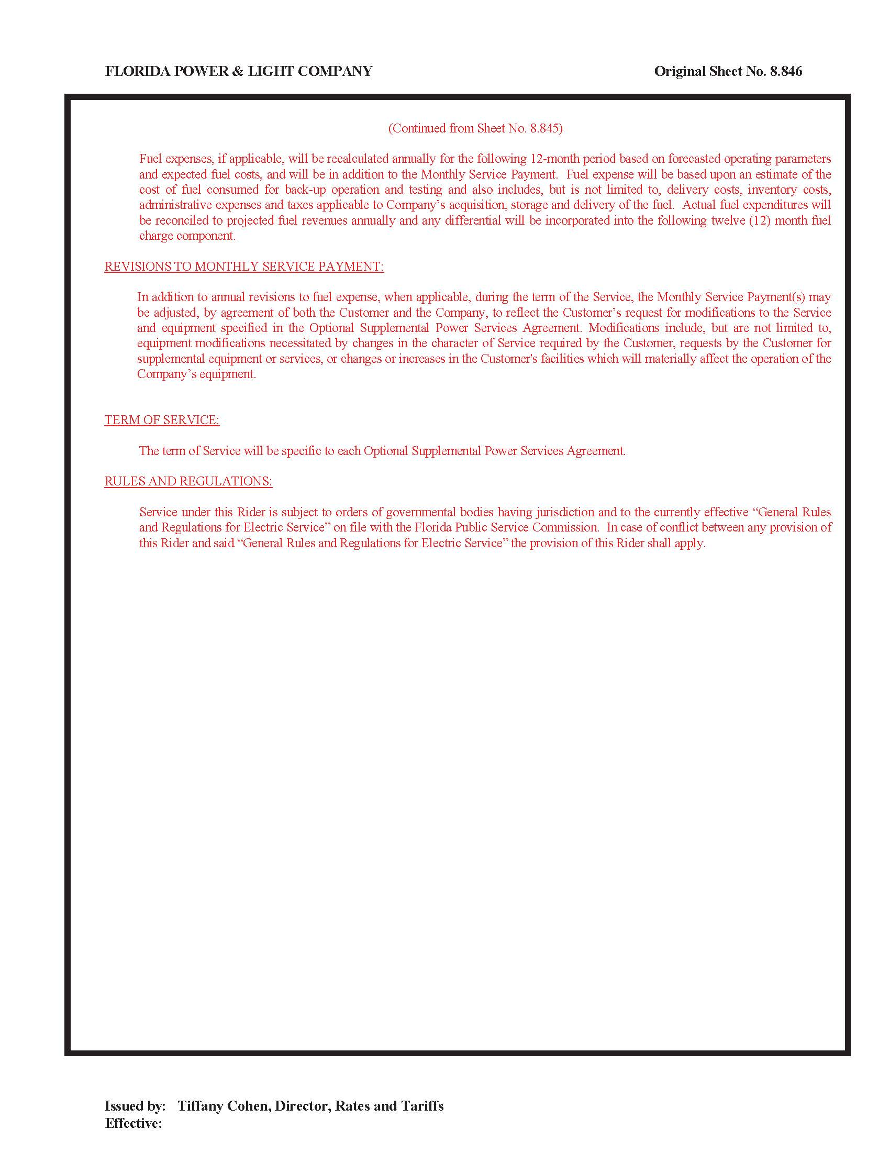

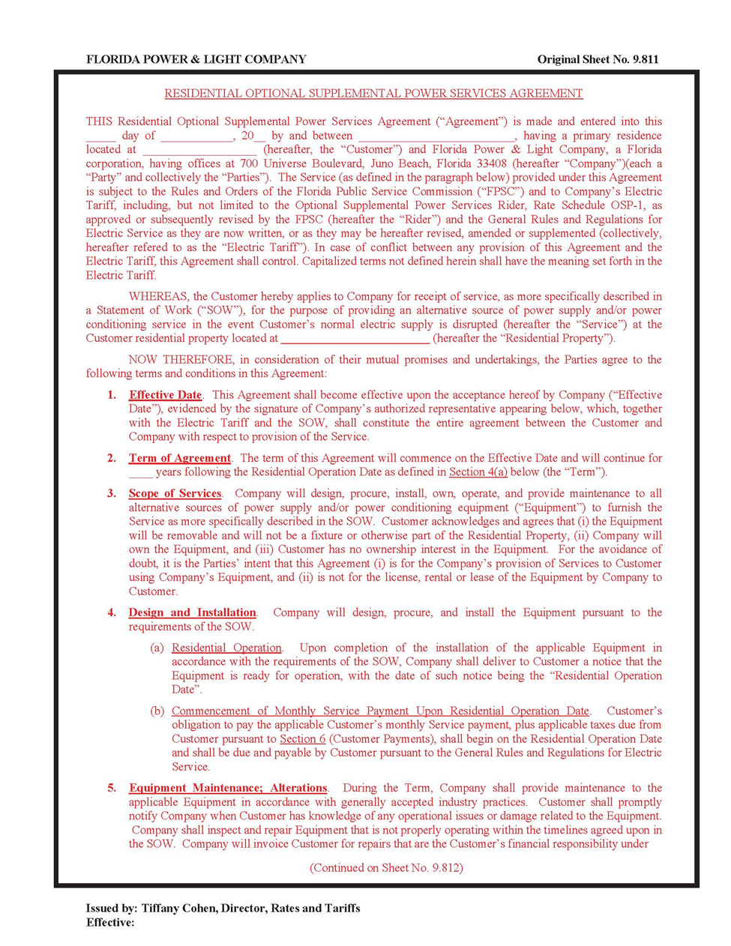

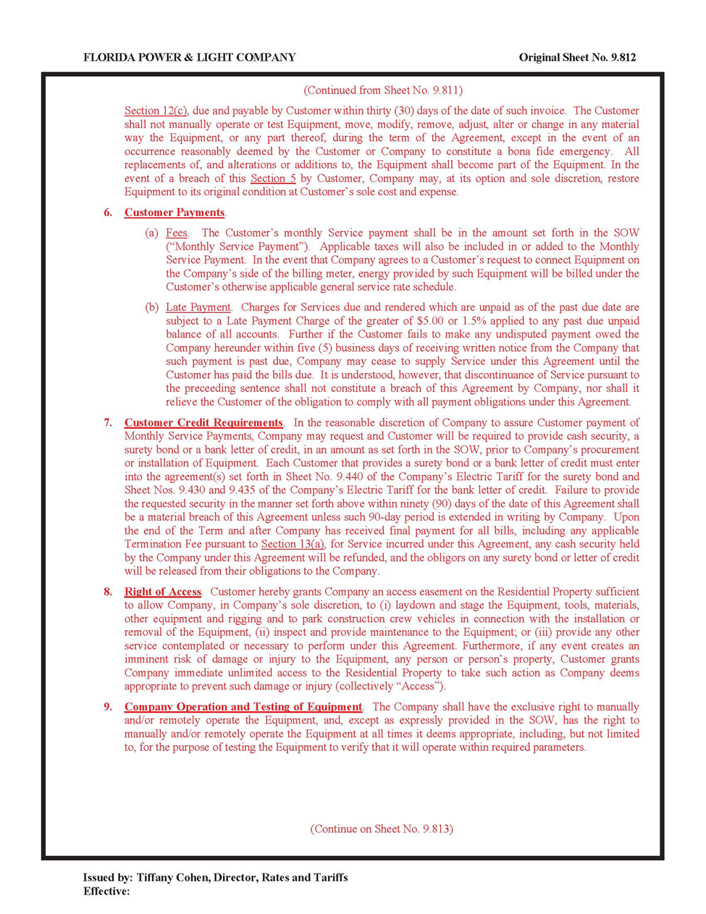

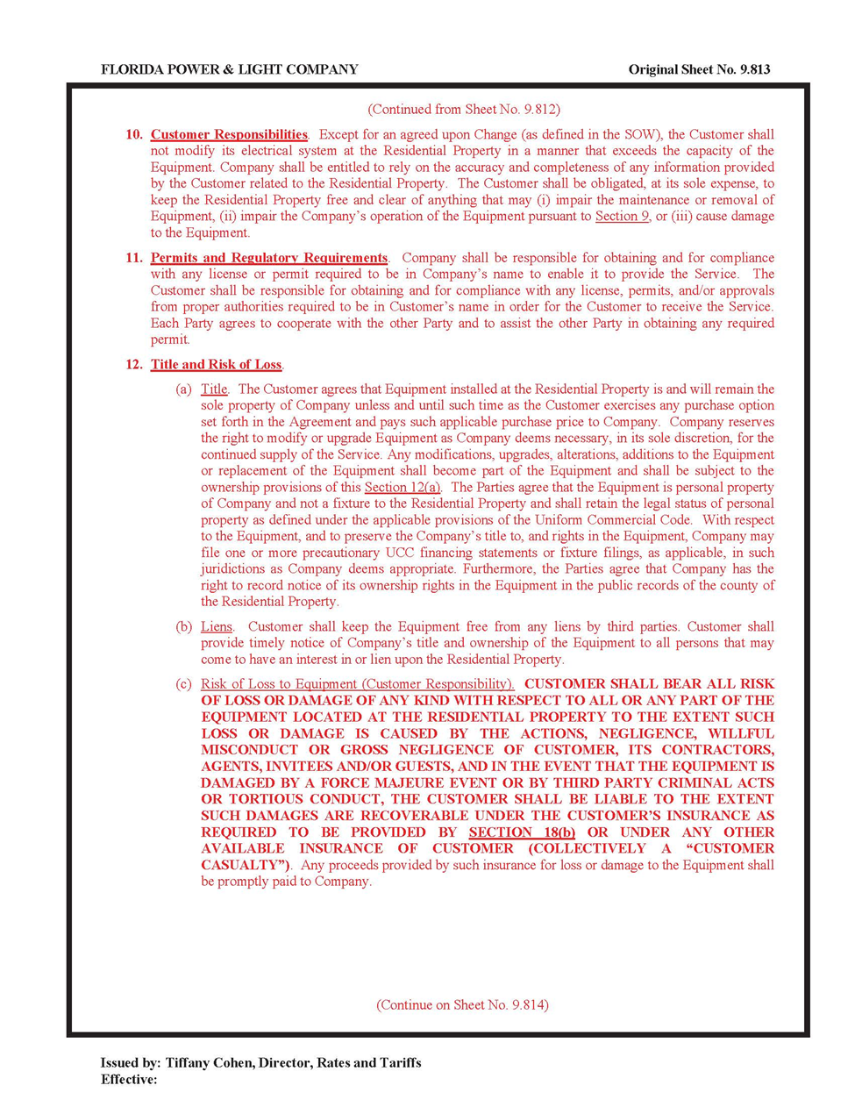

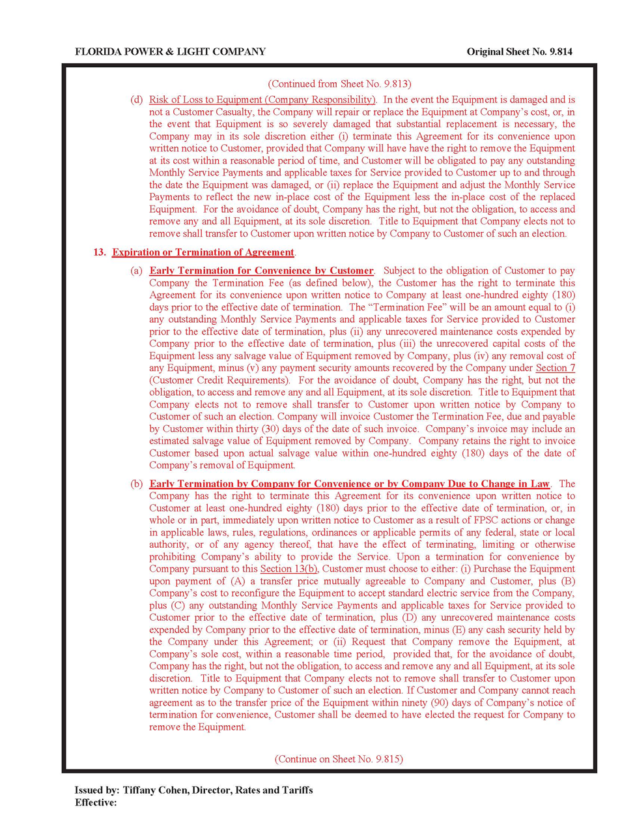

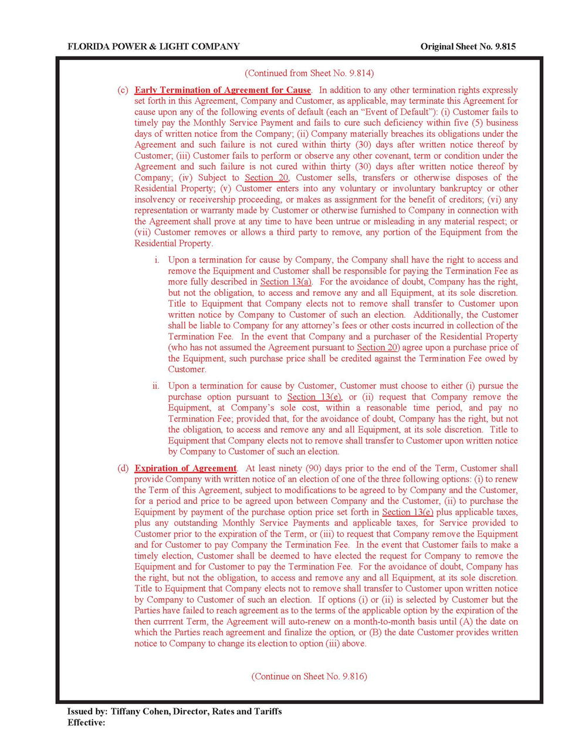

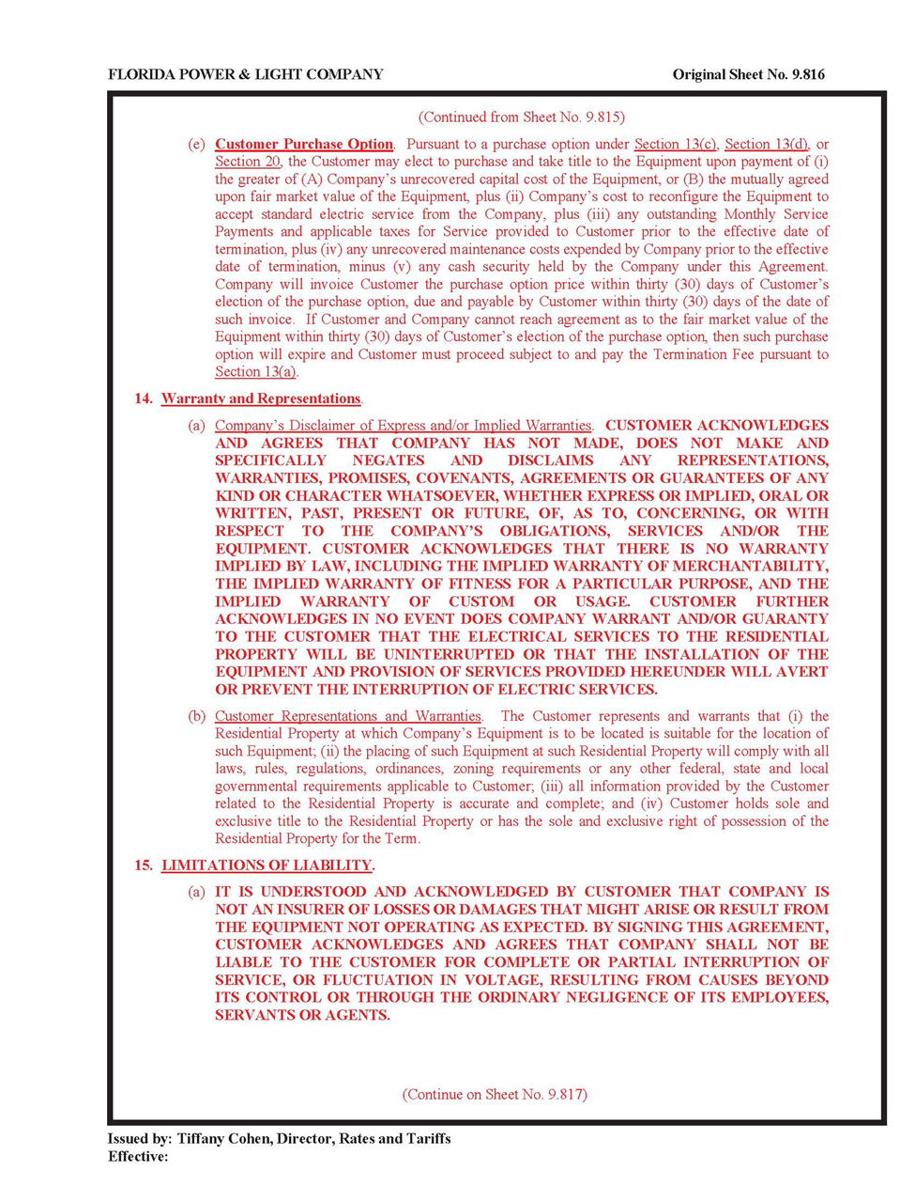

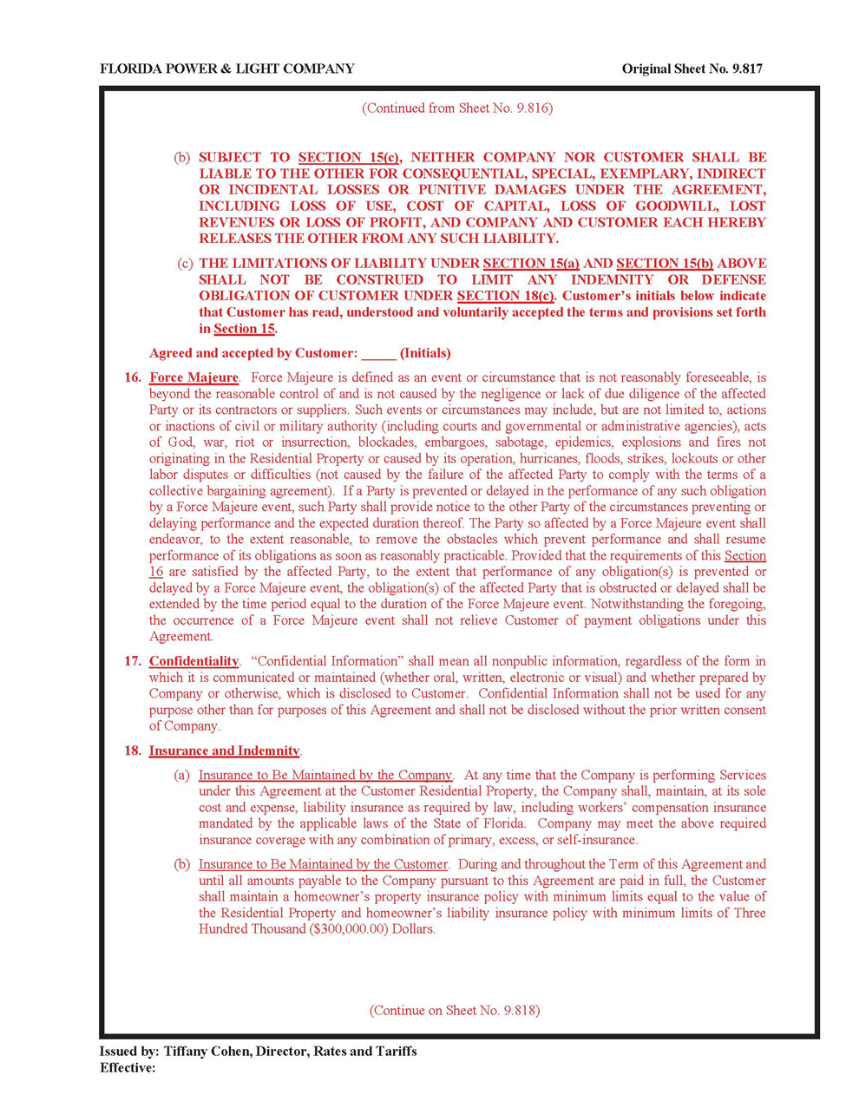

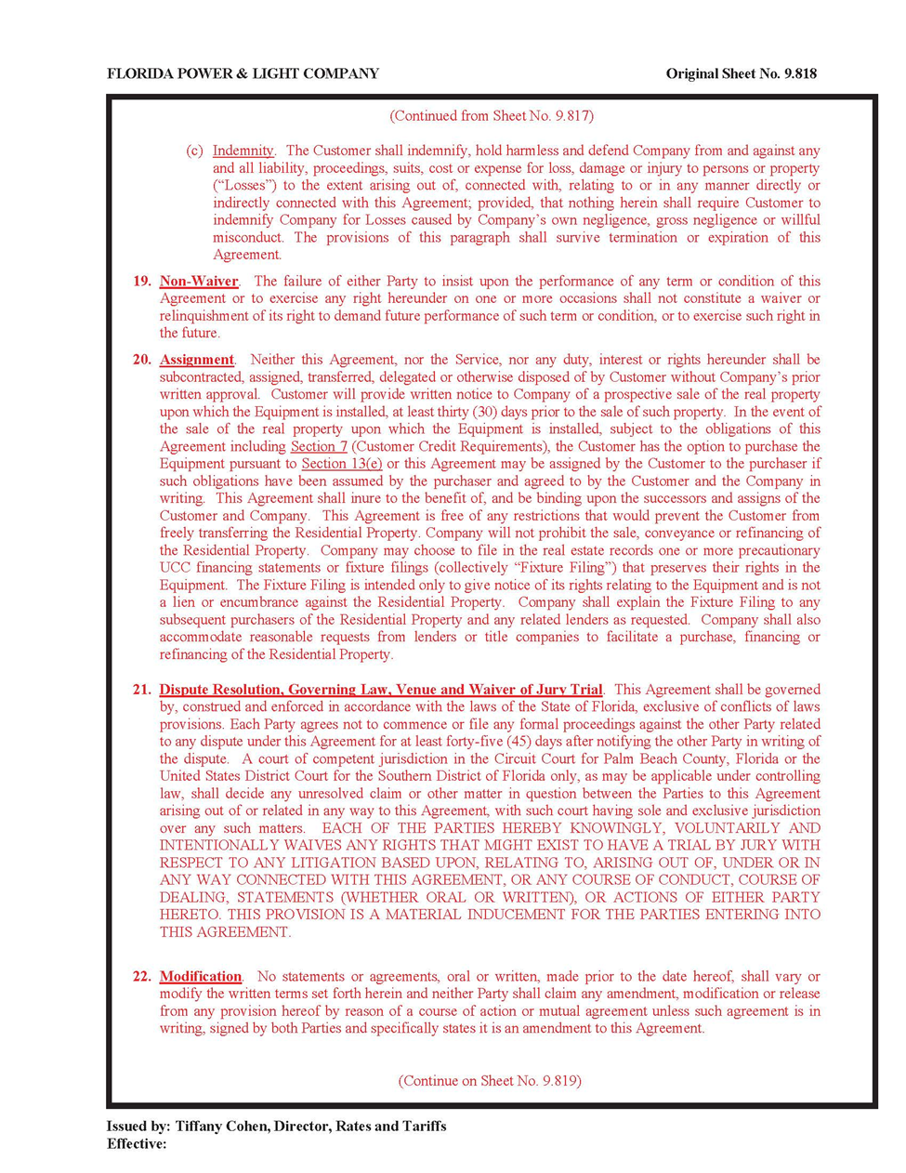

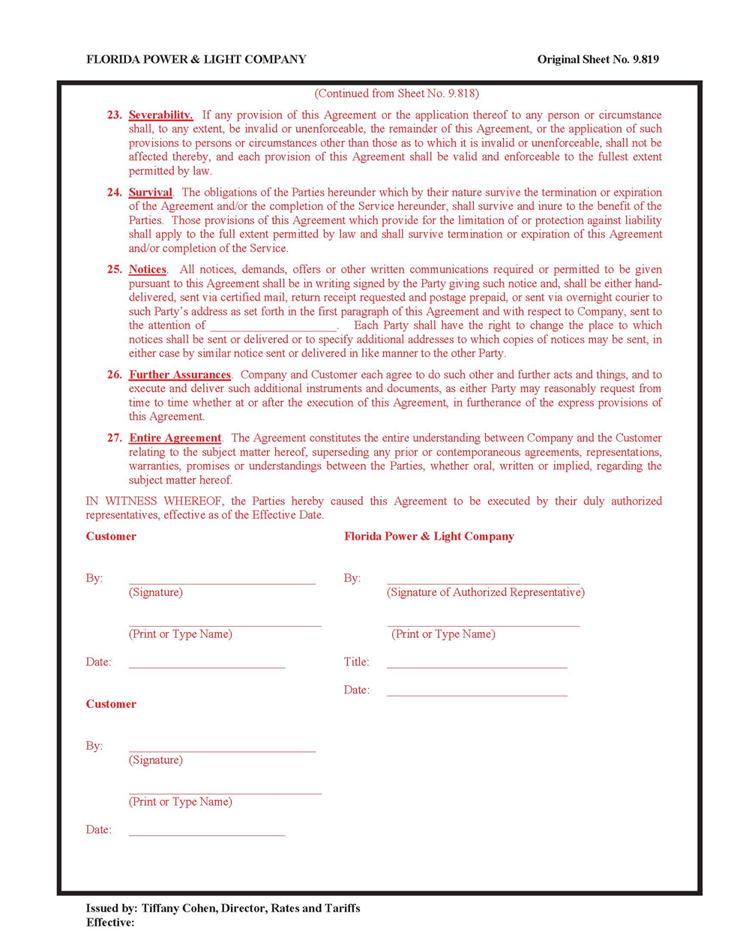

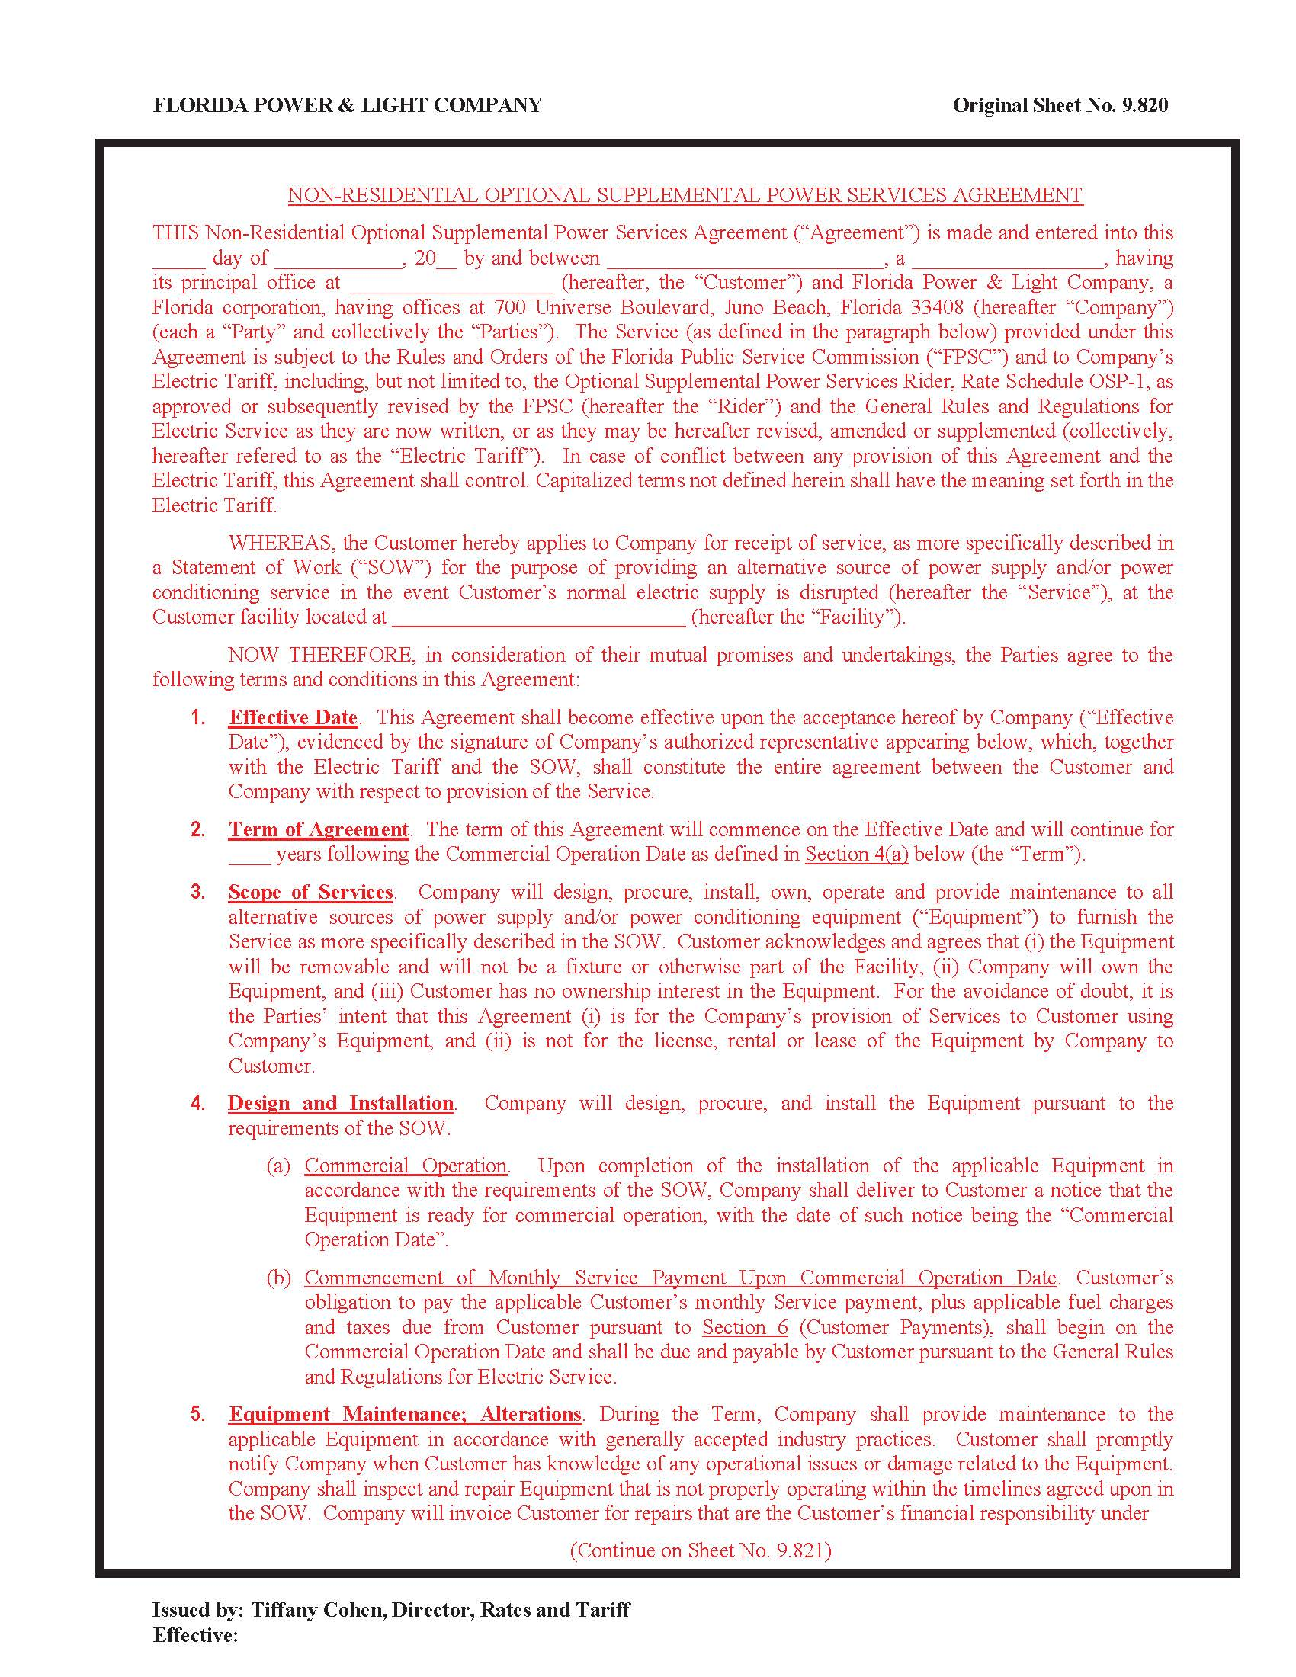

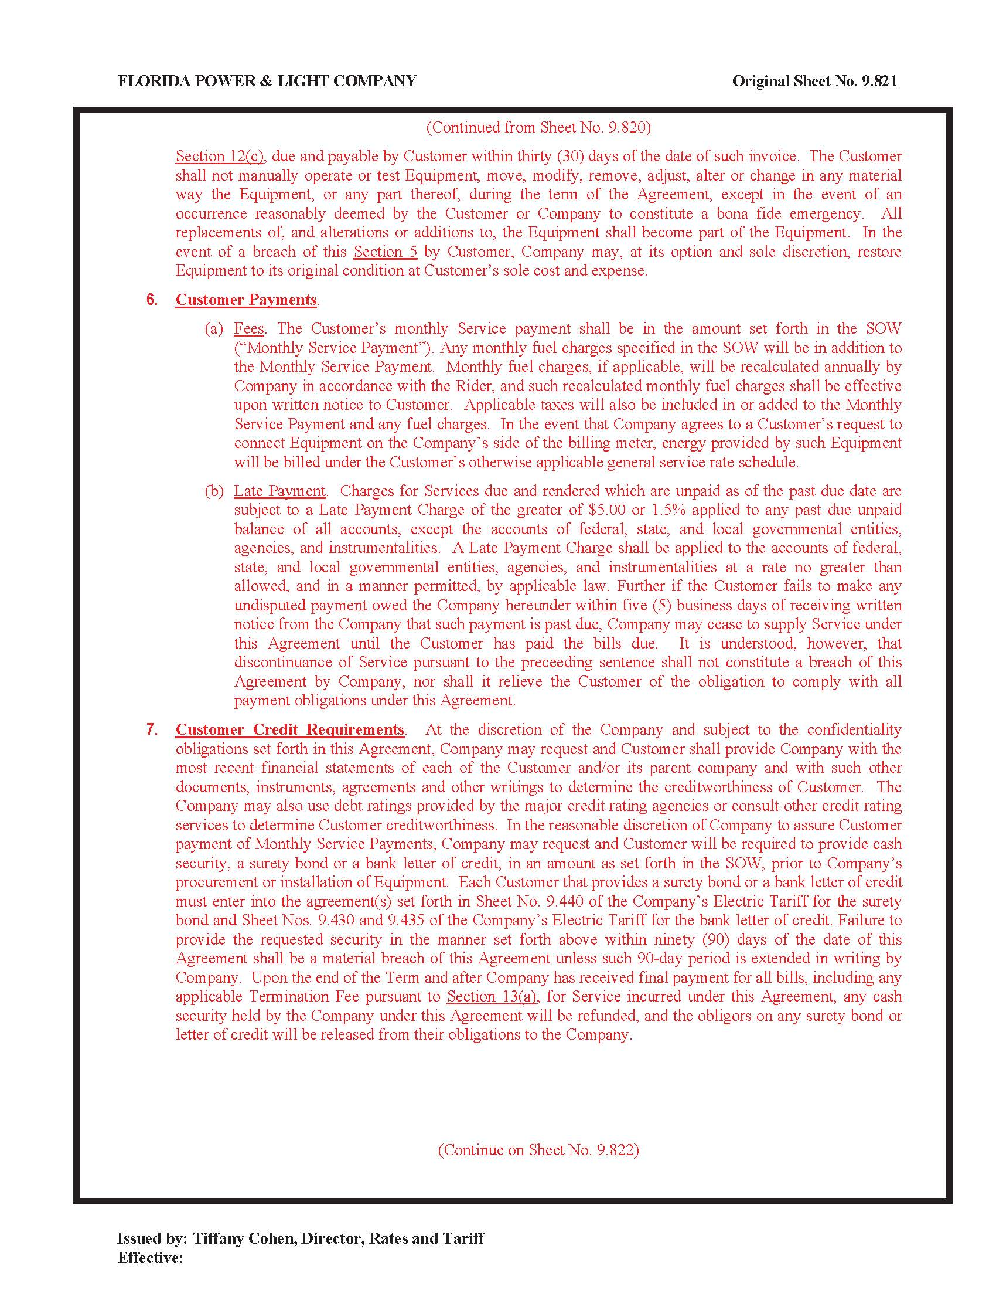

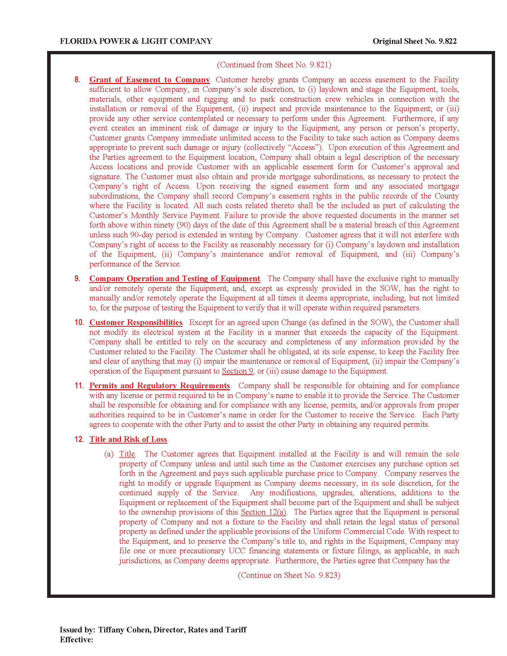

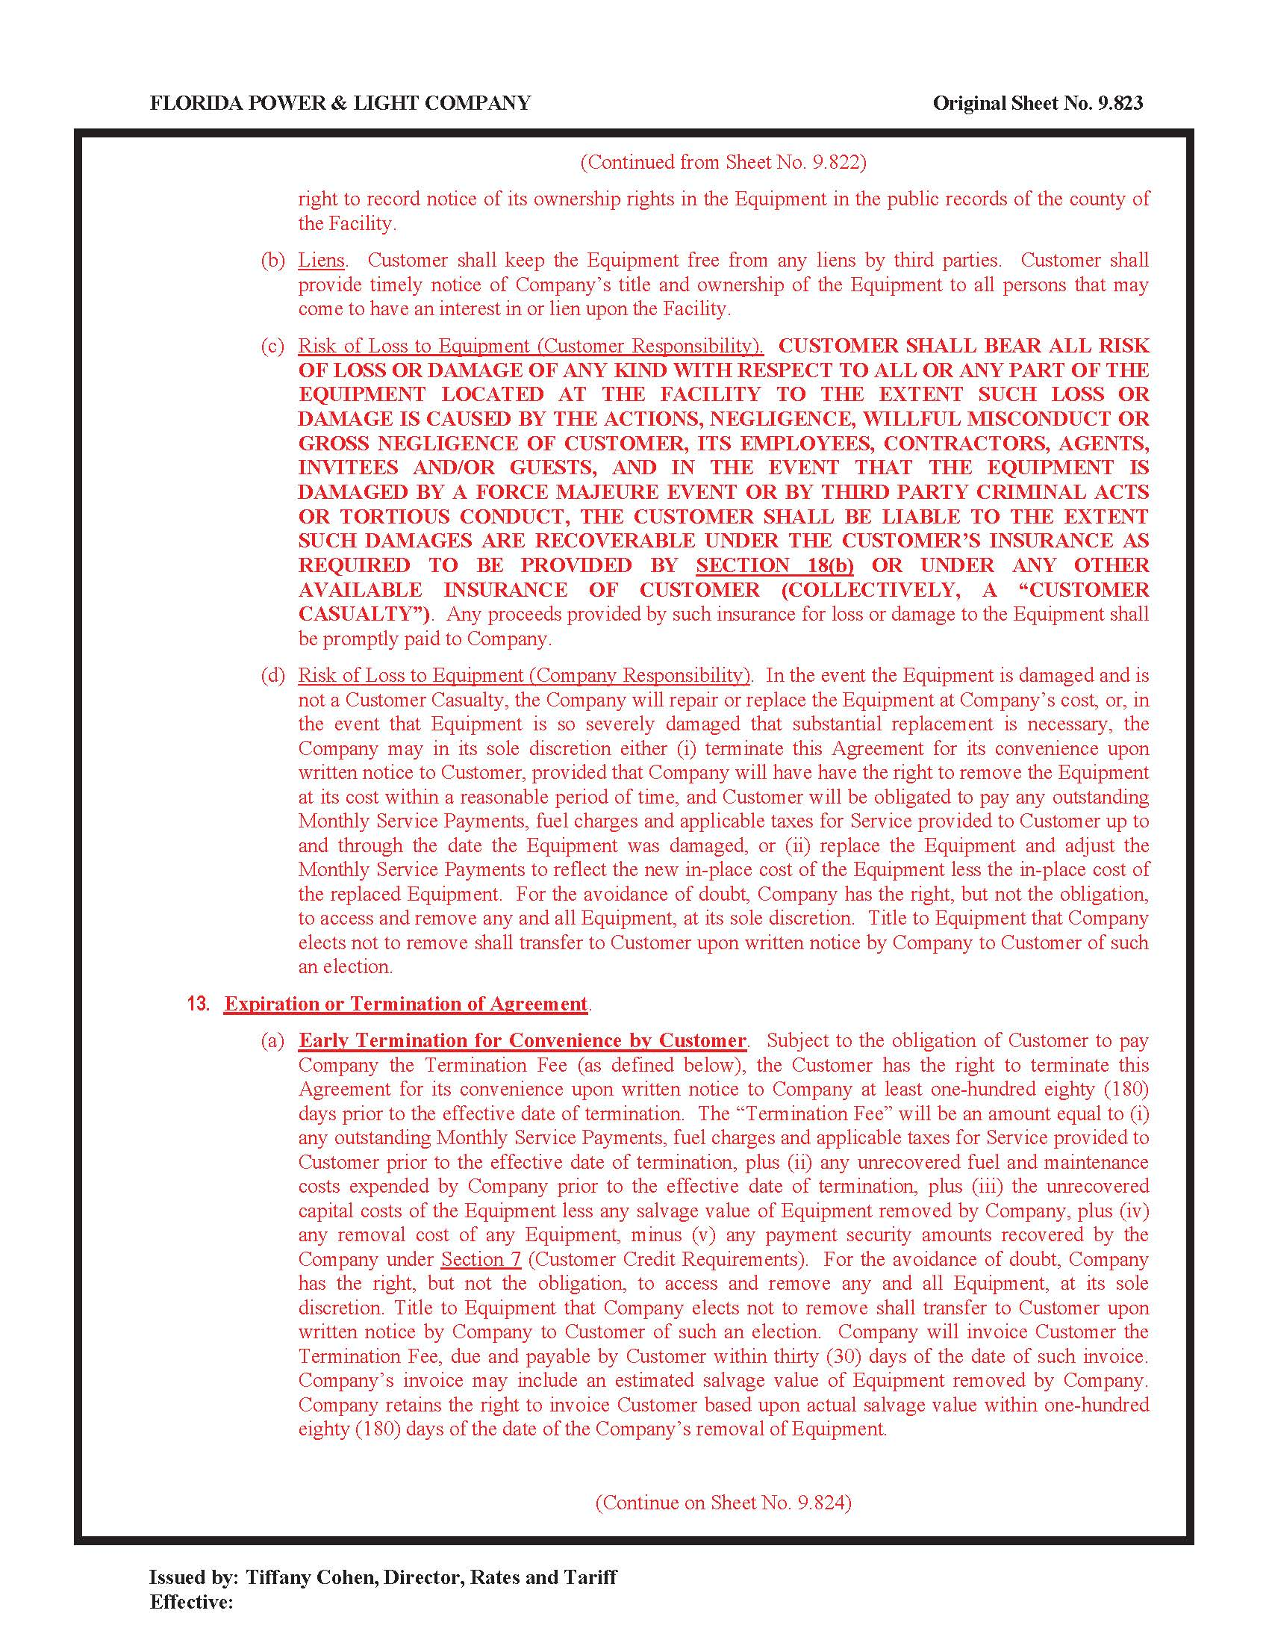

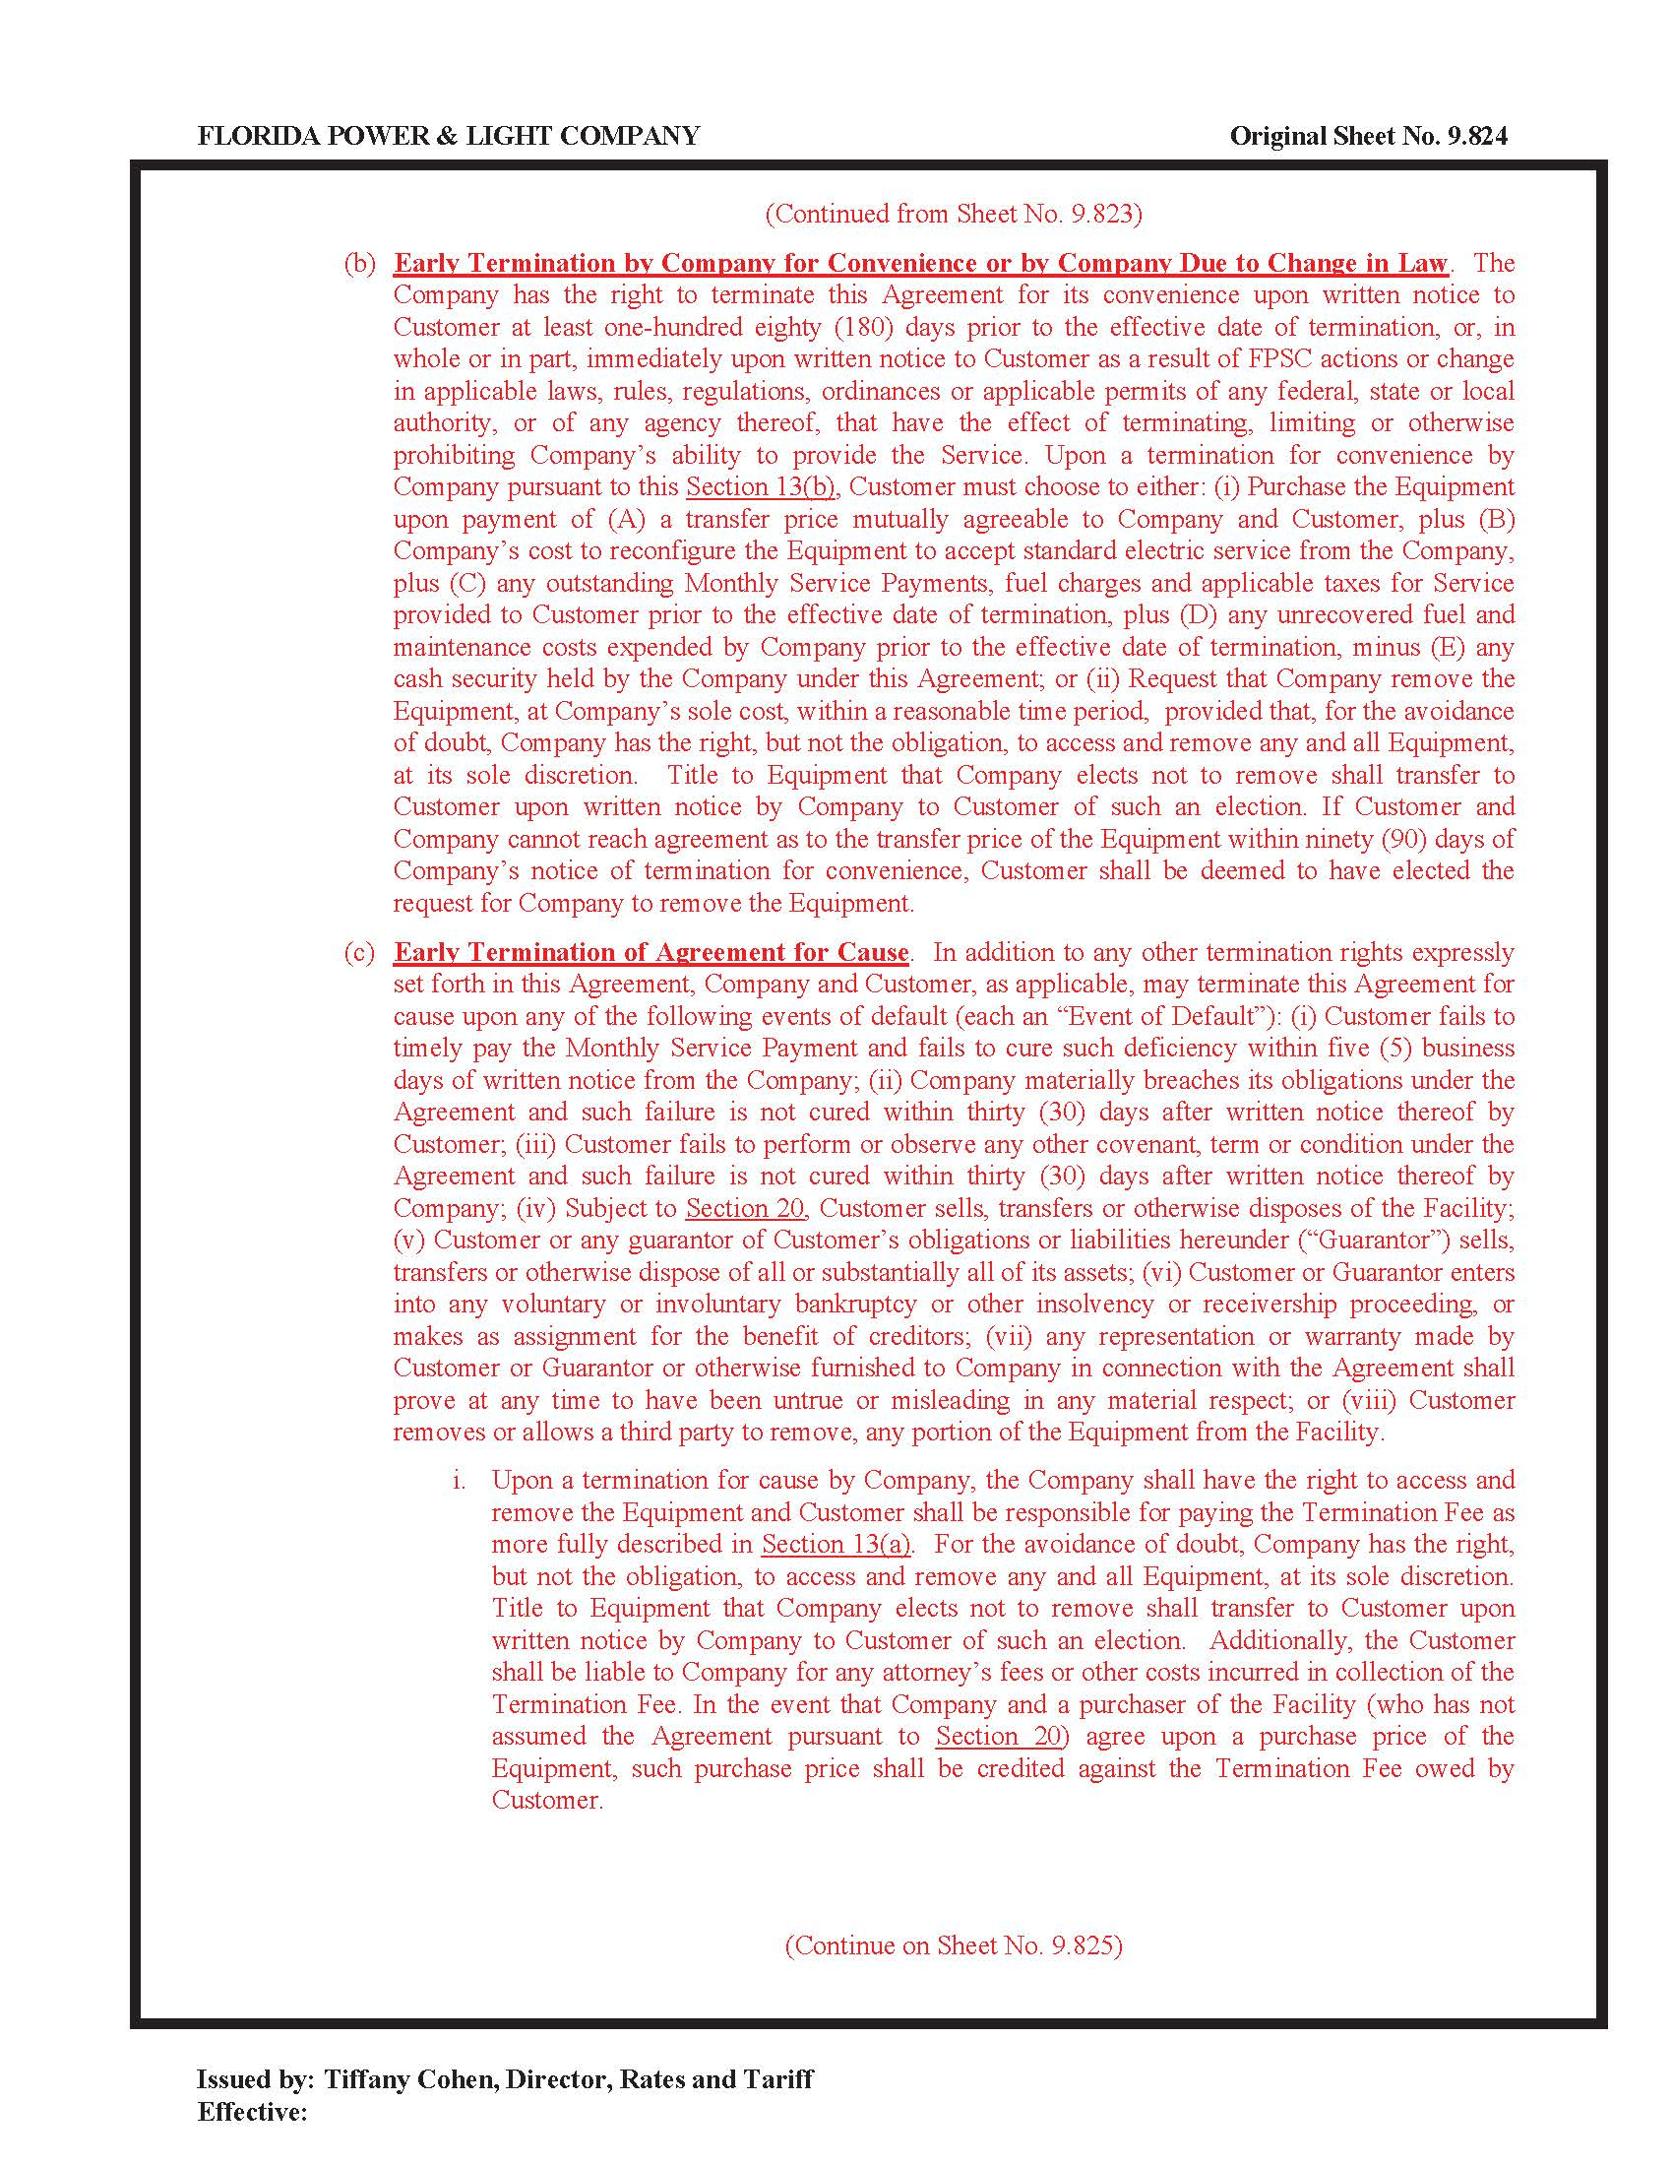

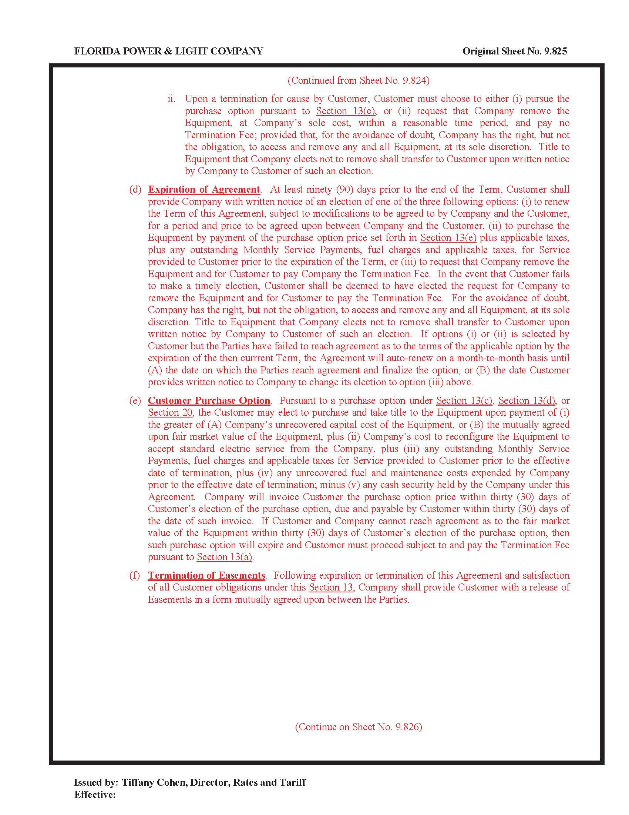

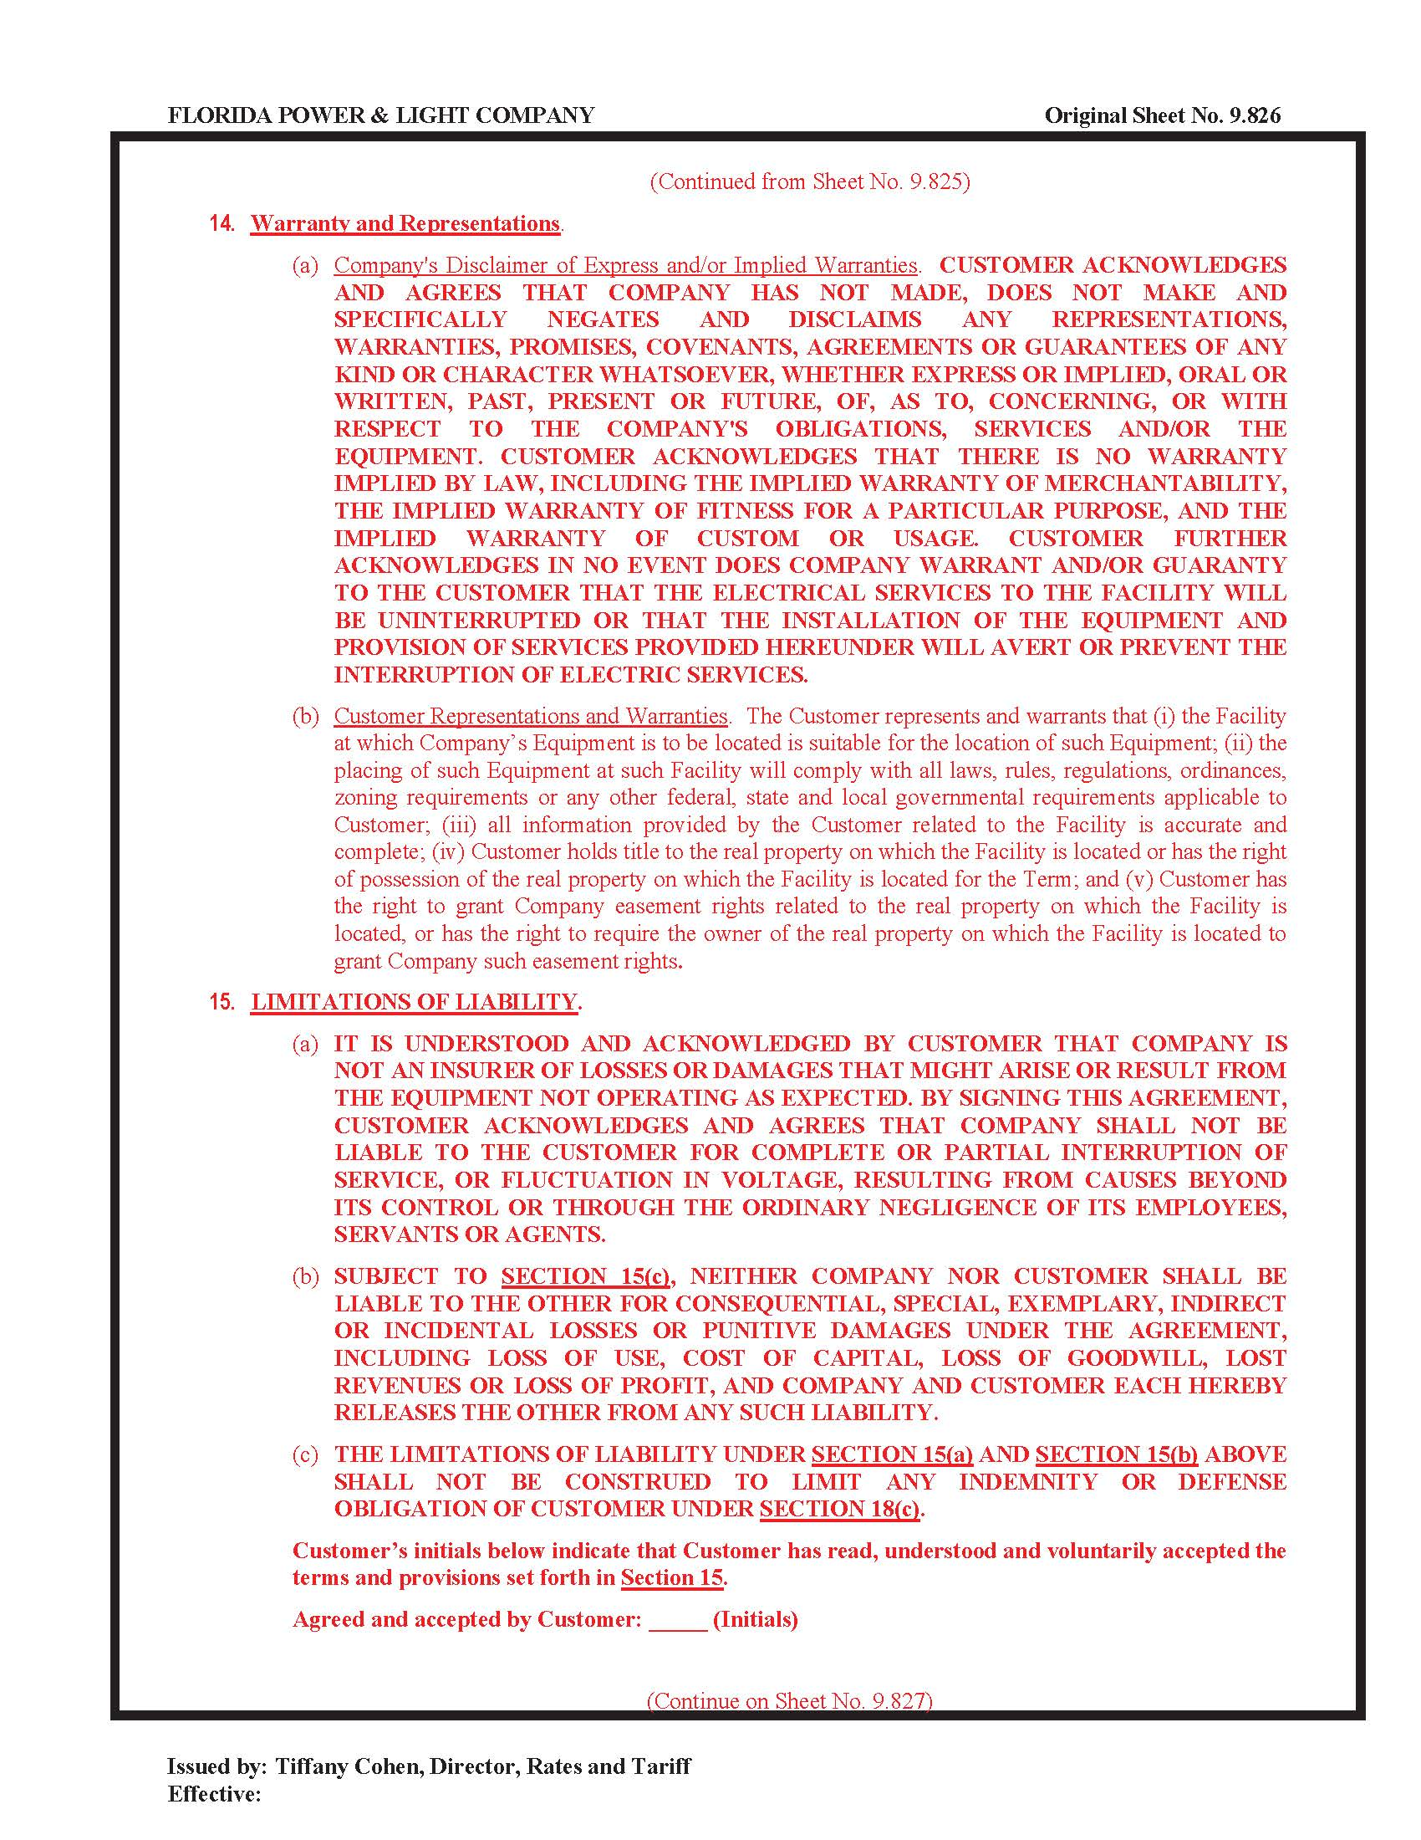

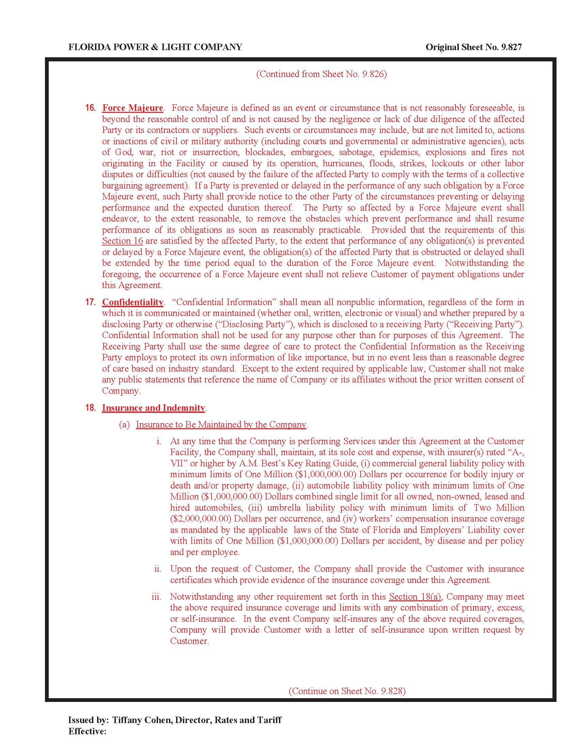

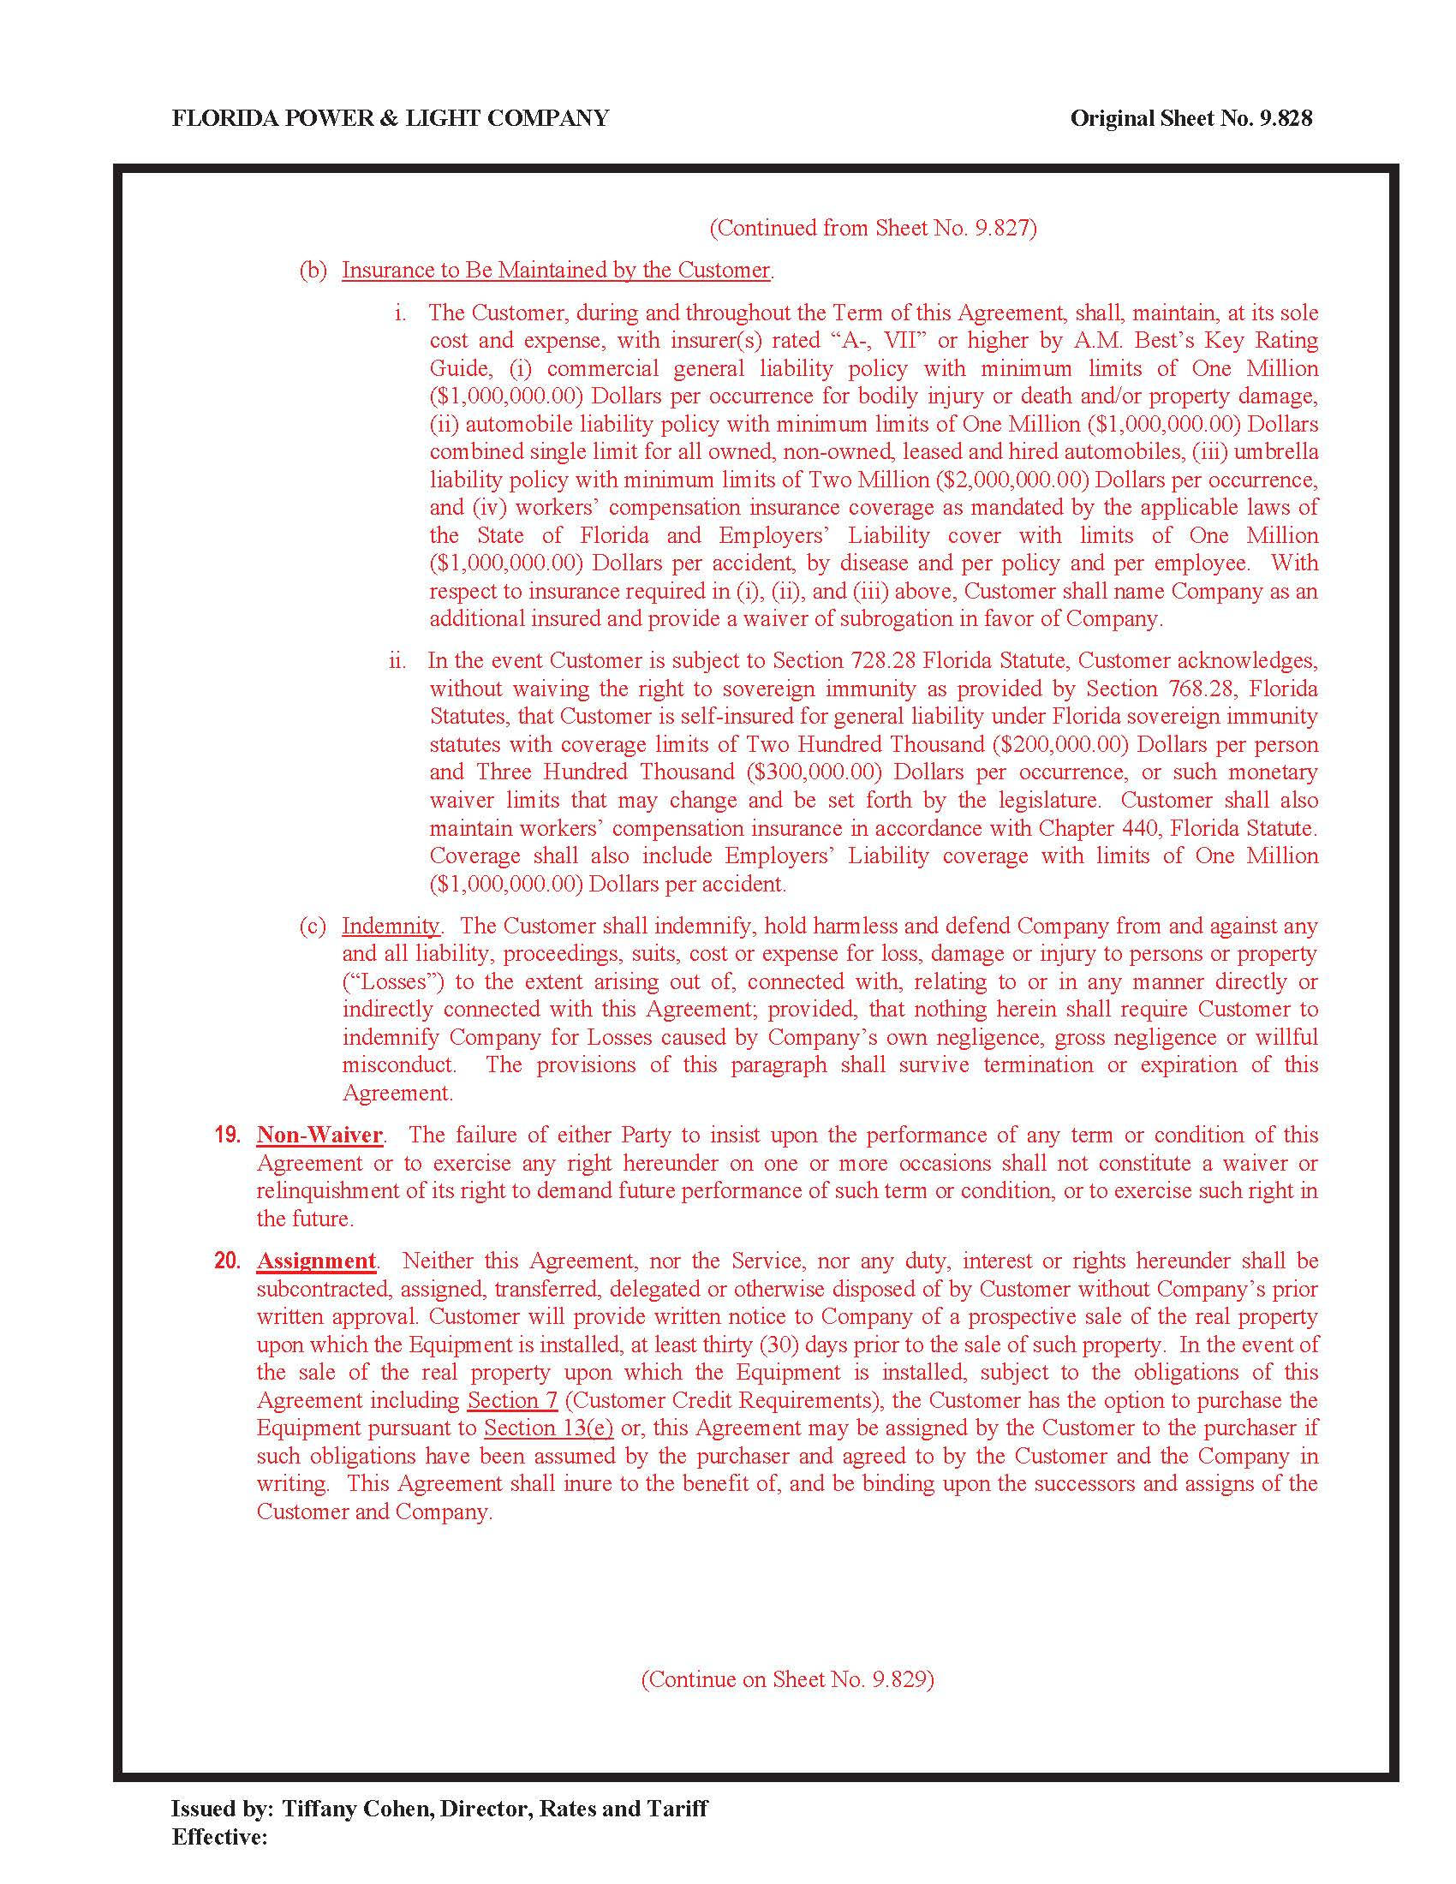

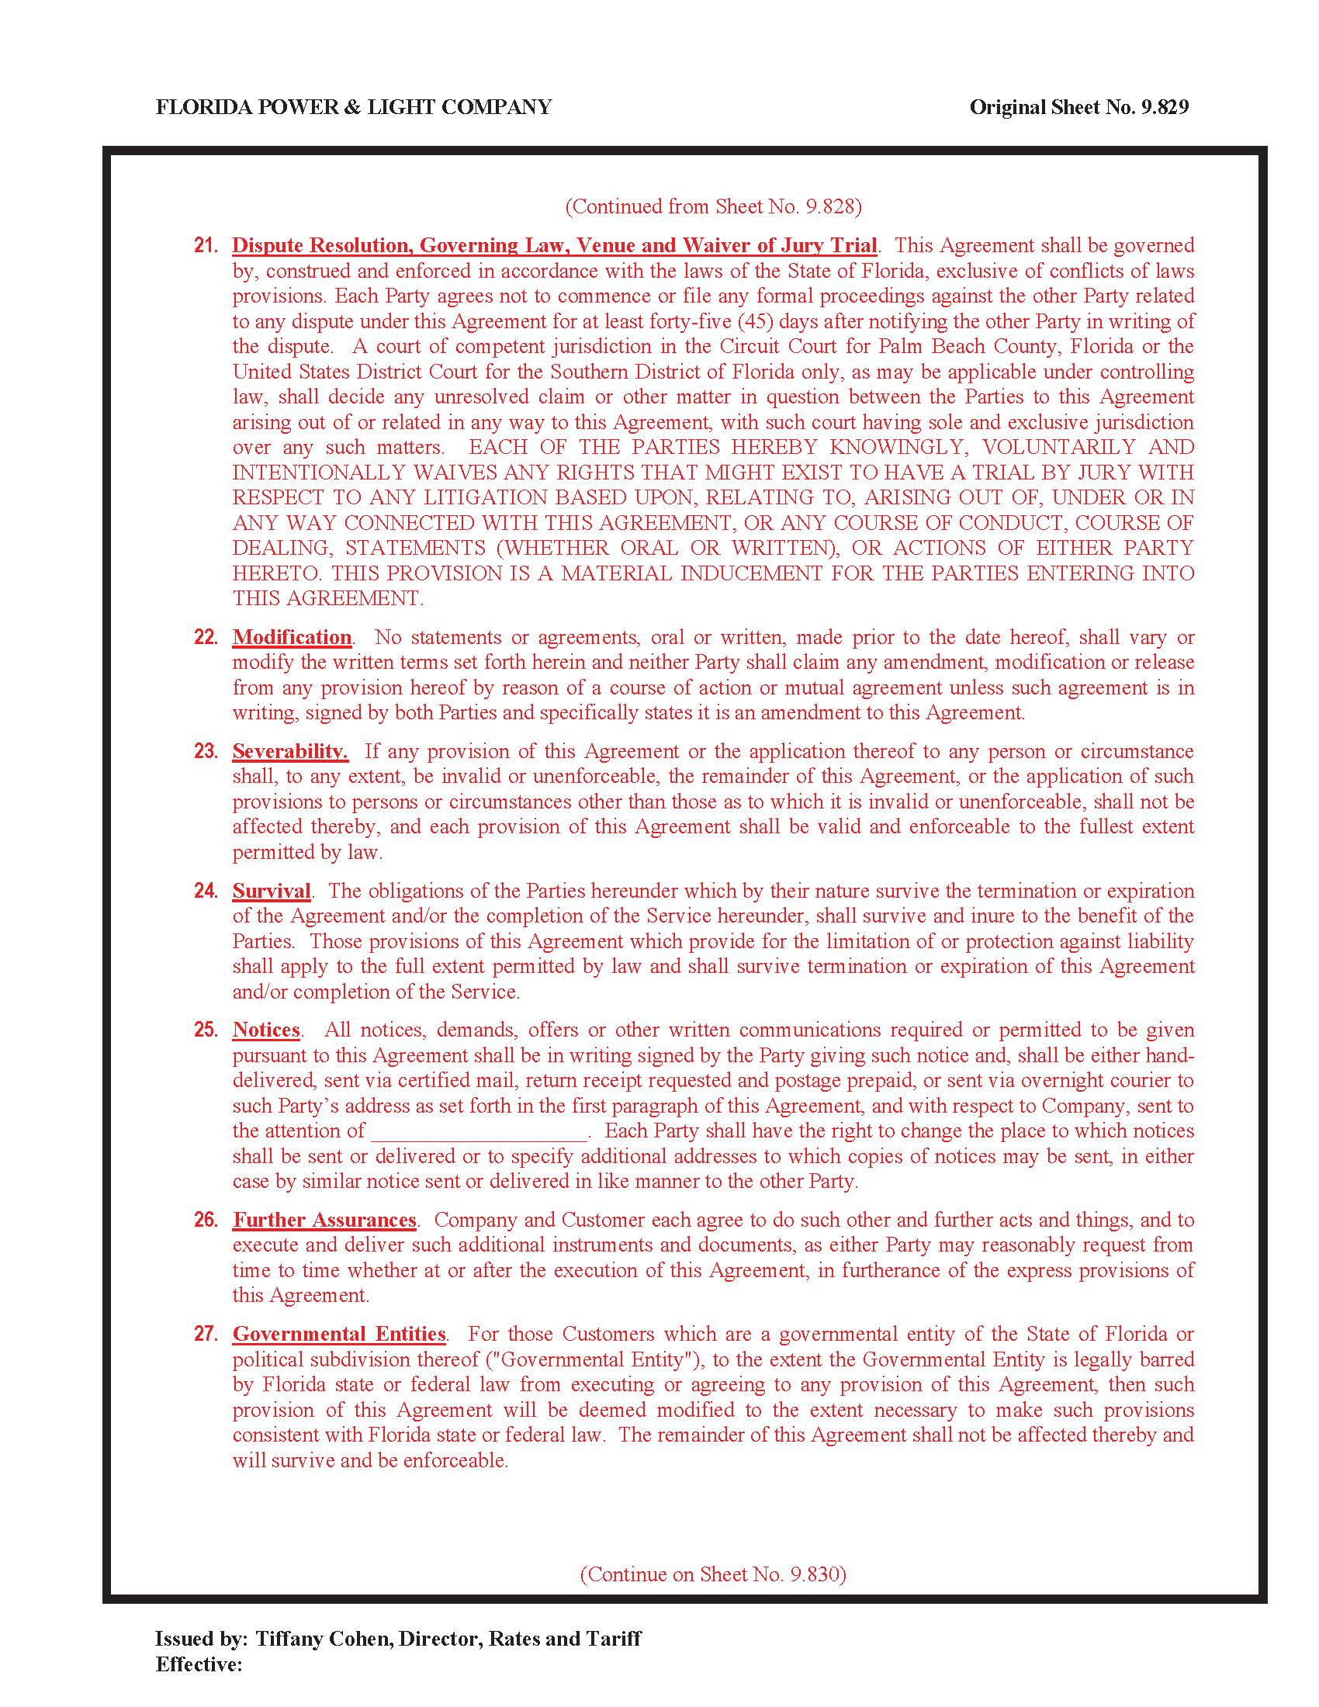

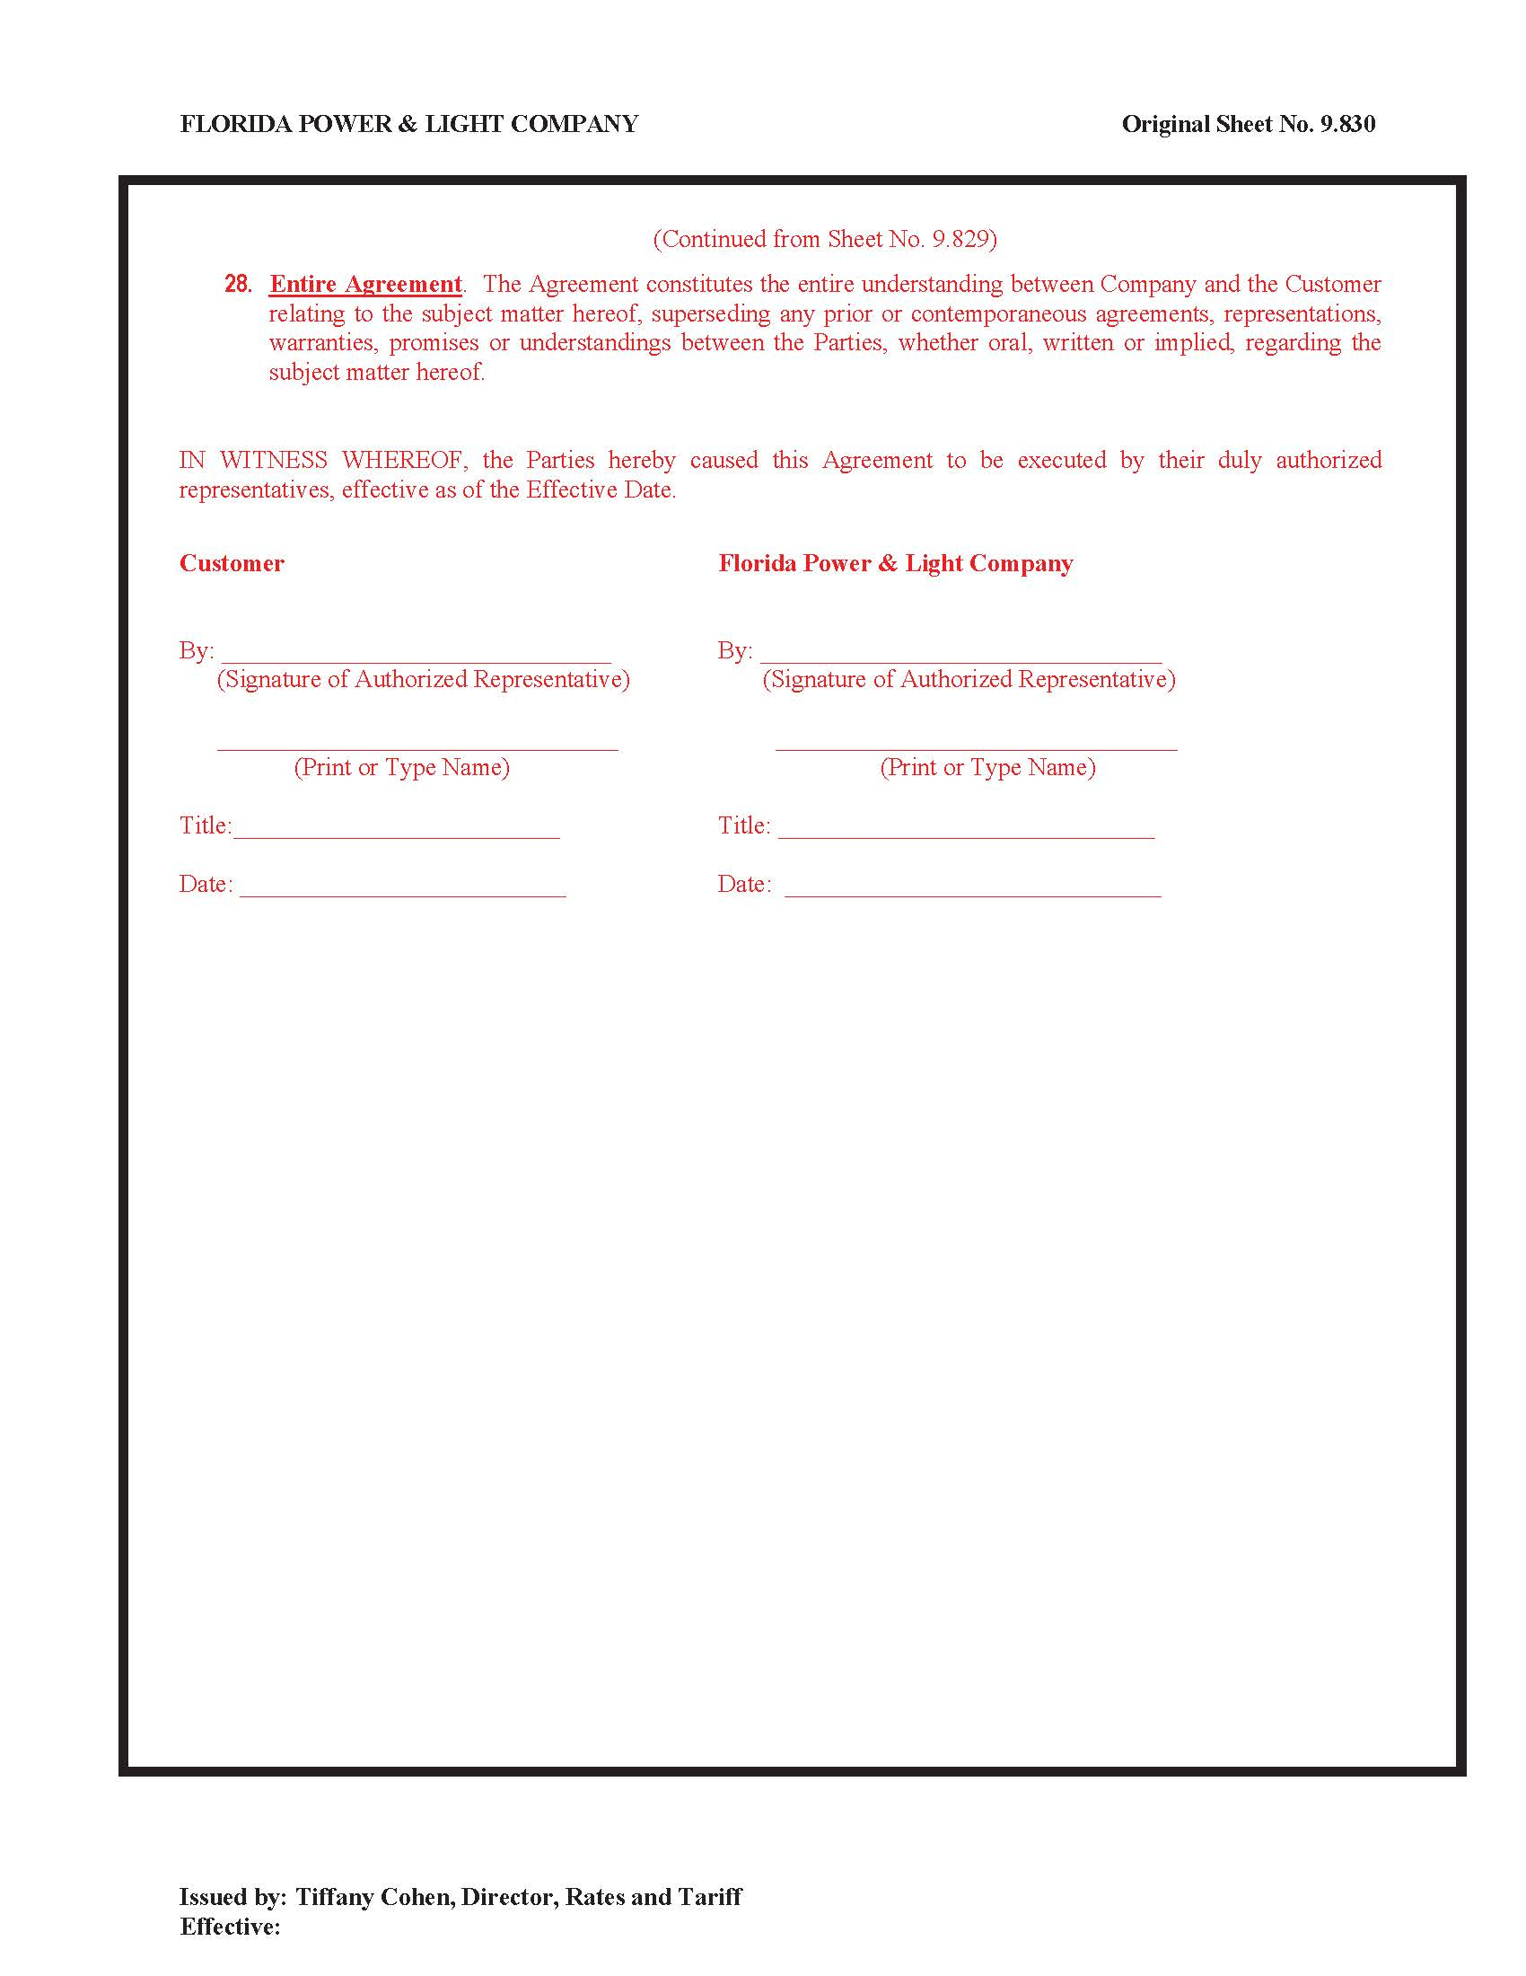

Order No. PSC-01-1648-TRF-EI, issued August 13, 2001, in Docket No. 010373-EI, In re: Petition for approval to provide optional Premier Power Service Rider, Rate Schedule PPS-1, for general service customers by Florida Power Corporation.
Rule 25-6.0436(3)(b), F.A.C., requires that: “[u]pon establishing a new account or subaccount classification, each utility shall request Commission approval of a depreciation rate for the new plant category.”
Code of Federal Regulations, Title 18, Subchapter C, Part 101, for Major Utilities, as revised April 1, 2013.
Rule 25-6.0436(1)(e), F.A.C., and Rule 25-6.0436(1)(m), F.A.C., specify the Commission’s depreciation rate formulae and methodologies.
FPL’s Responses to Staff’s First Data Request, Document Request No. 1.
Rule 25-6.0436(4)(a), F.A.C., requires investor-owned electric companies to file a depreciation study for Commission review at least once every four years from submission of the previous study and/or pursuant to Commission order.

