BEFORE THE FLORIDA PUBLIC SERVICE COMMISSION

In re: Application for limited proceeding for recovery of incremental storm restoration costs related to Hurricanes Irma and Nate, by Duke Energy Florida, LLC. | DOCKET NO. 20170272-EI  ORDER NO. PSC-2019-0232-AS-EI  ISSUED: June 13, 2019

The following Commissioners participated in the disposition of this matter:

ART GRAHAM, Chairman
JULIE I. BROWN
DONALD J. POLMANN
GARY F. CLARK
ANDREW GILES FAY

ORDER APPROVING SETTLEMENT AGREEMENT

APPEARANCES

MATTHEW BERNIER and DIANNE TRIPLETT, ESQUIRES, Duke Energy Florida, LLC, 106 East College Avenue, Suite 800, Tallahassee, Florida 32301-7740
On behalf of Duke Energy Florida, LLC (DEF).

J.R. KELLY, CHARLES J. REHWINKEL, and THOMAS A. DAVID, ESQUIRES, Office of Public Counsel, c/o The Florida Legislature, 111 West Madison Street, Room 812, Tallahassee, Florida 32399-1400
On behalf of the Citizens of the State of Florida (OPC).

JON C. MOYLE, JR., ESQUIRE, Moyle Law Firm, P.A., 118 North Gadsden Street, Tallahassee, Florida 32301
On behalf of Florida Industrial Power Users Group (FIPUG).

ROBERT SCHEFFEL WRIGHT and JOHN T. LAVIA, III, ESQUIRES, Gardner, Bist, Wiener, Wadsworth, Bowden, Bush, Dee, LaVia & Wright, P.A. 1300 Thomaswood Drive, Tallahassee, FL 32308
On behalf of the Florida Retail Federation (FRF).

RACHAEL DZIECHCIARZ and ASHLEY WEISENFELD, ESQUIRES, Florida Public Service Commission, 2540 Shumard Oak Boulevard, Tallahassee, Florida 32399-0850
On behalf of the Florida Public Service Commission (Staff).

MARY ANNE HELTON, ESQUIRE, Deputy General Counsel, Florida Public Service Commission, 2540 Shumard Oak Boulevard, Tallahassee, Florida 32399-0850
Advisor to the Florida Public Service Commission.

KEITH C. HETRICK, ESQUIRE, General Counsel, Florida Public Service Commission, 2540 Shumard Oak Boulevard, Tallahassee, Florida 32399-0850
Florida Public Service Commission General Counsel.

BY THE COMMISSION:

Background

On December 28, 2017, pursuant to Rules 28-106.201 and 25-6.0143, Florida Administrative Code (F.A.C.), and Order No. PSC-2017-0451-AS-EU, Duke Energy Florida, LLC (DEF) filed its application for limited proceeding for recovery of incremental storm restoration costs related to Hurricanes Irma and Nate. In its application, DEF sought to recover a total of $513.2 million, which includes $371 million in net retail costs, $132 million to replenish its storm reserve balance, and $10.2 million in costs associated with interest, bond issuance, and regulatory fees.

On January 24, 2018, DEF filed a Motion to Approve Implementation Stipulation, which was subsequently amended on February 5, 2018. The Amended Implementation Stipulation sought to avoid volatility in customer rates by recognizing and then utilizing annual tax reform benefits resulting from the 2017 Tax Act as a direct offset to avoid implementing a separate cost recovery of storm damage costs that customers would have otherwise been obligated to pay. By Order No. PSC-2018-0103-PCO-EI, issued on February 26, 2018, we approved the Amended Implementation Stipulation.

On February 16, 2018, an Order Establishing Procedure, Order No. PSC-2018-0082-PCO-EI, was issued in which the hearing procedures were established to govern the determination of the final storm recovery costs. The Office of Public Counsel (OPC), Florida Retail Federation (FRF), White Springs Agricultural Chemicals, Inc. d/b/a PCS Phosphate-White Springs (PCS Phosphate), and the Florida Industrial Power Users Group (FIPUG) intervened. On May 31, 2018, DEF filed its petition for approval of actual storm restoration costs and associated recovery process related to Hurricane Irma and Nate, revising its requested recovery to $510 million in actual recoverable costs. On August 17, 2018, DEF filed a Motion for Continuance to process, review, and organize a large amount of cost data and associated information pertaining to restoration costs. By Order No. PSC-2018-0410-PCO-EI, issued on August 20, 2018, DEF’s Motion for Continuance was granted.

On January 28, 2019, DEF filed supplemental exhibits to its May 31, 2019, petition, and further reduced its request to $508 million. On March 29, 2019, DEF filed a Motion to Abate seeking to abate the remaining filing dates as modified by Order No. PSC-2019-0116-PCO-EI (the Fourth Order Modifying Order Establishing Procedure), with the exception of the prehearing, hearing, and brief dates. In its motion to abate, DEF asserted that OPC, FRF, PCS Phosphate, and FIPUG had reached an agreement in principle to resolve all issues. DEF further asserted that the parties were working to finalize their agreement for filing with the Commission for approval. On April 3, 2019, by Order No. PSC-2019-0119-PCO-EI, the remaining controlling dates were abated, except the dates for the prehearing conference, hearing, and filing post-hearing briefs.

On April 9, 2019, DEF filed an unopposed Motion to Approve Storm Cost Settlement Agreement (Motion). In its Motion, DEF asserted that the Storm Cost Settlement Agreement is in the best interest of DEF’s customers, and requested our approval. On April 18, 2019, to correct a scrivener’s error, DEF filed a Corrected Storm Cost Settlement Agreement. On May 15, 2019, DEF filed an unopposed Motion to Approve Amended Storm Cost Settlement Agreement. The amendment provided clarification for the “Capitalized Costs” bullet point on page 15 of the Corrected Storm Cost Settlement Agreement. The Corrected Storm Cost Settlement Agreement and the Amended Storm Cost Settlement Agreement, collectively referred to as the Settlement Agreement, are appended to this Order as Attachment A. OPC, FRF, PCS Phosphate, and FIPUG support the Settlement Agreement.

We held an administrative hearing on May 21, 2019. At the conclusion of the evidentiary portion of the hearing, the parties indicated that they were willing to waive the filing of post-hearing briefs, and we approved the Settlement Agreement, as set forth herein, by bench vote.

The Settlement Agreement

The Settlement Agreement provides a compromise between the parties regarding the amount of recoverable storm costs, and also sets forth an extensive set of procedures for DEF to follow during future storms which are expected to provide substantial value to both DEF and its customers. The major elements of the Settlement Agreement are as follows:

- The Settlement Agreement will be effective upon issuance of this Order, after the time for filing an appeal has run.
- DEF will make a specific adjustment to capitalize contractor labor in the amount of $18 million, and make a corresponding reduction in the amount of storm damage costs charged.
- DEF will reclassify $995,000 of incremental storm costs to non-incremental costs, which can then be considered for recovery as part of base rates.
- The parties agreed to an aggregate adjustment of $5.005 million.
- DEF will be authorized to recover approximately $343 million in net retail costs and $10.2 million in costs associated with interest, bond issuance, and regulatory fees. DEF will be authorized to replenish its storm reserve balance to $132 million, under the conditions set forth in the Second Implementation Stipulation, filed in Docket No. 20190110-EI.
- The parties agreed to a set of principles and process changes intended to promote cost effective and timely storm damage recovery and service restoration. The future process improvements cover a broad range of storm cost recovery issues, including: contracting and vendor engagement, travel and work policies, cost documentation, auditing and regulatory recovery processes, and a methodology for determining incremental costs.
- The parties agreed to meet to evaluate the new procedures and consider the need to amend them during the first quarter of 2022, and every three years thereafter.
In addition, at the administrative hearing, DEF provided clarification regarding the implementation of the process improvements. DEF advised that all parties are in agreement regarding DEF’s primary objective following a storm, which is power restoration to its customers, and that “the company will not allow the policies and procedures to impede speedy power restoration for its customers.” DEF further clarified that the phrase “superseded by action of the PSC,” which is located in paragraph six of the Settlement Agreement, “means an action taken by the Commission in any rule-making proceeding or in any evidentiary proceeding to which the company is subject, whether initiated by DEF, third parties, or the Commission on its own motion, which addresses storm cost recovery and which has the effect of overriding or supplanting any provision of the settlement.”

Decision

The standard for approval of a settlement agreement is whether it is in the public interest. A determination of public interest requires a case-specific analysis based on consideration of the proposed settlement taken as a whole. By implementing the specific and aggregate adjustments above, as well as reclassifying $995,000 to non-incremental costs, the Settlement Agreement provides a fair and balanced resolution of the costs that were incurred by DEF. Further, as noted above, the Settlement Agreement and Amended Implementation Stipulation authorize DEF to credit the retail storm reserve from January 2018 through full recovery of the actual storm costs, without imposing an interim rate on its customers, due to the tax savings realized by DEF as a result of the 2017 Tax Act.

In addition, the future process improvements identified in the Settlement Agreement represent a good-faith effort by the parties to recognize and mitigate the kinds of issues that present themselves in the storm restoration process. The processes provide a range of guidance to DEF regarding documentation, communication, and expectations when storm cost recovery is sought. The parties articulated that their goal was to implement the best practices for how to safely, quickly, and efficiently restore power, and that the procedures will not impede future storm recovery efforts. The procedures are designed such that DEF maintains its priority of power restoration during a storm event, while also decreasing the time and expense of litigation post-storm when cost recovery is sought.

Based upon DEF’s application, its subsequent filings, our review of the Settlement Agreement, the testimony and evidence on the record, and the clarification provided by DEF at the hearing, we find that the Settlement Agreement is in the public interest and shall be approved. The Settlement Agreement resolves all of the issues in this docket.

Based on the foregoing, it is

ORDERED by the Florida Public Service Commission that the attached Settlement Agreement is approved. It is further

ORDERED that this docket shall be closed.

By ORDER of the Florida Public Service Commission this 13th day of June, 2019.

/s/ Adam J. Teitzman
ADAM J. TEITZMAN
Commission Clerk
Florida Public Service Commission
2540 Shumard Oak Boulevard
Tallahassee, Florida 32399
(850) 413-6770
www.floridapsc.com

Copies furnished: A copy of this document is provided to the parties of record at the time of issuance and, if applicable, interested persons.

RAD

NOTICE OF FURTHER PROCEEDINGS OR JUDICIAL REVIEW

The Florida Public Service Commission is required by Section 120.569(1), Florida Statutes, to notify parties of any administrative hearing or judicial review of Commission orders that is available under Sections 120.57 or 120.68, Florida Statutes, as well as the procedures and time limits that apply. This notice should not be construed to mean all requests for an administrative hearing or judicial review will be granted or result in the relief sought.

Any party adversely affected by the Commission's final action in this matter may request: 1) reconsideration of the decision by filing a motion for reconsideration with the Office of Commission Clerk, 2540 Shumard Oak Boulevard, Tallahassee, Florida 32399-0850, within fifteen (15) days of the issuance of this order in the form prescribed by Rule 25-22.060, Florida Administrative Code; or 2) judicial review by the Florida Supreme Court in the case of an electric, gas or telephone utility or the First District Court of Appeal in the case of a water and/or wastewater utility by filing a notice of appeal with the Office of Commission Clerk, and filing a copy of the notice of appeal and the filing fee with the appropriate court. This filing must be completed within thirty (30) days after the issuance of this order, pursuant to Rule 9.110, Florida Rules of Appellate Procedure. The notice of appeal must be in the form specified in Rule 9.900(a), Florida Rules of Appellate Procedure.

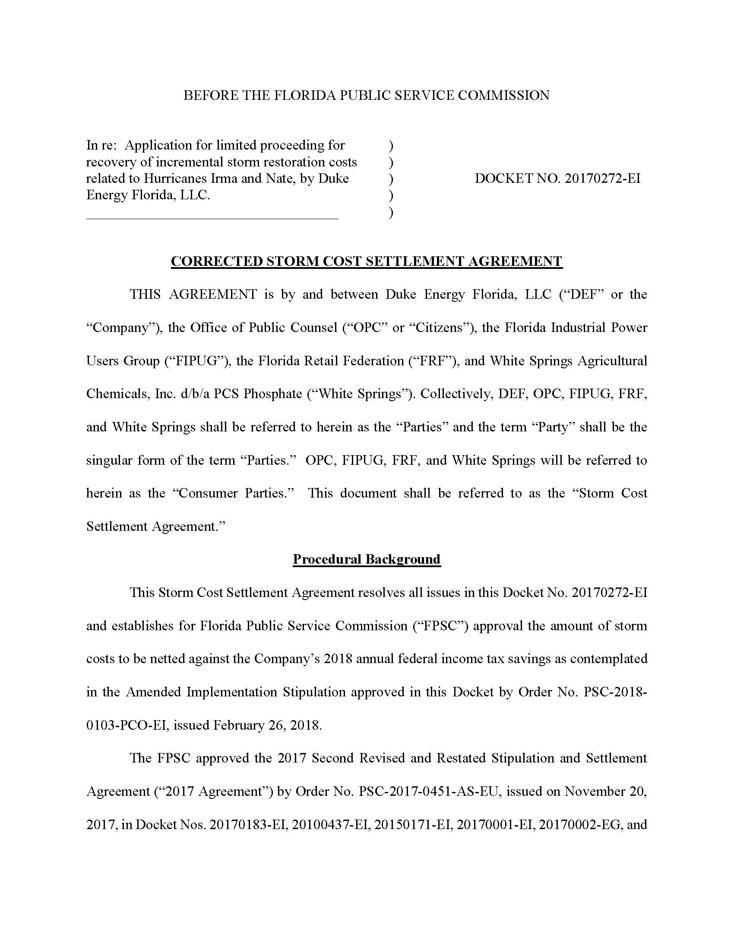
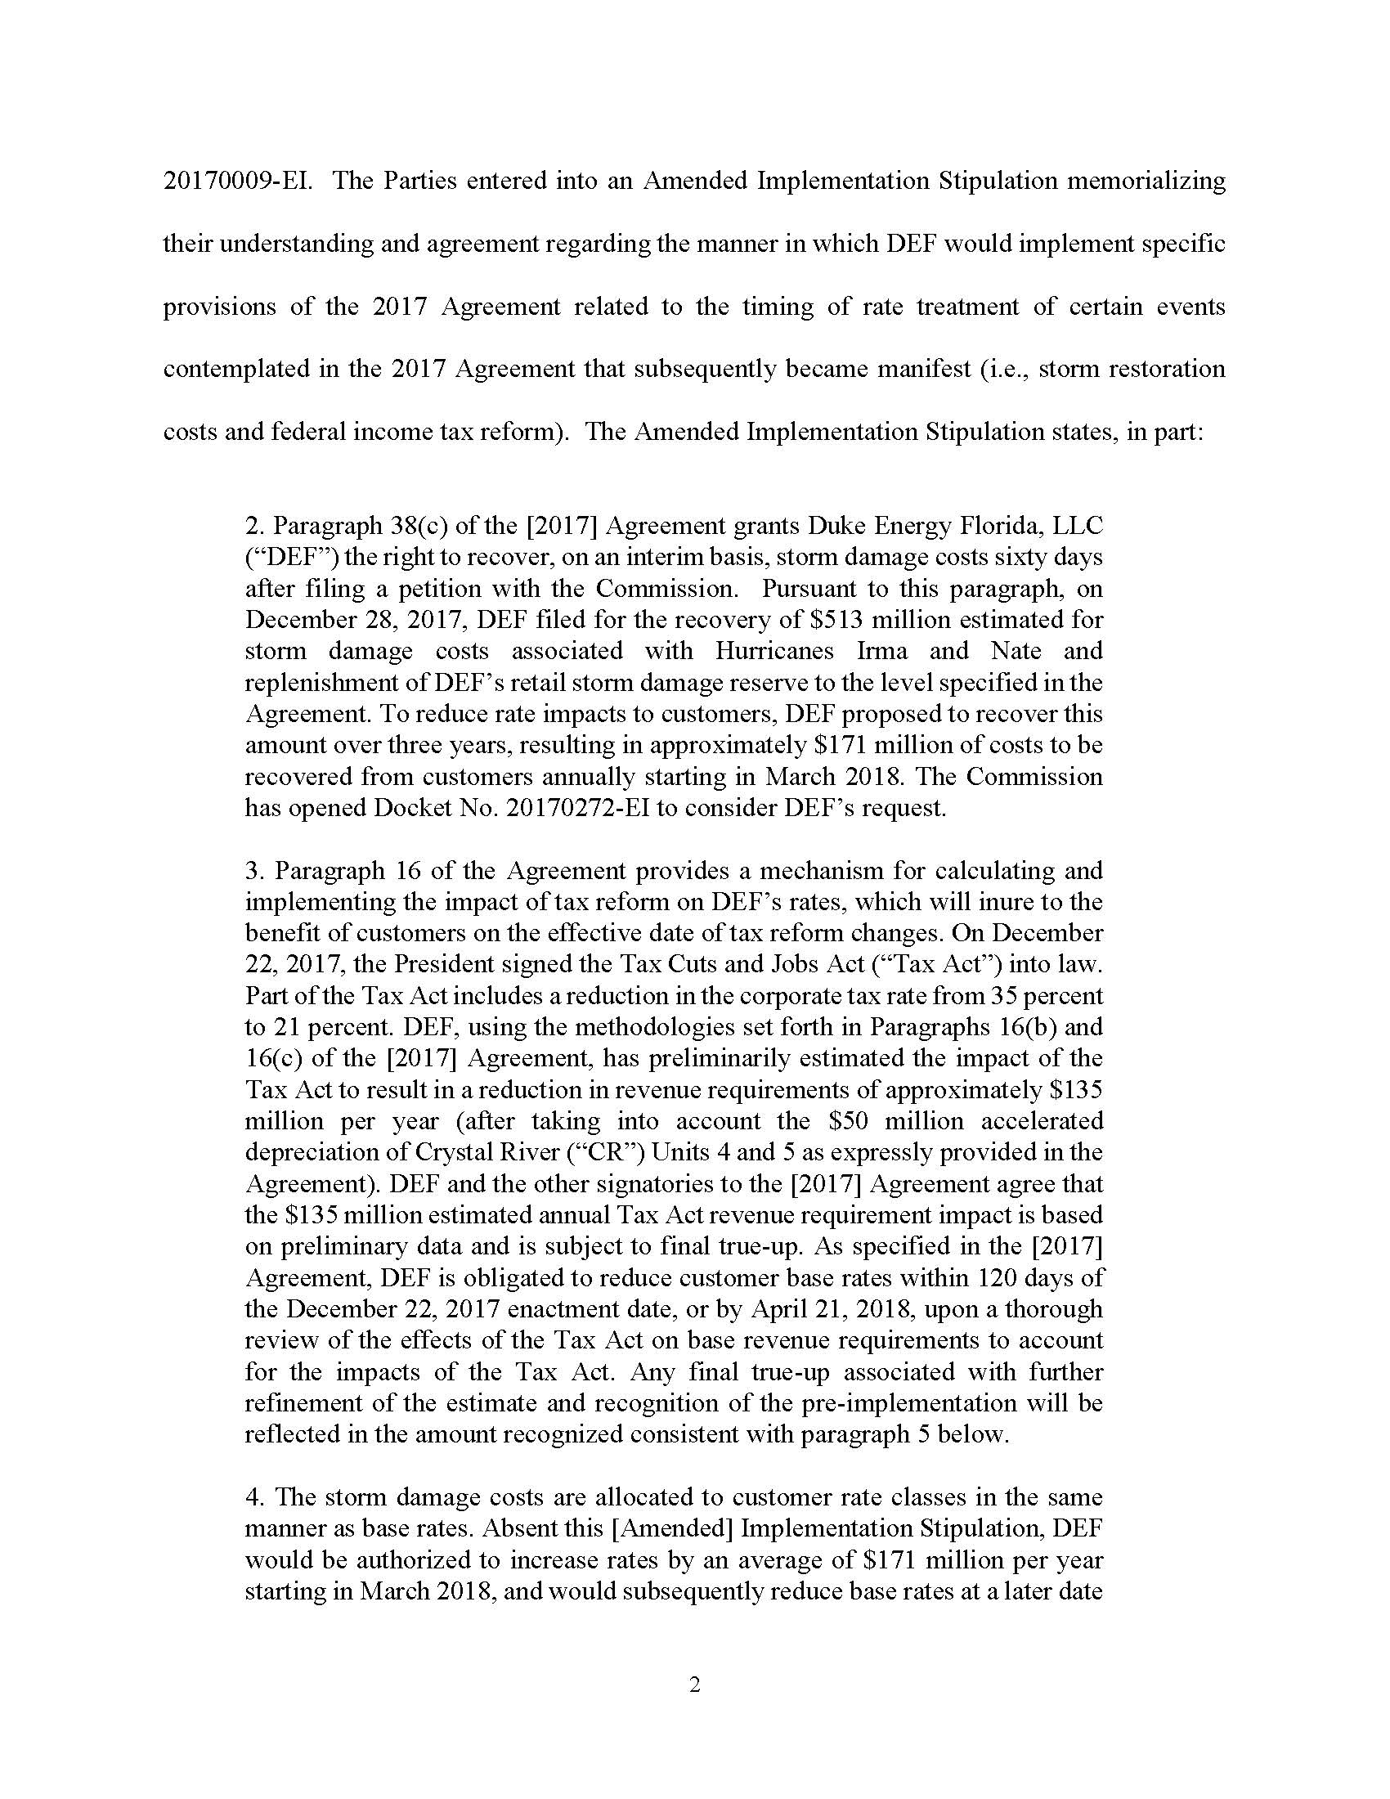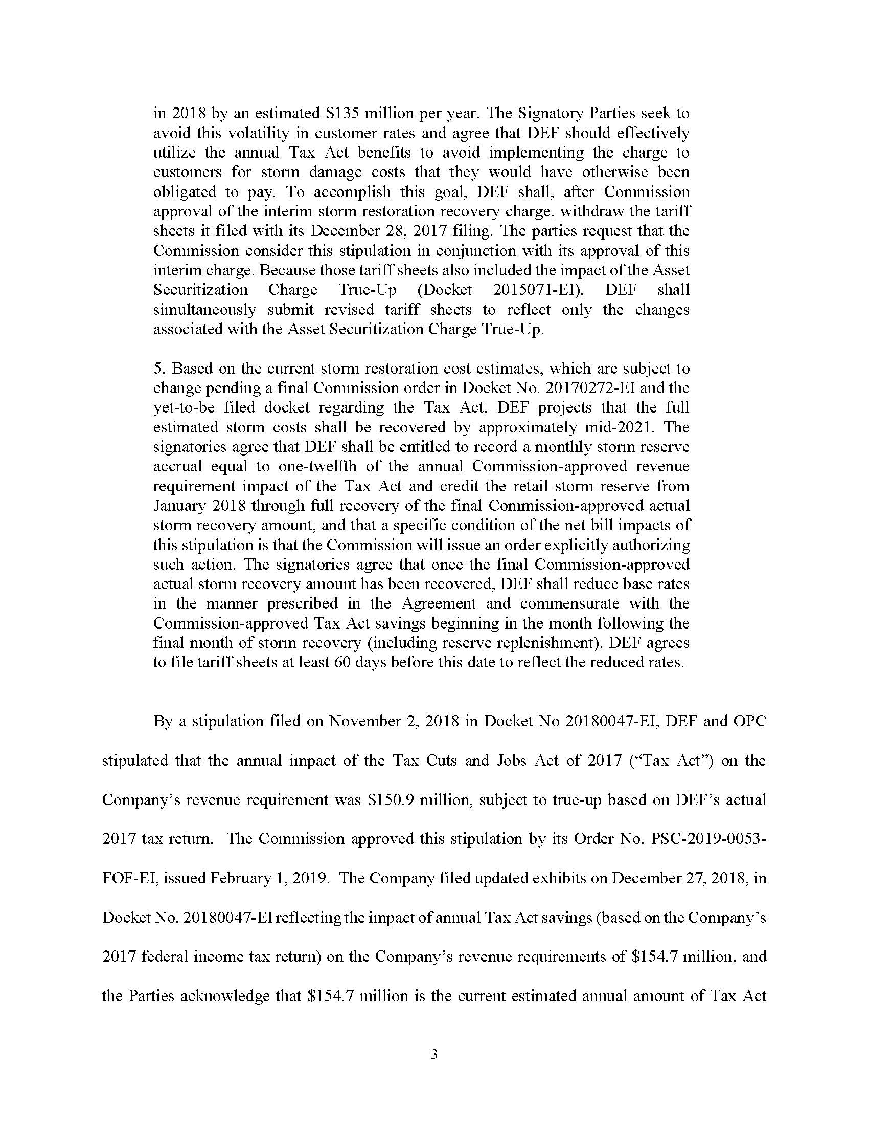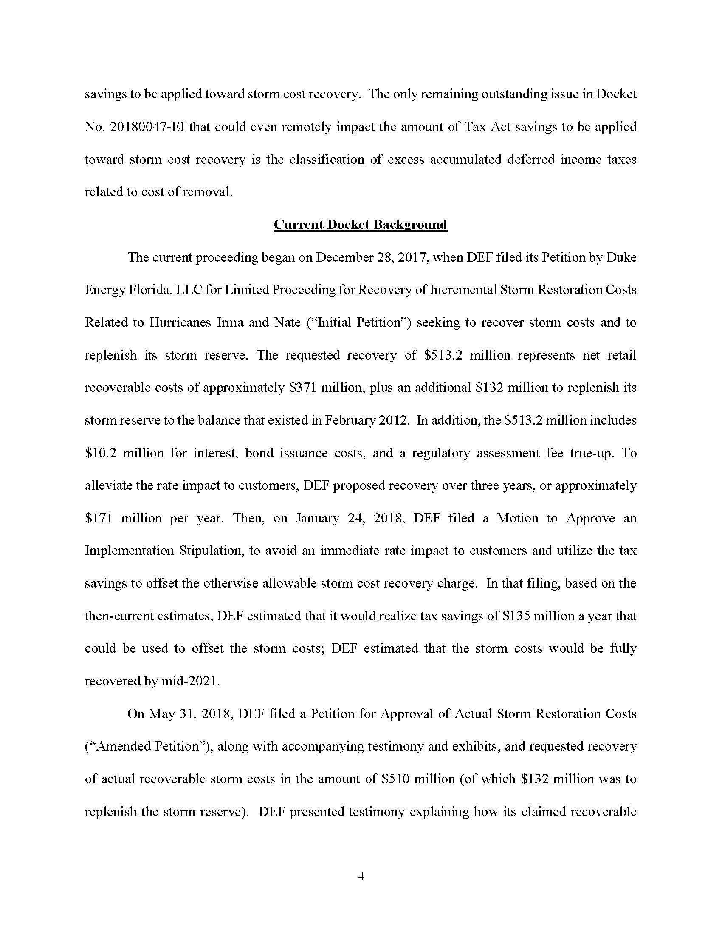
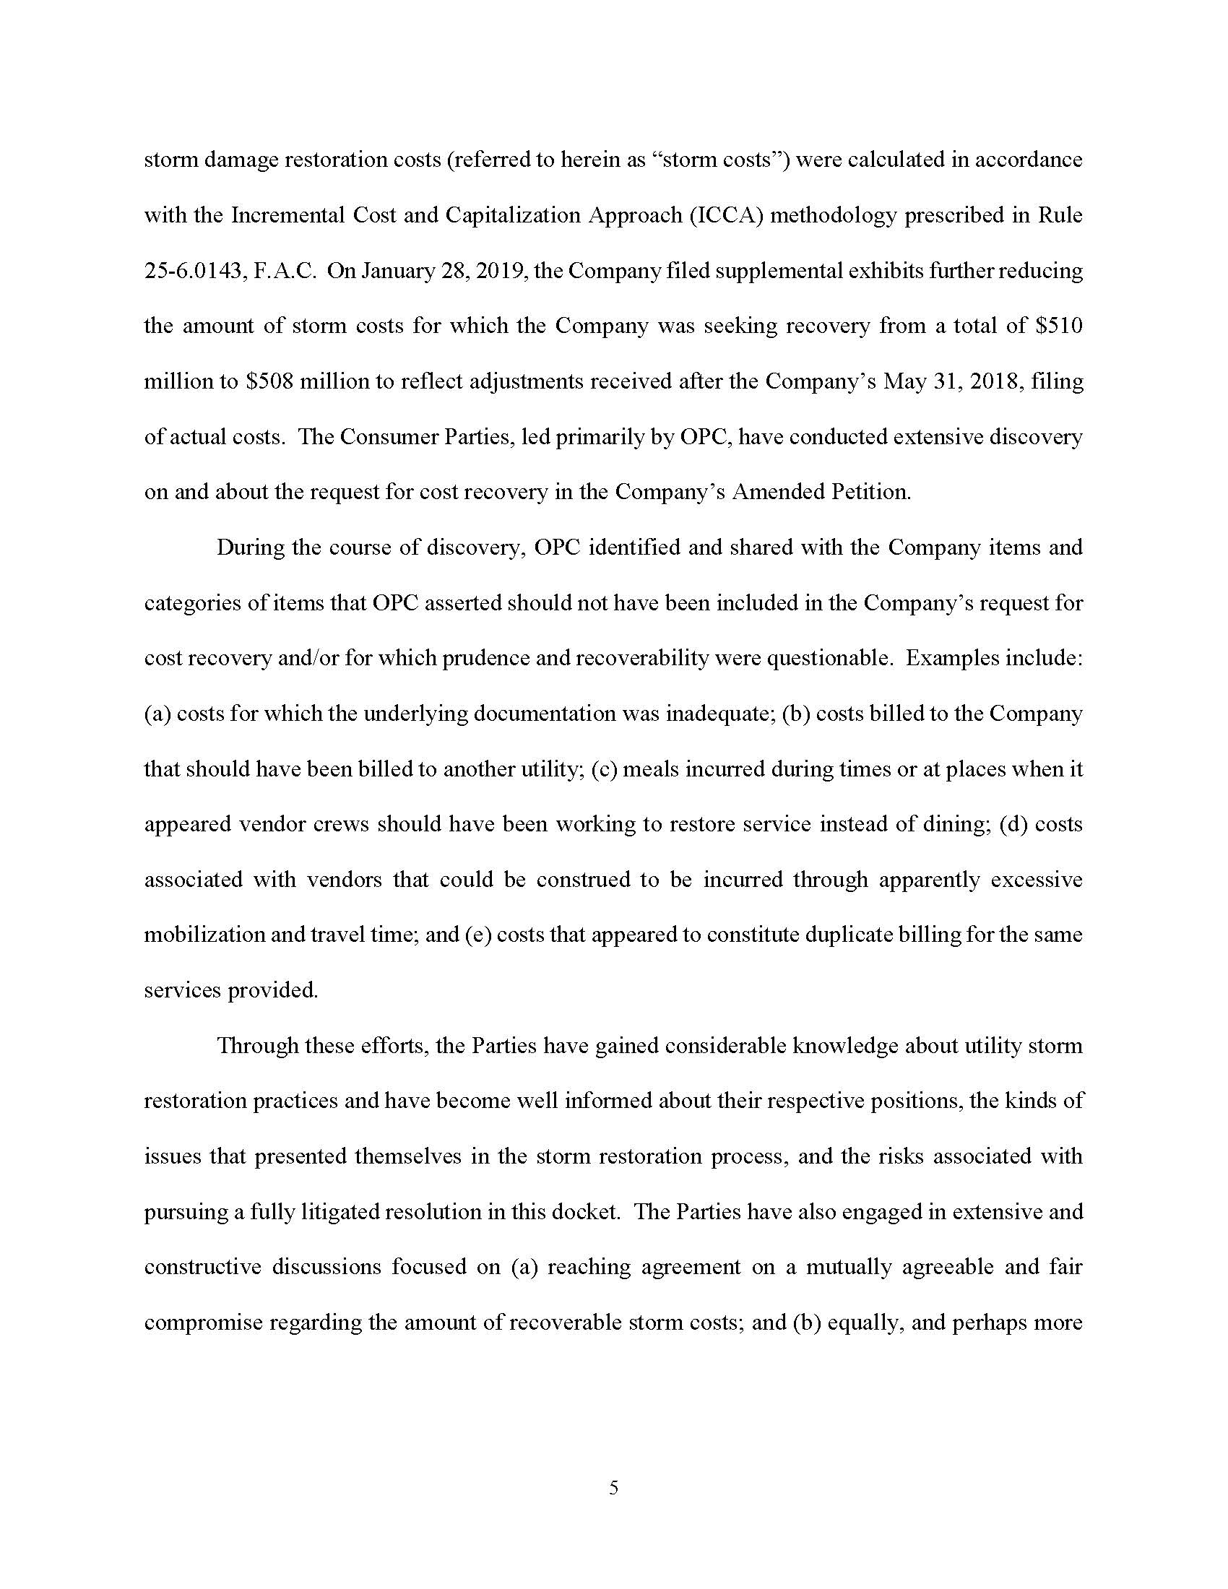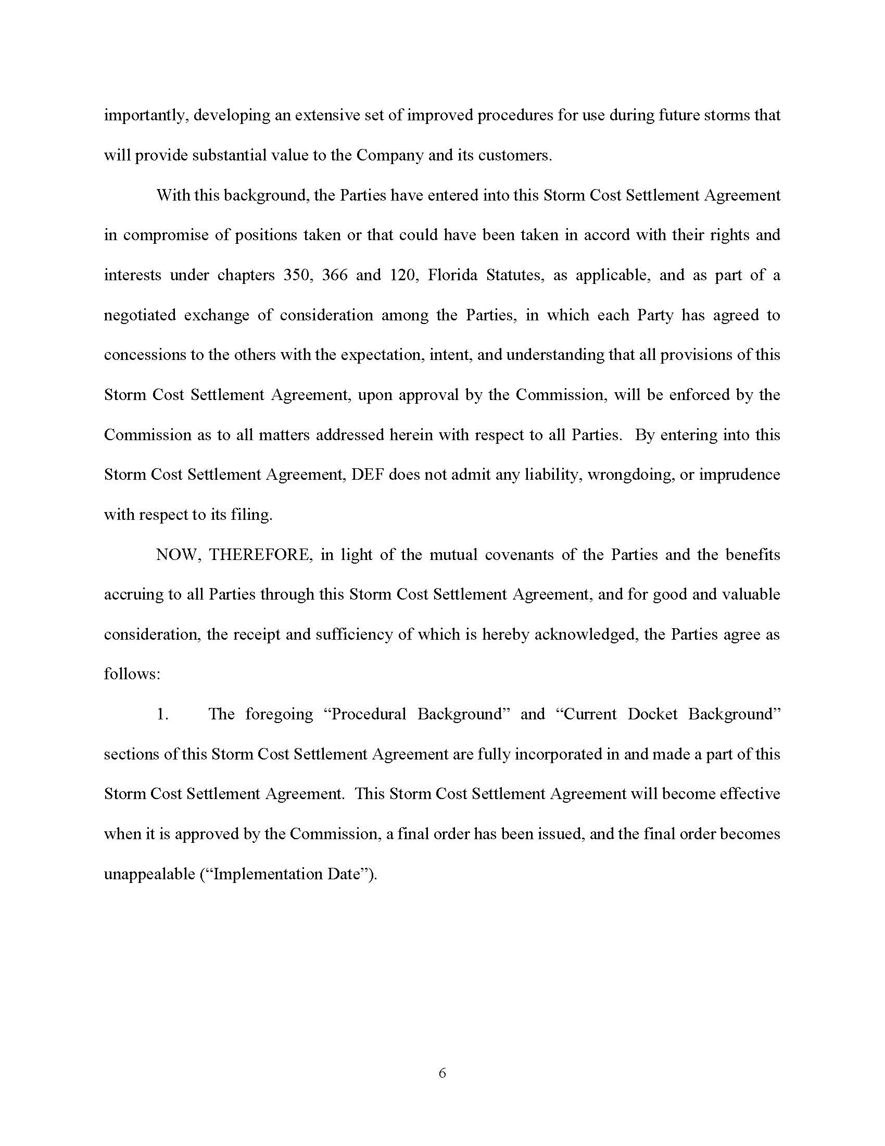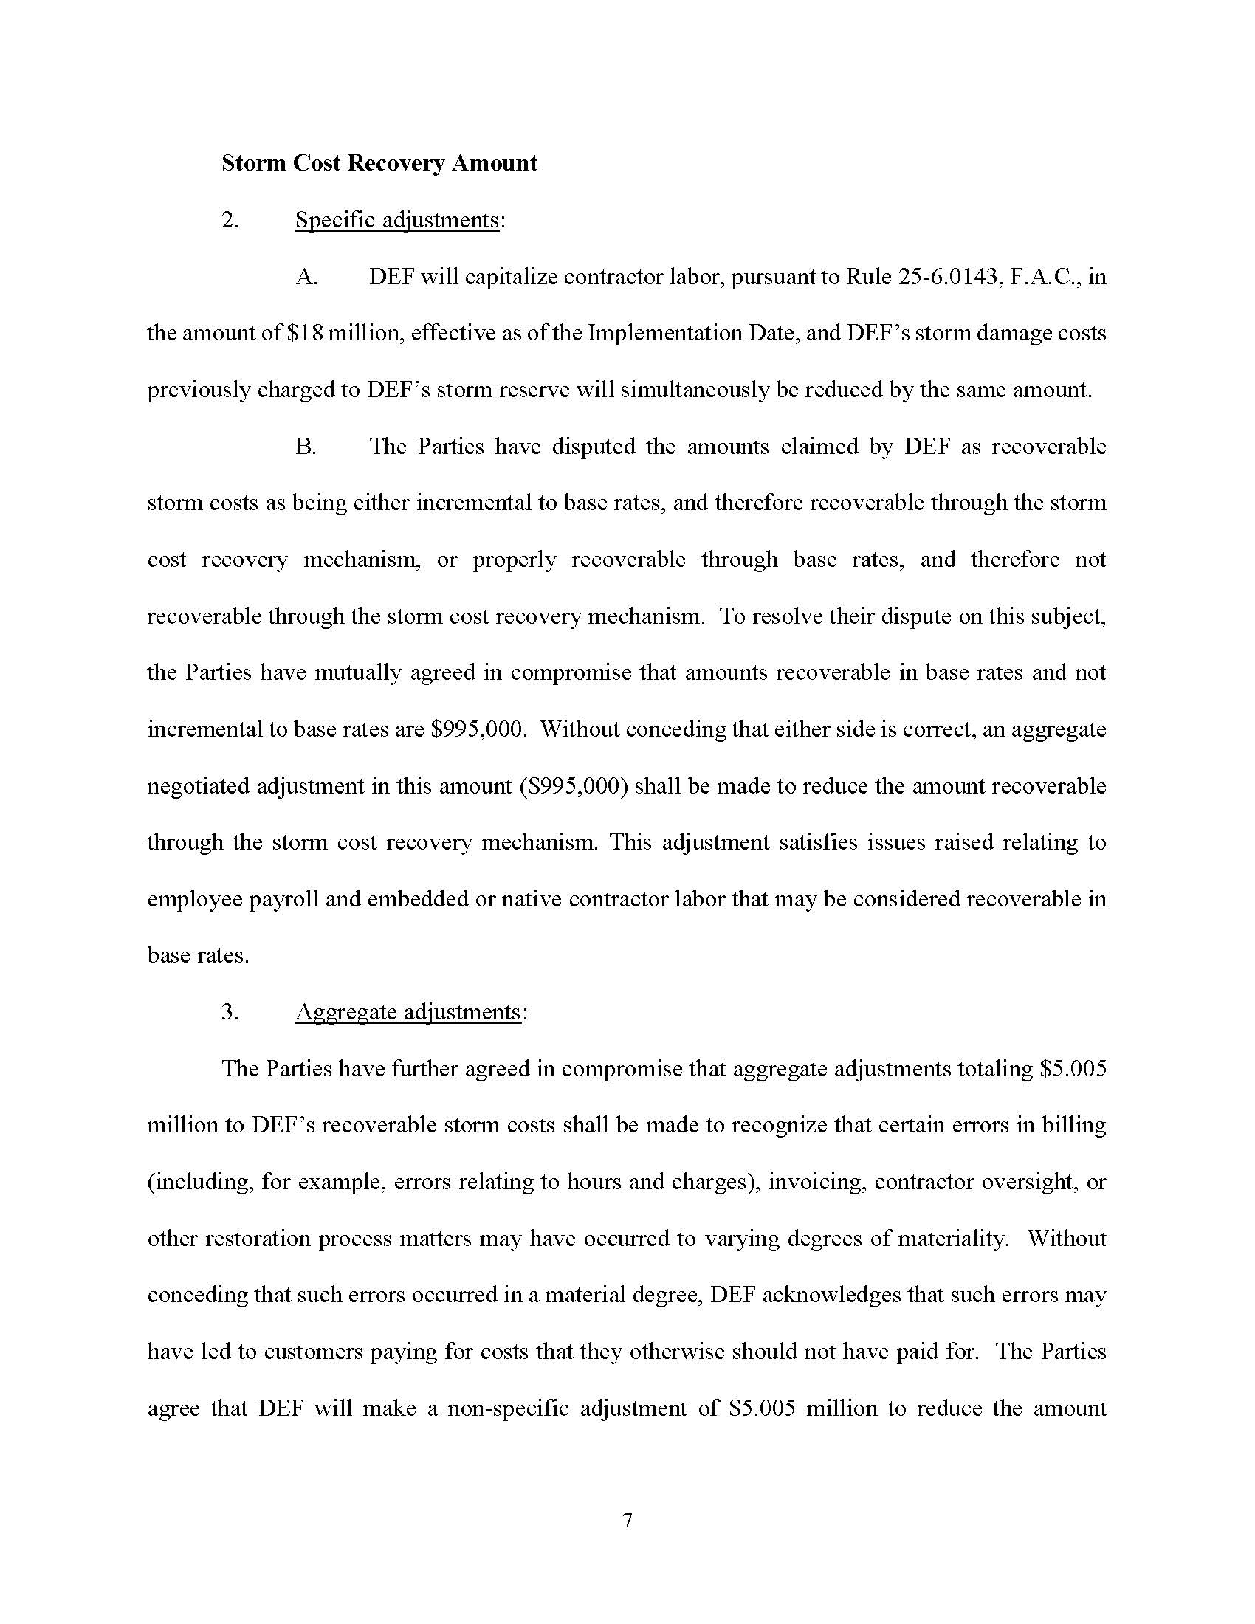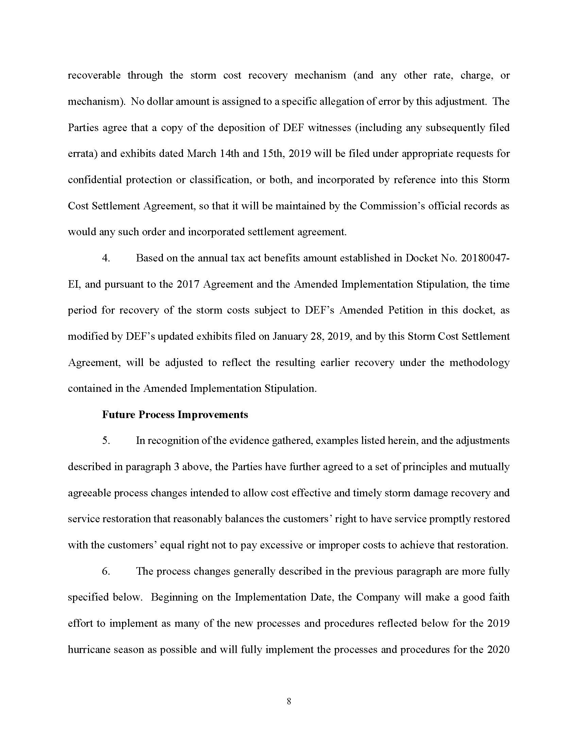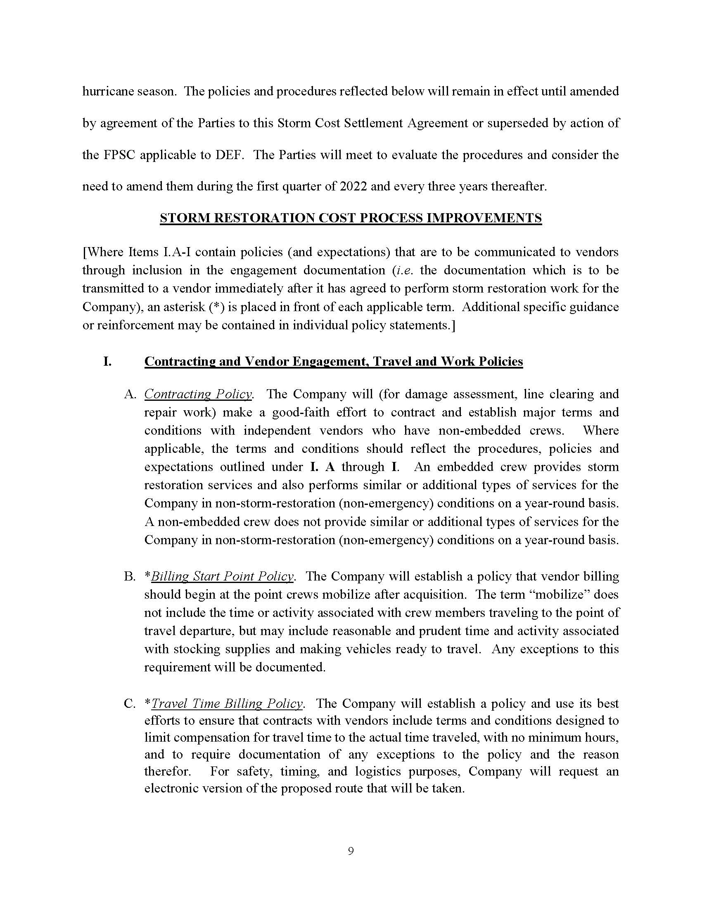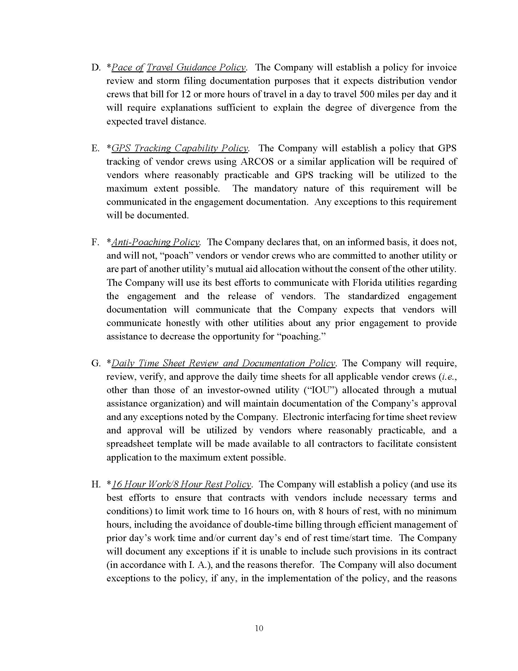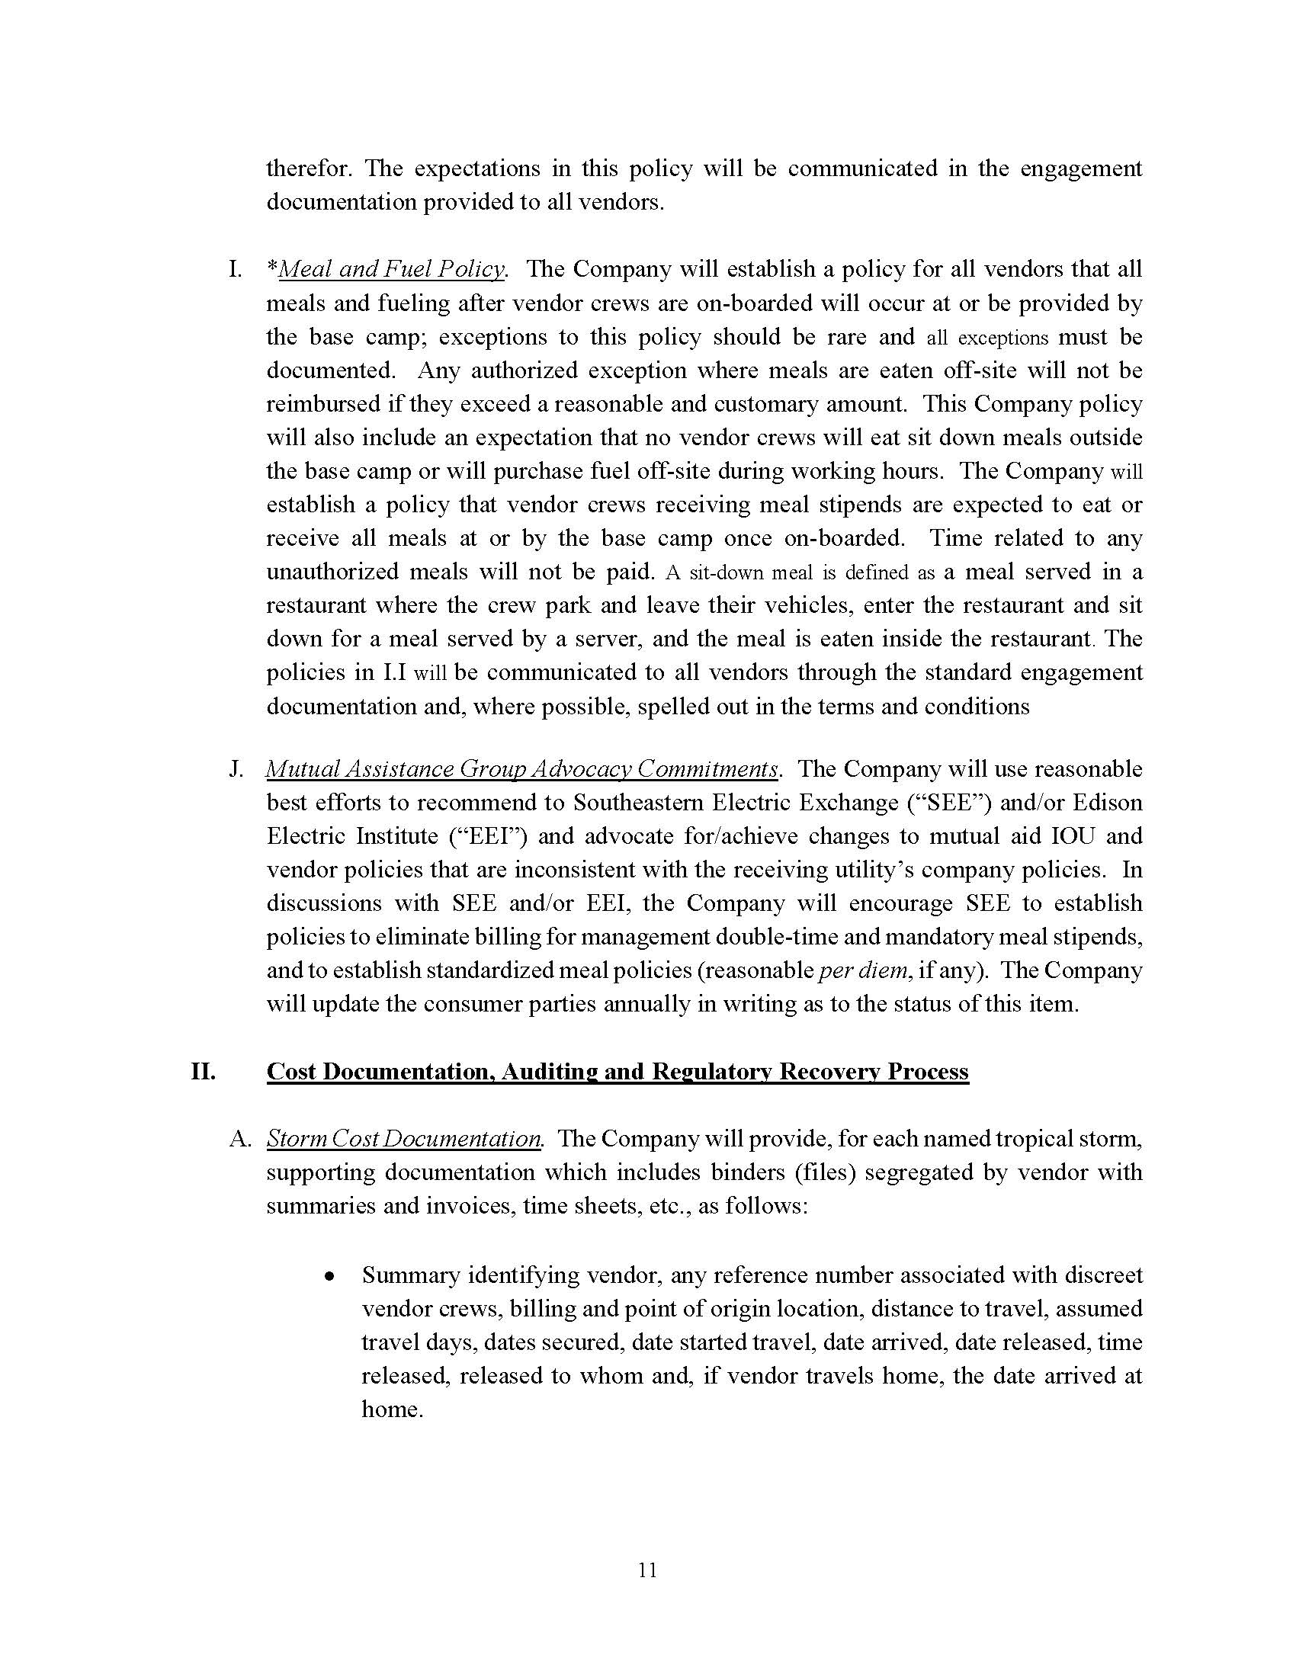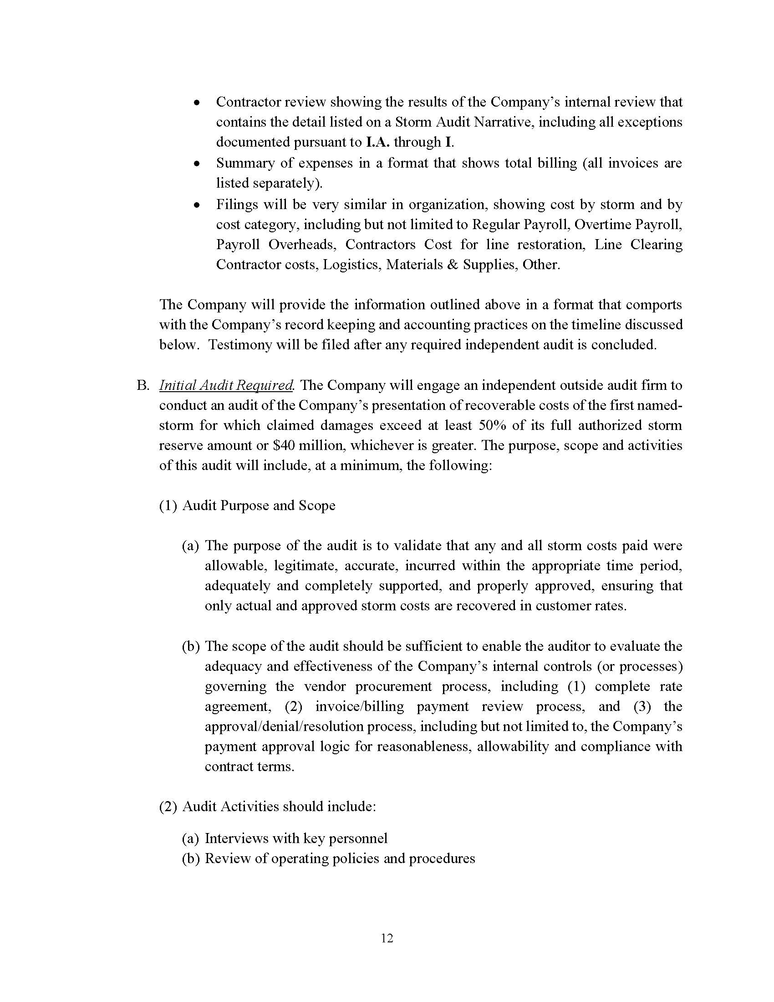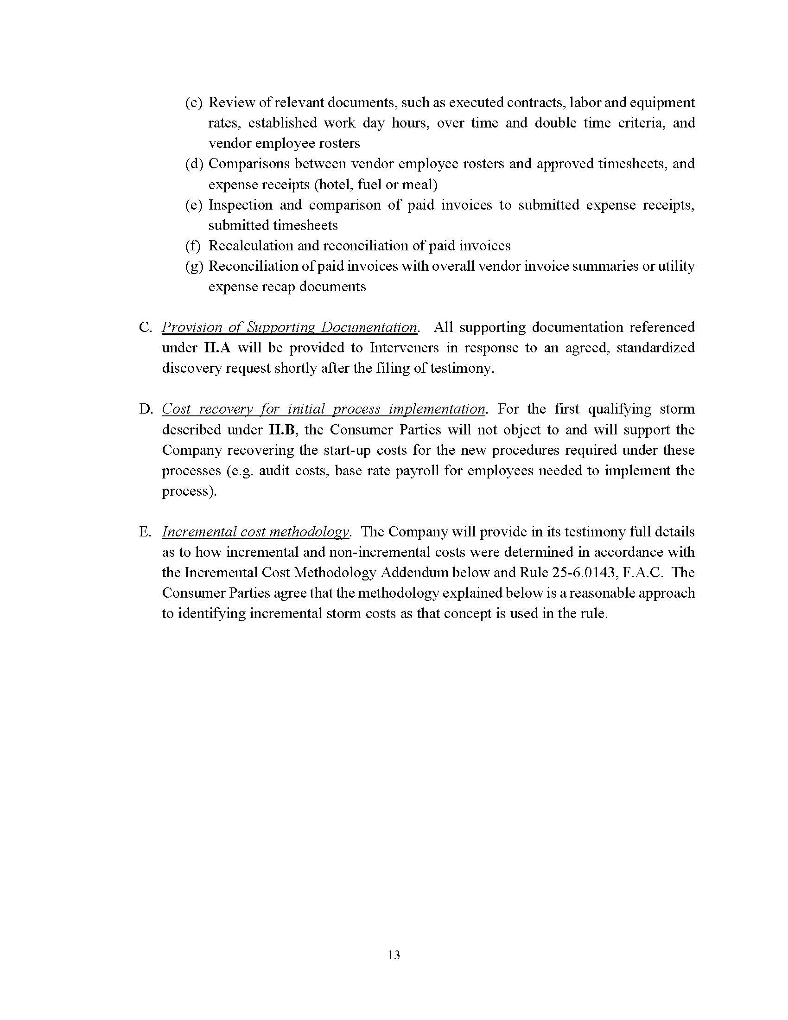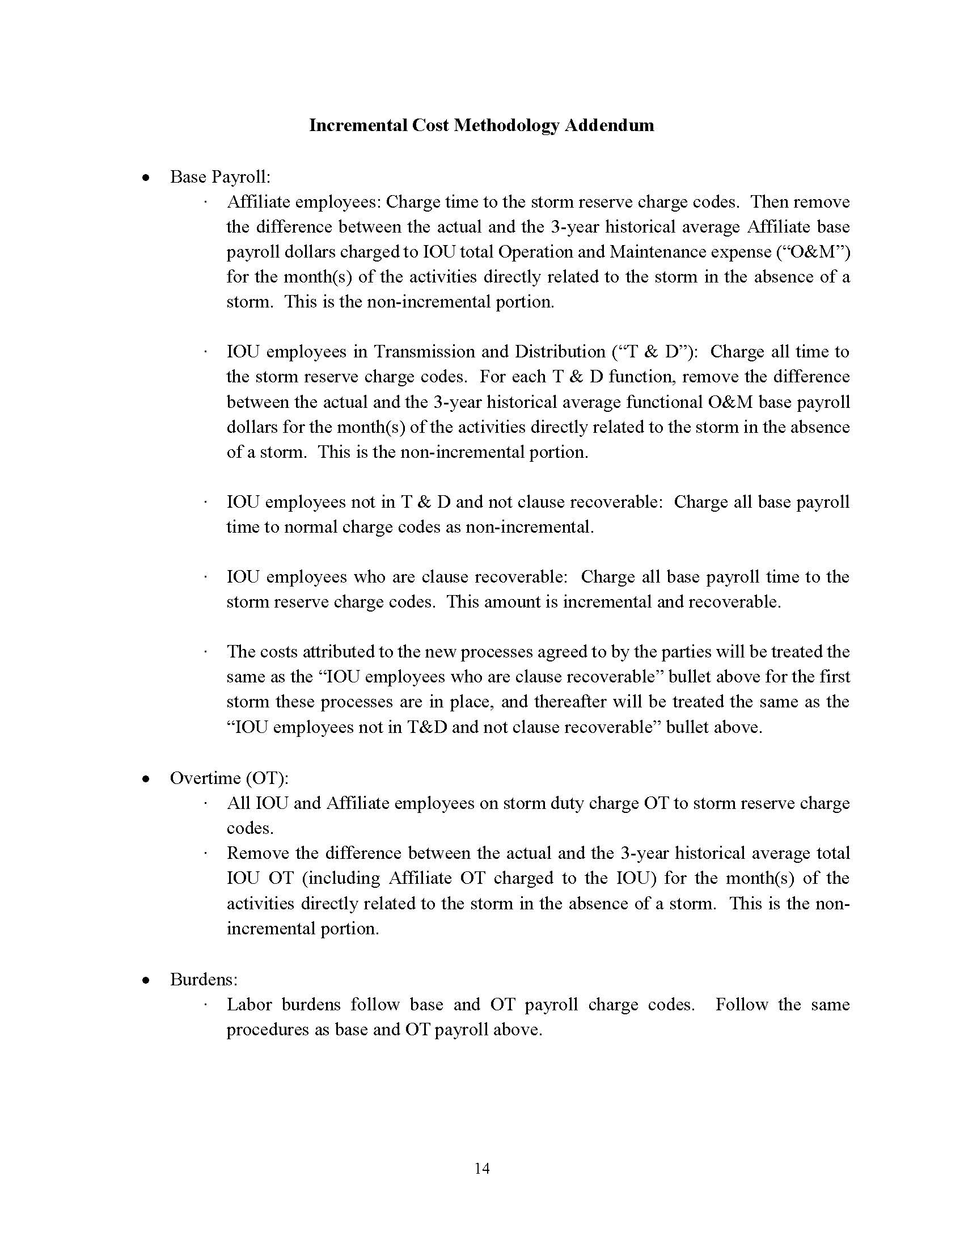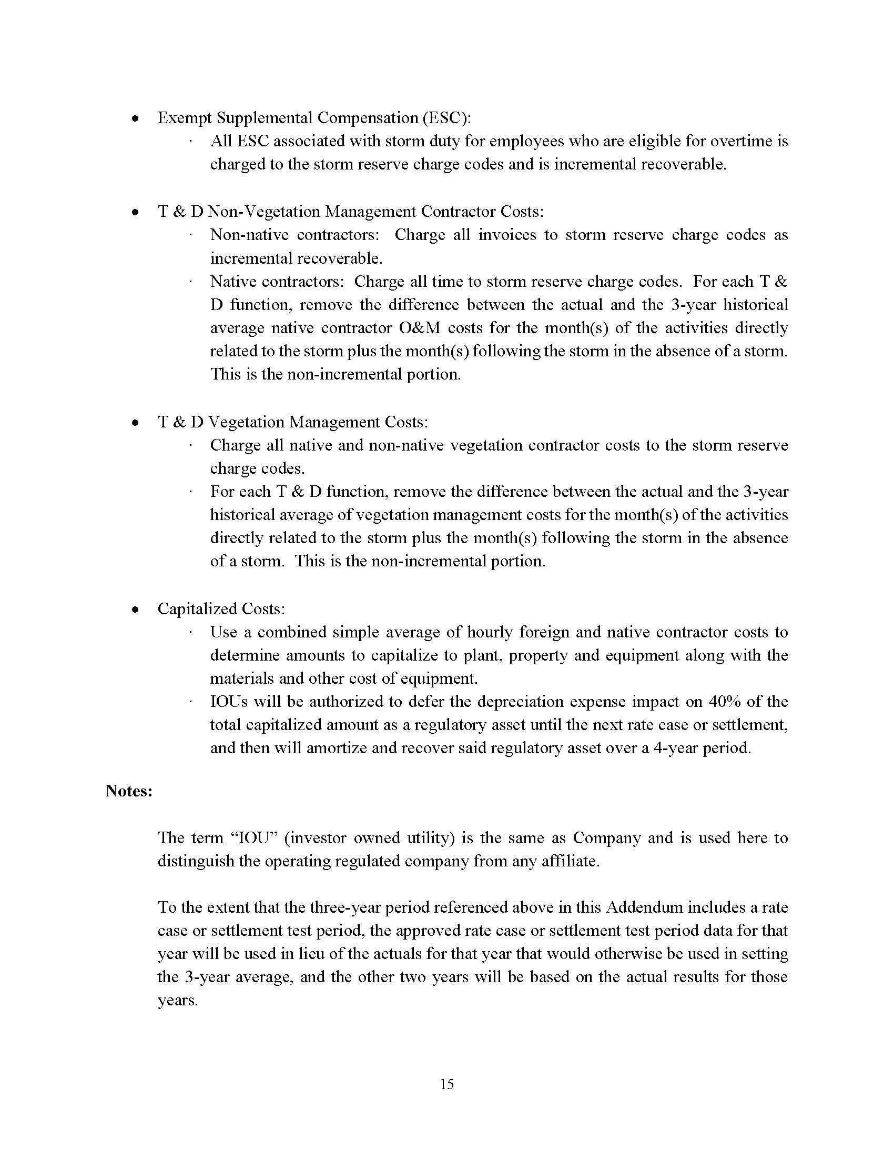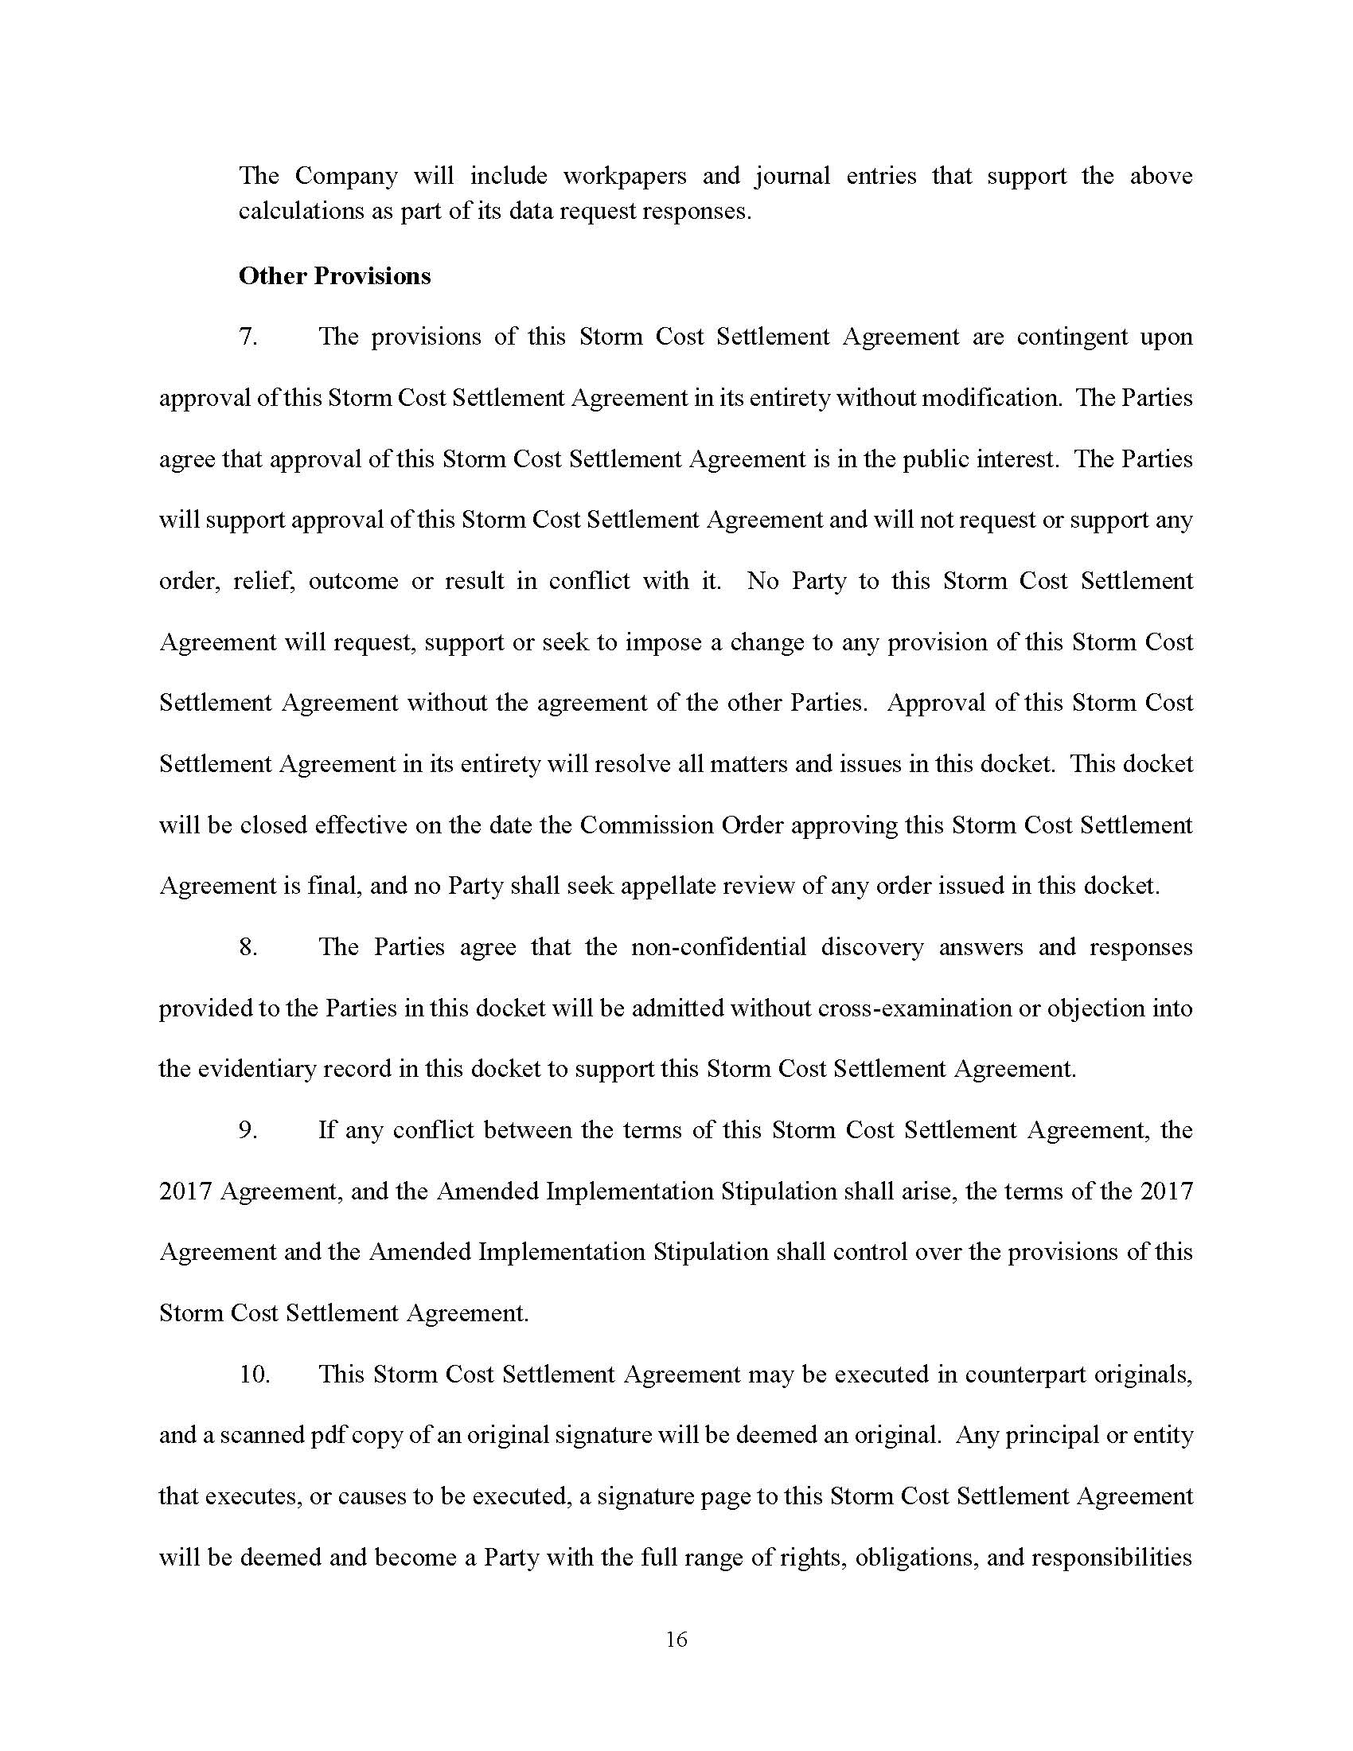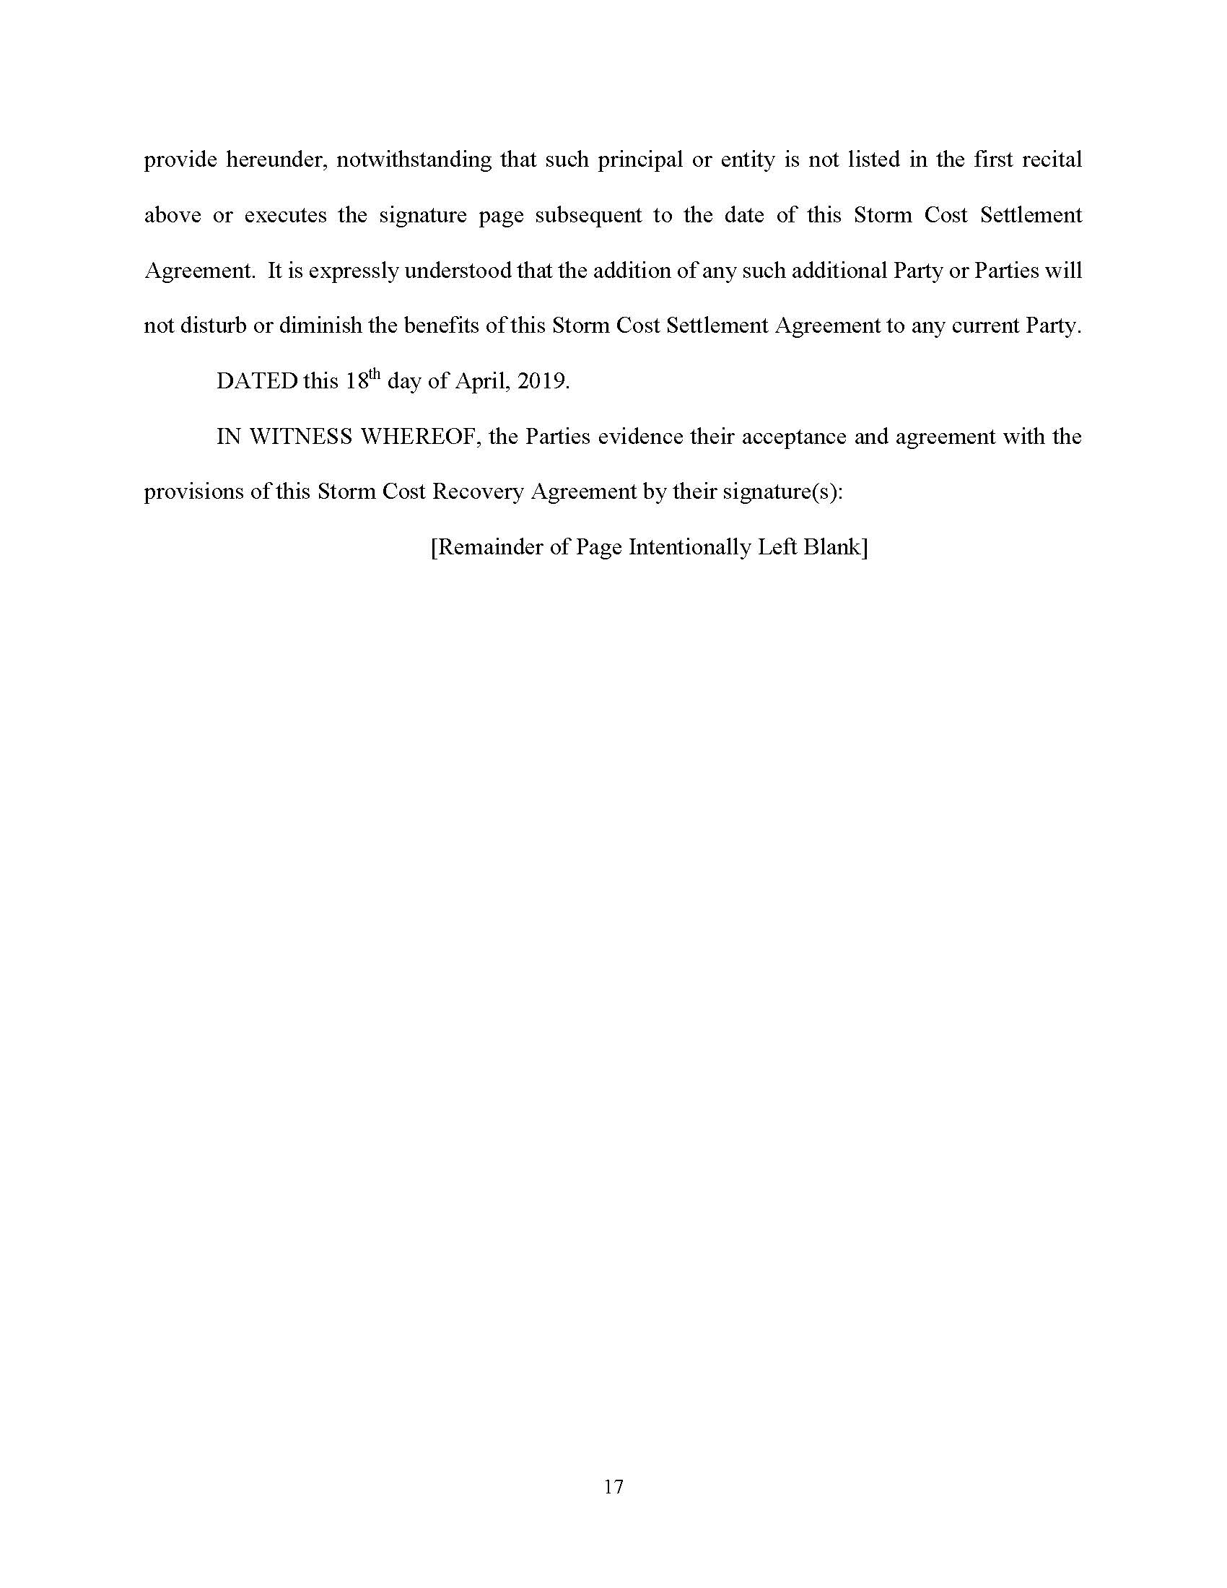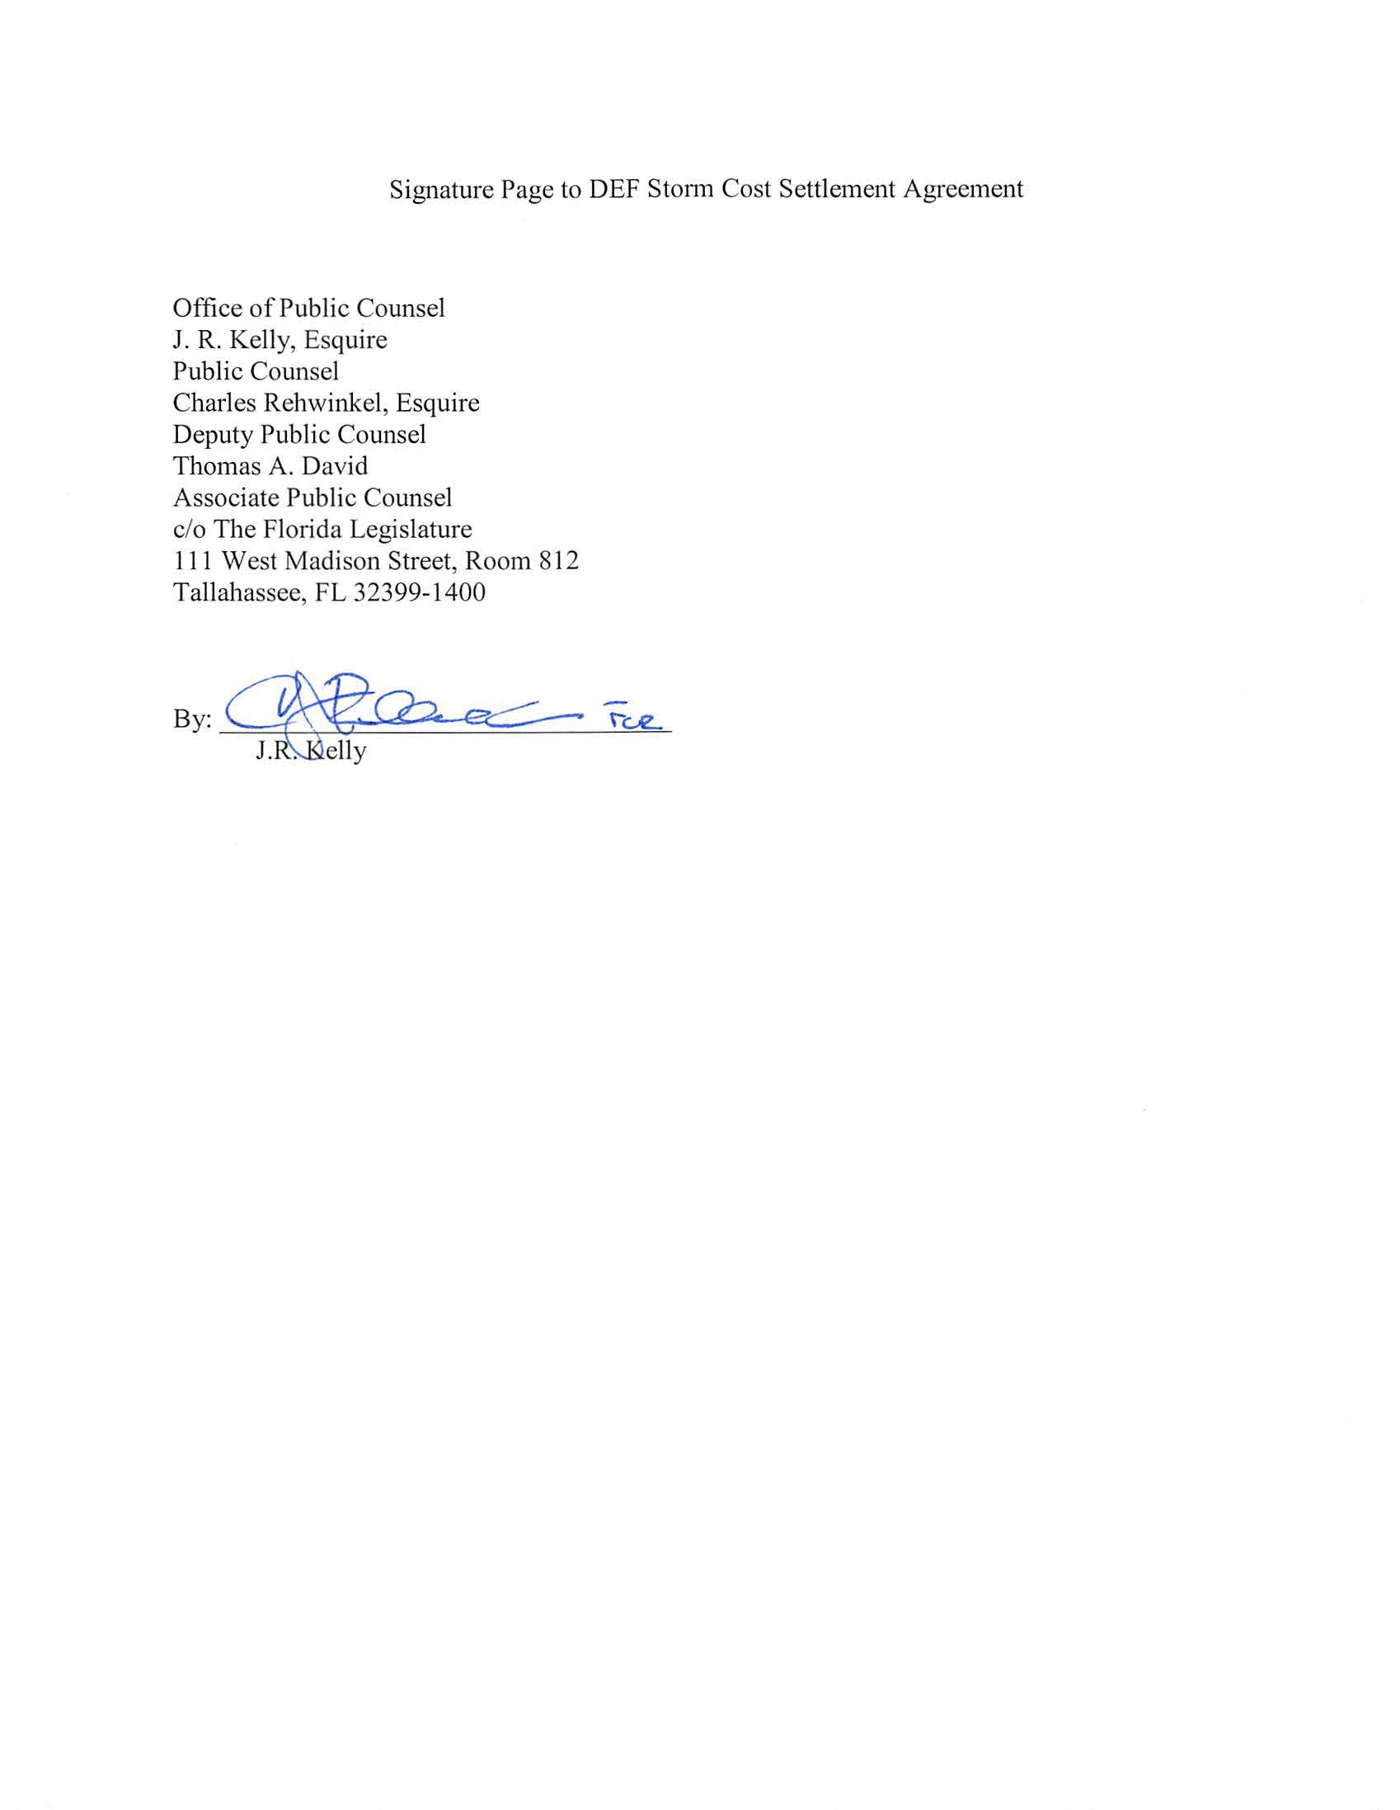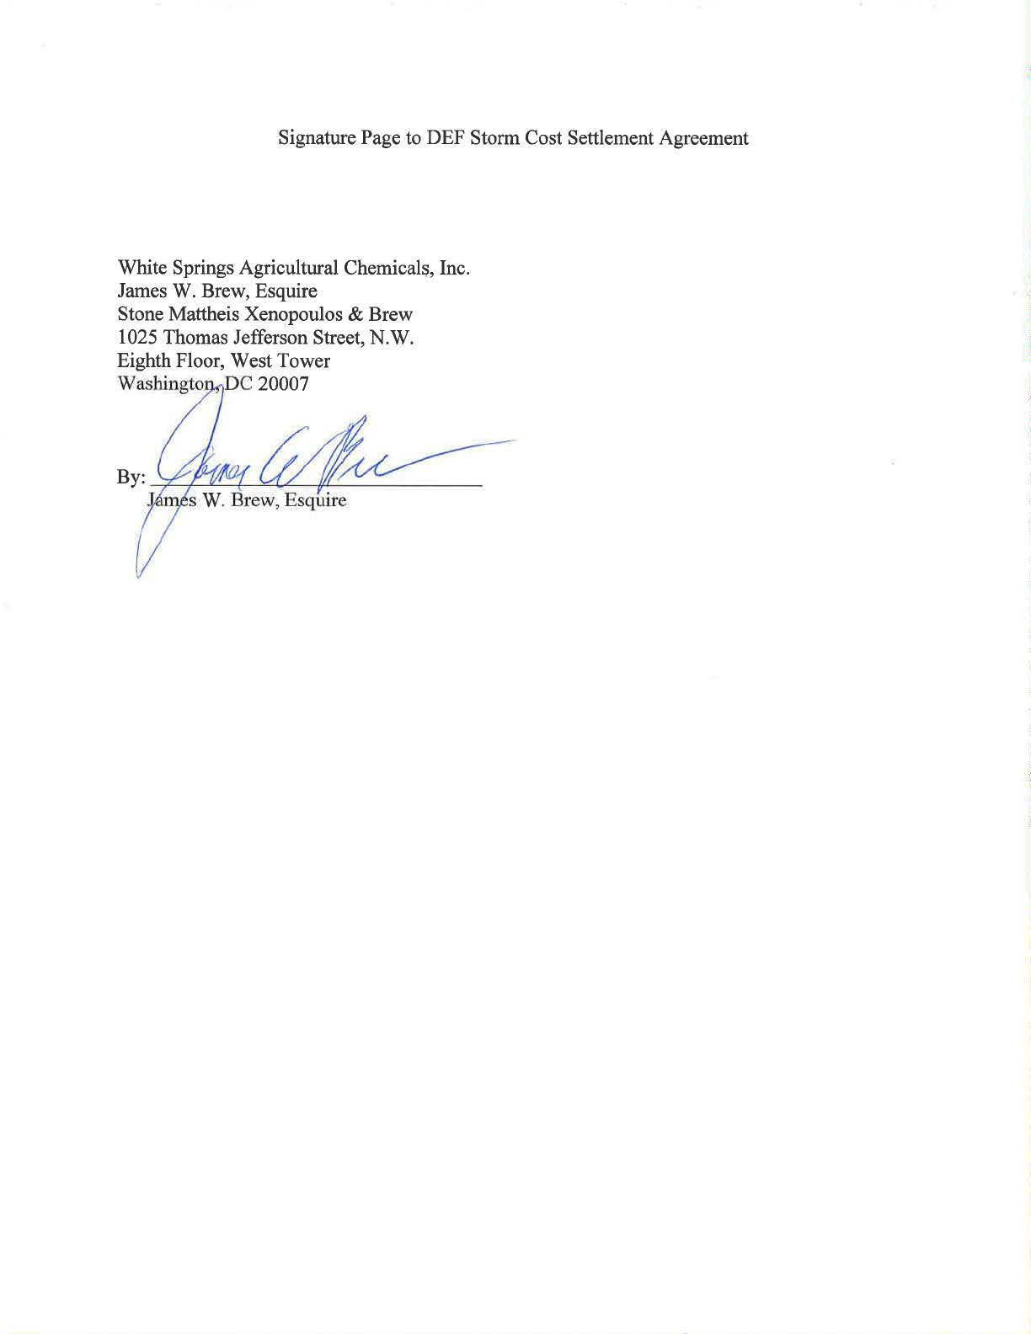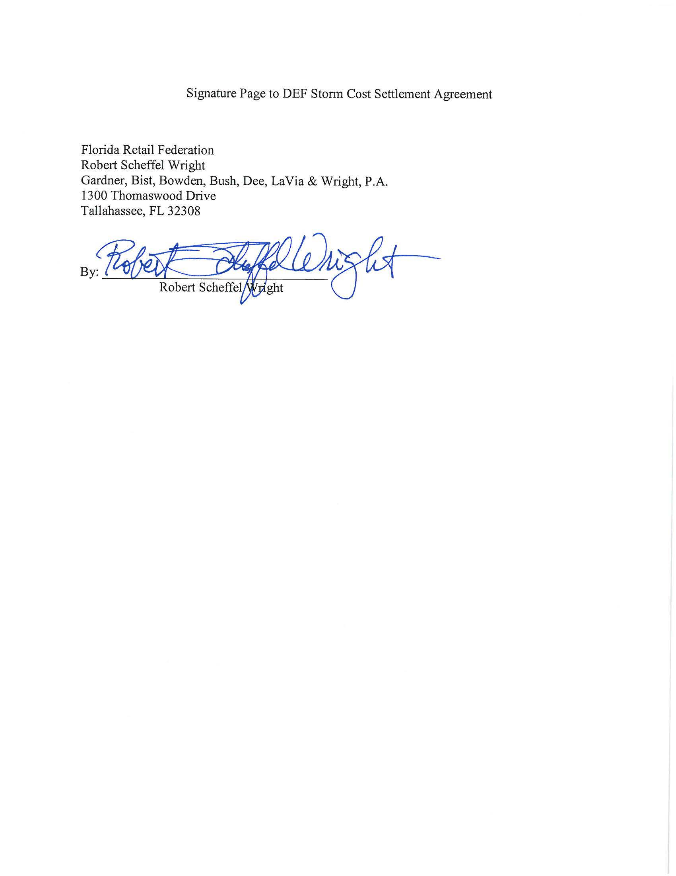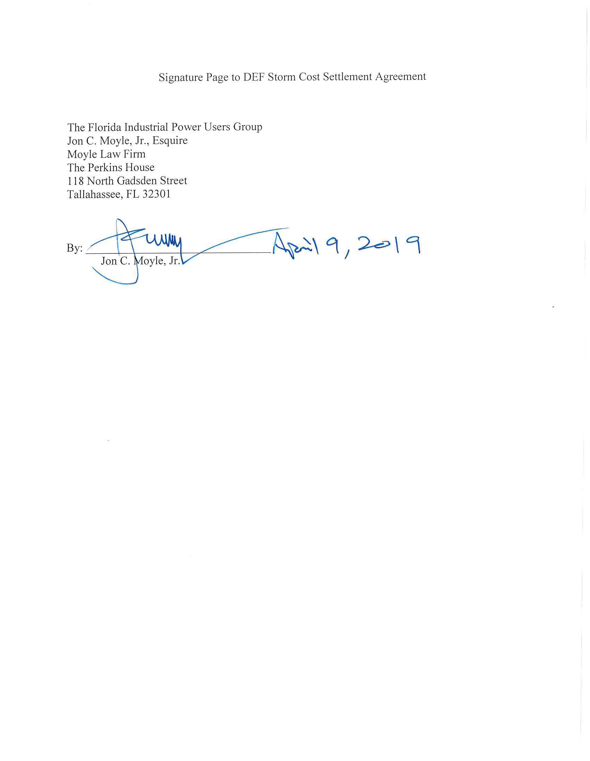

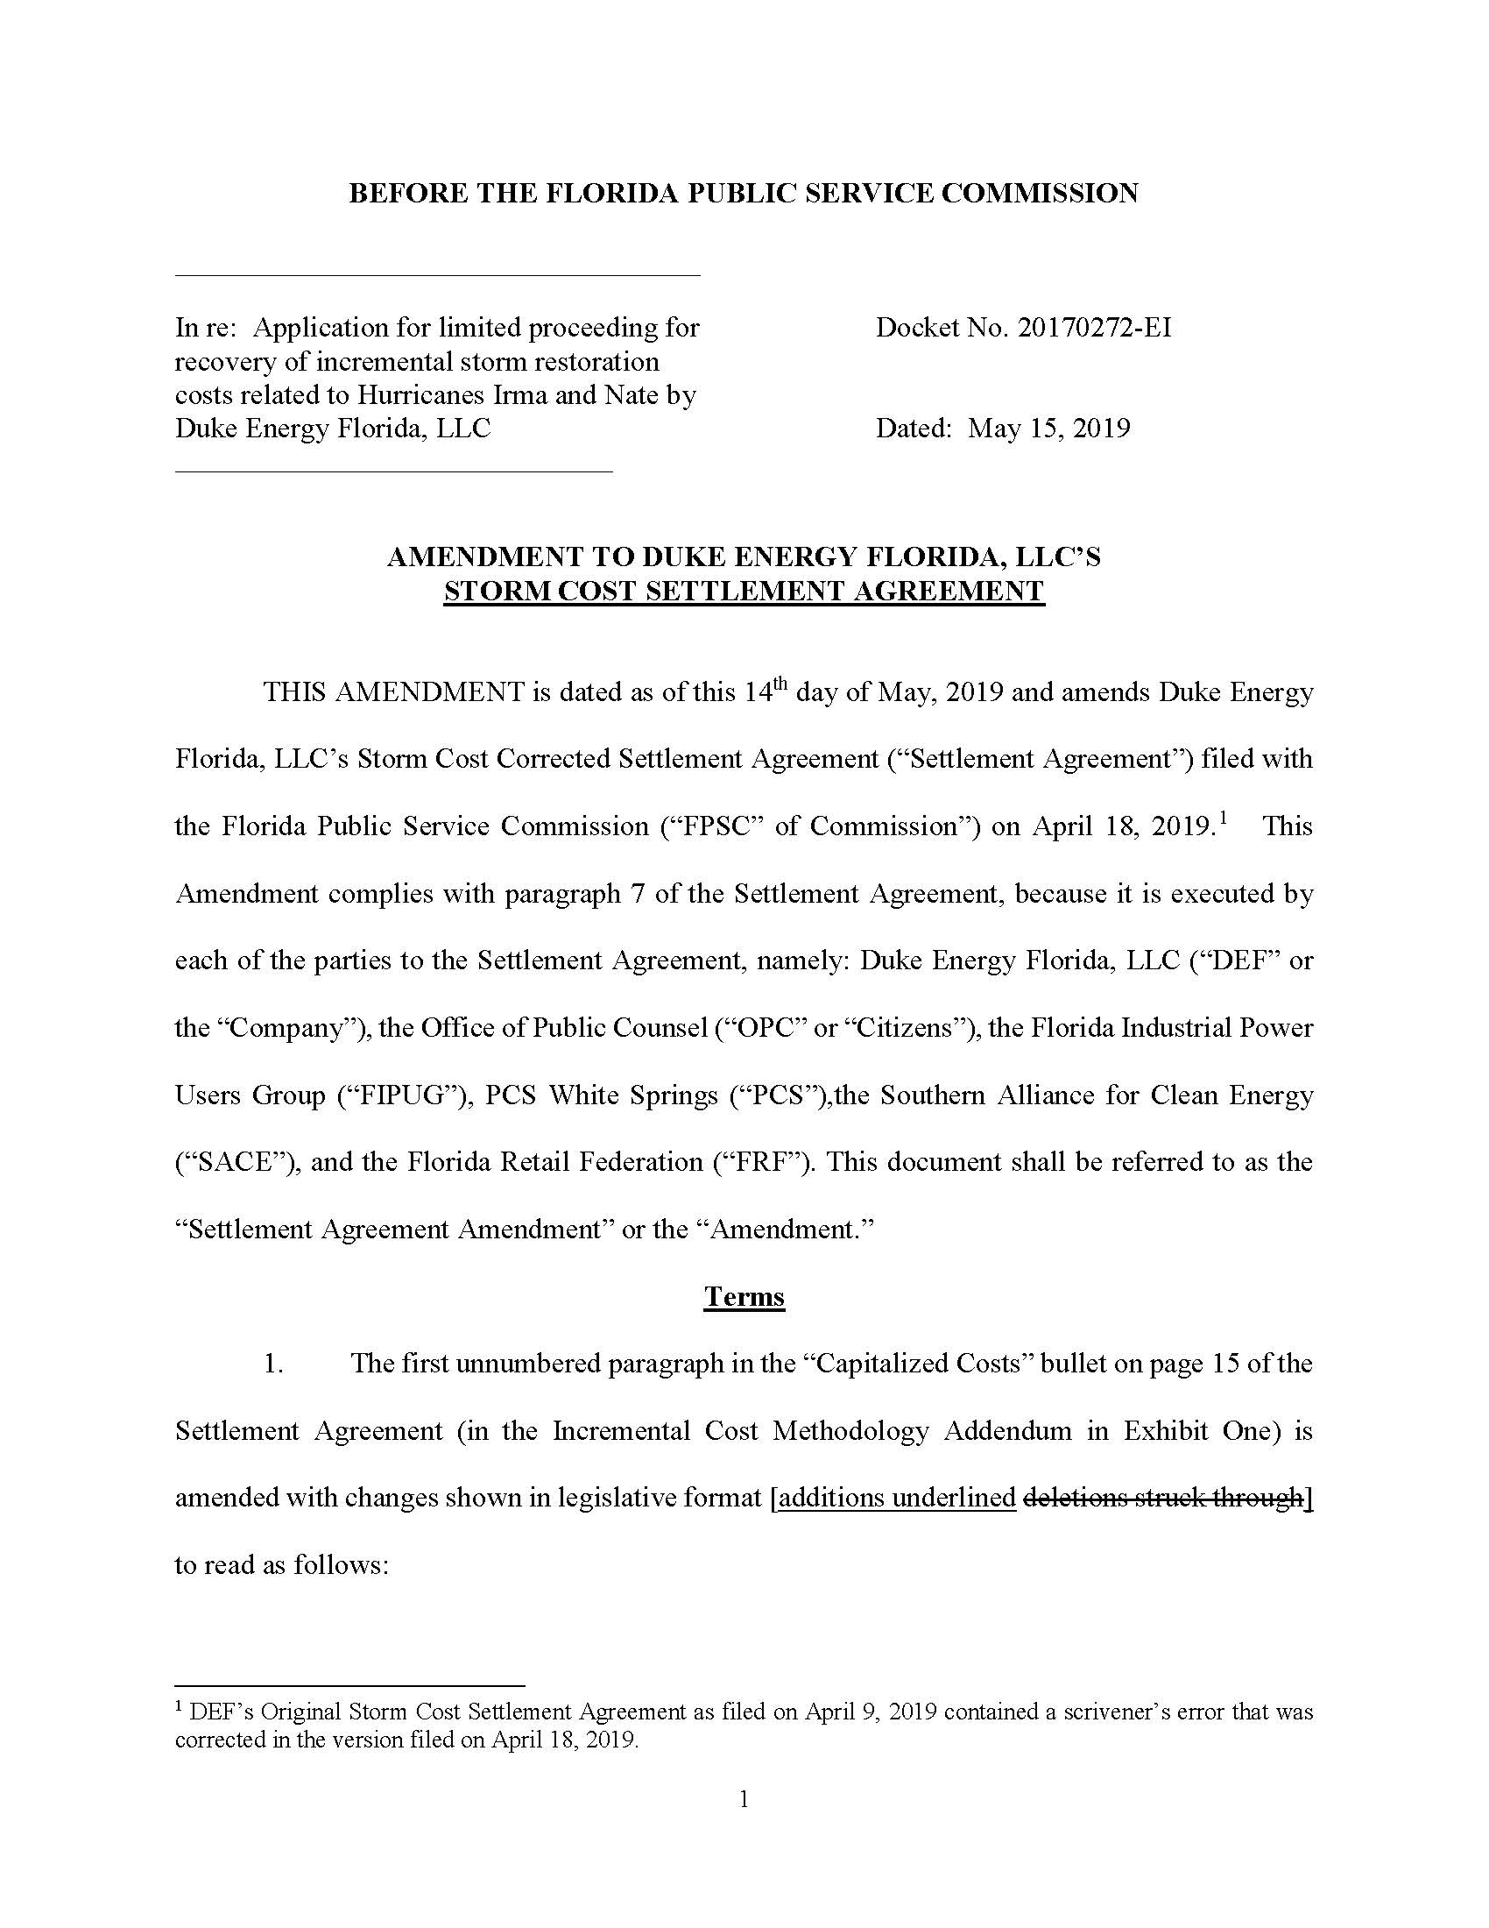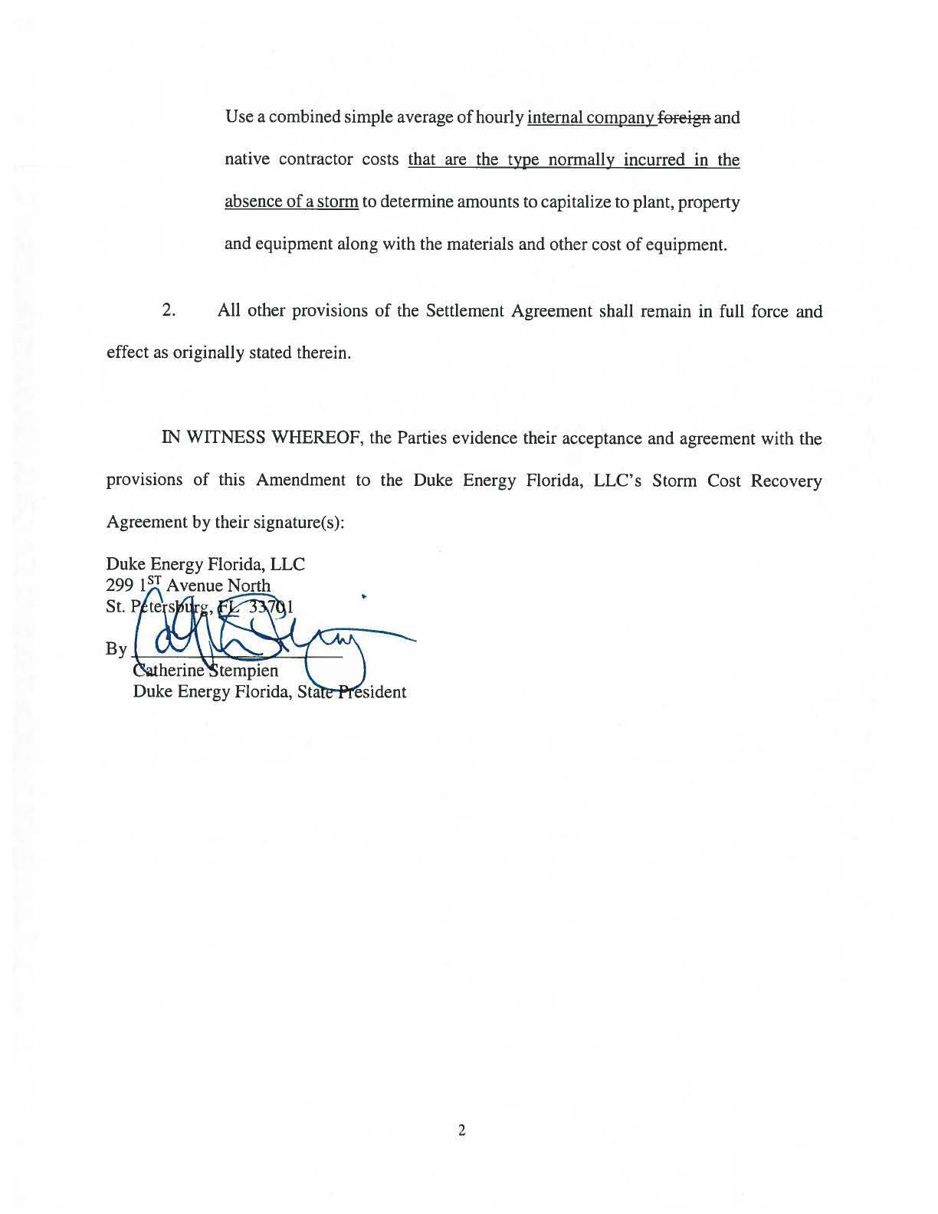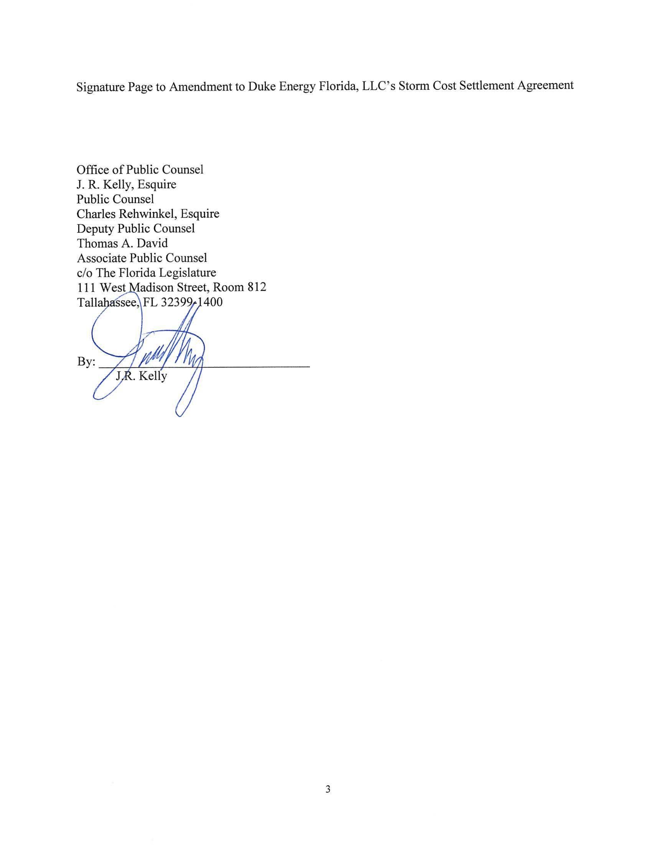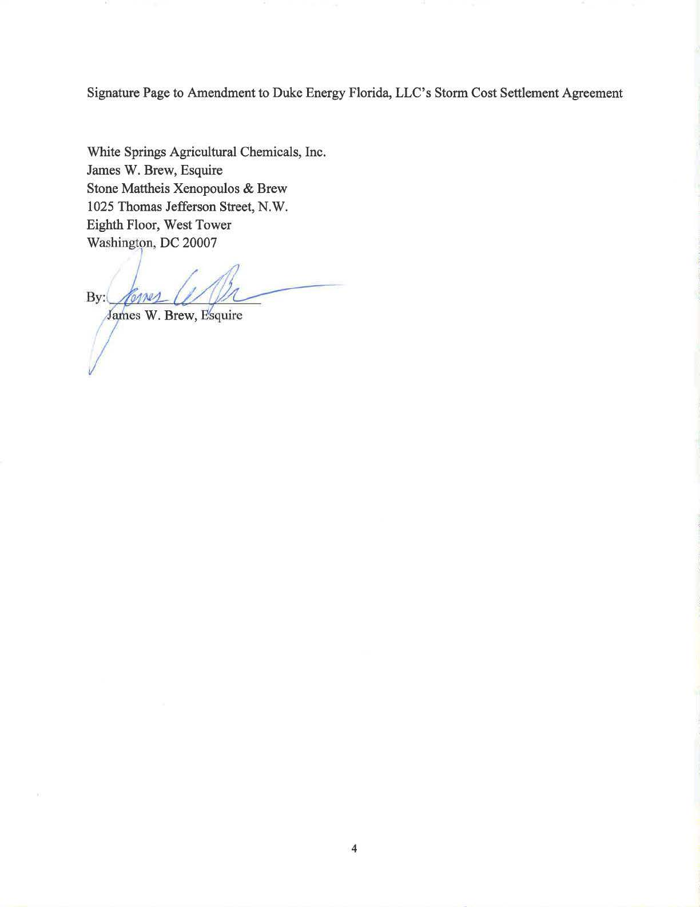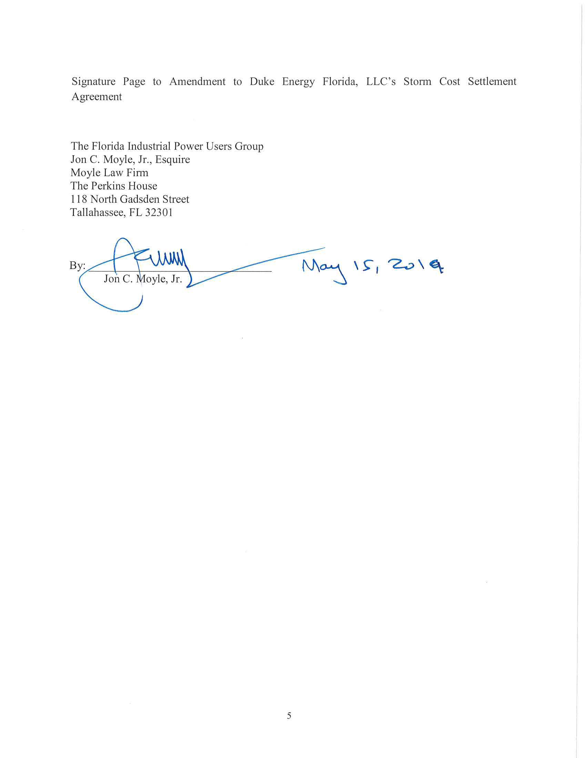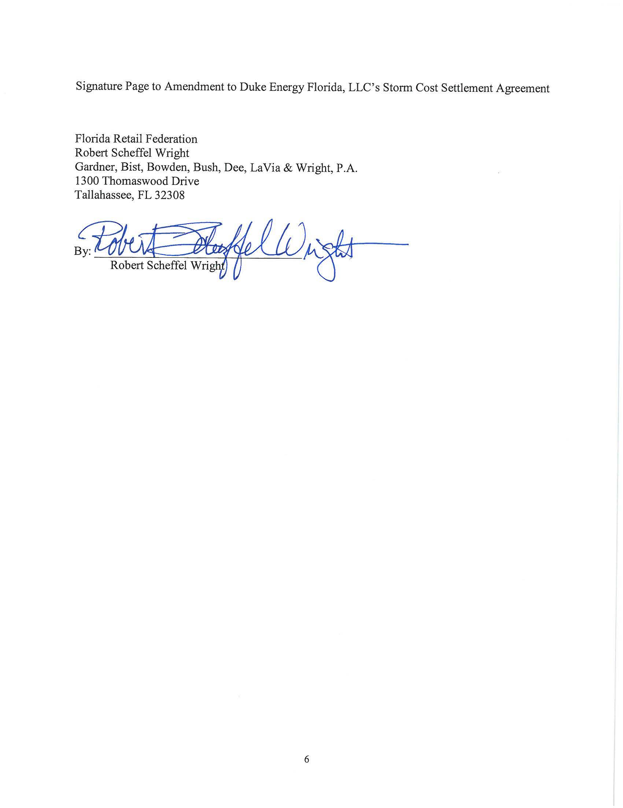

Order No. PSC-2017-0451-AS-EU, issued on November 20, 2017, in Docket No. 20170183-EI, In re: Application for limited proceeding to approve 2017 second revised and restated settlement agreement, including certain rate adjustments, by Duke Energy Florida, LLC.
See Document No. 04039-2019, in Docket No. 20190110-EI, In re: Petition for limited proceeding for recovery of incremental storm restoration costs related to Hurricane Michael and approval of second implementation stipulation, by Duke Energy Florida, LLC.
Order No. PSC-13-0023-S-EI, issued on January 14, 2013, in Docket No. 120015-EI, In re: Petition for increase in rates by Florida Power & Light Company; Order No. PSC-11-0089-S-EI, issued February 1, 2011, in Docket Nos. 080677 and 090130, In re: Petition for increase in rates by Florida Power & Light Company and In re: 2009 depreciation and dismantlement study by Florida Power & Light Company; Order No. PSC-10-0398-S-EI, issued June 18, 2010, in Docket Nos. 090079-EI, 090144-EI, 090145-EI, 100136-EI, In re: Petition for increase in rates by Progress Energy Florida, Inc., In re: Petition for limited proceeding to include Bartow repowering project in base rates, by Progress Energy Florida, Inc., In re: Petition for expedited approval of the deferral of pension expenses, authorization to charge storm hardening expenses to the storm damage reserve, and variance from or waiver of Rule 25-6.0143(1)(c), (d), and (f), F.A.C., by Progress Energy Florida, Inc., and In re: Petition for approval of an accounting order to record a depreciation expense credit, by Progress Energy Florida, Inc.; Order No. PSC-05-0945-S-EI, issued September 28, 2005, in Docket No. 050078-EI, In re: Petition for rate increase by Progress Energy Florida, Inc.
Order No. PSC-13-0023-S-EI, at p. 7.

