State of Florida |  | Public Service Commission  Capital Circle Office Center ● 2540 Shumard Oak Boulevard  Tallahassee, Florida 32399-0850  -M-E-M-O-R-A-N-D-U-M-
DATE: | June 26, 2019
TO: | Office of Commission Clerk (Teitzman)
FROM: | Division of Accounting and Finance (Snyder, M. Andrews, Mouring, L. Smith, D. Buys)  Division of Economics (Doherty, Draper)  Division of Engineering (Graves, King, Knoblauch, Lewis)  Office of the General Counsel (Trierweiler, J. Crawford, Schrader)
RE: | Docket No. 20190109-GU – Petition for recovery of costs associated with Hurricane Michael and replenishment of storm reserve, by Peoples Gas System.
AGENDA: | 07/09/19 – Regular Agenda – Interested Persons May Participate
COMMISSIONERS ASSIGNED: |  |  | All Commissioners
PREHEARING OFFICER: |  |  | Clark
CRITICAL DATES: |  |  | None
SPECIAL INSTRUCTIONS: |  |  | None

Case Background
On April 25, 2019, Peoples Gas System (Peoples or Company) filed a petition for recovery of approximately $3.4 million for the incremental restoration costs related to Hurricane Michael and to replenish the Company’s storm reserve. In its petition, Peoples asserted that, as a result of Hurricane Michael, it incurred total retail recoverable cost of approximately $3.3 million, which exceeds and fully depletes the pre-storm balance of $79,125 in Peoples’ storm reserve. Interest and the regulatory assessment fee gross-up add an additional $70,650. Peoples is also requesting recovery of $27,255 related to the write-off of accounts receivable for service provided prior to Hurricane Michael.
Peoples has proposed a $0.76 surcharge per month on the typical residential customer bill for storm recovery and restoration. The charge would be applied to all bills starting the first billing cycle of August 2019 and concluding at the end of the billing cycle when storm costs have been recovered and the reserve is replenished to the September 30, 2018 pre-storm balance of $79,125. Peoples is requesting that any over-recovery variance between the surcharge dollars and the incremental storm costs be applied to Peoples’ storm reserve.
On May 24, 2019, Peoples requested that its request be placed on the July Commission Conference. Peoples discussed this matter with counsel for OPC and all agree with the July date. Peoples waived the 60-day decision requirement under Section 366.06(3), Florida Statutes (F.S.).
The Office of Public Counsel intervened in this docket on May 2, 2019.
The Commission has jurisdiction over this matter pursuant to Sections 366.04, 366.05, 366.06, and 366.076, F.S.

Discussion of Issues
Issue 1: Should the Commission authorize Peoples Gas System to implement an interim storm restoration recovery charge?
Recommendation: Yes, the Commission should authorize Peoples Gas System to implement an interim storm restoration recovery charge. After the actual costs are reviewed for prudence and reasonableness, and are compared to the actual amount recovered through the interim storm restoration recovery charge, a determination will be made whether any over/under recovery has occurred. The disposition of any over/under recovery, and associated interest, will be considered by the Commission at a later date. (Snyder, Mouring)
Staff Analysis: As stated in the Case Background, Peoples filed a petition to recover costs associated with Hurricane Michael and to replenish its storm reserve. In its petition, Peoples asserted that, as a result of Hurricane Michael, it incurred total retail recoverable cost of $3.4 million, which fully depletes the pre-storm balance of $79,125 in the Company’s storm reserve. Peoples further asserts that this amount was calculated in accordance with the Incremental Cost and Capitalization Approach methodology prescribed in Rule 25-6.0143, Florida Administrative Code (F.A.C.). Peoples has requested implementing a surcharge starting with the first billing cycle in August 2019 and concluding when the storm reserve has been restored to the pre-storm balance of $79,125. Peoples anticipates this to occur in December 2019.
The approval of an interim storm restoration recovery charge should be preliminary in nature and subject to refund pending further review once the total actual storm restoration costs are known. After the actual costs are reviewed for prudence and reasonableness, and are compared to the actual amount recovered through the interim storm restoration recovery charge, a determination should be made whether any over or under recovery has occurred. The disposition of any over or under recovery, and associated interest, would be considered by the Commission at a later date.
Based on a review of the information provided by Peoples in its petition, staff recommends that the Commission authorize Peoples to implement an interim storm restoration recovery charge subject to refund. Staff emphasizes that this recommendation only allows Peoples to begin recovery on an interim basis. This interim recovery should be subject to refund pending a hearing or formal proceeding where the veracity and prudence of Peoples’ actual restoration costs can be fully vetted.

Issue 2: Should the Commission approve Peoples Gas System’s proposed tariffs and associated charges?
Recommendation: Yes. The Commission should approve Peoples Gas System’s tariffs as proposed in the petition to go into effect with the first billing cycle in August 2019. (Doherty)
Staff Analysis: Peoples is seeking approval of interim storm cost recovery charge factors as shown in proposed original tariff sheet no. 7.101-10 (Attachment A to this recommendation). Exhibit C to the petition shows the calculation of the storm cost recovery charge factors for all rate classes. Exhibit D to the petition includes revisions to all tariffs reflecting the addition of the interim storm recovery charges as shown on tariff sheet no. 7.101-10. A residential customer, with an average monthly usage of 12.8 therms per month, will see a $0.76 increase on the monthly bill beginning with the first billing cycle in August 2019.
Peoples indicated that the customers will be notified of the interim storm cost recovery charge factors via bill inserts on the first billing cycle in July 2019.
Staff recommends that the Commission approve Peoples’ proposed tariffs to go into effect with the first billing cycle in August 2019.

Issue 3:
What is the appropriate security to guarantee the amount collected subject to refund through the interim storm restoration recovery charge?

Recommendation:
The appropriate security to guarantee the funds collected subject to refund is a corporate undertaking. (L. Smith, D. Buys)

Staff Analysis:
Staff recommends that all funds collected subject to refund be secured by a corporate undertaking. The criteria for a corporate undertaking include sufficient liquidity, ownership equity, profitability, and interest coverage to guarantee any potential refund. Staff reviewed Peoples’ financial statements to determine if the Company can support a corporate undertaking to guarantee the funds collected for recovery of incremental storm restoration costs related to Hurricane Michael. Peoples’ 2016, 2017, and 2018 financial statements were used to determine the financial condition of the Company. Peoples’ financial performance demonstrates adequate levels of ownership equity, profitability, and interest coverage, but deficient liquidity due to negative working capital. However, Peoples’ average net income is 12 times the requested amount.
Staff believes Peoples has adequate resources to support a corporate undertaking in the amount requested. Based on this analysis, staff recommends that a corporate undertaking of $3.4 million is acceptable. This brief financial analysis is only appropriate for deciding if the Company can support a corporate undertaking in the amount proposed and should not be considered a finding regarding staff's position on other issues in this proceeding.

Issue 4: Should this docket be closed?

Recommendation: No, this docket should remain open pending final reconciliation of actual recoverable Hurricane Michael storm costs with the amount collected pursuant to the interim storm restoration recovery charge. The disposition of any over or under recovery, and associated interest, should be considered by the Commission at a later date. (Trierweiler)

Staff Analysis: No, this docket should remain open pending final reconciliation of actual recoverable Hurricane Michael storm costs with the amount collected pursuant to the interim storm restoration recovery charge. The disposition of any over or under recovery, and associated interest, should be considered by the Commission at a later date.

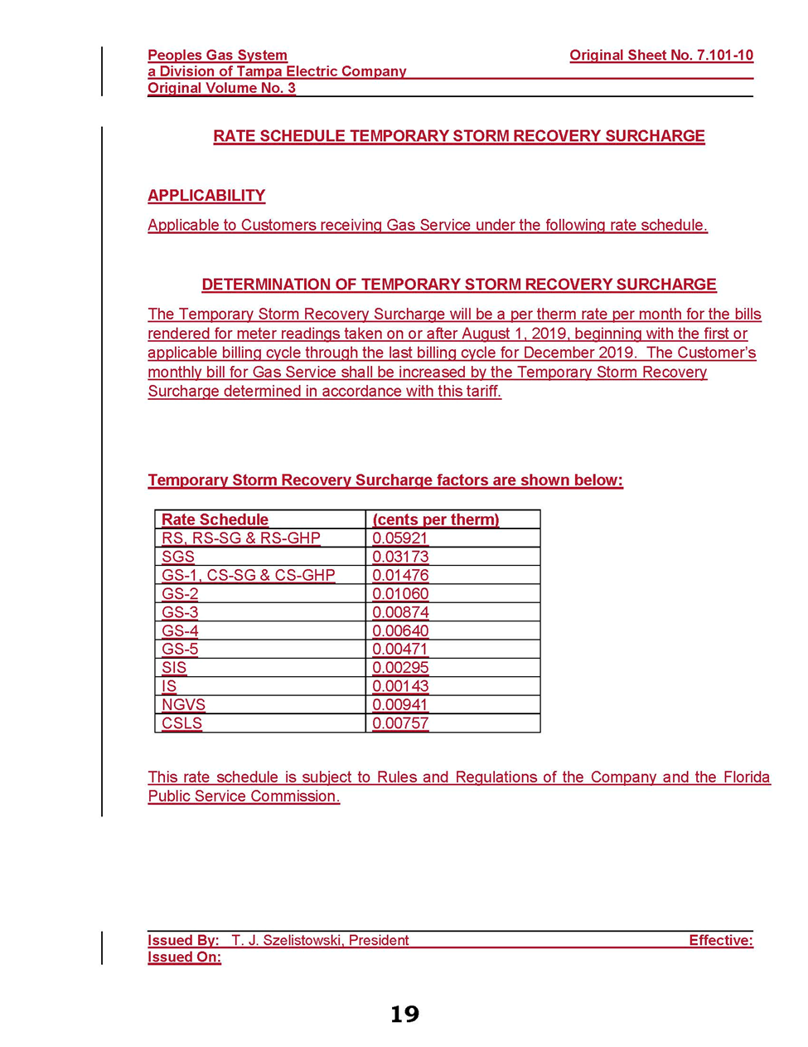

Document No. 04543-2019, filed May 24, 2019, in Docket No. 20190109-GU.

