State of Florida |  | Public Service Commission  Capital Circle Office Center ● 2540 Shumard Oak Boulevard  Tallahassee, Florida 32399-0850  -M-E-M-O-R-A-N-D-U-M-
DATE: | June 26, 2019
TO: | Office of Commission Clerk (Teitzman)
FROM: | Division of Engineering (Thompson, Doehling, Ellis)  Office of the General Counsel (Murphy)
RE: | Docket No. 20190079-EQ – Petition for approval of amended standard offer contract (Schedule COG-2) and amended interconnection agreement, by Duke Energy Florida, LLC.
AGENDA: | 07/09/19 – Regular Agenda – Proposed Agency Action – Interested Persons May Participate
COMMISSIONERS ASSIGNED: |  |  | All Commissioners
PREHEARING OFFICER: |  |  | Administrative
CRITICAL DATES: |  |  | None
SPECIAL INSTRUCTIONS: |  |  | None

Case Background
Section 366.91(3), Florida Statutes (F.S.), requires that each investor-owned utility (IOU) continuously offer to purchase capacity and energy from renewable energy generators (RF) and small qualifying facilities (QF). Florida Public Service Commission (Commission) Rules 25-17.200 through 25-17.310, Florida Administrative Code (F.A.C.), implement the statute and require each IOU to file with the Commission by April 1 of each year, a standard offer contract based on the next avoidable fossil fueled generating unit of each technology type identified in the utility’s current Ten-Year Site Plan.
On April 1, 2019, Duke Energy Florida, LLC (DEF) filed a petition for approval of its amended standard offer contract and associated rate schedule COG-2, based on its 2019 Ten-Year Site Plan, and amended interconnection agreement. On June 7, 2019, DEF refiled its standard offer contract to include supplemental revisions to Sheet 9.416 in response to staff’s first data request.
The Commission has jurisdiction over this standard offer contract pursuant to Sections 366.04 through 366.055 and 366.91, F.S.

Discussion of Issues

Issue 1:
Should the Commission approve the amended standard offer contract (Schedule COG-2) and amended interconnection agreement filed by Duke Energy Florida, LLC?

Recommendation:
Yes. The provisions of DEF’s amended standard offer contract and associated rate schedule COG-2, as revised on June 7, 2019, and amended interconnection agreement, as filed on April 1, 2019, conform to all requirements of Rules 25-17.200 through 25-17.310, F.A.C. The amended standard offer contract provides flexibility in the arrangements for payments so that a developer of renewable generation may select the payment stream best suited to its financial needs. (Doehling, Thompson)

Staff Analysis:
Rule 25-17.250, F.A.C., requires that DEF, an IOU, continuously make available a standard offer contract for the purchase of firm capacity and energy from renewable RF/QFs with design capacities of 100 kilowatts (kW) or less. Pursuant to Rule 25-17.250(1) and (3), F.A.C., the standard offer contract must provide a term of at least 10 years, and the payment terms must be based on the Utility’s next avoidable fossil-fueled generating unit identified in its most recent Ten-Year Site Plan or, if no avoided unit is identified, its next avoidable planned purchase. DEF has identified a 218 megawatt (MW) natural gas-fueled combustion turbine (CT) as the next planned generating unit in its 2019 Ten-Year Site Plan. The projected in-service date of the unit is June 1, 2027.
Under DEF’s standard offer contract, the RF/QF operator commits to certain minimum performance requirements based on the identified avoided unit, such as being operational and delivering an agreed upon amount of capacity by the in-service date of the avoided unit, and thereby becomes eligible for capacity payments in addition to payments received for energy. The standard offer contract may also serve as a starting point for negotiation of contract terms by providing payment information to an RF/QF operator, in a situation where one or both parties desire particular contract terms other than those established in the standard offer.
In order to promote renewable generation, the Commission requires each IOU to offer multiple options for capacity payments, including the options to receive early or levelized payments. If the RF/QF operator elects to receive capacity payments under the normal or levelized contract options, it will receive as-available energy payments only until the in-service date of the avoided unit (in this case June 1, 2027), and thereafter begin receiving capacity payments in addition to the energy payments. If either the early or early levelized option is selected, then the operator will begin receiving capacity payments earlier than the in-service date of the avoided unit. However, payments made under the early capacity payments options tend to be lower in the later years of the contract term because the net present value (NPV) of the total payments must remain equal for all contract payment options.
Table 1 contains estimates of the annual payments for each payment option available under the amended standard offer contract to an operator with a 50 MW renewable facility operating at a capacity factor of 95 percent, which is the minimum capacity factor required under the contract to qualify for full capacity payments. Normal and levelized capacity payments begin in 2027, reflecting the projected in-service date of the avoided unit (June 1, 2027).

Table 1 – Estimated Annual Payments to a 50 MW Renewable Facility
(95% Capacity Factor)
Year | Energy Payment | Capacity Payment (By Type)
 |  | Normal | Levelized | Early | Early Levelized
 | $(000) | $(000) | $(000) | $(000) | $(000)
2020 | 9,469 | - | - | - | -
2021 | 8,638 | - | - | - | -
2022 | 7,796 | - | - | - | -
2023 | 7,172 | - | - | - | -
2024 | 8,266 | - | - | - | -
2025 | 9,878 | - | - | 2,173 | 2,333
2026 | 10,850 | - | - | 2,201 | 2,335
2027 | 12,413 | 1,674 | 1,788 | 2,230 | 2,337
2028 | 13,409 | 2,908 | 3,067 | 2,260 | 2,339
2029 | 13,833 | 2,946 | 3,070 | 2,289 | 2,341
2030 | 15,079 | 2,985 | 3,072 | 2,319 | 2,343
2031 | 15,656 | 3,024 | 3,075 | 2,350 | 2,346
2032 | 16,942 | 3,064 | 3,078 | 2,381 | 2,348
2033 | 17,411 | 3,104 | 3,081 | 2,412 | 2,350
2034 | 17,725 | 3,145 | 3,084 | 2,444 | 2,352
2035 | 16,807 | 3,187 | 3,087 | 2,476 | 2,355
2036 | 17,429 | 3,229 | 3,090 | 2,509 | 2,357
2037 | 18,218 | 3,271 | 3,093 | 2,542 | 2,360
2038 | 19,774 | 3,314 | 3,097 | 2,576 | 2,362
2039 | 20,956 | 3,358 | 3,100 | 2,610 | 2,365
Total | 277,721 | 39,208 | 38,782 | 35,772 | 35,224
NPV (2019$) | 133,766 | 15,549 | 15,549 | 15,549 | 15,549
Source: DEF’s response to staff’s first data request.

The changes made to DEF’s tariff sheets are consistent with the updated avoided unit. Other revisions DEF made to its tariff sheets include: (1) financial and technical viability conditions; (2) completion/performance security requirements; (3) delivery voltage calculation methods; and (4) testing requirements.
The additional conditions to verify the RF/QF is both financially and technically viable, found on Sheet Nos. 9.416, 9.419, and 9.420, and the completion/performance security requirements, found on Sheet No. 9.425, were added to provide additional protection to both DEF and its customers. The technical viability and security requirements are consistent with conditions approved in FPL’s standard offer contract. The financial viability requirements on Sheet No. 9.416 were modified on June 7, 2019, to provide limited exemptions from these conditions. Staff believes the revised financial requirements are adequate to safeguard ratepayers and should not be overly burdensome to the RF/QF.
The revisions in the Delivery Voltage section, found on Sheet No. 9.458, were made so that the delivery voltage adjustment factor will be calculated based on the current delivery efficiencies in DEF’s tariff as approved by FERC. This will allow for the delivery voltage adjustment factors to stay up to date should there be any changes in DEF’s Open Access Tariff subsequent to the standard offer contract filing, and will be provided within 30 days of a written request by any interested person. Changes in testing requirements, found on Sheet No. 9.710, were made to reflect the current testing requirements of modern electrical relays. This is consistent with the manufacturer’s current recommendations.
In addition to the above revisions, there are a number of unsubstantial changes including updates to calendar dates, position titles, and typographical corrections. The type-and-strike format versions of the amended standard offer contract and associated rate schedule COG-2, as revised on June 7, 2019, are included as Attachment A to this recommendation. The amended interconnection agreement, as filed on April 1, 2019, is included as Attachment B to this recommendation.
Conclusion
The provisions of DEF’s amended standard offer contract and associated rate schedule COG-2, as revised on June 7, 2019, and amended interconnection agreement, as filed on April 1, 2019, conform to all requirements of Rules 25-17.200 through 25-17.310, F.A.C. The amended standard offer contract provides flexibility in the arrangements for payments so that a developer of renewable generation may select the payment stream best suited to its financial needs.

Issue 2:
Should this docket be closed?

Recommendation:
Yes. This docket should be closed upon issuance of a consummating order, unless a person whose substantial interests are affected by the Commission’s decision files a protest within 21 days of the issuance of the Commission’s Proposed Agency Action Order. Potential signatories should be aware that, if a timely protest is filed, DEF’s standard offer contract may subsequently be revised. (Murphy)

Staff Analysis:
This docket should be closed upon the issuance of a consummating order, unless a person whose substantial interests are affected by the Commission’s decision files a protest within 21 days of the issuance of the Commission’s Proposed Agency Action Order. Potential signatories should be aware that, if a timely protest is filed, DEF’s standard offer contract may subsequently be revised.

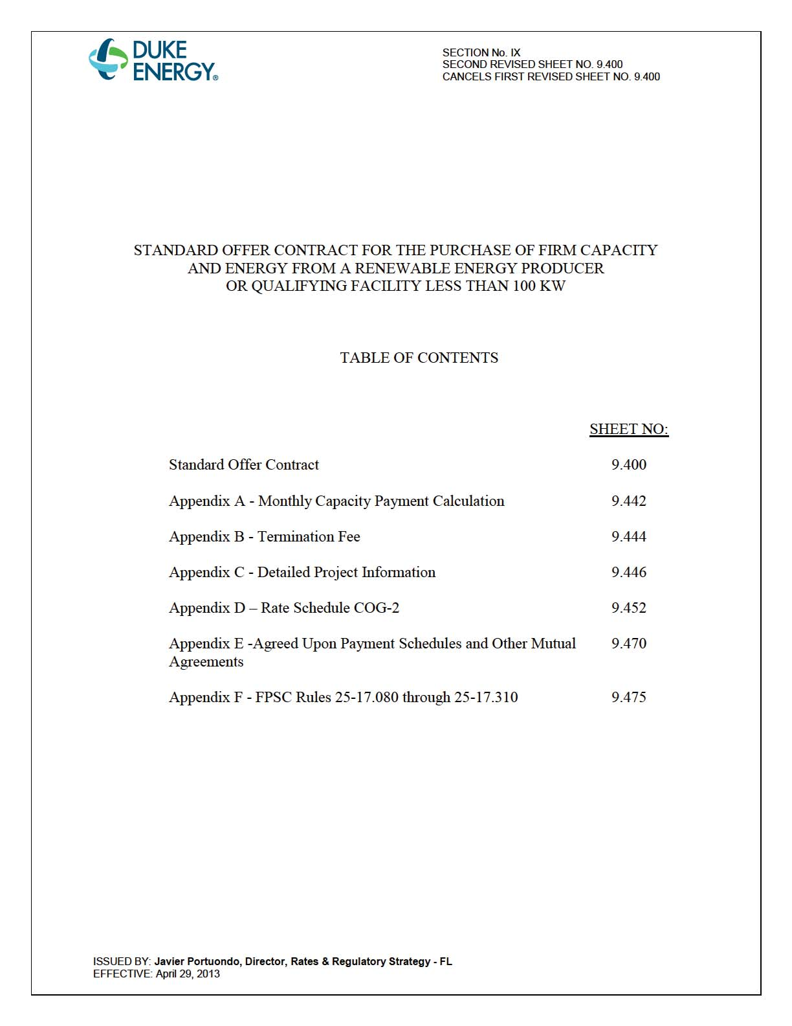

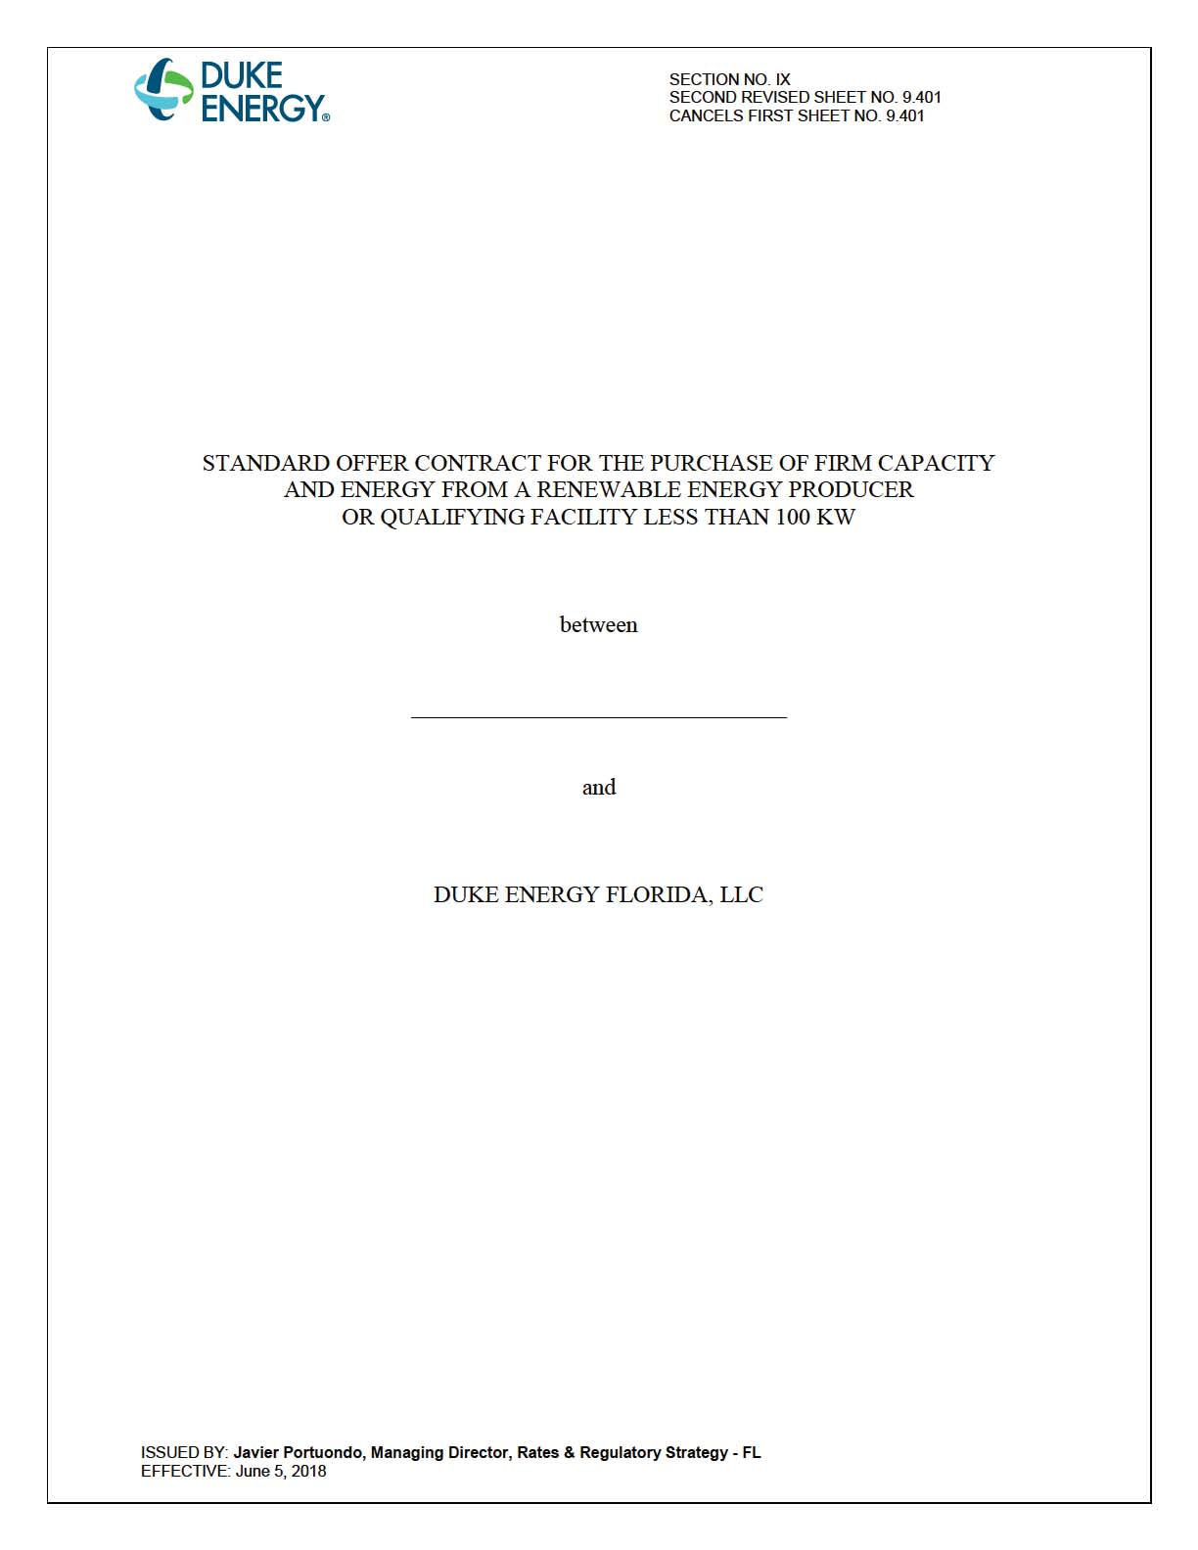

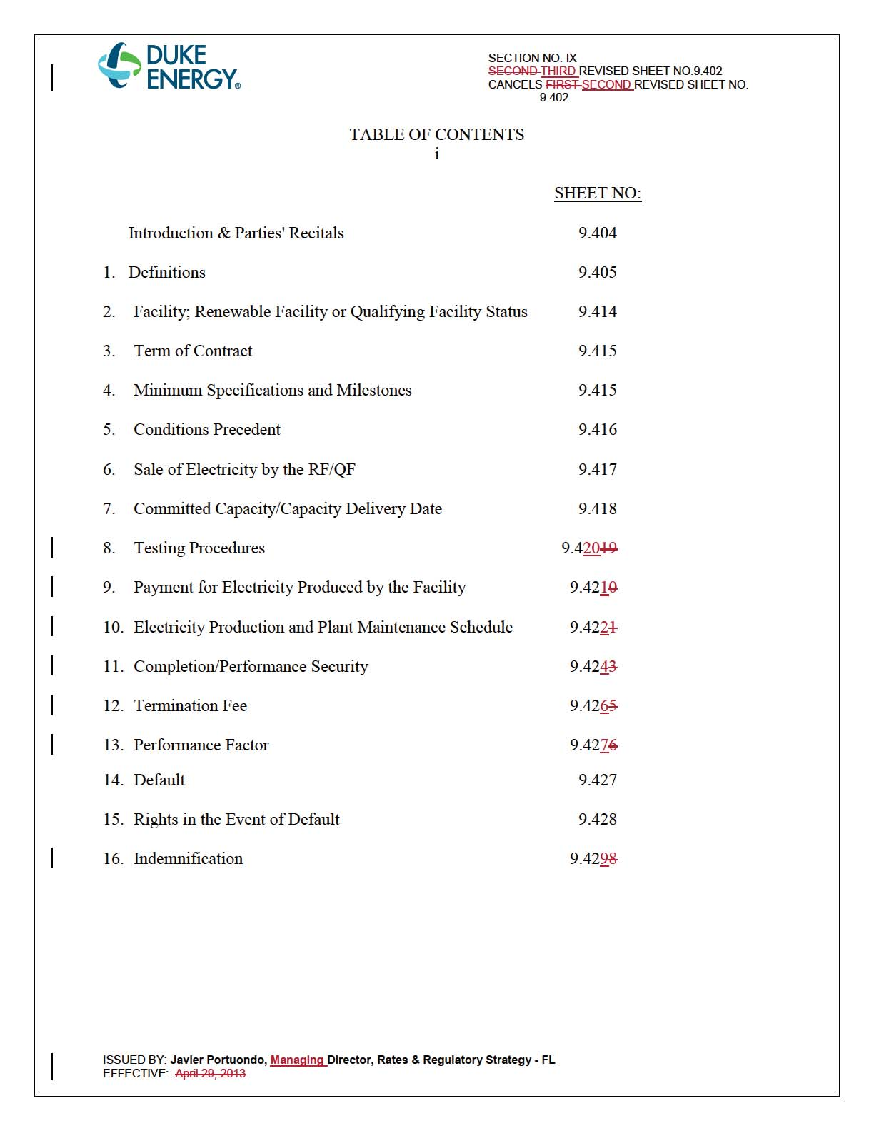

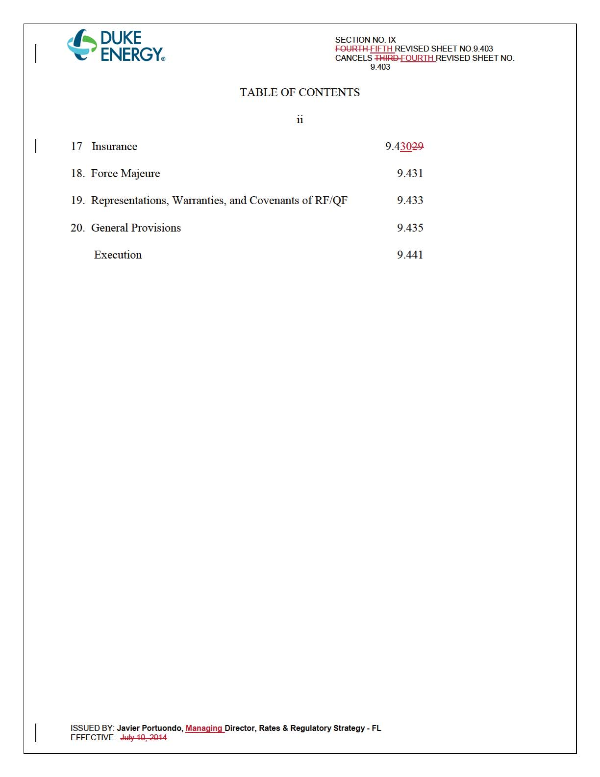

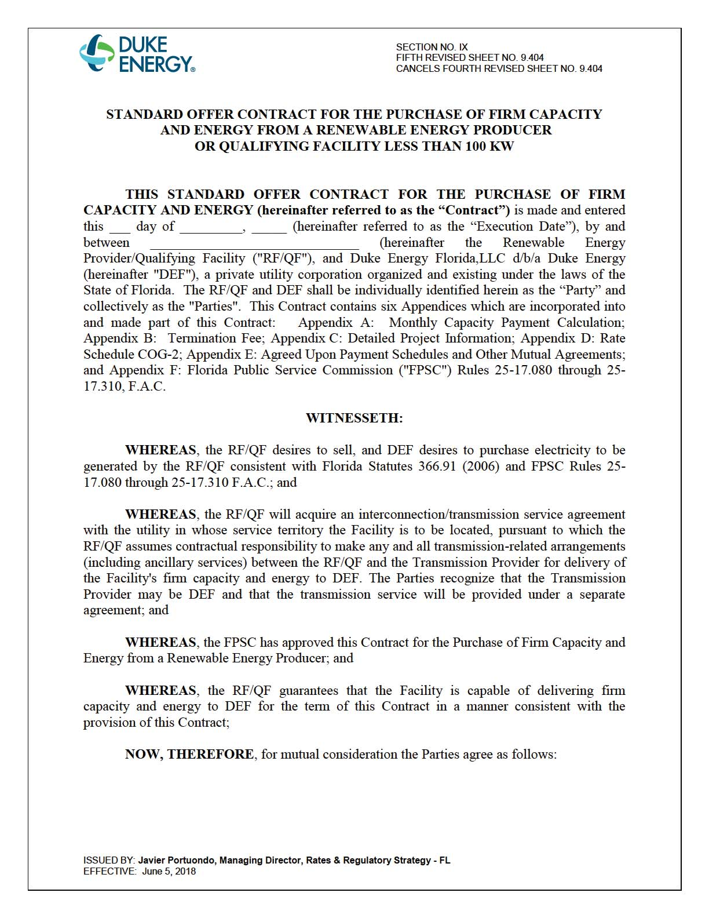

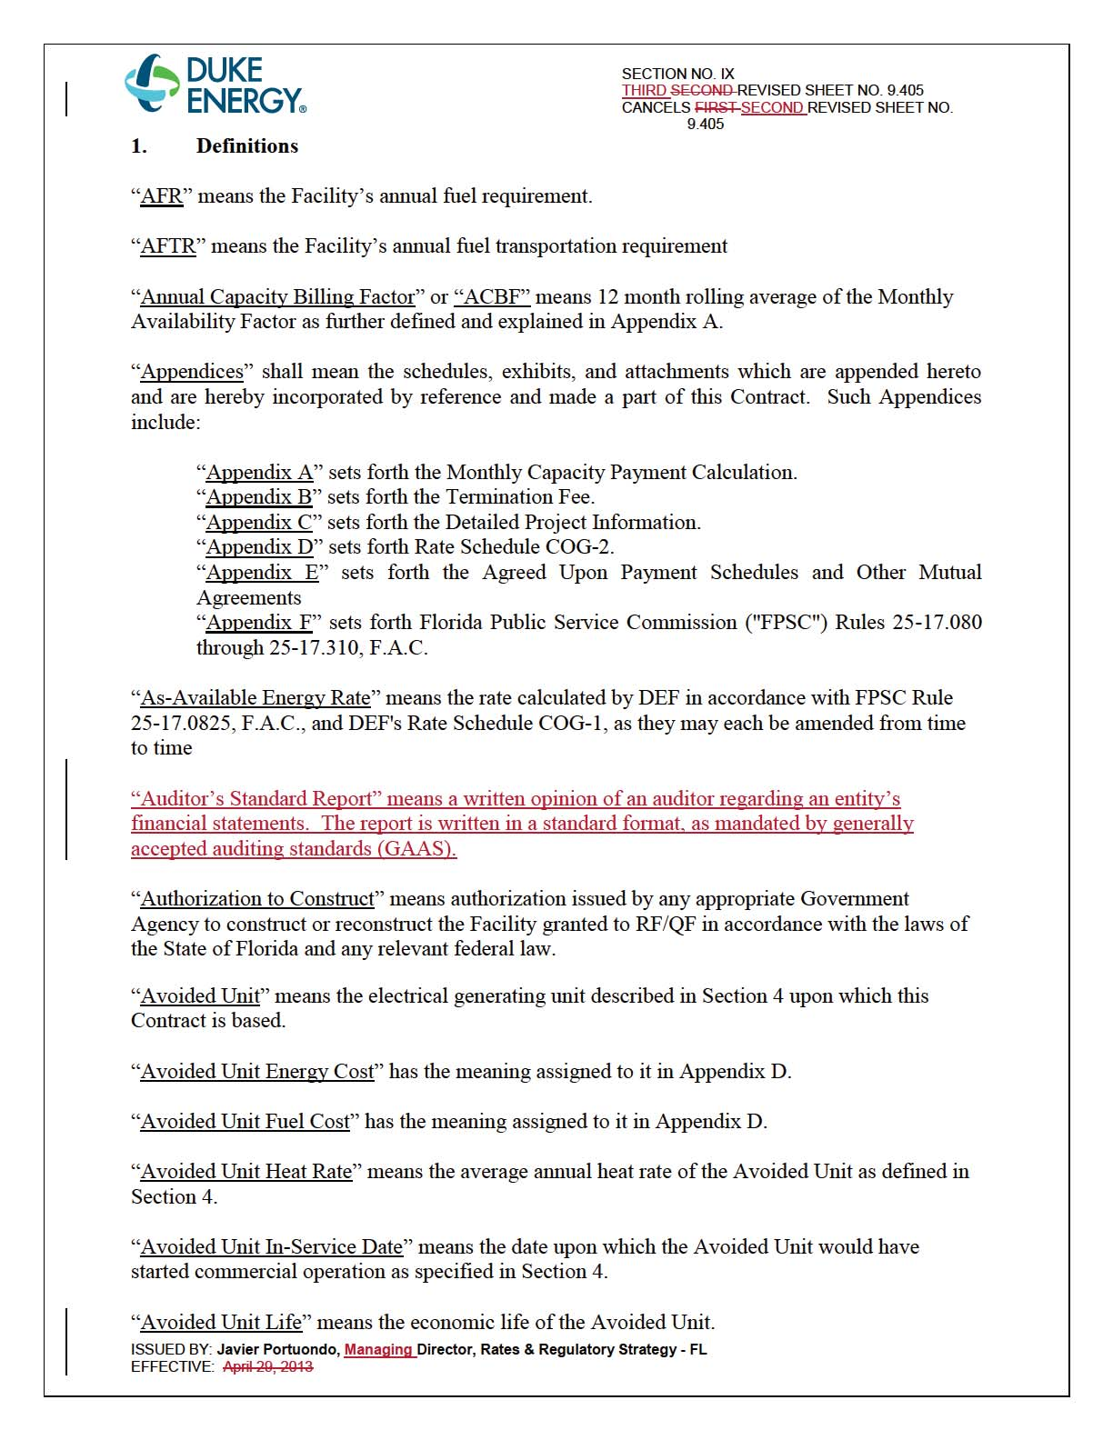

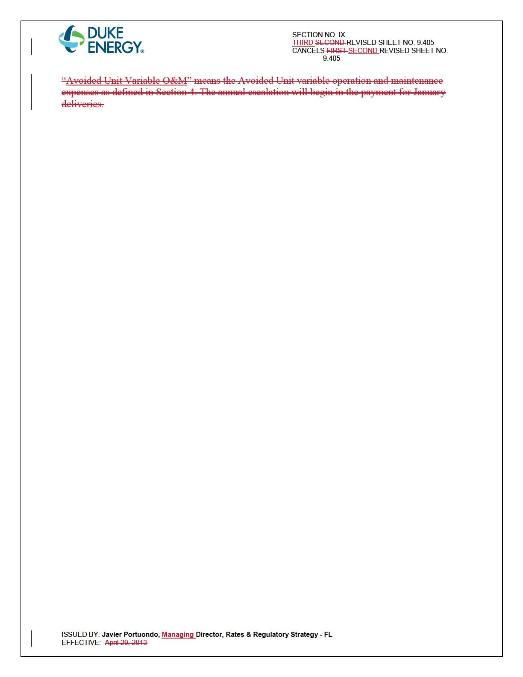

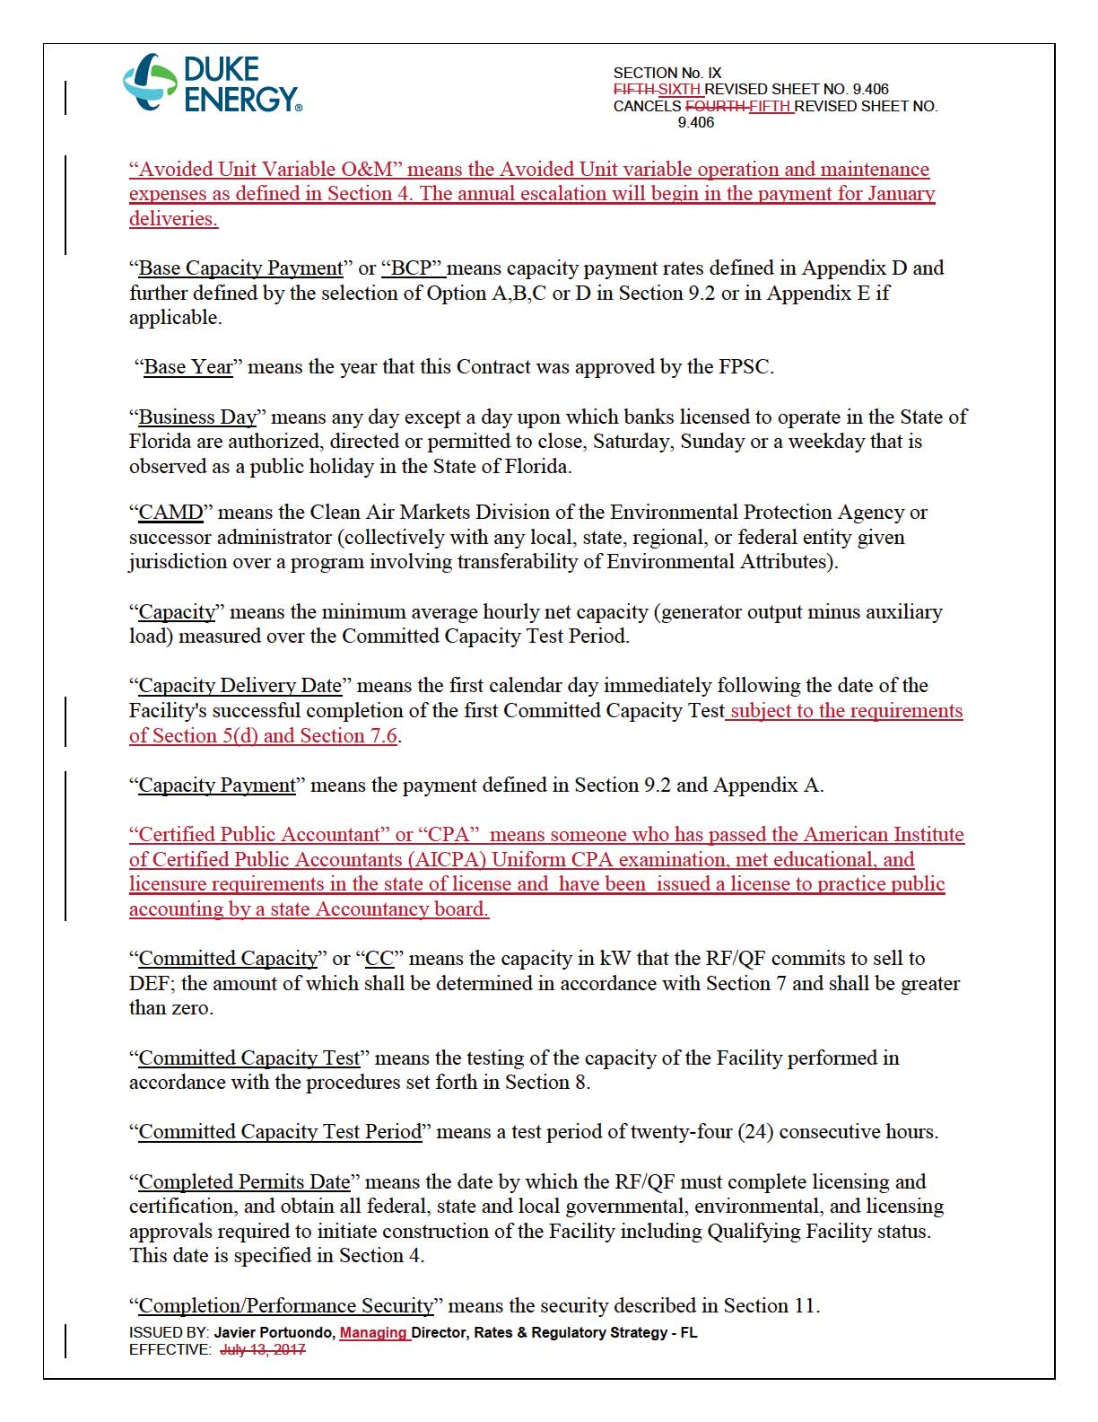

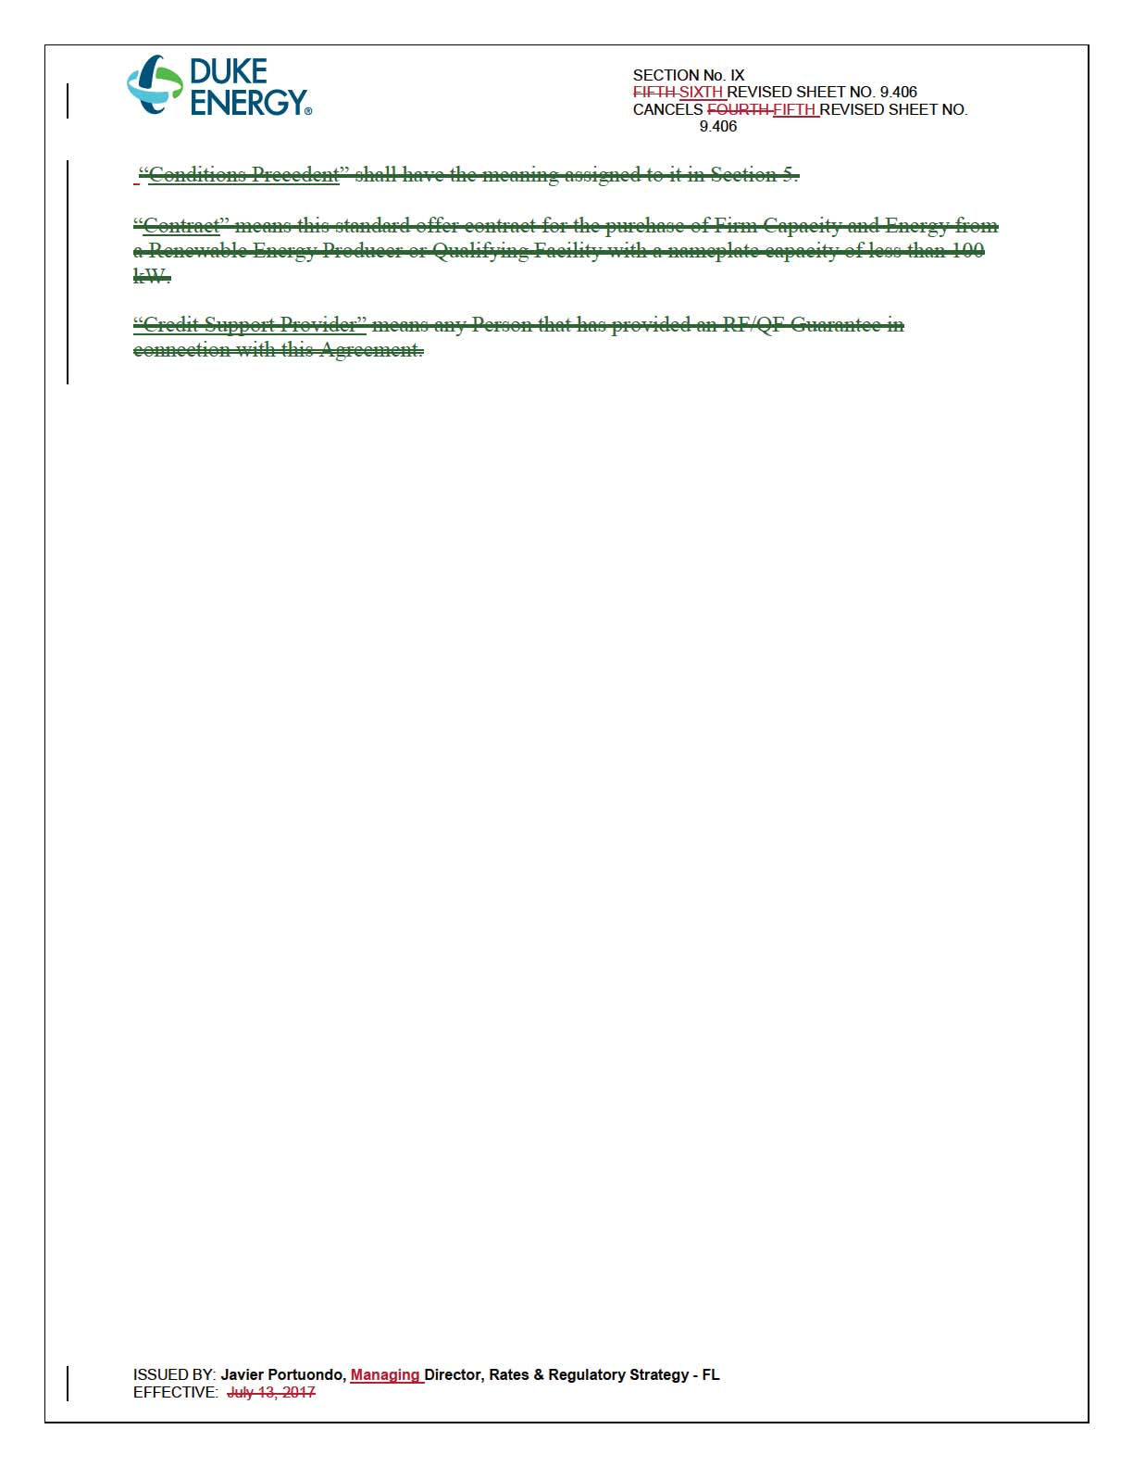

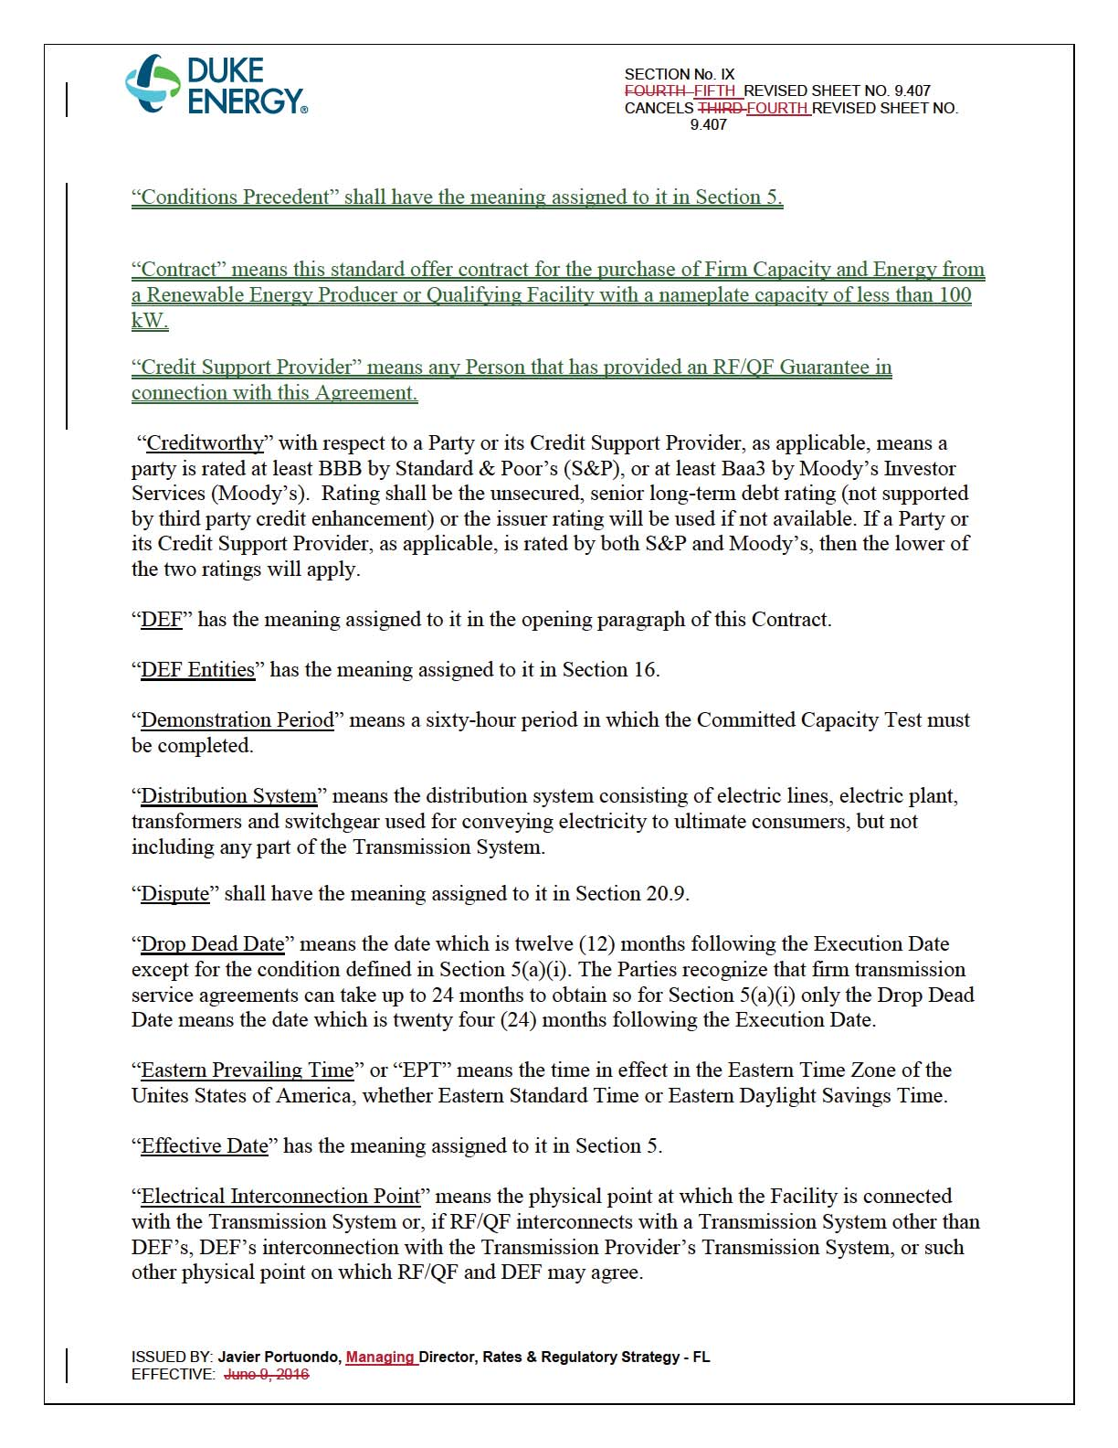

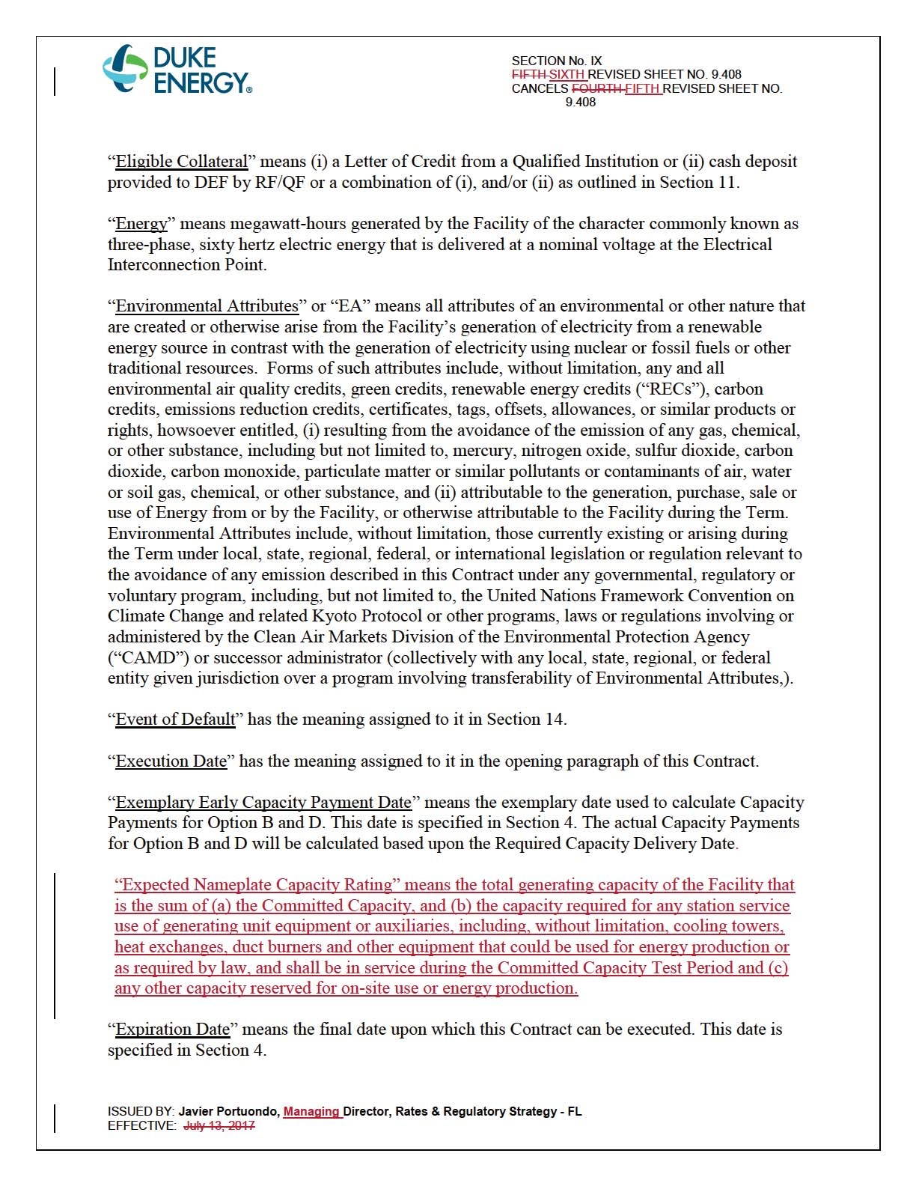

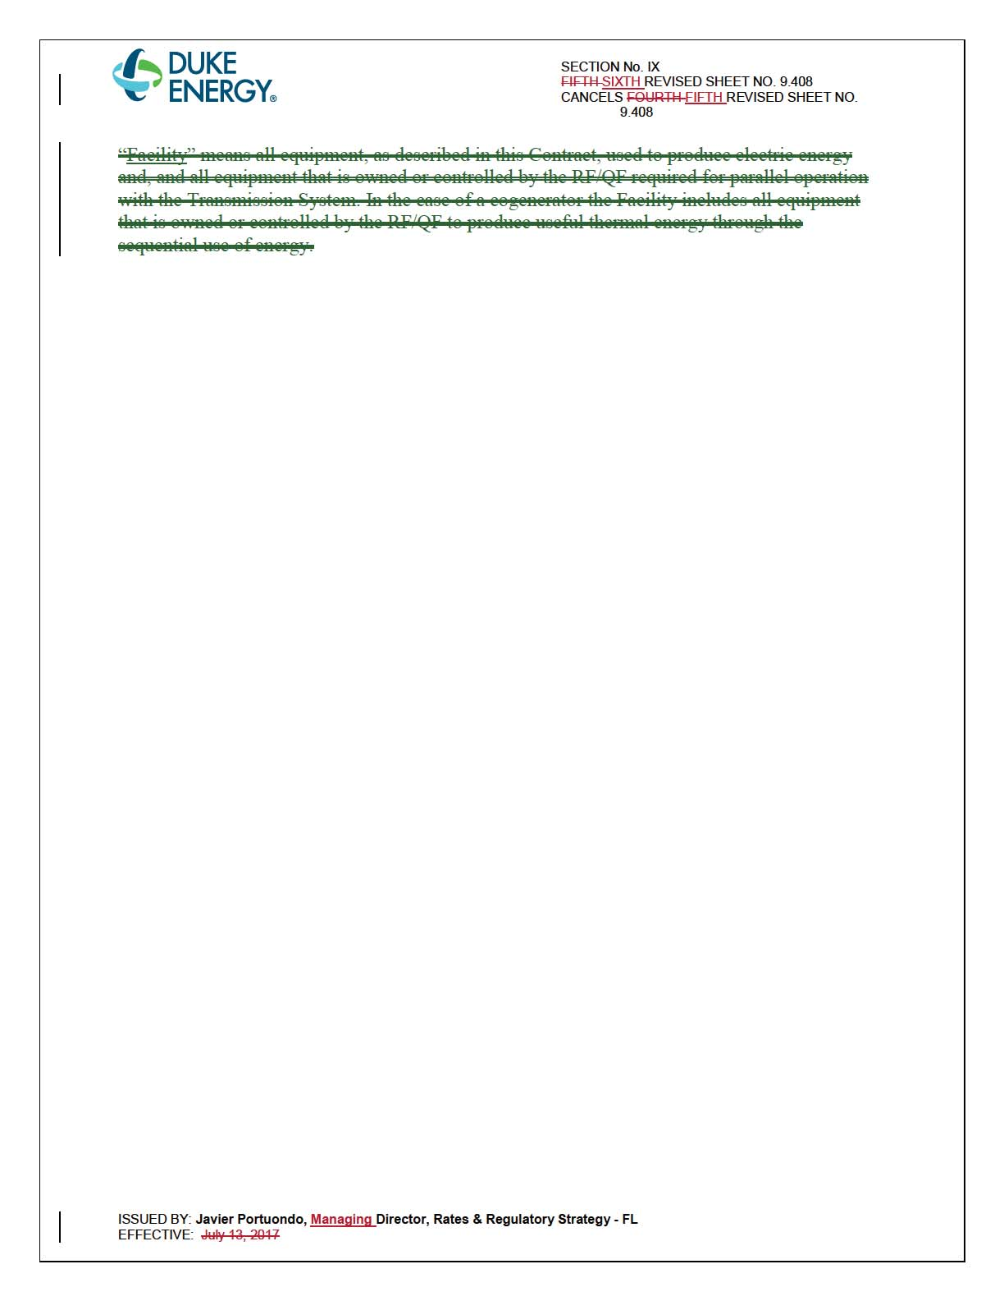

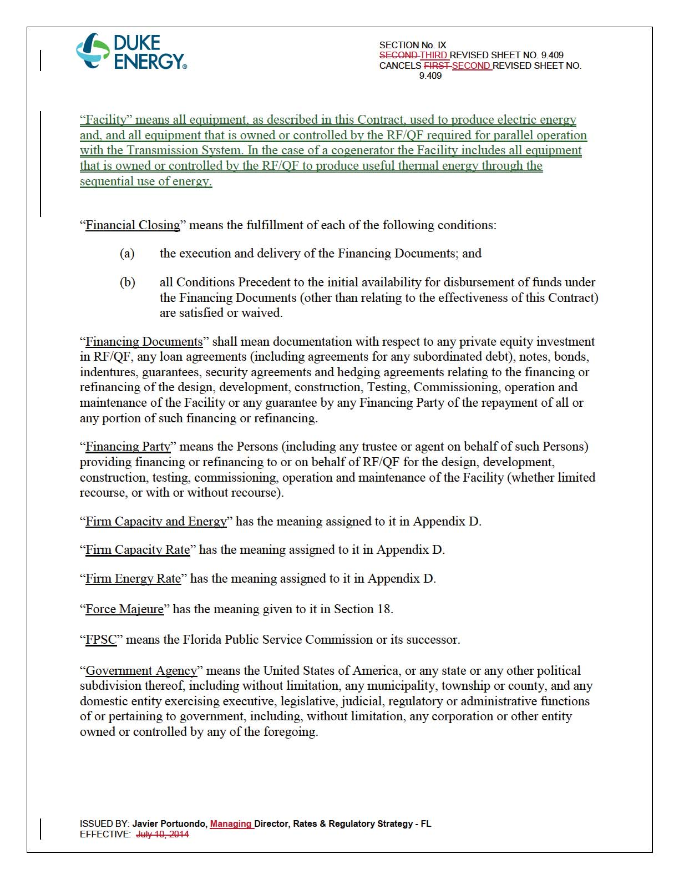

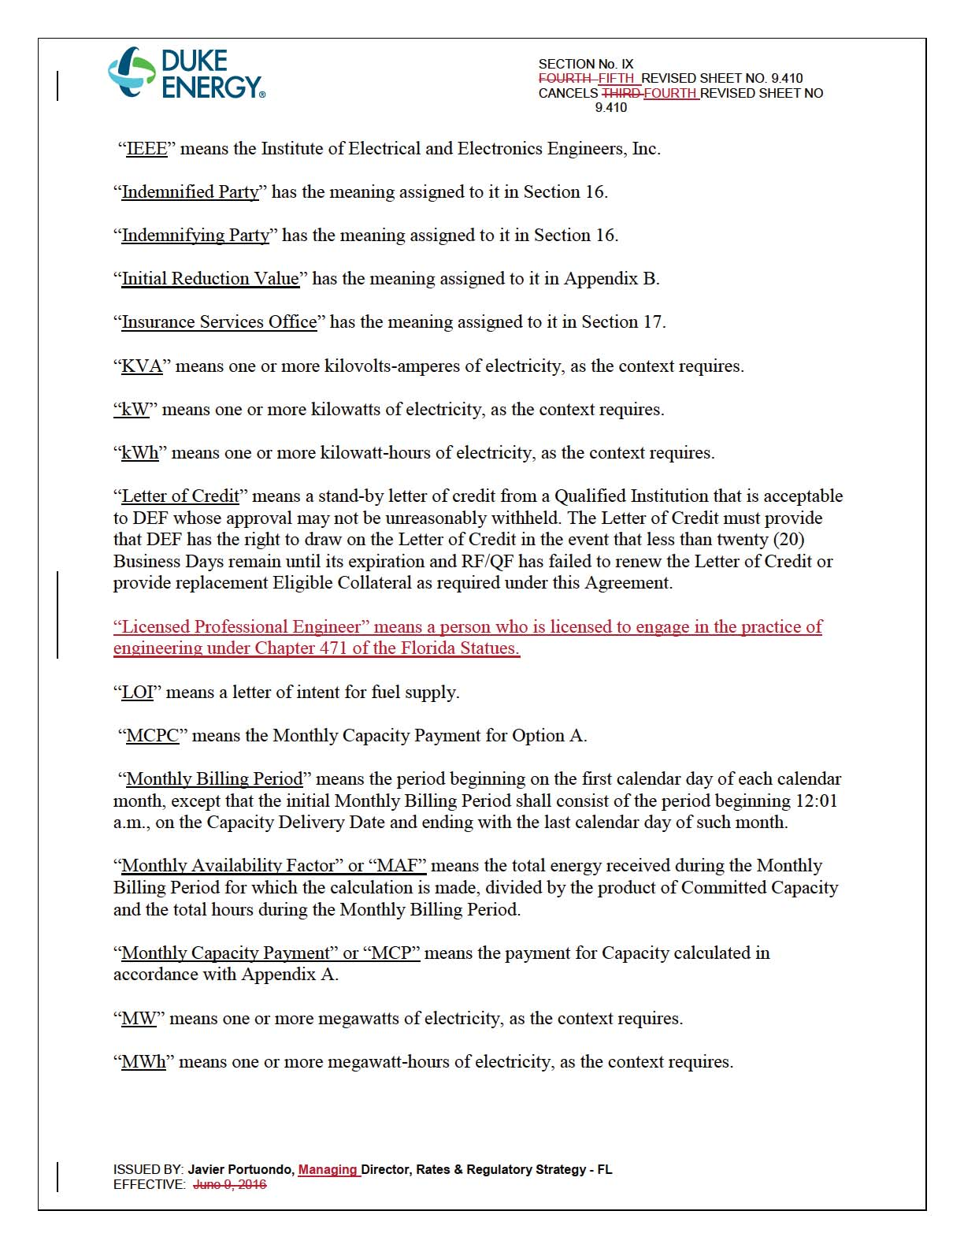

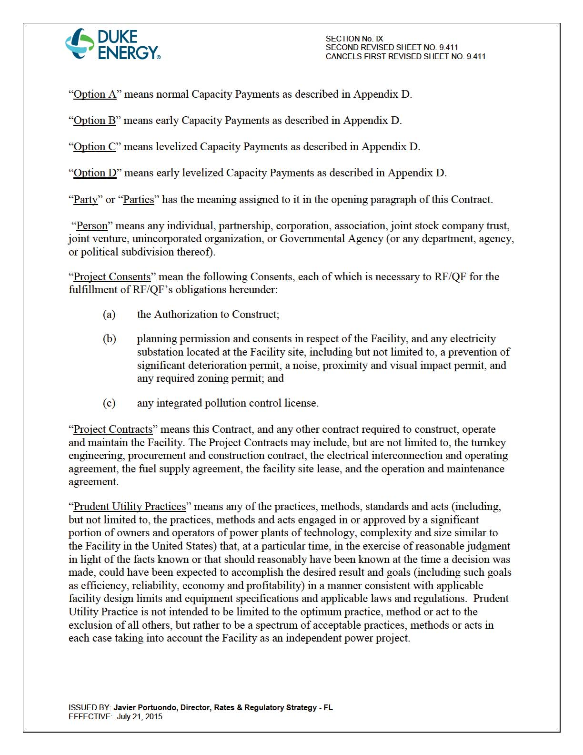

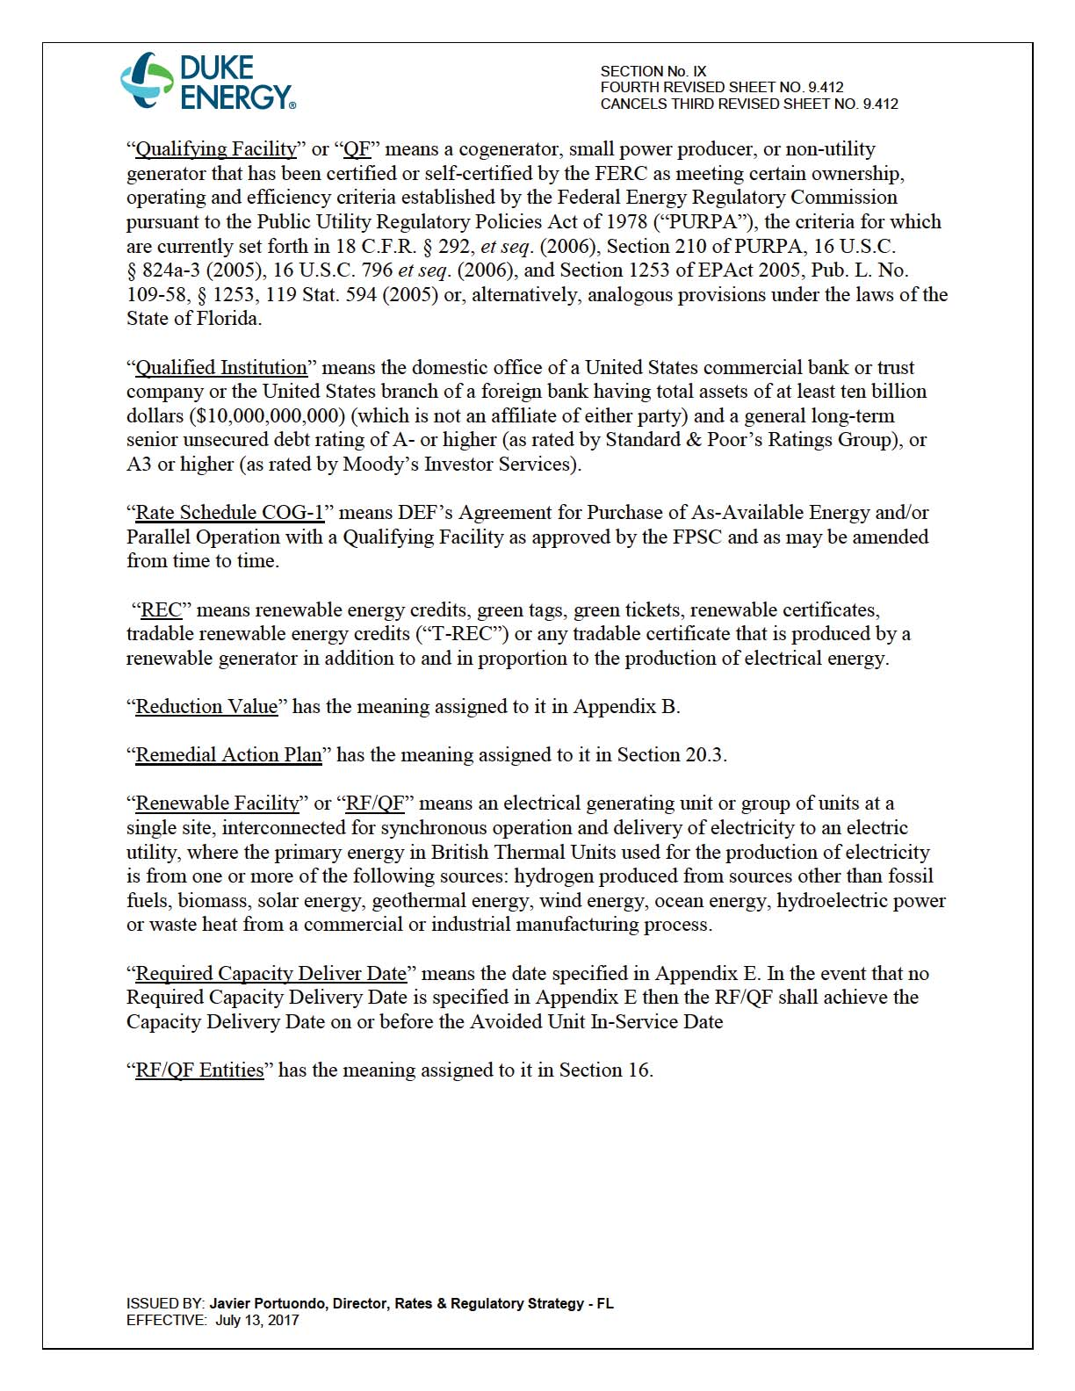

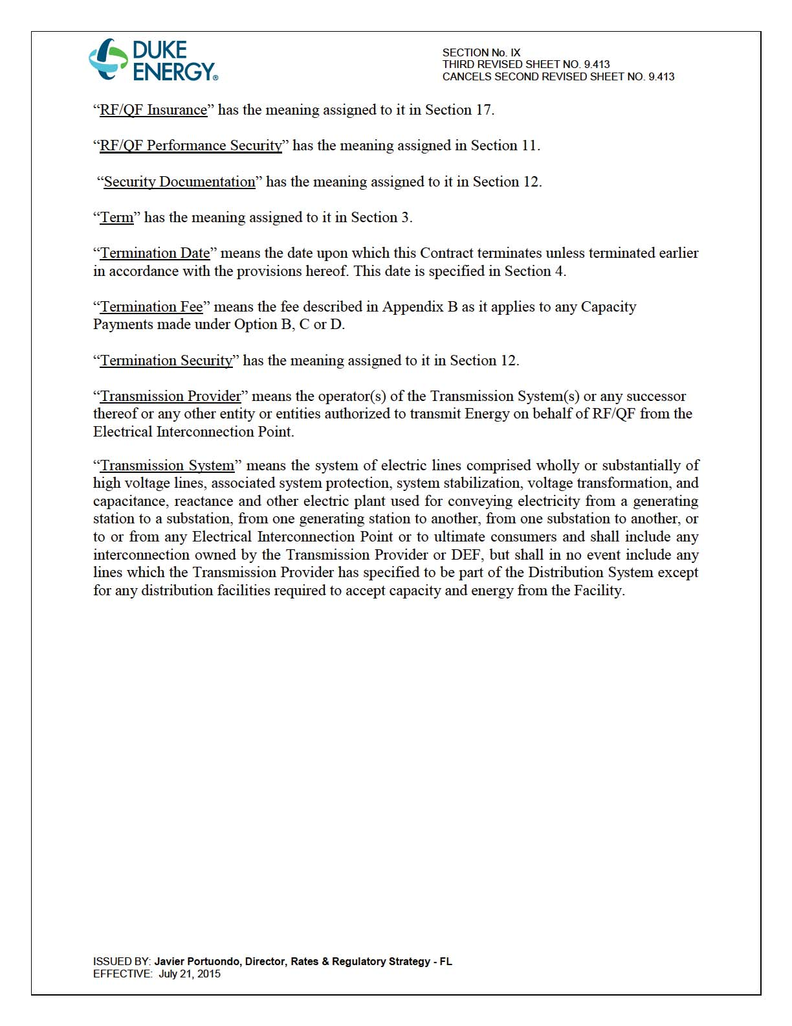

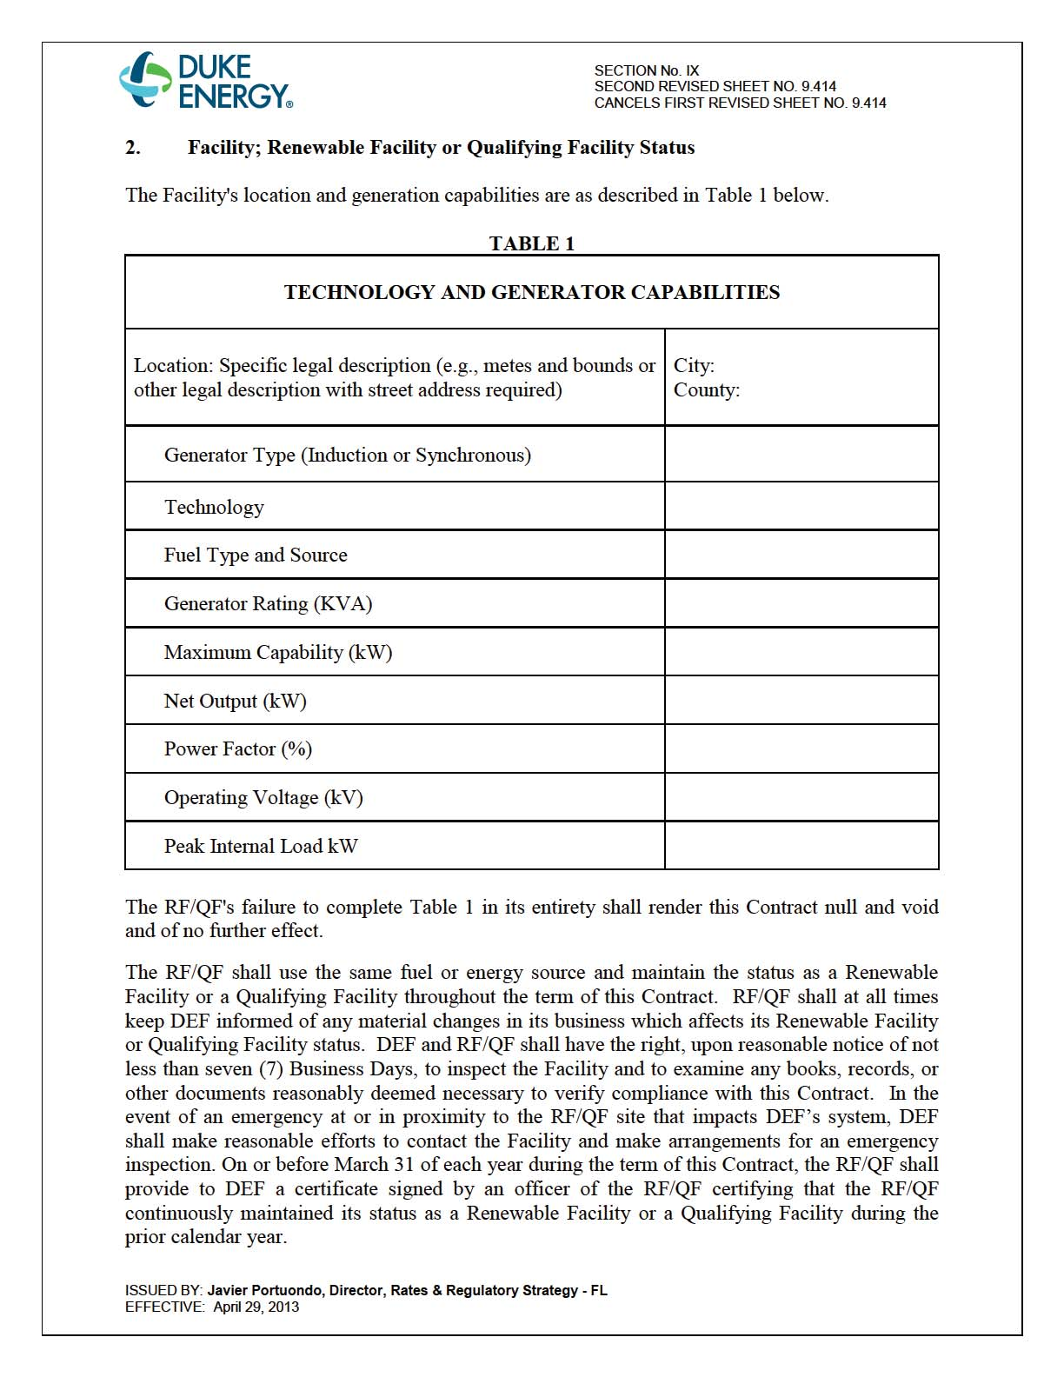

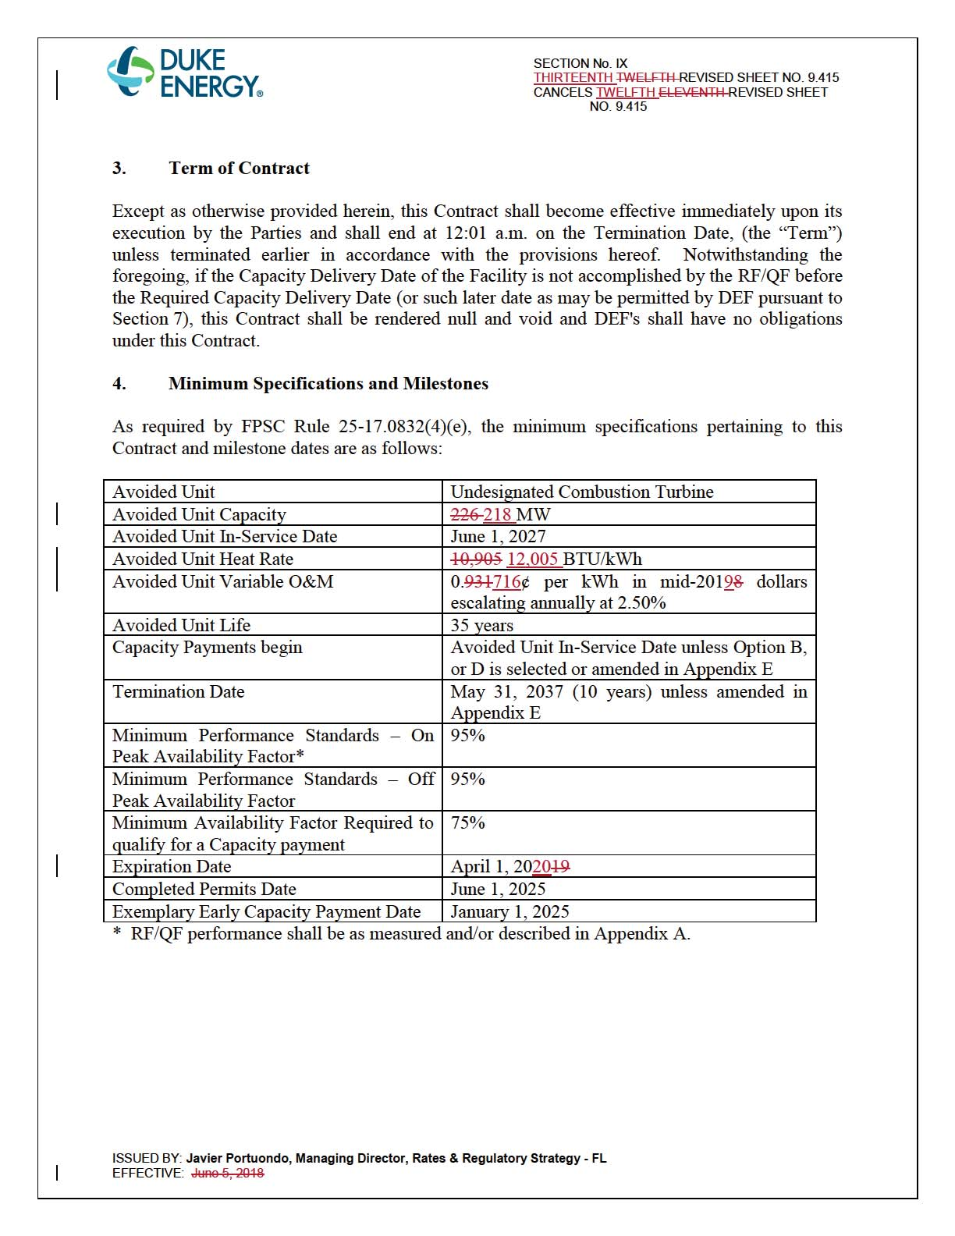

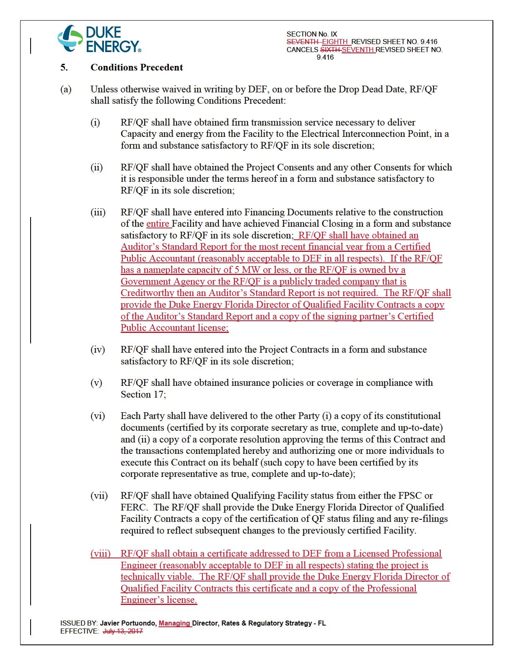

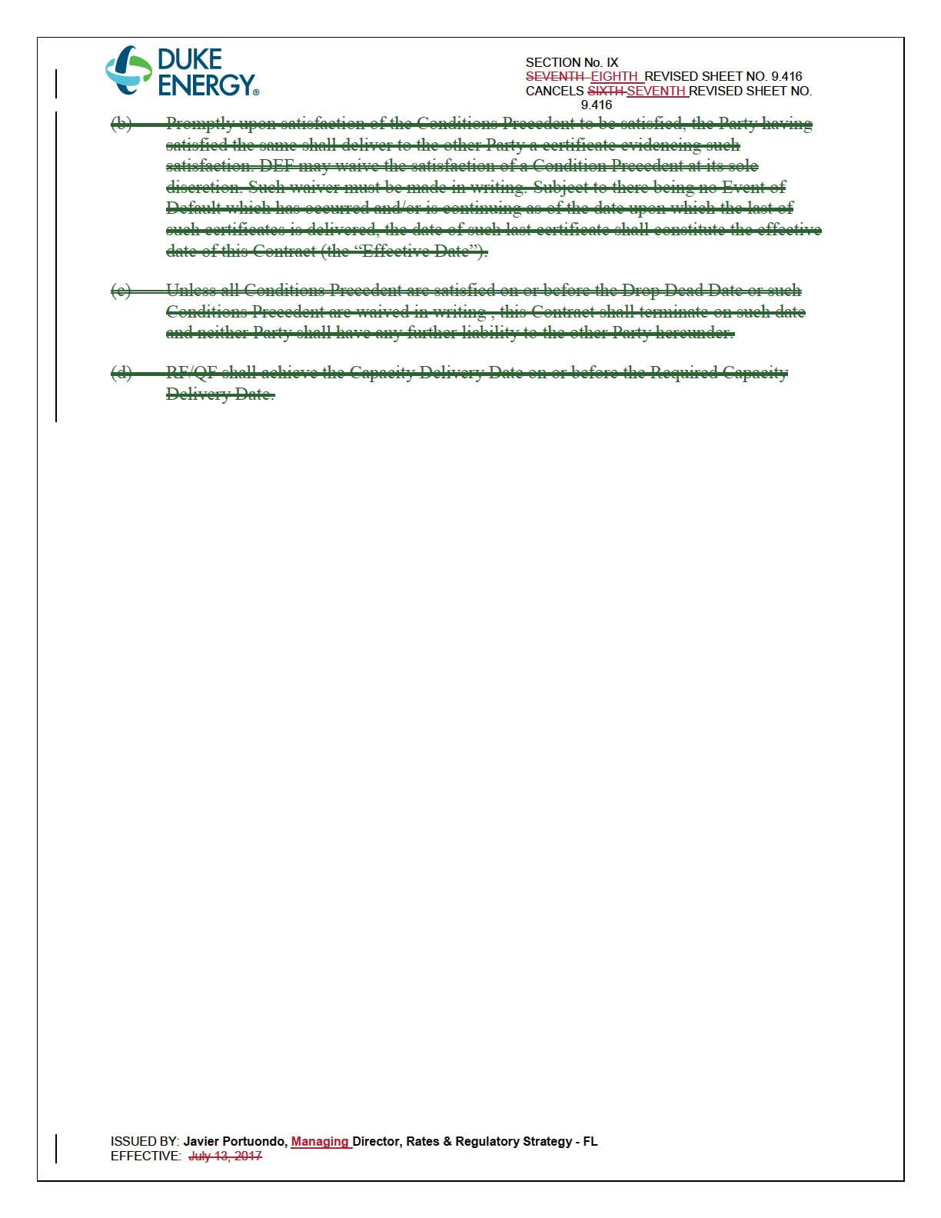

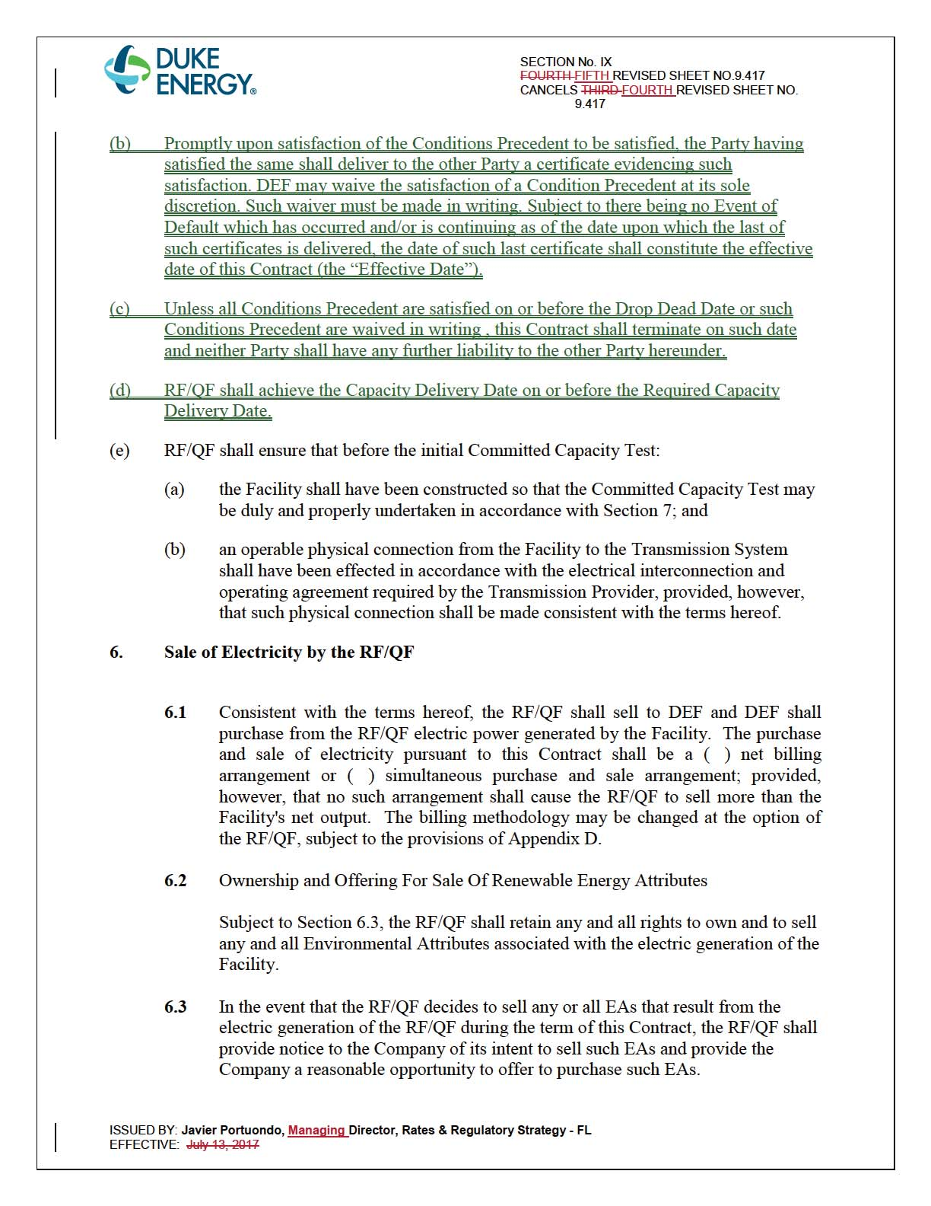

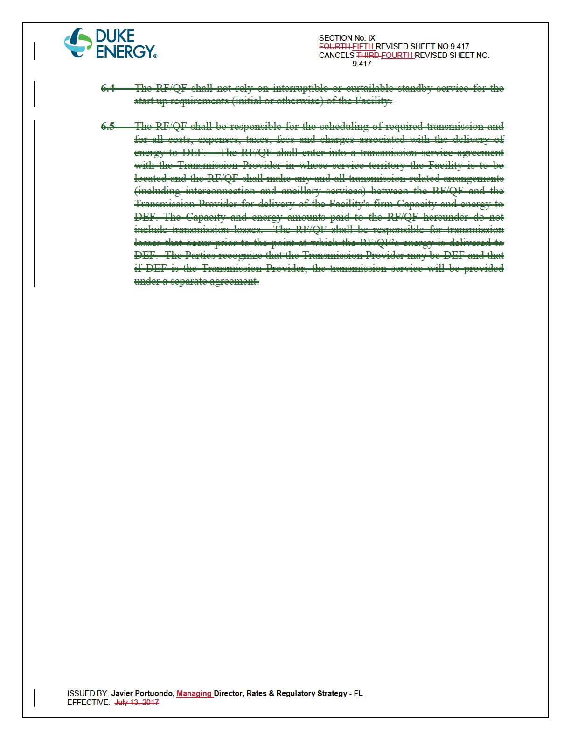

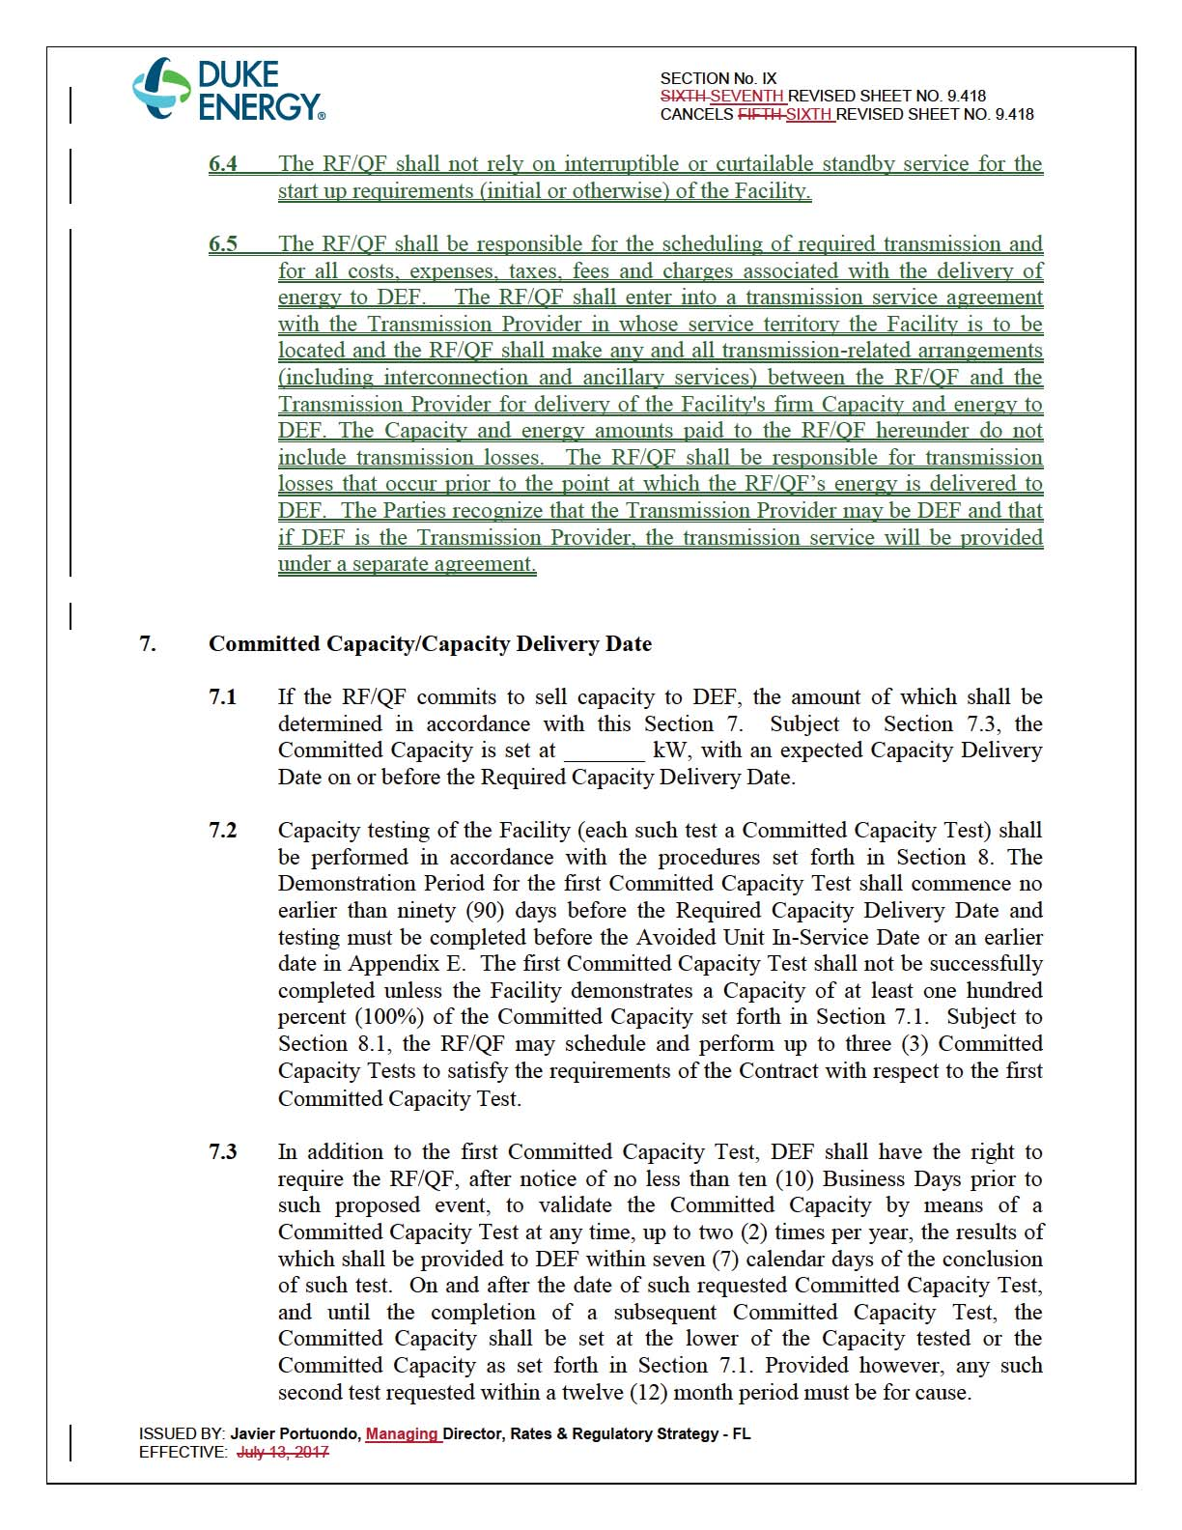

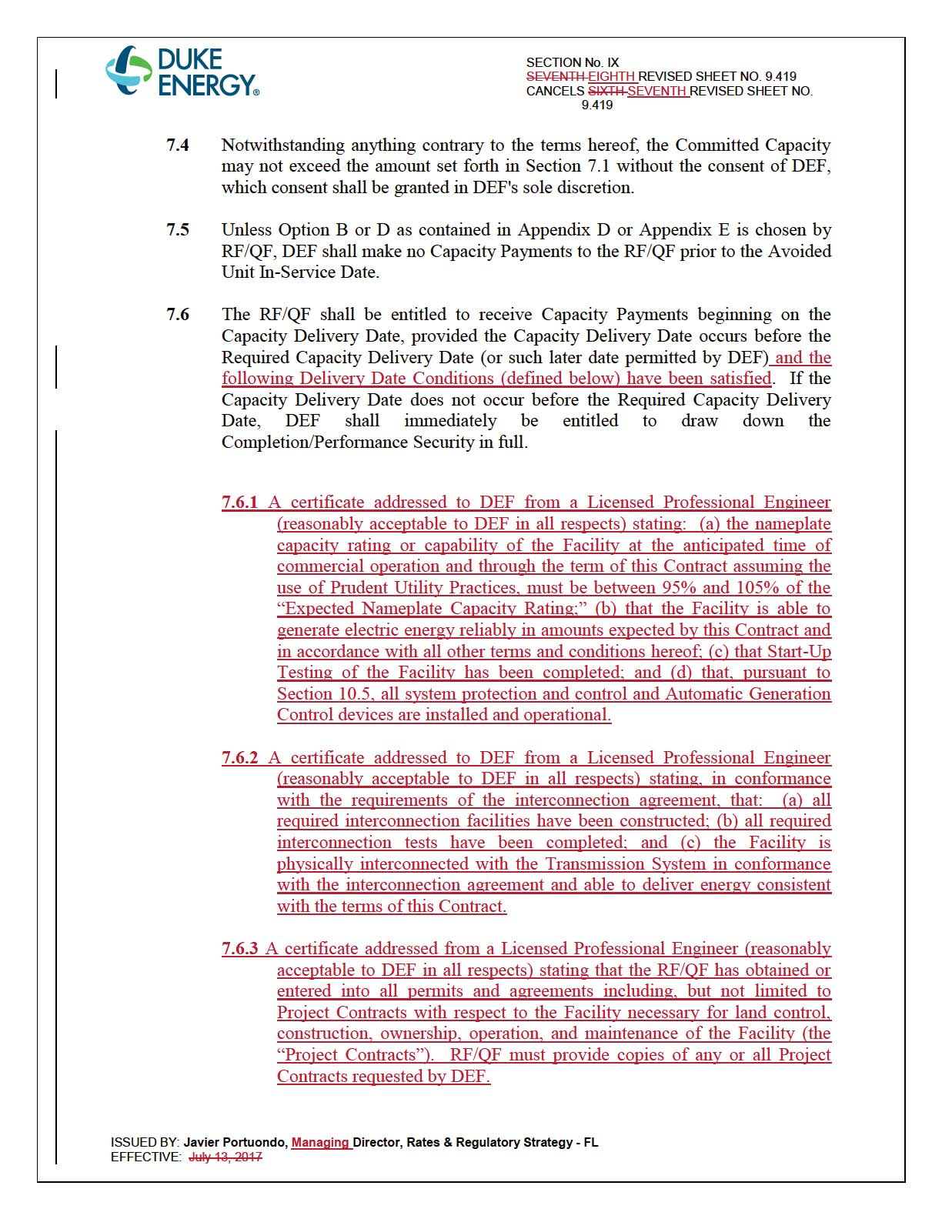

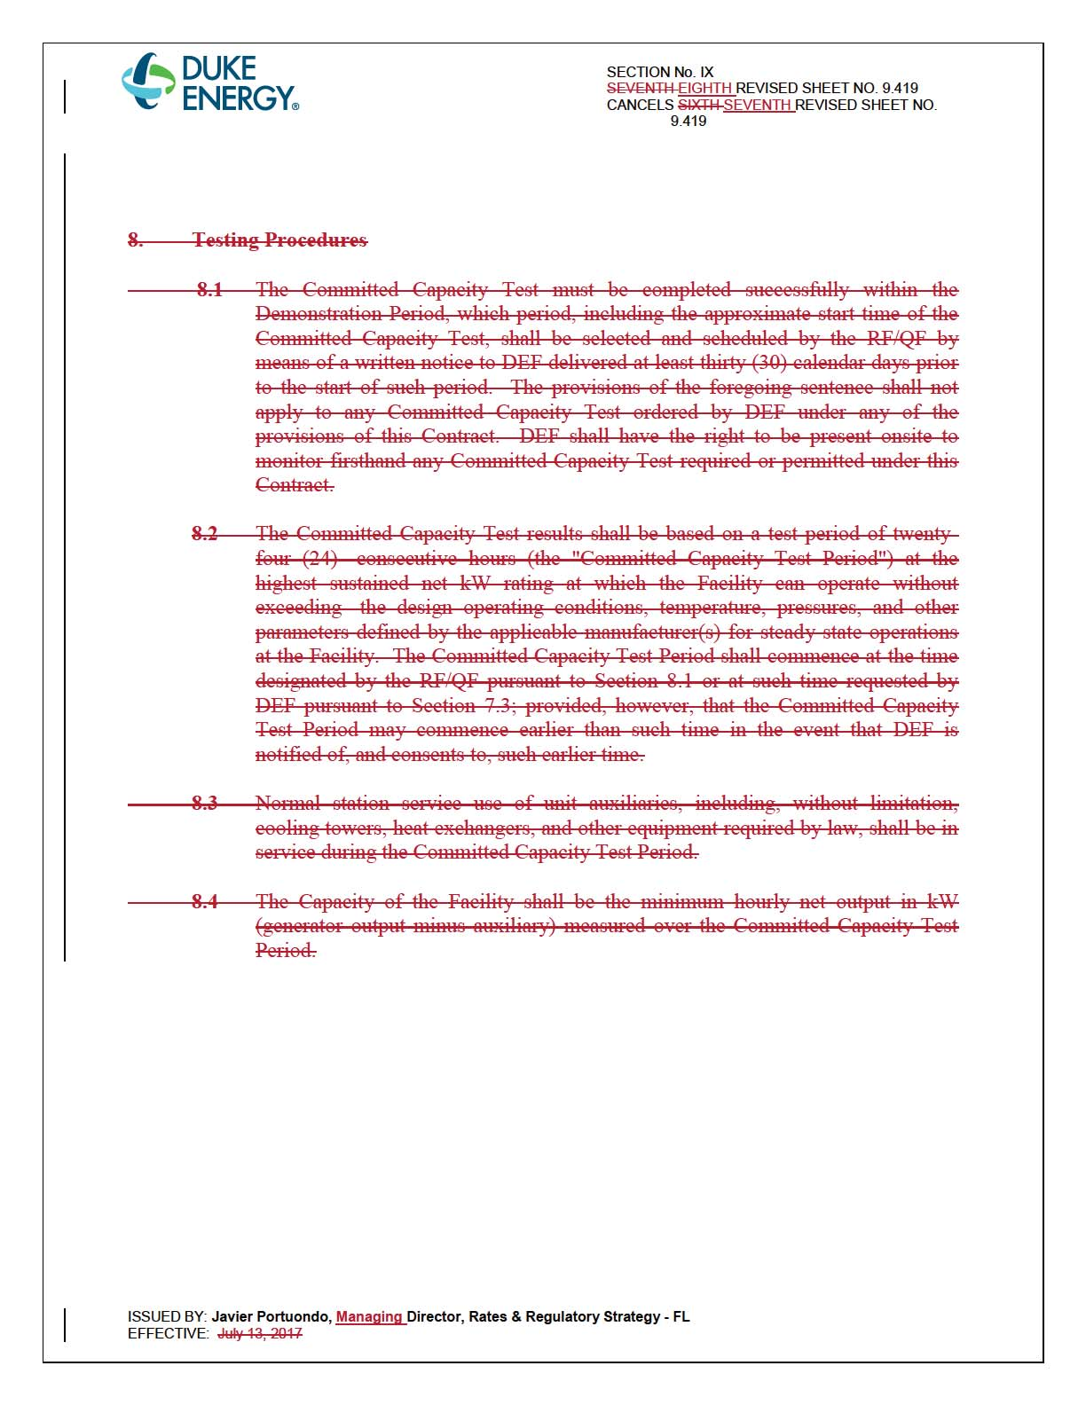

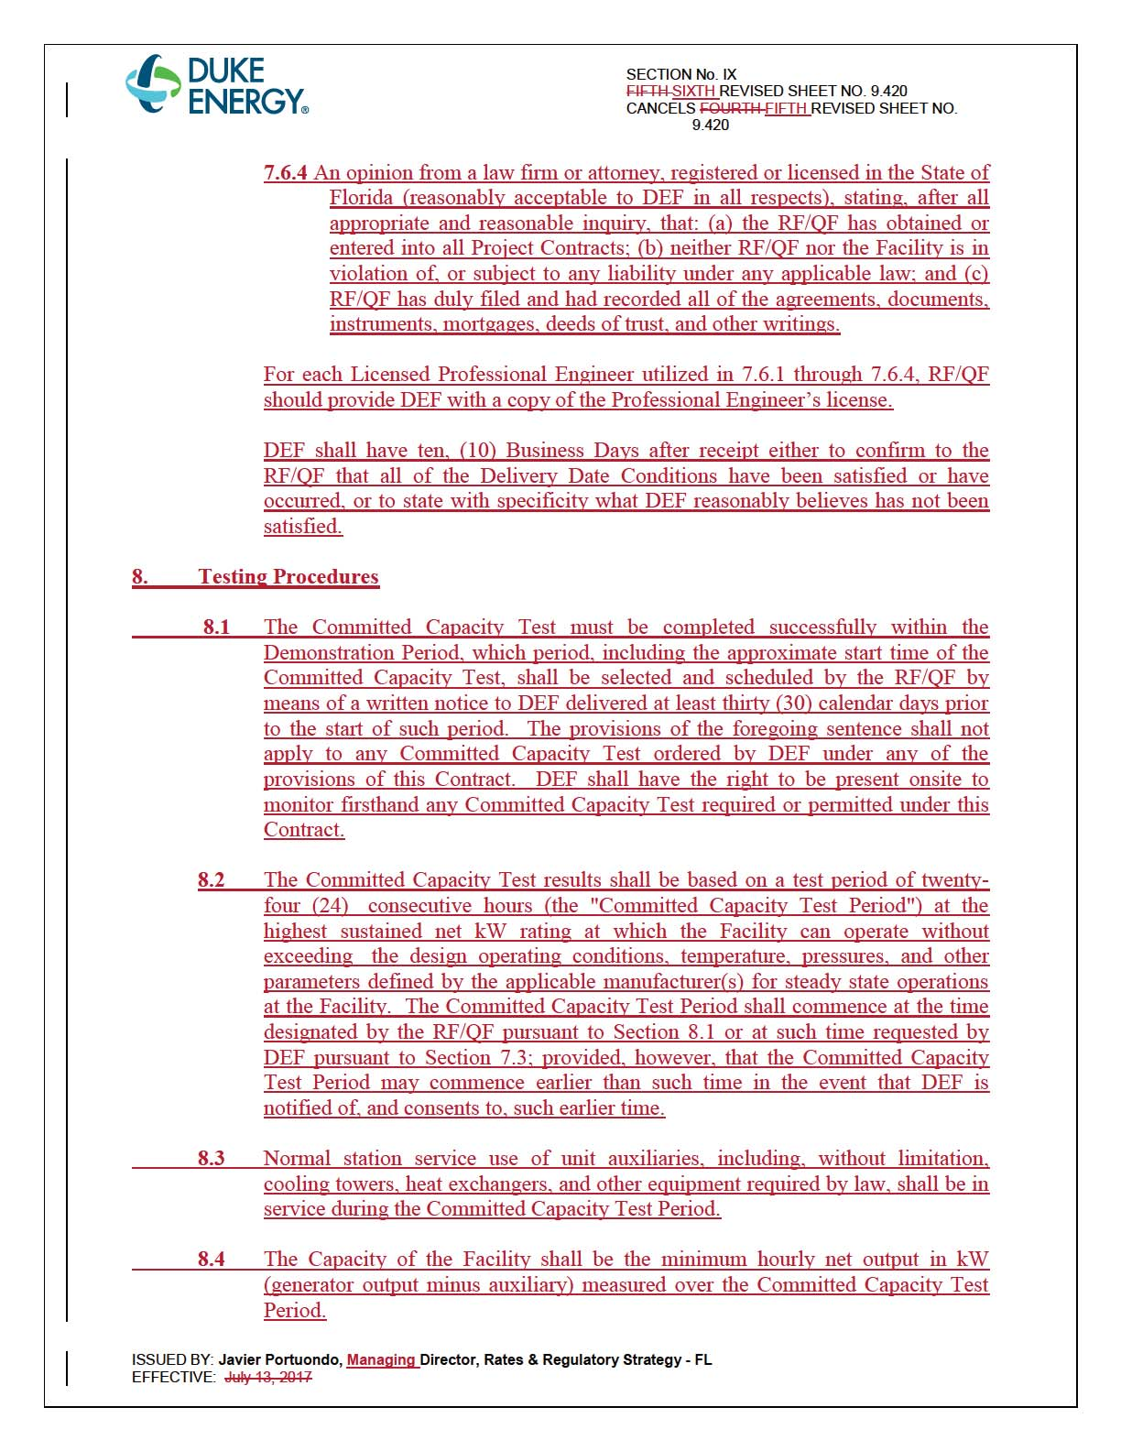

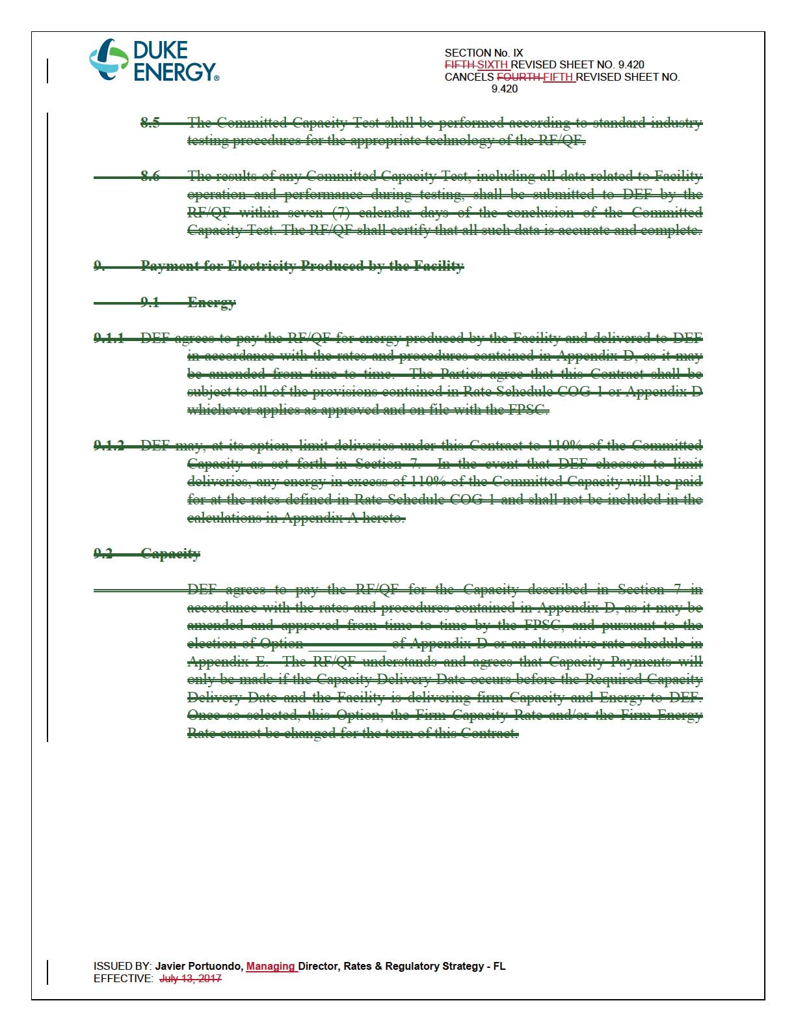

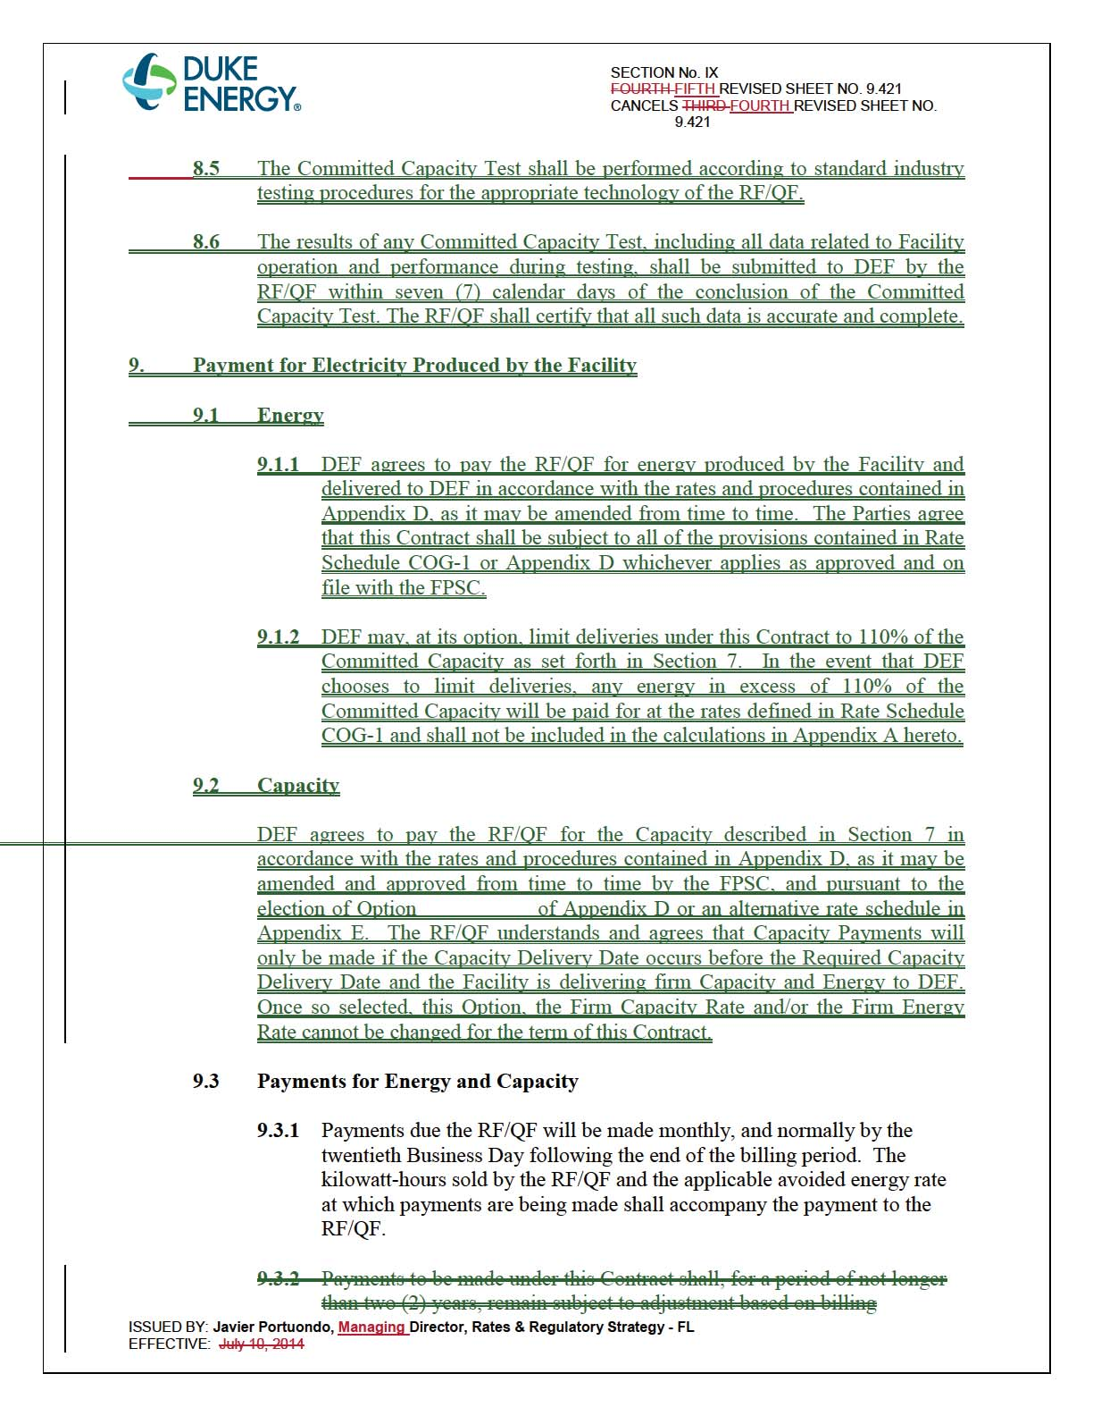

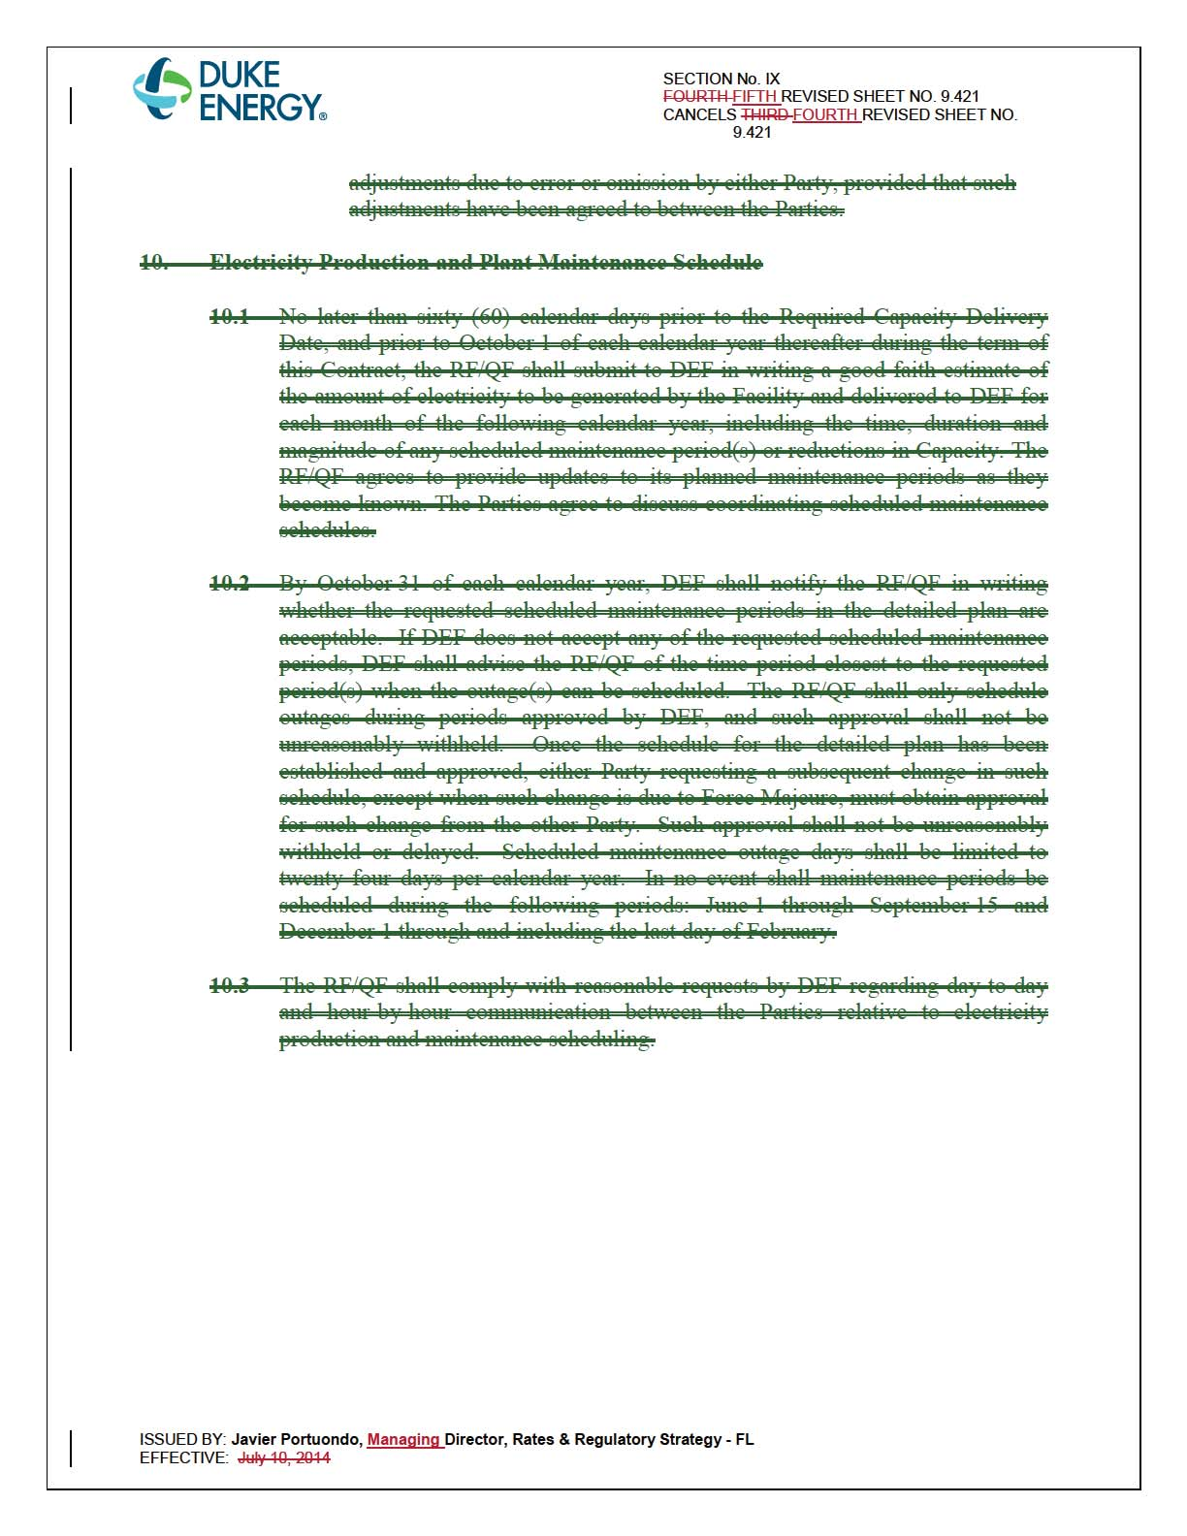

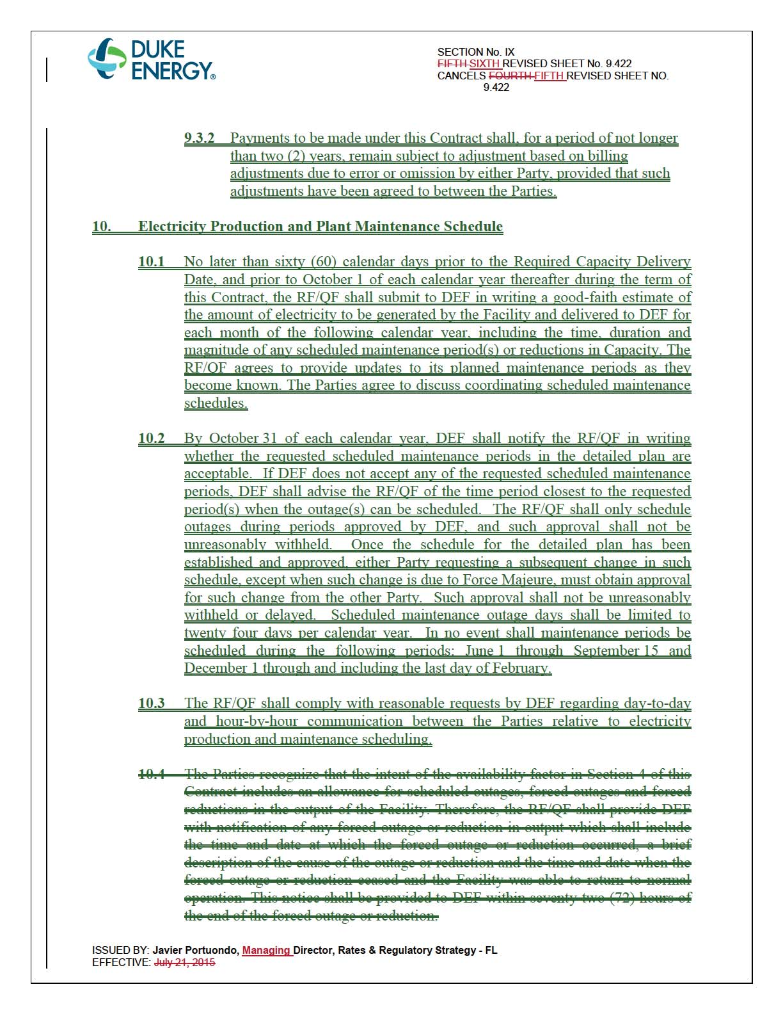

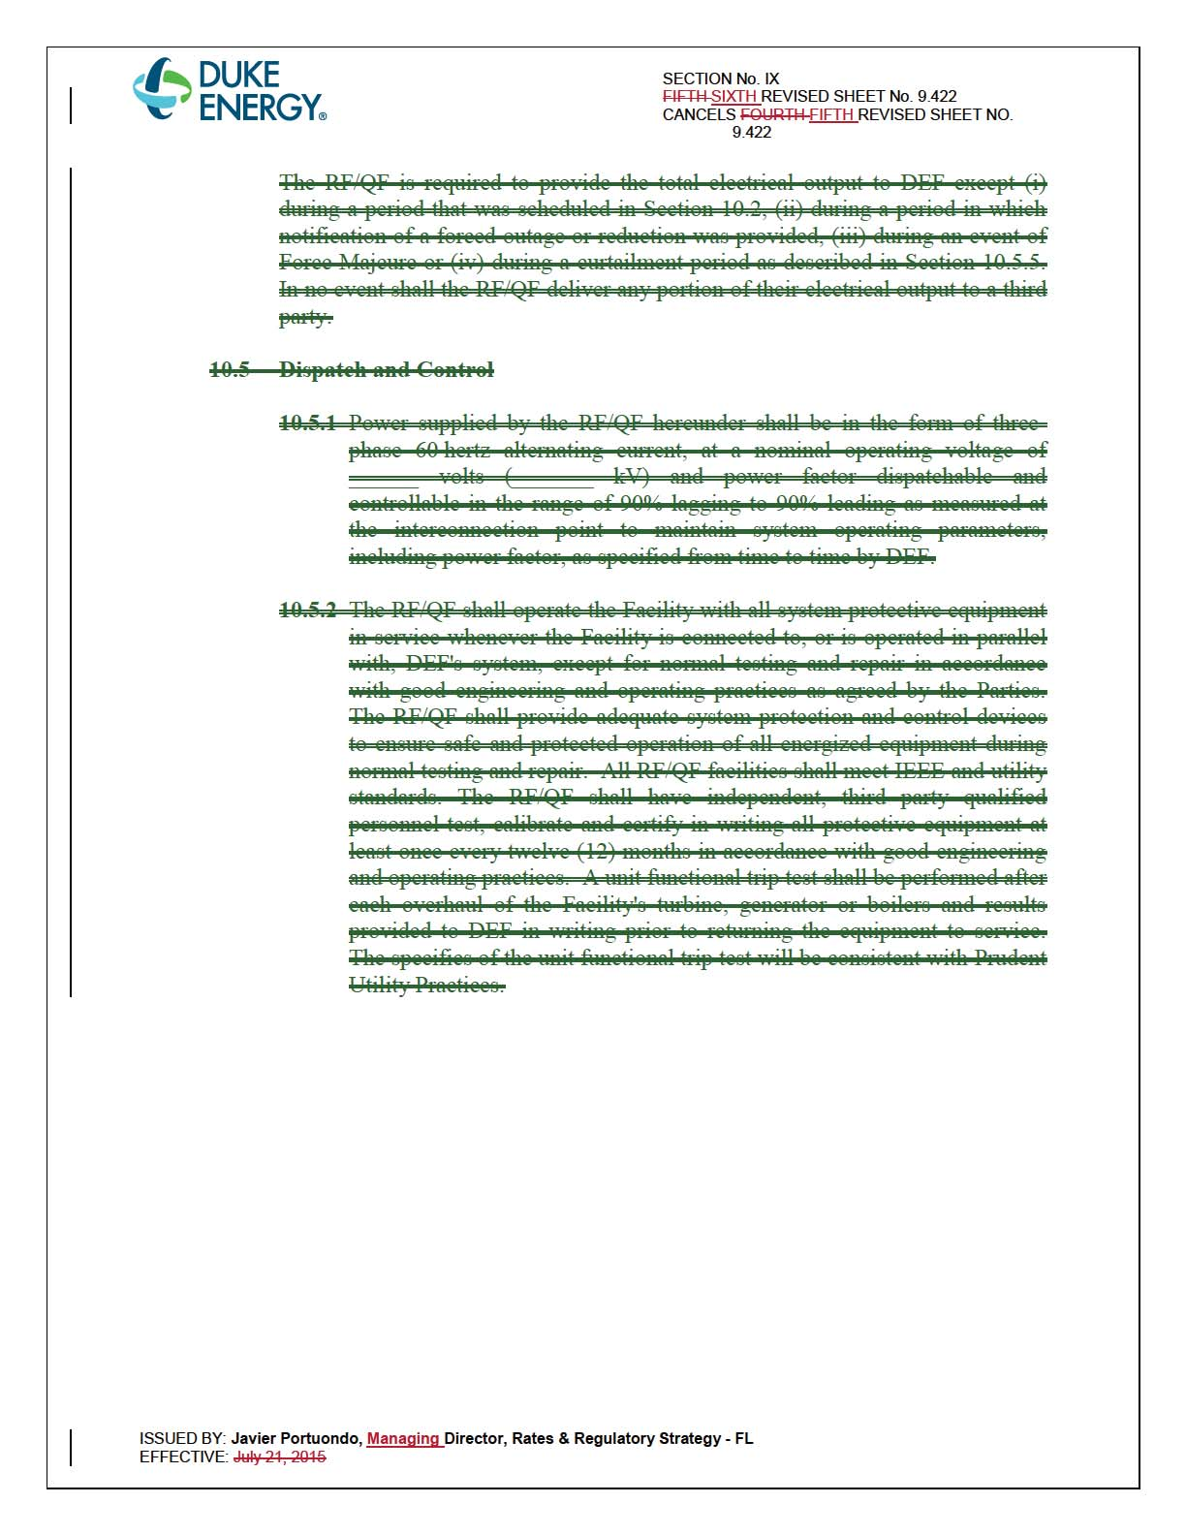

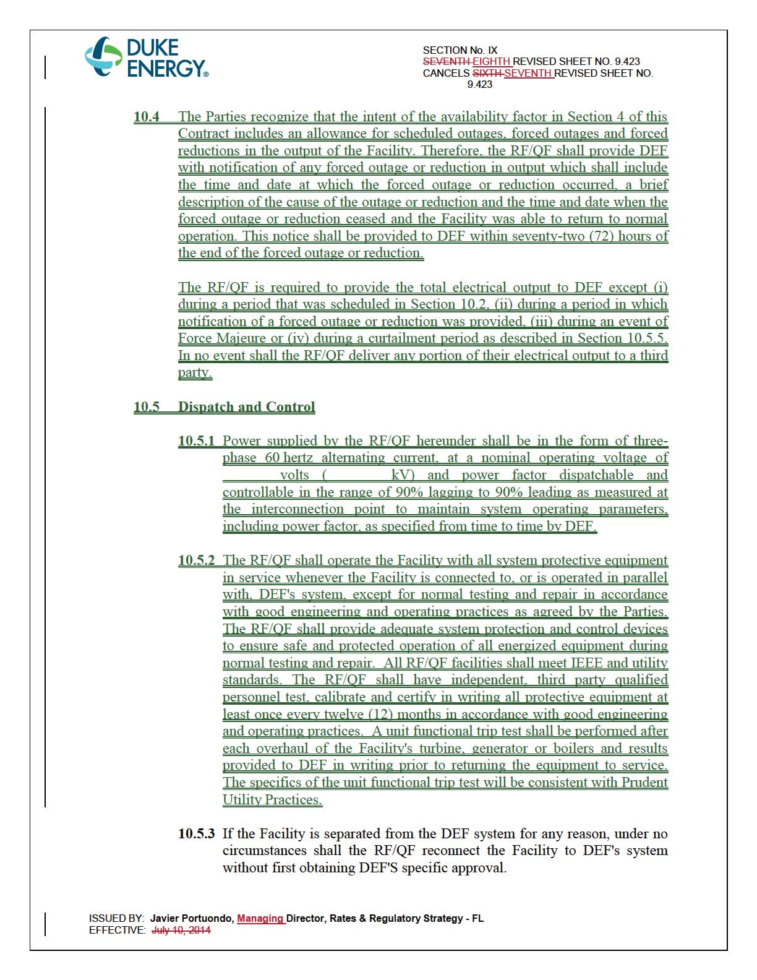

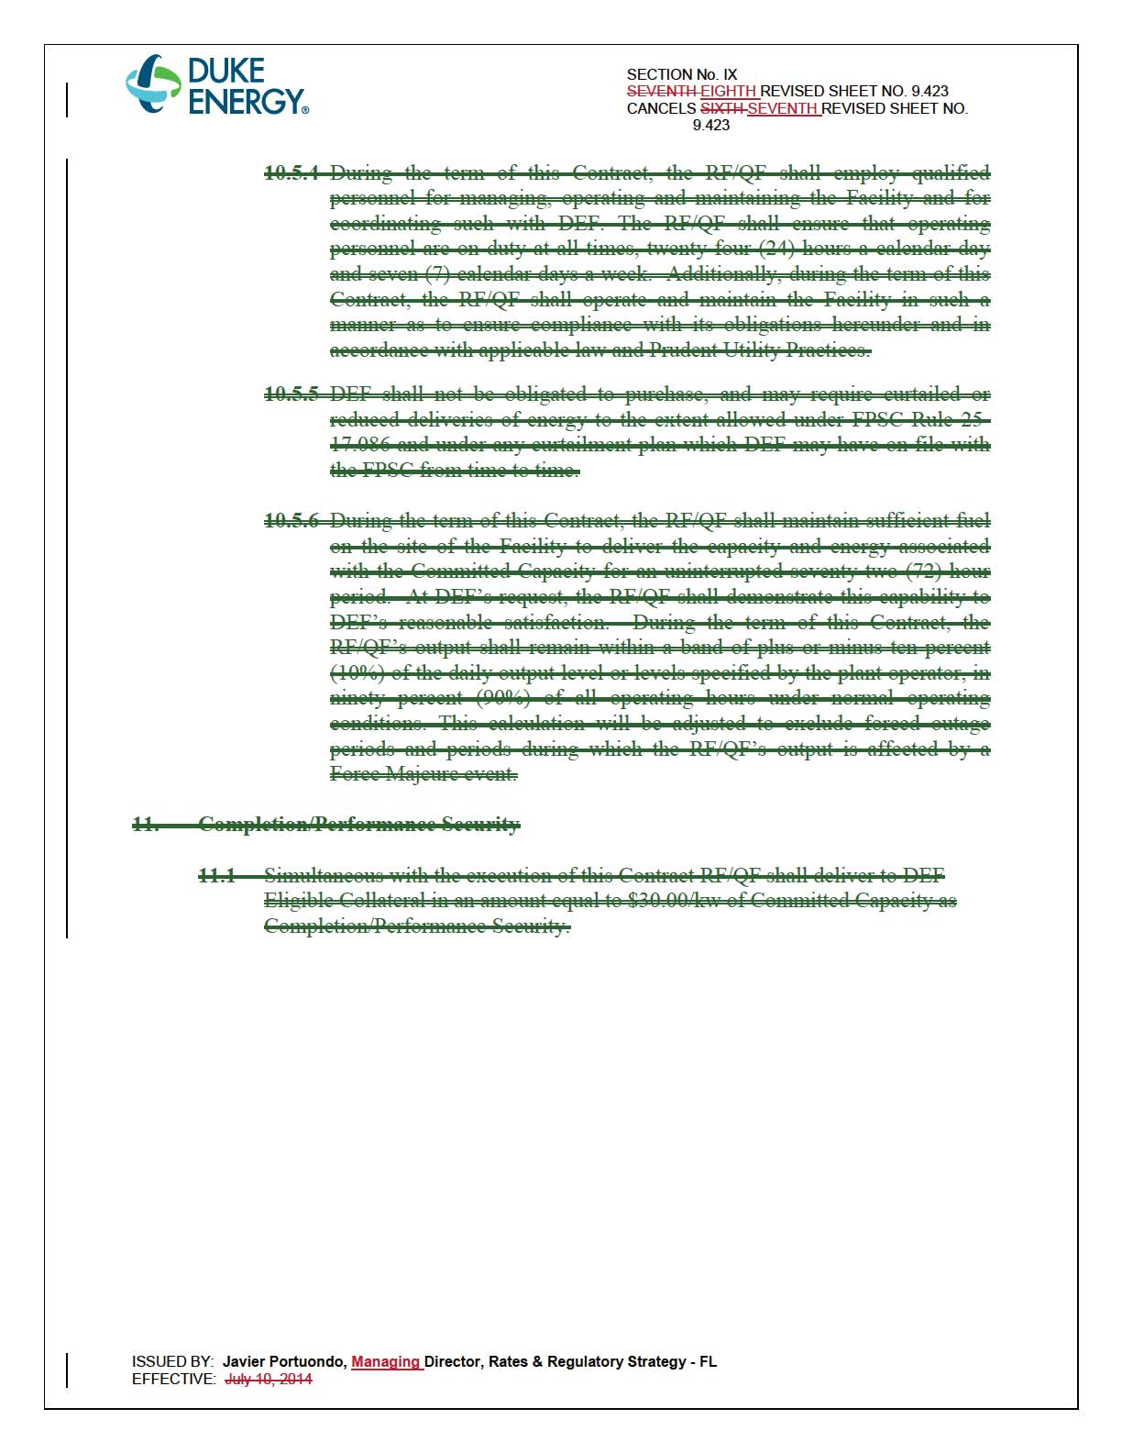

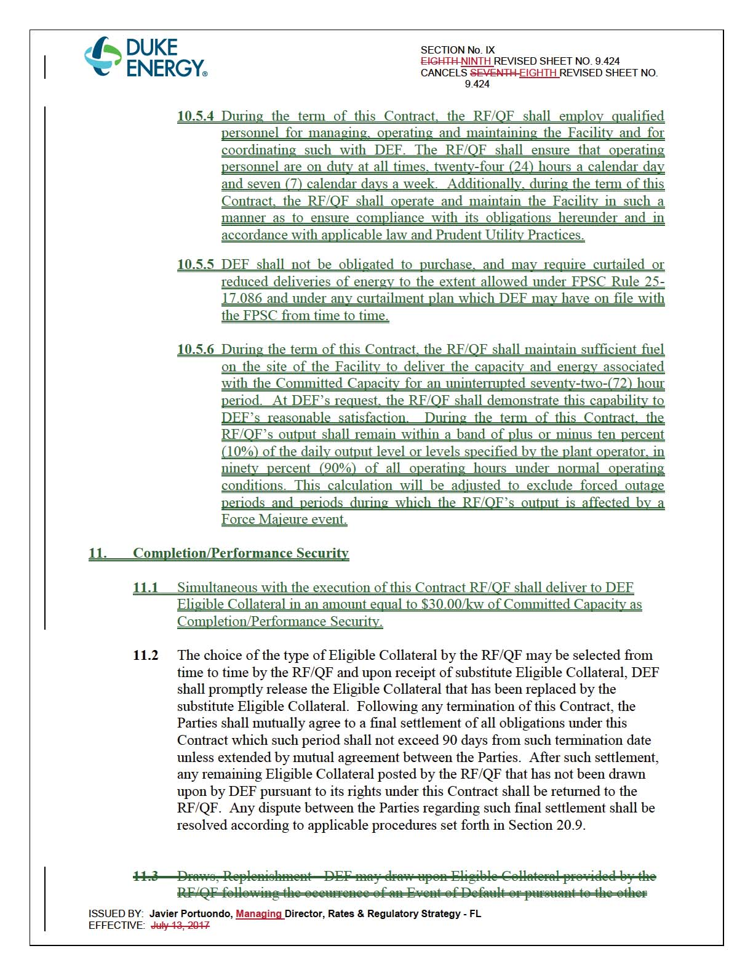

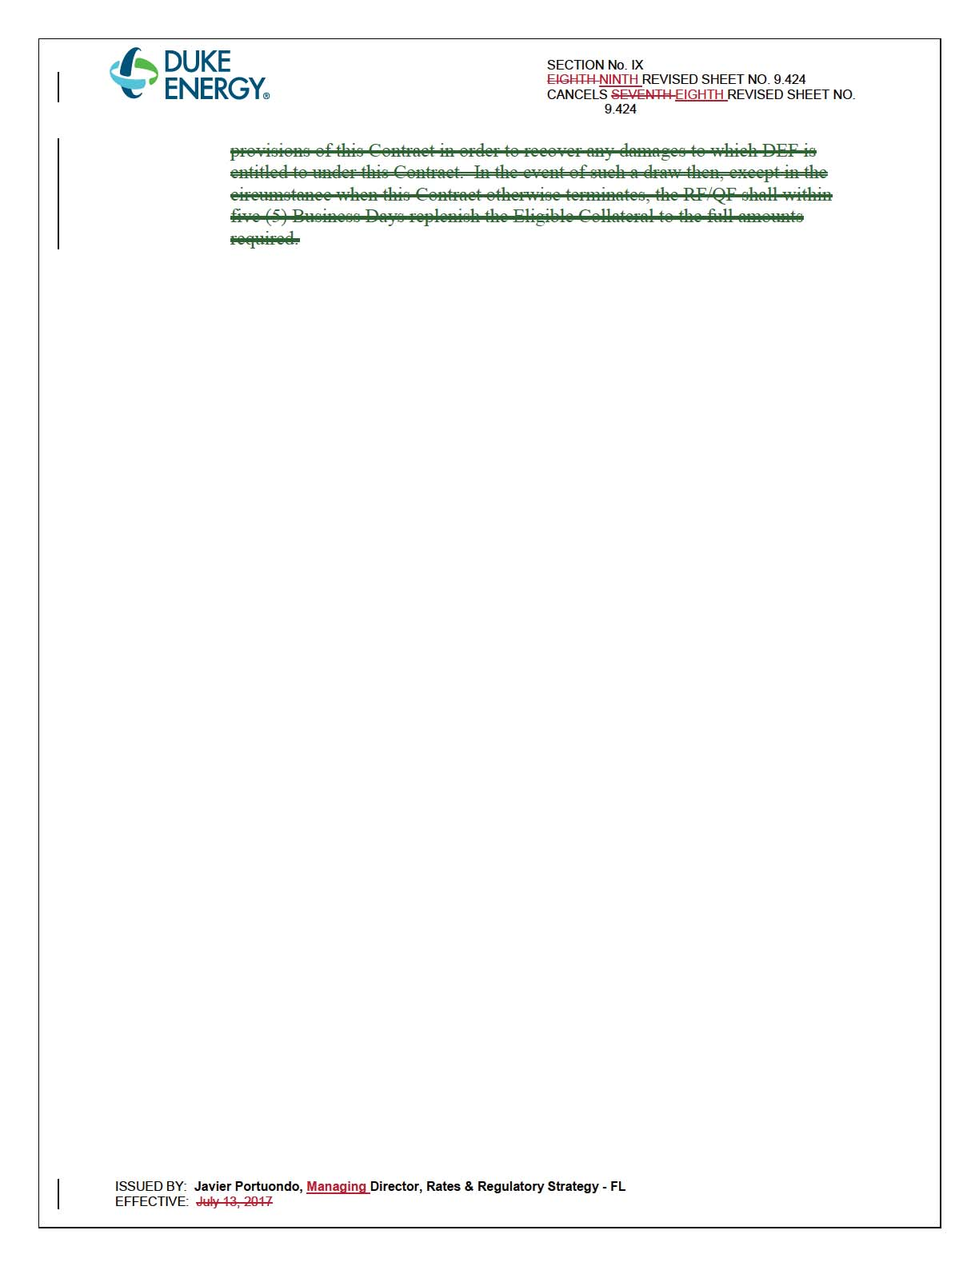

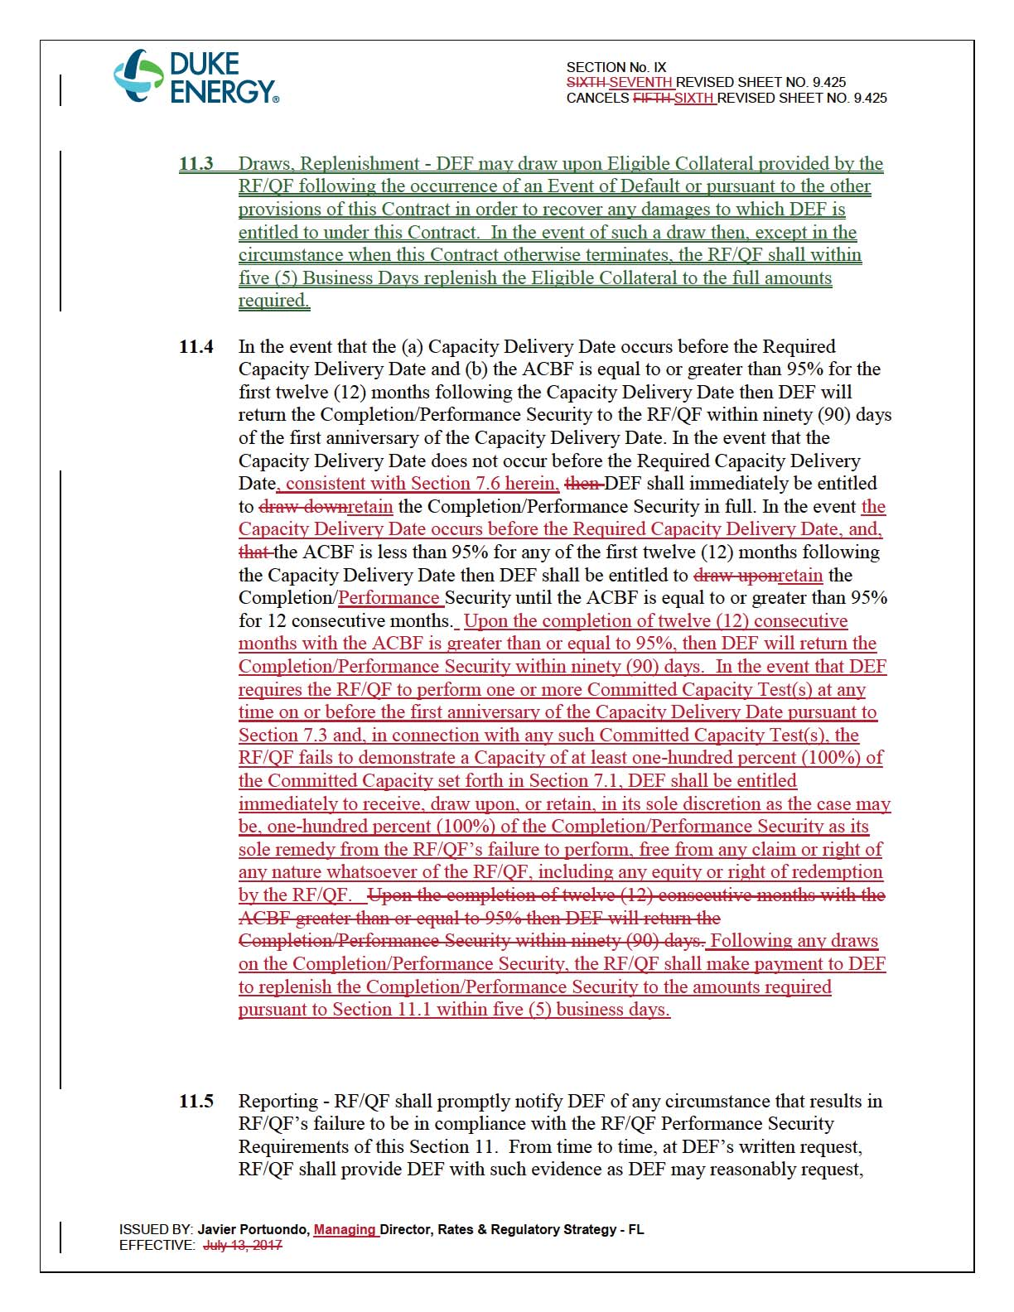

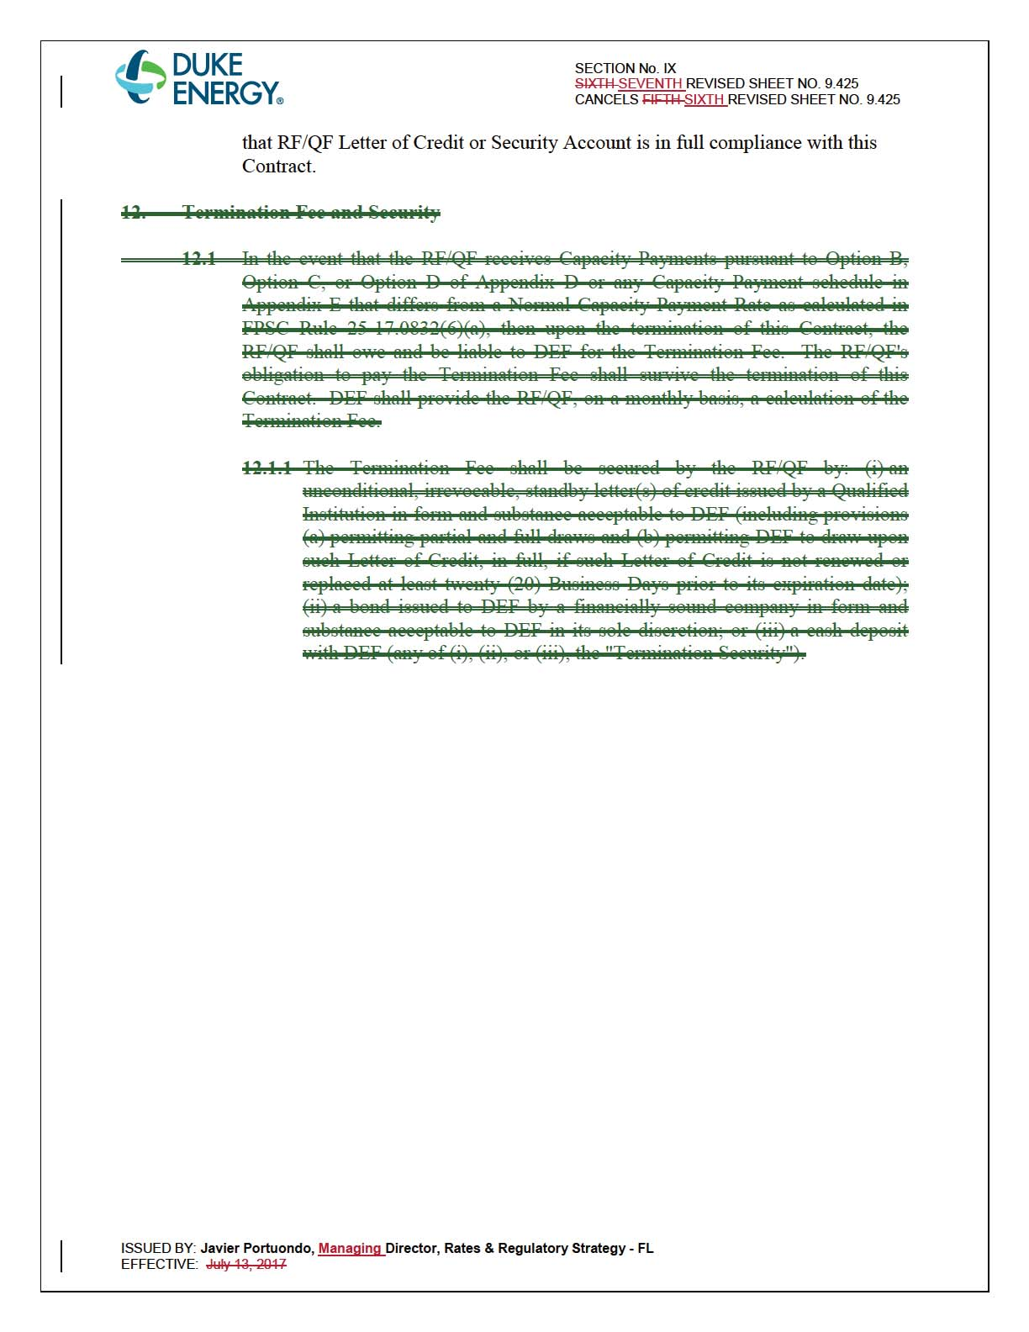

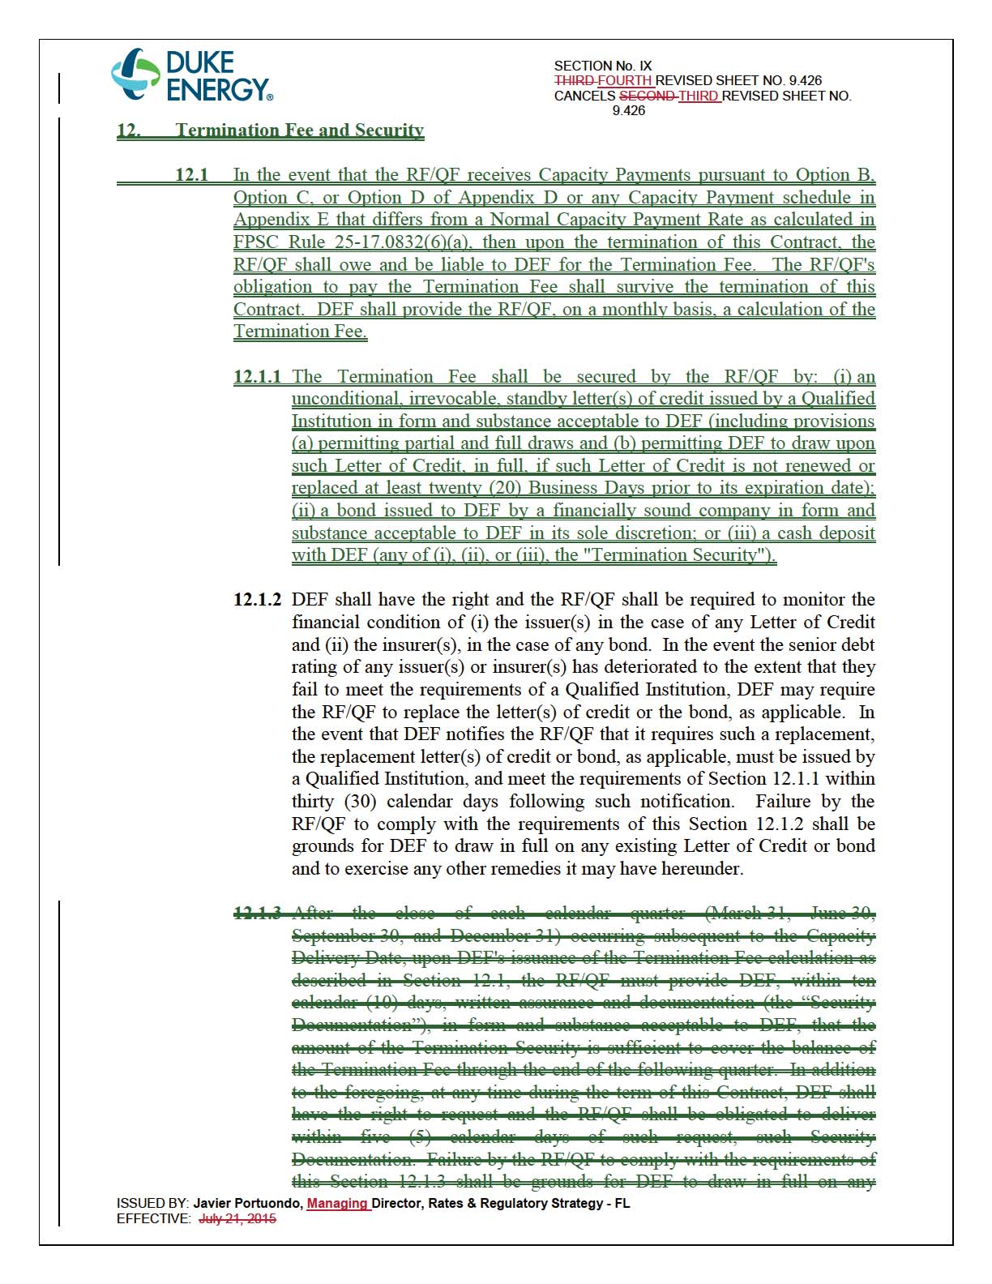

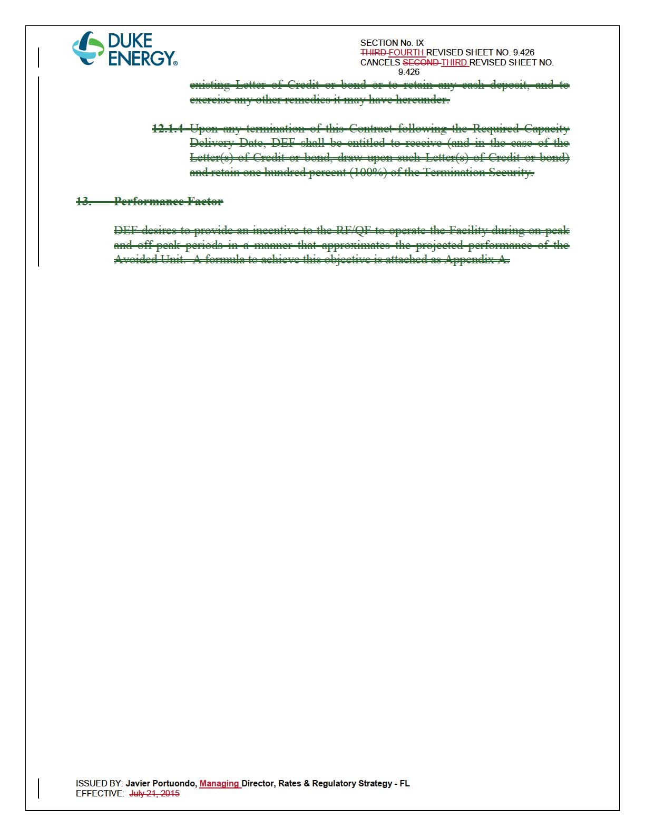

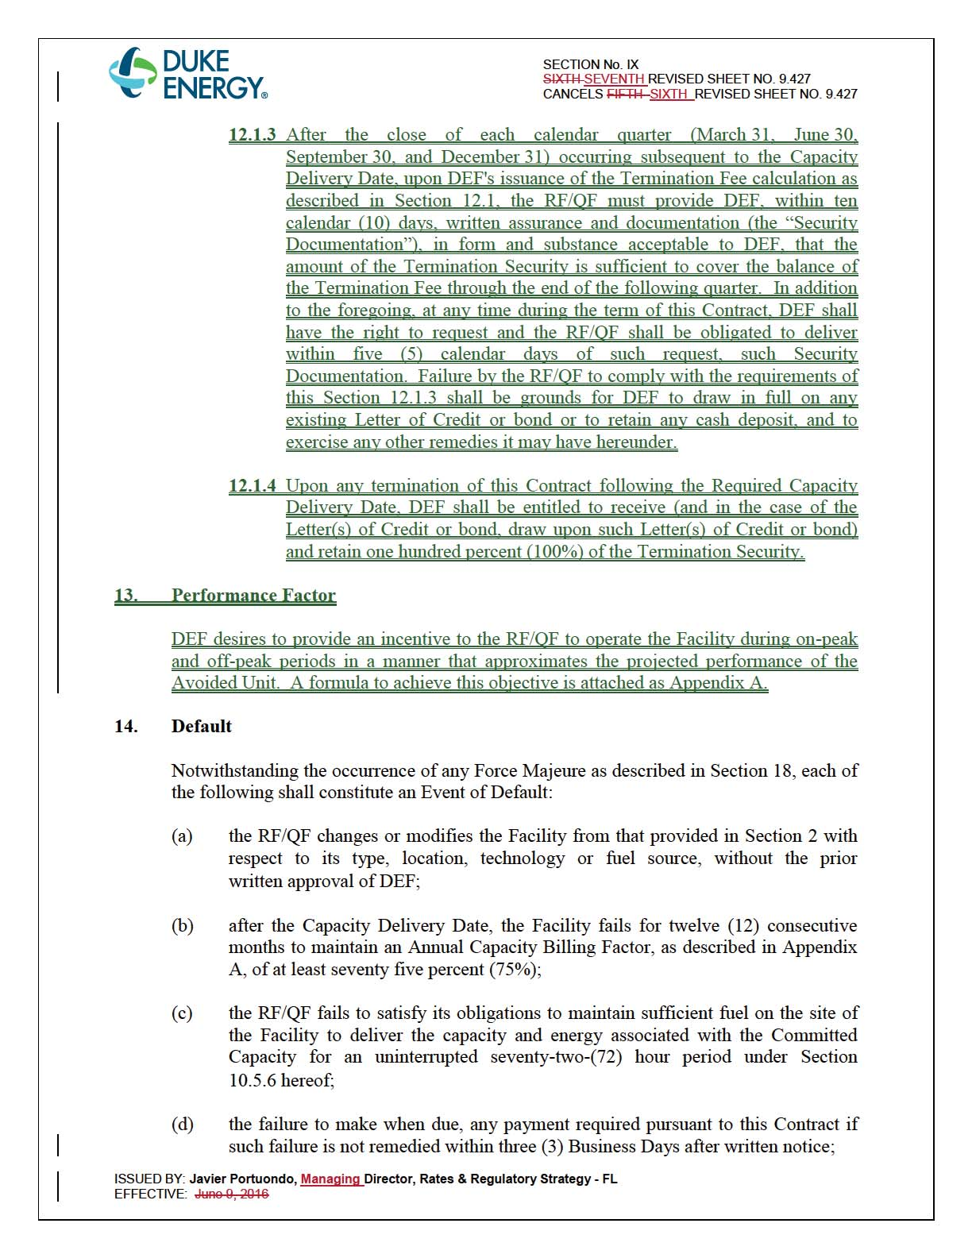

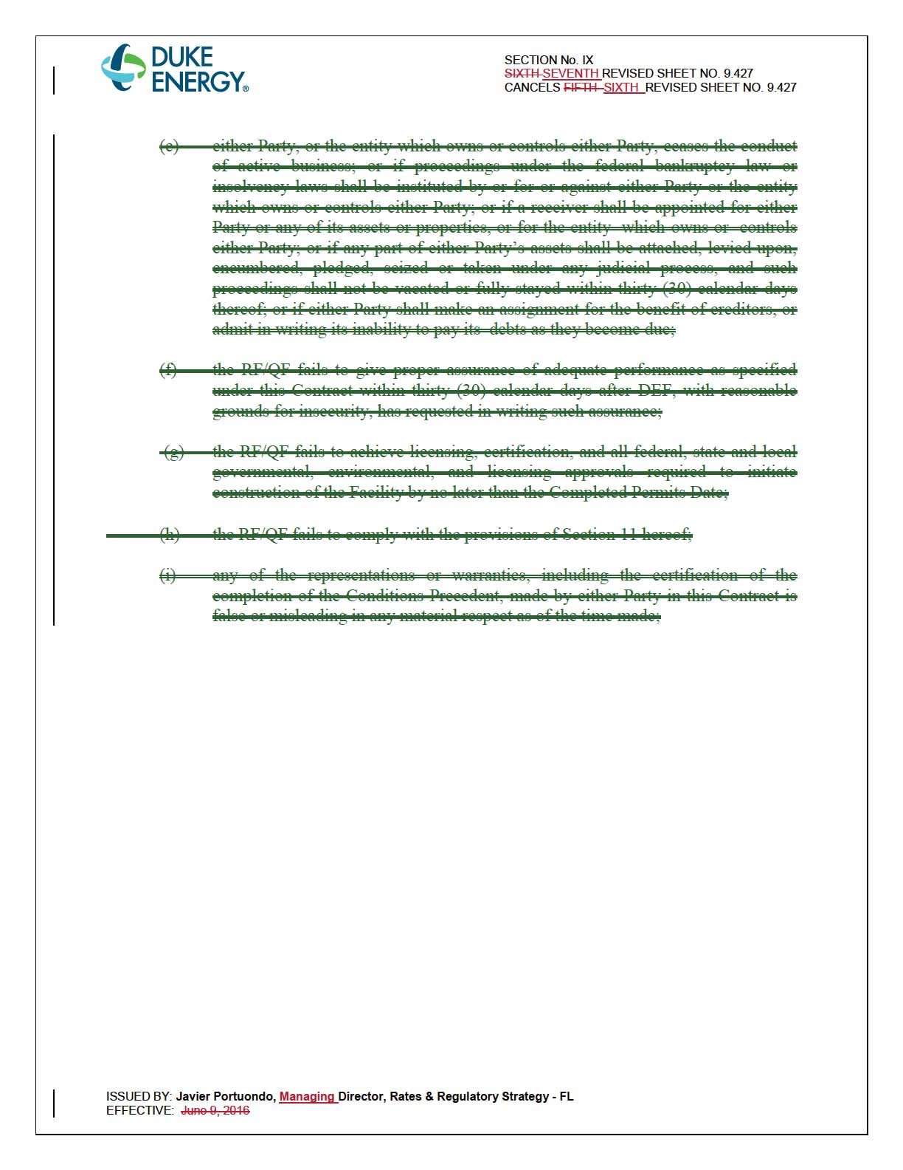

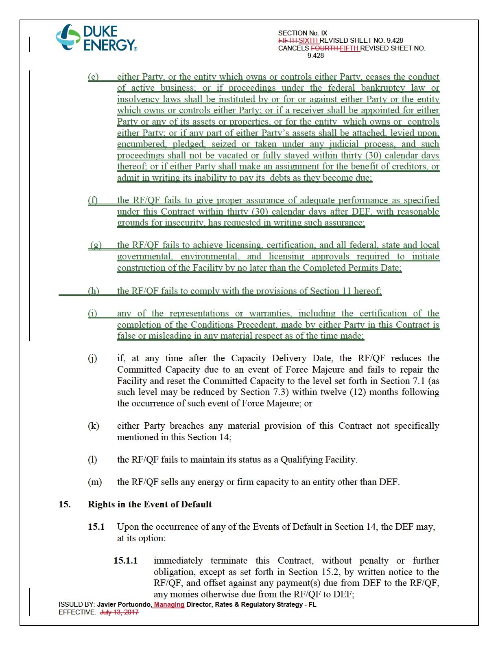

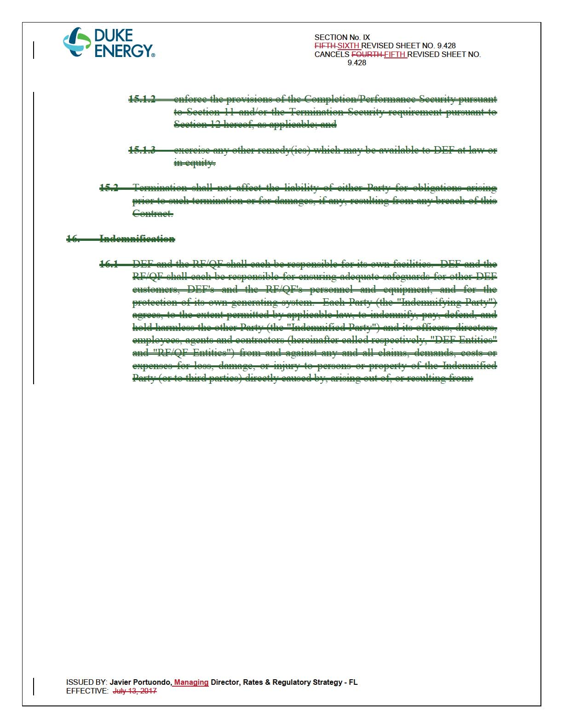

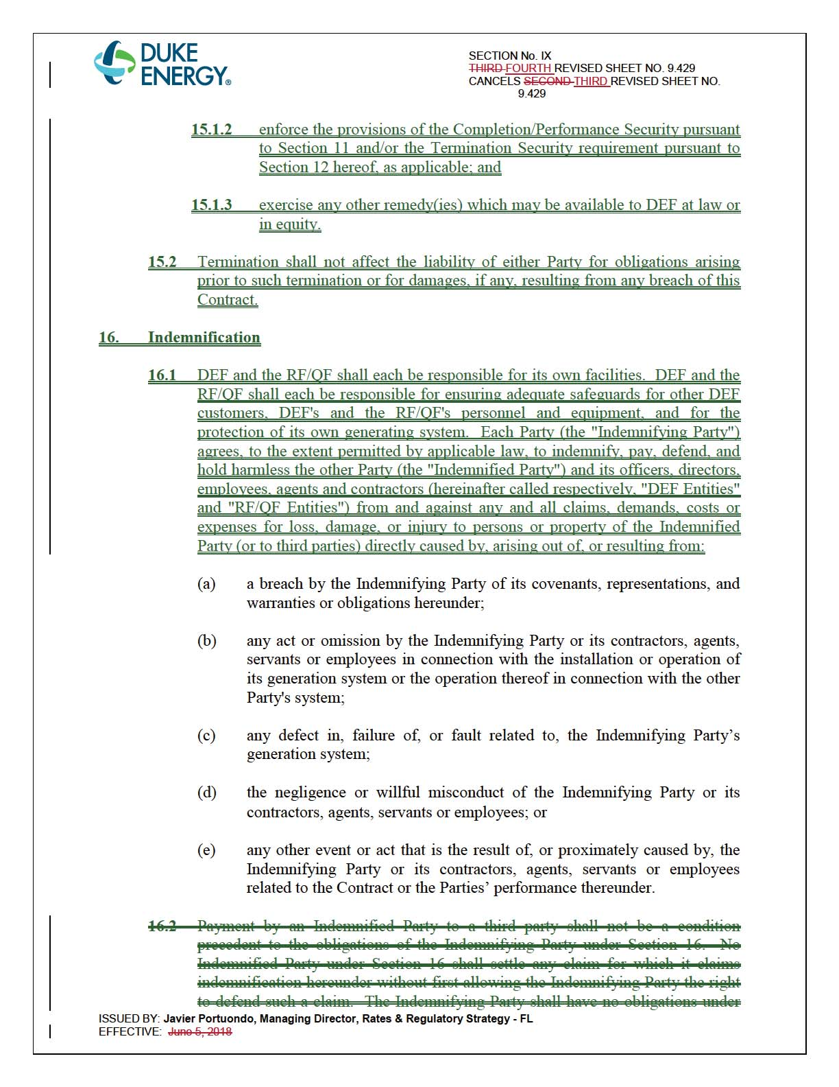

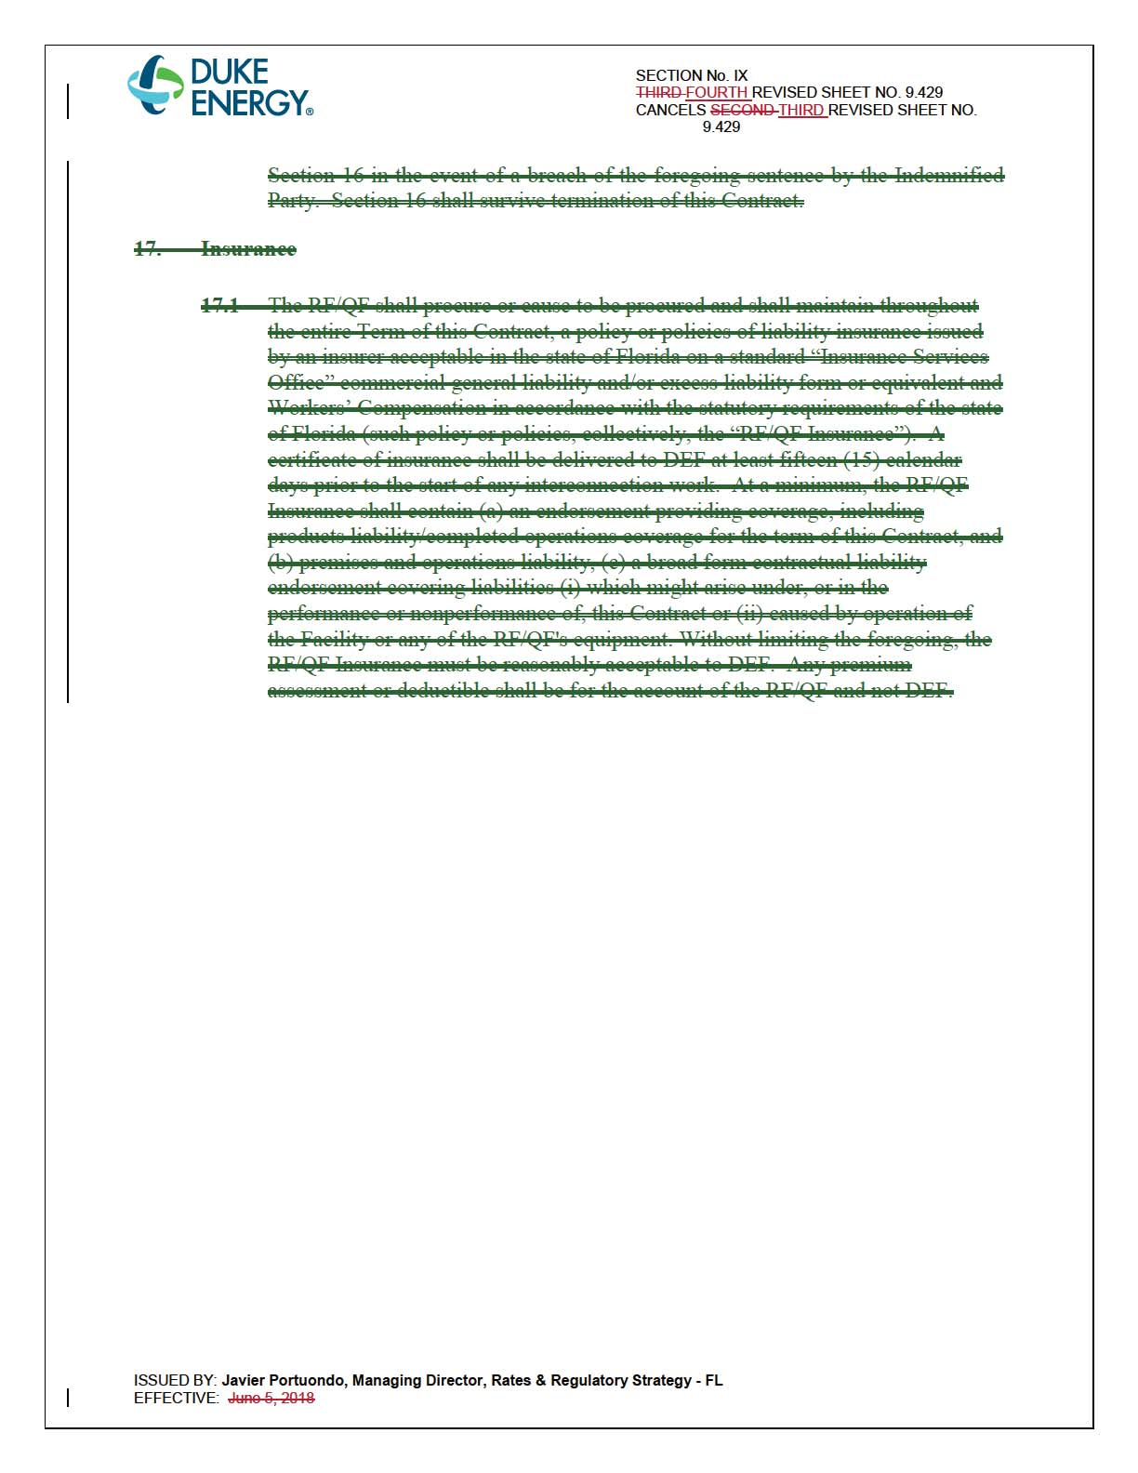

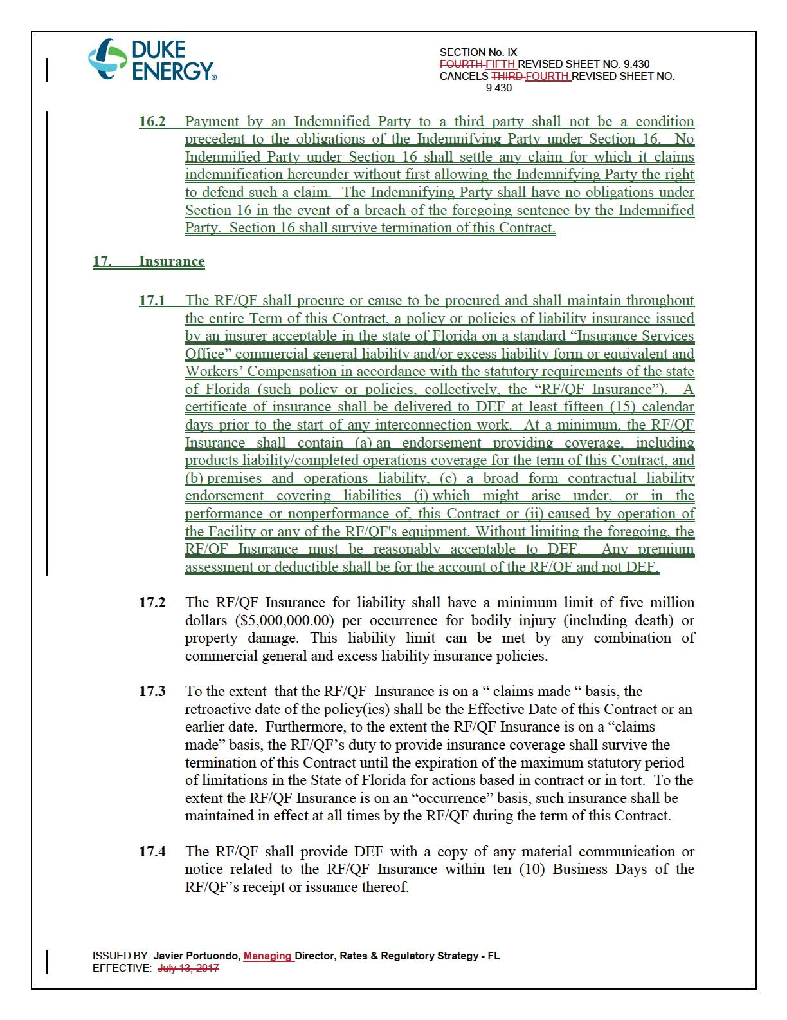

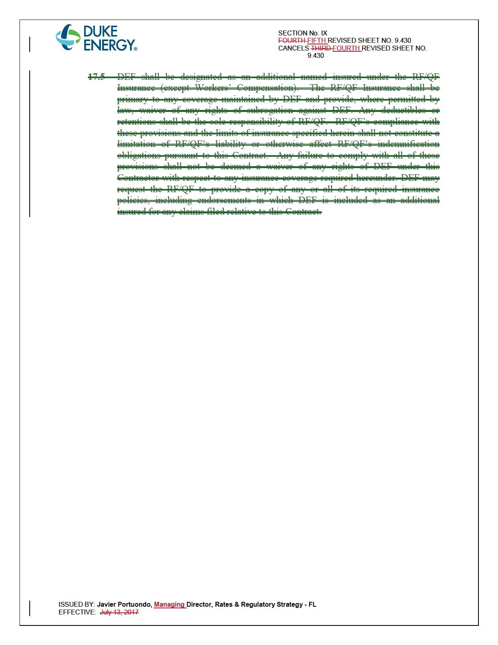

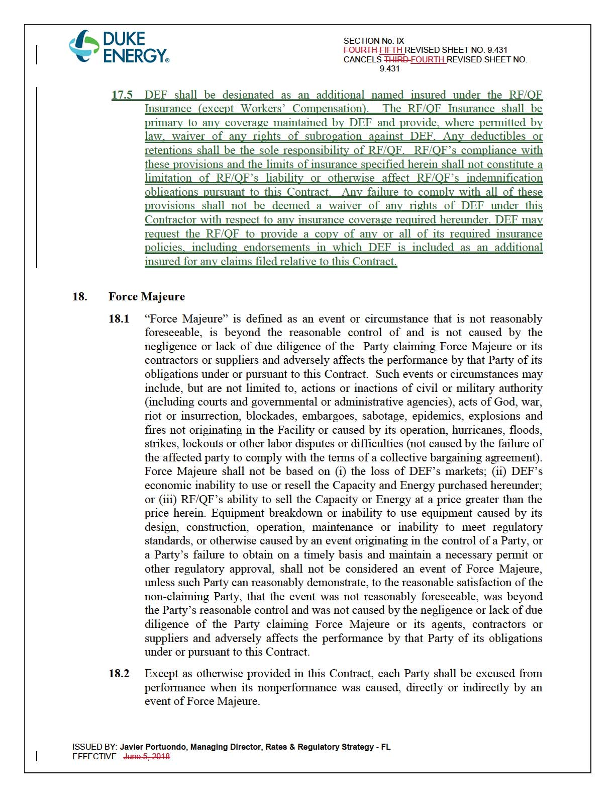

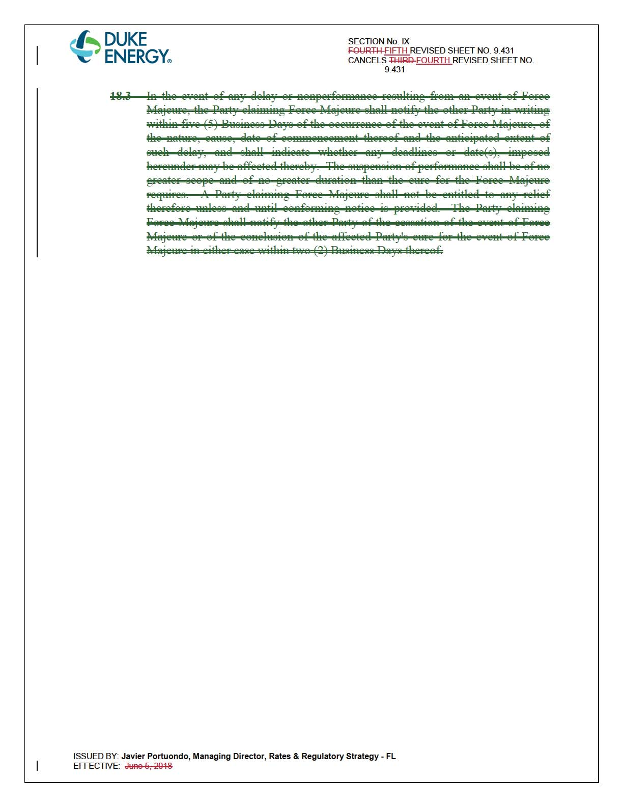

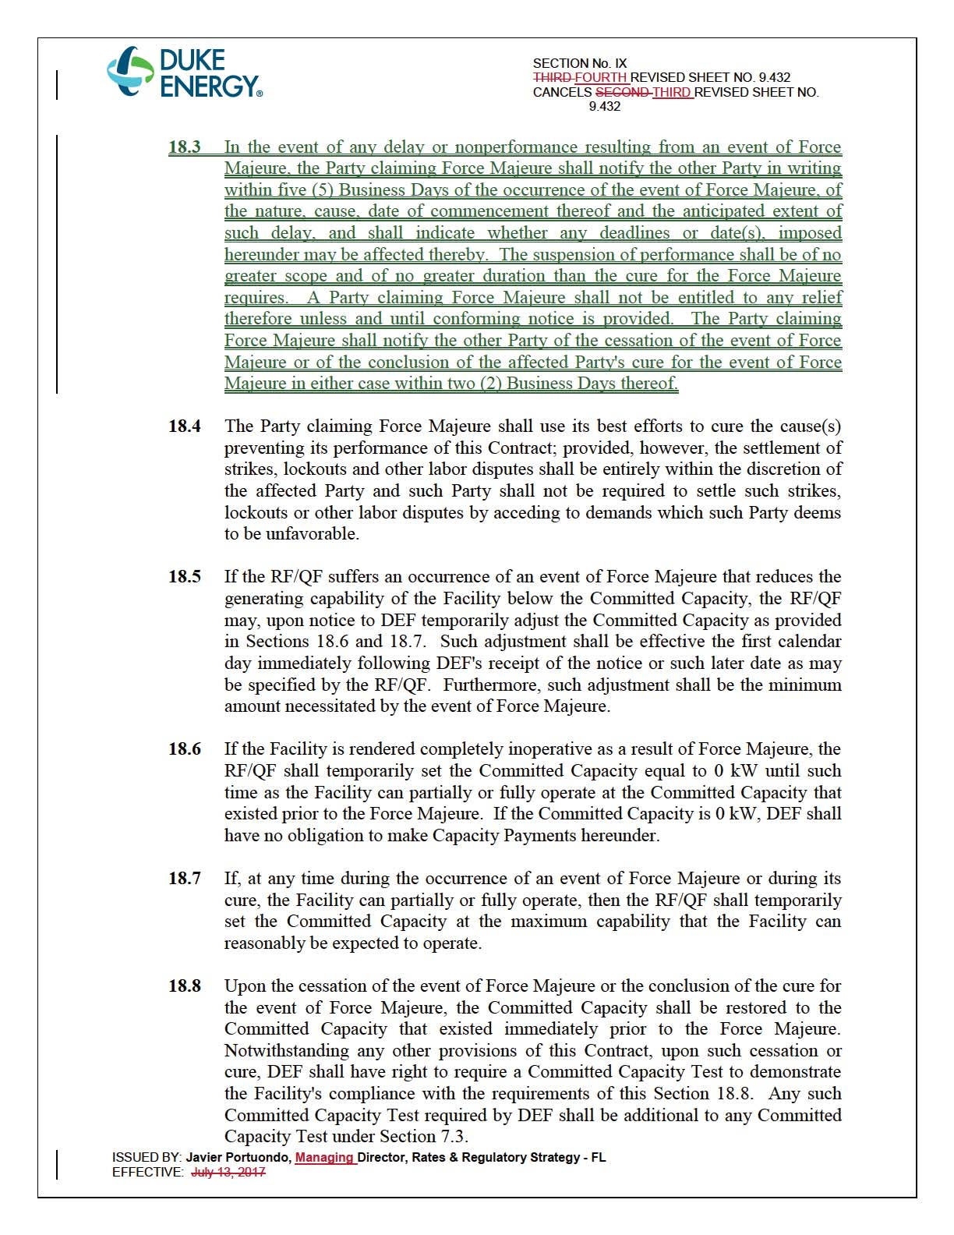

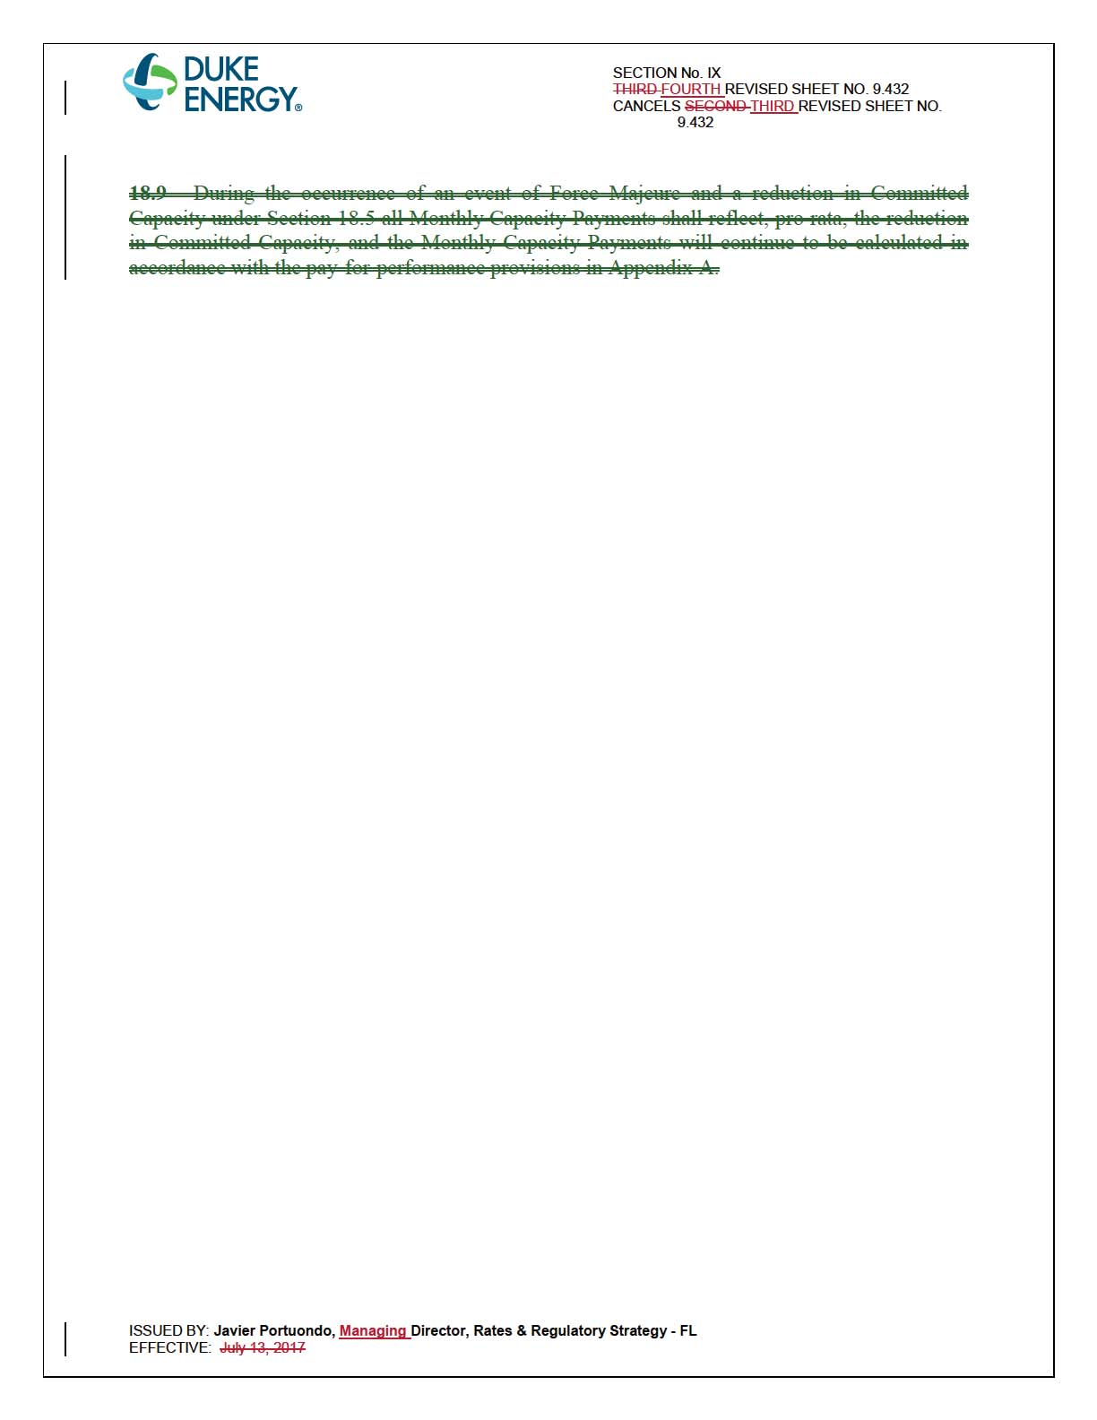

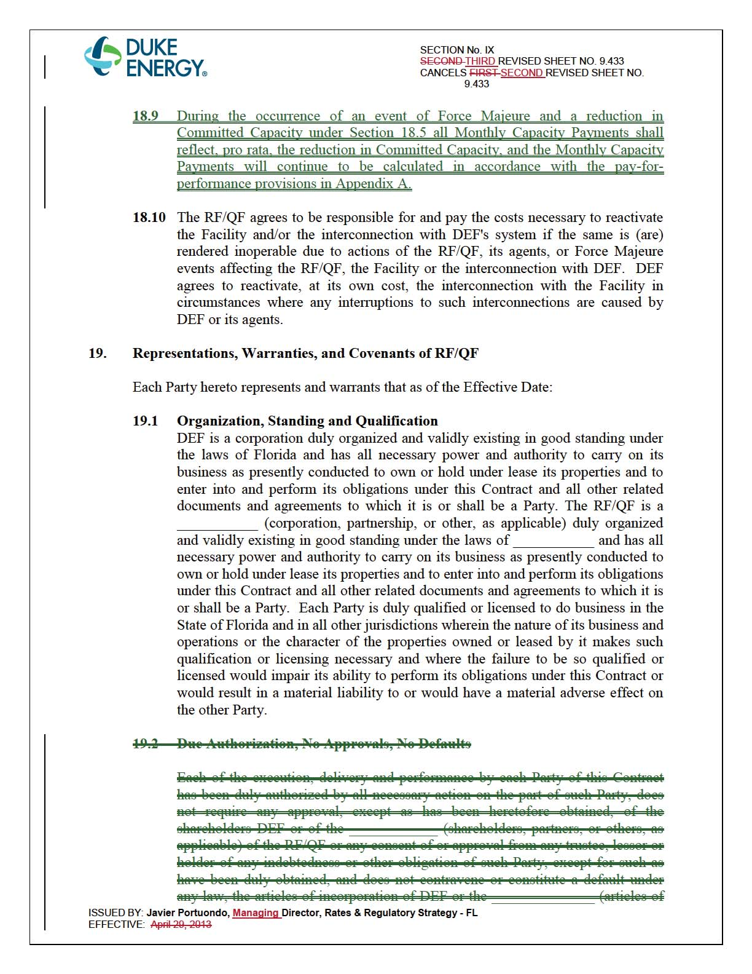

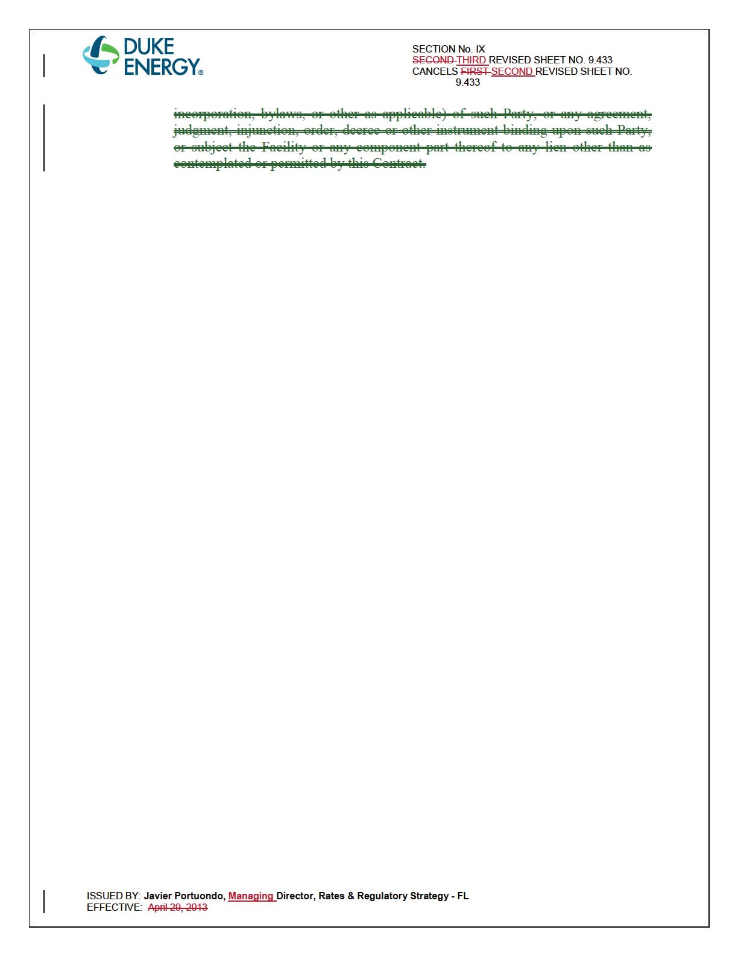

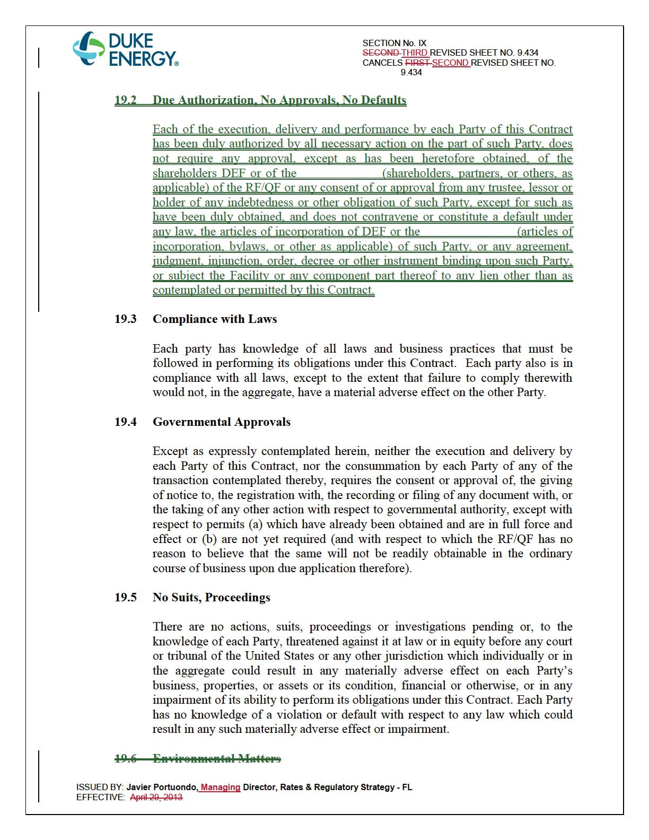

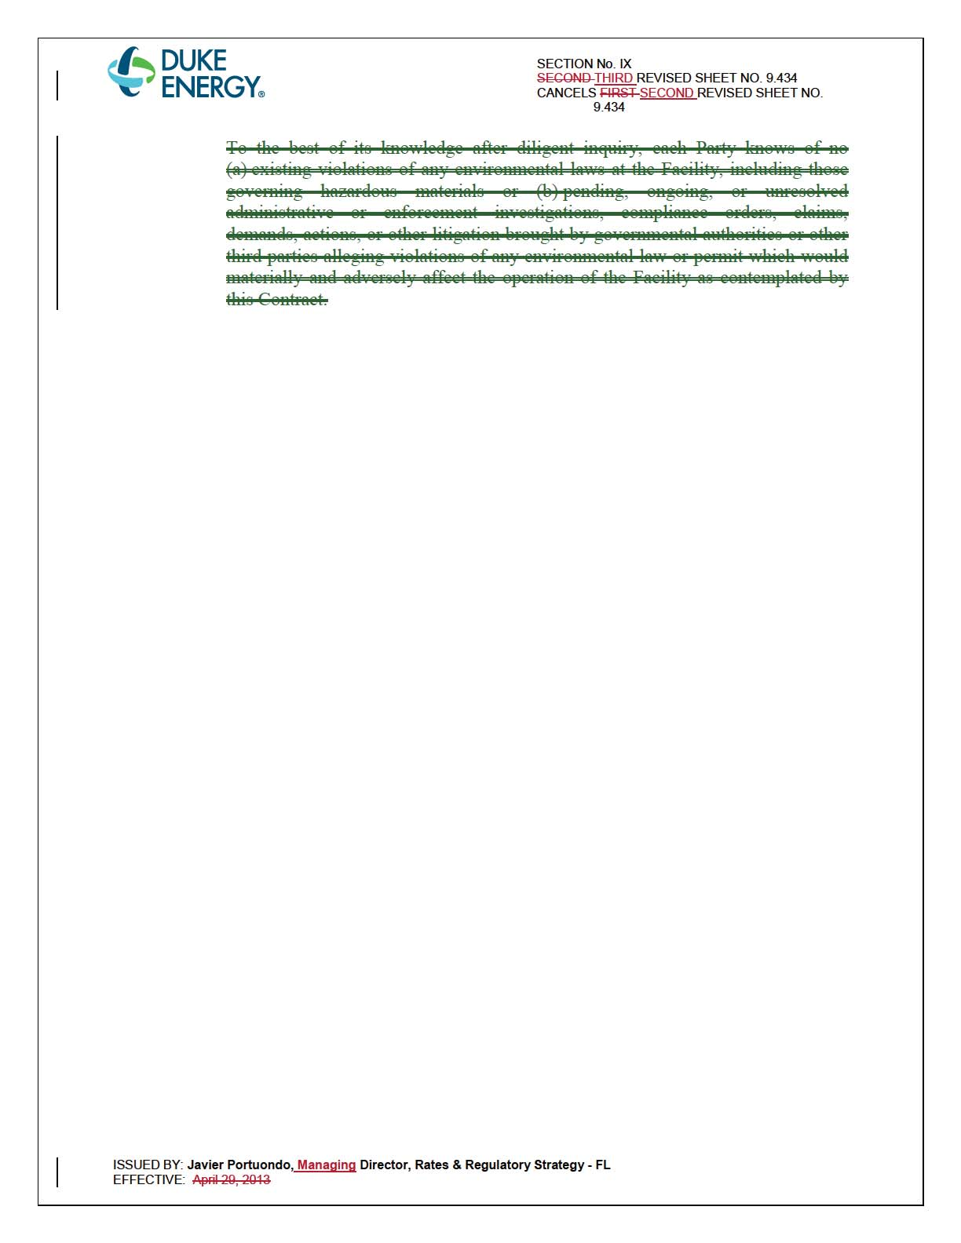

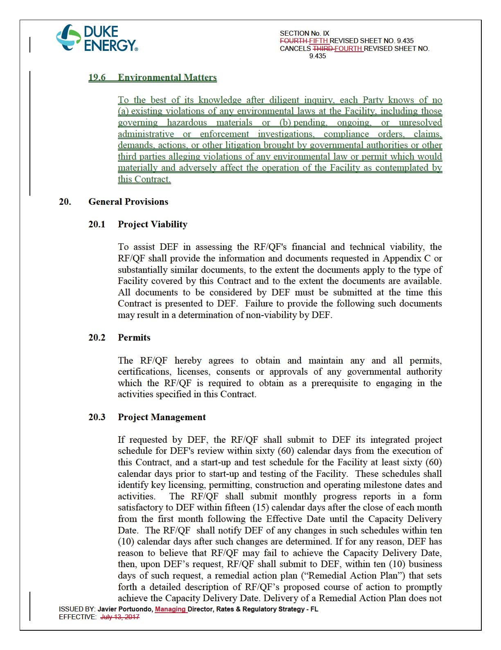

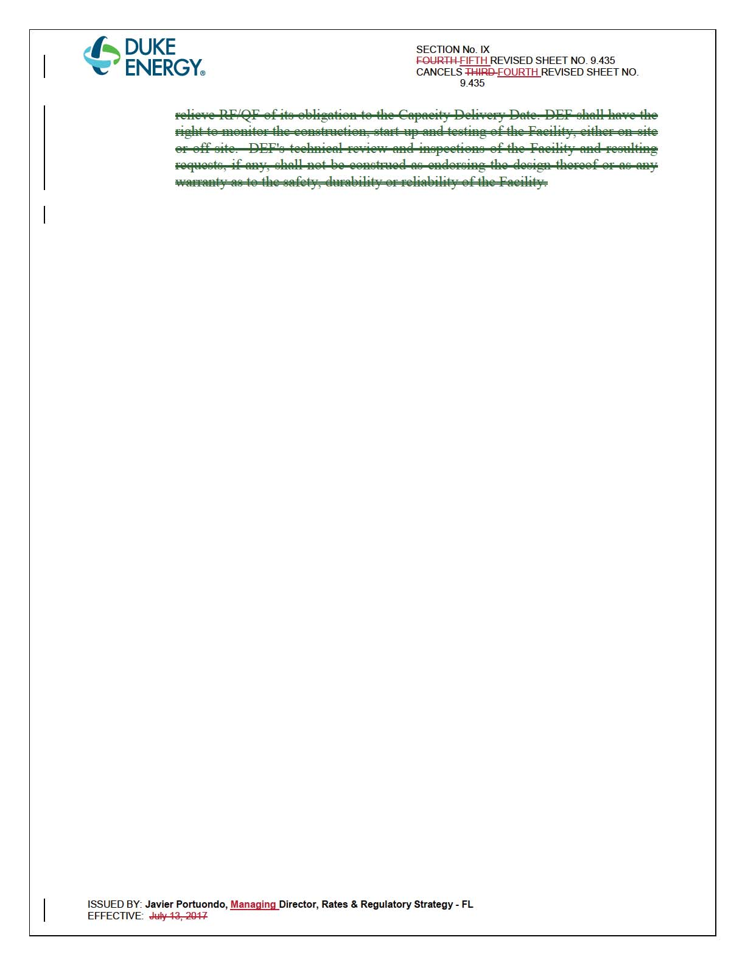

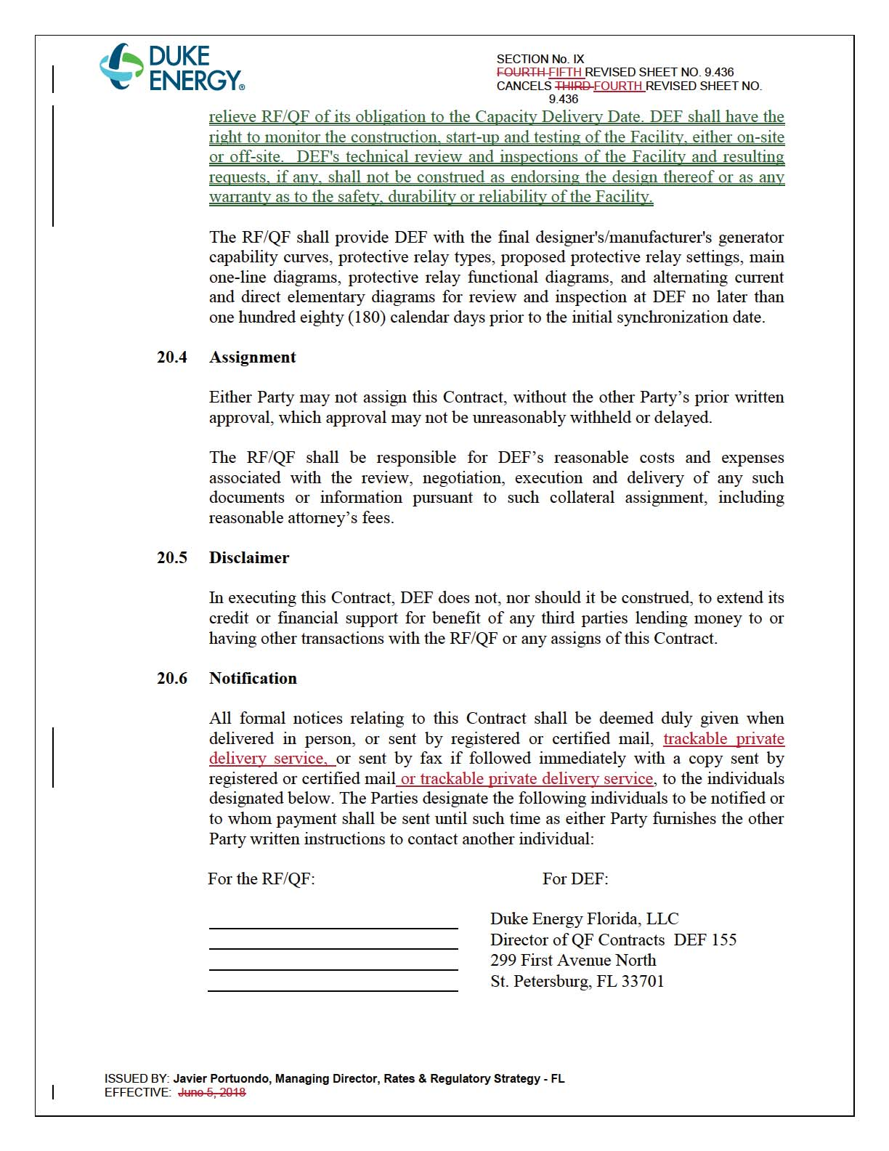

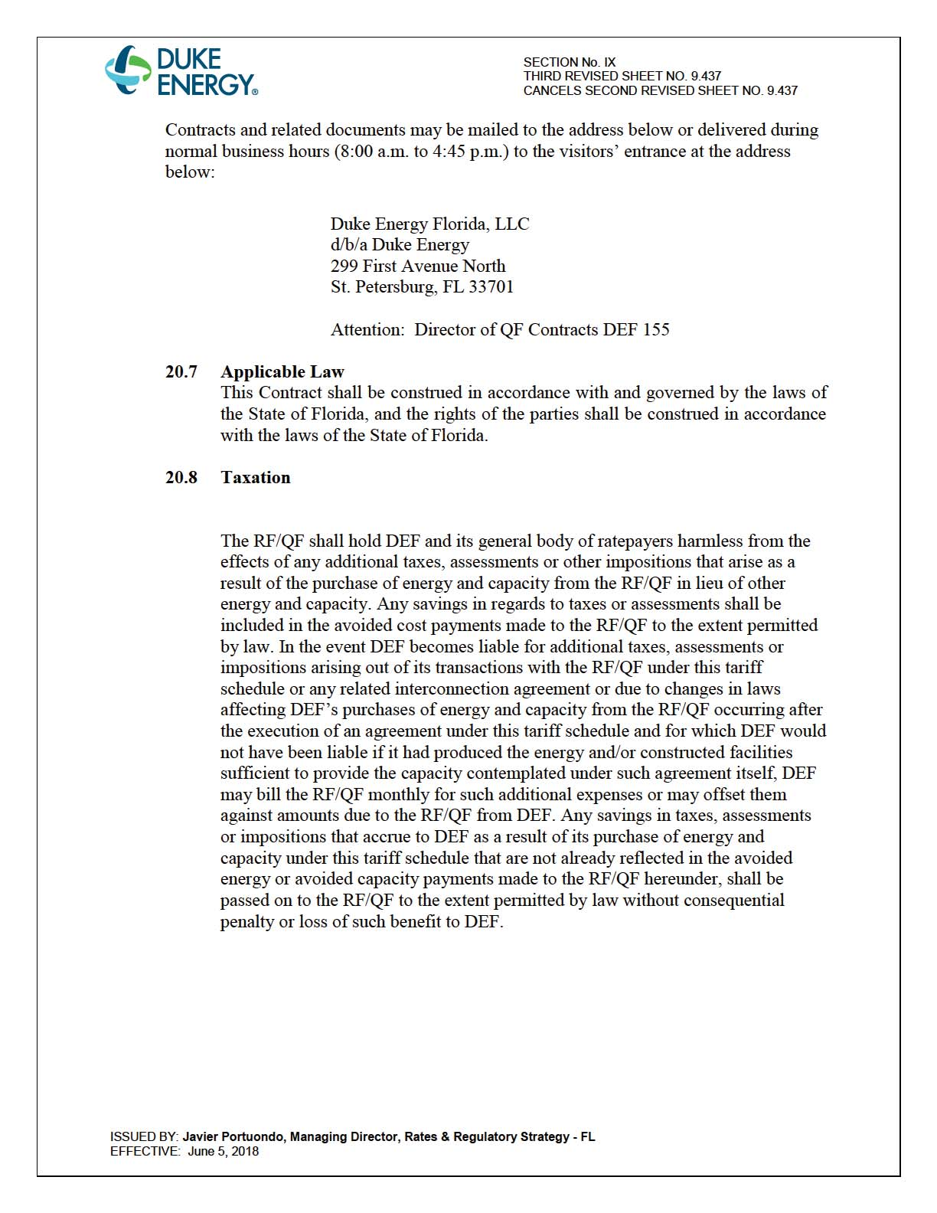

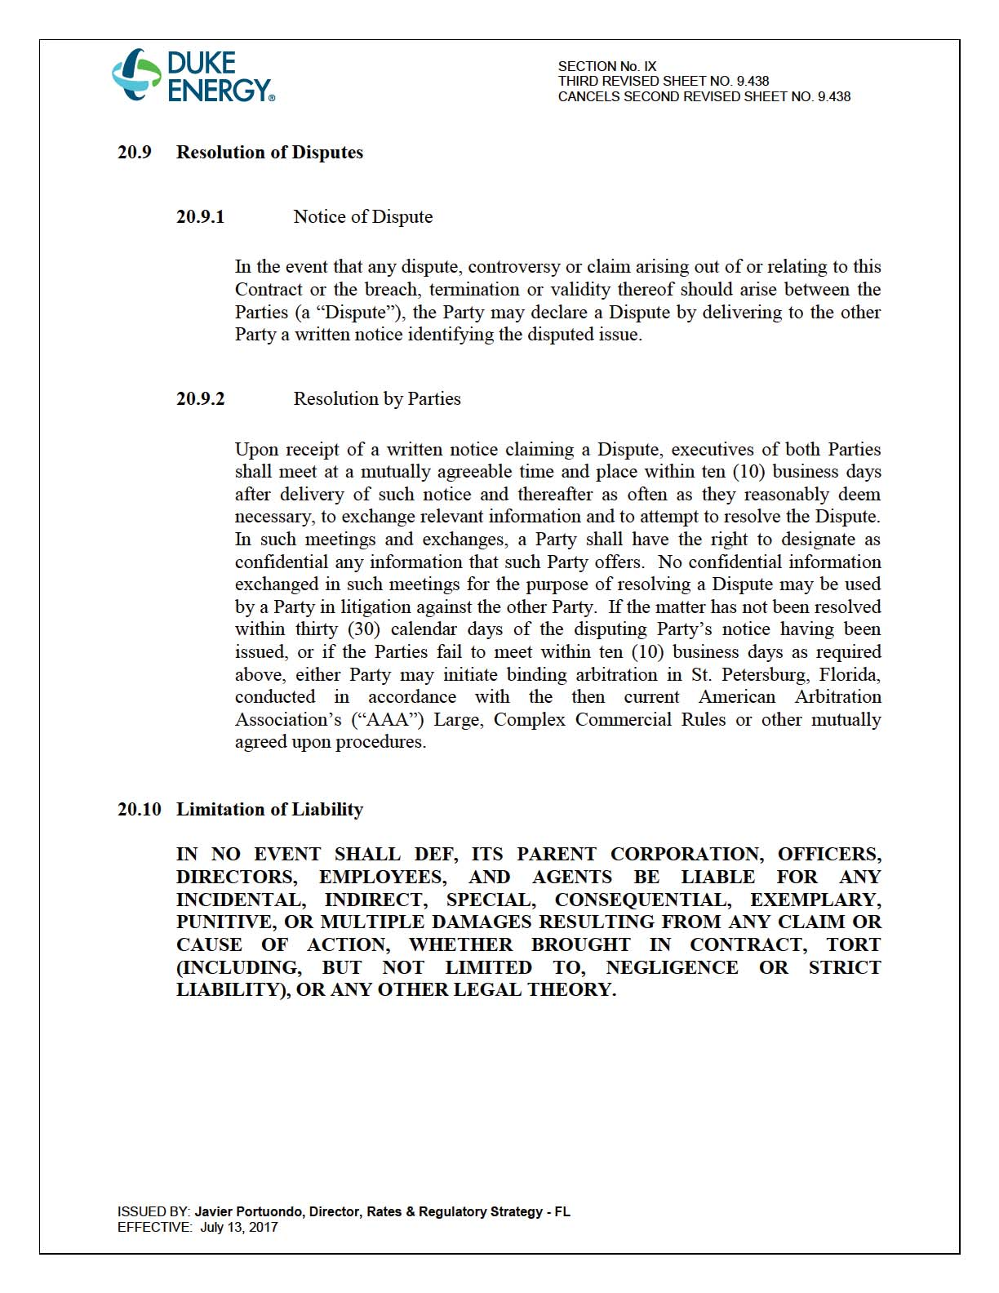

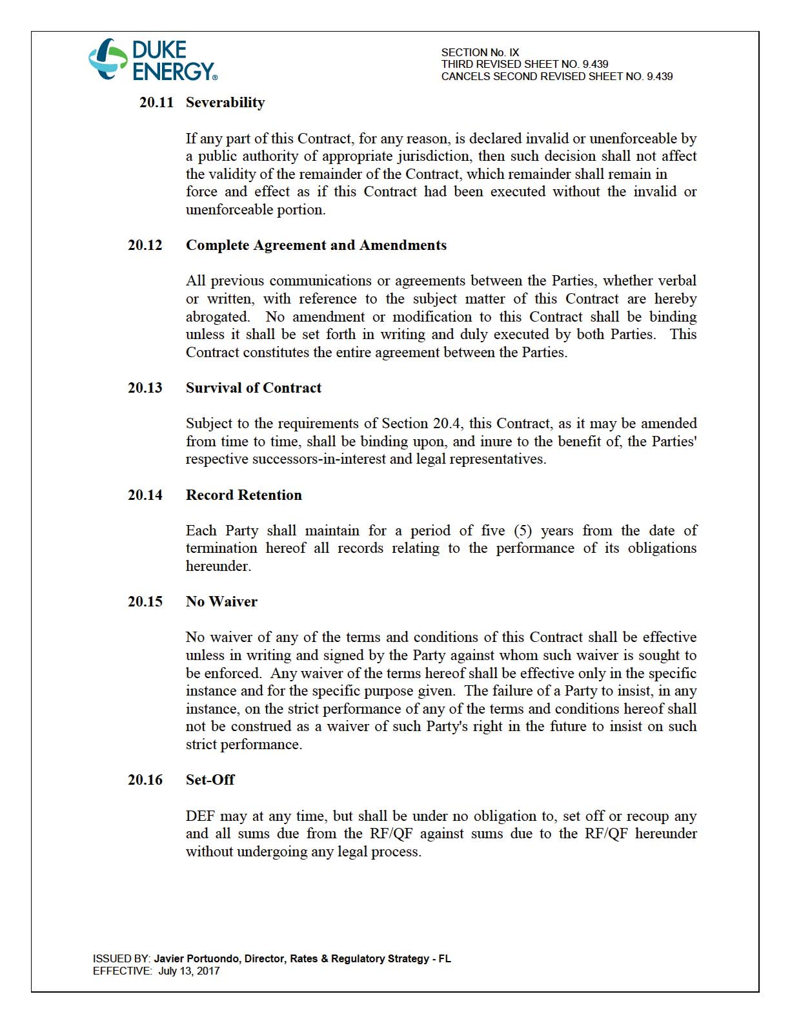

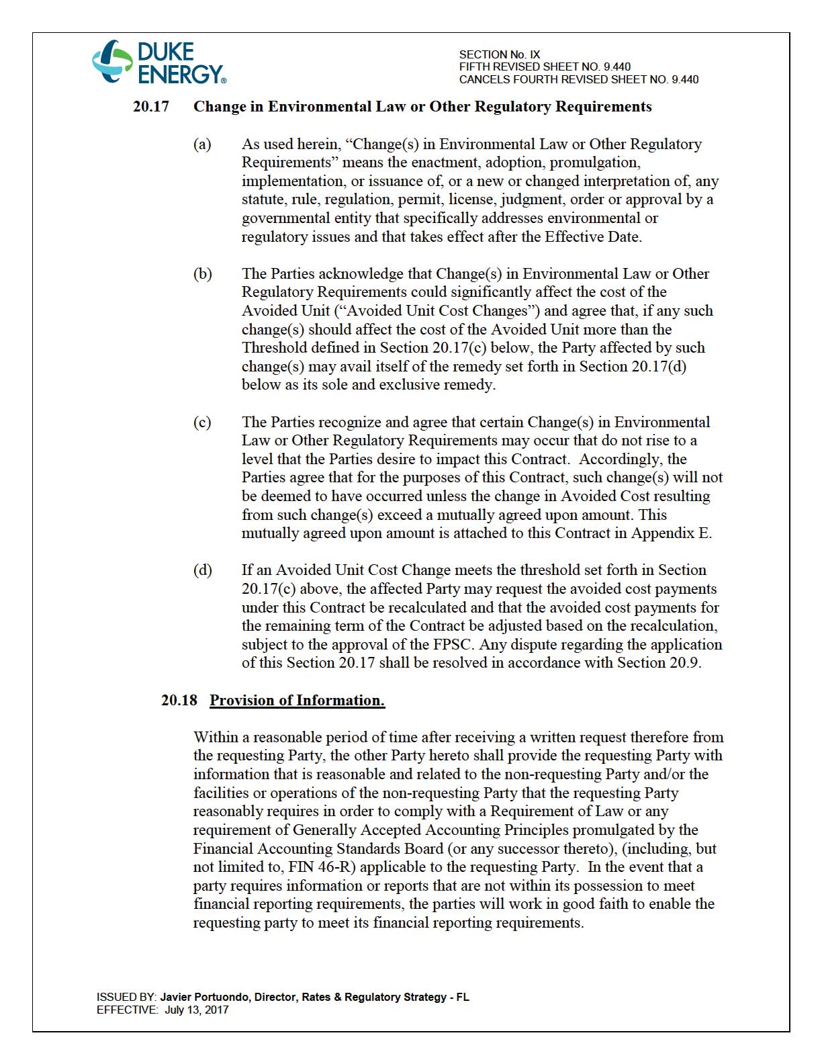

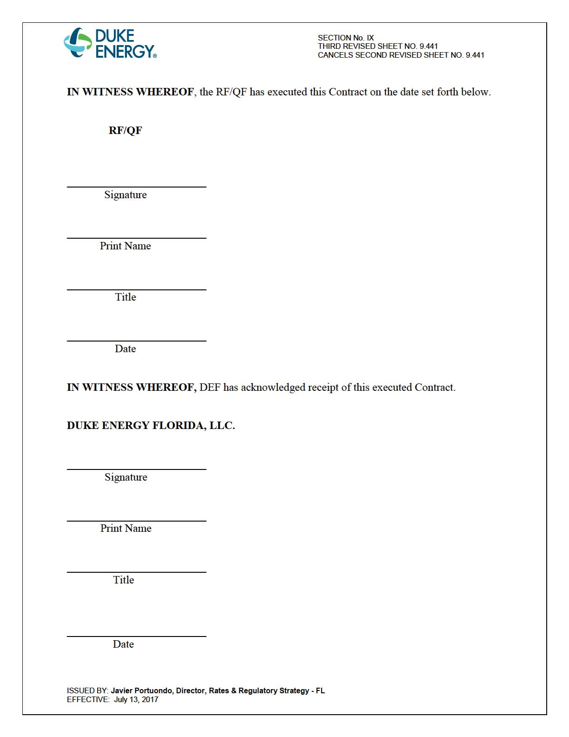

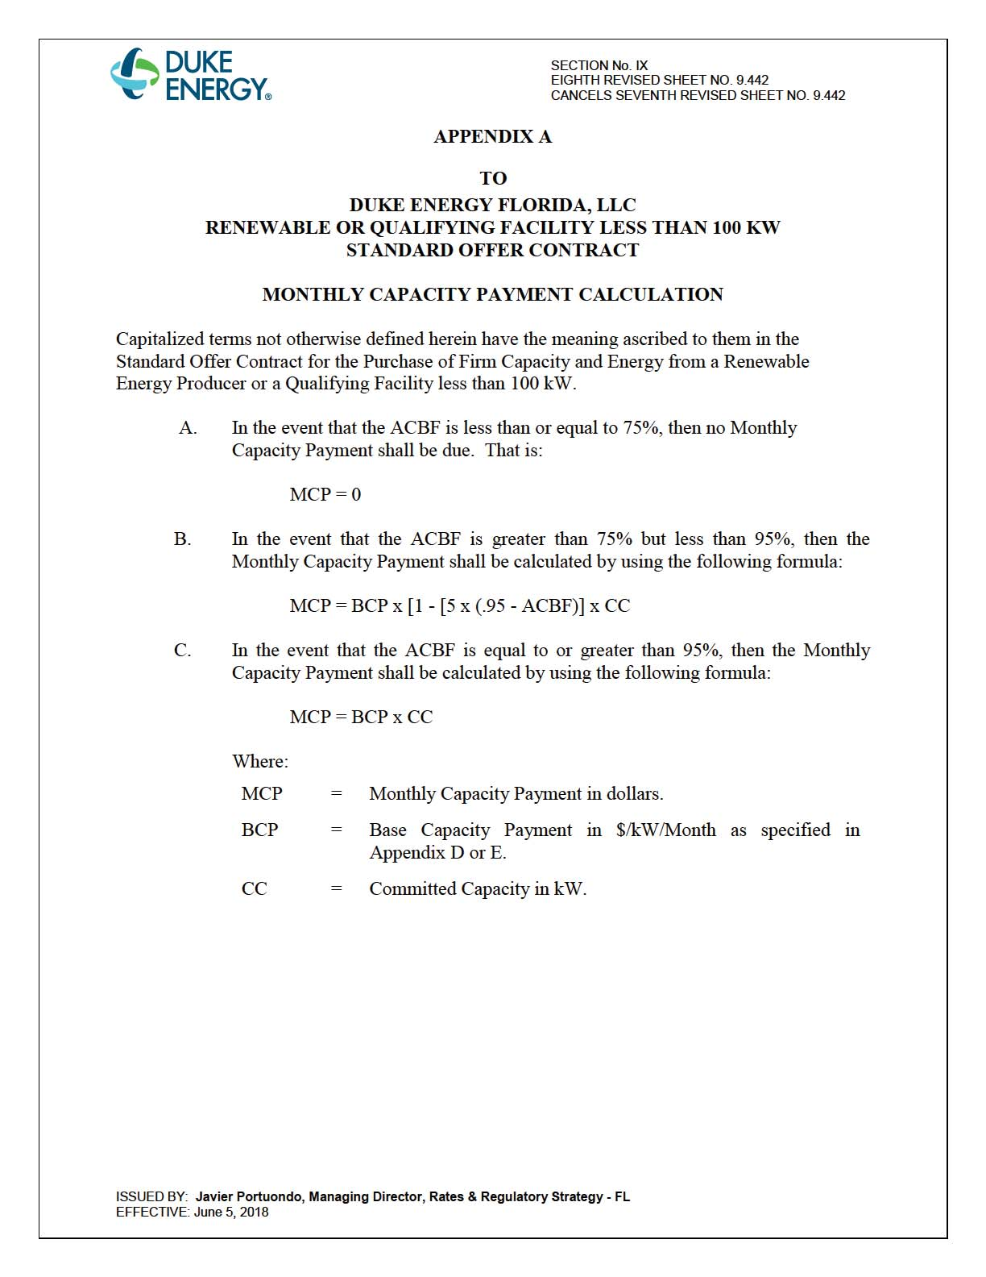

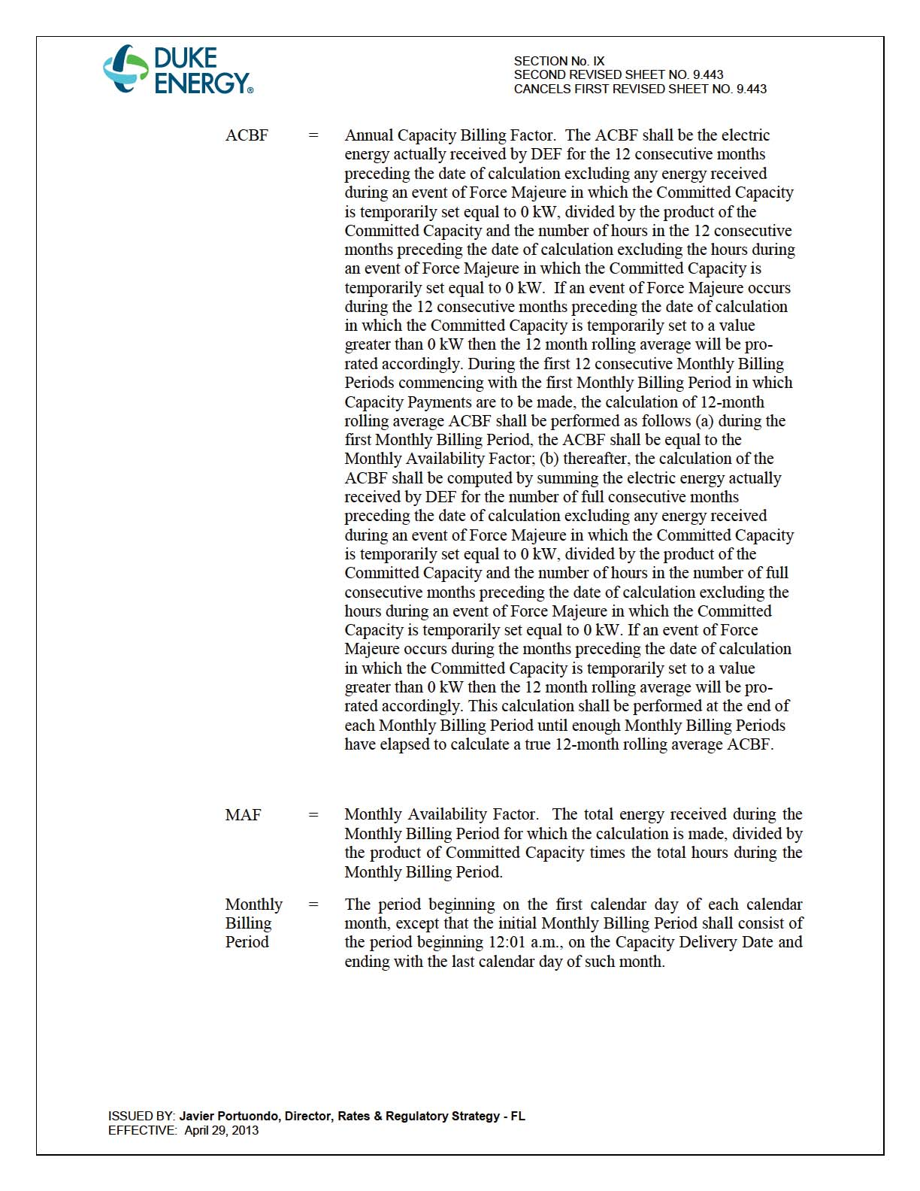

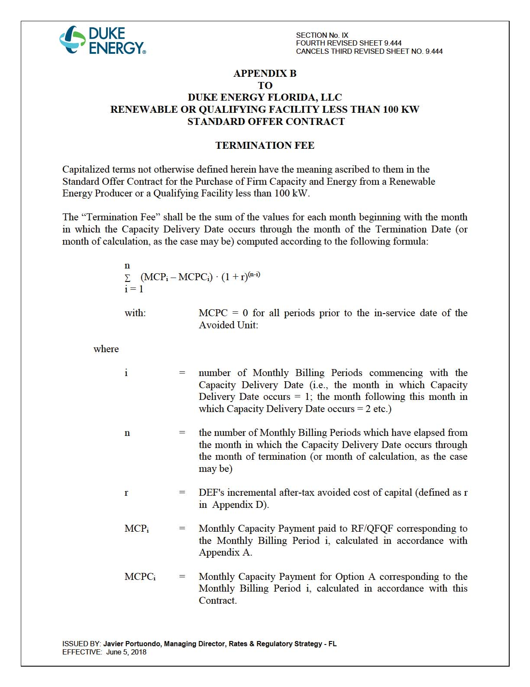

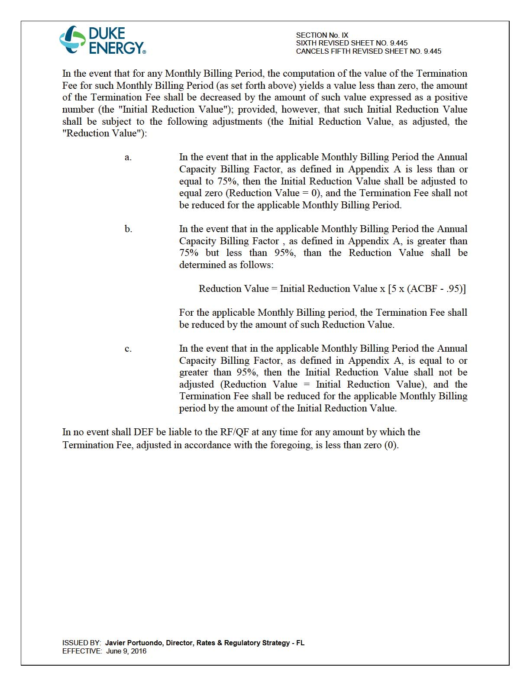

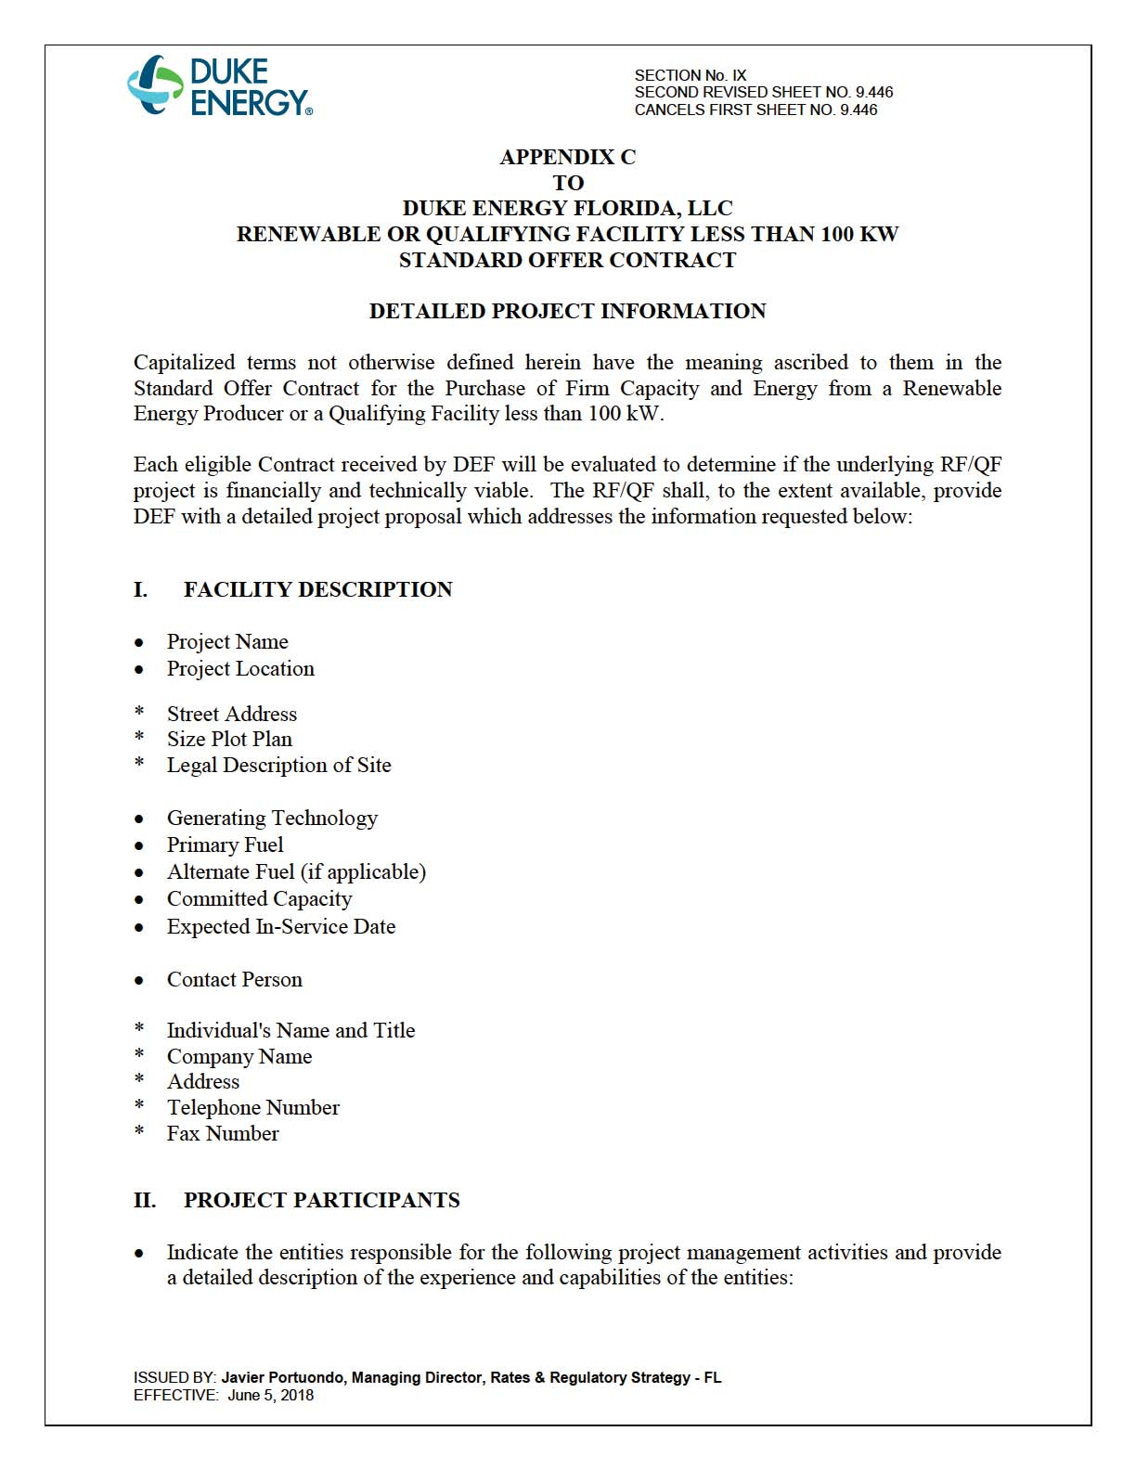

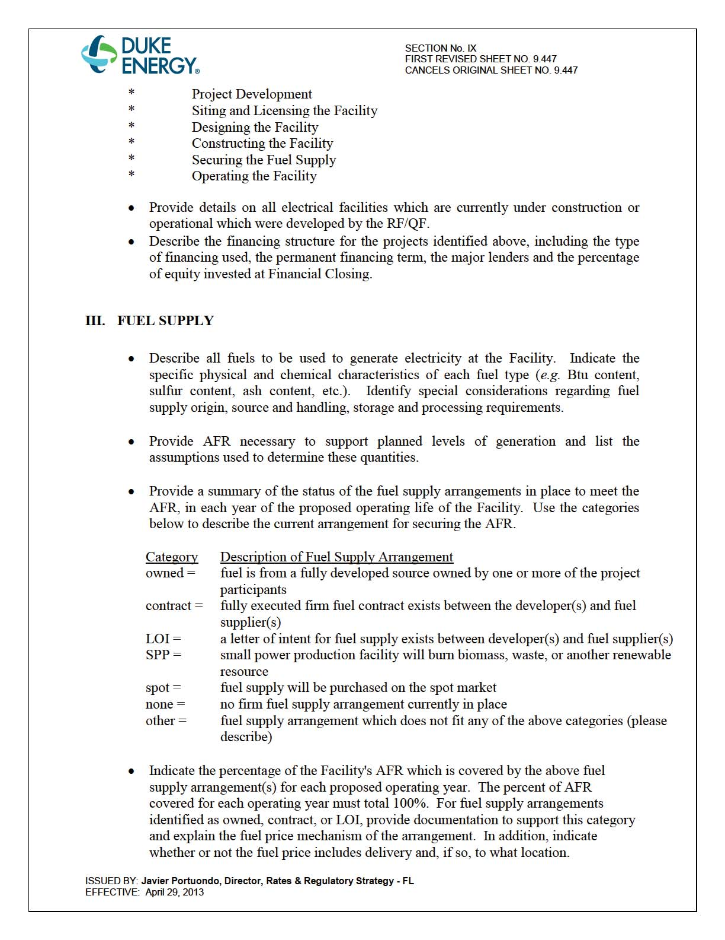

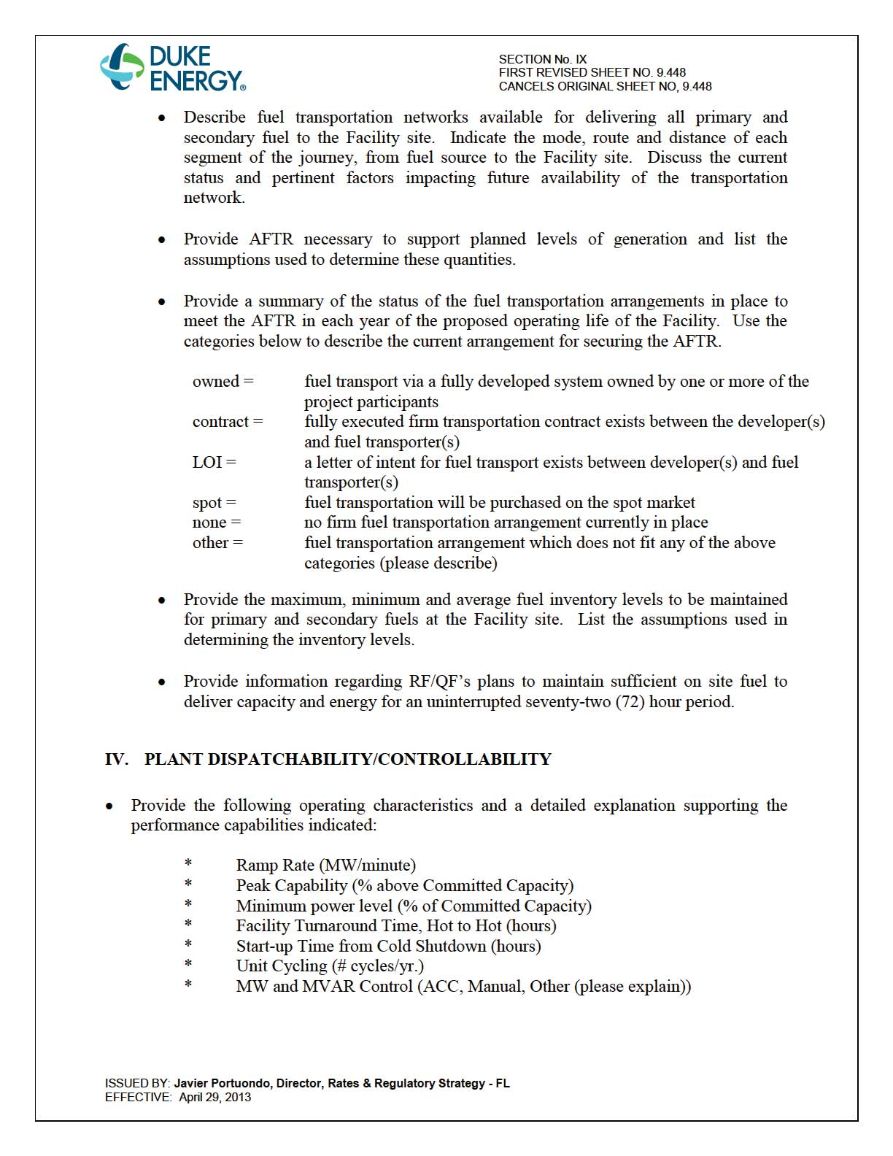

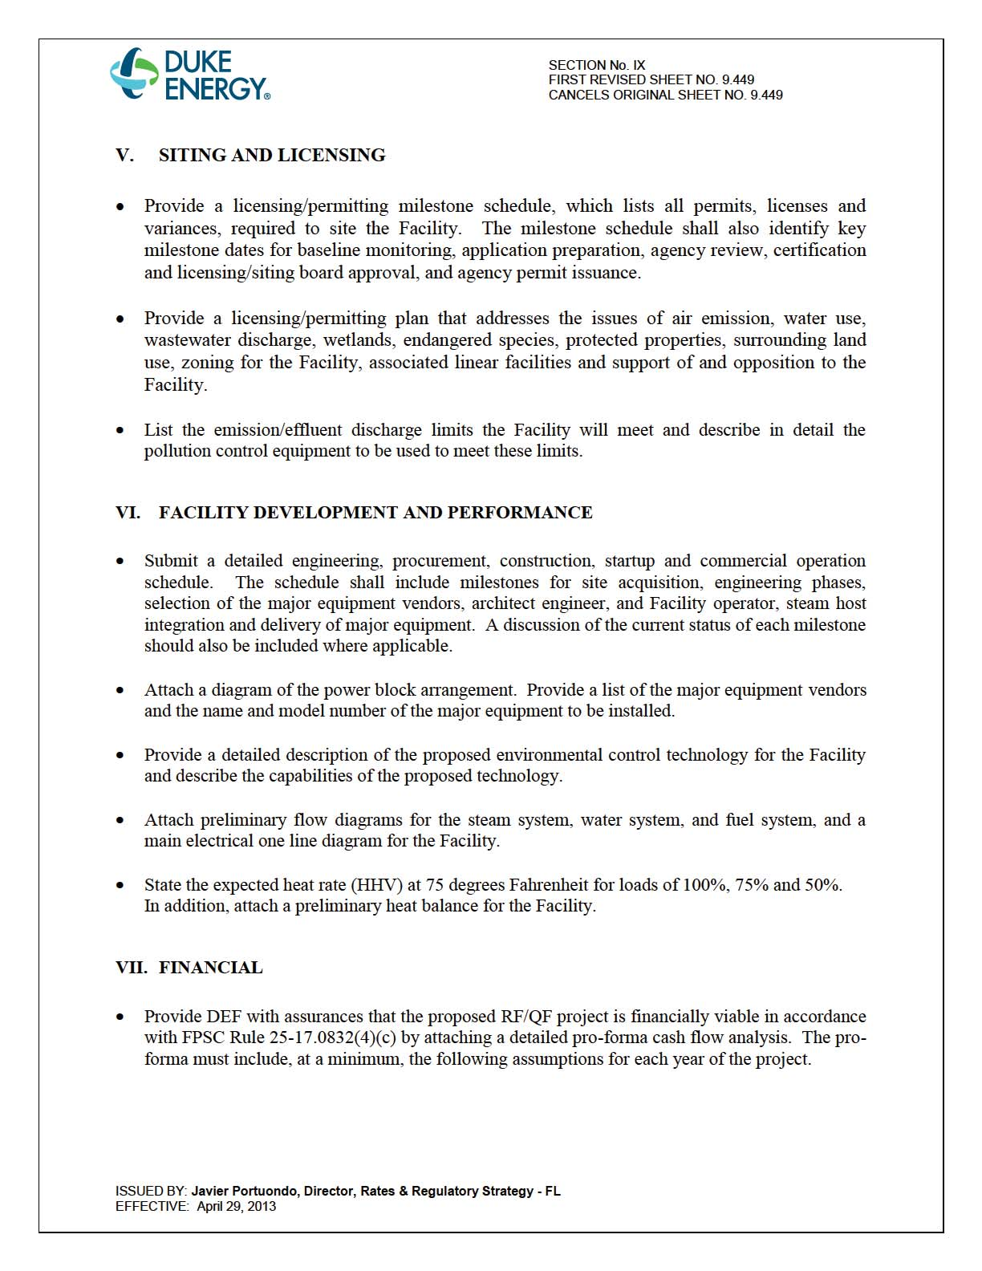

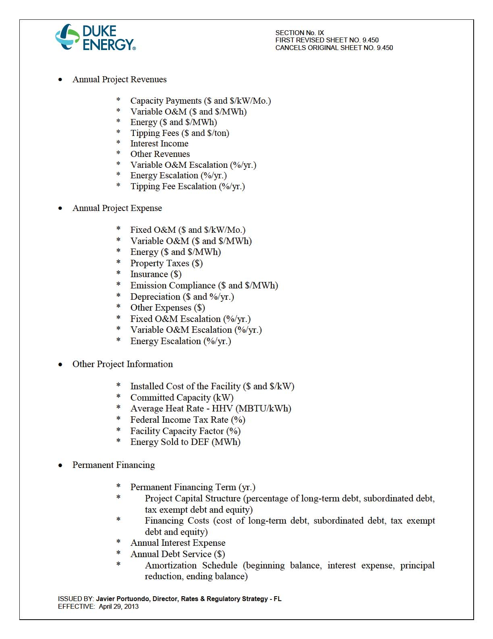

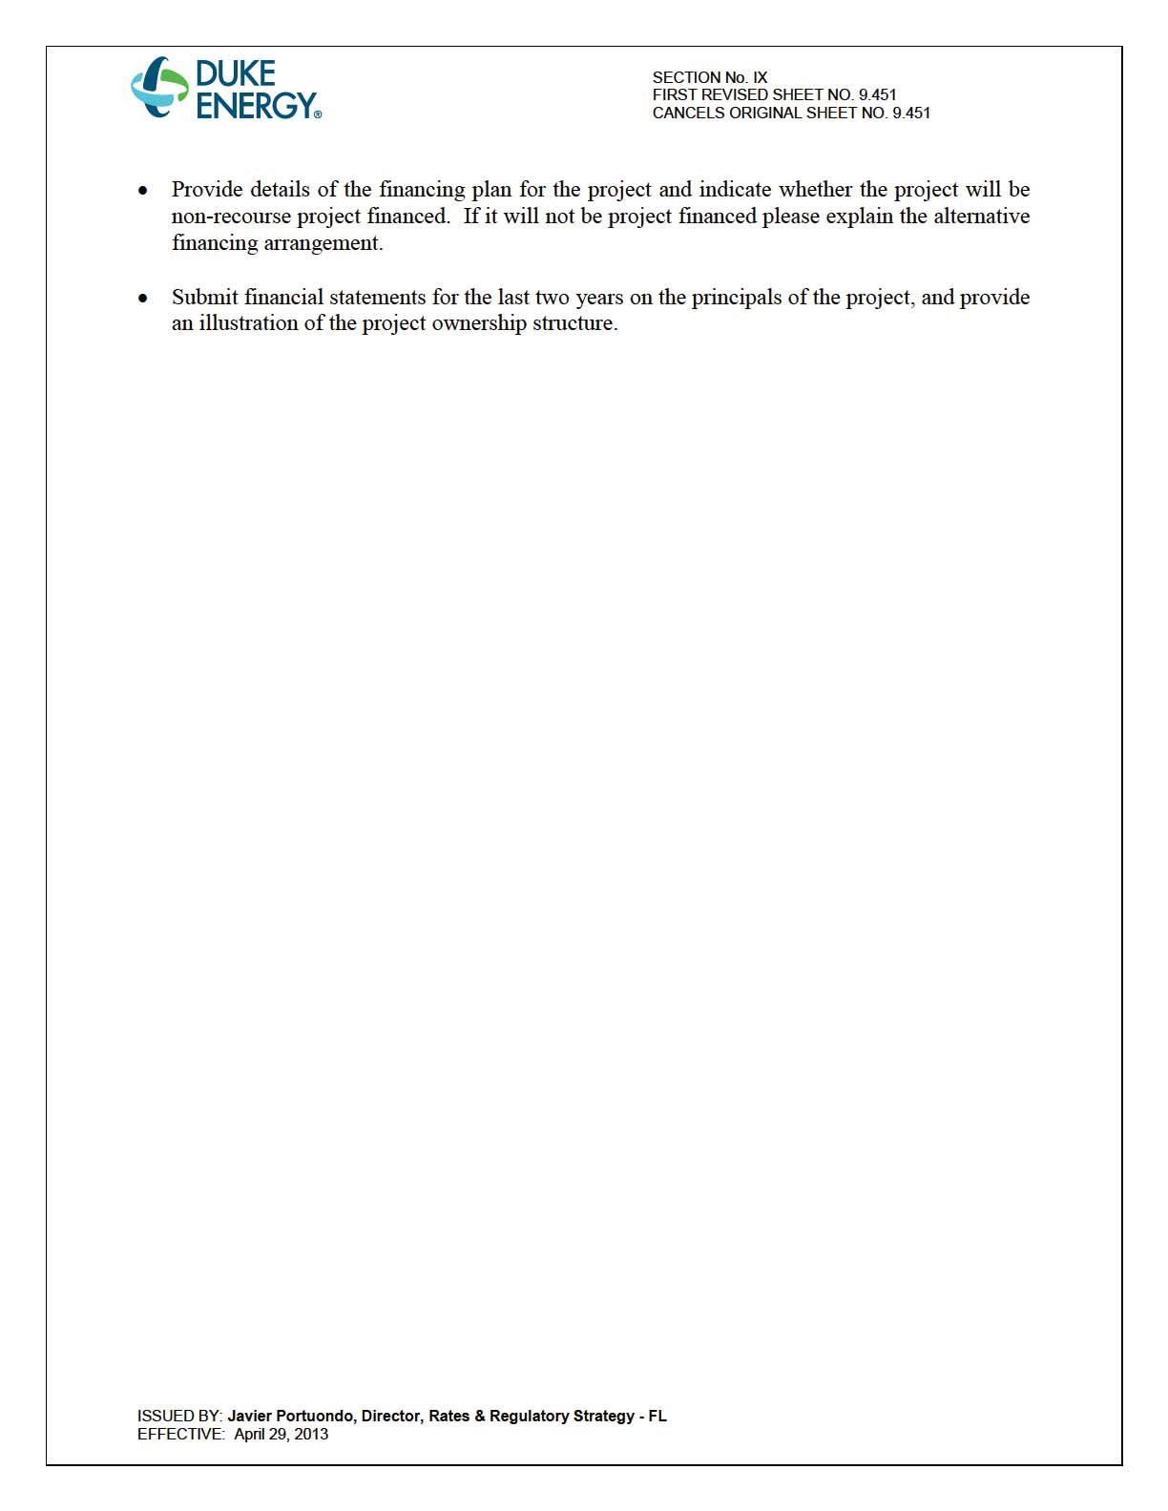

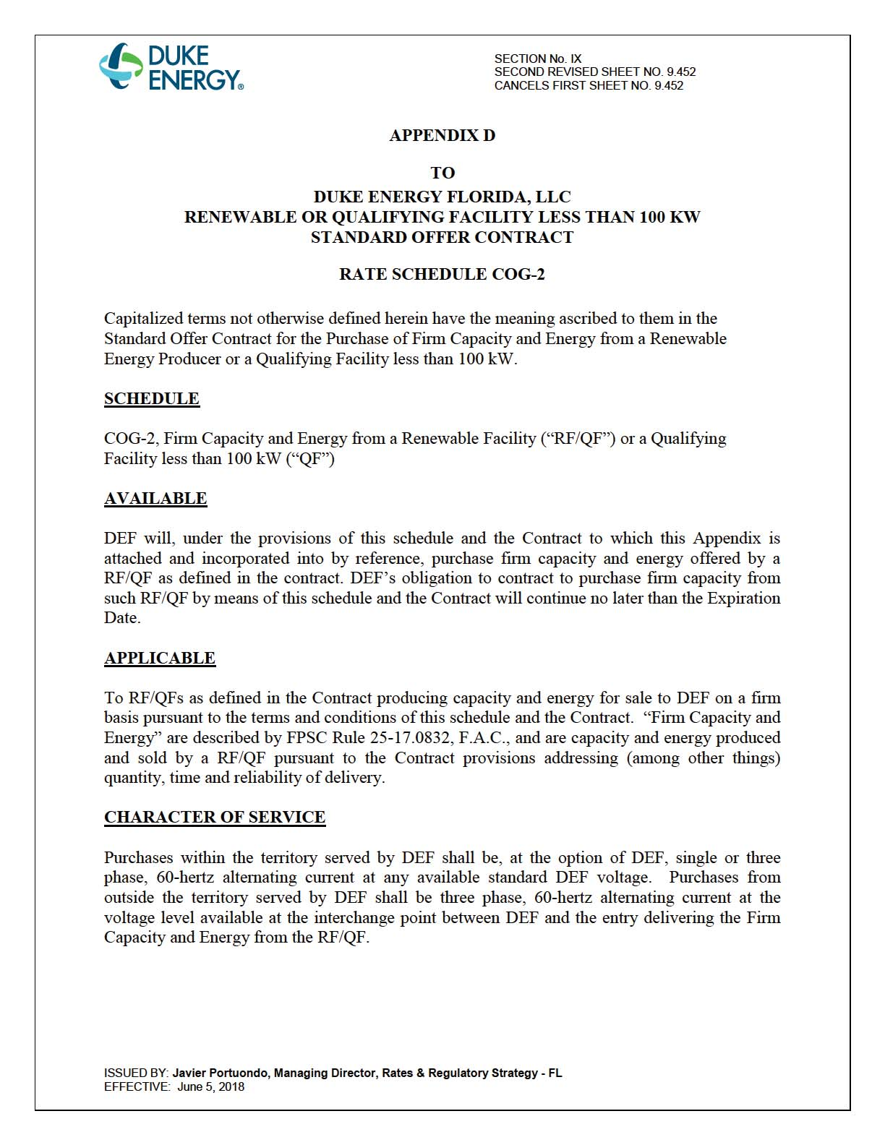

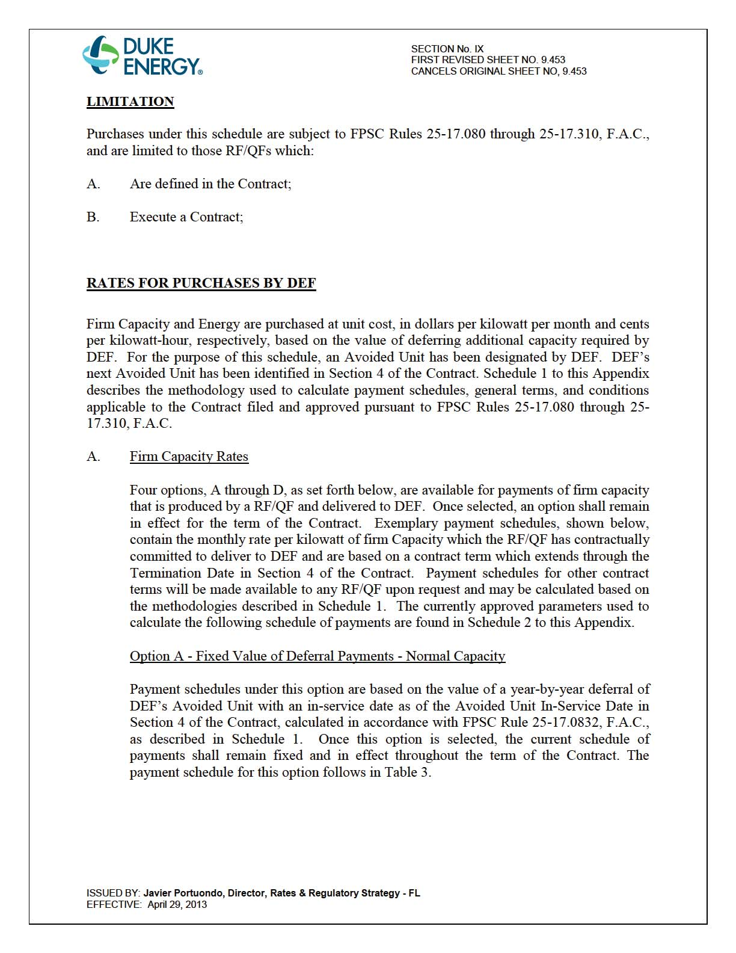

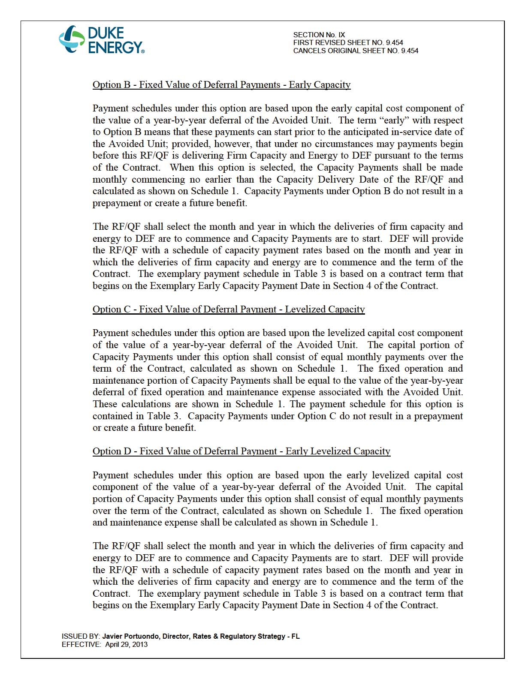

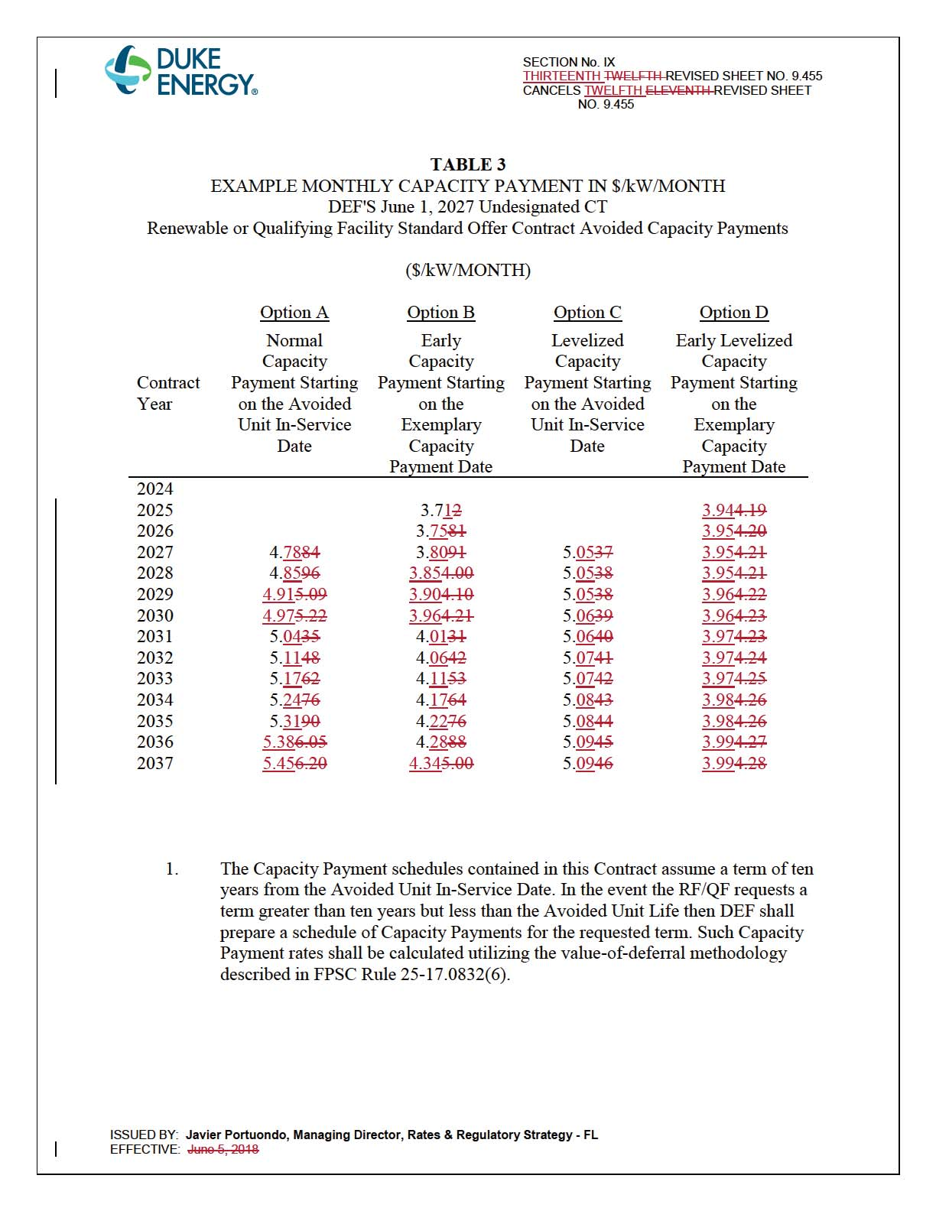

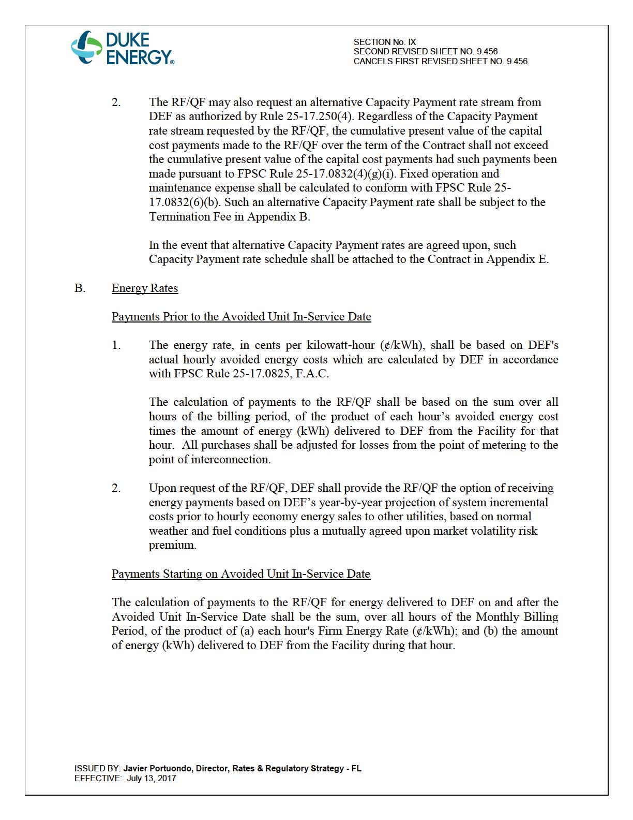

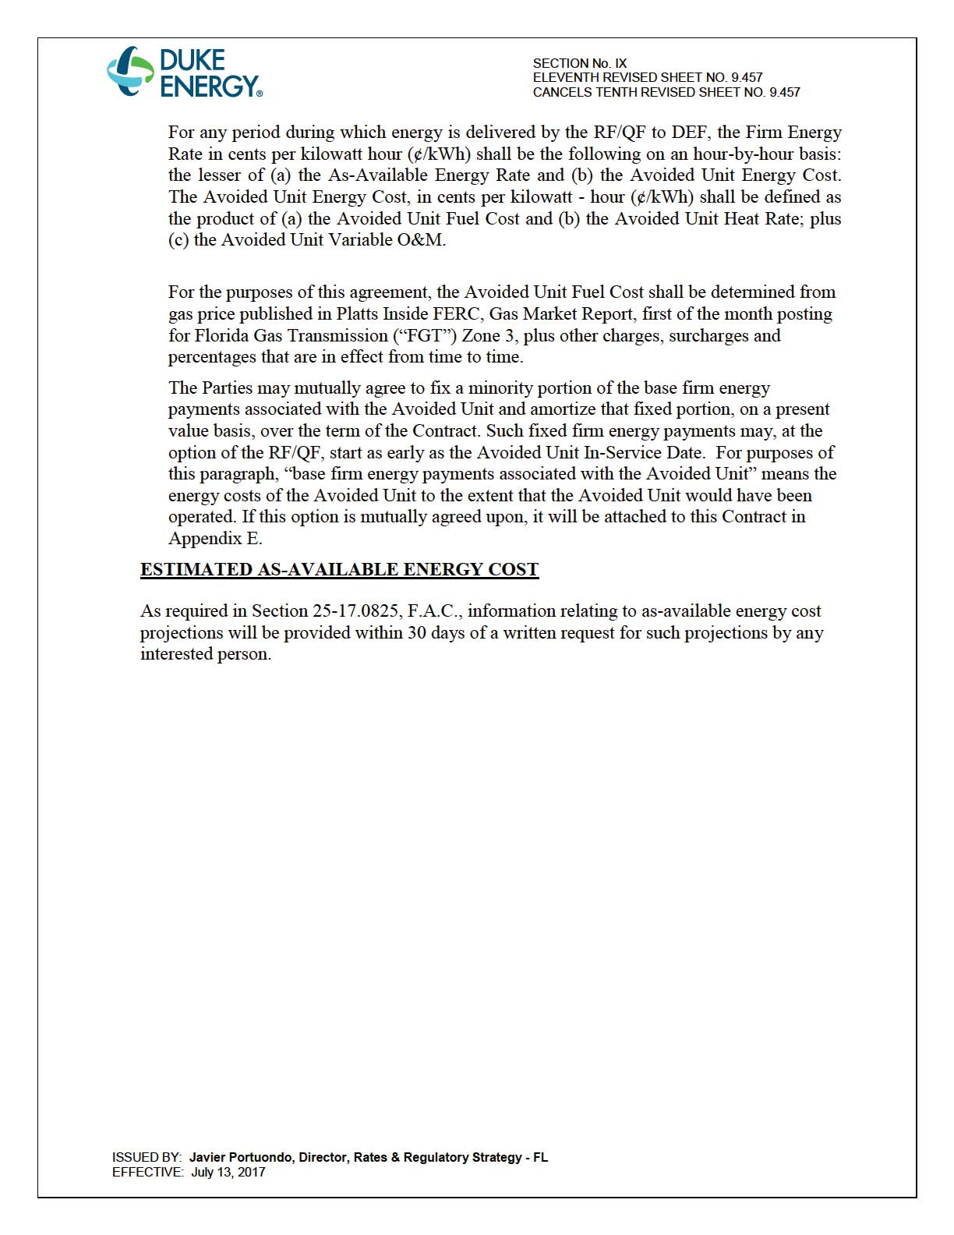

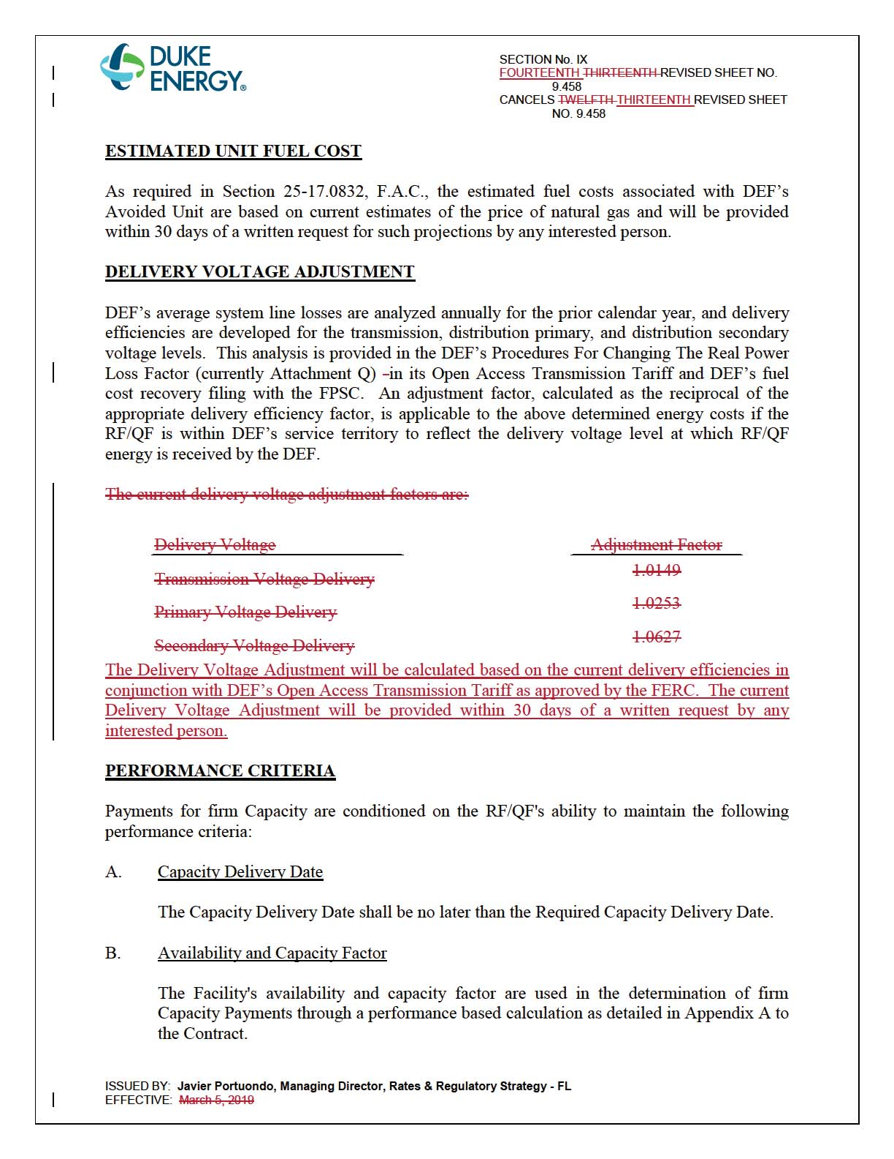

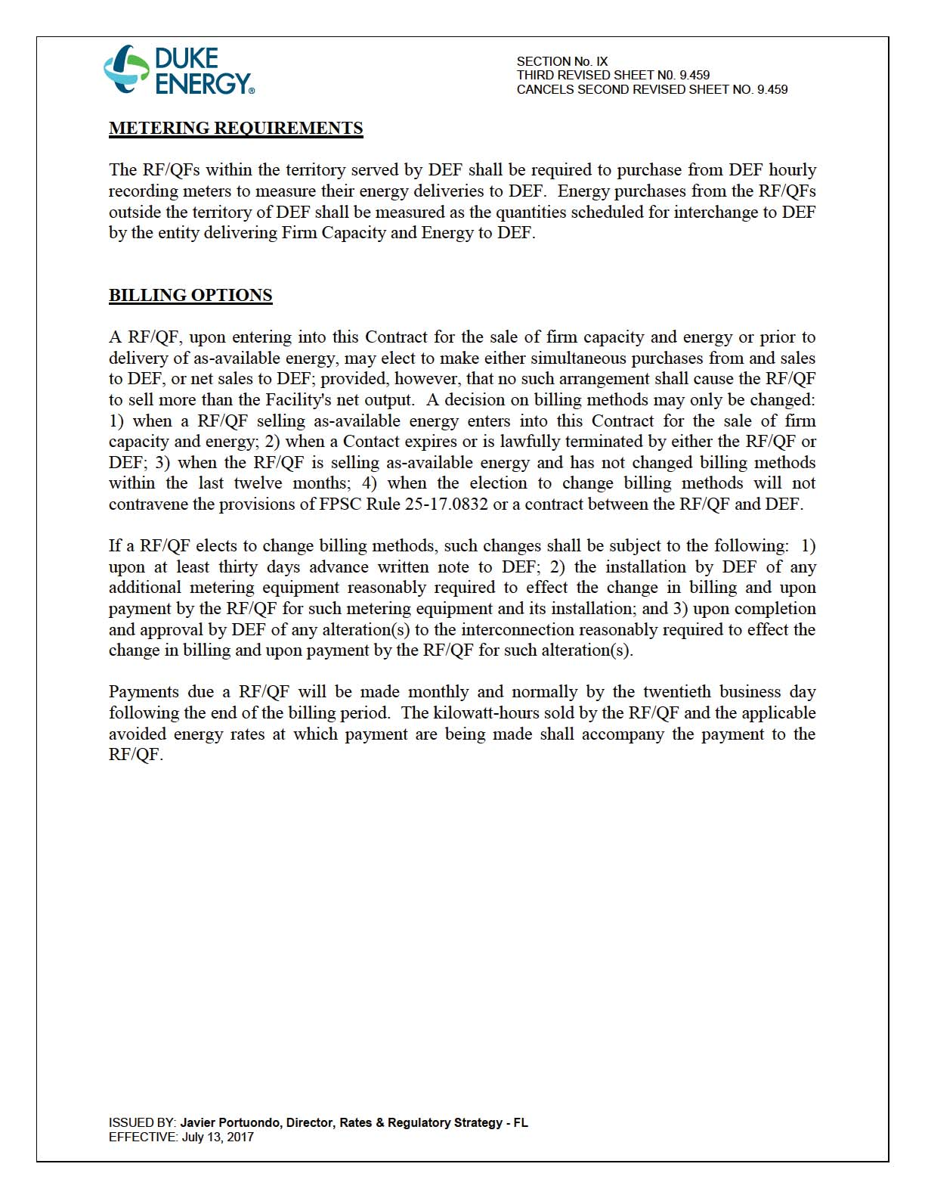

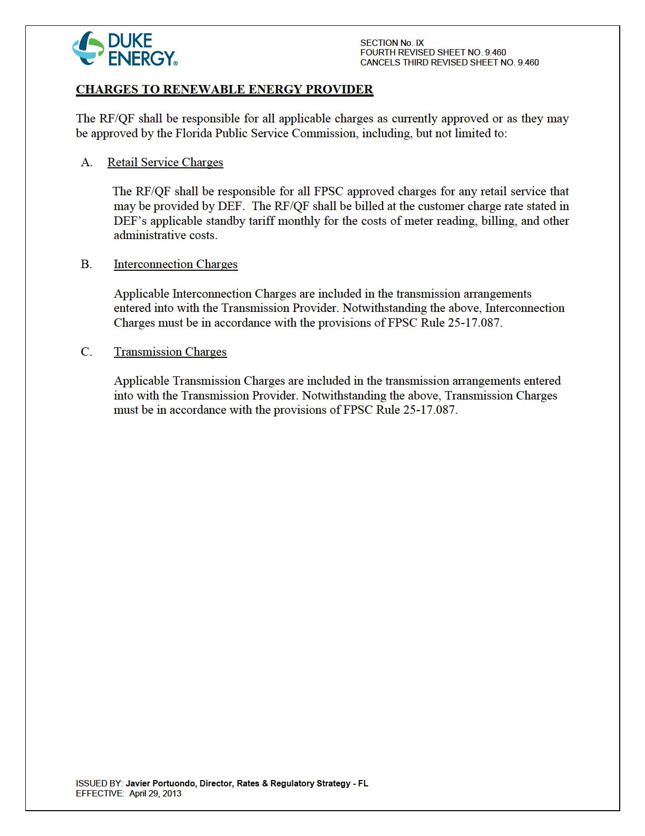

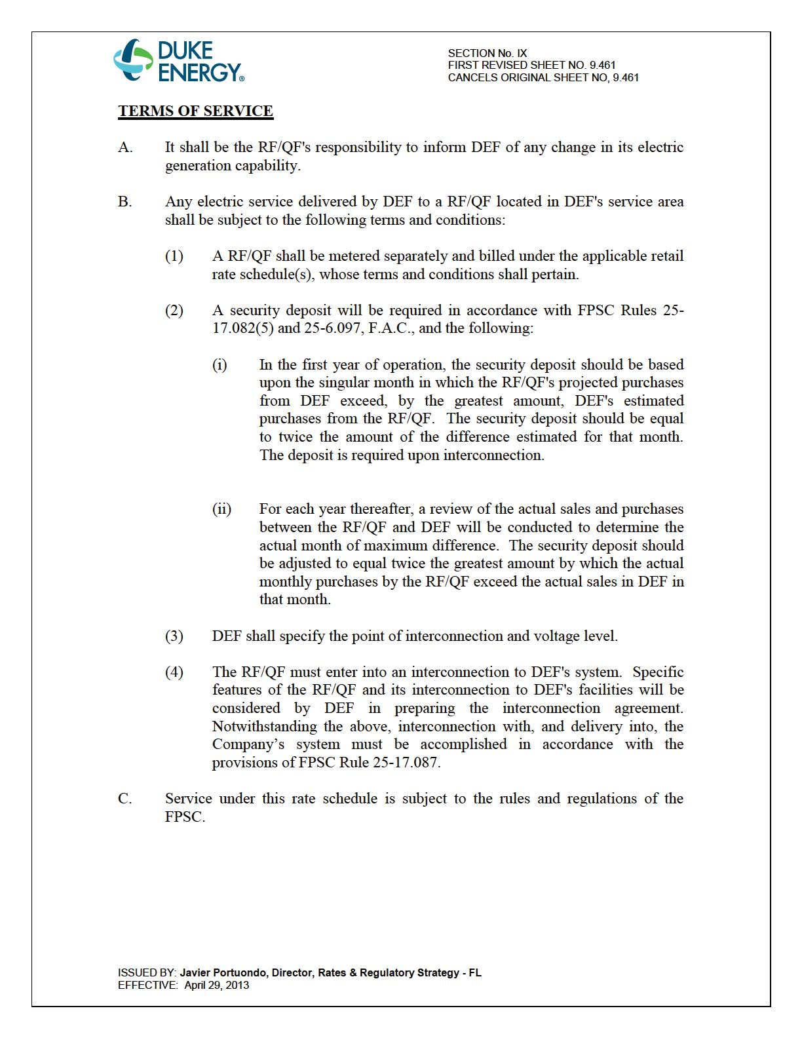

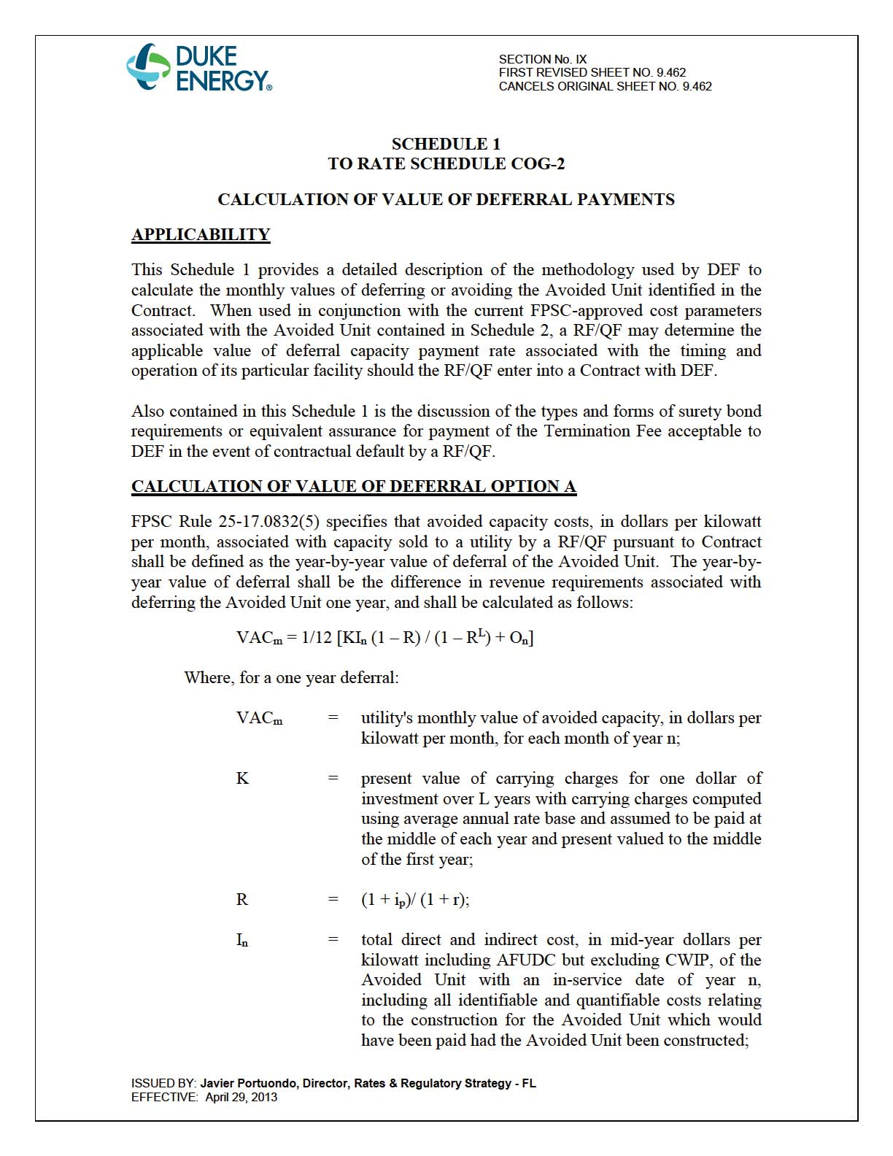

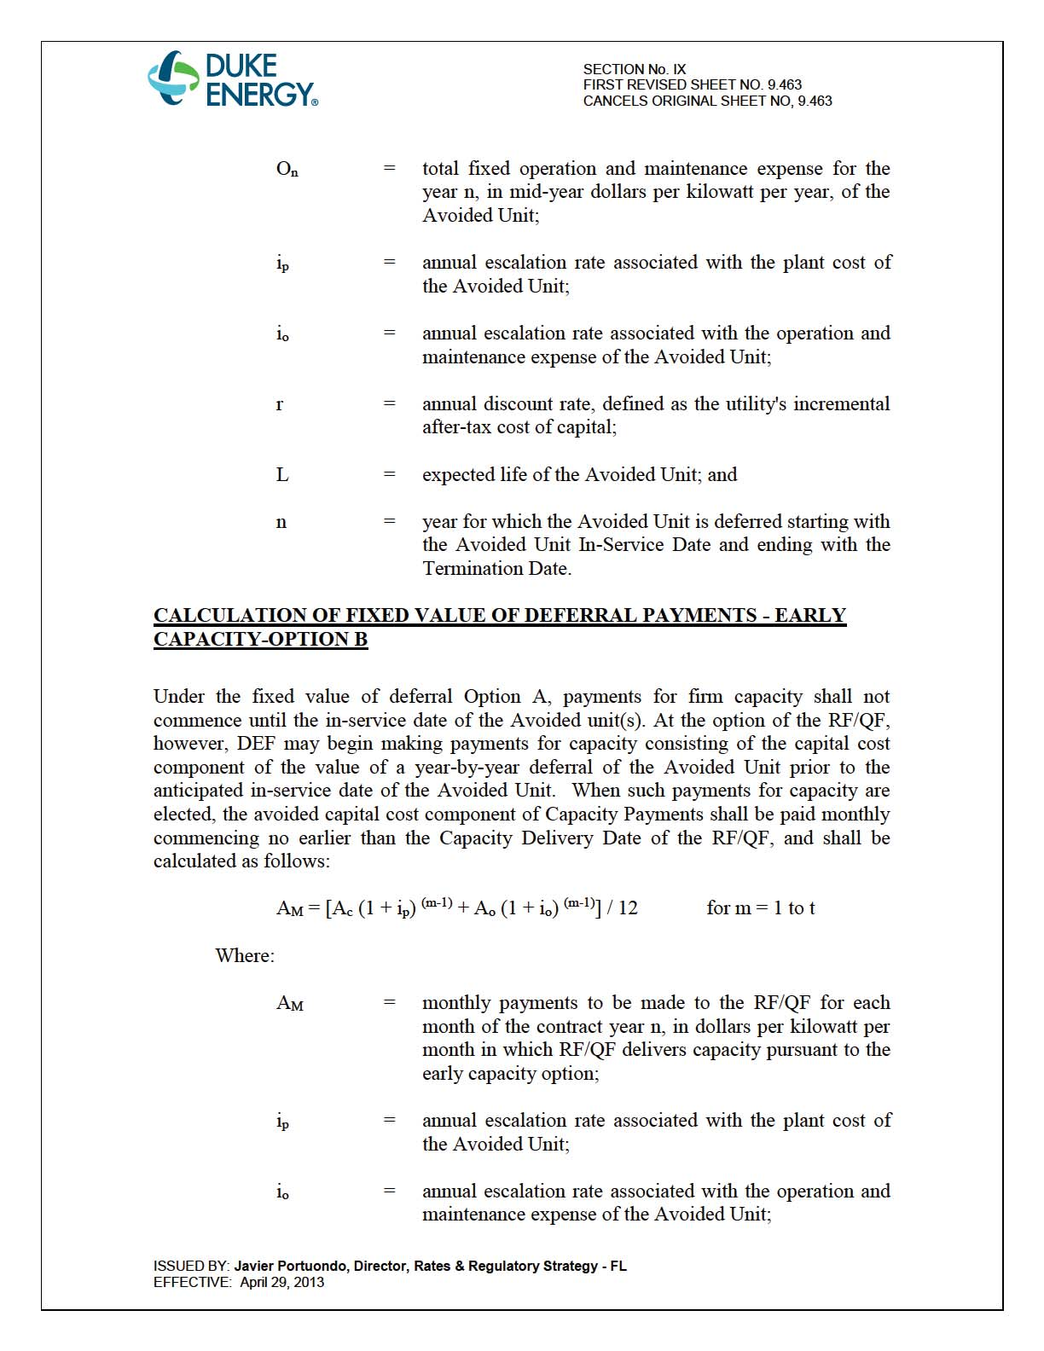

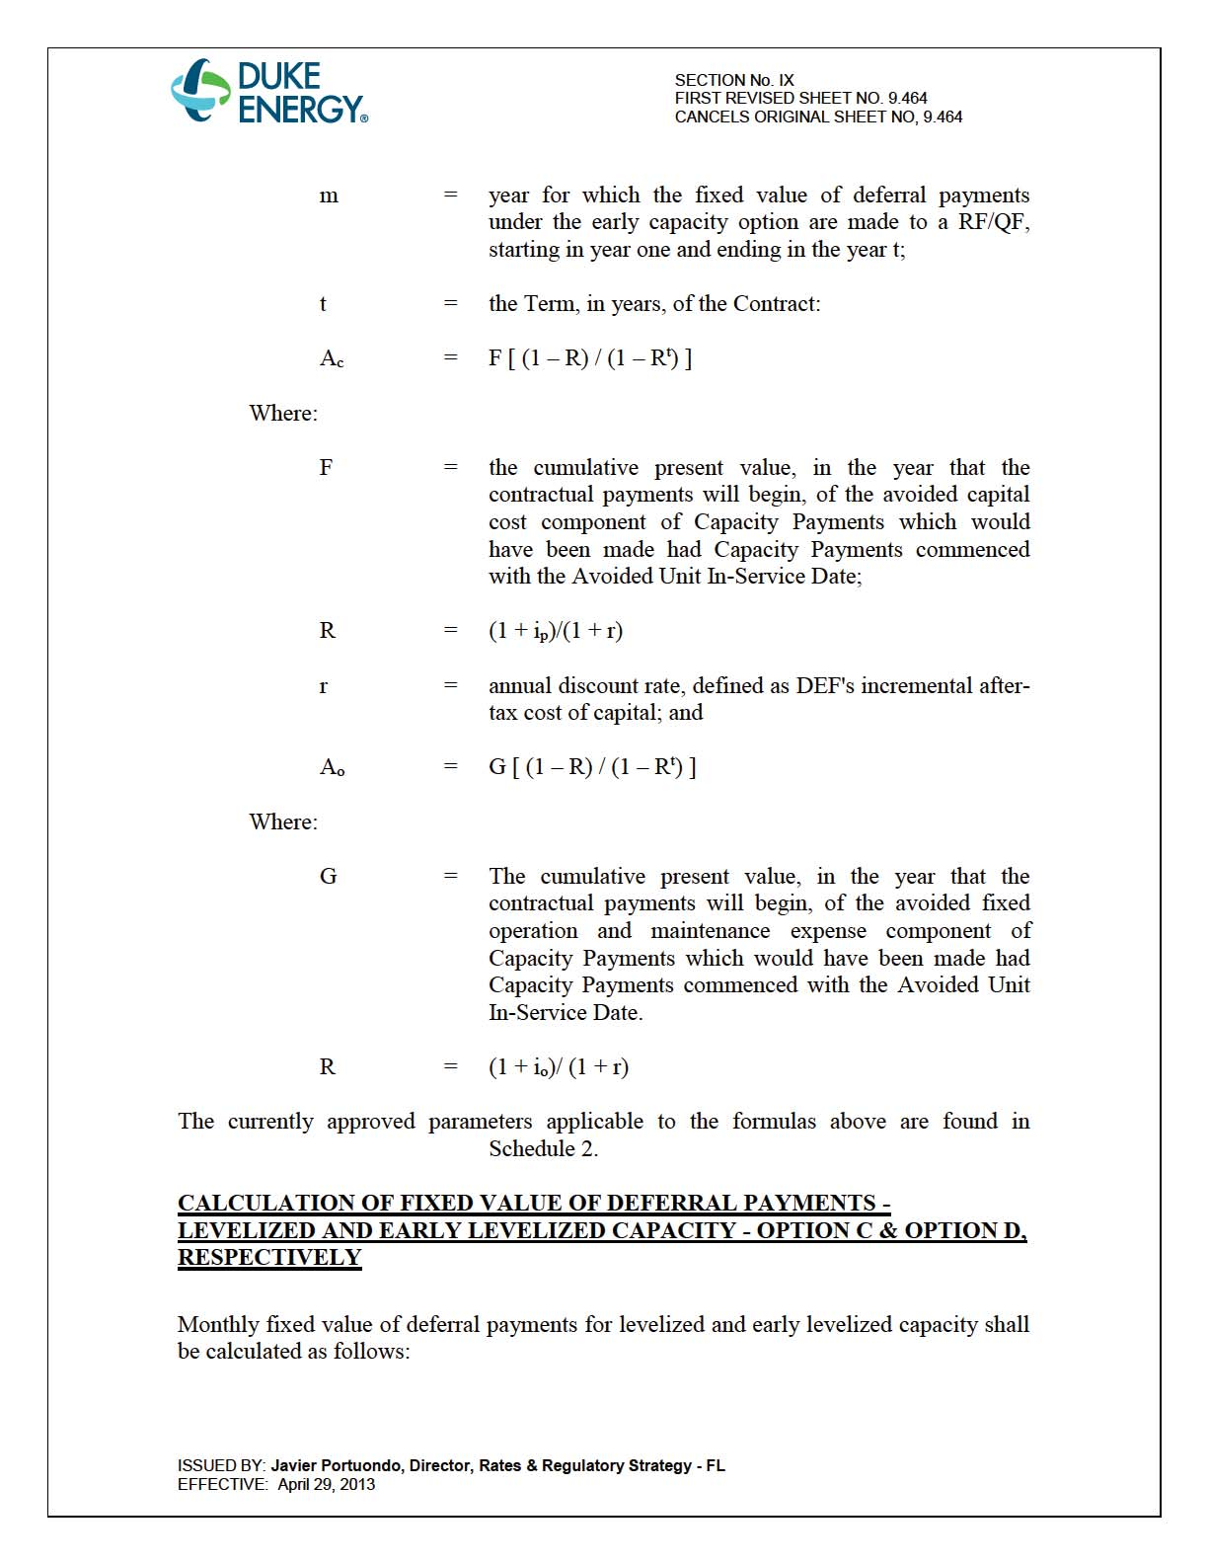

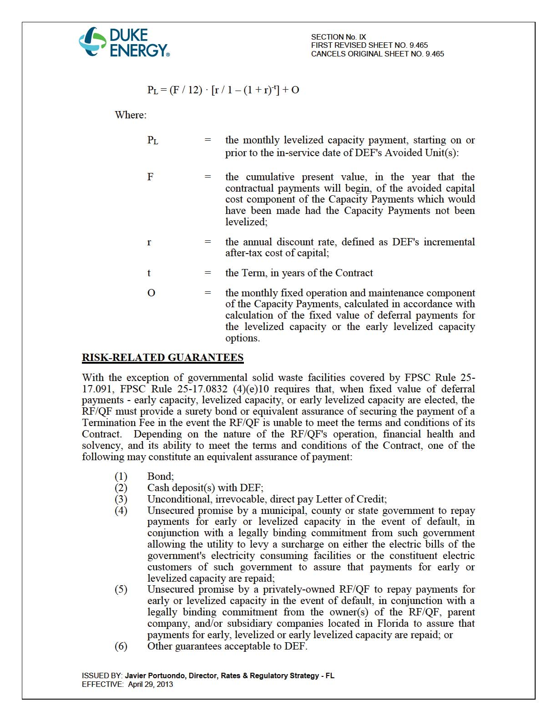

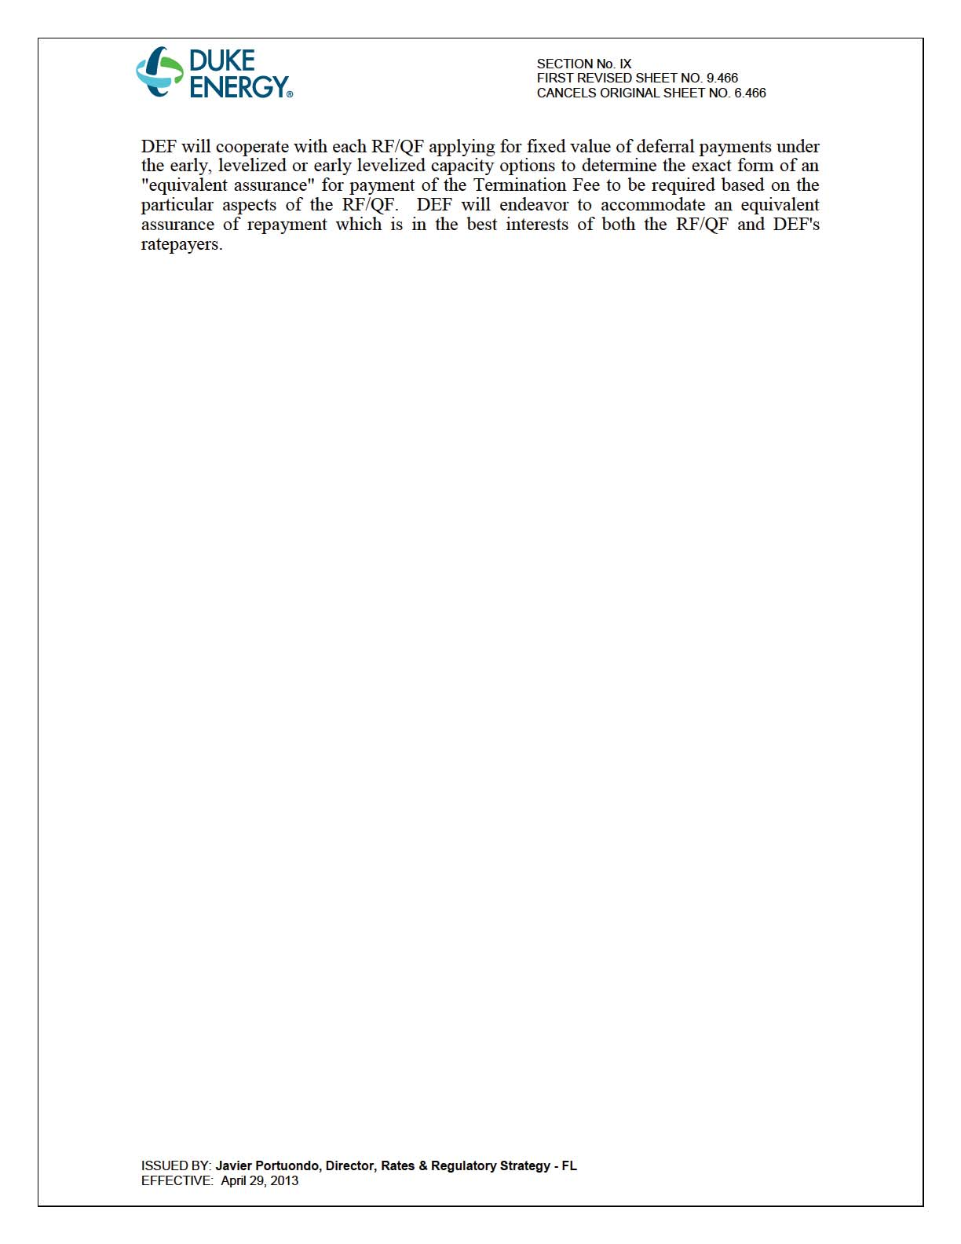

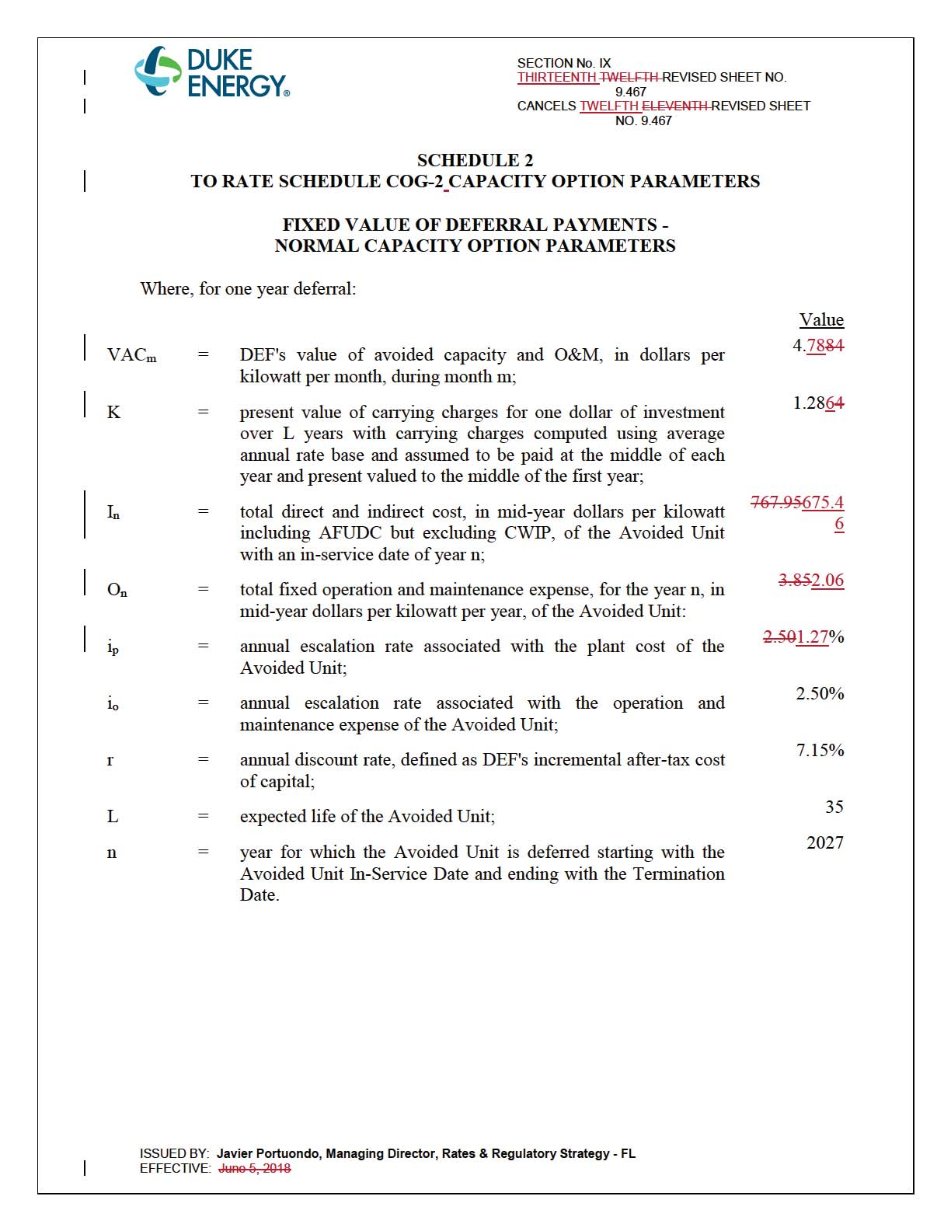

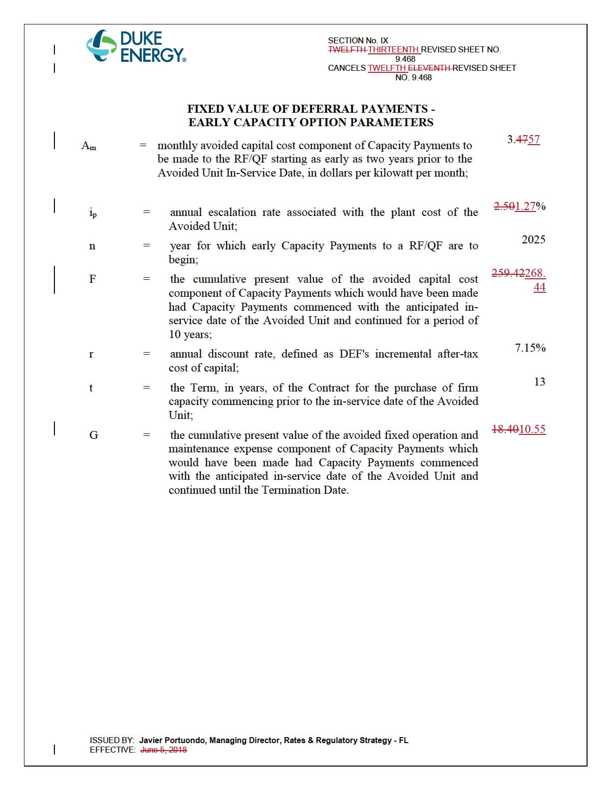

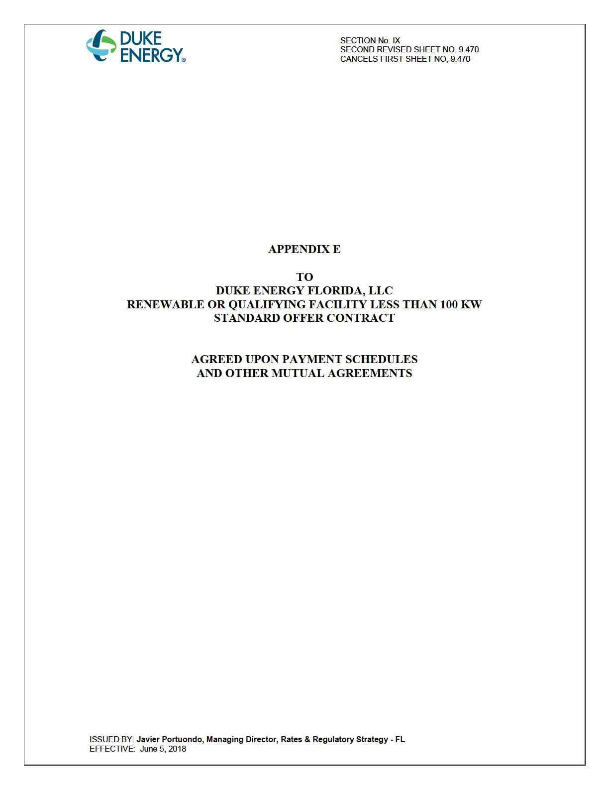

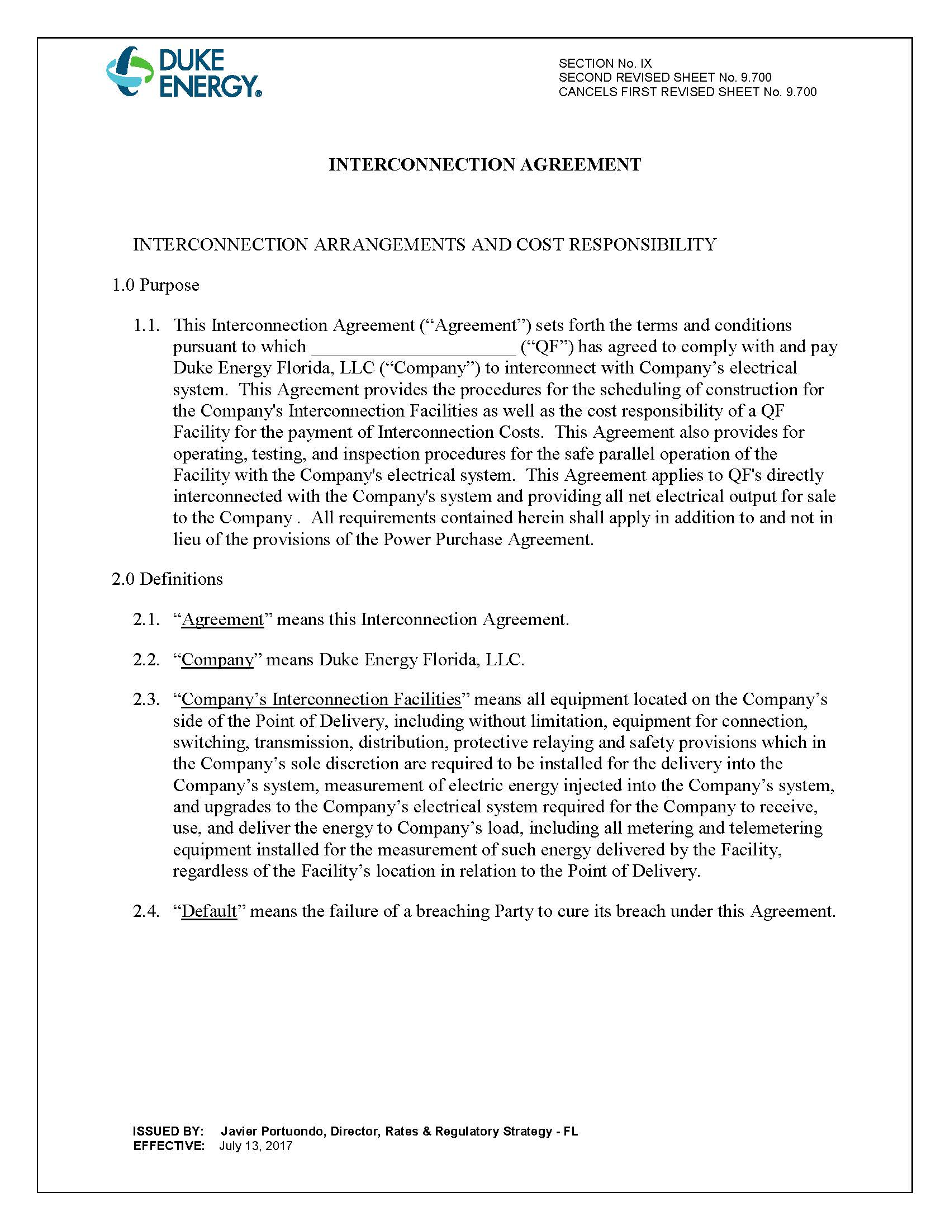

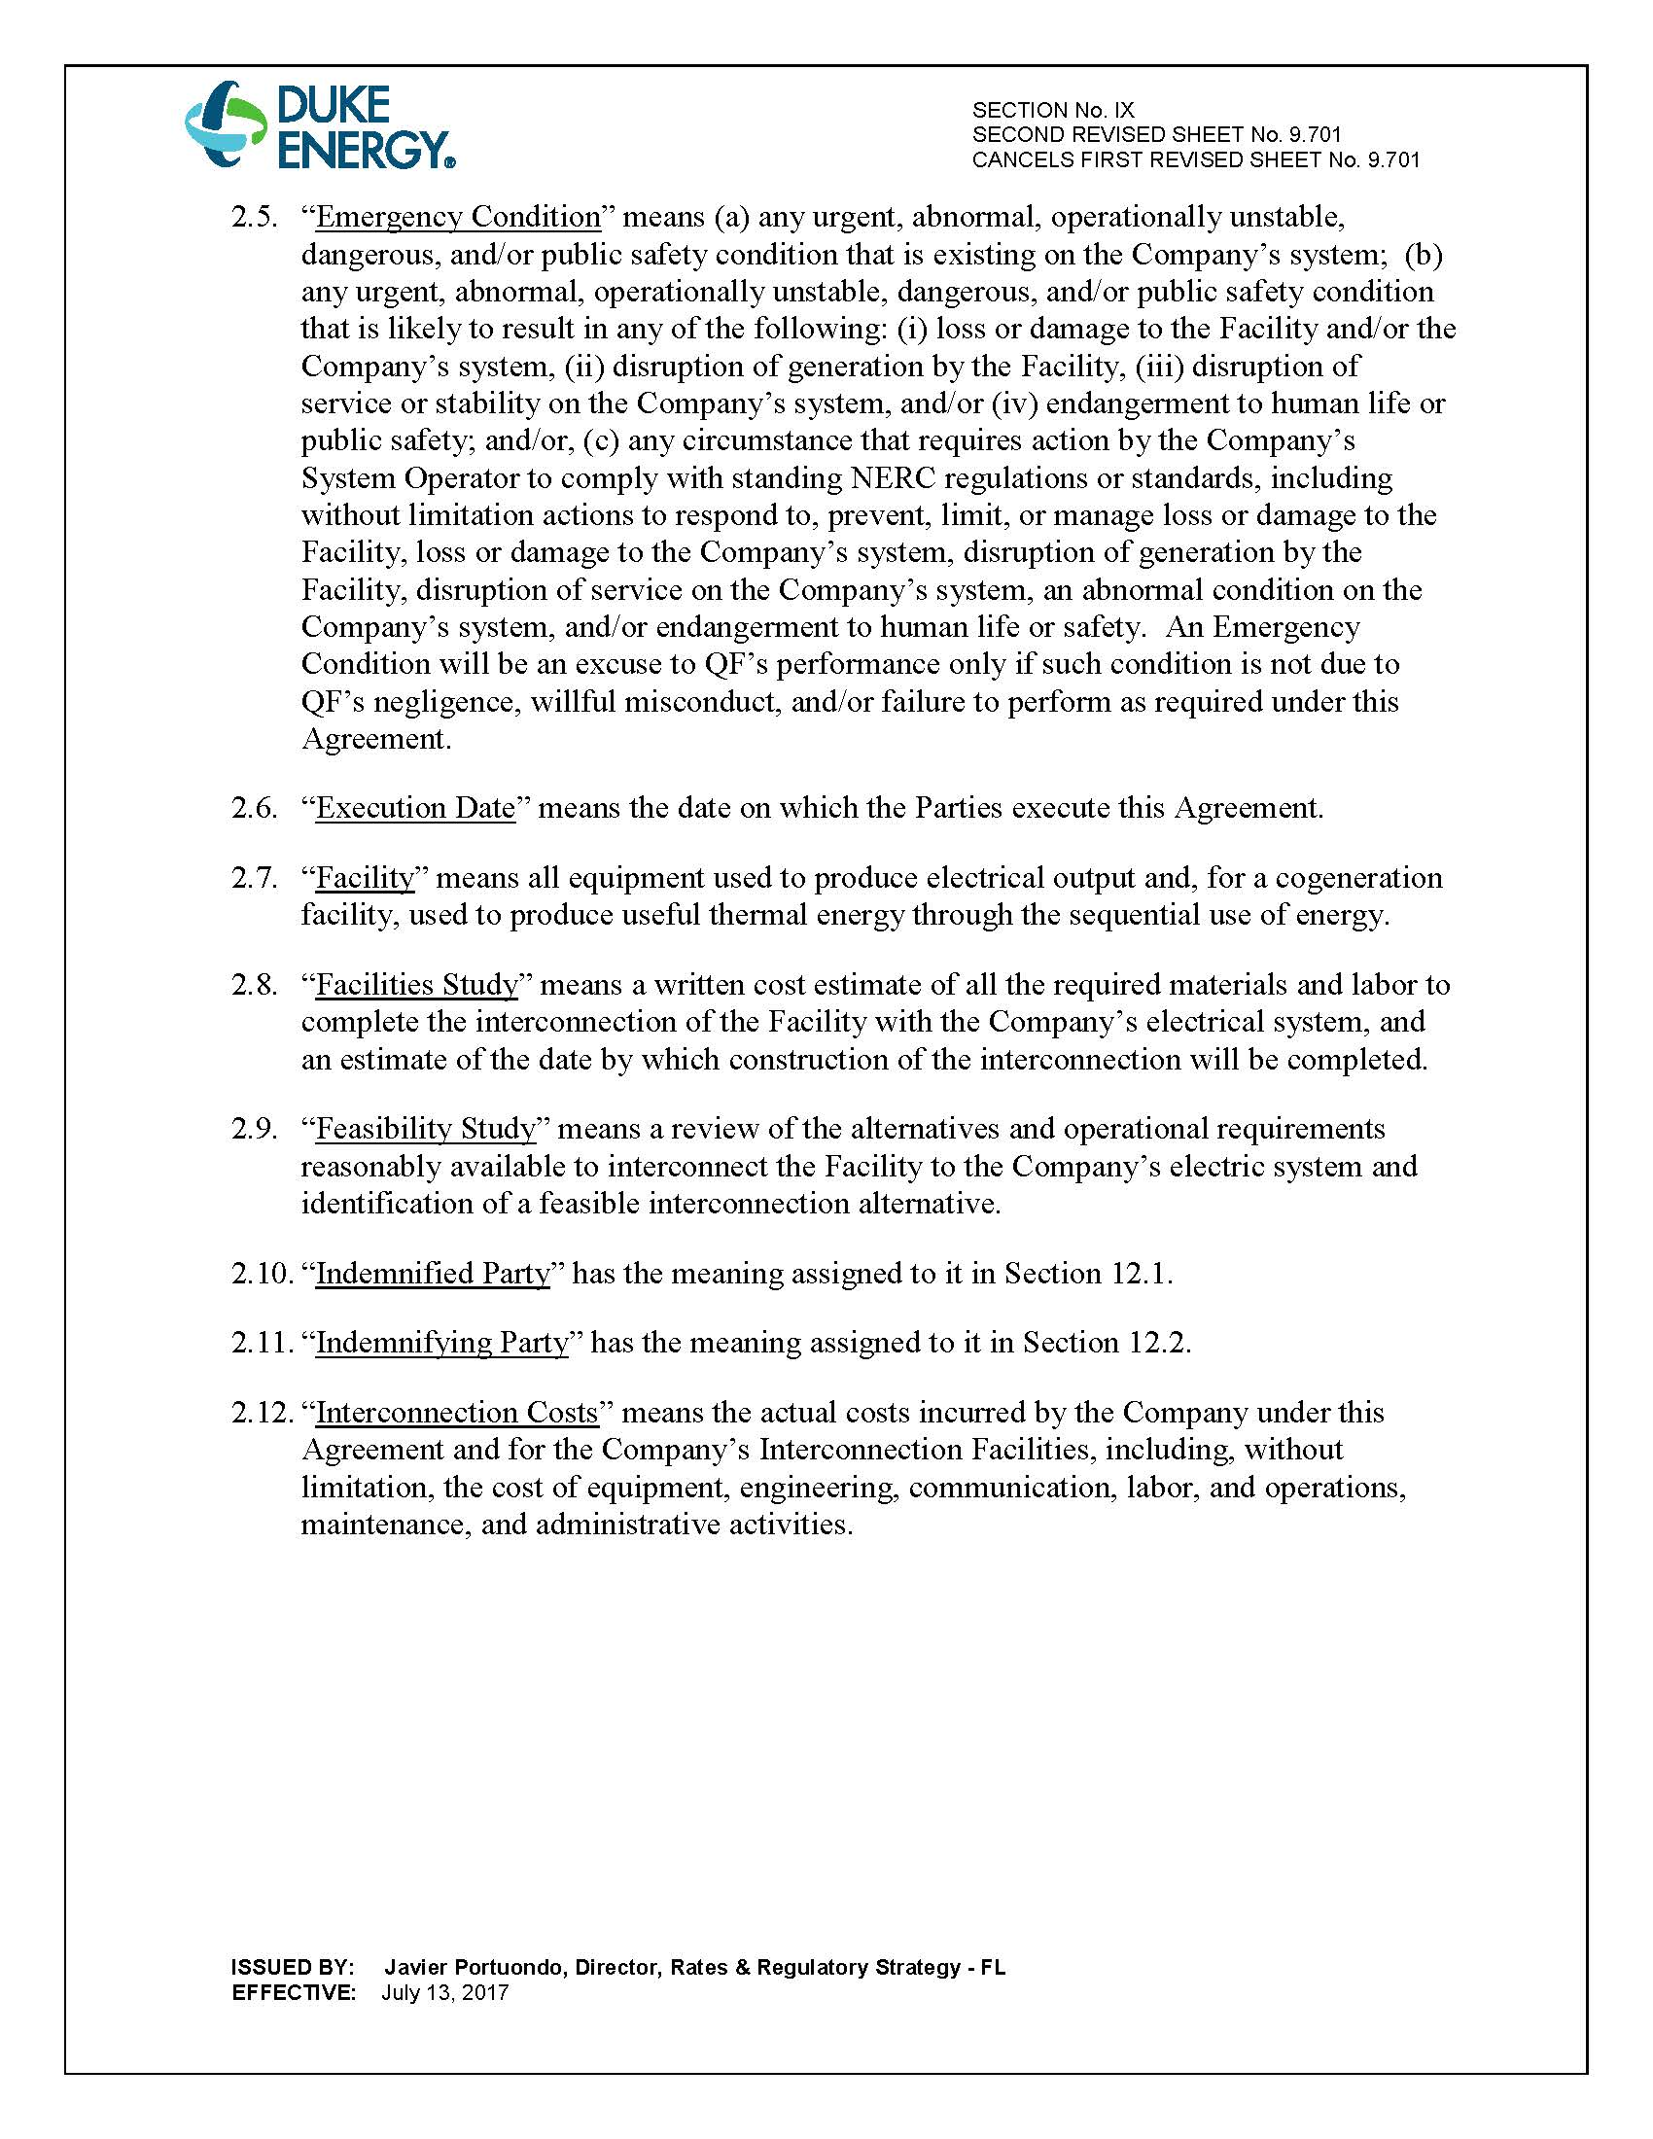

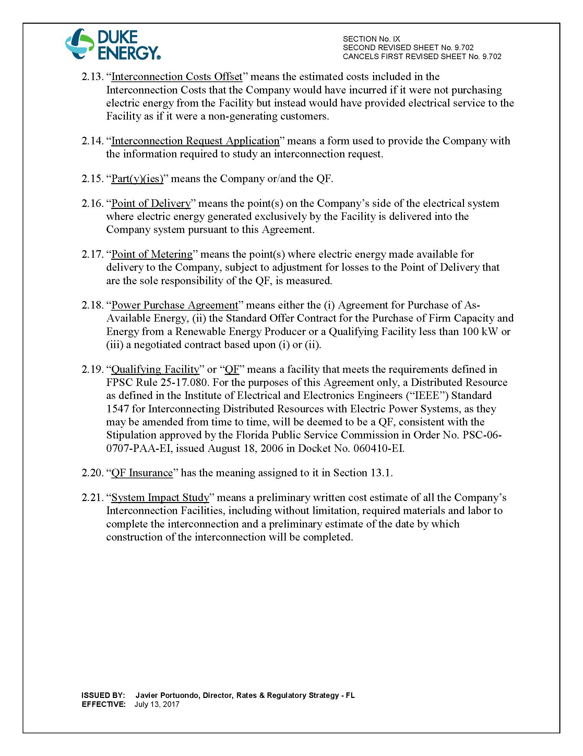

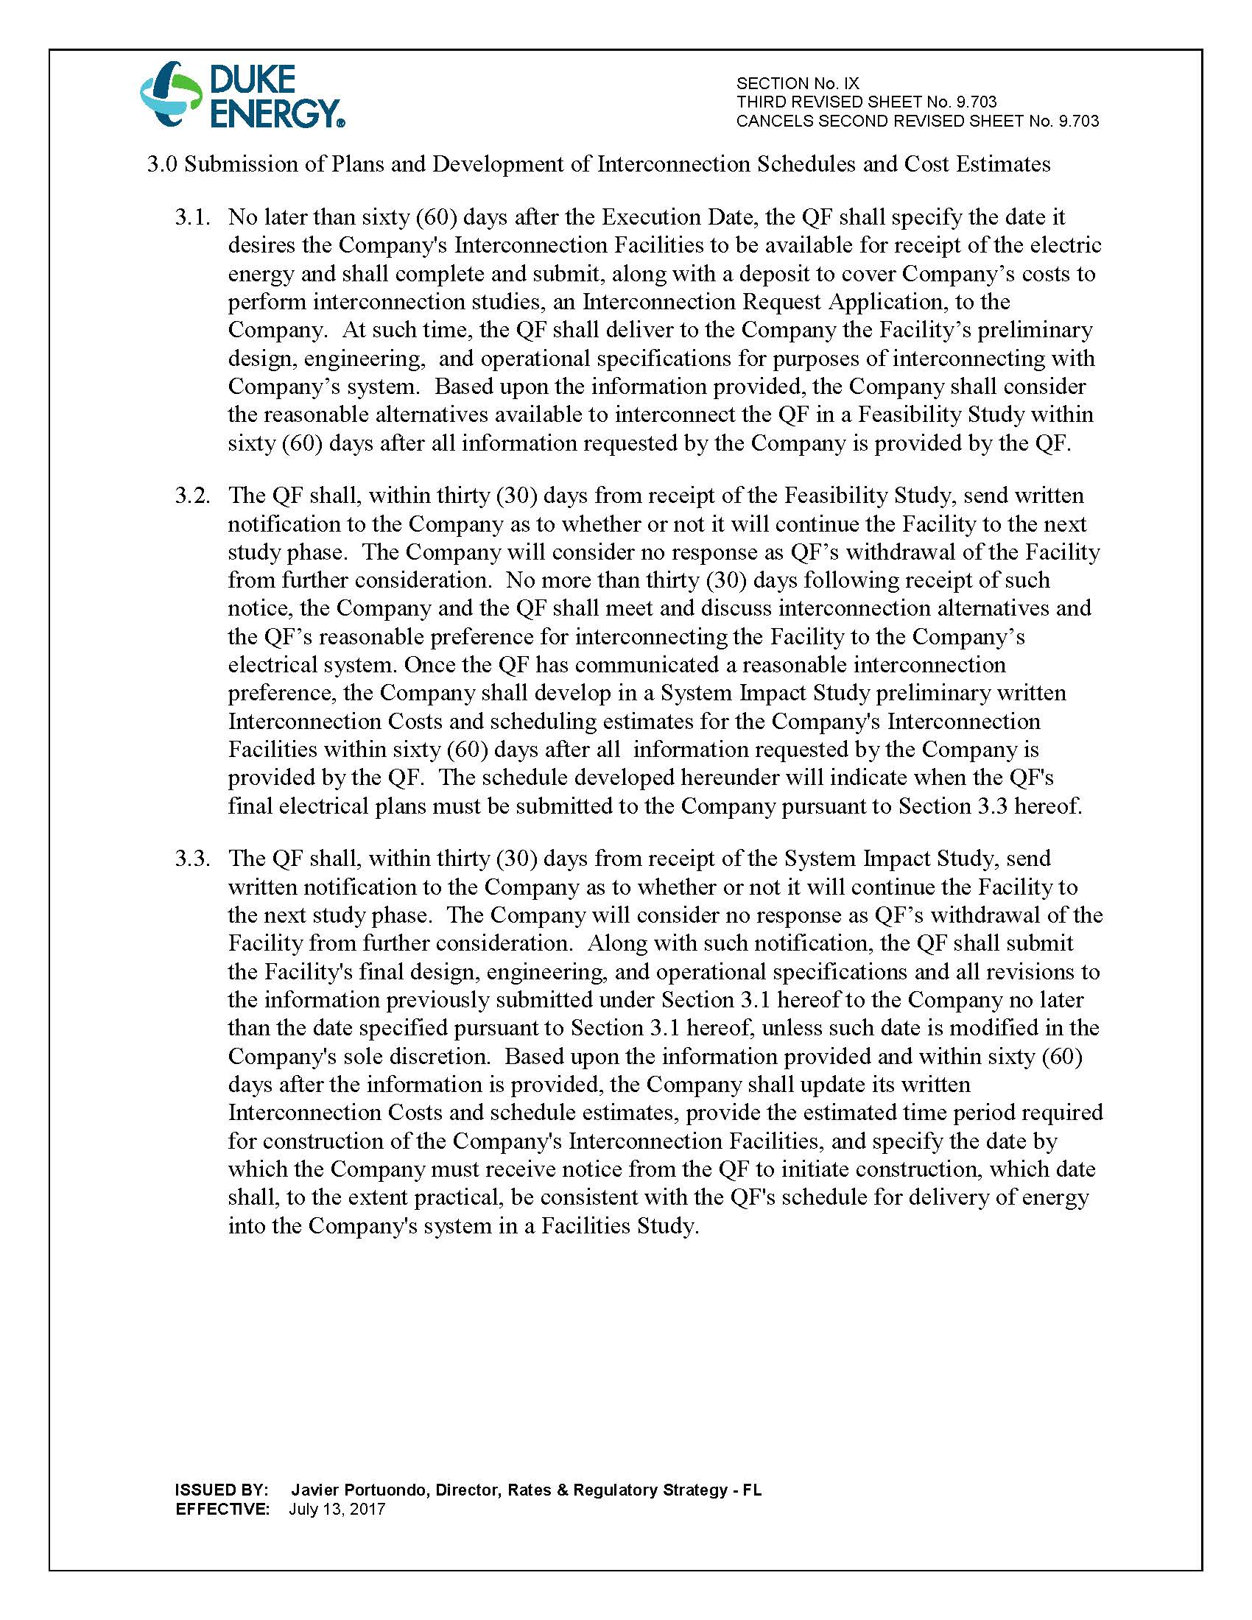

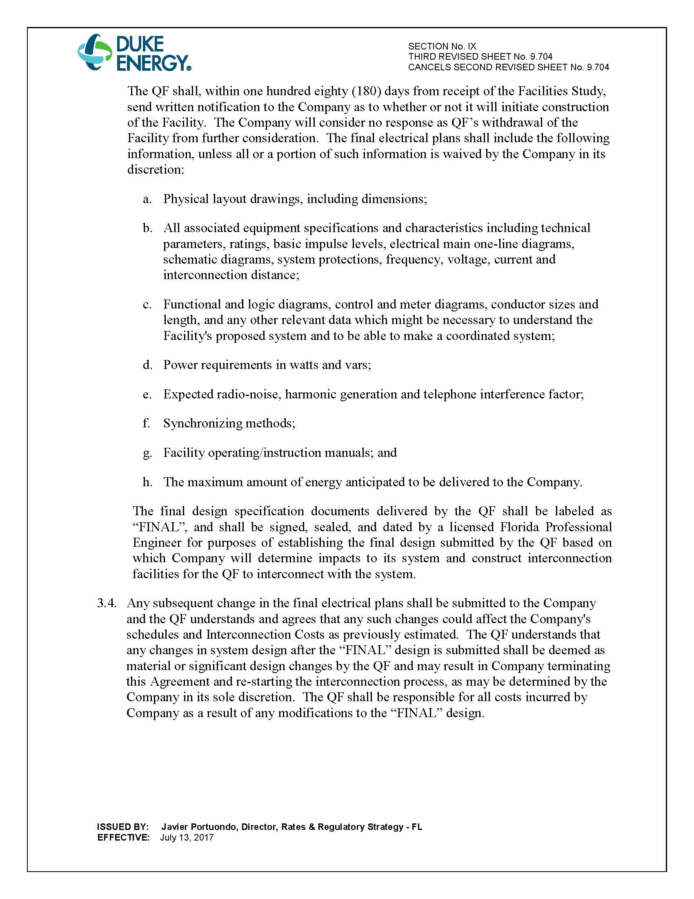

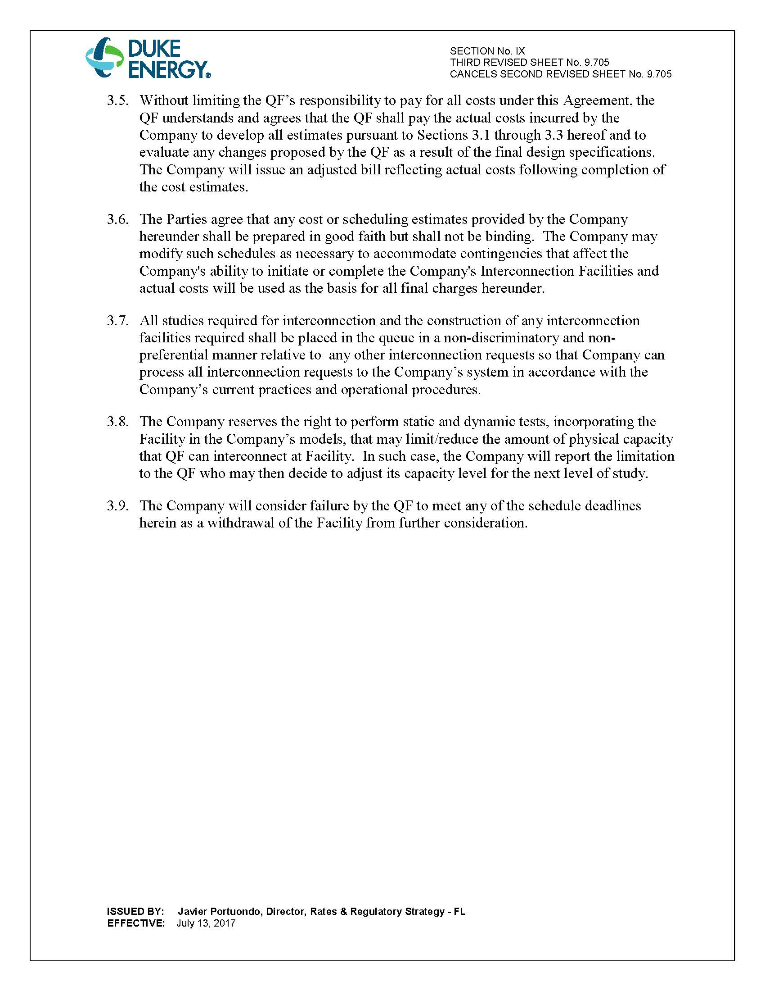

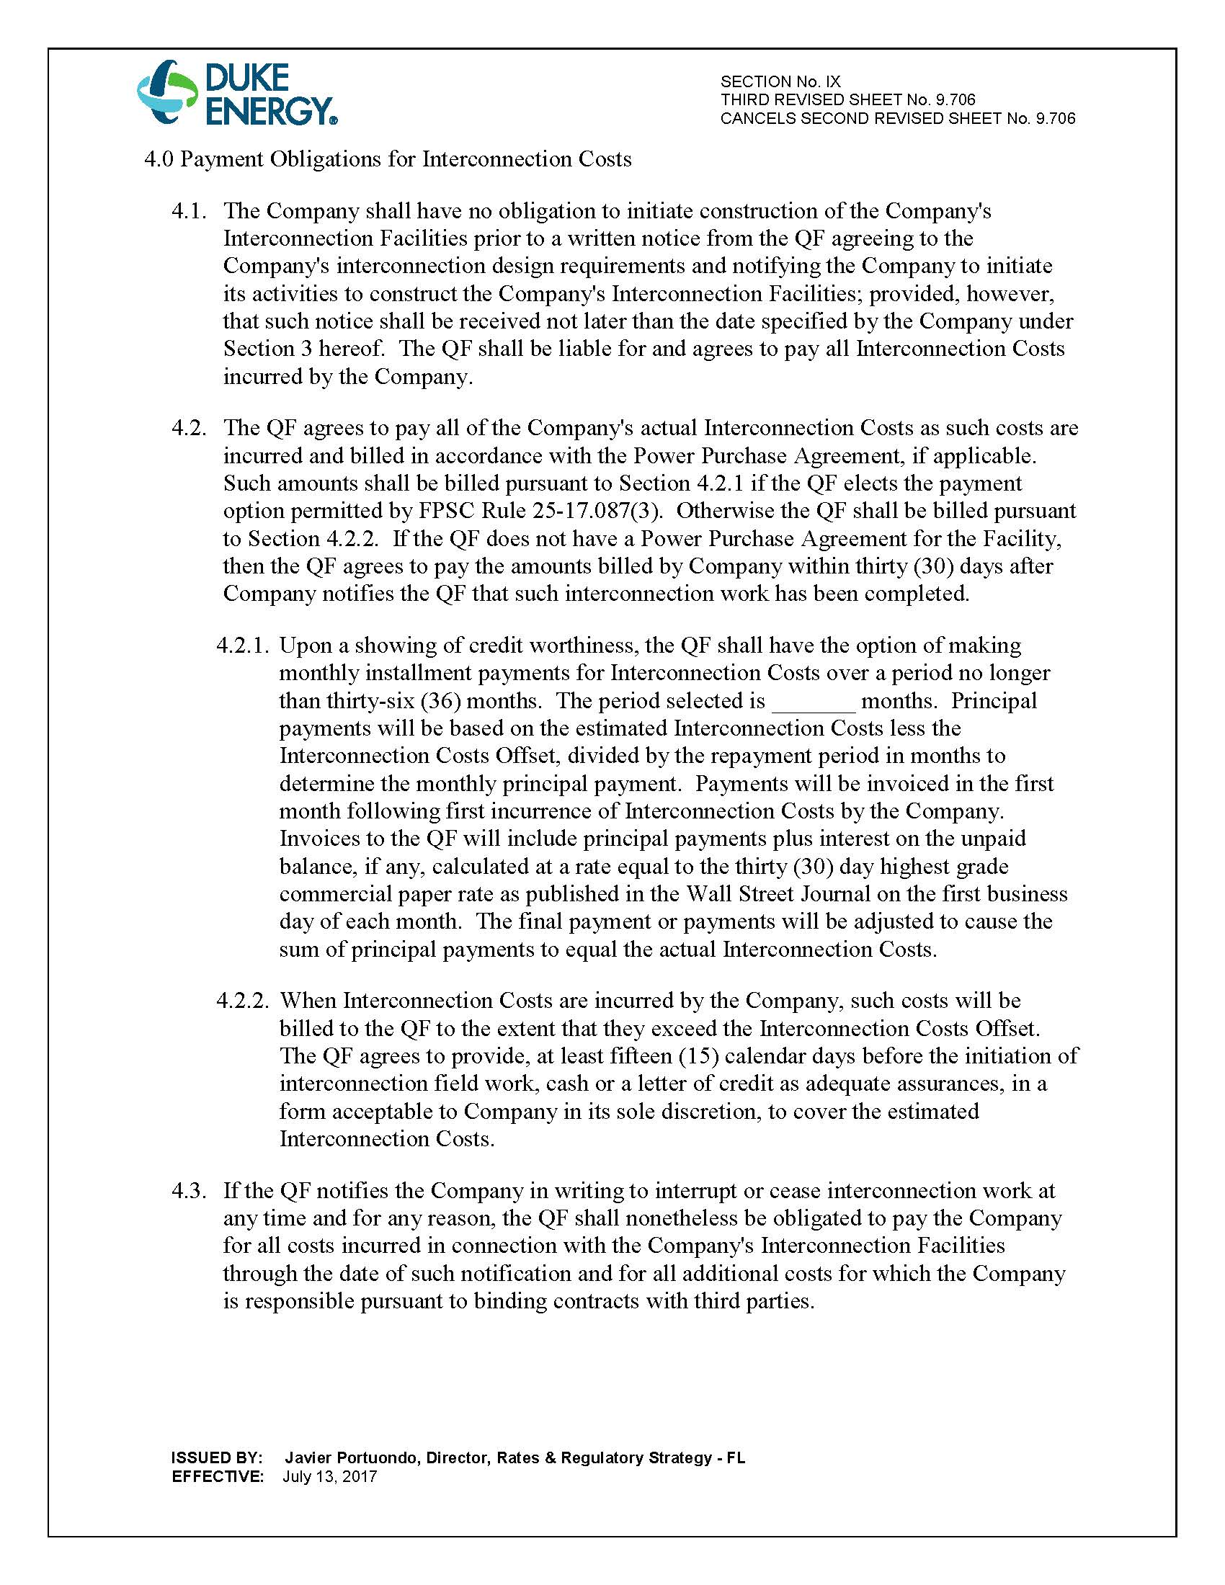

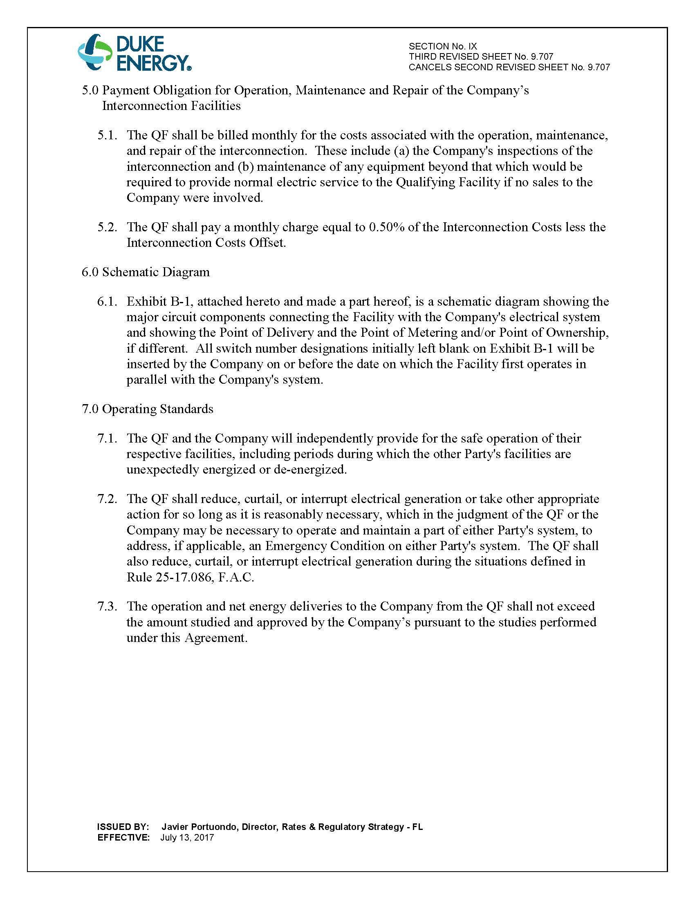

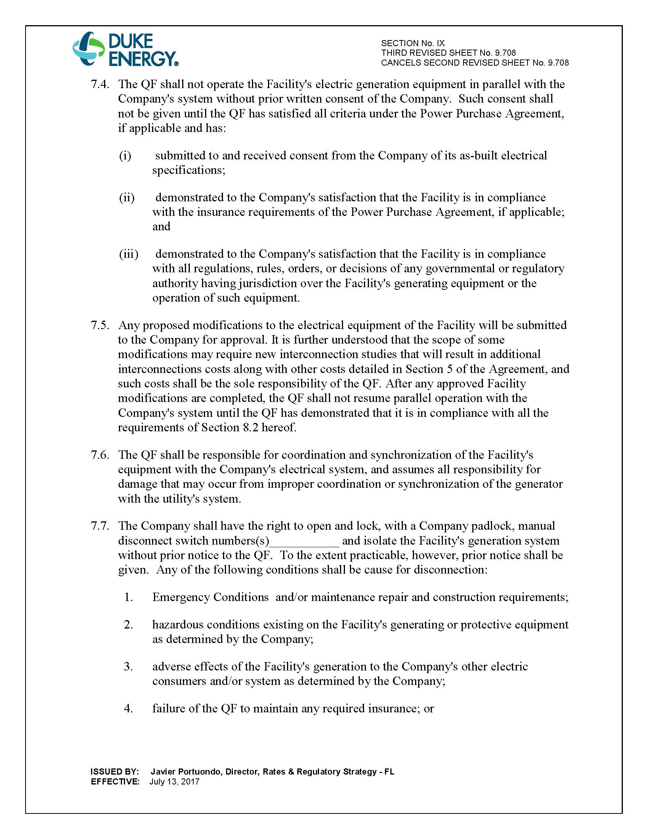

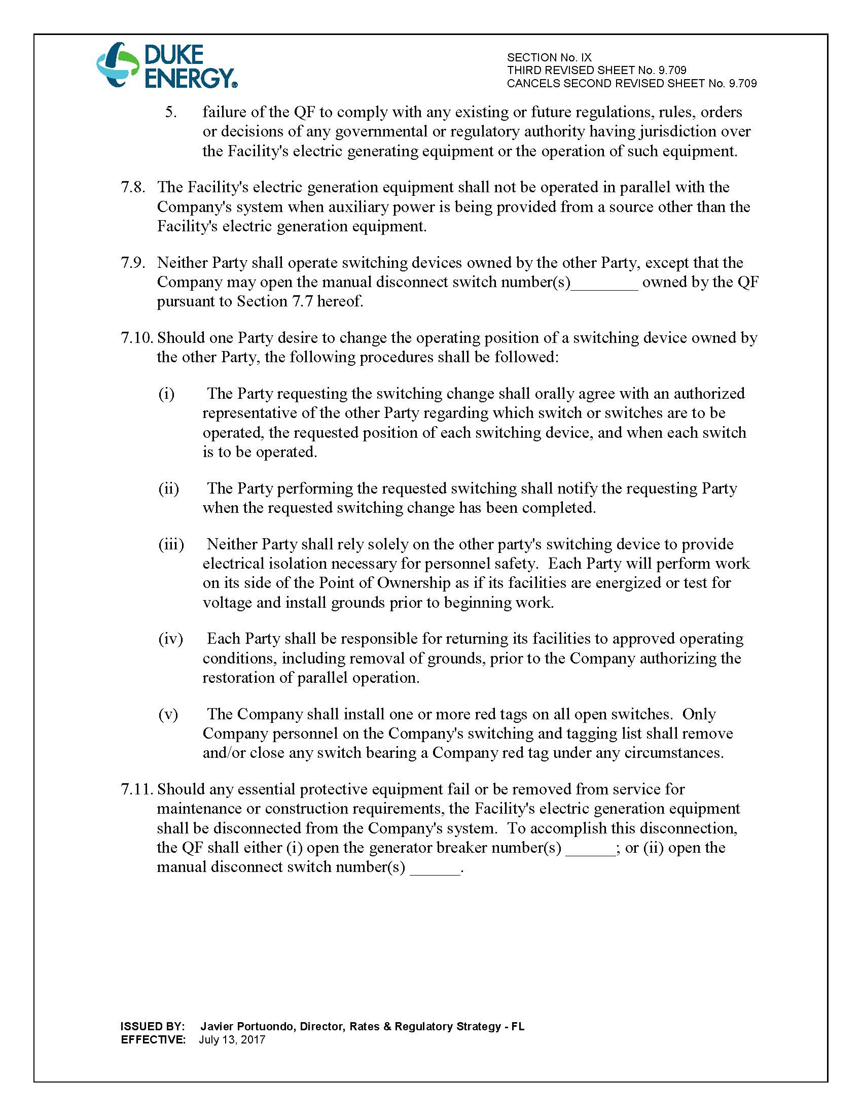

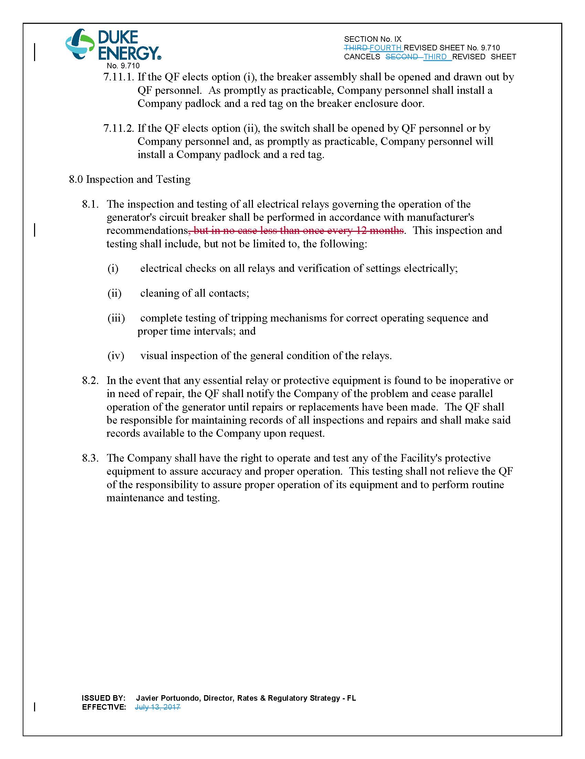

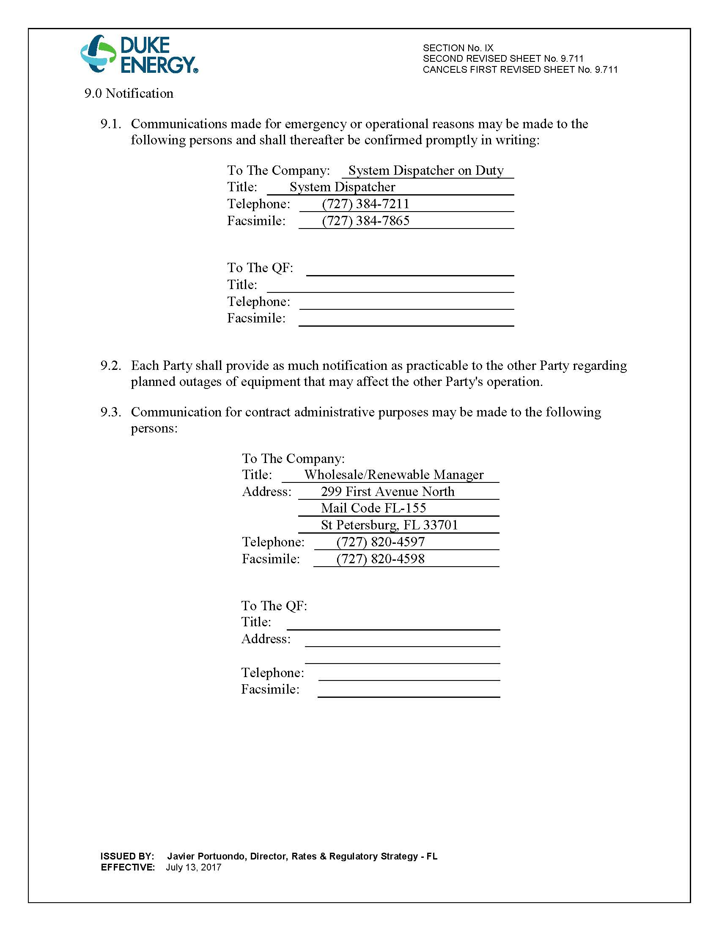

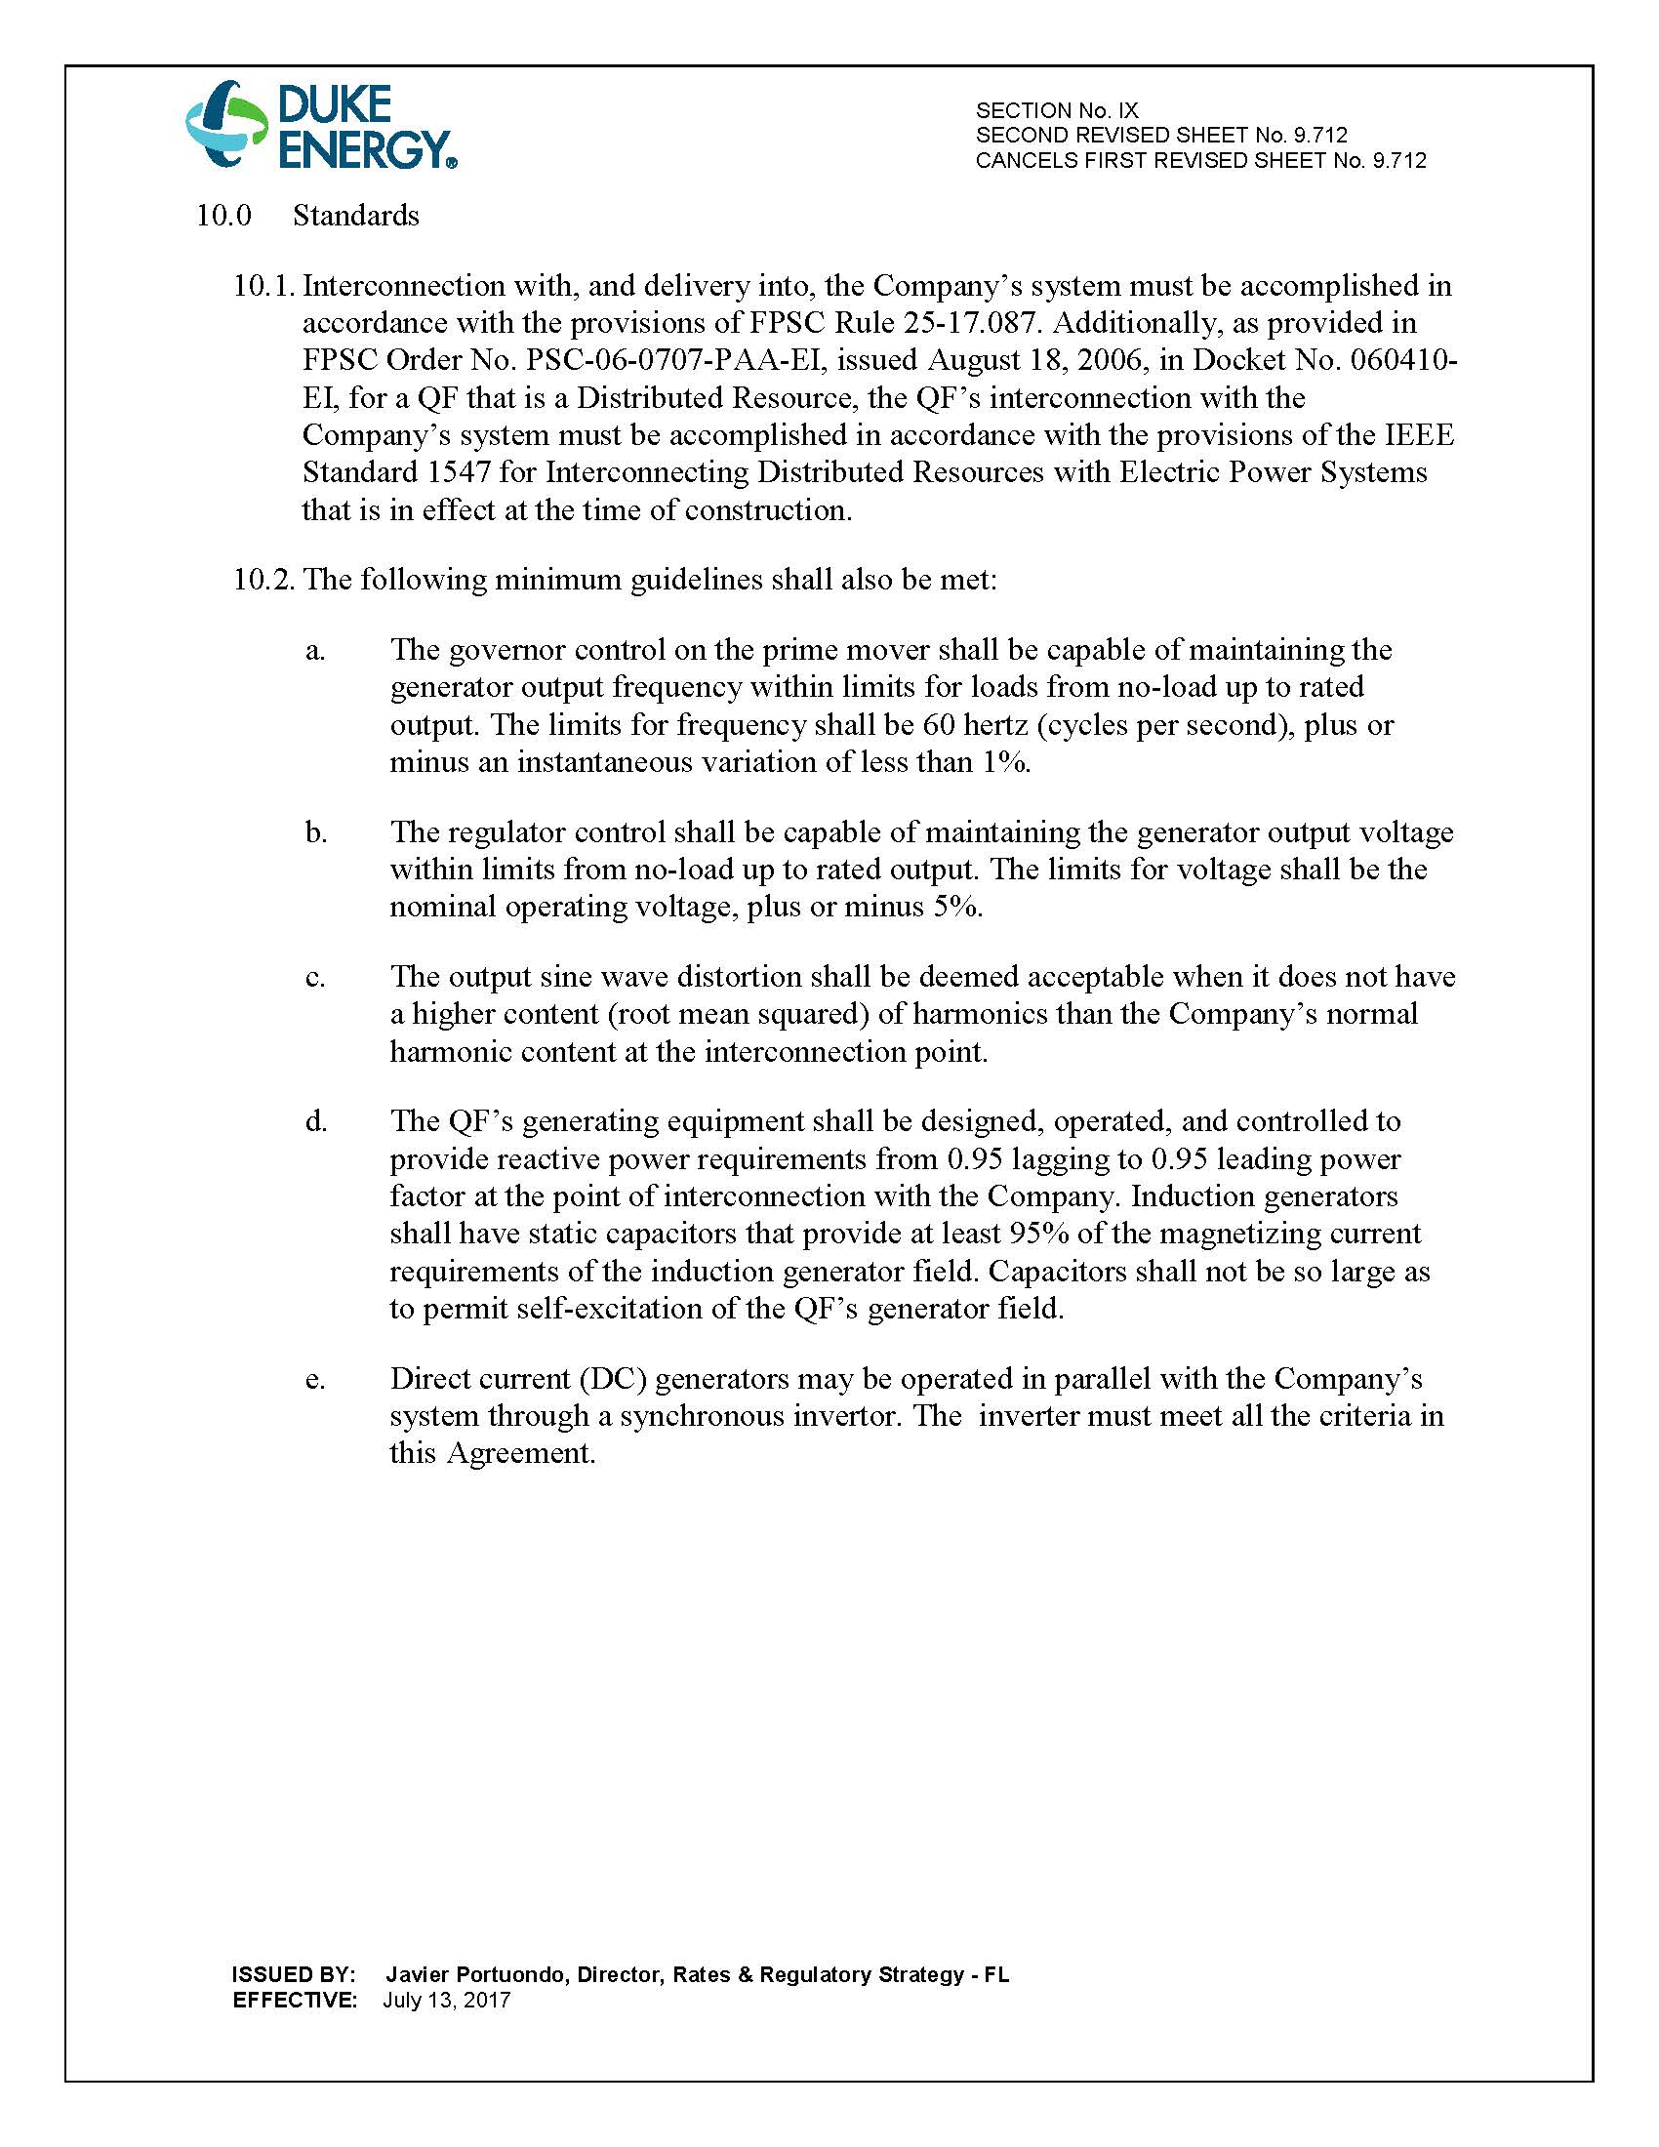

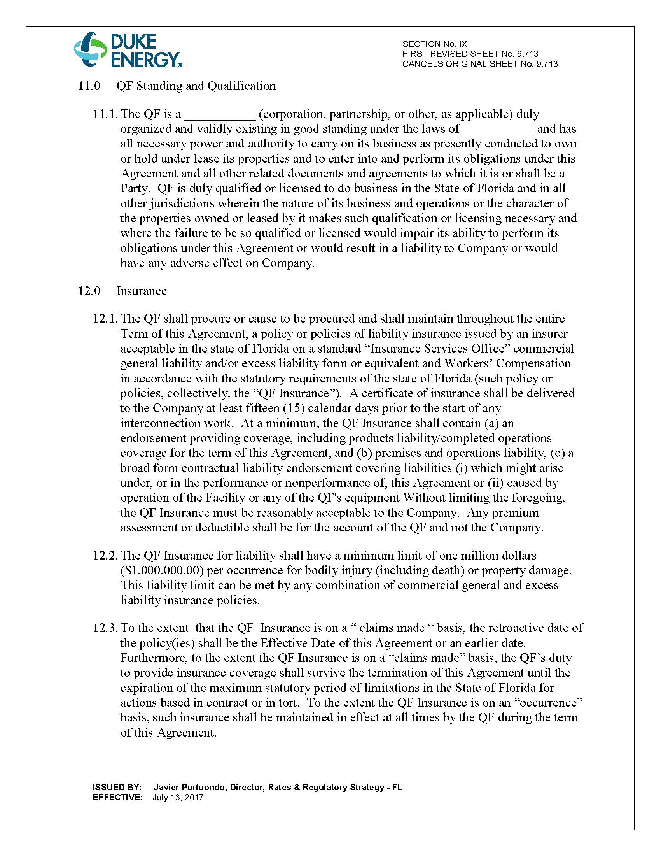

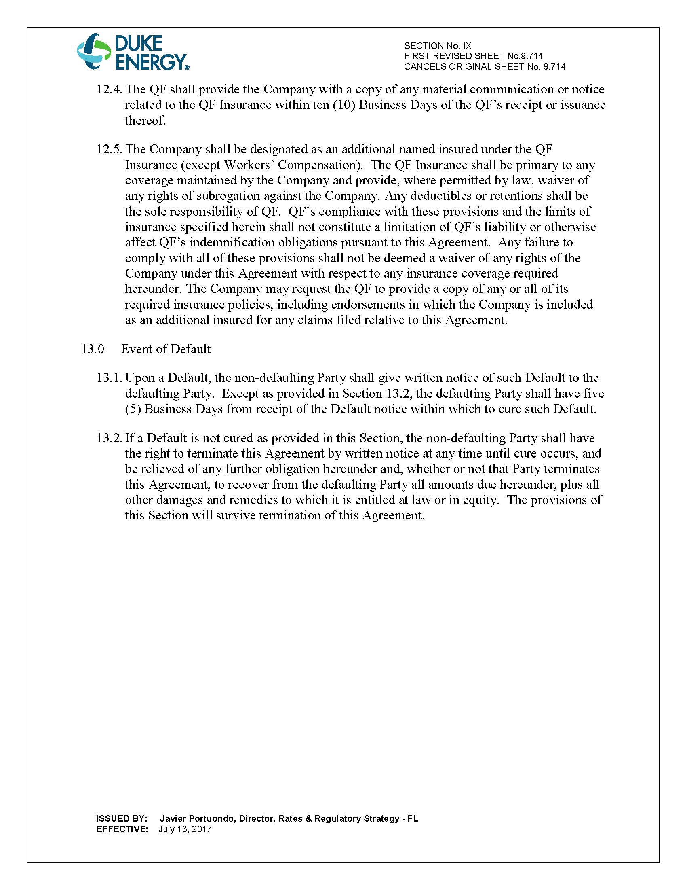

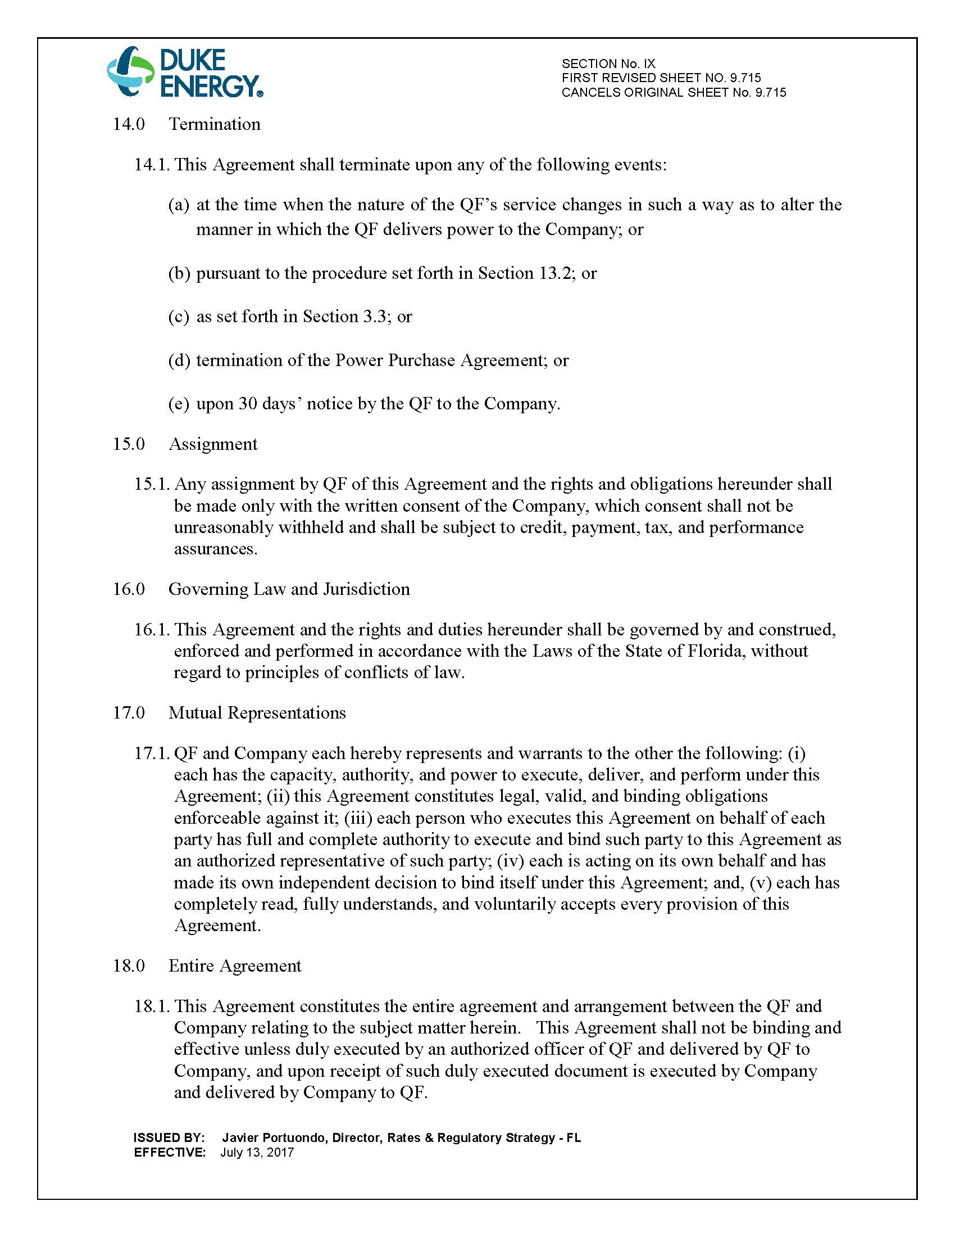

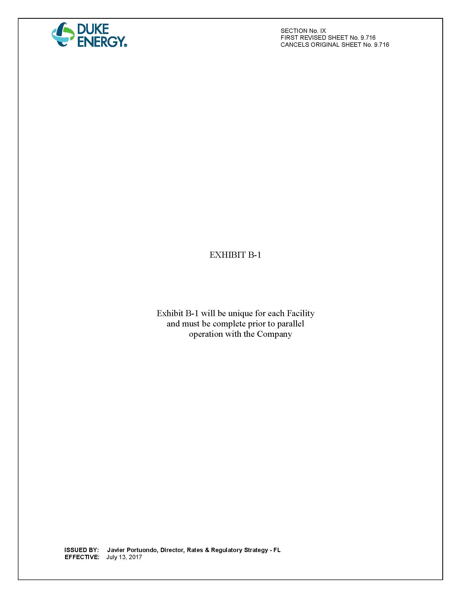

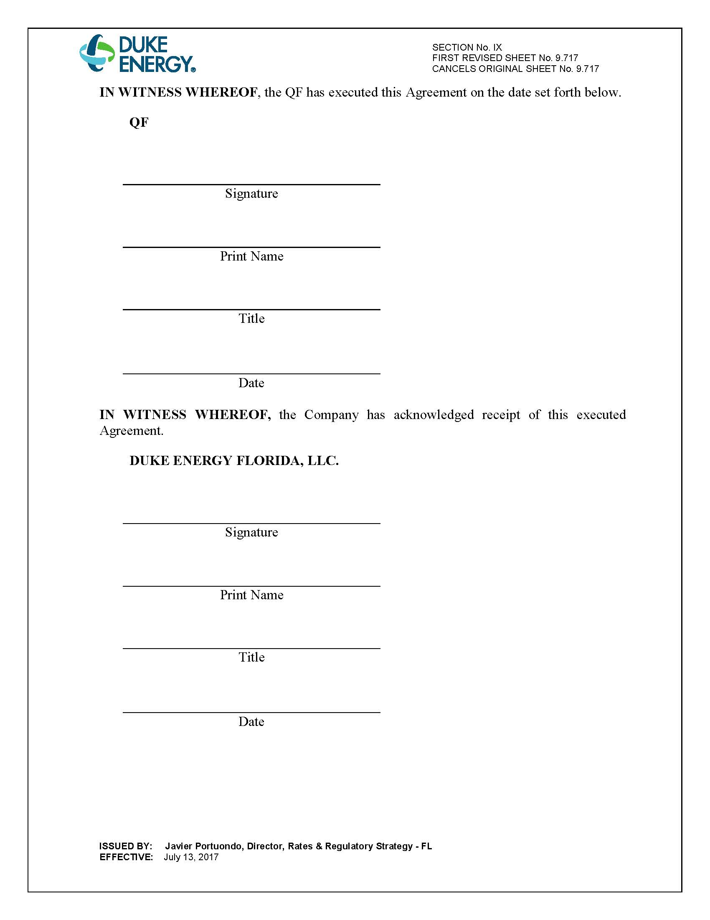

Document No. 04774-2019, filed June 7, 2017, in Docket No. 20190079-EQ.
Document No. 03911-2019, filed April 24, 2019, in Docket No. 20190079-EQ.
Order No. PSC-2018-0316-PAA-EQ, issued June 20, 2018, in Docket No. 20180083-EQ, In re: Petition for approval of renewable energy tariff and standard offer contract, by Florida Power & Light Company.

