BEFORE THE FLORIDA PUBLIC SERVICE COMMISSION

In re: Petition for approval of renewable energy tariff and standard offer contract, by Florida Power & Light Company. | DOCKET NO. 20190082-EQ  ORDER NO. PSC-2019-0265-PAA-EQ  ISSUED: July 1, 2019

The following Commissioners participated in the disposition of this matter:

ART GRAHAM, Chairman
JULIE I. BROWN
DONALD J. POLMANN
GARY F. CLARK
ANDREW GILES FAY

NOTICE OF PROPOSED AGENCY ACTION
ORDER APPROVING FLORIDA POWER & LIGHT COMPANY’S
STANDARD OFFER CONTRACT AND SCHEDULE QS-2

BY THE COMMISSION:

NOTICE is hereby given by the Florida Public Service Commission (Commission) that the action discussed herein is preliminary in nature and will become final unless a person whose interests are substantially affected files a petition for a formal proceeding, pursuant to Rule 25-22.029, Florida Administrative Code (F.A.C.).

Background
Section 366.91(3), Florida Statutes (F.S.), requires each investor-owned utility (IOU) to continuously offer to purchase capacity and energy from renewable generating facilities and small qualifying facilities. Commission Rules 25-17.200 through 25-17.310, F.A.C., implement the statute and require each IOU to file with this Commission, by April 1 of each year, a revised standard offer contract based on the next avoidable fossil fueled generating unit of each technology type identified in the utility’s current Ten-Year Site Plan. On April 1, 2019, Florida Power & Light Company (FPL) filed a petition for approval of its revised standard offer contract and rate schedule based on its 2019 Ten-Year Site Plan. We have jurisdiction over this standard offer contract pursuant to Sections 366.04 through 366.055, and 366.91, F.S.

Review
Section 366.91(3), F.S., and Rule 25-17.250, F.A.C., require that FPL, an IOU, continuously make available a standard offer contract for the purchase of firm capacity and energy from renewable generating facilities (RF) and small qualifying facilities (QF) with design capacities of 100 kilowatts (kW) or less. Pursuant to Rules 25-17.250(1) and (3), F.A.C., the standard offer contract must provide a term of at least 10 years, and the payment terms must be based on the utility’s next avoidable fossil-fueled generating unit identified in its most recent Ten-Year Site Plan, or if no avoided unit is identified, its next avoidable planned purchase. FPL has identified a 1,886 megawatt (MW) natural gas-fired combined cycle (CC) as its next fossil-fueled generating unit in its 2019 Ten-Year Site Plan. The projected in-service date of this unit is June 1, 2026. We believe this unit is sufficient as the avoided unit for standard offer purposes; however, FPL’s projected reliability need in 2026 is only 106 MW. We note that approval of a standard offer contract is not an approval to construct future generating units.
Under FPL’s standard offer contract, the RF/QF operator commits to certain minimum performance requirements based on the identified avoided unit, such as being operational and delivering an agreed upon amount of capacity by the in-service date of the avoided unit, and thereby becomes eligible for capacity payments in addition to payments received for energy. The standard offer contract may also serve as a starting point for negotiation of contract terms by providing payment information to an RF/QF operator, in a situation where one or both parties desire particular contract terms other than those established in the standard offer.
In order to promote renewable generation, we require the IOU to offer multiple options for capacity payments, including the options to receive early or levelized payments. If the RF/QF operator elects to receive capacity payments under the normal or levelized contract options, it will receive as-available energy payments only until the in-service date of the avoided unit (in this case June 1, 2026), and thereafter, begin receiving capacity payments in addition to the energy payments. If either the early or early levelized option is selected, then the operator will begin receiving capacity payments earlier than the in-service date of the avoided unit. However, payments made under the early capacity payment options tend to be lower in the later years of the contract term because the net present value (NPV) of the total payments must remain equal for all contract payment options.
Table 1 contains FPL’s estimates of the annual payments for each payment option available under the revised standard offer contract to an operator with a 50 MW facility, operating at a capacity factor of 94 percent, which is the minimum capacity factor required under the contract to qualify for full capacity payments. Normal and levelized capacity payments begin with the projected in-service date of the avoided CC unit (June 1, 2026).

Table 1 - Estimated Annual Payments to a 50 MW Renewable Facility
(94% Capacity Factor)
Year | Energy Payment | Capacity Payment (By Type)
 |  | Normal | Levelized | Early | Early Levelized
 | $(000) | $(000) | $(000) | $(000) | $(000)
2020 | 8,328 | - | - | - | -
2021 | 7,973 | - | - | - | -
2022 | 7,790 | - | - | 2,059 | 2,439
2023 | 8,020 | - | - | 2,110 | 2,439
2024 | 8,920 | - | - | 2,163 | 2,439
2025 | 10,151 | - | - | 2,217 | 2,439
2026 | 10,696 | 3,270 | 3,746 | 2,272 | 2,439
2027 | 11,045 | 3,352 | 3,746 | 2,329 | 2,439
2028 | 11,213 | 3,435 | 3,746 | 2,387 | 2,439
2029 | 11,663 | 3,521 | 3,746 | 2,447 | 2,439
2030 | 12,237 | 3,609 | 3,746 | 2,508 | 2,439
2031 | 12,943 | 3,700 | 3,746 | 2,571 | 2,439
2032 | 13,837 | 3,792 | 3,746 | 2,635 | 2,439
2033 | 13,592 | 3,887 | 3,746 | 2,701 | 2,439
2034 | 13,972 | 3,984 | 3,746 | 2,769 | 2,439
2035 | 13,261 | 4,084 | 3,746 | 2,838 | 2,439
2036 | 13,353 | 4,186 | 3,746 | 2,909 | 2,439
2037 | 14,435 | 4,290 | 3,746 | 2,981 | 2,439
2038 | 13,925 | 4,398 | 3,746 | 3,056 | 2,439
2039 | 15,361 | 4,508 | 3,746 | 3,132 | 2,439
Total | 232,717 | 54,015 | 52,442 | 46,084 | 43,897
NPV (2020$) | 106,878 | 20,069 | 20,069 | 20,068 | 20,067

Source: FPL’s Response to Staff’s First Data Request
FPL’s revised renewable energy tariff and standard offer contract, in type-and-strike format, are included as Attachment A of this Order. Revisions include updates to the avoided unit, dates, and payment information which reflect the current economic and financial assumptions for the avoided unit costs.

Decision

Upon review, we find that the provisions of FPL’s revised renewable energy tariff and standard offer contract conform to all requirements of Rules 25-17.200 through 25-17.310, F.A.C. FPL’s revised standard offer contract provides flexibility in the arrangements for payments so that a developer of renewable generation may select the payment stream best suited to its financial needs. Thus, FPL’s revised renewable energy tariff and standard offer contract are hereby approved as filed.

Based on the foregoing, it is

ORDERED by the Florida Public Service Commission that Florida Power & Light Company’s standard offer contract and schedule QS-2 are hereby approved. It is further

ORDERED that the provisions of this Order, issued as proposed agency action, shall become final and effective upon the issuance of a Consummating Order unless an appropriate petition, in the form provided by Rule 28-106.201, Florida Administrative Code, is received by the Commission Clerk, 2540 Shumard Oak Boulevard, Tallahassee, Florida 32399-0850, by the close of business on the date set forth in the “Notice of Further Proceedings” attached hereto. Potential signatories should be aware that, if a timely protest is filed, Florida Power & Light Company’s standard offer contract may subsequently be revised. It is further

ORDERED that this docket shall be closed upon the issuance of a consummating order, unless a person whose substantial interests are affected by the Commission’s decision files a protest within 21 days of the issuance of the Commission’s Proposed Agency Action Order.

By ORDER of the Florida Public Service Commission this 1st day of July, 2019.

ADAM J. TEITZMAN
Commission Clerk
Florida Public Service Commission
2540 Shumard Oak Boulevard
Tallahassee, Florida 32399
(850) 413-6770
www.floridapsc.com

Copies furnished: A copy of this document is provided to the parties of record at the time of issuance and, if applicable, interested persons.

MAD

NOTICE OF FURTHER PROCEEDINGS OR JUDICIAL REVIEW

The Florida Public Service Commission is required by Section 120.569(1), Florida Statutes, to notify parties of any administrative hearing that is available under Section 120.57, Florida Statutes, as well as the procedures and time limits that apply. This notice should not be construed to mean all requests for an administrative hearing will be granted or result in the relief sought.

Mediation may be available on a case-by-case basis. If mediation is conducted, it does not affect a substantially interested person's right to a hearing.

The action proposed herein is preliminary in nature. Any person whose substantial interests are affected by the action proposed by this order may file a petition for a formal proceeding, in the form provided by Rule 28-106.201, Florida Administrative Code. This petition must be received by the Office of Commission Clerk, 2540 Shumard Oak Boulevard, Tallahassee, Florida 32399-0850, by the close of business on July 22, 2019.

In the absence of such a petition, this order shall become final and effective upon the issuance of a Consummating Order.

Any objection or protest filed in this/these docket(s) before the issuance date of this order is considered abandoned unless it satisfies the foregoing conditions and is renewed within the specified protest period.

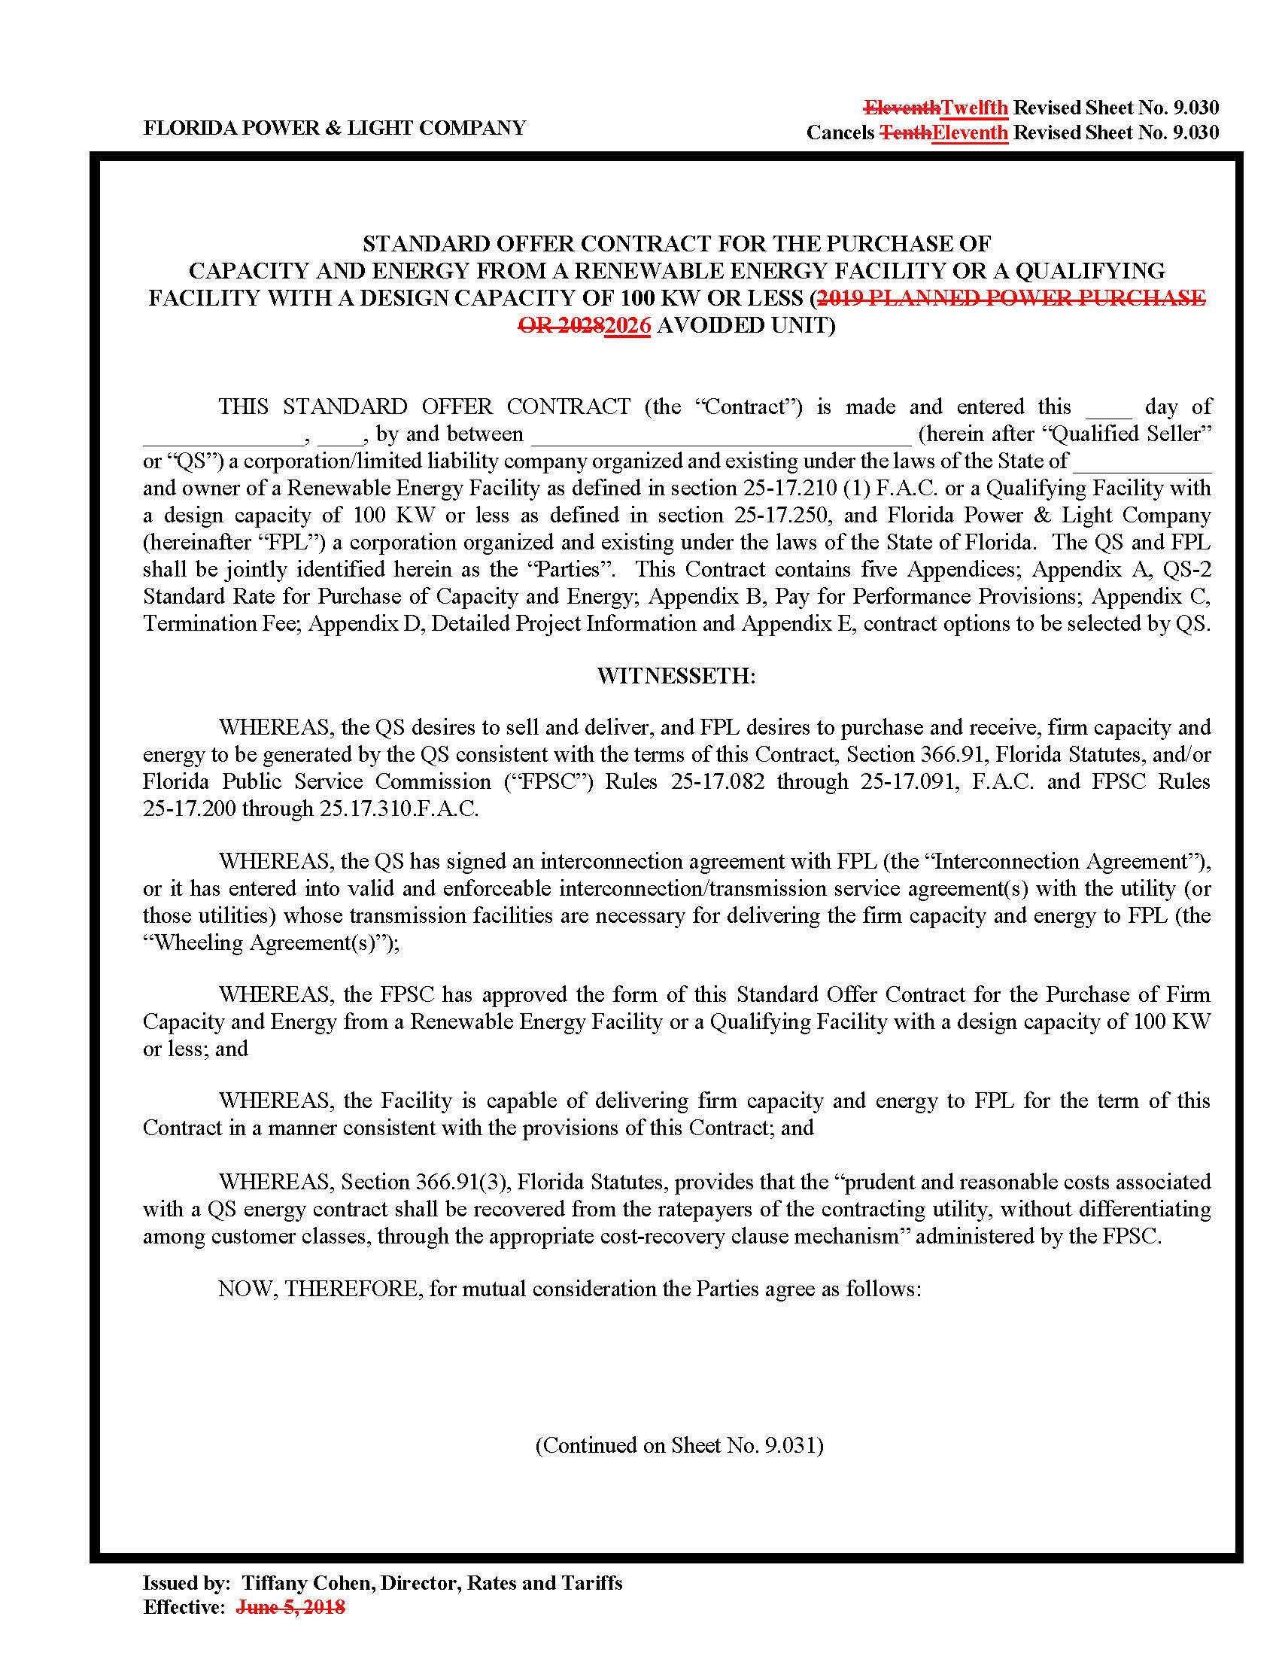
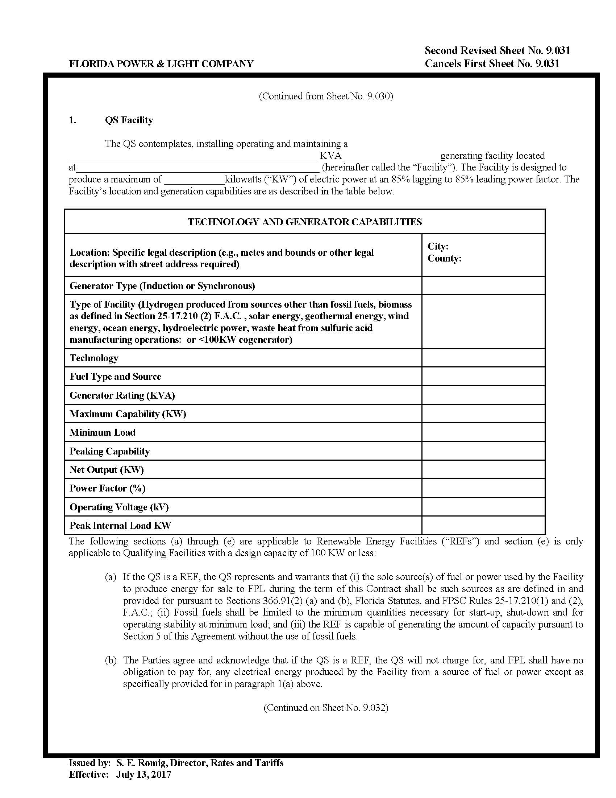
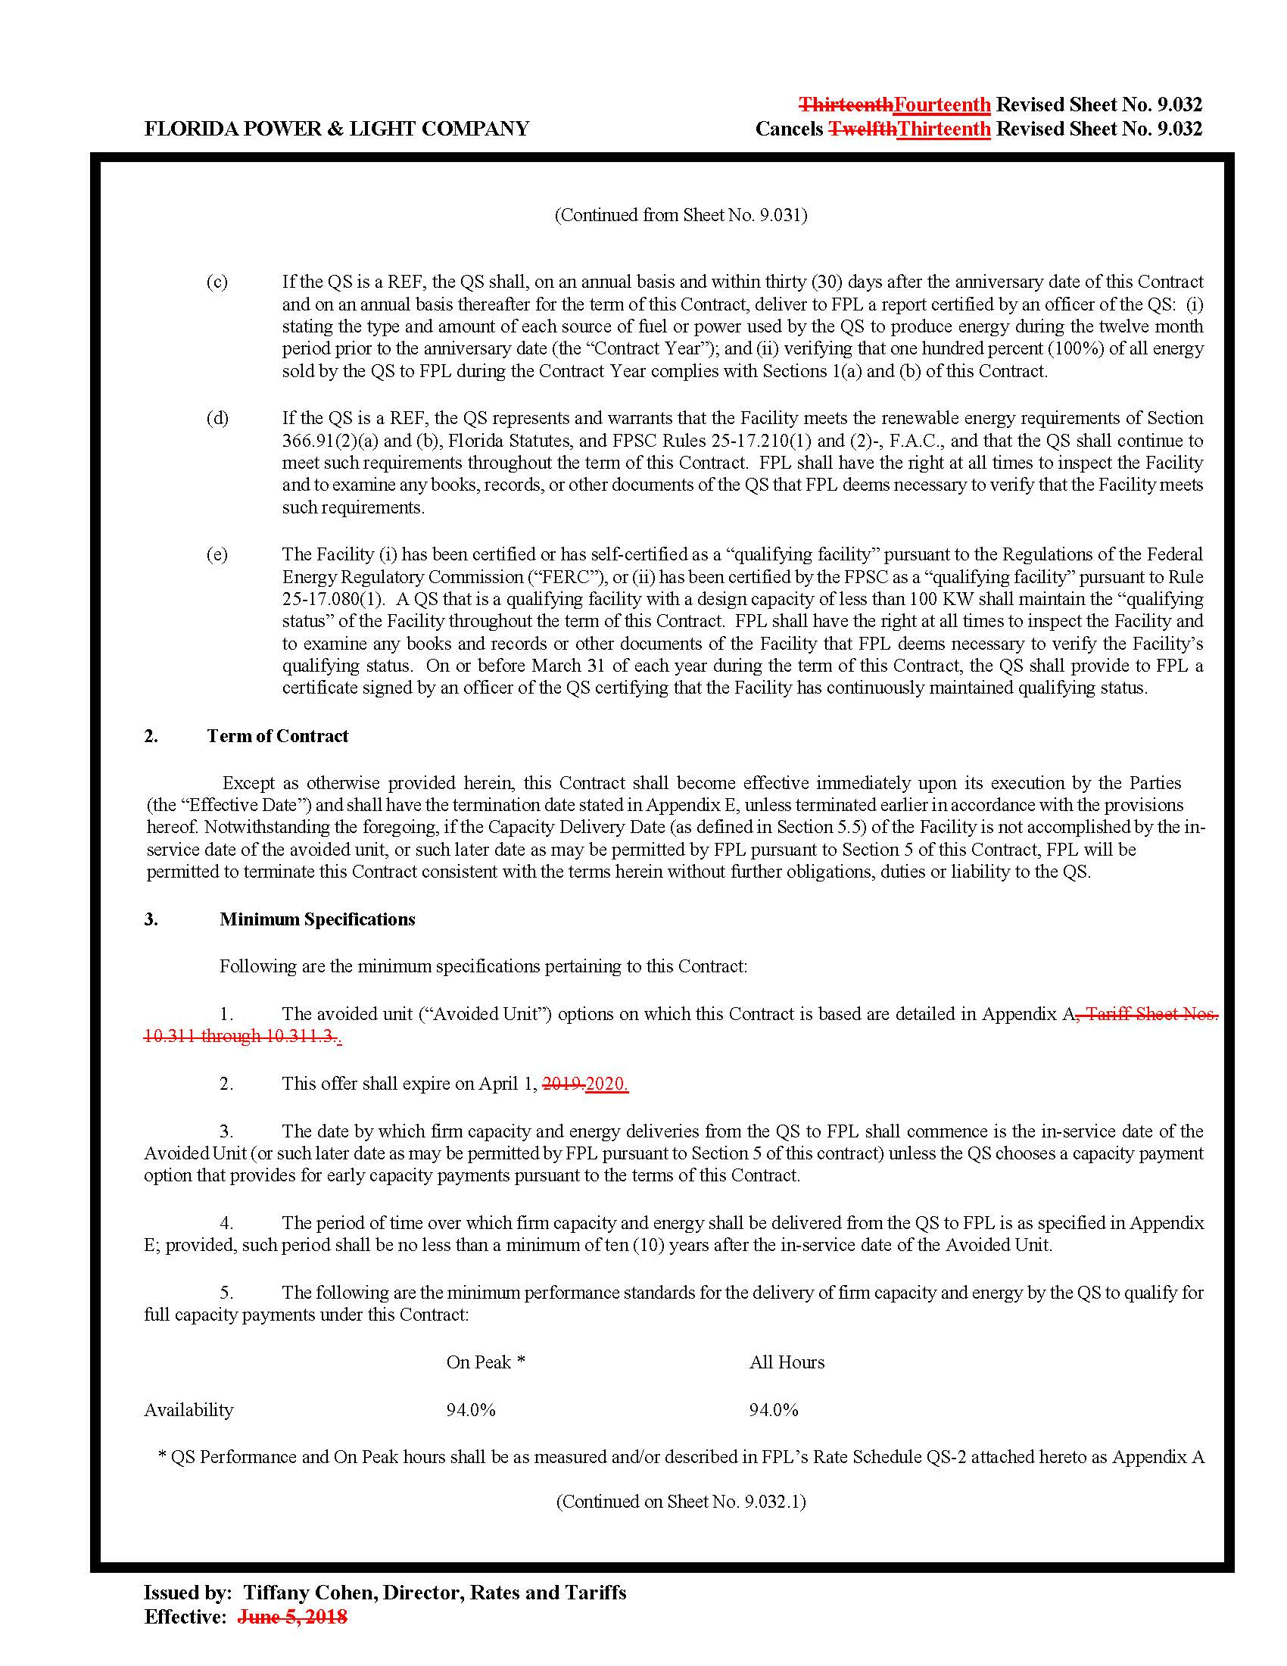
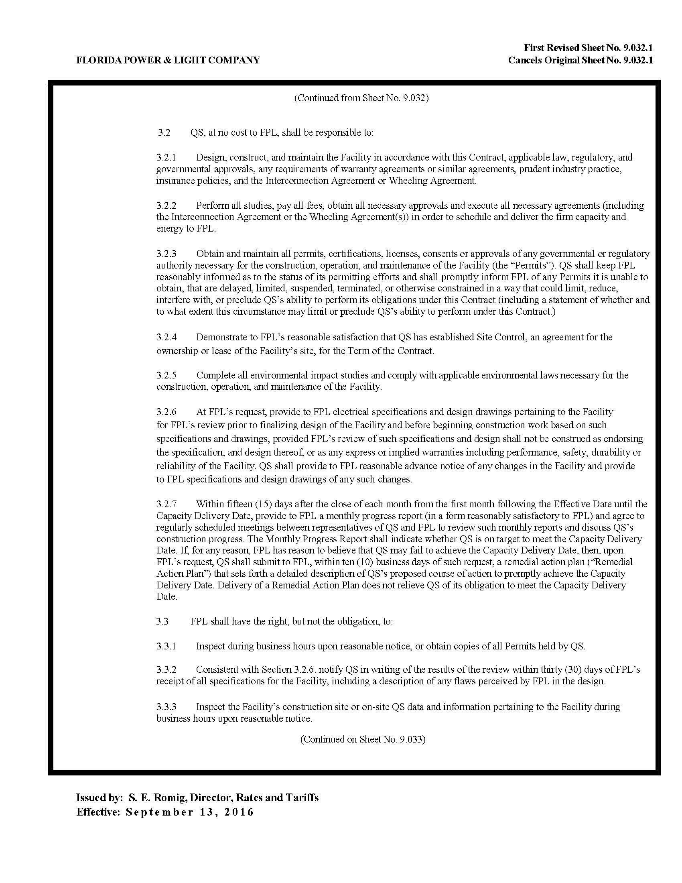
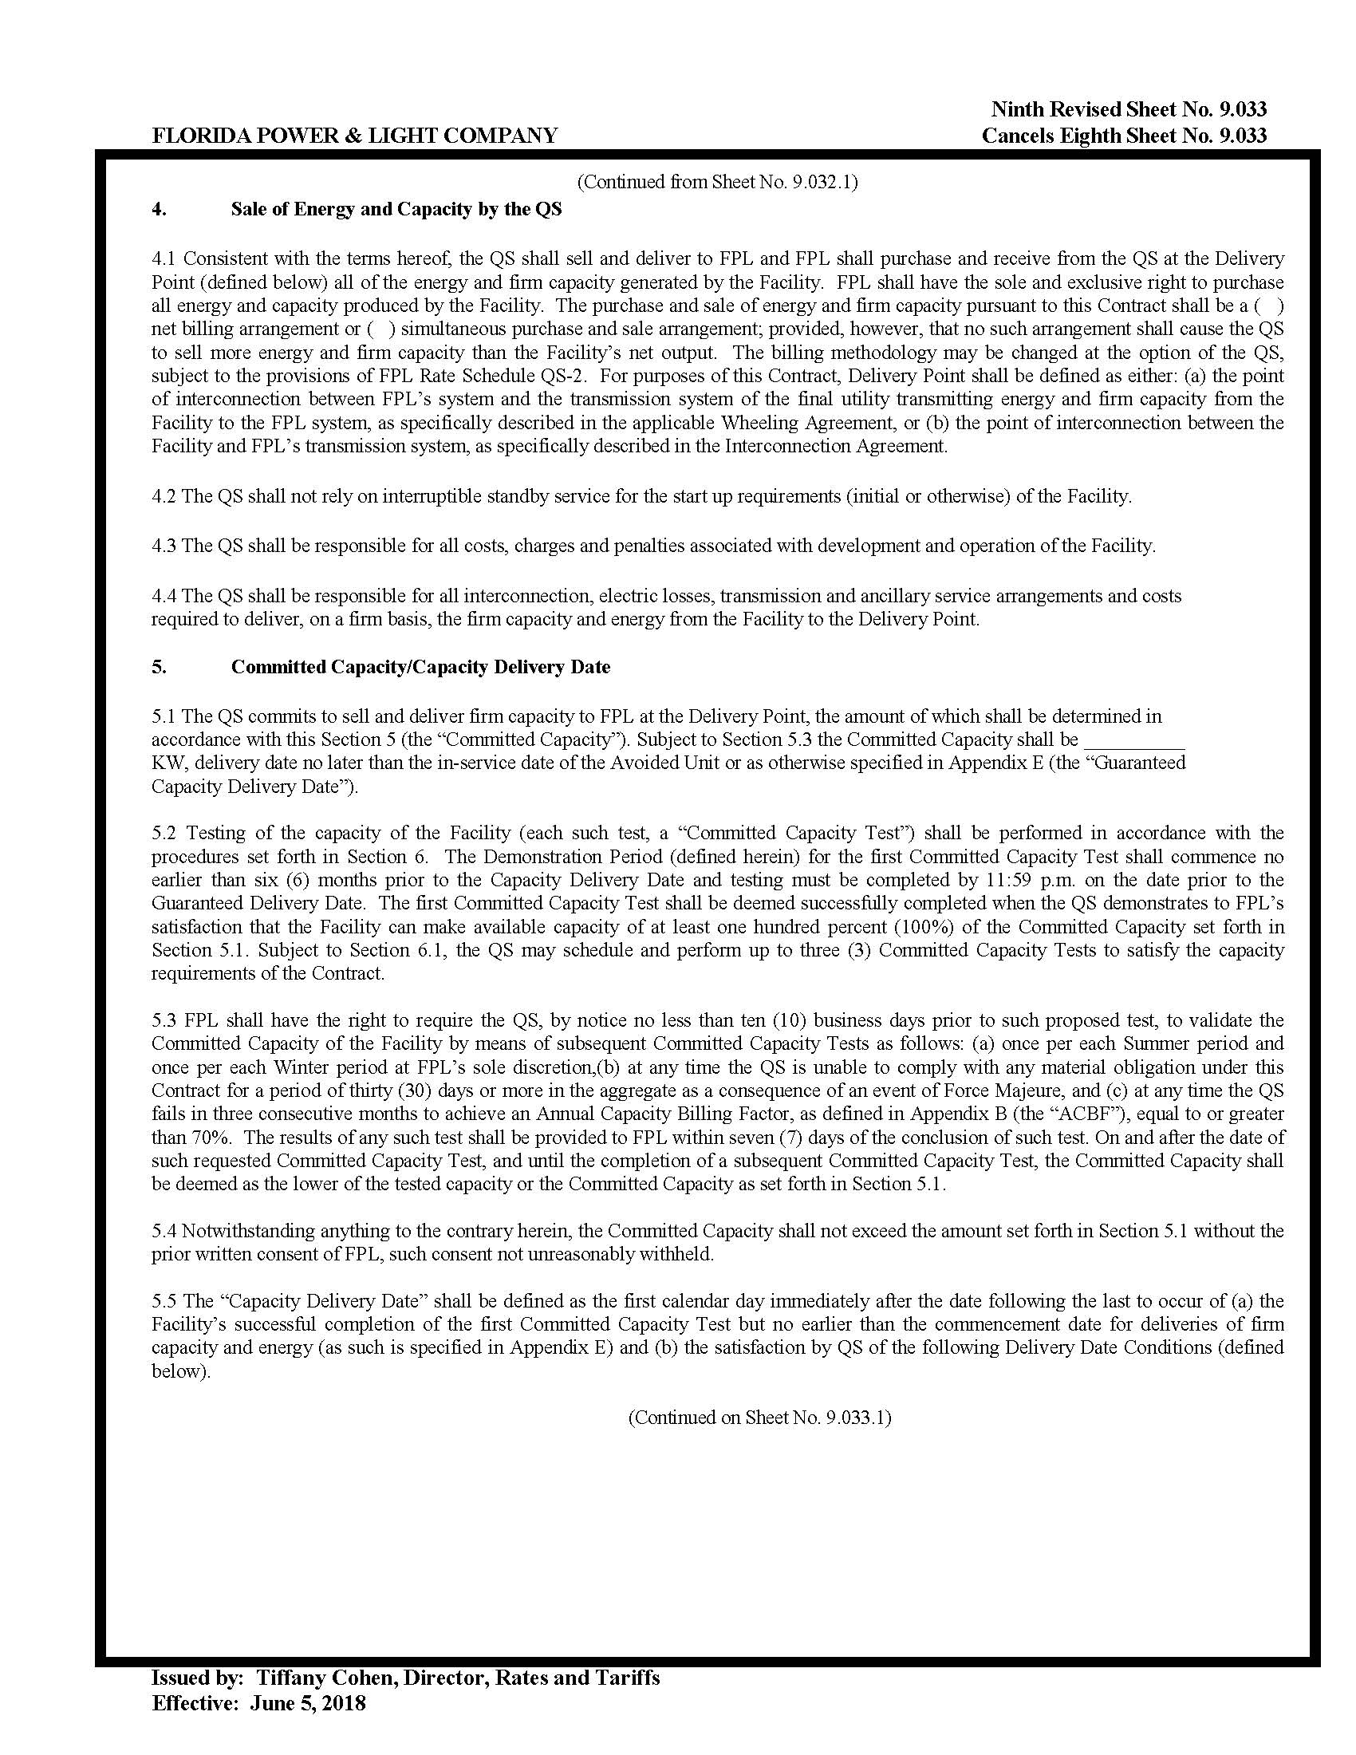
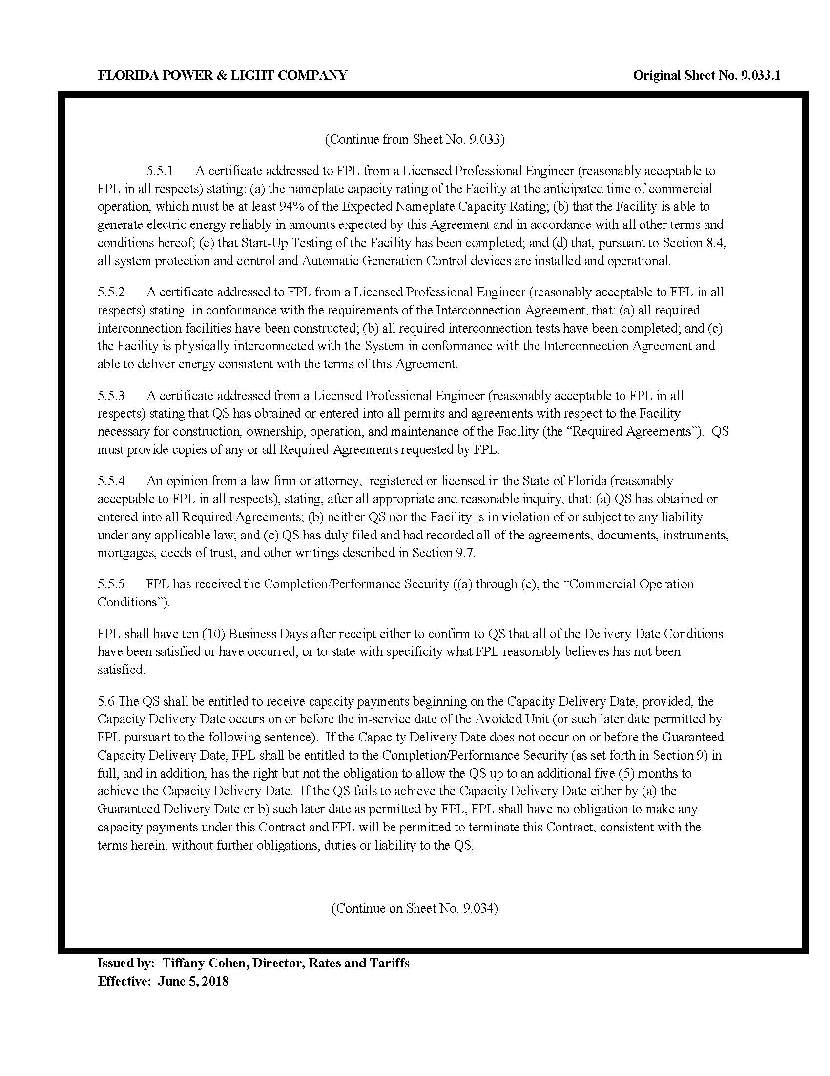
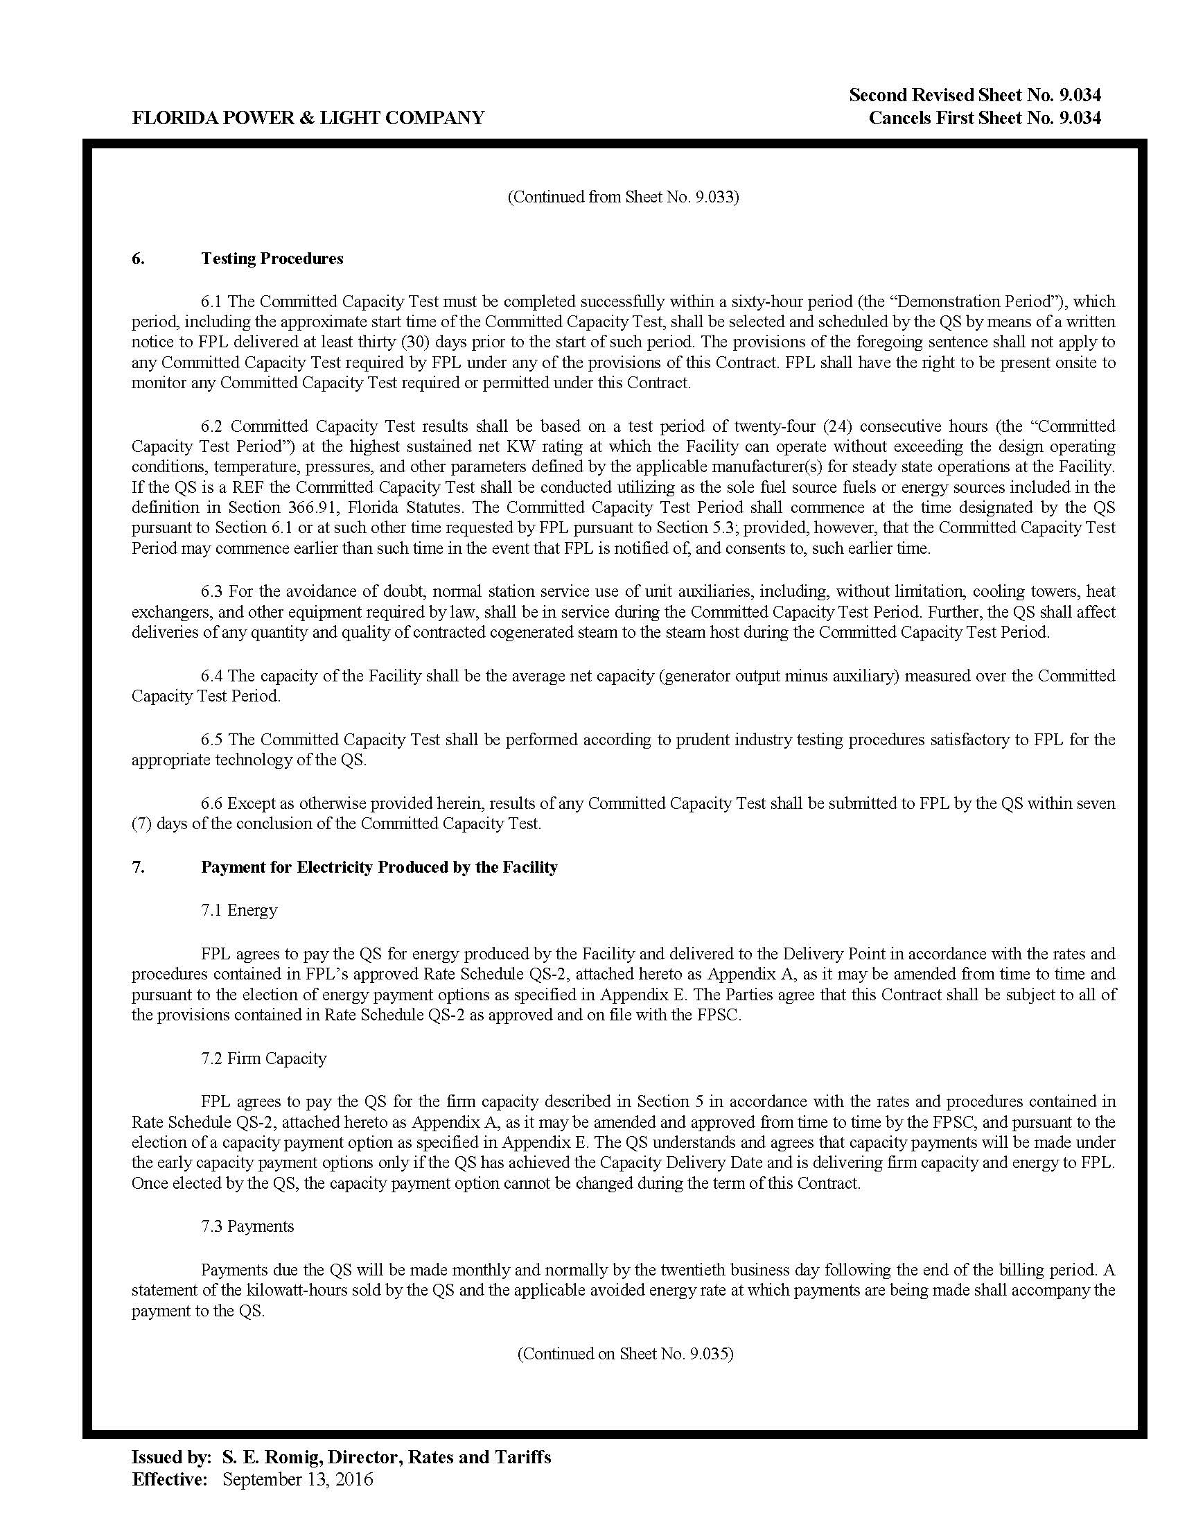
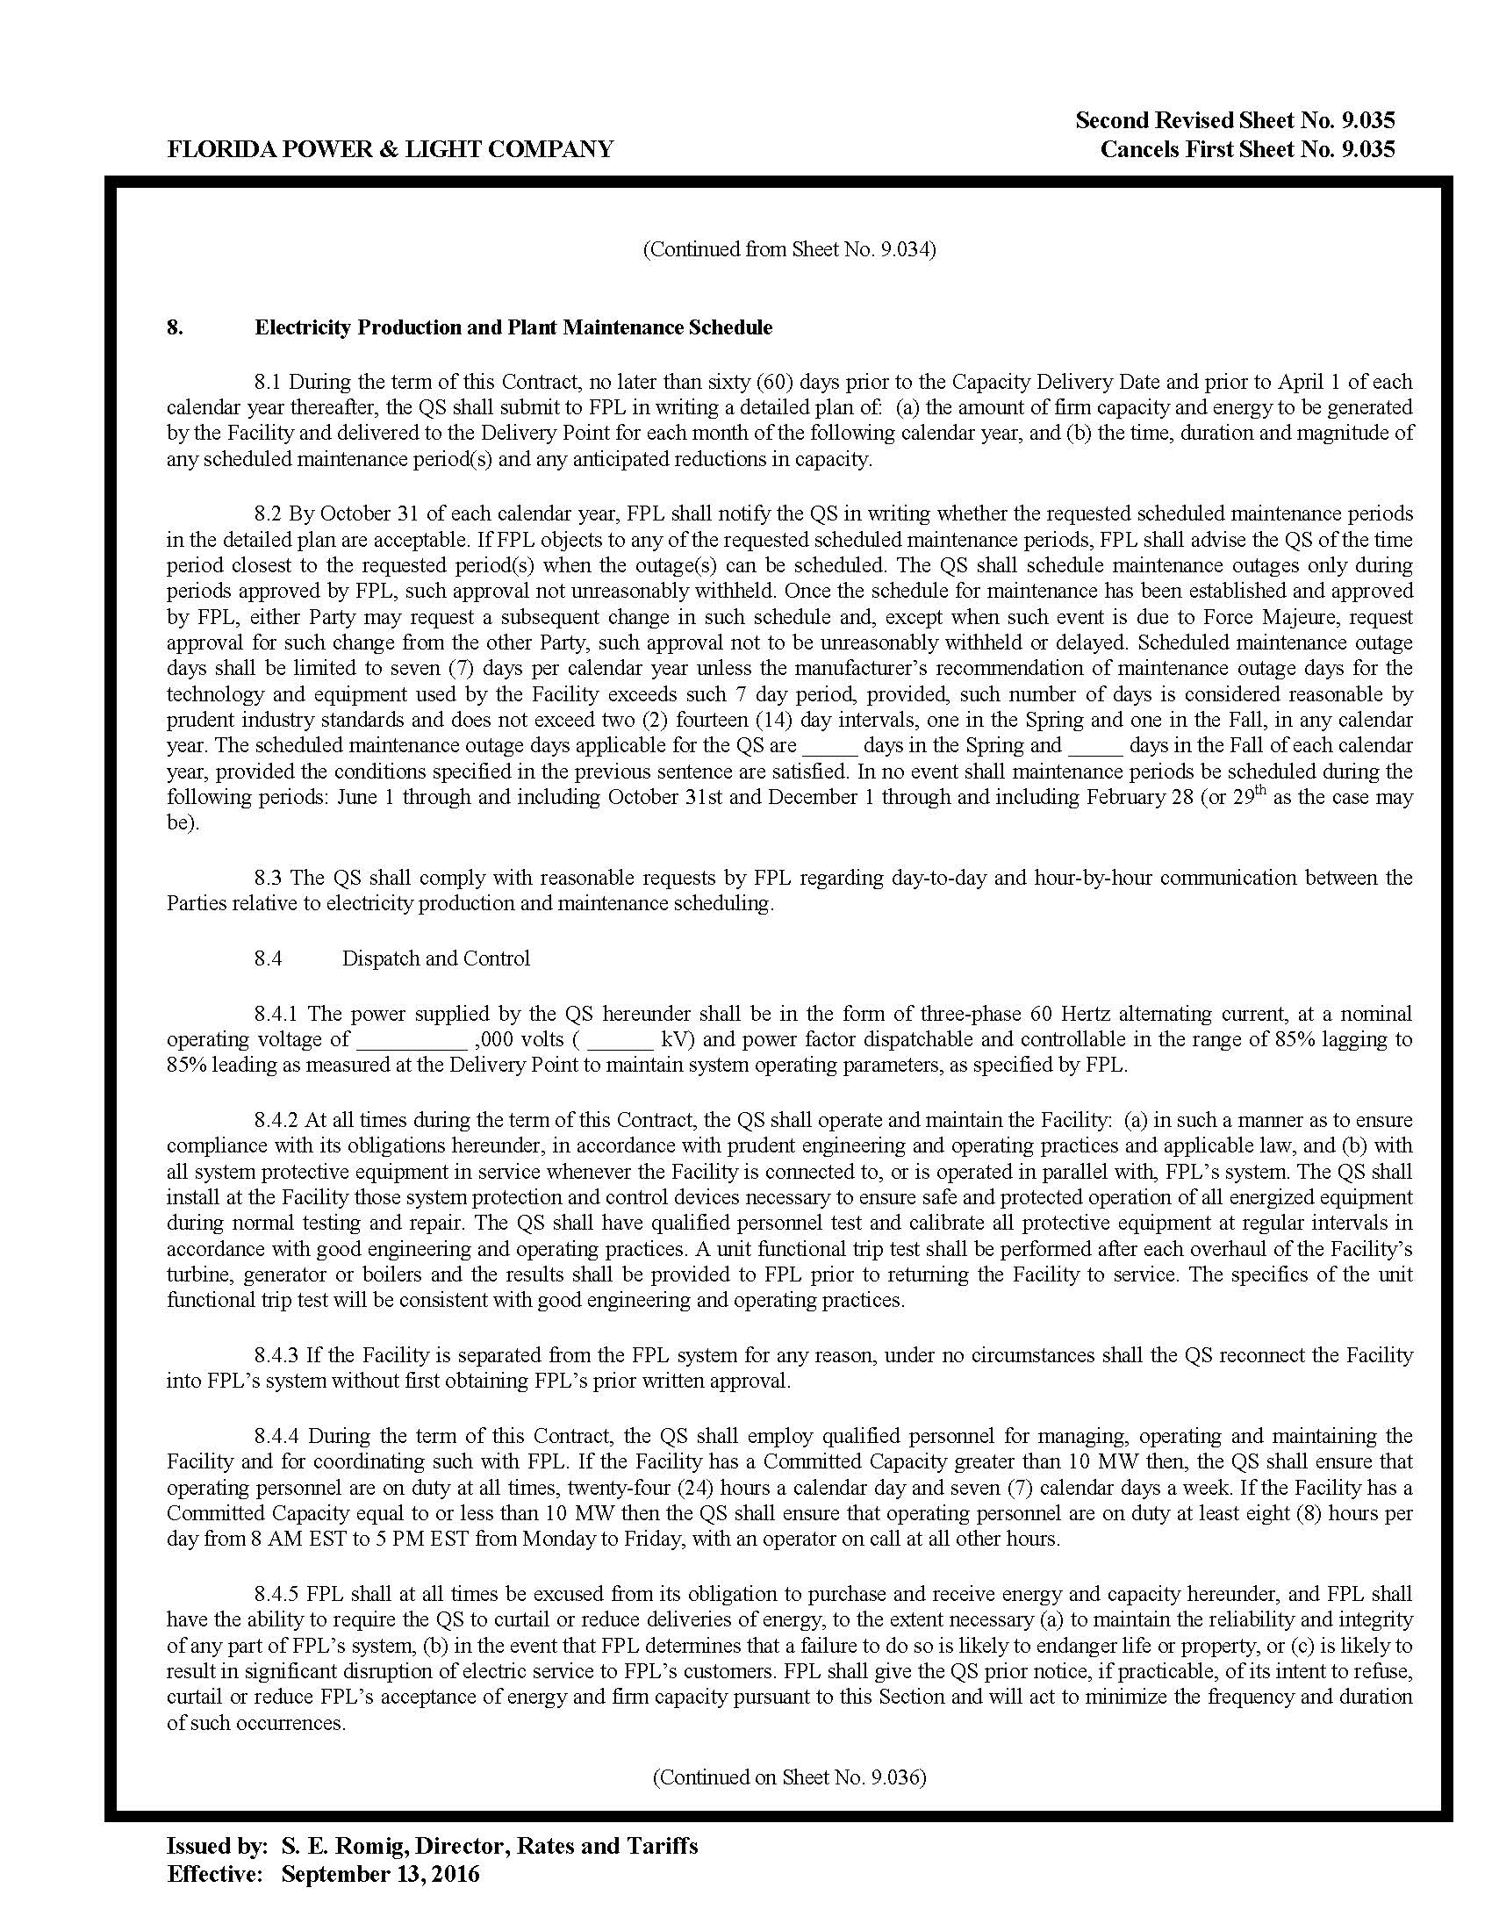
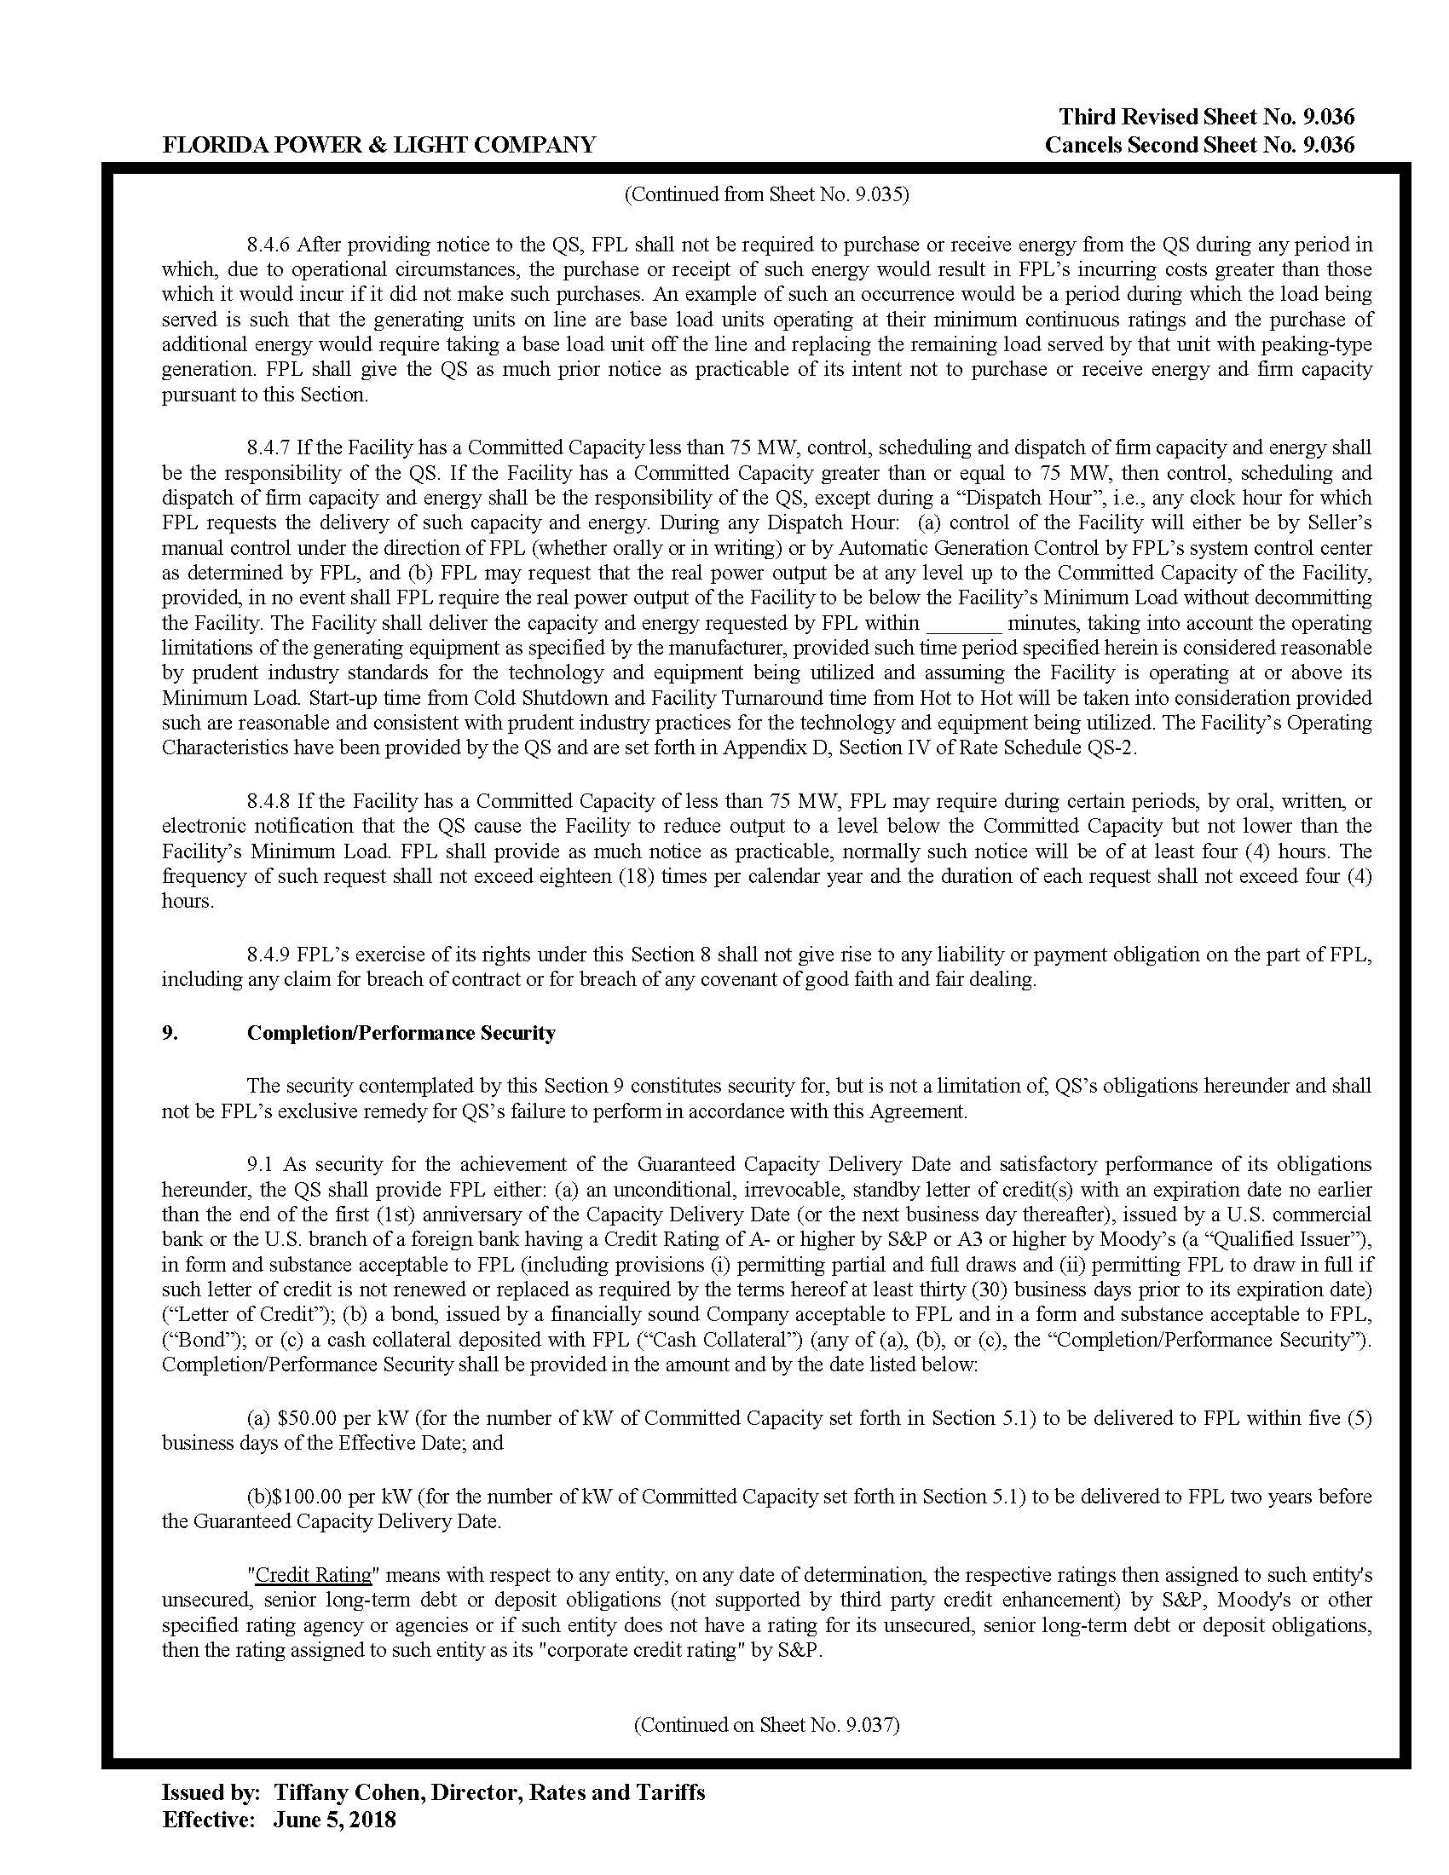
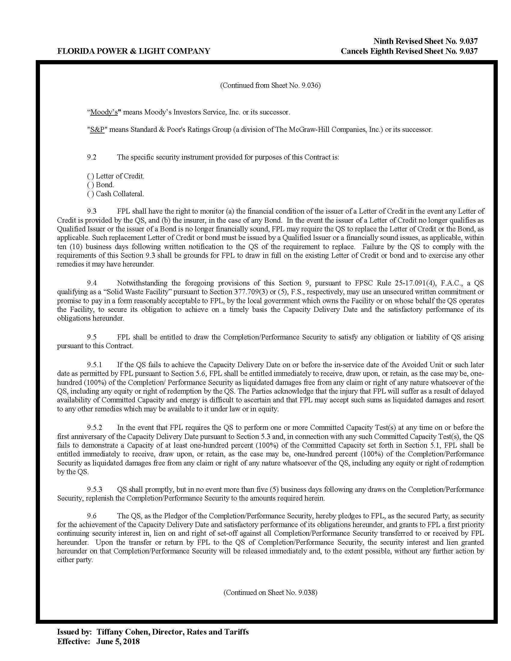
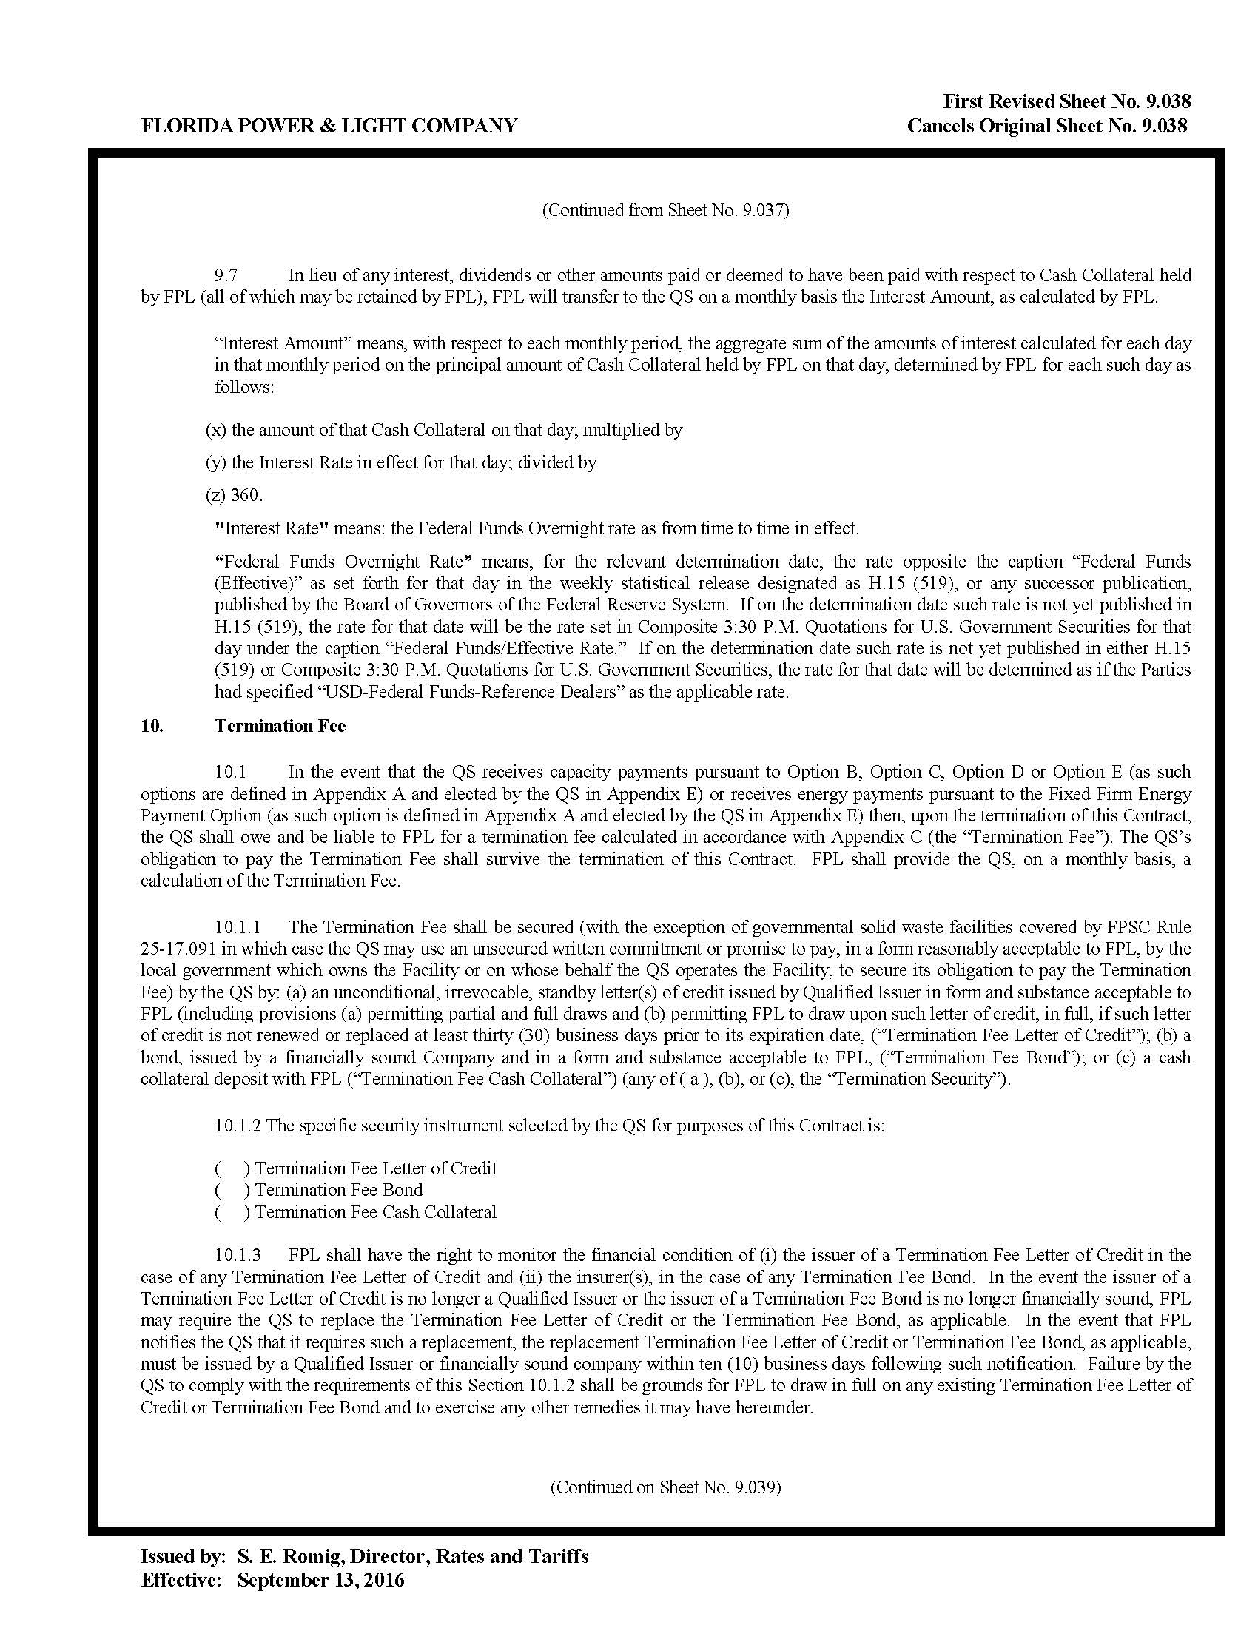
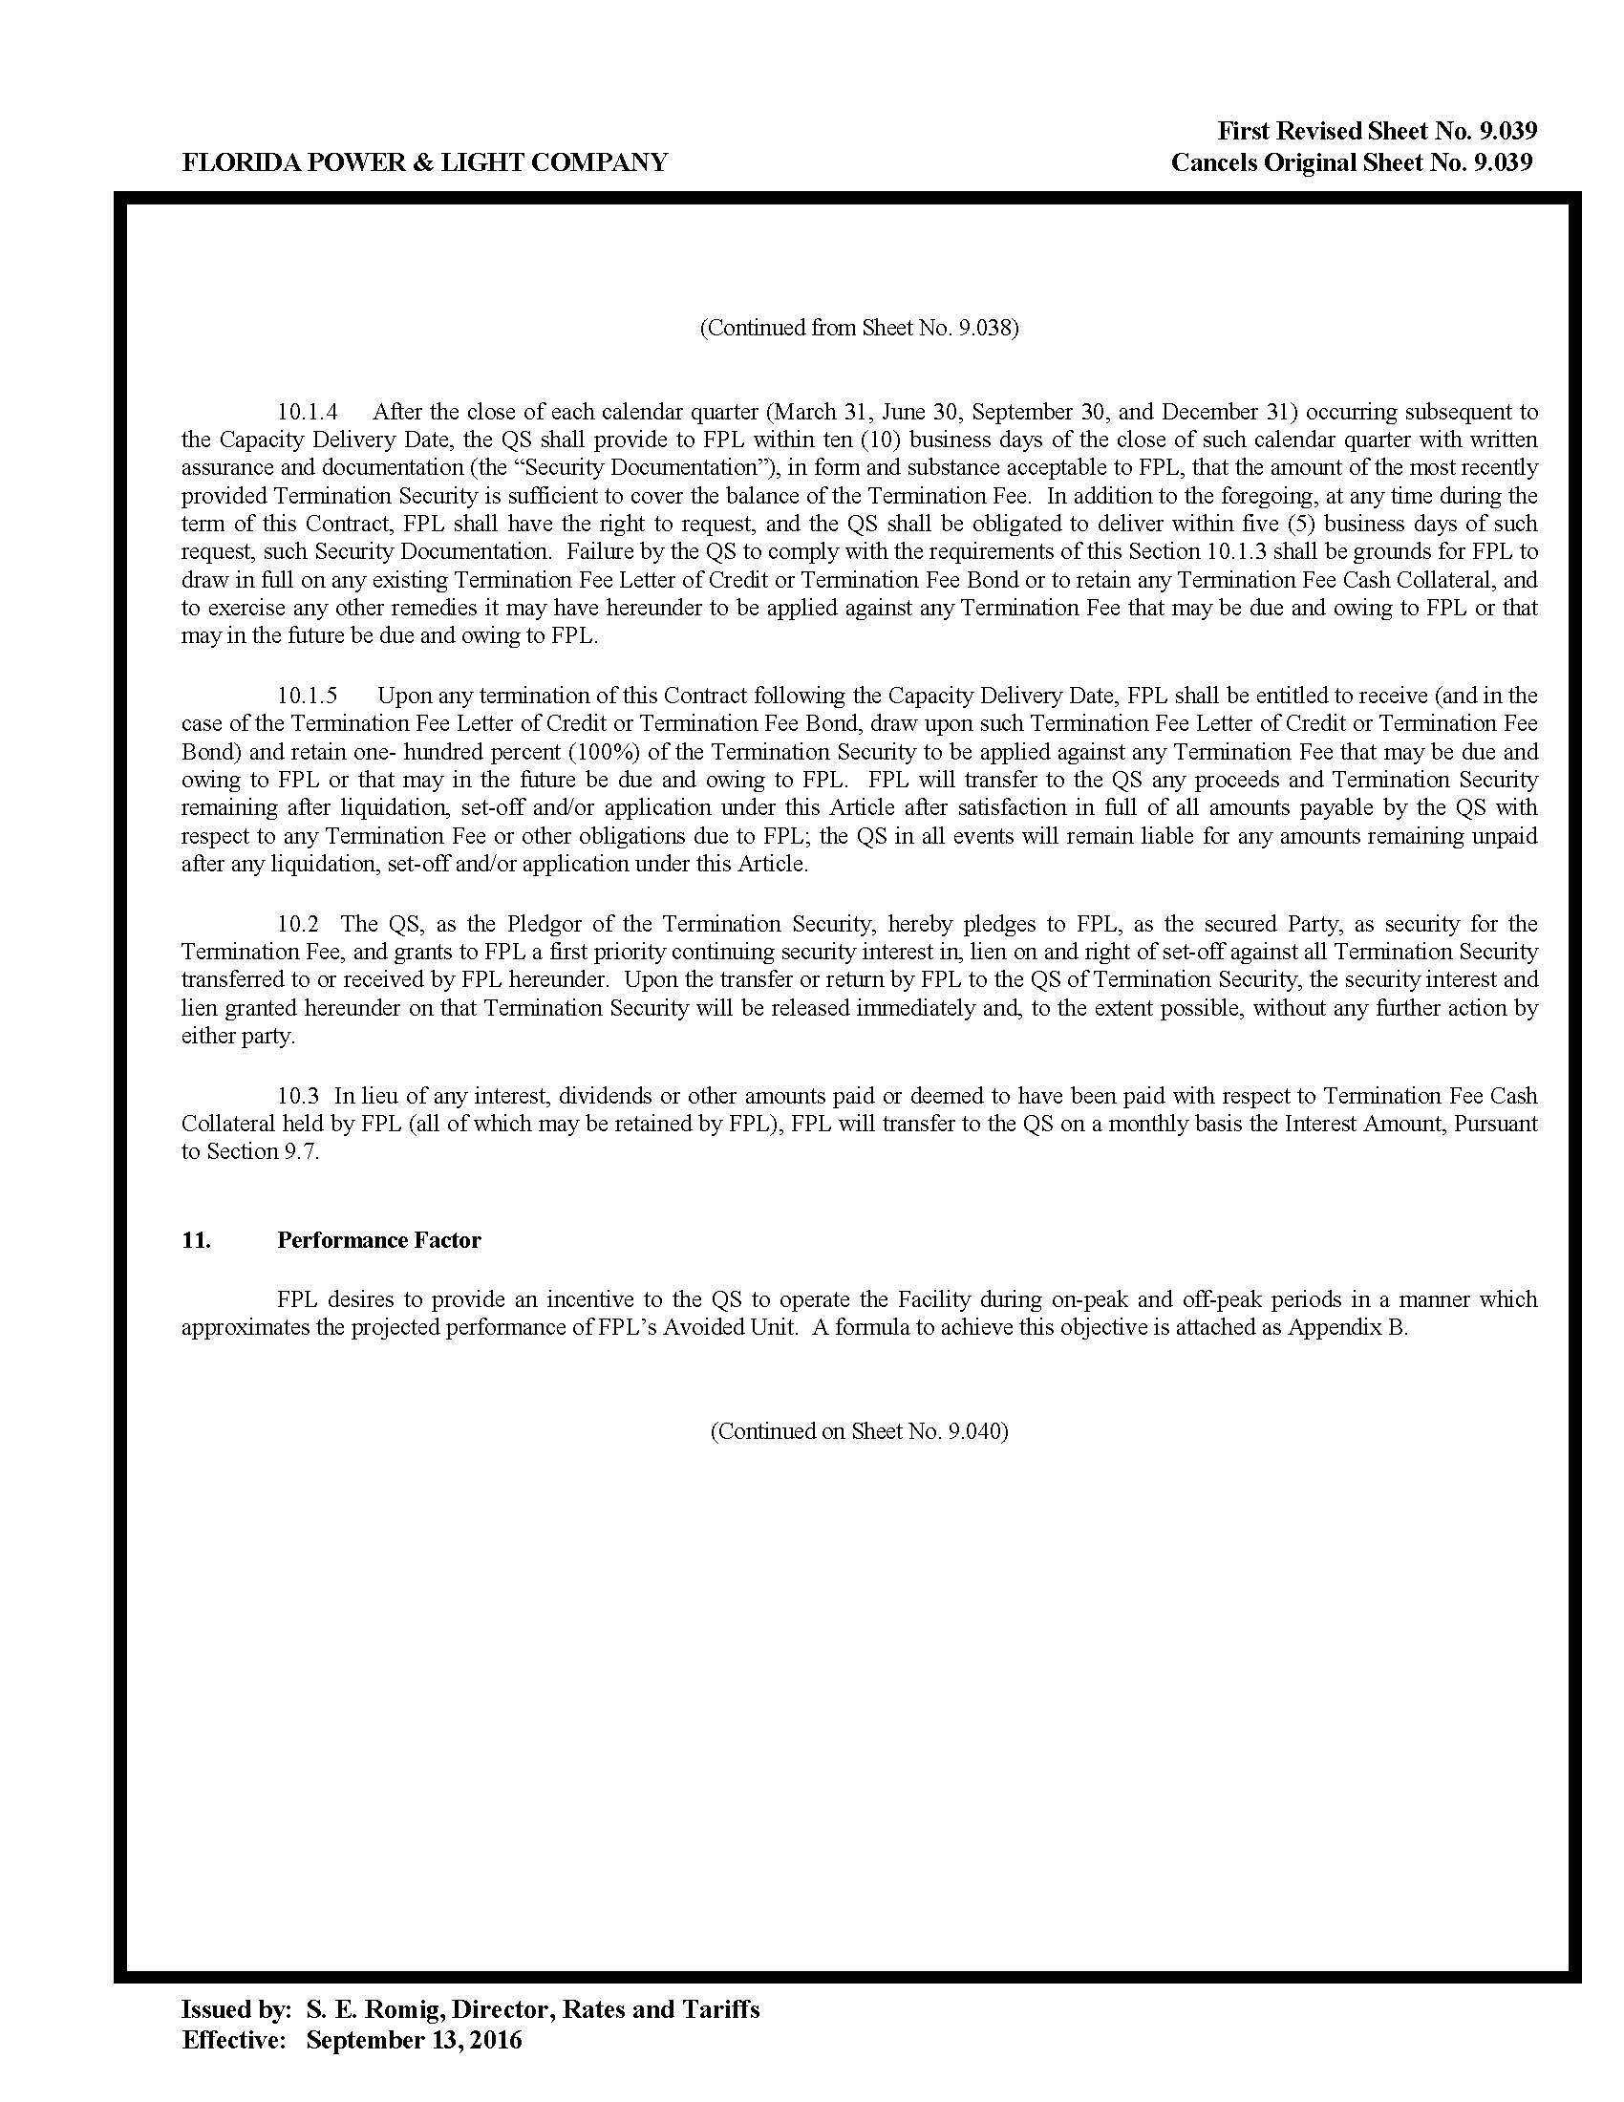
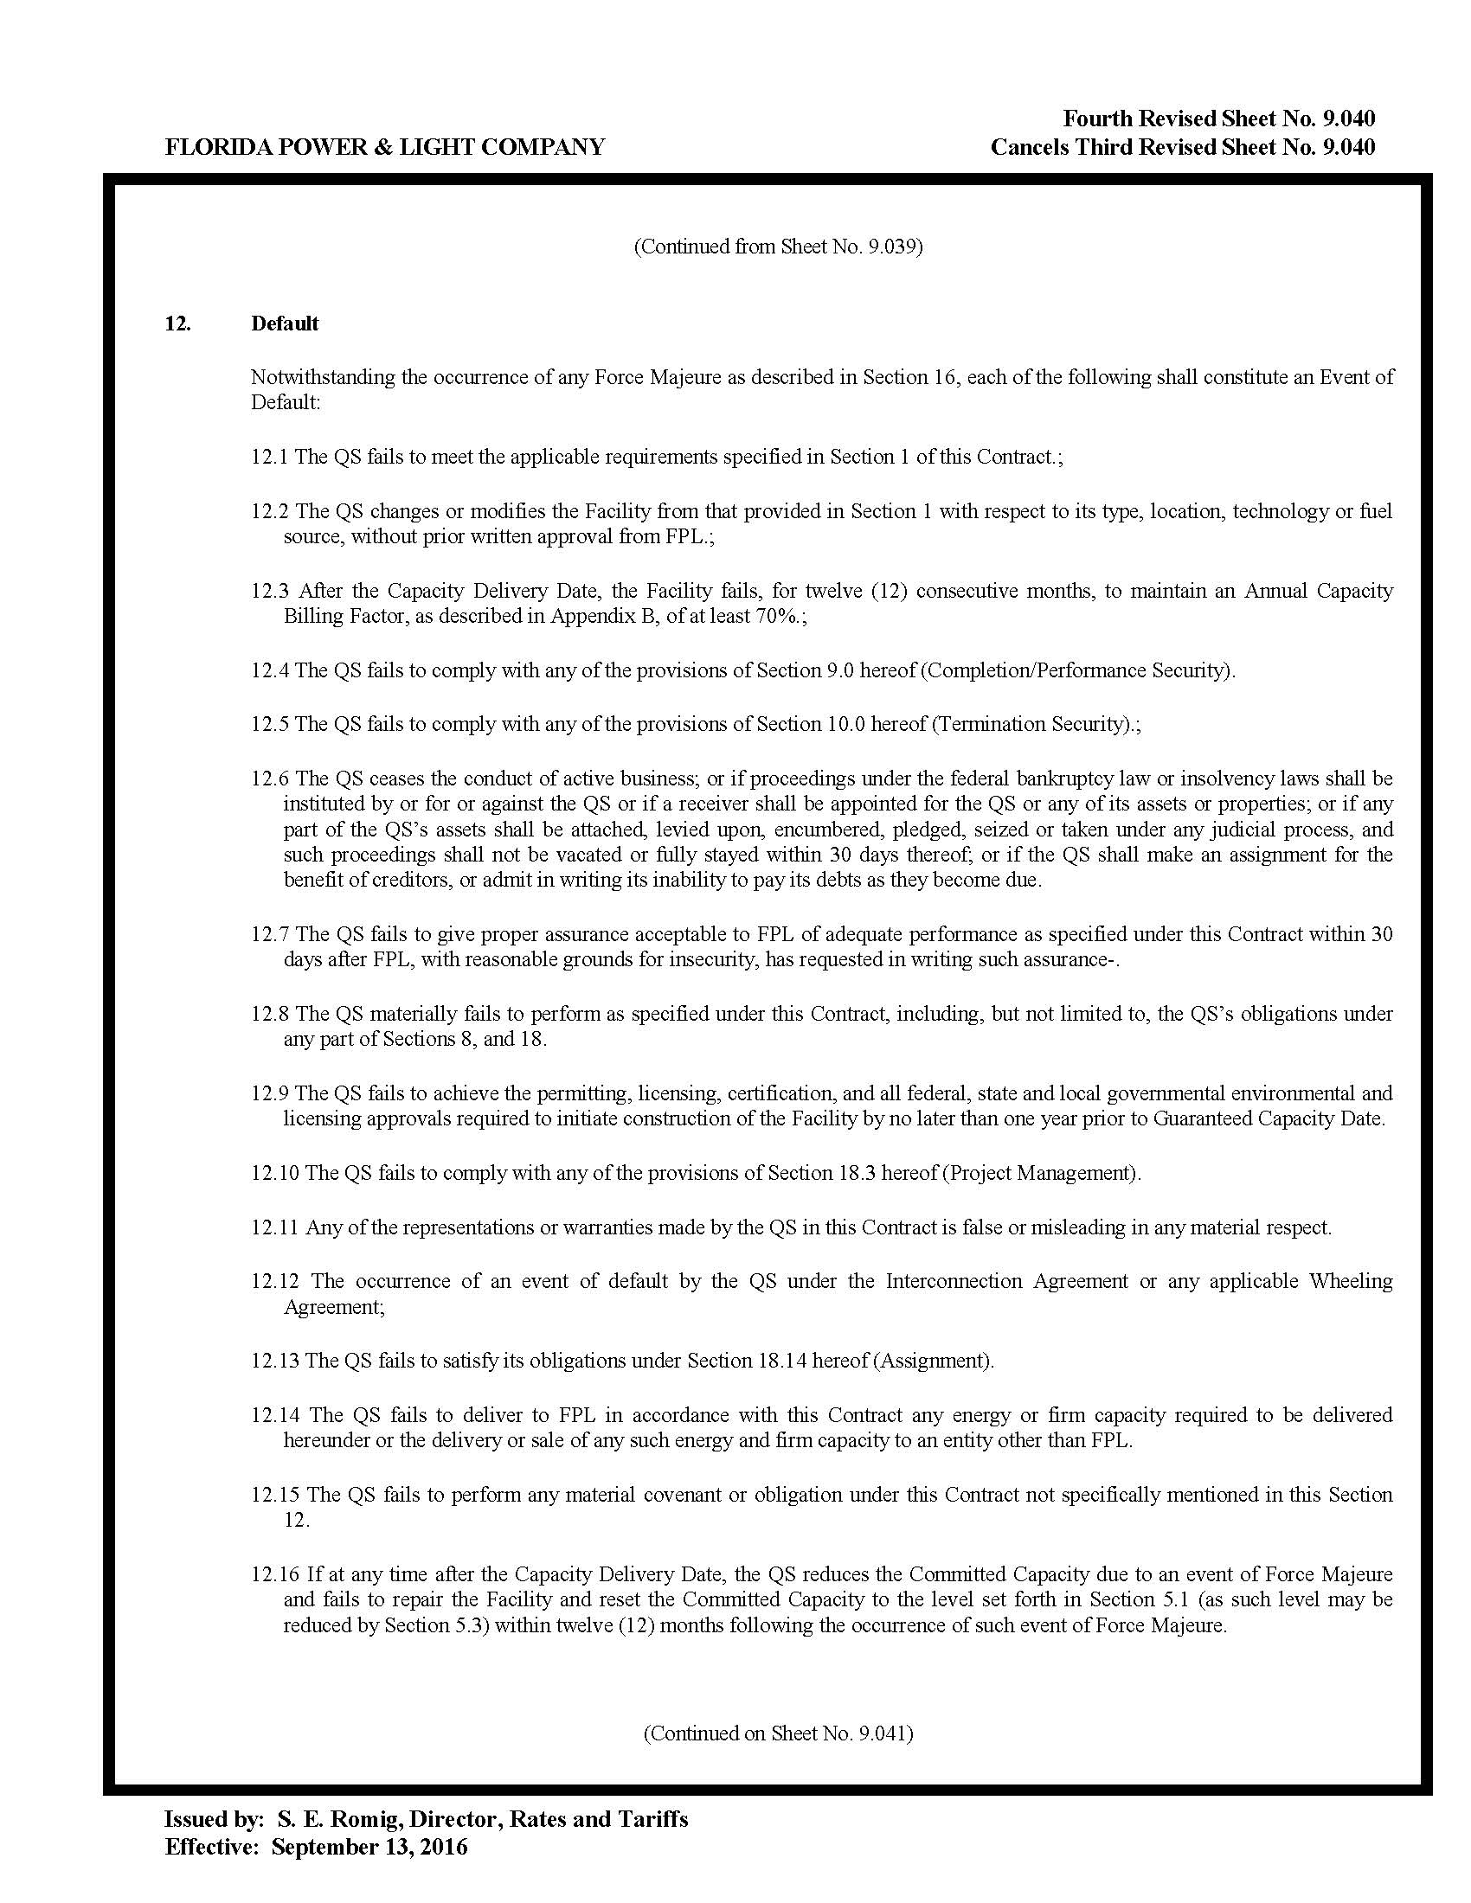
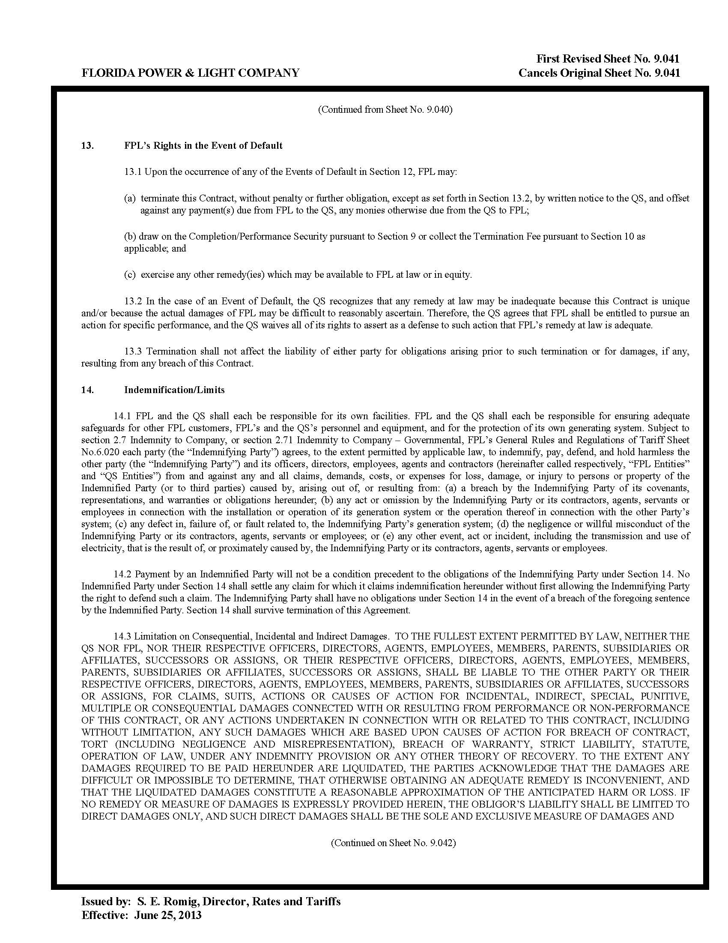
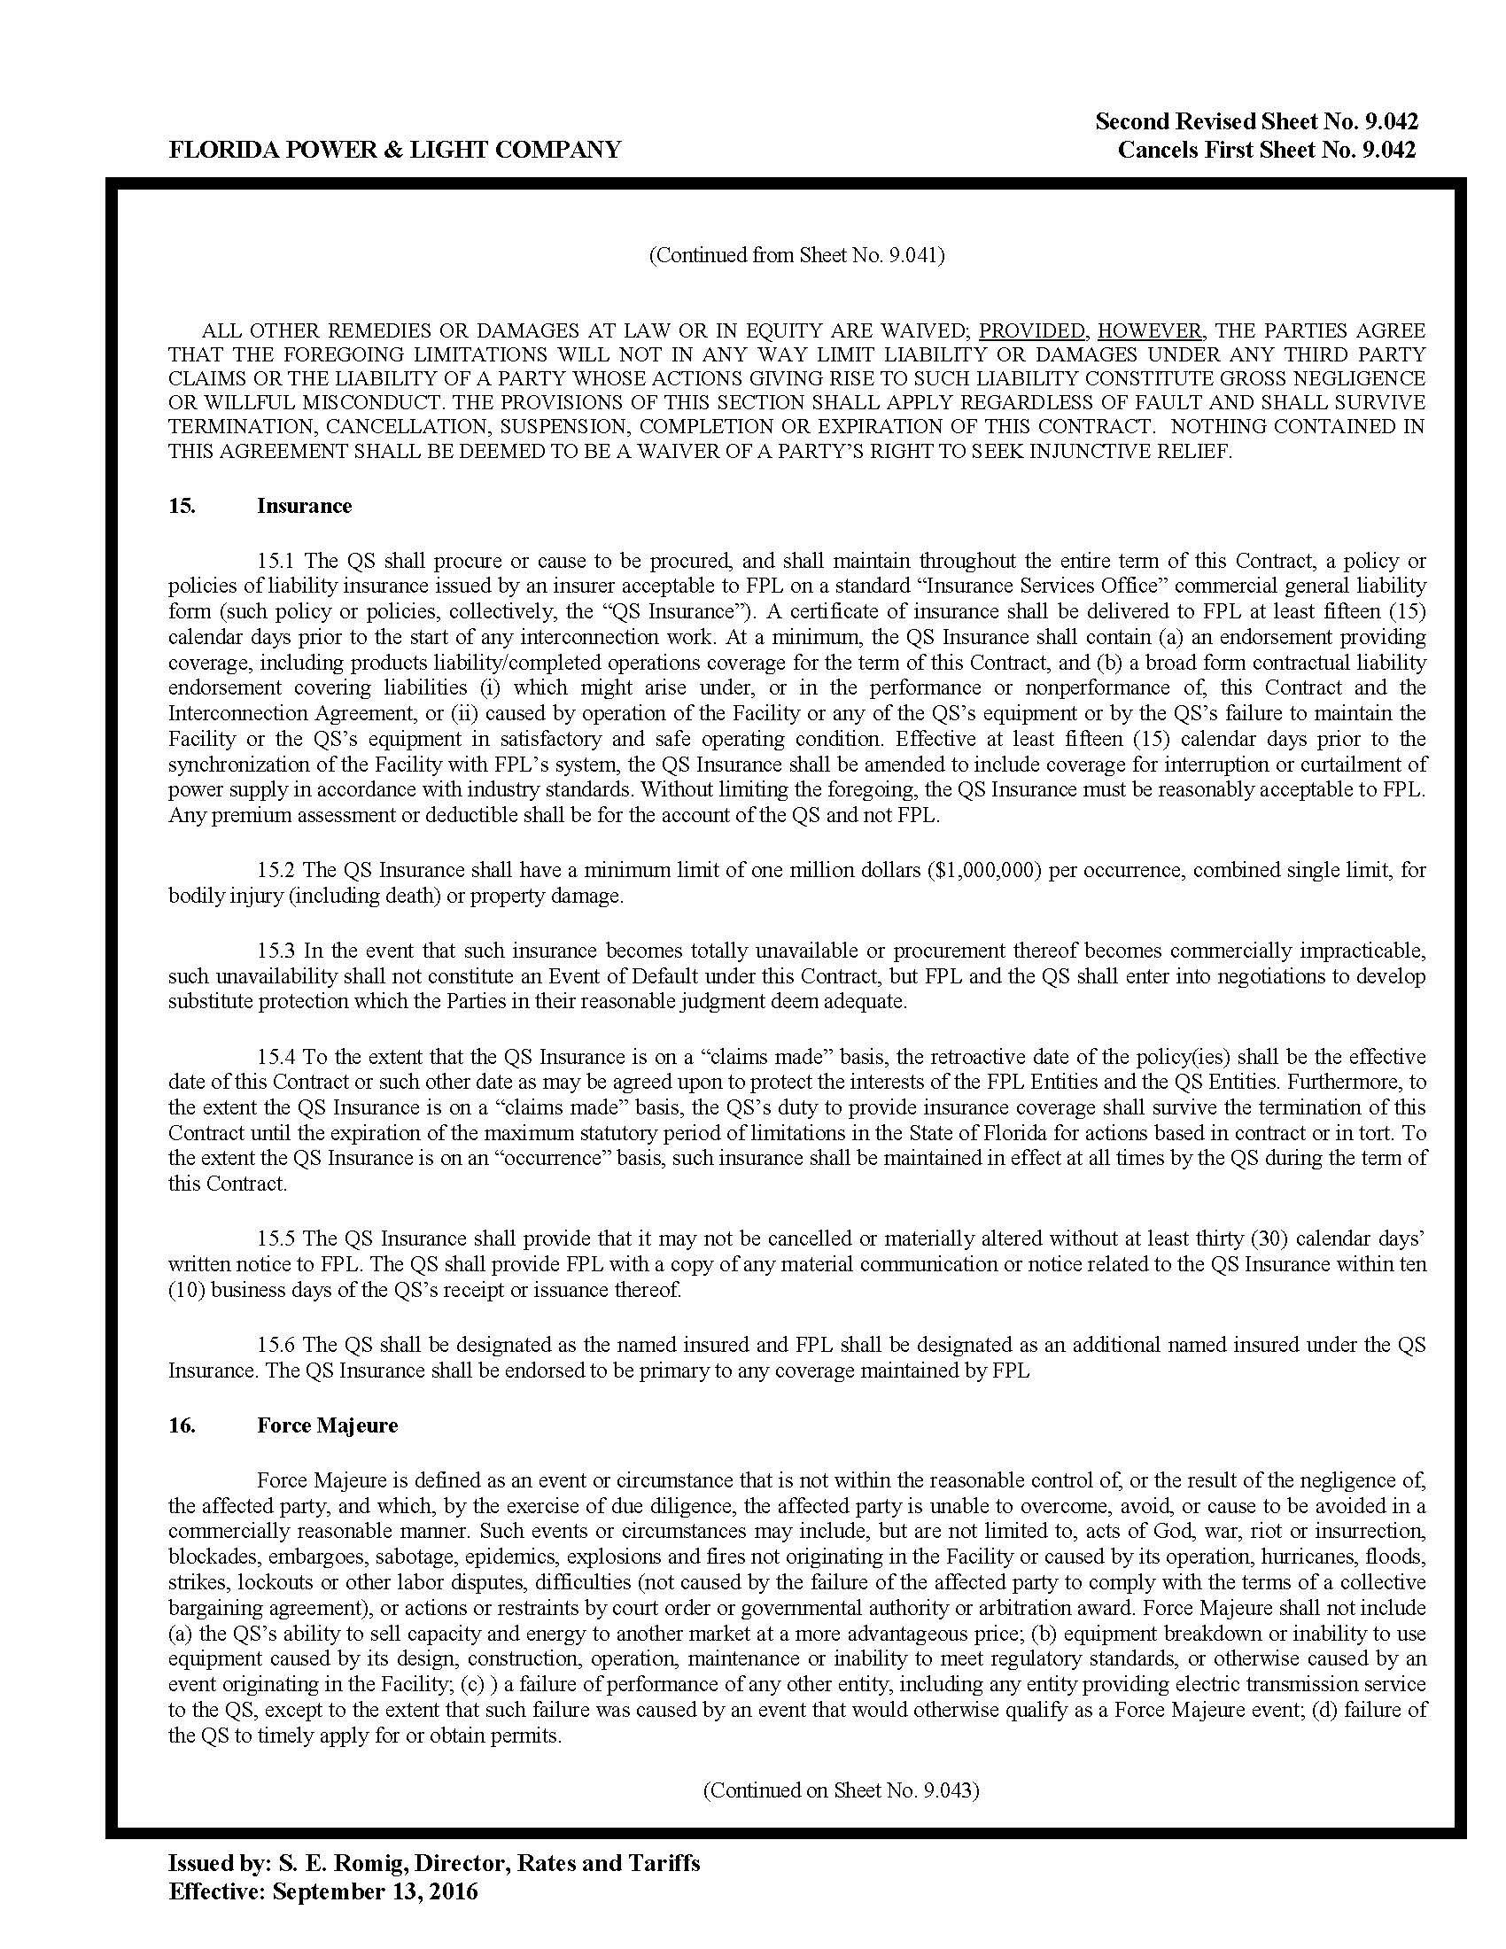
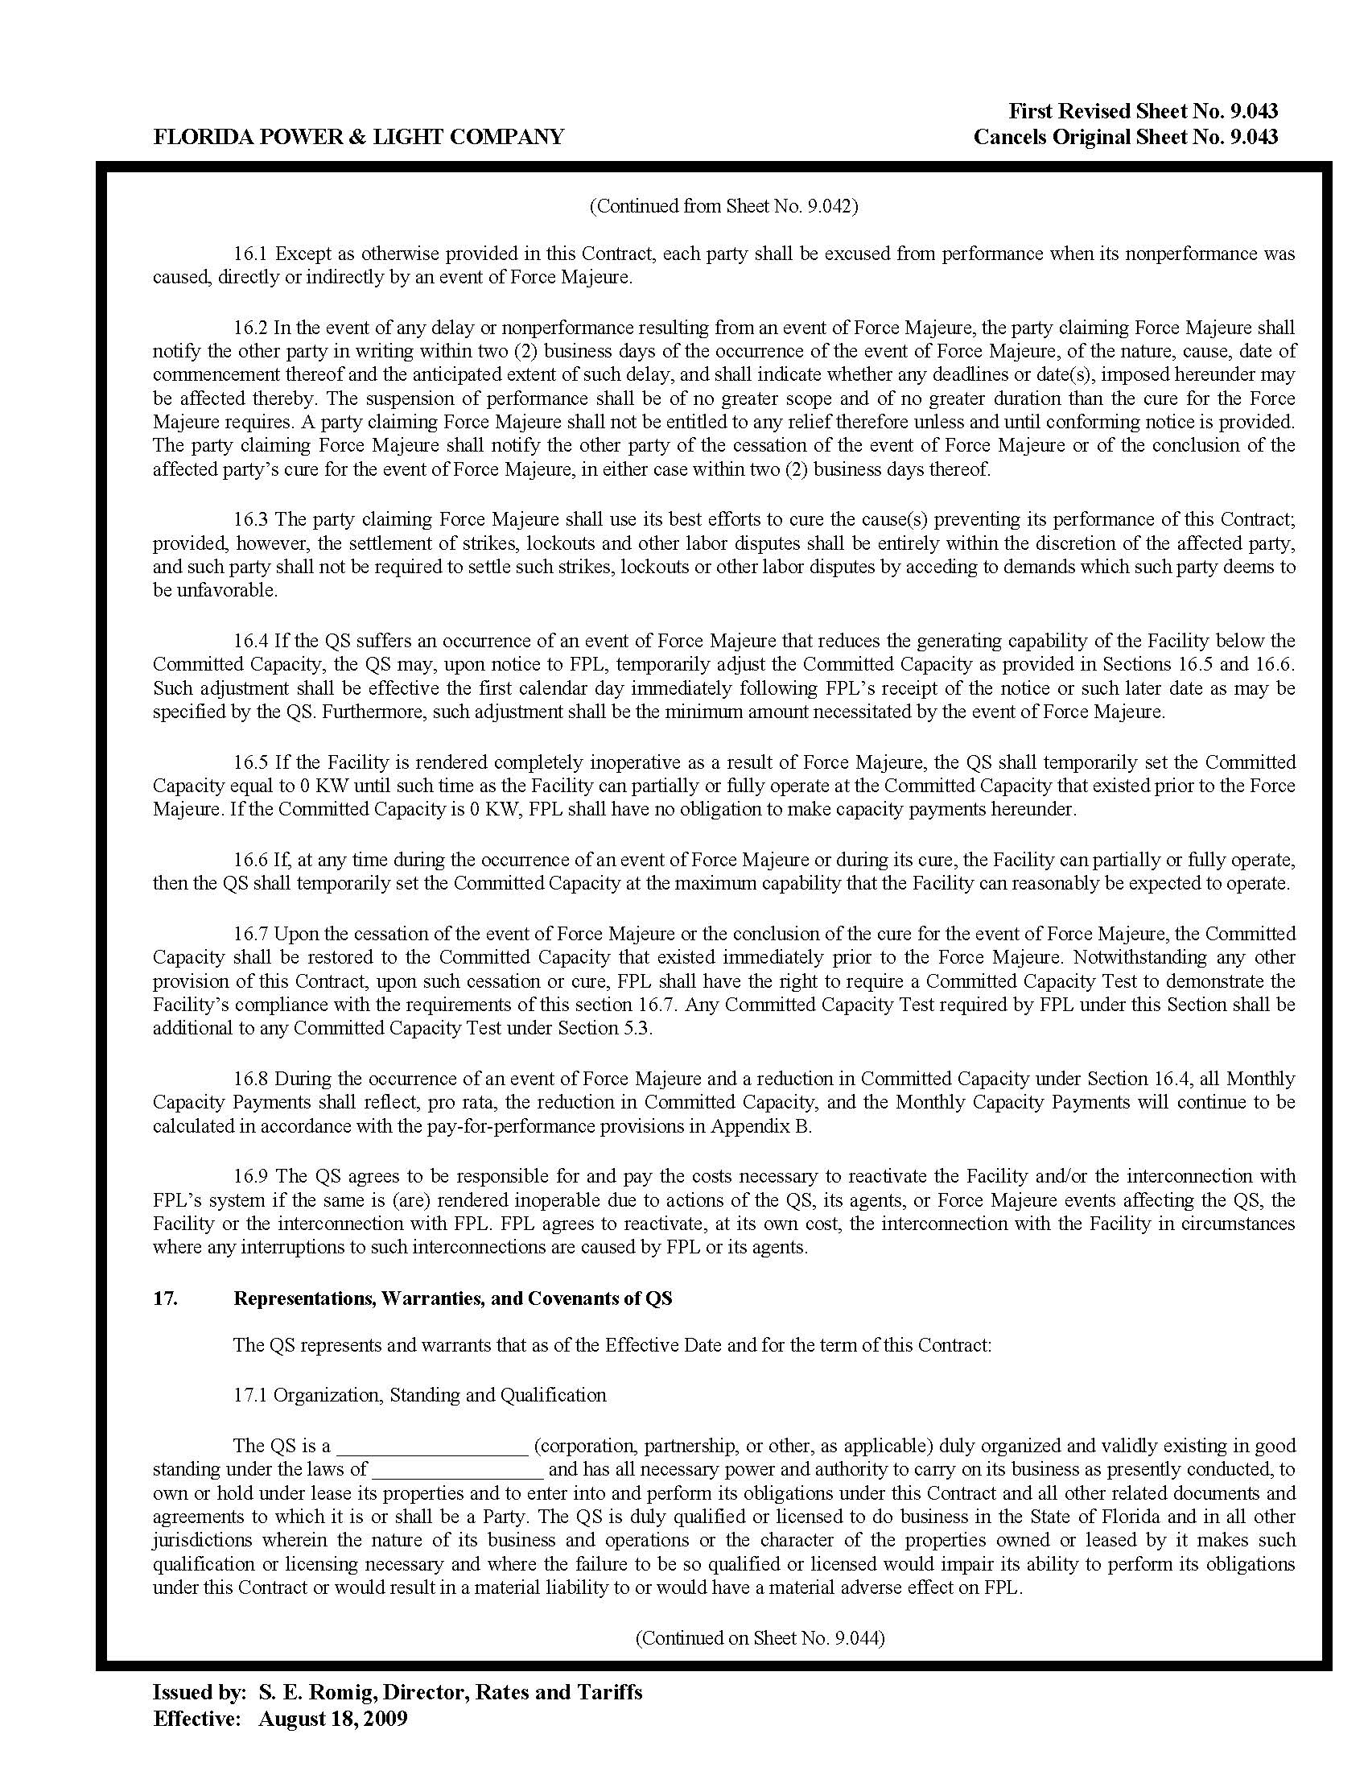
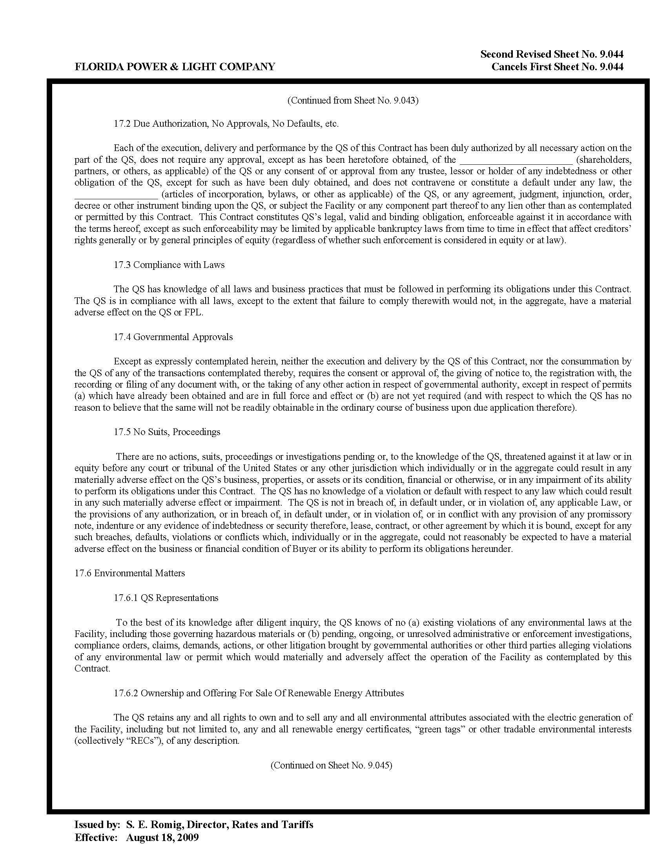
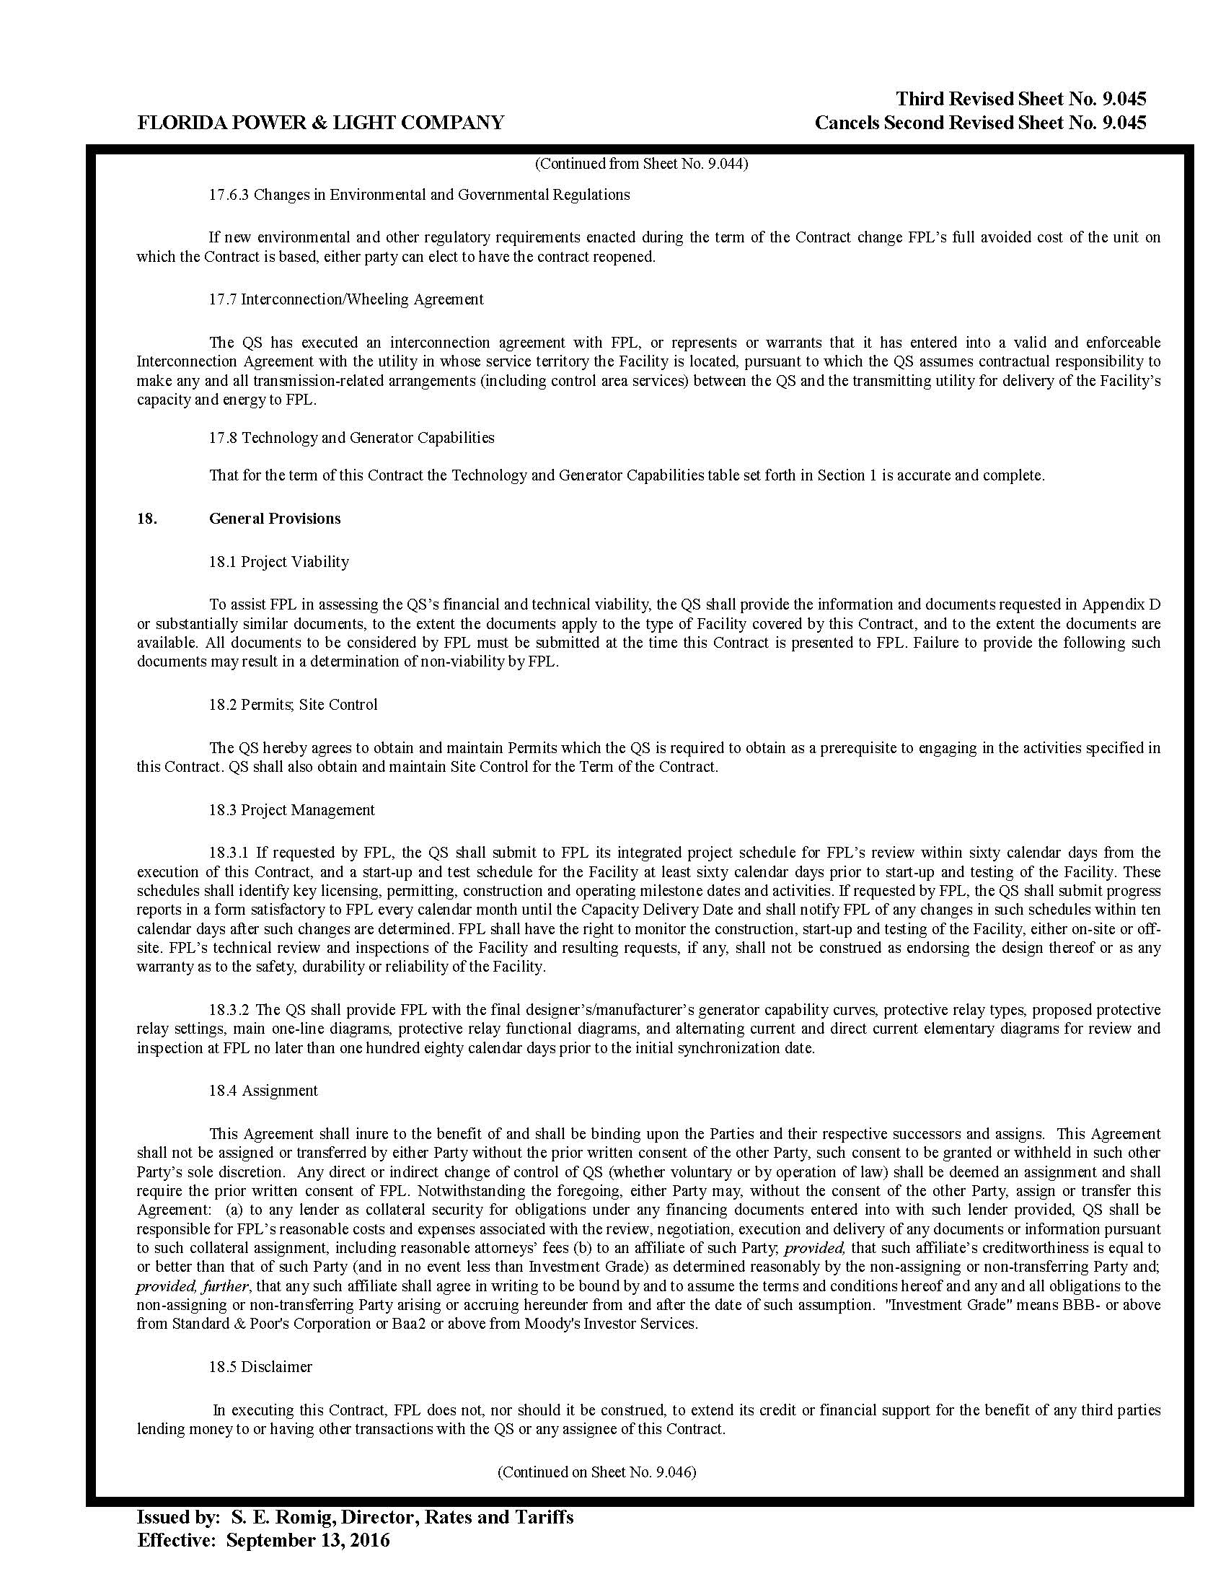
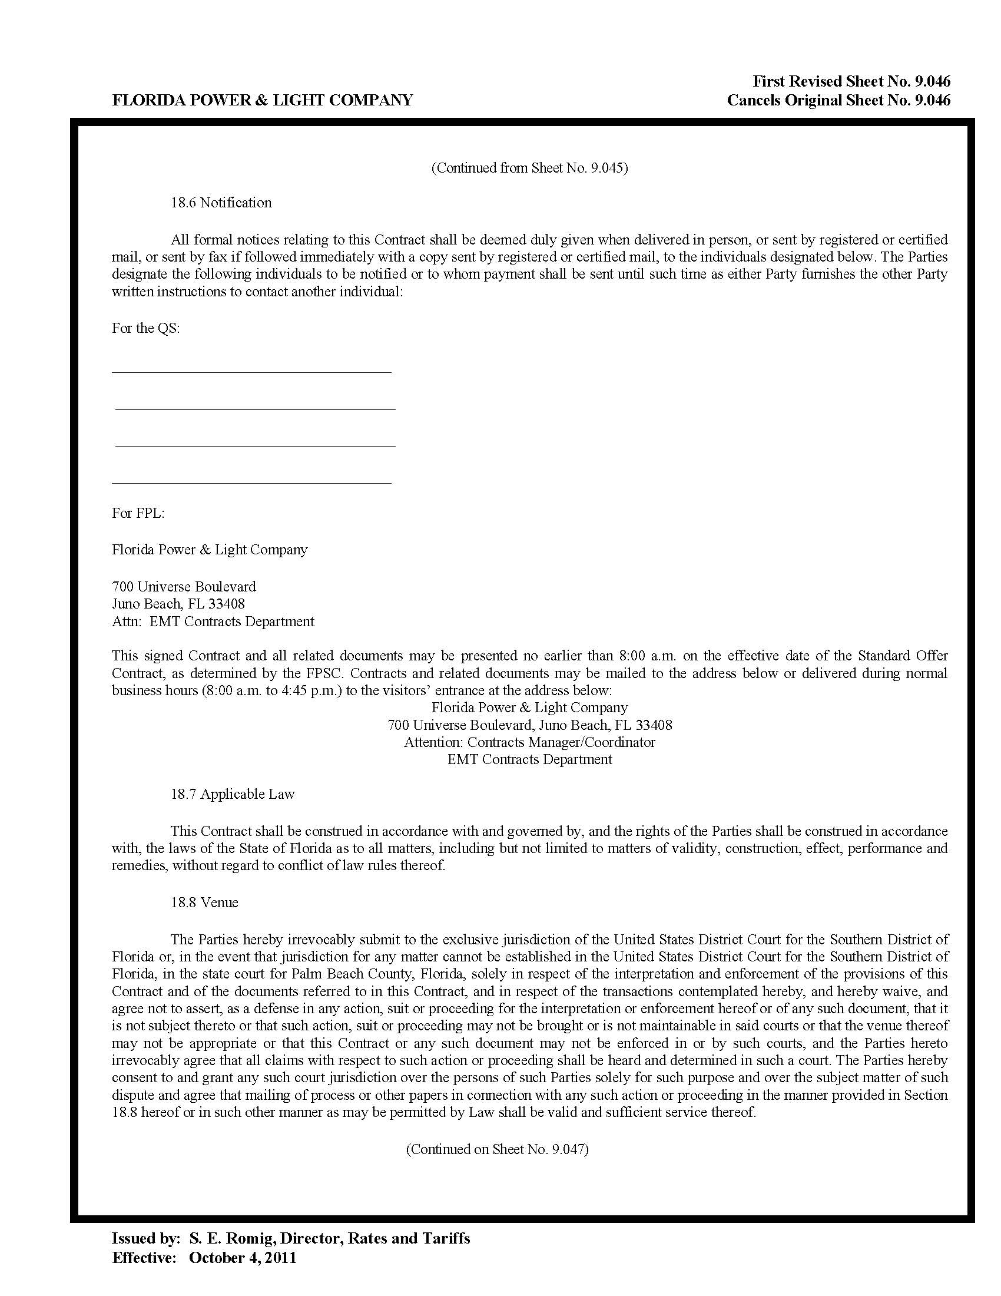
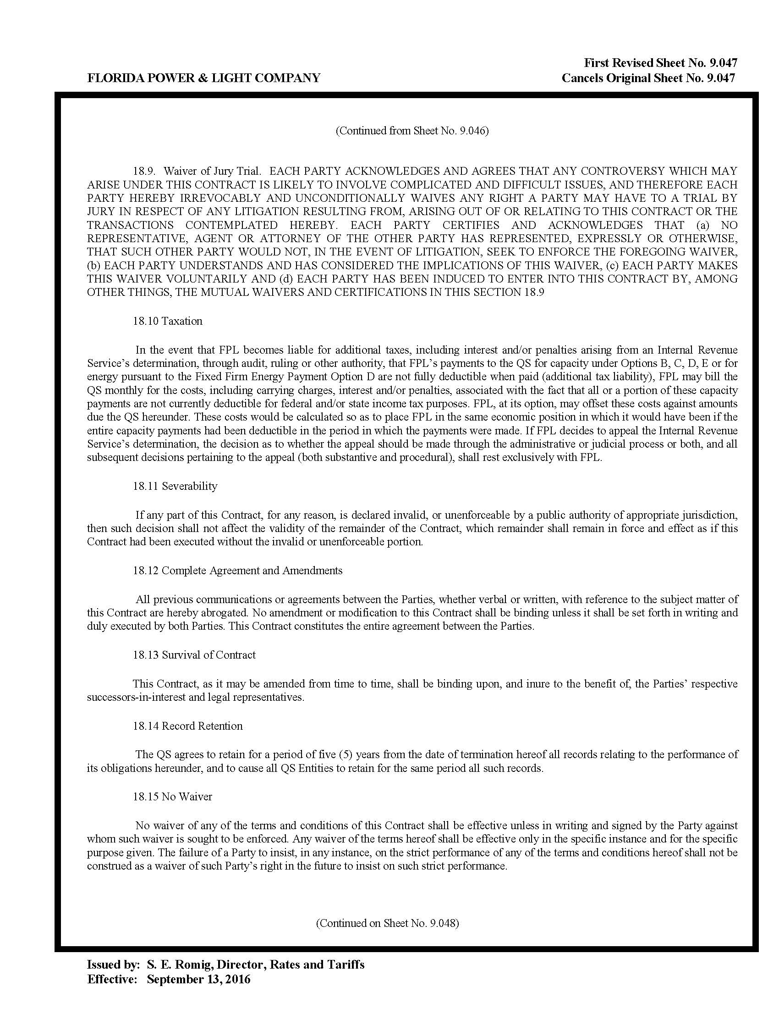
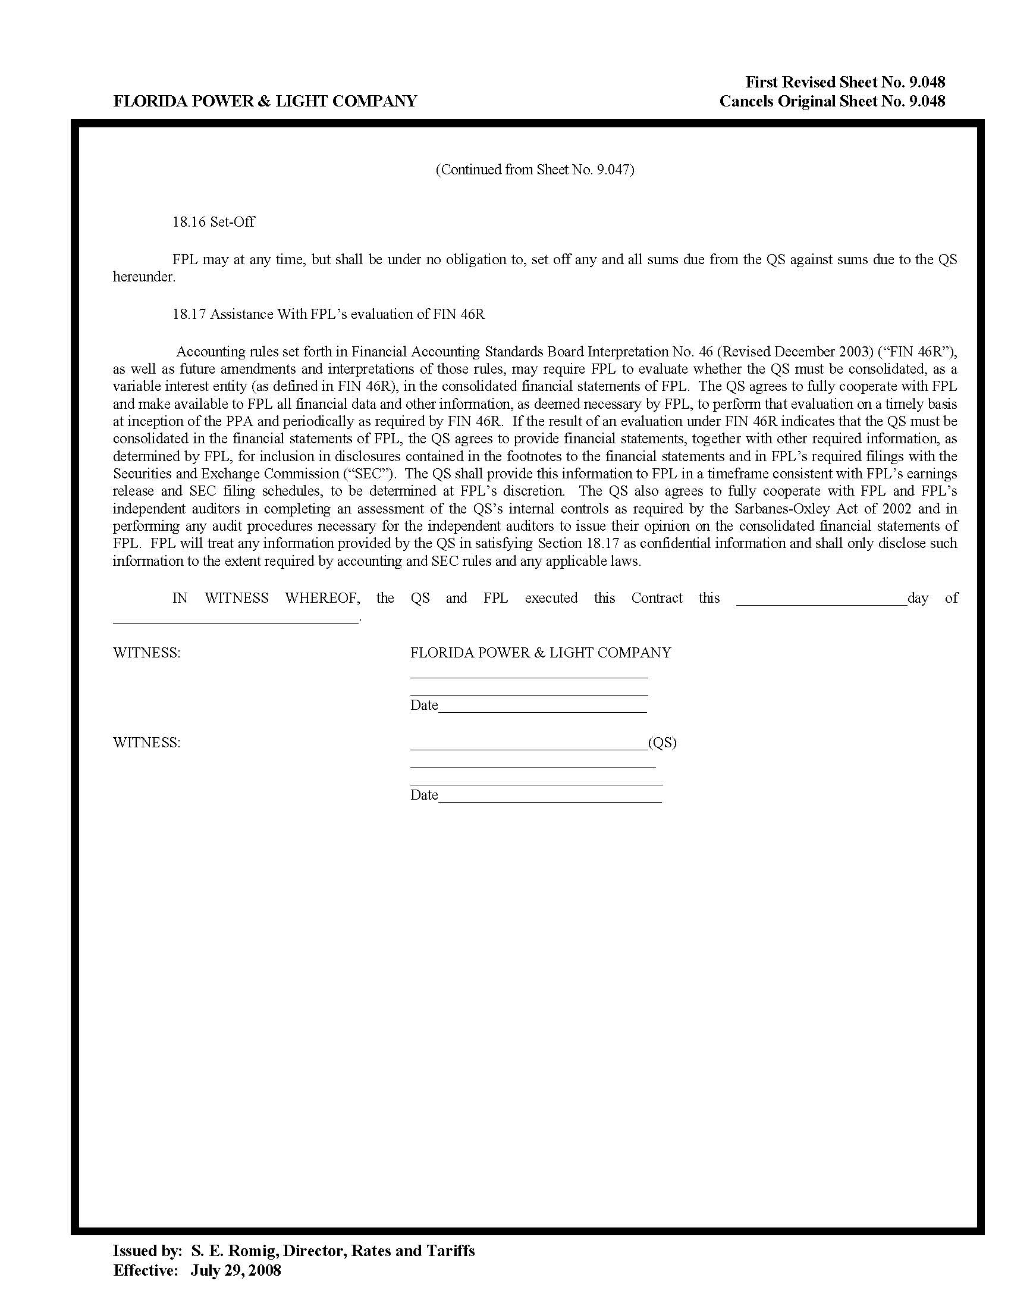
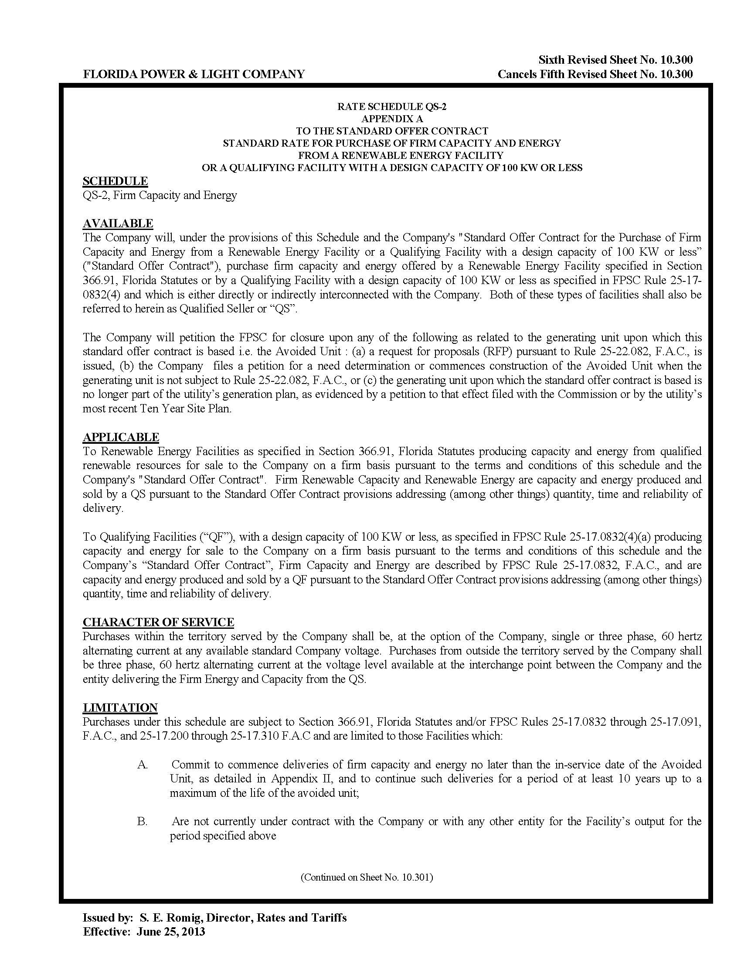
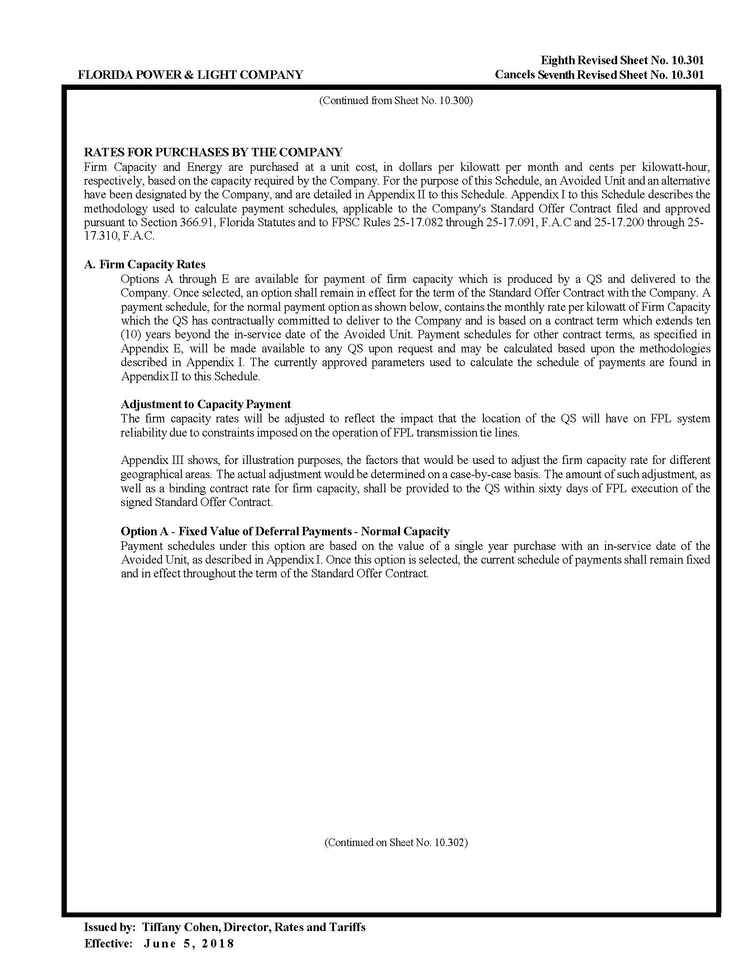
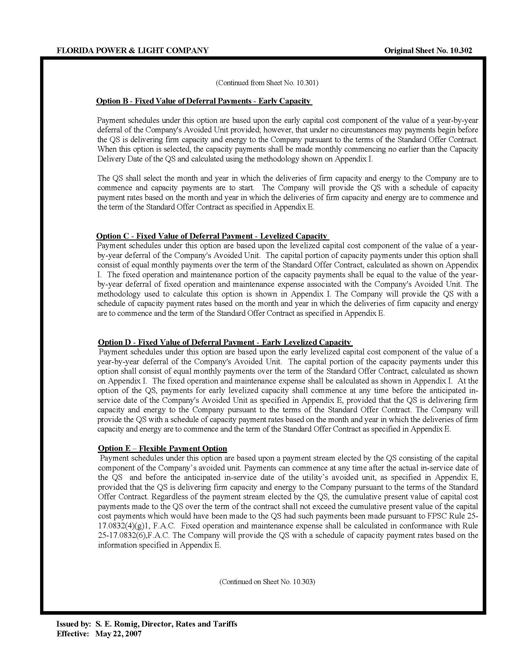
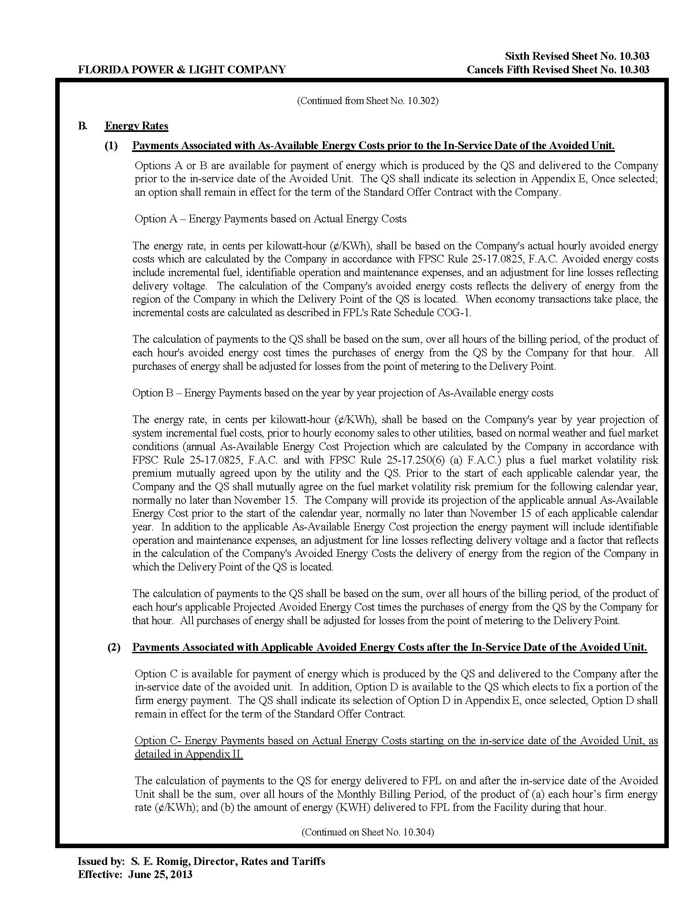
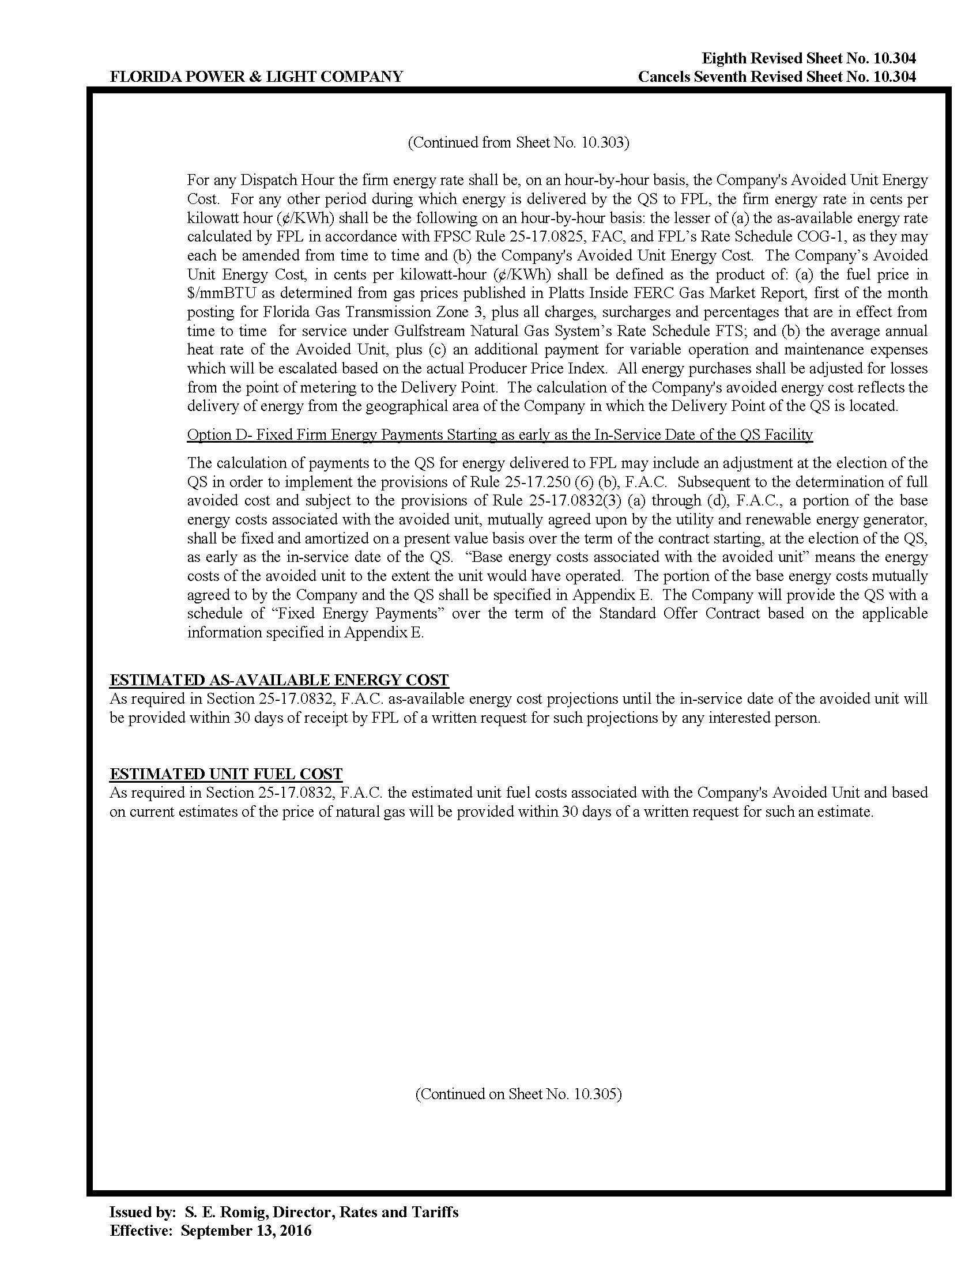
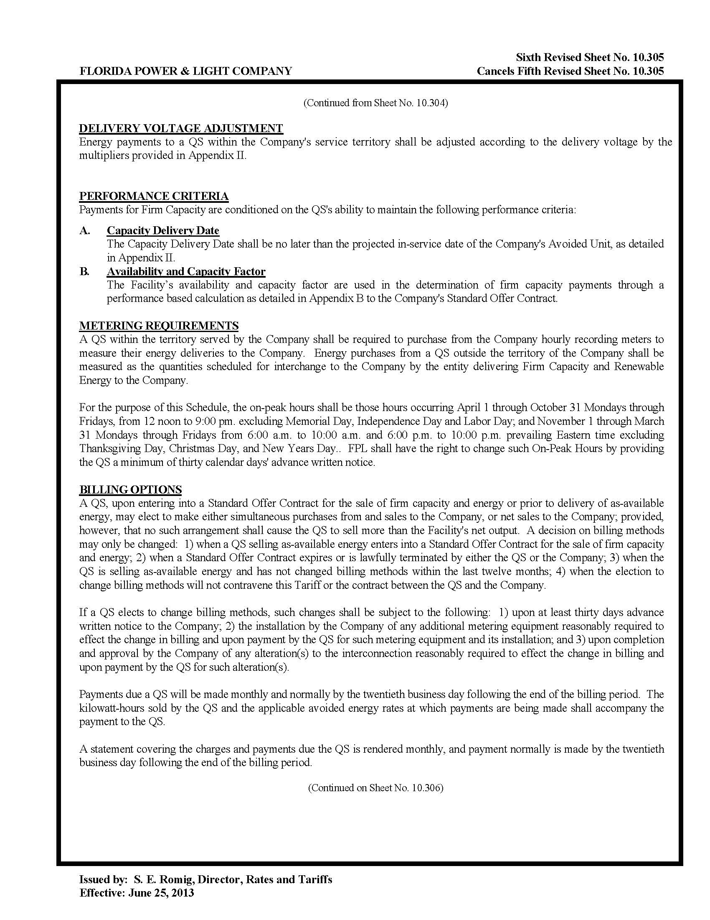
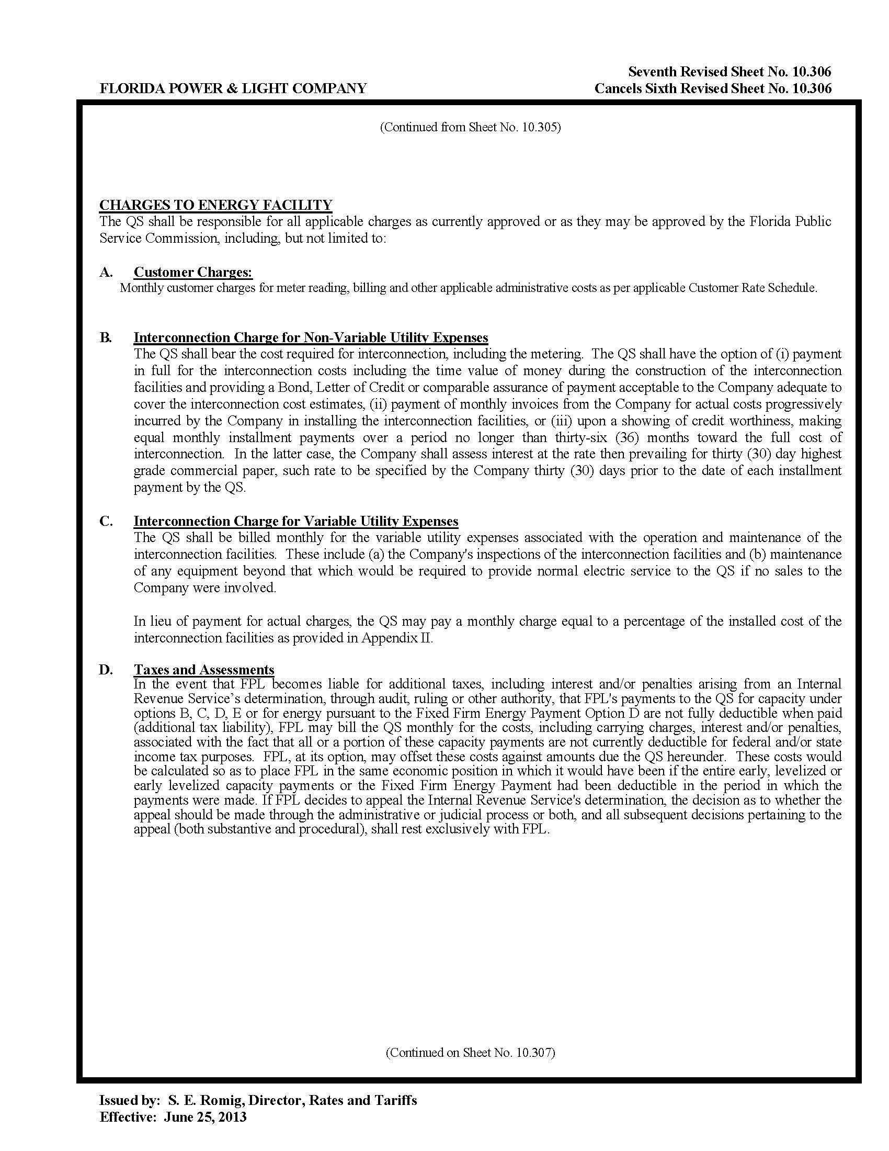
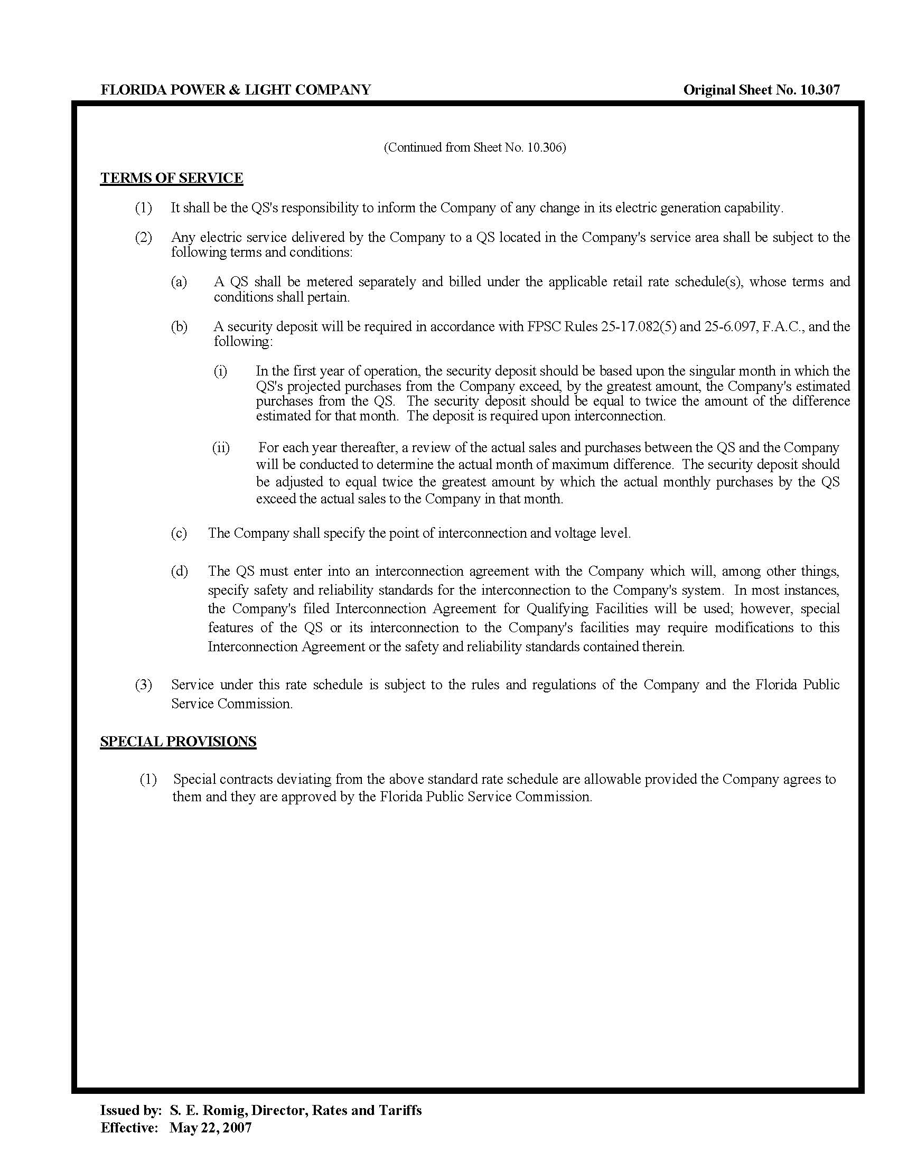
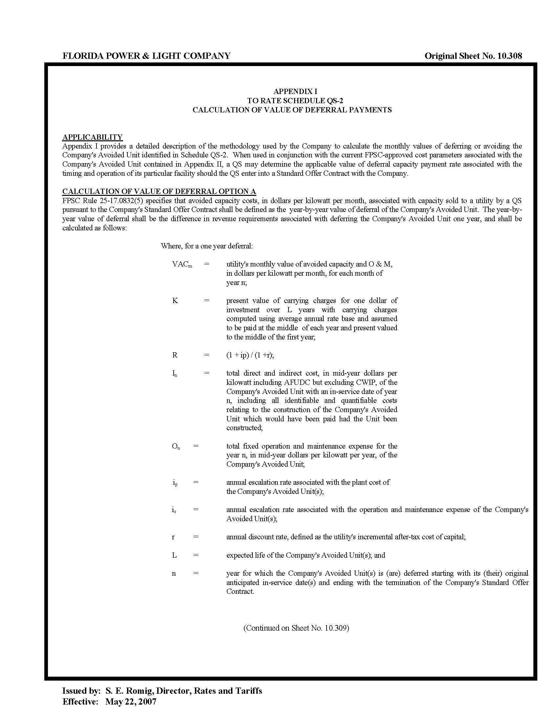
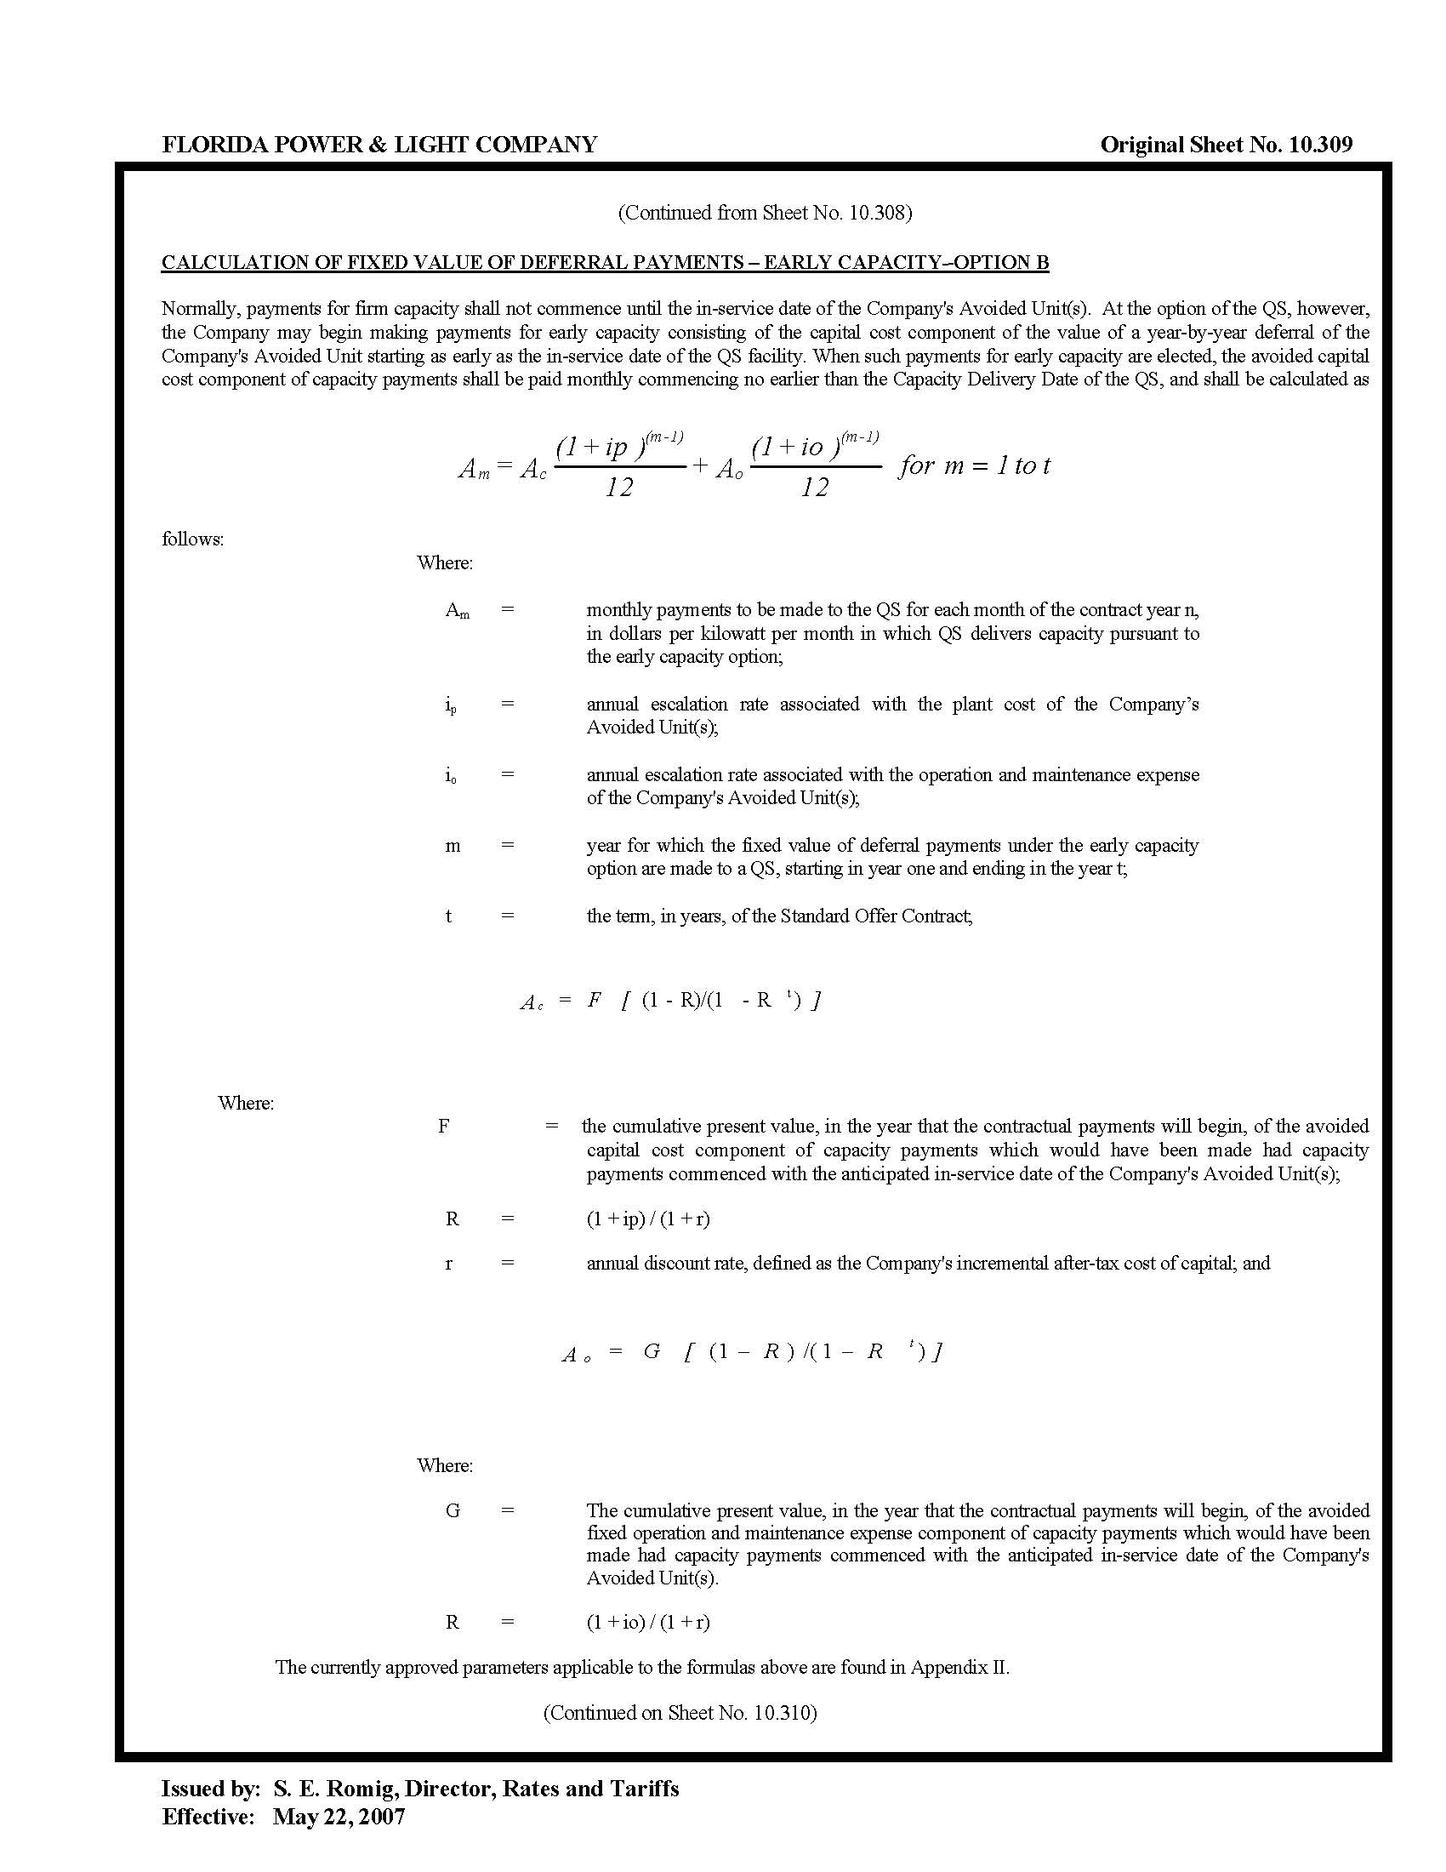
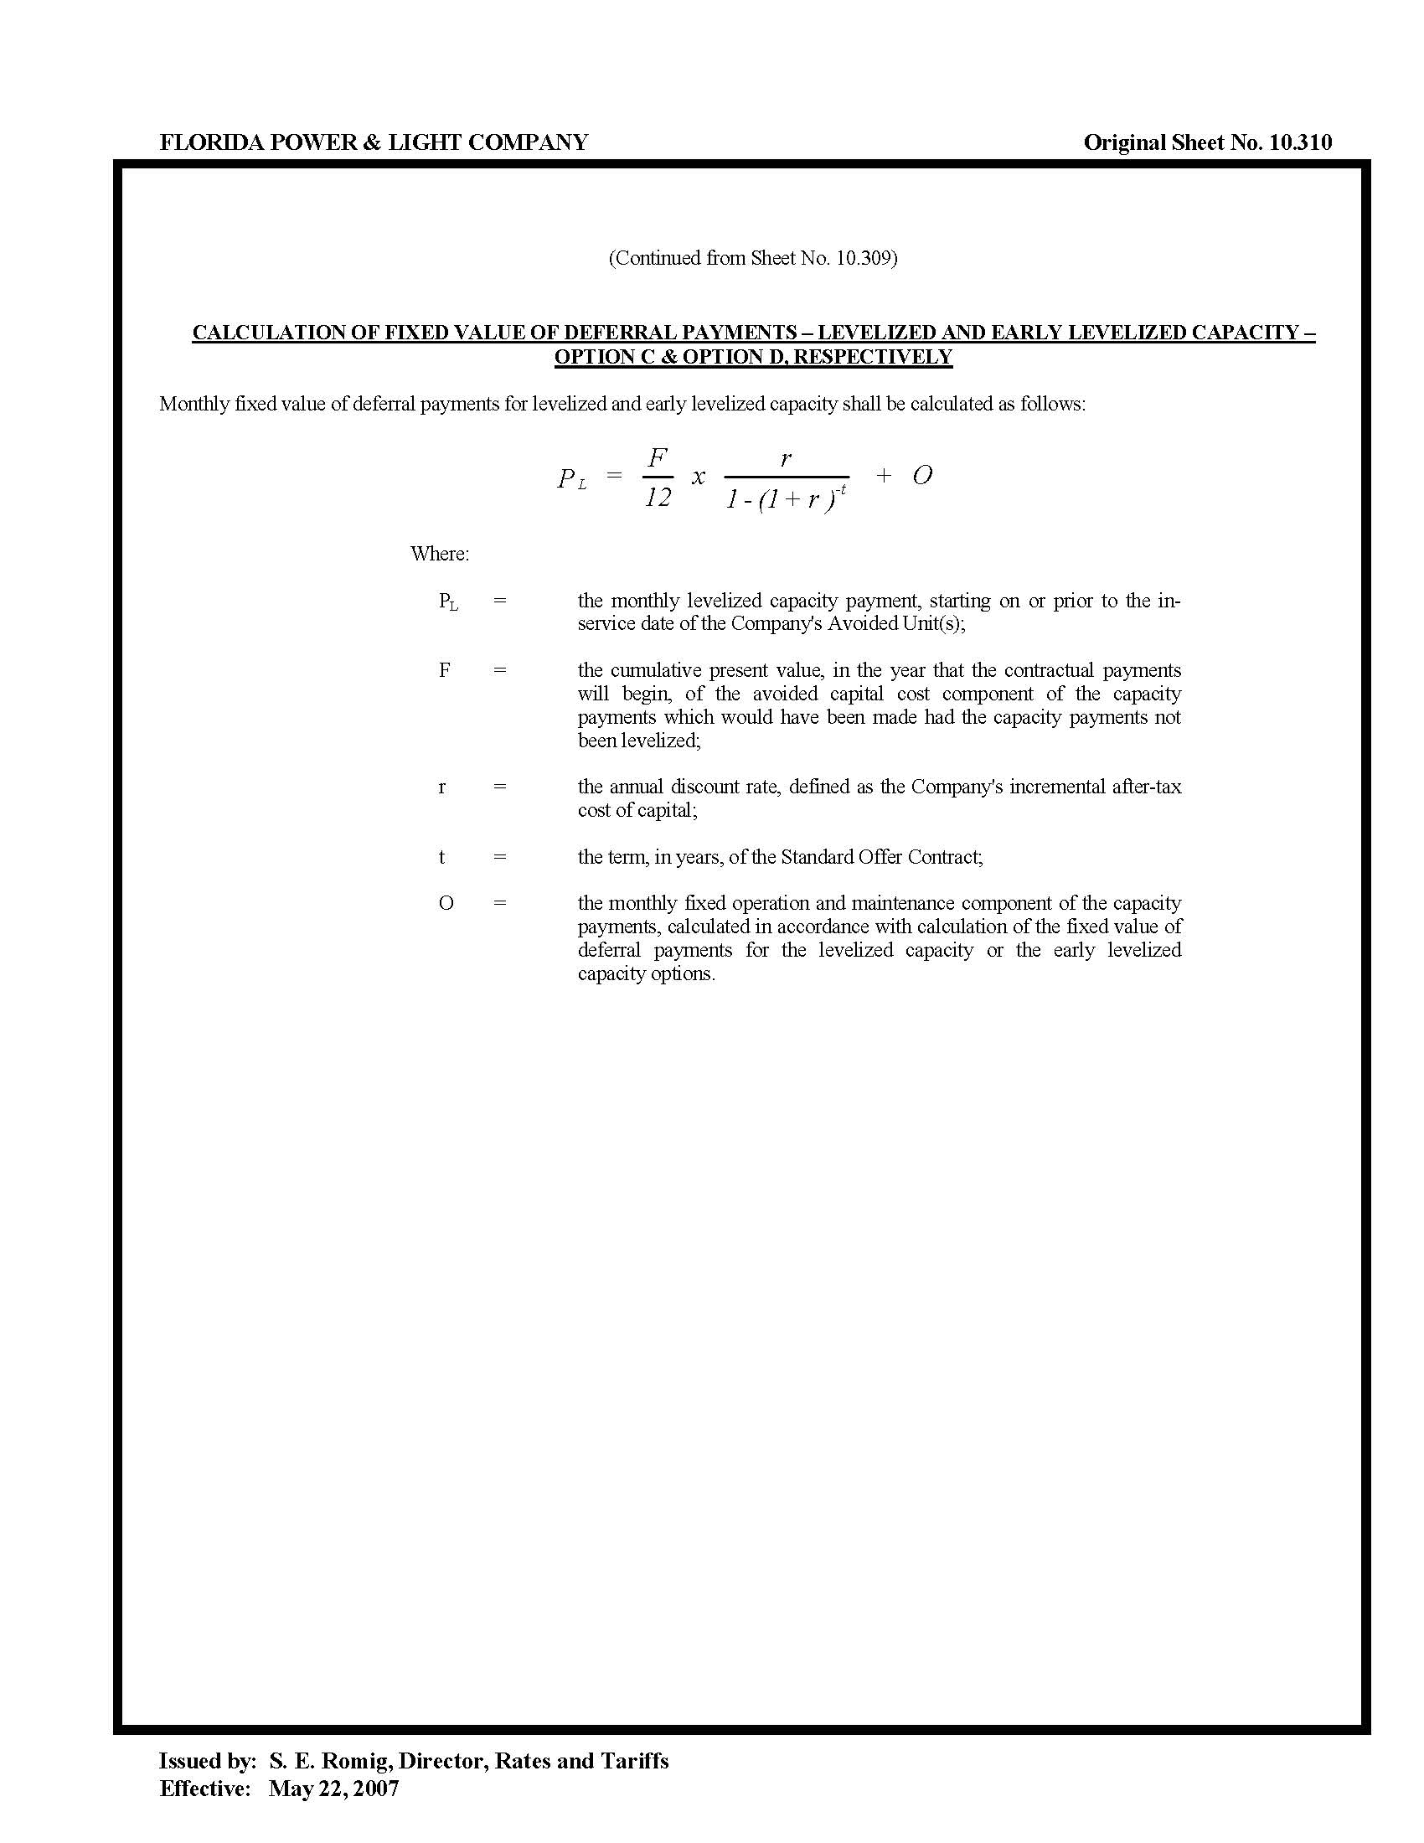
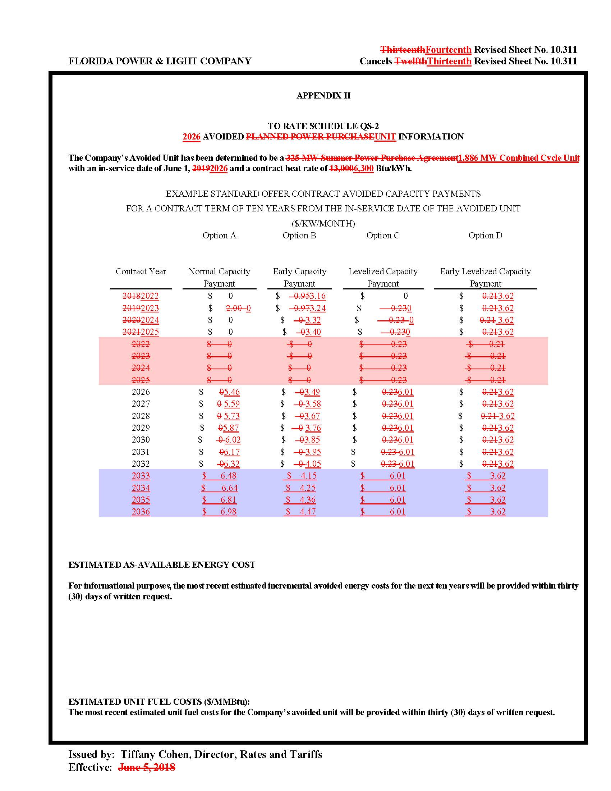
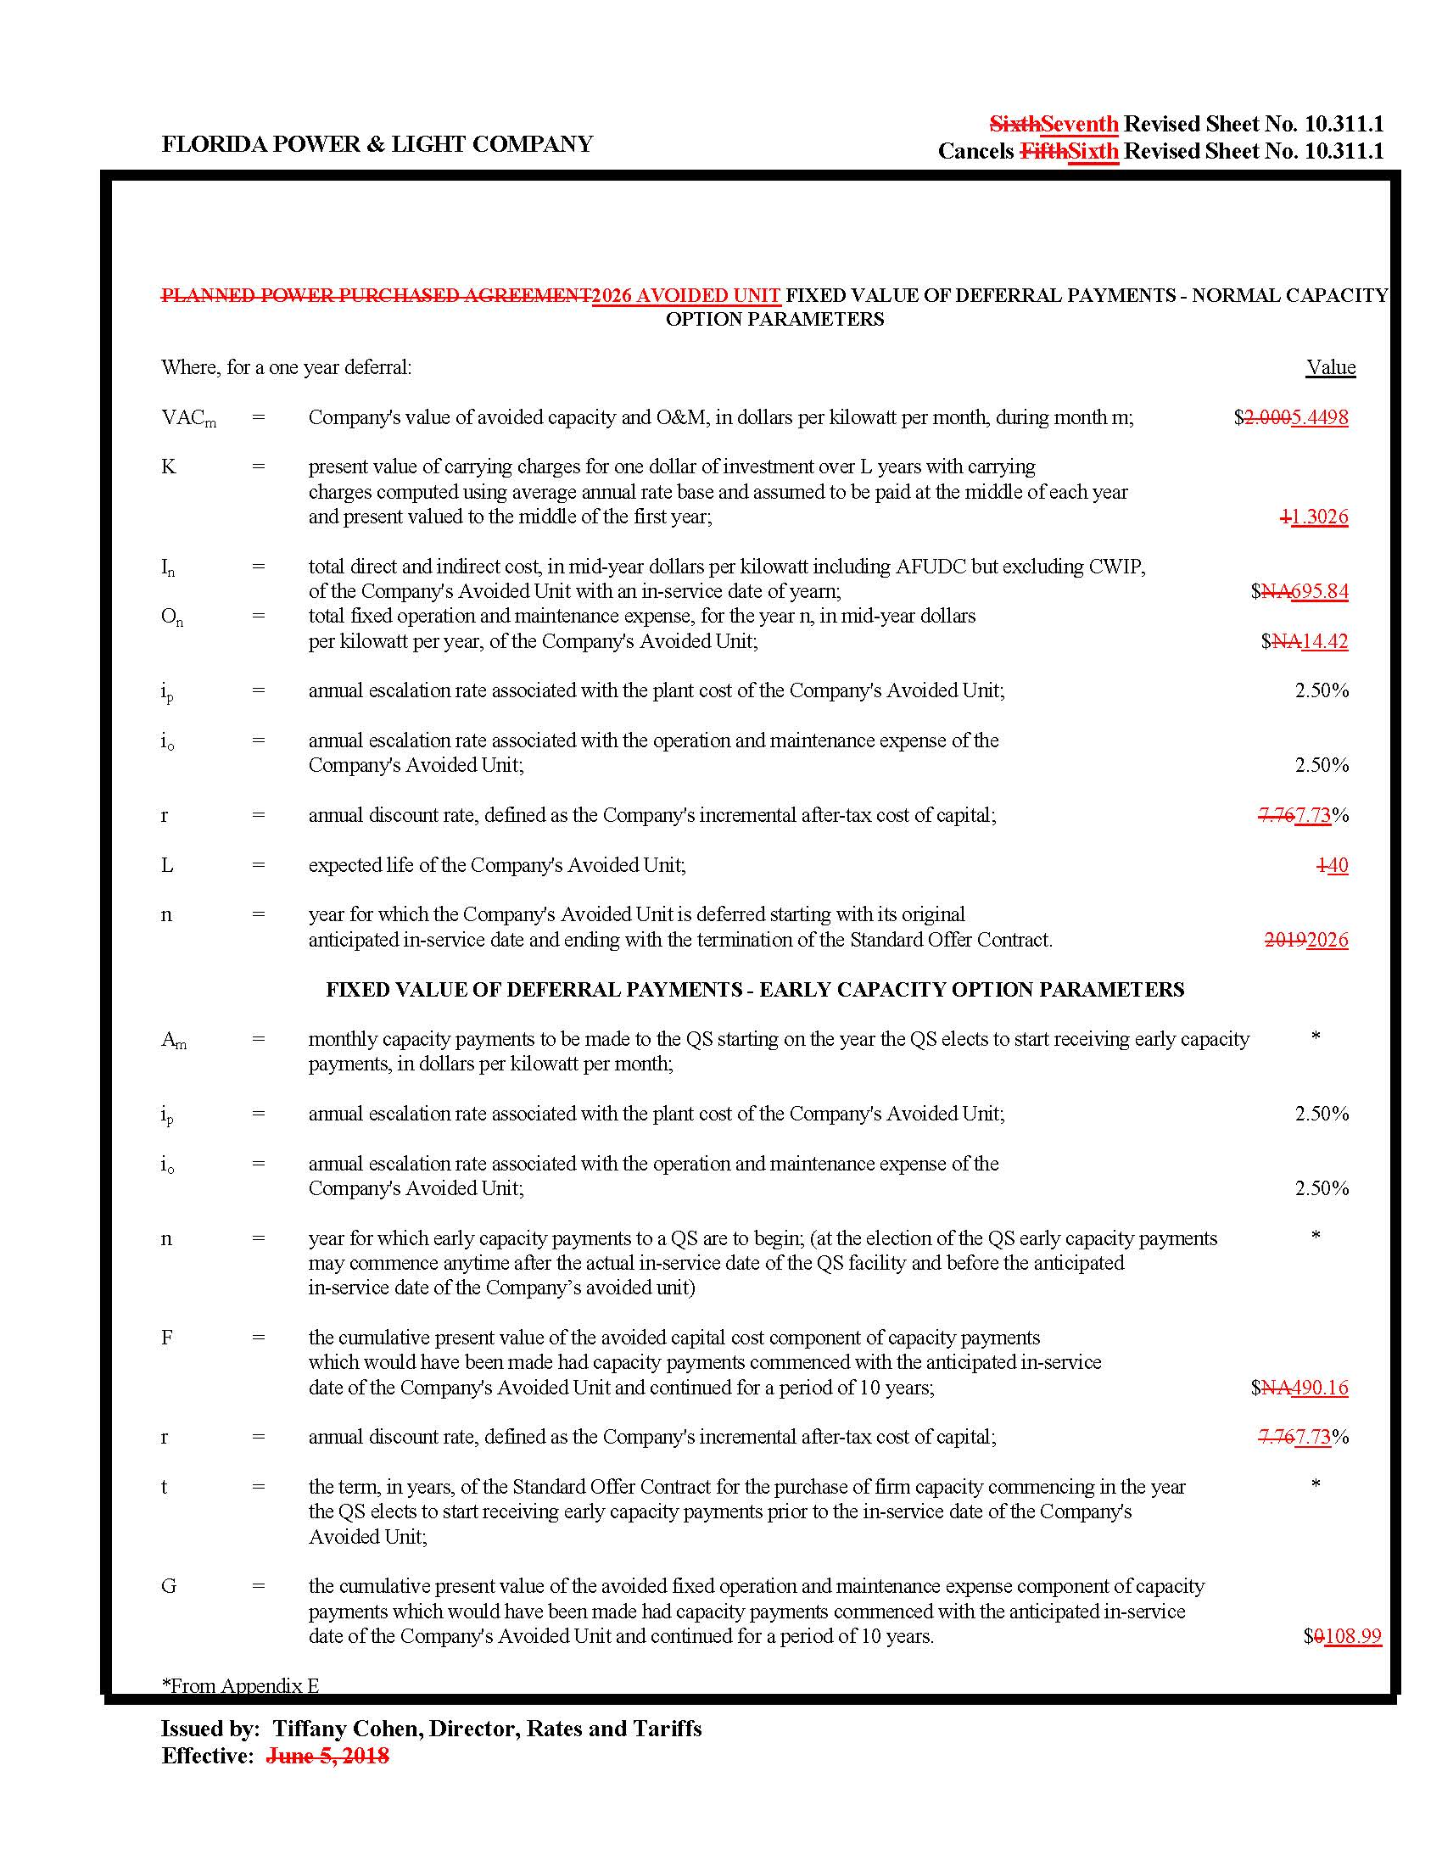
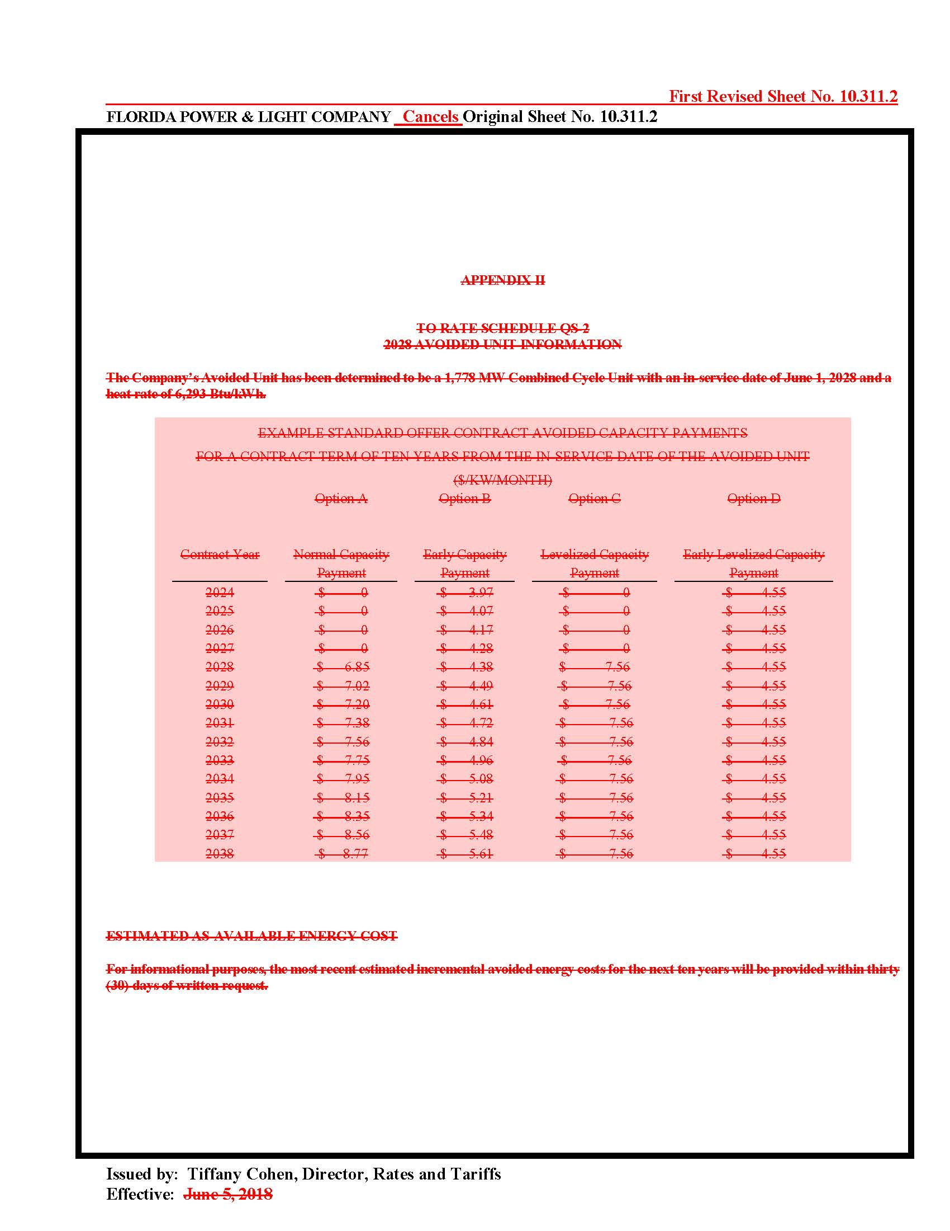
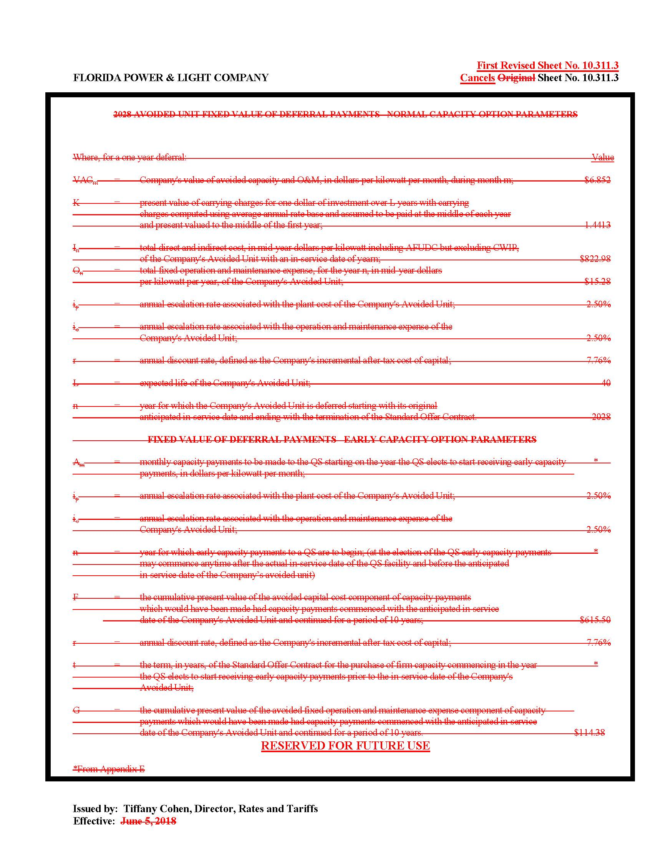
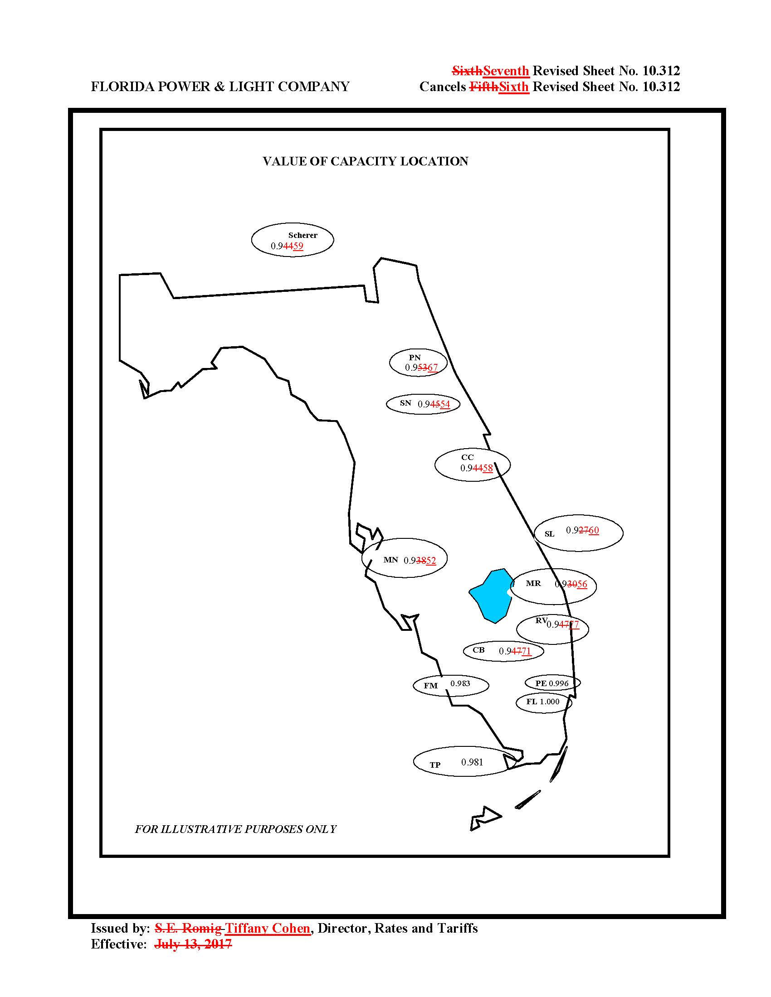
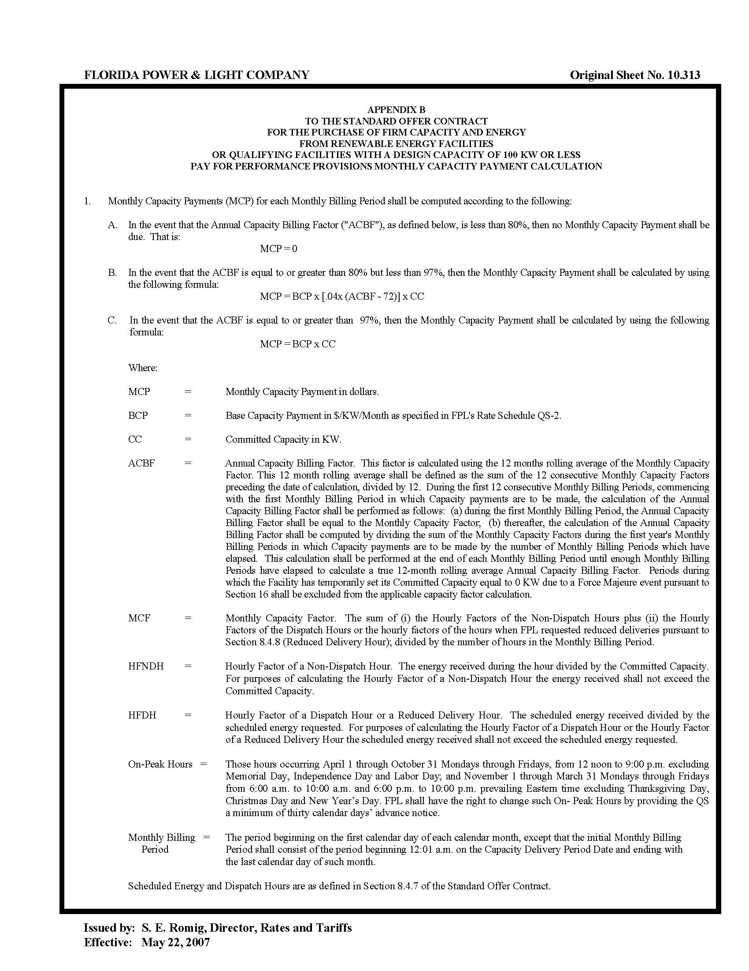
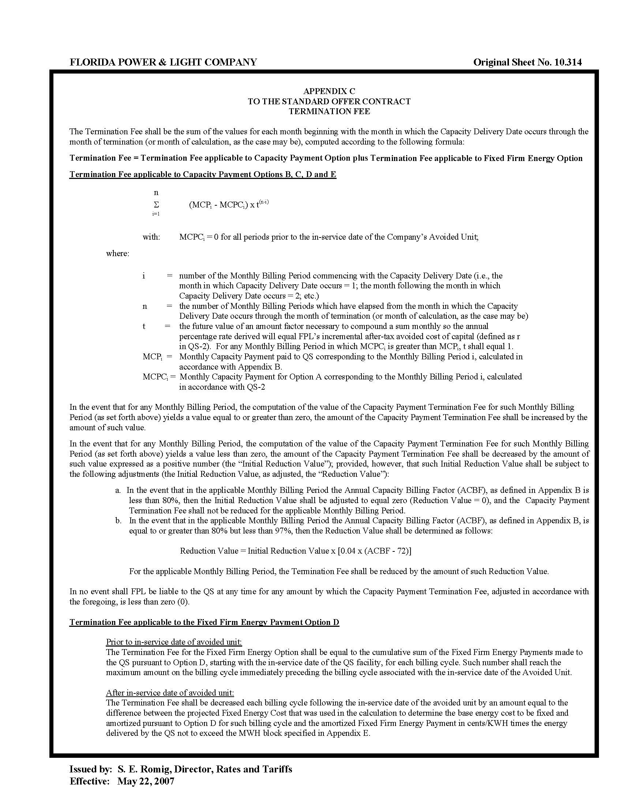
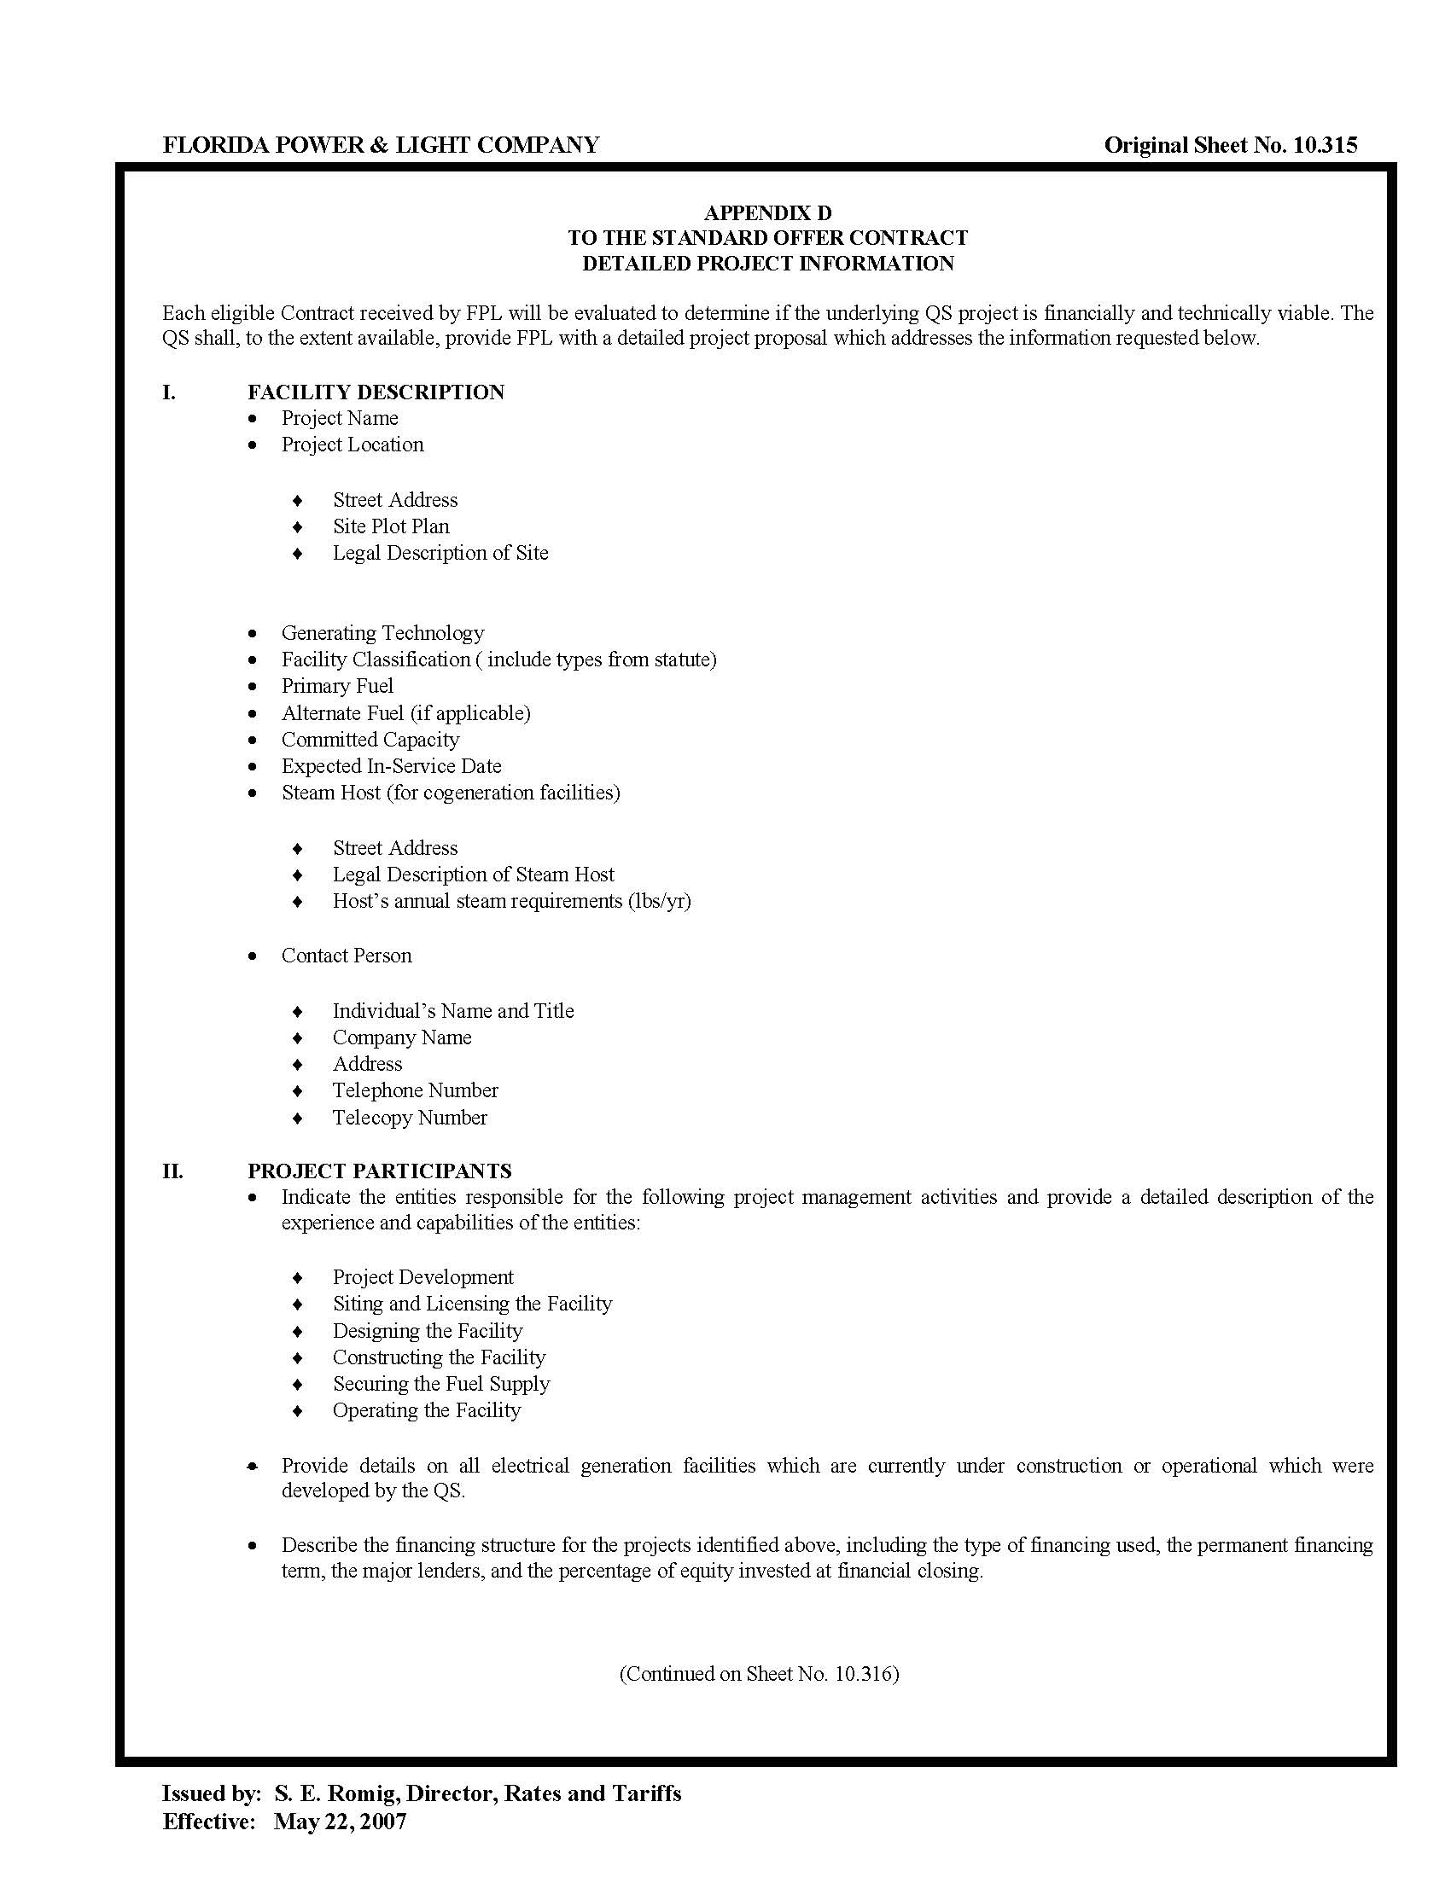
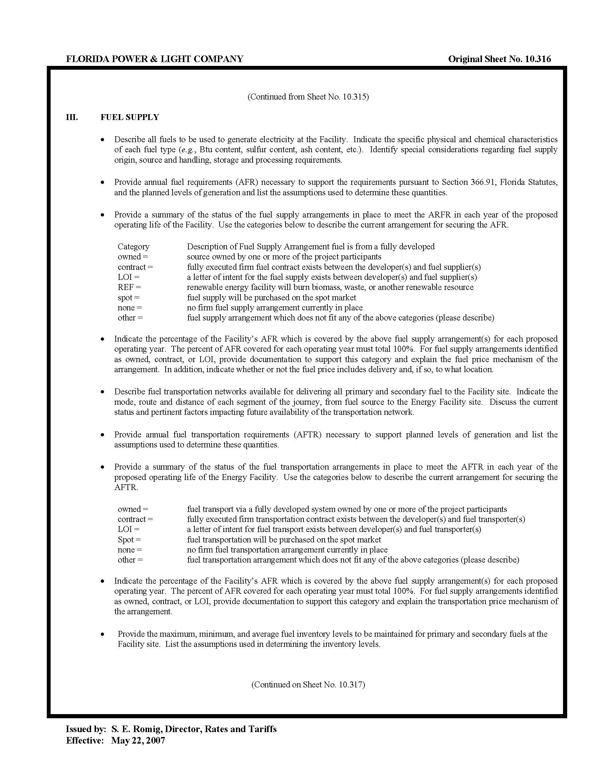
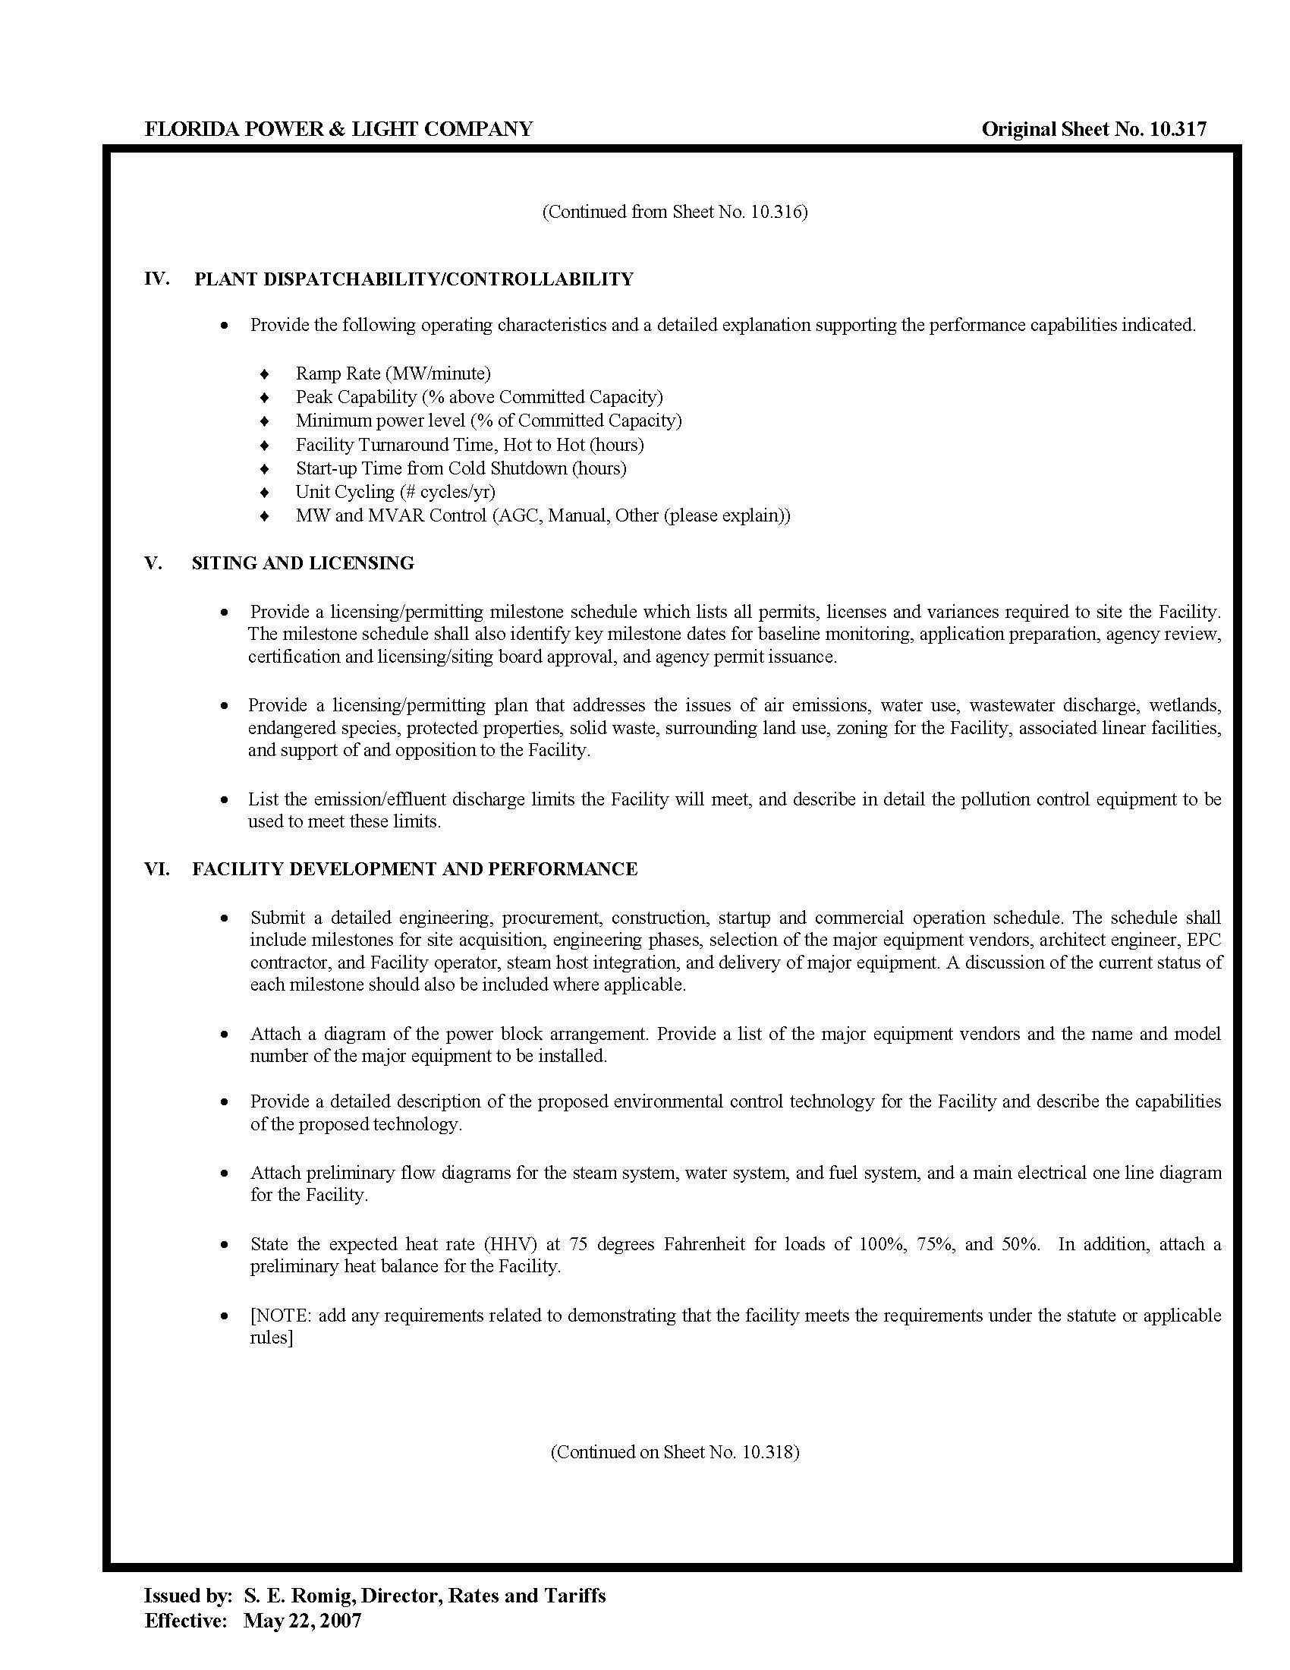
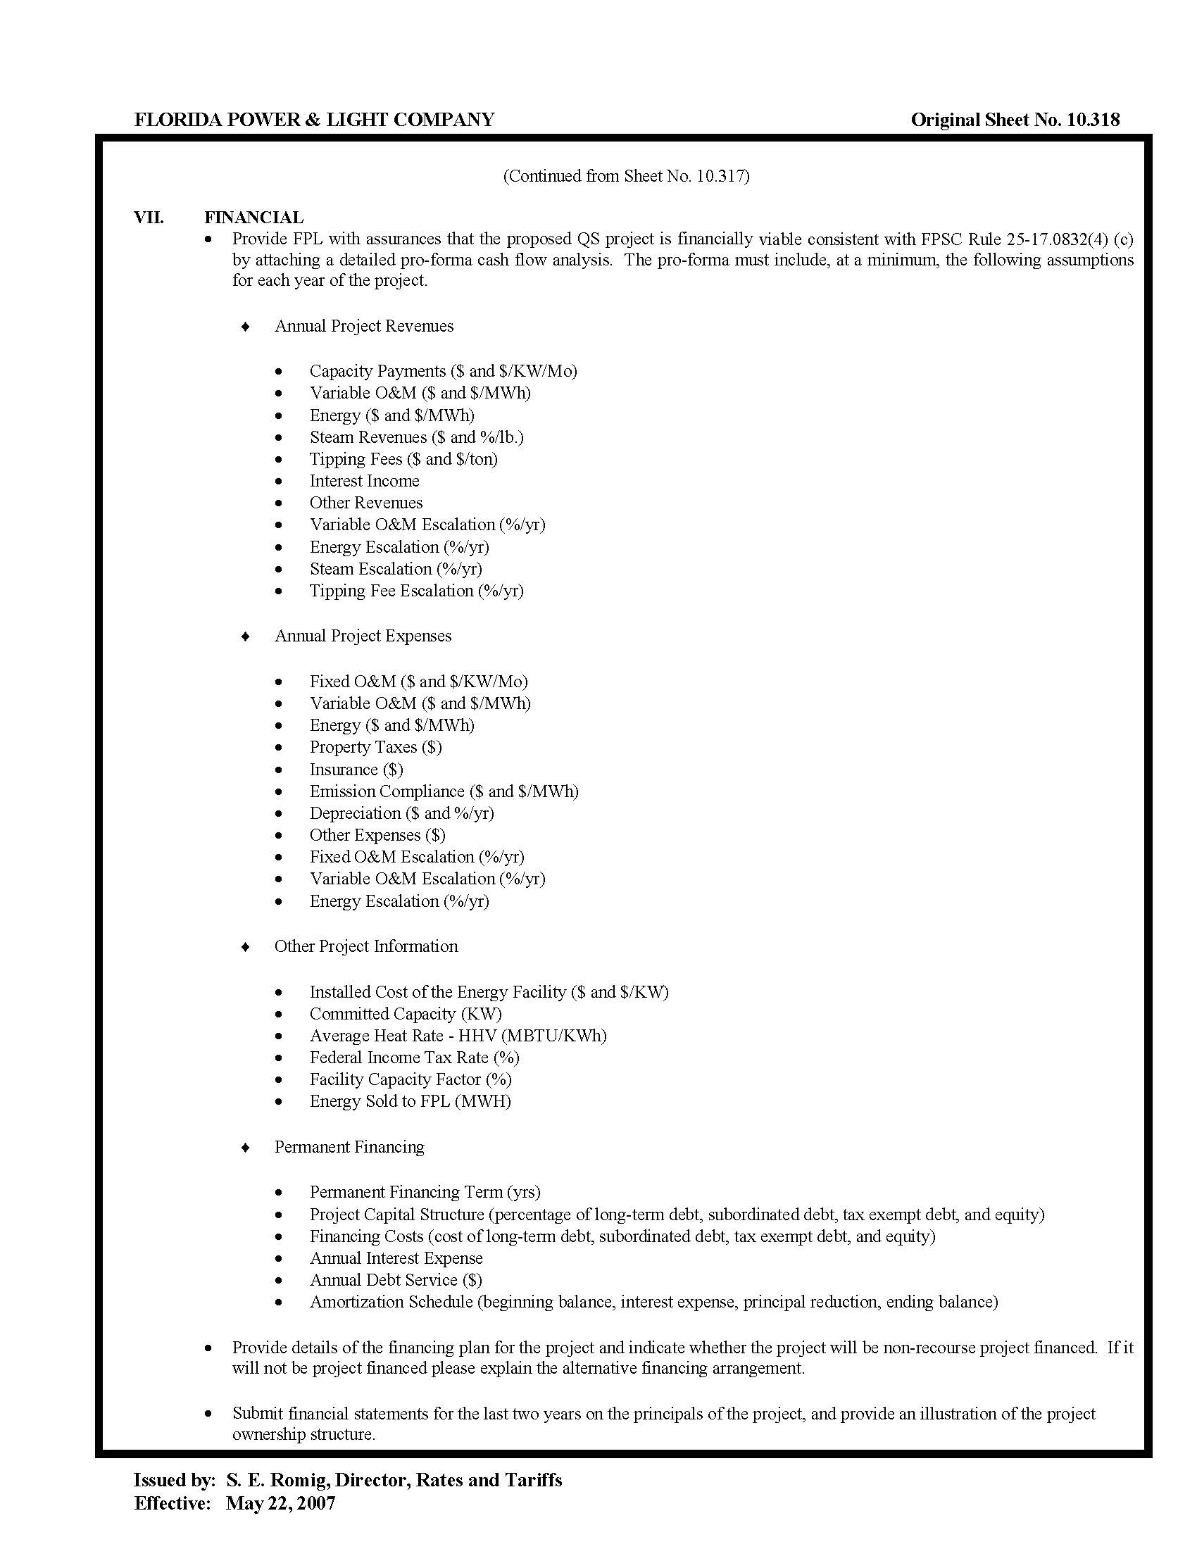
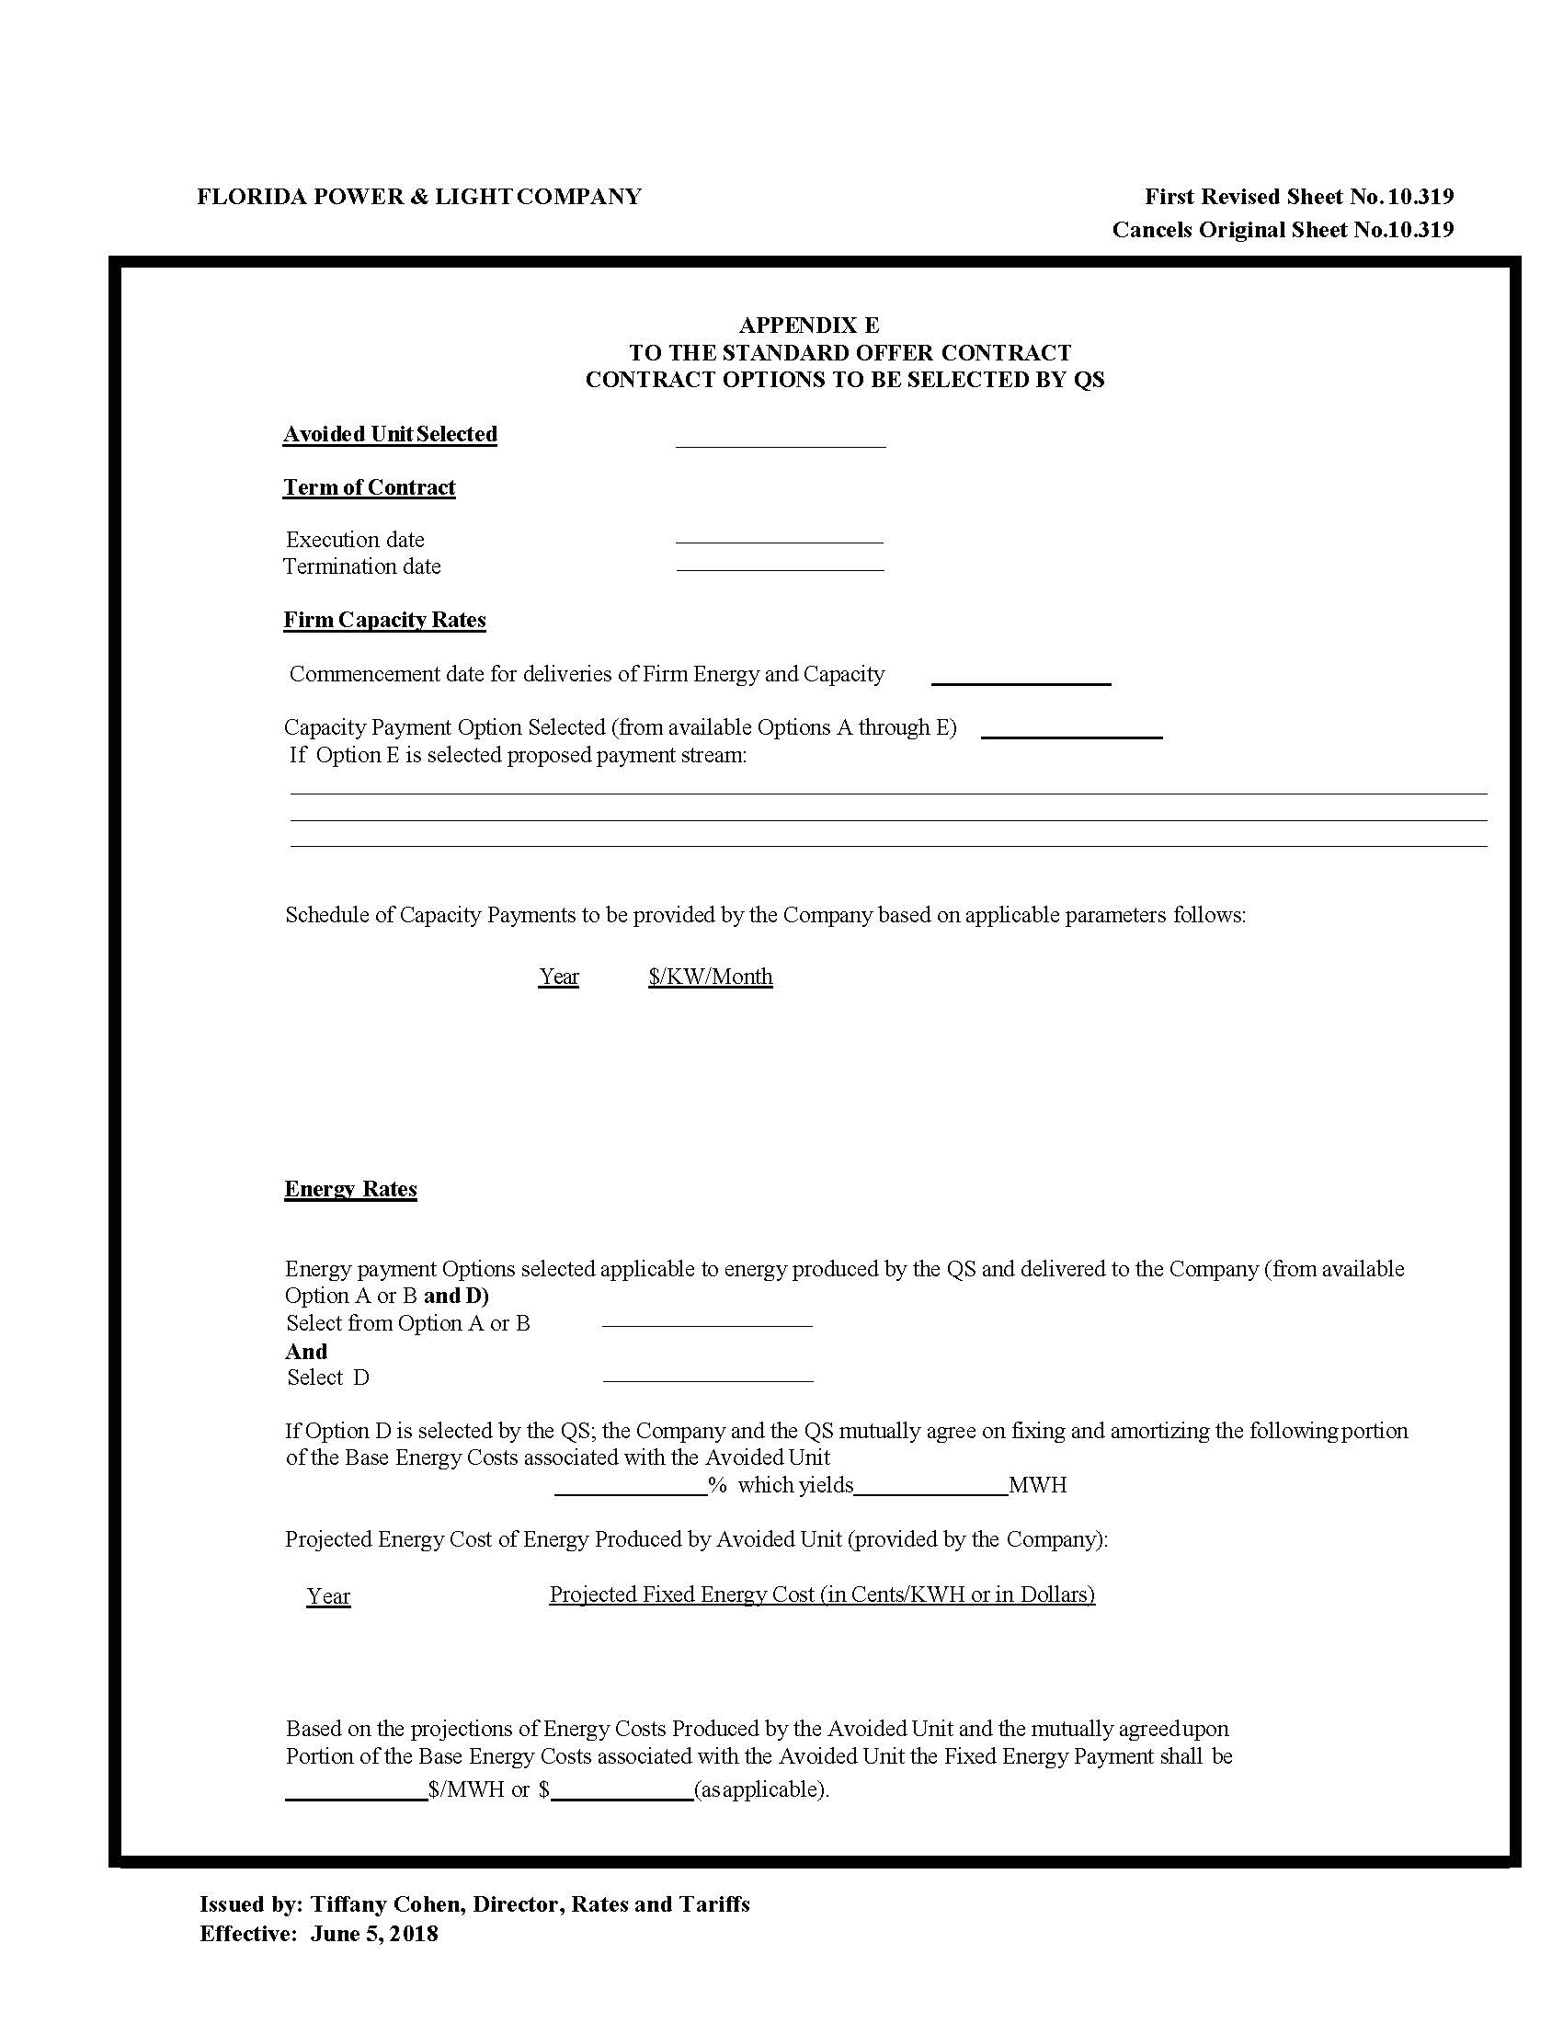

Differences due to rounding.
Document No. 03715-2019, filed April 15, 2019, in Docket No. 20190082-EQ.

