BEFORE THE FLORIDA PUBLIC SERVICE COMMISSION

In re: Petition for approval of amended standard offer contract (Schedule COG-2) and amended interconnection agreement, by Duke Energy Florida, LLC. | DOCKET NO. 20190079-EQ  ORDER NO. PSC-2019-0277-PAA-EQ  ISSUED: July 15, 2019

The following Commissioners participated in the disposition of this matter:

ART GRAHAM, Chairman
JULIE I. BROWN
DONALD J. POLMANN
GARY F. CLARK
ANDREW GILES FAY

NOTICE OF PROPOSED AGENCY ACTION ORDER APPROVING DUKE ENERGY FLORIDA, LLC’S PETITION TO AMEND STANDARD OFFER CONTRACT
(SCHEDULE COG-2) AND AMEND INTERCONNECTION AGREEMENT

BY THE COMMISSION:

NOTICE is hereby given by the Florida Public Service Commission that the action discussed herein is preliminary in nature and will become final unless a person whose interests are substantially affected files a petition for a formal proceeding, pursuant to Rule 25-22.029, Florida Administrative Code (F.A.C.).

Background
Section 366.91(3), Florida Statutes (F.S.), requires that each investor-owned utility (IOU) continuously offer to purchase capacity and energy from renewable energy generators (RF) and small qualifying facilities (QF). Florida Public Service Commission (Commission) Rules 25-17.200 through 25-17.310, Florida Administrative Code (F.A.C.), implement the statute and require each IOU to file with us by April 1 of each year, a standard offer contract based on the next avoidable fossil fueled generating unit of each technology type identified in the utility’s current Ten-Year Site Plan.
On April 1, 2019, Duke Energy Florida, LLC (DEF) filed a petition for approval of its amended standard offer contract and associated rate schedule COG-2, based on its 2019 Ten-Year Site Plan, and amended interconnection agreement. On June 7, 2019, DEF refiled its standard offer contract to include supplemental revisions to Sheet 9.416 in response to our first data request.
We have jurisdiction over this standard offer contract pursuant to Sections 366.04 through 366.055 and 366.91, F.S.
Review and Decision

Rule 25-17.250, F.A.C., requires that DEF, an IOU, continuously make available a standard offer contract for the purchase of firm capacity and energy from renewable RF/QFs with design capacities of 100 kilowatts (kW) or less. Pursuant to Rule 25-17.250(1) and (3), F.A.C., the standard offer contract must provide a term of at least 10 years, and the payment terms must be based on the Utility’s next avoidable fossil-fueled generating unit identified in its most recent Ten-Year Site Plan or, if no avoided unit is identified, its next avoidable planned purchase. DEF has identified a 218 megawatt (MW) natural gas-fueled combustion turbine (CT) as the next planned generating unit in its 2019 Ten-Year Site Plan. The projected in-service date of the unit is June 1, 2027.
Under DEF’s standard offer contract, the RF/QF operator commits to certain minimum performance requirements based on the identified avoided unit, such as being operational and delivering an agreed upon amount of capacity by the in-service date of the avoided unit, and thereby becomes eligible for capacity payments in addition to payments received for energy. The standard offer contract may also serve as a starting point for negotiation of contract terms by providing payment information to an RF/QF operator, in a situation where one or both parties desire particular contract terms other than those established in the standard offer.
In order to promote renewable generation, we require each IOU to offer multiple options for capacity payments, including the options to receive early or levelized payments. If the RF/QF operator elects to receive capacity payments under the normal or levelized contract options, it will receive as-available energy payments only until the in-service date of the avoided unit (in this case June 1, 2027), and thereafter begin receiving capacity payments in addition to the energy payments. If either the early or early levelized option is selected, then the operator will begin receiving capacity payments earlier than the in-service date of the avoided unit. However, payments made under the early capacity payments options tend to be lower in the later years of the contract term because the net present value (NPV) of the total payments must remain equal for all contract payment options.
Table 1 contains estimates of the annual payments for each payment option available under the amended standard offer contract to an operator with a 50 MW renewable facility operating at a capacity factor of 95 percent, which is the minimum capacity factor required under the contract to qualify for full capacity payments. Normal and levelized capacity payments begin in 2027, reflecting the projected in-service date of the avoided unit (June 1, 2027).

Table 1 – Estimated Annual Payments to a 50 MW Renewable Facility
(95% Capacity Factor)
Year | Energy Payment | Capacity Payment (By Type)
 |  | Normal | Levelized | Early | Early Levelized
 | $(000) | $(000) | $(000) | $(000) | $(000)
2020 | 9,469 | - | - | - | -
2021 | 8,638 | - | - | - | -
2022 | 7,796 | - | - | - | -
2023 | 7,172 | - | - | - | -
2024 | 8,266 | - | - | - | -
2025 | 9,878 | - | - | 2,173 | 2,333
2026 | 10,850 | - | - | 2,201 | 2,335
2027 | 12,413 | 1,674 | 1,788 | 2,230 | 2,337
2028 | 13,409 | 2,908 | 3,067 | 2,260 | 2,339
2029 | 13,833 | 2,946 | 3,070 | 2,289 | 2,341
2030 | 15,079 | 2,985 | 3,072 | 2,319 | 2,343
2031 | 15,656 | 3,024 | 3,075 | 2,350 | 2,346
2032 | 16,942 | 3,064 | 3,078 | 2,381 | 2,348
2033 | 17,411 | 3,104 | 3,081 | 2,412 | 2,350
2034 | 17,725 | 3,145 | 3,084 | 2,444 | 2,352
2035 | 16,807 | 3,187 | 3,087 | 2,476 | 2,355
2036 | 17,429 | 3,229 | 3,090 | 2,509 | 2,357
2037 | 18,218 | 3,271 | 3,093 | 2,542 | 2,360
2038 | 19,774 | 3,314 | 3,097 | 2,576 | 2,362
2039 | 20,956 | 3,358 | 3,100 | 2,610 | 2,365
Total | 277,721 | 39,208 | 38,782 | 35,772 | 35,224
NPV (2019$) | 133,766 | 15,549 | 15,549 | 15,549 | 15,549
Source: DEF’s response to staff’s first data request.

The changes made to DEF’s tariff sheets are consistent with the updated avoided unit. Other revisions DEF made to its tariff sheets include: (1) financial and technical viability conditions; (2) completion/performance security requirements; (3) delivery voltage calculation methods; and (4) testing requirements.

The additional conditions to verify the RF/QF is both financially and technically viable, found on Sheet Nos. 9.416, 9.419, and 9.420, and the completion/performance security requirements, found on Sheet No. 9.425, were added to provide additional protection to both DEF and its customers. The technical viability and security requirements are consistent with conditions approved in FPL’s standard offer contract. The financial viability requirements on Sheet No. 9.416 were modified on June 7, 2019, to provide limited exemptions from these conditions. We find that the revised financial requirements are adequate to safeguard ratepayers and should not be overly burdensome to the RF/QF.
The revisions in the Delivery Voltage section, found on Sheet No. 9.458, were made so that the delivery voltage adjustment factor will be calculated based on the current delivery efficiencies in DEF’s tariff as approved by FERC. This will allow for the delivery voltage adjustment factors to stay up to date should there be any changes in DEF’s Open Access Tariff subsequent to the standard offer contract filing, and will be provided within 30 days of a written request by any interested person. Changes in testing requirements, found on Sheet No. 9.710, were made to reflect the current testing requirements of modern electrical relays. This is consistent with the manufacturer’s current recommendations.
In addition to the above revisions, there are a number of unsubstantial changes including updates to calendar dates, position titles, and typographical corrections. The type-and-strike format versions of the amended standard offer contract and associated rate schedule COG-2, as revised on June 7, 2019, are included as Attachment A. The amended interconnection agreement, as filed on April 1, 2019, is included as Attachment B.
The provisions of DEF’s amended standard offer contract and associated rate schedule COG-2, as revised on June 7, 2019, and amended interconnection agreement, as filed on April 1, 2019, conform to all requirements of Rules 25-17.200 through 25-17.310, F.A.C. The amended standard offer contract provides flexibility in the arrangements for payments so that a developer of renewable generation may select the payment stream best suited to its financial needs.

Based on the foregoing, it is

ORDERED by the Florida Public Service Commission that Duke Energy Florida, LLC’s petition to amend its standard offer contract and associated rate schedule COG-2, as revised on June 7, 2019, and amended interconnection agreement, as filed on April 1, 2019, is hereby approved. It is further

ORDERED that the provisions of this Order, issued as proposed agency action, shall become final and effective upon the issuance of a Consummating Order unless an appropriate petition, in the form provided by Rule 28-106.201, Florida Administrative Code, is received by the Commission Clerk, 2540 Shumard Oak Boulevard, Tallahassee, Florida 32399-0850, by the close of business on the date set forth in the “Notice of Further Proceedings” attached hereto. Potential signatories should be aware that, if a timely protest is filed, Duke Energy Florida, LLC’s standard offer contract may subsequently be revised. It is further

ORDERED that in the event this Order becomes final, this docket shall be closed.

By ORDER of the Florida Public Service Commission this 15th day of July, 2019.

/s/ Adam J. Teitzman
ADAM J. TEITZMAN
Commission Clerk
Florida Public Service Commission
2540 Shumard Oak Boulevard
Tallahassee, Florida 32399
(850) 413-6770
www.floridapsc.com

Copies furnished: A copy of this document is provided to the parties of record at the time of issuance and, if applicable, interested persons.

TLT

NOTICE OF FURTHER PROCEEDINGS OR JUDICIAL REVIEW

The Florida Public Service Commission is required by Section 120.569(1), Florida Statutes, to notify parties of any administrative hearing that is available under Section 120.57, Florida Statutes, as well as the procedures and time limits that apply. This notice should not be construed to mean all requests for an administrative hearing will be granted or result in the relief sought.

Mediation may be available on a case-by-case basis. If mediation is conducted, it does not affect a substantially interested person's right to a hearing.

The action proposed herein is preliminary in nature. Any person whose substantial interests are affected by the action proposed by this order may file a petition for a formal proceeding, in the form provided by Rule 28-106.201, Florida Administrative Code. This petition must be received by the Office of Commission Clerk, 2540 Shumard Oak Boulevard, Tallahassee, Florida 32399-0850, by the close of business on August 5, 2019.

In the absence of such a petition, this order shall become final and effective upon the issuance of a Consummating Order.

Any objection or protest filed in this/these docket(s) before the issuance date of this order is considered abandoned unless it satisfies the foregoing conditions and is renewed within the specified protest period.

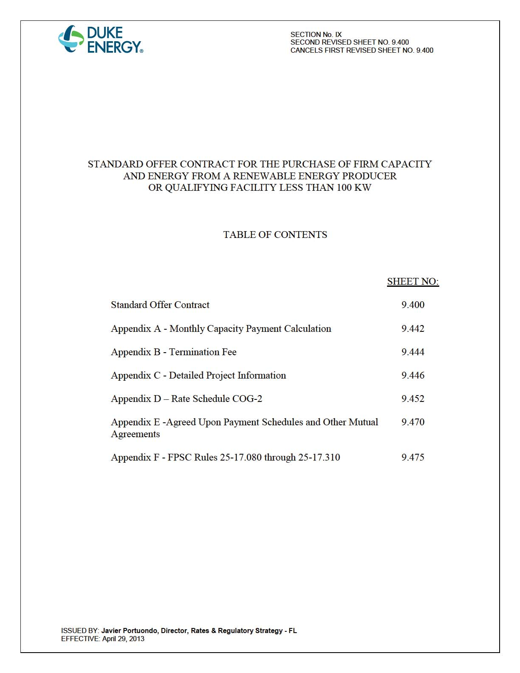
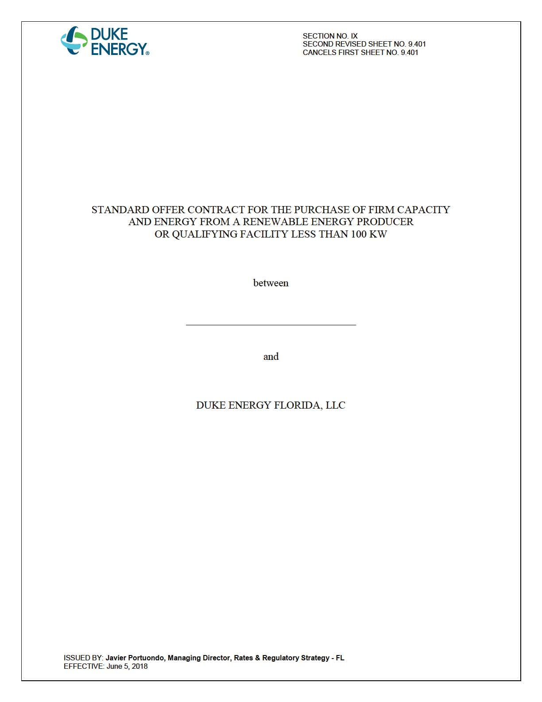
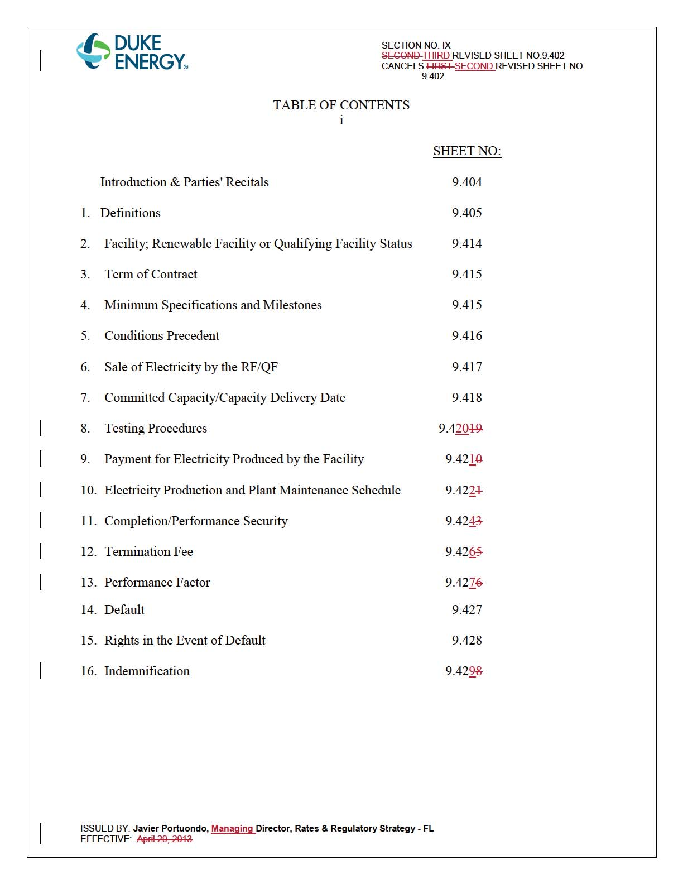
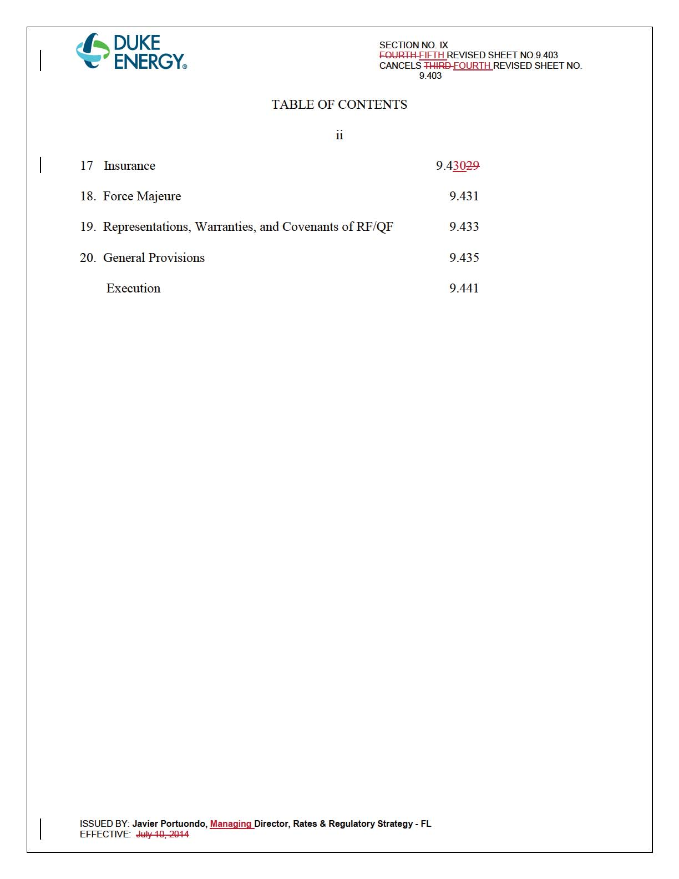
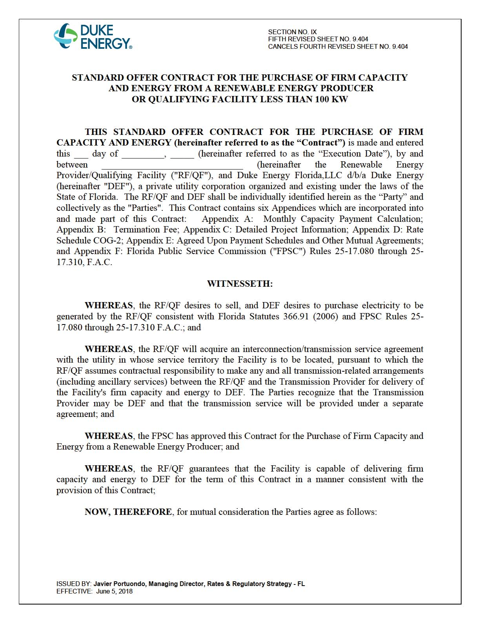
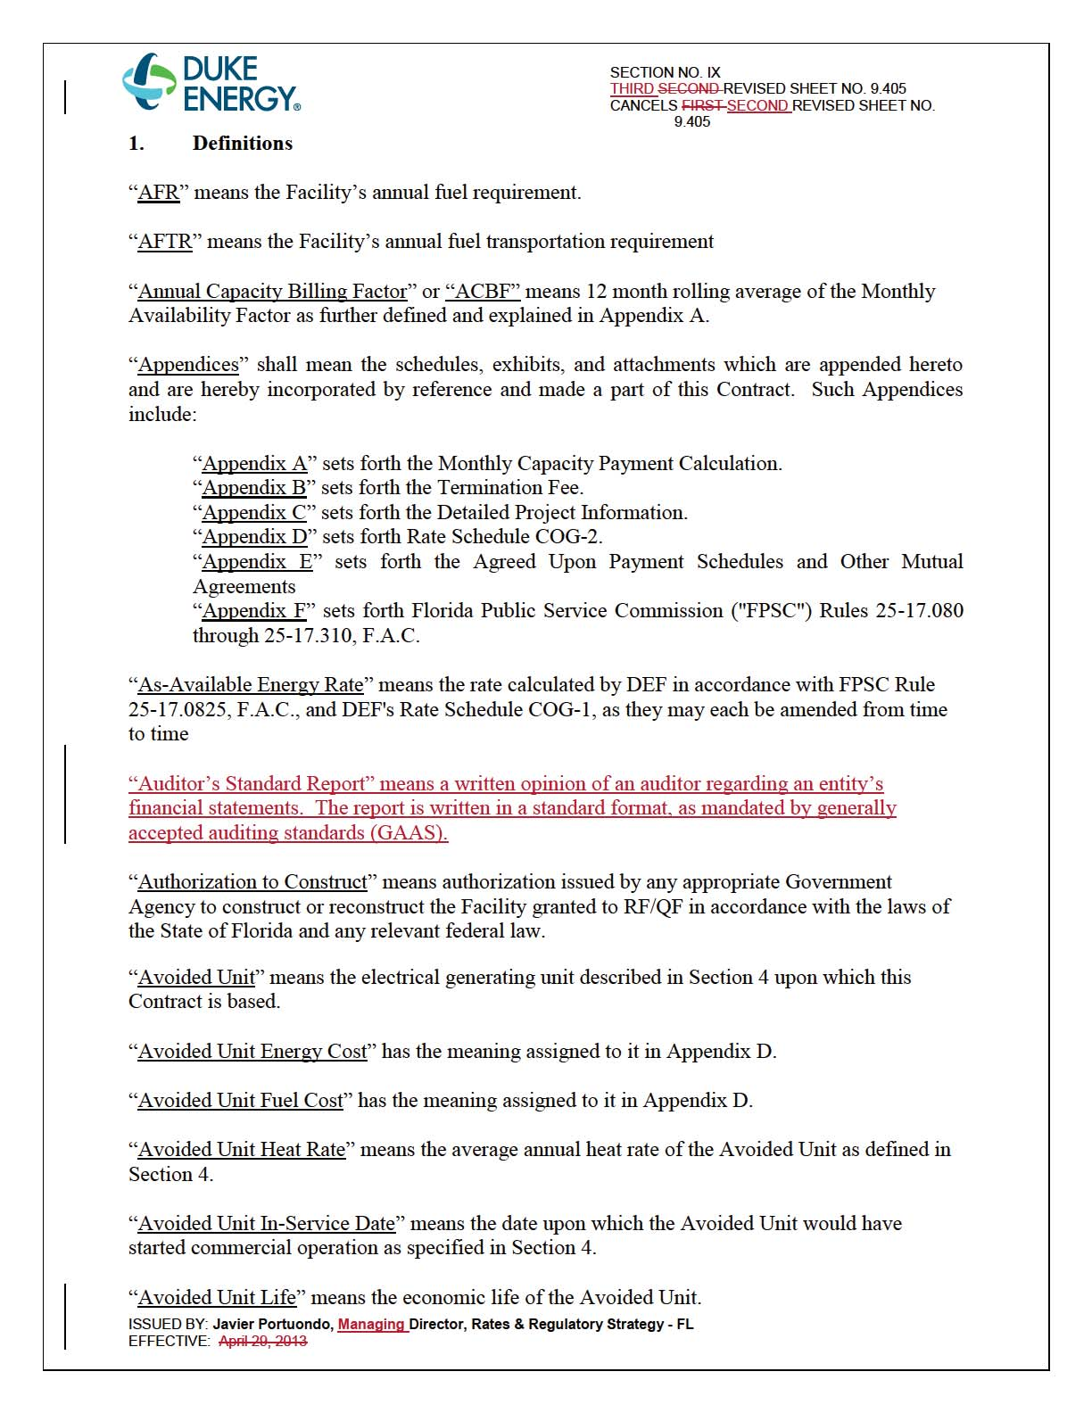
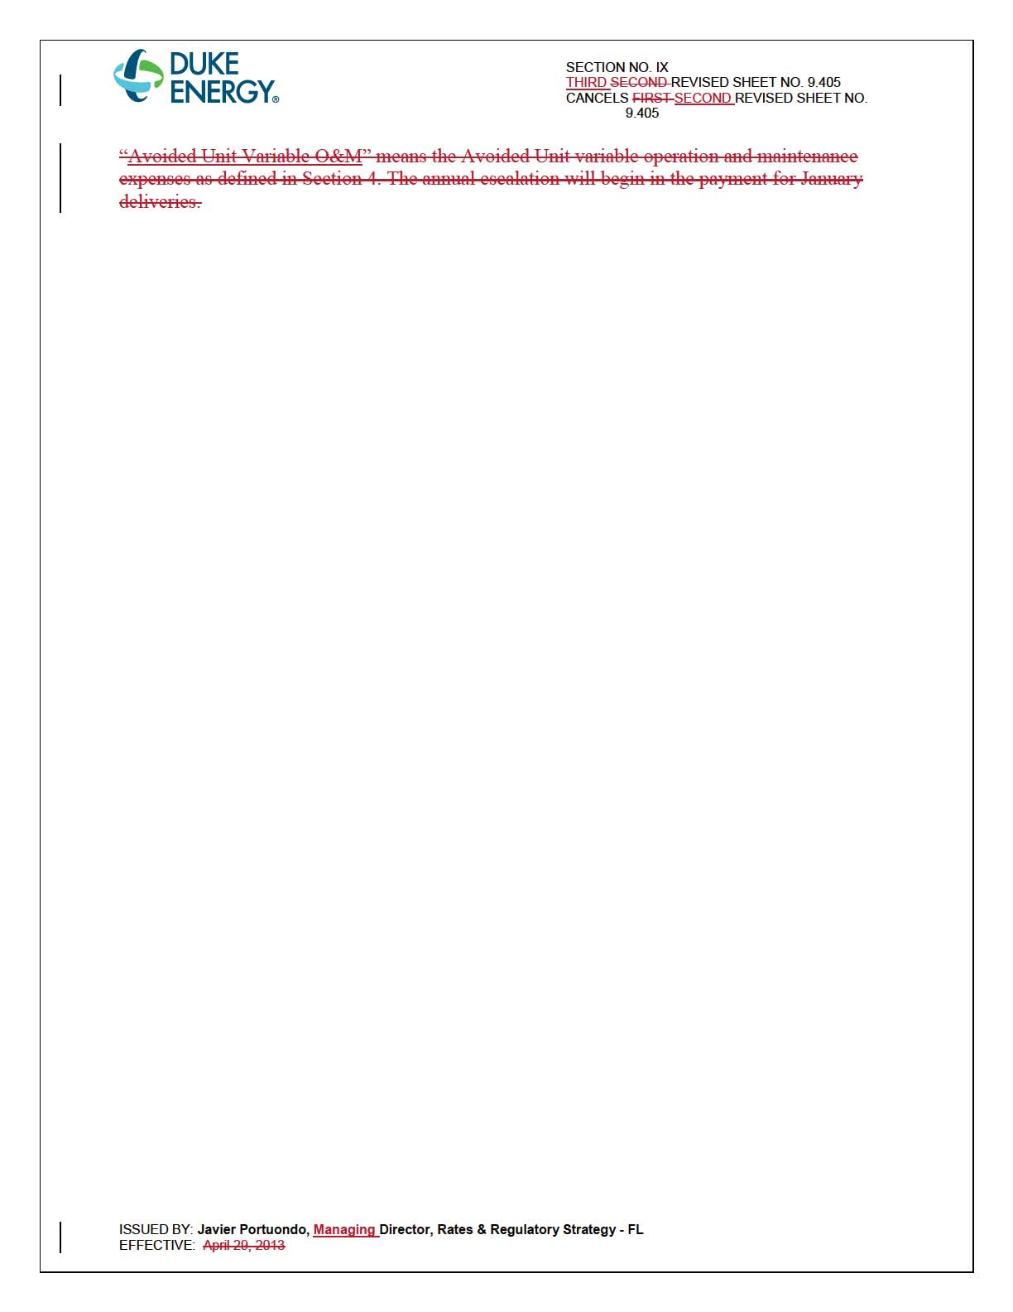
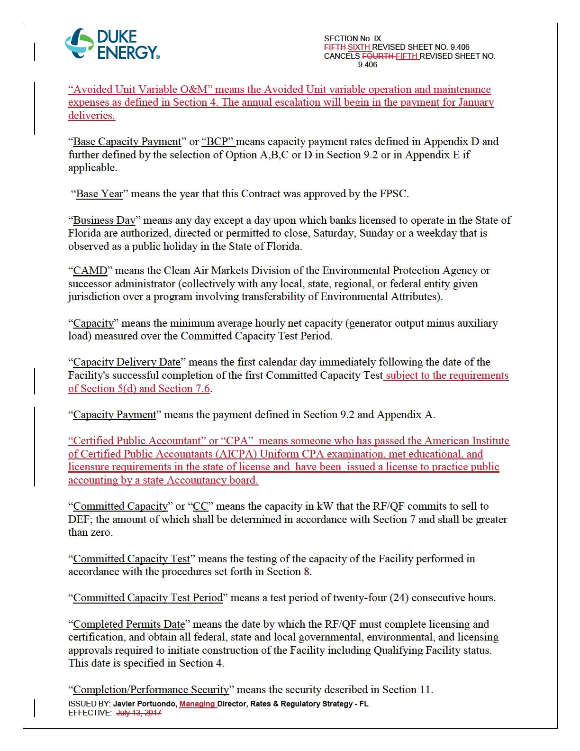
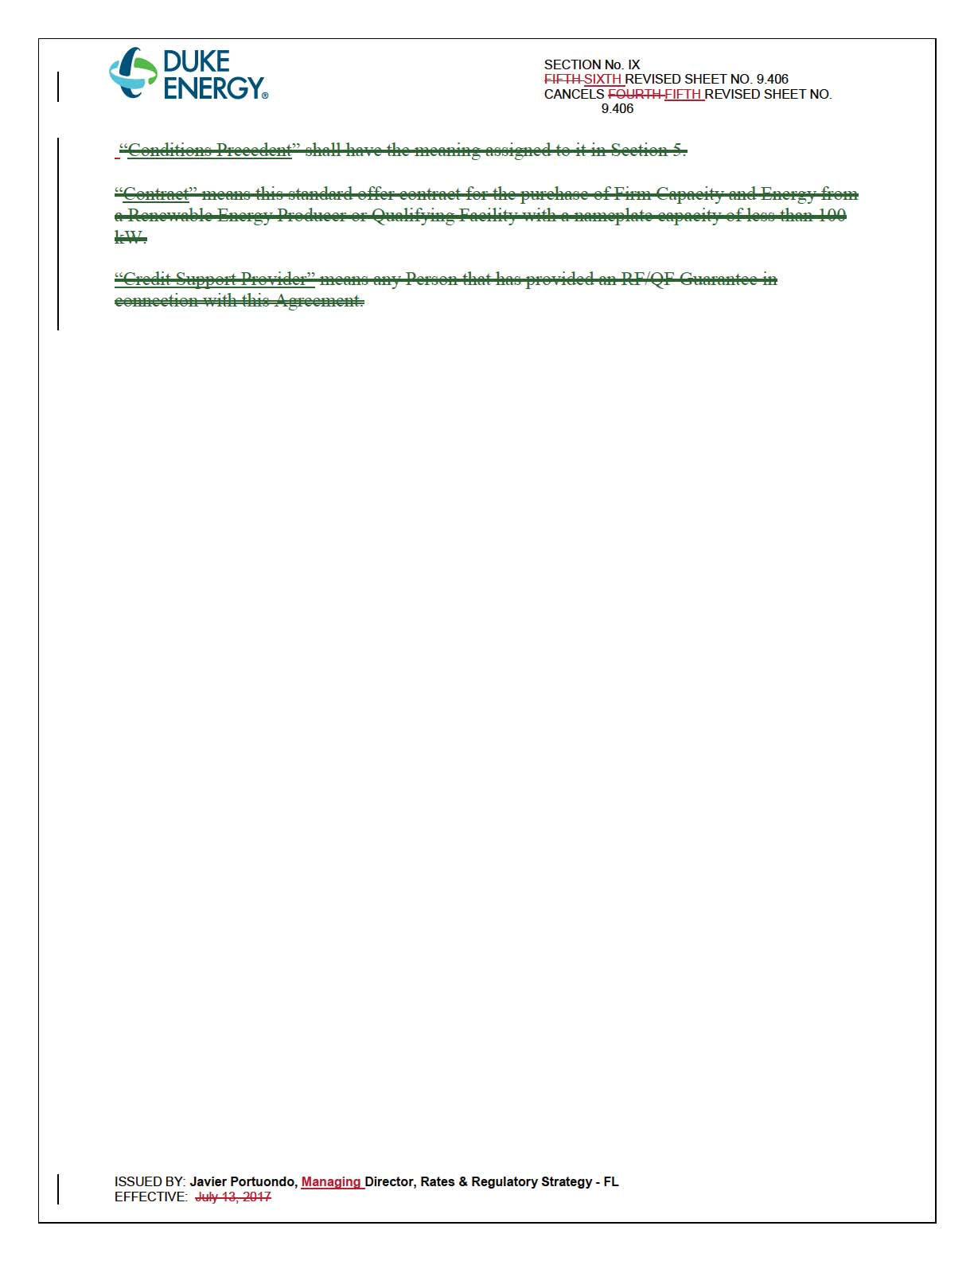
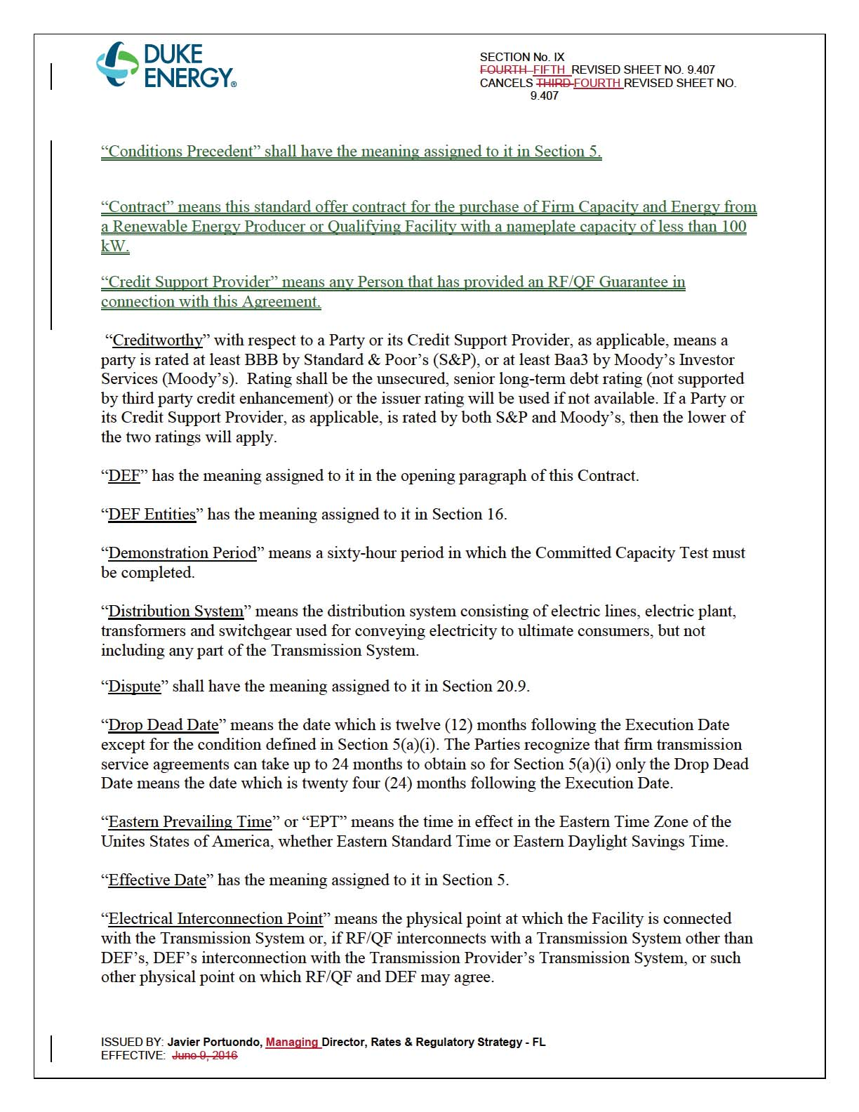
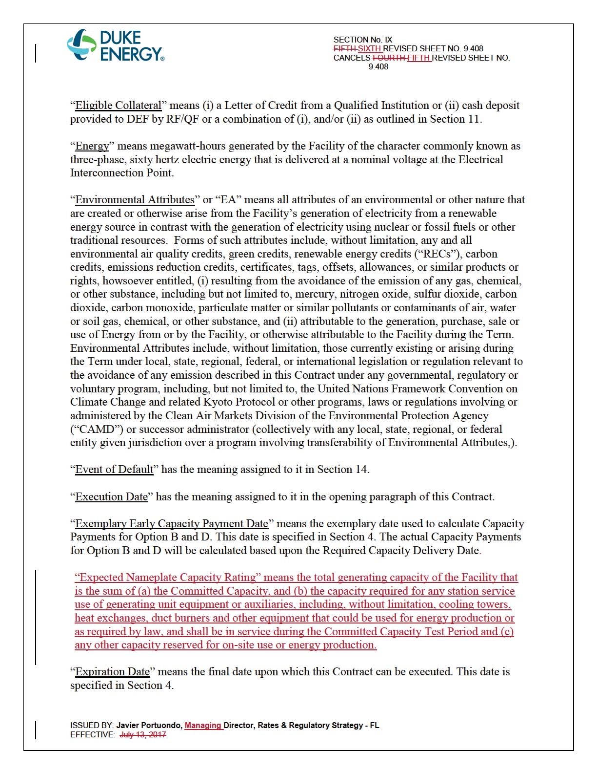
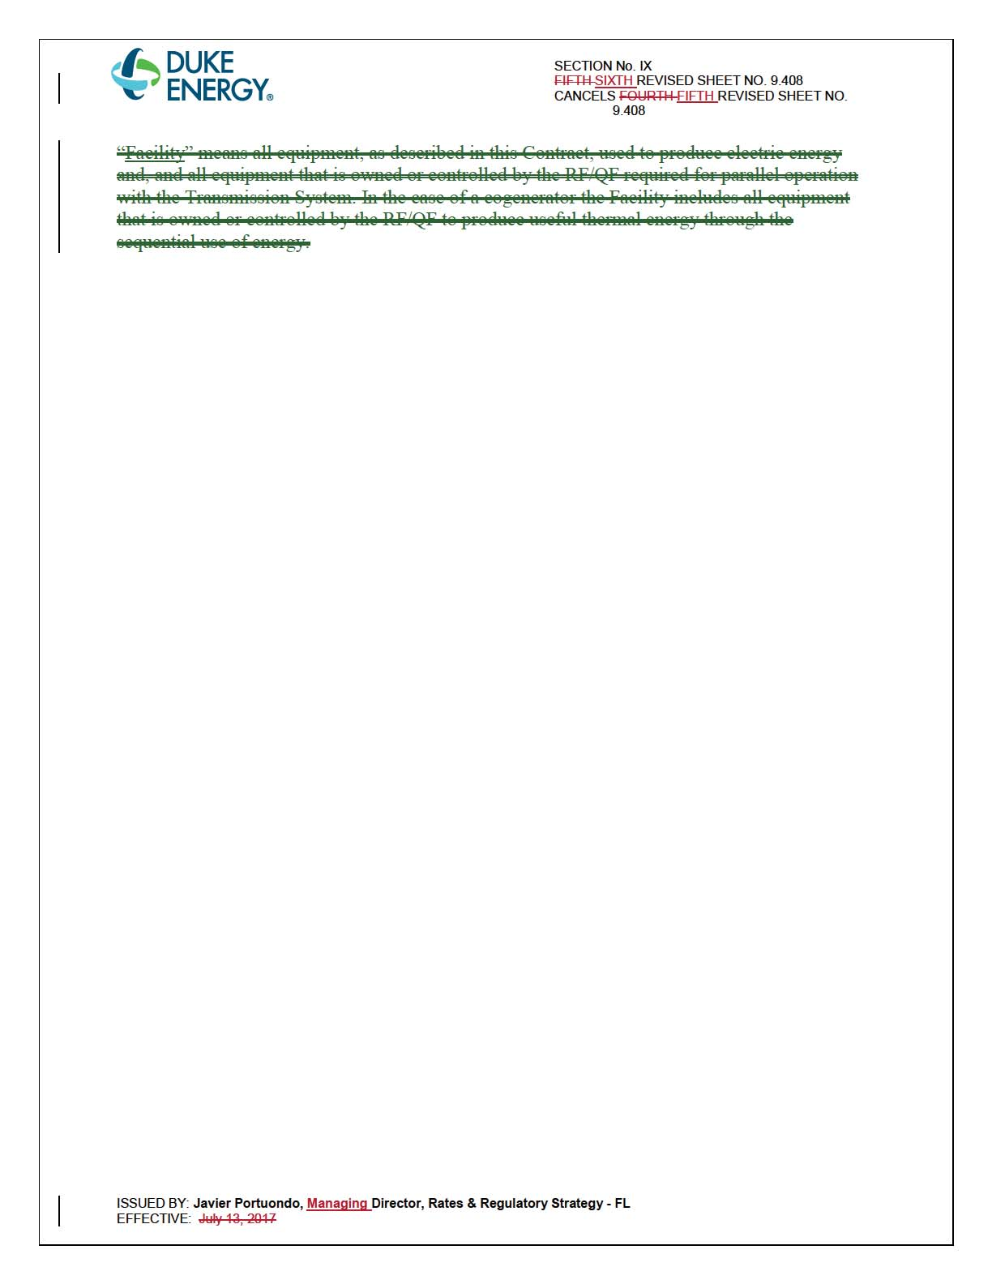
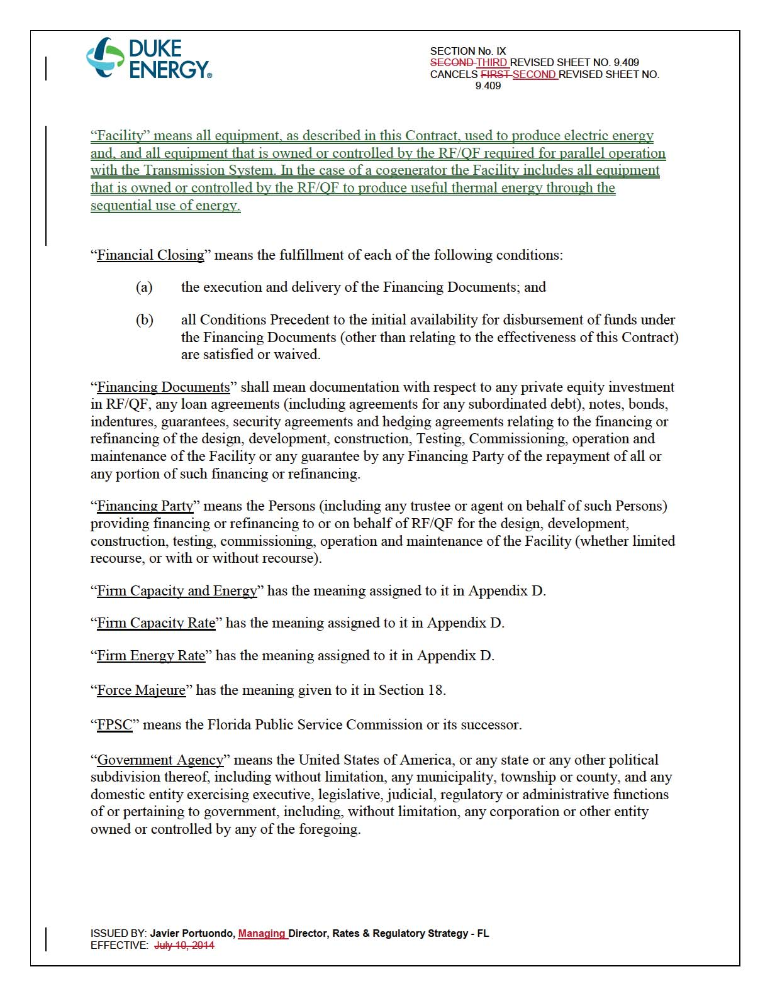
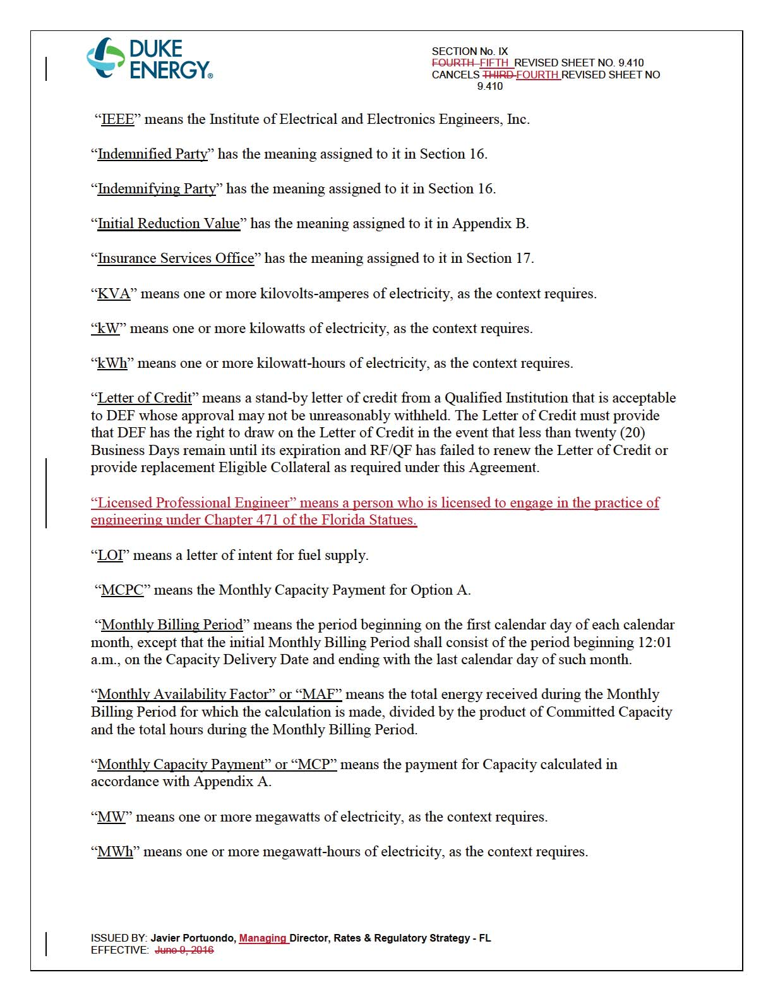
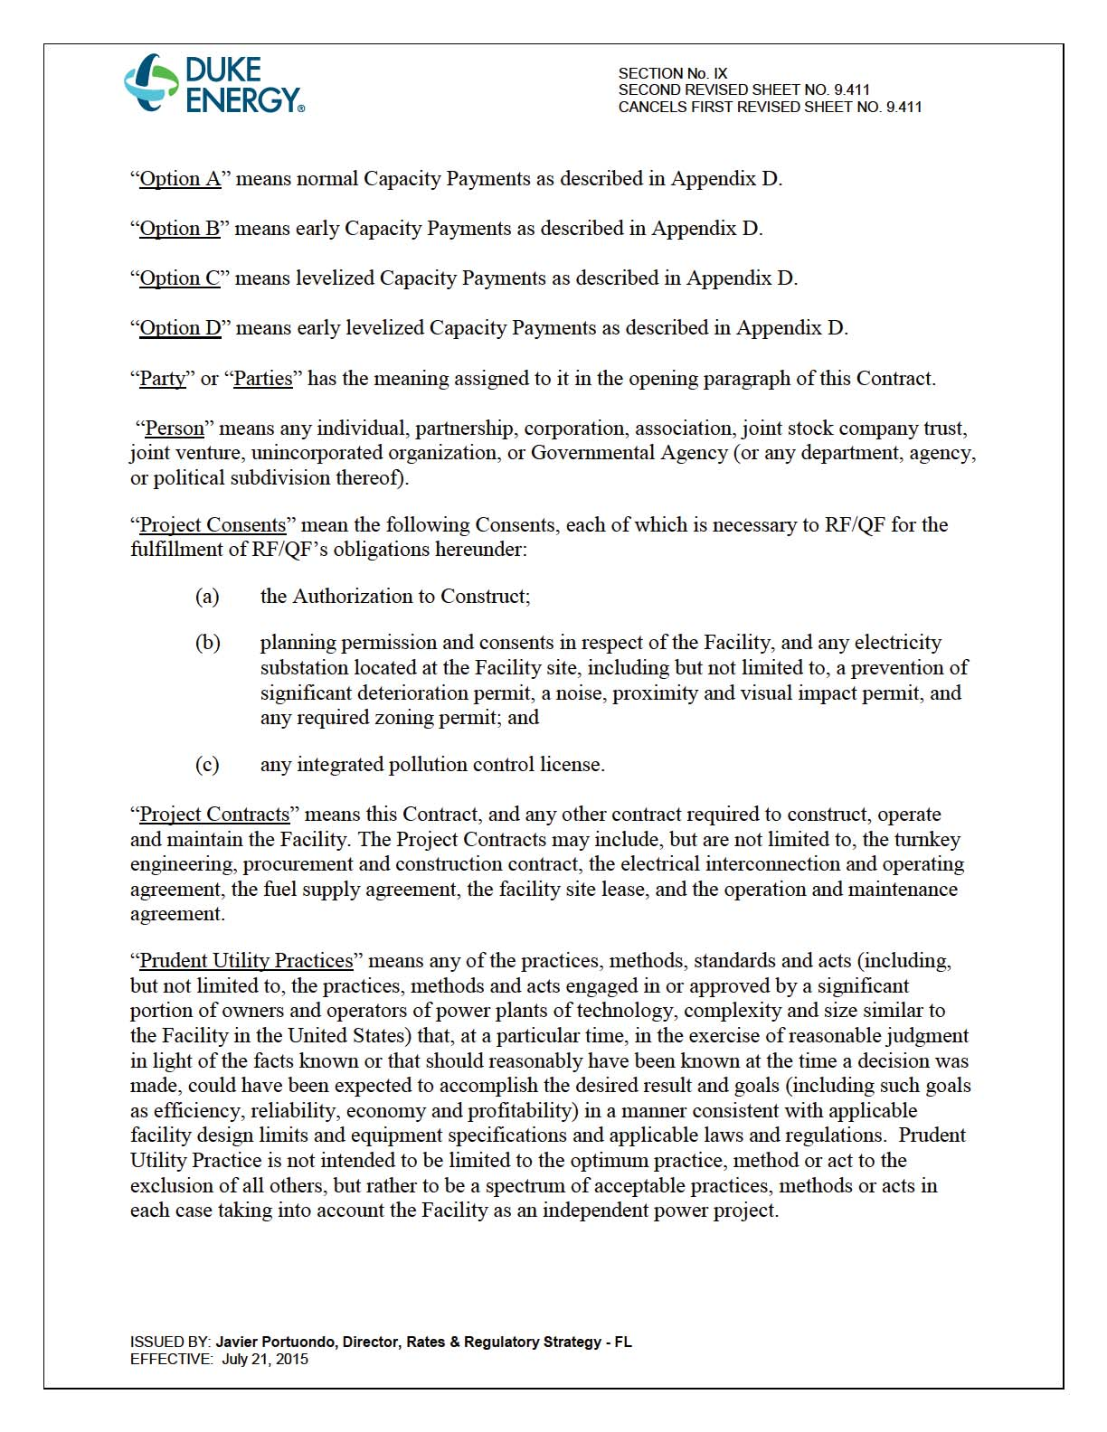
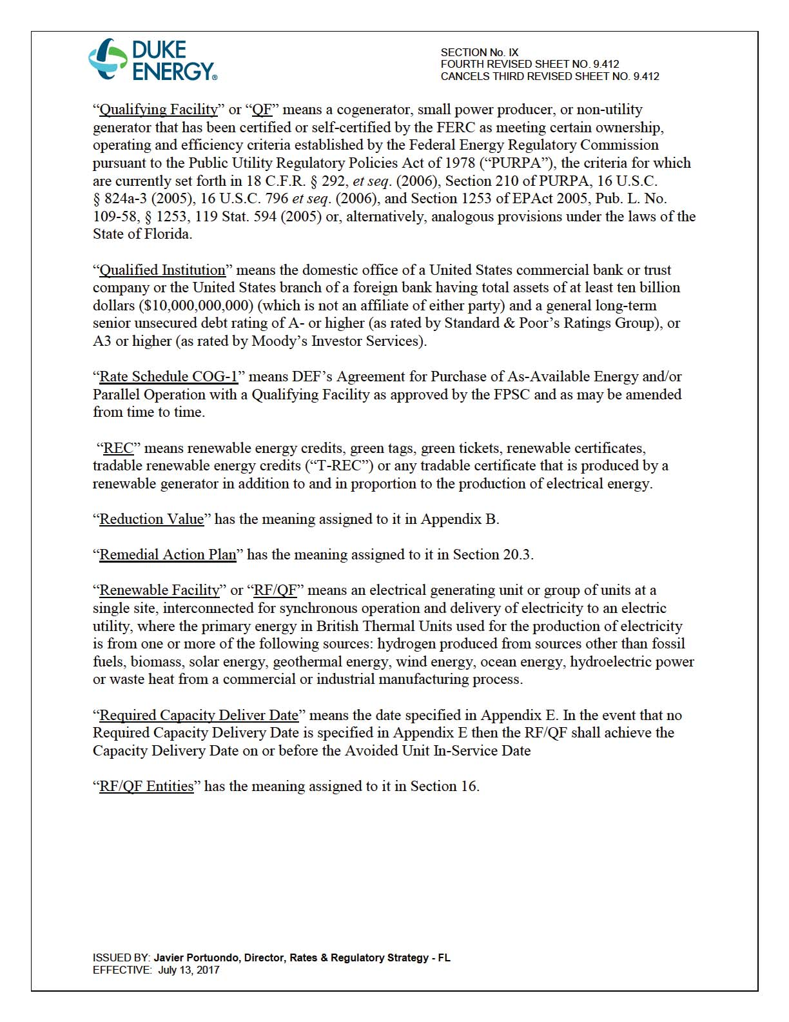
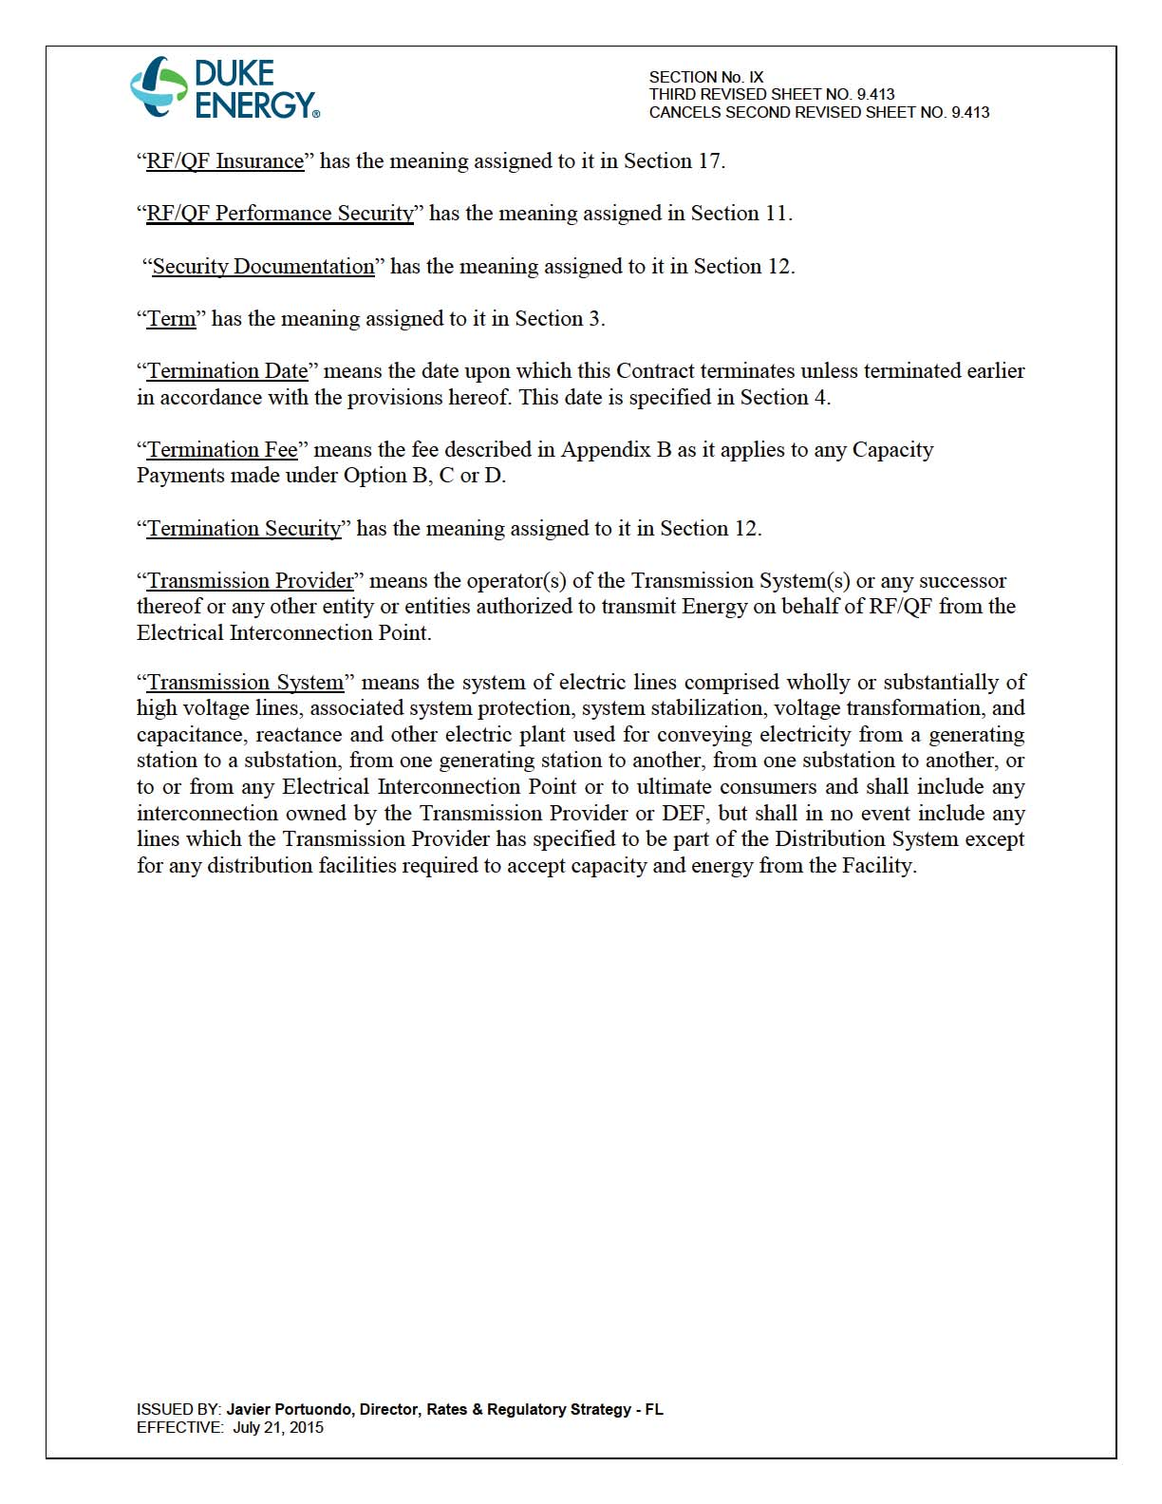
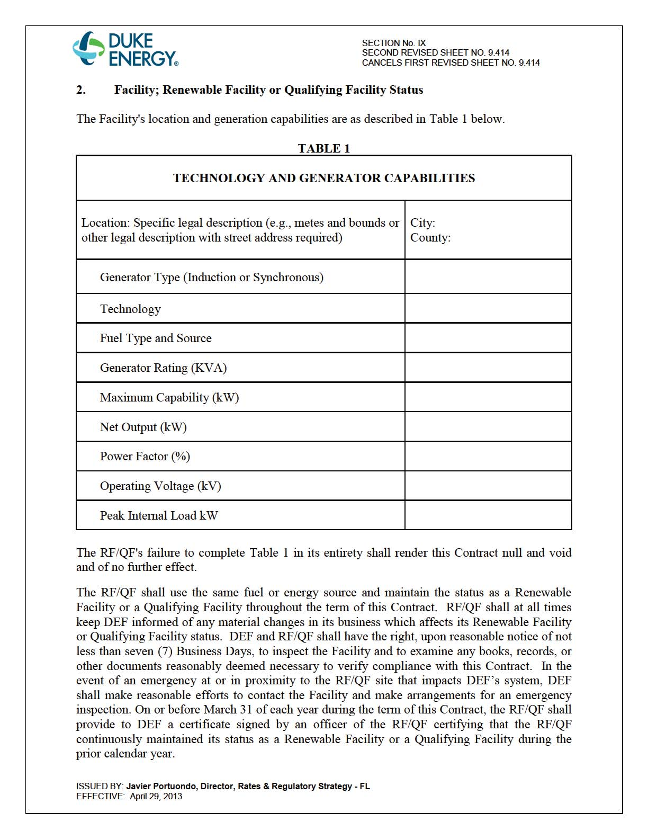
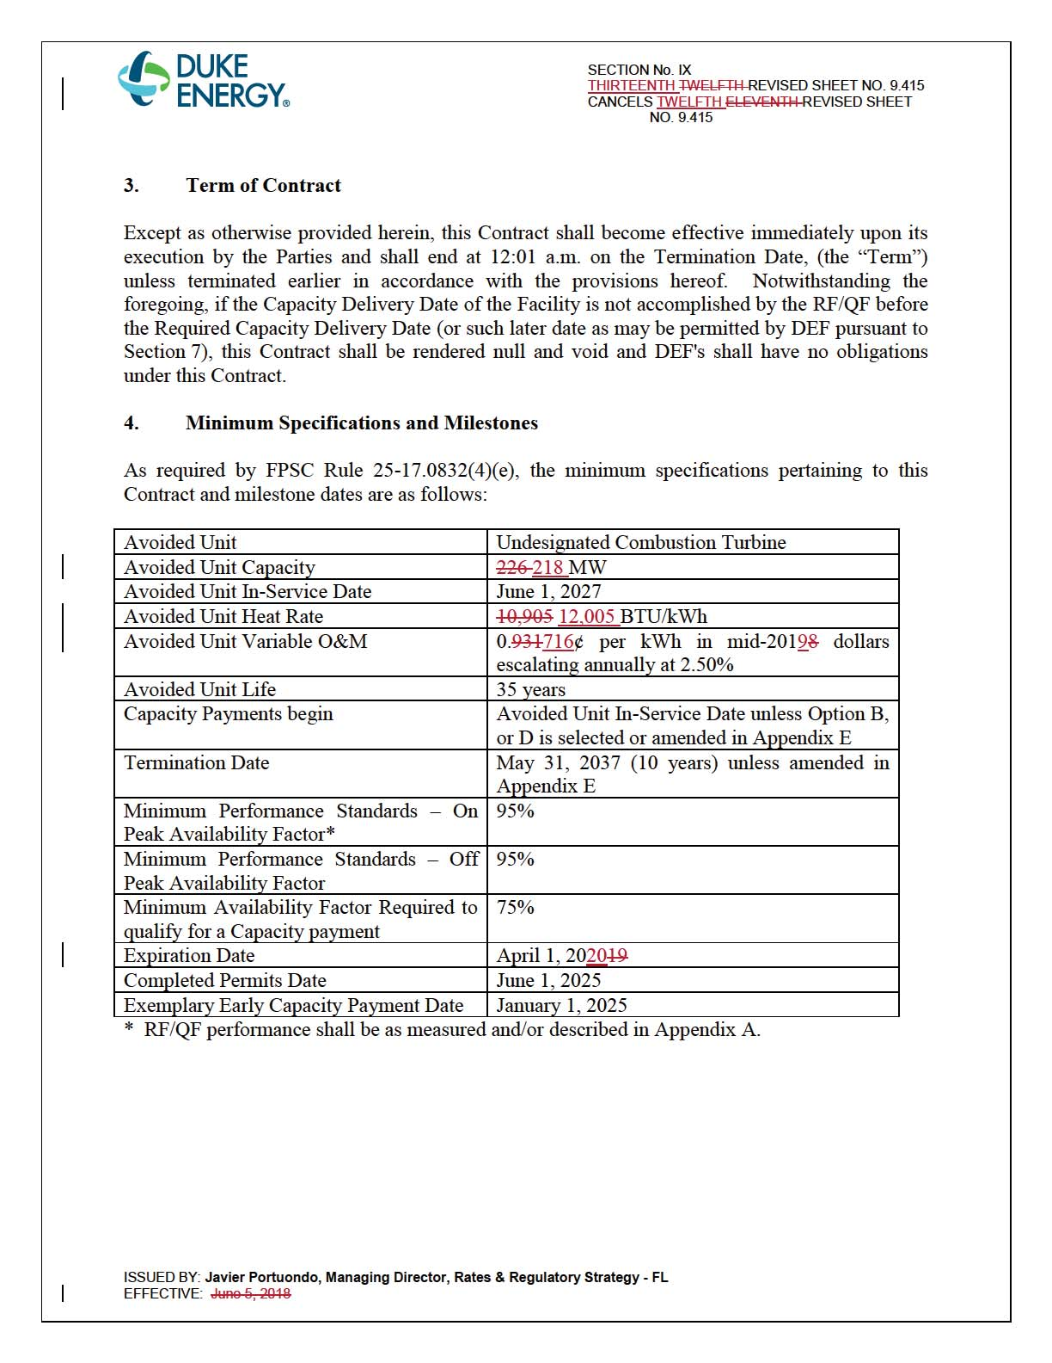
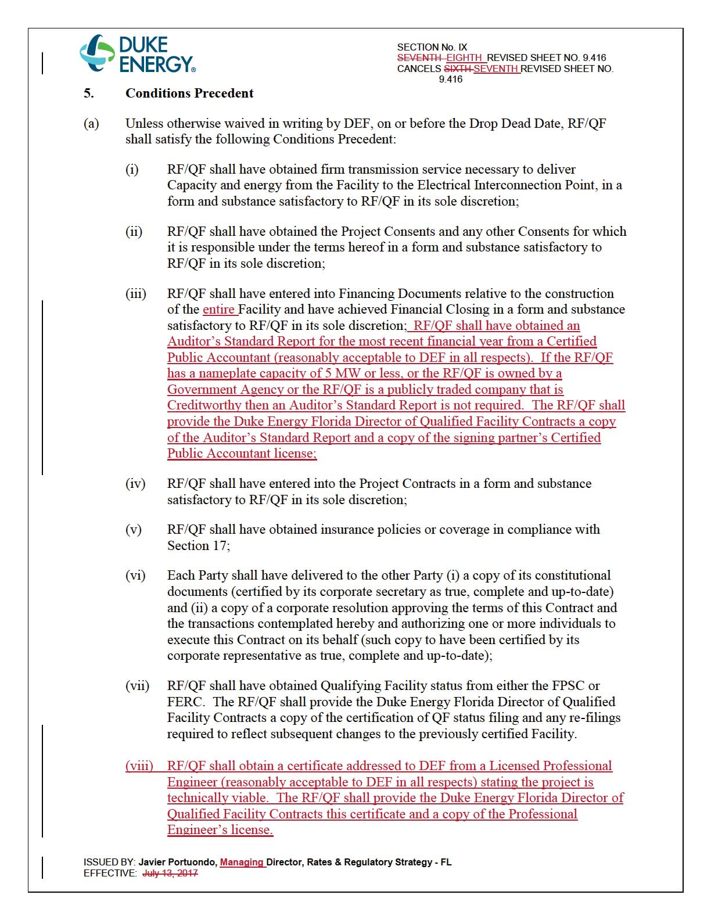
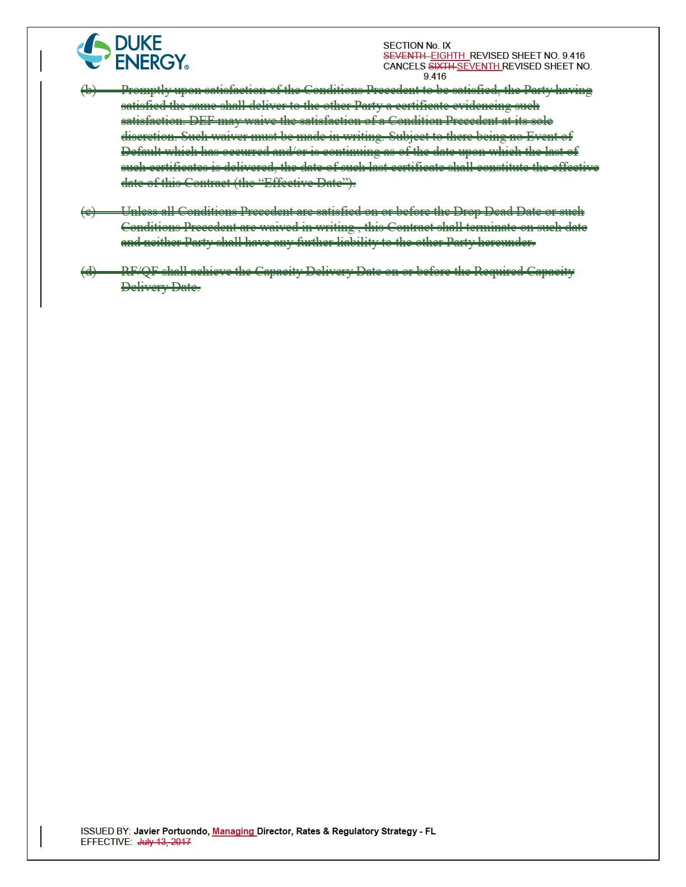
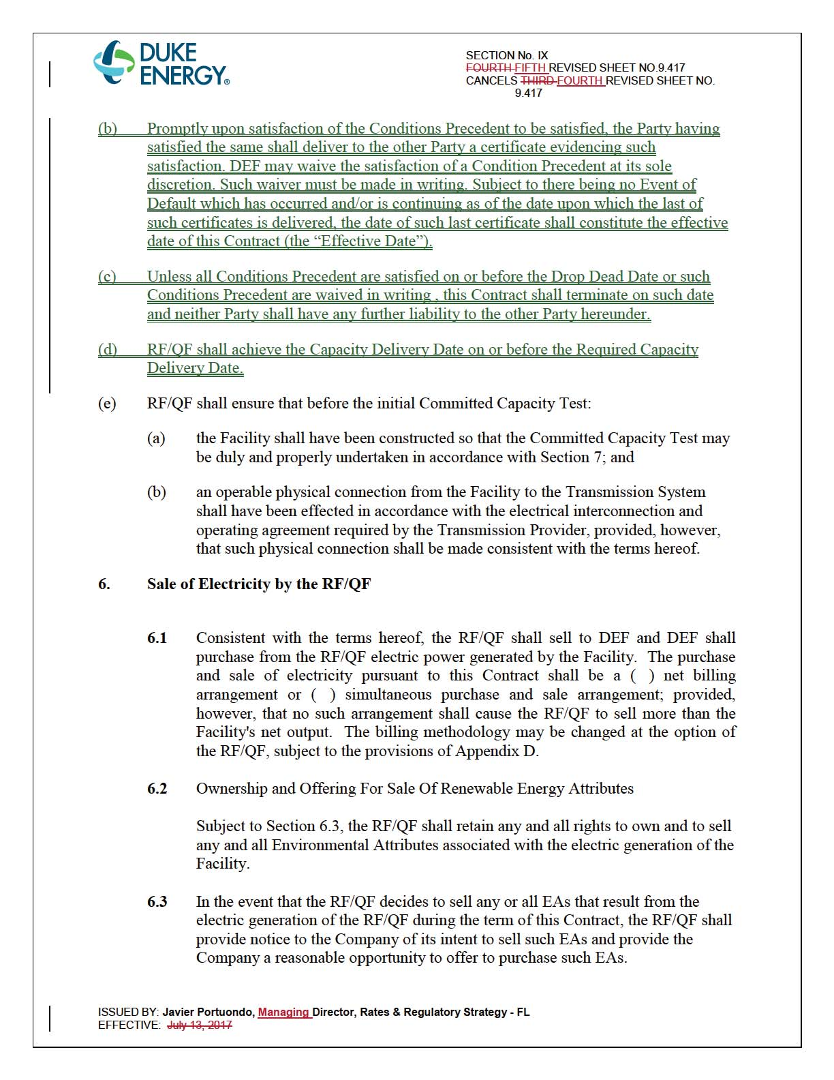
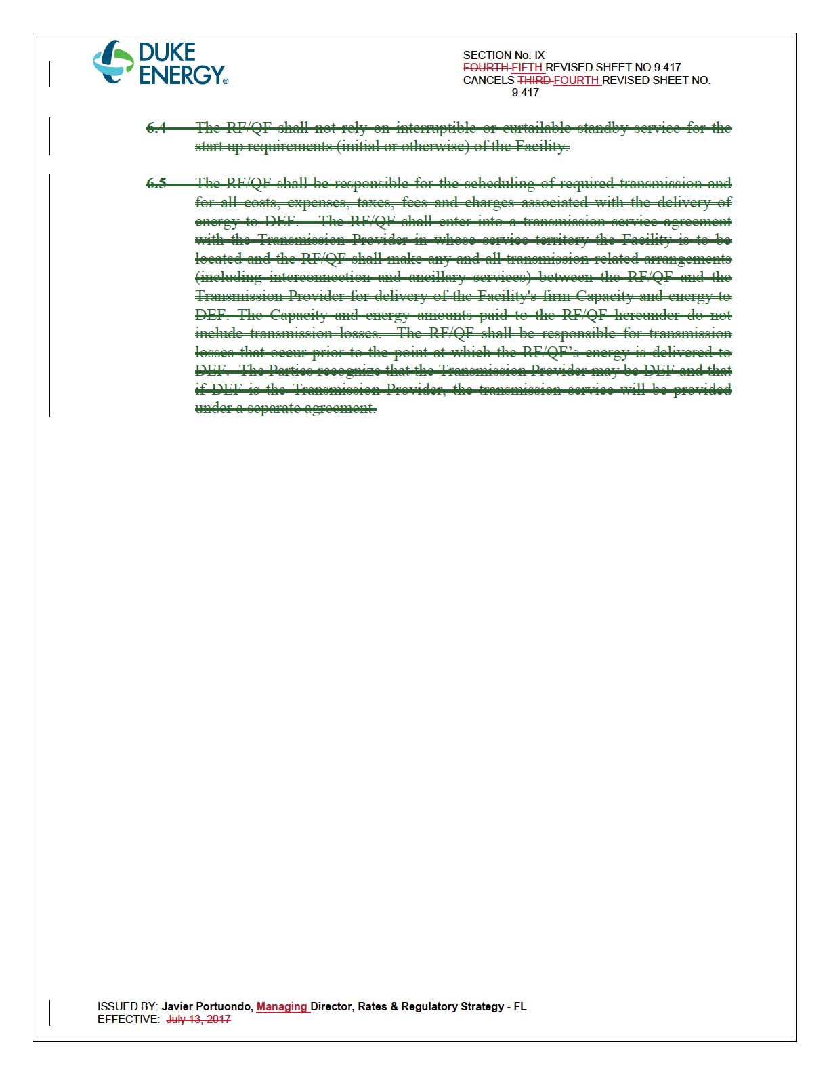
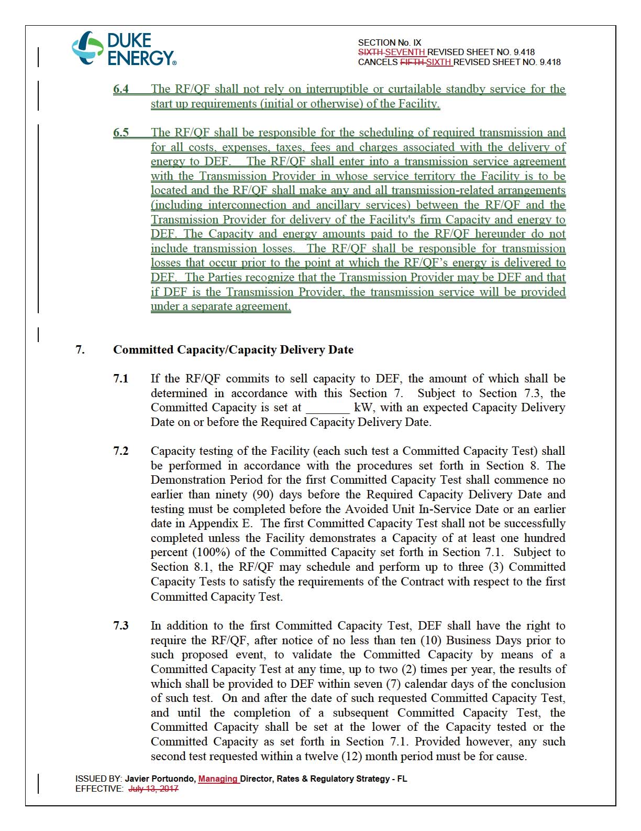
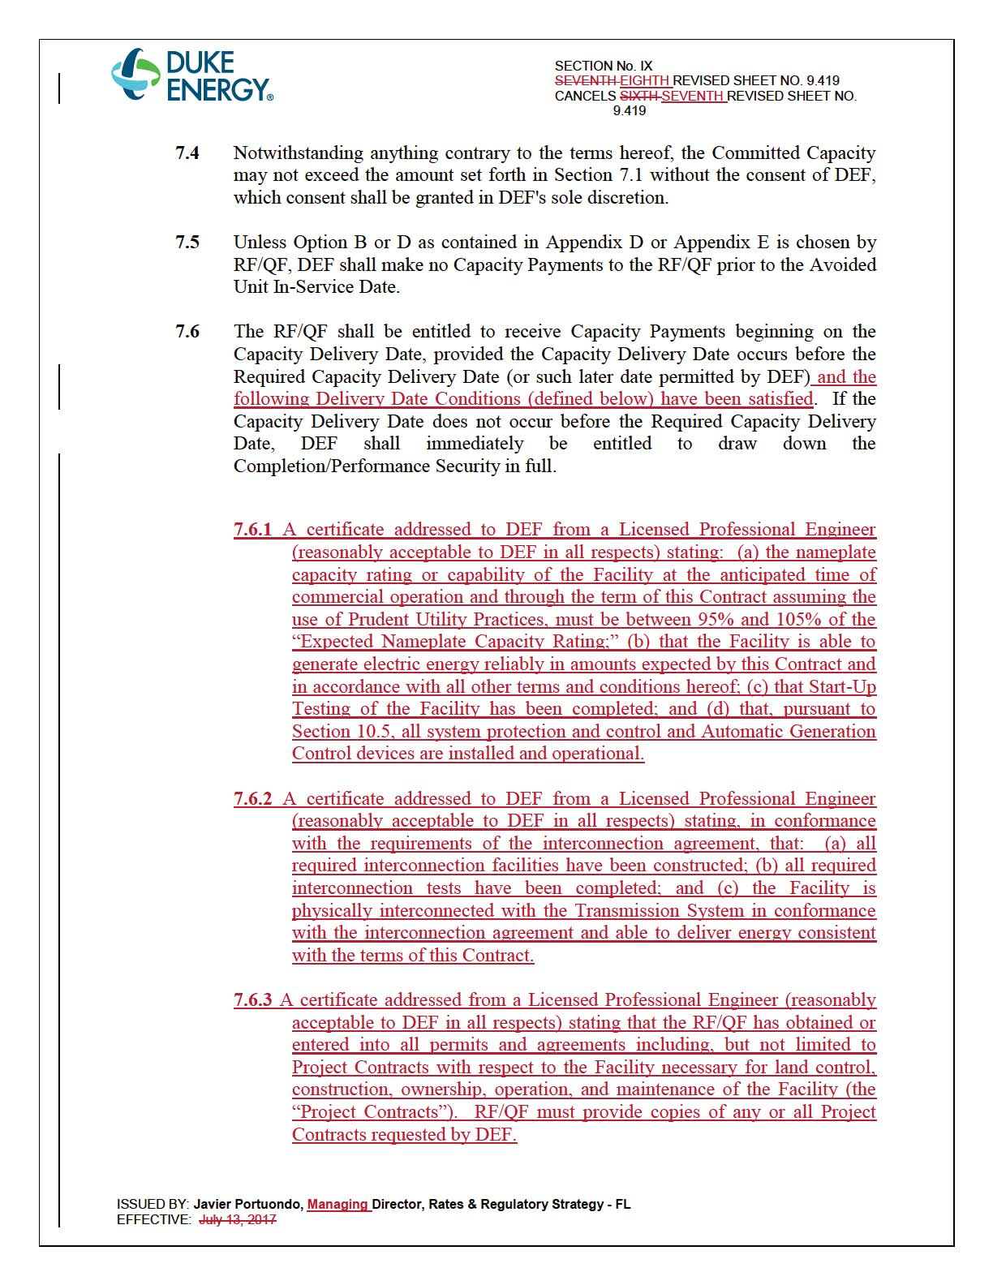
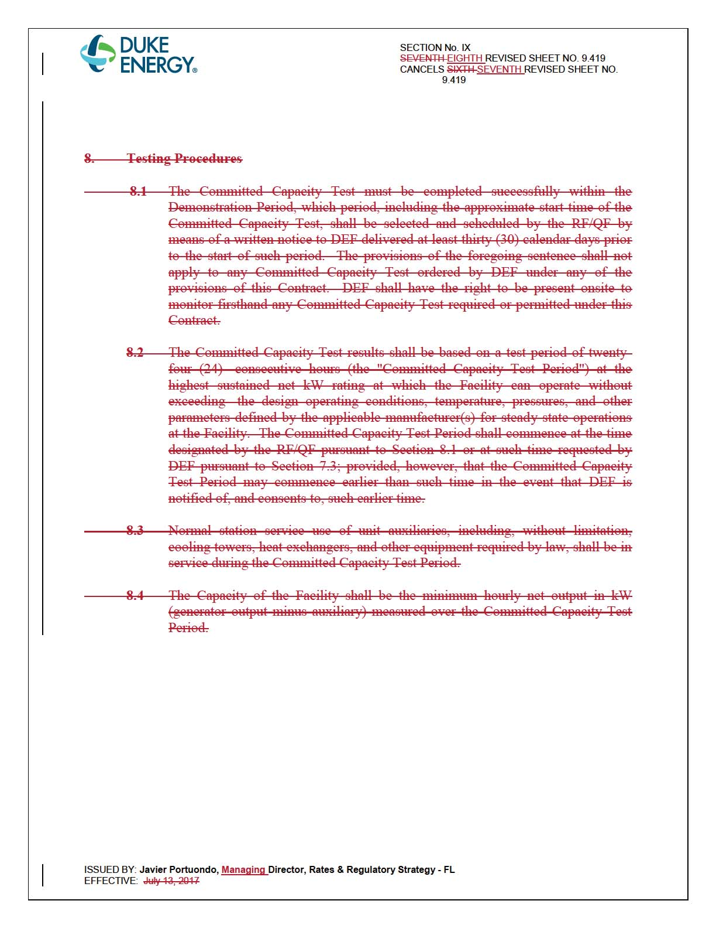
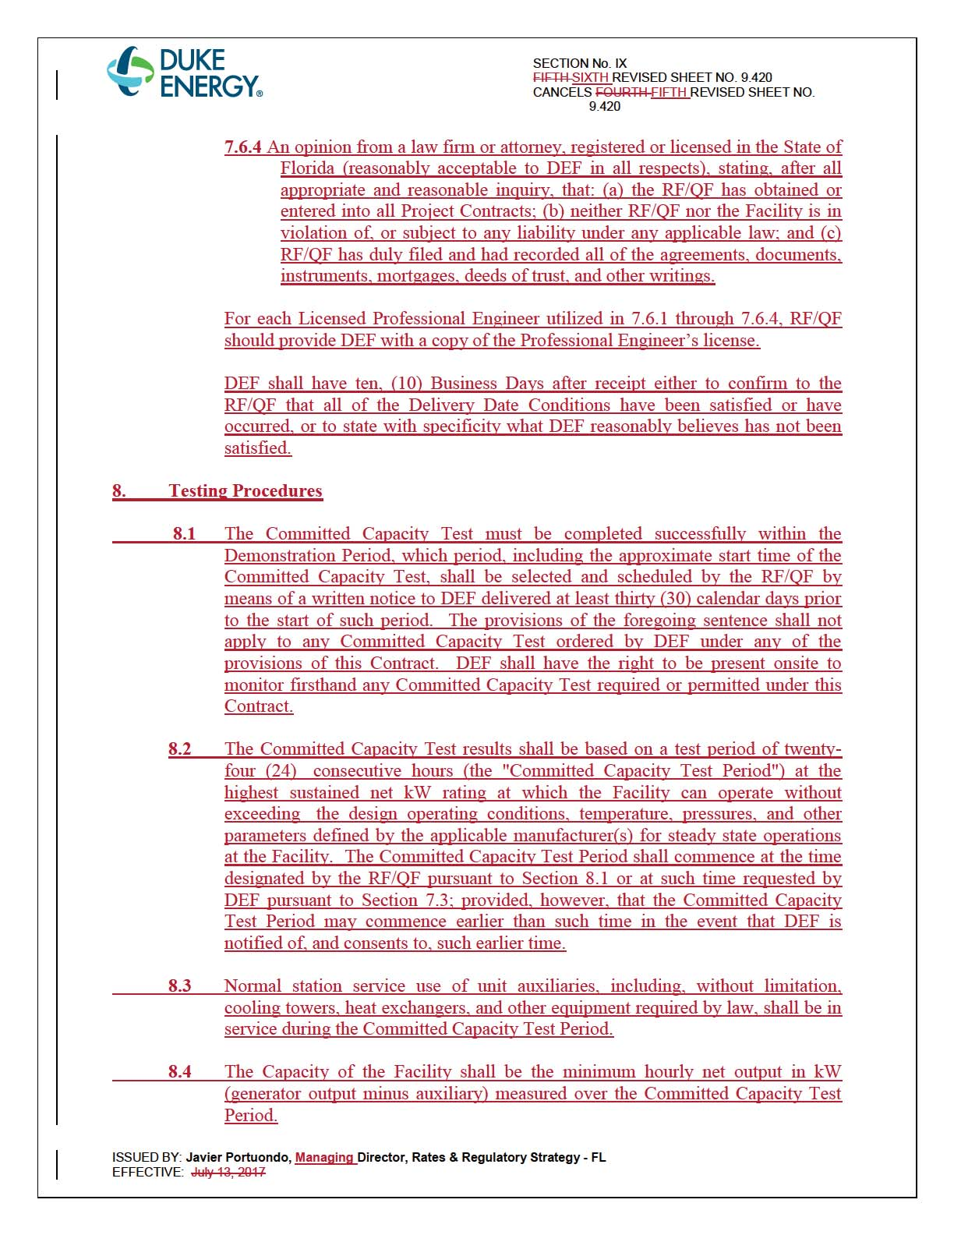
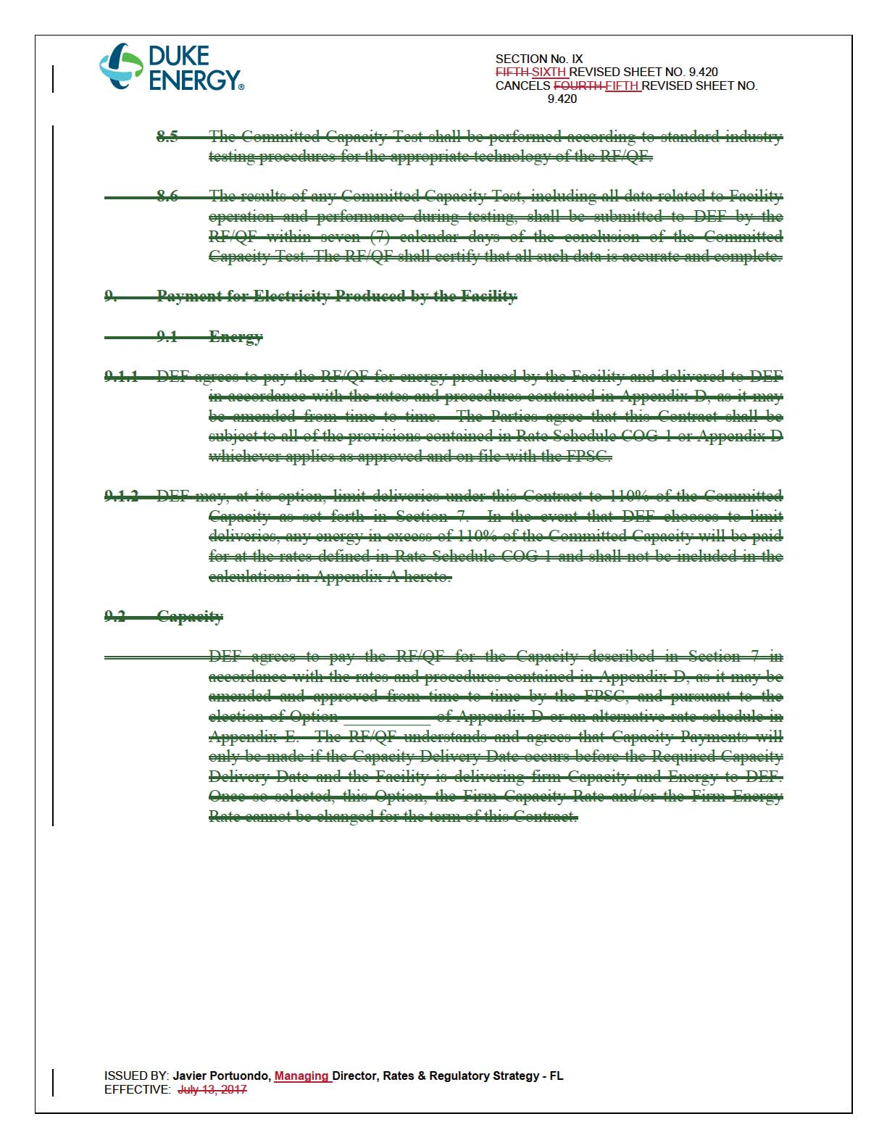
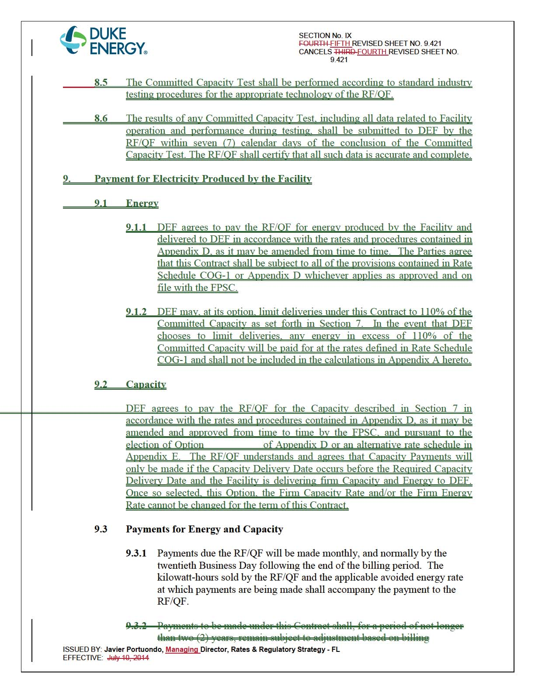
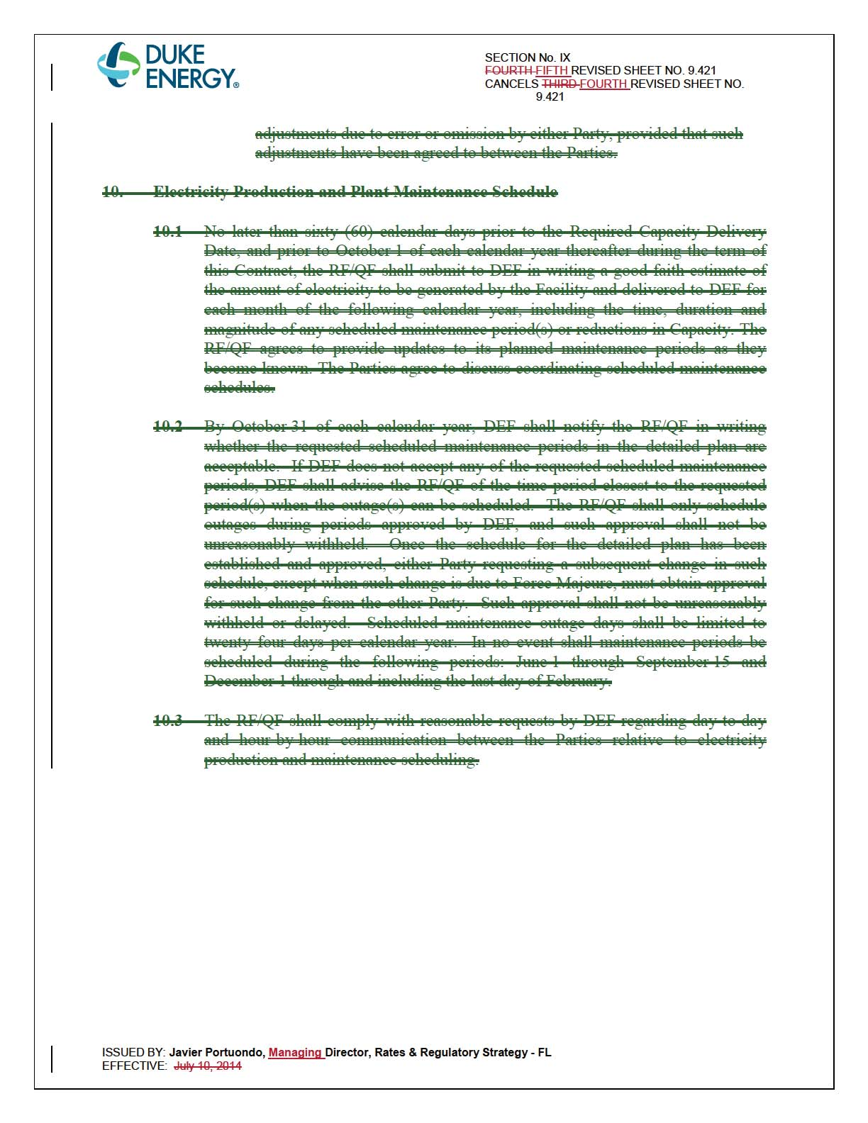
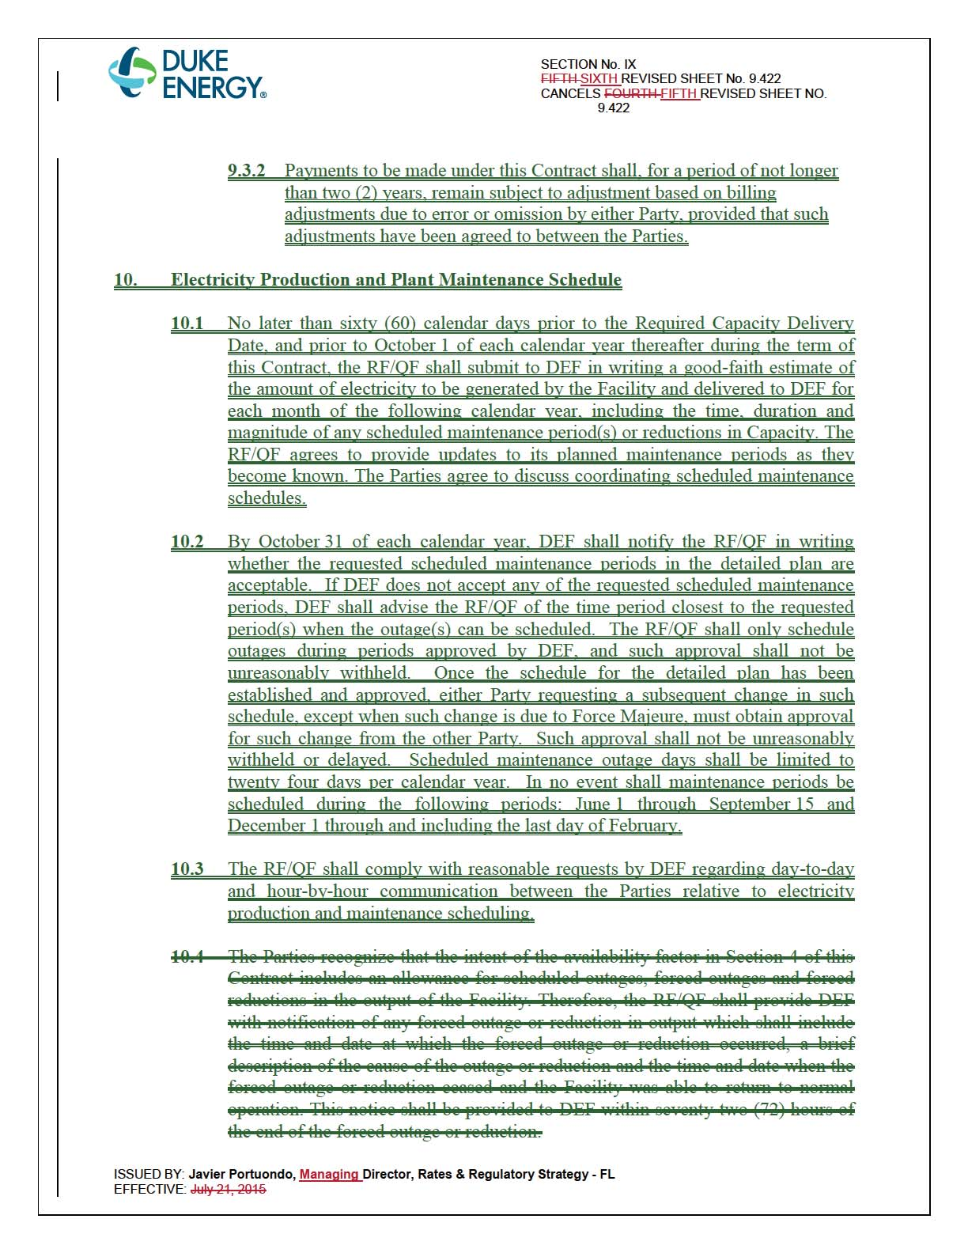
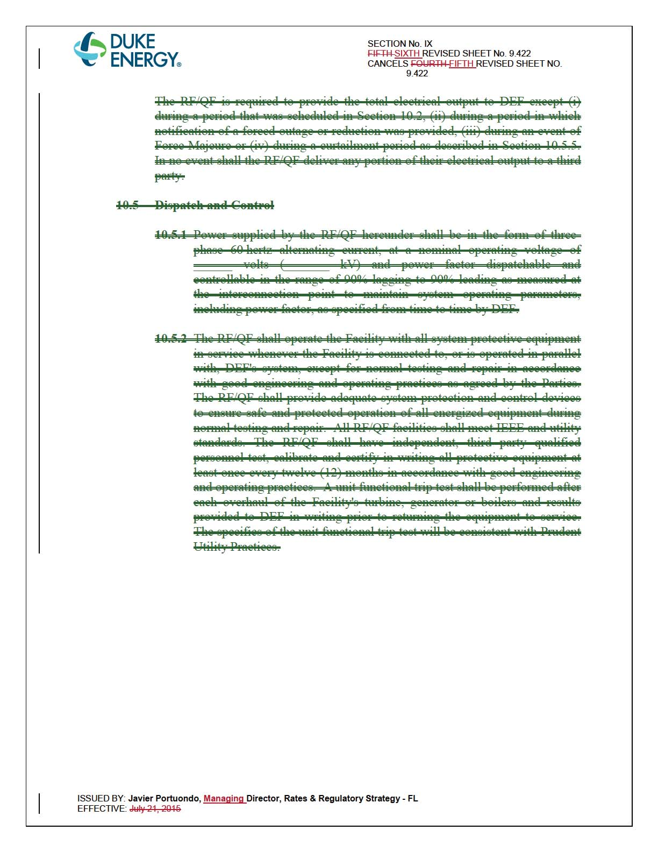
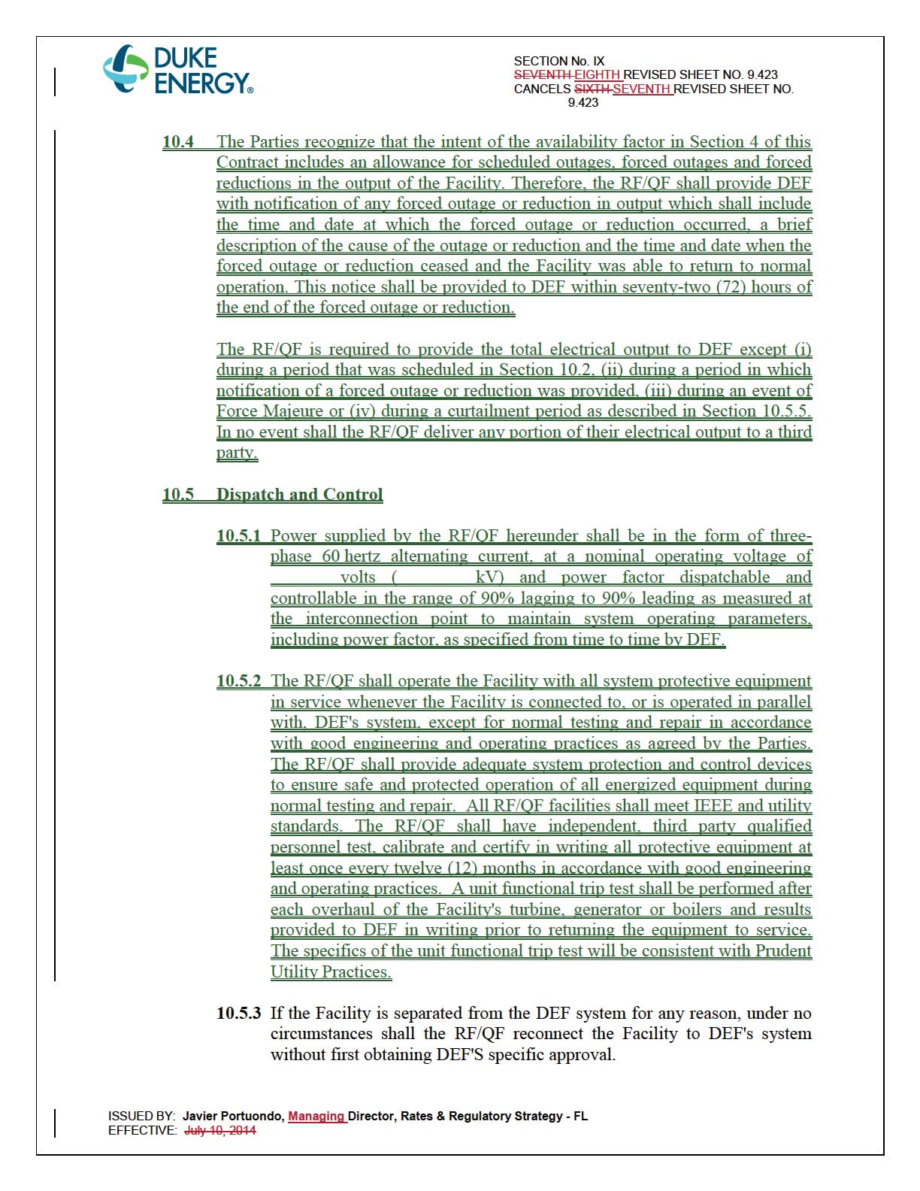
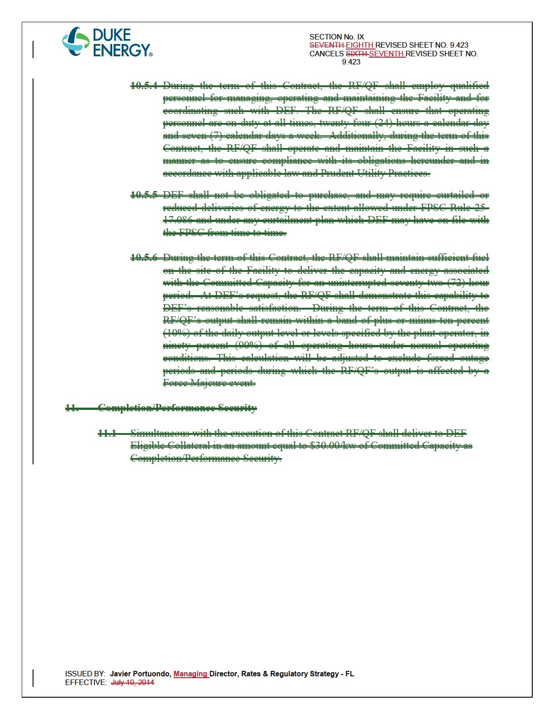
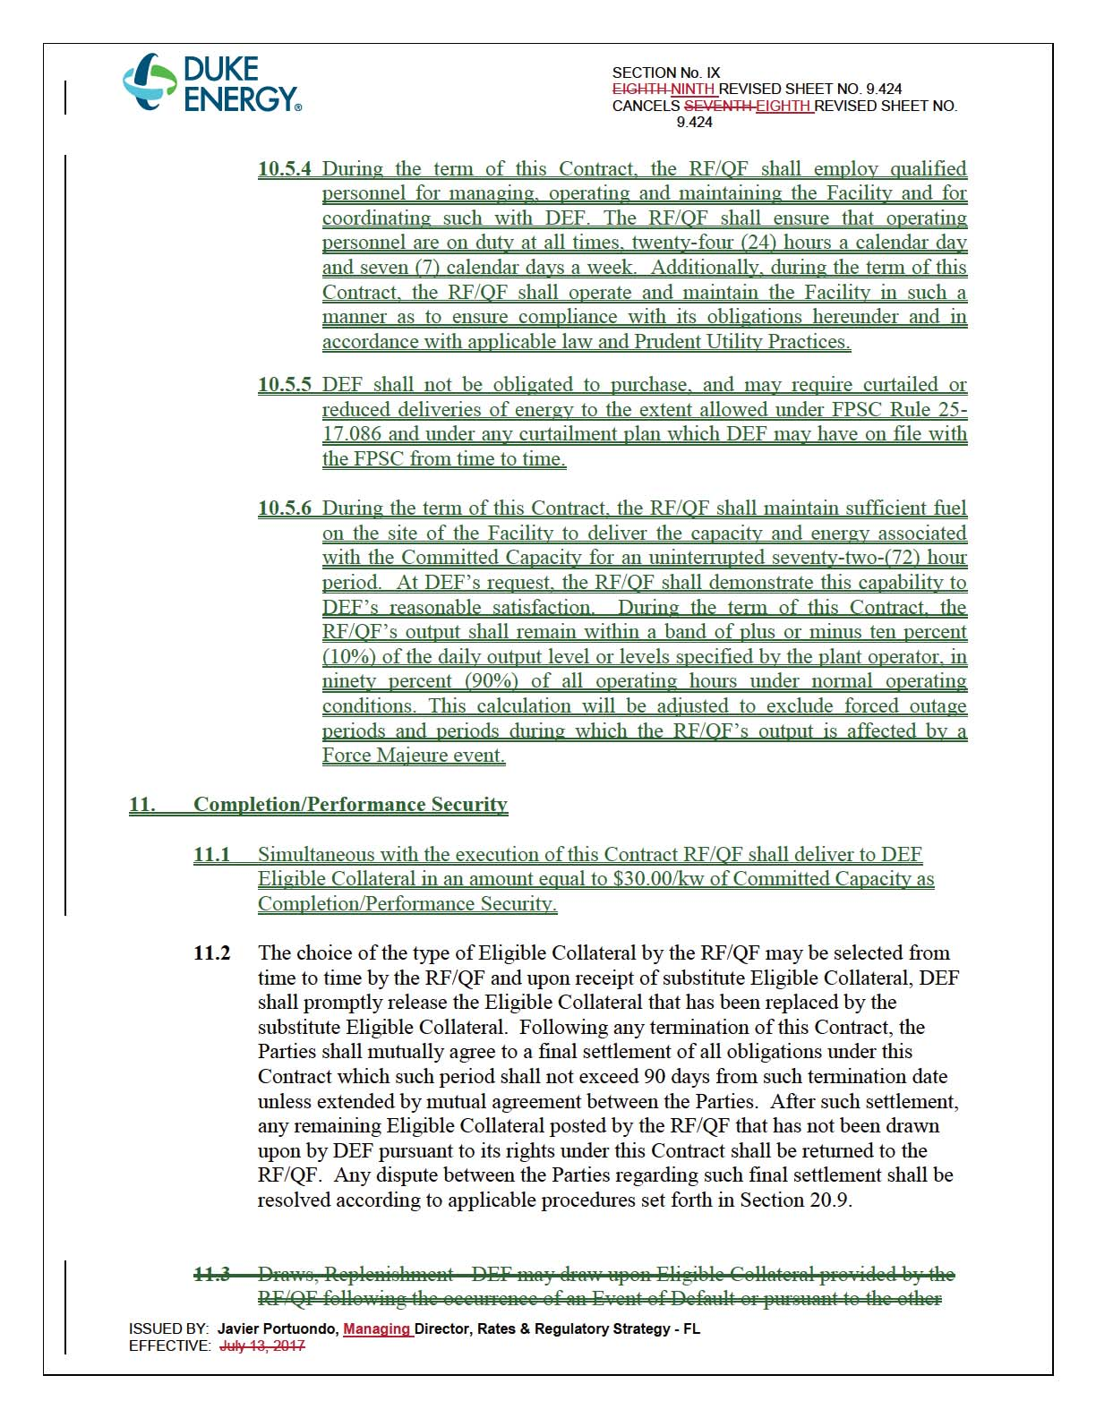
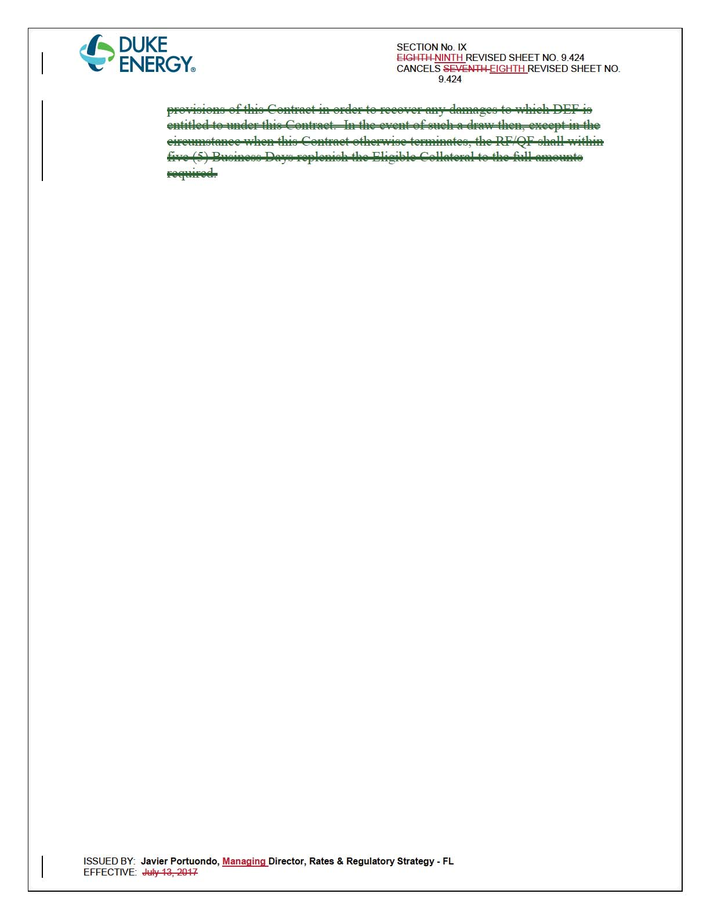
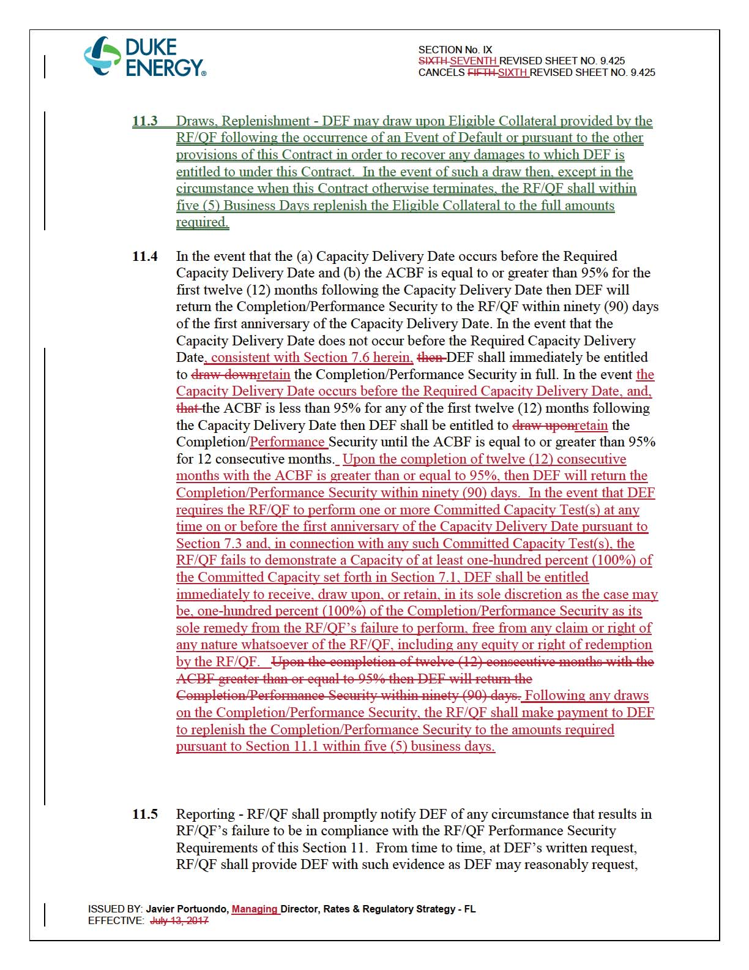
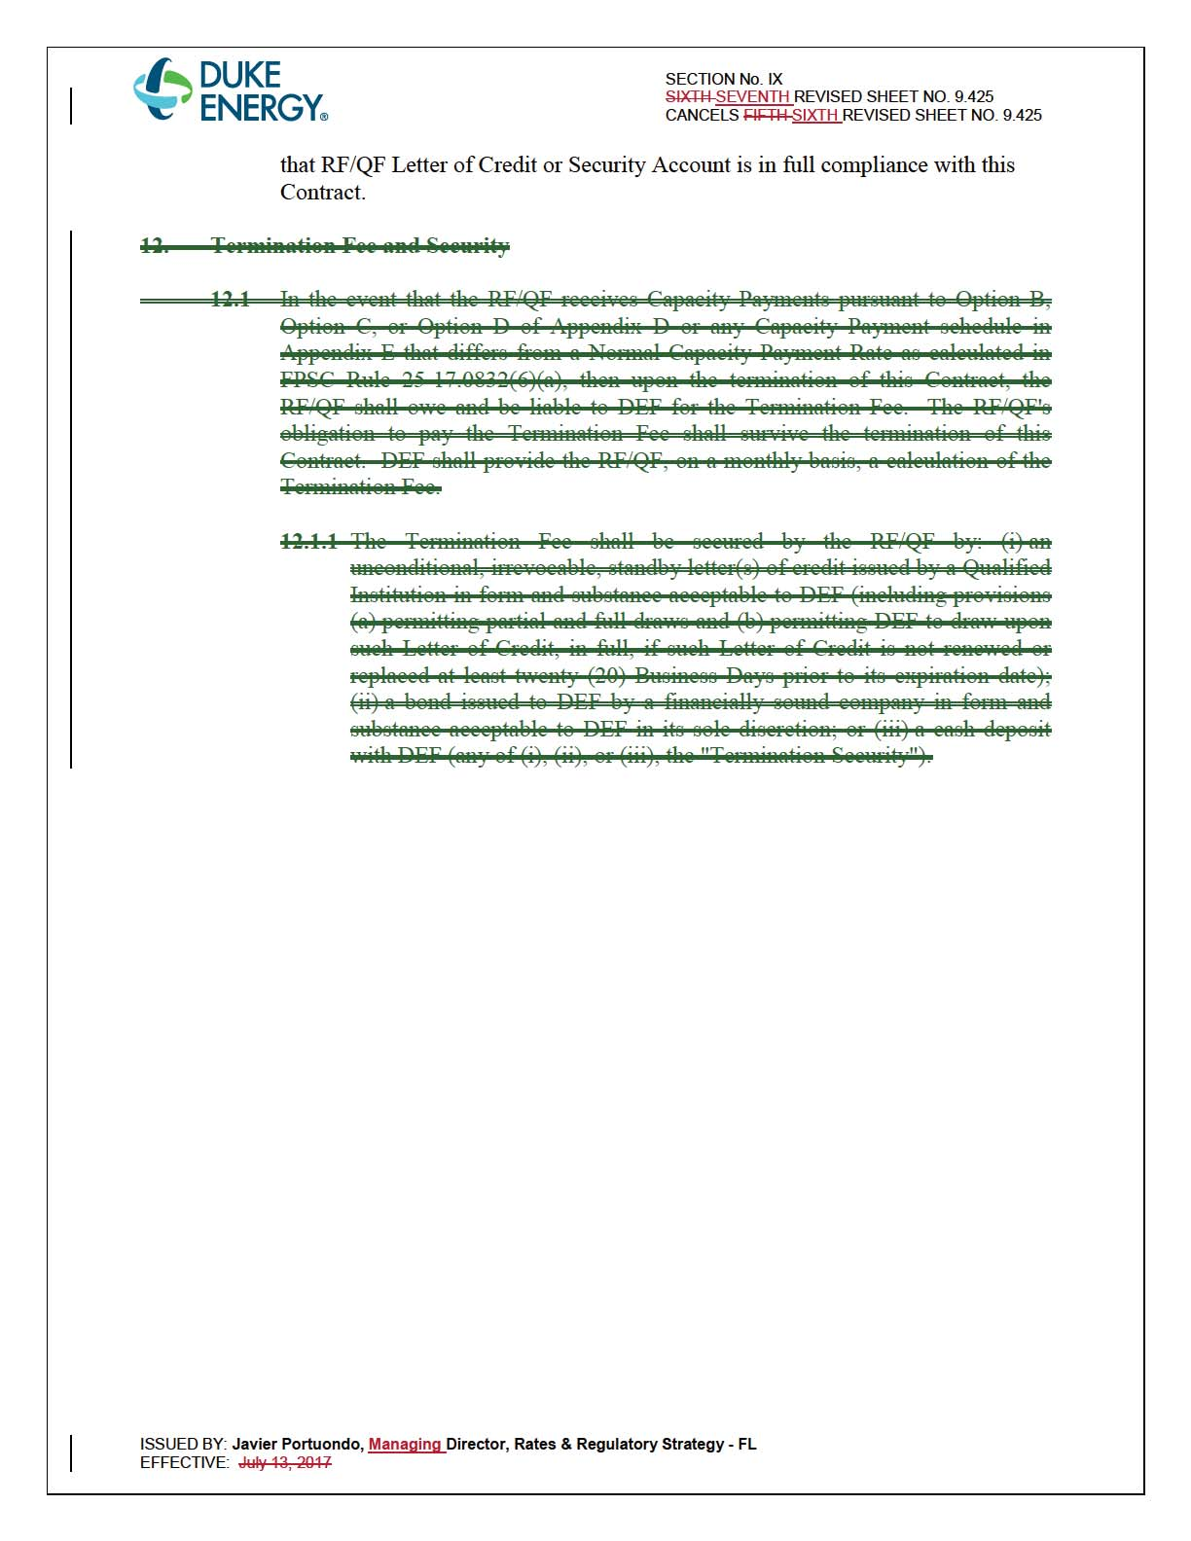
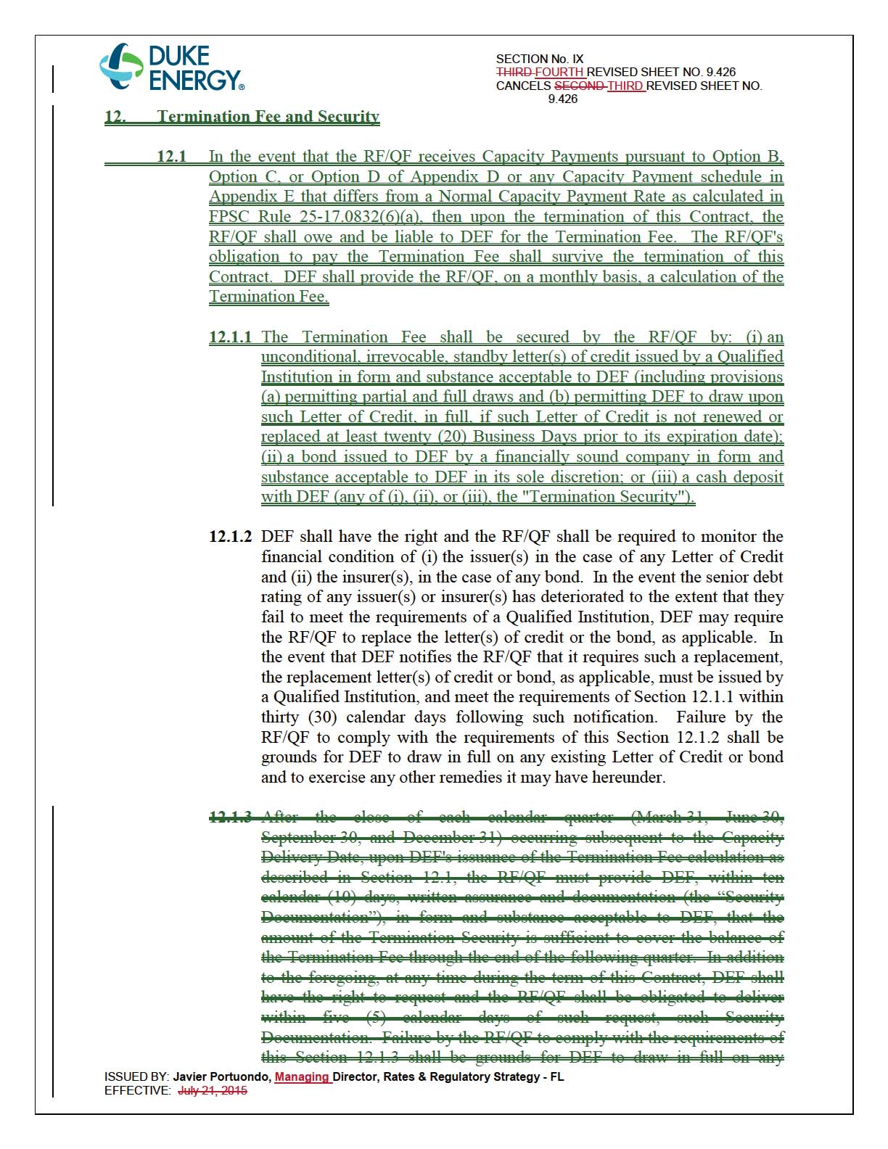
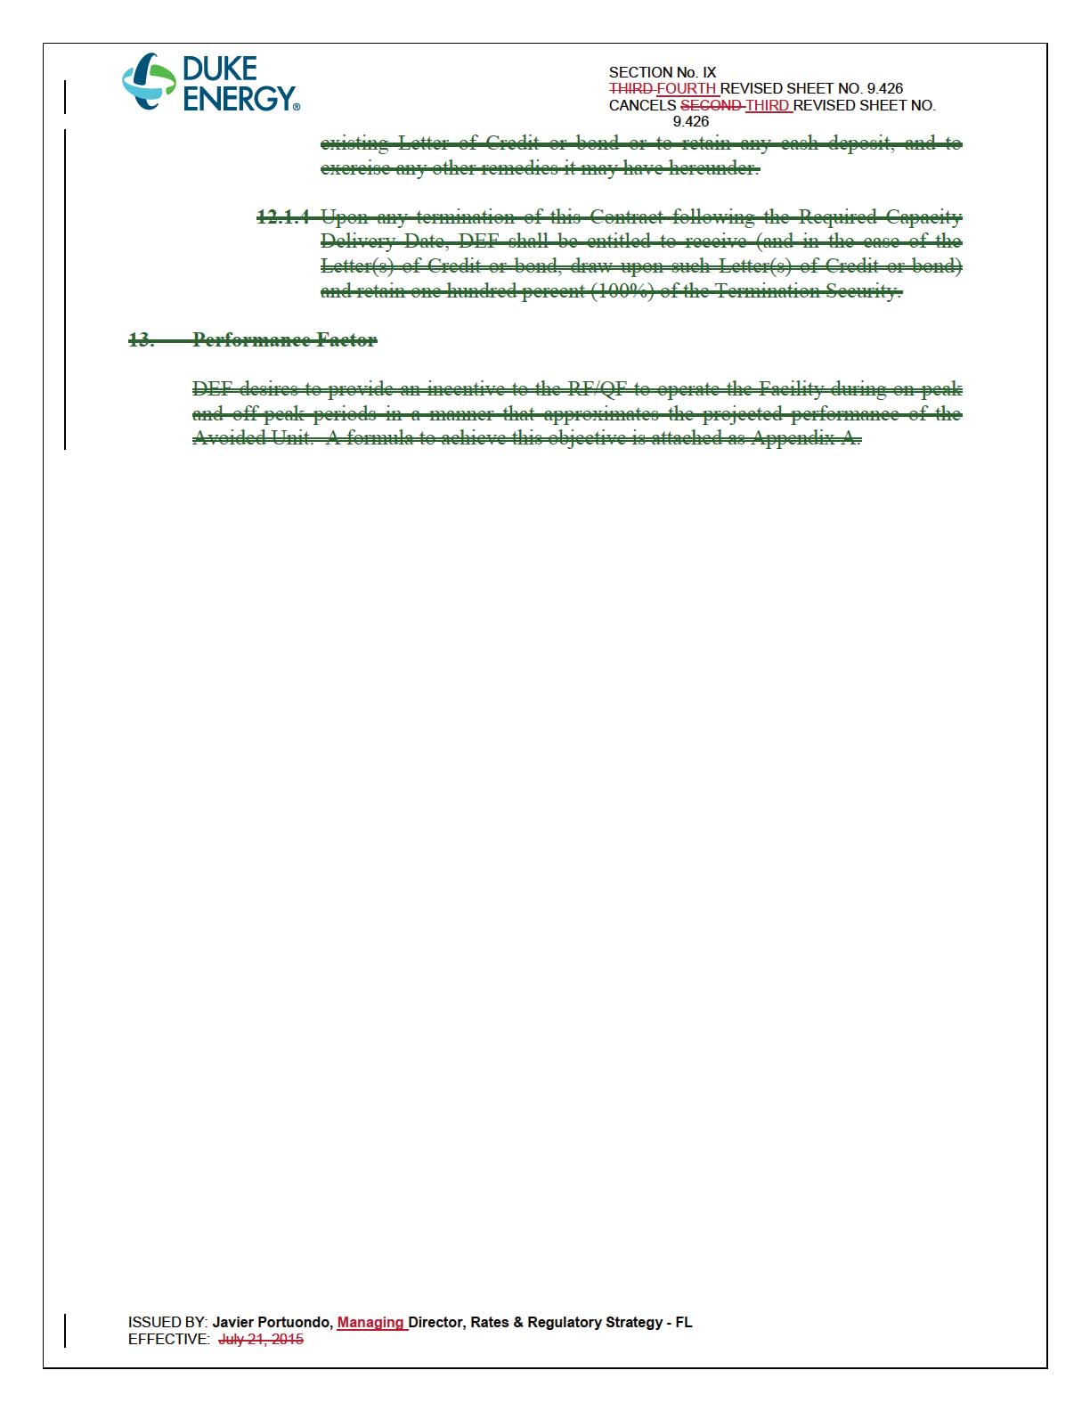
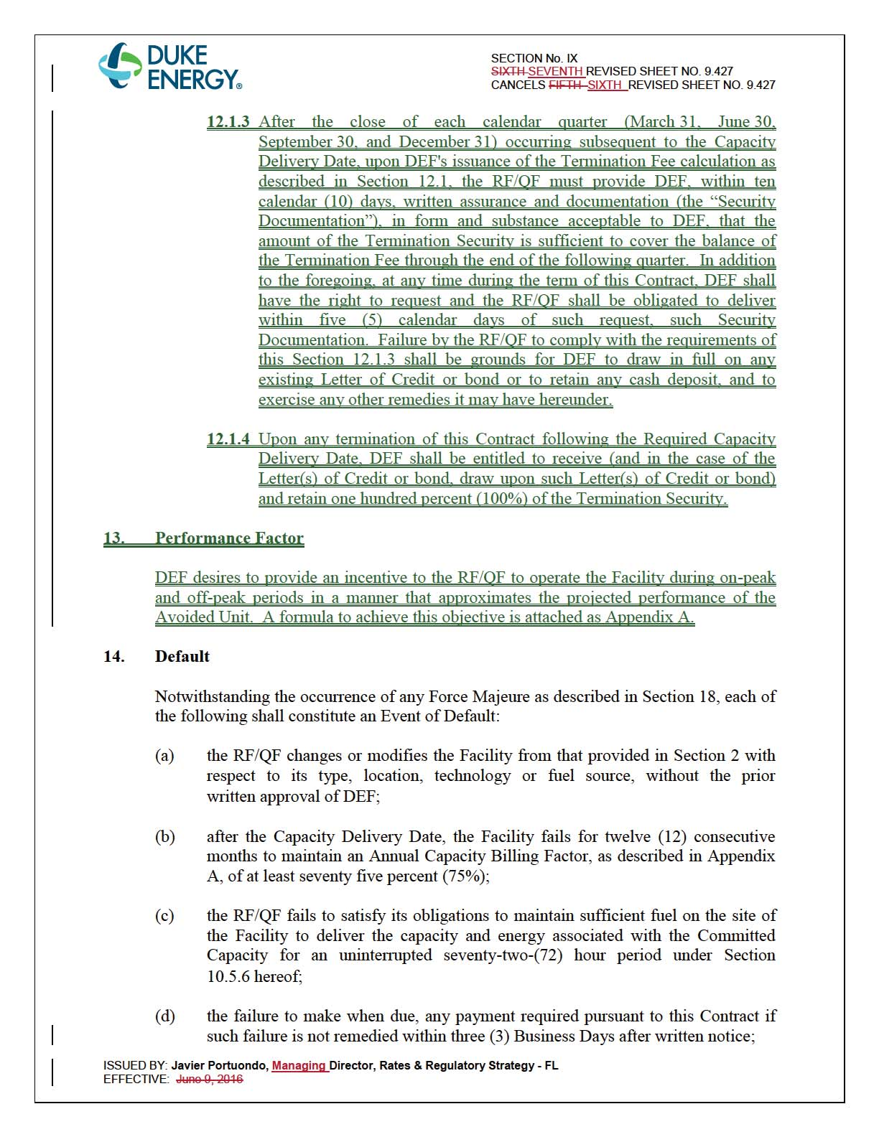
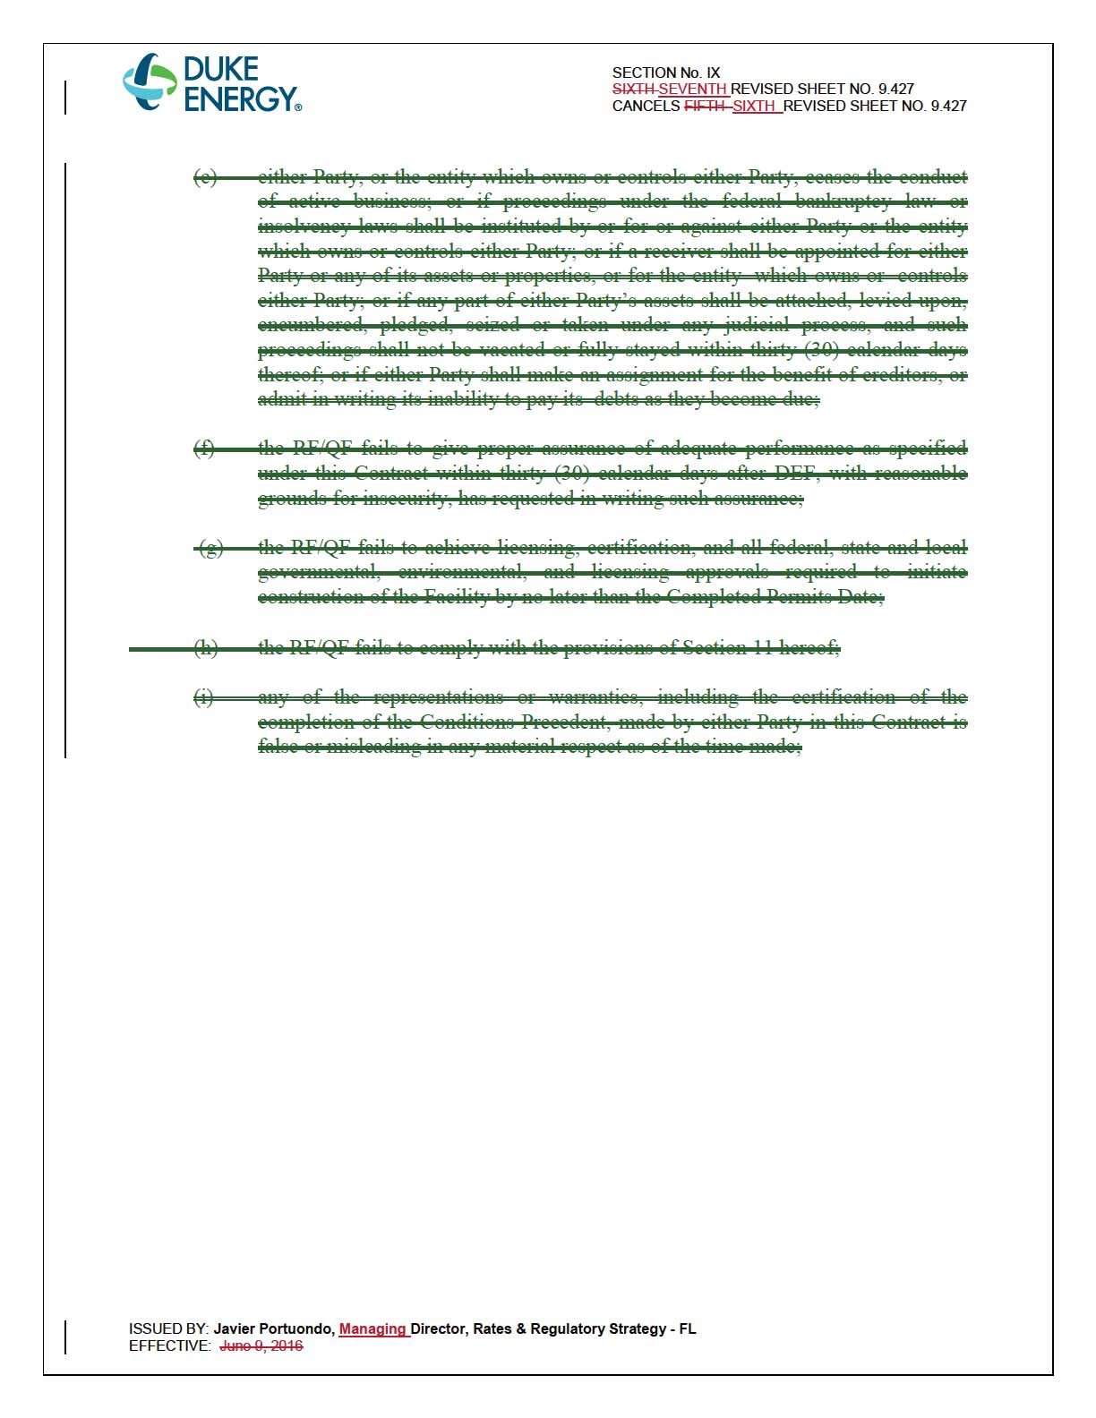
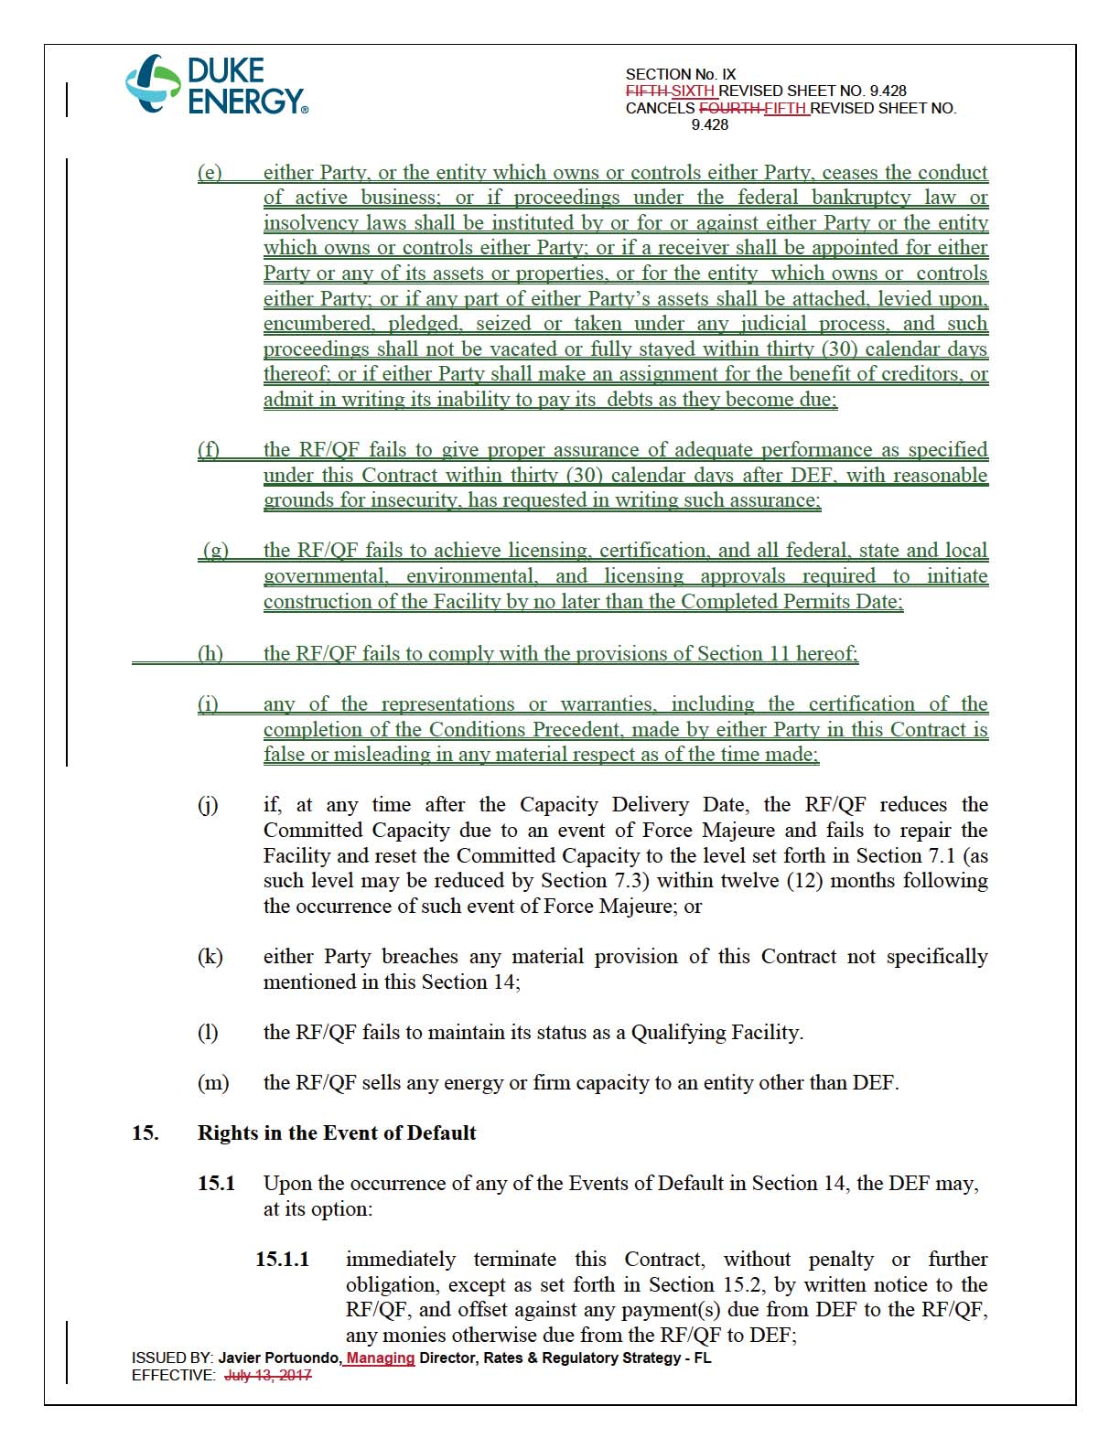
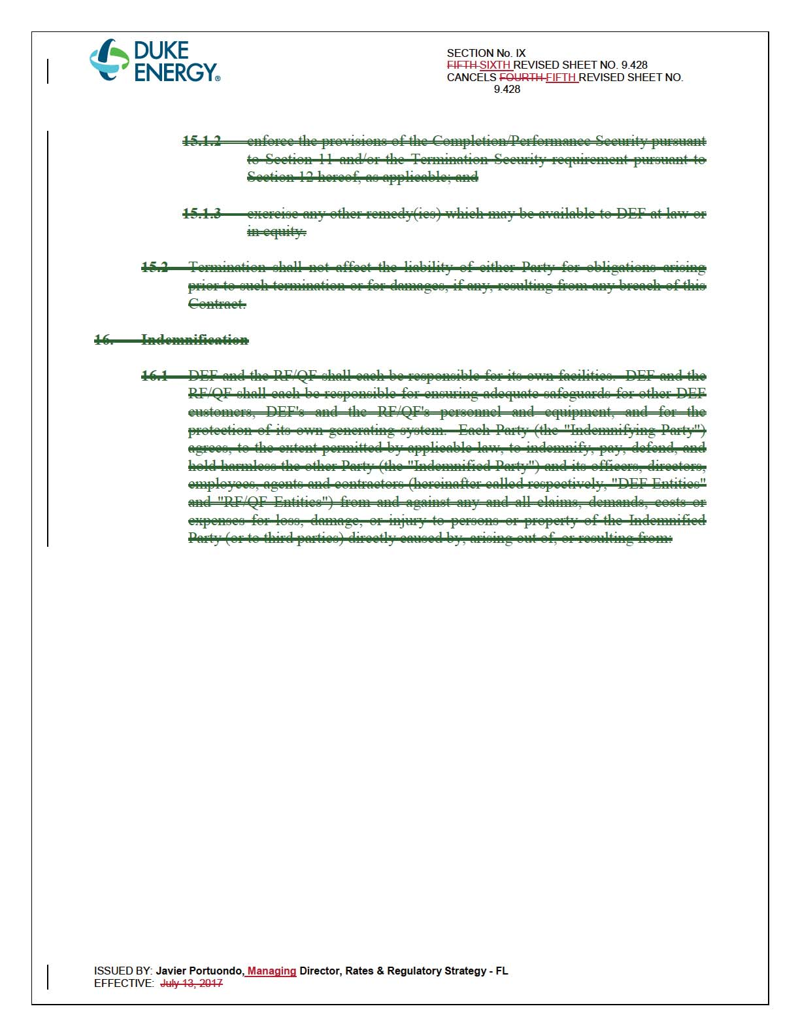
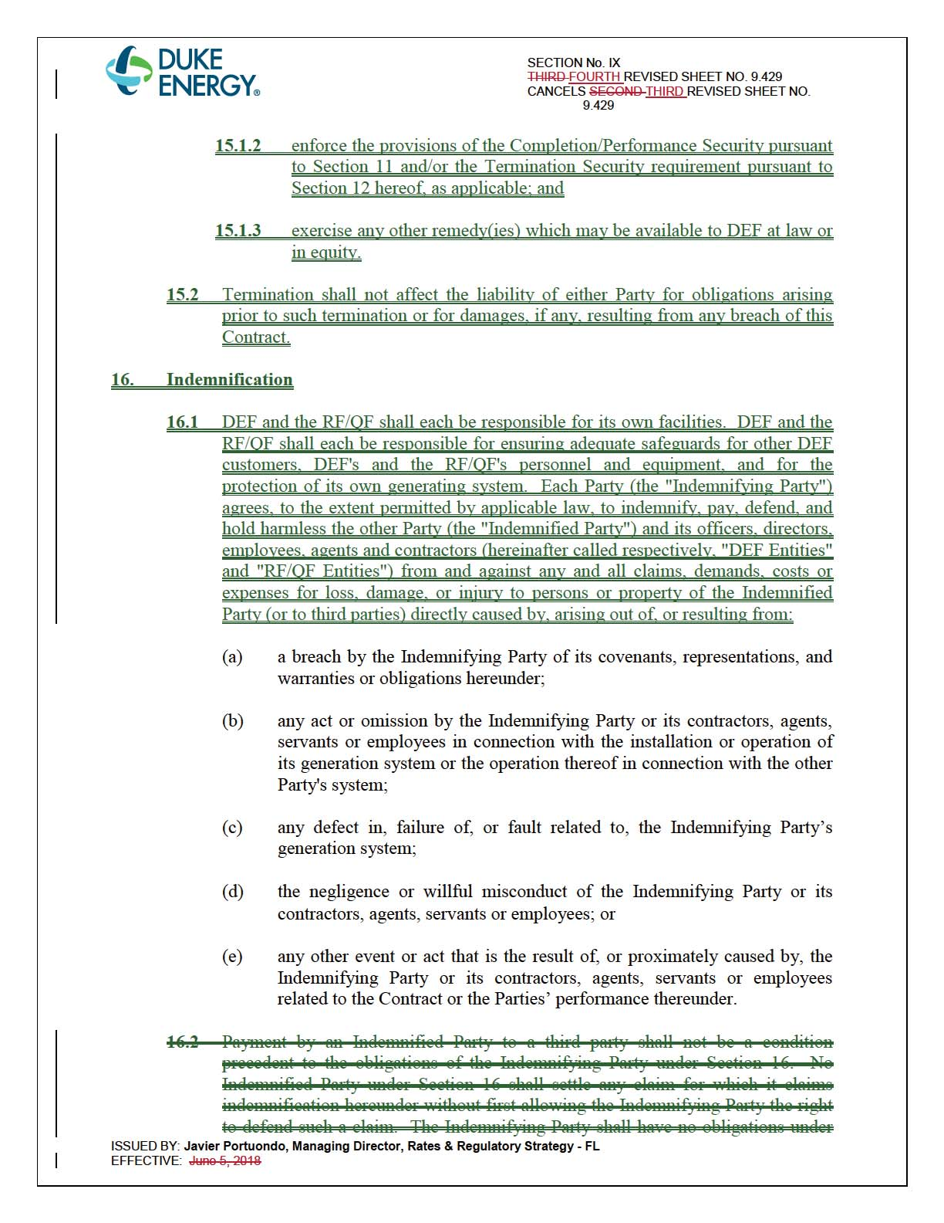
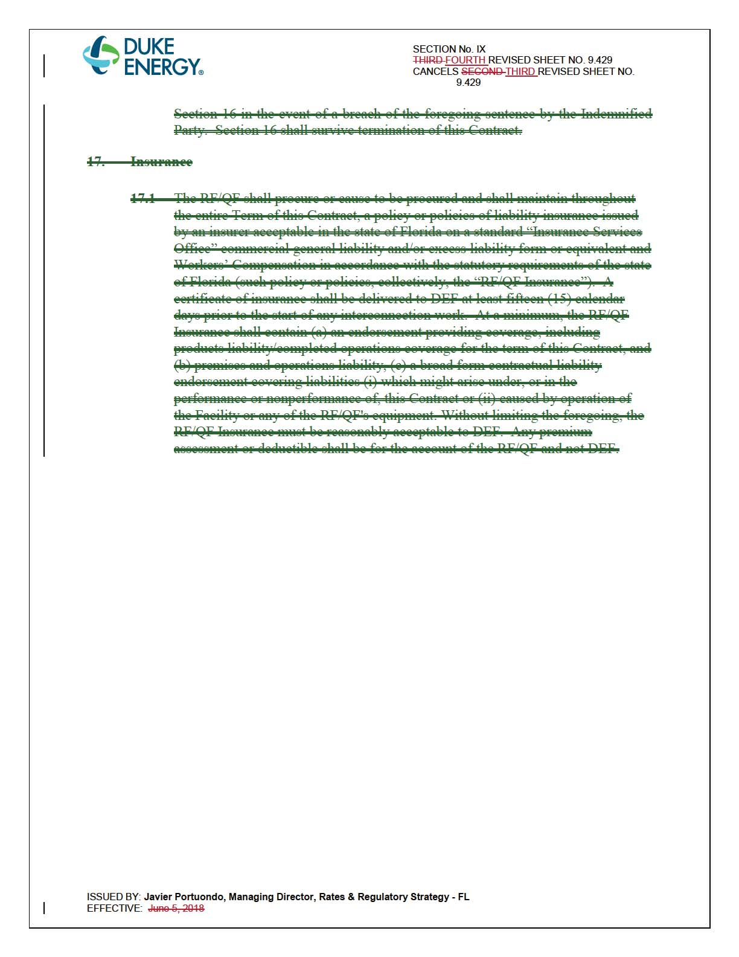
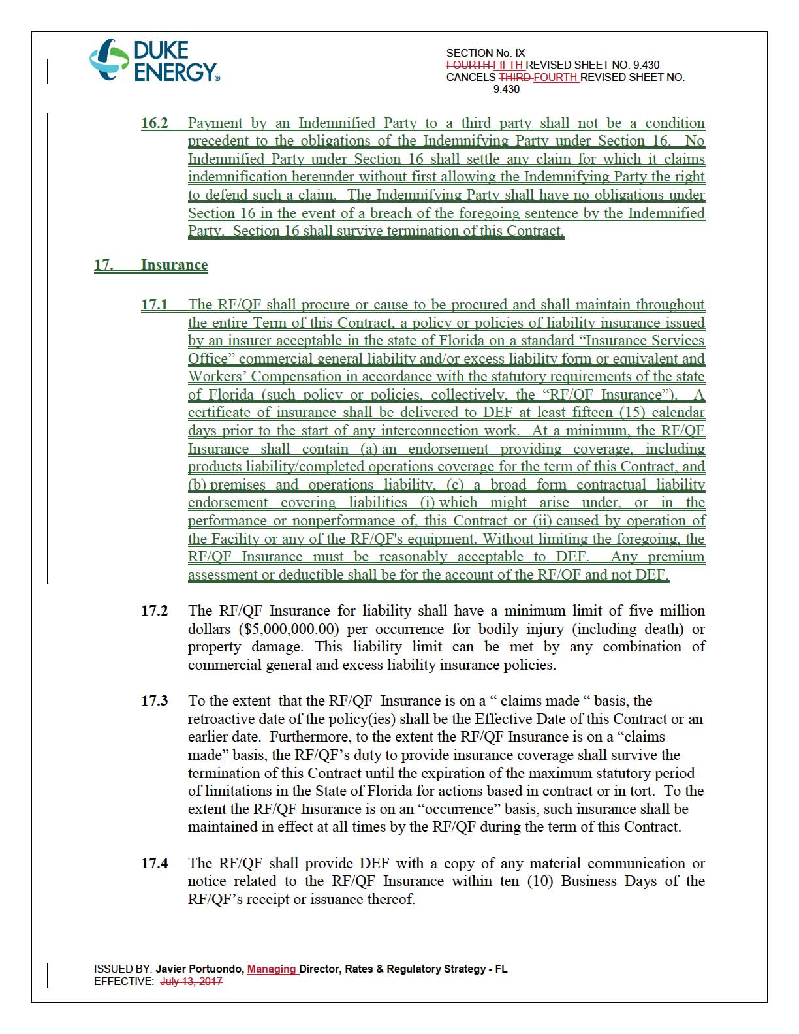
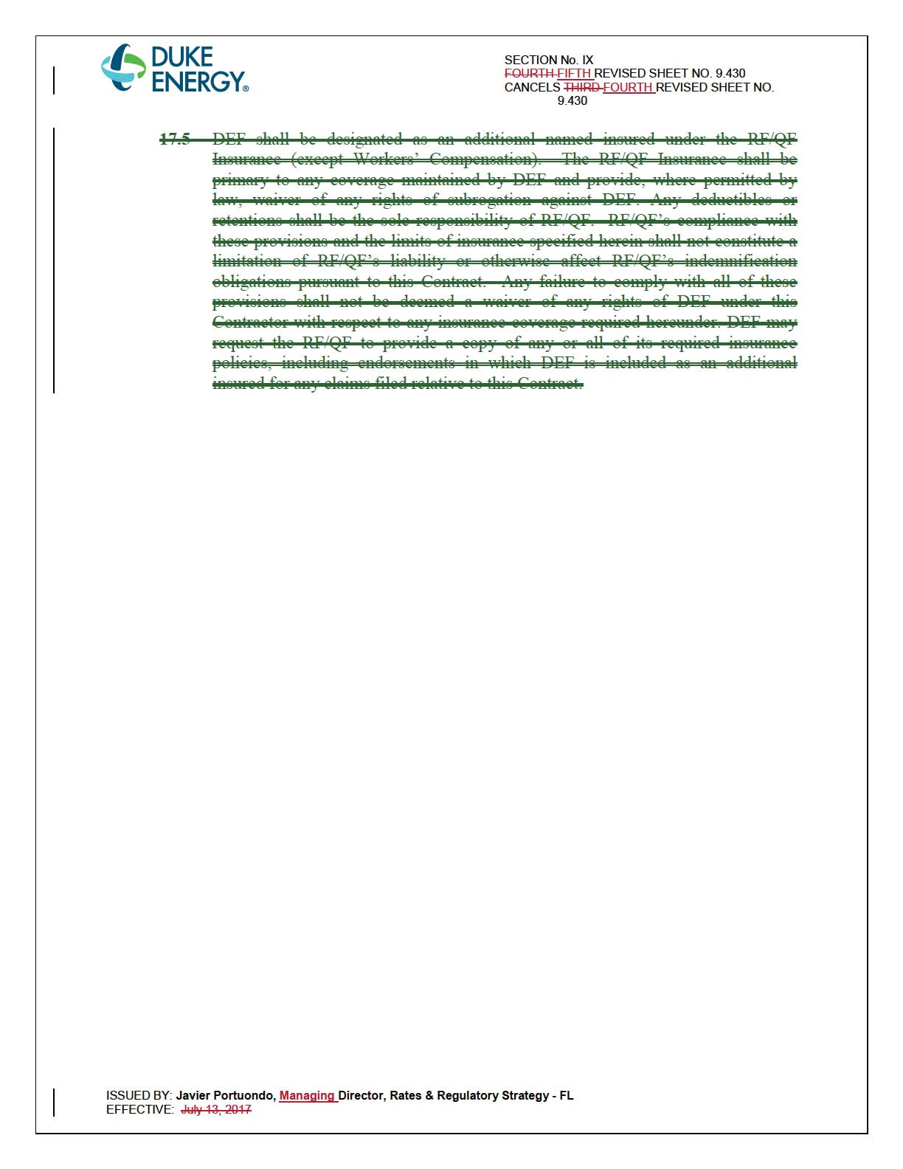
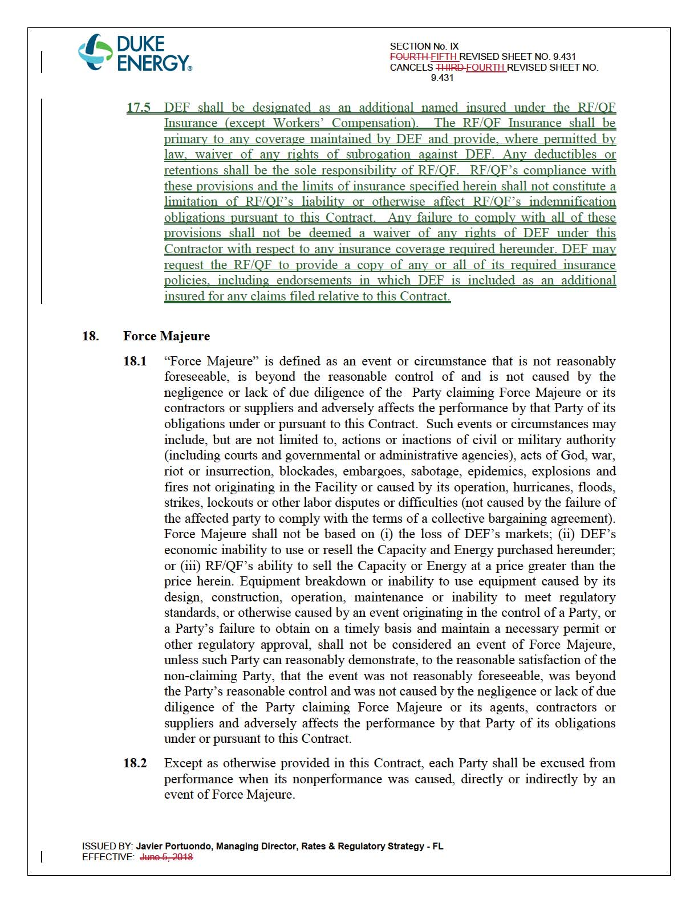
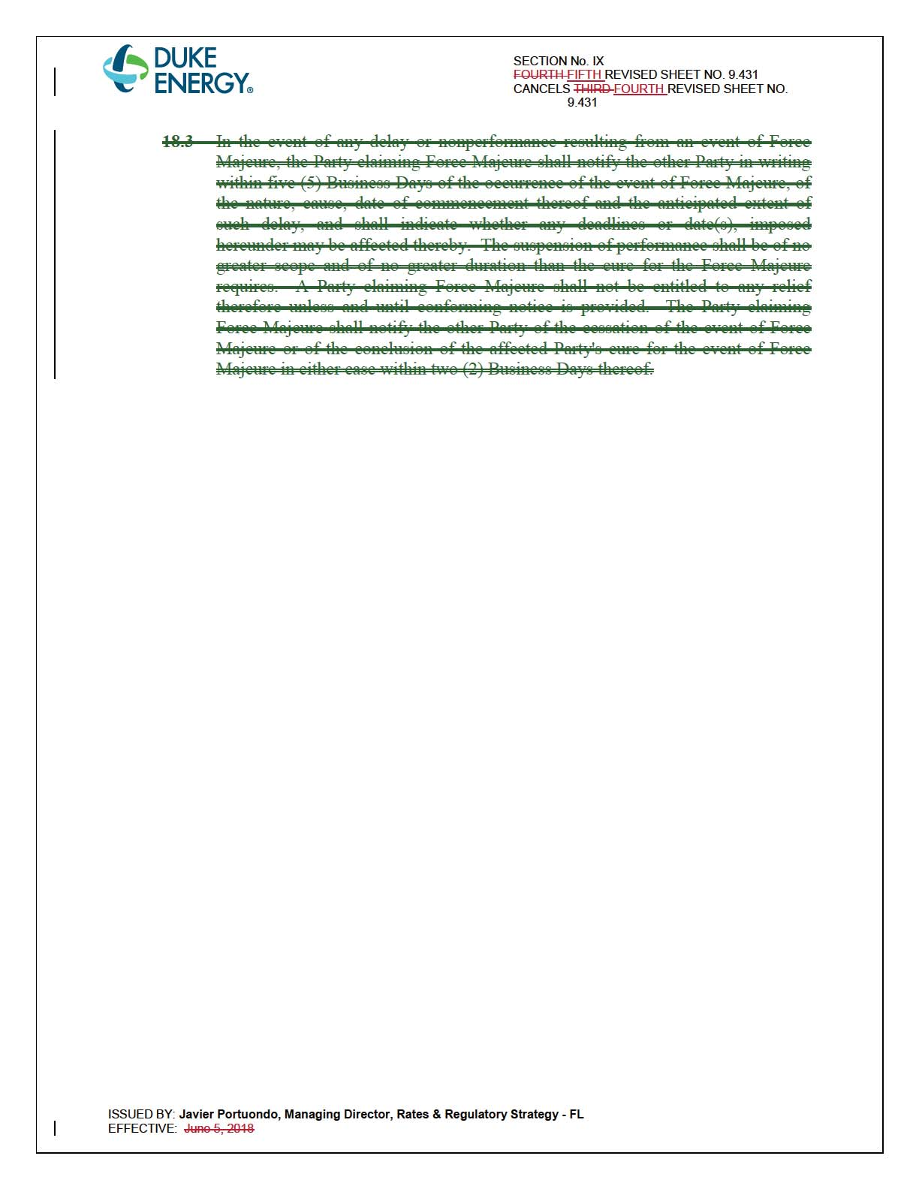
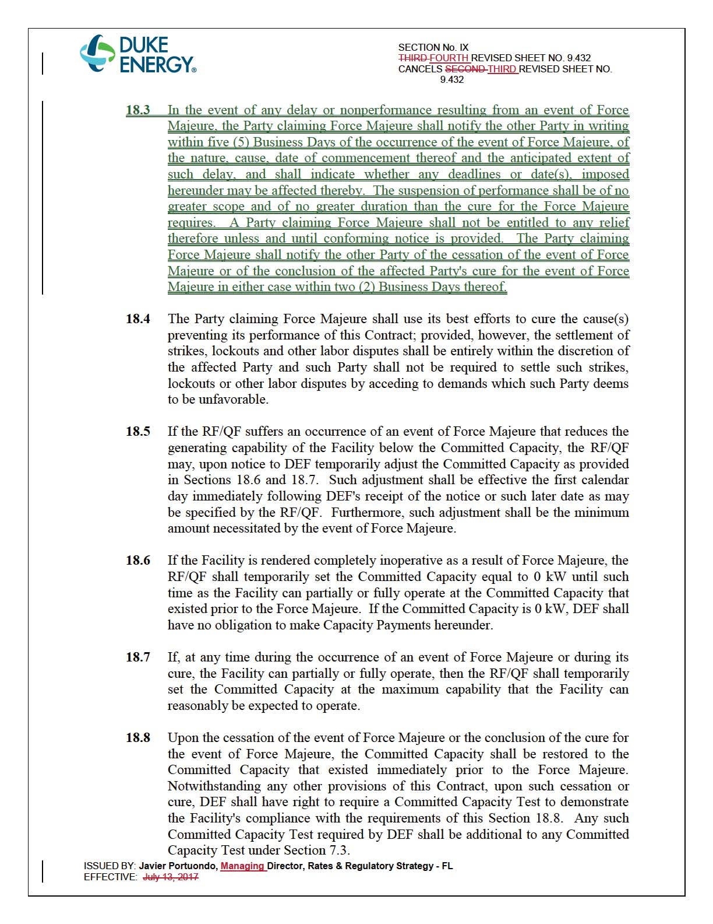
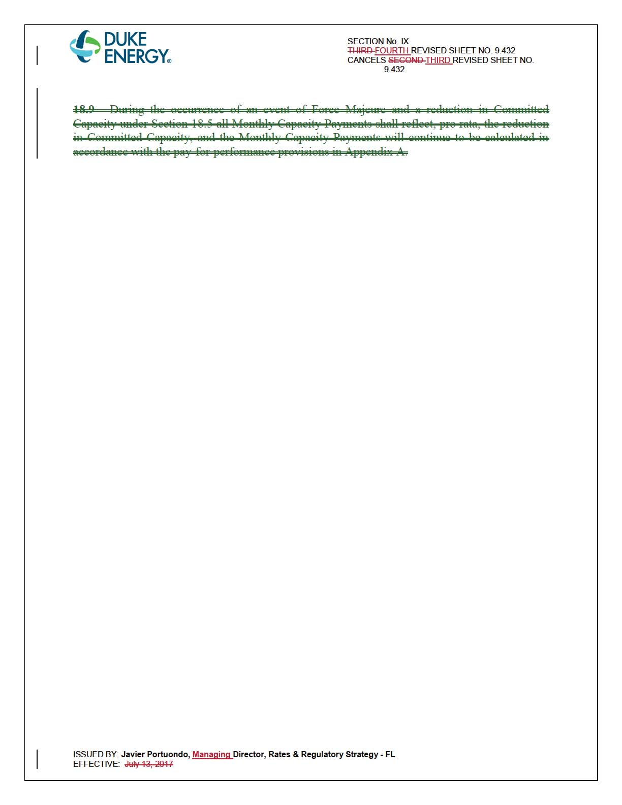
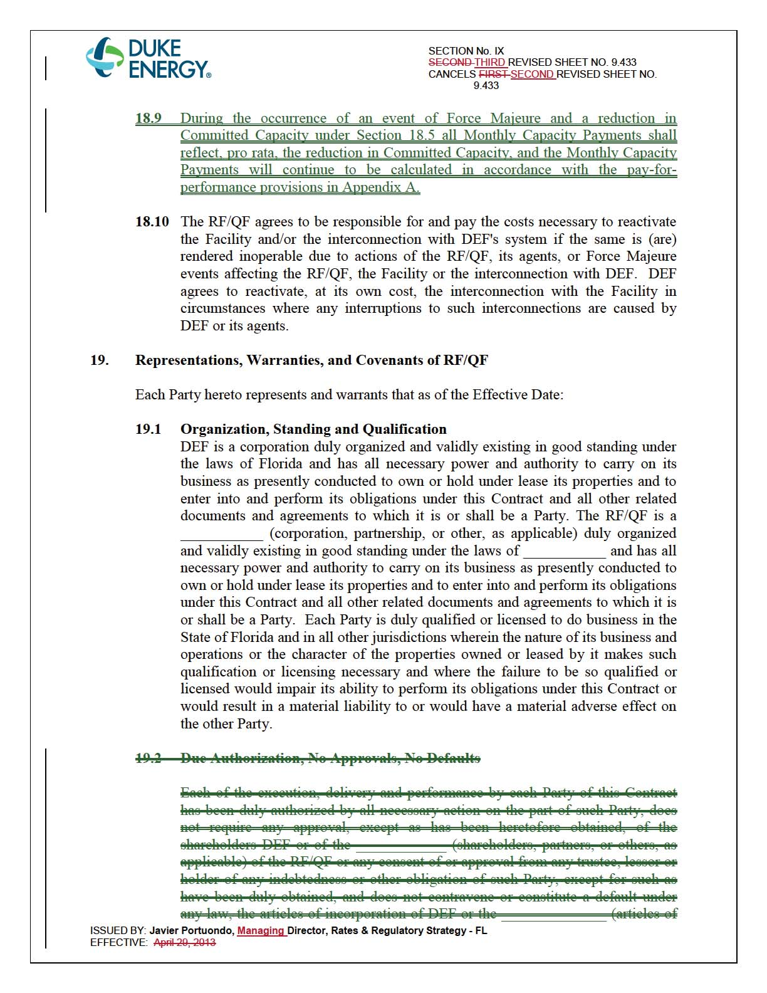
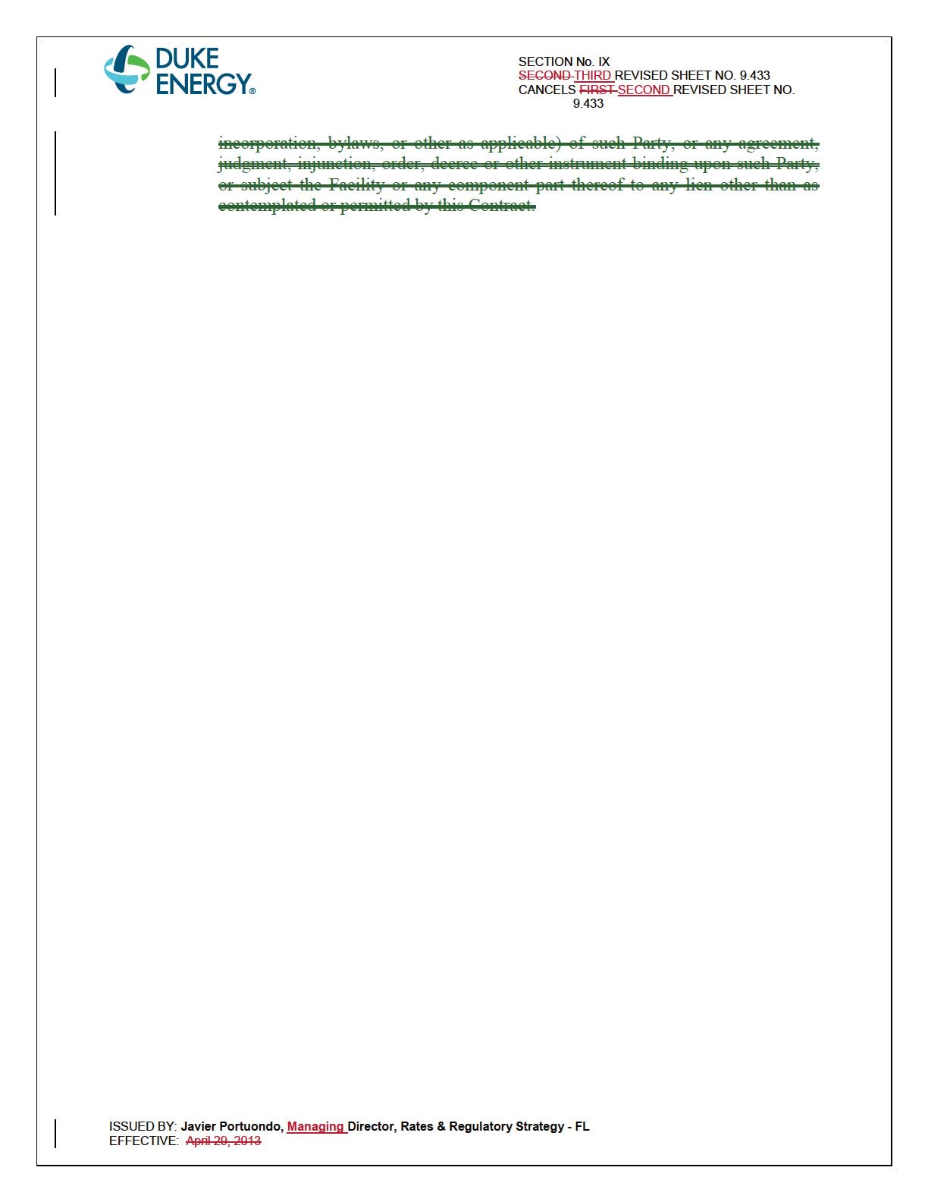
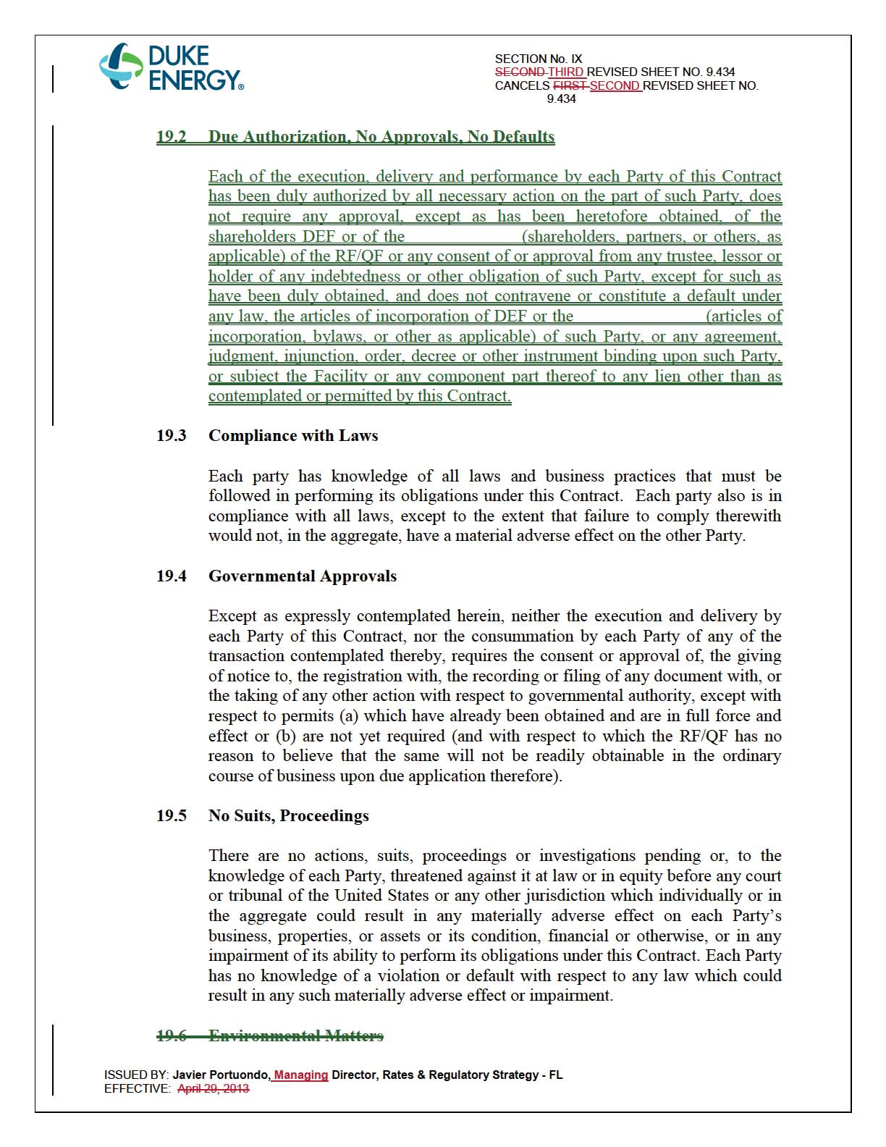
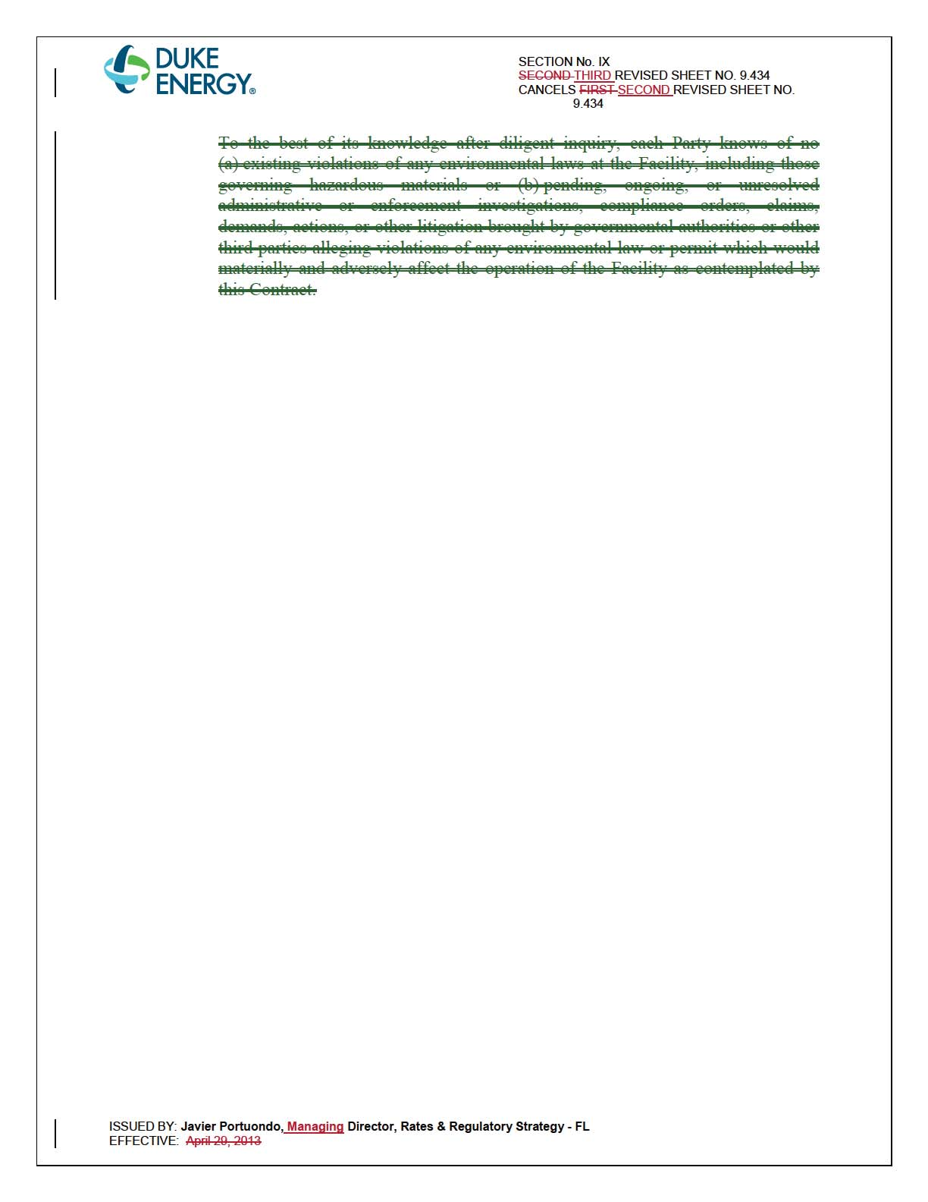
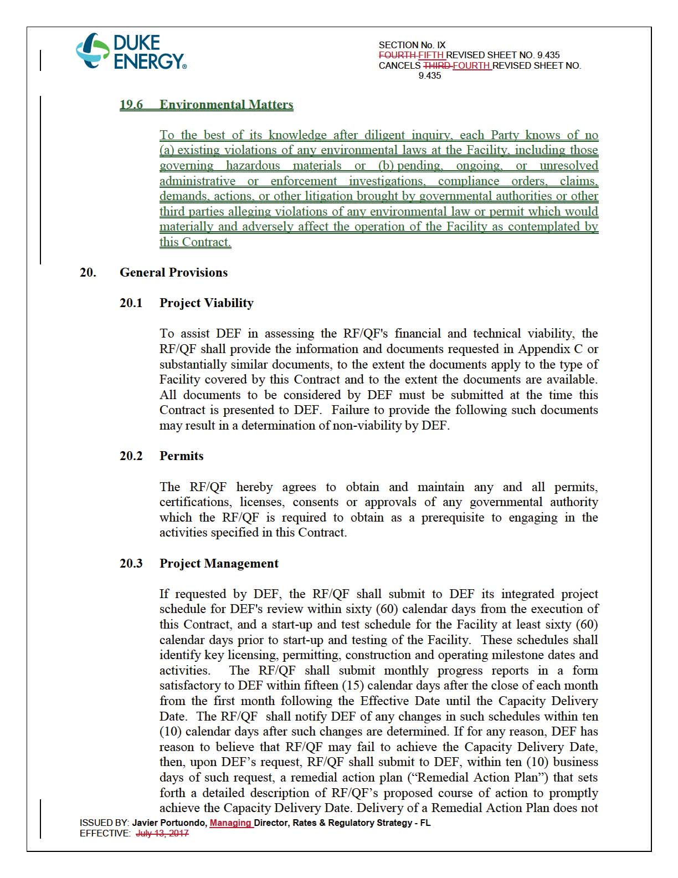
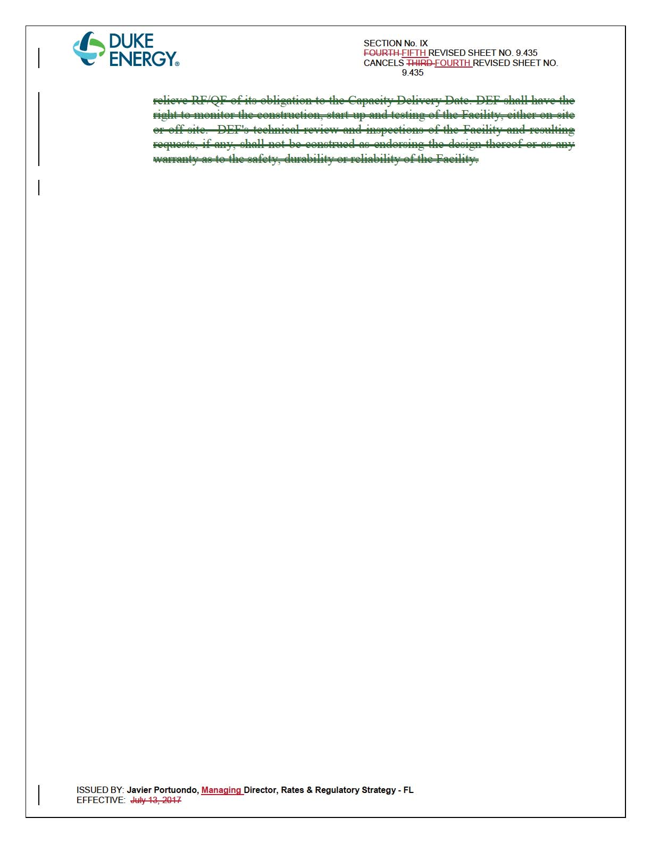
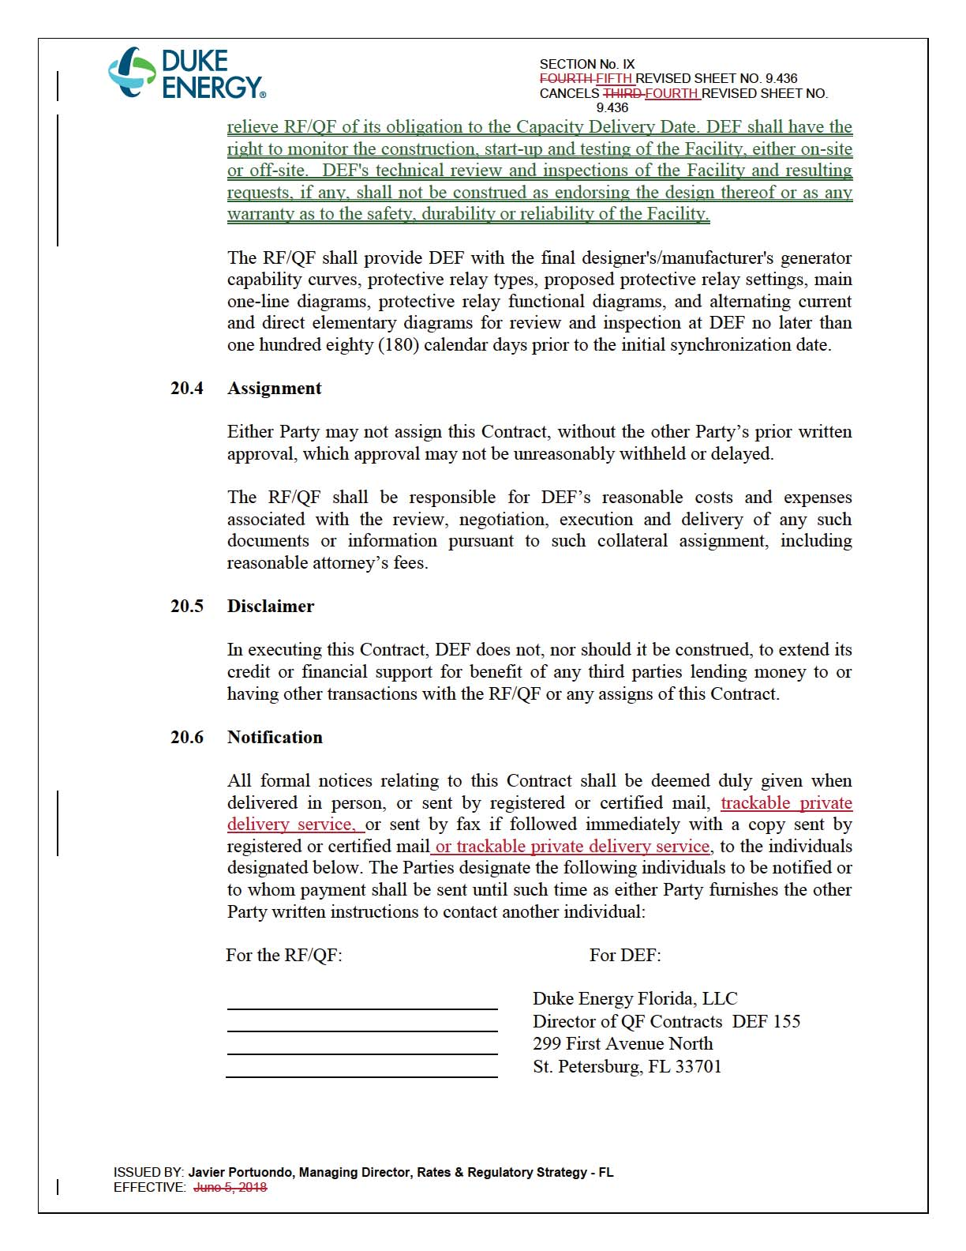
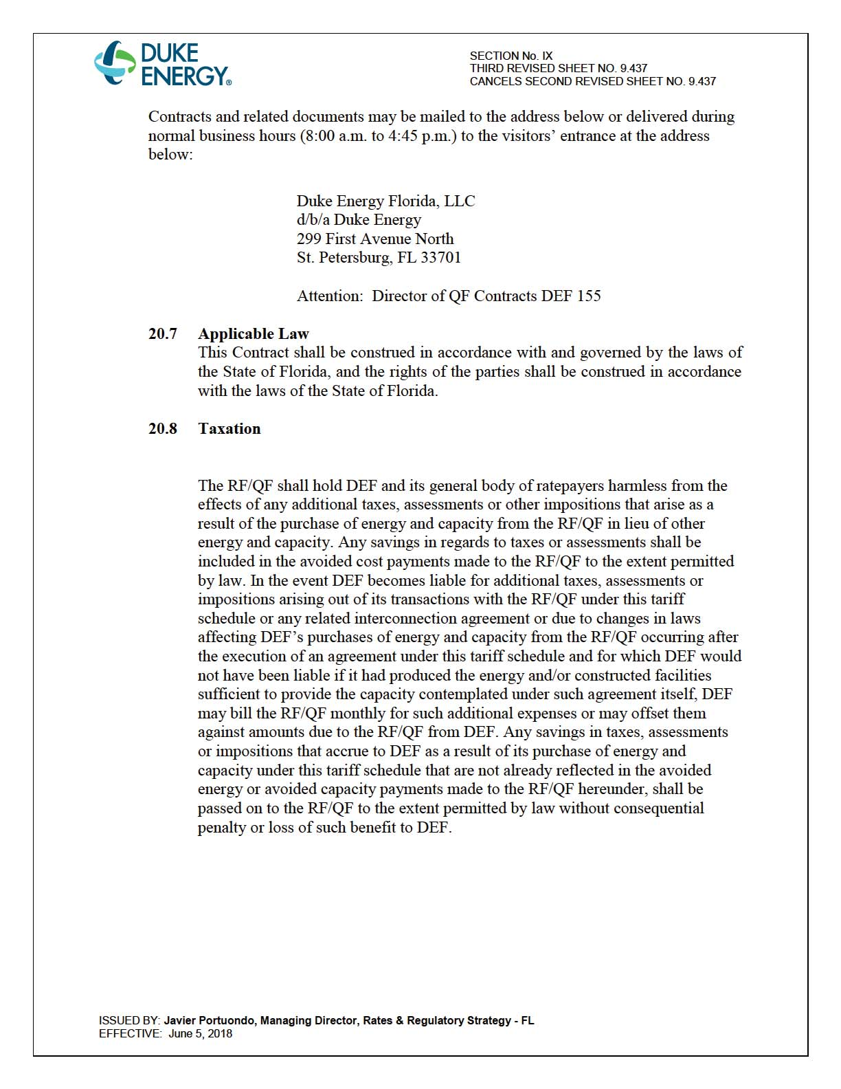
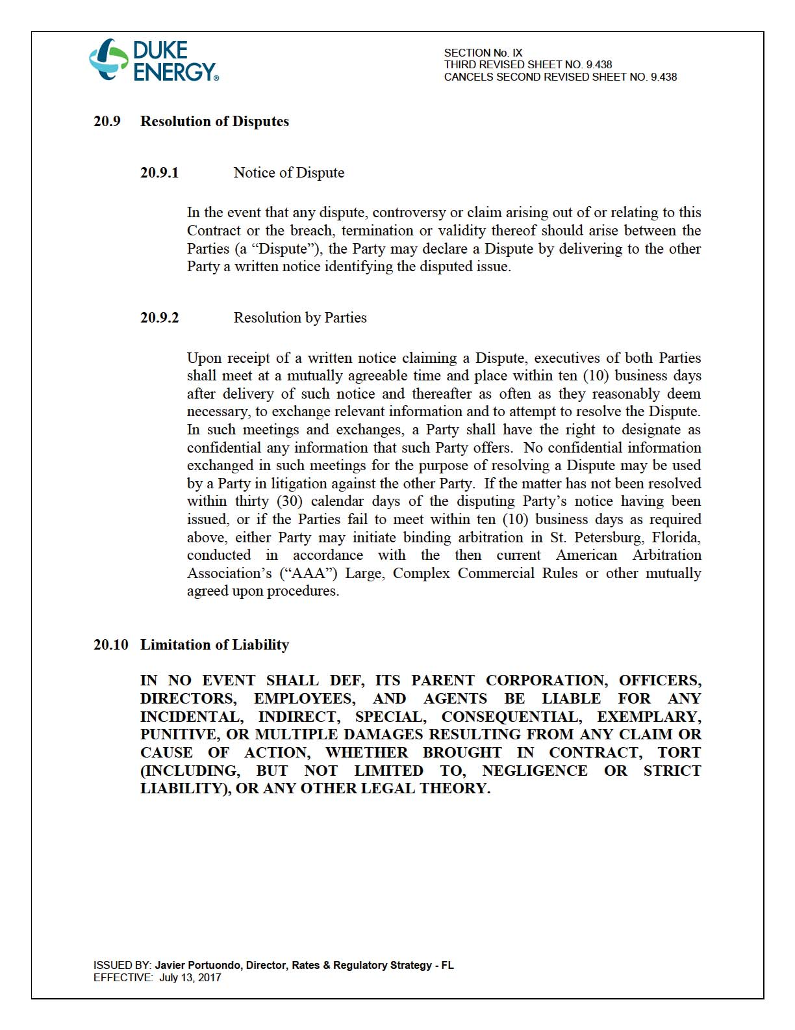
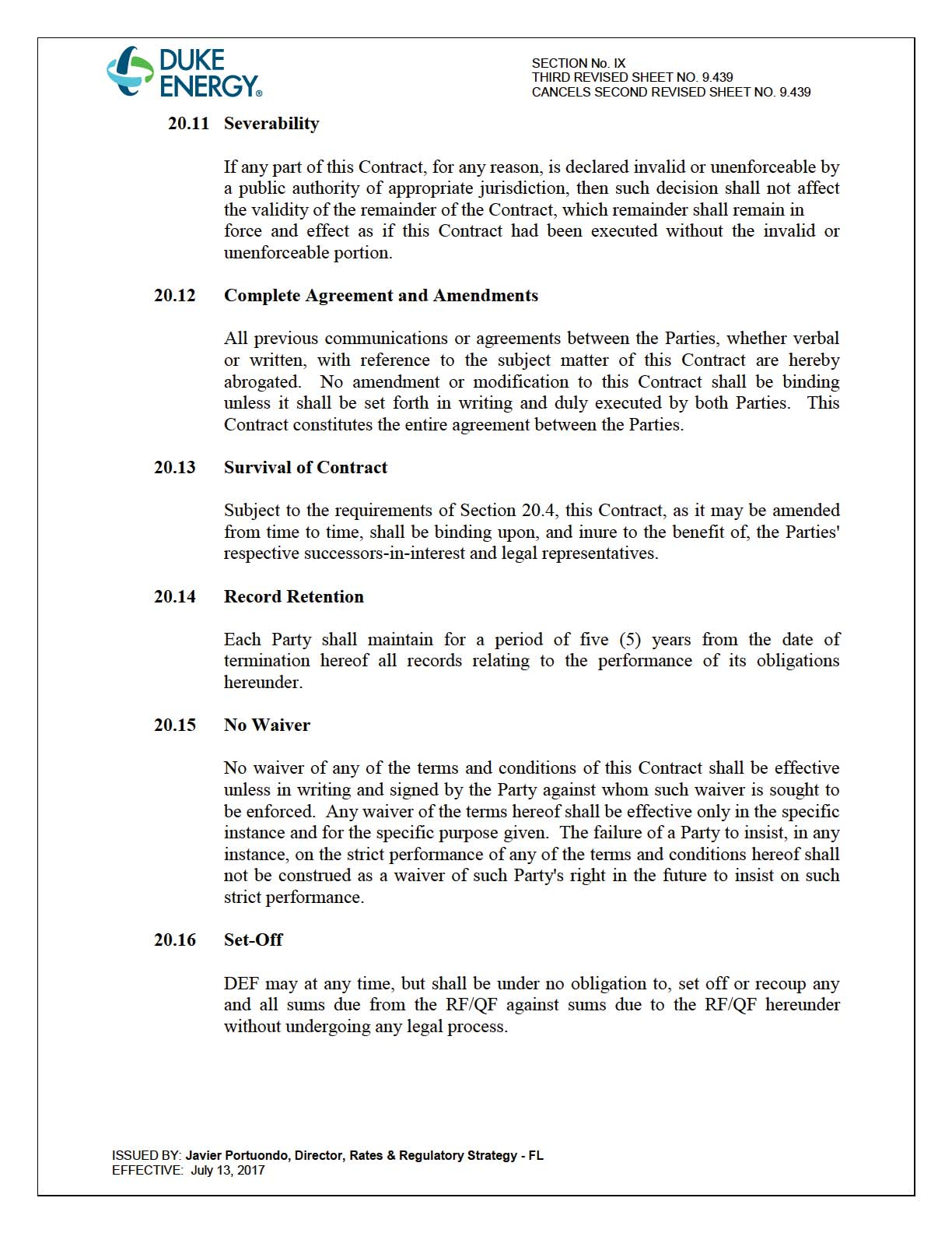
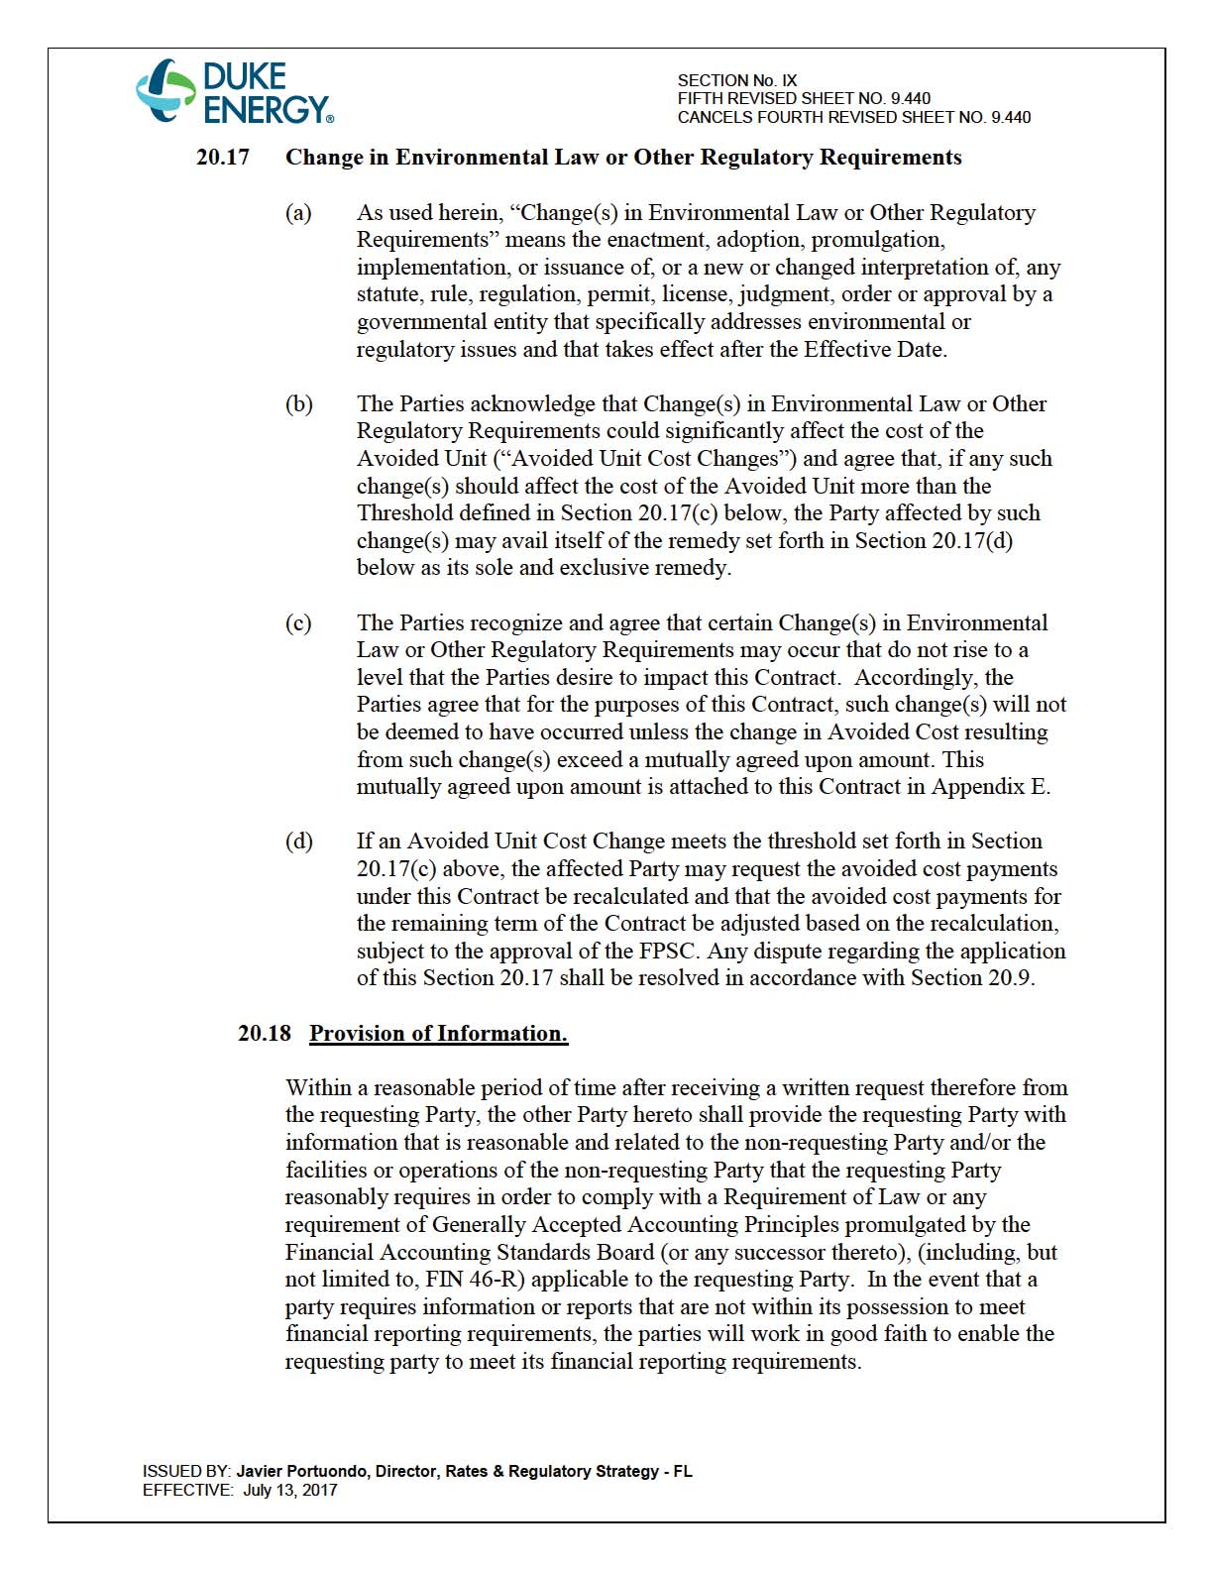
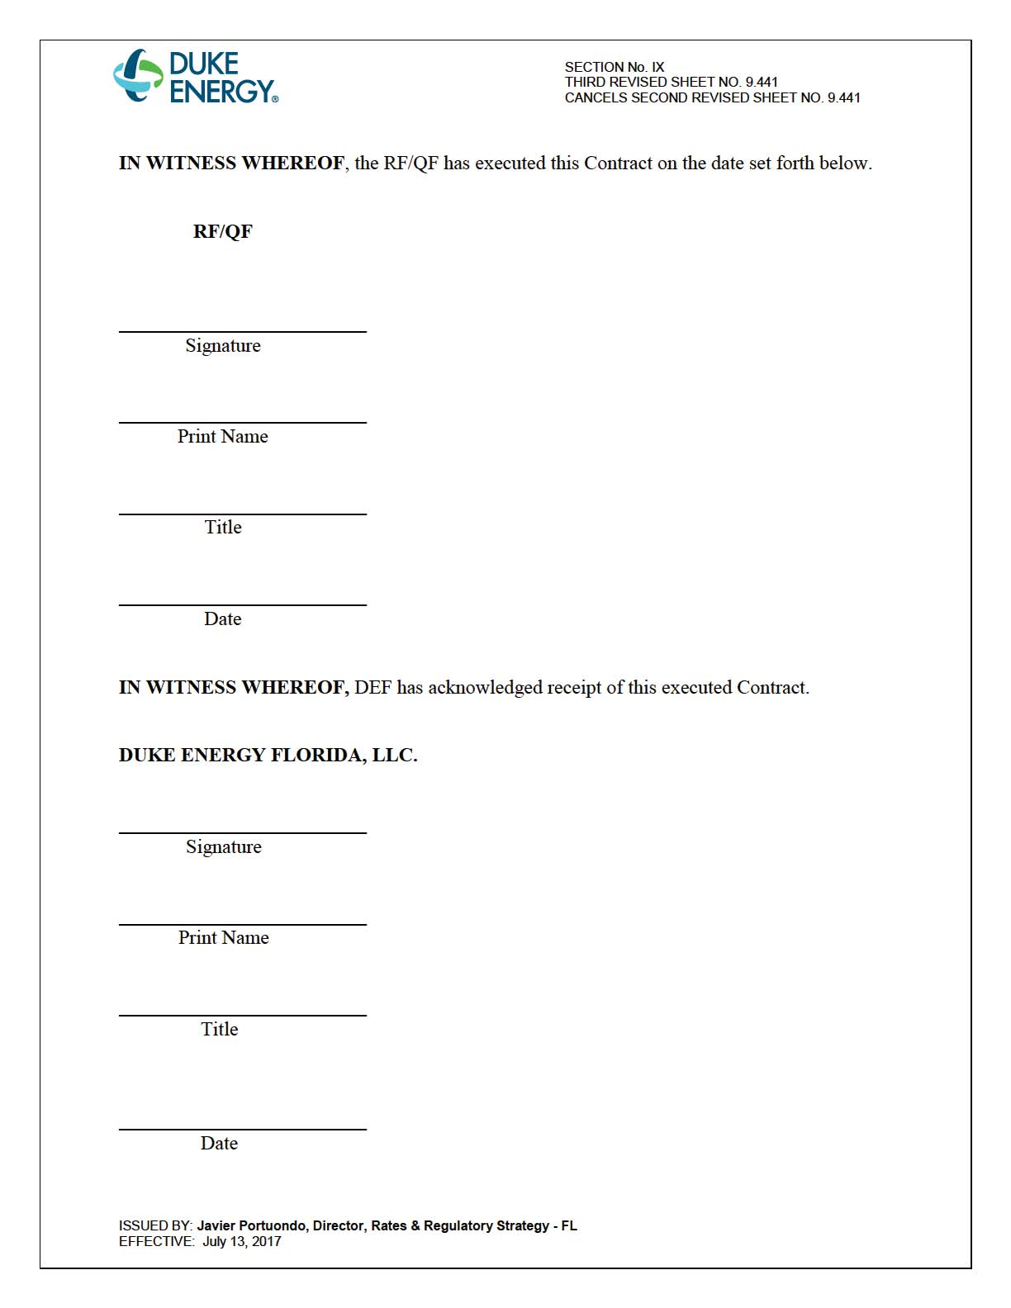
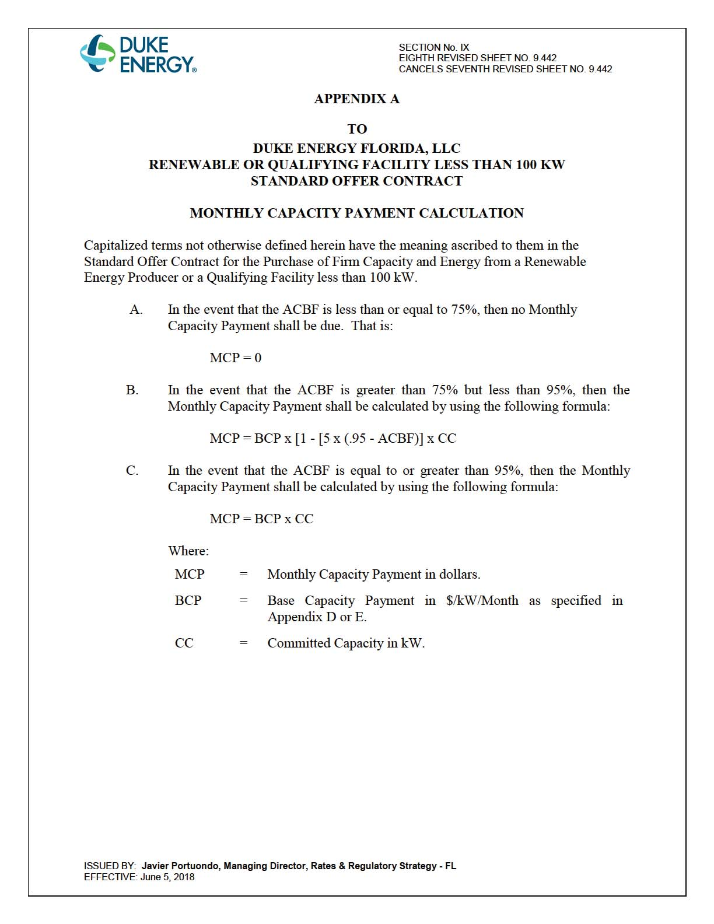
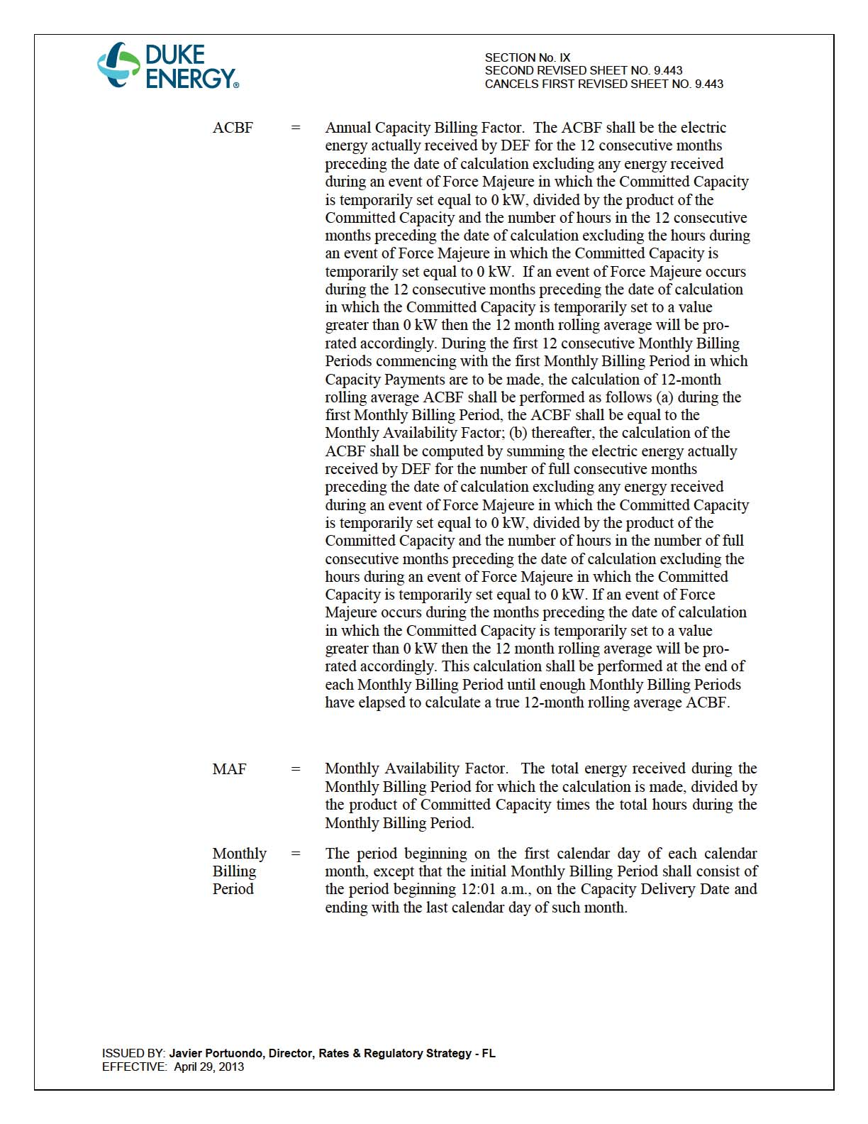
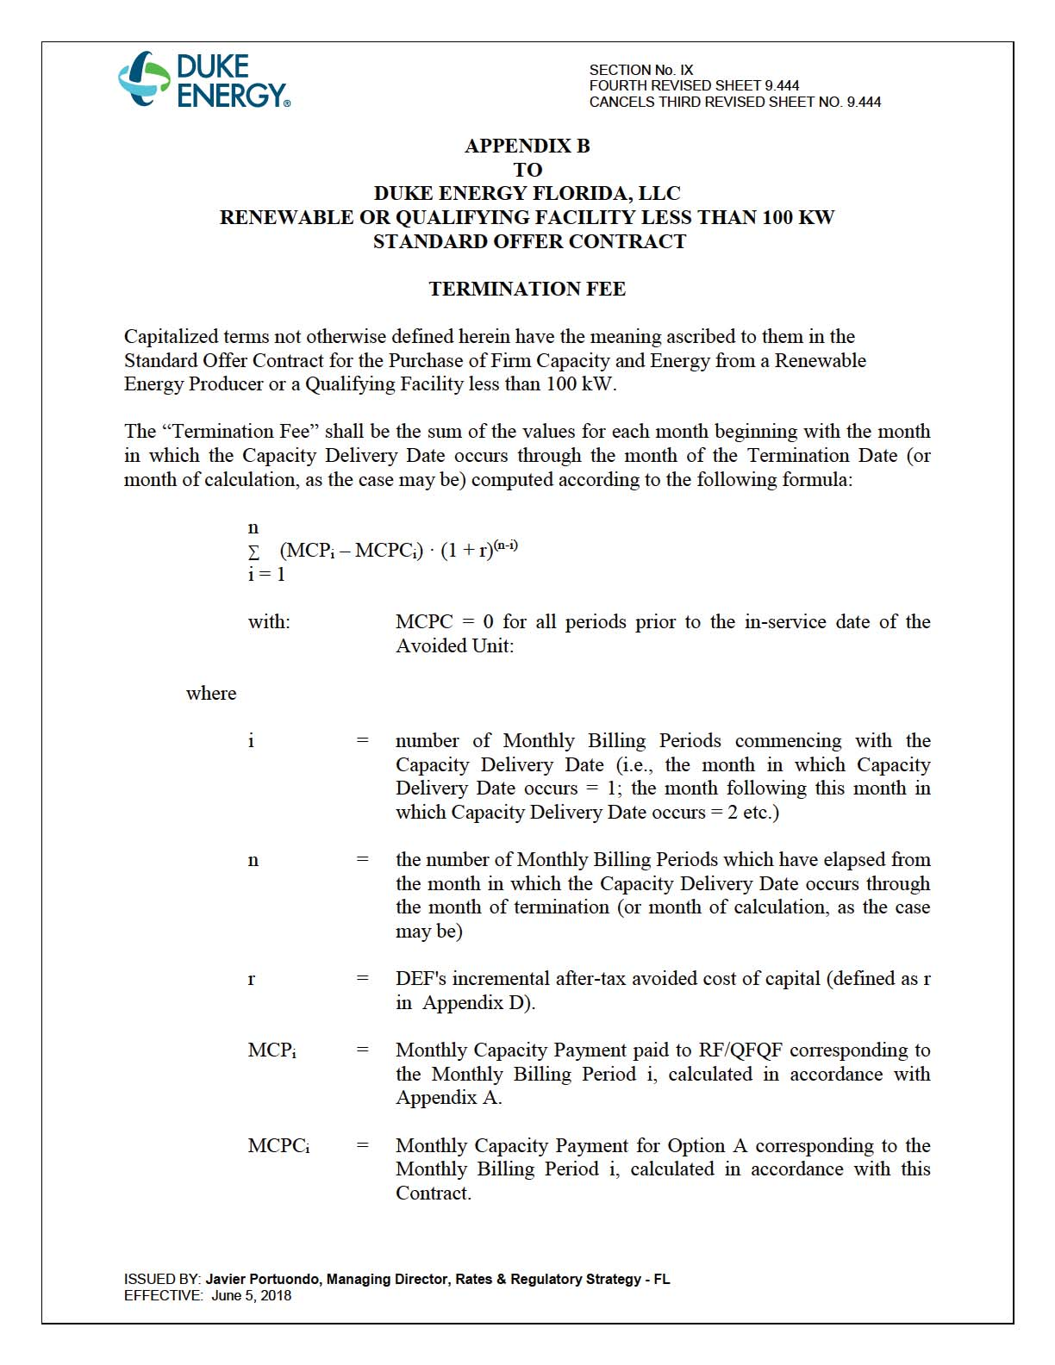
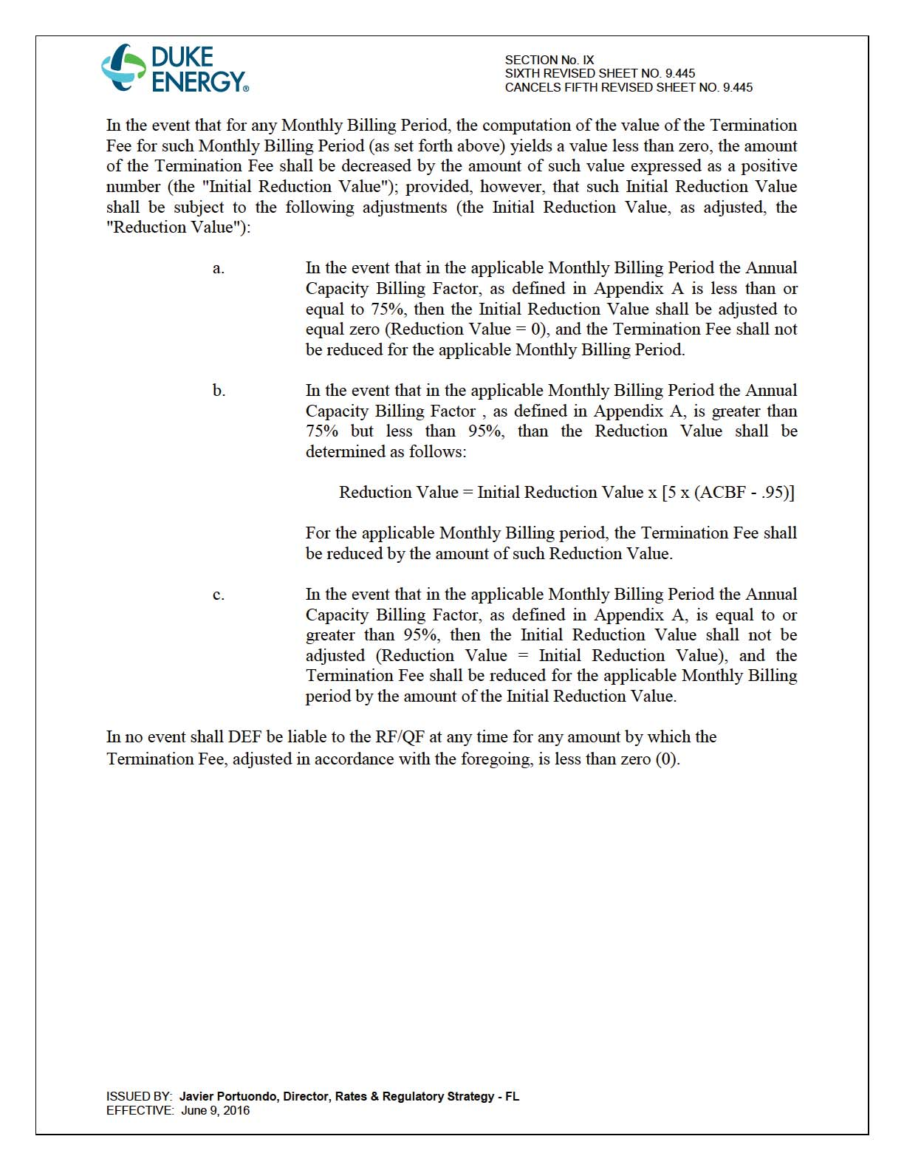
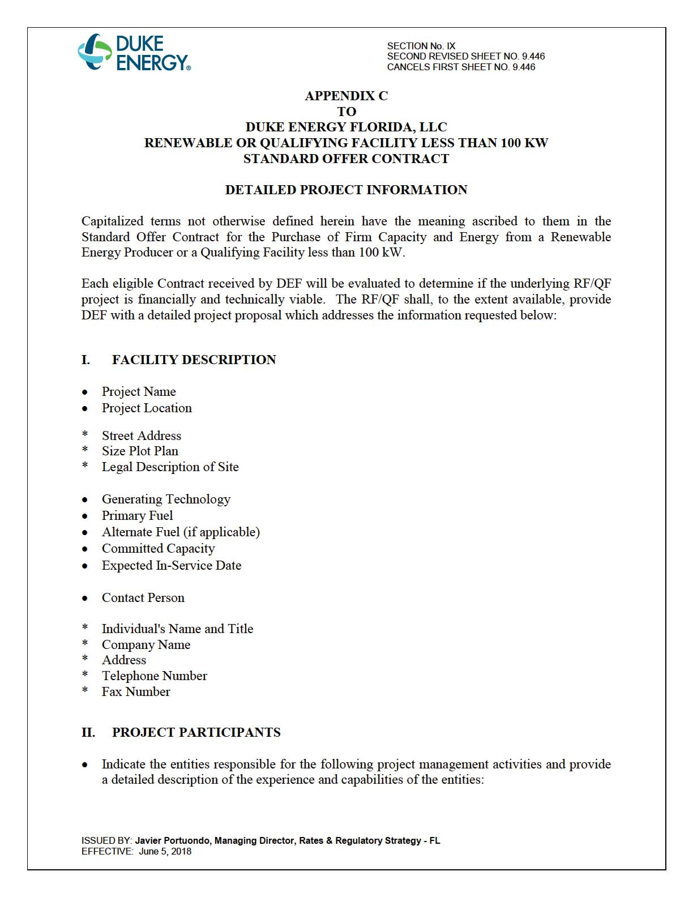
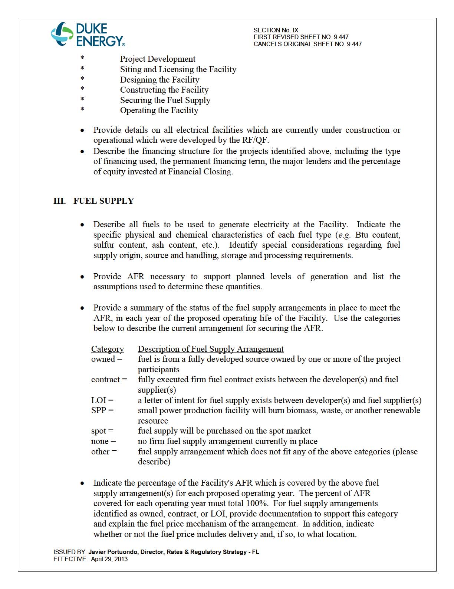
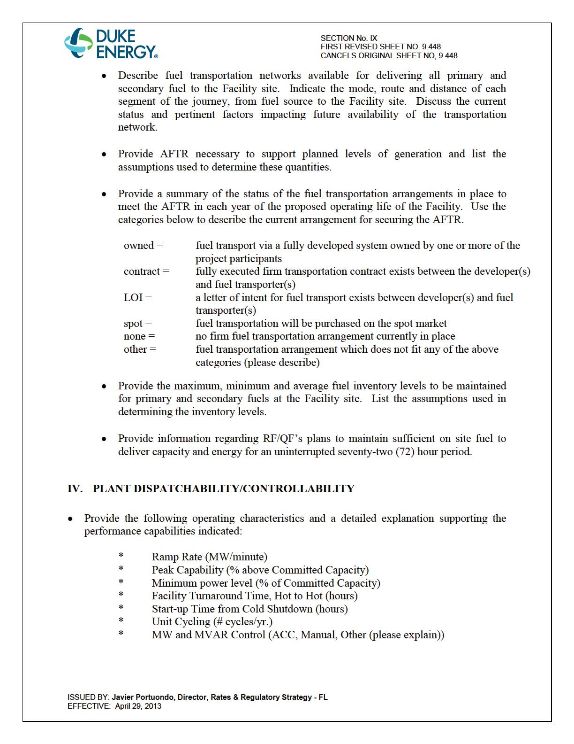
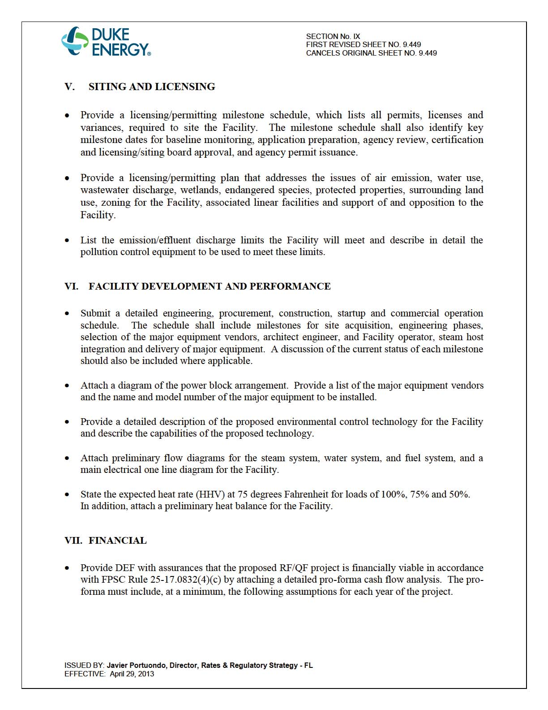
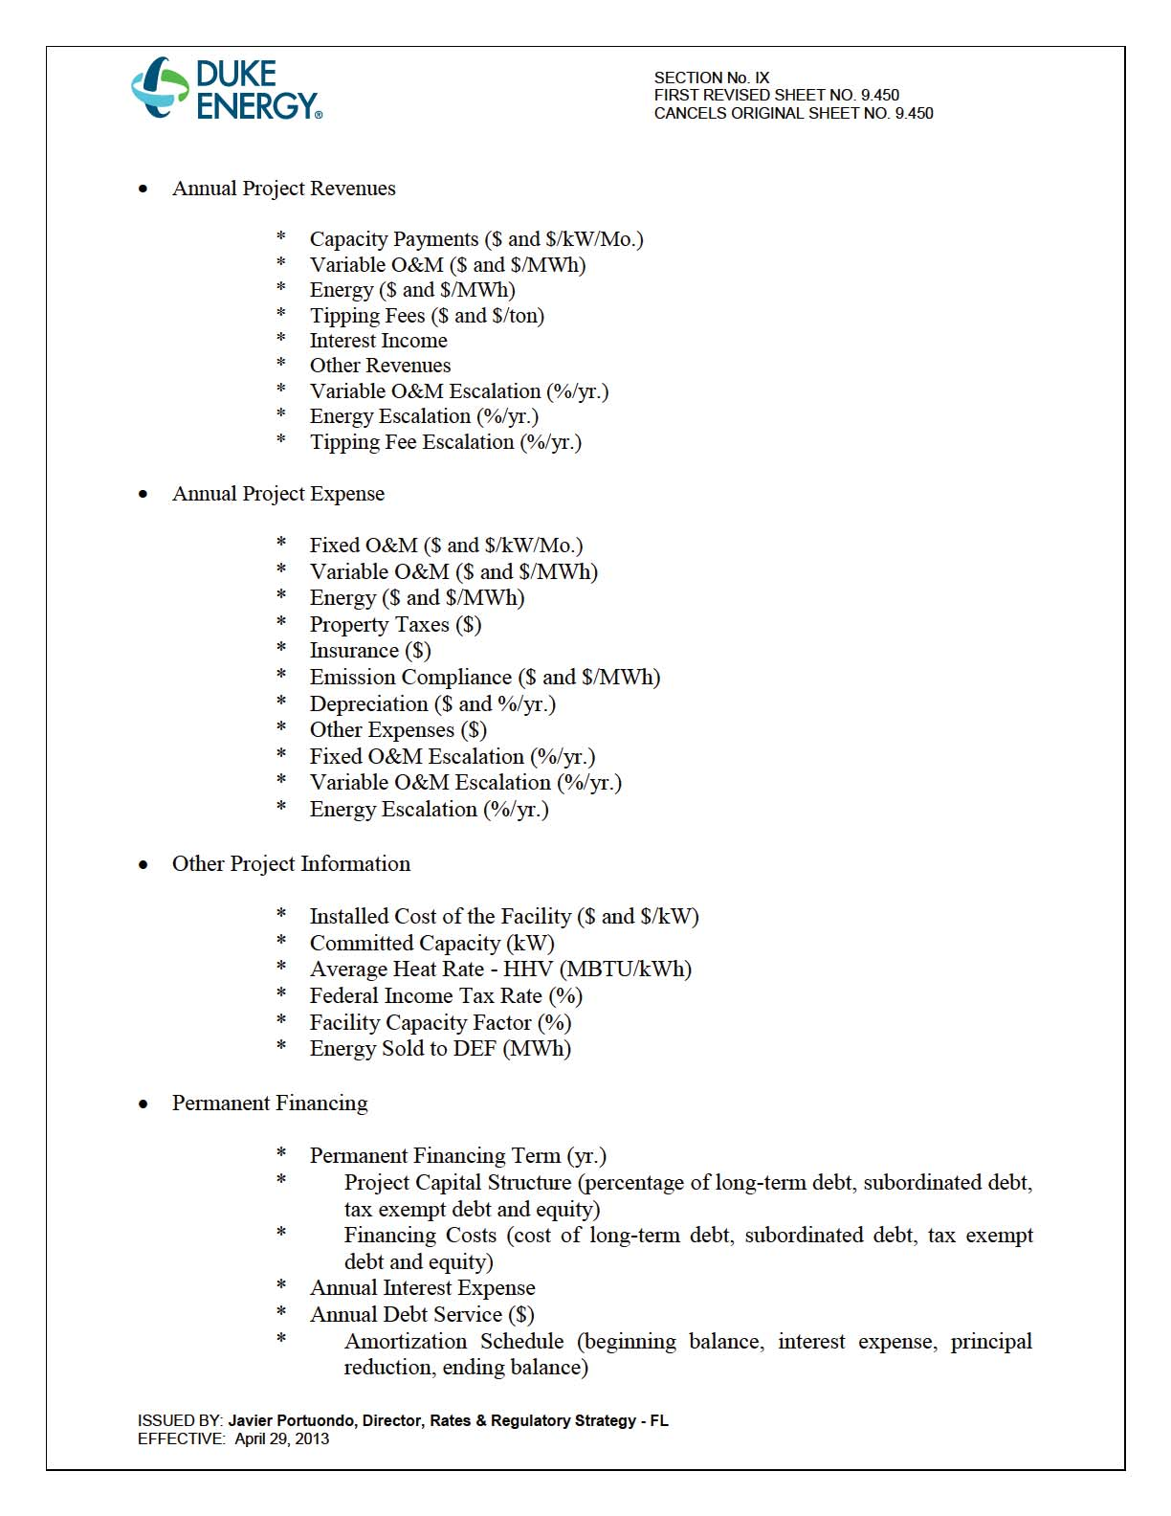
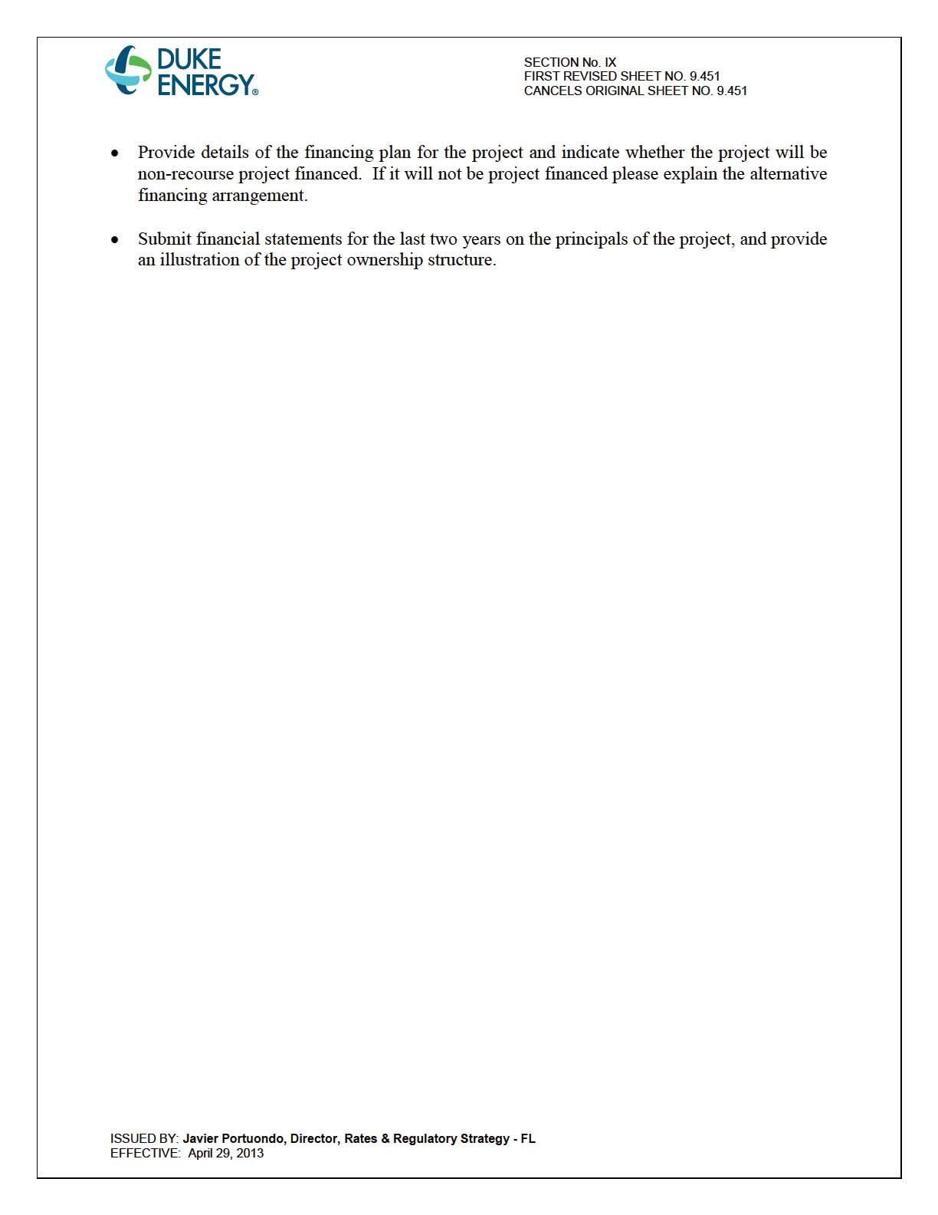
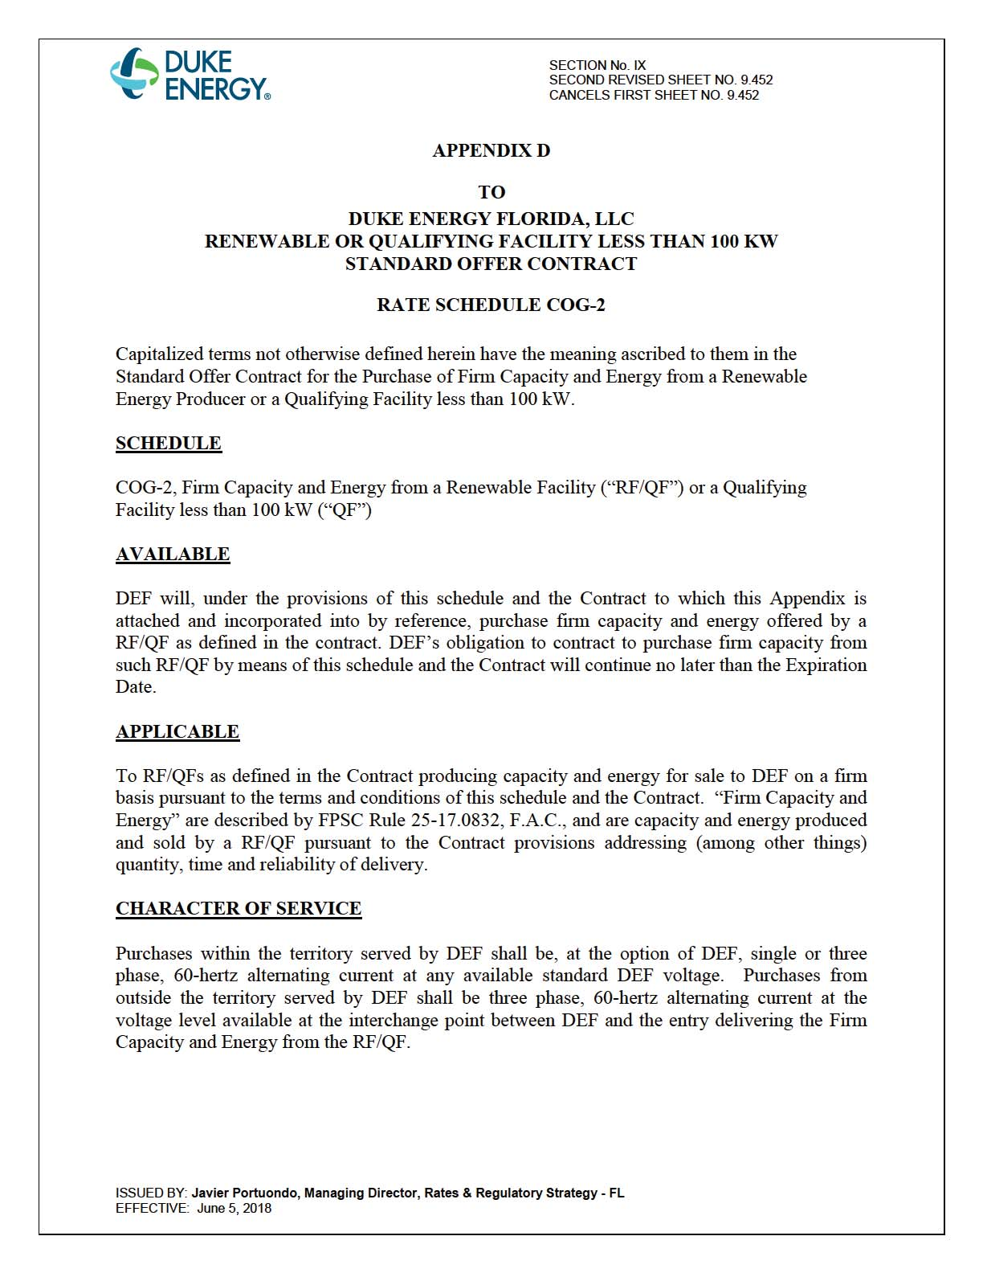
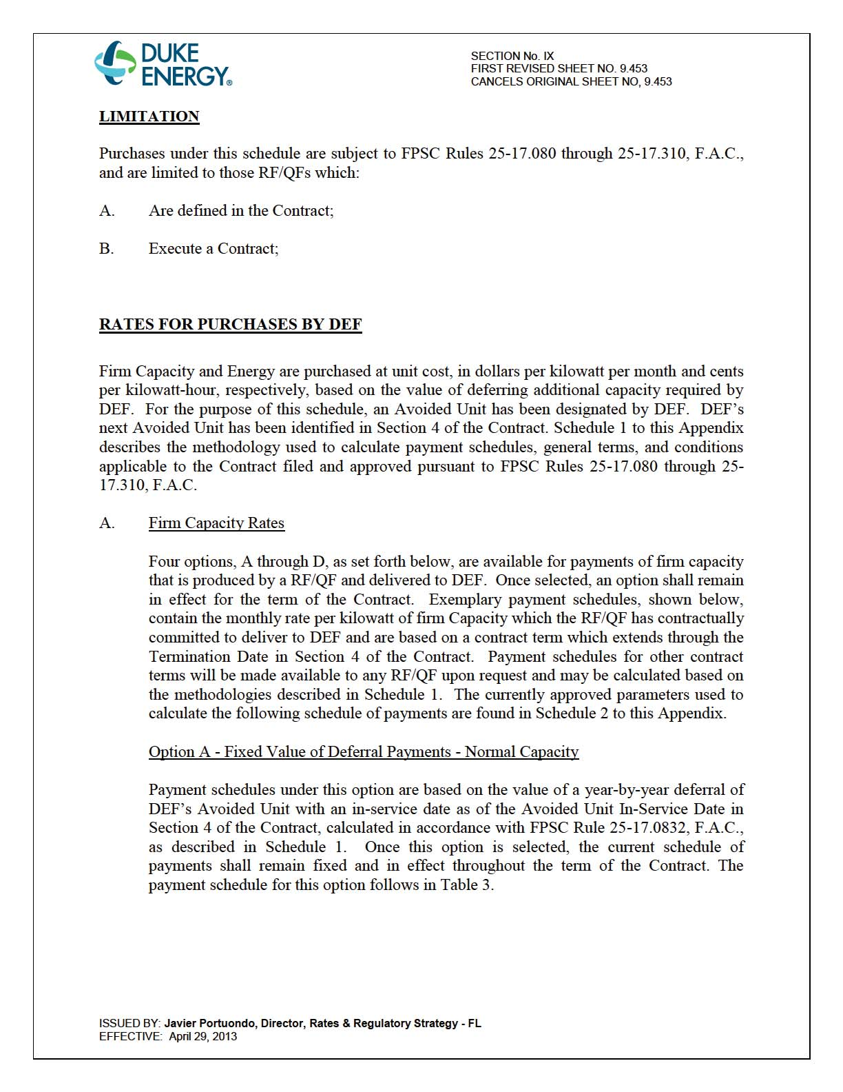
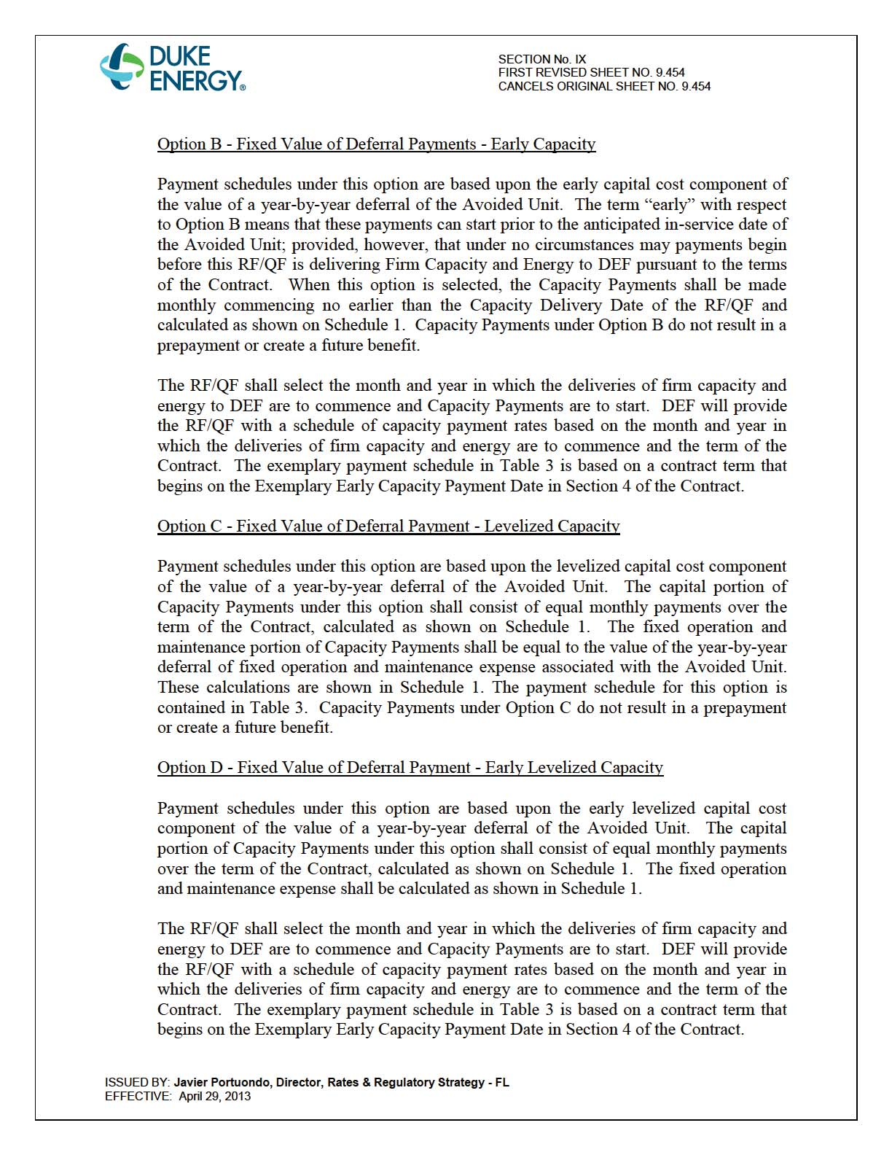
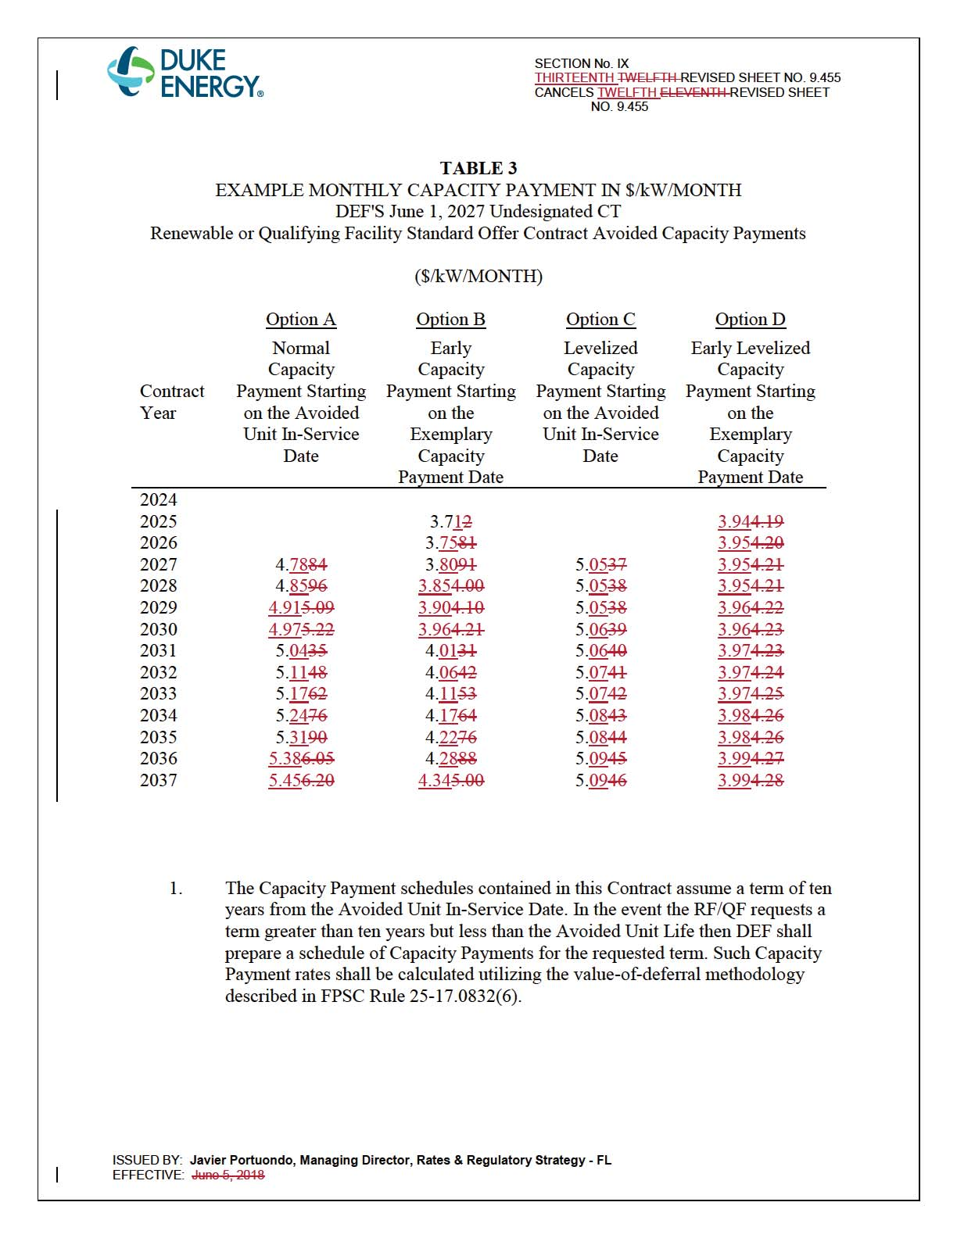
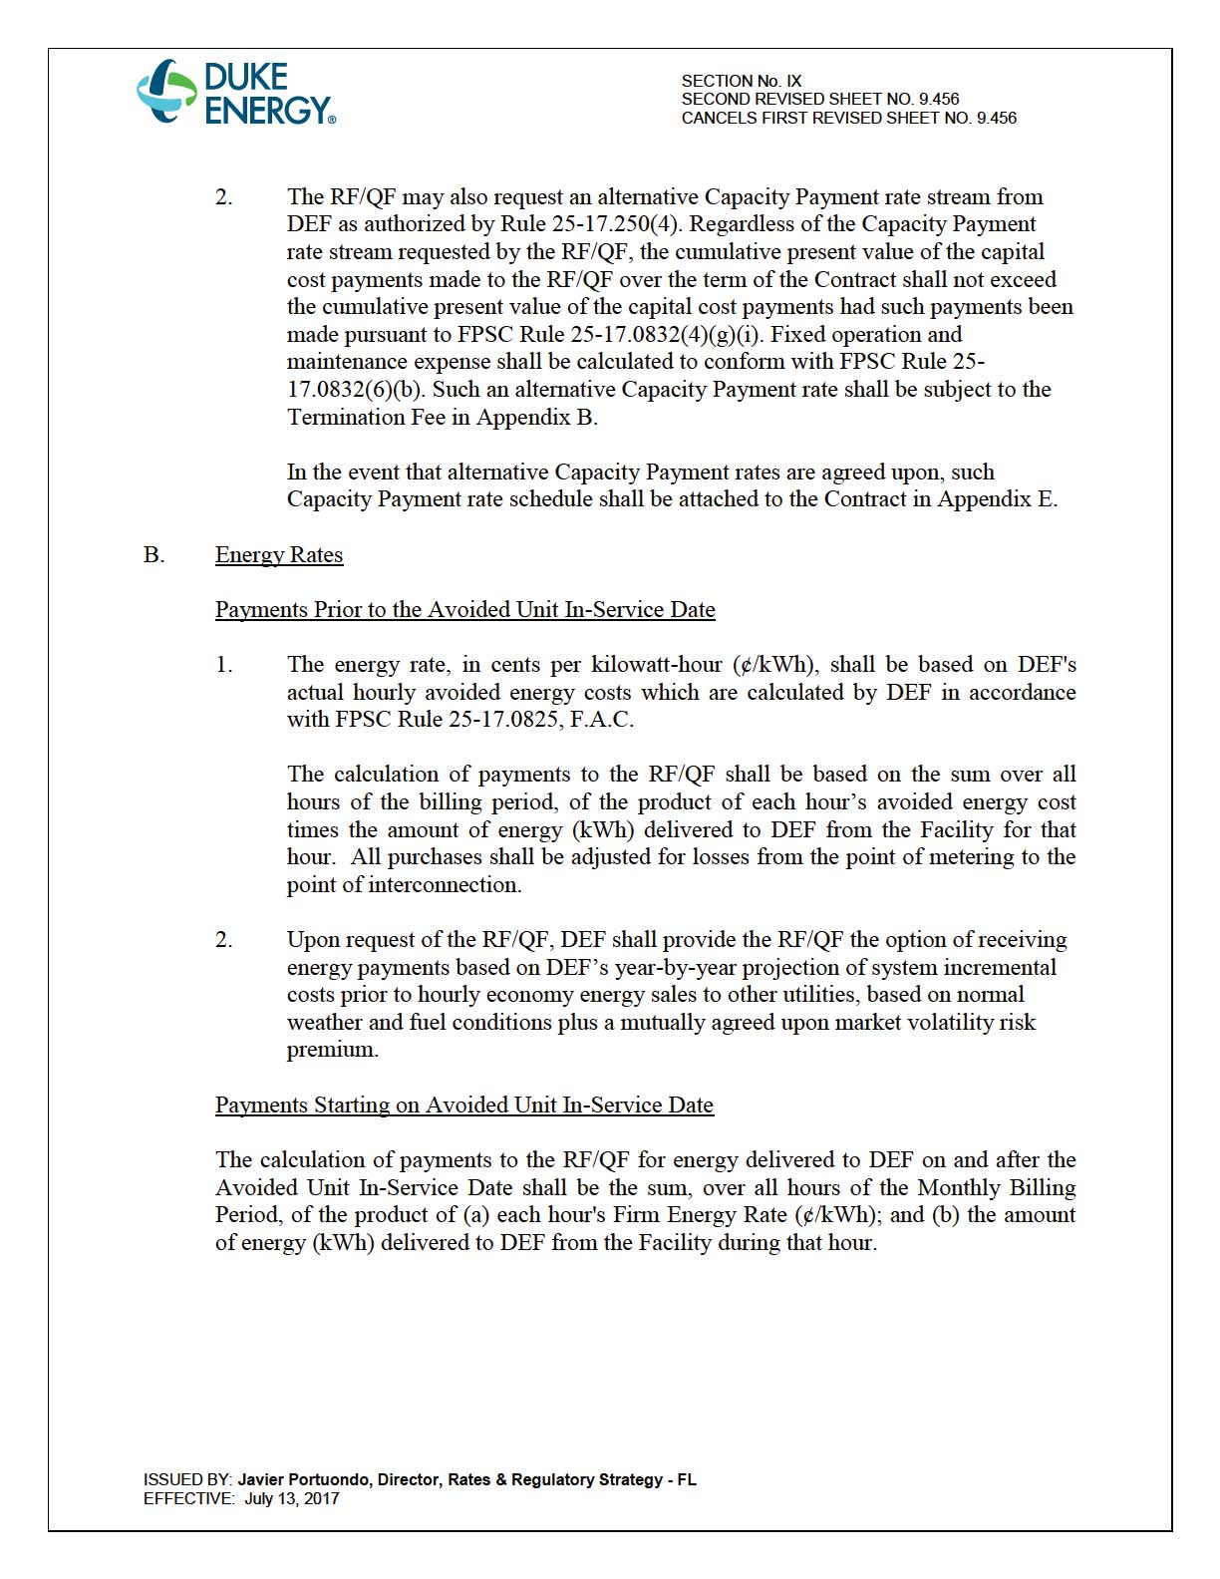
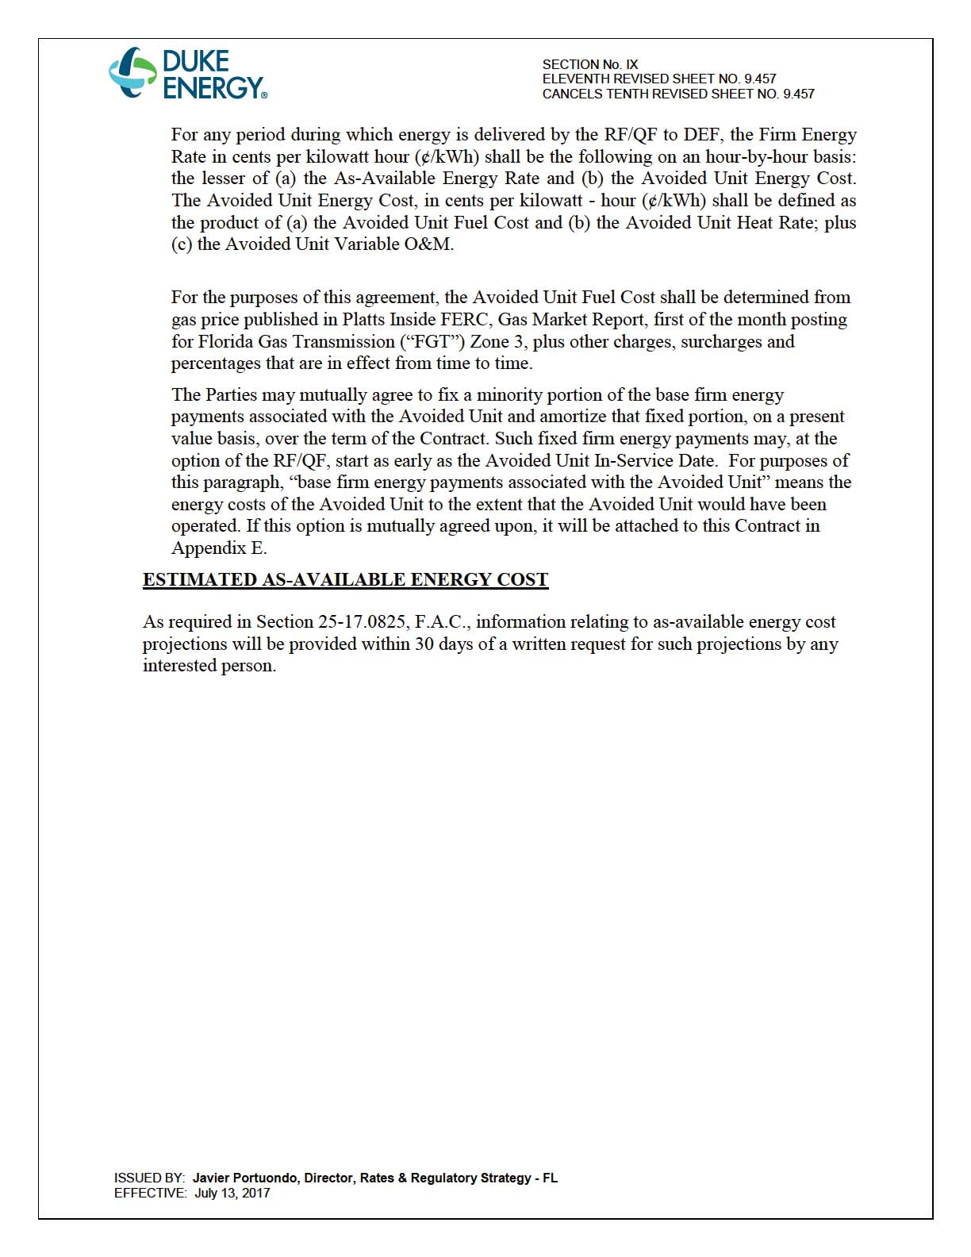
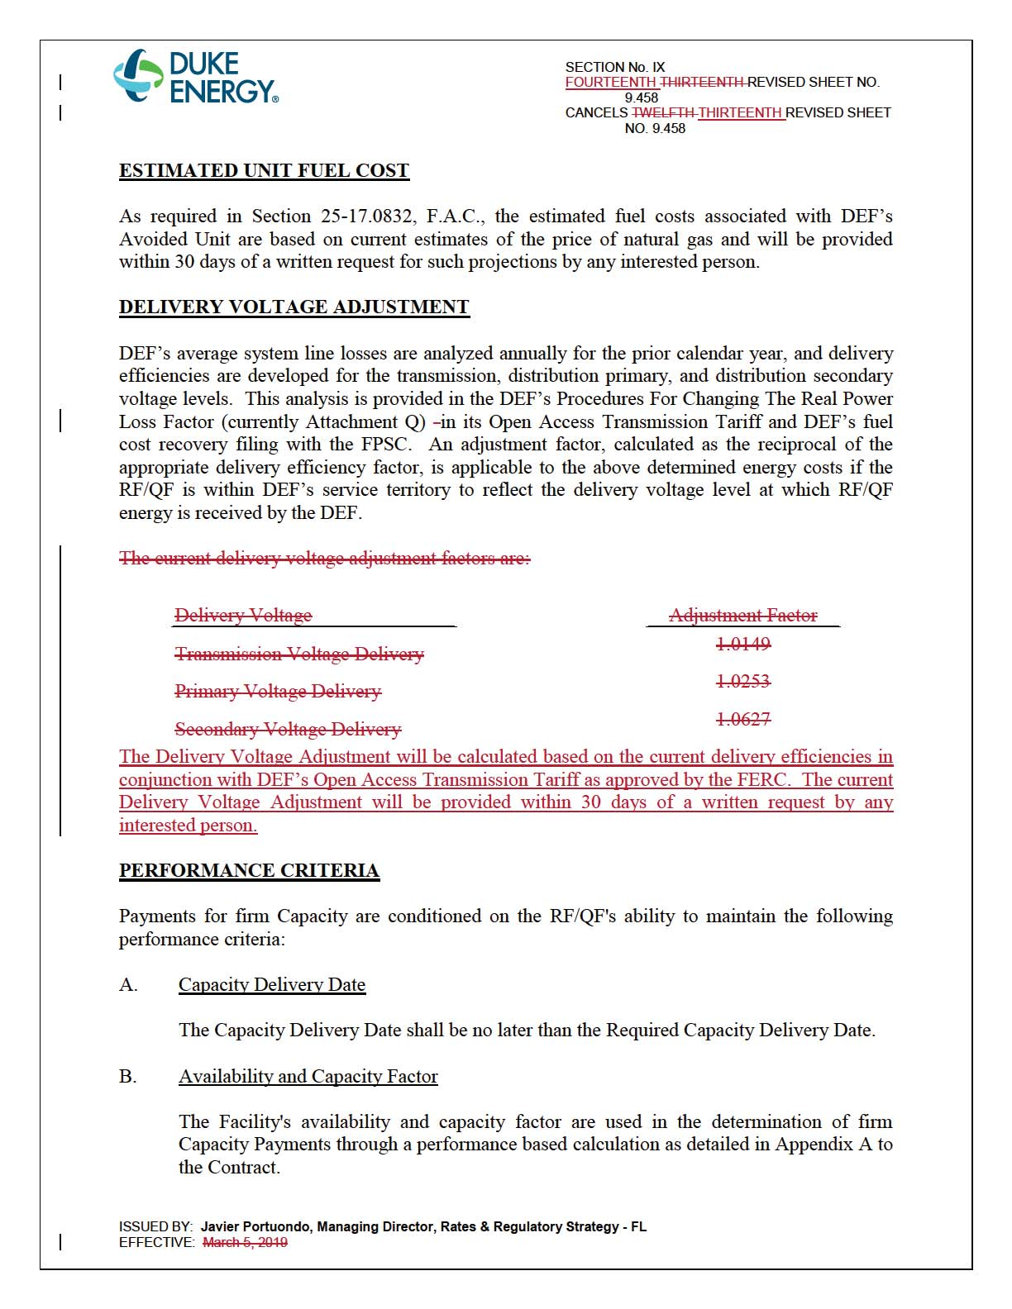
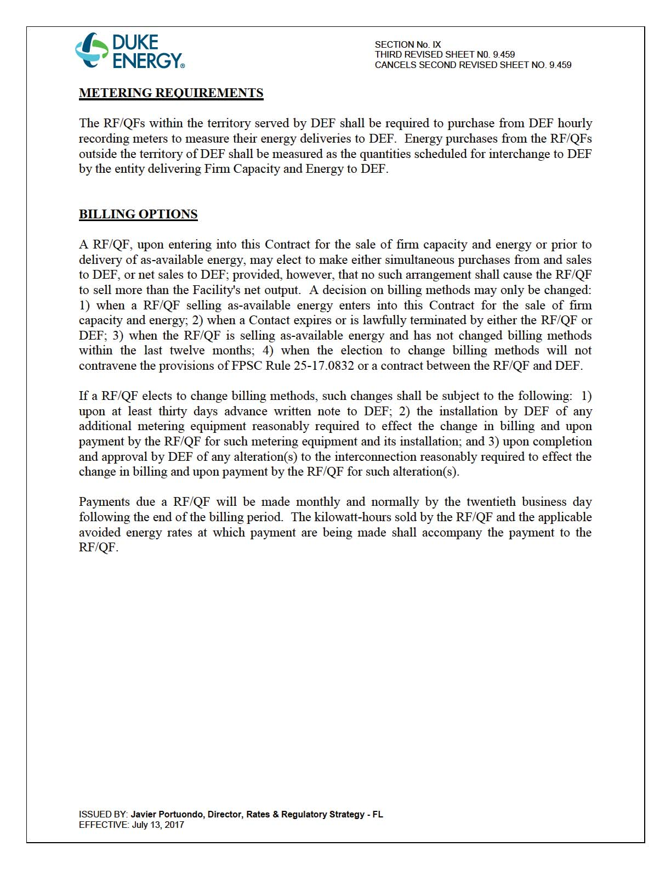
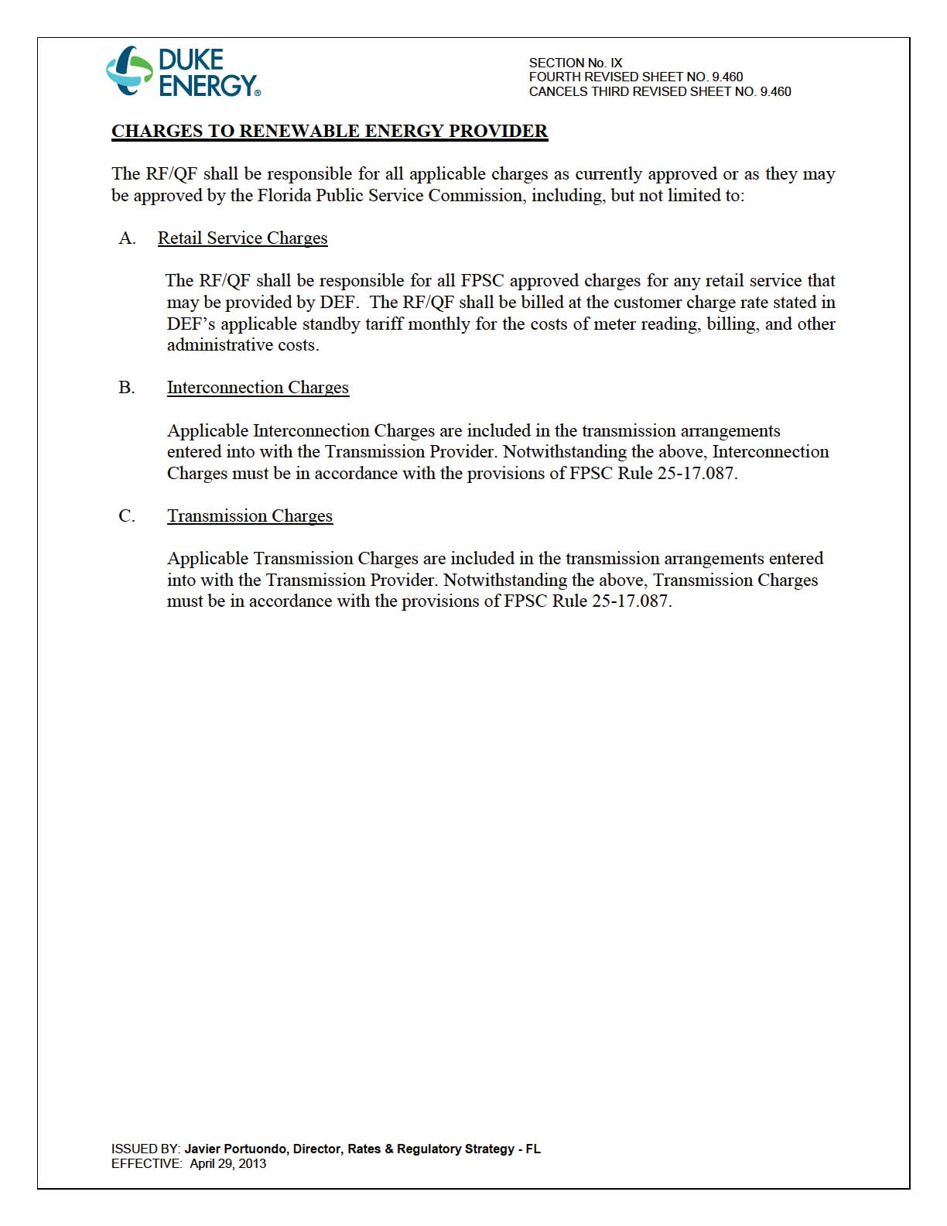
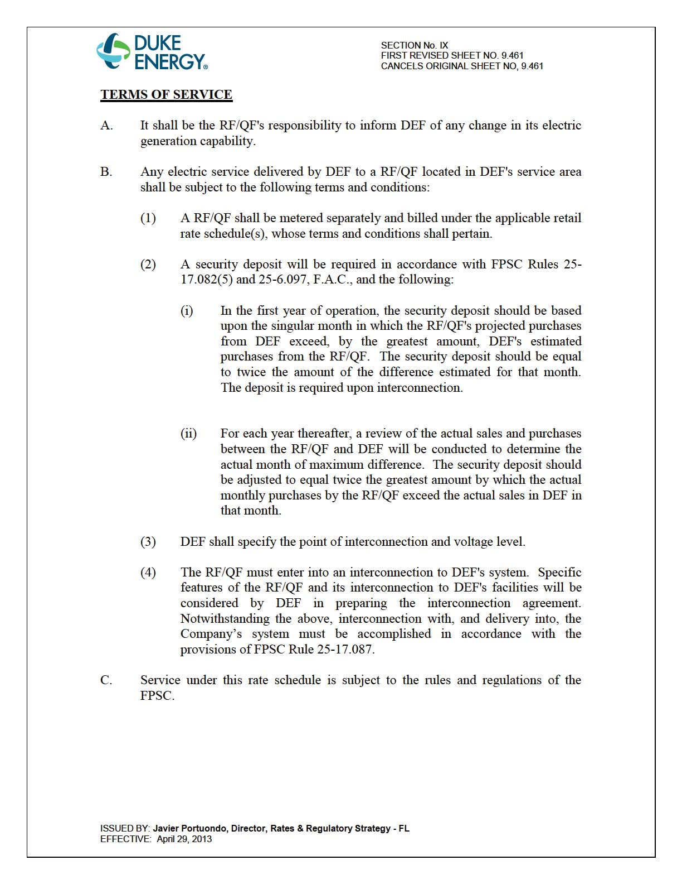
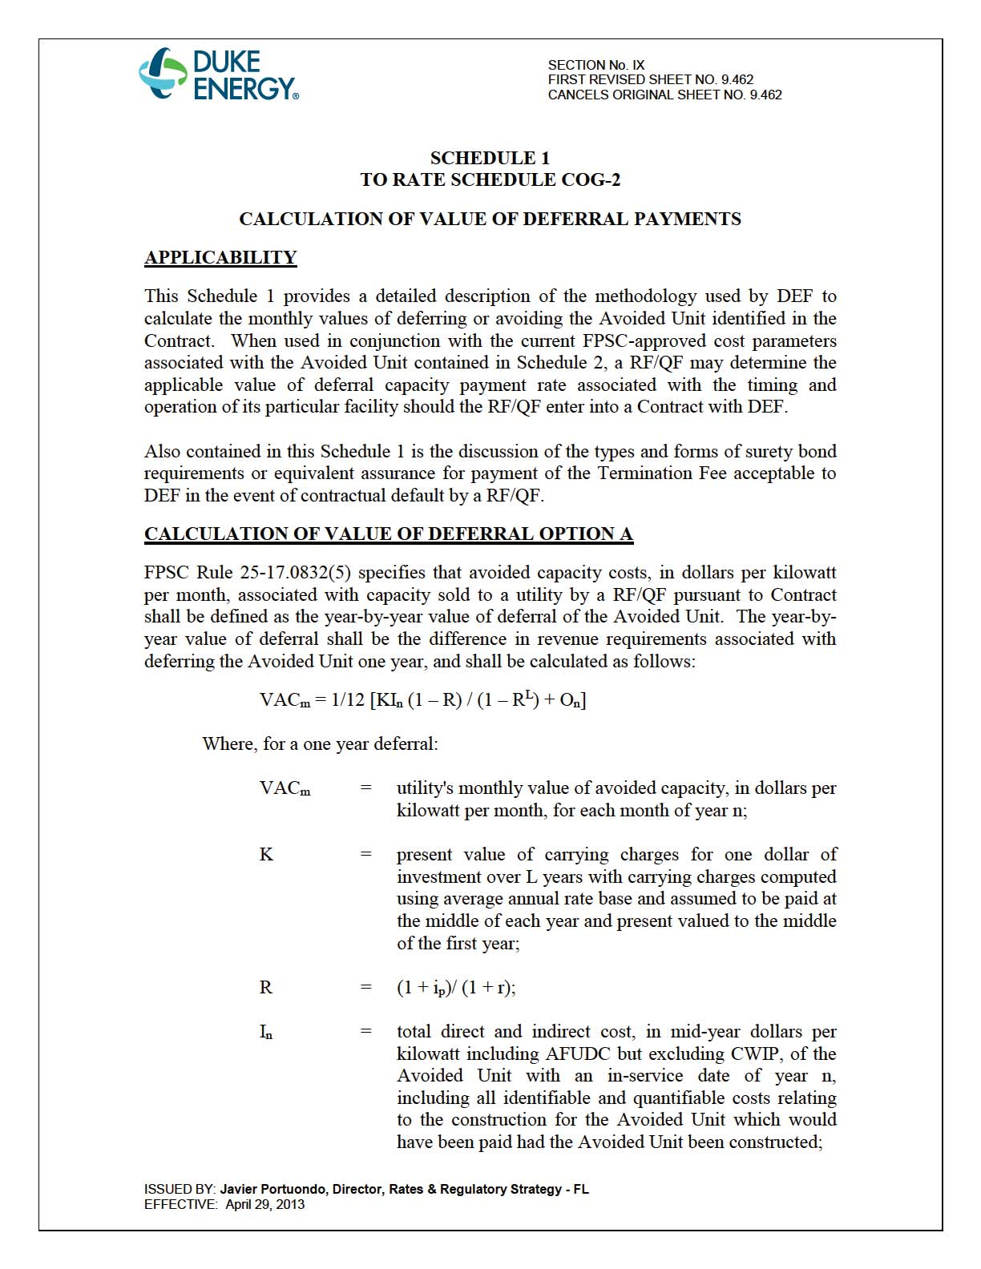
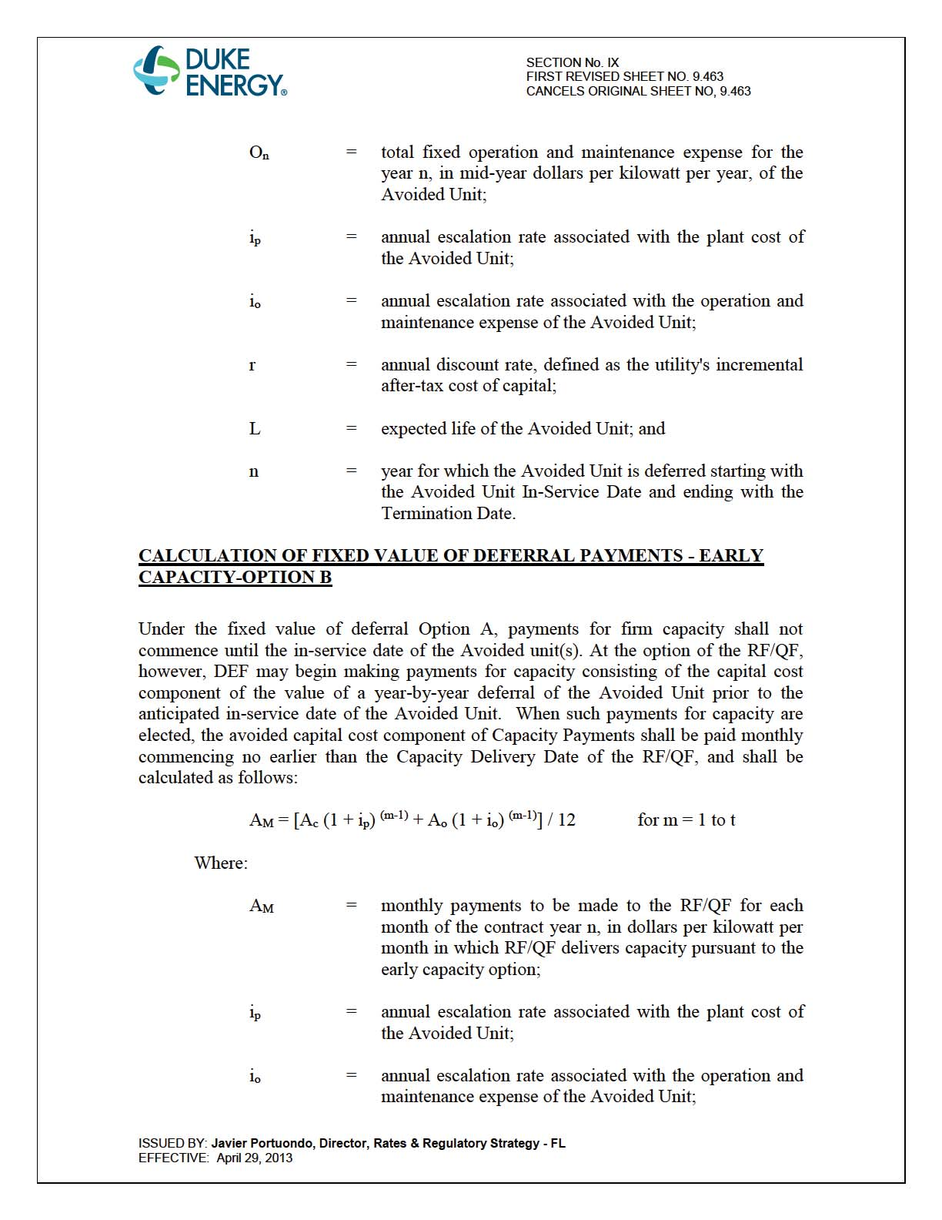
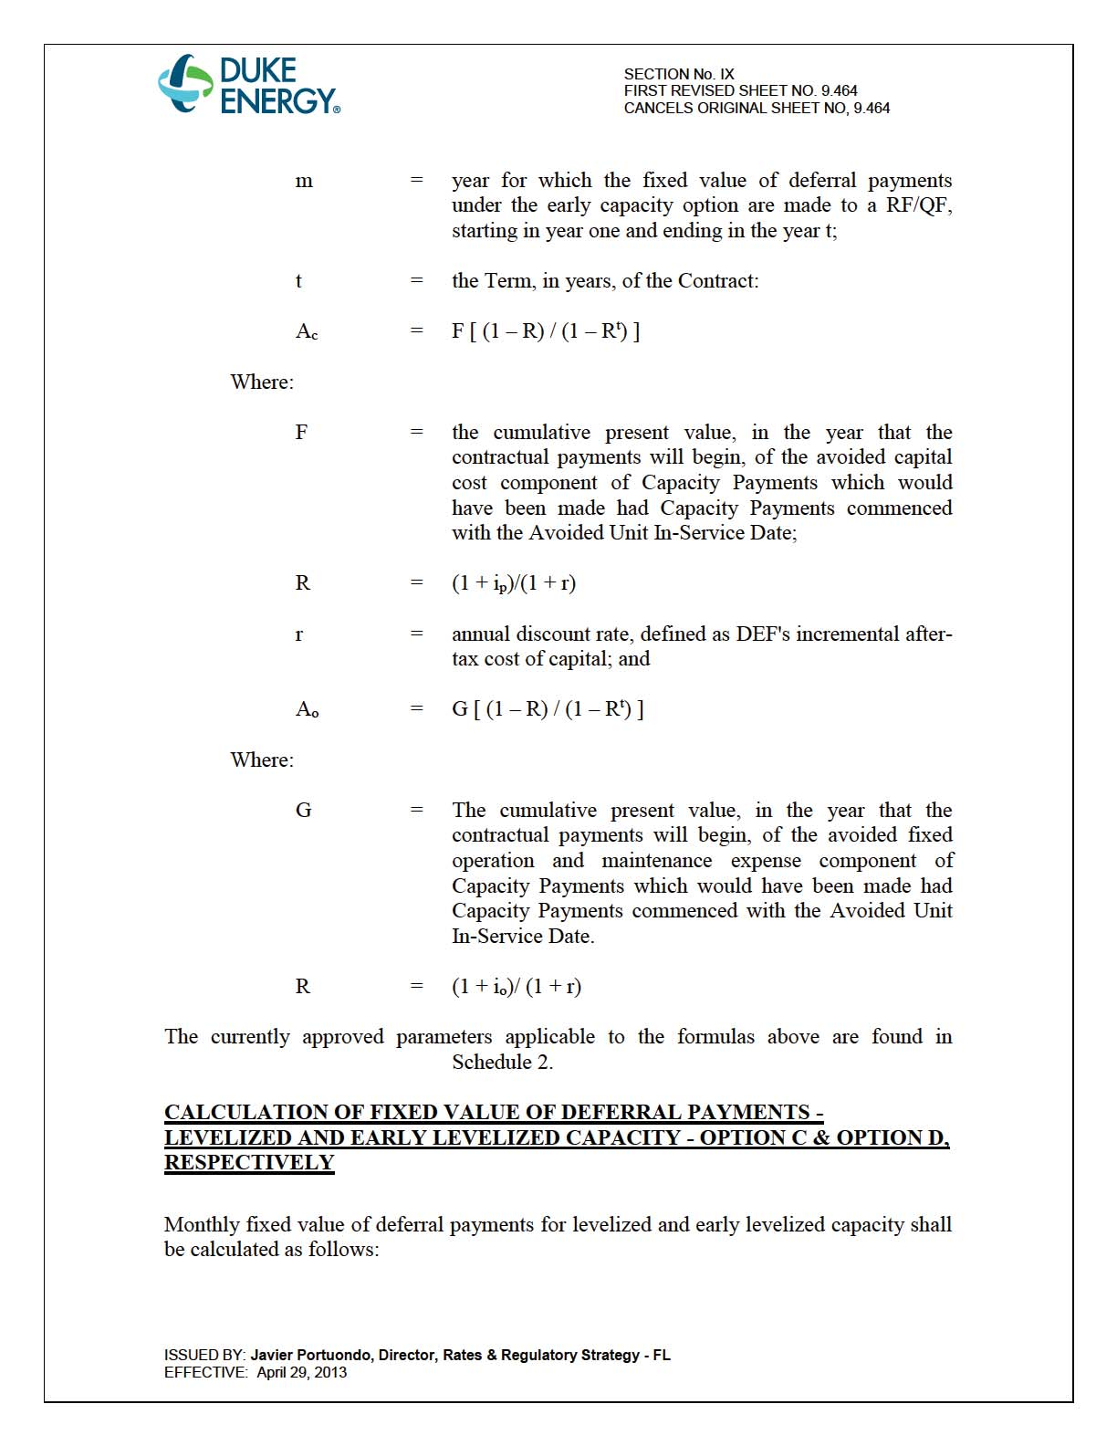
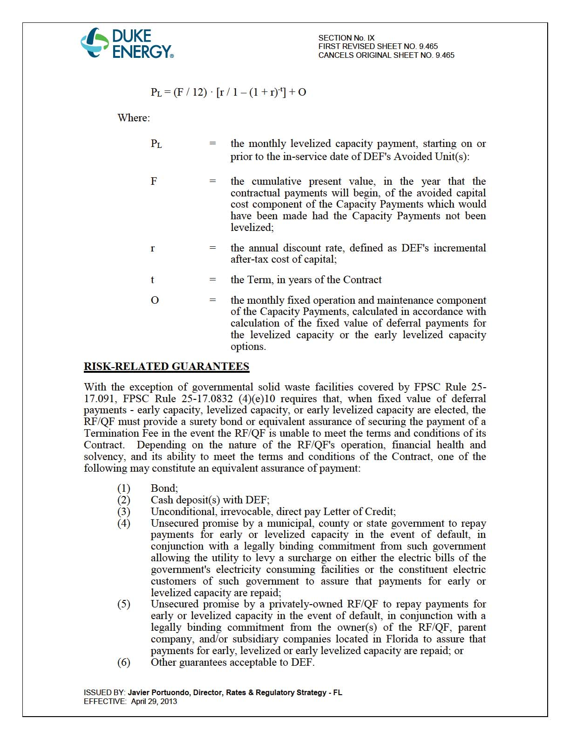
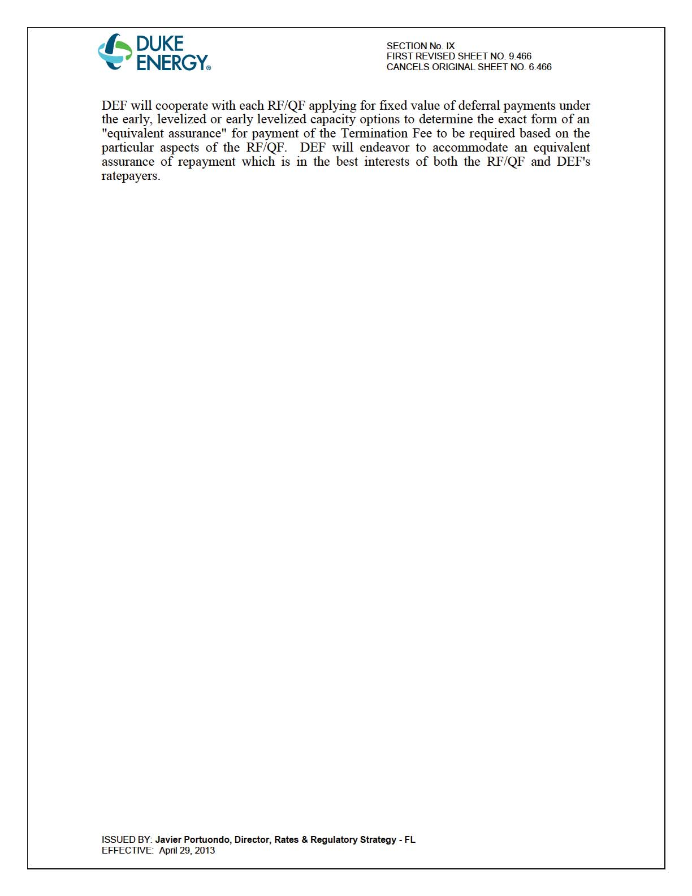
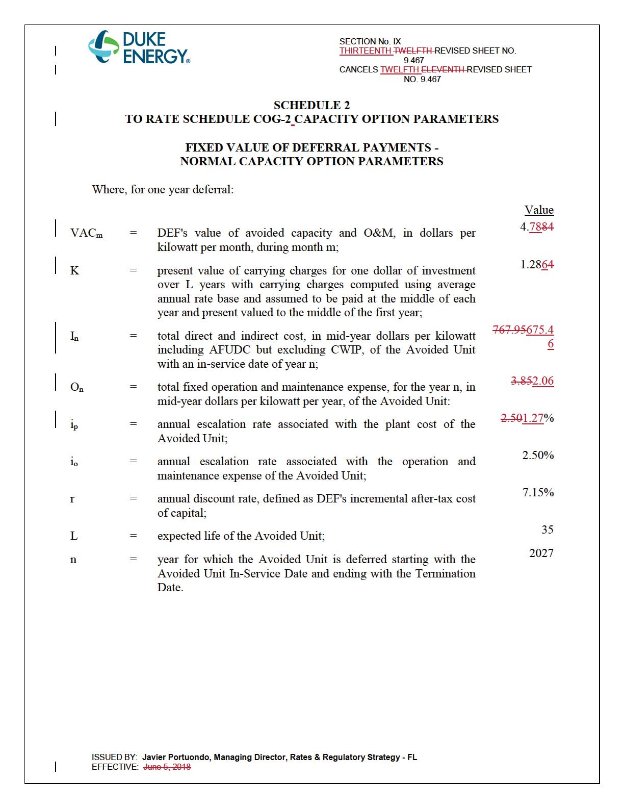
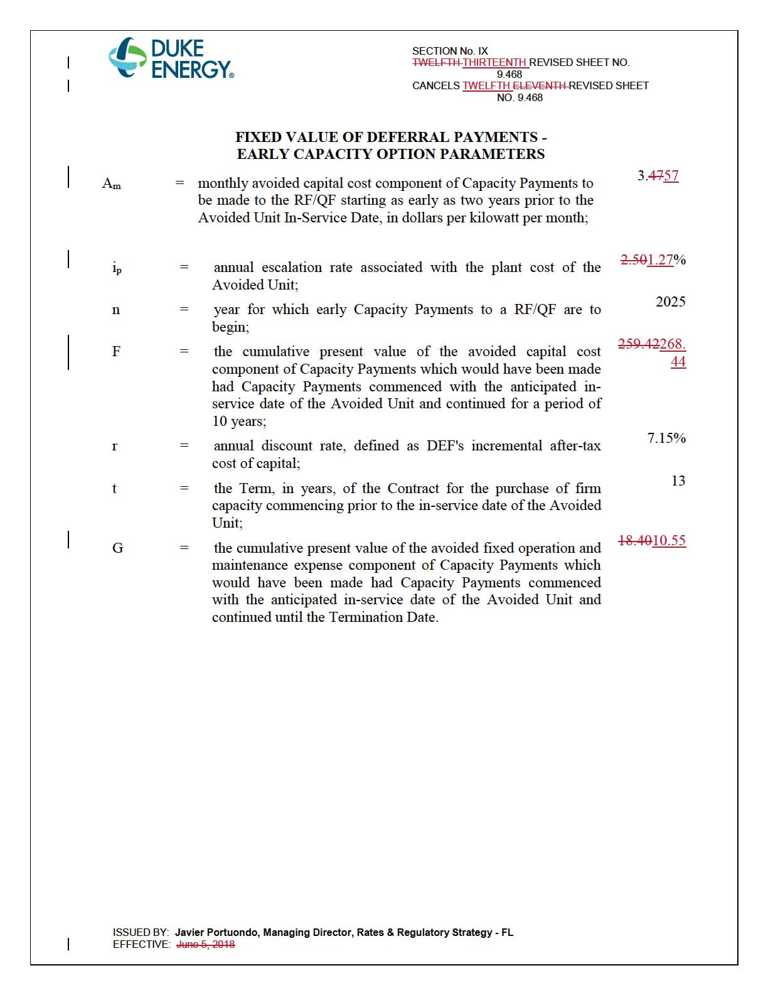
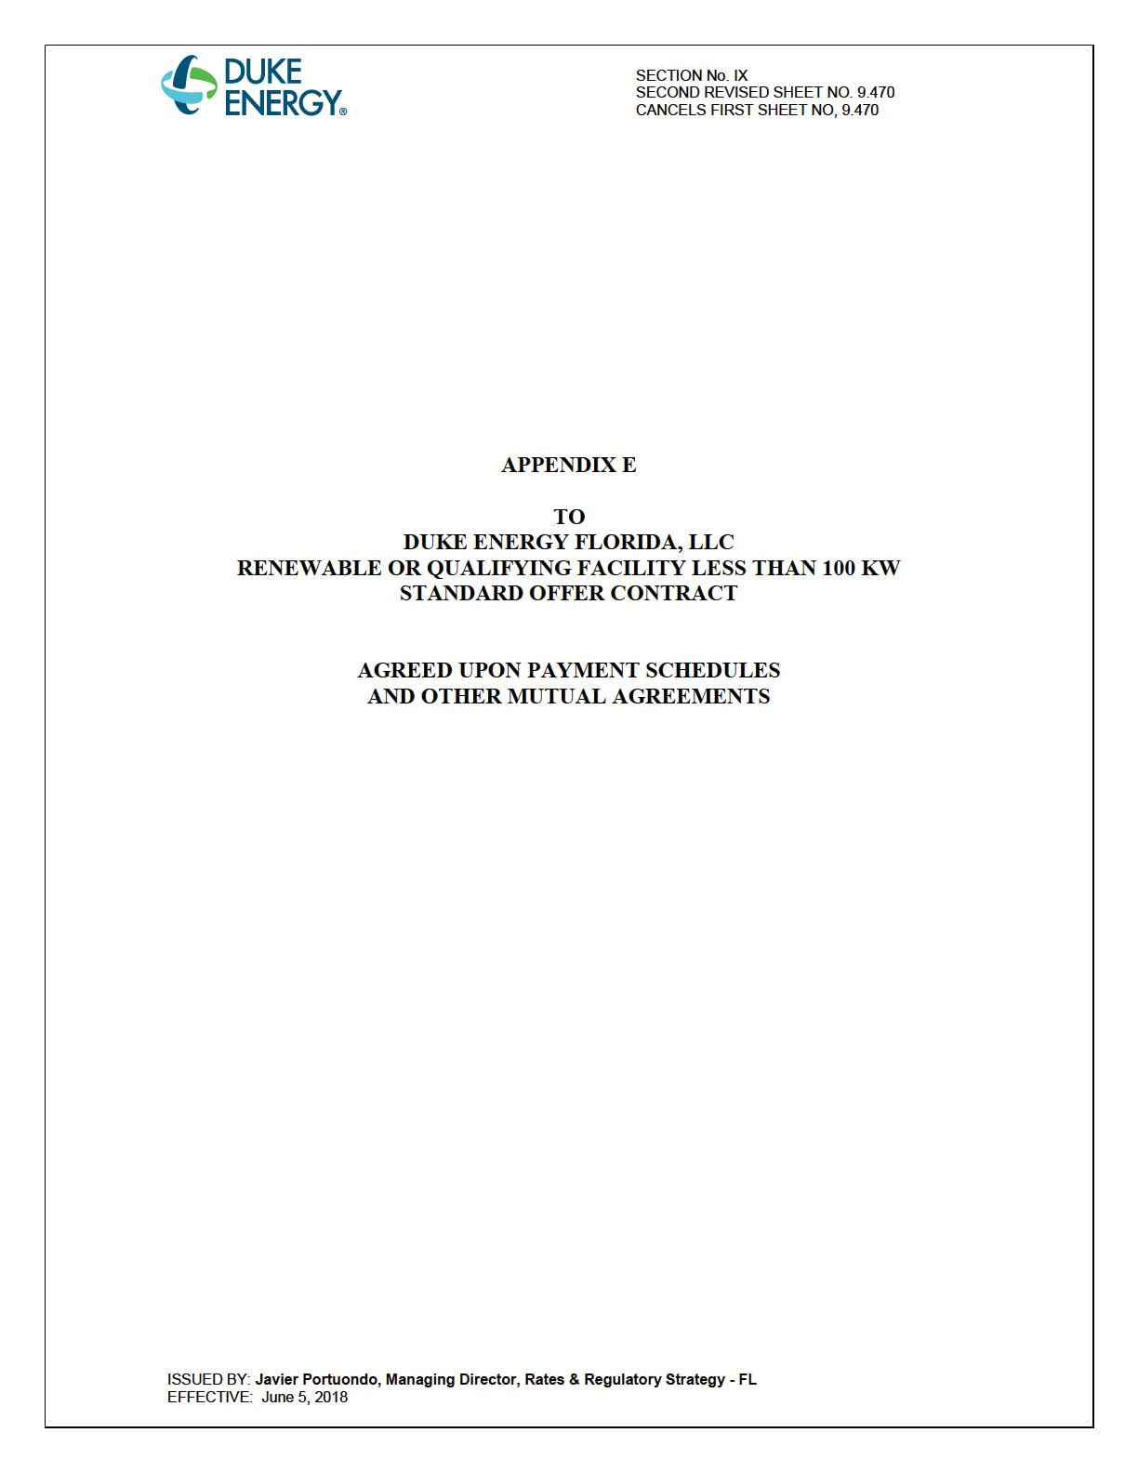

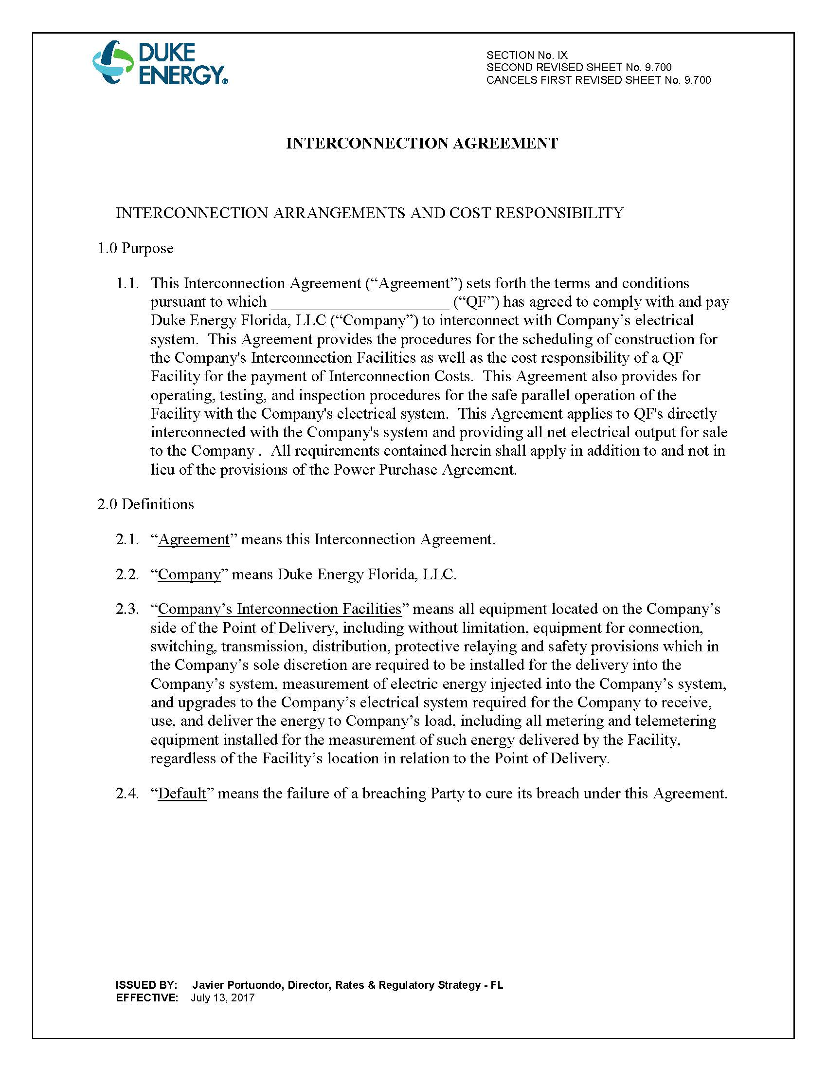
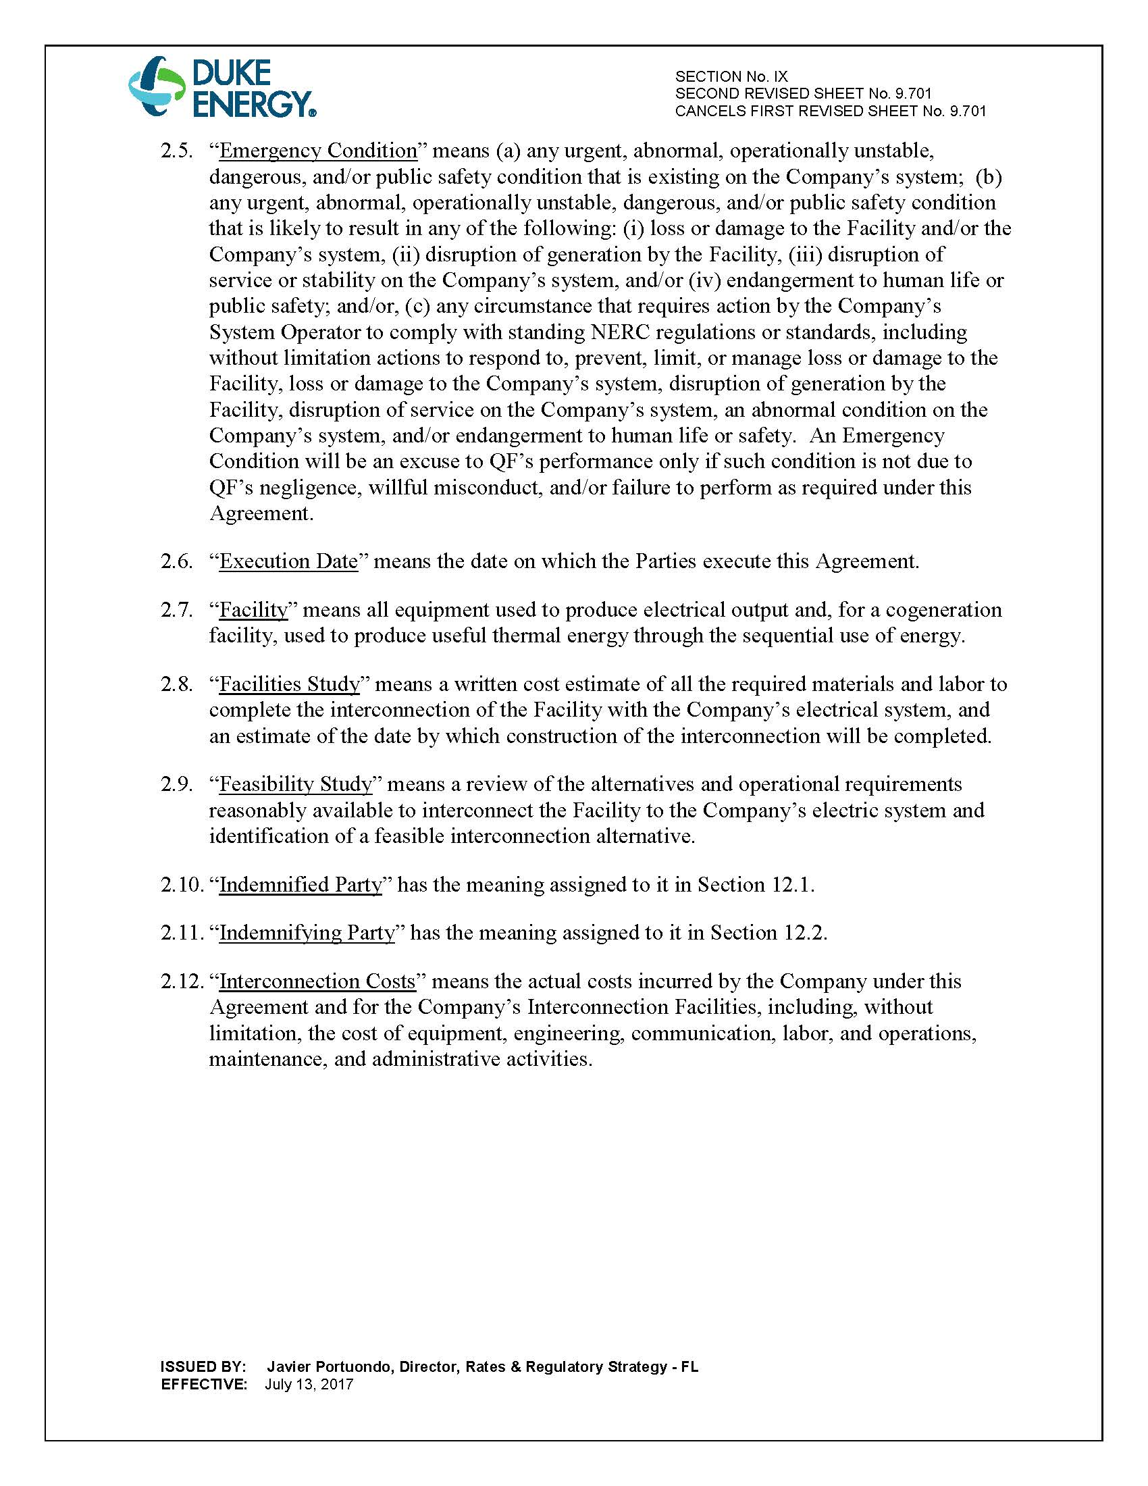
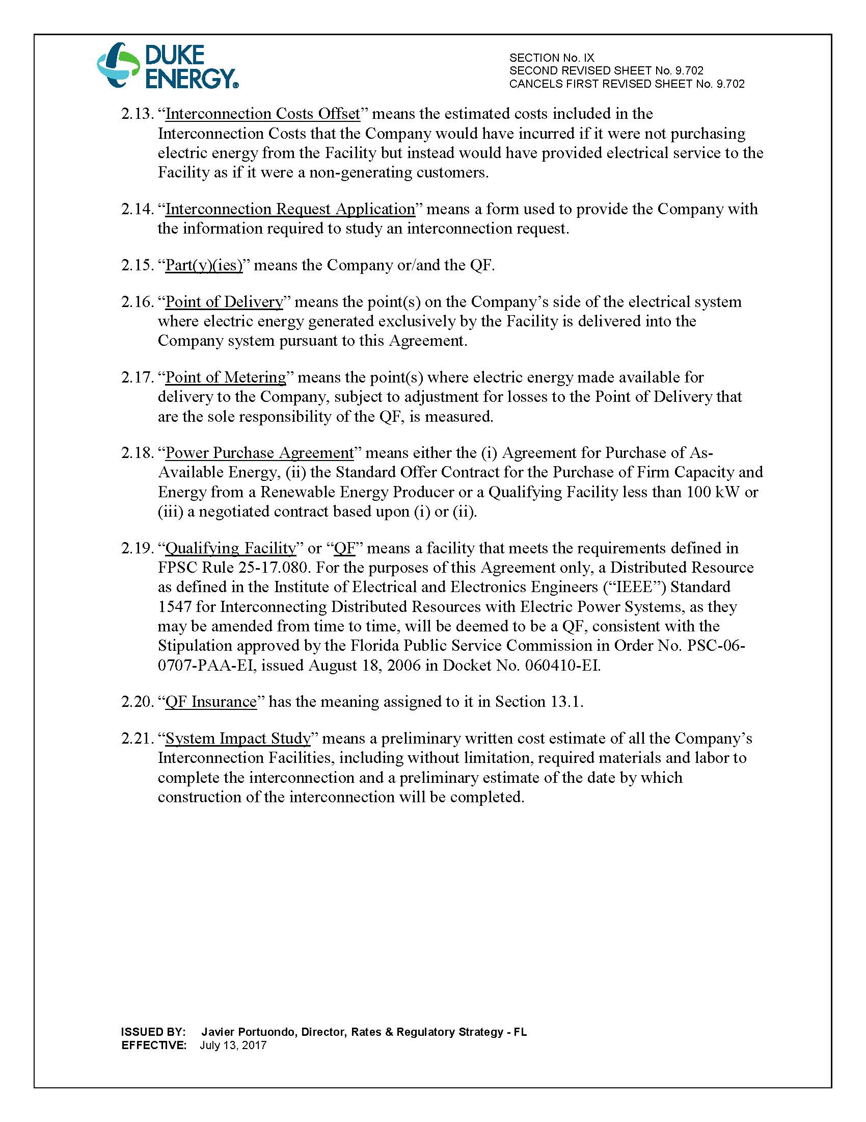
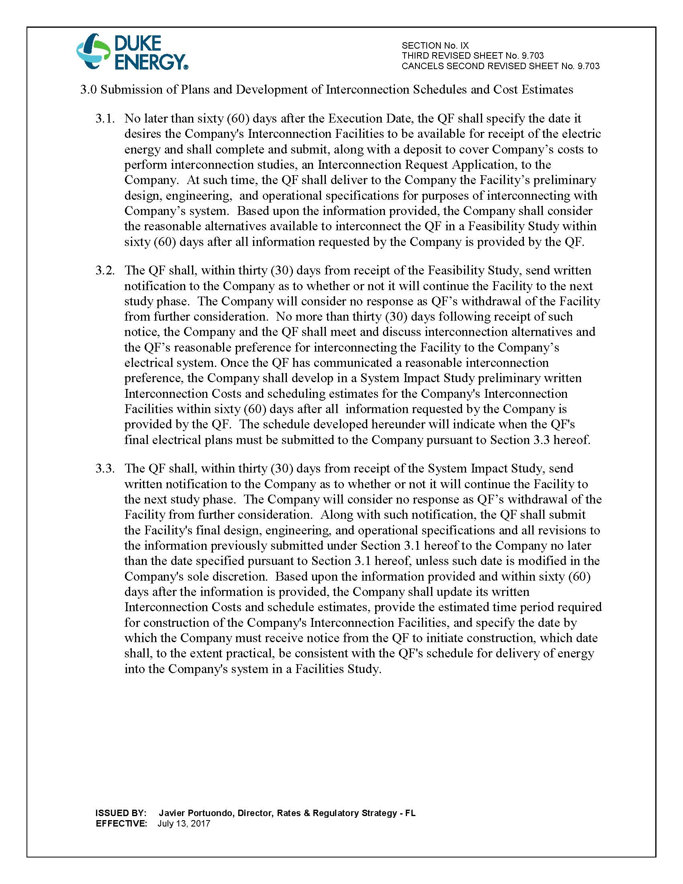
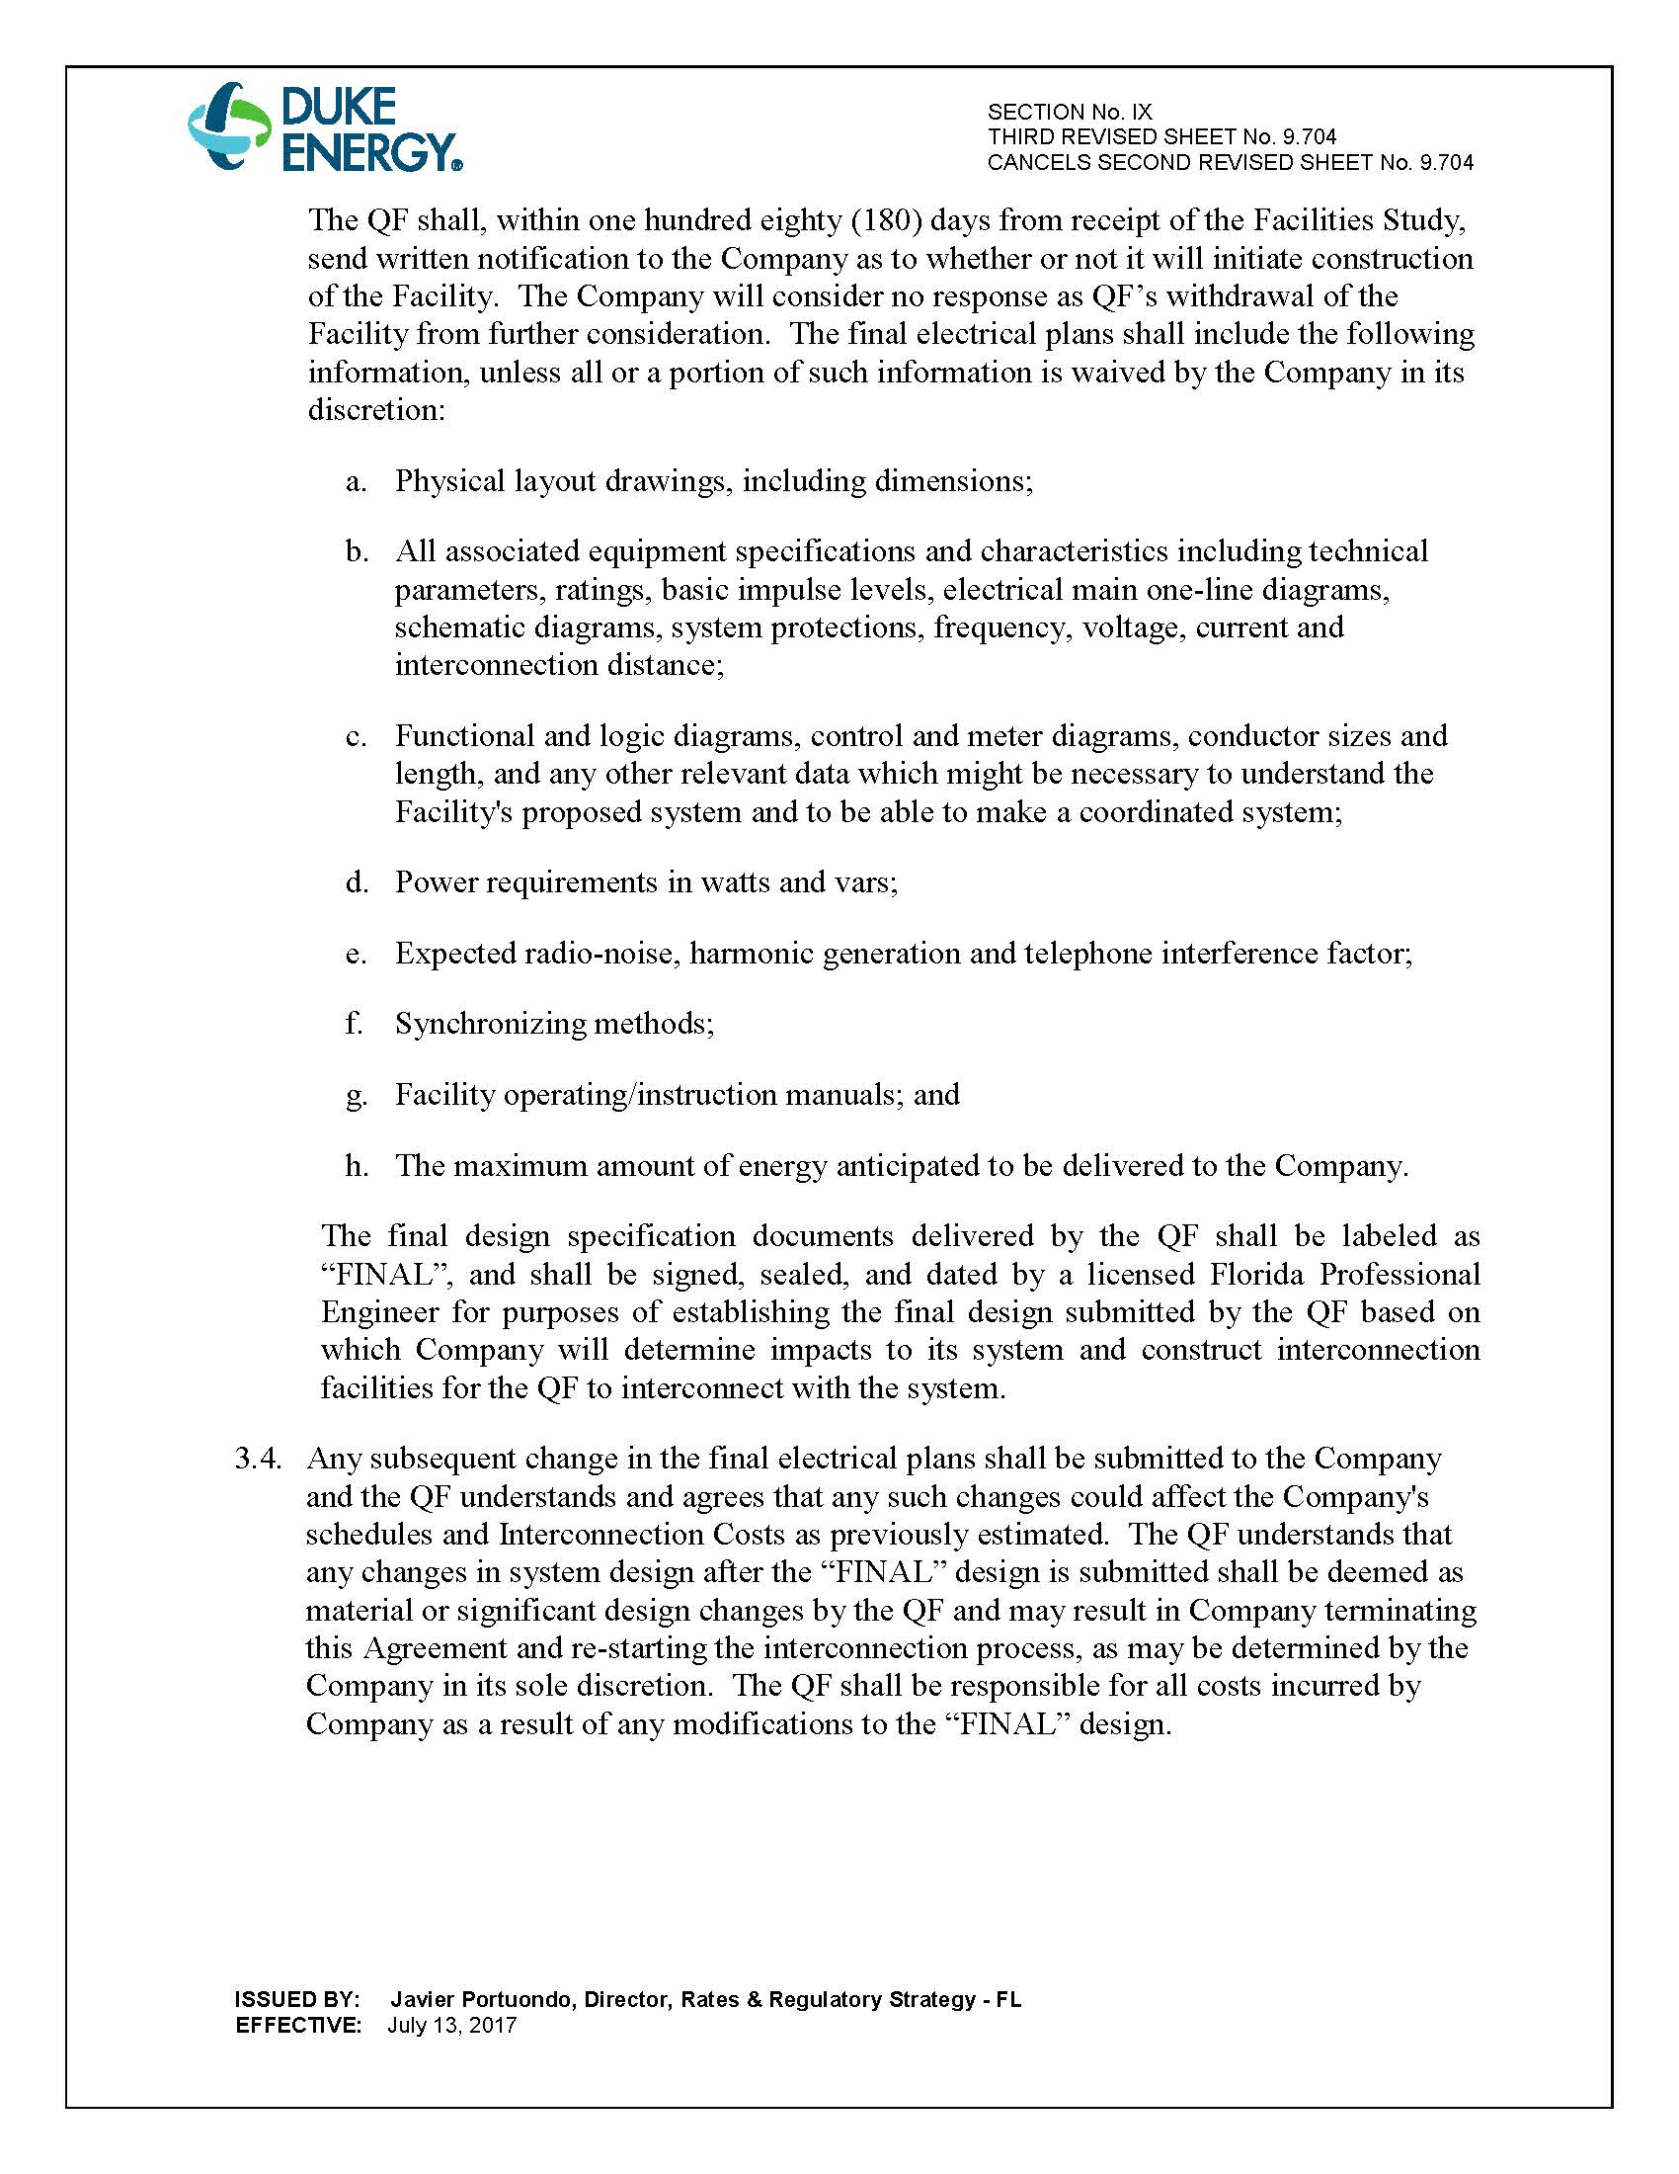
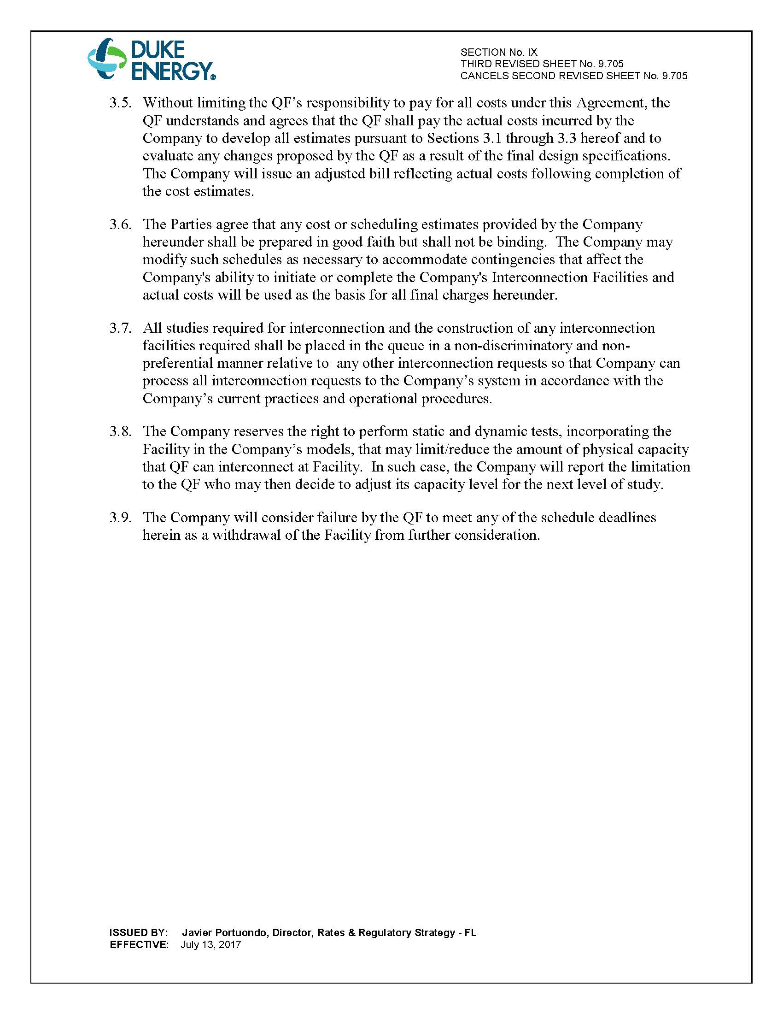
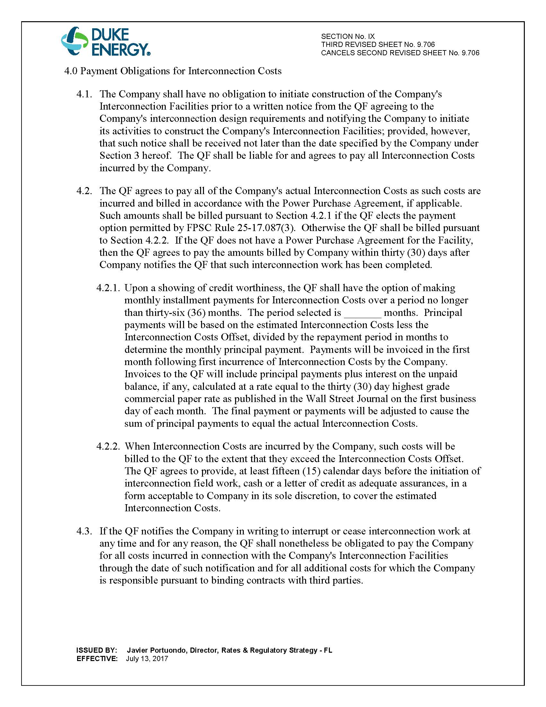
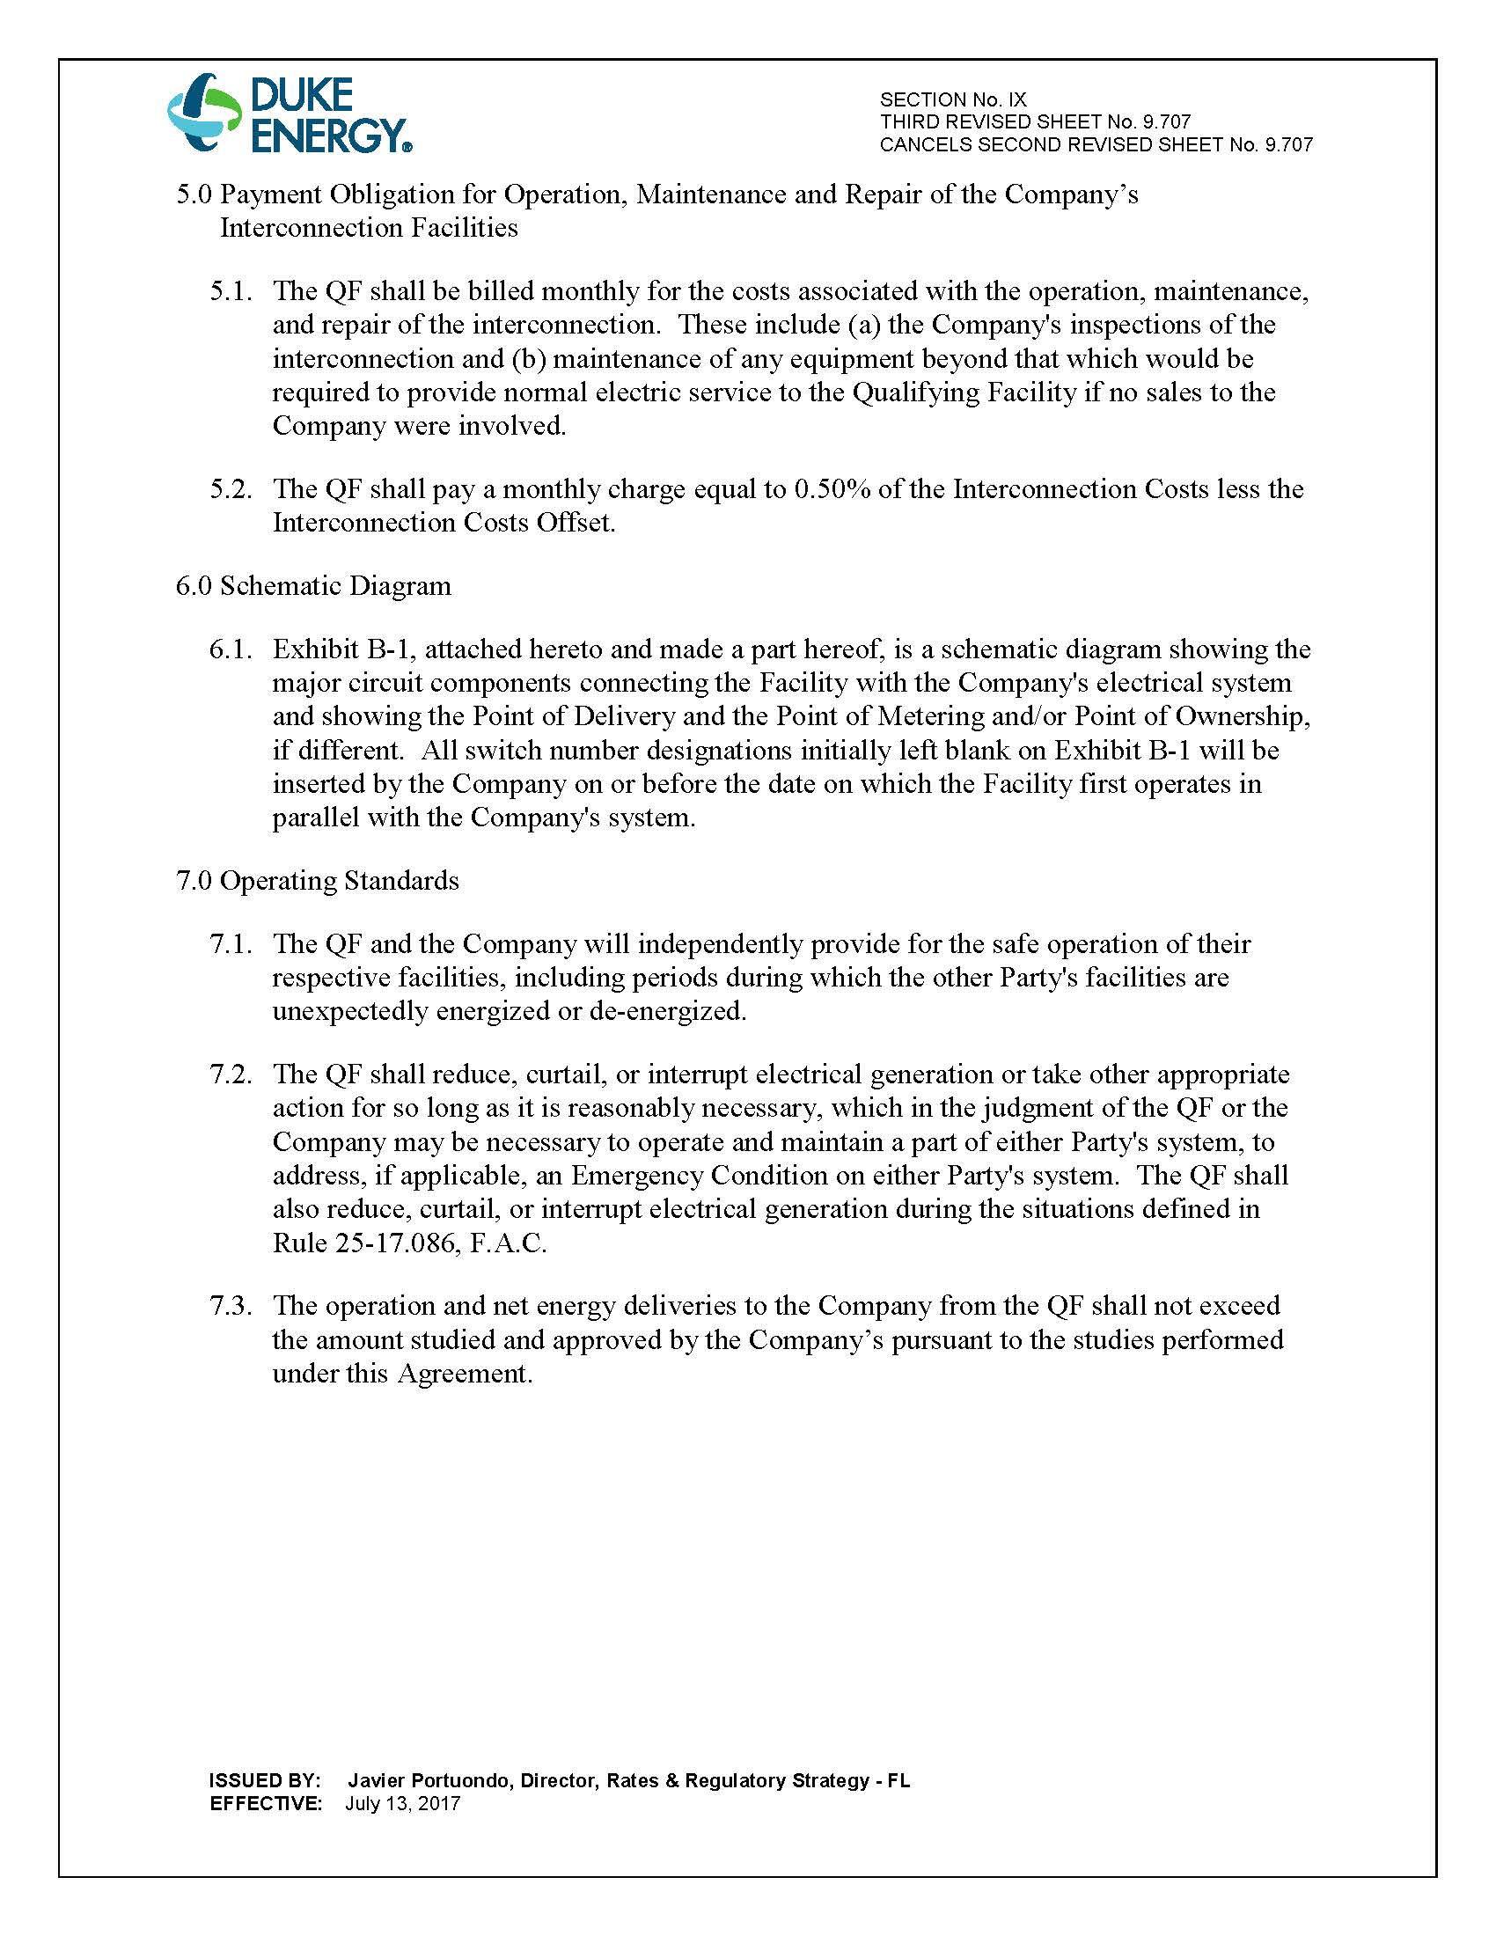
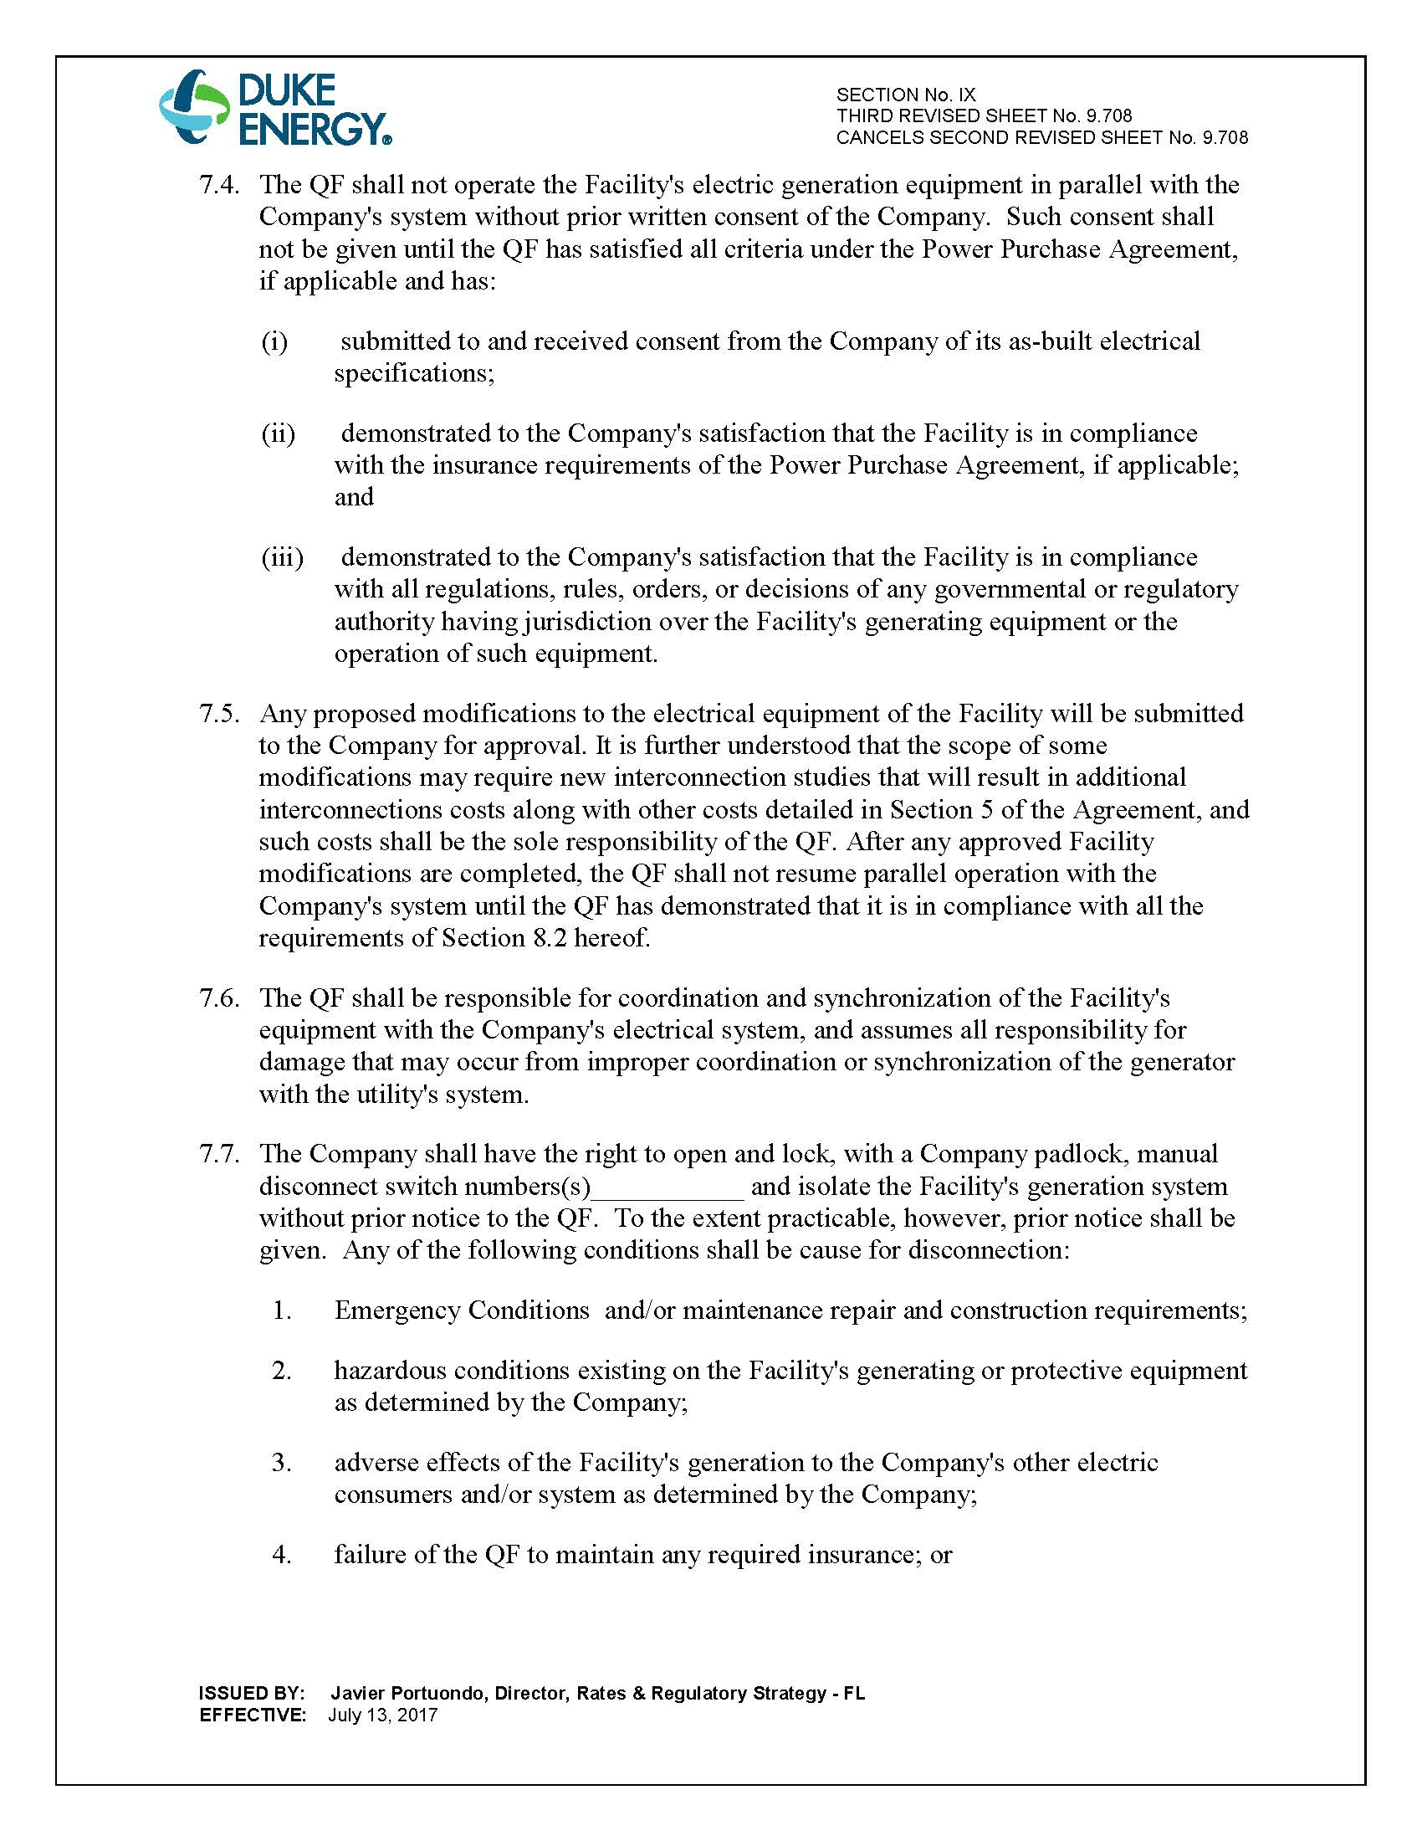
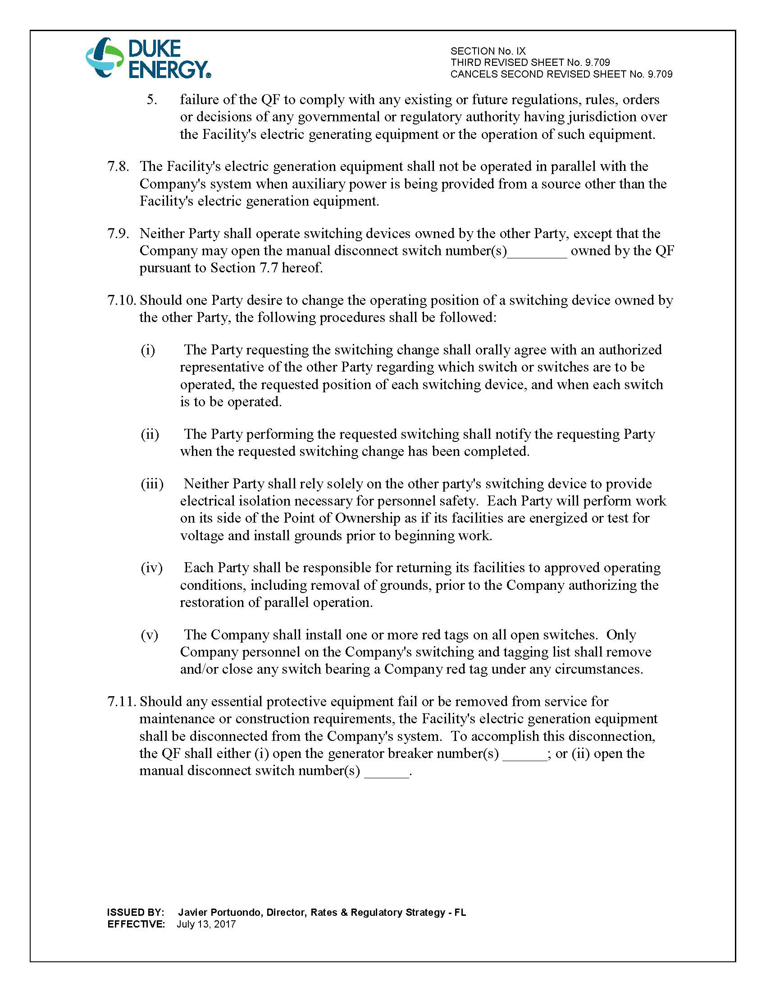
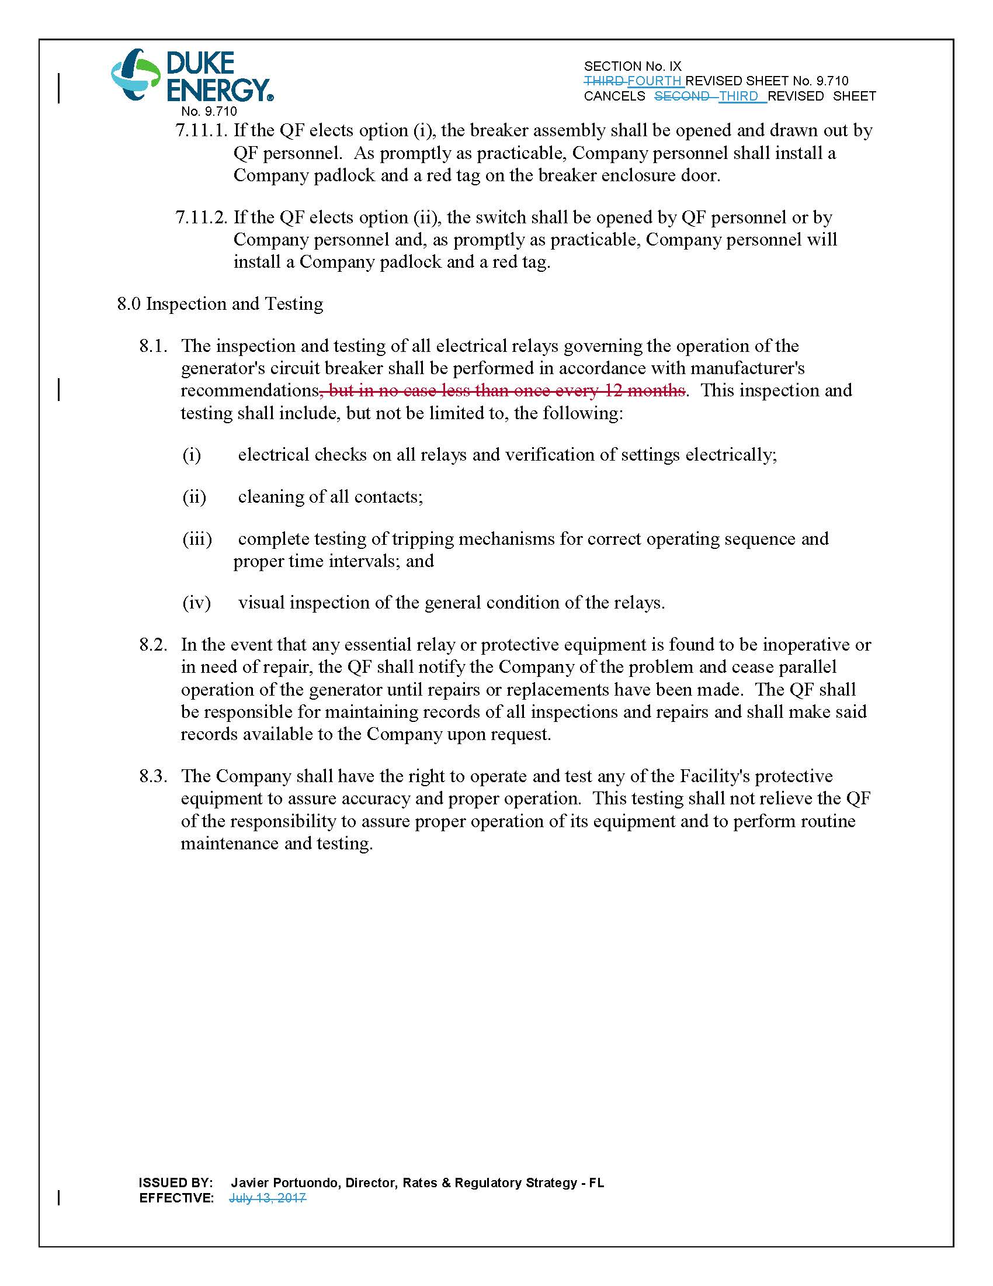
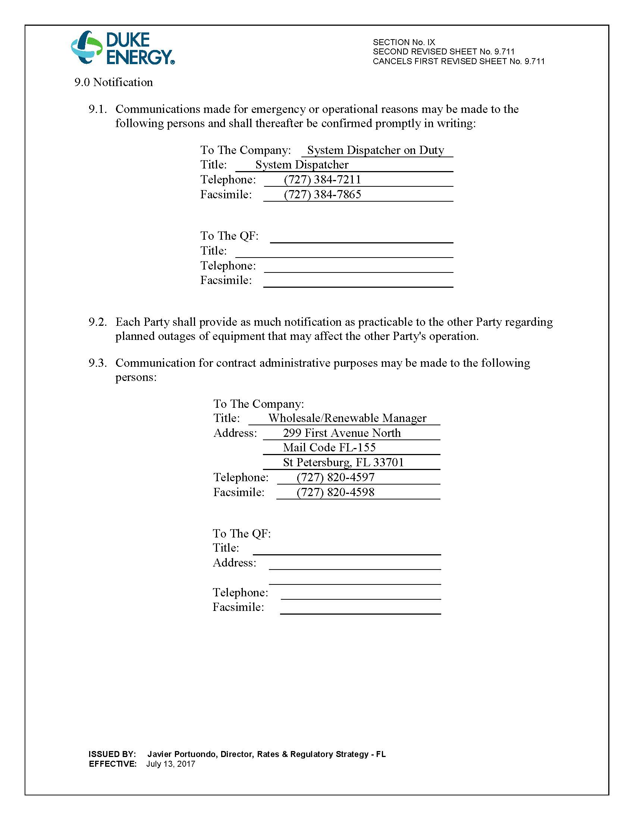
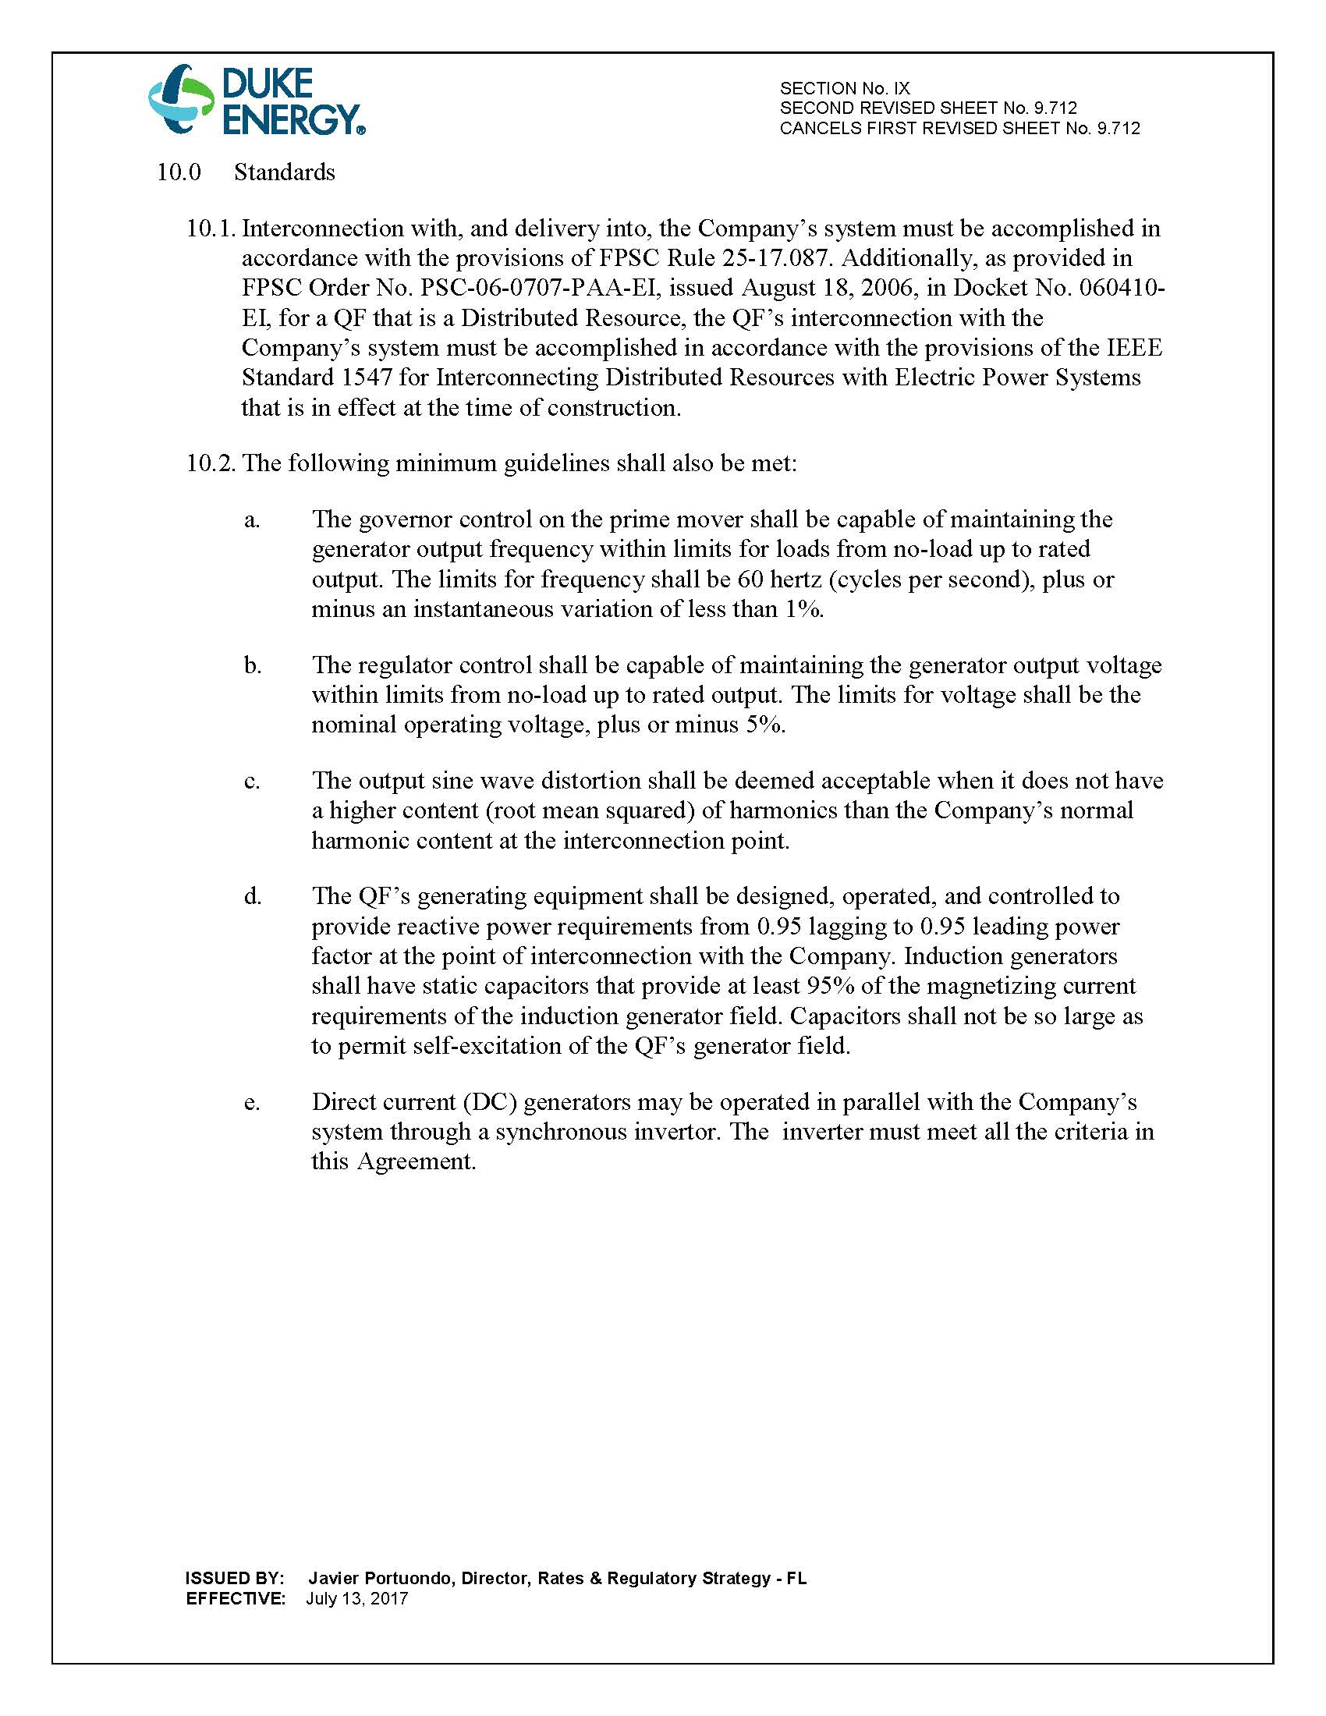
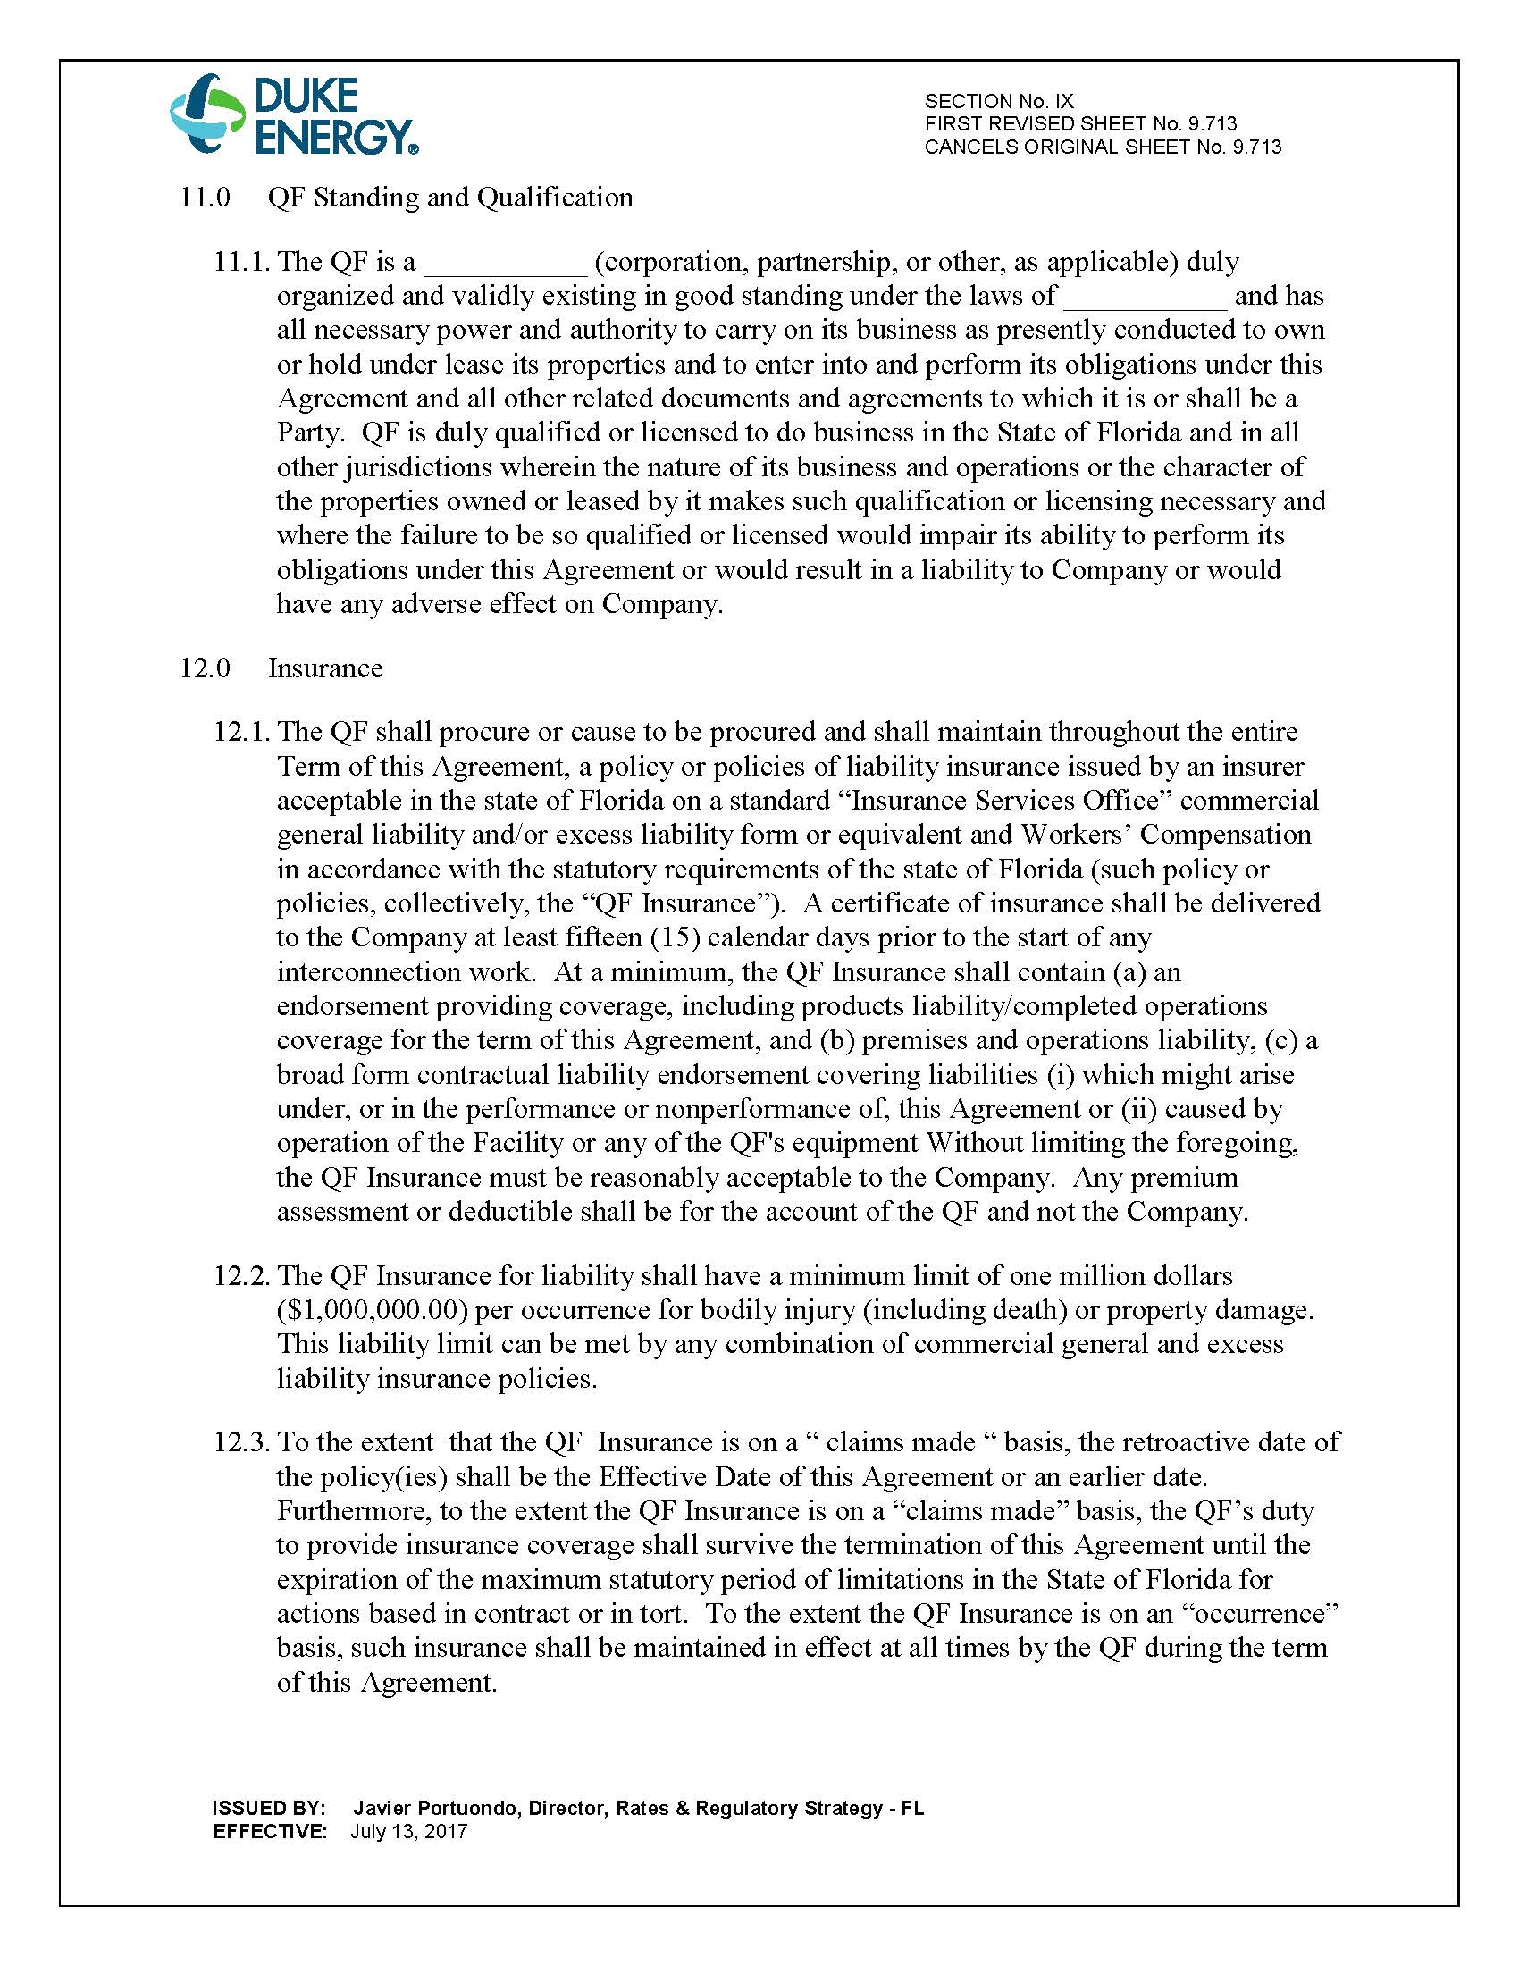
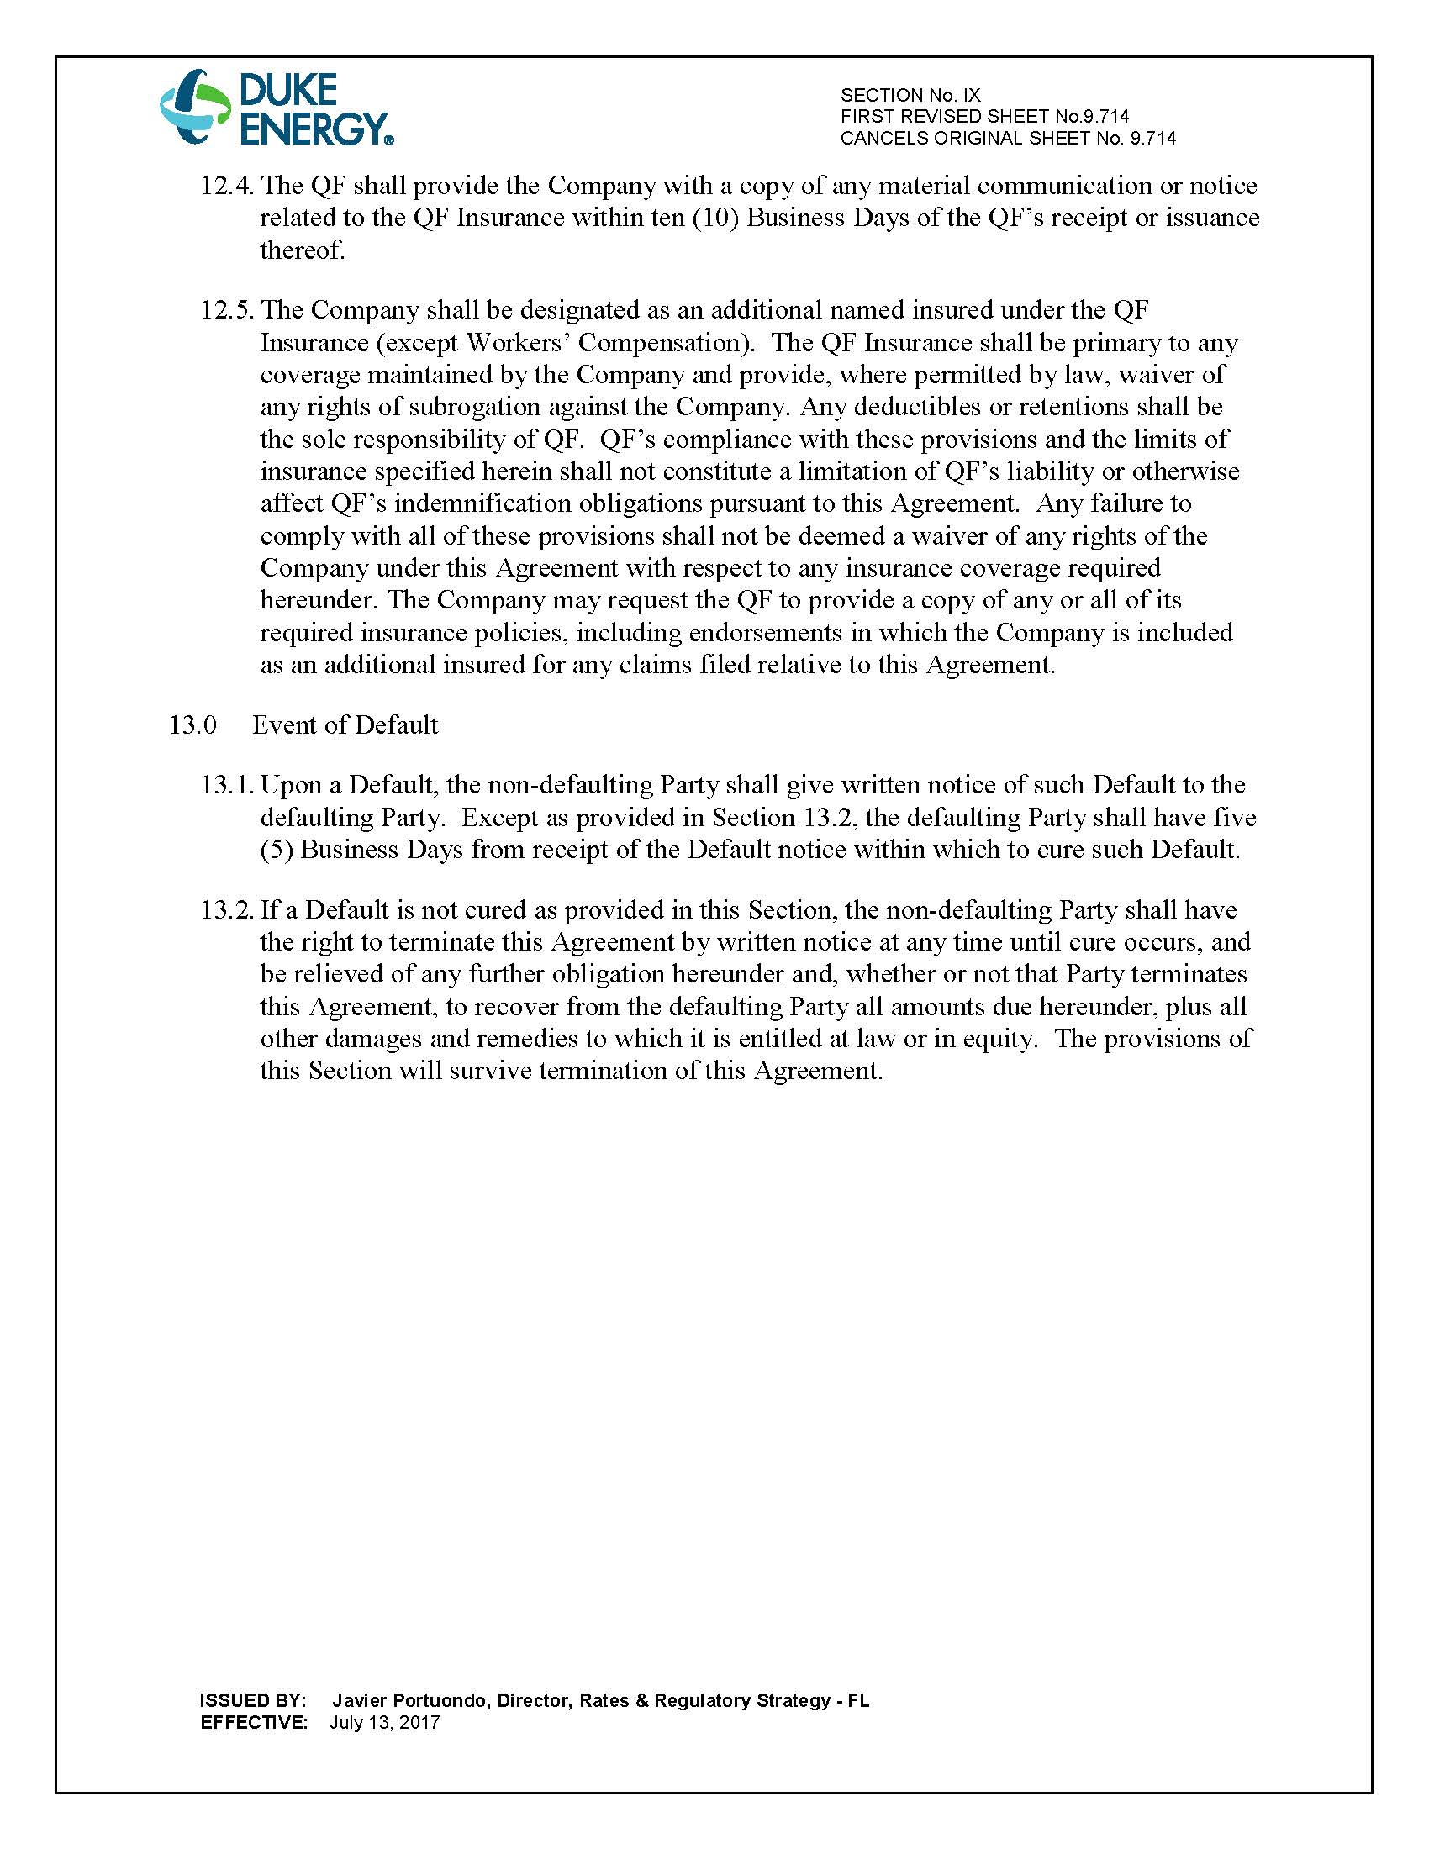
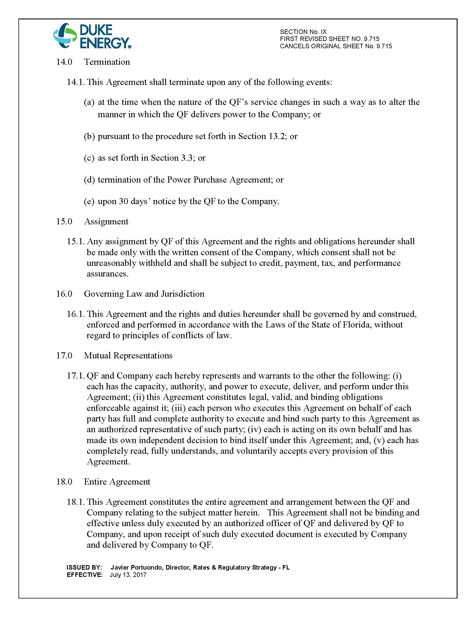
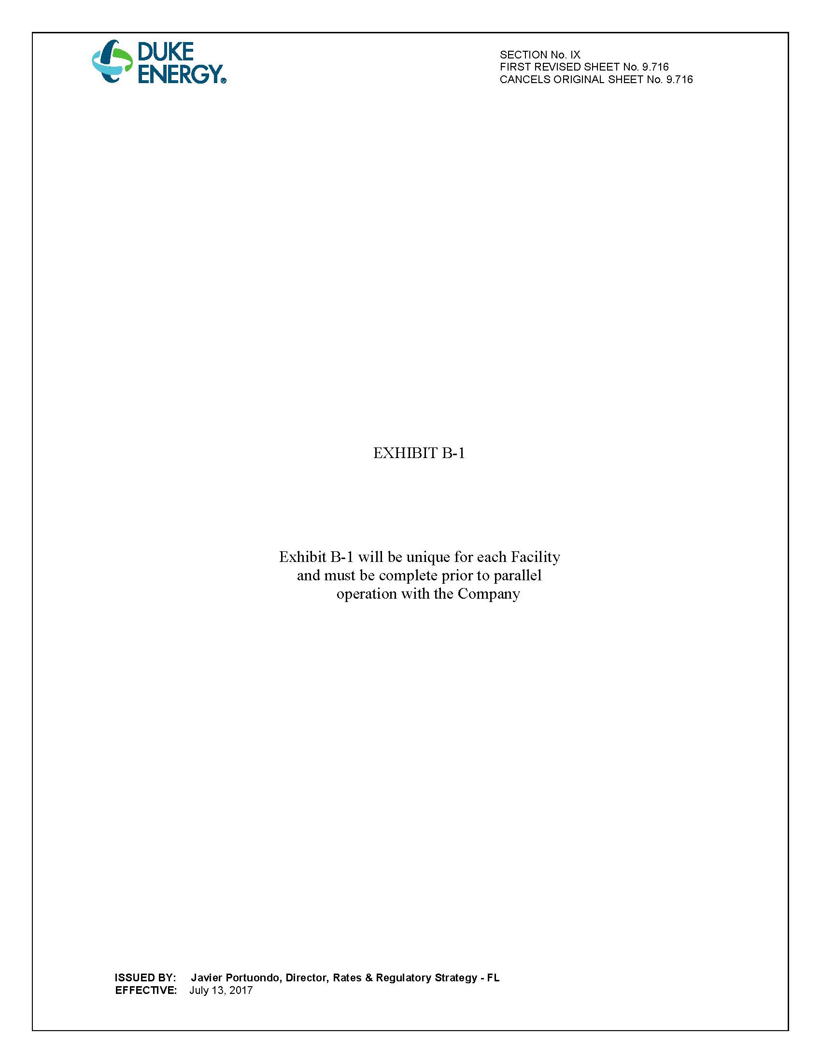
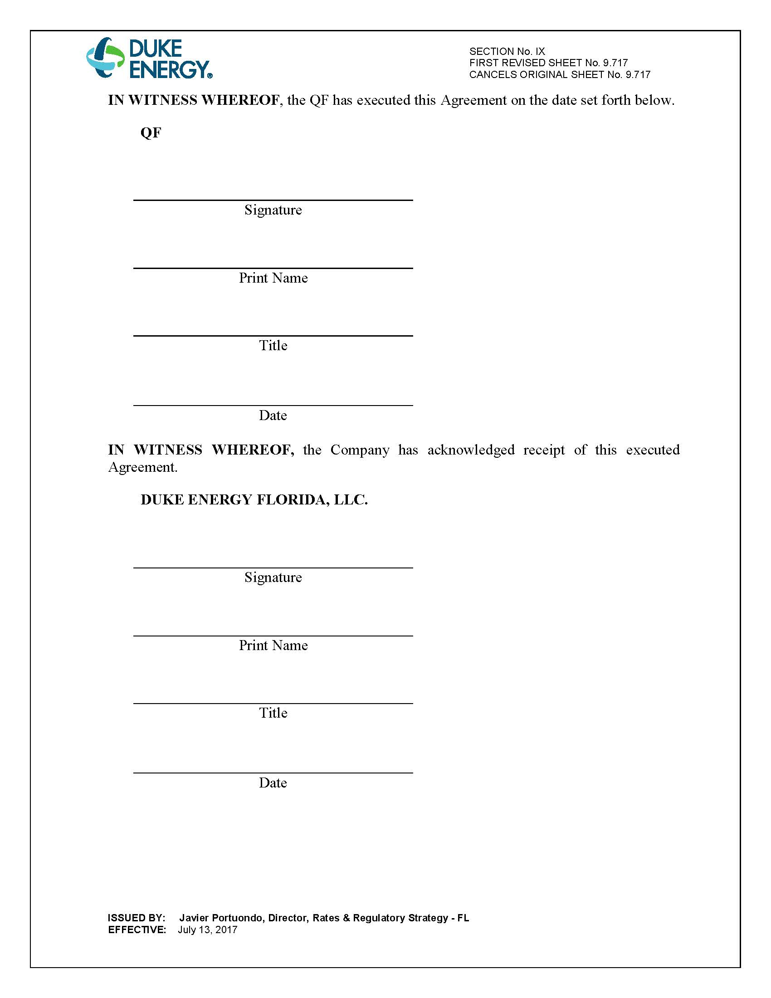

Document No. 04774-2019, filed June 7, 2017, in Docket No. 20190079-EQ.
Document No. 03911-2019, filed April 24, 2019, in Docket No. 20190079-EQ.
Order No. PSC-2018-0316-PAA-EQ, issued June 20, 2018, in Docket No. 20180083-EQ, In re: Petition for approval of renewable energy tariff and standard offer contract, by Florida Power & Light Company.

