State of Florida |  | Public Service Commission  Capital Circle Office Center ● 2540 Shumard Oak Boulevard  Tallahassee, Florida 32399-0850  -M-E-M-O-R-A-N-D-U-M-
DATE: | July 25, 2019
TO: | Office of Commission Clerk (Teitzman)
FROM: | Division of Economics (Sibley, Hudson)  Division of Accounting and Finance (Brown, Wilson)  Division of Engineering (King, Lewis)  Office of the General Counsel (DuVal)
RE: | Docket No. 20170147-WS – Application for staff-assisted rate case in Levy County by FIMC Hideaway, Inc.
AGENDA: | 08/06/19 – Regular Agenda – Proposed Agency Action - Interested Persons May Participate
COMMISSIONERS ASSIGNED: |  |  | All Commissioners
PREHEARING OFFICER: |  |  | Brown
CRITICAL DATES: |  |  | August 6, 2019 (Pursuant to Order No. PSC-2019-0074-PAA-WS)
SPECIAL INSTRUCTIONS: |  |  | None

Case Background
FIMC Hideaway, Inc. (FIMC or Utility) is a Class C utility that was granted water and wastewater certificates in 1984 to serve the Hideaway development when Levy County transferred jurisdiction to the Florida Public Service Commission (Commission) in 1983. The Hideaway systems were transferred to Florida Investors Mortgage Corporation Hideaway, Inc. in 1992 following its foreclosure on the Utility. Subsequently, the Commission approved a transfer of majority organizational control in 2005. In 2009, the Commission approved the transfer of the Springside water and wastewater systems from Par Utilities, Inc. to FIMC. The Hideaway and Springside water and wastewater systems were interconnected in April 2013.
On June 22, 2017, FIMC filed an application for a staff-assisted rate case. Pursuant to Order No. PSC-2018-0389-PAA-WS, the Commission approved rates and charges for FIMC. Order No. PSC-2018-0389-PAA-WS additionally ordered:
[T]he overall quality of service provided by FIMC Hideaway, Inc. shall be considered marginal until the utility can sufficiently demonstrate that it meets the Department of Environmental Protection’s [DEP] secondary water standards. The [U]tility shall file the results of its next primary and secondary water standards tests with this Commission in this docket by November 1, 2018. If the results are unfavorable, our staff will bring this item to this Commission by March 1, 2019, for further action.

By email, on October 8, 2018, FIMC provided Commission staff with the results of its 2018 DEP primary and secondary water tests. The test results indicated that the water service provided by the Utility continued to exceed certain DEP secondary standards for sulfates and total dissolved solids.

Pursuant to Order No. PSC-2019-0074-PAA-WS, issued February 25, 2019, the Commission directed FIMC to create an estimate of costs and benefits of a plausible solution to reduce sulfates and total dissolved solids to a level that is within DEP standards. That Order additionally stated:

We further direct FIMC to meet with its customers within 60-90 days of the issuance of this Order. The Utility shall provide the Office of Public Counsel and our staff with notification of the customer meeting date. In its meeting with customers, the Utility shall discuss the estimated costs and benefits of and time necessary for implementing a plausible solution to reduce sulfates and total dissolved solids to a level that is within acceptable DEP standards. The Utility shall report the results of the customer meeting to us within 30 days after the meeting is held. This item shall be brought back before us by the August 6, 2019 Commission Conference.

This recommendation addresses the Utility’s actions, as directed by Order No. PSC-2019-0074-PAA-WS. The Commission has jurisdiction pursuant to Sections 367.011, 367.081, 367.0812, 367.0814, and 367.091, Florida Statutes (F.S.).

Discussion of Issues

Issue 1:
Has FIMC Hideaway, Inc., complied with the requirements of Order No. PSC-2019-0074-PAA-WS?

Recommendation:
Yes. FIMC, with the assistance of the Florida Rural Water Association (FRWA), has complied with the requirements of Order No. PSC-2019-0074-PAA-WS. Furthermore, based on the results of the customer meeting, staff recommends no additional action at this time with respect to FIMC’s water quality. (Lewis)

Staff Analysis:
The Commission’s directives in Order No. PSC-2019-0074-PAA-WS, are consistent with the requirements found in Section 367.0812(2), F.S., which states:

(2)(a) In determining the quality of water service, the commission shall consider a finding by the Department of Environmental Protection as to whether the utility has failed to provide water service that meets the secondary water quality standards of the department.
(b) The utility shall create an estimate of the costs and benefits of a plausible solution to each issue identified by the commission.
(c) The utility shall meet with its customers within a time prescribed by the commission to discuss the estimated costs and benefits of and time necessary for implementing a plausible solution for each quality of water service issue identified, and the utility shall report the results of such meetings to the commission.
(d) The utility shall inform the commission, if:
1. The customers and the utility agree on a solution for each quality of water service issue identified, of each agreed-on solution and the cost of each solution; or
2. The customers and the utility prefer a different solution to at least one of the quality of water service issues identified, of the preferred solutions by each and the cost of each solution.

By email communication dated April 18, 2019, the Utility provided staff a copy of its customer meeting notice and indicated that it provided the notice to its customers by email on April 10, 2019, and by hand delivery between April 14, 2019, and April 17, 2019. The notice stated, in part, that the goal of the meeting was to discuss viable options to enhance the water quality that are amenable to the customers.

The FRWA assisted FIMC by identifying plausible solutions for the Utility’s water service issues and developing cost and benefit estimates for each solution. On April 24, 2019, the FRWA provided a draft presentation, which included a summary of the plausible solutions, to staff. The FRWA’s draft presentation was also shared with the Office of Public Counsel (OPC).

The plausible solutions, including estimated monetary costs, identified by the FRWA are summarized below.

- Connect to another water system such as Fowlers Bluff ($25,000 per
connection or $121 per month per connection)
- Find another source, surface water or ground water supply ($24,050 per connection or $116 per month per connection)
- Install additional treatment on the existing water ($10,000 per connection or $48 per month per connection)
- Accept current water quality, but do something for your own home ($125 to $3,000 per connection)
The customer meeting was held on May 1, 2019, at the same location that the customer meeting for the staff assisted rate case was held. Approximately 35 customers attended the meeting as well as representatives from Commission staff and the OPC. At the meeting, the FRWA presented the plausible solutions and estimated costs and benefits. On May 28, 2019, the FRWA provided staff with a summary of the customer meeting. The FRWA’s summary states the following:

During that meeting, options and costs for improving water quality were presented. We described and discuss[ed] in detail the water quality issues, possible solutions, costs, benefits, etc. We received customer input. We asked if the customers and the [U]tility agreed on a solution or preferred a different solution...[b]y a show of hands customers were in favor of option 4 and not in favor of options 1 through 3.

As previously stated, option 4 involved the customers accepting the current water quality and doing something at their home. Attachment A, which is appended to this recommendation, includes a copy of the FRWA’s summary and presentation.

At the conclusion of the meeting, Commission staff provided contact information to the customers to allow further input if desired. Copies of the FRWA’s presentation were also provided for attendees to take to any customers that were not able to participate at the meeting. As of the date of the filing of this recommendation, Commission staff has not been contacted by a customer of FIMC regarding the Utility’s water quality.

Summary
Staff recommends that FIMC, with the assistance of the FRWA, has complied with the requirements of Order No. PSC-2019-0074-PAA-WS. Furthermore, based on the results of the customer meeting, staff recommends no additional action at this time with respect to FIMC’s water quality.

Issue 2:
Should this docket be closed?

Recommendation:
Yes. If no person whose substantial interests are affected by the proposed agency action files a protest within 21 days of the issuance of the order, a consummating order should be issued and this docket should be closed administratively. (DuVal)

Staff Analysis:
If no person whose substantial interests are affected by the proposed agency action files a protest within 21 days of the issuance of the order, a consummating order should be issued and this docket should be closed administratively.

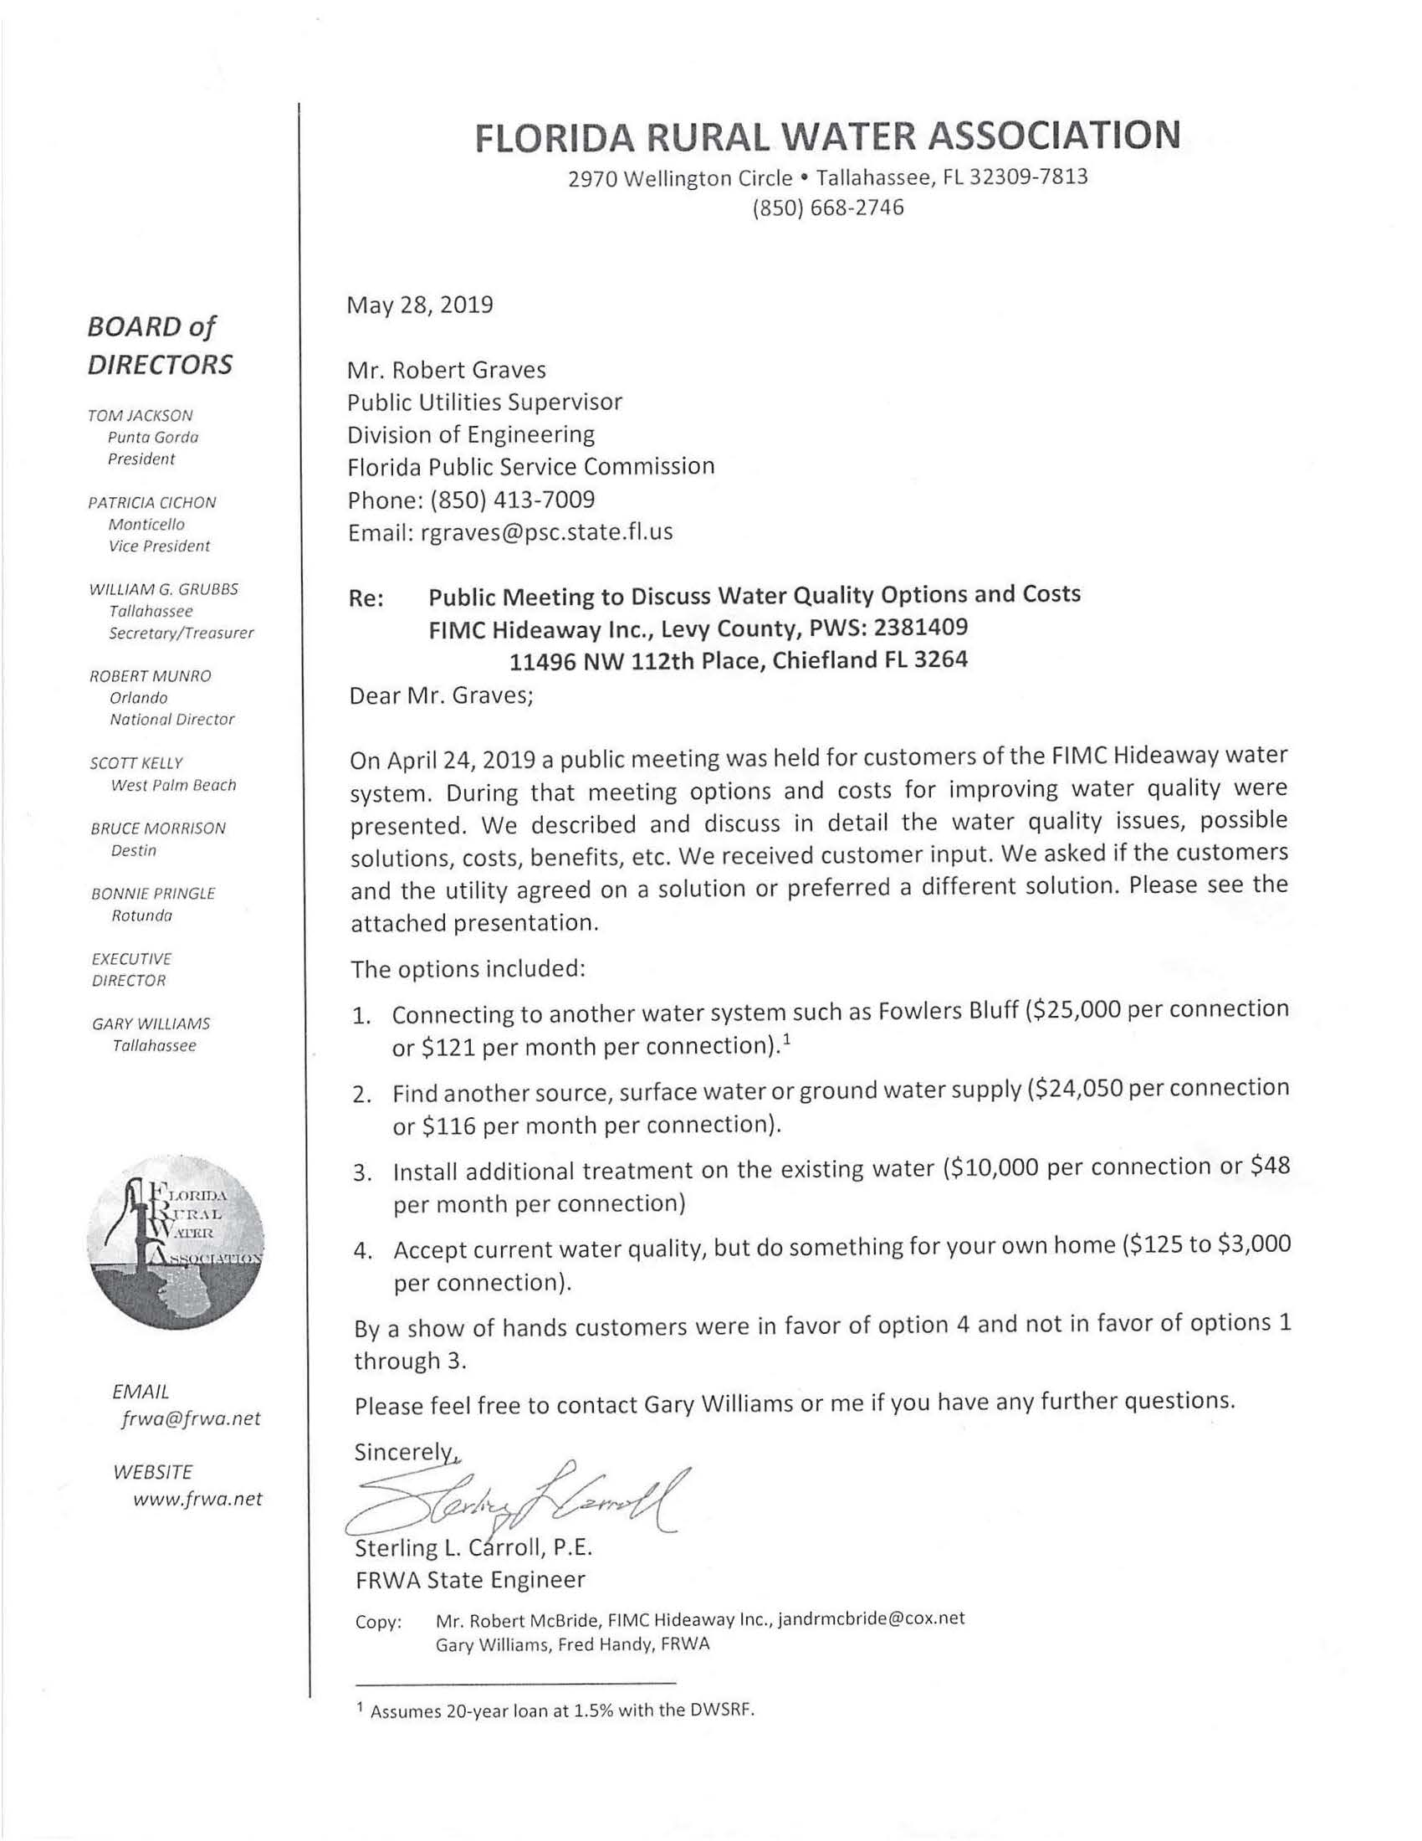

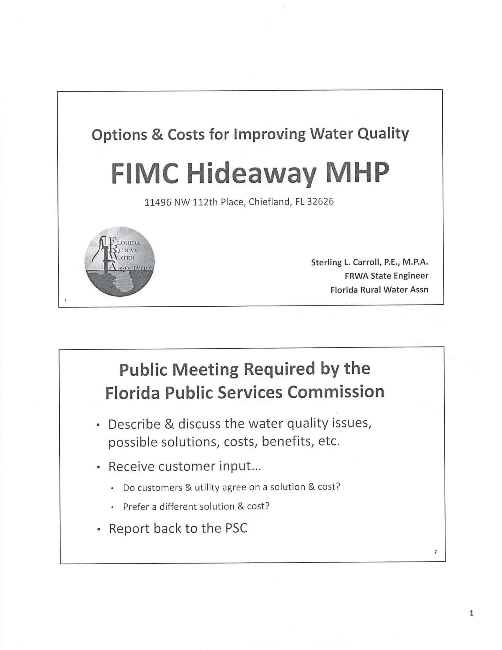

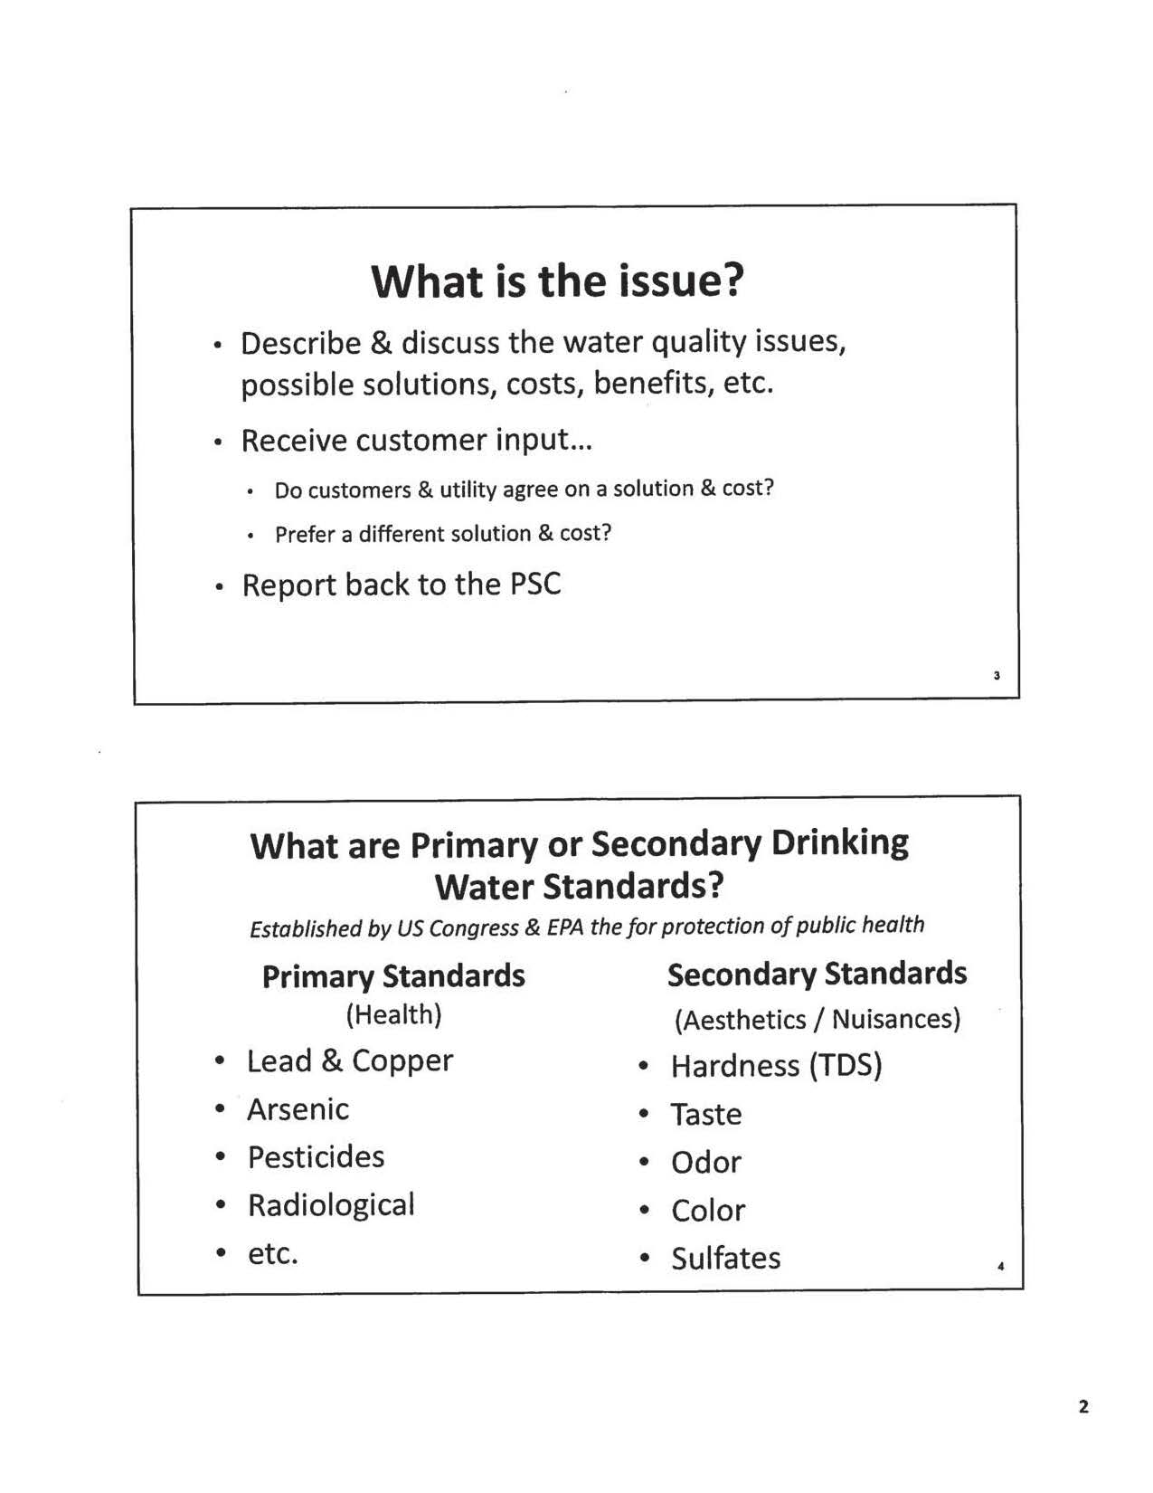

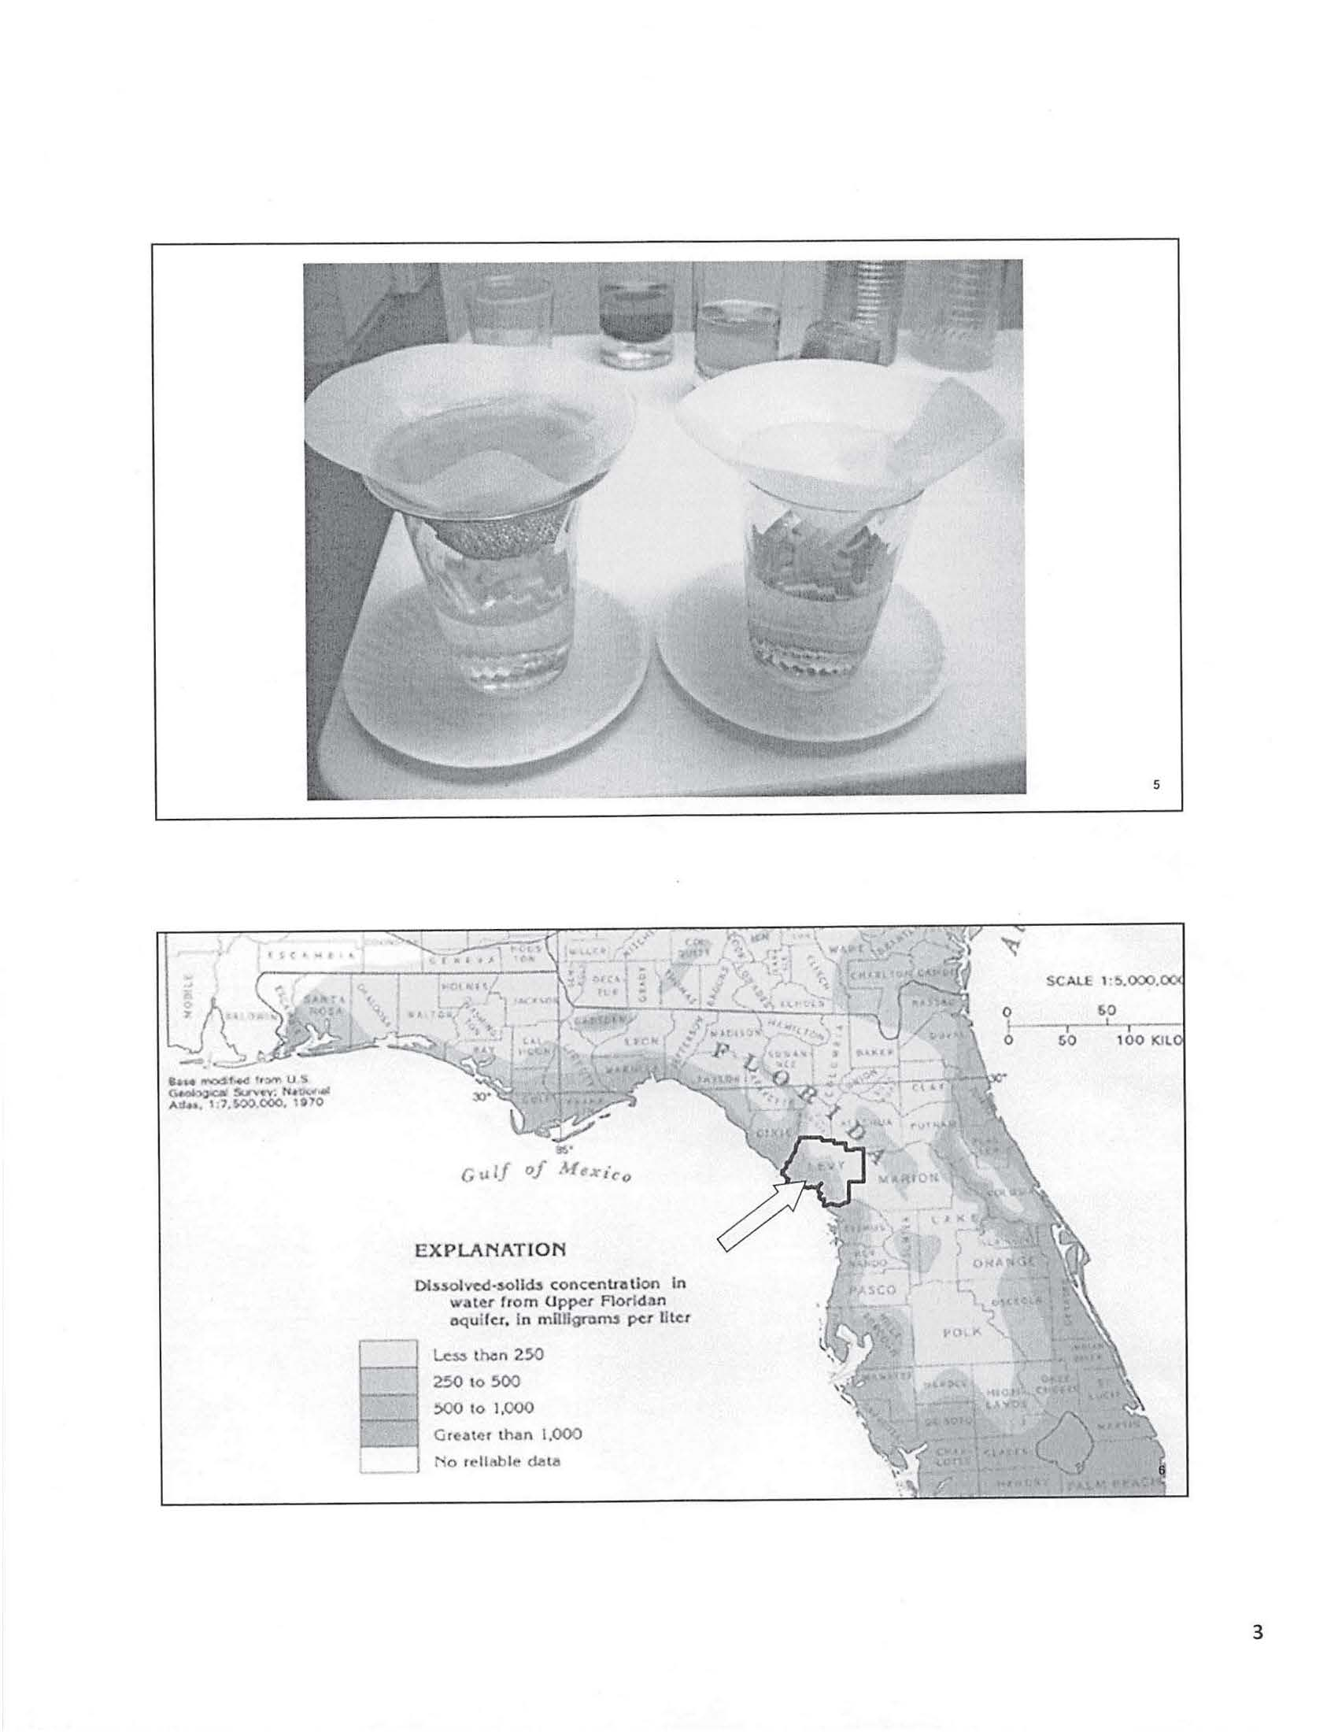

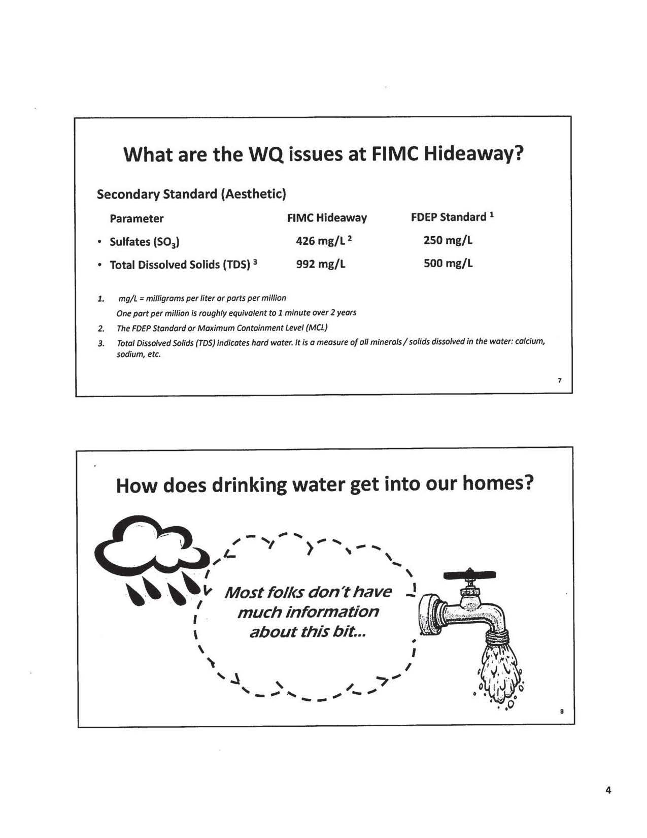

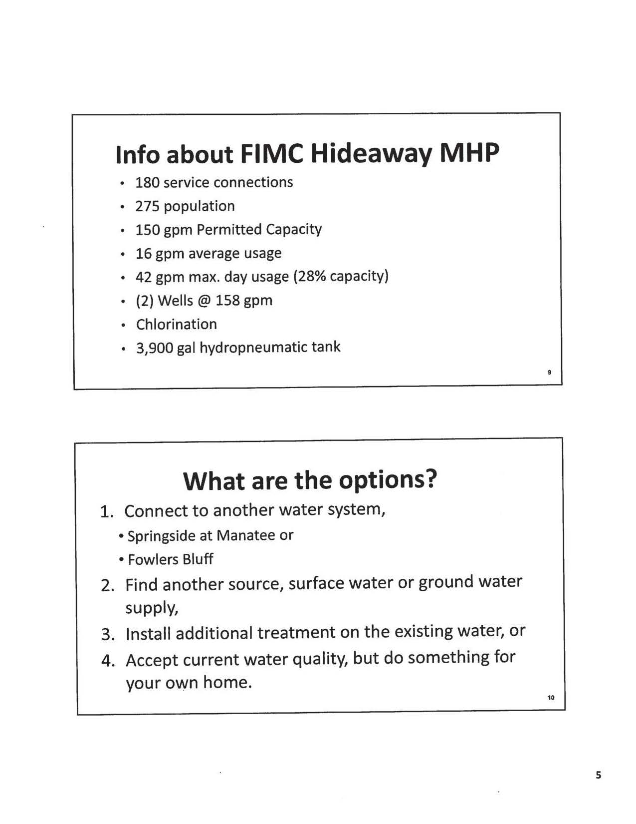

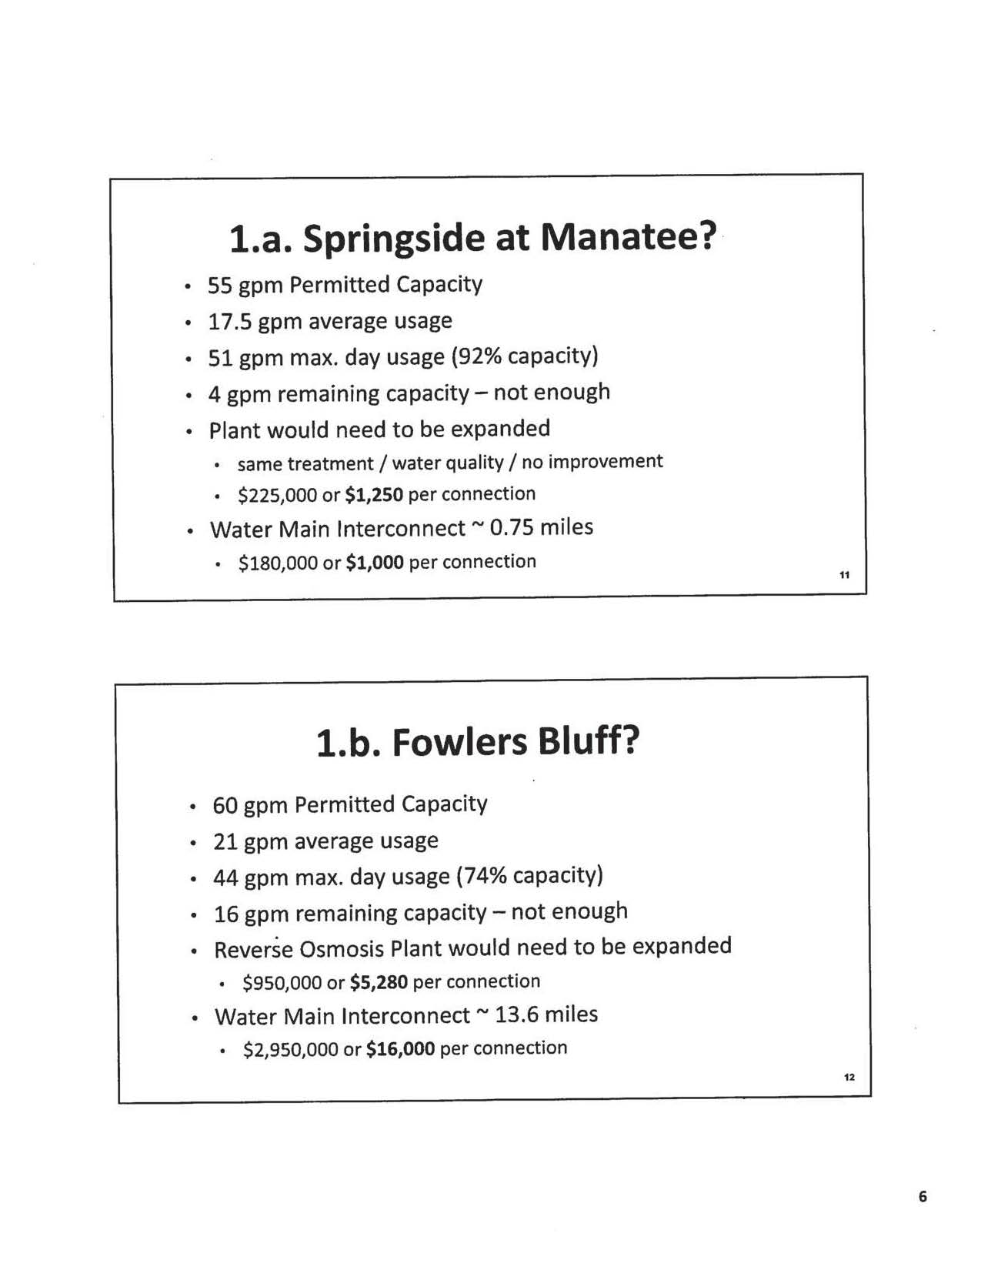

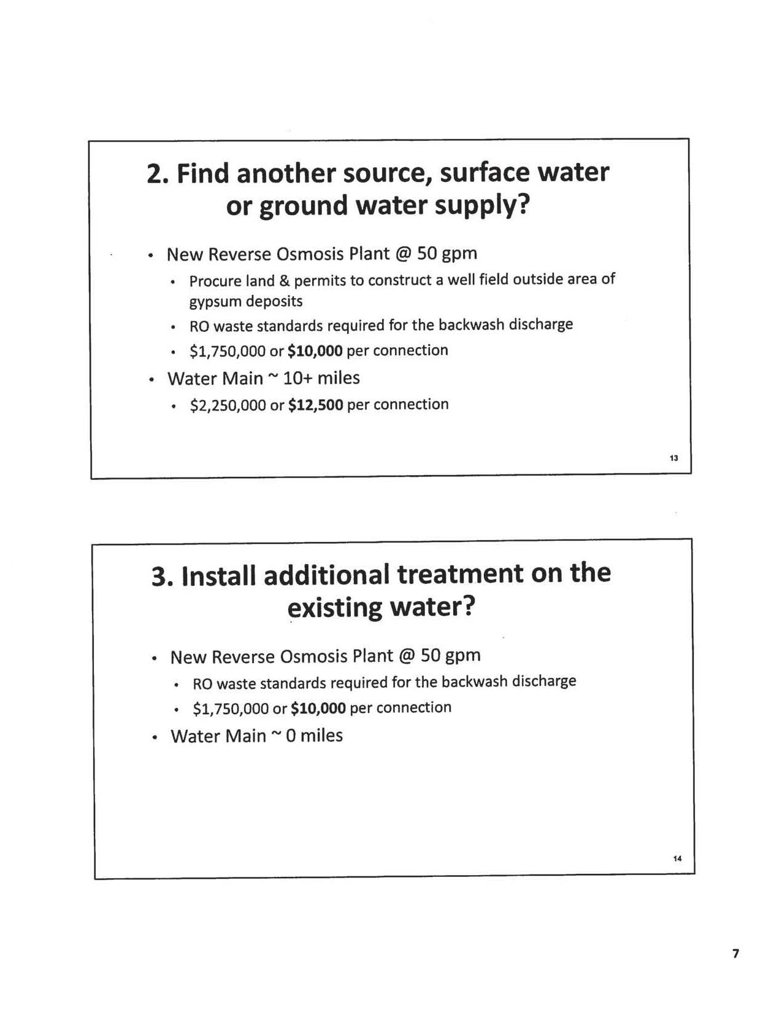

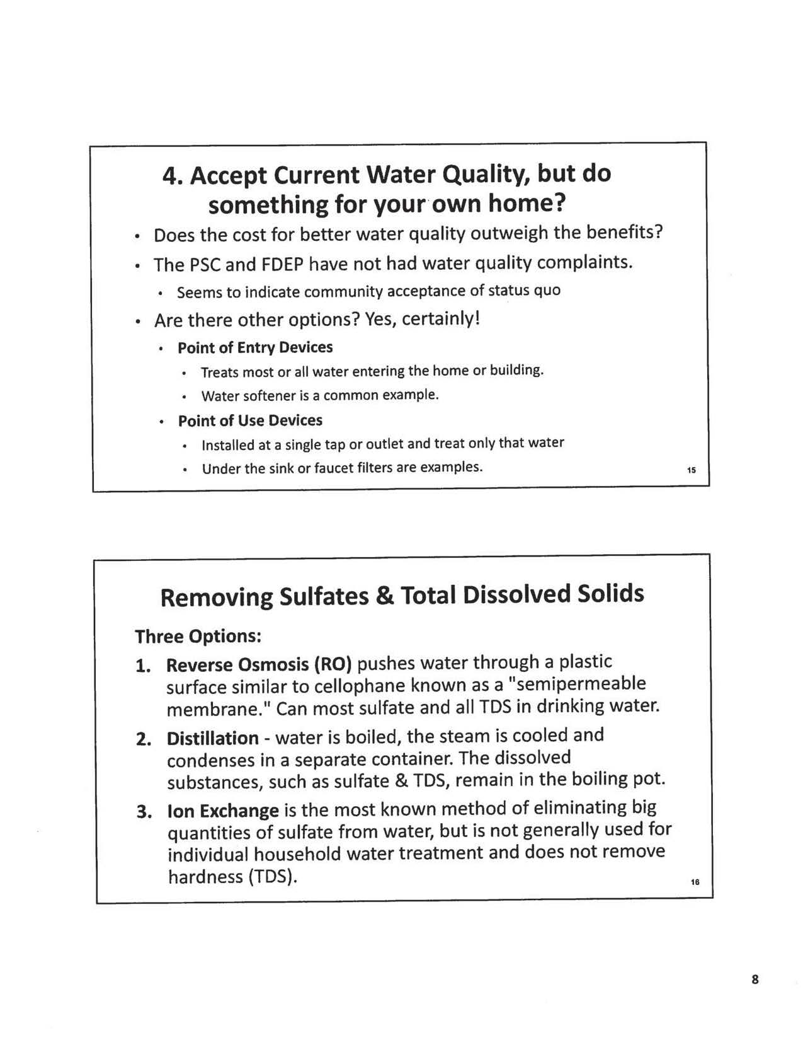

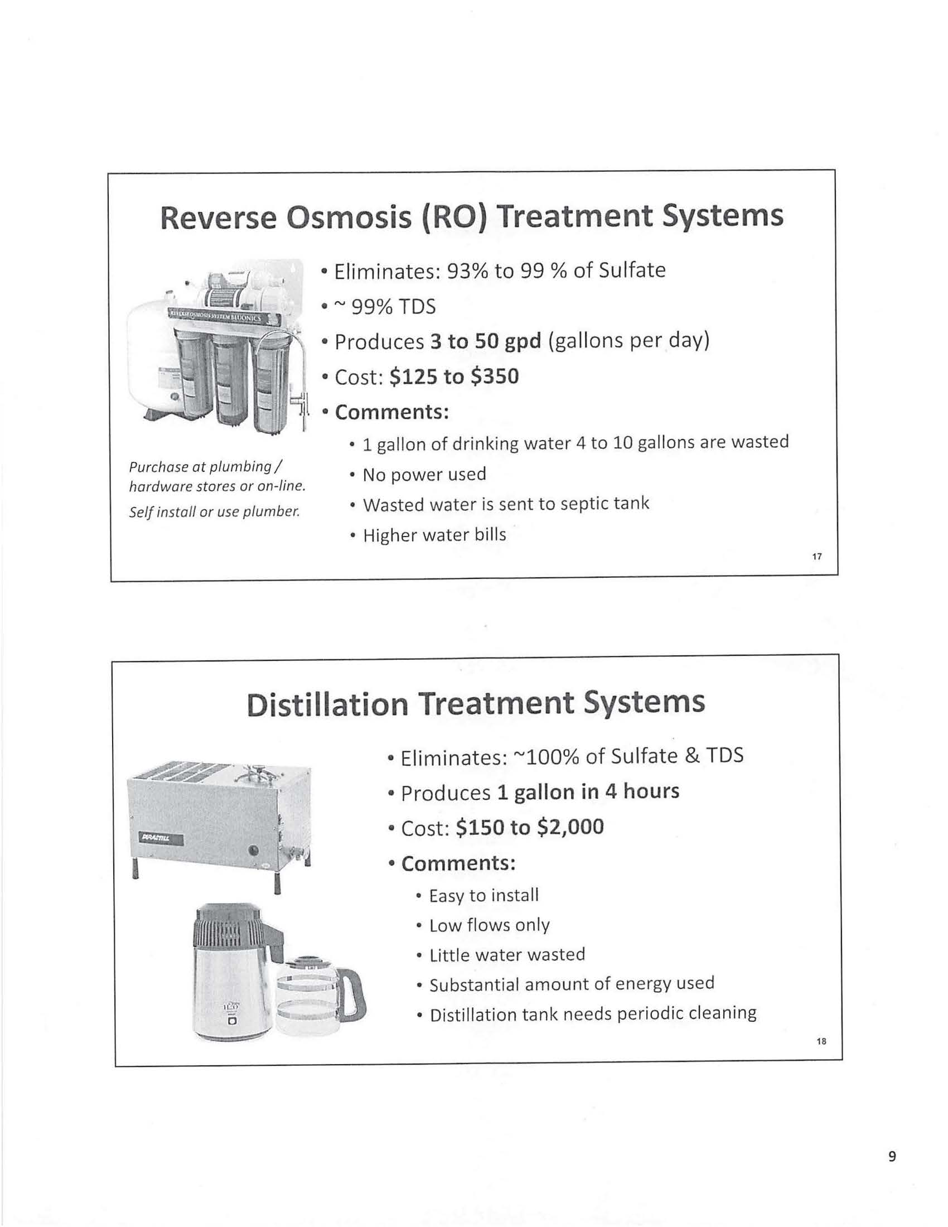

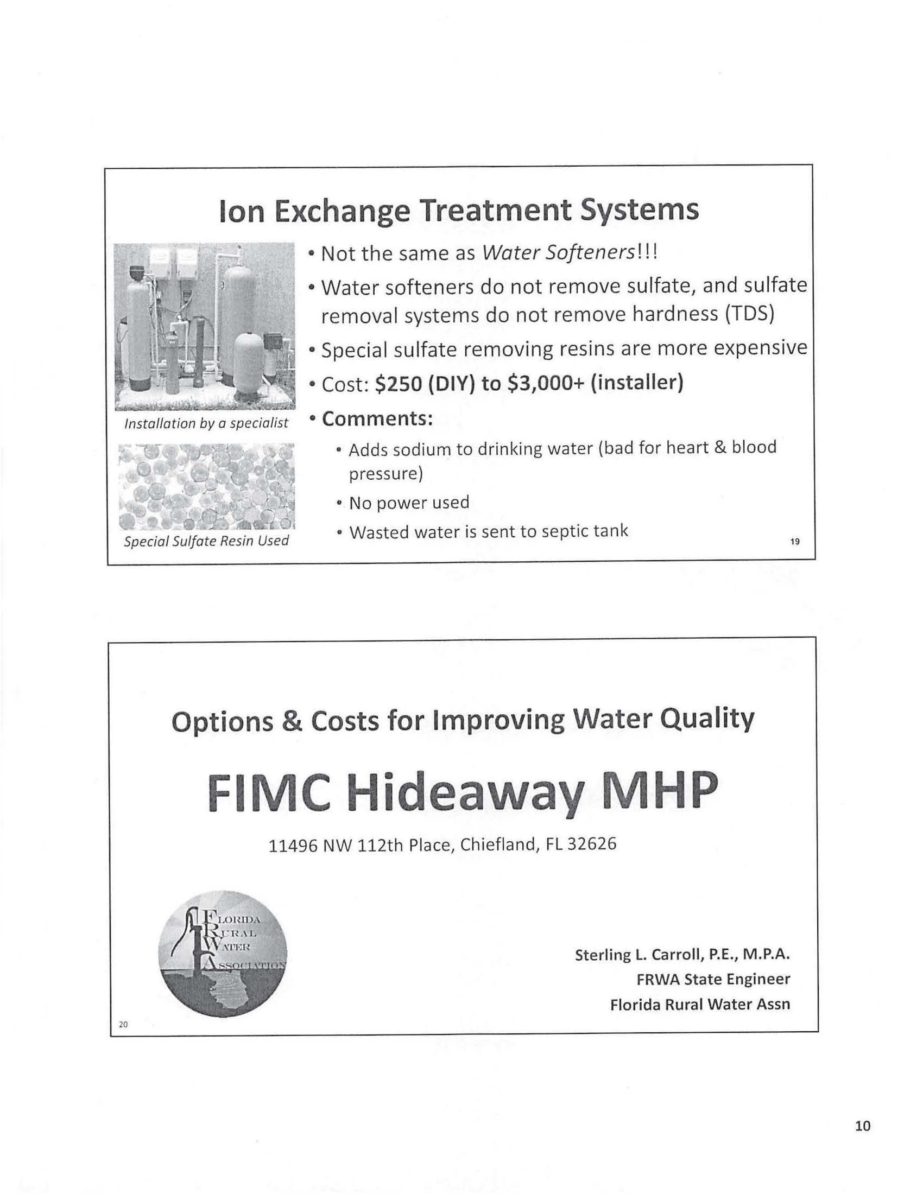

Order No. 13497, issued July 10, 1984, in Docket No. 19830552-WS, In re: Application of Hideaway Service, Inc. for a certificate to operate a water and sewer utility in Levy County.
Order No. 25584, issued January 8, 1992, in Docket No. 19910672-WS, In re: Application for transfer of Certificates Nos. 426-W and 362-S from Hideaway Service, Inc. to FIMC Hideaway, Inc. in Levy County.
Order No. PSC-05-0298-PAA-WS, issued March 18, 2005, in Docket No. 20040152-WS, In re: Application for transfer of majority organizational control of FIMC Hideaway, Inc. in Levy County from Florida Investors Mortgage Corporation, a Florida corporation, to Robert and Janet McBride.
Order No. PSC-09-0279-PAA-WS, issued April 29, 2009, in Docket No. 20080268-WS, In re: Joint Application for transfer of the Springside water and wastewater systems from Par Utilities, Inc. in Levy County to FIMC Hideaway, Inc.:, amendment of Certificates 426-W and 362-S held by FIMC Hideaway, Inc.; and amendment of Certificate 428-W and cancellation of Certificate 366-S held by Par Utilities, Inc.
The FRWA’s summary contains a scrivener’s error stating that the customer meeting occurred on April 24, 2019.

