State of Florida |  | Public Service Commission  Capital Circle Office Center ● 2540 Shumard Oak Boulevard  Tallahassee, Florida 32399-0850  -M-E-M-O-R-A-N-D-U-M-
DATE: | July 25, 2019
TO: | Office of Commission Clerk (Teitzman)
FROM: | Division of Economics (Sibley, Hudson)  Office of the General Counsel (Simmons)
RE: | Docket No. 20190133-WS – Application for approval of an 8" general service meter rate by Pluris Wedgefield, LLC.
AGENDA: | 08/06/19 – Regular Agenda – Tariff Filing – Interested Persons May Participate
COMMISSIONERS ASSIGNED: |  |  | All Commissioners
PREHEARING OFFICER: |  |  | Administrative
CRITICAL DATES: |  |  | 08/16/19 (60-Day Suspension Date)
SPECIAL INSTRUCTIONS: |  |  | None

Case Background
Pluris Wedgefield, LLC (Pluris or utility) is a Class A utility providing water service to 1,811 customers and wastewater service to 1,667 customers in Orange County. Water and wastewater rates were last established for this utility in 2017. According to the utility’s 2018 Annual Report, operating revenues were $1,507,075 for water and $982,652 for wastewater and operating expenses were $1,454,960 for water and $970,507 for wastewater.
On June 18, 2019, the utility applied for approval of an eight inch turbine general service meter rate in Orange County for both its water and wastewater systems. Pluris has added a general service customer that receives services through an eight inch turbine meter. The utility’s existing water and wastewater general service tariff sheets only provide base facility charges (BFCs) for meters sizes up to six inches. This recommendation addresses the utility’s request to include in its water and wastewater tariffs a BFC for an eight inch turbine meter. The proposed tariffs are shown in Attachment A of the recommendation. The Commission has jurisdiction pursuant to Sections 367.081 and 367.091, Florida Statutes (F.S.).

Discussion of Issues

Issue 1:
Should the utility's proposed tariffs containing the eight inch turbine general service meter be approved?

Recommendation:
Yes. The utility’s proposed tariffs as shown in Attachment A containing the eight inch turbine general service meter should be approved as filed because it is consistent with Rule 25-30.437(6), Florida Administrative Code (F.A.C.). The approved rates should be effective for service rendered on or after the stamped approval date on the tariff sheets pursuant to Rule 25-30.475(1), F.A.C. (Sibley)

Staff Analysis:
As stated in the case background, Pluris has added a general service customer that receives services through an eight inch turbine meter. The utility’s existing water and wastewater general service tariff sheets only provide BFCs for meter sizes up to six inches.
The utility’s proposed water BFC of $2,509.20 and wastewater BFC of $2,784.60 for the eight inch turbine meter is calculated by using the utility’s existing BFC for the 5/8” x 3/4” meter size of $27.88 for water and $30.94 for wastewater (Attachment A). This is done using the BFC as the foundation and applying the American Water Works Association meter equivalent factor as the usage characteristics onto the foundation (5/8” x 3/4” meter BFC times 90). This is consistent with Rule 25-30.437(6), F.A.C., which states that the rates are first established with the 5/8'' x 3/4'' meter as the foundation and for meter sizes larger than 5/8'', the base facility charge shall be based on the usage characteristics. The utility anticipates serving the one water only customer, which provides additional revenues of approximately $35,000. This represents an approximate revenue increase of 2.3 percent for water and will not have a material effect on the utility’s overall rate of return.
It is incumbent on public utilities to charge only those rates filed with and approved by the Commission pursuant to Section 367.081, F.S. Staff notes that the rate is the appropriate amount for the eight inch meter size. However, the utility should be cautioned to charge only those rates reflected in its Commission-approved tariffs.
Based on the above, the utility's proposed tariffs containing the eight inch turbine general service meter should be approved as filed because it is consistent with Rule 25-30.437(6), F.A.C. The approved rates should be effective for service rendered on or after the stamped approval date on the tariff sheets pursuant to Rule 25-30.475(1), F.A.C.

Issue 2:
Should this docket be closed?

Recommendation:
Yes. If Issue 1 is approved, the tariff sheets should become effective on or after the stamped approval date on the tariff sheets pursuant to Rule 25-30.475, F.A.C. If a protest is filed within 21 days of the issuance of the Order, the tariff should remain in effect with the revenues held subject to refund pending resolution of the protest and the docket should remain open. If no timely protest is filed, the docket should be closed upon the issuance of a Consummating Order. (Simmons)

Staff Analysis:
If Issue 1 is approved, the tariff sheets should become effective on or after the stamped approval date on the tariff sheets pursuant to Rule 25-30.475, F.A.C. If a protest is filed within 21 days of the issuance date of the Order, the tariff should remain in effect with the revenues held subject to refund pending resolution of the protest and the docket should remain open. If no timely protest is filed, the docket should be closed upon the issuance of a Consummating Order.

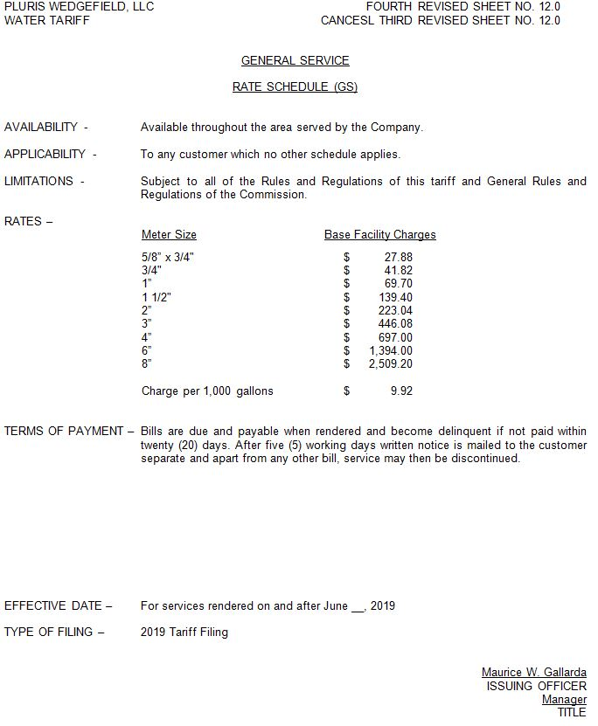

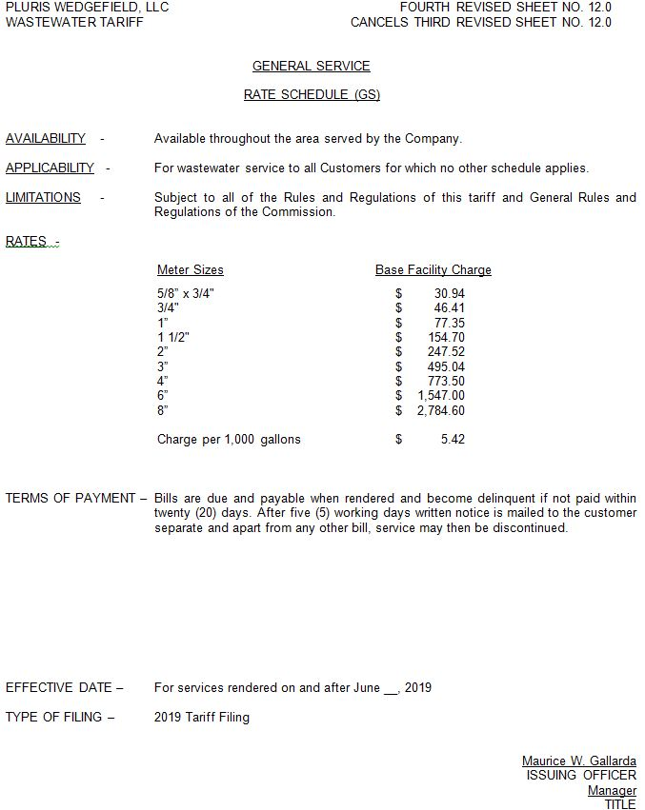

Order No. PSC-2018-0311-PAA-WS, issued June 13, 2018, in Docket No. 20170166-WS, In re: Application for limited proceeding rate increase in Orange County by Pluris Wedgefield, Inc.

