BEFORE THE FLORIDA PUBLIC SERVICE COMMISSION

In re: Petition for recovery of costs associated with Hurricane Michael and replenishment of storm reserve, by Peoples Gas System. | DOCKET NO. 20190109-GU  ORDER NO. PSC-2019-0310-PCO-GU  ISSUED: July 29, 2019

The following Commissioners participated in the disposition of this matter:

ART GRAHAM, Chairman
JULIE I. BROWN
DONALD J. POLMANN
GARY F. CLARK
ANDREW GILES FAY

ORDER APPROVING INTERIM STORM RECOVERY CHARGE

BY THE COMMISSION:

Background
On April 25, 2019, Peoples Gas System (Peoples or Company) filed a petition for recovery of approximately $3.4 million for the incremental restoration costs related to Hurricane Michael and to replenish the Company’s storm reserve. In its petition, Peoples asserted that, as a result of Hurricane Michael, it incurred total retail recoverable cost of approximately $3.3 million, which exceeds and fully depletes the pre-storm balance of $79,125 in Peoples’ storm reserve. Interest and the regulatory assessment fee gross-up add an additional $70,650. Peoples also requested recovery of $27,255 related to the write-off of accounts receivable for service provided prior to Hurricane Michael.
Peoples proposed a $0.76 surcharge per month on the typical residential customer bill for storm recovery and restoration. The charge would be applied to all bills starting the first billing cycle of August 2019 and concluding at the end of the billing cycle when storm costs have been recovered and the reserve is replenished to the September 30, 2018 pre-storm balance of $79,125. Peoples requested that any over-recovery variance between the surcharge dollars and the incremental storm costs be applied to Peoples’ storm reserve.
On May 24, 2019, Peoples requested that its request be placed on the July Commission Conference. Peoples discussed this matter with counsel for OPC and all agreed with the July date. In its request, Peoples also waived the 60-day decision requirement under Section 366.06(3), Florida Statutes (F.S.).
The Office of Public Counsel (OPC) intervened in this docket on May 2, 2019.
On July 3, 2019, Peoples and OPC filed a Joint Notice of Partial Stipulation in which PGS agreed to remove its request to recover $27,255.00 of uncollected accounts. In return, OPC does not object to Peoples’ interim surcharge, subject to final true-up of allowable incremental costs in a future proceeding.
We have has jurisdiction over this matter pursuant to Sections 366.04, 366.05, 366.06, and 366.076, F.S.

Decision
Interim Storm Restoration Recovery Charge
Peoples filed a petition to recover costs associated with Hurricane Michael and to replenish its storm reserve. In its petition, Peoples asserted that, as a result of Hurricane Michael, it incurred total retail recoverable cost of $3.4 million, which fully depleted the pre-storm balance of $79,125 in the Company’s storm reserve. Peoples further asserts that this amount was calculated in accordance with the Incremental Cost and Capitalization Approach methodology prescribed in Rule 25-6.0143, Florida Administrative Code (F.A.C.). Peoples has requested implementing a surcharge starting with the first billing cycle in August 2019 and concluding when the storm reserve has been restored to the pre-storm balance of $79,125. Peoples anticipates this to occur in December 2019.
The approval of an interim storm restoration recovery charge is preliminary in nature and subject to refund pending further review once the total actual storm restoration costs are known. After the actual costs are reviewed for prudence and reasonableness, and are compared to the actual amount recovered through the interim storm restoration recovery charge, a determination shall be made whether any over or under recovery has occurred. The disposition of any over or under recovery, and associated interest, will be considered by this Commission at a later date.

Based on a review of the information provided by Peoples in its petition, we approve Peoples’ petition to implement an interim storm restoration recovery charge, subject to refund. This only allows Peoples to begin recovery on an interim basis. This interim recovery should be subject to refund pending a hearing or formal proceeding where the veracity and prudence of Peoples’ actual restoration costs can be fully vetted.

Proposed Tariffs and Associated Charges
Peoples is seeking approval of interim storm cost recovery charge factors as shown in proposed original tariff sheet no. 7.101-10. (Attachment A). Peoples’ Exhibit C to the petition provided the calculation of the storm cost recovery charge factors for all rate classes. Exhibit D to the petition included revisions to all tariffs reflecting the addition of the interim storm recovery charges as shown on tariff sheet no. 7.101-10. Under the proposed tariff, a residential customer, with an average monthly usage of 12.8 therms per month, would see a $0.76 increase on the monthly bill beginning with the first billing cycle in August 2019.
Peoples indicated that the customers will be notified of the interim storm cost recovery charge factors via bill inserts on the first billing cycle in July 2019.

Peoples’ proposed tariffs are approved to go into effect with the first billing cycle in August 2019.

Appropriate Security to Guarantee Amount Collected Subject to Refund Through the Interim Storm Restoration Recovery Charge
All funds collected subject to refund shall be secured by a corporate undertaking. The criteria for a corporate undertaking include sufficient liquidity, ownership equity, profitability, and interest coverage to guarantee any potential refund. A review of Peoples’ financial statements to determine if the Company can support a corporate undertaking to guarantee the funds collected for recovery of incremental storm restoration costs related to Hurricane Michael. Peoples’ 2016, 2017, and 2018 financial statements were used to determine the financial condition of the Company. We find that Peoples’ financial performance demonstrates adequate levels of ownership equity, profitability, and interest coverage, but deficient liquidity due to negative working capital. However, Peoples’ average net income is 12 times the requested amount.
Our review supports a finding that Peoples has adequate resources to support a corporate undertaking in the amount requested. Based on this analysis, we find that a corporate undertaking of $3.4 million is acceptable. Our brief financial analysis is only appropriate for deciding if the Company can support a corporate undertaking in the determined amount and should not be considered a finding regarding other issues in this proceeding.

Based on the foregoing, it is

ORDERED by the Florida Public Service Commission that Peoples Gas System is hereby authorized to implement an interim storm restoration recovery charge subject to refund. It is further

ORDERED that Peoples Gas System’s tariffs as proposed in the petition are approved and shall go into effect with the first billing cycle in August 2019. It is further

ORDERED that the appropriate security to guarantee the funds collected subject to refund is a corporate undertaking. It is further

ORDERED that this docket shall remain open pending final reconciliation of actual recoverable Hurricane Michael storm costs with the amount collected pursuant to the interim storm restoration recovery charge. The disposition of any over or under recovery, and associated interest, shall be considered by the Commission at a later date.
By ORDER of the Florida Public Service Commission this 29th day of July, 2019.

/s/ Adam J. Teitzman
ADAM J. TEITZMAN
Commission Clerk
Florida Public Service Commission
2540 Shumard Oak Boulevard
Tallahassee, Florida 32399
(850) 413-6770
www.floridapsc.com

Copies furnished: A copy of this document is provided to the parties of record at the time of issuance and, if applicable, interested persons.

WLT

NOTICE OF FURTHER PROCEEDINGS

The Florida Public Service Commission is required by Section 120.569(1), Florida Statutes, to notify parties of any administrative hearing or judicial review of Commission orders that is available under Sections 120.57 or 120.68, Florida Statutes, as well as the procedures and time limits that apply. This notice should not be construed to mean all requests for an administrative hearing or judicial review will be granted or result in the relief sought.

Mediation may be available on a case-by-case basis. If mediation is conducted, it does not affect a substantially interested person's right to a hearing.

Any party adversely affected by this order, which is preliminary, procedural or intermediate in nature, may request: (1) reconsideration within 10 days pursuant to Rule 25-22.0376, Florida Administrative Code; or (2) judicial review by the Florida Supreme Court, in the case of an electric, gas or telephone utility, or the First District Court of Appeal, in the case of a water or wastewater utility. A motion for reconsideration shall be filed with the Office of Commission Clerk, in the form prescribed by Rule 25-22.0376, Florida Administrative Code. Judicial review of a preliminary, procedural or intermediate ruling or order is available if review of the final action will not provide an adequate remedy. Such review may be requested from the appropriate court, as described above, pursuant to Rule 9.100, Florida Rules of Appellate Procedure

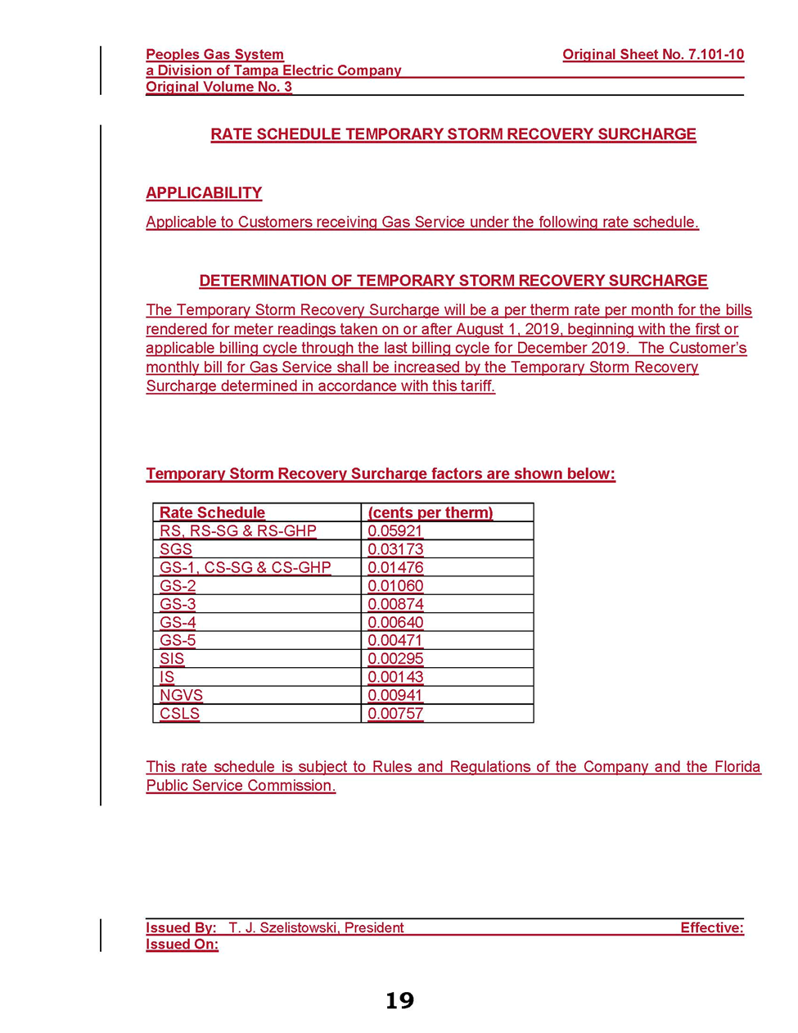

Document No. 04543-2019, filed May 24, 2019, in Docket No. 20190109-GU.

