BEFORE THE FLORIDA PUBLIC SERVICE COMMISSION

In re: Investigation into the billing practices of K W Resort Utilities Corp. in Monroe County. | DOCKET NO. 20170086-SU  ORDER NO. PSC-2019-0338-PAA-SU  ISSUED: August 21, 2019

The following Commissioners participated in the disposition of this matter:

JULIE I. BROWN
DONALD J. POLMANN
ANDREW GILES FAY

NOTICE OF PROPOSED AGENCY ACTION
ORDER APPROVING STIPULATION AND SETTLEMENT
AND SETTLEMENT OFFER

BY THE COMMISSION:

NOTICE is hereby given by the Florida Public Service Commission that the action discussed herein is preliminary in nature and will become final unless a person whose interests are substantially affected files a petition for a formal proceeding, pursuant to Rule 25-22.029, Florida Administrative Code (F.A.C.).

BACKGROUND

This docket was opened to investigate the billing practices of K W Resort Utilities Corporation (KWRU) to determine if KWRU had violated any Commission order, rule or statute. An audit was conducted by Commission staff for the period of April 2013 through March 2017, in which KWRU was found to have charged rates inconsistent with its tariffs. Based on this audit, Order No. PSC-2018-0444-PAA-SU (Order No. PSC-2018-0444) was issued on August 31, 2018.

The proposed agency action portion of Order No. PSC-2018-0444 found that:

- The April 2013 through March 2017 audit period utilized by Commission staff was reasonable.

- The appropriate time period for the refunds was April 2013 through March 2016.

- KWRU was required to refund Safe Harbor (Safe Harbor) $26,408 with interest in accordance with Rule 25-30.360, Florida Administrative Code (F.A.C.).

- KWRU was required to refund Sunset (Sunset) $41,034 with interest in accordance with Rule 25-30.360, F.A.C.

- KWRU was not required to refund rates charged for pools due to KWRU’s reasonable belief that the approved tariff for pools it had for Key West Golf Club–HOA “was applicable to any additional customers with pools.”

- KWRU did not have to refund general service customers that were billed base facility charges (BFC) based on units instead of Florida Keys Aqueduct Authority (FKAA) metered rates for several reasons: 1) the error occurred during the transition from flat to volumetric for residential customers in which a billing software error incorrectly identified these customers as residential units; 2) the billing determinants in KWRU’s 2009 rate case may have been based on units rather than meter sizes; and 3) KWRU corrected its billing practices following the implementation of Order No. PSC-16-0123-PAA-SU.

- KWRU’s settlement with Roy’s Trailer Park was a reasonable solution to address that customer’s corrected outstanding balance from being billed by KWRU based on units instead of FKAA meters.

The show cause portion of Order No. PSC-2018-0444 directed KWRU to show cause why it should not be fined a $10,000 penalty for violations of Sections 367.081(1) and 367.091(3), Florida Statutes (F.S.).

The Office of Public Counsel (OPC) filed a protest of the PAA Order on September 21, 2018. In its protest, OPC raised the issues of whether Rule 25-30.350, F.A.C., requires that refunds be granted for the entire period that overbilling took place, 2009 through April 2016, and the calculation of customer refunds. KWRU filed a Cross Petition for Formal Evidentiary Hearing (Cross Petition) on October 1, 2018. In its Cross Petition, KWRU protested the $10,000 penalty (Show Cause Order) and the refunds ordered for Safe Harbor and other customers. On March 14, 2019, Order No. PSC-2019-0101-PCO-SU (OEP) was issued setting a final hearing on the PAA order issues raised by OPC and KWRU for September 17-18, 2019.

On May 17, 2019, KWRU and OPC filed a Joint Motion for Approval of Stipulation and Settlement (Stipulation and Settlement). The Stipulation and Settlement is contained in Attachment A. The Stipulation and Settlement has the following provisions:
- Fourth Avenue, LLC shall be refunded $1,004.34 and ITNOR Waters Edge shall be refunded $1,025.49 within 30 days of Commission approval of the Stipulation and Settlement.
- OPC will withdraw its protest of the PAA Order filed on September 21, 2019.
- OPC takes no position on refunds to Safe Harbor or Sunset.
- The Stipulation and Settlement does not address the Show Cause portion of Order No. PSC-2018-0444.
- KWRU will limit its contested issues to refunds to Safe Harbor and Sunset (PAA Order) and the penalty (Show Cause Order).
- The Stipulation and Settlement must be approved by the Commission without modification.
On May 28, 2019, KWRU filed a Motion to Abate Proceedings. In its Motion to Abate, KWRU argued that the Stipulation and Settlement allowed both the PAA and Show Cause portions of Order No. PSC-2018-0444 to be resolved at an Agenda Conference, thereby negating the necessity for a formal evidentiary hearing. On June 4, 2019, KWRU filed the direct testimony of Christopher A. Johnson. The Motion to Abate was granted on June 14, 2019, by Order No. PSC-2019-0235-PCO-SU, suspending the hearing schedule in this docket until further notice.
On June 14, 2019, KWRU also filed an Offer of Settlement (KWRU Offer) to resolve the remaining issues in this docket not addressed in the Stipulation and Settlement. The KWRU Offer is contained in Attachment B. The KWRU Offer contains the following provisions:
- The Settlement Agreement and Release between Safe Harbor and KWRU dated May 12, 2016, Exhibit CAJ-9 to witness Johnson’s direct testimony, releases KWRU from any refund which may be due to Safe Harbor in this docket for overbilling and no additional refunds are necessary.
- The Settlement Agreement and Release between Sunset and KWRU dated October 23, 2019, Exhibit CAJ-8 to witness Johnson’s direct testimony, states that the payment of $41,034.00 by KWRU to Sunset is a complete satisfaction of any claim that Sunset is owed any additional refunds for overbilling by KWRU and no additional refunds are necessary.
- KWRU is willing to pay a penalty of $2,500.00 for improper billing.
Unlike most cases when a settlement is reached by the parties where an evidentiary hearing is scheduled, our staff has made recommendations with regard to Issues 1 and 2, the Stipulation and Settlement and KWRU’s Offer, both of which were filed to resolve the unique facts and posture of this case. The protested order involved refunds to customers for which staff is not a party, and a fine for which staff is a party and acts in a prosecutorial role. Because all issues have become so intertwined, we find that it an appropriate and expedient process for our staff to have made substantive recommendations on all settlement and stipulation issues before us.

This order addresses both the Stipulation and Settlement and KWRU Offer. We have jurisdiction pursuant to Section 367.081, F.S.

DECISION

The Stipulation and Settlement filed by the parties on May 17, 2019, proposes to settle several legal and billing issues addressed in Order No. PSC-2018-0444 that were protested by OPC and cross-protested by KWRU. Specifically, the Stipulation and Settlement requires KWRU to issue refunds to two additional KWRU customers: $1,004.34 to Fourth Ave., LLC, and $1,025.49 to ITNOR Waters Edge, within 30 days of our approval of the Stipulation and Settlement. These refunds would be paid in addition to any refunds issued up until the time of the filing of the Stipulation and Settlement,
OPC also agrees to withdraw its protest of the PAA Order and take no position regarding further refunds to Safe Harbor or Sunset. The parties also state that the Stipulation and Settlement “is in the best interests of both the Utility and its customers.” In sum, OPC has agreed to waive its right to a hearing on the factual and legal PAA Order issues it protested in exchange for the payment of refunds to two additional customers incorrectly billed by the use of BFCs based on the number of units or individual dwellings present behind a master meter, rather than based on the customer’s meter size.
Under the terms of the Stipulation and Settlement, KWRU is able to contest the refunds for Safe Harbor and Sunset (PAA Order issues) and the penalty issue (Show Cause Order issue). In its Motion to Abate, KWRU made the representation that approval of the Stipulation and Settlement would enable KWRU to resolve both the PAA and Show Cause Order issues “at the Commission Conference, negating the necessity for a formal administrative hearing.” From this statement, we conclude that if given an opportunity to present oral argument on the PAA and Show Cause Order issues at an Agenda Conference, KWRU envisions waiving its right to an evidentiary hearing on these issues.
Both OPC and KWRU have entered into the Stipulation and Settlement in good faith and represent that it is in the public interest. The Stipulation and Settlement resolves some protested billing issues and provides an administratively efficient means of resolving the issues that remain: Safe Harbor and Sunset refunds and the $10,000 penalty. Given these unique facts, the parties argue that the Stipulation and Settlement appears to be in the public interest and to fairly and reasonably settle the issues between KWRU and OPC in this docket. The KWRU Offer of Settlement (KWRU Offer) proposes to settle the remaining issues in this docket that were not addressed by the Stipulation and Settlement. The KWRU Offer asks that this Commission approve resolutions to the refund amounts due to Safe Harbor and Sunset and approve a lower amount for the Show Cause penalty.
Regarding the remaining refunds due to Safe Harbor and Sunset, KWRU filed the Settlement Agreement and Release it has reached with each party as exhibits to witness Christopher Johnson’s Prefiled Direct Testimony filed on June 4, 2019. The KWRU Offer asserts that the Settlement Agreement and Release reached with Safe Harbor on May 12, 2016, resolved a number of issues between KWRU and Safe Harbor “including, but not limited to, mutual obligations for refunds between the parties.” Further, the KWRU Offer states that, pursuant to this agreement and release, “any refund which may be due to Safe Harbor in this docket is deemed satisfied and no additional refunds are necessary.” For Sunset, the KWRU Offer states that the Settlement Agreement and Release, dated October 23, 2018, reached between KWRU and Sunset, provides that in consideration of a payment made by KWRU to Sunset of $41,034.00, Sunset released KWRU from all claims related to any further refunds due that are addressed in Order No. PSC-2018-0444.
Regarding the Show Cause penalty, KWRU states that Commission staff, during the August 6, 2018 Agenda Conference recommended a penalty of $1,000; however we increased this penalty to $10,000. KWRU argues that this penalty “greatly exceeds a reasonable amount based upon the particular circumstances of the KWRU tariff at that time.” In support of this argument, KWRU points to the arguments it previously made at the August 6, 2018 Agenda Conference, pointing in particular to the following discussion from the Conference:
Ms. [Patti] Daniels: ….I do want to reiterate and emphasize to you is that Mr. Friedman is absolutely correct that the –the tariff lacked clarity for many, many years…
Commissioner Brown: Are you – Patti, are you saying, though, that staff had a role in some of the confusion that occurred?
Ms. Daniels: Absolutely Commissioner.
Commissioner Brown: Is that why staff is recommending a nominal fee of a thousand dollar fine?
Ms. Daniel: Absolutely.

In consideration of its arguments, KWRU’s Settlement requests that we approve a penalty of $2,500 to resolve the Show Cause portion of Order No. PSC-2018-0444.
Regarding the refunds to Safe Harbor and Sunset, it appears that KWRU and those customers have reached a mutually agreeable resolution of the amounts due to those customers. Regarding the Show Cause penalty, it appears that while KWRU did violate its approved tariff, KWRU has reasonably shown that Commission staff had at least some role in the confusion that KWRU asserts it had regarding the interpretation and application of the tariff. Finally, KWRU has corrected its billing practices and is currently billing in accord with its tariff. Given these unique facts, we find that it is reasonable and in the public interest to acknowledge the agreements between KWRU and both Marinas and approve a lower penalty of $2,500.
Based on the foregoing, it is

ORDERED by the Florida Public Service Commission that the Stipulation and Settlement jointly filed by KW Resort Utilities Corporation and the Office of Public Counsel on May 17, 2019, Attachment A to this order, is hereby approved. It is further

ORDERED that KW Resort Utilities Corporation’s Offer of Settlement dated June 13, 2019, Attachment B to this Order, is hereby approved. It is further

ORDERED that the provisions of this order, issued as Proposed Agency Action, shall become final and effective upon the issuance of a Consummating Order unless an appropriate petition, in the form provided by Rule 28-106.201, Florida Administrative Code, is received by the Commission Clerk, 2540 Shumard Oak Boulevard, Tallahassee, Florida 32399-0850, by the close of business on the date set forth in the “Notice of Further Proceedings” attached hereto. It is further

ORDERED that if no person whose substantial interests are affected by the Proposed Agency Action files a protest within 21 days of the issuance of the Order, this docket shall be administratively closed upon the issuance of a Consummating Order.

By ORDER of the Florida Public Service Commission this 21st day of August, 2019.

/s/ Adam J. Teitzman
ADAM J. TEITZMAN
Commission Clerk
Florida Public Service Commission
2540 Shumard Oak Boulevard
Tallahassee, Florida 32399
(850) 413-6770
www.floridapsc.com

Copies furnished: A copy of this document is provided to the parties of record at the time of issuance and, if applicable, interested persons.
SBr

NOTICE OF FURTHER PROCEEDINGS OR JUDICIAL REVIEW

The Florida Public Service Commission is required by Section 120.569(1), Florida Statutes, to notify parties of any administrative hearing that is available under Section 120.57, Florida Statutes, as well as the procedures and time limits that apply. This notice should not be construed to mean all requests for an administrative hearing will be granted or result in the relief sought.

Mediation may be available on a case-by-case basis. If mediation is conducted, it does not affect a substantially interested person's right to a hearing.

The action proposed herein is preliminary in nature. Any person whose substantial interests are affected by the action proposed by this order may file a petition for a formal proceeding, in the form provided by Rule 28-106.201, Florida Administrative Code. This petition must be received by the Office of Commission Clerk, 2540 Shumard Oak Boulevard, Tallahassee, Florida 32399-0850, by the close of business on September 11, 2019.

In the absence of such a petition, this order shall become final and effective upon the issuance of a Consummating Order.

Any objection or protest filed in this/these docket(s) before the issuance date of this order is considered abandoned unless it satisfies the foregoing conditions and is renewed within the specified protest period.

ATTACHMENT A
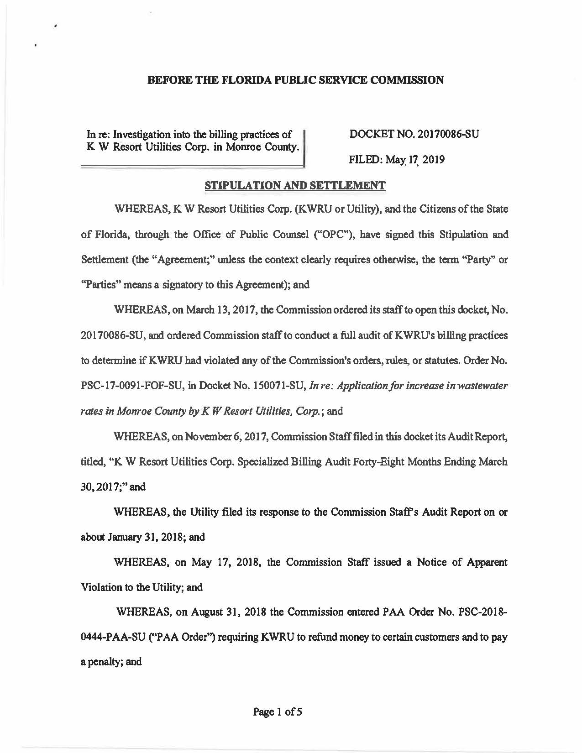

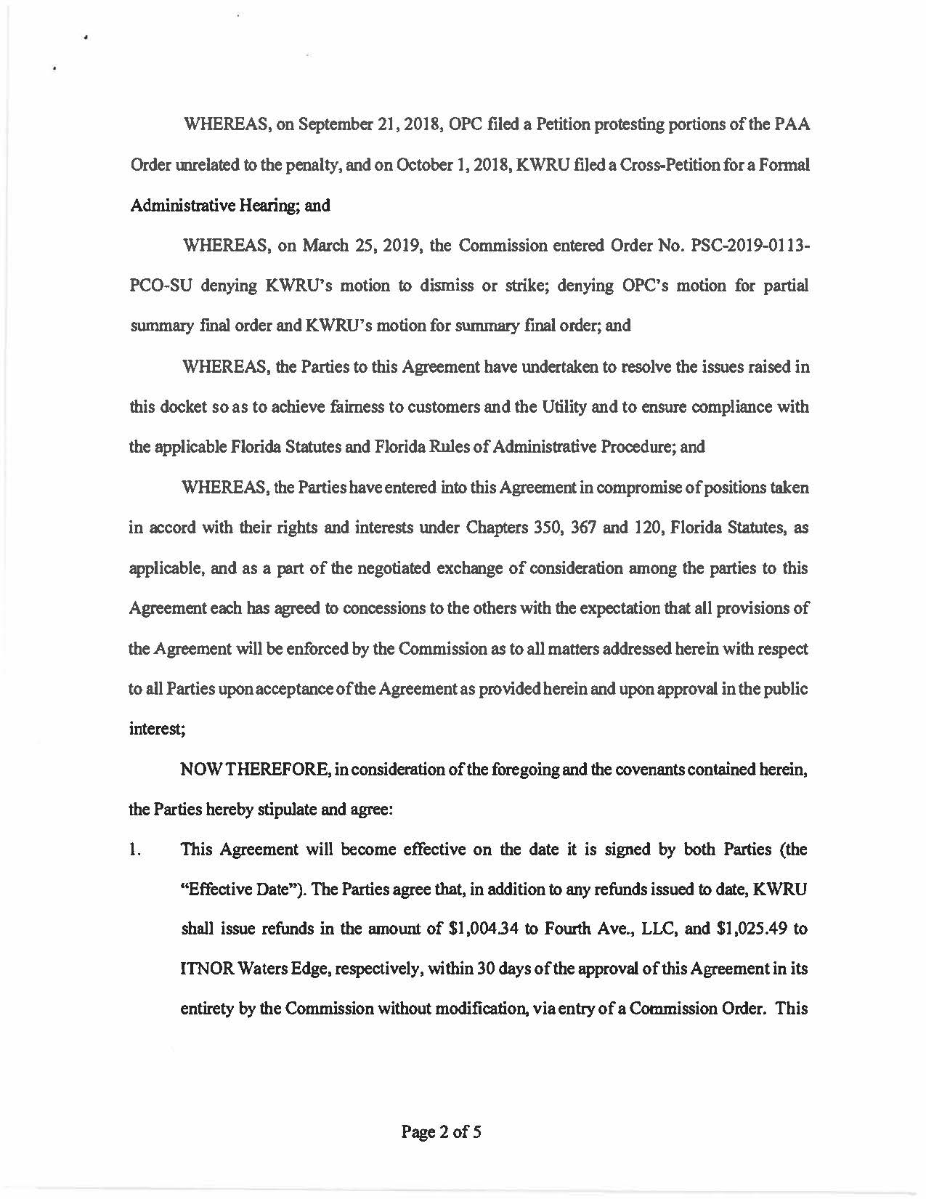

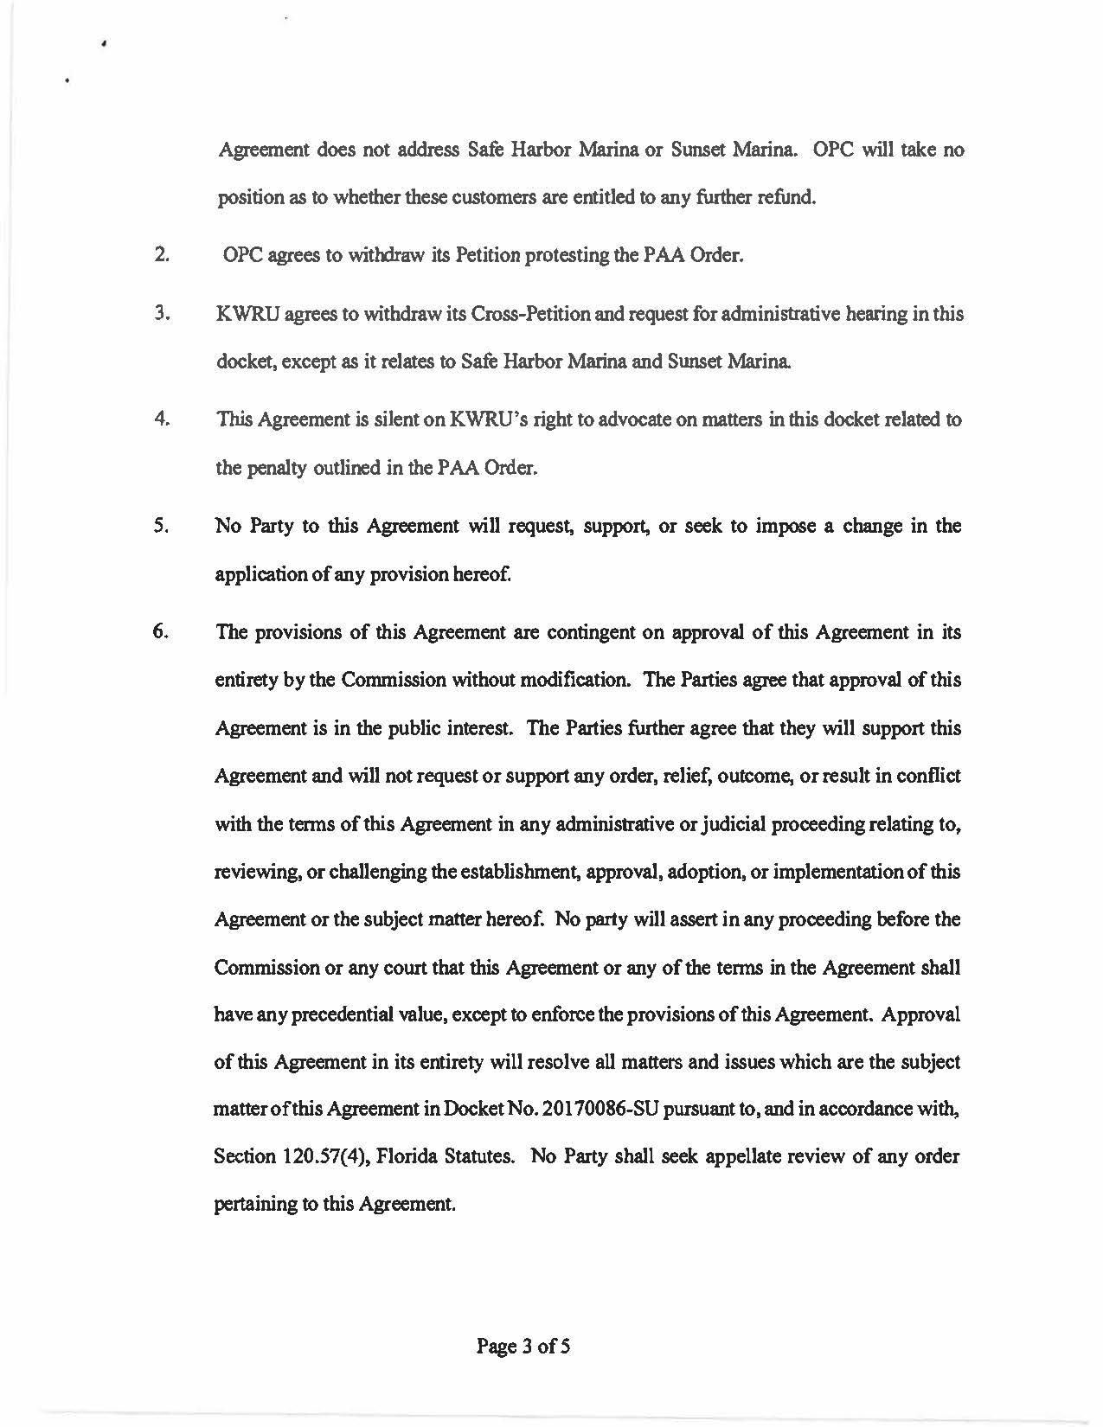

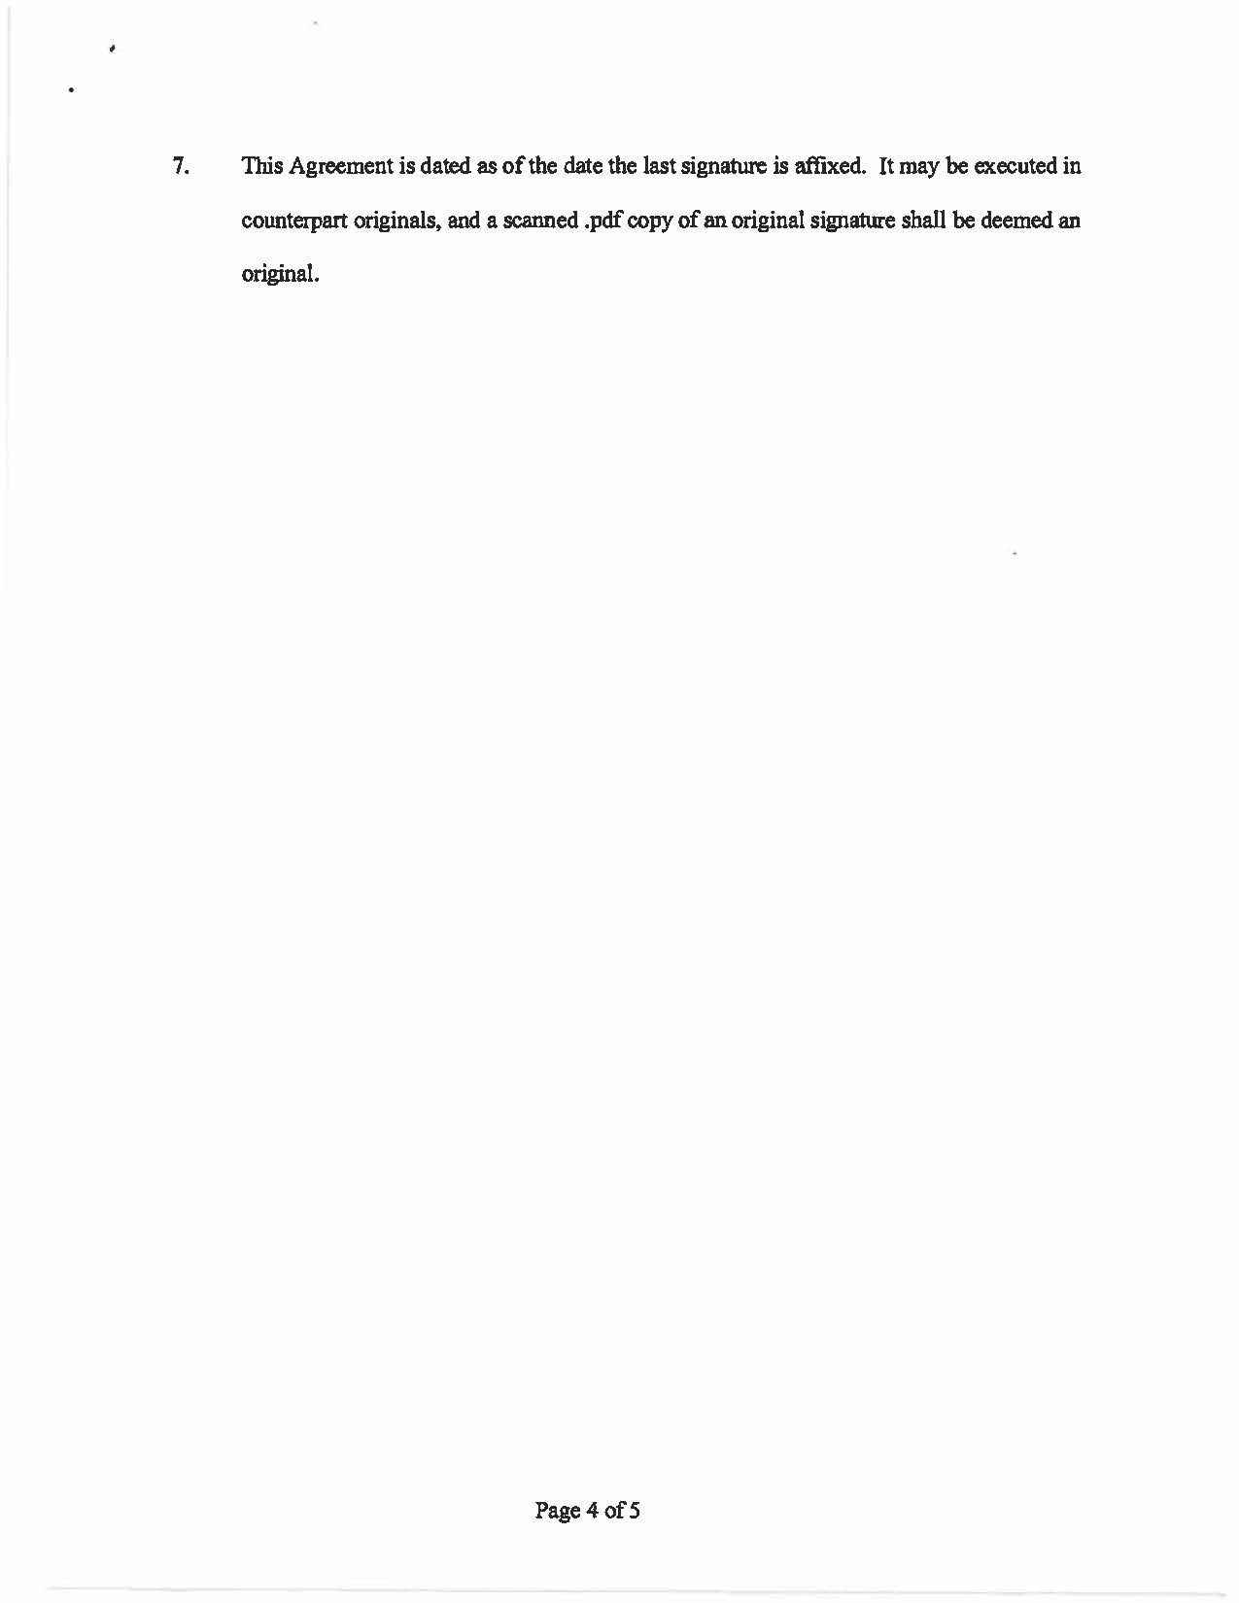

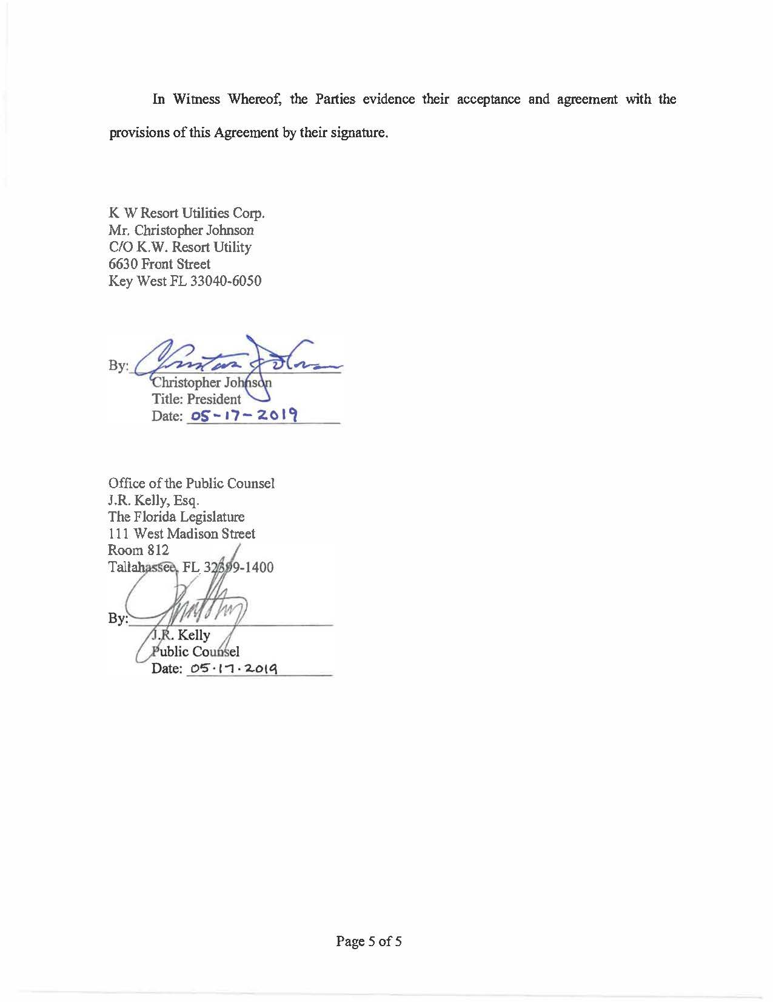

ATTACHMENT B
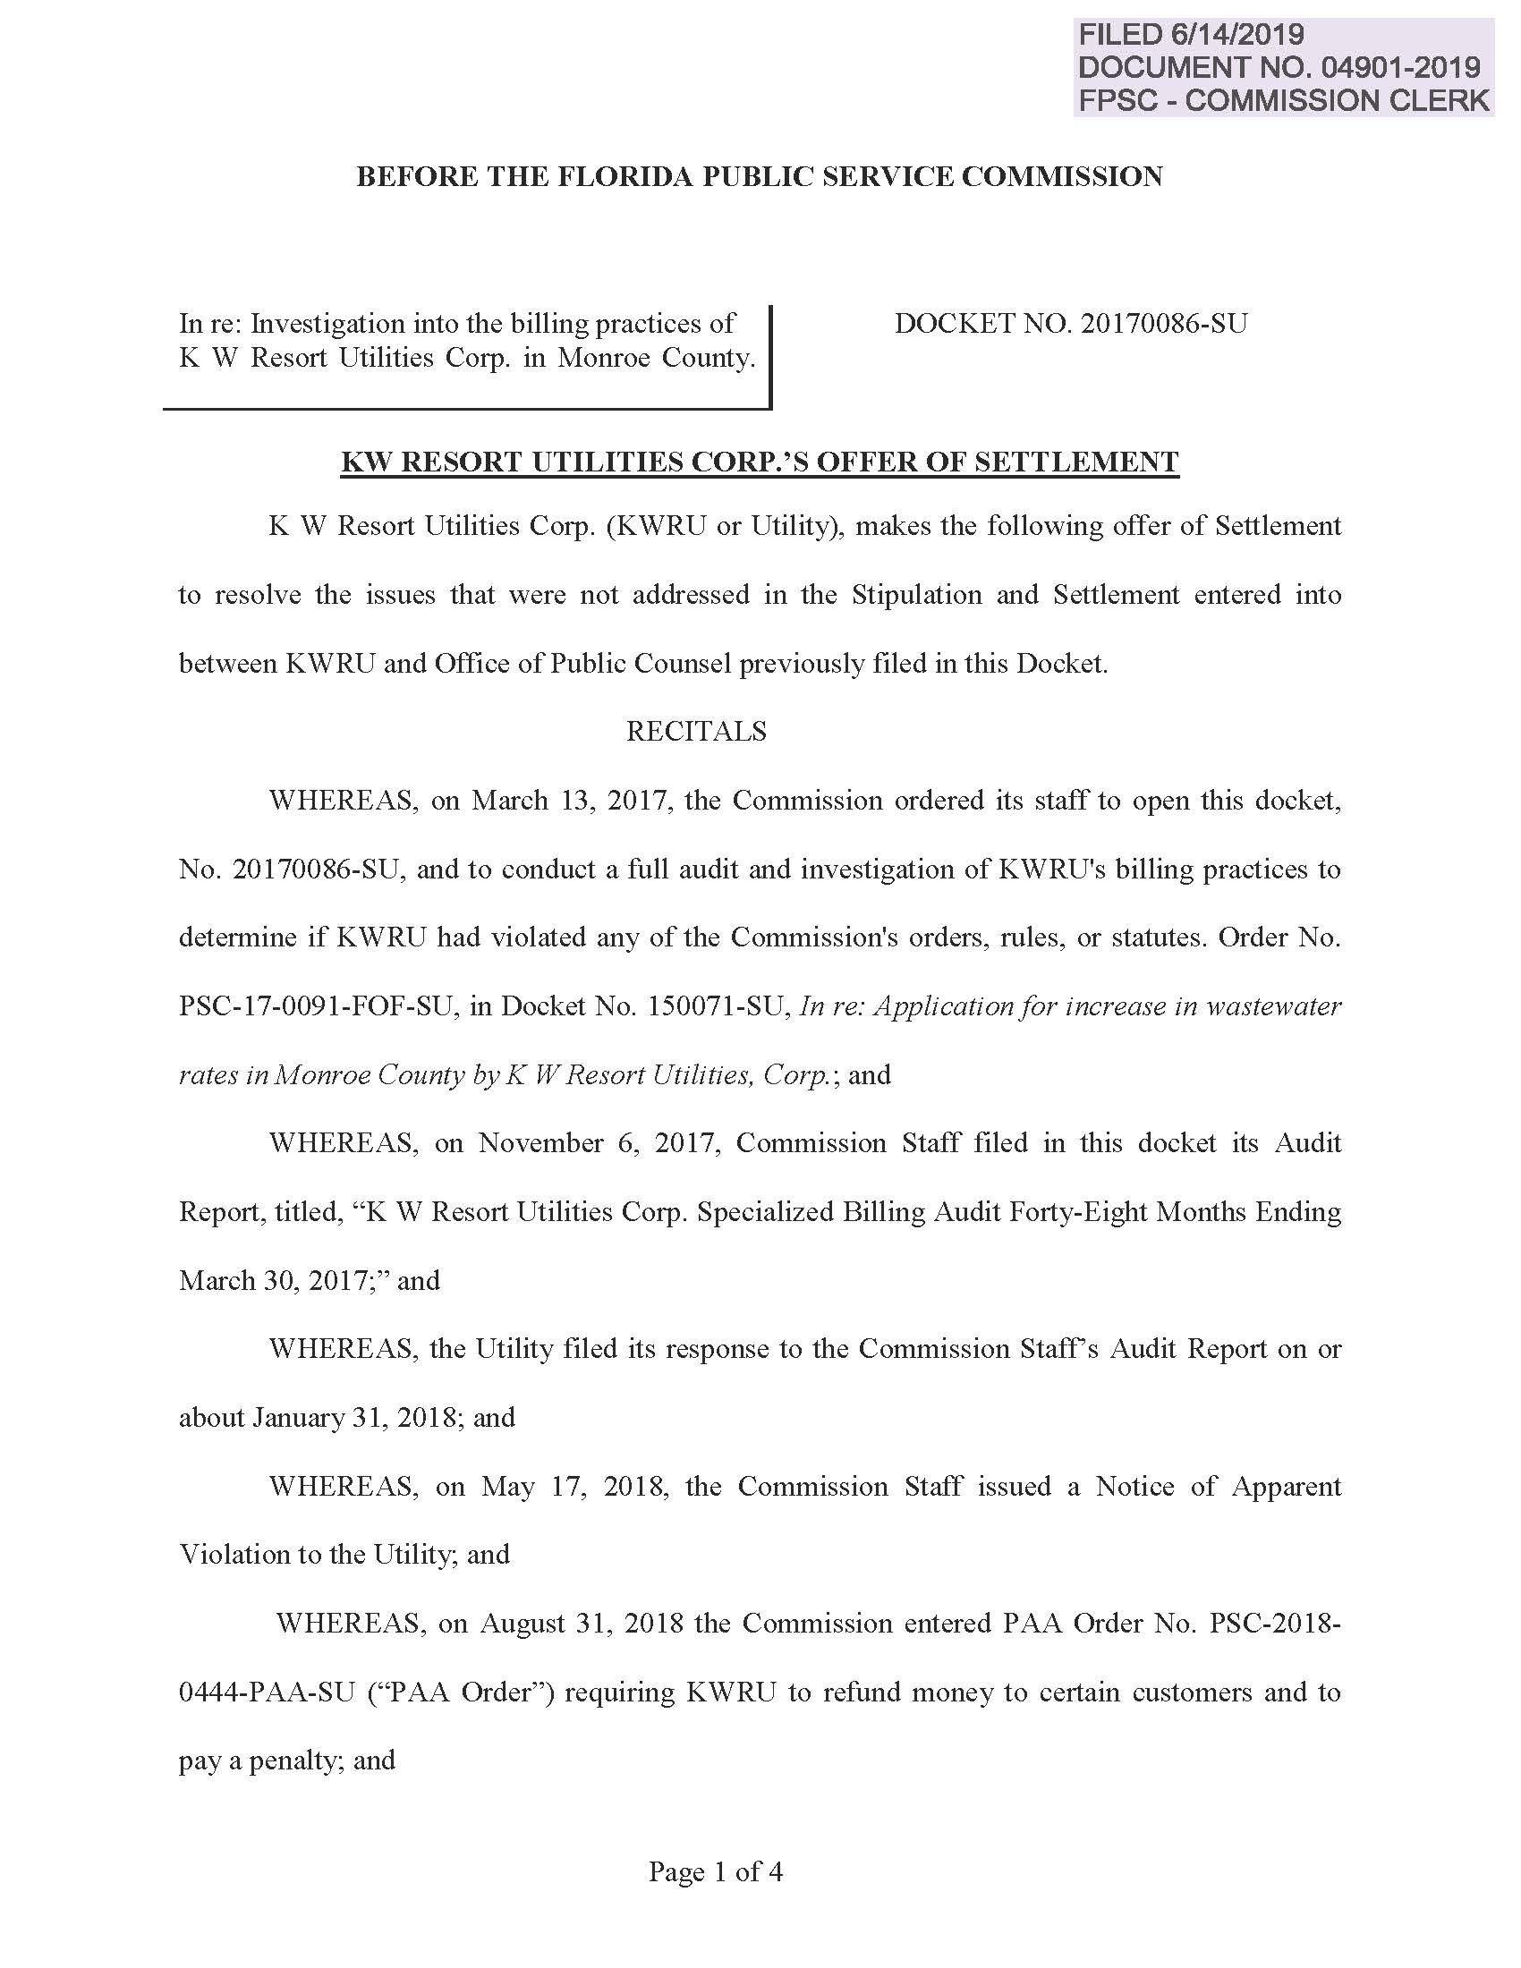

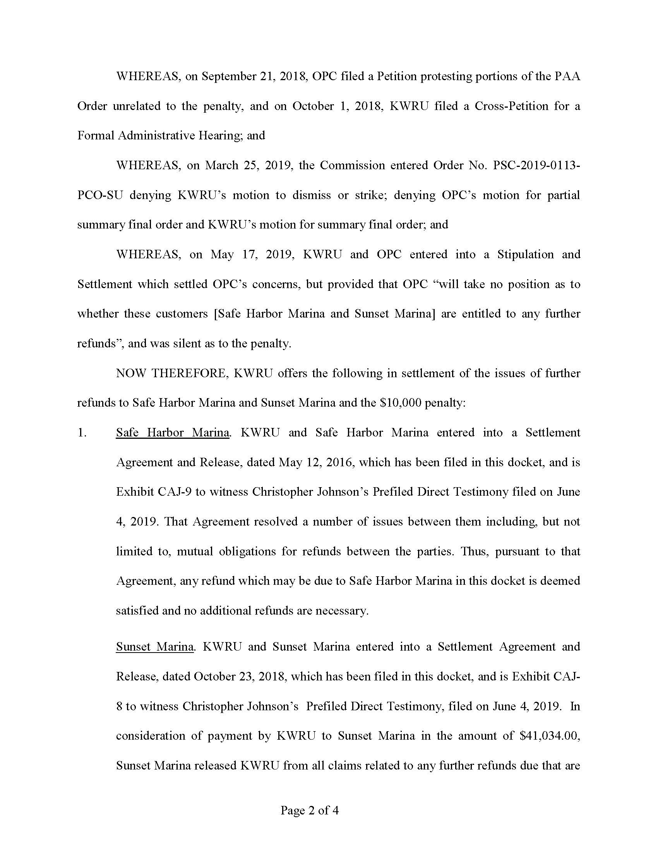

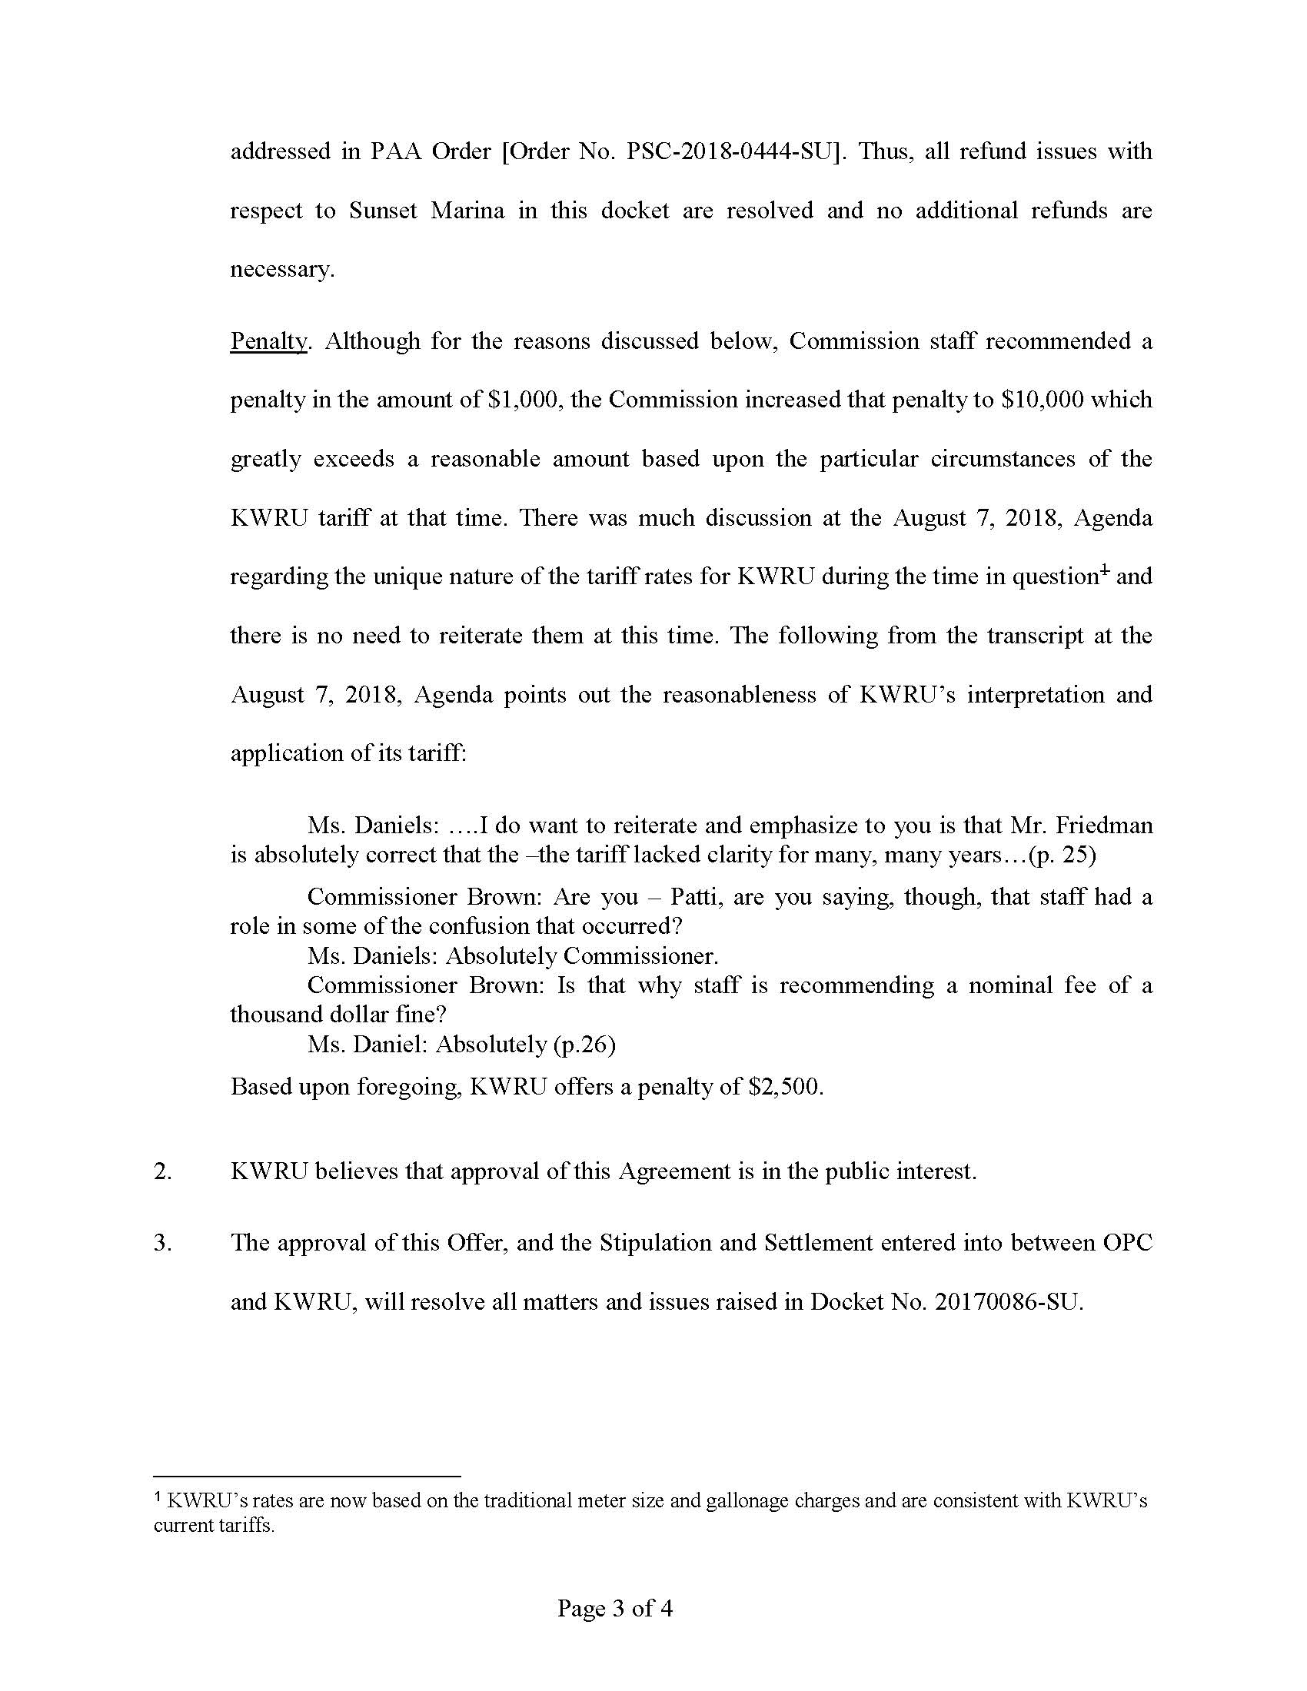

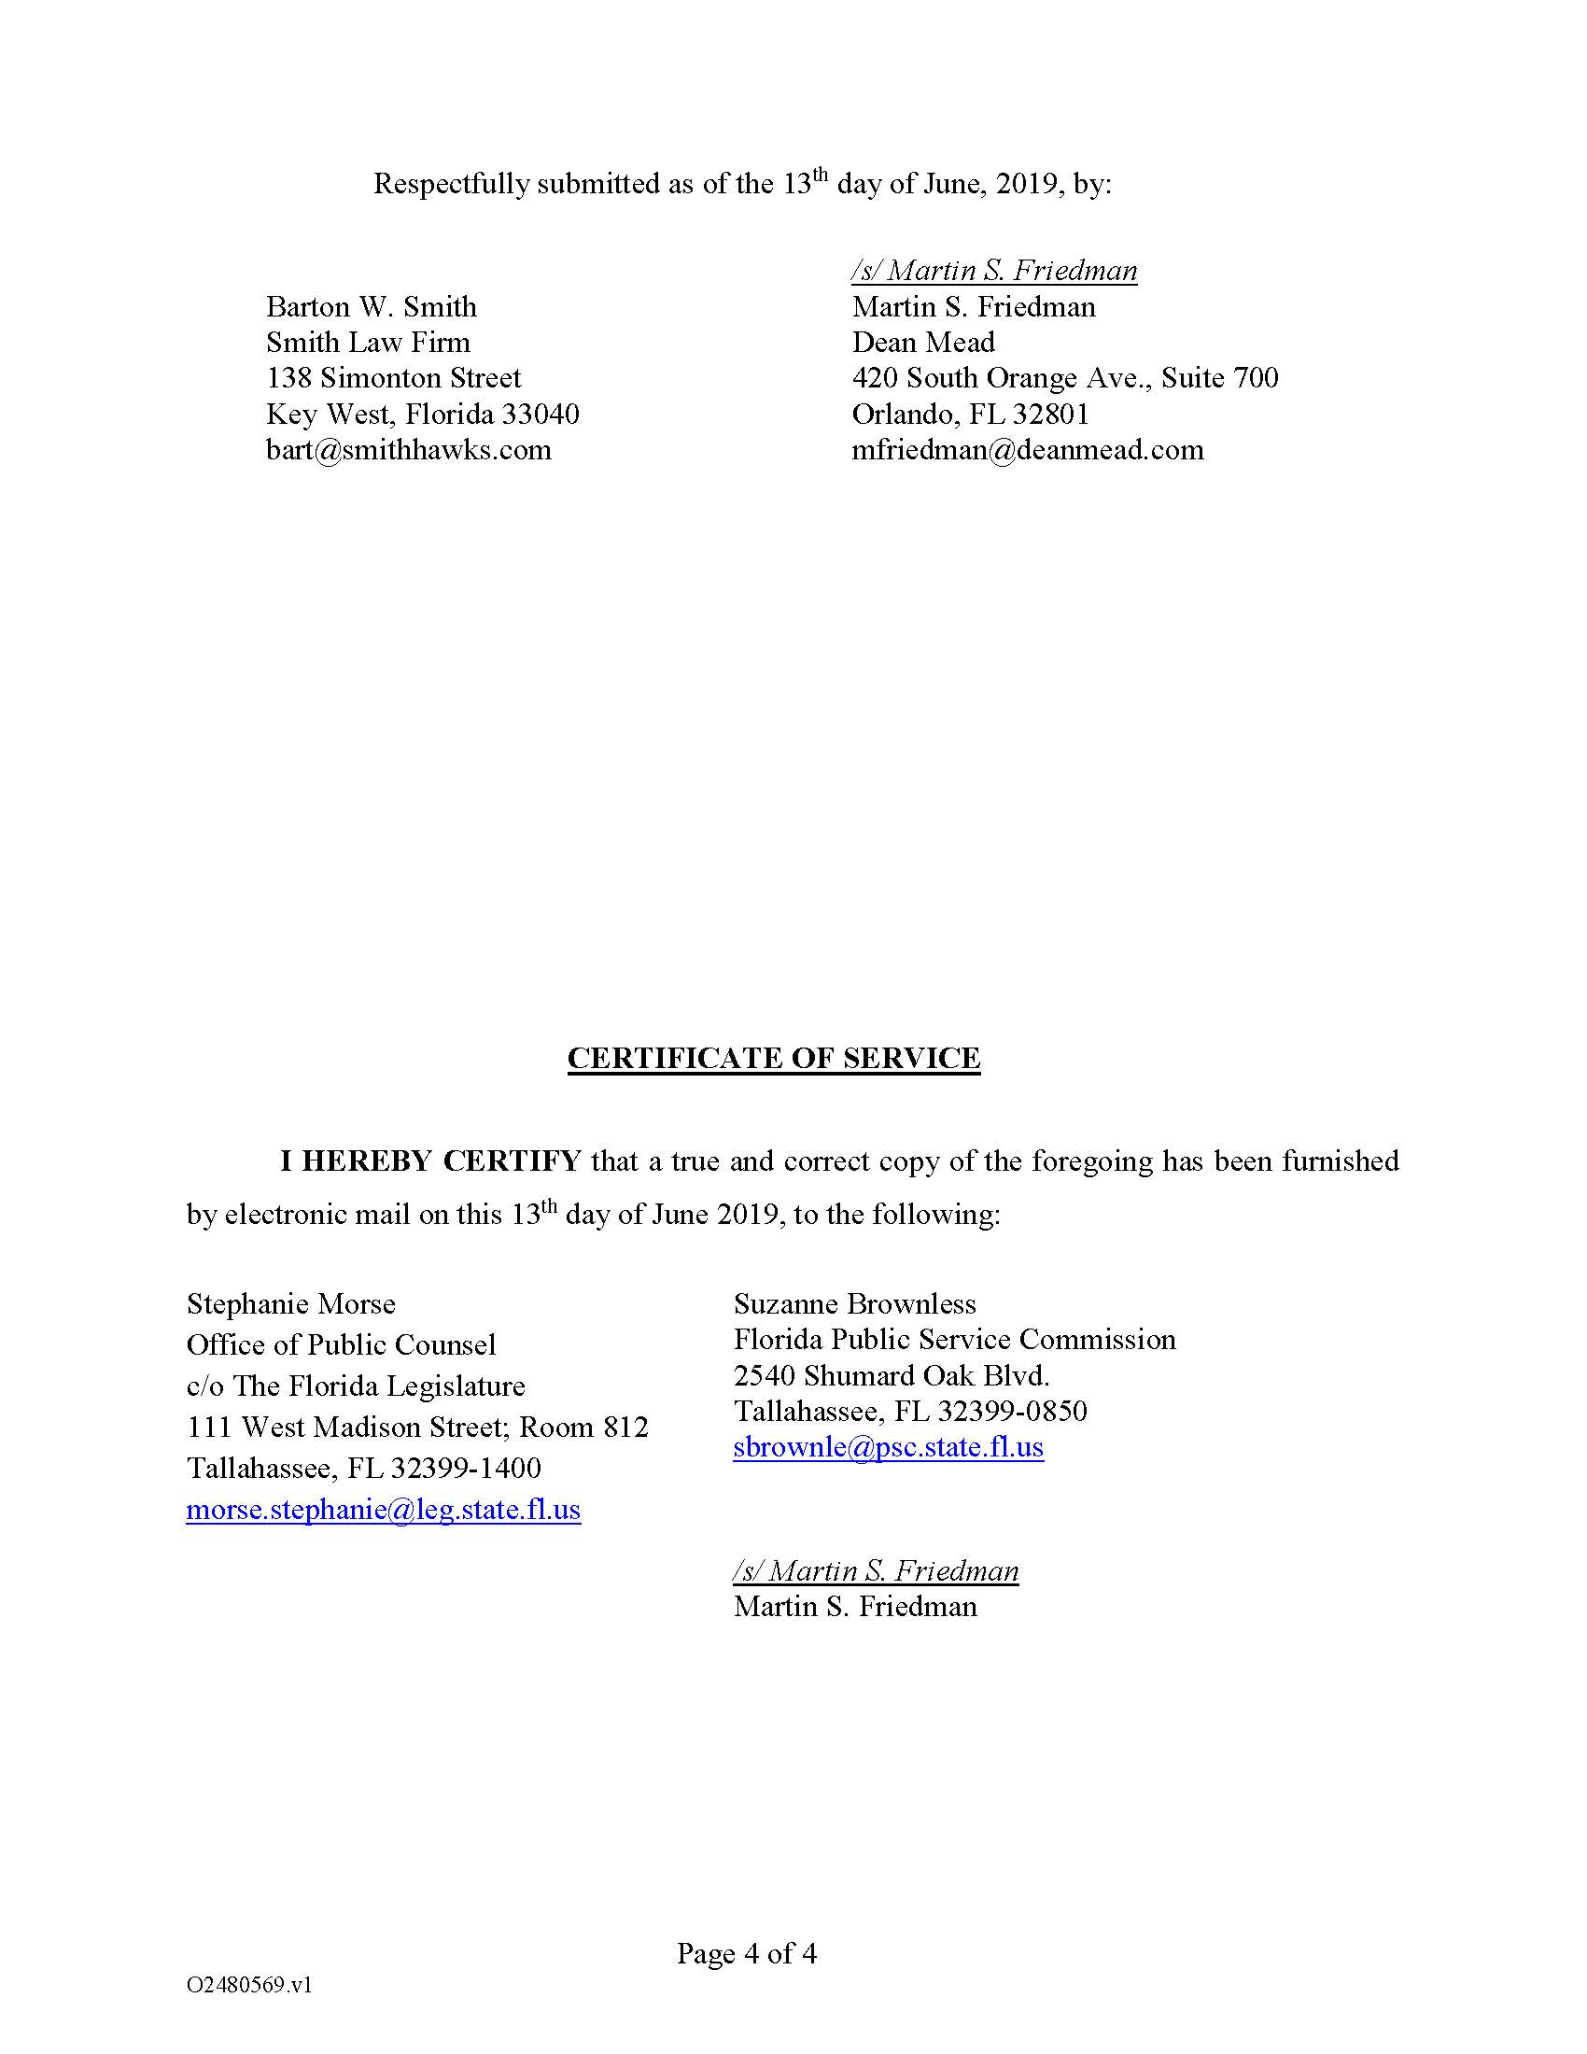

Order No. PSC-16-0123-PAA-SU, issued March 23, 2016, in Docket No. 150071-SU, In re: Application for increase in wastewater rates in Monroe County by K W Resort Utilities Corporation.
Order No. PSC-2018-0444 has two parts. The first part is proposed agency action (PAA) regarding the calculation of refunds for KWRU customers, which will be referenced herein as the PAA Order. The second part is a show cause order as to why KWRU should not be penalized $10,000 which shall be referenced herein as the Show Cause Order.
Order No. PSC-16-0123-PAA-SU, issued March 23, 2016, in Docket No. 150071-SU, In re: Application for increase in wastewater rates in Monroe County by K W Resort Utilities, Corp.
Agenda Conference 25-26, Aug 6, 2018.

