BEFORE THE FLORIDA PUBLIC SERVICE COMMISSION

In re: Application for staff-assisted rate case in Levy County by FIMC Hideaway, Inc. | DOCKET NO. 20170147-WS  ORDER NO. PSC-2019-0344-PAA-WS  ISSUED: August 22, 2019

The following Commissioners participated in the disposition of this matter:

ART GRAHAM, Chairman
JULIE I. BROWN
DONALD J. POLMANN
GARY F. CLARK
ANDREW GILES FAY

NOTICE OF PROPOSED AGENCY ACTION
ORDER FINDING FIMC HIDEAWAY, INC. IN COMPLIANCE WITH
ORDER NO. PSC-2019-0074-PAA-WS

BY THE COMMISSION:

NOTICE is hereby given by the Florida Public Service Commission (Commission) that the action discussed herein is preliminary in nature and will become final unless a person whose interests are substantially affected files a petition for a formal proceeding, pursuant to Rule 25-22.029, Florida Administrative Code.

Background
FIMC Hideaway, Inc. (FIMC or Utility) is a Class C utility that was granted water and wastewater certificates in 1984 to serve the Hideaway development when Levy County transferred jurisdiction to this Commission in 1983. The Hideaway systems were transferred to Florida Investors Mortgage Corporation Hideaway, Inc. in 1992 following its foreclosure on the Utility. Subsequently, this Commission approved a transfer of majority organizational control in 2005. In 2009, this Commission approved the transfer of the Springside water and wastewater systems from Par Utilities, Inc. to FIMC. The Hideaway and Springside water and wastewater systems were interconnected in April 2013.
On June 22, 2017, FIMC filed an application for a staff-assisted rate case. Pursuant to Order No. PSC-2018-0389-PAA-WS, we approved rates and charges for FIMC. Order No. PSC-2018-0389-PAA-WS additionally ordered:
[T]he overall quality of service provided by FIMC Hideaway, Inc. shall be considered marginal until the utility can sufficiently demonstrate that it meets the Department of Environmental Protection’s [DEP] secondary water standards. The [U]tility shall file the results of its next primary and secondary water standards tests with this Commission in this docket by November 1, 2018. If the results are unfavorable, our staff will bring this item to this Commission by March 1, 2019, for further action.

By email, on October 8, 2018, FIMC provided our staff with the results of its 2018 DEP primary and secondary water tests. The test results indicated that the water service provided by the Utility continued to exceed certain DEP secondary standards for sulfates and total dissolved solids.

Pursuant to Order No. PSC-2019-0074-PAA-WS, issued February 25, 2019, we directed FIMC to create an estimate of costs and benefits of a plausible solution to reduce sulfates and total dissolved solids to a level that is within DEP standards. That Order additionally stated:

We further direct FIMC to meet with its customers within 60-90 days of the issuance of this Order. The Utility shall provide the Office of Public Counsel and our staff with notification of the customer meeting date. In its meeting with customers, the Utility shall discuss the estimated costs and benefits of and time necessary for implementing a plausible solution to reduce sulfates and total dissolved solids to a level that is within acceptable DEP standards. The Utility shall report the results of the customer meeting to us within 30 days after the meeting is held. This item shall be brought back before us by the August 6, 2019 Commission Conference.

This Order addresses the Utility’s actions, as directed by Order No. PSC-2019-0074-PAA-WS. We have jurisdiction pursuant to Sections 367.011, 367.081, 367.0812, 367.0814, and 367.091, Florida Statutes (F.S.).

Decision
Our directives in Order No. PSC-2019-0074-PAA-WS, are consistent with the requirements found in Section 367.0812(2), F.S., which states:

(2)(a) In determining the quality of water service, the commission shall consider a finding by the Department of Environmental Protection as to whether the utility has failed to provide water service that meets the secondary water quality standards of the department.

(b) The utility shall create an estimate of the costs and benefits of a plausible solution to each issue identified by the commission.

(c) The utility shall meet with its customers within a time prescribed by the commission to discuss the estimated costs and benefits of and time necessary for implementing a plausible solution for each quality of water service issue identified, and the utility shall report the results of such meetings to the commission.

(d) The utility shall inform the commission, if:

1. The customers and the utility agree on a solution for each quality of water service issue identified, of each agreed-on solution and the cost of each solution; or

2. The customers and the utility prefer a different solution to at least one of the quality of water service issues identified, of the preferred solutions by each and the cost of each solution.

By email communication dated April 18, 2019, the Utility provided our staff a copy of its customer meeting notice and indicated that it provided the notice to its customers by email on April 10, 2019, and by hand delivery between April 14, 2019, and April 17, 2019. The notice stated, in part, that the goal of the meeting was to discuss viable options to enhance the water quality that are amenable to the customers.

The Florida Rural Water Association (FRWA) assisted FIMC by identifying plausible solutions for the Utility’s water service issues and developing cost and benefit estimates for each solution. On April 24, 2019, the FRWA provided a draft presentation, which included a summary of the plausible solutions, to our staff. The FRWA’s draft presentation was also shared with the Office of Public Counsel (OPC).

The plausible solutions, including estimated monetary costs, identified by the FRWA are summarized below.

- Connect to another water system such as Fowlers Bluff ($25,000 per
connection or $121 per month per connection)

- Find another source, surface water or ground water supply ($24,050 per connection or $116 per month per connection)

- Install additional treatment on the existing water ($10,000 per connection or $48 per month per connection)

- Accept current water quality, but do something for your own home ($125 to $3,000 per connection)

The customer meeting was held on May 1, 2019, at the same location that the customer meeting for the staff assisted rate case was held. Approximately 35 customers attended the meeting as well as representatives from our staff and the OPC. At the meeting, the FRWA presented the plausible solutions and estimated costs and benefits. On May 28, 2019, the FRWA provided our staff with a summary of the customer meeting. The FRWA’s summary states the following:

During that meeting, options and costs for improving water quality were presented. We described and discuss[ed] in detail the water quality issues, possible solutions, costs, benefits, etc. We received customer input. We asked if the customers and the [U]tility agreed on a solution or preferred a different solution...[b]y a show of hands customers were in favor of option 4 and not in favor of options 1 through 3.

As previously stated, option 4 involved the customers accepting the current water quality and doing something at their home. Attachment A, which is appended to this Order, includes a copy of the FRWA’s summary and presentation.

At the conclusion of the meeting, our staff provided contact information to the customers to allow further input if desired. Copies of the FRWA’s presentation were also provided for attendees to take to any customers that were not able to participate at the meeting. Since that customer meeting was held, we have not been contacted by any customers of FIMC regarding the Utility’s water quality.

Based on the above, we find that FIMC, with the assistance of the FRWA, has complied with the requirements of Order No. PSC-2019-0074-PAA-WS. Furthermore, based on the results of the customer meeting, we find that no additional action shall be ordered at this time with respect to FIMC’s water quality.

Based on the foregoing, it is

ORDERED by the Florida Public Service Commission that FIMC Hideaway, Inc. has complied with the requirements of Order No. PSC-2019-0074-PAA-WS and that no additional action shall be ordered at this time with respect to the Utility’s water quality. It is further

ORDERED that the provisions of this Order, issued as proposed agency action, shall become final and effective upon the issuance of a Consummating Order unless an appropriate petition, in the form provided by Rule 28-106.201, Florida Administrative Code, is received by the Commission Clerk, 2540 Shumard Oak Boulevard, Tallahassee, Florida 32399-0850, by the close of business on the date set forth in the “Notice of Further Proceedings” attached hereto. It is further

ORDERED that if no person whose substantial interests are affected by the proposed agency action files a protest within 21 days of the issuance of this Order, a Consummating Order shall be issued and this docket shall be closed administratively.

By ORDER of the Florida Public Service Commission this 22nd day of August, 2019.

/s/ Adam J. Teitzman
ADAM J. TEITZMAN
Commission Clerk
Florida Public Service Commission
2540 Shumard Oak Boulevard
Tallahassee, Florida 32399
(850) 413-6770
www.floridapsc.com

Copies furnished: A copy of this document is provided to the parties of record at the time of issuance and, if applicable, interested persons.

MAD

NOTICE OF FURTHER PROCEEDINGS OR JUDICIAL REVIEW

The Florida Public Service Commission is required by Section 120.569(1), Florida Statutes, to notify parties of any administrative hearing that is available under Section 120.57, Florida Statutes, as well as the procedures and time limits that apply. This notice should not be construed to mean all requests for an administrative hearing will be granted or result in the relief sought.

Mediation may be available on a case-by-case basis. If mediation is conducted, it does not affect a substantially interested person's right to a hearing.

The action proposed herein is preliminary in nature. Any person whose substantial interests are affected by the action proposed by this order may file a petition for a formal proceeding, in the form provided by Rule 28-106.201, Florida Administrative Code. This petition must be received by the Office of Commission Clerk, 2540 Shumard Oak Boulevard, Tallahassee, Florida 32399-0850, by the close of business on September 12, 2019.

In the absence of such a petition, this order shall become final and effective upon the issuance of a Consummating Order.

Any objection or protest filed in this/these docket(s) before the issuance date of this order is considered abandoned unless it satisfies the foregoing conditions and is renewed within the specified protest period.

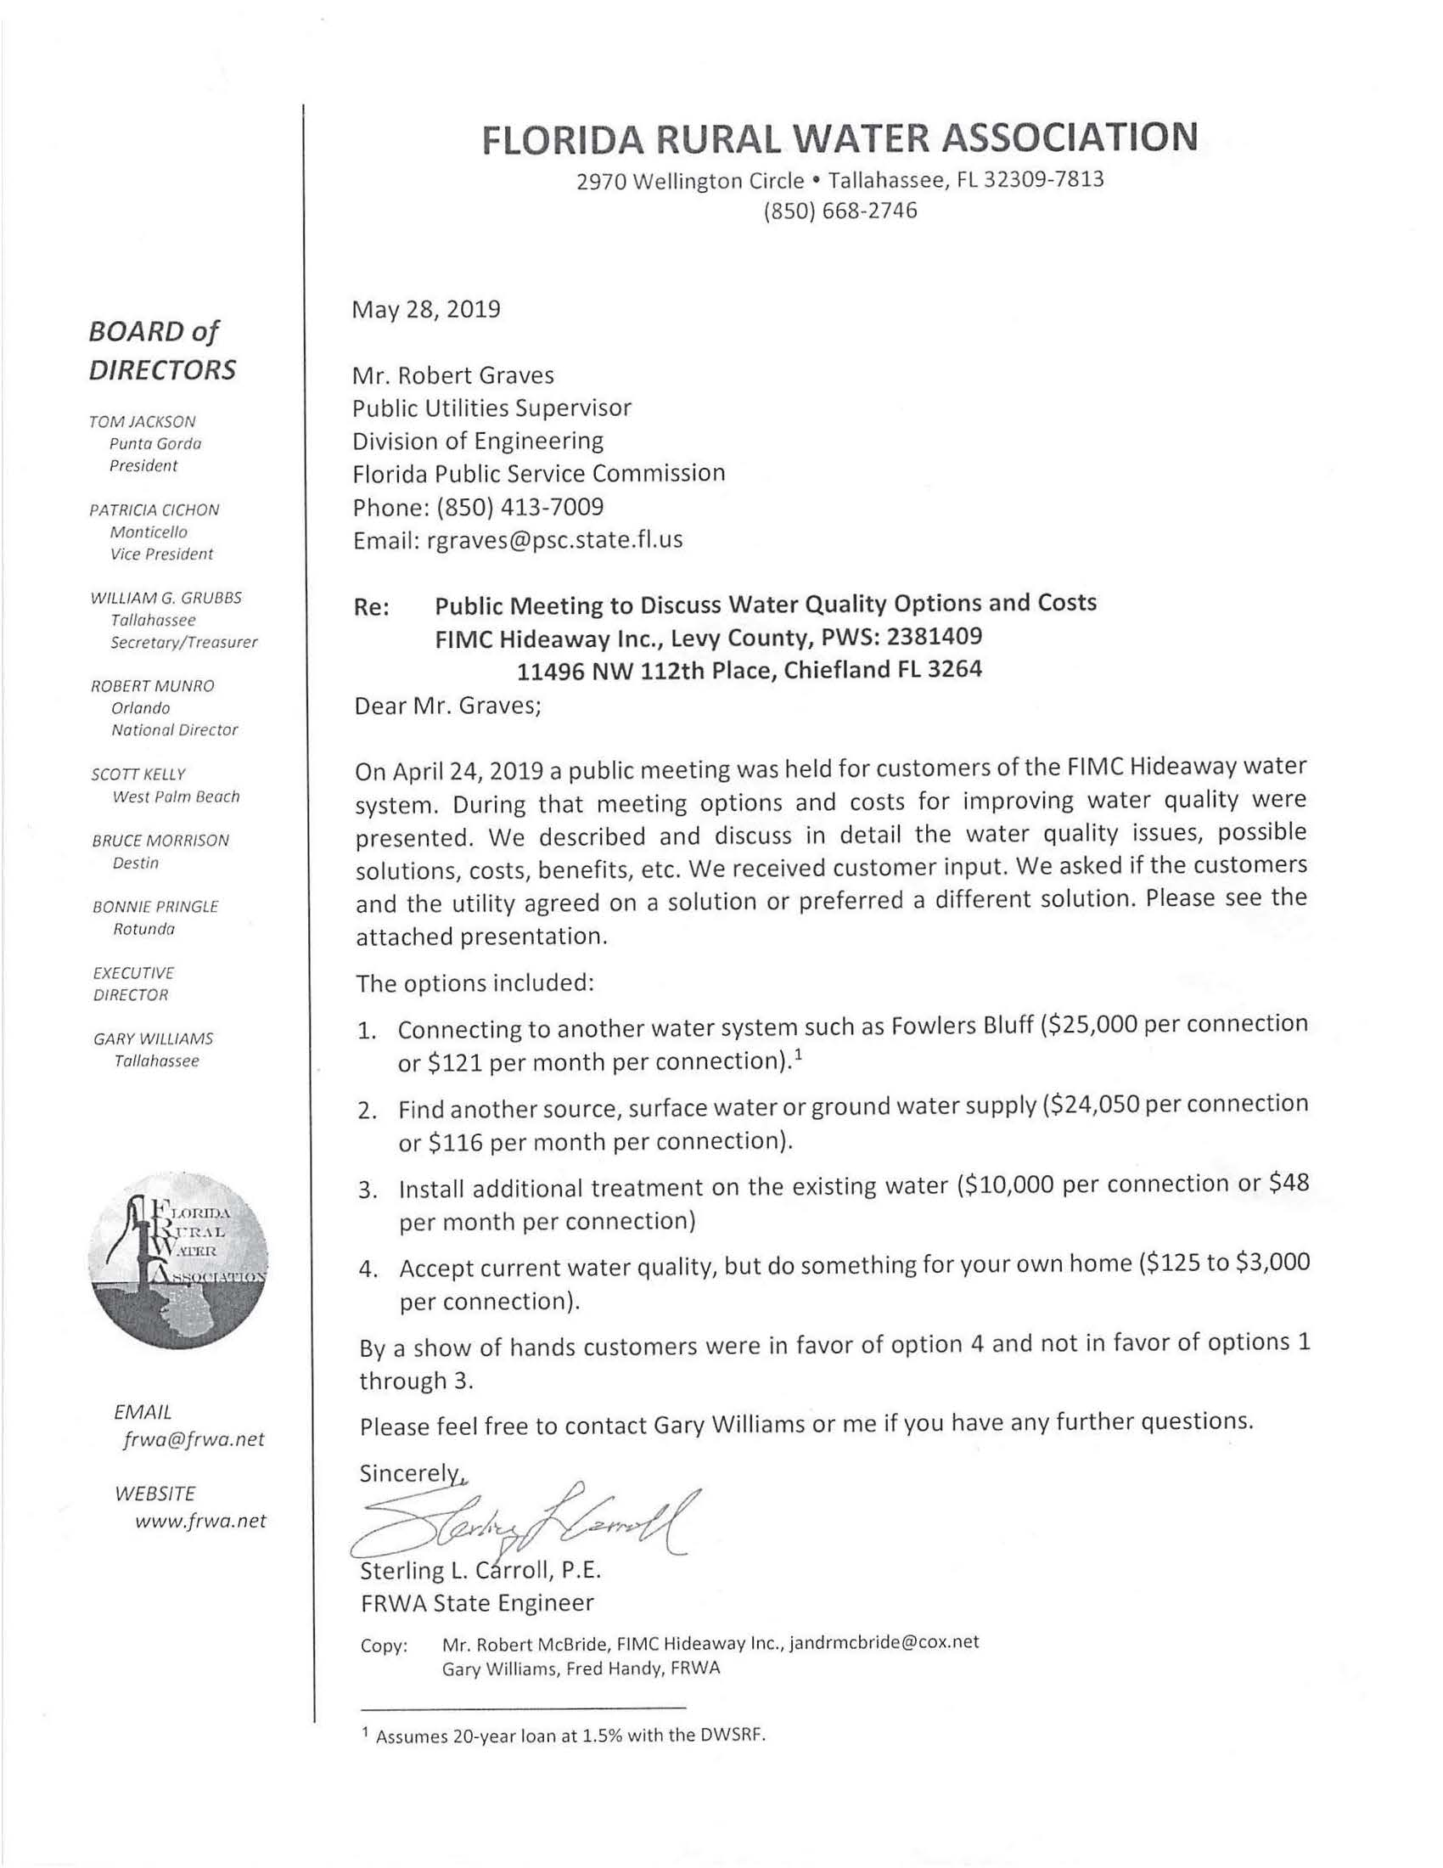
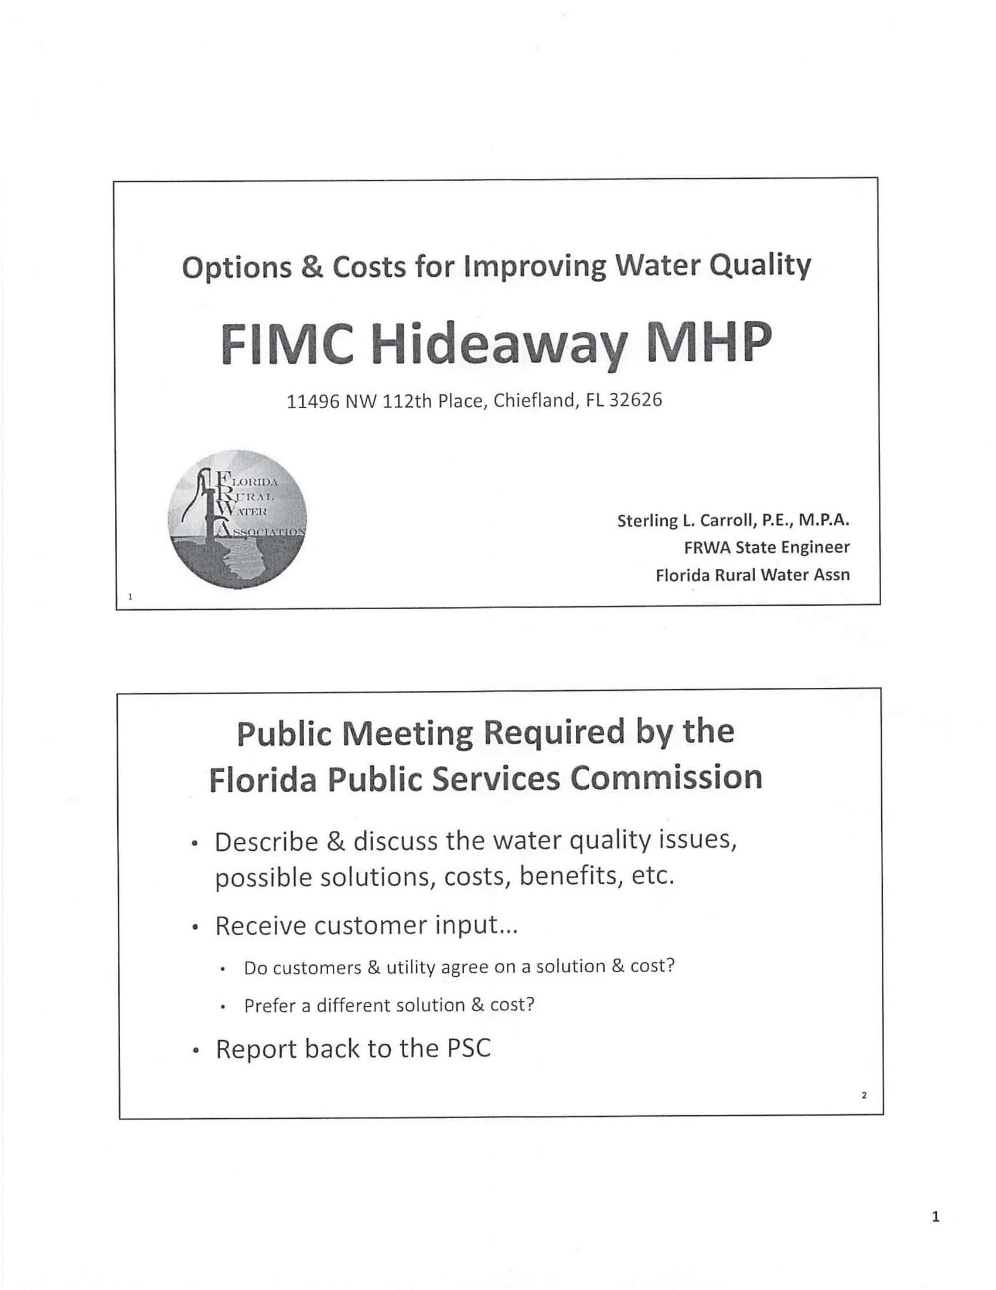
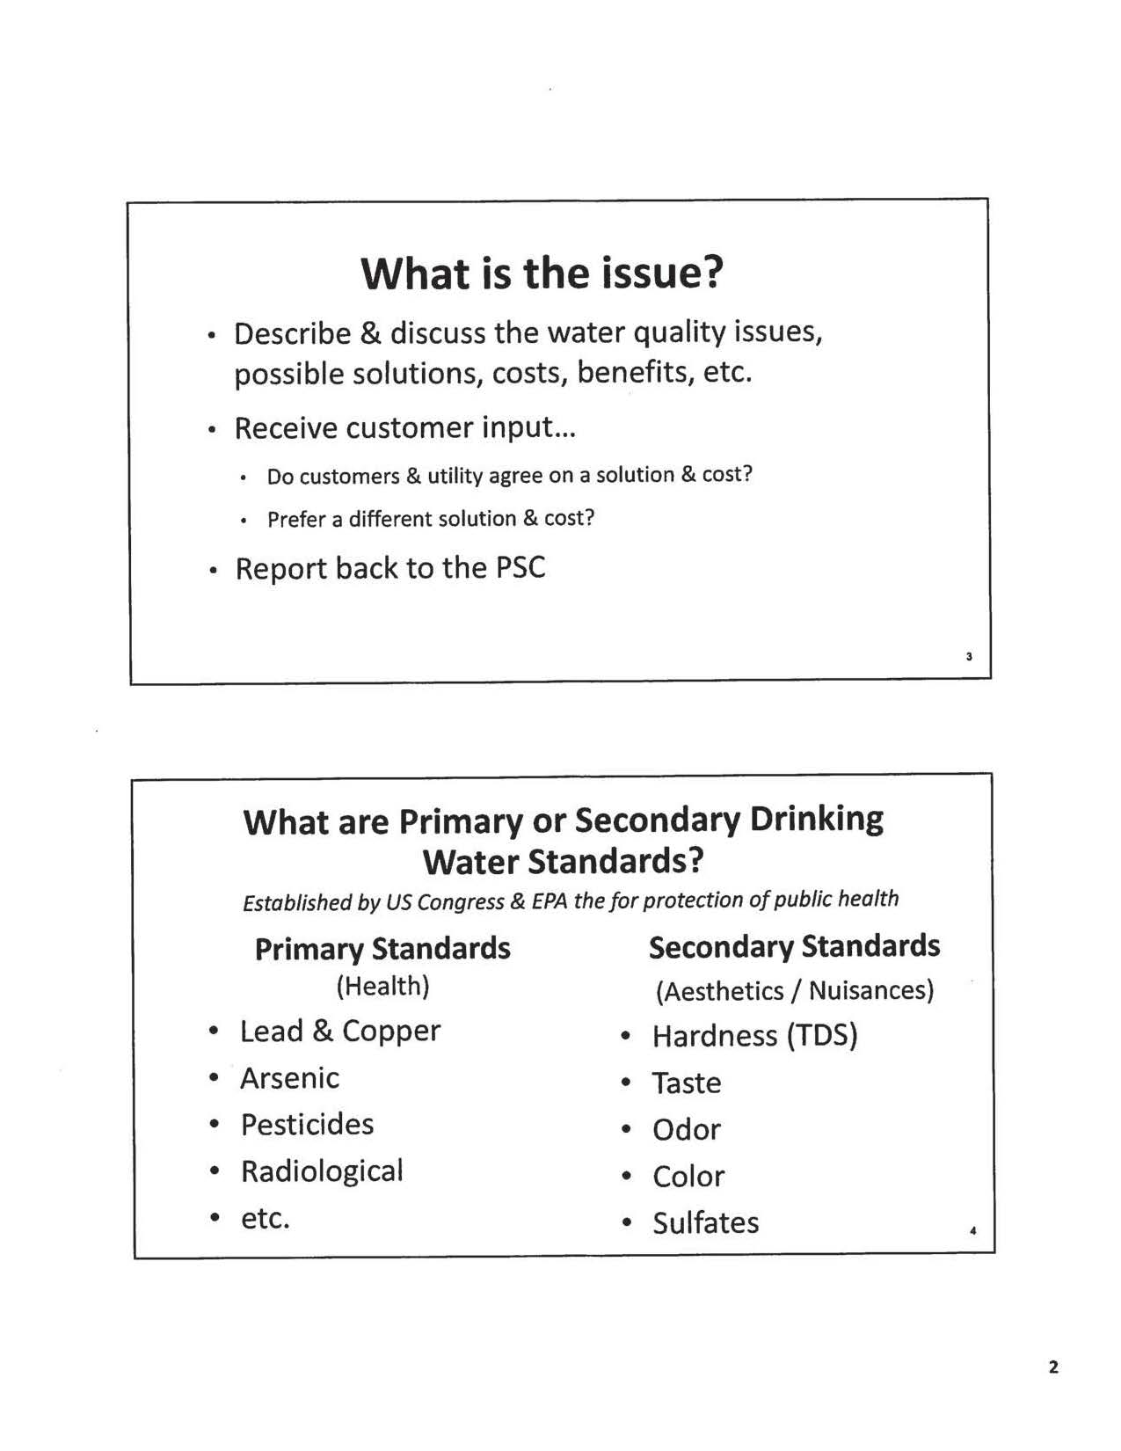
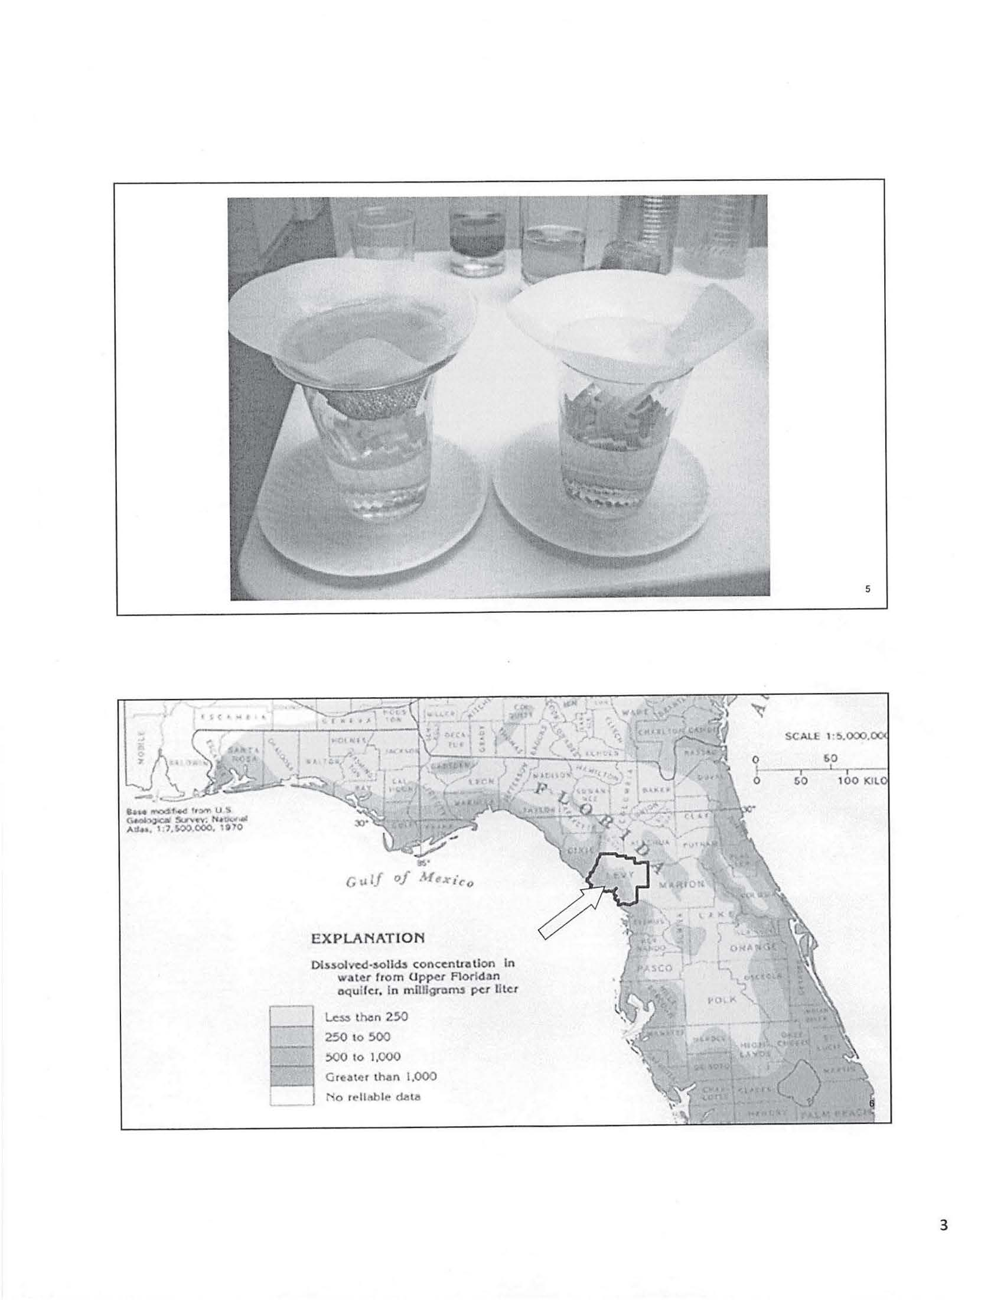
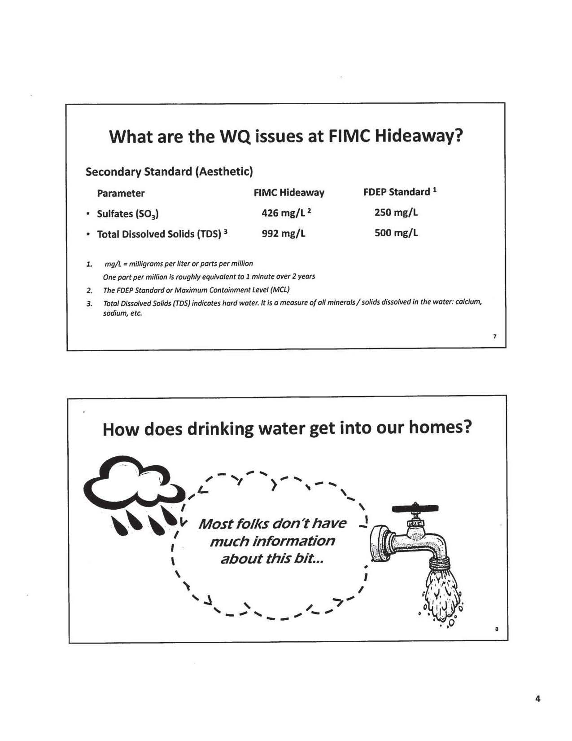
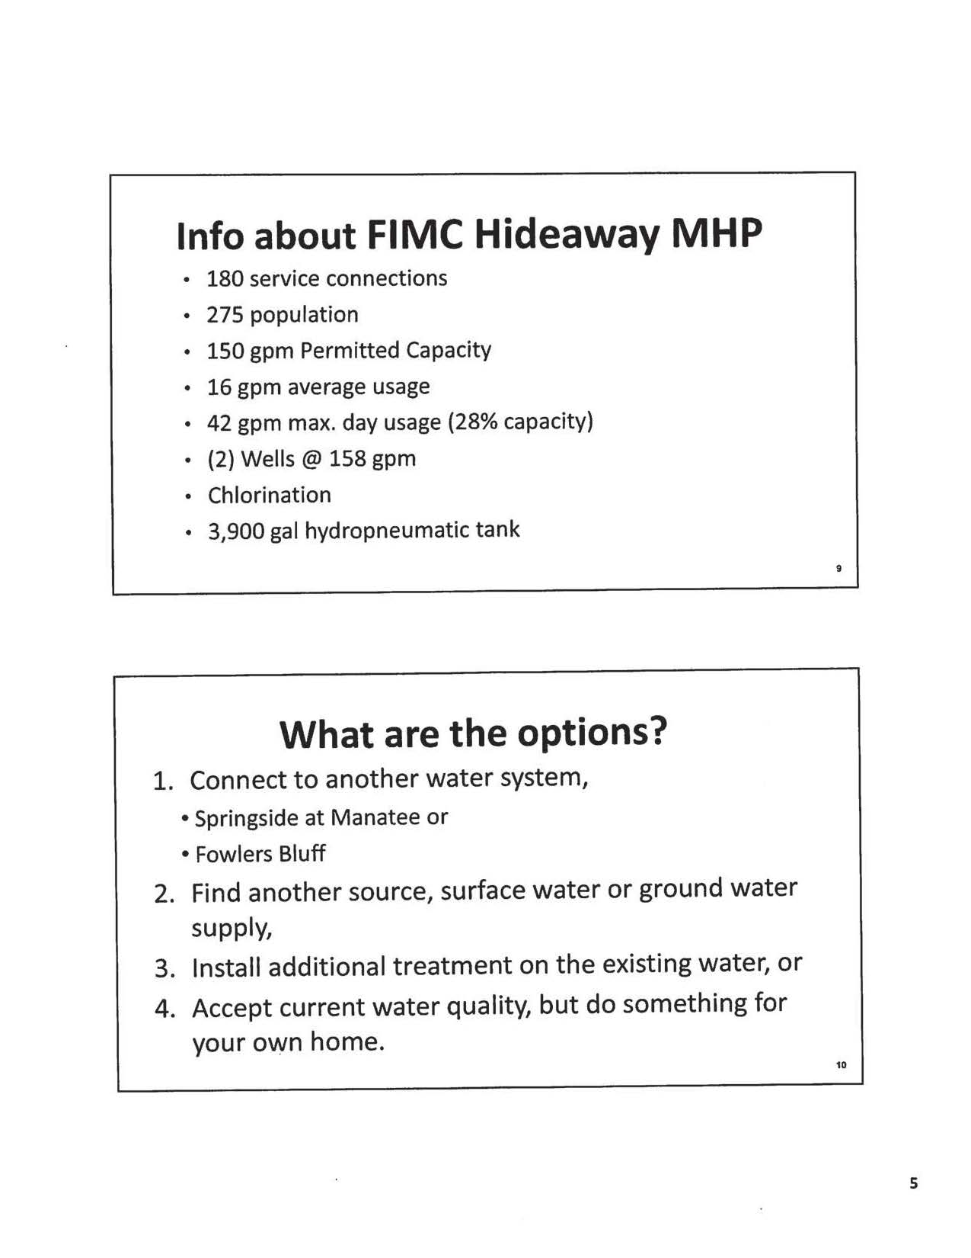
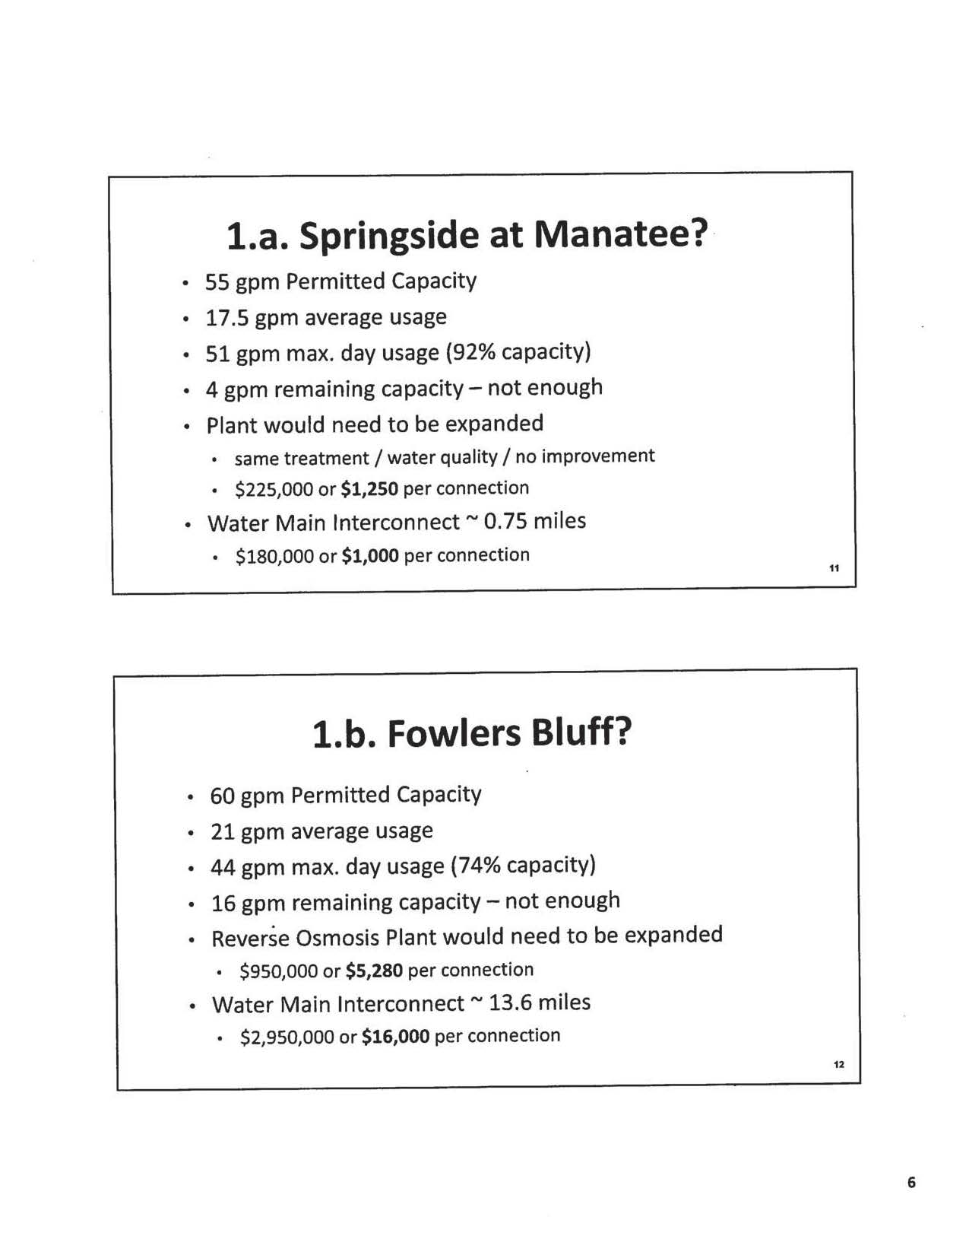
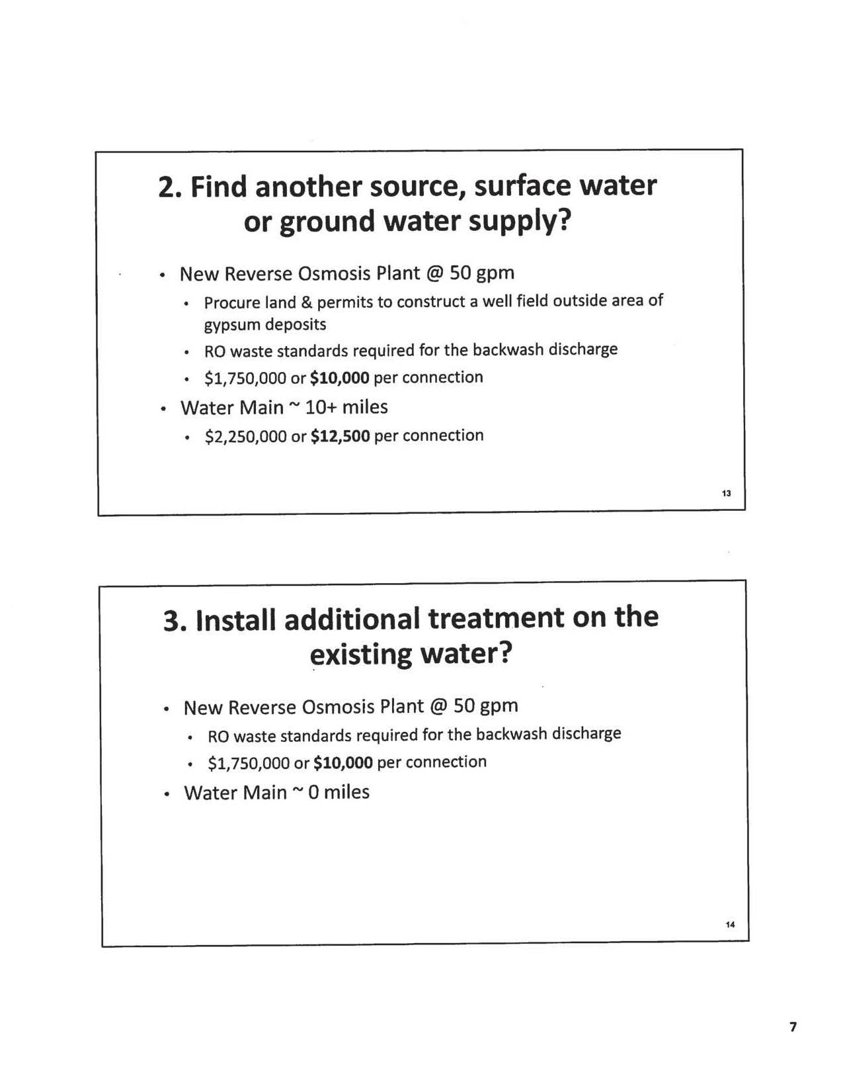
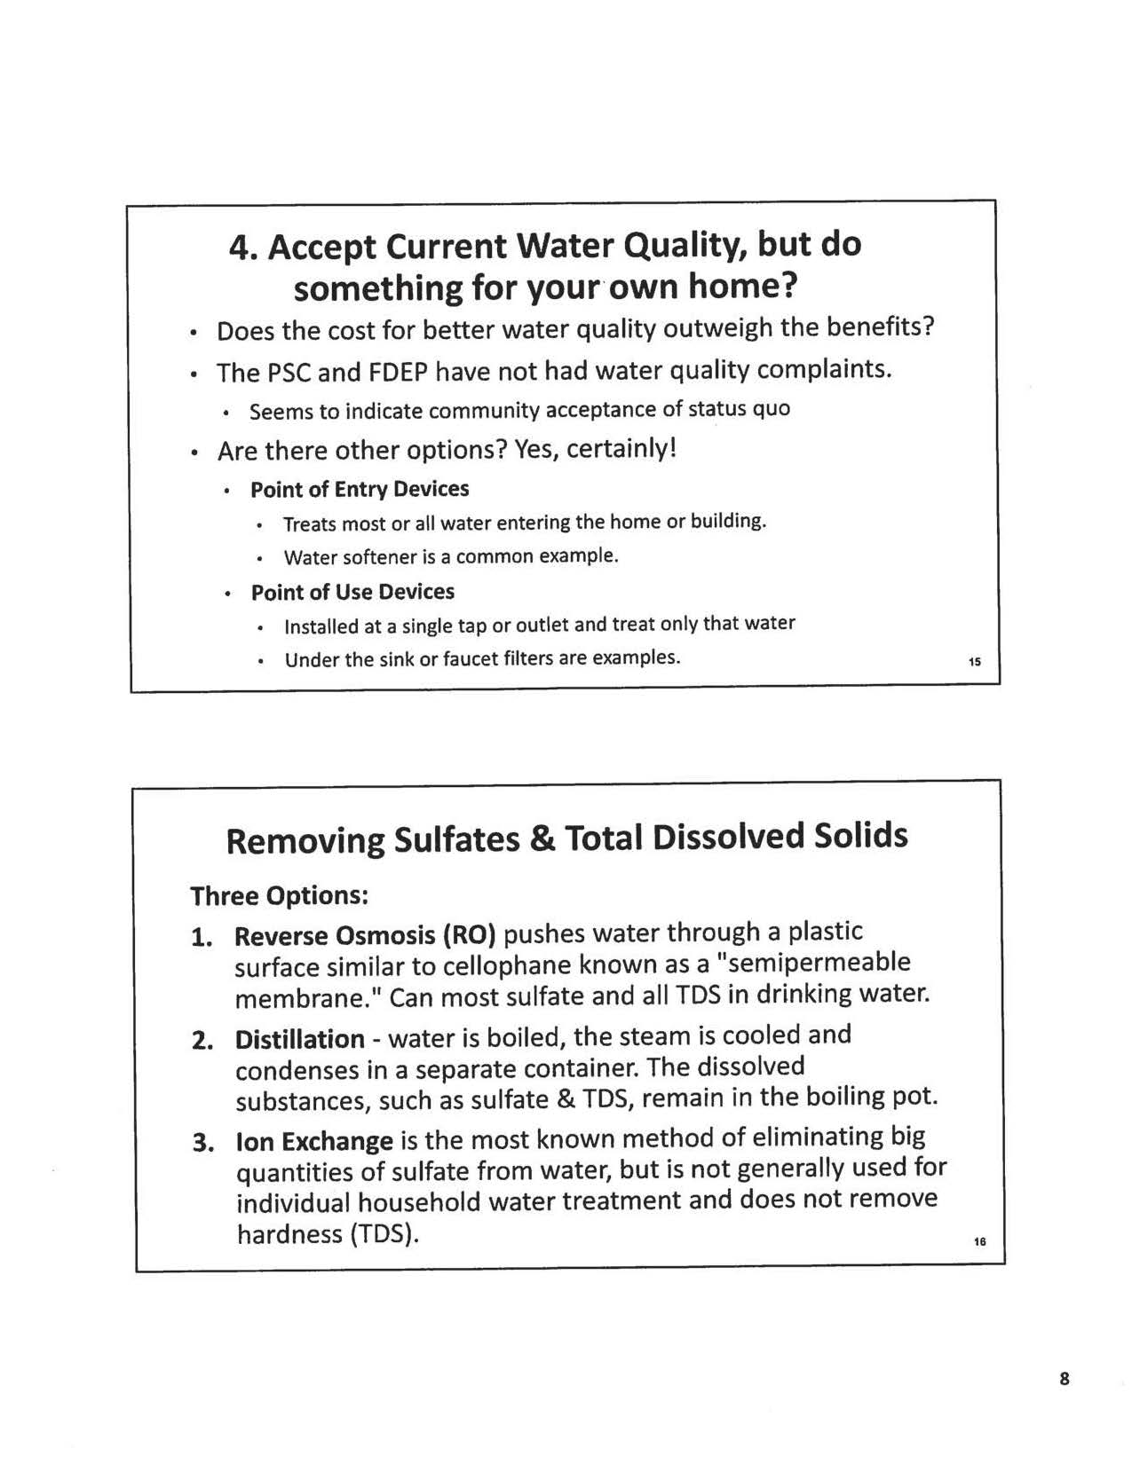
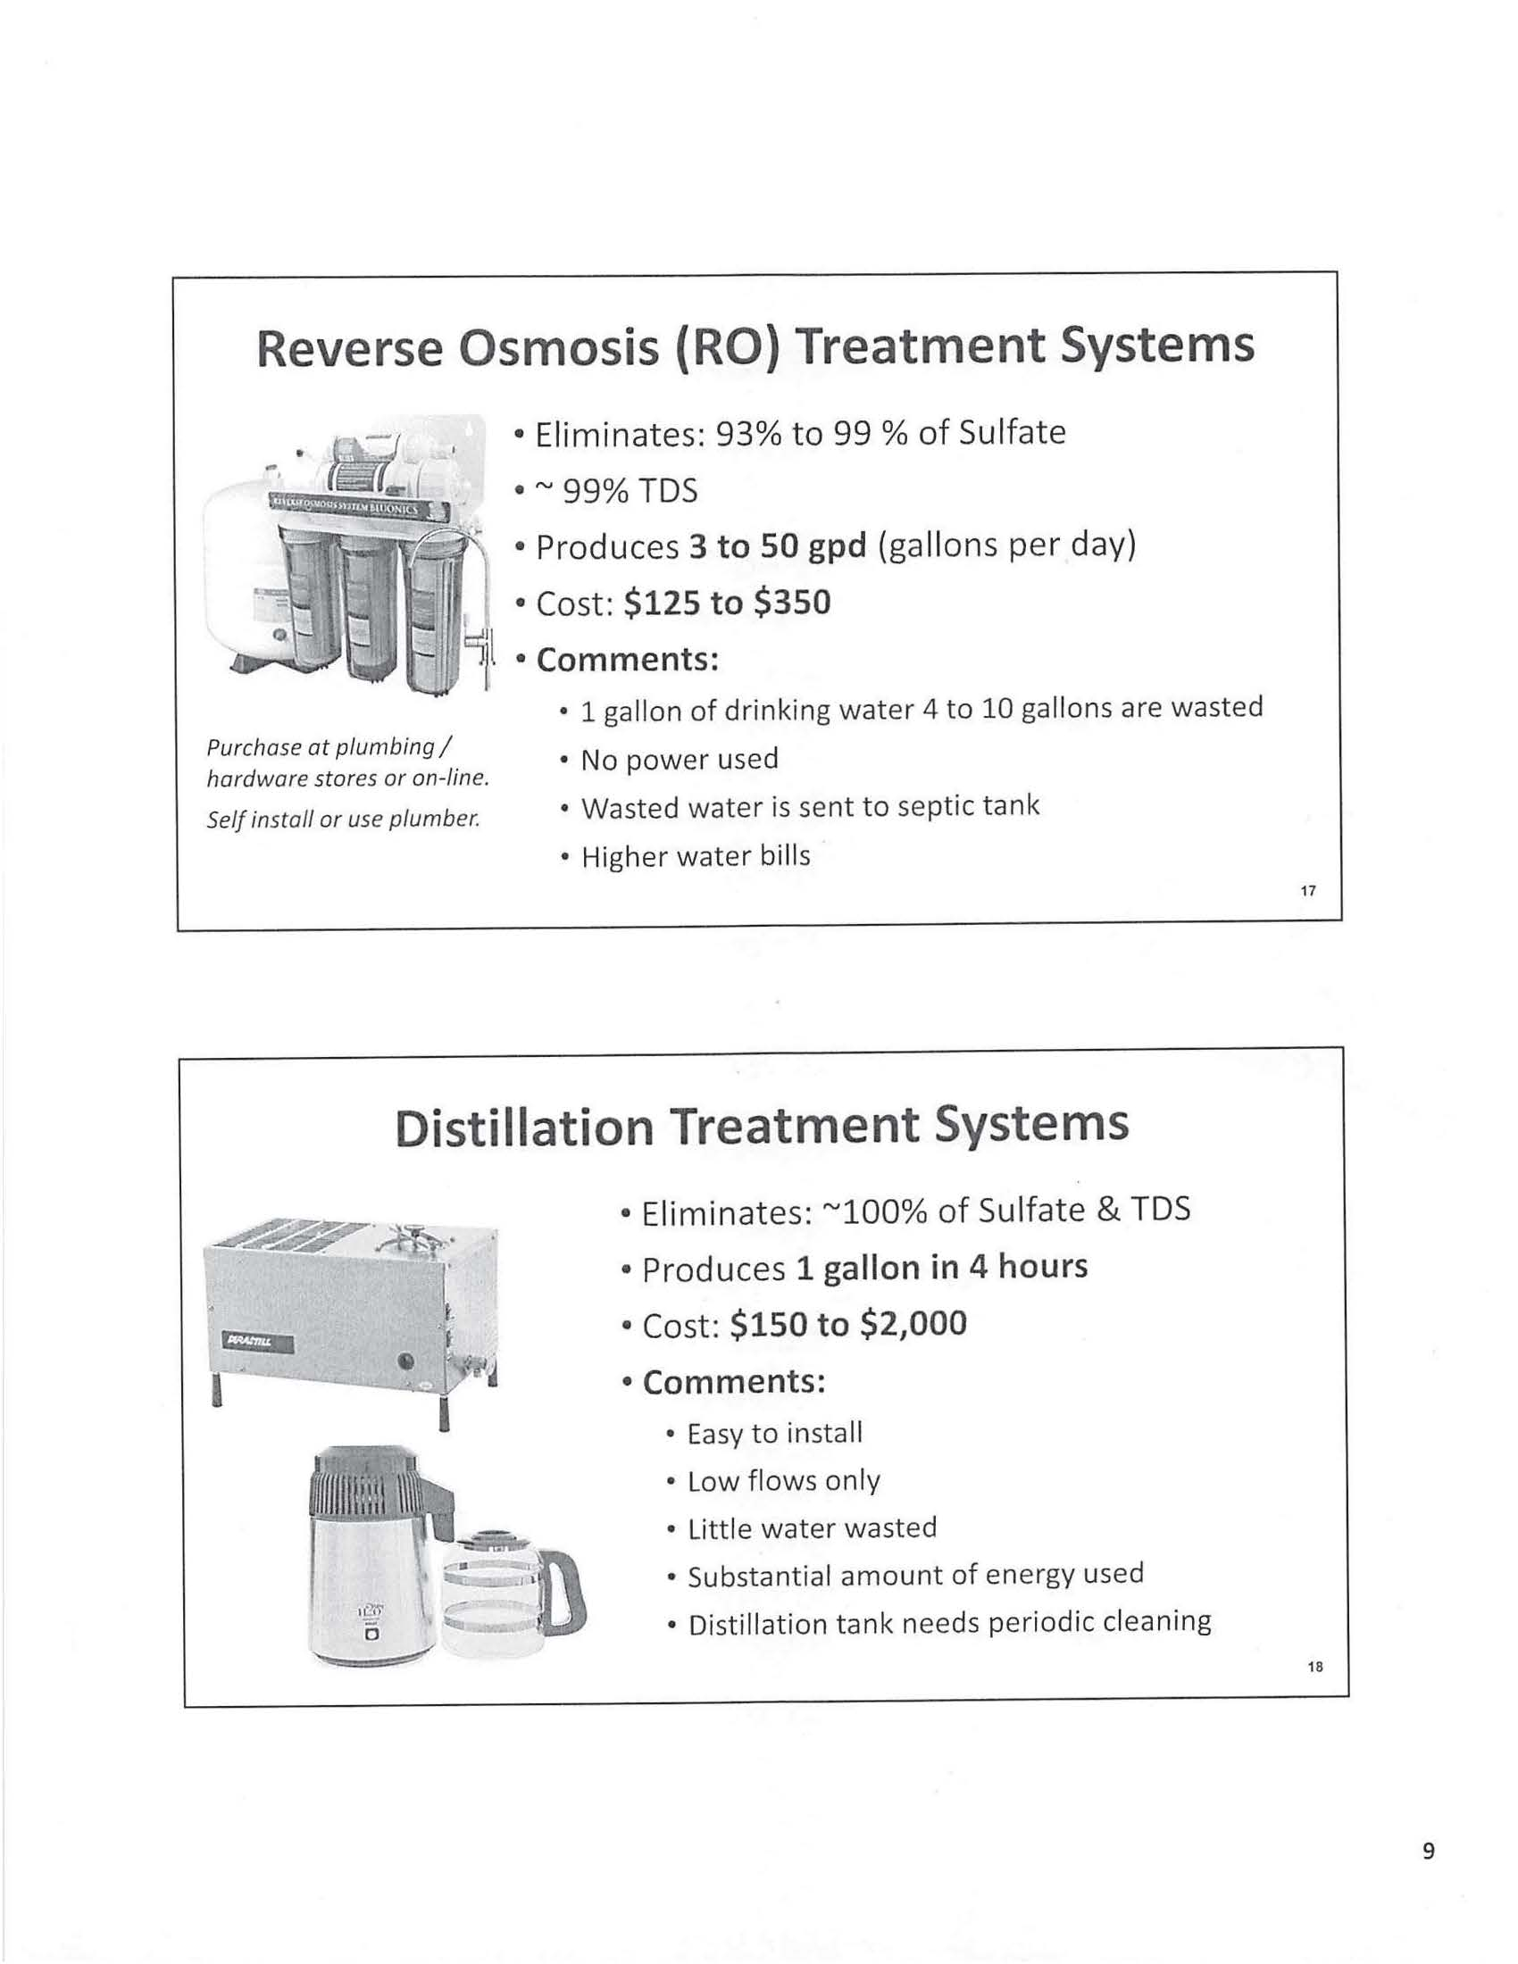
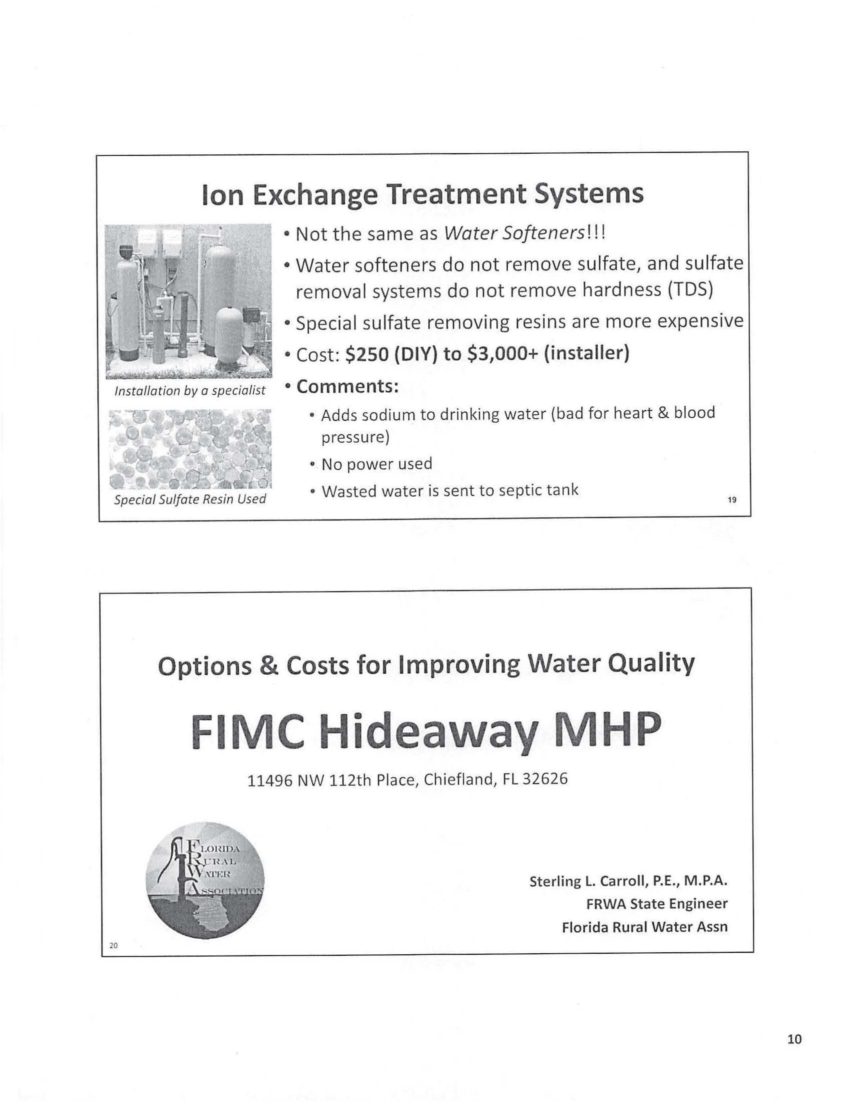

Order No. 13497, issued July 10, 1984, in Docket No. 19830552-WS, In re: Application of Hideaway Service, Inc. for a certificate to operate a water and sewer utility in Levy County.
Order No. 25584, issued January 8, 1992, in Docket No. 19910672-WS, In re: Application for transfer of Certificates Nos. 426-W and 362-S from Hideaway Service, Inc. to FIMC Hideaway, Inc. in Levy County.
Order No. PSC-05-0298-PAA-WS, issued March 18, 2005, in Docket No. 20040152-WS, In re: Application for transfer of majority organizational control of FIMC Hideaway, Inc. in Levy County from Florida Investors Mortgage Corporation, a Florida corporation, to Robert and Janet McBride.
Order No. PSC-09-0279-PAA-WS, issued April 29, 2009, in Docket No. 20080268-WS, In re: Joint Application for transfer of the Springside water and wastewater systems from Par Utilities, Inc. in Levy County to FIMC Hideaway, Inc.:, amendment of Certificates 426-W and 362-S held by FIMC Hideaway, Inc.; and amendment of Certificate 428-W and cancellation of Certificate 366-S held by Par Utilities, Inc.
The FRWA’s summary contains a scrivener’s error stating that the customer meeting occurred on April 24, 2019.

