Market Potential Study of Demand-Side Management in Tampa Electric Company’s Service Territory
Submitted to Tampa Electric Company

April, 2019

(This page intentionally left blank)

Contents

1 Executive Summary 5
1.1 Methodology 5
1.1.1 EE Potential 5
1.1.2 DR Potential 5
1.1.3 DSRE Potential 6
1.2 Savings Potential 6
1.2.1 EE Technical Potential 6
1.2.2 DR Technical Potential 6
1.2.3 DSRE Technical Potential 7
2 Introduction 8
2.1 Market Potential Study Approach 8
2.2 EE Potential Overview 10
2.3 DR Potential Overview 11
2.4 DSRE Potential Overview 11
3 Baseline Forecast Development 12
3.1 Market Characterization 12
3.1.1 Customer Segmentation 12
3.1.2 Forecast Disaggregation 14
3.1.2.1 Electricity Consumption (kWh) Forecast 14
3.1.2.2 Peak Demand (kW) Forecast 14
3.1.2.3 Estimating Consumption by End-Use Technology 14
3.2 Analysis of Customer Segmentation 15
3.2.1 Residential Customers (EE, DR, and DSRE Analysis) 15
3.2.2 Non-Residential (Commercial and Industrial) Customers (EE and DSRE Analysis) 16
3.2.3 Commercial and Industrial Customers (DR Analysis) 18
3.3 Analysis of System Load 18
3.3.1 System Energy Sales 18
3.3.2 System Demand 19
3.3.3 Load Disaggregation 19
4 DSM Measure Development 22
4.1 Methodology 22
4.2 EE Measures 22
4.3 DR Measures 25
4.4 DSRE Measures 25
5 Technical Potential 27
5.1 Methodology 27
5.1.1 EE Technical Potential 27
5.1.2 DR Technical Potential 30
5.1.3 DSRE Technical Potential 32
5.1.3.1 PV Systems 32
5.1.3.2 Battery Storage Systems 33
5.1.3.3 CHP Systems 34
5.1.4 Interaction of Technical Potential Impacts 35
5.2 EE Technical Potential 36
5.2.1 Summary 36
5.2.2 Residential 36
5.2.3 Non-Residential 38
5.2.3.1 Commercial Segments 38
5.2.3.2 Industrial Segments 39
5.3 DR Technical Potential 41
5.3.1 Residential 41
5.3.2 Non-Residential 42
5.3.2.1 Small C&I Customers 42
5.3.2.2 Large C&I Customers 43
5.4 DSRE Technical Potential 44
6 Appendices 45
Appendix A EE MPS Measure List A-1
Appendix B DR MPS Measure List B-1
Appendix C DSRE Measure List C-1
Appendix D Customer Demand Characteristics D-1

List of Figures
Figure 2-1: Approach to Market Potential Modeling 10
Figure 3-1: Residential Customer Segmentation 16
Figure 3-2: Commercial Customer Segmentation 17
Figure 3-3: Industrial Customer Segmentation 17
Figure 3-4: 2020 Electricity Sales Forecast by Sector 19
Figure 3-5: Residential Baseline (2020) Energy Sales by End-Use 20
Figure 3-6: Commercial Baseline (2020) Energy Sales by End-Use 20
Figure 3-7: Industrial Baseline (2020) Energy Sales by End-Use 21
Figure 5-1: Methodology for Estimating Cooling Loads 31
Figure 5-2: Residential EE Technical Potential by End-Use (Energy Savings) 36
Figure 5-3: Residential EE Technical Potential by End-Use (Summer Peak Savings) 37
Figure 5-4: Residential EE Technical Potential by End-Use (Winter Peak Savings) 37
Figure 5-5: Commercial EE Technical Potential by End-Use (Energy Savings) 38
Figure 5-6: Commercial EE Technical Potential by End-Use (Summer Peak Savings) 38
Figure 5-7: Commercial EE Technical Potential by End-Use (Winter Peak Savings) 39
Figure 5-8: Industrial EE Technical Potential by End-Use (Energy Savings) 39
Figure 5-9: Industrial EE Technical Potential by End-Use (Summer Peak Savings) 40
Figure 5-10: Industrial EE Technical Potential by End-Use (Winter Peak Savings) 40
Figure 5-11: Residential DR Technical Potential by End-Use 42
Figure 5-12: Small C&I DR Technical Potential by End-Use 42
Figure 5-13: Large C&I DR Technical Potential by Segment 43
Figure -1: Average Water Heaters Load Shapes D-2
Figure 6-2: Average Pool Pumps Load Shapes D-3
Figure 6-3: Aggregate Load Shapes for TECO Large C&I Customers D-4

List of Tables
Table 1-1: EE Technical Potential 6
Table 1-2: DR Technical Potential 7
Table 1-3: DSRE Technical Potential 7
Table 3-1: Customer Segmentation 13
Table 3-2: End-Uses 13
Table 3-3: Summary of Customer Classes for DR Analysis 18
Table 4-1: Measure Applicability Factors 24
Table 4-2: EE Measure Counts by Sector 24
Table 5-1: EE Technical Potential by Sector 36
Table 5-2: DR Technical Potential by Sector 41
Table 5-3: DSRE Technical Potential 44

Executive Summary
In October, 2017, the seven electric utilities subject to the Florida Energy Efficiency and Conservation Act (FEECA Utilities) retained Nexant, Inc. for the purpose of identifying and characterizing the market for demand-side management (DSM) opportunities, including energy efficiency (EE) improvement and building retrofits, peak load reductions from demand response (DR), and demand-side renewable energy (DSRE) systems. The main objectives of the study included:
- Assessing the technical potential of demand-side resources for reducing customer electric energy consumption and seasonal peak capacity demands.
This report provides the detailed methodology and results for the technical potential analysis of Tampa Electric Company’s (TECO) service territory.

Methodology
Nexant estimates DSM savings potential by applying an analytical framework that aligns baseline market conditions for energy consumption and demand with DSM opportunities. After describing the baseline condition, Nexant applies estimated measure savings to disaggregated consumption and demand data. The approach varies slightly according to the type of DSM resources and available data; the specific approaches used for each type of DSM are described below.

EE Potential
This study utilized Nexant’s Microsoft Excel-based EE modeling tool, TEA-POT (Technical / Economic / Achievable POTential). This modeling tool was built on a platform that provides the ability to calculate multiple scenarios and recalculate potential savings based on variable inputs such as sales/load forecasts, electricity prices, discount rates, and actual program savings. The methodology for the EE potential assessment was based on a hybrid “top-down/bottom-up” approach, which started with the current utility load forecast, then disaggregated it into its constituent customer-class and end-use components. Our assessment examined the effect of the range of EE measures and practices on each end-use, taking into account current market saturations, and technical feasibility. These unique impacts were aggregated to produce estimates of potential at the end-use, customer class, and system levels.

DR Potential
The assessment of DR potential in TECO’s service territory was an analysis of mass market direct load control programs for residential and small commercial and industrial (C&I) customers, and an analysis of DR programs for large commercial and industrial customers. The direct load control program assessment focused on the potential for demand reduction through heating, ventilation, and air conditioning (HVAC), water heater, and pool pump load control. These end-uses were of particular interest because of their large contribution to peak period system load. For this analysis, a range of direct load control measures were examined for each customer segment to highlight the range of potential. The assessment further accounted for existing DR programs for TECO when calculating the total DR potential.

DSRE Potential
The DSRE technologies included in this study are rooftop solar photovoltaic (PV) systems, battery storage systems charged from customer’s PV systems, and combined heat and power (CHP) systems. The study leveraged the customer segmentation and load disaggregation data assembled for the EE and DR analyses, and used a “bottom-up” modeling approach to estimate the potential of the various DSRE technologies for residential, commercial, and industrial customers. Individual distributed generation models were created for the three DSRE technologies studied to estimate market potential.

Savings Potential
Technical potential for EE, DR, DSRE are as follows:

EE Technical Potential
EE technical potential describes the savings potential when all technically feasible EE measures are fully implemented, ignoring all non-technical constraints on electricity savings, such as cost-effectiveness and customer willingness to adopt EE.
The estimated technical potential results are summarized in Table 1-1.
Table 1-1: EE Technical Potential
 | Savings Potential
 | Summer  Peak Demand (MW) | Winter  Peak Demand (MW) | Energy  (GWh)
Residential | 755 | 388 | 2,791
Non-Residential | 383 | 195 | 1,691
Total | 1,138 | 583 | 4,483

DR Technical Potential
DR technical potential describes the magnitude of loads that can be managed during conditions when grid operators need peak capacity. For residential and small C&I customers where DR generally takes the form of direct utility control, technical potential for DR is limited by the loads that can be controlled remotely at scale such as heating, cooling, water heaters, and pool pumps. For large C&I customers this included their entire electric demand during a utility’s system peak, as many of these types of customers will forego virtually all electric demand temporarily if the financial incentive is large enough.
The estimated technical potential results are summarized in Table 1-2.
Table 1-2: DR Technical Potential
 | Savings Potential
 | Summer Peak Demand  (MW) | Winter Peak Demand  (MW)
Residential | 1,208 | 1,645
Non-Residential | 1,191 | 673
Total | 2,398 | 2,318

DSRE Technical Potential
DSRE technical potential estimates quantify all technically feasible distributed generation opportunities from PV systems, battery storage systems charged from PV, and CHP technologies based on the customer characteristics of each FEECA utility’s customer base.
Table 1-3: DSRE Technical Potential
 | Savings Potential
 | Summer  Peak Demand (MW) | Winter  Peak Demand (MW) | Energy  (GWh)
PV Systems
Residential | 509 | 19 | 3,461
Non-Residential | 835 | 31 | 5,679
Total | 1,344 | 50 | 9,140
Battery Storage charged from PV Systems
Residential | 214 | 211 | -
Non-Residential | 1 | - | -
Total | 216 | 211 | -
CHP Systems
Total | 656 | 358 | 3,126

Introduction
In October, 2017, the seven electric utilities subject to the Florida Energy Efficiency and Conservation Act (FEECA Utilities) retained Nexant, Inc. for the purpose of identifying and characterizing the market for demand-side management (DSM) opportunities, including energy efficiency (EE) improvement and building retrofits, peak load reductions from demand response (DR), and demand-side renewable energy (DSRE) systems. The main objectives of the study included:
- Assessing technical potential of demand-side resources for reducing customer electric energy consumption and seasonal peak capacity demands.
This report provides the detailed methodology and results for technical potential analysis of Tampa Electric Company’s (TECO) service territory.
The following deliverables were developed by Nexant as part of the project and are addressed in this report:
- DSM measure list and detailed assumption workbooks
- Disaggregated baseline demand and energy use by year, state, sector, and end-use
- Baseline technology saturations, energy consumption, and demand
- Technical potential demand and energy savings
Supporting calculation spreadsheets

Market Potential Study Approach
DSM market potential studies (MPS) typically include three scenarios: technical, economic, and achievable potential. Each scenario is defined by specific criteria, which collectively describe levels of opportunity for DSM savings. Nexant only estimated technical potential for TECO, and TECO conducted their economic and achievable potential analyses.
Nexant estimates levels of DSM potential according to the industry standard categorization, as follows:
- Technical Potential is the theoretical maximum amount of energy and capacity that could be displaced by DSM, regardless of cost and other barriers that may prevent the installation or adoption of a DSM measure. For this study, technical potential included full application of commercially available DSM technologies to all residential, commercial, and industrial customers in the utility’s service territory.
- Economic Potential is the amount of energy and capacity that could be reduced by DSM measures that are considered cost-effective. Nexant did not perform this analysis for TECO.
- Achievable Potential is the DSM savings feasible when considering how utility-sponsored program might address market barriers and affect customer adoption of DSM technologies. Nexant did not perform this analysis for TECO.
Quantifying these levels of DSM potential is the result of an analytical process that refines DSM opportunities from the theoretical maximum to realistic measure savings. Nexant’s general methodology for estimating DSM market potential is a hybrid “top-down/bottom-up” approach, which includes the following steps:
- Develop a baseline forecast: the study began with a disaggregation of the utility’s official electric energy forecast to create a baseline electric energy forecast. This forecast does not include any utility-specific assumptions around DSM performance. Nexant applied customer segmentation and consumption data from each utility and data from secondary sources to describe baseline customer-class and end-use components.
- Collect cost and impact data for measures: For those measures passing the qualitative screening, conduct market research and estimate costs, energy, measure life, and demand savings. We differentiated between the type of cost (capital, installation labor, maintenance, etc.) to separately evaluate different implementation modes: retrofit (capital plus installation labor plus incremental maintenance); new construction (incremental capital and incremental maintenance); and burnout costs (incremental capital and incremental maintenance).
- Identify DSM opportunities: DSM opportunities applicable to TECO’s climate and customers were analyzed to best depict DSM market potential. Effects for a range of DSM technologies for each end-use could then be examined, while accounting for current market saturations, technical feasibility, measure impacts, and costs.

Figure 2-1 provides an illustration of the MPS process, with the assessment starting with the current utility load forecast, disaggregated into its constituent customer-class and end-use components, and calibrated to ensure consistency with the overall forecast. Nexant considered the range of DSM measures and practices application to each end-use, accounting for current market saturations, and technical feasibility. These unique impacts were aggregated to produce estimates of potential at the technology, end-use, customer class, and system levels.
Figure 2-1: Approach to Market Potential Modeling
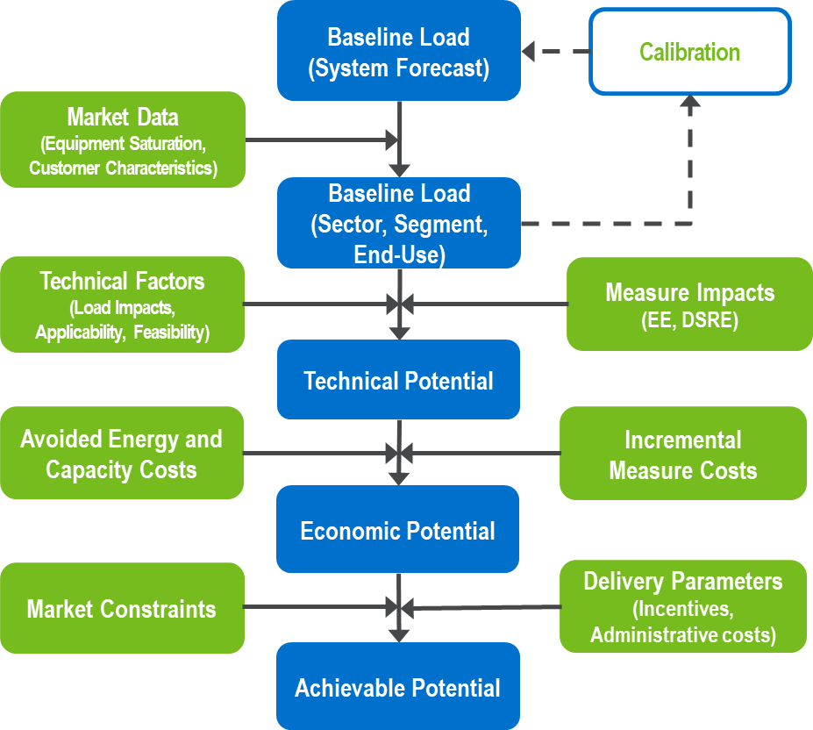

Nexant estimated DSM savings based on a combination of market research, analysis, and a review of TECO’s existing DSM programs, all in coordination with TECO. Nexant examined the technical potential for EE, DR, and DSRE opportunities; this report is organized to offer detail on each DSM category.

EE Potential Overview
To estimate EE market potential, this study utilized Nexant’s Microsoft Excel-based modeling tool, TEA-POT (Technical / Economic / Achievable POTential). This modeling tool was built on a platform that provides the ability to calculate multiple scenarios and recalculate potential savings based on variable inputs such as sales/load forecasts, electricity prices, discount rates, and actual utility program savings. The model provides transparency into the assumptions and calculations for estimating market potential.

DR Potential Overview
To estimate DR market potential, Nexant considered customer demand during utility peaking conditions and projected customer response to DR measures. Customer demand was determined by looking at interval data for a sample of each customer segment. For each segment, Nexant determined the portion of a customer’s load that could be curtailed during the system peak. Projected customer response to DR measures was developed based on the performance of existing Florida DR programs. If a DR strategy did not currently exist in Florida, other programs in the United States were used as a proxy to estimate the performance of the program if it were implemented in Florida.

DSRE Potential Overview
The DSRE technologies included in this study are rooftop solar photovoltaic (PV) systems, battery storage systems, and combined heat and power (CHP) systems. Nexant leveraged the customer segmentation and load disaggregation data assembled for the EE and DR analyses and used a “bottom-up” modeling approach to estimate the potential of the various DSRE technologies in the residential, commercial, and industrial sectors. Individual distributed generation models were created for the three DSRE technologies studied to estimate market potential.

Baseline Forecast Development

Market Characterization
The TECO base year energy use and sales forecast provided the reference point to determine potential savings. The end-use market characterization of the base year energy use and reference case forecast included customer segmentation and load forecast disaggregation. The characterization is described in this section, while the subsequent section addresses the measures and market potential energy and demand savings scenarios.

Customer Segmentation
In order to estimate EE, DR, and DSRE potential, the sales forecast and peak load forecasts were segmented by customer characteristics. As electricity consumption patterns vary by customer type, Nexant segmented customers into homogenous groups to identify which customer groups are eligible to adopt specific DSM technologies, have similar building characteristics and load profiles, or are able to provide DSM grid services.
Nexant segmented customers according to the following:
- By Sector – how much of TECO’s energy sales, summer peak, and winter peak load forecast is attributable to the residential, commercial, and industrial sectors?
- By Customer – how much electricity does each customer typically consume annually and during system peaking conditions?
- By End-Use – within a home or business, what equipment is using electricity during the system peak? How much energy does this end-use consume over the course of a year?
Table 3-1 summarizes the segmentation within each sector. The customer segmentation is discussed in Section 3.1.1. In addition to the segmentation described here for the EE and DSRE analyses, the residential customer segments were further segmented by heating type (electric heat, gas heat, or unknown) and by annual consumption bins within each sub-segment for the DR analysis.
Table 3-1: Customer Segmentation
Residential | Commercial |  | Industrial
Single Family | Assembly | Miscellaneous | Agriculture and Assembly | Primary Resources Industries
Multi-Family | College and University | Offices | Chemicals and Plastics | Stone/Glass/ Clay/Concrete
Manufactured Homes | Grocery | Restaurant | Construction | Textiles and Leather
 | Healthcare | Retail | Electrical and Electronic Equipment | Transportation Equipment
 | Hospitals | Schools K-12 | Lumber/Furniture/ Pulp/Paper | Water and Wastewater
 | Institutional | Warehouse | Metal Products and Machinery
 | Lodging/ Hospitality |  | Miscellaneous Manufacturing
From an equipment and energy use perspective, each segment has variation within each building type or sub-sector. For example, the energy consuming equipment in a convenience store will vary significantly from the equipment found in a supermarket. To account for this variation, the selected end-uses describe energy consumption patterns that are consistent with those typically studied in national or regional surveys, such as the U.S. Energy Information Administration’s Residential Energy Consumption Survey (RECS), Commercial Building Energy Consumption Survey (CBECS) and Manufacturing Energy Consumption Survey (MECS), among others. The end-uses selected for this study are listed in Table 3-2.
Table 3-2: End-Uses
Residential End-Uses | Commercial End-Uses | Industrial End-Uses
Space heating | Space heating | Process heating
Space cooling | Space cooling | Process cooling
Domestic hot water | Domestic hot water | Compressed air
Ventilation and circulation | Ventilation and circulation | Motors/pumps
Lighting | Interior lighting | Fan, blower motors
Cooking | Exterior lighting | Process-specific
Appliances | Cooking | Industrial lighting
Electronics | Refrigeration | Exterior lighting
Miscellaneous | Office equipment | HVAC
 | Miscellaneous | Other
For DR, the end-uses targeted were those with controllable load for residential customers (i.e. HVAC, water heaters, and pool pumps) and small C&I customers (HVAC). For large C&I customers, all load during peak hours was included assuming these customers would potentially would be willing to reduce electricity consumption for a limited time if offered a large enough incentive during temporary system peak demand conditions.

Forecast Disaggregation
A common understanding of the assumptions and granularity in the baseline load forecast was developed with input from TECO. Key discussion topics reviewed included:
- How are current DSM offerings reflected in the energy and demand forecast?
- What are the assumed weather conditions and hour(s) of the day when the system is projected to peak?
- How much of the load forecast is attributable to customers that are not eligible for DSM programs?
- How are projections of population increase, changes in appliance efficiency, and evolving distribution of end-use load shares accounted for in the peak demand forecast?
If separate forecasts are not developed by region or sector, are there trends in the load composition that Nexant should account for in the study?

Electricity Consumption (kWh) Forecast
Nexant segmented the TECO electricity consumption forecast into electricity consumption load shares by customer class and end-use. The baseline customer segmentation represents the electricity market by describing how electricity was consumed within the service territory. Nexant developed these forecasts for the years 2020-2029, and based it on data provided by TECO, primarily their 2017 Ten-Year Site Plan, which was the most recent plan available at the time the studies were initiated. The data addressed current baseline consumption, system load, and sales forecasts.

Peak Demand (kW) Forecast
A fundamental component of DR potential was establishing a baseline forecast of what loads or operational requirements would be absent due to existing dispatchable DR or time varying rates. This baseline was necessary to assess how DR can assist in meeting specific planning and operational requirements. We utilized TECO’s summer and winter peak demand forecast, which was developed for system planning purposes.

Estimating Consumption by End-Use Technology
As part of the forecast disaggregation, Nexant developed a list of electricity end-uses by sector (Table 3-2). To develop this list, Nexant began with TECO’s estimates of average end-use consumption by customer and sector. Nexant combined these data with other information, such as utility residential appliance saturation surveys, to develop estimates of customers’ baseline consumption. Nexant calibrated the utility-provided data with data available from public sources, such as the EIA’s recurring data-collection efforts that describe energy end-use consumption for the residential, commercial, and manufacturing sectors.
To develop estimates of end-use electricity consumption by customer segment and end-use, Nexant applied estimates of end-use and equipment-type saturation to the average energy consumption for each sector. The following data sources and adjustments were used in developing the base year 2020 sales by end-use:

Residential sector:
- The disaggregation was based on TECO rate class load shares and intensities.
- Baseline intensity was calibrated to account for differences in end-use saturation, fuel source, and equipment saturation as follows:
  - TECO rate class load share is based on average per customer.
  - Nexant made conversions to usage estimates generated by applying utility-provided residential appliance saturation surveys (RASS) and EIA end-use modeling estimates.

Commercial sector:
- The disaggregation was based on TECO rate class load shares, intensities, and EIA CBECS data.
- Segment data from EIA and TECO.
- Baseline intensity was calibrated to account for differences in end-use saturation, fuel source, and equipment saturation as follows:
  - Rate class load share based on EIA CBECS and end-use forecasts from TECO.

Industrial sector:
- The disaggregation was based on rate class load shares, intensities, and EIA MECS data.
- Segment data from EIA and TECO.
- Baseline intensity was calibrated to account for differences in end-use saturation, fuel source, and equipment saturation as follows:
  - Rate class load share based on EIA MECS and end-use forecasts from TECO.

Analysis of Customer Segmentation
Customer segmentation is important to ensuring that a MPS examines DSM measure savings potential in a manner that reflects the diversity of energy savings opportunities existing across the utility’s customer base. TECO provided Nexant with data concerning the premise type and loads characteristics for all customers for the MPS analysis. Nexant examined the provided data from multiple perspectives to identify customer segments. Nexant’s approach to segmentation varied slightly for non-residential and residential customers, but the overall logic was consistent with the concept of expressing the customers in terms that were relevant to DSM opportunities.

Residential Customers (EE, DR, and DSRE Analysis)
Segmentation of residential customer accounts enabled Nexant to align DSM opportunities with appropriate DSM measures. Nexant used utility customer data, supplemented with EIA data, to segment the residential sector by customer dwelling type (single family, multi-family, or manufactured home). The resulting distribution of customers according to dwelling unit type is presented in Figure 3-1.
Figure 3-1: Residential Customer Segmentation
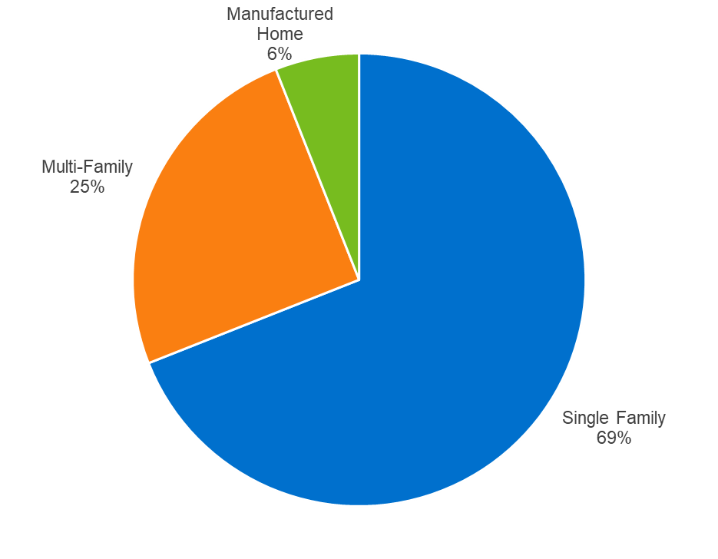

Non-Residential (Commercial and Industrial) Customers (EE and DSRE Analysis)
For the EE and DSRE analysis, Nexant segmented C&I customers using the utility’s North American Industry Classification System (NAICS) or Standard Industrial Classification (SIC) codes, supplemented by data produced by the EIA’s CBECS and MECS. Nexant classified the customers in this group as either commercial or industrial, on the basis of DSM measure information available and applicable to each. For example, agriculture and forestry DSM measures are commonly considered industrial savings opportunities. Nexant based this classification on the types of DSM measures applicable by segment, rather than on the annual energy consumption or maximum instantaneous demand from the segment as a whole. The estimated energy sales distributions Nexant applied are shown below in Figure 3-2 and Figure 3-3.
Figure 3-2: Commercial Customer Segmentation
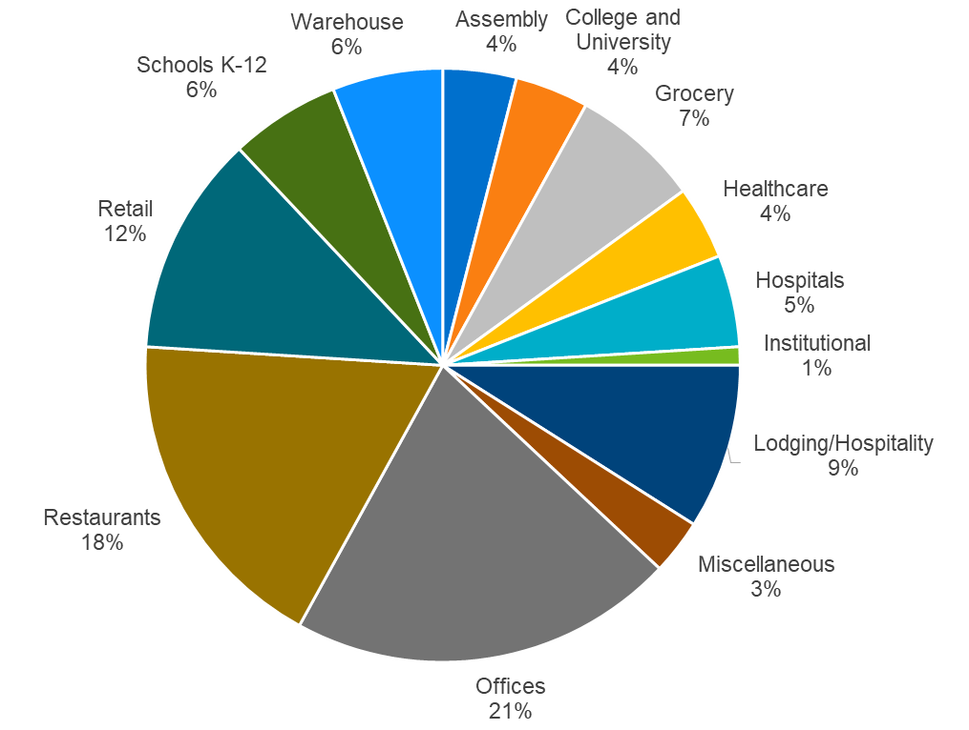
Figure 3-3: Industrial Customer Segmentation
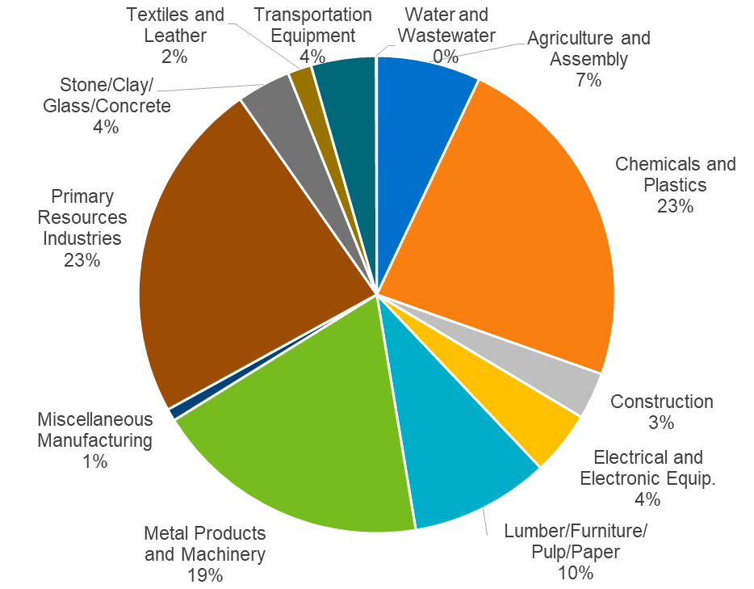

Commercial and Industrial Customers (DR Analysis)
For the DR analysis, Nexant divided the non-residential customers into the two customer classes of small C&I and large C&I using rate class and annual consumption. For the purposes of this analysis, small C&I customers are those on the General Service (GS) tariff. Large C&I customers are all customers on the General Service Demand (GSD) tariff. Nexant further segmented these two groups based on customer size. For small C&I segmentation was determined using annual customer consumption and for Large C&I the customer’s maximum demand was used. Both customer maximum demand and customer annual consumption were calculated using billing data provided by TECO.
Table 3-3 shows the account breakout between small C&I and large C&I.
Table 3-3: Summary of Customer Classes for DR Analysis
Customer Class | Annual kWh | Number of Accounts
Small C&I | 0-15,000 kWh | 43,096
 | 15,001-25,000 kWh | 9,401
 | 25,001-50,000 kWh | 9,062
 | 50,001 kWh + | 3,289
 | Total | 64,848
Large C&I | 0-50 kW | 8,294
 | 51-300 kW | 6,173
 | 301-500 kW | 702
 | 501 kW + | 702
 | Total | 15,841

Analysis of System Load

System Energy Sales
Technical potential is based on TECO’s load forecast for the year 2020 from their 2017 Ten Year Site Plan, which is illustrated in Figure 3-4.
Figure 3-4: 2020 Electricity Sales Forecast by Sector
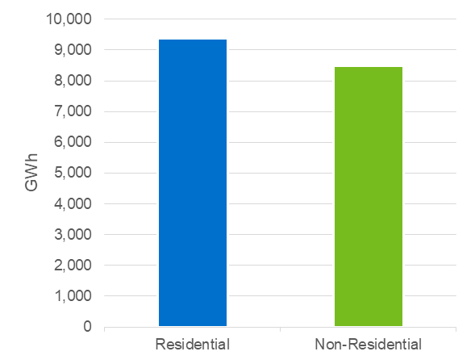

System Demand
To determine the technical potential for DR, Nexant first established peaking conditions for each utility by looking at when each utility historically experienced its maximum demand. The primary data source used to determine when maximum DR impact was the historical system load for TECO. The data provided contained the system loads all 8,760 hours of the most recent five years leading up to the study (2011-2016). The utility summer and winter peaks were then identified within the utility-defined peaking conditions. For TECO the summer peaking conditions were defined as July and August from 5:00-6:00 PM and the winter peaking conditions were defined as January and February from 7:00-8:00 AM. The seasonal peaks were then selected as the maximum demand during utility peaking conditions.

Load Disaggregation
The disaggregated loads for the base year 2020 by sector and end-use are summarized in Figure 3-5, Figure 3-6 and Figure 3-7.
Figure 3-5: Residential Baseline (2020) Energy Sales by End-Use
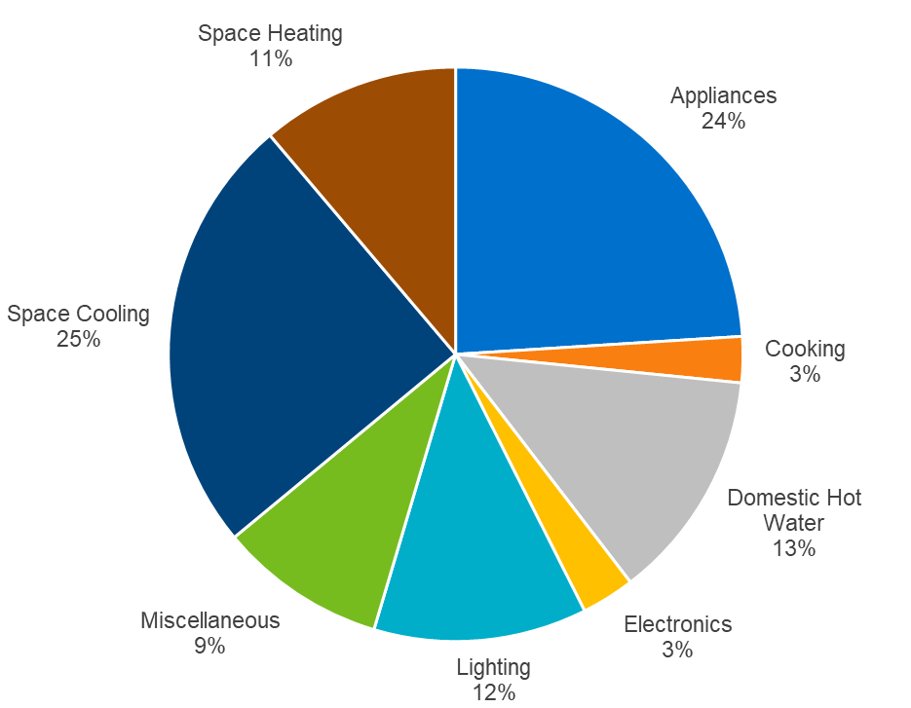
Figure 3-6: Commercial Baseline (2020) Energy Sales by End-Use
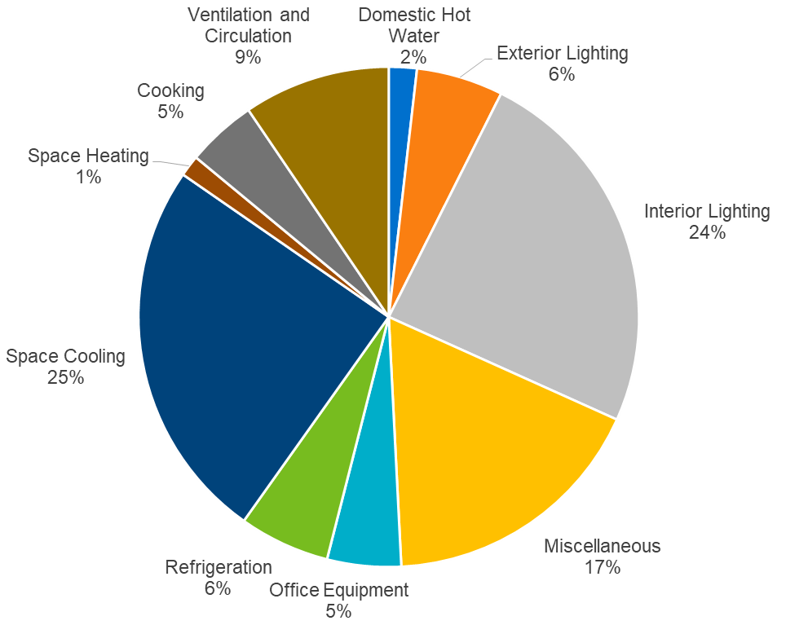
Figure 3-7: Industrial Baseline (2020) Energy Sales by End-Use
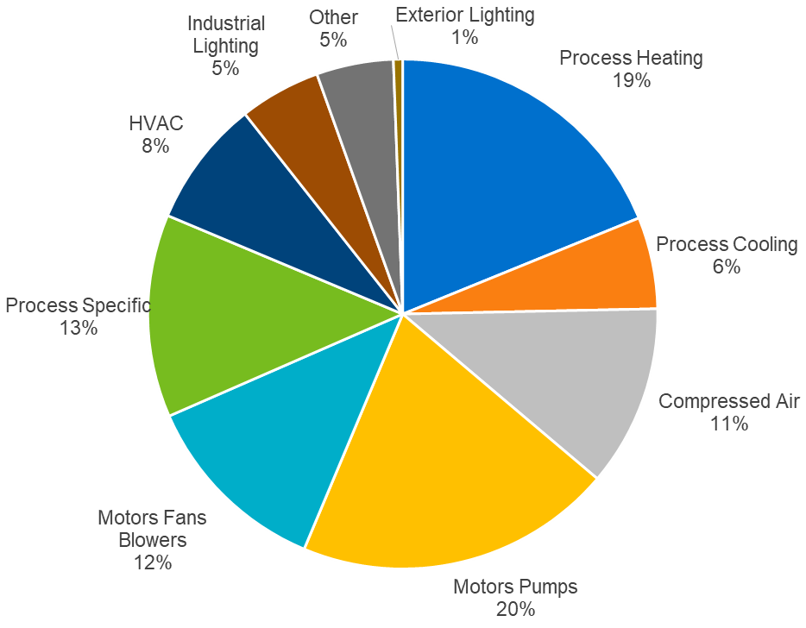

DSM Measure Development
Market potential is described by comparing baseline market consumption with opportunities for savings. Describing these individual savings opportunities results in a list of DSM measures to analyze. This section presents the methodology to develop the EE, DR, and DSRE measure lists.

Methodology
Nexant identified a comprehensive catalog of DSM measures for the study. The measure list is the same for all FEECA Utilities. The iterative vetting process with the utilities to develop the measure list began by initially examining the list of measures included in the 2014 Goals docket. This list was then adjusted based on proposed measure additions and revisions provided by the FEECA Utilities. Nexant further refined the measure list based on reviews of Nexant’s DSM measure library, compiled from similar market potential studies conducted in recent years throughout the United States, including recent studies for Georgia Power Company and Duke Energy Carolinas, as well as measures included in other utility programs where Nexant is involved with program design, implementation, or evaluation. In addition, Nexant evaluated whether each measure had the appropriate data available to estimate impacts in the potential analyses. A draft version of the measure list was shared with interested parties Earthjustice/Southern Alliance for Clean Energy (SACE) for Nexant and the FEECA Utilities to gather and consider their input. The results of that consideration were provided to Earthjustice/SACE and later shared with the Florida Public Service Commission Staff (Staff) and all other interested parties at an informal meeting held by Staff. The extensive, iterative review process involving multiple parties has ensured that the study included a robust and comprehensive set of DSM measures.
See Appendix A for the list of EE measures, Appendix B for the list of DR measures, and Appendix C for the list of DSRE measures analyzed in the study.

EE Measures
EE measures represent technologies applicable to the residential, commercial, and industrial customers in the FEECA Utilities’ service territories. The development of EE measures included consideration of:
- Applicability and commercial availability of EE technologies in Florida. Measures that are not applicable due to climate or customer characteristics were excluded, as were “emerging” technologies that are not currently commercially available to FEECA utility customers.
- Current and planned Florida Building Codes and federal equipment standards (Codes & standards) for baseline equipment. Measures included from prior studies were adjusted to reflect current Codes & standards as well as updated efficiency tiers, as appropriate.
- Eligibility for utility DSM offerings in Florida. For example, behavioral measures were excluded from consideration as they are not allowed to be counted towards utility DSM goals. Behavioral measures are intended to motivate customers to operate in a more energy-efficient manner (e.g., setting an air-conditioner thermostat to a higher temperature) without accompanying: a) physical changes to more efficient end-use equipment or to their building envelope, b) utility-provided products and tools to facilitate the efficiency improvements, or c) permanent operational changes that improve efficiency which are not easily revertible to prior conditions. These types of behavioral measures were excluded because of the variability in forecasting the magnitude and persistence of energy and demand savings from the utility’s perspective. Additionally, behavioral measure savings may be obtained in part from the installation of EE technologies, which would overlap with other EE measures included in the study.
Upon development of the final EE measure list, a Microsoft Excel workbook was developed for each measure to quantify measure inputs necessary for assessment of the measure’s potential and cost-effectiveness. Relevant inputs included the following:
- Measure description: measure classification by type, end-use, and subsector, and description of the base-case scenario.
- kWh savings: Energy savings associated with each measure were developed through engineering algorithms or building simulation modeling, taking weather zones and customer segments into consideration as appropriate. Reference sources used for developing residential and commercial measure savings included a variety of Florida-specific, as well as regional and national sources, such utility-specific measurement & verification (M&V) data, technical reference manuals (TRM) from other jurisdictions, ENERGY STAR calculators, and manufacturer or retailer specifications on particular products. Industrial measure savings were primarily based on Department of Energy’s (DOE) Industrial Assessment Center database, using assessments conducted in the Southeast region, as well as TRMs, utility reference data, and Nexant DSM program experience.
Energy savings were applied in Nexant’s TEA-POT model as a percentage of total baseline consumption. Peak demand savings were determined using utility-specific load shapes or coincidence factors.
- Measure Expected Useful Lifetime: Sources included the Database for Energy Efficient Resources (DEER), the American Society of Heating, Refrigerating and Air Conditioning Engineers (ASHRAE) Handbook, and other regional and national measure databases and EE program evaluations
- Measure Costs: Per-unit costs (full or incremental, depending on the application) associated with measure installations. Sources included: TRMs, ENERGY STAR calculator, online market research, RSMeans database, and other secondary sources.
Measure Applicability: A general term encompassing an array of factors, including: technical feasibility of installation, and the measure’s current saturation as well as factors to allocate savings associated with competing measures. Information used primarily derived from data in current regional and national databases, as well as TECO’s program tracking data. These factors are described in Table 4-1.
Table 4-1: Measure Applicability Factors
Measure Impact | Explanation | Sources
Technical Feasibility | The percentage of buildings that can have the measure physically installed. Various factors may affect this, including, but not limited to, whether the building already has the baseline measure (e.g., dishwasher), and limitations on installation (e.g., size of unit and space available to install the unit). | Various secondary sources and engineering experience.
Measure Incomplete Factor | The percentage of buildings without the specific measure currently installed. | Utility RASS; EIA RECS, CBECS; MECS; ENERGY STAR sales figures; and engineering experience.
Measure Share | Used to distribute the percentage of market shares for competing measures (e.g., only blown-in ceiling insulation or spray foam insulation, not both would be installed in an attic). | Utility customer data, Various secondary sources and engineering experience.

As shown in Table 4-2, the measure list includes 248 unique energy-efficiency measures. Expanding the measures to account for all appropriate combinations of segments, end-uses, and construction types resulted in 4,164 measure permutations.
Table 4-2: EE Measure Counts by Sector
Sector | Unique Measures | Permutations
Residential | 91 | 546
Commercial | 127 | 3,298
Industrial | 30 | 320

DR Measures
The DR measures included in the measure list utilize the following DR strategies:
- Direct Load Control. Customers receive incentive payments for allowing the utility to control their selected equipment, such as HVAC or water heaters.
- Critical Peak Pricing (CPP) with Technology. Electricity rate structures that vary based on time of day. Includes CPP when the rate is substantially higher for a limited number of hours or days per year (customers receive advance notification of CPP event) coupled with technology that enables customer to lower their usage in a specific end-use in response to the event (e.g. HVAC via smart thermostat).
- Contractual DR. Customers receive incentive payments or a rate discount for committing to reduce load by a pre-determined amount or to a pre-determined firm service level upon utility request.
- Automated DR. Utility dispatched control of specific end-uses at a customer facility.
DR initiatives that do not rely on the installation of a specific device or technology to implement (such as a voluntary curtailment program) were not included.
A workbook was developed for each measure which included the same measure inputs as previously described for the EE measures. In addition, the DR workbook included:
- Expected load reduction from the measure, based on utility technical potential, existing utility DR programs, and other nationwide DR programs if needed
For technical potential, Nexant did not break out results by measure because all of the developed measures target the end uses estimated for technical potential.

DSRE Measures
The DSRE measure list includes rooftop PV systems, battery storage systems charged from PV systems, and CHP systems.
PV Systems
PV systems utilize solar panels (a packaged collection of PV cells) to convert sunlight into electricity. A system is constructed with multiple solar panels, a DC/AC inverter, a racking system to hold the panels, and electrical system interconnections. These systems are often roof-mounted systems that face south-west, south, and/or, south-east. The potential associated with roof-mounted systems installed on residential and commercial buildings was analyzed.
Battery Storage Systems Charged from PV Systems
Distributed battery storage systems included in this study consist of behind-the-meter battery systems installed in conjunction with an appropriately-sized PV system at residential and commercial customer facilities. These battery systems typically consist of a DC-charged battery, a DC/AC inverter, and electrical system interconnections to a PV system. On their own battery storage systems do not generate or conserve energy, but can collect and store excess PV generation to provide power during particular time periods; which for DSM purposes would be to offset customer demand during the utility’s system peak.
CHP Systems
In most CHP applications, a heat engine creates shaft power that drives an electrical generator (fuel cells can produce electrical power directly from electrochemical reactions). The waste heat from the engine is then recovered to provide steam or hot water to meet on-site needs. Common prime mover technologies used in CHP applications and explored in this study include:
- Steam turbines
- Gas turbines
- Micro turbines
- Fuel Cells
- Internal combustion engines
A workbook was developed for each measure which included the inputs previously described for EE measures and prime mover operating parameters.

Technical Potential
In the previous sections, the approach for DSM measure development was summarized, and the 2020 base year load shares and reference-case load forecast were described. The outputs from these tasks provided the input for estimating the technical potential scenario, which is discussed in this section.
The technical potential scenario estimates the savings potential when all technically feasible DSM measures are implemented at their full market potential without regard for cost-effectiveness and customer willingness to adopt the most impactful EE, DR, or DSRE technologies. Since the technical potential does not consider the costs or time required to achieve these savings, the estimates provide a theoretical upper limit on electricity savings potential. Technical potential is only constrained by factors such as technical feasibility and applicability of measures. For this study, technical potential included full application of commercially available DSM measures to all residential, commercial, and industrial customers in the utility’s service territory.

Methodology

EE Technical Potential
EE technical potential refers to delivering less electricity to the same end-uses. In other words, technical potential might be summarized as “doing the same thing with less energy, regardless of the cost.”
DSM measures were applied to the disaggregated utility electricity sales forecasts to estimate technical potential. This involved applying estimated energy savings from equipment and non-equipment measures to all electricity end-uses and customers. Technical potential consists of the total energy and demand that can be saved in the market which Nexant reported as single numerical values for each utility’s service territory.
The core equation used in the residential sector EE technical potential analysis for each individual efficiency measure is shown in Equation 5-1 below, while the core equation used in the nonresidential sector technical potential analysis for each individual efficiency measure is shown in Equation 5-2.
Equation 5-1: Core Equation for Residential Sector Technical Potential
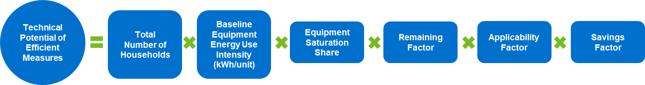
Where:
Baseline Equipment Energy Use Intensity = the electricity used per customer per year by each baseline technology in each market segment. In other words, the baseline equipment energy-use intensity is the consumption of the electrical energy using equipment that the efficient technology replaces or affects.
Equipment Saturation Share = the fraction of the end-use electrical energy that is applicable for the efficient technology in a given market segment. For example, for residential cooling, the saturation share would be the fraction of all residential electric customers that have central air conditioners in their household.
Remaining Factor = the fraction of equipment that is not considered to already be energy efficient. To extend the example above, the fraction of central air conditioners that is not already the most energy efficient technology.
Applicability Factor = the fraction of units that is technically feasible for conversion to the most efficient available technology from an engineering perspective (i.e., it may not be possible to install LEDs in all light sockets in a home because the available styles may not fit in every socket).
Savings Factor = the percentage reduction in electricity consumption resulting from the application of the efficient technology.
Equation 5-2: Core Equation for Non-Residential Sector Technical Potential
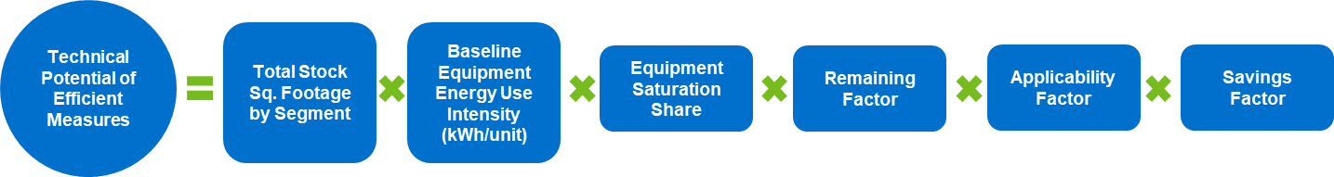
Where:
Total Stock Square Footage by Segment = the forecasted square footage level for a given building type (e.g., square feet of office buildings).
Baseline Equipment Energy Use Intensity = the electricity used per square foot per year by each baseline equipment type in each market segment.
Equipment Saturation Share = the fraction of total end-use energy consumption associated with the efficient technology in a given market segment. For example, for packaged terminal air-conditioner (PTAC), the saturation share would be the fraction of all space cooling kWh in a given market segment that is associated with PTAC equipment.
Remaining Factor = the fraction of equipment that is not considered to already be energy efficient.
Applicability Factor = the fraction of the equipment or practice that is technically feasible for conversion to the efficient technology from an engineering perspective (i.e., it may not be possible to install Variable Frequency Drives (VFD) on all motors in a given market segment).
Savings Factor = the percentage reduction in electricity consumption resulting from the application of the efficient technology.
It is important to note that the technical potential estimate represents electricity savings potential at a specific point in time. In other words, the technical potential estimate is based on data describing status quo customer electricity use and technologies known to exist today. As technology and electricity consumption patterns evolve over time, the baseline electricity consumption will also change accordingly. For this reason, technical potential is a discrete estimate of a dynamic market. Nexant reported the technical potential for 2020, based on currently known DSM measures and observed electricity consumption patterns.

Measure Interaction and Competition
While the technical potential equations listed above focus on the technical potential of a single measure or technology, Nexant’s modeling approach does recognize the overlap of individual measure impacts within an end-use or equipment type, and accounts for the following interactive effects:
- Measure interaction: Installing high-efficiency equipment could reduce energy savings in absolute terms (kWh) associated with non-equipment measures that impact the same end-use. For example, installing a high-efficiency heat pump will reduce heating and cooling consumption which will reduce the baseline against which attic insulation would be applied, thus reducing savings associated with installing insulation. To account for this interaction, Nexant’s TEA-POT model ranks measures that interact with one another and reduces the baseline consumption for the subsequent measure based on the savings achieved by the preceding measure. For technical potential, interactive measures are ranked based on total end-use energy savings percentage.
- Measure competition: The “measure share”—as defined above—accounted for competing measures, ensuring savings were not double-counted. This interaction occurred when two or more measures “competed” for the same end-use. For example, a T-12 lamp could be replaced with a T-8 or linear LED lamp.

Addressing Naturally-Occurring EE
Because the anticipated impacts of efficiency actions that may be taken even in the absence of utility intervention are included in the baseline forecast, savings due to naturally-occurring EE were considered separately in the potential estimates. Nexant verified with TECO’s forecasting group to ensure that the sales forecasts incorporated two known sources of naturally-occurring efficiency:
- Codes and Standards: The sales forecasts already incorporated the impacts of known Code & standards changes. While some changes have relatively little impact on overall sales, others—particularly the Energy Independence and Security Act (EISA) and other federal legislation—will have noticeable influence.
Baseline Measure Adoption: The sales forecast excluded the projected impacts of future DSM efforts, but included already implemented DSM penetration.
By properly accounting for these factors, the potential study estimated the net penetration rates, representing the difference between the anticipated adoption of efficiency measures as a result of DSM efforts and the “business as usual” adoption rates absent DSM intervention. This is true even in the technical potential, where adoption was assumed to be 100%.

DR Technical Potential
The concept of technical potential applies differently to DR than for EE. Technical potential for DR is effectively the magnitude of loads that can be curtailed during conditions when utilities need peak capacity reductions. In evaluating this potential at peak capacity, the following were considered: which customers are consuming electricity at those times? What end-uses are in play? Can those end-use loads be managed? Large C&I customers generally do not provide the utility with direct control over particular end-uses. Instead, many of these customers will forego virtually all electric demand temporarily if the financial incentive is large enough. For residential and small C&I customers where DR generally takes the form of direct utility control, technical potential for DR is limited by the loads that can be controlled remotely at scale.
This framework makes end-use disaggregation an important element for understanding DR potential, particularly in the residential and small C&I sectors. When done properly, end-use disaggregation not only provides insights into which loads are on and off when specific grid services are needed, it also provides insight concerning how key loads and end-uses, such as air conditioning use, vary across customers. Nexant’s approach used for load disaggregation is more advanced than what is used for most potential studies. Instead of disaggregating annual consumption or peak demand, Nexant produced end-use load disaggregation for all 8760 hours. This was needed because the loads available at times when different grid applications are needed can vary substantially. Instead of producing disaggregated loads for the average customer, the study was produced for several customer segments. For TECO, Nexant examined three residential segments based on customer housing type, four different small C&I segments based on customer size, and four different large C&I segments based on customer size, for a total of 11 different customer segments.
Technical potential, in the context of DR, is defined as the total amount of load available for reduction that is coincident with the period of interest; in this case, the system peak hour for the summer and winter seasons. Thus, two sets of capacity values are estimated: a summer capacity and a winter capacity.
As previously mentioned, for technical potential purposes, all coincident large C&I load is considered dispatchable, while residential and small C&I DR capacity is based on specific end-uses. Summer DR capacity for residential customers was comprised of air-conditioning (AC), pool pumps, and water heaters. For small C&I customers, summer capacity was based on AC load. For winter DR capacity, residential was based on electric heating, pool pumps, and water heaters. For small C&I customers, winter capacity was based on electric heating.
AC and heating load profiles were generated for residential and small C&I customers using interval data from a sample of customers provided by TECO. This sample included a customer breakout based on size and housing type for each rate class. Nexant then used the interval data from these customers to create an average load profile for each customer segment.
The average load profile for each customer segment was combined with historical weather data, and used to estimate hourly load as a function of weather conditions. AC and heating loads were estimated by first calculating the baseline load on days when cooling degree days (CDD) and heating degree days (HDD) were equal to zero, and then subtracting this baseline load. This methodology is illustrated by Figure 5-1 (a similar methodology was used to predict heating loads).
Figure 5-1: Methodology for Estimating Cooling Loads
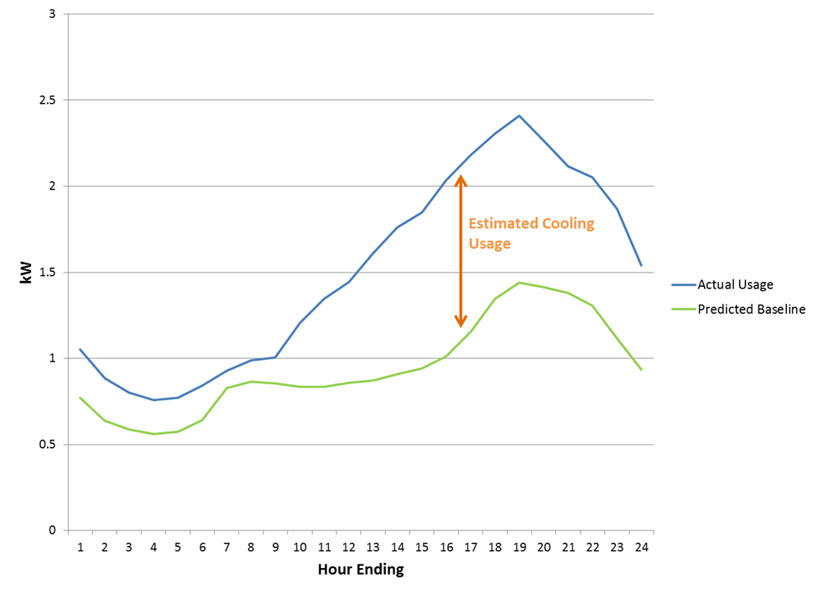
This method was able to produce estimates for average AC/heating load profiles for the seven different customer segments within the residential and small C&I sectors.
Profiles for residential water heater and pool pump loads were estimated by utilizing end-use load data from CPS Energy’s Home Manager DR program.
For all eligible loads, the technical potential was defined as the amount that was coincident with system peak hours for each season, which are July and August from 5:00-6:00 PM for summer, and January and February from 7:00-8:00 AM for winter.
As mentioned in Section 4, for technical potential there was also no measure breakout needed, because all measures will target the end-uses’ estimated total loads.
In order to account for existing utility DR programs, all customers currently enrolled in a DR offering were excluded from the technical potential. This methodology was consistent across all three sectors.

DSRE Technical Potential

PV Systems
To determine technical potential for PV systems, Nexant estimated the percentage of rooftop square footage in Florida that is suitable for hosting PV technology. Our estimate of technical potential for PV systems in this report is based in part on the available roof area and consisted of the following steps:
- Step 1: Outcomes from the forecast disaggregation analysis were used to characterize the existing and new residential, commercial and industrial building stocks. Relevant parameters included number of facilities, average number of floors, and average premises square footage.
- Step 2: The total available roof area feasible for installing PV systems was calculated. Relevant parameters included share of pitched and flat roofs and unusable area due to other rooftop equipment.
- Step 3: Estimated the expected power density (kW per square foot of roof area).
- Step 4: Using PVWatts, secondary research, and M&V evaluations of PV systems, Nexant used its technical potential PV calculator to calculate energy generation/savings using researched system capacity factors.
The methodology presented in this report uses the following formula to estimate overall technical potential of PVs:
Equation 5-3: Core Equation for Solar Technical Potential
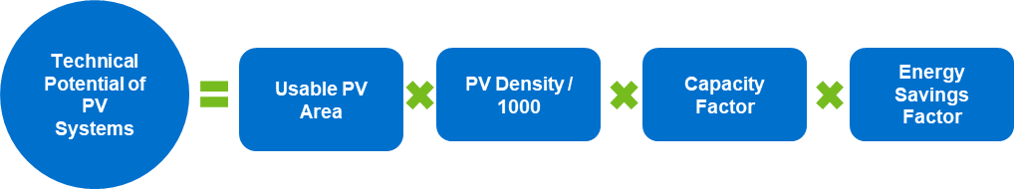
Where:
Usable PV Area for Residential: (Total Floor Area / Average No. of Stories) x ((% of Sloped Roofs x Usable Area of Sloped Roofs) + (% of Flat Roofs x Usable Area of Flat Roofs))
Usable PV Area for Commercial: Total Floor Area x ((% of Sloped Roofs x Usable Area of Sloped Roofs) + (% of Flat Roofs x Usable Area of Flat Roofs))
PV Density (Watts/Square foot): Maximum power generated in Watts per square foot of solar panel.
Capacity Factor: Annual Energy Generation Factor for PV
Energy Savings Factor: AC Energy Conversion factor for each kW of the system, obtained from PV Watts. Energy Savings Factor = Alternating Current System Output (kWh)/ Direct Current System Size (kW)

Battery Storage Systems
Battery storage systems on their own do not generate power or create efficiency improvements, but store power for use at different times. Therefore, in analyzing the technical potential for battery storage systems, the source of the stored power and overlap with technical potential identified in other categories was considered.
Battery storage systems that are powered directly from the grid do not produce annual energy savings but may be used to shift or curtail load during particular time periods. As the DR technical potential analyzes curtailment opportunities for the summer and winter peak period, and battery storage systems can be used as a DR technology, the study concluded that no additional technical potential should be claimed for grid-powered battery systems beyond that already attributed to DR.
Battery storage systems that are connected to on-site PV systems also do not produce additional energy savings beyond the energy produced from the PV system. However, PV-connected battery systems do create the opportunity to store energy during period when the PV system is generating more than the home or business is consuming, and use that stored power during utility system peak periods. To determine the additional technical potential peak demand savings for “solar plus storage” systems, our methodology consisted of the following steps:
- Develop an 8,760 hour annual load shape for a PV system based on estimated annual hours of available sunlight.
- Compare the PV generation with a total home or total business 8,760 hour annual load shape to determine the hours that the full solar energy is used and the hours where excess solar power is generated.
- Develop a battery charge/discharge 8,760 load profile to identify available stored load during summer and winter peak periods, which was applied as the technical potential.

CHP Systems
The CHP analysis created a series of unique distributed generation potential models for each primary market sector (commercial and industrial).
Only non-residential customer segments whose electric and thermal load profiles allow for the application of CHP were considered. The technical potential analysis followed a three-step process. First, minimum facilities size thresholds were determined for each non-residential customer segment. Next, the full population of non-residential customers were segmented and screened based on the size threshold established for that segment. Finally, the facilities that were of sufficient size were matched with the appropriately sized CHP technology.
To determine the minimum threshold for CHP suitability, a thermal factor was applied to potential candidate customer loads to reflect thermal load considerations in CHP sizing. In most cases, on-site thermal energy demand is smaller than electrical demand. Thus, CHP size is usually dictated by the thermal load in order to achieve improved efficiencies.
The study collected electric and thermal intensity data from other recent CHP studies. For industrial customers, Nexant assumed that the thermal load would primarily be used for process operations and was not modified from the secondary data sources for Florida climate conditions. For commercial customers, the thermal load is more commonly made up of water heating, space heating, and space cooling (through the use of an absorption chiller). Therefore, to account for the hot and humid climate in Florida, which traditionally limits weather-dependent internal heating loads, commercial customers’ thermal loads were adjusted to incorporate a higher proportion of space cooling to space heating as available opportunities for waste heat recovery.
After determination of minimum kWh thresholds by segment, Nexant used the utility-provided customer data with NAICS or SIC codes as well as annual consumption data, and categorized all non-residential customers by segment and size. Customers with annual loads below the kWh thresholds are not expected to have the consistent electric and thermal loads necessary to support CHP and were eliminated from consideration.
In general, internal combustion engines are the prime mover for systems under 500kW with gas turbines becoming progressively more popular as system size increases above that. Based on the available load by customer, adjusted by the estimated thermal factor for each segment, CHP technologies were assigned to utility customers in a top-down fashion (i.e. starting with the largest CHP generators).

Measure Interaction
PV systems and battery storage charged from PV systems were analyzed collectively due to their common power generation source; and therefore, the identified technical potential for these systems is additive. However, CHP systems were independently analyzed for technical potential without consideration of the competition between DSRE technologies or customer preference for a particular DSRE system. Therefore, results for CHP technical potential should not be combined with PV systems or battery storage systems for overall DSRE potential but used as independent estimates.

Interaction of Technical Potential Impacts
As described above, the technical potential was estimated using separate models for EE, DR, and DSRE systems. However, there is interaction between these technologies; for example, a more efficient HVAC system would result in a reduced peak demand available for DR curtailment. Therefore, after development of the independent models, the interaction between EE, DR, and DSRE was incorporated as follows:
- The EE technical potential was assumed to be implemented first, followed by DR technical potential and DSRE technical potential.
- To account for the impact of EE technical potential on DR, the baseline load forecast for the applicable end-uses was adjusted by the EE technical potential, resulting in a reduction in baseline load available for curtailment.
- For DSRE systems, the EE and DR technical potential was incorporated in a similar fashion, adjusting the baseline load used to estimate DSRE potential.
  - For the PV analysis this did not impact the results as the EE and DR technical potential did not affect the amount of PV that could be installed on available rooftops.
  - For the battery storage coupled with PV, the reduced baseline load from EE resulted in additional PV-generated energy being available for the battery systems and for use during peak periods. The impact of DR events during the assumed curtailment hours was incorporated into the modeling of available battery storage and discharge loads.
  - For CHP systems, the reduced baseline load from EE resulted in a reduction in the number of facilities that met the annual energy threshold needed for CHP installations. Installed DR capacity was assumed to not impact CHP potential as the CHP system feasibility was determined based on energy and thermal consumption at the facility. It should be noted that CHP systems not connected to the grid could impact the amount of load available for curtailment with utility-sponsored DR. Therefore, CHP technical potential should not be combined with DR potential but used as independent estimates.

EE Technical Potential

Summary
Table 5-1 summarizes the EE technical potential by sector:
Table 5-1: EE Technical Potential by Sector
 | Savings Potential
 | Summer  Peak Demand (MW) | Winter  Peak Demand (MW) | Energy  (GWh)
Residential | 755 | 388 | 2,791
Non-Residential | 383 | 195 | 1,691
Total | 1,138 | 583 | 4,483

Residential
Figure 5-2, Figure 5-3, and Figure 5-4 summarize the residential sector EE technical potential by end-use.
Figure 5-2: Residential EE Technical Potential by End-Use (Energy Savings)
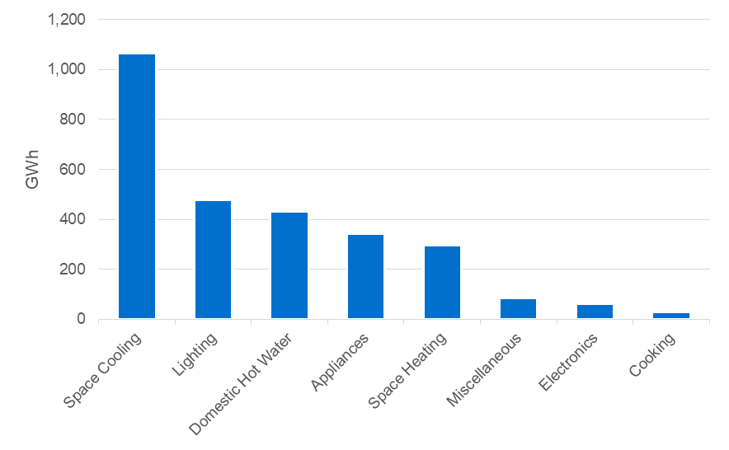
Figure 5-3: Residential EE Technical Potential by End-Use (Summer Peak Savings)
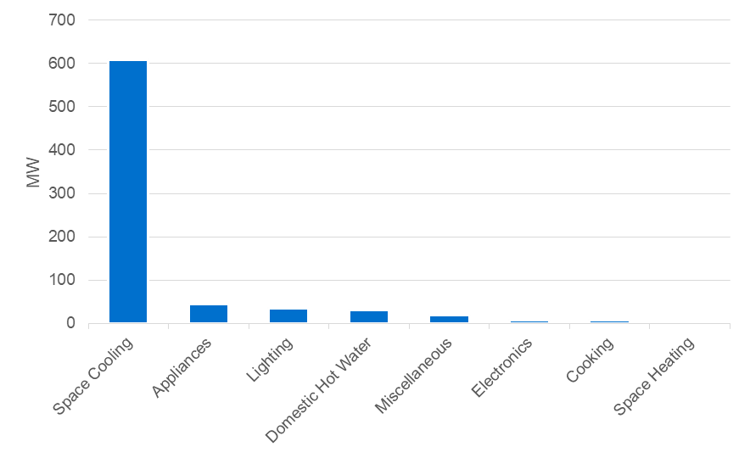
Figure 5-4: Residential EE Technical Potential by End-Use (Winter Peak Savings)
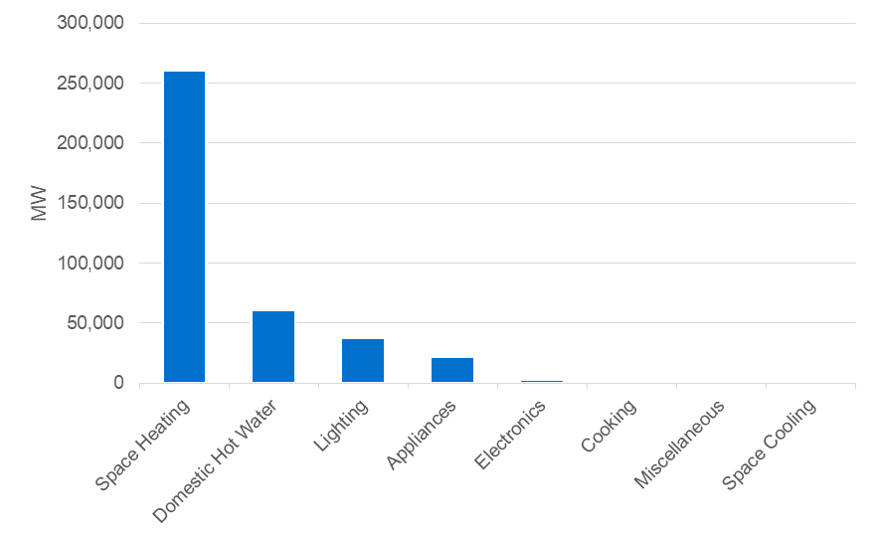

Non-Residential

Commercial Segments
Figure 5-5, Figure 5-6, and Figure 5-7 summarize the commercial EE technical potential by end-use.
Figure 5-5: Commercial EE Technical Potential by End-Use (Energy Savings)
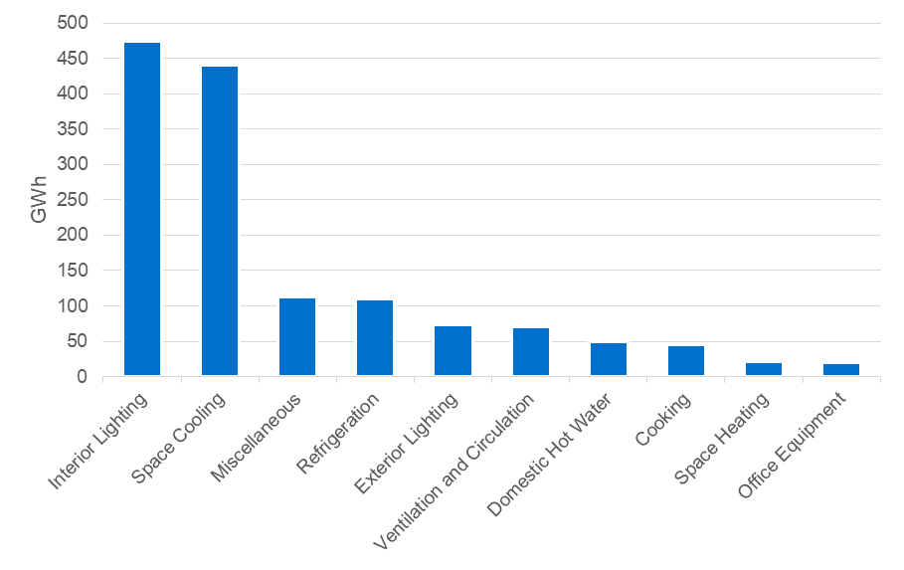
Figure 5-6: Commercial EE Technical Potential by End-Use (Summer Peak Savings)
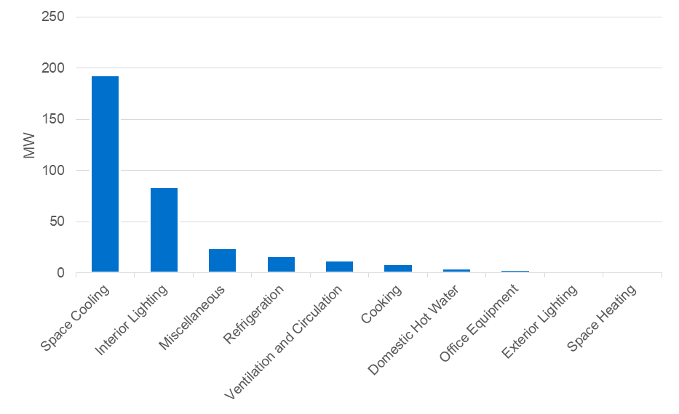
Figure 5-7: Commercial EE Technical Potential by End-Use (Winter Peak Savings)
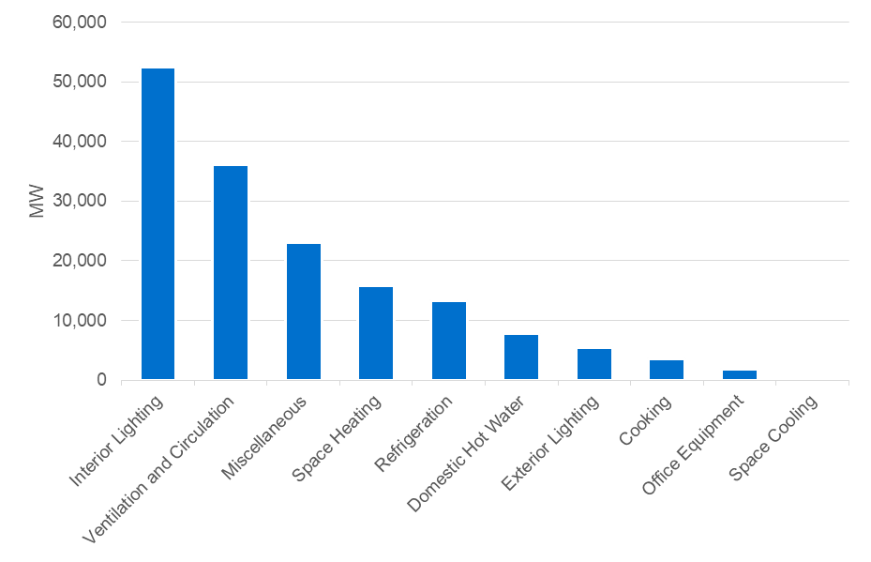

Industrial Segments
Figure 5-8, Figure 5-9, and Figure 5-10 summarize the industrial EE technical potential by end-use.
Figure 5-8: Industrial EE Technical Potential by End-Use (Energy Savings)
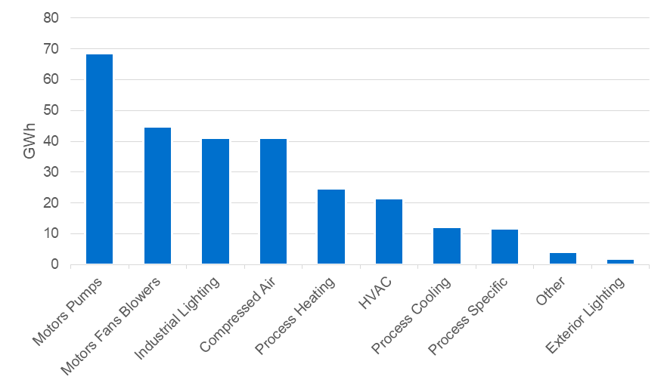
Figure 5-9: Industrial EE Technical Potential by End-Use (Summer Peak Savings)
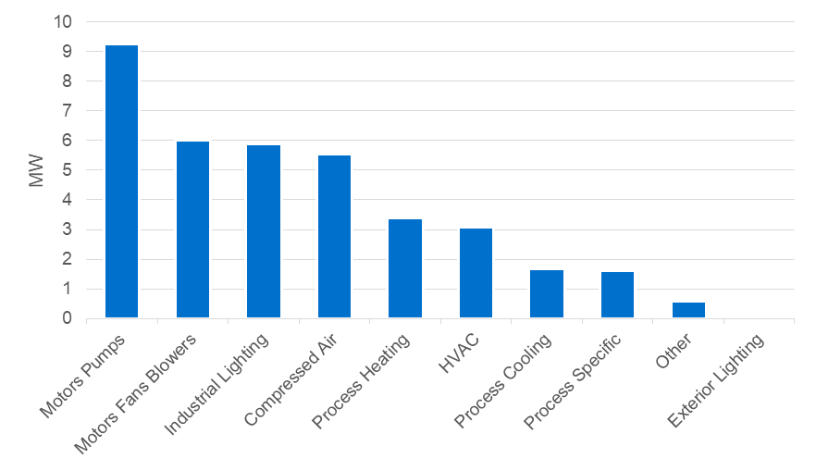
Figure 5-10: Industrial EE Technical Potential by End-Use (Winter Peak Savings)
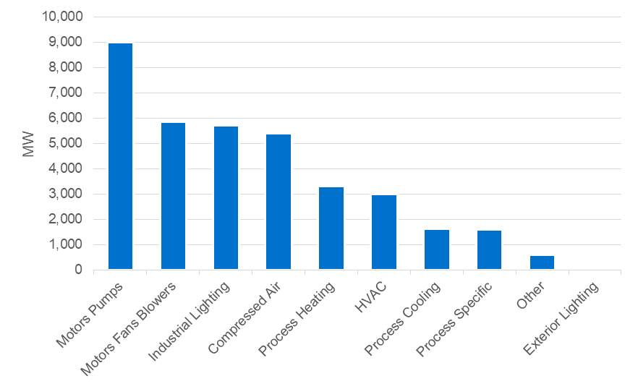

DR Technical Potential
Technical potential for DR is defined for each class of customers as follows:
- Residential & Small C&I customers – Technical potential is equal to the aggregate load for all end-uses that can participate in TECO’s current programs plus DR measures not currently offered in which the utility uses specialized devices to control loads (i.e. direct load control programs). This includes cooling and heating loads for residential and small C&I customers and water heater and pool pump loads for residential customers. Not all demand reductions are delivered via direct load control of end-uses. The magnitude of demand reductions from non-direct load control such as time varying pricing, peak time rebates and targeted notifications is linked to cooling and heating loads.
- Large C&I customers – Technical potential is equal to the total amount of load for each customer segment (i.e., that customers reduce their total load to zero when called upon).
Table 5-2 summarizes the seasonal DR technical potential by sector:
Table 5-2: DR Technical Potential by Sector
 | Savings Potential
 | Summer Peak Demand  (MW) | Winter Peak Demand  (MW)
Residential | 1,208 | 1,645
Non-Residential | 1,191 | 673
Total | 2,398 | 2,318

Residential
Residential technical potential is summarized in Figure 5-11.

Figure 5-11: Residential DR Technical Potential by End-Use
(Incremental to Existing)
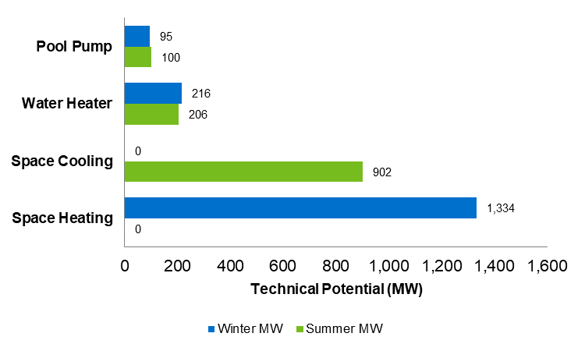

Non-Residential

Small C&I Customers
For small C&I technical potential looked at cooling and heating loads only. Small C&I technical potential is provided in Figure 5-12.
Figure 5-12: Small C&I DR Technical Potential by End-Use
(Incremental to Existing)
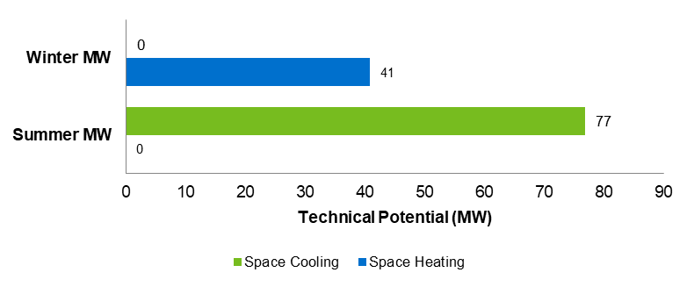

Large C&I Customers
Figure 5-13 provides the technical potential for large C&I customers, broken down by customer size.
Figure 5-13: Large C&I DR Technical Potential by Segment
(Incremental to Existing)
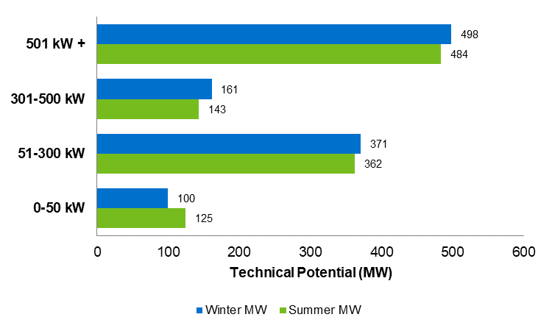

DSRE Technical Potential
Table 5-3 provides the detailed results of the DSRE technical potential.
Table 5-3: DSRE Technical Potential
 | Savings Potential
 | Summer  Peak Demand (MW) | Winter  Peak Demand (MW) | Energy  (GWh)
PV Systems
Residential | 509 | 19 | 3,461
Non-Residential | 835 | 31 | 5,679
Total | 1,344 | 50 | 9,140
Battery Storage charged from PV Systems
Residential | 214 | 211 | -
Non-Residential | 1 | - | -
Total | 216 | 211 | -
CHP Systems
Total | 656 | 358 | 3,126

Appendices

EE MPS Measure List
For information on how Nexant developed this list, please see Section 4.
Measures that are new for the 2019 MPS are indicated with an asterisk.

Residential Measures
Measure | End-Use | Description | Baseline
Energy Star Clothes Dryer | Appliances | One Electric Resistance Clothes Dryer meeting current ENERGY STAR® Standards | One Clothes Dryer meeting Federal Standard
Energy Star Clothes Washer | Appliances | One Clothes Washer meeting current ENERGY STAR® Standards | One Clothes Washer meeting Federal Standard
Energy Star Dishwasher | Appliances | One Dishwasher meeting current ENERGY STAR® Requirements | One Dishwasher meeting Federal Standard
Energy Star Freezer | Appliances | One Freezer meeting current ENERGY STAR® Standards | One Freezer meeting Federal Standard
Energy Star Refrigerator | Appliances | One Refrigerator meeting current ENERGY STAR® Standards | One Refrigerator meeting Federal Standard
Heat Pump Clothes Dryer* | Appliances | One Heat Pump Clothes Dryer | One Clothes Dryer meeting Federal Standard
Removal of 2nd Refrigerator-Freezer | Appliances | No Refrigerator | Current Market Average Refrigerator
High Efficiency Convection Oven* | Cooking | One Full-Size Convection Oven meeting current ENERGY STAR® Standards | One Standard Economy-Grade Full-Size Oven
High Efficiency Induction Cooktop* | Cooking | One residential induction cooktop | One standard residential electric cooktop
Drain Water Heat Recovery* | Domestic Hot Water | Hot Water Loop with 50 Gallon Electric Resistance Heater and Drain Water Heat Exchanger | Standard Hot Water Loop with 50 Gallon Electric Resistance Heater, No Drain Water Heat Recovery
Faucet Aerator | Domestic Hot Water | Low-flow lavatory faucet aerator, flow rate: 1.0 gpm | Federal lavatory flow rate standard, 1994, flow rate: 2.2 gpm
Heat Pump Water Heater | Domestic Hot Water | Heat Pump Water Heater (EF=2.50) | Code-Compliant 50 Gallon Electric Resistance Water Heater
Heat Trap | Domestic Hot Water | Heat Trap | Existing Water Heater without heat trap
Hot Water Pipe Insulation | Domestic Hot Water | 1' of Insulated Pipe in Unconditioned Spaces, Insulation of R-5 | 1' of Pipe in Unconditioned Spaces with Code Minimum of 1"of Insulation
Instantaneous Hot Water System* | Domestic Hot Water | Instantaneous Hot Water System | Standard Efficiency Storage Tank Water Heater
Low Flow Showerhead | Domestic Hot Water | Low-Flow Handheld Showerhead, Flow Rate: 1.50 gpm | Standard Handheld Showerhead, Flow Rate: 2.50 gpm
Solar Water Heater | Domestic Hot Water | Solar Powered 50 Gallon Electric Resistance Water Heater (EF = 1.84) | Code-Compliant 50 Gallon Electric Resistance Water Heater
Thermostatic Shower Restriction Valve* | Domestic Hot Water | Hot Water Loop with 50 Gallon Electric Resistance Heater and Pressure Balance Shower Valves | Standard Hot Water Loop with 50 Gallon Electric Resistance Heater and Standard Shower Valves
Water Heater Blanket | Domestic Hot Water | 50 Gallon Electric Resistance Water Heater with Insulated Tank Wrap (R-11) | Market Average 50 Gallon Electric Resistance Water Heater, No Tank Wrap
Water Heater Thermostat Setback | Domestic Hot Water | 50 Gallon Electric Resistance Water Heater with Temperature Set-point of 125°F | Market Average 50 Gallon Electric Resistance Water Heater, Temp. Set-point = 130°F
Water Heater Timeclock | Domestic Hot Water | Water Heater Timeclock | Existing Water Heater without time clock
Energy Star Air Purifier* | Electronics | One 120 CFM Air Purifier meeting current ENERGY STAR® Standards | One Standard Air Purifier
Energy Star Audio-Video Equipment | Electronics | One DVD/Blu-Ray Player meeting current ENERGY STAR® Standards | One Market Average DVD/Blu-Ray Player
Energy Star Imaging Equipment* | Electronics | One imaging device meeting current ENERGY STAR® Standards | One non-ENERGY STAR® imaging device
Energy Star Personal Computer | Electronics | One Personal Computer (desktop or laptop) meeting current ENERGY STAR® Standards | One non-ENERGY STAR® Personal Computer
Energy Star TV | Electronics | One Television meeting current ENERGY STAR® Standards | One non-ENERGY STAR® Television
Smart Power Strip | Electronics | Smart plug strips for entertainment centers and home office | Standard entertainment center or home office usage, no smart strip controls
CFL - 15W Flood | Lighting | CFL (assume 15W) replacing EISA-2020 compliant baseline lamp (65w flood) | EISA-2020 compliant baseline lamp (65W flood)
CFL - 15W Flood (Exterior) | Lighting | CFL (assume 15W) replacing EISA-2020 compliant baseline lamp (65w flood) | EISA-2020 compliant baseline lamp (65W flood)
CFL-13W | Lighting | CFL (assume 13W) replacing EISA-2020 compliant baseline lamp (60w equivalent) | EISA-2020 compliant baseline lamp (60W equivalent)
CFL-23W | Lighting | CFL (assume 23W) replacing EISA-2020 compliant baseline lamp (100w equivalent) | EISA-2020 compliant baseline lamp (100W equivalent)
Exterior Lighting Controls* | Lighting | Timer on Outdoor Lighting, Controlling 120 Watts | 120 Watts of Lighting, Manually Controlled
Interior Lighting Controls* | Lighting | Switch Mounted Occupancy Sensor, 120 Watts Controlled | 120 Watts of Lighting, Manually Controlled
LED - 14W | Lighting | LED (assume 14W) replacing EISA-2020 compliant baseline lamp (100w equivalent) | EISA-2020 compliant baseline lamp (100W equivalent)
LED - 9W | Lighting | LED (assume 9W) replacing EISA-2020 compliant baseline lamp (60w equivalent) | EISA-2020 compliant baseline lamp (60W equivalent)
LED - 9W Flood | Lighting | LED (assume 9W) replacing EISA-2020 compliant baseline lamp (65w flood) | EISA Compliant Halogen Lamp
LED - 9W Flood (Exterior) | Lighting | LED (assume 9W) replacing EISA-2020 compliant baseline lamp (65w flood) | EISA Compliant Halogen Lamp
LED Specialty Lamps-5W Chandelier* | Lighting | 5 W Chandelier LED | Standard incandescent chandelier lamp
Linear LED* | Lighting | Linear LED Lamps in Linear Fluorescent Fixture | Standard (32w) T8 lamps in Linear Fluorescent Fixture
Low Wattage T8 Fixture | Lighting | Low Wattage (28w) T8 Lamps in Linear Fluorescent Fixture | Standard (32w) T8 lamps in Linear Fluorescent Fixture
Energy Star Bathroom Ventilating Fan* | Miscellaneous | Bathroom Exhaust Fan meeting current ENERGY STAR Standards | Bathroom Exhaust Fan meeting Federal Standard
Energy Star Ceiling Fan* | Miscellaneous | 60" Ceiling Fan Meeting current ENERGY STAR Standards | Standard, non-ENERGYSTAR Ceiling Fan
Energy Star Dehumidifier* | Miscellaneous | One Dehumidifier meeting current ENERGY STAR Standards | One Dehumidifier meeting Federal Standard
Heat Pump Pool Heater* | Miscellaneous | Heat Pump Swimming Pool Heater | Electric Resistance Swimming Pool Heater
Solar Pool Heater* | Miscellaneous | Solar Swimming Pool Heater | Electric Resistance Swimming Pool Heater
Solar Powered Pool Pumps | Miscellaneous | Solar Powered Pool Pump | Single Speed Pool Pump Motor
Two Speed Pool Pump | Miscellaneous | Dual Speed Pool Pump Motor | Single Speed Pool Pump Motor
Variable Speed Pool Pump | Miscellaneous | Variable Speed Pool Pump Motor | Single Speed Pool Pump Motor
15 SEER Central AC | Space Cooling | 15 SEER Central AC | Code-Compliant Central AC, 14 SEER
16 SEER Central AC | Space Cooling | 16 SEER Central AC | Code-Compliant Central AC, 14 SEER
17 SEER Central AC | Space Cooling | 17 SEER Central AC | Code-Compliant Central AC, 14 SEER
18 SEER Central AC | Space Cooling | 18 SEER Central AC | Code-Compliant Central AC, 14 SEER
21 SEER Central AC | Space Cooling | 21 SEER Central AC | Code-Compliant Central AC, 14 SEER
Central AC Tune Up | Space Cooling | System tune-up, including coil cleaning, refrigerant charging, and other diagnostics | Existing Typical Central AC without Regular Maintenance/tune-up
Energy Star Room AC | Space Cooling | Room AC meeting current ENERGY STAR standards | Code-Compliant Room AC
Solar Attic Fan* | Space Cooling | Standard Central Air Conditioning with Solar Attic Fan | Standard Central Air Conditioning, No Solar Attic Fan
14 SEER ASHP from base electric resistance heating | Space Cooling, Space Heating | 14 SEER Air Source Heat Pump | Base AC, 14 SEER, Electric resistance heating, 3.41 HSPF
15 SEER Air Source Heat Pump | Space Cooling, Space Heating | 15 SEER Air Source Heat Pump | Code-Compliant ASHP, 14 SEER, 8.2 HSPF
16 SEER Air Source Heat Pump | Space Cooling, Space Heating | 16 SEER Air Source Heat Pump | Code-Compliant ASHP, 14 SEER, 8.2 HSPF
17 SEER Air Source Heat Pump | Space Cooling, Space Heating | 17 SEER Air Source Heat Pump | Code-Compliant ASHP, 14 SEER, 8.2 HSPF
18 SEER Air Source Heat Pump | Space Cooling, Space Heating | 18 SEER Air Source Heat Pump | Code-Compliant ASHP, 14 SEER, 8.2 HSPF
21 SEER Air Source Heat Pump | Space Cooling, Space Heating | 21 SEER Air Source Heat Pump | Code-Compliant ASHP, 14 SEER, 8.2 HSPF
21 SEER ASHP from base electric resistance heating | Space Cooling, Space Heating | 21 SEER Air Source Heat Pump | Base AC, 14 SEER, Electric resistance heating, 3.41 HSPF
Air Sealing-Infiltration Control | Space Cooling, Space Heating | Standard Heating and Cooling System with Improved Infiltration Control | Standard Heating and Cooling System with Standard Infiltration Control
Ceiling Insulation(R12 to R38) | Space Cooling, Space Heating | Blown-in insulation in ceiling cavity/attic, older (pre-1982) homes | Existing ceiling insulation based on building code at time of construction
Ceiling Insulation(R19 to R38) | Space Cooling, Space Heating | Blown-in insulation in ceiling cavity/attic, existing (1982-1985) homes | Existing ceiling insulation based on building code at time of construction
Ceiling Insulation(R2 to R38) | Space Cooling, Space Heating | Blown-in insulation in ceiling cavity/attic, older (pre-1982) homes | Existing ceiling insulation based on building code at time of construction
Ceiling Insulation(R30 to R38) | Space Cooling, Space Heating | Blown-in insulation in ceiling cavity/attic, existing (1986-2016) homes | Existing ceiling insulation based on building code at time of construction
Duct Insulation | Space Cooling, Space Heating | Standard Electric Heating and Central AC with Insulated Ductwork | Standard Electric Heating and Central AC with Uninsulated Ductwork
Duct Repair | Space Cooling, Space Heating | Duct Repair to eliminate/minimize leaks, includes testing and sealing | Standard Electric Heating and Central AC with typical duct leakage
Energy Star Certified Roof Products | Space Cooling, Space Heating | Energy Star Certified Roof Products | Standard Black Roof
Energy Star Door* | Space Cooling, Space Heating | 21ft2 of Opaque Door meeting current Energy Star Requirements | 21ft2 of Opaque Door meeting current FL Code Requirements
Energy Star Windows | Space Cooling, Space Heating | 100ft2 of Window meeting current Energy Star Version Requirements | 100ft2 of Window current FL energy code requirements
Floor Insulation* | Space Cooling, Space Heating | Increased Floor Insulation (R-13) | Standard Electric Heating and Central AC with Uninsulated Floor
Green Roof* | Space Cooling, Space Heating | Vegetated Roof Surface on top of Standard Roof | Standard Black Roof
Ground Source Heat Pump* | Space Cooling, Space Heating | Ground Source Heat Pump | Code-Compliant ASHP, 14 SEER, 8.2 HSPF
Heat Pump Tune Up | Space Cooling, Space Heating | System tune-up, including coil cleaning, refrigerant charging, and other diagnostics | Standard Heating and Cooling System without Regular Maintenance/tune-up
Home Energy Management System* | Space Cooling, Space Heating | Typical HVAC by Building Type Controlled by Home Energy Management System (smart hub and hub-connected thermostat) | Typical HVAC by Building Type, Manually Controlled
Programmable Thermostat | Space Cooling, Space Heating | Pre-set programmable thermostat that replaces manual thermostat | Standard Heating and Cooling System with Manual Thermostat
Radiant Barrier | Space Cooling, Space Heating | Radiant Barrier | No radiant barrier
Sealed crawlspace* | Space Cooling, Space Heating | Encapsulated and semi-conditioned crawlspace | Naturally vented, unconditioned crawlspace
Smart Thermostat* | Space Cooling, Space Heating | Thermostats that include "smart" features such as occupancy sensors, geo-fencing, multi-zone sensors | Standard Heating and Cooling System with Manual Thermostat
Spray Foam Insulation(Base R12) | Space Cooling, Space Heating | Open cell spray foam along roofline in older (pre-1982) homes | Existing ceiling insulation based on building code at time of construction
Spray Foam Insulation(Base R19) | Space Cooling, Space Heating | Open cell spray foam along roofline in existing (1982-1985) homes | Existing ceiling insulation based on building code at time of construction
Spray Foam Insulation(Base R2) | Space Cooling, Space Heating | Open cell spray foam along roofline in older (pre-1982) homes | Existing ceiling insulation based on building code at time of construction
Spray Foam Insulation(Base R30) | Space Cooling, Space Heating | Open cell spray foam along roofline in existing (1986-2016) homes | Existing ceiling insulation based on building code at time of construction
Storm Door* | Space Cooling, Space Heating | 21ft2 of Opaque Door meeting current Energy Star Version Requirements | 21ft2 of Opaque Door meeting current FL Code Requirements
Variable Refrigerant Flow (VRF) HVAC Systems* | Space Cooling, Space Heating | Variable Refrigerant Flow (VRF) HVAC Systems | Code-Compliant ASHP, 14 SEER, 8.2 HSPF
Wall Insulation | Space Cooling, Space Heating | Increased Exterior Above-Grade Wall Insulation (R-13) | Market Average Existing Exterior Above-Grade Wall Insulation
Window Sun Protection | Space Cooling, Space Heating | Window Film Applied to Standard Window | Standard Window with below Code Required Minimum SHGC
HVAC ECM Motor | Space Heating | Variable Speed Electronically Commutated Motor for an Electric Furnace | Permanent Split Capacitor Motor for Electric Furnace

Commercial Measures
Measure | End-Use | Description | Baseline
Efficient Exhaust Hood | Cooking | Kitchen ventilation with automatically adjusting fan controls | Kitchen ventilation with constant speed ventilation motor
Energy Star Commercial Oven | Cooking | One 12-Pan Combination Oven meeting current ENERGY STAR® Standards | One Standard Economy-Grade 12-Pan Combination Oven
Energy Star Fryer | Cooking | One Standard Vat Electric Fryer meeting current ENERGY STAR® Standards | One Standard Economy-Grade Standard Vat Electric Fryer
Energy Star Griddle | Cooking | One Griddle meeting current ENERGY STAR® Standards | One Conventional Griddle
Energy Star Hot Food Holding Cabinet | Cooking | One Hot Food Holding Cabinet meeting current ENERGY STAR® Standards | One Standard Hot Food Holding Cabinet
Energy Star Steamer | Cooking | One 4-Pan Electric Steamer meeting current ENERGY STAR® Standards | One Standard Economy-Grade 4-Pan Steamer
Induction Cooktops | Cooking | Efficient Induction Cooktop | One Standard Electric Cooktop
Drain Water Heat Recovery | Domestic Hot Water | Hot Water Loop with 50 Gallon Electric Resistance Heater and Drain Water Heat Exchanger | Standard Hot Water Loop with 50 Gallon Electric Resistance Heater, No Drain Water Heat Recovery
Energy Star Commercial Dishwasher | Domestic Hot Water | One Dishwasher meeting current ENERGY STAR® Requirements | One Dishwasher meeting Federal Standard
Faucet Aerator | Domestic Hot Water | Low-flow lavatory faucet aerator, flow rate: 1.0 gpm | Federal lavatory flow rate standard, 1994, flow rate: 2.2 gpm
Heat Pump Water Heater | Domestic Hot Water | Efficient 50 Gallon Electric Heat Pump Water Heater | Code-Compliant 50 Gallon Electric Heat Pump Water Heater
Hot Water Circulation Pump Control | Domestic Hot Water | Recirculation Pump with Demand Control Mechanism | Uncontrolled Recirculation Pump
Hot Water Pipe Insulation | Domestic Hot Water | 1' of Insulated Pipe in Unconditioned Spaces, Insulation of R-4 | 1' of Pipe in Unconditioned Spaces with Code Minimum of 1"of Insulation
Instantaneous Hot Water System* | Domestic Hot Water | Instantaneous Hot Water System | Code-Compliant Electric Storage Water Heater
Low Flow Shower Head* | Domestic Hot Water | Low-Flow Handheld Showerhead, Flow Rate: 1.50 gpm | Standard Handheld Showerhead, Flow Rate: 2.50 gpm
Low-Flow Pre-Rinse Sprayers | Domestic Hot Water | Low-Flow Pre-Rinse Sprayer with Flow Rate of 1.6 gpm | Pre-Rinse Sprayer 10% Less Efficient than Federal Standard
Solar Water Heater | Domestic Hot Water | Solar Powered 50 Gallon Electric Resistance Water Heater (EF = 4.05) | Code-Compliant 50 Gallon Electric Heat Pump Water Heater
Tank Wrap on Water Heater* | Domestic Hot Water | 50 Gallon Electric Resistance Water Heater with Insulated Tank Wrap (R-11) | Market Average 50 Gallon Electric Resistance Water Heater, No Tank Wrap
Thermostatic Shower Restriction Valve* | Domestic Hot Water | Hot Water Loop with 50 Gallon Electric Resistance Heater and Pressure Balance Shower Valves | Standard Hot Water Loop with 50 Gallon Electric Resistance Heater and Standard Shower Valves
Bi-Level Lighting Control (Exterior)* | Exterior Lighting | Bi-Level Controls on Exterior Lighting, 500 Watts Controlled | 500 Watts of Lighting, Manually Controlled
CFL - 15W Flood | Exterior Lighting | CFL (assume 15W) replacing EISA-2020 compliant baseline lamp (65w flood) | EISA-2020 compliant baseline lamp (65W flood)
High Efficiency HID Lighting | Exterior Lighting | One Pulse Start Metal Halide 200W | Average Lumen Equivalent High Intensity Discharge Fixture
LED - 9W Flood | Exterior Lighting | LED (assume 9W) replacing EISA-2020 compliant baseline lamp (65w flood) | EISA-2020 compliant baseline lamp (65W flood)
LED Display Lighting (Exterior)* | Exterior Lighting | One Letter of LED Signage, < 2ft in Height | One Letter of Neon or Argon-mercury Signage, < 2ft in Height
LED Exterior Lighting | Exterior Lighting | One 65W LED Canopy Light | Average Lumen Equivalent Exterior HID Area Lighting
LED Parking Lighting* | Exterior Lighting | One 160W LED Area Light | Average Lumen Equivalent Exterior HID Area Lighting
LED Street Lights* | Exterior Lighting | One 210W LED Area Light | Average Lumen Equivalent Exterior HID Area Lighting
LED Traffic and Crosswalk Lighting* | Exterior Lighting | LED Crosswalk Sign | Energy Star Qualifying Crosswalk Sign
Outdoor Lighting Controls | Exterior Lighting | Install Exterior Photocell Dimming Controls, 500 Watts Controlled | 500 Watts of Lighting, Manually Controlled
Bi-Level Lighting Control (Interior)* | Interior Lighting | Bi-Level Controls on Interior Lighting, 500 Watts Controlled | 500 Watts of Lighting, Manually Controlled
CFL-23W | Interior Lighting | CFL (assume 23W) replacing EISA-2020 compliant baseline lamp (100w equivalent) | EISA-2020 compliant baseline lamp (100W equivalent)
High Bay Fluorescent (T5) | Interior Lighting | One 4' 4-Lamp High Bay T5 Fixture | Average Lumen Equivalent High Intensity Discharge Fixture
High Bay LED | Interior Lighting | One 150W High Bay LED Fixture | Weighted Existing Fluorescent High-Bay Fixture
Interior Lighting Controls | Interior Lighting | Install Interior Photocell Dimming Controls, 500 Watts Controlled | 500 Watts of Lighting, Manually Controlled
LED - 14W | Interior Lighting | LED (assume 14W) replacing EISA-2020 compliant baseline lamp (100w equivalent) | EISA-2020 compliant baseline lamp (100W equivalent)
LED Display Lighting (Interior) | Interior Lighting | One Letter of LED Signage, < 2ft in Height | One Letter of Neon or Argon-mercury Signage, < 2ft in Height
LED Linear - Fixture Replacement* | Interior Lighting | 2x4 LED Troffer | Lumen-Equivalent 32-Watt T8 Fixture
LED Linear - Lamp Replacement | Interior Lighting | Linear LED (21W) | Lumen-Equivalent 32-Watt T8 Lamp
Premium T8 - Fixture Replacement | Interior Lighting | Reduced Wattage (28W) T8 Fixture with Low Ballast Factor | Lumen-Equivalent 32-Watt T8 Fixture
Premium T8 - Lamp Replacement | Interior Lighting | Replace Bulbs in T8 Fixture with Reduced Wattage (28W) Bulbs | 32-Watt T8 Fixture
Efficient Battery Charger* | Miscellaneous | Single-phase Ferro resonant or silicon-controlled rectifier charging equipment with power conversion efficiency >=89% & maintenance power <= 10 W | FR or SCR charging stations with power conversion efficiency < 89% or > 10 W
Efficient Motor Belts* | Miscellaneous | Synchronous belt, 98% efficiency | Standard V-belt drive
ENERGY STAR Commercial Clothes Washer* | Miscellaneous | One Commercial Clothes Washer meeting current ENERGY STAR® Requirements | One Commercial Clothes Washer meeting Federal Standard
ENERGY STAR Water Cooler* | Miscellaneous | One Storage Type Hot/Cold Water Cooler Unit meeting current ENERGY STAR® Standards | One Standard Storage Type Hot/Cold Water Cooler Unit
Engine Block Timer* | Miscellaneous | Plug-in timer that activates engine block timer to reduce unnecessary run time | Engine block heater (typically used for backup generators) running continuously
Regenerative Drive Elevator Motor* | Miscellaneous | Regenerative drive produced energy when motor in overhaul condition | Standard motor
Solar Pool Heater* | Miscellaneous | Solar Swimming Pool Heater | Electric Resistance Swimming Pool Heater
Heat Pump Pool Heater* | Miscellaneous | Heat Pump Swimming Pool Heater | Electric Resistance Swimming Pool Heater
Two Speed Pool Pump* | Miscellaneous | Dual Speed Pool Pump Motor | Single Speed Pool Pump Motor
Variable Speed Pool Pump* | Miscellaneous | Variable Speed Pool Pump Motor | Single Speed Pool Pump Motor
Solar Powered Pool Pump* | Miscellaneous | Solar Powered Pool Pump Motor | Single Speed Pool Pump Motor
VSD Controlled Compressor | Miscellaneous | Variable Speed Drive Control - includes all non-HVAC applications | Constant speed motors & pumps
Facility Energy Management System | Multiple End-Uses | Energy Management System deployed to automatically control HVAC, lighting, and other systems as applicable | Standard/manual facility equipment controls
Retro-Commissioning* | Multiple End-Uses | Perform facility retro-commissioning, including assessment, process improvements, and optimization of energy-consuming equipment and systems at the facility | Comparable facility, no retro-commissioning
ENERGY STAR Imaging Equipment | Office Equipment | One imaging device meeting current ENERGY STAR® Standards | One non-ENERGY STAR® imaging device
Energy Star PCs | Office Equipment | One Personal Computer (desktop or laptop) meeting current ENERGY STAR® Standards | One non-ENERGY STAR® Personal Computer
Energy Star Servers | Office Equipment | One Server meeting current ENERGY STAR Standards | One Standard Server
Energy Star Uninterruptable Power Supply* | Office Equipment | Standard Desktop Plugged into Energy Star Uninterruptable Power Supply at 25% Load | Standard Desktop Plugged into Uninterruptable Power Supply at 25% Load
Network PC Power Management* | Office Equipment | One computer and monitor attached to centralized energy management system that controls when desktop computers and monitors plugged into a network power down to lower power states. | One computer and monitor, manually controlled
Server Virtualization | Office Equipment | 2 Virtual Host Server | 20 Single Application Servers
Smart Strip Plug Outlet* | Office Equipment | One Smart Strip Plug Outlet | One Standard plug strip/outlet
Anti-Sweat Controls | Refrigeration | One Medium Temperature Reach-In Case with Anti-Sweat Heater Controls | One Medium Temperature Reach-In Case without Anti-Sweat Heater Controls
Automatic Door Closer for Walk-in Coolers and Freezers | Refrigeration | One Medium Temperature Walk-In Refrigerator Door with Auto-Closer | One Medium Temperature Walk-In Refrigerator Door without Auto-Closer
Demand Defrost | Refrigeration | Walk-In Freezer System with Demand-Controlled Electric Defrost Cycle | Walk-In Freezer System with Timer-Controlled Electric Defrost Cycle
Energy Star Commercial Glass Door Freezer* | Refrigeration | One Glass Door Freezer meeting current ENERGY STAR® Standards | One Glass Door Freezer meeting Federal Standards
Energy Star Commercial Glass Door Refrigerator* | Refrigeration | One Glass Door Refrigerator meeting current ENERGY STAR® Standards | One Glass Door Refrigerator meeting Federal Standards
Energy Star Commercial Solid Door Freezer* | Refrigeration | One Solid Door Freezer meeting current ENERGY STAR® Standards | One Solid Door Freezer meeting Federal Standards
Energy Star Commercial Solid Door Refrigerator* | Refrigeration | One Solid Door Refrigerator meeting current ENERGY STAR® Standards | One Solid Door Refrigerator meeting Federal Standards
Energy Star Ice Maker | Refrigeration | One Continuous Self-Contained Ice Maker meeting current ENERGY STAR® Standards (8.9 kWh / 100 lbs of ice) | One Continuous Self-Contained Ice Maker meeting Federal Standard
Energy Star Refrigerator* | Refrigeration | One Refrigerator meeting current ENERGY STAR® Standards | One Refrigerator meeting Federal Standard
Energy Star Vending Machine | Refrigeration | One Refrigerated Vending Machine meeting current ENERGY STAR® Standards | One standard efficiency Refrigerated Vending Machine
Floating Head Pressure Controls | Refrigeration | Medium-Temperature Refrigeration System with 5HP Compressor and Adjustable Condenser Head Pressure Control Valve | Medium-Temperature Refrigeration System with 5 HP Compressor without Adjustable Condenser Head Pressure Control Valve
Freezer-Cooler Replacement Gaskets | Refrigeration | New Door Gasket on One-Door Medium Temperature Reach-In Case | Worn or Damaged Door Gasket on One-Door Medium Temperature Reach-In Case
High Efficiency Refrigeration Compressor | Refrigeration | High Efficiency Refrigeration Compressors | Existing Compressor
High R-Value Glass Doors | Refrigeration | Display Door with High R-Value, One-Door Medium Temperature Reach-In Case | Standard Door, One-Door Medium Temperature Reach-In Case
Night Covers for Display Cases | Refrigeration | One Open Vertical Case with Night Covers | One Existing Open Vertical Case, No Night Covers
PSC to ECM Evaporator Fan Motor (Reach-In)* | Refrigeration | Medium Temperature Reach-In Case with Electronically Commutated Evaporator Fan Motor | Medium Temperature Reach-In Case with Permanent Split Capacitor Evaporator Fan Motor
PSC to ECM Evaporator Fan Motor (Walk-In, Refrigerator) | Refrigeration | Medium Temperature Walk-In Case with Electronically Commutated Evaporator Fan Motor | Medium Temperature Reach-In Case with Permanent Split Capacitor Evaporator Fan Motor
Refrigerated Display Case LED Lighting* | Refrigeration | 60" Refrigerated Case LED Strip | Lumen-Equivalent 32-Watt T8 Fixture
Refrigerated Display Case Lighting Controls* | Refrigeration | Occupancy Sensors for Refrigerated Case Lighting to reduce run time | Market-Share Weighted Existing Linear Fluorescent Fixture
Strip Curtains for Walk-ins | Refrigeration | Walk-in cooler with strip curtains at least 0.06 inches thick covering the entire area of the doorway | Walk-in cooler without strip curtains
Chilled Water Controls Optimization* | Space Cooling | Deploy an algorithm package on the chiller to totalize the available power inputs and calculate the cooling load, and accordingly apply small set-point adjustments to the plant control system | Standard chilled water controls
Chilled Water System - Variable Speed Drives | Space Cooling | 10HP Chilled Water Pump with VFD Control | 10HP Chilled Water Pump Single Speed
Cool Roof | Space Cooling | Cool Roof - Includes both DX and chiller cooling systems | Code-Compliant Flat Roof
High Efficiency Chiller (Air Cooled, 50 tons) | Space Cooling | High Efficiency Chiller (Air Cooled, 50 tons) | Code-Compliant Air Cooled Positive Displacement Chiller, 50 Tons
High Efficiency Chiller (Water cooled-centrifugal, 200 tons) | Space Cooling | Water Cooled Centrifugal Chiller with Integral VFD, 200 Tons | Code-Compliant Water Cooled Centrifugal Chiller, 200 Tons
Thermal Energy Storage | Space Cooling | Deploy thermal energy storage technology (ice harvester, etc.) to shift load | Code compliant chiller
Air Curtains* | Space Cooling, Space Heating | Air Curtain across door opening | Door opening with no air curtain
Airside Economizer* | Space Cooling, Space Heating | Airside Economizer | No economizer
Ceiling Insulation(R12 to R38) | Space Cooling, Space Heating | Blown-in insulation in ceiling cavity/attic | Market Average Existing Ceiling Insulation in older steep slope, residential style commercial building
Ceiling Insulation(R19 to R38) | Space Cooling, Space Heating | Blown-in insulation in ceiling cavity/attic | Market Average Existing Ceiling Insulation in older steep slope, residential style commercial building
Ceiling Insulation(R2 to R38) | Space Cooling, Space Heating | Blown-in insulation in ceiling cavity/attic | Market Average Existing Ceiling Insulation in older steep slope, residential style commercial building
Ceiling Insulation(R30 to R38) | Space Cooling, Space Heating | Blown-in insulation in ceiling cavity/attic | Market Average Existing Ceiling Insulation in older steep slope, residential style commercial building
Dedicated Outdoor Air System on VRF unit* | Space Cooling, Space Heating | Code-Compliant VRF utilizing Dedicated Outdoor Air System | Code-Compliant PTHP
Destratification Fans* | Space Cooling, Space Heating | Destratification Fans improve temperature distribution by circulating warmer air from the ceiling back down to the floor level | No destratification fan
Duct Insulation | Space Cooling, Space Heating | Standard Electric Heating and Central AC with Insulated Ductwork (R-8) | Standard Electric Heating and Central AC with Uninsulated Ductwork (R-4)
Duct Sealing Repair | Space Cooling, Space Heating | Duct Repair to eliminate/minimize leaks, includes testing and sealing | Standard AC with typical duct leakage
Energy Recovery Ventilation System (ERV) | Space Cooling, Space Heating | Unitary Cooling Equipment that Incorporates Energy Recovery | Current Market Packaged or Split DX Unit
Facility Commissioning* | Space Cooling, Space Heating | Perform facility commissioning to optimize building operations in new facilities | Standard new construction facility with no commissioning
Floor Insulation* | Space Cooling, Space Heating | Increased Floor Insulation (R-19) | Market Average Existing Floor Insulation
Geothermal Heat Pump | Space Cooling, Space Heating | Geothermal Heat Pump | Code-Compliant Air Source Heat Pump
Green Roof* | Space Cooling, Space Heating | Green Roof | Code-Compliant Flat Roof
High Efficiency Chiller (Water cooled-positive displacement, 100 tons) | Space Cooling, Space Heating | Water Cooled Positive Displacement Chiller with Integral VFD, 100 Tons | Code-Compliant Water Cooled Positive Displacement Chiller, 100 Tons
High Efficiency Data Center Cooling* | Space Cooling, Space Heating | High Efficiency CRAC (computer room air conditioner) | Standard Efficiency CRAC
High Efficiency DX 135k- less than 240k BTU | Space Cooling, Space Heating | High Efficiency DX Unit, 15 tons | Code-Compliant Packaged or Split DX Unit, 15 Tons
High Efficiency PTAC | Space Cooling, Space Heating | High Efficiency PTAC | Code-Compliant PTAC
High Efficiency PTHP | Space Cooling, Space Heating | High Efficiency PTHP | Code-Compliant PTHP
Hotel Card Energy Control Systems | Space Cooling, Space Heating | Guest Room HVAC Unit Controlled by Hotel-Key-Card Activated Energy Control System | Guest Room HVAC Unit, Manually Controlled by Guest
HVAC tune-up | Space Cooling, Space Heating | PTAC/PTHP system tune-up, including coil cleaning, refrigerant charging, and other diagnostics | Existing PTAC/PTHP without Regular Maintenance/tune-up
HVAC tune-up_RTU | Space Cooling, Space Heating | Rooftop Unit (RTU) System tune-up, including coil cleaning, refrigerant charging, and other diagnostics | Existing typical RTU without Regular Maintenance/tune-up
Infiltration Reduction - Air Sealing* | Space Cooling, Space Heating | Reduced leakage through caulking, weather-stripping | Standard Heating and Cooling System with Moderate Infiltration
Low U-Value Windows* | Space Cooling, Space Heating | 100ft2 of Window meeting current Energy Star Standards | 100ft2 of Window meeting Florida energy code
Programmable Thermostat* | Space Cooling, Space Heating | Pre-set programmable thermostat that replaces manual thermostat | Standard Heating and Cooling System with Manual Thermostat
Roof Insulation | Space Cooling, Space Heating | Roof Insulation (built-up roof applicable to flat/low slope roofs) | Code-Compliant Flat Roof
Smart Thermostat* | Space Cooling, Space Heating | Thermostats that include "smart" features such as occupancy sensors, geo-fencing, multi-zone sensors | Standard Heating and Cooling System with Manual Thermostat
Variable Refrigerant Flow (VRF) HVAC Systems* | Space Cooling, Space Heating | Variable Refrigerant Flow (VRF) HVAC Systems | Code-Compliant PTHP
Wall Insulation* | Space Cooling, Space Heating | Increased Exterior Above-Grade Wall Insulation | Market Average Existing Exterior Above-Grade Wall Insulation
Warehouse Loading Dock Seals* | Space Cooling, Space Heating | Seals to reduce infiltration losses at loading dock | Loading dock with no seals
Water Cooled Refrigeration Heat Recovery* | Space Cooling, Space Heating | The heat reclaim system transfers waste heat from refrigeration system to space heating or hot water | No heat recovery
Waterside Economizer* | Space Cooling, Space Heating | Waterside Economizer | No economizer
Window Sun Protection | Space Cooling, Space Heating | Window Sun Protection (Includes sunscreen, film, tinting or overhang to minimize heat gain through window) | Standard Window with below Code Required Minimum SHGC
ECM Motors on Furnaces | Space Heating | Variable Speed Electronically Commutated Motor for an Electric Furnace | Permanent Split Capacitor Motor for Electric Furnace
10HP Open Drip-Proof(ODP) Motor* | Ventilation and Circulation | High Efficiency 10 HP Open-Drip Proof Motor, 4-Pole, 1800 RPM | 10 HP Open-Drip Proof Motor with EPACT 1992 Efficiency
CO Sensors for Parking Garage Exhaust* | Ventilation and Circulation | Enclosed Parking Garage Exhaust with CO Control | Constant Volume Enclosed Parking Garage Exhaust
Demand Controlled Ventilation | Ventilation and Circulation | Return Air System with CO2 Sensors | Standard Return Air System, No Sensors
High Speed Fans | Ventilation and Circulation | High Speed Fan, 24" - 35" Blade Diameter | Standard Speed Fan, 24" - 35" Blade Diameter
VAV System* | Ventilation and Circulation | Variable Air Volume Distribution System | Constant Air Volume Distribution System

Industrial Measures
Measure | End-Use | Description | Baseline
Building Envelope Improvements | HVAC | Facility envelope improvements to improve thermal efficiency. Individual improvements may include additional insulation, cool roof, infiltration reduction, improved fenestration efficiency | Typical existing facility
HVAC Equipment Upgrades | HVAC | Equipment upgrades to improve operating efficiency. Includes high efficiency HVAC equipment (including DX units and chillers), HVAC VFDs, economizers, ECM motors | Market average HVAC equipment at existing facilities
HVAC Recommissioning | HVAC | Diagnostic evaluation and optimization of facility HVAC system | Comparable facility, no retro-commissioning
HVAC Improved Controls | HVAC | Improved control technologies such as EMS, thermostats, demand controlled ventilation | Standard/manual HVAC controls
Efficient Lighting - High Bay | Industrial Lighting | Efficient high bay lighting fixtures, including HID and LED | Market average high bay lighting
Efficient Lighting - Other Interior Lighting | Industrial Lighting | Efficient interior lighting, including conversion to efficient linear fluorescent, LEDs, and delamping | Market average interior lighting
Lighting Controls – Interior* | Industrial Lighting | Improved control technologies for interior lighting, such as time clocks, bi-level fixture controls, photocell controls, and occupancy/vacancy sensors | Standard/manual interior lighting controls
Efficient Lighting – Exterior* | Exterior Lighting | Efficient exterior lighting, including exterior walkway lighting, pathway lighting, security lighting, and customer-owned street lighting | Market average exterior lighting
Lighting Controls - Exterior | Exterior Lighting | Improved control technologies for exterior lighting, such as time clocks, bi-level fixture controls, photocell controls, and motion sensors | Standard/manual exterior lighting controls
Compressed Air System Optimization | Compressed Air | Compressed air system improvements, including system optimization, appropriate sizing, minimizing air pressure, replace compressed air use with mechanical or electrical functions | Standard compressed air system operations
Compressed Air Controls | Compressed Air | Improved control technologies for compressed air system, including optimized distribution system, VFD controls | Standard compressed air system operations with manual controls
Compressed Air Equipment | Compressed Air | Equipment upgrades to improve operating efficiency, including motor replacement, integrated VFD compressed air systems, improved nozzles, receiver capacity additions | Market average compressed air equipment
Fan Improved Controls | Motors Fans Blowers | Improved fan control technologies | Standard/manual fan controls
Fan System Optimization | Motors Fans Blowers | Fan system optimization | Standard fan operation
Fan Equipment Upgrades | Motors Fans Blowers | Equipment upgrades to improve operating efficiency, including motor replacement, VFD installation | Market average fan equipment
Pump Improved Controls | Motors Pumps | Improved pump control technologies | Standard/manual pump controls
Pump System Optimization | Motors Pumps | Pump system optimization | Standard pump system operations
Pump Equipment Upgrade | Motors Pumps | Equipment upgrades to improve operating efficiency, including motor replacement, VFD installation | Market average pump equipment
Motor Equipment Upgrades | Motors Pumps | Equipment upgrades to improve operating efficiency, including motor replacement, efficient drives, ECM motors, VFD installation | Market average motors
Motor Improved Controls | Motors Pumps | Improved motor control technologies | Standard/manual motor controls
Motor Optimization | Motors Pumps | Motor system optimization, including replacing drive belts, electric actuators, pump/motor rewinds | Standard motor operation
Process Heat Improved Controls | Process Heating | Improved process heat control technologies | Standard/manual process heat controls
Process Heat System Optimization | Process Heating | Process heat system optimization | Standard process heat system operations
Process Heat Equipment Upgrade | Process Heating | Equipment upgrades to improve operating efficiency | Market average process heating equipment
Process Other Systems Optimization | Process Specific | Process other system optimization | Standard process other system operations
Process Other Equipment Upgrades | Process Specific | Equipment upgrades to improve operating efficiency of industry-specific process equipment, such as injection molders, extruders, and other machinery | Market average process equipment
Process Refrig System Optimization | Process Cooling | Process refrigeration system optimization, including ventilation optimization, demand defrost, and floating head pressure controls | Standard process refrigeration system operations
Process Refrig Controls* | Process Cooling | Improved process refrigeration control technologies | Standard/manual process refrigeration controls
Process Refrig Equipment Upgrade* | Process Cooling | Equipment upgrades to improve operating efficiency, including efficient refrigeration compressors, evaporator fan motors, and related equipment | Market average process refrigeration equipment
Plant Energy Management | Multiple End-Uses | Facility control technologies and optimization to improve energy efficiency, including the installation of high efficient equipment, controls, and implementing system optimization practices to improve plant efficiency | Standard/manual plant energy management practices

The following EE measures from the 2014 Technical Potential Study were eliminated from the current study:

2014 EE Measures Eliminated from Current Study
Sector | Measure | 2014 End-Use
Residential | AC Heat Recovery Units | HVAC
Residential | HVAC Proper Sizing | HVAC
Residential | High Efficiency One Speed Pool Pump (1.5 hp) | Motor
Commercial | LED Exit Sign | Lighting-Exterior
Commercial | High Pressure Sodium 250W Lamp | Lighting-Interior
Commercial | PSMH, 250W, magnetic ballast | Lighting-Interior
Industrial | Compressed Air-O&M | Compressed Air
Industrial | Fans - O&M | Fans
Industrial | Pumps - O&M | Pumps
Industrial | Bakery - Process (Mixing) - O&M | Process Other
Industrial | O&M/drives spinning machines | Process Other
Industrial | O&M - Extruders/Injection Moulding | Process Other

DR MPS Measure List

Residential Measures
Measure | Type | Season | Measure Description
Central air conditioner - Load Shed | Direct load control | Summer | Direct load control program where utility provides day ahead notification that it will send remote signal to shed AC unit load during peak usage period.
Central Heating - Load Shed | Direct load control | Winter | Direct load control program where utility provides day ahead notification that it will send remote signal to shed AC unit load during peak usage period.
Central air conditioner - 50% cycling | Direct load control | Summer | Direct load control program where utility provides day ahead notification that it will send remote signal to cycle AC unit during peak usage period
Central Heating - 50% cycling | Direct load control | Winter | Direct load control program where utility provides day ahead notification that it will send remote signal to cycle AC unit during peak usage period
Smart thermostats - Utility Installation* | Direct load control | Summer and Winter | Similar to AC load control program, but allows customers to participate using a compatible smart thermostat rather than an AC switch
Smart thermostats – BYOT* | Direct load control | Summer and Winter | Similar to AC load control program, but allows customers to participate using a compatible smart thermostat rather than an AC switch
CPP + Tech | Pricing | Summer and Winter | Electricity rate that varies based on time of day. Can be same rate schedule for every day during a given season (time of use, or TOU) and with critical peak pricing (CPP) days when peak period rates are substantially higher for a limited number of days per year (customers receive advance notification of CPP event). Customers also receive technology that they can pre-program to curtail load when an event is called.
Water heater switches | Direct load control | Summer and Winter | Load control switch that is installed on a water heater
Pool pump switches | Direct load control | Summer and Winter | Load control program with switch installed on pool pump
Room AC* | Direct load control | Summer | Load control program that is focused on room AC units rather than central AC

Small C&I Measures
Measure | Type | Season | Measure Description
Central air conditioner - Load Shed | Direct load control | Summer | Direct load control program where utility provides day ahead notification that it will send remote signal to shed AC unit load during peak usage period.
Central Heating - Load Shed* | Direct load control | Winter | Direct load control program where utility provides day ahead notification that it will send remote signal to shed AC unit load during peak usage period.
Central air conditioner - 50% cycling | Direct load control | Summer | Direct load control program where utility provides day ahead notification that it will send remote signal to cycle AC unit during peak usage period
Central Heating - 50% cycling* | Direct load control | Winter | Direct load control program where utility provides day ahead notification that it will send remote signal to cycle AC unit during peak usage period
Smart thermostats - Utility Installation* | Direct load control | Summer and Winter | Similar to AC load control program, but allows customers to participate using a compatible smart thermostat rather than an AC switch
Smart thermostats – BYOT* | Direct load control | Summer and Winter | Similar to AC load control program, but allows customers to participate using a compatible smart thermostat rather than an AC switch
CPP + Tech | Pricing | Summer and Winter | Electricity rate that varies based on time of day. Can be same rate schedule for every day during a given season (time of use, or TOU) and with critical peak pricing (CPP) days when peak period rates are substantially higher for a limited number of days per year (customers receive advance notification of CPP event). Customers also receive technology that they can pre-program to curtail load when an event is called.

Large C&I Measures
Measure | Type | Season | Measure Description
CPP + Tech* | Pricing | Summer and Winter | Electricity rate that varies based on time of day. Can be same rate schedule for every day during a given season (time of use, or TOU) and with critical peak pricing (CPP) days when peak period rates are substantially higher for a limited number of days per year (customers receive advance notification of CPP event). Customers also receive technology that they can pre-program to curtail load when an event is called.
Auto DR* | Utility-controlled loads | Summer and Winter | Custom load control of specific end-uses/processes that is triggered by utility signal to building management system; customer can sometimes opt-out of specific events
Firm Service Level | Contractual | Summer and Winter | Customer commits to a maximum usage level during peak periods and, when notified by the utility, agrees to cut usage to that level.
Guaranteed Load Drop* | Contractual | Summer and Winter | Customer agrees to reduce usage by an agreed upon amount when notified

No DR measures from the 2014 Technical Potential Study were eliminated from the current study.

DSRE Measure List

Residential Measures
Measure | Measure Description
PV System | Roof-mounted system, including multiple panels, AC/DC inverter, racking system, and electrical system interconnections
Battery Storage from PV System* | Lithium-ion battery system designed to integrate with an on-site PV system to store and discharge excess energy from PV generation

Non-Residential Measures
Measure | Measure Description
PV System | Roof-mounted system, including multiple panels, AC/DC inverter, racking system, and electrical system interconnections
Battery Storage from PV System* | Lithium-ion battery system designed to integrate with an on-site PV system to store and discharge excess energy from PV generation
CHP – Fuel Cell* | An electrochemical cell-based generator that reacts hydrogen fuel with oxygen
CHP – Micro Turbine* | Small combustion turbine that burns gaseous or liquid fuel to drive a generator
CHP – Gas Turbine* | A combustion turbine that burns gaseous or liquid fuel to drive a generator
CHP – Reciprocating Engine* | An engine that uses one or more pistons to convert pressure into rotational motion
CHP - Steam Turbine* | A turbine that extracts thermal energy from pressured steam to drive a generator

No DSRE measures from the 2014 Technical Potential Study were eliminated from the current study.

Customer Demand Characteristics
Customer demand on peak days was analyzed by rate classes within each sector. Outputs presentation includes load shapes on peak days and average days, along with the estimates of technical potential by end-uses. The two end-uses, Air Conditioning and Heating, were studied for both residential and small C&I customers; however, in residential sector, another two end-uses were also incorporated into the analyses, which are Water Heaters and Pool Pumps.
Residential and Small C&I
Air Conditioning (Residential and Small C&I)
The cooling load shapes on the summer peak weekday and average weekdays were generated from interval data from a sample of customers in TECO territory for 2016. A regression model was built to estimate relationship between load values and cooling degree days (CDD) (shown as Equation (1)). The p-values of the model and coefficient are both less than 0.05, which means that they are of statistically significance. The product of actual hourly CDD values and coefficient would be used as cooling load during that hour in terms of per customer.
Equation (1):
$${Load}_{t}= {CDD}_{t}* β_{1}+i. month+ε$$
Where:
$t$ Hours in each day in year 2016
${Load}_{t}$ Load occurred in each hour
${CDD}_{t}$ Cooling Degree Day value associated with each hour
$β_{1}$ Change in average load per CDD
$i.month$ Nominal variable, month
$ε$ The error term
To study the peak technical potential, a peak day was selected if it has the hour with system peak load during summer period (July and August from 5-6 pm). Technical potential for residential customers was then calculated as the aggregate consumption during that summer peak hour.
Space Heating (Residential and Small C&I)
Similar to the analyses for air conditioning, interval data from a sample of customers in TECO territory for 2016, and the peak day was defined as the day with system peak load during winter period (January and February from 7-8 am). The regression model was modified to evaluate relationship between energy consumption and heating degree days (HDD) (shown as Equation (2)), but the technical potential was calculated in the same way as illustrated earlier.
Equation (2):
$${Load}_{t}= {HDD}_{t}* β_{1}+i. month+ε$$
Where:
$t$ Hours in each day in year 2013 and 2014
${Load}_{t}$ Load occurred in each hour
${HDD}_{t}$ Heating Degree Day value associated with each hour
$β_{1}$ Change in average load per HDD
$i.month$ Nominal variable, month
$ε$ The error term
Water Heaters (Residential Only)
Interval load data by end-use are not available for individual customers in TECO territory, so the analyses of water heaters was completed based on end-use metered data from CPS (San Antonio) Home Manager Program. As water heater loads were assumed to be relatively constant throughout the year (used for summer and winter), average load profiles for water heaters on CPS’s 2013 system peak were assumed to be representative for residential customers in TECO’s jurisdiction.
Figure -1: Average Water Heaters Load Shapes
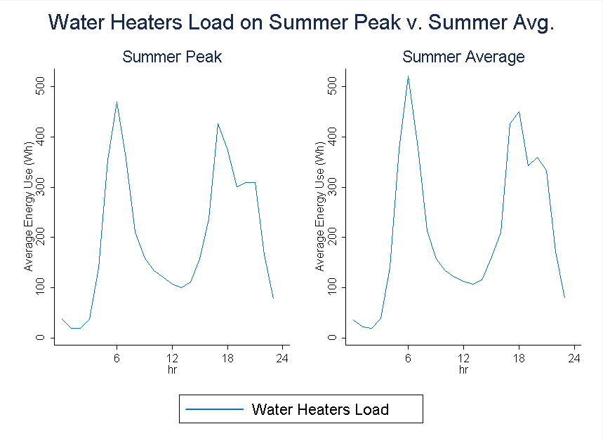
It is apparent from the Figure 8-3 that there is not much difference from peak usage and average usage, which proves that water heater loads has low sensitivity to weather. There are two spikes in a day, indicating two shifts when people would be likely to take showers. The time periods with highest consumption are 5:00 am – 7:00 am and 5:00 pm – 8:00 pm.
Pool Pumps (Residential Only)
Likewise, pool pump loads were assumed to be fairly constant throughout the summer time as well, so the average load profiles for pool pumps from CPS’s project were also used to represent for residential customers in the FEECA Utilities’ jurisdictions.
Figure 6-2: Average Pool Pumps Load Shapes

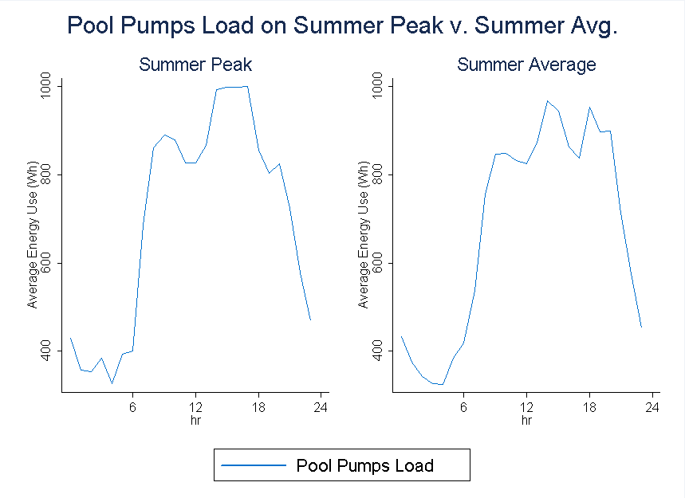
According to the Figure 8-4, the peak hours for pool pumps are 3:00 pm to 6:00 pm, and there is minor sensitivity with weather observed by comparing peak loads and average loads.
Large C&I Customers
Estimates of technical potential were based on one year of interval data (2016) for all customers in the GSD rate classes. Customers were categorized into one of four max demand segments for the purpose of analysis. Technical potential for these customers was defined as the aggregate usage within each segment during summer and winter peak system hours.
Visual presentations of the results are shown below. These graphs are useful to identify the segments with the highest potential as well as examine the weather-sensitivity of each segment by comparing peak usage to the average usage in each season.
Figure 6-3: Aggregate Load Shapes for TECO Large C&I Customers
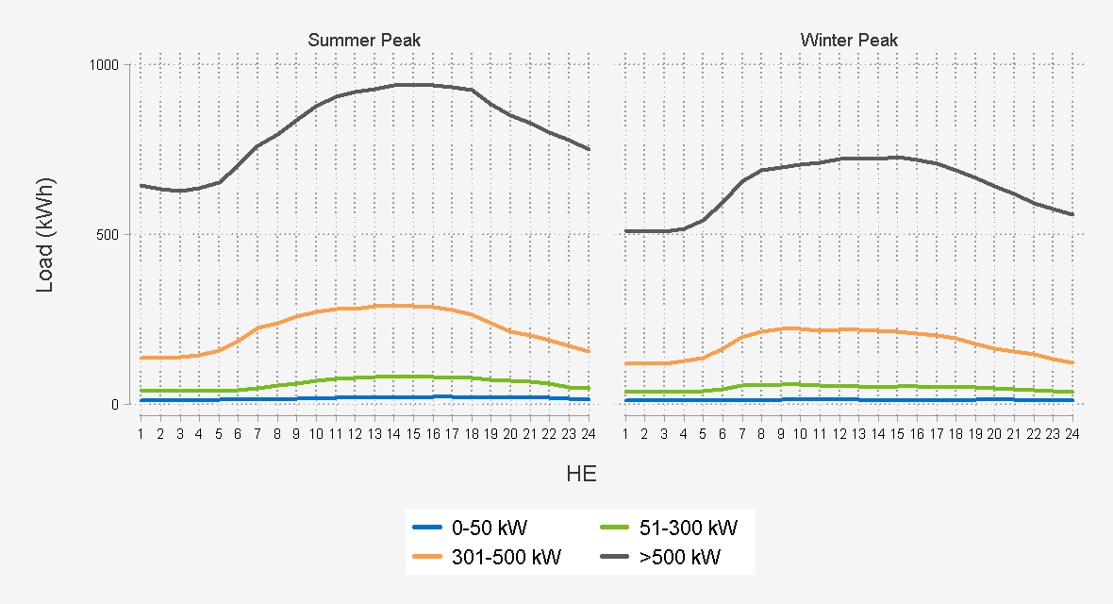

Nexant, Inc.
Headquarters
101 2nd Street, Suite 1000
San Francisco CA 94105-3651
Tel: (415) 369-1000
Fax: (415) 369-9700

nexant.com

Non-Residential results include all commercial and industrial customer segments
PV systems and CHP systems were independently analyzed for technical potential without consideration of the competition between technologies or customer preference for DSRE system.
To be eligible, customers cannot have annual usage less than 9,000 kWh.
As the study is being used to inform 2020-2029 DSM planning, for applicable lighting technologies, the baseline lighting standard is compliant with the 2020 EISA backstop provision.
Due to the heterogeneous nature of the Industrial sector, including variations in equipment, operating schedule, process loads, and other segment-specific characteristics, the unique industrial measures encompass multiple individual equipment and technology improvements. Savings estimates for industrial measures reflect the implementation of these various individual improvements as summarized in the measure list in Appendix A.
This study did not include ground-mounted or utility-scale solar PV installations as these were determined to often not be connected to customer premise metering and therefore outside the scope of this analysis.
PVWatts estimates PV energy production and costs. Developed by the National Renewable Energy Laboratory. http://pvwatts.nrel.gov/
Utility-provided data and US Census, South Region
Single Family = RECS, South Atlantic Region; Multi-Family = US Census, South Region https://www.census.gov/construction/chars/mfu.html
Floor space = based on utility data. Average floors by building type = Commercial Building Energy Consumption Survey (CBECS), South Atlantic Region
Non-Residential results include all commercial and industrial customer segments
All currently enrolled DR customers are excluded
All currently enrolled DR customers are excluded
All currently enrolled DR customers are excluded
PV systems and CHP systems were independently analyzed for technical potential without consideration of the competition between technologies or customer preference for DSRE system.

