BEFORE THE FLORIDA PUBLIC SERVICE COMMISSION

In re: Application for approval of an 8" general service meter rate by Pluris Wedgefield, LLC. | DOCKET NO. 20190133-WS  ORDER NO. PSC-2019-0358-TRF-WS  ISSUED: August 26, 2019

The following Commissioners participated in the disposition of this matter:

ART GRAHAM, Chairman
JULIE I. BROWN
DONALD J. POLMANN
GARY F. CLARK
ANDREW GILES FAY

TARIFF ORDER APPROVING AN EIGHT INCH GENERAL
SERVICE METER RATE BY PLURIS WEDGEFIELD, LLC

BY THE COMMISSION:

Background
Pluris Wedgefield, LLC (Pluris or Utility) is a Class A utility providing water service to 1,811 customers and wastewater service to 1,667 customers in Orange County. Water and wastewater rates were last established for this Utility in 2017. According to the Utility’s 2018 Annual Report, operating revenues were $1,507,075 for water and $982,652 for wastewater and operating expenses were $1,454,960 for water and $970,507 for wastewater.
On June 18, 2019, the Utility applied for approval of an eight inch turbine general service meter rate for both its water and wastewater systems. Currently, the Utility’s water and wastewater general service tariff sheets only provide base facility charges (BFCs) for meter sizes up to six inches. This Order addresses the Utility’s request to include in its water and wastewater tariffs a BFC for an eight inch turbine meter. The proposed tariffs are shown in Attachment A. We have jurisdiction pursuant to Sections 367.081 and 367.091, Florida Statutes (F.S.).

Decision
As stated in the case background, the Utility’s existing water and wastewater general service tariff sheets only provide BFCs for meter sizes up to six inches. However, Pluris has added a general service customer that receives services through an eight inch turbine meter.
The Utility is proposing a water BFC of $2,509.20 and a wastewater BFC of $2,784.60 for the eight inch turbine meter. Pluris calculated these amounts by using its existing BFC for the 5/8” x 3/4” meter size of $27.88 for water and $30.94 for wastewater (Attachment A) as the foundation, and applying the American Water Works Association meter equivalent factor as the usage characteristics onto the foundation (5/8” x 3/4” meter BFC times 90). This method is consistent with Rule 25-30.437(6), Florida Administrative Code (F.A.C.), which states that the rates are first established with the 5/8'' x 3/4'' meter as the foundation and for meter sizes larger than 5/8'', the base facility charge shall be based on the usage characteristics.
Service to the water only general service customer through the eight inch turbine meter provides additional revenues of approximately $35,000. This represents an approximate revenue increase of 2.3 percent for water and will not have a material effect on the Utility’s overall rate of return.
It is incumbent on public utilities to charge only those rates filed with and approved by us pursuant to Section 367.081, F.S. We find that the rate is the appropriate amount for the eight inch meter size. However, the Utility should be cautioned to charge only those rates reflected in its Commission-approved tariffs.
Based on the above, the Utility's proposed tariffs containing the eight inch turbine general service meter are approved as filed because they are consistent with Rule 25-30.437(6), F.A.C. The approved rates will be effective for service rendered on or after the stamped approval date on the tariff sheets pursuant to Rule 25-30.475(1), F.A.C.

Based on the foregoing, it is

ORDERED by the Florida Public Service Commission that Pluris Wedgefield, LLC’s petition for an eight inch general service meter rate is hereby approved. The approved rates shall be effective for service rendered on or after the stamped approval date on the tariff sheets pursuant to Rule 25-30.475(1), Florida Administrative Code. It is further

ORDERED that if a protest is filed within 21 days of issuance of this Order, the tariffs shall remain in effect with any charges held subject to refund pending resolution of the protest. It is further

ORDERED that if no timely protest is filed, this docket shall be closed upon the issuance of a Consummating Order.

By ORDER of the Florida Public Service Commission this 26th day of August, 2019.

/s/ Adam J. Teitzman
ADAM J. TEITZMAN
Commission Clerk
Florida Public Service Commission
2540 Shumard Oak Boulevard
Tallahassee, Florida 32399
(850) 413-6770
www.floridapsc.com

Copies furnished: A copy of this document is provided to the parties of record at the time of issuance and, if applicable, interested persons.

KBS

NOTICE OF FURTHER PROCEEDINGS

The Florida Public Service Commission is required by Section 120.569(1), Florida Statutes, to notify parties of any administrative hearing or judicial review of Commission orders that is available under Sections 120.57 or 120.68, Florida Statutes, as well as the procedures and time limits that apply. This notice should not be construed to mean all requests for an administrative hearing or judicial review will be granted or result in the relief sought.

Mediation may be available on a case-by-case basis. If mediation is conducted, it does not affect a substantially interested person's right to a hearing.

The Commission's decision on these tariffs is interim in nature and will become final, unless a person whose substantial interests are affected by the proposed action files a petition for a formal proceeding, in the form provided by Rule 28-106.201, Florida Administrative Code. This petition must be received by the Office of Commission Clerk, 2540 Shumard Oak Boulevard, Tallahassee, Florida 32399-0850, by the close of business on September 16, 2019. In the absence of such a petition, this Order shall become final and effective upon the issuance of a Consummating Order.

Any objection or protest filed in this docket before the issuance date of this Order is considered abandoned unless it satisfies the foregoing conditions and is renewed within the specified protest period.

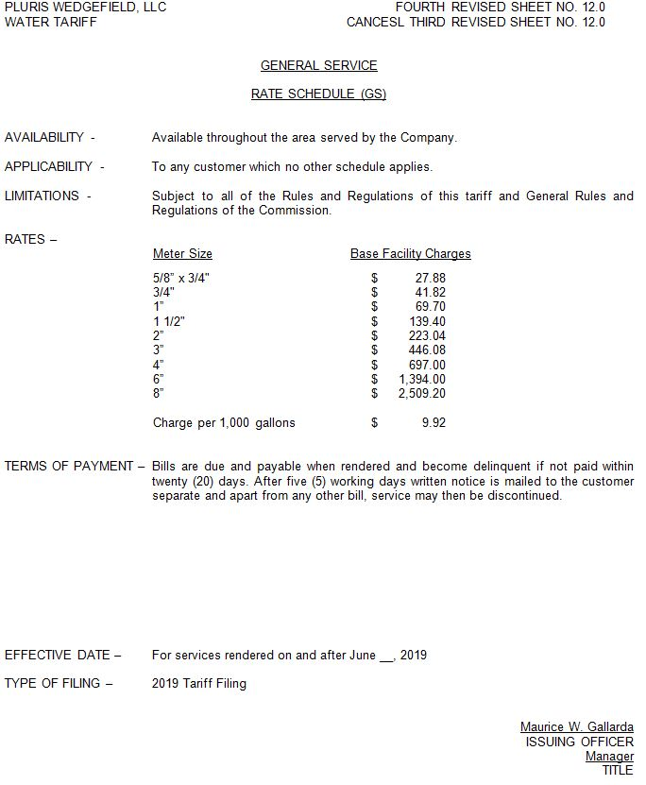
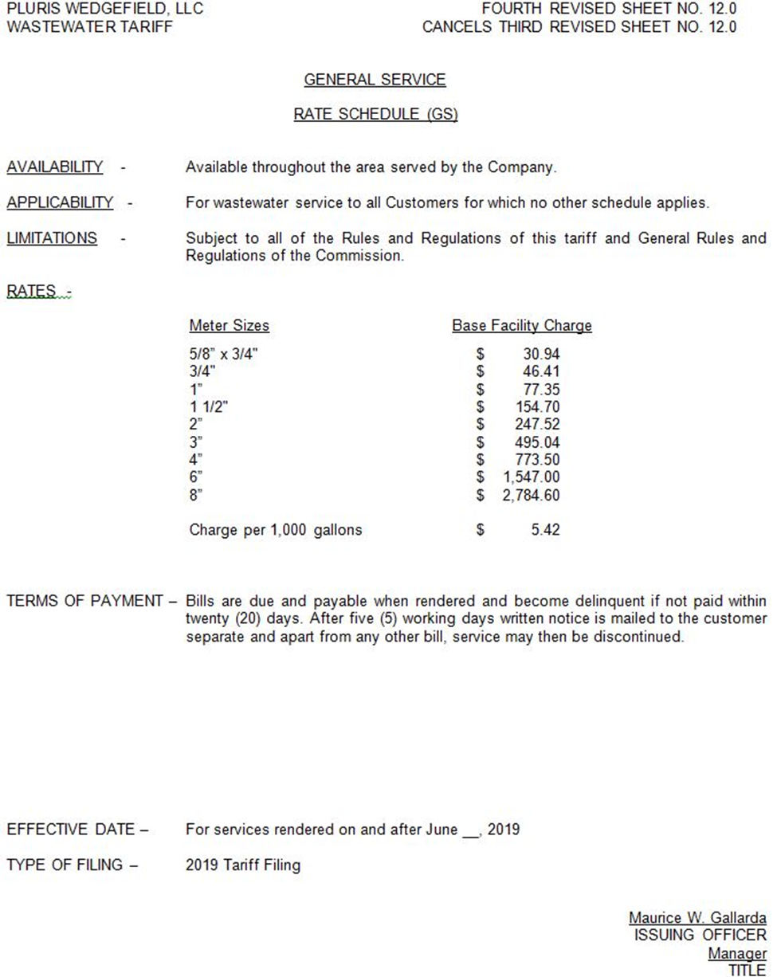

Order No. PSC-2018-0311-PAA-WS, issued June 13, 2018, in Docket No. 20170166-WS, In re: Application for limited proceeding rate increase in Orange County by Pluris Wedgefield, Inc.

