BEFORE THE FLORIDA PUBLIC SERVICE COMMISSION

In re: Petition for approval of 2019 revisions to underground residential and commercial differential tariffs, by Florida Power & Light Company. | DOCKET NO. 20190081-EI  ORDER NO. PSC-2019-0360-TRF-EI  ISSUED: August 26, 2019

The following Commissioners participated in the disposition of this matter:

ART GRAHAM, Chairman
JULIE I. BROWN
DONALD J. POLMANN
GARY F. CLARK
ANDREW GILES FAY

ORDER APPROVING 2019 REVISIONS TO UNDERGROUND RESIDENTIAL AND COMMERCIAL TARIFFS BY FLORIDA POWER & LIGHT COMPANY

BY THE COMMISSION:

Background
On April 1, 2019, Florida Power & Light Company (FPL or utility) filed a petition for approval of revisions to its underground residential differential (URD) and underground commercial differential (UCD) tariffs. The URD and UCD tariffs apply to new residential and commercial developments and represent the additional costs, if any, FPL incurs to provide underground distribution service in place of overhead service. Based on current cost, including long term operational cost, FPL does not incur any additional costs to provide residential underground service; therefore, the proposed URD differentials are $0. The proposed (legislative version) URD and UCD tariffs are contained in Attachments A and B. We approved FPL’s current URD and UCD tariffs by Order No. PSC-16-0424-TRF-EI.
We suspended FPL’s proposed tariffs in Order No. PSC-2019-0211-PCO-EI. FPL responded to Commission staff’s first data request on May 31, 2019 and filed a revised response to Commission staff’s second data request No. 6 on July 2, 2019. We have jurisdiction over this matter pursuant to Sections 366.03, 366.04, 366.05, and 366.06, Florida Statutes (F.S.).

Decision
Rule 25-6.078, Florida Administrative Code (F.A.C.), defines investor-owned utilities’ (IOU) responsibilities for filing updated URD tariffs. FPL has filed the instant petition pursuant to subsection (3) of the rule, which requires IOUs to file supporting data and analyses for URD tariffs at least once every three years.

The URD tariffs provide charges for underground service in new residential subdivisions and represent the additional costs, if any, the utility incurs to provide underground service in place of overhead service. The cost of standard overhead construction is recovered through base rates from all ratepayers. In lieu of overhead construction, customers have the option of requesting underground facilities. Any additional cost is paid by the customer as contribution-in-aid-of construction (CIAC). Typically, the URD customer is the developer of a subdivision.

Traditionally, three standard model subdivision designs have been the basis upon which each IOU submits URD tariff changes for Commission approval: low density, high density, and a high density subdivision where dwelling units take service at ganged meter pedestals (groups of meters at the same physical location). Examples of this last subdivision type include mobile home and recreational vehicle parks. While actual construction may differ from the model subdivisions, the model subdivisions are designed to reflect average overhead and underground subdivisions.

Costs for underground construction have historically been higher for standard overhead construction and the additional cost is paid by the customer as a CIAC. In FPL’s 2016 underground differential tariff, the cost differential was zero for ganged meters and some tiers of the low and high density subdivisions. As shown on Table 1, FPL’s proposed URD differential charges are now $0 for all three subdivision models. Therefore, the URD customer will not be assessed a CIAC charge for requesting underground service in a new residential subdivision. FPL explained that the decrease in the differentials, for some subdivision tiers, is primarily attributable to changes in operational costs as discussed in more detail in the section of the recommendation titled operational costs.

Table 1 shows the current and proposed URD differentials for the low density, high density, and ganged meter subdivisions.

Table 1
Comparison of Differential Per Service Lateral
Types of Subdivision | Number of Service Laterals in Subdivision | Current URD Differential | Proposed URD Differential
Low Density | Tier 1 – 200 or more | $0 | $0
 | Tier 2 – 85 – 199 | $183.35 | $0
 | Tier 3 – less than 85 | $266.35 | $0
High Density | Tier 1 – 300 or more | $0 | $0
 | Tier 2 – 100-299 | $0 | $0
 | Tier 3 – less than 100 | $57.97 | $0
Ganged Meter | All Tiers | $0 | $0
Source: 2016 order and FPL’s 2019 filing
The calculations of the proposed URD charges include (1) updated labor and material costs along with the associated loading factors and (2) operational costs. These costs are discussed below.
Labor and Material Costs
The installation costs of both underground and overhead facilities include the labor and material costs to provide primary, secondary, and service distribution lines as well as transformers. The costs of poles are specific to overhead service while the costs of trenching and backfilling are specific to underground service. The utilities are required, by Rule 25-6.078(5) F.A.C., to use current labor and material costs.
FPL explained that generally the majority of overhead and underground material and labor costs have increased since 2016. With respect to labor costs, the cost of underground labor increased at a higher rate than it increased for overhead labor. FPL stated that contractual arrangements driven by market conditions determine the labor rates for both FPL employees and contractors.
Table 2 provides the labor and material differential, or pre-operational, costs. As Table 2 shows, only the low density cost differential of $210.53 is a positive number, indicating that underground labor/material costs are higher than overhead labor/material costs for the low density subdivision. For the high density and ganged meter subdivisions, overhead labor/material costs are higher than underground labor/material costs.

Table 2
Labor and Material Costs (Pre-operational Costs)
Low Density | 2016 Costs | 2019 Costs | Difference
Underground labor/material costs | $2,413.84 | $2,558.39 | $144.55
Overhead labor/material costs | $2,272.49 | $2,347.86 | $75.37
Per service lateral differential | $141.35 | $210.53 | $69.18
High Density
Underground labor/material costs | $1,640.45 | $1,767.54 | $127.09
Overhead labor/material costs | $1,691.48 | $1,773.71 | $82.23
Per service lateral differential | ($51.03) | ($6.17) | ($44.86)
Ganged Meter
Underground labor/material costs | $1,051.82 | $1,125.49 | $73.67
Overhead labor/material costs | $1,344.17 | $1,397.83 | $53.66
Per service lateral differential | ($292.35) | ($272.34) | ($20.01)
Source: 2016 Order and FPL’s 2019 filing
Operational Costs
Rule 25-6.078, F.A.C., requires that the differences in net present value of operational costs between overhead and underground systems, including average historical storm restoration costs over the life of the facilities, be included in the URD charge. The non-storm operational costs represent the cost differential between maintaining and operating an underground versus an overhead system over the life of the facilities. The storm cost component represents storm restoration costs avoided when an area is undergrounded, thereby reducing the cost to restore an overhead system. The avoided storm cost is subtracted from pre-operational and non-storm operational costs, thus reducing the URD differential charge. FPL’s methodology to calculate the operational costs was approved in Order No. PSC-08-0774-TRF-EI and remains the same in the instant docket.

Non-storm Operational Costs

FPL’s operational costs for an overhead system are higher than the operational cost for an underground system, resulting in a negative number as shown in Column B in Table 3. For the low density subdivision, for example, the operational cost differential in 2016 was $208 (indicating that underground operational costs were higher than overhead operational costs). As shown in Table 3, the operational cost differential for the low density subdivision is now -$2,103. FPL explained that the primary reason for this change in operational cost is the increase in overhead operational costs as a result of FPL’s increased capital investments associated with its distribution storm hardening initiatives. The utility used a 5-year average of historical operational costs (2014-2018) for its calculations in this docket.

Storm Restoration Costs

FPL explained that the 2016 and 2017 hurricane season significantly increased the avoided storm restoration cost impacts. Specifically, FPL stated that the utility incorporated more than $1.5 billion in overhead storm restoration costs for hurricanes Matthew, Hermine, and Irma. Therefore, the amount representing avoided storm restoration costs increased significantly from 2016.
Table 3 presents the pre-operational, non-storm operational, and the avoided storm restoration cost differentials between overhead and underground systems. The proposed differential is $0 when the calculation results in a negative number.
Table 3
Components of the URD Charges
Type of Subdivision | Number of Service Laterals in Subdivision | Pre-Operational Costs  (A) | Non-storm Operational costs  (B) | Avoided Storm costs  (C) | Proposed URD Differentials  (A)+(B)+(C)
Low Density | Tier 1 – 200 or more | $210.53 | ($2,103) | ($827) | $0
 | Tier 2 – 85 – 199 |  | ($2,103) | ($331) | $0
 | Tier 3 – less than 85 |  | ($2,103) | ($165) | $0
High Density | Tier 1 – 300 or more | $0.00 | ($1,796) | ($827) | $0
 | Tier 2 – 100 – 299 |  | ($1,796) | ($331) | $0
 | Tier 3 – less than 100 |  | ($1,796) | ($165) | $0
Ganged Meter | Tier 1 – 300 or more | $0.00 | ($1,796) | ($827) | $0
 | Tier 2 – 100 – 299 |  | ($1,796) | ($331) | $0
 | Tier 3 – less than 100 |  | ($1,796) | ($165) | $0
Source: FPL’s 2019 Filing
A review of FPL’s proposed URD tariffs and associated charges, its accompanying work papers, and its responses to Commission staff’s data requests support a finding that the proposed URD tariffs and associated charges are reasonable. We approve FPL’s request that the URD tariffs and associated charges be made effective 30 days with an effective date of September 5, 2019.

Underground Commercial Differential Tariffs

Utilities are not required to file UCD tariffs pursuant to Rule 25-6.078, F.A.C.; however, as in prior URD petitions, FPL included proposed UCD tariffs in its petition. The UCD tariffs apply to small commercial or industrial customers (applicant) that request the installation of underground electric distribution facilities for a new building. The requested underground distribution facilities consist of underground service conductors, placed in conduit, and associated equipment that is installed from overhead feeder mains (or overhead termination point) to the designed point of delivery (where the utility’s wires are connected to those of the customer).

The UCD charges represent the differential costs for underground commercial facilities and their equivalent overhead design. The calculations provided by FPL in its petition employ FPL’s standard engineering design criteria and are based on actual 2018 labor and material costs. Unlike the URD calculations, the UCD calculations do not include long term operational and avoided storm restoration costs. In addition, the UCD tariffs provide credits that apply if the applicant provides trenching, backfilling, or installs FPL provided conduit or a concrete pad for a pad-mounted transformer.

FPL explained that including cost-based UCD charges in its tariff provides clarity to customers and FPL’s field employees regarding the costs for commercial underground distribution facilities.

We find that FPL’s proposed UCD tariffs and associated charges as reflected in Attachment B are cost based and reasonable. FPL’s proposed UCD tariffs and associated charges are hereby approved and they will be effective 30 days after our vote.

Based on the foregoing, it is

ORDERED by the Florida Public Service Commission that Florida Power & Light Company’s proposed URD tariffs and associated charges as shown in Attachment A are approved effective September 5, 2019. It is further

ORDERED that the utility’s proposed UCD tariffs and associated charges as shown in Attachment B, are approved effective September 5, 2019. It is further

ORDERED that if a protest is filed within 21 days of issuance of the Order, the tariffs shall remain in effect with any charges held subject to refund pending resolution of the protest. It is further

ORDERED that if no timely protest is filed, this docket shall be closed upon the issuance of a Consummating Order.

By ORDER of the Florida Public Service Commission this 26th day of August, 2019.

/s/ Adam J. Teitzman
ADAM J. TEITZMAN
Commission Clerk
Florida Public Service Commission
2540 Shumard Oak Boulevard
Tallahassee, Florida 32399
(850) 413-6770
www.floridapsc.com

Copies furnished: A copy of this document is provided to the parties of record at the time of issuance and, if applicable, interested persons.
WLT

NOTICE OF FURTHER PROCEEDINGS

The Florida Public Service Commission is required by Section 120.569(1), Florida Statutes, to notify parties of any administrative hearing or judicial review of Commission orders that is available under Sections 120.57 or 120.68, Florida Statutes, as well as the procedures and time limits that apply. This notice should not be construed to mean all requests for an administrative hearing or judicial review will be granted or result in the relief sought.

Mediation may be available on a case-by-case basis. If mediation is conducted, it does not affect a substantially interested person's right to a hearing.

The Commission's decision on this tariff is interim in nature and will become final, unless a person whose substantial interests are affected by the proposed action files a petition for a formal proceeding, in the form provided by Rule 28-106.201, Florida Administrative Code. This petition must be received by the Office of Commission Clerk, 2540 Shumard Oak Boulevard, Tallahassee, Florida 32399-0850, by the close of business on September 16, 2019.

In the absence of such a petition, this Order shall become final and effective upon the issuance of a Consummating Order.

Any objection or protest filed in this docket before the issuance date of this order is considered abandoned unless it satisfies the foregoing conditions and is renewed within the specified protest period.

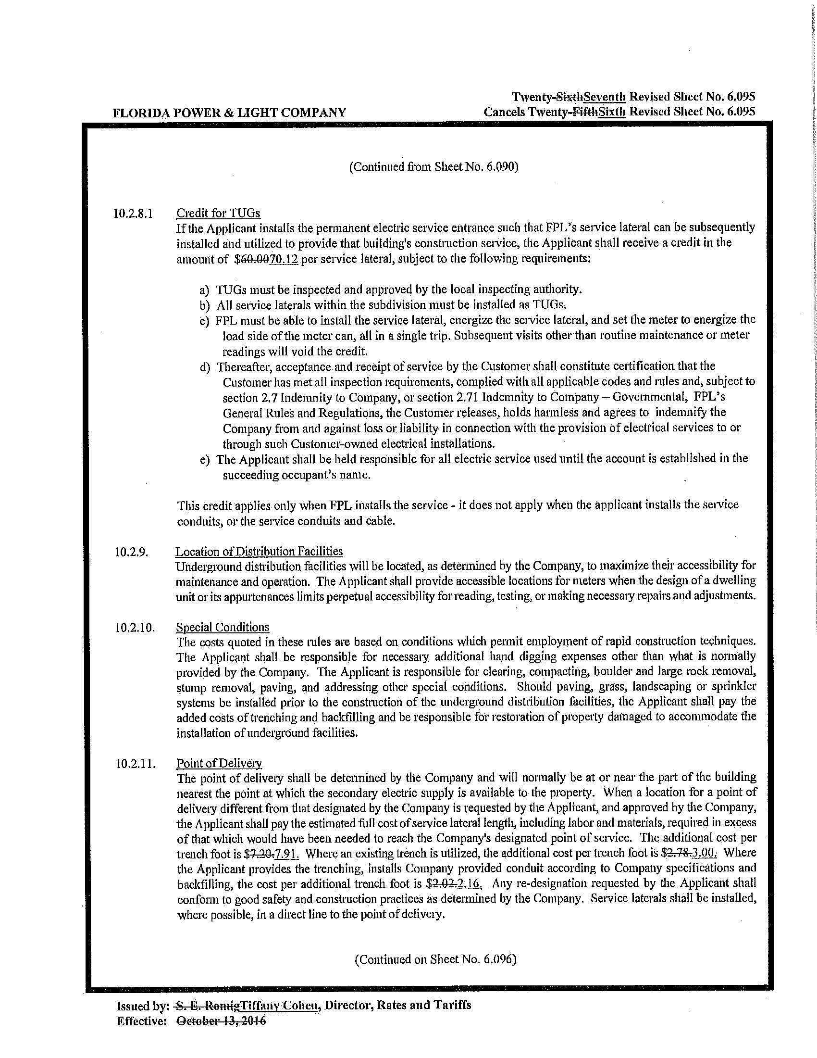

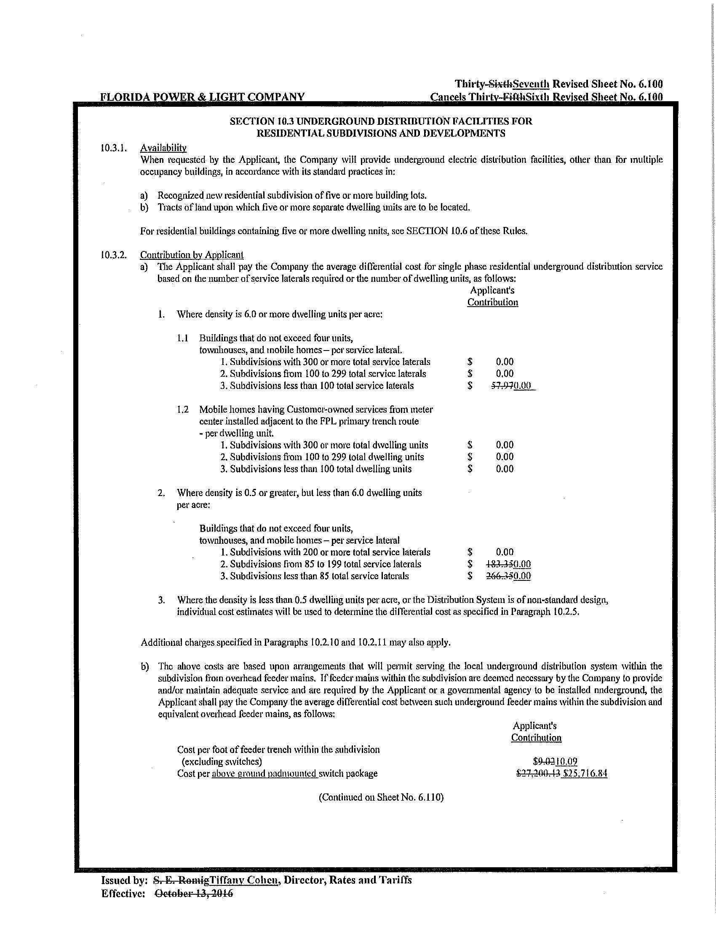

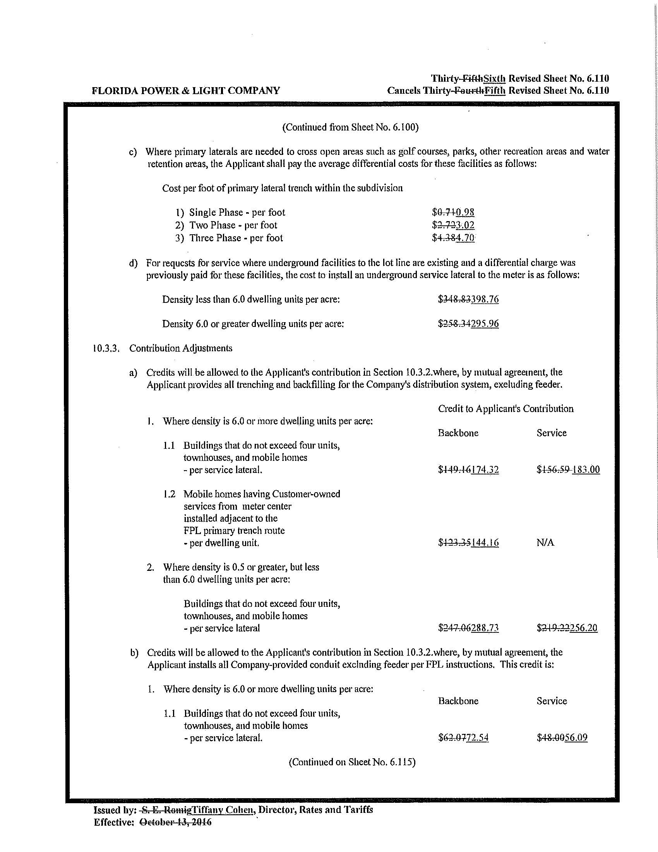
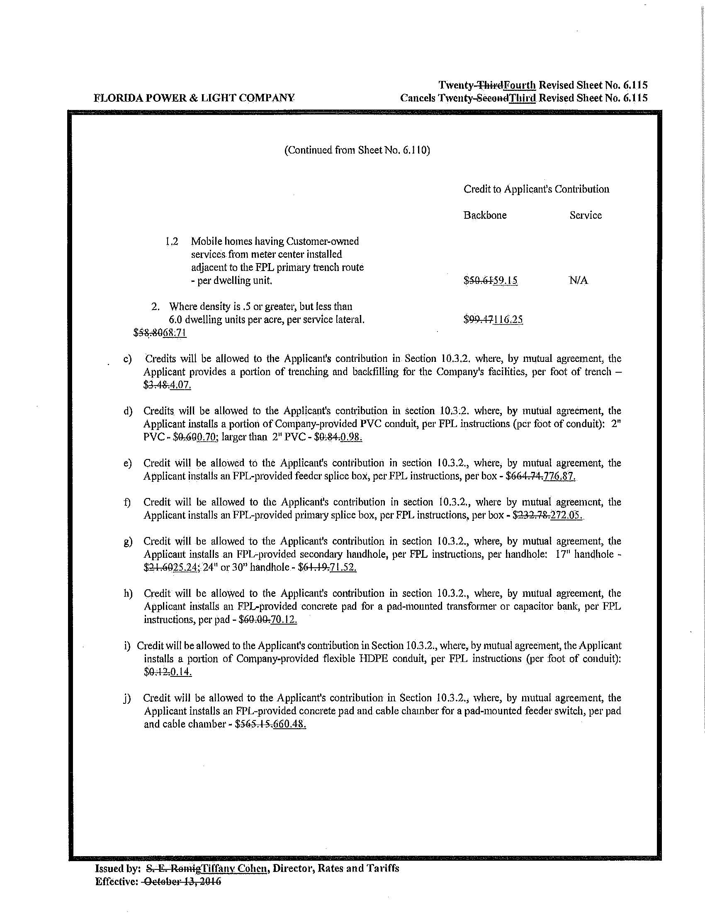

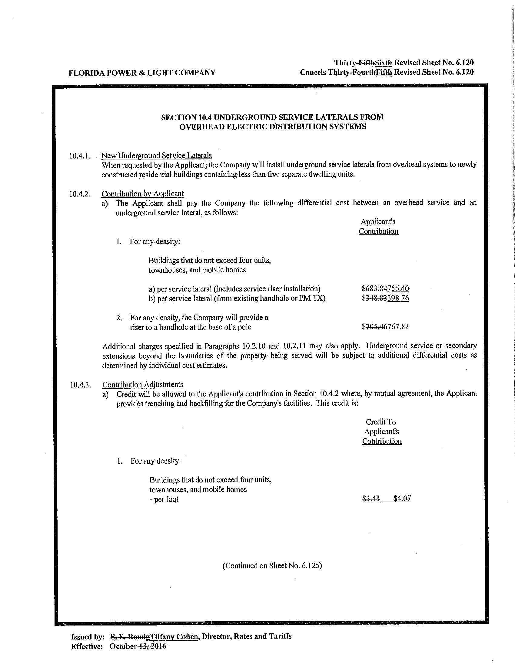
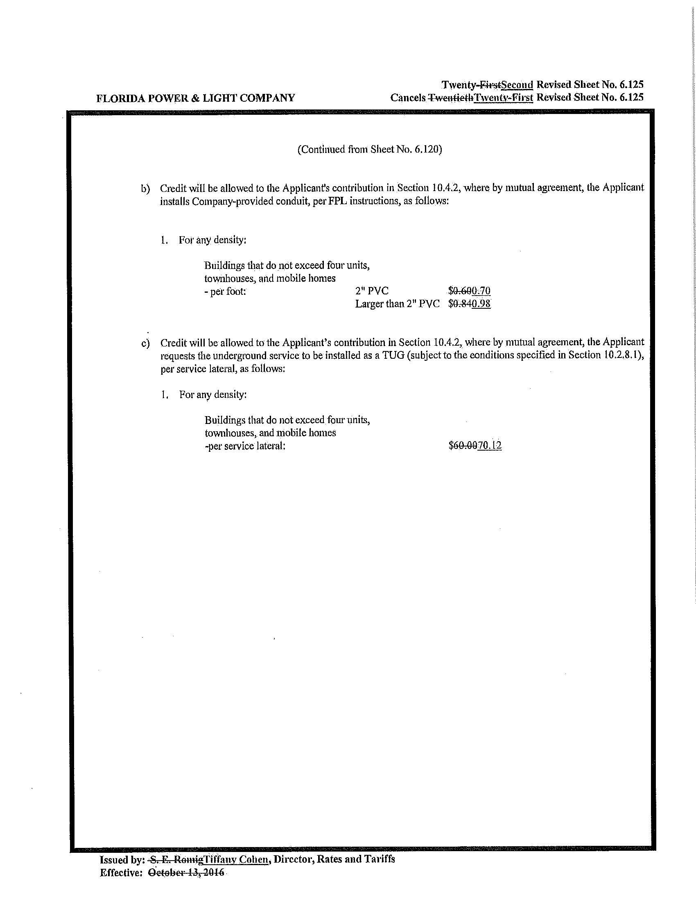

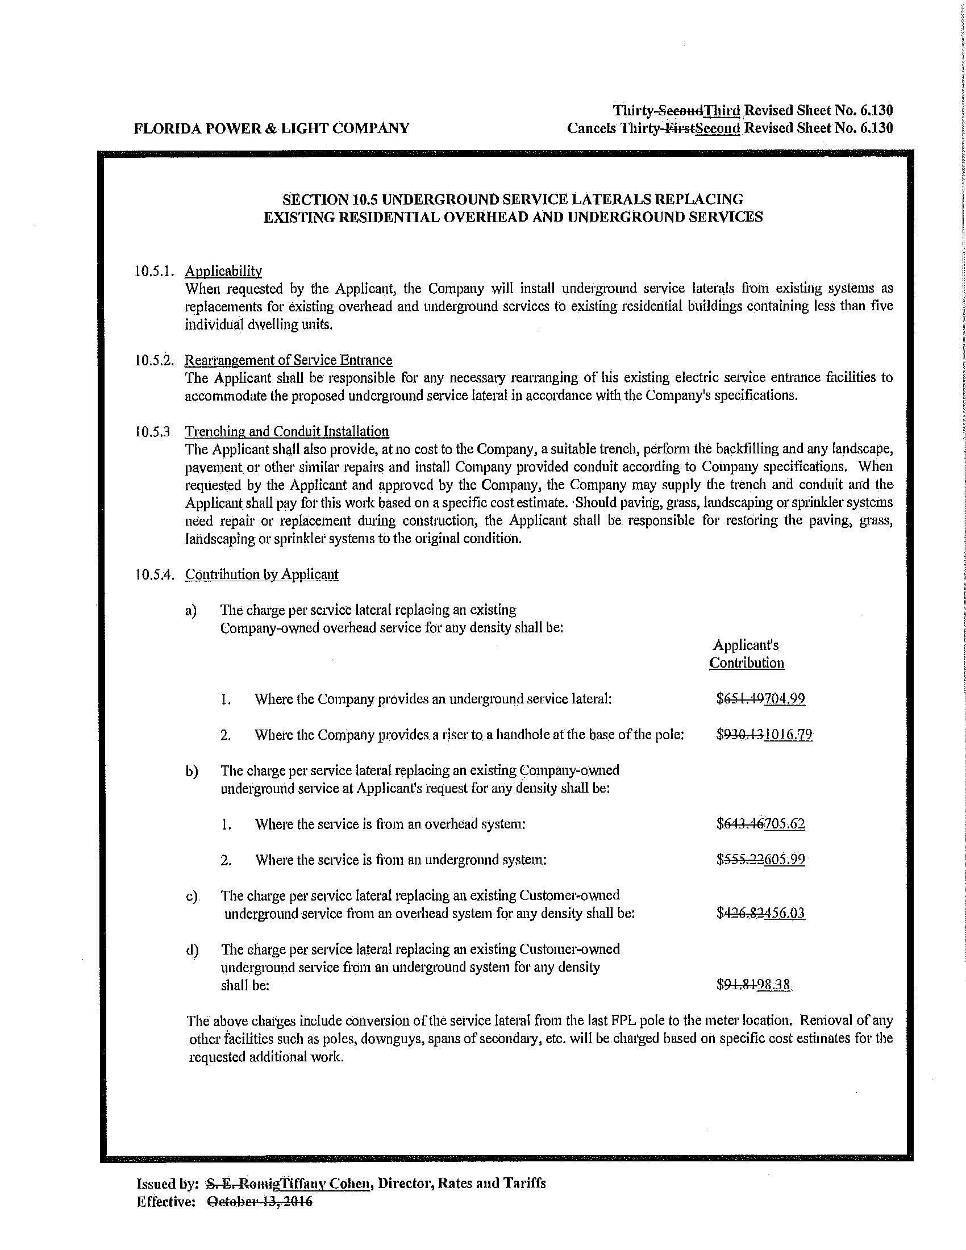
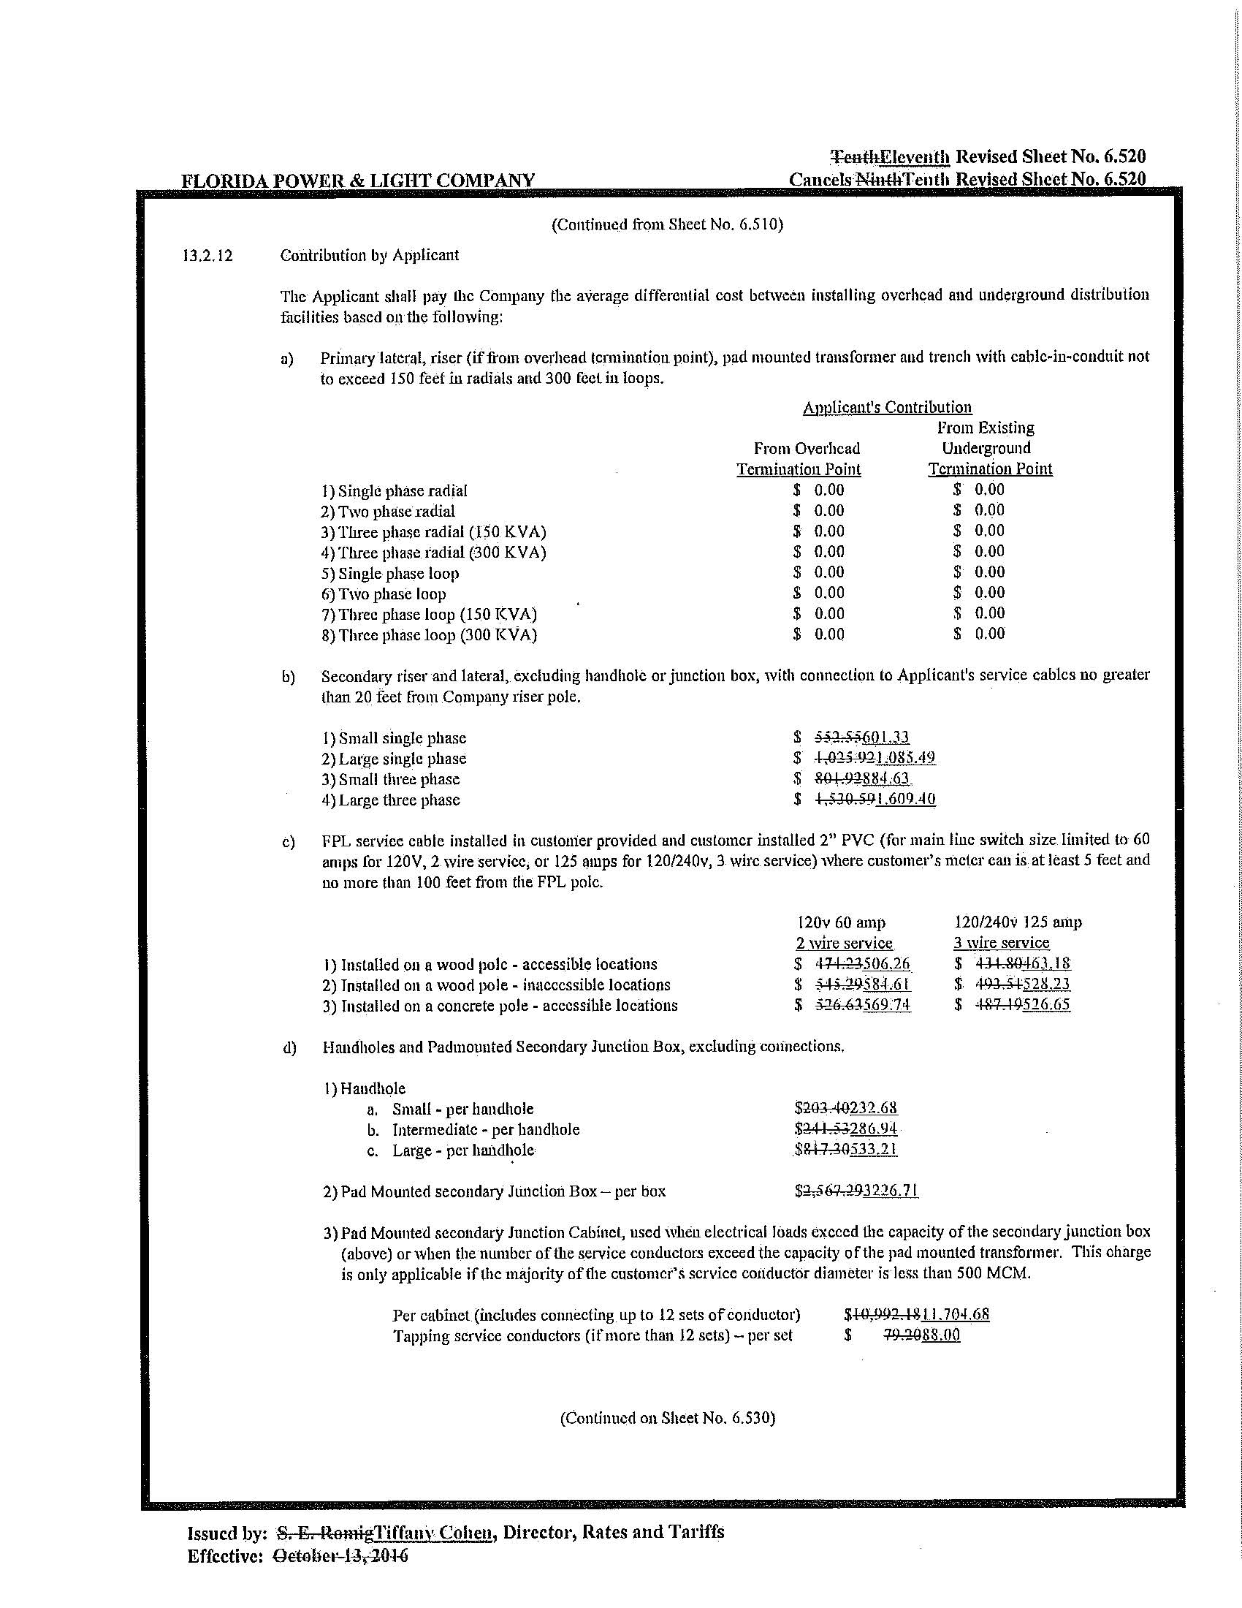

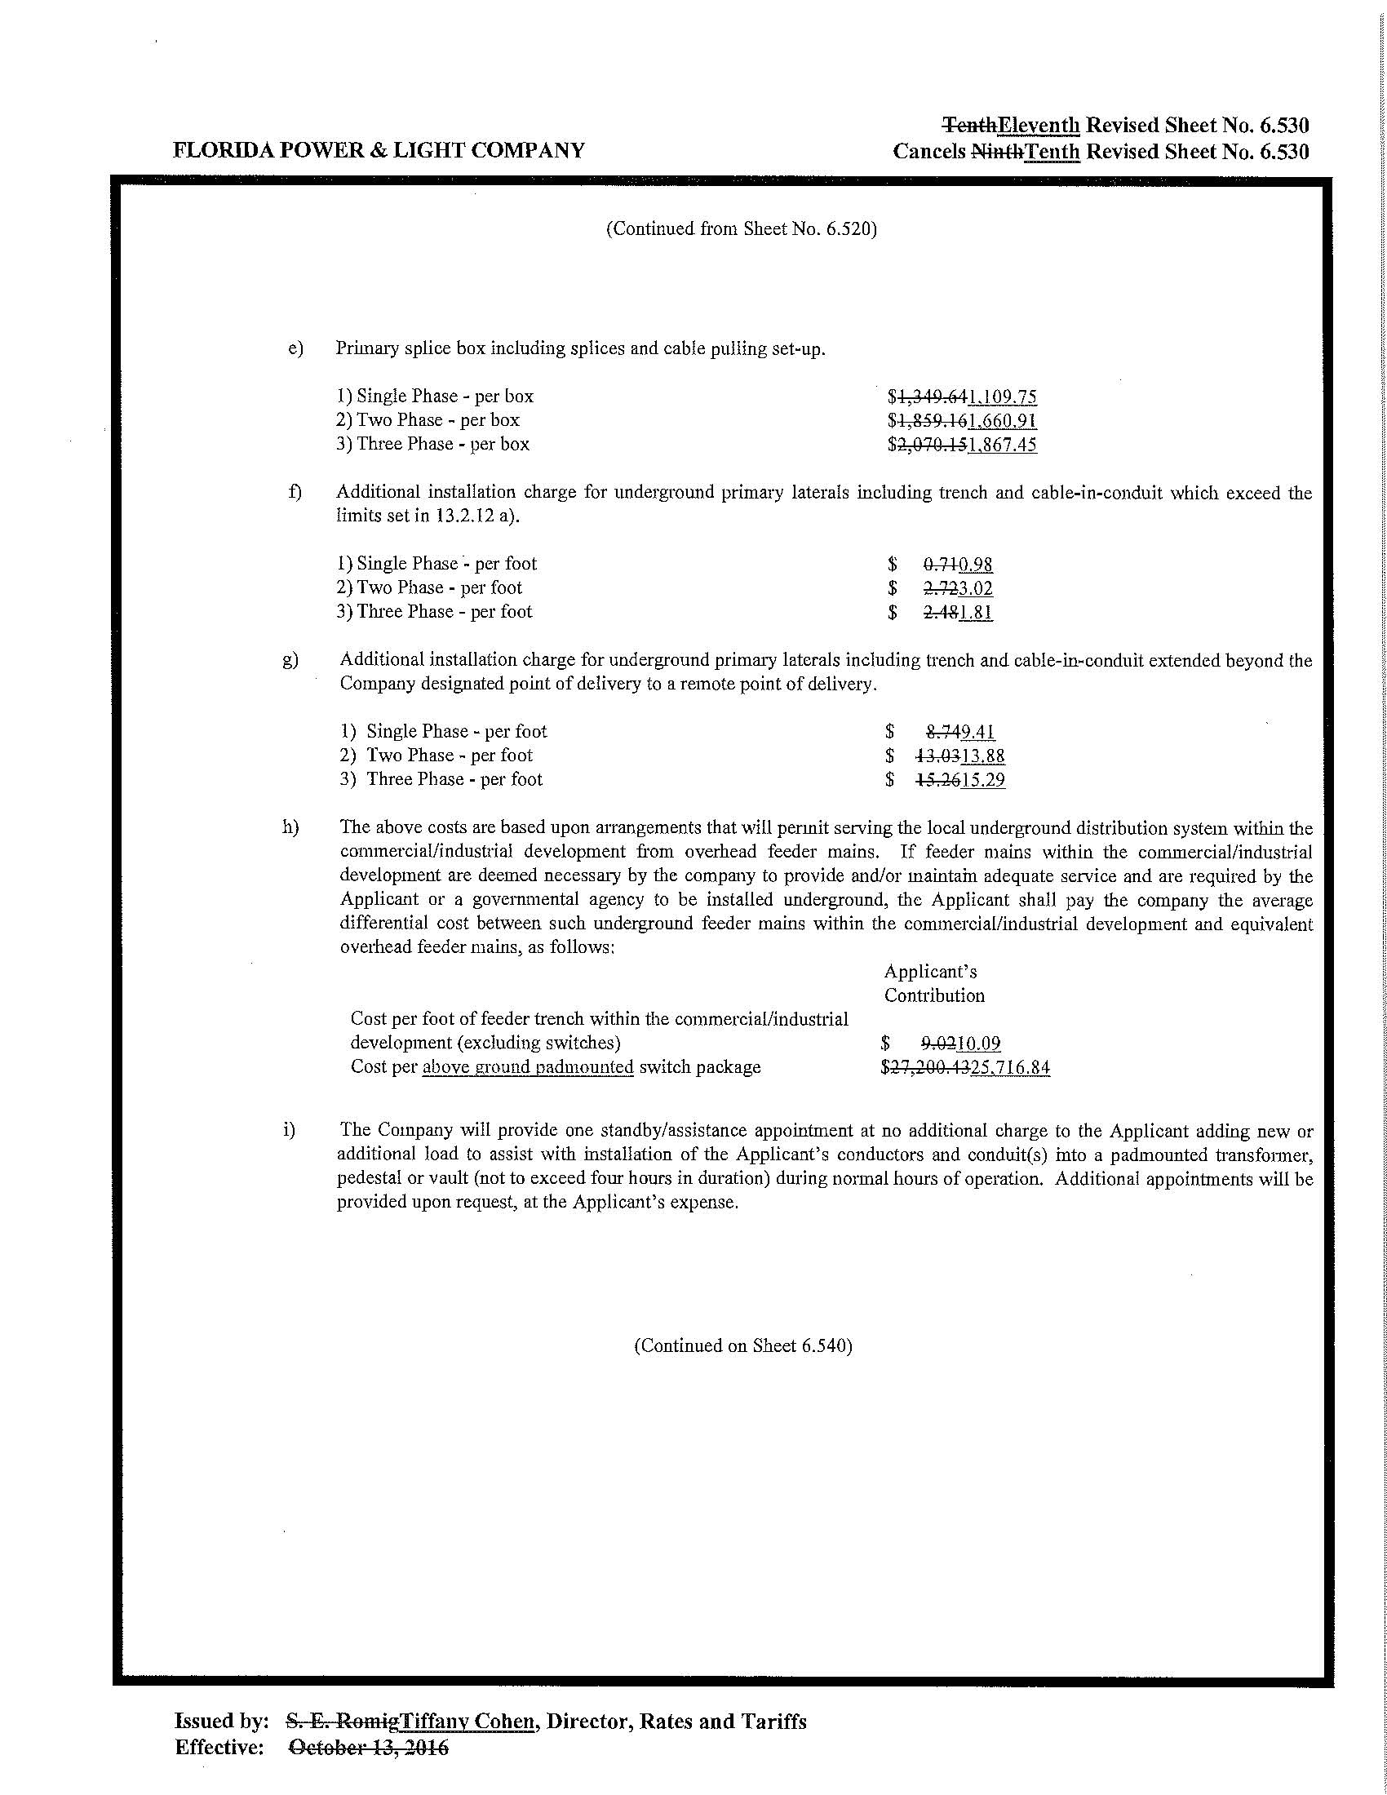

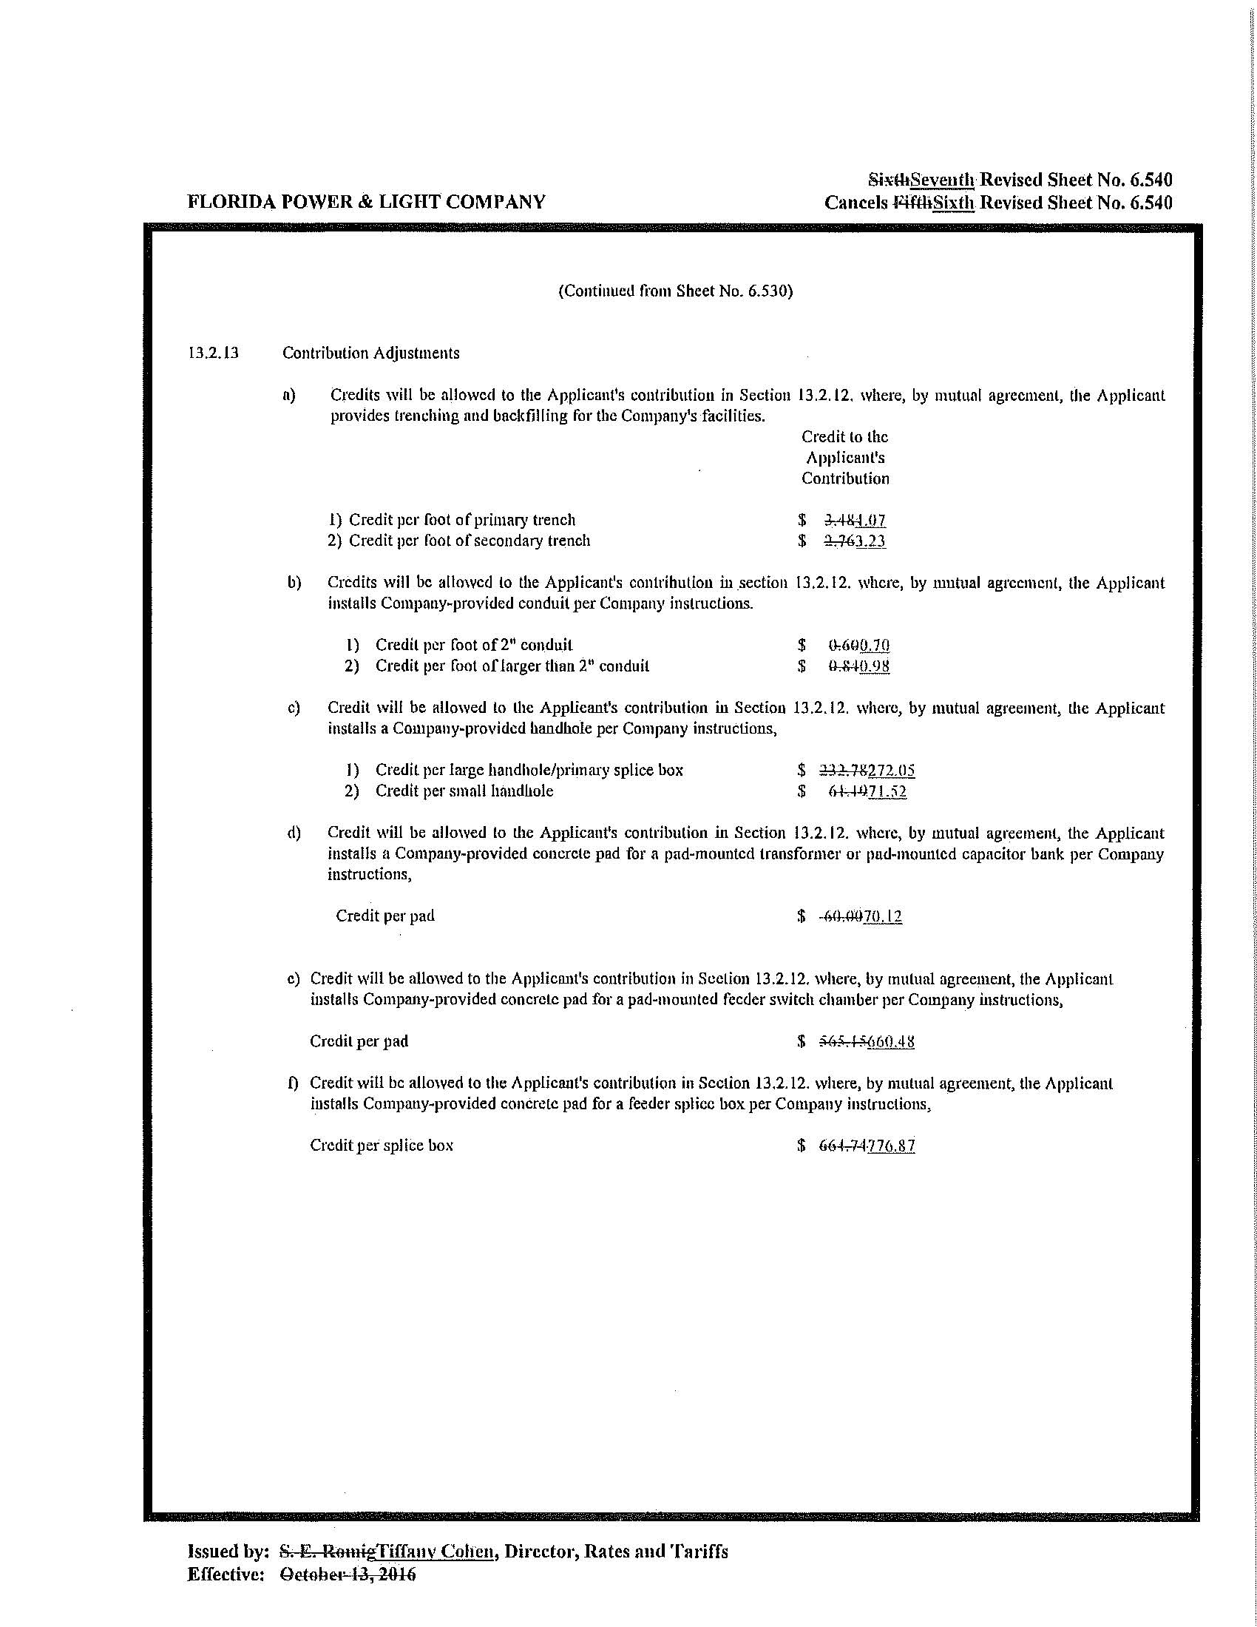

Order No. PSC-16-0424-TRF-EI, issued October 3, 2016, in Docket No. 160071-EI, In re: Petition for approval of 2016 revisions to underground residential and commercial differential tariffs, by Florida Power & Light Company.
Order No. PSC-2019-0211-PCO-EI, issued June 3, 2019, in Docket No. 20190081-EI, In re: Petition for approval of 2019 revisions to underground residential and commercial differential tariffs, by Florida Power & Light Company.
Order No. PSC-08-0774-TRF-EI, issued November 24, 2008, in Docket No. 070231-EI, In re: Petition for approval of 2007 revisions to underground residential and commercial distribution tariff, by Florida Power & Light Company.

