BEFORE THE FLORIDA PUBLIC SERVICE COMMISSION

In re: Petition for approval of demand side management goals and residential customer assisted and commercial walk-through energy audit programs, by Peoples Gas System. | DOCKET NO. 20180186-GU  ORDER NO. PSC-2019-0361-PAA-GU  ISSUED: August 26, 2019

The following Commissioners participated in the disposition of this matter:

ART GRAHAM, Chairman
JULIE I. BROWN
DONALD J. POLMANN
GARY F. CLARK
ANDREW GILES FAY

NOTICE OF PROPOSED AGENCY ACTION
ORDER GRANTING RULE WAIVER,
APPROVING NUMERIC CONSERVATION GOALS,
AND APPROVING RESIDENTIAL AND COMMERCIAL AUDIT PROGRAMS

BY THE COMMISSION:

NOTICE is hereby given by the Florida Public Service Commission (Commission) that the action discussed herein is preliminary in nature and will become final unless a person whose interests are substantially affected files a petition for a formal proceeding, pursuant to Rule 25-22.029, Florida Administrative Code (F.A.C.).

Background
Sections 366.80 through 366.83, and 403.519, Florida Statutes (F.S.), are known collectively as the Florida Energy Efficiency and Conservation Act (FEECA). Originally enacted in 1980, FEECA emphasizes the utilization of efficient and cost-effective demand-side renewable energy and conservation systems. Pursuant to Section 366.82, F.S., this Commission must review the conservation goals of each utility subject to FEECA at least every five years, and must require that each utility offer energy audit programs to its residential customers. We may extend the audit program requirement to some or all commercial customers. Currently, all five investor-owned electric utilities and two municipal electric utilities are subject to FEECA. Peoples Gas System (PGS or Company) is the only natural gas utility subject to these requirements.
In 1980, this Commission adopted rules that set statewide conservation goals; however, these rules were repealed in 1990, following the sunset provision in FEECA. In 1996, this Commission adopted Rule 25-17.009, F.A.C., which establishes a methodology for assessing the cost-effectiveness of demand-side management (DSM) programs for natural gas utilities. However, Rule 25-17.009, F.A.C., does not establish a process by which goals are to be set for natural gas utilities. Since 1981, PGS has offered a variety of conservation programs which have been reviewed by us pursuant to Rule 25-17.015, F.A.C., the Energy Conservation Cost Recovery (ECCR) clause. The Company’s residential and commercial DSM programs were first approved by this Commission in 1990, with several modifications and additions being made since that time.
In October 2015, the State of Florida Auditor General issued Report No. 2016-022, which found this Commission had not fully implemented FEECA requirements for natural gas utilities. The report recommended that the Commission management either fully implement FEECA specifically as it applies to natural gas utilities or seek legislative clarification regarding whether we are required to adopt energy conservation and DSM goals for natural gas utilities and whether natural gas utilities are to offer residential energy audits. Through several meetings both internally and with legislative staff, Commission management determined the best way to comply with the Auditor General’s findings was to request that PGS, in a manner similar to that followed by the FEECA electric utilities, develop and file annual conservation goals along with residential and commercial energy audit programs for our approval.
On October 15, 2018, PGS filed a petition for approval of its natural gas DSM goals for the period 2019-2028, and its residential and commercial energy audit programs. In response to staff-issued data requests, the Company provided updated numeric conservation goals.
On May 28, 2019, PGS filed a petition seeking waiver of Rule 25-17.003(3)(a) and (b), F.A.C., which requires PGS to offer residential customers Building Energy-Efficiency Rating System (BERS) Audits, Computer-Assisted Audits, and Walk-Through Audits. Specifically, PGS seeks a waiver from the residential on-site evaluation and walk-through audit requirements; reasoning the purpose of the underlying statute can be achieved by other means and strict application of the Rule would result in a substantial hardship to PGS. Pursuant to Section 120.542(6), F.S., notice of the petition seeking waiver was published in the Florida Administrative Register on June 5, 2019. No comments were received, and the time for filing comments expired on June 19, 2019.
We have jurisdiction over this matter pursuant to Sections 120.542, 366.80 through 366.83, and 403.519, F.S.

Decision

1. Rule Waiver

A. Petition

PGS requested a rule waiver of Rule 25-17.003(3)(a) and (b), F.A.C. (Rule). The Rule requires PGS to offer BERS, Computer-Assisted, and Walk-Through Audits to eligible residential customers, all of which must be performed on-site at the customer’s residence. PGS stated that fulfilling the on-site residential energy audit requirements would have an undue impact on the costs passed on to customers and would require PGS to dispatch Tampa-based employees, or position employees, across the Company’s entire service territory. As such, the Company has requested permission to offer only a Computer-Assisted Audit without the on-site evaluation and walk-through audit requirements of the Rule.
PGS asserted that an electronic, online-only version of the Computer-Assisted Audit is a reasonable means of achieving the purpose of the statutes implemented by Rule 25-17.003(3)(a) and (b), F.A.C., because it can provide eligible residential customers with the same type of feedback regarding energy usage and recommendations to improve energy efficiency as would be provided by an on-site residential energy audit. The Company further asserted that, if required to have employees physically present throughout its territory, it would need to employ multiple additional energy audit personnel or outsource the energy audits to third parties in order to satisfy the on-site residential energy audit requirements, creating a substantial hardship for PGS.

B. Facts

Rule 25-17.003, F.A.C., specifies the minimum requirements for performing energy audits by utilities subject to FEECA. Rule 25-17.003(3)(a) and (b), F.A.C., require those utilities to offer BERS, Computer-Assisted, and Walk-Through Audits to eligible residential customers.

Rule 25-17.003(2)(a), F.A.C., defines a BERS Audit as an energy analysis of a residence performed in compliance with Florida law pertaining to energy-efficiency ratings for buildings. Rule 25-17.003(2)(b), F.A.C., defines a Computer-Assisted Audit as an energy analysis of a residence in which a qualified auditor performs a comprehensive on-site evaluation of the residence. Rule 25-17.003(2)(i), F.A.C., defines a Walk-Through Audit as an energy analysis of a residence in which a qualified auditor walks through the residence making extensive observations as to the physical structure and components, performs simplified heat gain and heat loss computations, and advises the customer of feasible energy conservation practices and measures.

C. Requirements of Section 120.542, F.S.

Section 120.542(2), F.S., authorizes us to grant variances or waivers from agency rules when the person subject to the rule demonstrates that the purpose of the underlying statute will be or has been achieved by other means and application of the rule would cause the person substantial hardship. As defined by Section 120.542(2), F.S., “substantial hardship” means a demonstrated economic, technological, legal, or other type of hardship.

D. Purpose of the Underlying Statutes

As previously provided, Sections 366.80-366.83 and 403.519, F.S., are known collectively as FEECA. The purpose of FEECA is to utilize the most efficient and cost-effective demand-side renewable energy systems and conservation systems. Furthermore, FEECA requires each qualifying utility to offer, or contract to offer, energy audits to its residential customers, but provides that this requirement need not be uniform and may be based on such factors as level of usage, geographic location, or any other reasonable criterion, so long as all eligible customers are notified.
PGS requested a waiver of the Rule’s on-site residential energy audit requirements. Instead, PGS proposed that it can achieve the purpose of the underlying statutes by offering an electronic, online-only version of the Computer-Assisted Audit to its eligible residential customers. The Company, therefore, contended that it will offer energy audits to its residential customers that provide the same type of feedback regarding energy usage and recommendations to improve energy efficiency, as would be provided by an on-site residential energy audit.
The Company’s proposed electronic, online-only version of the Computer-Assisted Audit advances the Company’s ability to utilize the most efficient and cost-effective renewable energy systems and conservation systems. Further, given that the requirement to offer, or contract to offer, energy audits to residential customers need not be uniform, it appears that the Company’s proposed electronic, online-only version of the Computer-Assisted Audit is a reasonable means to achieve the purpose of FEECA, at least on a temporary basis. Therefore, we find that PGS has demonstrated that the purpose of the underlying statutes will be achieved by other means.

E. Substantial Hardship

As stated, pursuant to Section 120.542(2), F.S., the petition must demonstrate that application of the rule would create a substantial hardship. Further, Section 120.542(2), F.S., defines substantial hardship as demonstrated economic, technological, legal, or other type of hardship to the person requesting the waiver.
PGS asserted that strict application of the Rule would create a substantial economic hardship due to additional employment and/or travel expenses. The Company estimated that its adherence to the on-site residential energy audit requirements would lead to an average cost per audit in excess of $500.
Given that this is the first time that PGS has been required to comply with FEECA by developing and filing residential audit programs, the strict application of Rule 25-17.003(3)(a) and (b), F.A.C., in the instant docket would create a substantial economic hardship for PGS, at least on a temporary basis, based on the Company’s anticipated additional costs.

F. Conclusion

Section 120.542, F.S., requires companies to demonstrate that the purpose of the underlying statute will be or has been achieved by other means by the Company and that application of the rule would create a substantial hardship. We find that PGS has demonstrated that the purpose of the underlying statutes will be achieved by offering an electronic, online-only version of the Computer-Assisted Audit to its eligible residential customers. We further find that PGS has demonstrated that application of Rule 25-17.003(3)(a) and (b), F.A.C., will create a substantial hardship to the Company. Therefore, we hereby grant the Company a temporary waiver of the on-site residential energy audit requirements of Rule 25-17.003(3)(a) and (b), F.A.C., and hereby allow PGS to offer an electronic, online-only version of the Computer-Assisted Audit to its eligible residential customers until our next review of the Company’s goals, plans, and programs.

2. Numeric Conservation Goals
A. Technical Potential
Section 366.82(3), F.S., requires us, in developing conservation goals, to evaluate the technical potential of all available DSM measures applicable to a utility’s system. To facilitate this evaluation, PGS has provided an analysis of the maximum system-wide therm savings theoretically possible from implementation of DSM measures, regardless of cost and other barriers that may prevent installation or adoption. We have evaluated the development of this therm savings analysis, termed the Technical Potential, by reviewing each of its four parts: (1) the identification of the DSM measures to be evaluated; (2) the calculation of the theoretical per-site therm savings for each DSM measure; (3) the calculation of the system-wide therm savings for each DSM measure; and (4) the determination of system-wide therm savings in consideration of measure interactions.

DSM Measure Identification

PGS identified the DSM measures for inclusion in the Technical Potential by first compiling a list of technologies known to the Company to be commercially available in Florida that, when applied in a residential, commercial, or industrial setting, yield reductions in the use of natural gas. The Company then compared this list against other utility, state, and federal technical potential studies and technical reference manuals to identify any missing measures. Those measures found to be missing were filtered by commercial availability in Florida before being added to the list of DSM measures evaluated in PGS’ Technical Potential. Ultimately, 31 residential, 29 commercial, and 22 industrial measures addressing water heating, cooking, HVAC, laundry, and industrial process use-cases were evaluated. As such, we find that the methodology used to compile the list of DSM measures evaluated in PGS’ Technical Potential is adequate.

Per-Site DSM Measure Savings

PGS calculated theoretical per-site therm savings for each DSM measure. Similar to the methodology used by electric FEECA utilities, only the savings from new, replaced, or retrofitted measures that surpassed those savings based on minimum appliance energy efficiencies in the Florida Building Code or the associated Federal Appliance Efficiency Standards, whichever greater, were counted. Energy consumption parameters used in savings calculations were derived from a combination of state and national industry sources, current building code and appliance standards, and a review of historical DSM program activity. In response to staff-issued data requests, the Company provided updated theoretical per-site therm savings. As such, we find that the methodology used by PGS in the updated calculations adequately assesses the theoretical per-site therm savings of the DSM measures evaluated.

System-wide DSM Measure Savings

PGS calculated system-wide theoretical therm savings on a per-measure basis by applying the per-site therm savings (which were previously calculated) to modified counts of its sector-specific customer populations (applicable populations). The Company utilized the 2019 residential and small-commercial population projections, discussed in the Annual Therm Savings Goals section of this Order, as the basis for both sectors’ applicable population. The basis of the applicable population for industrial DSM measures, however, was a simple count of PGS’ 62 industrial and large commercial customers. PGS then modified the baseline applicable populations for each DSM measure to account for existing measure prevalence and incompatibility with a customer’s premises, as indicated by the Company’s recent residential equipment market survey and a review of the characteristics of its commercial and industrial customer populations. As such, we find that the methodology used by PGS to calculate system-wide theoretical therm savings on a per-measure basis is adequate.

Consideration of Measure Interactions

To arrive at its final determination of the Technical Potential, PGS took into account measure interactions, overlapping effects, and potential rebound effects when combining the system-wide therm savings of all evaluated DSM measures. The Company approached adjustments for measure interactions by selecting DSM measure input assumptions that would maximize the Technical Potential. Similarly, PGS addressed overlapping effects by including in the final sum only those DSM measures that resulted in the maximum Technical Potential. PGS examined the potential for rebound effects in its development of the Technical Potential, but did not find any supporting evidence. As such, we find that PGS took adequate consideration of measure interaction, overlapping effects, and potential rebound effects in its final determination of the Technical Potential. Using the updated therm savings calculations, PGS developed the Technical Potential seen in Table 1, below.

Table 1
2019 Technical Potential
Sector | Therm Savings
Residential | 60,134,211
Commercial | 150,064,380
Industrial | 246,275,380
Total | 456,473,972
Source: Document No. 03158-2019

Conclusion

PGS has analyzed the maximum system-wide therm savings theoretically possible from implementation of DSM measures available in Florida. As such, we hereby find that the updated Technical Potential seen in Table 1 is an adequate assessment of the full technical potential, and serves as an acceptable basis for the Company’s annual therm savings goals.

B. Annual Therm Savings Goals

Section 366.82(2), F.S., requires us to adopt appropriate conservation goals to promote energy efficiency and the development of DSM programs. Section 366.82(3), F.S., states that, in establishing these goals, we shall take into consideration: (1) the costs and benefits to customers participating in a program; (2) the costs and benefits to the general body of ratepayers; (3) the need for incentives to promote both customer-owned and utility-owned energy efficiency and demand-side renewable energy systems; and (4) the costs imposed by state and federal regulations on the emission of greenhouse gases.
PGS has proposed annual conservation goals for the years 2019-2028 which focus on achieving overall therm usage reductions at residential and small-commercial end-use sites. The Company has based these goals on achievable therm savings from its portfolio of current Commission-approved DSM programs. The residential DSM programs were approved by this Commission in 2010, and the commercial programs were approved by this Commission in 2014. These programs are comprised of eight residential and ten small-commercial DSM measures, which each implement use-specific energy-saving technology at natural gas points-of-use throughout a customer’s property. Because the Company’s DSM programs serve as the basis for its proposed annual conservation goals, we first reviewed these programs, taking into consideration those factors enumerated in Section 366.82(3), F.S. We then evaluated the development of PGS’ proposed achievable therm savings by reviewing each of its three parts: (1) the projection of DSM measure participation over the years 2019-2028; (2) the calculation of achievable per-site therm savings for each DSM measure; and (3) the projection of achievable annual therm savings over the 2019-2028 period. We note that PGS did not propose conservation goals, nor did it incorporate any DSM measures, into its DSM portfolio for large commercial or industrial customers. This is because these customers are entirely either natural gas fired cogenerators or interruptible customers and, per Order No. 23576, these two rate classes are excluded from cost recovery through the ECCR clause.

Benefits and Costs to Participants and the General Body of Ratepayers

Section 366.82(3)(a), F.S., requires that we take into consideration the costs and benefits to customers participating in a program. Section 366.82(3)(b), F.S., requires that we take into consideration the costs and benefits to the general body of ratepayers as a whole, including utility incentives and participant contributions. Per Rule 25-17.009, F.A.C., utilities seeking cost recovery for an existing, new, or modified demand-side management program must file the cost effectiveness test results of the Participants Test and the Rate Impact Measure Test. The Participants Test measures the impact of a program on the participating customers. In 2010 and 2014, all PGS residential and commercial programs passed the Participants Test with scores above 1.0., The Gas Rate Impact Measure (Gas RIM) Test, a modified version of the Rate Impact Measure Test specific to natural gas utilities, is an indirect measure of the program impact on customer rates that addresses utility incentives and participation. In 2010 and 2014, all PGS residential and commercial programs passed the Gas RIM with scores above 1.0., Therefore, we find that both Sections 366.82(3)(a) and (b), F.S., are adequately addressed by the proposed DSM goals.

Need for Incentives

Section 366.82(3)(c), F.S., requires that we take into consideration the need for incentives to promote both customer-owned and utility-owned energy efficiency and demand-side renewable energy systems. As stated previously, the proposed DSM goals are based upon PGS’ current Commission-approved DSM programs. The current residential DSM programs were approved in 2010, and this Commission found that the cash incentive allowances were cost-effective and did not impose an undue rate impact on PGS customers’ monthly bills. The current commercial DSM programs were approved in 2014, when this Commission also found the incentive levels of these programs appropriate. The design of the incentives for both residential and commercial programs included consideration of free ridership and, thus, balanced incentive effectiveness with the ability of these programs to contribute to the defrayal of the costs associated with the installation of natural gas supply lines, internal piping, venting and equipment. Therefore, we find that Section 366.82(3)(c), F.S., is adequately addressed by the proposed DSM goals.

Greenhouse Gas Emissions

Section 366.82(3)(d), F.S., requires that we take into consideration the costs imposed by state and federal regulations on the emission of greenhouse gases. Currently, there are no costs imposed by state and federal regulations on the emissions of greenhouse gases. In addition, emission costs from fossil fueled power plants are more appropriately considered when reviewing electric utility DSM goals and programs. Pursuant to Section 366.82(6), F.S., we have the authority to change conservation goals for a reasonable cause. Once compliance costs associated with any regulations on the emission of greenhouse gases are established, we may review and, if appropriate, modify goals.

Projection of DSM Measure Participation

PGS began the process of forecasting DSM measure participation by analyzing customer growth rates. Each of the Company’s 14 divisions maintains both a residential and a small-commercial customer model developed using Itron’s MetrixND forecasting tool. These models primarily use population growth as inputs to forecast division-specific customer growth, with additional variables used to adjust for customer seasonality, unexpected events, and other variations. PGS combined the customer growth projections of each of its divisions to derive a total residential and small-commercial customer forecast for the years 2019-2028. Yearly growth rates were derived from the composite projections. Residential customers are projected to grow at an average rate of 2.17 percent per year over the 2019-2028 period, while over the same period, commercial customers are expected to grow at an average yearly rate of 2.48 percent. PGS states that yearly growth rates calculated in this manner have historically approximated the growth in yearly participation rates of the Company’s DSM measures. Accordingly, PGS used these customer growth rates to escalate DSM measure participation through the 2019-2028 period. This method assumes that as the customer population grows, the number of customers enrolled in DSM measures will increase proportionally. After reviewing the information presented, including the major assumptions, key data sources and criteria utilized to develop and evaluate its customer forecast, we find that PGS’ forecasting method and the resulting customer forecast is appropriate for use in DSM goal setting in the instant docket.

Achievable Per-Site DSM Measure Savings

PGS next calculated achievable per-site therm savings for each DSM measure currently found in its DSM program portfolio. Similar to the methodology used in the Technical Potential discussed earlier, only the savings from measure implementation that exceeded those savings based on minimum appliance energy efficiencies in the Florida Building Code or the associated Federal Appliance Efficiency Standards, whichever greater, were counted. Energy consumption parameters used in DSM measure savings calculations were derived from a combination of state and national industry sources, responses to customer surveys, and a review of historical DSM program activity. In response to staff-issued data requests, the Company provided updated achievable per-site therm savings. Based on the foregoing, we find that the methodology used by PGS in the updated calculations, as well as the incorporation of marketplace forces into the determination of achievable therm savings, result in per-site savings that adequately represent those savings likely to come from real-world implementation of the DSM measures considered.

Achievable Annual Therm Savings

By combining projected yearly DSM measure participation with the updated DSM measure achievable per-site therm savings, PGS derived achievable annual therm savings over the 2019-2028 period. These savings can be seen in Table 2, alongside a cumulative count of projected savings, and are the Company’s proposed annual conservation goals for the period 2019-2028. We hereby find it appropriate to establish the annual therm savings seen in Table 2 as PGS’ annual conservation goals for the period 2019-2028.

Table 2
2019-2028 Achievable Therm Savings For All Current DSM Measures
Year | Residential |  | Small-commercial |  | Combined
 | Yearly | Cumulative | Yearly | Cumulative | Yearly | Cumulative
2019 | 338,439 | 338,439 | 216,155 | 216,155 | 554,594 | 554,594
2020 | 347,108 | 685,548 | 222,062 | 438,217 | 569,170 | 1,123,764
2021 | 355,569 | 1,041,116 | 227,968 | 666,184 | 583,537 | 1,707,301
2022 | 363,728 | 1,404,845 | 233,833 | 900,017 | 597,561 | 2,304,862
2023 | 371,562 | 1,776,406 | 239,661 | 1,139,678 | 611,222 | 2,916,084
2024 | 379,045 | 2,155,451 | 245,457 | 1,385,135 | 624,502 | 3,540,586
2025 | 386,682 | 2,542,133 | 251,338 | 1,636,473 | 638,019 | 4,178,605
2026 | 394,475 | 2,936,608 | 257,304 | 1,893,777 | 651,779 | 4,830,385
2027 | 402,429 | 3,339,037 | 263,357 | 2,157,134 | 665,786 | 5,496,171
2028 | 410,546 | 3,749,583 | 269,500 | 2,426,634 | 680,046 | 6,176,217
Source: Document No. 03158-2019

Other Matters

PGS has indicated that, because these savings are based upon current Commission-approved DSM programs, the net effect of establishing these savings as DSM goals for PGS is zero additional cost to customers, excluding those costs associated with the new Residential Customer Assisted Energy Audit and the Commercial Walk-Through Energy Audit, discussed in Section 3 of this Order. The Company intends to review its DSM goals every five years, with the next review to occur in 2023, to align it with our periodic conservation goals review as required by Section 366.82(6), F.S. Additionally, PGS will provide annual DSM reports on the achievements of incremental natural gas therm savings by March 1 of each year. Our staff will monitor these annual reports in an effort to refine the natural gas goal-setting process used in this proceeding.

Conclusion

We hereby find that the annual therm savings seen in Table 2 shall be established as PGS’ annual conservation goals for the period 2019-2028. We further find that the Company’s proposed conservation goals adequately address the considerations enumerated in Section 366.82(3), F.S.

3. Residential and Commercial Audit Programs

Pursuant to Section 366.82(11), F.S., we must require FEECA utilities to offer energy audits to its residential customers. We may extend the audit program requirement to some or all commercial customers. PGS has proposed two new audit programs: (1) the Residential Customer Assisted Energy Audit (RA); and (2) the Commercial Walk-Through Energy Audit (CA). We have analyzed the scope of these audits and preliminary estimates of their administrative costs on a per-audit basis.

A. Audit Scope

Both the RA and CA are designed to increase customer awareness of natural gas energy use on their premises, and are offered for free to all existing PGS customers of the appropriate rate class that are located within PGS’ service area. The RA is an online energy audit that combines responses to survey questions with either historical or customer-entered natural gas energy usage to provide personalized conservation recommendations. The CA is a walk-through energy audit conducted by a trained commercial energy auditor who inspects the equipment and systems utilized in a customer’s facility, and recommends a tailored list of energy conservation programs aimed at increasing the customer’s overall efficiency. Both audits facilitate customer participation in PGS’ DSM programs. Program descriptions and standards for both audits can be found in Attachment A of this Order.

B. Audit Costs

We performed a preliminary analysis of the administrative costs, on a per-audit basis, of both audit programs and believe them to be reasonably comparable to other utilities’ audit program costs. However, we note that the determination of reasonable and prudent expenditures shall occur within ECCR clause proceedings, and that this preliminary analysis was performed for informational purposes only. PGS has indicated that, given program approval, audit expenses and participation will be reported to us through its annual FEECA DSM and ECCR filings.

C. Conclusion

Given that we have granted the Company a temporary waiver of the on-site residential energy audit requirements of Rule 25-17.003(3)(a) and (b), F.A.C., the Company’s new residential and commercial audit programs shall be approved. PGS shall be allowed recovery of reasonable and prudent expenditures associated with these audit programs through the ECCR clause. Further, we hereby find that the scope of both the Residential Customer Assisted Energy Audit and the Commercial Walk-Through Energy Audit meet the requirements established by FEECA at least on a temporary basis.

Based on the foregoing, it is

ORDERED by the Florida Public Service Commission that Peoples Gas System is hereby granted a temporary waiver of the on-site residential energy audit requirements of Rule 25-17.003(3)(a) and (b), F.A.C., and hereby allowed to offer an electronic, online-only version of the Computer-Assisted Audit to its eligible residential customers until our next review of the Company’s goals, plans, and programs. It is further

ORDERED that the updated Technical Potential seen in Table 1 is an adequate assessment of the full technical potential, and serves as an acceptable basis for Peoples Gas System’s annual therm savings goals. It is further

ORDERED that the annual therm savings seen in Table 2 are hereby established as Peoples Gas System’s annual conservation goals for the period 2019-2028. It is further

ORDERED that Peoples Gas System’s proposed conservation goals adequately address the considerations enumerated in Section 366.82(3), F.S. It is further

ORDERED that Peoples Gas System’s new residential and commercial audit programs are hereby approved and Peoples Gas System shall be allowed recovery of reasonable and prudent expenditures associated with these audit programs through the Energy Conservation Cost Recovery clause. The scope of both the Residential Customer Assisted Energy Audit and the Commercial Walk-Through Energy Audit meet the requirements established by the Florida Energy Efficiency and Conservation Act at least on a temporary basis. It is further

ORDERED that the provisions of this Order, issued as proposed agency action, shall become final and effective upon the issuance of a Consummating Order unless an appropriate petition, in the form provided by Rule 28-106.201, Florida Administrative Code, is received by the Commission Clerk, 2540 Shumard Oak Boulevard, Tallahassee, Florida 32399-0850, by the close of business on the date set forth in the “Notice of Further Proceedings” attached hereto. It is further

ORDERED that if no person whose substantial interests are affected by the proposed agency action (PAA) files a protest within 21 days of the issuance of the PAA Order, a Consummating Order shall be issued and the docket shall be closed. The Commission-approved Residential Customer Assisted Energy Audit and Commercial Walk-Through Energy Audit programs shall become effective on the date of the Consummating Order. If a protest is filed within 21 days of the issuance of the PAA Order, the programs shall not be implemented until after the resolution of the protest. Within 90 days of the issuance of the final order, Peoples Gas System shall file a demand-side management plan designed to meet its approved goals.

By ORDER of the Florida Public Service Commission this 26th day of August, 2019.

/s/ Adam J. Teitzman
ADAM J. TEITZMAN
Commission Clerk
Florida Public Service Commission
2540 Shumard Oak Boulevard
Tallahassee, Florida 32399
(850) 413-6770
www.floridapsc.com

Copies furnished: A copy of this document is provided to the parties of record at the time of issuance and, if applicable, interested persons.

MAD

NOTICE OF FURTHER PROCEEDINGS OR JUDICIAL REVIEW

The Florida Public Service Commission is required by Section 120.569(1), Florida Statutes, to notify parties of any administrative hearing that is available under Section 120.57, Florida Statutes, as well as the procedures and time limits that apply. This notice should not be construed to mean all requests for an administrative hearing will be granted or result in the relief sought.

Mediation may be available on a case-by-case basis. If mediation is conducted, it does not affect a substantially interested person's right to a hearing.

The action proposed herein is preliminary in nature. Any person whose substantial interests are affected by the action proposed by this order may file a petition for a formal proceeding, in the form provided by Rule 28-106.201, Florida Administrative Code. This petition must be received by the Office of Commission Clerk, 2540 Shumard Oak Boulevard, Tallahassee, Florida 32399-0850, by the close of business on September 16, 2019.

In the absence of such a petition, this order shall become final and effective upon the issuance of a Consummating Order.

Any objection or protest filed in this/these docket(s) before the issuance date of this order is considered abandoned unless it satisfies the foregoing conditions and is renewed within the specified protest period.

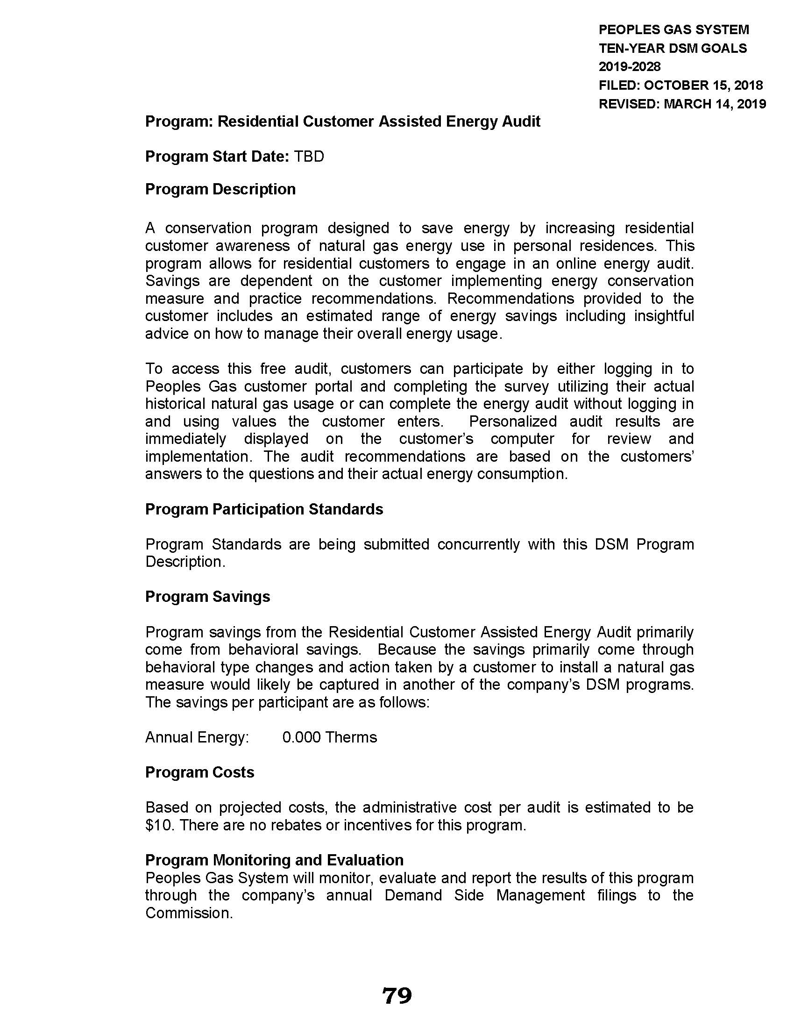
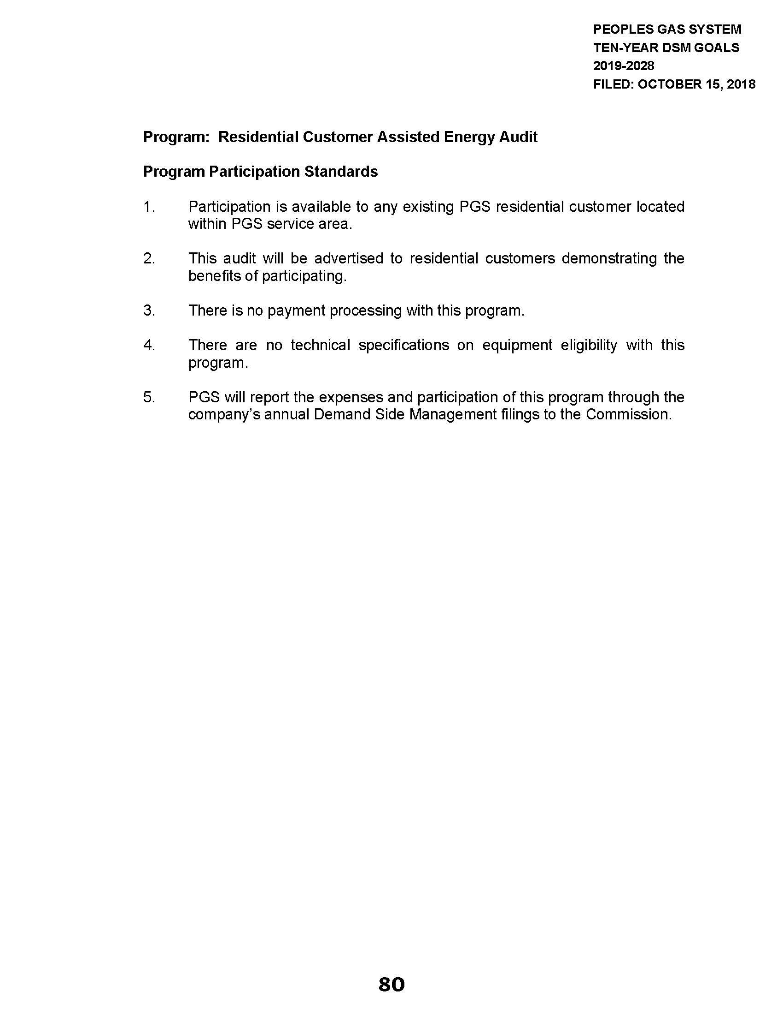
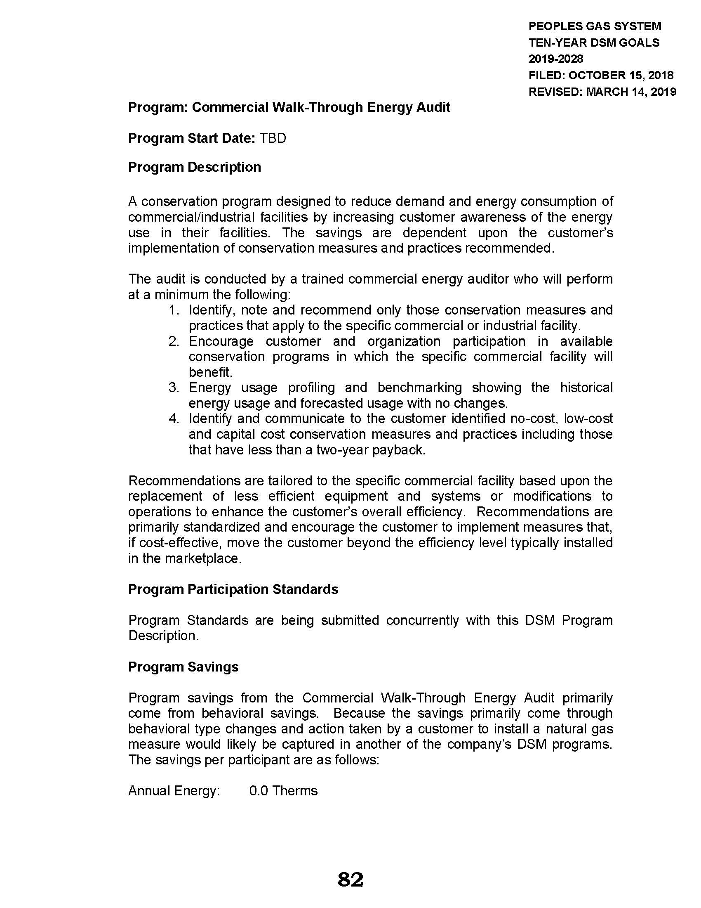
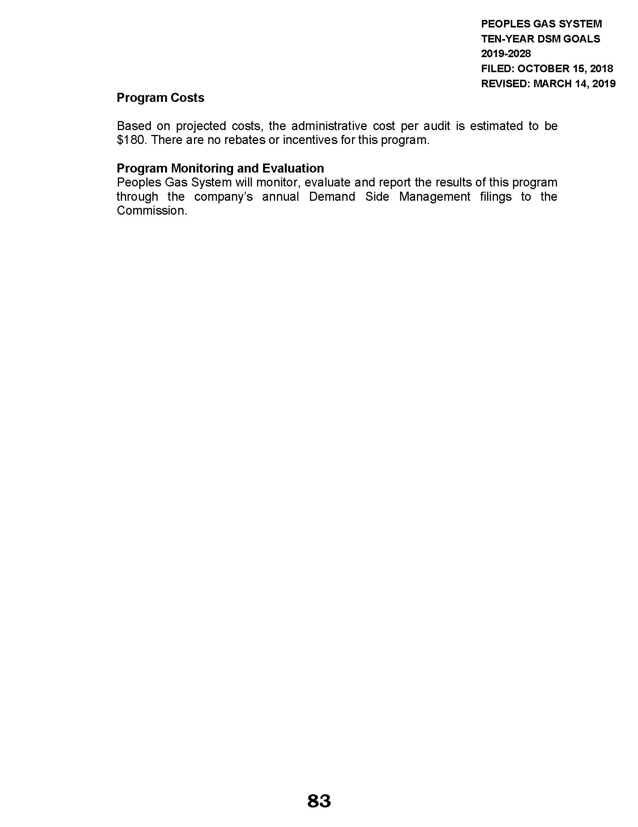
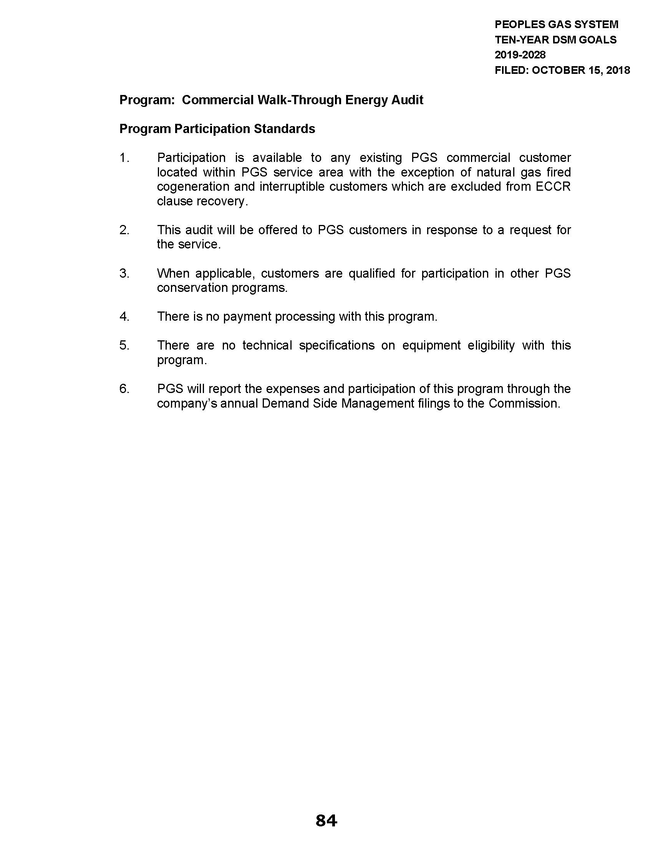

Section 366.82, F.S., provides that a natural gas utility is subject to FEECA requirements if a utility’s annual retail sales volume is equal to or greater than 100 million therms.
Order No. 23462, issued September 11, 1990, in Docket No. 19900089-EG, In re: Request for approval of Energy Conservation Plan by Peoples Gas System, Inc.; Order No. PSC-06-0816-PAA-EG, issued October 4, 2006, in Docket No. 20060478-EG, In re: Petition for approval of modifications to approved energy conservation programs, by Peoples Gas System.; Order No. PSC-10-0113-PAA-EG, issued February 25, 2010, in Docket No. 20090122-EG, In re: Petition for approval of modifications to approved energy conservation programs, by Associated Gas Distributors of Florida.; Order No. PSC-10-0551-PAA-EG, issued September 2, 2010, in Docket No. 20100186-EG, In re: Petition for approval of natural gas residential energy conservation programs, by Associated Gas Distributors of Florida.; Order No. PSC-14-0039-PAA-EG, issued January 14, 2014, in Docket No. 20130167-EG, In re: Petition for approval of natural gas energy conservation programs for commercial customers, by Associated Gas Distributors of Florida.; Order No. PSC-15-0095-PAA-EG, issued February 6, 2015, in Docket No. 20140196-EG, In re: Petition for approval of extension of conservation demonstration and development program, by Associated Gas Distributors of Florida.
Report No. 2016-022, issued October 2015, Public Service Commission Nuclear Power Plant Cost Recovery, Florida Energy Efficiency and Conservation Act, and Selected Administrative Activities.
PGS provided that its service territory is non-contiguous and spans 26 counties, from Dade County to Bay County.
A list of all DSM measures evaluated in the Technical Potential can be found in Appendix A of Exhibit A on pages 20-22 of PGS’ petition, dated October 15, 2018.
Order No. PSC-10-0551-PAA-EG, issued September 2, 2010, in Docket No. 20100186-EG, In re: Petition for approval of natural gas residential energy conservation programs, by Associated Gas Distributors of Florida.
Order No. PSC-14-0039-PAA-EG, issued January 14, 2014, in Docket No. 20130167-EG, In re: Petition for approval of natural gas energy conservation programs for commercial customers, by Associated Gas Distributors of Florida.
Order No. 23576, issued October 3, 1990, in Docket No. 19900002-EG, In re: Conservation Cost Recovery Clause.
Order No. PSC-10-0551-PAA-EG, issued September 2, 2010, in Docket No. 20100186-EG, In re: Petition for approval of natural gas residential energy conservation programs, by Associated Gas Distributors of Florida.
Order No. PSC-14-0039-PAA-EG, issued January 14, 2014, in Docket No. 20130167-EG, In re: Petition for approval of natural gas energy conservation programs for commercial customers, by Associated Gas Distributors of Florida.
Order No. PSC-10-0551-PAA-EG, issued September 2, 2010, in Docket No. 20100186-EG, In re: Petition for approval of natural gas residential energy conservation programs, by Associated Gas Distributors of Florida.
Order No. PSC-14-0039-PAA-EG, issued January 14, 2014, in Docket No. 20130167-EG, In re: Petition for approval of natural gas energy conservation programs for commercial customers, by Associated Gas Distributors of Florida.
This requirement corresponds to Rule 25-17.0021(5), F.A.C., that the FEECA electric utilities operate under regarding annual DSM reports.
The CA is not offered to commercial natural gas-fired cogeneration and interruptible customers because expenses associated with these customers do not qualify for cost recovery under the ECCR clause.

