State of Florida |  | Public Service Commission  Capital Circle Office Center ● 2540 Shumard Oak Boulevard  Tallahassee, Florida 32399-0850  -M-E-M-O-R-A-N-D-U-M-
DATE: | September 20, 2019
TO: | Office of Commission Clerk (Teitzman)
FROM: | Division of Economics (Coston, Draper)  Office of the General Counsel (Schrader)
RE: | Docket No. 20190078-EI – Petition for approval of 2019 revisions to underground residential distribution tariffs, by Gulf Power Company.
AGENDA: | 10/03/19 – Regular Agenda – Tariff Filing – Interested Persons May Participate
COMMISSIONERS ASSIGNED: |  |  | All Commissioners
PREHEARING OFFICER: |  |  | Administrative
CRITICAL DATES: |  |  | 12/01/19 (8-Month Effective Date)
SPECIAL INSTRUCTIONS: |  |  | None

Case Background
On April 1, 2019, Gulf Power Company (Gulf or utility) filed a petition for approval of revisions to its underground residential distribution (URD) tariffs. The URD tariffs apply to new residential subdivisions and represent the additional costs Gulf incurs to provide underground distribution service in place of overhead service. The proposed URD tariffs (legislative version) are contained in Attachment A to the recommendation. Gulf’s current URD charges were approved in Order No. PSC-2017-0356-TRF-EI.
The Commission suspended Gulf’s proposed tariffs by Order No. PSC-2019-0214-PCO-EI. Gulf responded to staff’s first data request on June 20, 2019. The Commission has jurisdiction over this matter pursuant to Sections 366.03, 366.04, 366.05, 366.06, Florida Statutes (F.S.).

Discussion of Issues

Issue 1:
Should the Commission approve Gulf's proposed URD tariffs and associated charges?

Recommendation:
Yes, the Commission should approve Gulf’s proposed URD tariffs and associated charges, as shown in Attachment A, effective October 3, 2019. (Coston, Draper)

Staff Analysis:
Rule 25-6.078, Florida Administrative Code (F.A.C.), specifies investor-owned utilities’ (IOU) responsibilities for filing updated URD tariffs. Gulf filed the instant petition pursuant to subsection (3) of the rule, which requires IOUs to file supporting data and analyses for updated URD tariffs if the cost varies from the Commission-approved differential by more than ten percent. On October 30, 2018, Gulf informed the Commission that its differential for the low density subdivision increased by 14 percent from the differential approved in the 2017 order.
The URD tariffs provide charges for underground service in new residential subdivisions and represent the additional costs, if any, the utility incurs to provide underground service in place of overhead service. The cost of standard overhead construction is recovered through base rates from all ratepayers. In lieu of overhead construction, customers have the option of requesting underground facilities. Any additional cost is paid by the customer as contribution-in-aid-of construction (CIAC). Typically, the URD customer is the developer of a subdivision.
Gulf’s URD charges are based on two standard model subdivisions: a 210-lot low density subdivision and a 176-lot high density subdivision. While actual construction may differ from the model subdivisions, the model subdivisions are designed to reflect average overhead and underground subdivisions.
Table 1-1 shows the current and proposed URD differentials for the low and high density subdivisions. The charges shown are per-lot charges. Gulf’s URD tariffs also provide for reduced charges if the customer chooses to supply and/or install the primary and secondary trench and duct system.
Table 1-1
Type of Subdivision | Current URD  Differential | Proposed URD  Differential
Low Density | $498 | $568
High Density | $562 | $609
Comparison of URD Differential per Lot
Source: Commission Order PSC-2017-0356-TRF-EI and 2019 Petition.
As shown in Table 1-1, the proposed URD differentials show an increase for both model subdivisions. The calculations of the proposed URD charges include (1) updated labor and material costs along with the associated loading factors and (2) operational costs. These costs are discussed below.

Labor and Material Costs
The installation costs of both underground and overhead facilities include the labor and material costs to provide primary, secondary, and service distribution lines, as well as transformers. The costs of poles are specific to overhead service, while the costs of trenching and backfilling are specific to underground service. Utilities are required, by Rule 25-6.078(5) F.A.C., to use current labor and materials costs in calculating its underground and overhead differential.
Gulf stated that there have not been any design changes to either the low or high density subdivision since 2015. The mix of Gulf employee and contractor labor remains the same as it was in 2017. Gulf employees continue to perform distribution construction activities. However, contract labor is also utilized to perform distribution overhead construction. Both Gulf and contractor labor rates have increase as specified in their respective contracts. Table 1-2 below compares total 2017 and 2019 per-lot labor and material costs for the two subdivisions.
Table 1-2
Labor and Material Costs per Lot
 | 2017 Costs | 2019 Costs | Difference
Low Density
Underground Labor/Material Costs | $2,460 | $2,749 | $289
Overhead Labor/Material Costs | $1,740 | $1,972 | $232
Per lot Differential | $720 | $777 | $57
High Density
Underground Labor/Material Costs | $1,976 | $2,198 | $222
Overhead Labor/Material Costs | $1,352 | $1,528 | $176
Per lot Differential | $624 | $670 | $46
Source: Commission Order PSC-2017-0356-TRF-EI and 2019 Petition.
As Table 1-2 shows, there has been an increase in underground and overhead labor and material costs. Gulf explained that the increase is due to increases in its direct labor rate, material costs, and engineering and supervision overhead for both labor and materials. Specifically, labor costs have increased approximately 20 percent for both overhead and underground since 2017.

Operational Costs
Rule 25-6.078(4), F.A.C., requires that the differences in net present value (NPV) of operational costs between overhead and underground systems, including average historical storm restoration costs over the life of the facilities, be included in the URD charge. The inclusion of the operational cost is intended to capture longer term costs and benefits of undergrounding.
Operational costs include operations and maintenance costs and capital costs and represent the cost differential between maintaining and operating an underground versus an overhead system over the life of the facilities. The inclusion of the storm restoration cost in the URD differential lowers the differential, since an underground distribution system generally incurs less damage than an overhead system as a result of a storm and, therefore, less restoration costs when compared to an overhead system. Gulf’s operational costs, last updated for the 2017 filing represent a five-year average of historical operational costs (2013-2017). The methodology used by Gulf for calculating the NPV of operational costs was approved in Order No. PSC-12-0531-TRF-EI. Gulf’s NPV calculation used a 32-year life of the facilities and a 7.35 percent discount rate. Staff notes that operational costs may vary in amount for different IOUs as a result of differences in size of service territory, miles of coastline, regions subject to extreme winds, age of the distribution system, or construction standards.
Gulf’s combined non-storm operational costs and avoided storm costs have decreased slightly for both overhead and underground since 2017. In the low density model, the combined cost differential is -$209, as compared to -$222 in 2017. For the high density model, the combined cost differential is -$61, as compared to -$62 in 2017. Overhead operational costs for both subdivisions are higher than underground operational costs. Therefore, the inclusion of the operational costs results in a reduction to the pre-operational differential.

Gulf states that hurricane Michael storm costs are not included in the calculations of avoided storm costs in this filing. Staff notes that Rule 25-6.078(3), F.A.C., requires IOUs to file with the Office of Commission Clerk in the undocketed filings by October 15 of each year an updated calculation of the low density subdivision using current costs. If the calculated cost differential varies from the Commission-approved differential by more than ten percent, the utility is required to file a petition for updated URD tariffs on or before April 1 of the following year.

Table 1-3 presents the pre-operational, non-storm operational, and the avoided storm restoration cost differentials between overhead and underground systems. As noted above, the operational cost differentials are slightly lower than in the 2017. Overall, the proposed URD differential increase is related to the pre-operational labor and materials.
Table 1-3
NPV of Operational Costs Differential per Lot
Type of Subdivision | Pre-Operational  (A) | Non-storm Operational costs  (B) | Avoided Storm costs  (C) | Proposed URD Differentials  (A)+(B)+(C)
Low Density | $777 | ($174) | ($35) | $568
High Density | $670 | ($43) | ($18) | $609
Source: 2019 Petition and Staff Data Requests.

Conclusion
Staff has reviewed Gulf’s proposed URD tariffs and associated charges, its accompanying work papers, and responses to staff’s data requests. Staff believes the proposed URD tariffs and associated charges are reasonable. Staff recommends approval of Gulf’s proposed URD tariffs and associated charges, as shown in Attachment A, effective October 3, 2019.

Issue 2:
Should this docket be closed?

Recommendation:
If Issue 1 is approved and a protest is filed within 21 days of the issuance of the order, the tariffs should remain in effect, with any revenues held subject to refund, pending resolution of the protest. If no timely protest is filed, this docket should be closed upon the issuance of a consummating order. (Schrader)

Staff Analysis:
If Issue 1 is approved and a protest is filed within 21 days of the issuance of the order, the tariffs should remain in effect, with any revenues held subject to refund, pending resolution of the protest. If no timely protest is filed, this docket should be closed upon the issuance of a consummating order.

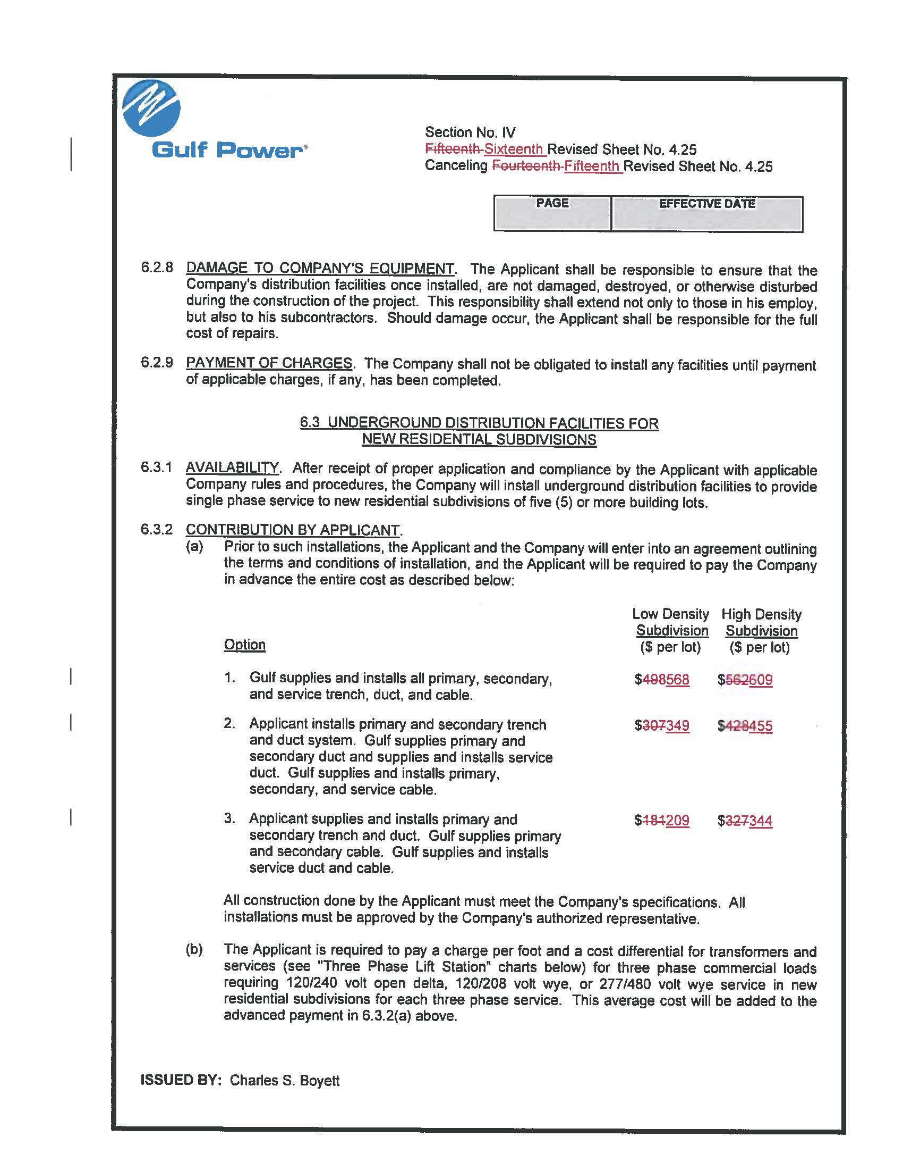

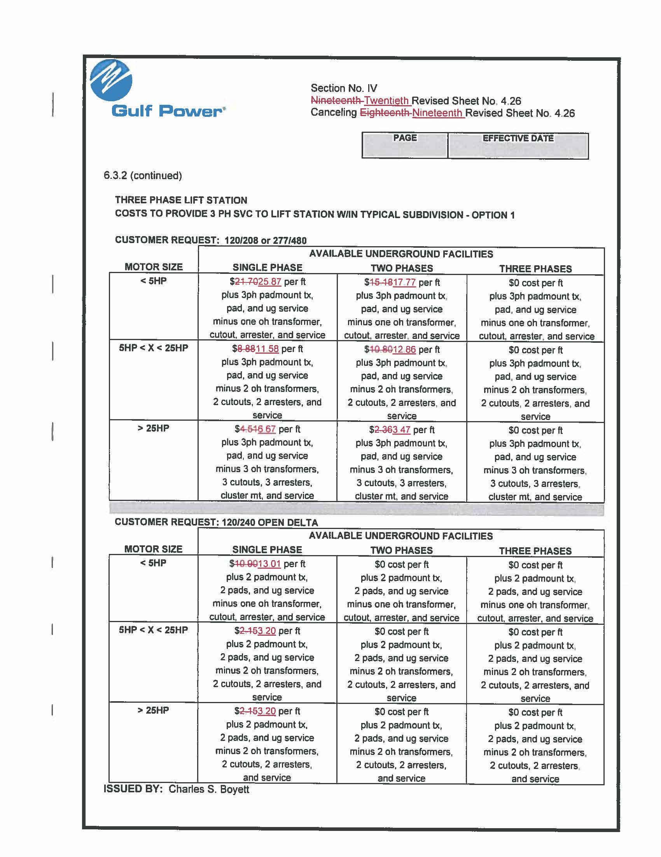

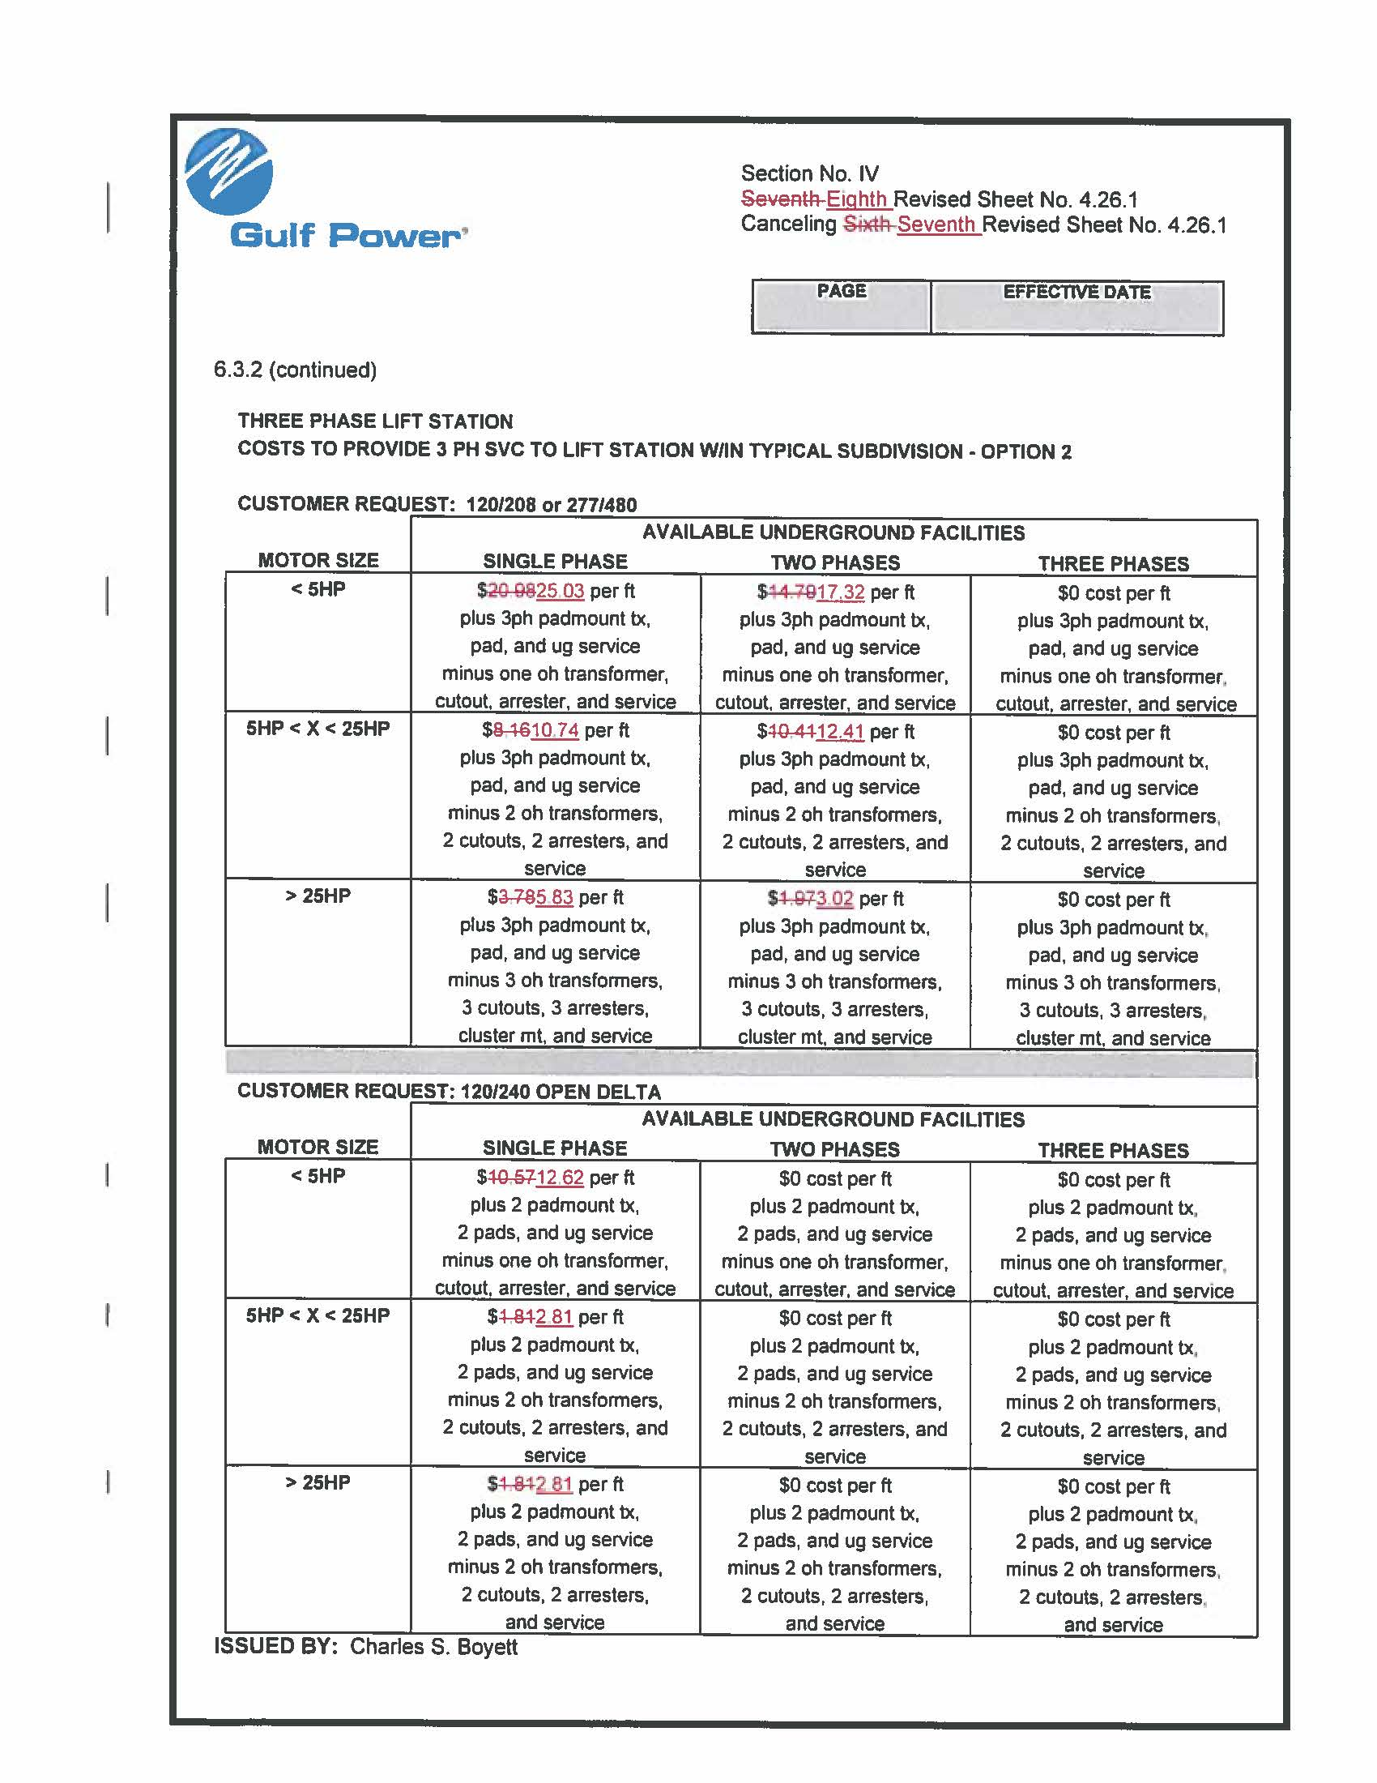

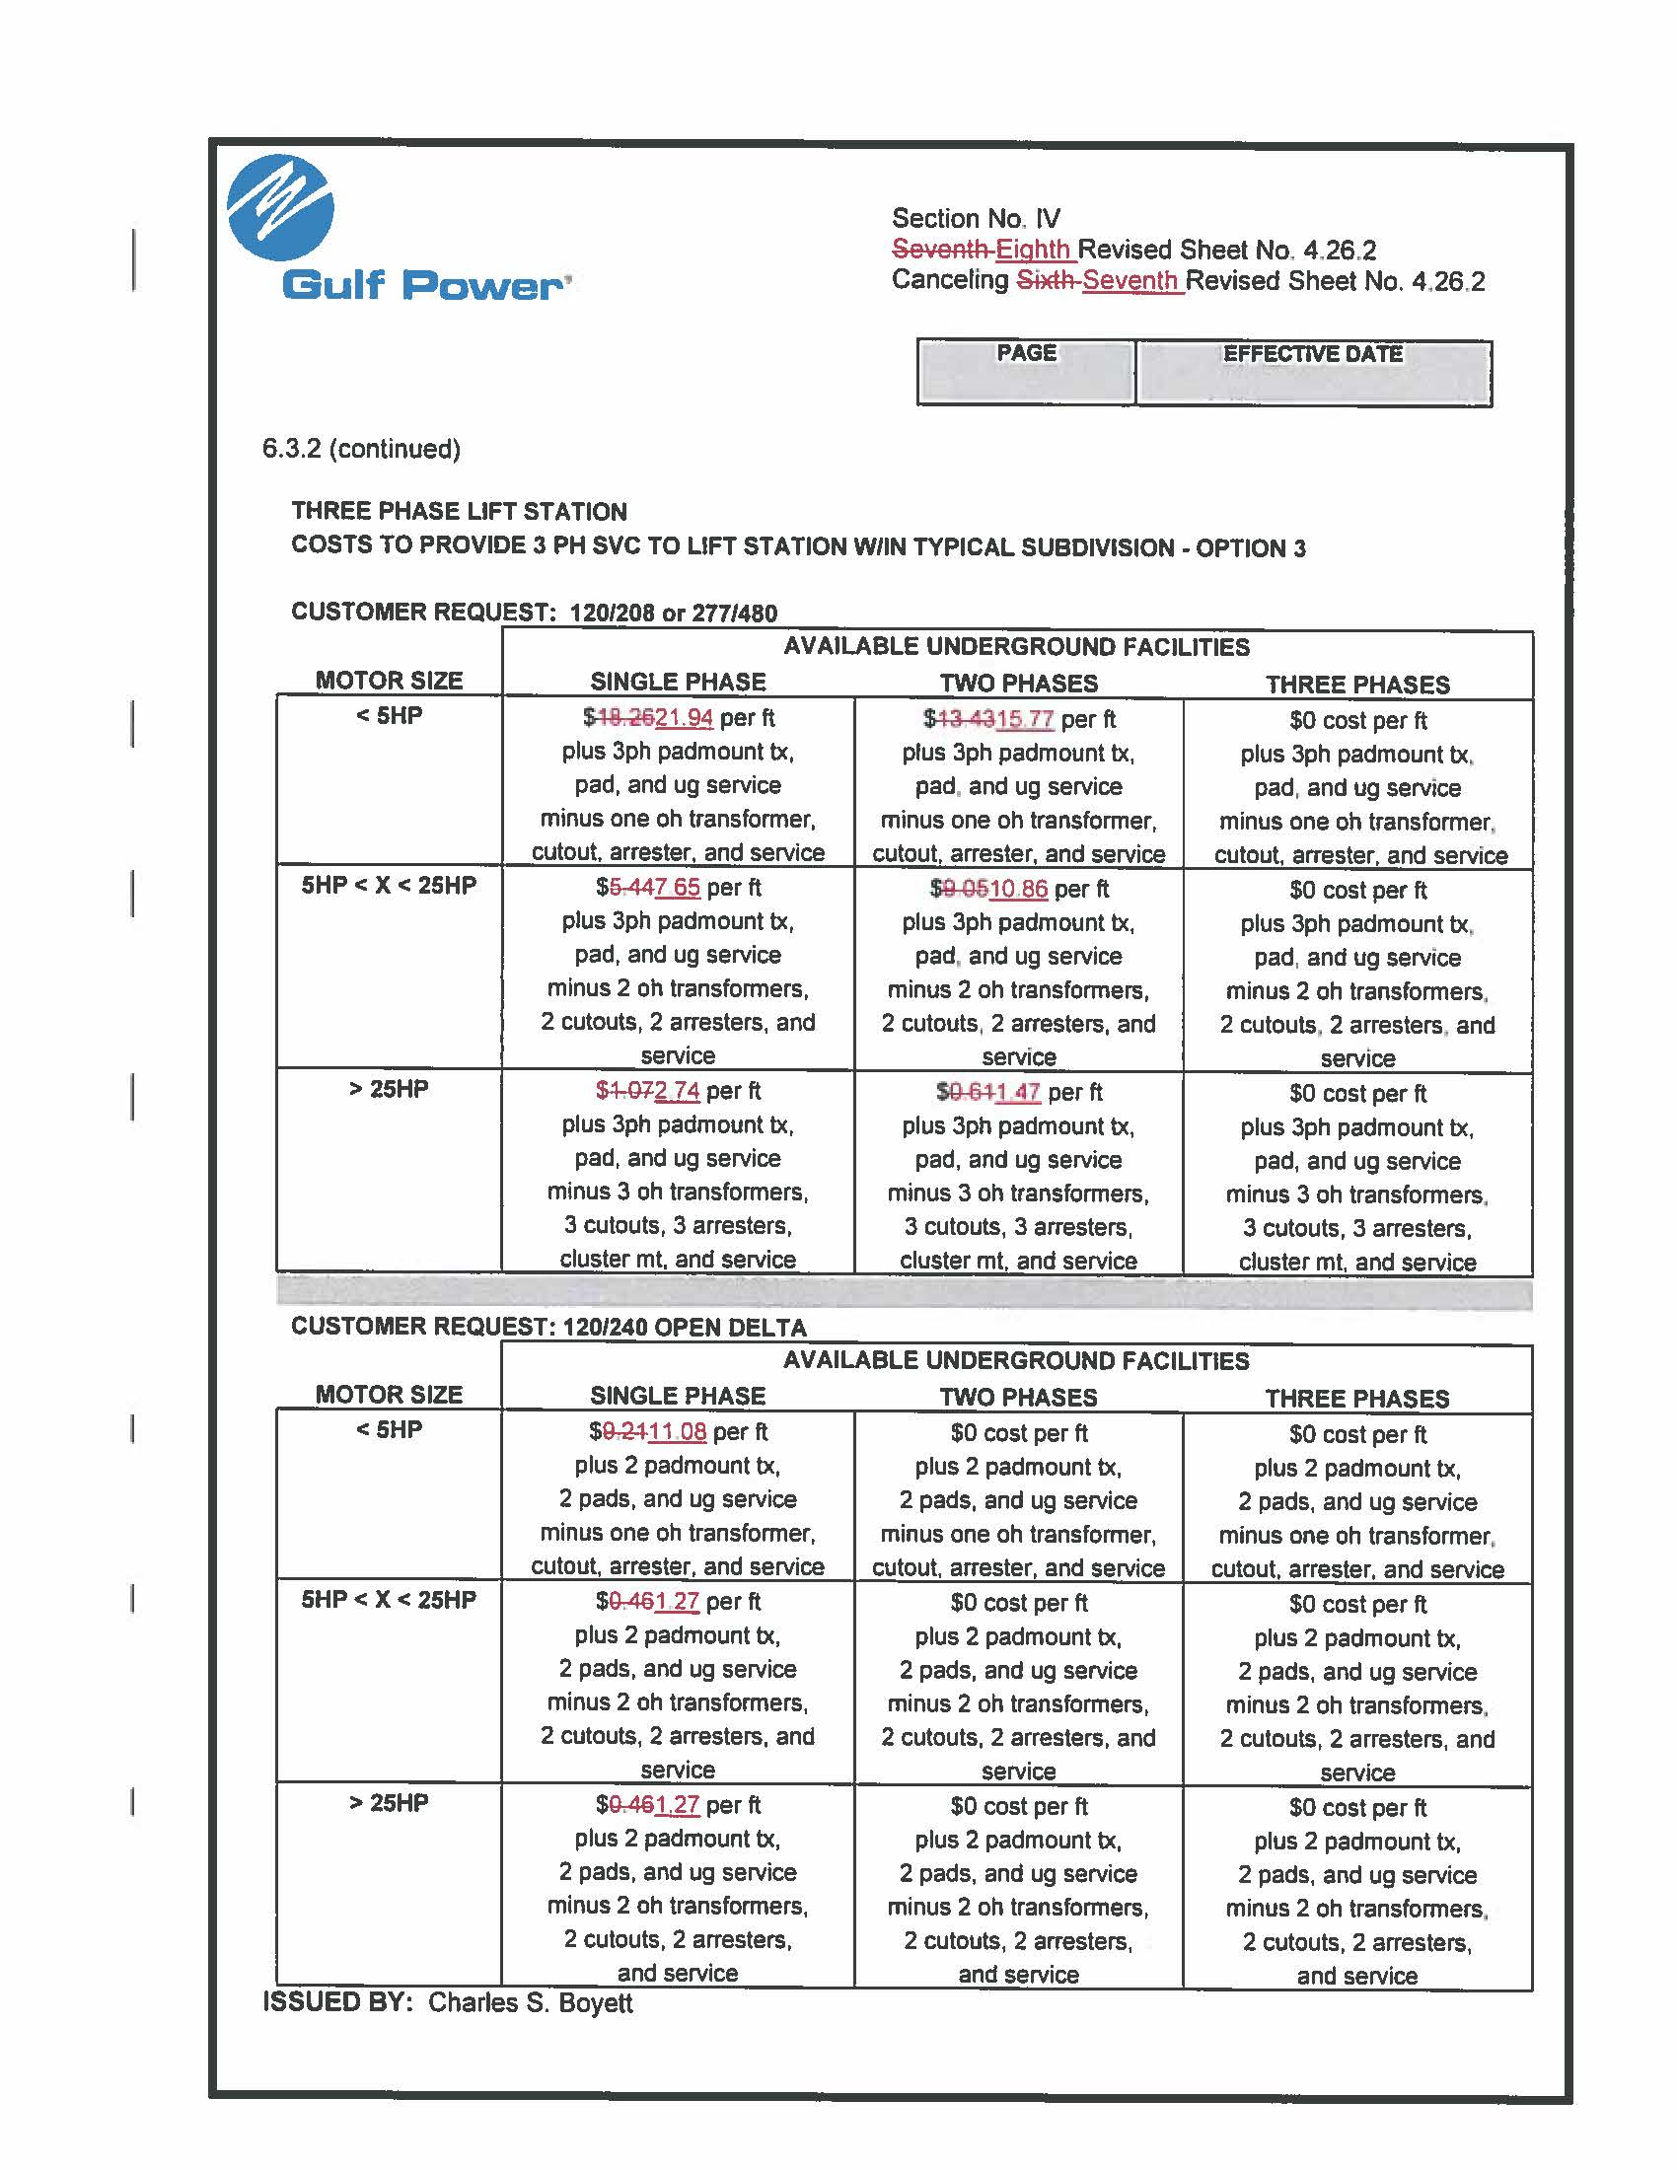

Order No. PSC-2017-0356-TRF-EI, issued September 20, 2017, in Docket No. 20170074-EI, In re: Petition for approval of 2017 revisions to underground residential distribution tariffs, by Gulf Power Company.
Order No. PSC-2019-0214-PCO-EI, issued June 3, 2019, in Docket No. 20190078-EI, In re: Petition for approval of 2019 revisions to underground residential distribution tariffs, by Gulf Power Company.
Order No. PSC-12-0531-TRF-EI, issued October 4, 2012, in Docket No. 120075-EI, In re: Request by Gulf Power Company to modify its underground residential differential tariffs.

