BEFORE THE FLORIDA PUBLIC SERVICE COMMISSION

Notice of development of rulemaking

ALL INTERESTED PERSONS

UNDOCKETED

IN RE: Proposed Amendment of Rule 25-30.457, F.A.C.,
Limited Alternative Rate Increase

ISSUED: October 10, 2019

NOTICE is hereby given pursuant to Section 120.54, Florida Statutes, that the Florida Public Service Commission staff has initiated rulemaking to amend Rule 25-30.457, Florida Administrative Code, to clarify the requirements for applications for limited alternative rate increase for small water and wastewater utilities.

The attached Notice of Development of Rulemaking appeared in the October 9, 2019, edition of the Florida Administrative Register. A staff rule development workshop will be held at the following time and place:

October 30, 2019, at 9:30 a.m.
Florida Public Service Commission
Gerald L. Gunter Building, Room 105
2540 Shumard Oak Boulevard
Tallahassee, FL 32399-0850

The draft rule and the agenda for the workshop are attached. One or more Commissioners may be in attendance and participate in the workshop. The person to be contacted regarding the rule development is Kathryn G.W. Cowdery, Office of the General Counsel, 2540 Shumard Oak Blvd., Tallahassee, FL 32399-0850 at (850) 413-6216, or kcowdery@psc.state.fl.us.

In accordance with the Americans with Disabilities Act, persons needing a special accommodation to participate at this workshop should contact the Office of Commission Clerk no later than five days prior to the workshop at 2540 Shumard Oak Boulevard., Tallahassee, Florida 32399-0850 or 850-413-6770 (Florida Relay Service, 1-800-955-8770 Voice or 1-800-955-8771 TDD). Assisted Listening Devices are available upon request from the Office of Commission Clerk, Gerald L. Gunter Building, Room 152.

If a named storm or other disaster requires cancellation of the workshop, Commission staff will attempt to give timely notice to the public. Notice of cancellation will also be provided on the Commission’s website (http://www.psc.state.fl.us/) under the Hot Topics link found on the home page. Cancellation can also be confirmed by calling the Office of the General Counsel at 850-413-6199.

By DIRECTION of the Florida Public Service Commission this 10th day of October, 2019.

ADAM J. TEITZMAN
Commission Clerk
Florida Public Service Commission
2540 Shumard Oak Boulevard
Tallahassee, Florida 32399
(850) 413-6770
www.floridapsc.com

Copies furnished: A copy of this document is provided to the parties of record at the time of issuance and, if applicable, interested persons.

KGWC

Notice of Development of Rulemaking

PUBLIC SERVICE COMMISSION
RULE NO: RULE TITLE
25-30.457 Limited Alternative Rate Increase
PURPOSE AND EFFECT: The purpose of this rulemaking is to amend the rule to clarify the application requirements for a limited alternative rate increase and to simplify the language to make it more understandable. The effect of this rulemaking will be to make the rule requirements clear to all interested persons.
Docket No. Undocketed
SUBJECT AREA TO BE ADDRESSED: Applications for limited alternative rate increases for small water and wastewater utilities
RULEMAKING AUTHORITY: 350.127(2), 367.0814, 367.121 FS.
LAW IMPLEMENTED: 367.0814 FS.
A RULE DEVELOPMENT WORKSHOP WILL BE HELD AT THE DATE, TIME AND PLACE SHOWN BELOW:
DATE AND TIME: October 30, 2019, 9:30 a.m.
PLACE: Gerald L. Gunter Building, Room 105, 2540 Shumard Oak Boulevard, Tallahassee, FL 32399-0850
One or more Commissioners may be in attendance and participate in the workshop. In accordance with the Americans with Disabilities Act, persons needing a special accommodation to participate at this workshop should contact the Office of Commission Clerk no later than five days prior to the workshop at 2540 Shumard Oak Boulevard., Tallahassee, Florida 32399-0850 or (850)413-6770 (Florida Relay Service, 1(800)955-8770 Voice or 1(800)955-8771 TDD). Assisted Listening Devices are available upon request from the Office of Commission Clerk, Gerald L. Gunter Building, Room 152.
THE PERSON TO BE CONTACTED REGARDING THE PROPOSED RULE DEVELOPMENT AND A COPY OF THE PRELIMINARY DRAFT, IF AVAILABLE, IS: Kathryn G.W. Cowdery, Florida Public Service Commission, Office of the General Counsel, 2540 Shumard Oak Blvd., Tallahassee, FL 32399-0850, (850)413-6216, kcowdery@psc.state.fl.us. The agenda for the workshop and a copy of the preliminary draft of the proposed rule amendment will be available on the Commission’s website, www.floridapsc.com, under the Rule Development tab by October 16, 2019.
THE PRELIMINARY TEXT OF THE PROPOSED RULE DEVELOPMENT IS AVAILABLE AT NO CHARGE FROM THE CONTACT PERSON LISTED ABOVE.

25-30.457 Limited Alternative Rate Increase.
(1) As an alternative to a staff assisted rate case as described in Rrule 25-30.455, F.A.C., or to staff assistance in alternative rate setting as described in Rrule 25-30.456, F.A.C., water utilities whose total gross annual operating revenues are $300,000 or less for water service and wastewater utilities whose total gross annual operating revenues are $300,000 or less for wastewater service may file with the Office of Commission Clerk an application petition the Commission for a limited alternative rate increase of up to 20 percent applied to metered or flat recurring rates of all classes of service by filing with the Office of Commission Clerk the information required by subsections (7), (8) and (9) of this rule.
(2) The application for limited alternative rate increase must contain the following information:
(a) The name of the utility as it appears on the utility’s certificate and the address of the utility’s principal place of business;
(b) The type of business organization under which the utility’s operations are conducted.
1. If the utility is a corporation, the date of incorporation and the names and addresses of all persons who own five percent or more of the utility’s stock; or
2. If the utility is not a corporation, the names and addresses of the owners of the business;
(c) A schedule showing the annualized revenues by customer class and meter size for the most recent 12-month period using the rates in effect at the time the utility files its application;
(d) A schedule showing the current and proposed rates for all classes of customers;
(e) A statement explaining why the utility is, or is expected to, underearn its authorized rate of return;
(f) A statement that the figures and calculations upon which the change in rates is based are accurate and that the change will not cause the utility to exceed its last authorized rate of return on equity.
(g) A statement that the utility is currently in compliance with its annual report filing in accordance with Rule 25-30.110(3), F.A.C.;
(h) A statement that the utility has paid all required regulatory assessment fees or is current on any approved regulatory assessment fee payment plan;
(i) A statement that an order in a rate proceeding that established the utility’s rate base, capital structure, annual operating expenses and revenues has been issued for the utility within the 7-year period prior to the official date of filing of the application; and
(j) Any additional relevant information in support of the application that the utility may wish to file and reasons why the information should be considered.
(3) Within 30 days of the application’s filing date, Commission staff will notify the utility in writing that the application requirements of subsection (2) of this rule have been met or that the requirements of subsection (2) have not been met with an explanation of the application’s deficiencies.
(2) Within 30 days of receipt of the completed petition, the Commission will evaluate the petition and determine the petitioner’s eligibility for a limited alternative rate increase.
(3) The Commission will notify the petitioner in writing as to whether the petition is accepted or denied. If the petition is accepted, staff assistance in alternative rate setting will be initiated. If the petition is denied, the notification of petition denial will state the deficiencies in the petition with reference to the criteria set out in subsection (5) of this rule.
(4) The date of Commission staff’s written notification to the utility that the requirements of subsection (2) of this rule have been met will be considered the date of official acceptance by the Commission of the application. The official date of filing is established as will be 30 days after the date of official acceptance by the Commission of the application the written notification to the petitioner of the Commission’s acceptance of the petition.
(5) In determining whether to grant or deny the petition, the Commission will consider the following criteria:
(a) Whether the petitioner qualifies for staff assistance pursuant to subsection (1) of this rule;
(b) Whether the petitioners’ books and records are organized consistent with rule 25-30.110, F.A.C, so as to allow Commission personnel to verify costs and other relevant factors within the 30-day time frame set out in this rule;
(c) Whether the petitioner has filed annual reports;
(d) Whether the petitioner has paid applicable regulatory assessment fees;
(e) Whether the petitioner has at least one year of experience in utility operation;
(f) Whether the petitioner has filed additional relevant information in support of eligibility together with reasons why the information should be considered;
(g) Whether the utility was granted a rate case increase within the 2-year period prior to the receipt of the petition under review;
(h) Whether a final order in a rate proceeding that established the utility’s rate base, capital structure, annual operating expenses and revenues has been issued for the utility within the 7-year period prior to the receipt of the petition under review.
(5)(6) The Commission will deny the application will be denied petition if the utility petitioner does not remit the filing fee, as provided by paragraph 25-30.020(2)(f), F.A.C., within 30 days after the official acceptance of the application petition.
(7) Each petitioner for limited alternative rate increase shall provide the following general information to the Commission:
(a) The name of the utility as it appears on the utility’s certificate and the address of the utility’s principal place of business; and,
(b) The type of business organization under which the utility’s operations are conducted:
1. If the petitioner is a corporation, the date of incorporation and the names and addresses of all persons who own five percent or more of the petitioner’s stock; or
2. If the petitioner is not a corporation, the names and addresses of the owners of the business.
(8) The petitioner shall provide a schedule showing:
(a) Annualized revenues by customer class and meter size for the most recent 12-month period using the rates in effect at the time the utility files its petition; and,
(b) Current and proposed rates for all classes of customers.
(9) The petitioner shall provide a statement that the figures and calculations upon which the change in rates is based are accurate and that the change will not cause the utility to exceed its last authorized rate of return on equity.
(6)(10) A financial or engineering audit of the utility’s financial or engineering books and records will shall not be required in determining whether to approve or deny the application conjunction with the petition under review.
(7)(11) The application petition will be approved, denied, or approved with modifications within 90 days from the official filing date as established in subsection (4) of this rule.
(8)(12) Any revenue increase granted under the provisions of this rule shall be held subject to refund with interest in accordance with Rrule 25-30.360(4), F.A.C., for a period of 15 months after the filing of the utility’s annual report required by rule 25-30.110, F.A.C., for the year the adjustment in rates was implemented.
(9) (13) To insure overearnings will not occur due to the implementation of this rate increase, Tthe Commission staff will conduct an earnings review of the twelve-month period following the implementation of the revenue increase. utility’s annual report to determine any potential overearnings for the year the adjustment in rates was implemented.
(a) At the end of the twelve-month period, the utility has 90 days to complete and file Form PSC #### (X/XX), entitled “Limited Alternative Rate Increase Earnings Review,” which is incorporated into this rule by reference and is available at [Dep’t of State hyperlink]
(b) In the event the utility needs additional time to complete the form, the utility may request an extension of time supported by a statement of good cause that must be filed with Commission staff within seven days prior to the 90-day deadline. “Good cause” means a showing of financial hardship, unforeseen events, or other events outside the control of the utility, but does not include reasons such a management oversight.
(c)(14) If, within 15 months after the filing of a utility’s annual report the Commission staff’s earnings review demonstrates finds that the utility exceeded the range of its last authorized rate of return on equity after an adjustment in rates, as authorized by this rule, was implemented within the year for which the report was filed, such overearnings, up to the amount held subject to refund, with interest, shall be disposed of for the benefit of the customers. If the Commission staff determines that the utility did not exceed the range of its last authorized return on equity, the revenue increase will no longer be held subject to refund.
(10)(15) In the event of a protest of the pProposed aAgency aAction oOrder is protested pursuant to Rrule 28-106.111, F.A.C., by a substantially affected person other than the utility, the utility must file a staff assisted rate case application pursuant to Rule 25-30.455, F.A.C., within 21 days from the date the protest is filed or the utility’s application for a limited alternative rate increase will be deemed withdrawn.
(11) Upon the utility filing a staff assisted rate case application pursuant to subsection (10) of this rule:
(a) unless the Proposed Agency Action Order proposes a rate reduction, Tthe utility may implement the rates established in the pProposed aAgency aAction oOrder on a temporary basis subject to refund with interest in accordance with Rrule 25-30.360, F.A.C.; upon the utility filing a staff assisted rate case application pursuant to rule 25-30.455, F.A.C., within 21 days of the date the protest is filed.
(b)(16) In the event of a protest, Tthe limit on the maximum increase provided in subsection (1) of this rule will shall no longer apply; and
(c) The application will be processed under Rule 25-30.455, F.A.C.
(17) If the utility fails to file a staff assisted rate case application within 21 days in the event of a protest, the petition for a limited alternative rate increase will be deemed withdrawn.
Rulemaking Authority 350.127(2), 367.0814, 367.121 FS. Law Implemented 367.0814 FS. History–New 3-15-05, Amended 12-16-08, 8-10-14, 7-1-18,____________.

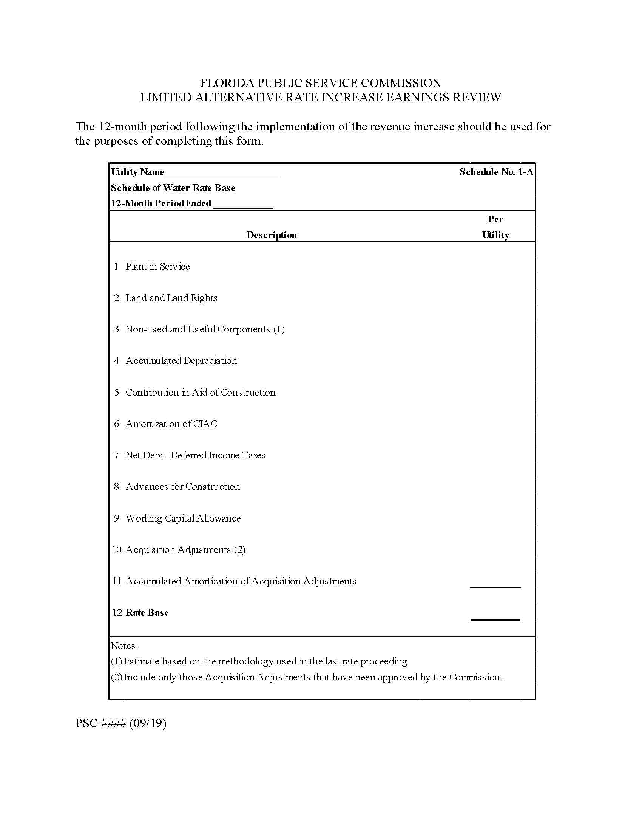

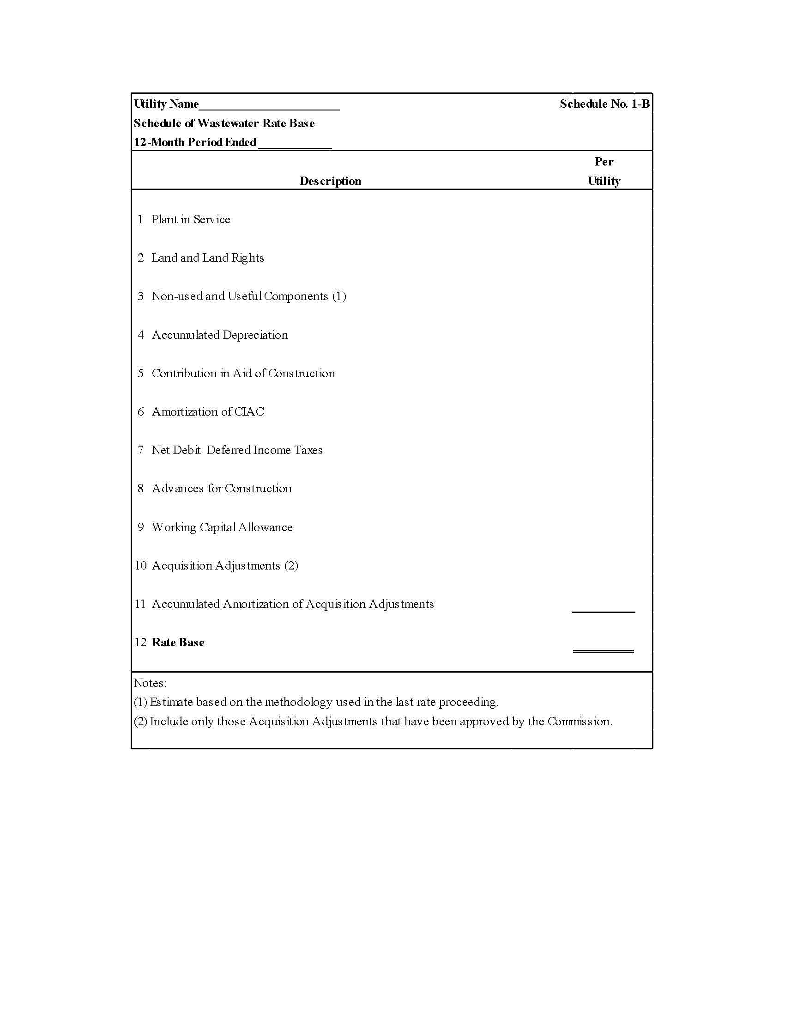

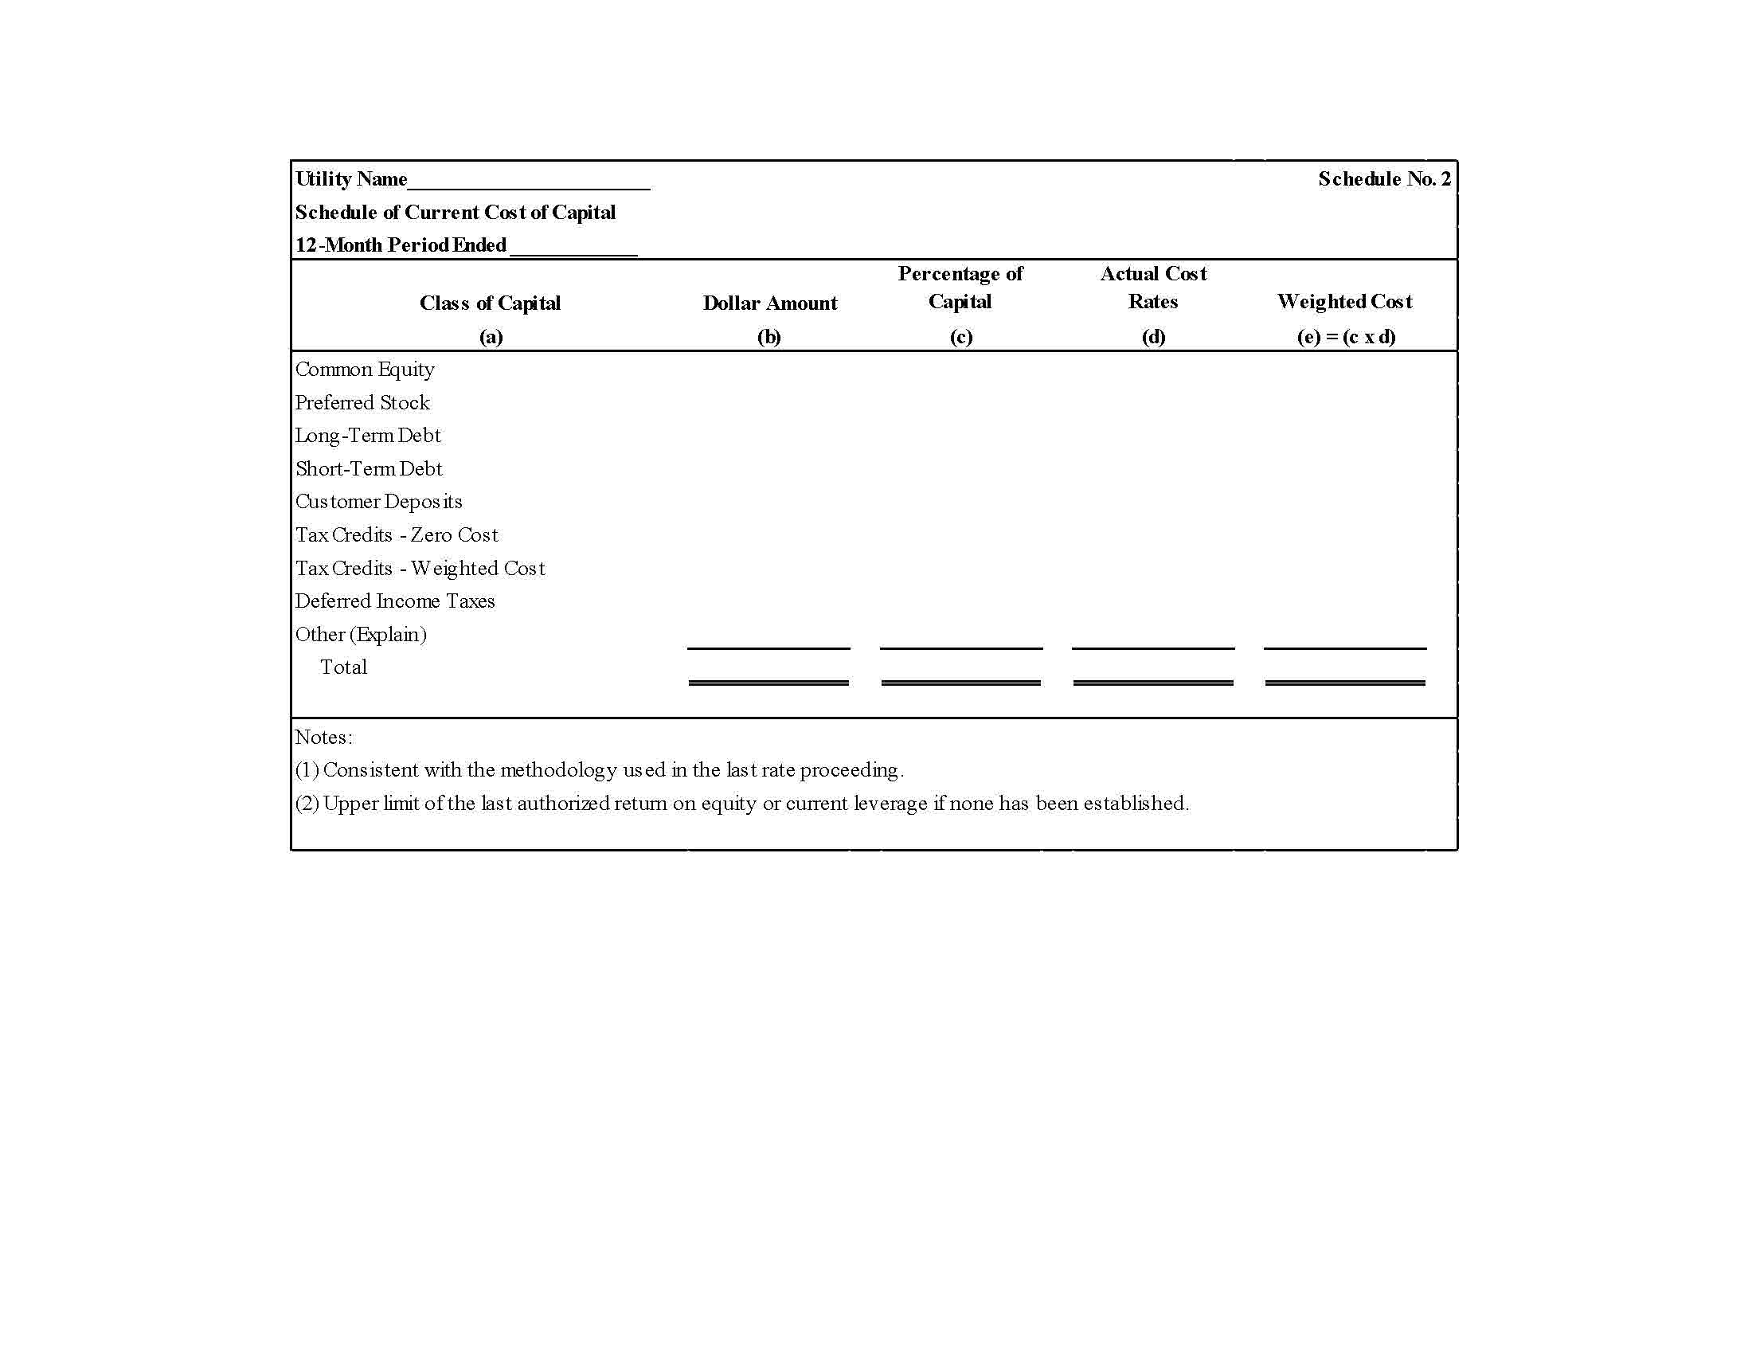

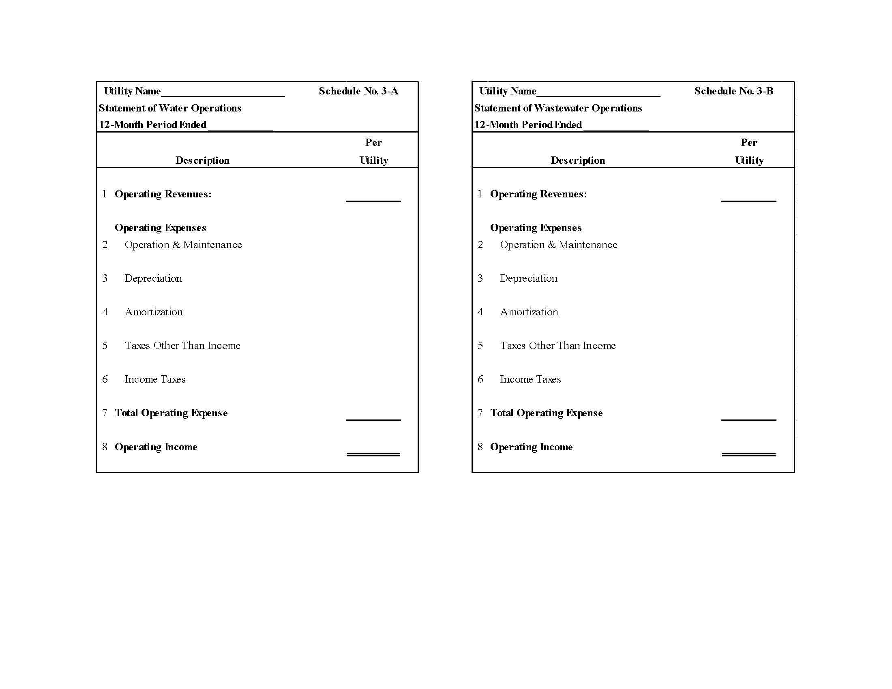

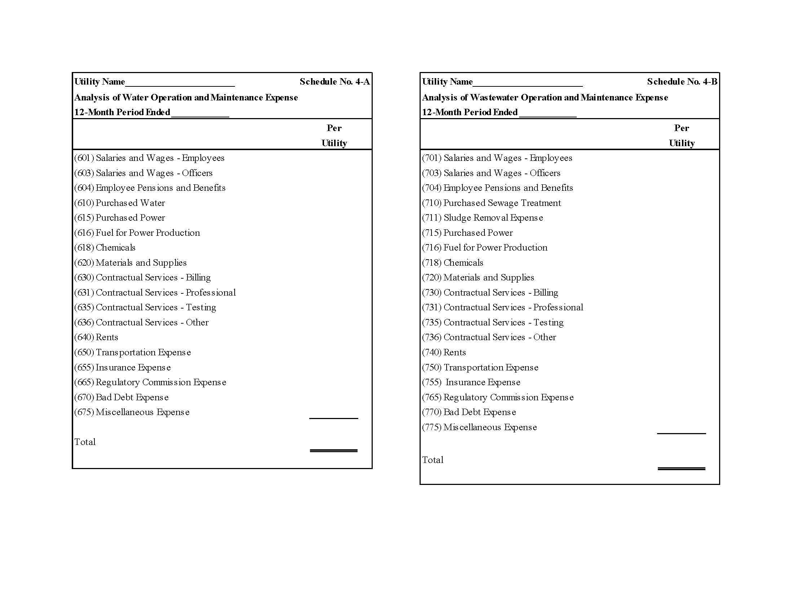

FLORIDA PUBLIC SERVICE COMMISSION

AGENDA

STAFF WORKSHOP

IN RE: Proposed Amendment of Rule 25-30.457, F.A.C., Limited Alternative Rate Increase

October 30, 2019, at 9:30 a.m.
Florida Public Service Commission
Gerald L. Gunter Building, Room 105
2540 Shumard Oak Boulevard
Tallahassee, FL 32399-0850

1. Staff overview of draft rule

2. Comments and alternative suggestions from interested persons

3. Discussion of suggested changes and timeframes for next steps

4. Adjournment

