BEFORE THE FLORIDA PUBLIC SERVICE COMMISSION

In re: Joint petition for approval of territorial agreement in Marion County, by Clay Electric Cooperative, Inc. and City of Ocala. | DOCKET NO. 20190137-EU  ORDER NO. PSC-2019-0444-PAA-EU  ISSUED: October 23, 2019

The following Commissioners participated in the disposition of this matter:

ART GRAHAM, Chairman
JULIE I. BROWN
DONALD J. POLMANN
GARY F. CLARK
ANDREW GILES FAY

NOTICE OF PROPOSED AGENCY ACTION ORDER
APPROVING TERRITORIAL AGREEMENT IN MARION COUNTY,
BY CLAY ELECTRIC COOPERATIVE, INC. AND CITY OF OCALA

BY THE COMMISSION:

NOTICE is hereby given by the Florida Public Service Commission that the action discussed herein is preliminary in nature and will become final unless a person whose interests are substantially affected files a petition for a formal proceeding, pursuant to Rule 25-22.029, Florida Administrative Code (F.A.C.).

Background
On July 2, 2019, Clay Electric Cooperative, Inc. (Clay) and the City of Ocala Electric Utility (Ocala), collectively the joint petitioners, filed a petition seeking Commission approval of a territorial agreement (agreement) delineating their respective modified service boundaries in Marion County. The proposed agreement, map depicting the current service territories and proposed changes, and written descriptions of the territorial boundaries are provided in Attachment A, attached to this order.
In 1986, we approved a territorial agreement that established the boundaries for Clay and Ocala’s service territories in Marion County. The 1986 agreement was a 25-year agreement which was effective from January 7, 1987 to January 7, 2012. Since 2012, the parties state that they have continued to honor and operate pursuant to the terms of the 1986 agreement. Pursuant to Section 6.1, the proposed agreement will be in effect for a term of 25 years from the date of the issuance of our order.
During the review of this joint petition, Commission staff issued a data request to Clay and Ocala on July 19, 2019, for which responses were received on August 8, 2019. The responses have been placed in the docket file. We have jurisdiction over this matter pursuant to Section 366.04, Florida Statutes (F.S.).

Decision

The Agreement
Pursuant to Section 366.04(2)(d), F.S., and Rule 25-6.0440, F.A.C., we have the jurisdiction to approve territorial agreements between and among rural electric cooperatives, municipal electric utilities, and other electric utilities. Unless we determine that the agreement will cause a detriment to the public interest, the agreement should be approved.
Prior to the 1986 agreement, parts of Marion County and areas east of City of Ocala were being served by both utilities. The 1986 agreement delineated and established specific service territories in Marion County for Clay and Ocala. In the instant docket, the parties state that they have made modest modifications to their service boundaries in order to accurately reflect land development that has occurred since 1986 and to provide reliable and efficient service to the impacted customers.
Through the proposed agreement, the joint petitioners will transfer 30 (25 residential and 5 general service commercial) customers from Clay to Ocala. In addition, three residential and two general service commercial Ocala customers will be transferred to Clay. The joint petitioners explained that customer transfers would be completed within 36 months of the order approving the agreement; however, to make the process easy and simple for customers, the utilities have agreed not to immediately transfer any customers. Customer transfers will occur when a customer applies for service at a new location or when a customer changes the type of account (i.e., residential to commercial). The joint petitioners further stated that any customers not transferred as a result of a change in service or type of account will be transferred prior to the expiration of the 36 months. In response to Commission staff’s data request, the joint petitioners stated that when the 30 CEC customers are transferred to Ocala, they will be billed pursuant to Ocala’s approved tariffs and when five Ocala customers are transferred to CEC, they will be billed pursuant to CEC’s approved tariffs. No special or temporary tariff rates are anticipated for the transferred customers of both utilities.
The amended territorial agreement also contemplates the transfer of certain secondary service distribution facilities between the parties. In response to Commission staff’s data request, the petitioners stated these facilities have been fully depreciated due to age and condition and therefore no purchase price is assessed. Rather, the parties will exchange the facilities on a like-kind basis. The joint petitioners assert that the proposed amended territorial agreement will prevent uneconomic duplication of facilities and, if approved, would continue and remain in effect for a period of 25 years from the date of our order.

Customer Notification

In accordance with Rule 25-6.0440(1)(d), F.A.C., the petitioners state that prior to the filing of this petition, the impacted customers were notified by mail of the transfer and provided a description of the differences in rates between Clay and Ocala. In response to Commission staff’s data request, the utilities stated that they have not received any negative responses from impacted customers. We have not received any objections from impacted customers. In response to Commission staff’s data request, the petitioners provided updated customer notification letters. As of June 2018, the bill for a Clay residential customer using 1,000 kilowatt-hours (kWh) per month was $112.90 and the bill for an Ocala residential customer using 1,000 kWh per month was $114.64.

Conclusion

After review of the petition and the petitioners’ joint responses to Commission staff’s data request, we find that the proposed agreement is in the public interest and will enable Clay and Ocala to serve their current and future customers efficiently. It appears that the proposed agreement eliminates any potential uneconomic duplication of facilities and will not cause a decrease in reliability of electric service. As such, we find the proposed agreement between Clay and Ocala will not cause a detriment to the public interest and approve the agreement.
Based on the foregoing, it is

ORDERED by the Florida Service Commission that the amended territorial agreement between Clay Electric Cooperative, Inc. and the City of Ocala is approved. It is further

ORDERED that the provisions of this Order, issued as proposed agency action, shall become final and effective upon the issuance of a Consummating Order unless an appropriate petition, in the form provided by Rule 28-106.201, Florida Administrative Code, is received by the Commission Clerk, 2540 Shumard Oak Boulevard, Tallahassee, Florida 32399-0850, by the close of business on the date set forth in the “Notice of Further Proceedings” attached hereto. It is further

ORDERED that in the event this Order becomes final, this docket shall be closed.

By ORDER of the Florida Public Service Commission this 23rd day of October, 2019.

/s/ Adam J. Teitzman
ADAM J. TEITZMAN
Commission Clerk
Florida Public Service Commission
2540 Shumard Oak Boulevard
Tallahassee, Florida 32399
(850) 413-6770
www.floridapsc.com

Copies furnished: A copy of this document is provided to the parties of record at the time of issuance and, if applicable, interested persons.

WLT

NOTICE OF FURTHER PROCEEDINGS OR JUDICIAL REVIEW

The Florida Public Service Commission is required by Section 120.569(1), Florida Statutes, to notify parties of any administrative hearing that is available under Section 120.57, Florida Statutes, as well as the procedures and time limits that apply. This notice should not be construed to mean all requests for an administrative hearing will be granted or result in the relief sought.

Mediation may be available on a case-by-case basis. If mediation is conducted, it does not affect a substantially interested person's right to a hearing.

The action proposed herein is preliminary in nature. Any person whose substantial interests are affected by the action proposed by this order may file a petition for a formal proceeding, in the form provided by Rule 28-106.201, Florida Administrative Code. This petition must be received by the Office of Commission Clerk, 2540 Shumard Oak Boulevard, Tallahassee, Florida 32399-0850, by the close of business on November 13, 2019.

In the absence of such a petition, this order shall become final and effective upon the issuance of a Consummating Order.

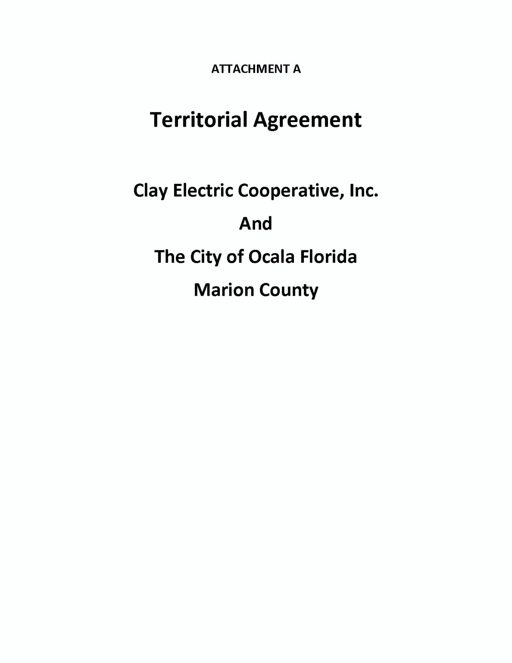

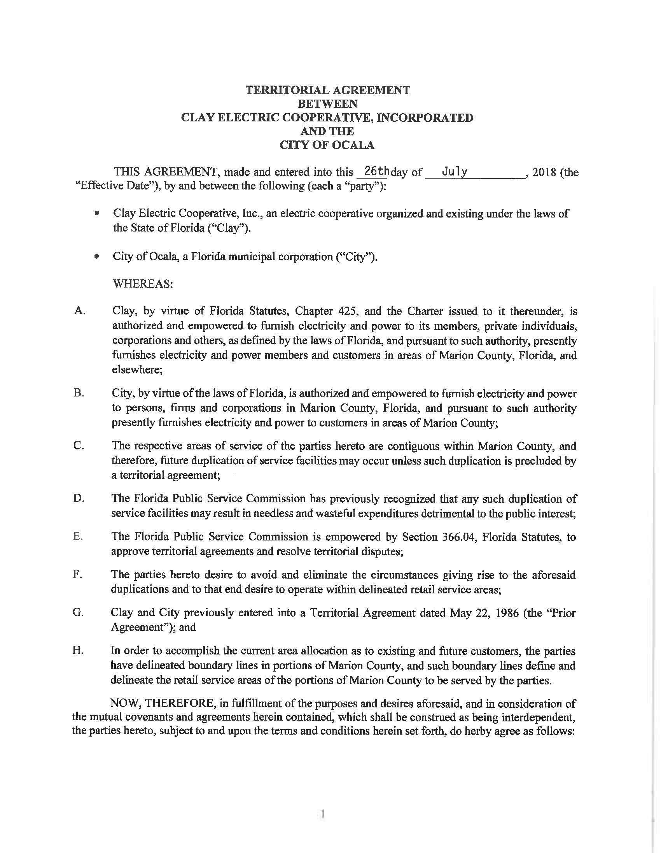

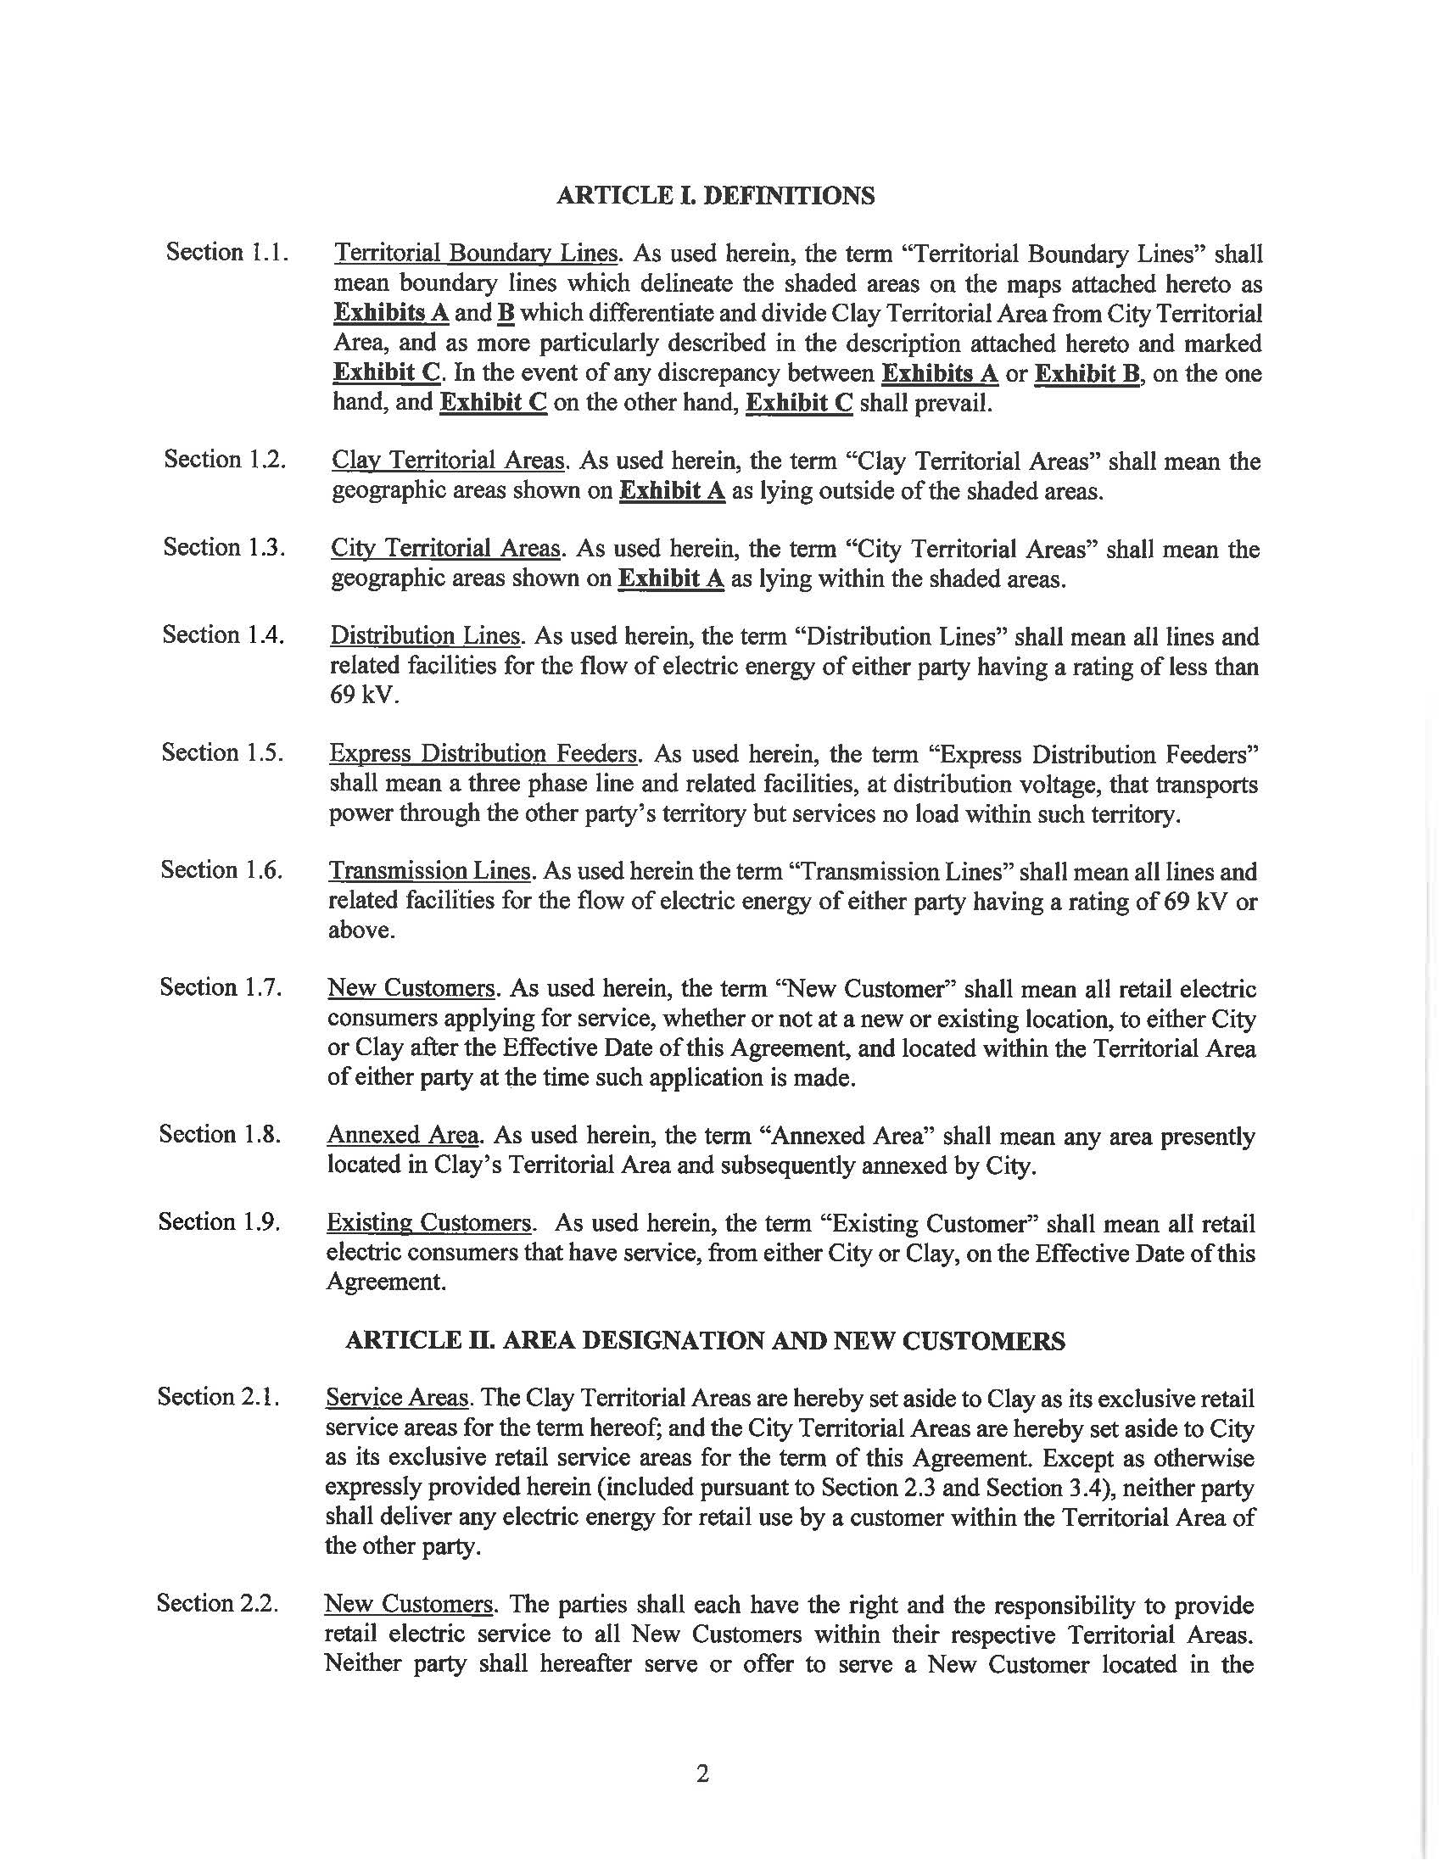

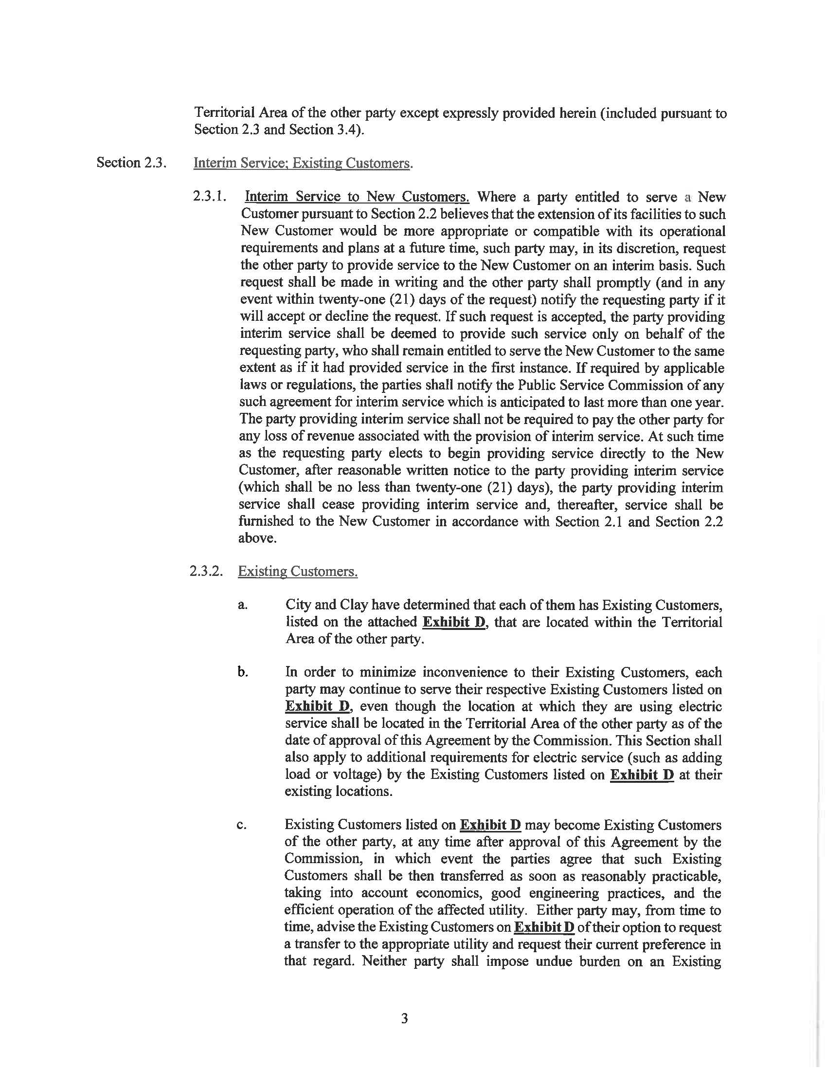

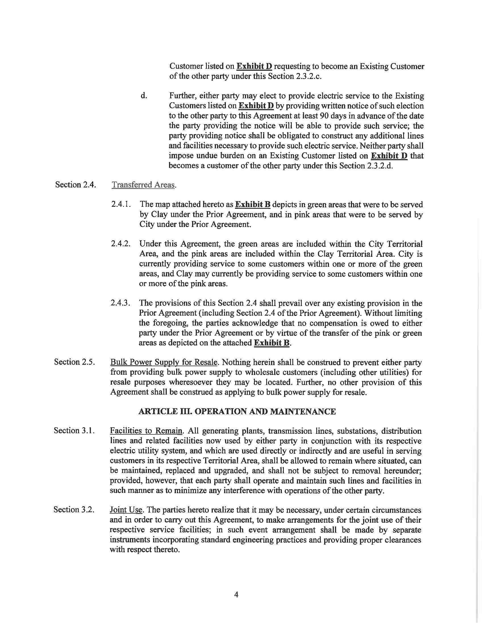

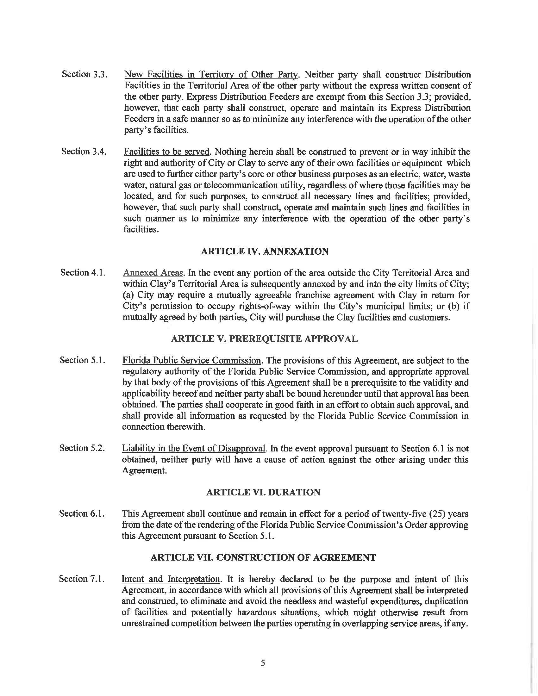

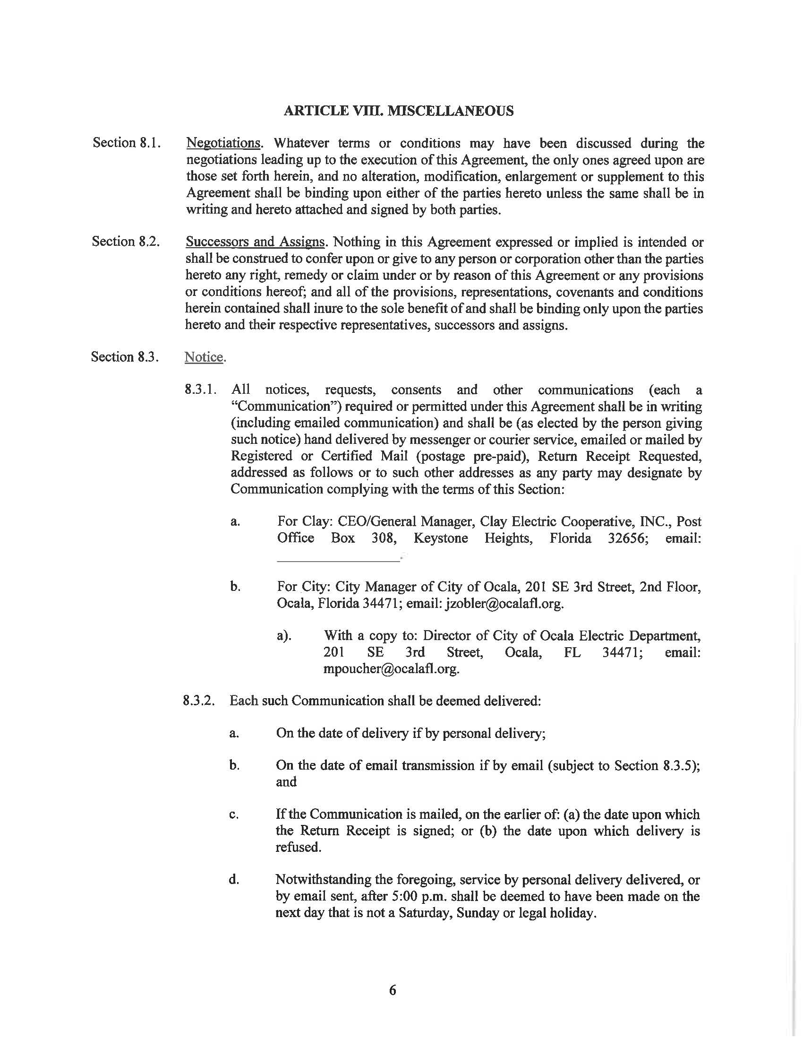

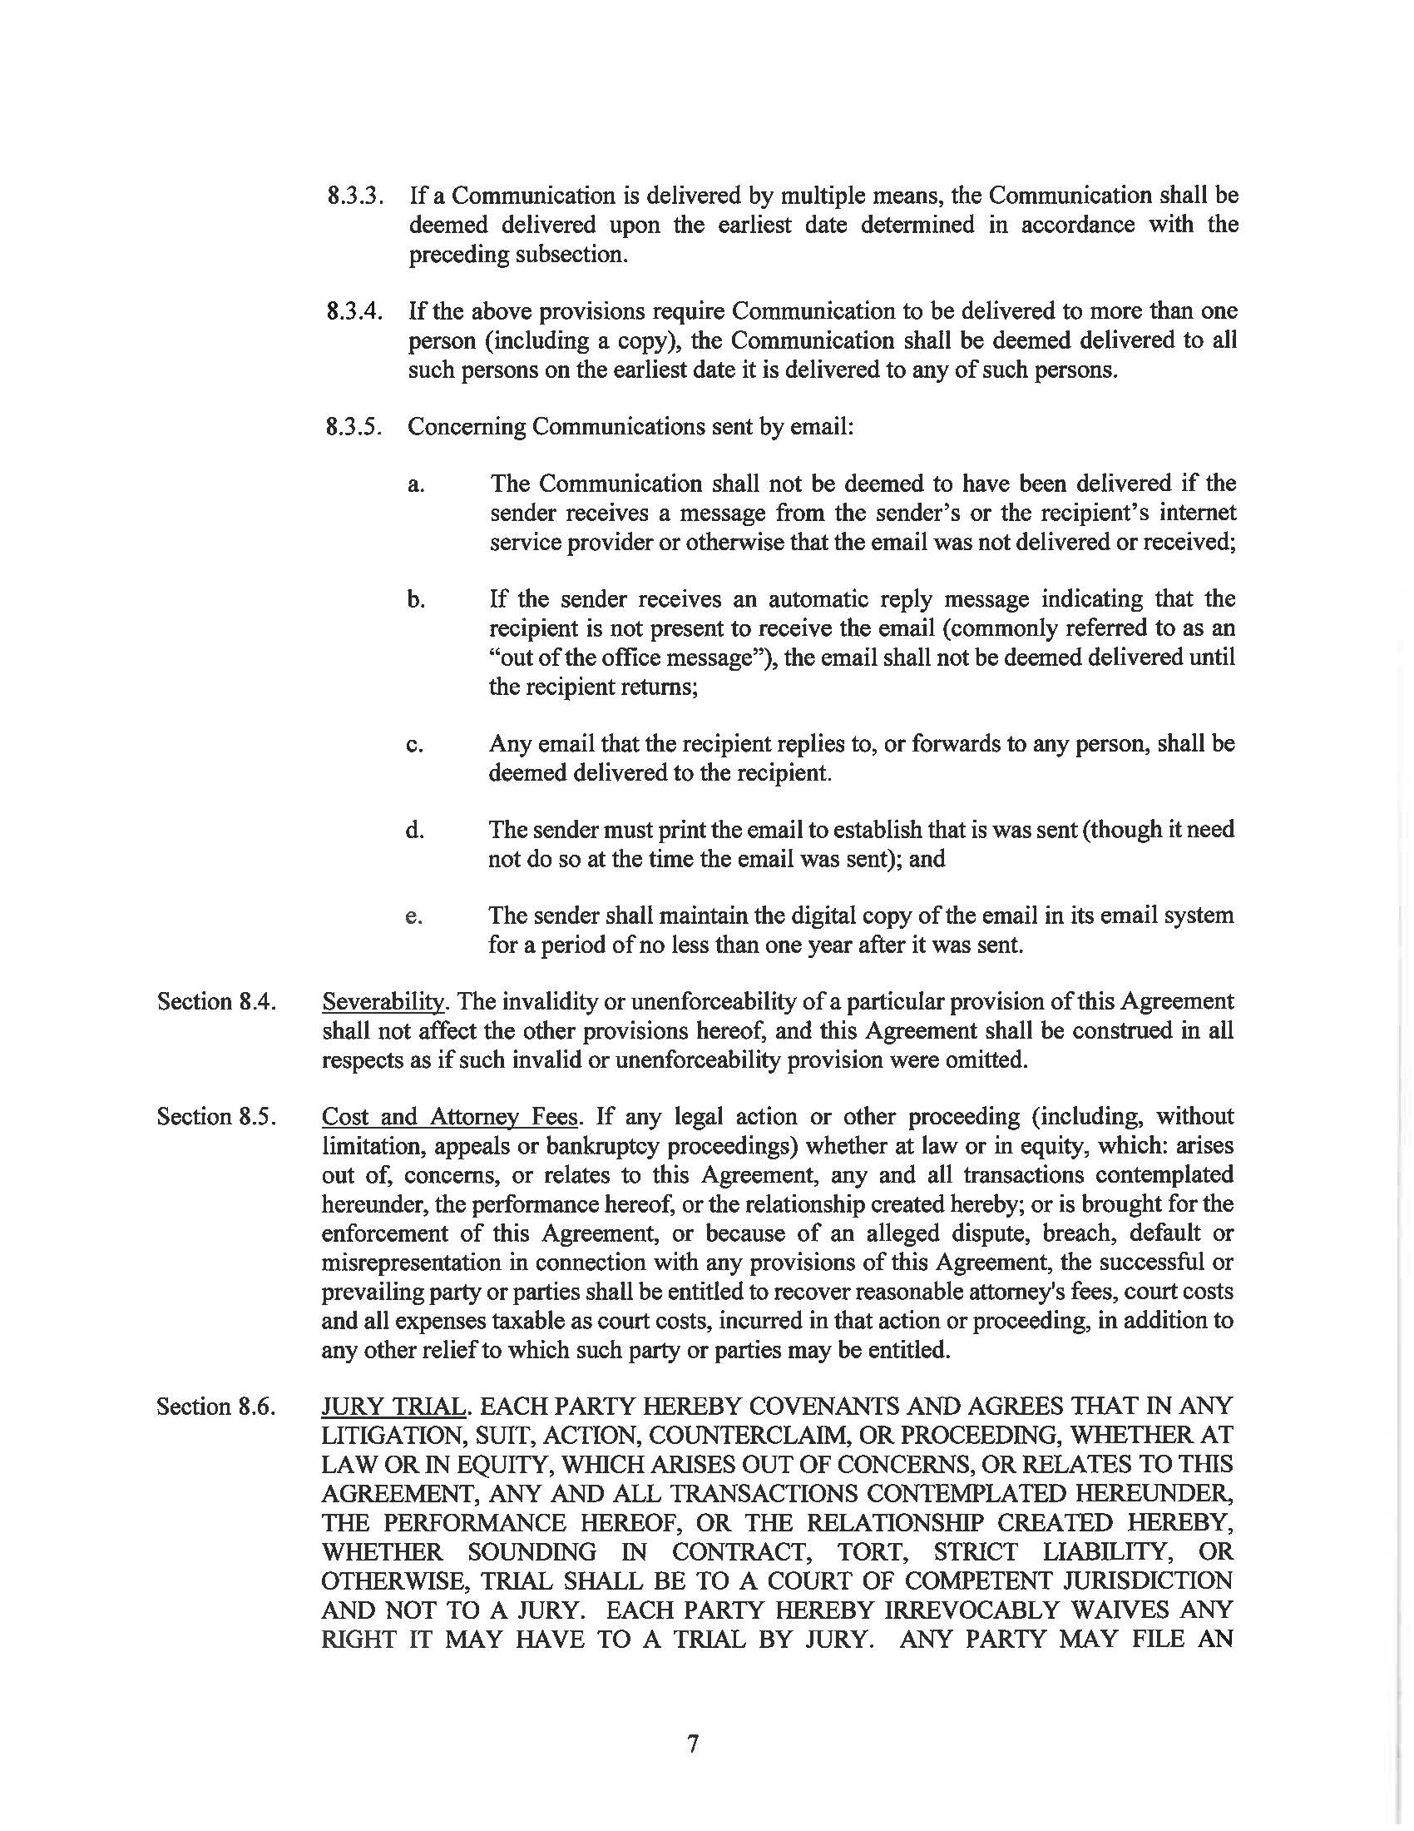

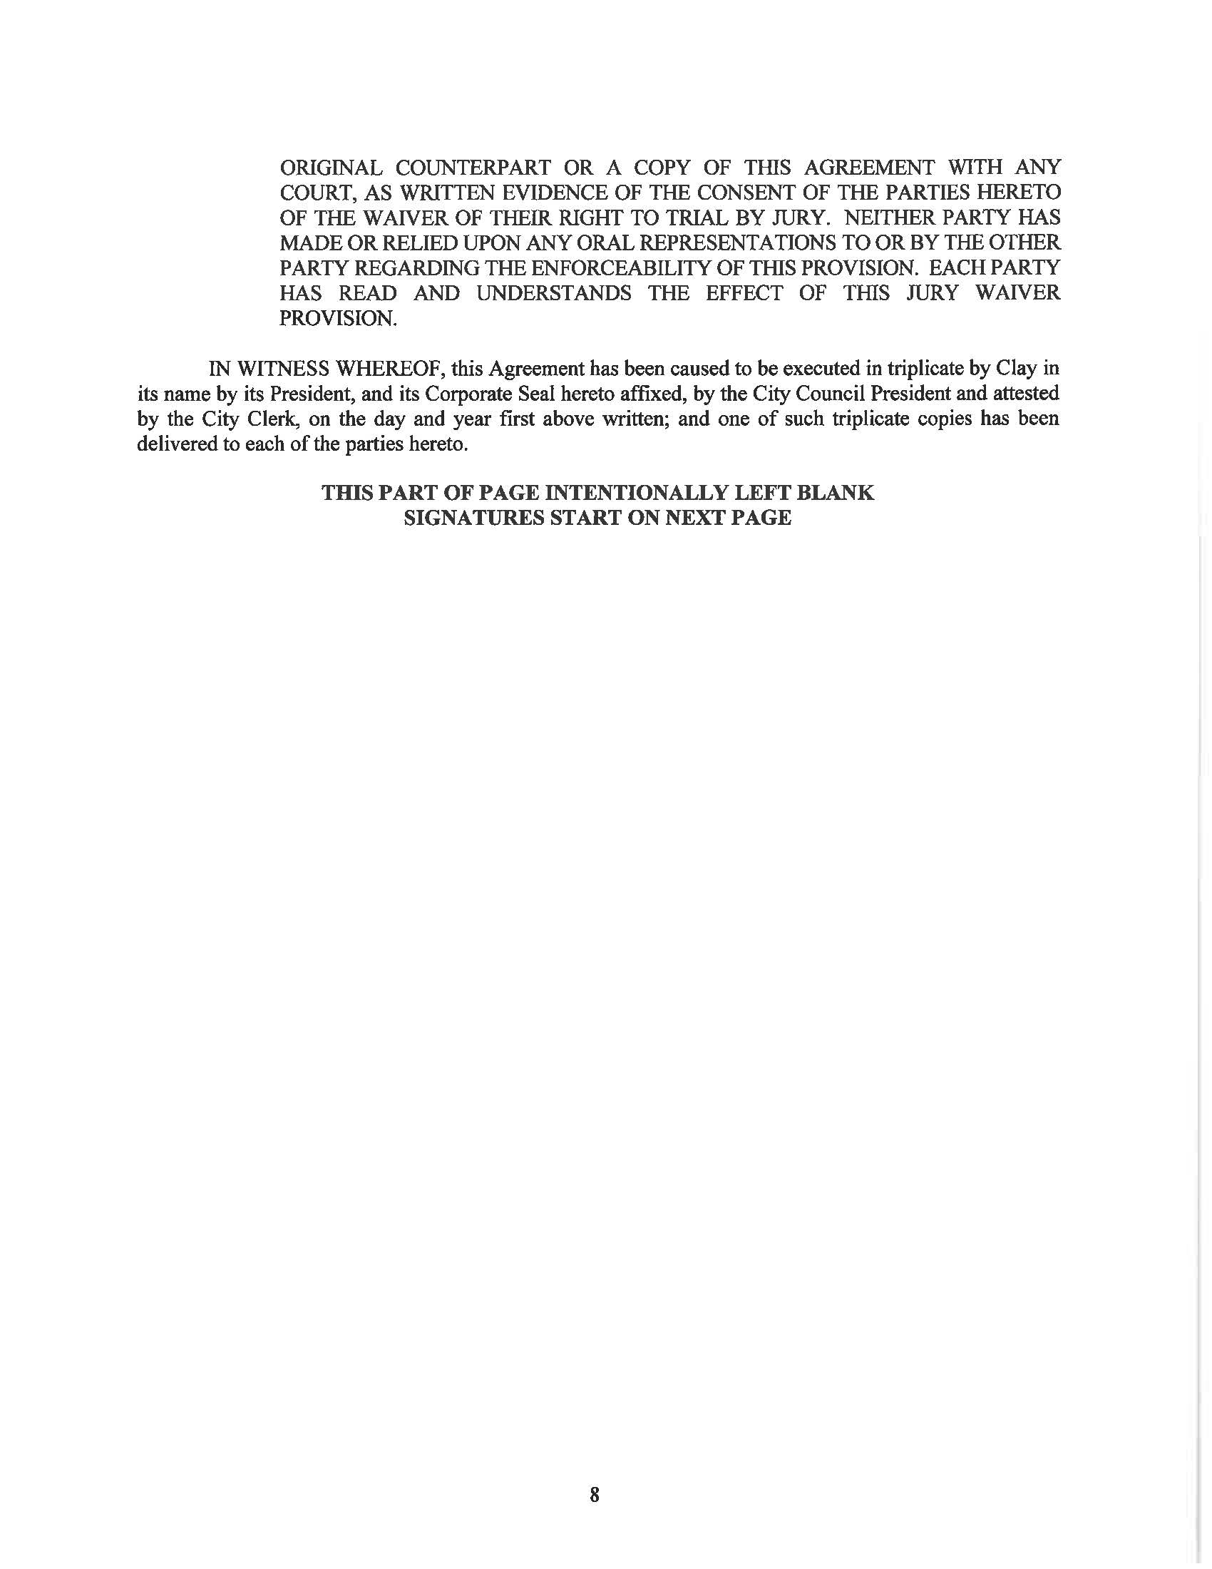

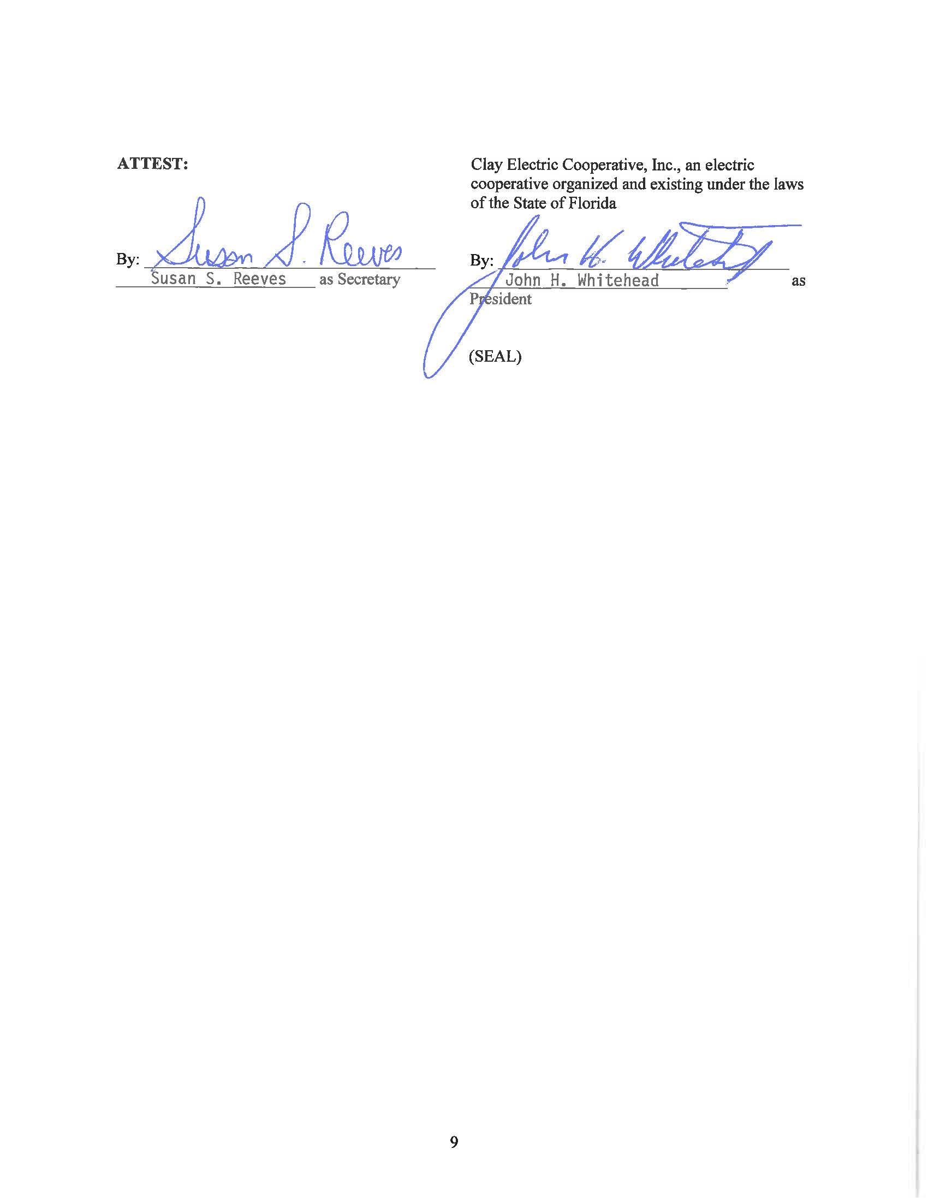

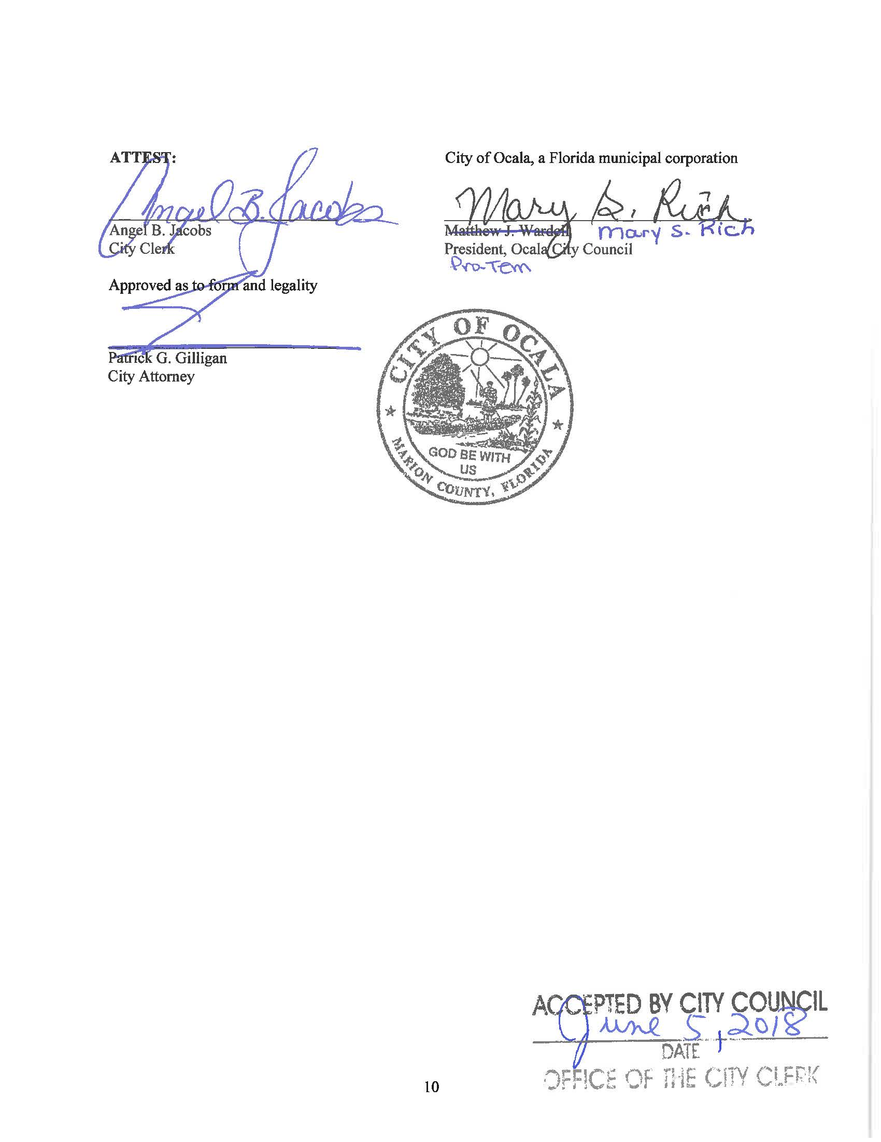

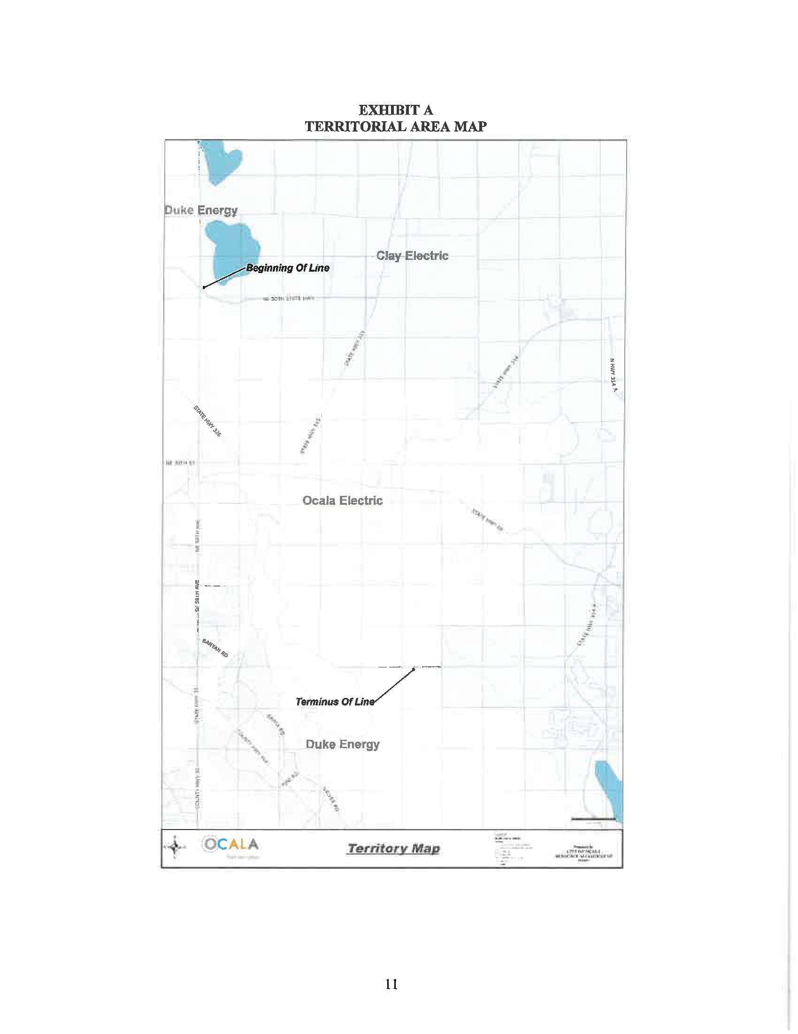

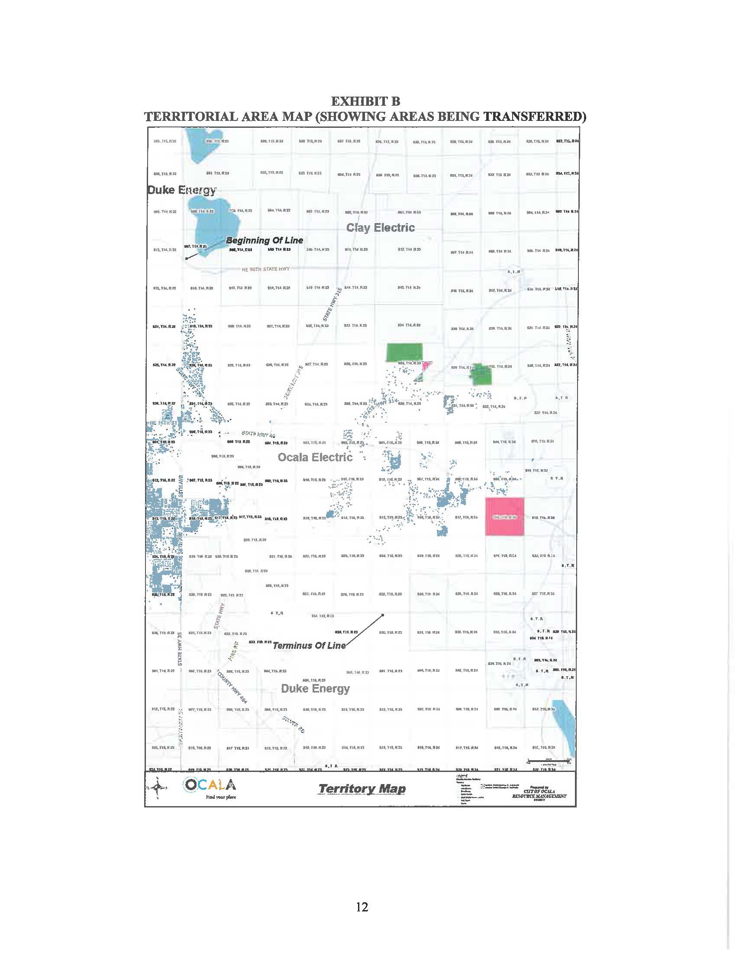

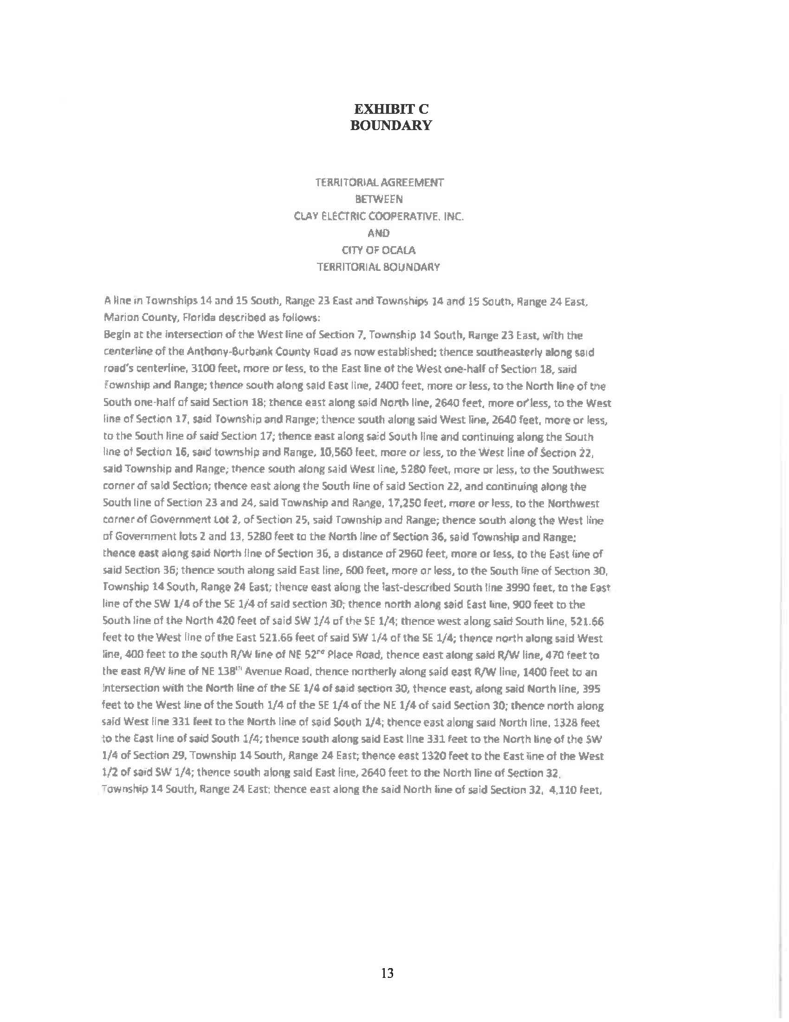

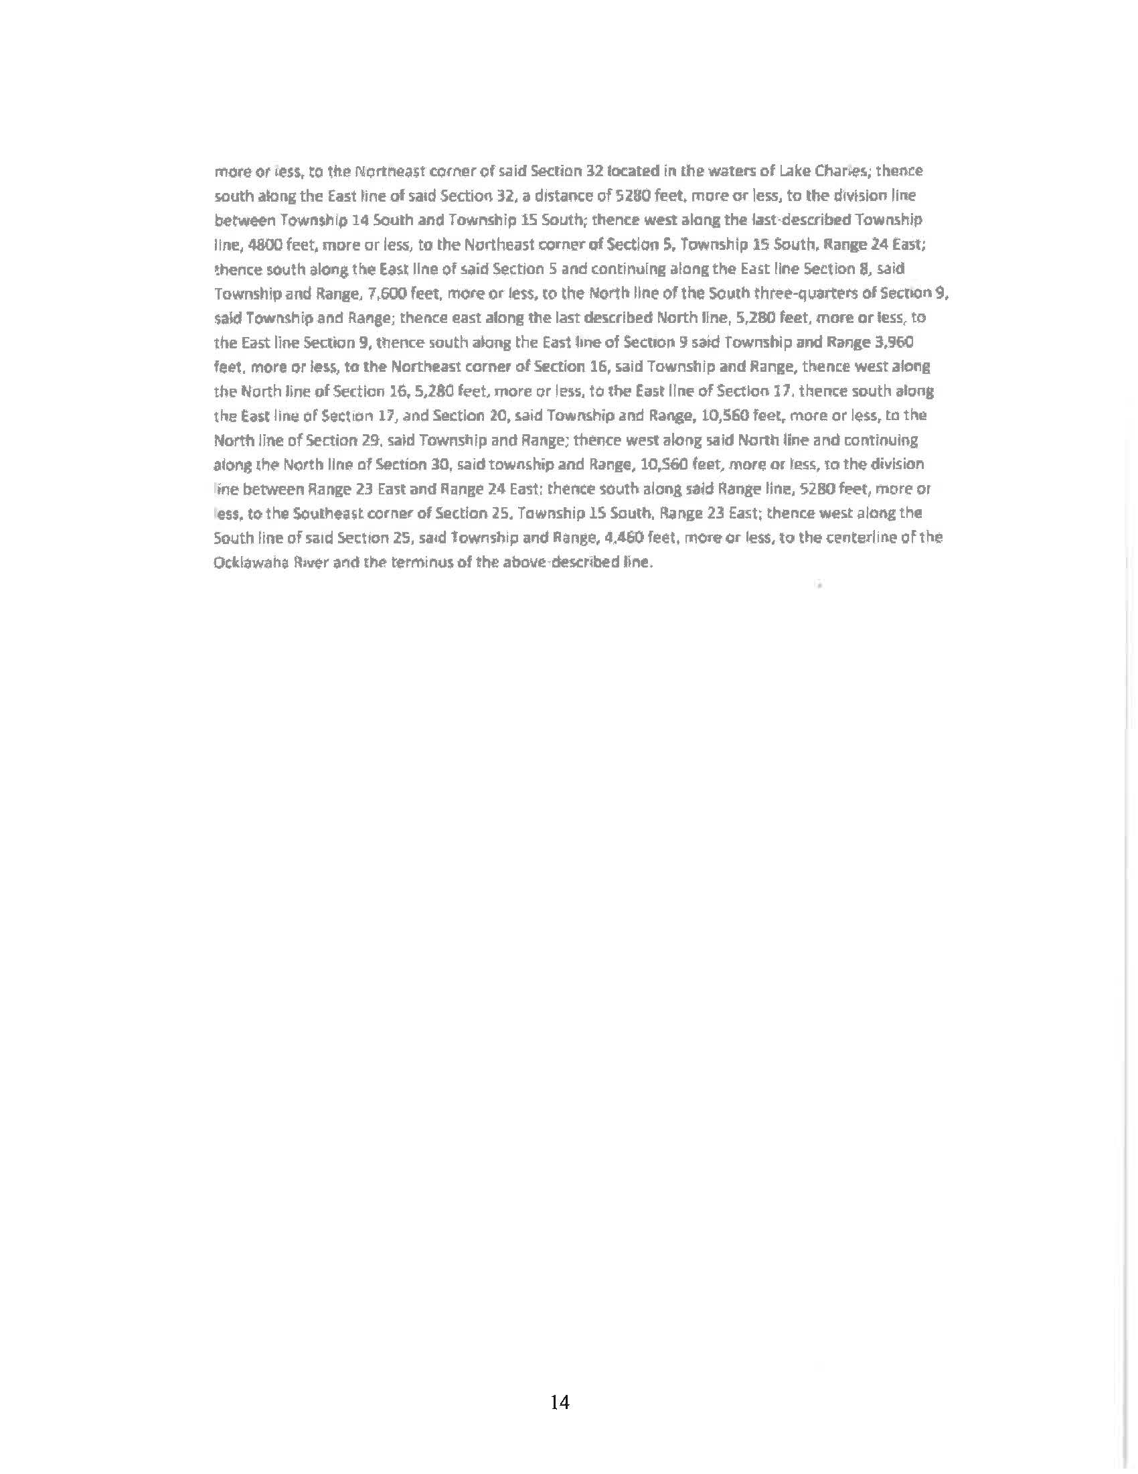

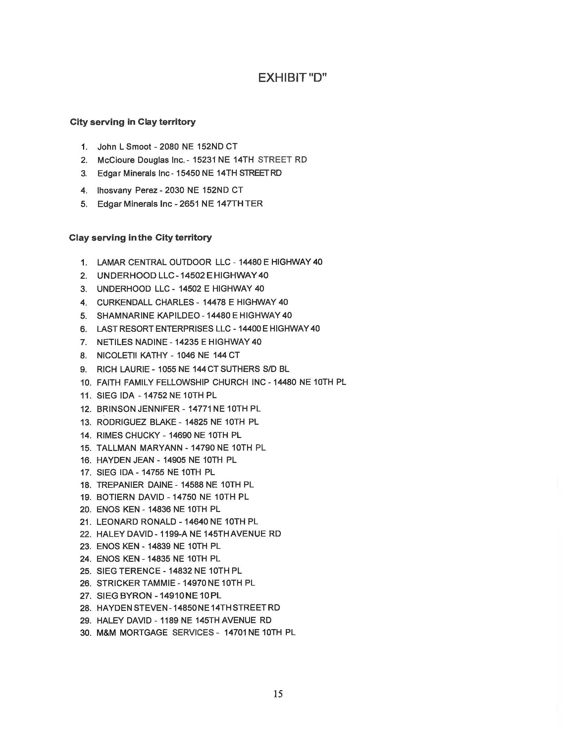

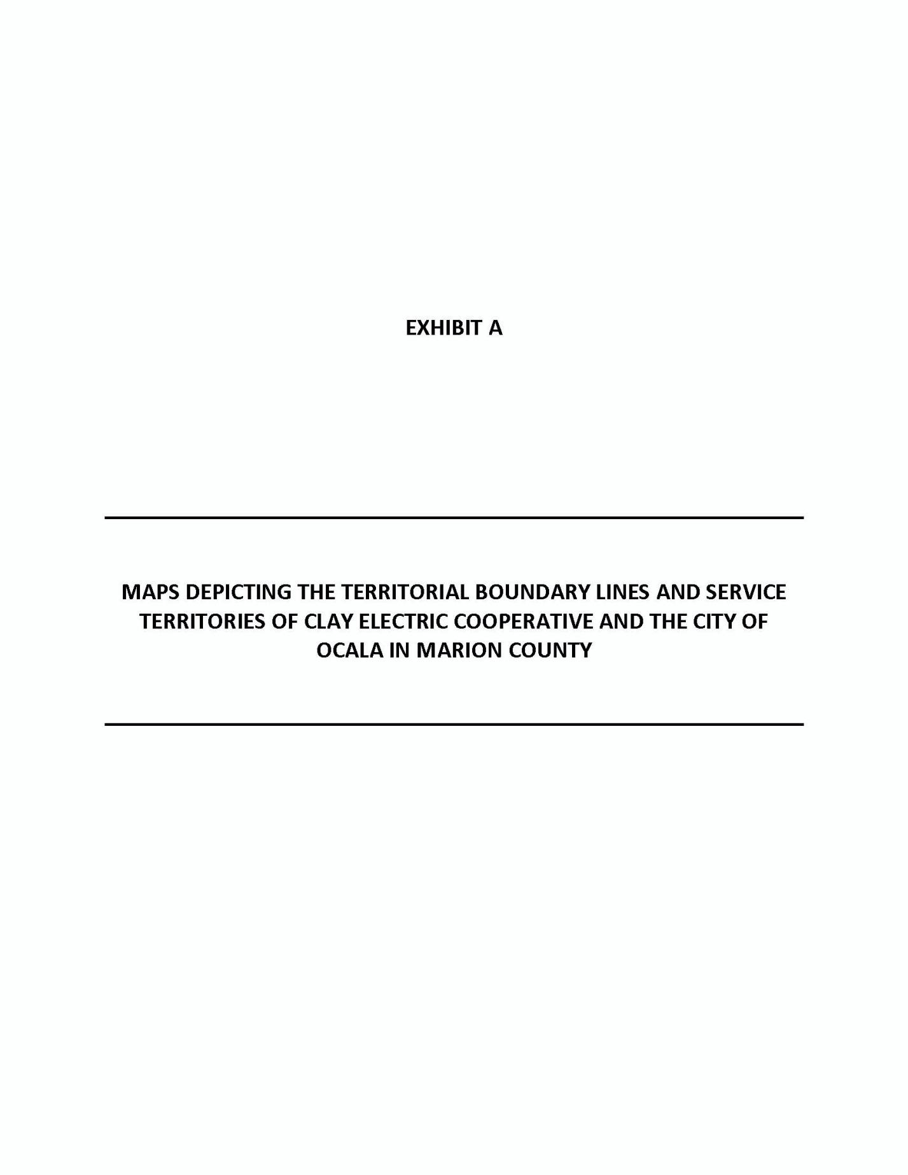

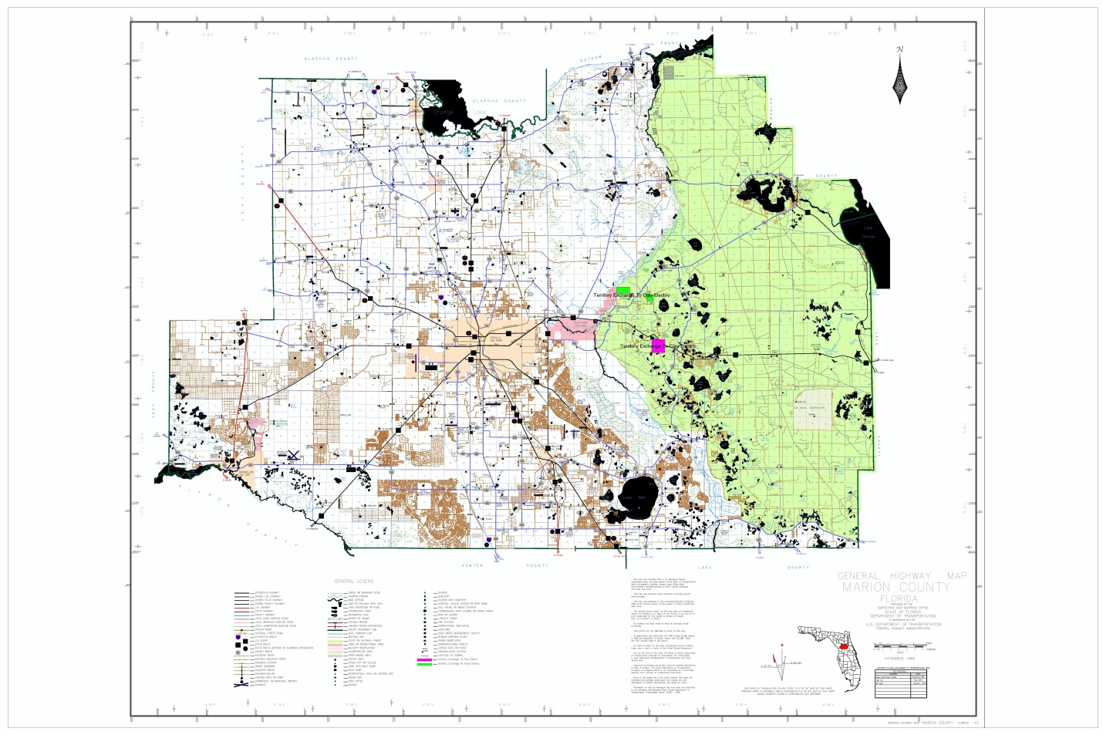

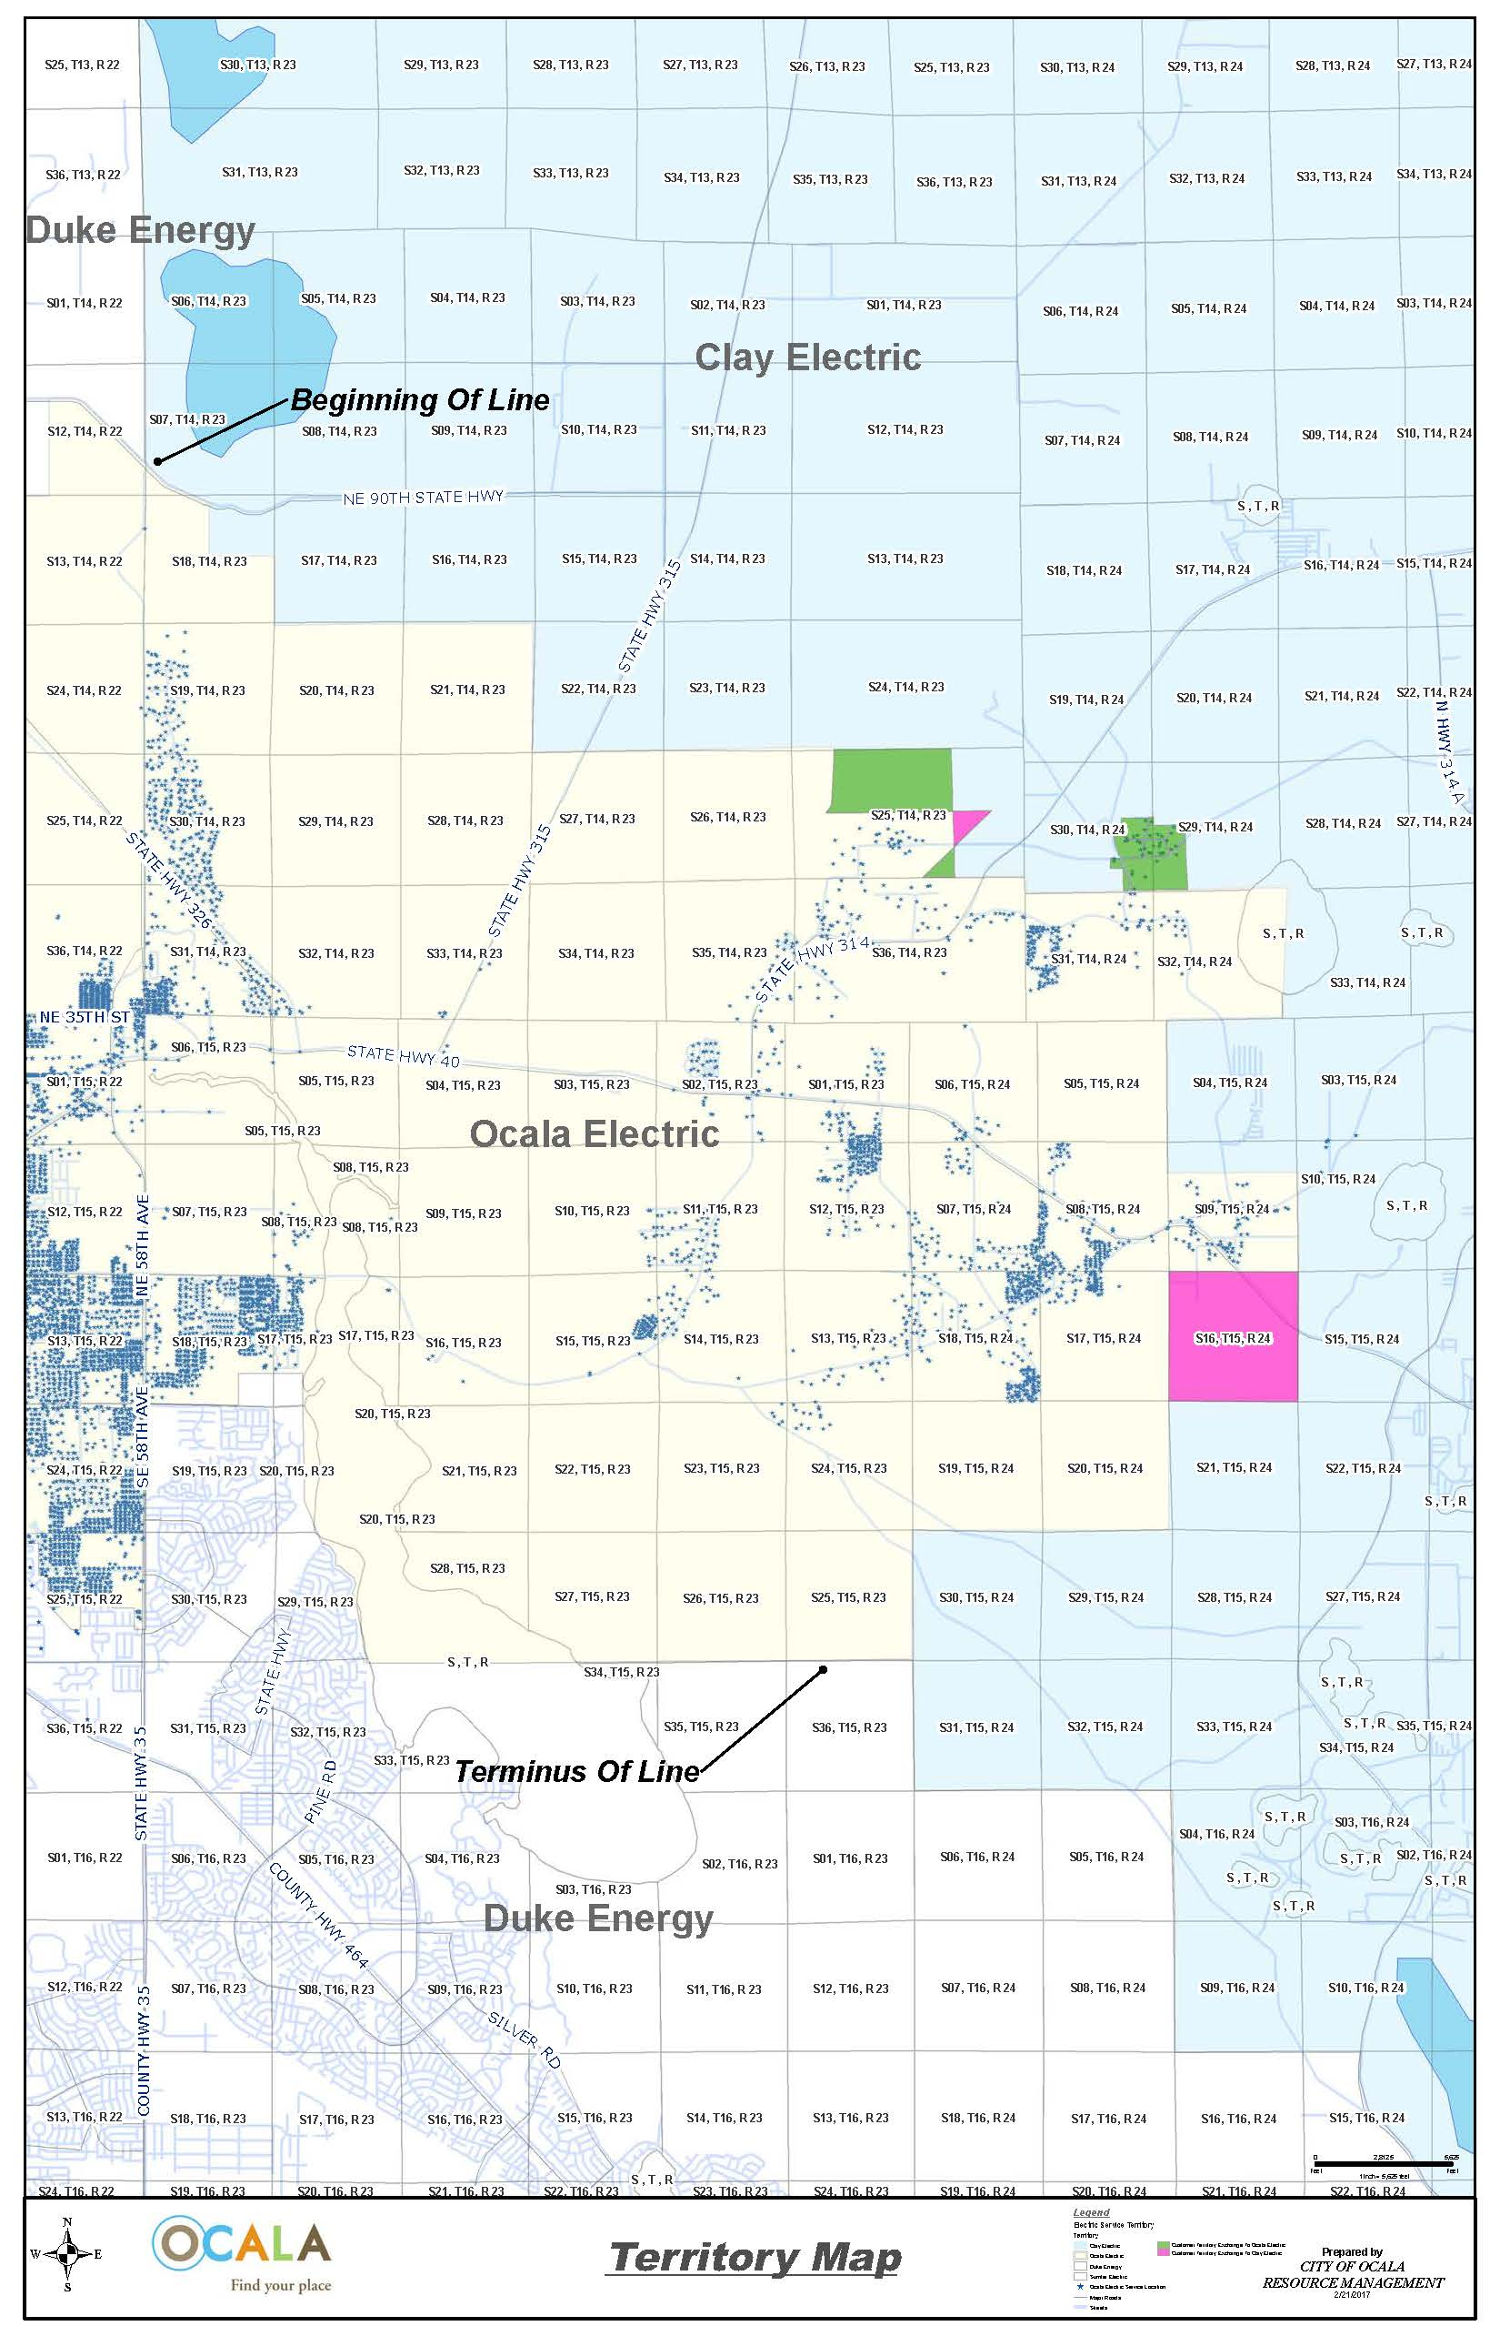
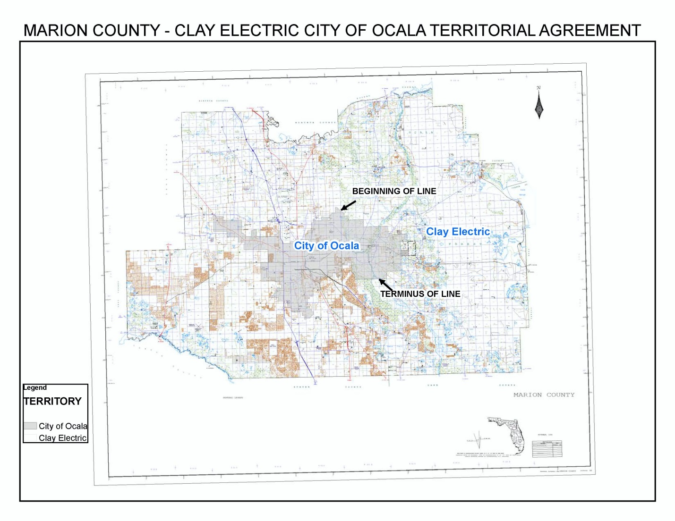

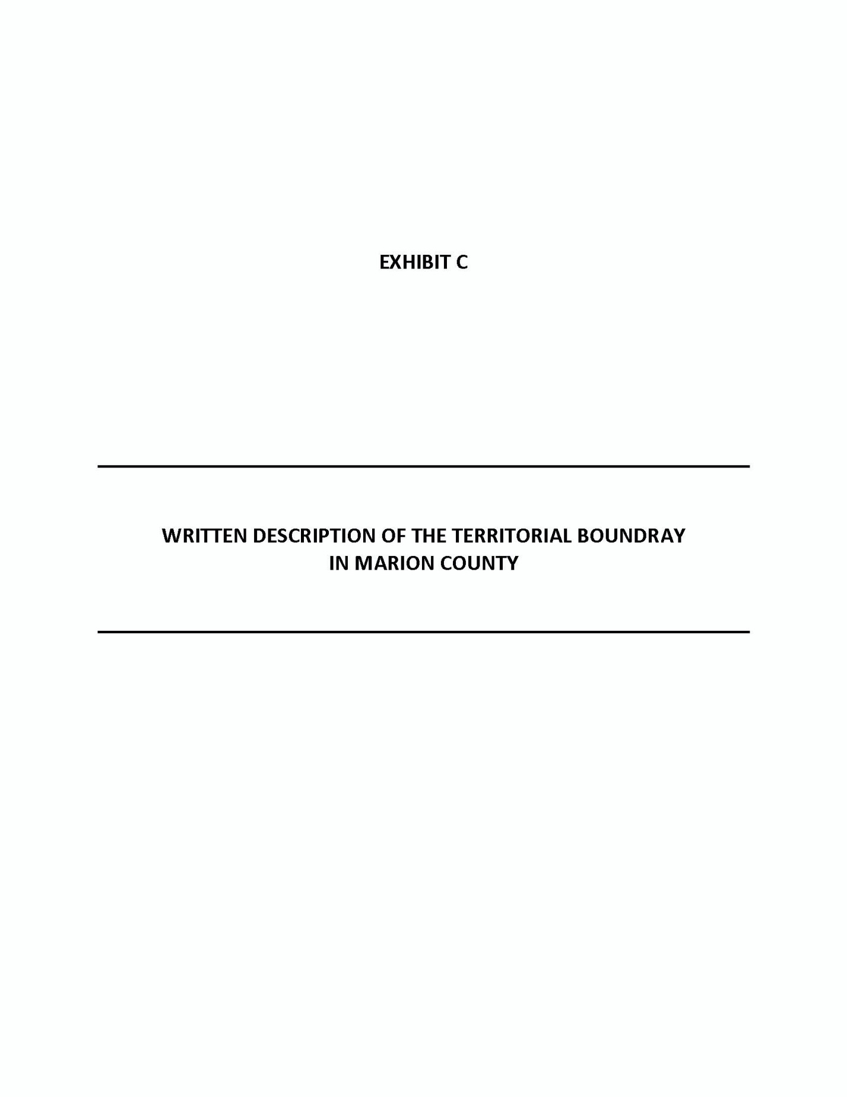

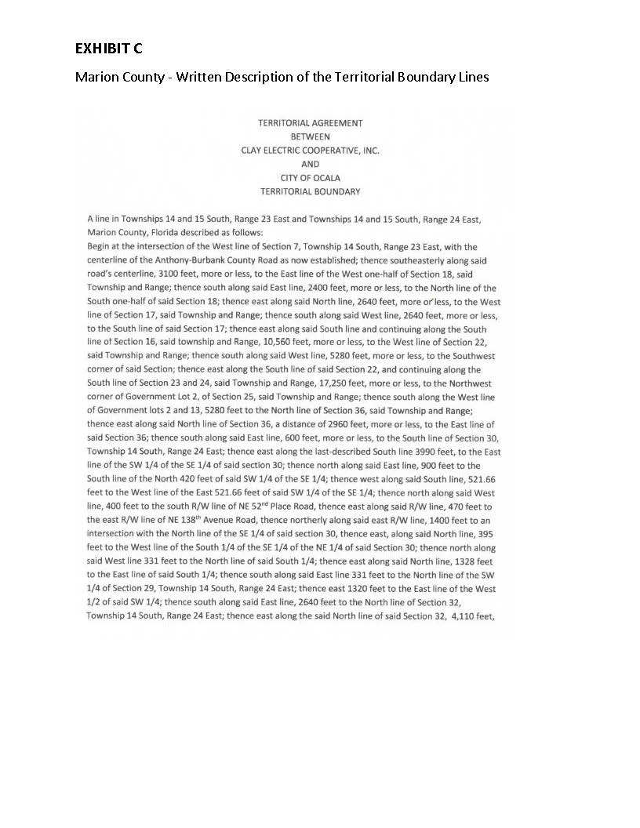
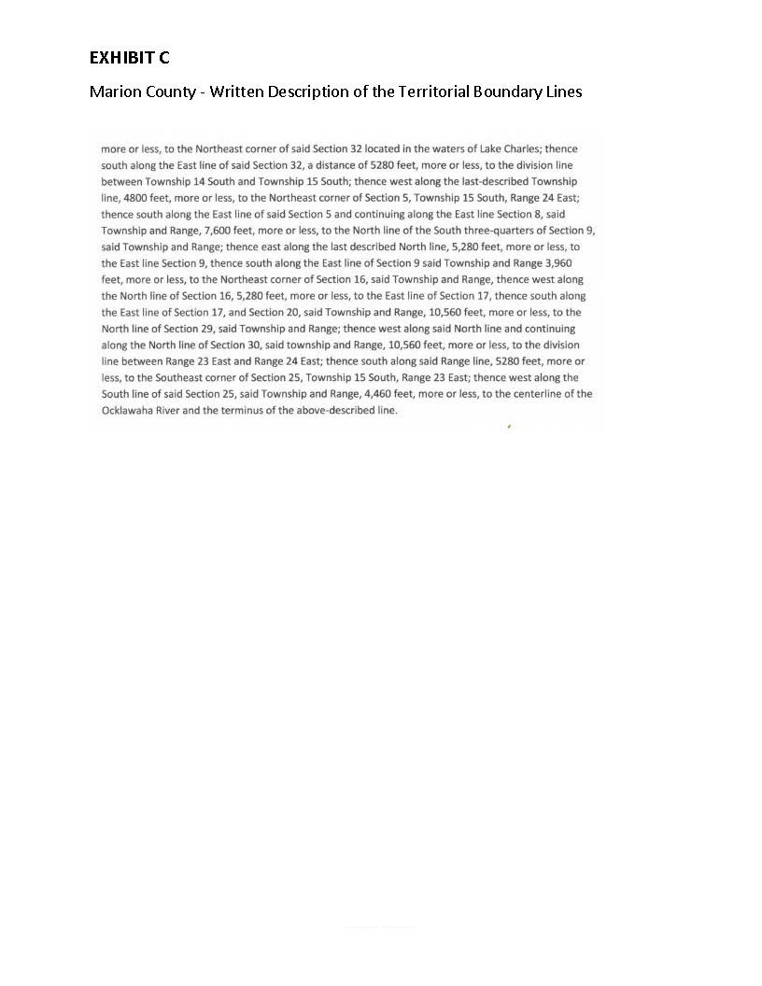

Order No. 16967, issued December 17, 1986, in Docket No. 860658-EU, In re: Joint Petition for Approval of Territorial Agreement Between the City of Ocala and Clay Electric Cooperative, Inc.
Utilities Commission of the City of New Smyrna Beach v. Florida Public Service Commission, 469 So. 2d 731 (Fla. 1985).
Order No. 16967, issued December 17, 1986, in Docket No. 860658-EU, In re: Joint Petition for Approval of Territorial Agreement Between the City of Ocala and Clay Electric Cooperative, Inc.
Response #4 in Commission staff’s first Data Request.
Joint response to questions 16 and 17 in Commission staff’s First Data Request.
Exhibit D of the petition.
Response #13 and Exhibits 2 and 3 in response #14 to Commission staff’s First Data Request.

