BEFORE THE FLORIDA PUBLIC SERVICE COMMISSION

In re: Joint petition for approval of amendment to territorial agreement in Nassau County, by Florida Power & Light Company and Okefenoke Rural Electric Membership Corporation. | DOCKET NO. 20190142-EU  ORDER NO. PSC-2019-0445-PAA-EU  ISSUED: October 23, 2019

The following Commissioners participated in the disposition of this matter:

ART GRAHAM, Chairman
JULIE I. BROWN
DONALD J. POLMANN
GARY F. CLARK
ANDREW GILES FAY

NOTICE OF PROPOSED AGENCY ACTION
ORDER APPROVING CLARIFICATION AND AMENDMENT OF TERRITORIAL AGREEMENT BETWEEN FLORIDA POWER & LIGHT COMPANY AND OKEFENOKE RURAL ELECTRIC MEMBERSHIP CORPORATION

BY THE COMMISSION:

NOTICE is hereby given by the Florida Public Service Commission that the action discussed herein is preliminary in nature and will become final unless a person whose interests are substantially affected files a petition for a formal proceeding, pursuant to Rule 25-22.029, Florida Administrative Code (F.A.C.).

- Background
On July 17, 2019, Florida Power & Light Company (FPL) and Okefenoke Rural Electric Membership Corporation (Okefenoke) (collectively, the Joint Petitioners), filed a petition seeking Commission approval of a clarification and amendment to the Joint Petitioners’ current territorial agreement as it relates to certain boundaries in Nassau County (2019 Amendment).
In May 1992, FPL filed three petitions to resolve territorial disputes with Okefenoke in Baker and Nassau Counties. The three dockets were consolidated for hearing purposes. After lengthy negotiations, the parties reached an agreement approved by this Commission in 1995 (1995 Agreement). The parties currently operate pursuant to that 1995 Agreement. The proposed 2019 Amendment would correct a discrepancy in the maps delineating the territorial boundaries approved in the 1995 Agreement, in an area in Nassau County known as the Crawford Diamond. The amendment would also allow FPL to provide electric service to the adjacent property. All other provisions of the 1995 Agreement would remain in effect. No customer transfers are contemplated in the 2019 Amendment. The 2019 Amendment, dated July 13, 2019, is attached as Attachment A to this Order. This Commission has jurisdiction over this matter pursuant to Section 366.04, Florida Statutes (F.S.).

- Decision
Pursuant to Section 366.04(2)(d), F.S., and Rule 25-6.0440(2), F.A.C., we have the jurisdiction to approve territorial agreements between and among rural electric cooperatives, municipal electric utilities, and other electric utilities. Unless we determine that the agreement will cause a detriment to the public interest, the agreement should be approved.
FPL is an investor-owned utility operating under the jurisdiction of this Commission pursuant to Chapter 366, F.S. Okefenoke is a rural electric corporation organized and existing under the laws of Georgia and registered to conduct business in Florida pursuant to Section 425.27, F.S. Both petitioners presently provide electric service in Baker and Nassau Counties and are operating pursuant to the 1995 Agreement. The 1995 Agreement does not specify a term. Rather, Section 4.1 of the 1995 Agreement states that the agreement will continue and remain in effect until this Commission, by order, modifies or withdraws its approval after proper noticing and hearing.
Through the proposed 2019 Amendment, the Joint Petitioners seek to clarify a discrepancy in the maps approved in the 1995 Agreement and to amend the 1995 Agreement to allow FPL to serve a property which is currently located within Okefenoke’s service territory. The proposed amendment involves an area called the Crawford Diamond, which is located in Nassau County. The Crawford Diamond is a 1,815 acre property which is zoned as an industrial park. The petitioners explained that the Crawford Diamond is located adjacent to railroads and road infrastructure. FPL states that, through its economic development team, it is promoting this location to attract new commercial and industrial customers. In addition, FPL explained to Commission staff that it is conducting preliminary engineering and permitting to potentially construct the Nassau Solar Energy Center in the Crawford Diamond. However, there are no customers or electric service facilities in the Crawford Diamond or the adjacent property at this time. The clarification and the amendment to the 1995 Agreement are discussed below.
The joint petition states that two conflicting maps approved in the 1995 Agreement can be interpreted to allow both FPL and Okefenoke to serve a portion of the Crawford Diamond. The 1995 Agreement includes several pages of maps (shown in Attachment A to the Order approving the 1995 Agreement). Specifically, the petition states that the map on page 25 of the 1995 Agreement and the maps on pages 47 and 48 of the maps are not consistent. The area of discrepancy within the Crawford Diamond is shown on page 7 of 13 in Attachment A to this Order. The parties now seek to clarify the discrepancy and amend the territorial boundaries approved in the 1995 Agreement to allow FPL to serve the area of discrepancy.
The proposed 2019 Amendment also seeks Commission approval to allow FPL to serve potential future customers in a 335.86 acre property that is adjacent to the area of discrepancy discussed above. The property is currently in Okefenoke’s service territory. Page 8 of 13 in Attachment A to this Order indicates the revised territorial boundary lines.
In addition to the proposed 2019 Amendment, FPL and Okefenoke have entered into a Memorandum of Understanding (MOU) dated November 15, 2018. The Joint Petitioners attached the MOU in Exhibit E of their petition in the instant docket. The Joint Petitioners are not seeking Commission approval of the MOU. The Joint Petitioners explained that the MOU represents the negotiated provisions necessary to resolve the discrepancy in the 1995 Agreement maps. The MOU also includes other terms and provisions that are not generally included in territorial agreements for Commission approval. The MOU will terminate if this Commission does not issue an order approving the 2019 Amendment by December 31, 2019.
Pursuant to the MOU, FPL plans to construct an FPL-owned substation and associated transmission and distribution lines in the Crawford Diamond. FPL will also build a second substation and transfer this substation to Okefenoke for $10 (Okefenoke Substation). Any transmission assets installed by FPL to serve the Okefenoke Substation would be retained by FPL. FPL estimates the construction cost for the Okefenoke Substation to be approximately $6.8 to $7.6 million. The Okefenoke Substation will be constructed on FPL land which then will be transferred to Okefenoke pursuant to a special warranty deed. Exhibit A to the MOU shows that the Okefenoke Substation will be built at the boundary line between FPL and Okefenoke. FPL stated that once the Okefenoke Substation is completed, and the transfer of ownership of the substation and the land on which it is located has been made from FPL to Okefenoke, FPL will come back to this Commission to request further modification of the territorial agreement and indicate that the subject property has been transferred to Okefenoke and will thereafter be part of Okefenoke’s service territory.
FPL also asserts that it is currently not seeking recovery of any costs to build the Okefenoke Substation and FPL is not asking this Commission, in this docket, to make a prudence determination in this docket regarding FPL’s activities. FPL stated that if we approve the proposed 2019 Amendment and the costs to construct the Okefenoke Substation are incurred, FPL may seek recovery of those costs in a future base rate filing. If such a filing is made by FPL, we would be asked to review the cost and prudence associated with the Okefenoke Substation and the associated transmission assets FPL would retain.
The Joint Petitioners assert that the 2019 Amendment will provide certainty to future electric customers and the Joint Petitioners regarding the provision of electric service within the Crawford Diamond. Customers will not be transferred as a result of the proposed 2019 Amendment. The Joint Petitioners further state the proposed 2019 Amendment represents a mutually agreeable solution to the boundary discrepancy, provides benefits to both FPL and Okefenoke, and eliminates the need for this Commission to resolve a potential future territorial dispute.
After review of the petition and FPL’s responses to Commission staff’s inquiries, we find that the proposed 2019 Amendment is in the public interest. The proposed amendment will resolve the boundary line discrepancy that exists in the Crawford Diamond in Nassau County and will enable FPL and Okefenoke to serve their customers in an efficient manner. In addition, no current customers will be affected as a result of the proposed 2019 Amendment. As such, we find that the proposed clarification and amendment to the 1995 Agreement between FPL and Okefenoke will not cause a detriment to the public interest and, therefore, we approve this clarification and amendment.
However, we note that in approving the 2019 Amendment, we do not make a finding regarding the prudence or potential recovery of the costs to construct the Okefenoke Substation that will be transferred to Okefenoke. Such costs would properly be the subject of a future, appropriate rate proceeding.

Based on the foregoing, it is

ORDERED by the Florida Public Service Commission that the proposed 2019 clarification and amendment to the 1995 territorial agreement between Florida Power & Light Company and Okefenoke Rural Electric Membership Corporation, attached as Exhibit A hereto, is approved. It is further

ORDERED that the provisions of this Order, issued as proposed agency action, shall become final and effective upon the issuance of a Consummating Order unless an appropriate petition, in the form provided by Rule 28-106.201, Florida Administrative Code, is received by the Commission Clerk, 2540 Shumard Oak Boulevard, Tallahassee, Florida 32399-0850, by the close of business on the date set forth in the “Notice of Further Proceedings” attached hereto. It is further

ORDERED that in the event this Order becomes final, this docket shall be closed.

By ORDER of the Florida Public Service Commission this 23rd day of October, 2019.

/s/ Adam J. Teitzman
ADAM J. TEITZMAN
Commission Clerk
Florida Public Service Commission
2540 Shumard Oak Boulevard
Tallahassee, Florida 32399
(850) 413-6770
www.floridapsc.com

Copies furnished: A copy of this document is provided to the parties of record at the time of issuance and, if applicable, interested persons.

KMS

NOTICE OF FURTHER PROCEEDINGS OR JUDICIAL REVIEW

The Florida Public Service Commission is required by Section 120.569(1), Florida Statutes, to notify parties of any administrative hearing that is available under Section 120.57, Florida Statutes, as well as the procedures and time limits that apply. This notice should not be construed to mean all requests for an administrative hearing will be granted or result in the relief sought.

Mediation may be available on a case-by-case basis. If mediation is conducted, it does not affect a substantially interested person's right to a hearing.

The action proposed herein is preliminary in nature. Any person whose substantial interests are affected by the action proposed by this order may file a petition for a formal proceeding, in the form provided by Rule 28-106.201, Florida Administrative Code. This petition must be received by the Office of Commission Clerk, 2540 Shumard Oak Boulevard, Tallahassee, Florida 32399-0850, by the close of business on November 13, 2019.

In the absence of such a petition, this order shall become final and effective upon the issuance of a Consummating Order.

Any objection or protest filed in this/these docket(s) before the issuance date of this order is considered abandoned unless it satisfies the foregoing conditions and is renewed within the specified protest period.

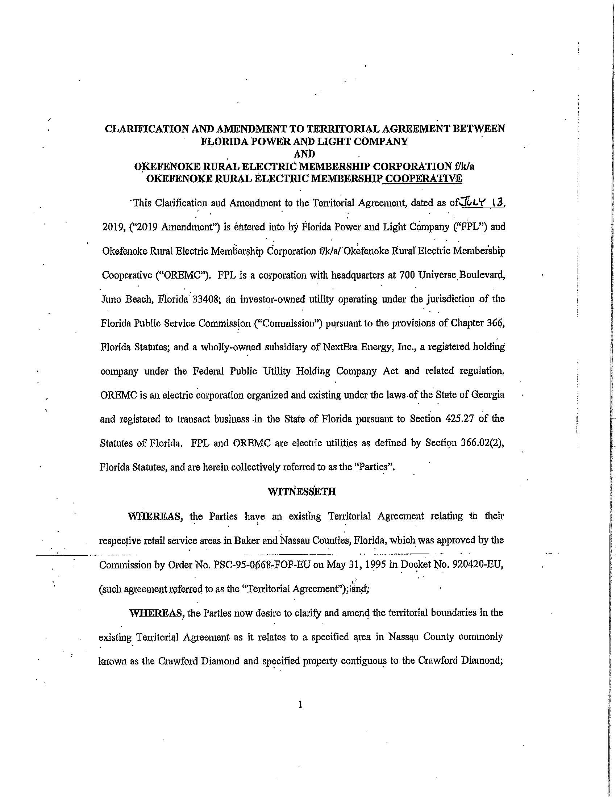

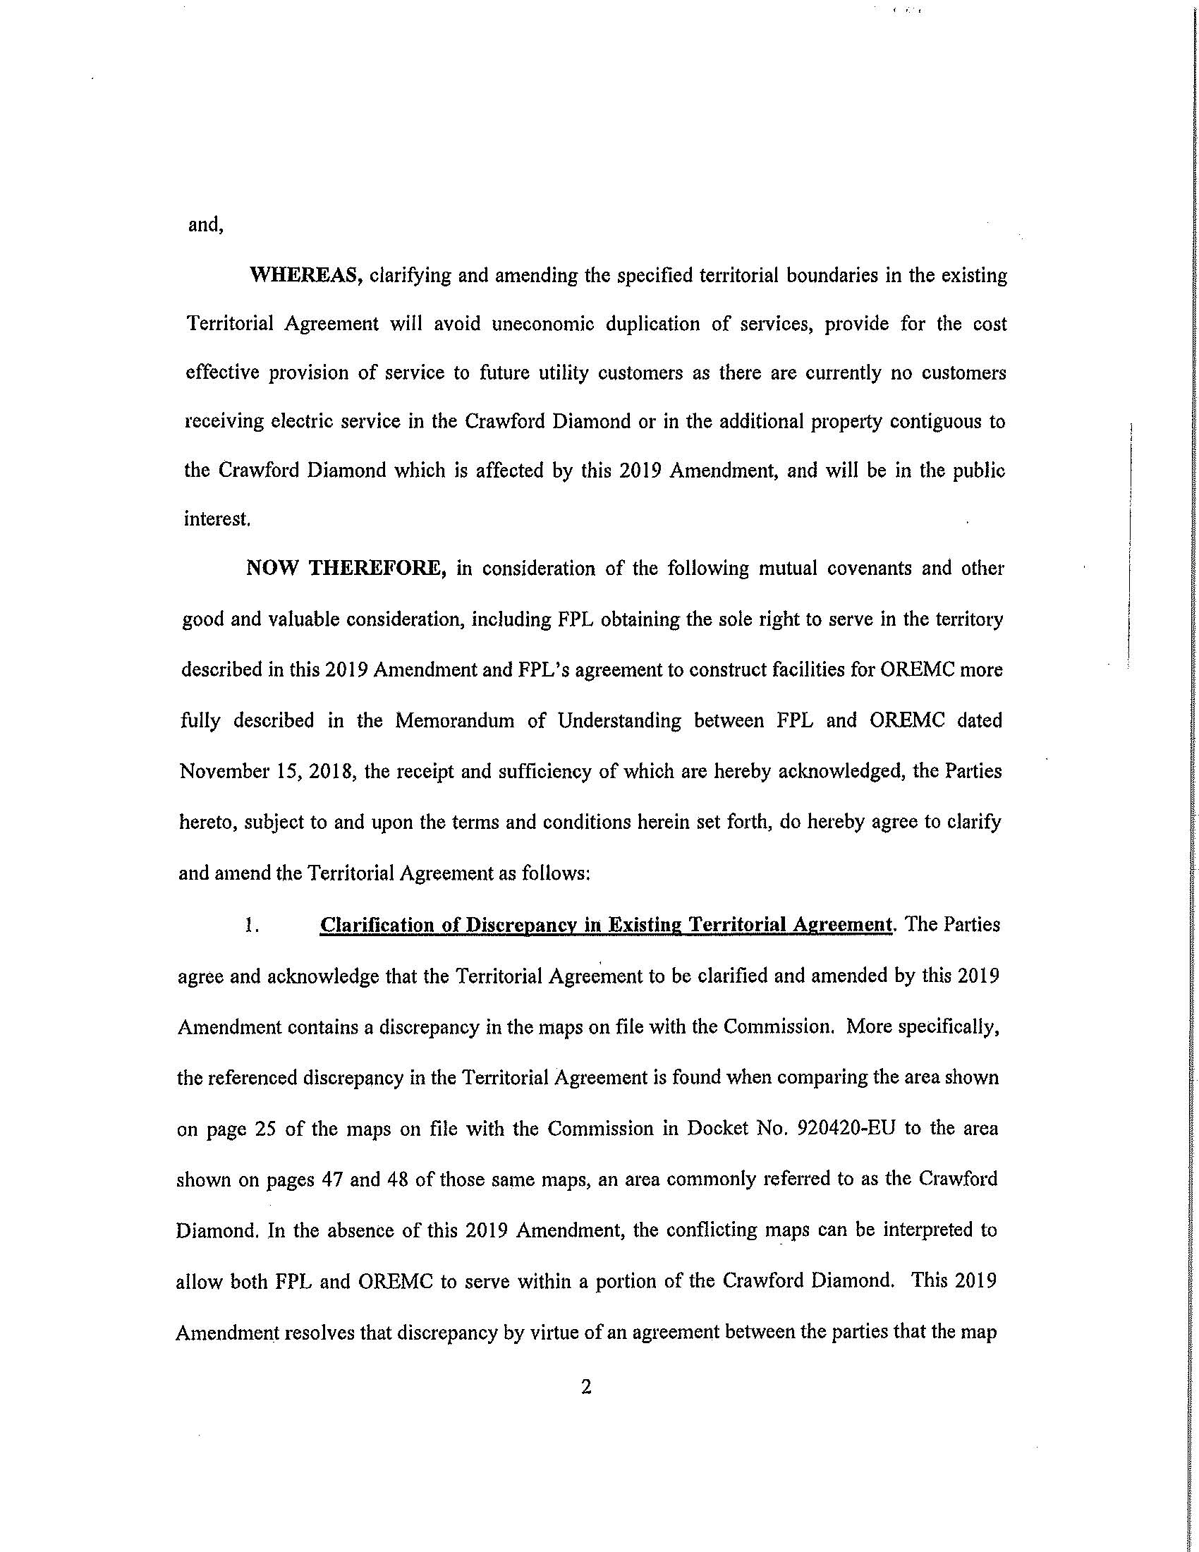

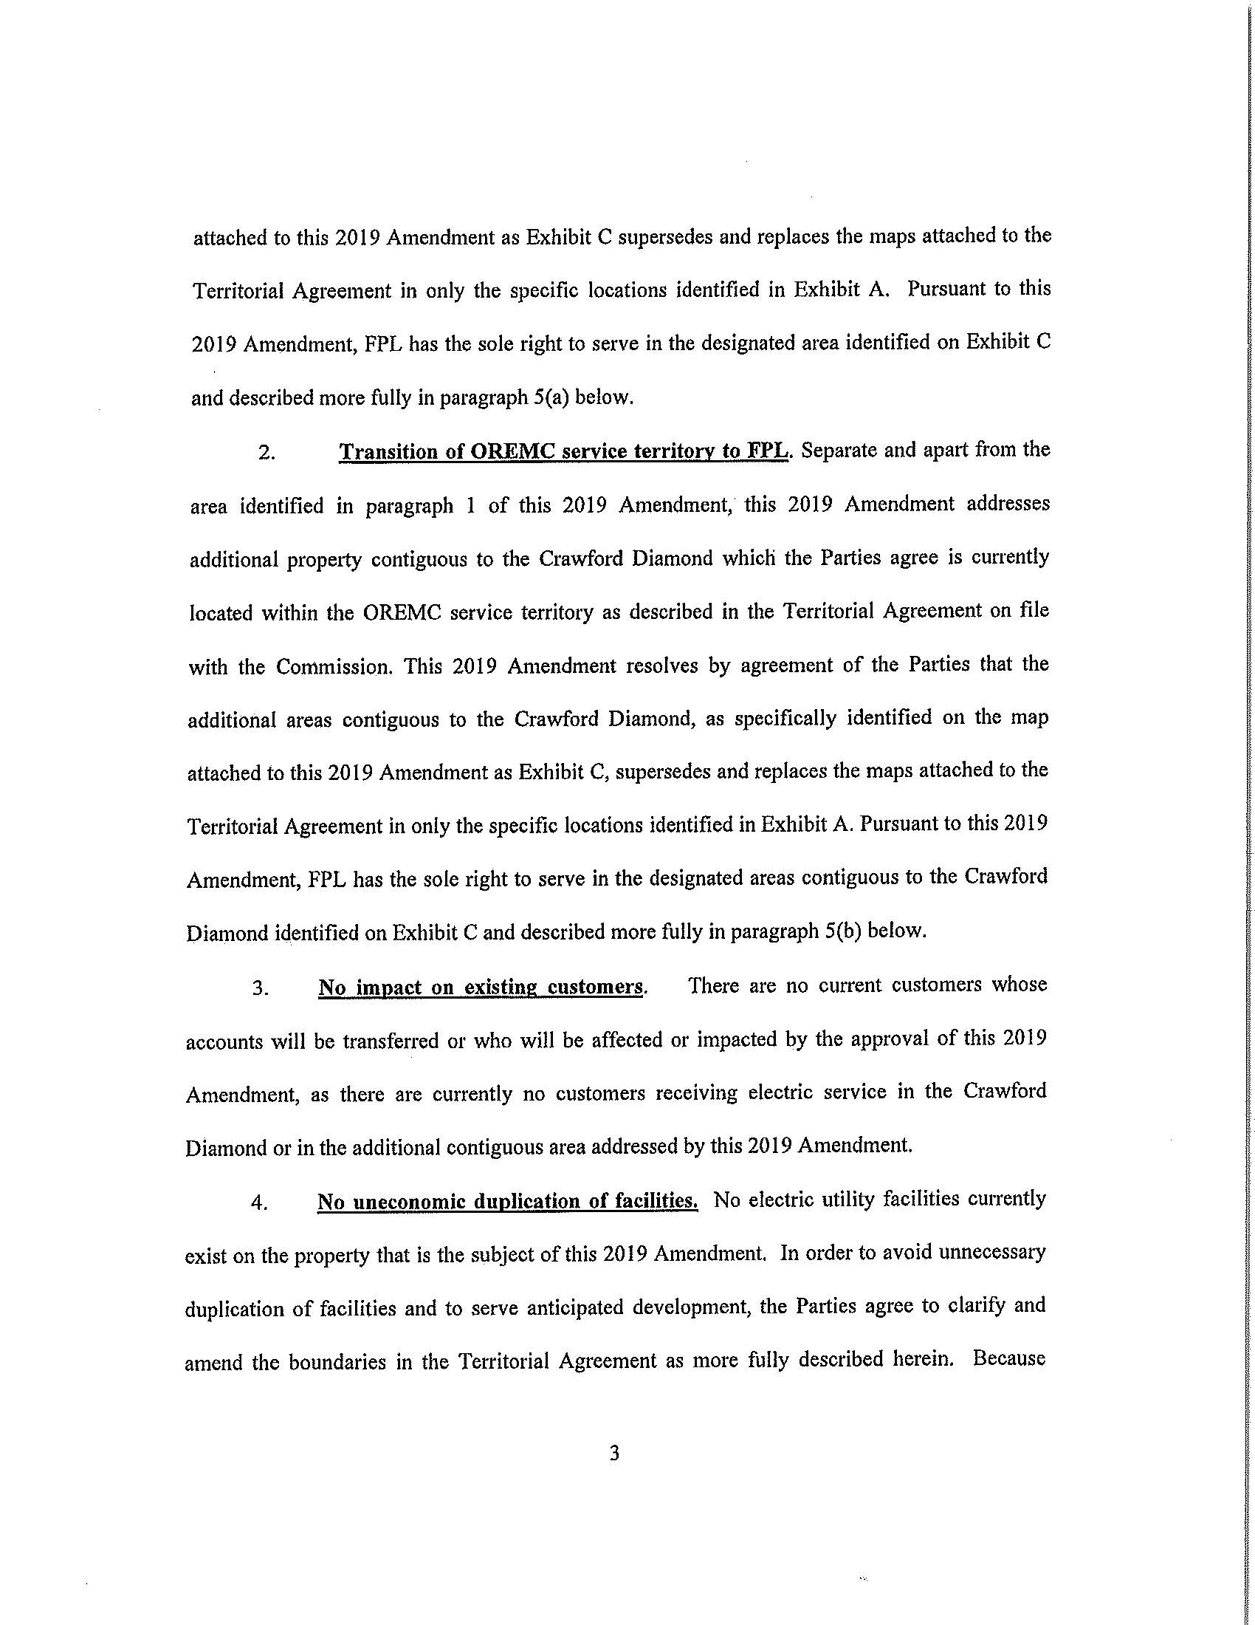

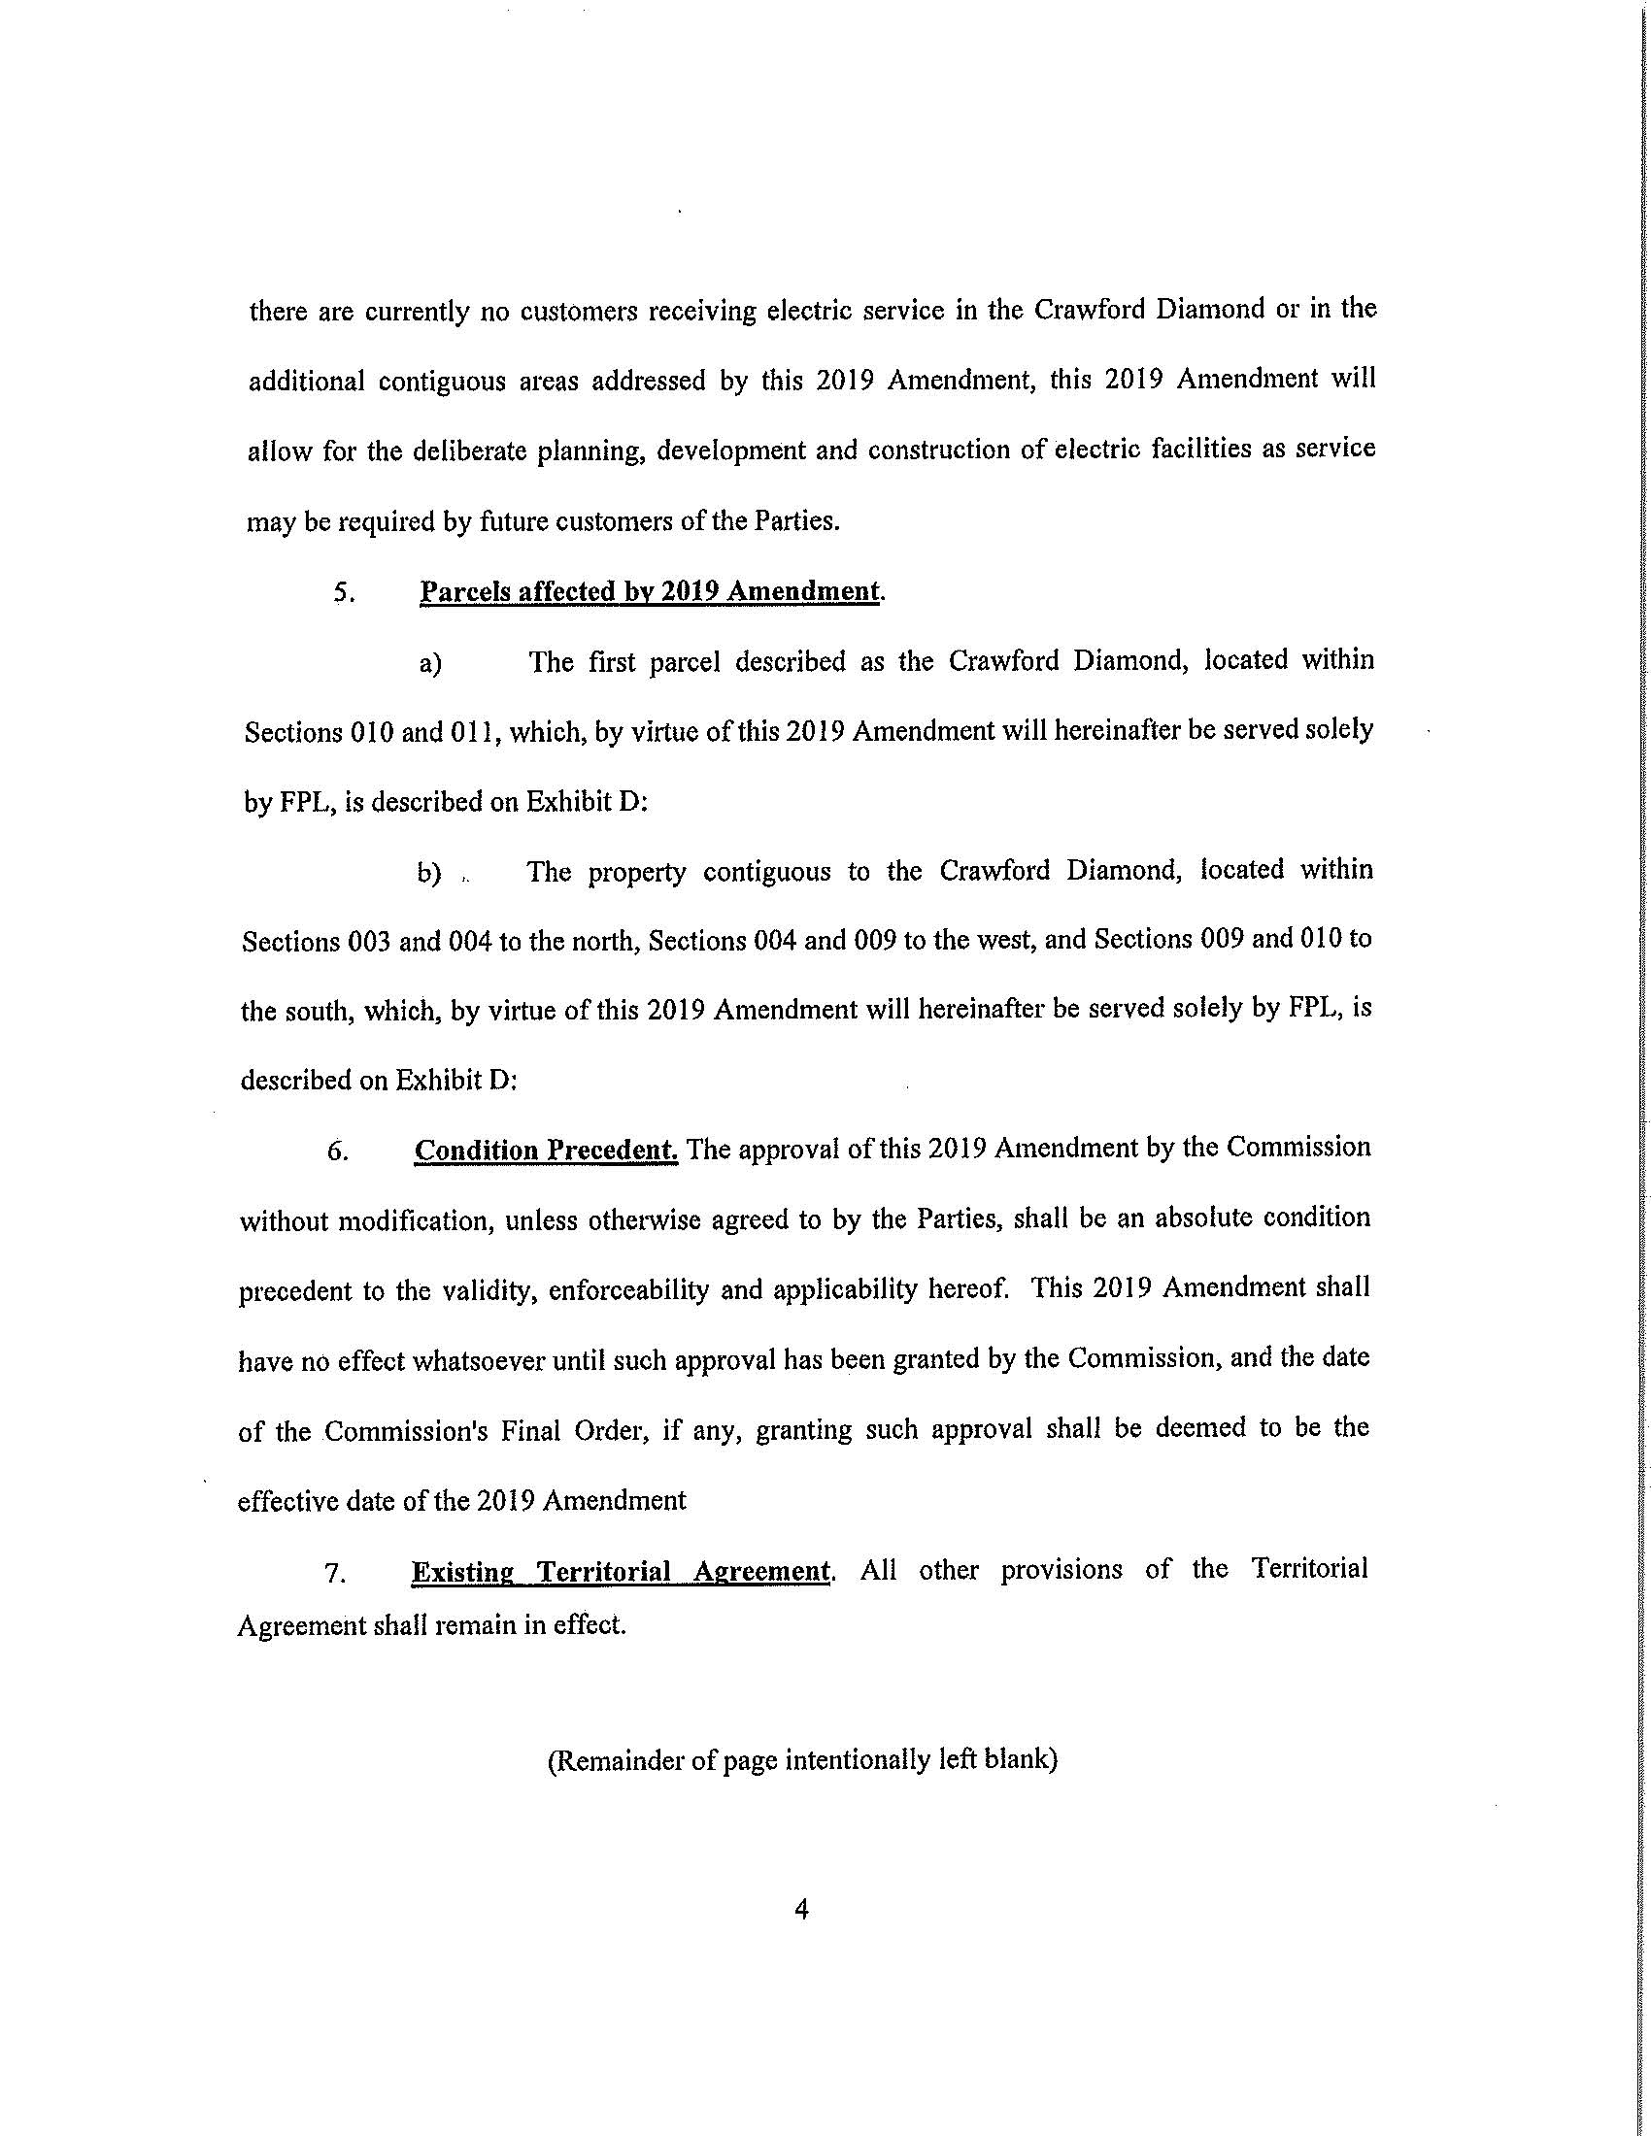

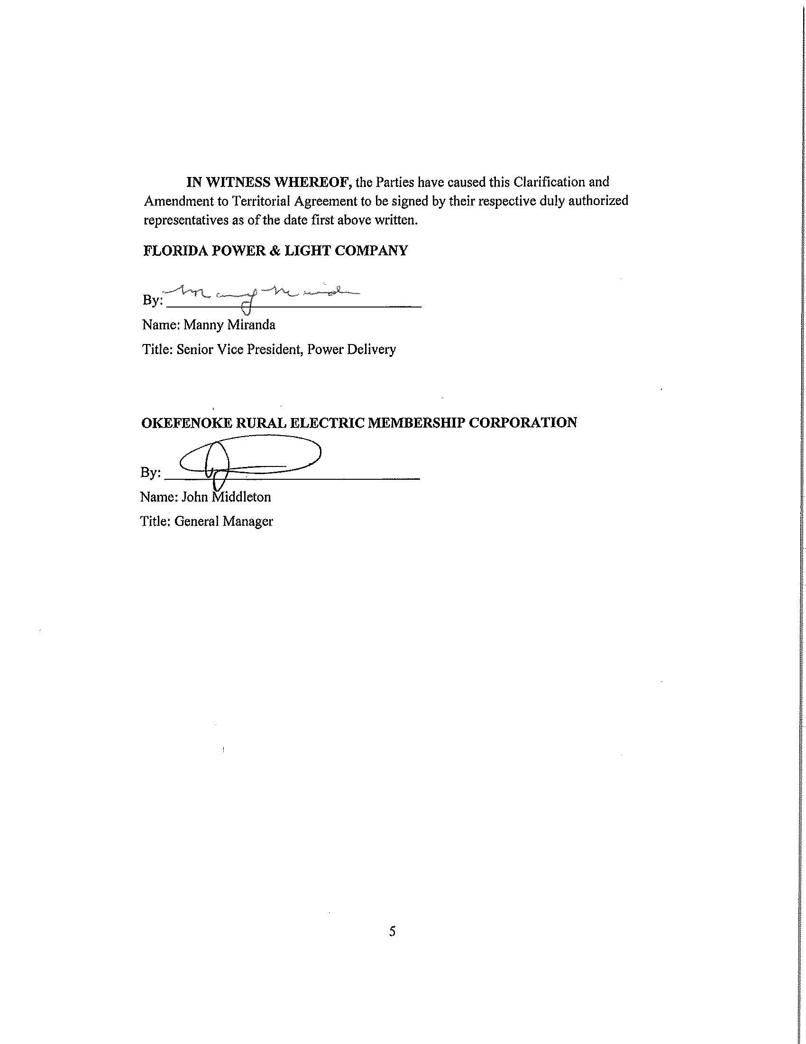

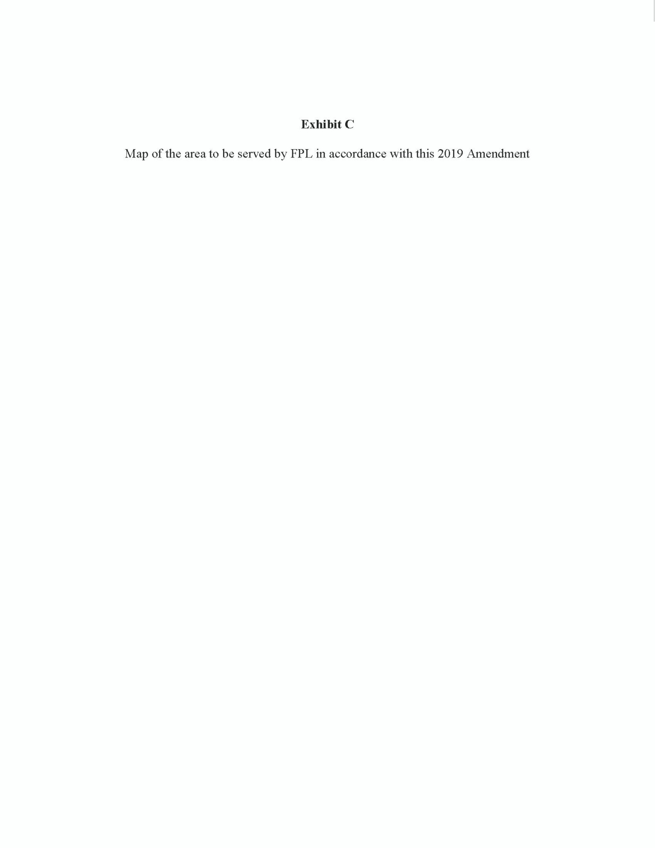

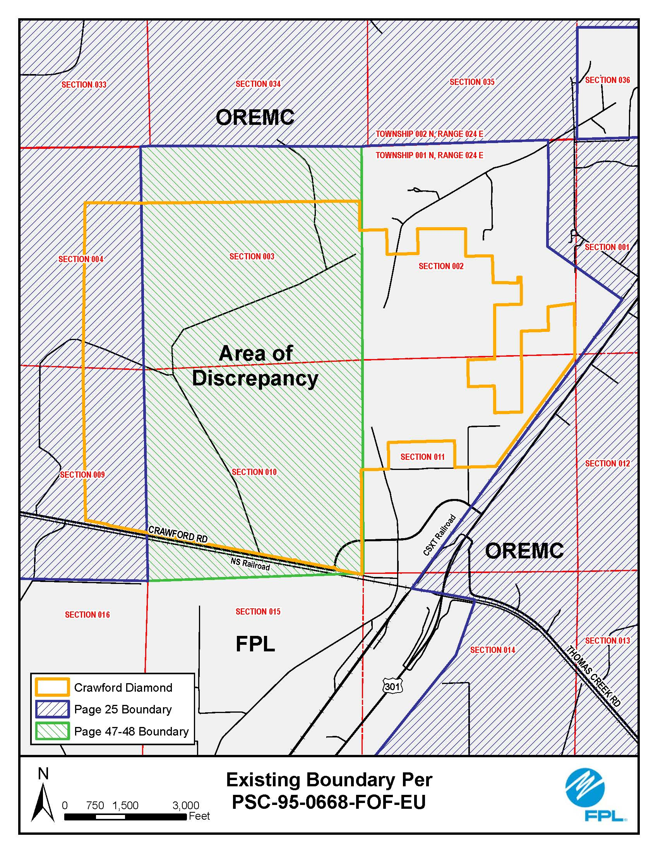

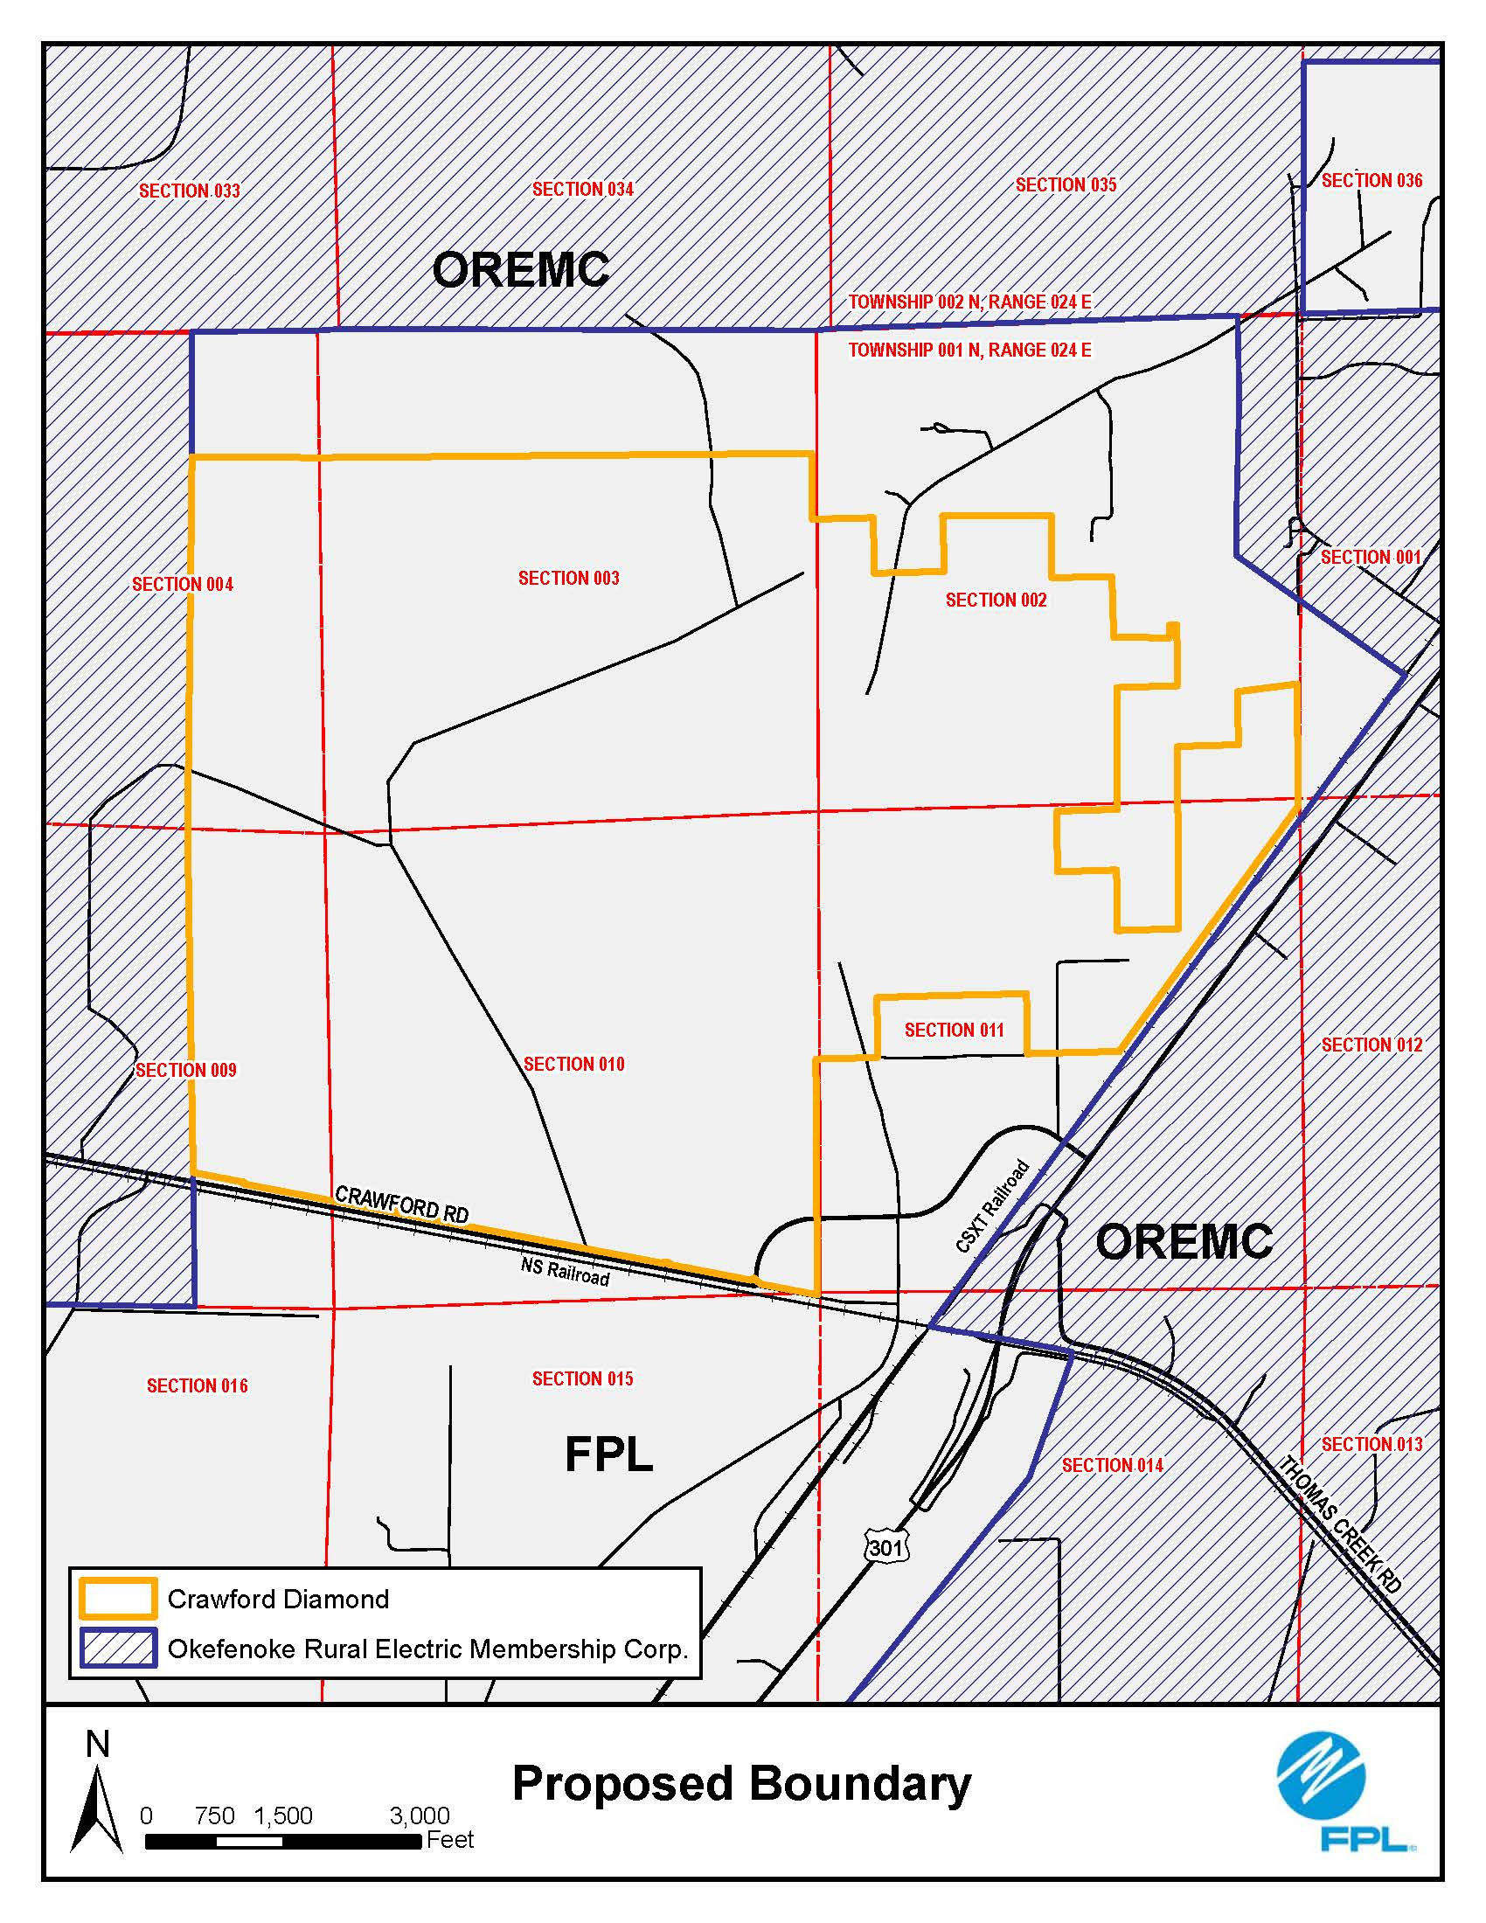

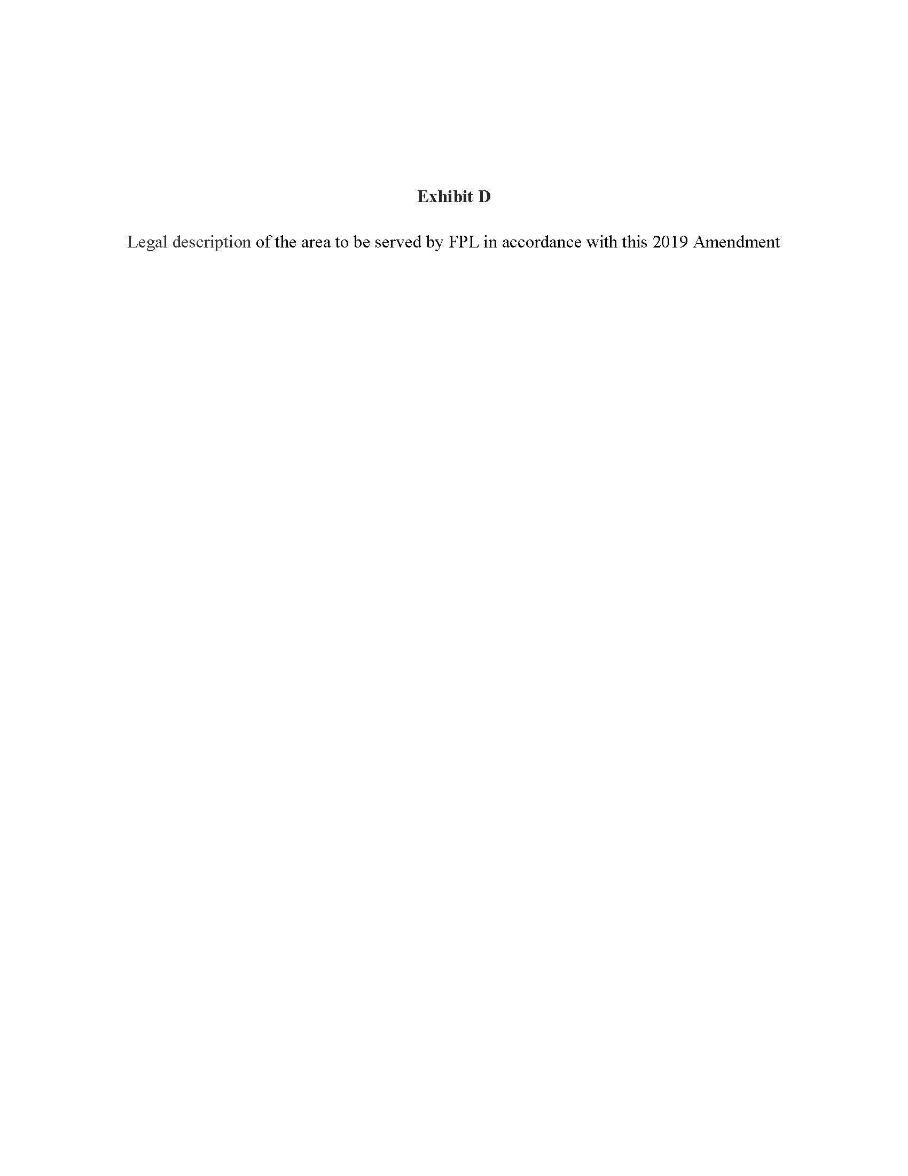

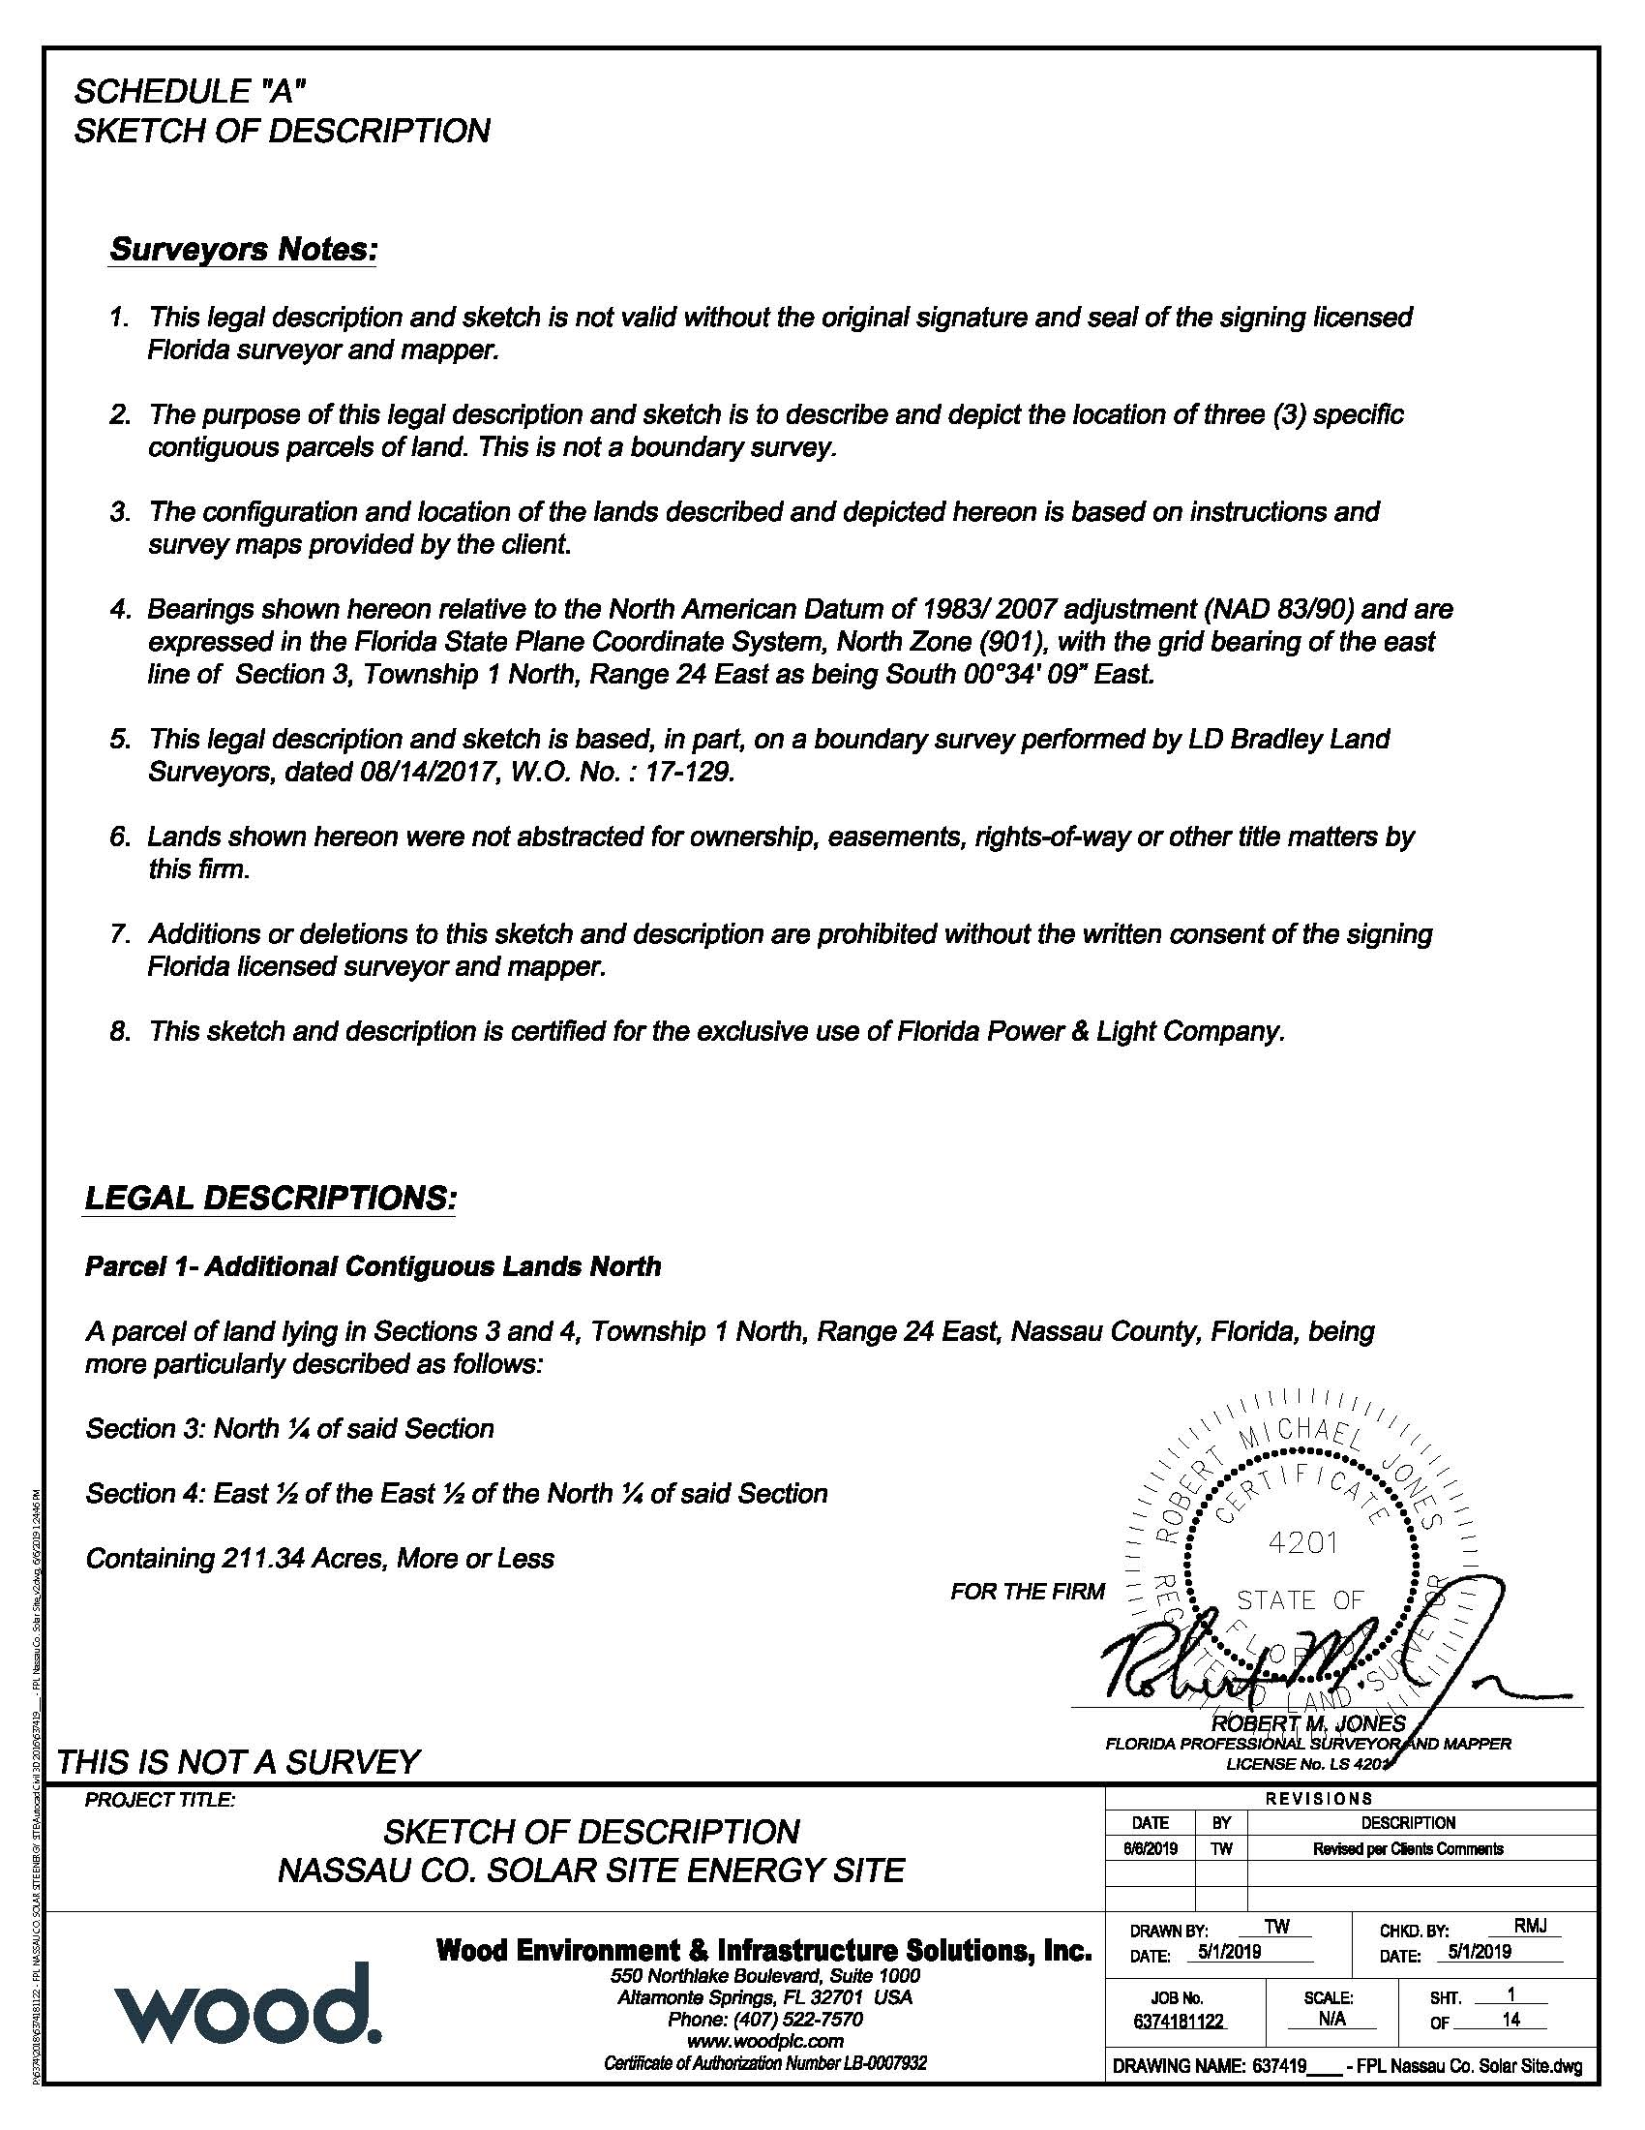

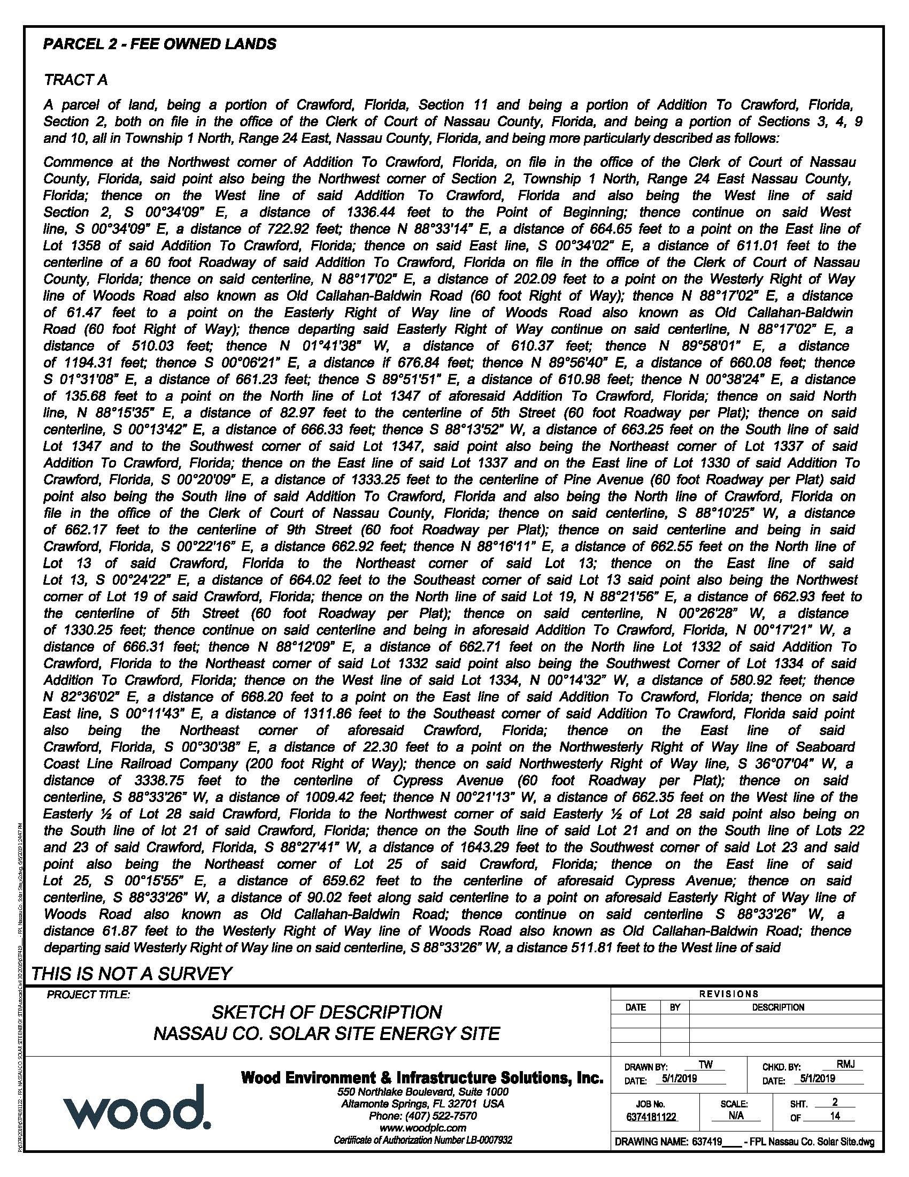

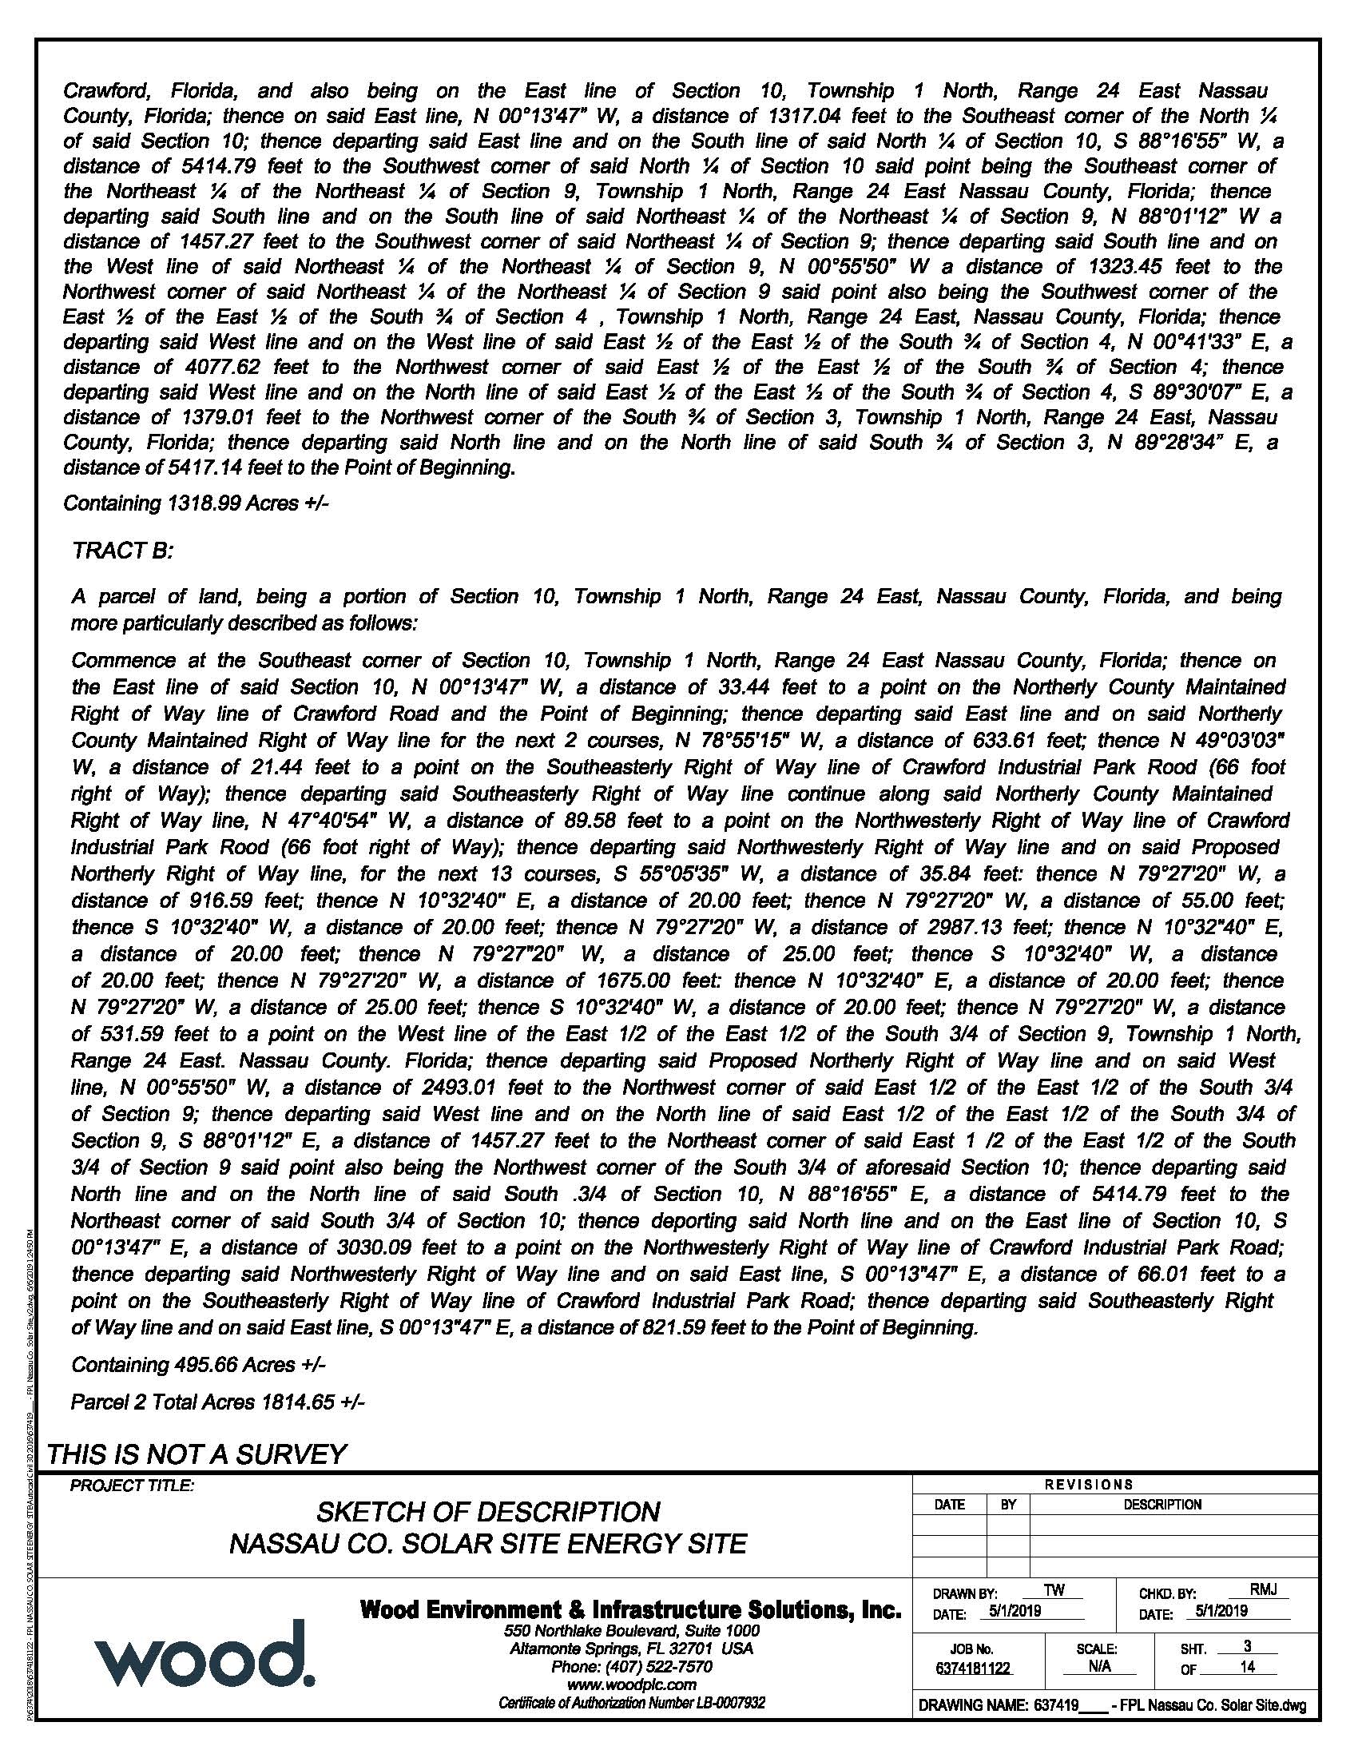

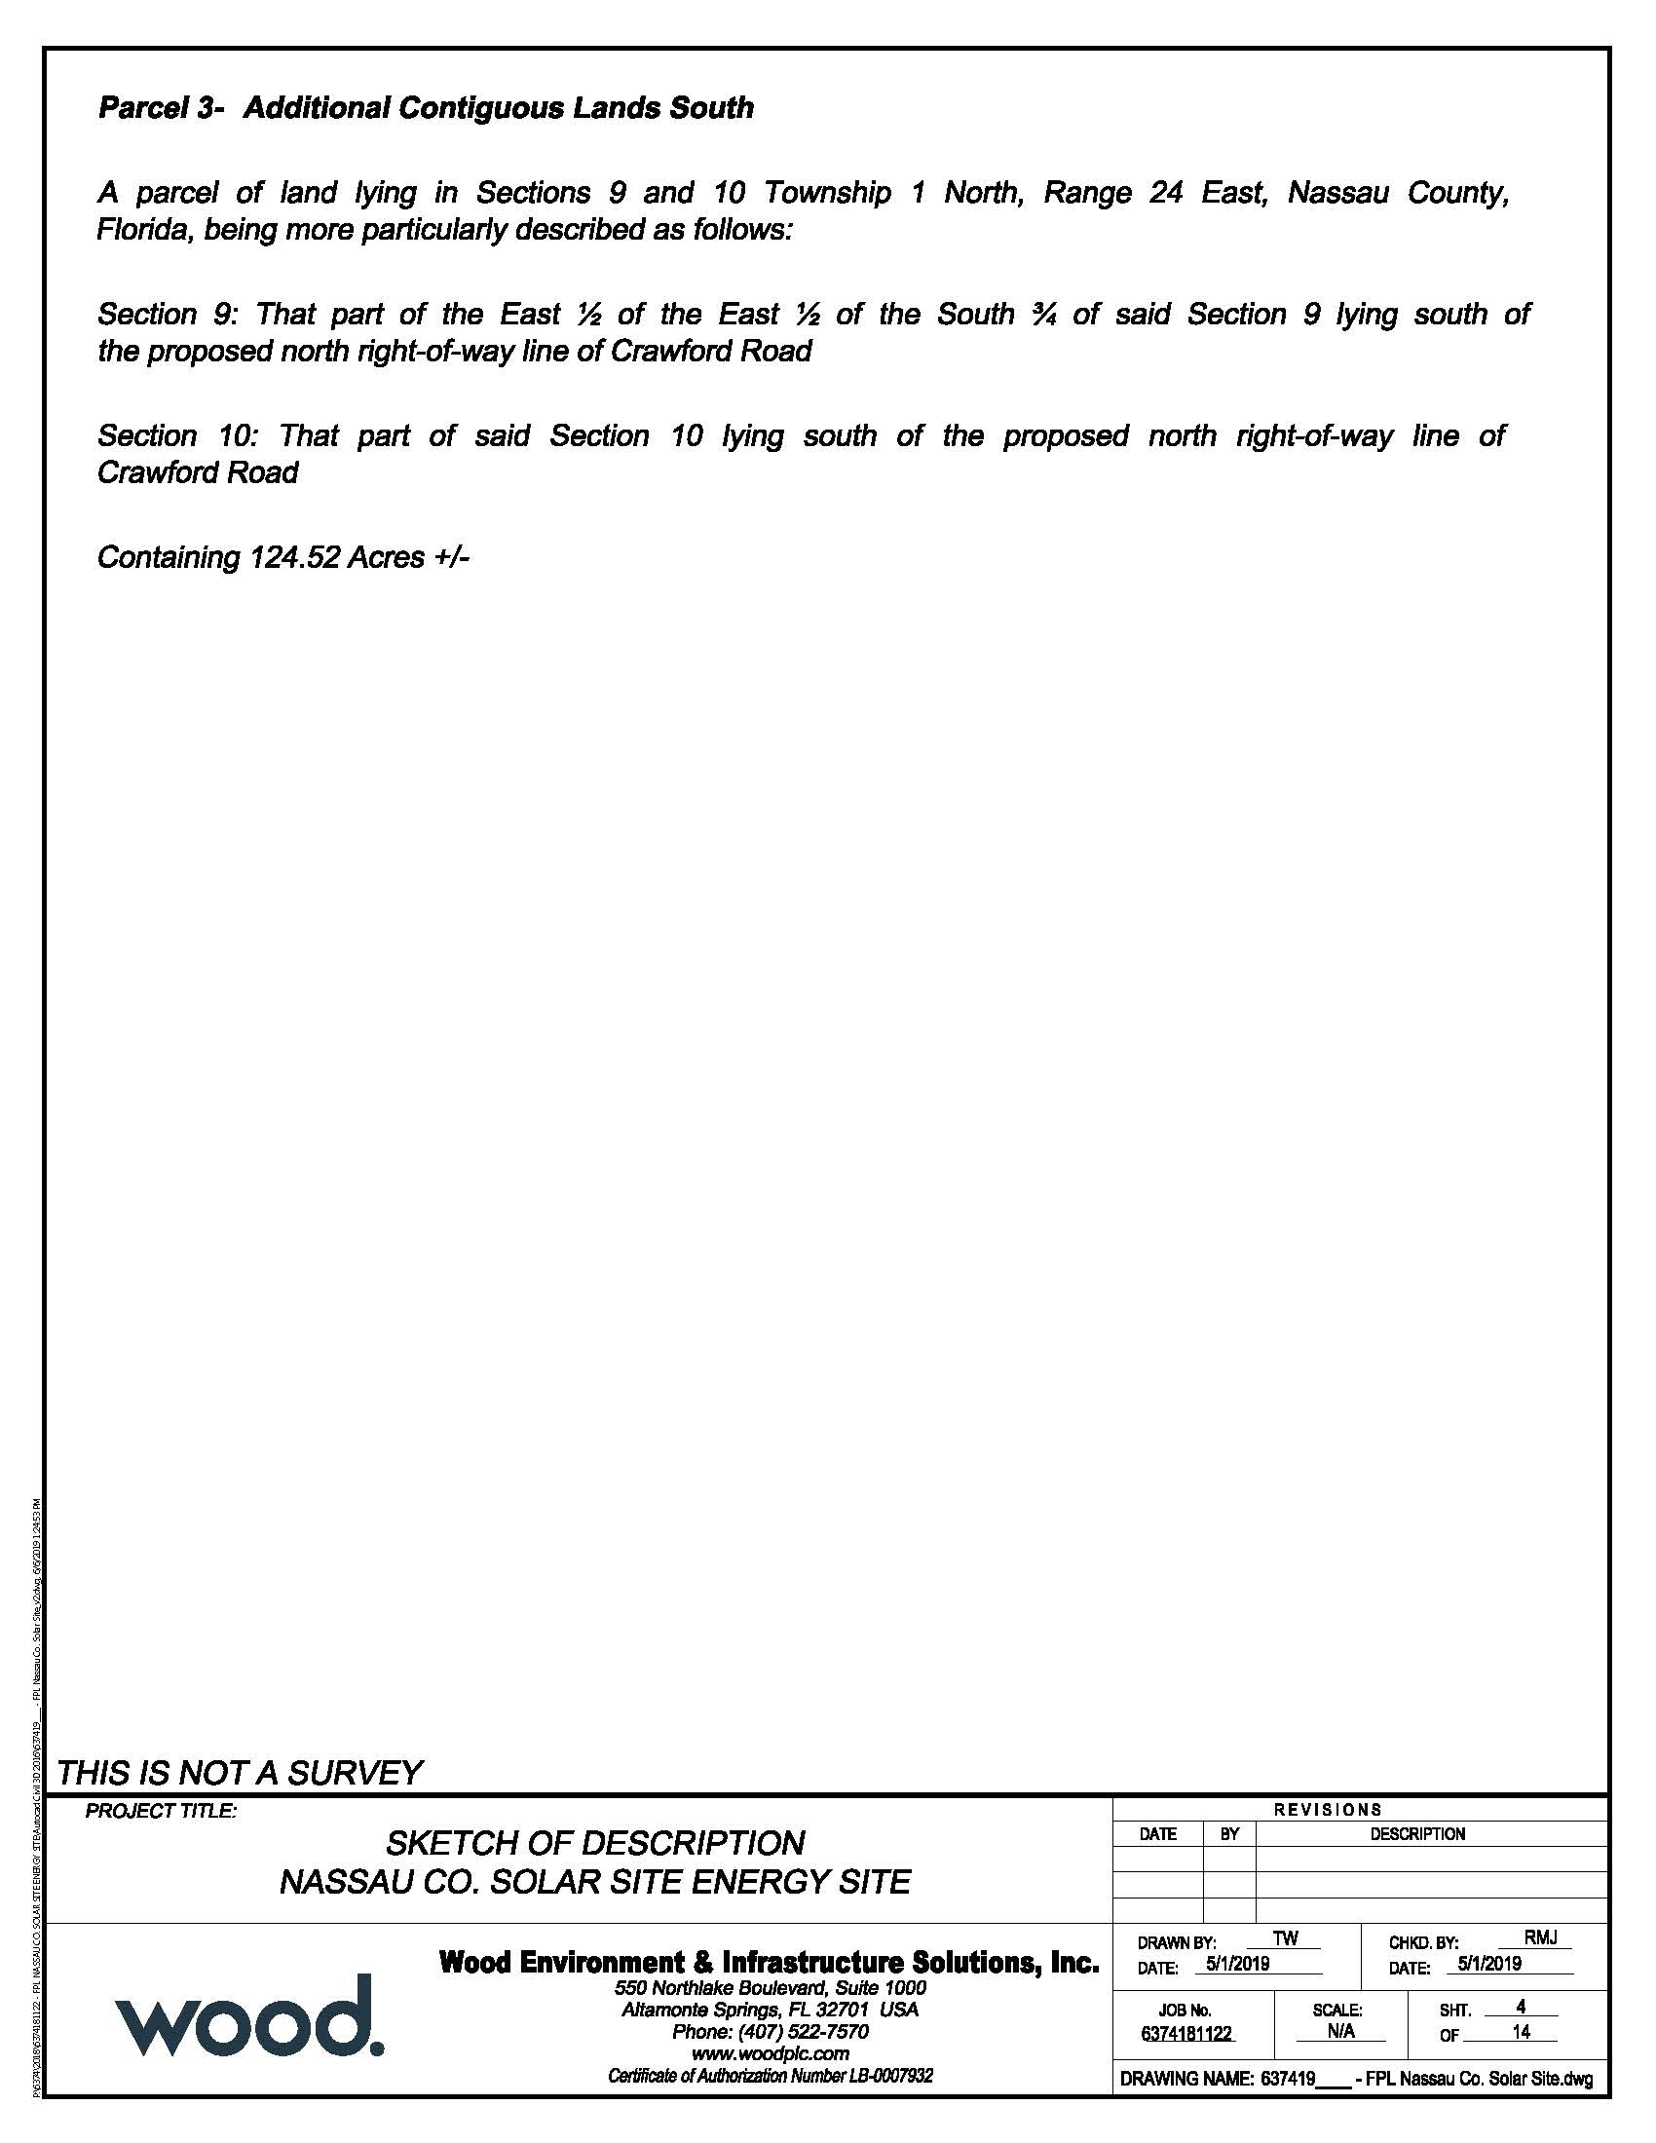

Order No. PSC-95-0668-FOF-EU, issued May 31, 1995, in Docket No. 920420-EU, In re: Petition to resolve territorial dispute in Baker County with Okefenoke Rural Electric Membership Corporation by Florida Power and Light Company.
Utilities Commission of the City of New Smyrna Beach v. Florida Public Service Commission, 469 So. 2d 731 (Fla. 1985).
See FPL Resp. to Comm’n Staff’s 1st Data Request No. 3, filed on Aug. 27, 2019.
See Document No. 08730-2019, filed on Sep. 11, 2019.
Id.

