BEFORE THE FLORIDA PUBLIC SERVICE COMMISSION

In re: Petition for expedited approval of shared solar rider tariff modification, by Tampa Electric Company. | DOCKET NO. 20190144-EI  ORDER NO. PSC-2019-0446-TRF-EI  ISSUED: October 23, 2019

The following Commissioners participated in the disposition of this matter:

ART GRAHAM, Chairman
JULIE I. BROWN
DONALD J. POLMANN
GARY F. CLARK
ANDREW GILES FAY

ORDER GRANTING TAMPA ELECTRIC COMPANY’S
PETITION FOR EXPEDITED SOLAR RIDER TARIFF MODIFICATION

BY THE COMMISSION:
Background

By Order No. PSC-2019-0215-TRF-EI, we approved Tampa Electric Company’s (TECO or utility) Shared Solar Tariff (SSR-1 tariff). The SSR-1 tariff provides residential and commercial customers with the option to purchase energy produced from a TECO-owned solar generation facility to replace all or a portion of their monthly energy consumption. Participants are charged a Shared Solar Charge of $0.063 per kilowatt-hour. The SSR-1 tariff became effective on June 25, 2019, after TECO completed programming its billing system to administer the SSR-1 tariff.

On July 19, 2019, TECO filed for approval of a modification to tariff Sheet No. 3.305 of the SSR-1 tariff. This order addresses the proposed modification to tariff Sheet No. 3.305 as shown in Attachment A to our order. On September 3, 2019, the utility waived the 60-day file and suspend provision of Section 366.06(3), Florida Statutes (F.S.), until the October 3, 2019 Agenda Conference. We have jurisdiction pursuant to Section 366.06, F.S.

Decision
TECO has proposed deleting language in its current SSR-1 that precludes customers in its budget billing program from participating in the voluntary SSR-1 tariff. The budget billing plan, or levelized payment plan, is an optional tariff that allows customers to make budgeted monthly payment amounts to help stabilize their monthly payments. TECO explained that at the time the utility developed the SSR-1 tariff, the billing system had limitations that were excluding customers on the budget billing plan from participating in the SSR-1 tariff. As a result of the billing system limitations, TECO included in its original petition for the SSR-1 tariff a provision which provided that customers may not take service under both the budget billing plan and the SSR-1 tariff. As of August 13, 2019, 102 customers have subscribed to TECO’s SSR-1 tariff.
TECO stated that following our approval of the SSR-1 tariff, the utility was able to modify its billing system to allow the SSR-1 tariff to be made available to customers also taking service under the utility’s budget billing plan. Therefore, TECO proposed to modify tariff sheet No. 3.305 to allow customers that elect to participate in the budget billing program to also take service under the SSR-1 tariff. TECO stated it currently has 55,602 customers that utilize the budget billing program.
The proposed removal of Special Provision No. 6 on tariff sheet No. 3.505 will make the SSR-1 tariff available to levelized payment plan customers. We approve TECO’s proposed modification to tariff sheet No. 3.305, as shown in Attachment A, as reasonable, with an effective date of October 3, 2019.

Based on the foregoing, it is

ORDERED by the Florida Public Service Commission that Tampa Electric Company’s proposed modification to tariff sheet No. 3.305, as shown in Attachment A, is hereby granted, effective October 3, 2019.
ORDERED that if a protest is filed within 21 days of issuance of the Order, the tariff shall remain in effect with any charges held subject to refund pending resolution of the protest. It is further

ORDERED that if no timely protest is filed, this docket shall be closed upon the issuance of a Consummating Order.

By ORDER of the Florida Public Service Commission this 23rd day of October, 2019.

/s/ Adam J. Teitzman
ADAM J. TEITZMAN
Commission Clerk
Florida Public Service Commission
2540 Shumard Oak Boulevard
Tallahassee, Florida 32399
(850) 413-6770
www.floridapsc.com

Copies furnished: A copy of this document is provided to the parties of record at the time of issuance and, if applicable, interested persons.

WLT

NOTICE OF FURTHER PROCEEDINGS

The Florida Public Service Commission is required by Section 120.569(1), Florida Statutes, to notify parties of any administrative hearing or judicial review of Commission orders that is available under Sections 120.57 or 120.68, Florida Statutes, as well as the procedures and time limits that apply. This notice should not be construed to mean all requests for an administrative hearing or judicial review will be granted or result in the relief sought.

Mediation may be available on a case-by-case basis. If mediation is conducted, it does not affect a substantially interested person's right to a hearing.

The Commission's decision on this tariff is interim in nature and will become final, unless a person whose substantial interests are affected by the proposed action files a petition for a formal proceeding, in the form provided by Rule 28-106.201, Florida Administrative Code. This petition must be received by the Office of Commission Clerk, 2540 Shumard Oak Boulevard, Tallahassee, Florida 32399-0850, by the close of business on November 13, 2019.

In the absence of such a petition, this Order shall become final and effective upon the issuance of a Consummating Order.

Any objection or protest filed in this docket before the issuance date of this order is considered abandoned unless it satisfies the foregoing conditions and is renewed within the specified protest period.

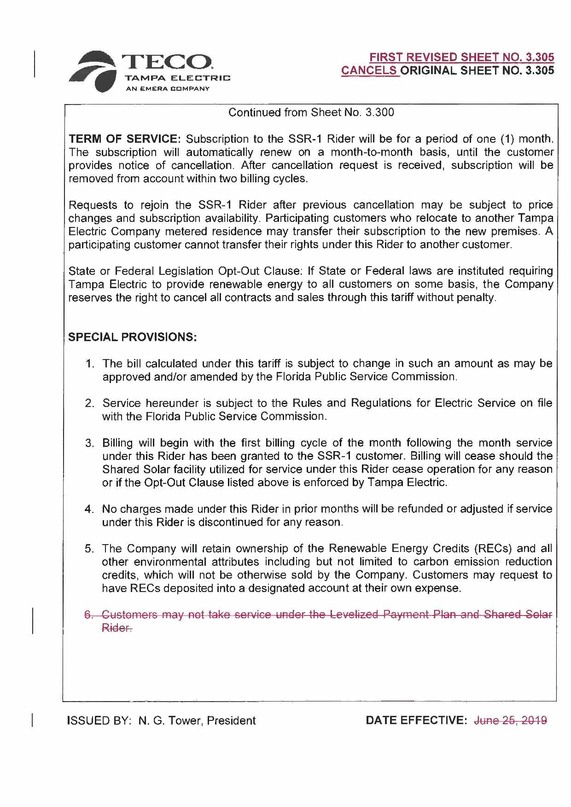

Order No. PSC-2019-0215-TRF-EI, issued June 3, 2019, in Docket No 20180204-EI, In re: Petition for approval of shared solar tariff, by Tampa Electric Company.

