State of Florida |  | Public Service Commission  Capital Circle Office Center ● 2540 Shumard Oak Boulevard  Tallahassee, Florida 32399-0850  -M-E-M-O-R-A-N-D-U-M-
DATE: | October 24, 2019
TO: | Office of Commission Clerk (Teitzman)
FROM: | Division of Economics (Ward, Coston)  Division of Accounting and Finance (Buys, Cicchetti, Hightower)  Office of the General Counsel (Crawford)
RE: | Docket No. 20190172-GU – Petition for approval of safety, access, and facility enhancement program true-up and 2020 cost recovery factors, by Florida City Gas.
AGENDA: | 11/05/19 – Regular Agenda – Tariff Filing – Interested Persons May Participate
COMMISSIONERS ASSIGNED: |  |  | All Commissioners
PREHEARING OFFICER: |  |  | Administrative
CRITICAL DATES: |  |  | 8-month effective date: 05/03/20 (60-day suspension date waived by the utility)
SPECIAL INSTRUCTIONS: |  |  | None

Case Background
On September 3, 2019, Florida City Gas (City Gas or utility) filed a petition for approval of its safety, access, and facility enhancement program (SAFE program) true-up and 2020 cost recovery factors. The SAFE program was originally approved by the Commission in Order No. PSC-15-0390-TRF-GU (2015 order) to recover the cost of relocating on an expedited basis certain existing gas mains and associated facilities from rear lot easements to the street front. In the 2015 order, the Commission found that the relocation of mains and services to the street front provides for more direct access to the facilities and will enhance the level of service provided to all customers through improved safety and reliability. The SAFE factor is a surcharge on customers’ bills. The Commission ordered the utility to file an annual petition, beginning in 2016, for review and resetting of the SAFE factors to true-up any prior over- or under-recovery and to set the surcharge for the coming year. The SAFE program is a 10-year program effective from 2015 through 2025. The current 2019 SAFE factors were approved by Order No. PSC-2018-0545-TRF-GU (2018 order).
During the review process of the current petition, staff issued two data requests to the utility, for which the responses were both received on September 20, 2019. In its filing, City Gas waived the 60-day suspension deadline pursuant to Section 366.06(3), Florida Statutes (F.S.). On October 4, 2019, City Gas filed an amended petition to correct an inadvertent accounting error that had a minor impact on the proposed SAFE factors. The proposed tariff sheets, as corrected on October 4, 2019, are shown in Attachment 2 to the recommendation. The Commission has jurisdiction over this matter pursuant to Sections 366.03, 366.04, 366.05, 366.06, and Chapter 368, F.S.

Discussion of Issues

Issue 1:
Should the Commission approve City Gas's proposed SAFE factors for the period January through December 2020?

Recommendation:
Yes. The Commission should approve City Gas’s proposed SAFE factors for the period January through December 2020. (Ward, Coston, Hightower)

Staff Analysis:
Under the SAFE program, City Gas will relocate or replace 254.3 miles of mains and 11,443 miles of associated service lines from rear property easements to the street front over a 10-year period ending in 2025. City Gas began its mains and services replacements at the end of 2015, as provided for in the 2015 order, and the surcharges have been in effect since January 2016. As of 2019, the utility has replaced 113.4 miles of mains and 5,831 services as shown in Attachment 1 to this recommendation.
As stated in City Gas’s response to staff’s data request, the utility’s current 2019 replacement plans include 13 projects located in Merritt Island in Brevard County, Port Saint Lucie in Saint Lucie County, City of Hialeah, City of Miami Gardens, South Miami Heights neighborhood, Sierra neighborhood, and Westchester neighborhood in Miami-Dade County. The utility’s projected 2020 replacement plans include five additional projects located in Saint Lucie County, City of Miami Gardens, and Westchester neighborhood in Miami-Dade County.
City Gas stated that its replacement projects are generally prioritized based on the risk assessment model in the utility’s Distribution Integrity Management Program. Prioritization factors include, but are not limited to, location of the pipeline, rear lot pipelines with maintenance access complications and customer encroachments, leak incident rate, material of pipe, age of the pipeline, and operating pressure of the pipeline.

True-ups by Year
As required in the 2015 order, City Gas’s calculations for the 2020 revenue requirement and SAFE factors include a final true-up for 2018, an actual/estimated true-up for 2019, and projected costs for 2020.

Final True-up for 2018
City Gas stated that the revenues collected for 2018 were $1,450,631 compared to a revenue requirement of $1,029,927, resulting in an over-recovery of $420,704. Adding the 2017 final under-recovery of $81,979, and the $420,704 over-recovery of 2018, results in a final 2018 over-recovery of $338,727. In City Gas’s 2017 rate case, the Commission approved a Stipulation and Settlement Agreement (settlement) among the parties to the rate case. The settlement includes a provision that reset the SAFE factors to $0 for June through December 2018; therefore, the final true-up for 2018 only includes actual data for January through May 2018.

Actual/Estimated 2019 True-up
City Gas provided actual revenues for January through July and forecast revenues for August through December of 2019, totaling $287,788, compared to an actual/estimated revenue requirement of $500,599, resulting in an under-recovery of $212,810. Adding the 2018 over-recovery of $338,727 to the 2019 under-recovery of $212,810, the resulting total 2019 true-up, including interest, is an over-recovery of $134,022. It should be noted that Attachment B, Schedule 2 of the petition shows no investments for January through April 2019. City Gas explained that eligible replacements were inadvertently captured in Capital Work In Progress (CWIP) instead of investments for the period January through April 2019. In May 2019, City Gas corrected its schedules and eligible replacements that were in service were moved from CWIP to investments.

Projected 2020 Costs
The utility’s projected investment for 2020 is $10,321,901 for its five new projects located in Saint Lucie and Miami-Dade Counties. The revenue requirement, which includes a return on investment, depreciation, and taxes, is $1,785,425. The return on investment calculation includes federal income taxes, regulatory assessment fees, and bad debt. After subtracting the 2019 over-recovery of $134,022, the total 2020 revenue requirement is $1,651,403. Table 1-1 displays the projected 2020 revenue requirement calculation.
Table 1-1
2020 Revenue Requirement Calculation
2020 Projected Investment |  | $10,321,901
Return on Investment | $1,232,472
Depreciation Expense | 427,446
Property Tax Expense | 125,506
2020 Revenue Requirement | $1,785,425
Less 2019 Over-recovery | 134,022
Total 2020 Revenue Requirement | $1,651,403
Source: Attachment B of the Petition and response to Staff’s First Data Request No. 3.

Proposed 2020 SAFE Factors
The SAFE factors are fixed monthly charges. City Gas’s cost allocation method was approved in the 2015 order and was used in the instant filing. The approved methodology allocates the current cost of a 2-inch pipe to all customers on a per customer basis and allocates the incremental cost of replacing a pipe larger than 2 inches to customers who use over 6,000 therms per year. For customers who require 4-inch pipes, the cost takes into account that the minimum pipe is insufficient to serve their demand and, therefore, allocates an incremental per foot cost in addition to the all-customer cost. The resulting allocation factors are applied to the 2020 total revenue requirement to develop the monthly SAFE factors.
The proposed fixed monthly SAFE factor is $1.21 for customers using less than 6,000 therms per year (current factor is $0.21). The proposed fixed monthly SAFE factor for customers using more than 6,000 therms per year is $2.26 (current factor is $0.40). As previously mentioned, the 2018 rate case set the SAFE factors back to $0.00 for the period June through December 2018. The SAFE factors are cumulative charges, which explains the increase in the SAFE factors between 2019 and 2020. In its original 2015 petition for the SAFE program, the utility estimated that the SAFE factor surcharge for customers using less than 6,000 therms annually would be $9.45 by 2025.

Accounting and Tax Considerations
The state corporate income tax rate changed from 5.5 percent to 4.458 percent beginning on January 1, 2019 through January 1, 2022. The change in tax rate was announced by the Department of Revenue’s Tax Information Publication on September 12, 2019. Therefore, the proposed 2020 factors that are addressed in this recommendation do not reflect the lower tax rate. In a noticed informal meeting on October 15, 2019, Commission staff, utility representatives, and interested persons discussed the change in the tax rate. Based on the discussions and comments made by the utilities, staff recommends that Florida City Gas address the impact of the lower tax rate in the 2019 true-up calculations provided in the surcharge petition that will be filed in September 2020 for 2021 factors.
Commission staff reviewed the City Gas weighted average cost of capital (WACC), as filed in its amended petition. The utility is proposing to make an adjustment to the WACC used to calculate the SAFE revenue requirements as necessary in order to be consistent with Internal Revenue Code (IRC) §1.167(l)-1. City Gas states that since it did not meet or exceed the limitation provision, it adjusted the depreciation-related accumulated deferred income taxes (ADITs) included in the year-end ADIT balance using projected period data and the proration formula required by the IRC. Staff recommends acceptance of the WACC for the 2020 factors as filed. However, if a subsequent adjustment to the WACC is necessary, staff recommends any adjustment be made in a subsequent true-up filing.

Conclusion
Staff has reviewed City Gas’s filings and supporting documentation and believes that the calculations are consistent with the methodology approved in the 2015 order and are reasonable and accurate. Staff also reviewed City Gas’s calculation of the 2019 true-up and 2020 projected cost calculations and verified that the calculation includes the 21 percent federal tax rate, as required by the settlement. Therefore, staff recommends approval of City Gas’s proposed SAFE factors for the period January through December 2020.

Issue 2:
Should this docket be closed?

Recommendation:
Yes. If Issue 1 is approved and a protest is filed within 21 days of the issuance of the order, the tariffs should remain in effect, with any revenues held subject to refund, pending resolution of the protest. If no timely protest is filed, this docket should be closed upon the issuance of a consummating order. (Crawford)
Staff Analysis: If Issue 1 is approved and a protest is filed within 21 days of the issuance of the order, the tariffs should remain in effect, with any revenues held subject to refund, pending resolution of the protest. If no timely protest is filed, this docket should be closed upon the issuance of a consummating order.

Table 1
Florida City Gas’s SAFE Program Progress
 | Main Replacements |  | Service Replacements
Year* | Replaced Main (miles) | Total Miles Remaining | Replaced Services (number) | Total Remaining Services
2014 | 0.0 | 254.3 | 0 | 11443
2015 | 0.0 | 254.3 | 49 | 11394
2016 | 17.1 | 237.2 | 1433 | 9961
2017 | 37.5 | 199.7 | 1551 | 8410
2018 | 27.6 | 172.1 | 1634 | 6776
2019 | 31.2 | 141.0 | 1164 | 5612
2020 | 29.4 | 111.6 | 1060 | 4552
2021 | 29.2 | 82.3 | 1290 | 3262
2022 | 24.0 | 58.3 | 1055 | 2207
2023 | 23.8 | 34.5 | 1046 | 1161
2024 | 23.5 | 11.0 | 1032 | 128
2025 | 11.0 | 0.0 | 128 | 0
Source: Attachment A of the petition for Docket No. 20190172-GU. *Actuals 2014-July 2019. Projections August 2019-2025.
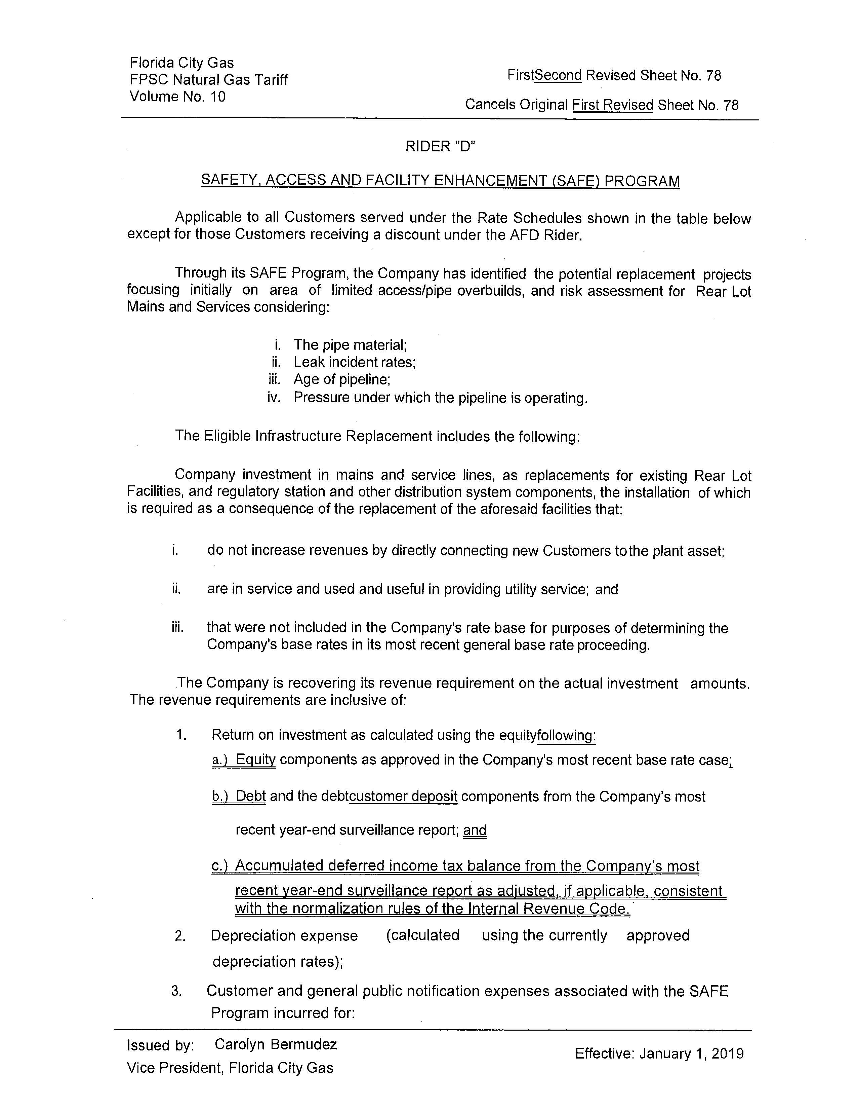
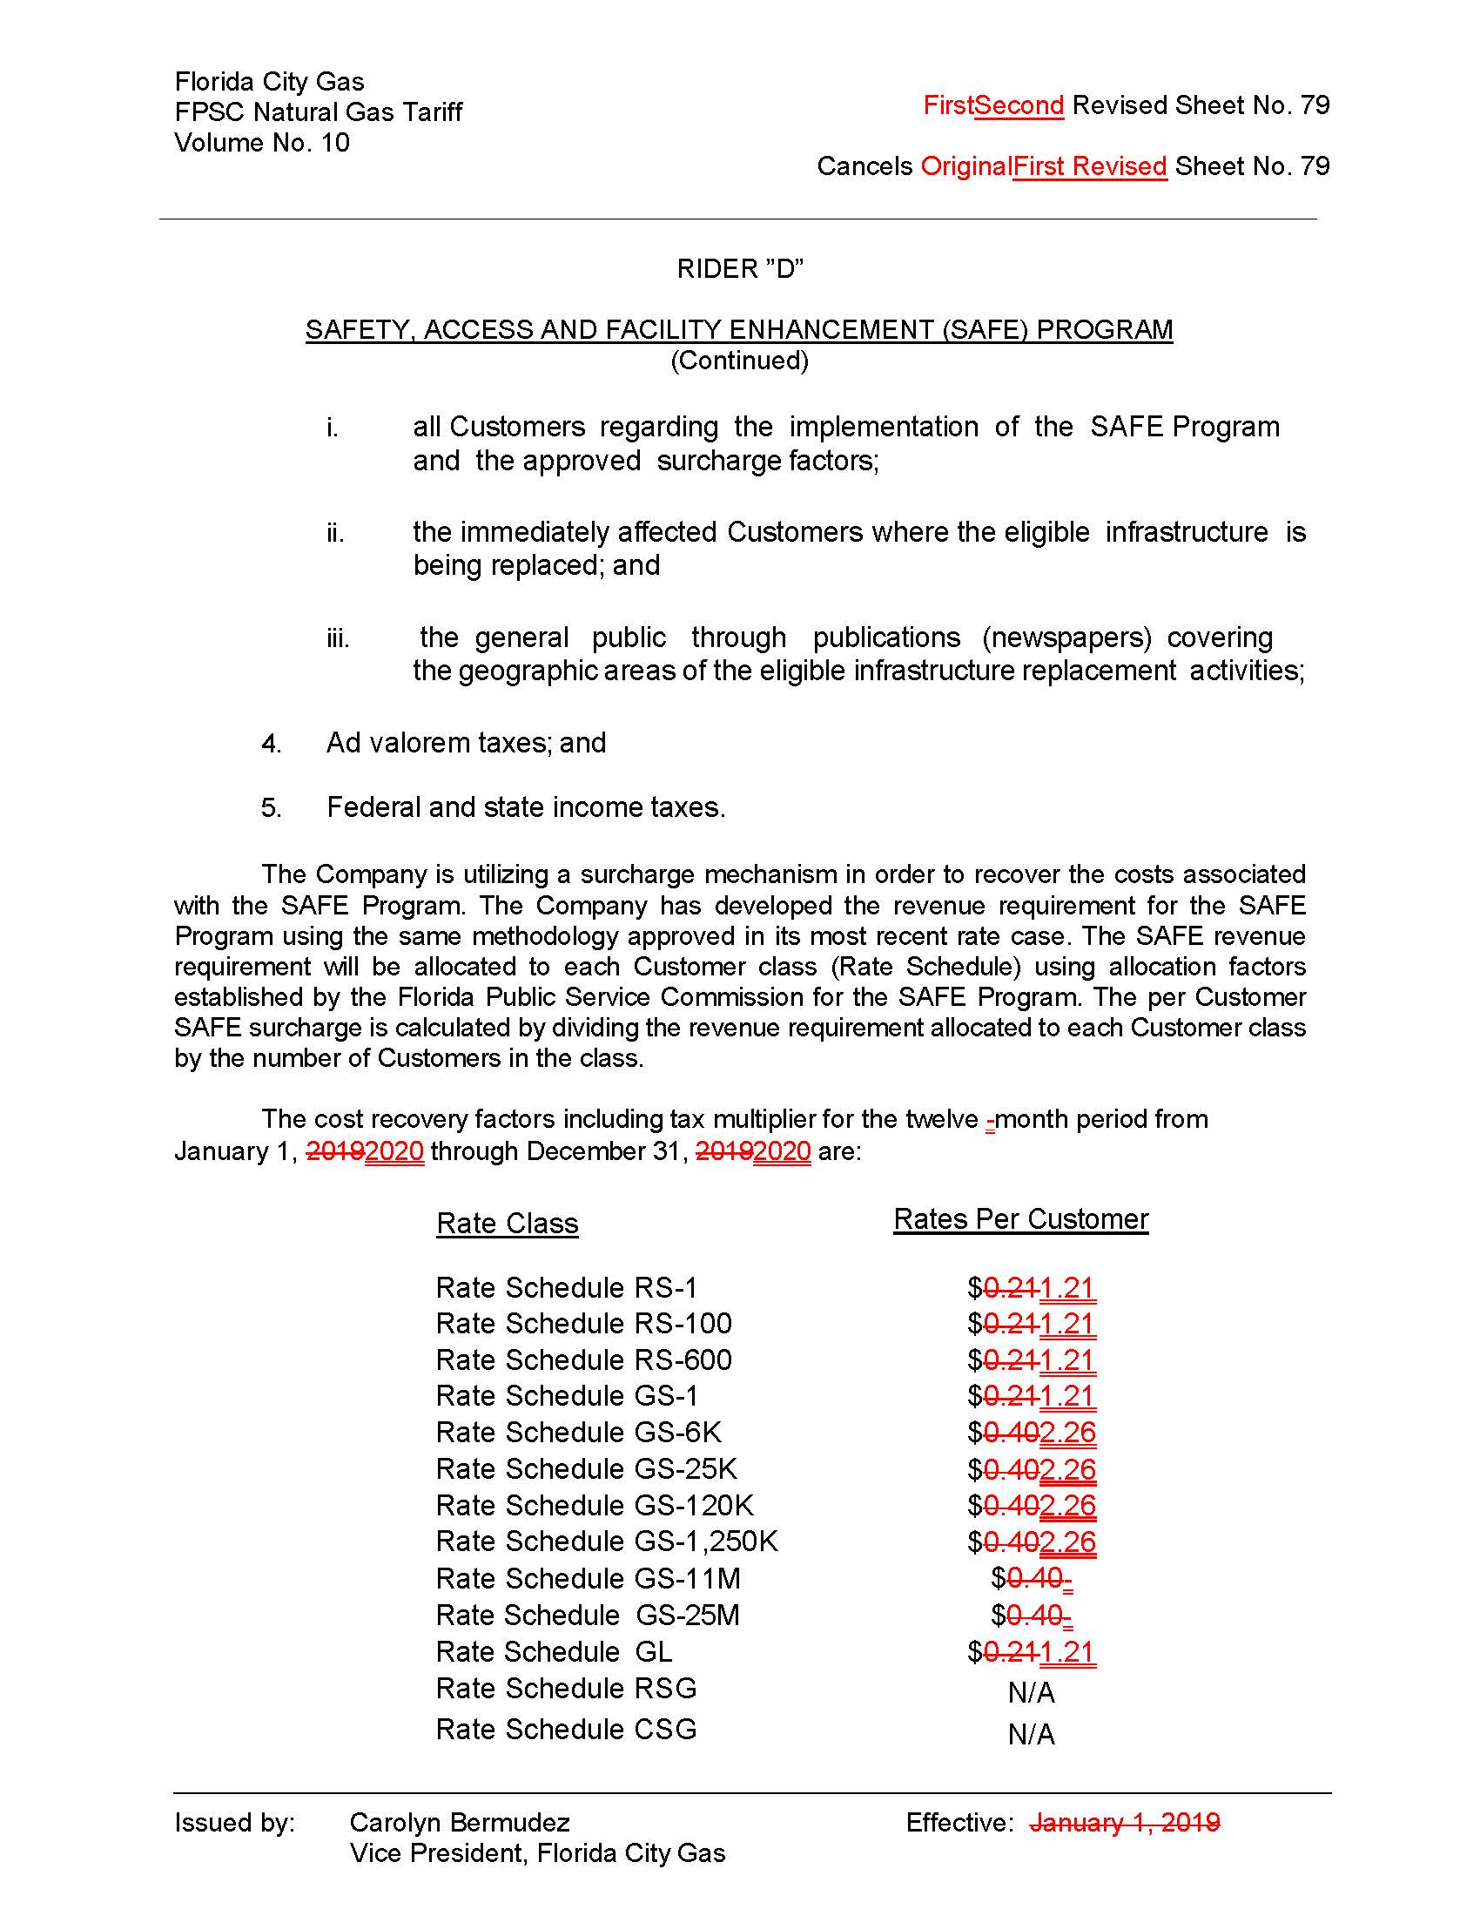
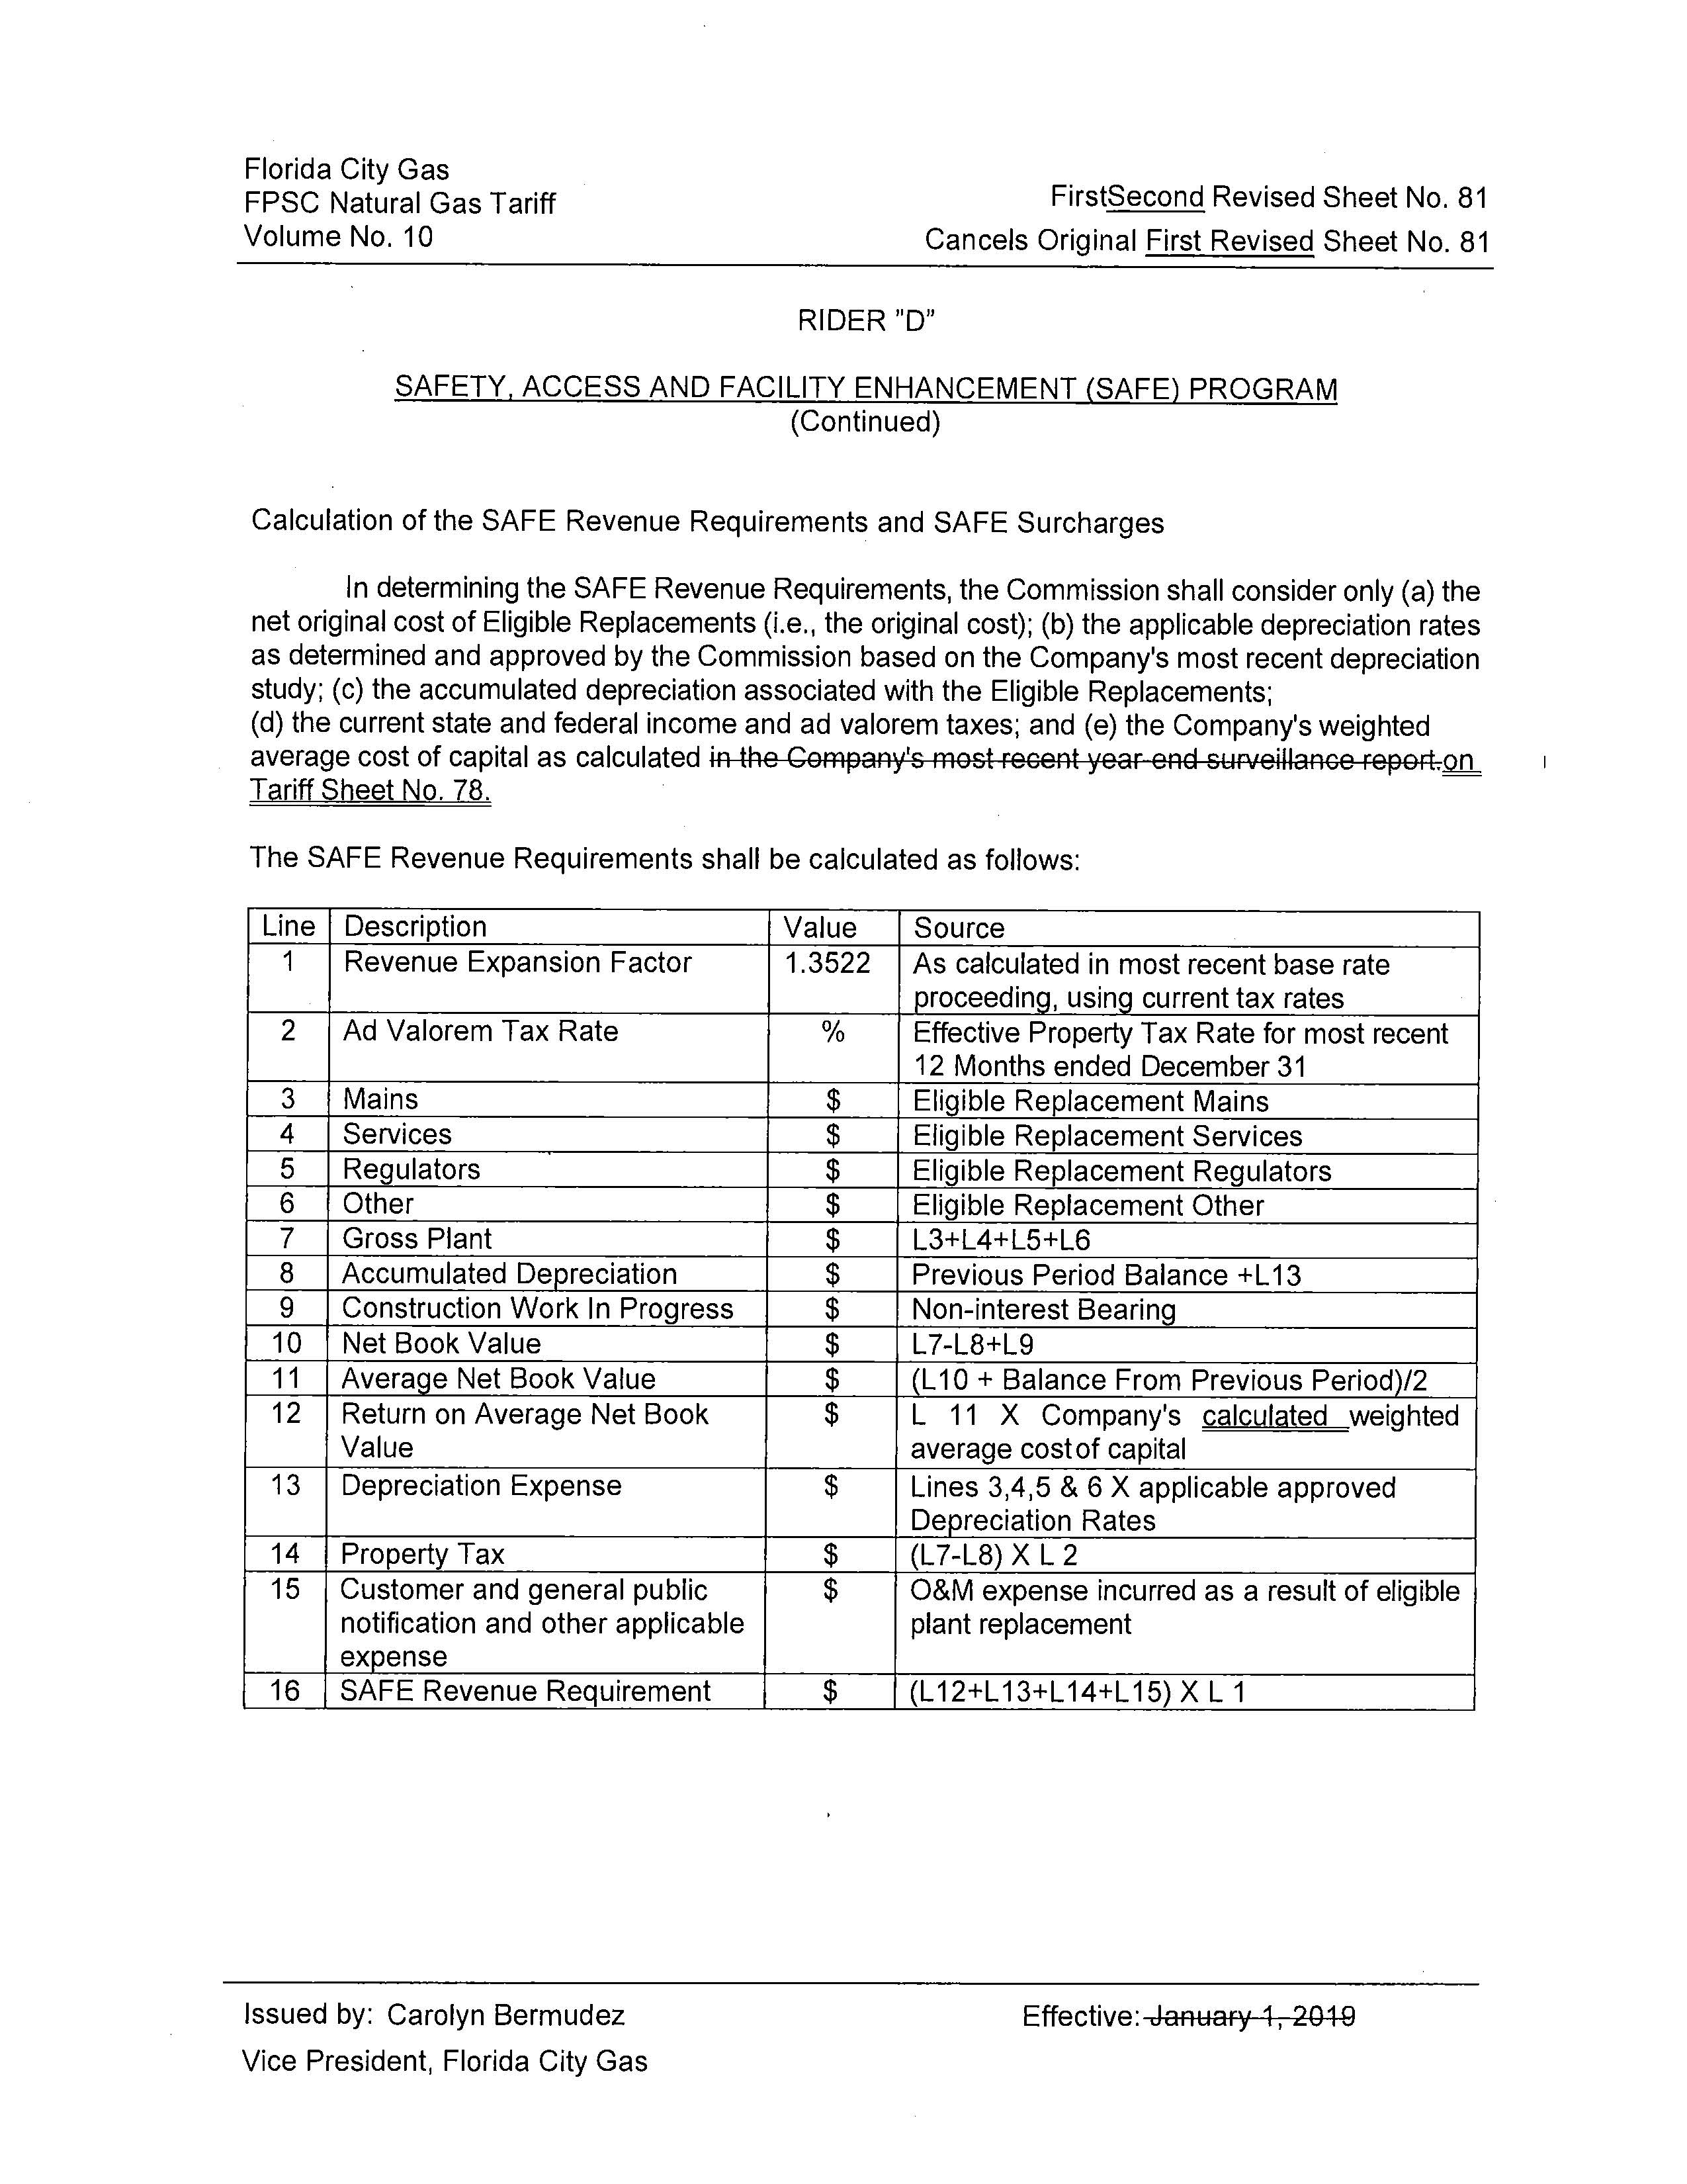

Order No. PSC-15-0390-TRF-GU, issued September 15, 2015, in Docket No. 150116-GU, In re: Petition for approval of safety, access, and facility enhancement program and associated cost recovery methodology, by Florida City Gas.
Order No. PSC-2018-0545-TRF-GU, issued November 19, 2018, in Docket No. 20180164-GU, In re: Petition for approval of safety, access, and facility enhancement program true-up and 2019 cost recovery factors, by Florida City Gas.
Order No. PSC-2018-0190-FOF-GU, issued April 20, 2018, in Docket No. 20170179-GU, In re: Petition for rate increase by Florida City Gas.

