State of Florida |  | Public Service Commission  Capital Circle Office Center ● 2540 Shumard Oak Boulevard  Tallahassee, Florida 32399-0850  -M-E-M-O-R-A-N-D-U-M-
DATE: | October 24, 2019
TO: | Office of Commission Clerk (Teitzman)
FROM: | Office of the General Counsel (Dziechciarz)  Office of Industry Development and Market Analysis (Fogleman, Wendel)
RE: | Docket No. 20190193-TX – Initiation of show cause proceeding against Tele Circuit Network Corporation for apparent violation of Order Nos. PSC-05-0361-PAA-TX and PSC-11-0419-PAA-TX.
AGENDA: | 11/5/19 – Regular Agenda – Show Cause – Interested Persons May Participate
COMMISSIONERS ASSIGNED: |  |  | All Commissioners
PREHEARING OFFICER: |  |  | None
CRITICAL DATES: |  |  | None
SPECIAL INSTRUCTIONS: |  |  | None

Case Background
Staff of the Florida Public Service Commission (Commission) opened this docket to initiate a show cause proceeding against Tele Circuit Network Corporation (Tele Circuit or Company) for apparent violation of Commission Order Nos. PSC-05-0361-PAA-TX and PSC-11-0419-PAA-TX.
Tele Circuit is a privately-held corporation, incorporated in Georgia, and authorized to transact business as a foreign corporation in Florida since July 14, 2003. By Order No. PSC-05-0361-PAA-TX (CLEC Order), issued on April 4, 2005, this Commission granted Tele Circuit a Competitive Local Exchange Company (CLEC) Certificate, No. 8573, pursuant to Section 364.335(1)(b)(2), Florida Statutes (F.S.). Tele Circuit provides service in BellSouth Telecommunications, LLC d/b/a AT&T Florida d/b/a AT&T Southeast’s (AT&T) territory as a reseller of AT&T service.
By Order No. PSC-11-0419-PAA-TX (ETC Order), issued on September 28, 2011, the Commission designated Tele Circuit as a landline (or “wireline”) Eligible Telecommunications Carrier (ETC) throughout AT&T’s service territory, pursuant to Chapter 47 Code of Federal Regulations (C.F.R.), Section 54.201(c). In Florida, a company may receive a wireline ETC designation from the Commission, but must seek a wireless ETC designation from the Federal Communications Commission (FCC). Companies that are designated as ETCs have the ability to receive Universal Service Fund (USF) support from the Universal Service Administration Company (USAC) for providing qualifying services from the four major USF programs: High-Cost, Low-Income (Lifeline), Rural Health Care, and the Schools and Libraries divisions. USF support is provided to ETCs in the form of monetary reimbursement.
Tele Circuit’s purpose in seeking its ETC designation was to receive federal support for offering the Lifeline discount to its low-income customers. The Company currently serves approximately 300 customers in the state of Florida, and claims reimbursement from the USF for 34 of its customers under the Lifeline program.
On May 16, 2019, staff received a complaint concerning a customer’s desire to acquire wireline service under the Lifeline program from Tele Circuit. The customer informed staff that a Tele Circuit representative stated that the Company is no longer offering wireline service, but that the customer could instead receive the Lifeline discount if they used a wireless service.
On May 21, 2019, staff emailed Tele Circuit to determine if the Company had in fact stopped offering the Lifeline discount for wireline service, as this is the only type of service Tele Circuit is authorized to provide pursuant to the ETC Order. Tele Circuit responded that it was unable to provide new customers with the Lifeline discount using wireline service due to a technical issue, but that if the customer was willing to use a wireless phone, the Company would still offer the Lifeline discount after verifying the customer’s eligibility.
Following additional conversations with Tele Circuit, staff learned that due to a dispute regarding overcharges in billing between AT&T and Tele Circuit, the Company was not able to sell wireline service in Florida to new customers., Staff also confirmed that Tele Circuit was advertising a “wireless home phone-hub” service to its customers, and providing new customers who wished to receive the Lifeline discount with wireless phone service via the phone-hub.
Staff requested a copy of any advertising material or user manual(s) provided to Tele Circuit customers for the wireless home phone-hub. The wireless home phone-hub appears to operate on either the Sprint or Verizon wireless networks, but Tele Circuit apparently believes it qualifies as wireline service. It is unclear if customers are informed that they are not receiving wireline service when receiving this technology from Tele Circuit. In a follow-up response, Tele Circuit stated that only one of its 34 Lifeline customers in Florida is utilizing the wireless home phone-hub service, and that the remaining 33 customers are using wireline service.
Tele Circuit further advised staff that the Company contacted USAC to ensure that use of the wireless home phone-hub technology was permissible for the Lifeline program. Staff requested the name of the contact at USAC and any formal documentation of USAC’s approval of the use of the wireless technology. Tele Circuit informed staff that it did not know the individual’s name, nor did it receive any formal documentation. Staff contacted USAC to verify the approval of the technology; however, USAC did not provide any information.
Staff requested additional information from AT&T and Tele Circuit regarding the nature of the dispute between the companies. AT&T informed staff that it reached a settlement agreement with Tele Circuit that dictated that the Company must remove all customers from AT&T lines by December 31, 2019. AT&T also provided staff with a letter sent by Tele Circuit to its customers informing them of the Company’s need to migrate its customers off of its current network.
When staff requested information from Tele Circuit regarding the dispute, the Company originally stated that the dispute was resolved, and advised that it was able to provide wireline service to new customers in Florida. After further inquiry, the Company advised that AT&T and Tele Circuit were still in negotiations regarding their dispute, but did not advise staff of the settlement agreement.
Similarly, Tele Circuit provided contradictory responses to staff regarding its current bankruptcy status. In a response to a data request regarding the 2019 Status of Competition in the Telecommunications Industry Report, Tele Circuit advised that it filed for Chapter 11 bankruptcy in June 2018. However, in a data request response regarding the Commission’s annual Lifeline Assistance Report, Tele Circuit failed to state that it had filed for bankruptcy within the last year.
Tele Circuit also stated in its data request response that it was not involved in any FCC enforcement actions within the last two years. However, during the course of the informal investigation into Tele Circuit’s provision of wireless service for its Lifeline customers, staff discovered a Notice of Apparent Liability for Forfeiture (NAL), issued by the FCC on April 27, 2018, which the Company should have disclosed.
In the NAL, the FCC proposed that the Company pay a $5.3 million fine due to the egregious nature of Tele Circuit’s apparent misconduct, which involved the deceptive practices commonly referred to as “slamming” and “cramming.” Slamming refers to the practice of changing a customer’s preferred service provider without proper authorization, and cramming refers to the practice of placing unauthorized charges for long distance service on a customer’s bill. Slamming and cramming cause consumers to spend significant time and effort to return to their preferred carriers, to remove unauthorized charges from their bills, and to file complaints with law enforcement agencies.
Notably, the FCC stated that:
In some instances, the apparent misconduct of Tele Circuit left vulnerable consumers without telephone service for extended periods of time – with Tele Circuit allegedly refusing to reinstate service until the crammed charges were paid in full. Further, it appears that some of the third-party verification recordings that Tele Circuit provided to the Commission as “evidence” of consumer authorization were fabricated.
The FCC emphasized how Tele Circuit’s apparent misconduct caused “great consternation among these victims and their family members, and created dangerous or potentially life-threatening situations.” In one example, the complainant alleged that Tele Circuit persuaded a 94-year old customer to switch carriers to Tele Circuit, and then cut off service before the elderly customer’s guardian knew the service had been switched. The complainant noted that “[t]his is the only way she or her caregivers can contact me or anyone in case of an emergency.”
Another complainant alleged that Tele Circuit wrongfully switched her mother’s service, and ultimately disconnected her. When the complainant requested to listen to the recording of her mother allegedly authorizing Tele Circuit’s carrier switch, the Company could not provide it. She stated that “[a]s of right now my mother is without a phone and if anything happens to her, she can’t even dial 911 because she has no service at all ... [i]t’s sad that these companies prey on the elderly.” Staff contacted the FCC to determine if there was any settlement or additional actions that resulted from the NAL, but has not received any additional information to date.
Given the serious nature of the allegations that the FCC presented against Tele Circuit, the Company’s apparent inability to provide staff with consistent and accurate information, and its prohibited use of wireless technology for Lifeline customers, staff determined that it appears that Tele Circuit was in violation of its ETC Order and CLEC Order. Issue 1 is staff’s recommendation regarding Tele Circuit’s apparent violation of its ETC Order, for use of non-compliant wireless technology for its Lifeline customers, and because it is no longer in the public interest for Tele Circuit to be designated as an ETC. Issue 2 is staff’s recommendation regarding Tele Circuit’s apparent violation of its CLEC Order, due to insufficient managerial capability to provide CLEC service in Florida.
The procedure followed by the Commission in dockets such as this is to consider the Commission staff’s recommendation and determine whether the alleged facts warrant requiring the entity to respond. If the Commission agrees with staff’s recommendation, the Commission issues an Order to Show Cause (Show Cause Order). A Show Cause Order is considered an administrative complaint by the Commission against the entity, pursuant to Section 120.60(5), F.S. If the Commission issues a Show Cause Order for Issue 1, then to keep its ETC designation in the state of Florida, Tele Circuit would have to provide a response to the Commission within 21 days, which disputes the factual allegations contained in the Show Cause Order, and contains a request for a hearing pursuant to Sections 120.569 and 120.57, F.S. If the Company requests a hearing, a further proceeding would be scheduled before the Commission makes a final determination on the matter.
If the Commission issues a Show Cause Order for Issue 2, then to keep its CLEC Certificate, Tele Circuit would have to provide a response to the Commission within 21 days which disputes the factual allegations contained in the Show Cause Order, and contains a request for a hearing pursuant to Sections 120.569 and 120.57, F.S. If the Company requests a hearing, a further proceeding would be scheduled before the Commission makes a final determination on the matter.
If Tele Circuit fails to timely respond to the Show Cause Order, then it would be deemed to have admitted the factual allegations contained in the Show Cause Order. The Company’s failure to timely respond would also constitute a waiver of its right to a hearing. If the Company does not timely respond, a final order would be issued imposing the sanctions set out in the Show Cause Order.
If a final order is issued regarding Issue 1, then Tele Circuit’s ETC status would be revoked in the state of Florida, and the Company would no longer be able to offer the Lifeline discount to its customers in Florida. Tele Circuit would also be prohibited from receiving monetary support from the USF for its Lifeline customers in Florida. Tele Circuit submitted an application to the FCC for wireless ETC status on July 6, 2012; however, the application is still pending. If approved, Tele Circuit would be permitted to provide wireless Lifeline service (including in Florida), and again receive support from the USF. If a final order is issued regarding Issue 2, then Tele Circuit’s CLEC certificate would be revoked, and the Company would no longer be able to provide any wireline service in the state of Florida.
The Commission has jurisdiction pursuant to Sections 364.10(2), 364.285, and 364.335, F.S.

Discussion of Issues

Issue 1:
Should the Commission order Tele Circuit to show cause, in writing, within 21 days from the issuance of the order, why its Eligible Telecommunications Carrier status in Florida should not be revoked for apparent violation of Order No. PSC-11-0419-PAA-TX, due to use of non-compliant wireless technology for its Lifeline customers, and because it is no longer in the public interest for Tele Circuit to be designated as an ETC?

Recommendation:
Yes, Tele Circuit Network Corporation should be ordered to show cause, in writing, within 21 days from the issuance of the order, why its Eligible Telecommunications Carrier status in Florida should not be revoked for apparent violation of Order No. PSC-11-0419-PAA-TX, due to use of non-compliant wireless technology for its Lifeline customers, and because it is no longer in the public interest for Tele Circuit to be designated as an ETC. (Dziechciarz, Fogleman, Wendel)

Staff Analysis:

Law
State commissions have the primary responsibility for performing ETC designations. In the state of Florida, the Commission has the jurisdiction to designate wireline, but not wireless, ETCs. 47 C.F.R. Section 54.201(c), provides that:
Upon request and consistent with the public interest, convenience, and necessity, the state commission may, in the case of an area served by a rural telephone company, and shall, in the case of all other areas, designate more than one common carrier as an eligible telecommunications carrier for a service area designated by the state commission, so long as each additional requesting carrier meets the requirements of paragraph (d) of this section. Before designating an additional eligible telecommunications carrier for an area served by a rural telephone company, the state commission shall find that the designation is in the public interest.
47 C.F.R. Section 54.201(d), provides that carriers designated as ETCs shall, throughout the designated service area: (1) offer the services that are supported by federal universal support mechanisms whether using their own facilities or a combination of their own facilities and the resale of another carrier’s services, and (2) advertise the availability of such services and related charges therefore using media of general distribution.
In addition to the responsibility for performing wireline ETC designations, the Commission also possesses the authority to revoke ETC designations for the failure of an ETC’s compliance with any conditions imposed by the state. The FCC has found that individual state commissions are qualified to determine what information is necessary to ensure that ETCs are in compliance with applicable requirements, including state-specific ETC eligibility requirements.
Pursuant to Section 364.285(1), F.S., the Commission may impose upon any entity subject to its jurisdiction a penalty of not more than $25,000 for each such day a violation continues, if such entity is found to have refused to comply with or to have willfully violated any lawful rule or order of the Commission, or any provision of Chapter 364, F.S. Each day a violation continues is treated as a separate offense. Each penalty is a lien upon the real and personal property of the entity and is enforceable by the Commission as a statutory lien.
As an alternative to the above monetary penalties, Section 364.285(1), F.S., provides that the Commission may amend, suspend, or revoke any certificate issued by the Commission for any such violation. Part of the determination the Commission must make in evaluating whether and how to penalize a company is whether the company willfully violated the order, rule, or statute. Section 364.285(1), F.S., does not define what it is to “willfully violate” an order, rule, or statute. Willfulness is a question of fact. The plain meaning of "willful" typically applied by the Courts in the absence of a statutory definition, is an act or omission that is done “voluntarily and intentionally” with specific intent and “purpose to violate or disregard the requirements of the law.”

“It is a common maxim, familiar to all minds that ‘ignorance of the law’ will not excuse any person, either civilly or criminally.” In making similar decisions, the Commission has repeatedly held that certificated companies are charged with the knowledge of the Commission’s orders, rules, and statutes, and that the intent of Section 364.285(1) is to penalize those who affirmatively act in opposition to those orders, rules, or statutes. In other words, a company cannot excuse its violation because it “did not know.”

In recommending a monetary penalty or a form of certificate suspension or revocation, staff reviews prior Commission orders. While Section 364.285(1), F.S., treats each day of each violation as a separate offense with penalties of up to $25,000 per offense, staff believes that the general purpose of imposing monetary penalties is to obtain compliance with the Commission’s orders, rules, or statutes. If a company has a pattern of noncompliance with an order, rule, or statute, or in particular if the violation of an order, rule, or statute adversely impacts the public health, safety, or welfare, then staff believes that a monetary penalty may not be appropriate or suffice to address the situation. In such a case, staff believes that the sanction should be the most severe. In this docket, staff’s informal investigation revealed that Tele Circuit appears to be using non-compliant wireless technology to claim reimbursement for its Lifeline customers. This is in direct violation of Order No. PSC-11-0419-PAA-TX. Therefore, staff believes that it is no longer in the public interest for Tele Circuit to be designated as an ETC, and staff is recommending the penalty of revoking Tele Circuit’s ETC designation.
Factual Allegations

As a wireline ETC in Florida, Tele Circuit may only claim Lifeline support for customers receiving wireline telecommunications service. As noted in the Case Background, on May 21, 2019, staff learned that Tele Circuit appears to be providing wireless technology to new Lifeline customers. Telecommunications carriers may provide their customers with service using any underlying technology they see fit; however, with respect to customers participating in the Lifeline program, Tele Circuit is only authorized in Florida to provide wireline service in order to receive access to the monies available via the USF. Staff’s analysis indicates that Tele Circuit appears to be intentionally claiming reimbursement from USAC for Florida Lifeline customers using wireless technology, and staff recommends that Tele Circuit’s ETC designation be revoked for this abuse of the USF.

In addition, staff learned that a condition of the dispute resolution between Tele Circuit and AT&T is that Tele Circuit must migrate its end-users off of the AT&T network by December 31, 2019. It appears to staff that Tele Circuit plans to migrate all of its Lifeline customers to the non-compliant wireless technology, as Tele Circuit does not have any pending request to interconnect with a different wireline carrier in AT&T’s service territory. Therefore, it appears that Tele Circuit’s intentional non-compliance will only be exacerbated in 2020, and potentially in perpetuity thereafter unless the Commission or USAC take action.
Further, Tele Circuit’s ETC designation was granted by this Commission as being in the public interest, and upon a showing that the Company was committed to abide by both state and federal rules and procedures. In light of the FCC’s NAL, staff believes that it is no longer in the public interest for Tele Circuit to keep its ETC designation. In fact, staff believes it would be in the public interest to revoke Tele Circuit’s ETC designation, since this would be one less avenue for the company to use to prey on low-income and elderly customers.
Conclusion
It appears that Tele Circuit is intentionally providing Lifeline customers with wireless technology, in direct violation of its ETC Order. Tele Circuit also appears to be intentionally engaging in deceptive, and in some instances dangerous, business activity, which is contrary to the public interest. Accordingly, staff recommends that the Commission order Tele Circuit to show cause, in writing, within 21 days from the issuance of the order, why its ETC designation should not be revoked for apparent violation of Commission Order No. PSC-11-0419-PAA-TX, due to use of non-compliant wireless technology for its Lifeline customers, and because it is no longer in the public interest for Tele Circuit to be designated as an ETC.

Staff recommends that the order incorporate the following conditions:
- This Show Cause Order is an administrative complaint by the Florida Public Service Commission, as petitioner, against Tele Circuit Network Corporation, as respondent.
- Tele Circuit shall respond to the Show Cause Order within 21 days of service on the Company, and the response shall reference Docket No. 20190193-TX, Initiation of show cause proceeding against Tele Circuit Network Corporation for apparent violation of Order Nos. PSC-05-0361-PAA-TX and PSC-11-0419-PAA-TX.
- Tele Circuit has the right to request a hearing to be conducted in accordance with Sections 120.569 and 120.57, F.S., and to be represented by counsel or other qualified representative.
- Requests for hearing shall comply with Rule 28-106.2015, F.A.C.
- Tele Circuit’s response to the show cause order shall identify those material facts that are in dispute. If there are none, the petition must so indicate.
- If Tele Circuit files a timely written response and makes a request for a hearing pursuant to Sections 120.569 and 120.57, F.S., a further proceeding will be scheduled before a final determination of this matter is made.
- A failure to file a timely written response to the Show Cause Order will constitute an admission of the facts alleged herein, and a waiver of the right to a hearing on this issue.
- If Tele Circuit fails to file a timely response, then staff will contact USAC and obtain the names and addresses of the Company’s current Lifeline customers in Florida. Staff will send a letter to the Lifeline customers that explains which carriers remain authorized to provide the Lifeline discount in their area.
In the event that Tele Circuit fails to file a timely response to the Show Cause Order, the Company’s ETC status will be deemed revoked, and a final order would be issued. Any customers who wish to continue to receive the Lifeline discount would have to find a new carrier that is designated as either a wireline or wireless ETC.

Issue 2: Should Tele Circuit Network Corporation be ordered to show cause, in writing, within 21 days from the issuance of the order, why its Competitive Local Exchange Certificate, No. 8573, should not be revoked for apparent violation of Commission Order No. PSC-05-0361-PAA-TX, for insufficient managerial capability to provide Competitive Local Exchange Certificate service in Florida?

Recommendation:
Yes. Tele Circuit Network Corporation should be ordered to show cause, in writing, within 21 days from the issuance of the order, why its Competitive Local Exchange Certificate, No. 8573, should not be revoked for apparent violation of Commission Order No. PSC-05-0361-PAA-TX, for insufficient managerial capability to provide Competitive Local Exchange Certificate service in Florida. (Dziechciarz, Fogleman, Wendel)

Staff Analysis:

Law
Tele Circuit’s CLEC application was granted upon a showing that the company had “sufficient technical, financial, and managerial capability to provide such [CLEC] service,” pursuant to Section 364.335(2), F.S. Section 364.335(2), F.S., provides that:
The [C]ommission shall grant a certificate of authority to provide telecommunications service upon a showing that the applicant has sufficient technical, financial, and managerial capability to provide such service in the geographic area proposed to be served. The applicant shall ensure continued compliance with applicable business formation, registration, and taxation provisions of law.
Pursuant to Section 364.285(1), F.S., the Commission may impose upon any entity subject to its jurisdiction a penalty of not more than $25,000 for each such day a violation continues, if such entity is found to have refused to comply with or to have willfully violated any lawful rule or order of the Commission, or any provision of Chapter 364, F.S. Each day a violation continues is treated as a separate offense. Each penalty is a lien upon the real and personal property of the entity and is enforceable by the Commission as a statutory lien.
As an alternative to the above monetary penalties, Section 364.285(1), F.S., provides that the Commission may amend, suspend, or revoke any certificate issued by the Commission for any such violation. Part of the determination the Commission must make in evaluating whether and how to penalize a company is whether the company willfully violated the order, rule, or statute. Section 364.285(1), F.S., does not define what it is to “willfully violate” an order, rule, or statute. Willfulness is a question of fact. The plain meaning of "willful" typically applied by the Courts in the absence of a statutory definition, is an act or omission that is done “voluntarily and intentionally” with specific intent and “purpose to violate or disregard the requirements of the law.”
“It is a common maxim, familiar to all minds that ‘ignorance of the law’ will not excuse any person, either civilly or criminally.” In making similar decisions, the Commission has repeatedly held that certificated companies are charged with the knowledge of the Commission’s orders, rules, and statutes, and that the intent of Section 364.285(1) is to penalize those who affirmatively act in opposition to those orders, rules, or statutes. In other words, a company cannot excuse its violation because it “did not know.”

In recommending a monetary penalty or a form of certificate suspension or revocation, staff reviews prior Commission orders. While Section 364.285(1), F.S., treats each day of each violation as a separate offense with penalties of up to $25,000 per offense, staff believes that the general purpose of imposing monetary penalties is to obtain compliance with the Commission’s orders, rules, or statutes. If a company has a pattern of noncompliance with an order, rule, or statute, or in particular if the violation of an order, rule, or statute adversely impacts the public health, safety, or welfare, then staff believes that a monetary penalty may not be appropriate or suffice to address the situation. In such a case, staff believes that the sanction should be the most severe. In this docket, staff’s informal investigation revealed that Tele Circuit appears to be using non-compliant wireless technology to claim reimbursement for its Lifeline customers, that it is no longer in the public interest for Tele Circuit to be designated as an ETC, and that Tele Circuit no longer possesses sufficient managerial capabilities to provide CLEC service in Florida; therefore, staff is recommending the most severe penalty which is revocation of Tele Circuit’s CLEC Certificate.
Factual Allegations

As indicated in the Case Background, Tele Circuit does not appear to possess sufficient managerial capability to provide CLEC service to customers in the state of Florida. Throughout the course of staff’s informal investigation, Tele Circuit was unable to provide clear, consistent, and accurate responses to staff’s data requests. Tele Circuit appears to believe it is in compliance with its ETC Order by utilizing wireless technology, even though its ETC designation is for wireline only. Staff also notes that the company has an “F” rating on the Better Business Bureau website, and continues to receive complaints of slamming, cramming, and other misleading and deceptive marketing practices.
Additionally, staff believes that the allegations set forth in the FCC’s NAL are of such a serious nature as to question Tele Circuit’s managerial capabilities. As indicated in the Case Background, the allegations against Tele Circuit are egregious. Multiple complainants expressed anger and frustration against the Company for misleading and defrauding a particularly vulnerable portion of the population – those who are elderly and in need of low-income assistance. Further, the FCC found that Tele Circuit not only apparently willfully and repeatedly violated FCC rules related to slamming and cramming, but also fabricated evidence in an attempt to prove Tele Circuit’s compliance with the FCC’s rules. These edited tapes have been played for some complainants, who stated that either the recording was not their voice, or the questions being asked were not the same as the original phone call. During the course of the FCC’s investigation, Tele Circuit issued general denials of wrongdoing, but did not attempt to refute specific allegations made by consumers, nor did the Company specifically refute the allegations of evidence fabrication. Staff believes that Tele Circuit’s apparent willingness to fabricate third party verification tapes, or at best its ambivalence toward such a charge, shows not only a lack of managerial capability to halt employee misconduct, but also suggests that Tele Circuit management may be engaged in willfully deceiving customers and regulators as a method of profit-seeking.

Conclusion

For the foregoing reasons, staff believes that Tele Circuit no longer possesses the managerial capability to ensure that the Company will conduct business in a manner compliant with federal and state orders, rules, and statutes, and is therefore in violation of its CLEC Order. Accordingly, staff recommends that the Commission order Tele Circuit to show cause, in writing, within 21 days from the issuance of the order, why its Competitive Local Exchange Certificate, No. 8573, should not be revoked for apparent violation of Commission Order No. PSC-05-0361-PAA-TX, for insufficient managerial capability to provide CLEC service in Florida.

Staff recommends that the order incorporate the following conditions:
- This Show Cause Order is an administrative complaint by the Florida Public Service Commission, as petitioner, against Tele Circuit Network Corporation, as respondent.
- Tele Circuit shall respond to the Show Cause Order within 21 days of service on the Company, and the response shall reference Docket No. 20190193-TX, Initiation of show cause proceeding against Tele Circuit Network Corporation for apparent violation of Order Nos. PSC-05-0361-PAA-TX and PSC-11-0419-PAA-TX.
- Tele Circuit has the right to request a hearing to be conducted in accordance with Sections 120.569 and 120.57, F.S., and to be represented by counsel or other qualified representative.
- Requests for hearing shall comply with Rule 28-106.2015, F.A.C.
- Tele Circuit’s response to the show cause order shall identify those material facts that are in dispute. If there are none, the petition must so indicate.
- If Tele Circuit files a timely written response and makes a request for a hearing pursuant to Sections 120.569 and 120.57, F.S., a further proceeding will be scheduled before a final determination of this matter is made.
- A failure to file a timely written response to the Show Cause Order will constitute an admission of the facts alleged herein, and a waiver of the right to a hearing on this issue.
In the event that Tele Circuit fails to file a timely response to the Show Cause Order, the Company’s CLEC Certificate, No. 8573, would be deemed revoked, and a final order would be issued. Tele Circuit would be required to pay any outstanding Regulatory Assessment Fees pursuant to Rule 25-4.0161, F.A.C. Any current wireline customers of Tele Circuit would have to find a new wireline service provider, or switch to wireless service.

Issue 3:
Should this docket be closed?

Recommendation:
If the Commission orders Tele Circuit to show cause as to Issues 1 and/or 2, and Tele Circuit timely responds in writing to the Show Cause Order, this docket should remain open to allow for the appropriate processing of the response. If the Commission orders Tele Circuit to show cause as to Issues 1 and/or 2, and Tele Circuit does not timely respond to the Show Cause Order, then the Commission should issue a Final Order, and this docket should be closed after the time for filing an appeal has run. If the Commission does not order Tele Circuit to show cause as to Issues 1 and 2, then this docket should be closed. (Dziechciarz)

Staff Analysis:
If the Commission orders Tele Circuit to show cause as to Issues 1 and/or 2, and Tele Circuit timely responds in writing to the Show Cause Order, this docket should remain open to allow for the appropriate processing of the response. If the Commission orders Tele Circuit to show cause as to Issues 1 and/or 2, and Tele Circuit does not timely respond to the Show Cause Order, then the Commission should issue a Final Order, and this docket should be closed after the time for filing an appeal has run. If the Commission does not order Tele Circuit to show cause as to Issues 1 and 2, then this docket should be closed.

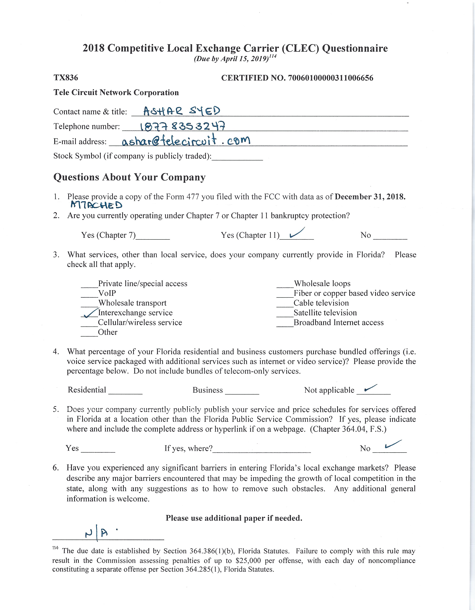
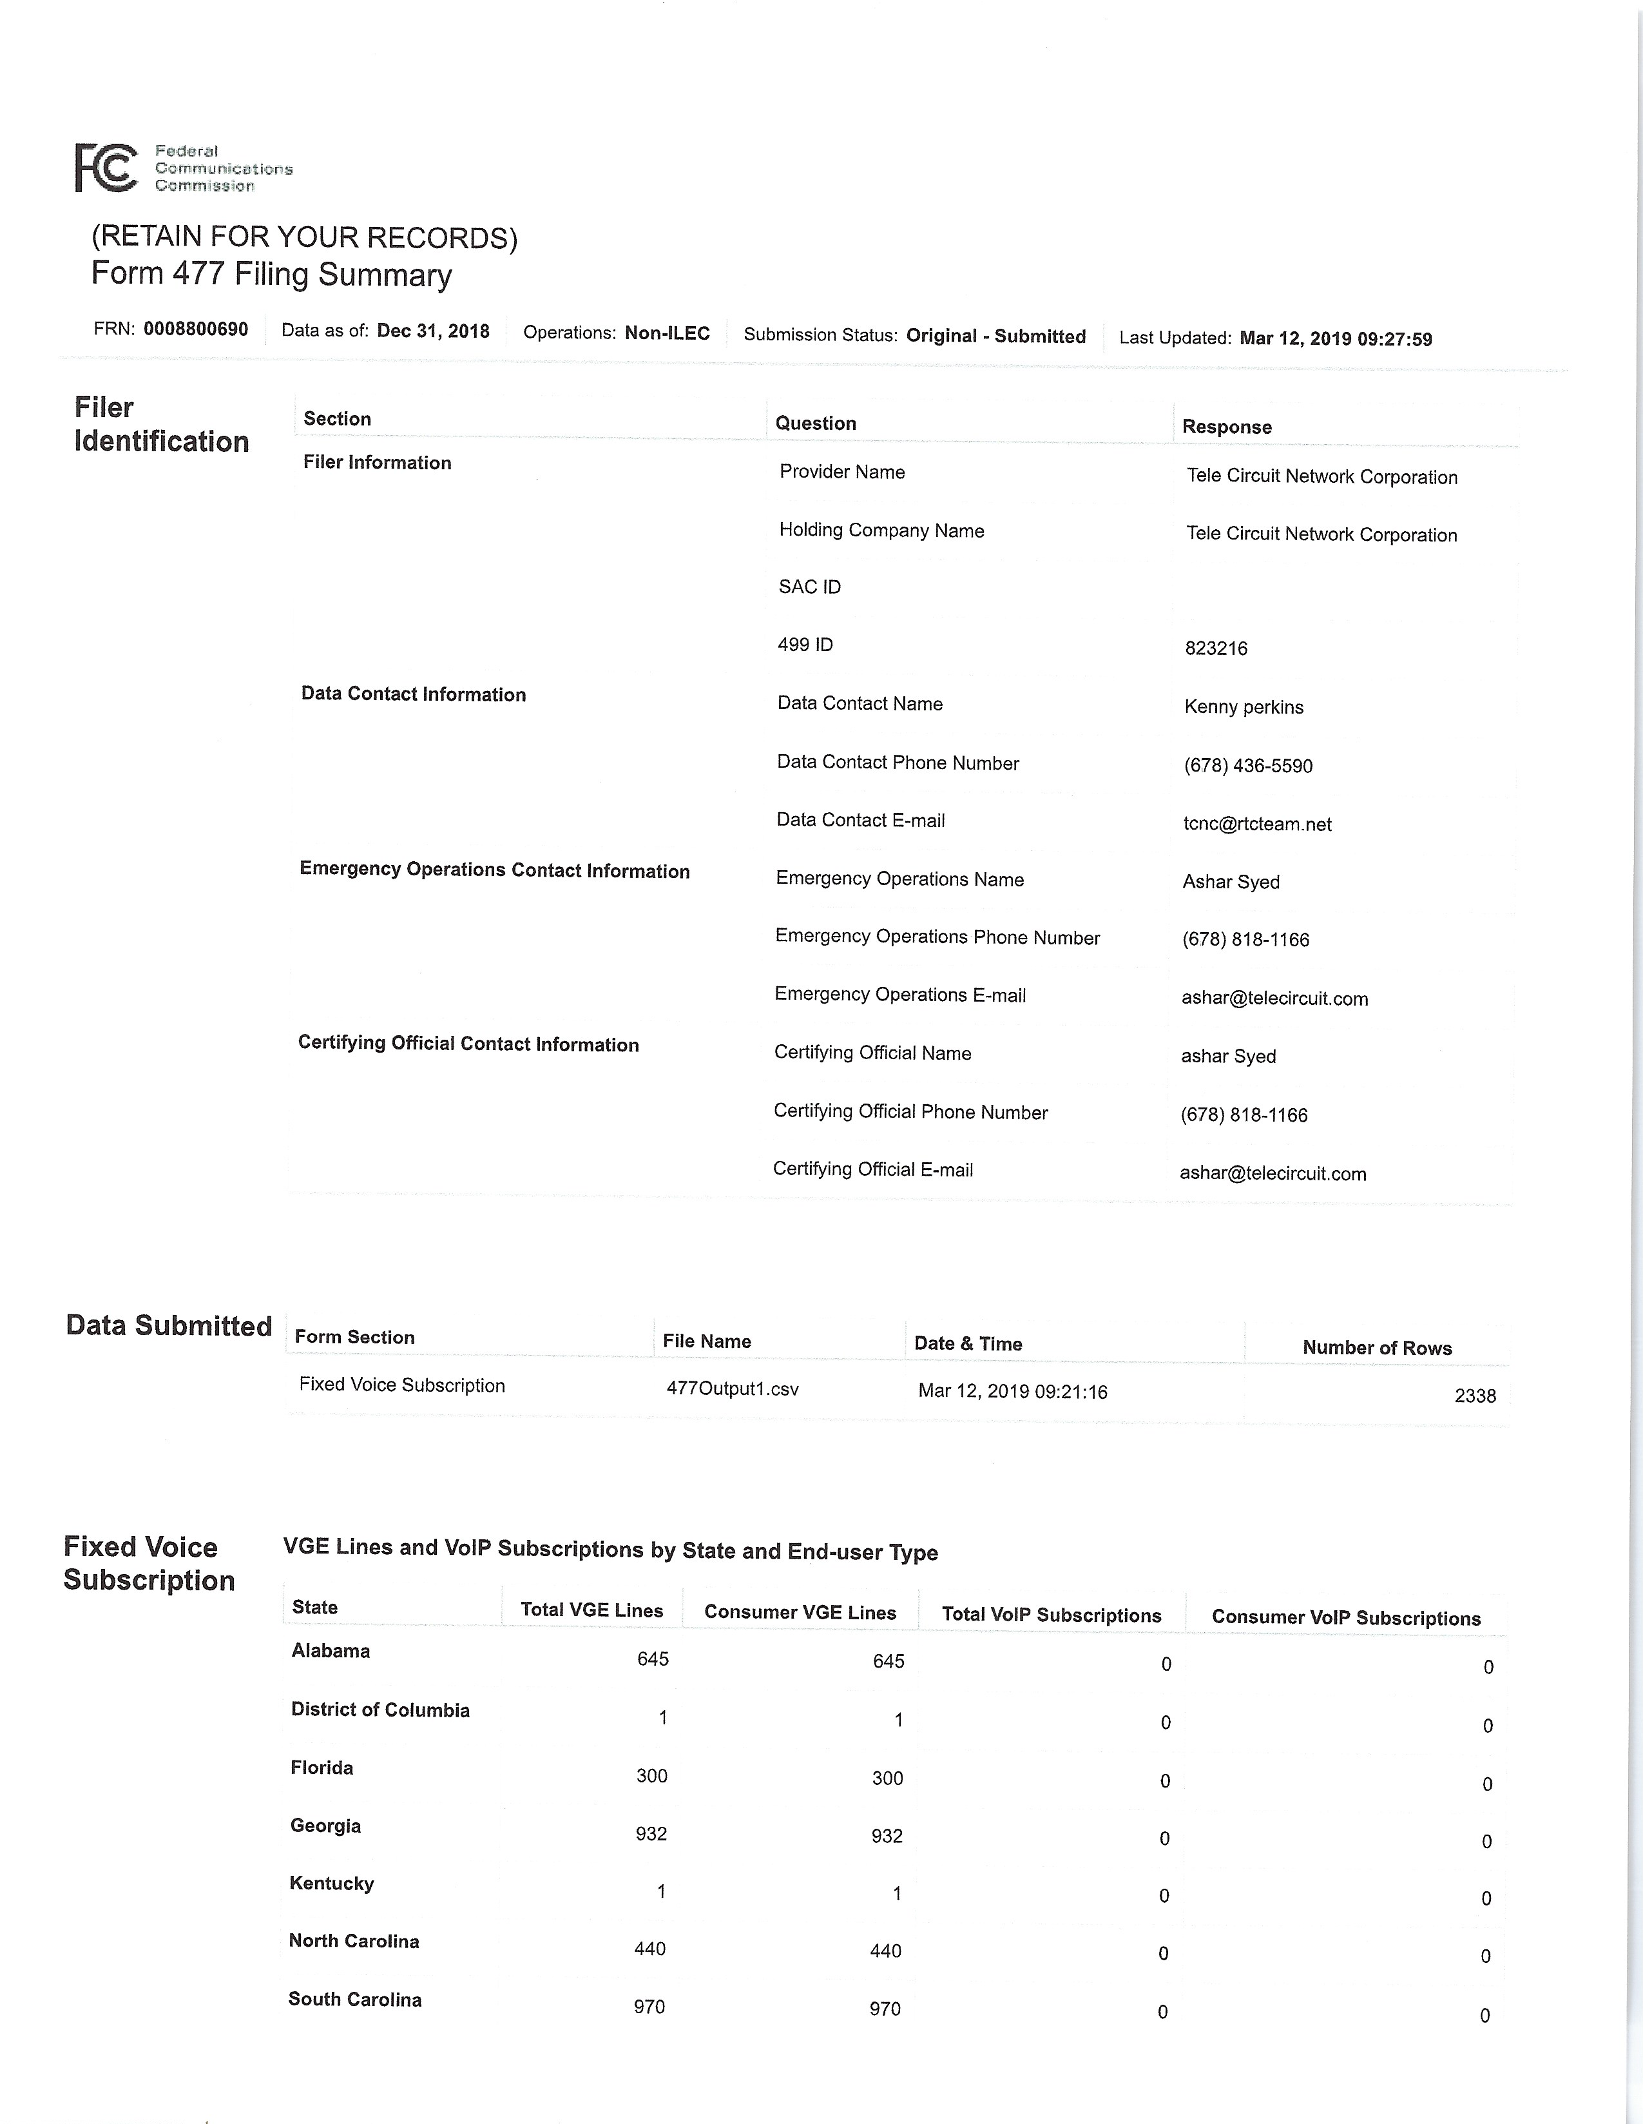
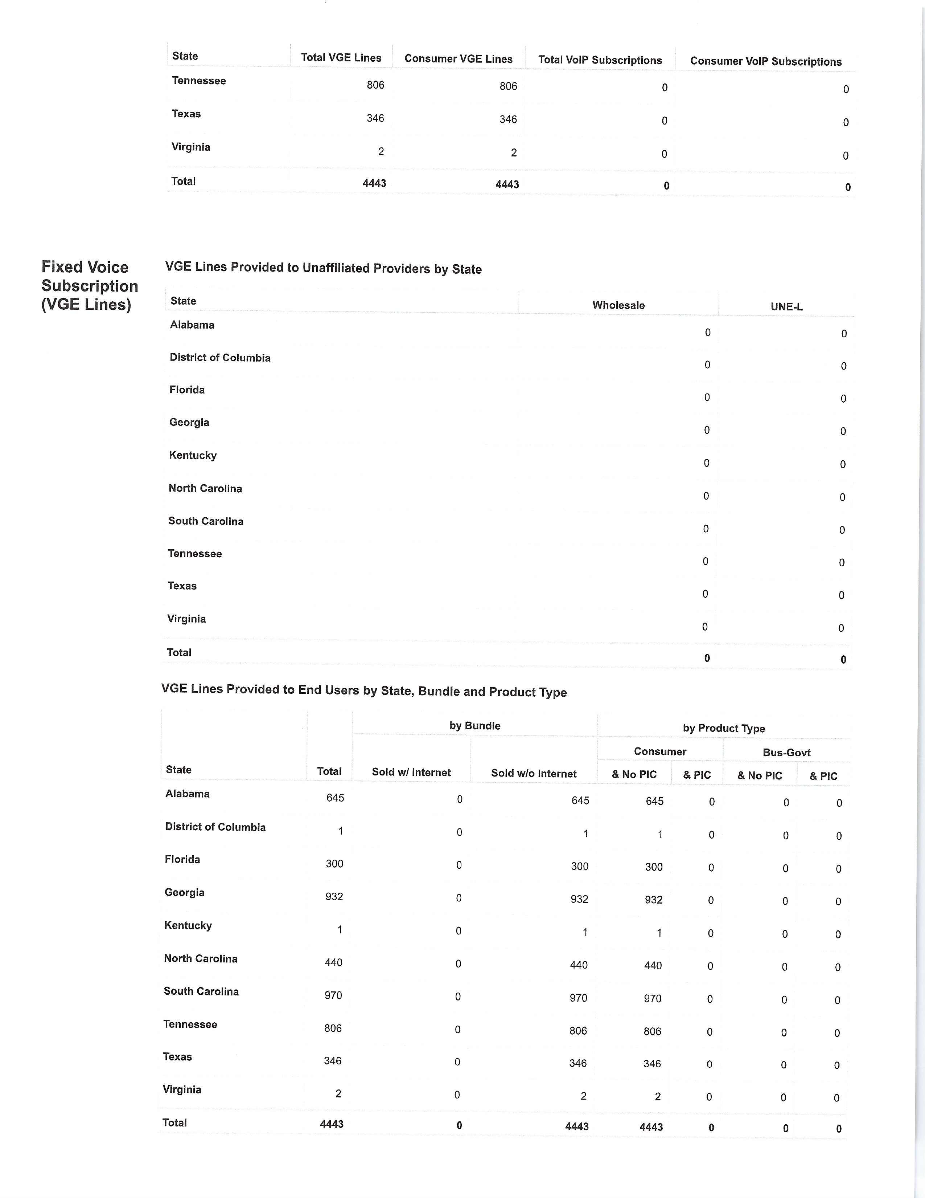
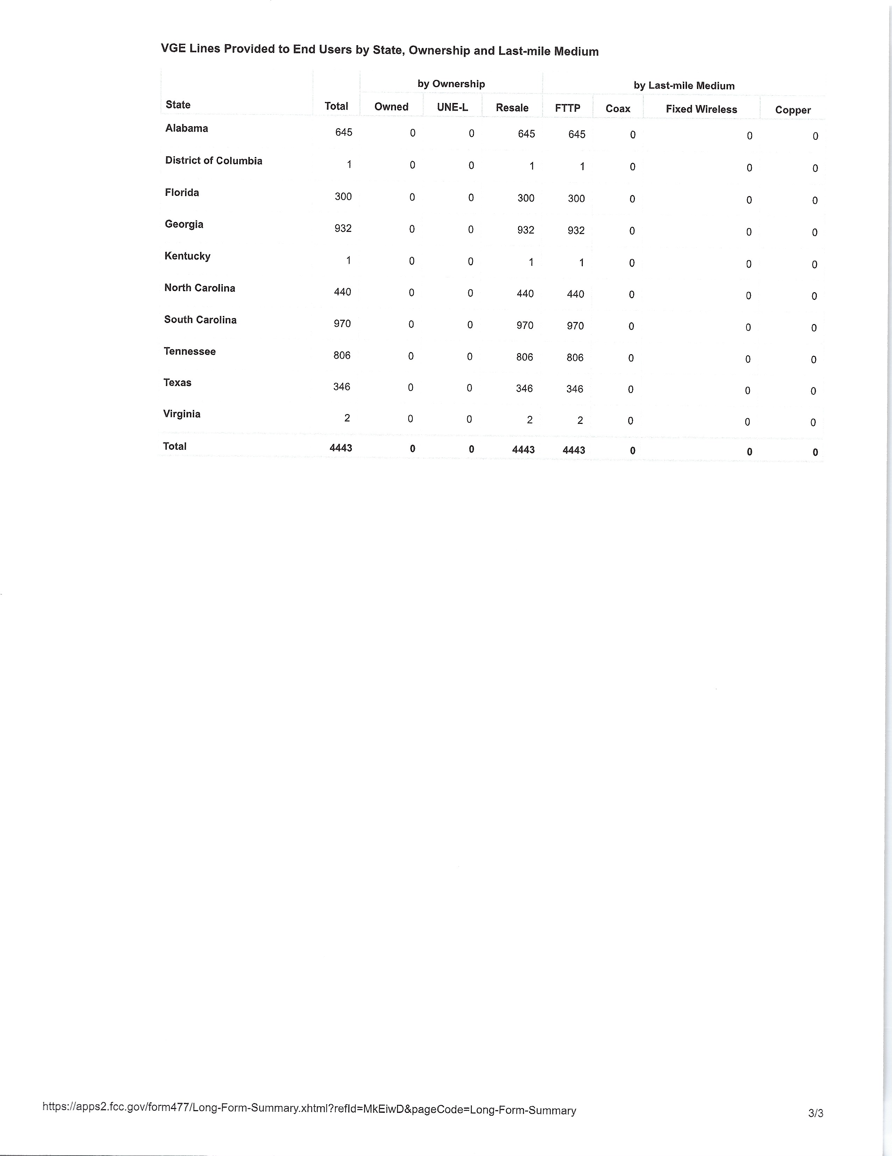
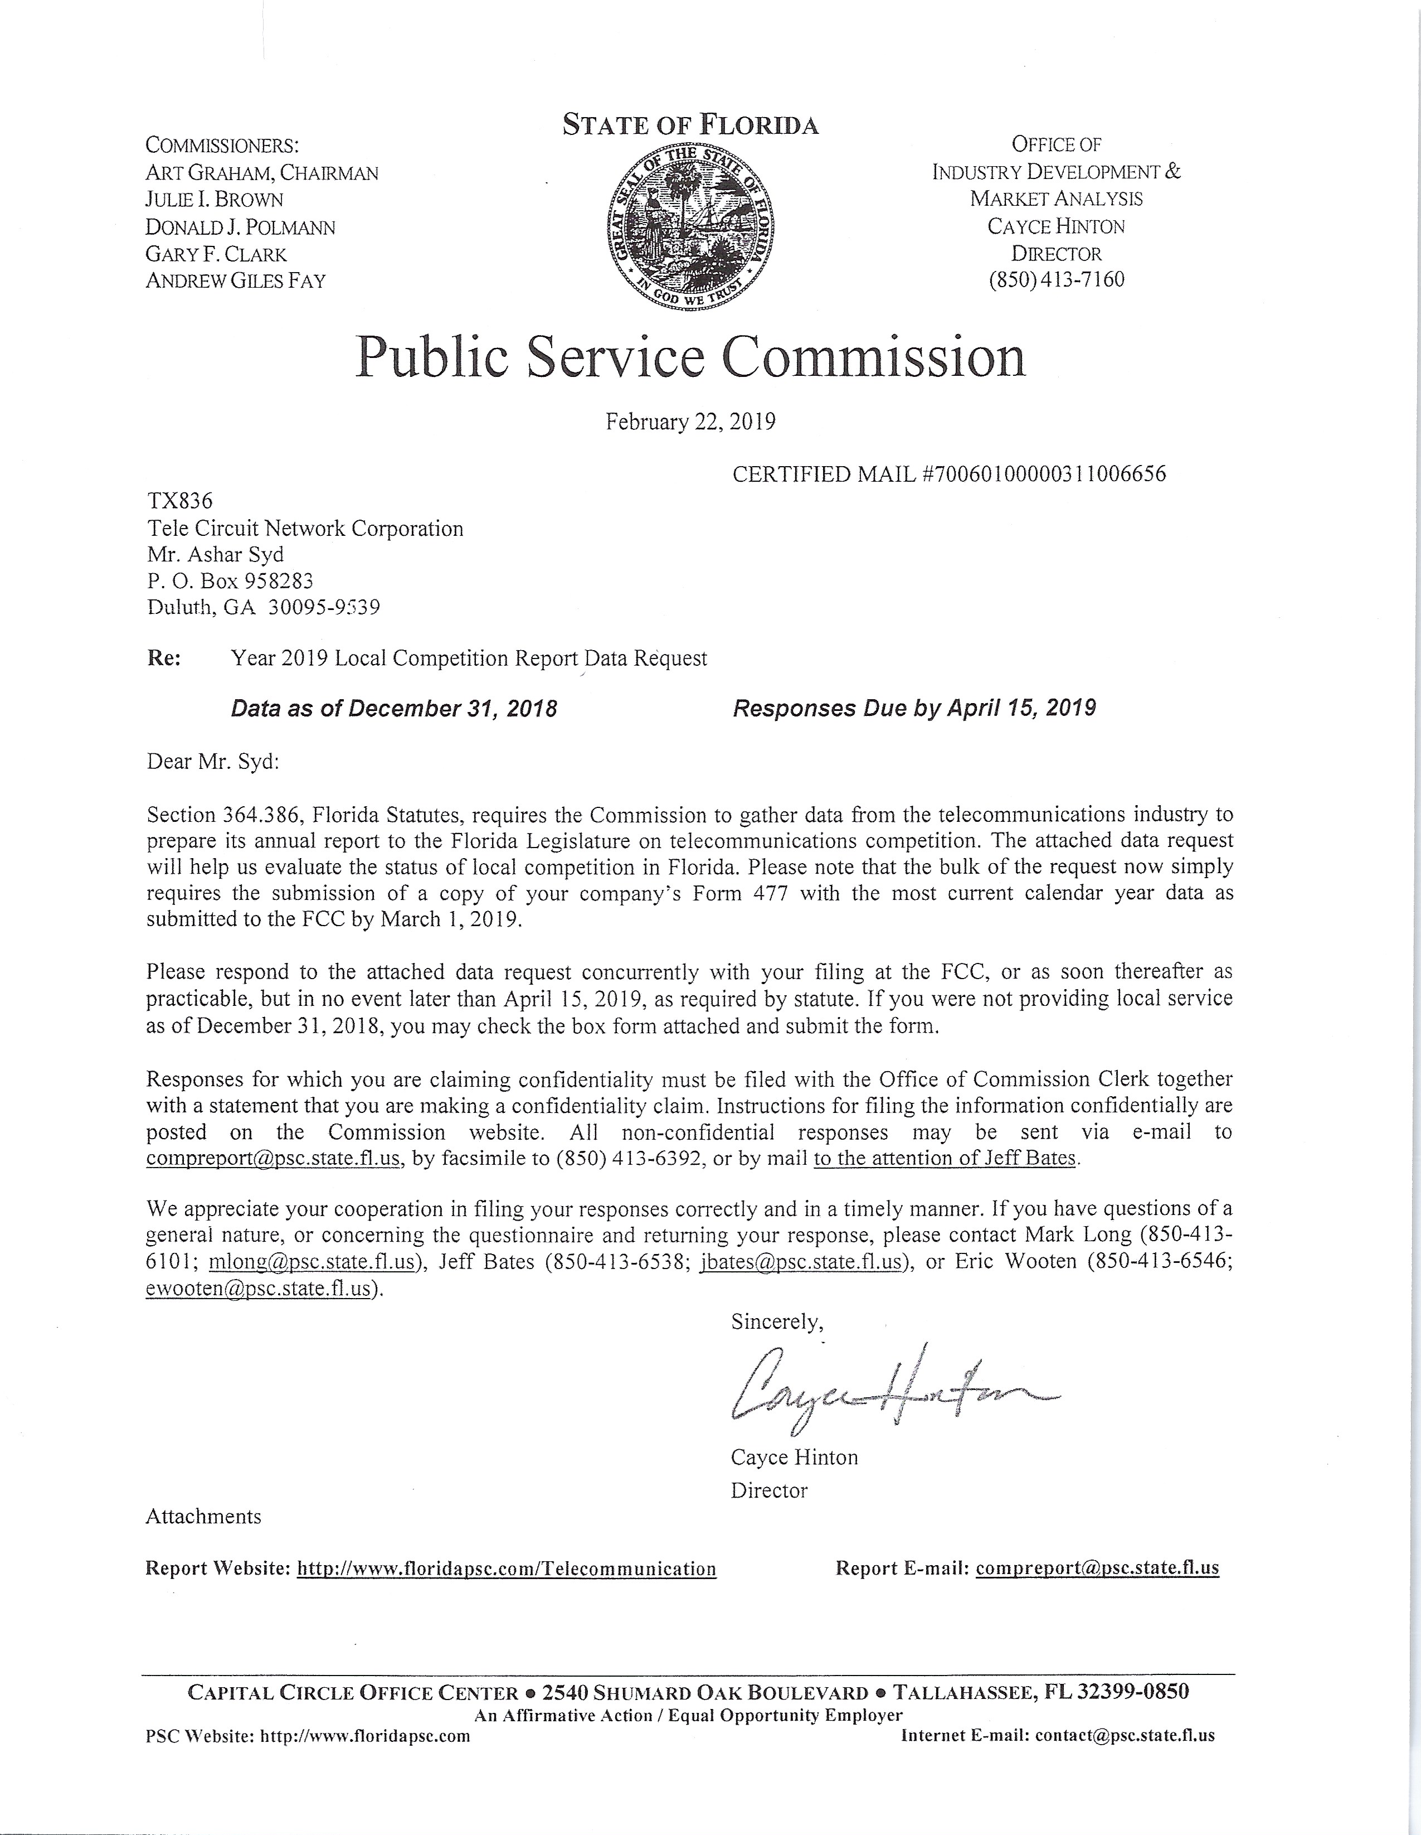
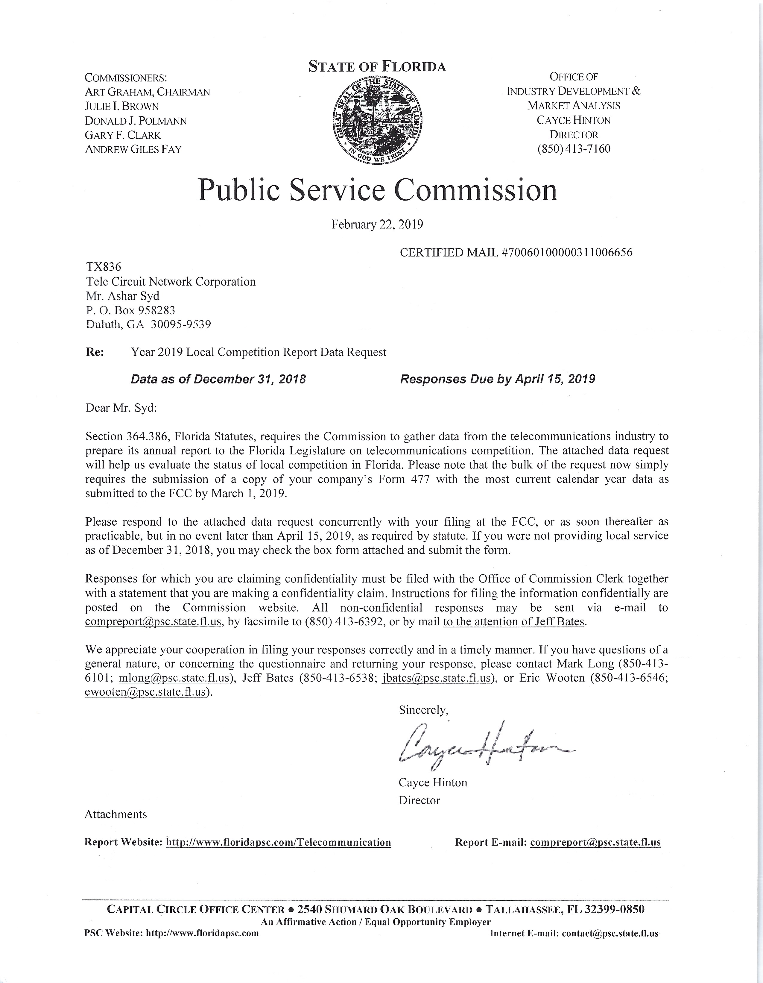

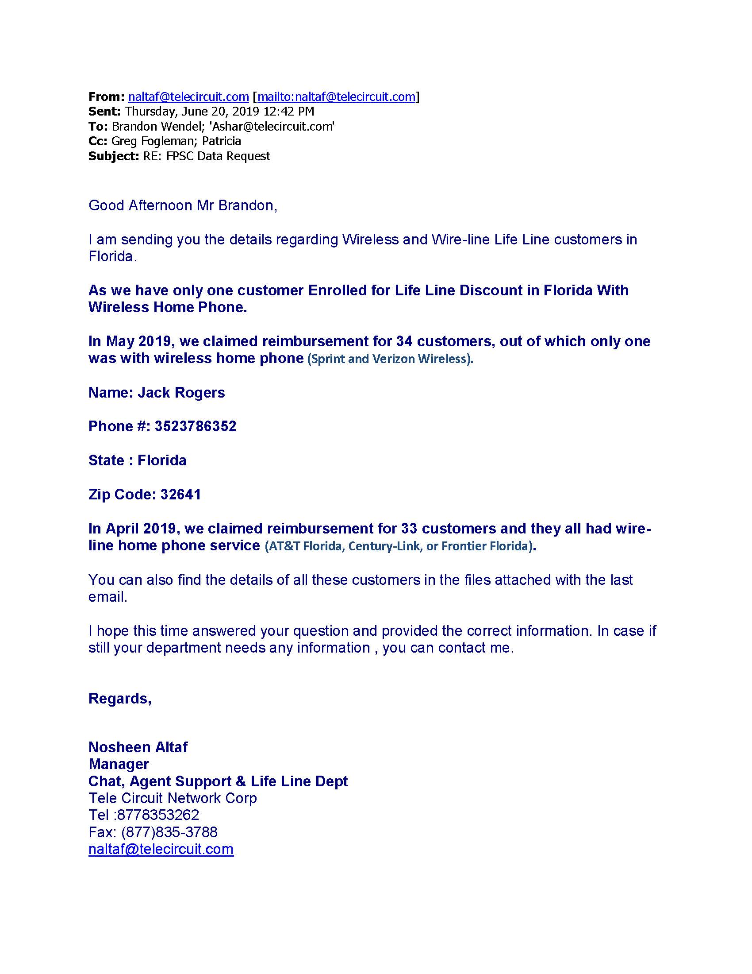

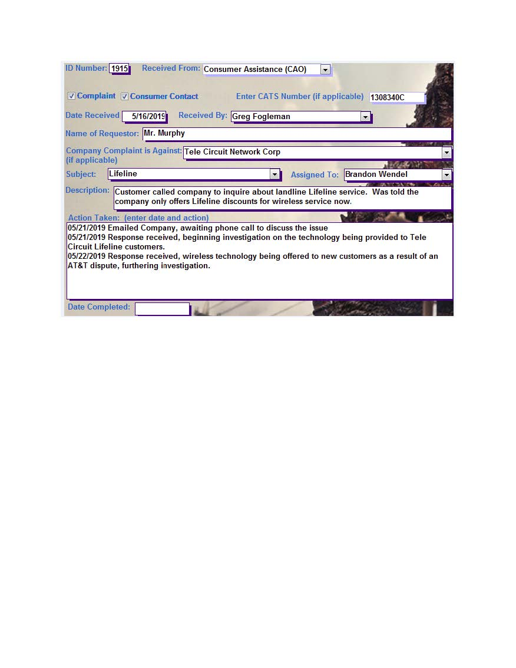

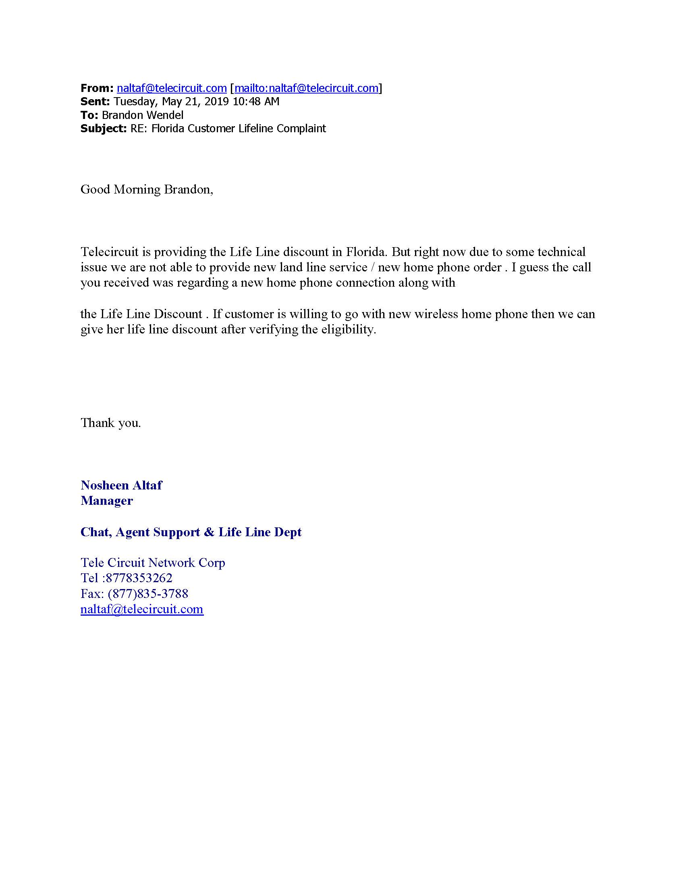

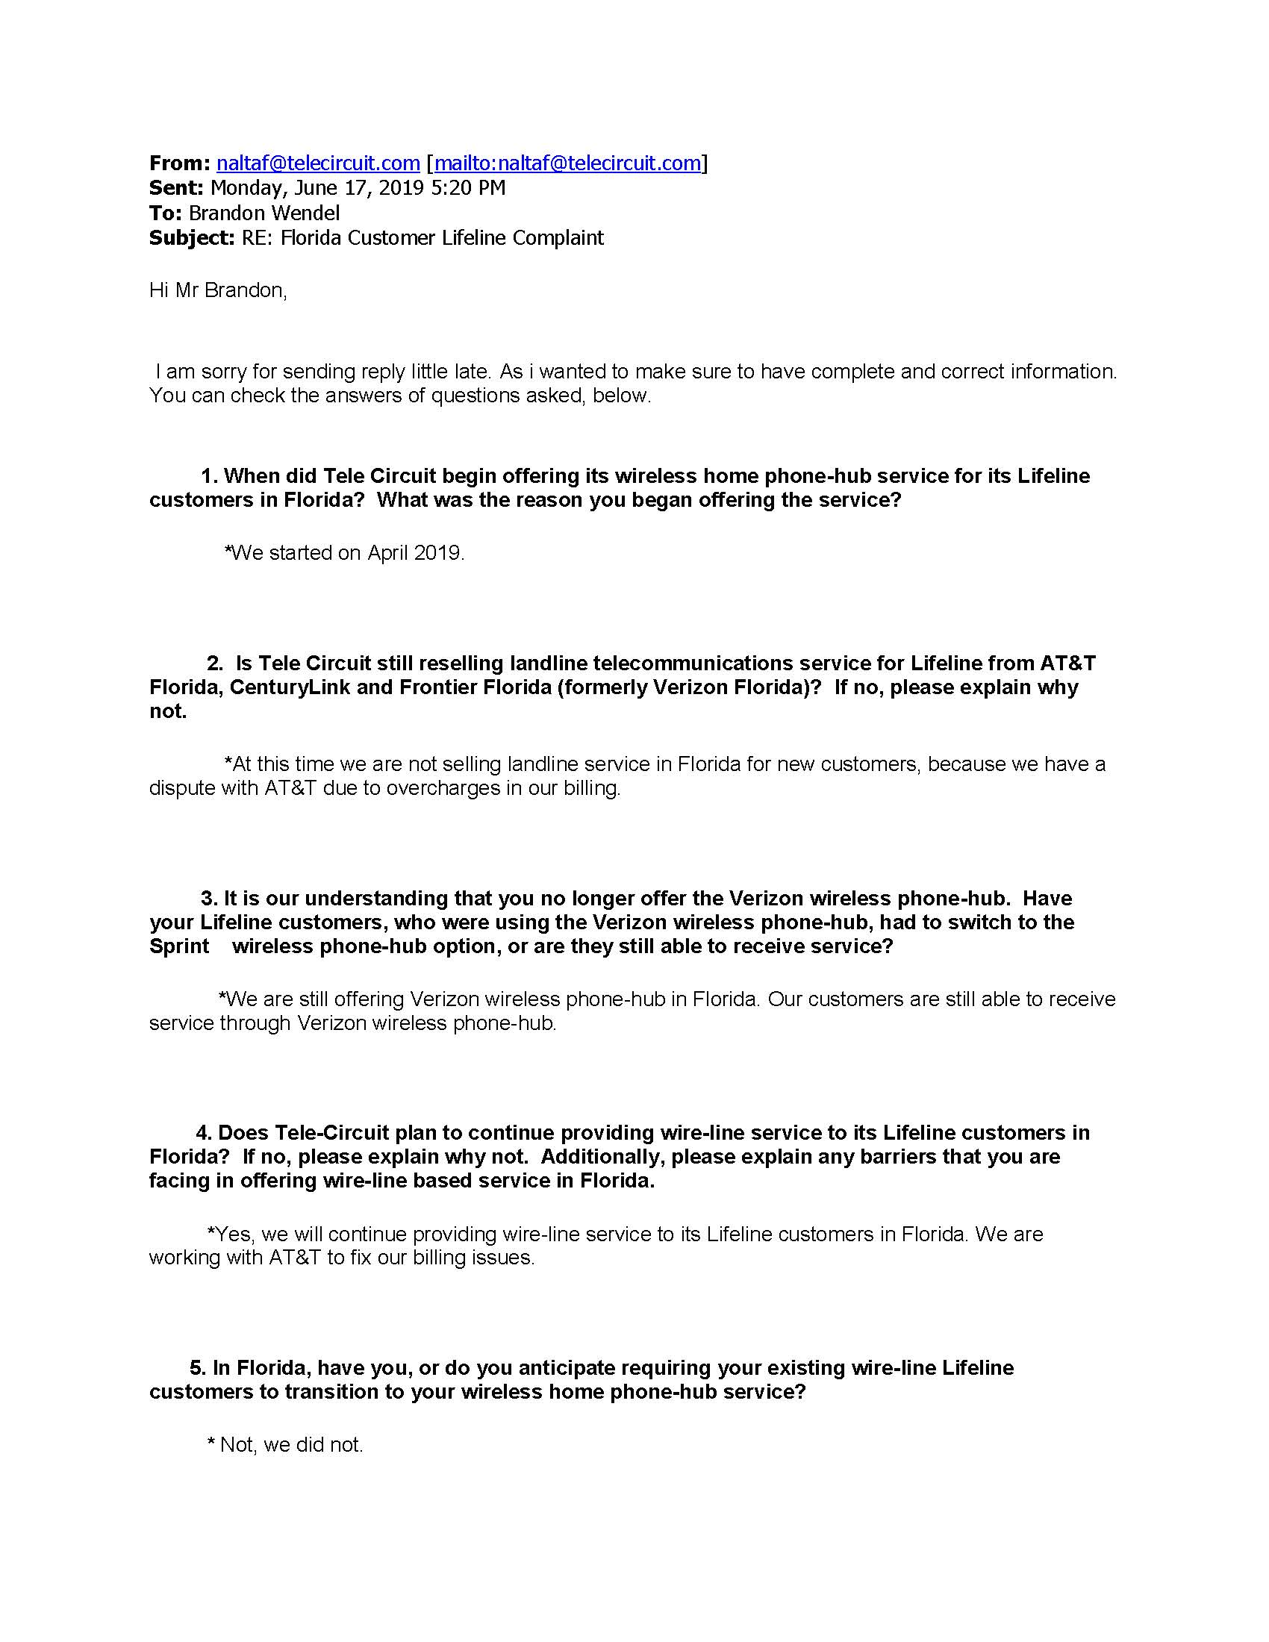
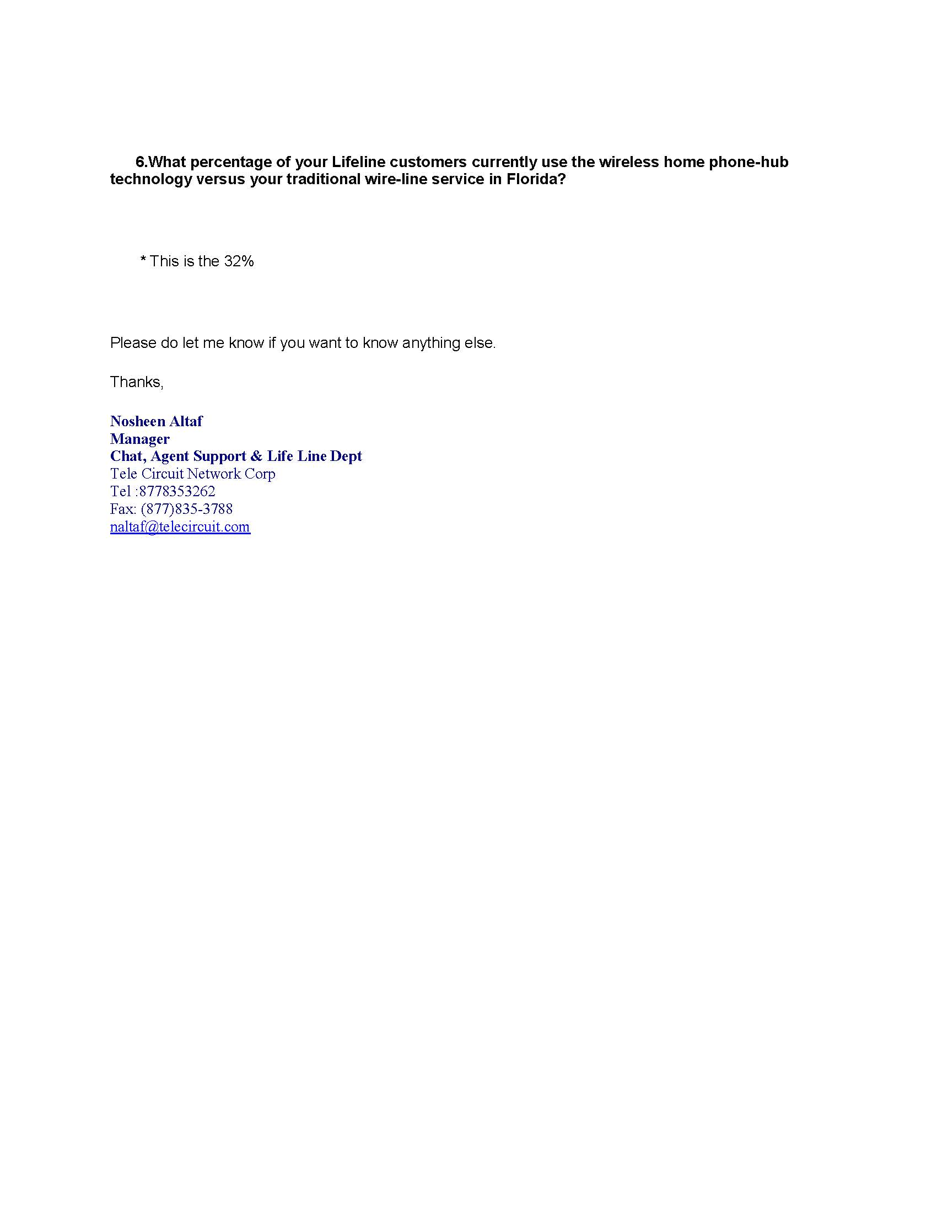

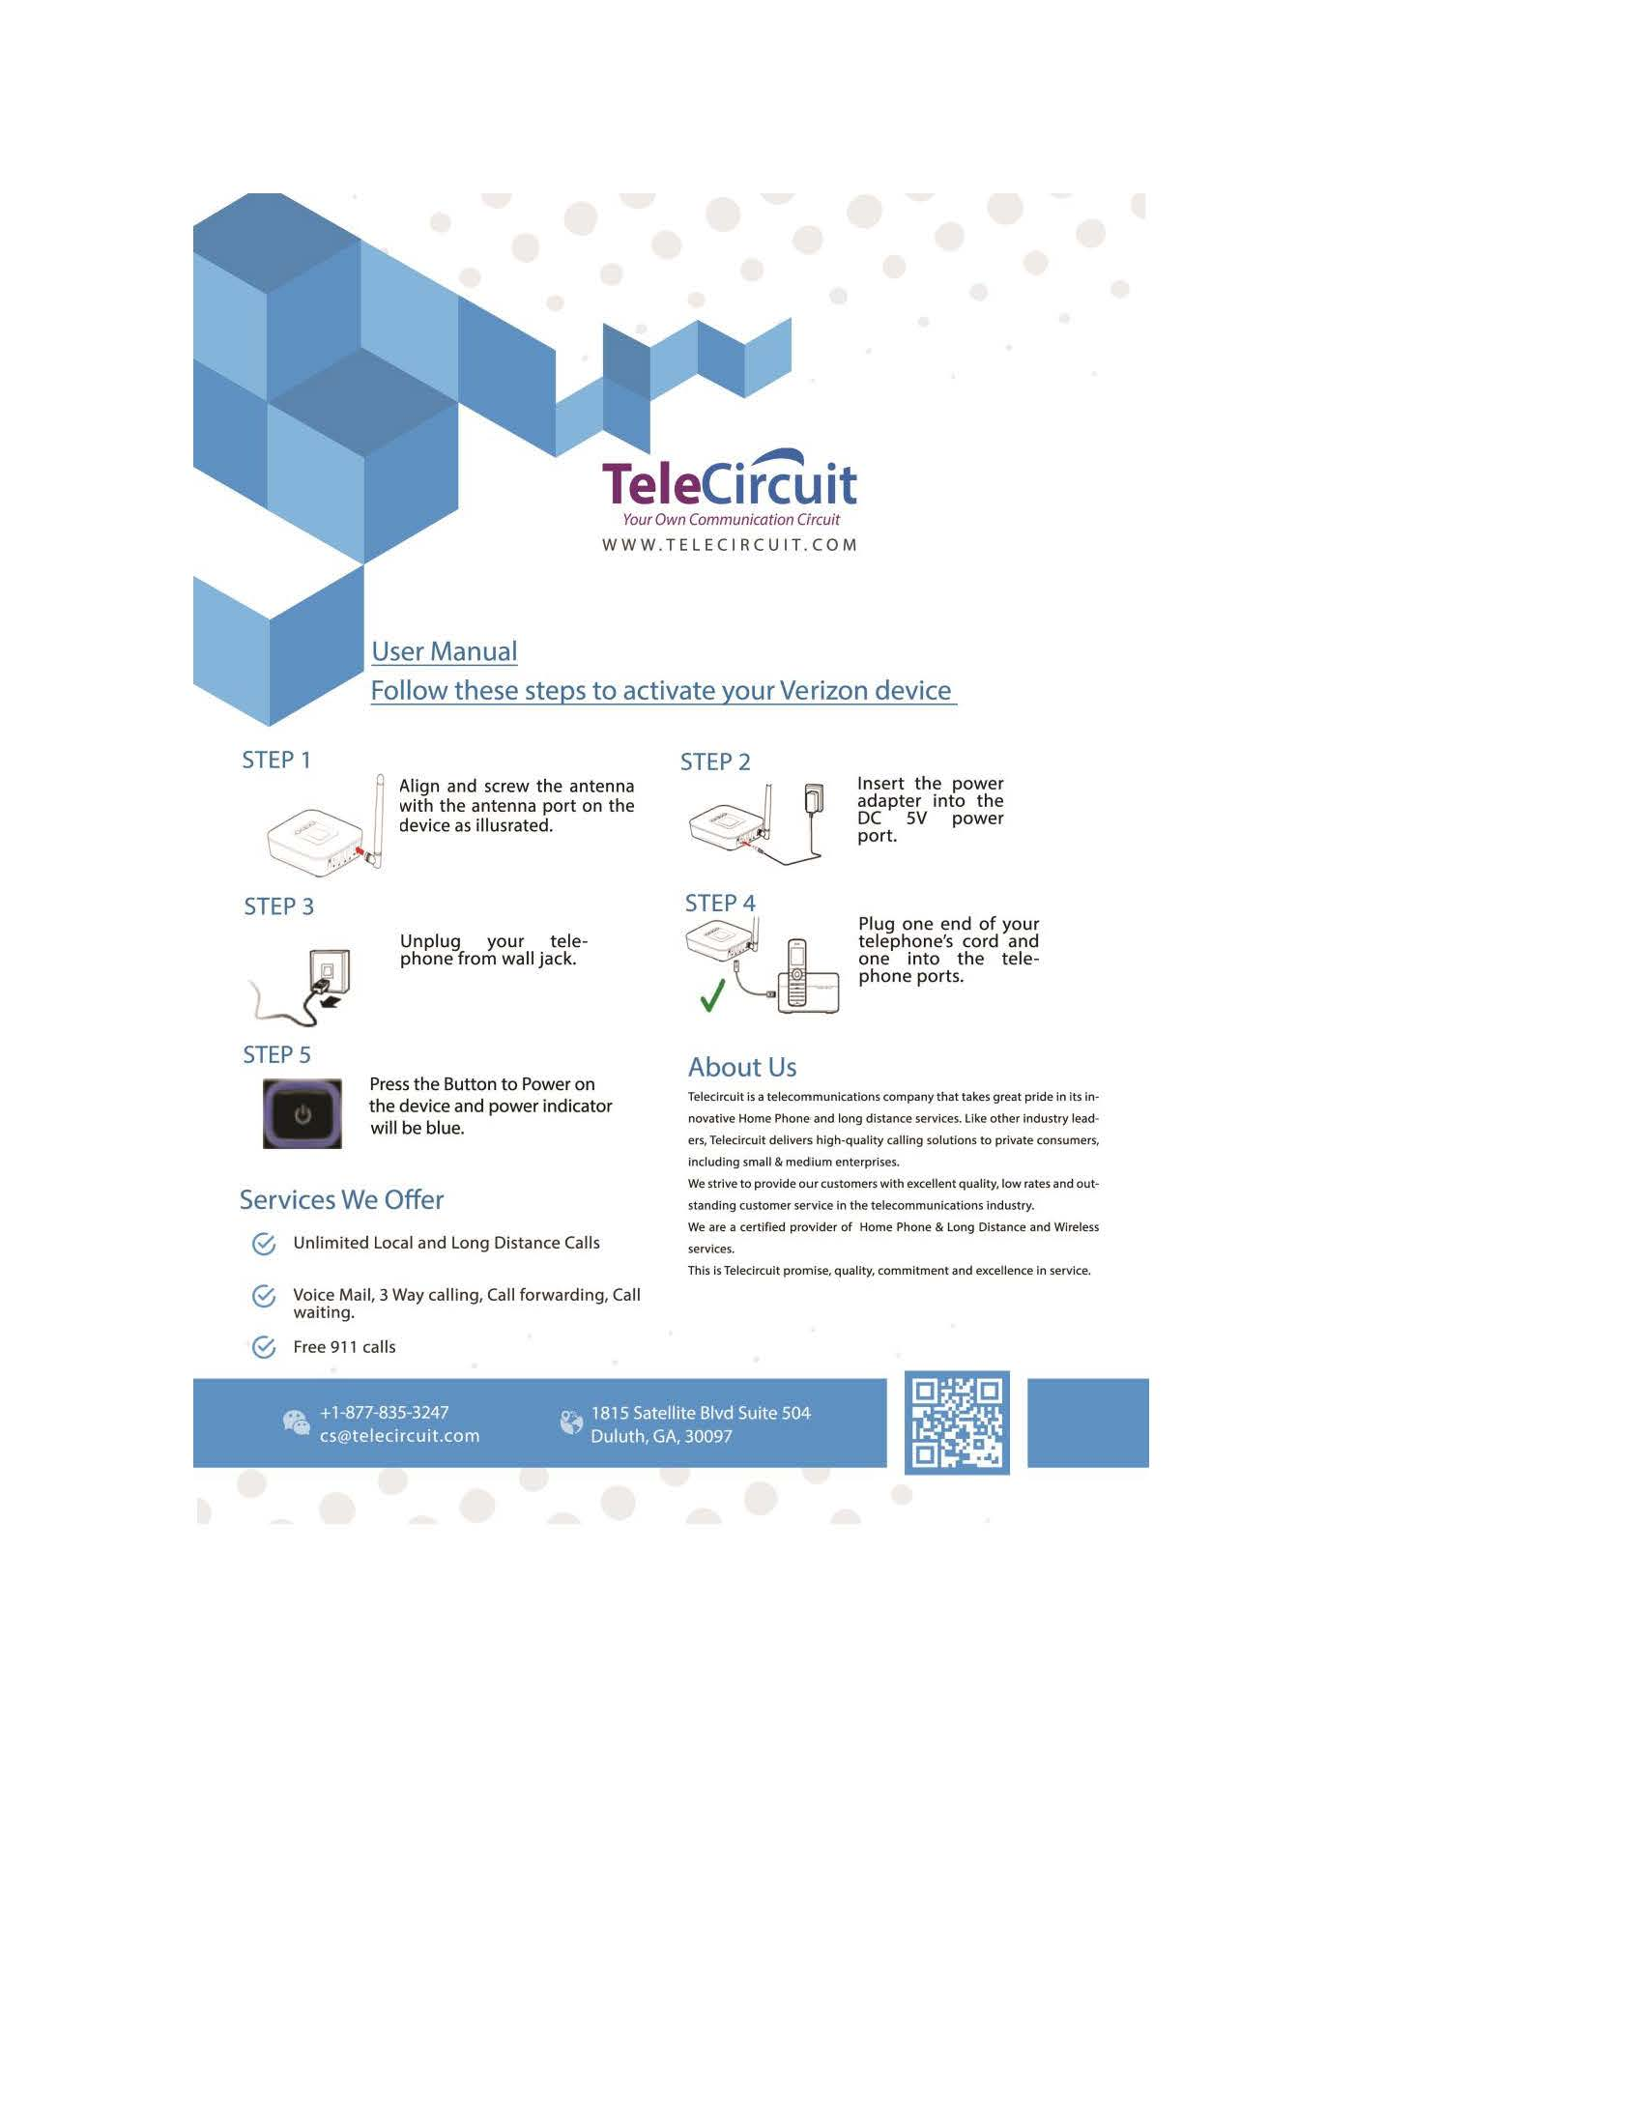

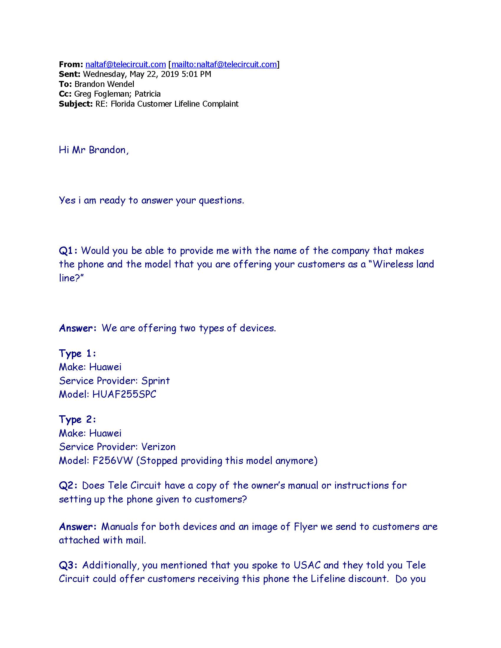
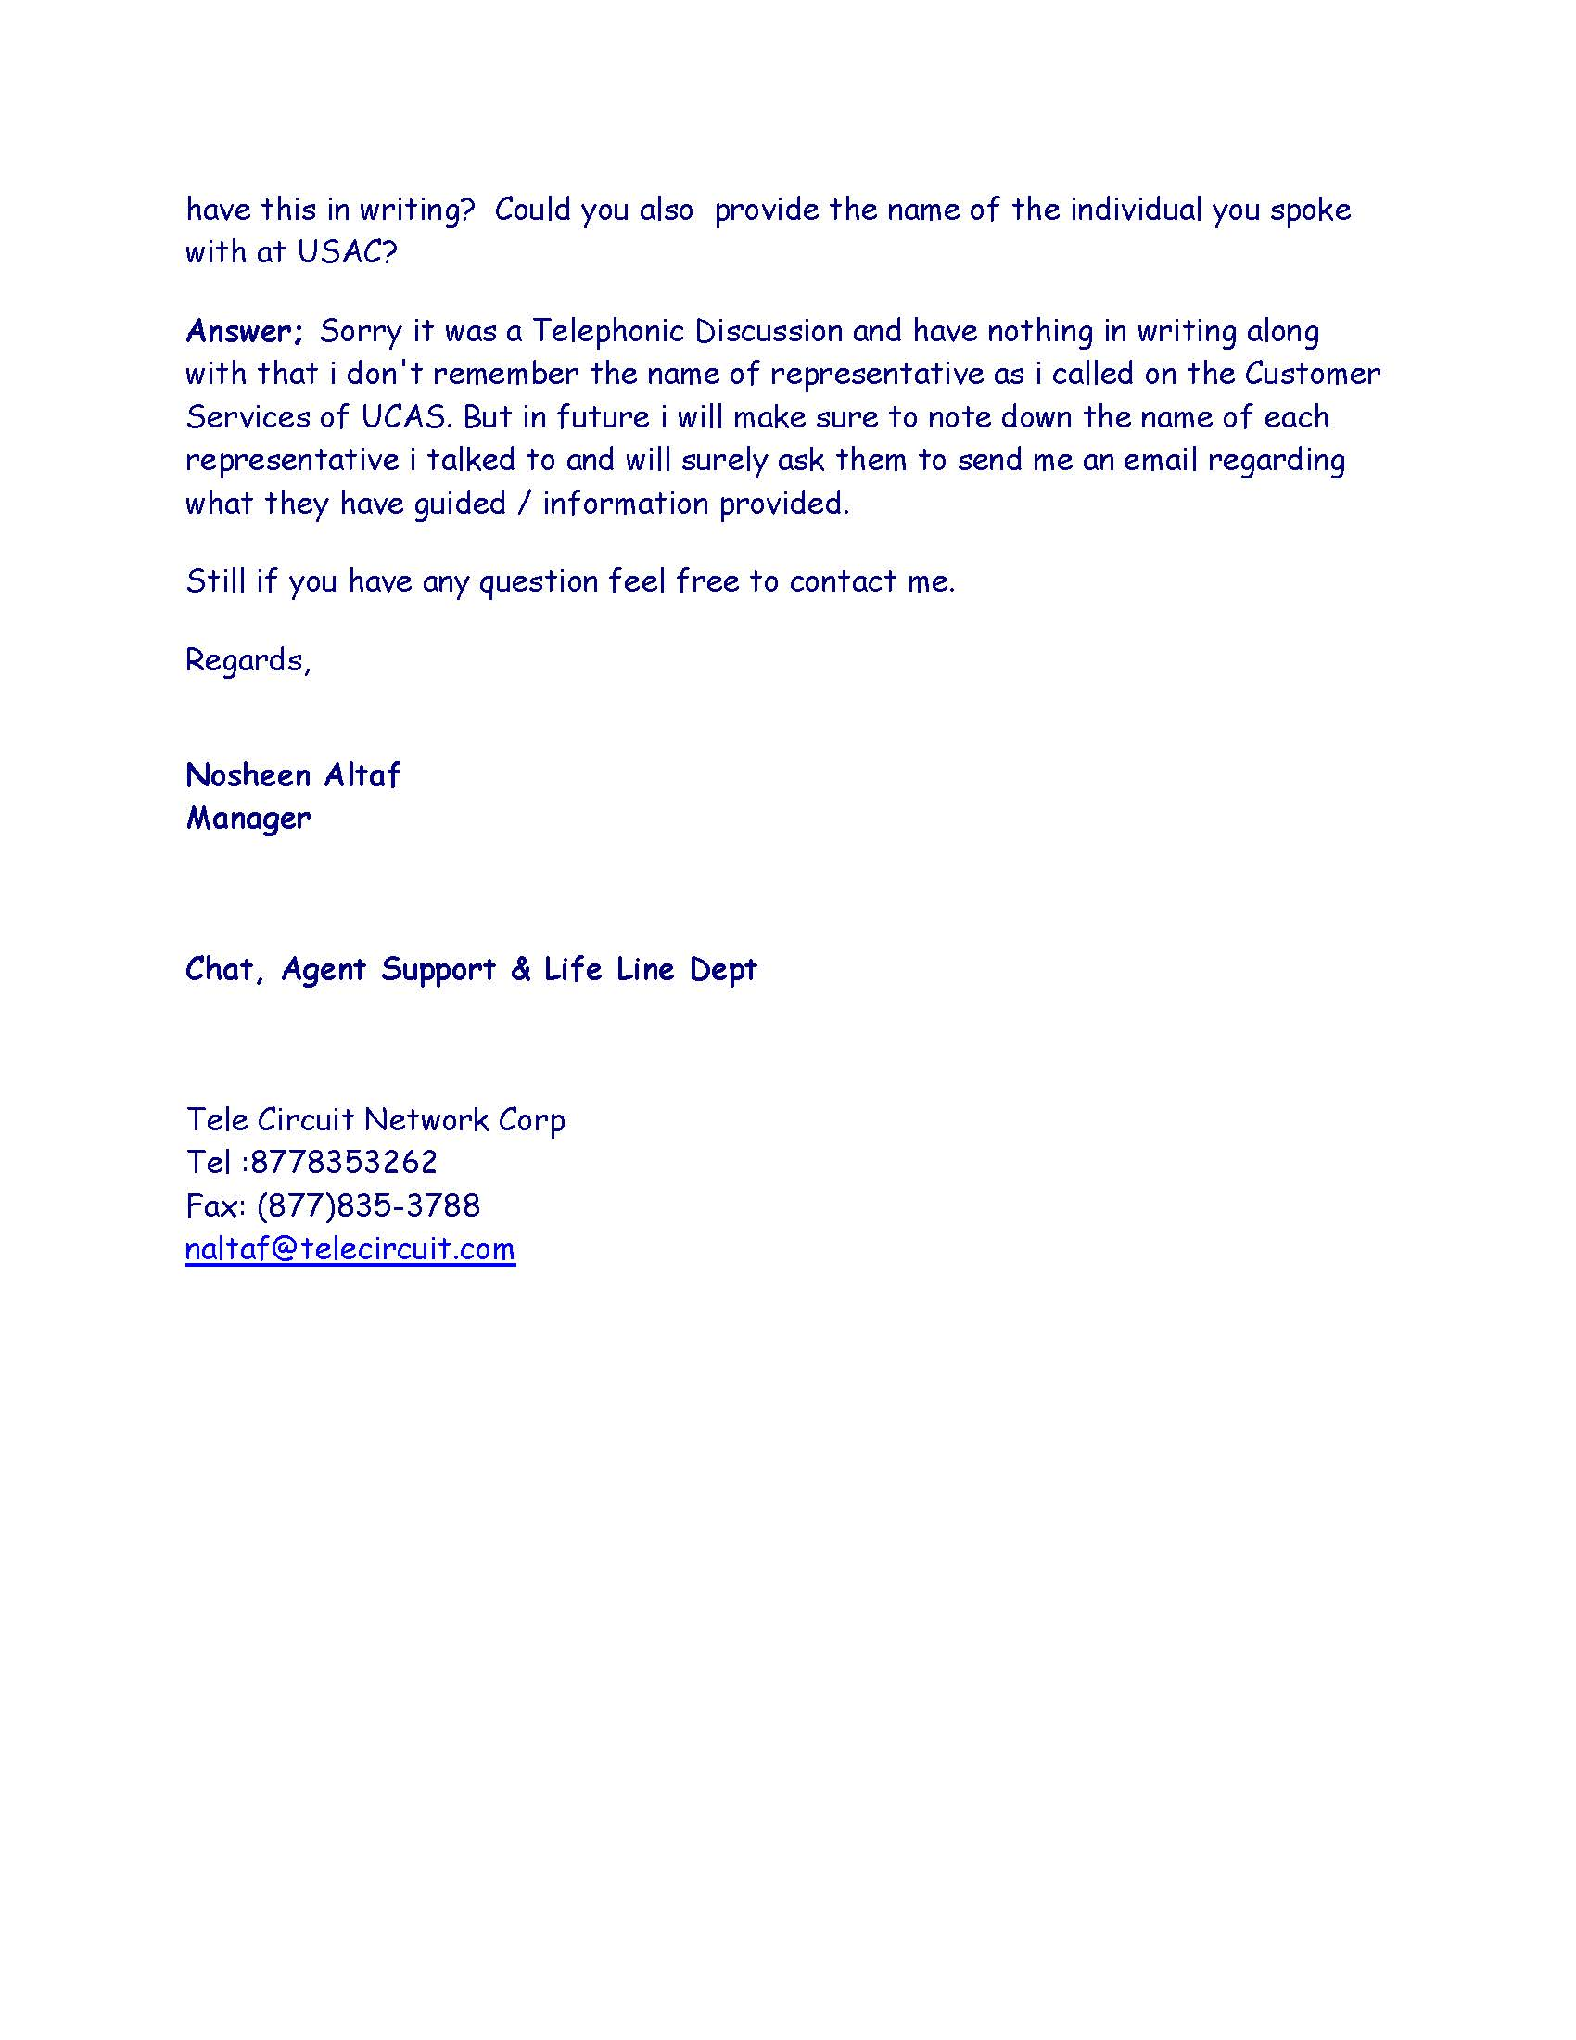

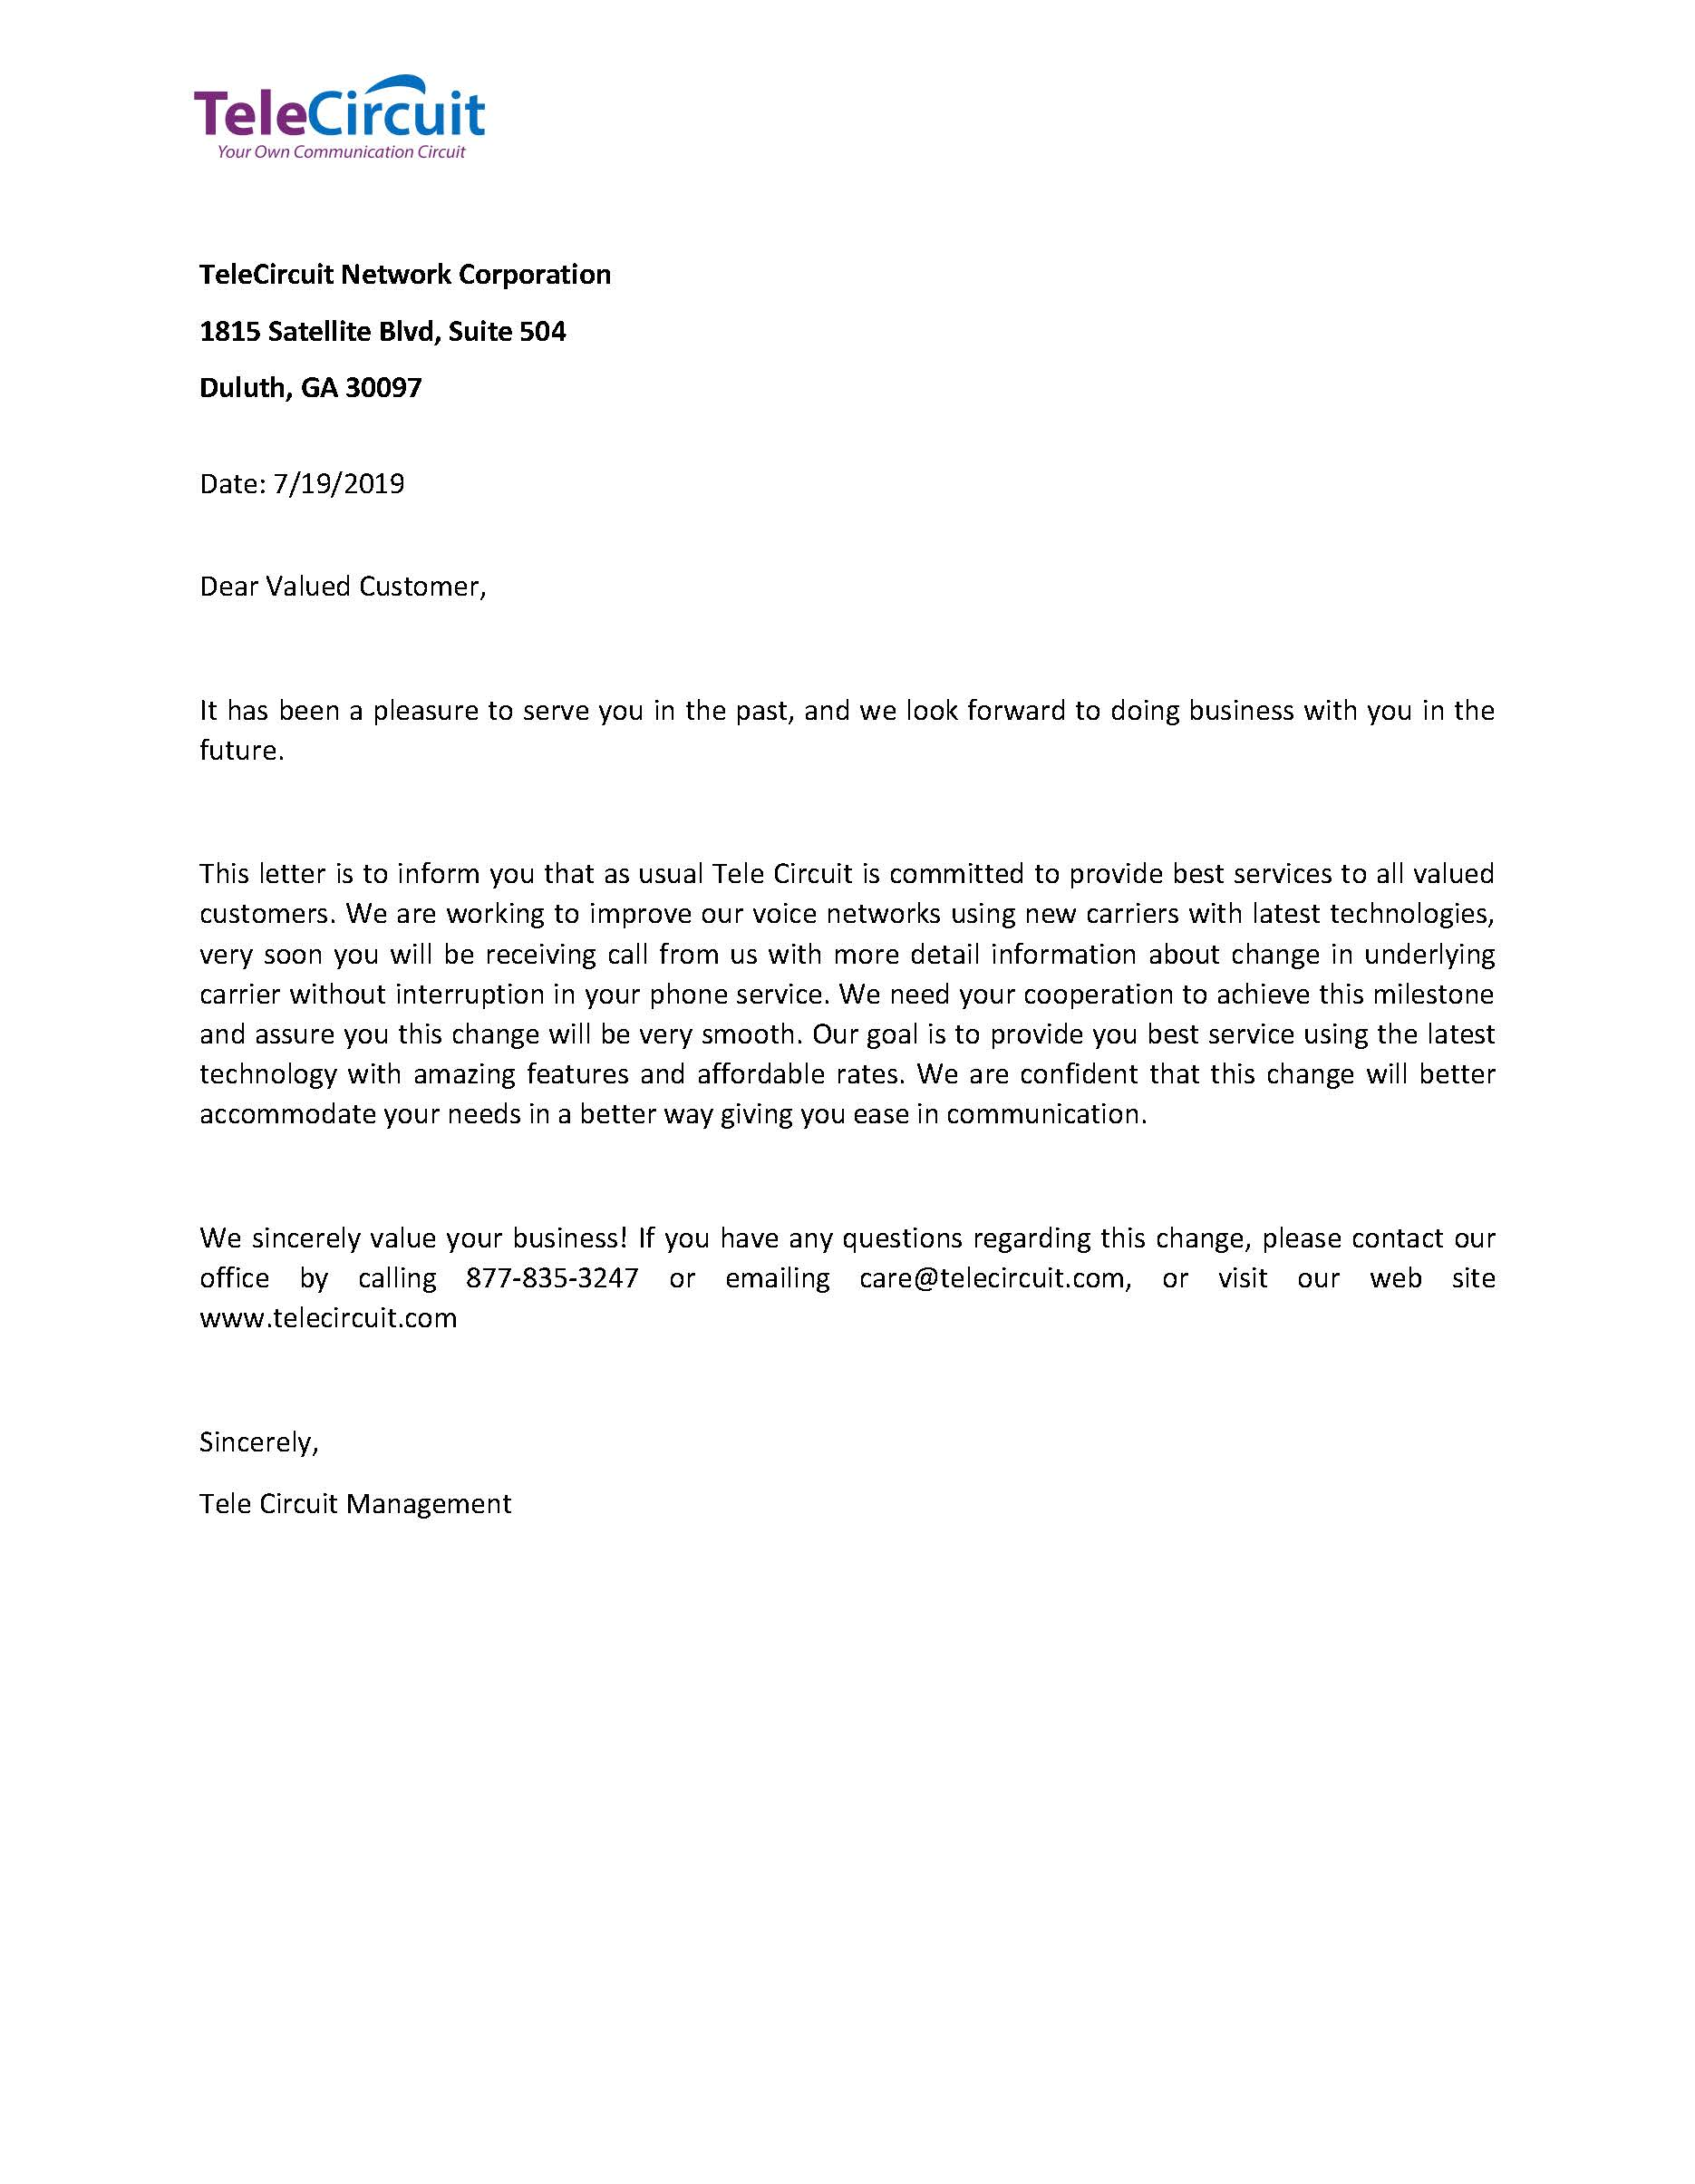

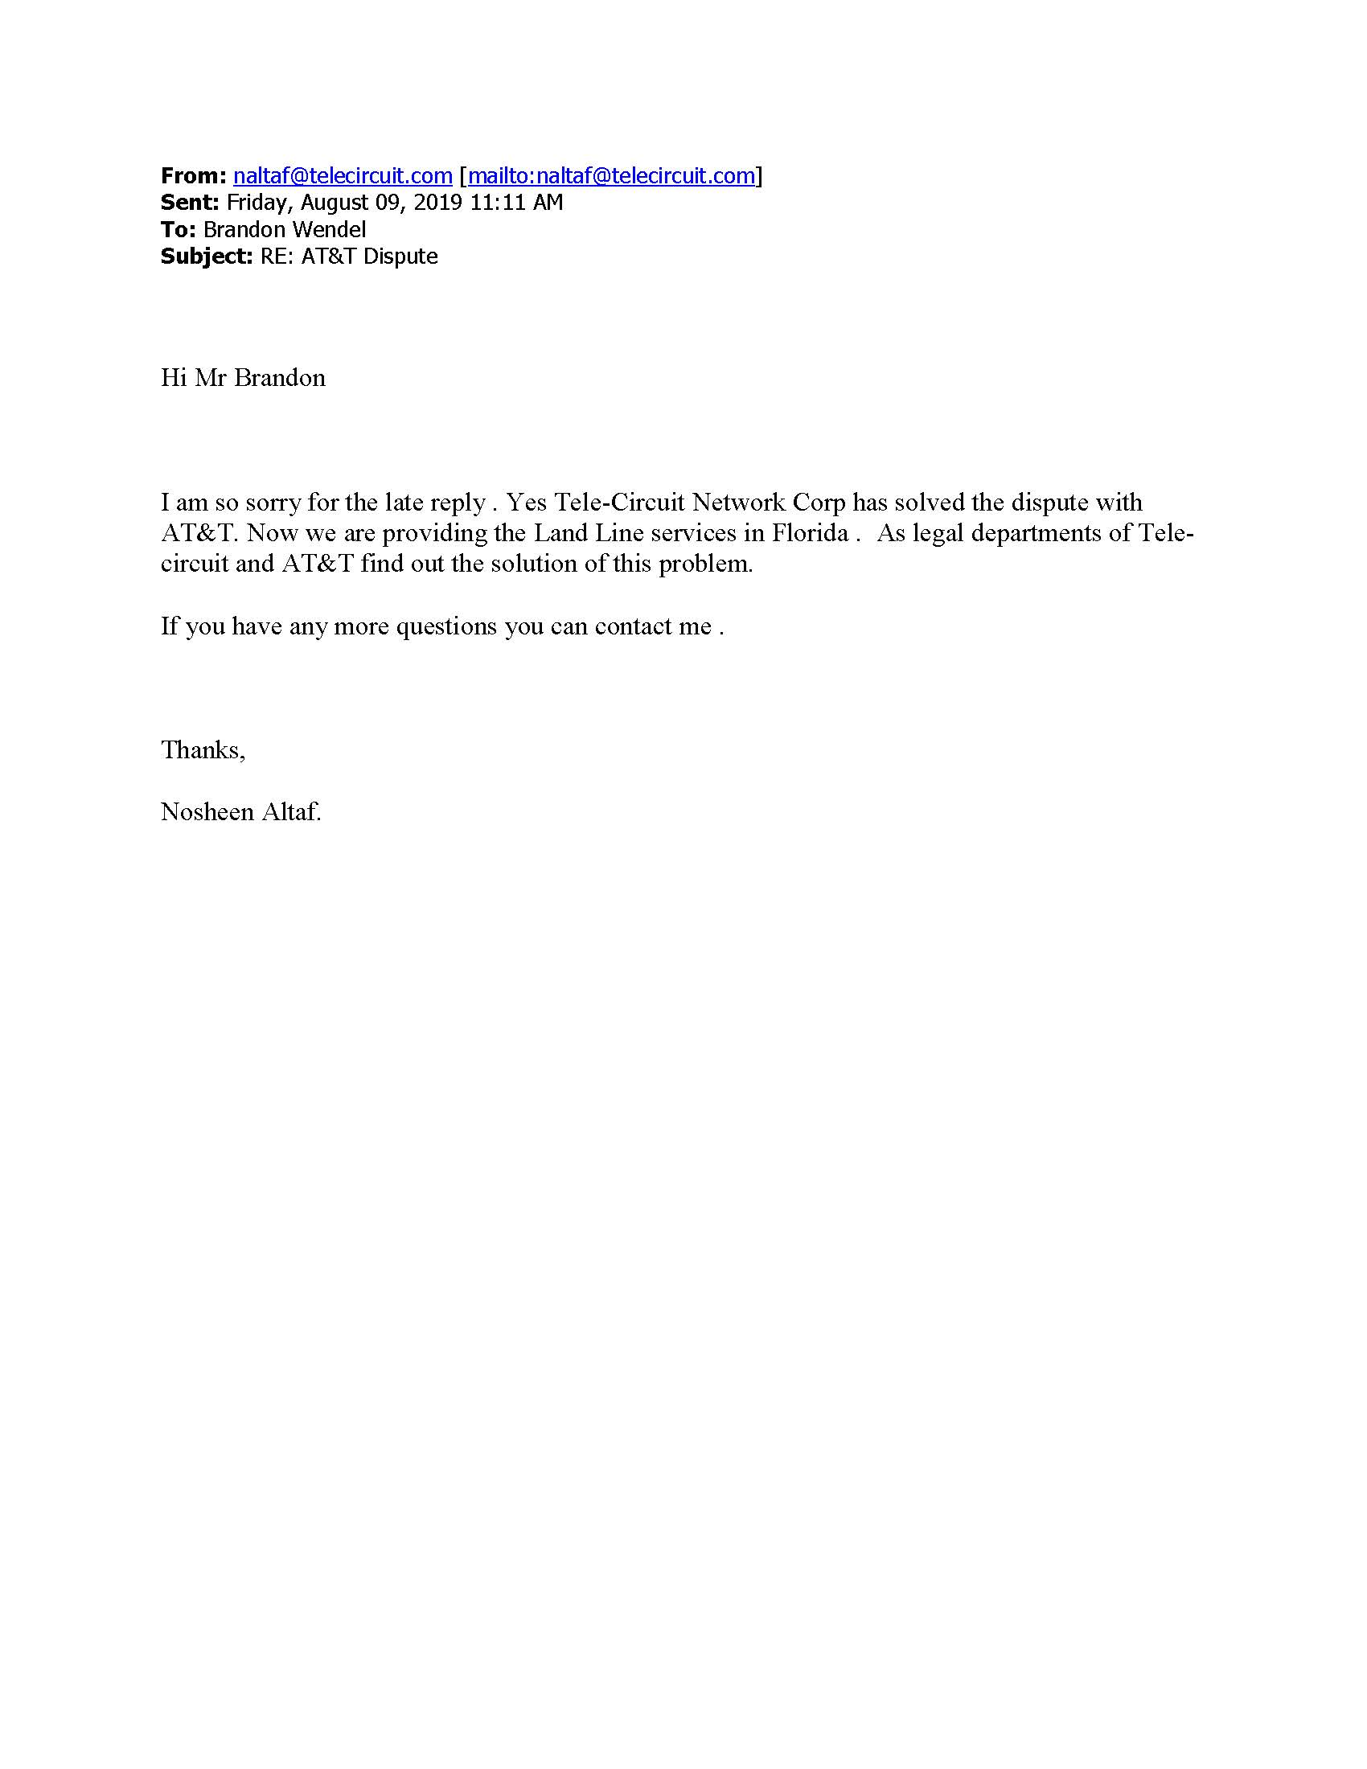

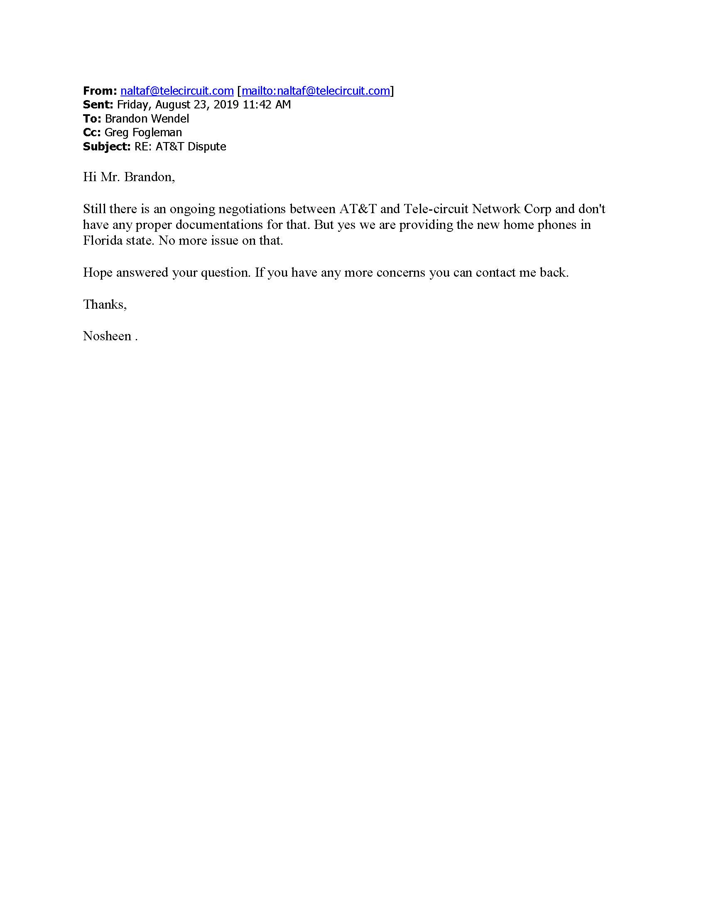

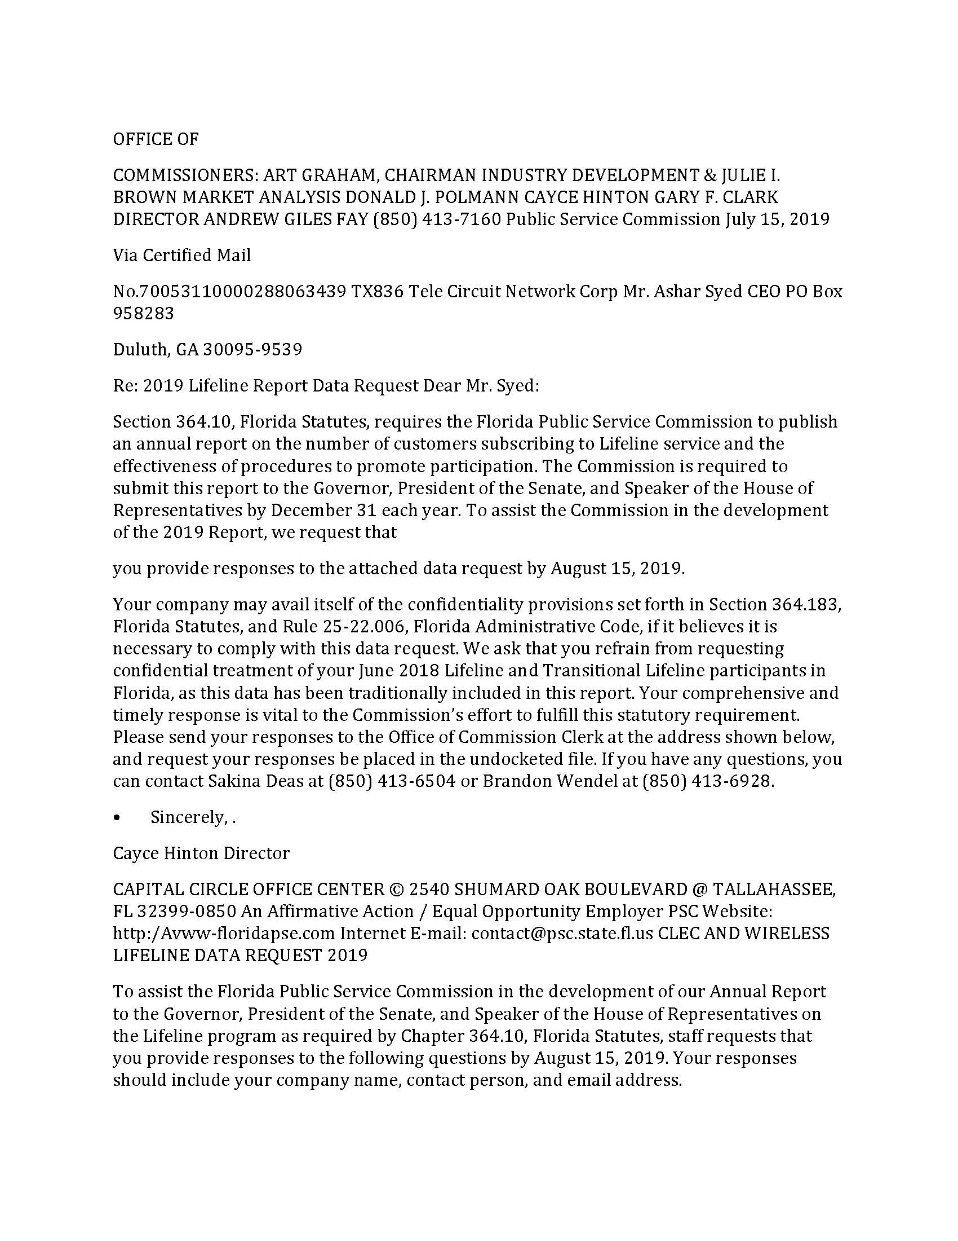
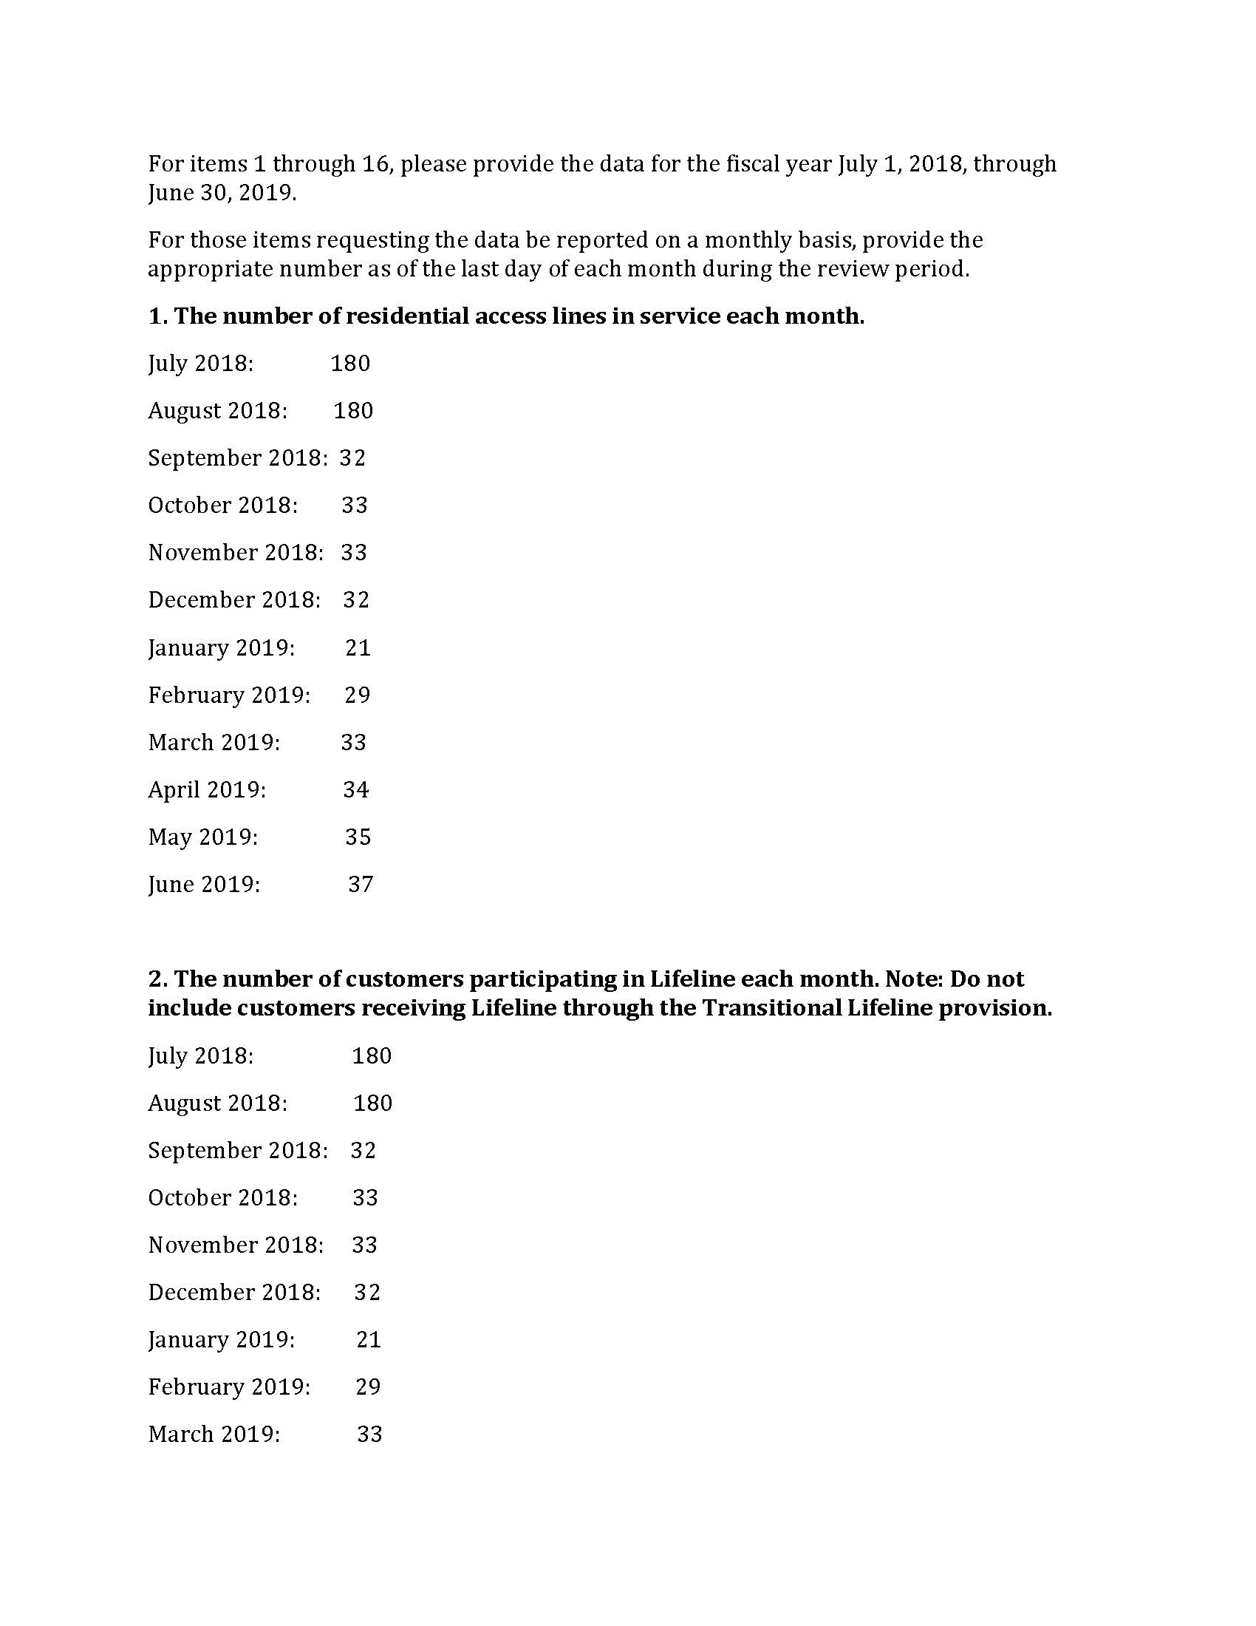
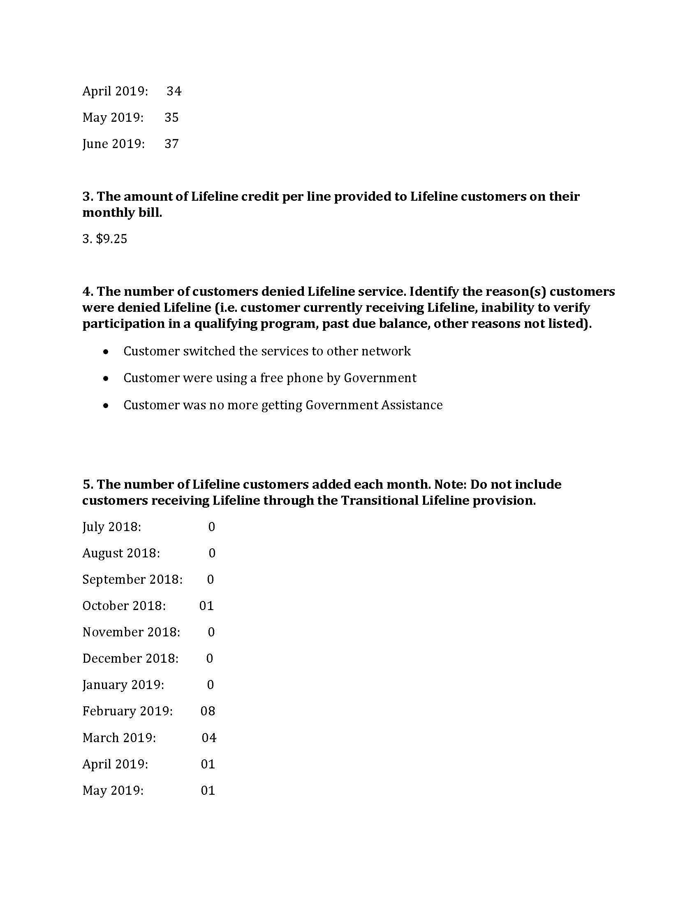
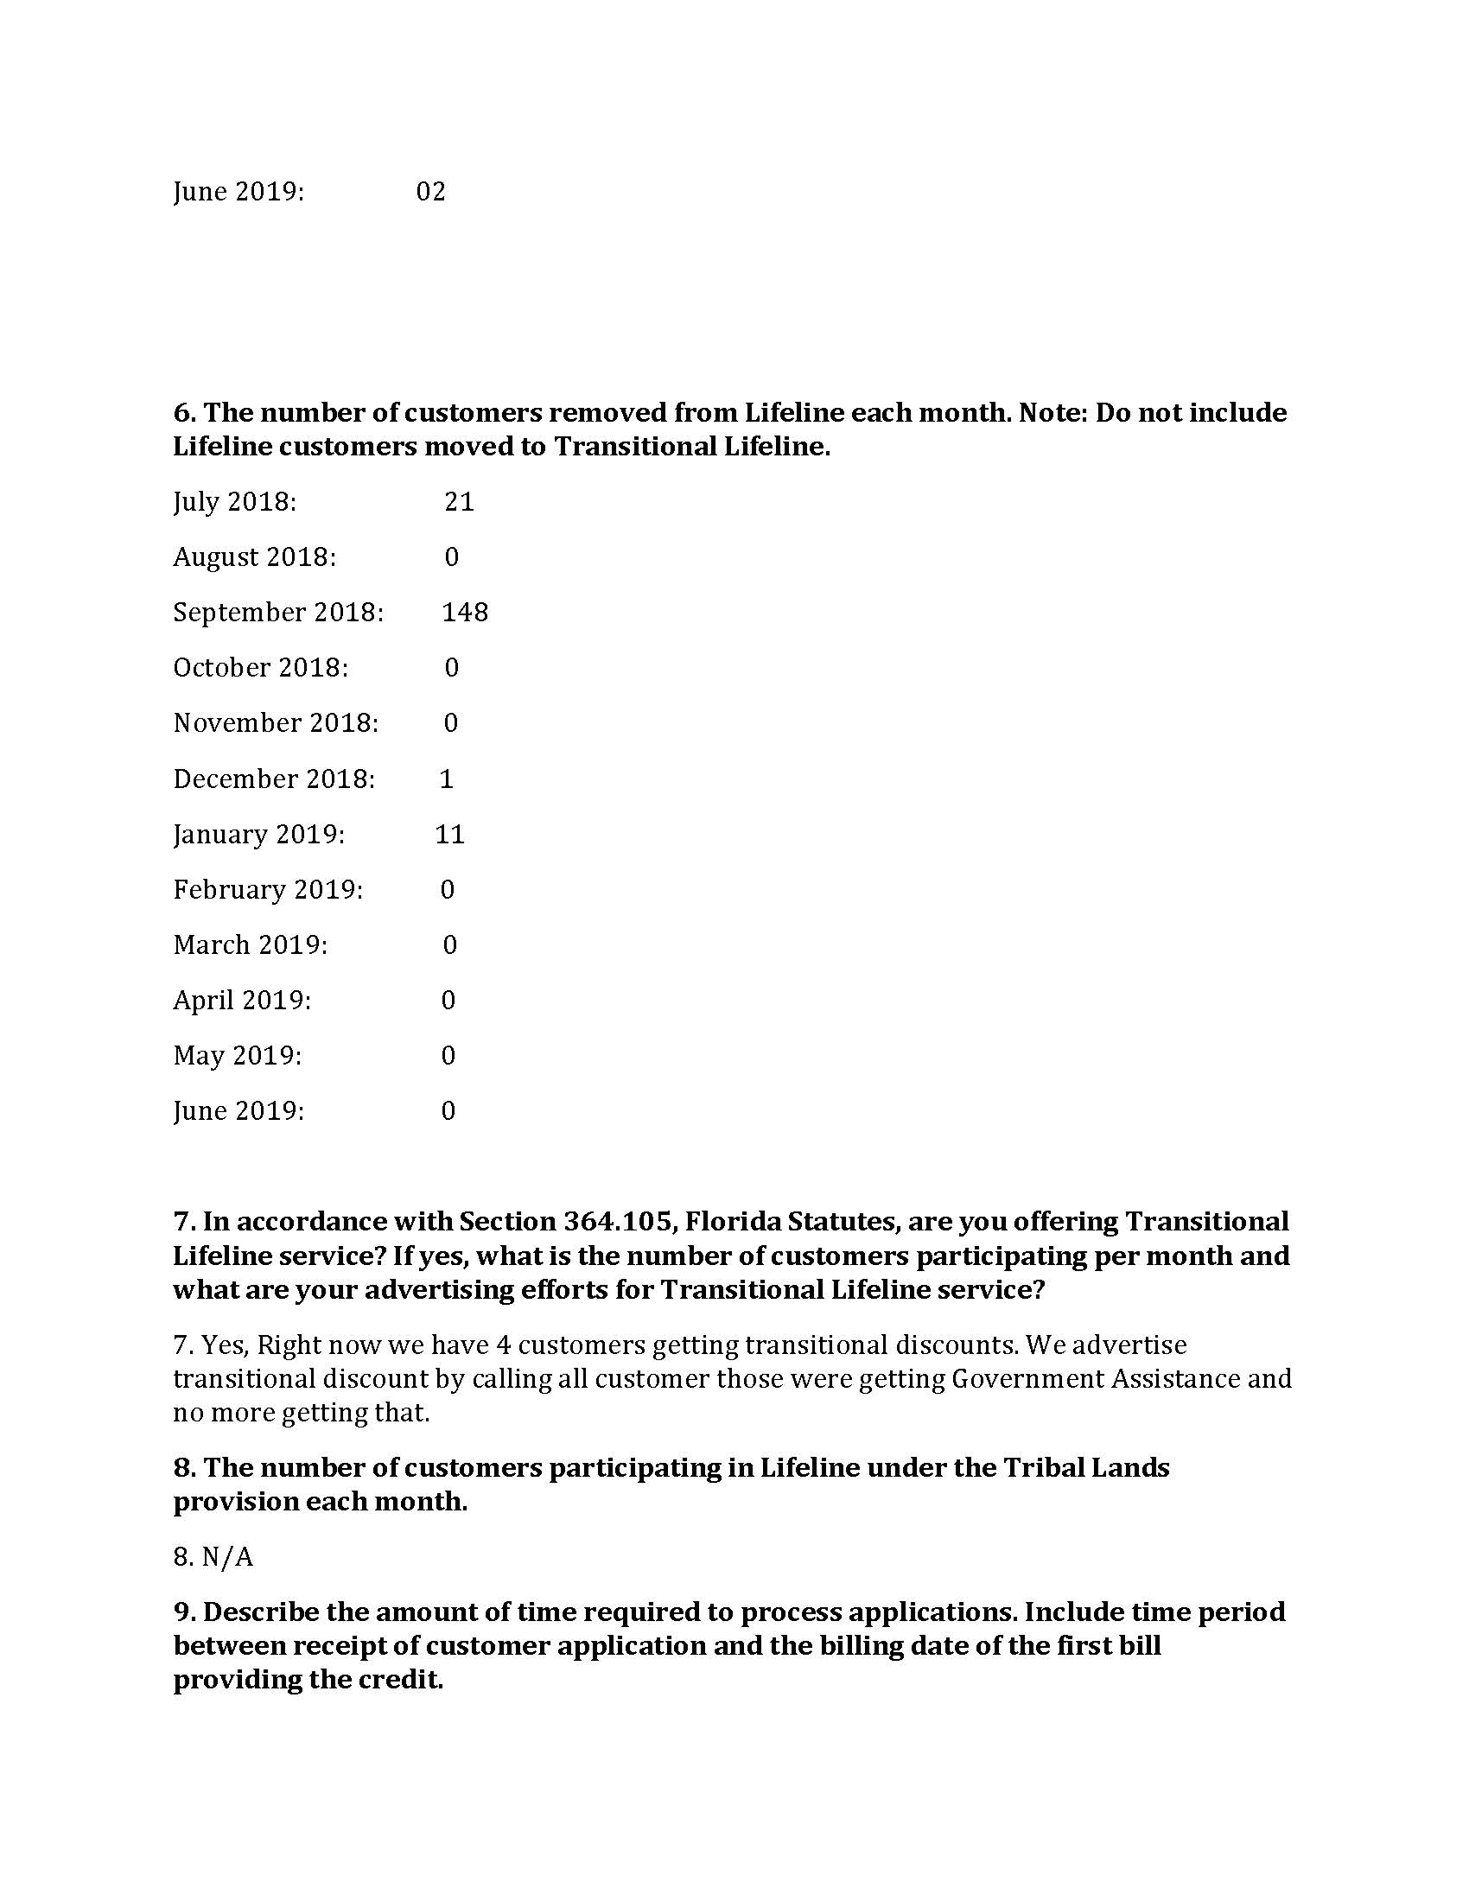
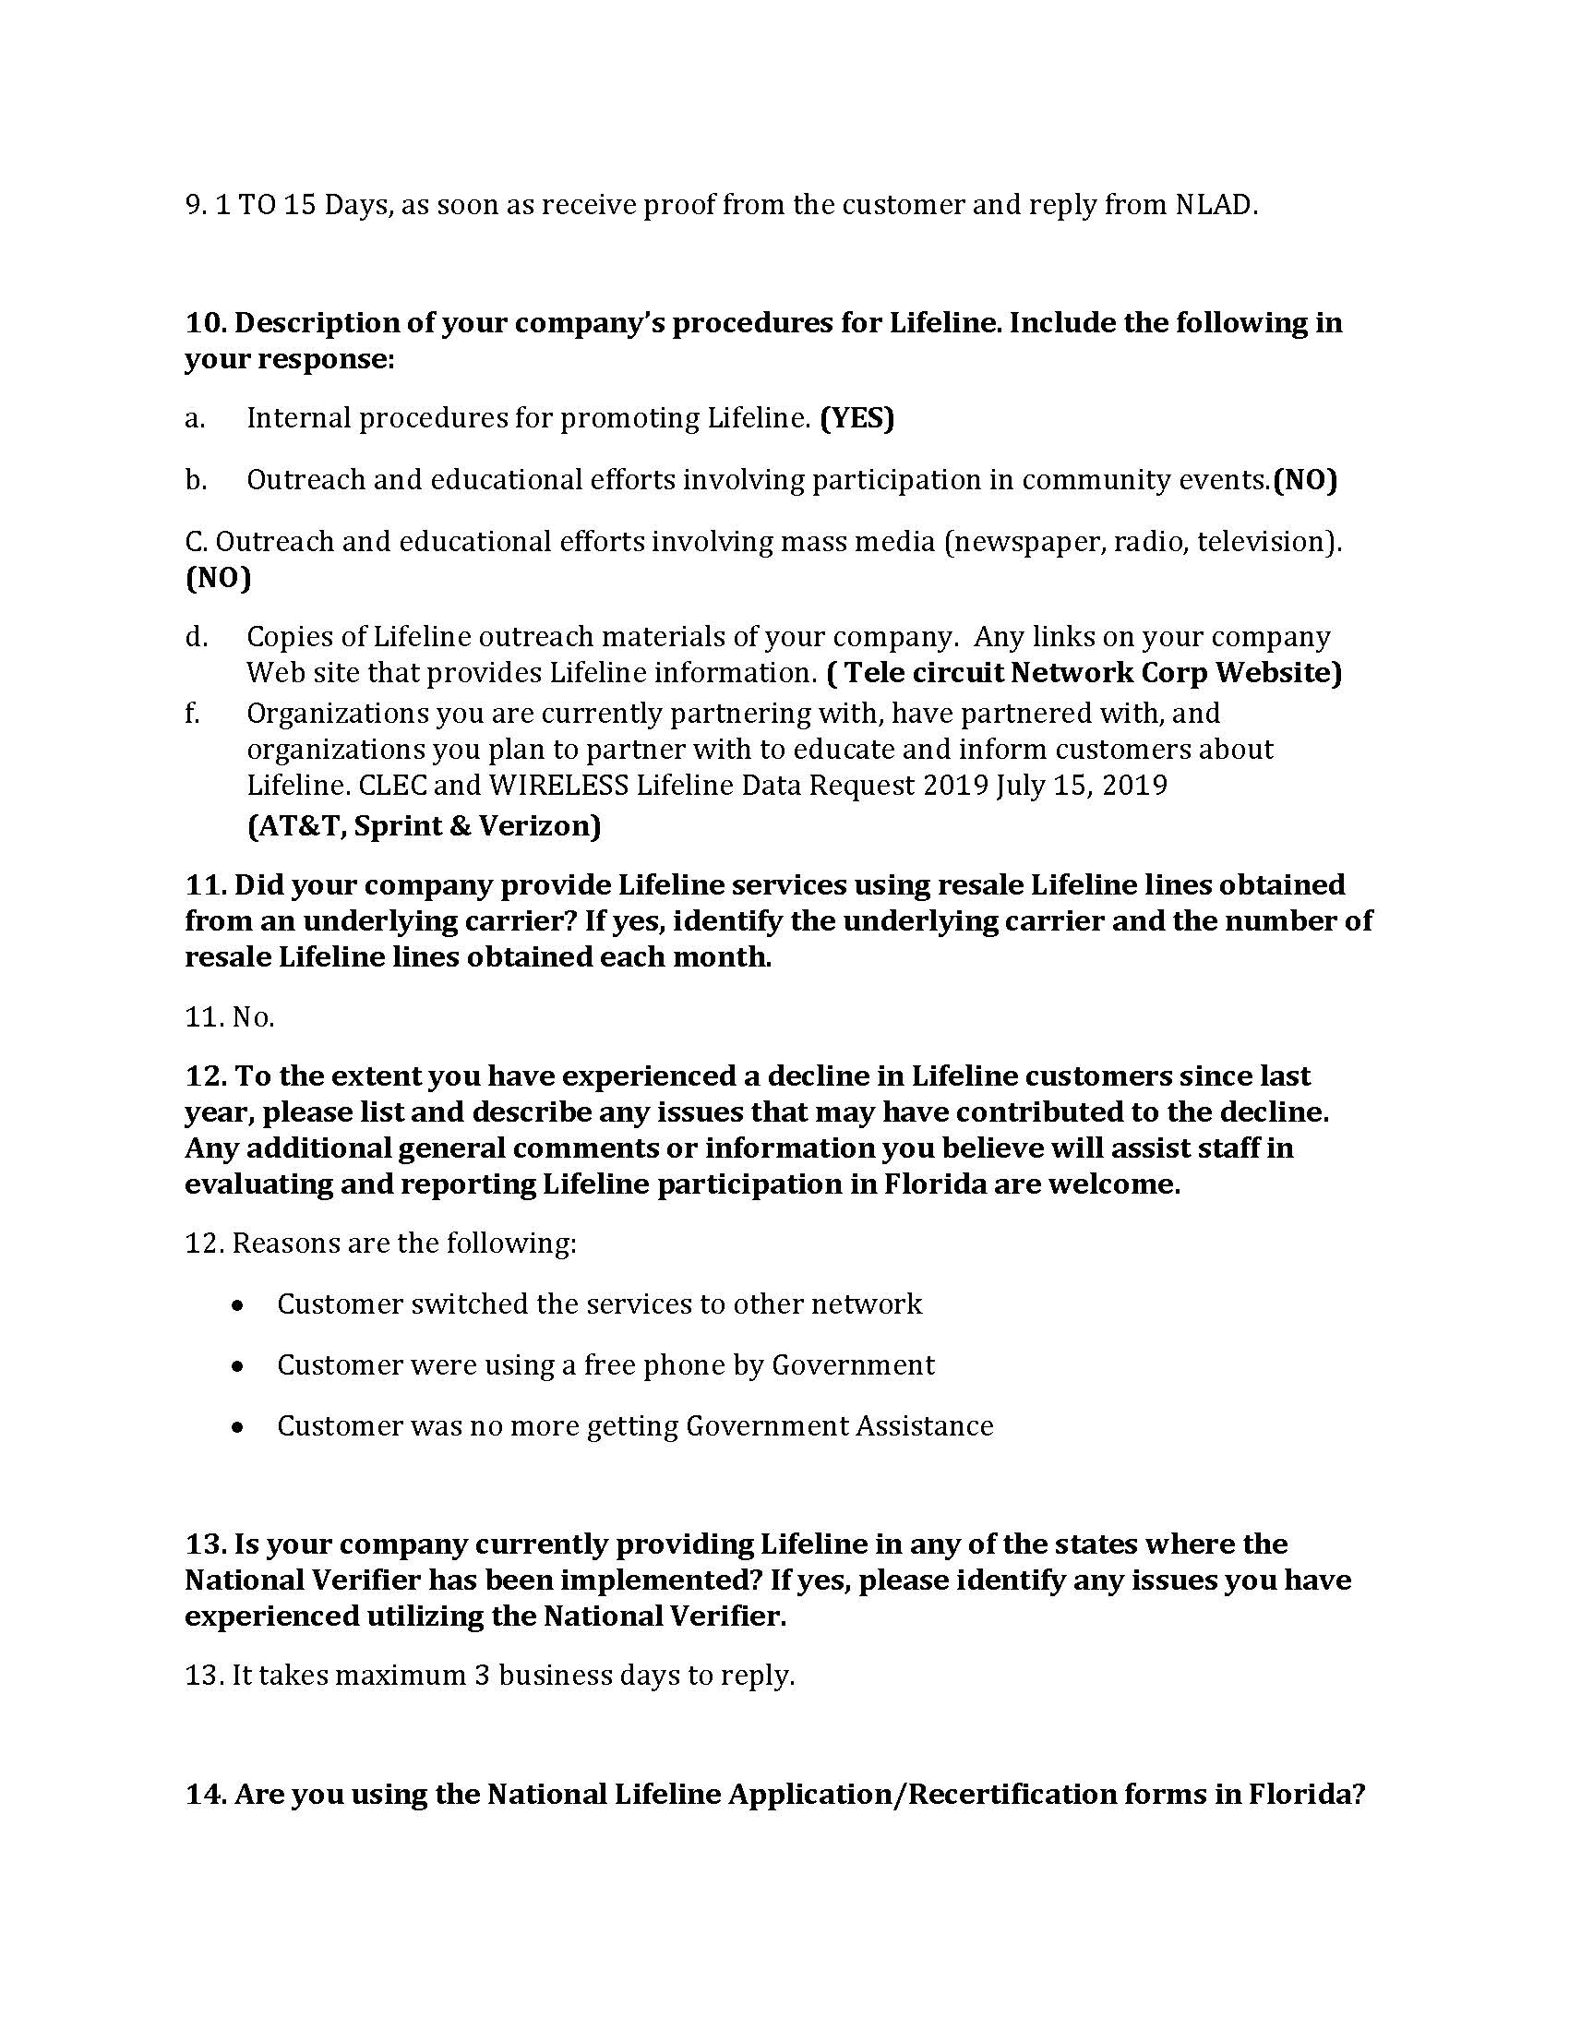
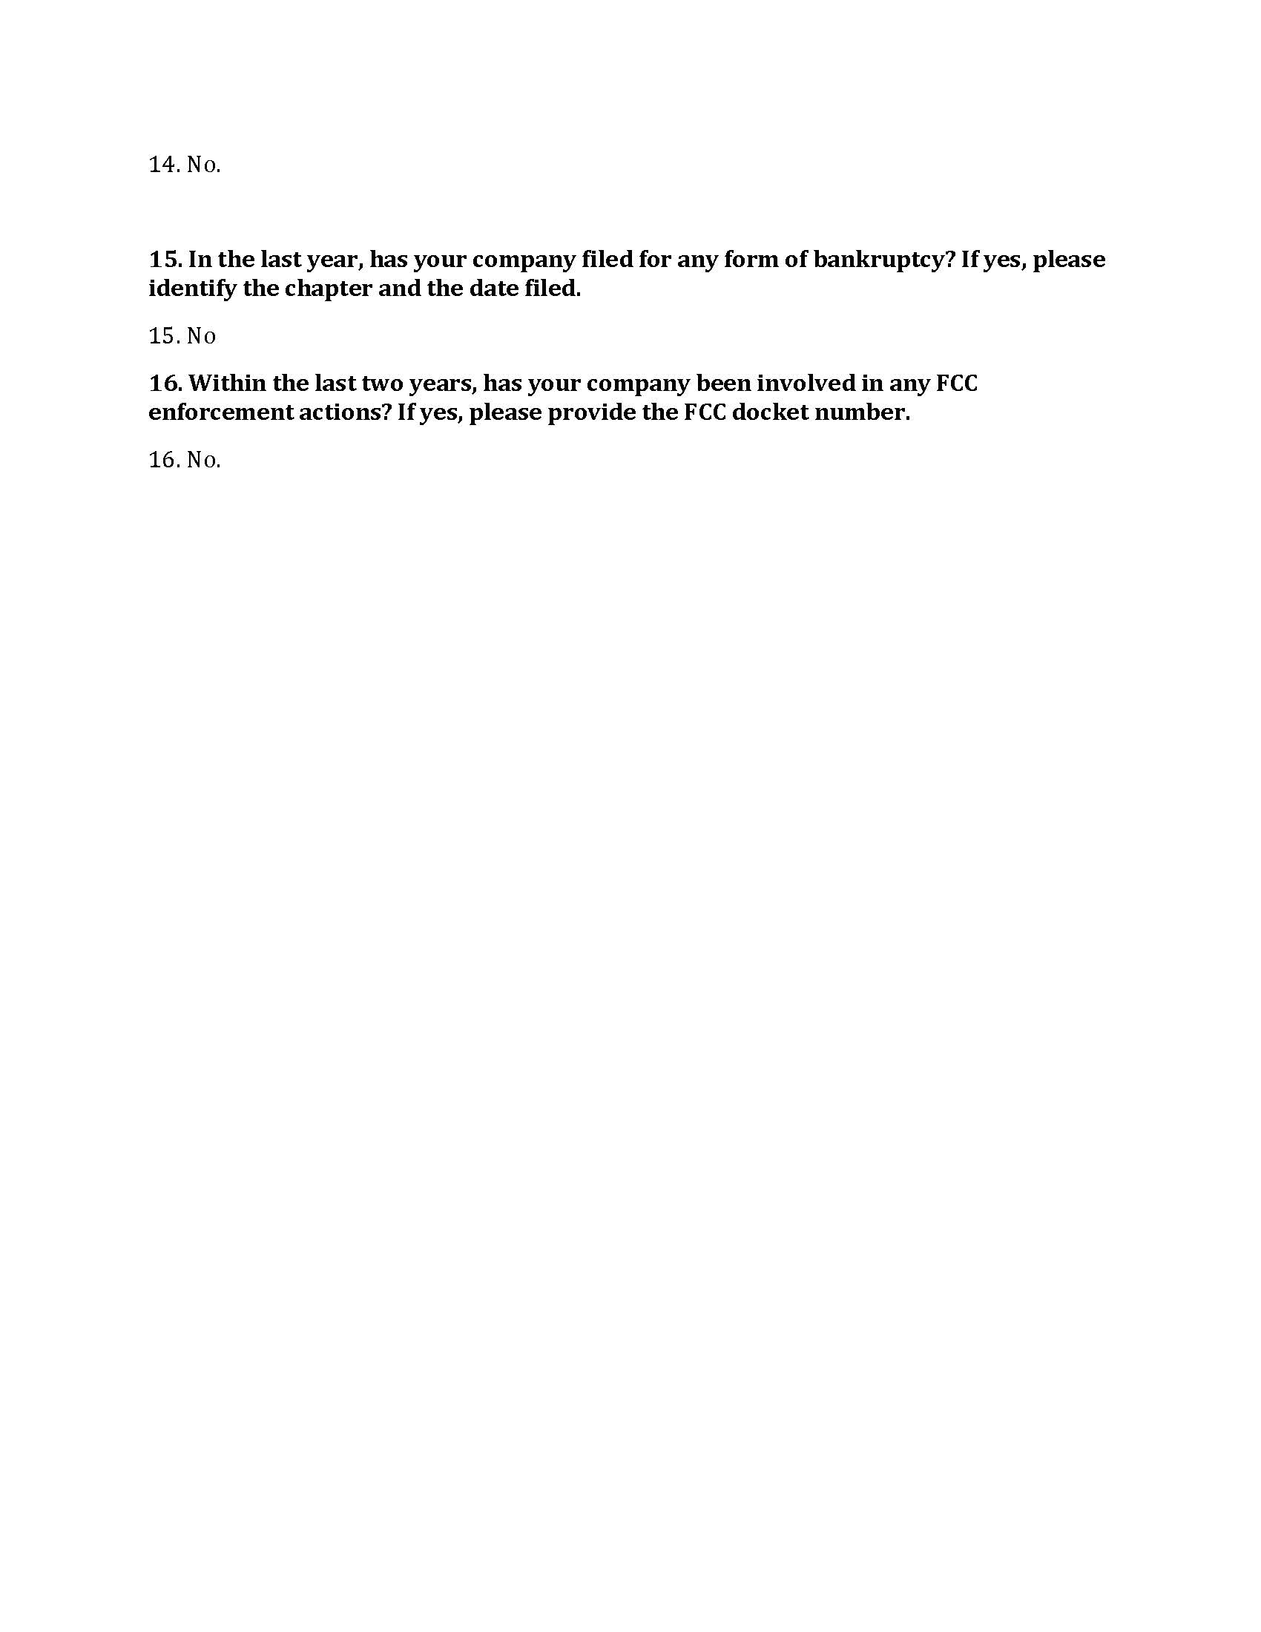

Order No. PSC-05-0361-PAA-TX, issued April 4, 2005, in Docket No. 20050126-TX, In re: Application for certificate to provide competitive local exchange telecommunications service by Tele Circuit Network Corporation.
Order No. PSC-11-0419-PAA-TX, issued September 28, 2011, in Docket No. 20080201-TX, In re: Application for designation as an eligible telecommunications carrier by Tele Circuit Network Corporation.
See Document No. 02631, Docket No. 20080201-TX, In re: Application for designation as an eligible telecommunications carrier by Tele Circuit Network Corporation, page 8.
See 04/15/2019 Tele Circuit CLEC Questionnaire Response (Attachment A) and 06/20/2019 Email from Tele Circuit to Commission staff (Attachment B).
See 05/16/2019 Consumer Activity Tracking System Entry (Attachment C).
See 05/21/2019 Email from Tele Circuit to Commission staff (Attachment D).
See Document No. 07498-2017, in Docket No. 20170196-TP, In re: Request for approval of interconnection, unbundling, resale, and collocation agreement between BellSouth Telecommunications, LLC d/b/a AT&T Florida d/b/a AT&T Southeast and Tele Circuit Corporation, Section 12.6.5, page 30 of 55.
See 6/17/2019 Email from Tele Circuit to Commission staff (Attachment E).
Id.
See Tele Circuit User Manual (Attachment F).
See Attachment B.
See 05/22/2019 Email from Tele Circuit to Commission staff (Attachment G).
See 07/19/2019 Letter from Tele Circuit (Attachment H).
See 08/09/2019 Email from Tele Circuit to Commission staff (Attachment I).
See 08/23/2019 Email from Tele Circuit to Commission staff (Attachment J).
See Attachment A.
See Tele Circuit Lifeline Assistance Report Data Request Response (Attachment K), Question 15.
Id. at Question 16.
See FCC WC Docket No. 18-54, https://docs.fcc.gov/public/attachments/FCC-18-54A1.pdf, page 1.
Id.
Id. at 4.
Id.
Id.
Section 364.011(4), F.S.
FCC Docket Nos. 05-46 and 96-45, https://docs.fcc.gov/public/attachments/FCC-05-46A1.pdf, page 34.
Id. at 33.
Fugate v. Fla. Elections Comm’n, 924 So. 2d 74, 75 (Fla. 1st DCA 3006), citing, Metro. Dade County v. State Dep't of Envtl. Prot., 714 So. 2d 512, 517 (Fla. 3d DCA 1998).
Id. at 76.
Barlow v. United States, 32 U.S. 404, 411 (1833).
See Order No. PSC-15-0391-SC-TX, issued on November 10, 2015, in Docket No. 20150158-TX, In re: Initiation of show cause proceedings against Sun-Tel USA, Inc. for apparent violation of Section 364.335(2), F.S., (Application for Certificate of Authority), Section 364.183(1), F.S., (Access to Company Records), Rule 25-4.0665(20), F.A.C., (Lifeline Service), and Rule 25-4.0051, F.A.C., (Current Certificate Holder Information).
See ETC Order, page 7.
There are up to 5 wireless ETCs and 2 wireline ETCs that could provide the Lifeline discount to Tele Circuit’s current customers, depending on the geographic location of the customer.
See CLEC Order, page 1.
Fugate v. Fla. Elections Comm’n, 924 So. 2d 74, 75 (Fla. 1st DCA 3006), citing, Metro. Dade County v. State Dep't of Envtl. Prot., 714 So. 2d 512, 517 (Fla. 3d DCA 1998).
Id. at 76.
Barlow v. United States, 32 U.S. 404, 411 (1833).
See Order No. PSC-15-0391-SC-TX, issued on November 10, 2015, in Docket No. 20150158-TX, In re: Initiation of show cause proceedings against Sun-Tel USA, Inc. for apparent violation of Section 364.335(2), F.S., (Application for Certificate of Authority), Section 364.183(1), F.S., (Access to Company Records), Rule 25-4.0665(20), F.A.C., (Lifeline Service), and Rule 25-4.0051, F.A.C., (Current Certificate Holder Information).
See Attachments A, B, D, E, G, I-K.
See Attachment B.
See BBB, Complaints, Tele Circuit Network, https://www.bbb.org/us/ga/duluth/profile/telephone-system-dealers/telecircuit-network-0443-17001143.
See FCC WC Docket No. 18-54, https://docs.fcc.gov/public/attachments/FCC-18-54A1.pdf, page 1.
Pursuant to Chapter 11 U.S. Code §362(a), the filing of a petition for Chapter 11 bankruptcy relief acts as an automatic stay that enjoins a governmental entity from exercising its regulatory authority to collect a pre-petition debt. However, staff notes that Tele Circuit filed for Chapter 11 bankruptcy on June 28, 2018, and is current on its payment of Regulatory Assessment Fees to date. Therefore, any new Regulatory Assessment Fees incurred would be classified as post-petition debt, and thus collectible by the Commission.

