State of Florida |  | Public Service Commission  Capital Circle Office Center ● 2540 Shumard Oak Boulevard  Tallahassee, Florida 32399-0850  -M-E-M-O-R-A-N-D-U-M-
DATE: | October 24, 2019
TO: | Office of Commission Clerk (Teitzman)
FROM: | Office of the General Counsel (King)  Division of Accounting and Finance (Bulecza-Banks, D. Buys, Cicchetti)  Division of Economics (Coston, Guffey)  Division of Engineering (P. Buys)
RE: | Docket No. 20190164-EI – Proposed amendment of Rule 25-6.0141, F.A.C., Allowance for Funds Used During Construction; Rule 25-6.033, F.A.C., Tariffs; Rule 25-6.036, F.A.C., Inspection of Plant; and Rule 25-6.037, F.A.C., Extent of System Which Utility Shall Operate and Maintain.
AGENDA: | 11/05/19 – Regular Agenda – Rule Proposal – Interested Persons May Participate
COMMISSIONERS ASSIGNED: |  |  | All Commissioners
PREHEARING OFFICER: |  |  | Clark
RULE STATUS: |  |  | Proposal May Be Deferred
SPECIAL INSTRUCTIONS: |  |  | None

Case Background
In the summer of 2018, the Joint Administrative Procedures Committee (JAPC) conducted a review of a number of the Commission’s existing rules in chapter 25-6 of the Florida Administrative Code (F.A.C.). On August 17, 2018, JAPC sent the Commission a letter outlining the results of that review. That letter is included as Attachment C. Staff considered JAPC’s comments and initiated this rulemaking to recommend amendments to Rules 25-6.0141, 25-6.033, 25-6.036, and 25-6.037, F.A.C., to address JAPC’s concerns regarding those rules.

The notice of development of rulemaking appeared in the April 30, 2019 edition of the Florida Administrative Register. The notice did not propose a rulemaking workshop but allowed interested parties to request one. No one requested a workshop, but the Commission received comments on the recommended changes from Duke Energy Florida (DEF), Tampa Electric Company (TECO), and the Office of Public Counsel (OPC).

The Commission has jurisdiction pursuant to Sections 120.54 and 350.127(2), Florida Statutes (F.S.).

Discussion of Issues

Issue 1:
Should the Commission propose amendments to Rules 25-6.0141, 25-6.033, and 25-6.037, F.A.C., as well as the repeal of Rule 25-6.036, F.A.C.?

Recommendation:
Yes, the Commission should propose amendments to Rules 25-6.0141, 25-6.033, and 25-6.037, F.A.C., as well as the repeal of Rule 25-6.036, F.A.C., as set forth in Attachment A. The Commission should certify Rules 25-6.0141 and 25-6.033, F.A.C., as minor violation rules. (Bulecza-Banks, D. Buys, P. Buys, Cicchetti, Coston, Guffey, King)

Staff Analysis:
Staff recommends several amendments to Rules 25-6.0141, 25-6.033, 25-6.036, and 25-6.037, F.A.C., most of which are intended to either enhance the readability of those rules or address JAPC’s comments. Staff is also recommending the repeal of Rule 25-6.036, F.A.C., and one amendment to Rule 25-6.0141, F.A.C., that was suggested by DEF during the rule development process.

JAPC Review of Commission Rules
JAPC has the authority and responsibility under Section 120.545(1), F.S., to examine agency rules to determine whether any rules violate certain statutory standards. Among those is whether the rule is an invalid exercise of delegated authority, which is defined in Section 120.52(8), F.S., to include, among other things, any rule that is “vague” or “fails to establish adequate standards for agency decisions.” JAPC is also tasked with determining whether “[t]he rule could be made less complex or more easily comprehensible to the general public.” § 120.545(1)(i), F.S. Pursuant to this authority, JAPC reviewed several of the Commission’s rules in chapter 25-6 of the F.A.C. JAPC’s comments served as the impetus for this rulemaking, and its comments are discussed below.

The Plain Language Movement
In addition to addressing JAPC’s comments, staff is also recommending certain amendments that are designed to enhance the readability of these rules. The Commission’s Style Guide advocates for “the adoption of a more readable writing style.” This includes techniques like “[u]sing clear language that is commonly used by the intended audience,” presenting the reader with “[o]nly the information needed,” and constructing “[s]hort sentences . . . in the active voice that make it clear who is responsible for what.” The Style Guide also speaks positively of the “Plain Language Movement” that made its way through state and federal government institutions in the early 2000’s. The Federal Plain Language Guidelines urges agencies to stop using the word “shall” in their rules because the word is both “outdated” and “imprecise.” See also Gutierrez de Martinez v. Lamagno, 515 U.S. 417, 432 n.9 (1995) (“Though ‘shall’ generally means ‘must,’ legal writers sometimes use, or misuse, ‘shall’ to mean ‘should,’ ‘will,’ or even ‘may.’”). In other words, one rarely encounters “shall” in everyday speech, and using it in administrative rules can lead to ambiguities. Several of staff’s recommended changes to the rules at issue here are meant to enhance readability by employing more commonly used grammar and syntax, including substituting “must,” “will,” or “may” for “shall” as the context requires.

Rule 25-6.0141 Allowance for Funds Used During Construction
In its August 17, 2018 letter, JAPC pointed out that subsection (9) of Rule 25-6.0141, F.A.C., which consists of two date triggers controlling the effective date of the rule, is no longer necessary because both of those date triggers passed two decades ago. Staff recommends that subsection (9) be removed from the rule. Removing superfluous language makes the rule less complex and more easily comprehensible to the general public. See § 120.545(1)(i), F.S. Likewise, it satisfies the Style Guide’s direction to enhance readability by presenting the reader with only necessary information.
To further enhance readability, staff recommends formatting changes to create consistent references to specific accounts from the federal Uniform System of Accounts. See 18 C.F.R. pt. 101. In Rule 25-6.0141, F.A.C., some of these account titles are separated from the account number using an en dash, while others are separated by a comma. Staff is recommending consistent use of the comma, which mirrors the formatting used in the Uniform System of Accounts. E.g., 18 C.F.R. pt. 101. As discussed above, staff also recommends replacing “shall” with “must” or “will” as appropriate.
Lastly, in its comments, DEF suggests changing the threshold for listing projects individually in a utility’s Forecasted Surveillance Report contained in subsection (8). DEF would like to change the threshold from a static $10,000,000 to 0.5 percent of the utility’s combined balances in Account 101, Electric Plant in Service, and Account 106, Completed Construction not Classified. This change would raise the threshold for DEF from $10,000,000 to $91,000,000. This new threshold would of course have different effects on different utilities based on the balances each utility carries in accounts 101 and 106.

TECO supports DEF’s suggestion, and OPC does not object. All three note that this change would establish an internal consistency within Rule 25-6.0141, F.A.C., because this same percentage threshold is used in subsection (1) to determine whether a project is eligible for AFUDC. Staff agrees and recommends the Commission propose DEF’s suggested amendment in order to promote internal consistency within the rule.

Rule 25-6.033 Tariffs
Staff is recommending several changes to Rule 25-6.033, F.A.C. Specifically, it is recommending deleting subsections (3) and (5). It is also recommending rewording several of the remaining subsections to enhance the readability of the rule. Finally, staff is recommending changes to subsection (2) that will direct readers to the requirements of chapter 25-9 of the F.A.C., which contains specific requirements for tariff filings.
JAPC points out that subsection (3) refers to a 1961 Commission order that has not been properly incorporated by reference. Material incorporated into a rule by reference must be specifically identified, and the rule must state how an affected person can obtain a copy of the referenced material. Rule 1-1.013(2)(a), (c), F.A.C.; see, e.g., Rule 25-6.0345, F.A.C. (properly incorporating the National Electrical Safety Code by reference). The reference in this rule fails both of these requirements. The incorporated order is identified solely by its title—the reference lacks the order number and the issue date—and there is no language providing guidance on how one might obtain the fifty-eight-year-old order.
More importantly, staff recommends deleting subsection (3) because it is redundant of the requirements in chapter 25-9. Subsection (3) directs utilities to conform their tariff filings to the requirements contained in the 1961 order; however, chapter 25-9, which was adopted six years after Rule 25-6.033, F.A.C., was last amended, contains specific requirements for tariff filings. Because chapter 25-9 contains specific requirements for a utility’s tariff filings, the more general requirements of the 1961 order are without effect. In sum, because subsection (3) of the rule does not properly incorporate the order by reference and the reference to the order is no longer needed, staff recommends removing subsection (3) entirely.
Staff also recommends removing subsection (5). Subsection (5) requires each utility to keep a copy of its rate schedules and rules and regulations on file at its offices, and it requires that utilities make these documents available for public inspection. OPC expresses concern about whether customers will have a right to access a utility’s tariffs if this rule is repealed. However, Rule 25-9.003, F.A.C., requires utilities to keep copies of their tariffs and make them available to customers. OPC further asks why, “in today’s electronic world,” utilities are not required to post their tariffs on the Commission’s website. However, every investor-owned utility currently posts its tariff on its website. The Commission also maintains links to those websites on its own website. Staff believes that the requirements of Rule 25-9.003, F.A.C., sufficiently protect customers’ interests, and there is no need to amend Rule 25-9.003, F.A.C., to require an action that utilities are currently undertaking freely.

Rule 25-6.036 Inspection of Plant
Staff recommends deleting the second sentence in Rule 25-6.036, F.A.C., and moving the remaining two sentences to Rule 25-6.037, F.A.C., effectively repealing this rule.
JAPC asks how the Commission defines the term “accepted good practice” in relation to a utility’s required plant and equipment inspection program and points out that Section 120.52(8)(d), F.S., declares any rule that is “vague” or “fails to establish adequate standards for agency decisions” to be an “invalid exercise of delegated legislative authority.”
Staff agrees with JAPC that “accepted good practice” is vague and fails to establish an adequate standard for the Commission to enforce. For this reason, staff recommends removing this sentence of the rule. The remainder of the rule—the first and third sentences—which would move to Rule 25-6.037, F.A.C., would still require each utility to adopt a program for inspecting its facilities and keep records establishing compliance with that program. An inspection program properly designed to “determine the necessity for replacement and repair” will necessarily require inspections at intervals that accord with “the utility’s experience and accepted good practice.”

Rule 25-6.037 Extent of System Which Utility Shall Operate and Maintain
Staff recommends removing vague language requiring utilities to maintain their “facilities and equipment used in connection with the production, transmission, distribution, regulation, and delivery of electricity” in a “safe, efficient, and proper condition.” Staff also recommends splitting this rule into two subsections to accommodate the remaining portion of Rule 25-6.036, F.A.C. Subsection (1) will be the amended language of the current rule, and subsection (2) will be the amended language of Rule 25-6.036, F.A.C. This amendment makes changes to the title of the rule necessary. Lastly, staff is recommending a few substitutions of “must” for “shall” to enhance readability.
Like its comments on Rule 25-6.036, F.A.C., JAPC pointed out that the term “safe, efficient, and proper condition” was vague and may violate Section 120.52(8)(d), F.S. Staff agrees and recommends clarifying the standard in Rule 25-6.037, F.A.C., by referencing several other rules from chapter 25-6 that contain more specific safety requirements. Rules 25-6.034 and 25-6.0345, F.A.C., mandate that utilities “maintain and operate” their facilities in accordance with the 2017 edition of the National Electric Safety Code. Rule 25-6.0341, F.A.C., sets standards to ensure “safe and efficient access” to a utility’s distribution facilities “for installation and maintenance.” Finally, Rule 25-6.040, F.A.C., proscribes grounding requirements to ensure distribution circuits are reasonably safe to person and property.

Minor Violation Rules Certification
Pursuant to Section 120.695, F.S., the Commission must certify whether any of its rules should be designated as a rule the violation of which would be a minor violation. Under Section 120.695(2)(b), F.S., a violation of a rule is minor if it does not result in economic or physical harm to a person or adversely affect the public health, safety, or welfare or create a significant threat of such harm. Currently, Rules 25-6.0141, 25-6.033, and 25-6.036, F.A.C., are minor violation rules. None of staff’s recommended amendments change the fact that a violation of these rules will not result in economic or physical harm to a person or adversely affect the public health, safety, or welfare or create a significant threat of such harm. On the other hand, Rule 25-6.037, F.A.C., is not a minor violation rule. A utility’s duty to inspect and maintain its plant and other assets is integral to it producing and/or distributing electricity in a safe and reliable manner. A violation of this rule could create a significant threat of economic or physical harm to a person or could adversely affect the public health, safety, or welfare. Staff’s recommended amendments to that rule do not change this; therefore, Rule 25-6.037, F.A.C, should not be certified as a minor violation rule.

Statement of Estimated Regulatory Costs
Pursuant to Section 120.54(3)(b)1., F.S., agencies are encouraged to prepare a statement of estimated regulatory costs (SERC) before the adoption, amendment, or repeal of any rule. A SERC was prepared for this rulemaking and is appended as Attachment B. As required by Section 120.541(2)(a)1., F.S., the SERC analysis includes whether the rule amendments are likely to have an adverse impact on economic growth, private sector job creation or employment, or private sector investment in excess of $1 million in the aggregate within five years after implementation. Staff notes that none of the impact/cost criteria will be exceeded as a result of the recommended revisions.

The SERC concludes that the amendments and repeal are not likely to directly or indirectly increase regulatory costs in excess of $200,000 within 1 year after implementation. Further, the SERC concludes that the amendment repeal will not likely increase regulatory costs, including any transactional costs, or have an adverse impact on business competitiveness, productivity, or innovation in excess of $1 million in the aggregate within five years of implementation. Thus the amendments and repeal do not require legislative ratification, pursuant to Section 120.541(3), F.S.

In addition, the SERC states that the amendments and repeal would have no impact on small businesses, would have no implementation or enforcement cost on the Commission or any other state and local government entity and would have no impact on small cities or small counties. The SERC states that no additional transactional costs are likely to be incurred by individuals and entities required to comply with the requirements.

Conclusion
Staff recommends that the Commission should propose staff’s recommended repeal of Rule 25-6.036, F.A.C., as well as its recommended amendments to Rules 25-6.0141, 25-6.033, and 25-6.037, F.A.C.

Issue 2:
Should this docket be closed?

Recommendation:
Yes. If no requests for hearing or comments are filed, the rules should be filed with the Department of State, and the docket should be closed. (King)

Staff Analysis:
If no requests for hearing or comments are filed, the rules may be filed with the Department of State and the docket closed.

25-6.0141 Allowance for Funds Used During Construction.
(1) Construction work in progress (CWIP) or nuclear fuel in process (NFIP) not under a lease agreement that is not included in rate base may accrue allowance for funds used during construction (AFUDC), under the following conditions:
(a) Eligible projects. The following projects may be included in CWIP or NFIP and accrue AFUDC:
1. Projects that involve gross additions to plant in excess of 0.5 percent of the sum of the total balance in Account 101, – Electric Plant in Service, and Account 106, Completed Construction not Classified, at the time the project commences and
a. Are expected to be completed in excess of one year after commencement of construction, or
b. Were originally expected to be completed in one year or less and are suspended for six months or more, or are not ready for service after one year.
(b) Ineligible projects. The following projects may be included in CWIP or NFIP, but may not accrue AFUDC:
1. Projects, or portions thereof, that do not exceed the level of CWIP or NFIP included in rate base in the utility’s last rate case.
2. Projects where gross additions to plant are less than 0.5 percent of the sum of the total balance in Account 101, – Electric Plant in Service, and Account 106, – Completed Construction not Classified, at the time the project commences.
3. Projects expected to be completed in less than one year after commencement of construction.
4. Property that has been classified as Property Held for Future Use.
(c) Unless otherwise authorized by the Commission, the following projects may not be included in CWIP or NFIP, nor accrue AFUDC:
1. Projects that are reimbursable by another party.
2. Projects that have been cancelled.
3. Purchases of assets which are ready for service when acquired.
4. Portions of projects providing service during the construction period.
(d) Other conditions. Accrual of AFUDC is subject to the following conditions:
1. Accrual of AFUDC is not to be reversed when a project originally expected to be completed in excess of one year is completed in one year or less;
2. AFUDC may not be accrued retroactively if a project expected to be completed in one year or less is subsequently suspended for six months, or is not ready for service after one year;
3. When a project is completed and ready for service, it shall be immediately transferred to the appropriate plant account(s) or Account 106, Completed Construction Not Classified, and may no longer accrue AFUDC;
4. Where a work order covers the construction of more than one property unit, the AFUDC accrual must shall cease on the costs related to each unit when that unit reaches an in-service status;
5. When the construction activities for an ongoing project are expected to be suspended for a period exceeding six (6) months, the utility must shall notify the Commission of the suspension and the reason(s) for the suspension, and must shall submit a proposed accounting treatment for the suspended project; and
6. When the construction activities for a suspended project are resumed, the previously accumulated costs of the project may not accrue AFUDC if such costs have been included in rate base for ratemaking purposes. However, the accrual of AFUDC may be resumed when the previously accumulated costs are no longer included in rate base for ratemaking purposes.
(e) Subaccounts. Account 107, Construction Work in Progress, and Account 120.1, Nuclear Fuel in Process of Refinement, Conversion, Enrichment and Fabrication, shall must be subdivided so as to segregate the cost of construction projects that are eligible for AFUDC from the cost of construction projects that are ineligible for AFUDC.
(f) Prior to the commencement of construction on a project, a utility may file a petition to seek approval to include an individual project in rate base that would otherwise qualify for AFUDC treatment per paragraph (1)(a).
(g) On a prospective basis, the Commission, upon its own motion, may determine that the potential impact on rates may require the exclusion of an amount of CWIP from a utility’s rate base that does not qualify for AFUDC treatment per paragraph (1)(a) and to allow the utility to accrue AFUDC on that excluded amount.
(2) The applicable AFUDC rate will shall be determined as follows:
(a) The most recent 13-month average embedded cost of capital, except as noted below, must shall be derived using all sources of capital and adjusted using adjustments consistent with those used by the Commission in the utility’s last rate case.
(b) The cost rates for the components in the capital structure will shall be the midpoint of the last allowed return on common equity, the most recent 13-month average cost of short term debt and customer deposits, and a zero cost rate for deferred taxes and all investment tax credits. The cost of long term debt and preferred stock will shall be based on end of period cost. The annual percentage rate must shall be calculated to two decimal places.
(3) Discounted monthly AFUDC rate. A discounted monthly AFUDC rate, calculated to six decimal places, must shall be employed to insure that the annual AFUDC charged does not exceed authorized levels.
(a) The formula used to discount the annual AFUDC rate to reflect monthly compounding is as follows:
M = [(1 + A/100)^{1/12} – 1] x 100
Where:
M | = | discounted monthly AFUDC rate
A | = | annual AFUDC rate
(b) The monthly AFUDC rate, carried out to six decimal places, must shall be applied to the average monthly balance of eligible CWIP and NFIP that is not included in rate base.
(4) The following schedules must shall be filed with each petition for a change in AFUDC rate:
(a) Schedule A. A schedule showing the capital structure, cost rates and weighted average cost of capital that are the basis for the AFUDC rate in subsection (2).
(b) Schedule B. A schedule showing capital structure adjustments including the unadjusted capital structure, reconciling adjustments and adjusted capital structure that are the basis for the AFUDC rate in subsection (2).
(c) Schedule C. A schedule showing the calculation of the monthly AFUDC rate using the methodology set out in this rule.
(5) No utility may charge or change its AFUDC rate without prior Commission approval. The new AFUDC rate will shall be effective the month following the end of the 12-month period used to establish that rate and may not be retroactively applied to a previous fiscal year unless authorized by the Commission.
(6) Each utility charging AFUDC must shall include in its December Earnings Surveillance Reports to the Commission Schedules A and B identified in subsection (4) of this rule, as well as disclosure of the AFUDC rate it is currently charging.
(7) The Commission may, on its own motion, initiate a proceeding to revise a utility’s AFUDC rate.
(8) Each utility must shall include in its Forecasted Surveillance Report a schedule of individual projects that commence during that forecasted period and are estimated to have equal or exceed a gross cost in excess of 0.5 percent of the sum of the total balance in Account 101, Electric Plant in Service, and Account 106, Completed Construction not Classified of $10,000,000. The schedule must shall include the following minimum information:
(a) Description of the project.
(b) Estimated total cost of the project.
(c) Estimated construction commencement date.
(d) Estimated in-service date.
(9) The provisions of this rule are effective January 1, 1996 and shall be implemented by all electric utilities no later than January 1, 1999, or the utility’s next rate proceeding, whichever occurs first.
Rulemaking Authority 350.127(2), 366.05(1) FS. Law Implemented 350.115, 366.04(2)(a), (f) 366.06(1), (2), 366.08 FS. History–New 8-11-86, Formerly 25-6.141, Amended 11-13-86, 12-7-87, 1-7-97,_____________.

25-6.033 Tariffs.
(1) A each utility may adopt such additional non-discriminatory rules and regulations governing its relations with customers in addition to those required by Commission rules. as are necessary and which are not inconsistent with these rules or orders of the Commission. But any sSuch rules or and regulations must be consistent with Commission rules and must be filed with shall constitute an integral part of the utility’s tariffs and shall be filed with them.
(2) Each utility shall file with the Commission tariffs containing schedules for all rates and charges and copies of all rules and regulations governing the relation of customer and utility.
(a) Each utility shall include in its tariffs without limiting them to the following provisions:
(2) All tariff filings must conform to Chapter 25-9, Florida Administrative Code, and must include the following provisions:
(a)1. Definitions of classes of customers classes.
(b)2. Rules with which prospective customers must comply with as a condition of receiving service, and the terms of any required contracts required.
(c)3. Rules for establishing governing the establishment of credit by customers for payment of service bills.
(d)4. Rules governing deposits and interest on deposits.
(e)5. Rules governing the procedure for followed in disconnecting and reconnecting service.
(f)6. Rules governing a customer’s request to discontinue service. Notice by customer required for having service discontinued.
(g)7. Rules governing temporary, emergency, auxiliary or stand-by service.
(h)8. Rules covering billing periods.
(i)9. Rules covering a customer’s construction requirements.
(j)10. Rules covering a special type of construction commonly requested by customers that which the utility allows to be connected and terms upon which such construction will be permitted. This applies, for example, to a case where a customer desires underground service in overhead territory.
(k)11. Rules covering any such portion of service which the utility furnished, owns, and maintains.
(l)12. Rules covering inspection of customer-owned facilities by proper authorities before service is rendered.
(3) All tariff filings shall be in the manner and form as prescribed by the Commission under separate Order entitled “Rules and Regulations Governing the Construction and Filing of Tariffs by Public Utilities.”
(3) (4) No rules and regulations, or schedules of rates or charges, or modification or revisions of the same, will shall be effective until filed with and approved by the Commission as provided by Law.
(5) A copy of the rules contained herein, as promulgated and adopted by the Commission, also a copy of the rate schedules and rules and regulations of the utility as filed with the Commission, shall be kept on file in the local commercial offices of the utility for inspection by its customers. A customer shall, upon request, be furnished a copy of the rate schedule applicable to his service.
Rulemaking Authority 350.127(2), 366.05(1) FS. Law Implemented 366.03, 366.05(1), 366.06 FS. History–New 7-29-69, Formerly 25-6.33, Amended ___________

25-6.036 Inspection of Plant.
Each utility shall adopt a program of inspection of its electric plant in order to determine the necessity for replacement and repair. The frequency of the various inspection shall be based on the utility’s experience and accepted good practice. Each utility shall keep sufficient records to give evidence of compliance with its inspection program.
Rulemaking Authority 366.05(1) FS. Law Implemented 366.04(2)(c), (5), 366.05(1), 366.055, 366.08 FS. History–New 7-29-69, Formerly 25-6.36, Repealed ___________.

25-6.037 Extent of Facilities and Equipment That a System Which Utility Must Shall Inspect, Operate, and Maintain.
(1) Each utility must, unless specifically relieved in any case by the Commission from such obligations, shall operate and maintain in safe, efficient, and proper condition, pursuant to Rules 25-6.034, 25-6.0341, 25-6.0345, and 25-6.040, F.A.C. the standards referenced herein, all of the facilities and equipment used in connection with the production, transmission, distribution, regulation, and delivery of electricity to any customer up to the point of delivery. The utility is also responsible for the safe, efficient measurement of electrical consumption consistent with test procedures and accuracies prescribed by the Commission.
(2) Each utility must adopt a program governing the inspection of its electric facilities and equipment in order to determine the necessity for replacement and repair. Each utility must keep records to establish compliance with its inspection program.
Rulemaking Authority 350.127(2), 366.04(6), 366.05(1) FS. Law Implemented 366.03, 366.04(1), (2)(c), (f), (5), (6), 366.05(1), (3) FS. History–New 7-29-69, Amended 4-13-80, ________, Formerly 25-6.37.
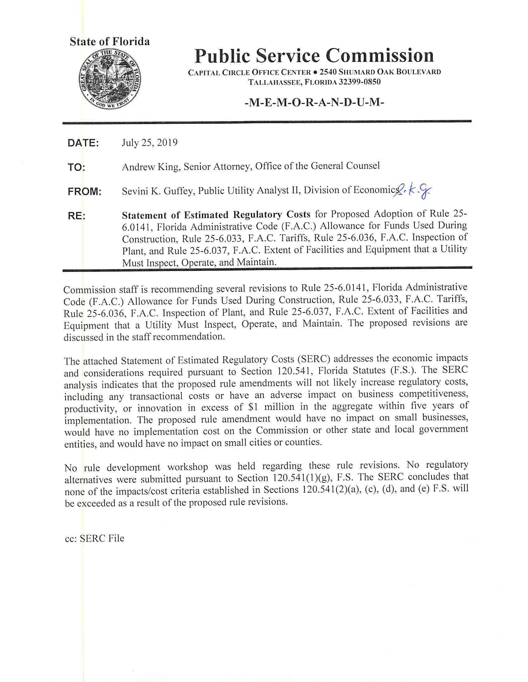

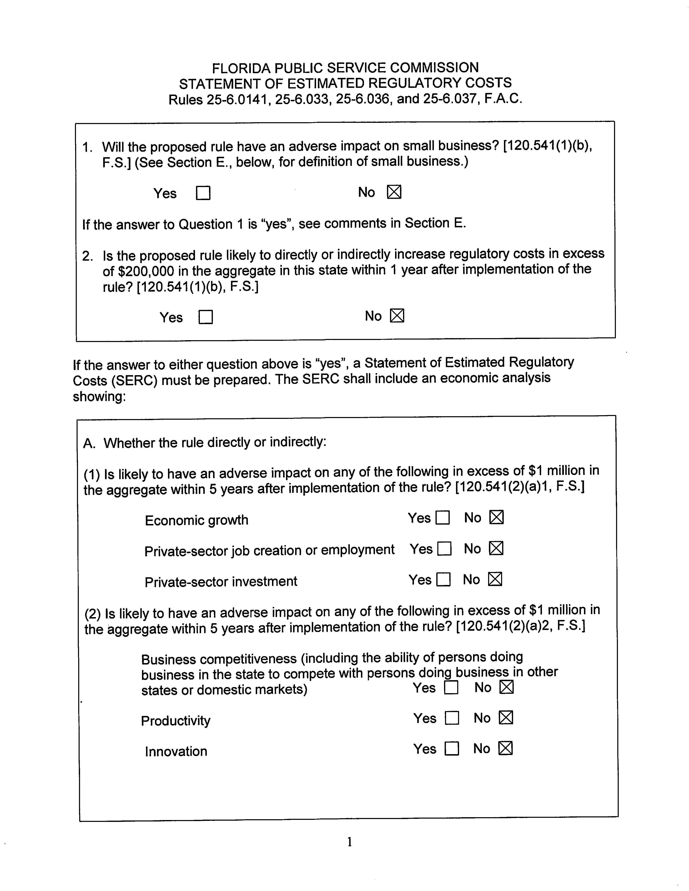

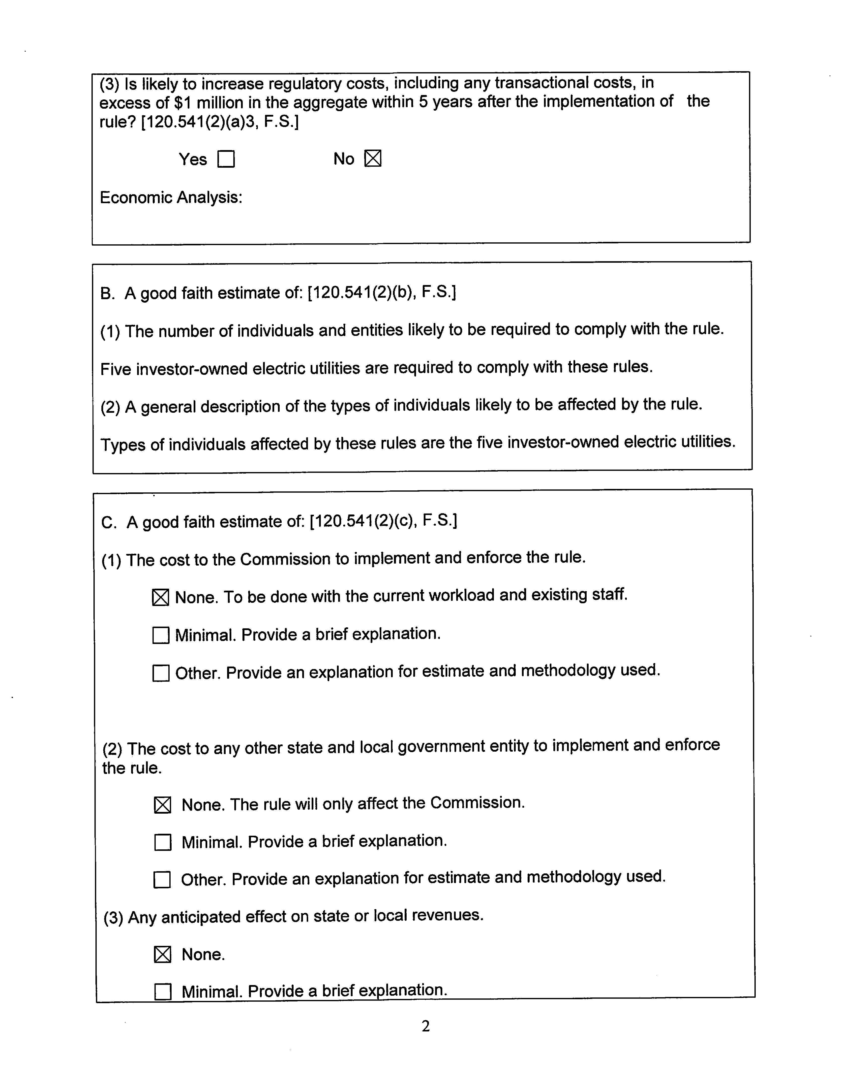

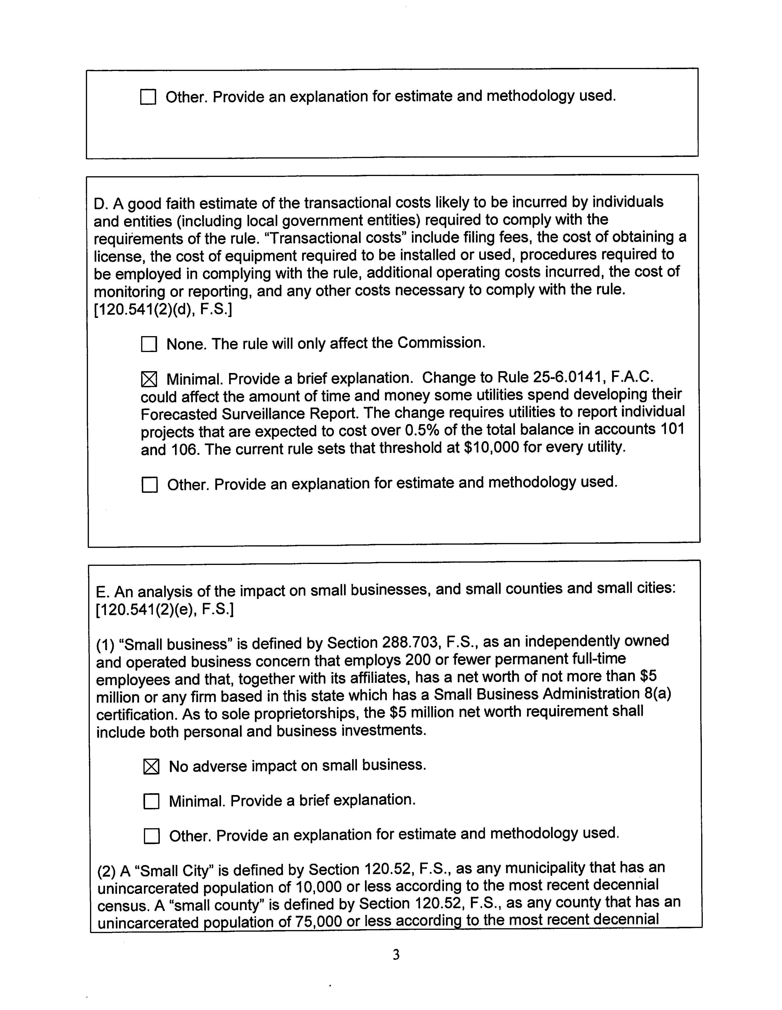

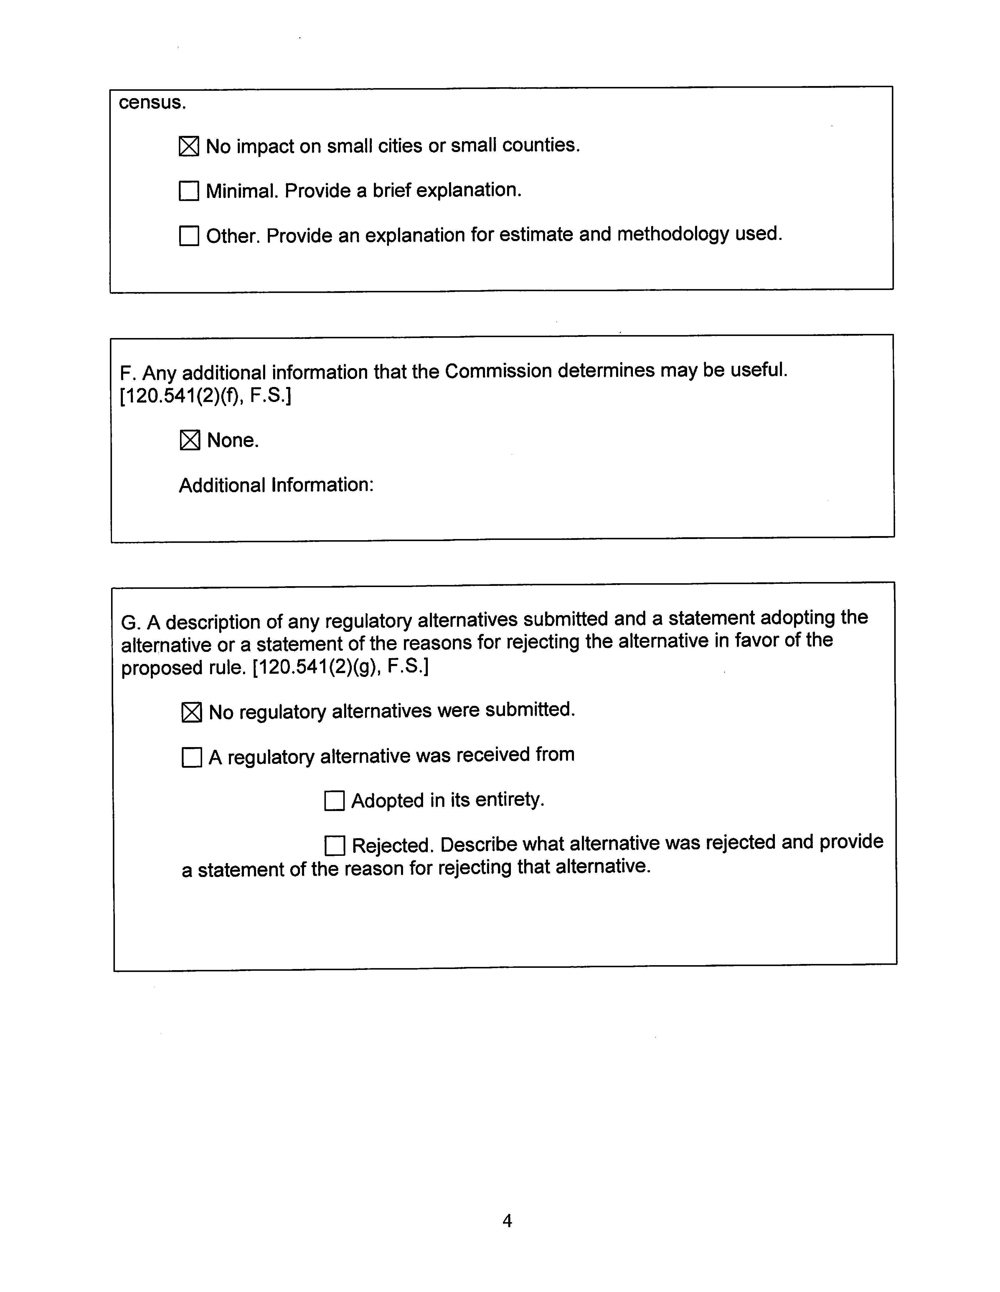
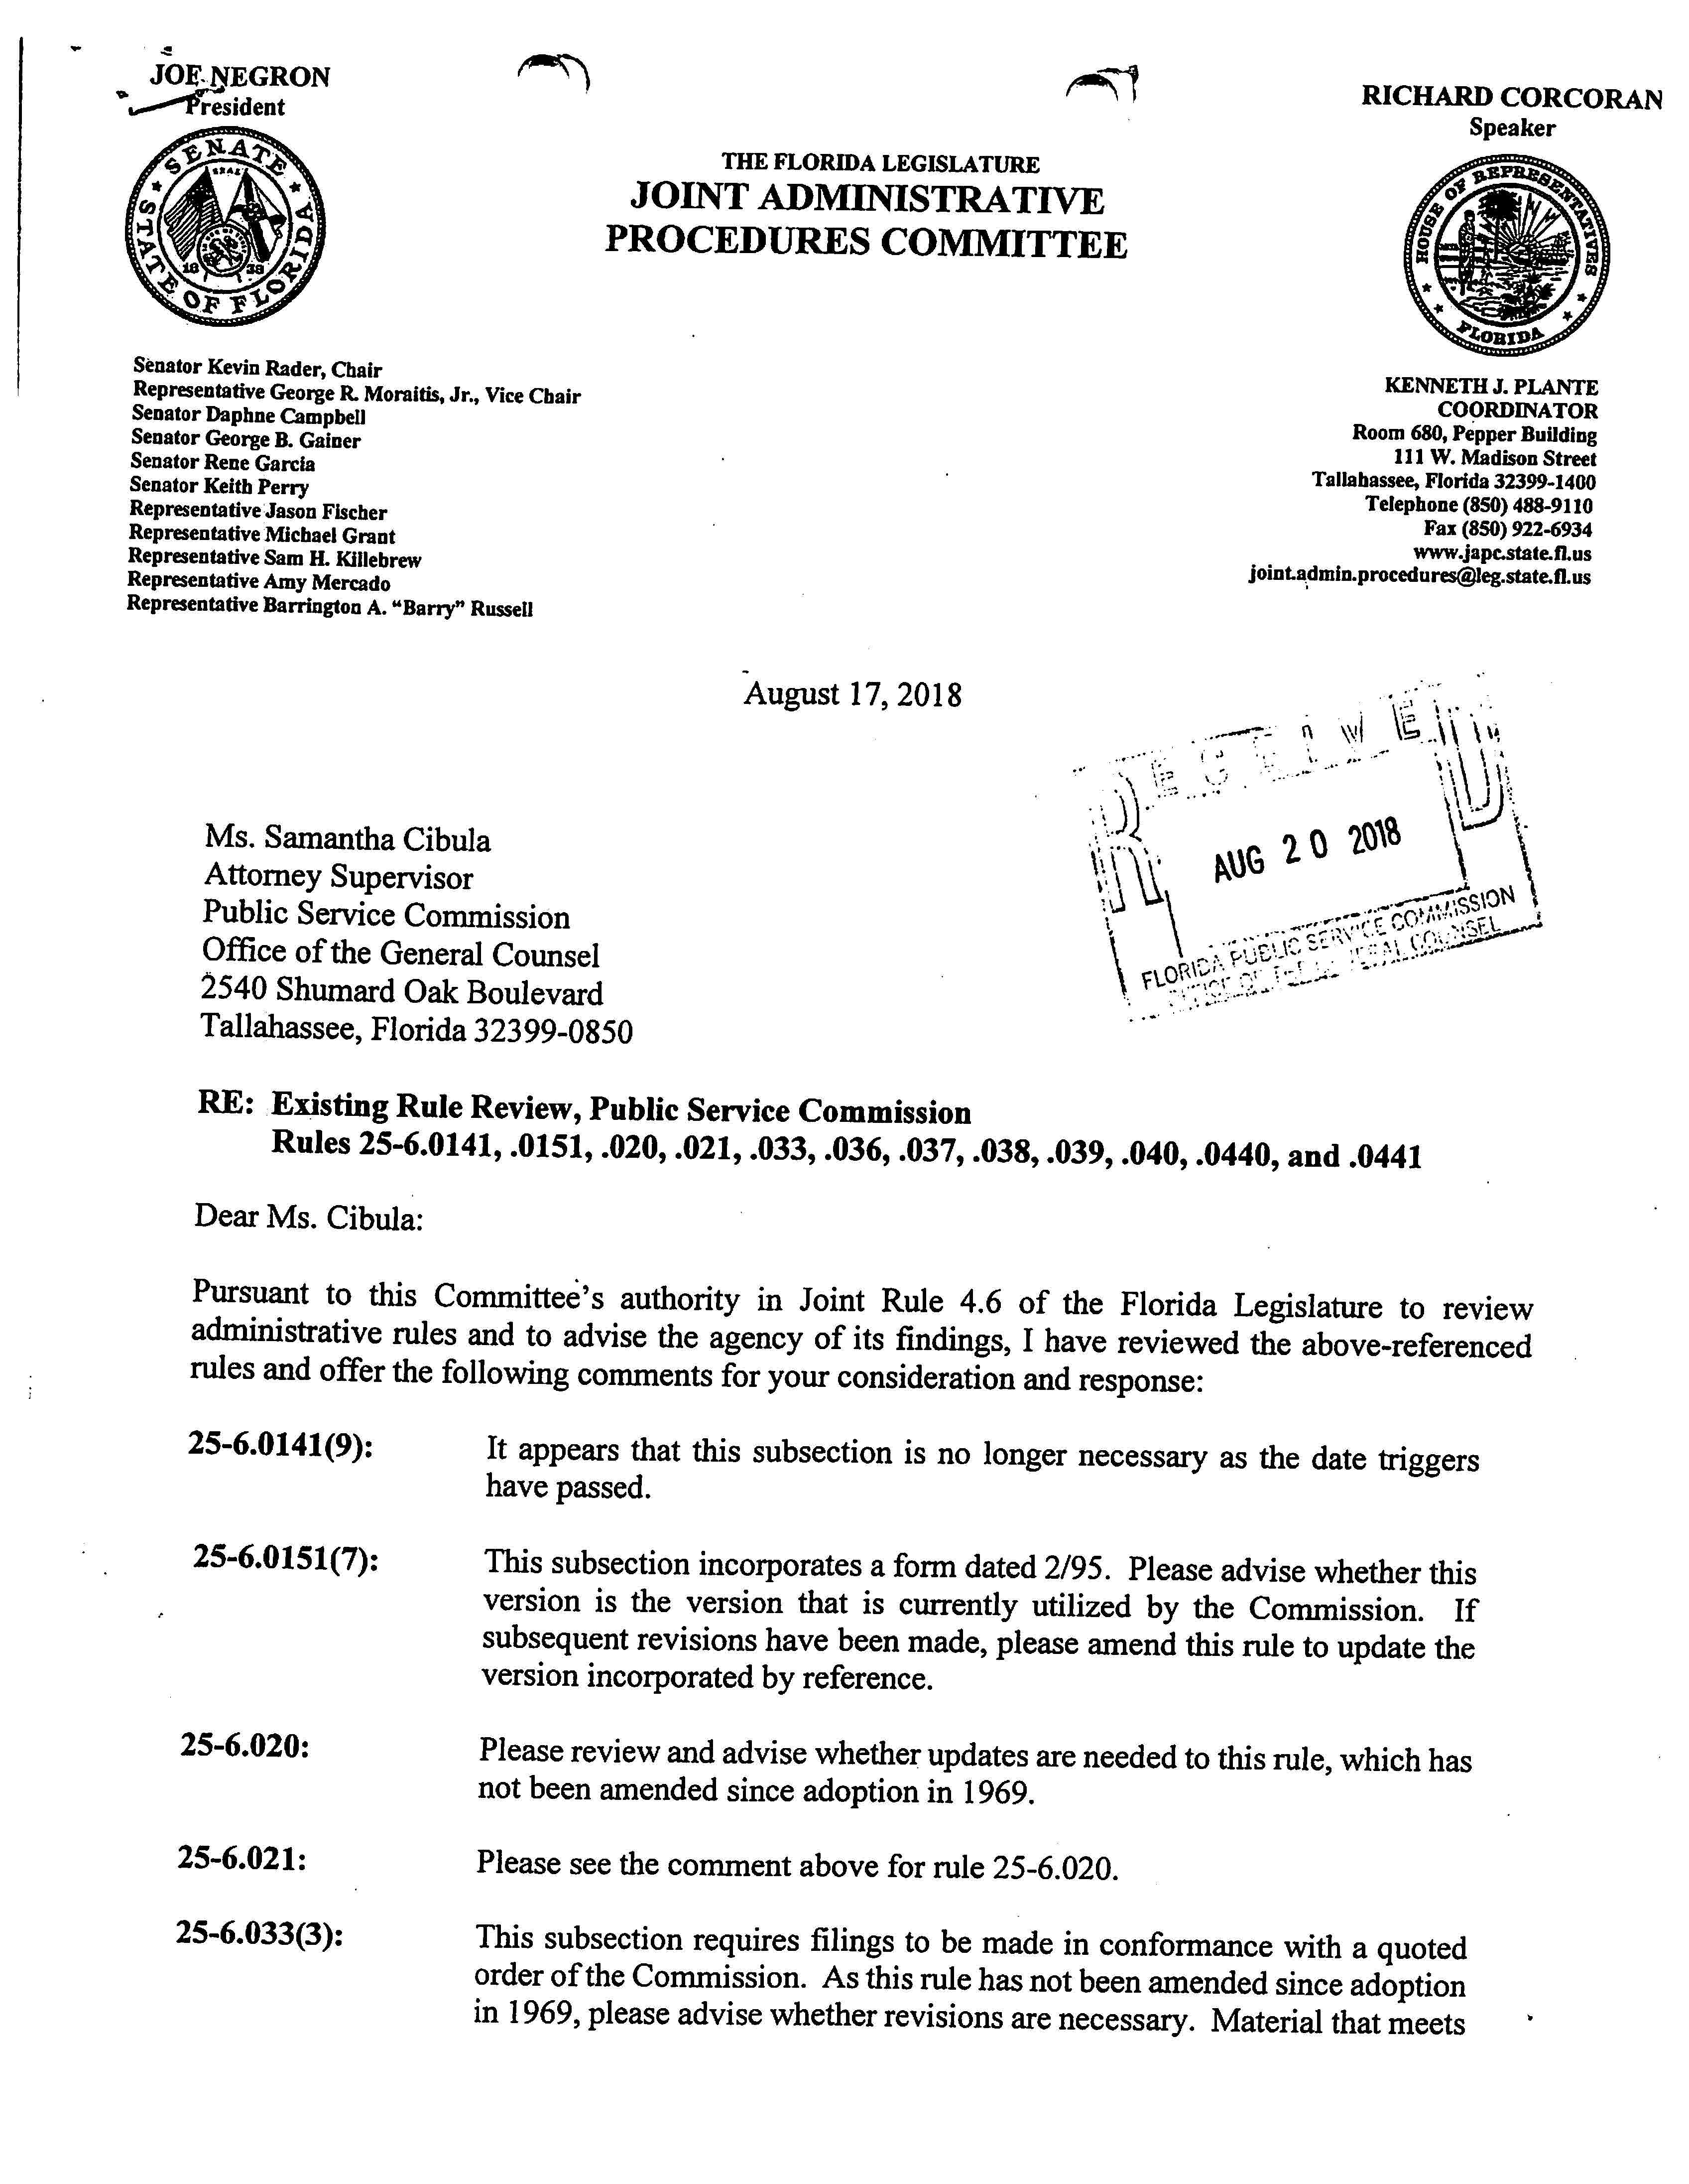

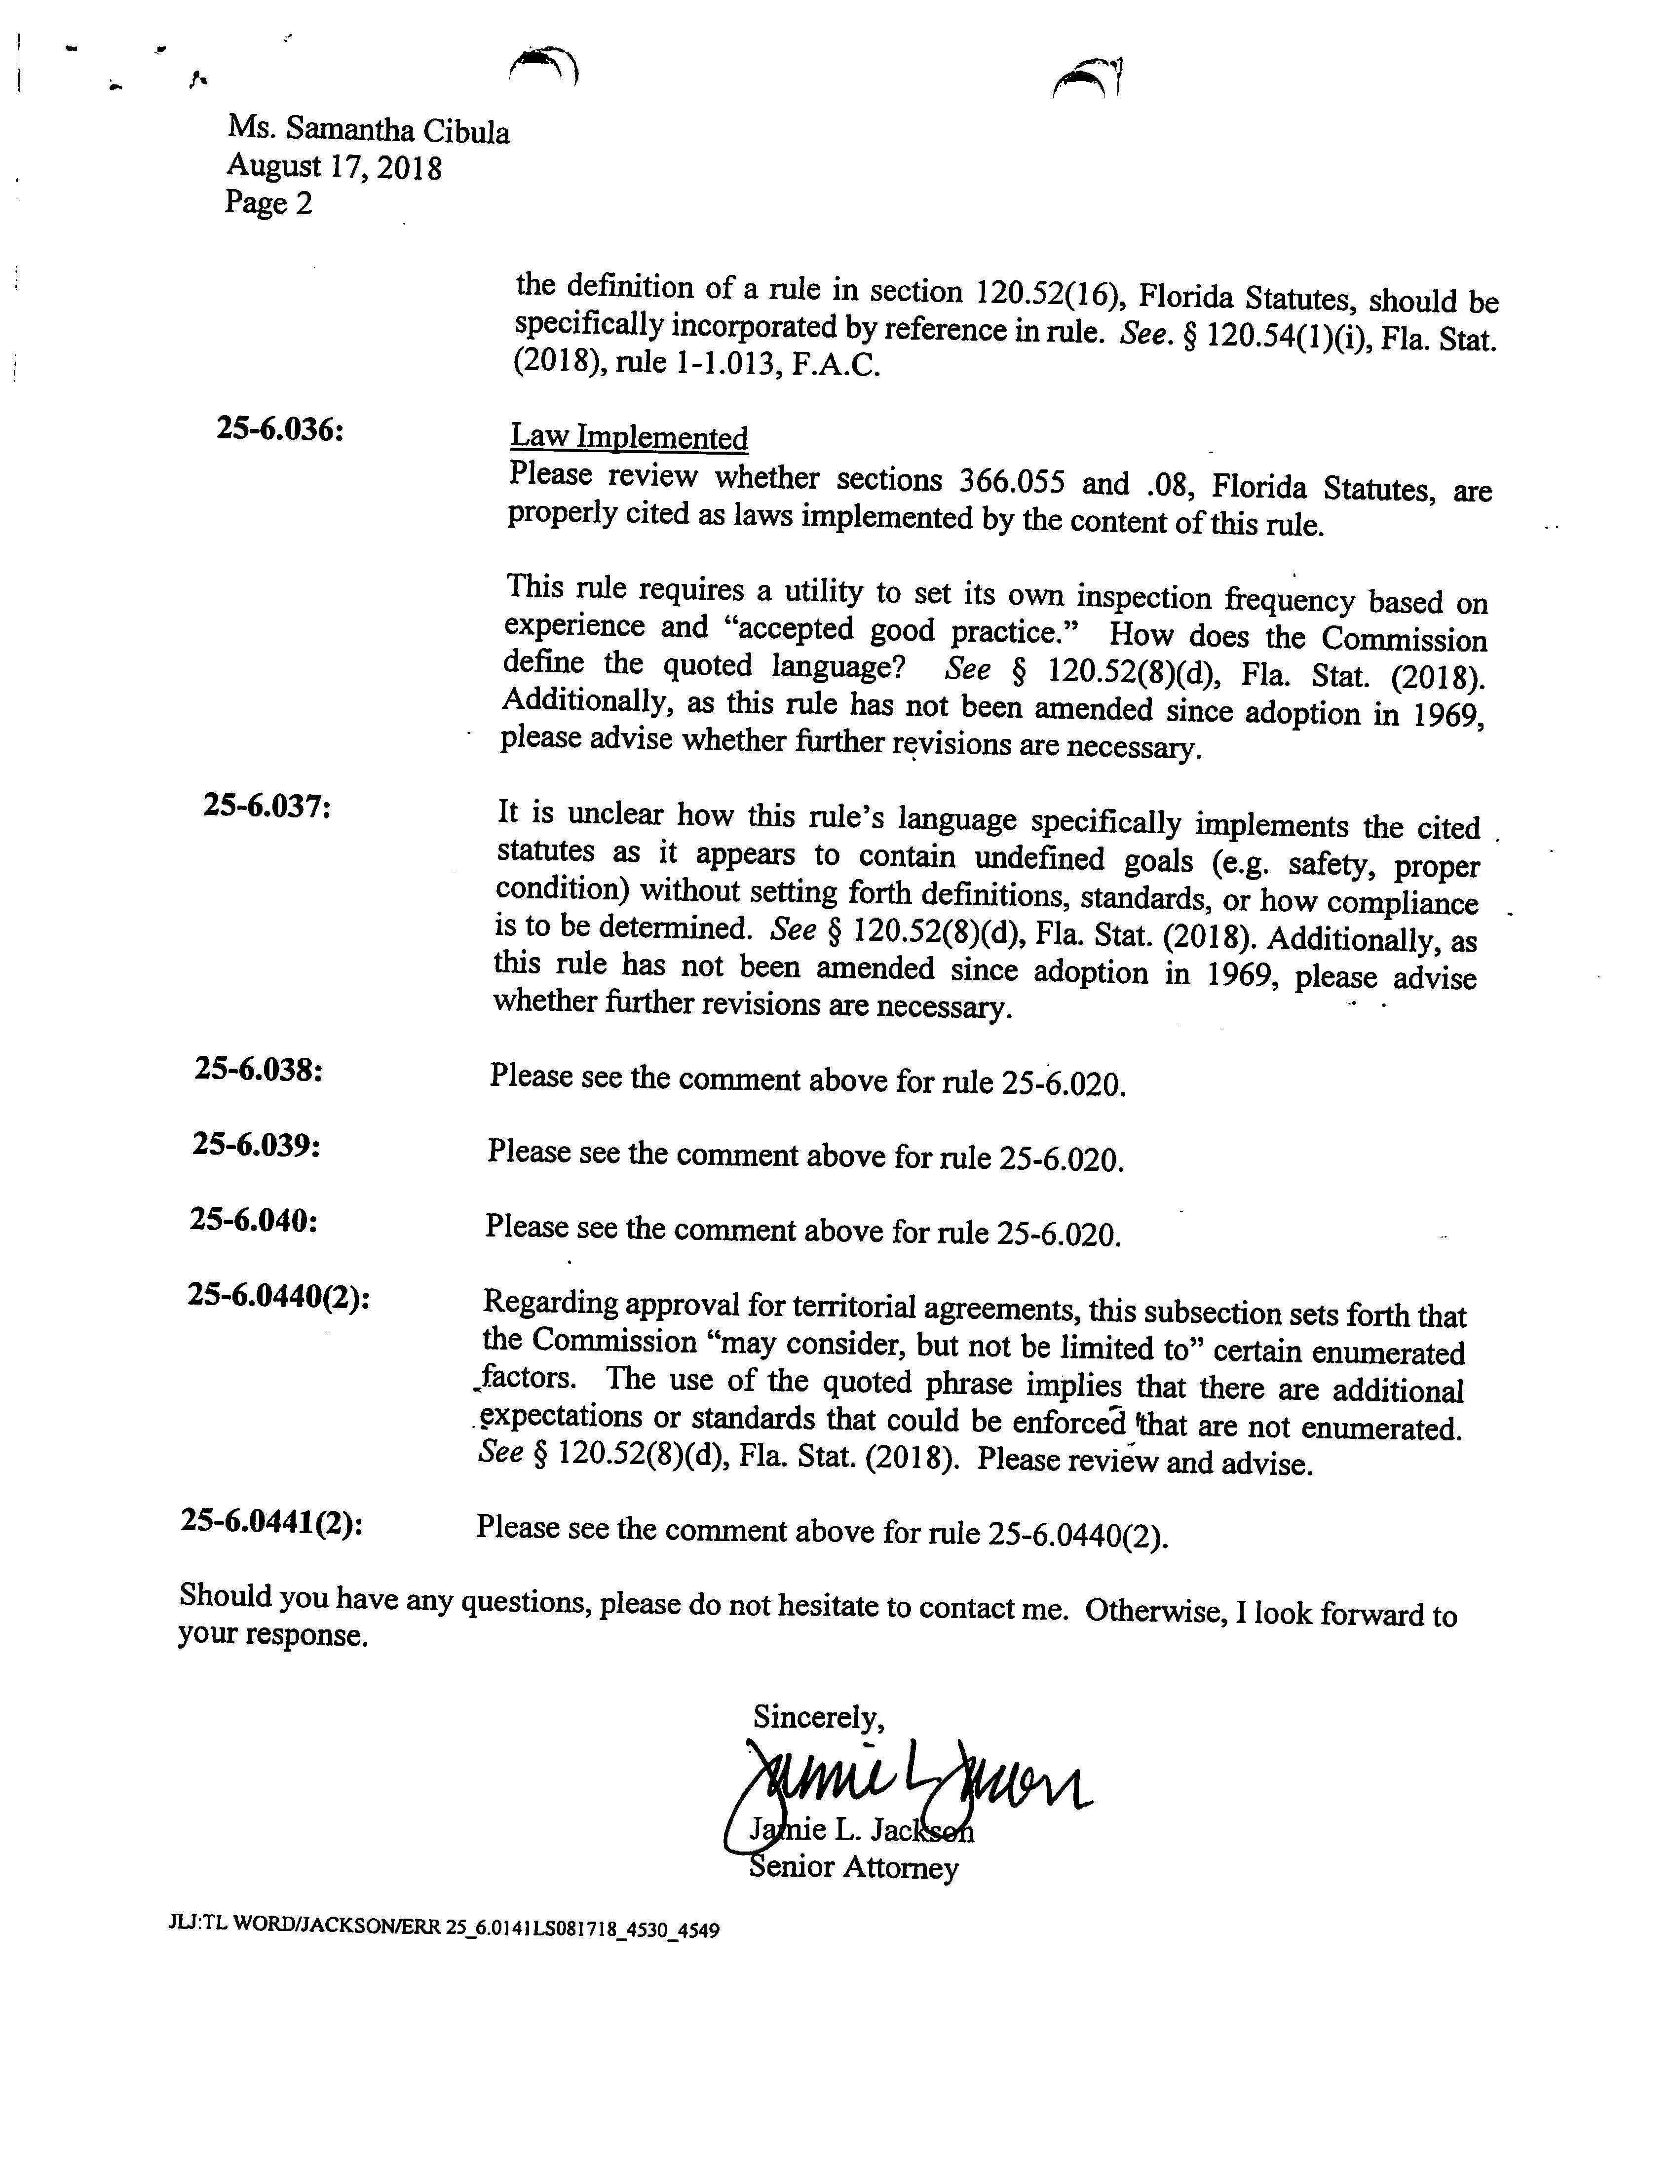

JAPC’s letter contained comments and questions about several other rules in chapter 25-6, F.A.C., as well. As to Rules 25-6.020, 25-6.021, 25-6.038, 25-6.039, and 25-6.040, F.A.C., JAPC asked “whether updates are needed” because the rules have “not been amended since adoption in 1969.” Staff reviewed those rules and made technical changes to the Rulemaking Authority and Law Implemented sections of Rules 25-6.038, 25-6.039, and 25-6.040, F.A.C. Doc. No. 07326-2018, at 2. Staff determined that no changes were needed for Rules 25-6.020 and 25-6.021, F.A.C. Doc. No. 07279-2018, at 2–3. Similarly, JAPC asked if the form referenced in Rule 25-6.0151(7), F.A.C., is up to date. Staff believes that it is and does not recommend an amendment to that rule. Doc. No. 07279-2018, at 2. Finally, staff plans to address JAPC’s concerns about Rules 25-6.0440 and 25-6.0441, F.A.C., in a future rulemaking proceeding.
For example, in subparagraph (1)(a)1., account 101 is separated from its title with an en dash (Account 101 – Electric Plant in Service), but account 106 is separated from its title with a comma (Account 106, Completed Construction not Classified). But in subparagraph (1)(b)2., account 106 is separated from its title with an en dash (Account 106 – Completed Construction not Classified).
As used in this recommendation, “utility” refers to the investor-owned electric utilities. See Rule 25-6.002(1) (applying chapter 25-6 to “all public electric utilities” unless the context of the rule clearly indicates otherwise).

