BEFORE THE FLORIDA PUBLIC SERVICE COMMISSION

In re: Application for staff-assisted rate case in Volusia County by North Peninsula Utilities Corporation. | DOCKET NO. 20180138-SU  ORDER NO. PSC-2019-0461-PAA-SU  ISSUED: October 25, 2019

The following Commissioners participated in the disposition of this matter:

ART GRAHAM, Chairman
JULIE I. BROWN
DONALD J. POLMANN
GARY F. CLARK
ANDREW GILES FAY

NOTICE OF PROPOSED AGENCY ACTION ORDER
APPROVING RATES AND FINAL ORDER ADDRESSING
RATE CASE EXPENSE, APPROVING TEMPORARY RATES
AND REQUIRING ADJUSTMENT OF BOOKS

BY THE COMMISSION:

NOTICE is hereby given by the Florida Public Service Commission (Commission) that the actions discussed herein, except for (1) the reduction of rates after four years based upon the recovery of rate case expense, (2) the granting of temporary rates in the event of protest, and (3) the requirement for proof of adjustment of books and records, are preliminary in nature and will become final unless a person whose interests are substantially affected files a petition for a formal proceeding, pursuant to Rule 25-22.029, Florida Administrative Code (F.A.C.). The reduction of rates after four years, the granting of temporary rates in the event of protest, and the requirement for proof of adjustment of books and records are final agency actions and subject to reconsideration and appeal as described below under the heading, “NOTICE OF FURTHER PROCEEDINGS OR JUDICIAL REVIEW.”

Case Background
North Peninsula Utilities Corporation (NPUC or Utility) is a Class B wastewater only utility serving approximately 428 residential and 5 general service customers in Volusia County. The Commission granted the transfer of Certificate No. 249-S from Shore Utility Corporation to NPUC, effective December 5, 1989. The Utility’s rates were last established in 2000 during an investigation of possible overearnings conducted by the Commission. On November 21, 2016, the Commission issued an Order approving in part and denying in part a proposed territory expansion by the Utility. This is NPUC’s first staff-assisted rate case (SARC).

On July 6, 2018, following the Department of Environmental Protection (DEP) issued a Consent Order to NPUC, for failing to properly maintain its wastewater treatment facility. The Consent Order requires NPUC to immediately implement preventative measures to ensure system failure does not occur due to deteriorating facility components while reconstruction is under way.

On July 20, 2018, NPUC filed its application for a SARC. Pursuant to Section 367.0814(2), Florida Statutes (F.S.), the official filing date of the SARC has been determined to be September 14, 2018. The 12-month period ended June 30, 2018, was selected as the test year for the instant case. NPUC is requesting recovery of costs associated with the improvements mandated by the Consent Order, as well as other improvements necessary for the upkeep of its wastewater treatment facility. According to NPUC’s 2018 Annual Report, its total operating revenue was $261,335 and its net operating income was a loss of $15,175. We have jurisdiction in this case pursuant to Sections 367.011, 367.081, 367.0812, 367.0814, and 367.091, F.S.

Review and Decision

1. Quality of Service
Pursuant to Section 367.081(2)(a)1, F.S., and Rule 25-30.433(1), F.A.C., in wastewater rate cases, we determine the overall quality of service provided by the Utility. For a wastewater only utility, the determination is made from an evaluation of the Utility’s attempt to address customer satisfaction. The Rule further states that outstanding citations, violations, and Consent Orders on file with the DEP and the county health department, along with any DEP and county health department officials’ testimony concerning quality of service shall be considered. In addition, we review any customer testimony and comments. The operating condition of the wastewater system is addressed at Section 2 of this Order “DEP Compliance.” The quality of service provided by North Peninsula Utilities Corporation is satisfactory.

We reviewed the complaints filed in our Consumer Activity Tracking System (CATS), filed with the DEP, and received by the Utility from July 1, 2013, through June 30, 2018. We performed a supplemental review of the complaints filed in CATS and with the DEP during the course of this Docket, and following the customer meeting held on May 8, 2019. Upon review, we find the quality of service provided by North Peninsula Utilities Corporation to be satisfactory. The Table below shows the number of complaints reviewed by source and subject.

Subject of Complaint | CATS Records | DEP Records | Utility Records | Total
Overflows Outside Utility Property | 2 | 1 | 9 | 12
Plant Noise | 1 | 2 | 4 | 7
Plant Odor | 1 | 3 | 5 | 9
Plant Fencing | - | - | 1 | 1
Equipment State | 1 | 1 | 1 | 3
Other | - | - | 1 | 1
Total* | 5 | 7 | 21 | 33

*A single customer complaint may be counted multiple times if it fits into multiple categories.

One complaint was filed in CATS on September 15, 2017. The customer reported that wastewater had overflowed into several front yards in the neighborhood. The Utility’s response was that the problem was caused by losing power during Hurricane Irma. Once the storm subsided, the Utility pumped down the lift station until power was restored. When the storm and river water receded from the customer’s property, the Utility pumped out the swale and disinfected the area to resolve the issue. Two additional complaints have been received. One was from the same customer and they again reported that wastewater had overflowed into their yard. They stated that this has happened five times since 2006, and that the Utility has not upgraded its equipment to resolve this issue. They stated that the Utility did not respond to the issue for over 24 hours; therefore, lime became caked onto their new pavers. The Utility’s response was that a power surge appeared to damage the alarm system that advises the Utility of issues. The Utility hired an electrician to repair this issue. Regarding the customer’s statement about NPUC taking over 24 hours to respond to the issue, the Utility stated that the septic company’s truck broke down on the way to clean the customer’s area. The Utility asserted that the customer did not want an employee from the Utility to clean their pavers; therefore, a septic company cleaned them at a later date. The other complaint was related to pump noise and odor. The Utility requested that a Volusia County Environmental Specialist test the noise levels at the facility, and the Utility was determined to be in compliance with the Volusia County noise ordinance. Regarding the odor, the Utility stated that it could have been caused by periodic pumping of sludge, which is a part of normal operation, or equipment failures which are repaired as quickly as possible. These complaints have been closed.

The Utility received a total of 16 customer complaints during the specified timeframe and two during the course of this Docket. The majority of complaints received were related to overflows, odor, and noise. NPUC stated that overflows outside the Utility property have been few, but those that occurred were due to electrical power failures, mechanical problems, or storms/hurricanes. The Utility has replaced parts for the control system to the lift stations and installed surge protectors for control panels, and it intends to continue to make upgrades to its electrical system and mechanical equipment through pro forma plant improvements discussed below in Section 4 of this Order. The Utility asserts that plant odor is due to periodic sludge pumping and mechanical problems which are repaired as soon as possible. Our staff did not notice any excessive odors during the site visit; however, as acknowledged by the Utility, the odor does tend to be more prominent in the direction of the wind. NPUC is in compliance with the Volusia County noise ordinance. Nonetheless, the Utility has installed sound deadening fences to help with this issue. Other complaints received and resolved by the Utility include a fallen fence, a damaged manhole, and depression in a customer’s yard due to a cracked clay pipe. The DEP provided four complaints during this timeframe related to odor, noise, and equipment, and one during the course of this Docket related to an overflow. The DEP investigated these issues, and the complaints were closed.
A customer meeting was held on May 8, 2019. Sixteen customers were in attendance and six customers provided oral comments. At the meeting, customers expressed concerns regarding the issues discussed above as well as rate concerns. The customers discussed the necessity of plant equipment improvements to control plant noise, odor, and overflows. The condition of the wastewater facility will be discussed immediately below at Section 2 of this Order.
NPUC has been responsive to customer complaints, and intends to complete the pro forma plant improvements discussed at Section 4 of this Order to be in compliance with the DEP, and to help ensure customer satisfaction. Therefore, we find that the quality of service is satisfactory.

2. DEP Compliance and Wastewater System Operating Condition

Rule 25-30.225(2), F.A.C., requires each wastewater utility to maintain and operate its plant and facilities by employing qualified operators in accordance with the rules of the DEP. Rule 25-30.433(2), F.A.C., requires consideration of whether the infrastructure and operating conditions of the plant and facilities are in compliance with Rule 25-30.225, F.A.C. In making this determination, we must consider testimony of the DEP and county health department officials, compliance evaluation inspections, citations, violations, and Consent Orders issued to the utility, customer testimony, comments, and complaints, and utility testimony and responses to the aforementioned items.
NPUC’s wastewater system is an existing 210,000 gallons per day (gpd) design capacity and 181,000 gpd annual average daily flow (AADF) permitted capacity domestic wastewater treatment plant (WWTP). We reviewed NPUC’s compliance evaluation inspections conducted by the DEP to determine the Utility’s overall wastewater facility compliance. A review of the March 7, 2017 inspection, indicated that NPUC’s wastewater treatment facility was in compliance with the DEP’s rules and regulations. However, as a result of the March 20, 2018, inspection, NPUC was issued a Consent Order from the DEP to address noted disrepairs. The Consent Order requires NPUC to immediately implement preventative measures to ensure system failure does not occur due to deteriorating facility components while reconstruction is under way. This includes but is not limited to: (1 repairing the holes and corrosion in the tanks; (2 repairing the travelling bridge at Plant #3; (3 repairing or replacing the damaged splitter box; and (4 repairing the clarifier skimmer at Plant #3. The Utility is working to address the deficiencies noted in the Consent Order from the DEP through the pro forma plant improvements discussed at Section 4 below. NPUC is required to provide quarterly progress updates to the DEP, and the most recent update is included as Attachment A. Currently, the work completed by NPUC to address noted deficiencies includes having partially repaired holes in the tanks, and having repaired the damaged splitter box.
NPUC is not currently in compliance with the DEP, but is working to address the issues noted in the DEP Consent Order through the pro forma plant improvements discussed in Issue 4. The Utility also plans to address other plant improvements necessary to ensure that its facilities and equipment are in safe, efficient, and proper condition.

3. Used and Useful
NPUC’s wastewater system was constructed in 1979. As discussed at Section 2 above, NPUC’s wastewater facility is permitted by the DEP as a 181,000 gpd AADF facility. The collection system is composed of vitrified clay pipes (VCP) and polyvinyl chloride (PVC) pipes, and there are two lift stations in the service area. NPUC’s wastewater collection system comprises 5,420 feet of 6 inch PVC force mains, 10,305 feet of 8 inch VCP collecting mains, and 10,777 feet of 8 inch PVC collecting mains. There are approximately 87 manholes in the service area.

Rates were last established for NPUC in Docket No. 20000715-SU, and the Utility’s used and useful (U&U) for its WWTP and collection system was last established in that Docket. In that Docket, we determined the Utility’s WWTP and collection system to be 100 percent U&U.

Infiltration and Inflow

Rule 25-30.432, F.A.C., provides that in determining the WWTP amount of U&U, we must consider excessive infiltration and inflow (I&I). Infiltration typically results from groundwater entering a wastewater collection system through broken or defective pipes and joints; whereas, inflow results from water entering a wastewater collection system through manholes or lift stations. By convention, the allowance for infiltration is 500 gpd per inch diameter pipe per mile, and an additional 10 percent of residential water billed is allowed for inflow.
Since all wastewater collection systems experience I&I, the conventions noted above provide guidance for determining whether the I&I experienced at a WWTP is excessive. We calculate the allowable infiltration based on system parameters, and calculate the allowable inflow based on water sold to customers. The sum of these amounts is the allowable I&I. We next calculate the estimated amount of wastewater returned from customers. The estimated return is determined by summing 80 percent of the water sold to residential customers with 90 percent of the water sold to non-residential customers. Adding the estimated return to the allowable I&I yields the maximum amount of wastewater that should be treated by the wastewater system without incurring adjustments to operating expenses. If this amount exceeds the actual amount treated, no adjustment is made. If it is less than the gallons treated, then the difference is the excessive amount of I&I.
The allowance for infiltration was calculated as 6,953,527 gallons per year. However, as discussed at Section 10 of this Order, the Utility has a flat rate billing structure, and the format of the metered water data provided would require a significant amount of time to determine the water usage per customer. Therefore, we were unable to determine the allowance for inflow and thus the total allowable I&I, or the maximum amount of wastewater allowed to be treated.

Used and Useful Percentages

As discussed above, we previously found both the WWTP and collection system to be 100 percent U&U. The Utility has not increased the capacity of its WWTP, but it has expanded its territory since rates were last established. The Utility has currently only connected four new customers since the territory amendment, but has additional connection capacity of 288 equivalent residential connections (ERCs). The Utility has not built additional facilities to address the increased capacity of its collection system. Therefore, consistent with our previous decision, we find the Utility’s WWTP and collection system to be 100 percent U&U.

NPUC’s WWTP and collection system are 100 percent U&U. There shall be no adjustment to purchased power and chemicals for excessive I&I.

4. Average Test Year Rate Base
The appropriate components of the Utility’s rate base include Utility plant in service (UPIS), land, accumulated depreciation, contributions-in-aid-of-construction (CIAC), accumulated amortization of CIAC, and working capital. The last proceeding in which we established balances for rate base was Docket No. 20000715-SU. We selected the test year ended June 30, 2018, for the instant rate case. A summary of each component and the approved adjustments follows.
Utility Plant in Service (UPIS)

The Utility recorded $960,499 for UPIS. We approve a UPIS balance of $892,604 which represents a reduction of $67,895. We identified several adjustments resulting in a net decrease to UPIS of $77,595 to reflect the appropriate balances and additions that were not booked. We increased UPIS by $1,462 for the connection of a new customer. We also made an averaging adjustment to decrease UPIS by $5,409. We made an adjustment increasing UPIS by $47,088 to reflect pro forma plant additions offset by a decrease of $33,441 to reflect pro forma plant retirement. We approve an average UPIS balance of $892,604 ($960,499 - $77,595 + $1,462 - $5,409 + $47,088 - $33,441). Pro Forma Plant Additions follow:

The Table below identifies NPUC’s pro forma plant projects, some of which were explicitly mandated by DEP’s Consent Order. Other projects are plant improvements necessary for the Utility to continue to provide reliable service to its customers, consistent with the Consent Order and Rule 25-30.225, F.A.C. The wastewater treatment facility is located on a narrow peninsula between the Atlantic Ocean and the Halifax River in Ormond Beach, Florida. According to the Utility, weather and saltwater conditions have led to the corrosion of the wastewater facility. The Utility asserts that the area frequently experiences strong storms, and that the facility has dealt with two major hurricanes in recent years. During a site visit, our staff corroborated the corrosive condition of the facility.
As contemplated by Section 367.081(2)(a) 2, F.S., we have included pro forma items that have been completed or are anticipated to be completed by June 30, 2020, 24 months after the end of the test year. The Replace Travelling Bridge Return at Plant #3 was explicitly mandated for completion in the Consent Order. The other items mandated for completion by the DEP are operation and maintenance (O&M) pro forma items; these and other O&M pro forma expense items are included in the Table at Section 7 of this Order titled “Pro Forma O&M Items.”

Pro-Forma Plant Items
Project | Acct. No. | Amount | Retirement
Replace Lift Station #1 Panel and New Electrical Equipment | 371 | $8,000 | ($6,000)
New Sludge Return Troughs in Plant #1 | 380 | $7,911 | ($5,933)
Repaired and Replaced Parts for Control Systems to Lift Station | 371 | $1,670 | ($1,253)
Replace Air Supply Lines in Clarifiers | 380 | $3,447 | ($2,585)
Installed New Motors for the Treatment Plant and Lift Station #2 | 371 | $2,360 | ($1,770)
Two New Mechanical Gear Drives | 380 | $8,105 | ($6,079)
Installed New Ultrasonic Flow Meter | 364 | $2,500 | ($0)
Installed Surge Protectors for Control Panels | 380 | $686 | ($515)
Replaced Main Circuit Board and Flying Lead Transformer | 380 | $315 | ($236)
Replaced Bad Wire to Subpanel and All Damaged Components | 380 | $3,660 | ($2,745)
Rebuilt Pump for Lift Station #2 | 371 | $1,315 | ($986)
Installed New Magnetic Contactor | 380 | $468 | ($351)
Replace Travelling Bridge Return at Plant #3* | 380 | $5,275 | ($3,956)
Replaced Entrance Gate | 354 | $1,375 | ($1,031)

Pro Forma Plant
Acct. | Addition | Retirement | Dep Exp. | Net Plant | A/D Adj.
354 | $1,375 | $1,031 | $13 | $331 | $1,019
364 | $2,500 | $0 | $500 | $2,000 | ($500)
371 | $13,345 | $10,009 | $223 | $3,114 | $9,786
380 | $29,868 | $22,401 | $498 | $6,969 | $21,903
 | $47,088 | $33,441 | $1,233 | $12,414 | $32,207

Although the DEP explicitly mandated certain items for completion in the Consent Order, it required NPUC to “Immediately implement preventative measures to ensure system failure does not occur due to deteriorating facility components while the process of reconstruction is under way, including but not limited to . . .” those specific items. Also, Rule 25-30.225, F.A.C., requires each wastewater utility to construct, maintain, and operate its plant in such a way that ensures all of the Utility’s facilities and equipment are in proper condition for rendering safe and adequate service. The items requested in addition to the DEP mandated items are also necessary for the upkeep of the facility. The Table below shows the status of each pro forma project.

Pro Forma Project Status of Completion
Project | Completed | To Be Completed by 12/31/2019 | To Be Completed by 1/31/2020
Replace Lift Station #1 Panel and New Electrical Equipment |  | X
New Sludge Return Troughs in Plant #1 |  | X
Repaired and Replaced Parts for Control Systems to Lift Station | X
Replace Air Supply Lines in Clarifiers |  | X
Installed New Motors for the Treatment Plant and Lift Station #2 | X
Two New Mechanical Gear Drives |  | X
Installed New Ultrasonic Flow Meter | X
Installed Surge Protectors for Control Panels | X
Replaced Main Circuit Board and Flying Lead Transformer | X
Replaced Bad Wire to Subpanel and All Damaged Components | X
Rebuilt Pump for Lift Station #2 | X
Installed New Magnetic Contactor | X
Replace Travelling Bridge Return at Plant #3* |  | X
Replaced Entrance Gate | X
Repair Holes in Tank* |  | X
Repaired Splitter Box* | X
Repair Clarifier Skimmer at Plant #3* |  | X
Sanitary Manhole Repair |  |  | X
Repair Holes in Bulkhead & Sidewall of Plant #1 |  | X
*DEP mandated item.

As discussed at Section 2 of this Order, the work completed by NPUC to address the deficiencies noted in the Consent Order includes having partially repaired holes in the tanks, and having repaired the damaged splitter box. Work is currently under way to complete the remaining projects mandated by the DEP, and the Utility intends to have each completed by the end of December 2019 as shown in the Table above.
We asked that all bids received be provided for each requested pro forma project. Two bids were provided for the Sanitary Manhole Repair, Replace Lift Station #1 Panel and New Electrical Equipment, and Replaced Entrance Gate projects, and the least cost bidder was selected. For the DEP mandated items, New Sludge Return Troughs in Plant #1, Two New Mechanical Gear Drives, Replace Air Supply Lines in Clarifiers, and Repair Holes in Bulkhead & Sidewall of Plant #1 pro forma projects, the Utility stated that additional bids were requested; however, other vendors were unwilling to provide bids against a vendor that is familiar with the facility. The Utility asserts that the vendor completing these projects has worked with the facility since operations began and has a thorough understanding of the needed improvements.

All other projects listed in the Table immediately above were emergency items requiring immediate attention; therefore, the Utility did not have time to request multiple bids. Due to the January 23, 2020 deadline contemplated in the DEP Consent Order for the completion of all mandated items, and the requirements of Rule 25-30.225, F.A.C., we find that the project costs are appropriate.

Land & Land Rights

The Utility recorded a test year land value of $46,800. Based on our review, no adjustments are necessary. Therefore, the approved land and land rights balance is $46,800.

Accumulated Depreciation

The Utility recorded an accumulated depreciation balance of $926,024. Upon review, we approve an accumulated depreciation balance of $735,029, which represents a reduction of $190,995. We recalculated the accumulated depreciation balance using the prescribed depreciation rates set forth in Rule 25-30.140, F.A.C., and included depreciation associated with plant additions and retirements. We decreased accumulated depreciation by $158,547 to reflect the appropriate test year starting balance of $767,477. Our balance includes adjustments the Utility should have recorded, and adjustments to correct accounts that the Utility continued to depreciate past the life of the asset. We increased accumulated depreciation by $21 for the connection of a new customer. We also made an averaging adjustment to accumulated depreciation that resulted in a decrease of $262. Further, we made corresponding adjustments to accumulated depreciation based on the pro forma plant additions and retirements resulting in an additional decrease of $32,207. Our adjustments result in an accumulated depreciation balance of $735,029 ($926,024 – $158,547 + $21 – $262 – $32,207).

Contributions In Aid of Construction

The Utility recorded a Contributions In Aid of Construction (CIAC) balance of $640,994. Upon review, we approve a CIAC balance of $641,725, which represents an increase of $731. In June 2018, a new customer was connected to the Utility’s force main, however, the Utility did not reflect a customer connection during the test year. As a result, we increased CIAC by $1,462 ($762 main extension charge and a $700 inspection fee). Additionally, we decreased CIAC by $731 to reflect an averaging adjustment. Thus, the approved CIAC balance is $641,725 ($640,994 + $1,462 – $731).

Accumulated Amortization of CIAC

The Utility recorded accumulated amortization of CIAC of $640,994. Upon review, we approve accumulated amortization of CIAC of $641,015, which represents an increase of $21. Prior to adding the new customer connection, CIAC was fully amortized in the year ended 2007. We increased accumulated amortization of CIAC by $21 to reflect the new connection. Thus, we approve accumulated amortization of CIAC balance of $641,015 ($640,994 + $21).

Working Capital Allowance

Working capital is the short-term funds that are necessary to meet operating expenses of the Utility. Consistent with Rule 25-30.433(2), F.A.C., we used the one-eighth of the O&M expense formula approach for calculating the working capital allowance. We also removed the unamortized balance of rate case expense of $1,147 ($4,589 ÷ 4) pursuant to Section 367.081(9), F.S. Applying this formula, we approve a working capital allowance of $28,381 ($227,050 ÷ 8), based on the adjusted O&M expense of $227,050 ($228,197 – $1,147).

Rate Base Summary

Based on the foregoing, we find that the appropriate average test year rate base is $232,047. Rate base is shown on Schedule No. 1-A. The related adjustments are shown on Schedule No. 1-B.

5. Return on Equity and Overall Rate of Return

The Utility has negative common equity of $940,160 on its 2018 annual report due to a negative retained earnings balance. In accordance with our practice, we set the negative common equity to zero. The Utility does not have any customer deposits on its books. The Utility also recorded a long-term debt balance of $1,093,091.
The Utility’s capital structure has been reconciled with its approved rate base. Upon review, the appropriate return on equity (ROE) for the Utility is 10.55 percent based upon our approved leverage formula currently in effect. We approve an ROE of 10.55 percent with a range of 9.55 percent to 11.55 percent, and an overall rate of return of 6.70 percent. The overall rate of return is the Utility’s weighted average cost of long-term debt. The long-term debt is comprised of multiple notes at different rates, which equates to a weighted average of 6.70 percent, as detailed in the Table below. The ROE and overall rate of return are shown on Schedule No. 2.

Long-Term Debt – Weighted Average
Loan | Amount | % of  Total | Int.Rate | Weighted  Cost
Intracoastal Bank | $727,307 | 66.54% | 6.70% | 4.46%
Line of Credit – PNC | 17,136 | 1.57% | 10.29% | 0.16%
Business Card – PNC | 13,696 | 1.25% | 14.58% | 0.18%
SeaCoast Bank | 68,896 | 6.30% | 6.08% | 0.38%
Intracoastal Bank | 218,968 | 20.03% | 6.08% | 1.22%
Pro Forma Project Loan | 47,088 | 4.31% | 7.00% | 0.30%
Total | $1,093,091 | 100.00% |  | 6.70%

As reflected in Schedule 2 of this Order, we approve an ROE of 10.55 percent and an overall rate of return of 6.70 percent.

6. Test Year Revenues
NPUC does not keep a formal general ledger, but rather an excel spreadsheet of the check register. As a result, we used the regulatory assessment fee (RAF) form as a basis for the test year revenues. The RAF forms reflected test year revenues of $242,291. We also evaluated the billing determinants and the number of miscellaneous occurrences during the test year. The Utility had a price index increase subsequent to the test year. The Utility’s billing determinants and the rates that became effective after the test year result in annualized test year service revenues of $241,705. In addition, the Utility had 306 test year late payment occurrences. Applying the Utility’s approved miscellaneous service charges to the number of occurrences during the test year results in miscellaneous revenues of $2,072. Thus, test year revenues are $243,777 ($241,705 + $2,072). We made an adjustment of $1,486 ($243,777 - $242,291) to reflect the appropriate test year revenues. Thus, the appropriate test year revenues for NPUC’s wastewater system are $243,777.

We approve test year revenues of $243,777 for NPUC’s wastewater system.

7. Operating Expense

The Utility recorded total operating expense of $322,537. We reviewed the O&M expenses including invoices and other supporting documentation and made the adjustments to the Utility’s operating expenses discussed below.

O&M Expenses

Sludge Removal (711)

The Utility recorded sludge removal expense of $22,860. We reviewed invoices provided by the Utility and agree with the amount. We make no adjustment to sludge removal expense.

Purchased Power (715)

The Utility recorded purchased power expense of $12,245. We decreased purchased power expense by $949 to remove out of test year amounts. We also decreased this amount by $33 to reflect removal of late fees. Therefore, we approve purchased power expense of $11,263 ($12,245 – $949 – $33).

Chemicals (718)

The Utility recorded chemicals expense of $5,776. We decreased chemicals expense by $389 to remove out of test year amounts. Therefore, we approve chemicals expense of $5,387 ($5,776 – $389).

Materials and Supplies (720)

The Utility recorded materials and supplies expense of $613 for two orders of File Cards. It appears that the cards are for billing customers. We reviewed the invoices provided by the Utility and approve this amount; therefore, we make no adjustment to materials and supplies expense.

Contractual Services – Engineering (731)

The Utility recorded contractual services – engineering expense of $800. The Utility retained the services of Cadenhead Environmental Engineering Services, Inc. (Cadenhead) to prepare a Florida Department of Environmental Protection (FDEP) permit renewal application. The Utility paid Cadenhead $1,600 to prepare and submit the renewal application to FDEP, which was paid in two installments of $800. The application fee due to FDEP was $3,000 paid on March 2, 2018. The permit covers a five-year period. We increased engineering expense by $120 to reflect the total expense of $4,600 ($1,600 + $3,000) amortized over five years. Therefore, we approve contractual services – engineering expense of $920 ($4,600 / 5).

Contractual Services – Accounting (732)

The Utility recorded contractual services – accounting expense of $4,500. Martin, Klayer and Associates provided bookkeeping and accounting services for $1,350 plus $750 for preparation of the Utility’s tax return, IRS Form 1120S. The bookkeeping and accounting services provided by Martin, Klayer and Associates took place outside of the test year and appear duplicative of the services provided by Willdan Financial Services, therefore we remove $1,350.

Willdan Financial Services provided the following services at a cost of $2,400:

- Prepare the Annual Report for the year in an Excel compatible format for submission to the Florida Public Service Commission.
- Coordinate with Utility staff to prepare and submit the required Annual Report paperwork and copies to the Commission.
- Prepare any necessary true-up journal entries to be posted by the Utility to its accounting records.
- Prepare any necessary monthly journal entries including those for depreciation and amortization expense.
- Prepare Annual Indexing application and file with the Commission.

Thus, we approve contractual services – accounting expense of $3,150 ($750 + $2,400)

Contractual Services – Legal (733)

The Utility recorded contractual services – legal expense of $1,030. This expense was for a one time legal matter. We removed this amount due to lack of supporting documentation from the Utility. The Utility asserts that contracts with Doran Sims Wolfe & Ciocchetti for legal services which relate to collection activities on behalf of NPUC. On average, the Utility pays $150 for these collection activities four times a year. Therefore, we approve contractual services – legal expense of $600 ($150 × 4).

Contractual Services – Management Fees (734)

The Utility recorded Contractual Services – management fee of $135,487. This expense is paid to Peninsula Management Incorporated (PMI) based on a contract between NPUC and PMI to handle the administrative and management functions of the Utility. The President and Vice President of the Utility are also the owners of PMI. The first time we approved an expense for the PMI contract was in Docket No. 19960984-SU. The approved amount was $20,000. The PMI contract consists of two parts; Overhead and Administration, and a Management Fee. The Management Fee is compensation for the President and Vice President of NPUC who are also the owners. Upon review, we approve $29,812 for the Overhead and Administration portion of the contract, plus $62,273 for the Officer Salary portion of the contract, for a total Management Fee of $92,085 ($29,812 + $62,273).

Overhead and Administration

The Utility recorded $33,960 for the overhead and administration portion of the PMI contract. The Utility provided a list of the services and costs included in the PMI contract classified as Overhead and Administration. Upon review, we make two adjustments to the overhead and administration expense: a reduction of $3,600 for Miscellaneous Expenses and a reduction of $548 to Vehicle Expense. The overhead and administration costs included in the PMI contract and our adjusted amounts are reflected in the Table below.

PMI Contract – Overhead and Administration
Service | Per Utility | Staff Adj. | Per Staff
Office Rental | $6,600 | $0 | $6,600
Employee Salary | $12,960 | $0 | $12,960
Utilities, Insurance, Supplies & Equipment | $4,800 | $0 | $4,800
Miscellaneous Expenses | $3,600 | ($3,600) | $0
Auto Expense | $6,000 | ($548) | $5,452
Total: | $33,960 | ($4,158) | $29,812

Office Rental

The Utility shares office space with HW Peninsula, LLC which is also owned by NPUC’s owners. The Utility provided a copy of the office lease dated December 1, 2009, which is currently in effect. According to the Utility, NPUC’s portion of the office rental is $6,600 per year. We find this to be reasonable and therefore, approve the office rental portion of the contract with PMI.

Employee Salary

There is one employee who is paid through the PMI contract. This employee is responsible for many of the daily administrative duties necessary for NPUC such as billing, customer service, customer receipts and accounts receivable. In addition, the employee is responsible for setting up new customer accounts and closing cancelled customer accounts. The Utility, through PMI, pays an annual salary of $12,960 for this employee. We find this to be reasonable and therefore approve the employee salary portion of the contract with PMI.

Utilities, Insurance, Supplies and Equipment

The Utility reports that the annual costs for office utilities, insurance, supplies, equipment, accounting and office up-keep is $4,800. We find this amount to be reasonable for a business this size, and therefore, approve the office utilities, insurance, supplies and equipment portion of the contract with PMI.

Miscellaneous Expenses

PMI charges the Utility $3,600 to cover miscellaneous expenses. Such expenses include “various miscellaneous expenses incurred throughout the year including printing supplies (ink and toner), small equipment purchases (i.e. dot-matrix printer for bills, laptops), incidentals, office supplies, etc.” Upon review, we find that the $3,600 for miscellaneous expenses is duplicative of what is included in supplies and equipment discussed above and unsupported. Therefore, we are removing the $3,600 for miscellaneous expense.
Auto Expense

The Utility does not own any vehicles. NPUC/PMI owners and its employee use their personal vehicles for Utility purposes. PMI charges NPUC $6,000 per year for vehicle expense. The Utility logs approximately 9,400 miles of travel annually. The Internal Revenue Service (IRS) standard mileage rate for 2019 is $0.58 per mile driven for business use. Based on the IRS standard, we find the appropriate vehicle expense to be 9,400 miles times $0.58 per mile, or $5,452 annually. Therefore, we decreased the vehicle expense by $548 ($6,000 – $5,452).

Management Fee

The management fee portion of the PMI contract is the combined compensation paid to the President and Vice President of NPUC. During the test year ended June 30, 2018, PMI billed NPUC $101,527 for the compensation portion of the management fee. The amount is determined on a per ERC basis and is currently based on 603 ERCs. The most recent PMI contract includes a management fee of $14.18 per ERC which was last increased in 2017. NPUC reports that in a typical month, the President works an average of 100 hours and the Vice President works an average of 15 hours on Utility matters, for a total of 115 hours per month. Based on a typical work month of approximately 173 hours, 115 hours equates to 66 percent of one full-time officer. Upon review, we find that compensation of $101,527 for two officers that collectively work 115 hours per month is unreasonable.

Using the 2018 American Water Works Association (AWWA) Small Utility Survey, we determined that the position of Small System General Manager with a salary range of $64,143 to $93,680 was representative of the duties performed by NPUC’s President and Vice President as described by the Utility. A salary range for a President and Vice President was not listed in the 2018 AWWA Small Utility Survey. Considering that NPUC’s President and Vice President combine to contribute 66 percent of one full-time officer, a reasonable salary range would be between $42,638 ($64,143 X 0.66) and $62,273 ($93,680 X 0.66). We have approved president/owner salaries of $78,709, $72,704, and $63,200, in recent SARC dockets similar to this rate case. Accordingly, we find that compensation of $62,273 for the President and Vice President combined is reasonable and reduce the Utility’s requested amount of $101,527 by $38,804.

Contractual Services – Testing (735)

The Utility recorded a contractual services' – testing fee of $12,588. The Utility contracts with Wetherell Treatment Systems to perform state required tests as detailed in Table below totaling $10,288. The Utility also contracts with Pace Analytical Services for other EPA regulated testing totaling $2,300. We approve the reported amount for contractual services – testing expense.

State Required Tests performed by Wetherell Treatment Systems
Description | Amount
Effluent CBOD and TSS Tests | $4,248
Fecal Coliform Tests | $1,540
Nitrate Tests | $1,080
TDS and Chloride Analysis | $1,680
Nitrogen Tests | $1,020
Phosphorus Tests | $720
Total | $10,288

Contractual Services – Other (736)

The Utility recorded contractual services – other of $34,788. The Utility contracts outside individuals for the supervision and repairs of the treatment plant, in addition to the operation of the plant. The Utility recorded $25,317 for supervision and repairs of the plant. We reviewed all of the invoices and verified the expenses. We increased this amount by $95 to reflect the total amount reflected on the invoices. We approve a total of $25,412 ($25,317 + $95) for plant supervision and repairs.

The plant operator generally works 12 hours per week. The Utility has entered into a new agreement with the plant operator, which increased the pay rate from $9,471 ($15.18 hourly) to $12,480 ($20.00 hourly) in order to more closely reflect the average pay rate for a state licensed plant operator. This increase represents an additional $3,009 ($12,480 – $9,471) annually. We find the $12,480 to be reasonable and therefore approve an increase of $3,009.

We increased this amount by $3,715 to reflect expenses amortized over five years associated with pro forma projects shown in the Table below.

Pro Forma O&M Items
Project | Acct. No. | Amount
Repair Holes in Tank* | 380 | $4,606
Repair Splitter Box* | 380 | $1,675
Repair Clarifier Skimmer at Plant #3* | 380 | $1,826
Sanitary Manhole Repair | 363 | $2,468
Repair Holes in Bulkhead & Sidewall of Plant #1 | 380 | $8,000
Total | - | $18,575
*DEP mandated item.
The Table below shows the services provided by contractual services – other. We approve contractual services – other expense of $41,607 ($25,412 + $12,480 + $3,715).

Services Provided in Contractual Services – Other
Description | Amount
Treatment Plant Supervision and Repairs | $25,412
Salary for Treatment Plant Operator | $12,480
Pro forma Expenses | $3,715
Total | $41,607

Insurance – General Liability (757)

The Utility recorded insurance – general liability expense of $2,252. We decreased this amount by $30 to reflect removal of late fees charged to the Utility. Therefore, we approve insurance – general liability expense of $2,222 ($2,252 – $30).

Rate Case Expense (766)

The Utility paid a filing fee of $1,000 on September 5, 2018. The Utility, in its SARC filing, did not record any rate case expense. By Rule 25-22.0407, F.A.C., the Utility is required to mail notices of the customer meeting, notices of final rates in this case, and notices of four-year rate reduction to its customers. For these notices, we estimated $714 for postage expense, $346 for printing expense, and $65 for envelopes, resulting in a noticing expense of $1,125 ($714 + $346 + $65).

We estimated $200 for lodging expense for the Utility to send a representative to the Commission Conference. The distance from Ormond Beach to Tallahassee is 456 miles round trip. Using the 2019 IRS approved business travel rate of $0.58 per mile, mileage expense is $264 (456 x $0.58). Total travel expense to attend the Commission Conference is estimated to be $464 ($200 + $264).

The Utility has retained the services of Willdan Financial Services to assist with this rate case and submitted three invoices each for $1,000 dated February 11, 2019; April 17, 2019; and July 1, 2019. Section 367.0814 F.S. states:

The Commission may award rate case expenses for attorney fees or fees of other outside consultants if such fees are incurred for the purpose of providing consulting or legal services to the Utility after the initial staff report is made available to customers and the Utility.

The Staff Report was filed on April 9, 2019, therefore only the costs incurred on the April 17, and July 1 invoices are eligible for recovery through rates. Thus, we approve a consultant fee of $2,000.

Based on the foregoing, we approve a total rate case expense of $4,589 ($1,000 + $1,125 + $464 + $2,000), which amortized over four years results in a rate case expense of $1,147 ($4,589 ÷ 4).

Regulatory Commission Expense – Other (767)

The Utility incurred expenses in a previous Service Territory Expansion which was the subject of Docket No. 20130209-SU. These expenses have not been recovered through rates. The expansion was due, in part, to a DEP plan to move residents living on the peninsula off of their current septic tank systems and on to a sewage system. In December of 2015, Volusia County enacted an ordinance that requires mandatory connection to municipal or investor owned wastewater facilities within five years when such facilities become available. Rule 25-30.433, F.A.C., states that non-recurring expenses shall be amortized over a five-year period unless a shorter or longer period can be justified. We find that using a four-year amortization period is appropriate as the expenses were incurred over a four-year period from 2013 to 2016. If a longer amortization period were to be used, full recovery of the expenses would not be realized until after 2023.

The Utility reported a cost of $145,481, which amortized over four years, equates to $36,370 annually for legal and engineering expenses related to Docket No. 20130209-SU. The Utility retained the services of GAI Consultants and Hartman Consultants, LLC to provide engineering services. Additionally, the Utility retained Holland & Knight and Dean Mead to provide legal services. We verified invoices for GAI Consultants and approve the invoiced amount of $24,721. We also verified invoices for Hartman Consultants, LLC in the amount of $38,440.

In reference to the $52,605 billed by Holland & Knight, the Utility indicated NPUC has an outstanding balance of $25,459 for the services provided by Holland & Knight. The Utility has been in discussions with Holland & Knight seeking to write-off all or a portion of the outstanding balance. As of December 31, 2018, there is an outstanding balance due to Holland & Knight of $25,459. Therefore, we approve only the paid portion to Holland & Knight which is $27,146 ($52,605 – $25,459) for recovery. The Utility reported a cost of $29,714 for legal services provided by Dean Mead.

We approve a total amount of $120,022 ($24,721 + $38,440 + $27,146 + $29,714) to be amortized over four years for an annual amount of $30,005 ($120,022 ÷ 4). This amount represents an adjustment of $6,365.

Miscellaneous Expense (775)

The Utility recorded miscellaneous expense of $7,067. A $1,000 payment to the City of Ormond Beach was a one-time deposit necessary for the Utility to provide water to a worksite in response to Hurricane Irma. This amount was nonrecurring and the Utility received a refund of the deposit. Thus we shall remove the $1,000.

The Utility uses Roto-Rooter at various times throughout the year to help clear lines and perform other services as necessary. Two invoices were submitted by the Utility for work performed at residential addresses, one for $604 which was work performed due to Hurricane Irma including a $9 interest payment for a past due amount, and $650 for root clearing from a customer’s wastewater lines. These invoices totaled $1,254 ($604 + $650). We removed the $9 interest payment and amortized the remaining $1,245 ($1,254 – $9) over five years for an annual amount of $249 ($1,245 ÷ 5).

The Utility submitted an invoice for Woody’s Septic Tank for $1,313. According to the invoice, the services provided by Woody’s Septic Tank fell outside of the test year. Thus, we shall remove the full amount of $1,313.

The Utility records $2,555 annually for postage as part of their billing expenses. With 433 customers, this amount equates to approximately $0.49 ($2,555 ÷ 12 ÷ 433) per customer per month. We approve this postage rate per customer and all other costs associated with miscellaneous expense as detailed in the Table below. Therefore, we approve miscellaneous expense of $3,749 ($7,067 – $1,000 – $1,005 – $1,313).

Miscellaneous Expenses
Description | Per Utility | Staff Adj | Per Staff
City of Ormond Beach (Hydrant Meter Deposit) | $1,000 | ($1,000) | $0
Roto-Rooter | $1,254 | ($1,005) | $249
Woody’s Septic Tank | $1,313 | ($1,313) | $0
Postage | $2,555 | $0 | $2,555
Annual Billing Software License | $520 | $0 | $520
Tools and Supplies | $275 | $0 | $275
Florida Department of State (Corporation Renewal) | $150 | $0 | $150
Total | $7,067 | ($3,318) | $3,749

O&M Expenses Summary

The Utility recorded O&M expenses of $276,376 for the test year. Based on the foregoing, adjustments, the O&M expense balance has been decreased by $48,179, resulting in a total O&M expense of $228,197 ($276,376 - $48,179). Our approved adjustments to O&M expenses are shown on Schedule 3-C.

Depreciation Expense

The Utility recorded depreciation expense of $27,508 for the test year. However, the Utility continued to depreciate plant accounts after they had been fully depreciated. We recalculated depreciation expense using the prescribed rates set forth in Rule 25-30.140, F.A.C. and reduced depreciation expense by $22,910. We also removed depreciation expense of $41 from account 352 – Franchises which appeared to become fully depreciated after the end of the test year. We increased depreciation expense by $1,233 associated with pro forma plant additions. Based on the foregoing, we approve a test year depreciation expense of $5,791 ($27,508 – $22,910 - $41 + $1,233).

Taxes Other Than Income (TOTI)

The Utility recorded TOTI of $18,653. We increased this amount by $67 to reflect the appropriate RAFs based on corrected Utility test year revenues. We increased TOTI by $888 to reflect the increased property taxes due to pro forma plant additions. We increased TOTI by $1,169 to reflect the appropriate RAFs associated with the approved revenue increase. We therefore approve TOTI of $20,777 ($18,653 + $67 + $888 + $1,169).

Income Tax

The Utility is a Subchapter S Corporation and therefore did not record any income tax expense for the test year. NPUC has shown a net loss for the last several years in its Annual Reports. We make no adjustment to income tax expense.

The application of our adjustments to North Peninsula’s test year operating expenses result in operating expense of $254,765. Operating expenses are shown on Schedule No. 3-A. The related adjustments are shown on Schedule No. 3-B.

8. Operating Ratio Methodology
Rule 25-30.4575(2), F.A.C., requires that we use the operating ratio methodology if the Utility’s rate base is below 125 percent of O&M expenses. As discussed in Sections 4 and 7 of this Order, we have approved a rate base of $232,047 and O&M expenses of $228,197. Thus, NPUC’s rate base is 102 percent of total O&M expenses. As such, NPUC meets the criteria for the operating ratio methodology established in Rule 25-30.4575(2), F.A.C. Therefore, we shall apply the operating ratio methodology at a margin of 12 percent of O&M expenses with a cap of $15,000 for determining the wastewater revenue requirement.

9. Revenue Requirement

NPUC shall be allowed an annual increase of $25,988 (10.66 percent). The calculations are shown in the Table below.

Revenue Requirement
Adjusted O&M Expense | $228,197
Operating Margin (%) | 12.00%
Operating Margin ($27,384 capped at $15,000 Cap) | $15,000
Adjusted O&M Expense | $228,197
Depreciation Expense (Net) | $5,791
Taxes Other Than Income | $20,777
Income Taxes | 0
Revenue Requirement | $269,765
Less Test Year Revenues | 243,777
Annual Increase | $25,988
Percent Increase | 10.66%

10. Rate Structure and Rates

NPUC is located in Volusia County within the St. Johns River Water Management District. The Utility provides wastewater service to 428 residential single family homes, four condominium associations, and a restaurant. Water service is provided by the City of Ormond Beach. The Utility’s current wastewater rates consist of a monthly flat rate per ERC for the residential and general service classes, which was approved in 1985. A residential single family home and condominium unit are billed as one ERC. However, the restaurant is billed as 14 ERCs. For the condominium associations, the Utility sends one bill to each condominium association based on the respective number of ERCs.
In order to evaluate alternative rate structures, we asked the Utility provide metered water data. The Utility provided 12 months of metered water data from the City of Ormond Beach (City); however, due to the format of the data, it would take a significant amount of administrative time to identify and isolate the water usage for each customer. The Utility also expressed concern that it would incur additional costs, on a prospective basis, for obtaining the monthly metered water usage data from the City for billing purposes. Upon review, we find that it is not cost effective to bill based on the metered water usage. The Utility shall continue the current flat rate structure based on ERCs. We calculated 7,200 ERCs for wastewater as shown on the Table below. Our approved flat rates are shown on Schedule No. 4. Because a single bill is sent to each condominium association, we approve bulk flat rates based on the respective ERCs.

Our Calculated ERCs
Wastewater Customers | Number of Units | Monthly ERCs | Annual ERCs
Residential
Single Family Residential Homes | 428 | 428 | 5,136
General Service
Las Olas Townhomes | 6 | 6 | 72
Ocean Air | 17 | 17 | 204
Seabridge North | 65 | 65 | 780
Seabridge South | 70 | 70 | 840
Restaurant | 1 | 14 | 168
Total ERCs |  | 600 | 7,200

The approved rate structures and monthly wastewater rates are shown on Schedule No. 4. The Utility shall file revised tariff sheets and a proposed customer notice to reflect the approved rates. The approved rates shall be effective for service rendered on or after the stamped approval date on the tariff sheets pursuant to Rule 25-30.475(1), F.A.C. In addition, the approved rates shall not be implemented until our staff has approved the proposed customer notice and the notice has been received by the customers. The Utility shall provide proof of the date notice was given within 10 days of the date of the notice.

11. Rate Case Expense (Final Agency Action)

Section 367.081(8), F.S., requires that rates be reduced immediately following the expiration of the four-year period by the amount of the rate case expense previously included in rates. The reduction will reflect the removal of revenue associated with the amortization of rate case expense and the gross-up for RAFs. This results in a reduction of $1,201. Thus, the wastewater rates shall be reduced, as shown on Schedule No. 4, to remove rate case expense grossed-up for RAFs and amortized over a four-year period. The decrease in rates shall become effective immediately following the expiration of the four-year rate case expense recovery period, pursuant to Section 367.081(8), F.S. NPUC is required to file revised tariffs and a proposed customer notice setting forth the lower rates and the reason for the reduction no later than one month prior to the actual date of the required rate reduction. If the Utility files this reduction in conjunction with a price index or pass-through rate adjustment, separate data shall be filed for the price index and/or pass-through increase or decrease and the reduction in the rates due to the amortized rate case expense.
12. Temporary Rates (Final Agency Action)

By this Order we propose an increase in wastewater rates. A timely protest might delay what may be a justified rate increase resulting in an unrecoverable loss of revenue to the Utility. Therefore, pursuant to Section 367.0814(7), F.S., in the event of a protest filed by a party other than the Utility, the approved rates shall be approved as temporary rates. NPUC shall file revised tariff sheets and a proposed customer notice to reflect the approved rates. The approved rates shall be effective for service rendered on or after the stamped approval date on the tariff sheet, pursuant to Rule 25-30.475(1), F.A.C. In addition, the temporary rates shall not be implemented until our staff has approved the proposed notice, and the notice has been received by the customers. The approved rates collected by the Utility shall be subject to the refund provisions discussed below.

NPUC is authorized to collect the temporary rates upon our staff's approval of an appropriate security for the potential refund and the proposed customer notice. Security shall be in the form of a bond or letter of credit in the amount of $17,558. Alternatively, the Utility could establish an escrow agreement with an independent financial institution.
If the Utility chooses a bond as security, the bond shall contain wording to the effect that it will be terminated only under the following conditions:
1) This Commission approves the rate increase; or,
2) If this Commission denies the increase, the Utility shall refund the amount collected that is attributable to the increase.
If the Utility chooses a letter of credit as a security, it shall contain the following conditions:
1) The letter of credit is irrevocable for the period it is in effect, and,
2) The letter of credit will be in effect until a final Commission Order is rendered, either approving or denying the rate increase.
If security is provided through an escrow agreement, the following conditions shall be part of the agreement:
1) The Commission Clerk, or his or her designee, must be a signatory to the escrow agreement; and,
2) No monies in the escrow account may be withdrawn by the Utility without the prior written authorization of the Commission Clerk, or his or her designee;
3) The escrow account shall be an interest bearing account;
4) If a refund to the customers is required, all interest earned by the escrow account shall be distributed to the customers;
5) If a refund to the customers is not required, the interest earned by the escrow account shall revert to the Utility;
6) All information on the escrow account shall be available from the holder of the escrow account to a Commission representative at all times;
7) The amount of revenue subject to refund shall be deposited in the escrow account within seven days of receipt;
8) This escrow account is established by the direction of the Florida Public Service Commission for the purpose(s) set forth in its Order requiring such account. Pursuant to Cosentino v. Elson, 263 So. 2d 253 (Fla. 3d DCA 1972), escrow accounts are not subject to garnishments;
9) The account must specify by whom and on whose behalf such monies were paid.
In no instance shall the maintenance and administrative costs associated with the refund be borne by the customers. These costs are the responsibility of, and shall be borne by, the Utility. Irrespective of the form of security chosen by the Utility, an account of all monies received as a result of the rate increase shall be maintained by the Utility. If a refund is ultimately required, it shall be paid with interest calculated pursuant to Rule 25-30.360(4), F.A.C.
If the rates are approved by the Commission on a temporary basis, NPUC shall maintain a record of the amount of the security, and the amount of revenues that are subject to refund. After the increased rates are in effect, pursuant to Rule 25-30.360(6), F.A.C., the Utility shall file reports with our Office of Commission Clerk no later than the 20th of each month indicating the monthly and total amount of money subject to refund at the end of the preceding month. The report filed shall also indicate the status of the security being used to guarantee repayment of any potential refund.

13. Adjusting Books (Final Agency Action)
The Utility is hereby required to notify this Commission, in writing that it has adjusted its books in accordance with our decision. NPUC shall submit a letter within 90 days of the Final Order in this Docket, confirming that the adjustments to all the applicable National Association of Regulatory Utility Commissioners Uniform System of Accounts have been made to the Utility’s books and records. In the event the Utility needs additional time to complete the adjustments, notice shall be provided not less than seven days prior to deadline. Our staff has administrative authority to grant an extension of up to 60 days upon providing good cause.
14. Closing Docket

If no person whose substantial interests are affected by the proposed agency action files a protest within 21 days of the issuance of the Order, a Consummating Order shall be issued. The docket shall remain open for staff’s verification that the revised tariff sheets and customer notice have been filed by the Utility and approved by our staff. The Utility shall submit reports to this Commission every 6 months for our staff to verify that pro forma items have been completed. Upon verification that all pro forma items have been completed and the revised tariff sheets and customer notice have been approved by our staff, this Docket shall be closed administratively.

Based on the foregoing, it is

ORDERED by the Florida Public Service Commission that the quality of service provided by North Peninsula Utilities Corporation is satisfactory. It is further
ORDERED that North Peninsula Utilities Corporation is not currently in compliance with the Department of Environmental Protection but is working to address the issues noted in the DEP Consent Order through pro forma plant improvements. It is further
ORDERED that North Peninsula Utilities Corporation’s waste water treatment plant and collection system are 100 percent U&U. No adjustment to purchased power and chemicals shall be made for excessive infiltration and inflow. It is further
ORDERED that the appropriate average test year rate base for North Peninsula Utilities Corporation is $232,047. It is further
ORDERED that the appropriate return on equity is 10.55 percent with a range of 9.55 percent to 11.55 percent. The appropriate rate of return is 6.70 percent. It is further
ORDERED that the test year revenues for North Peninsula Utilities Corporation’s wastewater system are $243,777. It is further
ORDERED that the operating expense for North Peninsula Utilities Corporation is $254,765. It is further
ORDERED that we shall use the operating ratio methodology for calculating the revenue requirement for North Peninsula Utilities Corporation. The margin shall be 12 percent of O&M expense, capped at $15,000. It is further
ORDERED that North Peninsula Utilities Corporation’s revenue requirement is $269,765, resulting in an annual increase of $25,988 (10.66 percent). It is further
ORDERED that the approved rate structure and monthly wastewater rates are shown on Schedule No. 4. North Peninsula Utilities Corporation shall file revised tariff sheets and a proposed customer notice to reflect the approved rates. The approved rates shall be effective for service rendered on or after the stamped approval date on the tariff sheets pursuant to Rule 25-30.475(1), F.A.C. The approved rates shall not be implemented until our staff has approved the proposed customer notice and the notice has been received by the customers. The Utility shall provide proof of the date notice was given within 10 days of the date of the notice. It is further

ORDERED that in four years, the wastewater rates shall be reduced, as shown on Schedule No. 4, to remove rate case expense grossed-up for RAFs and amortized over a four-year period. The decrease in rates shall become effective immediately following the expiration of the four-year rate case expense recovery period, pursuant to Section 367.081(8), F.S. North Peninsula Utilities Corporation is required to file revised tariffs and a proposed customer notice setting forth the lower rates and the reason for the reduction no later than one month prior to the actual date of the required rate reduction. If the Utility files this reduction in conjunction with a price index or pass-through rate adjustment, separate data shall be filed for the price index and/or pass-through increase or decrease and the reduction in the rates due to the amortized rate case expense. (Final Agency Action) If is further
ORDERED that, in the event of a protest filed by a party other than North Peninsula Utilities Corporation, the approved rates are approved for the Utility on a temporary basis, subject to refund with interest. North Peninsula Utilities Corporation shall file revised tariff sheets and a proposed customer notice to reflect the Commission-approved rates. The approved rates shall be effective for service rendered on or after the stamped approval date on the tariff sheet, pursuant to Rule 25-30.475(1), F.A.C. The temporary rates shall not be implemented until our staff has approved the proposed notice, and the notice has been received by the customers. Prior to implementation of any temporary rates, the utility shall provide appropriate security. If the approved rates are approved on a temporary basis, the rates collected by the utility shall be subject to the refund provisions set forth in the body of this Order. Once the increased rates are in effect, pursuant to Rule 25-30.360(6), F.A.C., the Utility shall file reports with our Office of Commission Clerk no later than the 20th of each month indicating the monthly and total amount of money subject to refund at the end of the preceding month. The report filed shall also indicate the status of the security being used to guarantee repayment of any potential refund. (Final Agency Action) It is further
ORDERED that North Peninsula Utilities Corporation shall notify this Commission, in writing, that it has adjusted its books in accordance with our decisions in this Docket. The Utility shall submit a letter within 90 days of the Final Order in this Docket, confirming that the adjustments to all the applicable National Association of Regulatory Utility Commissioners Uniform System of Accounts primary accounts, as shown on Schedule No. 5, have been made to the Utility’s books and records. In the event the Utility needs additional time to complete the adjustments, notice shall be provided not less than seven days prior to the deadline. Our staff has administrative authority to grant an extension of up to 60 days upon providing good cause. (Final Agency Action) It is further
ORDERED that the provisions of this Order, issued as proposed agency action, shall become final and effective upon the issuance of a Consummating Order unless an appropriate petition, in the form provided by Rule 28-106.201, Florida Administrative Code, is received by the Commission Clerk, 2540 Shumard Oak Boulevard, Tallahassee, Florida 32399-0850, by the close of business on the date set forth in the “Notice of Further Proceedings” attached hereto. It is further

ORDERED that this Docket shall remain open for our staff’s verification that the revised tariff sheets and customer notice have been filed by the Utility and approved by our staff. The Utility shall submit reports to this Commission every 6 months for our staff to verify that pro forma items have been completed. Upon verification that proforma items have been completed and that revised tariff sheets and the customer notice have been approved by our staff, this docket shall be closed administratively.
By ORDER of the Florida Public Service Commission this 25th day of October, 2019.

/s/ Adam J. Teitzman
ADAM J. TEITZMAN
Commission Clerk
Florida Public Service Commission
2540 Shumard Oak Boulevard
Tallahassee, Florida 32399
(850) 413-6770
www.floridapsc.com

Copies furnished: A copy of this document is provided to the parties of record at the time of issuance and, if applicable, interested persons.

CWM

NOTICE OF FURTHER PROCEEDINGS OR JUDICIAL REVIEW

The Florida Public Service Commission is required by Section 120.569(1), Florida Statutes, to notify parties of any administrative hearing or judicial review of Commission orders that is available under Sections 120.57 or 120.68, Florida Statutes, as well as the procedures and time limits that apply. This notice should not be construed to mean all requests for an administrative hearing or judicial review will be granted or result in the relief sought.

As identified in the body of this order, our action except for (1) the reduction of rates after four years based upon the recovery of rate case expense, (2) the granting of temporary rates in the event of protest, and (3) the requirement for proof of adjustment of books and records, are preliminary in nature. Any person whose substantial interests are affected by the action proposed by this order may file a petition for a formal proceeding, in the form provided by Rule 28-106.201, Florida Administrative Code. This petition must be received by the Office of Commission Clerk, at 2540 Shumard Oak Boulevard, Tallahassee, Florida 32399-0850, by the close of business on November 15, 2019. If such a petition is filed, mediation may be available on a case-by-case basis. If mediation is conducted, it does not affect a substantially interested person's right to a hearing. In the absence of such a petition, this order shall become effective and final upon the issuance of a Consummating Order.

Any objection or protest filed in this docket before the issuance date of this order is considered abandoned unless it satisfies the foregoing conditions and is renewed within the specified protest period.

Any party adversely affected by the Commission's final action in this matter may request: (1) reconsideration of the decision by filing a motion for reconsideration with the Office of Commission Clerk, within fifteen (15) days of the issuance of this order in the form prescribed by Rule 25-22.060, Florida Administrative Code; or (2) judicial review by the Florida Supreme Court in the case of an electric, gas or telephone utility or the First District Court of Appeal in the case of a water or wastewater utility by filing a notice of appeal with the Office of Commission Clerk and filing a copy of the notice of appeal and the filing fee with the appropriate court. This filing must be completed within thirty (30) days after the issuance of this order, pursuant to Rule 9.110, Florida Rules of Appellate Procedure. The notice of appeal must be in the form specified in Rule 9.900(a), Florida Rules of Appellate Procedure.

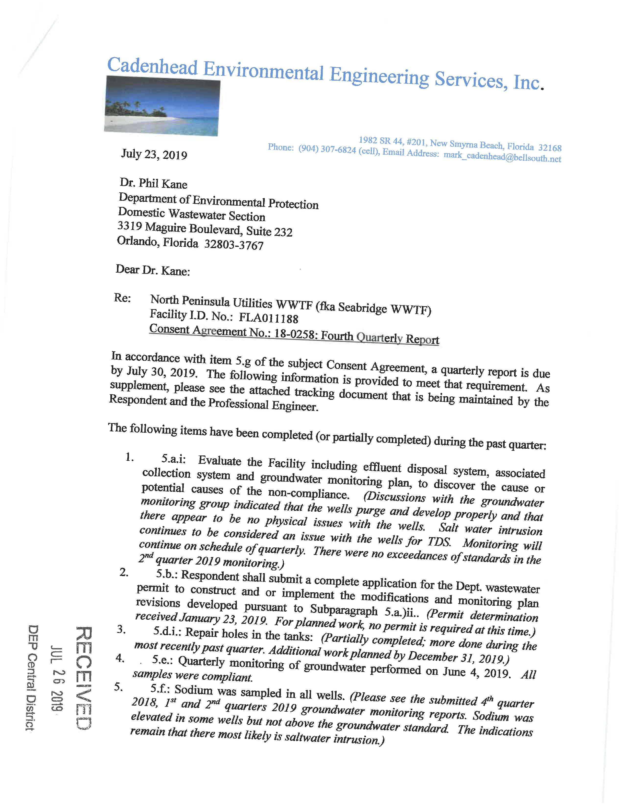

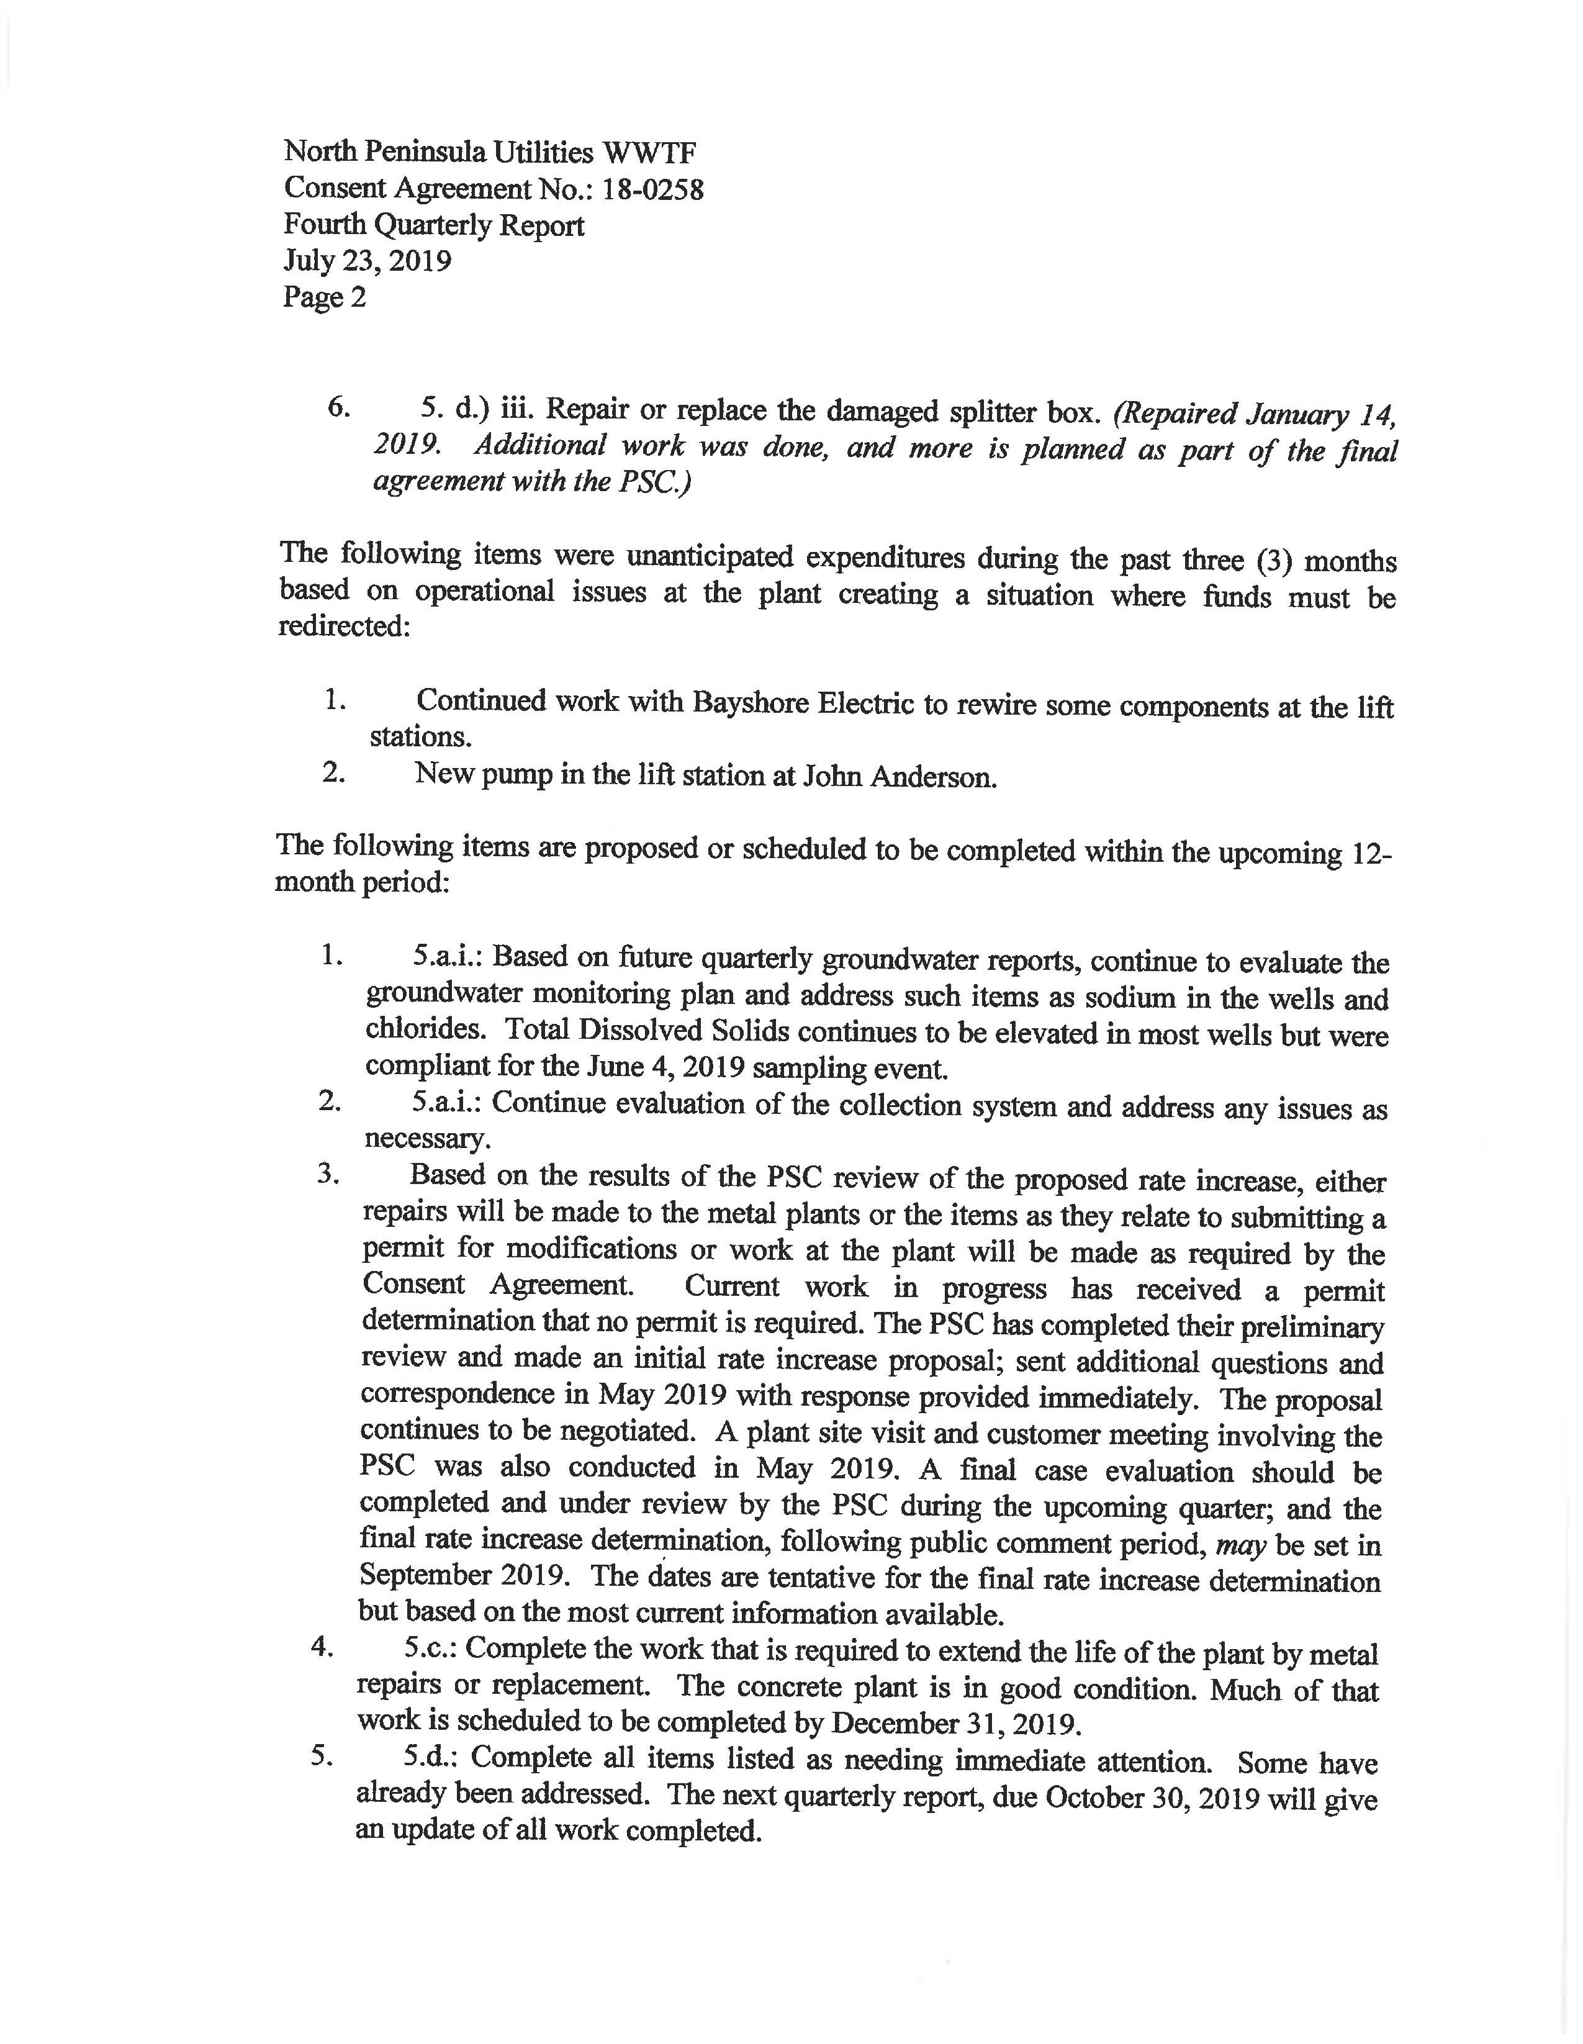

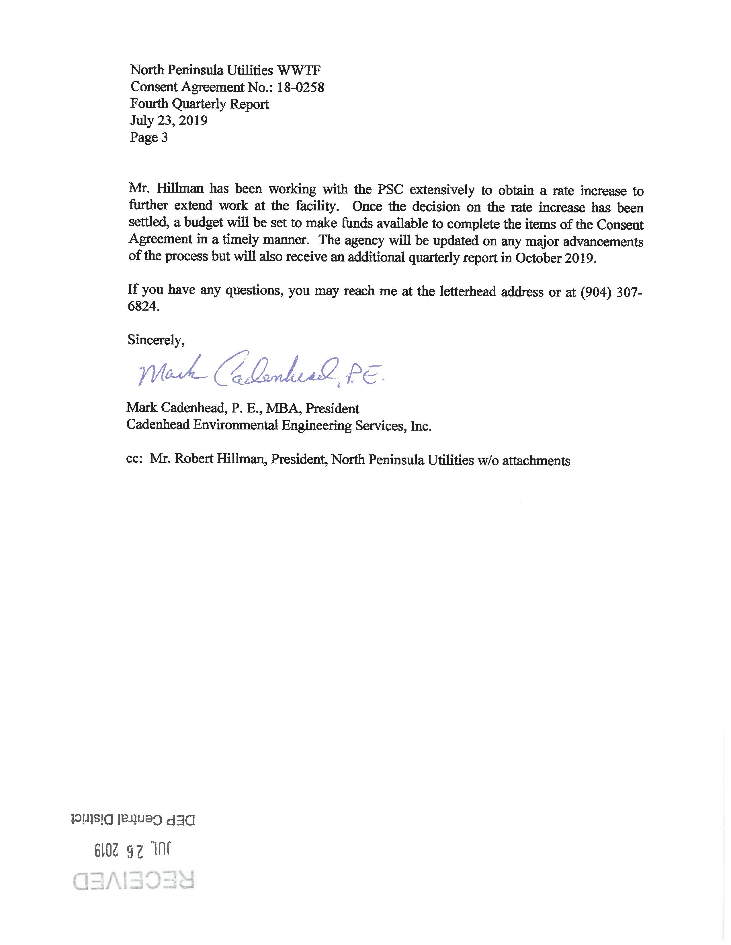

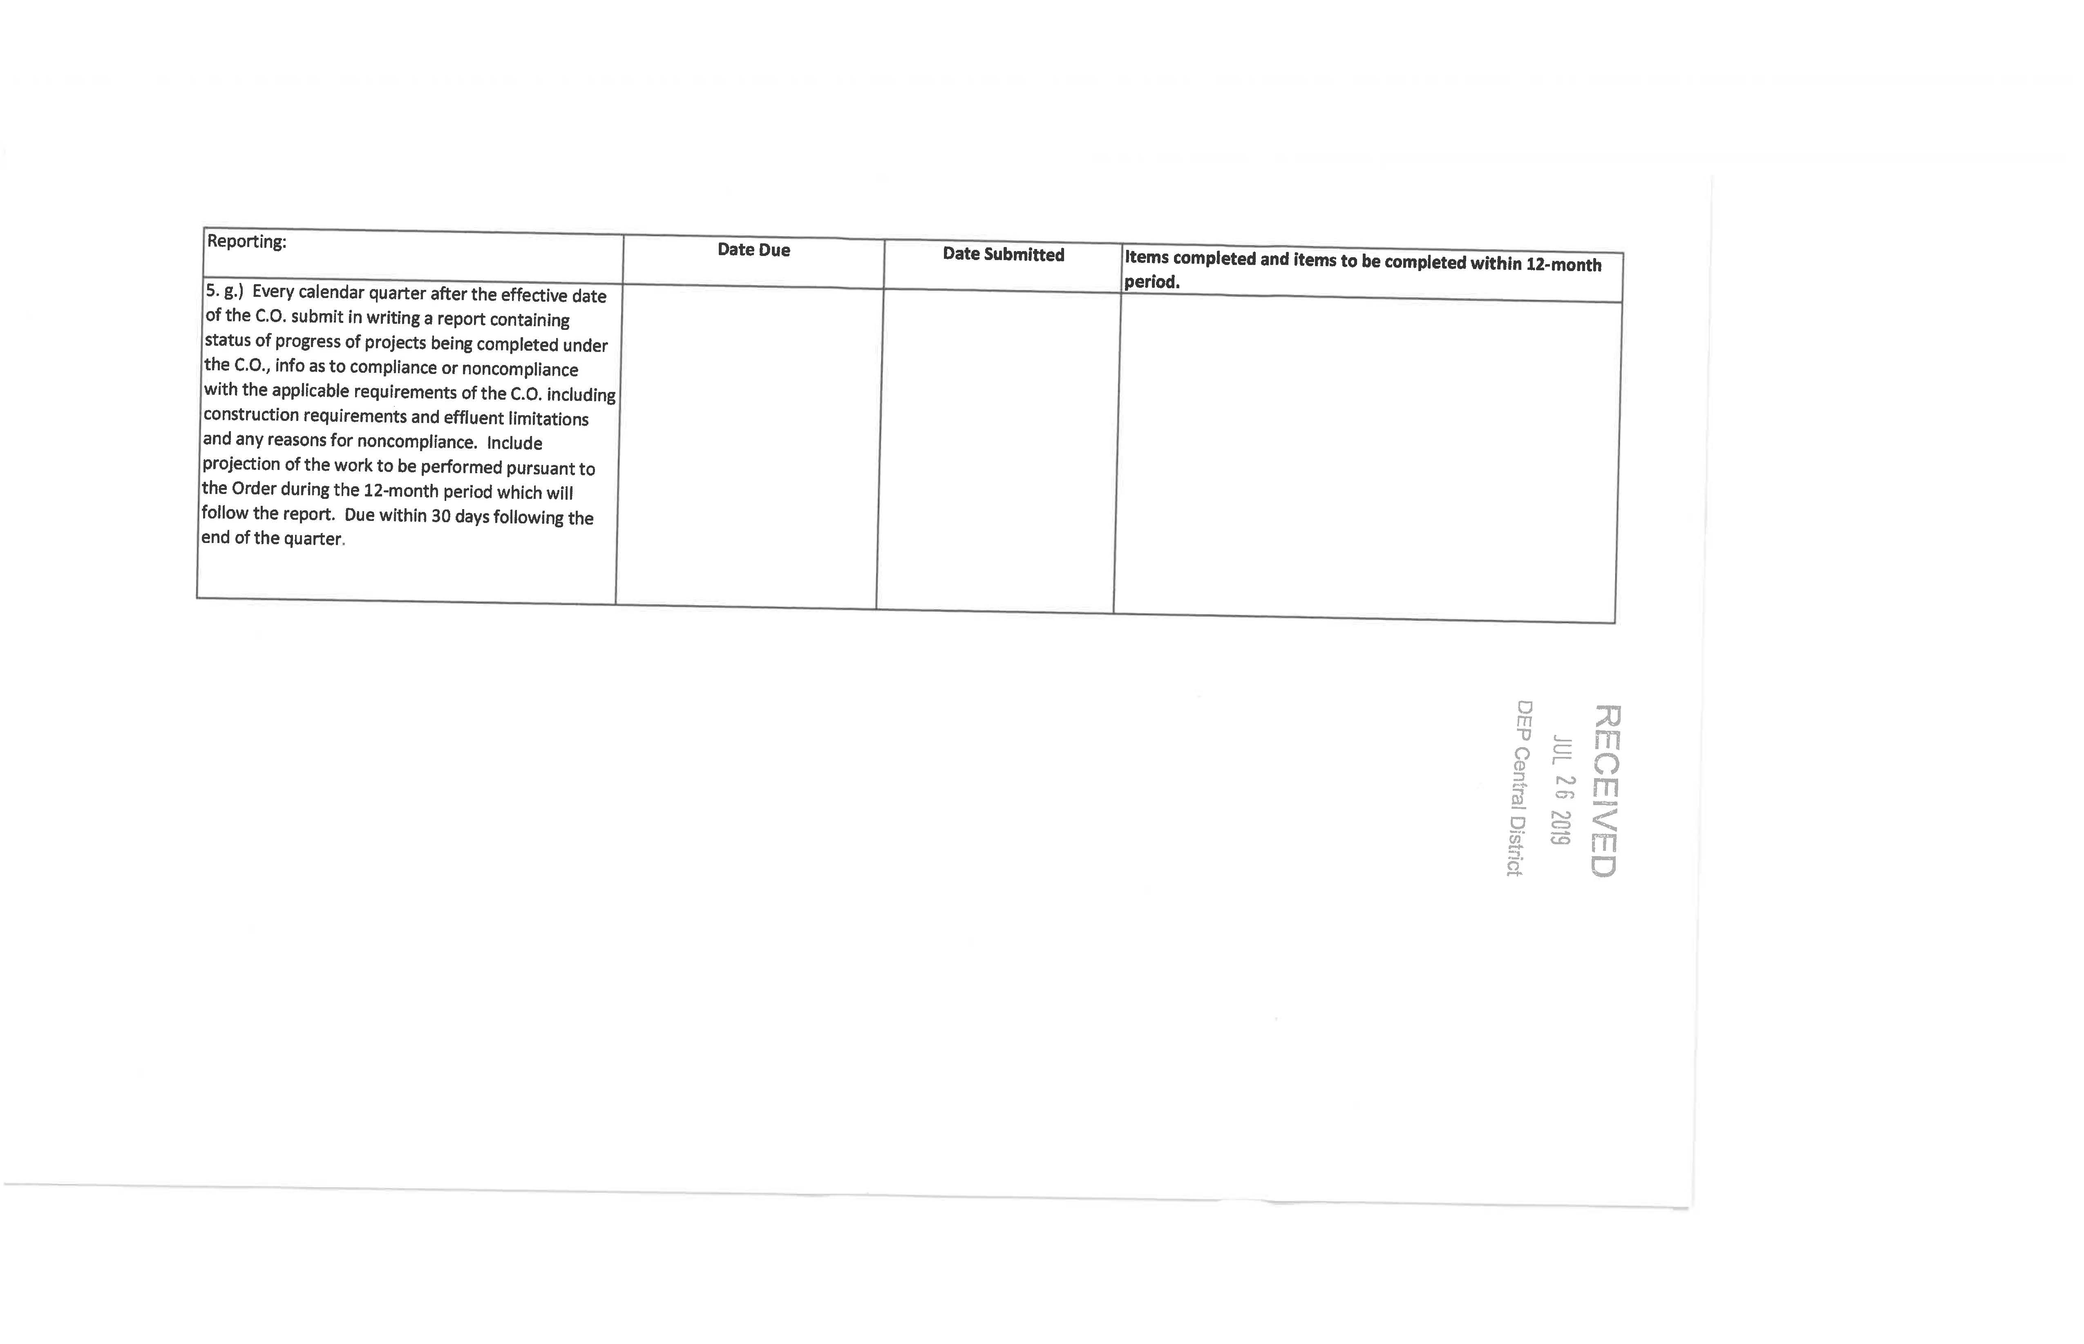
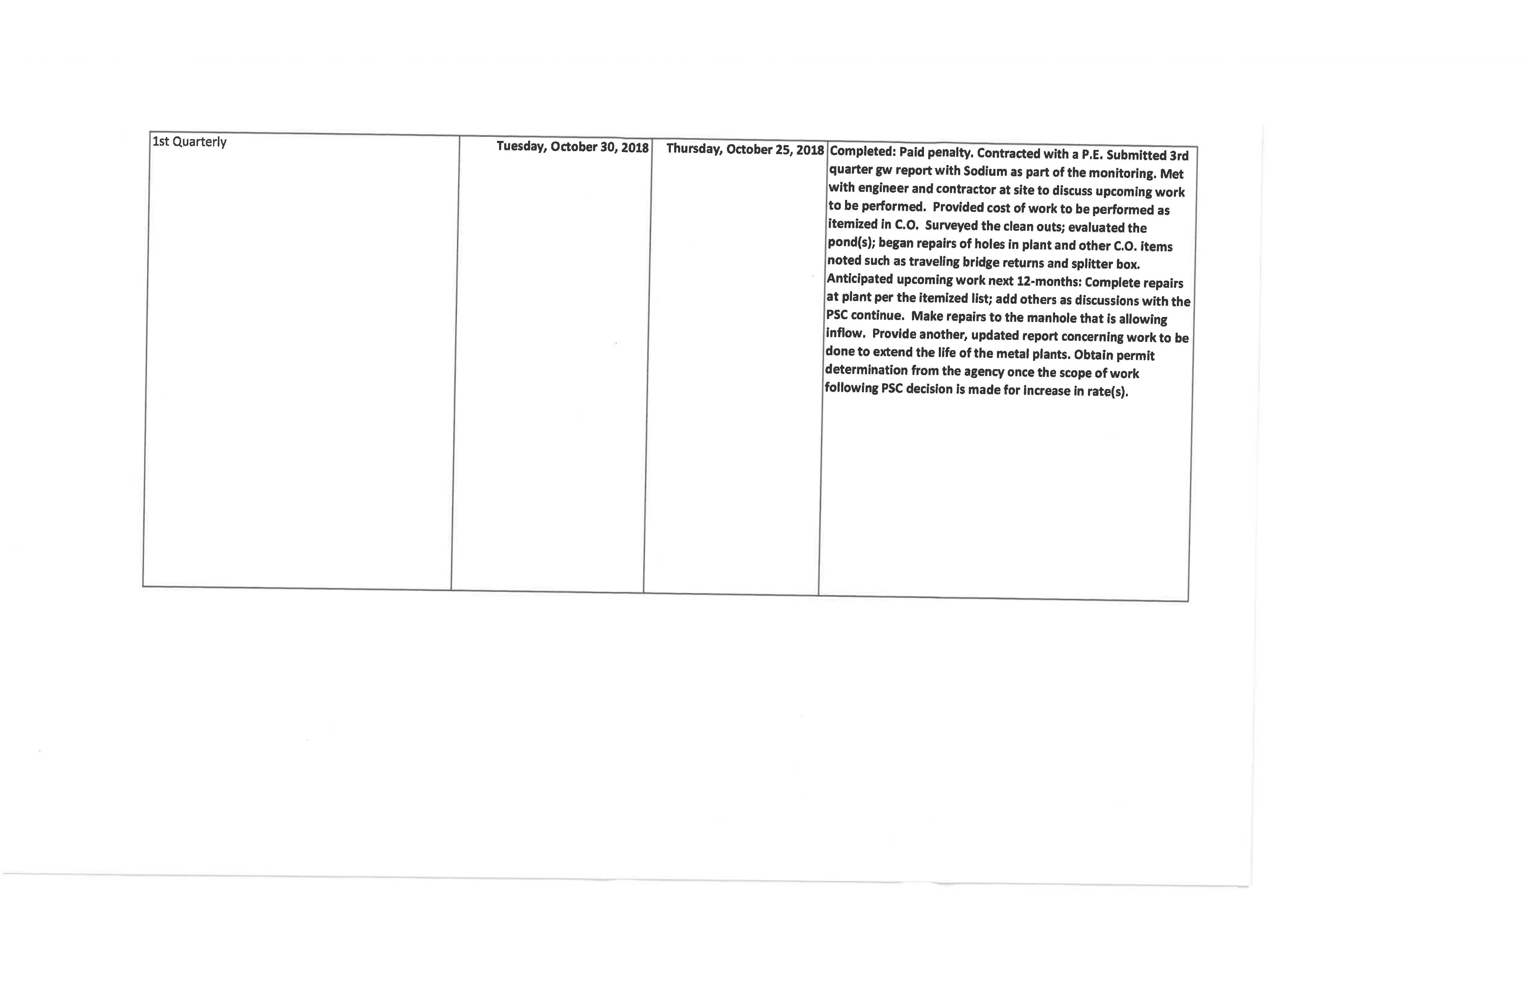
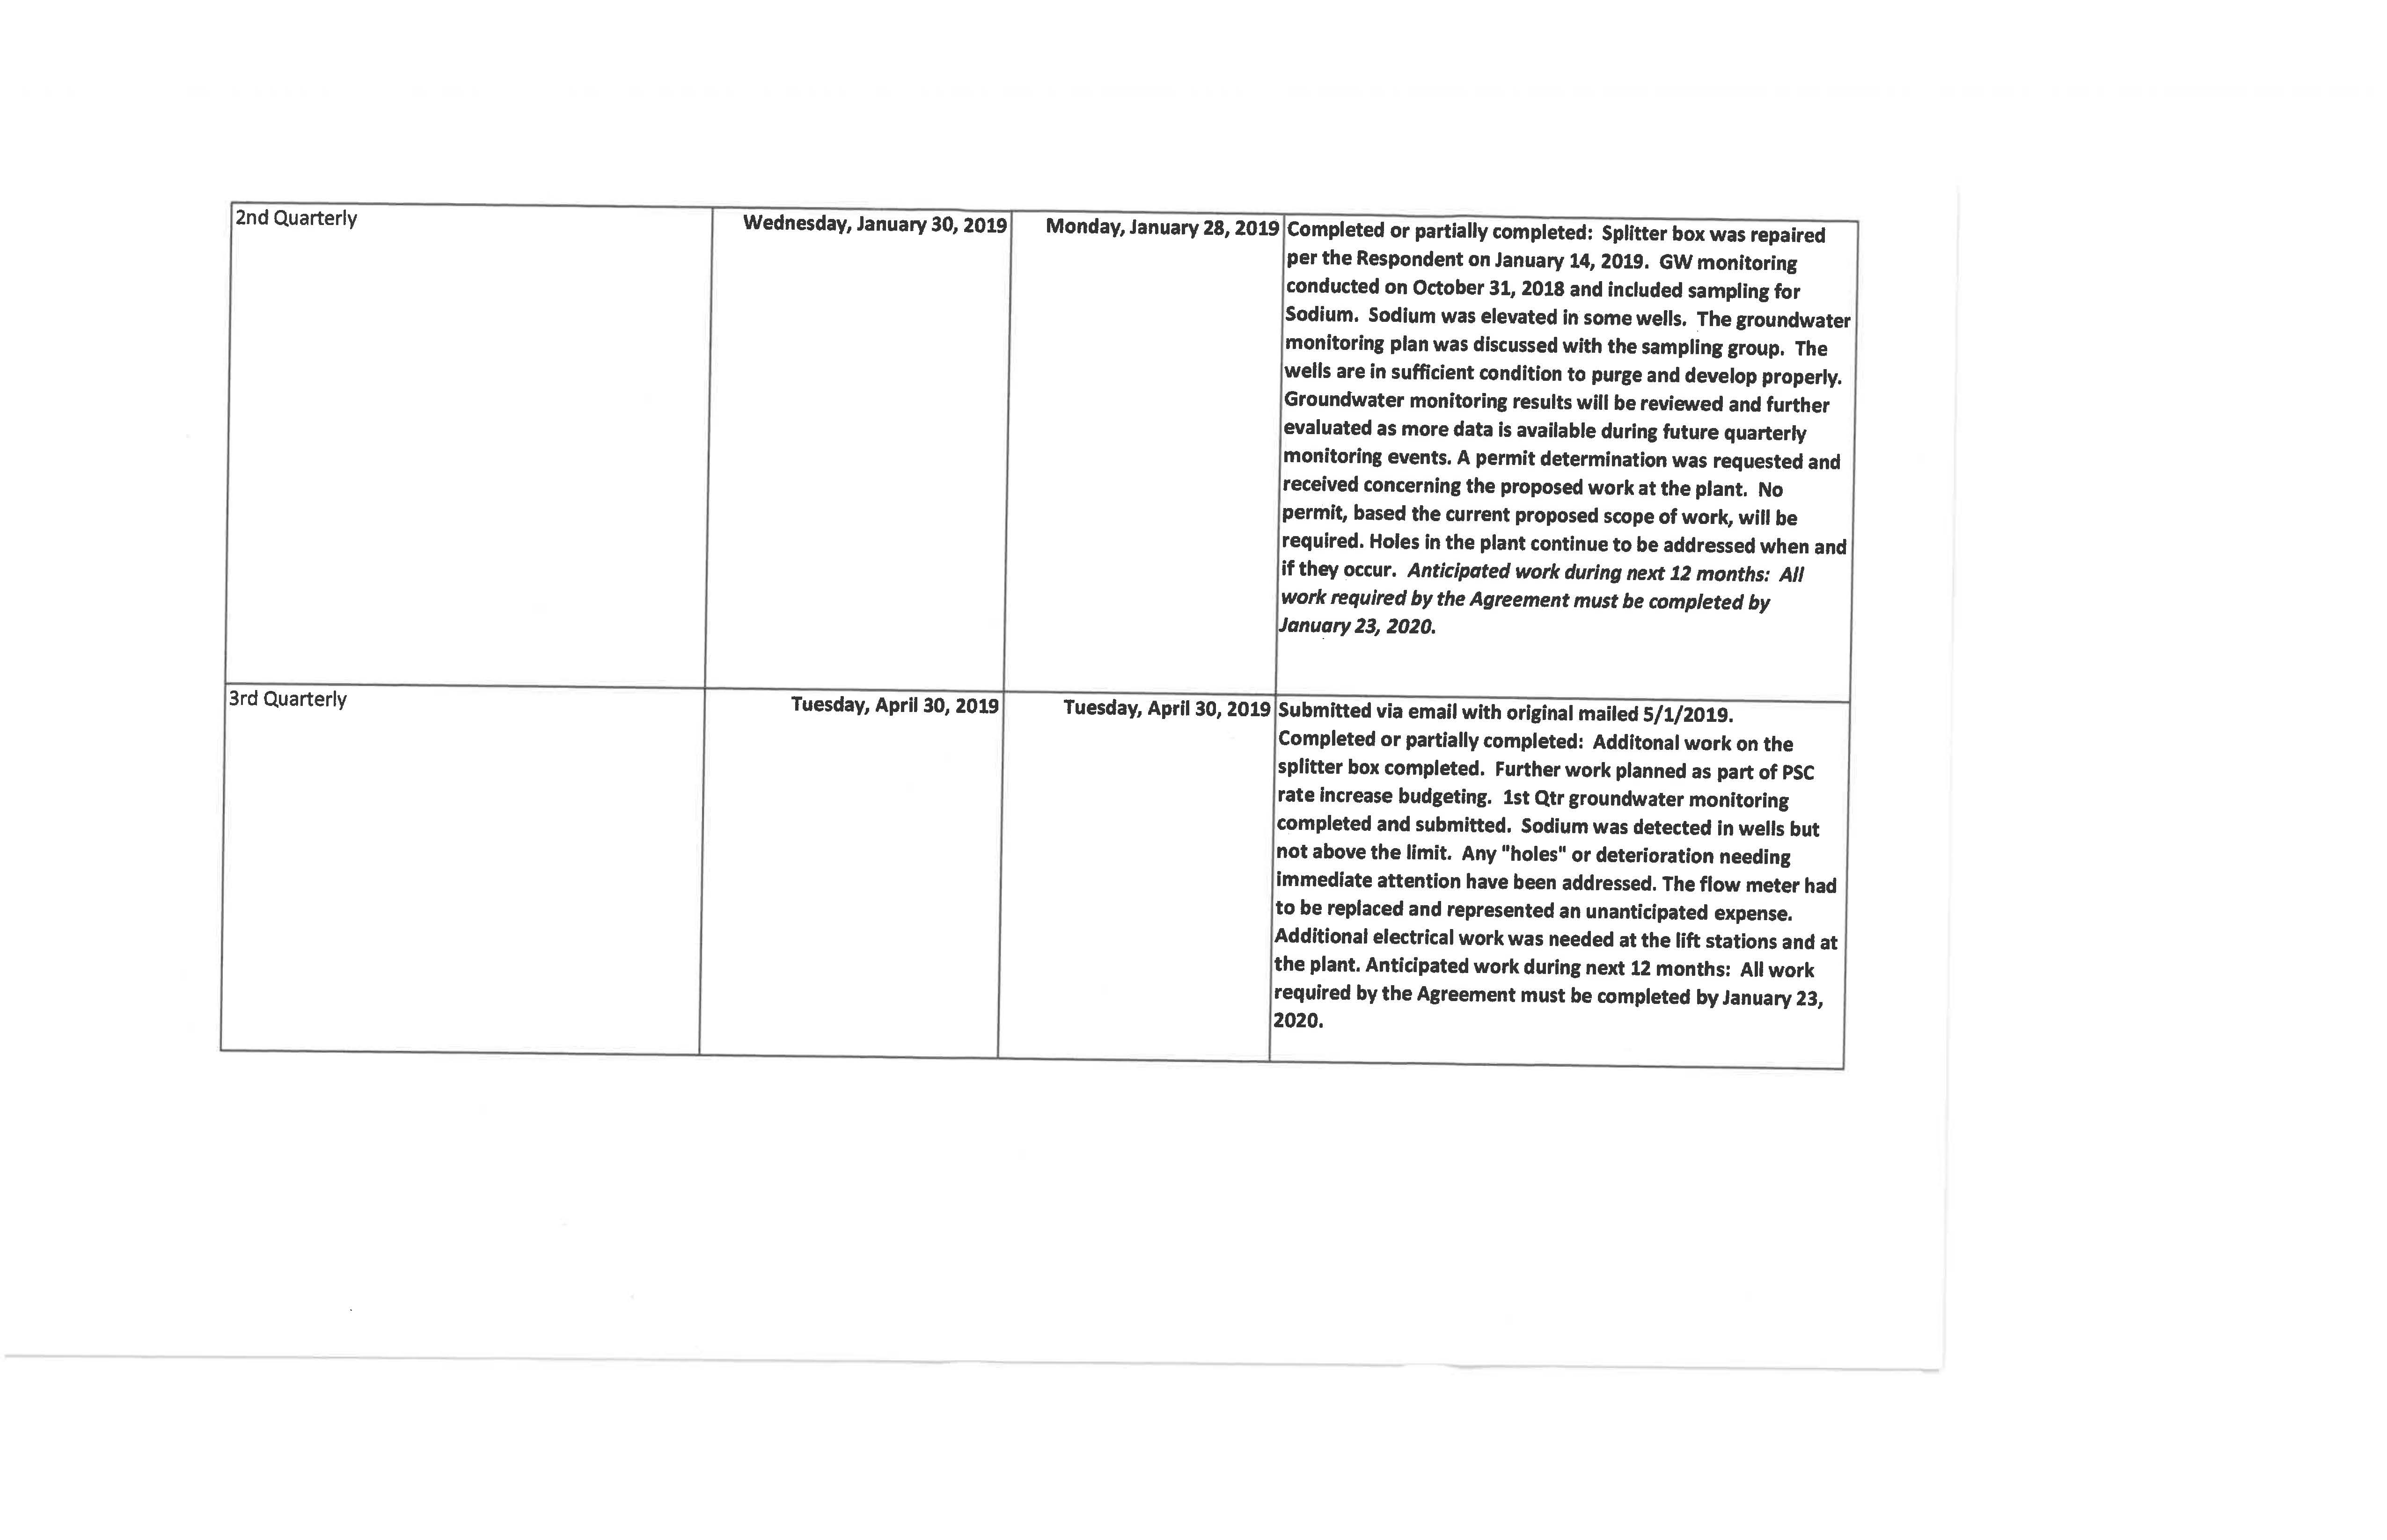
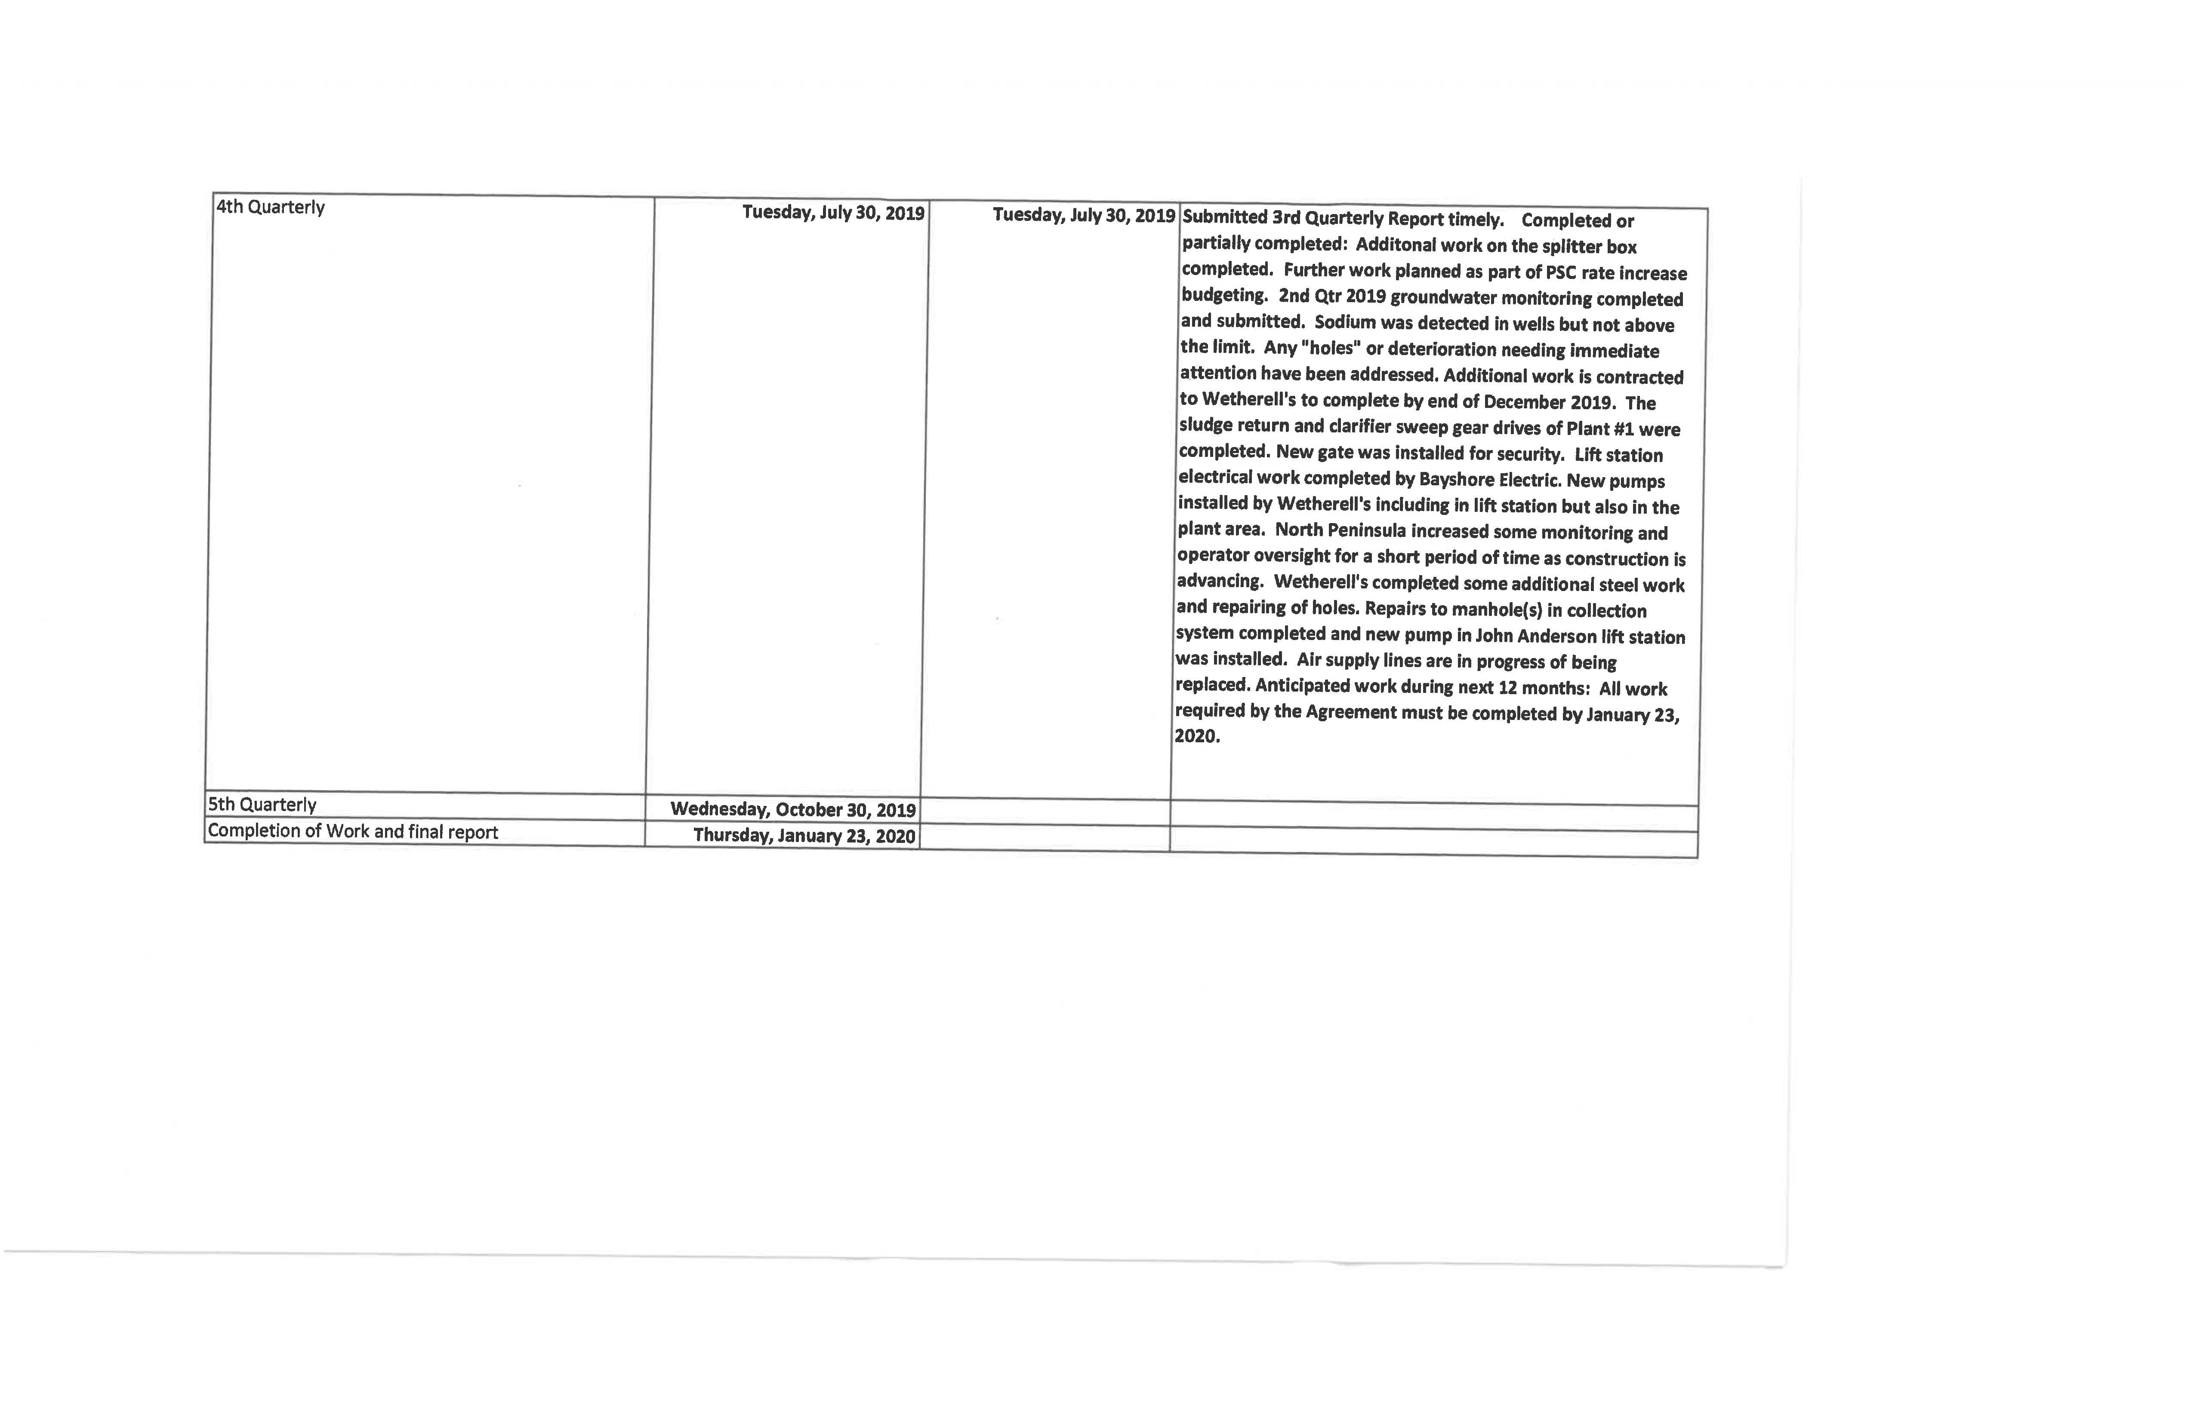

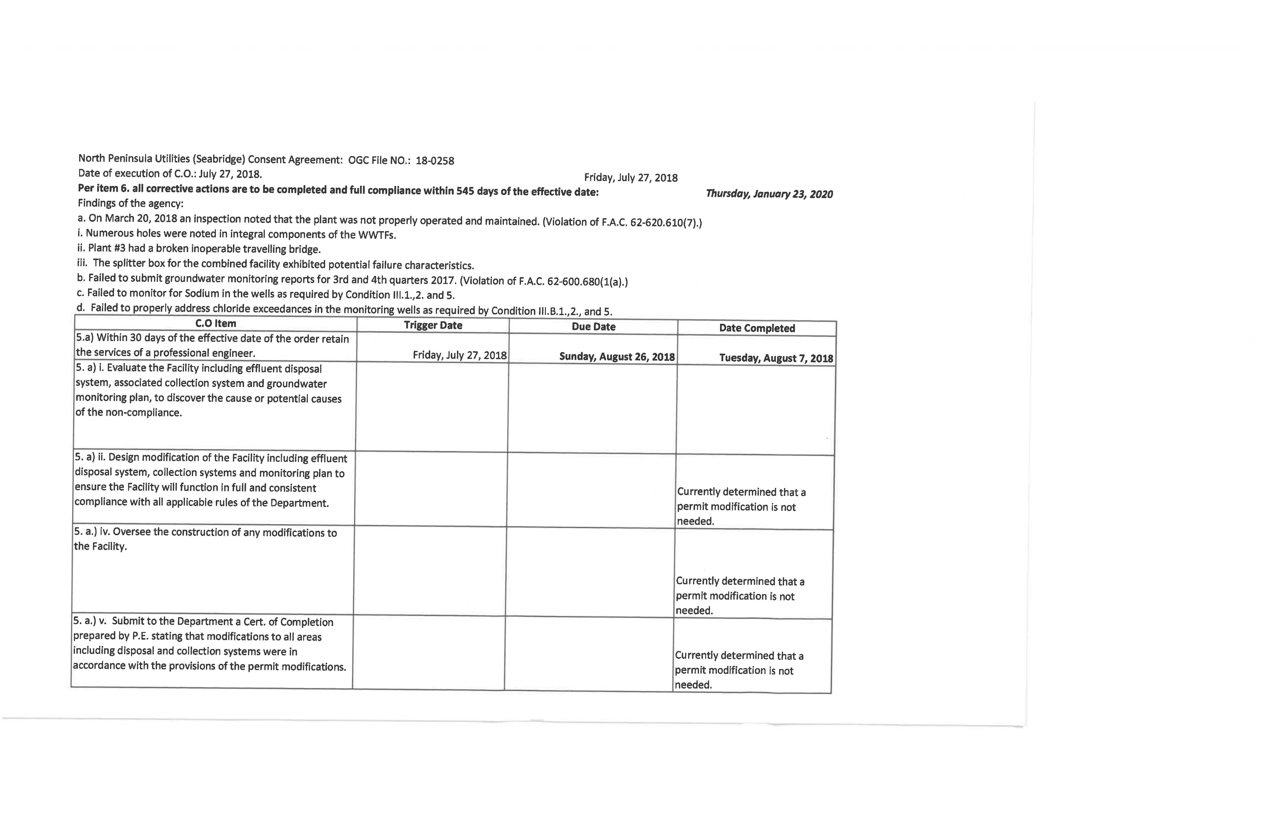
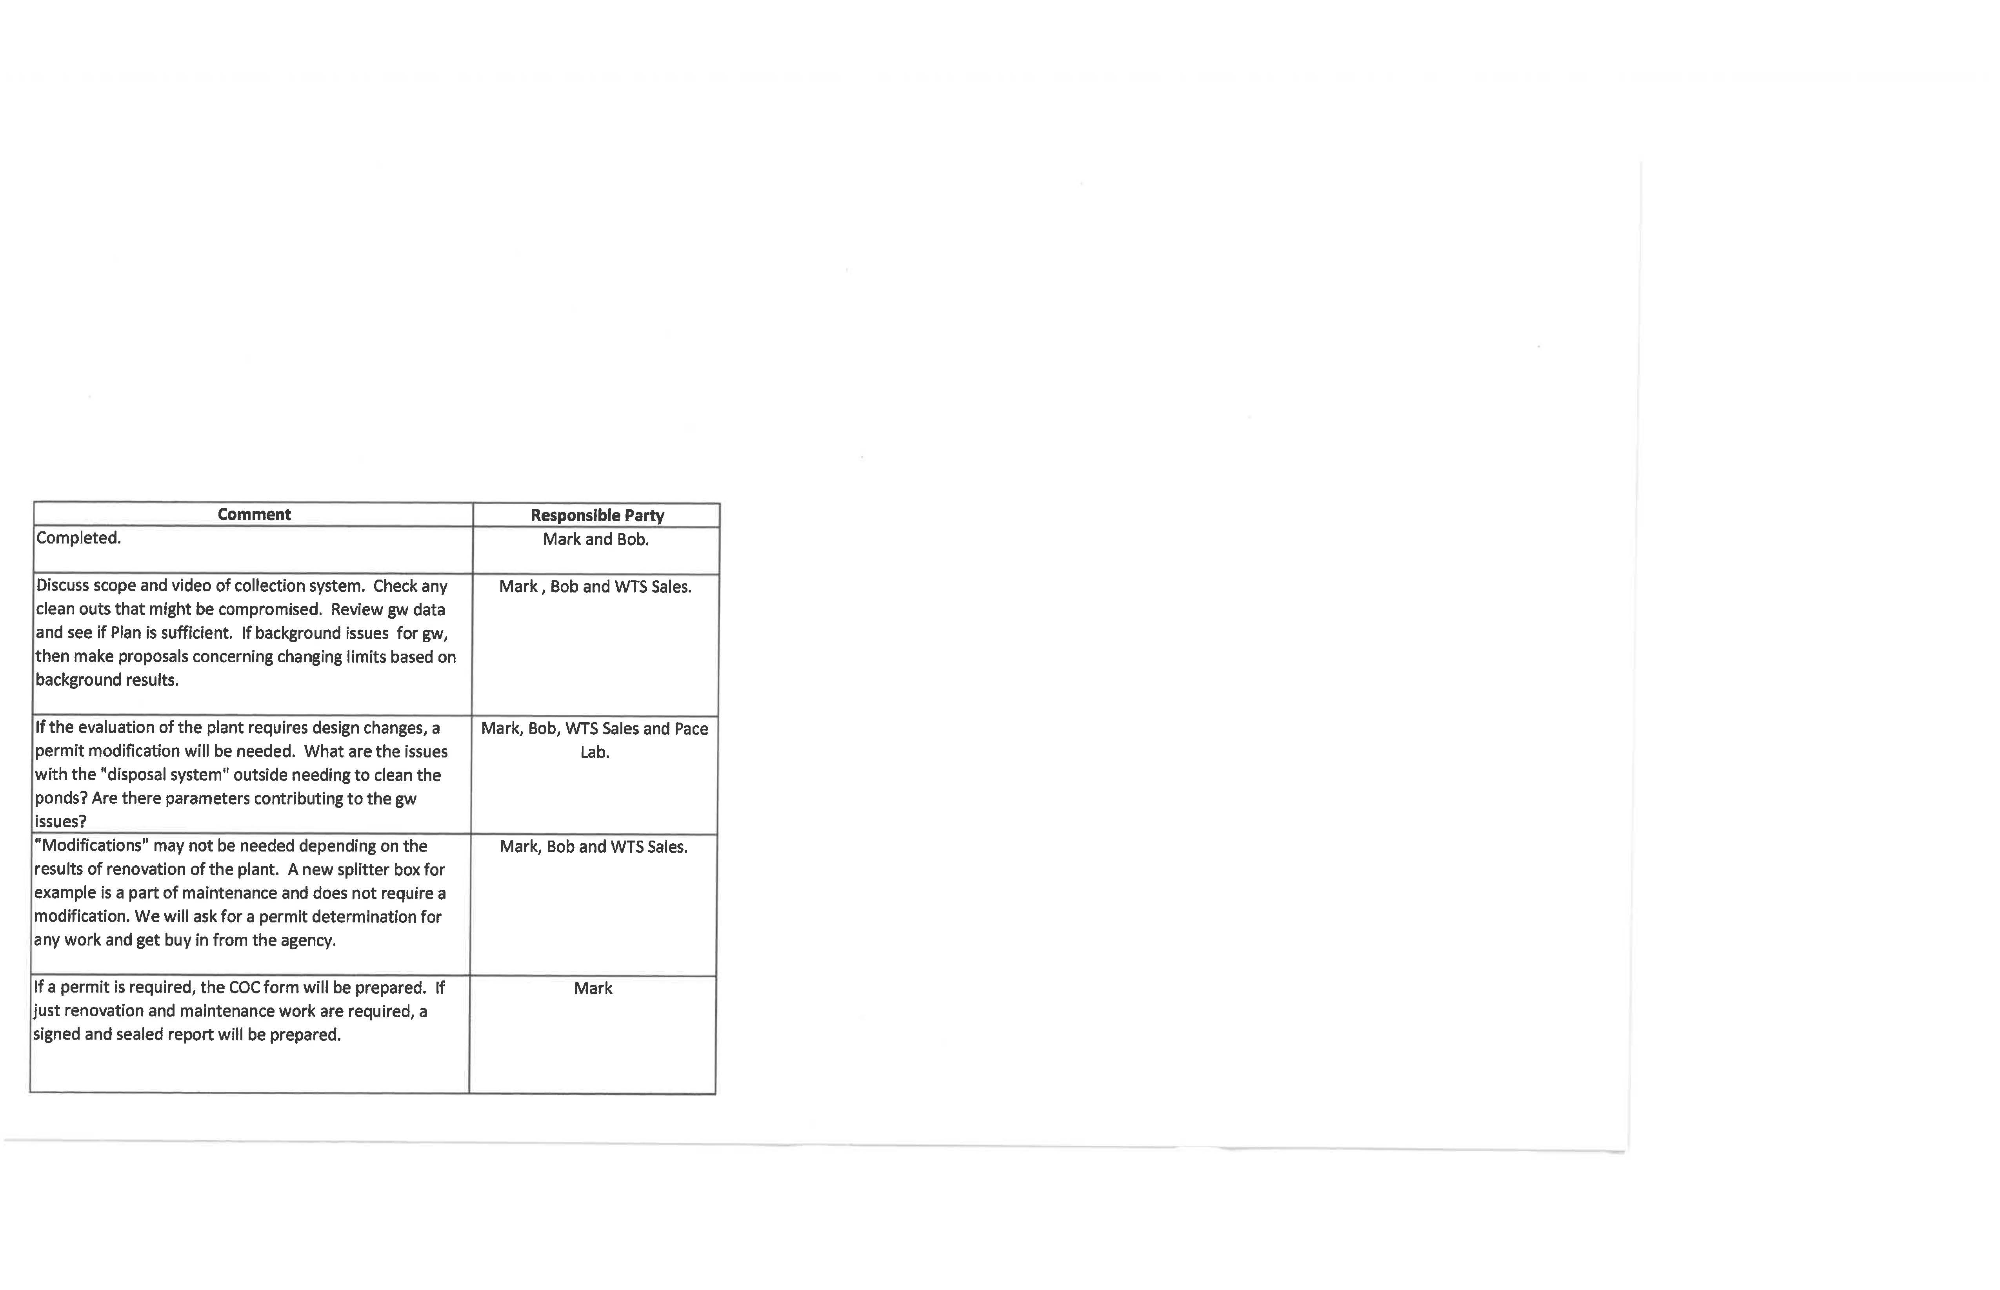
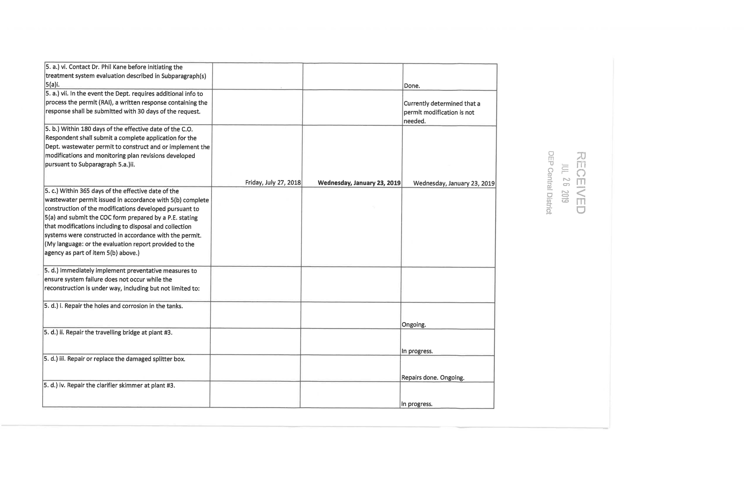
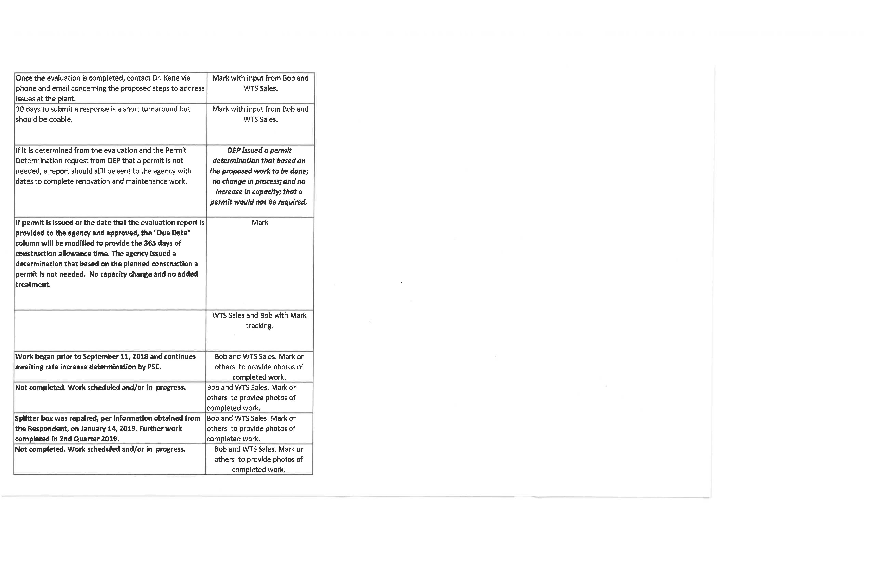
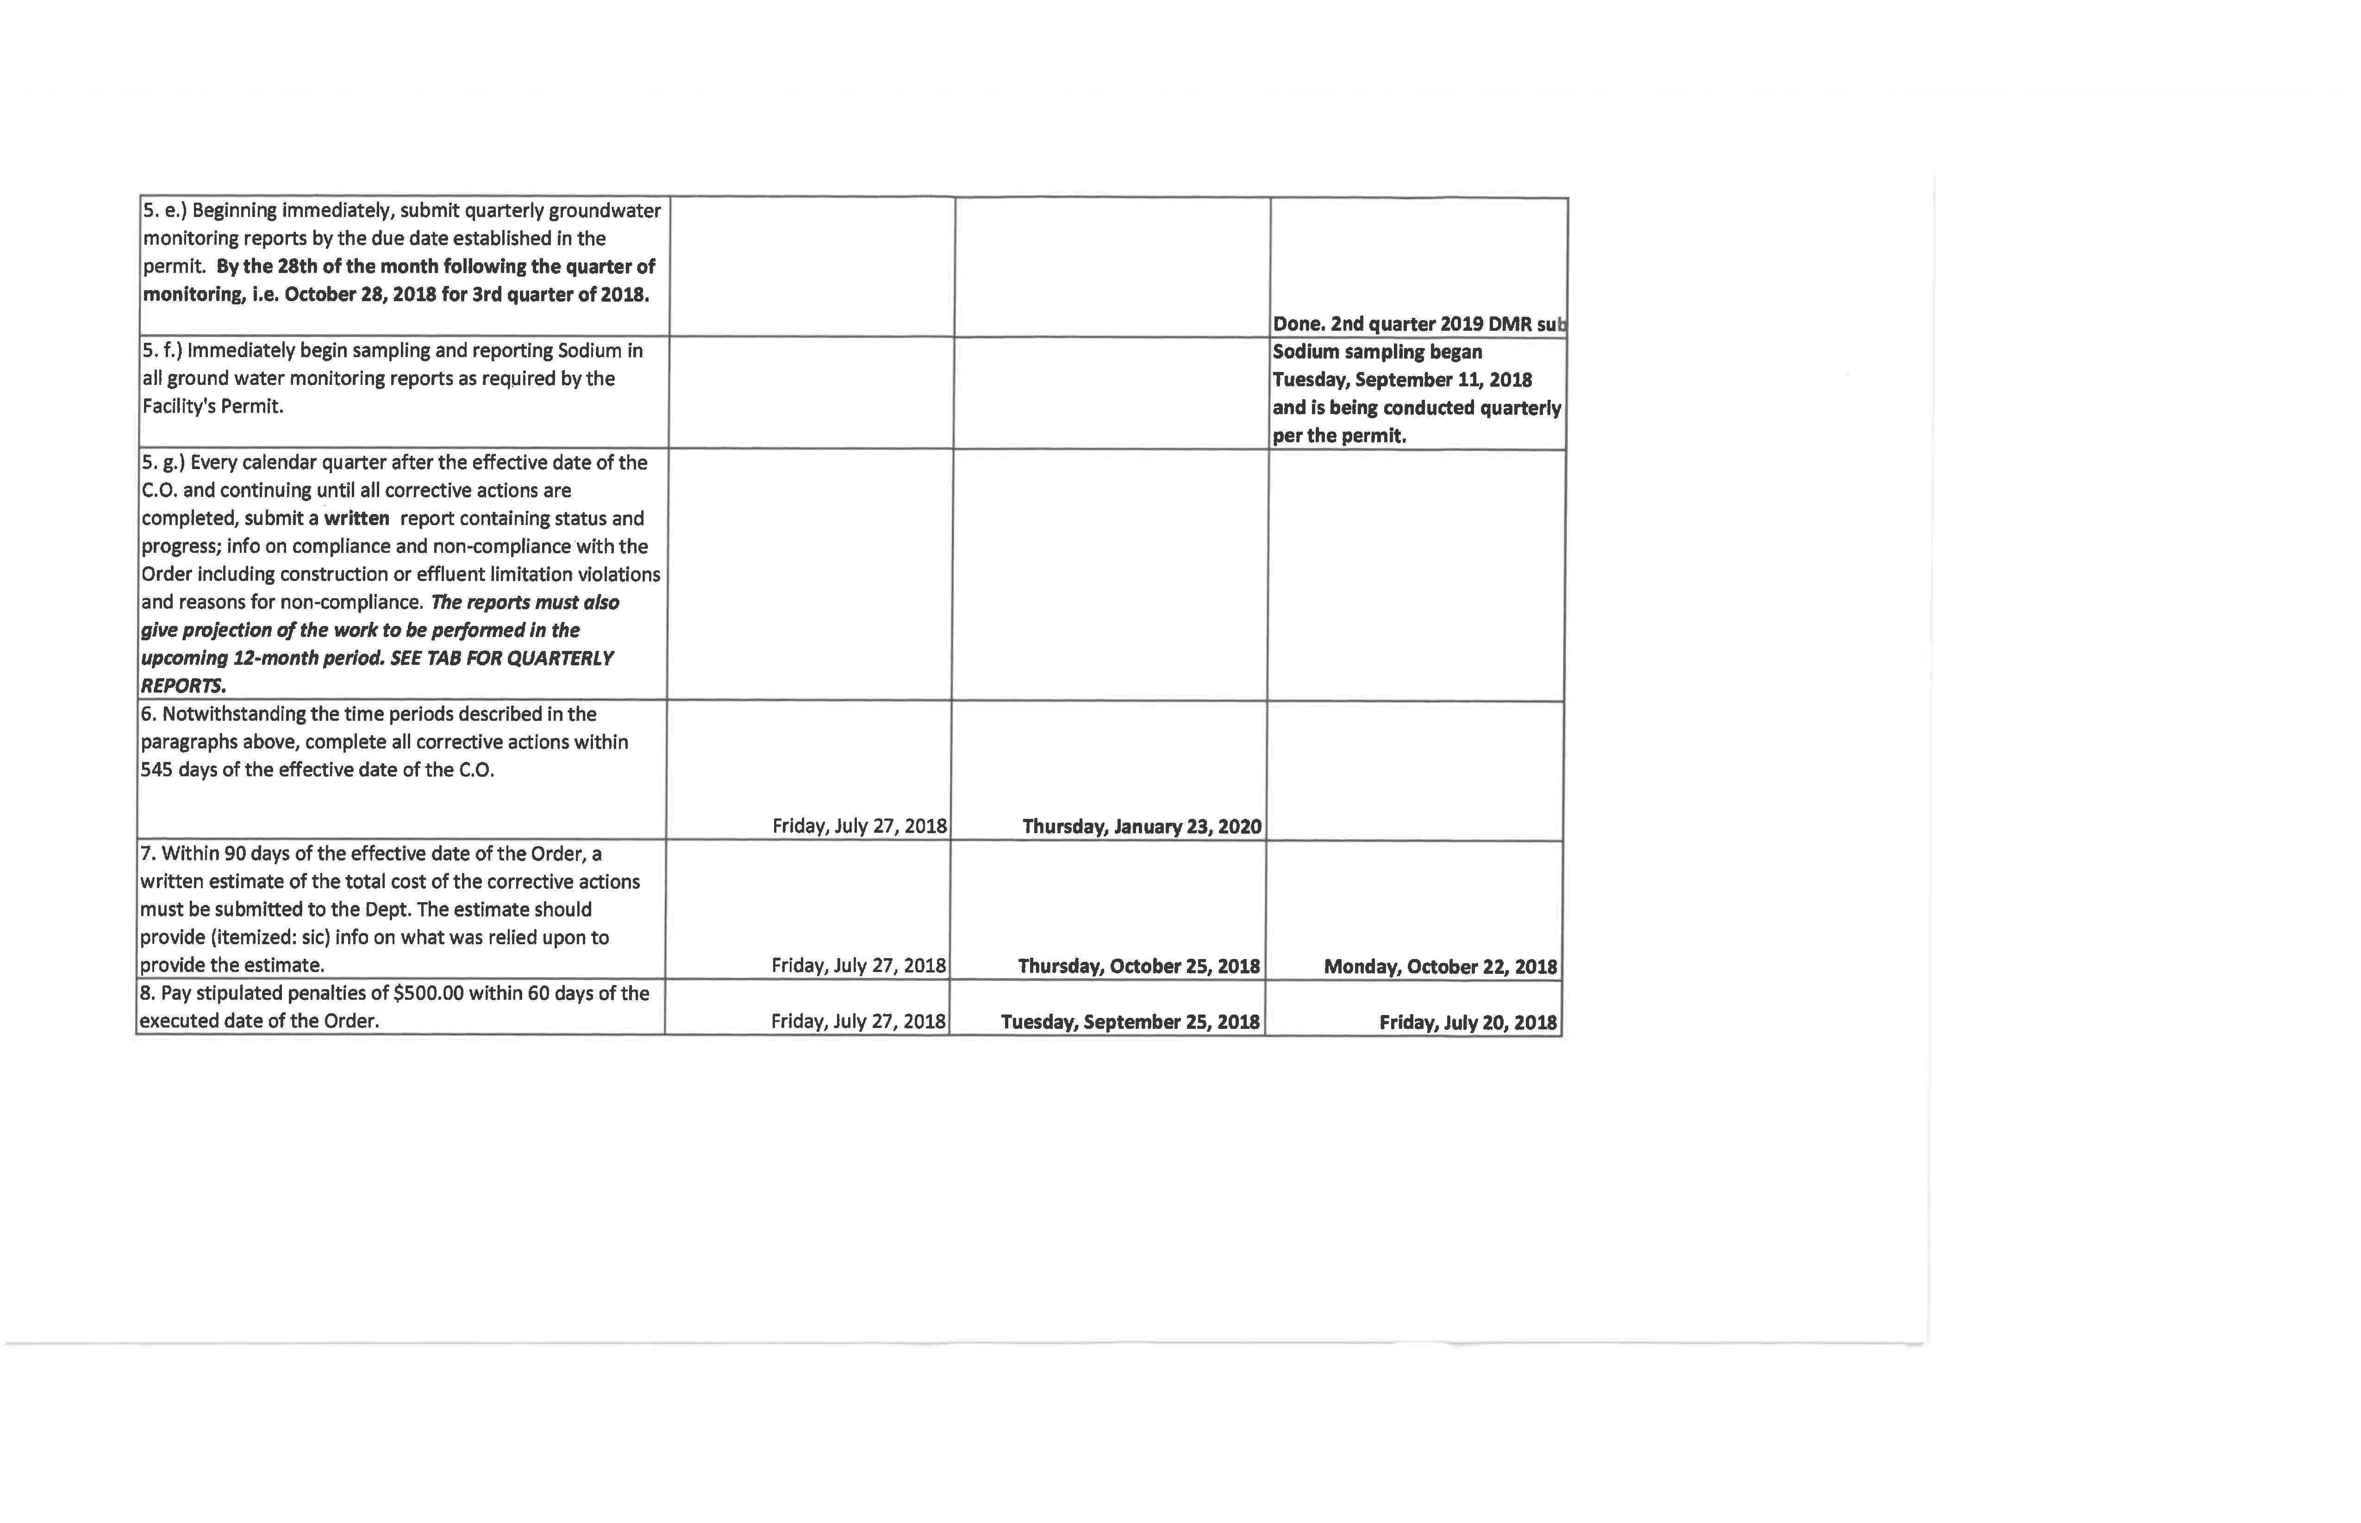
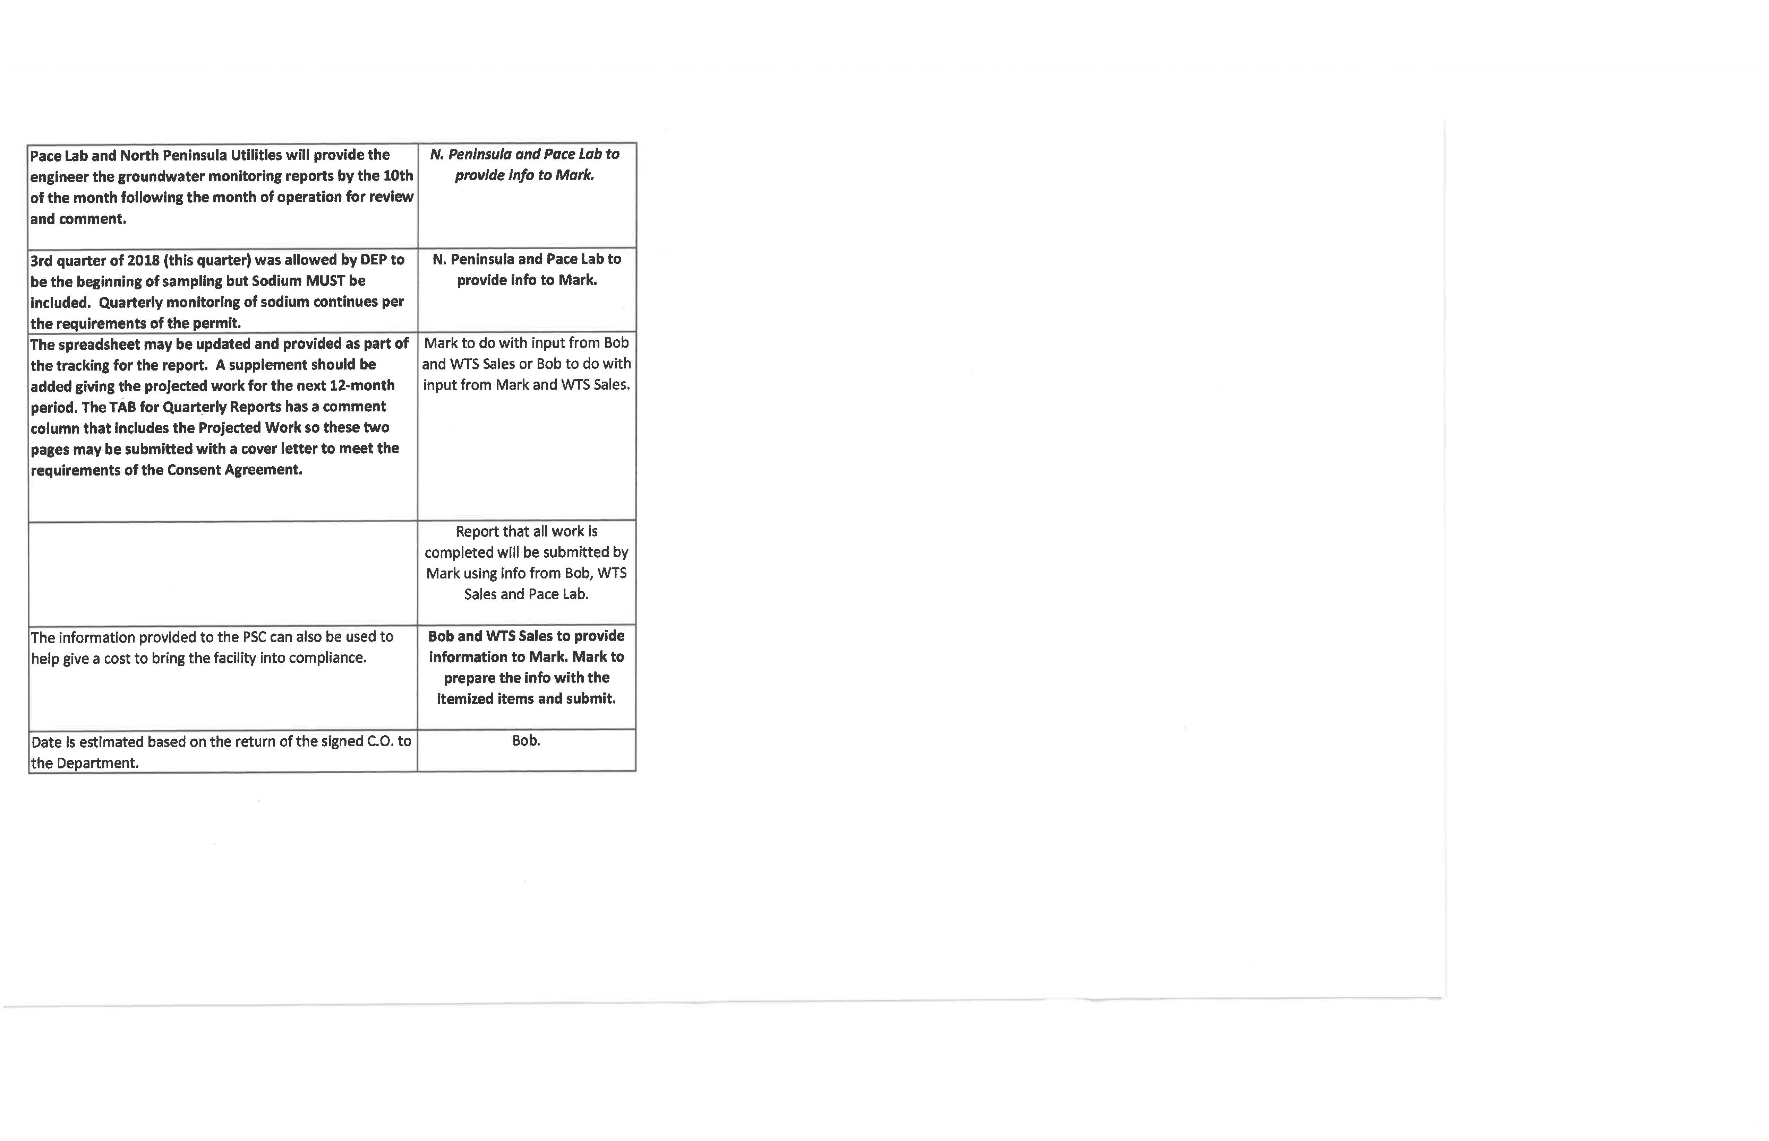

 | NORTH PENINSULA UTILITIES CORPORATION |  | SCHEDULE NO. 1-A
 | TEST YEAR ENDED 06/30/2018 |  | DOCKET NO. 20180138-SU
 | SCHEDULE OF WASTEWATER RATE BASE
 |  | BALANCE |  | BALANCE
 |  | PER | ADJUST. | PER
 | DESCRIPTION | UTILITY | TO UTIL. BAL. | COMM.
1. | UTILITY PLANT IN SERVICE | $960,499 | ($67,895) | $892,604
2. | LAND & LAND RIGHTS | 46,800 | 0 | 46,800
3. | NON-USED AND USEFUL COMPONENTS | 0 | 0 | 0
4. | ACCUMULATED DEPRECIATION | (926,024) | 190,995 | (735,029)
5. | CIAC | (640,994) | (731) | (641,725)
6. | ACCUMULATED AMORTIZATION OF CIAC | 640,994 | 21 | 641,015
7. | WORKING CAPITAL ALLOWANCE | 0 | 28,381 | 28,381
8. | WASTEWATER RATE BASE | $81,275 | $150,772 | $232,047

 | NORTH PENINSULA UTILITIES CORPORATION | SCHEDULE NO. 1-B
 | TEST YEAR ENDED 06/30/2018 | DOCKET NO. 20180138-SU
 | ADJUSTMENTS TO RATE BASE
 |  |  | WASTEWATER
 | UTILITY PLANT IN SERVICE
1. | To reflect appropriate plant in service. |  | ($77,595)
2. | To reflect addition of new customer. |  | 1,462
3. | To reflect an averaging adjustment. |  | (5,409)
4. | To reflect pro forma addition. |  | 47,088
5. | To reflect pro forma retirement |  | (33,441)
 | Total |  | ($67,895)
 | ACCUMULATED DEPRECIATION
1. | To reflect appropriate accumulated depreciation. |  | $158,547
2. | To reflect addition of new customer. |  | (21)
3. | To reflect an averaging adjustment. |  | 262
4. | To reflect pro forma adjustment. |  | 32,207
 | Total |  | $190,995
 | CIAC
1. | To reflect addition for new customer. |  | ($1,462)
2. | To reflect an averaging adjustment. |  | 731
 | Total |  | ($731)
 | ACCUMULATED AMORTIZATION OF CIAC
 | To reflect addition of new customer. |  | $21
 | WORKING CAPITAL ALLOWANCE
 | To reflect 1/8 of test year O&M expenses. |  | $28,381

NORTH PENINSULA UTILITIES CORPORATION |  |  |  |  |  |  | SCHEDULE NO. 2
TEST YEAR ENDED 06/30/2018 |  |  |  |  |  |  | DOCKET NO. 20180138-SU
SCHEDULE OF CAPITAL STRUCTURE
 |  |  | SPECIFIC | BALANCE | PRO RATA | BALANCE | PERCENT
 |  | PER | ADJUST | AFTER | ADJUST- | PER | OF |  | WEIGHTED
 | CAPITAL COMPONENT | UTILITY | MENTS | ADJUSTMENTS | MENTS | COMM. | TOTAL | COST | COST
1. | COMMON STOCK | $100 | ($100) | $0 | $0 | $0 | 0.00% |  | 0.00%
2. | RETAINED EARNINGS | ($940,660) | $940,660 | $0 | $0 | $0 | 0.00% |  | 0.00%
3. | PAID IN CAPITAL | $400 | ($400) | $0 | $0 | $0 | 0.00% |  | 0.00%
4. | OTHER COMMON EQUITY | $0 | $0 | $0 | $0 | $0 | 0.00% |  | 0.00%
 | TOTAL COMMON EQUITY | ($940,160) | $940,160 | $0 | $0 | $0 | 0.00% | 10.55% | 0.00%
5. | LONG-TERM DEBT | $1,093,091 | $0 | $1,093,091 | ($861,044) | $232,047 | 100.00% | 6.70% | 6.70%
6. | SHORT-TERM DEBT | $0 | $0 | $0 | $0 | $0 | 0.00% | 0.00% | 0.00%
7. | PREFERRED STOCK | $0 | $0 | $0 | $0 | $0 | 0.00% | 0.00% | 0.00%
 | TOTAL LONG TERM DEBT | $1,093,091 | $0 | $1,093,091 | ($861,044) | $232,047 | 100.00% | 6.70% | 6.70%
8. | CUSTOMER DEPOSITS | $0 | $0 | $0 | $0 | $0 | 0.00% | 2.00% | 0.00%
9. | TOTAL | $152,931 | $940,160 | $1,093,091 | ($861,044) | $232,047 |  |  | 6.70%
 |  |  |  |  | RANGE OF REASONABLENESS |  |  | LOW | HIGH
 |  |  |  |  | RETURN ON EQUITY |  |  | 9.55% | 11.55%
 |  |  |  |  | OVERALL RATE OF RETURN |  |  | 6.70% | 6.70%

 | NORTH PENINSULA UTILITIES CORPORATION |  |  | SCHEDULE NO. 3-A
 | TEST YEAR ENDED 06/30/2018 |  |  | DOCKET NO. 20180138-SU
 | SCHEDULE OF WASTEWATER OPERATING INCOME
 |  | TEST | COMM. |  | COMM.  ADJ. | ADJUST.
 |  | YEAR PER | ADJUST- |  | TEST | FOR | REVENUE
 |  | UTILITY | MENTS |  | YEAR | INCREASE | REQ.
1. | OPERATING REVENUES | $242,292 | $1,485 |  | $243,777 | $25,988 | $269,765
 |  |  |  |  |  | 10.66%
 | OPERATING EXPENSES:
2. | OPERATION & MAINTENANCE | $276,376 | ($48,179) |  | $228,197 |  | $228,197
3. | DEPRECIATION (NET) | 27,508 | (21,717) |  | 5,791 |  | 5,791
4. | AMORTIZATION | 0 | 0 |  | 0 |  | 0
5. | TAXES OTHER THAN INCOME | 18,653 | 955 |  | 19,608 | 1,169 | 20,777
6. | INCOME TAXES | 0 | 0 |  | 0 |  | 0
7. | TOTAL OPERATING EXPENSES | $322,537 | ($68,942) |  | $253,595 |  | $254,765
8. | OPERATING INCOME/(LOSS) | ($80,245) |  |  | ($9,818) |  | $15,000
9. | WASTEWATER RATE BASE | $81,275 |  |  | $232,047 |  | $232,047
10 | OPERATING MARGIN |  |  |  |  |  | 6.46%

 | NORTH PENINSULA UTILITIES CORPORATION | SCHEDULE 3-B
 | TEST YEAR ENDED 06/30/2018 | DOCKET NO. 20180138-SU
 | ADJUSTMENTS TO OPERATING INCOME | PAGE 1 OF 2
 |  | WASTEWATER
 | OPERATING REVENUES
1. | To reflect the appropriate test year revenue. | $1,485
 | OPERATION AND MAINTENANCE EXPENSES
1. | Purchased Power (715)
 | a. To reflect removal of out of test year amounts. | ($949)
 | b. To reflect removal of late fees. | (33)
 | Subtotal | ($982)
2. | Chemicals (718)
 | To reflect removal of out of test year amounts. | ($389)
3. | Contractual Services - Engineering (731)
 | To reflect DEP permit and filing amortized over five years. | $120
4. | Contractual Services - Accounting (732)
 | To reflect removal of out of test year amounts. | ($1,350)
5. | Contractual Services - Legal (733)
 | a. To reflect removal due to lack of supporting documentation. | ($1,030)
 | b. To reflect average expenses related to collection activities. | 600
 | Subtotal | ($430)
6. | Contractual Services - Mgt. Fees (734)
 | a. To reflect removal of miscellaneous expenses from contract. | ($3,600)
 | b. To reflect 2019 IRS adjustment to auto expense. | (548)
 | c. To reflect reduced management compensation portion of contract. | (39,254)
 | Subtotal | ($43,402)
7. | Contractual Services - Other (736)
 | a. To reflect adjustments to repairs per invoice. | $95
 | b. To reflect increased pay rate for plant operator. | 3,009
 | c. To reflect pro forma plant expenses amortized over five years. | 3,715
 | Subtotal | $6,819
8. | Insurance - General Liability (757)
 | To reflect removal of late fees. | ($30)
9. | Rate Case Expense (766)
 | Allowance for rate case expense amortized over four years. | $1,147
10. | Regulatory Commission Expense - Other (767)
 | To reflect removal of amount written off amortized over four years. | ($6,365)
 | NORTH PENINSULA UTILITIES CORPORATION | SCHEDULE 3-B
 | TEST YEAR ENDED 06/30/2018 | DOCKET NO. 20180138-SU
 | ADJUSTMENTS TO OPERATING INCOME | PAGE 2 OF 2
 |  | WASTEWATER
11. | Miscellaneous Expenses (775)
 | a. To reflect removal of refunded deposit to City of Ormond Beach. | ($1,000)
 | b. To reflect removal of late payment to Roto-Rooter. | (9)
 | c. To reflect five year amortization of Roto-Rooter expense. | (996)
 | d. To reflect removal of out of test year amount to Woody's Septic Tank. | (1,313)
 | Subtotal | ($3,318)
 | TOTAL OPERATION AND MAINTENANCE ADJUSTMENTS | ($48,179)
 | DEPRECIATION EXPENSE
1. | To reflect the appropriate test year depreciation expense. | ($22,910)
2. | To reflect Account 352 - Franchises being fully depreciated. | ($41)
3. | To reflect depreciation expense of new customer. | 21
4. | To reflect the amortization of CIAC for new customer. | (21)
5. | To reflect pro forma additions. | 1,233
 | Total | ($21,717)
 | TAXES OTHER THAN INCOME
1. | To reflect appropriate test year RAFs. | $67
2. | To reflect property taxes associated with pro forma plant additions. | 888
 | Total | $955
 | TOTAL OPERATING EXPENSE | ($68,942)

 | NORTH PENINSULA UTILITIES CORPORATION | SCHEDULE NO. 3-C
 | TEST YEAR ENDED 06/30/2018 | DOCKET NO. 20180138-SU
 | ANALYSIS OF WASTEWATER O&M EXPENSE
 |  | TOTAL | COMM. | TOTAL
 |  | PER | ADJUST- | PER
Acct. # | Description | UTILITY | MENT | COMM.
711 | Sludge Removal | $22,860 | $0 | $22,860
715 | Purchased Power | 12,245 | (982) | 11,263
718 | Chemicals | 5,776 | (389) | 5,387
720 | Materials and Supplies | 613 | 0 | 613
731 | Contractual Services - Engineering | 800 | 120 | 920
732 | Contractual Services - Accounting | 4,500 | (1,350) | 3,150
733 | Contractual Services - Legal | 1,030 | (430) | 600
734 | Contractual Services - Mgt. Fees | 135,487 | (43,402) | 92,085
735 | Contractual Services - Testing | 12,588 | 0 | 12,588
736 | Contractual Services - Other | 34,788 | 6,819 | 41,607
757 | Insurance - General Liability | 2,252 | (30) | 2,222
766 | Rate Case Expense (RCE) | 0 | 1,147 | 1,147
767 | Regulatory Commission Expense - Other | 36,370 | (6,365) | 30,005
775 | Miscellaneous Expense | 7,067 | (3,318) | 3,749
 | Total O & M Expense | $276,376 | ($48,179) | $228,197
 | Working Capital is 1/8 of O&M Less RCE |  |  | $28,381

NORTH PENINSULA  UTILITIES CORPORATION |  |  | SCHEDULE NO. 4
TEST YEAR ENDED 6/30/2018 |  |  | DOCKET NO. 20180138-SU
MONTHLY WASTEWATER RATES
 |  | COMM. | 4 YEAR
 | CURRENT | APPROVED | RATE
 | RATES | RATES | REDUCTION
Residential Flat Rate
Single Family Residential Homes | $33.57 | $37.47 | $0.17
General Service Flat Rate
Las Olas Townhomes | $201.42 | $224.82 | $1.00
Ocean Air | $570.69 | $636.99 | $2.84
Seabridge North | $2,182.05 | $2,435.55 | $10.84
Seabridge South | $2,349.90 | $2,622.90 | $11.68
Restaurant | $469.98 | $524.58 | $2.34

NORTH PENINSULA UTILITIES CORPORATION |  | SCHEDULE NO. 5
TEST YEAR ENDED 06/30/2018 |  | DOCKET NO. 20180138-SU
PLANT, ACCUM. DEPRECIATION, CIAC, & CIAC AMORTIZATION BALANCES
 |  | PLANT | ACCUM. DEP
 |  | 6/30/2018 | 6/30/2018
ACCOUNT | DESCRIPTION | (DEBIT) | (CREDIT)
352 | Franchises | $6,310 | $6,269
353 | Land and Land Rights | 46,800 | N/A
354 | Structures & Improvements | 166,919 | 156,857
360 | Collection Sewers - Force | 322,603 | 318,363
361 | Collection Sewers - Gravity | 5,410 | 3,317
363 | Services to Customers | 29,870 | 29,150
364 | Flow Measuring Devices | 2,500 | 500
370 | Receiving Wells | 1,278 | 1,127
371 | Pumping Equipment | 42,652 | 1,756
380 | Treatment and Disposal - Equipment | $315,062 | $217,692
 | TOTAL INCLUDING LAND | $939,404 | $735,029
 |  | CIAC
 |  | AMORT | CIAC
 |  | 6/30/2018 | 6/30/2018
 |  | (DEBIT) | (CREDIT)
 |  | $641,015 | $641,725

Order No. 22345, issued December 27, 1989, in Docket No. 19891016-SU, In re: Application of North Peninsula Utilities Corporation for transfer of Certificate No. 249-S from Shore Utility Corporation in Volusia County.
Order No. PSC-00-1676-PAA-SU, issued September 19, 2000, in Docket No. 20000715-SU, In re: Investigation of possible overearnings by North Peninsula Utilities Corporation in Volusia County.
Order No. PSC-16-0522-PAA-SU, issued November 21, 2016, in Docket No. 20130209-SU, In re: Application for expansion of certificate (CIAC) (new wastewater line extension charge) by North Peninsula Utilities Corp.
Order No. PSC-00-1676-PAA-SU, issued September 19, 2000, in Docket No. 20000715-SU, In re: Investigation of possible overearnings by North Peninsula Utilities Corporation in Volusia County.
Order No. PSC-2000-1676-PAA-SU, issued September 19, 2000, in Docket No. 20000715-SU, In re: Investigation of possible overearnings by North Peninsula Utilities Corporation in Volusia County.
Section 367.081(9), F.S., states, “A utility may not earn a return on the unamortized balance of the rate case expense. Any unamortized balance of rate case expense shall be excluded in calculating the utility’s rate base.”
Order Nos. PSC-2016-0537-PAA-WU, issued November 23, 2016, in Docket No. 20150181-WU, In re: Application for staff-assisted rate case in Duval County by Neighborhood Utilities, Inc.; PSC-2015-0535-PAA-WU, issued November 19, 2015, in Docket No. 20140217-WU, In re: Application for staff-assisted rate case in Sumter County by Cedar Acres, Inc.; PSC-2013-0140-PAA-WU, issued March 25,2013, in Docket No. 20120183-WU, In re: Application for staff-assisted rate case in Lake County by TLP Water, Inc.
Order No. PSC-2019-0267-PAA-WS, issued July 1, 2019, in Docket No. 20190006-WS, In re: Water and wastewater industry annual reestablishment of authorized range of return on common equity for water and wastewater utilities pursuant to Section 367.081(4)(f), F.S.
Order No. PSC-1997-0263-FOF-SU, issued March 11, 1997, in Docket No. 19960984-SU, In re: Investigation of possible overearnings in Volusia County by North Peninsula Utilities Corporation.

