BEFORE THE FLORIDA PUBLIC SERVICE COMMISSION

In re: Petition for a limited proceeding to approve third SoBRA, by Tampa Electric Company. | DOCKET NO. 20190136-EI  ORDER NO. PSC-2019-0477-FOF-EI  ISSUED: November 12, 2019

The following Commissioners participated in the disposition of this matter:

ART GRAHAM, Chairman
JULIE I. BROWN
DONALD J. POLMANN
GARY F. CLARK
ANDREW GILES FAY

JAMES D. BEASLEY, J. JEFFRY WAHLEN and MALCOLM N. MEANS, ESQUIRES, Ausley McMullen, P.O. Box 391 Tallahassee, Florida, 32302
On behalf of Tampa Electric Company (TECO).

JON C. MOYLE, JR. and KAREN PUTNAL ESQUIRES, Moyle Law Firm, P.A., 118 North Gadsden Street, Tallahassee, Florida, 32312
On behalf of the Florida Industrial Power Users Group (FIPUG).

J.R. KELLY and CHARLES REHWINKLE, ESQUIRES, Public Counsel and Deputy Public Counsel, Office of the Public Counsel c/o The Florida Legislature, 111 W. Madison Street, Room 812, Tallahassee, Florida, 32399
On behalf of the Citizens of the State of Florida (OPC).

KURT SCHRADER and WALT TRIERWEILER, ESQUIRES, Senior Attorneys, Florida Public Service Commission, 2540 Shumard Oak Boulevard, Tallahassee, Florida 32399-0850
On behalf of the Florida Public Service Commission (Staff).

MARY ANNE HELTON, ESQUIRE, Deputy General Counsel, Florida Public Service Commission, 2540 Shumard Oak Boulevard, Tallahassee, Florida 32399-0850
Advisor to the Florida Public Service Commission.

KEITH C. HETRICK, ESQUIRE, General Counsel, Florida Public Service Commission, 2540 Shumard Oak Boulevard, Tallahassee, Florida 32399-0850
Florida Public Service Commission General Counsel

FINAL ORDER APPROVING TAMPA ELECTRIC COMPANY’S
THIRD SOLAR RATE BASE ADJUSTMENTS

BY THE COMMISSION:

- Background

Tampa Electric Company’s (TECO) petition for a limited proceeding to approve its 2017 Amended and Restated Stipulation and Settlement Agreement (2017 Settlement) was approved by the Commission on November 27, 2017, by Order No. PSC-2017-0456-S-EI. Paragraph 6(b) of the 2017 Settlement allows TECO to petition us for cost recovery of up to 150 megawatts (MW) of solar generation in 2020.

TECO’s first solar rate base adjustment (SoBRA) was approved by Order No. PSC-2018-0288-FOF-EI, issued June 5, 2018. TECO’s Second SoBRA was approved by Order No. PSC-2018-0571-FOF-EI, issued December 7, 2018.

On June 28, 2019, TECO filed a petition for a limited proceeding seeking approval for its third solar base rate adjustment (Third SoBRA). In its petition, TECO seeks cost recovery approval for the Wimauma Solar Project (Wimauma) and the Little Manatee River Solar Project (LMR) pursuant to paragraph 6 of the 2017 Settlement. TECO stated that both projects are expected to go into service on or before January 1, 2020. The Office of Public Counsel (OPC) and the Florida Industrial Power Users Group (FIPUG) have intervened in this matter. On October 2, 2019, TECO filed proposed stipulations in this docket. The proposed stipulations asserted that TECO and OPC reached proposed stipulations on a basic position and all issues in this docket, and that FIPUG took no position on the proposed stipulations. TECO filed a minor revision to the proposed stipulations on October 8, 2019 (Revised Stipulations), which was agreed to by OPC and upon which FIPUG took no position. A copy of the Revised Stipulations is attached to this Order as Attachment A.

We held a hearing on October 17, 2019, to consider approval of the Revised Stipulations. FIPUG requested and was granted excusal from the hearing. Prefiled testimony and exhibits, as well as discovery responses, were admitted into the record at hearing. We have jurisdiction over the subject matter under the provisions of Chapter 366, Florida Statutes (F.S.).

- Decision

- The Revised Stipulations

The Revised Stipulations in Attachment A provide that the two projects in TECO’s Third SoBRA both satisfy the cost-effectiveness test specified in the 2017 Agreement. Further, the Revised Stipulations state that the projected installed cost of Wimauma and LMR is $1,479 and $1,410 per kW_{ac}, respectively. These projected installed costs are under the $1,500 per kW_{ac} installed cost cap established in subparagraph 6(d) of the 2017 Agreement. The Revised Stipulations propose that we approve the annual revenue requirement of $26,596,000 for the two projects comprising the Third SoBRA, as well as the proposed base rate increases needed to collect the estimated annual revenue requirement for the two projects (see Attachment B to this order). The Revised Stipulations also provide that the parties or the Commission may take appropriate action if at least 550 MW of solar generation is not built out, and that the proposed stipulations have no precedential value beyond this case and the 2017 Agreement.

At the hearing, TECO discussed the impact of a recently-announced state income tax reduction that is retroactive to January 1, 2019, and the potential impact of that reduction on this matter. TECO concedes that this tax reduction would fall within the scope of Paragraph 9 of the 2017 Agreement, which requires that any SoBRA not yet implemented (such as the Third SoBRA under consideration here) take into account any state income tax change. TECO explained that the proposed stipulations in this case were entered into prior to the parties having knowledge of the state income tax reduction. Thus, instead of further revising the Revised Stipulations, TECO intends to file a future petition to fulfill its obligations to address the revised state income tax rate. TECO stated that its target effective date for such a petition would be January 1, 2020, which would be the same effective date as the Third SoBRA under consideration here. TECO further explained that it intends to work with the consumer parties and Commission Staff to pursue the petition with “efficiency and dispatch.”

- Approval of the Proposed Stipulations

The standard for approval of a settlement agreement is whether it is in the public interest. A determination of public interest requires a case-specific analysis based on consideration of the proposed settlement taken as a whole.

Section 120.57(4), F.S., permits us to informally dispose of any proceeding by stipulation, agreed settlement, or consent order. Section 120.57(2), F.S., permits us to proceed with hearings not involving disputed issues of material fact. We heard opening statements from TECO and OPC regarding the Revised Stipulations. In its opening statement, TECO stated that the Revised Stipulations are supported by the evidence in the record, the projected installed costs for Wimauma and LMR are cost effective, and the rate design provided in the Revised Stipulations meets the requirements of the 2017 Agreement. TECO also reiterated its intent to work with the intervenors and Commission staff to pursue filing a petition concerning the revision of state income taxes. In its opening statement, OPC expressed its support of the Revised Stipulations and concurred in TECO’s proposed handling of the state income tax reduction. OPC also agreed the Revised Stipulations were in the public interest. Following some questioning and discussion, we approved the Revised Stipulations in Attachment A as being in the public interest, resolving all matters within this docket.

Having approved TECO’s petition for cost recovery for the two projects in the Third SoBRA, we also approve the attached tariff sheets (Attachment B). These sheets reflect the base rate adjustments necessary to recover the revenue requirement associated with the Third SoBRA projects, which result in rates that are fair, just and reasonable. These tariff revisions are approved with a January 1, 2020, effective date.

Based on the foregoing, it is

ORDERED by the Florida Public Service Commission that the Revised Stipulations in Attachment A, are hereby approved. It is further

ORDERED that the tariff revisions in Attachment B are approved effective January 1, 2020. It is further

ORDERED that this docket shall be closed.

By ORDER of the Florida Public Service Commission this 12th day of November, 2019.

/s/ Adam J. Teitzman
ADAM J. TEITZMAN
Commission Clerk
Florida Public Service Commission
2540 Shumard Oak Boulevard
Tallahassee, Florida 32399
(850) 413-6770
www.floridapsc.com

Copies furnished: A copy of this document is provided to the parties of record at the time of issuance and, if applicable, interested persons.

KMS

NOTICE OF FURTHER PROCEEDINGS OR JUDICIAL REVIEW

The Florida Public Service Commission is required by Section 120.569(1), Florida Statutes, to notify parties of any administrative hearing or judicial review of Commission orders that is available under Sections 120.57 or 120.68, Florida Statutes, as well as the procedures and time limits that apply. This notice should not be construed to mean all requests for an administrative hearing or judicial review will be granted or result in the relief sought.

Any party adversely affected by the Commission's final action in this matter may request: 1) reconsideration of the decision by filing a motion for reconsideration with the Office of Commission Clerk, 2540 Shumard Oak Boulevard, Tallahassee, Florida 32399-0850, within fifteen (15) days of the issuance of this order in the form prescribed by Rule 25-22.060, Florida Administrative Code; or 2) judicial review by the Florida Supreme Court in the case of an electric, gas or telephone utility or the First District Court of Appeal in the case of a water and/or wastewater utility by filing a notice of appeal with the Office of Commission Clerk, and filing a copy of the notice of appeal and the filing fee with the appropriate court. This filing must be completed within thirty (30) days after the issuance of this order, pursuant to Rule 9.110, Florida Rules of Appellate Procedure. The notice of appeal must be in the form specified in Rule 9.900(a), Florida Rules of Appellate Procedure.

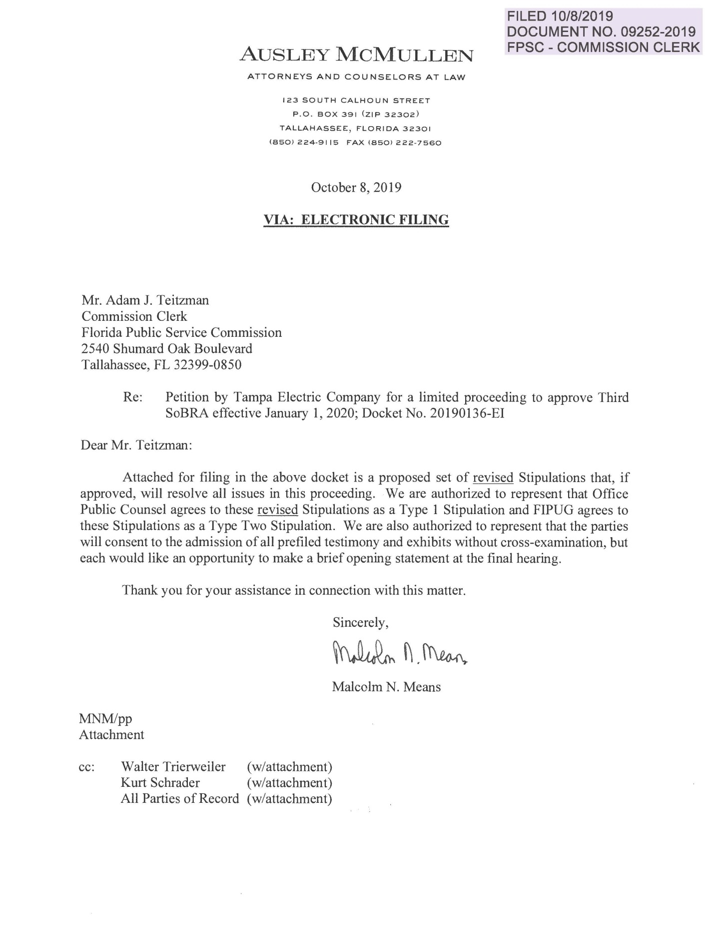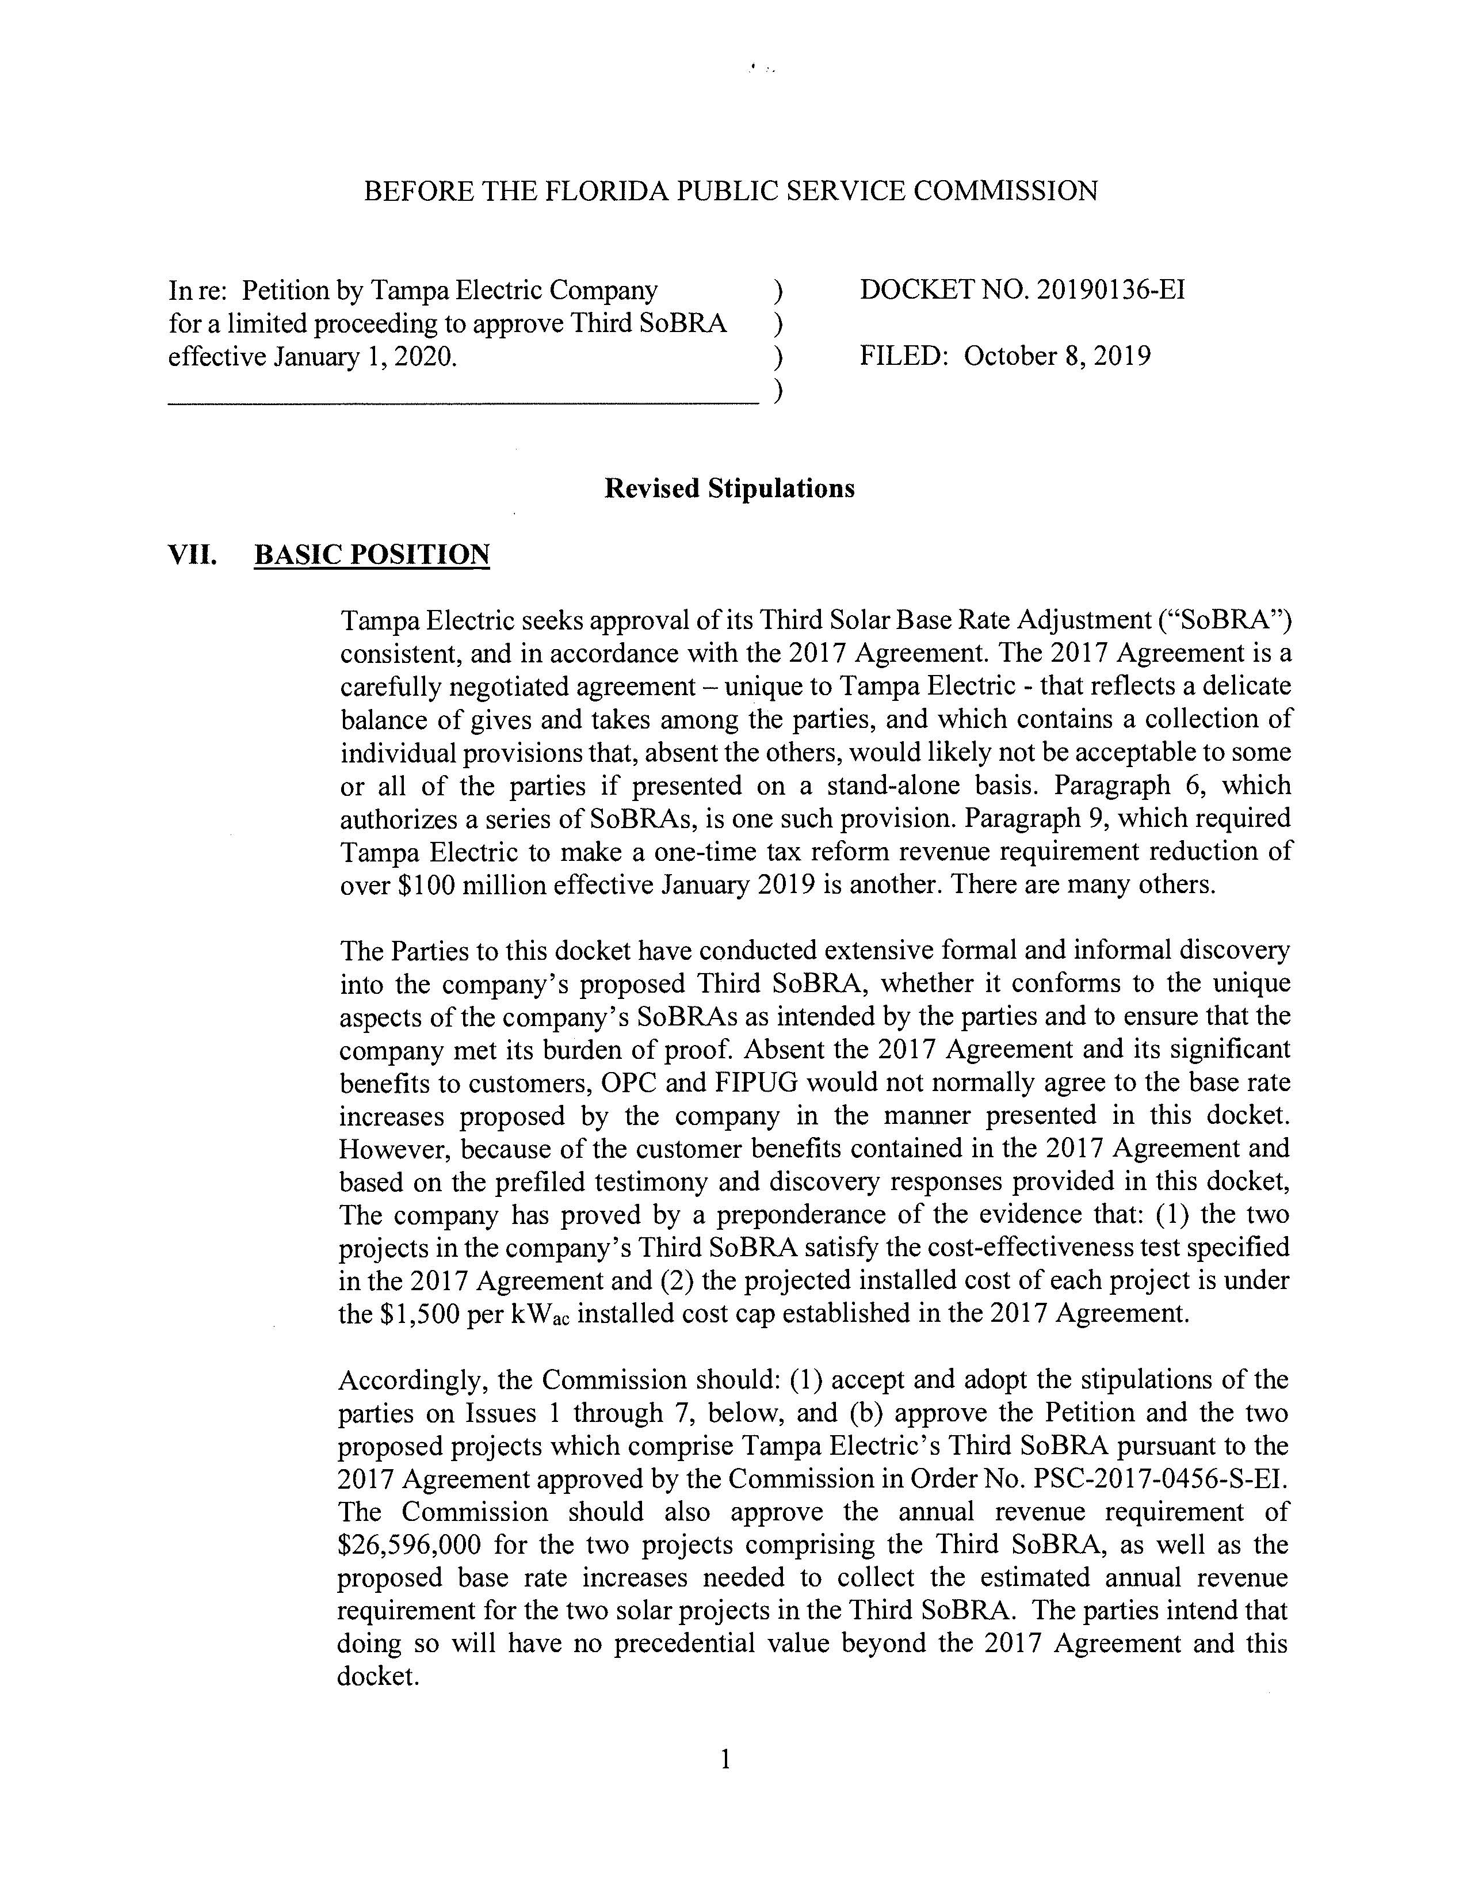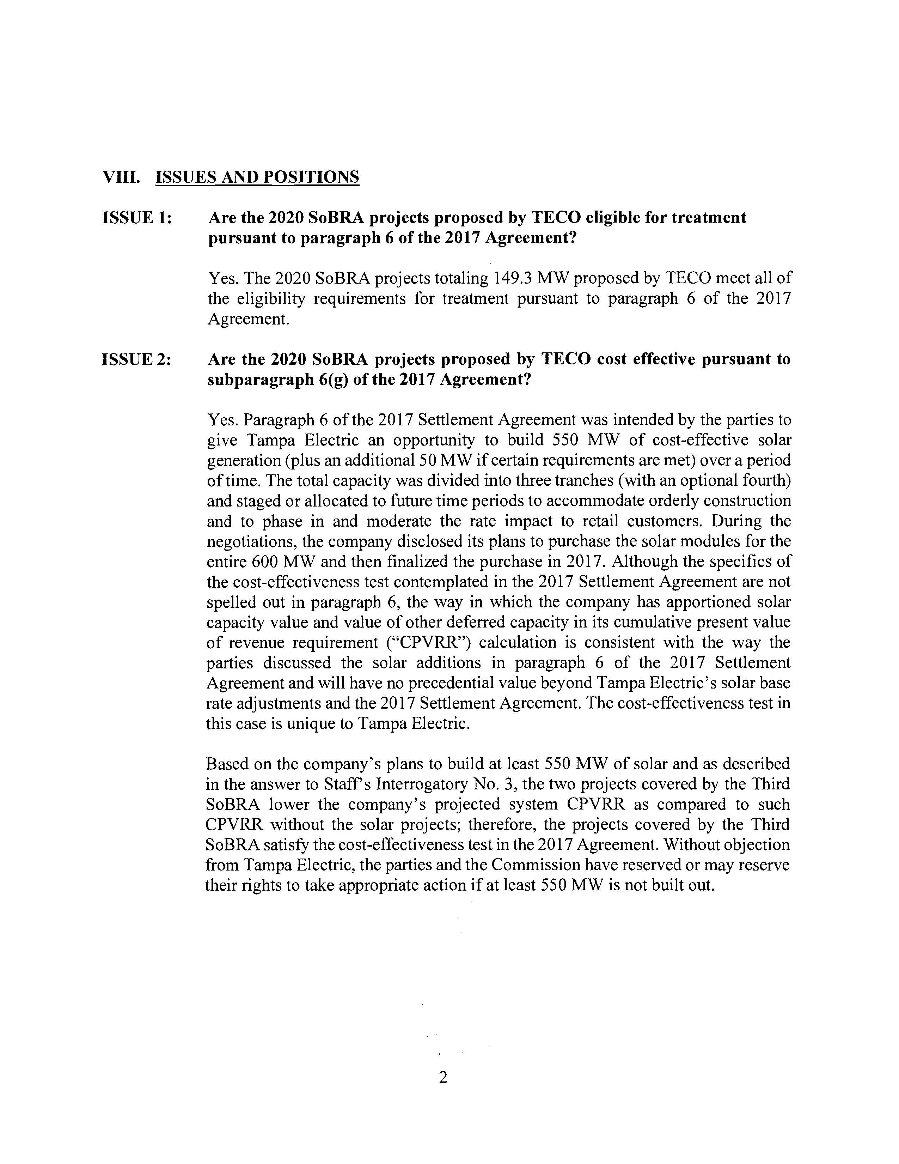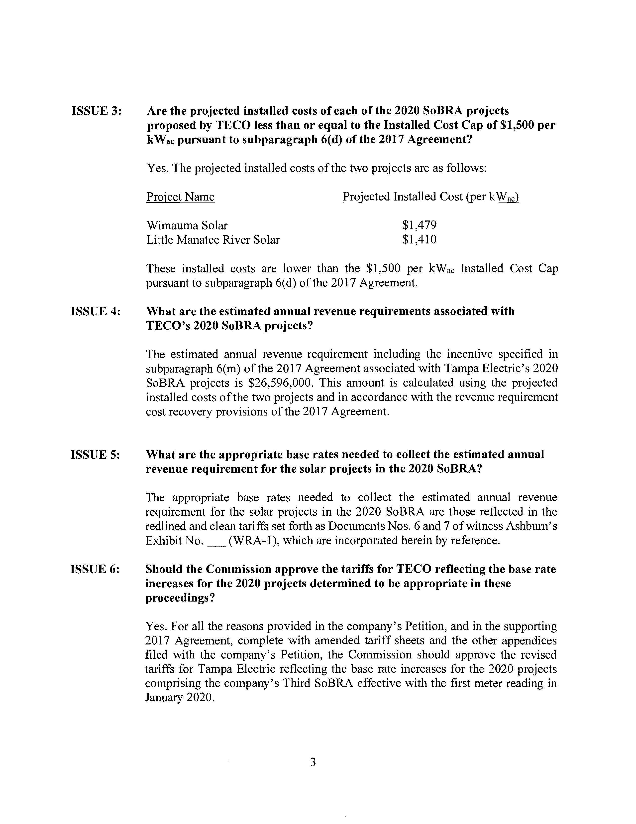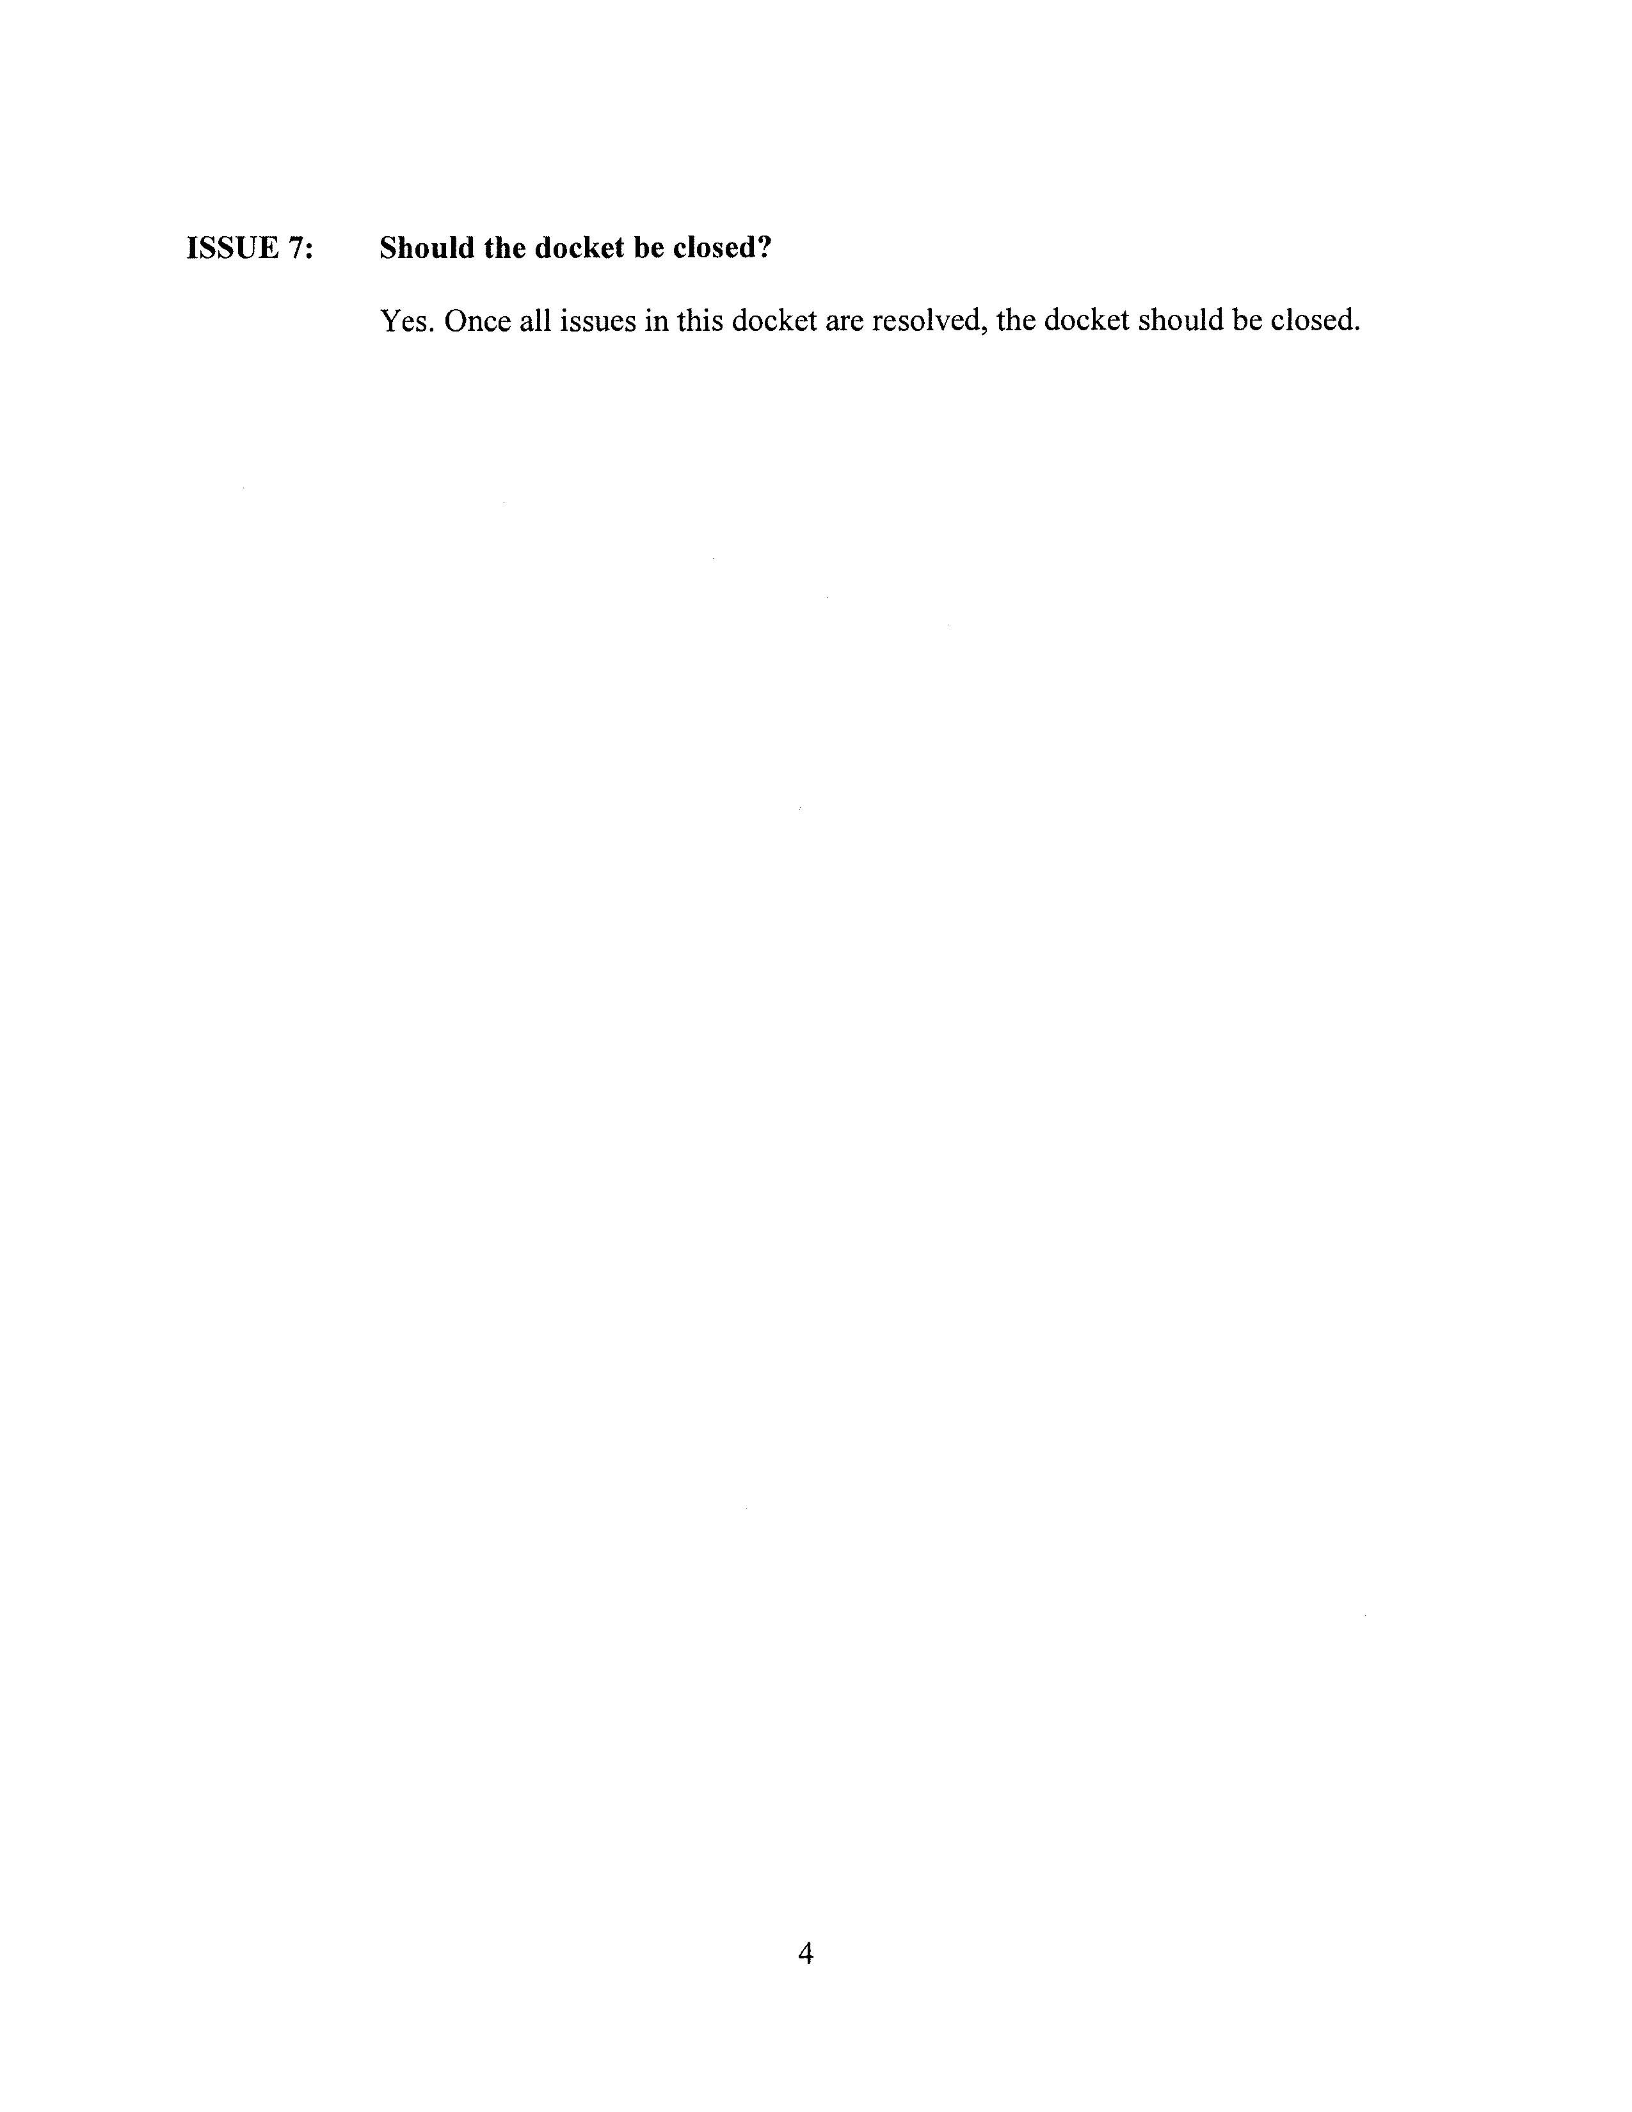

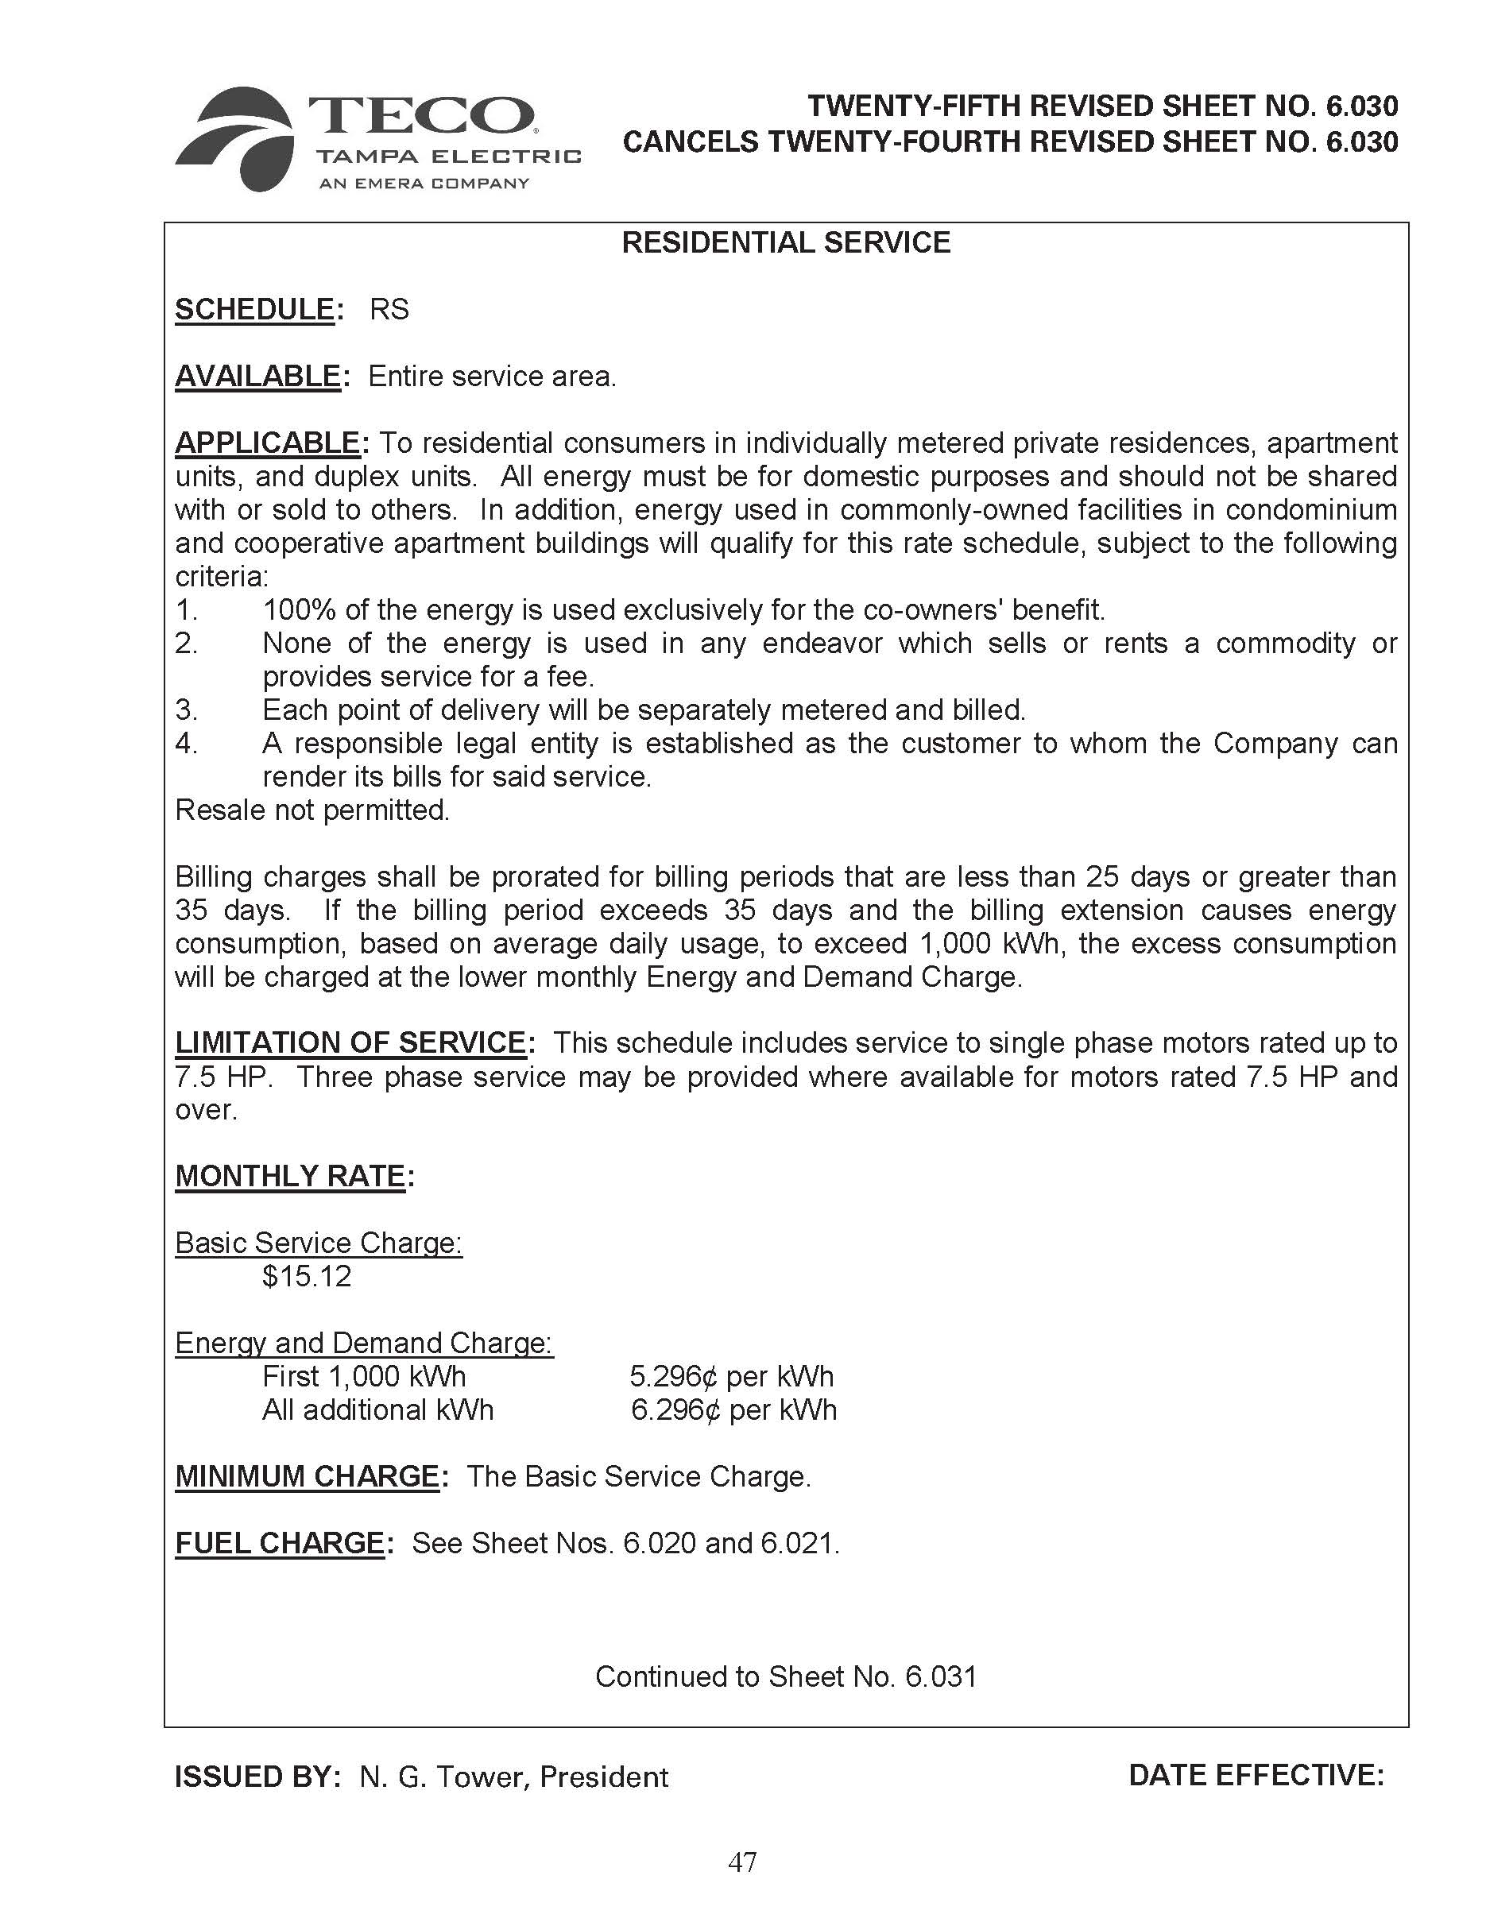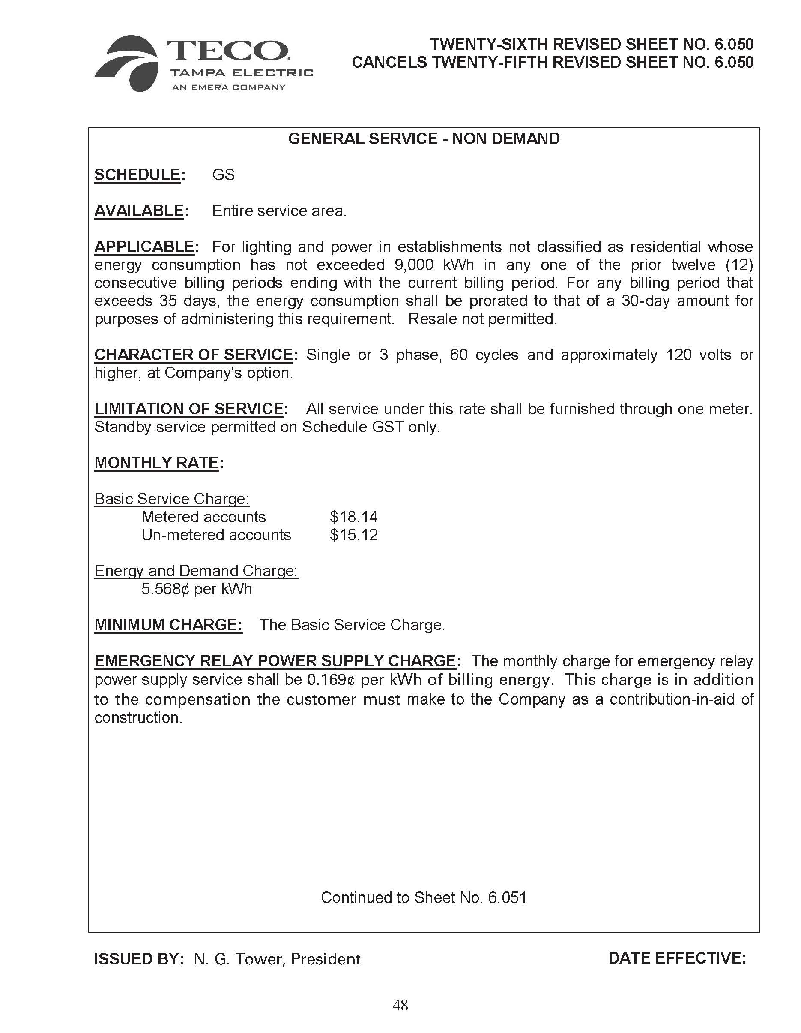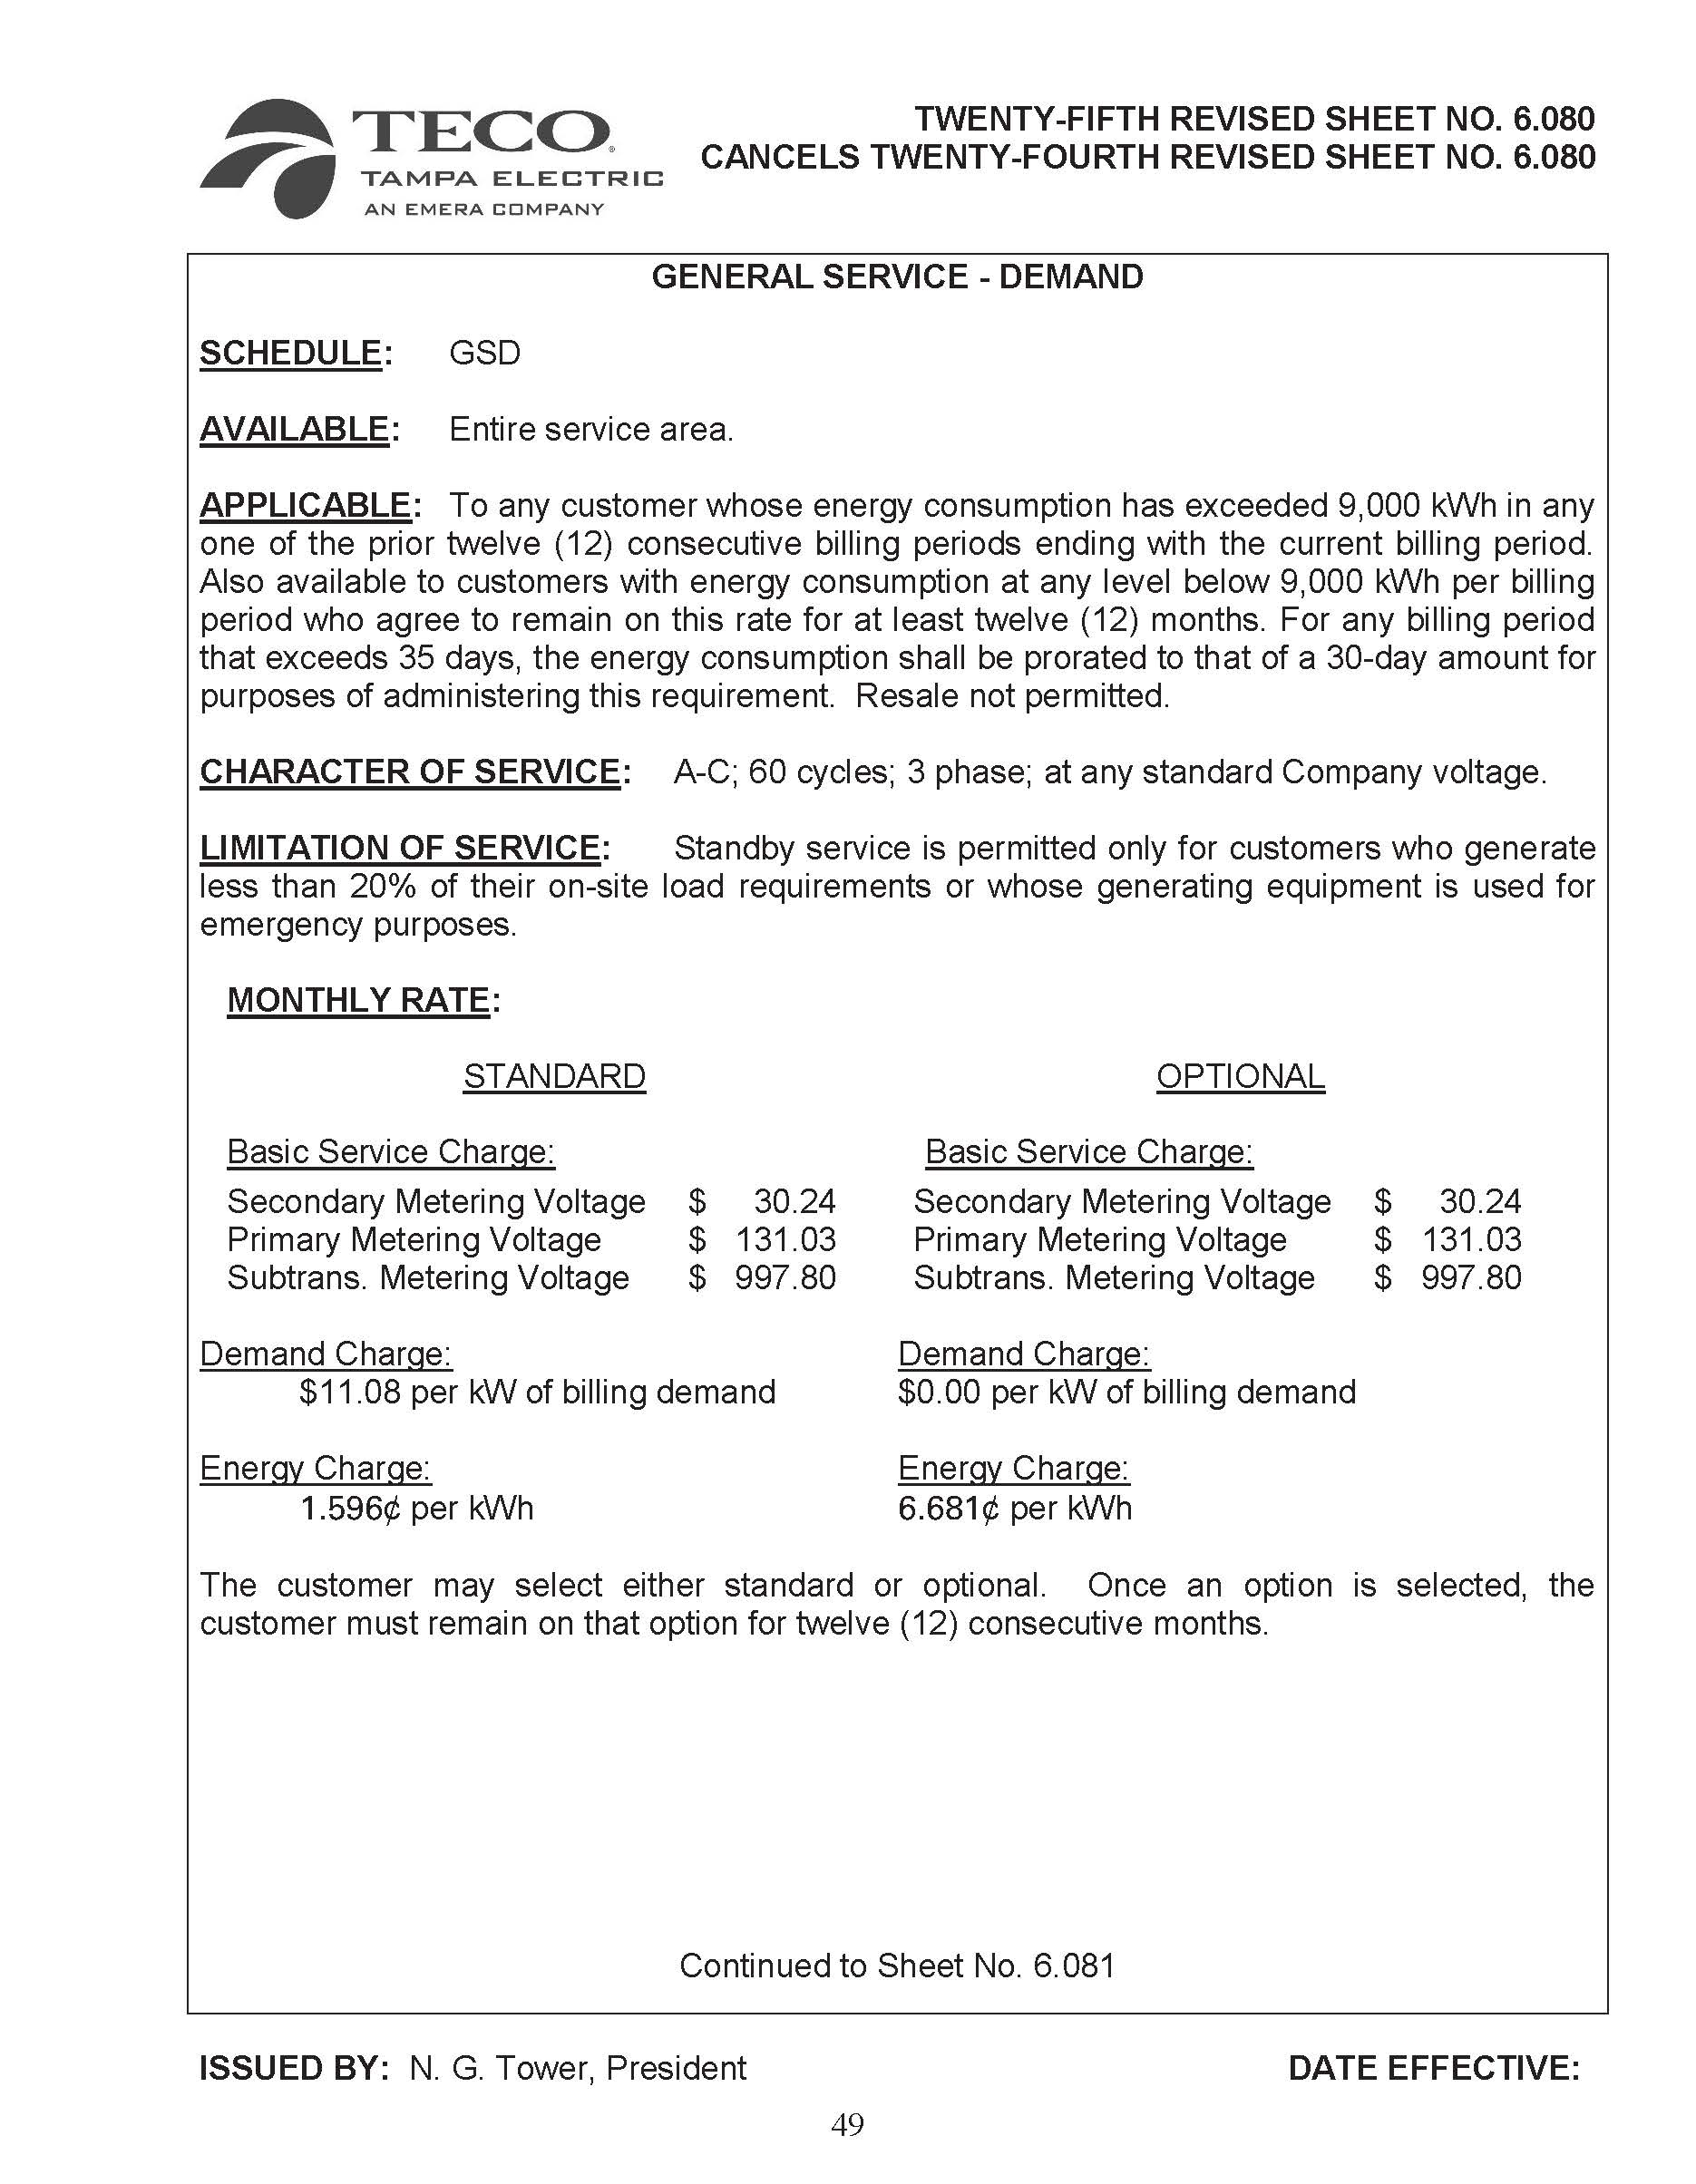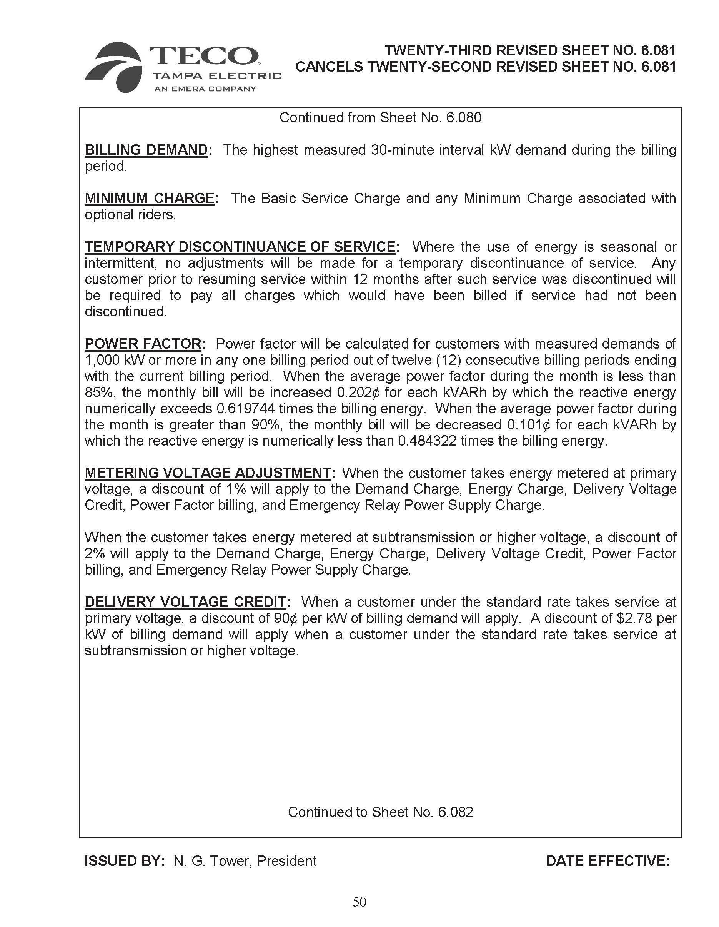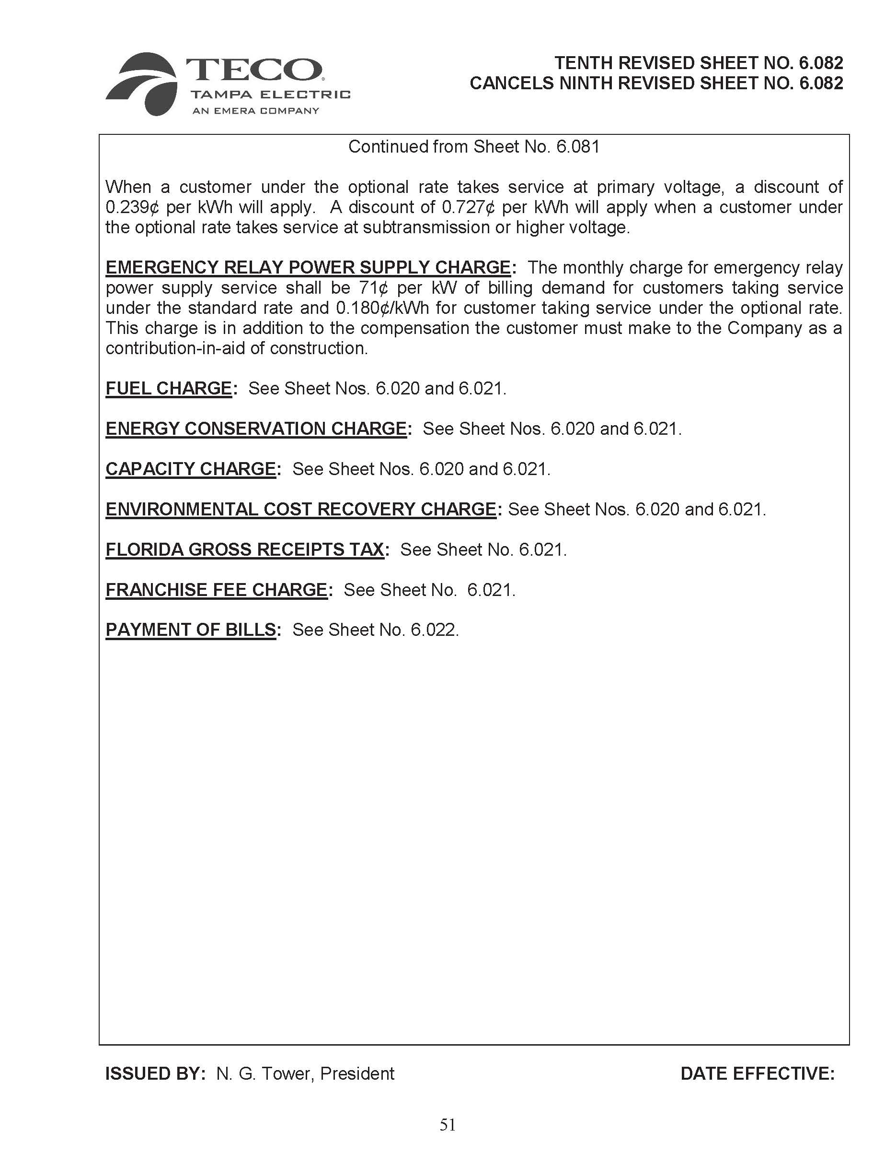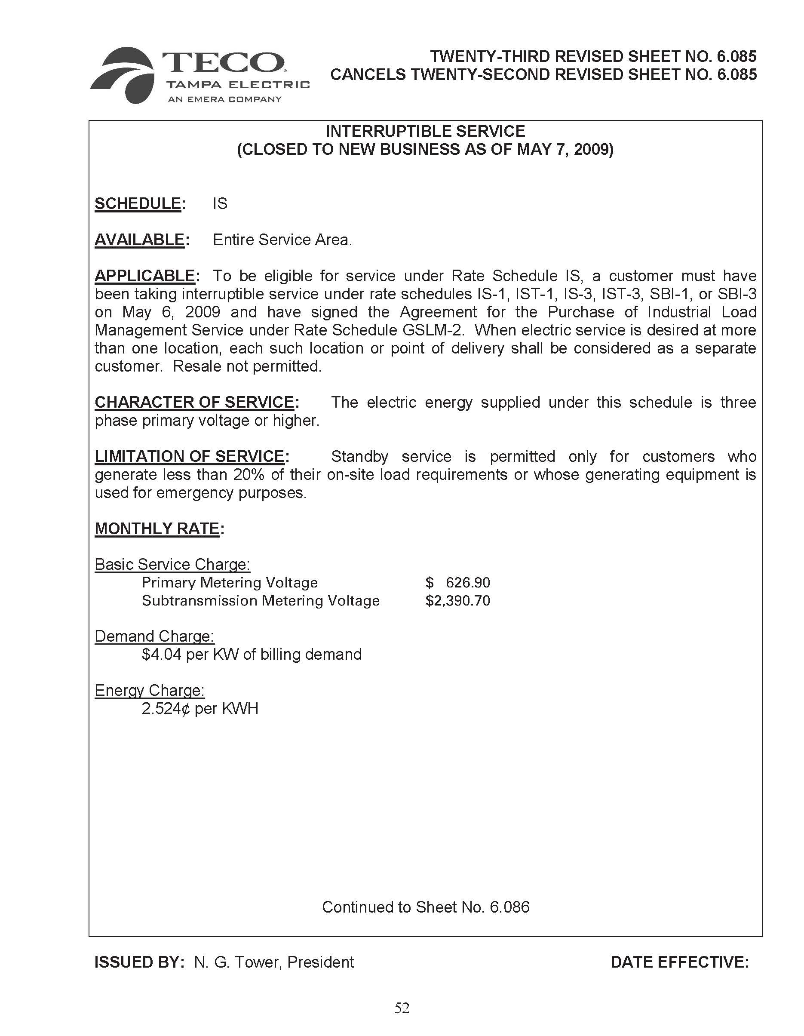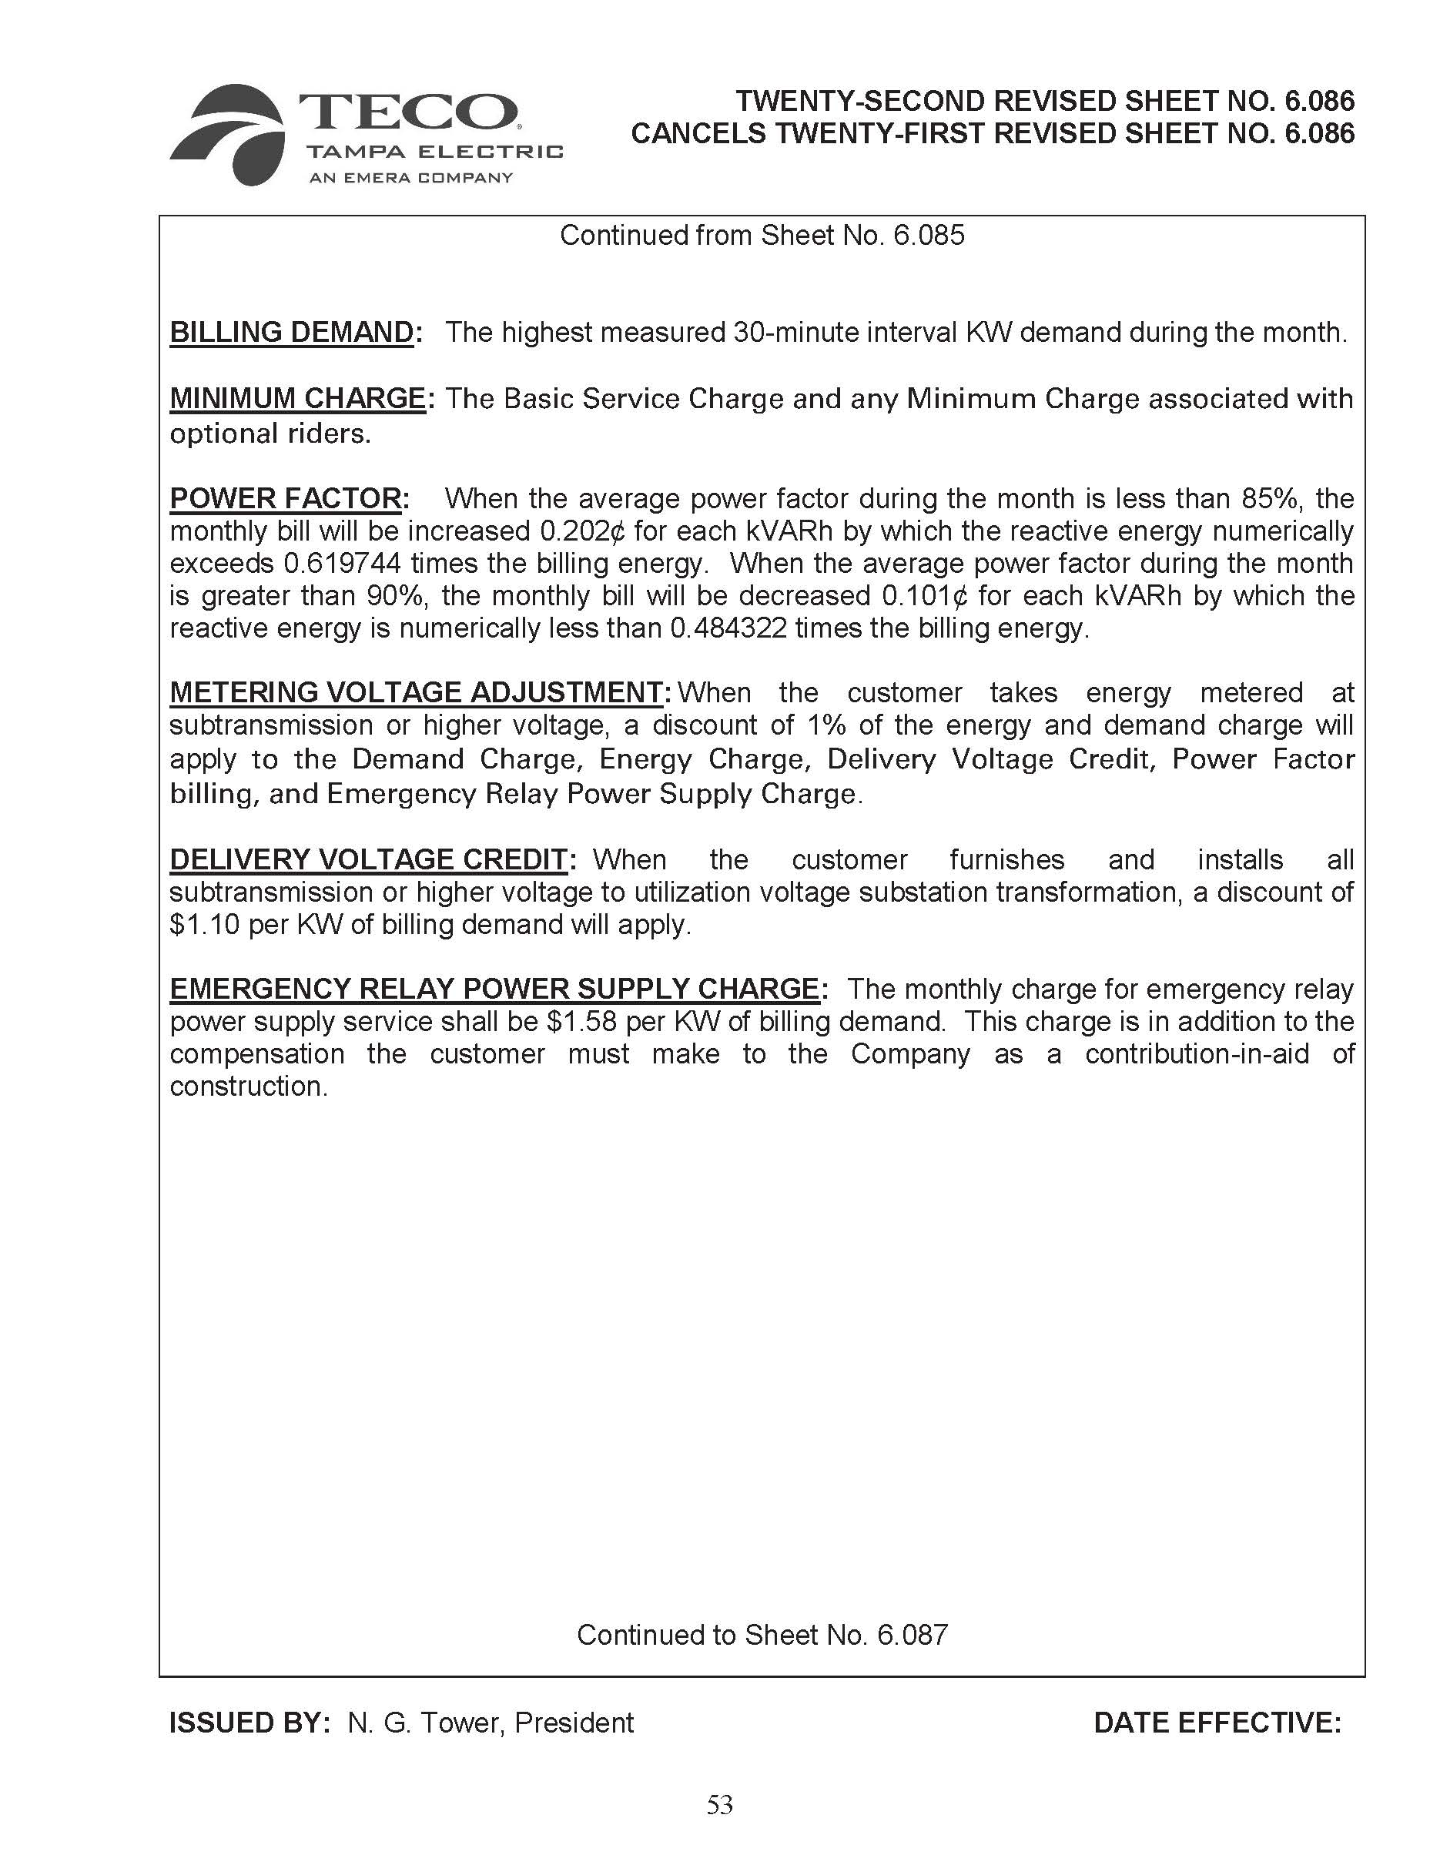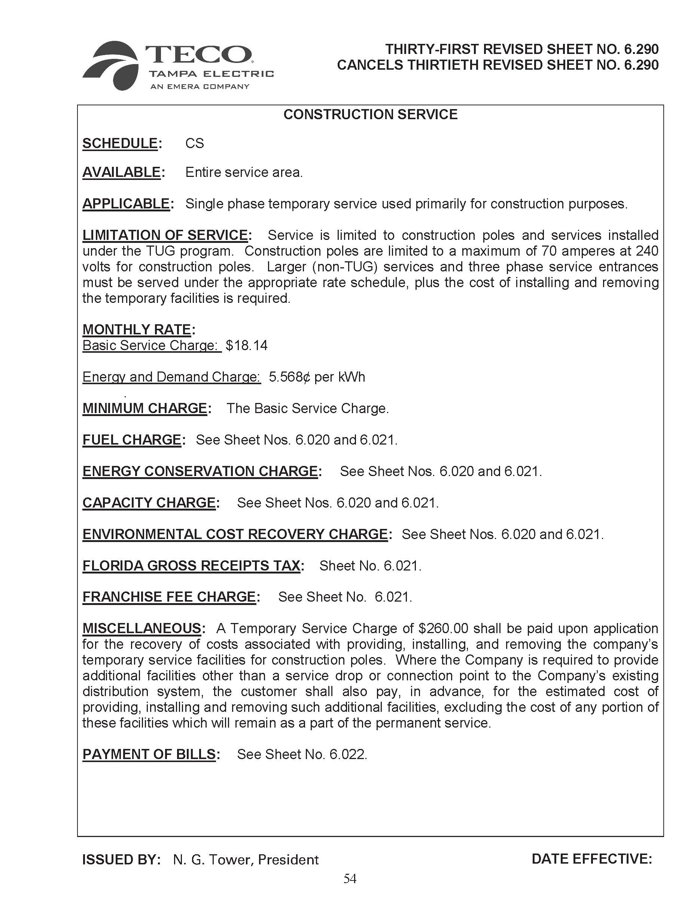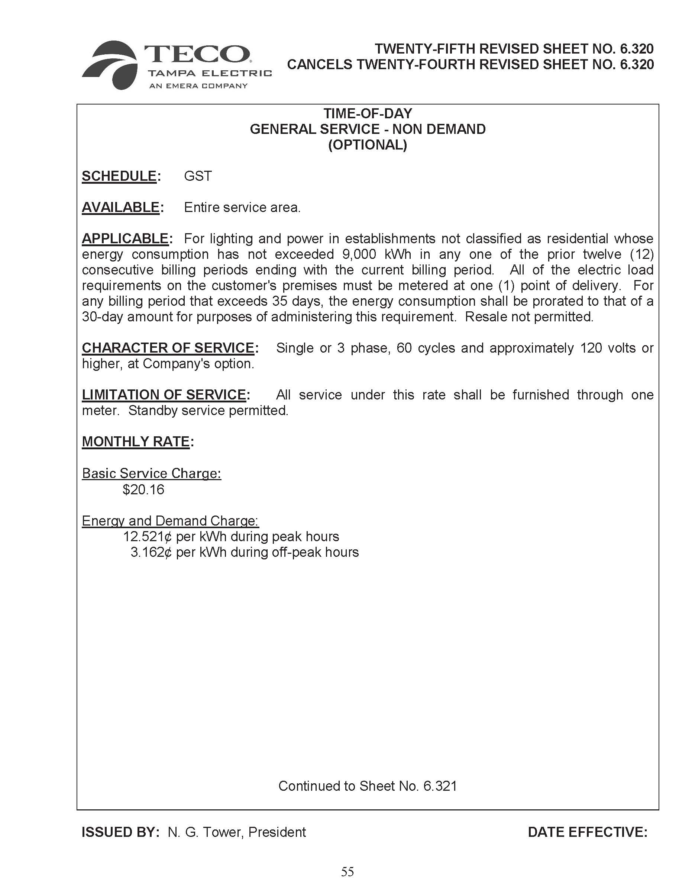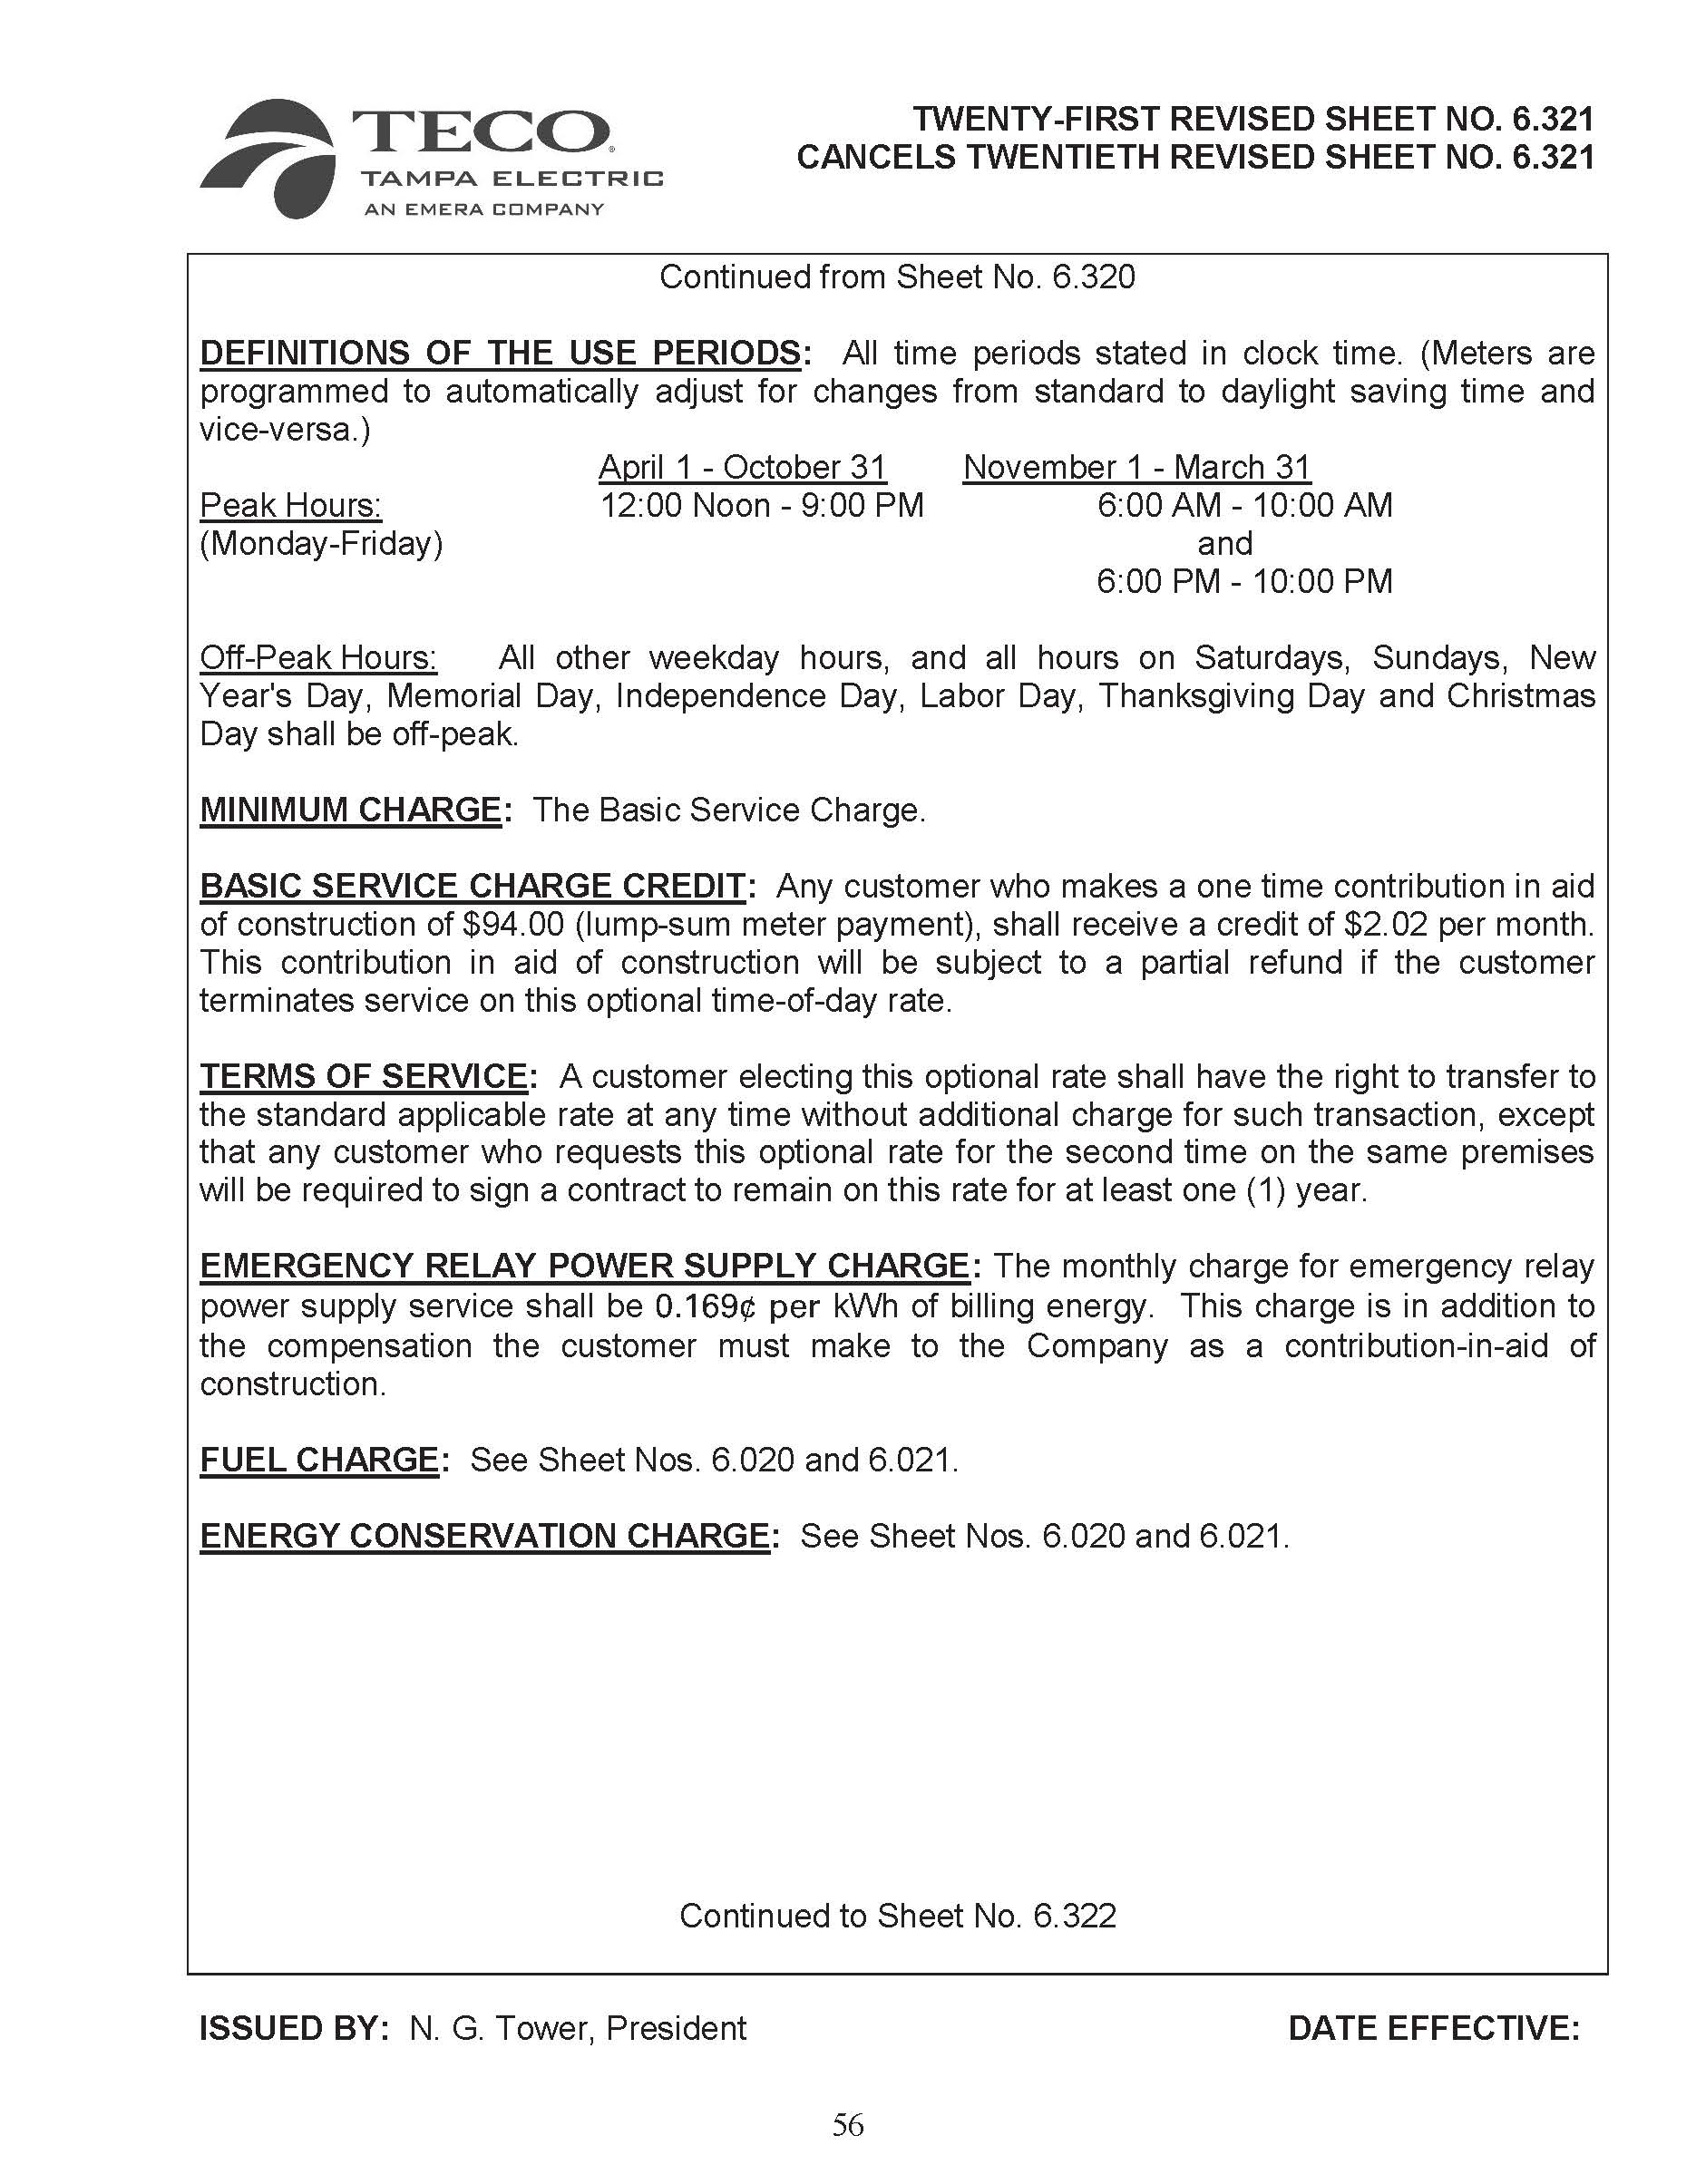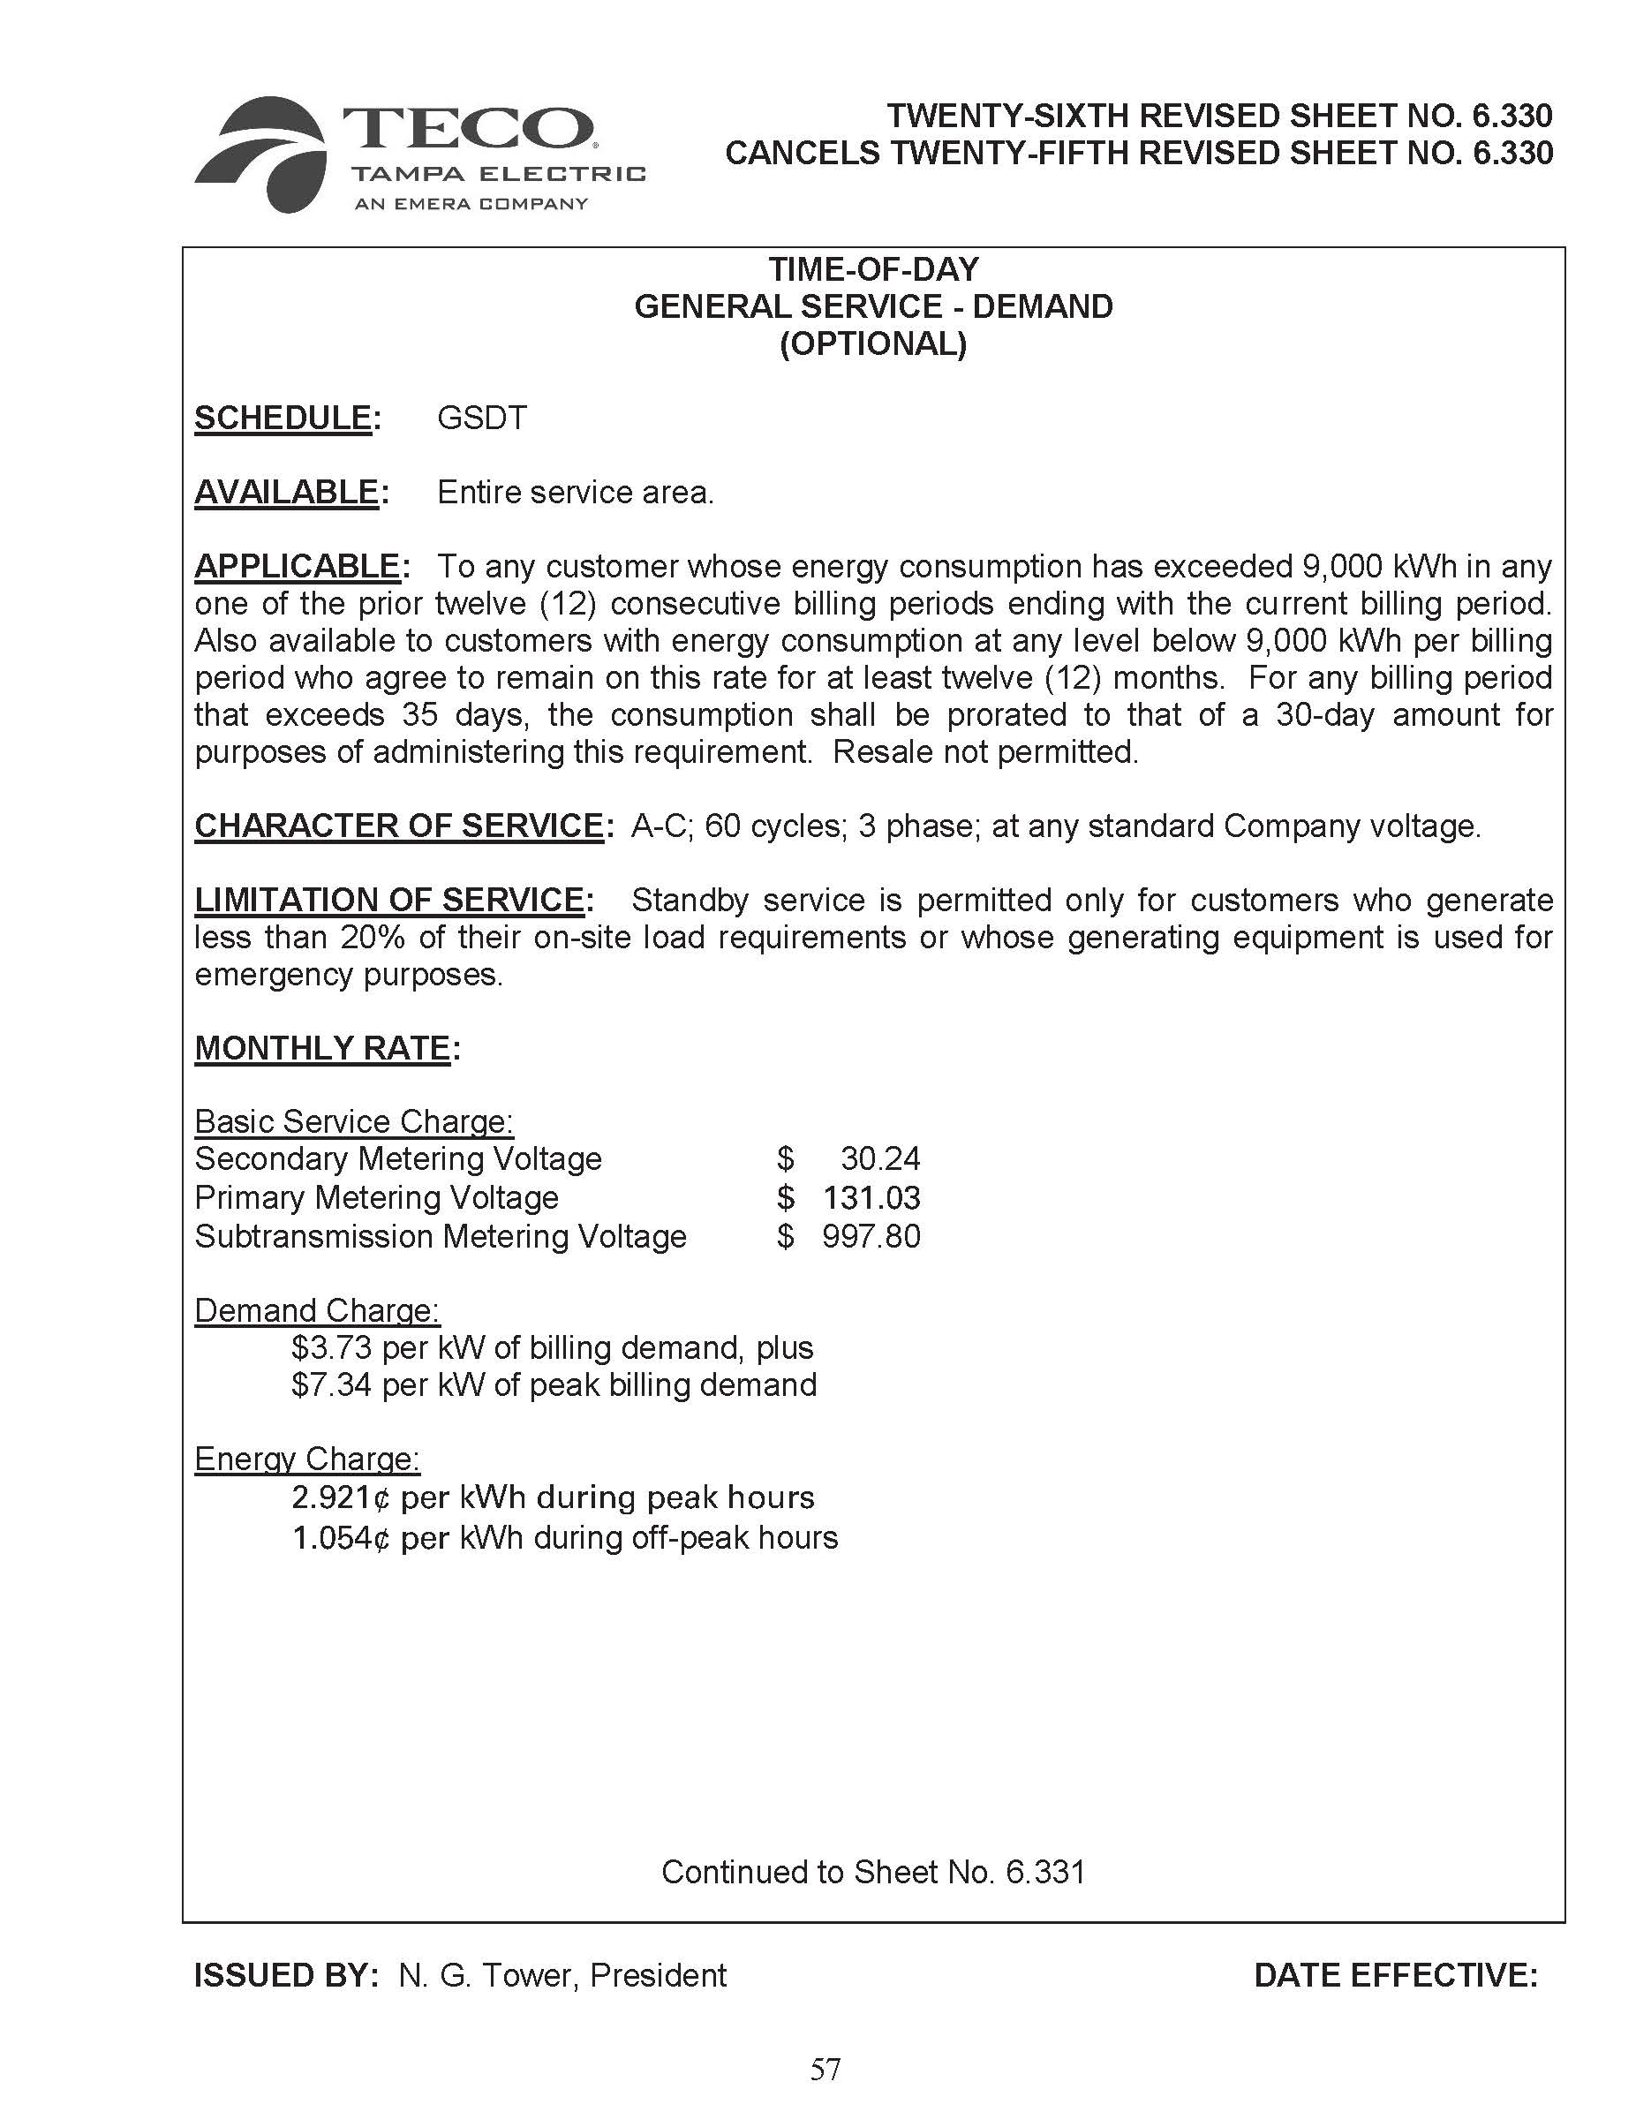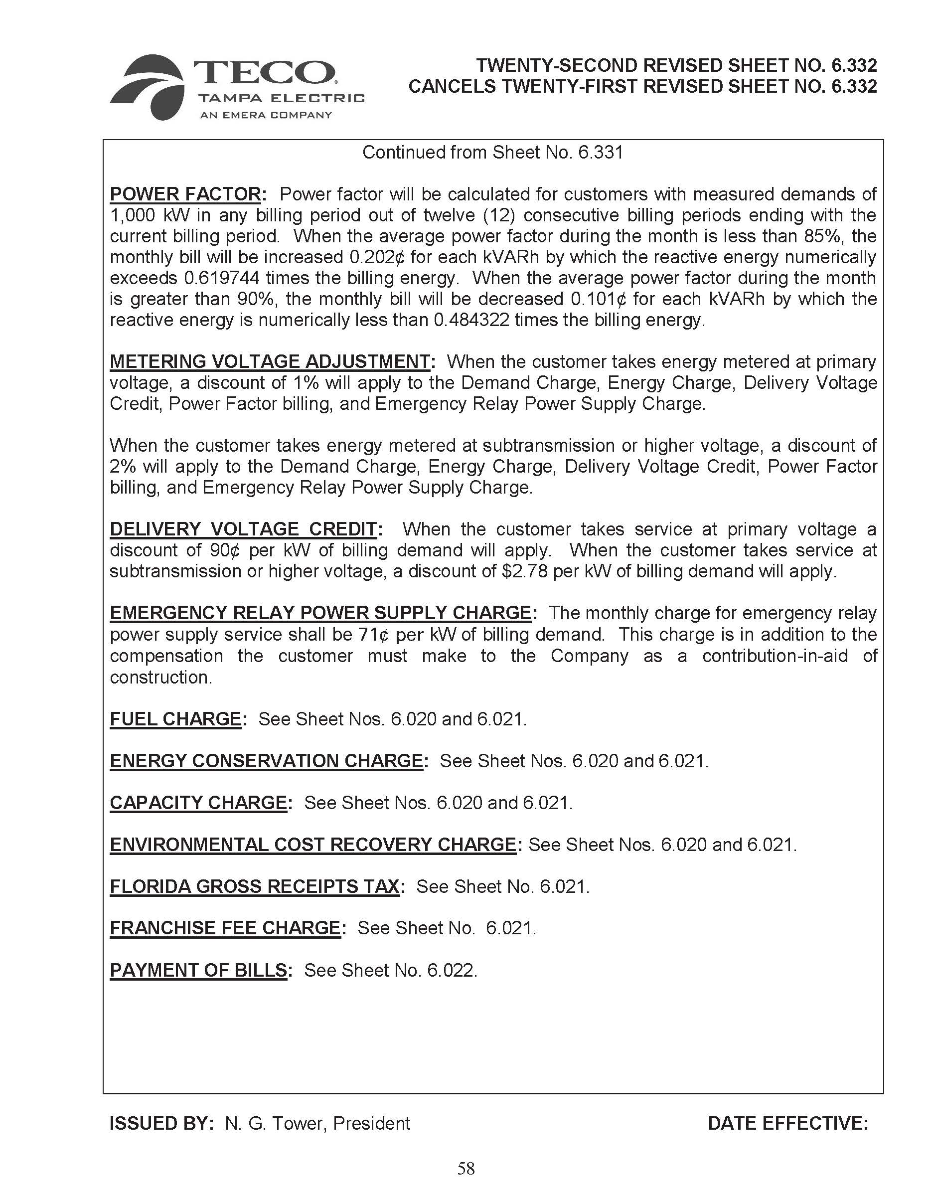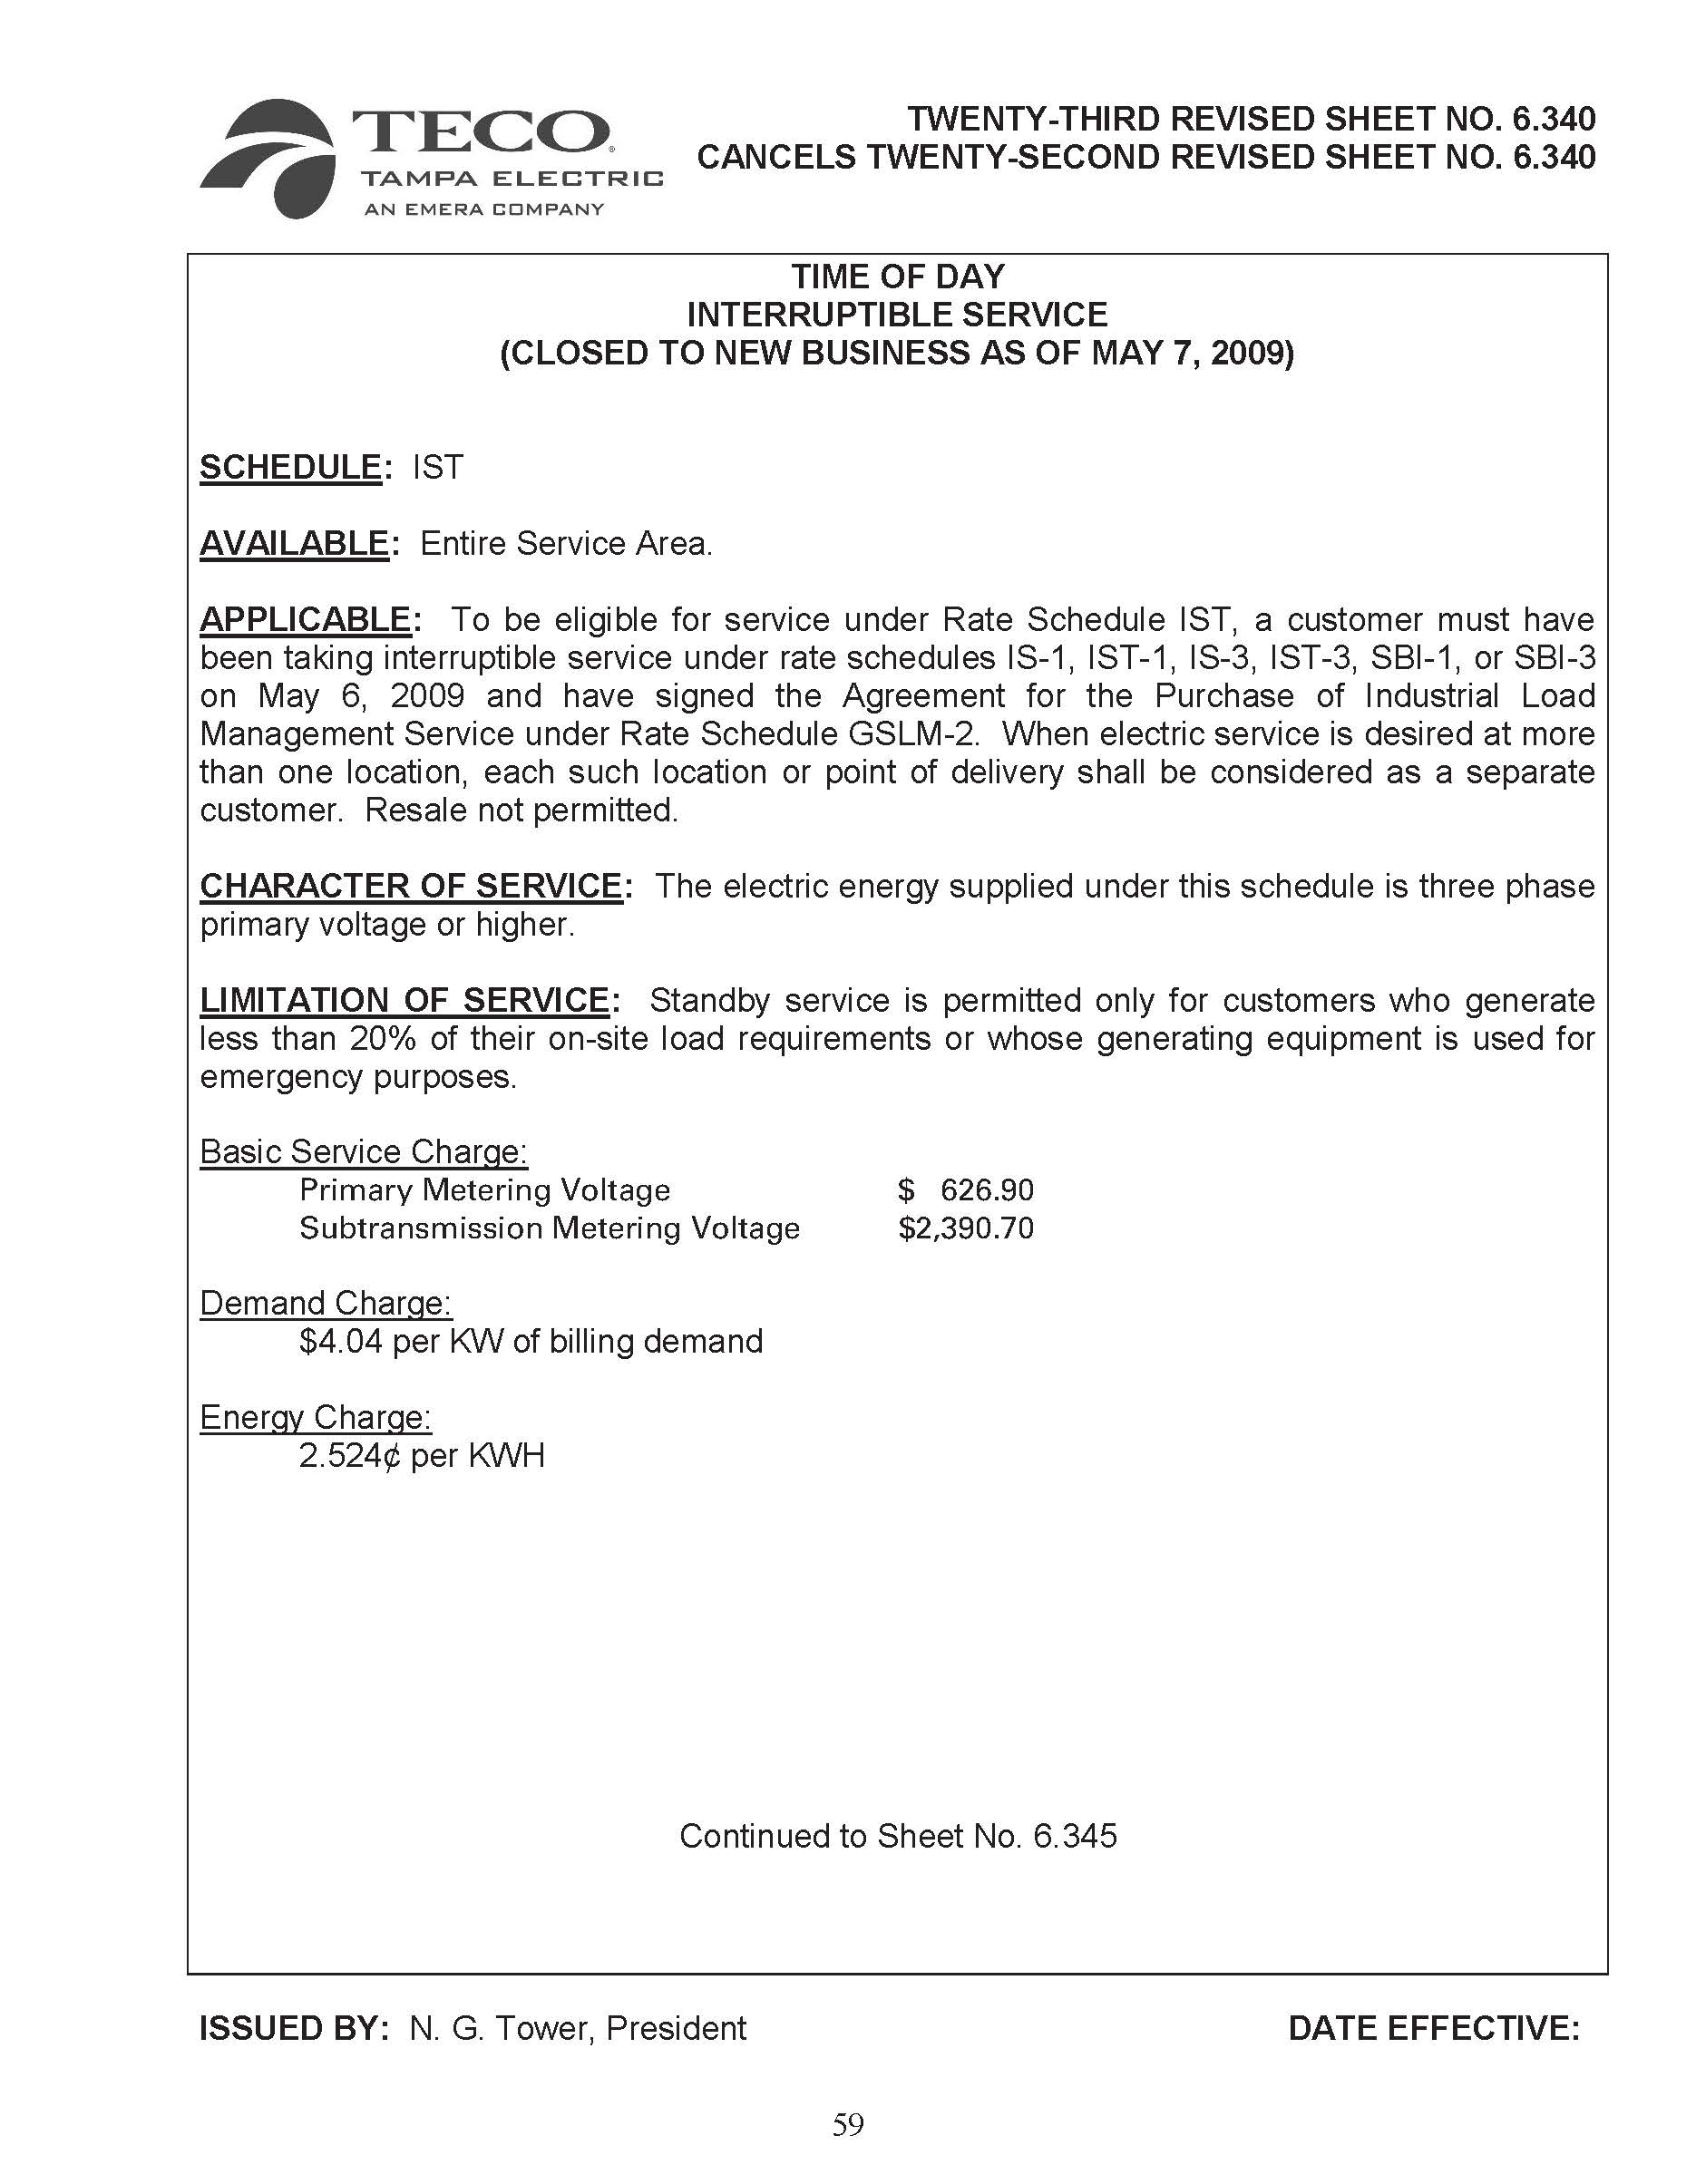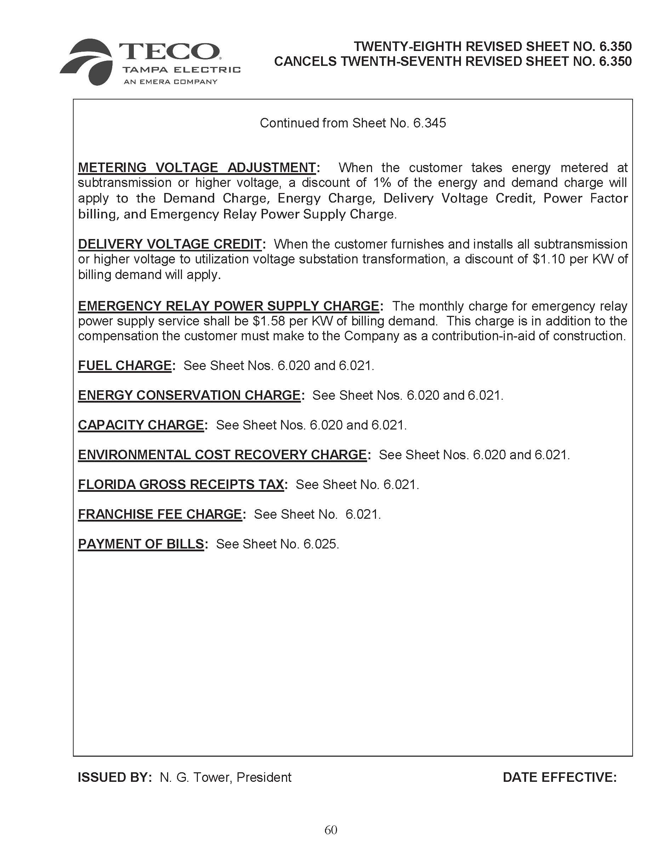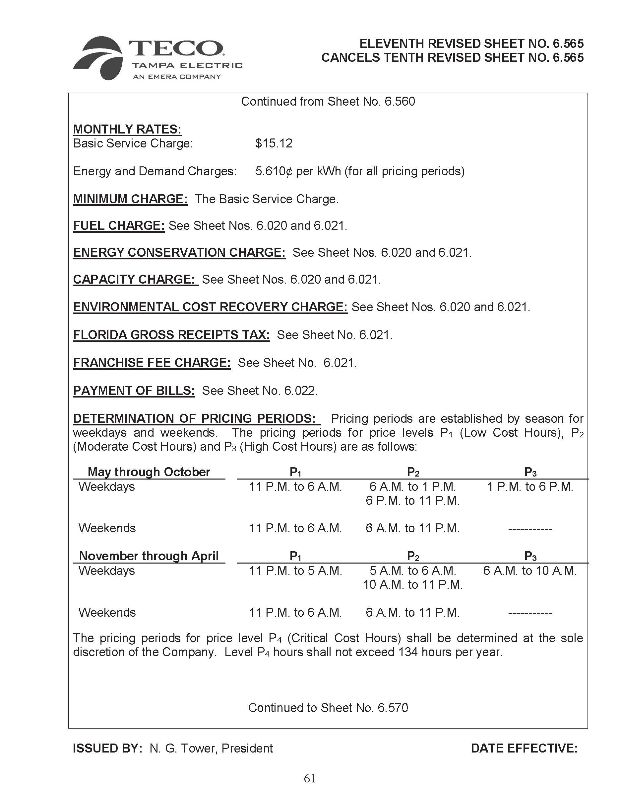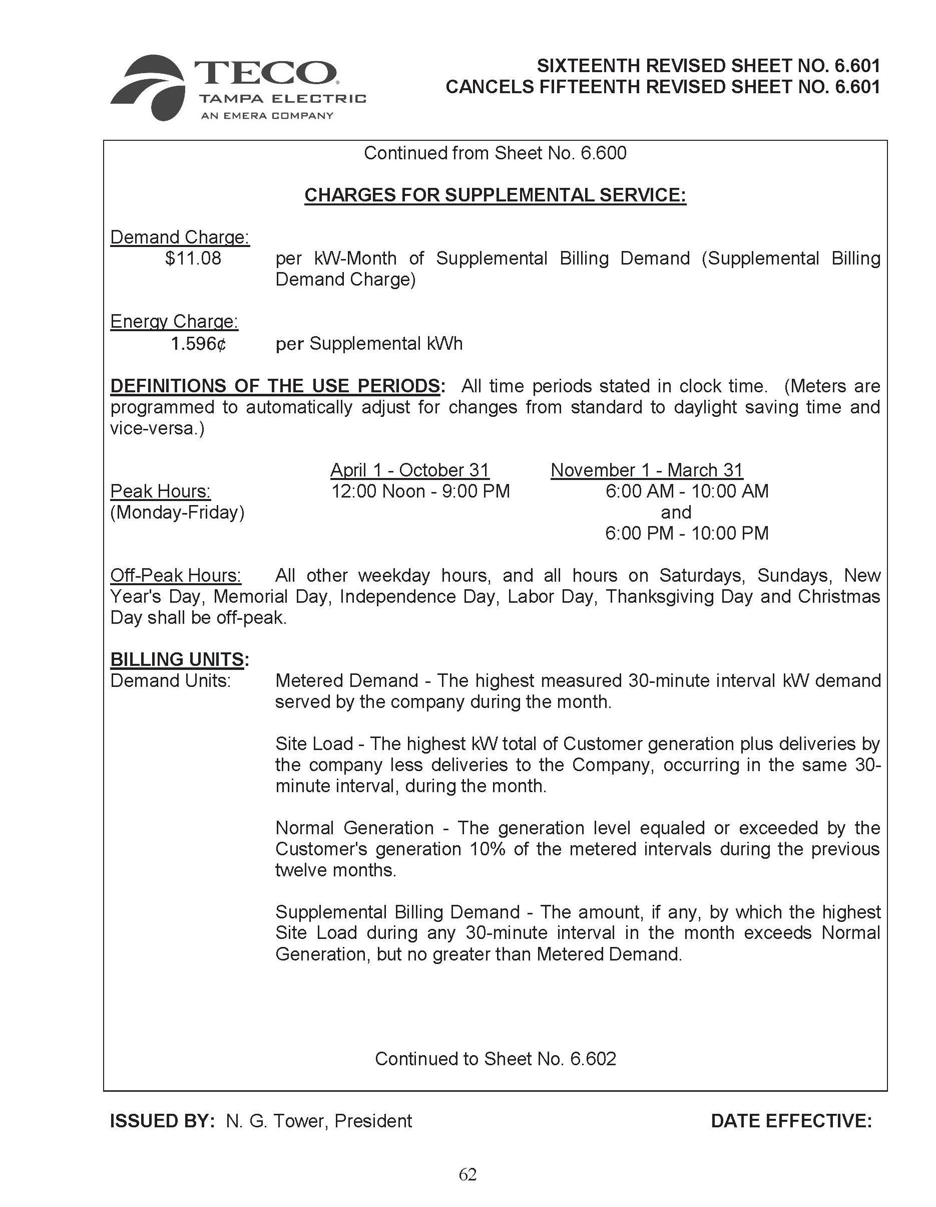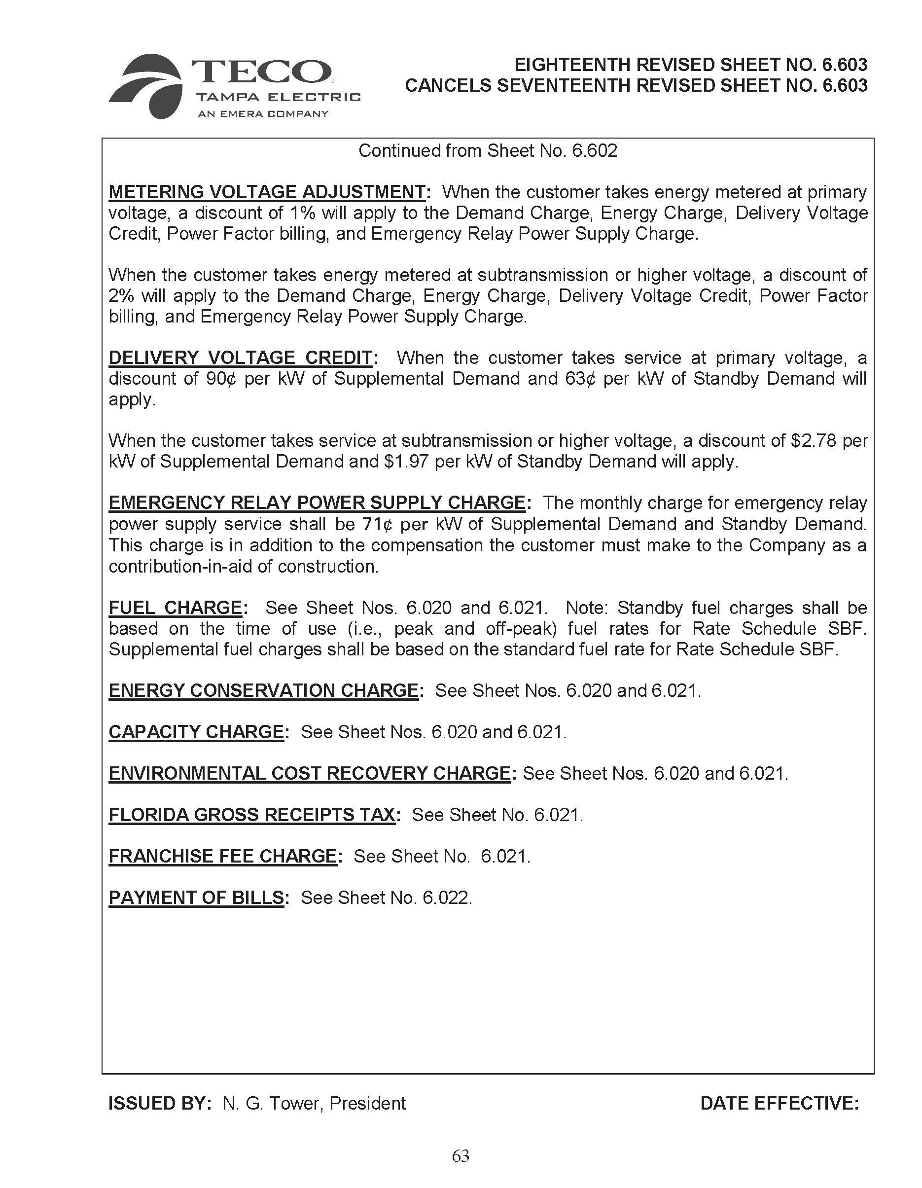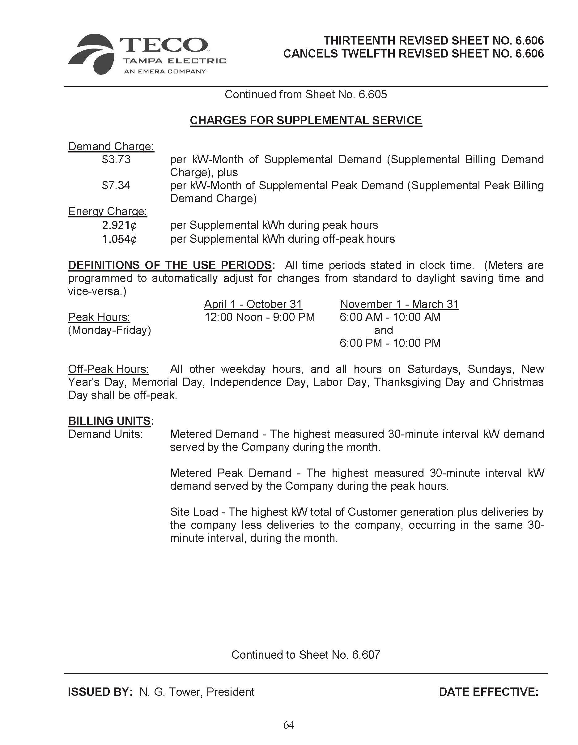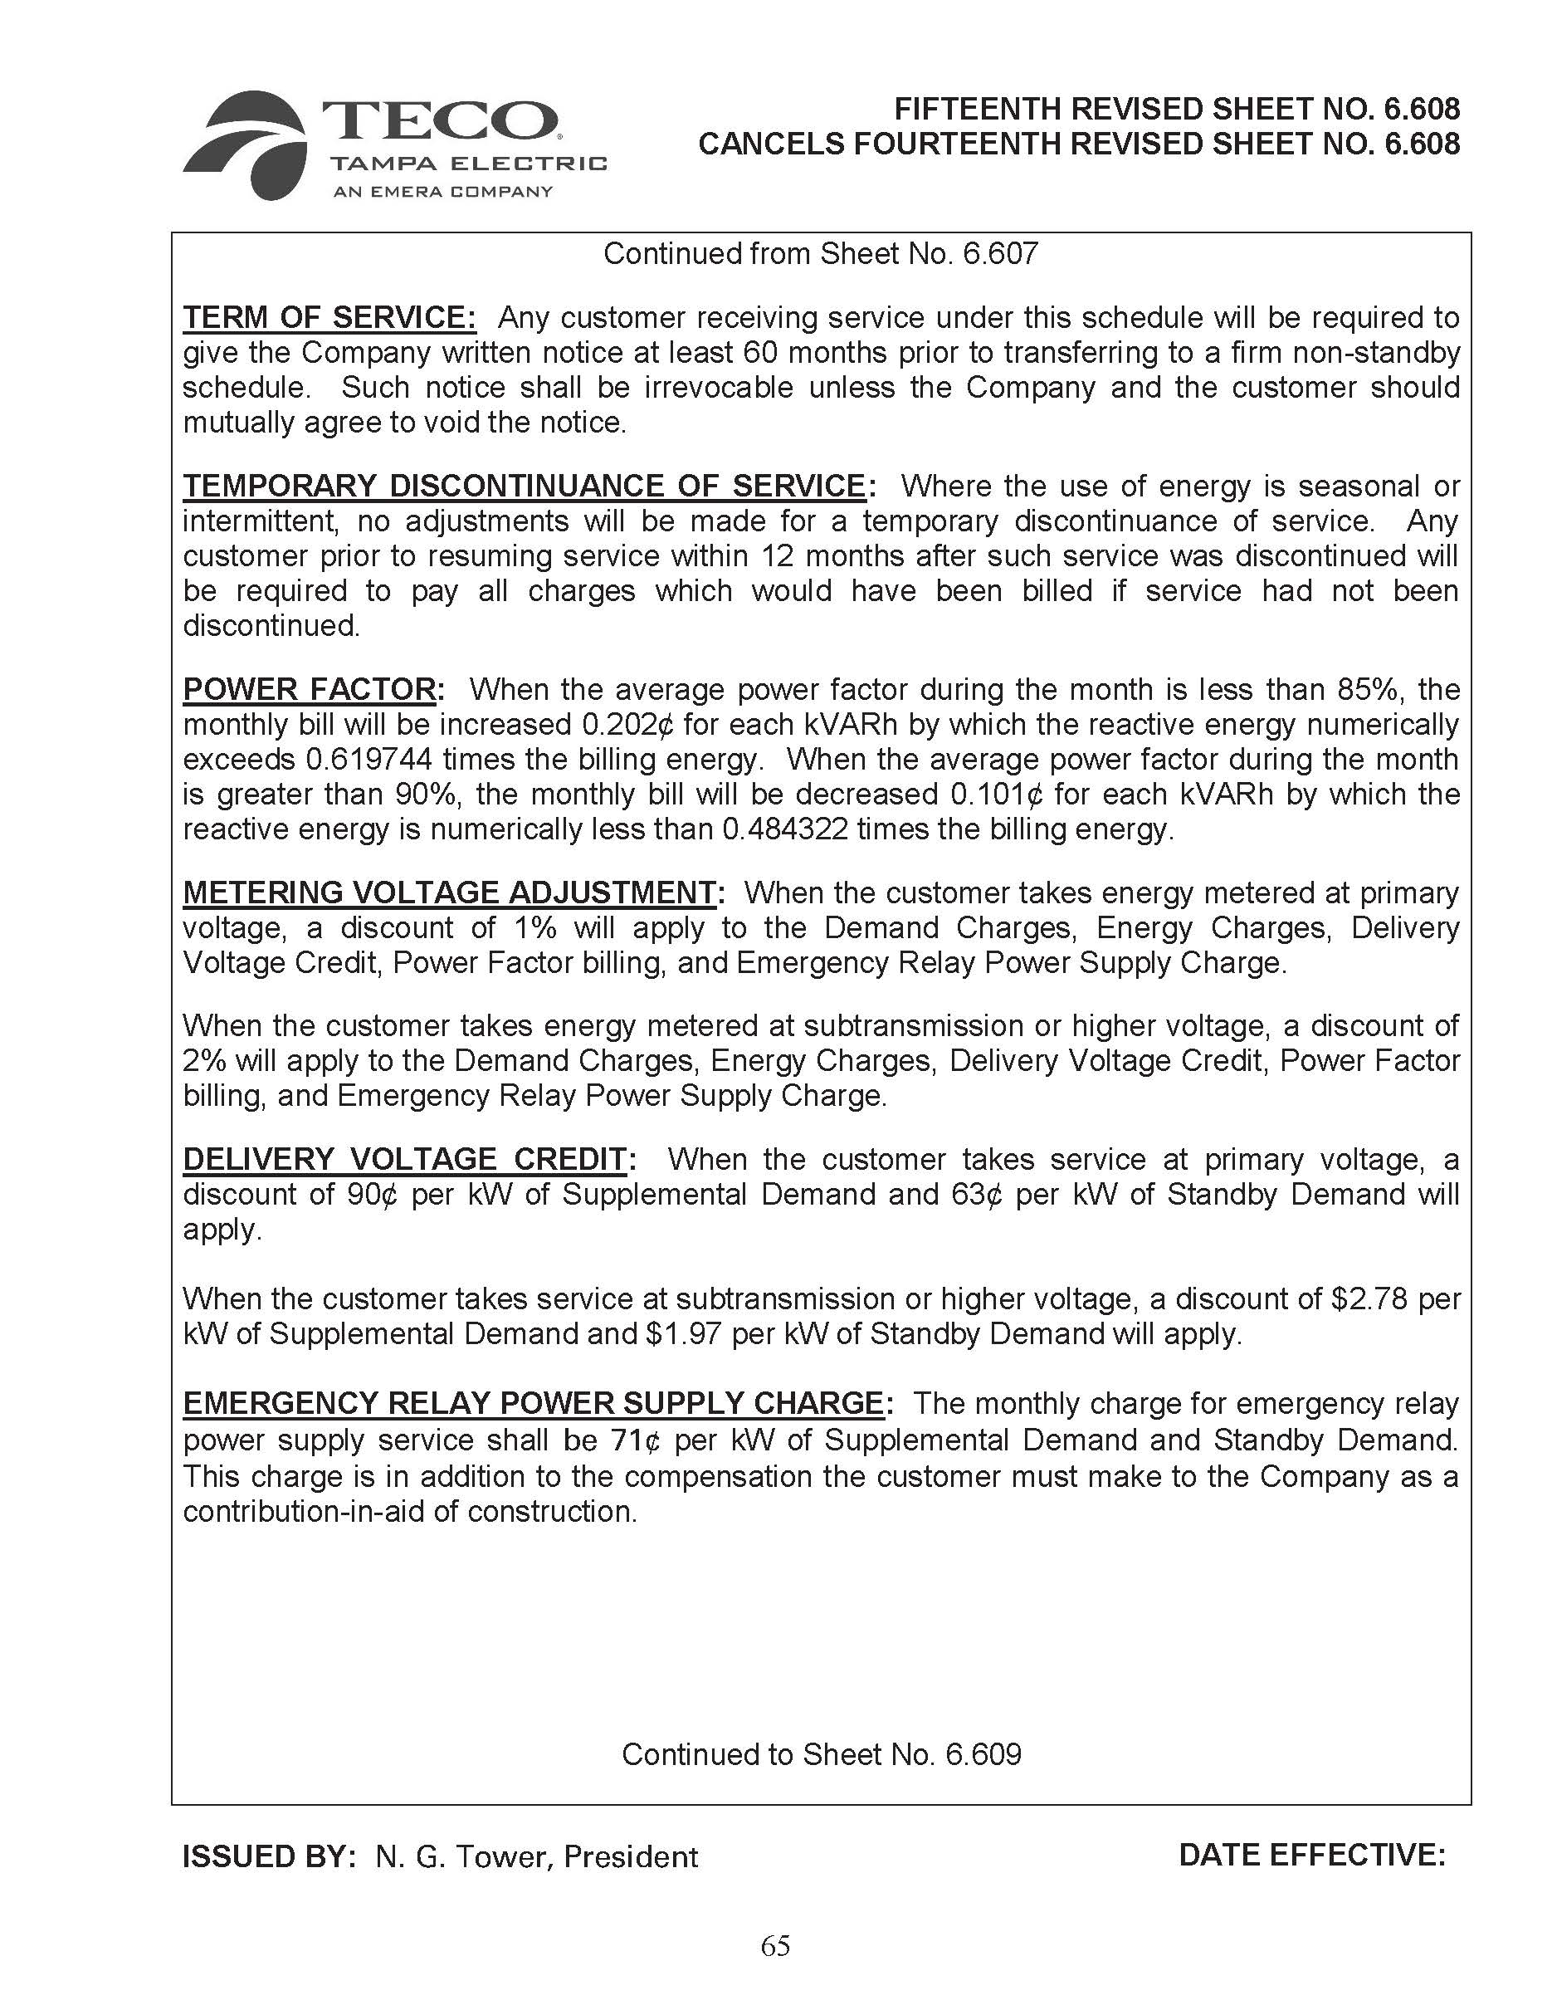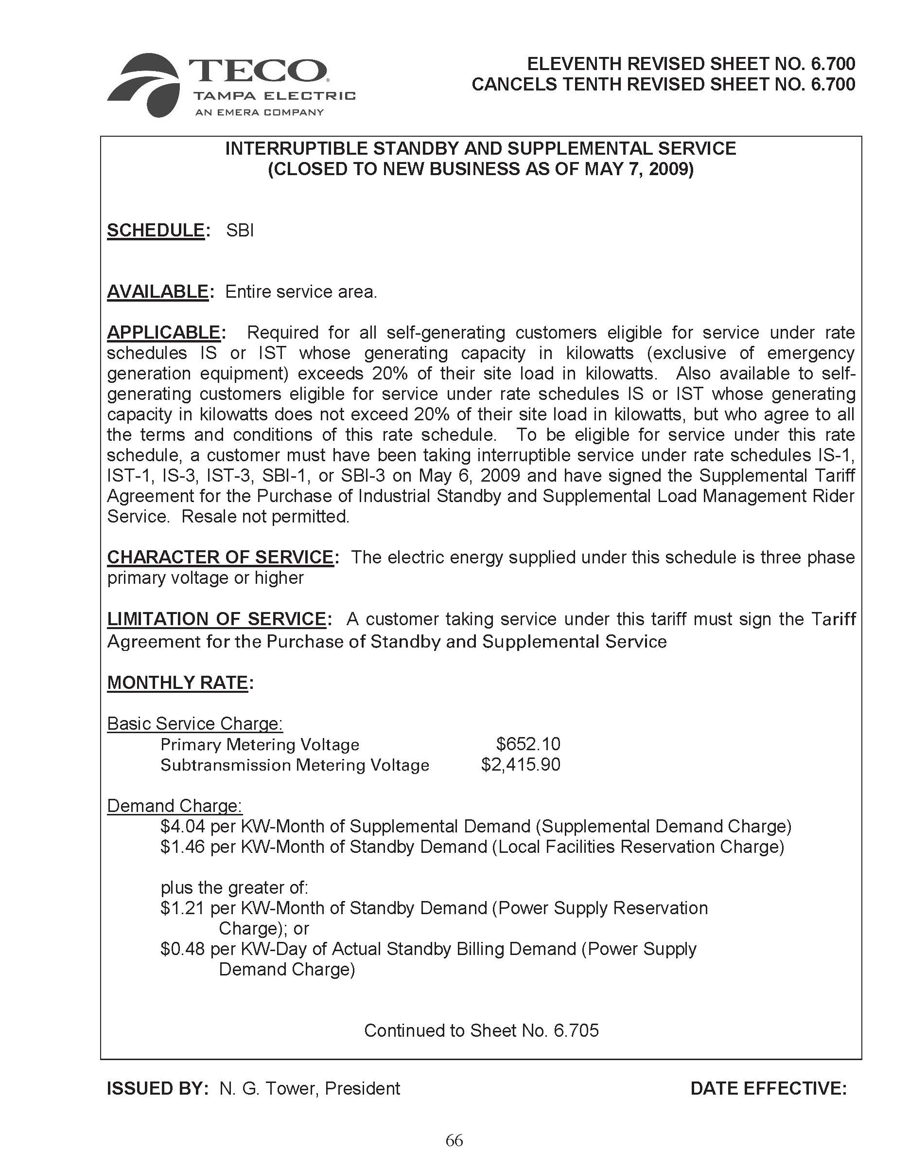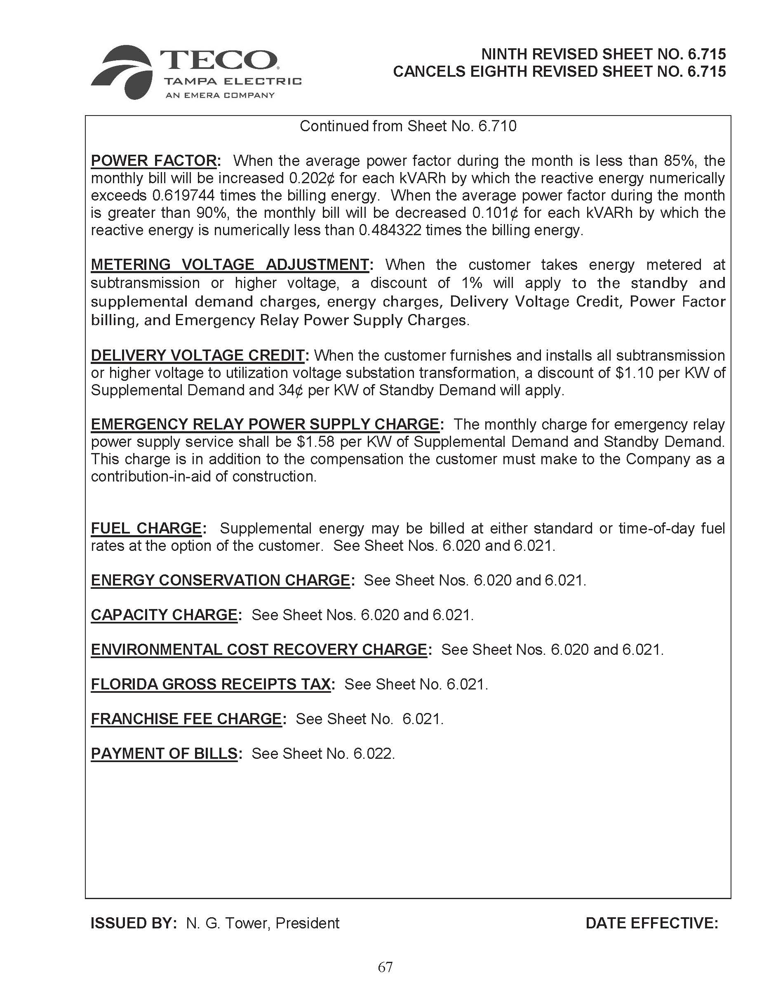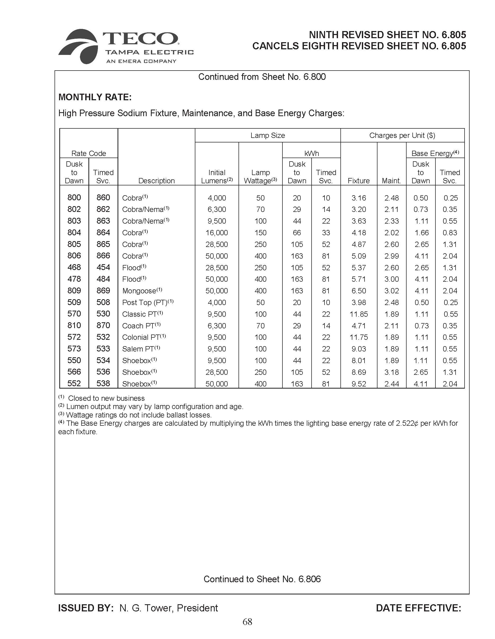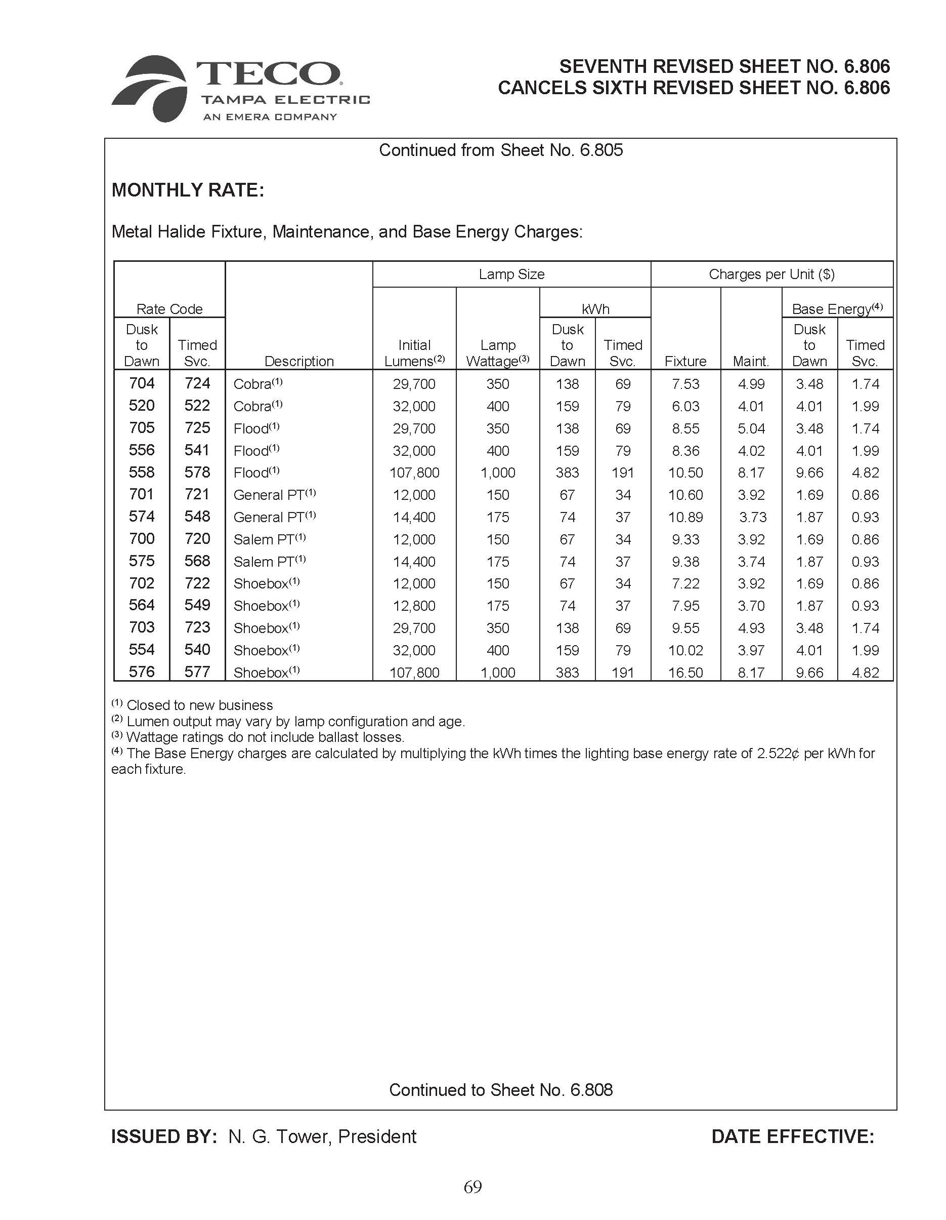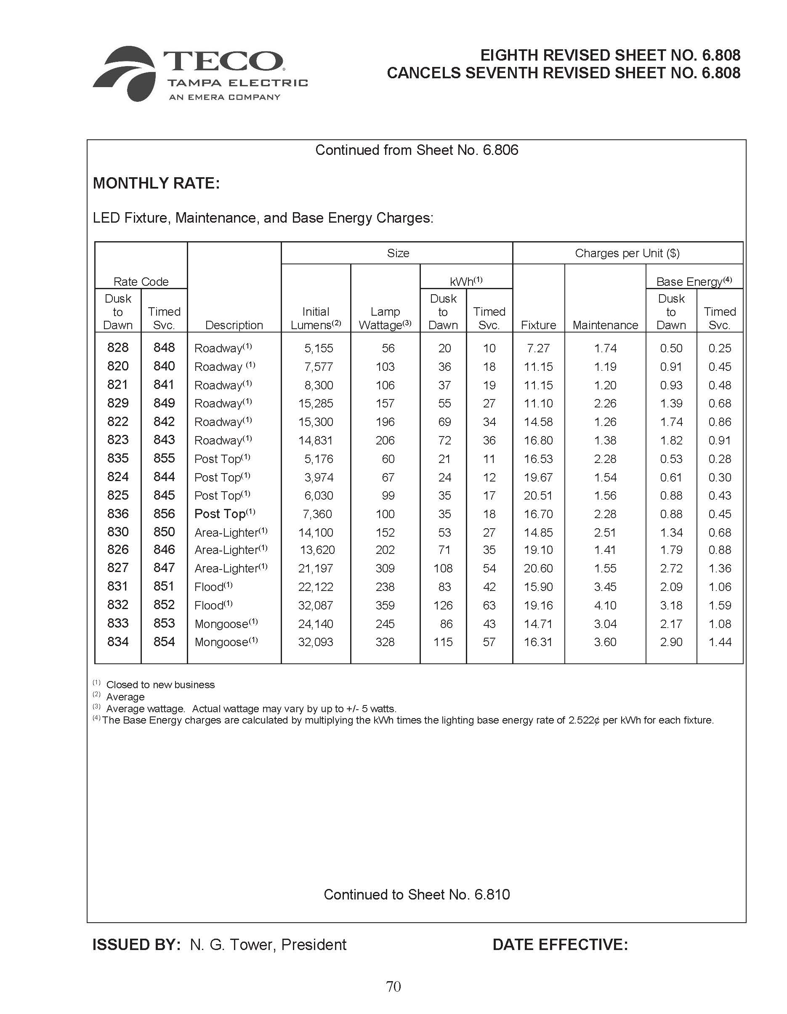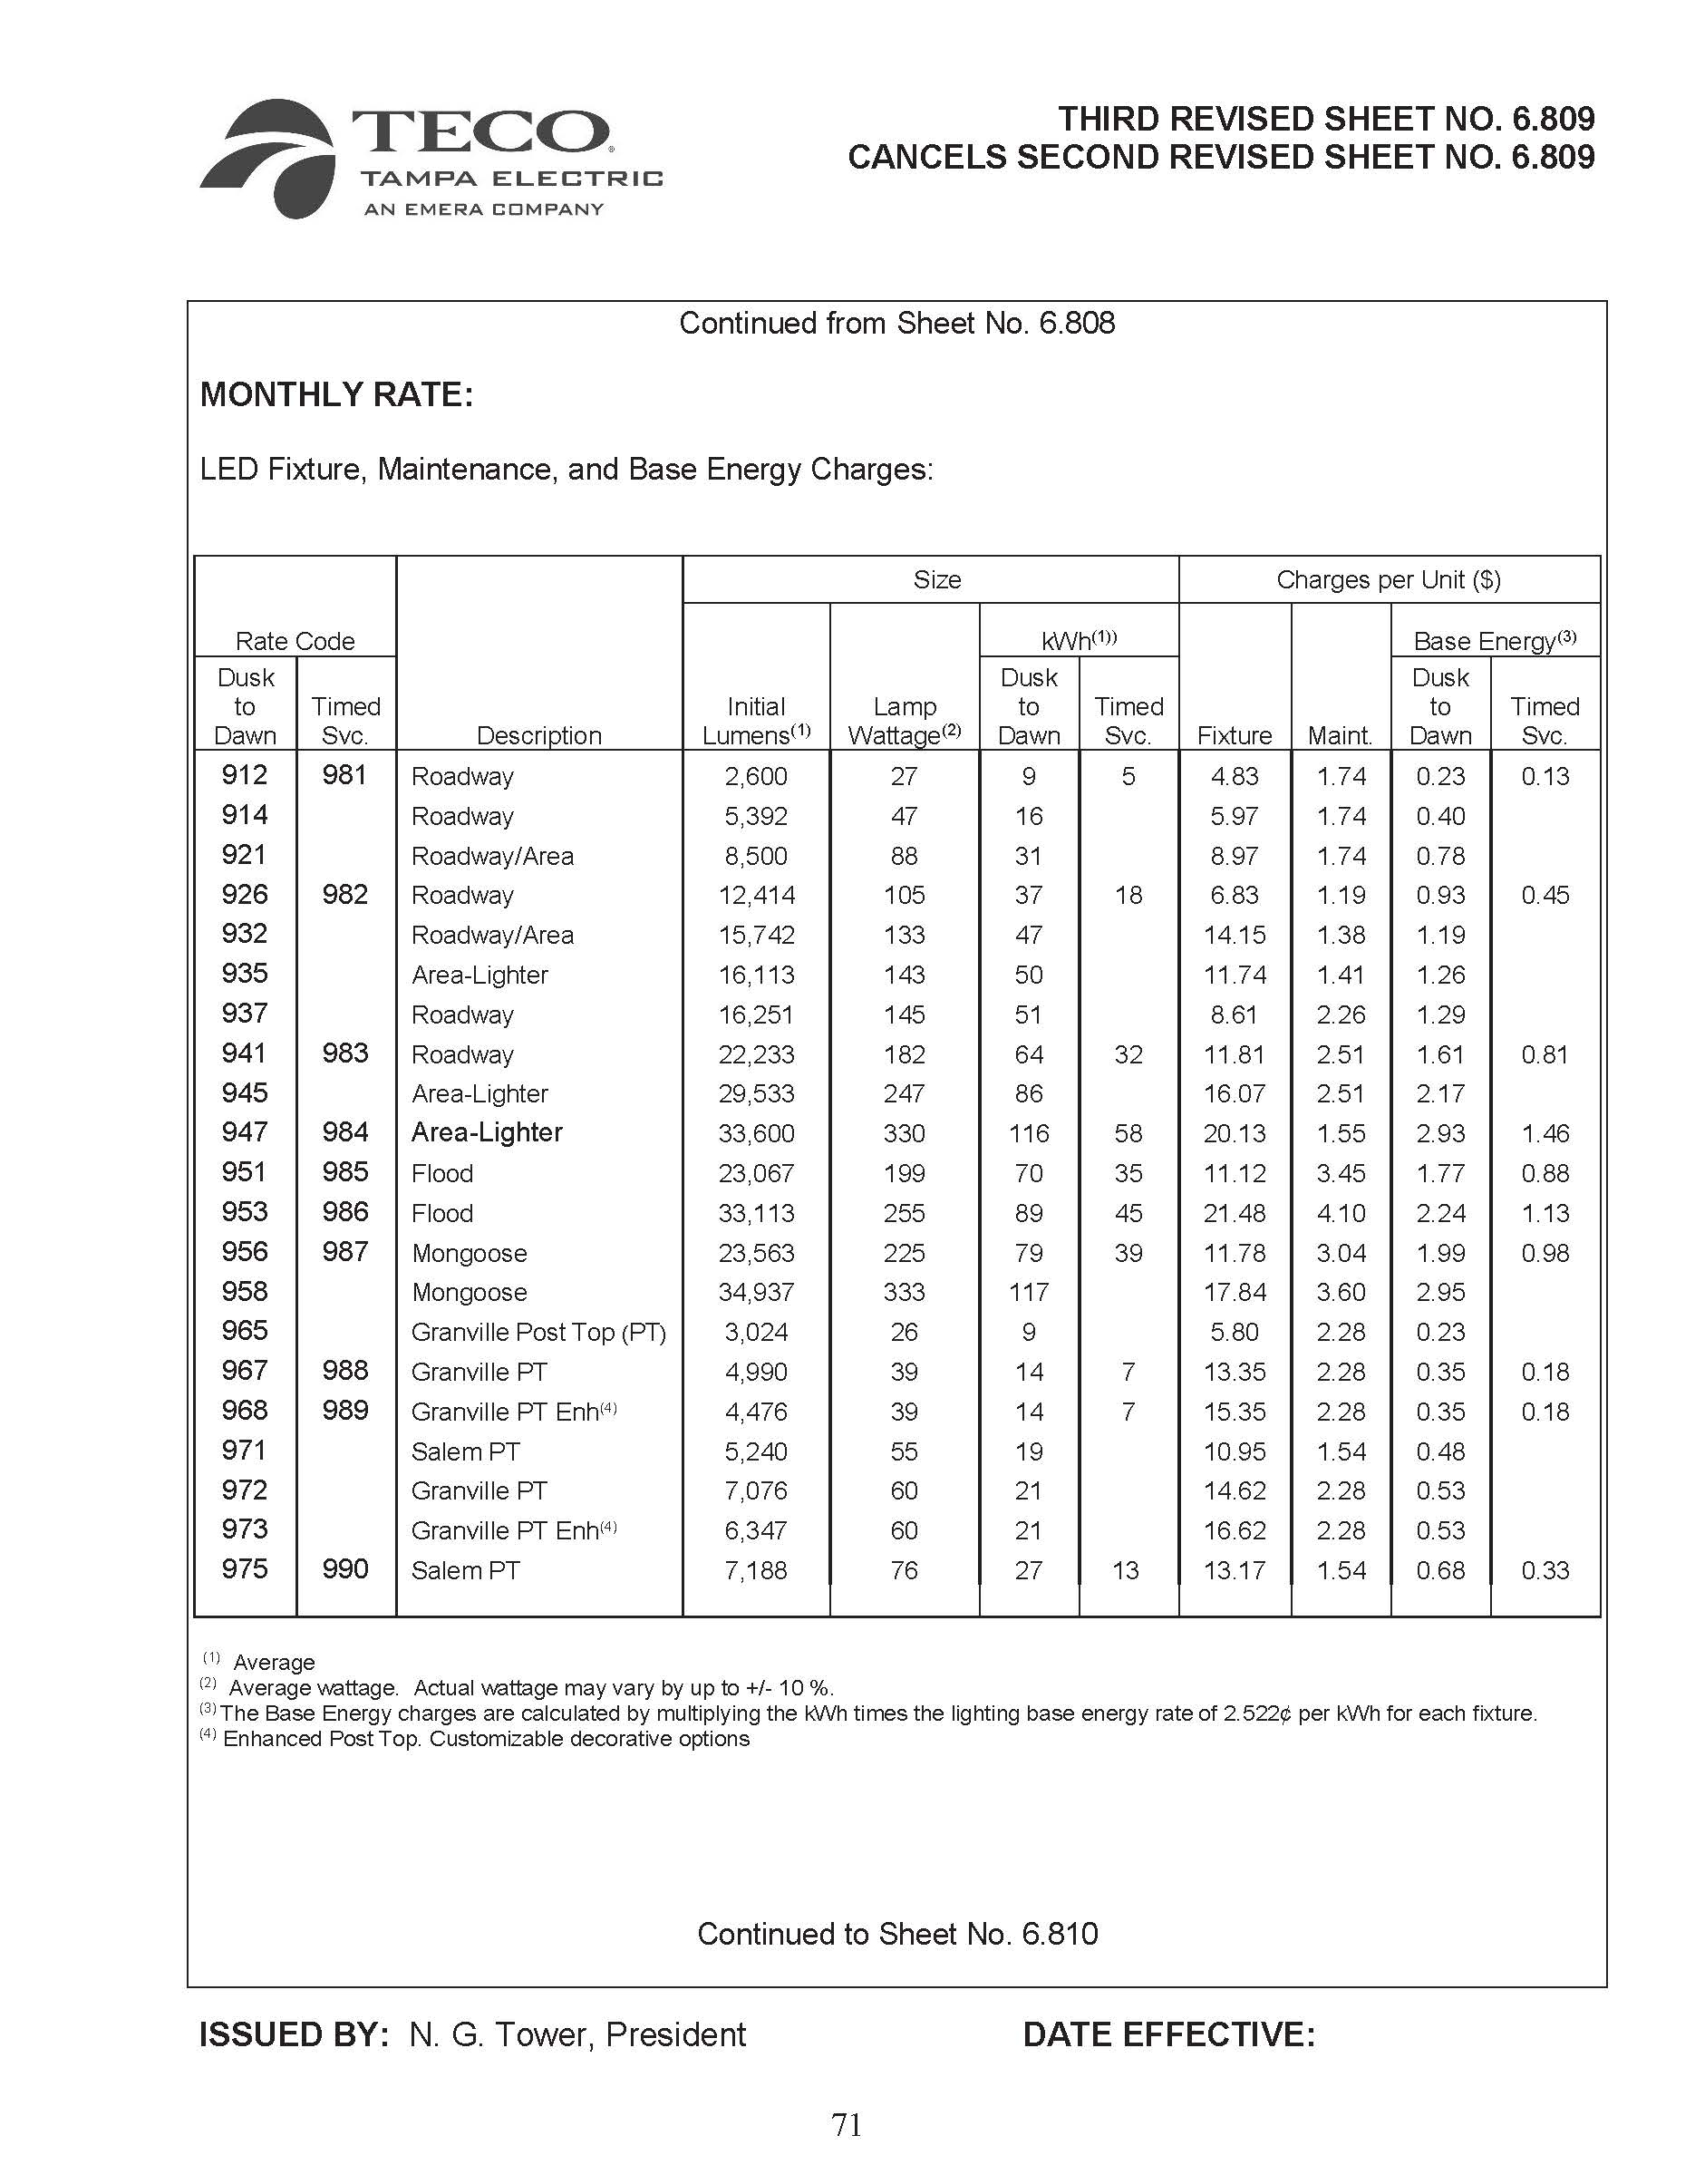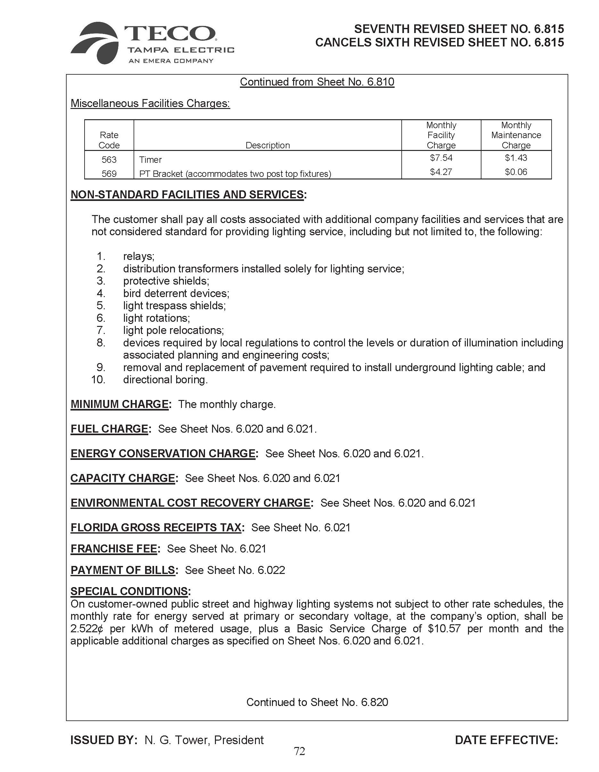

Order No. PSC-13-0023-S-EI, issued January 14, 2013, in Docket No. 120015-EI, In re: Petition for increase in rates by Florida Power & Light Company; Order No. PSC-11-0089-S-EI, issued February 1, 2011, in Docket Nos. 080677-EI and 090130, In re: Petition for increase in rates by Florida Power & Light Company and In re: 2009 depreciation and dismantlement study by Florida Power & Light Company; Order No. PSC-13-0023-S-EI, issued January 14, 2013, in Docket No. 120015-EI, In re: Petition for increase in rates by Florida Power & Light Company; PSC-10-0398-S-EI, issued June 18, 2010, in consolidated Docket Nos. 090079-EI, In re: Petition for increase in rates by Progress Energy Florida, Inc.; and 090144-EI, In re: Petition for limited proceeding to include Bartow repowering project in base rates, by Progress Energy Florida, Inc.; Docket No. 090145-EI, In re: Petition for expedited approval of the deferral of pension expenses, authorization to charge storm hardening expenses to the storm damage reserve, and variance from or waiver of Rule 25-6.0143(1)(c), (d), and (f), F.A.C., by Progress Energy Florida, Inc.; and Docket No. 100136-EI, In re: Petition for approval of an accounting order to record a depreciation expense credit, by Progress Energy Florida, Inc.; and Order No. PSC-05-0945-S-EI, issued September 28, 2005, in Docket No. 050078-EI, In re: Petition for rate increase by Progress Energy Florida, Inc.
Order No. PSC-13-0023-S-EI, at p. 7.

