BEFORE THE FLORIDA PUBLIC SERVICE COMMISSION

In re: Joint petition for approval of swing service rider rates for January through December 2020, by Florida Public Utilities Company, Florida Public Utilities Company-Indiantown Division, Florida Public Utilities Company-Fort Meade, and Florida Division of Chesapeake Utilities Corporation. | DOCKET NO. 20190160-GU  ORDER NO. PSC-2019-0491-TRF-GU  ISSUED: November 19, 2019

The following Commissioners participated in the disposition of this matter:

ART GRAHAM, Chairman
JULIE I. BROWN
DONALD J. POLMANN
GARY F. CLARK
ANDREW GILES FAY

TARIFF ORDER APPROVING REVISED SWING SERVICE RIDER RATES

BY THE COMMISSION:

- Background
On August 16, 2019, Florida Public Utilities Company, Florida Public Utilities Company – Indiantown Division (Indiantown), and Florida Public Utilities Company – Fort Meade (jointly, FPUC), as well as the Florida Division of Chesapeake Utilities Corporation (Chesapeake) (jointly, Companies), filed a petition for approval of a revised swing service rider tariff for the period January through December 2020 (Tariff Petition). FPUC is a local distribution company (LDC) subject to our regulatory jurisdiction pursuant to Chapter 366, Florida Statutes (F.S.). FPUC is a wholly-owned subsidiary of Chesapeake Utilities Corporation, which is headquartered in Dover, Delaware. Chesapeake is also an LDC subject to our jurisdiction under Chapter 366, F.S., and is an operating division of Chesapeake Utilities Corporation.
We first approved the Companies’ swing service rider tariff in Order No. PSC-16-0422-TRF-GU (Swing Service Order) with the initial swing service rider rates placed in effect for the period of March through December 2017. The Companies submitted, by the September 1, 2019, deadline specified in the Swing Service Order, the Tariff Petition with revised 2020 swing service rider rates for Commission approval. The swing service rider is a cents per therm charge that is included in the monthly gas bill of transportation customers.
On August 3, 2019, the Companies waived their 60-day file and suspend provision via e-mail, which was placed into the docket file for this matter. The Companies’ proposed revised tariff sheets are attached as Attachment A to this Order. We have jurisdiction over this matter pursuant to Sections 366.04, 366.05, and 366.06, F.S.
- Decision
The Companies incur intrastate capacity costs when they transport natural gas on intrastate pipelines (i.e., pipelines operating within Florida only). The Companies have two types of natural gas customers: sales and transportation. The swing service rider allows the Companies to recover the intrastate capacity costs directly from all transportation customers as intrastate pipeline projects benefit all customers.
- Types of Natural Gas Customers

Sales customers are primarily residential and small commercial customers that purchase natural gas from an LDC and receive allocations of intrastate capacity costs through the Purchased Gas Adjustment (PGA) charge. Of the joint petitioners in the instant docket, only Florida Public Utilities Company and Florida Public Utilities Company – Fort Meade have sales customers.
Transportation customers receive natural gas from third party marketers, also known as shippers and, therefore, do not pay the PGA charge to the LDC. The Companies’ transportation customers can be categorized as Transitional Transportation Service (TTS) or non-TTS. TTS program shippers purchase gas in aggregated customer pools for residential and small commercial customers, who do not contract directly with a shipper for their gas supply. Of the joint petitioners in the instant docket, only Indiantown and Chesapeake have TTS customers.
TTS customers receive allocations of intrastate capacity costs through the swing service rider. Prior to the approval of the swing service rider, TTS customers received allocations of intrastate capacity cost through the Operational Balancing Account (OBA) mechanism. The OBA mechanism allowed Indiantown and Chesapeake to assign intrastate capacity costs to TTS shippers, who then passed the costs on to the TTS customers for whom they purchase gas. With the approval of the swing service rider, TTS customers are now charged directly for their allocated portion of the intrastate capacity costs (rather than Indiantown and Chesapeake charging the shippers who then passed the costs on to the TTS customers).
Non-TTS customers are primarily large commercial or industrial customers who contract directly with a shipper for their natural gas supply. Prior to the approval of the swing service rider, non-TTS customers were not paying a share of the intrastate capacity costs. We approved a stepped implementation process for the swing service rider for non-TTS customers because the implementation of the swing service rider can have a significant financial impact on those customers who previously had not been allocated any portion of the intrastate capacity costs.
Specifically, the Swing Service Order approved a five-year implementation period for non-TTS customers with a 20 percent per year stepped allocation. Accordingly, the 2019 swing service charges included a 60 percent allocation of intrastate capacity costs to the non-TTS customers; the Tariff Petition includes an 80 percent allocation of intrastate capacity costs to the non-TTS customers.
- Proposed Swing Service Rider Rates

The proposed 2020 swing service rider rates were calculated based on the same methodology approved in the Swing Service Order. As shown in the Tariff Petition, the total intrastate capacity costs for the period July 2018 through June 2019 are $12,357,380. The total intrastate capacity costs reflect payments by FPUC to intrastate pipelines for the transportation of natural gas, pursuant to Commission-approved transportation agreements. In addition, the intrastate capacity costs include payments to outside contractors FPUC hired to provide expertise on the purchase of commodity and capacity.
Of these costs, $5,045,570 will be billed directly to certain large special contract customers. The remaining costs of $7,311,810 are allocated between sales and transportation customers.
The Companies used actual therm usage data for the period July 2018 through June 2019 to allocate the intrastate capacity costs. Based on the usage data, the appropriate split for allocating the cost is $5,286,466 (72.3 percent) to transportation customers and $2,025,344 (27.7 percent) to sales customers. The sales customers’ share of the cost is embedded in the PGA.
The transportation customers’ share is allocated to the various transportation rate schedules in proportion with each rate schedule’s share of the Companies’ total throughput. To calculate the swing service rider rates, the cost allocated to each rate schedule is divided by the rate schedule’s number of therms.
As stated earlier, TTS customers are charged an allocated portion of the intrastate capacity costs, while non-TTS customers are subject to a phased implementation. Since non-TTS customers are allocated 80 percent of the total intrastate capacity costs in 2020, the swing service revenues the Companies will receive is a total of $4,328,730; the remaining $957,736 ($5,286,466 - $4,328,730) of intrastate capacity costs allocated to transportation customers will be recovered through the PGA cost recovery clause from sales customers.
- Credit to the PGA

The total intrastate capacity costs are embedded in the PGA with the projected 2020 swing service rider revenues incorporated as a credit in the calculation of the 2020 PGA. The amount credited to the 2020 PGA is $4,328,730, plus $5,045,570 received from special contract customers, for a total of $9,374,300. At the end of the stepped implementation period in 2021, non-TTS customers will no longer receive a reduced allocation of the intrastate capacity cost. As a result, the credit to the PGA will increase and sales customers will no longer absorb a portion of the non-TTS intrastate capacity costs.
- Conclusion

Based on our review of the information provided in the Tariff Petition and the Companies’ responses to Commission staff’s data requests, we find the Companies’ proposed swing service rider to be reasonable. We have also reviewed the total projected intrastate capacity costs and find theses costs to be appropriate. Finally, we find the costs included in these rates to be appropriate and the methodology for calculating the swing service rider rates to be consistent with the Swing Service Order. Given these findings, we approve the proposed swing service rider rates for the period January through December 2020.

Based on the foregoing, it is

ORDERED by the Florida Public Service Commission that Florida Public Utilities Company, Florida Public Utilities Company – Indiantown Division, Florida Public Utilities Company – Fort Meade, and Florida Division of Chesapeake Utilities Corporation’s swing service rider rates for the period January through December 2020 are approved as specified in this Order.

ORDERED that if a protest is filed within 21 days of issuance of this Order, the tariff shall remain in effect with any charges held subject to refund pending resolution of the protest. It is further

ORDERED that if no timely protest is filed, this docket shall be closed upon the issuance of a Consummating Order.

By ORDER of the Florida Public Service Commission this 19th day of November, 2019.

/s/ Adam J. Teitzman
ADAM J. TEITZMAN
Commission Clerk
Florida Public Service Commission
2540 Shumard Oak Boulevard
Tallahassee, Florida 32399
(850) 413-6770
www.floridapsc.com

Copies furnished: A copy of this document is provided to the parties of record at the time of issuance and, if applicable, interested persons.

KMS

NOTICE OF FURTHER PROCEEDINGS

The Florida Public Service Commission is required by Section 120.569(1), Florida Statutes, to notify parties of any administrative hearing or judicial review of Commission orders that is available under Sections 120.57 or 120.68, Florida Statutes, as well as the procedures and time limits that apply. This notice should not be construed to mean all requests for an administrative hearing or judicial review will be granted or result in the relief sought.

Mediation may be available on a case-by-case basis. If mediation is conducted, it does not affect a substantially interested person's right to a hearing.

The Commission's decision on this tariff is interim in nature and will become final, unless a person whose substantial interests are affected by the proposed action files a petition for a formal proceeding, in the form provided by Rule 28-106.201, Florida Administrative Code. This petition must be received by the Office of Commission Clerk, 2540 Shumard Oak Boulevard, Tallahassee, Florida 32399-0850, by the close of business on December 10, 2019.

In the absence of such a petition, this Order shall become final and effective upon the issuance of a Consummating Order.

Any objection or protest filed in this docket before the issuance date of this order is considered abandoned unless it satisfies the foregoing conditions and is renewed within the specified protest period.

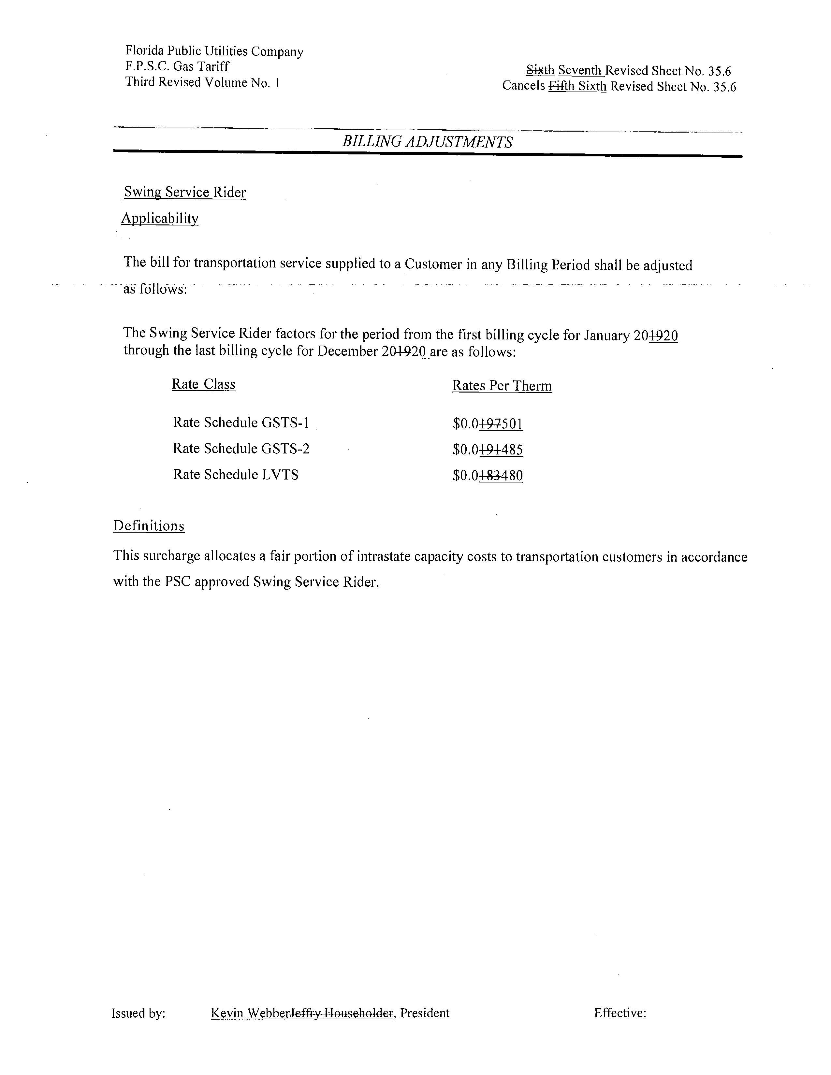

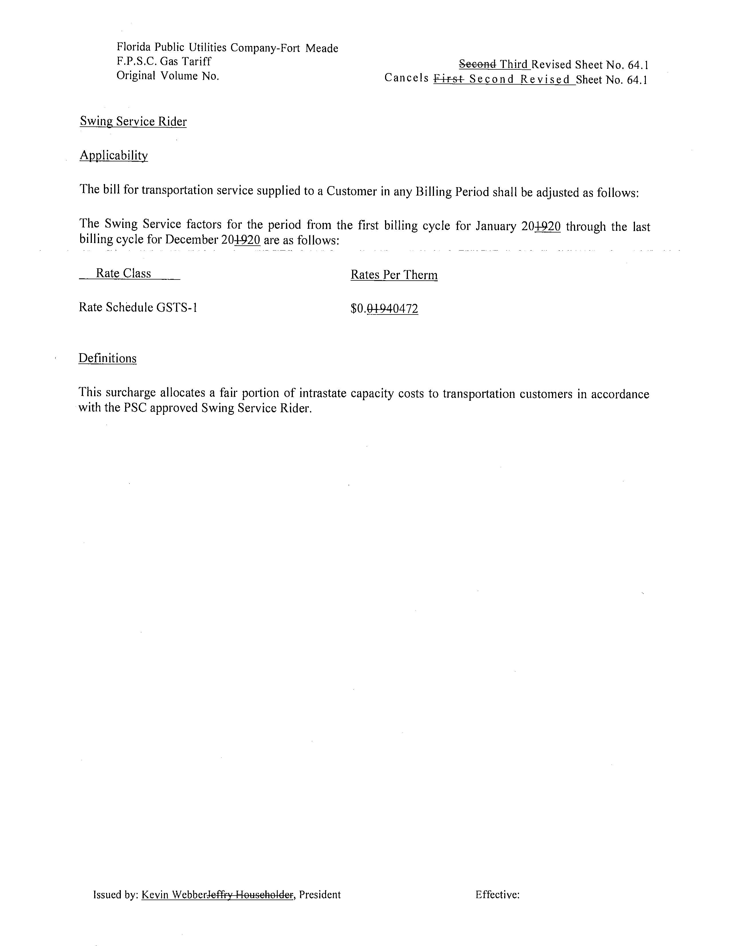
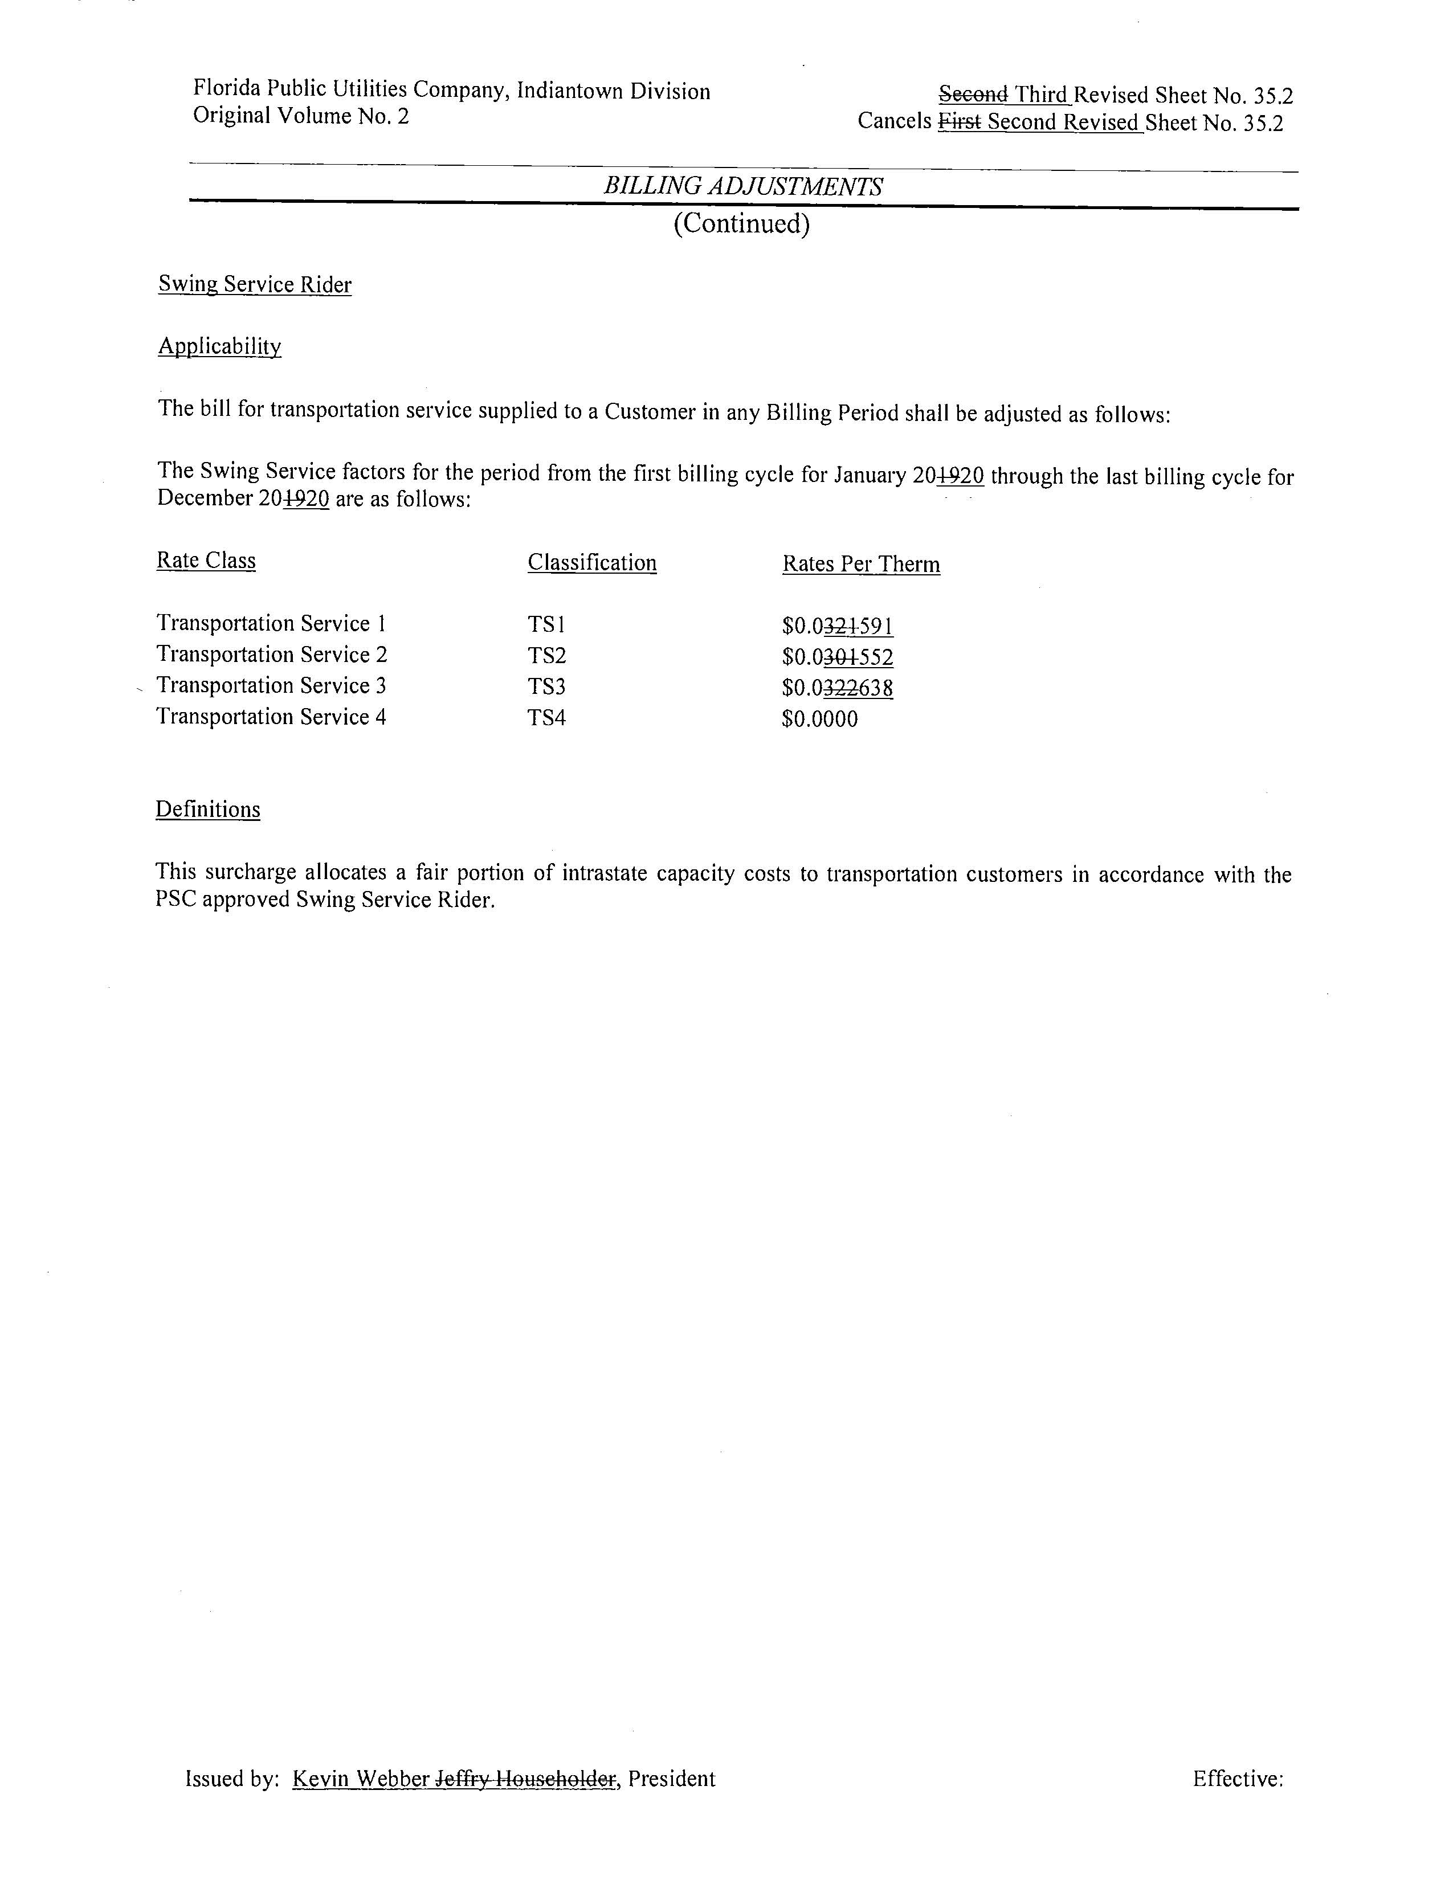

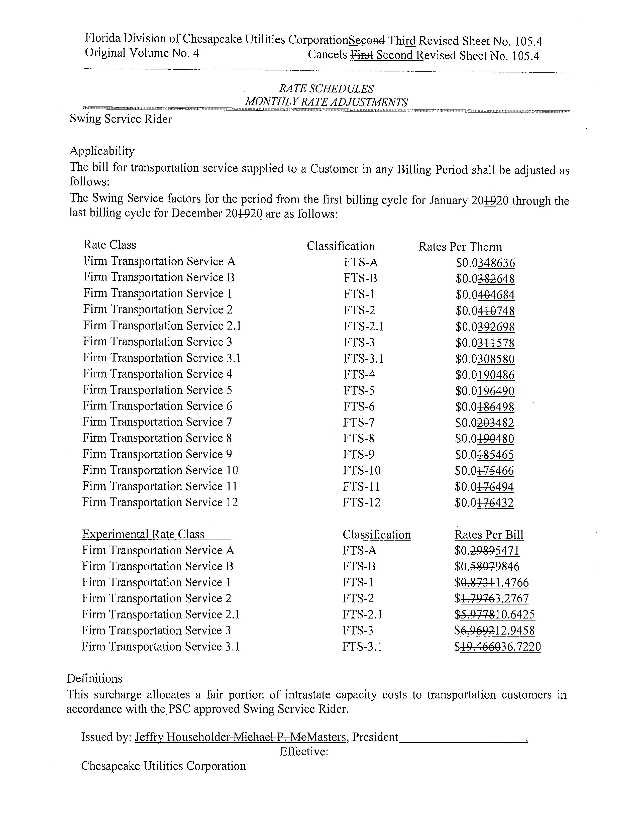

Order No. PSC-16-0422-TRF-GU, issued October 3, 2016, Docket No. 160085-GU, In re: Joint petition for approval of swing service rider, by Florida Public Utilities Company, Florida Public Utilities Company-Indiantown Division, Florida Public Utilities Company-Fort Meade, and Florida Division of Chesapeake Utilities Corporation.
We set the PGA charge in the annual PGA cost recovery clause proceeding.
We do not regulate the shippers or their charges for the gas commodity.
See direct testimony of Michelle D. Napier on behalf of FPUC, filed on August 9, 2019, Document No. 07322-2019, in Docket No. 20190003-GU, Exhibit No. MDN-1, Schedule E-1, line 8 on Page 1 of 6.

