BEFORE THE FLORIDA PUBLIC SERVICE COMMISSION

In re: Initiation of show cause proceeding against Tele Circuit Network Corporation for apparent violation of Order Nos. PSC-05-0361-PAA-TX and PSC-11-0419-PAA-TX. | DOCKET NO. 20190193-TX  ORDER NO. PSC-2019-0498-PAA-TX  ISSUED: November 22, 2019

The following Commissioners participated in the disposition of this matter:

ART GRAHAM, Chairman
JULIE I. BROWN
DONALD J. POLMANN
GARY F. CLARK
ANDREW GILES FAY

NOTICE OF PROPOSED AGENCY ACTION ORDER
FOR TELE CIRCUIT NETWORK CORPORATION TO SHOW CAUSE
FOR APPARENT VIOLATION OF ORDER NO. PSC-11-0419-PAA-TX, OR
REVOKE TELE CIRCUIT NETWORK CORPORATION’S
ELIGIBLE TELECOMMUNICATIONS CARRIER STATUS
AND
FOR TELE CIRCUIT NETWORK CORPORATION TO SHOW CAUSE
FOR APPARENT VIOLATION OF ORDER NO. PSC-05-0361-PAA-TXX, OR
REVOKE TELE CIRCUIT NETWORK CORPORATION’S
COMPETITIVE LOCAL EXCHANGE COMPANY CERTIFICATE, NO. 8573

BY THE COMMISSION:

Background
We opened this docket to initiate a show cause proceeding against Tele Circuit Network Corporation (Tele Circuit or Company) for apparent violation of Florida Public Service Commission (Commission) Order Nos. PSC-05-0361-PAA-TX and PSC-11-0419-PAA-TX.
Tele Circuit is a privately-held corporation, incorporated in Georgia, and authorized to transact business as a foreign corporation in Florida since July 14, 2003. By Order No. PSC-05-0361-PAA-TX (CLEC Order), issued on April 4, 2005, we granted Tele Circuit a Competitive Local Exchange Company (CLEC) Certificate, No. 8573, pursuant to Section 364.335(1)(b)(2), Florida Statutes (F.S.). Tele Circuit provides service in BellSouth Telecommunications, LLC d/b/a AT&T Florida d/b/a AT&T Southeast’s (AT&T) territory as a reseller of AT&T service.
By Order No. PSC-11-0419-PAA-TX (ETC Order), issued on September 28, 2011, we designated Tele Circuit as a landline (or “wireline”) Eligible Telecommunications Carrier (ETC) throughout AT&T’s service territory, pursuant to Chapter 47 Code of Federal Regulations (C.F.R.), Section 54.201(c). In Florida, a company may receive a wireline ETC designation from the Commission, but must seek a wireless ETC designation from the Federal Communications Commission (FCC). Companies that are designated as ETCs have the ability to receive Universal Service Fund (USF) support from the Universal Service Administration Company (USAC) for providing qualifying services from the four major USF programs: High-Cost, Low-Income (Lifeline), Rural Health Care, and the Schools and Libraries divisions. USF support is provided to ETCs in the form of monetary reimbursement.
Tele Circuit’s purpose in seeking its ETC designation was to receive federal support for offering the Lifeline discount to its low-income customers. The Company currently serves approximately 300 customers in the state of Florida, and claims reimbursement from the USF for 34 of its customers under the Lifeline program.
On May 16, 2019, we received a complaint concerning a customer’s desire to acquire wireline service under the Lifeline program from Tele Circuit. Upon further investigation, we learned that Tele Circuit had in fact stopped offering the Lifeline discount for wireline service, despite wireline being the only type of service Tele Circuit is authorized to provide pursuant to its ETC Order. Tele Circuit advised us that it was unable to provide new customers with the Lifeline discount using wireline service due to a technical issue, but that if a customer was willing to use a wireless phone, the Company would still offer the Lifeline discount after verifying the customer’s eligibility.
Following additional conversations with Tele Circuit, we learned that due to a dispute regarding overcharges in billing between AT&T and Tele Circuit, the Company was not able to sell wireline service in Florida to new customers., We also confirmed that Tele Circuit was advertising a “wireless home phone-hub” service to its customers, and providing new customers who wished to receive the Lifeline discount with wireless phone service via the phone-hub.
Upon request, we received a copy of the advertising material or user manual(s) provided to Tele Circuit customers for the wireless home phone-hub. The wireless home phone-hub appears to operate on either the Sprint or Verizon wireless networks, but Tele Circuit apparently believes it qualifies as wireline service. It is unclear if customers are informed that they are not receiving wireline service when receiving this technology from Tele Circuit. Tele Circuit advised that only one of its 34 Lifeline customers in Florida is utilizing the wireless home phone-hub service, and that the remaining 33 customers are using wireline service.
Tele Circuit further advised that the Company contacted USAC to ensure that use of the wireless home phone-hub technology was permissible for the Lifeline program. We requested the name of the contact at USAC and any formal documentation of USAC’s approval of the use of the wireless technology; however, Tele Circuit informed us that it did not know the individual’s name, nor did it receive any formal documentation. We also contacted USAC to verify the approval of the technology; however, USAC did not provide any information.
We requested additional information from AT&T and Tele Circuit regarding the nature of the dispute between the companies. AT&T informed us that it reached a settlement agreement with Tele Circuit that dictated that the Company must remove all customers from AT&T lines by December 31, 2019. AT&T also provided us with a letter sent by Tele Circuit to its customers informing them of the Company’s need to migrate its customers off of its current network. In contrast, Tele Circuit originally stated that the dispute was resolved, and advised that it was able to provide wireline service to new customers in Florida. After further inquiry, however, the Company advised that AT&T and Tele Circuit were still in negotiations regarding their dispute, but did not advise us of the settlement agreement.
Similarly, Tele Circuit provided contradictory responses to us regarding its current bankruptcy status. In a response to a data request regarding the 2019 Status of Competition in the Telecommunications Industry Report, Tele Circuit advised that it filed for Chapter 11 bankruptcy in June 2018. However, in a data request response regarding our annual Lifeline Assistance Report, Tele Circuit failed to state that it had filed for bankruptcy within the last year.
Tele Circuit also stated in its data request response that it was not involved in any FCC enforcement actions within the last two years. However, during the course of the informal investigation into Tele Circuit’s provision of wireless service for its Lifeline customers, we discovered a Notice of Apparent Liability for Forfeiture (NAL), issued by the FCC on April 27, 2018, which the Company should have disclosed.
In the NAL, the FCC proposed that the Company pay a $5.3 million fine due to the egregious nature of Tele Circuit’s apparent misconduct, which involved the deceptive practices commonly referred to as “slamming” and “cramming.” Slamming refers to the practice of changing a customer’s preferred service provider without proper authorization, and cramming refers to the practice of placing unauthorized charges for long distance service on a customer’s bill. Slamming and cramming cause consumers to spend significant time and effort to return to their preferred carriers, to remove unauthorized charges from their bills, and to file complaints with law enforcement agencies.
Notably, the FCC stated that:
In some instances, the apparent misconduct of Tele Circuit left vulnerable consumers without telephone service for extended periods of time – with Tele Circuit allegedly refusing to reinstate service until the crammed charges were paid in full. Further, it appears that some of the third-party verification recordings that Tele Circuit provided to the Commission as “evidence” of consumer authorization were fabricated.
The FCC emphasized how Tele Circuit’s apparent misconduct caused “great consternation among these victims and their family members, and created dangerous or potentially life-threatening situations.” In one example, the complainant alleged that Tele Circuit persuaded a 94-year old customer to switch carriers to Tele Circuit, and then cut off service before the elderly customer’s guardian knew the service had been switched. The complainant noted that “[t]his is the only way she or her caregivers can contact me or anyone in case of an emergency.”
Another complainant alleged that Tele Circuit wrongfully switched her mother’s service, and ultimately disconnected her. When the complainant requested to listen to the recording of her mother allegedly authorizing Tele Circuit’s carrier switch, the Company could not provide it. She stated that “[a]s of right now my mother is without a phone and if anything happens to her, she can’t even dial 911 because she has no service at all ... [i]t’s sad that these companies prey on the elderly.” We contacted the FCC to determine if there was any settlement or additional actions that resulted from the NAL, but have not received any additional information to date.
Given the serious nature of the allegations that the FCC presented against Tele Circuit, the Company’s apparent inability to provide us with consistent and accurate information, and its prohibited use of wireless technology for Lifeline customers, we find that Tele Circuit is in violation of its ETC Order, for use of non-compliant wireless technology for its Lifeline customers, and because it is no longer in the public interest for Tele Circuit to be designated as an ETC. Further, we find that Tele Circuit is in violation of its CLEC Order, due to insufficient managerial capability to provide CLEC service in Florida.
Accordingly, this Order to Show Cause (Show Cause Order) is considered an administrative complaint by the Commission against the entity, pursuant to Section 120.60(5), F.S. In order to keep its ETC designation in the state of Florida, and to keep its CLEC Certificate, Tele Circuit must provide a response to us within 21 days, which disputes the factual allegations contained in this Show Cause Order, and contains a request for a hearing pursuant to Sections 120.569 and 120.57, F.S. If the Company requests a hearing, a further proceeding will be scheduled before the Commission makes a final determination on this matter.
If Tele Circuit fails to timely respond to this Show Cause Order, then it will be deemed to have admitted the factual allegations contained in this Show Cause Order. The Company’s failure to timely respond will also constitute a waiver of its right to a hearing. If the Company does not timely respond, a final order will be issued imposing the sanctions set out in this Show Cause Order. If a final order is issued in this docket, then Tele Circuit’s ETC status will be revoked in the state of Florida, and the Company will no longer be able to offer the Lifeline discount to its customers in Florida. Tele Circuit’s CLEC certificate will also be revoked, and the Company will no longer be able to provide any wireline service in the state of Florida. Tele Circuit will be prohibited from receiving monetary support from the USF for its Lifeline customers in Florida.
We have jurisdiction pursuant to Sections 364.10(2), 364.285, and 364.335, F.S.

Analysis & Decision

I. Revocation of Tele Circuit’s ETC Status
A. Applicable Law

State commissions have the primary responsibility for performing ETC designations. In the state of Florida, we have the jurisdiction to designate wireline, but not wireless, ETCs. 47 C.F.R. Section 54.201(c), provides that:
Upon request and consistent with the public interest, convenience, and necessity, the state commission may, in the case of an area served by a rural telephone company, and shall, in the case of all other areas, designate more than one common carrier as an eligible telecommunications carrier for a service area designated by the state commission, so long as each additional requesting carrier meets the requirements of paragraph (d) of this section. Before designating an additional eligible telecommunications carrier for an area served by a rural telephone company, the state commission shall find that the designation is in the public interest.
47 C.F.R. Section 54.201(d), provides that carriers designated as ETCs shall, throughout the designated service area: (1) offer the services that are supported by federal universal support mechanisms whether using their own facilities or a combination of their own facilities and the resale of another carrier’s services, and (2) advertise the availability of such services and related charges therefore using media of general distribution.
In addition to the responsibility for performing wireline ETC designations, we also possess the authority to revoke ETC designations for the failure of an ETC’s compliance with any of the conditions imposed by us. The FCC has found that individual state commissions are qualified to determine what information is necessary to ensure that ETCs are in compliance with applicable requirements, including state-specific ETC eligibility requirements.
Pursuant to Section 364.285(1), F.S., we may impose upon any entity subject to our jurisdiction a penalty of not more than $25,000 for each such day a violation continues, if such entity is found to have refused to comply with or to have willfully violated any lawful rule or order of the Commission, or any provision of Chapter 364, F.S. Each day a violation continues is treated as a separate offense. Each penalty is a lien upon the real and personal property of the entity and is enforceable by us as a statutory lien.
As an alternative to the above monetary penalties, Section 364.285(1), F.S., provides that we may amend, suspend, or revoke any certificate issued by us for any such violation. Part of the determination we must make in evaluating whether and how to penalize a company is whether the company willfully violated the order, rule, or statute. Section 364.285(1), F.S., does not define what it is to “willfully violate” an order, rule, or statute. Willfulness is a question of fact. The plain meaning of "willful" typically applied by the Courts in the absence of a statutory definition, is an act or omission that is done “voluntarily and intentionally” with specific intent and “purpose to violate or disregard the requirements of the law.”

“It is a common maxim, familiar to all minds that ‘ignorance of the law’ will not excuse any person, either civilly or criminally.” In making similar decisions, we have repeatedly held that certificated companies are charged with the knowledge of our orders, rules, and statutes, and that the intent of Section 364.285(1) is to penalize those who affirmatively act in opposition to those orders, rules, or statutes. In other words, a company cannot excuse its violation because it “did not know.”

In recommending a monetary penalty or a form of certificate suspension or revocation, we review prior Commission orders. While Section 364.285(1), F.S., treats each day of each violation as a separate offense with penalties of up to $25,000 per offense, we believe that the general purpose of imposing monetary penalties is to obtain compliance with the Commission’s orders, rules, or statutes. If a company has a pattern of noncompliance with an order, rule, or statute, or, in particular, if the violation of an order, rule, or statute adversely impacts the public health, safety, or welfare, then we find that a monetary penalty may not be appropriate or suffice to address the situation. In such a case, we find that the sanction should be the most severe. In this docket, our informal investigation revealed that Tele Circuit appears to be using non-compliant wireless technology to claim reimbursement for its Lifeline customers. This is in direct violation of Order No. PSC-11-0419-PAA-TX. Therefore, we find that it is no longer in the public interest for Tele Circuit to be designated as an ETC, and we find that the appropriate penalty is revoking Tele Circuit’s ETC designation.
B. Factual Allegations
As a wireline ETC in Florida, Tele Circuit may only claim Lifeline support for customers receiving wireline telecommunications service. As noted in the Case Background, we learned that Tele Circuit appears to be providing wireless technology to new Lifeline customers. Telecommunications carriers may provide their customers with service using any underlying technology they see fit; however, with respect to customers participating in the Lifeline program, Tele Circuit is only authorized in Florida to provide wireline service in order to receive access to the monies available via the USF. Our analysis indicates that Tele Circuit appears to be intentionally claiming reimbursement from USAC for Florida Lifeline customers using wireless technology, and we find that Tele Circuit’s ETC designation be revoked for this abuse of the USF.

In addition, we learned that a condition of the dispute resolution between Tele Circuit and AT&T is that Tele Circuit must migrate its end-users off of the AT&T network by December 31, 2019. It appears to us that Tele Circuit plans to migrate all of its Lifeline customers to the non-compliant wireless technology, as Tele Circuit does not have any pending request to interconnect with a different wireline carrier in AT&T’s service territory. Therefore, it appears that Tele Circuit’s intentional non-compliance will only be exacerbated in 2020, and potentially in perpetuity thereafter unless we or USAC take action.
Further, Tele Circuit’s ETC designation was granted by us as being in the public interest, and upon a showing that the Company was committed to abide by both state and federal rules and procedures. In light of the FCC’s NAL, we find that it is no longer in the public interest for Tele Circuit to keep its ETC designation. In fact, we find that it would be in the public interest to revoke Tele Circuit’s ETC designation, since this would be one less avenue for the Company to use to prey on low-income and elderly customers.
It appears that Tele Circuit is intentionally providing Lifeline customers with wireless technology, in direct violation of its ETC Order. Tele Circuit also appears to be intentionally engaging in deceptive, and in some instances dangerous, business activity, which is contrary to the public interest. Accordingly, we order Tele Circuit to show cause, in writing, within 21 days from the issuance of this Show Cause Order, why its ETC designation should not be revoked for apparent violation of Commission Order No. PSC-11-0419-PAA-TX, due to use of non-compliant wireless technology for its Lifeline customers, and because it is no longer in the public interest for Tele Circuit to be designated as an ETC.

In the event that Tele Circuit fails to file a timely response to this Show Cause Order, the Company’s ETC status will be deemed revoked, and a final order will be issued. Our staff will contact USAC and obtain the names and addresses of the Company’s current Lifeline customers in Florida, and will send a letter to the Lifeline customers that explains which carriers remain authorized to provide the Lifeline discount in their area. Any customers who wish to continue to receive the Lifeline discount would have to find a new carrier that is designated as either a wireline or wireless ETC.

II. Revocation of Tele Circuit’s CLEC Certificate

A. Applicable Law
Tele Circuit’s CLEC application was granted upon a showing that the company had “sufficient technical, financial, and managerial capability to provide such [CLEC] service,” pursuant to Section 364.335(2), F.S. Section 364.335(2), F.S., provides that:

The [C]ommission shall grant a certificate of authority to provide telecommunications service upon a showing that the applicant has sufficient technical, financial, and managerial capability to provide such service in the geographic area proposed to be served. The applicant shall ensure continued compliance with applicable business formation, registration, and taxation provisions of law.

Pursuant to Section 364.285(1), F.S., we may impose upon any entity subject to our jurisdiction a penalty of not more than $25,000 for each such day a violation continues, if such entity is found to have refused to comply with or to have willfully violated any lawful rule or order of the Commission, or any provision of Chapter 364, F.S. Each day a violation continues is treated as a separate offense. Each penalty is a lien upon the real and personal property of the entity and is enforceable by us as a statutory lien.

As an alternative to the above monetary penalties, Section 364.285(1), F.S., provides that we may amend, suspend, or revoke any certificate issued by us for any such violation. Part of the determination we must make in evaluating whether and how to penalize a company is whether the company willfully violated the order, rule, or statute. Section 364.285(1), F.S., does not define what it is to “willfully violate” an order, rule, or statute. Willfulness is a question of fact. The plain meaning of "willful" typically applied by the Courts in the absence of a statutory definition, is an act or omission that is done “voluntarily and intentionally” with specific intent and “purpose to violate or disregard the requirements of the law.”

“It is a common maxim, familiar to all minds that ‘ignorance of the law’ will not excuse any person, either civilly or criminally.” In making similar decisions, we have repeatedly held that certificated companies are charged with the knowledge of our orders, rules, and statutes, and that the intent of Section 364.285(1) is to penalize those who affirmatively act in opposition to those orders, rules, or statutes. In other words, a company cannot excuse its violation because it “did not know.”

In recommending a monetary penalty or a form of certificate suspension or revocation, we review prior Commission orders. While Section 364.285(1), F.S., treats each day of each violation as a separate offense with penalties of up to $25,000 per offense, we believe that the general purpose of imposing monetary penalties is to obtain compliance with the Commission’s orders, rules, or statutes. If a company has a pattern of noncompliance with an order, rule, or statute, or in particular if the violation of an order, rule, or statute adversely impacts the public health, safety, or welfare, then we find that a monetary penalty may not be appropriate or suffice to address the situation. In such a case, we find that the sanction should be the most severe. In this docket, our informal investigation revealed that Tele Circuit appears to be using non-compliant wireless technology to claim reimbursement for its Lifeline customers, that it is no longer in the public interest for Tele Circuit to be designated as an ETC, and that Tele Circuit no longer possesses sufficient managerial capabilities to provide CLEC service in Florida; therefore, we find that the appropriate penalty is revocation of Tele Circuit’s CLEC Certificate.

B. Factual Allegations

As indicated in the Case Background, Tele Circuit does not appear to possess sufficient managerial capability to provide CLEC service to customers in the state of Florida. Throughout the course of our informal investigation, Tele Circuit was unable to provide clear, consistent, and accurate responses to our staff’s data requests. Tele Circuit appears to believe it is in compliance with its ETC Order by utilizing wireless technology, even though its ETC designation is for wireline only. We also note that the Company has an “F” rating on the Better Business Bureau website, and continues to receive complaints of slamming, cramming, and other misleading and deceptive marketing practices.

Additionally, we find that the allegations set forth in the FCC’s NAL are of such a serious nature as to question Tele Circuit’s managerial capabilities. As indicated in the Case Background, the allegations against Tele Circuit are egregious. Multiple complainants expressed anger and frustration against the Company for misleading and defrauding a particularly vulnerable portion of the population – those who are elderly and in need of low-income assistance. Further, the FCC found that Tele Circuit not only apparently willfully and repeatedly violated FCC rules related to slamming and cramming, but also fabricated evidence in an attempt to prove Tele Circuit’s compliance with the FCC’s rules. These edited tapes have been played for some complainants, who stated that either the recording was not their voice, or the questions being asked were not the same as the original phone call. During the course of the FCC’s investigation, Tele Circuit issued general denials of wrongdoing, but did not attempt to refute specific allegations made by consumers, nor did the Company specifically refute the allegations of evidence fabrication. We find that Tele Circuit’s apparent willingness to fabricate third party verification tapes, or at best its ambivalence toward such a charge, shows not only a lack of managerial capability to halt employee misconduct, but also suggests that Tele Circuit management may be engaged in willfully deceiving customers and regulators as a method of profit-seeking.

For the foregoing reasons, we find that Tele Circuit no longer possesses the managerial capability to ensure that the Company will conduct business in a manner compliant with federal and state orders, rules, and statutes, and is therefore in violation of its CLEC Order. Accordingly, we order Tele Circuit to show cause, in writing, within 21 days from the issuance of the order, why its CLEC Certificate, No. 8573, should not be revoked for apparent violation of Commission Order No. PSC-05-0361-PAA-TX, for insufficient managerial capability to provide CLEC service in Florida.

In the event that Tele Circuit fails to file a timely response to this Show Cause Order, the Company’s CLEC Certificate, No. 8573, will be deemed revoked, and a final order will be issued. Tele Circuit will be required to pay any outstanding Regulatory Assessment Fees pursuant to Rule 25-4.0161, F.A.C. Any current wireline customers of Tele Circuit will have to find a new wireline service provider, or switch to wireless service.

Based on the foregoing, it is

ORDERED by the Florida Public Service Commission that Tele Circuit Network Corporation shall show cause, in writing, within 21 days from the issuance of this Show Cause Order, why its ETC designation should not be revoked for apparent violation of Commission Order No. PSC-11-0419-PAA-TX, due to use of non-compliant wireless technology for its Lifeline customers, and because it is no longer in the public interest for Tele Circuit to be designated as an ETC. It is further

ORDERED that Tele Circuit Network Corporation shall show cause, in writing, within 21 days from the issuance of this Show Cause Order, why its Competitive Local Exchange Carrier Certificate, No. 8573, should not be revoked for apparent violation of Commission Order No. PSC-05-0361-PAA-TX, for insufficient managerial capability to provide CLEC service in Florida. It is further

ORDERED that this Show Cause Order is an administrative complaint by the Florida Public Service Commission, as petitioner, against Tele Circuit Network Corporation, as respondent. It is further

ORDERED that Tele Circuit Network Corporation shall respond to this Show Cause Order within 21 days of service on the Company, and the response shall reference Docket No. 20190193-TX, Initiation of show cause proceeding against Tele Circuit Network Corporation for apparent violation of Order Nos. PSC-05-0361-PAA-TX and PSC-11-0419-PAA-TX. It is further

ORDERED that Tele Circuit Network Corporation has the right to request a hearing to be conducted in accordance with Sections 120.569 and 120.57, F.S., and to be represented by counsel or other qualified representative. It is further

ORDERED that requests for hearing shall comply with Rule 28-106.2015, F.A.C. It is further

ORDERED that Tele Circuit Network Corporation’s response to this Show Cause Order shall identify those material facts that are in dispute. If there are none, the petition must so indicate. It is further

ORDERED that if Tele Circuit Network Corporation files a timely written response and makes a request for a hearing pursuant to Sections 120.569 and 120.57, F.S., a further proceeding will be scheduled before a final determination of this matter is made. It is further

ORDERED that a failure to file a timely written response to this Show Cause Order will constitute an admission of the facts alleged herein, and a waiver of the right to a hearing on these issues. It is further

ORDERED that if Tele Circuit Network Corporation fails to file a timely response, then our staff will contact USAC and obtain the names and addresses of the Company’s current Lifeline customers in Florida. Our staff will send a letter to the Lifeline customers that explains which carriers remain authorized to provide the Lifeline discount in their area. It is further

ORDERED that if Tele Circuit Network Corporation timely responds in writing to this Show Cause Order, this docket should remain open to allow for the appropriate processing of the response. It is further

ORDERED that if Tele Circuit Network Corporation does not timely respond to this Show Cause Order, then we shall issue a Final Order, and this docket shall be closed after the time for filing an appeal has run.

By ORDER of the Florida Public Service Commission this 22nd day of November, 2019.

ADAM J. TEITZMAN
Commission Clerk
Florida Public Service Commission
2540 Shumard Oak Boulevard
Tallahassee, Florida 32399
(850) 413-6770
www.floridapsc.com

Copies furnished: A copy of this document is provided to the parties of record at the time of issuance and, if applicable, interested persons.

RAD

NOTICE OF FURTHER PROCEEDINGS OR JUDICIAL REVIEW

The Florida Public Service Commission is required by Section 120.569(1), Florida Statutes, to notify parties of any administrative hearing or judicial review of Commission orders that is available under Sections 120.57 or 120.68, Florida Statutes, as well as the procedures and time limits that apply. This notice should not be construed to mean all requests for an administrative hearing or judicial review will be granted or result in the relief sought.

Mediation may be available on a case-by-case basis. If mediation is conducted, it does not affect a substantially interested person's right to a hearing.

This order is preliminary, procedural or intermediate in nature. Any person whose substantial interests are affected by this show cause order may file a response within 21 days of issuance of the show cause order as set forth herein. This response must be received by the Office of Commission Clerk, 2540 Shumard Oak Boulevard, Tallahassee, Florida 32399-0850, by the close of business on December 13, 2019.

Failure to respond within the time set forth above shall constitute an admission of all facts and a waiver of the right to a hearing and a default pursuant to Rule 28-106.111(4), Florida Administrative Code. Such default shall be effective on the day subsequent to the above date.

If an adversely affected person fails to respond to this order within the time prescribed above, that party may request judicial review by the Florida Supreme Court in the case of any electric, gas or telephone utility or by the First District Court of Appeal in the case of a water or wastewater utility by filing a notice of appeal with the Office of Commission Clerk, and filing a copy of the notice of appeal and the filing fee with the appropriate court. This filing must be completed within thirty (30) days of the effective date of this order, pursuant to Rule 9.110, Florida Rules of Appellate Procedure.

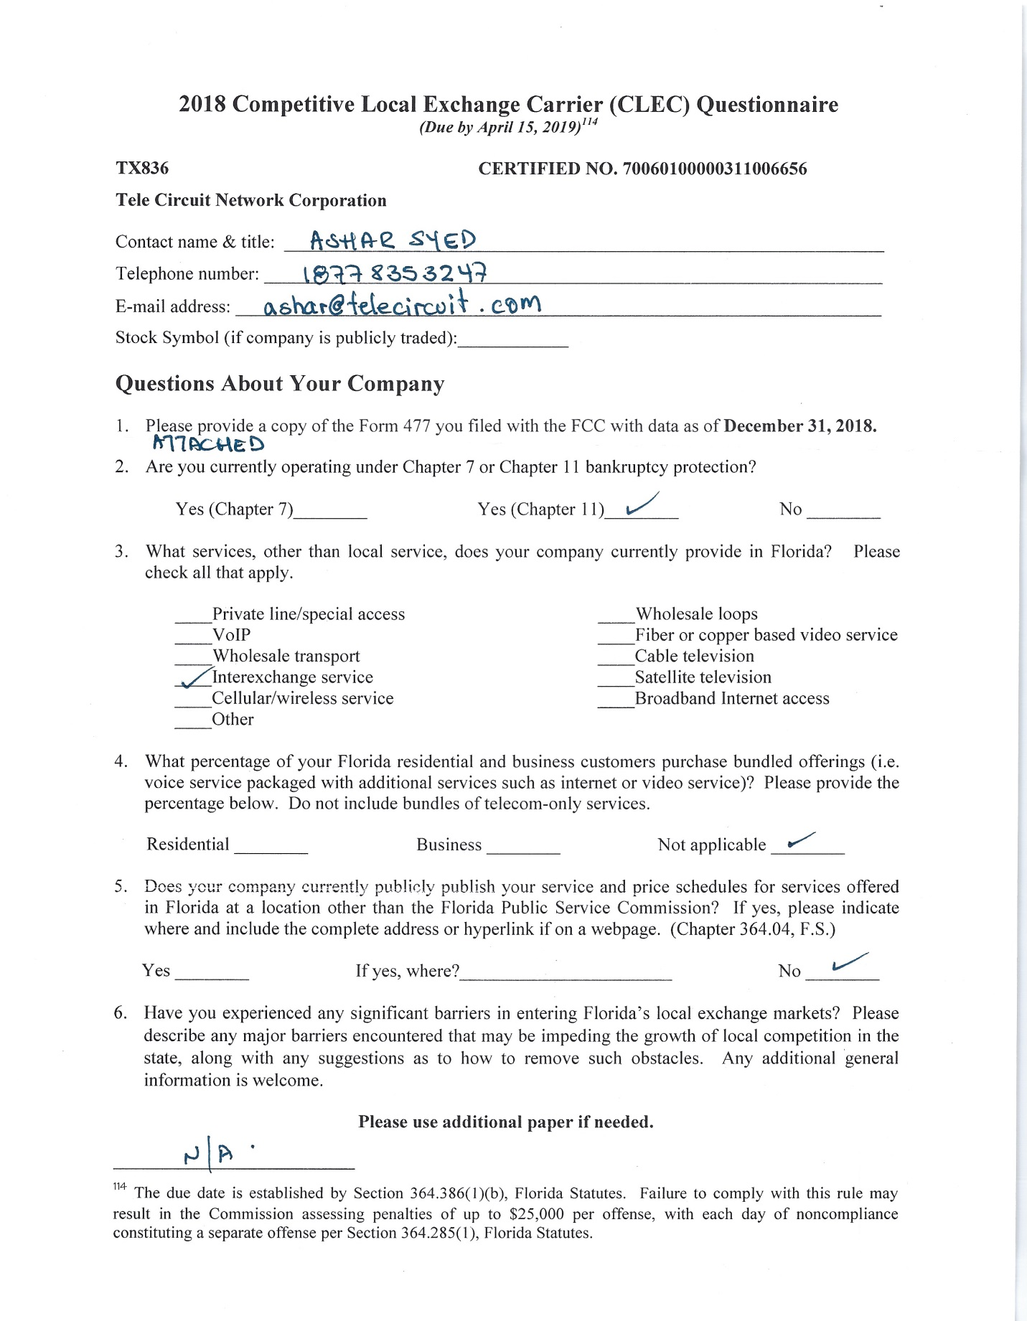
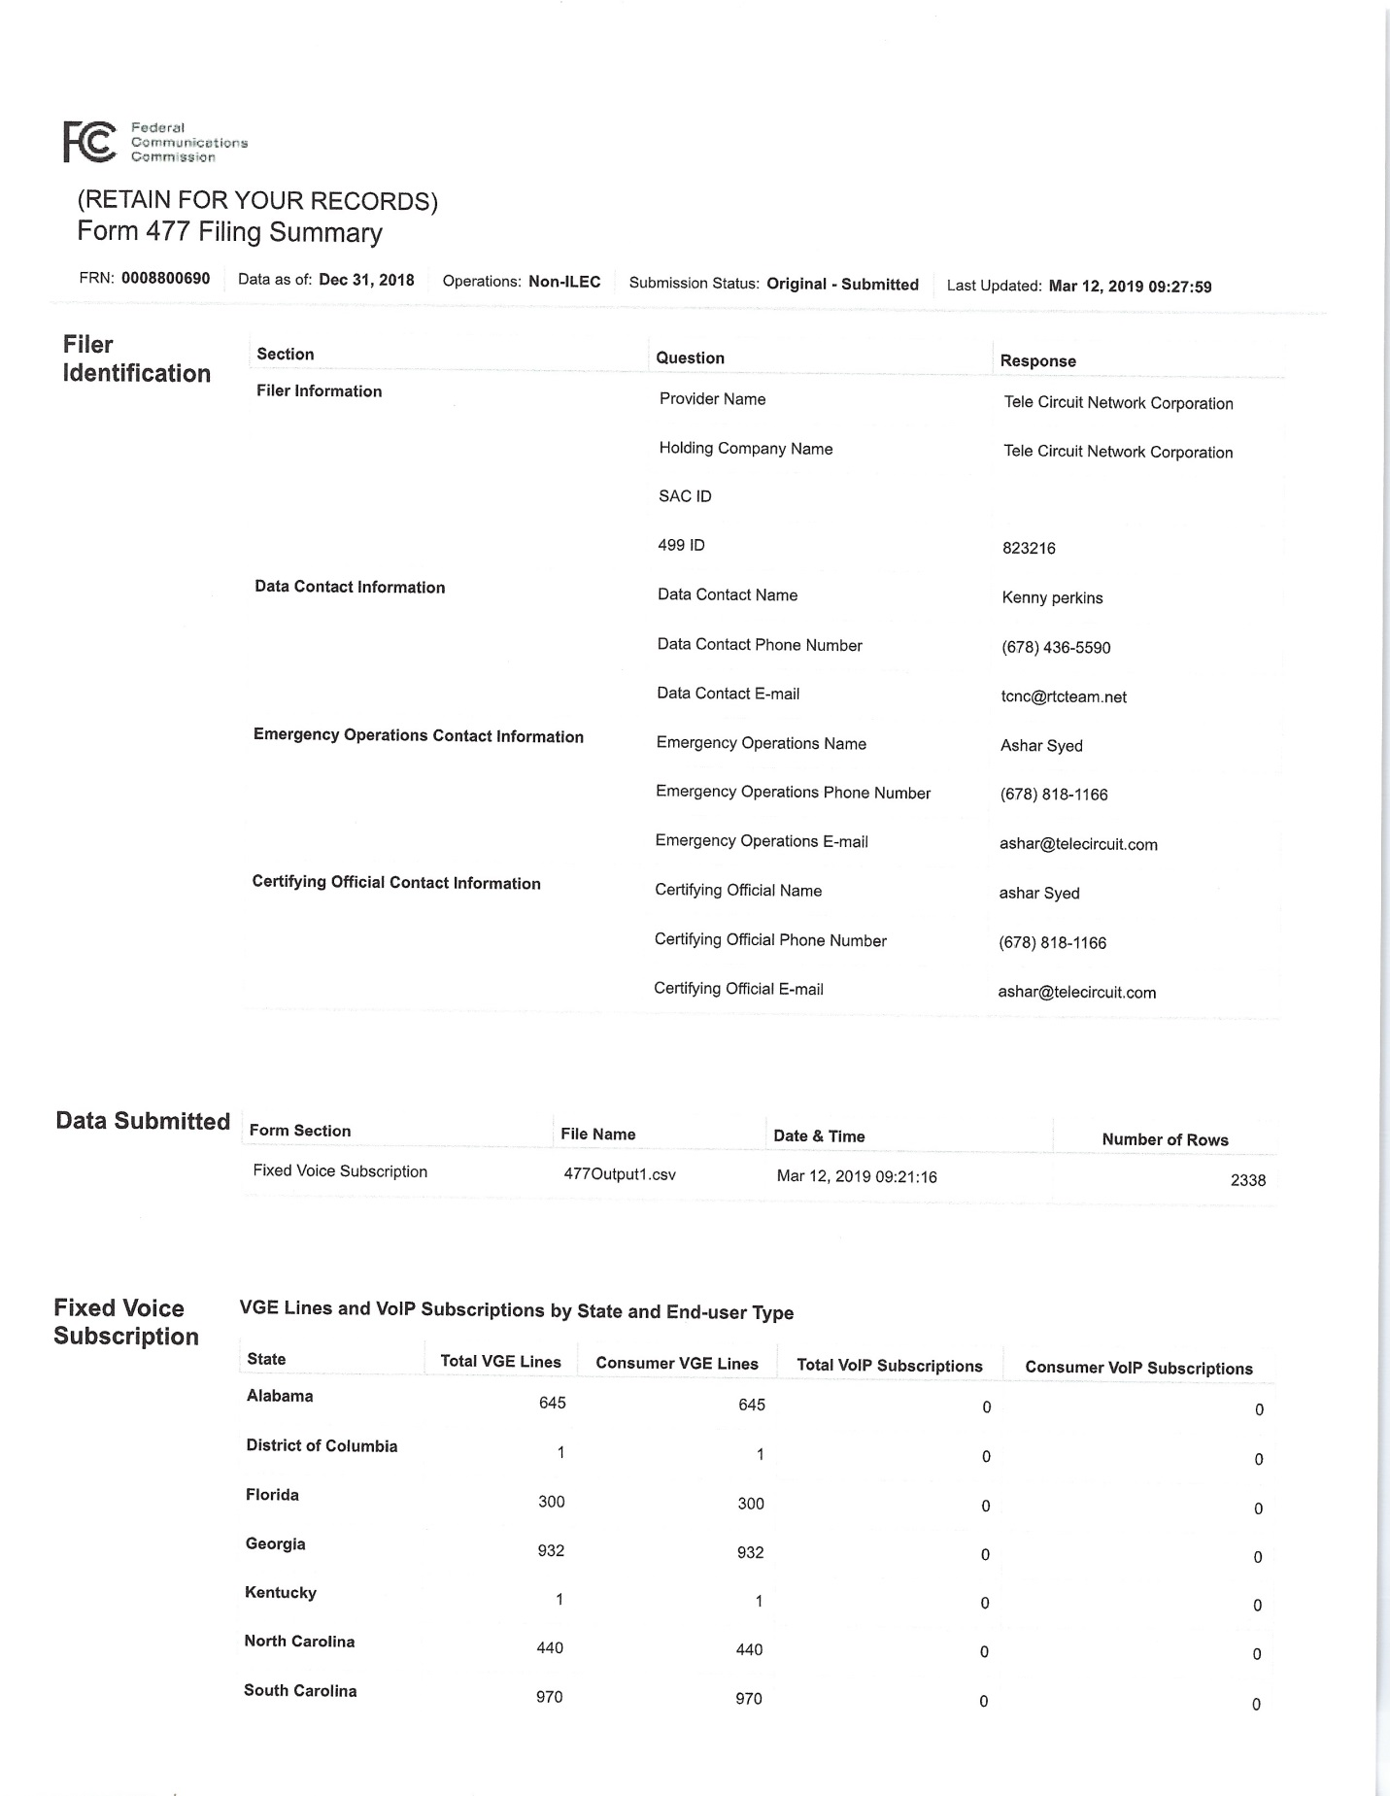
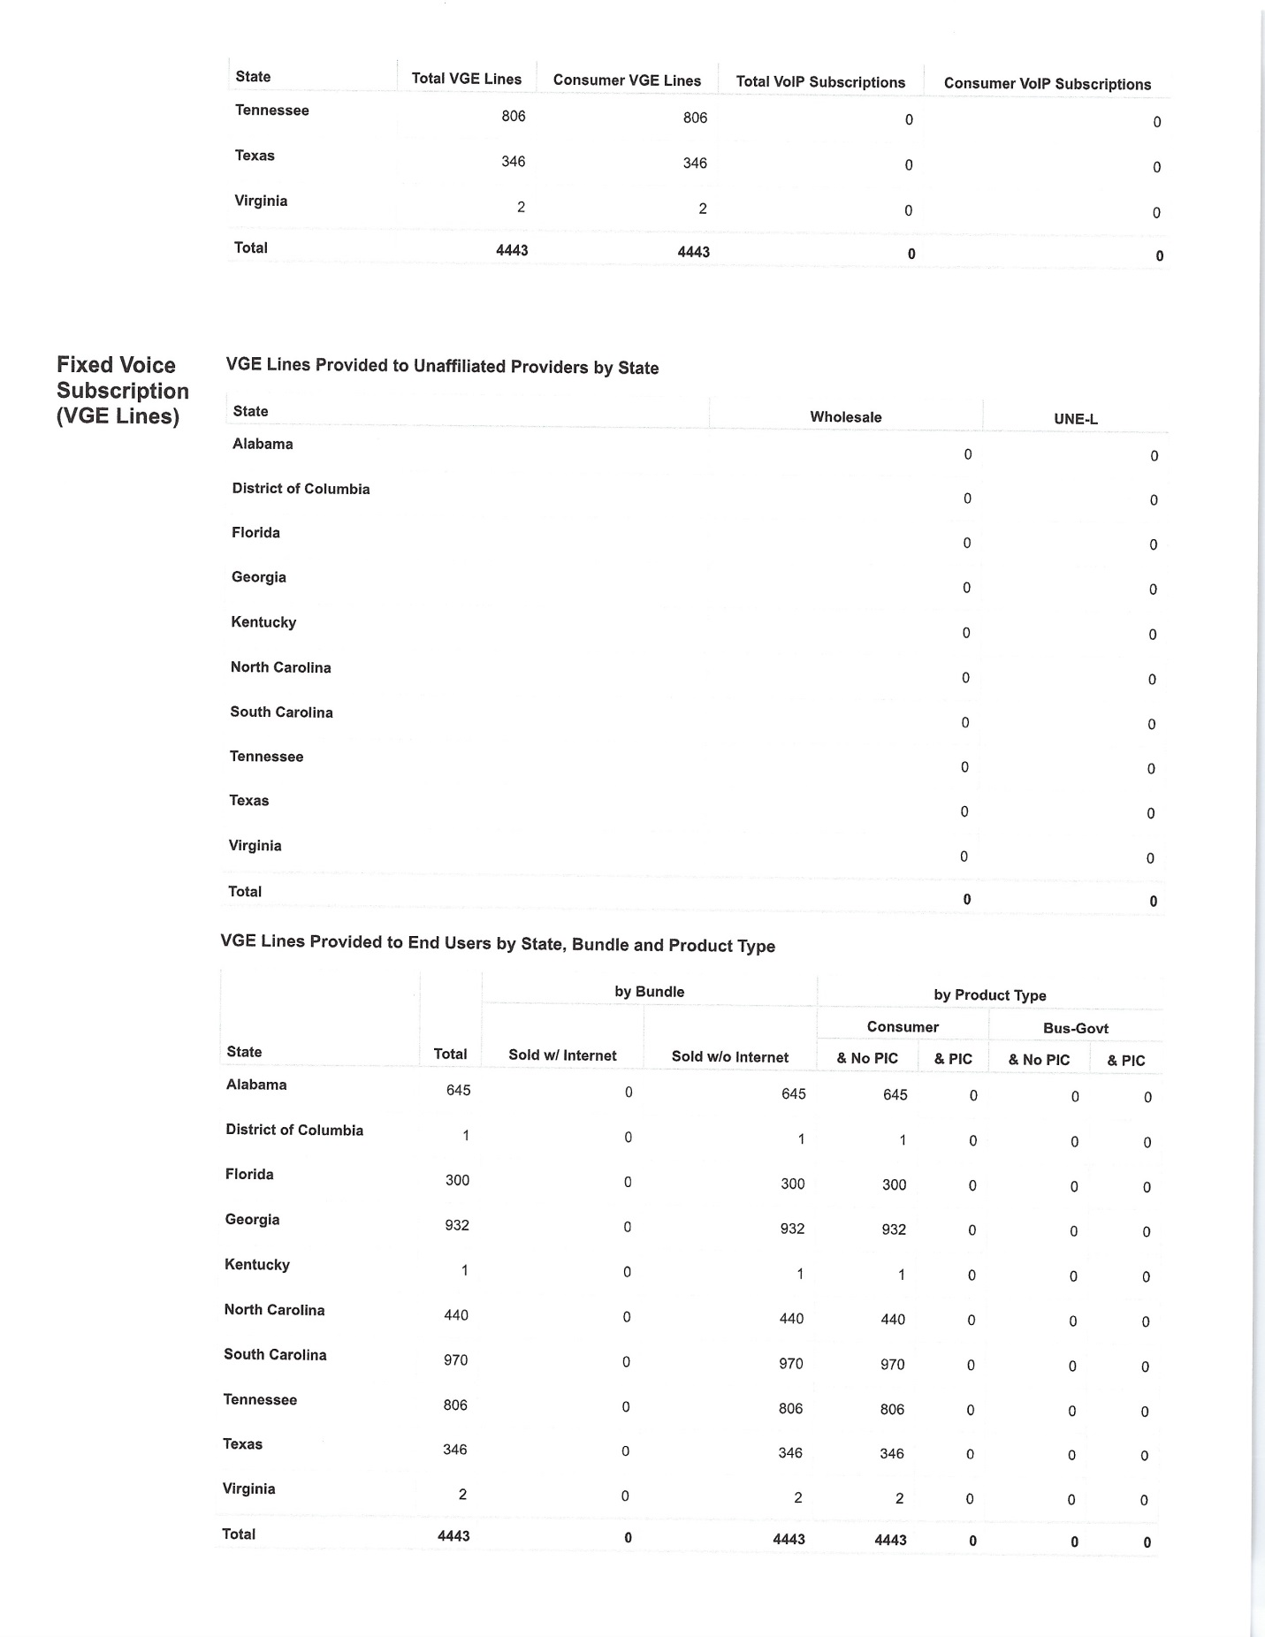
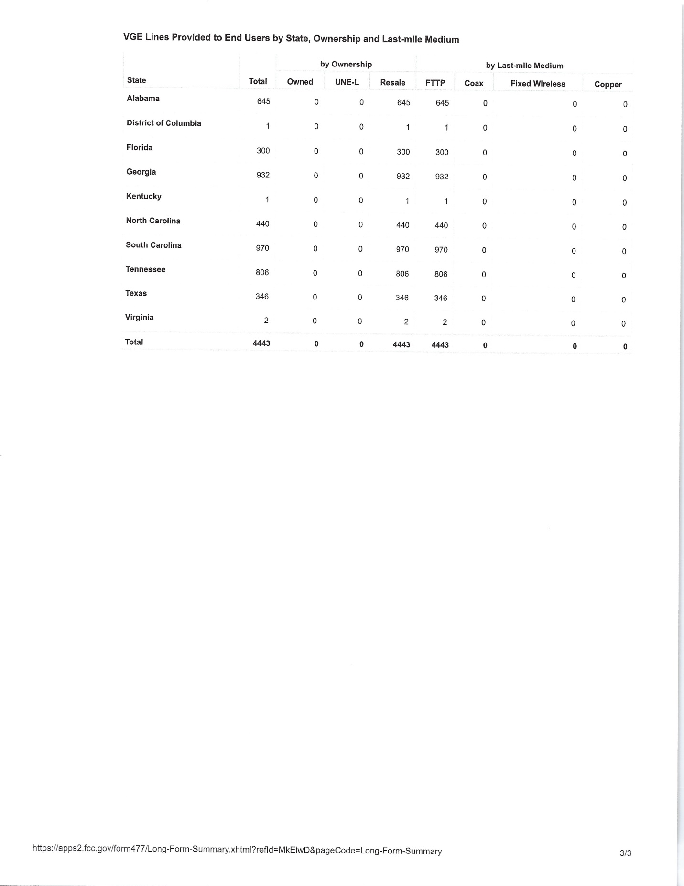
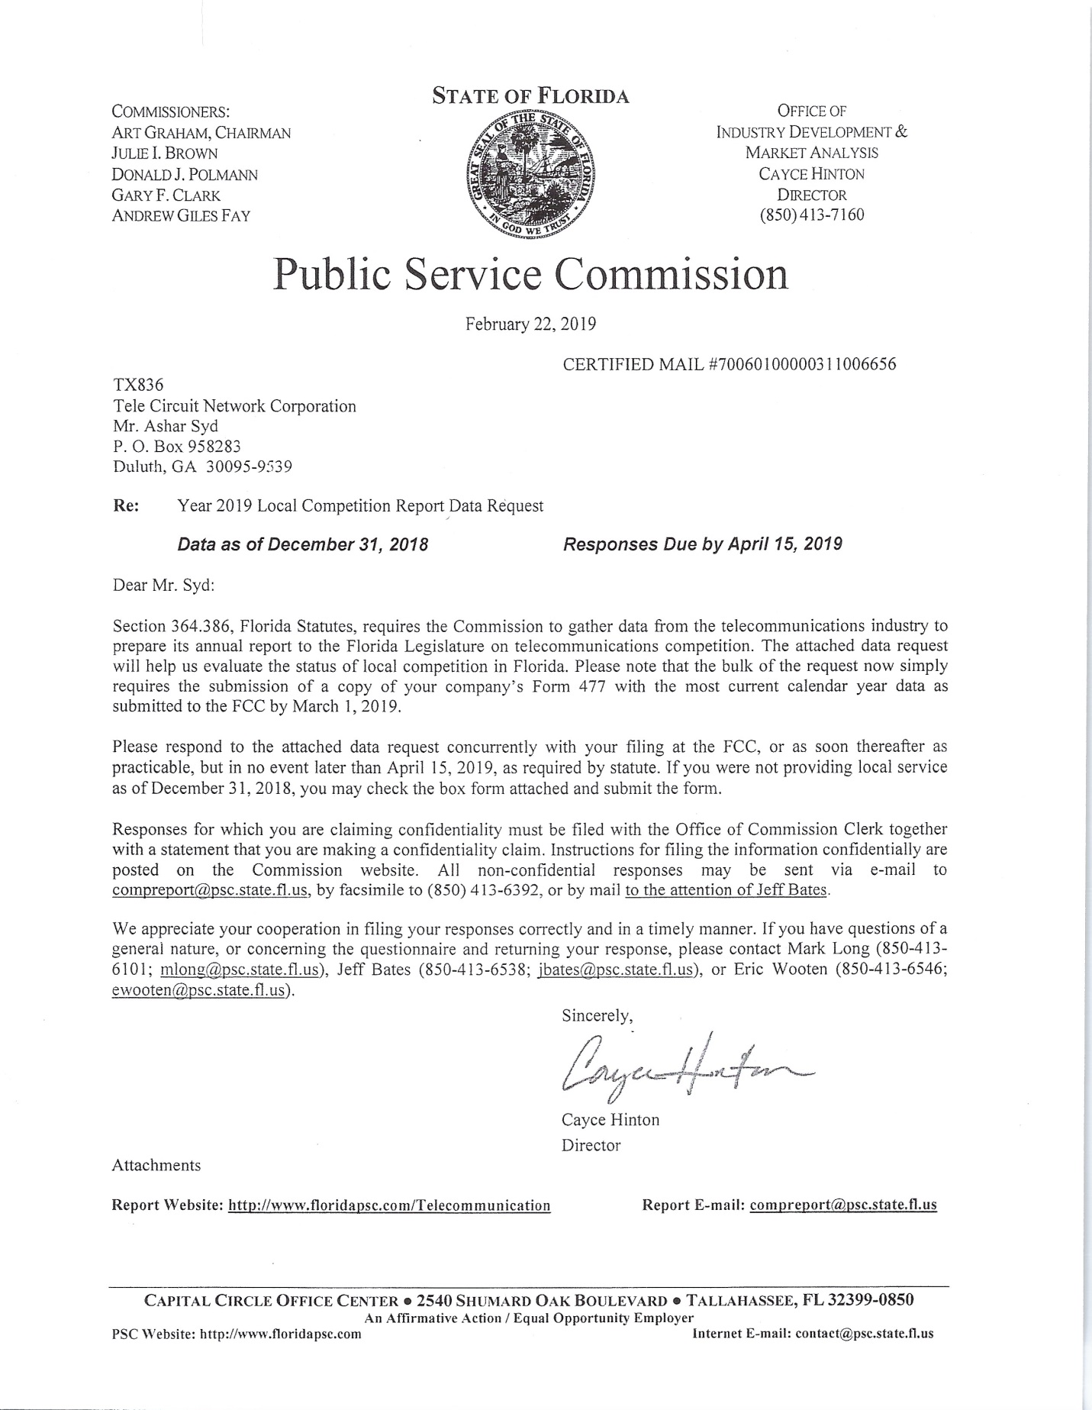
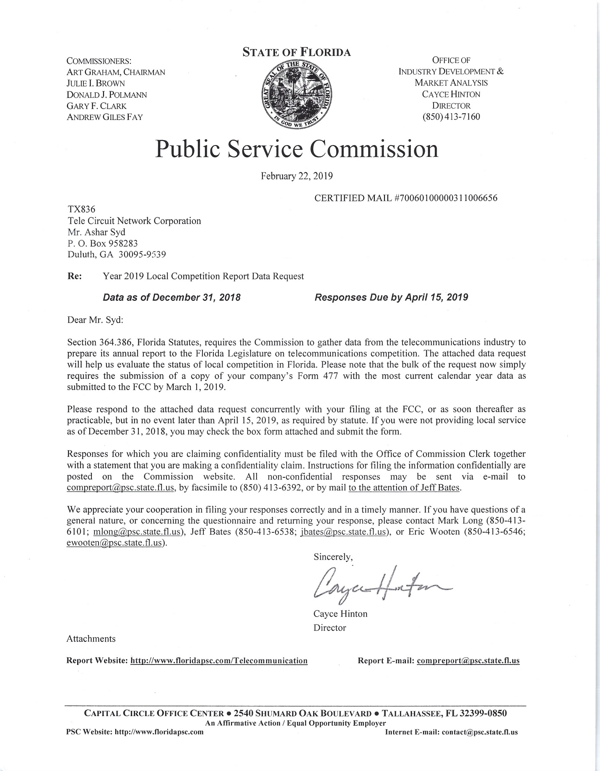

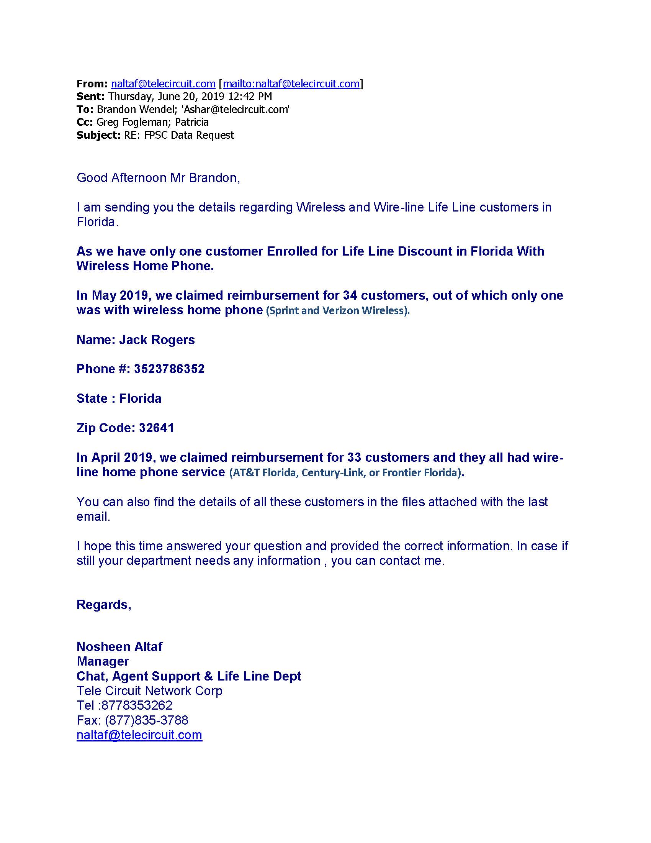

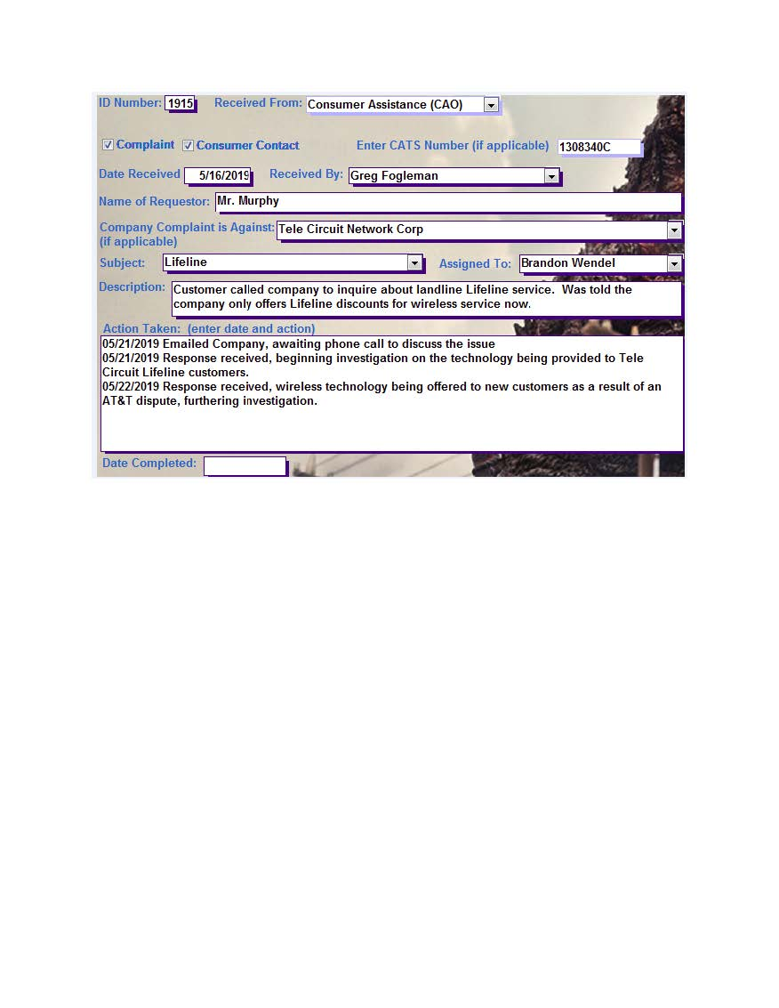

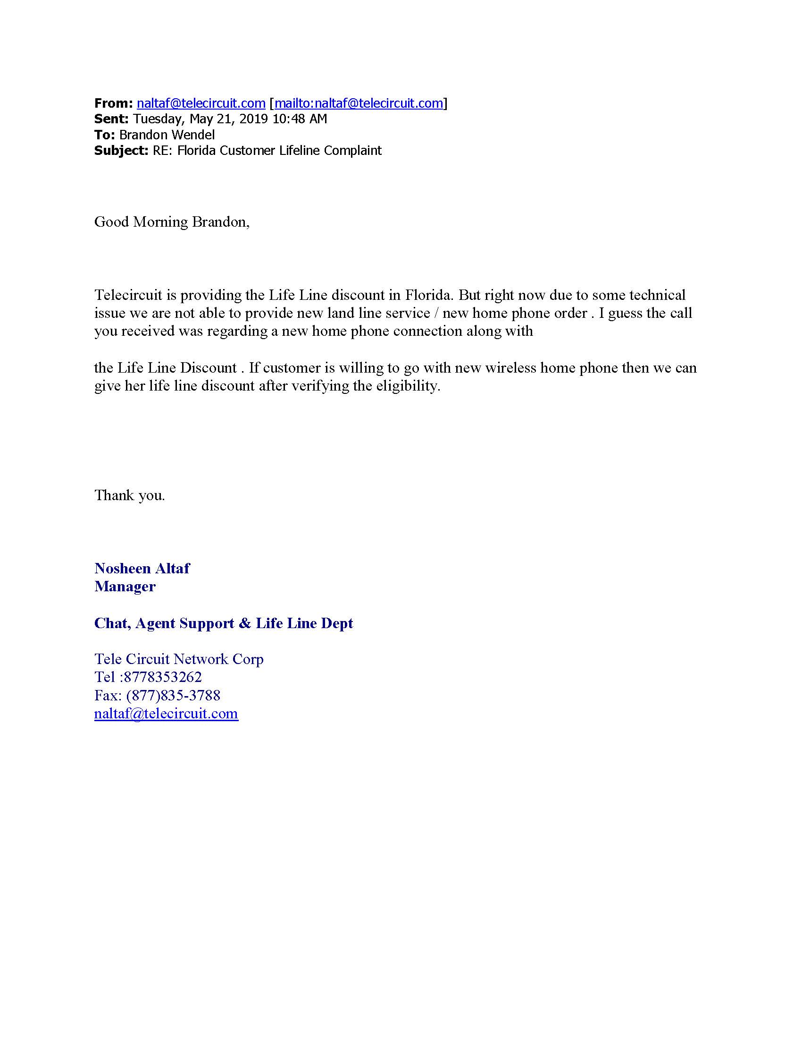

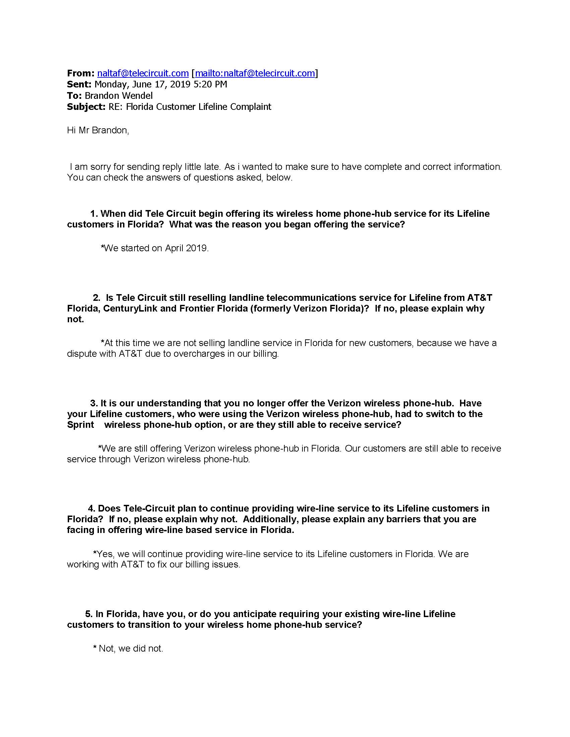
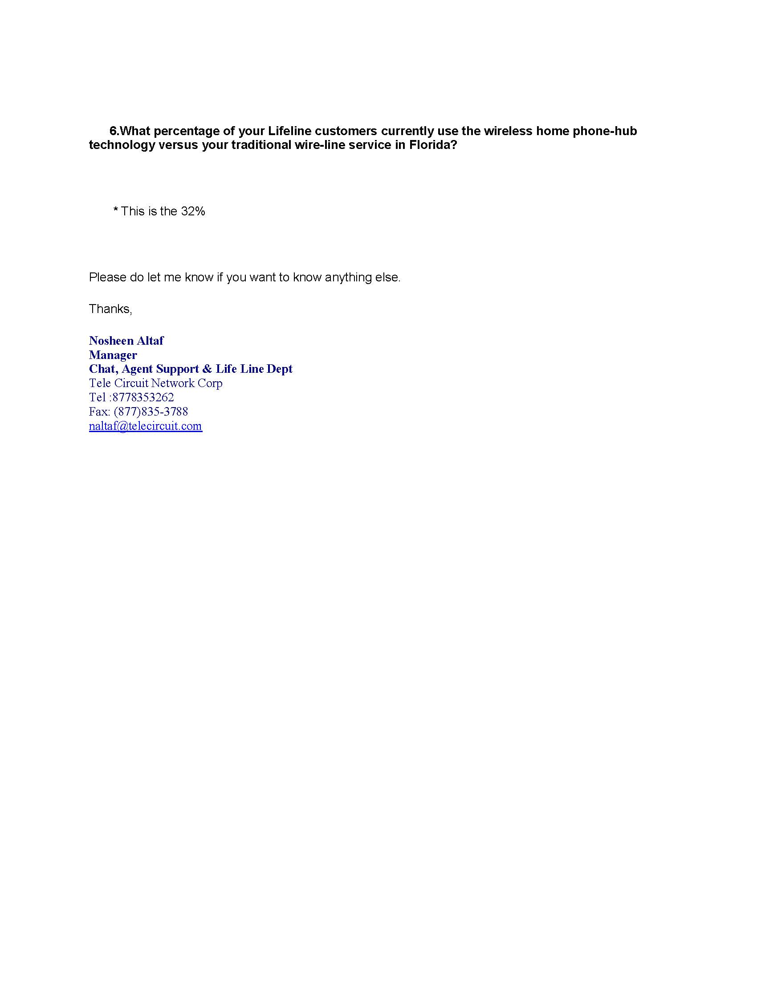

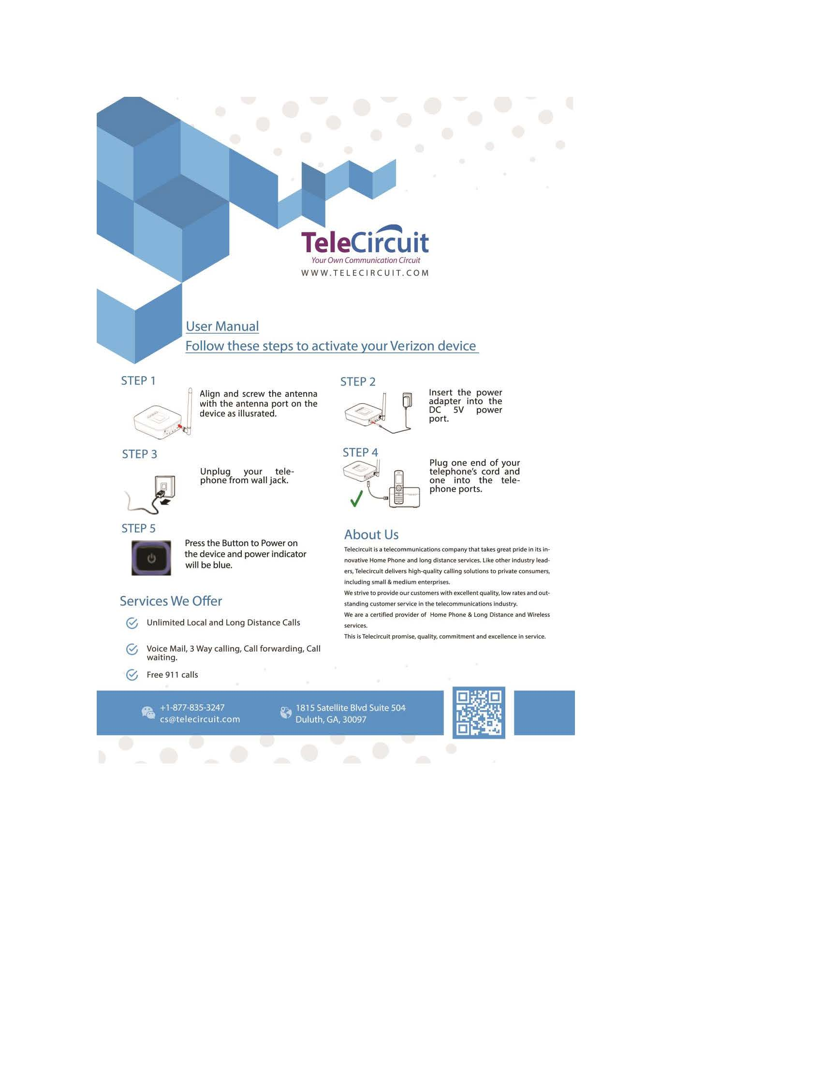

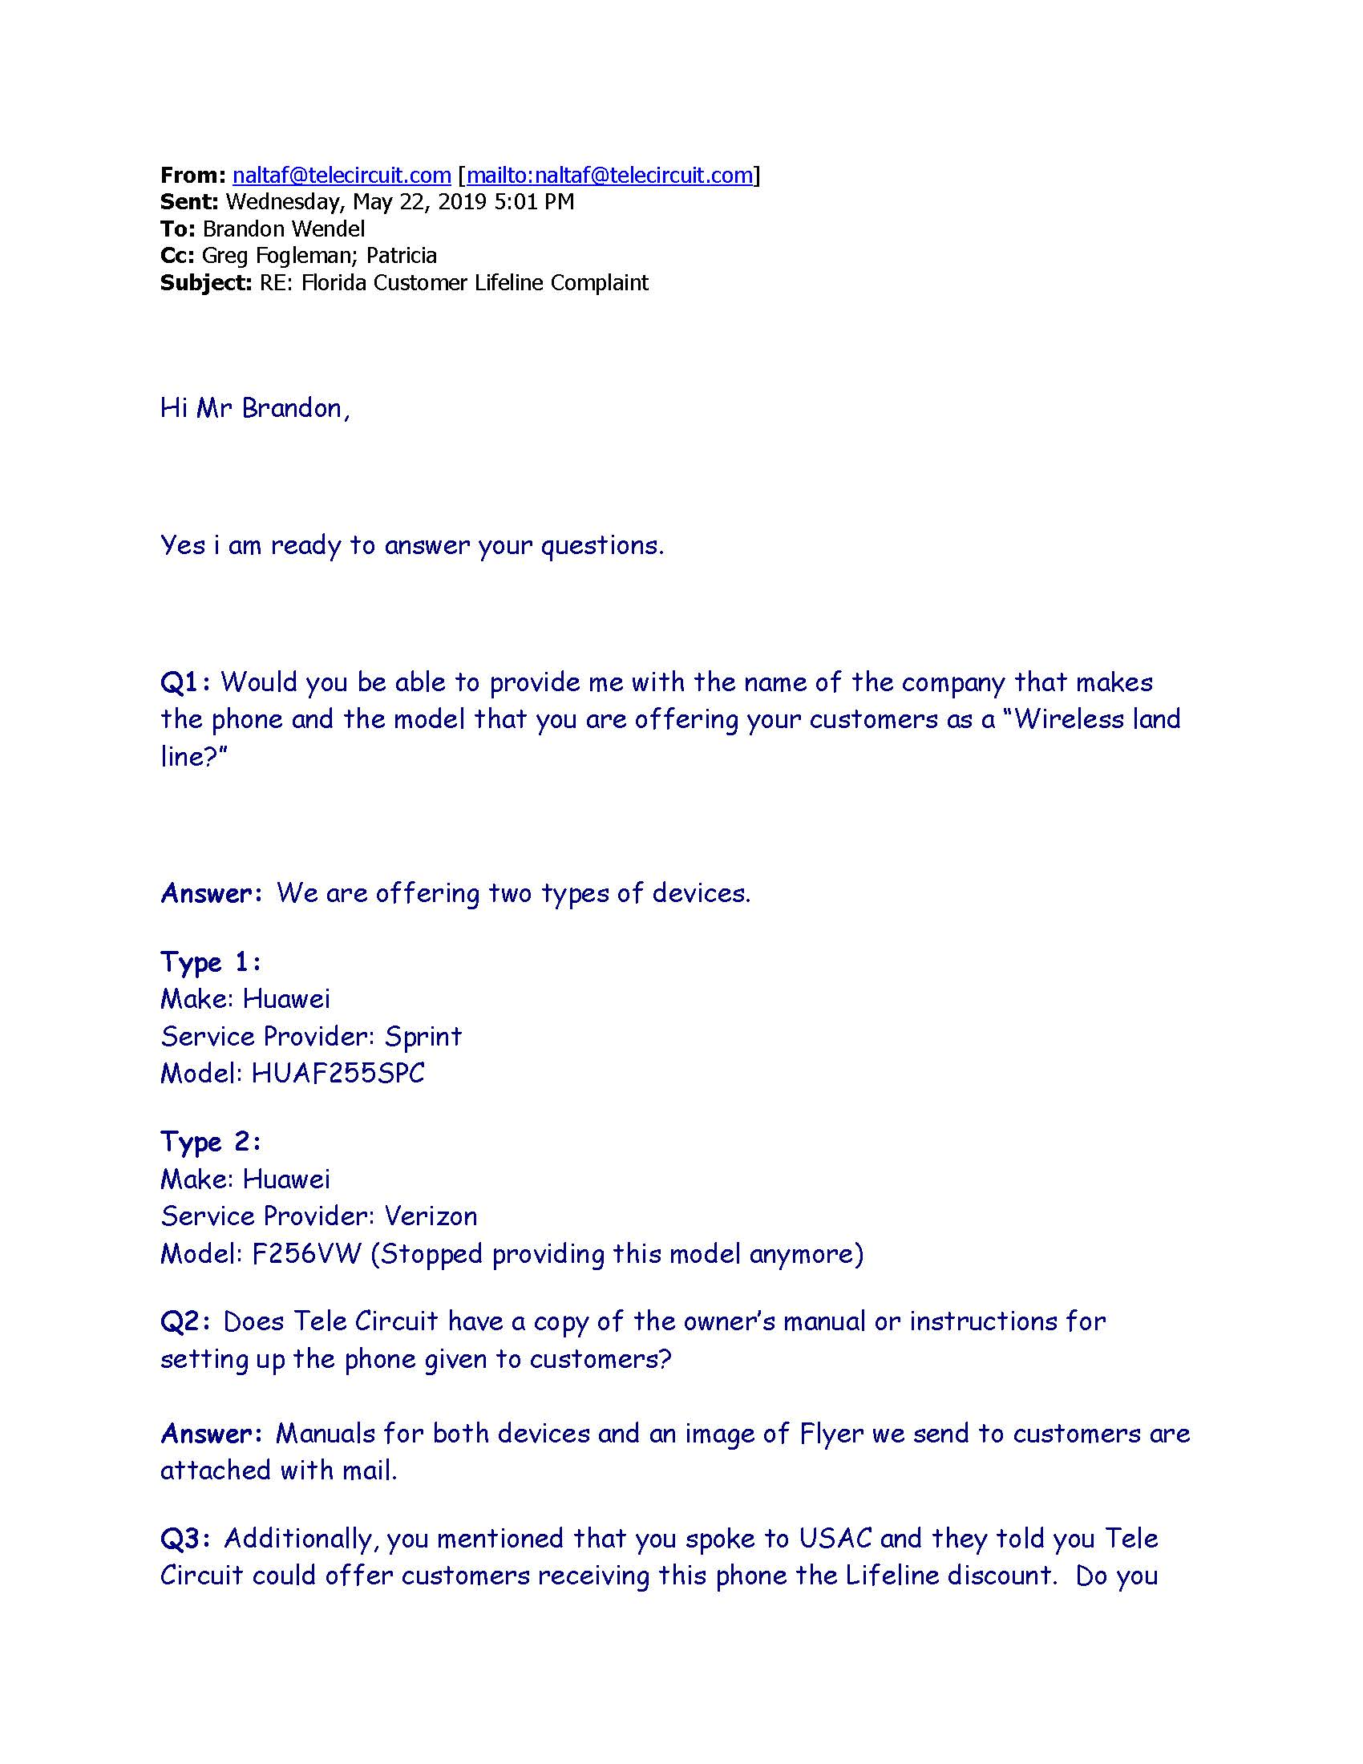
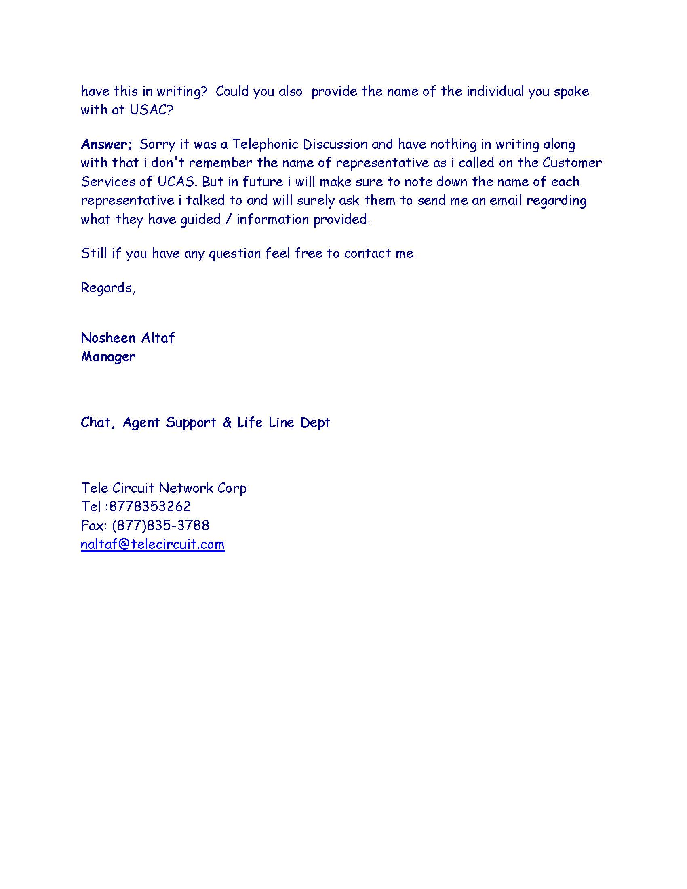

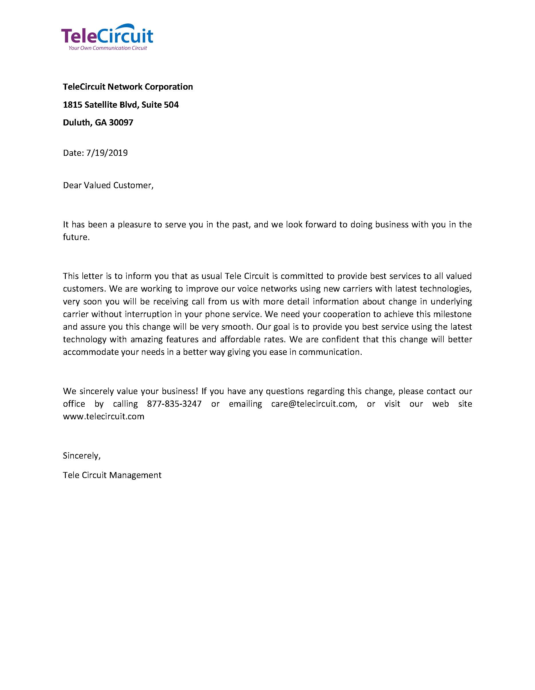

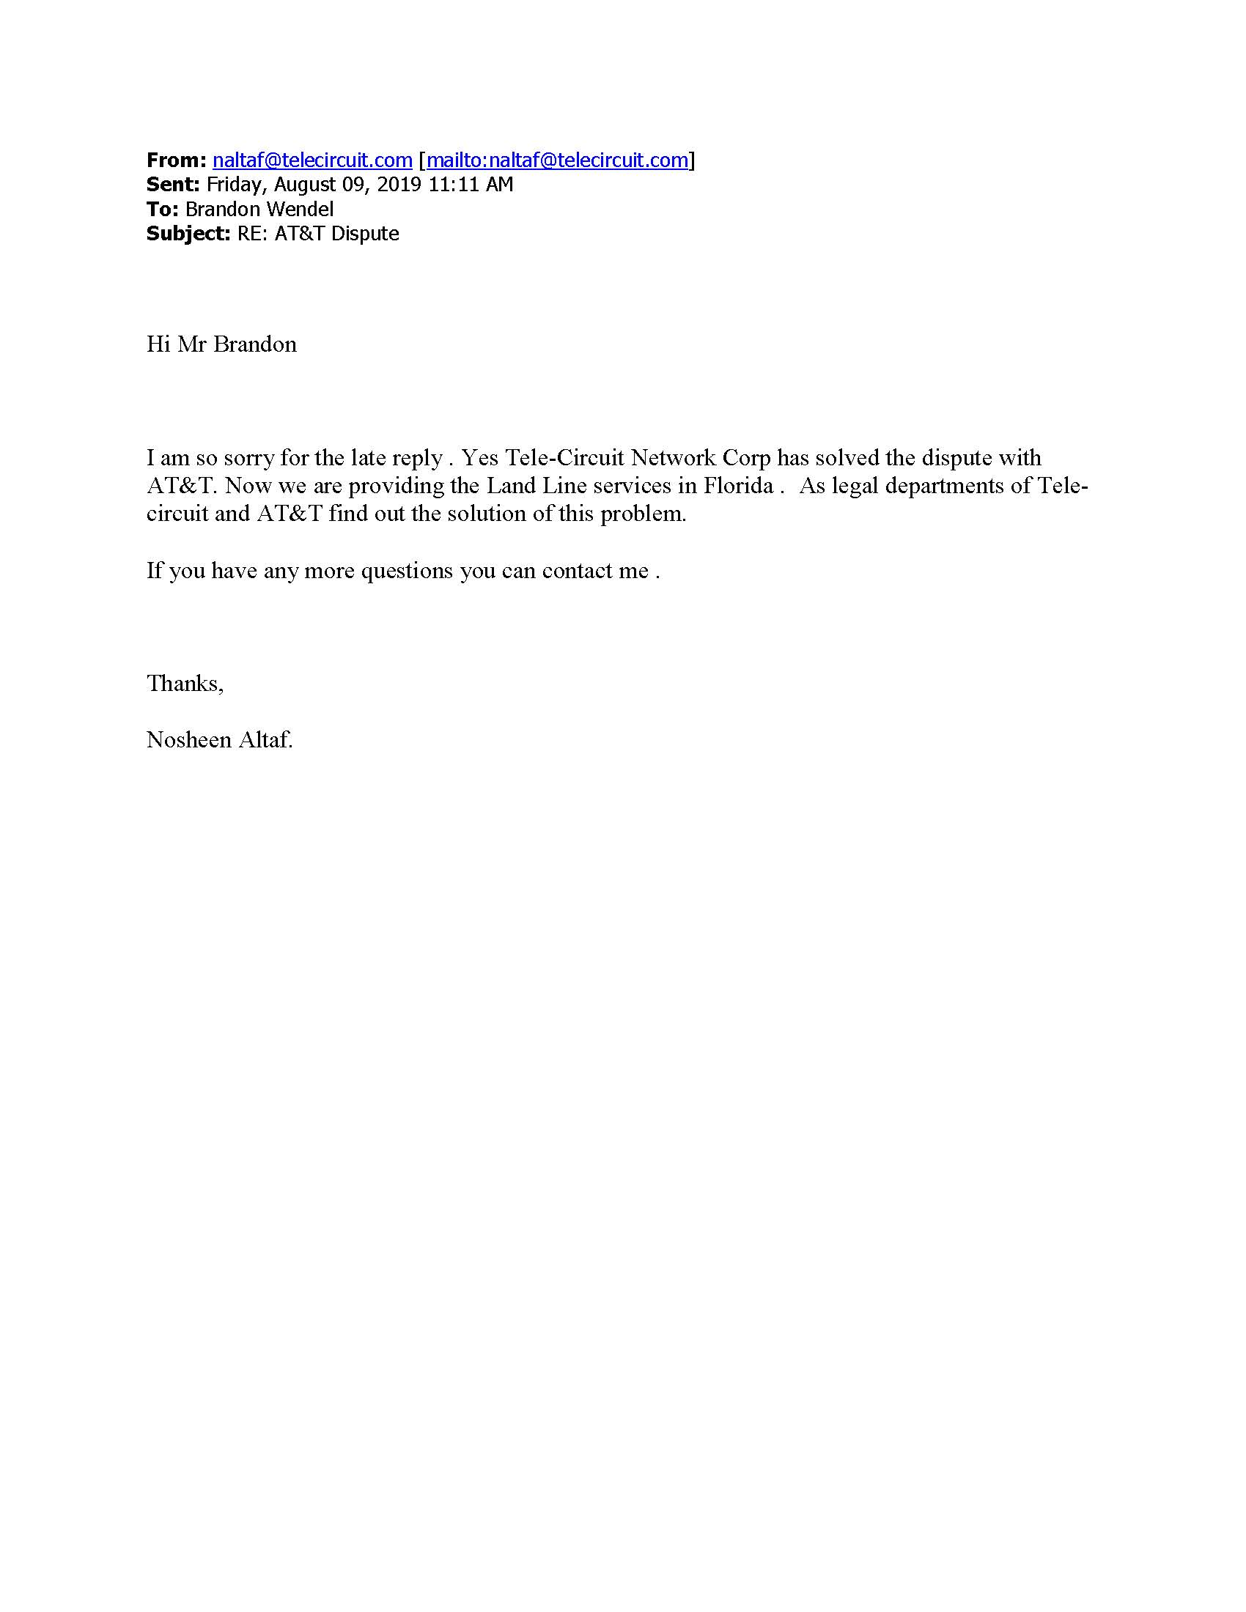

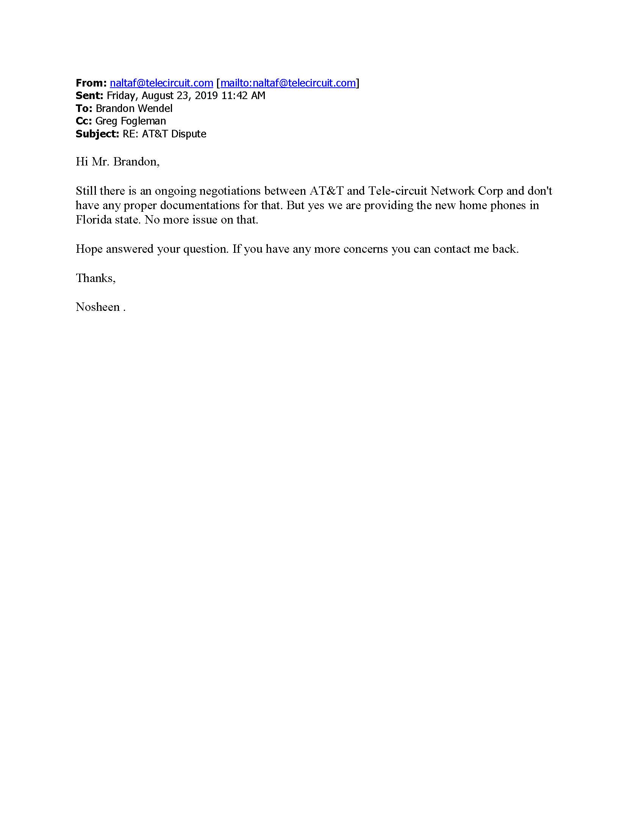

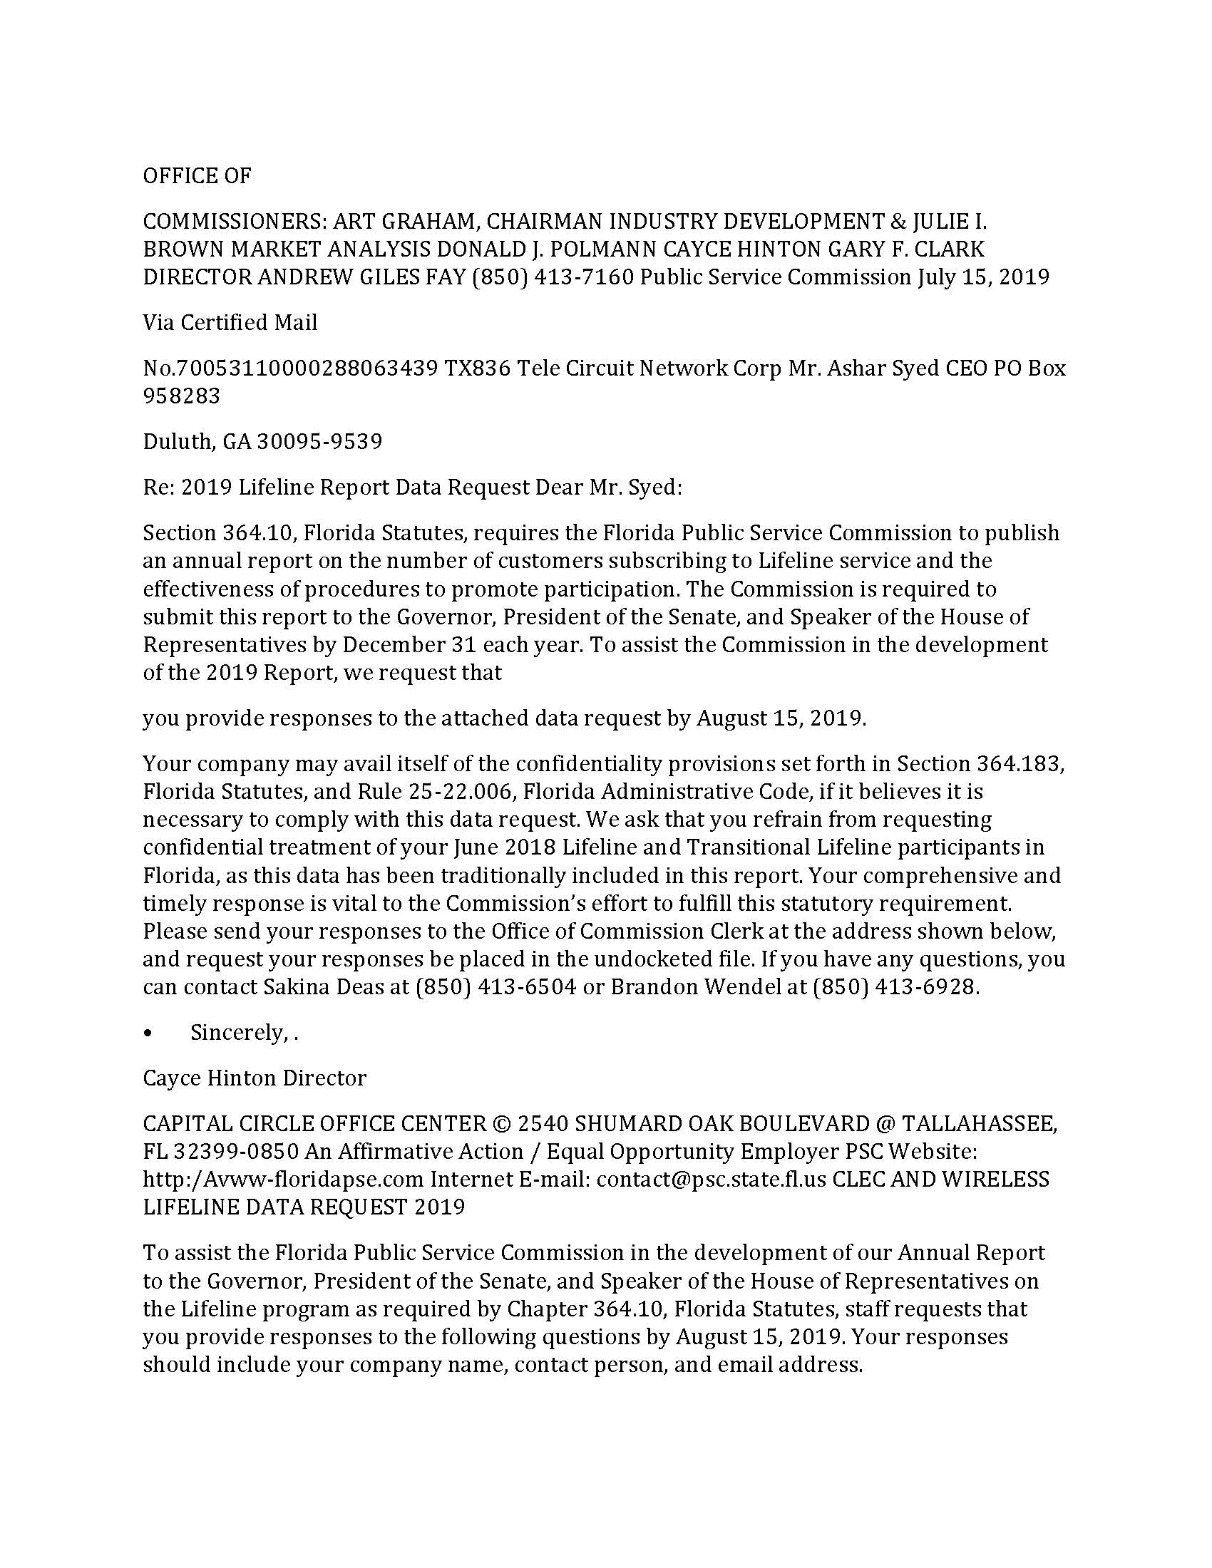
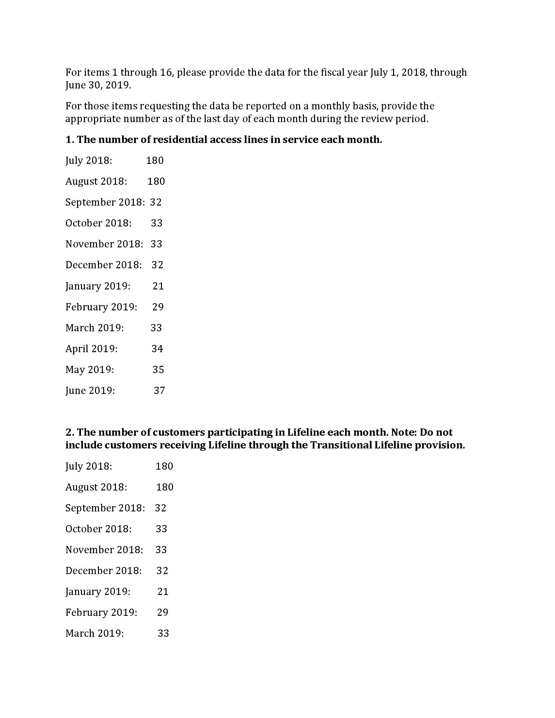
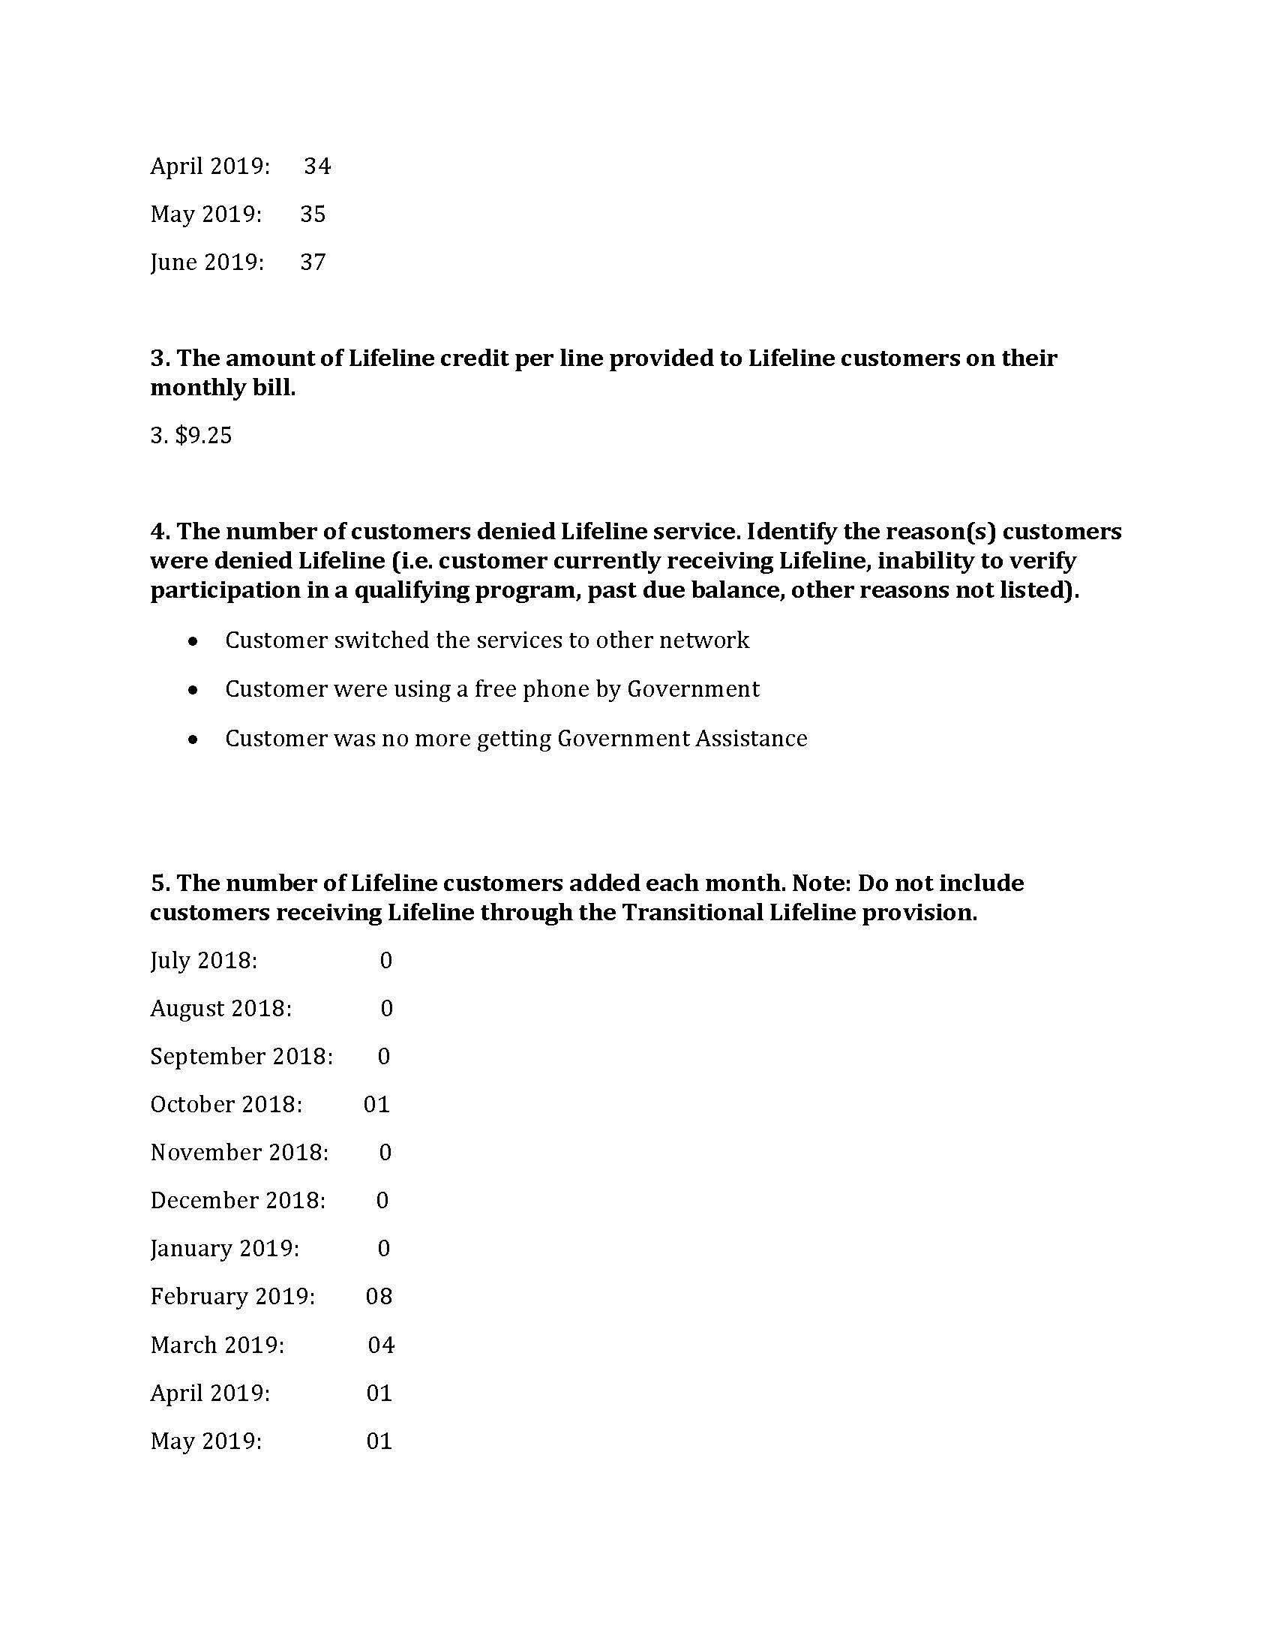
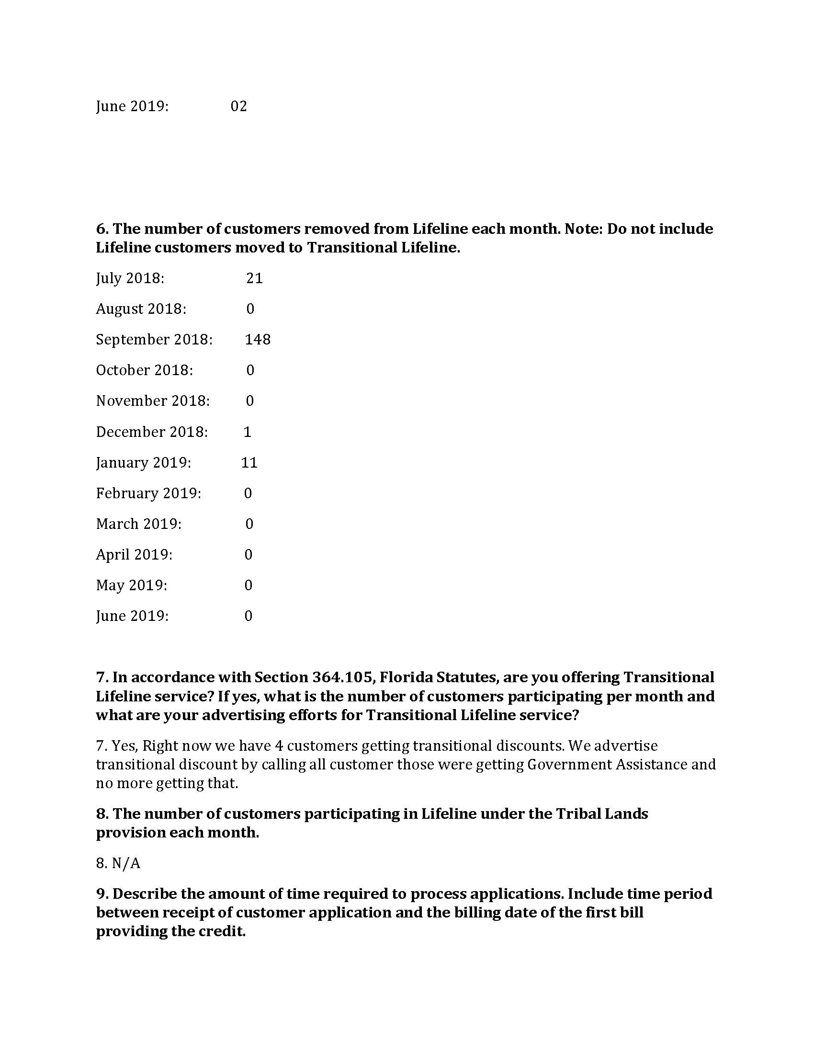
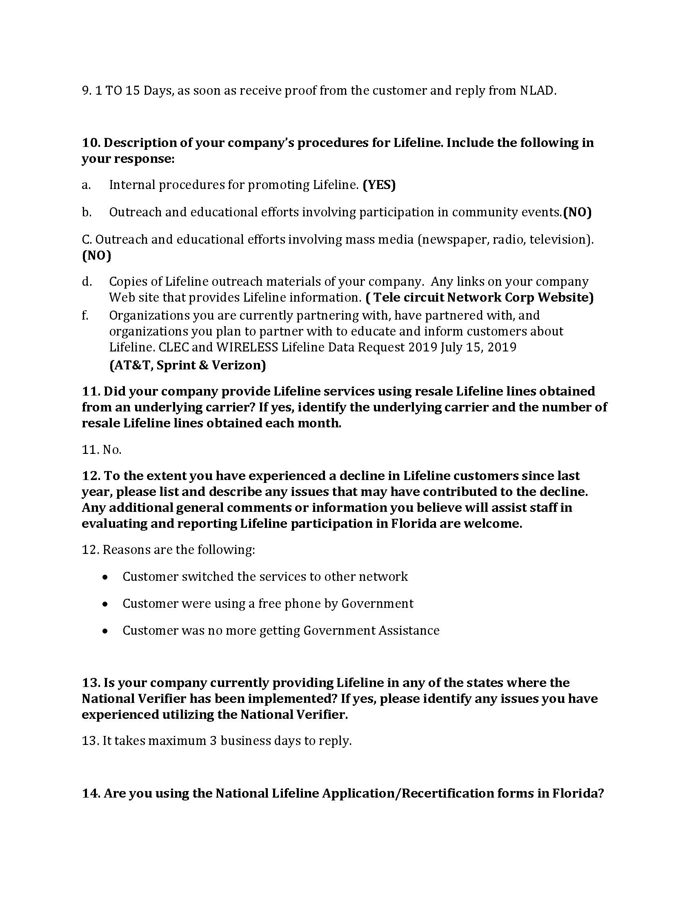
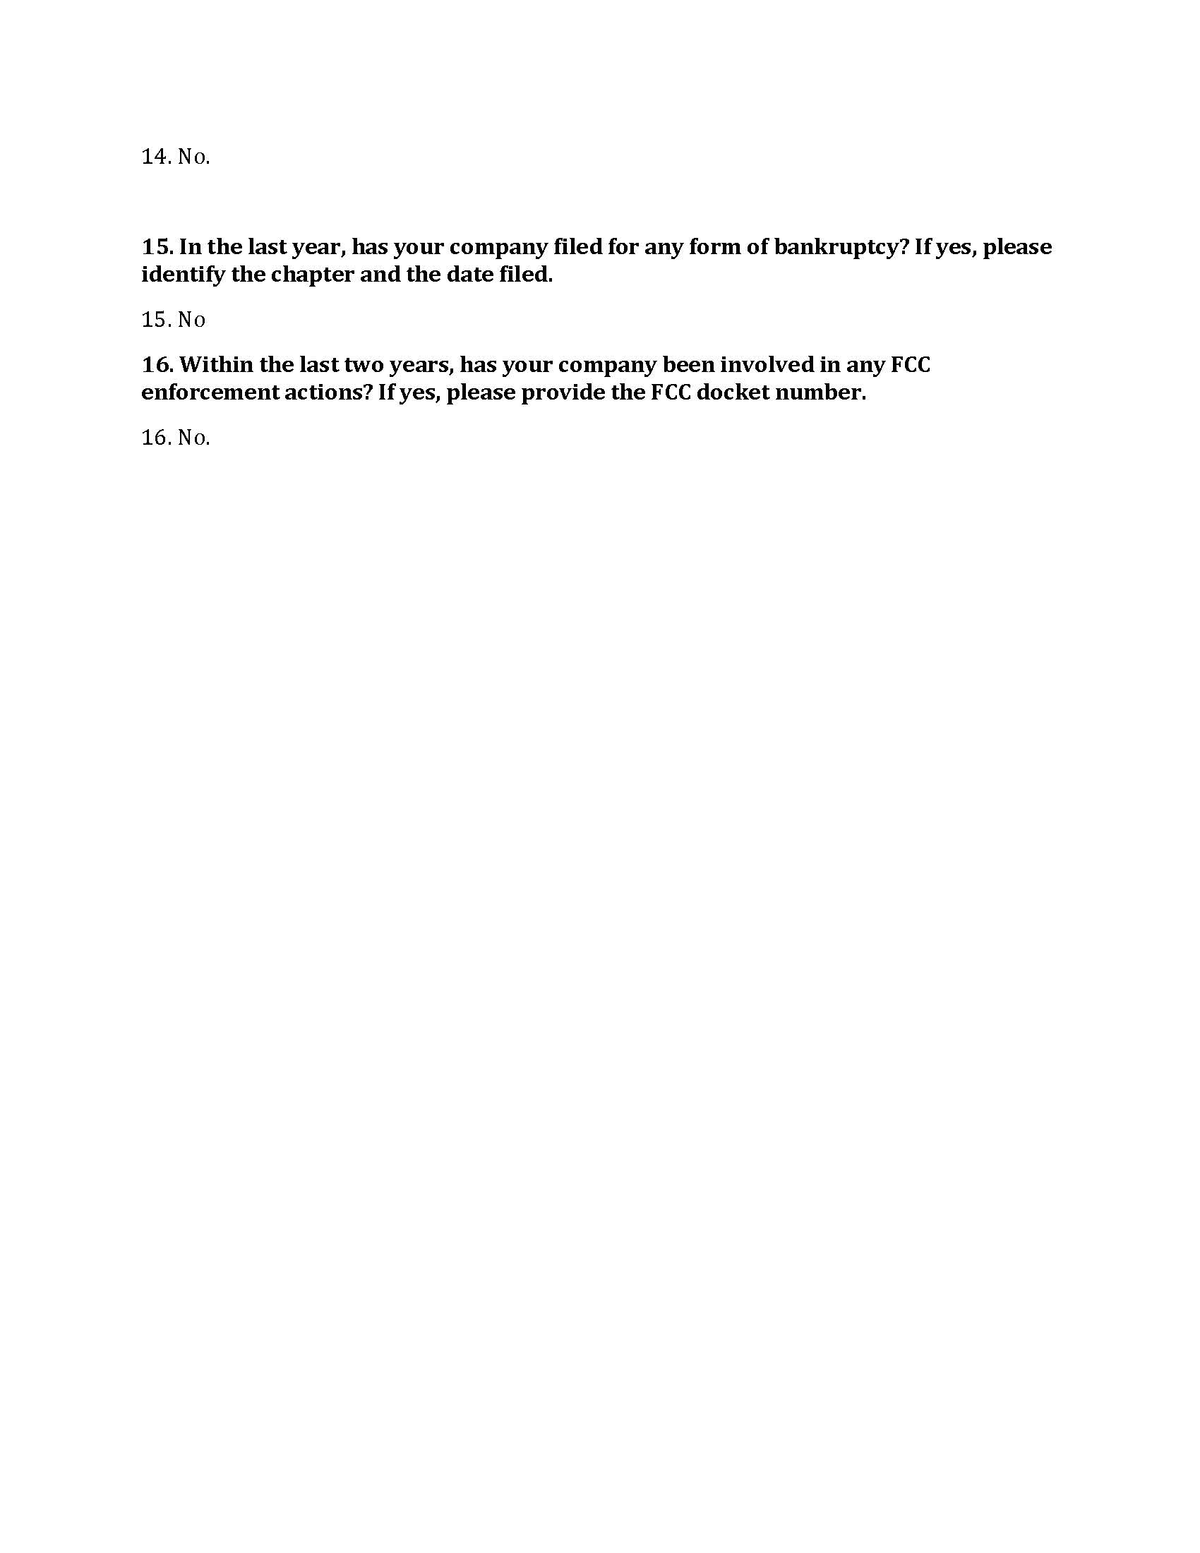

Order No. PSC-05-0361-PAA-TX, issued April 4, 2005, in Docket No. 20050126-TX, In re: Application for certificate to provide competitive local exchange telecommunications service by Tele Circuit Network Corporation.
Order No. PSC-11-0419-PAA-TX, issued September 28, 2011, in Docket No. 20080201-TX, In re: Application for designation as an eligible telecommunications carrier by Tele Circuit Network Corporation.
See Document No. 02631, Docket No. 20080201-TX, In re: Application for designation as an eligible telecommunications carrier by Tele Circuit Network Corporation, page 8.
See 04/15/2019 Tele Circuit CLEC Questionnaire Response (Attachment A) and 06/20/2019 Email from Tele Circuit to Commission staff (Attachment B).
See 05/16/2019 Consumer Activity Tracking System Entry (Attachment C).
See 05/21/2019 Email from Tele Circuit to Commission staff (Attachment D).
See Document No. 07498-2017, in Docket No. 20170196-TP, In re: Request for approval of interconnection, unbundling, resale, and collocation agreement between BellSouth Telecommunications, LLC d/b/a AT&T Florida d/b/a AT&T Southeast and Tele Circuit Corporation, Section 12.6.5, page 30 of 55.
See 6/17/2019 Email from Tele Circuit to Commission staff (Attachment E).
Id.
See Tele Circuit User Manual (Attachment F).
See Attachment B.
See 05/22/2019 Email from Tele Circuit to Commission staff (Attachment G).
See 07/19/2019 Letter from Tele Circuit (Attachment H).
See 08/09/2019 Email from Tele Circuit to Commission staff (Attachment I).
See 08/23/2019 Email from Tele Circuit to Commission staff (Attachment J).
See Attachment A.
See Tele Circuit Lifeline Assistance Report Data Request Response (Attachment K), Question 15.
Id. at Question 16.
See FCC WC Docket No. 18-54, https://docs.fcc.gov/public/attachments/FCC-18-54A1.pdf, page 1.
Id.
Id. at 4.
Id.
Id.
Tele Circuit submitted an application to the FCC for wireless ETC status on July 6, 2012; however, the application is still pending. If approved, Tele Circuit would be permitted to provide wireless Lifeline service (including in Florida), and again receive support from the USF.
Section 364.011(4), F.S.
FCC Docket Nos. 05-46 and 96-45, https://docs.fcc.gov/public/attachments/FCC-05-46A1.pdf, page 34.
Id. at 33.
Fugate v. Fla. Elections Comm’n, 924 So. 2d 74, 75 (Fla. 1st DCA 2006), citing, Metro. Dade County v. State Dep't of Envtl. Prot., 714 So. 2d 512, 517 (Fla. 3d DCA 1998).
Id. at 76.
Barlow v. United States, 32 U.S. 404, 411 (1833).
See Order No. PSC-15-0391-SC-TX, issued on November 10, 2015, in Docket No. 20150158-TX, In re: Initiation of show cause proceedings against Sun-Tel USA, Inc. for apparent violation of Section 364.335(2), F.S., (Application for Certificate of Authority), Section 364.183(1), F.S., (Access to Company Records), Rule 25-4.0665(20), F.A.C., (Lifeline Service), and Rule 25-4.0051, F.A.C., (Current Certificate Holder Information).
See ETC Order, page 7.
There are up to 5 wireless ETCs and 2 wireline ETCs that could provide the Lifeline discount to Tele Circuit’s current customers, depending on the geographic location of the customer.
See CLEC Order, page 1.
Fugate v. Fla. Elections Comm’n, 924 So. 2d 74, 75 (Fla. 1st DCA 2006), citing, Metro. Dade County v. State Dep't of Envtl. Prot., 714 So. 2d 512, 517 (Fla. 3d DCA 1998).
Id. at 76.
Barlow v. United States, 32 U.S. 404, 411 (1833).
See Order No. PSC-15-0391-SC-TX, issued on November 10, 2015, in Docket No. 20150158-TX, In re: Initiation of show cause proceedings against Sun-Tel USA, Inc. for apparent violation of Section 364.335(2), F.S., (Application for Certificate of Authority), Section 364.183(1), F.S., (Access to Company Records), Rule 25-4.0665(20), F.A.C., (Lifeline Service), and Rule 25-4.0051, F.A.C., (Current Certificate Holder Information).
See Attachments A, B, D, E, G, I-K.
See Attachment B.
See BBB, Complaints, Tele Circuit Network, https://www.bbb.org/us/ga/duluth/profile/telephone-system-dealers/telecircuit-network-0443-17001143.
See FCC WC Docket No. 18-54, https://docs.fcc.gov/public/attachments/FCC-18-54A1.pdf, page 1.
Pursuant to Chapter 11 U.S. Code §362(a), the filing of a petition for Chapter 11 bankruptcy relief acts as an automatic stay that enjoins a governmental entity from exercising its regulatory authority to collect a pre-petition debt. However, staff notes that Tele Circuit filed for Chapter 11 bankruptcy on June 28, 2018, and is current on its payment of Regulatory Assessment Fees to date. Therefore, any new Regulatory Assessment Fees incurred would be classified as post-petition debt, and thus collectible by the Commission.

