State of Florida |  | Public Service Commission  Capital Circle Office Center ● 2540 Shumard Oak Boulevard  Tallahassee, Florida 32399-0850  -M-E-M-O-R-A-N-D-U-M-
DATE: | November 26, 2019
TO: | Office of Commission Clerk (Teitzman)
FROM: | Division of Engineering (Lewis, Graves, Johnson, Knoblauch)  Division of Accounting and Finance (Norris, Sewards, Thurmond)  Division of Economics (Bethea, Hudson)  Office of the General Counsel (Schrader)
RE: | Docket No. 20190166-WS – Application for increase in water rates in Highlands County by HC Waterworks, Inc.
AGENDA: | 12/10/19 – Regular Agenda – Decision on Suspension of Rates and Interim Rates – Participation is at the Discretion of the Commission
COMMISSIONERS ASSIGNED: |  |  | All Commissioners
PREHEARING OFFICER: |  |  | Fay
CRITICAL DATES: |  |  | 12/16/19 (60-Day Suspension Date)
SPECIAL INSTRUCTIONS: |  |  | None

Case Background
HC Waterworks, Inc. (Utility or HC) is a Class B Utility serving approximately 954 water customers in three subdivisions known as Leisure Lakes, Lake Josephine, and Sebring Lakes. The Utility’s last rate case was in 2014. According to the Utility’s 2018 Annual Report, HC reported net operating revenues of $641,745 and net operating expenses of $420,732. On October 15, 2019, HC filed its application for the rate increase at issue in the instant docket.

On November 12, 2019, staff sent the Utility a letter indicating deficiencies in the filing of its minimum filing requirements (MFRs). As of the date of this recommendation, there are deficiencies in the MFRs. The Utility requested that the application be processed using the Proposed Agency Action (PAA) procedure and requested interim rates. The test year established for interim and final rates is based on a 13-month average for the period ended June 30, 2019. HC requested an interim revenue increase of $137,384 (24.11 percent). The Utility requested a final revenue increase of $175,171 (30.75 percent).

The 60-day statutory deadline for the Commission to suspend the Utility’s requested final rates and approve interim rates is December 16, 2019. This recommendation addresses the suspension of the Utility’s requested final rates and its requested interim rates. The Commission has jurisdiction pursuant to Sections 367.081 and 367.082, Florida Statutes (F.S.).

Discussion of Issues

Issue 1:
Should the Utility’s proposed final water rates be suspended?

Recommendation:
Yes. HC’s proposed final water rates should be suspended. (Lewis, Johnson, Knoblauch, Bethea)

Staff Analysis:
Section 367.081(6), F.S., provides that the Commission may, for good cause, withhold consent to the implementation of requested rates within 60 days after the date the rate request is filed. Further, Section 367.081(10), F.S., permits the proposed rates to go into effect (secured and subject to refund) at the expiration of five months from the official date of filing if: (1) the Commission has not acted upon the requested rate increase; or (2) the Commission’s action is protested by a party other than the Utility.
Staff reviewed the filing and considered the information filed in support of the rate application and the proposed final rates. Staff believes that further investigation of this information, including on-site reviews, is needed. Staff initiated an audit of HC’s books and records. The audit is tentatively due on January 20, 2020. In addition, staff sent its first data request to the Utility on November 21, 2019. The Utility’s response to the data request is due on December 20, 2019. Based on the foregoing, staff recommends HC’s proposed final water rates be suspended.

Issue 2:
Should any interim revenue increase be approved?

Recommendation:
Yes. HC should be authorized to collect annual revenues as indicated below:
 | Adjusted Test  Year Revenues | $ Increase | Revenue  Requirement | % Increase
Water | $569,711 | $66,364 | $636,075 | 11.65%
(Thurmond, Lewis, Johnson, Knoblauch)

Staff Analysis:
On October 15, 2019, HC filed its rate base, cost of capital, and operating statements to support its requested interim increase in rates. Pursuant to Section 367.082(1), F.S., in order to establish a prima facie entitlement for interim relief, the Utility shall demonstrate that it is earning outside the range of reasonableness on its rate of return. Pursuant to Section 367.082(2)(a), F.S., in a proceeding for an interim increase in rates, the Commission shall authorize, within 60 days of the filing for such relief, the collection of rates sufficient to earn the minimum of the range of rate of return. Based on the Utility’s filing and the recommended adjustments below, staff believes that the Utility has demonstrated a prima facie entitlement in accordance with Section 367.082(1), F.S.
Pursuant to Section 367.082(5)(b)1., F.S., the achieved rate of return for interim purposes must be calculated by applying adjustments consistent with adjustments made in the Utility’s most recent rate proceeding and annualizing any rate changes. Staff reviewed HC's interim request, as well as the order from the Utility’s most recent rate proceeding, and believes adjustments are necessary as discussed below. Staff has attached accounting schedules to illustrate staff's recommended rate base, capital structure, and test year operating income amounts. Rate base is labeled as Schedule No. 1-A, with the adjustments shown on Schedule No. 1-B. Capital structure is labeled as Schedule No. 2. Operating income is labeled as Schedule No. 3-A, with the adjustments shown on Schedule No. 3-B.

Rate Base
Pursuant to Section 367.082, F.S., the method used to calculate Used and Useful (U&U) in HC’s last rate case must be used for interim purposes. In Order No. PSC-2015-0282-PAA-WS, the Commission found that HC’s system of water treatment plants, on a consolidated basis, was 89.9 percent U&U. Additionally, the Commission found HC’s storage to be 100 percent U&U, and the consolidated water distribution systems were found to be 95.3 percent U&U. Based on a review of the prior order and the Utility’s filing in this case, staff recommends that the water treatment plant be considered 89.9 percent U&U, its storage be considered 100 percent U&U, and its water distribution system be considered 95.3 percent U&U.
In its filing, the Utility made a non-U&U adjustment of $166,262 to reduce plant in service and a $54,927 reduction to accumulated depreciation, for a net reduction of $111,335 to rate base. Staff recommends an adjustment to further increase the non-U&U adjustment to rate base by $82,185. In addition, staff recommends a corresponding adjustment to further decrease depreciation expense and property tax expense by $4,480 and $1,564, respectively.
Pursuant to Rule 25-30.433(5), Florida Administrative Code (F.A.C.), the averaging method used by the Commission to calculate rate base and cost of capital in a rate case proceeding shall be the beginning and end-of-year average for Class B utilities. The Utility’s interim filing reflected the accumulated depreciation balance from the beginning of the test year. Staff recommends an increase of $83,822 to accumulated depreciation to reflect the average balance. Additionally, corresponding MFR Schedule A-9, reflected an accumulated depreciation balance of $7,640 for transportation equipment. However, the corresponding plant account had a zero balance. The same plant account also reflected depreciation expense of $1,389 in the test year. Upon further review of the Final Order from HC’s last rate case, this account was brought to a zero balance to remove negative depreciation. Since there have been no plant additions since that case, staff recommends a decrease in accumulated depreciation of $7,640 and a corresponding decrease to depreciation expense of $1,389. In total, staff recommends a net increase to accumulated depreciation of $76,182 ($83,822 - $7,640).
On interim MFR Schedule G-2, the Utility reflected a contribution in aid of construction (CIAC) balance of $904,320. Upon review of corresponding MFR Schedule A-12, staff found this balance does not include $11,395 of CIAC associated with main extension charges. Therefore, staff recommends an increase of $11,395 to CIAC to reflect the main extension charge CIAC incorrectly excluded.
Pursuant to Rule 25-30.433(3), F.A.C., the working capital allowance for Class B utilities shall be calculated using the formula method (one-eighth of operation and maintenance expenses). As a result of the adjustments staff is recommending to operation and maintenance (O&M) a corresponding decrease of working capital by $1,754. This results in a working capital allowance of $46,545 ($372,364/8). Based on the above, staff recommends that HC’s interim rate base should be $2,415,696.

Cost of Capital
Pursuant to Section 367.082(2)(a), F.A.C., in a proceeding for an interim increase in rates, the Commission shall authorize, within 60 days of the filing of such relief, the collection of rates sufficient to earn the minimum of the range of return calculated in accordance with subparagraph (5)(b)2. Based on the above, staff recommends an interim return on equity for HC be lowered from 9.67 percent to 8.52 percent, consistent with Order No. PSC-2015-0282-PAA-WS.
Pursuant to Rule 25-30.433(5), F.A.C., the averaging method used by the Commission to calculate rate base and cost of capital in a rate case proceeding shall be the beginning and end-of-year average for Class B utilities. In its filing, the Utility used a 13-month average to calculate customer deposits. As a result, staff decreased customer deposits by $4,316 to reflect the beginning and end-of-year average.
Based on the above, staff recommends that the overall cost of capital be reduced from 7.39 percent to 6.83 percent.

Net Operating Income
In order to attain the appropriate amount of interim test year operation revenues, staff removed the Utility's requested interim revenue increase of $137,384. Staff also reduced regulatory assessment fees (RAFs) by $15,547 to reflect the removal of the Utility’s requested revenue increase. Based on the above, staff recommends that the appropriate test year operating income, before any revenue increase is $101,608.
On interim MFR Schedule G-4, the Utility reflected an O&M expense in the amount of $386,388. Upon review of corresponding MFR Schedules B-1 and B-3, staff determined that the total included adjustments to the test year amount. Staff reviewed these adjustments and recommends removing the pro forma adjustments made to increase chemical expense by $3,473 and purchased power expense by $7,262, as interim does not allow for pro forma adjustments. Additionally, staff recommends removing $1,486 of rate case expense corresponding to the current rate case. Therefore, staff recommends a total decrease to O&M of $12,221 ($3,473 + $7,262 + $1,486).
Rule 25-30.4325(1)(e), F.A.C., describes excessive unaccounted water as unaccounted for water in excess of 10 percent of the amount produced. Based on its MFRs, HC listed that in the test year 53,224,000 gallons were pumped, 33,693,000 gallons were sold, and 12,944,919 gallons were used for other uses, on a consolidated basis. The Utility calculated that 6,586,081 gallons or 12.4 percent of the water was unaccounted for, resulting in 2.4 percent of excessive unaccounted water. Applying staff’s recommended EUW percentage results in a decrease to purchased power expense of $959 (2.4 percent x $39,975) and a decrease to chemical expense of $844 (2.4 percent x $35,152). This results in a total EUW O&M expense reduction of $1,803.
On interim MFR Schedule G-4, the Utility reflected depreciation expense of $134,552. Upon review of corresponding MFR Schedule B-13, staff determined that the total amount included $11,449 of depreciation expense associated with pro forma items. As a result, staff recommends a decrease to depreciation expense of $11,449.

Revenue Requirement
Based on the above adjustments, staff recommends a revenue requirement of $636,075. This represents an interim increase in annual revenues of $66,364 (or 11.65 percent). This increase will allow the Utility the opportunity to recover its operating expenses and earn 6.83 percent return on its rate base.

Issue 3:
What are the appropriate interim water rates?

Recommendation:
The recommended interim rate increase of 11.86 percent for water should be applied as an across-the-board increase to the existing service rates. The rates, as shown on Schedule No. 4, should be effective for service rendered on or after the stamped approval date on the tariff sheets pursuant to Rule 25-30.475(1), F.A.C. The Utility should file revised tariff sheets and a proposed customer notice to reflect the Commission-approved rates. In addition, the approved rates should not be implemented until the required security has been filed, staff has approved the proposed customer notice, and the notice has been received by the customers. The Utility should provide proof of the date notice was given to customers within 10 days of the date of the notice. (Bethea)

Staff Analysis:
Staff recommends that interim service rates for HC Waterworks be designed to allow the Utility the opportunity to generate annual operating revenues of $636,075 for water. Before removal of miscellaneous revenues, this would result in an increase of $66,364 (11.65 percent). To determine the appropriate increase to apply to the service rates, miscellaneous revenues should be removed from the test year revenues. The calculation is as follows:

Table 3
Percentage Service Rate Increase
 |  | Water
1 | Total Test Year Revenues | $569,711
2 | Less: Miscellaneous Revenues | $10,237
3 | Test Year Revenues from Service Rates | $559,474
4 | Revenue Increase | $66,364
5 | Percentage Service Rate Increase (Line 4/Line 3) | 11.86%
Source: Staff’s Recommended Revenue Requirement and MFRs

Staff recommends that the interim rate increase of 11.86 percent for water be applied as an across-the-board increase to the existing service rates. The rates, as shown on Schedule No. 4 should be effective for service rendered on or after the stamped approval date on the tariff sheets pursuant to Rule 25-30.475(1), F.A.C. The Utility should file revised tariff sheets and a proposed customer notice to reflect the Commission-approved rates. In addition, the approved rates should not be implemented until the required security has been filed, staff has approved the proposed customer notice, and the notice has been received by the customers. The Utility should provide proof of the date notice was given to customers within 10 days of the date of the notice.

Issue 4:
What is the appropriate security to guarantee the interim increase?

Recommendation:
The appropriate security to guarantee the funds collected subject to refund is a corporate undertaking. (Thurmond)

Staff Analysis:
Pursuant to Section 367.082, F.S., revenues collected under interim rates shall be placed under bond, escrow, letter of credit, or corporate undertaking subject to refund with interest at a rate ordered by the Commission. As recommended in Issue 2, the recommended total annual interim revenue increase is $66,364. Staff calculated the potential refund of revenues and interest collected under interim conditions in accordance with Rule 25-30.360, F.A.C., and determined the amount to be $44,511. This amount is based on an estimated eleven months of revenue being collected from staff's recommended interim rates over the Utility's current authorized rates.
The owner/president provided the most recent three years of his personal financial net worth. Staff reviewed the confidential personal financial information provided by the owner/president. Staff believes that in this circumstance the owner/president has demonstrated the financial ability and wherewithal to guarantee the interim refund in this rate increase, if necessary. Further, the owner/president provided a personal guarantee in the amount of $44,511, in this docket.
Pursuant to Rule 25-30.360(6), F.A.C., the Utility should provide a report by the 20th day of each month indicating the monthly and total revenue collected subject to refund. Should a refund be required, the refund should be with interest and undertaken in accordance with Rule 25-30.360, F.A.C. Under no circumstances should maintenance and administrative costs associated with any refund be borne by the customers. Such costs are the responsibility of, and should be borne by, the Utility.

Accordingly, the appropriate security to guarantee the funds collected subject to refund is a corporate undertaking.

Issue 5:
Should this docket be closed?

Recommendation:
The docket should remain open pending the Commission’s PAA decision on the Utility’s requested rate increase. (Schrader)

Staff Analysis:
The docket should remain open pending the Commission’s PAA decision on the Utility’s requested rate increase.

HC Waterworks, Inc. |  |  |  |  | Schedule No. 1-A
Schedule of Water Rate Base |  |  |  |  | Docket No. 20190166-WS
Test Year Ended 6/30/2019
 |  | Test Year | Utility | Adjusted | Staff | Staff
 |  | Per | Adjust- | Test Year | Adjust- | Adjusted
Description |  | Utility | ments | Per Utility | ments | Test Year
1 | Plant in Service | $4,654,511 | $0 | $4,654,511 | $0 | $4,654,511
2 | Land and Land Rights | 25,450 | 0 | 25,450 | 0 | 25,450
3 | Non-used and Useful Components | 0 | (111,335) | (111,335) | (82,185) | (193,520)
4 | Accumulated Depreciation | (1,274,455) | 0 | (1,274,455) | (76,182) | (1,350,637)
5 | CIAC | (904,320) | 0 | (904,320) | (11,395) | (915,715)
6 | Amortization of CIAC | 623,602 | 0 | 623,602 | 0 | 623,602
7 | Acquisition Adjustment | (809,041) | 0 | (809,041) | 0 | (809,041)
8 | Accum. Amort. of Acquisition Adjustment | 334,500 | 0 | 334,500 | 0 | 334,500
9 | Working Capital Allowance | 48,299 | 0 | 48,299 | (1,754) | 46,545
10 | Rate Base | $2,698,546 | ($111,335) | $2,587,211 | ($171,515) | $2,415,696

HC Waterworks, Inc. |  | Schedule No. 1-B
Adjustments to Rate Base |  | Docket No. 20190166-WS
Test Year Ended 6/30/2019
Explanation |  | Water
 | Non-used and Useful
 | To reflect net non-used and useful adjustment. | ($82,185)
 | Accumulated Depreciation
1 | To reflect average balance. | ($83,822)
2 | To make adjustment consistent with last rate case. | 7,640
 | Total | ($76,182)
 | CIAC
 | To add test year CIAC. | ($11,395)
 | Working Capital
 | To reflect 1/8 O&M. | ($1,754)

HC Waterworks, Inc. |  |  |  |  |  |  |  |  | Schedule No. 2
Capital Structure-Simple Average |  |  |  |  |  |  | Docket No. 20190166-WS
Test Year Ended 6/30/2019
 |  |  | Specific | Subtotal | Prorata | Capital
 |  | Total | Adjust- | Adjusted | Adjust- | Reconciled |  | Cost | Weighted
 | Description | Capital | ments | Capital | ments | to Rate Base | Ratio | Rate | Cost
Per Utility
1 | Long-term Debt | $1,592,168 | $0 | $1,592,168 | ($92,041) | $1,500,127 | 49.65% | 5.25% | 2.61%
2 | Short-term Debt | 0 | 0 | 0 | 0 | 0 | 0.00% | 0.00% | 0.00%
3 | Preferred Stock | 0 | 0 | 0 | 0 | 0 | 0.00% | 0.00% | 0.00%
4 | Common Equity | 1,578,675 | 0 | 1,578,675 | (91,261) | 1,487,414 | 49.23% | 9.67% | 4.76%
5 | Customer Deposits | 36,034 | 0 | 36,034 | (2,083) | 33,951 | 1.12% | 2.00% | 0.02%
6 | Deferred Income Taxes | 0 | 0 | 0 | 0 | 0 | 0.00% | 0.00% | 0.00%
7 | Total Capital | $3,206,877 | $0 | $1,614,710 | ($185,385) | $3,021,492 | 100.00% |  | 7.39%
Per Staff
8 | Long-term Debt | $1,592,168 | $0 | $1,592,168 | ($391,194) | $1,200,974 | 49.72% | 5.25% | 2.61%
9 | Short-term Debt | 0 | 0 | 0 | 0 | 0 | 0.00% | 0.00% | 0.00%
10 | Preferred Stock | 0 | 0 | 0 | 0 | 0 | 0.00% | 0.00% | 0.00%
11 | Common Equity | 1,578,675 | 0 | 1,578,675 | (387,879) | 1,190,796 | 49.29% | 8.52% | 4.20%
12 | Customer Deposits | 36,034 | (4,316) | 31,719 | (7,793) | 23,925 | 0.99% | 2.00% | 0.02%
13 | Deferred Income Taxes | 0 | 0 | 0 | 0 | 0 | 0.00% | 0.00% | 0.00%
14 | Total Capital | $3,206,877 | ($4,316) | $3,202,562 | ($786,866) | $2,415,696 | 100.00% |  | 6.83%
 |  |  |  |  |  |  | LOW | HIGH
 |  |  |  |  | RETURN ON EQUITY |  | 8.52% | 10.52%
 |  |  |  |  | OVERALL RATE OF RETURN |  | 6.83% | 7.82%

HC Waterworks, Inc. |  |  |  |  |  |  |  | Schedule No. 3-A
Statement of Water Operations |  |  |  |  |  |  | Docket No. 20190166-WS
Test Year Ended 6/30/2019
 |  | Test Year | Utility | Adjusted | Staff | Staff
 |  | Per | Adjust- | Test Year | Adjust- | Adjusted | Revenue | Revenue
 | Description | Utility | ments | Per Utility | ments | Test Year | Increase | Requirement
1 | Operating Revenues: | $569,711 | $137,384 | $707,095 | ($137,384) | $569,711 | $66,364 | $636,075
 |  |  |  |  |  |  | 11.65%
 | Operating Expenses
2 | Operation & Maintenance | 386,388 | $0 | 386,388 | (14,024) | 372,364 |  | 372,364
3 | Depreciation | 134,552 | 0 | 134,552 | (17,318) | 117,234 |  | 117,234
4 | Amortization | (74,935) | 0 | (74,935) | 0 | (74,935) |  | (74,935)
5 | Taxes Other Than Income | 64,369 | 6,182 | 70,551 | (17,111) | 53,440 | 2,986 | 56,427
6 | Income Taxes | 0 | 0 | 0 | 0 | 0 | 0 | 0
7 | Total Operating Expense | 510,374 | 6,182 | 516,556 | (48,453) | 468,103 | 2,986 | 471,090
8 | Operating Income | $59,337 | $131,202 | $190,539 | ($88,931) | $101,608 | $63,378 | $164,985
9 | Rate Base | $2,587,211 |  | $2,587,211 |  | $2,415,696 |  | $2,415,696
10 | Rate of Return | 2.29% |  | 7.36% |  | 4.21% |  | 6.83%

HC Waterworks, Inc. |  | Schedule 3-B
Adjustment to Operating Income |  | Docket No. 20190166-WS
Test Year Ended 6/30/2019
 | Explanation | Water
 | Operating Revenues
 | Remove requested interim revenue increase. | ($137,384)
 | Operation and Maintenance Expense
1 | To remove pro-forma chemical expense. | ($3,473)
2 | To remove pro-forma purchased power expense. | (7,262)
3 | To remove amortized rate case expense from current docket. | (1,486)
4 | Reduction to chemical and purchased power for EUW. | (1,803)
 | Total | ($14,024)
 | Depreciation Expense - Net
1 | To reflect accumulated depreciation adjustment from last case. | ($1,389)
2 | To remove pro-forma depreciation expense. | (11,449)
3 | To remove net depreciation on non-U&U adjustment above. | (4,480)
 | Total | ($17,318)
 | Taxes Other Than Income
1 | RAFs on revenue adjustments above. | ($15,547)
2 | To remove property taxes on non-U&U adjustment above. | (1,564)
 | Total | ($17,111)

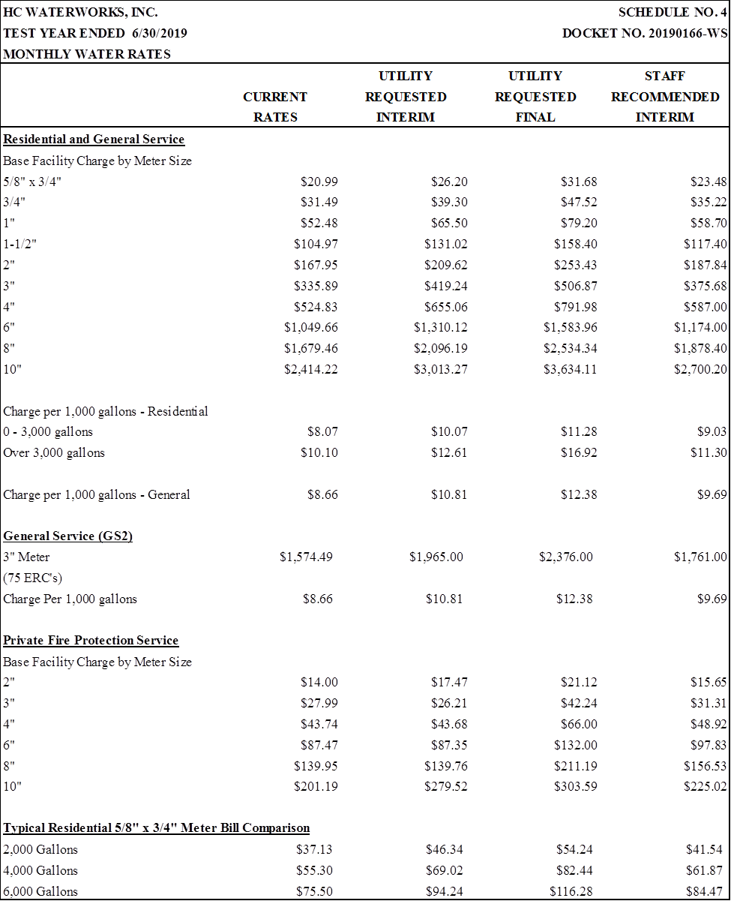

Order No. PSC-2015-0282-PAA-WS, issued July 8, 2015, in Docket No. 20140158-WS, In re: Application for increase in water/wastewater rates in Highlands County by HC Waterworks, Inc.
Order No. PSC-2015-0282-PAA-WS, issued July 8, 2015, in Docket No. 20140158-WS, In re: Application for increase in water/wastewater rates in Highlands County by HC Waterworks, Inc.
Order No. PSC-2015-0282-PAA-WS, issued July 8, 2015, In Docket No. 140158-WS, In re: Application for increase in water/wastewater rates in Highlands County by HC Waterworks, Inc.
Document No. 10882-2019 in Docket No. 20190166-WU.
Document No. 10817-2019 in Docket No. 20190166-WU.

