State of Florida |  | Public Service Commission  Capital Circle Office Center ● 2540 Shumard Oak Boulevard  Tallahassee, Florida 32399-0850  -M-E-M-O-R-A-N-D-U-M-
DATE: | November 26, 2019
TO: | Office of Commission Clerk (Teitzman)
FROM: | Division of Economics (Guffey, Coston, Draper)  Office of the General Counsel (Simmons)
RE: | Docket No. 20190145-GU – Joint petition for approval of restructured Nassau County agreements to reflect Callahan expansion, by Peoples Gas System, Florida Public Utilities Company, SeaCoast Gas Transmission, and Peninsula Pipeline Company, Inc.
AGENDA: | 12/10/19 – Regular Agenda – Proposed Agency Action - Interested Persons May Participate
COMMISSIONERS ASSIGNED: |  |  | All Commissioners
PREHEARING OFFICER: |  |  | Polmann
CRITICAL DATES: |  |  | None
SPECIAL INSTRUCTIONS: |  |  | None

Case Background
On July 19, 2019, Florida Public Utilities Company (FPUC), Peoples Gas System (Peoples), Peninsula Pipeline Company, Inc. (Peninsula), and SeaCoast Gas Transmission, LLC, (SeaCoast) (collectively, the joint petitioners), filed a petition seeking Commission approval of restructured Nassau County transportation agreements to reflect the new Callahan intrastate pipeline (Callahan pipeline). The Callahan pipeline, which is currently under construction, will allow the joint petitioners to expand natural gas service in Nassau and Duval counties in Northeast Florida.

FPUC and Peoples are local distribution companies (LDCs) which own and operate natural gas distribution facilities to serve retail customers and are subject to the Commission’s regulatory jurisdiction under Chapter 366, Florida Statutes (F.S.). Peninsula and SeaCoast operate as intrastate natural gas transmission companies as defined in Section 368.103, F.S., and only transport natural gas.

In Order No. PSC-07-1012-TRF-GP, Peninsula received approval of an intrastate gas pipeline tariff that allows it to construct and operate intrastate pipeline facilities and to actively pursue agreements with gas customers and enter into certain gas transmission agreements without prior Commission approval. Both Peninsula and FPUC are subsidiaries of Chesapeake Utilities Corporation; therefore, any agreements between the affiliates require Commission approval, pursuant to Section 368.105, F.S., and Order No. PSC-07-1012-TRF-GP.
Similarly to Peninsula, in Order No. PSC-08-0747-TRF-GP, SeaCoast received approval of an intrastate gas pipeline tariff that allows it to construct and operate intrastate pipeline facilities and to actively pursue agreements with gas customers and enter into certain gas transmission agreements without prior Commission approval. SeaCoast and Peoples are affiliates in that their parent company is TECO Energy, Inc. and, therefore, their agreements must be approved by the Commission.

The joint petitioners’ plans for the provision of natural gas service to residents in Nassau and Duval counties were previously addressed by the Commission in Order No. PSC-12-0230-PAA-GU. Specifically, in 2012, the Commission approved a Nassau-Duval County territorial agreement between FPUC and Peoples. The Nassau-Duval County territorial agreement provides that Peoples’ service area includes Duval County and the WestRock facility (formerly known as RockTenn), a large paper mill on the northern tip of Amelia Island, while FPUC’s service area is Nassau County.
In the same order, the Commission approved transportation service agreements between Peninsula and FPUC and between Peninsula and Peoples. The 2012 transportation agreements were needed in order to allow FPUC to serve Nassau County by transporting natural gas from Peoples’ existing interconnection with the Florida Gas Transmission Company (FGT) interstate pipeline through Peoples’ pipeline into the Fernandina Beach Line. The Fernandina Beach Line was jointly constructed in 2012 by Peoples and Peninsula.
The joint petitioners explained that since 2012, Nassau and Duval counties have experienced significant growth and, therefore, they jointly developed the proposed plan to bring additional natural gas capacity into the area. Furthermore, the joint petitioners stated that the existing Fernandina Beach Line is approaching full capacity and Peoples is experiencing pressure concerns in northern Duval County and has commitments for new customers. The joint petitioners state that the proposed agreements do not impact the 2012 Commission-approved Nassau-Duval County territorial agreement.
In the instant petition, the joint petitioners are seeking Commission approval of the following:

- A new Firm Service Agreement between SeaCoast and Peoples (Issue 1)
- Amendment to Peninsula and FPUC’s 2012 Transportation Service Agreement (Issue 2)
- Cancellation of Peninsula and Peoples’ 2012, and amended in 2015, Transportation Agreement (Issue 3).

This recommendation includes three attachments. Attachment A is a map depicting the Callahan pipeline, Attachment B includes the SeaCoast/Peoples Firm Service Agreement as discussed in Issue 1, and Attachment C includes the 2012 Peninsula/FPUC Transportation Service Agreement and the 2019 amendment as discussed in Issue 2.

During the evaluation of the instant petition, staff issued a data request to the joint petitioners for which responses were received on October 10, 2019. On November 6, 2019, staff held an informal meeting with the joint petitioners. The Commission has jurisdiction over this matter pursuant to Sections 366.04, 366.05(1), 366.06, and 368.105, F.S.

Discussion of Issues

Issue 1:
Should the Commission approve the Firm Service Agreement (agreement) dated July 19, 2019, between SeaCoast and Peoples?

Recommendation:
Yes, the Commission should approve the agreement dated July 19, 2019, between SeaCoast and Peoples as shown in Attachment B to this recommendation. (Guffey, Coston, Draper)

Staff Analysis:
The new 16-inch steel Callahan pipeline is being constructed to allow FPUC and Peoples to expand natural gas service in Nassau and Duval counties. The construction of the Callahan pipeline does not need Commission approval; however, staff believes a description of the Callahan pipeline project is helpful to establish context for the joint petition. Investment and ownership in the Callahan pipeline is split 50/50 between Peninsula and SeaCoast. Peoples and FPUC explained that contracting with the intrastate pipelines to construct and own the Callahan pipeline, as opposed to building it themselves, will avoid the LDCs undertaking the costs and risk for this project, thus protecting their ratepayers. Peoples and FPUC also stated that the intrastate companies are well experienced in permitting, land acquisition, and construction of a project of this size and scope.

The Callahan pipeline will interconnect with the Southern Natural Gas Company, LLC, interstate pipeline (SONAT) in western Nassau County and will extend 26.5 miles eastward and terminate at the existing Fernandina Beach Line. In Attachment A to this recommendation, the Callahan pipeline is shown as the green line and the Fernandina Beach Line is shown as the red line. The joint petitioners explained that since both FPUC and Peoples need additional natural gas quantities in Nassau and Duval counties, the jointly constructed pipeline avoids two companies constructing separate pipelines and, therefore, avoids a duplication of facilities. In addition, the interconnect with SONAT will provide FPUC and Peoples the ability to receive natural gas from a second interstate pipeline. The current interconnect for FPUC and Peoples to receive natural gas in Northeast Florida is with the FGT pipeline.
Since SeaCoast and Peoples are affiliated companies, the proposed agreement requires Commission approval. Pursuant to the agreement, SeaCoast will provide firm transportation service for Peoples over its portion of the Callahan pipeline for an initial term of 20 years, with an option to extend for an additional ten years. Peoples will recover its payments to SeaCoast through the Purchased Gas Adjustment (PGA) mechanism and from transportation customers, consistent with prior pipeline projects. The effective date of the agreement is expected to be September 30, 2020, which is the estimated in-service date of the Callahan pipeline.
SeaCoast and Peoples assert that the negotiated reservation charge set forth in the agreement is a cost-based market rate and is designed to allow SeaCoast to recover its costs associated with the Callahan pipeline. Based on the petition and responses to staff’s data request, SeaCoast and Peoples have supported the need of the new Callahan pipeline and associated agreement. Staff believes the proposed agreement is reasonable, meets the requirements of Section 368.105, F.S., and benefits Peoples’ customers by allowing Peoples to expand natural gas service to new customers and ensure appropriate natural gas pressure for existing customers. Therefore, staff recommends approval of the agreement dated July 19, 2019, between SeaCoast and Peoples.

Issue 2:
Should the Commission approve the Amended Firm Gas Transportation Service Agreement dated July 19, 2019, between Peninsula and FPUC?

Recommendation:
Yes, the Commission should approve the Amended Transportation Service Agreement (amended agreement) between Peninsula and FPUC as shown in Attachment C to this recommendation. (Guffey, Coston, Draper)

Staff Analysis:
The current Commission-approved transportation service agreement dated February 1, 2012 (2012 agreement), between Peninsula and FPUC allows Peninsula to transport and deliver natural gas to FPUC through Peoples’ distribution system and the Fernandina Beach Line. The negotiated confidential charges contained in the 2012 agreement require FPUC to pay Peninsula for the transportation of the natural gas. Transportation agreements typically include terms such as the Maximum Daily Transportation Quantity (MDTQ), the negotiated monthly reservation charge, and points of delivery. The MDTQ is the largest daily quantity of gas Peninsula is obligated to transport on a firm basis for delivery to FPUC.
Once the Callahan pipeline is in operation, FPUC will no longer need Peninsula to transport natural gas for delivery through Peoples’ distribution system. Instead, Peninsula will transport natural gas for delivery to FPUC across its portion of the Callahan pipeline and the Fernandina Beach Line. FPUC stated that the Callahan pipeline is a large diameter pipe compared to Peoples’ line which allows for natural gas to be delivered at a high pressure. Therefore, Peninsula will be able to deliver increased quantities of natural gas to FPUC.

To reflect the transportation of gas via the Callahan pipeline, Peninsula and FPUC are proposing to amend their 2012 agreement to increase the MDTQ and the corresponding change in the monthly reservation charge. The negotiated monthly reservation charge in the amended agreement is designed to recover Peninsula’s portion of the Callahan project. The amended agreement changes the delivery point from the FGT/Peoples interconnect to the Callahan interconnect with SONAT. In addition, the agreement adds additional points of delivery to FPUC at several locations along the Callahan route in Nassau County. Finally, the initial 15-year term of the 2012 agreement will be extended for 13 years.

The amended agreement only provides for revisions to the first page and Exhibit A to the 2012 agreement. For clarity, staff included in Attachment C to this recommendation the entire 2012 agreement and the amendment to that agreement. Staff believes the proposed amendment is reasonable and benefits FPUC’s customers by allowing FPUC to expand natural gas service in Nassau County. Therefore, staff recommends approval of the amended agreement between Peninsula and FPUC.

Issue 3:
Should the Commission approve the cancellation of the Gas Transportation Agreement between Peninsula and Peoples?

Recommendation:
Yes, the Commission should approve the cancellation of the Gas Transportation Agreement between Peninsula and Peoples effective with the in-service date of the Callahan pipeline. (Guffey, Coston)

Staff Analysis:
In 2012, the Commission approved a Gas Transportation Agreement between Peninsula and Peoples. This agreement allows Peoples to provide transportation service to Peninsula across Peoples’ system (yellow line in Attachment A to this recommendation). Because Peninsula and Peoples negotiated a payment structure not anticipated in Peoples’ tariff, Rule 25-9.034, Florida Administrative Code, requires the Commission to approve this special contract. The fixed monthly charge, payable by Peninsula, was designed to recover Peoples’ investment in certain upgrades to its facilities to support Peoples’ transportation of natural gas for Peninsula.

In 2015, the Commission approved in Order No. PSC-15-0318-PAA-GP an amendment to the special contract between Peninsula and Peoples. The amendment enabled Peoples to provide Peninsula with incremental transportation service.

The joint petitioners explained that when the Callahan pipeline becomes operational, Peoples will no longer transport natural gas on behalf of Peninsula. Therefore, this contractual obligation becomes obsolete and both parties have agreed to terminate the agreement. While Peoples will no longer receive payments from Peninsula after the agreement is terminated, Peoples stated that it will recover its investment through revenue derived from new growth in St. Johns County and in Duval County. In response to staff’s data request, the joint petitioners stated that the anticipated effective date of the termination of the agreement is September 30, 2020 (the current anticipated in-service date of the Callahan pipeline). Since the existing agreement between Peninsula and Peoples will become obsolete when the Callahan pipeline goes into service, staff recommends approval of the cancellation of the Gas Transportation Agreement between Peninsula and Peoples.

Issue 4:
Should this docket be closed?

Recommendation:
Yes. If no protest is filed by a person whose substantial interests are affected within 21 days of the issuance of the Order, this docket should be closed upon the issuance of a Consummating Order. (Simmons)

Staff Analysis:
If no protest is filed by a person whose substantial interests are affected within 21 days of the issuance of the Order, this docket should be closed upon the issuance of a Consummating Order.

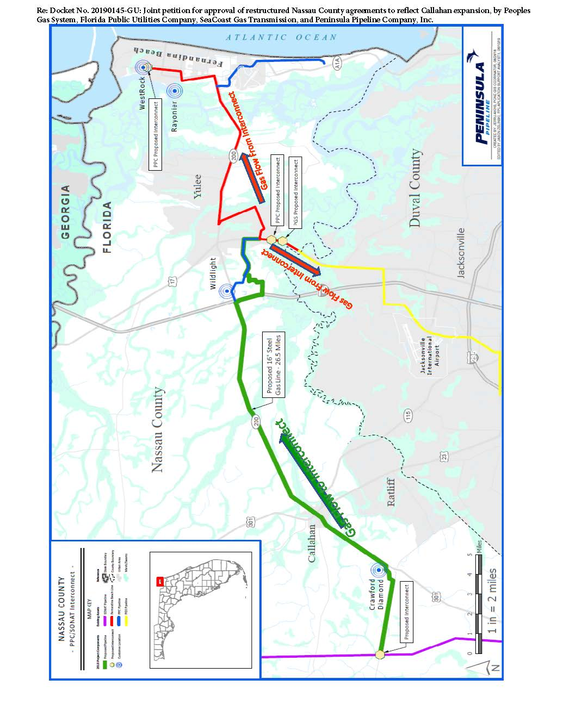
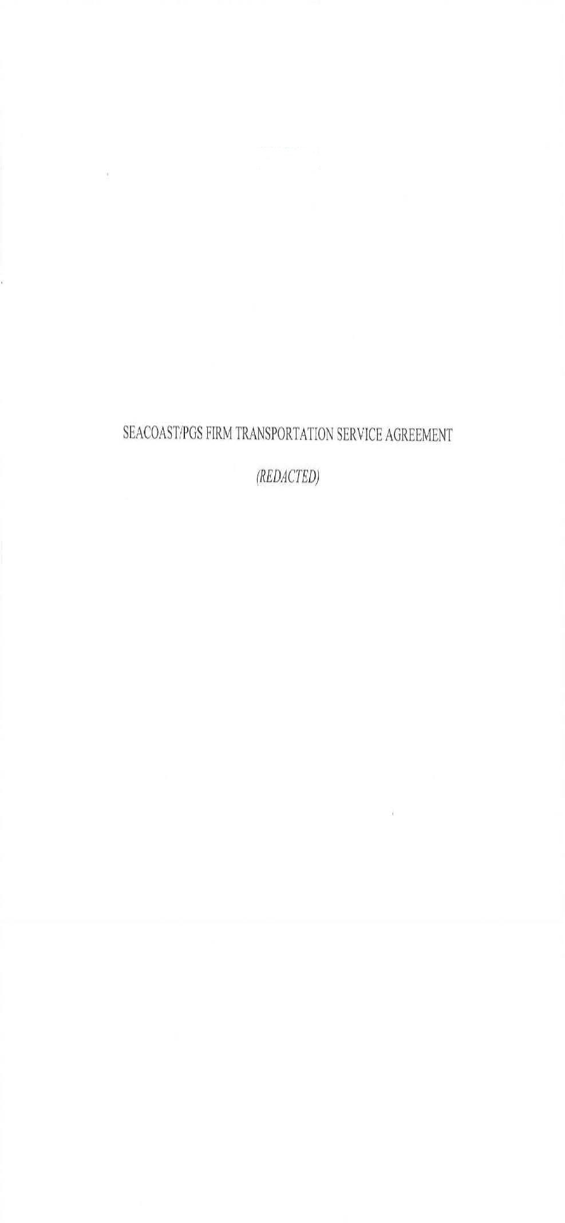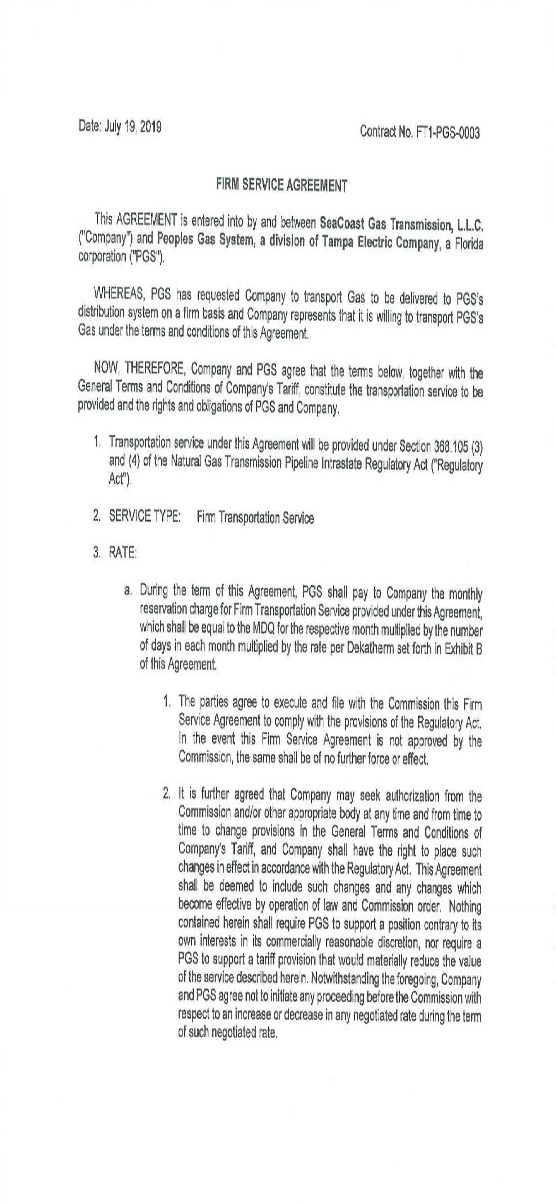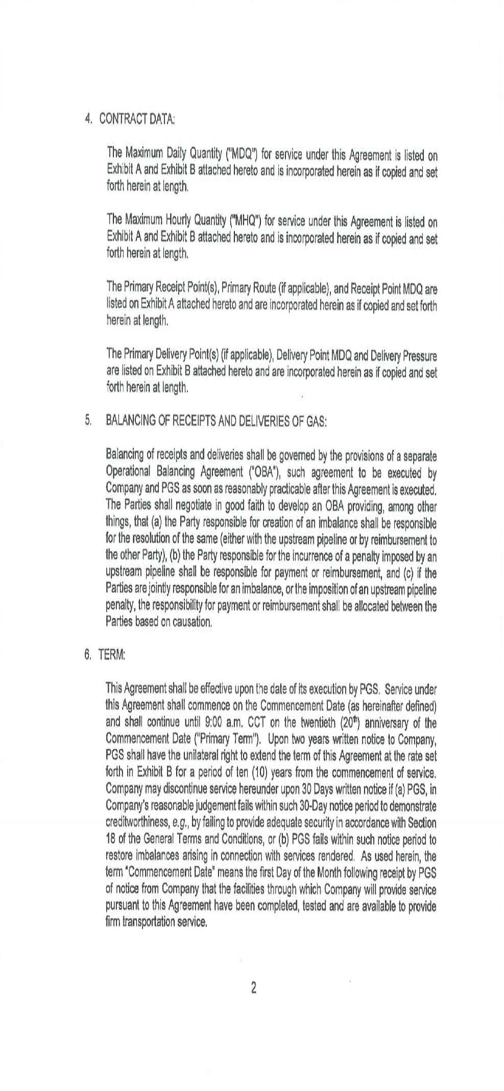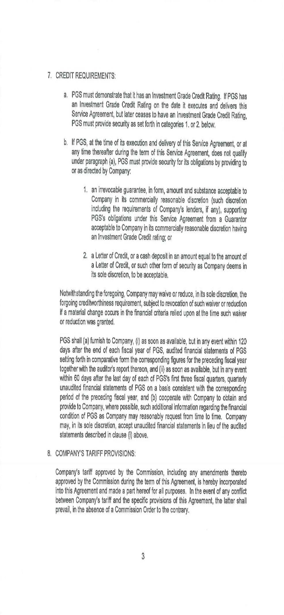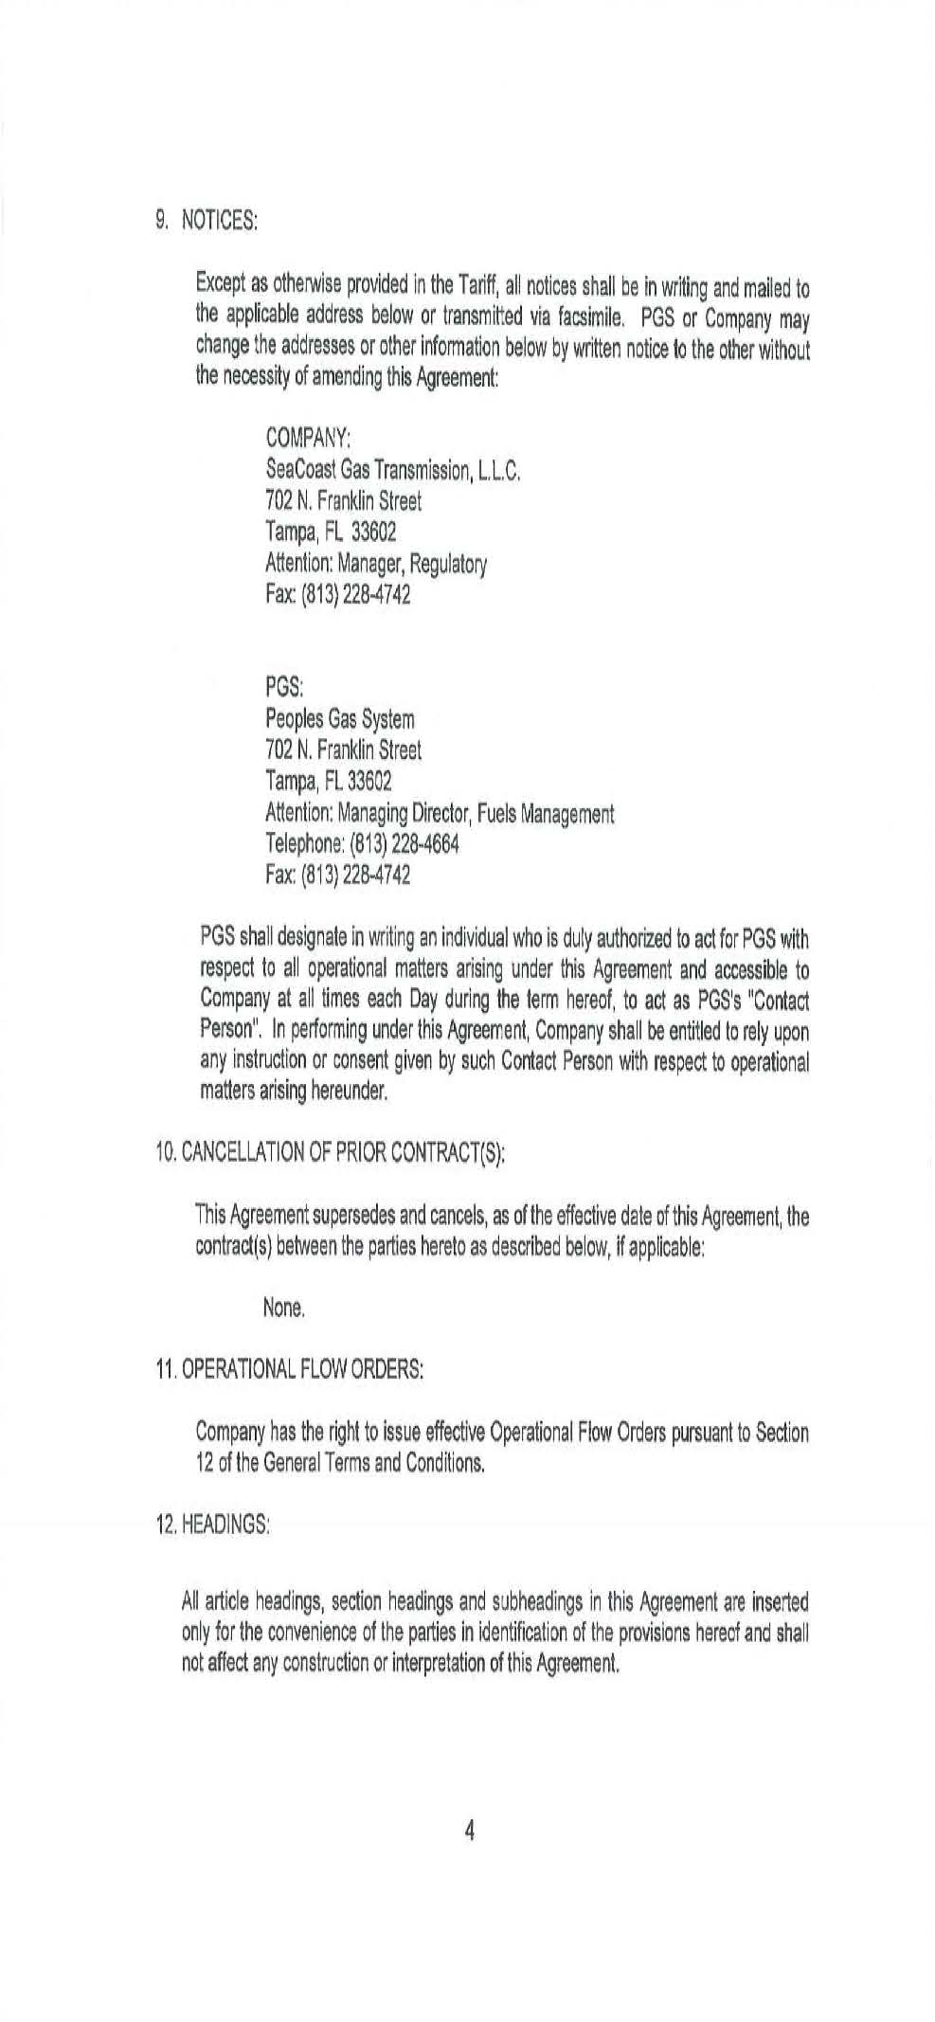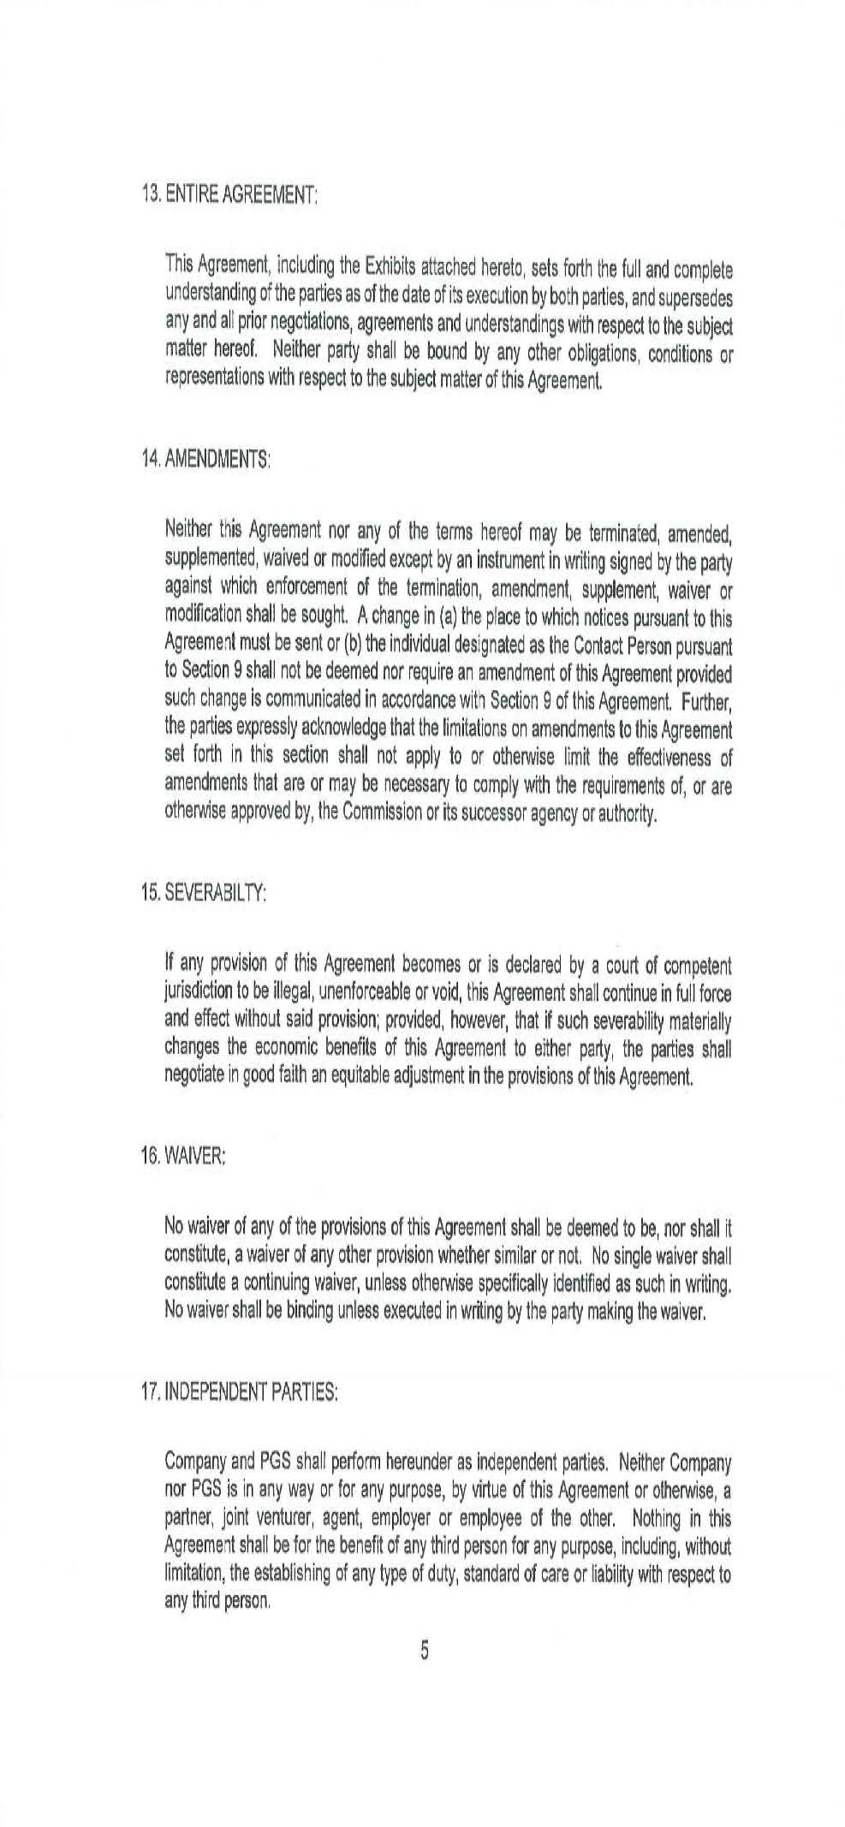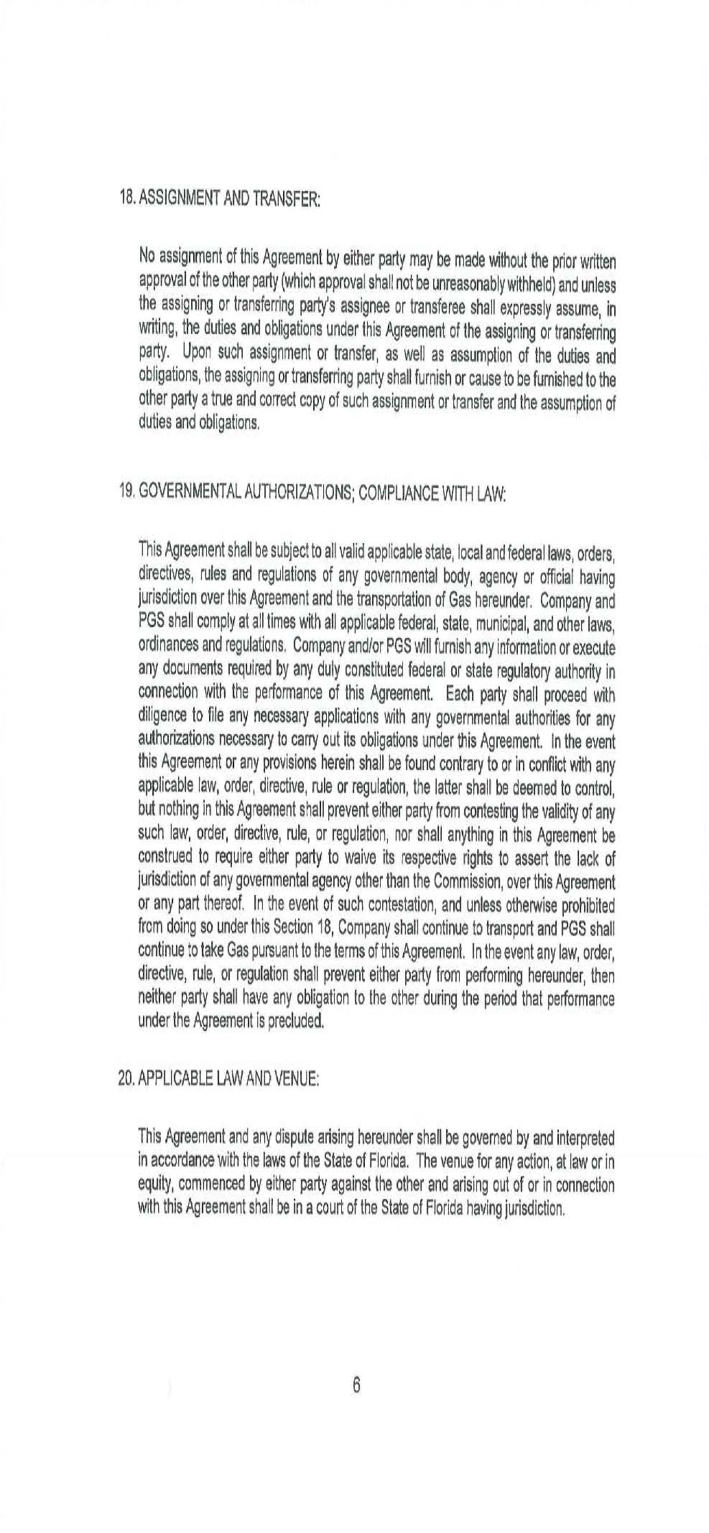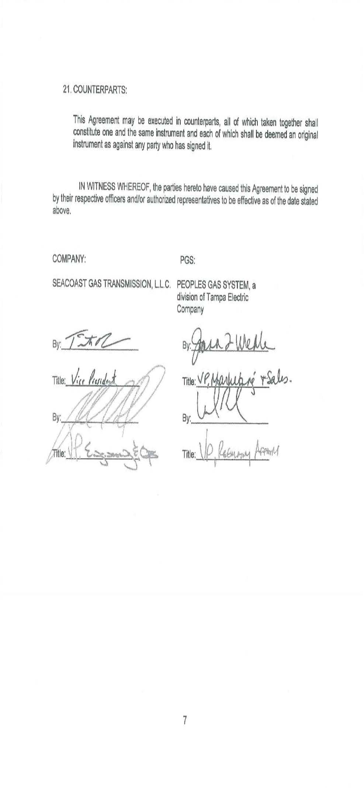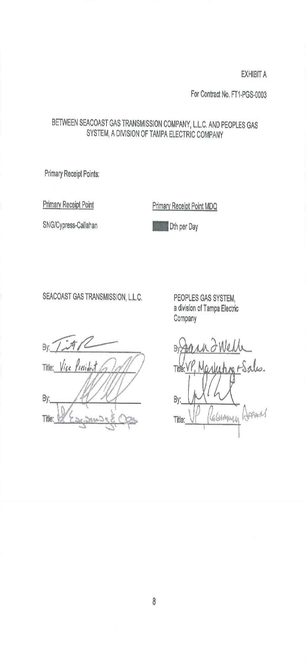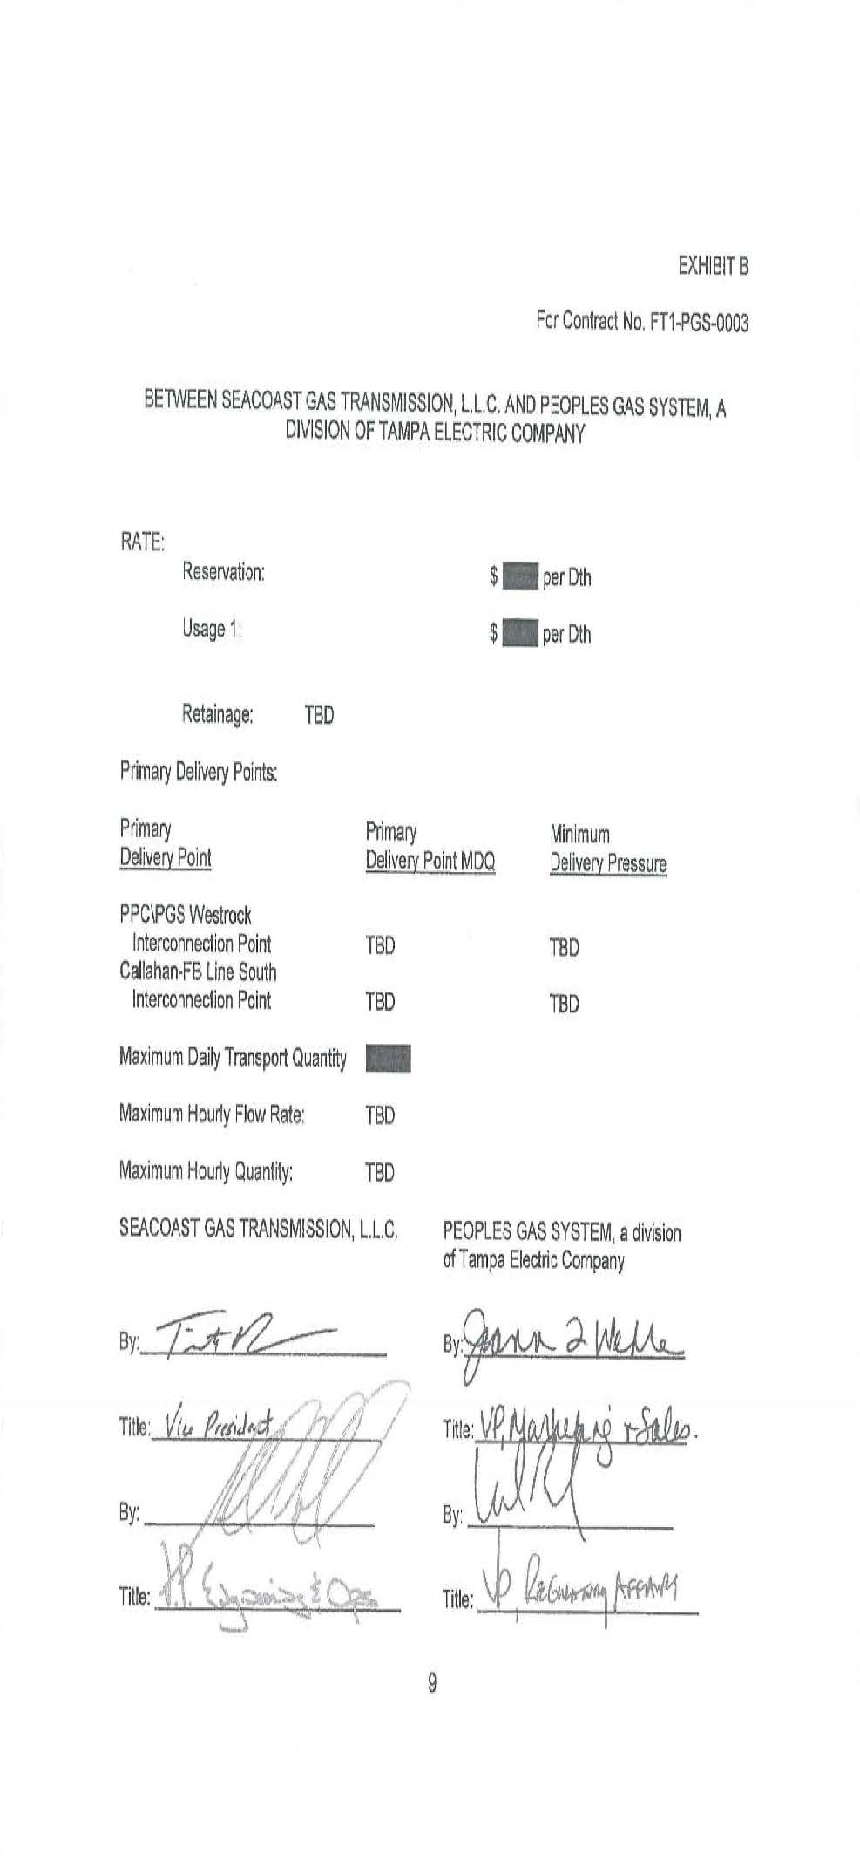
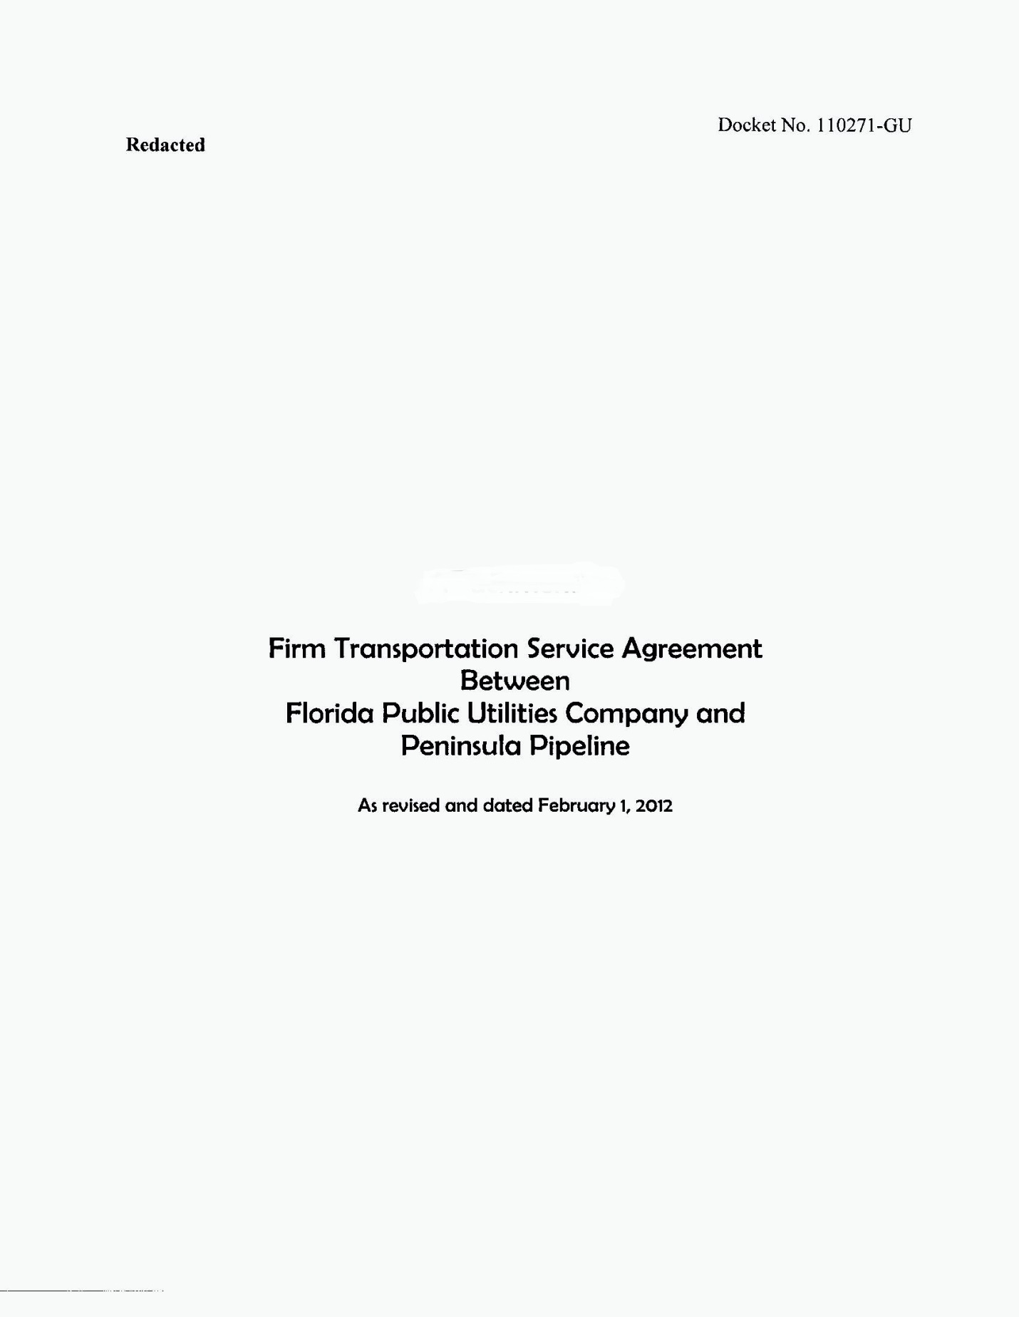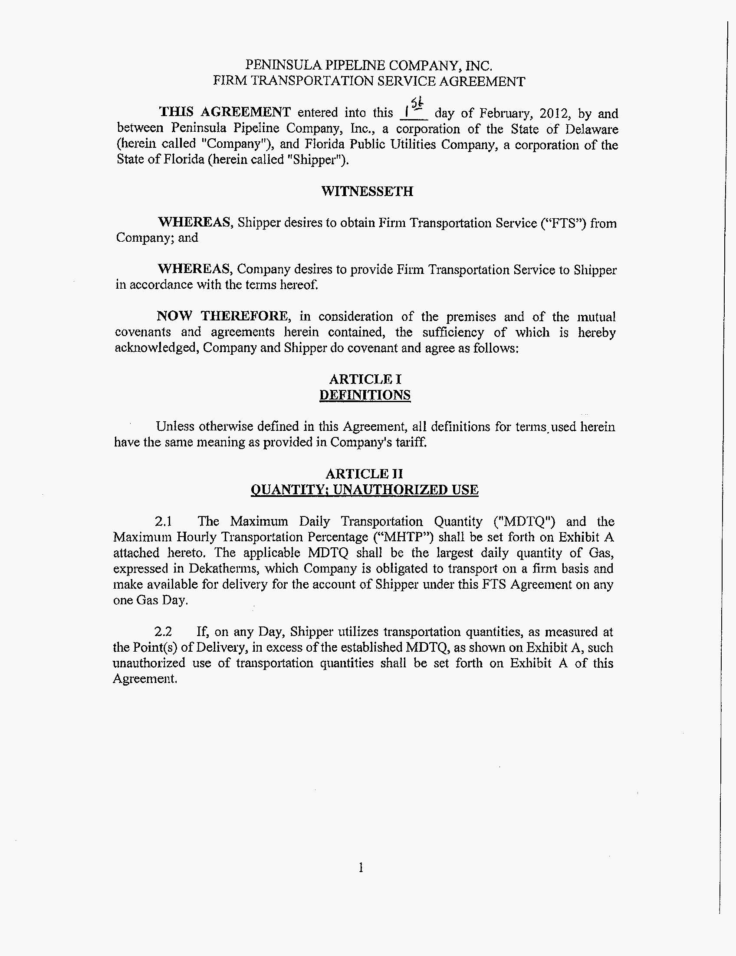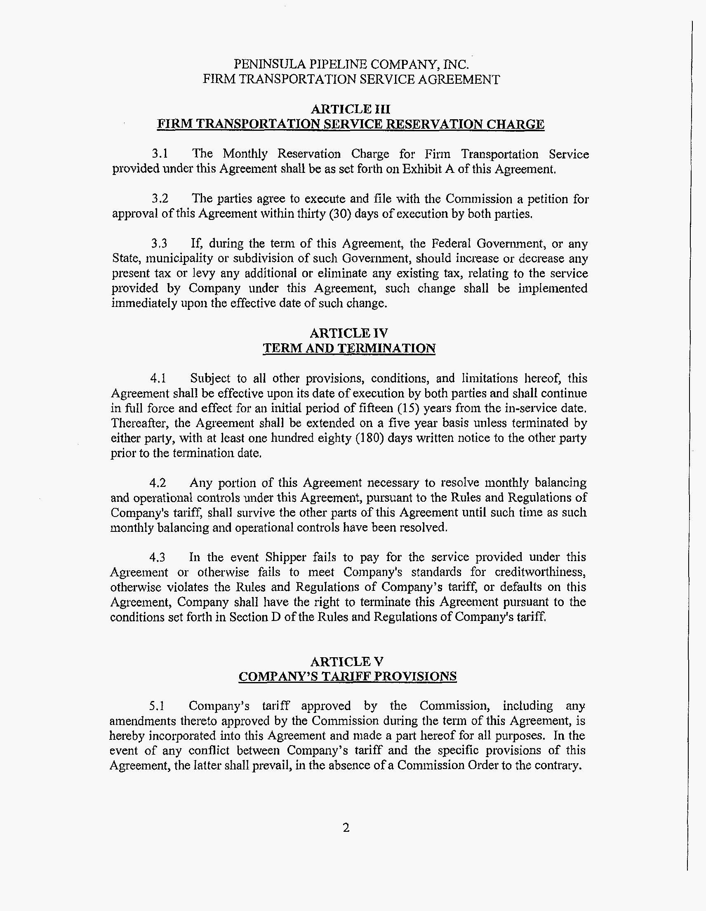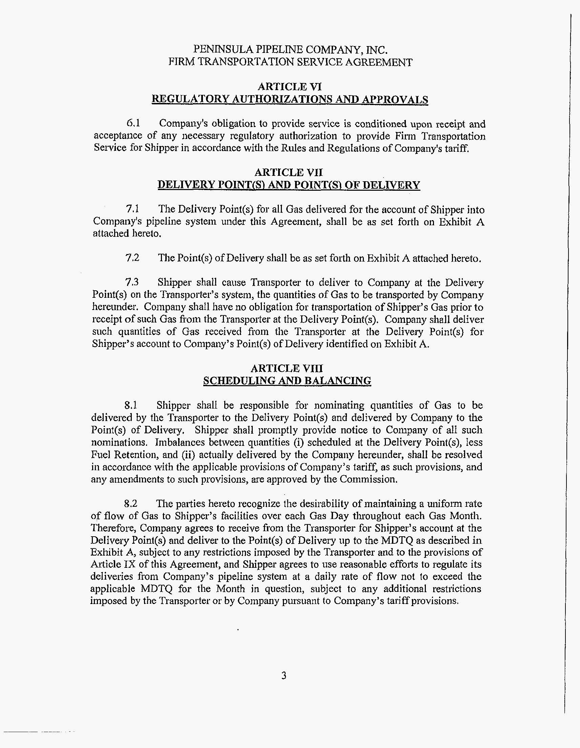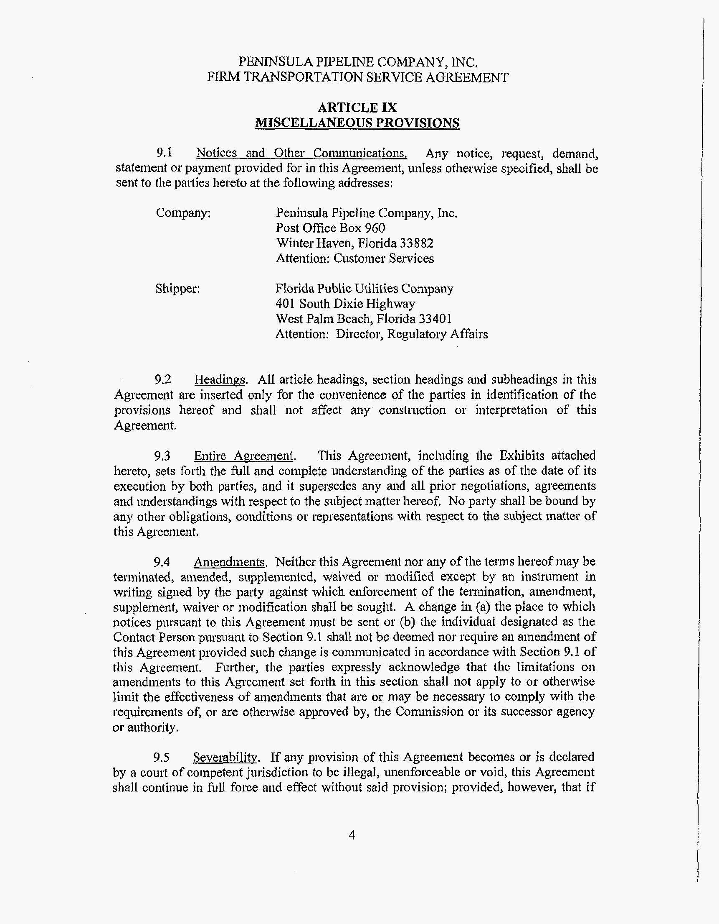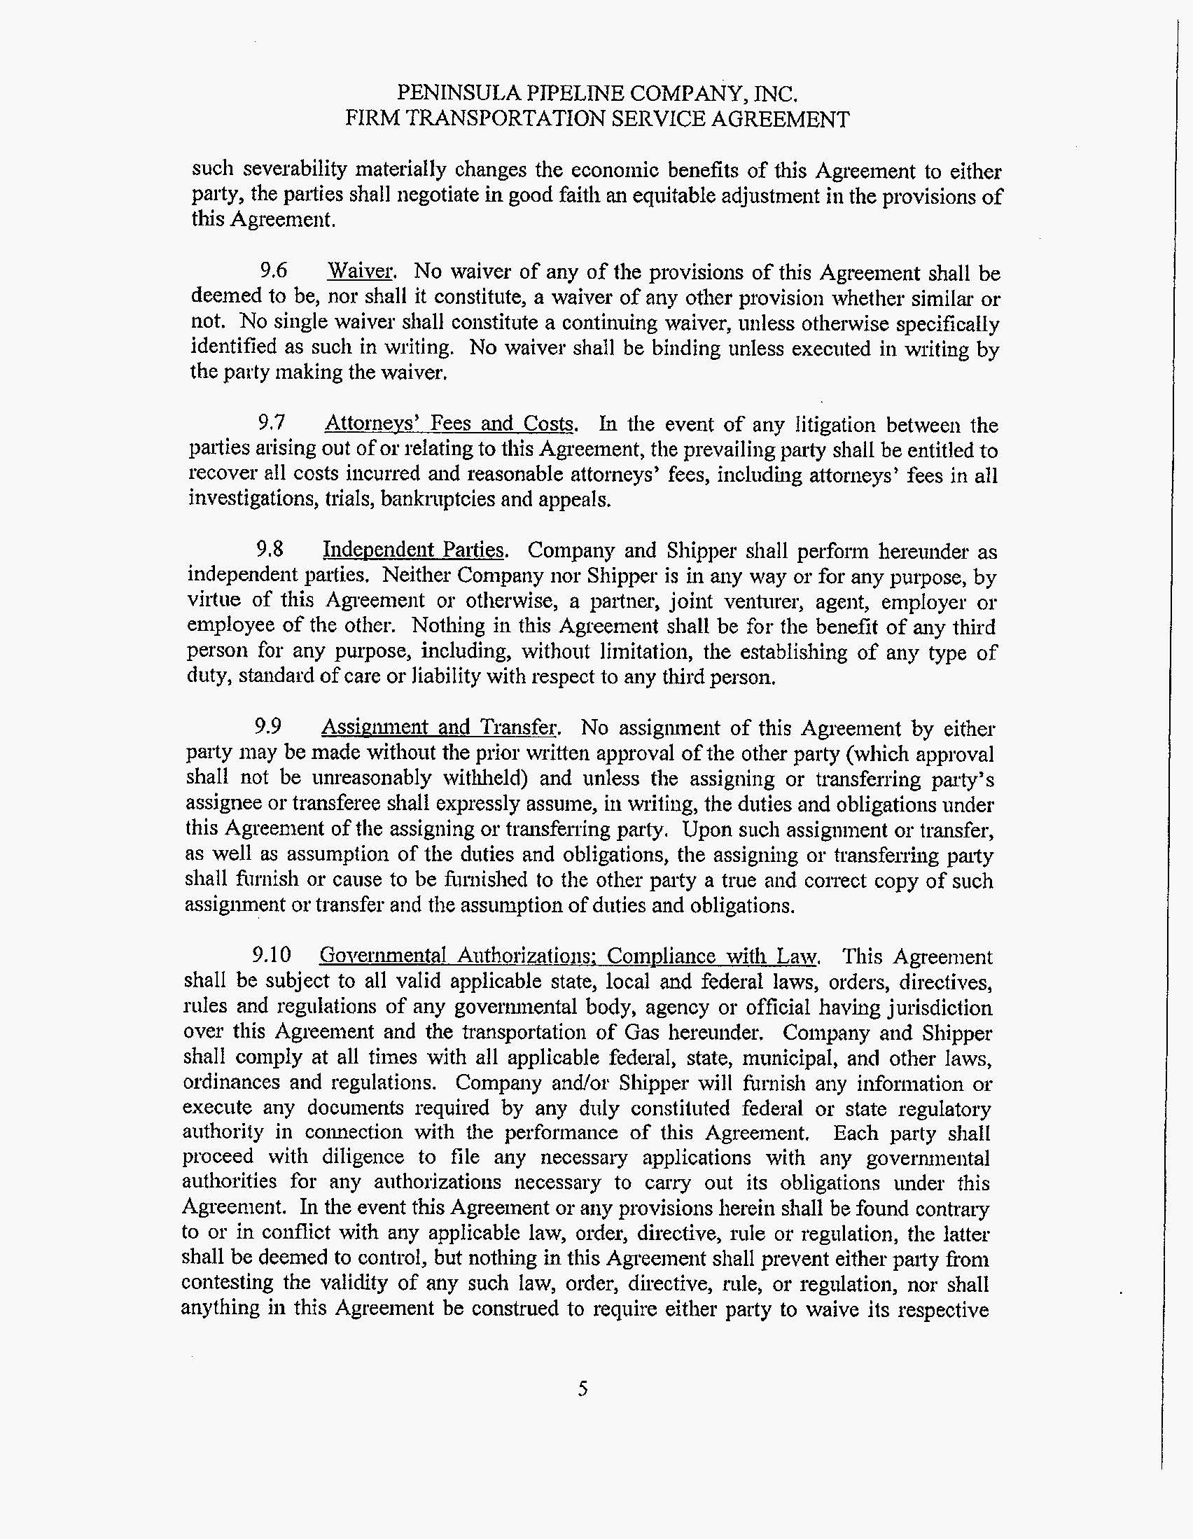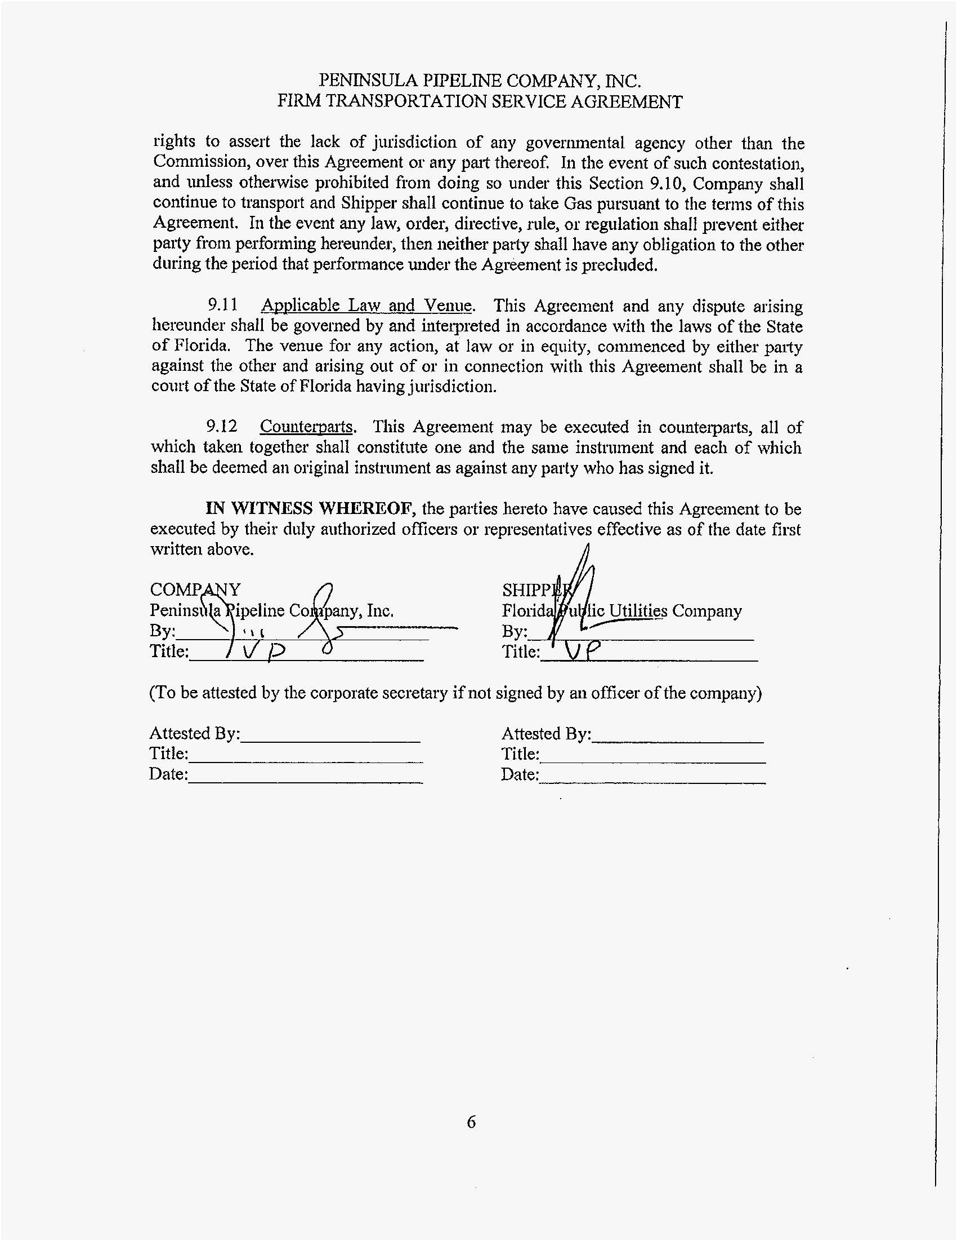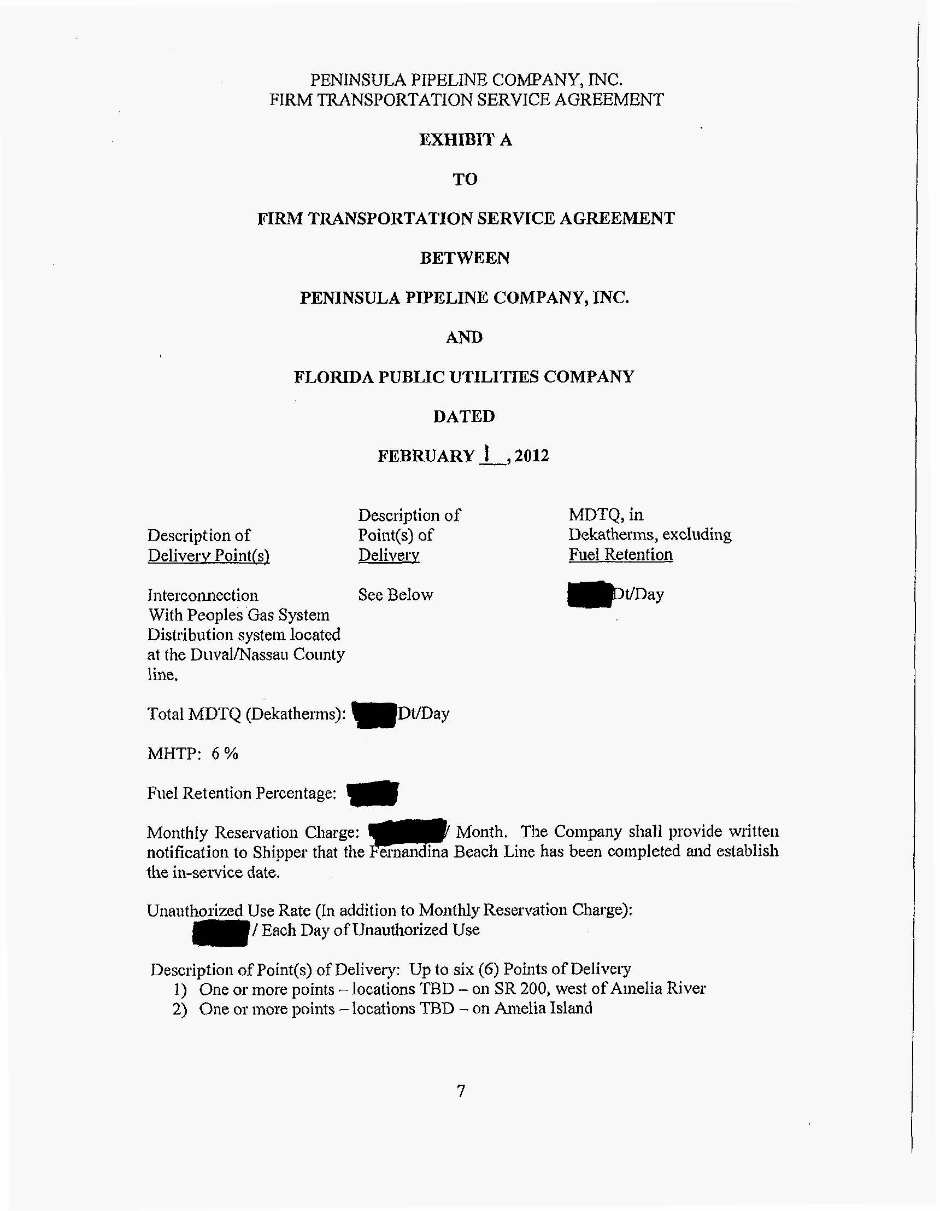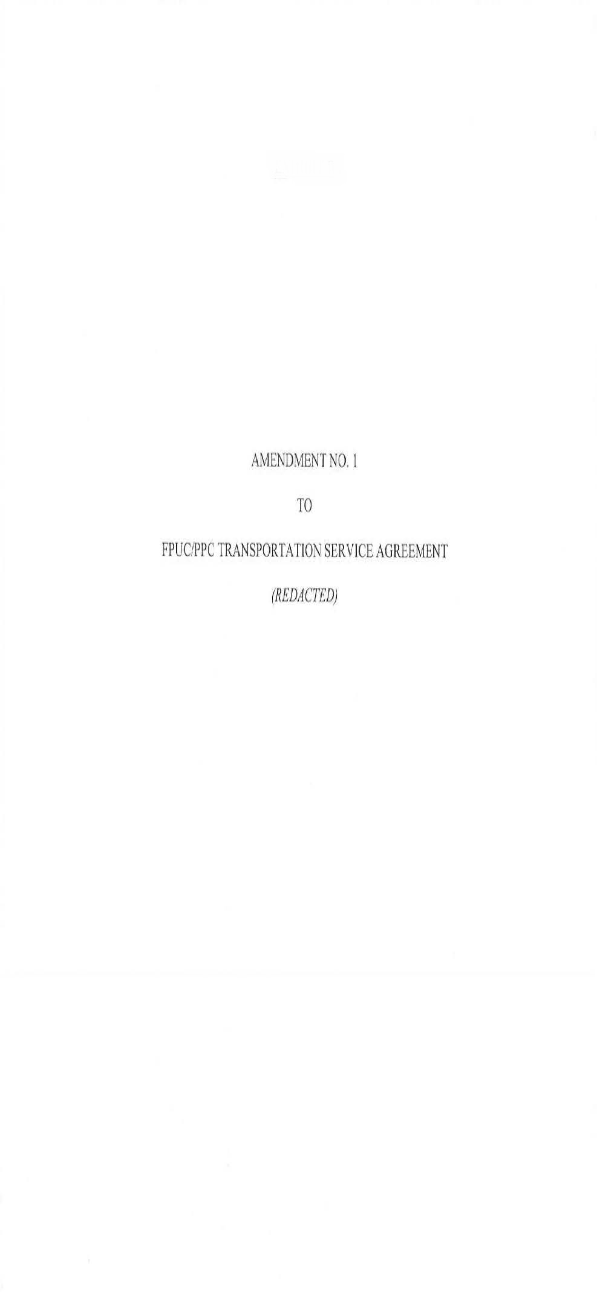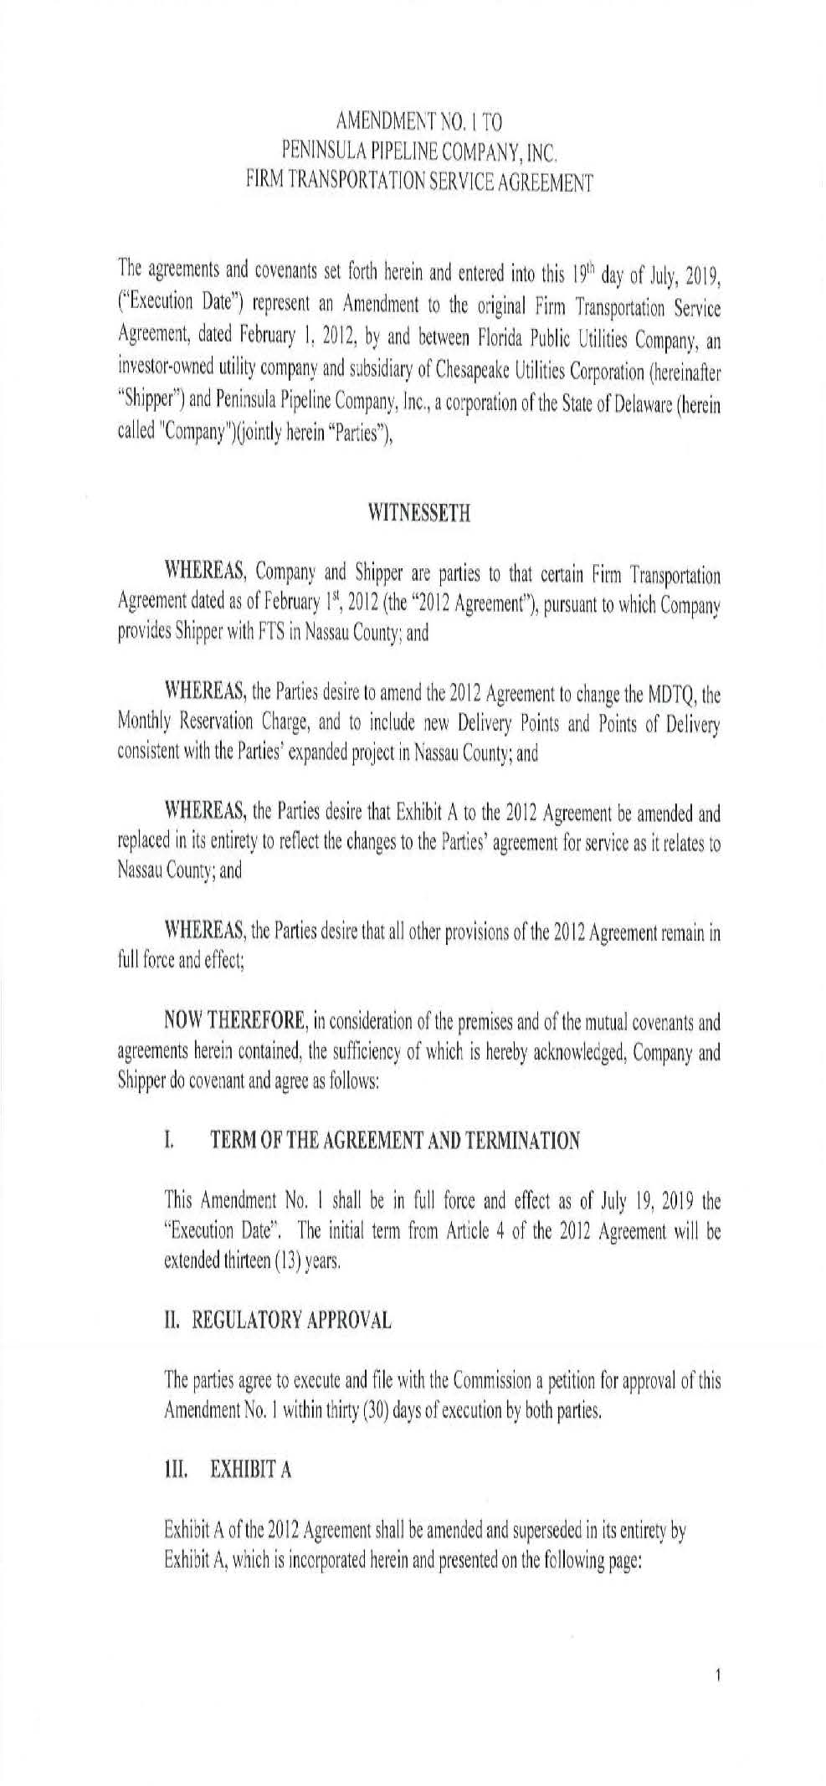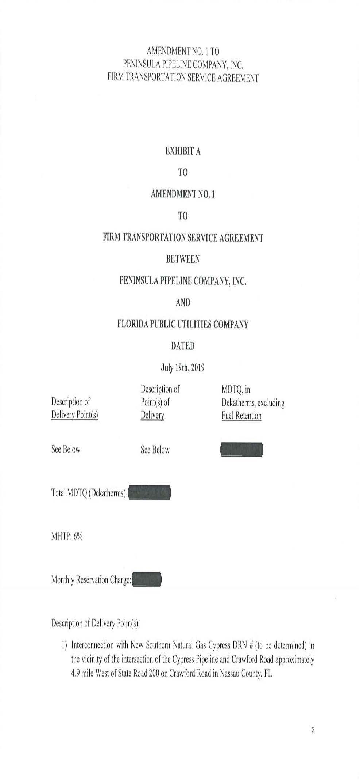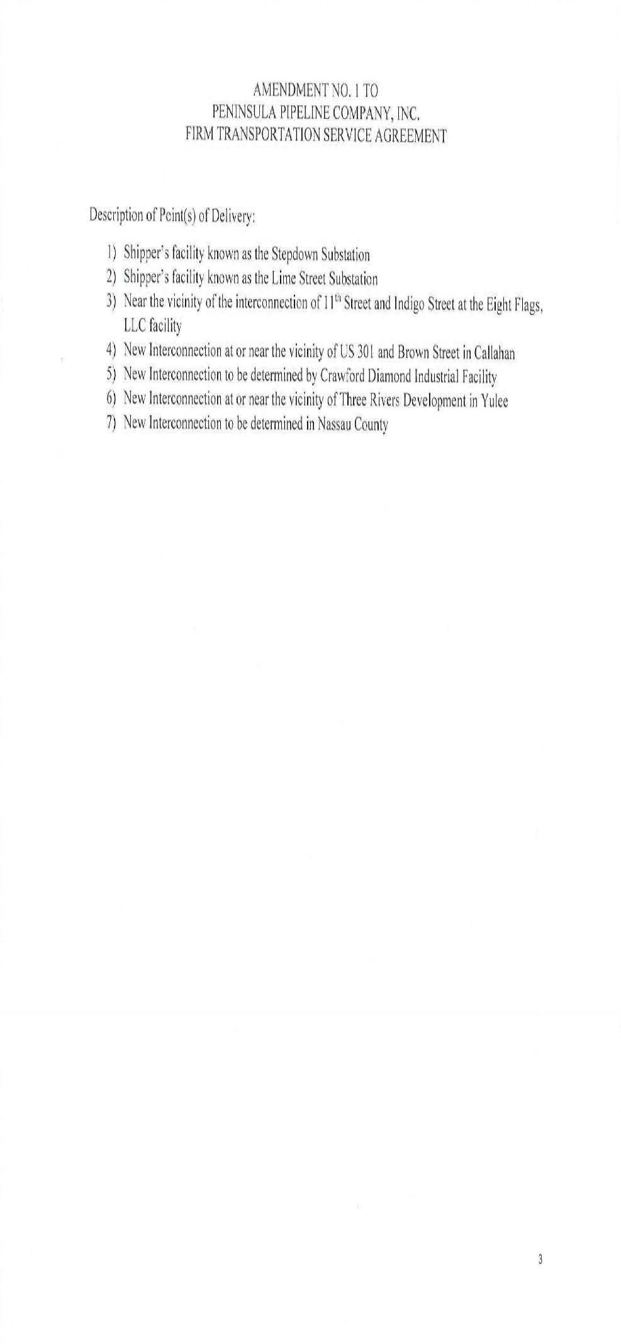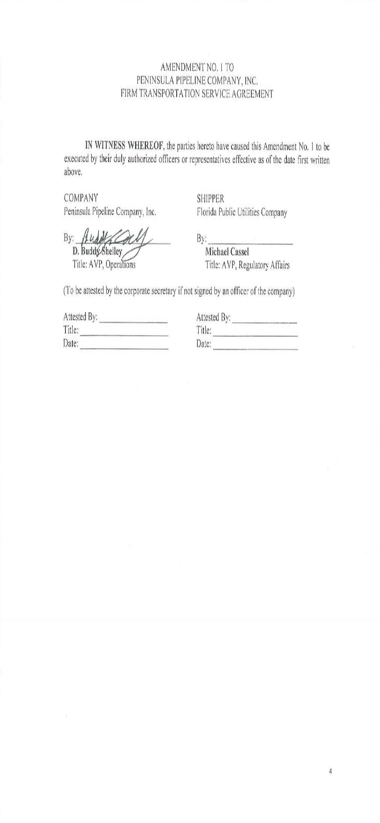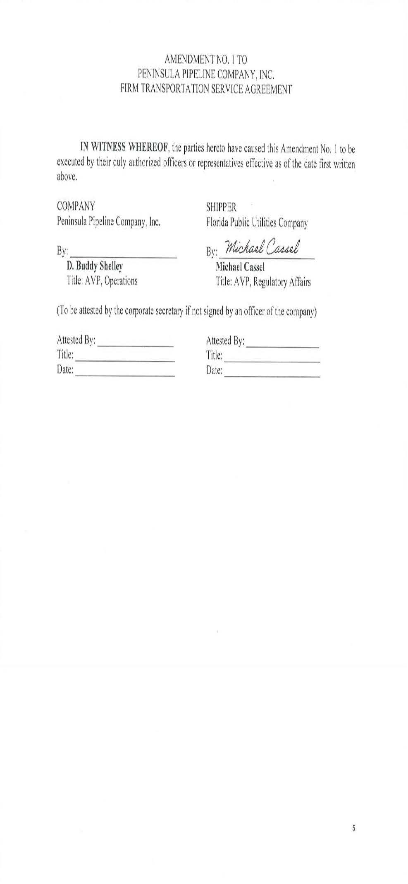

Order No. PSC-07-1012-TRF-GP, issued December 21, 2007, in Docket No. 20070570-GP, In re: Petition for approval of natural gas transmission pipeline tariff by Peninsula Pipeline Company, Inc.
Order No. PSC-08-0747-TRF-GP, issued November 12, 2008, in Docket No. 20080561-GP, In re: Petition for approval of natural gas transmission pipeline tariff by SeaCoast Gas Transmission, LLC.
Order No. PSC-12-0230-PAA-GU, issued on May 9, 2012, in Docket No. 20110271-GU, In re: Petition for approval of transportation service agreement with Florida Public Utilities Company, by Peninsula Pipeline Company, Inc,. and Docket No. 20110277-GU, In re: Joint petition for approval of territorial agreement in Nassau and Duval Counties by Peoples Gas System and Florida Public Utilities Company; gas transportation agreement by Peoples Gas System and Peninsula Pipeline Company, Inc.; and application for approval of tariff revisions to reflect service in Nassau and Okeechobee Counties, by Florida Public Utilities Company.
Total capacity of the Callahan pipeline will be 148,248 dekatherms/day, with Peninsula and SeaCoast each holding 74,124 dekatherms/day of that capacity.
Order No. PSC-12-0230-PAA-GU.
Order No. PSC-12-0230-PAA-GU.
Order No. PSC-15-0318-PAA-GP, issued August 10, 2015, in Docket No. 20150094-GP, In re: Petition for approval of amendment to special contract with Peninsula Pipeline Company, by Peoples Gas System.

