State of Florida |  | Public Service Commission  Capital Circle Office Center ● 2540 Shumard Oak Boulevard  Tallahassee, Florida 32399-0850  -M-E-M-O-R-A-N-D-U-M-
DATE: | November 26, 2019
TO: | Office of Commission Clerk (Teitzman)
FROM: | Division of Economics (Hampson, Coston)  Office of the General Counsel (Simmons, Trierweiler)
RE: | Docket No. 20190190-EI – Petition for approval of twelve-month extension of voluntary solar partnership rider and program, by Florida Power & Light Company.
AGENDA: | 12/10/19 – Regular Agenda – Tariff Filing – Interested Persons May Participate
COMMISSIONERS ASSIGNED: |  |  | All Commissioners
PREHEARING OFFICER: |  |  | Administrative
CRITICAL DATES: |  |  | 60-Day Suspension Date Waived by FPL until 12/10/2019
SPECIAL INSTRUCTIONS: |  |  | None

Case Background
On October 7, 2019, Florida Power & Light Company (FPL) filed a petition for a one-year extension of its Voluntary Solar Partnership (VSP) pilot program and associated tariff. The VSP program was first approved in 2014 (2014 order) as a pilot with a termination date of December 31, 2017. The VSP pilot program offers all FPL customers an opportunity, for $9 per month, to participate in a voluntary program designed to fully-fund the construction and operation of solar photovoltaic generation facilities. These solar facilities are located in communities throughout FPL’s service territory. FPL markets the VSP pilot program to customers as FPL SolarNow. Customers may enroll or cancel their enrollment at any time.
In 2017, the Commission approved a one-year extension to allow FPL to gather additional data regarding the durability of customer interest over a more substantial period. In 2018, the Commission approved an additional one-year extension to allow FPL to complete and evaluate research regarding how the VSP pilot program and a community shared solar program, scheduled to be filed in 2019, may impact one another. On March 13, 2019, FPL filed the community shared solar program and tariff, known as SolarTogether, for approval before the Commission.

Since the Commission is not scheduled to make a decision regarding SolarTogether until 2020, FPL is requesting an additional one-year extension to the VSP pilot program. This additional extension will allow FPL to assess and evaluate the potential overlap in customer interest for the two programs, if SolarTogether is approved by the Commission. FPL’s proposed VSP tariff revision, as shown in Attachment A to this recommendation, changes the termination date for service under the pilot program from December 31, 2019, to December 31, 2020.

FPL waived the 60-day file and suspend provision of Section 366.06(3), Florida Statutes (F.S.), until the December 10, 2019 Agenda Conference. During the evaluation of the petition, staff issued data requests to FPL for which responses were filed on October 29, November 4, and November 14, 2019. The Commission has jurisdiction over this matter pursuant to Sections 366.05, 366.06, and 366.075, F.S.

Discussion of Issues

Issue 1:
Should the Commission approve FPL’s one-year extension of its VSP pilot program?

Recommendation:
Yes. The Commission should approve the one-year extension of the VSP pilot program. This extension would allow FPL to evaluate the potential overlap in customer interest for the proposed SolarTogether program and the VSP pilot program, if SolarTogether is approved in 2020. The revised tariff, as shown in Attachment A, should be effective January 1 to December 31, 2020. FPL should petition the Commission regarding the future status of the VSP pilot program, prior to its expiration. (Hampson)

Staff Analysis:

Description of the Current VSP Pilot Program
The VSP pilot program is designed to be fully-funded by customers who contribute on a voluntary basis. Participants contribute to the revenue requirement associated with constructing and operating solar structures. The revenue requirement includes a return, depreciation, operations and maintenance expenses, and other costs such as property taxes and insurance. As required by the 2014 order, marketing and administrative expenses are capped at 20 percent of participant contributions. FPL has met this requirement each year since the VSP pilot program’s inception.
Since 2016, FPL has demonstrated that the revenues received under the VSP pilot program exceed the revenue requirement of the solar facilities. FPL projects that the 2019 voluntary customer contributions will total $5,231,000 by end-of-year, while the 2019 revenue requirement for the VSP pilot program will total $4,670,000 by end-of-year. The electricity generated by the solar facilities displaces fuel that otherwise would have been used for generation, resulting in avoided fuel costs. FPL calculated the 2019 fuel savings to be $85,000, resulting in a positive net impact to all customers of $646,000.
As discussed in the 2014 order, FPL sizes the VSP pilot program’s solar projects based on the level of participation. As of August 31, 2019, FPL has installed 145 solar structures at 63 locations for a total of 2,325 direct current kilowatts (kW) of solar capacity. An additional 15 solar structures are under construction. FPL stated that the completed and planned solar structures comprise a diverse set of assets, including ground-mount structures, rooftop installations, covered walkways, parking canopies, and tree-like structures. These projects are located in public areas, such as parks, zoos, schools, museums, and transportation hubs. The installation size of the structures ranges from two kW to 250 kW. In response to staff’s first data request, No. 7, FPL stated it will not pursue any additional construction until after the Commission has reached a decision regarding SolarTogether, aside from the 15 solar structures already in-construction or ready for construction.
Table 1-1 shows the total number of customers participating in the VSP pilot program for the period May 2015 through May 2019. As of May 2019, there are 54,846 total participants, a 58 percent increase from May 2018.
Table 1-1
VSP Participants
 | Residential | Commercial | Total Participants
May 2015 | 155 | 1 | 156
May 2016 | 3,043 | 27 | 3,070
May 2017 | 19,226 | 83 | 19,309
May 2018 | 31,177 | 638 | 34,646
May 2019 | 54,221 | 625 | 54,846
Source: FPL response to staff’s first data request, No. 4.

Proposed FPL SolarTogether Program in Docket No. 20190061-EI
In March 2019, FPL petitioned the Commission for approval of the proposed SolarTogether program and associated tariff. The matter was originally set for an administrative hearing on October 15-16, 2019. However, in response to a motion for continuance, the matter is now set for a hearing on January 14-16, 2020.
FPL states that until the Commission issues a ruling on the proposed SolarTogether program, it cannot complete an assessment regarding the VSP pilot program and SolarTogether. Therefore, FPL states that until it can complete an assessment regarding the two programs, providing any recommendation regarding the future of the VSP pilot program would be premature. In response to staff’s first data request, FPL stated it had three tasks for a comprehensive assessment of the two programs: (1) gather information about those interested in SolarTogether; (2) determine if there is an overlap in those interested in the two programs; and (3) determine if the overlap will have an impact on the VSP pilot program. Among other things, the proposed SolarTogether program differs from the VSP pilot program in that it would provide participants with direct credits on their electric bill associated with energy generated by the subscribed blocks of solar capacity.

Conclusion
Staff agrees that, pending a Commission decision regarding SolarTogether, a one-year extension will allow FPL to evaluate the two programs and any potential overlaps in customer interest. Therefore, staff recommends approval of the one-year extension of the VSP pilot program and tariff. The revised tariff, as shown in Attachment A, should be effective January 1 to December 31, 2020. FPL should petition the Commission regarding the future status of the VSP pilot program, prior to its expiration.

Issue 2: Should this docket be closed?

Recommendation:
If Issue 1 is approved and a protest is filed within 21 days of the issuance of the order, the tariff should remain in effect, with any revenues held subject to refund, pending resolution of the protest. If no timely protest is filed, this docket should be closed upon the issuance of a consummating order. (Simmons)

Staff Analysis:
If Issue 1 is approved and a protest is filed within 21 days of the issuance of the order, the tariff should remain in effect, with any revenues held subject to refund, pending resolution of the protest. If no timely protest is filed, this docket should be closed upon the issuance of a consummating order.
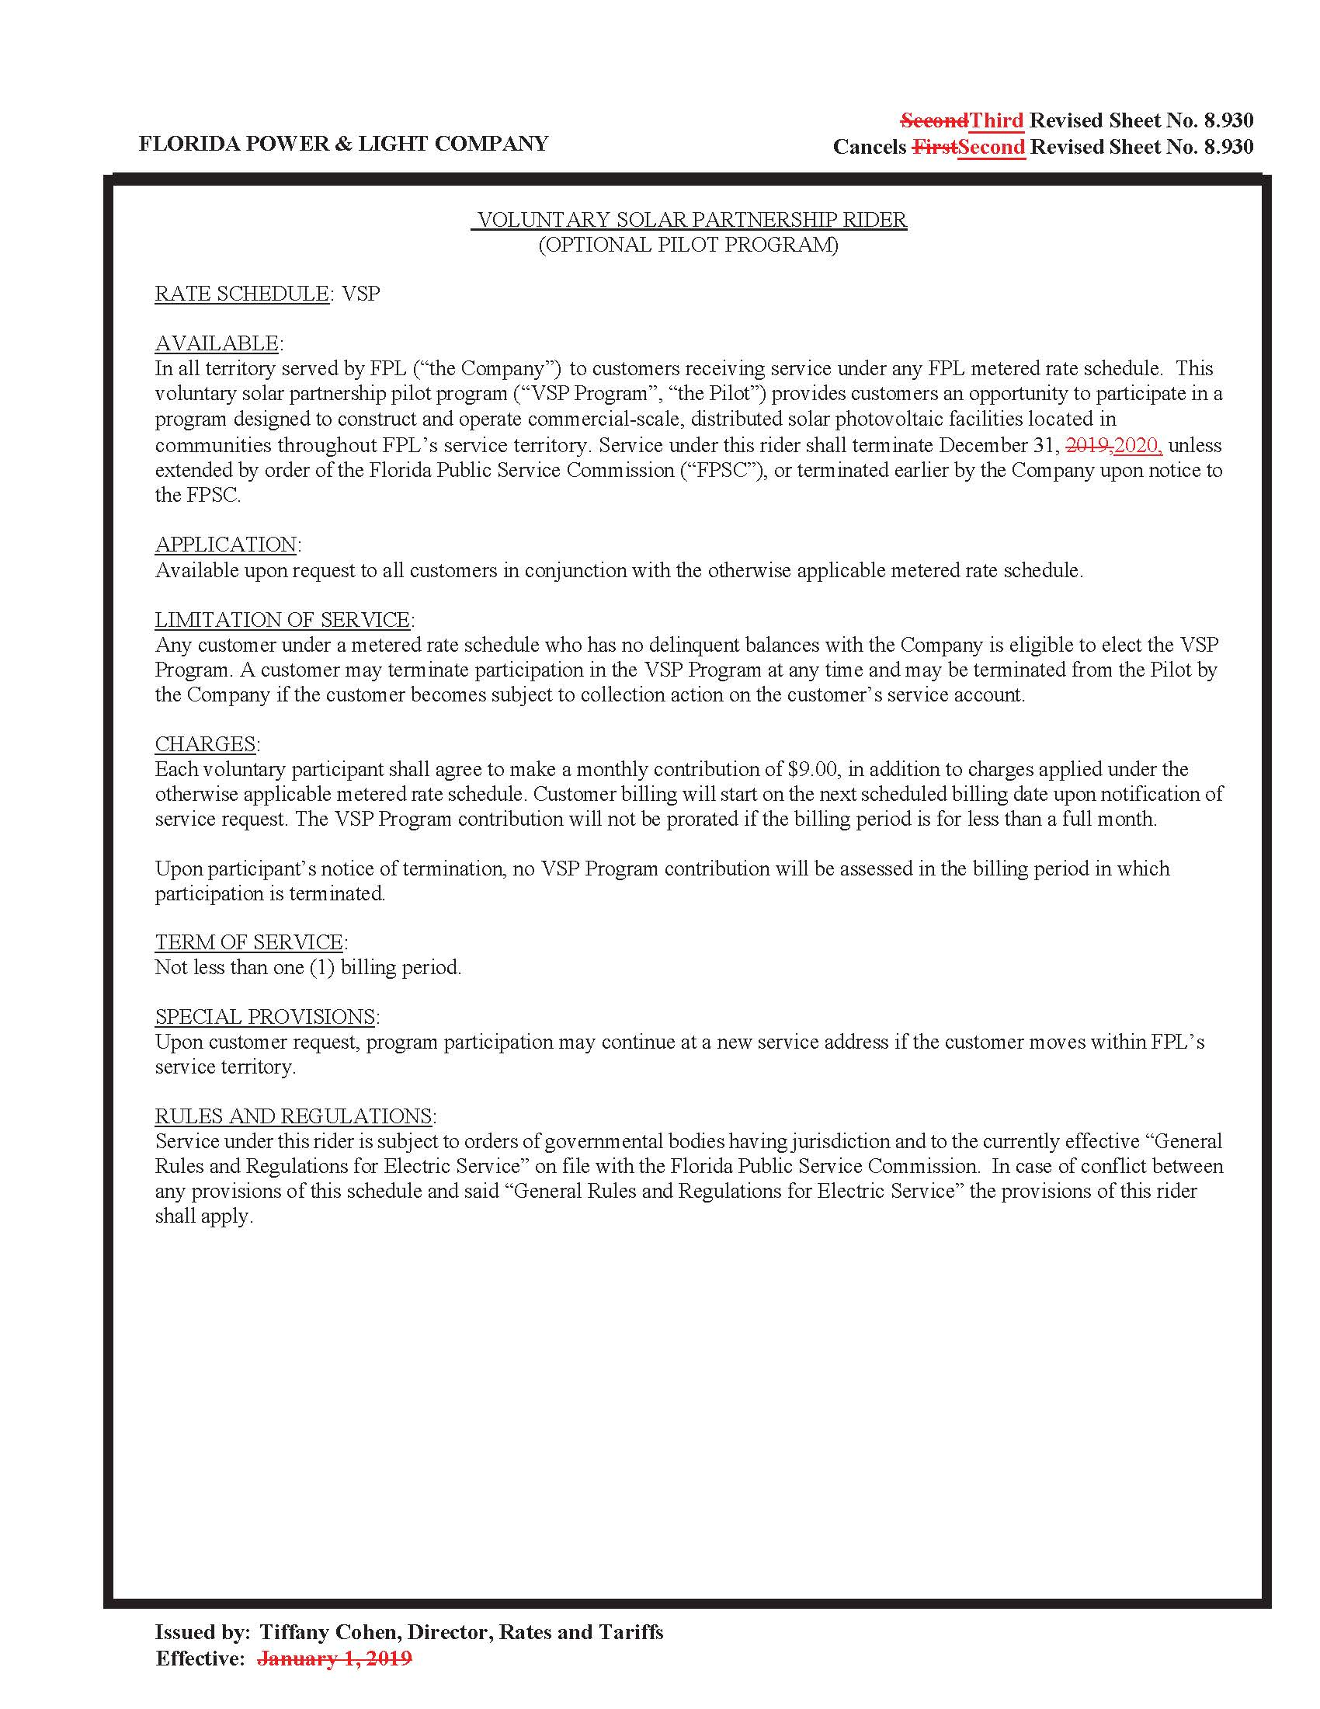

Order No. PSC-14-0468-TRF-EI, issued August 29, 2014, in Docket No. 20140070-EI, In re: Petition for approval of voluntary solar partnership pilot program and tariff, by Florida Power & Light Company.
Order No. PSC-2017-0499-TRF-EI, issued December 29, 2017, in Docket No. 20170212-EI, In re: Petition for one-year extension of voluntary solar partnership rider and program, by Florida Power & Light Company.
Order No. PSC-2018-0581-TRF-EI, issued December 17, 2018, in Docket No. 20180160-EI, In re: Petition for 12-month extension of voluntary solar partnership rider and program, by Florida Power & Light Company.
Document No. 03066-2019, filed March 13, 2019, in Docket No. 20190061-EI, In re: Petition for approval of FPL SolarTogether program and tariff, by Florida Power & Light Company.
Amounts reflect actuals through August 2019 and forecasted data for September 2019 – December 2019. See FPL’s response to staff’s first data request, No. 2. (DN 09789-2019).
$5,231,000-$4,670,000+$85,000= $646,000.
FPL provided a listing of all completed and planned solar projects not previously identified in response to staff’s first data request, No. 1. (DN 09789-2019).

