BEFORE THE FLORIDA PUBLIC SERVICE COMMISSION

In re: Petition for approval of twelve-month extension of voluntary solar partnership rider and program, by Florida Power & Light Company. | DOCKET NO. 20190190-EI  ORDER NO. PSC-2019-0544-TRF-EI  ISSUED: December 20, 2019

The following Commissioners participated in the disposition of this matter:

ART GRAHAM, Chairman
JULIE I. BROWN
DONALD J. POLMANN
GARY F. CLARK
ANDREW GILES FAY

ORDER APPROVING VOLUNTARY SOLAR PARTNERSHIP EXTENSION

BY THE COMMISSION:

Background
On October 7, 2019, Florida Power & Light Company (FPL) filed a petition for a one-year extension of its Voluntary Solar Partnership (VSP) pilot program and associated tariff. The VSP program was first approved in 2014 (2014 Order) as a pilot with a termination date of December 31, 2017. The VSP pilot program offers all FPL customers an opportunity, for $9 per month, to participate in a voluntary program designed to fully-fund the construction and operation of solar photovoltaic generation facilities. These solar facilities are located in communities throughout FPL’s service territory. FPL markets the VSP pilot program to customers as FPL SolarNow. Customers may enroll or cancel at any time.

In 2017, we approved a one-year extension to allow FPL to gather additional data regarding the durability of customer interest over a more substantial period. In 2018, we approved an additional one-year extension to allow FPL to complete and evaluate research regarding how the VSP pilot program and a community shared solar program, scheduled to be filed in 2019, may impact one another. On March 13, 2019, FPL filed a petition for approval of the community shared solar program and tariff, known as SolarTogether.

Since we are not scheduled to make a decision regarding SolarTogether until 2020, FPL is requesting an additional one-year extension to the VSP pilot program. This additional extension will allow FPL to assess and evaluate the potential overlap in customer interest for the two programs, if SolarTogether is approved by this Commission. FPL’s proposed VSP tariff revision, as shown in Attachment A, changes the termination date for service under the VSP pilot program from December 31, 2019, to December 31, 2020.

FPL waived the 60-day file and suspend provision of Section 366.06(3), Florida Statutes (F.S.), until the December 10, 2019 Agenda Conference. During the evaluation of the petition, Commission staff issued data requests to FPL for which responses were filed on October 29, November 4, and November 14, 2019. We have jurisdiction over this matter pursuant to Sections 366.05, 366.06, and 366.075, F.S.

Decision

VSP Pilot Program Description

The VSP pilot program is designed to be fully-funded by customers who contribute on a voluntary basis. Participants contribute to the revenue requirement associated with constructing and operating solar structures. The revenue requirement includes a return, depreciation, operations and maintenance expenses, and other costs such as property taxes and insurance. As required by the 2014 Order, marketing and administrative expenses are capped at 20 percent of participant contributions. FPL has met this requirement each year since the VSP pilot program’s inception.
Since 2016, FPL has demonstrated that the revenues received under the VSP pilot program exceed the revenue requirement of the solar facilities. FPL projects that the 2019 voluntary customer contributions will total $5,231,000 by end-of-year, while the 2019 revenue requirement for the VSP pilot program will total $4,670,000 by end-of-year. The electricity generated by the solar facilities displaces fuel that otherwise would have been used for generation, resulting in avoided fuel costs. FPL calculated the 2019 fuel savings to be $85,000, resulting in a positive net impact to all customers of $646,000.
As discussed in the 2014 Order, FPL sizes the VSP pilot program’s solar projects based on the level of participation. As of August 31, 2019, FPL has installed 145 solar structures at 63 locations for a total of 2,325 direct current kilowatts (kW) of solar capacity. An additional 15 solar structures are under construction. FPL stated that the completed and planned solar structures comprise a diverse set of assets, including ground-mount structures, rooftop installations, covered walkways, parking canopies, and tree-like structures. These projects are located in public areas, such as parks, zoos, schools, museums, and transportation hubs. The installation size of the structures ranges from two kW to 250 kW. In response to Commission staff’s first data request, No. 7, FPL stated it will not pursue any additional construction until we have reached a decision regarding SolarTogether, aside from the 15 solar structures already under construction or ready for construction.
Table 1 shows the total number of customers participating in the VSP pilot program for the period May 2015 through May 2019. As of May 2019, there were a total of 54,846 participants, a 58 percent increase from May 2018.

Table 1
VSP Participants
 | Residential | Commercial | Total Participants
May 2015 | 155 | 1 | 156
May 2016 | 3,043 | 27 | 3,070
May 2017 | 19,226 | 83 | 19,309
May 2018 | 31,177 | 638 | 34,646
May 2019 | 54,221 | 625 | 54,846
Source: FPL response to Commission staff’s first data request, No. 4.

SolarTogether

In March 2019, FPL petitioned this Commission for approval of the SolarTogether program and associated tariff. The matter was originally set for an administrative hearing on October 15-16, 2019. However, in response to a motion for continuance, the matter is now set for a hearing on January 14-16, 2020.
FPL states that until we issue a ruling on the SolarTogether program, it cannot complete an assessment regarding the VSP pilot program and SolarTogether. Therefore, FPL states that until it can complete an assessment regarding the two programs, providing any recommendation regarding the future of the VSP pilot program would be premature. In response to Commission staff’s first data request, FPL stated it had three tasks for a comprehensive assessment of the two programs: (1) gather information about those interested in SolarTogether; (2) determine if there is an overlap in those interested in the two programs; and (3) determine if the overlap will have an impact on the VSP pilot program. Among other things, the SolarTogether program differs from the VSP pilot program in that it would provide participants with direct credits on their electric bill associated with energy generated by the subscribed blocks of solar capacity.

Conclusion

We agree that, pending our decision regarding SolarTogether, a one-year extension will allow FPL to evaluate the two programs and any potential overlaps in customer interest. Therefore, we hereby approve the one-year extension of the VSP pilot program and tariff. The revised tariff, as shown in Attachment A, shall be effective January 1 to December 31, 2020. Prior to the expiration of the VSP pilot program, FPL shall petition this Commission regarding the future status of the VSP pilot program.

Based on the foregoing, it is

ORDERED by the Florida Public Service Commission that the one-year extension of Florida Power & Light Company’s VSP pilot program is hereby approved. It is further

ORDERED that the revised tariff, as shown in Attachment A, shall be effective January 1 to December 31, 2020. It is further

ORDERED that prior to the expiration of the VSP pilot program, Florida Power & Light Company shall petition this Commission regarding the future of the VSP pilot program. It is further

ORDERED that if a protest is filed within 21 days of issuance of this Order, the tariff shall remain in effect with any charges held subject to refund pending resolution of the protest. It is further

ORDERED that if no timely protest is filed, this docket shall be closed upon the issuance of a Consummating Order.
By ORDER of the Florida Public Service Commission this 20th day of December, 2019.

/s/ Adam J. Teitzman
ADAM J. TEITZMAN
Commission Clerk
Florida Public Service Commission
2540 Shumard Oak Boulevard
Tallahassee, Florida 32399
(850) 413-6770
www.floridapsc.com

Copies furnished: A copy of this document is provided to the parties of record at the time of issuance and, if applicable, interested persons.

KBS

NOTICE OF FURTHER PROCEEDINGS

The Florida Public Service Commission is required by Section 120.569(1), Florida Statutes, to notify parties of any administrative hearing or judicial review of Commission orders that is available under Sections 120.57 or 120.68, Florida Statutes, as well as the procedures and time limits that apply. This notice should not be construed to mean all requests for an administrative hearing or judicial review will be granted or result in the relief sought.

Mediation may be available on a case-by-case basis. If mediation is conducted, it does not affect a substantially interested person's right to a hearing.

The Commission's decision on this tariff is interim in nature and will become final, unless a person whose substantial interests are affected by the proposed action files a petition for a formal proceeding, in the form provided by Rule 28-106.201, Florida Administrative Code. This petition must be received by the Office of Commission Clerk, 2540 Shumard Oak Boulevard, Tallahassee, Florida 32399-0850, by the close of business on January 10, 2020. In the absence of such a petition, this Order shall become final and effective upon the issuance of a Consummating Order. Any objection or protest filed in this docket before the issuance date of this Order is considered abandoned unless it satisfies the foregoing conditions and is renewed within the specified protest period.

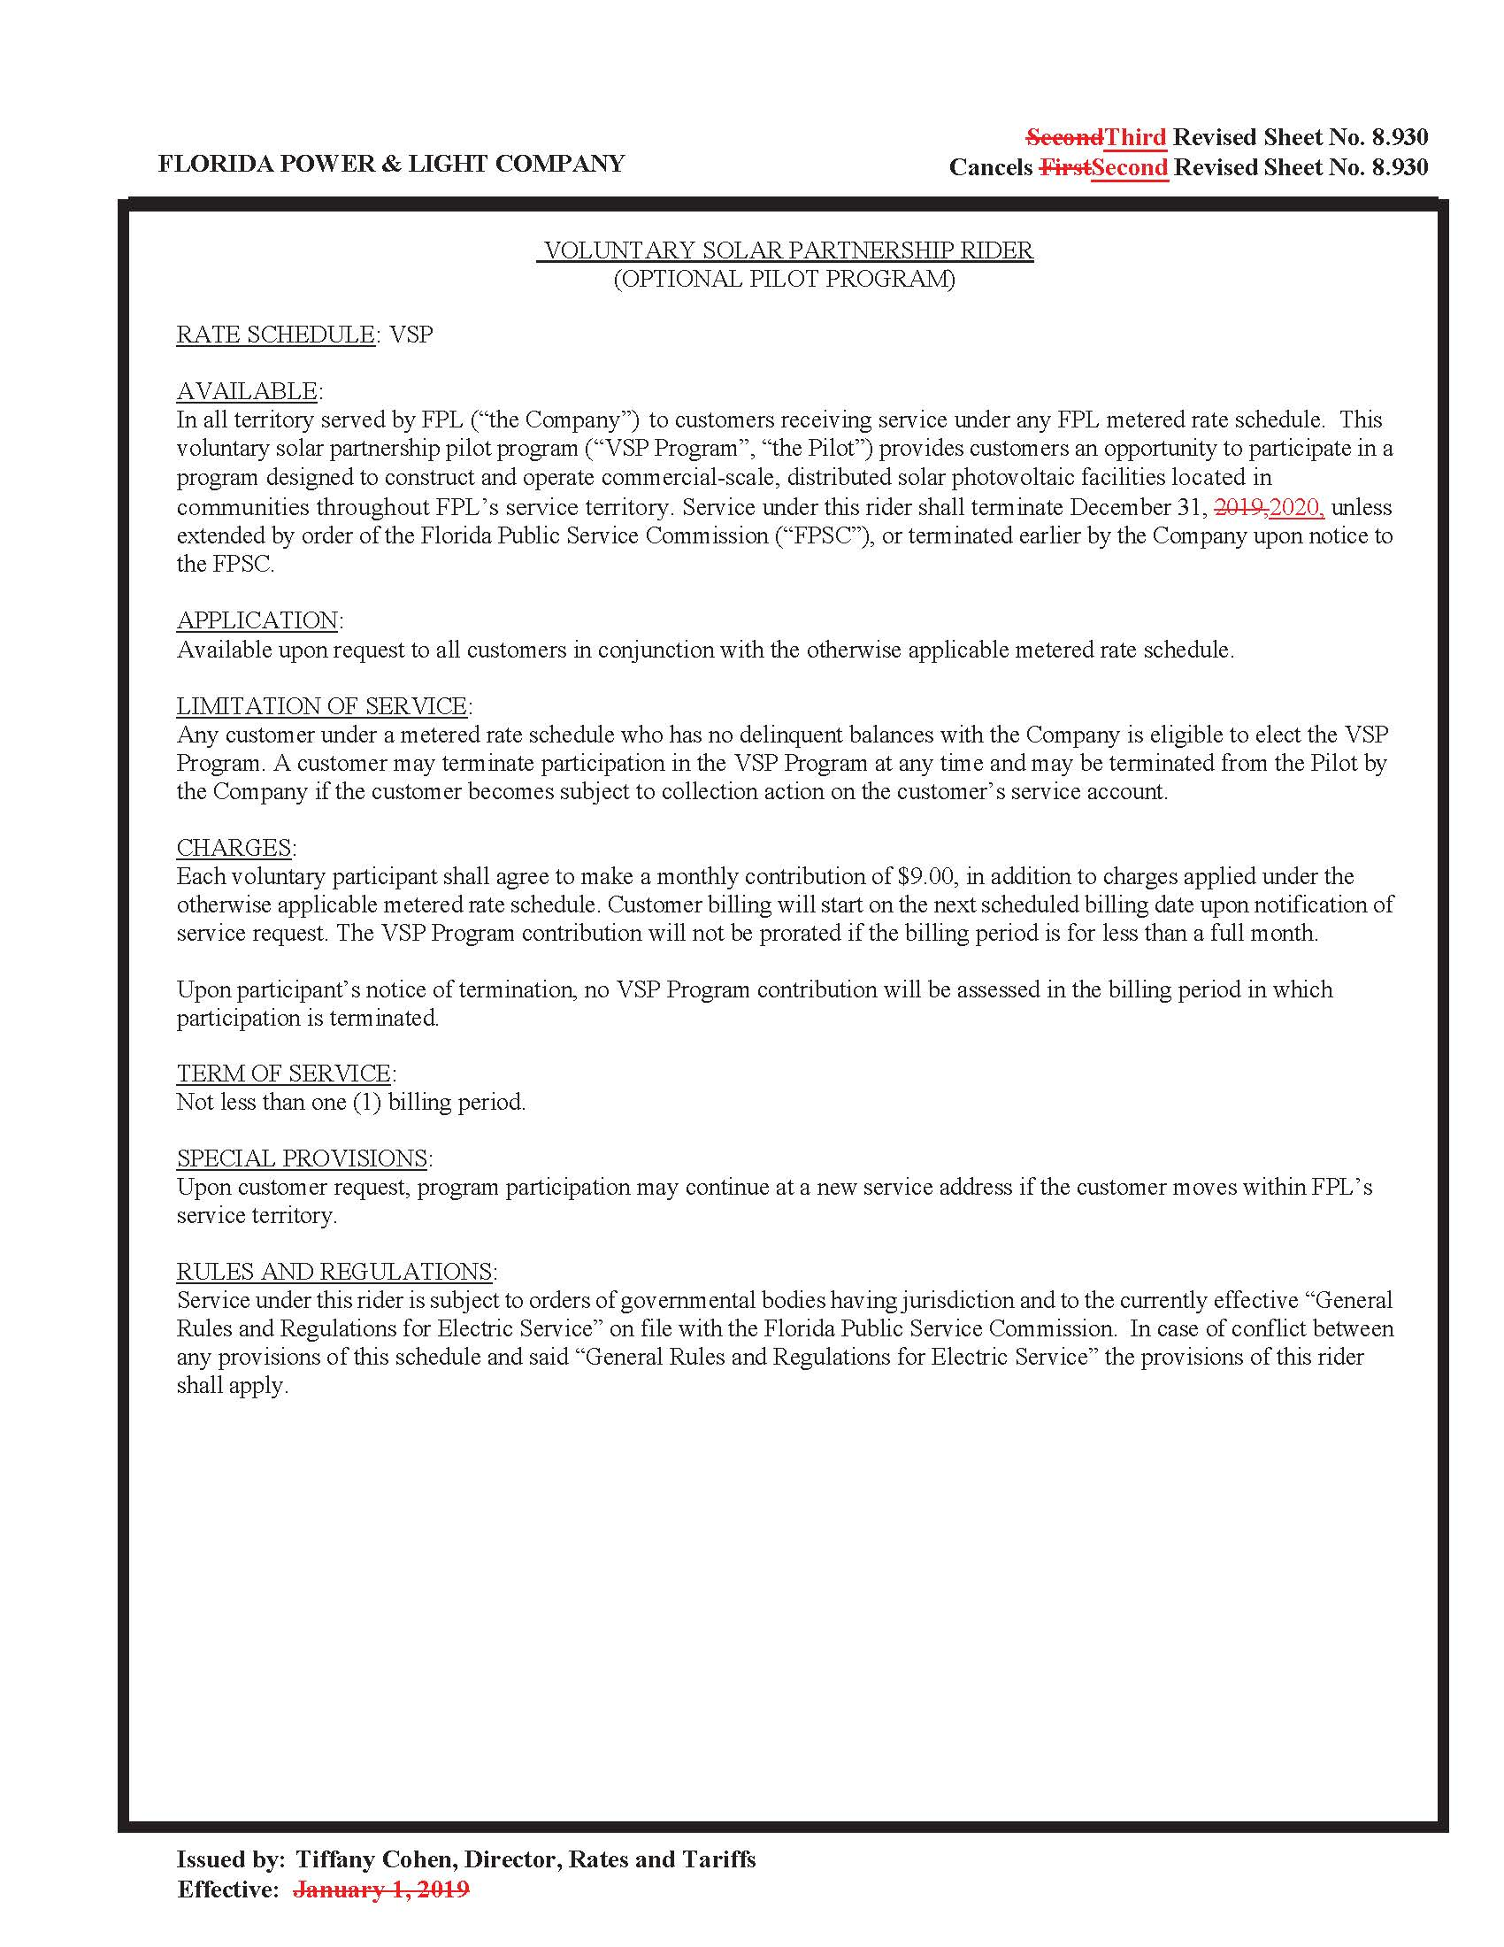

Order No. PSC-14-0468-TRF-EI, issued August 29, 2014, in Docket No. 20140070-EI, In re: Petition for approval of voluntary solar partnership pilot program and tariff, by Florida Power & Light Company.
Order No. PSC-2017-0499-TRF-EI, issued December 29, 2017, in Docket No. 20170212-EI, In re: Petition for one-year extension of voluntary solar partnership rider and program, by Florida Power & Light Company.
Order No. PSC-2018-0581-TRF-EI, issued December 17, 2018, in Docket No. 20180160-EI, In re: Petition for 12-month extension of voluntary solar partnership rider and program, by Florida Power & Light Company.
Document No. 03066-2019, filed March 13, 2019, in Docket No. 20190061-EI, In re: Petition for approval of FPL SolarTogether program and tariff, by Florida Power & Light Company.
Amounts reflect actuals through August 2019 and forecasted data for September 2019 – December 2019. See FPL’s response to Commission staff’s first data request, No. 2 (DN 09789-2019).
$5,231,000-$4,670,000+$85,000= $646,000.
In response to Commission staff’s first data request, No. 1, FPL provided a listing of all completed and planned solar projects not previously identified (DN 09789-2019).
Id. at 4.

