BEFORE THE FLORIDA PUBLIC SERVICE COMMISSION

In re: Joint petition for approval of restructures Nassau County agreements to reflect Callahan expansion, by Peoples Gas System, Florida Public Utilities Company, SeaCoast Gas Transmission, and Peninsula Pipeline Company, Inc. | DOCKET NO. 20190145-GU  ORDER NO. PSC-2019-0545-PAA-GU  ISSUED: December 20, 2019

The following Commissioners participated in the disposition of this matter:

ART GRAHAM, Chairman
JULIE I. BROWN
DONALD J. POLMANN
GARY F. CLARK
ANDREW GILES FAY

NOTICE OF PROPOSED AGENCY ACTION
ORDER APPROVING RESTRUCTURED NASSAU COUNTY
AGREEMENTS TO REFLECT CALLAHAN EXPANSION

BY THE COMMISSION:

NOTICE is hereby given by the Florida Public Service Commission (Commission) that the action discussed herein is preliminary in nature and will become final unless a person whose interests are substantially affected files a petition for a formal proceeding, pursuant to Rule 25-22.029, Florida Administrative Code (F.A.C.).

Background
On July 19, 2019, Florida Public Utilities Company (FPUC), Peoples Gas System (Peoples), Peninsula Pipeline Company, Inc. (Peninsula), and SeaCoast Gas Transmission, LLC, (SeaCoast) (collectively, the joint petitioners), filed a petition seeking approval of restructured Nassau County transportation agreements to reflect the new Callahan intrastate pipeline (Callahan pipeline). The Callahan pipeline, which is currently under construction, will allow the joint petitioners to expand natural gas service in Nassau and Duval counties in Northeast Florida.

FPUC and Peoples are local distribution companies (LDCs) which own and operate natural gas distribution facilities to serve retail customers and are subject to our jurisdiction under Chapter 366, Florida Statutes (F.S.). Peninsula and SeaCoast operate as intrastate natural gas transmission companies as defined in Section 368.103, F.S., and only transport natural gas.

In Order No. PSC-07-1012-TRF-GP, Peninsula received approval of an intrastate gas pipeline tariff that allows it to construct and operate intrastate pipeline facilities and to actively pursue agreements with gas customers and enter into certain gas transmission agreements without prior approval. However, since both Peninsula and FPUC are subsidiaries of Chesapeake Utilities Corporation, any agreements between the affiliates require our approval pursuant to Section 368.105, F.S., and Order No. PSC-07-1012-TRF-GP.
Similarly to Peninsula, in Order No. PSC-08-0747-TRF-GP, SeaCoast received approval of an intrastate gas pipeline tariff that allows it to construct and operate intrastate pipeline facilities and to actively pursue agreements with gas customers and enter into certain gas transmission agreements without prior approval. However, SeaCoast and Peoples are affiliates in that their parent company is TECO Energy, Inc. and, therefore, their agreements must be approved by this Commission.

The joint petitioners’ plans for the provision of natural gas service to residents in Nassau and Duval counties were previously addressed by this Commission in Order No. PSC-12-0230-PAA-GU. Specifically, in 2012, we approved a Nassau-Duval County territorial agreement between FPUC and Peoples. The Nassau-Duval County territorial agreement provides that Peoples’ service area includes Duval County and the WestRock facility (formerly known as RockTenn), a large paper mill on the northern tip of Amelia Island, while FPUC’s service area is Nassau County.
In the same 2012 order, we approved transportation service agreements between Peninsula and FPUC and between Peninsula and Peoples. The 2012 transportation agreements were needed in order to allow FPUC to serve Nassau County by transporting natural gas from Peoples’ existing interconnection with the Florida Gas Transmission Company (FGT) interstate pipeline through Peoples’ pipeline into the Fernandina Beach Line. The Fernandina Beach Line was jointly constructed in 2012 by Peoples and Peninsula.
The joint petitioners explained that since 2012, Nassau and Duval counties have experienced significant growth and, therefore, they jointly developed the proposed plan to bring additional natural gas capacity into the area. Furthermore, the joint petitioners stated that the existing Fernandina Beach Line is approaching full capacity and Peoples is experiencing pressure concerns in northern Duval County and has commitments for new customers. The joint petitioners state that the proposed agreements do not impact the 2012 Commission-approved Nassau-Duval County territorial agreement.
In the instant petition, the joint petitioners are seeking approval of: (1) a new firm transportation service agreement between SeaCoast and Peoples; (2) an amendment to Peninsula and FPUC’s 2012 firm transportation service agreement; and (3) cancellation of Peninsula and Peoples’ 2012, and amended in 2015, firm transportation service agreement. During the evaluation of the instant petition, Commission staff issued a data request to the joint petitioners for which responses were received on October 10, 2019. On November 6, 2019, an informal meeting was held with the joint petitioners. We have jurisdiction over this matter pursuant to Sections 366.04, 366.05(1), 366.06, and 368.105, F.S.

Decision
New Firm Transportation Service Agreement Between Peoples and SeaCoast

The new 16-inch steel Callahan pipeline is being constructed to allow FPUC and Peoples to expand natural gas service in Nassau and Duval counties. The construction of the Callahan pipeline does not need our approval; however, a description of the Callahan pipeline project is helpful to establish context for the joint petition. Investment and ownership in the Callahan pipeline is split 50/50 between Peninsula and SeaCoast. Peoples and FPUC explained that contracting with the intrastate pipelines to construct and own the Callahan pipeline, as opposed to building it themselves, will avoid the LDCs undertaking the costs and risk for this project, thus protecting their ratepayers. Peoples and FPUC also stated that the intrastate companies are well experienced in permitting, land acquisition, and construction of a project of this size and scope.

The Callahan pipeline will interconnect with the Southern Natural Gas Company, LLC, interstate pipeline (SONAT) in western Nassau County and will extend 26.5 miles eastward and terminate at the existing Fernandina Beach Line. In Attachment A, the Callahan pipeline is shown as the green line and the Fernandina Beach Line is shown as the red line. The joint petitioners explained that since both FPUC and Peoples need additional natural gas quantities in Nassau and Duval counties, the jointly constructed pipeline avoids two companies constructing separate pipelines and, therefore, avoids a duplication of facilities. In addition, the interconnect with SONAT will provide FPUC and Peoples the ability to receive natural gas from a second interstate pipeline. The current interconnect for FPUC and Peoples to receive natural gas in Northeast Florida is with the FGT pipeline.
Since SeaCoast and Peoples are affiliated companies, the proposed agreement requires our approval. Pursuant to the agreement (see Attachment B), SeaCoast will provide firm transportation service for Peoples over its portion of the Callahan pipeline for an initial term of 20 years, with an option to extend for an additional ten years. Peoples will recover its payments to SeaCoast through the Purchased Gas Adjustment (PGA) mechanism and from transportation customers, consistent with prior pipeline projects. The effective date of the agreement is expected to be September 30, 2020, which is the estimated in-service date of the Callahan pipeline.
SeaCoast and Peoples assert that the negotiated reservation charge set forth in the agreement is a cost-based market rate and is designed to allow SeaCoast to recover its costs associated with the Callahan pipeline. Based on the petition and responses to Commission staff’s data request, SeaCoast and Peoples have supported the need of the new Callahan pipeline and associated agreement. The proposed agreement is reasonable, meets the requirements of Section 368.105, F.S., and benefits Peoples’ customers by allowing Peoples to expand natural gas service to new customers and ensure appropriate natural gas pressure for existing customers. Therefore, we hereby approve the agreement between SeaCoast and Peoples.
Amended Firm Transportation Service Agreement Between Peninsula and FPUC
The current Commission-approved transportation service agreement dated February 1, 2012 (2012 agreement), between Peninsula and FPUC allows Peninsula to transport and deliver natural gas to FPUC through Peoples’ distribution system and the Fernandina Beach Line. The negotiated confidential charges contained in the 2012 agreement require FPUC to pay Peninsula for the transportation of the natural gas. Transportation agreements typically include terms such as the Maximum Daily Transportation Quantity (MDTQ), the negotiated monthly reservation charge, and points of delivery. The MDTQ is the largest daily quantity of gas Peninsula is obligated to transport on a firm basis for delivery to FPUC.
Once the Callahan pipeline is in operation, FPUC will no longer need Peninsula to transport natural gas for delivery through Peoples’ distribution system. Instead, Peninsula will transport natural gas for delivery to FPUC across its portion of the Callahan pipeline and the Fernandina Beach Line. FPUC stated that the Callahan pipeline is a large diameter pipe compared to Peoples’ line which allows for natural gas to be delivered at a high pressure. Therefore, Peninsula will be able to deliver increased quantities of natural gas to FPUC.

To reflect the transportation of gas via the Callahan pipeline, Peninsula and FPUC are proposing to amend their 2012 agreement to increase the MDTQ and the corresponding change in the monthly reservation charge. The negotiated monthly reservation charge in the amended agreement is designed to recover Peninsula’s portion of the Callahan project. The amended agreement changes the delivery point from the FGT/Peoples interconnect to the Callahan interconnect with SONAT. In addition, the agreement adds additional points of delivery to FPUC at several locations along the Callahan route in Nassau County. Finally, the initial 15-year term of the 2012 agreement will be extended for 13 years.

The amended agreement only provides for revisions to the first page and Exhibit A to the 2012 agreement. For clarity, the entire 2012 agreement and the amendment to that agreement are included in Attachment C. The proposed amendment is reasonable and benefits FPUC’s customers by allowing FPUC to expand natural gas service in Nassau County. Therefore, we hereby approve the amended agreement between Peninsula and FPUC.

Cancellation of Firm Transportation Service Agreement Between Peninsula and Peoples

In 2012, we approved a gas transportation agreement between Peninsula and Peoples. This agreement allows Peoples to provide transportation service to Peninsula across Peoples’ system (yellow line in Attachment A). Because Peninsula and Peoples negotiated a payment structure not anticipated in Peoples’ tariff, Rule 25-9.034, F.A.C., requires this Commission to approve this special contract. The fixed monthly charge, payable by Peninsula, was designed to recover Peoples’ investment in certain upgrades to its facilities to support Peoples’ transportation of natural gas for Peninsula.

In Order No. PSC-15-0318-PAA-GP, we approved an amendment to the special contract between Peninsula and Peoples. The amendment enabled Peoples to provide Peninsula with incremental transportation service.

The joint petitioners explained that when the Callahan pipeline becomes operational, Peoples will no longer transport natural gas on behalf of Peninsula. Therefore, this contractual obligation becomes obsolete and both parties have agreed to terminate the agreement. While Peoples will no longer receive payments from Peninsula after the agreement is terminated, Peoples stated that it will recover its investment through revenue derived from new growth in St. Johns County and in Duval County. In response to Commission staff’s data request, the joint petitioners stated that the anticipated effective date of the termination of the agreement is September 30, 2020 (the current anticipated in-service date of the Callahan pipeline). Since the existing agreement between Peninsula and Peoples will become obsolete when the Callahan pipeline goes into service, we approve the cancellation of the gas transportation agreement between Peninsula and Peoples.
Based on the foregoing, it is

ORDERED by the Florida Public Service Commission that the new firm transportation service agreement between SeaCoast and Peoples is hereby approved. It is further

ORDERED that the amendment to the 2012 firm transportation service agreement between Peninsula and FPUC is hereby approved. It is further

ORDERED that the cancellation of the firm transportation service agreement between Peninsula and Peoples is hereby approved, effective with the in-service date of the Callahan pipeline. It is further

ORDERED that the provisions of this Order, issued as proposed agency action, shall become final and effective upon the issuance of a Consummating Order unless an appropriate petition, in the form provided by Rule 28-106.201, Florida Administrative Code, is received by the Commission Clerk, 2540 Shumard Oak Boulevard, Tallahassee, Florida 32399-0850, by the close of business on the date set forth in the “Notice of Further Proceedings” attached hereto. It is further

ORDERED that, if a protest is filed within 21 days of the issuance of this Order, this docket shall remain open pending resolution of the protest. If no protest is timely filed, this docket shall be closed upon the issuance of a Consummating Order.

By ORDER of the Florida Public Service Commission this 20th day of December, 2019.

/s/ Adam J. Teitzman
ADAM J. TEITZMAN
Commission Clerk
Florida Public Service Commission
2540 Shumard Oak Boulevard
Tallahassee, Florida 32399
(850) 413-6770
www.floridapsc.com

Copies furnished: A copy of this document is provided to the parties of record at the time of issuance and, if applicable, interested persons.

KBS

NOTICE OF FURTHER PROCEEDINGS OR JUDICIAL REVIEW

The Florida Public Service Commission is required by Section 120.569(1), Florida Statutes, to notify parties of any administrative hearing that is available under Section 120.57, Florida Statutes, as well as the procedures and time limits that apply. This notice should not be construed to mean all requests for an administrative hearing will be granted or result in the relief sought.

Mediation may be available on a case-by-case basis. If mediation is conducted, it does not affect a substantially interested person's right to a hearing.

The action proposed herein is preliminary in nature. Any person whose substantial interests are affected by the action proposed by this Order may file a petition for a formal proceeding, in the form provided by Rule 28-106.201, Florida Administrative Code. This petition must be received by the Office of Commission Clerk, 2540 Shumard Oak Boulevard, Tallahassee, Florida 32399-0850, by the close of business on January 10, 2020. In the absence of such a petition, this Order shall become final and effective upon the issuance of a Consummating Order. Any objection or protest filed in this docket before the issuance date of this Order is considered abandoned unless it satisfies the foregoing conditions and is renewed within the specified protest period.

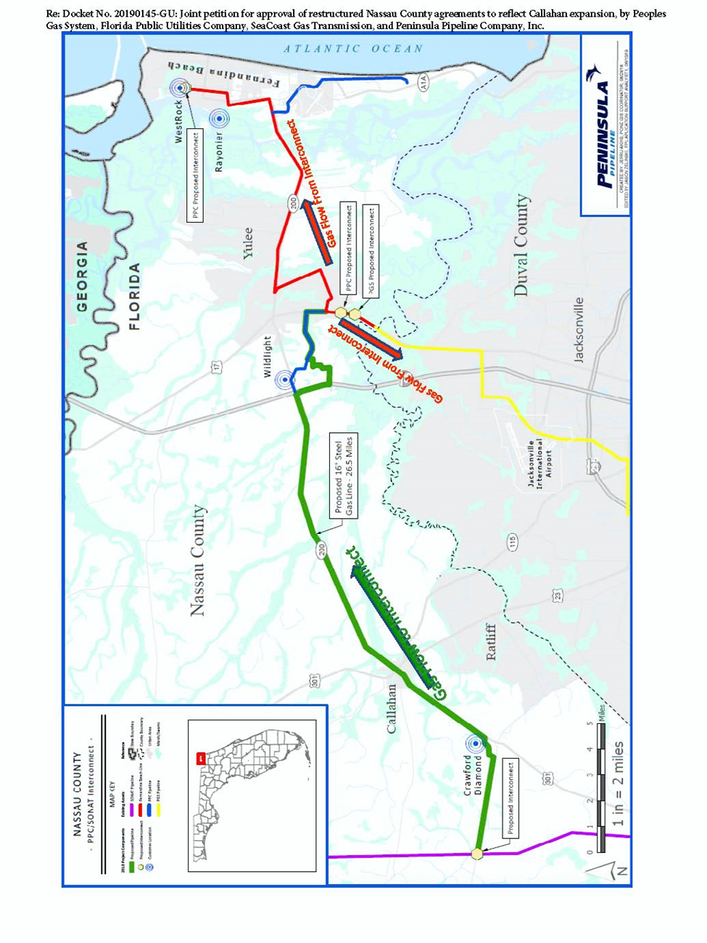

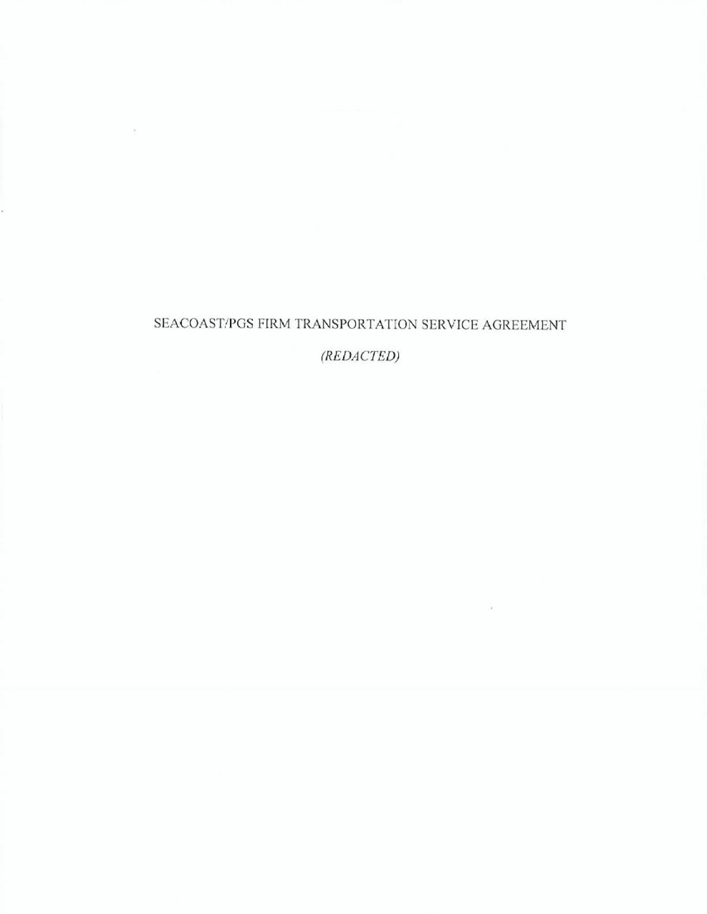

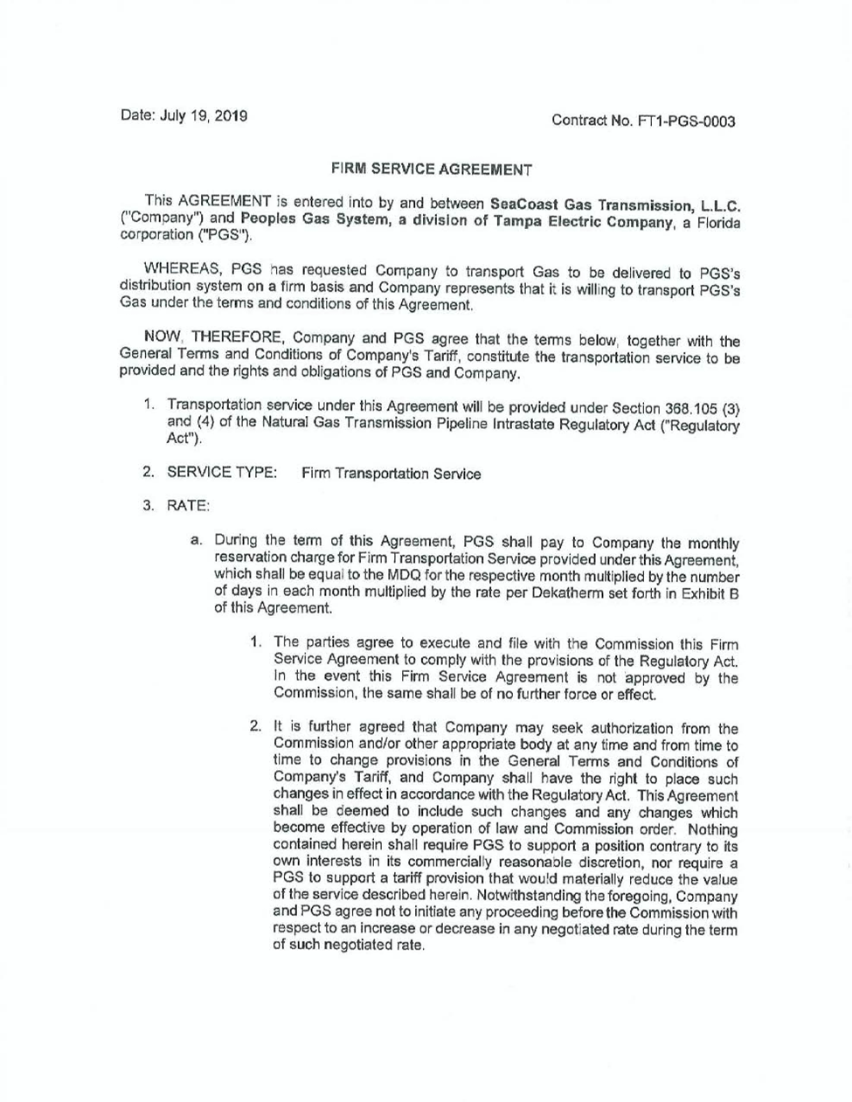

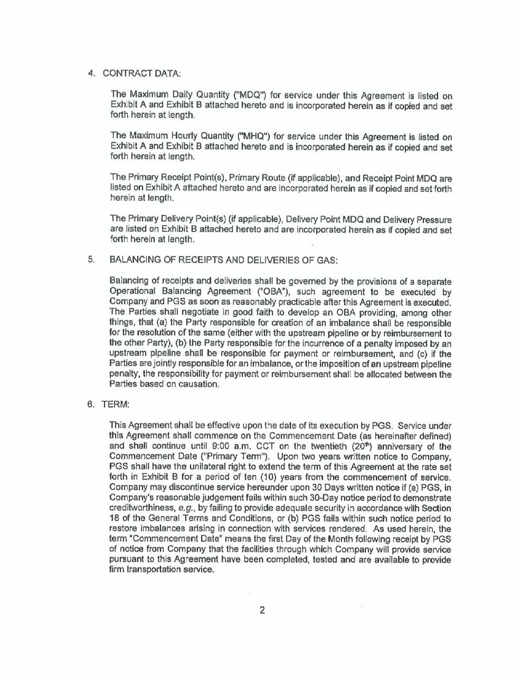

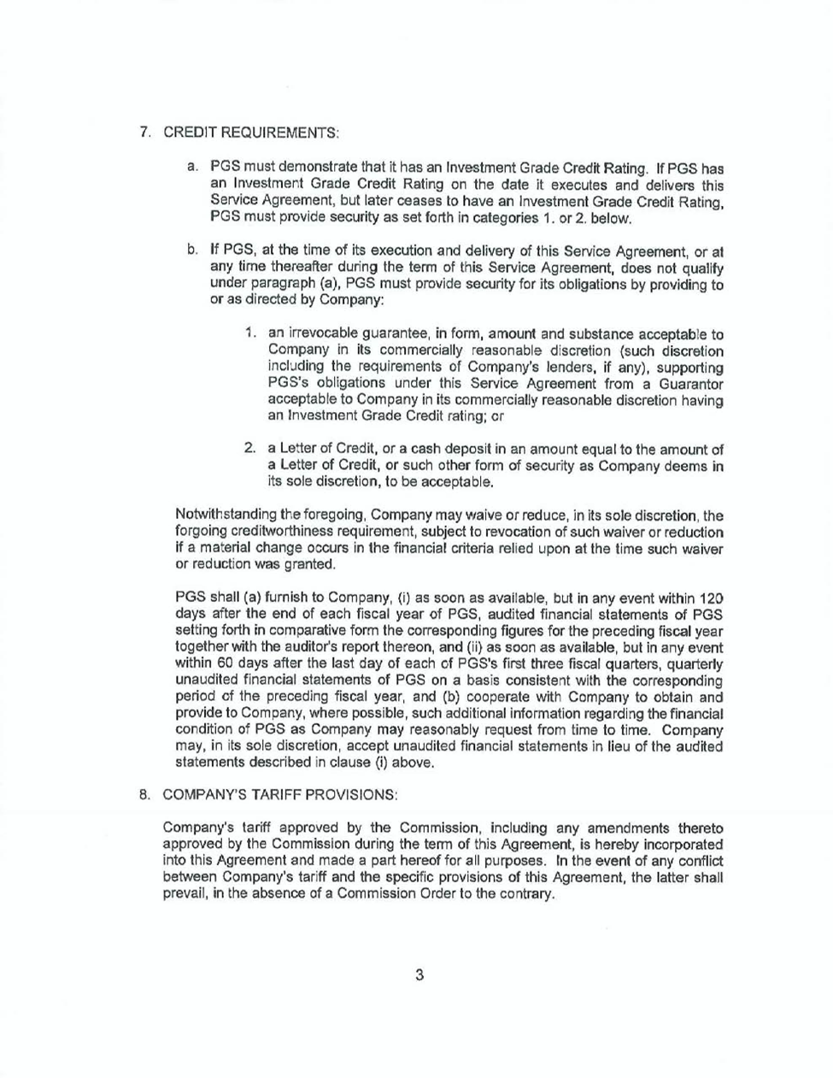
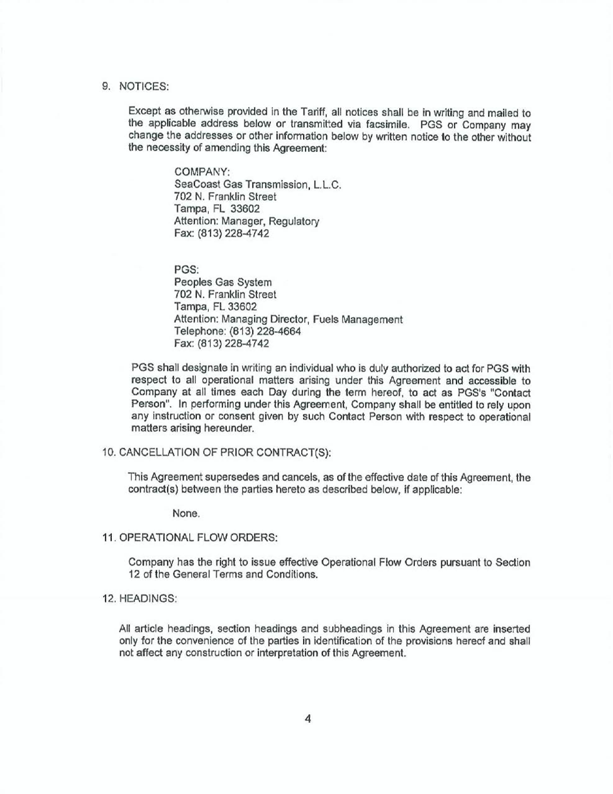

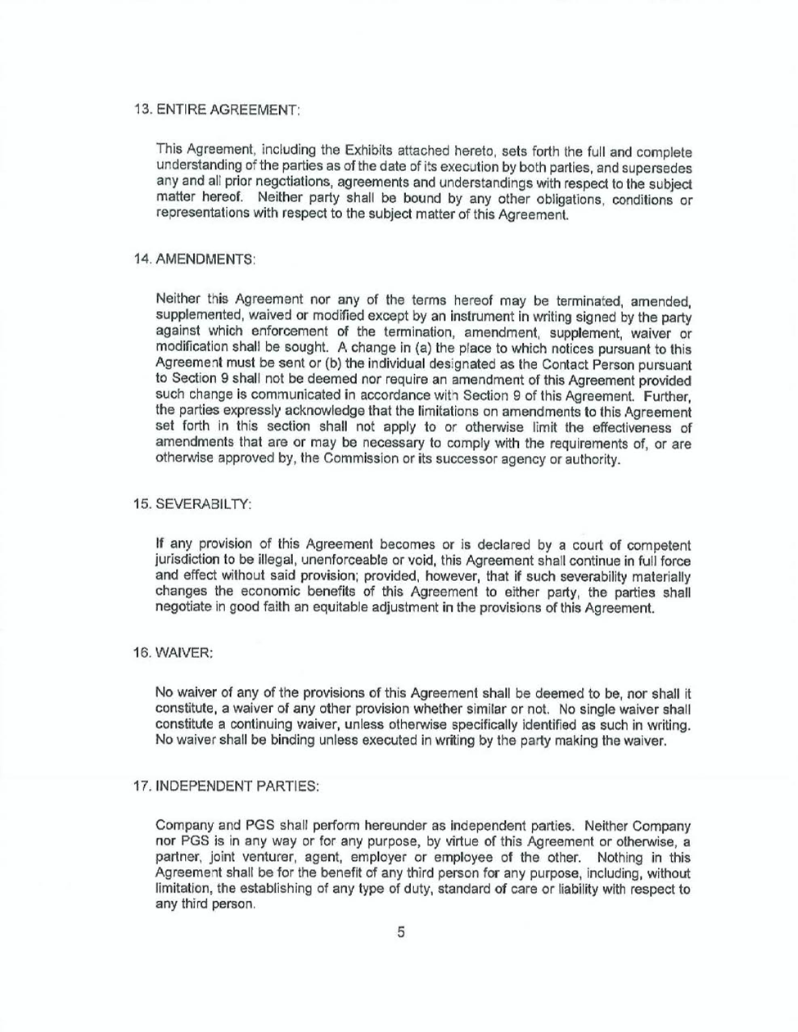
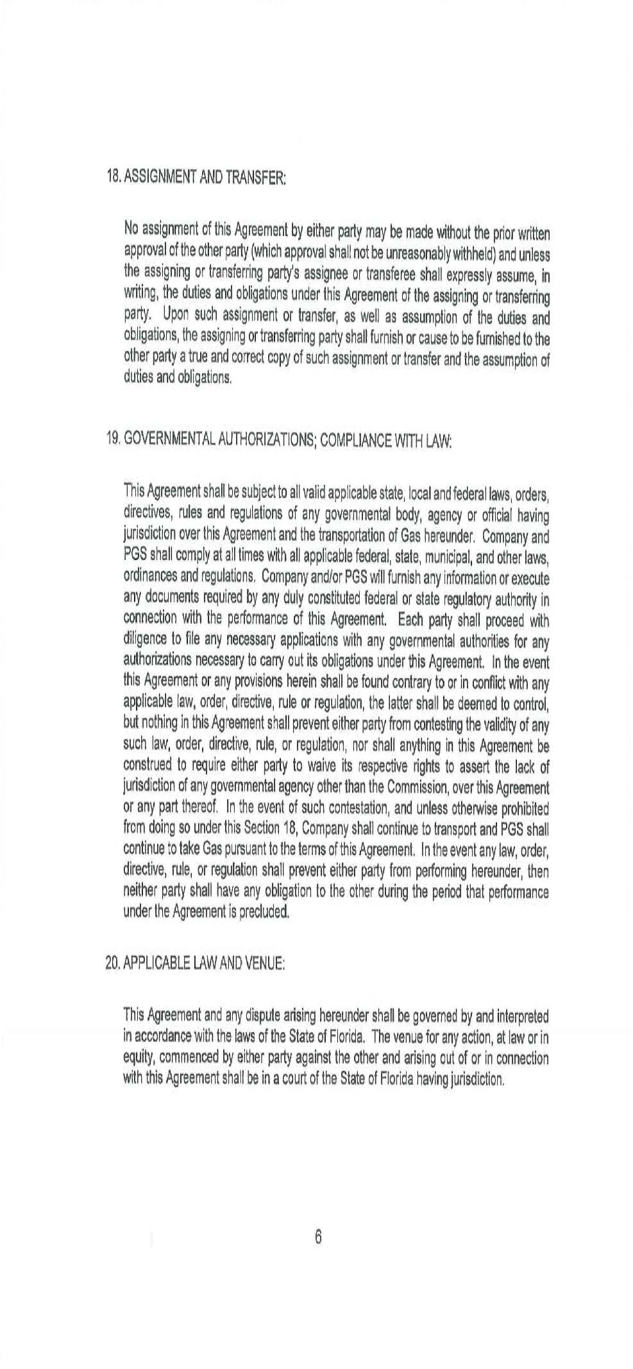

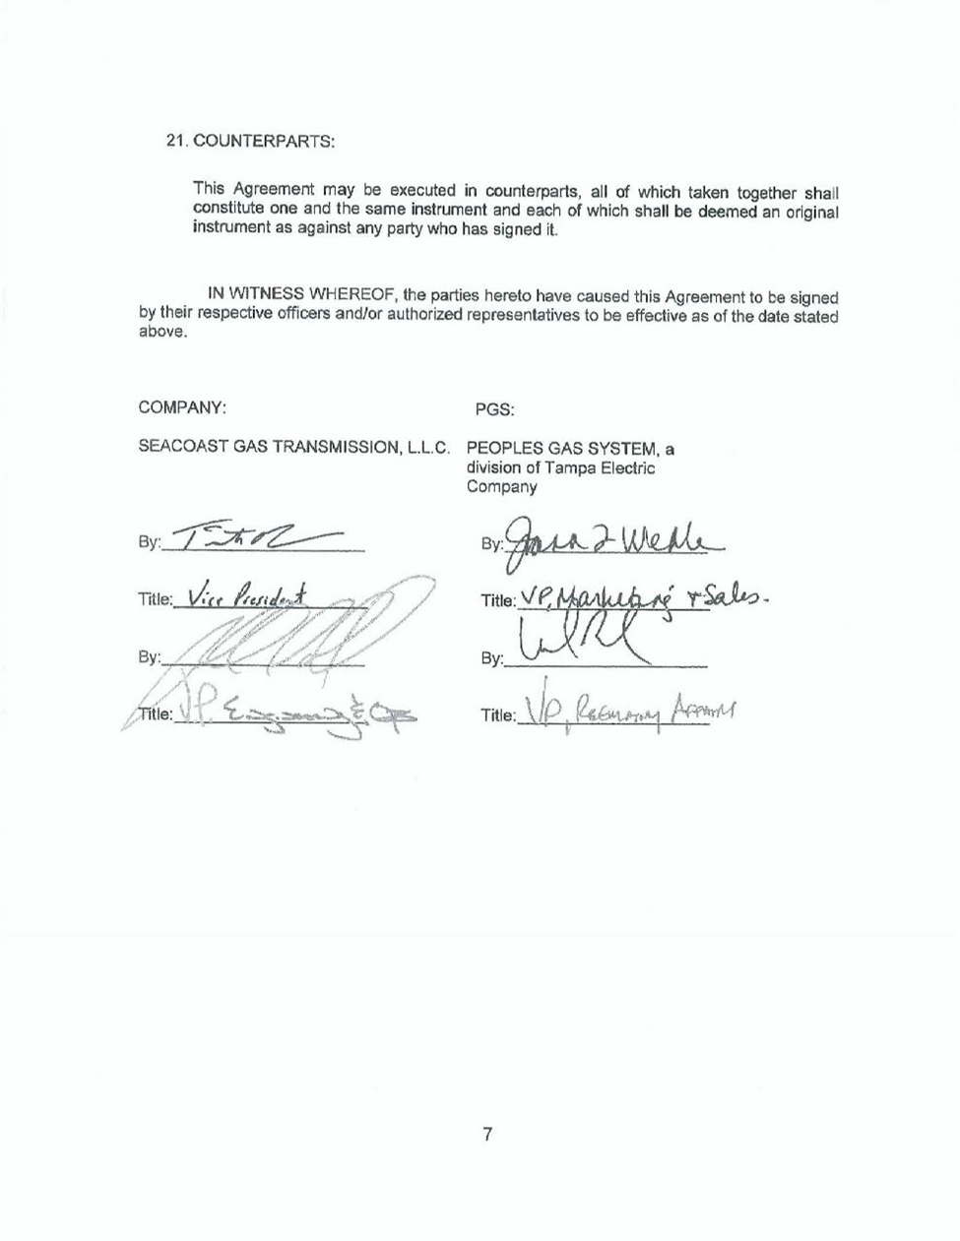
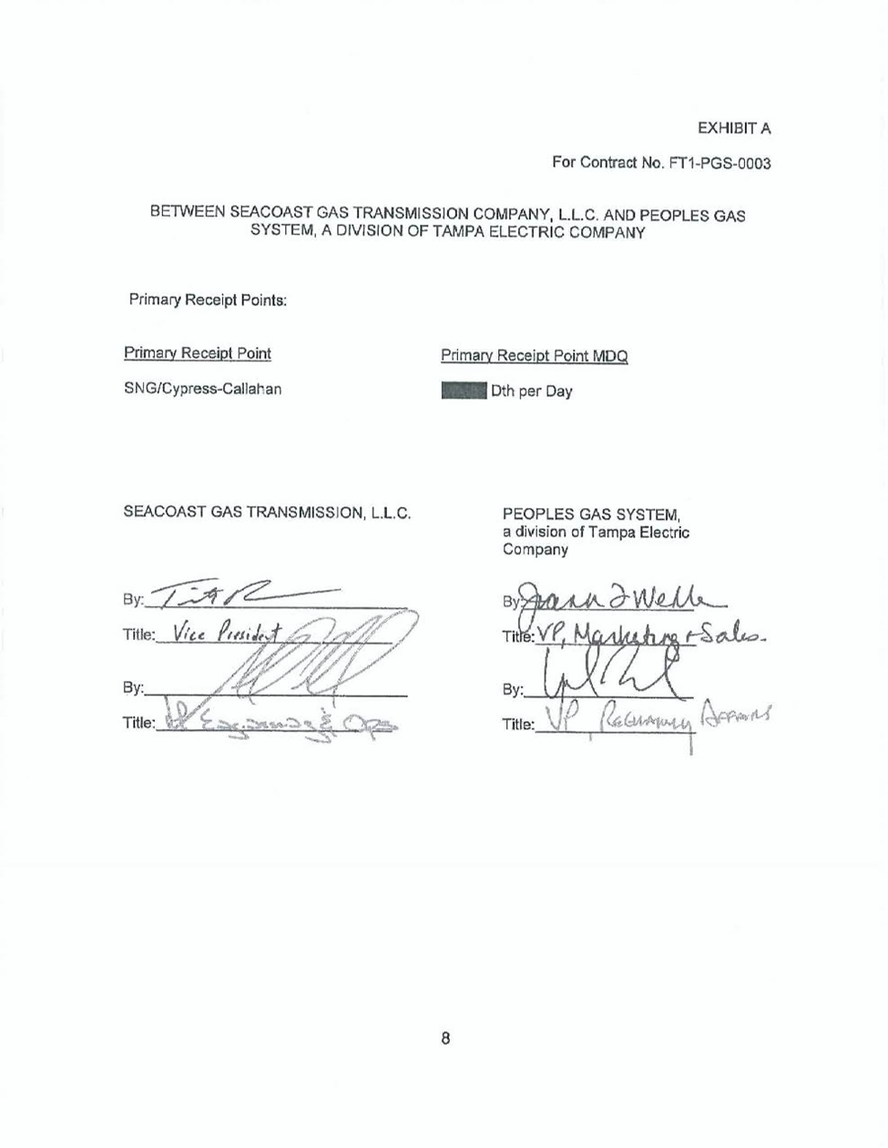

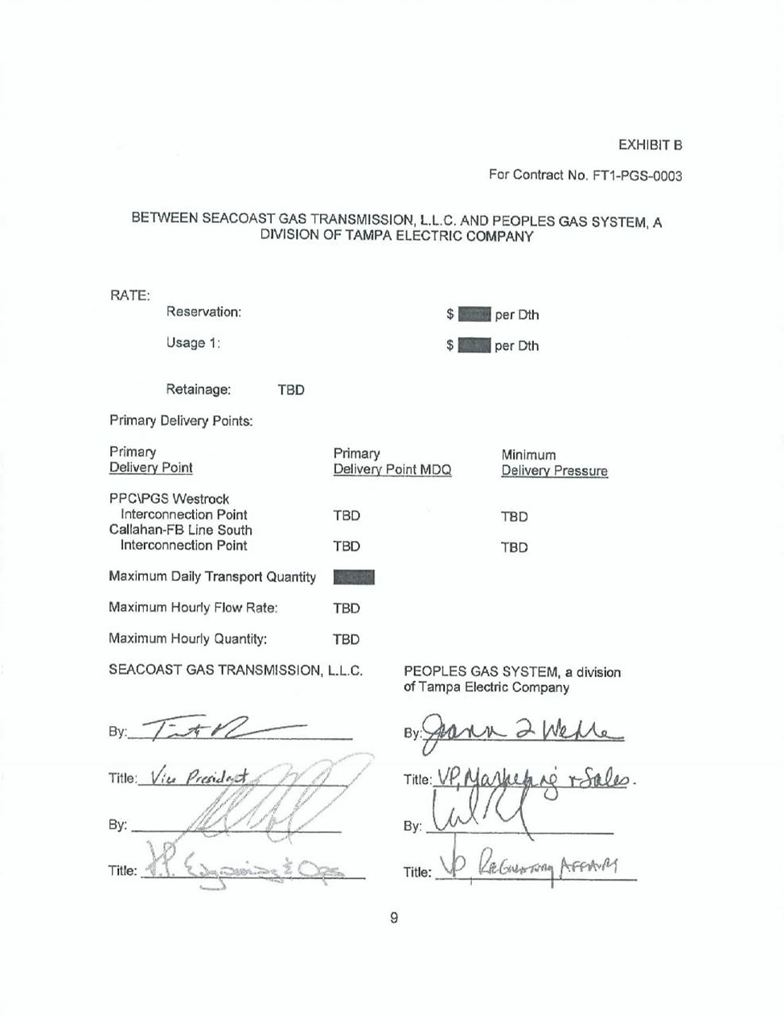
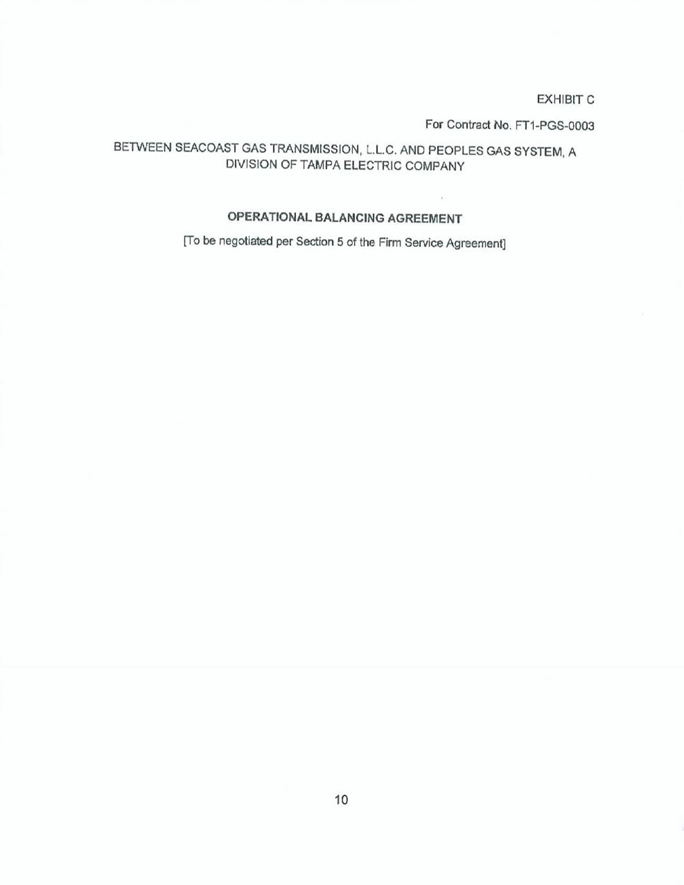

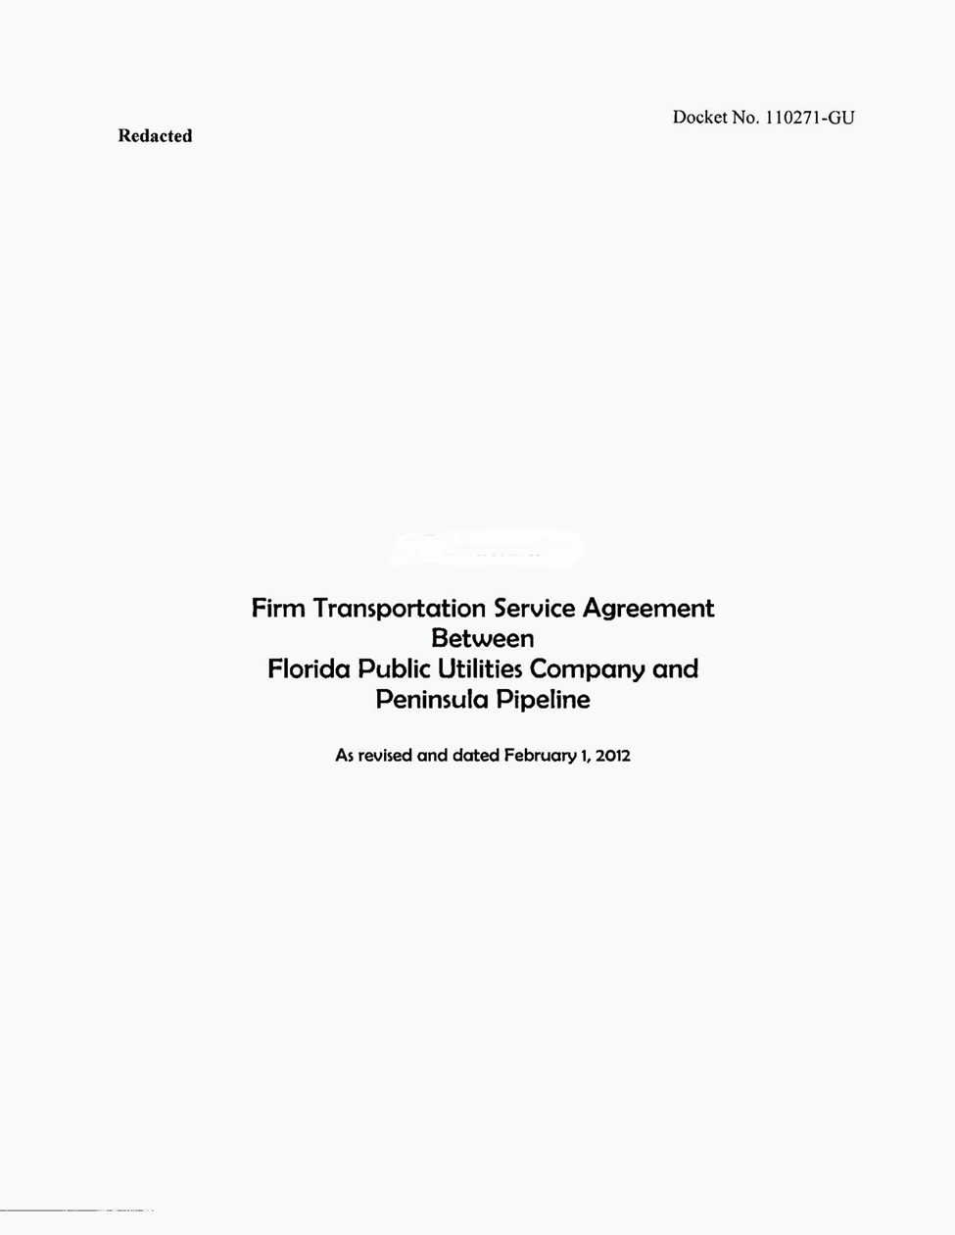
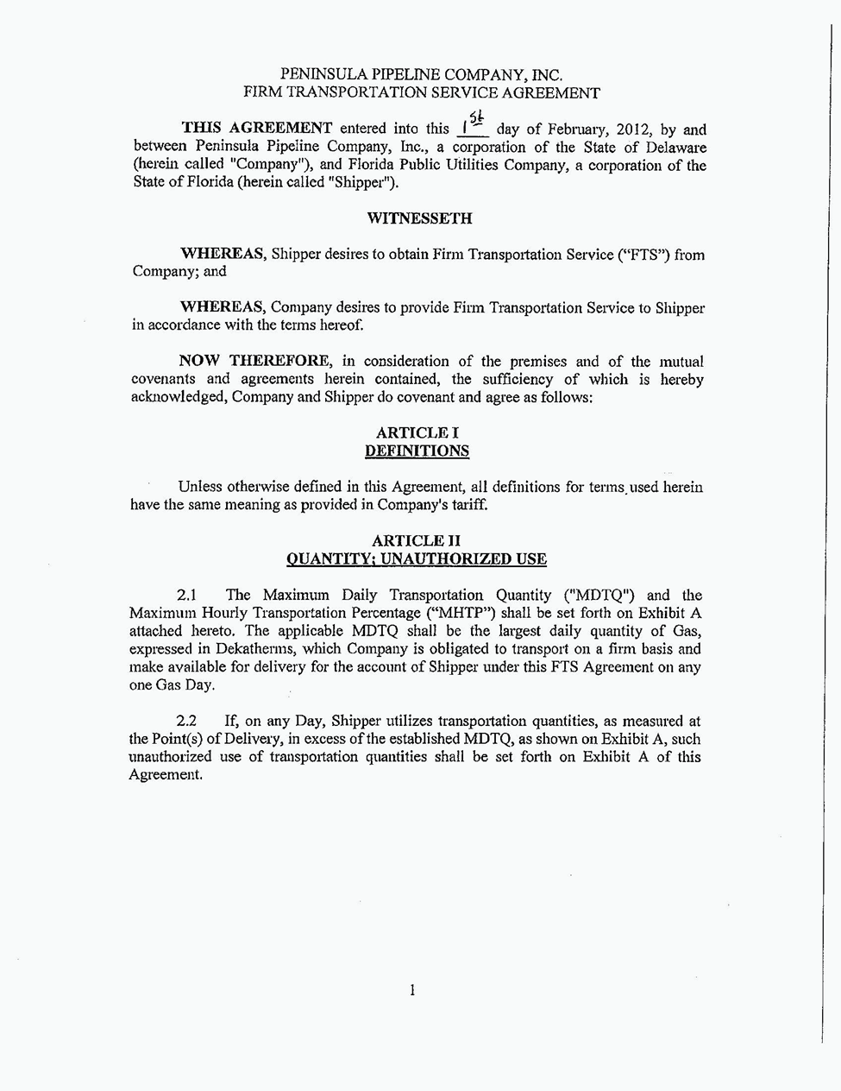

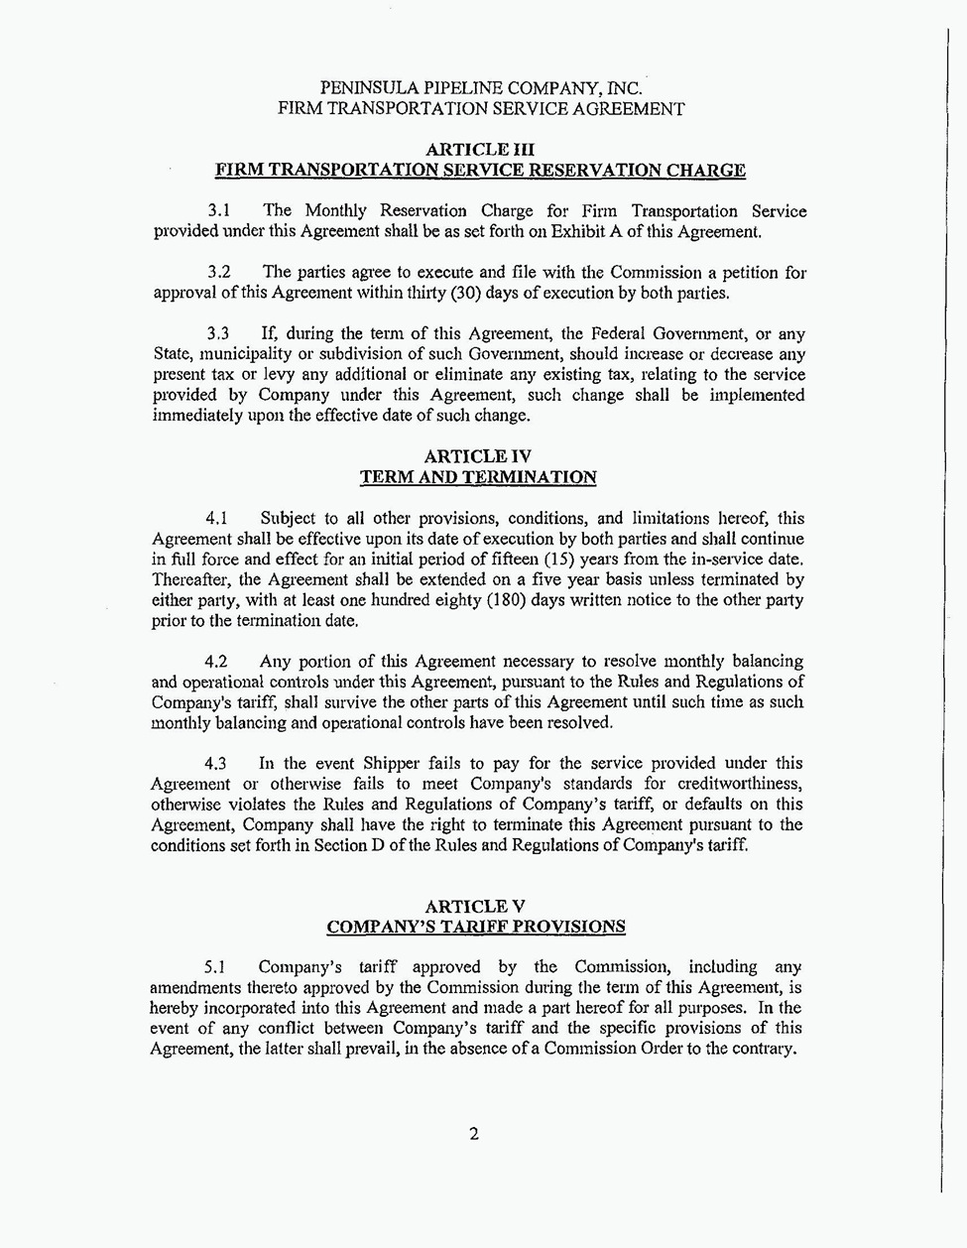
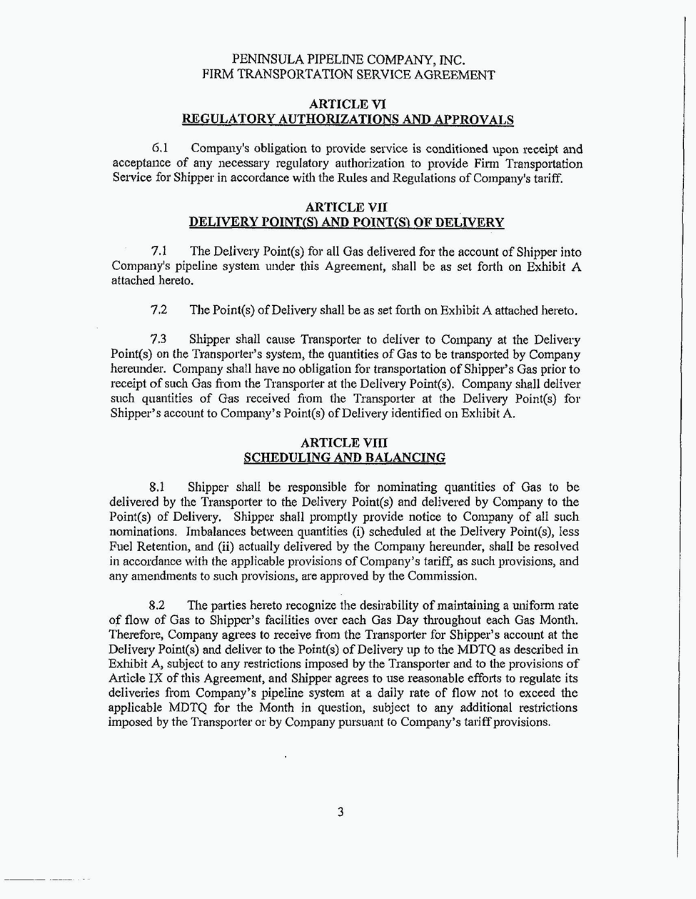

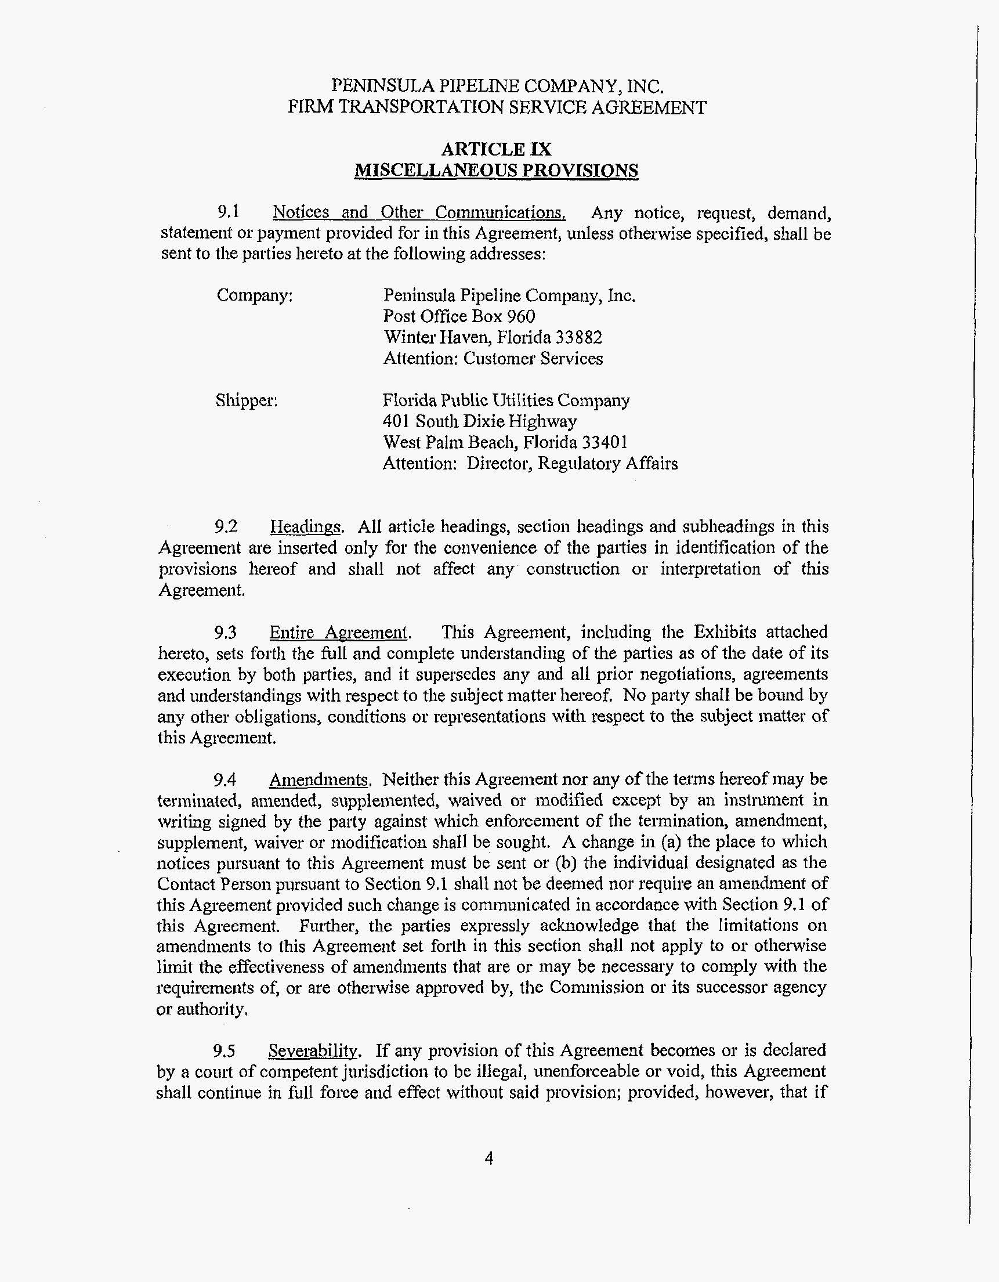

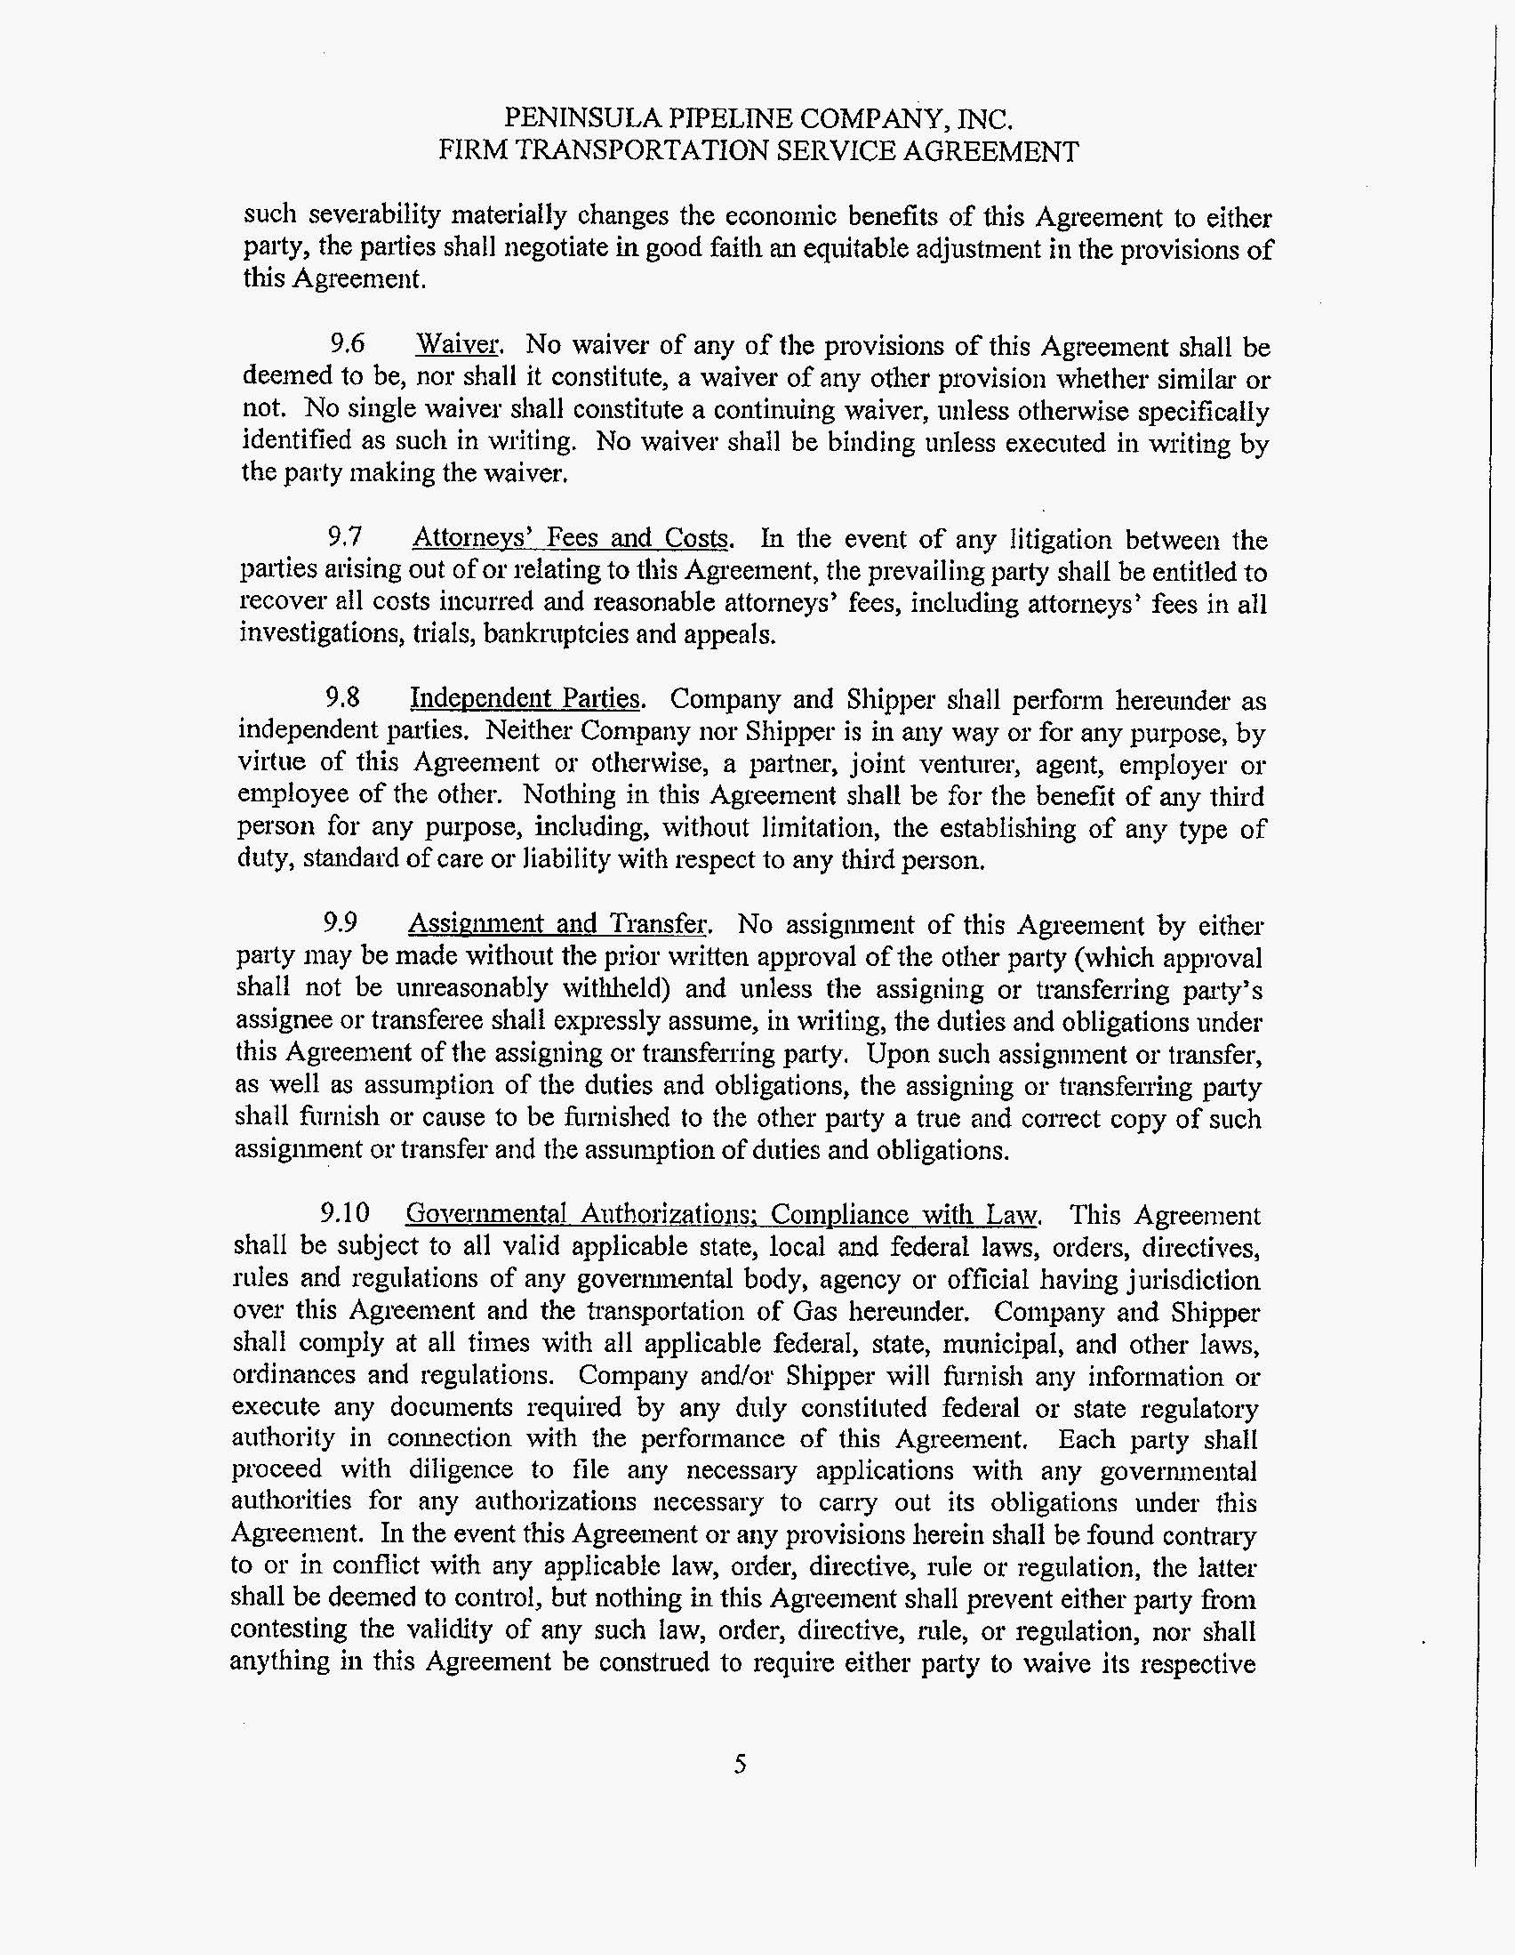

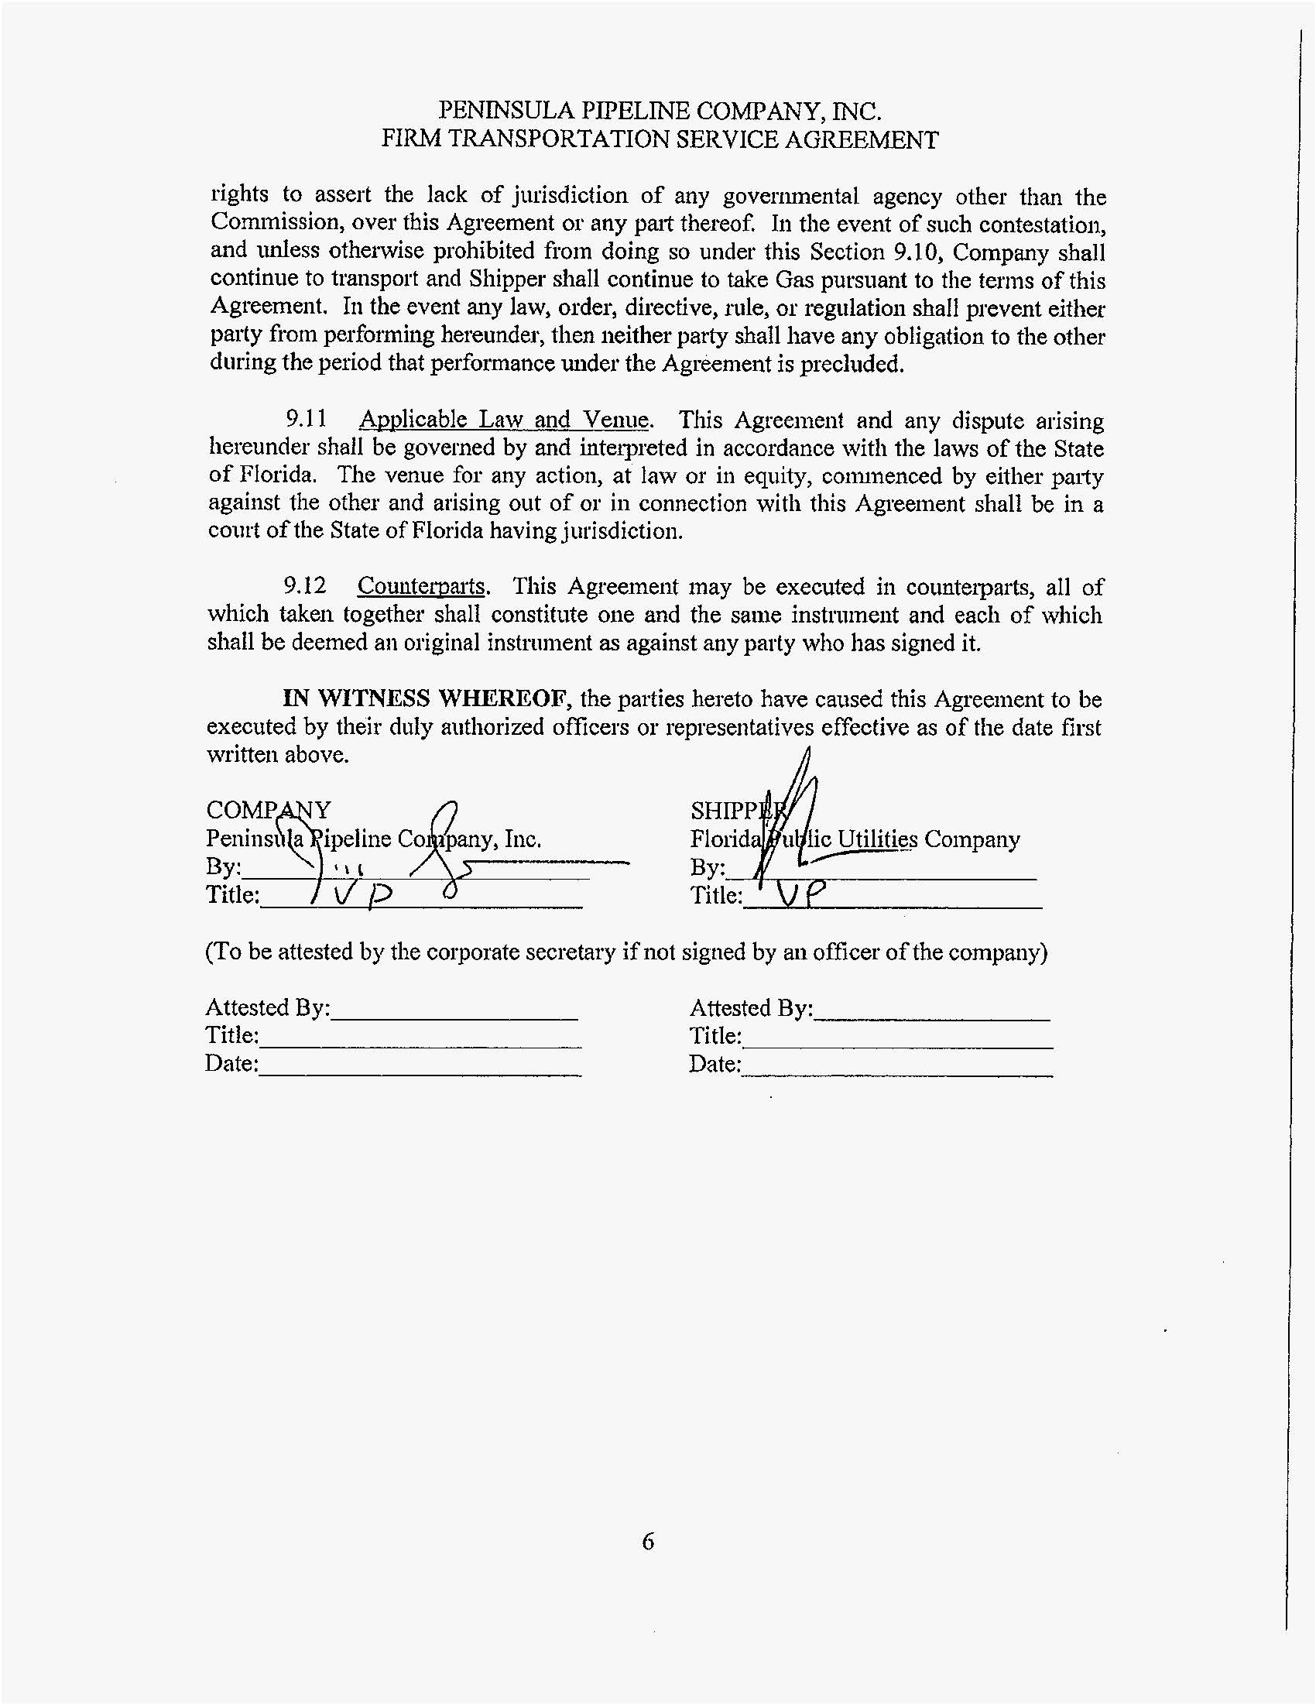
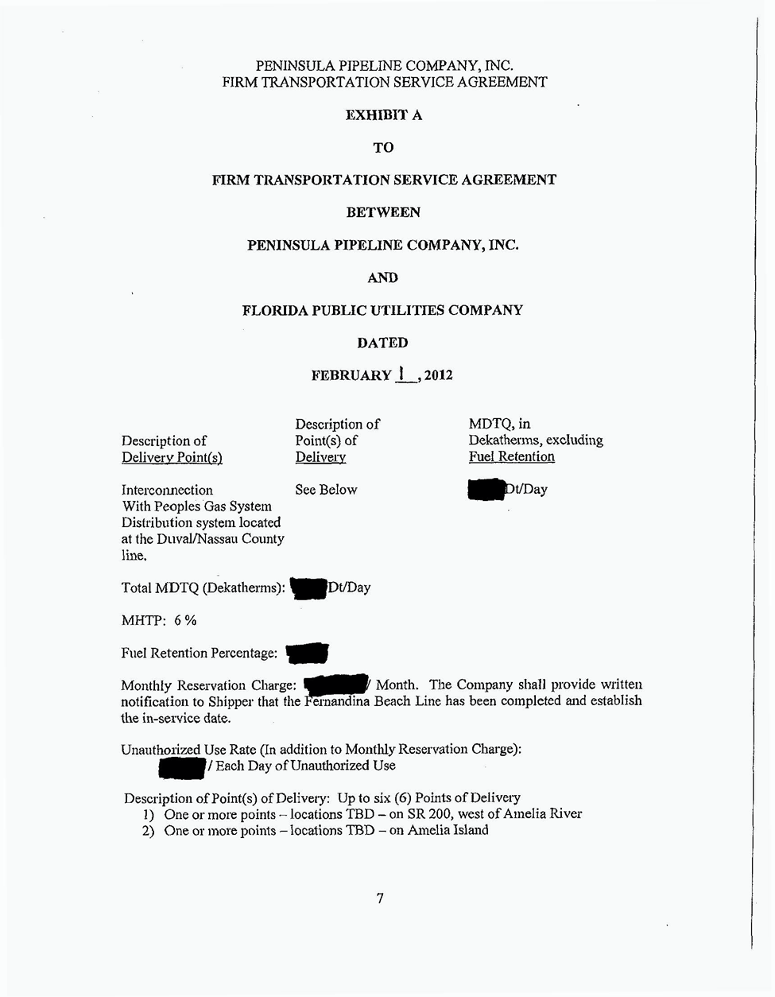

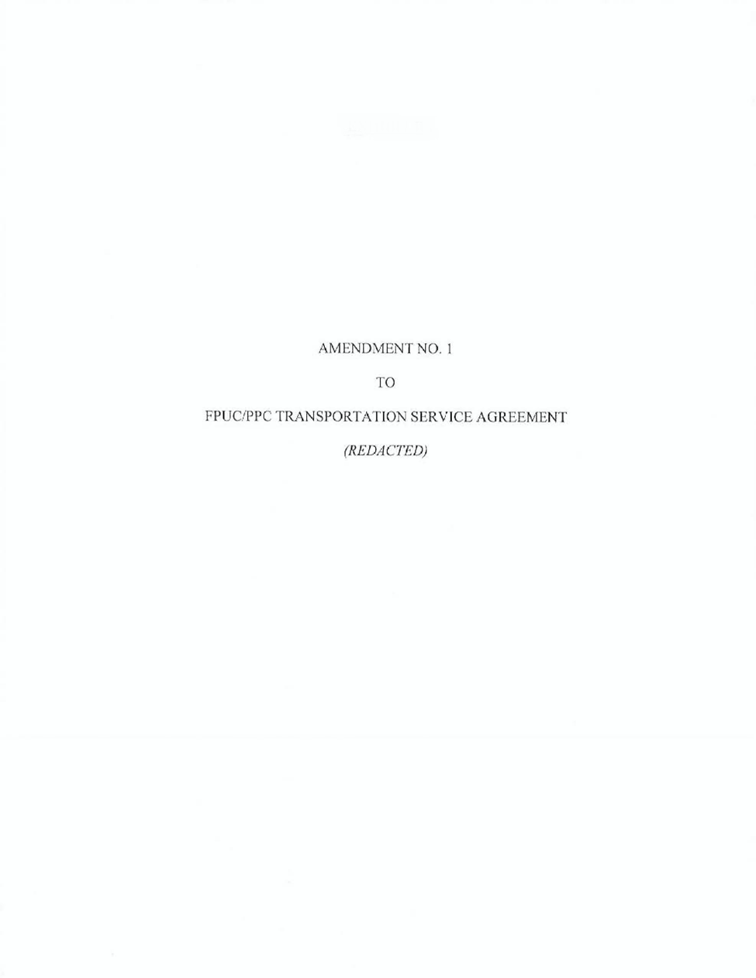
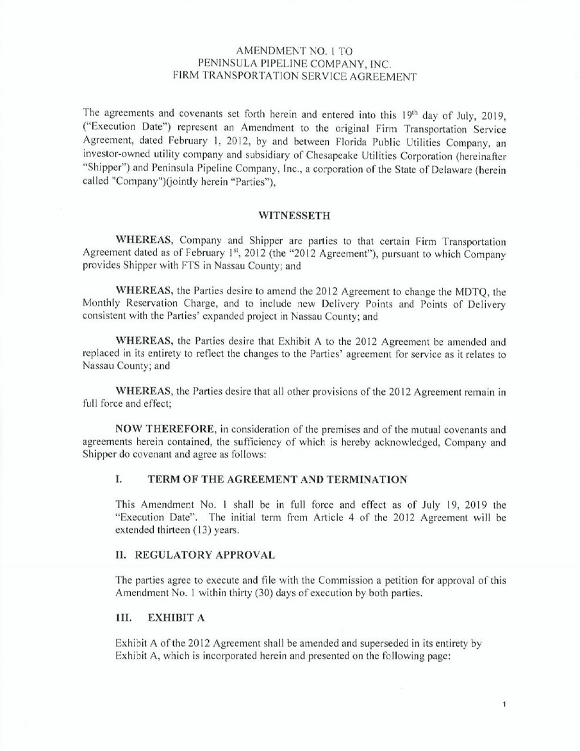

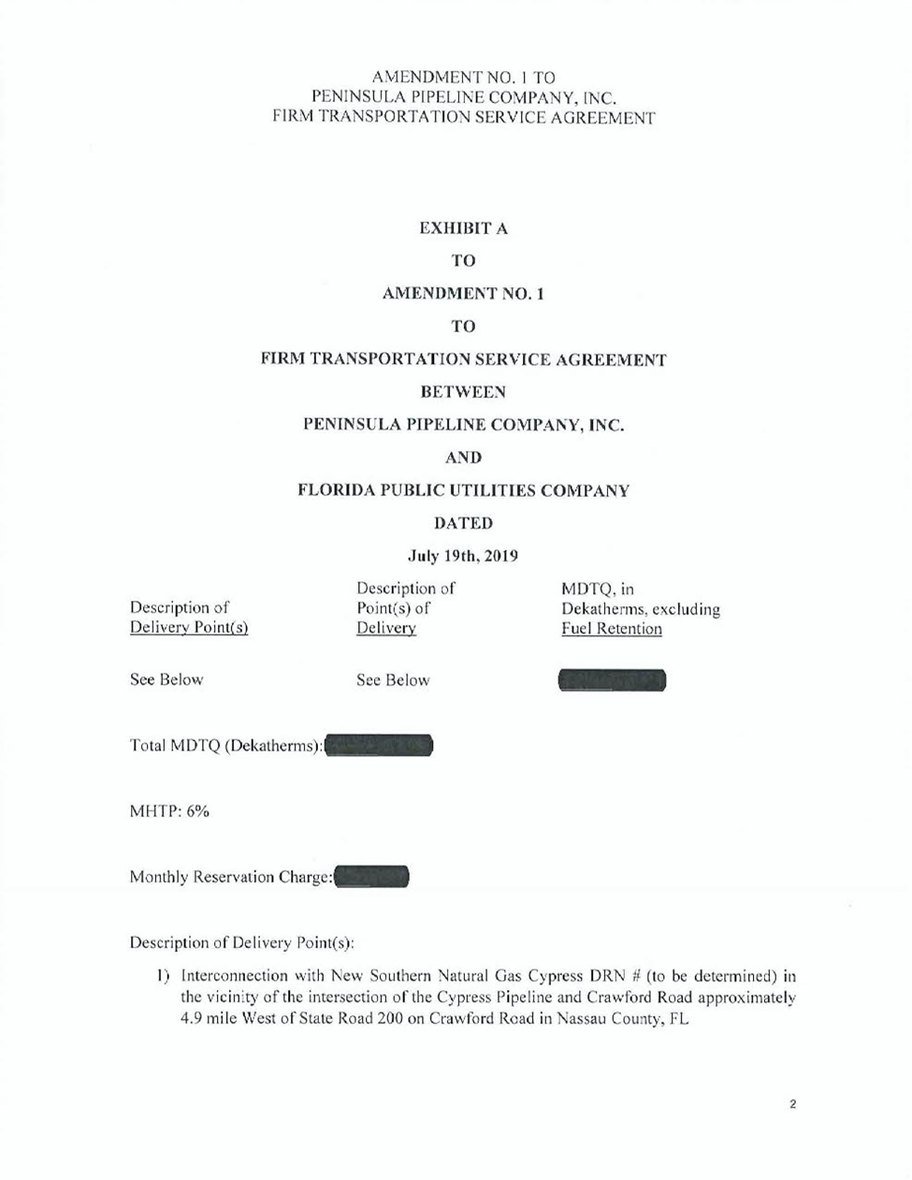
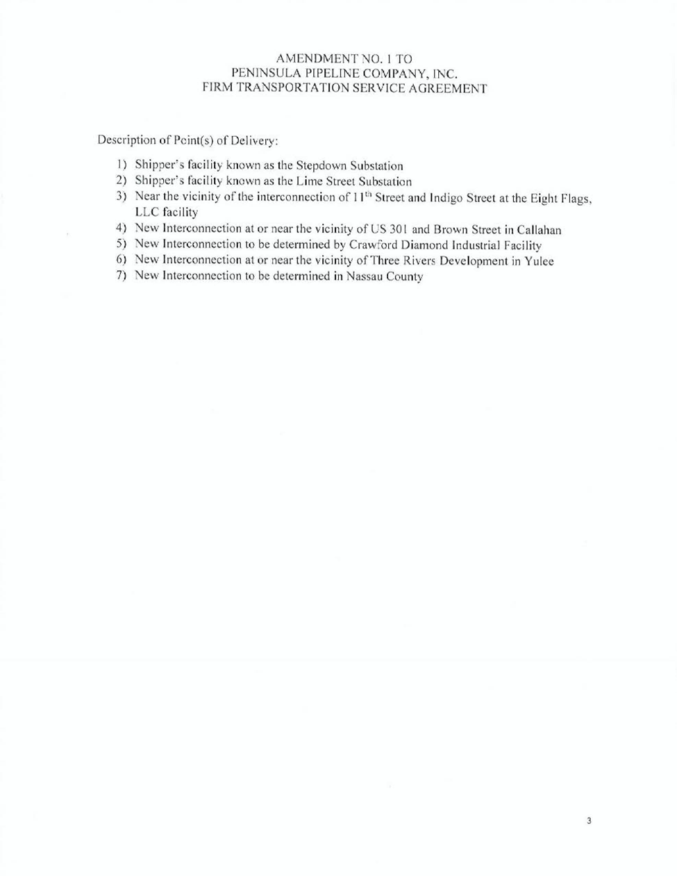

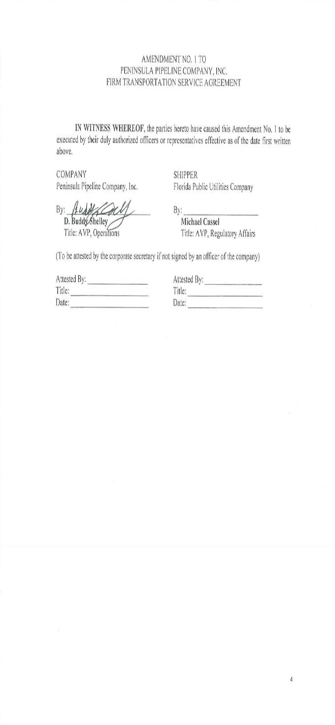
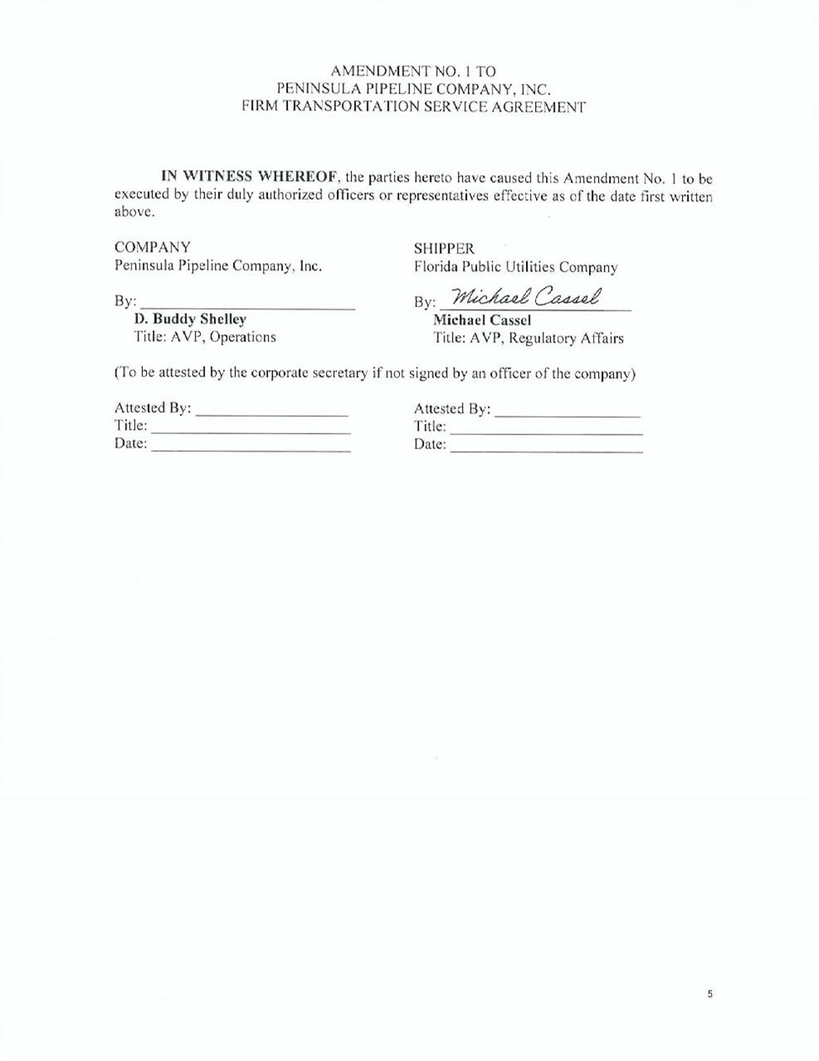

Order No. PSC-07-1012-TRF-GP, issued December 21, 2007, in Docket No. 20070570-GP, In re: Petition for approval of natural gas transmission pipeline tariff by Peninsula Pipeline Company, Inc.
Order No. PSC-08-0747-TRF-GP, issued November 12, 2008, in Docket No. 20080561-GP, In re: Petition for approval of natural gas transmission pipeline tariff by SeaCoast Gas Transmission, LLC.
Order No. PSC-12-0230-PAA-GU, issued on May 9, 2012, in Docket No. 20110271-GU, In re: Petition for approval of transportation service agreement with Florida Public Utilities Company, by Peninsula Pipeline Company, Inc., and Docket No. 20110277-GU, In re: Joint petition for approval of territorial agreement in Nassau and Duval Counties by Peoples Gas System and Florida Public Utilities Company; gas transportation agreement by Peoples Gas System and Peninsula Pipeline Company, Inc.; and application for approval of tariff revisions to reflect service in Nassau and Okeechobee Counties, by Florida Public Utilities Company.
Total capacity of the Callahan pipeline will be 148,248 dekatherms/day, with Peninsula and SeaCoast each holding 74,124 dekatherms/day of that capacity.
Id. at 3.
Id. at 3.
Order No. PSC-15-0318-PAA-GP, issued August 10, 2015, in Docket No. 20150094-GP, In re: Petition for approval of amendment to special contract with Peninsula Pipeline Company, by Peoples Gas System.

