State of Florida |  | Public Service Commission  Capital Circle Office Center ● 2540 Shumard Oak Boulevard  Tallahassee, Florida 32399-0850  -M-E-M-O-R-A-N-D-U-M-
DATE: | January 23, 2020
TO: | Office of Commission Clerk (Teitzman)
FROM: | Division of Economics (Guffey)  Office of the General Counsel (Lherisson)
RE: | Docket No. 20190201-GU – Petition for authority for approval of revised transportation nomination tariffs, by Florida Public Utilities Company and Florida Public Utilities Company-Fort Meade.
AGENDA: | 02/04/20 – Regular Agenda – Tariff Filing – Interested Persons May Participate
COMMISSIONERS ASSIGNED: |  |  | All Commissioners
PREHEARING OFFICER: |  |  | Administrative
CRITICAL DATES: |  |  | 01/07/20 (60-Day Suspension Date waived by the company until 2/4/2020.)
SPECIAL INSTRUCTIONS: |  |  | None

Case Background
On November 8, 2019, Florida Public Utilities Company (FPUC) and Florida Public Utilities Company-Fort Meade (FPUC-Fort Meade) (collectively Companies) filed a petition for approval of revised tariffs related to gas transportation nomination methodology. The intent of the revised tariffs is to allow pool managers one mid-month gas nomination change, no later than the 15th of each month, to adjust the quantities of gas delivered to FPUC and FPUC-Fort Meade.
Gas is delivered by the pool managers to the Local Distribution Company’s (LDC) gate station at a constant level daily even though transportation customers’ daily therm usage varies, creating negative or positive imbalances. At the end of each month, the Companies calculate each pool manager’s imbalance level by aggregating customer usage in their pool and comparing it to each pool manager’s natural gas deliveries.
A negative (short) imbalance results when the gas consumption of a transportation customer pool exceeds what the pool manager delivered that month; therefore, the Companies sell natural gas to the pool manager. A positive (long) imbalance results when more natural gas was delivered than was needed for the transportation customers; therefore, the Companies purchase the excess gas delivered by the pool manager.
During the review process of the petition, Commission staff issued a data request to the Companies, for which the responses were received on December 19, 2019. The revised tariff pages of FPUC are in Attachment 1 and revised tariff pages for FPUC-Fort Meade are in Attachment 2 to this recommendation. On November 15, 2019, the Companies provided a waiver of the 60-day file and suspend provision of Section 366.06(3), Florida Statutes (F.S.), until the February 4, 2020 Agenda Conference. The Commission has jurisdiction over this matter pursuant to Sections 366.03, 366.04, 366.05, and 366.06, F.S.

Discussion of Issues

Issue 1:
Should the Commission approve FPUC and FPUC-Fort Meade's revised gas transportation nomination methodology tariffs contained in Attachments 1 and 2 to this recommendation?

Recommendation:
Yes, the Commission should approve FPUC and FPUC-Fort Meade's revised gas transportation nomination methodology tariffs contained in Attachments 1 and 2 to this recommendation. The proposed revisions are designed to allow pool managers an additional opportunity during the month to address their gas imbalances. The revised tariffs should become effective with the Commission’s vote on February 4, 2020. (Guffey)

Staff Analysis:
Rule 25-7.0335, Florida Administrative Code (F.A.C.), requires local distribution companies (LDCs), such as FPUC and FPUC-Fort Meade, to make gas transportation service available to non-residential customers. Transportation service is a voluntary program that allows customers to use a pool manager, or third-party marketer/shipper, rather than the LDC, to supply their natural gas requirements.
Both FPUC and FPUC-Fort Meade function as traditional LDCs providing gas service for sales customers and provide optional transportation service as required by Rule 25-7.0335, F.A.C. Currently, there are 12 pool managers for FPUC and Fort Meade combined. The transportation customers pay the pool manager’s charges for the supply of natural gas and are not subject to the Companies’ Commission-approved Purchased Gas Adjustment (PGA) rates. The Commission does not approve or review the natural gas prices of third-party marketers.
In April 2019, the Commission approved tariff revisions, which allowed FPUC and FPUC-Fort Meade to modify pool manager monthly imbalance cash out tiers and the associated cash out rates. The imbalance tariffs apply to pool managers who are responsible for purchasing natural gas for the Companies’ transportation customers. The intent of the April 2019 revisions was to discourage pool managers from purchasing extra quantities of gas and then selling the excess gas back to the Companies at the PGA rate.
In the instant docket, the Companies state that subsequent to the above approval, pool managers expressed concern over the penalties pool mangers may incur on their daily delivery quantities (DDQ) that are assigned to the Companies. Currently, the tariff allows the Companies to assess a penalty for pool managers who deliver more natural gas than what is consumed by the pool managers’ customers, and the Companies must pay the pool mangers the full PGA rate for the excess gas. Pursuant to the petition, the pool managers assert that they lack the ability to avoid penalties described in FPUC Tariff sheet No. 33.2 and FPUC-Fort Meade Tariff Sheet No. 52.1, because they do not have the opportunity to adjust nominated quantities of gas during the month.
In order to remedy the pool managers’ concerns, FPUC and FPUC-Fort Meade in the instant docket are proposing to allow pool managers one mid-month nomination change, no later than the 15th of each month, allowing them to adjust the quantities of gas delivered to the Company. The proposed tariff revisions are to FPUC tariff sheets 33.1, 33.2, and 35.1 and FPUC-Fort Meade tariff revisions are to sheets 52.1, 53, 53.1, and 60.
The proposed revisions also include requirements of additional information to be provided by the pool managers twice a month to the Companies such as customer name, pool manager account number, receipt location, upstream and downstream delivery points, and quantity of gas for each nomination. In responses to staff’s data request, the Companies stated that such information is consistently required by other LDCs in Florida. The Companies will notify all participating pool managers of the required information which would become effective as of the first day of the month following Commission approval. The revised tariff sheets are in Attachments 1 and 2 to this recommendation.
The Companies stated that they have communicated with the pool managers about the requested tariff modifications and that the pool managers have been receptive of the mid-month nomination change opportunity. The Companies’ data responses also state that the Companies will notify all participating pool managers about the requisite changes to be effective as of the first day of the month following the Commission vote.

Conclusion
The requested tariff revisions are intended to provide the pool managers an opportunity to make an intra-monthly modification (no later than the 15th of each month) to the quantity of gas delivered to the Companies pursuant to the daily delivery requirement methodology, thereby reducing penalties for excessive gas purchased.
This proposed revision is consistent with Peoples Gas System’s tariff which allows pool managers, by the 20th of each month, to request an increase or a decrease in the quantity of gas delivered.
In light of the foregoing, staff recommends approval of FPUC and FPUC-Fort Meade’s tariff modifications, as shown in Attachments 1 and 2 to this recommendation. The revised tariffs should become effective with the Commission’s vote on February 4, 2020.

Issue 2:
Should this docket be closed?

Recommendation:
If Issue 1 is approved and a protest is filed within 21 days of the issuance of the order, the tariffs should remain in effect, with any revenues held subject to refund, pending resolution of the protest. If no timely protest is filed, this docket should be closed upon the issuance of a consummating order. (Lherisson)

Staff Analysis:
If Issue 1 is approved and a protest is filed within 21 days of the issuance of the order, the tariffs should remain in effect, with any revenues held subject to refund, pending resolution of the protest. If no timely protest is filed, this docket should be closed upon the issuance of a consummating order.

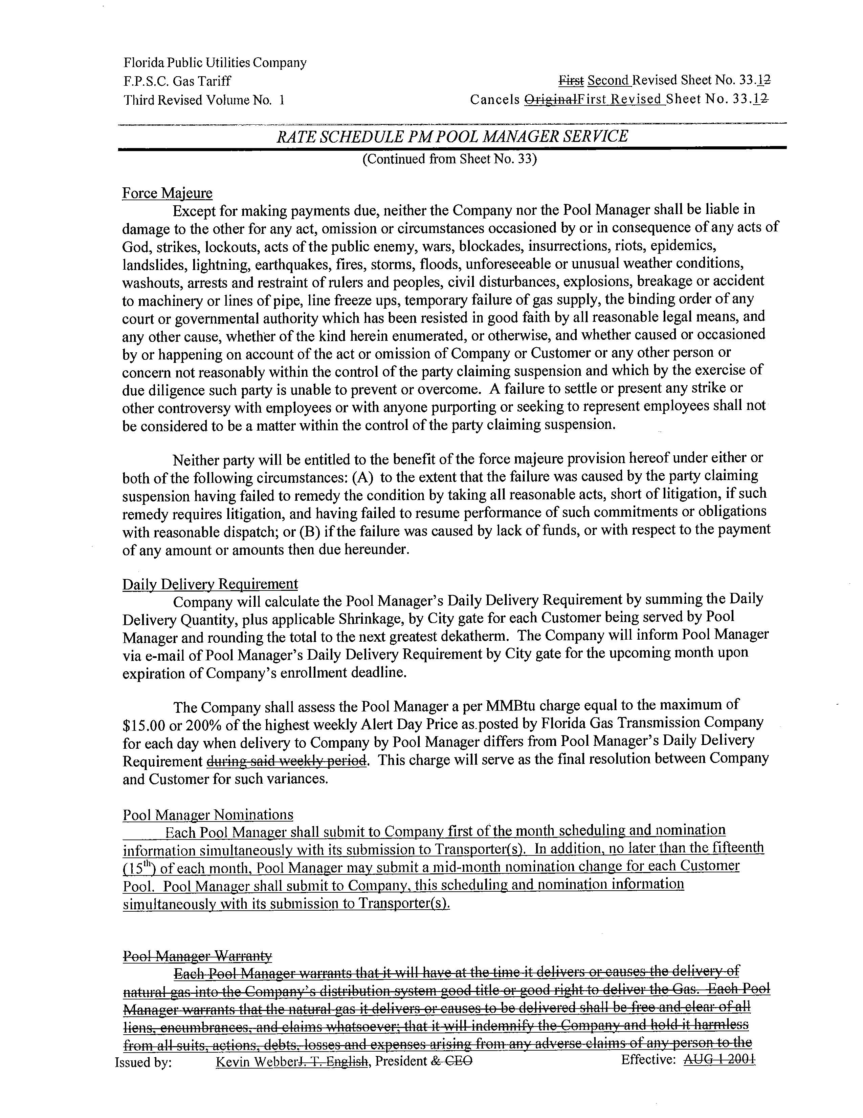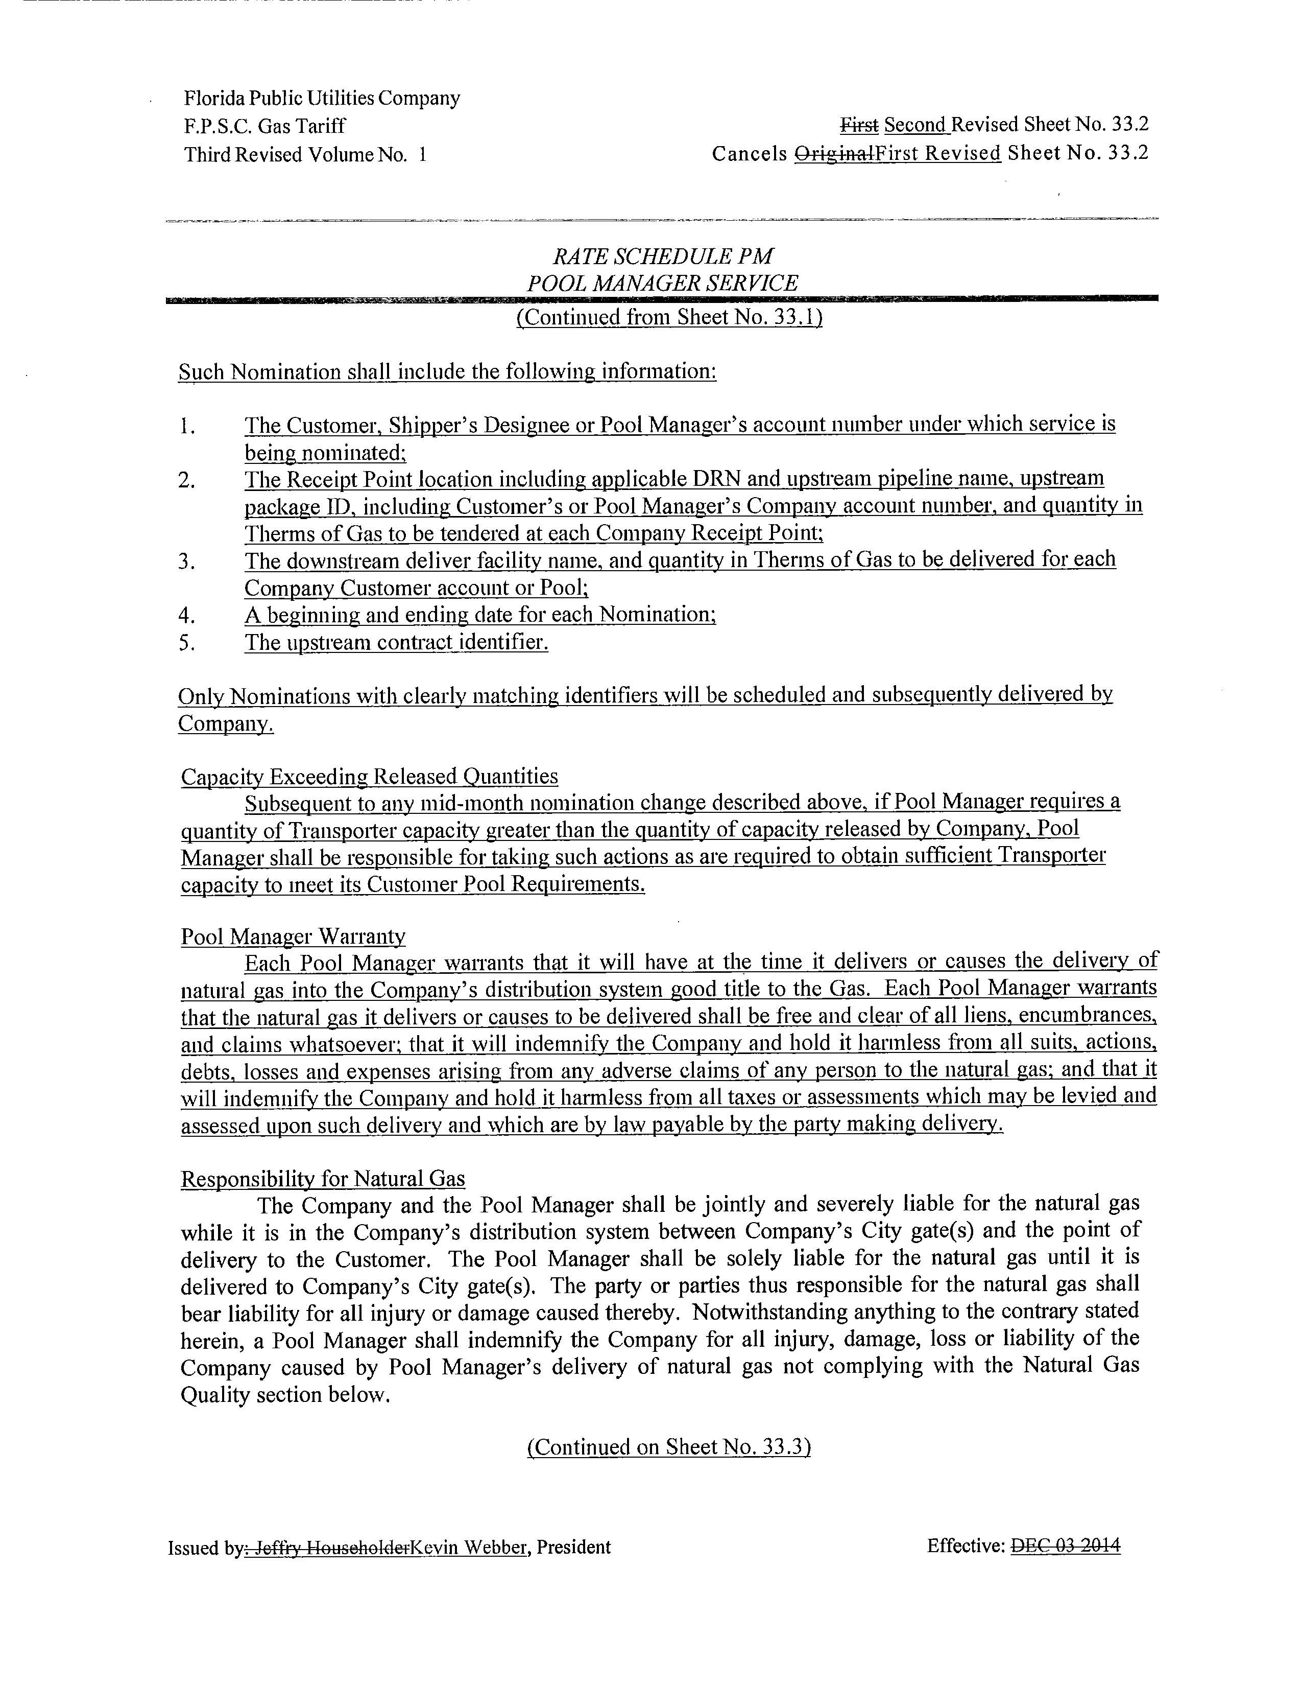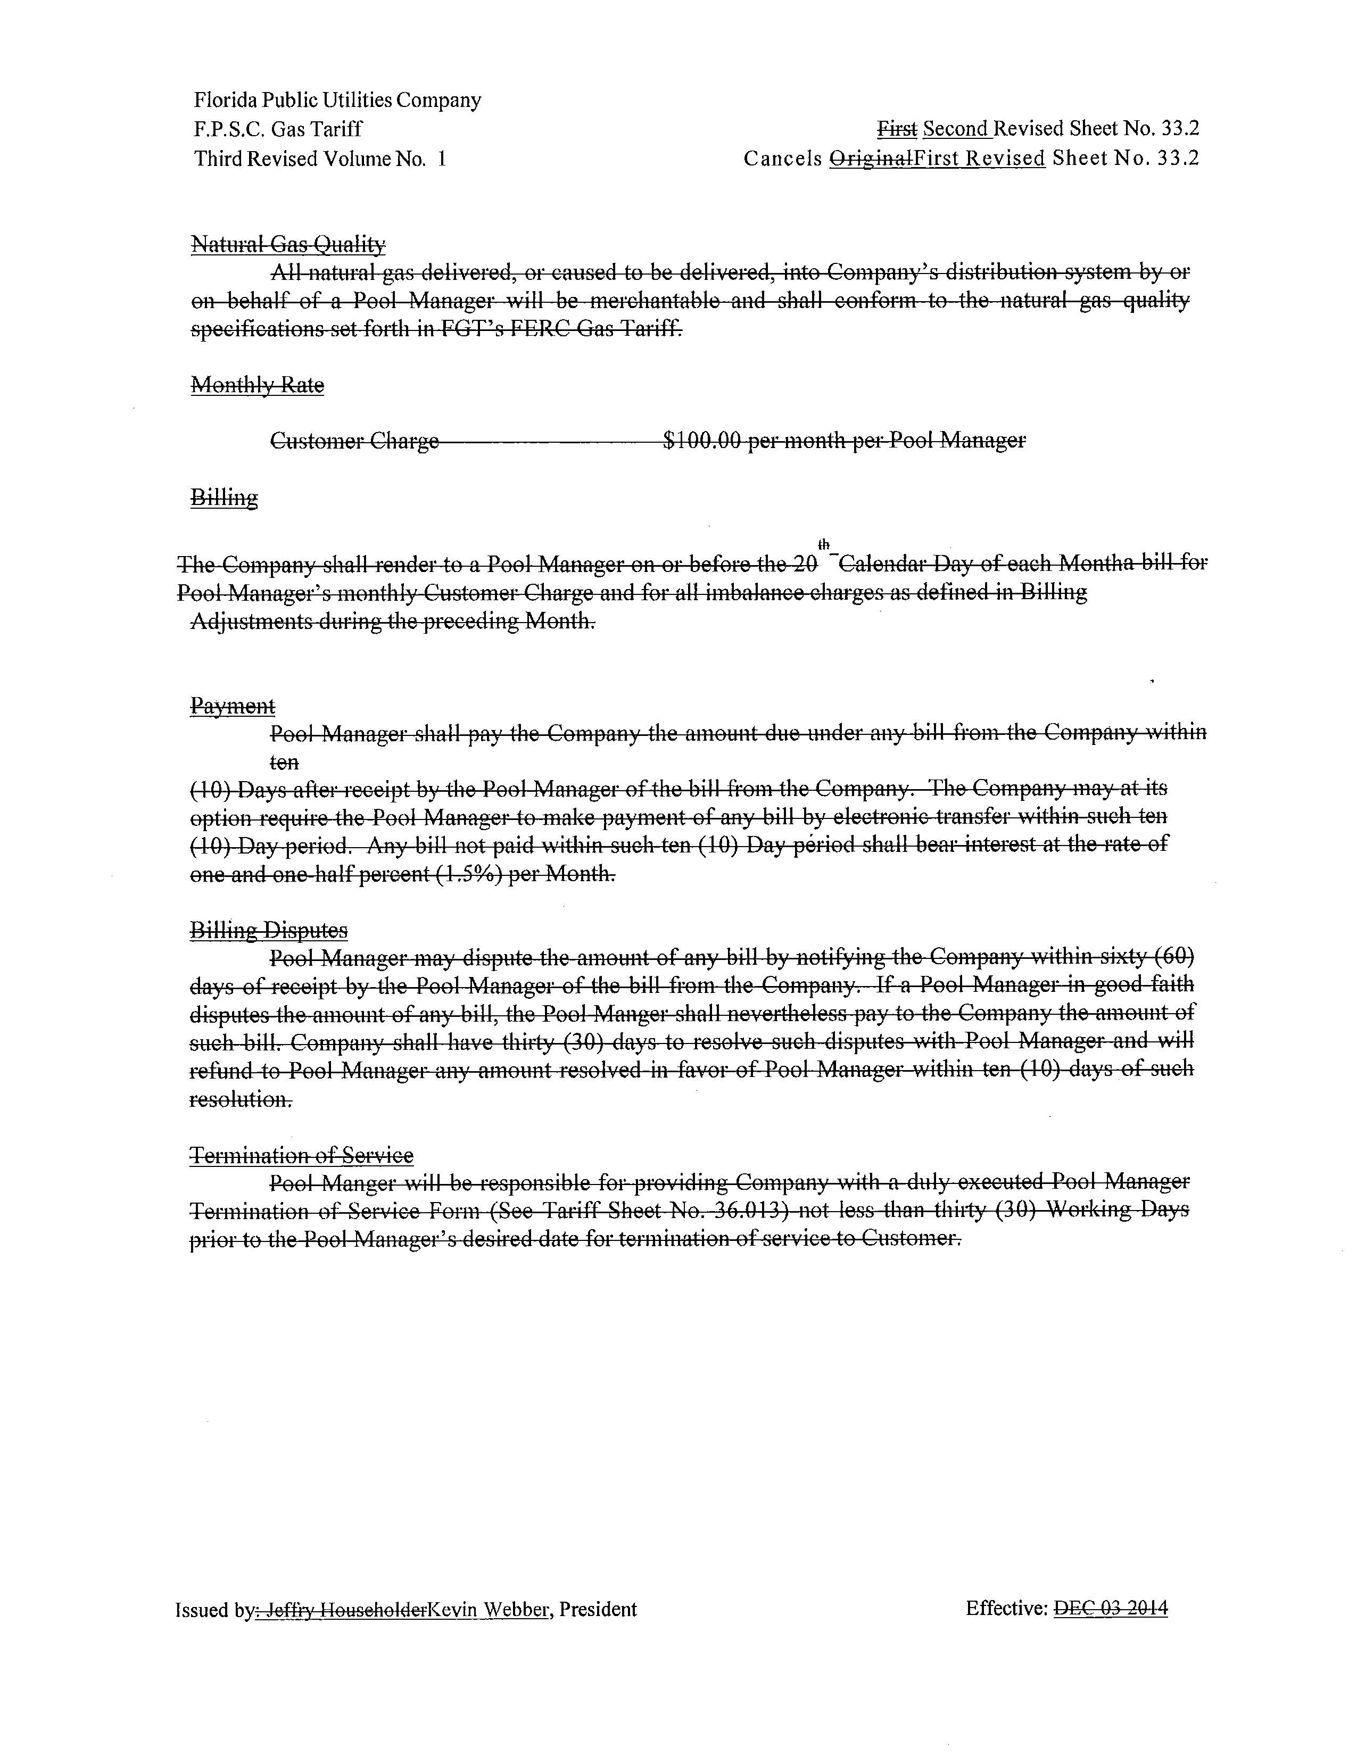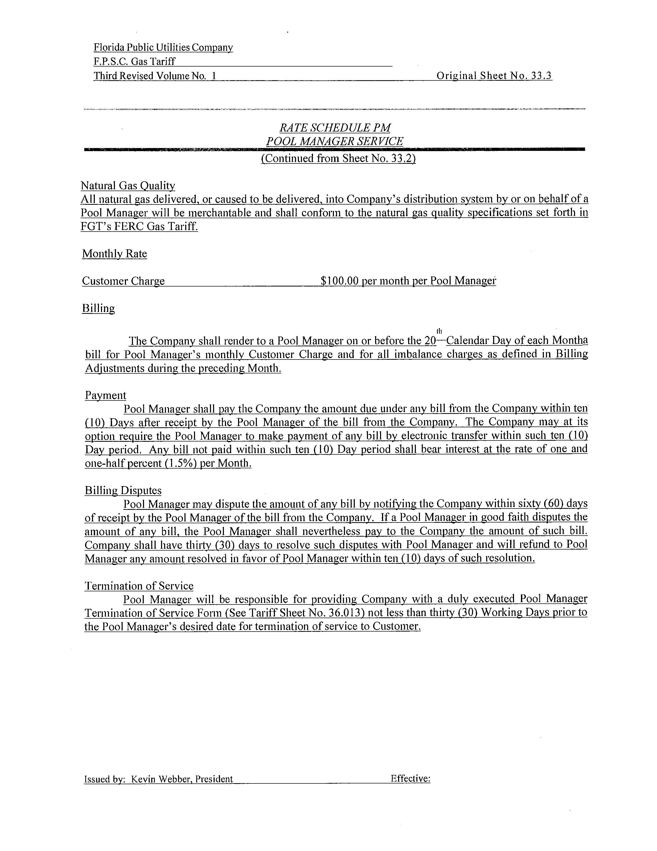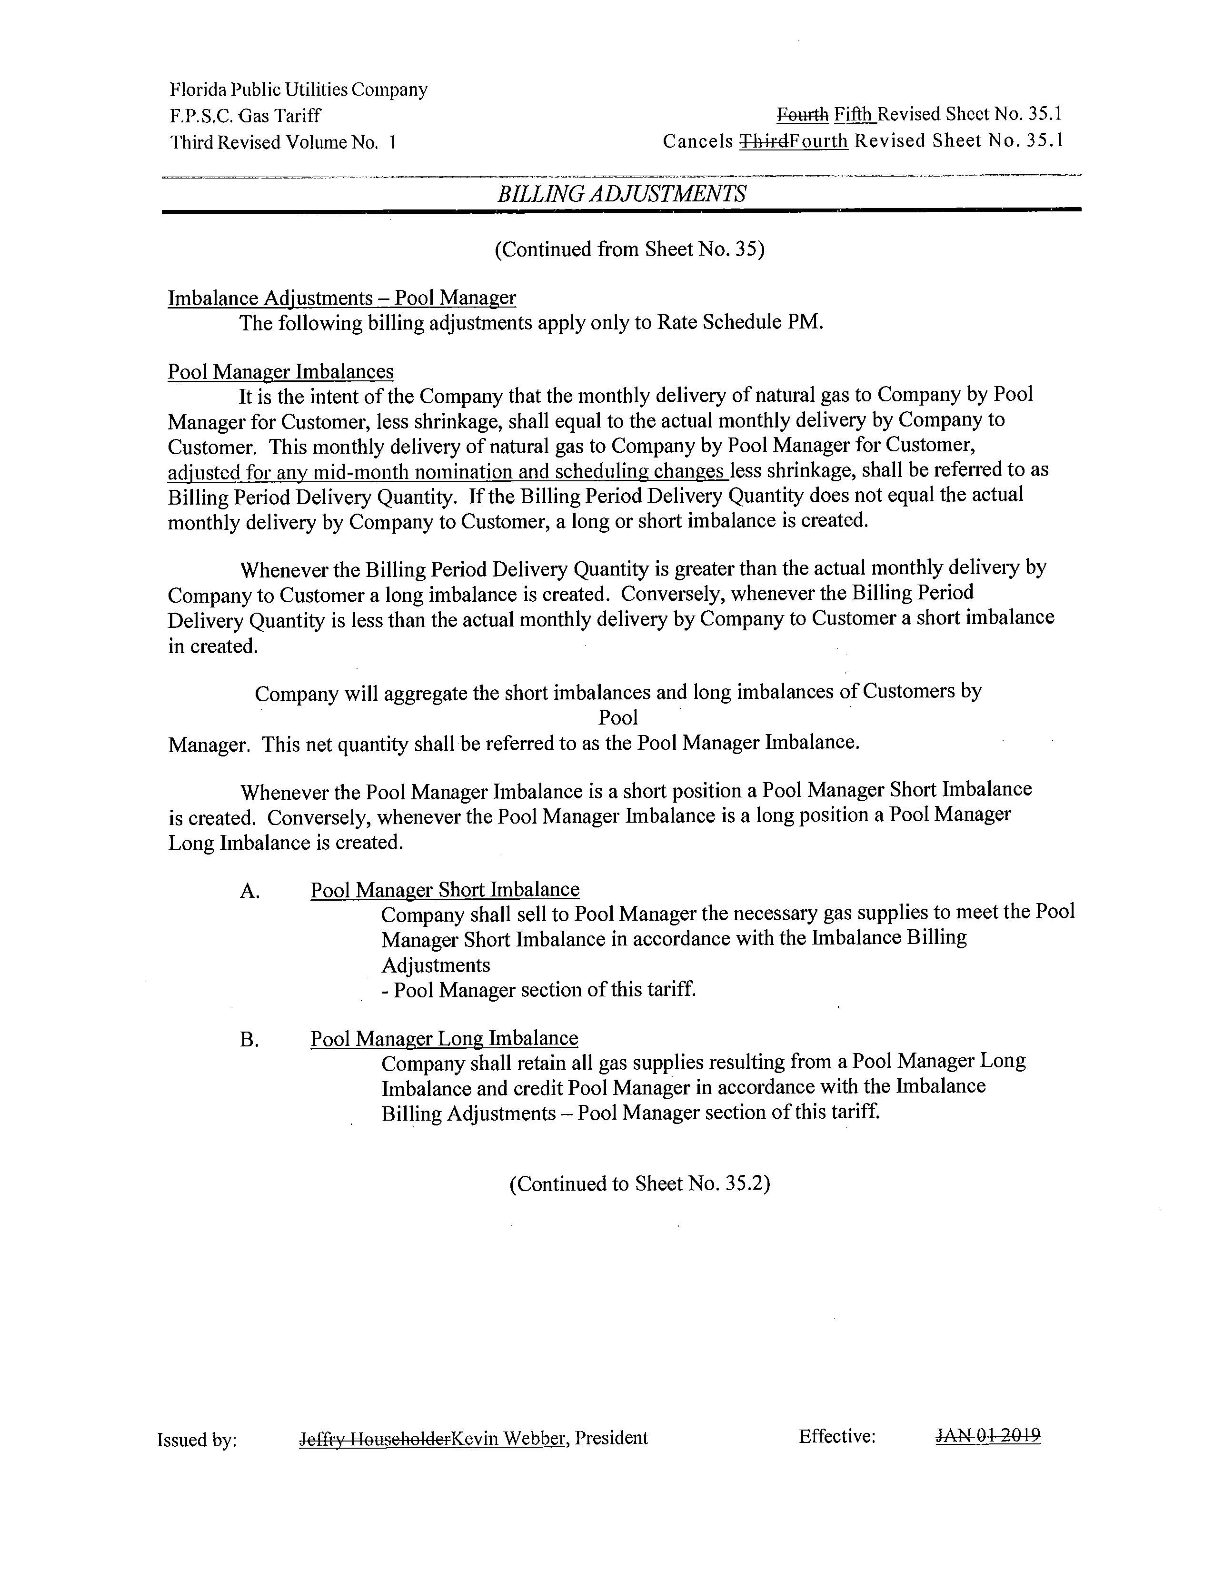
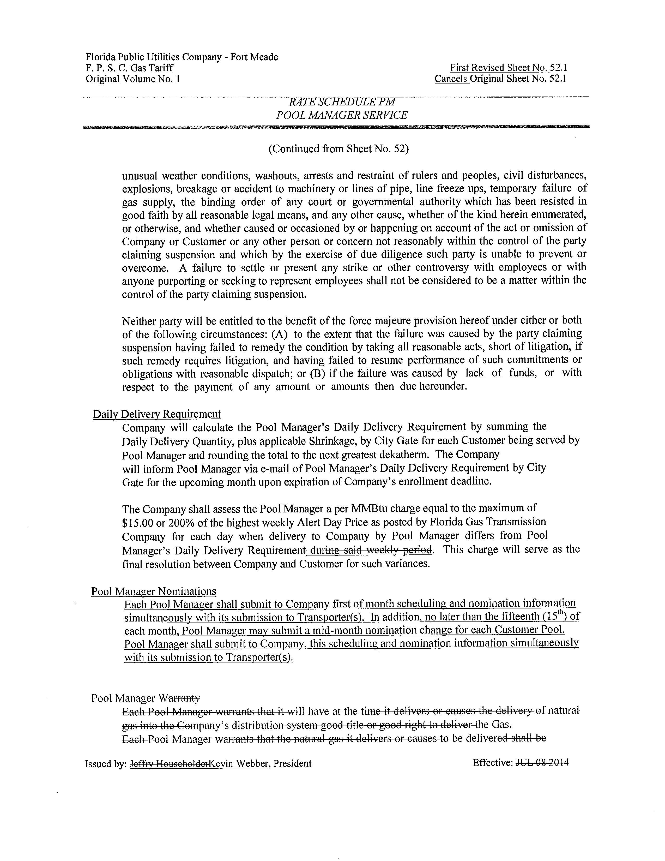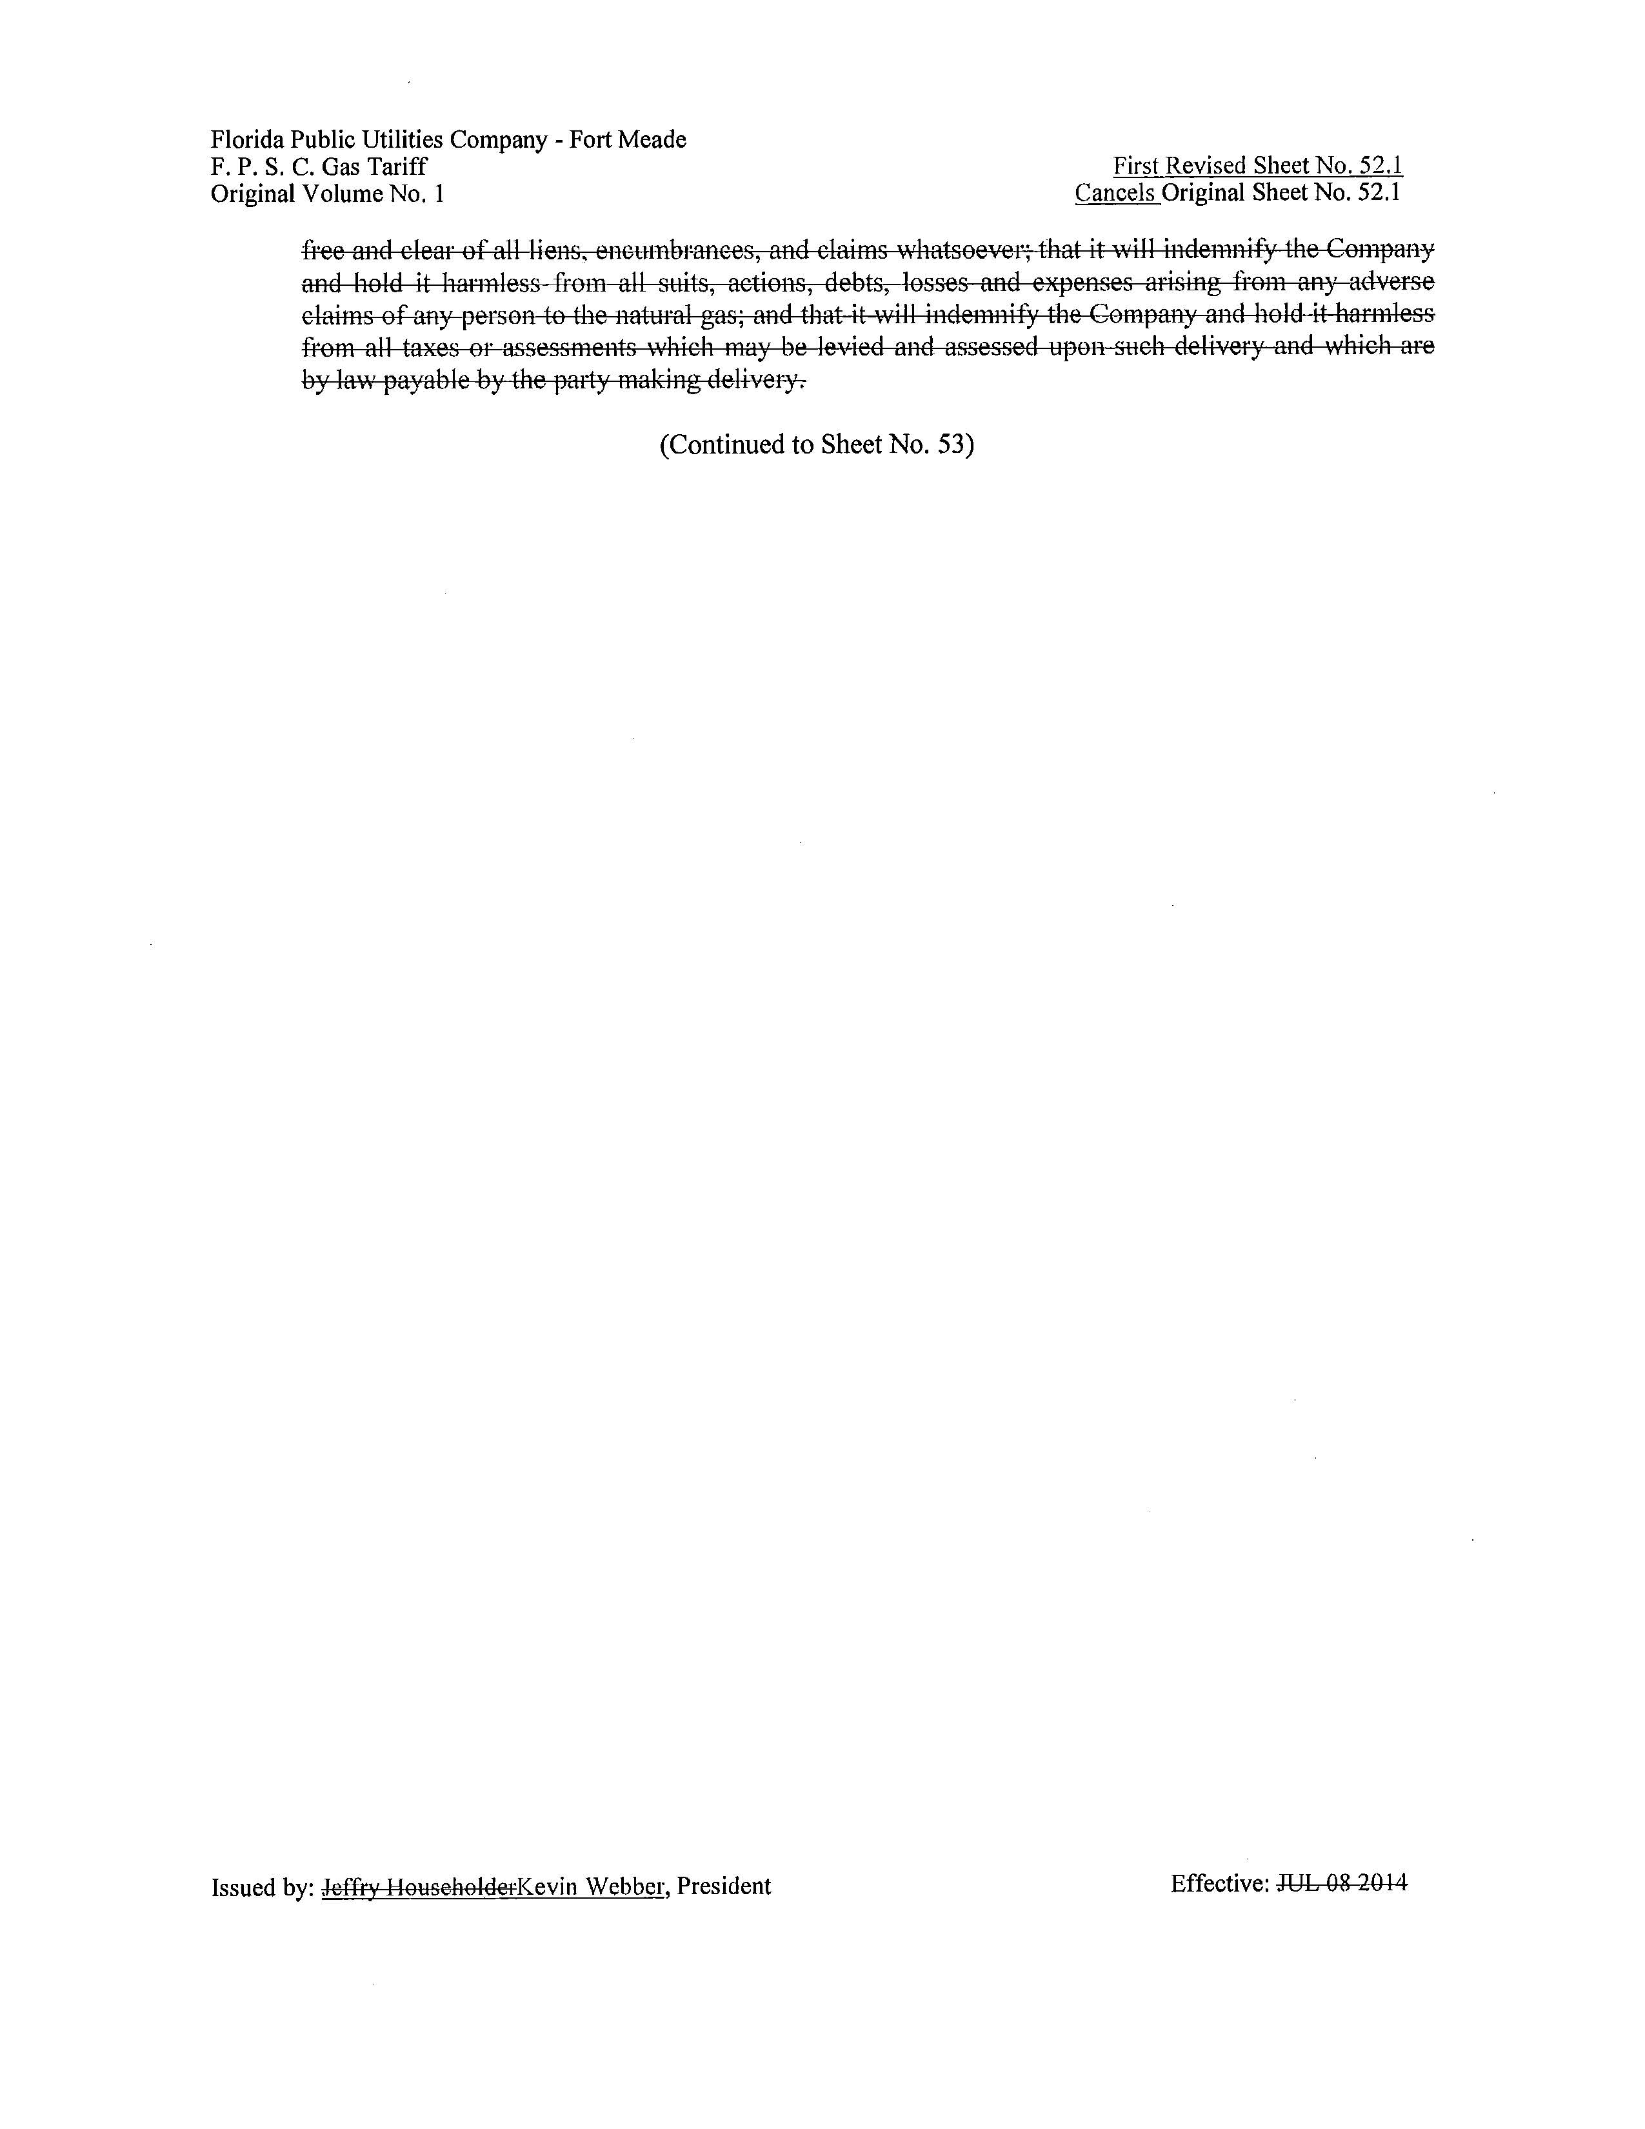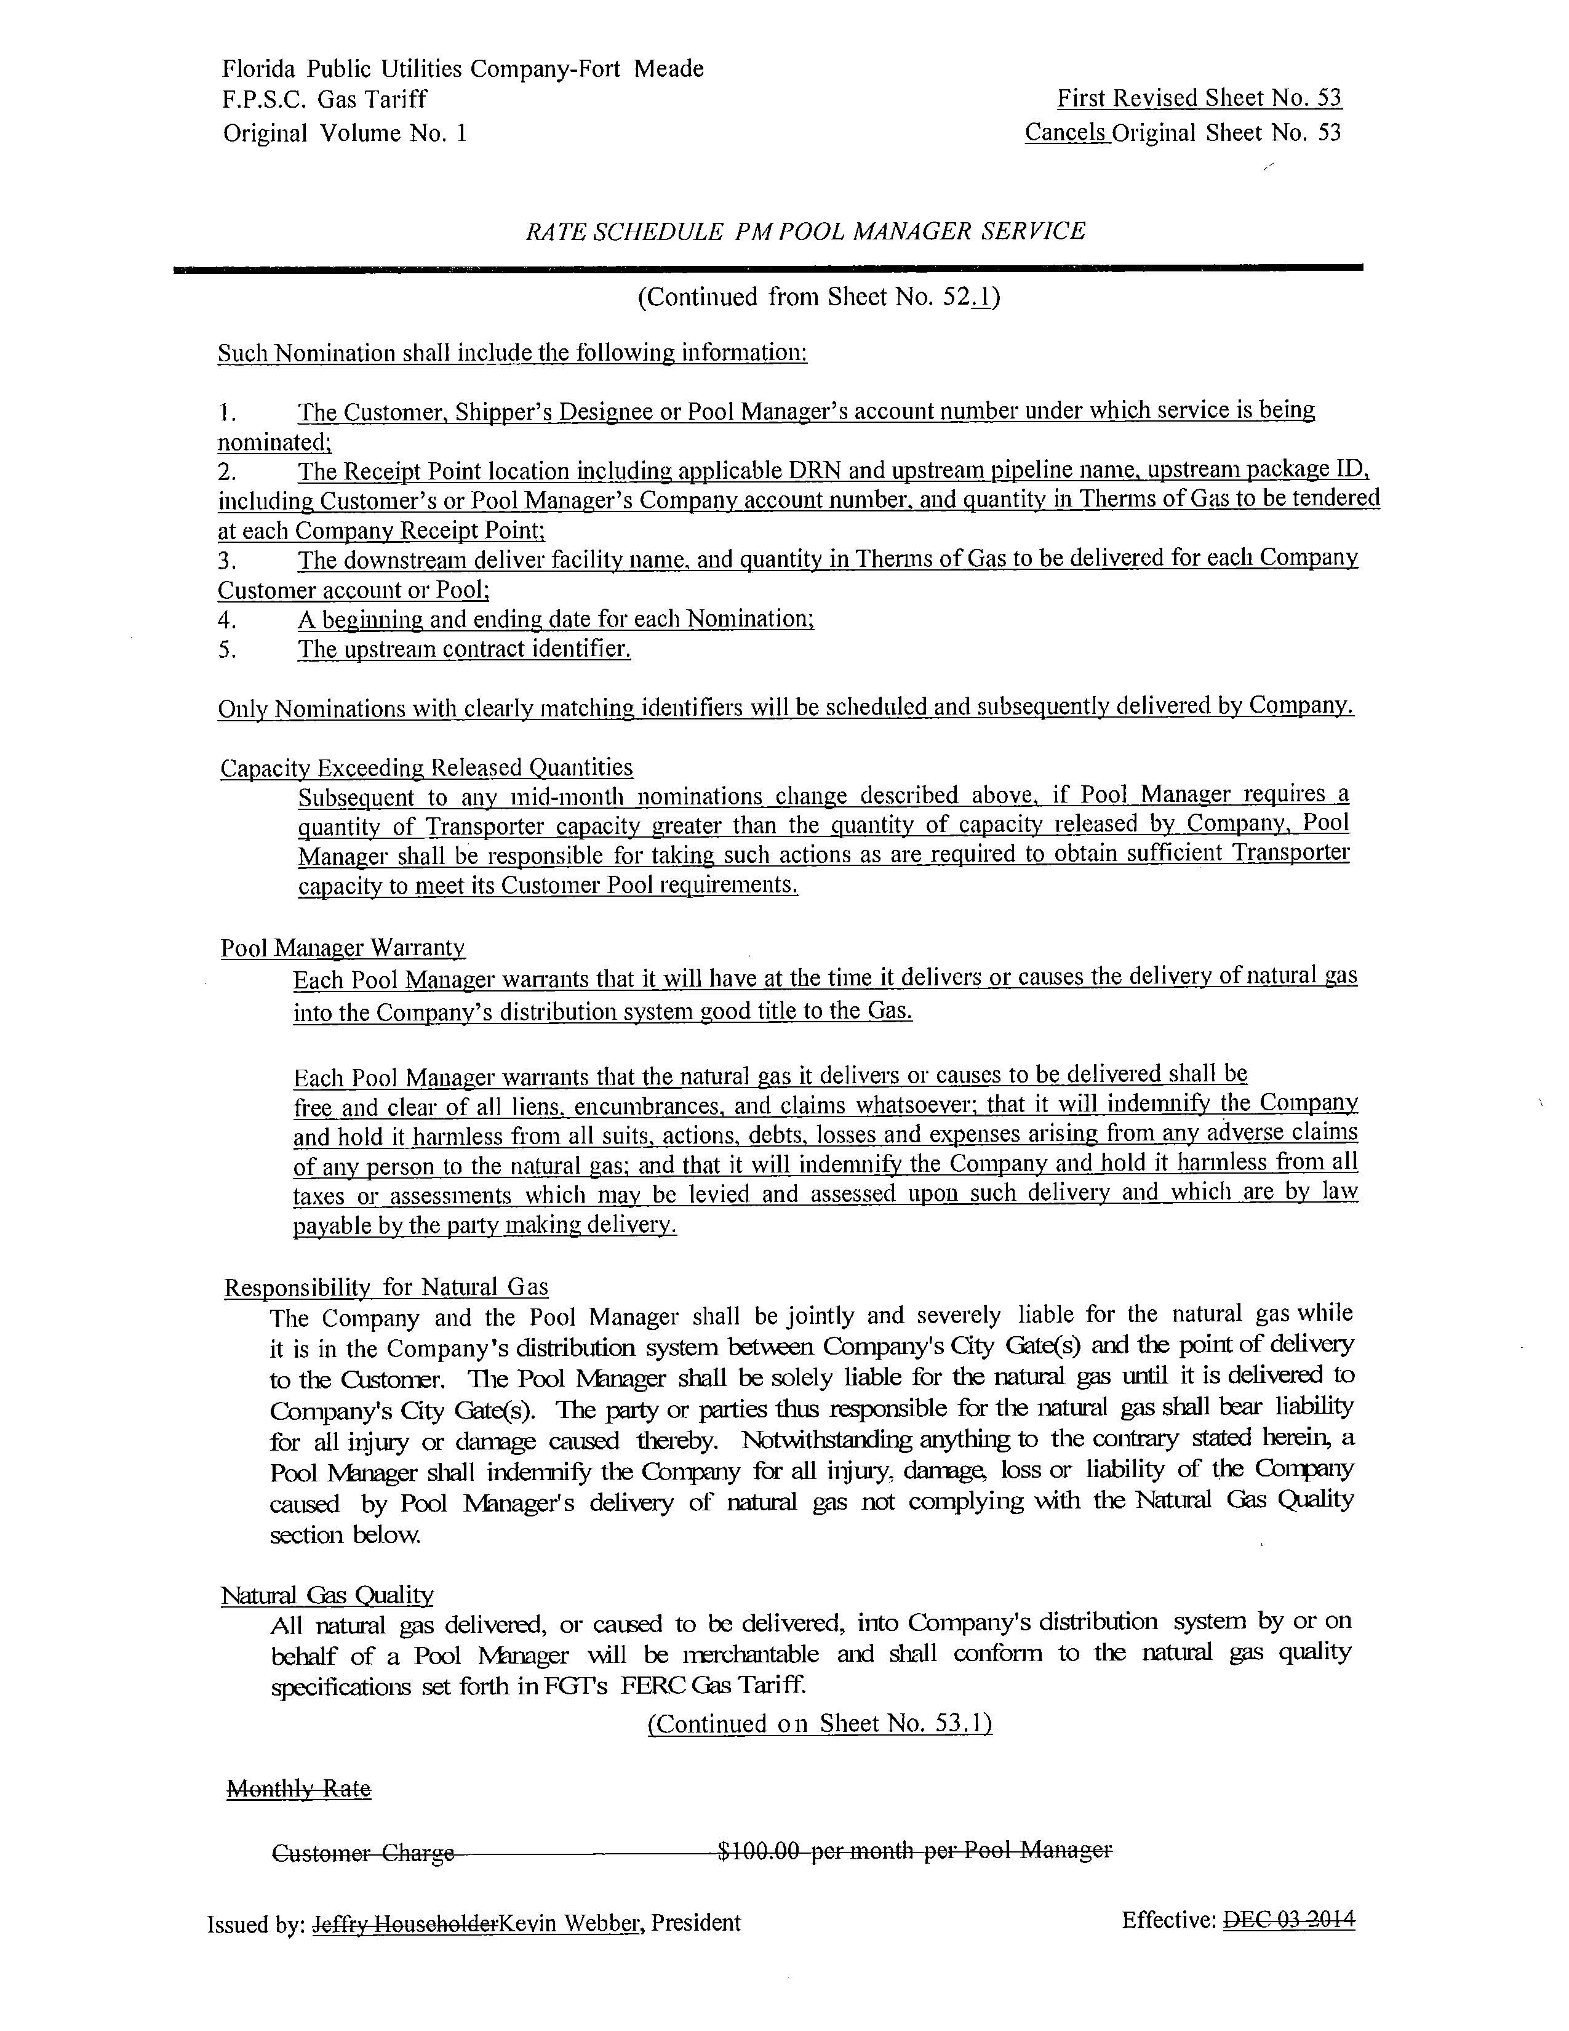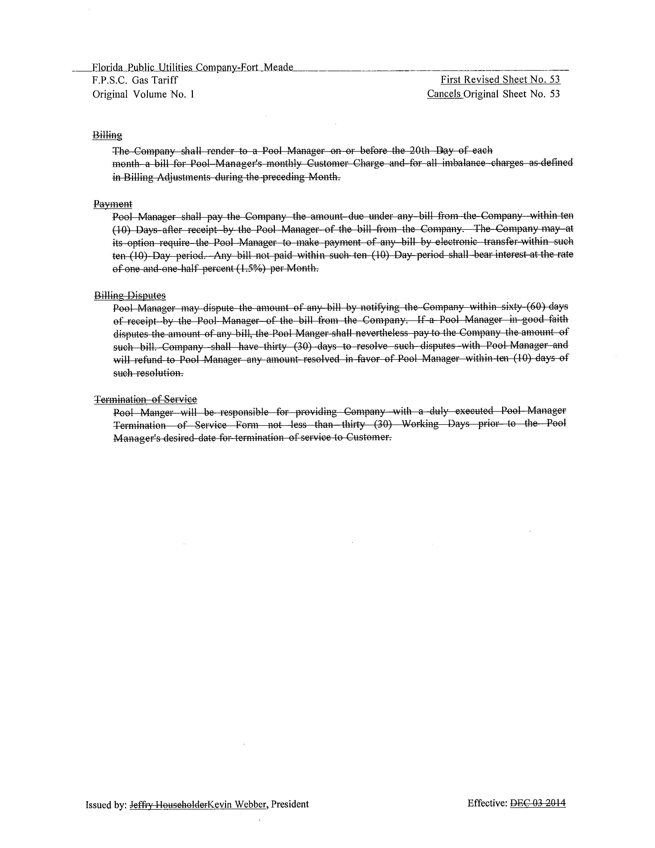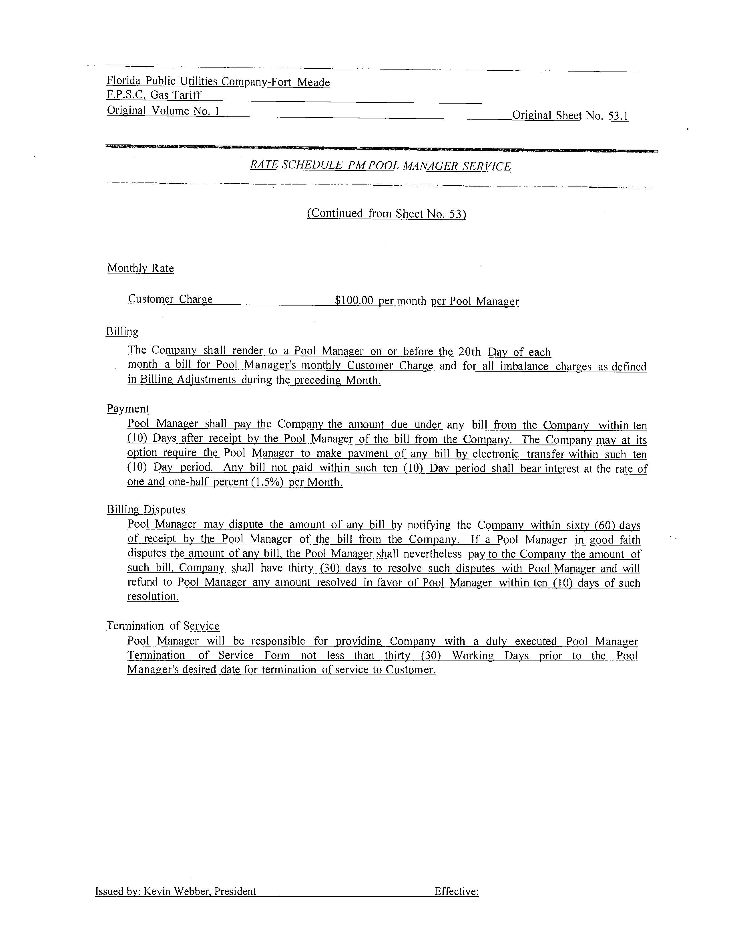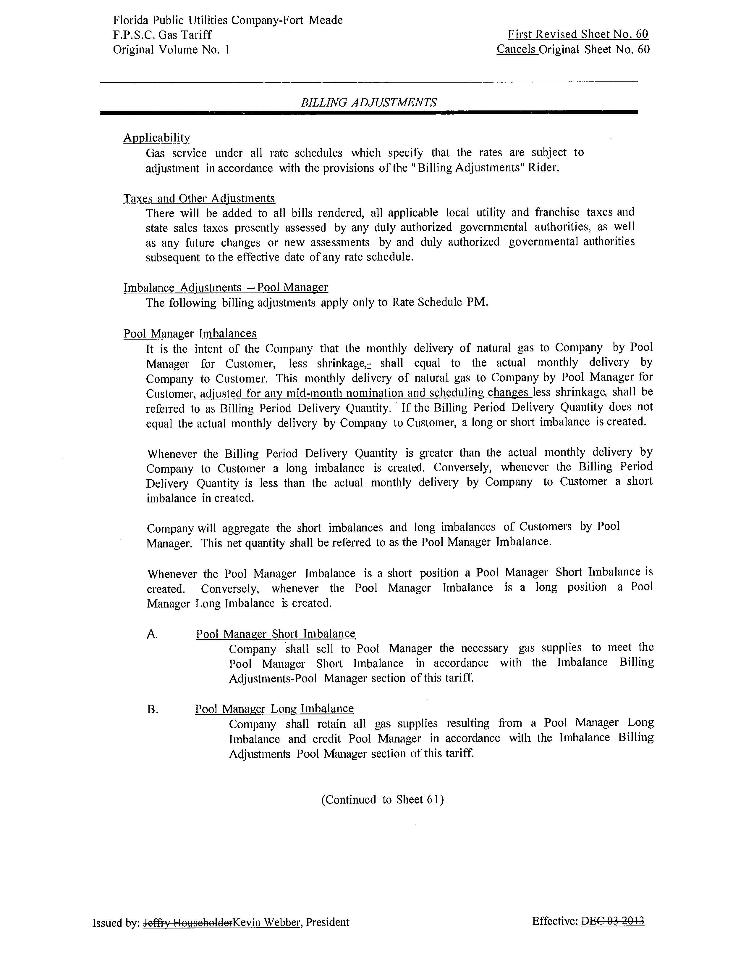

FPUC currently has 2,436 transportation customers and 60,958 sales customers while FPUC-Fort Meade currently has 9 transportation customers and 579 sales customers (source: Response #4 in Staff’s First Data Request, Document No. 11400-2019.).
Order No. PSC-2019-0153-TRF-GU, issued April 24, 2019, in Docket No. 20190036-GU, In re: Petition for authority for approval of revised transportation imbalance tariffs, by Florida Public Utilities Company; Florida Public Utilities Company-Ft. Meade.
When pool managers deliver more natural gas than what is consumed by their customers (resulting in an imbalance), the Companies pay the pool managers for the excess gas. The payments to pool managers are based on natural gas cash-out rates as reported in the Platts Gas Daily and published pipeline capacity charges.
See Peoples Gas System Tariff Sheet No. 8.119-5, Section 4.4 and Order No. PSC-16-0503-TRF-GU, issued October 31, 2016, in Docket No. 20160120-GU, In re: Petition for approval of tariff modifications to rider NCTS, the firm delivery and operational balancing agreement, and negative imbalance cash-out prices, by Peoples Gas System.

