BEFORE THE FLORIDA PUBLIC SERVICE COMMISSION

In re: Petition for authority for approval of revised transportation nomination tariffs, by Florida Public Utilities Company and Florida Public Utilities Company-Fort Meade. | DOCKET NO. 20190201-GU  ORDER NO. PSC-2020-0055-TRF-GU  ISSUED: February 24, 2020

The following Commissioners participated in the disposition of this matter:

GARY F. CLARK, Chairman
ART GRAHAM
JULIE I. BROWN
DONALD J. POLMANN
ANDREW GILES FAY

ORDER GRANTING FLORIDA PUBLIC UTILITIES COMPANY AND
FLORIDA UTILITIES COMPANY-FORT MEADE’S PETITION FOR
APPROVAL OF REVISED TRANSPORTATION NOMINATION TARIFFS

BY THE COMMISSION:

Background
On November 8, 2019, Florida Public Utilities Company (FPUC) and Florida Public Utilities Company-Fort Meade (FPUC-Fort Meade) (collectively Companies) filed a petition for approval of revised tariffs related to gas transportation nomination methodology. The intent of the revised tariffs is to allow pool managers one mid-month gas nomination change, no later than the 15th of each month, to adjust the quantities of gas delivered to FPUC and FPUC-Fort Meade.
Gas is delivered by the pool managers to the Local Distribution Company’s (LDC) gate station at a constant level daily even though transportation customers’ daily therm usage varies, creating negative or positive imbalances. At the end of each month, the Companies calculate each pool manager’s imbalance level by aggregating customer usage in their pool and comparing it to each pool manager’s natural gas deliveries.
A negative (short) imbalance results when the gas consumption of a transportation customer pool exceeds what the pool manager delivered that month; therefore, the Companies sell natural gas to the pool manager. A positive (long) imbalance results when more natural gas was delivered than was needed for the transportation customers; therefore, the Companies purchase the excess gas delivered by the pool manager.
During the review process of the petition, Commission staff issued a data request to the Companies, for which the responses were received on December 19, 2019. The revised tariff pages of FPUC are in Attachment 1 and revised tariff pages for FPUC-Fort Meade are in Attachment 2 to this Order. On November 15, 2019, the Companies provided a waiver of the 60-day file and suspend provision of Section 366.06(3), Florida Statutes (F.S.), until the February 4, 2020 Agenda Conference. We have jurisdiction over this matter pursuant to Sections 366.03, 366.04, 366.05, and 366.06, F.S.

Decision
Rule 25-7.0335, Florida Administrative Code (F.A.C.), requires local distribution companies (LDCs), such as FPUC and FPUC-Fort Meade, to make gas transportation service available to non-residential customers. Transportation service is a voluntary program that allows customers to use a pool manager, or third-party marketer/shipper, rather than the LDC, to supply their natural gas requirements.
Both FPUC and FPUC-Fort Meade function as traditional LDCs providing gas service for sales customers and provide optional transportation service as required by Rule 25-7.0335, F.A.C. Currently, there are 12 pool managers for FPUC and Fort Meade combined. The transportation customers pay the pool manager’s charges for the supply of natural gas and are not subject to the Companies’ Commission-approved Purchased Gas Adjustment (PGA) rates. We do not approve or review the natural gas prices of third-party marketers.
In April 2019, we approved tariff revisions which allowed FPUC and FPUC-Fort Meade to modify pool manager monthly imbalance cash out tiers and the associated cash out rates. The imbalance tariffs apply to pool managers who are responsible for purchasing natural gas for the Companies’ transportation customers. The intent of the April 2019 revisions was to discourage pool managers from purchasing extra quantities of gas and then selling the excess gas back to the Companies at the PGA rate.
In the instant docket, the Companies state that subsequent to the above approval, pool managers expressed concern over the penalties pool mangers may incur on their daily delivery quantities (DDQ) that are assigned to the Companies. Currently, the tariff allows the Companies to assess a penalty for pool managers who deliver more natural gas than what is consumed by the pool managers’ customers, and the Companies must pay the pool mangers the full PGA rate for the excess gas. Pursuant to the petition, the pool managers assert that they lack the ability to avoid penalties described in FPUC Tariff sheet No. 33.2 and FPUC-Fort Meade Tariff Sheet No. 52.1, because they do not have the opportunity to adjust nominated quantities of gas during the month.
In order to remedy the pool managers’ concerns, FPUC and FPUC-Fort Meade in the instant docket are proposing to allow pool managers one mid-month nomination change, no later than the 15th of each month, allowing them to adjust the quantities of gas delivered to the Company. The proposed tariff revisions appear on FPUC tariff sheets 33.1, 33.2, and 35.1 and FPUC-Fort Meade tariff revisions appear on sheets 52.1, 53, 53.1, and 60.
The proposed revisions also include requirements of additional information to be provided by the pool managers twice a month to the Companies such as customer name, pool manager account number, receipt location, upstream and downstream delivery points, and quantity of gas for each nomination. In responses to Commission staff’s data request, the Companies stated that such information is consistently required by other LDCs in Florida. The Companies will notify all participating pool managers of the required information which would become effective as of the first day of the month following our approval. The revised tariff sheets are in Attachments 1 and 2 to this Order.
The Companies stated that they have communicated with the pool managers about the requested tariff modifications and that the pool managers have been receptive of the mid-month nomination change opportunity. The Companies’ data responses also state that the Companies will notify all participating pool managers about the requisite changes to be effective as of the first day of the month following our vote.

Conclusion

The requested tariff revisions are intended to provide the pool managers an opportunity to make an intra-monthly modification (no later than the 15th of each month) to the quantity of gas delivered to the Companies pursuant to the daily delivery requirement methodology, thereby reducing penalties for excessive gas purchased.
The requested tariff revisions are consistent with Peoples Gas System’s tariff which allows pool managers, by the 20th of each month, to request an increase or a decrease in the quantity of gas delivered.
In light of the foregoing, we hereby approve FPUC and FPUC-Fort Meade’s tariff modifications, as shown in Attachments 1 and 2 to this Order, effective February 4, 2020.
Based on the foregoing, it is

ORDERED by the Florida Public Service Commission that Florida Public Utilities Company and Florida Public Utilities Company-Fort Meade’s petition for authority for approval of revised transportation nomination tariffs is hereby approved, effective February 4, 2020. It is further
ORDERED that if a protest is filed within 21 days of issuance of the Order, the tariffs shall remain in effect with any revenues held subject to refund pending resolution of the protest. It is further

ORDERED that if no timely protest is filed, this docket shall be closed upon the issuance of a Consummating Order.

By ORDER of the Florida Public Service Commission this 24th day of February, 2020.

/s/ Adam J. Teitzman
ADAM J. TEITZMAN
Commission Clerk
Florida Public Service Commission
2540 Shumard Oak Boulevard
Tallahassee, Florida 32399
(850) 413-6770
www.floridapsc.com

Copies furnished: A copy of this document is provided to the parties of record at the time of issuance and, if applicable, interested persons.

BYL

NOTICE OF FURTHER PROCEEDINGS

The Florida Public Service Commission is required by Section 120.569(1), Florida Statutes, to notify parties of any administrative hearing or judicial review of Commission orders that is available under Sections 120.57 or 120.68, Florida Statutes, as well as the procedures and time limits that apply. This notice should not be construed to mean all requests for an administrative hearing or judicial review will be granted or result in the relief sought.

Mediation may be available on a case-by-case basis. If mediation is conducted, it does not affect a substantially interested person's right to a hearing.

The Commission's decision on this tariff is interim in nature and will become final, unless a person whose substantial interests are affected by the proposed action files a petition for a formal proceeding, in the form provided by Rule 28-106.201, Florida Administrative Code. This petition must be received by the Office of Commission Clerk, 2540 Shumard Oak Boulevard, Tallahassee, Florida 32399-0850, by the close of business on March 16, 2020.

In the absence of such a petition, this Order shall become final and effective upon the issuance of a Consummating Order.

Any objection or protest filed in this docket before the issuance date of this order is considered abandoned unless it satisfies the foregoing conditions and is renewed within the specified protest period.

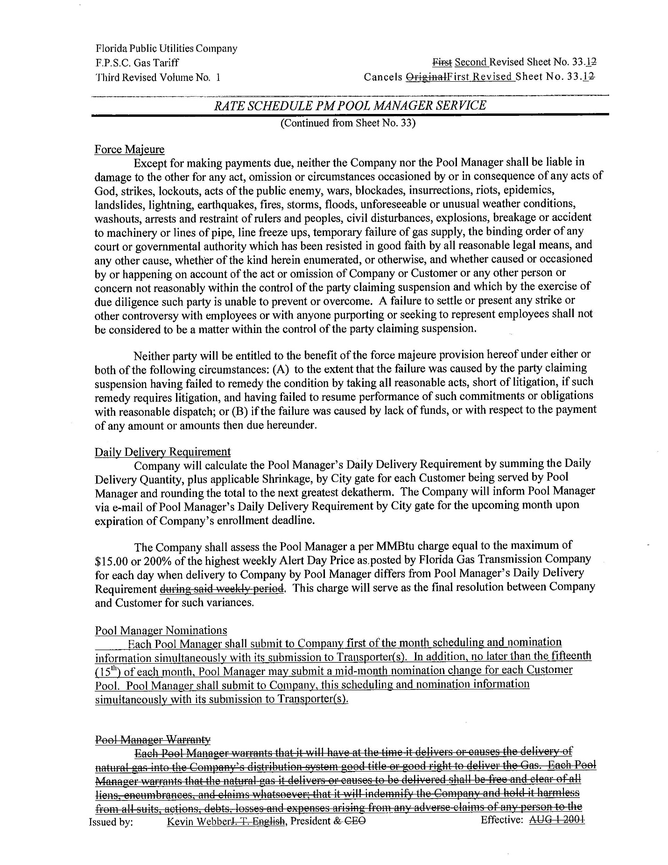

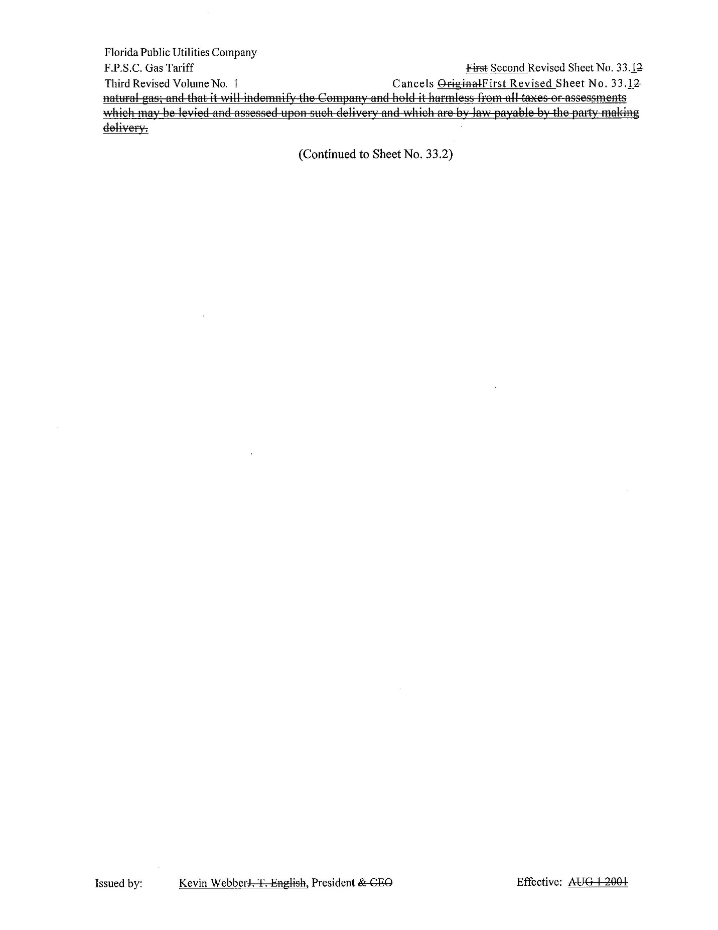

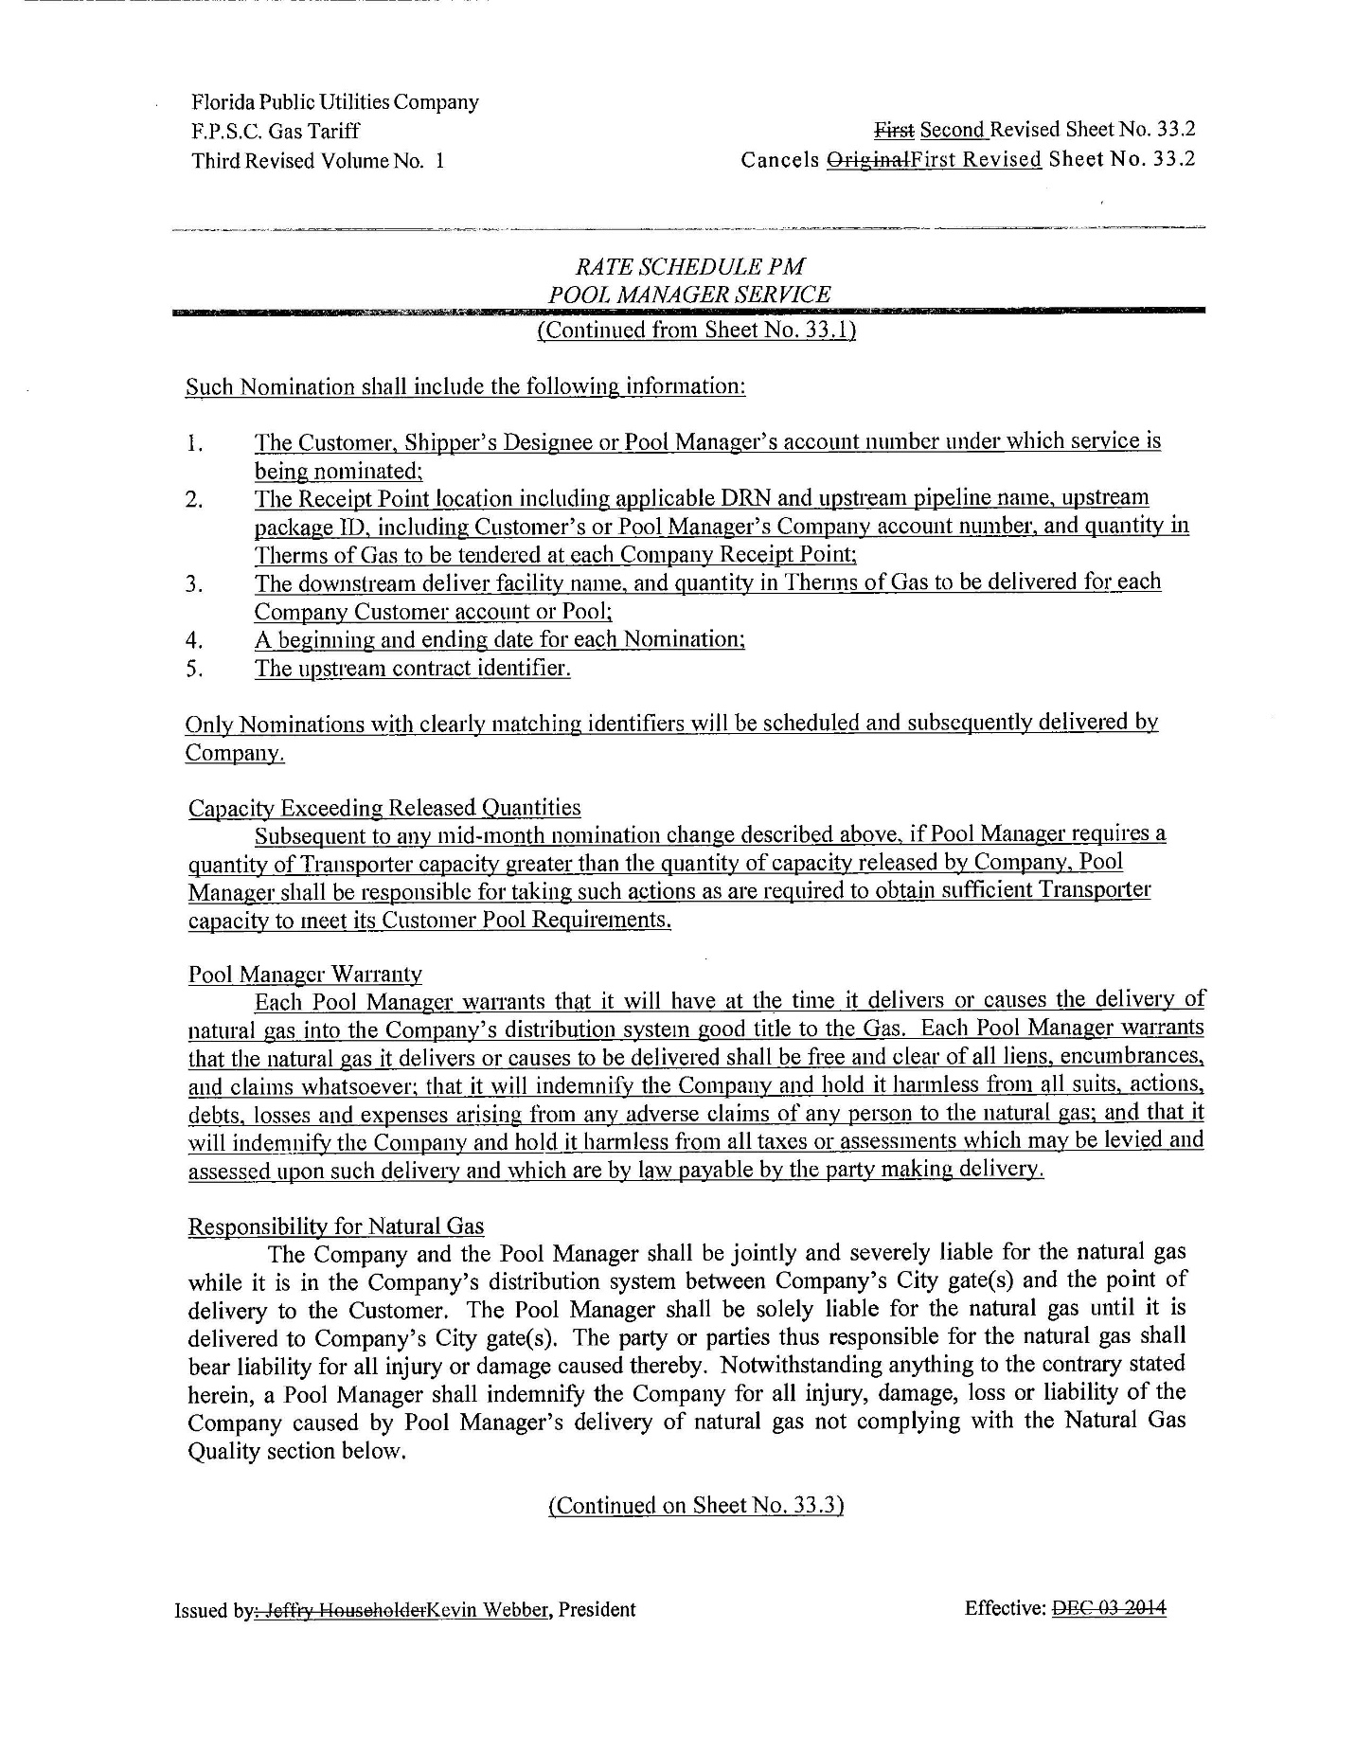

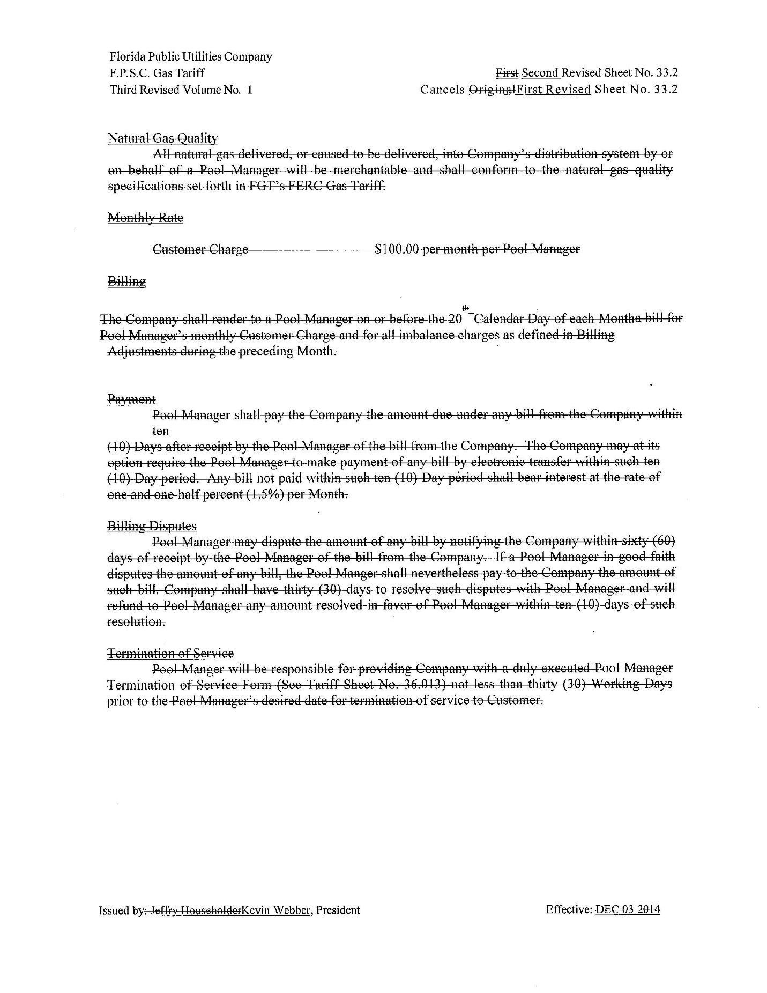

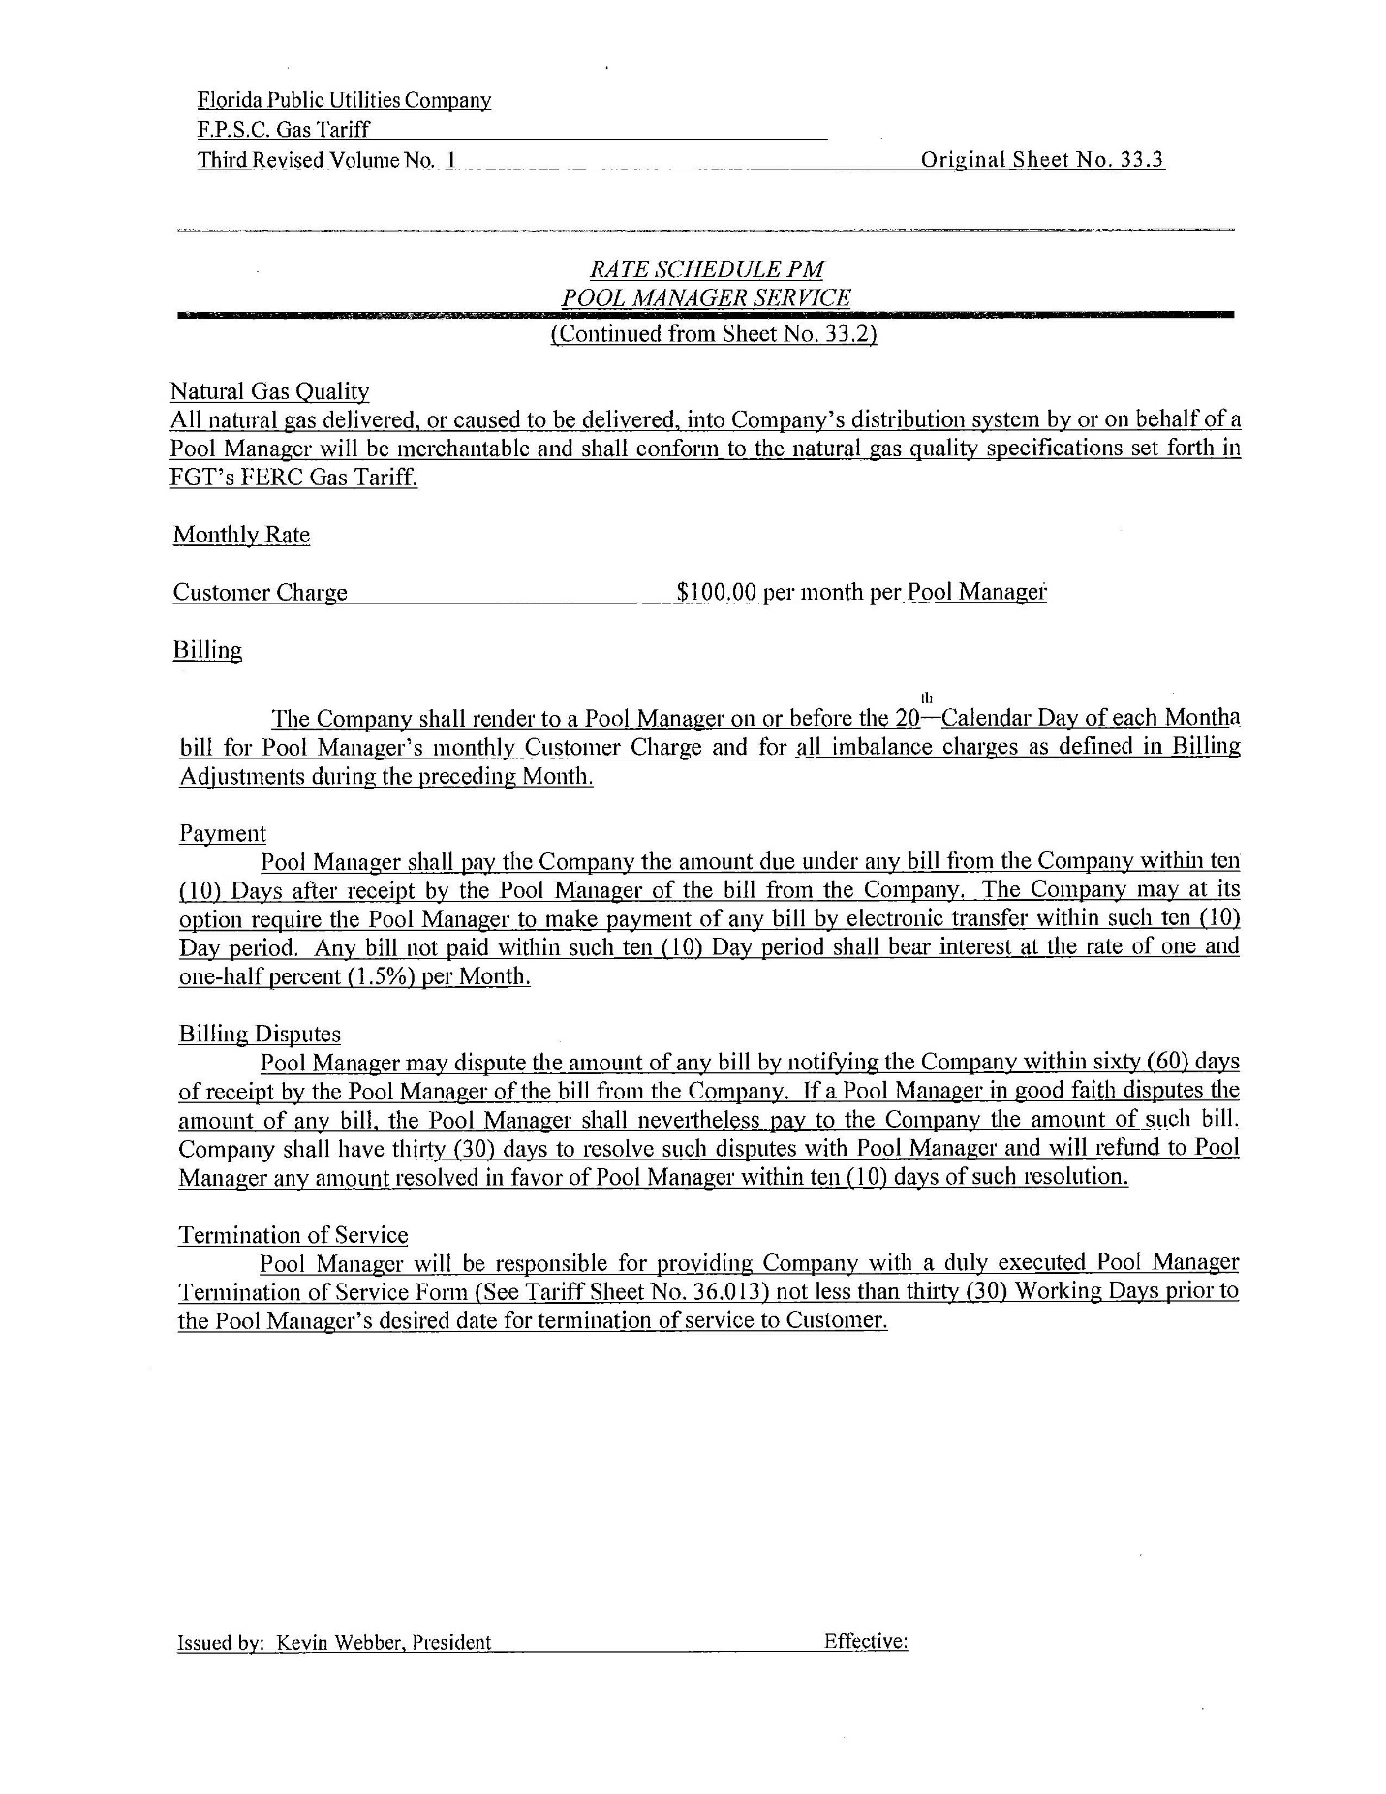

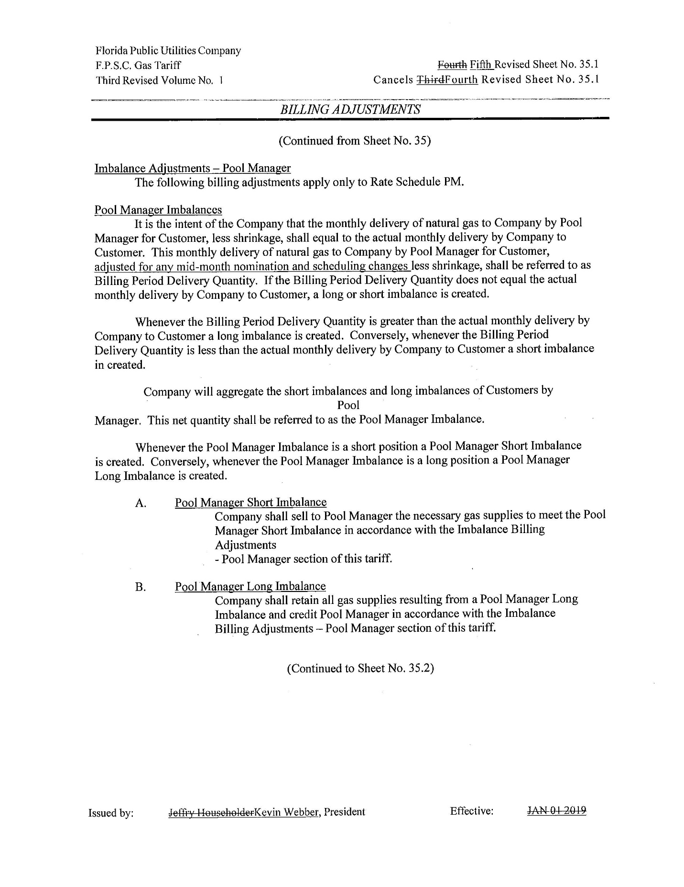
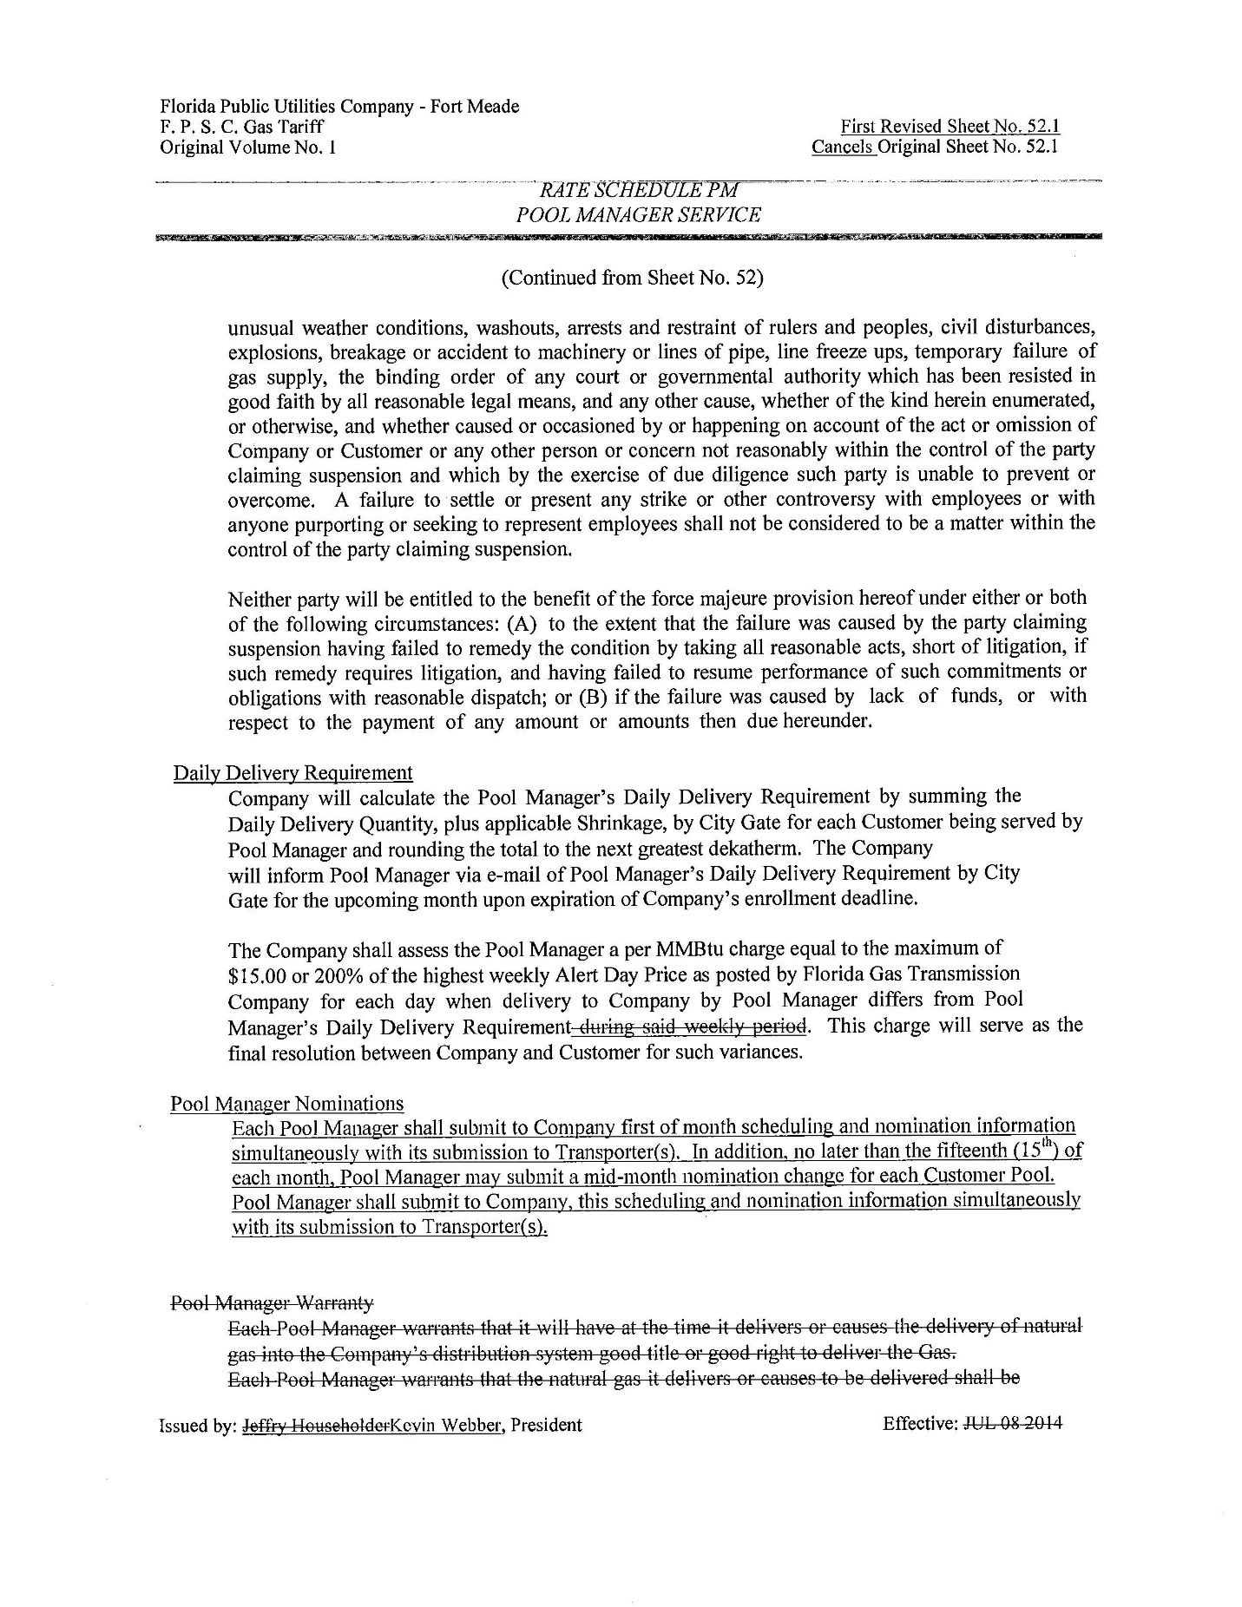

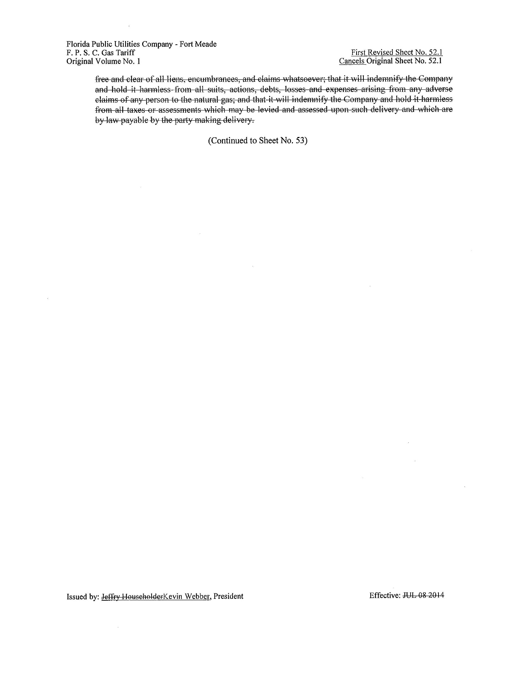

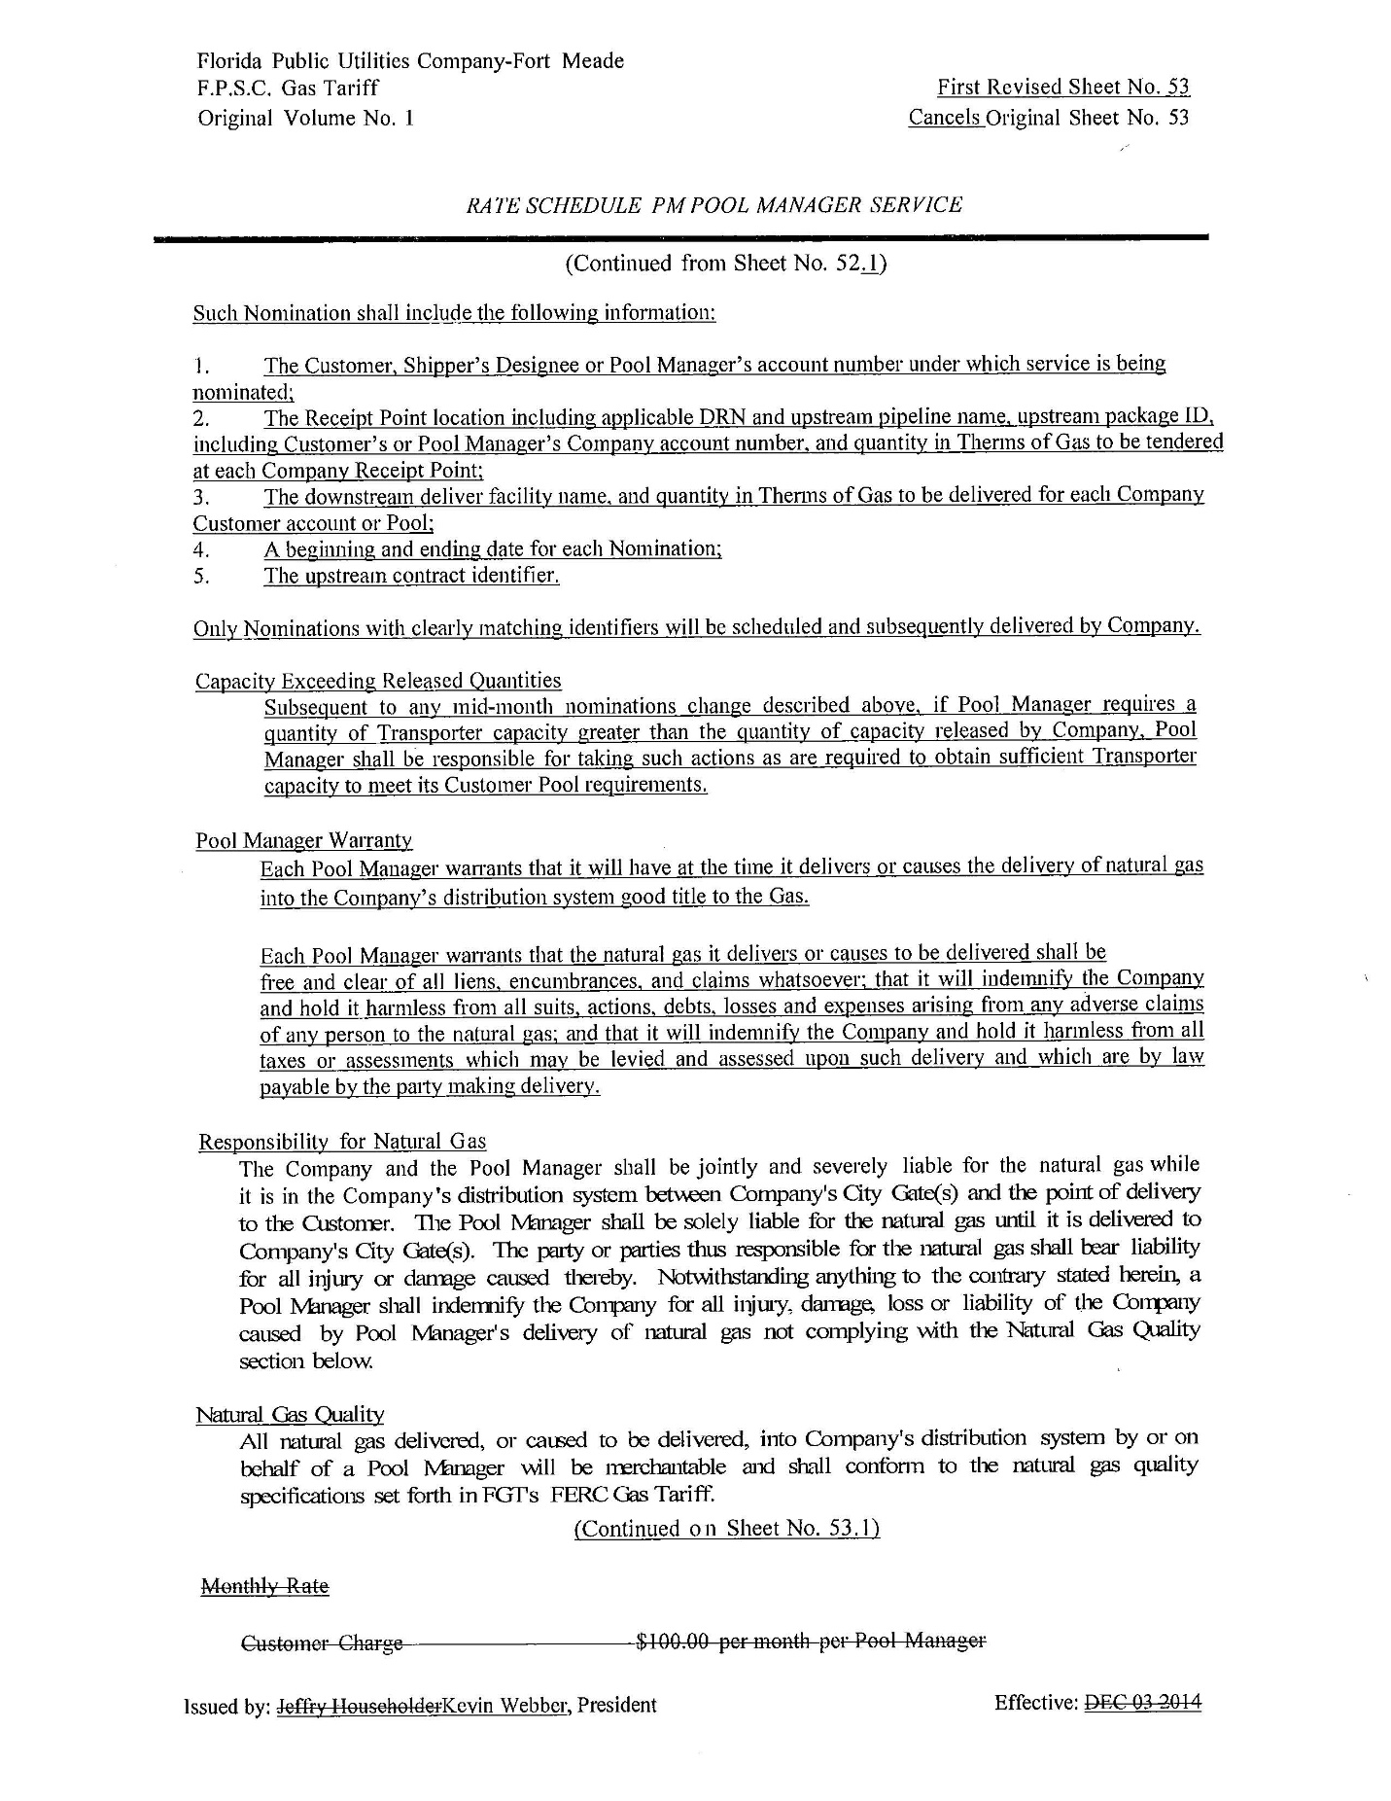

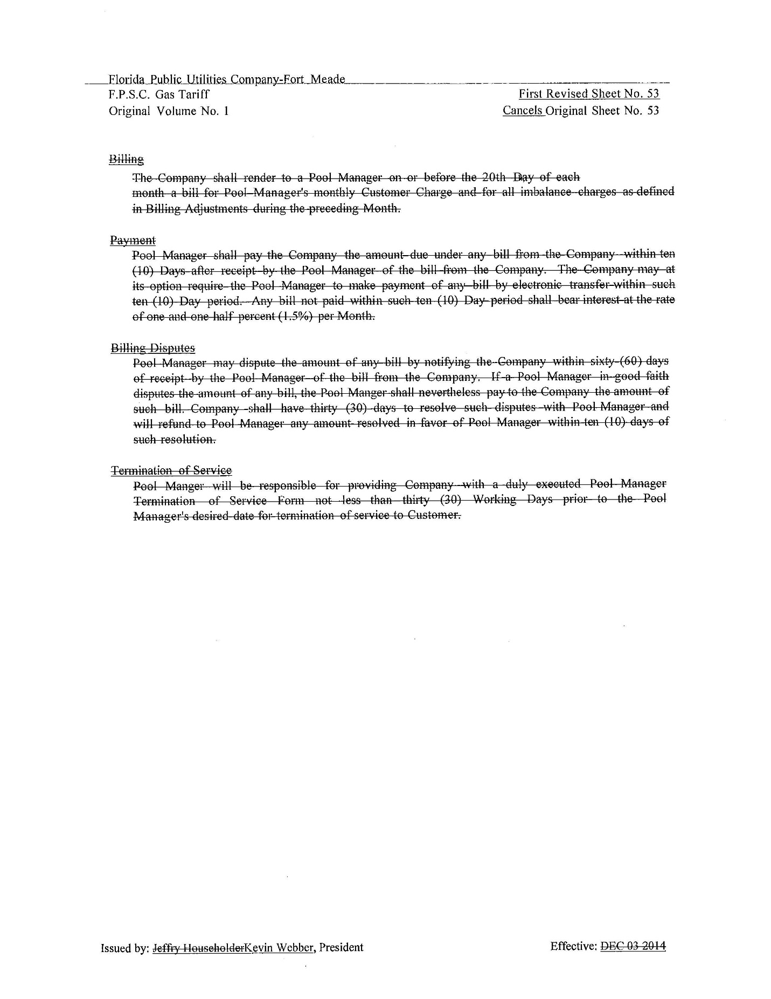

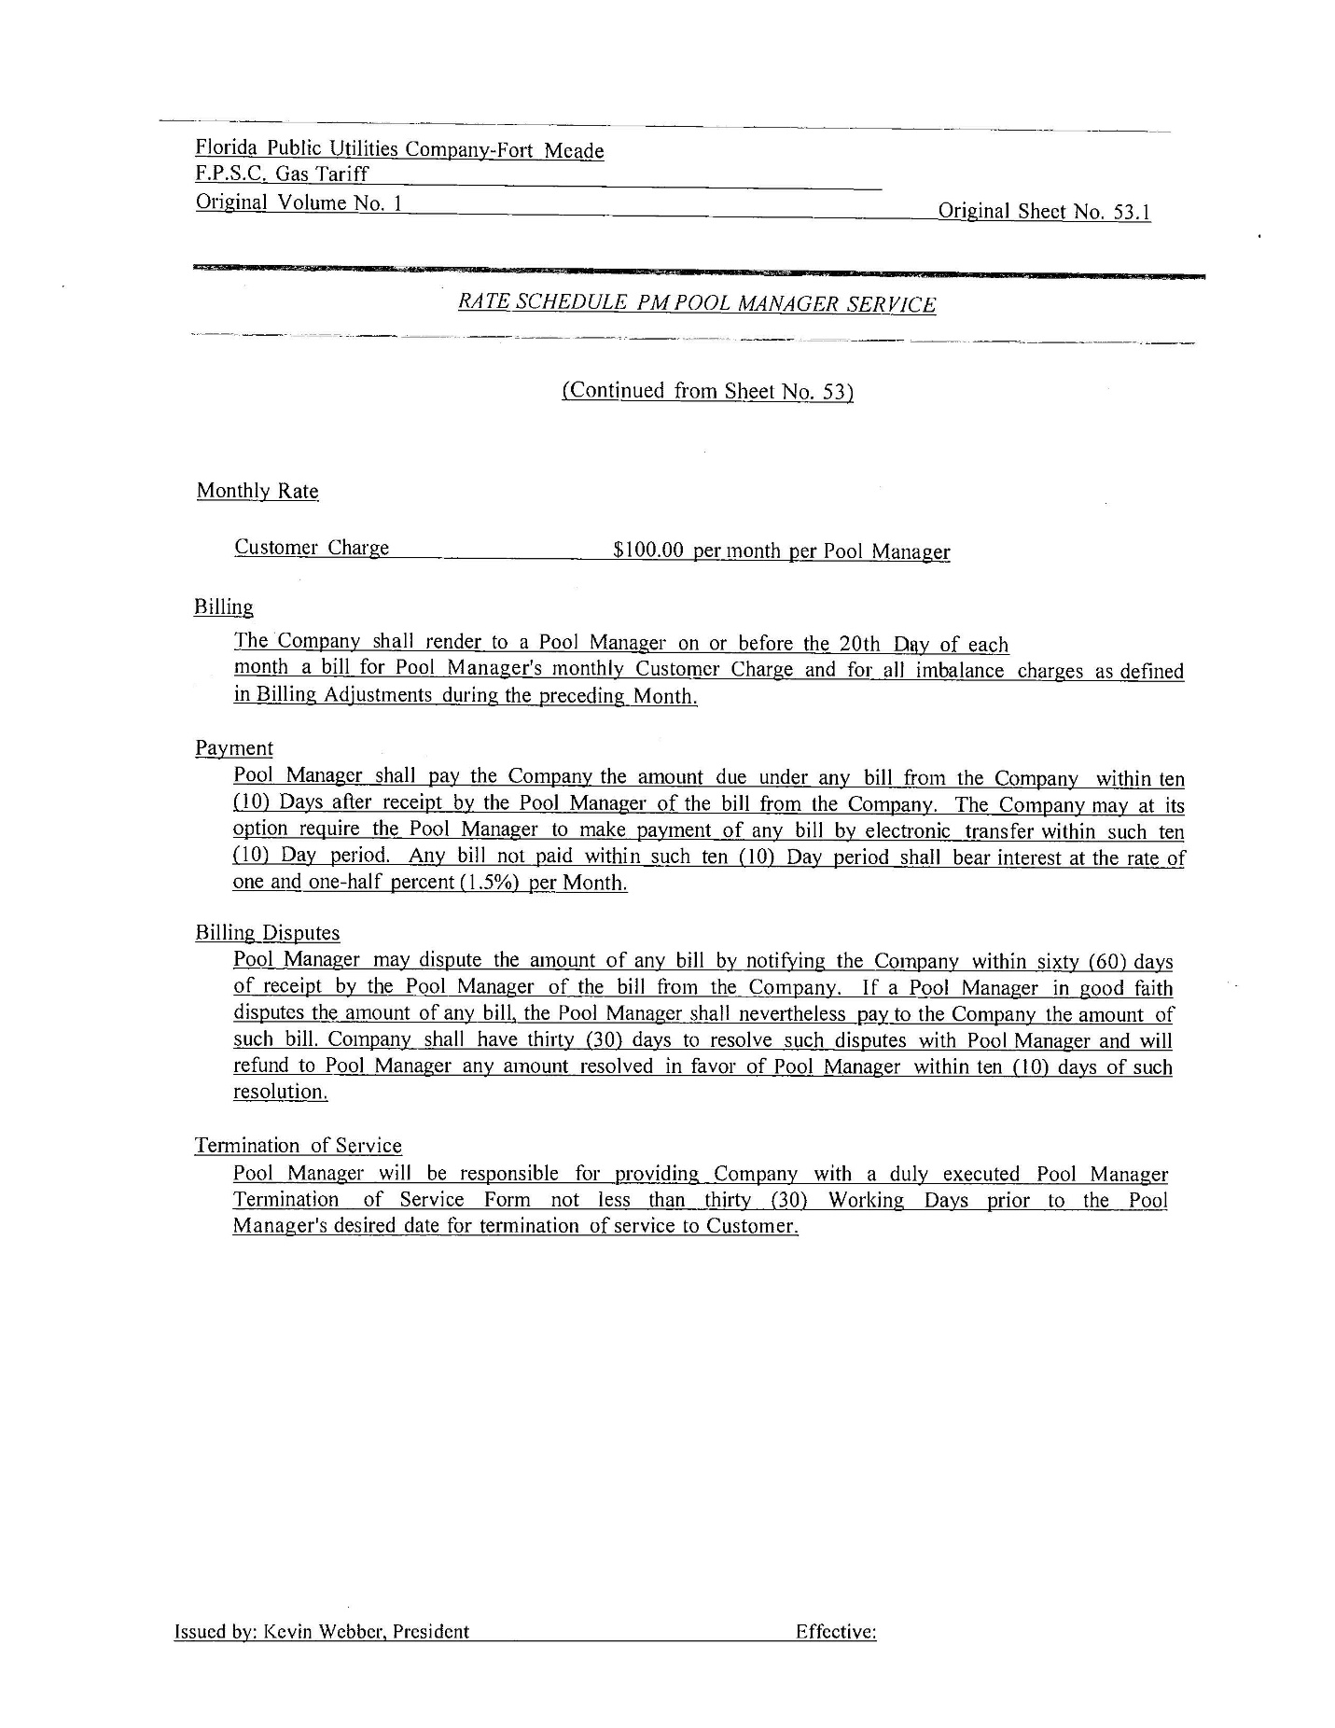

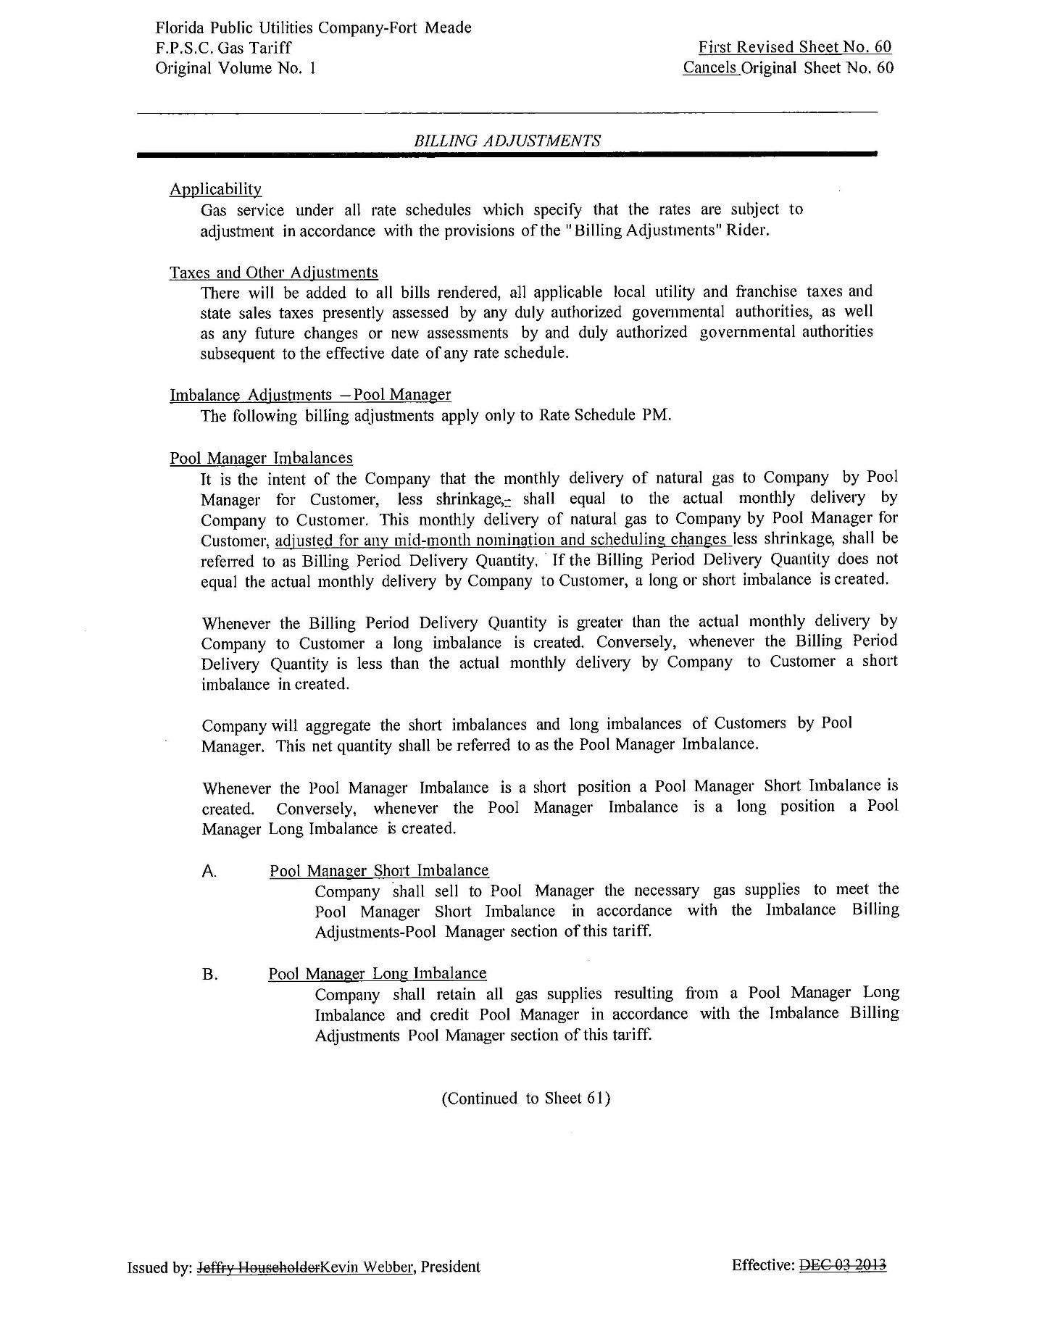

FPUC currently has 2,436 transportation customers and 60,958 sales customers while FPUC-Fort Meade currently has 9 transportation customers and 579 sales customers (source: Response #4 in Commission Staff’s First Data Request, Document No. 11400-2019.).
Order No. PSC-2019-0153-TRF-GU, issued April 24, 2019, in Docket No. 20190036-GU, In re: Petition for authority for approval of revised transportation imbalance tariffs, by Florida Public Utilities Company; Florida Public Utilities Company-Ft. Meade.
When pool managers deliver more natural gas than what is consumed by their customers (resulting in an imbalance), the Companies pay the pool managers for the excess gas. The payments to pool managers are based on natural gas cash-out rates as reported in the Platts Gas Daily and published pipeline capacity charges.
See Peoples Gas System Tariff Sheet No. 8.119-5, Section 4.4 and Order No. PSC-16-0503-TRF-GU, issued October 31, 2016, in Docket No. 20160120-GU, In re: Petition for approval of tariff modifications to rider NCTS, the firm delivery and operational balancing agreement, and negative imbalance cash-out prices, by Peoples Gas System.

