State of Florida |  | Public Service Commission  Capital Circle Office Center ● 2540 Shumard Oak Boulevard  Tallahassee, Florida 32399-0850  -M-E-M-O-R-A-N-D-U-M-
DATE: | March 19, 2020
TO: | Office of Commission Clerk (Teitzman)
FROM: | Division of Economics (Hampson, Coston)  Division of Engineering (Graves)  Office of the General Counsel (Stiller, Crawford)
RE: | Docket No. 20200046-GU – Petition to revise tariffs for Florida Public Utilities Company, Florida Public Utilities Company - Indiantown Division, Florida Public Utilities Company - Fort Meade, Florida Division of Chesapeake Utilities Corporation, and Peninsula Pipeline Company to update the description of gas quality and character of service.
AGENDA: | 03/31/20 – Regular Agenda – Tariff Filing – Interested Persons May Participate
COMMISSIONERS ASSIGNED: |  |  | All Commissioners
PREHEARING OFFICER: |  |  | Administrative
CRITICAL DATES: |  |  | 04/03/2020 (60-Day Suspension Date)
SPECIAL INSTRUCTIONS: |  |  | None

Case Background
Florida Public Utilities Company (FPUC), Florida Public Utilities Company - Indiantown Division (Indiantown), Florida Public Utilities Company - Fort Meade (Fort Meade), Florida Division of Chesapeake Utilities Corporation (Chesapeake), and Peninsula Pipeline Company (Peninsula) (jointly, Companies) proposed tariff revisions related to the description of gas quality and character of service. FPUC, Indiantown, Fort Meade, and Chesapeake are local distribution companies (LDCs) which own and operate natural gas distribution facilities to serve retail customers and are subject to the Commission’s regulatory jurisdiction under Chapter 366, Florida Statutes (F.S.). Peninsula operates as an intrastate natural gas transmission company as defined in Section 368.103, F.S., and only transports natural gas. The Companies are affiliates or subsidiaries of Chesapeake Utilities Corporation.
The purpose of the proposed tariff revisions is to require the quality of natural gas entering the system to be consistent with the standards used by interstate pipelines. The Companies have stated that the revisions do not impact rates, rate structure, or terms and conditions of service; nor do they preclude the receipt of renewable natural gas.
When initially providing the revised tariffs to staff, the Companies requested that they be approved administratively by staff. After review, staff determined that some tariffs did not appear to meet the requirements to be approved administratively as outlined in Section 2.07C-5(a) of the Commission’s Administrative Procedures Manual. Specifically, Section 2.07C-5(a) does not provide for administrative approval of tariffs filed by intrastate natural gas transmission companies, such as Peninsula. On February 3, 2020, staff established this docket for Commission review of the modified tariffs.
During the evaluation of the petition, staff issued one data request to the Companies on February 10, 2020, to which responses were filed on February 24, 2020. The Companies’ revised tariff sheets are in Attachments 1 through 5 to this recommendation. The Commission has jurisdiction over this matter pursuant to Sections 366.05, 366.06, and 368.05, 368.104, F.S.

Discussion of Issues

Issue 1:
Should the Commission approve the Companies’ proposed tariff revisions?

Recommendation:
Yes, the Commission should approve the Companies’ proposed tariff revisions, effective March 31, 2020. (Hampson)

Staff Analysis:
Currently, the Companies accept natural gas that conforms to the quality standards set by the specific pipeline companies which deliver gas to the Companies’ system. Under these revisions, natural gas that is delivered from an interconnected pipeline will continue to be accepted at the standards set by that specific pipeline. In addition, the Companies have now proposed to establish gas quality standards, in each of their own tariffs, for any gas entering the Companies’ system that does not come from an interconnected pipeline.
The primary purpose of this change is to allow for the receipt of a broader range of natural gas, while maintaining the integrity of the distribution system and acceptable standards for customers. The proposed Quality of Gas section includes a list of standards for gas that is not delivered by interconnected pipelines, allowing the Companies to diversify their natural gas supply mix. Gas not delivered by interconnected pipelines can come from various sources, such as compressed, liquid, or renewable natural gas. The same standards have been proposed for each Company to ensure consistency.
The proposed Quality of Gas chart specifies the maximum allowable amount of various containments that could possibly be found in natural gas. The chart also defines ranges for specific natural gas properties, such as heating value. Finally, there is an additional requirement that gas should be commercially free of hazardous waste, solid or liquid matter, dust, gums, or any other substance that may impact the merchantability of the gas or impact any facilities the gas flows through.
Staff believes that the proposed Quality of Gas section is comparable to the standards set by interstate pipelines transporting gas to Florida, such as Florida Gas Transmission and Southern Natural Gas Company. Additionally, these standards are similar to what is currently contained in Peoples Gas System’s tariff.
In addition to the revisions discussed above, the LDC’s have also requested to revise certain Character of Service sections. These revisions are designed to reference the newly proposed Quality of Gas tariffs and include a definition for transportation service. These revisions do not alter service, but seek to reorganize and clarify the tariffs. As such, staff recommends that they be approved as well. Due to the structure of the tariffs, this revision must be made on each rate schedule, for each utility.

Conclusion
After review of the revisions requested by the Companies, staff believes that all revisions are reasonable and do not impact customer rates nor the terms and conditions of service. Staff believes that the quality of gas standards requested by the Companies to be reasonable and comparable to standards previously approved by the Commission. Therefore, staff recommends approval of the proposed tariff revisions, effective March 31, 2020.
Issue 2:
Should this docket be closed?

Recommendation:
If Issue 1 is approved and a protest is filed within 21 days of the issuance of the order, the tariff should remain in effect, with any revenues held subject to refund, pending resolution of the protest. If no timely protest is filed, this docket should be closed upon the issuance of a consummating order. (Stiller)

Staff Analysis:
If Issue 1 is approved and a protest is filed within 21 days of the issuance of the order, the tariff should remain in effect, with any revenues held subject to refund, pending resolution of the protest. If no timely protest is filed, this docket should be closed upon the issuance of a consummating order.

Attachment 1: Florida Public Utilities Company
Fourth Revised Sheet No. 11
Original Sheet No. 22.4
Nineteenth Revised Sheet No. 24
Sixth Revised Sheet No. 24.1
Fourteenth Revised Sheet No. 25
Twenty-first Revised Sheet No. 26
Seventh Revised Sheet No. 26.1
Nineteenth Revised Sheet No. 28
Twenty-second Revised Sheet No. 29
Eighteenth Revised Sheet No. 31
First Revised Sheet No. 33.3

Attachment 2: Florida Public Utilities Company- Fort Meade
First Revised Sheet No. 9
First Revised Sheet No. 31
First Revised Sheet No. 34
First Revised Sheet No. 35
First Revised Sheet No. 39
Second Revised Sheet No.45
Second Revised Sheet No. 53

Attachment 3: Florida Public Utilities- Indiantown Division
Third Revised Sheet No. 21
Third Revised Sheet No. 22
Third Revised Sheet No. 23
Third Revised Sheet No. 25
Second Revised Sheet No. 37
Second Revised Sheet No. 53
Original Sheet No. 53.1

Attachment 4: Florida Division of Chesapeake Utilities Corporation
Second Revised Sheet No. 15
Second Revised Sheet No. 61
Original Sheet No. 61.1
Second Revised Sheet No. 71
Second Revised Sheet No. 72
Second Revised Sheet No. 73
Second Revised Sheet No. 74
Second Revised Sheet No. 75
Second Revised Sheet No. 76
First Revised Sheet No. 77
Second Revised Sheet No. 78
First Revised Sheet No. 78.1
First Revised Sheet No. 78.2
Second Revised Sheet No. 79
Second Revised Sheet No. 80
First Revised Sheet No. 80.1
First Revised Sheet No. 80.2
Second Revised Sheet No. 81
Second Revised Sheet No. 82
Second Revised Sheet No. 83
Second Revised Sheet No. 84
Third Revised Sheet No. 85
Third Revised Sheet No. 86
Third Revised Sheet No. 87
Third Revised Sheet No. 88
Third Revised Sheet No. 89
Second Revised Sheet No. 90.1

Attachment 5: Peninsula Pipeline Company
First Revised Sheet No. 9
First Revised Sheet No. 18
Original Sheet No. 18.1

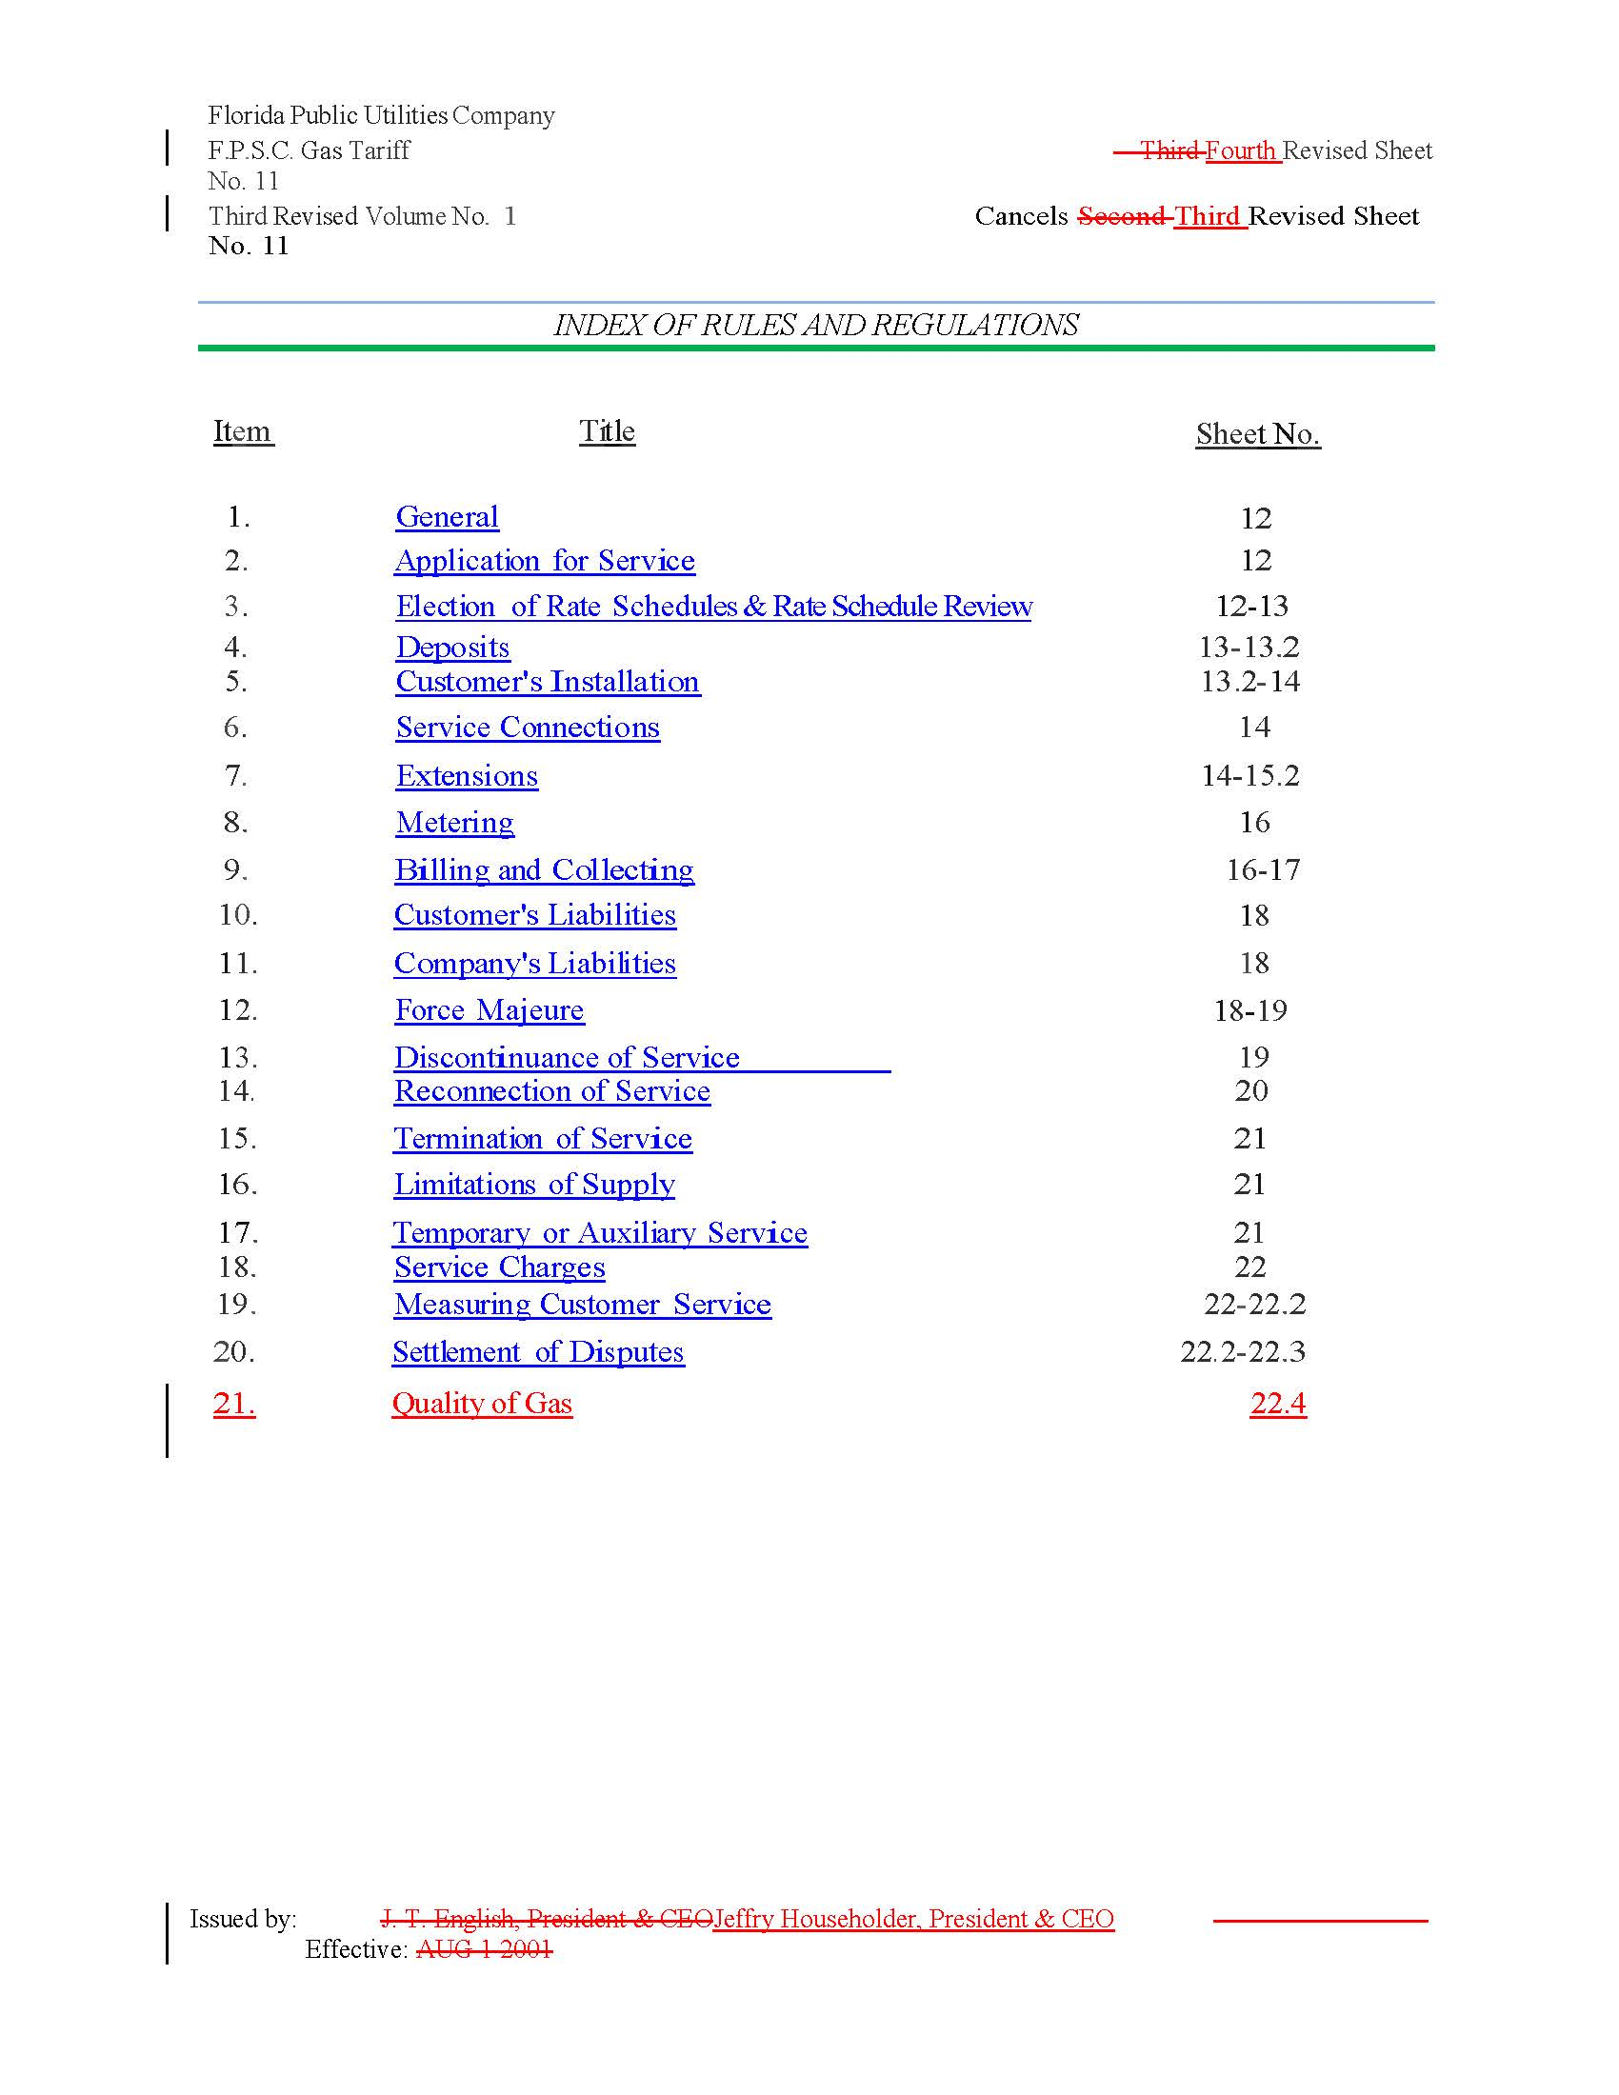

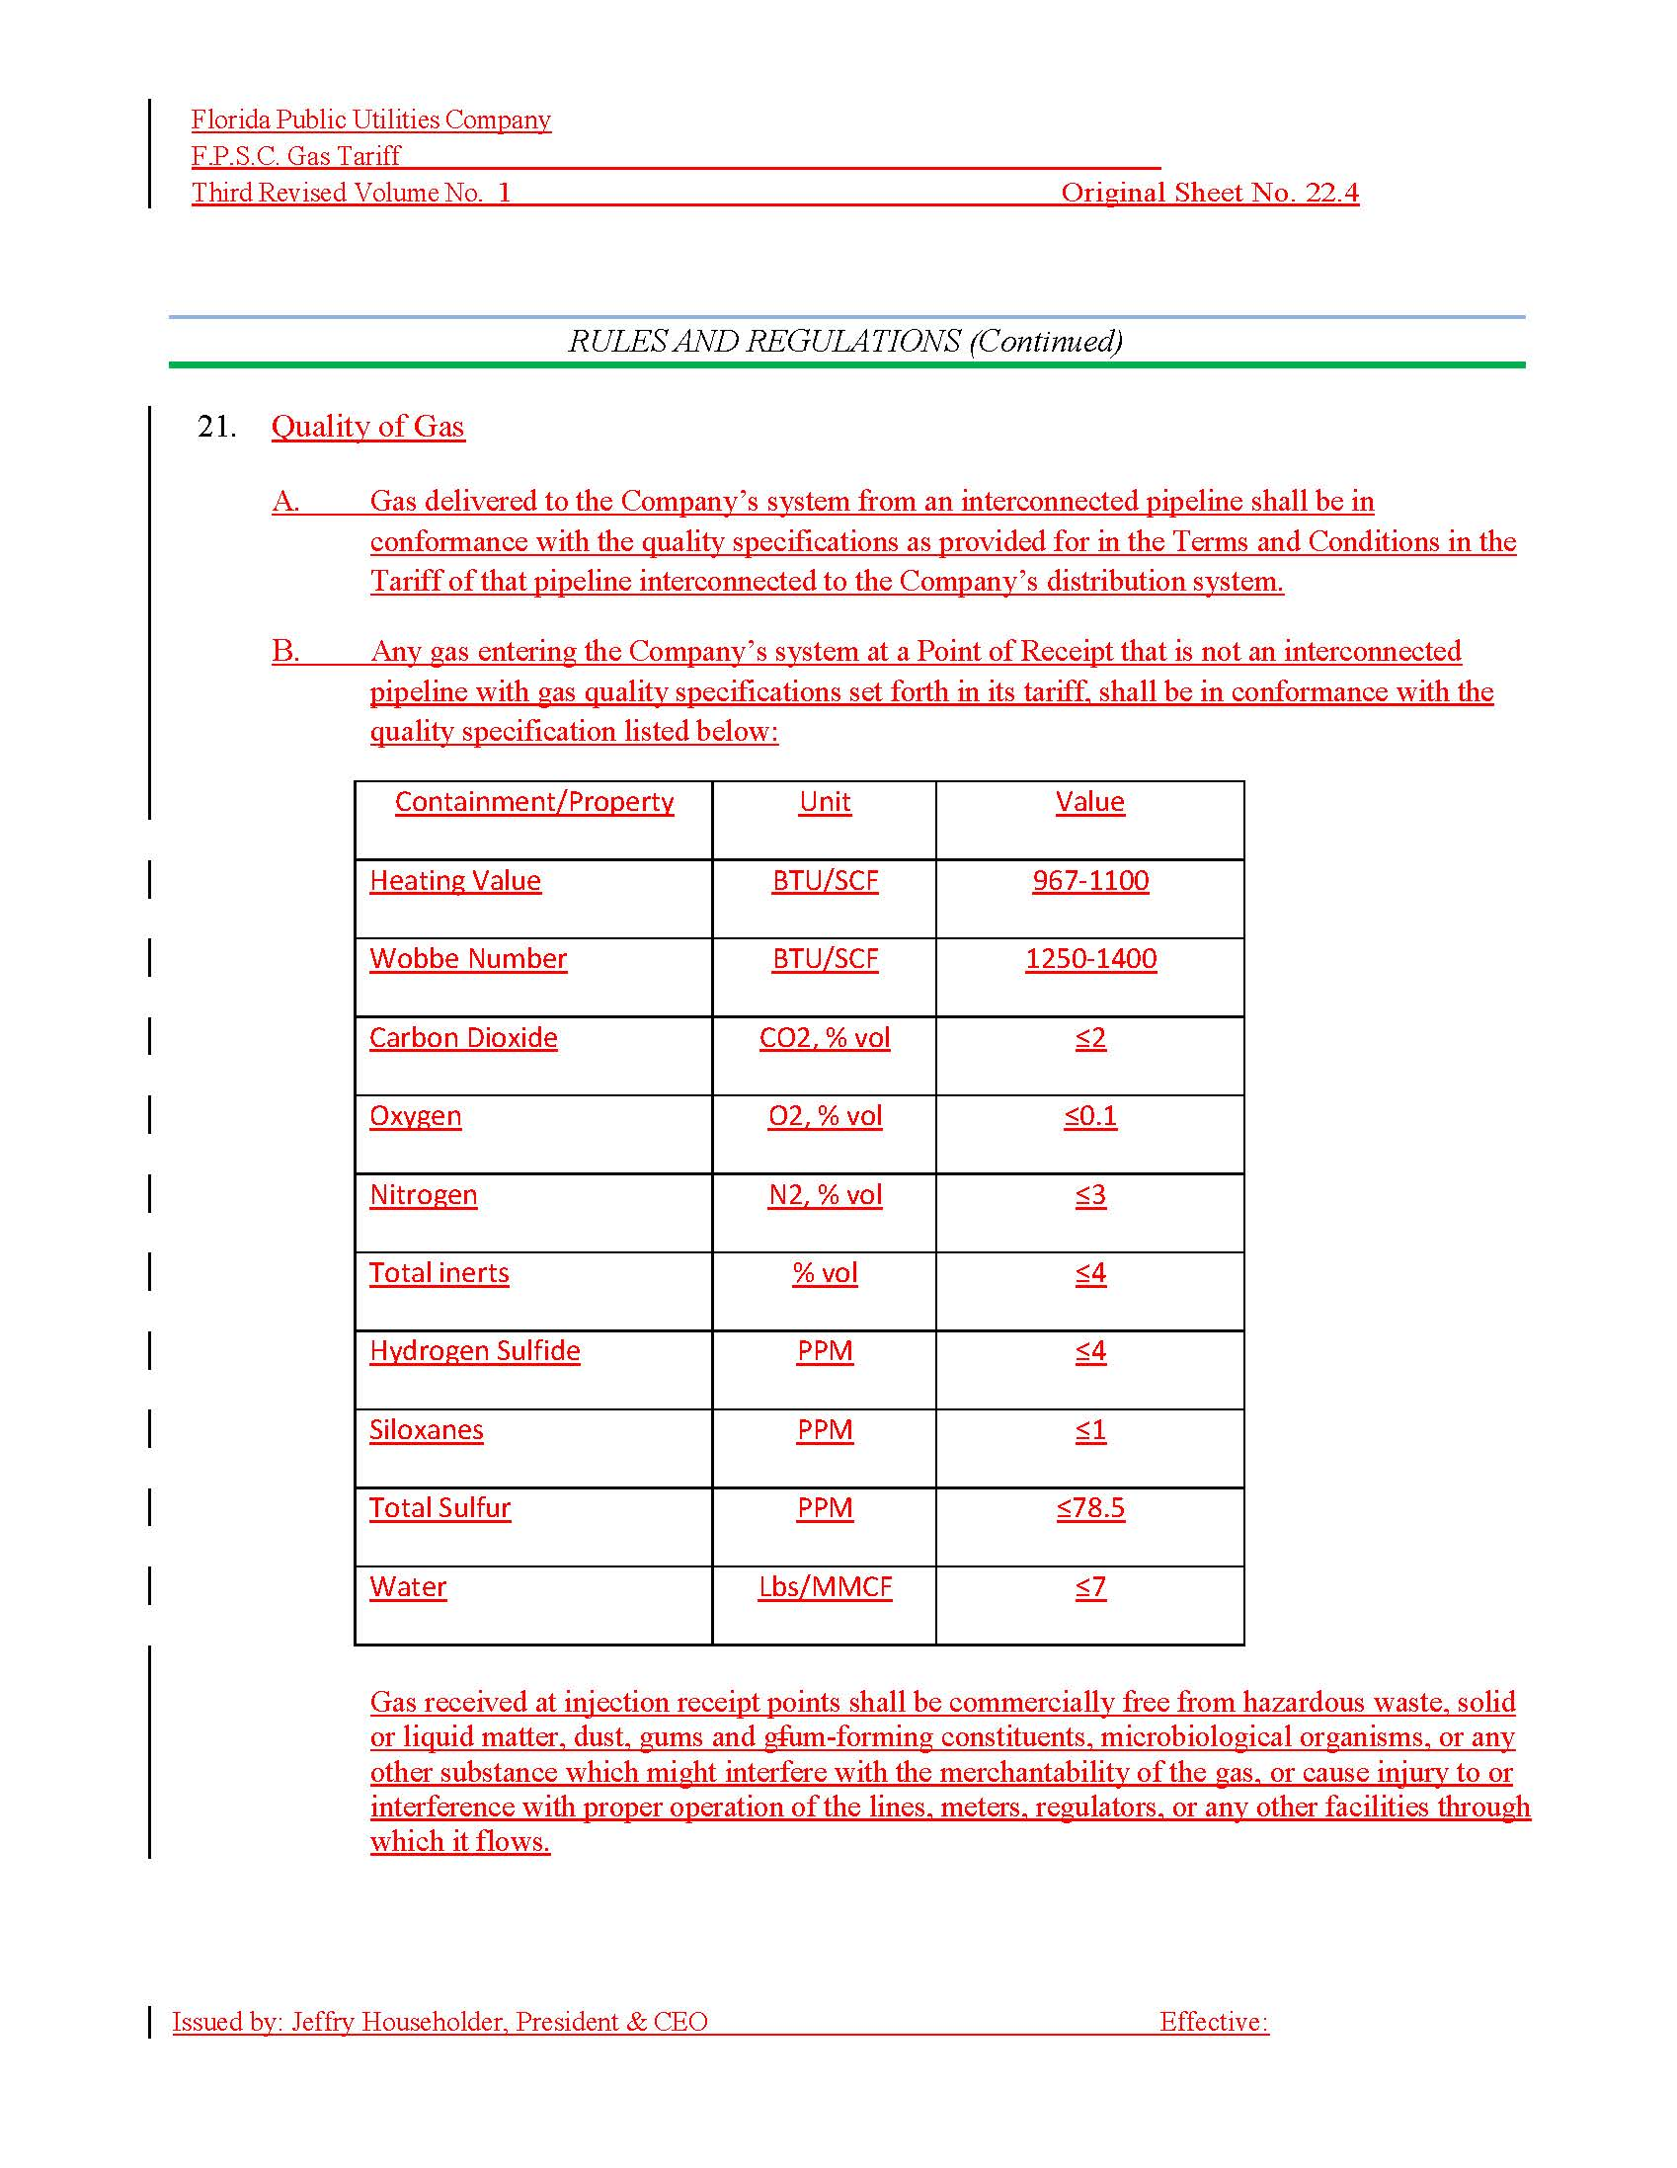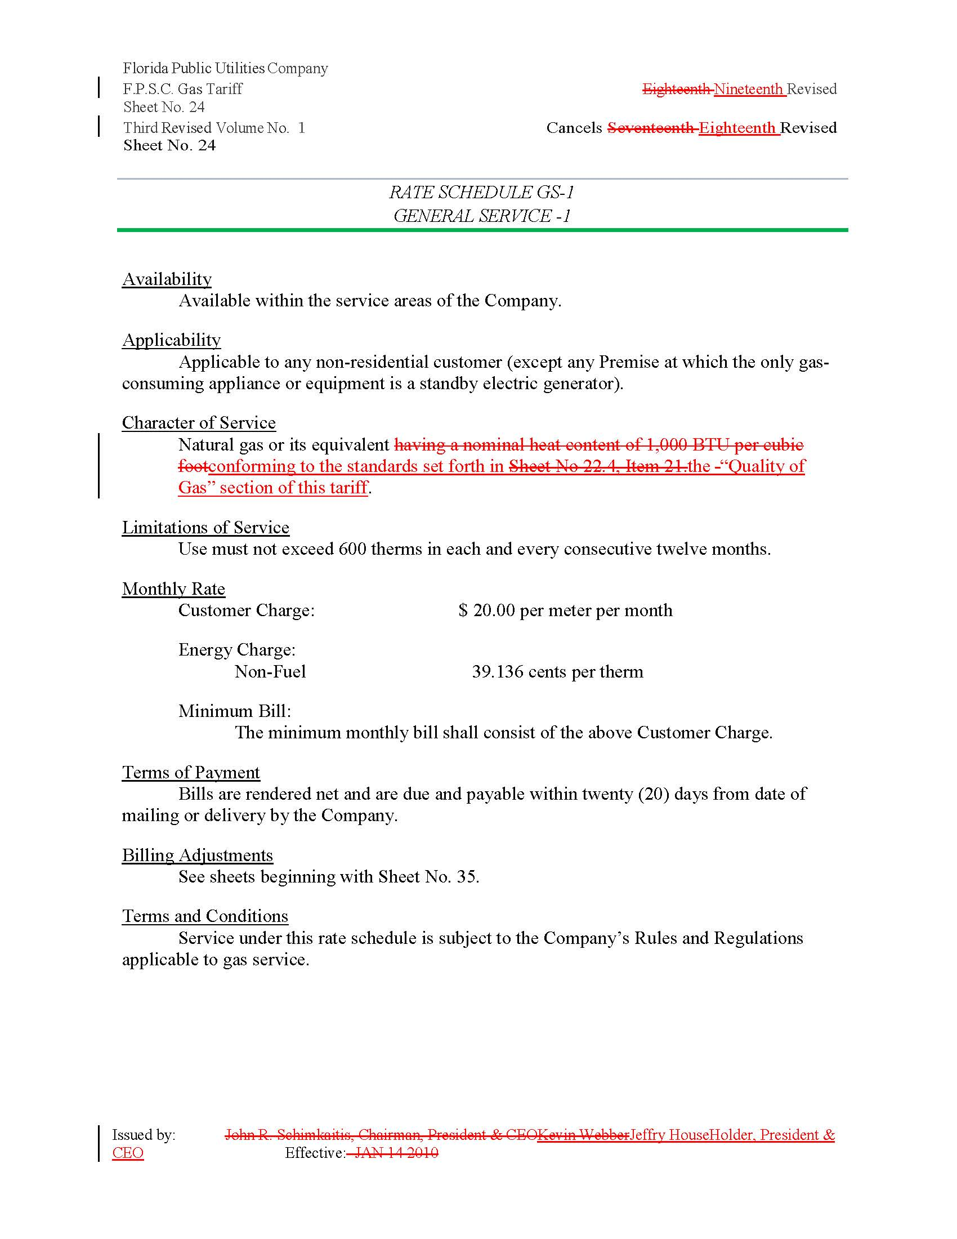

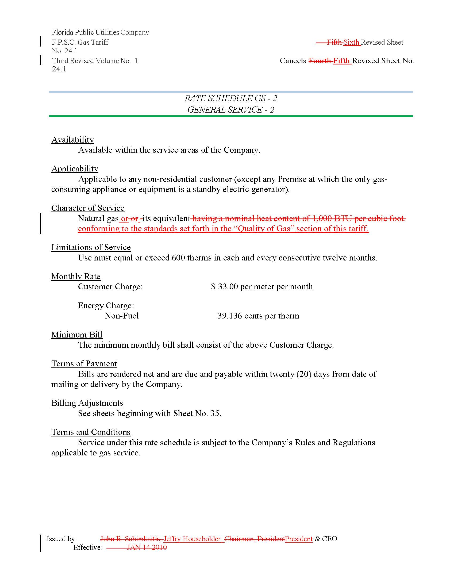

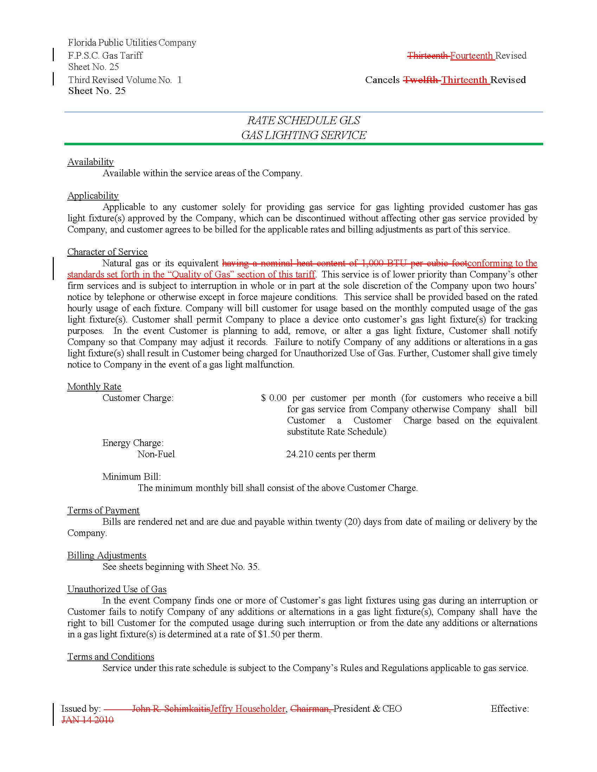

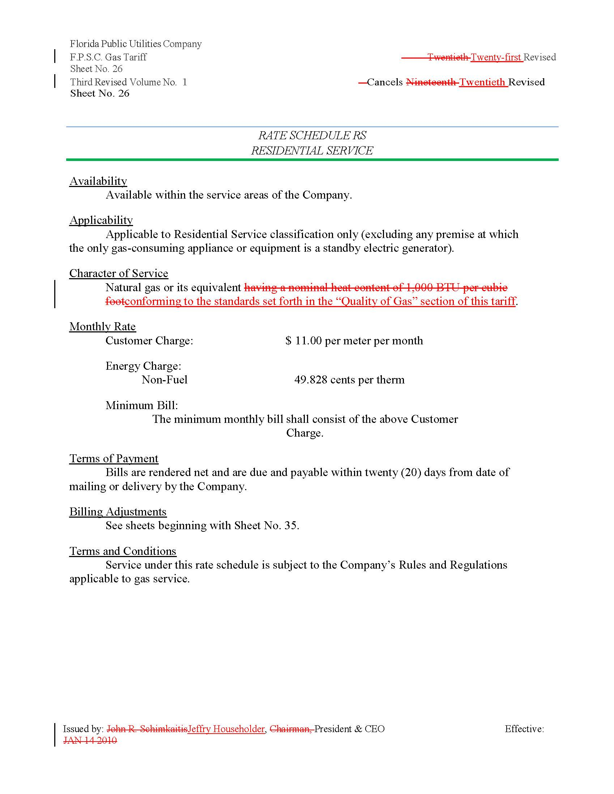

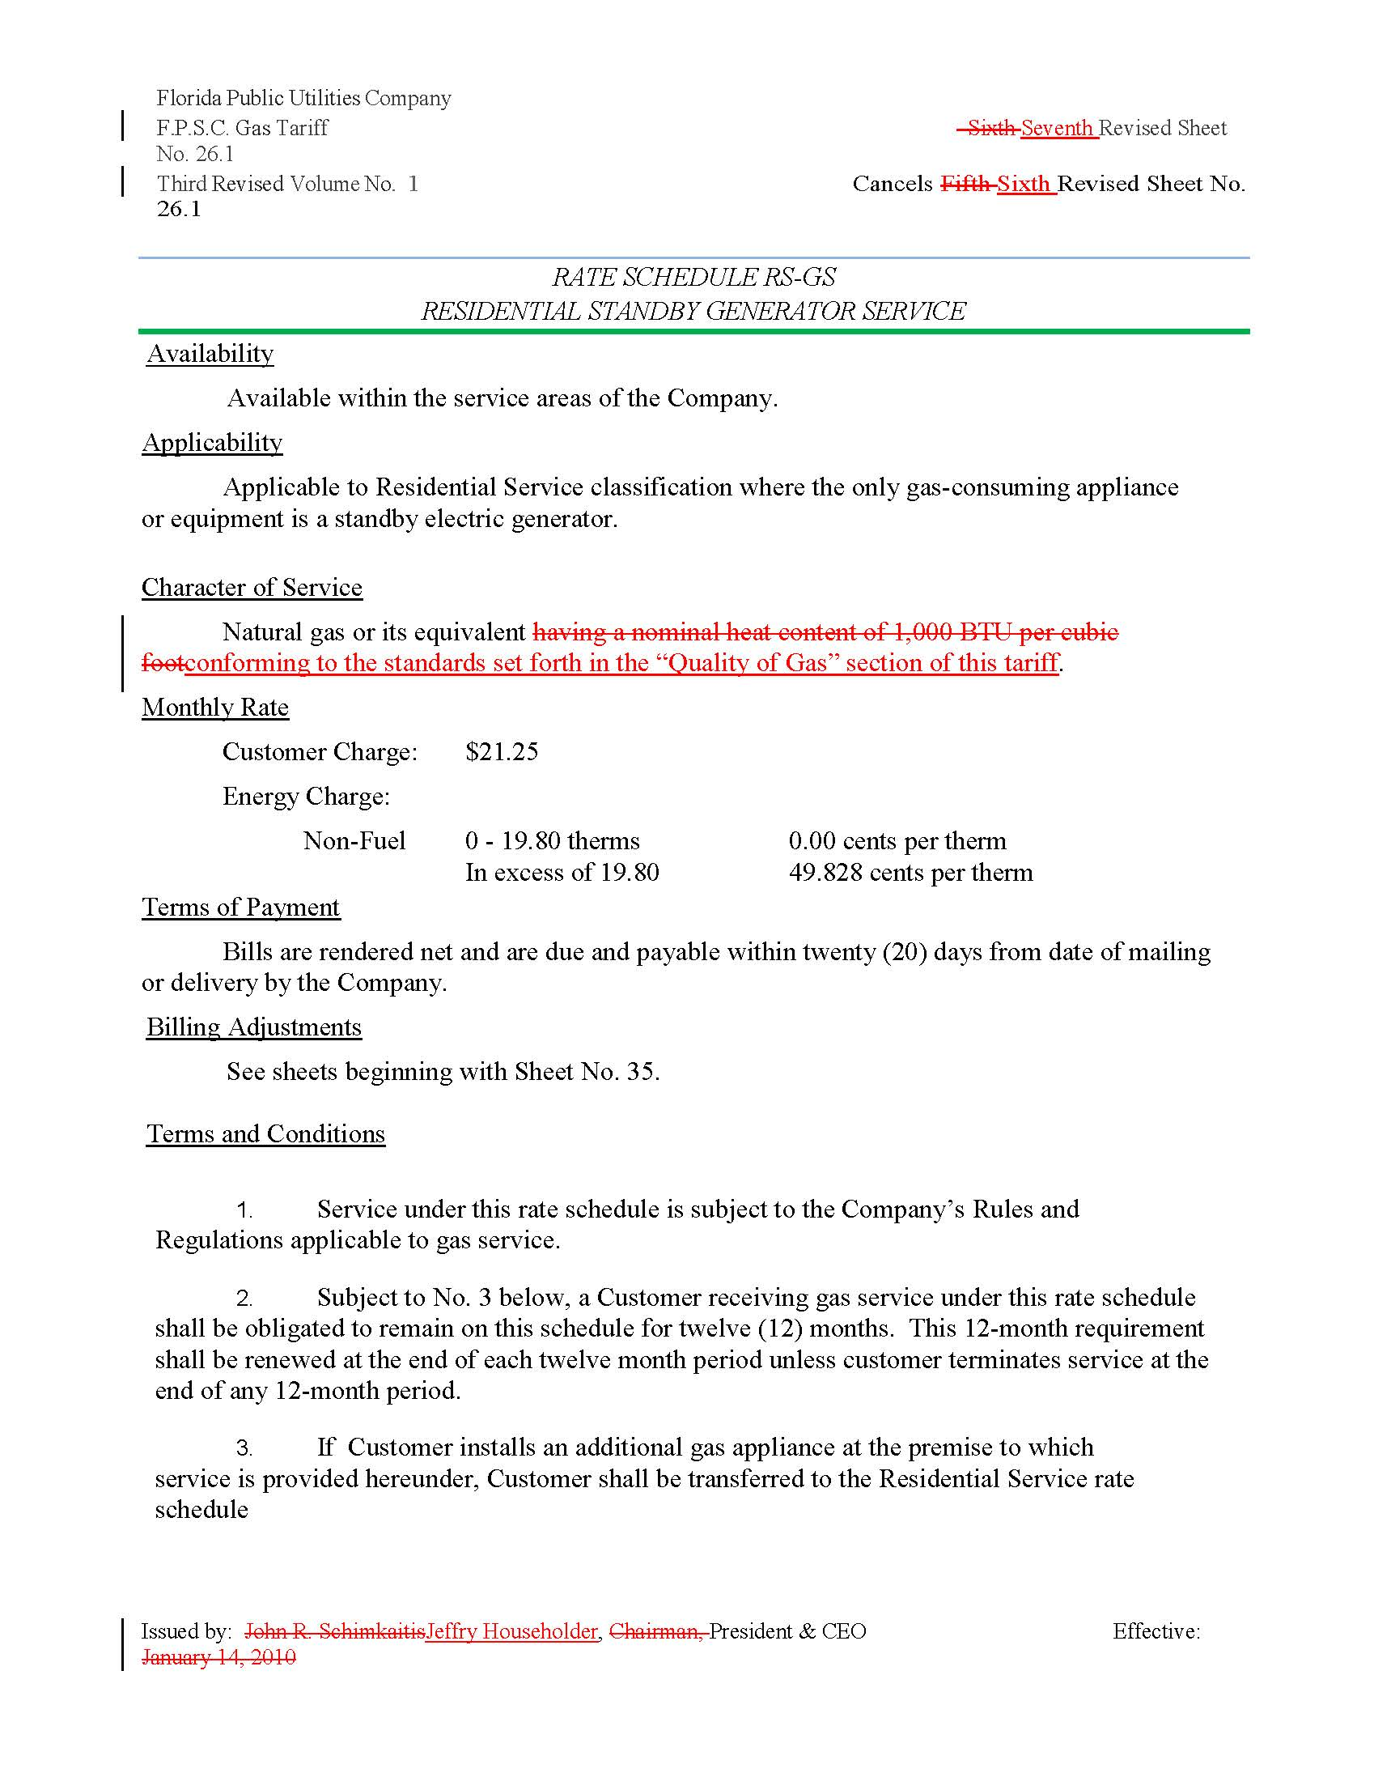

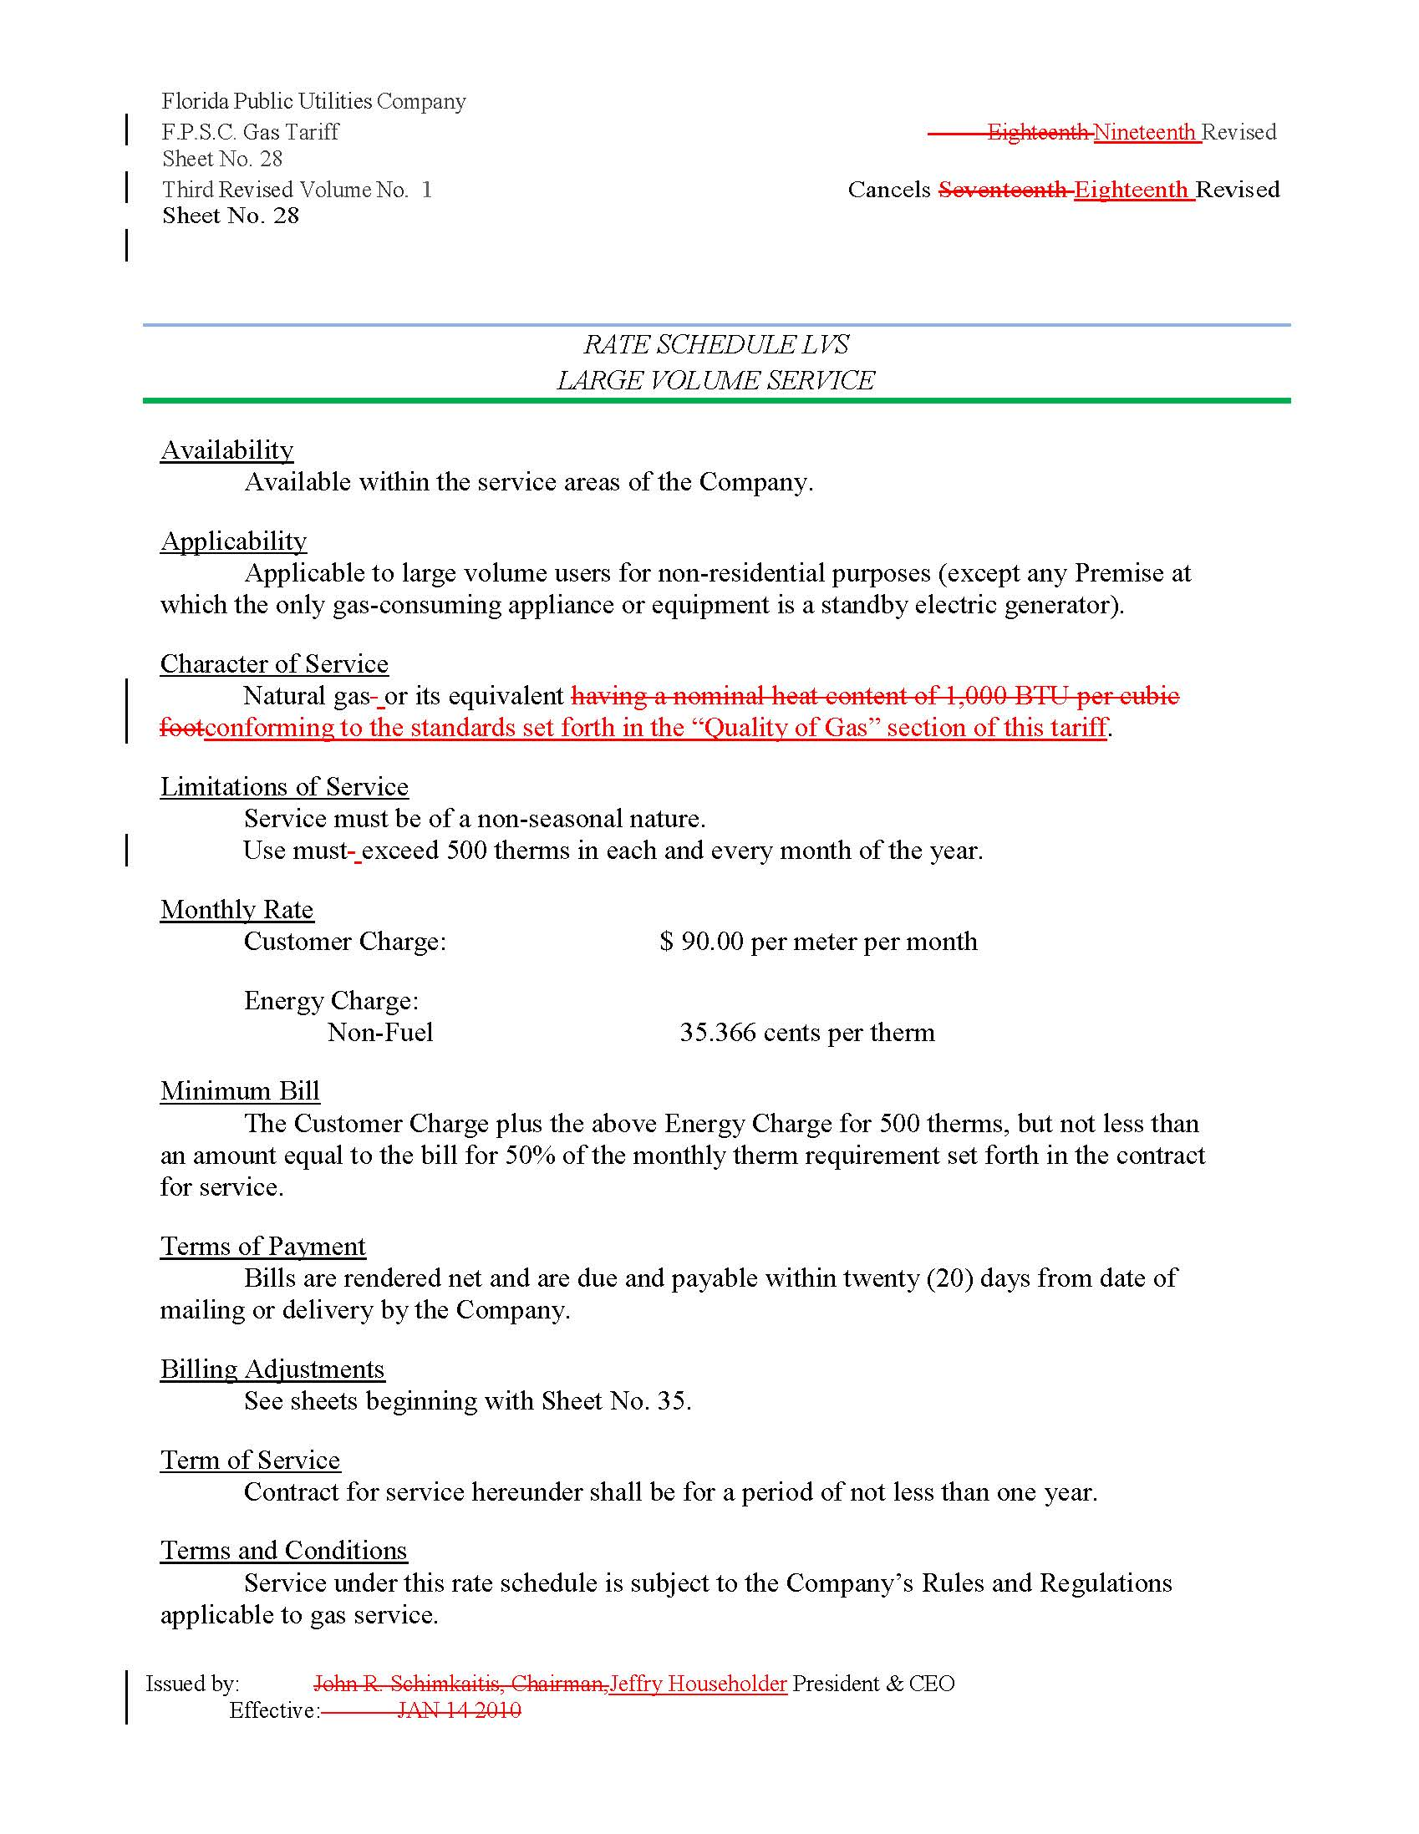

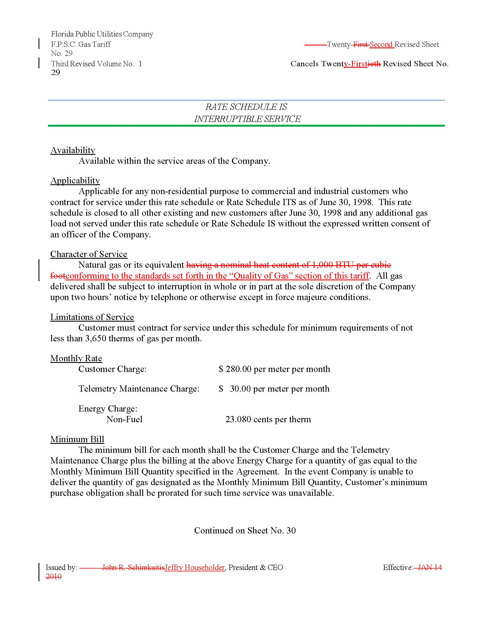

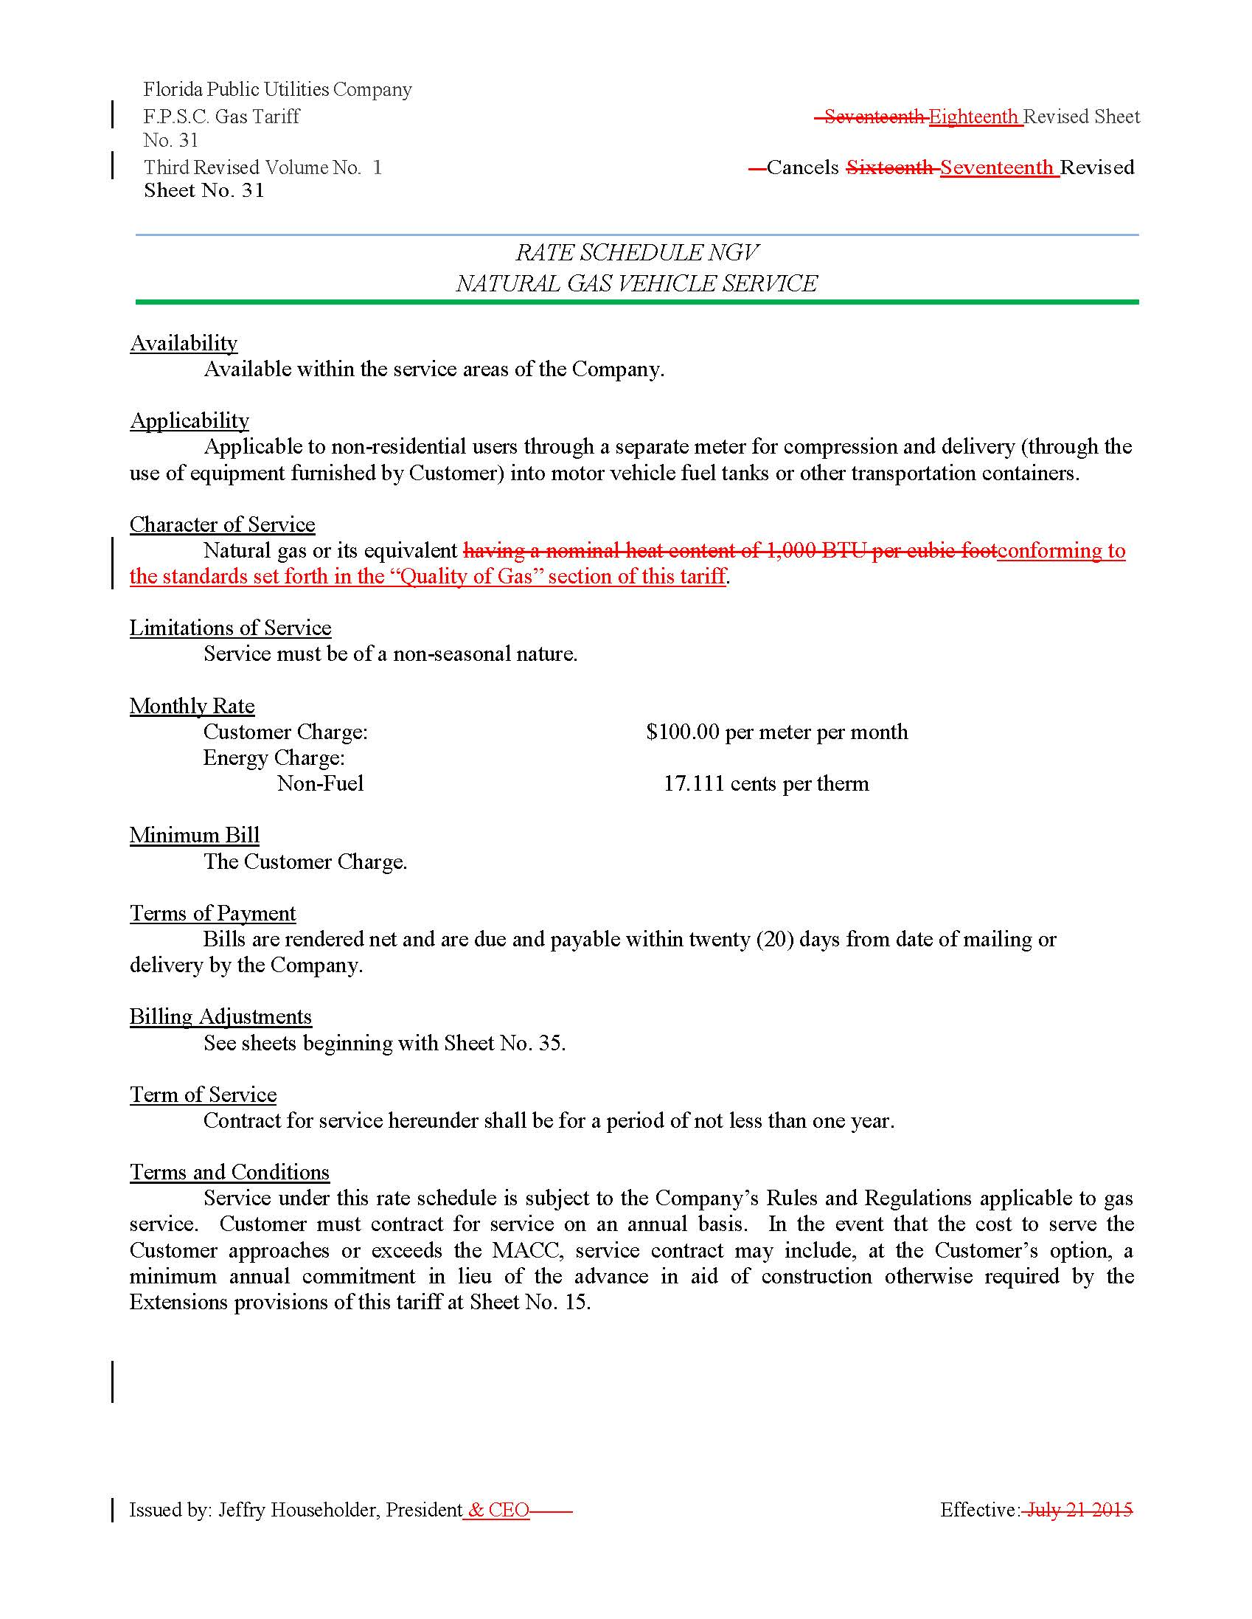

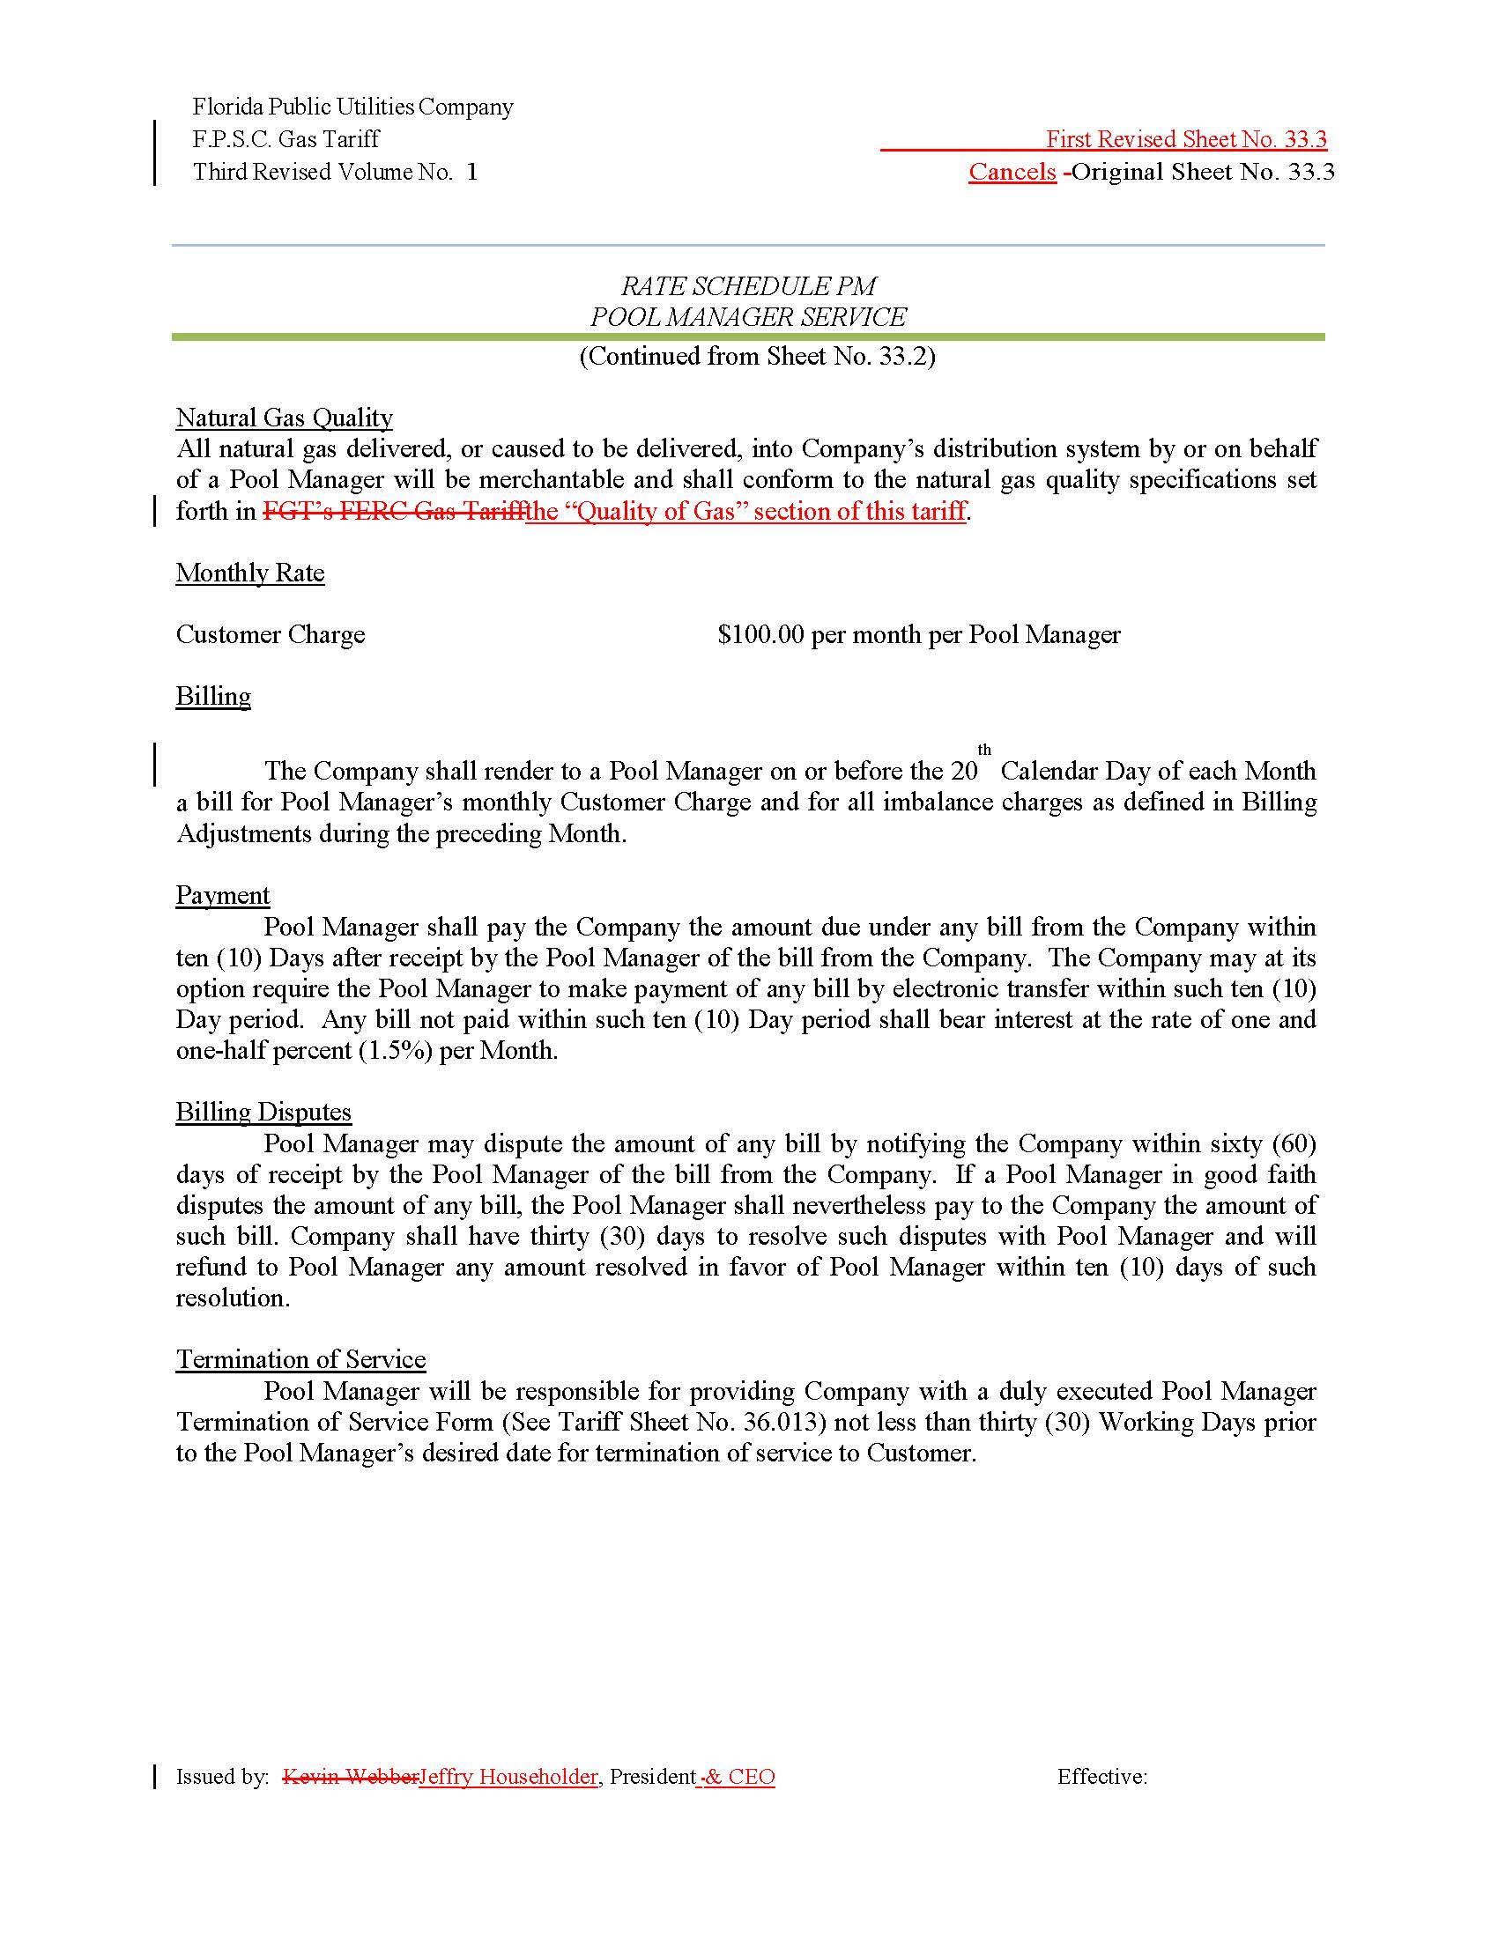

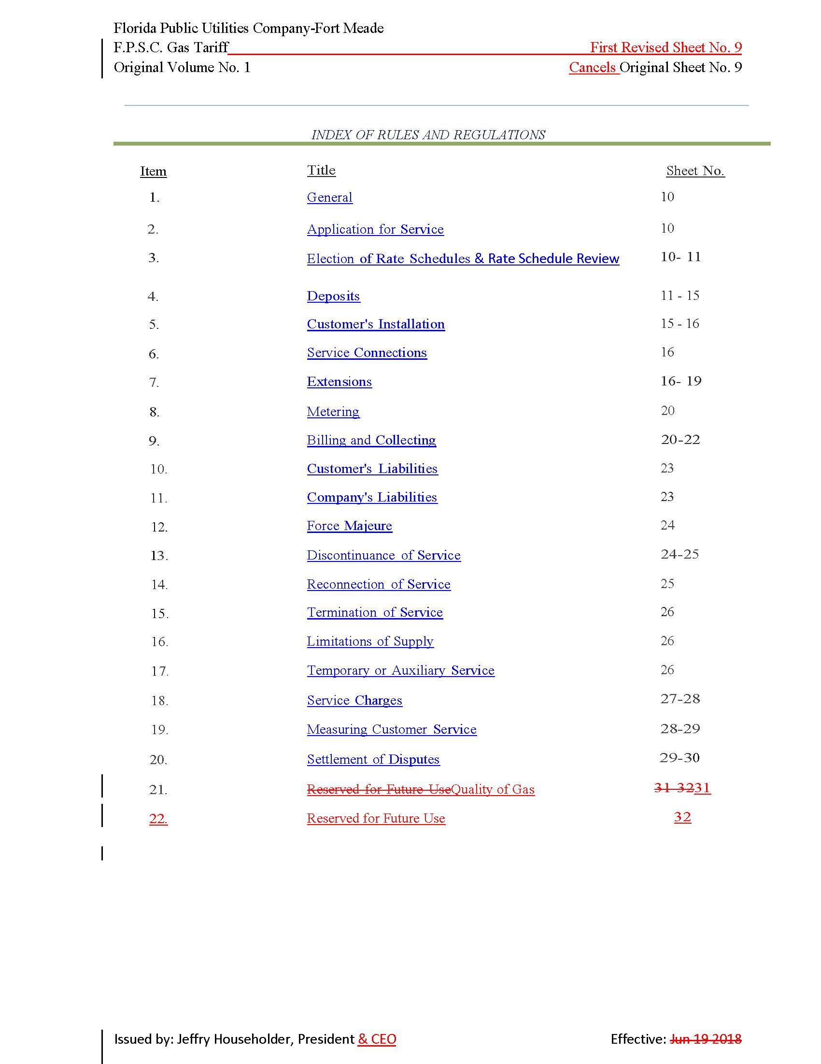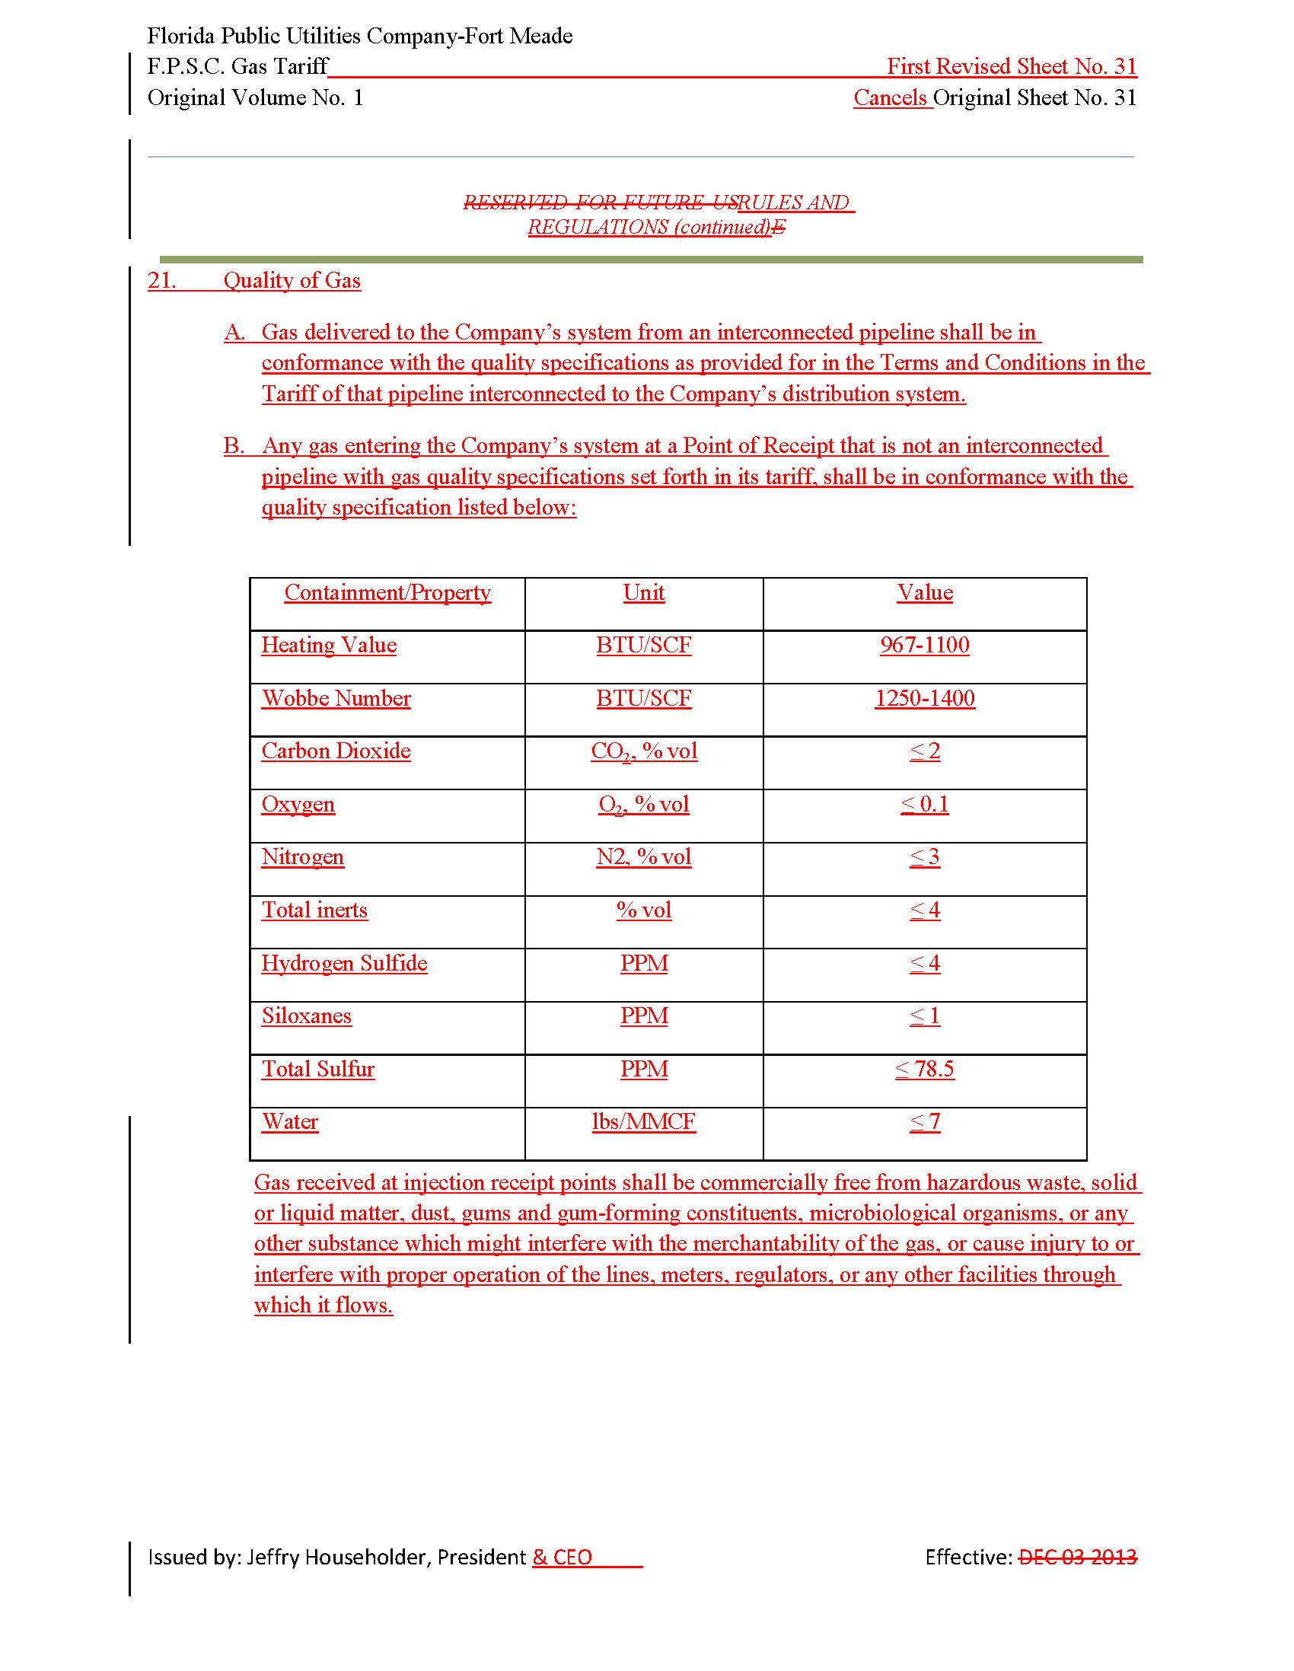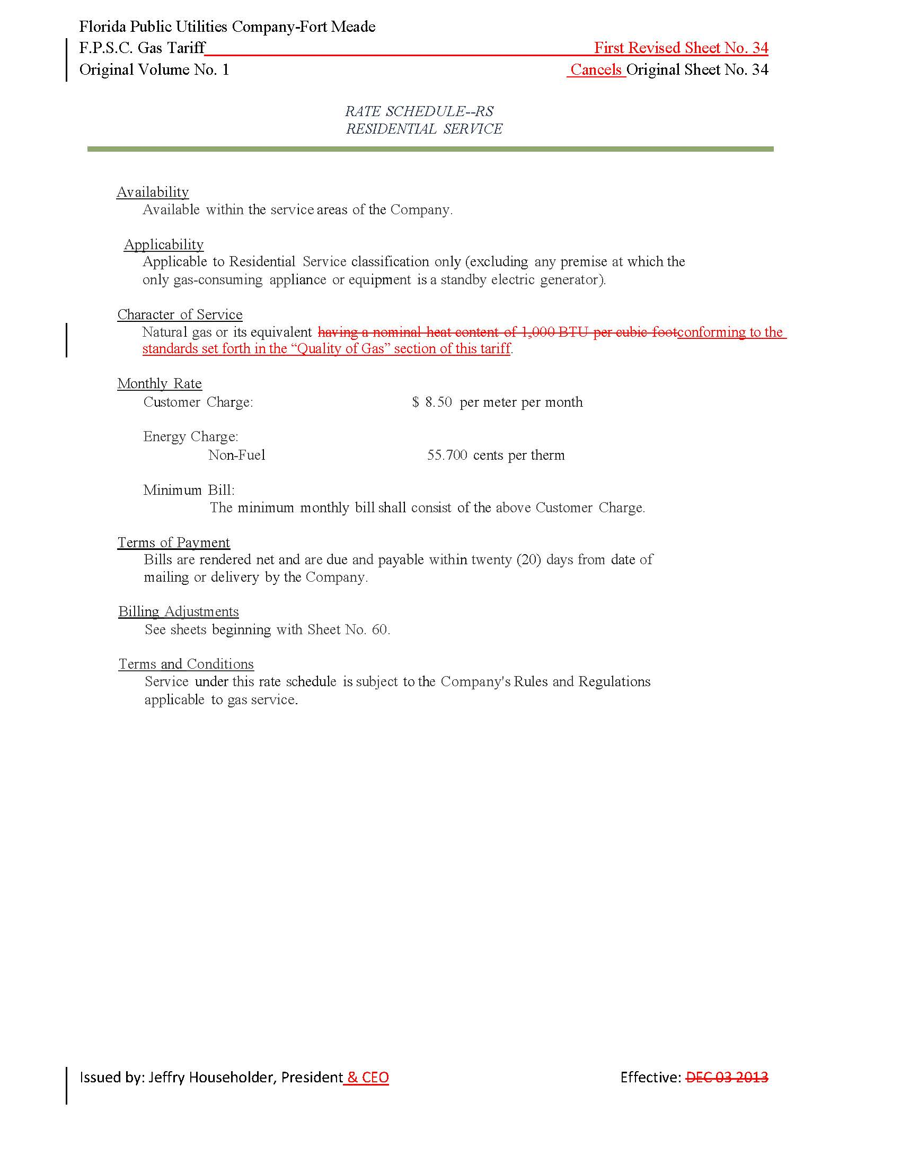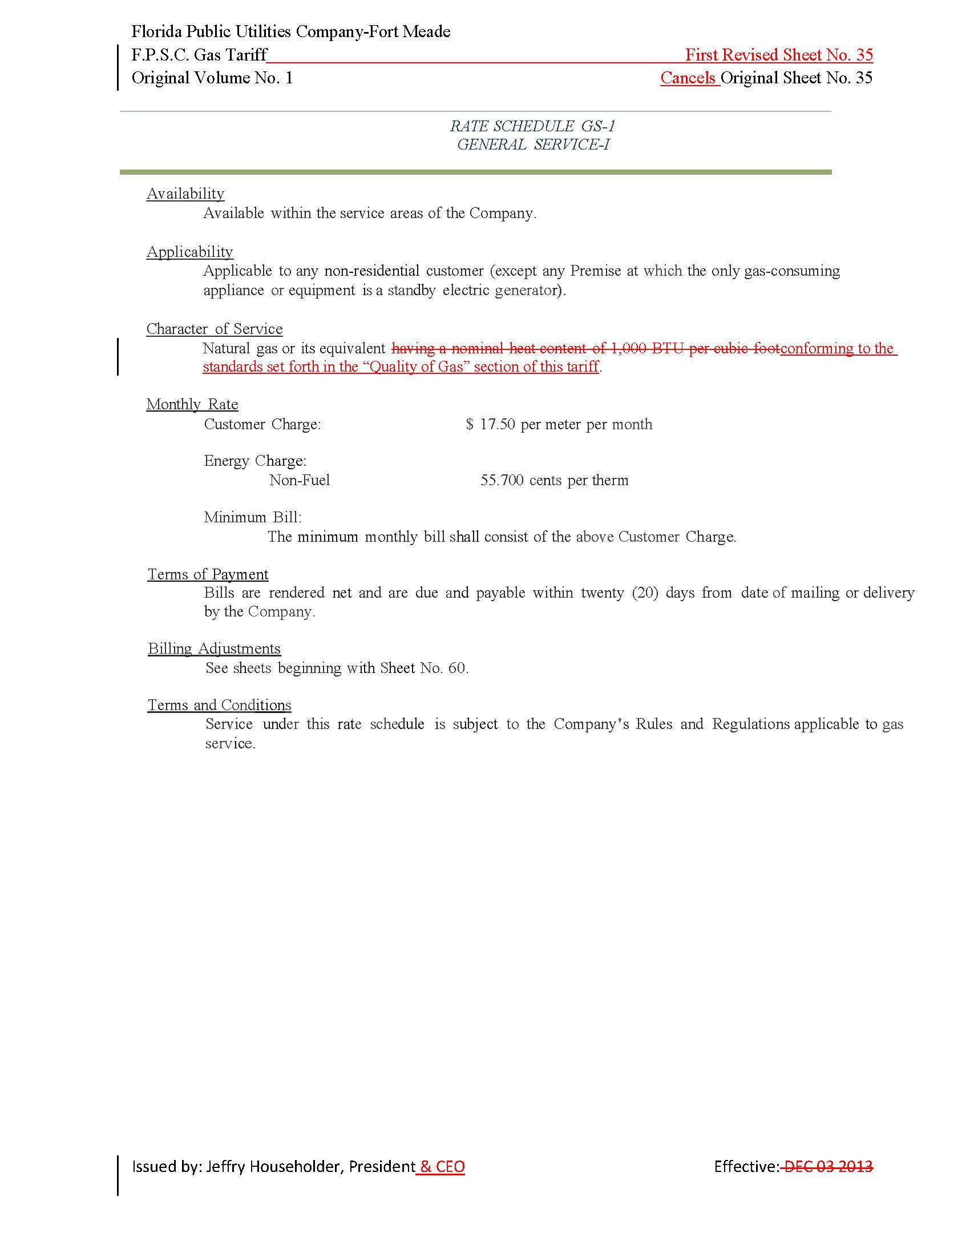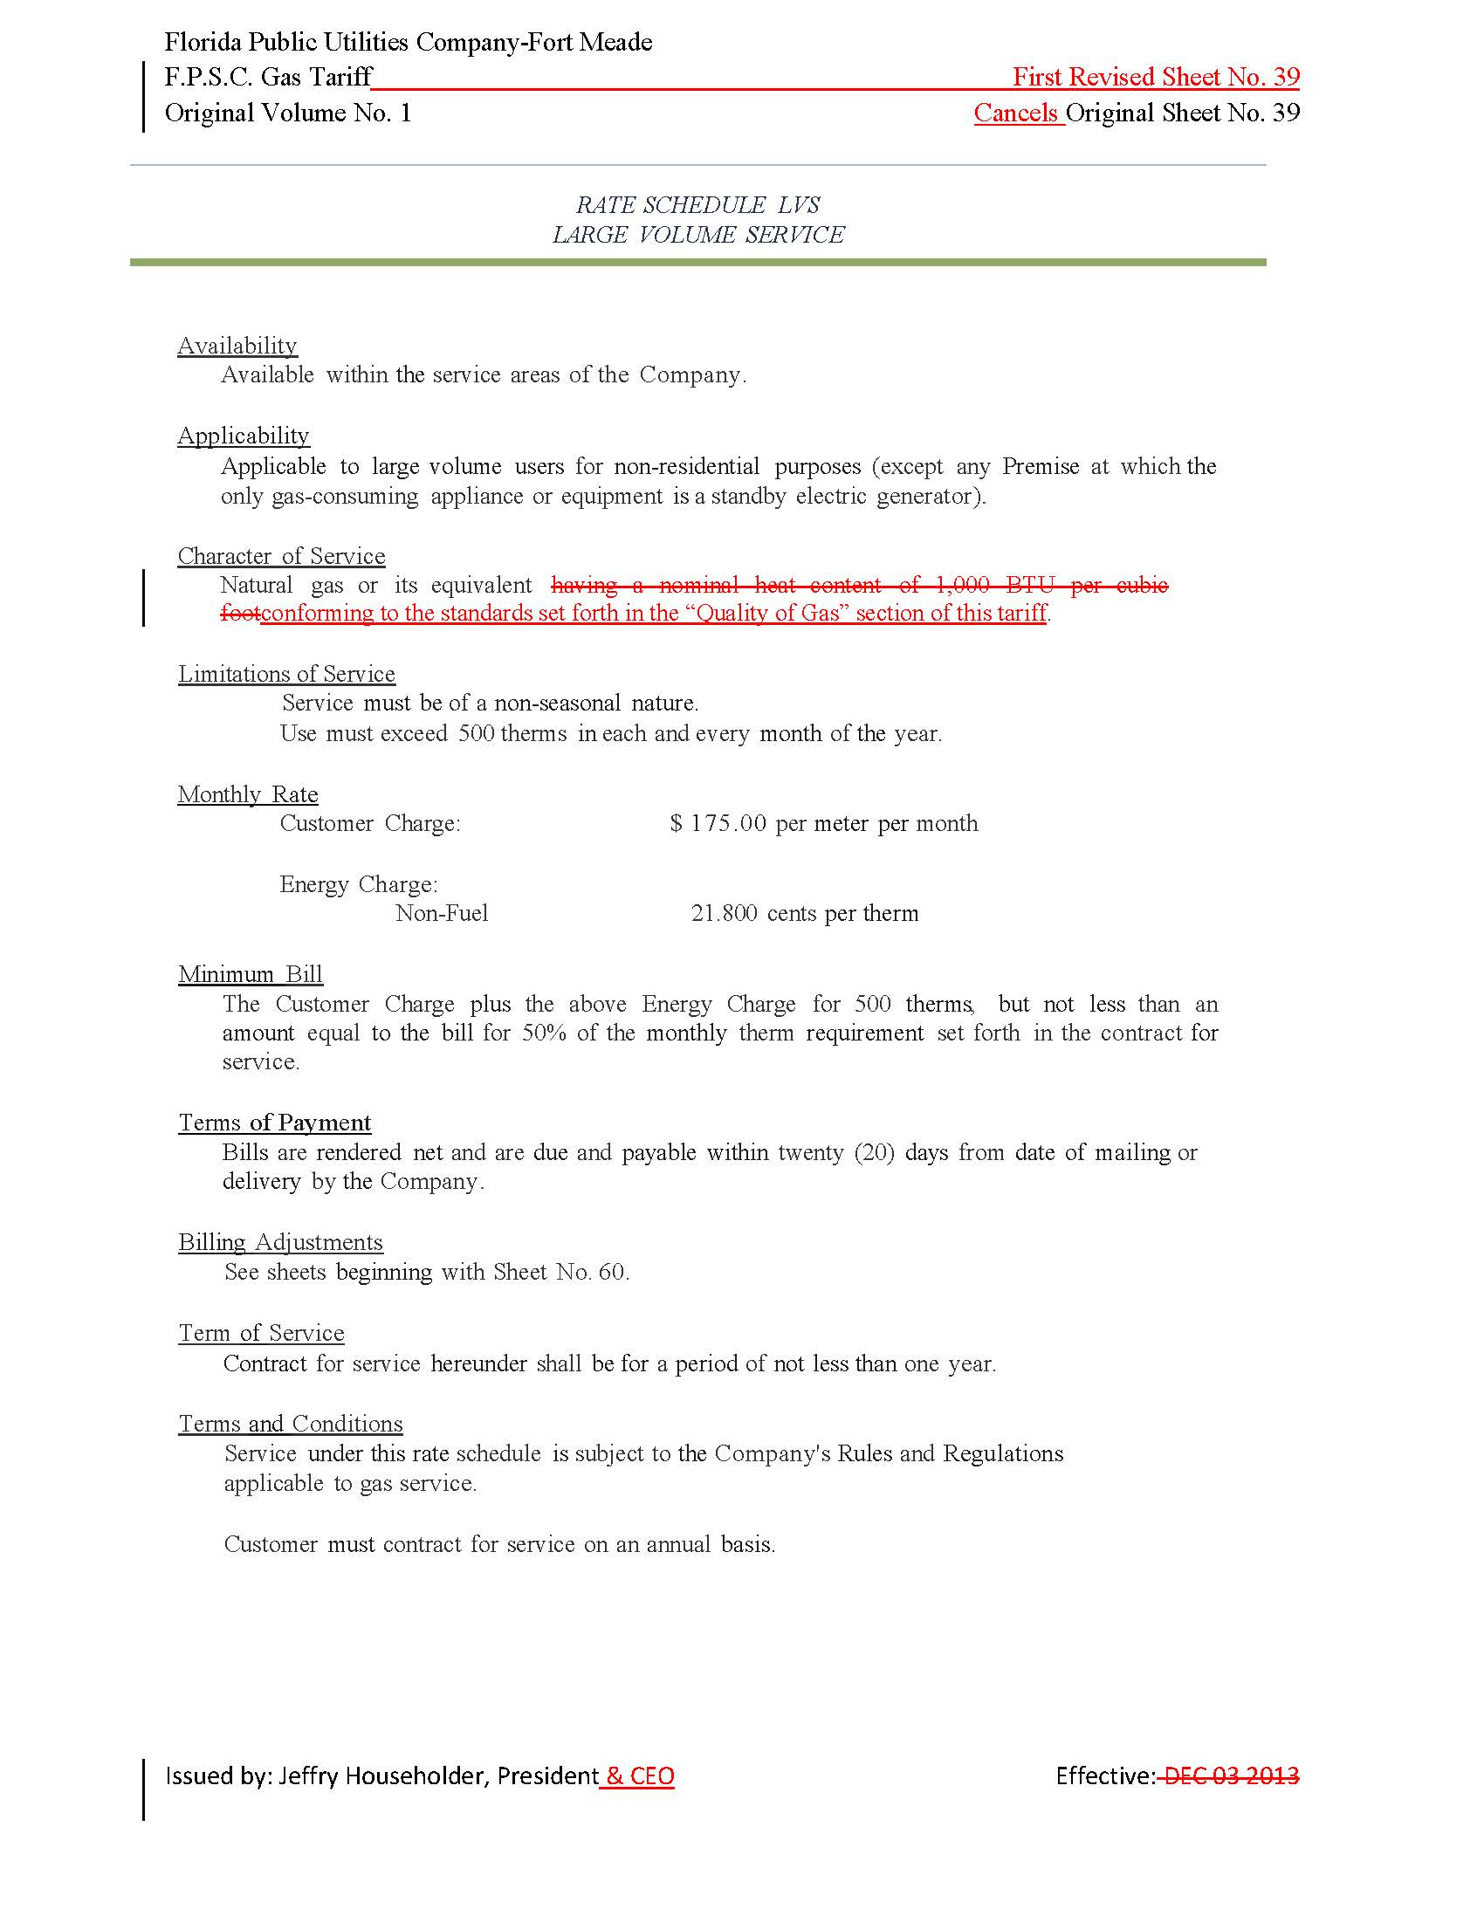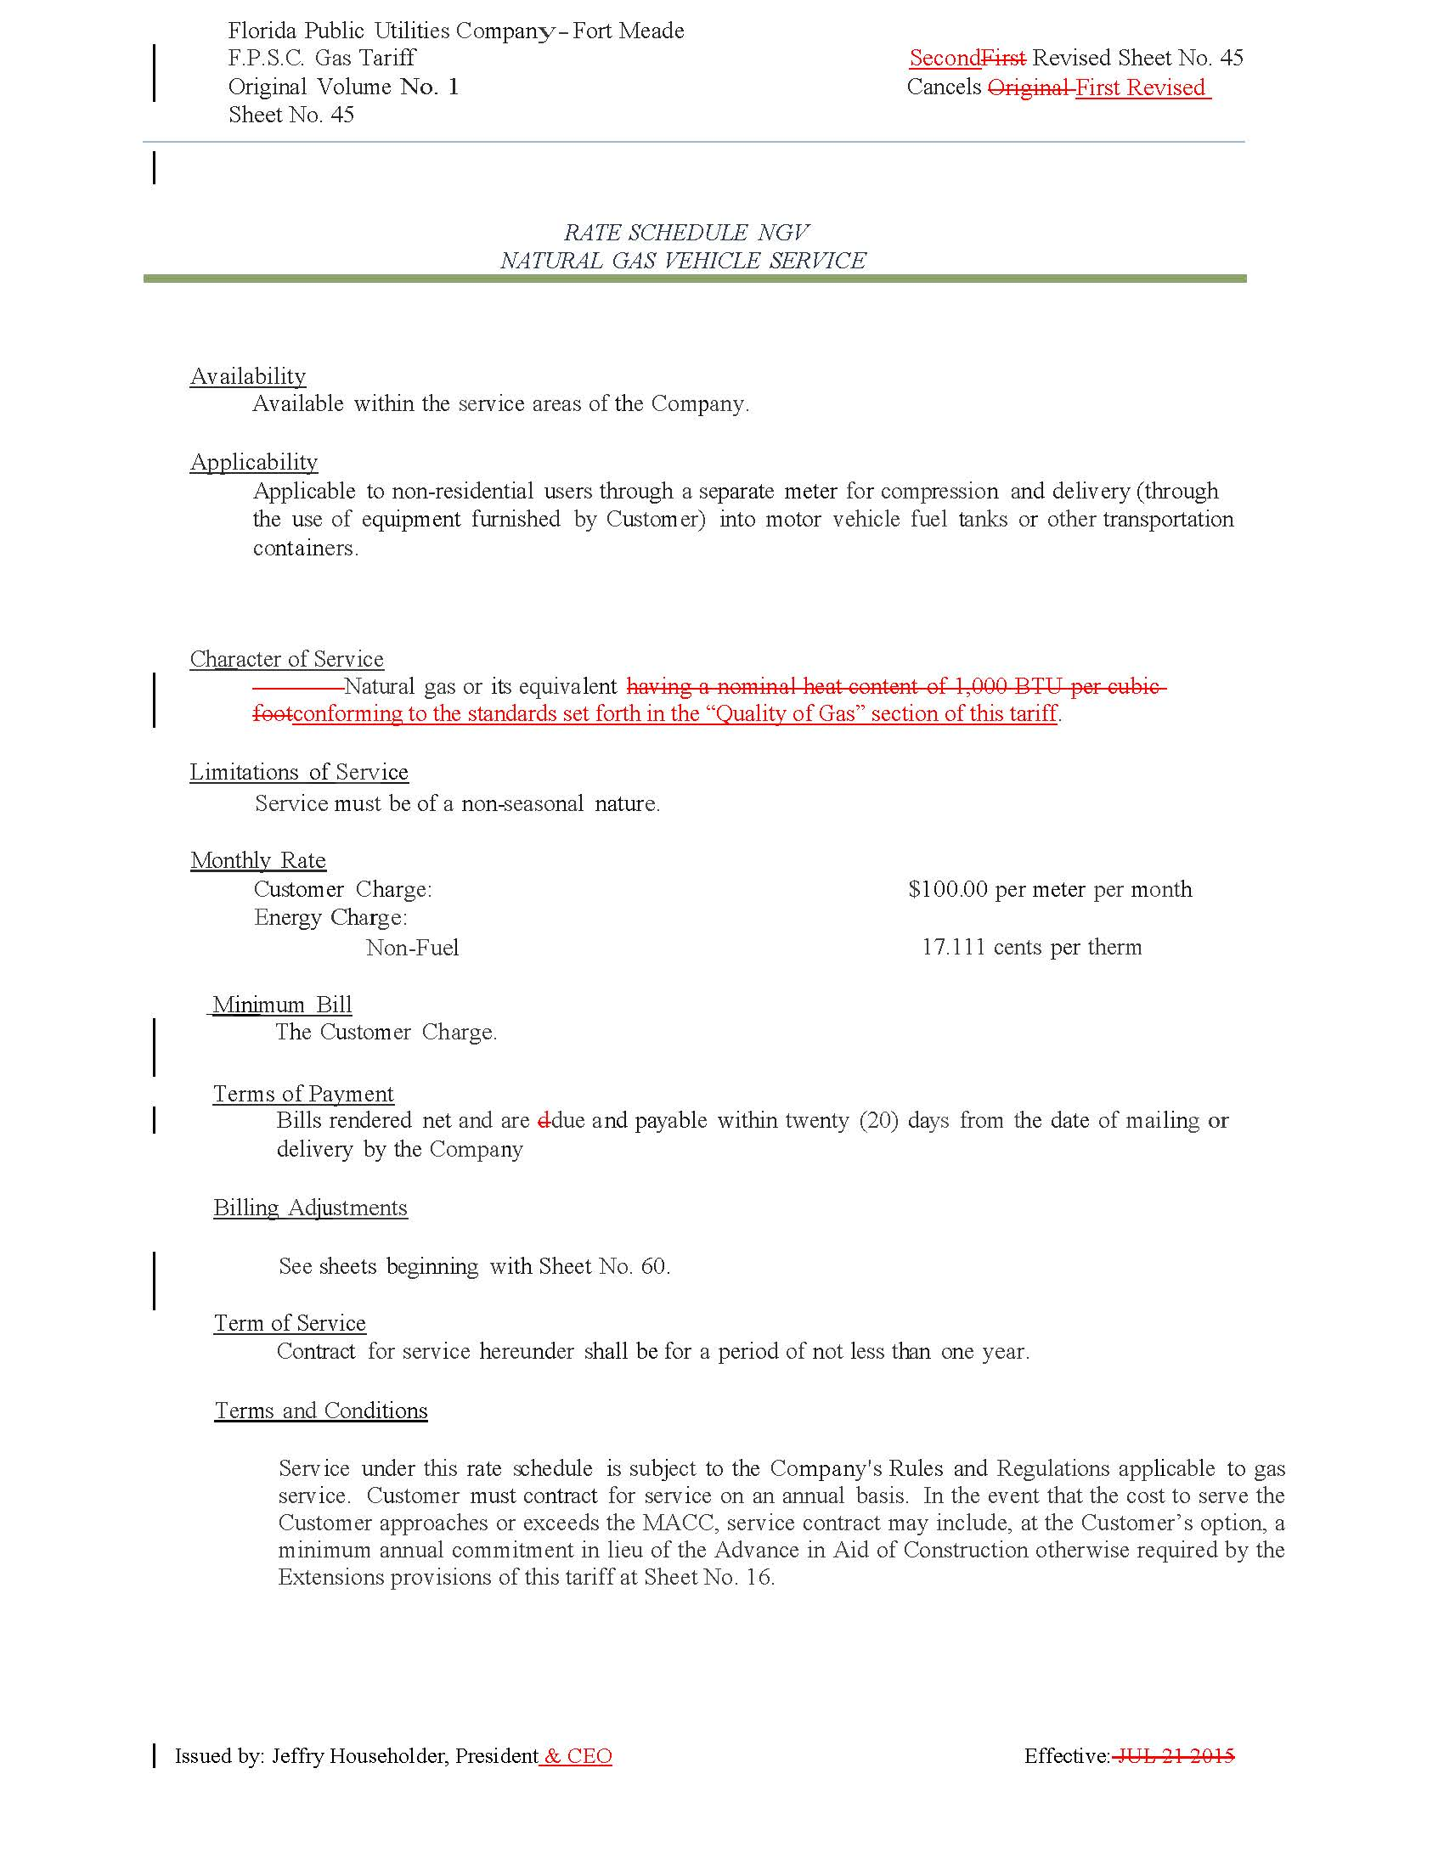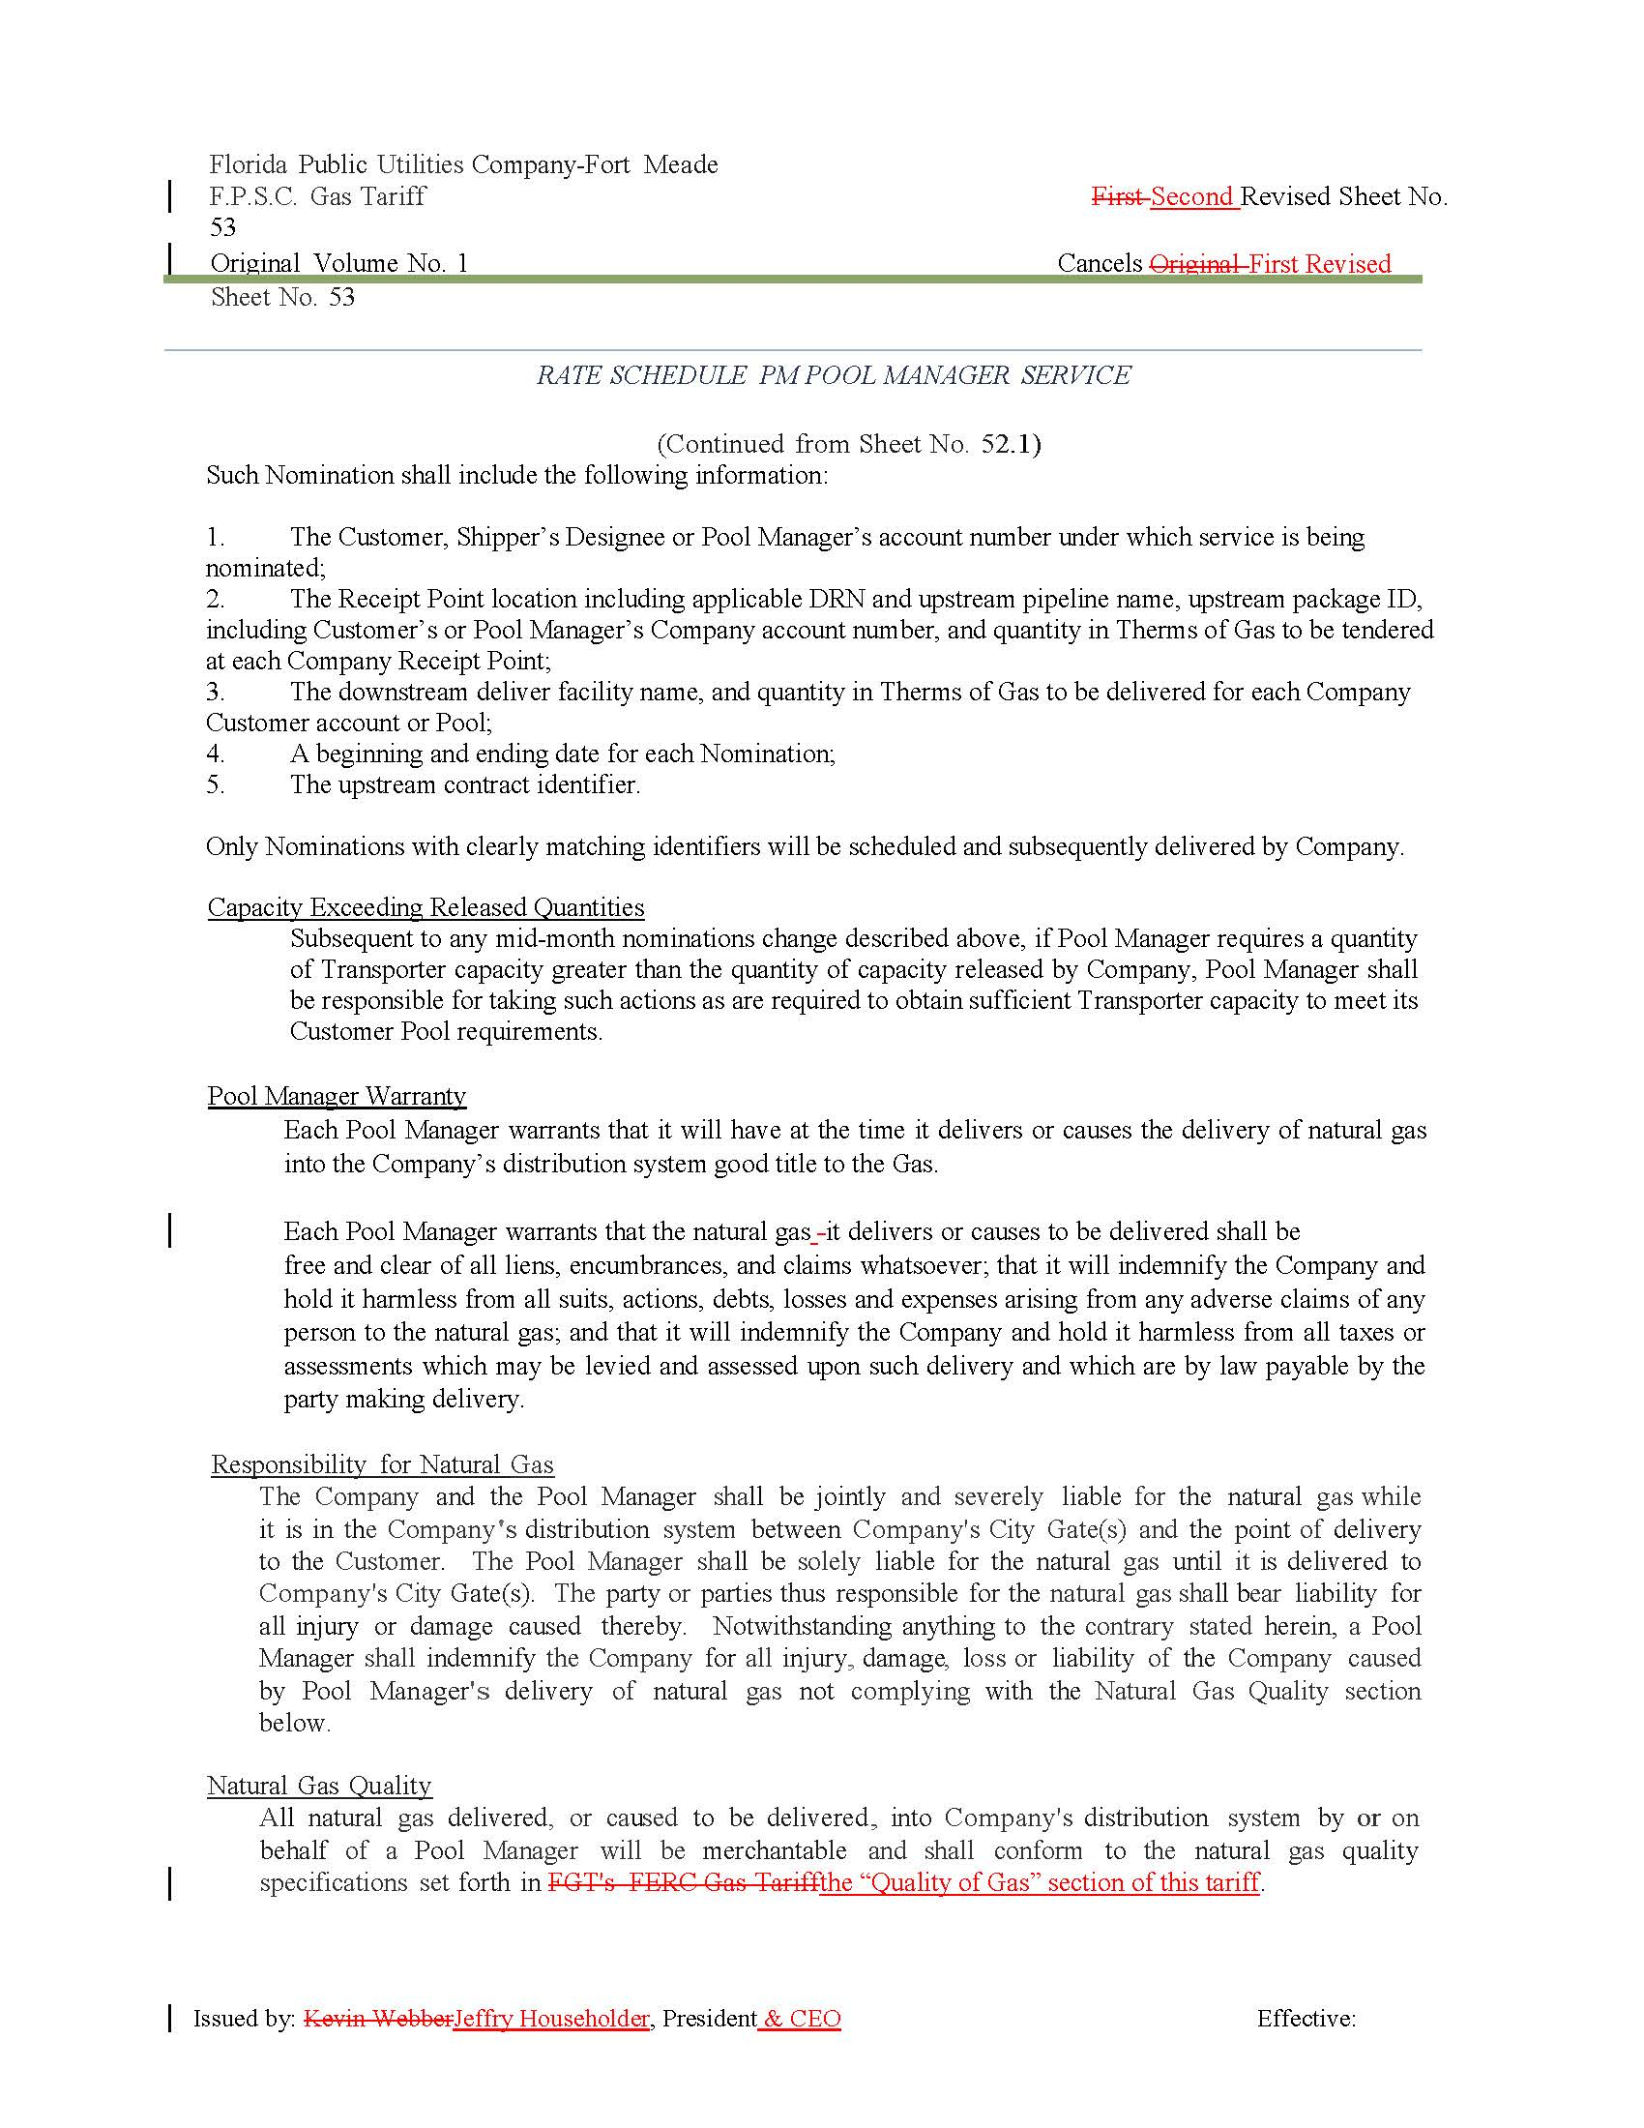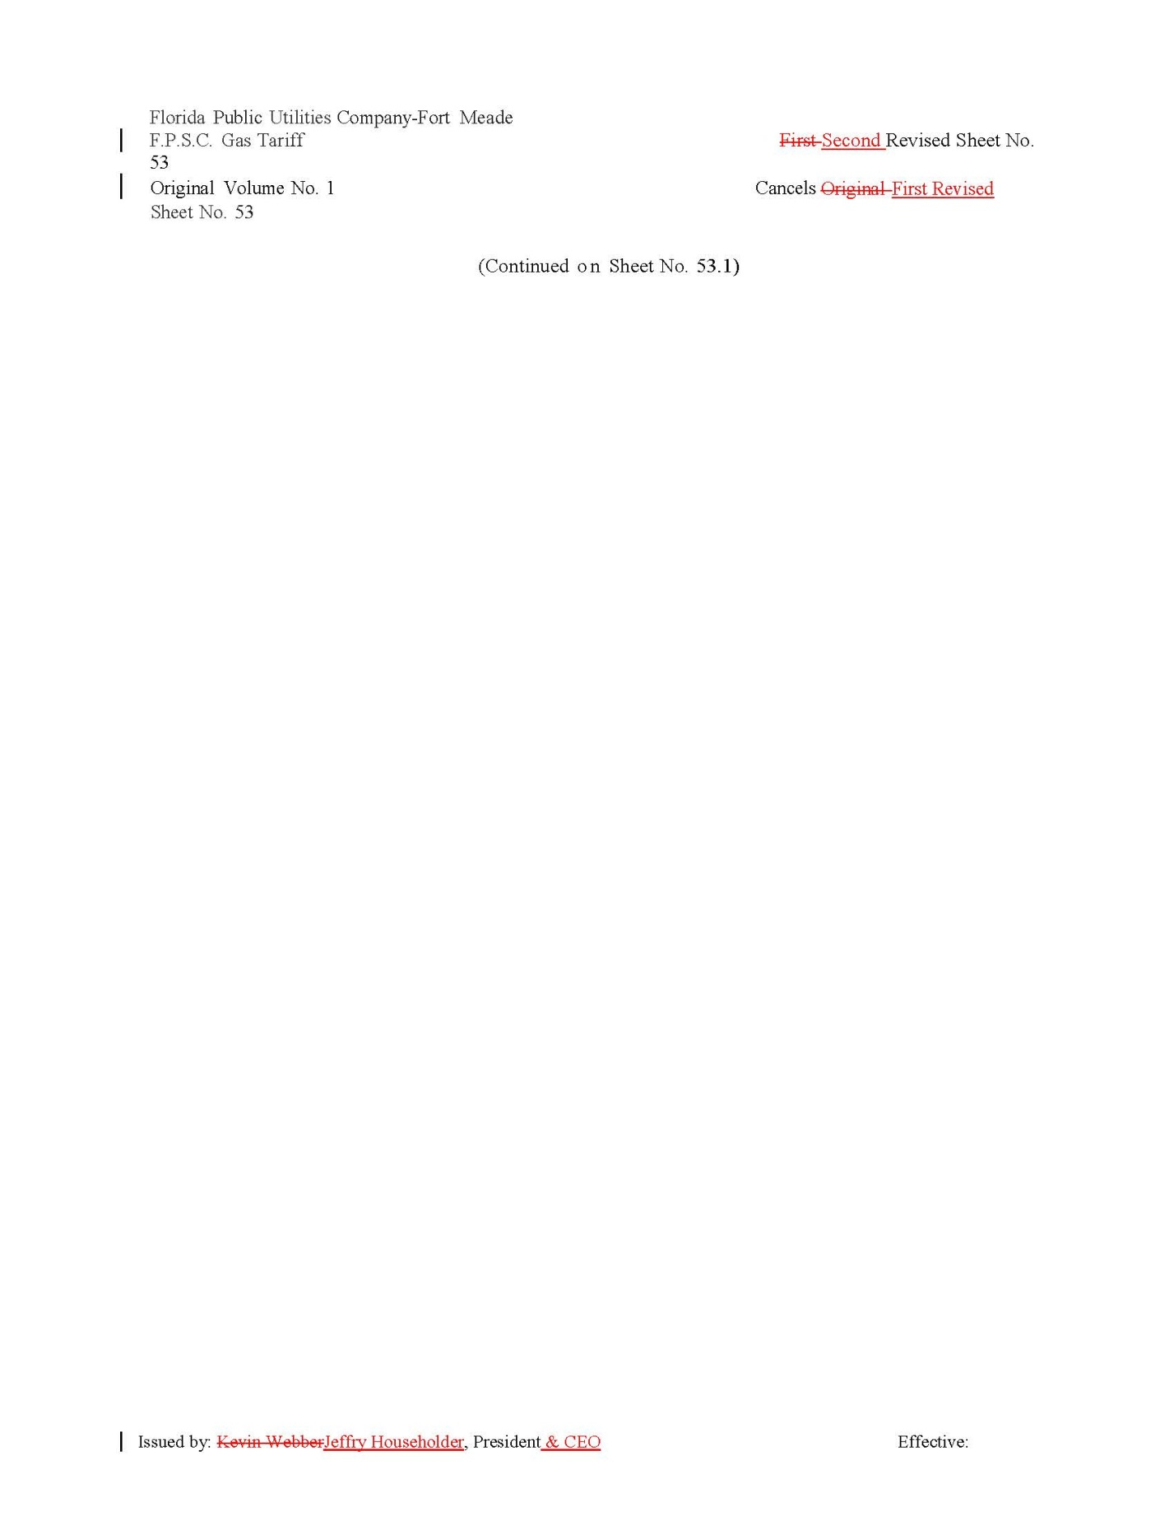
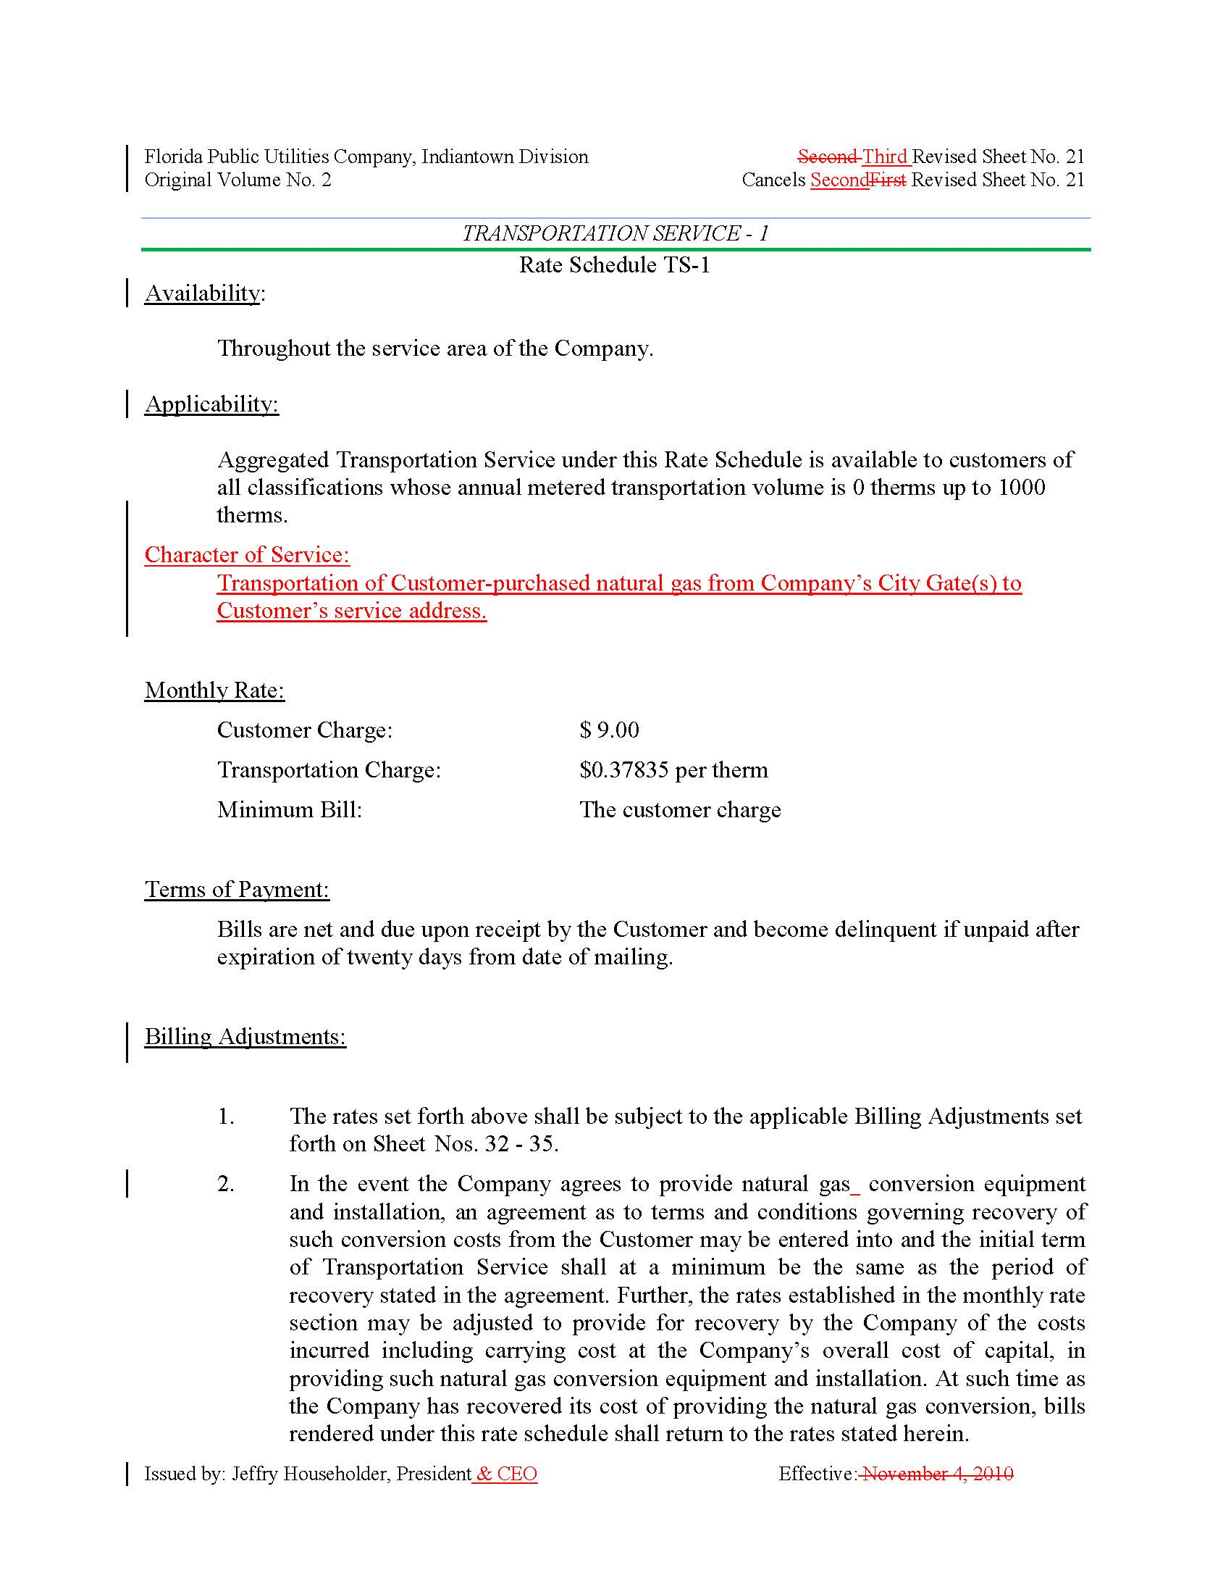

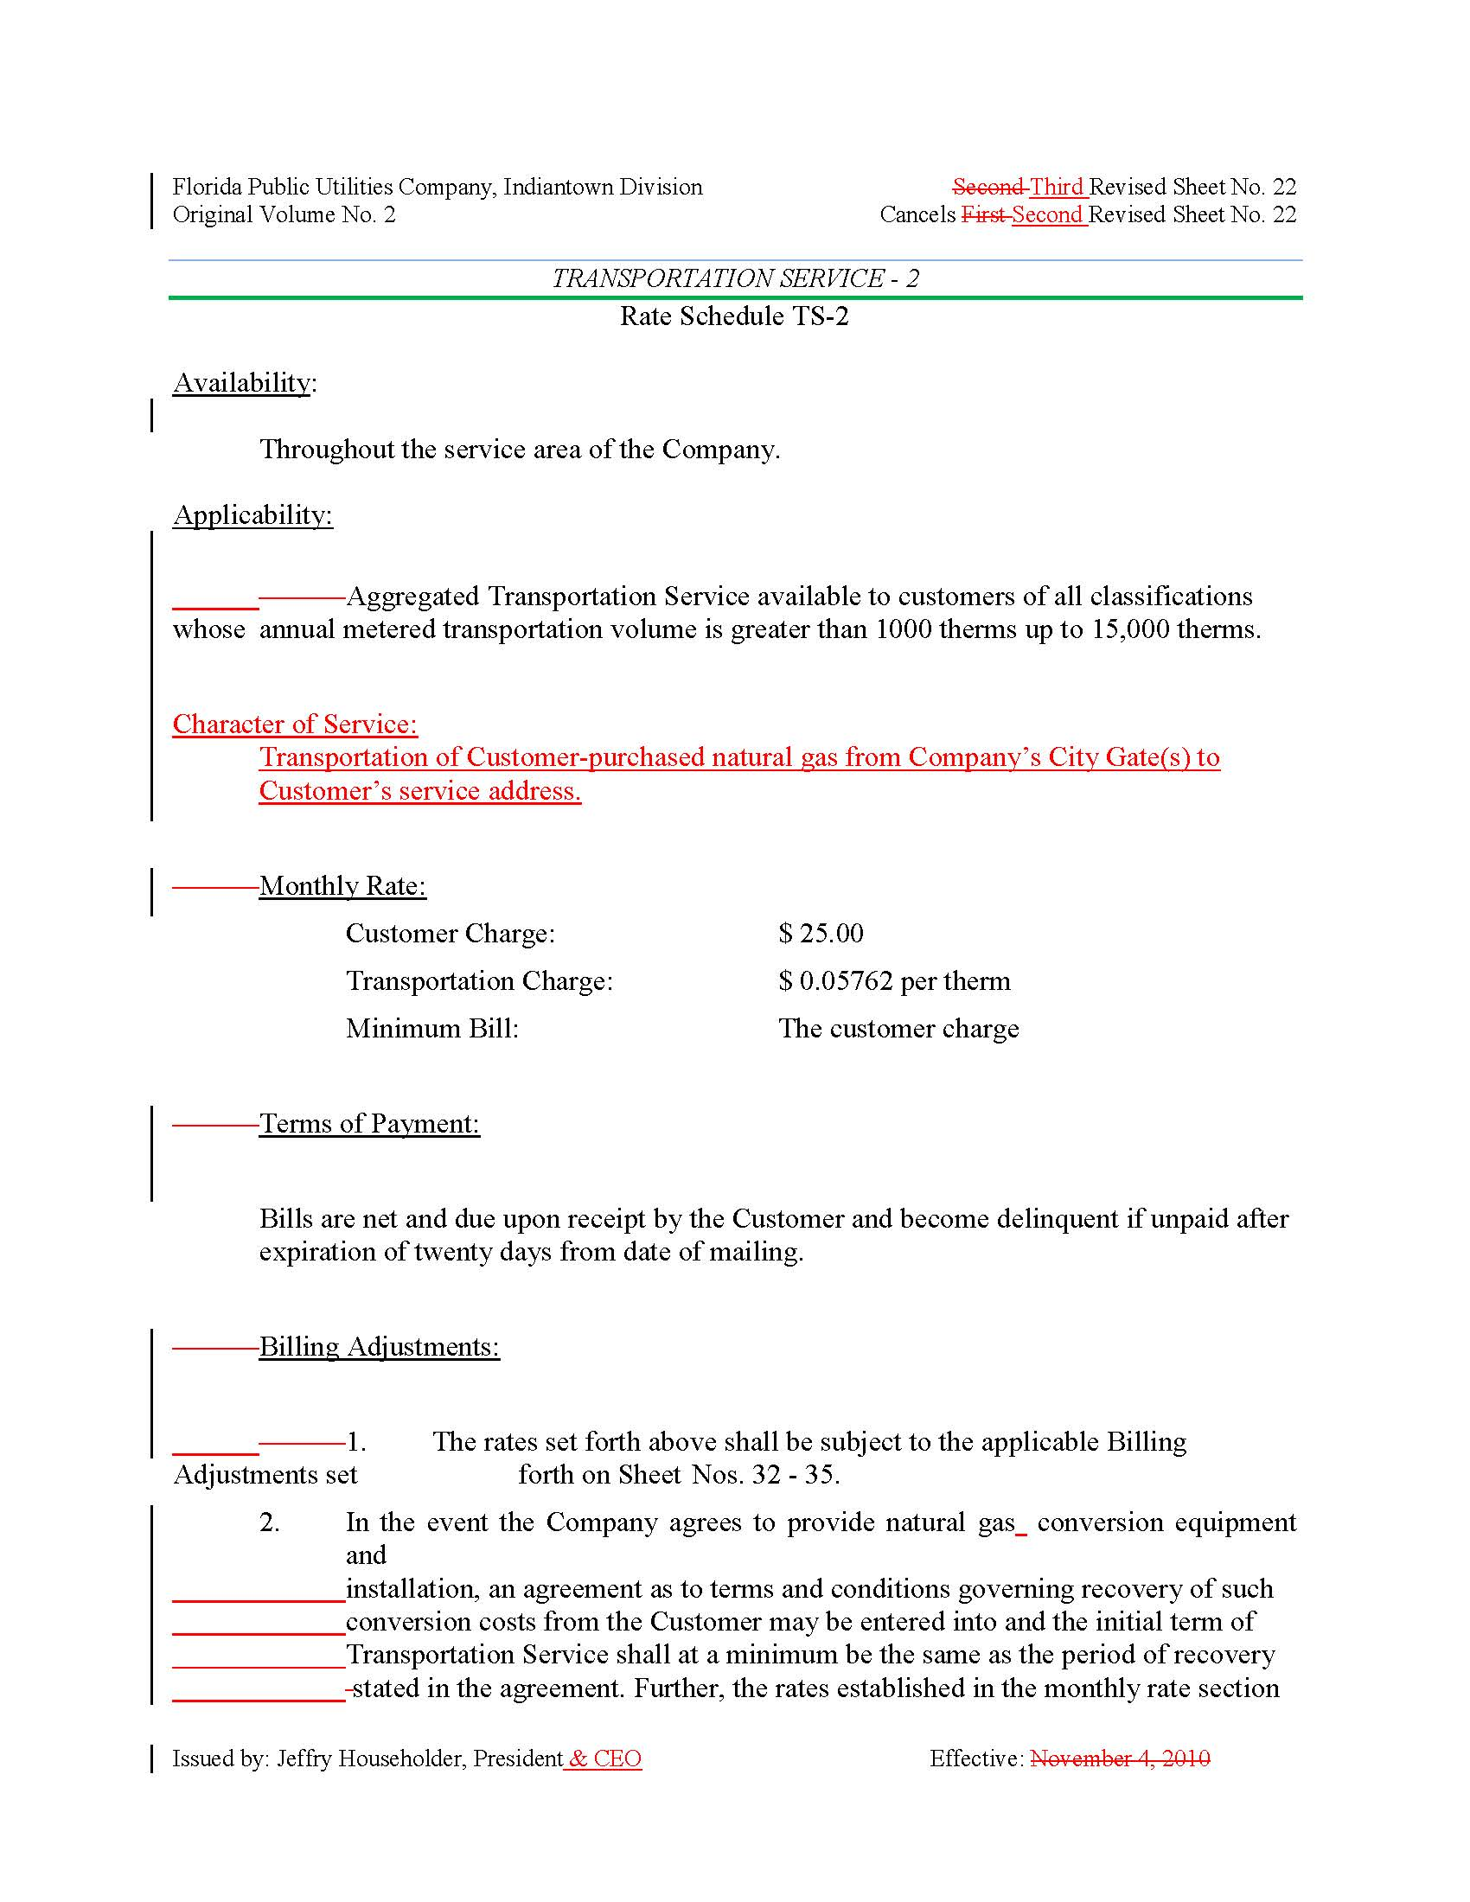

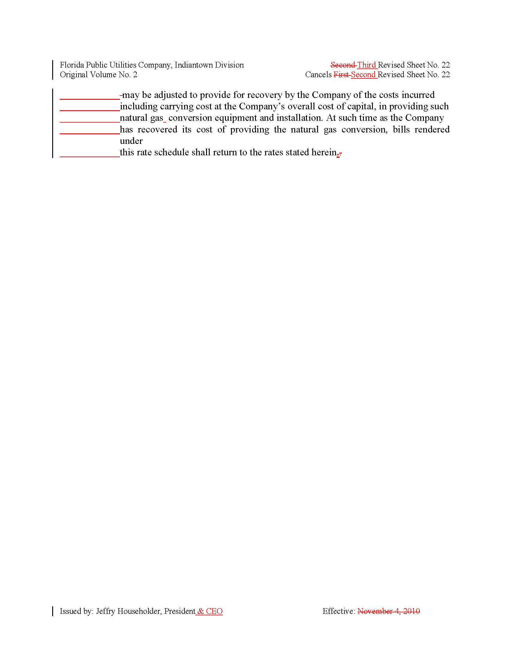

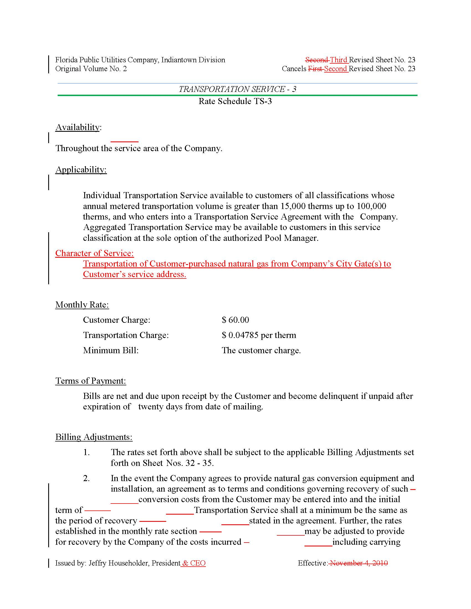

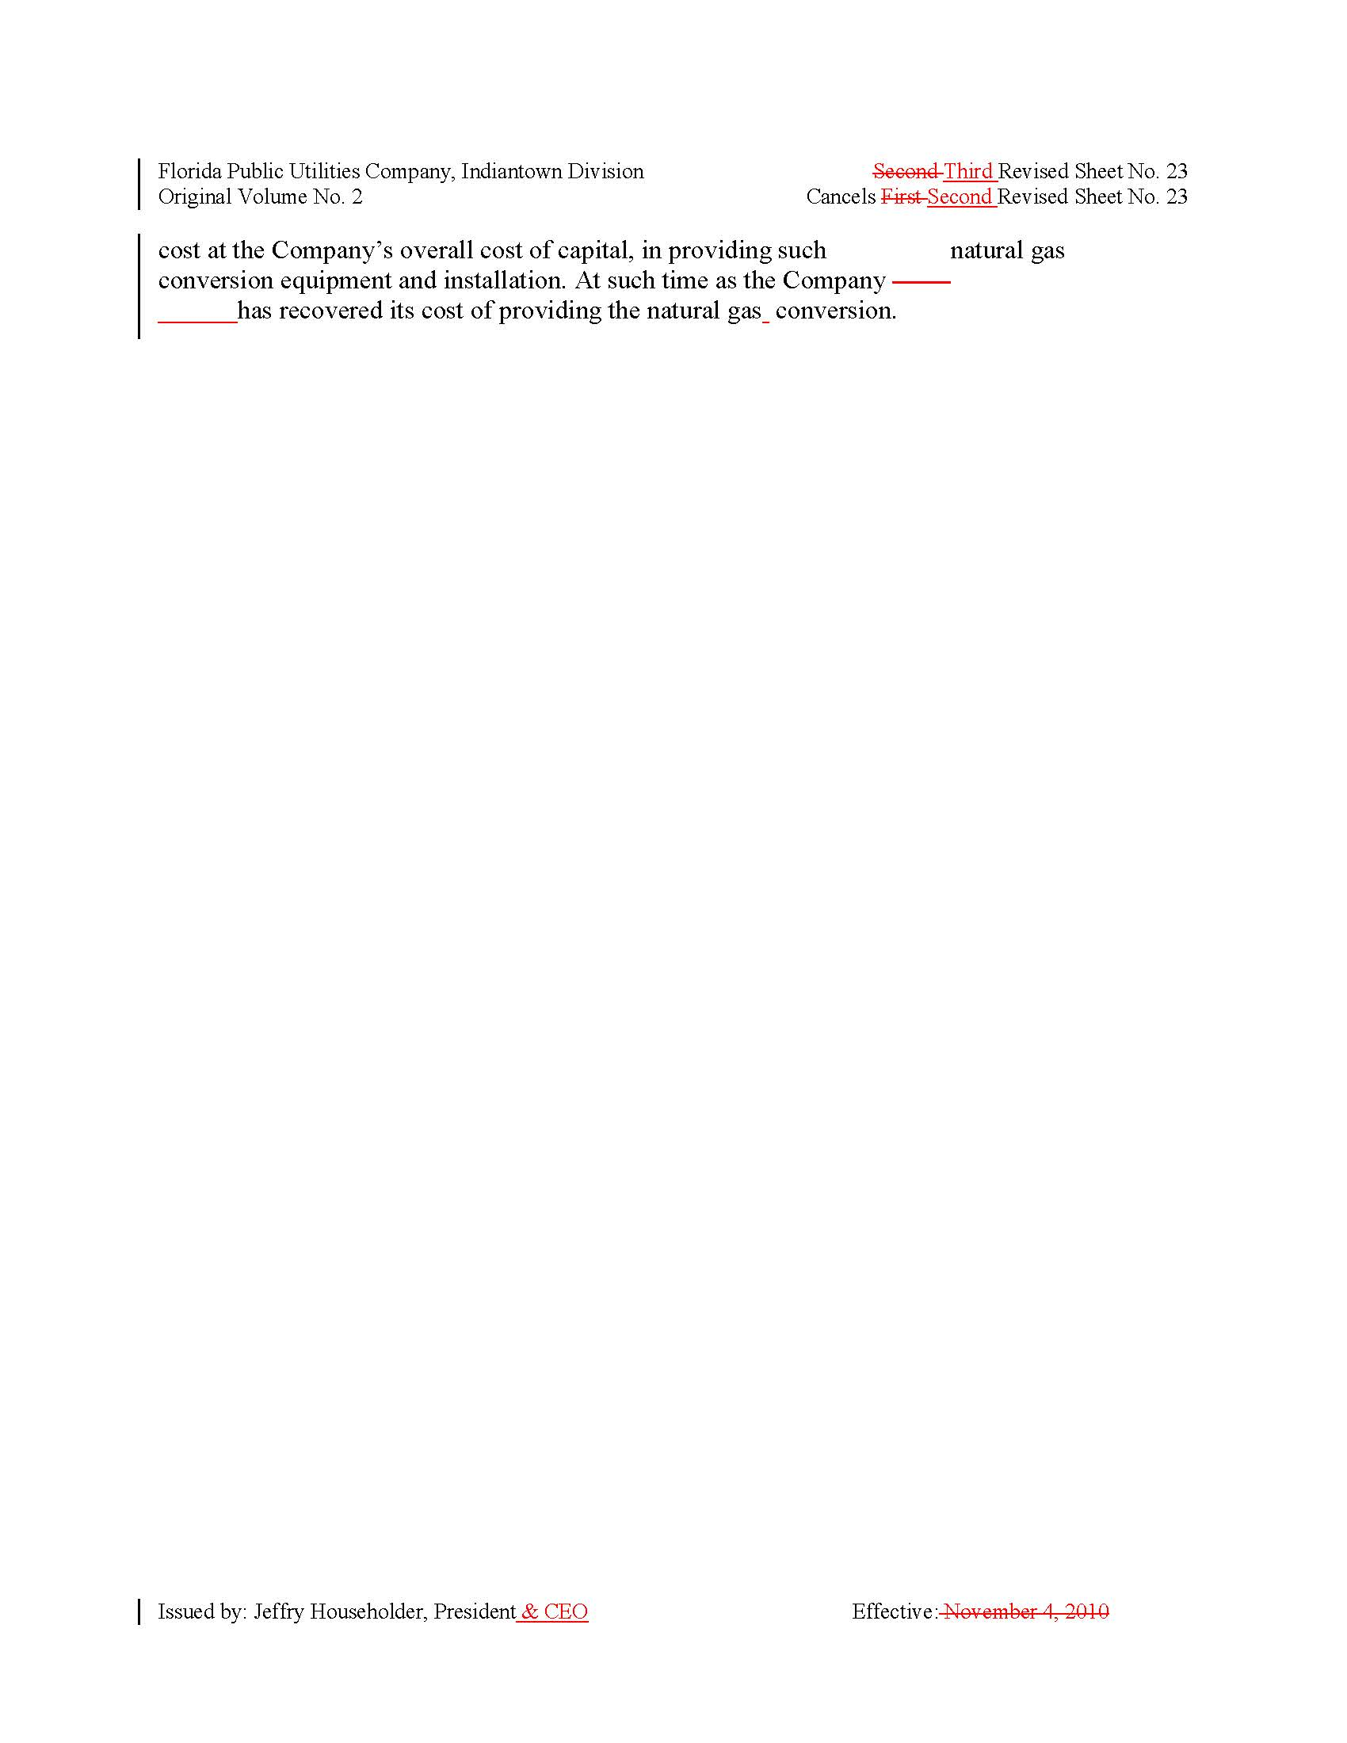

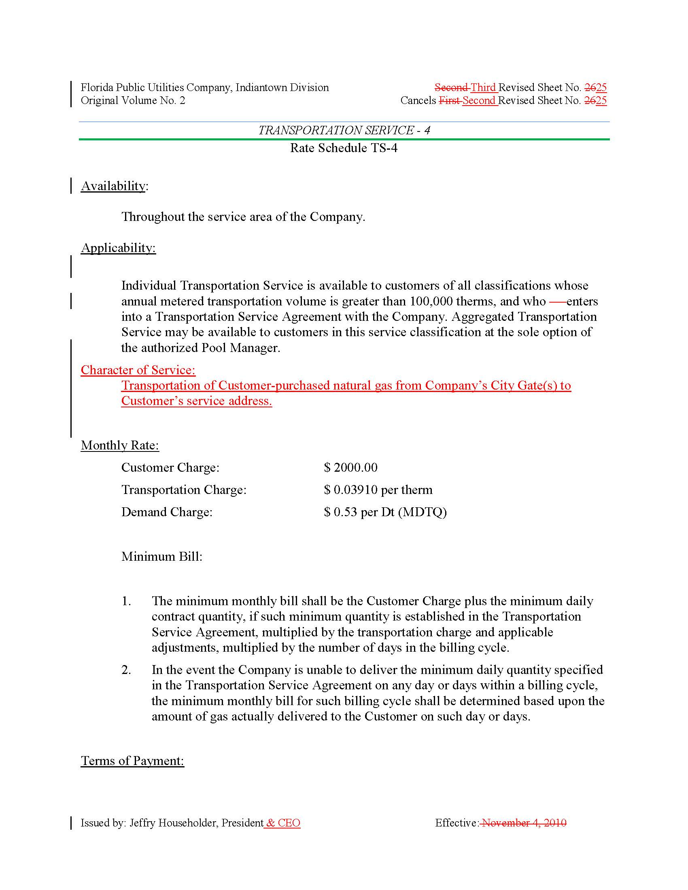

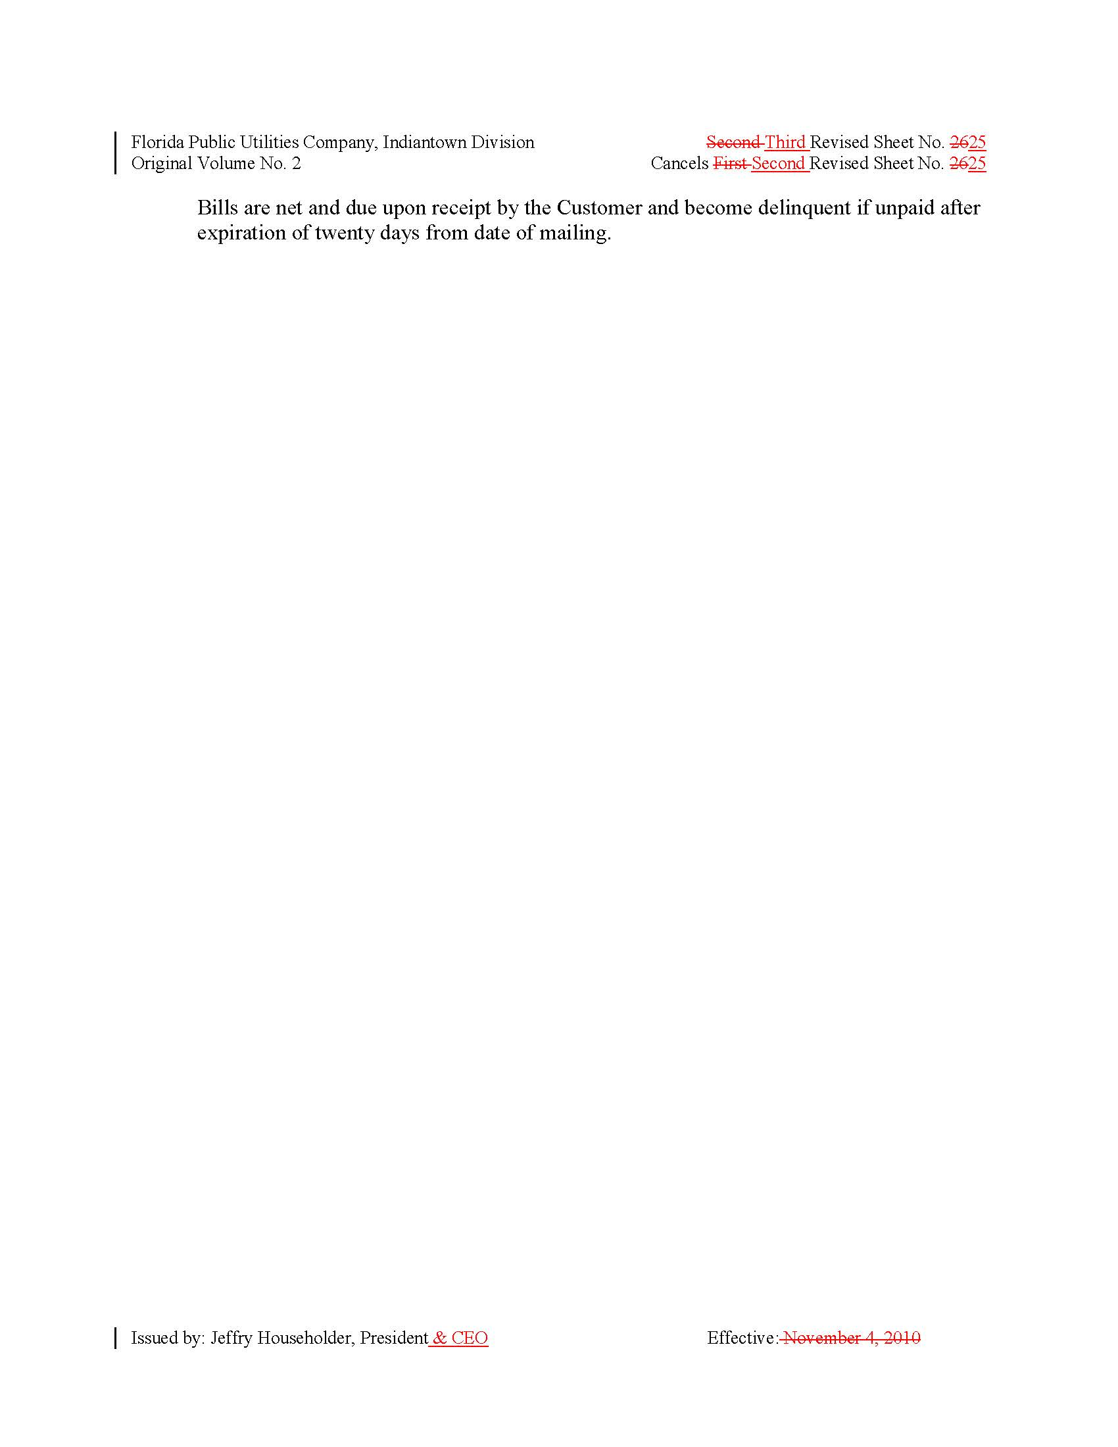
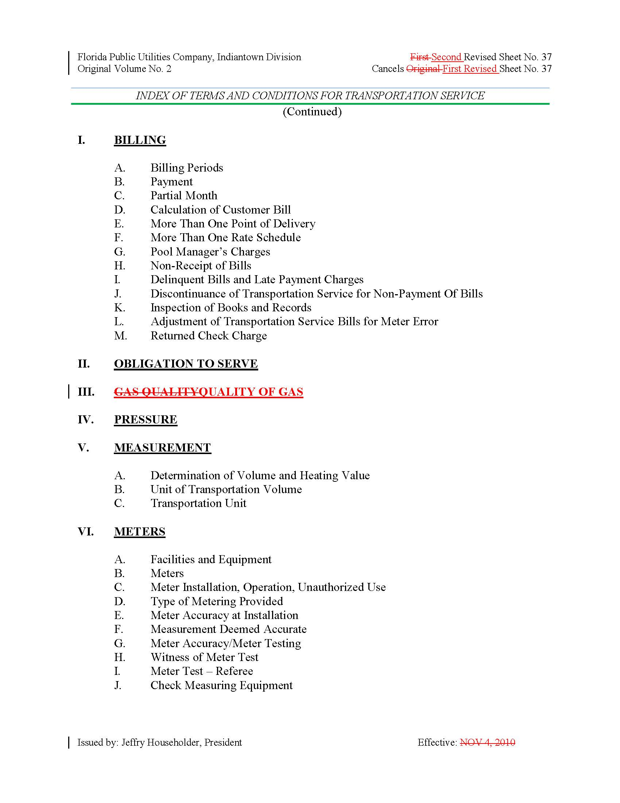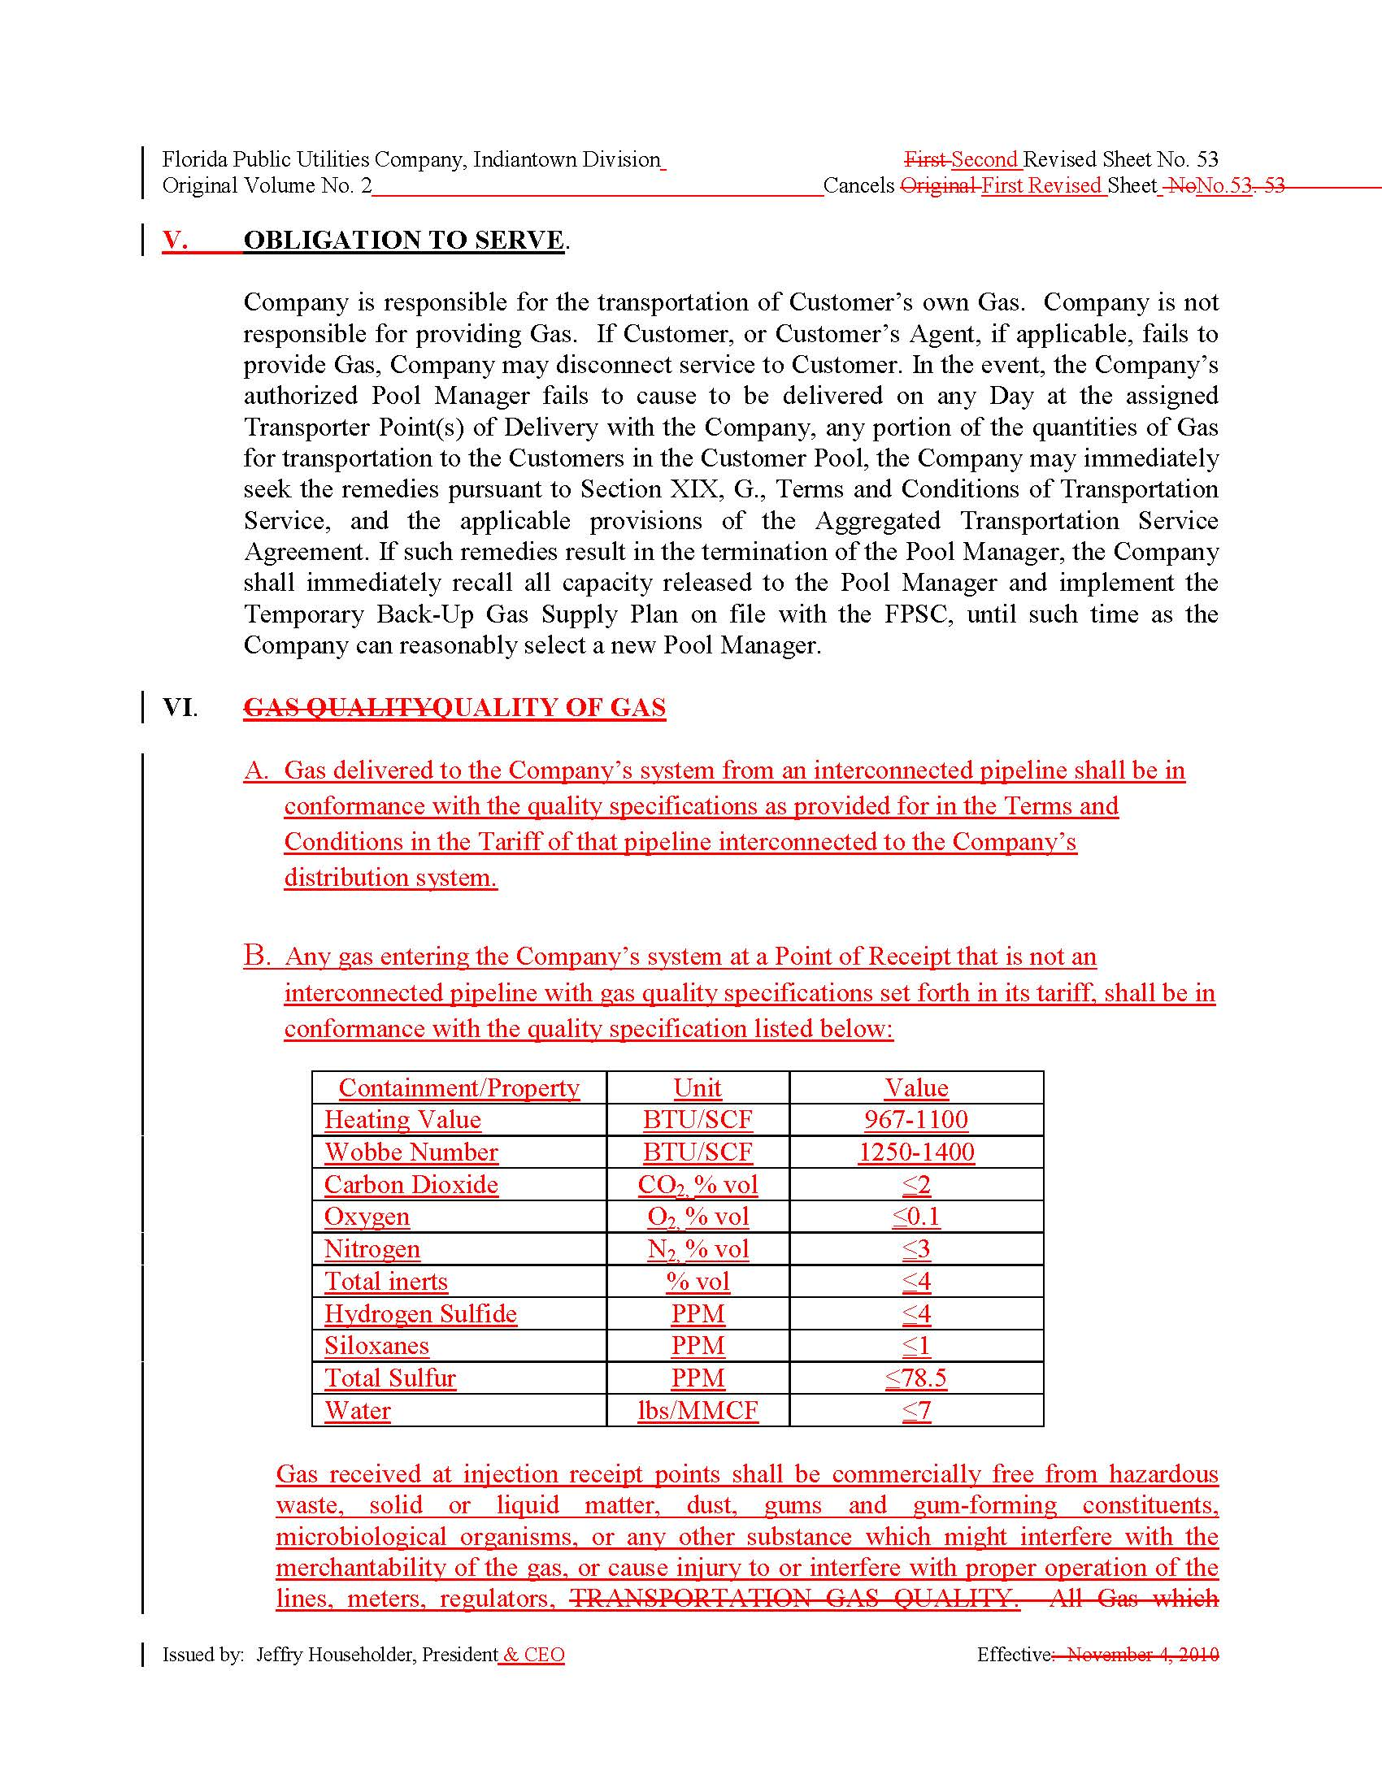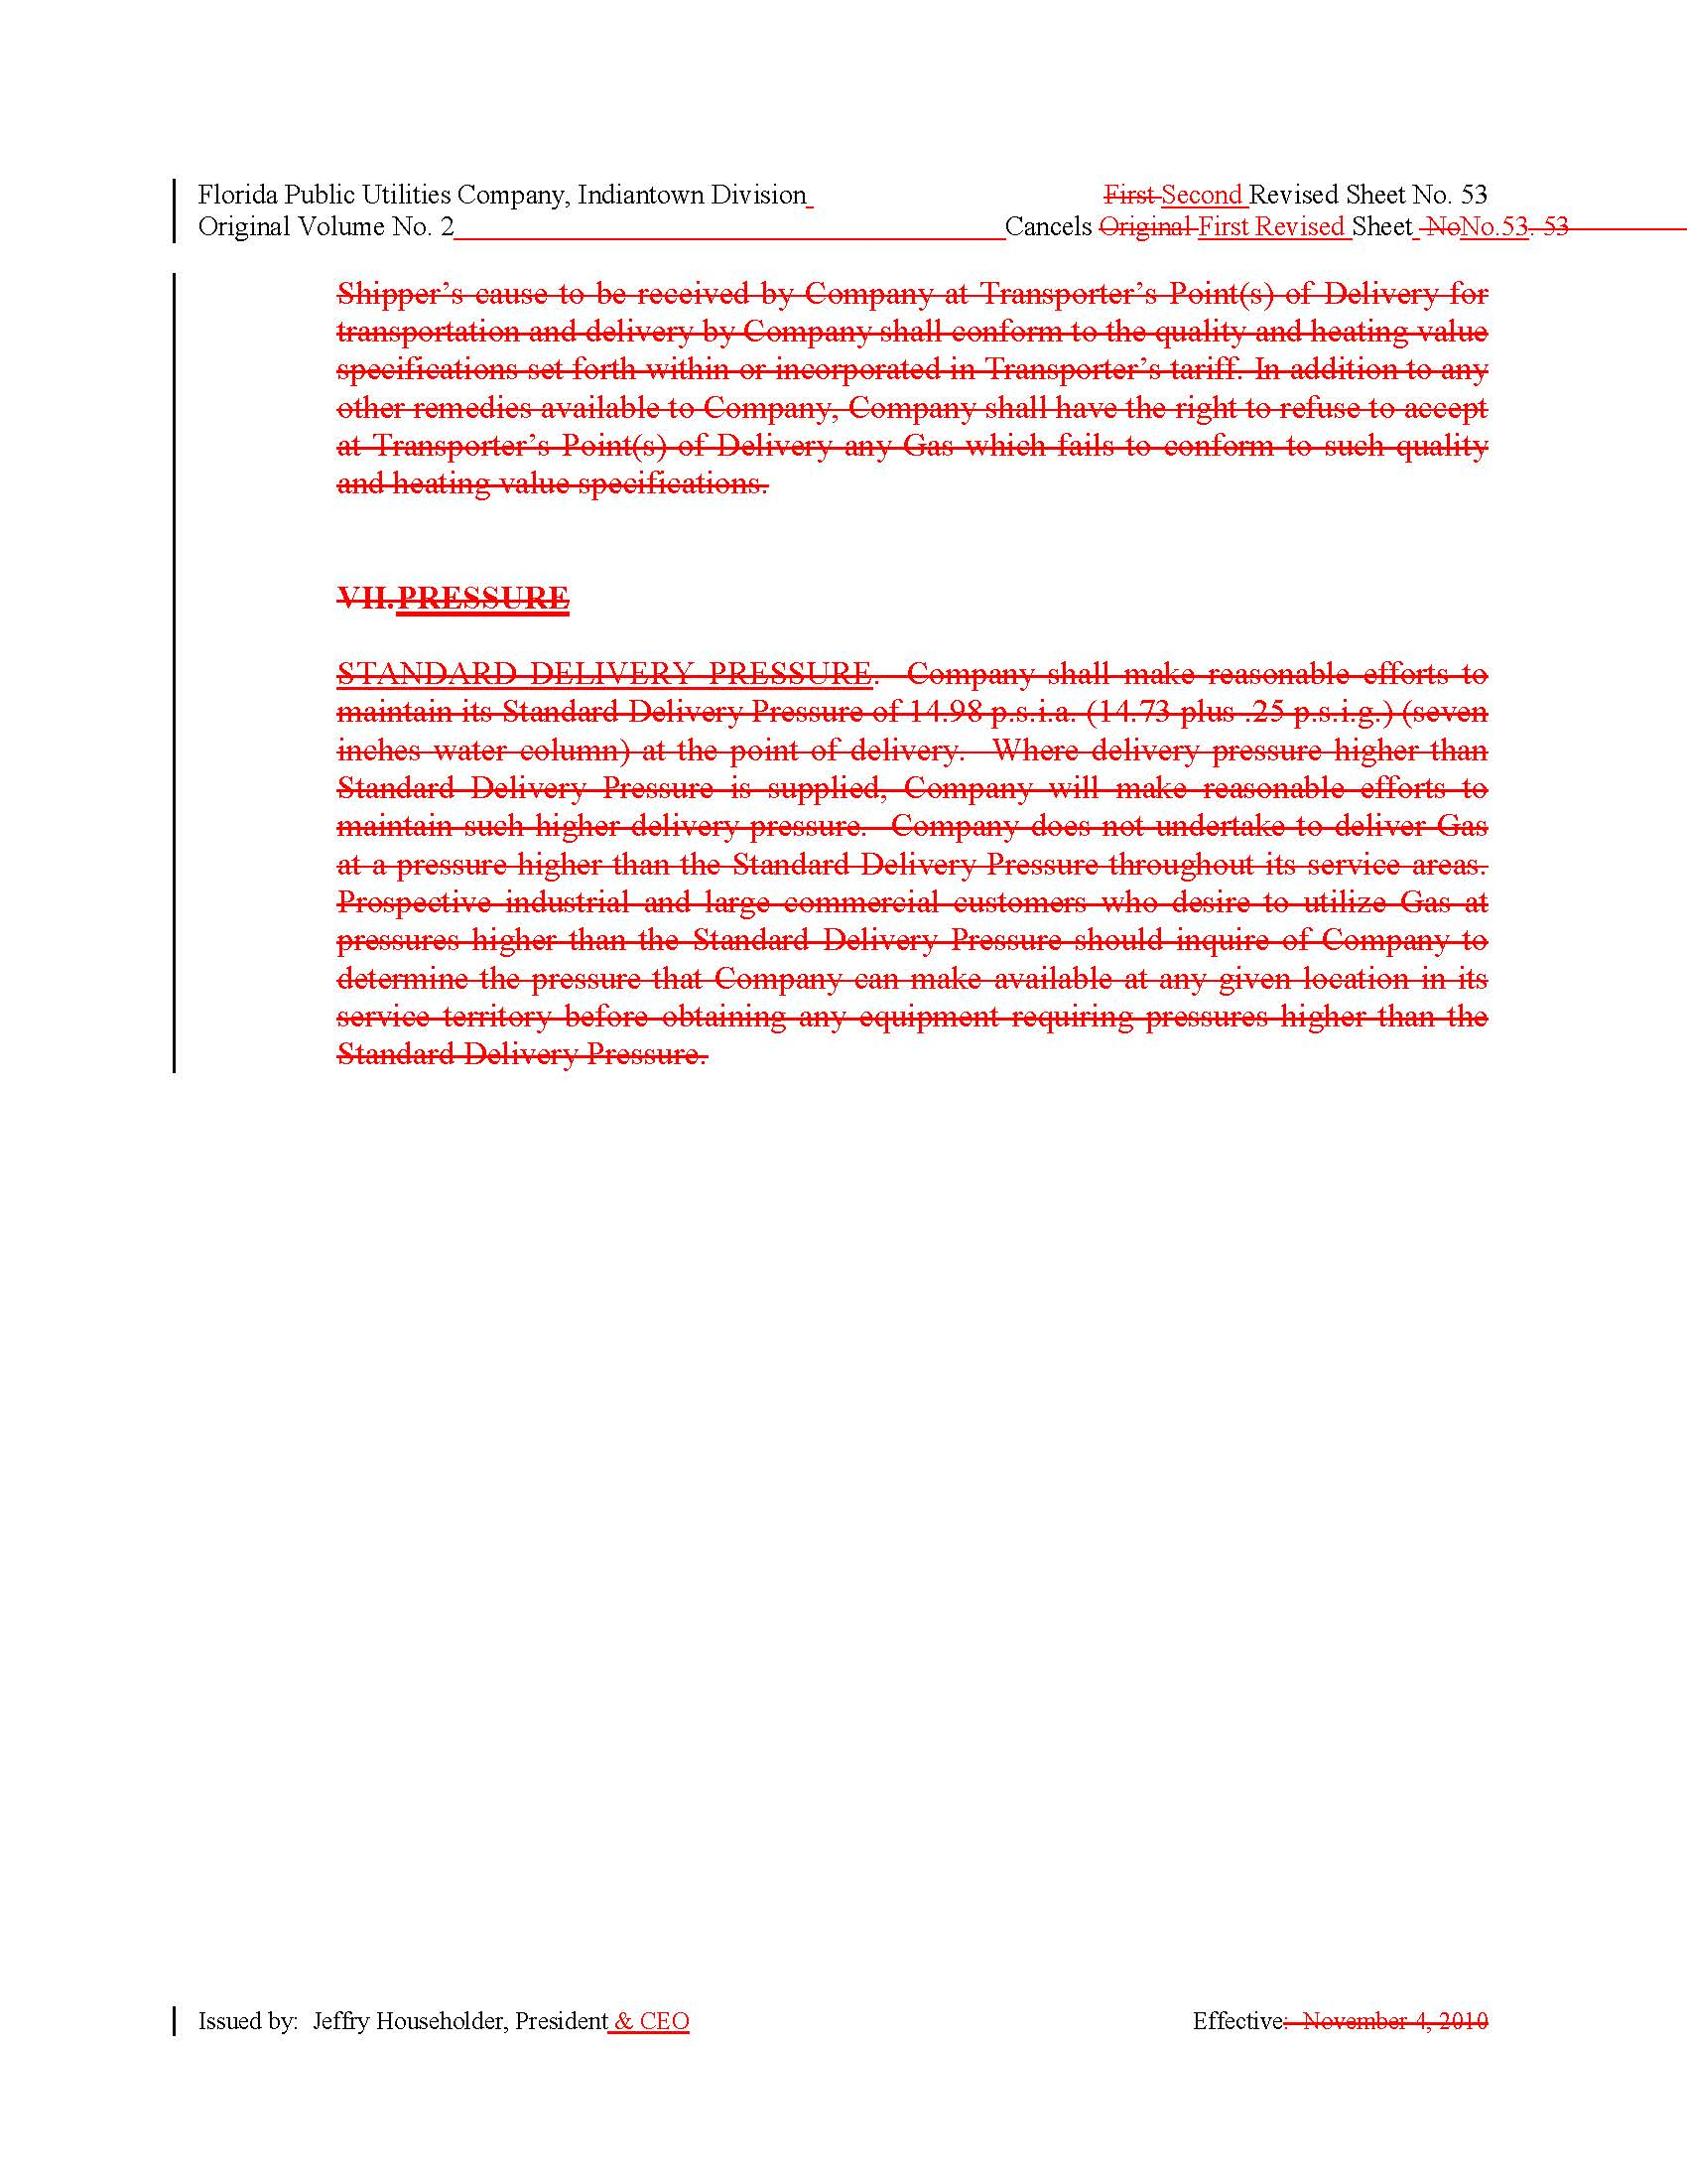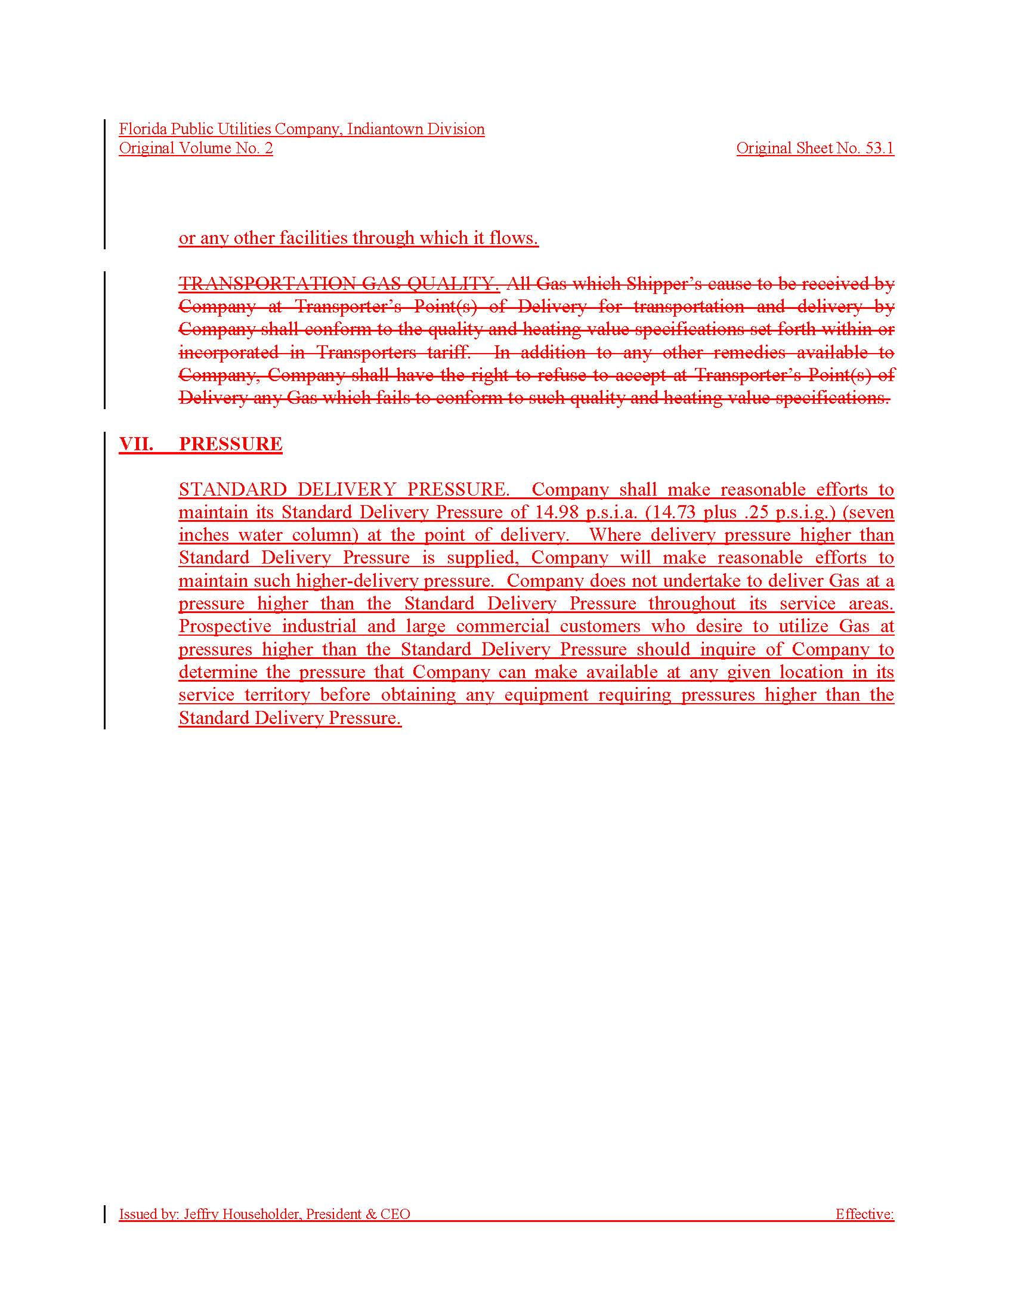

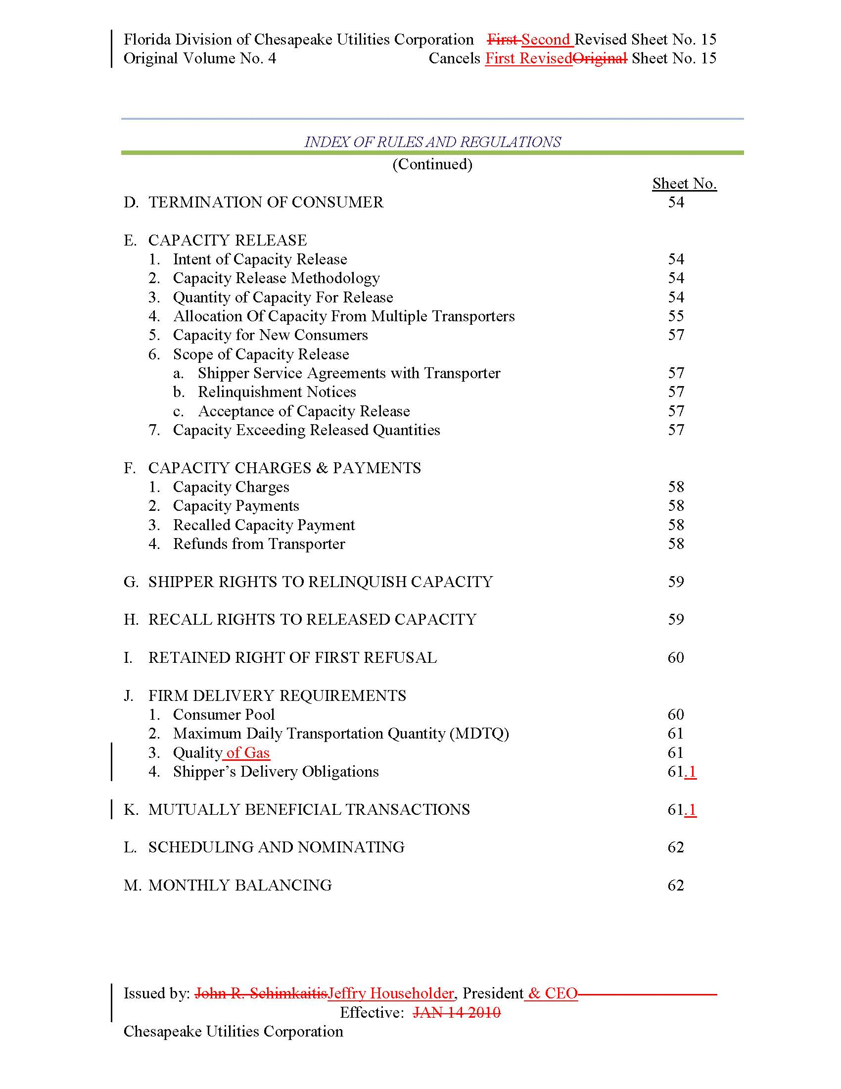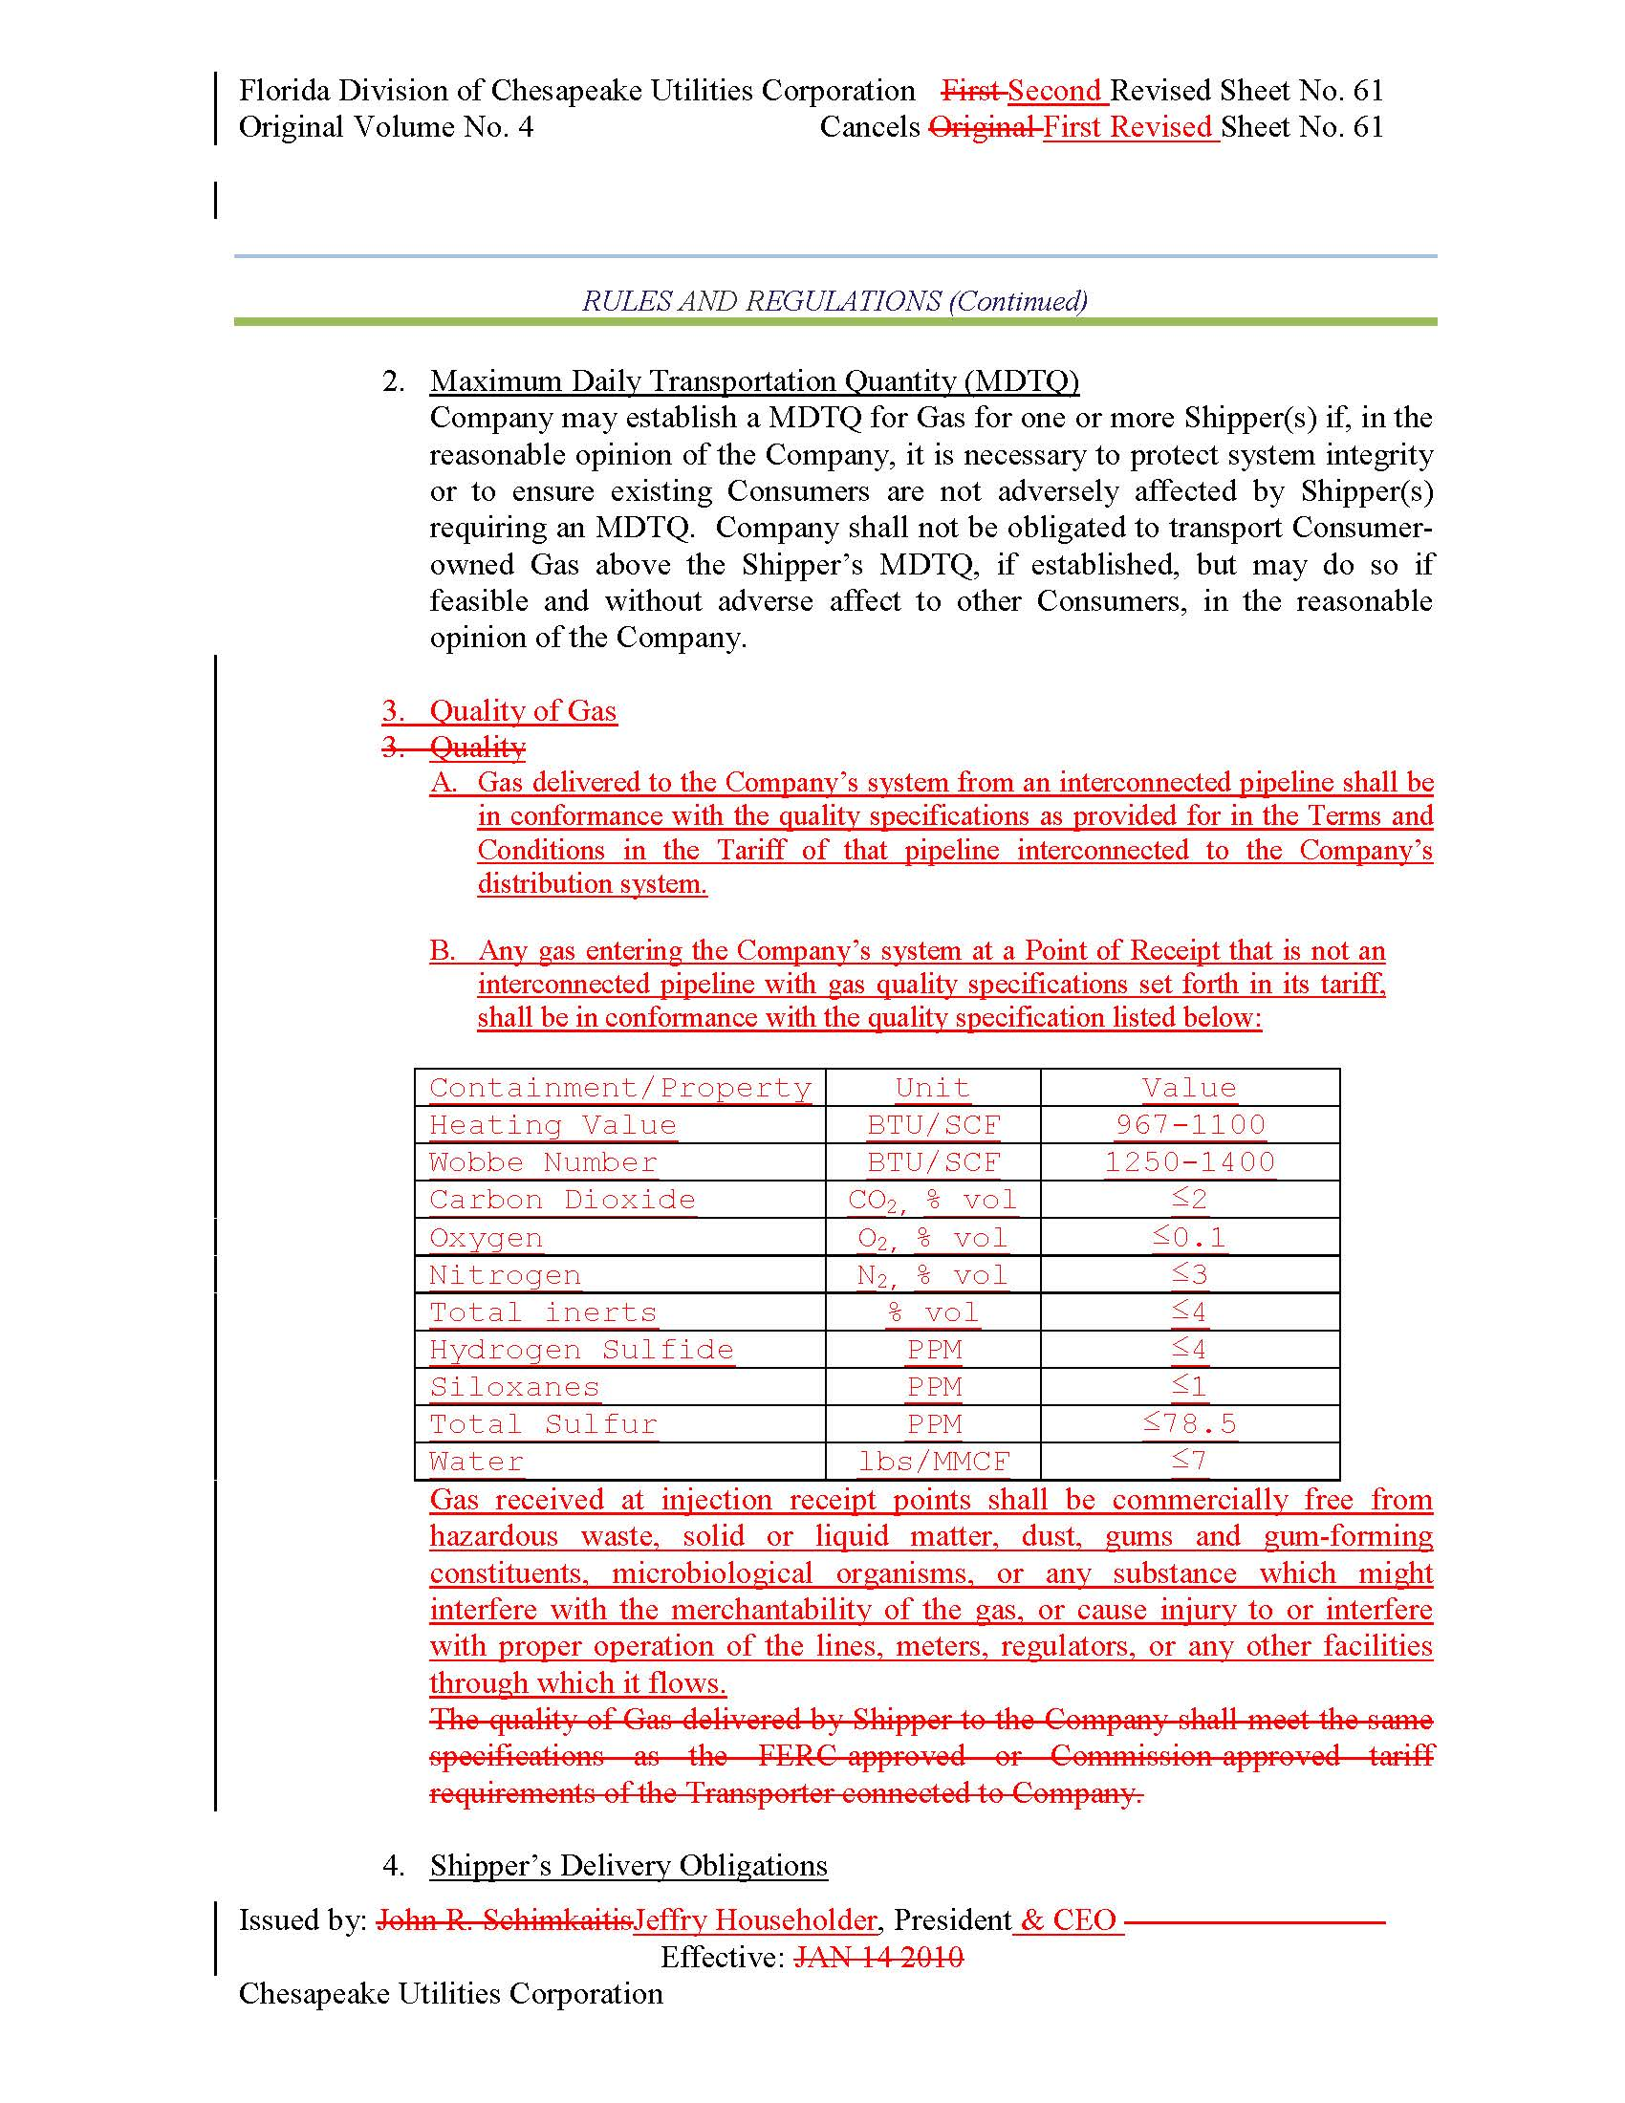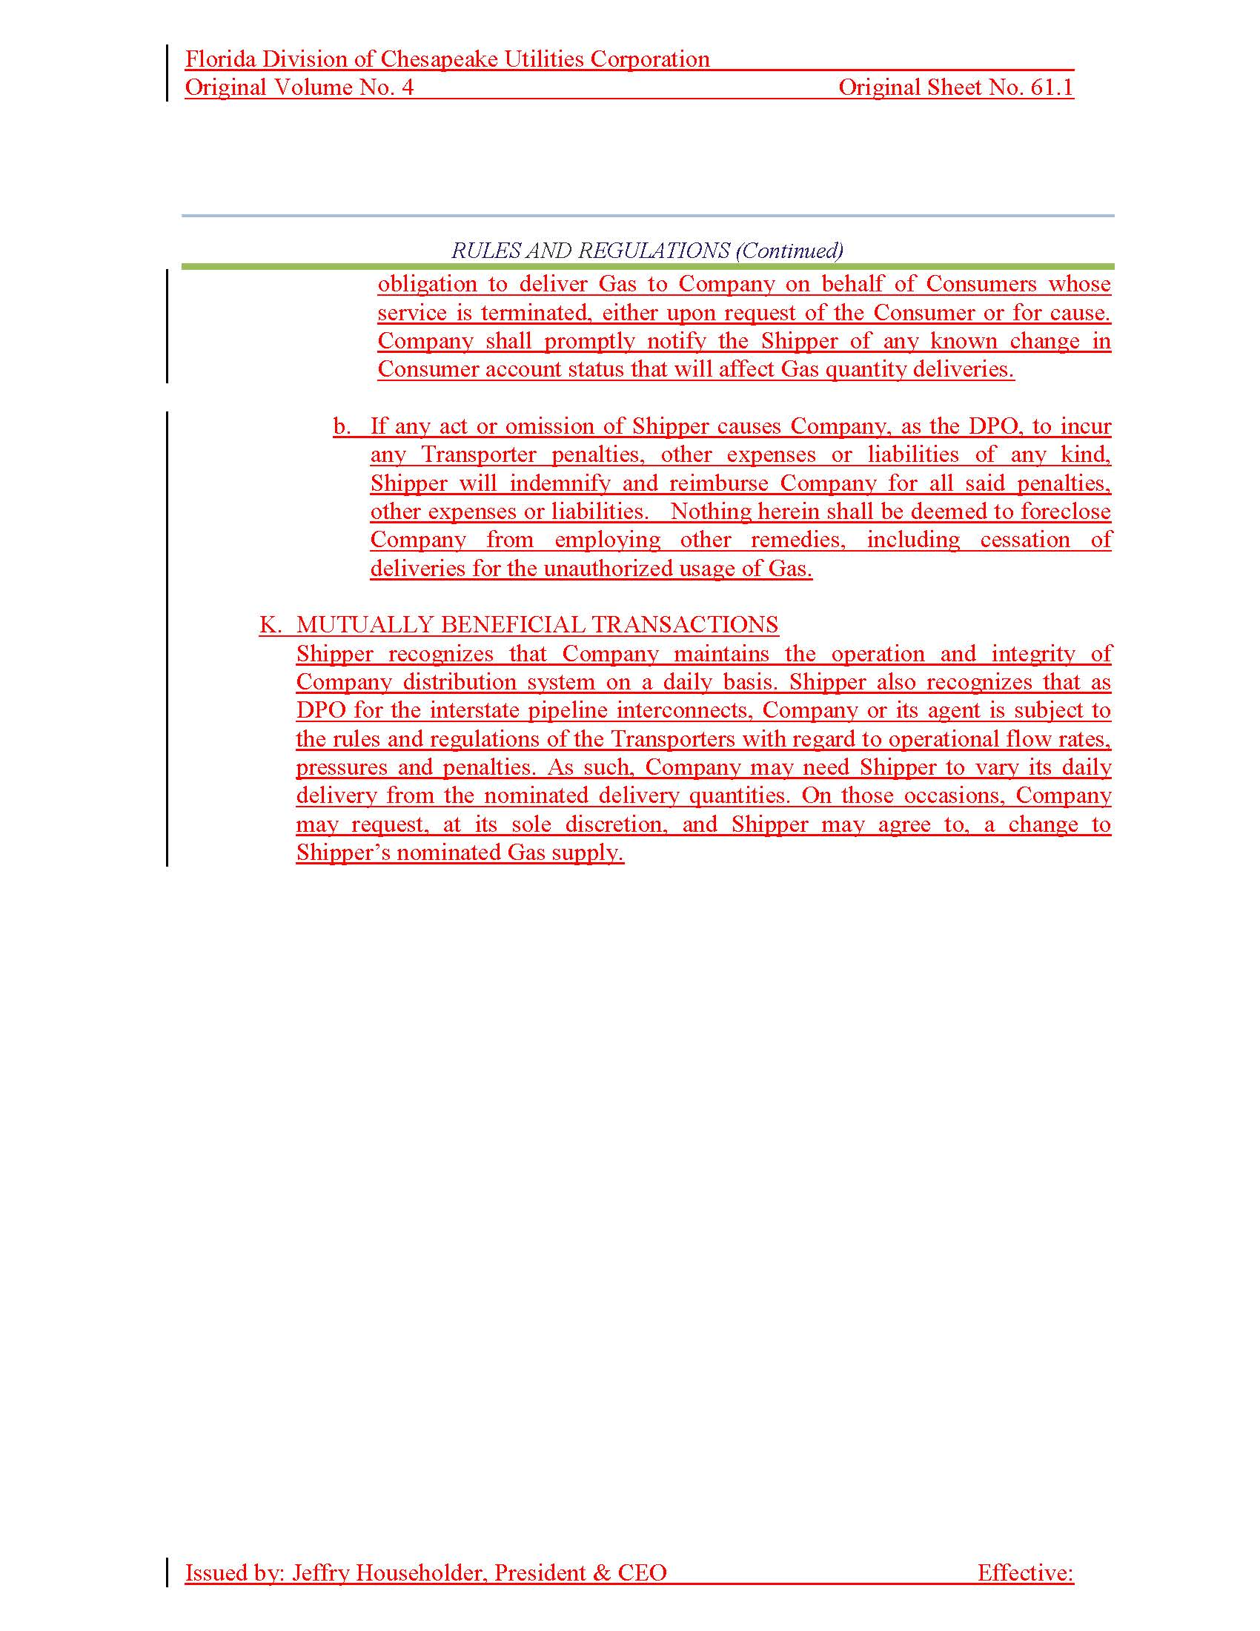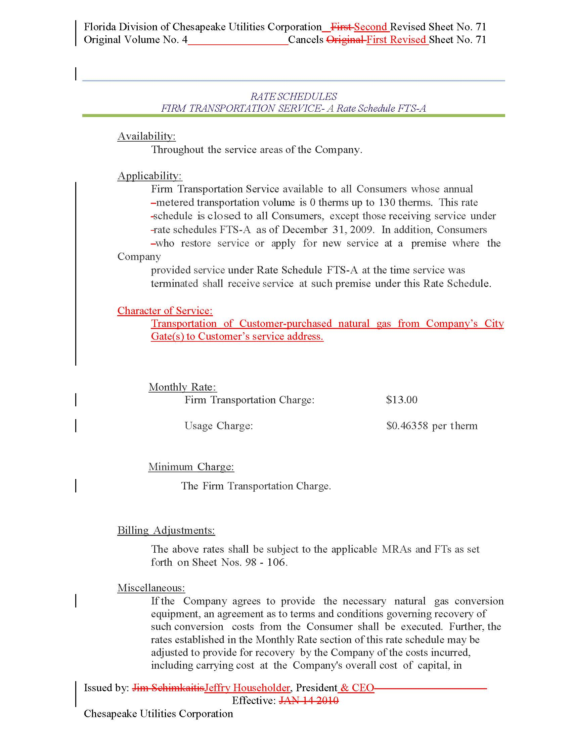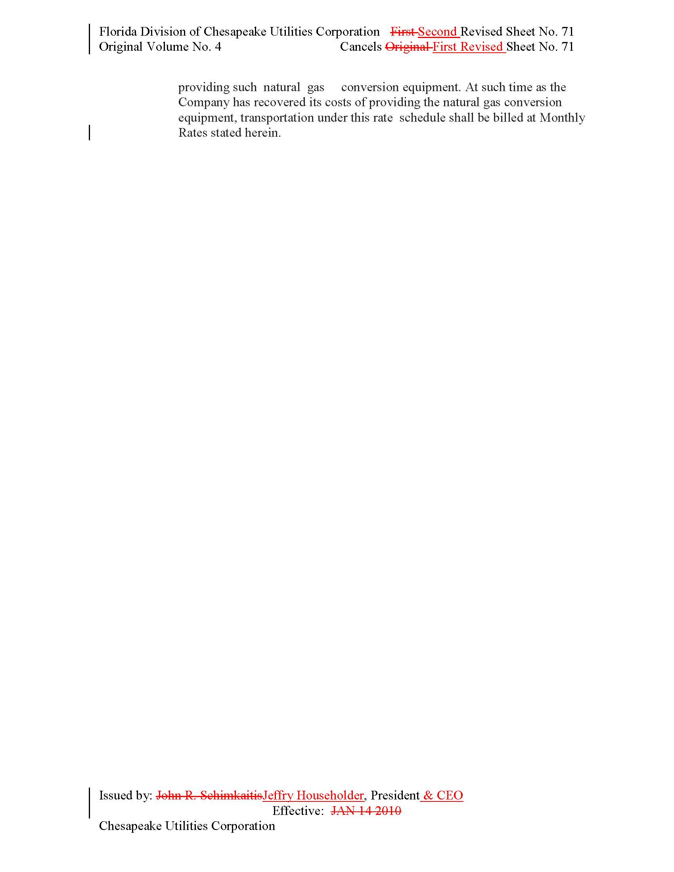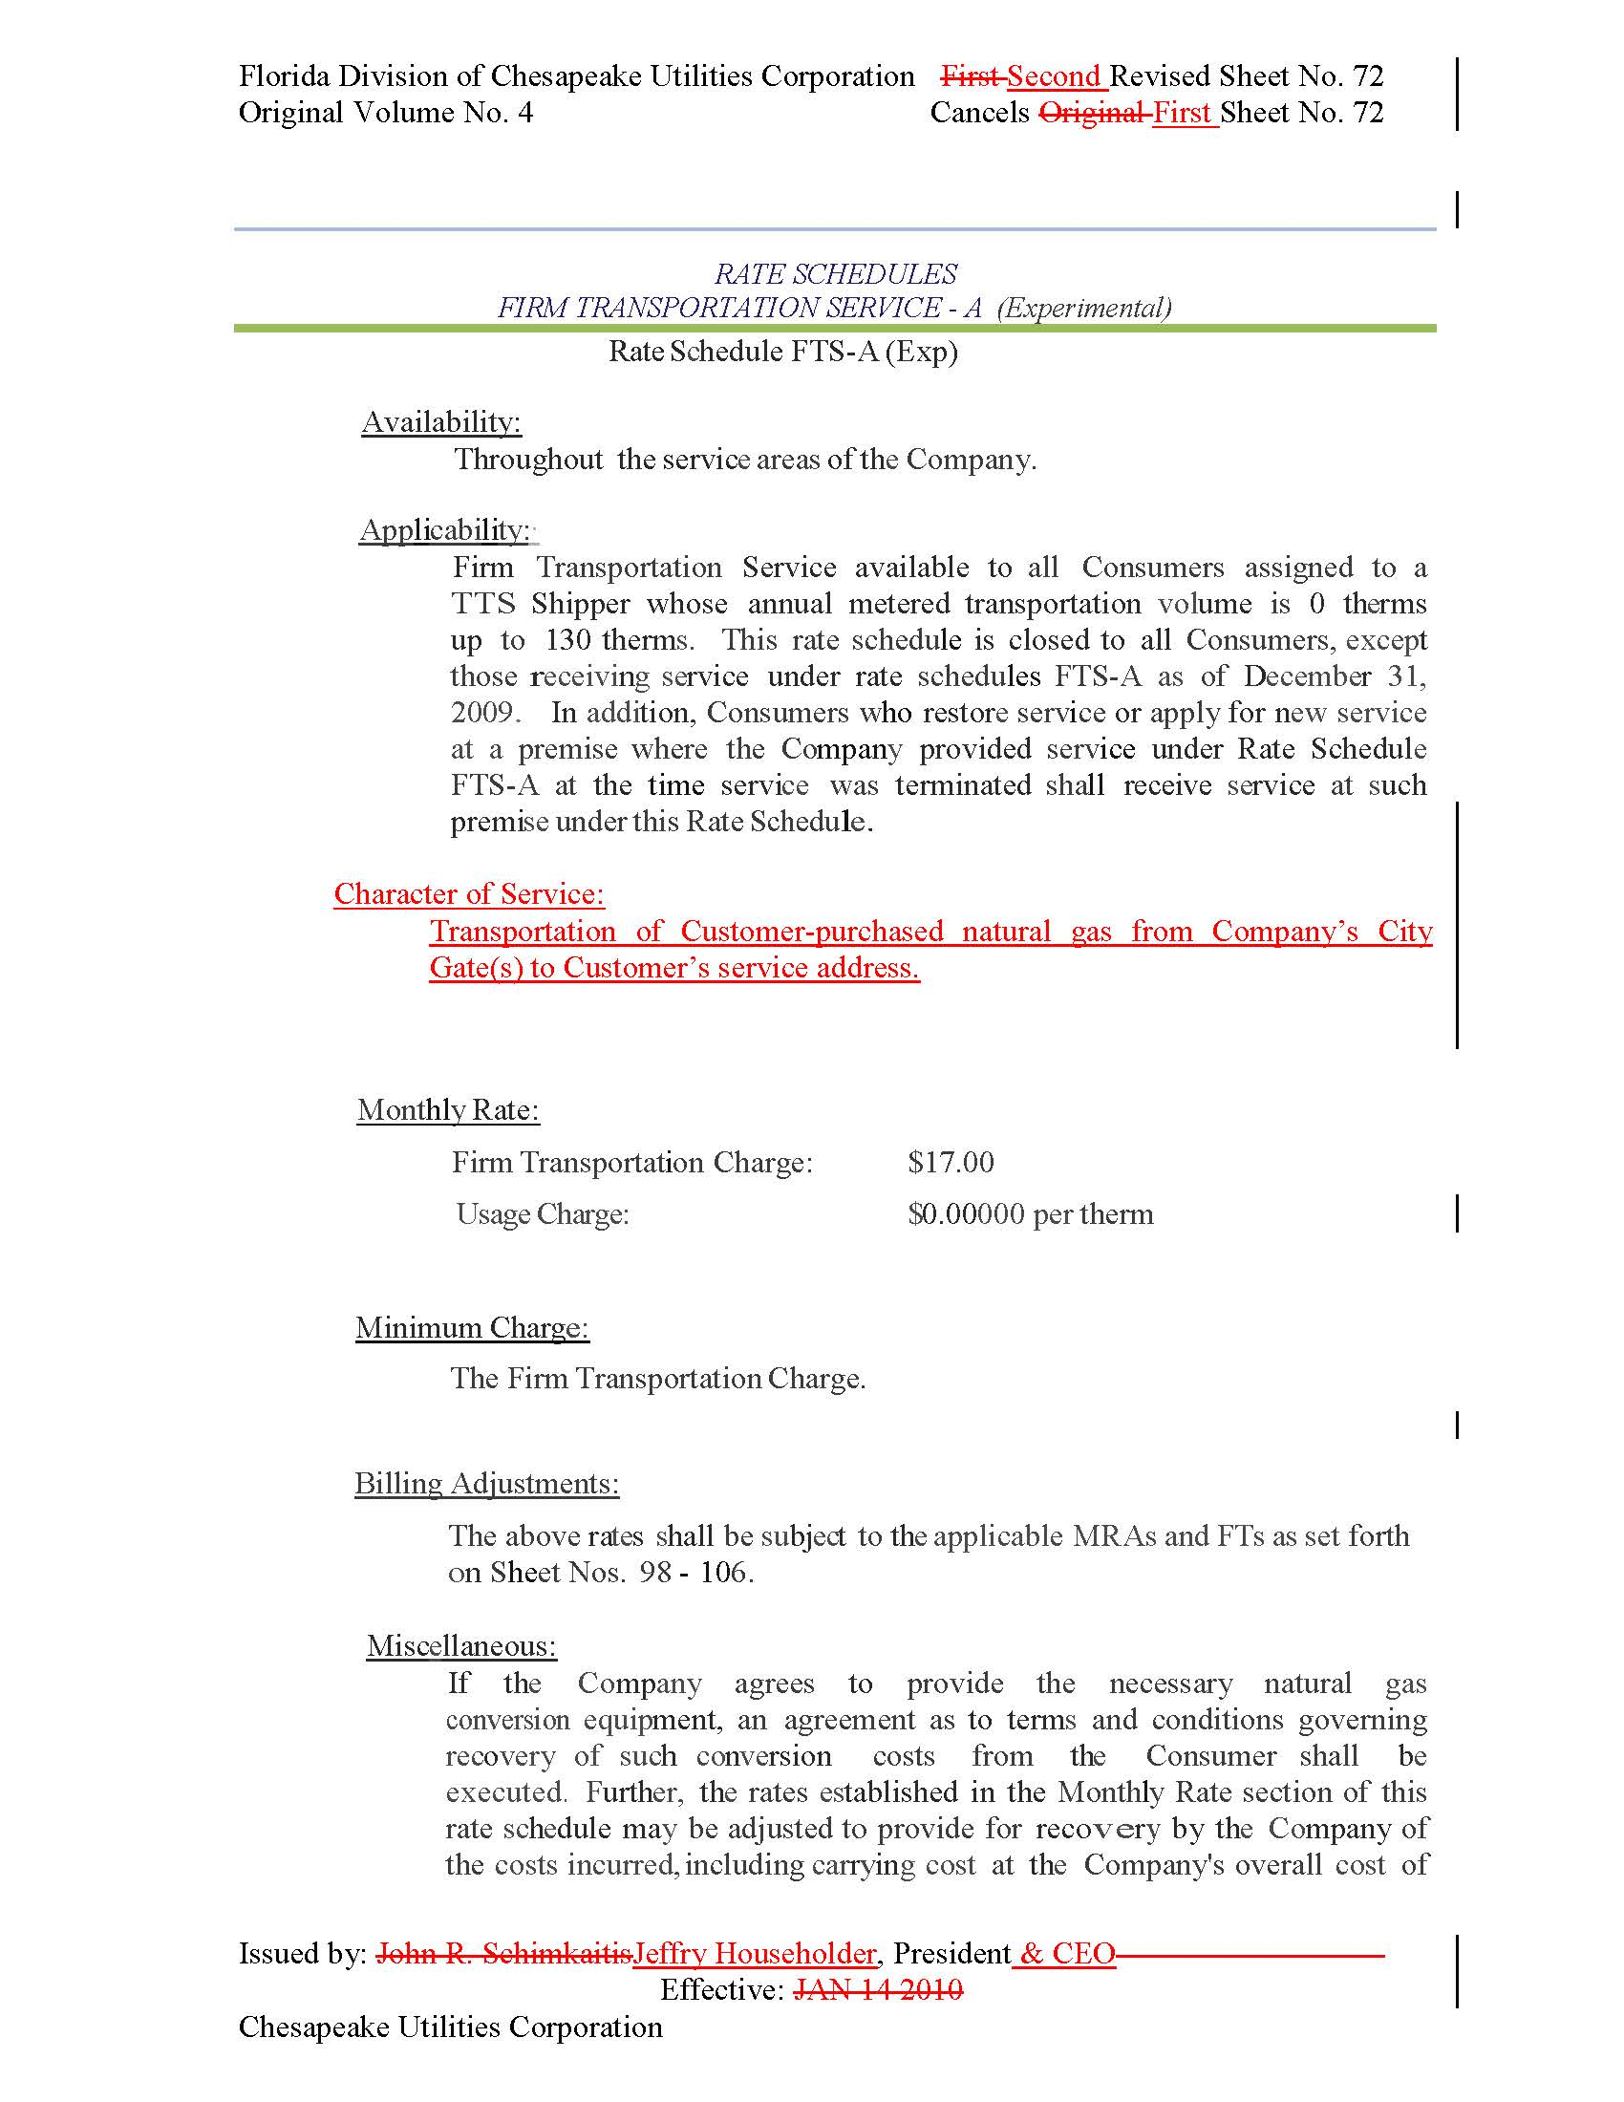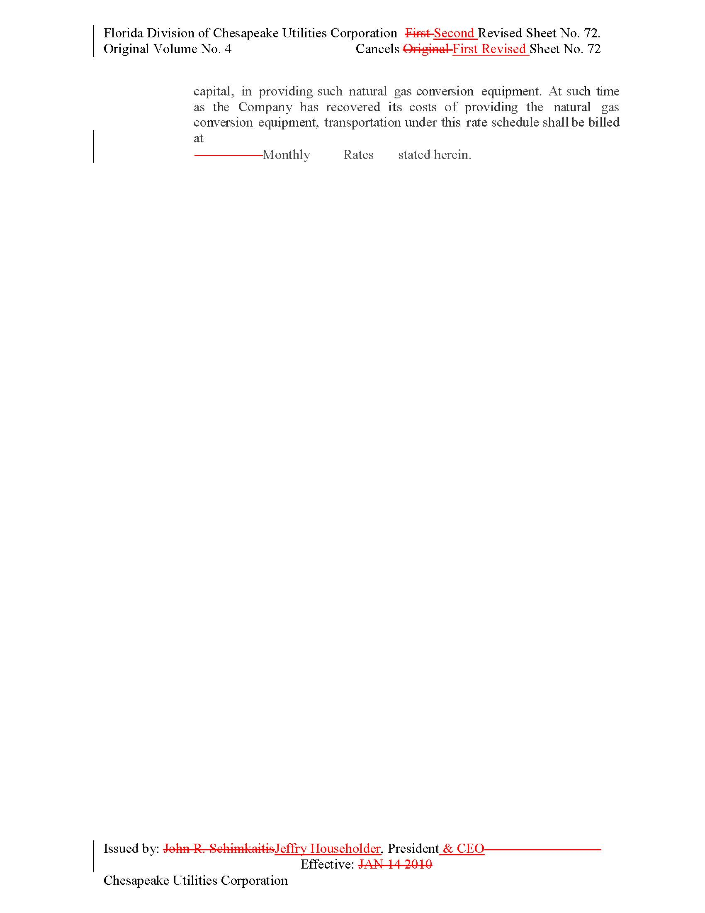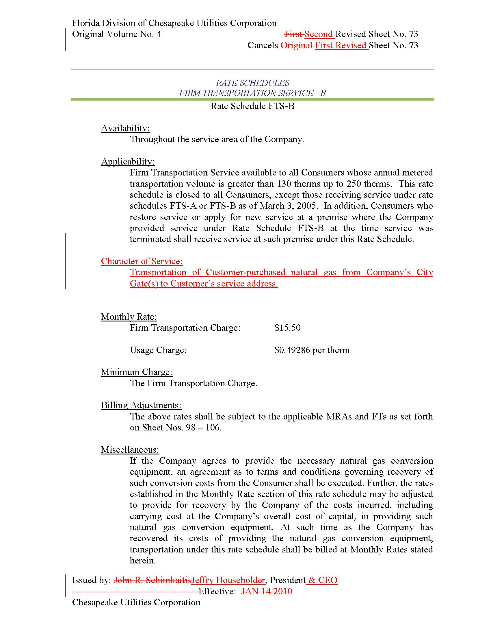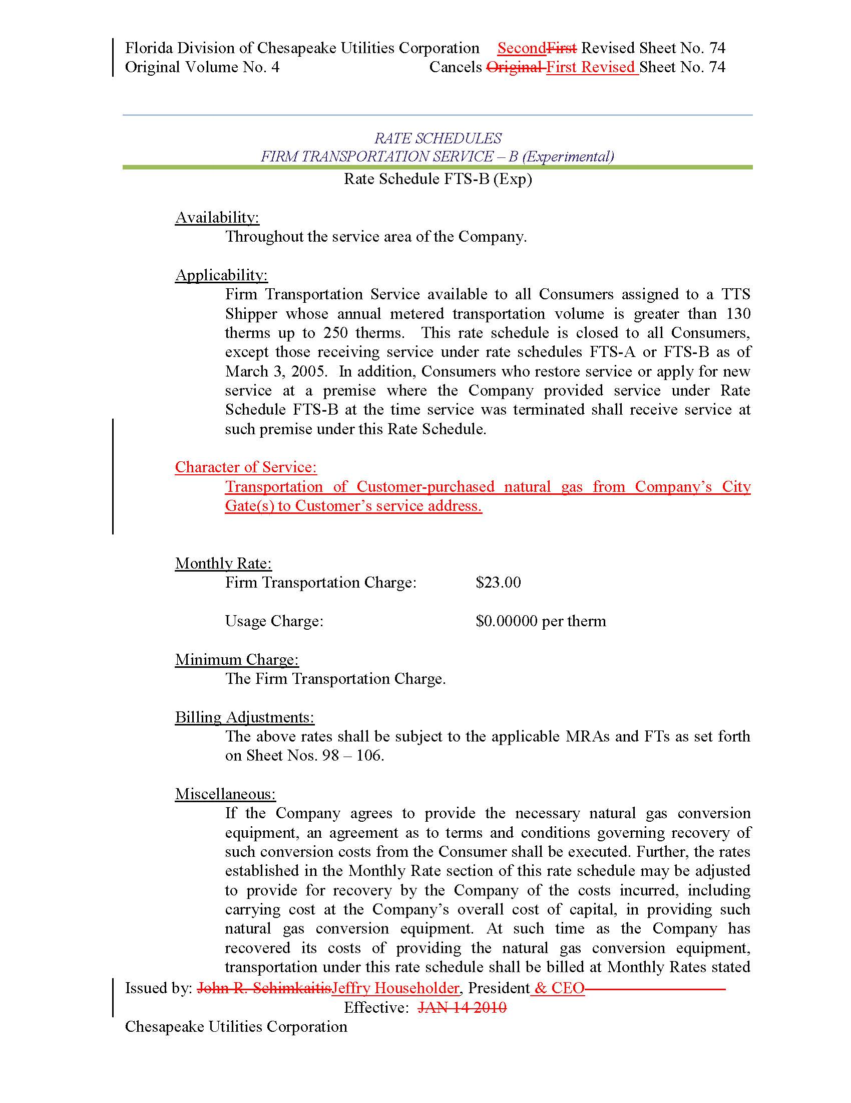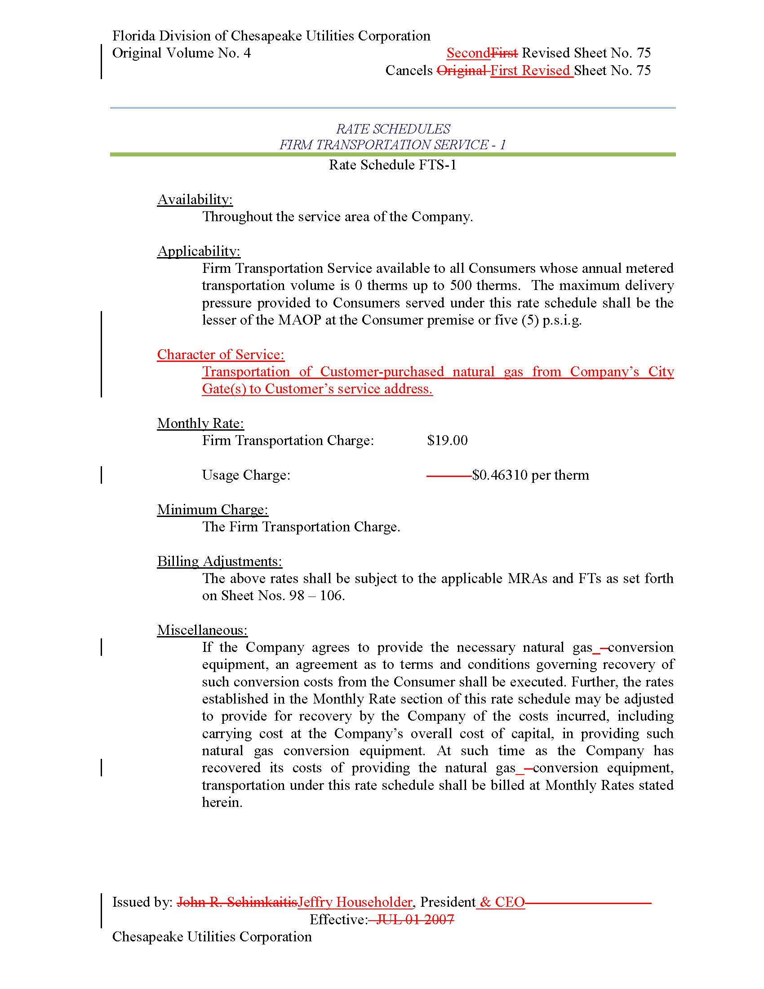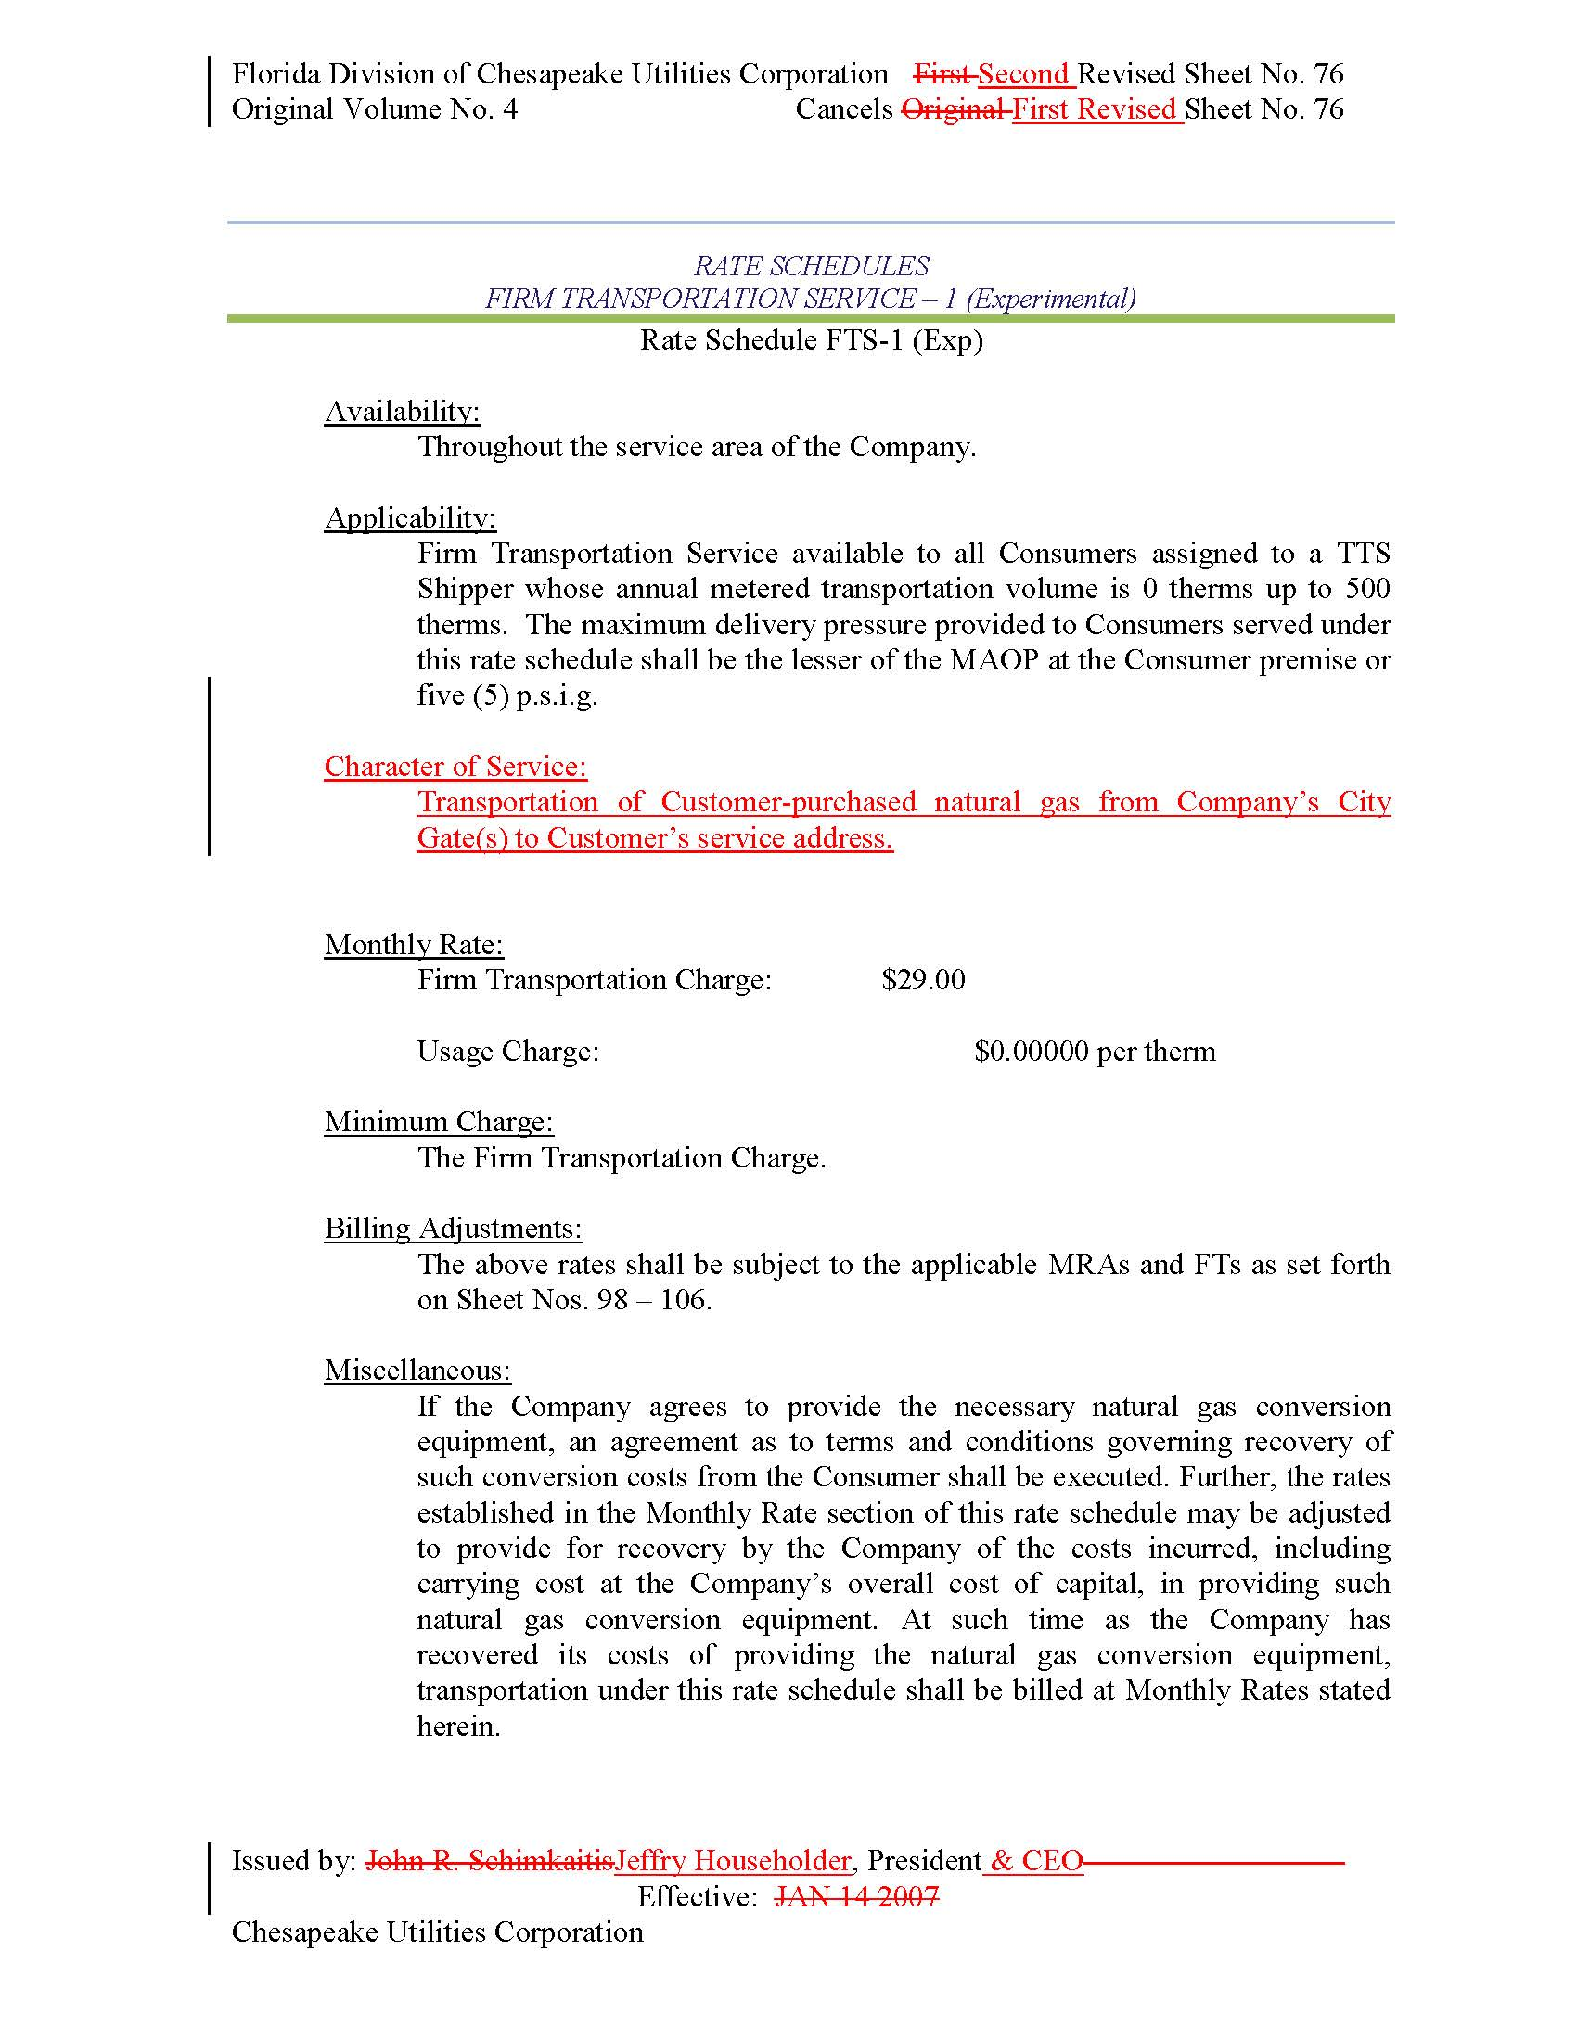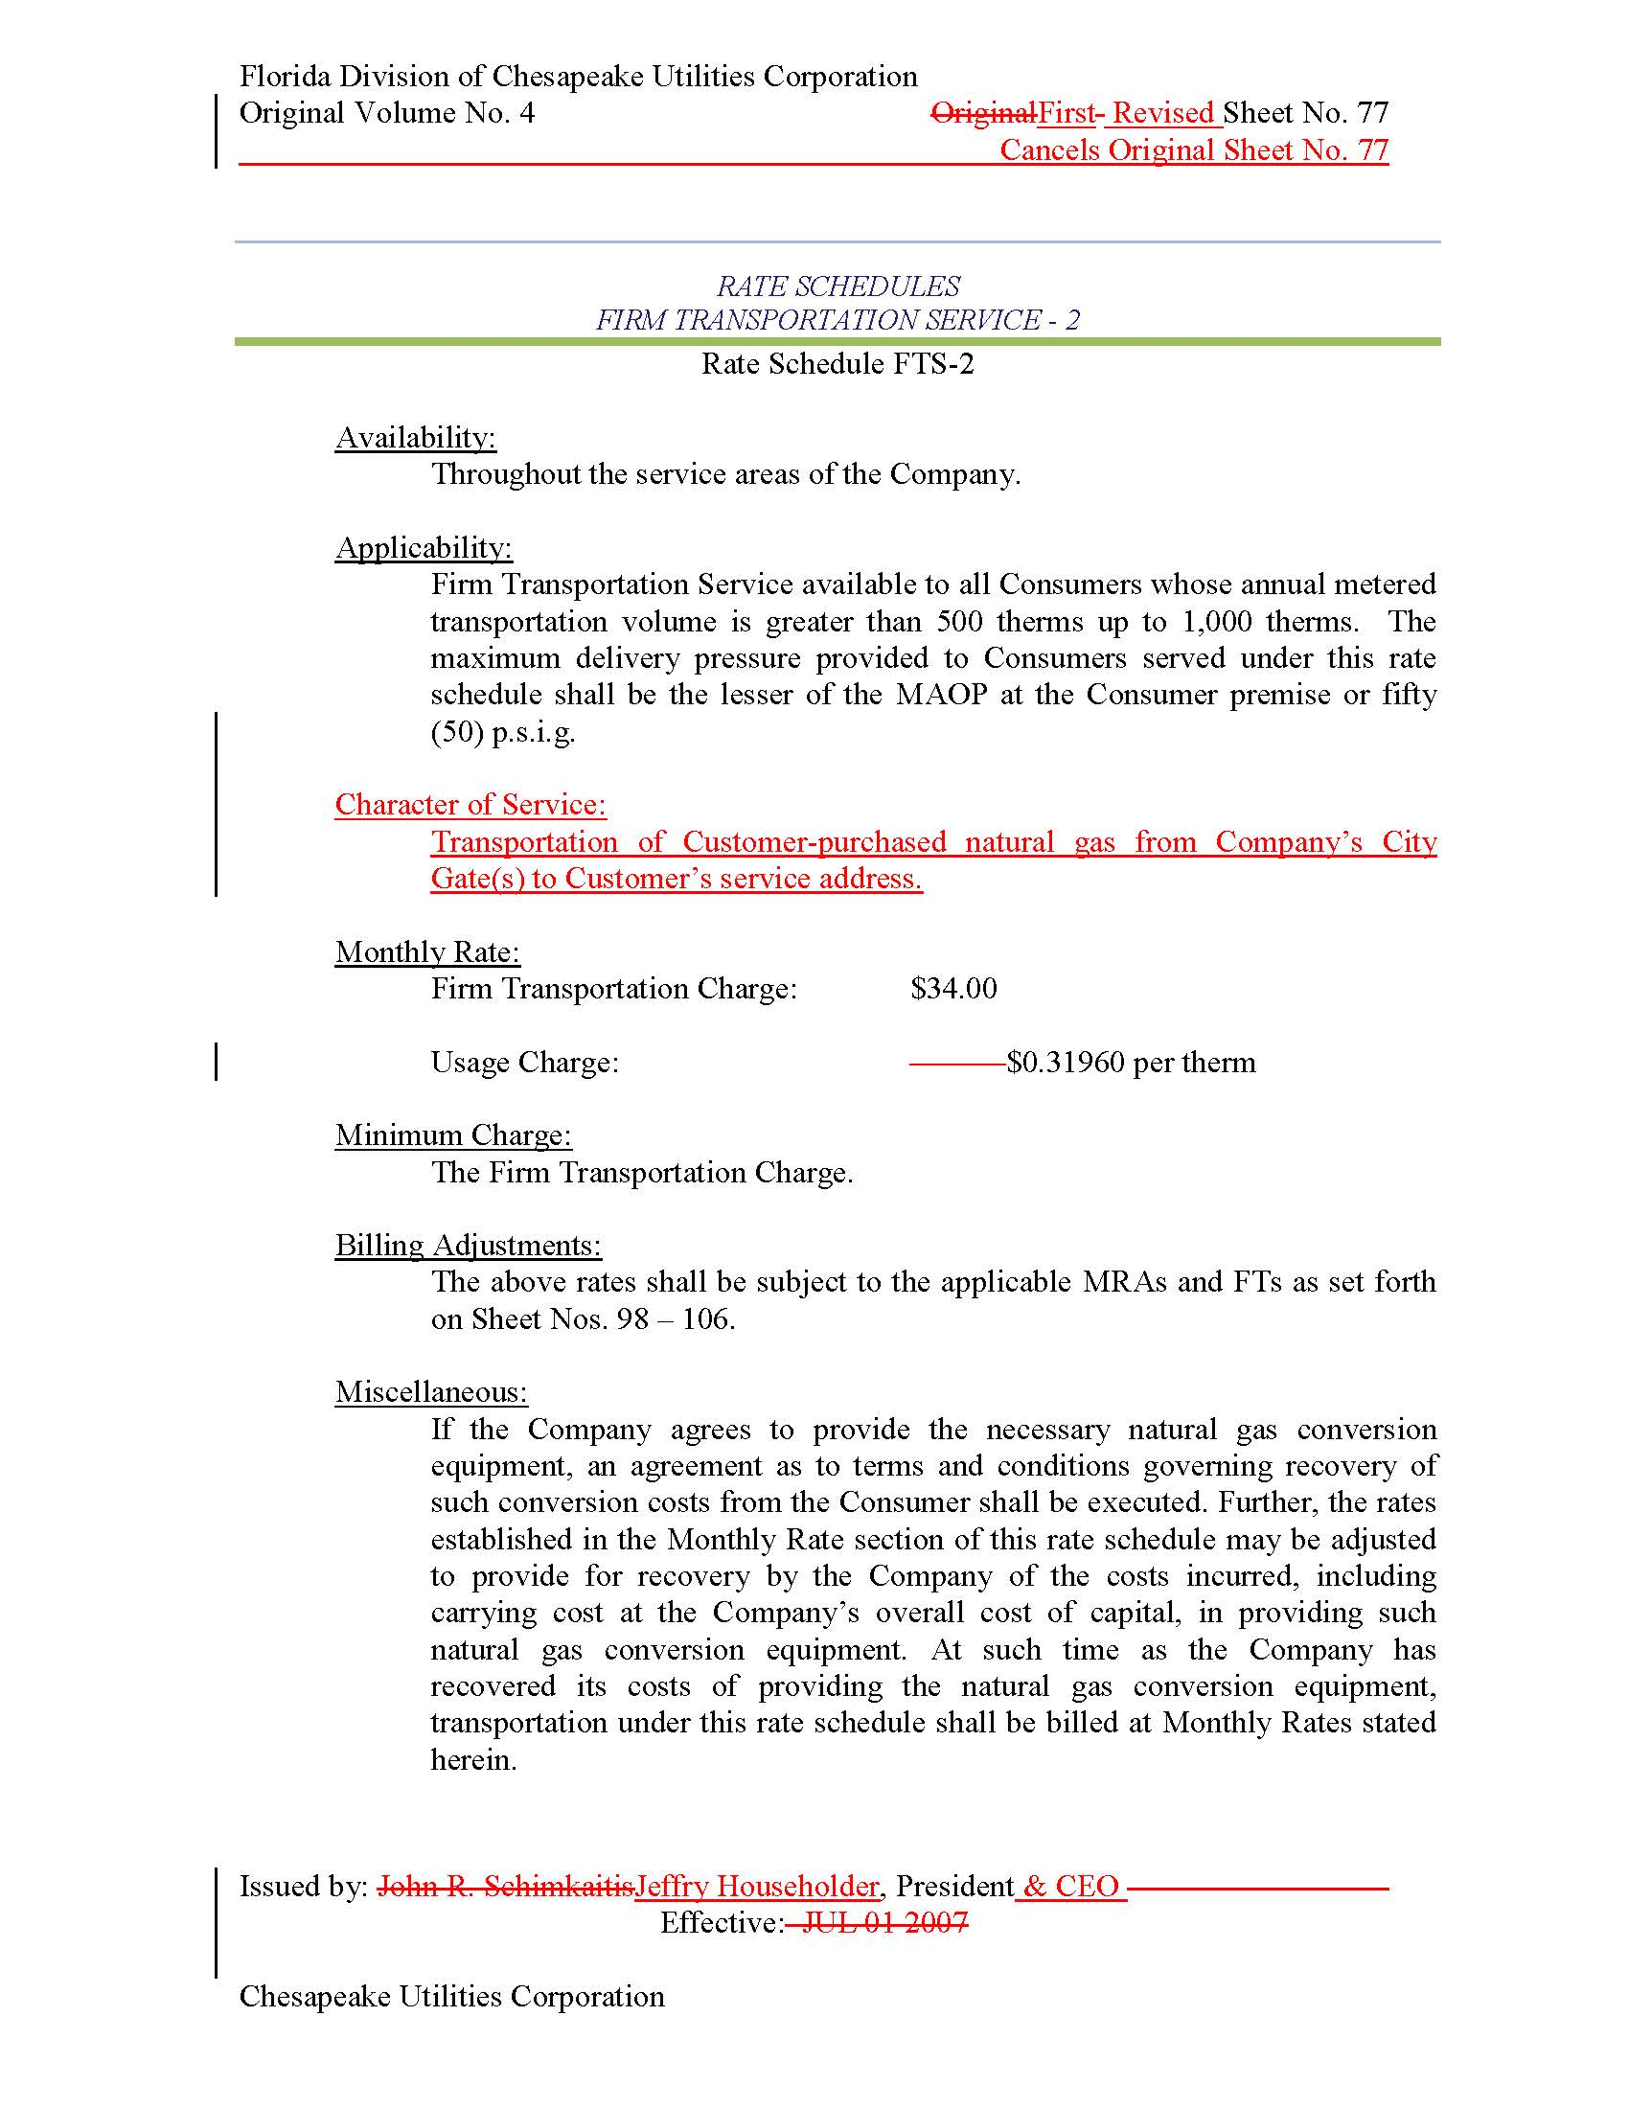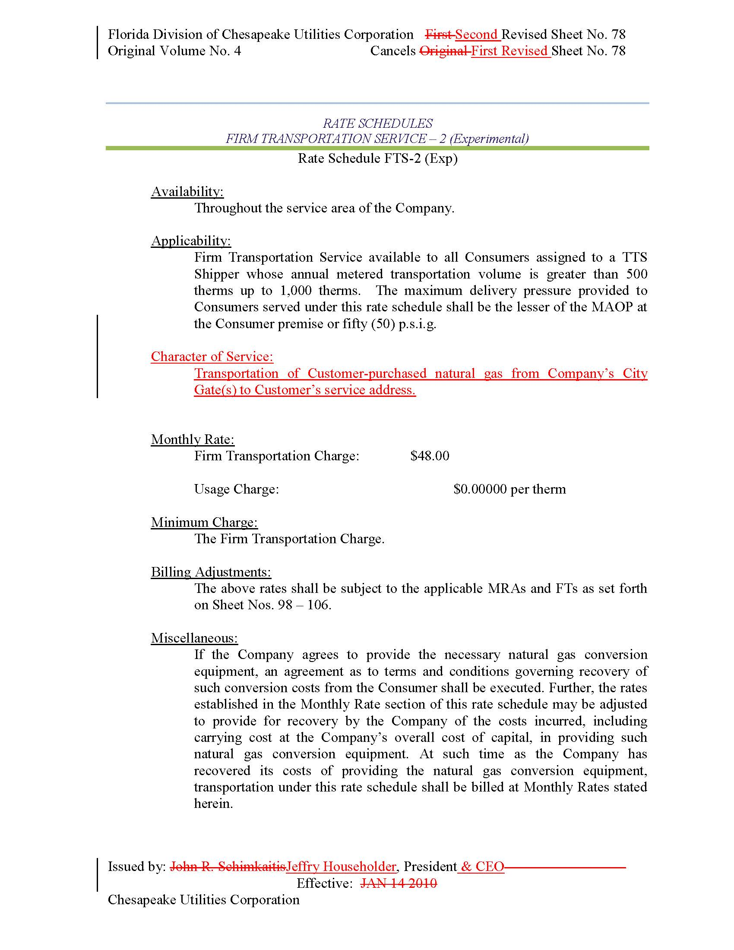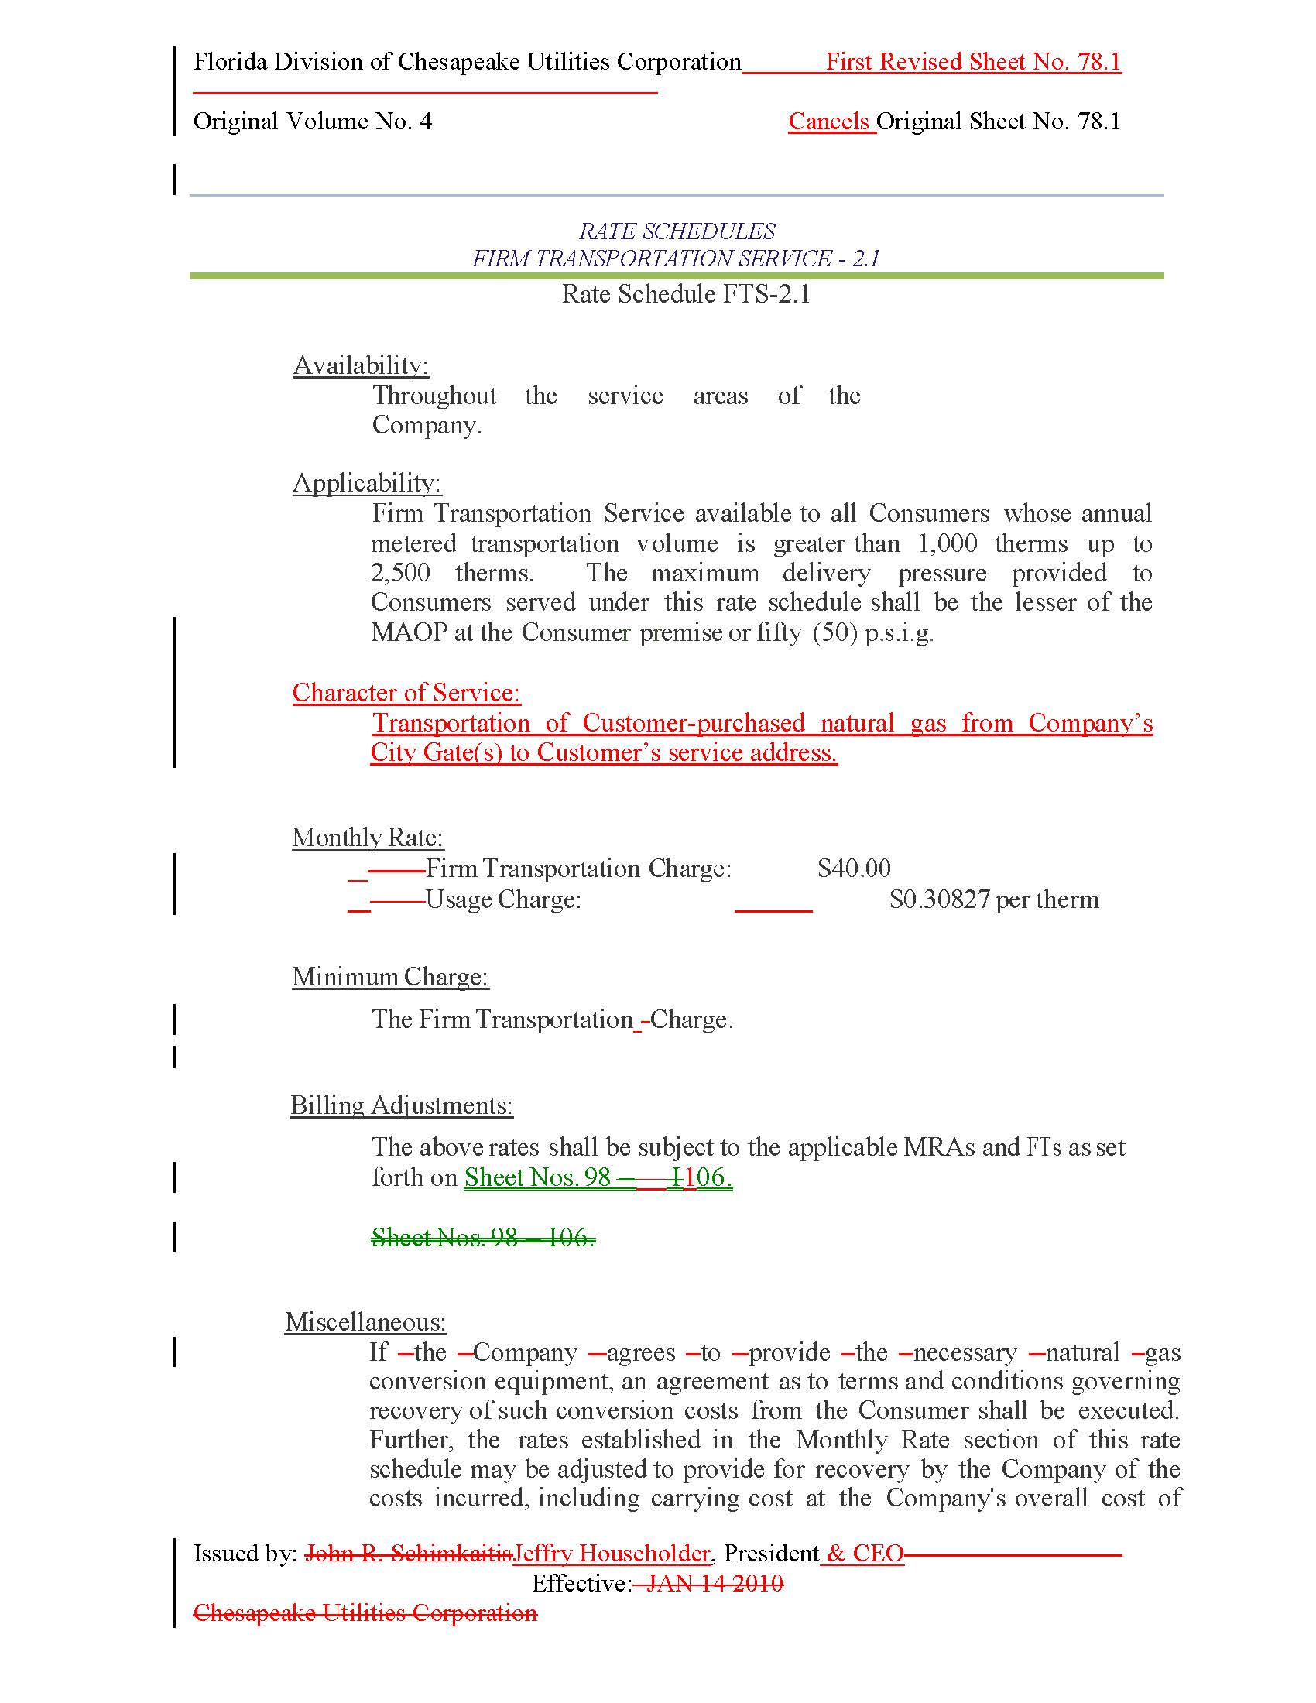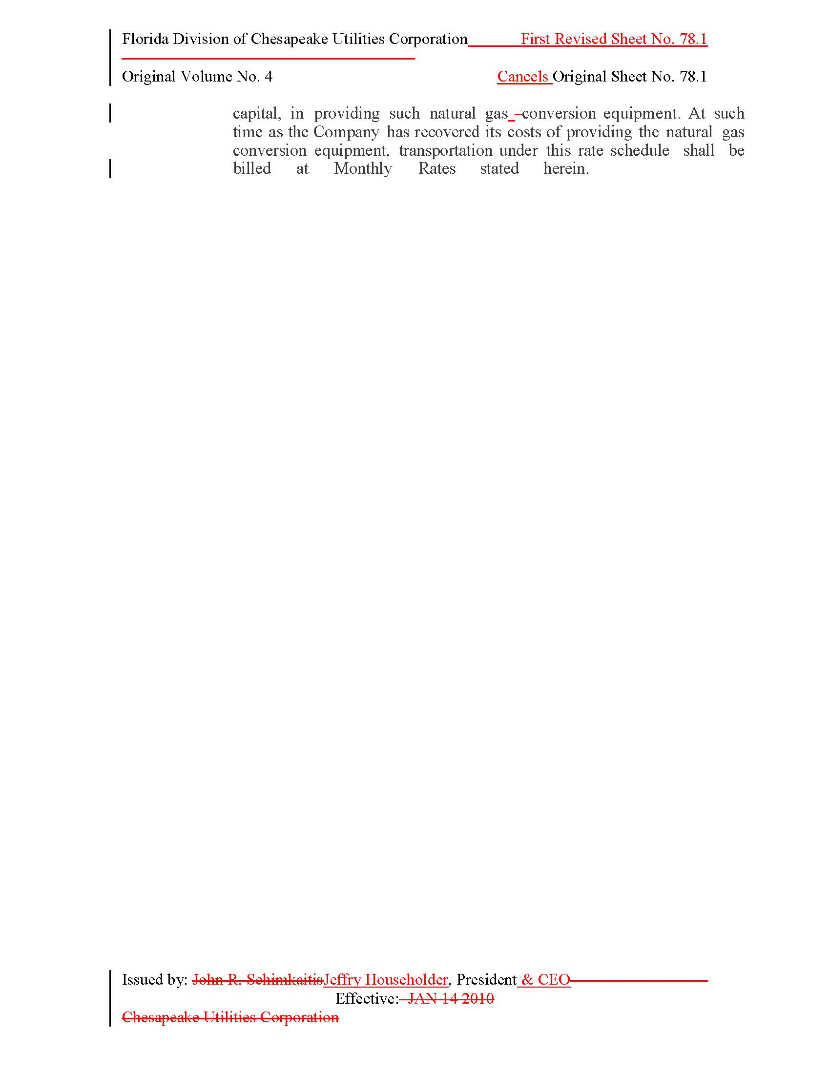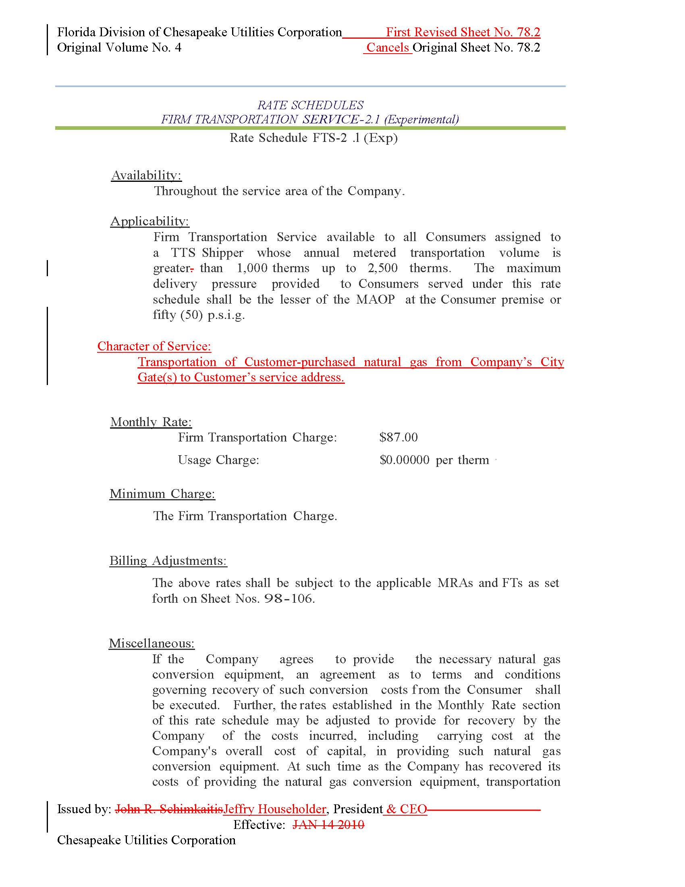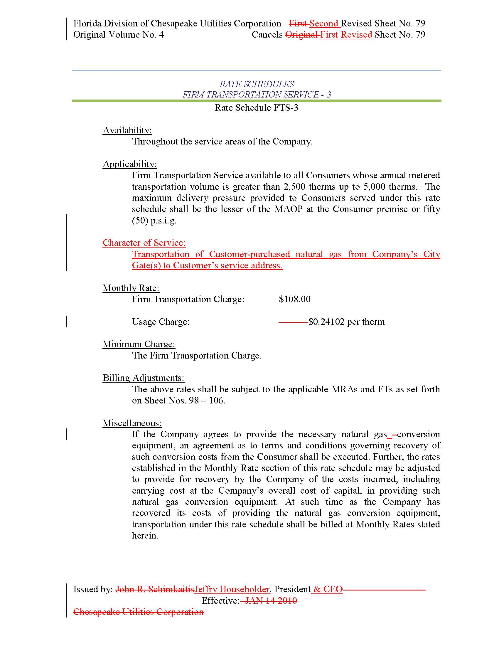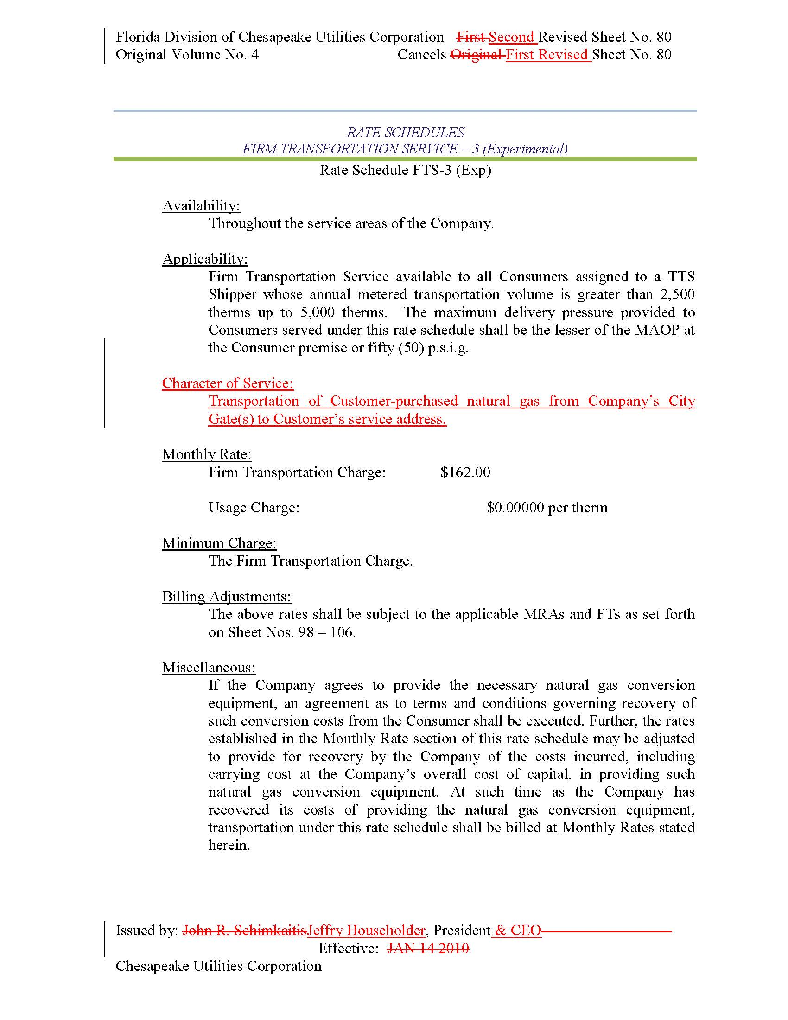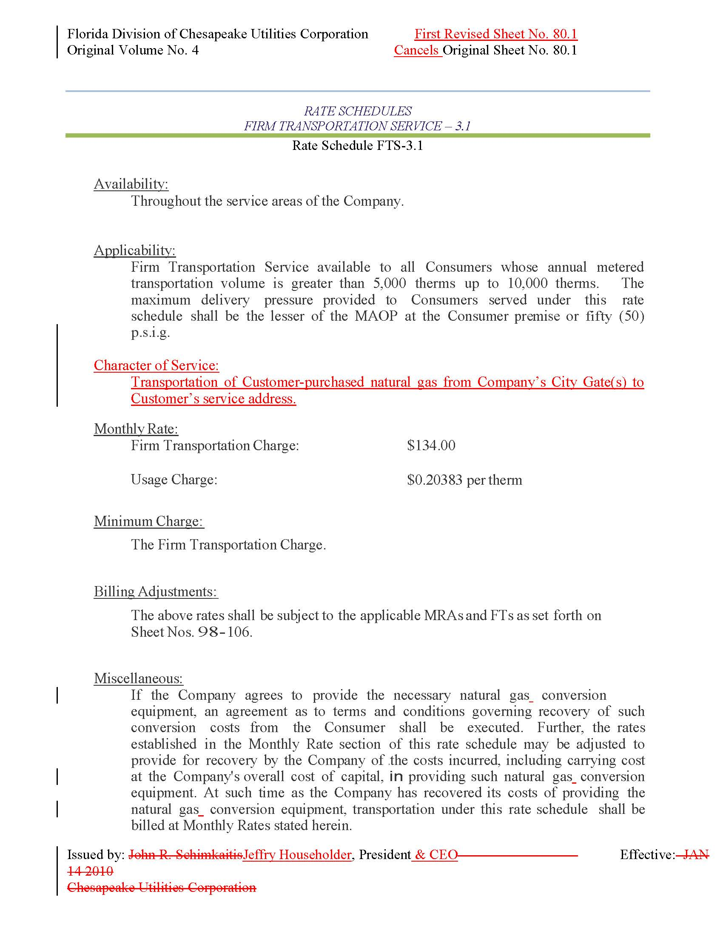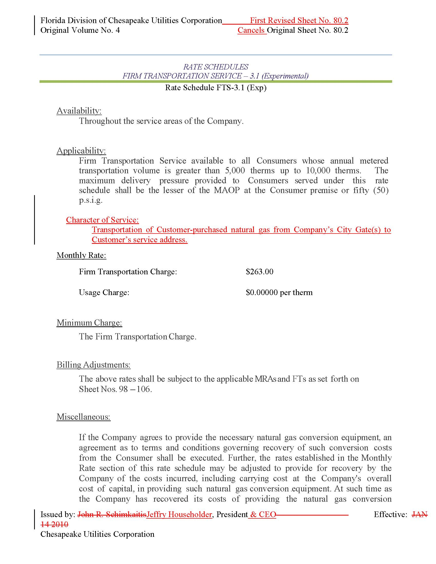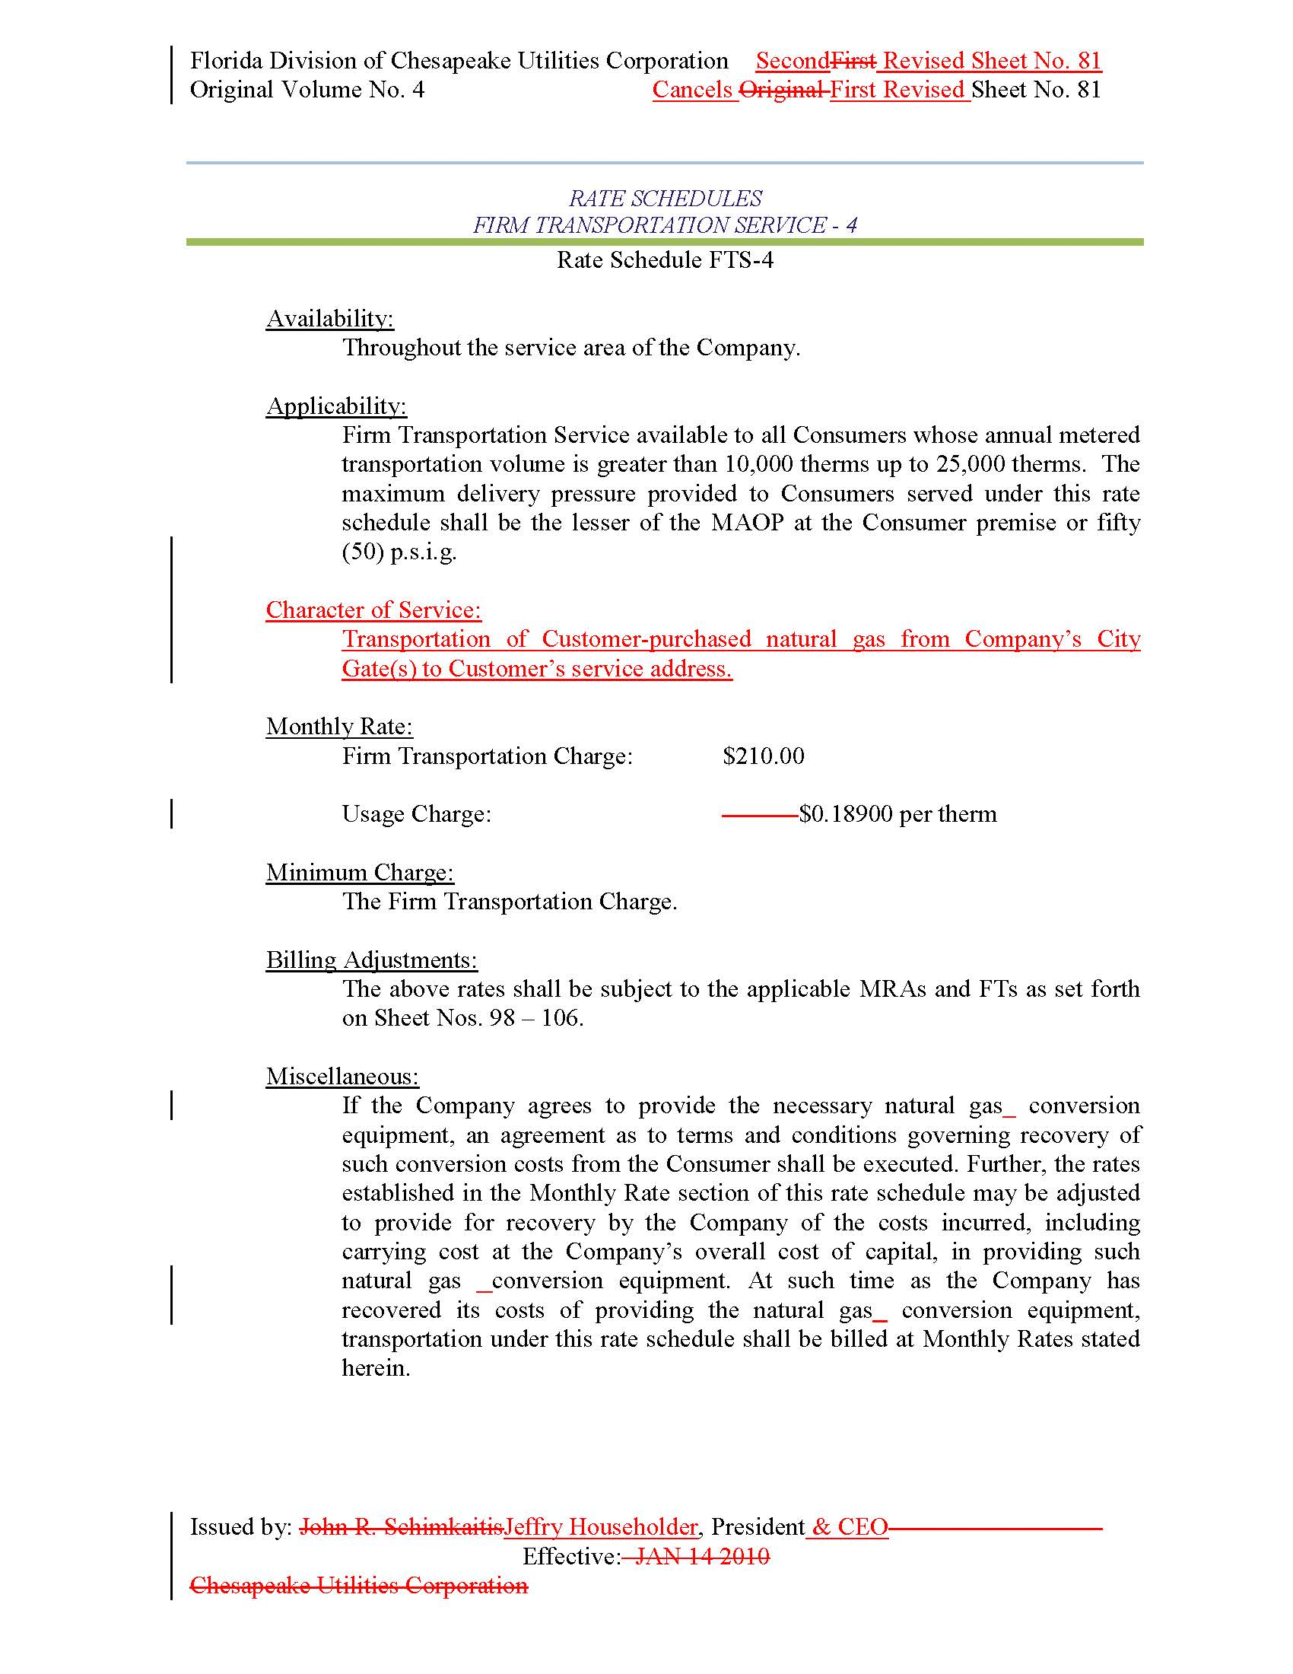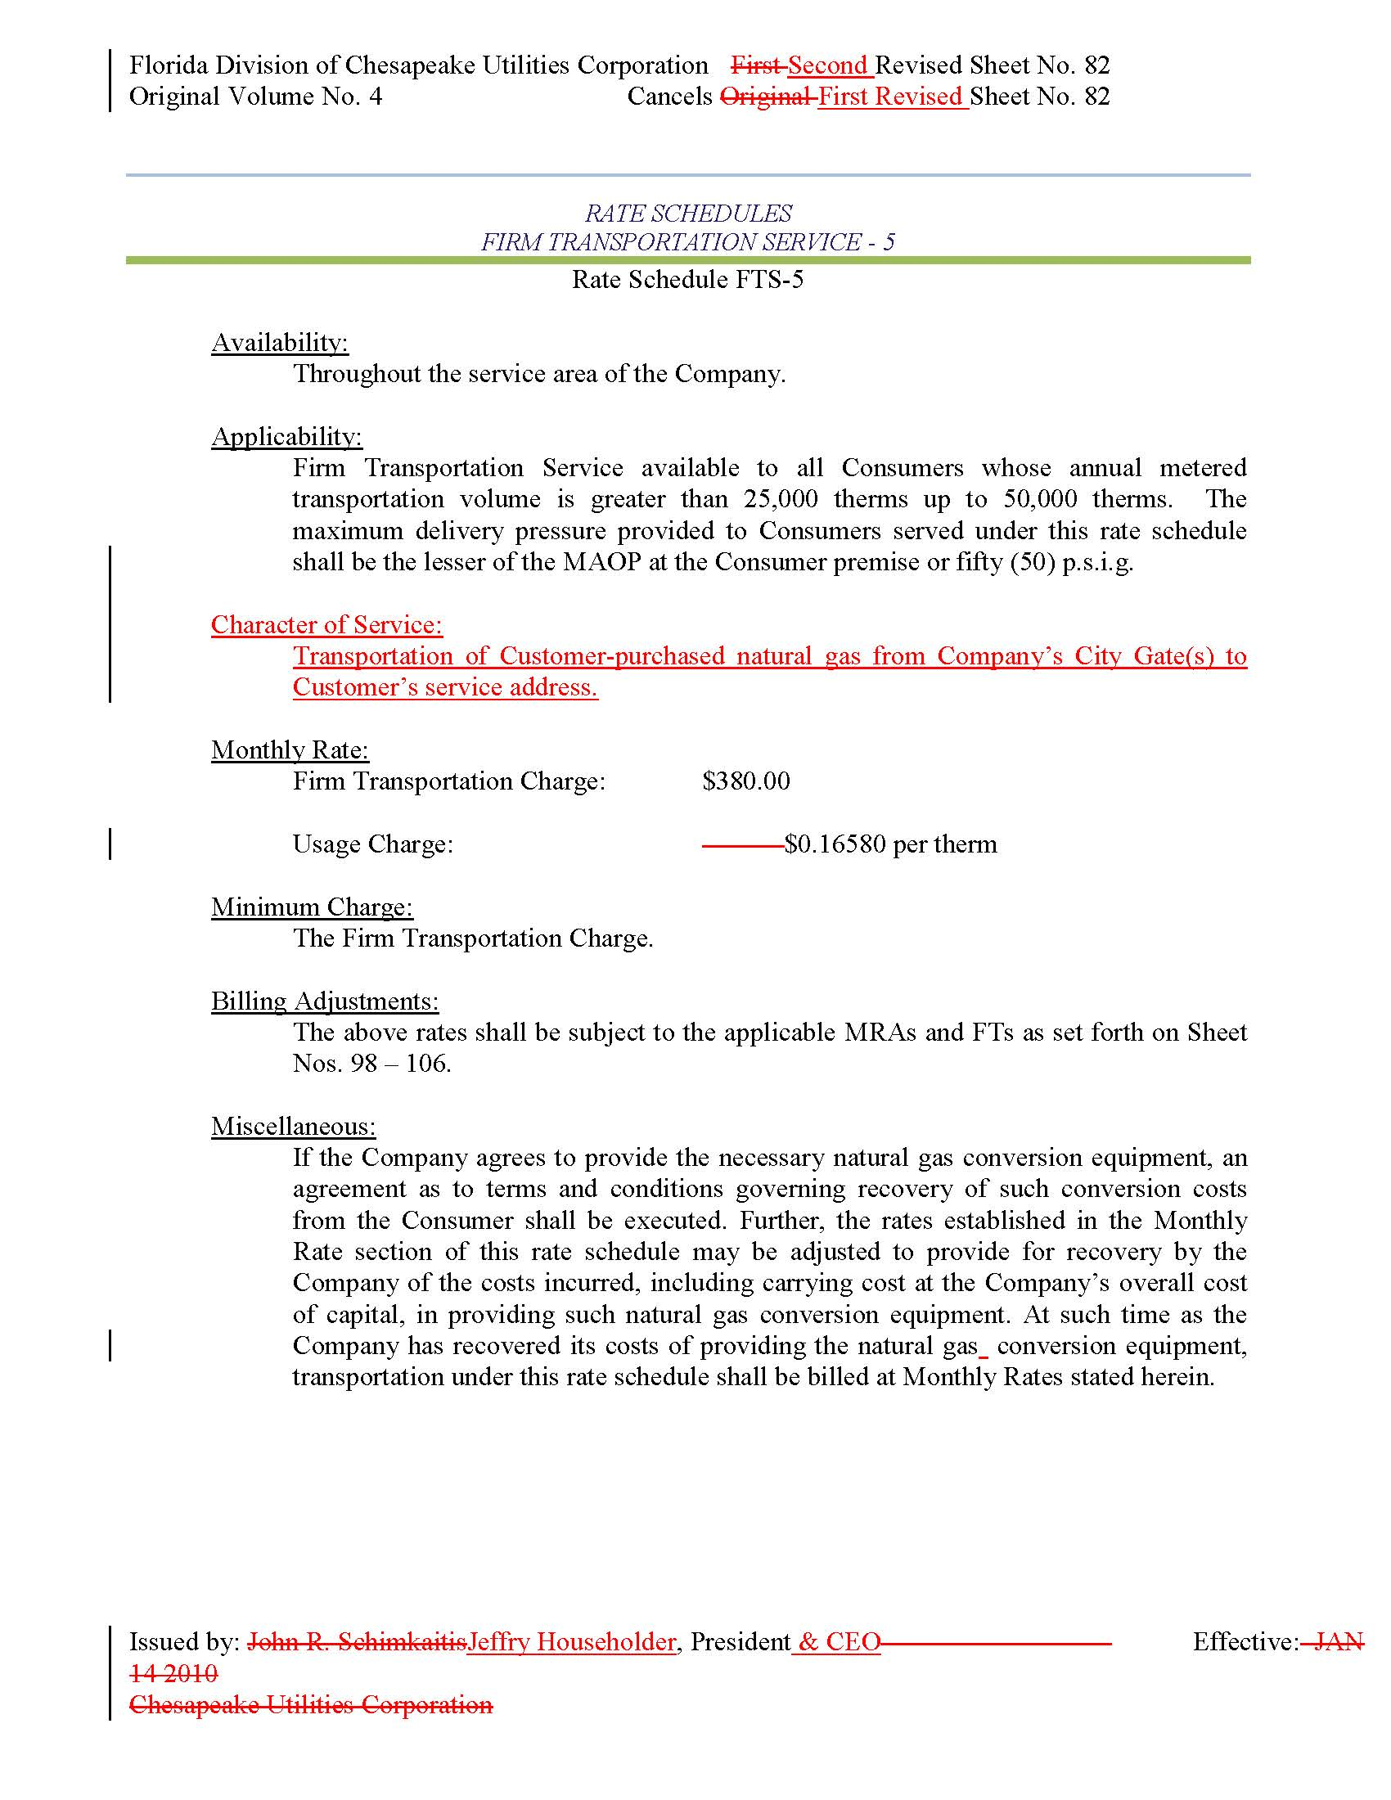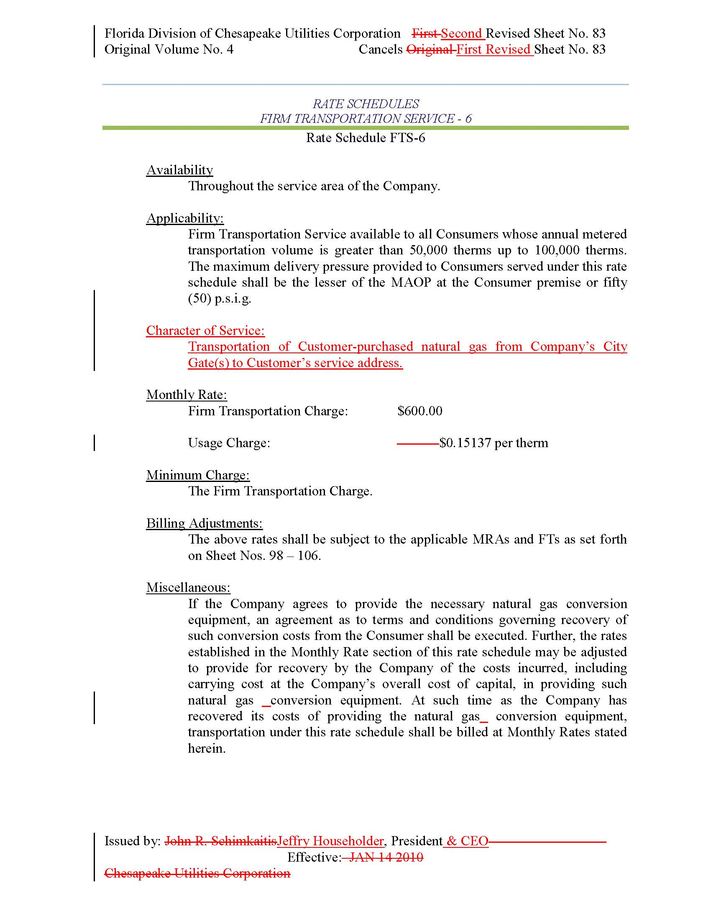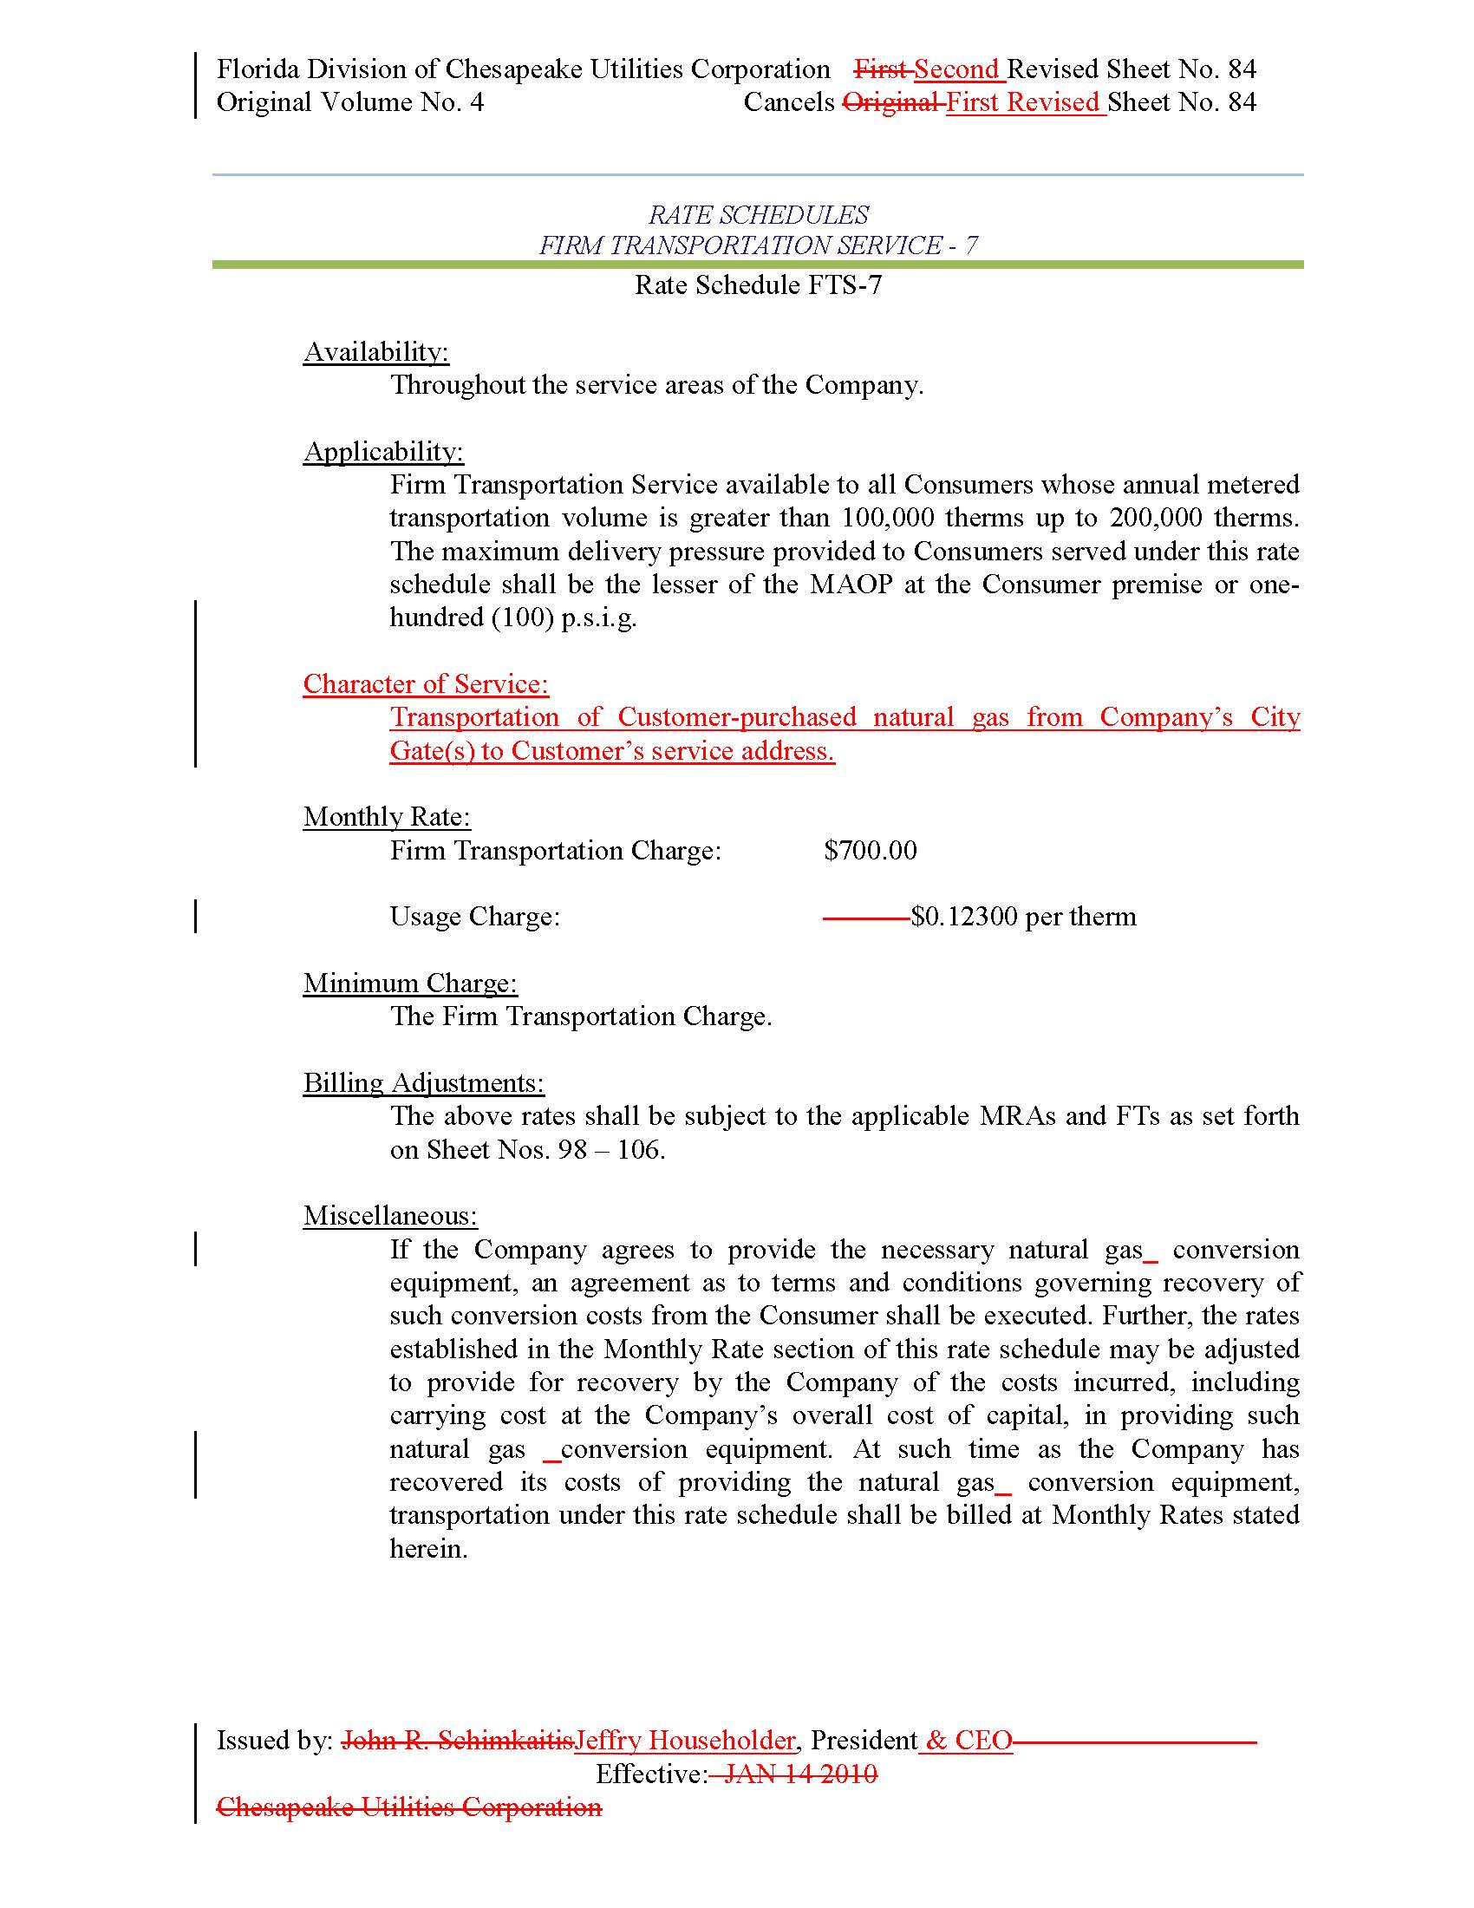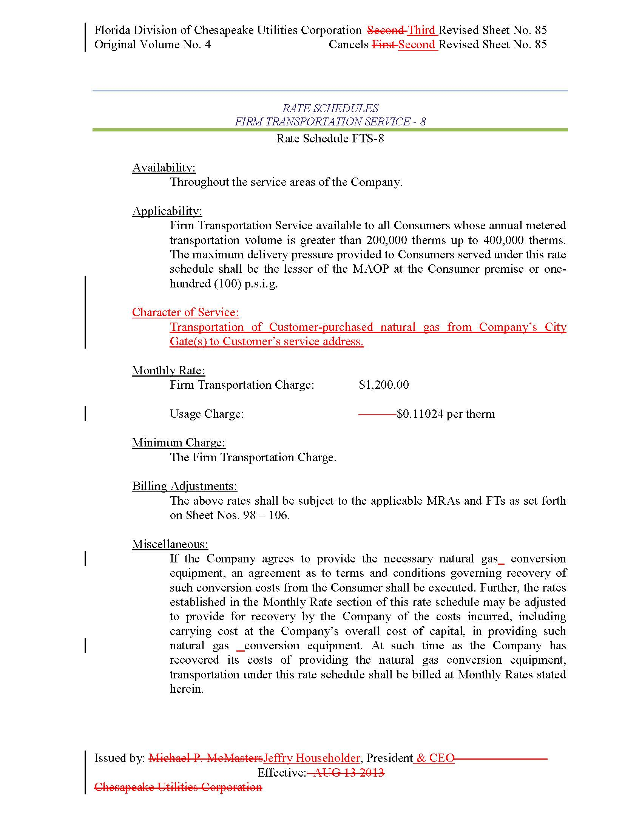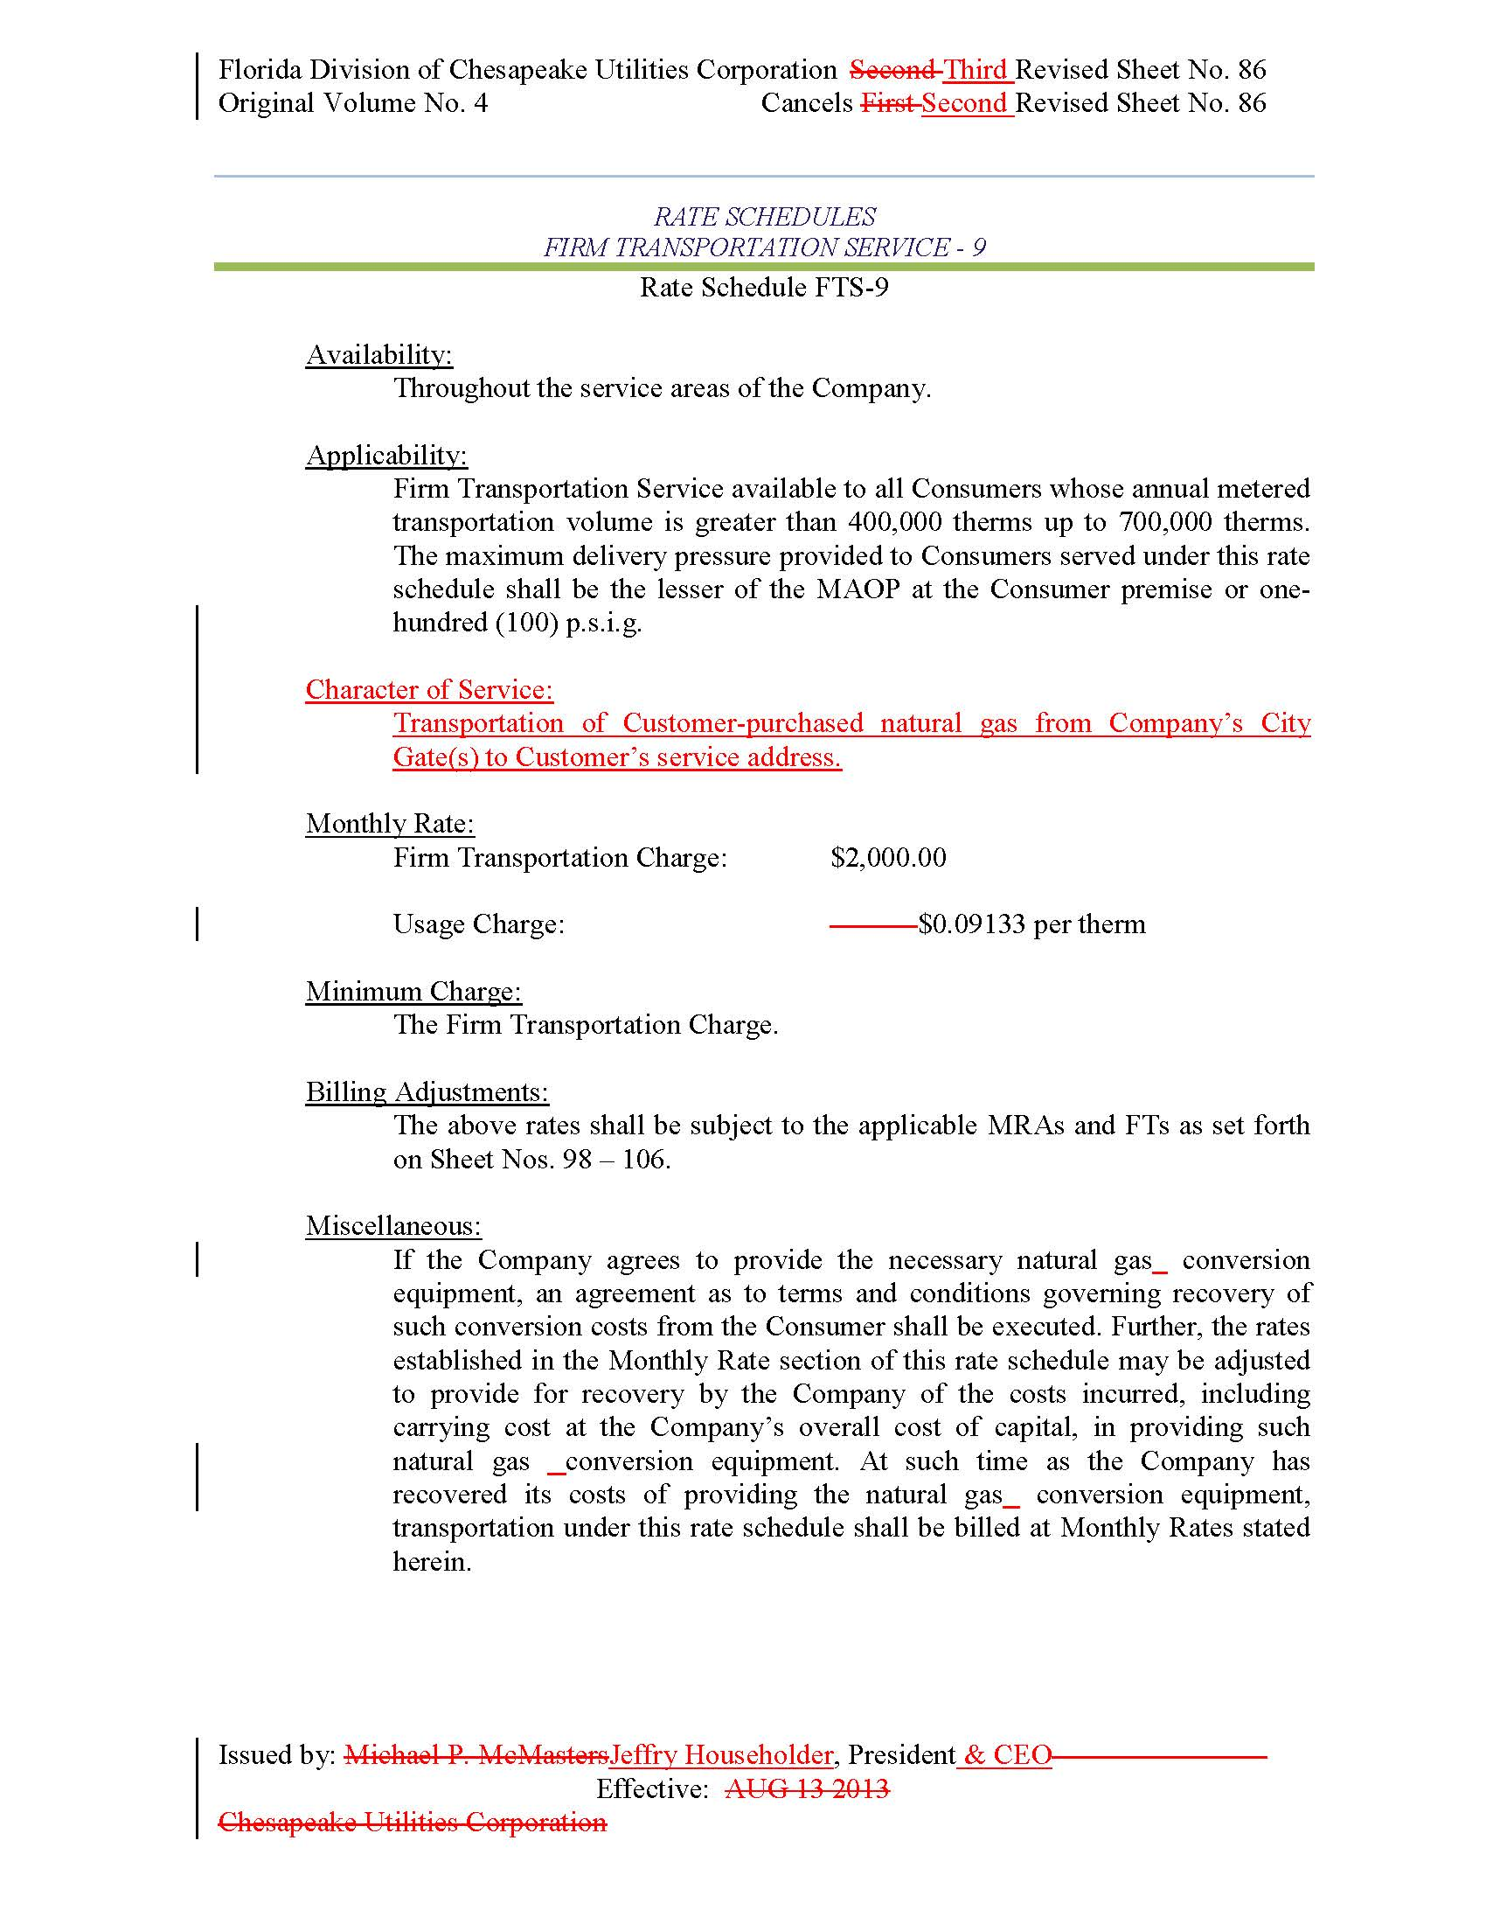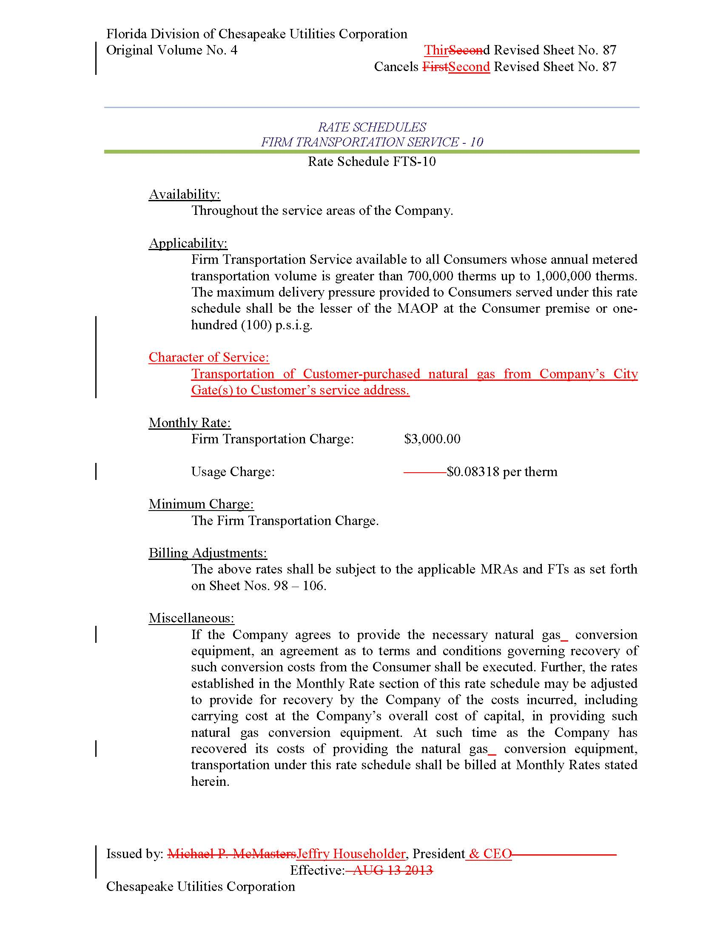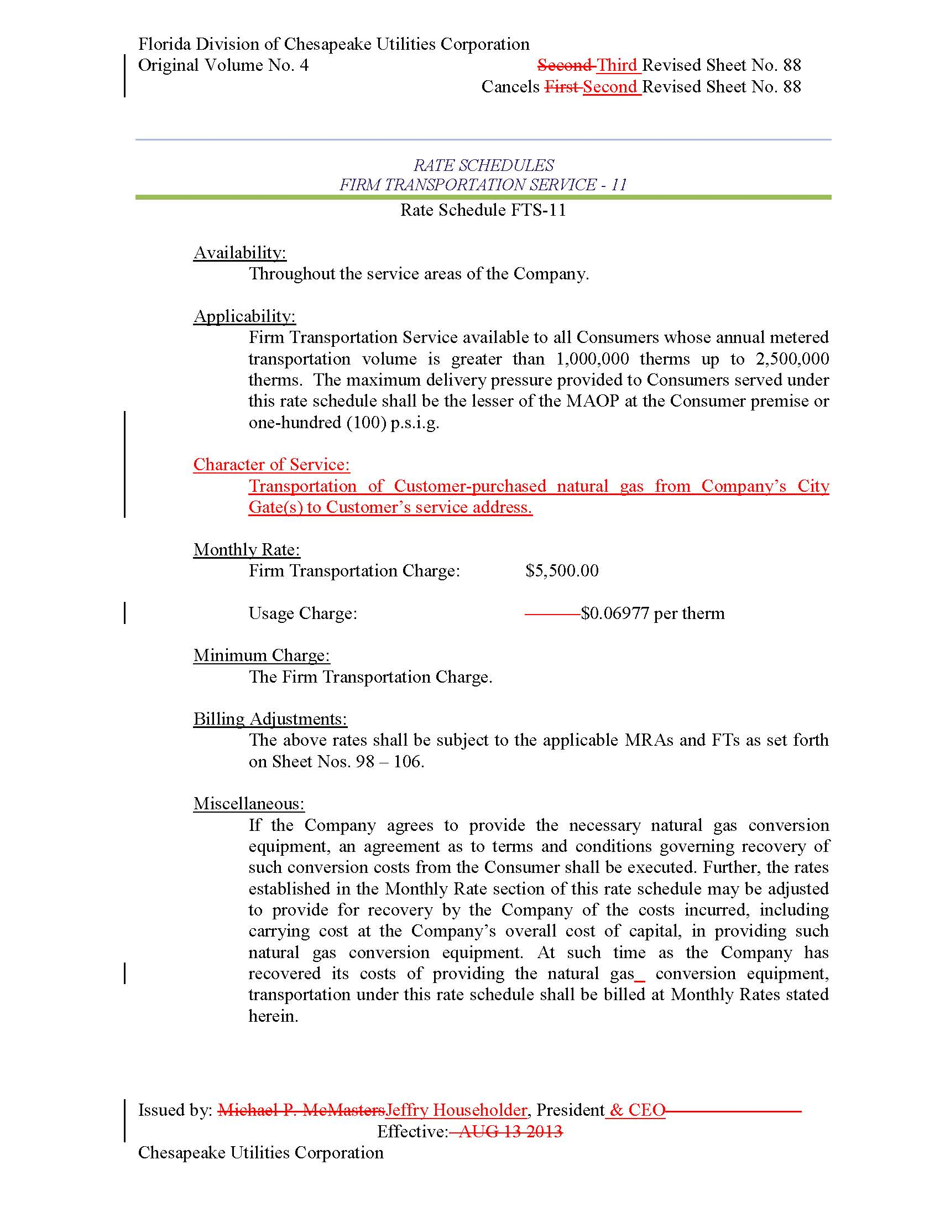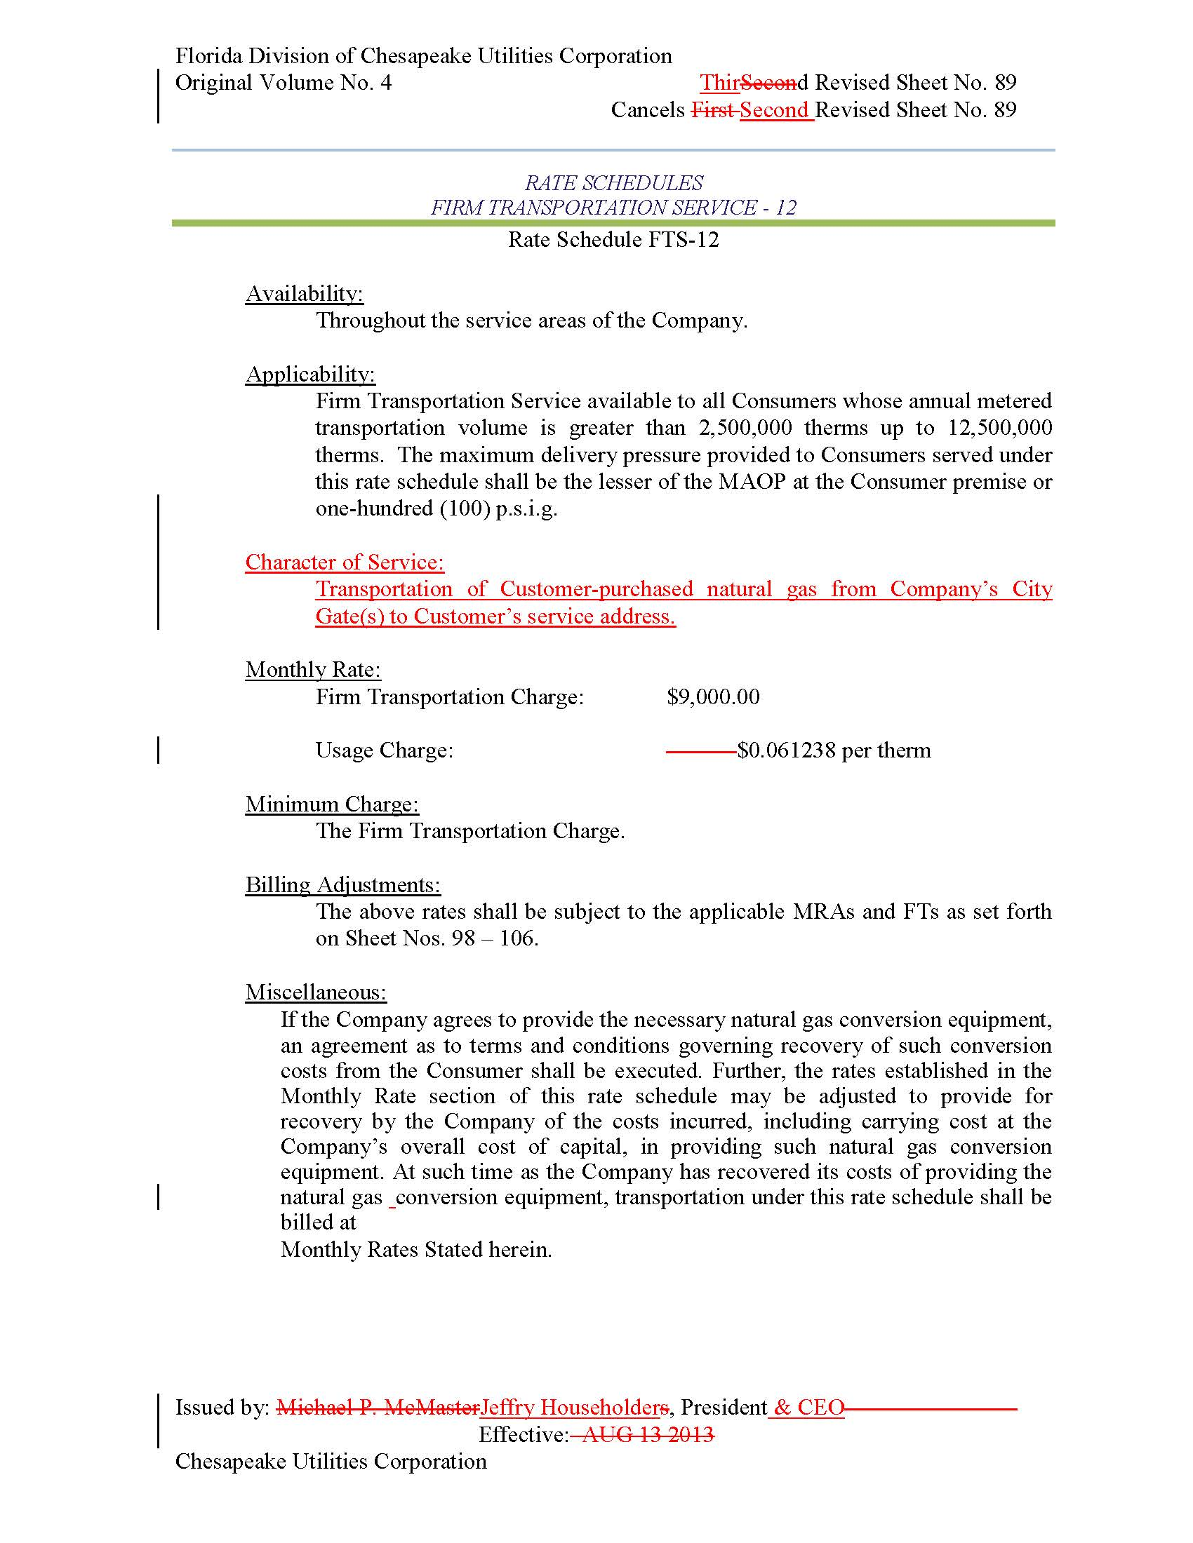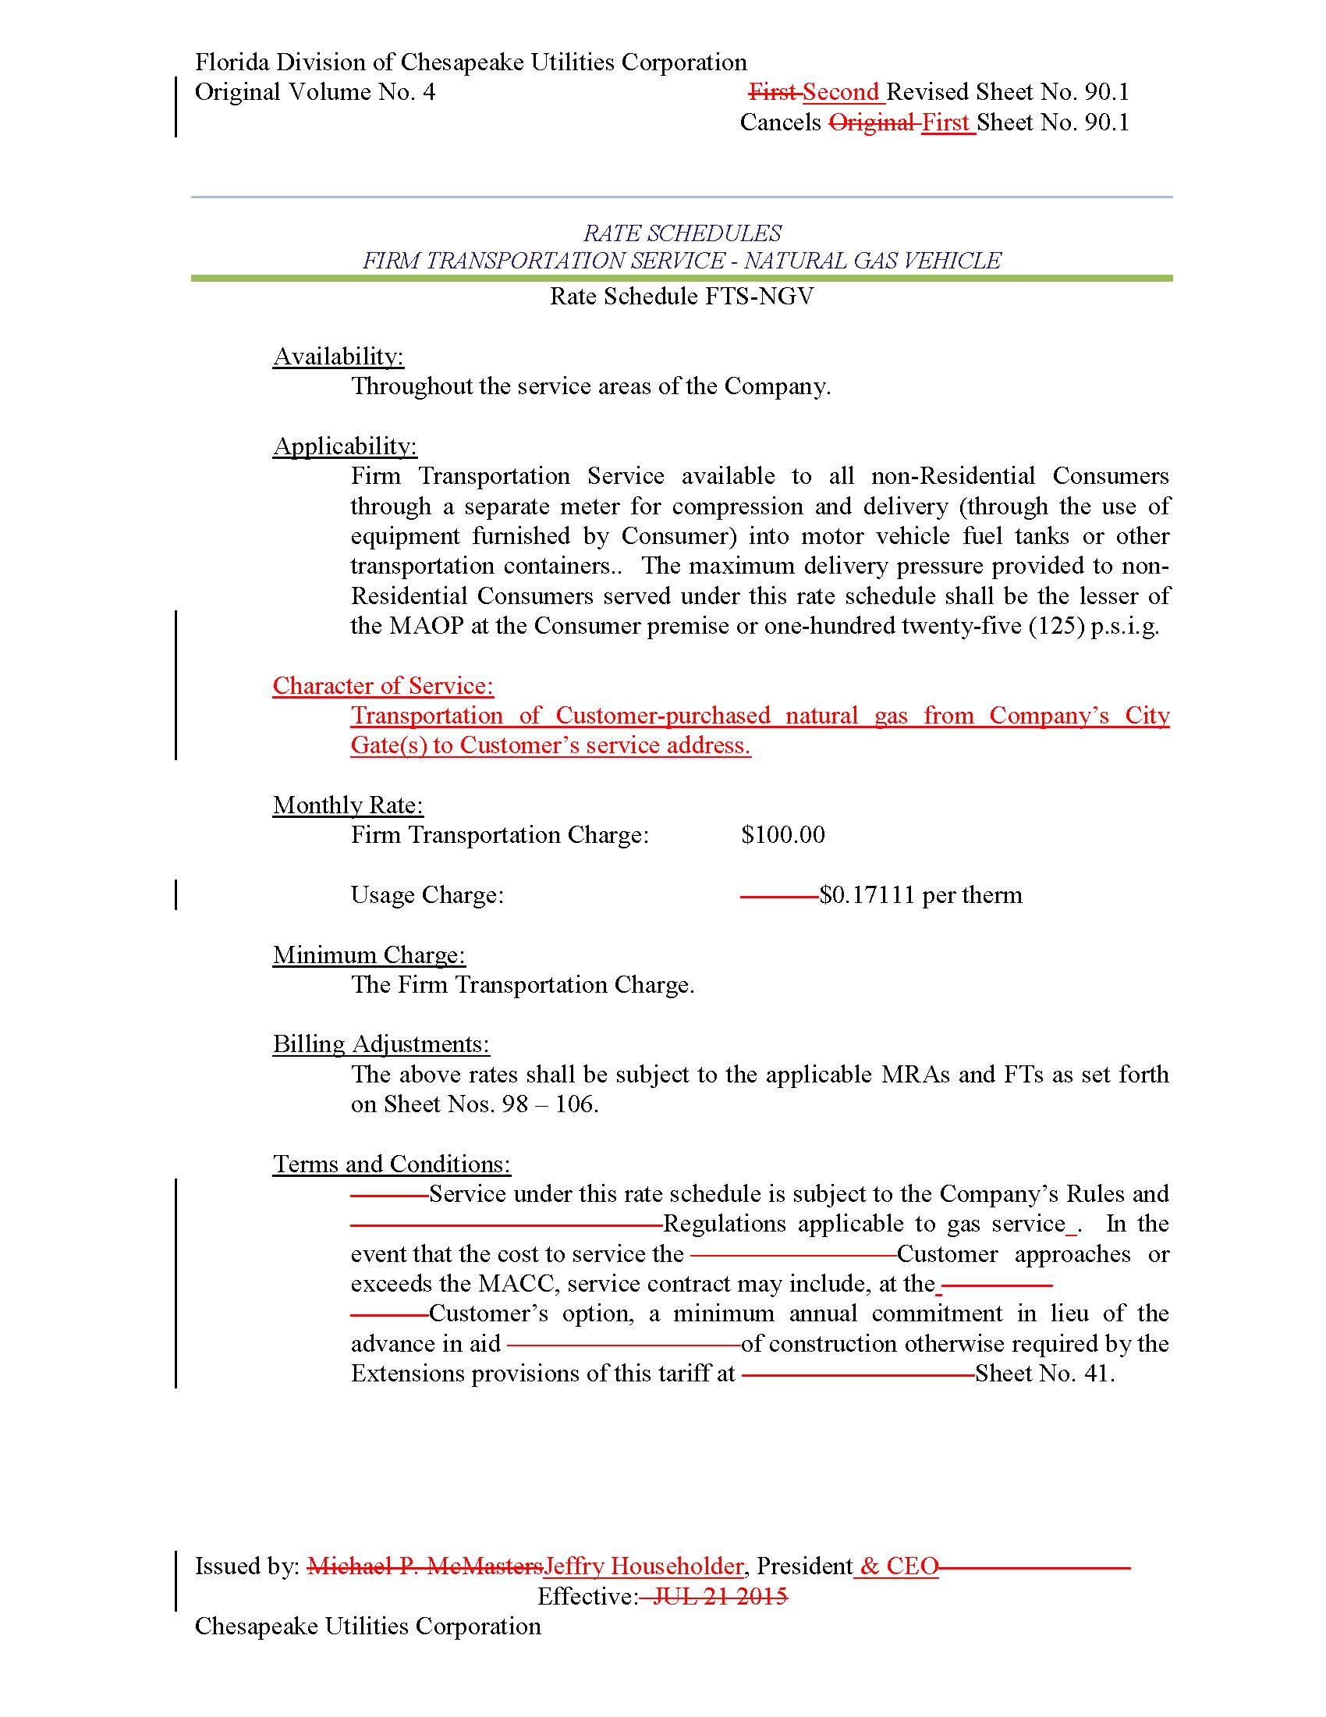
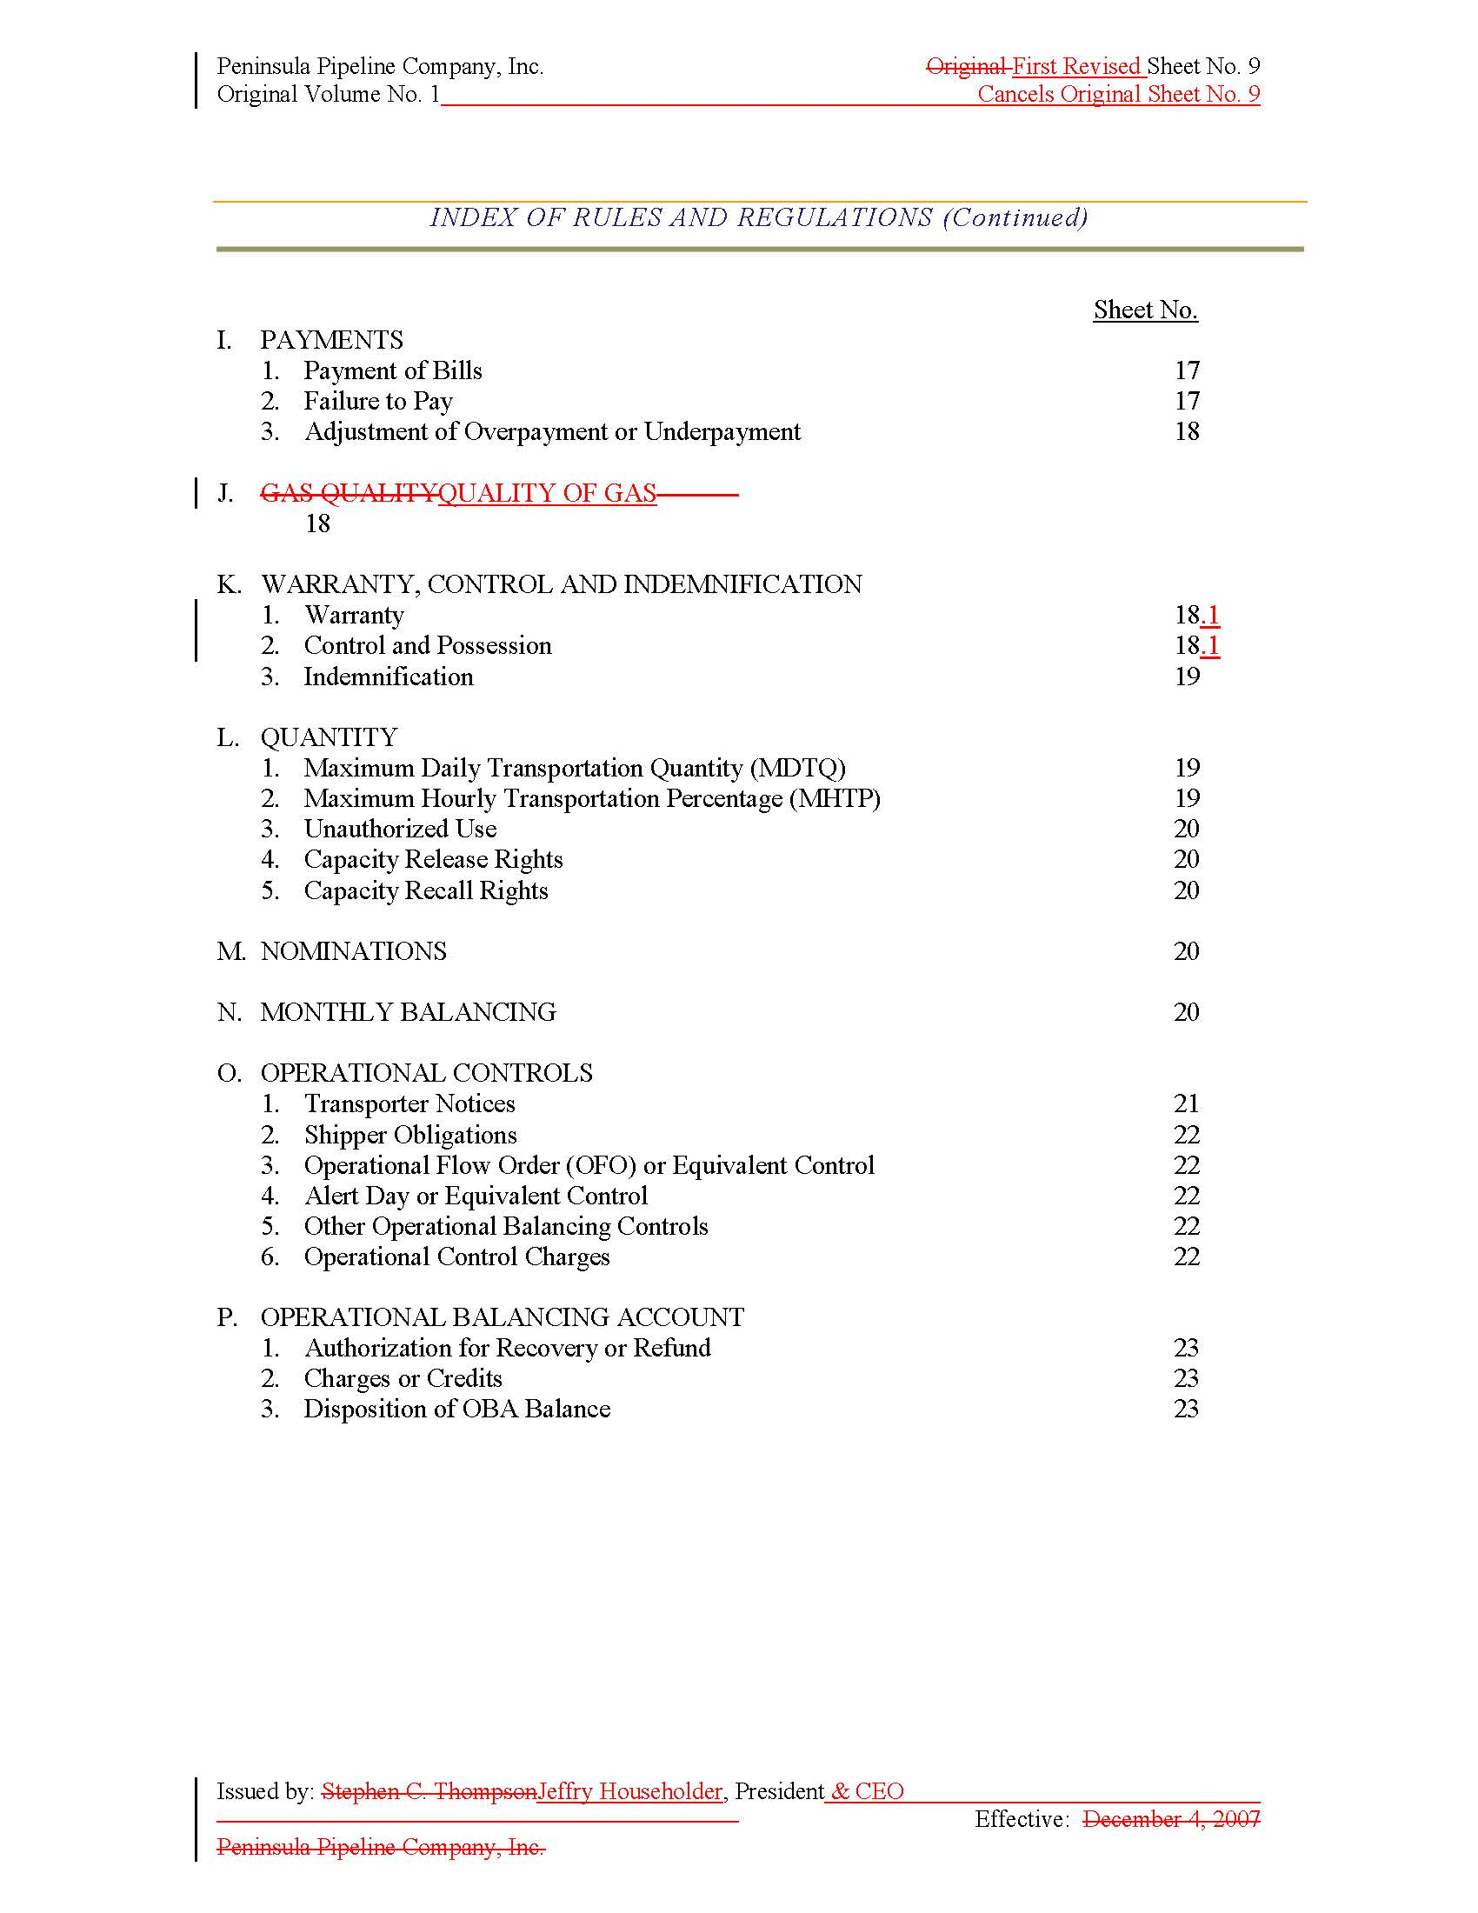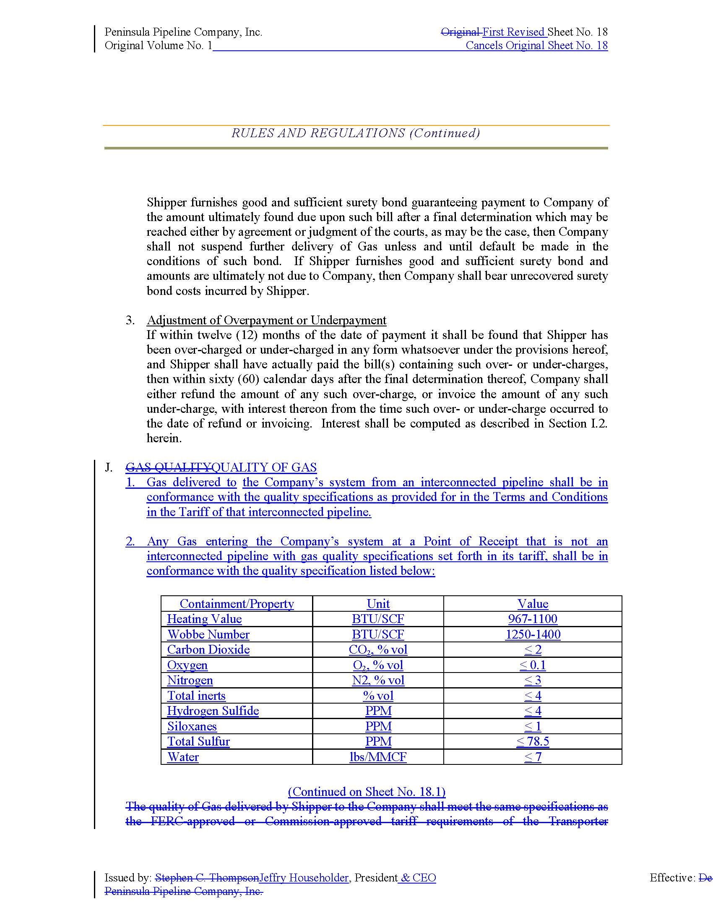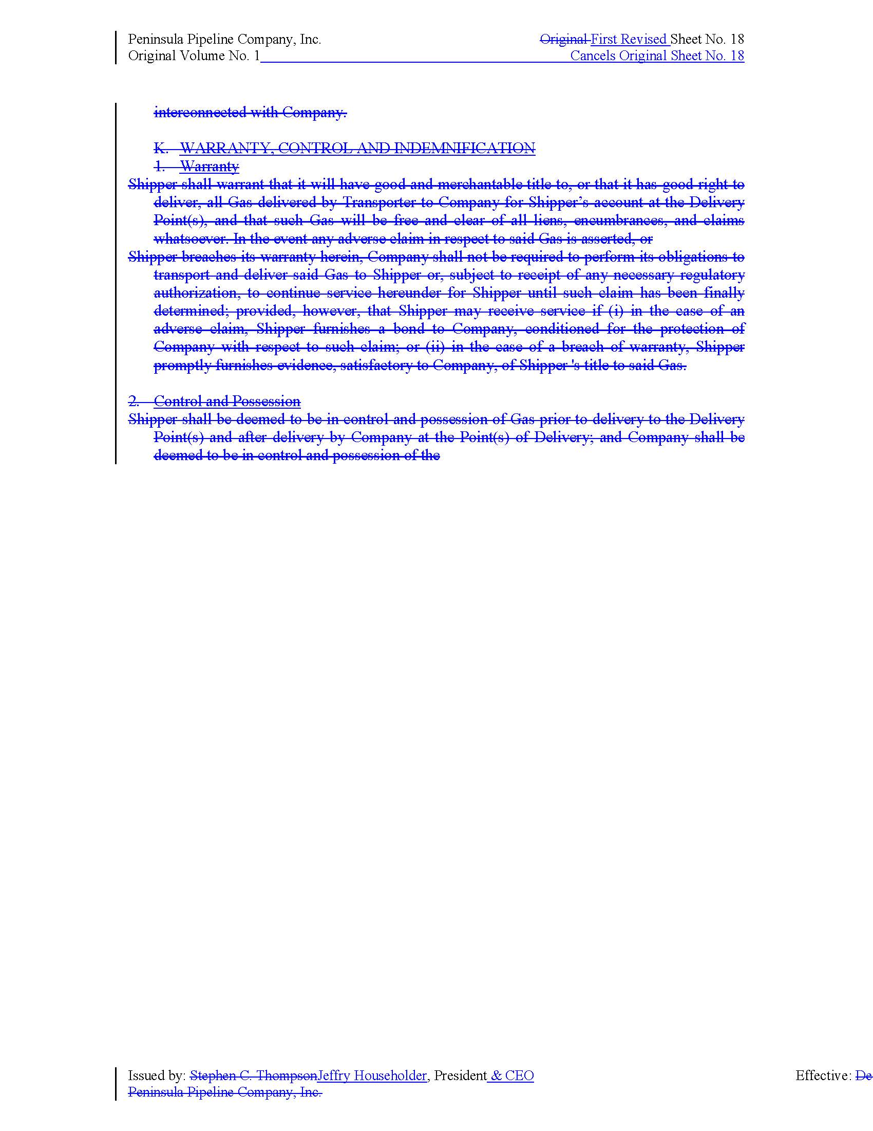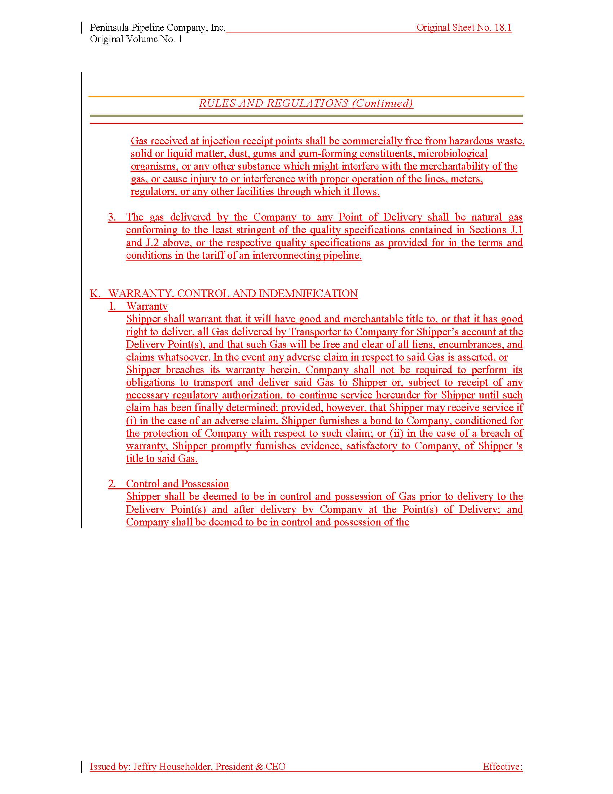

Document No. 00853-2020
The term “containments” is used by the Companies to describe the carbon dioxide, oxygen, nitrogen, inert gases, hydrogen sulfide, siloxanes, total sulfur, and water, which can be found in natural gas.
Tariff Sheet Nos. 5.501-3 and 5.501-4
The added definition states: “Transportation of Customer-purchased natural gas from Company’s City Gate(s) to Customer’s service address.”

