State of Florida |  | Public Service Commission  Capital Circle Office Center ● 2540 Shumard Oak Boulevard  Tallahassee, Florida 32399-0850  -M-E-M-O-R-A-N-D-U-M-
DATE: | March 24, 2020
TO: | Office of Commission Clerk (Teitzman)
FROM: | Division of Economics (Hampson, Coston)  Office of the General Counsel (Brownless)
RE: | Docket No. 20200095-EI – Petition for approval of emergency modification to Duke Energy's rate schedule SC-1, tariff sheet 6.110 by Duke Energy Florida, LLC.
AGENDA: | 03/31/20 – Regular Agenda – Tariff Filing – Interested Persons May Participate
COMMISSIONERS ASSIGNED: |  |  | All Commissioners
PREHEARING OFFICER: |  |  | Administrative
CRITICAL DATES: |  |  | 05/18/2020 (60-Day Suspension Date)
SPECIAL INSTRUCTIONS: |  |  | None

Case Background
On March 19, 2020, Duke Energy Florida (DEF or utility) petitioned for approval of an emergency modification to its Service Charge Rate Schedule (Tariff Sheet No. 6.110). This modification is in response to the public health emergency in Florida related to the outbreak of COVID-19 and the related Executive Orders issued by Governor Ron DeSantis. DEF states it has already temporarily suspended disconnecting customers for non-payment and will offer more robust payment arrangements for customers in need. Further, the utility states it will make the necessary adjustments to its plans to continue to serve customers, and that this may require additional requests to the Commission.
The current tariff allows the utility to waive the Establishment of Service charges in situations of natural disasters or other similar conditions for which an emergency has been declared by an authorized governmental body. The March 19, 2020 tariff modification seeks to give DEF the additional discretion to waive late payment charges, returned check charges, and charges for investigating unauthorized use of electricity. Additionally, the tariff modification expands the waiver language to include any period of declared emergencies by an authorized governmental body, not just those involving natural disasters. On March 23, 2020, the utility modified its petition to exclude the waiver of charges related to the investigation of unauthorized use of electricity.
DEF’s revised tariff sheet is Attachment 1 to this recommendation. The Commission has jurisdiction over this matter pursuant to Sections 366.04, 366.05, 366.06, Florida Statutes.

Discussion of Issues

Issue 1:
Should the Commission approve the DEF's proposed modifications to Tariff Sheet No. 6.110?

Recommendation:
Yes, the Commission should approve the modifications to Tariff Sheet No. 6.110, effective March 31, 2020. (Hampson)

Staff Analysis:
Currently, Tariff Sheet No. 6.110 allows DEF the discretion to waive applicable charges related to establishment of service and reconnection for customers impacted by natural disasters or similar situations where an emergency has been declared by a governing body. This modification would expand the waiver language to encompass late payment charges and returned check charges. Furthermore, the modification expands the waiver language to apply to any emergency declaration by an authorized governmental body. Florida Power & Light Company has a similar provision in its Commission-approved tariff regarding miscellaneous service charges.
Staff believes the modifications will allow DEF further flexibility to mitigate customer impact during the current public health emergency and the related Executive Orders issued by Governor DeSantis, while still reliably serving customers as a whole. Therefore, staff recommends the Commission should approve the modifications to Tariff Sheet No. 6.110, effective March 31, 2020.

Issue 2:
Should this docket be closed?

Recommendation:
If Issue 1 is approved and a protest is filed within 21 days of the issuance of the order, the tariff should remain in effect, with any revenues held subject to refund, pending resolution of the protest. If no timely protest is filed, this docket should be closed upon the issuance of a consummating order. (Brownless)

Staff Analysis:
If Issue 1 is approved and a protest is filed within 21 days of the issuance of the order, the tariff should remain in effect, with any revenues held subject to refund, pending resolution of the protest. If no timely protest is filed, this docket should be closed upon the issuance of a consummating order.

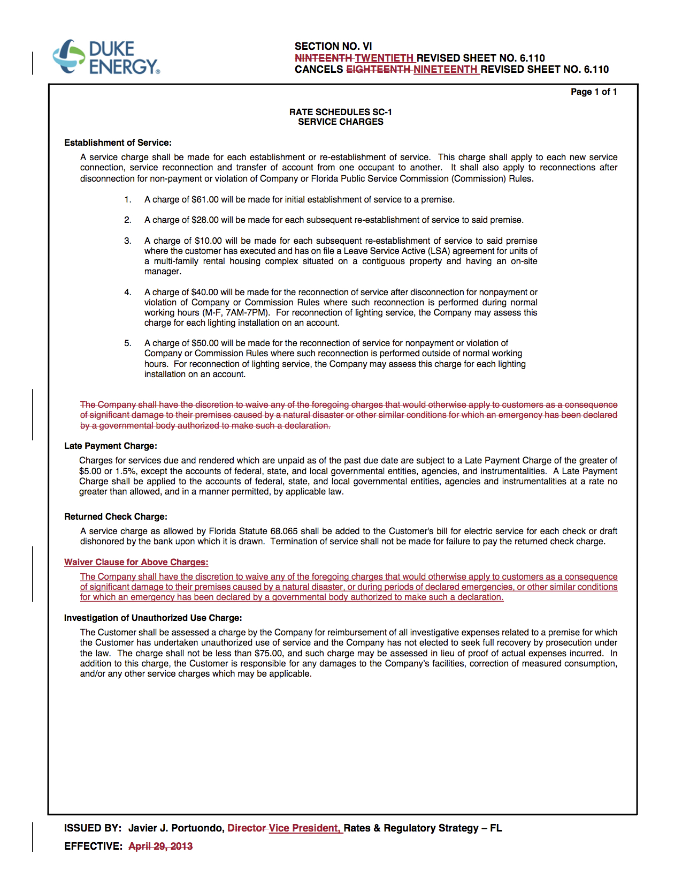

Rule 25-6.105(5), Florida Administrative Code, states “As applicable, each utility may refuse or discontinue service under the following conditions. . .(g) For non-payment of bills or non-compliance with the utility’s rules and regulations. . .”
Florida Power & Light Company Fourteenth Revised Sheet No. 4.020 approved by Order No. PSC-92-0912A-FOF-EI, issued September 16, 1992, in Docket No. 920800-EI, In re: Petition by Florida Power & Light Company to Waive Certain Service Charges For Good-Paying Customers.

