BEFORE THE FLORIDA PUBLIC SERVICE COMMISSION

In re: Evaluation of storm restoration costs for Florida Power & Light Company related to Hurricane Irma. | DOCKET NO. 20180049-EI  ORDER NO. PSC-2020-0104-PAA-EI  ISSUED: April 14, 2020

The following Commissioners participated in the disposition of this matter:

GARY F. CLARK, Chairman
ART GRAHAM
JULIE I. BROWN
DONALD J. POLMANN
ANDREW GILES FAY

NOTICE OF PROPOSED AGENCY ACTION
ORDER APPROVING HURRICANE IRMA SETTLEMENT
IMPLEMENTATION AGREEMENT

BY THE COMMISSION:

NOTICE is hereby given by the Florida Public Service Commission that the action discussed herein is preliminary in nature and will become final unless a person whose interests are substantially affected files a petition for a formal proceeding, pursuant to Rule 25-22.029, Florida Administrative Code (F.A.C.).

BACKGROUND

On February 22, 2018, we established this docket to review and evaluate Florida Power & Light Company’s (FPL or Company) storm restoration costs associated with Hurricane Irma. On August 31, 2018, the Company filed testimony and exhibits in support of the Company’s request to recover approximately $1.27 billion by charging the incremental storm damage to base O&M expenses and offsetting this amount with projected tax savings as a result of the Tax Cuts and Jobs Act (TCJA) of 2017. On June 6, 2019, a Joint Motion to Approve a Stipulation and Settlement (Storm Settlement) between the Office of Public Counsel (OPC) and FPL was filed in this case. Subsequently, a hearing was held in this case on July 9, 2019, for us to take final action regarding the evaluation of storm restoration costs for FPL associated with Hurricane Irma. By Order No. PSC-2019-0319-S-EI, we approved the Storm Settlement.
On February 25, 2020, OPC and FPL filed a Joint Motion to Approve the Hurricane Irma Settlement Implementation Agreement (Implementation Agreement). The Implementation Agreement is attached as Attachment A. The Implementation Agreement will only impact the timing of the one-time audit provision described in Paragraph 18 of the Storm Settlement. The proposed Hurricane Irma Settlement Implementation Agreement would delay the one-time audit until FPL’s smart phone application for tracking restoration crews’ time and expenses is actually deployed during a hurricane restoration. The Florida Industrial Power Users Group (FIPUG) and the Florida Retail Federation (FRF), parties to this docket, take no position on this motion. This Implementation Agreement will take effect upon our approval.
DECISION
The standard for approval of a settlement agreement is whether it is in the public interest. A determination of public interest requires a case-specific analysis based on consideration of the proposed settlement taken as a whole.
As stated above, the Implementation Agreement will only impact the timing of the one-time audit provision described in Paragraph 18 of the Storm Settlement. The audit is linked to the data that will be provided by an FPL-created smart phone application (App) for entry, recording, and approval of time and expenses for line crews and vegetation management crews during a hurricane restoration. This data can be exported to sortable and searchable Excel files to produce reports giving information on crews, billing, exceptions to regular billing procedures, etc. Since a significant amount of the costs associated with storm restoration is associated with line crew and vegetation management activities, it was the intent of the signatories that the audit of the costs associated with a named storm with more than $250 million in costs required by Paragraph 18 be done when the application was in place and fully functional. While Hurricane Dorian, which threatened Florida in 2019, did generate more than $250 million in costs, FPL’s App was not yet fully vetted and functional at that time. The App is now fully functional and will be used in the 2020 hurricane season.
There have been no objections expressed by any signatory to the Storm Settlement. Further, OPC, the statutory representative for FPL’s ratepayers, negotiated the Implementation Agreement and supports this modification to the Storm Settlement.
Given the circumstances discussed above, allowing the parties to modify the Storm Settlement to delay the audit until the next qualifying named storm is reasonable and fulfills the intent of the provisions in the Storm Settlement that we previously approved. Thus, we find that the Implementation Agreement is hereby approved as in the public interest.
Based on the foregoing, it is
ORDERED by the Florida Public Service Commission that the Joint Motion of the Office of Public Counsel and Florida Power & Light Company to Approve Hurricane Irma Settlement Implementation Agreement is hereby granted. It is further
ORDERED that the Implementation Agreement dated February 17, 2020, referred to herein as Implementation Agreement, and attached hereto as Attachment A, is hereby approved. It is further
ORDERED that the provisions of this order, issued as proposed agency action, shall become final and effective upon the issuance of a Consummating Order unless an appropriate petition, in the form provided by Rule 28-106.201, F.A.C., is received by the Office of the Commission Clerk, 2540 Shumard Oak Boulevard, Tallahassee, Florida 32399-0850, by the close of business on the date set forth in the “Notice of Further Proceedings” attached hereto. It is further

ORDERED that, if a protest is filed within 21 days of the issuance of this order, the order shall remain in effect pending resolution of the protest. If no timely protest is filed, this docket shall be closed upon the issuance of a Consummating Order.

By ORDER of the Florida Public Service Commission this 14th day of April, 2020.

/s/ Adam J. Teitzman
ADAM J. TEITZMAN
Commission Clerk
Florida Public Service Commission
2540 Shumard Oak Boulevard
Tallahassee, Florida 32399
(850) 413-6770
www.floridapsc.com

Copies furnished: A copy of this document is provided to the parties of record at the time of issuance and, if applicable, interested persons.

SBr

NOTICE OF FURTHER PROCEEDINGS OR JUDICIAL REVIEW

The Florida Public Service Commission is required by Section 120.569(1), Florida Statutes, to notify parties of any administrative hearing that is available under Section 120.57, Florida Statutes, as well as the procedures and time limits that apply. This notice should not be construed to mean all requests for an administrative hearing will be granted or result in the relief sought.

Mediation may be available on a case-by-case basis. If mediation is conducted, it does not affect a substantially interested person's right to a hearing.

The action proposed herein is preliminary in nature. Any person whose substantial interests are affected by the action proposed by this order may file a petition for a formal proceeding, in the form provided by Rule 28-106.201, Florida Administrative Code. This petition must be received by the Office of Commission Clerk, 2540 Shumard Oak Boulevard, Tallahassee, Florida 32399-0850, by the close of business on May 5, 2020.

In the absence of such a petition, this order shall become final and effective upon the issuance of a Consummating Order.

Any objection or protest filed in this/these docket(s) before the issuance date of this order is considered abandoned unless it satisfies the foregoing conditions and is renewed within the specified protest period.

ATTACHMENT A
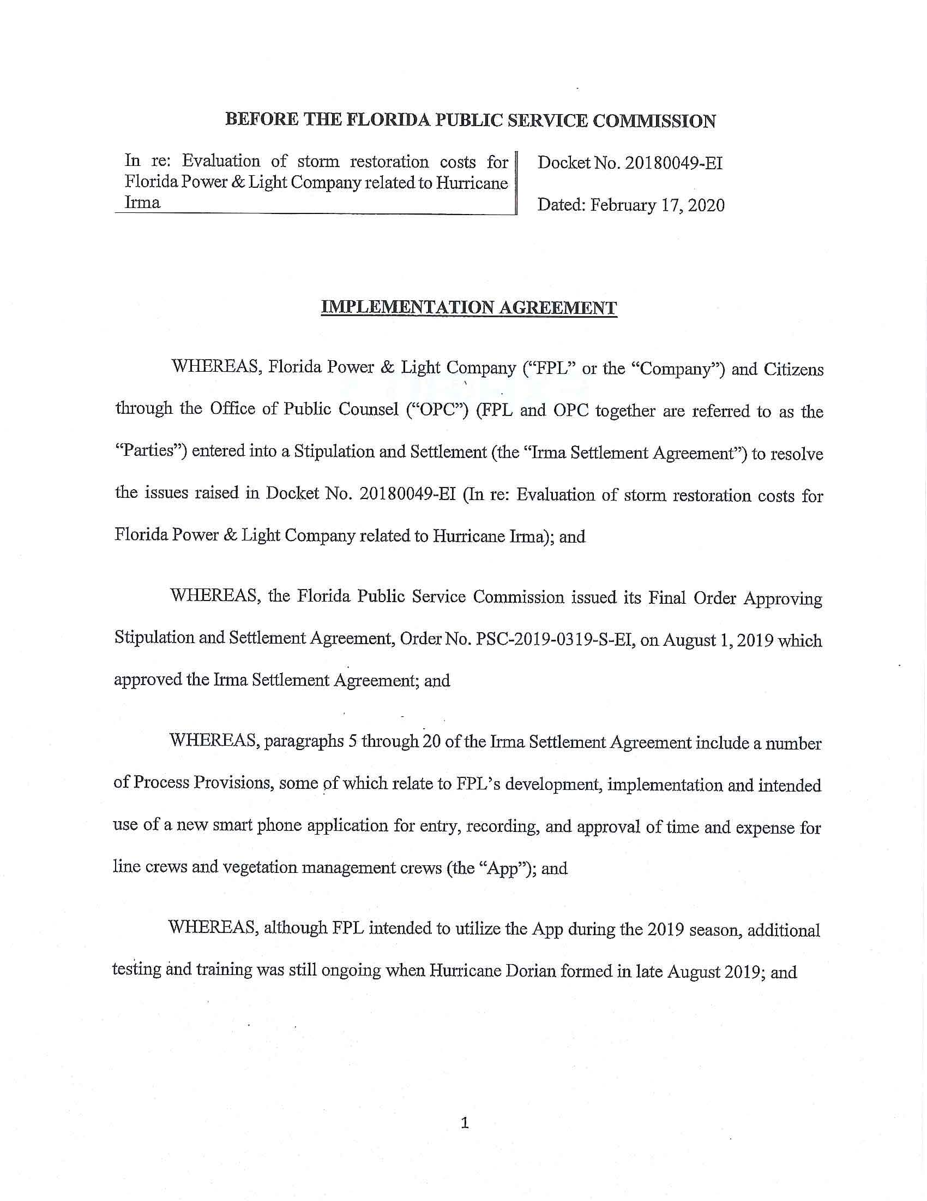
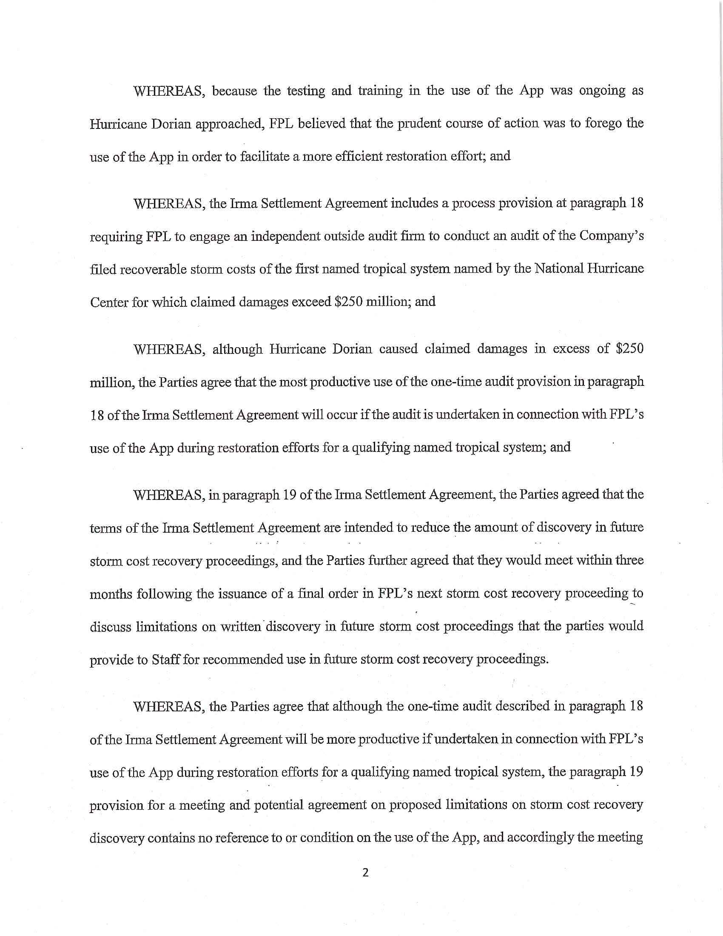

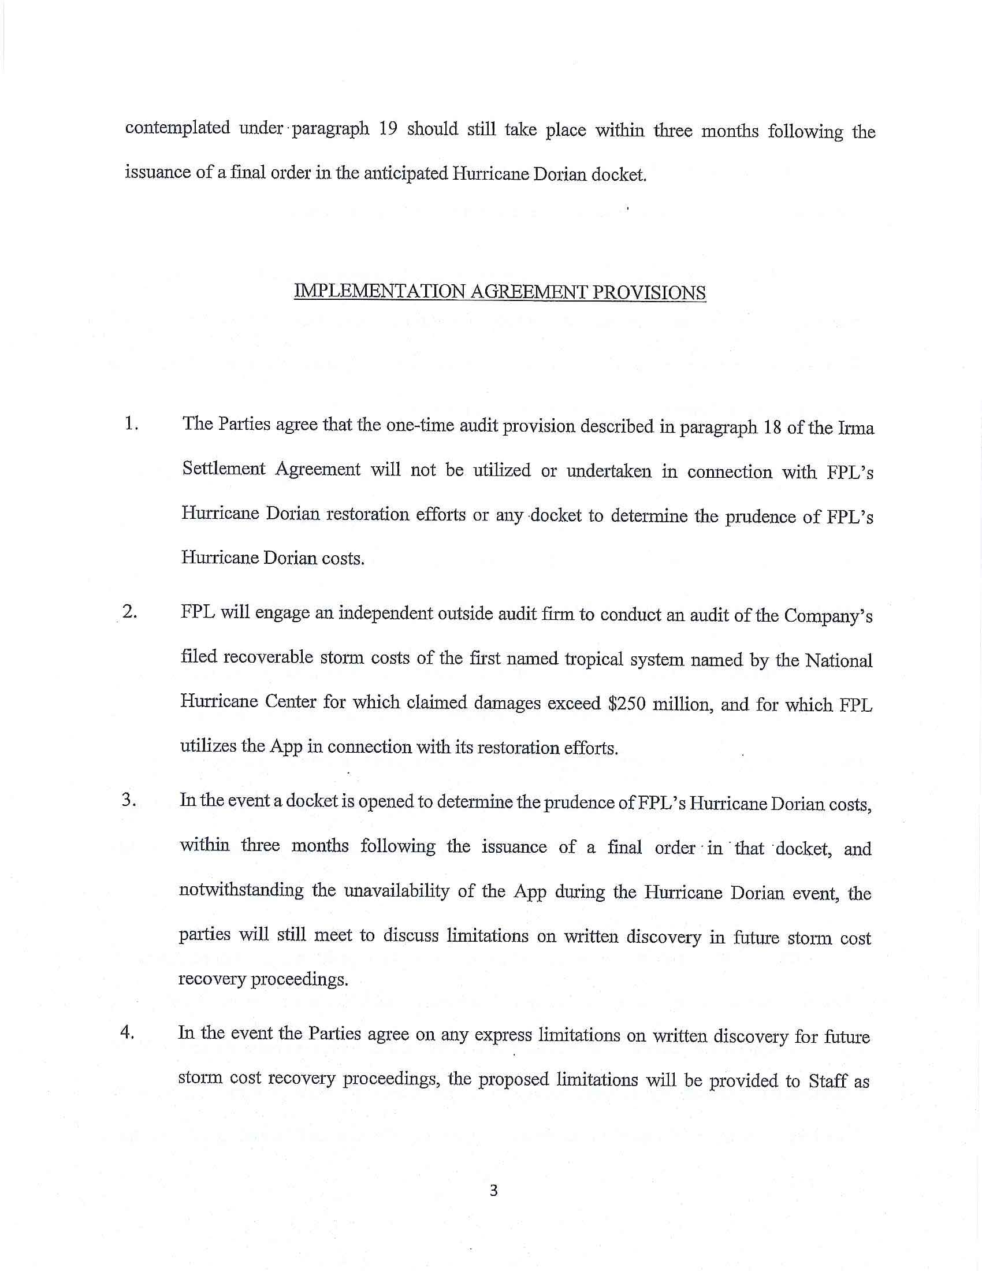

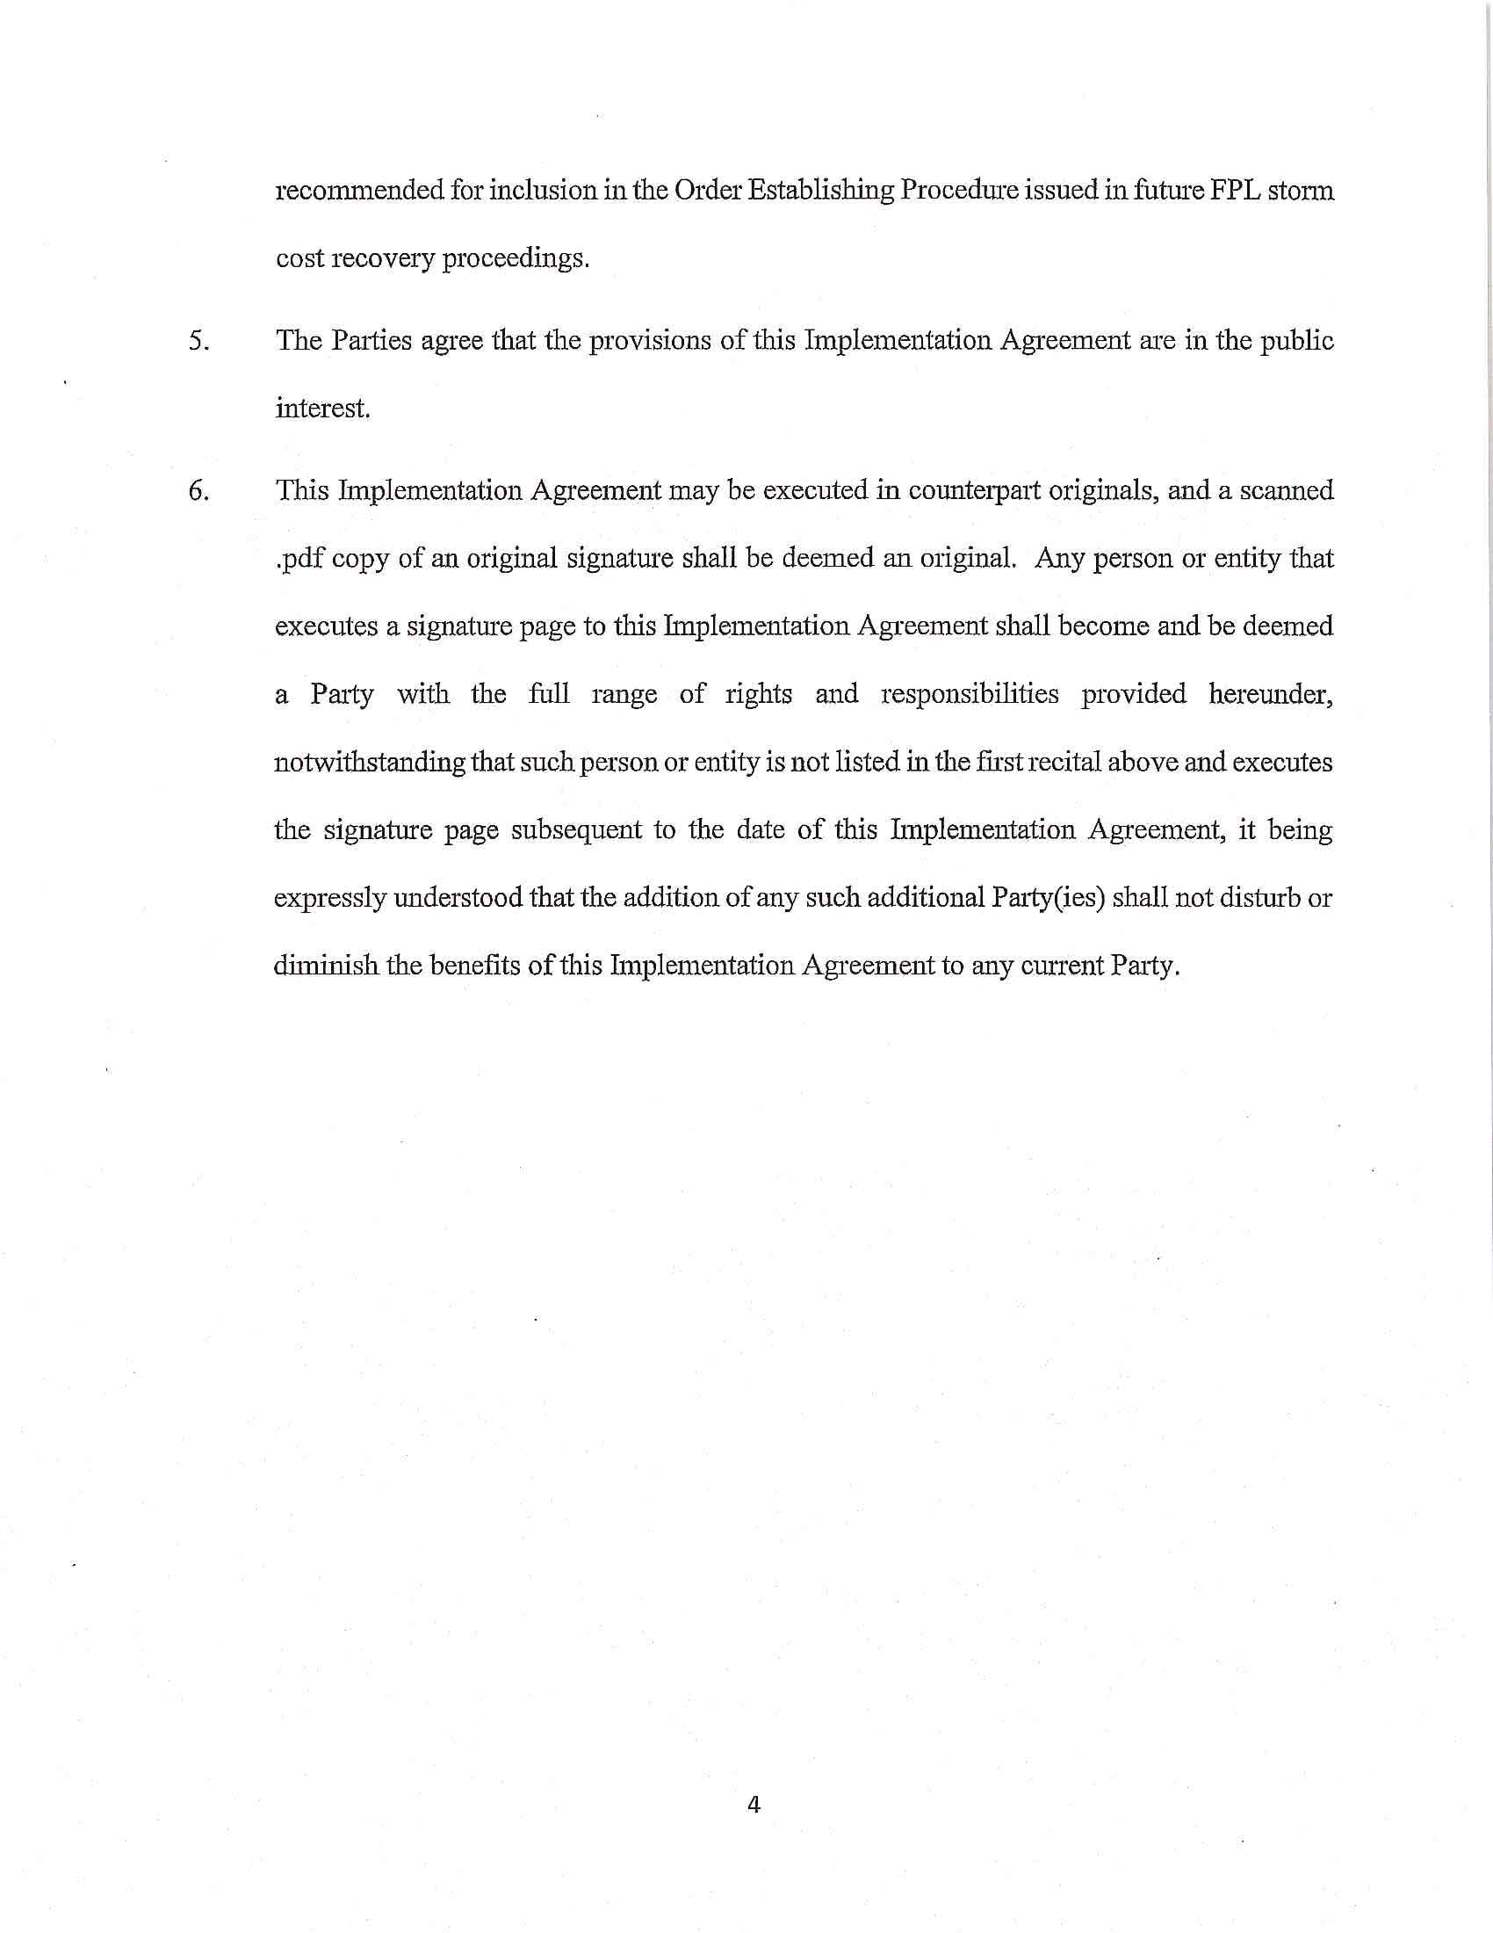

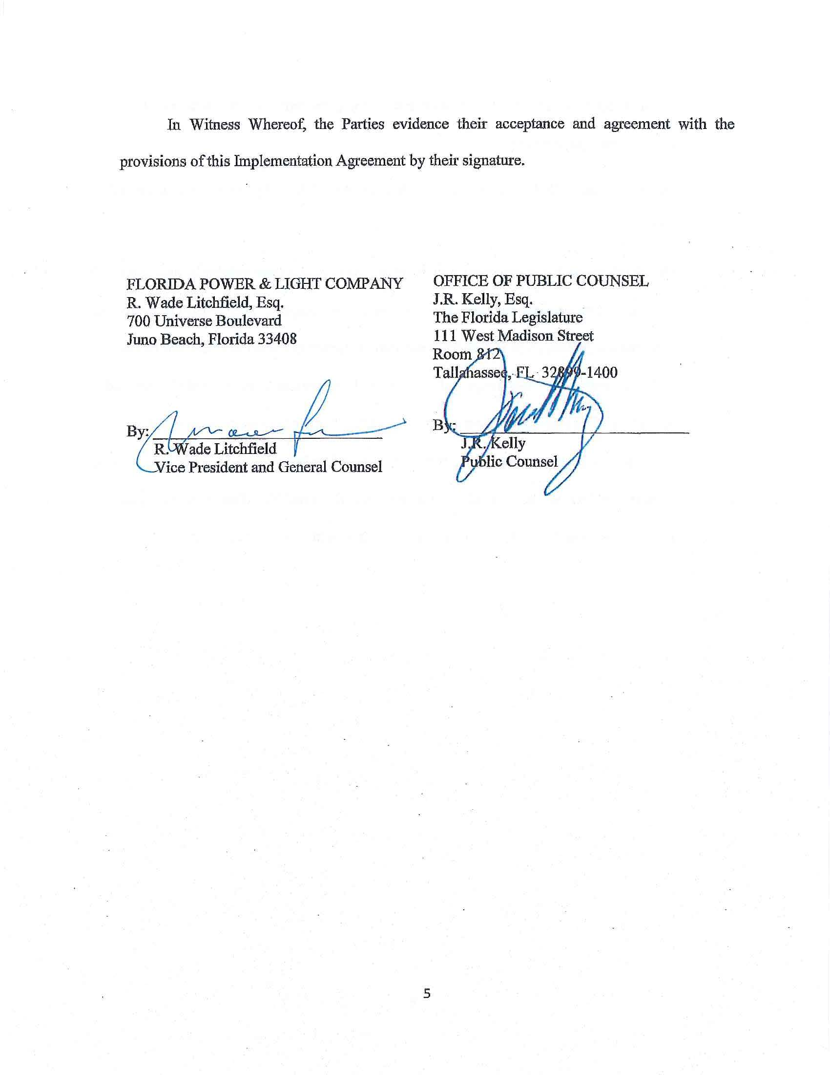

Although the Florida Industrial Power Users Group (FIPUG) was not initially a signatory to the proposed Storm Settlement, it subsequently endorsed the proposed Storm Settlement. See Document No. 04584-2019.
Order No. PSC-2019-0319-S-EI, issued August 1, 2019, in Docket No. 20180049-EI, In re: Evaluation of storm restoration costs for Florida Power & Light Company related to Hurricane Irma.
Sierra Club v. Brown, 243 So. 3d 903, 910-913 (Fla. 2018); Order No. PSC-13-0023-S-EI, issued on January 14, 2013, in Docket No. 120015-EI, In re: Petition for increase in rates by Florida Power & Light Company; Order No. PSC-11-0089-S-EI, issued February 1, 2011, in Docket Nos. 080677 and 090130, In re: Petition for increase in rates by Florida Power & Light Company and In re: 2009 depreciation and dismantlement study by Florida Power & Light Company; Order No. PSC-10-0398-S-EI, issued June 18, 2010, in Docket Nos. 090079-EI, 090144-EI, 090145-EI, 100136-EI, In re: Petition for increase in rates by Progress Energy Florida, Inc., In re: Petition for limited proceeding to include Bartow repowering project in base rates, by Progress Energy Florida, Inc., In re: Petition for expedited approval of the deferral of pension expenses, authorization to charge storm hardening expenses to the storm damage reserve, and variance from or waiver of Rule 25-6.0143(1)(c), (d), and (f), F.A.C., by Progress Energy Florida, Inc., and In re: Petition for approval of an accounting order to record a depreciation expense credit, by Progress Energy Florida, Inc.; Order No. PSC-05-0945-S-EI, issued September 28, 2005, in Docket No. 050078-EI, In re: Petition for rate increase by Progress Energy Florida, Inc.
Order No. PSC-13-0023-S-EI, at p. 7.
Paragraph 6 of the Storm Settlement.

