BEFORE THE FLORIDA PUBLIC SERVICE COMMISSION

In re: Amended unopposed joint motion to modify Order PSC-2012-0425-PAA-EU regarding weighted average cost of capital methodology. | DOCKET NO. 20200118-EU  ORDER NO. PSC-2020-0165-PAA-EU  ISSUED: May 20, 2020

The following Commissioners participated in the disposition of this matter:

GARY F. CLARK, Chairman
ART GRAHAM
JULIE I. BROWN
DONALD J. POLMANN
ANDREW GILES FAY

NOTICE OF PROPOSED AGENCY ACTION
ORDER APPROVING AMENDED JOINT MOTION MODIFYING
WEIGHTED AVERAGE COST OF CAPITAL METHODOLOGY

BY THE COMMISSION:

NOTICE is hereby given by the Florida Public Service Commission that the action discussed herein is preliminary in nature and will become final unless a person whose interests are substantially affected files a petition for a formal proceeding, pursuant to Rule 25-22.029, Florida Administrative Code (F.A.C.).

BACKGROUND

The cost recovery clause dockets, Fuel and Purchased Power Cost Recovery Clause (Fuel Clause), the Energy Conservation Cost Recovery Clause (ECCR), and the Environmental Cost Recovery Clause (ECRC) are continuing dockets that handle issues pertaining to Florida’s Investor-Owned electric Utilities (IOUs). These IOUs are Duke Energy Florida, LLC (DEF), Florida Power & Light Company (FPL), Gulf Power Company (Gulf), Tampa Electric Company (TECO), and Florida Public Utilities Company (FPUC) (collectively, the IOUs). Intervenors for all three cost recovery clauses include the Office of Public Counsel (OPC), Florida Industrial Power Users Group (FIPUG), and White Springs Agricultural Chemicals, Inc., d/b/a PCS Phosphate – White Springs (PCS Phosphate).
When appropriate, we allow recovery of a return on capital investments through the Fuel Clause, the ECCR and the ECRC. Historically, we have relied on the jurisdictional capital structure and cost rates for each component of the capital structure approved in each utility’s last base rate case to determine the appropriate weighted average cost of capital (WACC).
On August 16, 2012, we issued Order No. PSC-2012-0425-PAA-EU approving a stipulation and settlement agreement entered into by the IOUs, OPC, and FIPUG specifying the methodology for calculating the WACC applicable to clause-recoverable investments. This methodology relied on the historical May Earnings Surveillance Report (ESR) WACC for the calendar year in which the filing is made for all three clause filings: the Projected Filing, the Actual/Estimated True-up Filing, and the Final True-up Filing.
The Internal Revenue Service (IRS) issued Private Letter Rulings (PLRs) on October 3, 2017, and August 11, 2017, regarding the IRS Normalization Rules. These PLRs state that IRC Treasury Regulation Section §1.167(1)-1(h)(6)(ii) requires public utilities to apply the Normalization Rules by utilizing a consistency adjustment and proration formula to compute the depreciation-related accumulated deferred income tax (ADIT) balance to be included for ratemaking purposes when a forecasted test period is utilized to set rates unless, as described below, the Limitation Provision is met or exceeded.
On August 21, 2019, DEF filed an Unopposed Joint Motion to Modify Order No. PSC-2012-0425-PAA-EU Regarding the Weighted Average Cost of Capital Methodology (Unopposed Joint Motion) on behalf of the IOUs as it pertains to the clause-recovery dockets. In the Unopposed Joint Motion, the IOUs proposed to change the methodology to comply with the Internal Revenue Code (IRC) Treasury Regulation.

On February 6 2020, Commission staff held a noticed workshop regarding the IOUs’ proposed methodology to calculate the WACC as it pertains to depreciation-related accumulated deferred federal income taxes in clause-recovery dockets. In response to the February 6, 2020 workshop, the IOUs filed Joint Comments on March 13, 2020, in which the IOUs collectively agreed with our staff’s position as outlined at the workshop.

On March 26, 2020, the IOUs filed an Amended Unopposed Joint Motion to Modify Order No. PSC-2012-0425-PAA-EU Regarding Weighted Average Cost of Capital Methodology (Amended Unopposed Joint Motion) in accord with the February 6, 2020 workshop and the March 13, 2020 Joint Comments.

We have jurisdiction over this matter pursuant to Chapter 120 and Sections 366.04, 366.05 and 366.06, Florida Statutes (F.S.)
DECISION

On August 16, 2012, we issued Order No. PSC-2012-0425-PAA-EU approving a stipulation and settlement agreement entered into by the IOUs, OPC, and FIPUG specifying the methodology for calculating the WACC applicable to clause-recoverable investments. The 2012 methodology uses a historical WACC to calculate the rate of return in a projected future clause recovery period. However, the 2012 methodology no longer comports with the IRS Normalization Rules regarding the calculation of the ADIT balance in the capital structure.
Treasury Regulation Section §1.167(1)-1(h)(6)(ii) provides that if a future period is solely used for such determination, the limit on the amount of depreciation-related ADITs for the period is the amount at the beginning of the future period with a pro rata adjustment for any increases or decreases during that period. There is a specific proration formula that must be applied to project changes in depreciation-related ADITs if the Limitation Provision is not met.
The IRS issued PLRs on October 3, 2017, and August 11, 2017, regarding IRS Normalization Rules. These PLRs state that IRC Treasury Regulation Section §1.167(1)-1(h)(6)(ii) requires public utilities to apply normalization by utilizing a consistency adjustment and proration formula to compute the depreciation-related ADIT balance to be included for ratemaking purposes when a forecasted test period is utilized to set rates unless the Limitation Provision is met or exceeded. The Limitation Provision in Treasury Regulation Section §1.167(1)-1(h)(6)(i) states that as long as the amount of depreciation-related ADIT used in ratemaking is lower than the amount that would have been used under the Consistency Rule, then there is no violation of normalization. The purpose of the IRS Normalization Rules is to preserve for regulated utilities the benefits of accelerated depreciation as a source of cost-free capital. Further, the purpose of the consistency rule and the proration formula is to prevent the immediate flow-through of the benefits of accelerated depreciation to ratepayers.
On March 26, 2020, the IOUs submitted their Amended Unopposed Joint Motion, revising the original, August 21, 2019 Joint Motion as it relates to the methodology proposed to comply with the IRC Treasury Regulation Section §1.167(1)-1(h)(6). The IOUs maintain that the modifications proposed herein are in the public interest because the modified methodology will accurately align current costs with cost recovery while enabling compliance with IRC Treasury Regulation Section §1.167(1)-1(h)(6). The IOUs would apply the new methodology starting with the 2021 clause filing cycle, which would begin with the 2021 Projection Filings to be filed in 2020, and then carried through to the 2021 Actual/Estimated Filings to be filed in 2021 and the 2021 Final True-Up Filings to be filed in 2022. The IOUs further propose that the Final True-Up Filing date for all clauses be no earlier than April 1 of each year in order to allow the IOUs enough time to incorporate the WACC from the December ESR, which is completed and filed with the Commission on or about February 15 each year.
We agree with the IOUs that the WACC calculation methodology approved in Order No. PSC-2012-0425-PAA-EU no longer comports with the requirements of IRC §1.167(l)-1(h)(6). Further, we find that the methodology for calculating the allowable rate of return on clause-approved investments described in the Amended Unopposed Joint Motion is in the public interest because the methodology more accurately reflects expected costs. For these reasons, we hereby grant the Amended Unopposed Joint Motion, Attachment A to this order, and find that the filing date for the Final True-Up Filings for all related clauses shall be no earlier than April 1 of each year to give time for filing of the December ESR.

Based on the foregoing, it is

ORDERED that the Amended Unopposed Joint Motion to Modify Order No. PSC-2012-0425-PAA-EU Regarding Weighted Average Cost of Capital Methodology, Attachment A hereto, is hereby granted as stated in the body of this order. It is further

ORDERED that the filing date for the Final True-Up Filings for all related clauses, and any future cost recovery clauses that involve the recovery of a rate of return on investment, shall be no earlier than April 1 of each year. It is further

ORDERED that the provisions of this order, issued as proposed agency action, shall become final and effective upon the issuance of a consummating order unless an appropriate petition, in the form provided by Rule 28-106.201, F.A.C., is received by the Commission Clerk, 2540 Shumard Oak Boulevard, Tallahassee, Florida 32399-0850, by the close of business on the date set forth in the “Notice of Further Proceedings” attached hereto. It is further

ORDERED that if no person whose substantial interests are affected by this proposed agency action files a timely protest within 21 days of the issuance of this order, a consummating order shall be issued and this docket shall be closed. If a timely protest is filed, this docket shall remain open to address the evidentiary issues presented.

By ORDER of the Florida Public Service Commission this 20th day of May, 2020.

/s/ Adam J. Teitzman
ADAM J. TEITZMAN
Commission Clerk
Florida Public Service Commission
2540 Shumard Oak Boulevard
Tallahassee, Florida 32399
(850) 413-6770
www.floridapsc.com

Copies furnished: A copy of this document is provided to the parties of record at the time of issuance and, if applicable, interested persons.
SBr

NOTICE OF FURTHER PROCEEDINGS OR JUDICIAL REVIEW

The Florida Public Service Commission is required by Section 120.569(1), Florida Statutes, to notify parties of any administrative hearing that is available under Section 120.57, Florida Statutes, as well as the procedures and time limits that apply. This notice should not be construed to mean all requests for an administrative hearing will be granted or result in the relief sought.

Mediation may be available on a case-by-case basis. If mediation is conducted, it does not affect a substantially interested person's right to a hearing.

The action proposed herein is preliminary in nature. Any person whose substantial interests are affected by the action proposed by this order may file a petition for a formal proceeding, in the form provided by Rule 28-106.201, Florida Administrative Code. This petition must be received by the Office of Commission Clerk, 2540 Shumard Oak Boulevard, Tallahassee, Florida 32399-0850, by the close of business on June 10, 2020.

In the absence of such a petition, this order shall become final and effective upon the issuance of a Consummating Order.

Any objection or protest filed in this/these docket(s) before the issuance date of this order is considered abandoned unless it satisfies the foregoing conditions and is renewed within the specified protest period.

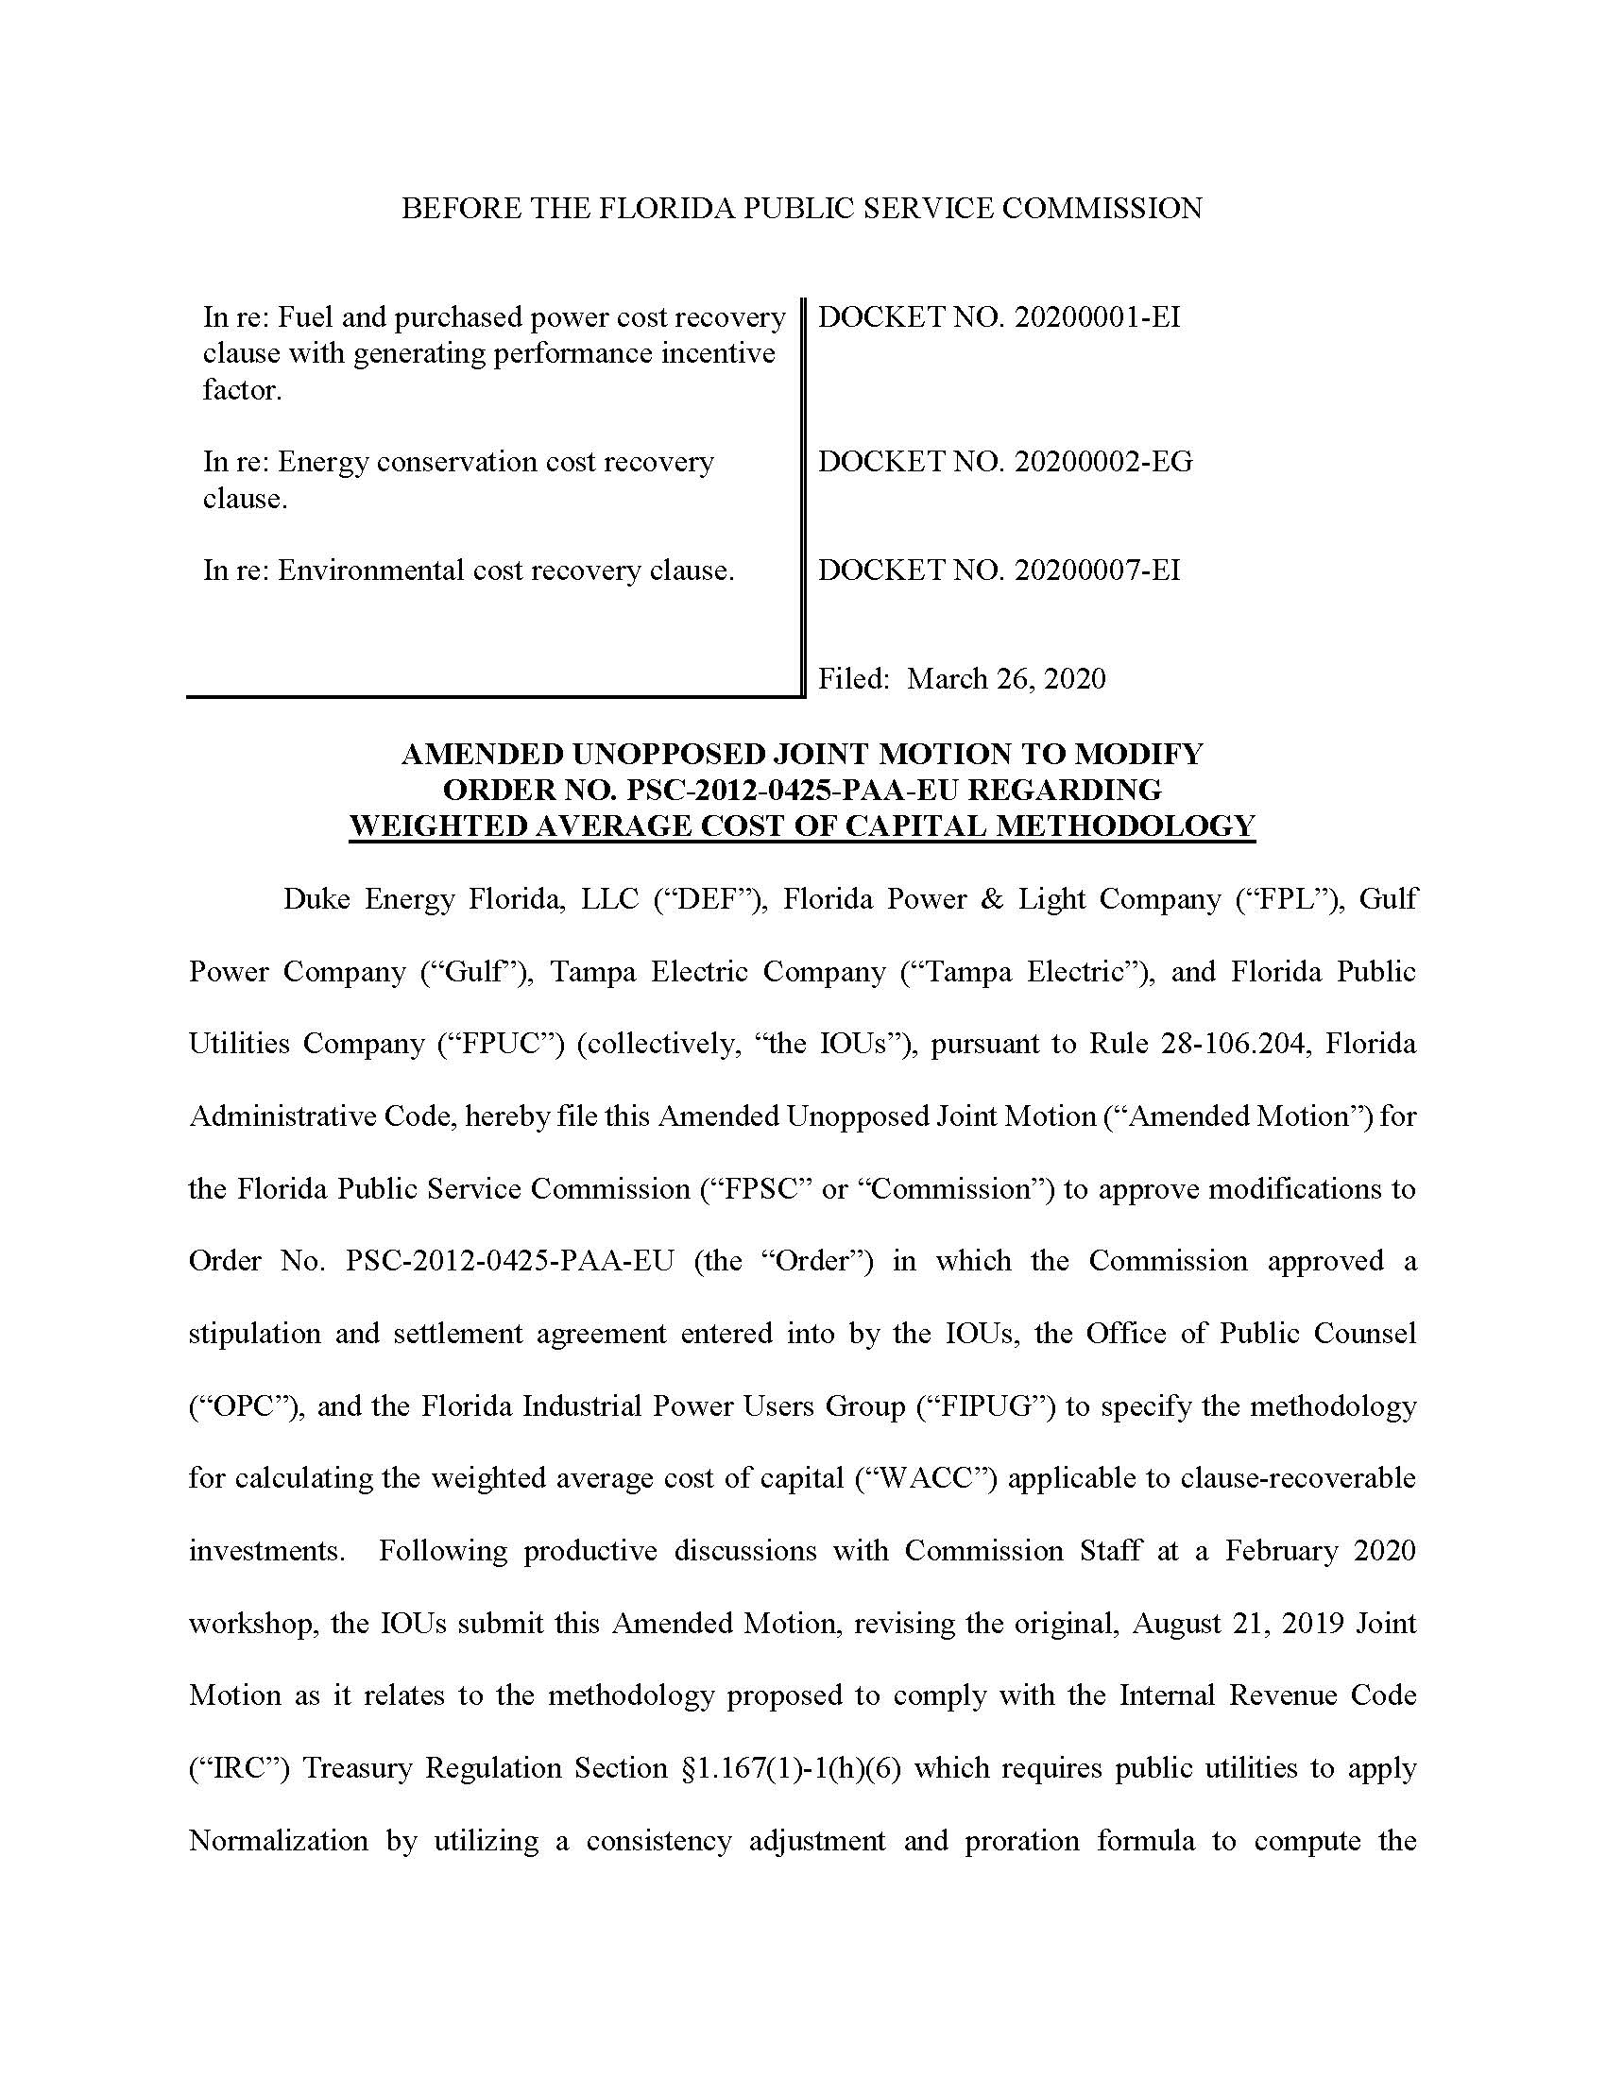

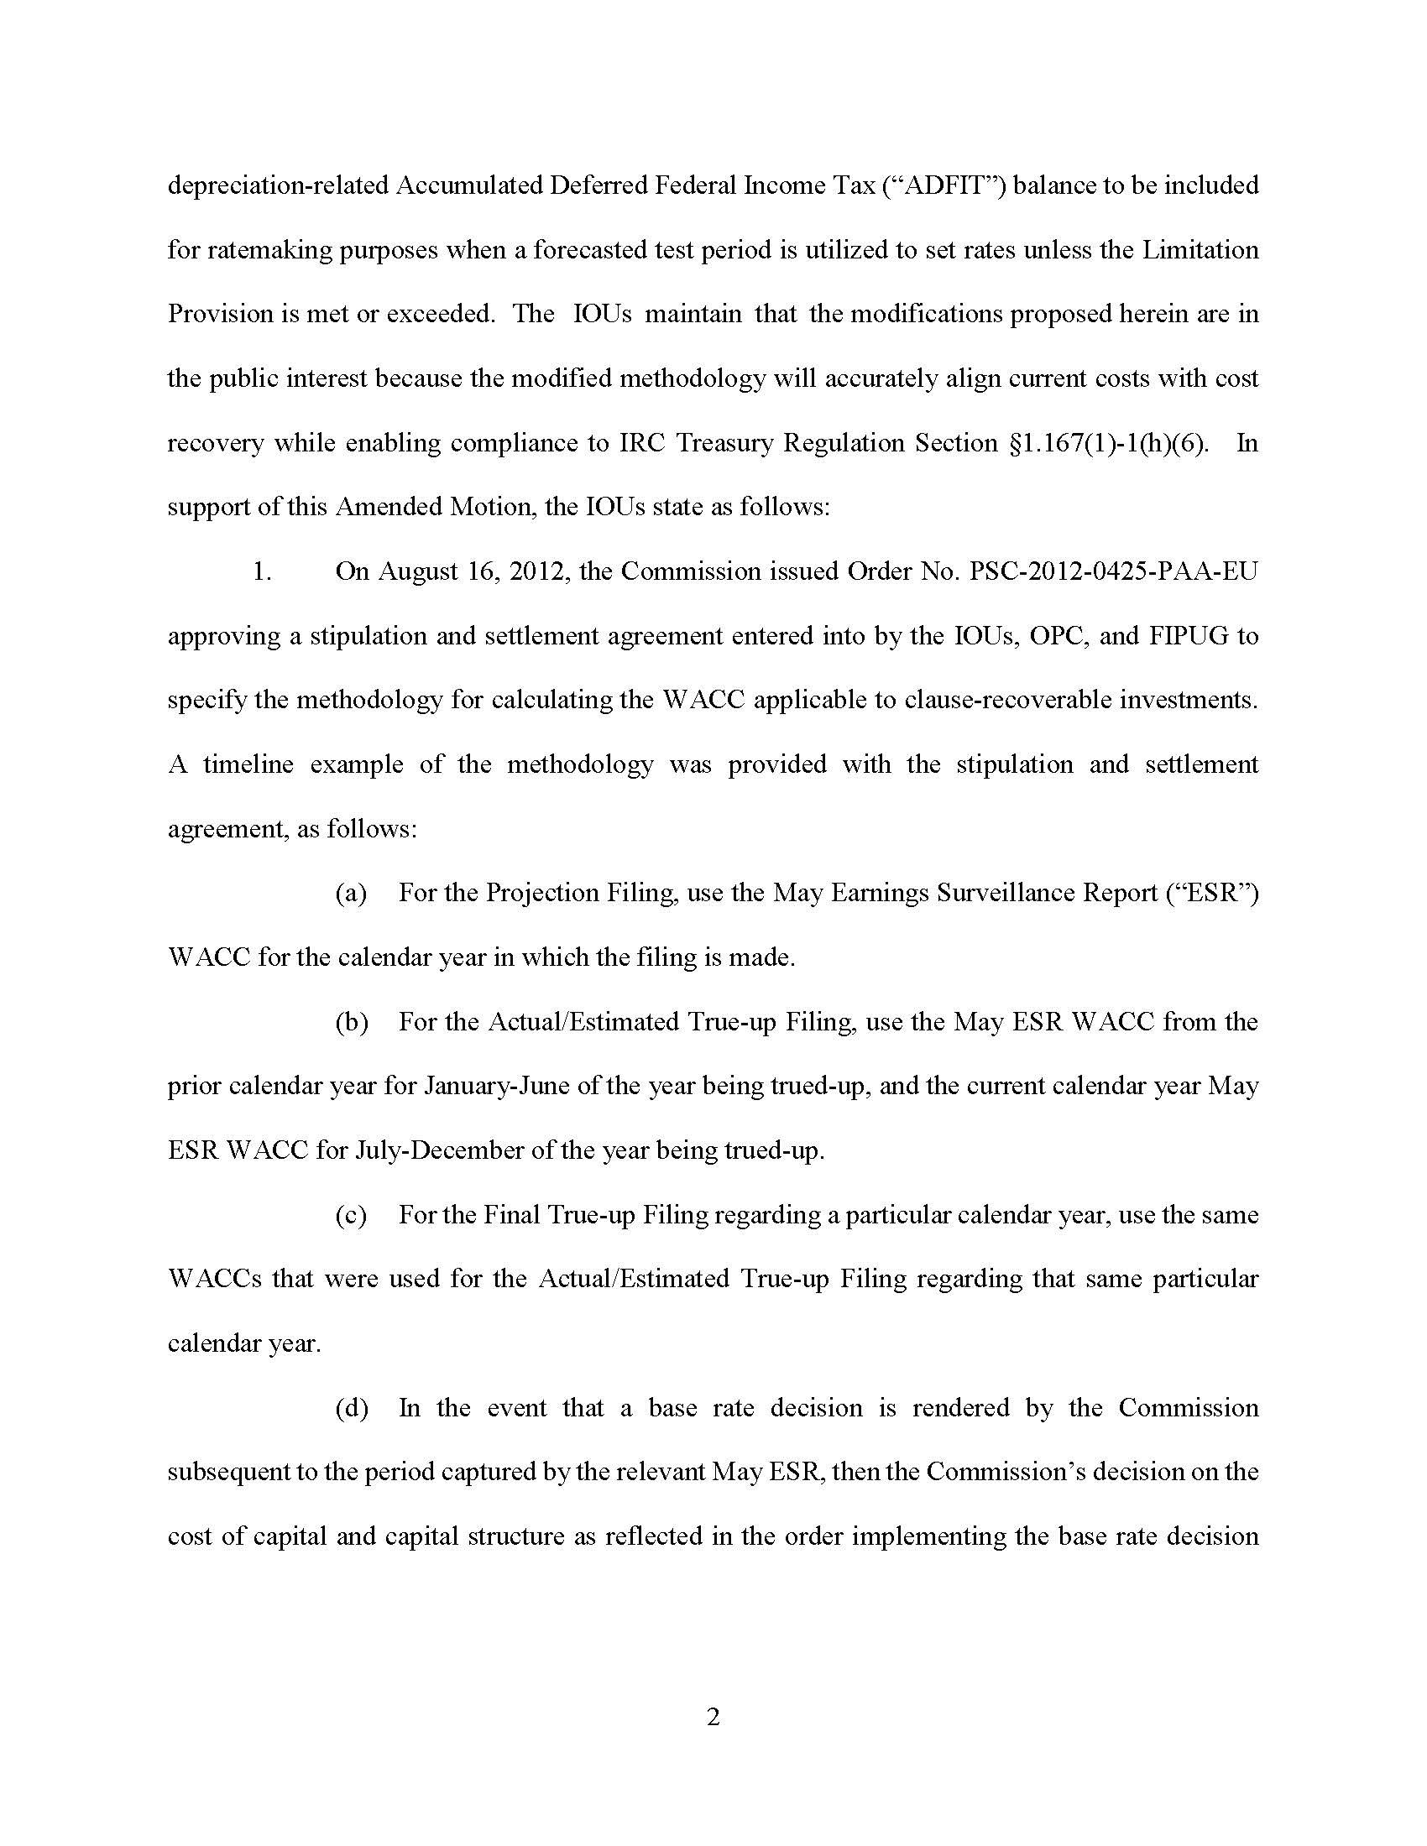
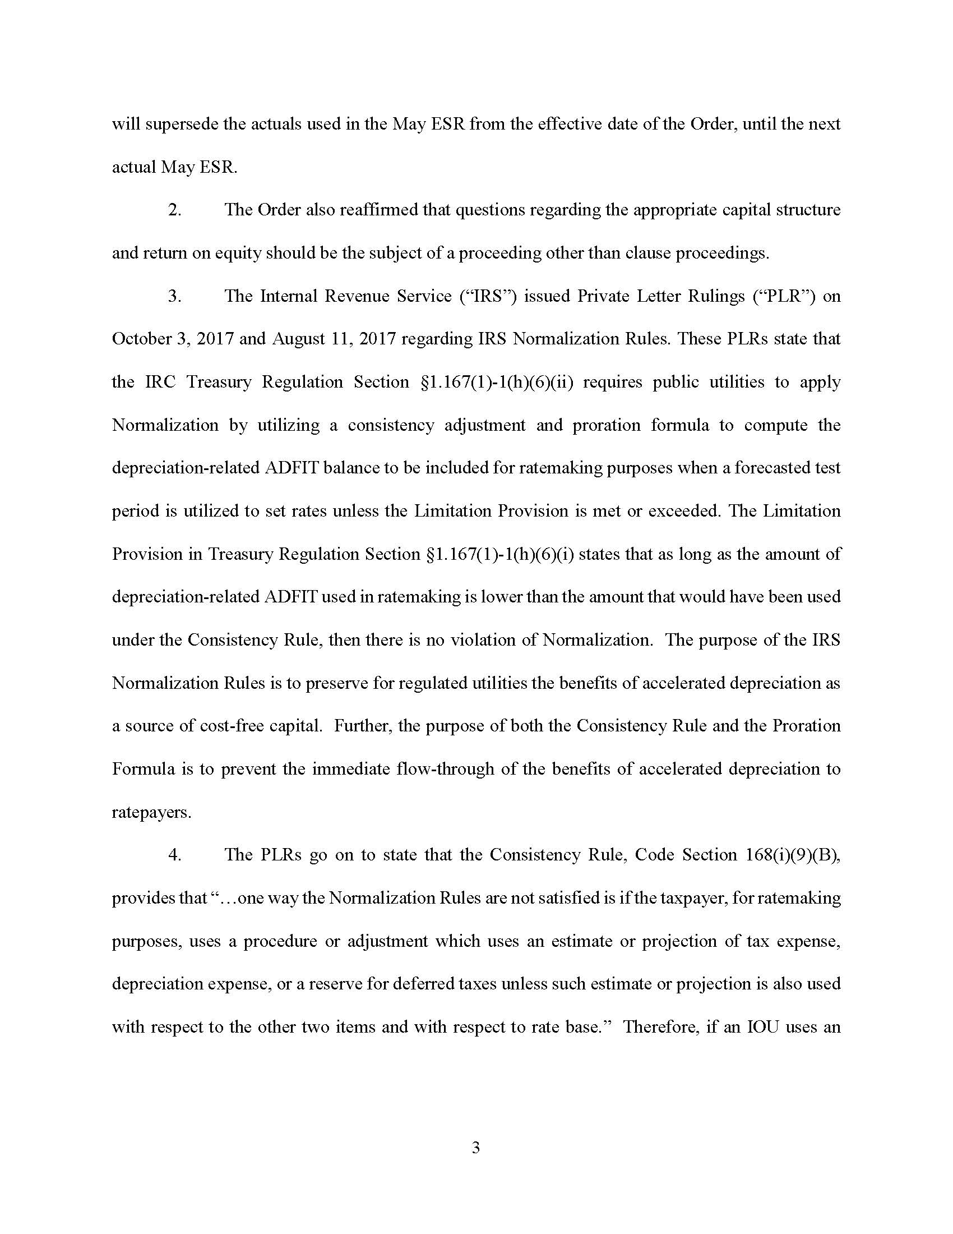

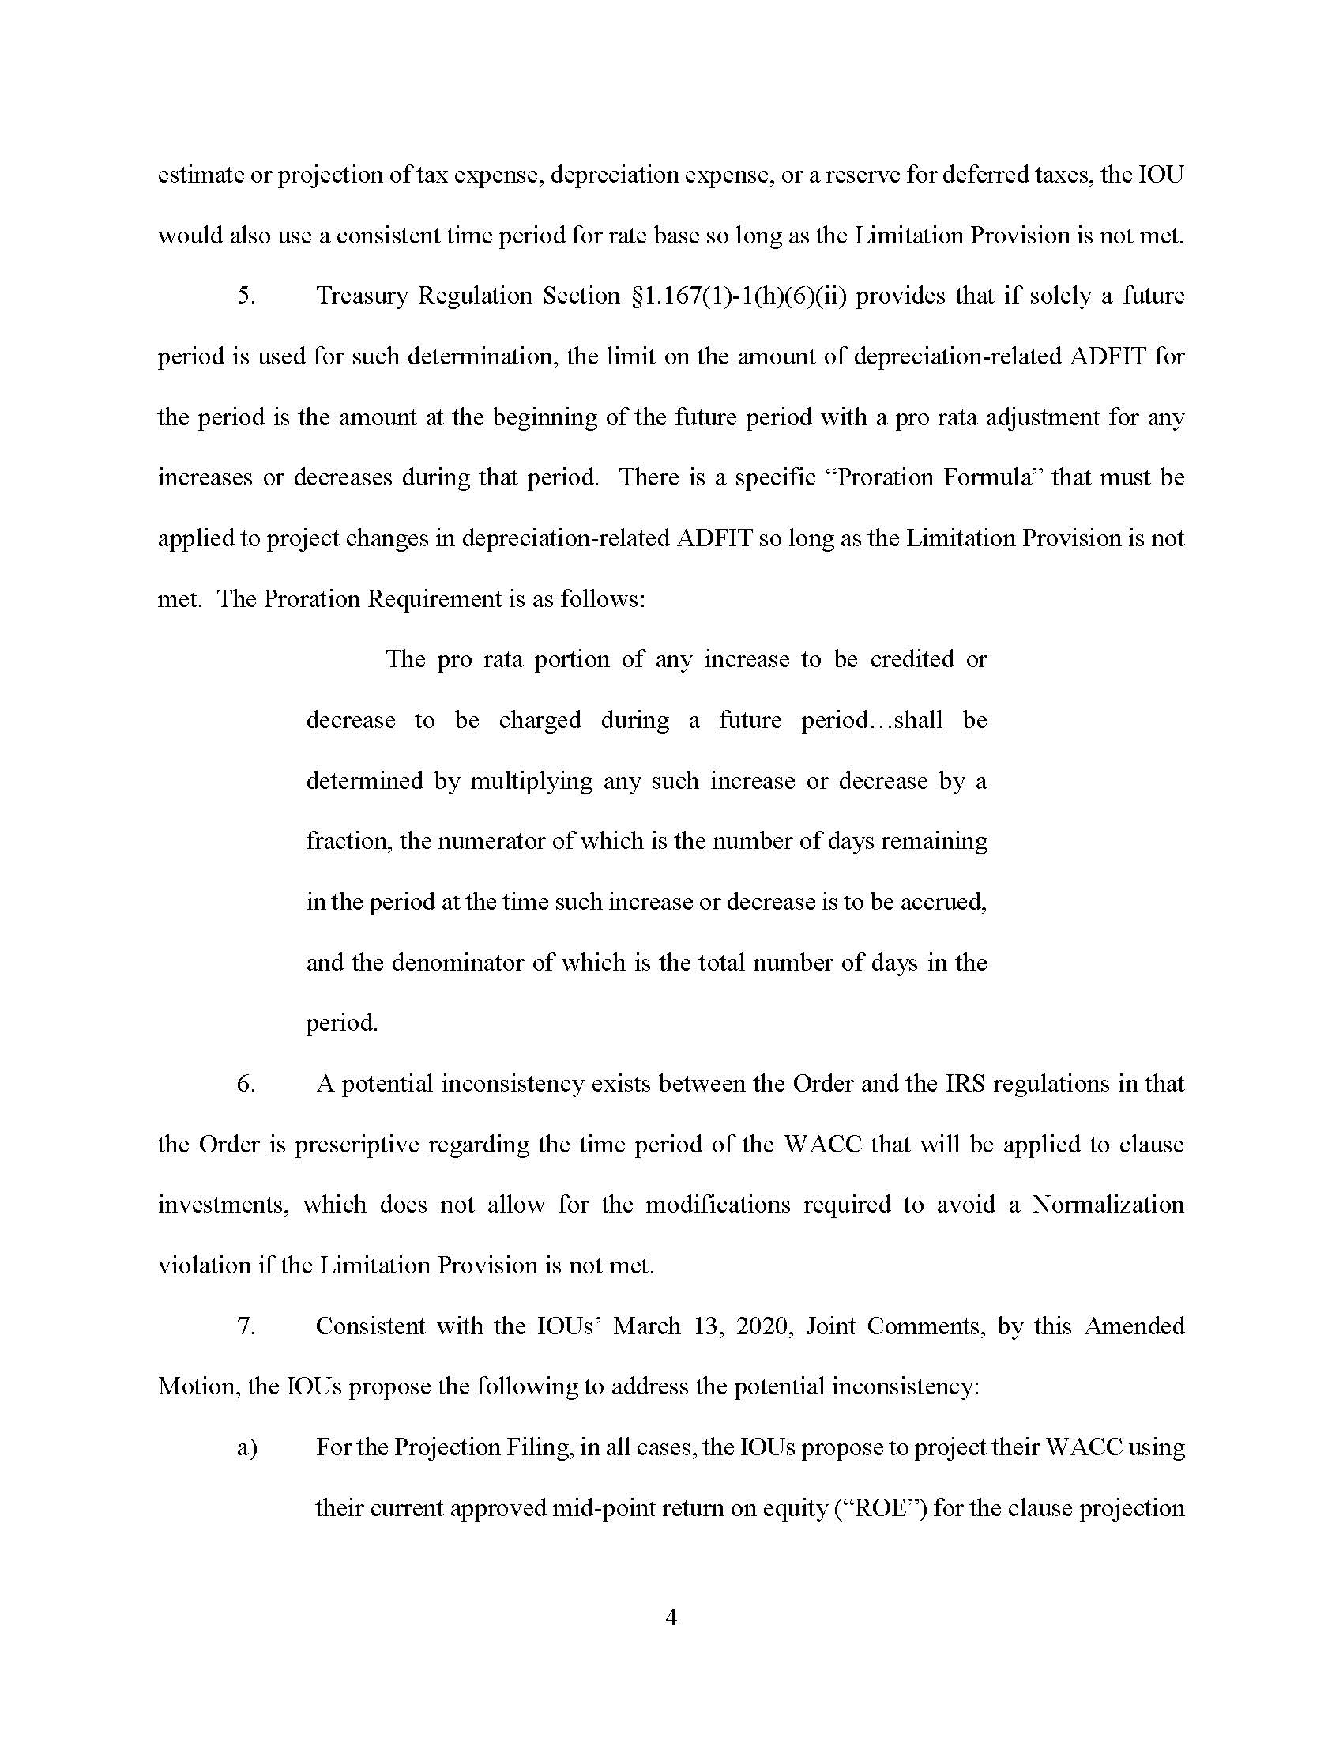

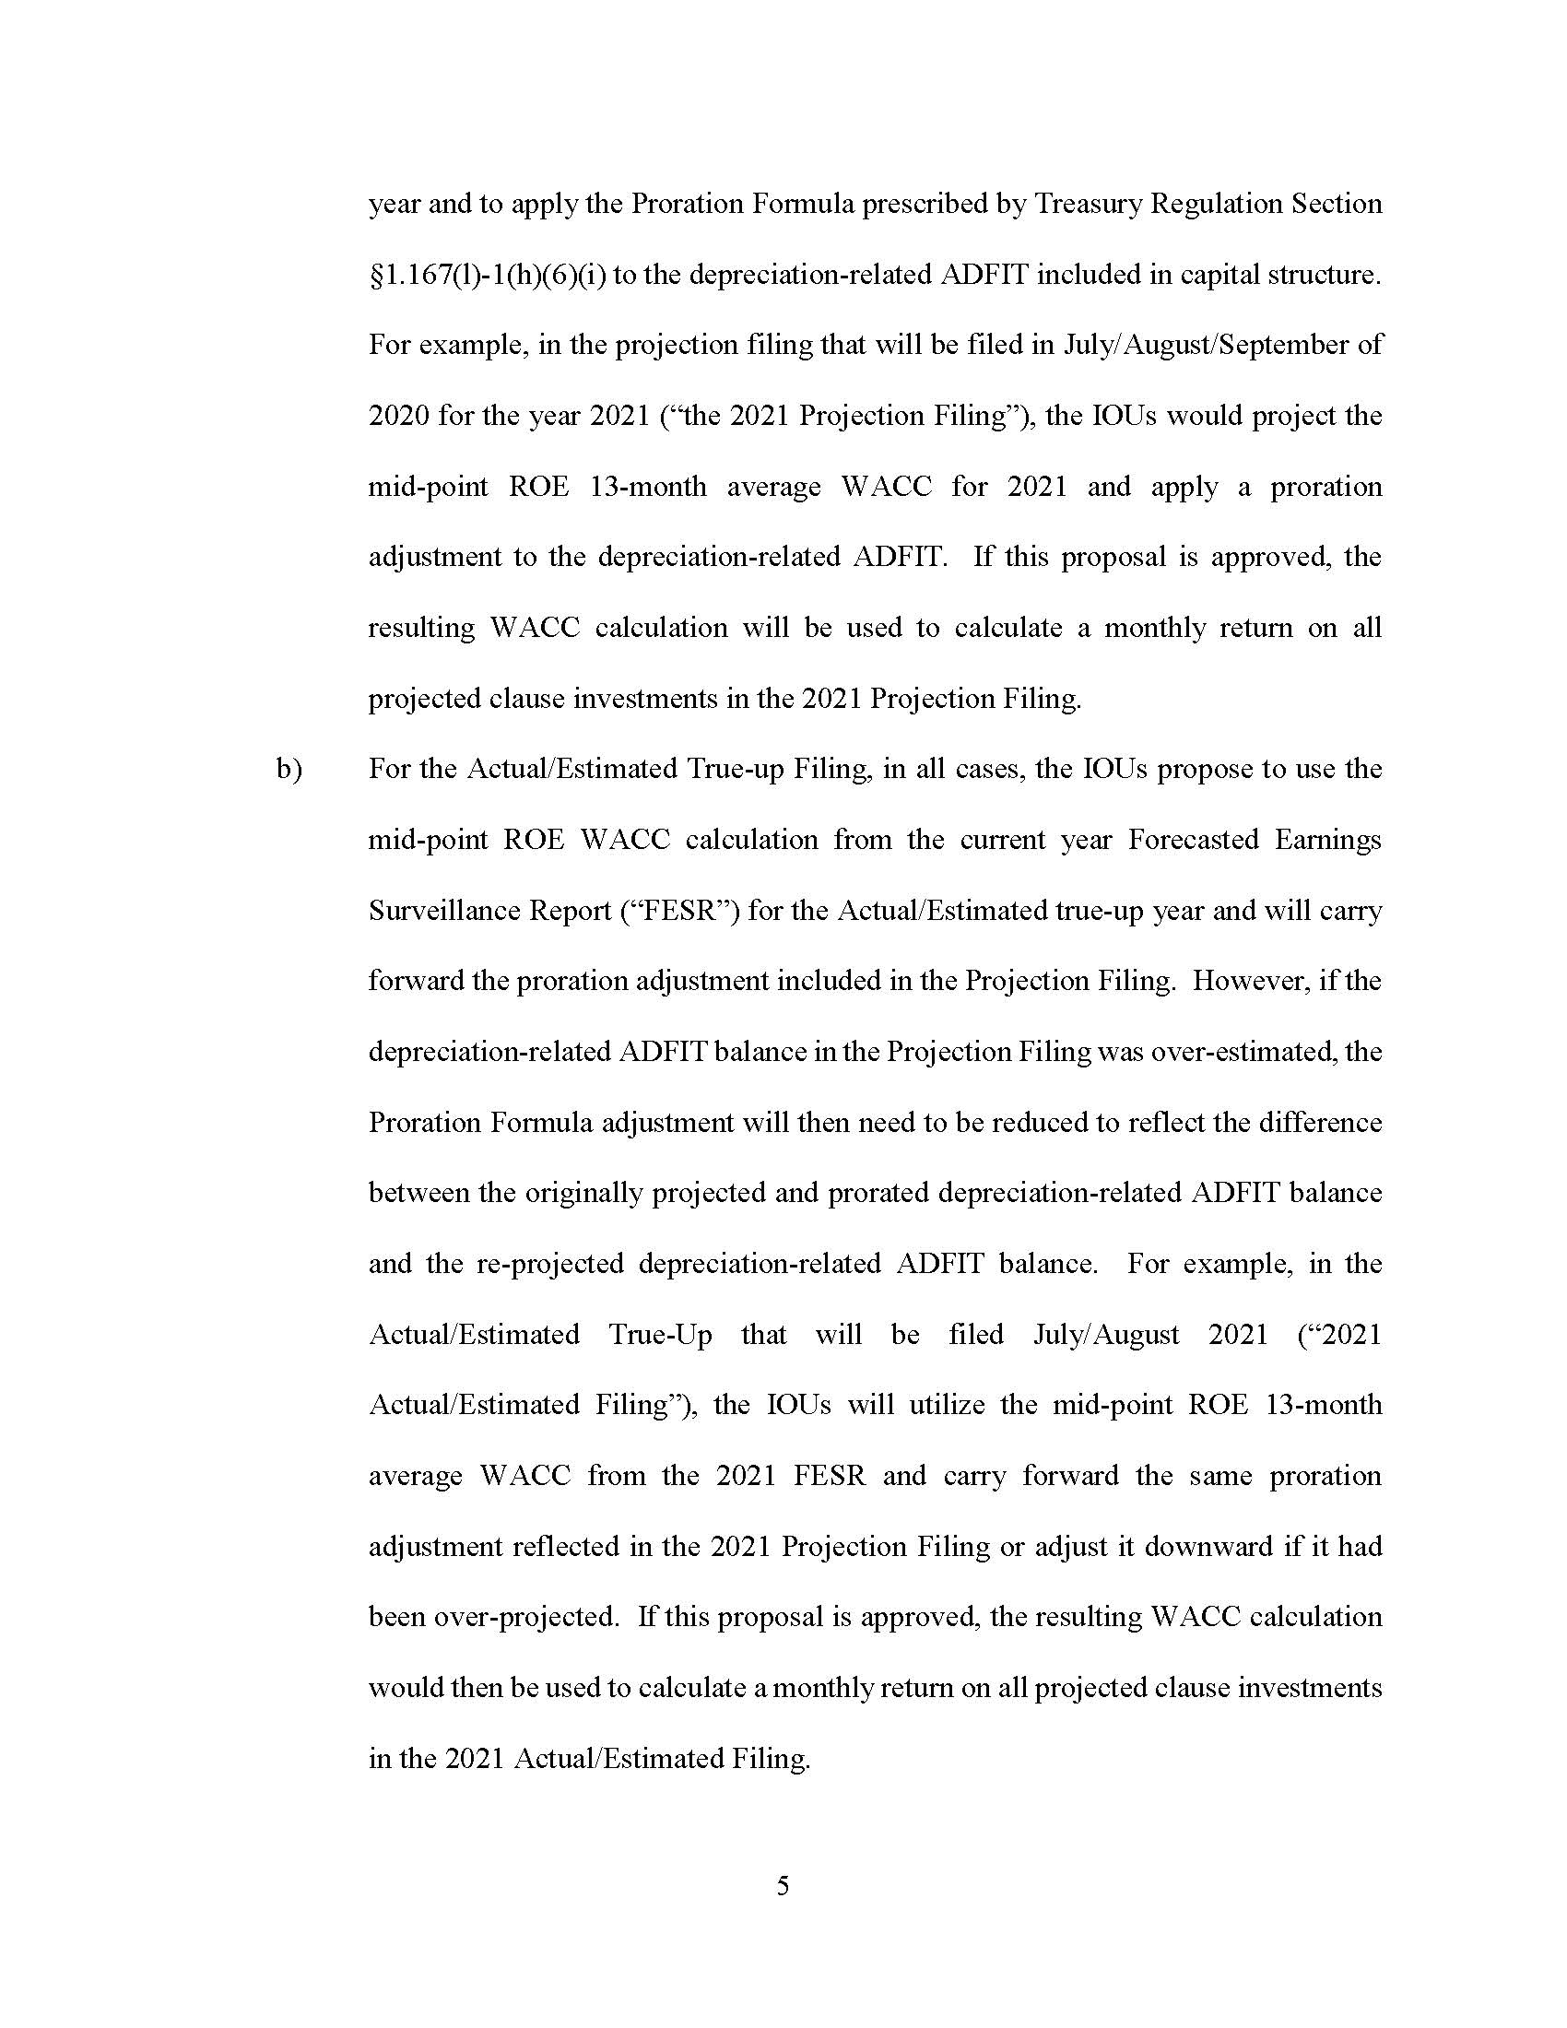

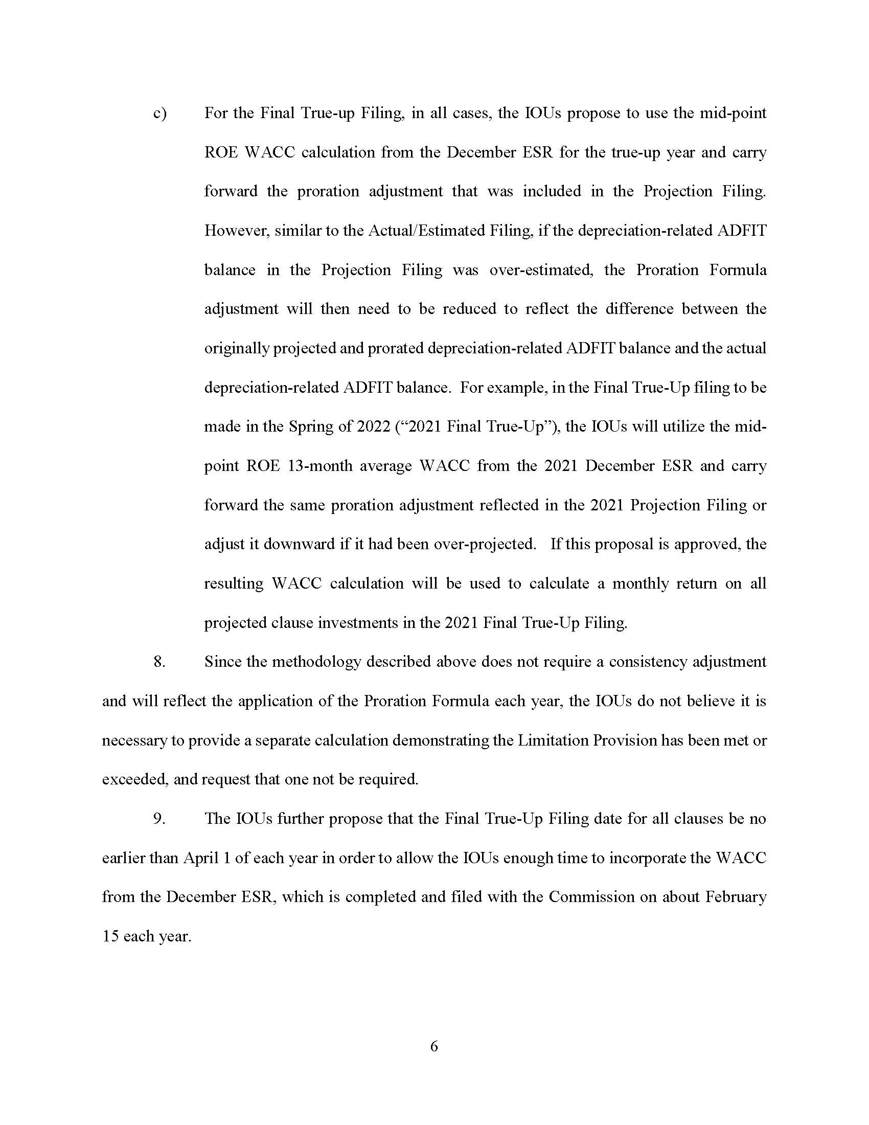

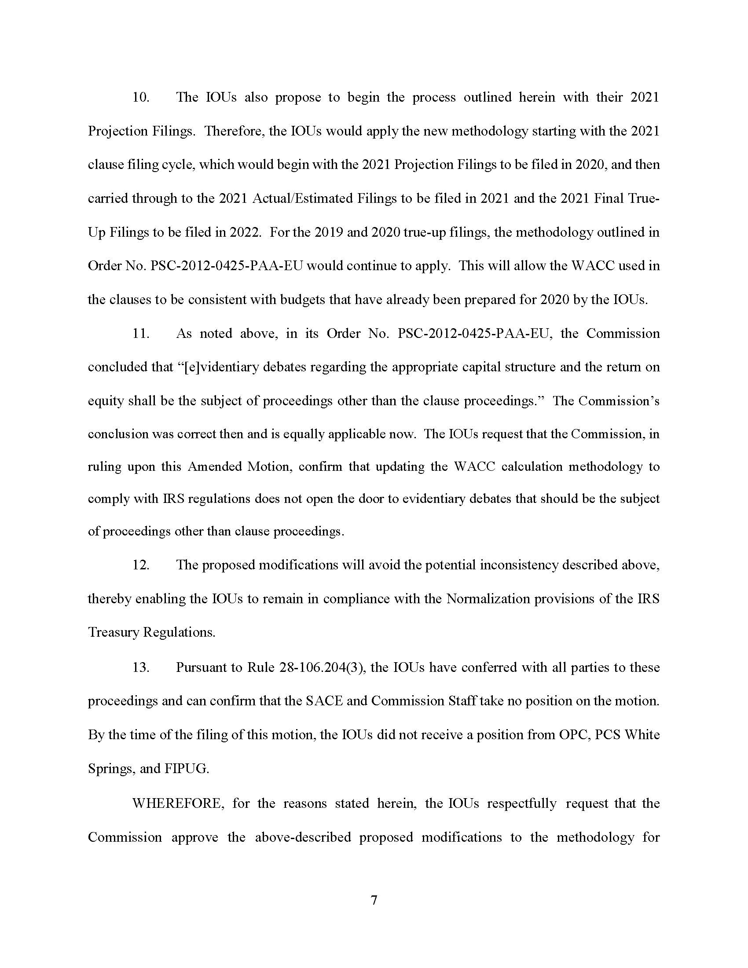
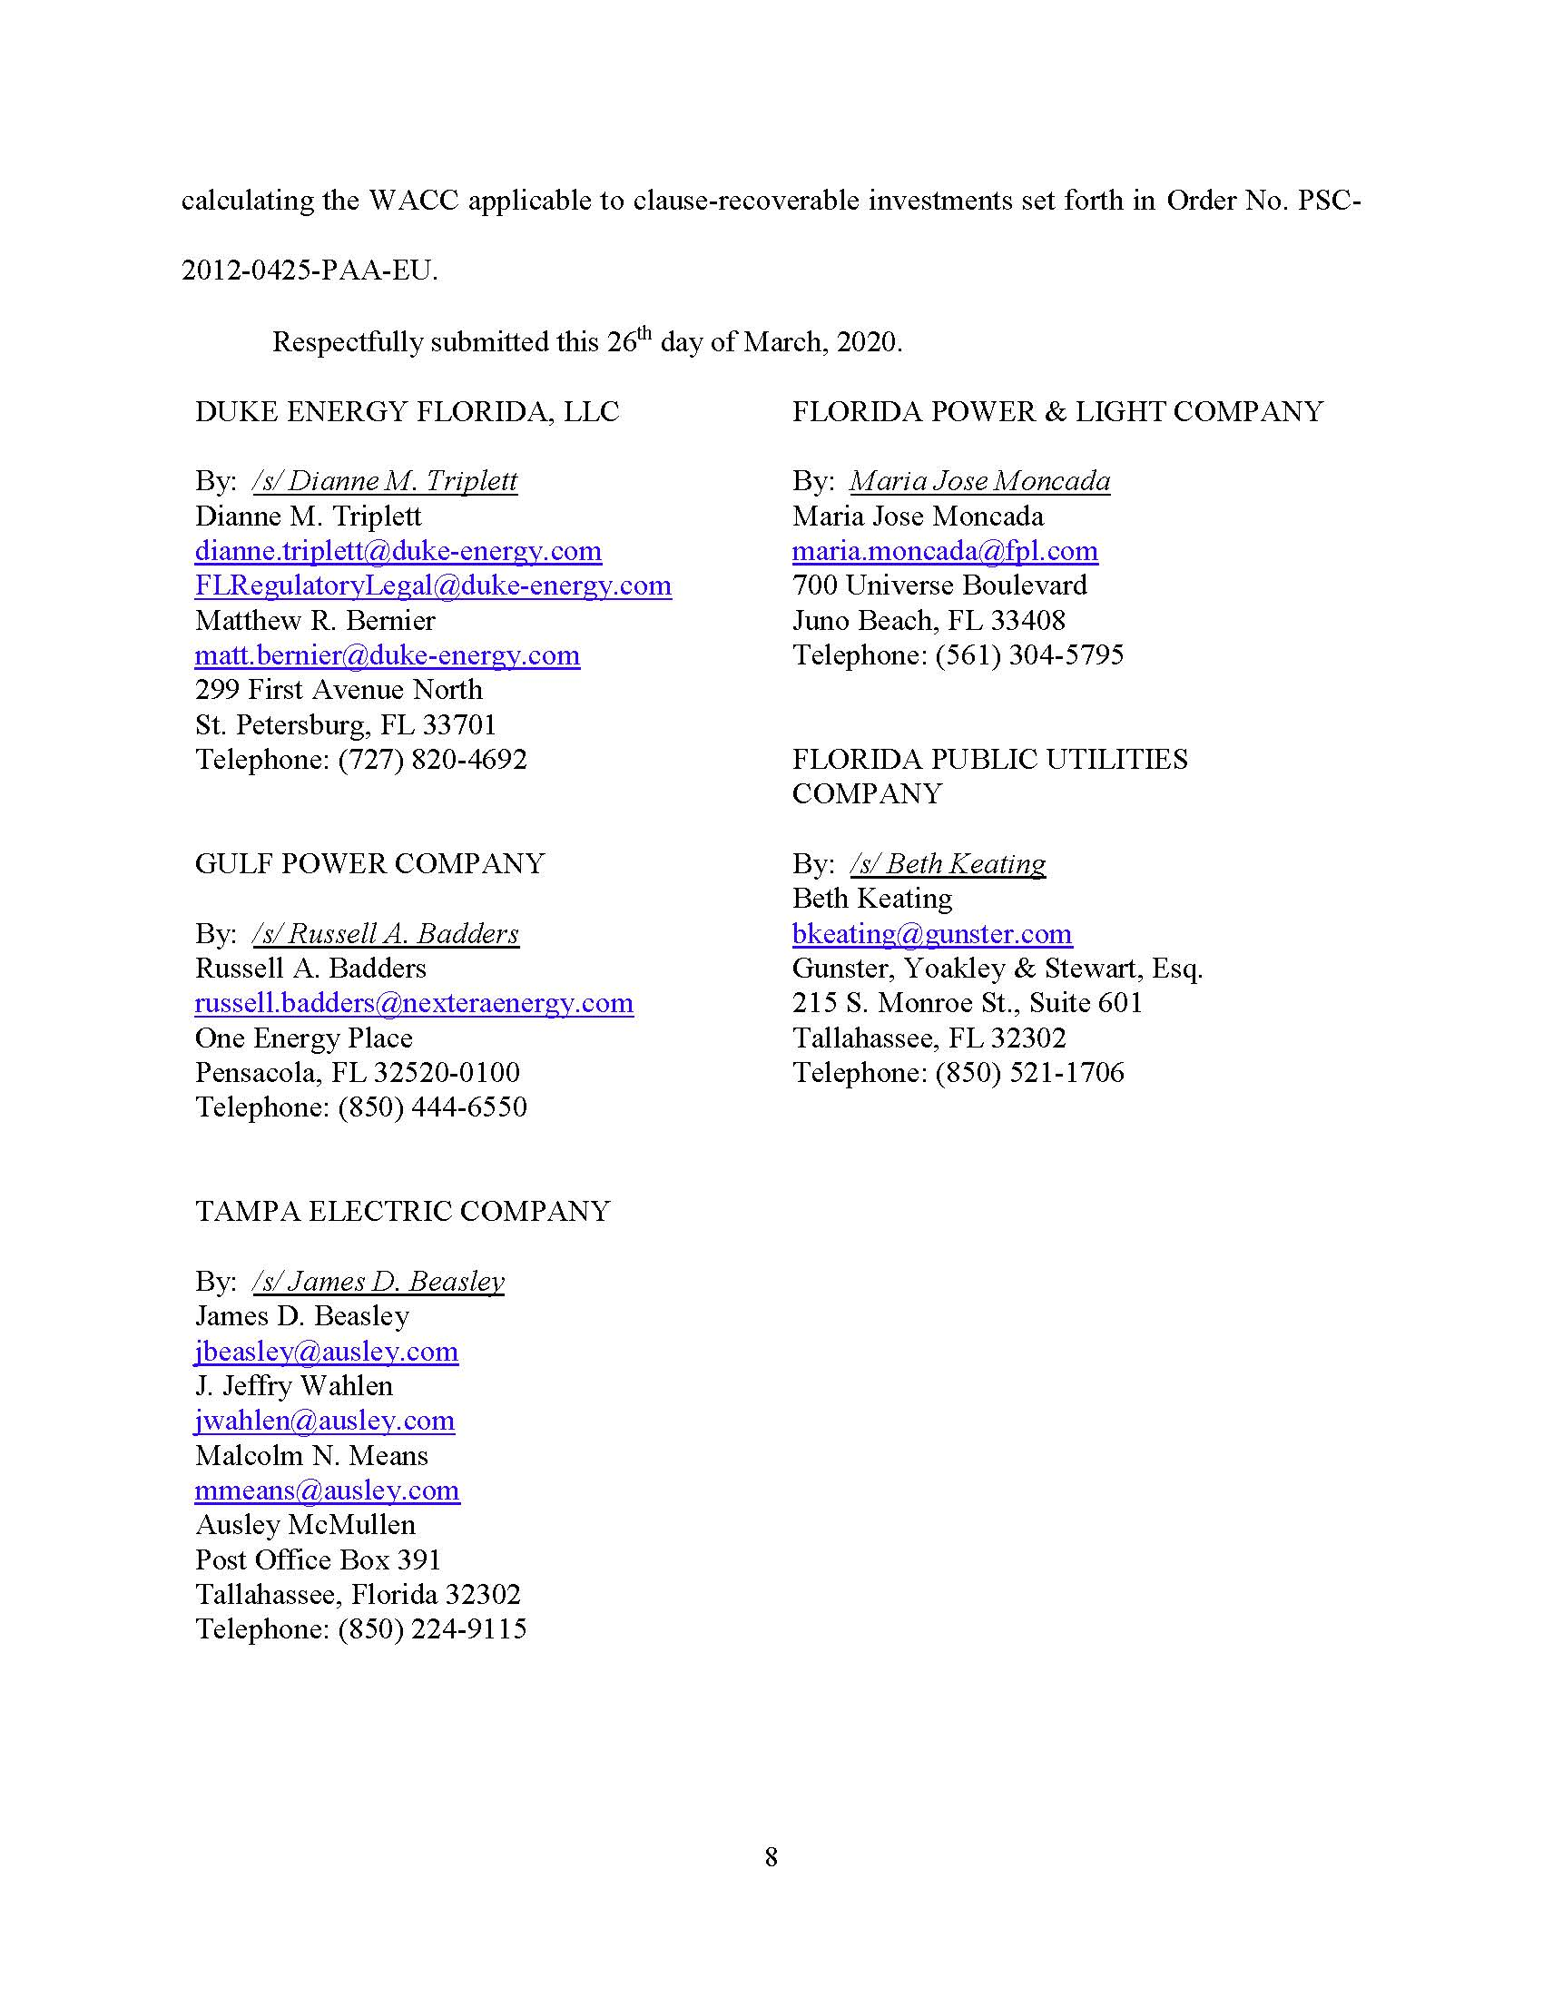

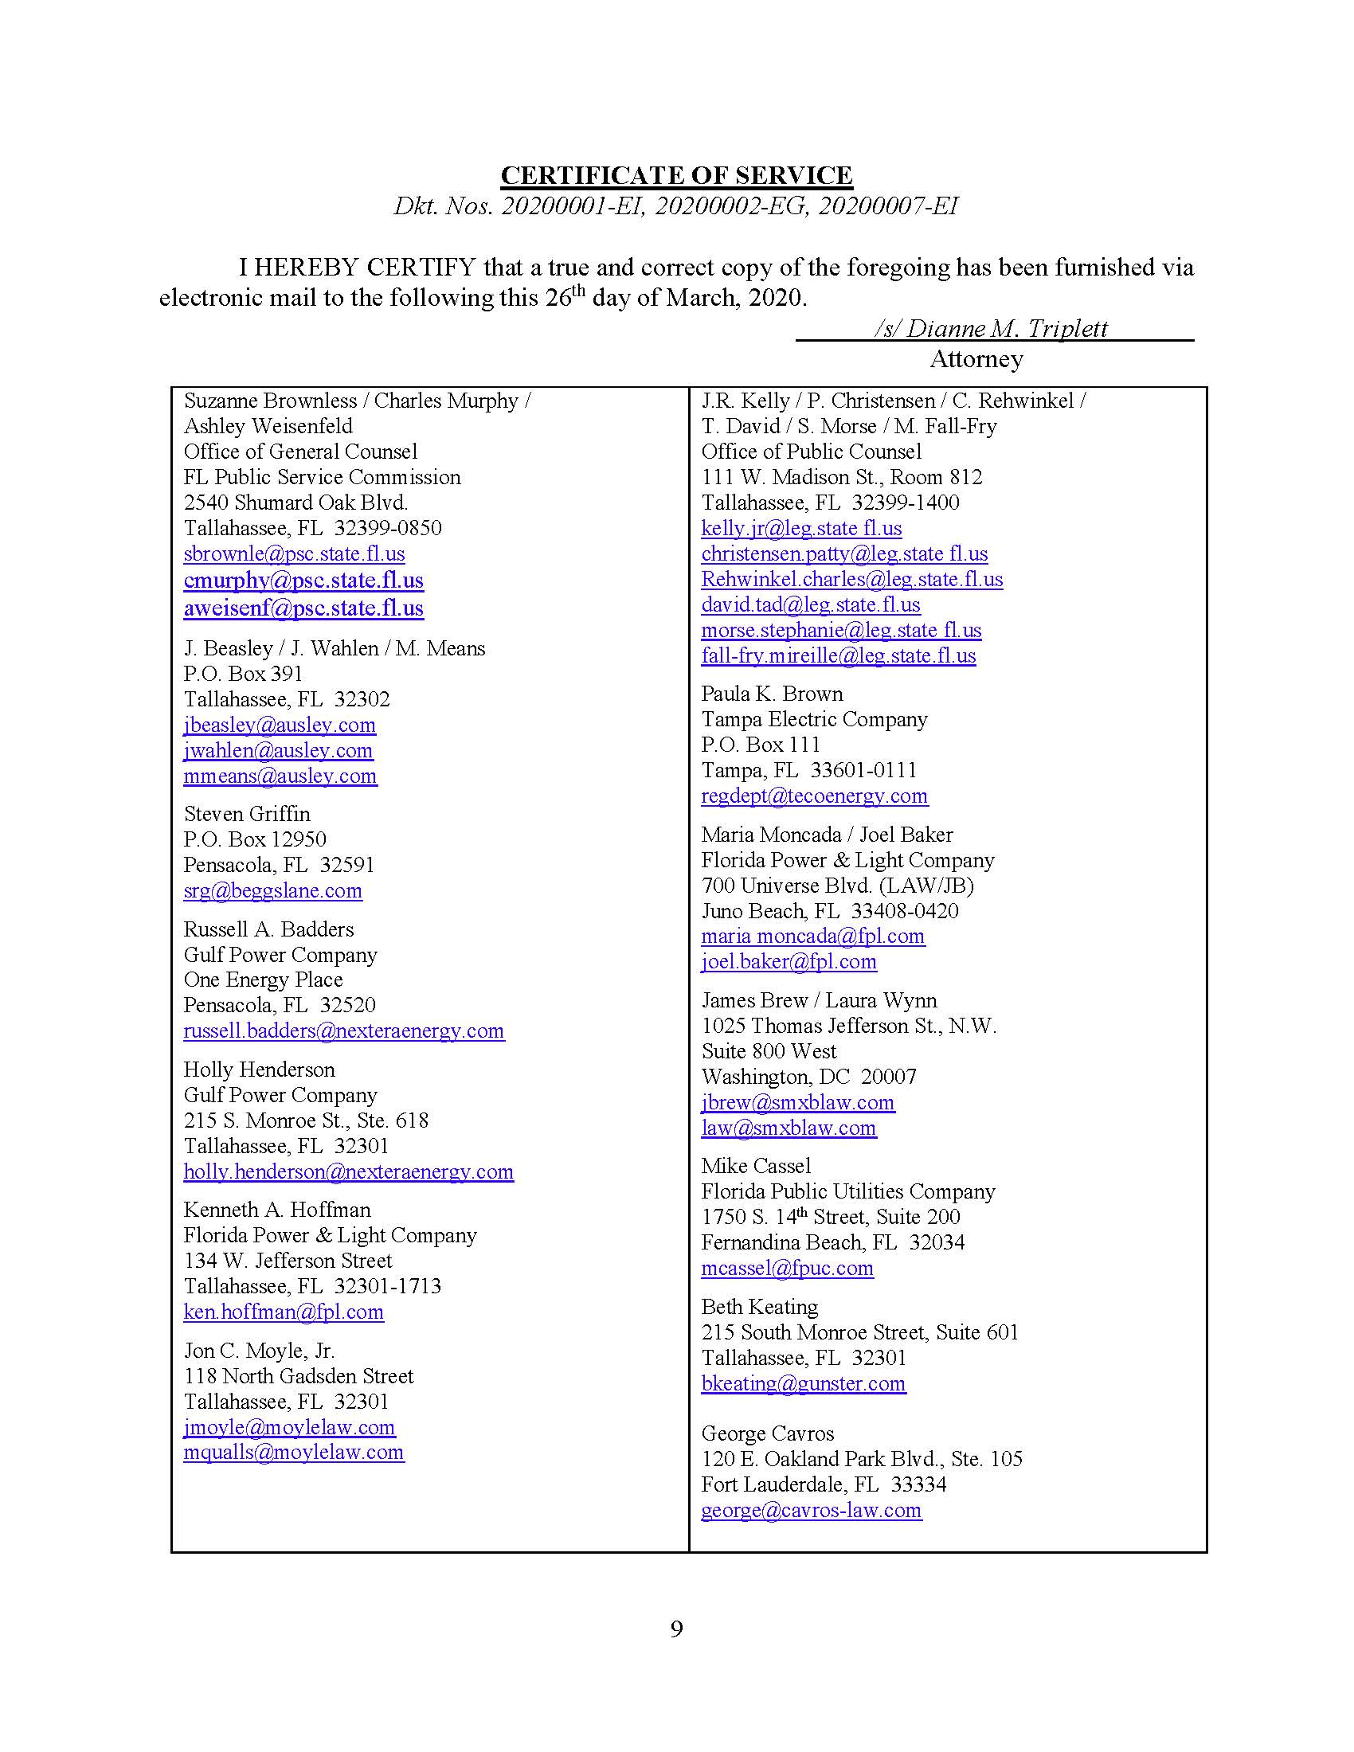

Order No. PSC-2012-0425-PAA-EU, issued August 16, 2012, in Docket No. 20120001-EI, In re: Fuel and purchased power cost recovery clause with generating performance incentive factor.
IRS Normalization Rules require public utilities to implement consistency between regulatory accounting for ratemaking and book accounting for income tax purposes when calculating income tax expense.
Document No. 08312-2019, filed August 21, 2019, in Docket No. 20190001-EI, In re: Fuel and purchased power cost recovery clause with generating performance incentive factor, Docket No. 20190002-EG, In re: Energy conservation cost recovery clause, and Docket No. 20190007-EI, In re: Environmental Cost Recovery Clause.
Document No. 00788-2020, filed February 4, 2020, in Docket No. 20200001-EI, In re: Fuel and purchased power cost recovery clause with generating performance incentive factor, Docket No. 20200002-EG, In re: Energy conservation cost recovery clause, and Docket No. 20200007-EI, In re: Environmental Cost Recovery Clause.
Document No. 01393-2020, filed March 13, 2020, in Docket No. 20200001-EI, In re: Fuel and purchased power cost recovery clause with generating performance incentive factor, Docket No. 20200002-EG, In re: Energy conservation cost recovery clause, and Docket No. 20200007-EI, In re: Environmental Cost Recovery Clause.
Document No. 01616-2020, filed March 26, 2020, in Docket No. 20200001-EI, In re: Fuel and purchased power cost recovery clause with generating performance incentive factor, Docket No. 20200002-EG, In re: Energy conservation cost recovery clause, and Docket No. 20200007-EI, In re: Environmental Cost Recovery Clause.
Treasury Regulation Section §168(i)(9).
The Consistency Rule states that in order for a utility to use a normalization method of accounting with respect to any public utility property, the utility must use a method of depreciation with respect to such property that is the same as, and a depreciation period that is no shorter than, the method and period used to compute its depreciation expense for such purposes, in computing its tax expense for purposes of establishing its cost of service for ratemaking purposes and reflecting operating results in its regulated books of account. If the amount allowable as a deduction under this section with respect to such property differs from the amount that would be allowable as a deduction under Treasury Regulation Section 167 using the method used to compute regulated tax expense under clause (i), the taxpayer must make consistency adjustments to a reserve to reflect the deferral of taxes resulting from such difference.
Id.

