State of Florida |  | Public Service Commission  Capital Circle Office Center ● 2540 Shumard Oak Boulevard  Tallahassee, Florida 32399-0850  -M-E-M-O-R-A-N-D-U-M-
DATE: | May 28, 2020
TO: | Office of Commission Clerk (Teitzman)
FROM: | Office of Industry Development and Market Analysis (Williams, Fogleman)  Office of the General Counsel (Murphy)
RE: | Docket No. 20200073-TP – Commission Approval of Florida Telecommunications Relay, Inc.'s Fiscal Year 2020/2021 Proposed Budget.
AGENDA: | 06/09/20 – Regular Agenda – Interested Persons May Participate
COMMISSIONERS ASSIGNED: |  |  | All Commissioners
PREHEARING OFFICER: |  |  | Administrative
CRITICAL DATES: |  |  | None
SPECIAL INSTRUCTIONS: |  |  | Anticipate the need for sign language interpreters and assisted listening devices. Please place near the beginning of the agenda to reduce interpreter costs.

Case Background
The Telecommunications Access System Act of 1991 (TASA) established a statewide telecommunications relay system. Section 427.704(1), Florida Statutes (F.S.), provides that the Florida Public Service Commission (Commission or FPSC) shall establish, implement, promote, and oversee the administration of the statewide telecommunications access system to provide access to telecommunications relay services by persons who are deaf, hard of hearing or speech impaired. The telecommunications access system is tasked with the purchase and distribution of specialized telecommunications devices as defined in Section 427.703(11), F.S. As defined by Section 427.703(16), F.S., this system provides telecommunications service for deaf or hard of hearing persons functionally equivalent to the service provided to hearing persons.
The telecommunications access system provides deaf or hard of hearing persons access to basic telecommunications services by using a specialized Communications Assistant that relays information between the deaf or hard of hearing person and the other party to the call. The primary function of the telecommunications access system is accomplished by the deaf or hard of hearing person using a Telecommunications Device for the Deaf (TDD). The person using the TDD types a message to the Communications Assistant who in turn voices the message to the other party or types the message to a Captioned Telephone which displays real-time captions of the conversation.
Florida Telecommunications Relay, Inc. (FTRI), a non-profit corporation formed by the local exchange telephone companies, was selected by the Commission to serve as the TASA Administrator. FTRI is primarily responsible for the purchase and distributions of specialized telecommunications equipment. As part of this process, FTRI contracts with other organizations to distribute equipment and provide customer training on the proper use of the equipment and the relay service. FTRI also conducts marketing to raise awareness of available specialized equipment and related relay service. Relay services are paid for by FTRI as part of its responsibilities.
FTRI, as the TASA Administrator, is funded through the Telecommunications Relay Service (TRS) surcharge. This surcharge was capped by the Florida Legislature at a maximum of $0.25 per landline access line per month. The Florida Legislature also limited collection of the surcharge on only the first 25 lines of each account. Only local exchange telecommunications companies are required to collect and remit this surcharge to FTRI. The initial TRS surcharge was set at $0.05 per access line per month. Since then, the FPSC has changed the surcharge to meet FTRI’s budgetary needs. The monthly surcharge is currently $0.10 per access line.
As part of its oversight responsibilities for the telecommunications access system, the Commission reviews and approves a budget submitted by FTRI on an annual basis. Attachment A is FTRI’s proposed budget for Fiscal Year 2020/2021, which was approved by its Board of Directors. FTRI also compared its proposed budget to the Commission-approved budget, as well as the estimated revenue and expenses, for Fiscal Year 2019/2020. FTRI’s estimated revenue and expenses were based on actual data from the first two quarters and estimated data for the third and fourth quarter.
Staff sent data requests to FTRI on a number of issues included in its Fiscal Year 2019/2020 estimate of expenses and its proposed Fiscal Year 2020/2021 budget. FTRI’s responses to staff’s data requests are included in the docket file. On April 28, 2020, FTRI filed third quarter financial information. With this updated information, staff formulated its own estimated expenses for Fiscal Year 2019/2020. Staff’s estimate is reflected in Attachment B.
This recommendation addresses FTRI’s proposed budget and staff’s recommended TRS surcharge for Fiscal Year 2020/2021. The TRS surcharge is the only rate the Commission establishes for telecommunications companies. The Commission is vested with jurisdiction pursuant to Chapter 427, F.S.

Discussion of Issues

Issue 1:
Should the Commission approve Florida Telecommunications Relay, Inc.'s (FTRI) proposed budget as presented in Attachment A for Fiscal Year 2020/2021, effective August 1, 2020, and should the Commission maintain the current Telecommunications Relay Service (TRS) surcharge at $0.10 per month?

Recommendation:
Staff recommends the Commission reduce FTRI’s proposed budget expenses for Fiscal Year 2020/2021 by $96,000 for TTY/TDD Equipment, $58,597 for VCP Hearing Impaired Equipment, $24,000 for VCP Speech Impaired Equipment, $128,481 for Regional Distribution Centers, $6,000 for Leasehold Improvements, and $2,000 for Employee Training. Staff recommends the Commission allow FTRI to transfer $165,211 from the Reserve Account to offset a projected revenue shortfall. Staff recommends the Commission order all local exchange companies to continue billing the $0.10 TRS surcharge for Fiscal Year 2020/2021. Staff further recommends the Commission require FTRI to conduct a financial break-even analysis of the RDC fee structure and present the results to the Commission with its Fiscal Year 2021/2022 budget filing. (Williams, Fogleman, Murphy)

Staff Analysis:

Traditional Telecommunications Relay Service
The traditional TRS cost to FTRI as approved in Sprint Communications Company, L.P.’s (Sprint) contract is currently $1.35 per session minute. Sprint’s projections indicate that traditional minutes will decrease by 3.6 percent during Fiscal Year 2020/2021 from the current fiscal year. Traditional relay users are transitioning to the following services:

- Internet Protocol (IP) Relay
- Video Relay Service (VRS)
- Captioned Telephone (CapTel) Service
- IP Captioned Telephone Service
- Internet Protocol Speech-to-Speech (STS) Service
- Wireless Service

CapTel Service
The CapTel cost to FTRI as approved in the Sprint contract is currently $1.69 per session minute. CapTel service uses a specialized telephone that provides captioning of the incoming call for a deaf or hard of hearing person. Sprint’s projections show that CapTel minutes of use will decline by 24 percent during Fiscal Year 2020/2021 from the current fiscal year. CapTel users are transitioning to Internet Protocol Captioned Telephone Service and wireless services.

Florida Telecommunications Relay, Inc. Budget
Attachment A reflects FTRI’s Fiscal Year 2020/2021 proposed budget, which was reviewed and adopted by FTRI’s Board of Directors prior to filing with the Commission. The FTRI proposed budget projects total operating revenue of $4,906,838 and total expenses of $5,387,127. Based on the projected revenue and expenses, FTRI requests that the Commission grant FTRI authority to transfer $480,289 from the Reserve Account to offset the shortfall. FTRI also requests that the TRS surcharge be maintained at $0.10 per access line for Fiscal Year 2020/2021.

FTRI’s proposed budget represents a projected decrease in revenue of $502,871 (9 percent) from that included in the Fiscal Year 2019/2020 Commission-approved budget. This projected revenue decrease is attributed to an expected six percent decrease in access lines from the current fiscal year that are assessed the TRS surcharge.

FTRI’s proposed budget also includes a decrease in expenses of $308,296 (5.4 percent) from the Fiscal Year 2019/2020 Commission-approved budget. The most significant decline in FTRI’s proposed budget expense ($301,210) relates to an expected decline in minutes of use.

Sprint’s estimated Fiscal Year 2020/2021 traditional TRS minutes of use are 1,105,917, at a rate of $1.35 per minute, for the TRS related expense of $1,492,988. Sprint’s estimated CapTel minutes of use are 450,871, at a rate of $1.69 per minute for the CapTel related expense of $761,972. The Fiscal Year 2019/2020 Commission-approved budget reflected traditional TRS minutes of 1,147,727 and CapTel minutes of 595,703. The total expense for TRS and CapTel for Fiscal Year 2019/2020 was $2,556,170.

A comparison of FTRI’s Fiscal Year 2019/2020 Commission-approved budget, FTRI’s Fiscal Year 2019/2020 estimated revenues and expenses, and FTRI’s Fiscal Year 2020/2021 proposed budget as filed is shown in Table 1 below.

Table 1
FTRI Budget Comparison
 | Commission Approved 2019/2020 | FTRI Estimated 2019/2020 | FTRI Proposed 2020/2021
Operating Revenue:
Surcharges | $5,315,788 | $5,098,137 | $4,792,249
Interest Income | 93,921 | 111,674 | 114,589
Total Operating Revenue | $5,409,709 | $5,209,811 | $4,906,838
Operating Expenses:
Relay Provider Services | $2,556,170 | $2,556,170 | $2,254,960
Equipment & Repairs | 938,394 | 806,530 | 951,832
Equipment Distribution & Training | 707,389 | 564,344 | 695,458
Outreach | 535,650 | 535,650 | 535,650
General & Administrative | 957,820 | 877,841 | 949,227
Total Expenses | $5,695,423 | $5,340,535 | $5,387,127
Annual Surplus | ($285,714) | ($130,724) | ($480,289)
Reserve Account | 16,957,128 | 17,353,184 | 17,222,460
Total Reserve | $16,671,414 | $17,222,460 | $16,742,171
Source: FTRI’s Fiscal Year 2020/2021 proposed budget.

Analysis
Based upon current industry trends, FTRI estimates that access lines will decrease at the rate of approximately six percent from the current fiscal year as more consumers transition from landline phones. Holding the TRS surcharge constant, a decrease in access lines results in a decrease in revenues to support FTRI’s activities. Continued effort by FTRI to reduce expenses is important.

Staff developed an estimate of FTRI’s expenses for Fiscal Year 2019/2020. This data is presented in Attachment B. Staff used actual data from the first three quarters of the fiscal year, and took an average of those three quarters to estimate the fourth. Staff’s estimates were then used as one element in evaluating FTRI’s proposed budget. Attachment B also includes FTRI’s budgeted information for comparison purposes. Staff also analyzed past Commission-approved FTRI budgets to identify and evaluate ongoing cost reduction measures. Below is staff’s review of selected items from FTRI’s proposed budget expense by category.

Category I – Relay Services
Category I captures expenses for traditional TRS and CapTel service currently provided by Sprint. The proposed budget recognizes a $301,210 expense reduction from the Fiscal Year 2019/2020 Commission-approved budget, primarily due to declining minutes and service cost associated with CapTel service.

The relay service expenses are based on the minutes of use as projected by Sprint and relay service contract rates. Sprint’s historical projections have proven to be reasonable and it has multi-state experience with such projections. Staff believes that the estimates for Fiscal Year 2020/2021 are reasonable and should be used for budgetary purposes.

Category II – Equipment & Repairs
Category II expenses reflect the purchase of equipment to be distributed to clients and the repairs that FTRI must make to keep the equipment in working order. FTRI used contract pricing for equipment multiplied by the number of units it plans to order over the course of the year. These contracts for equipment between FTRI and equipment vendors are separate from the contract for relay service approved by the Commission. FTRI’s proposed budget represents a $13,438 increase in expense when compared to the Fiscal Year 2019/2020 Commission-approved budget.

CapTel Phone Equipment
FTRI’s Fiscal Year 2019/2020 CapTel Phone Equipment expense increased from the previous year by $16,875 as a result of projected demand and expiration of a 2015 agreement FTRI had with Sprint to provide the CapTel 840 PLUS at no cost through Fiscal Year 2018/2019. FTRI’s Fiscal Year 2020/2021 proposed budget reduces CapTel Equipment expense by $16,875. FTRI has determined that it has enough inventory on hand and is refurbishing returned units.

Text Telephone / Texting Device for the Deaf Equipment
Text Telephone (TTY) and Texting Device for the Deaf (TDD) are interchangeable terms used to refer to text-based telecommunications equipment used by deaf or hard of hearing consumers. FTRI’s proposed Fiscal Year 2020/2021 budget includes $96,000 for advanced technologies under the TTY/ TDD equipment budget line item. In support of its budget filing, FTRI states:

Telecommunications Devices for the Deaf have traditionally been TTY (text telephones for the Deaf). Over the past decade or more, these units have become less preferred by Deaf consumers and replaced by newer technology. Smart Phones, Tablets, Captioning services are some of the new technology that may be piloted.

TASA currently provides funding for the distribution of specialized telecommunications devices for the deaf, hard of hearing or speech impaired and the provision of intrastate relay service. In response to staff’s Fiscal Year 2020/2021 data request, FTRI explained that it had budgeted $96,000 based on plans to “distribute 80 iPads priced at $1,200 per unit configured with applications that enable Florida residents who are deaf or severely hard of hearing to access the telecommunications system.”

Staff agrees that traditional TTY/TDD equipment has become less preferred by consumers. This is evident by declines in equipment distributed by FTRI, and TRS and CapTel minutes of use. However, the Florida Legislature narrowly defined TDD as “a mechanism which is connected to a standard telephone line, operated by means of a keyboard, and used to transmit or receive signals through telephone lines.” Section 427.703(14), F.S. Because iPads are not connected to a standard telephone line (i.e., landline) and do not transmit or receive signals through telephone lines, staff believes that they are not TDDs.

Moreover, by Section 427.703(11), F.S., the Florida Legislature defined “specialized telecommunications devices” as “TDD, a volume control handset, a ring signaling device, or any other customer premises telecommunications equipment specifically designed or used to provide basic access to telecommunications service for a hearing impaired, speech impaired, or dual sensory impaired person.” In contrast, iPads are, in basic terms, tablet computers. Consumers can use an iPad for browsing the web, reading and sending email, enjoying photos, watching videos, listening to music, playing games, and reading e-books. Software can be purchased for other productivity functions, such as drafting documents, creating spreadsheets, developing presentations, and editing photographs. While additional applications may be available that provide assistance to the deaf and hard of hearing community, staff believes that the iPad is not a specialized telecommunications device specifically designed or used to provide basic access to telecommunications service for a hearing impaired, speech impaired, or dual sensory impaired person.

Because an iPad is neither a TDD nor a specialized telecommunications device, staff recommends that distribution of iPads by FTRI is not authorized by applicable law and that FTRI’s budget should be reduced by $96,000 for TTY/TDD equipment.

VCP Hearing Impaired Equipment
FTRI’s Fiscal Year 2019/2020 estimated expense for VCP Hearing Impaired Equipment is $646,535. FTRI’s proposed budget is $635,800 for Fiscal Year 2020/2021. However, staff’s estimate for Fiscal Year 2019/2020 is $577,203. As stated earlier, staff’s estimated expense for 2019/2020 includes three quarters of actual data, while FTRI’s includes only two quarters of historical data. Over the past several years, there has been a steady decline in expense related to this category of equipment. FTRI has not presented any information that would suggest a change in this trend. For these reasons and staff’s estimate for the current year, staff recommends that the Commission reduce FTRI’s budget by $58,597.

VCP Speech Impaired Equipment
FTRI has also proposed $24,000 for VCP Speech Impaired equipment for Fiscal Year 2020/2021. FTRI states that the request is to pilot newer technology equipment using documented pilot program parameters for the program. FTRI explains that over the past decade or more, new technology such as smartphones and tablets have become available to assist speech impaired persons connect with the communications systems. FTRI indicated in its response to staff’s data request that its budget for this category of equipment was based on plans to distribute 20 iPads. It intends for these iPads to be configured with applications that enable speech impaired Florida residents to access the telecommunications system.

As discussed earlier, staff understands that a growing number of consumers prefer to use newer devices that offer varied services and applications. Staff appreciates FTRI’s challenge to provide attractive technology under Chapter 427. However, as noted earlier, staff does not believe that iPads meet the statutory definition of a “specialized telecommunications device.” Furthermore, considering FTRI’s budgetary constraints based on declining access line revenue, staff does not support FTRI’s proposed funding. Staff recommends that FTRI’s request of $24,000 be denied.

VRS Signaling Equipment
FTRI’s proposed Fiscal Year 2020/2021 budget is $16,400 for VRS Signaling Equipment. FTRI’s Fiscal Year 2019/2020 Commission-approved budget is $7,733. This year’s budget request includes increasing the number of Bellman-Symdon devices distributed, which were piloted last year. These more advanced devices allow users to control the unit plugged directly into the phone or by transmitter alerting the user of a ring if the unit is in another room. The Commission denied FTRI’s Fiscal Year 2019/2020 proposed funding level for the Bellman-Symdon device, voting to maintain the budget of $7,733. FTRI was directed to provide information regarding consumer demand and product quality of the Bellman-Symdon device for the following year. In response to staff’s Fiscal Year 2020/2021 data request, FTRI explained that based on results from its pilot, ninety-five percent of its clients benefited from the device. FTRI further explained that all twenty units piloted during Fiscal Year 2019/2020 remain in use by the original recipients. Based on FTRI’s reported pilot results, staff recommends that FTRI’s Fiscal Year 2020/2021 proposed $16,400 expense be approved.

Category III – Equipment Distribution & Training
Category III reflects the cost of distributing equipment throughout the state and the training of consumers in the use of that equipment. FTRI’s proposed budget reflects a slight decrease in expense of $11,931 from the Fiscal Year 2019/2020 Commission-approved budget. This decrease is the result of decreased freight cost.

Regional Distribution Centers
Expenses related to Regional Distribution Centers (RDCs) are the largest component of Category III expenses. FTRI’s proposed budget for RDCs is unchanged from the Fiscal Year 2019/2020 Commission-approved budget of $664,128. Staff notes that FTRI’s proposed budget exceeds its Fiscal Year 2019/2020 estimated expenditures by $128,481. In response to staff’s data request, FTRI indicated that it intends to “expand the quantity of Regional Distribution Centers (RDCs) while working with the existing RDCs to evaluate and implement a business model that enables them to provide FTRI services at break-even.”

By comparison, staff estimates that RDC expense for Fiscal Year 2019/2020 is $483,984. This amount is 27 percent less than this year’s Commission-approved budget. While staff does not recommend approval of FTRI’s proposed Fiscal Year 2020/2021 expense of $664,128, we are hesitant to recommend staff’s current estimate as it is based primarily on historical data. Given that FTRI has indicated its intent to increase the number of RDCs, and recognizing the importance of adequately funding equipment distribution channels, staff recommends continued funding at FTRI’s estimated 2019/2020 expense level of $535,647.

In support of its budget request, FTRI indicated in its response to staff’s inquiry that the current fee per service structure is not financially performing at a break-even point for the RDCs. FTRI contracts with the non-profit RDCs to perform equipment distribution and training throughout Florida. Currently there are 27 RDCs. The amount of funds for FTRI’s contracts with RDCs varies based on the number of clients they assist. More funds are provided for connecting a new client, while fewer funds are provided to assist existing clients in the system. FTRI did not present sufficient cost detail regarding the compensation to RDCs and their associated costs. Staff recommends that FTRI conduct a financial break-even analysis of the RDC fee structure and present the results to the Commission with its Fiscal Year 2021/2022 budget filing. Additional information is needed to confirm the appropriate reimbursement rate FTRI pays RDCs.

Category IV – Outreach
Outreach efforts are designed to promote FTRI’s equipment distribution services and to raise awareness about Florida relay service. FTRI’s proposed Fiscal Year 2020/2021 outreach budget remains unchanged from the Commission-approved outreach budget for Fiscal Year 2019/2020. Recent budgets have seen a slight decline in the outreach expense from year to year.

FTRI employs various forms of communication in its outreach strategy. FTRI plans to continue advertising in newspapers using free-standing insert ads (flyers) in markets where such ads continue to be effective. However, FTRI acknowledges that it has witnessed rapid changes in the newspaper industry. In response, FTRI will utilize other print tools such as direct mail post cards and coupon book advertisements. FTRI also plans to continue expanding its digital marketing campaign, including increased use of banner ads on websites, targeted email campaigns, and social media campaigns.

The Commission has previously encouraged FTRI to research and consider more technologically advanced and cost-effective forms of outreach in addition to traditional newspapers. Staff takes note of FTRI’s efforts to make its outreach strategy more cost-effective and to put more focus on digital marketing strategies. Staff believes FTRI’s proposed budget for Category IV expense is reasonable.

Category V – General & Administrative
Category V reflects the expenses associated with FTRI’s operations, such as office and furnishings, employee compensation, contracted services (auditors, attorney, and computer consultants), computers and other operating expenses. FTRI is proposing an overall $8,593 decrease in Category V expense for Fiscal Year 2020/2021.

Legal Services
When it evaluated FTRI’s budget for the 2017/2018 fiscal year, the Commission reduced legal expense from $72,000 to $36,000 based on an analysis that paying an attorney an hourly rate may be more cost-effective than paying a retainer. Subsequent to the Commission’s 2017 order, FTRI signed a legal services agreement with an attorney guaranteeing a monthly flat fee of $3,000 per month (12 hours at $250 per hour), with additional hours billed for specified services as needed at $225 per hour. This agreement was for a minimum of $36,000, and resulted in a subsequent proposed Fiscal Year 2018/2019 budget of $55,823. The Commission rejected that amount and once again approved a budget of $36,000. For the current 2019/2020 fiscal year the Commission approved a budget of $33,500, as requested by FTRI.

For Fiscal Year 2020/2021, FTRI has proposed a budget of $28,776 for legal expenses. Based on Commission’s prior decisions staff believes that FTRI’s proposed budget of $28,776 for Fiscal Year 2020/2021 is reasonable.

Leasehold Improvements
FTRI included a new line item in its proposed Fiscal Year 2020/2021 budget for Leasehold Improvements. FTRI is requesting approval of the first year of amortized expense of $6,000 for replacing the flooring in their office, which was originally installed in 2001. FTRI’s total cost for replacement would be $30,000 amortized over 5 years. Leasehold improvements are negotiable between landlords and tenants. Landlords may offer payment or a discount on rent for tenants that make necessary or desired improvements themselves.

FTRI renewed its lease in 2017 at the same rate as the previous lease. FTRI’s rate has remained steady for the past five years and FTRI states that it is not expected to change. The Fiscal Year 2020/2021 proposed rent expense is $91,715.

In general, building maintenance is the responsibility of the landlord. Staff does not support this expense at this time. It is not clear to staff why FTRI would seek to pay for replacing the carpet as opposed to asking the landlord to do so, or at least negotiating the need for improvements with the landlord. To the extent that FTRI’s landlord is unwilling to make necessary improvements to the facility, FTRI should begin reviewing other lease options and related relocation expenses.

Retirement
In recent years, the Commission has ordered FTRI to conduct in-house analyses for retirement and to include quotes from other retirement plans offered by comparably sized nonprofit and for-profit entities. In response, FTRI filed reports performed by Regions Institutional Services (Regions) on the plan design, investment returns, and administrative structure of FTRI’s pension plan. The analysis pointed out that FTRI’s current plan through NTCA boasts roughly $2 billion in assets with over 17,000 participants. It further stated that the cooperative nature of the plan allows the assets to be pooled for investment purposes and the large asset base attracts outside managers not generally available to smaller defined benefit plans.

Regions concluded that there are no glaring issues with FTRI’s plan design or operation. However, Regions did recommend that FTRI continue to review investment returns, fees, and plan design to ensure that NTCA’s plan remains cost-effective. The Commission ordered FTRI to continue to conduct in-house analyses for retirement expenses and submit its findings every three years, with the next due on January 31, 2022. Retirement expense is based on salary and related pension costs. For Fiscal Year 2020/2021, FTRI has proposed retirement expense of $77,030. This represents a 4.7 percent decrease from the Fiscal Year 2019/2020 Commission-approved budget. FTRI’s proposed budget is based on staffing eight full-time positions. Staff believes FTRI’s proposed retirement budget is reasonable.

Insurance
In FTRI’s proposed Fiscal Year 2018/2019 budget, it initially requested $192,496 for insurance expense, which represented an increase of 5.12 percent from 2017/2018 estimated expenditures. However, FTRI’s insurance budget was based on an estimate from its previous insurance provider. In response to staff’s inquiry, FTRI provided a revised insurance estimate of $153,027 from another insurance provider. FTRI’s Fiscal Year 2018/2019 budget line item for insurance was reduced to reflect the updated estimate provided by FTRI. FTRI was also required to continue to conduct in-house analyses for insurance expense and submit its findings to the Commission every three years. Last year’s Commission-approved budget for insurance increased to $165,266. FTRI’s proposed Fiscal Year 2020/2021 budget for insurance expense is $181,893. FTRI indicated that this amount includes a ten percent premium increase based on quotes from its insurance provider reflecting increasing healthcare costs. Staff recommends approval of FTRI’s proposed budget for insurance. Staff notes that FTRI is required to present the Commission an in-house analysis for insurance expense on January 31, 2021.

Employee Compensation
FTRI’s proposed Fiscal Year 2020/2021 employee compensation budget represents a $25,451 decrease compared to the Fiscal Year 2019/2020 Commission-approved budget. A data entry position experienced turnover in February 2019, reducing the number of employees from nine to eight. Eight positions are budgeted for Fiscal Year 2020/2021 with a three percent merit increase pool based on current employee salaries. Staff believes that it is important for an organization like FTRI to attract and retain skilled employees in order to maintain organizational effectiveness from year to year. As such, staff believes FTRI’s proposed budget for employee compensation, including the three percent merit-based salary increase pool, is reasonable.

Travel and Business Expense
FTRI proposes a budget of $8,111 for Fiscal Year 2020/2021. This represents an increase of $4,056 from last year’s Commission-approved budget. For the current year, staff estimated that FTRI travel expense will be closer to $3,431. The requested travel is based on six trips for FTRI staff to meet with RDCs and/or vendors and one trip to the Telecommunications Equipment Distribution Program Association annual conference. By comparison, last year’s budget included a total of five trips. Staff believes the increased number of trips and related expense is reasonable given FTRI’s expressed interest in developing additional RDC locations. Additional RDC locations may improve equipment distribution and relay service promotion. FTRI should, however, consider having more virtual meetings and conference calls as cost-cutting measures.

Employee Training
FTRI requests a budget of $4,145 for Fiscal Year 2020/2021. This represents an increase of $3,195 from last year’s Commission-approved budget. FTRI budgeted for two staff retreats that may be held off-site. FTRI also included other training and professional development through the LinkedIn program. In light of budget constraints, staff recommends reducing the proposed increase by $2,000. FTRI should consider having more in-house training as a cost-cutting measure.
Surcharge
FTRI recommends that the Commission order all local exchange companies to continue billing the $0.10 monthly surcharge for Fiscal Year 2020/2021. Staff’s recommended total budget includes a shortfall of $165,211. FTRI proposed drawing from the Reserve Account to cover the shortfall in its proposed budget. Staff notes that a $0.01 increase in the surcharge would produce approximately $479,225 in additional revenue. Staff recommends that rather than increasing the surcharge, it is appropriate to transfer the funds from the Reserve Account to cover the budgeted shortfall for Fiscal Year 2020/2021. Staff notes that in a future year it may be necessary to evaluate whether a temporary increase in the surcharge may be a reasonable approach to cover budgetary needs and to replenish the Reserve Account.

Staff Adjustments to FTRI’s Proposed Budget
Based on the analysis above, staff recommends adjustments to the following expenses in Table 2.

Table 2
Proposed Expense Category Reductions
Expense Category | FTRI Proposed 2020/2021 | FPSC Staff’s Proposed 2020/2021 | Staff’s Proposed Reduction
TTY/TDD Equipment | $96,000 | $0 | $96,000
VCP Hearing Impaired Equipment | 635,800 | 577,203 | 58,597
VCP Speech Impaired Equipment | 24,000 | 0 | 24,000
Regional Distribution Centers | 664,128 | 535,647 | 128,481
Leasehold Improvements | 6,000 | 0 | 6,000
Employee Training/Development | 4,145 | 2,145 | 2,000

Conclusion
Staff believes FTRI’s expense reductions continue to better position FTRI to meet its obligations under Chapter 427, F.S., in a changing industry with declining revenues. However, a sustained effort is necessary for FTRI to strategically position itself in a rapidly changing environment. Staff has identified six expense line items in FTRI’s proposed Fiscal Year 2020/2021 budget that should be reduced. Staff also recommends that additional cost analysis related to RDC expense be conducted.

Staff recommends that the Commission reduce FTRI' s proposed budget expenses for Fiscal Year 2020/2021 by $96,000 for TTY/TDD Equipment, $58,597 for VCP Hearing Impaired Equipment, $24,000 for VCP Speech Impaired Equipment, $128,481 for Regional Distribution Centers, $6,000 for Leasehold Improvements, and $2,000 for Employee Training. Staff also recommends that the Commission allow FTRI to transfer $165,211 from the Reserve Account to offset a projected revenue shortfall. Staff recommends that the Commission order all local exchange companies to continue billing the $0.10 TRS surcharge for Fiscal Year 2020/2021. Staff further recommends that the Commission require FTRI to conduct a financial break-even analysis of the RDC fee structure and present the results to the Commission with its Fiscal Year 2021/2022 budget filing.

Issue 2:
Should this docket be closed?

Recommendation:
If no person whose substantial interests are affected by the proposed agency action files a protest within 21 days of the issuance of the order, this docket should be closed upon the issuance of a consummating order. (Murphy)

Staff Analysis:
At the conclusion of the protest period, if no protest is filed this docket should be closed upon the issuance of a consummating order.

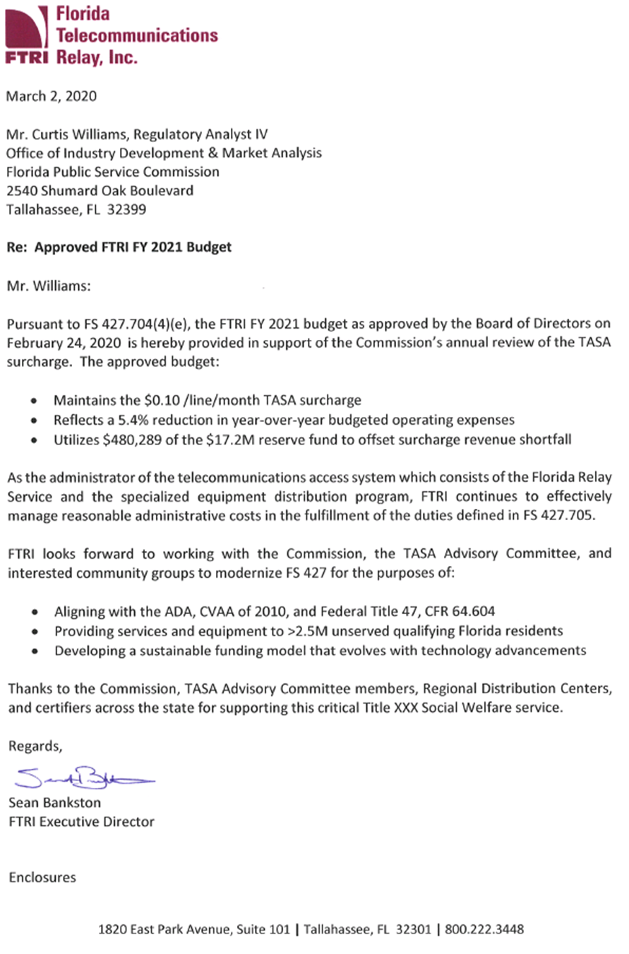
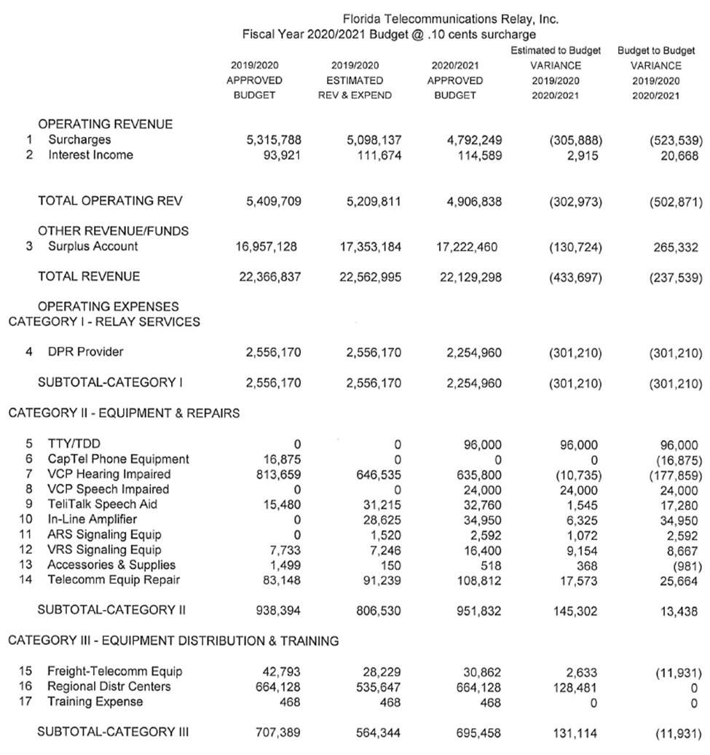

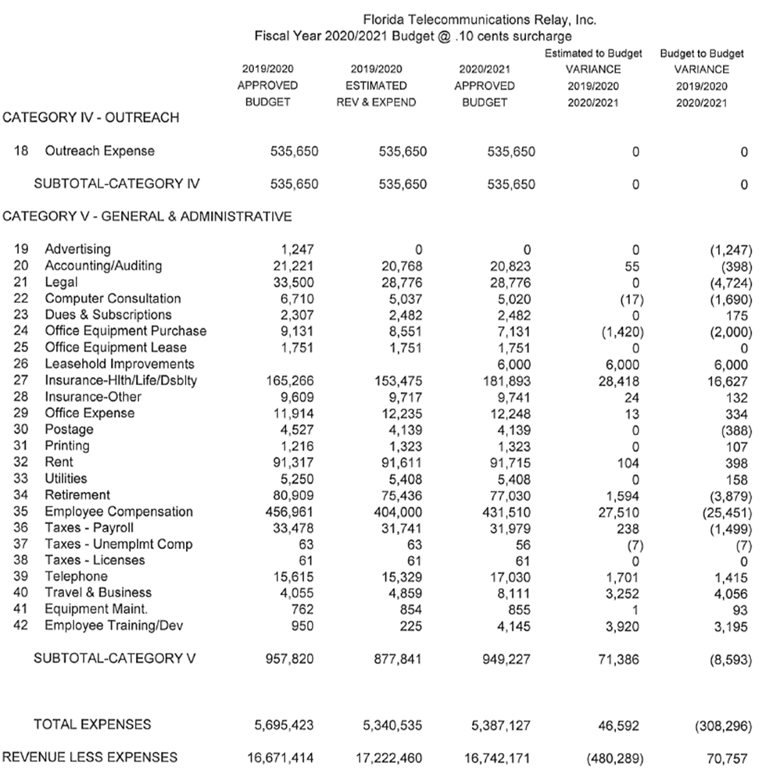

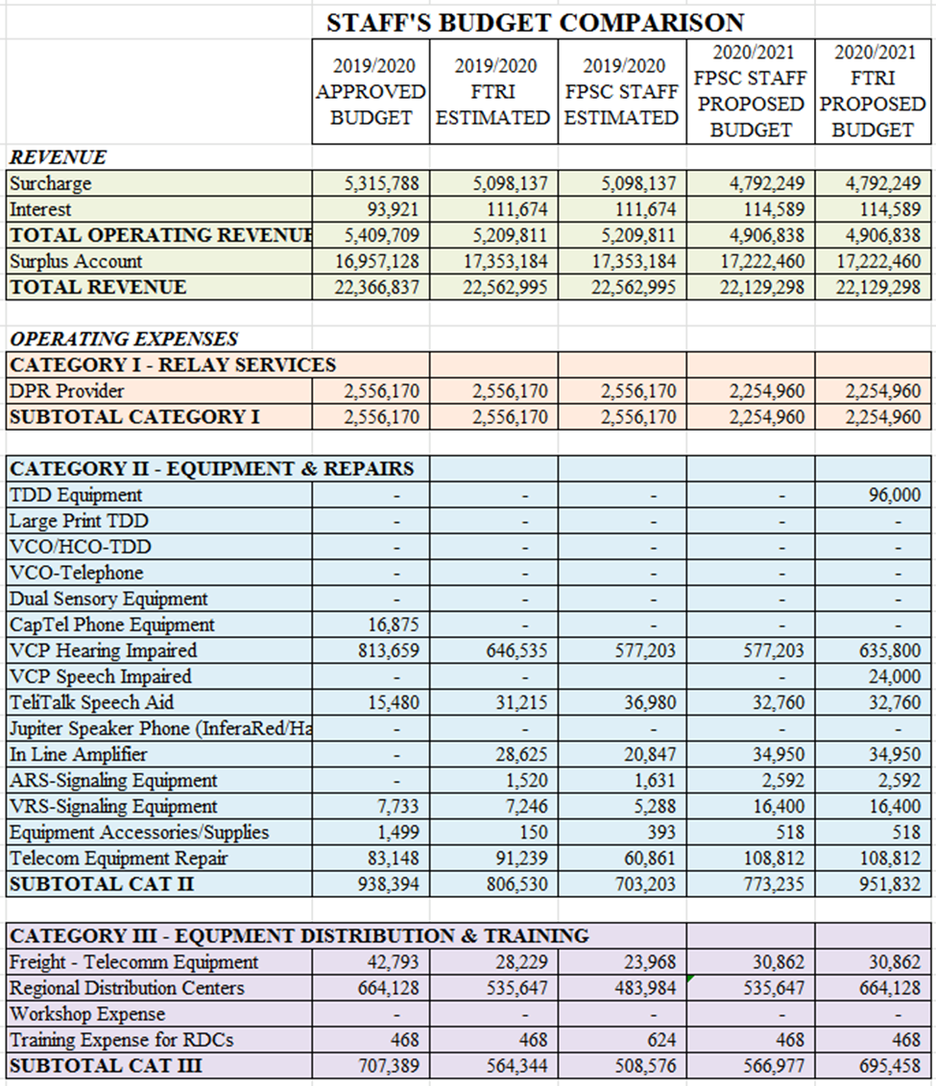

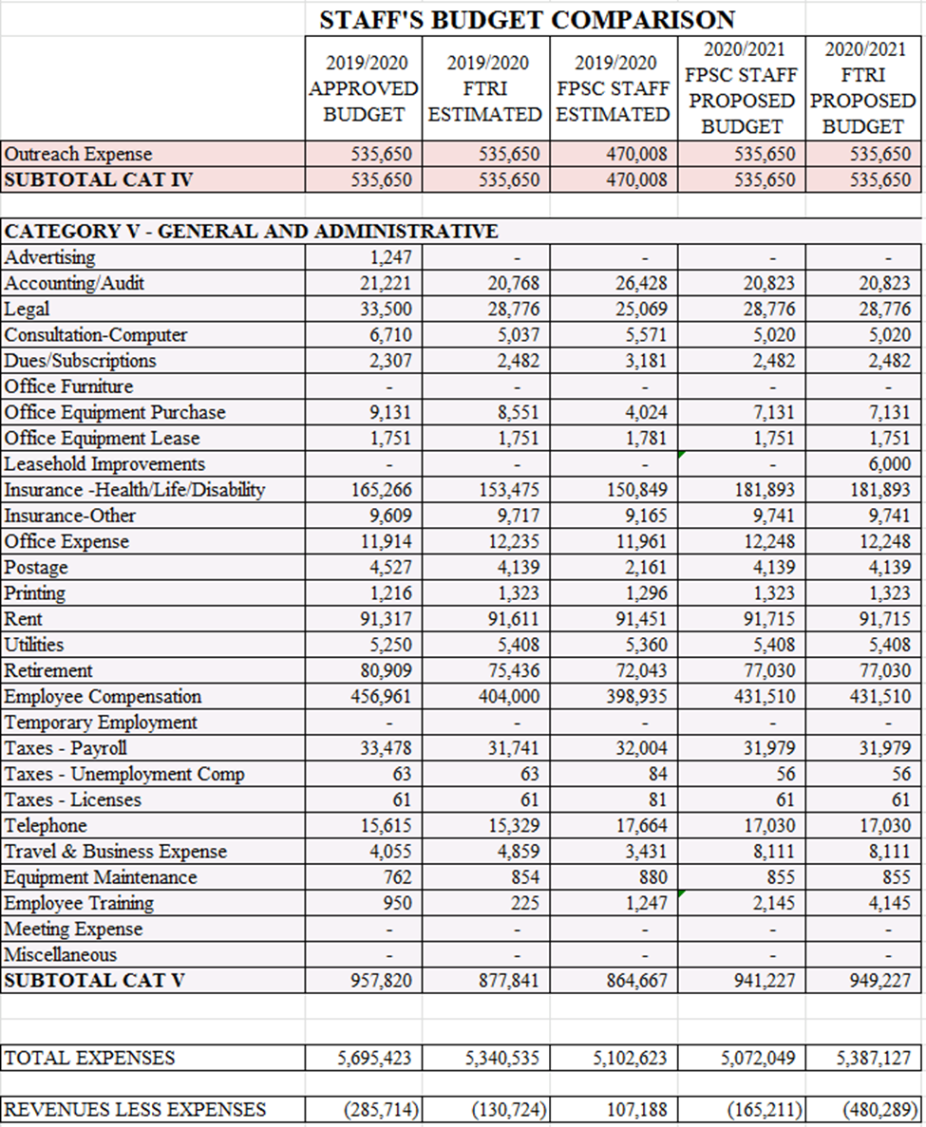

Order No. 24581, issued May 24, 1991, Docket No. 910496-TP.
IP Relay allows people who have difficulty hearing or speaking to communicate using a computer and the Internet, rather than a Text Telephone (TTY) and a telephone line.
VRS enables persons with hearing disabilities who use American Sign Language to communicate with voice telephone users through video equipment, rather than through typed text. Video equipment links the VRS user with a TRS operator so that the VRS user and the operator can see and communicate with each other in signed conversation.
A CapTel telephone is a telephone that displays real-time captions of a conversation.
IP captioned telephone service allows the user to simultaneously listen to and read the text of what the other party in a telephone conversation has said, where the connection carrying the captions between the service and the user is via an IP addressed and routed link.
STS relay service utilizes a specially trained Communications Assistant who understands the speech patterns of persons with speech disabilities and can repeat the words spoken by such an individual to the other party to the call. IP STS uses the Internet, rather than the public switched telephone network, to connect the consumer to the relay provider.
Wireless services offer applications such as text, instant messaging, and Facetime.
The Federal Communication Commission (FCC) could mandate state funding of Video Relay Service, Internet Protocol Relay Service, and Internet Protocol Captioned Telephone Service. It is estimated that at a minimum $32 million would be needed to adequately fund the state program. On June 8, 2018, in CG Docket No. 13-24 and CG Docket No. 03-123, the FCC released a Report and Order, Declaratory Ruling, Further Notice of Proposed Rulemaking, and Notice of Inquiry addressing, in part, whether state relay programs should be allowed or required to administer Internet Protocol Relay Service. Staff notes if this FCC action occurs, a change in state law may be required for the FPSC to implement. https://docs.fcc.gov/public/attachments/FCC-18-79A1.pdf

