State of Florida |  | Public Service Commission  Capital Circle Office Center ● 2540 Shumard Oak Boulevard  Tallahassee, Florida 32399-0850  -M-E-M-O-R-A-N-D-U-M-
DATE: | May 28, 2020
TO: | Office of Commission Clerk (Teitzman)
FROM: | Division of Engineering (M. Watts, K. Johnson, Ramos)  Office of the General Counsel (Lherisson)
RE: | Docket No. 20200012-WS – Application for amendment of Certificates 669-W and 571-S to delete territory in Sumter County, by South Sumter Utility Company, LLC.
AGENDA: | 06/09/20 – Regular Agenda – Interested Persons May Participate
COMMISSIONERS ASSIGNED: |  |  | All Commissioners
PREHEARING OFFICER: |  |  | Graham
CRITICAL DATES: |  |  | None
SPECIAL INSTRUCTIONS: |  |  | None

Case Background

South Sumter Utility Company, LLC (SSU or Utility) is a Class C utility which provides service in Sumter County to approximately 1,854 water and wastewater customers. The Utility is in the Southwest Florida Management District and is not in a water use caution area. In its 2018 Annual Report, the Utility reported operating revenues of $3,220 for water and $4,136 for wastewater, and a net operating loss of $218,749 for water and $226,407 for wastewater.

On January 8, 2020, pursuant to Section 367.045, Florida Statutes (F.S.), the Utility applied for an amendment to delete part of its service territory from Certificate Nos. 669-W and 571-S. The Utility does not currently provide water or wastewater service to this area. The Utility requested this territory be deleted from the service area because of the separation by the Florida Turnpike and the related difficulty in extending service to the area. For these reasons, SSU believes it is not the best alternative for water and wastewater service to the area. The Commission has jurisdiction pursuant to Section 367.045, F.S.

Discussion of Issues

Issue 1:
Should the Commission approve SSU’s application for amendment of Certificate Nos. 669-W and 571-S to delete territory from its certificated service area in Sumter County?

Recommendation:
Yes. The Commission should approve the application filed by SSU to delete territory, as reflected on Attachment A, from its certificated service area, effective the day of the Commission’s vote. The resultant order should serve as SSU’s amended certificate and should be retained by the Utility. (M. Watts)

Staff Analysis:
As stated, on January 8, 2020, SSU applied for an amendment to delete a portion of its certificated area. The area proposed to be deleted (deletion area) is currently undeveloped.
The deletion area is planned to be developed to serve approximately 1,161 equivalent residential connections. However, the deletion area is separated from adjacent SSU territory by Florida’s Turnpike. SSU stated in its application that the reason for the proposed deletion is the difficulty in extending service across Florida’s Turnpike. In response to staff’s first data request, SSU stated that a newly created water and wastewater service provider, Gibson Place Utility Company, LLC (Gibson), is the best alternative to provide water and wastewater service to the deletion area. Staff has been advised that Gibson, which is affiliated with the Villages, plans to file an application for original water and wastewater certificates to serve territory that will include the territory being deleted from SSU’s certificated territory.

An adequate service territory map and a territory description have been provided as prescribed by Rule 25-30.036(4)(e) and (g), Florida Administrative Code (F.A.C.). A description of the territory requested to be deleted by the Utility is appended to this recommendation as Attachment A. The Utility submitted an affidavit with its January 8, 2020, application consistent with Rule 25-30.036(4)(k), F.A.C., stating that it has tariffs and annual reports on file with the Commission. Within its application, the Utility indicated it had filed its 2018 Annual Report. The Utility has requested an additional extension through June 1, 2020, to file its 2019 Annual Report. In addition, the application contains proof of compliance with the noticing provisions set forth in Rule 25-30.030, F.A.C. No objections to the application have been received and the time for filing such has expired.
Staff recommends that it is in the public interest to approve the application filed by SSU to amend its water certificate to delete the territory shown on Attachment A from its certificated service area. The resultant Commission order should serve as SSU’s amended certificate and should be retained by the Utility.

Issue 2:
Should this docket be closed?

Recommendation:
Yes. If staff’s recommendation in Issue 1 is approved, no further action is required, and the docket should be closed. (Lherisson)

Staff Analysis:
If Issue 1 is approved, no further action is required, and the docket should be closed.

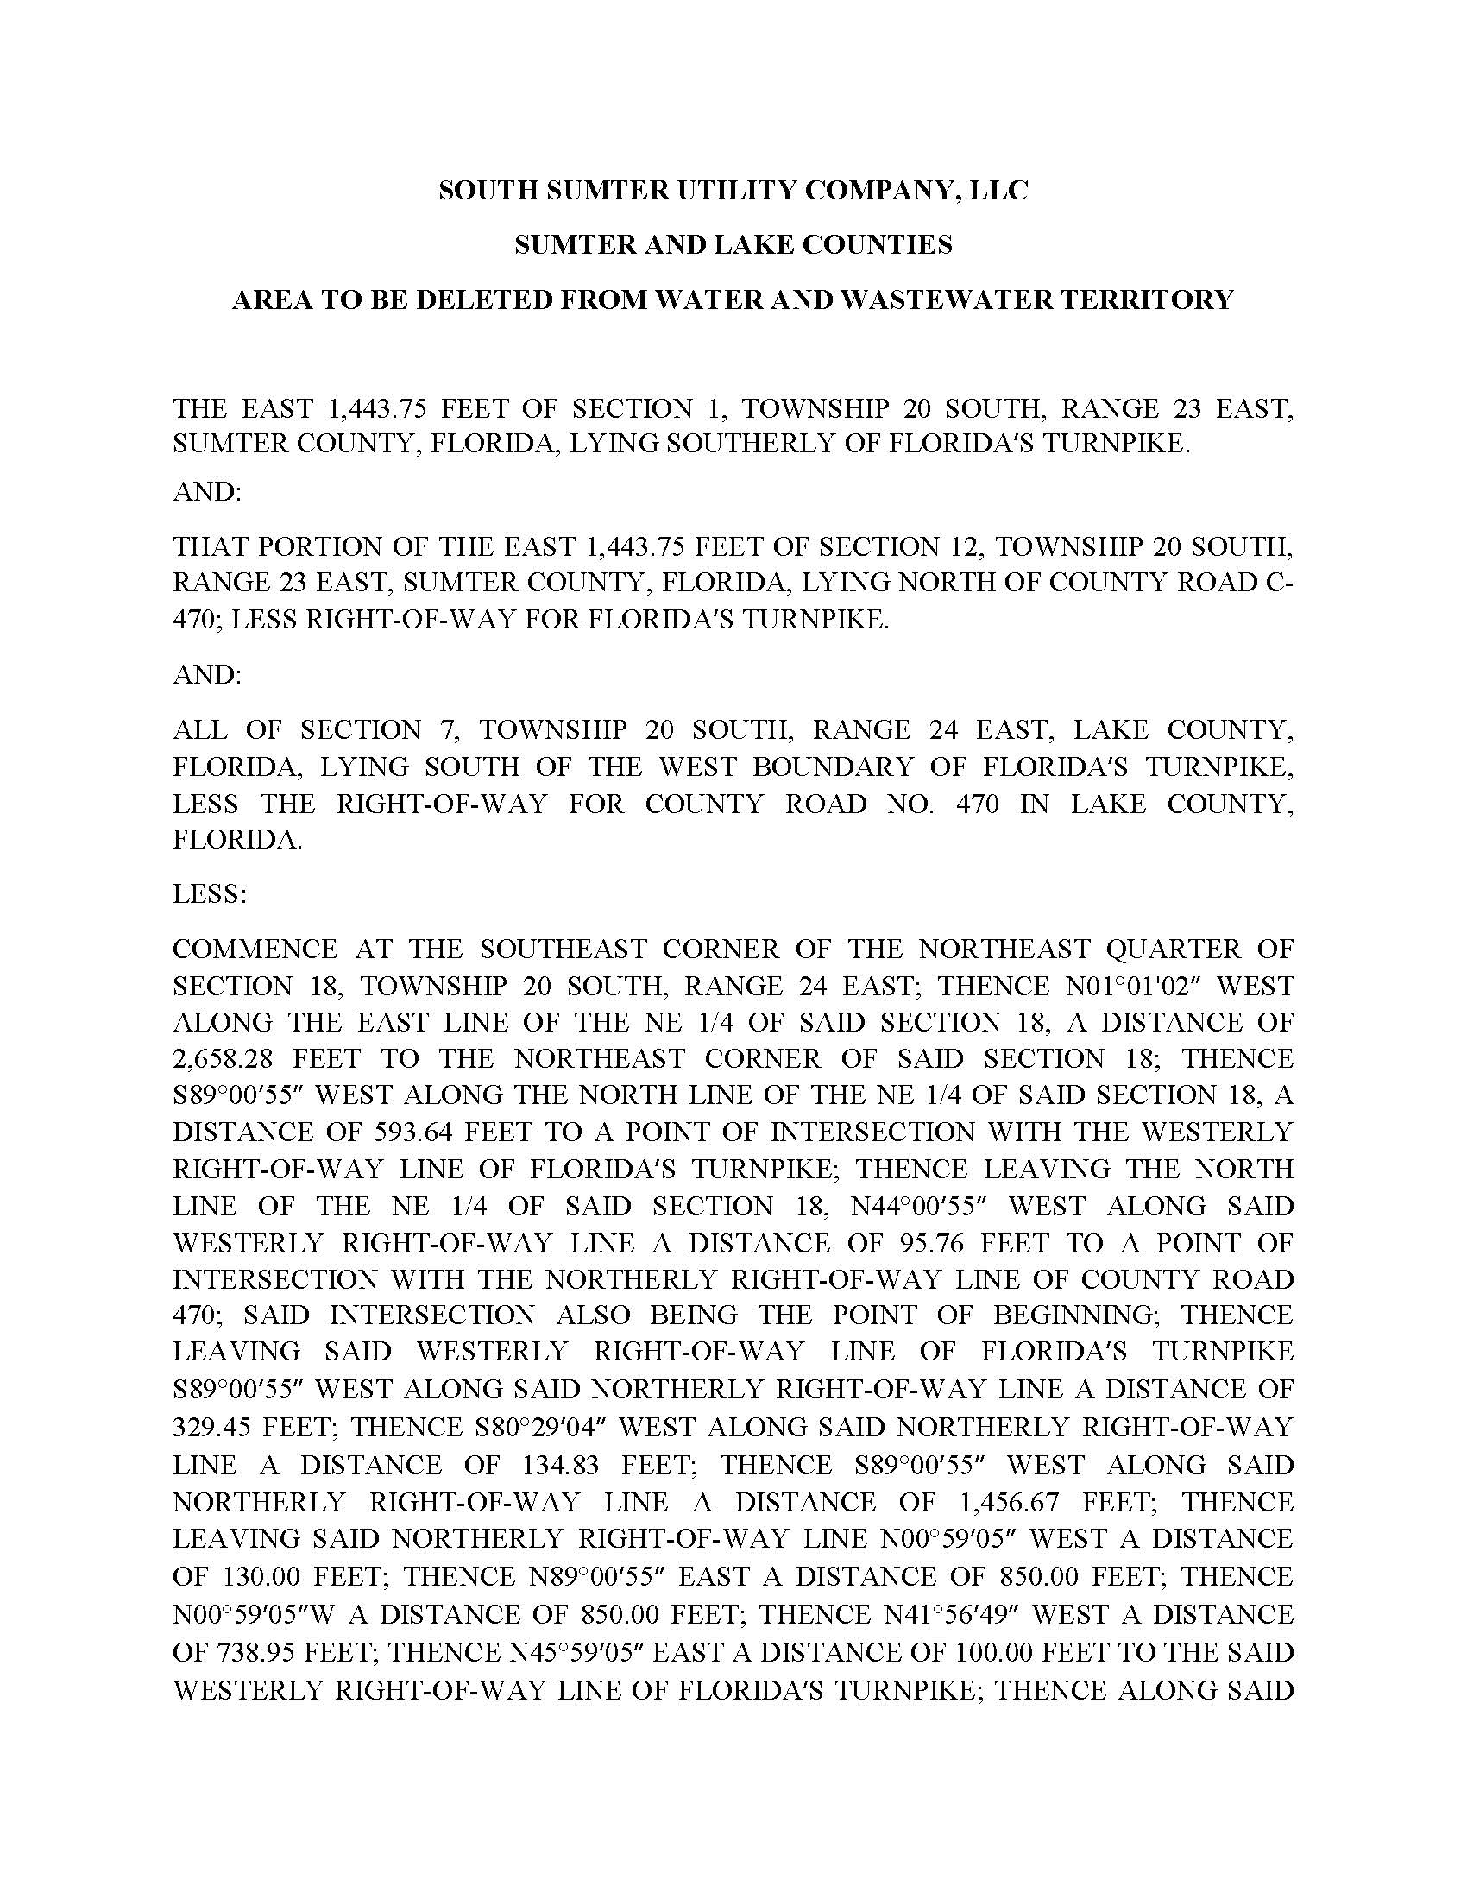

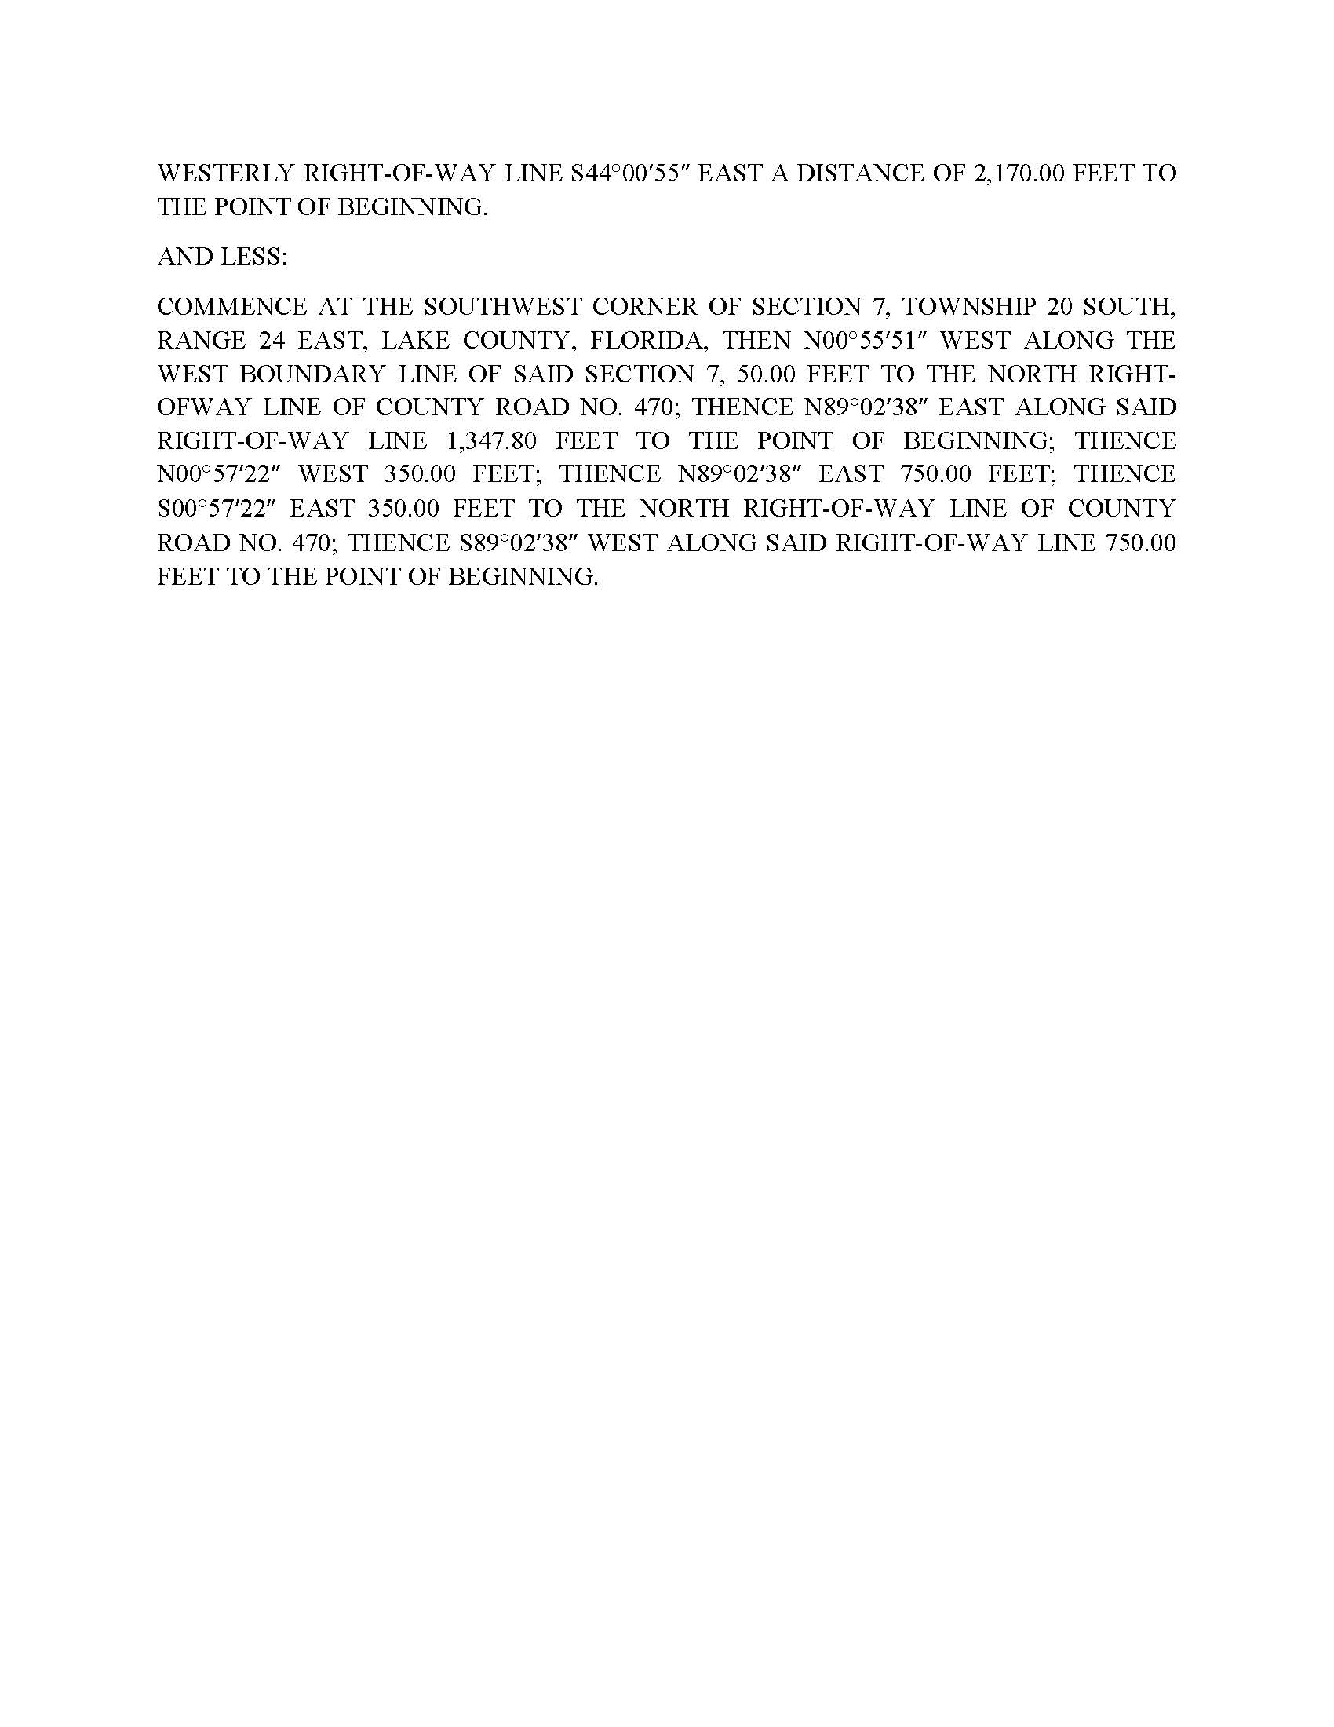

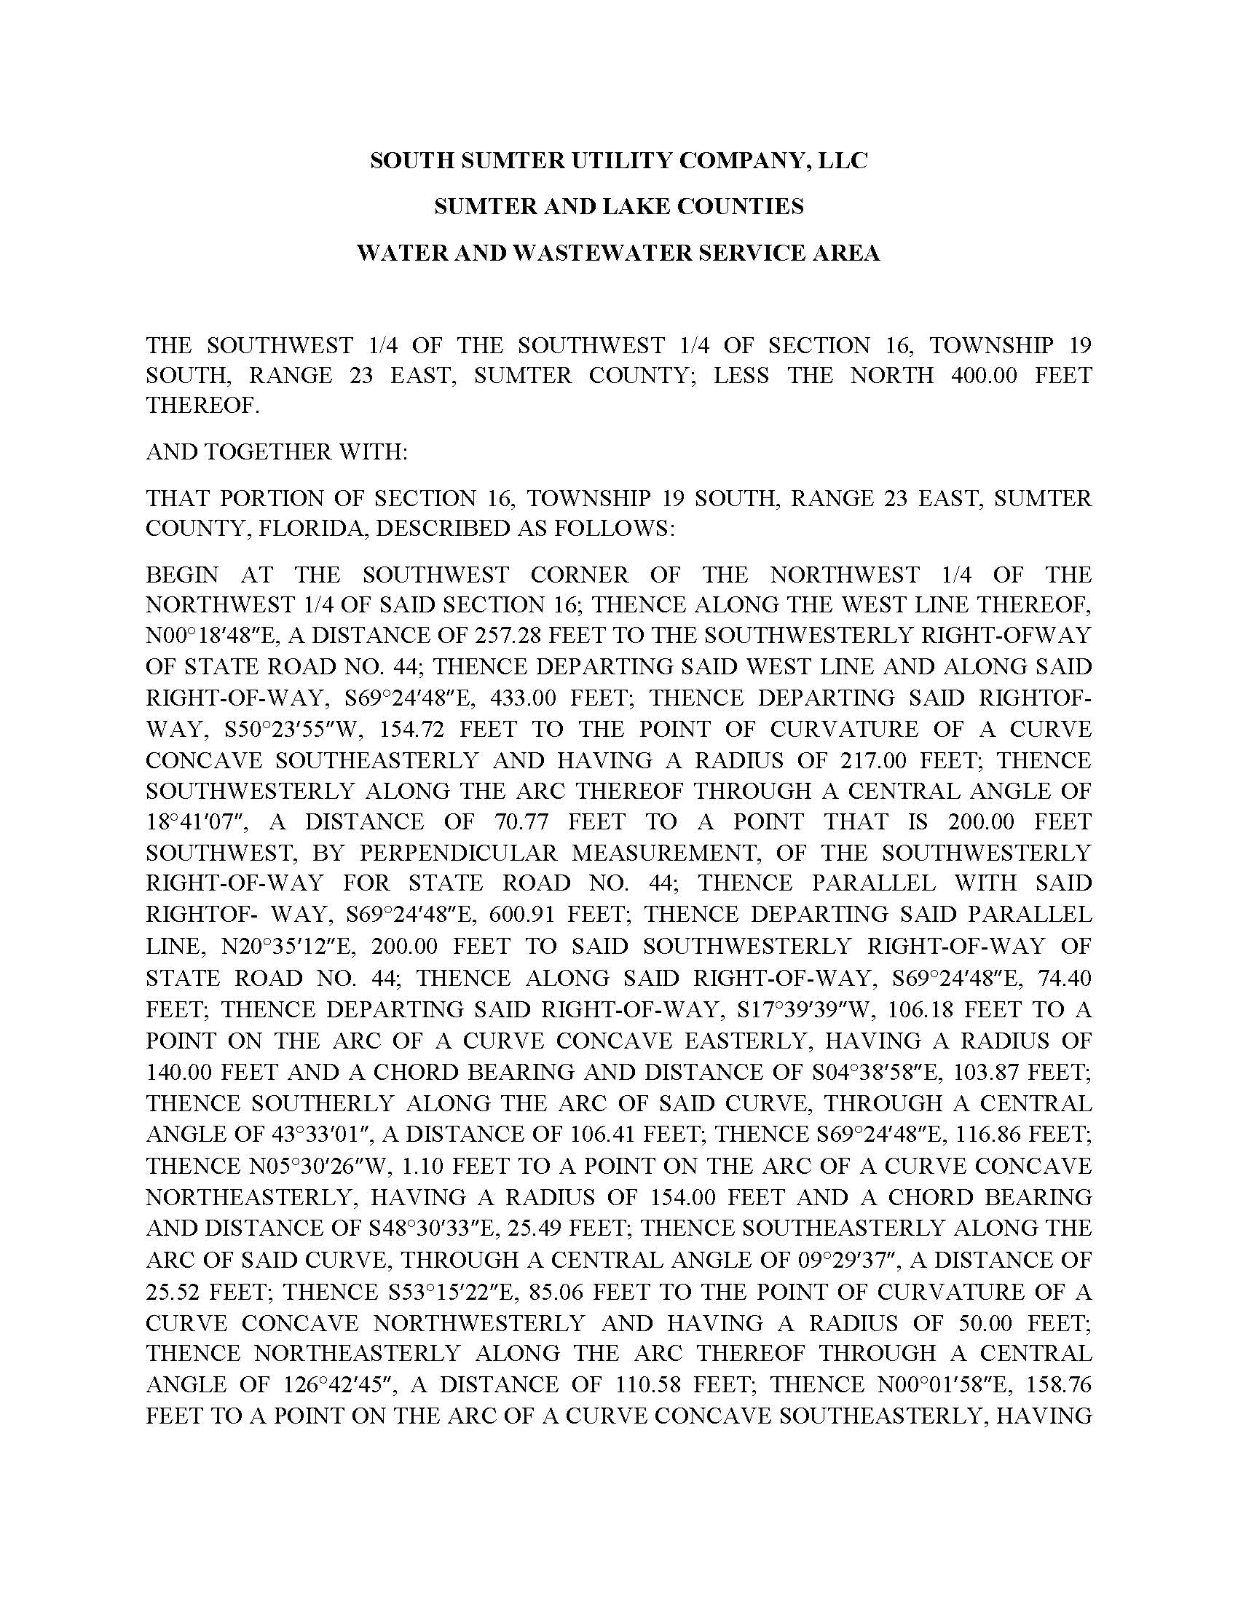

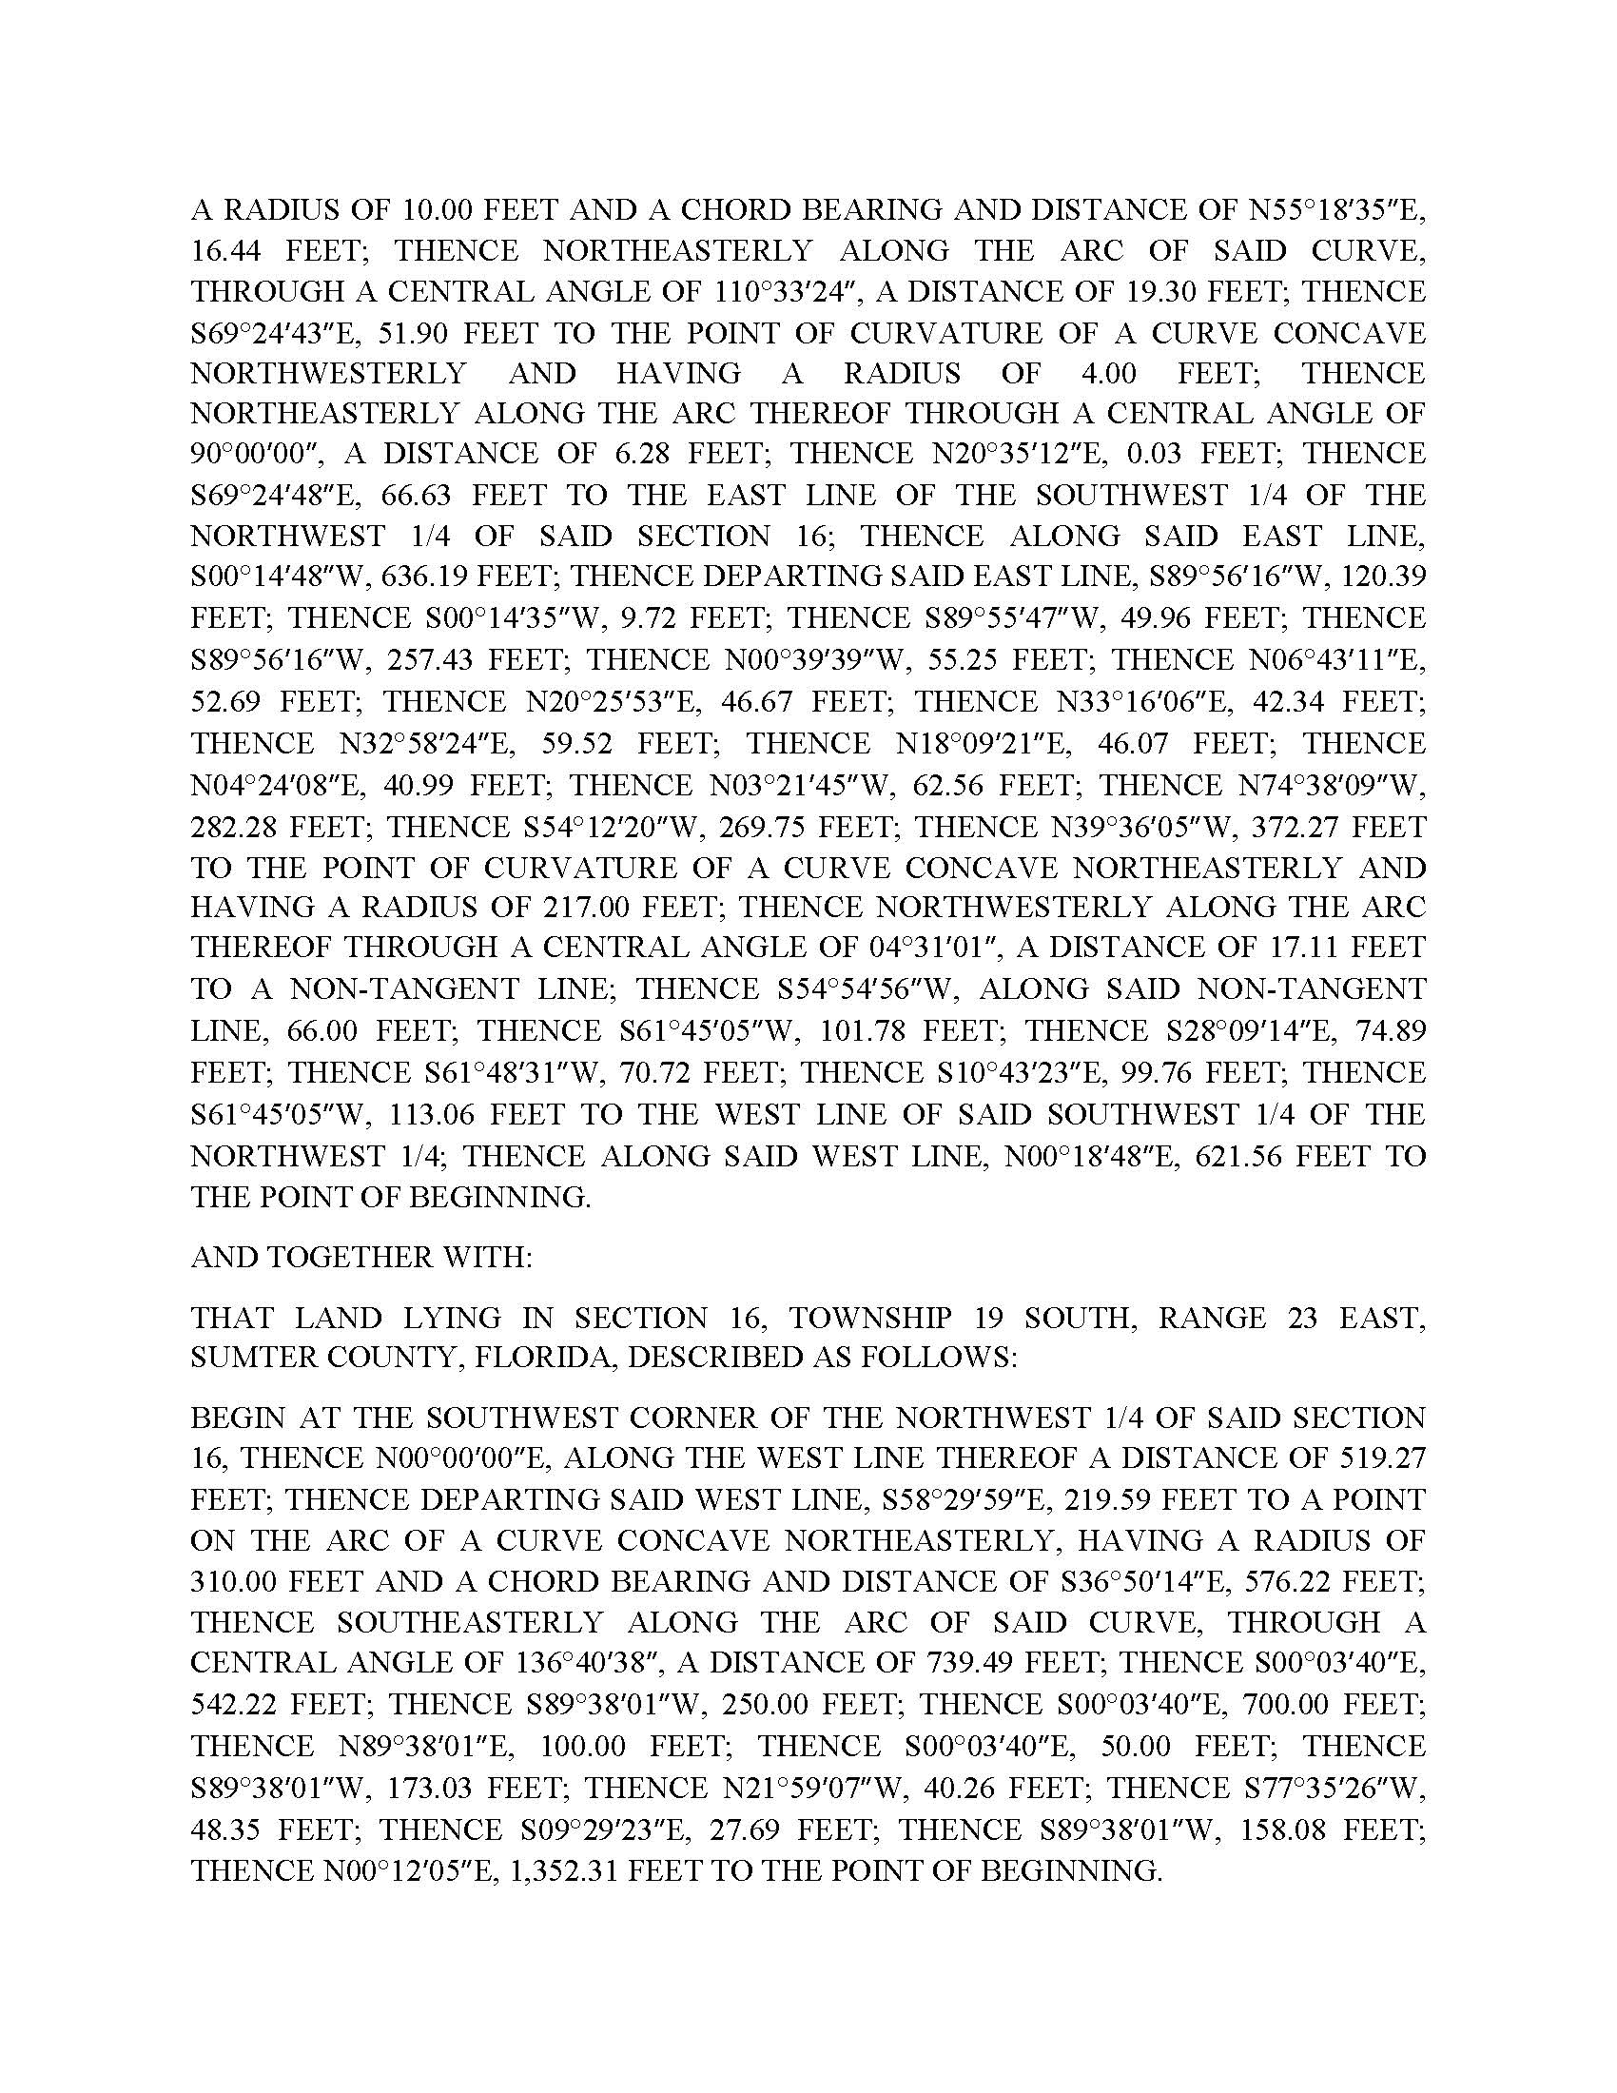

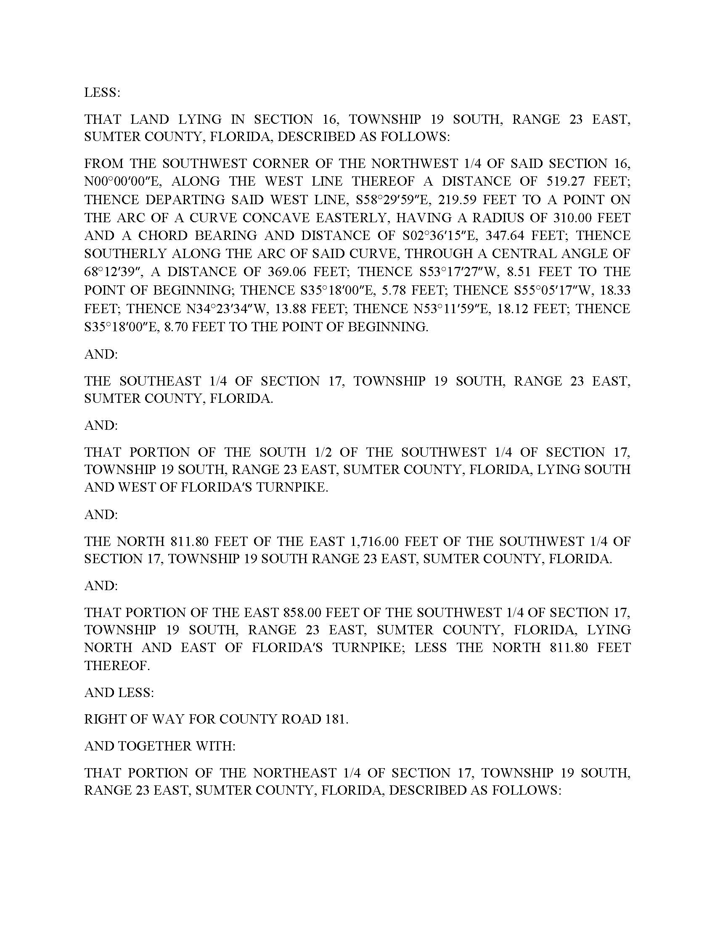

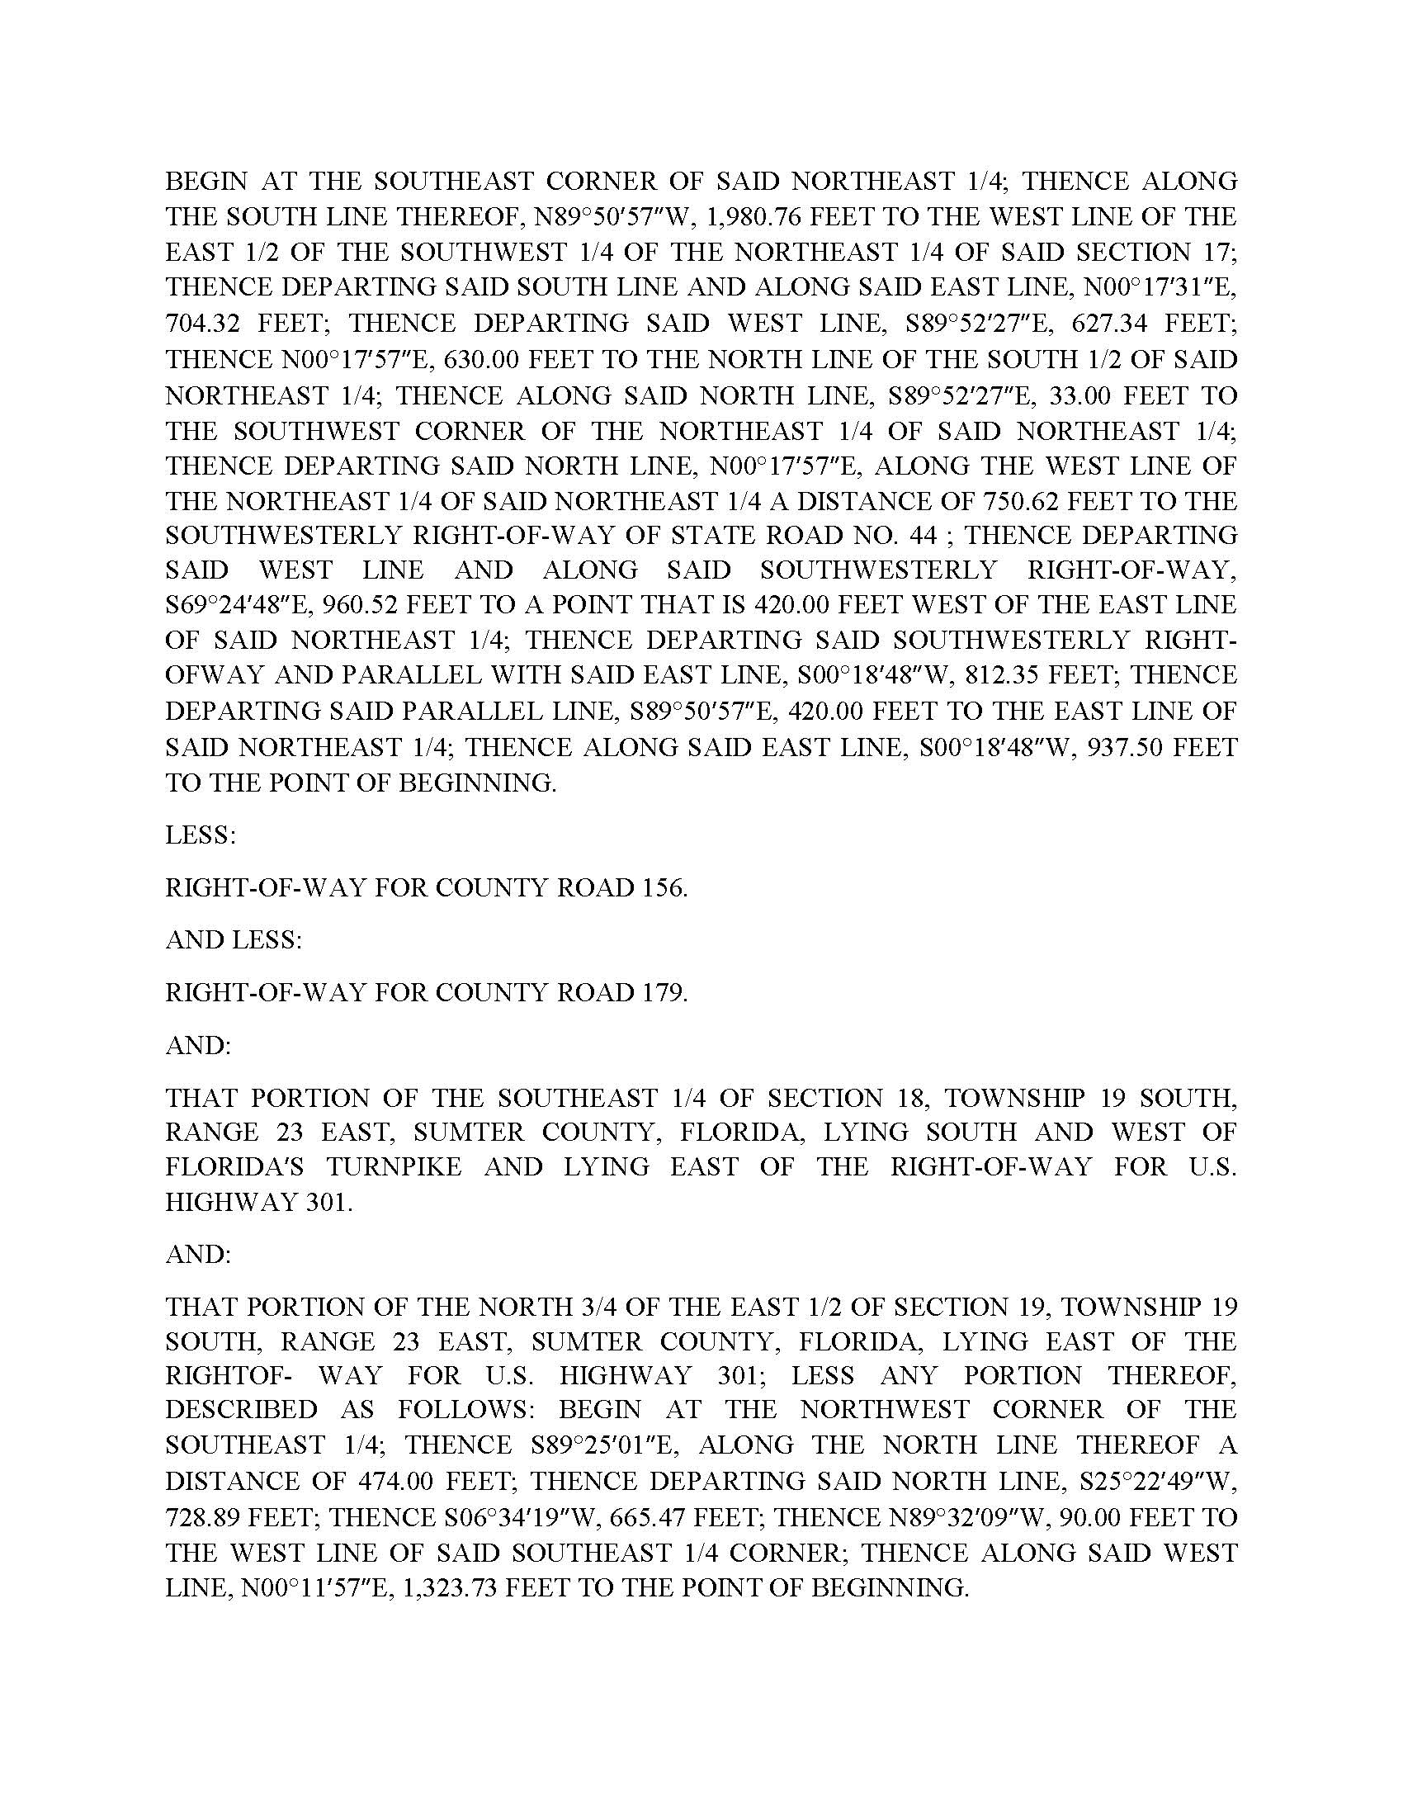

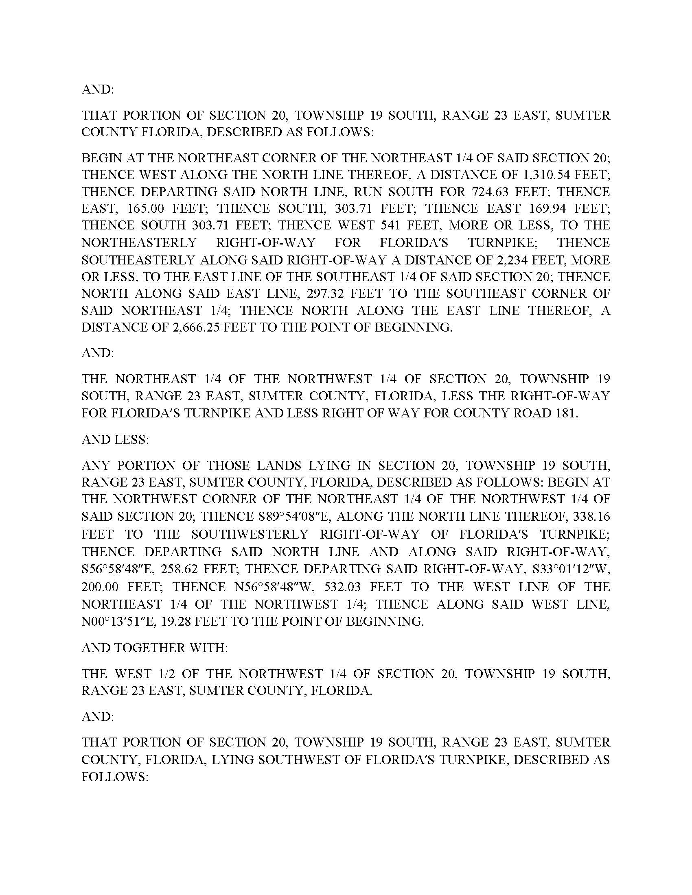

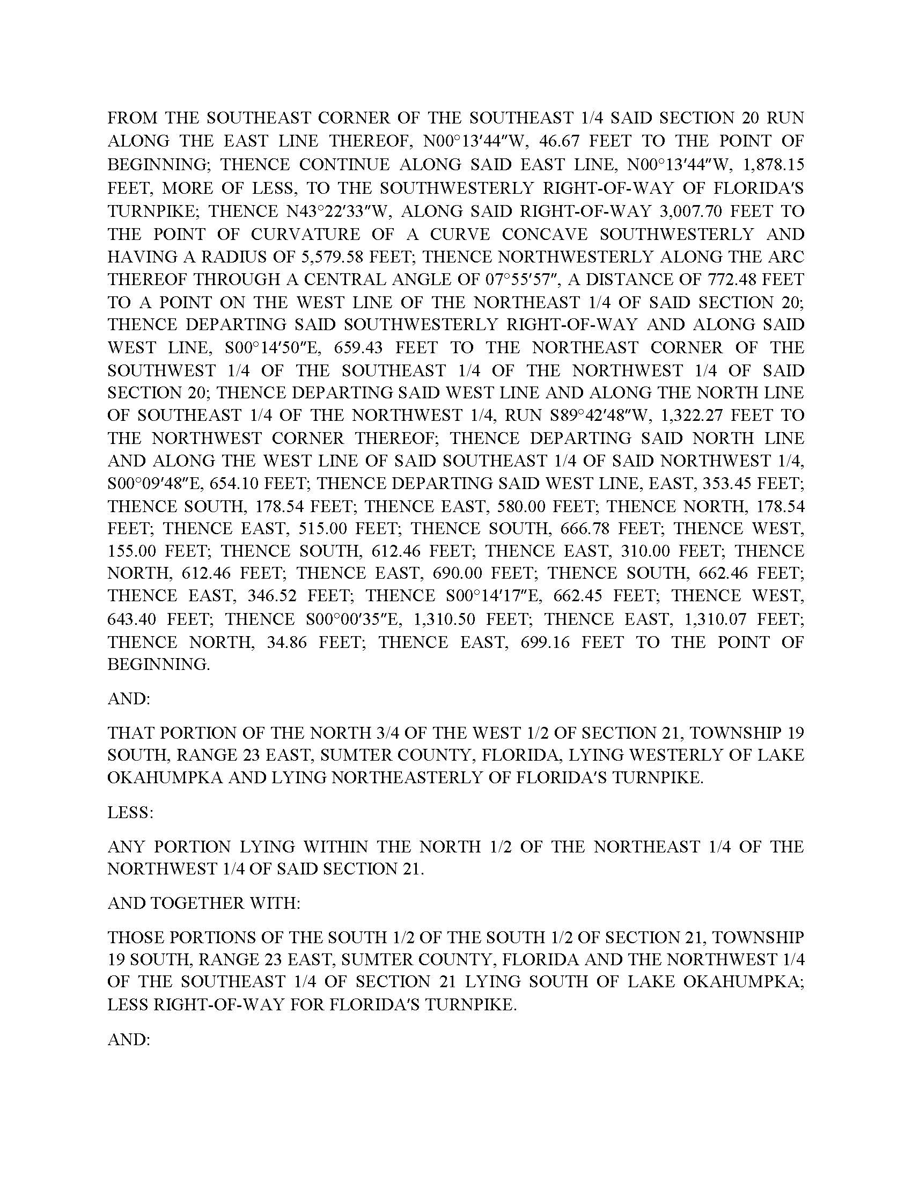

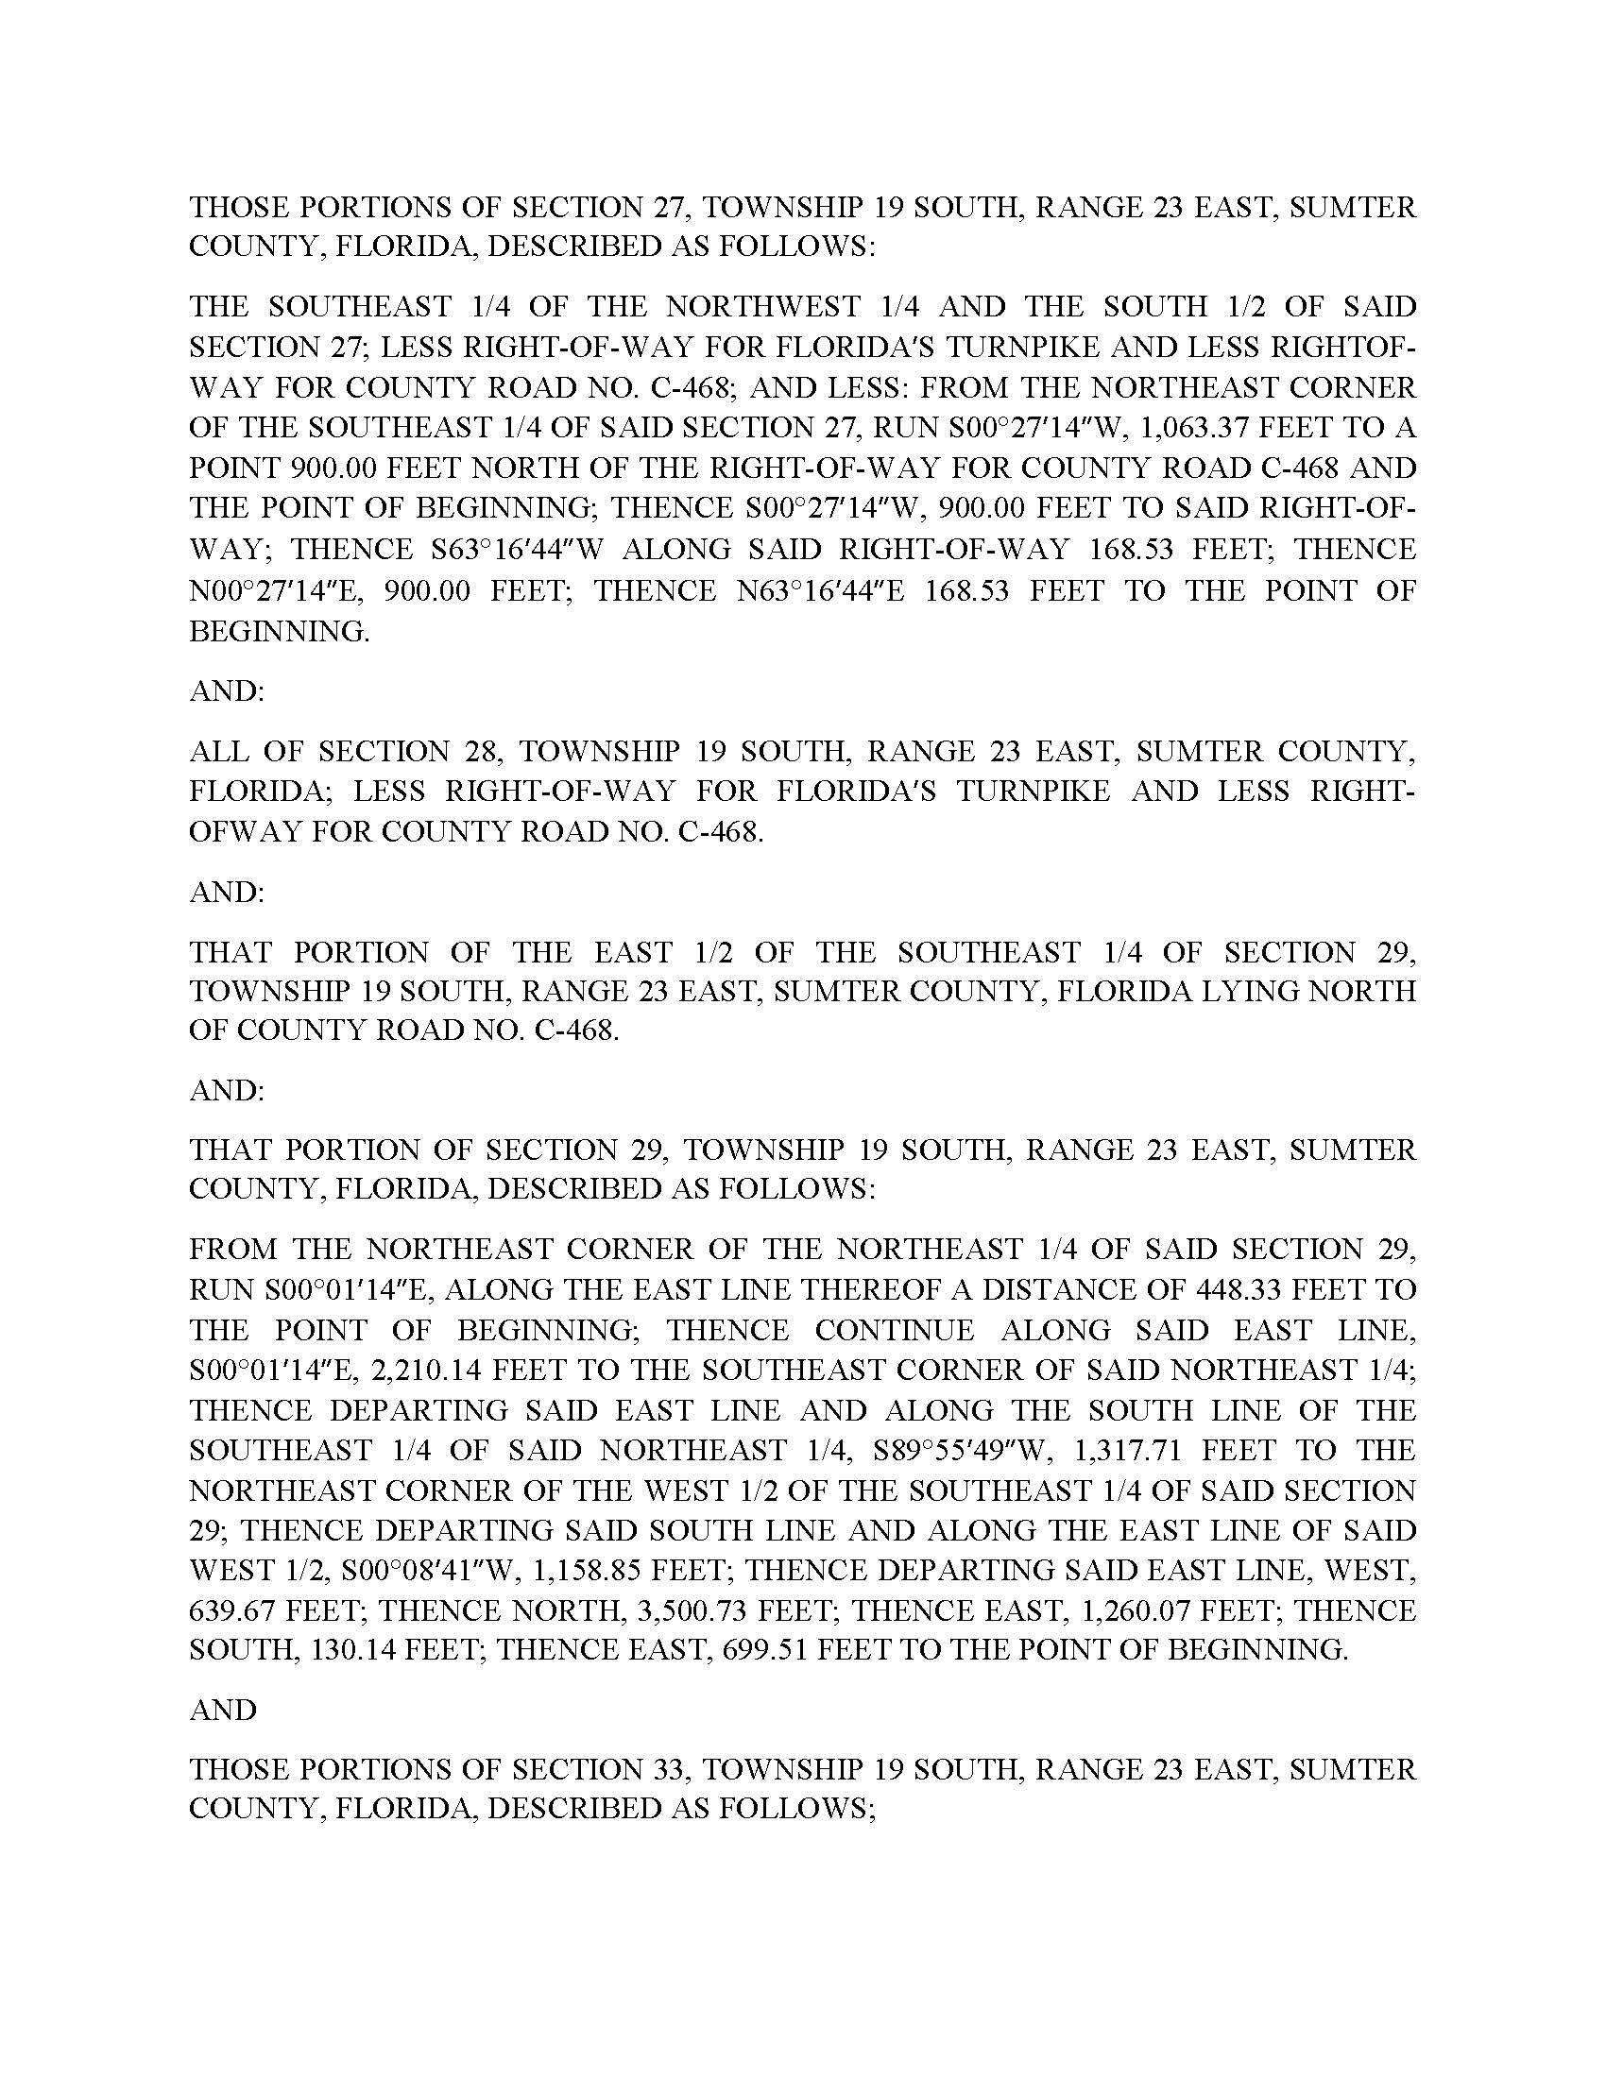

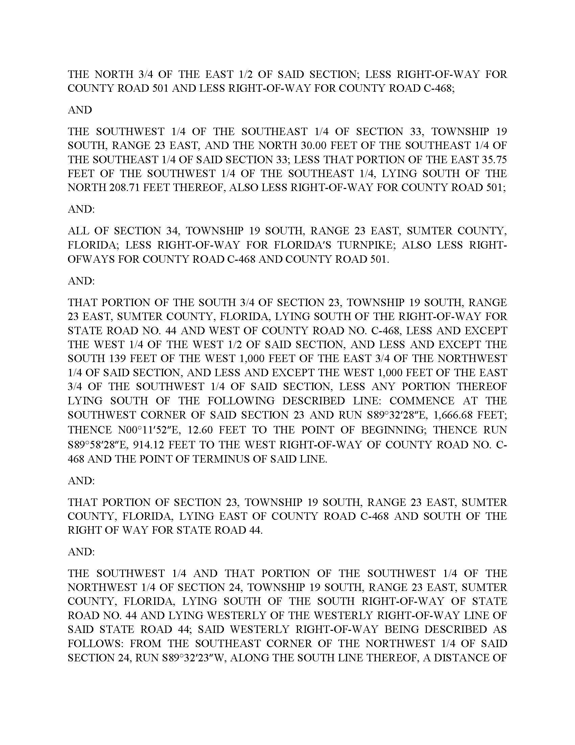

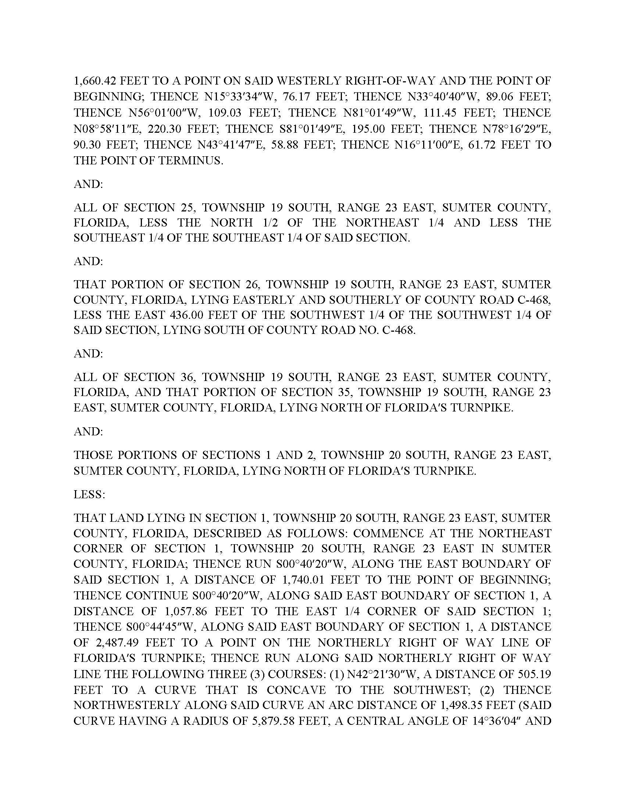

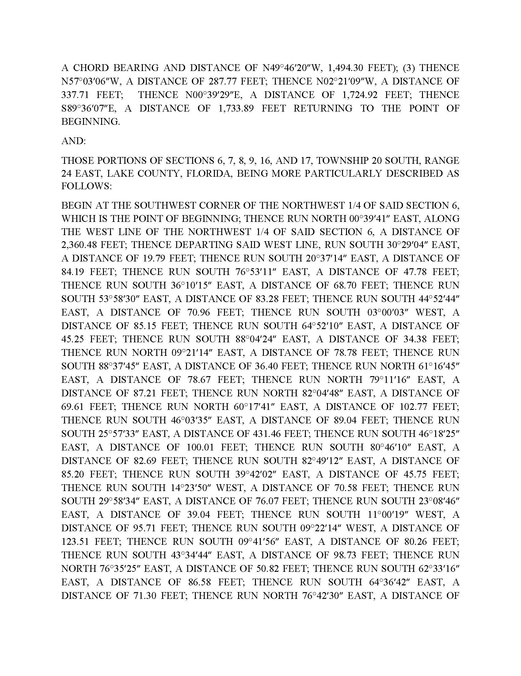

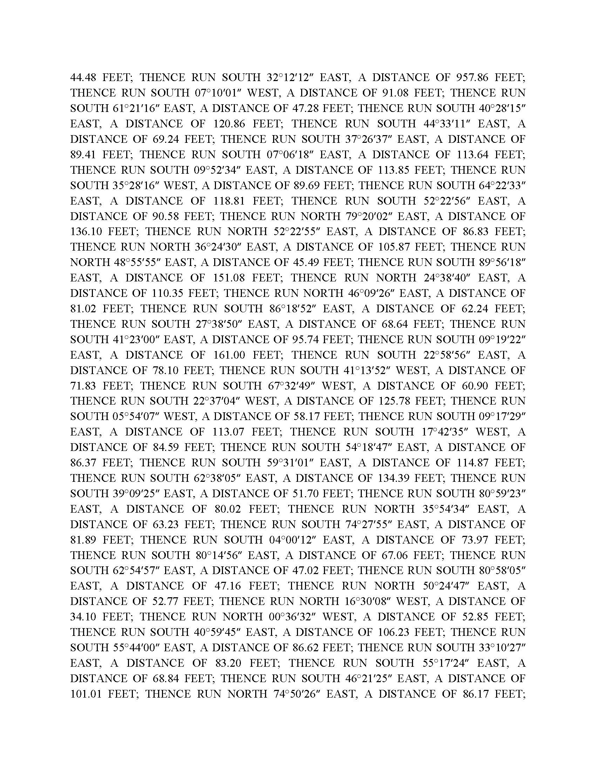

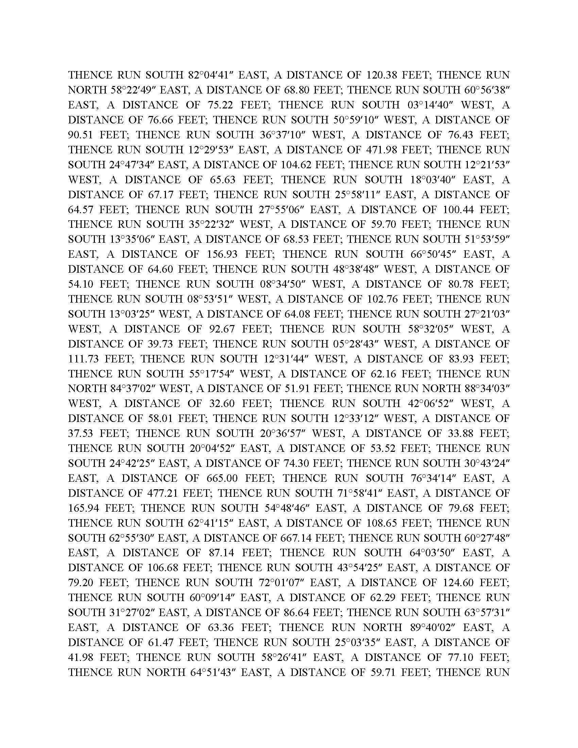

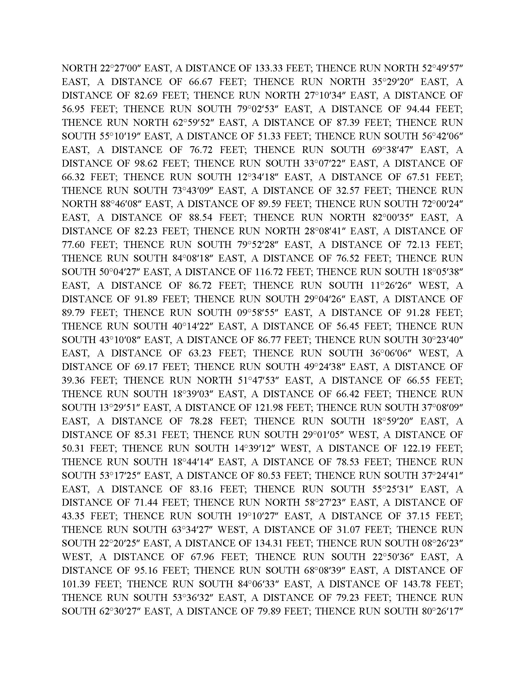

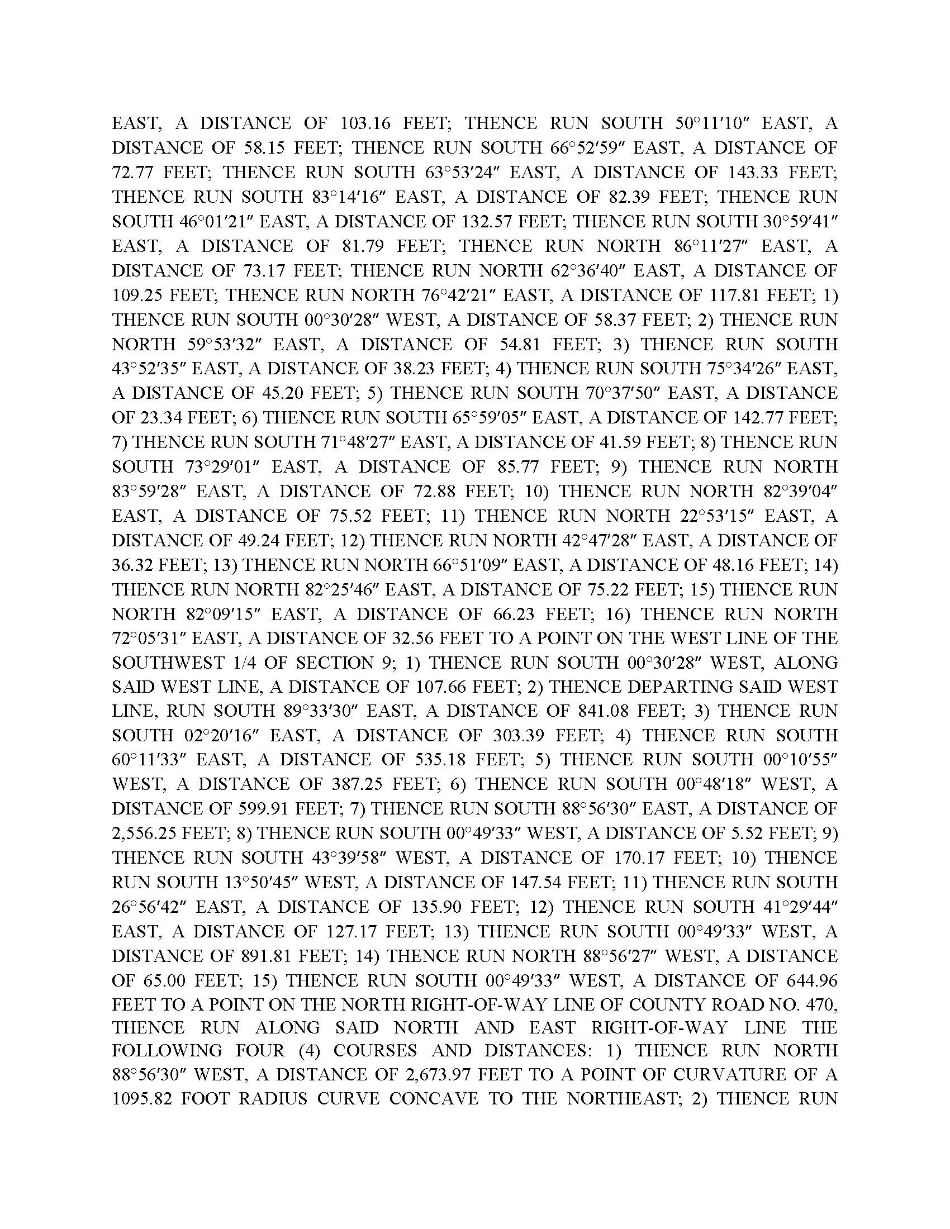

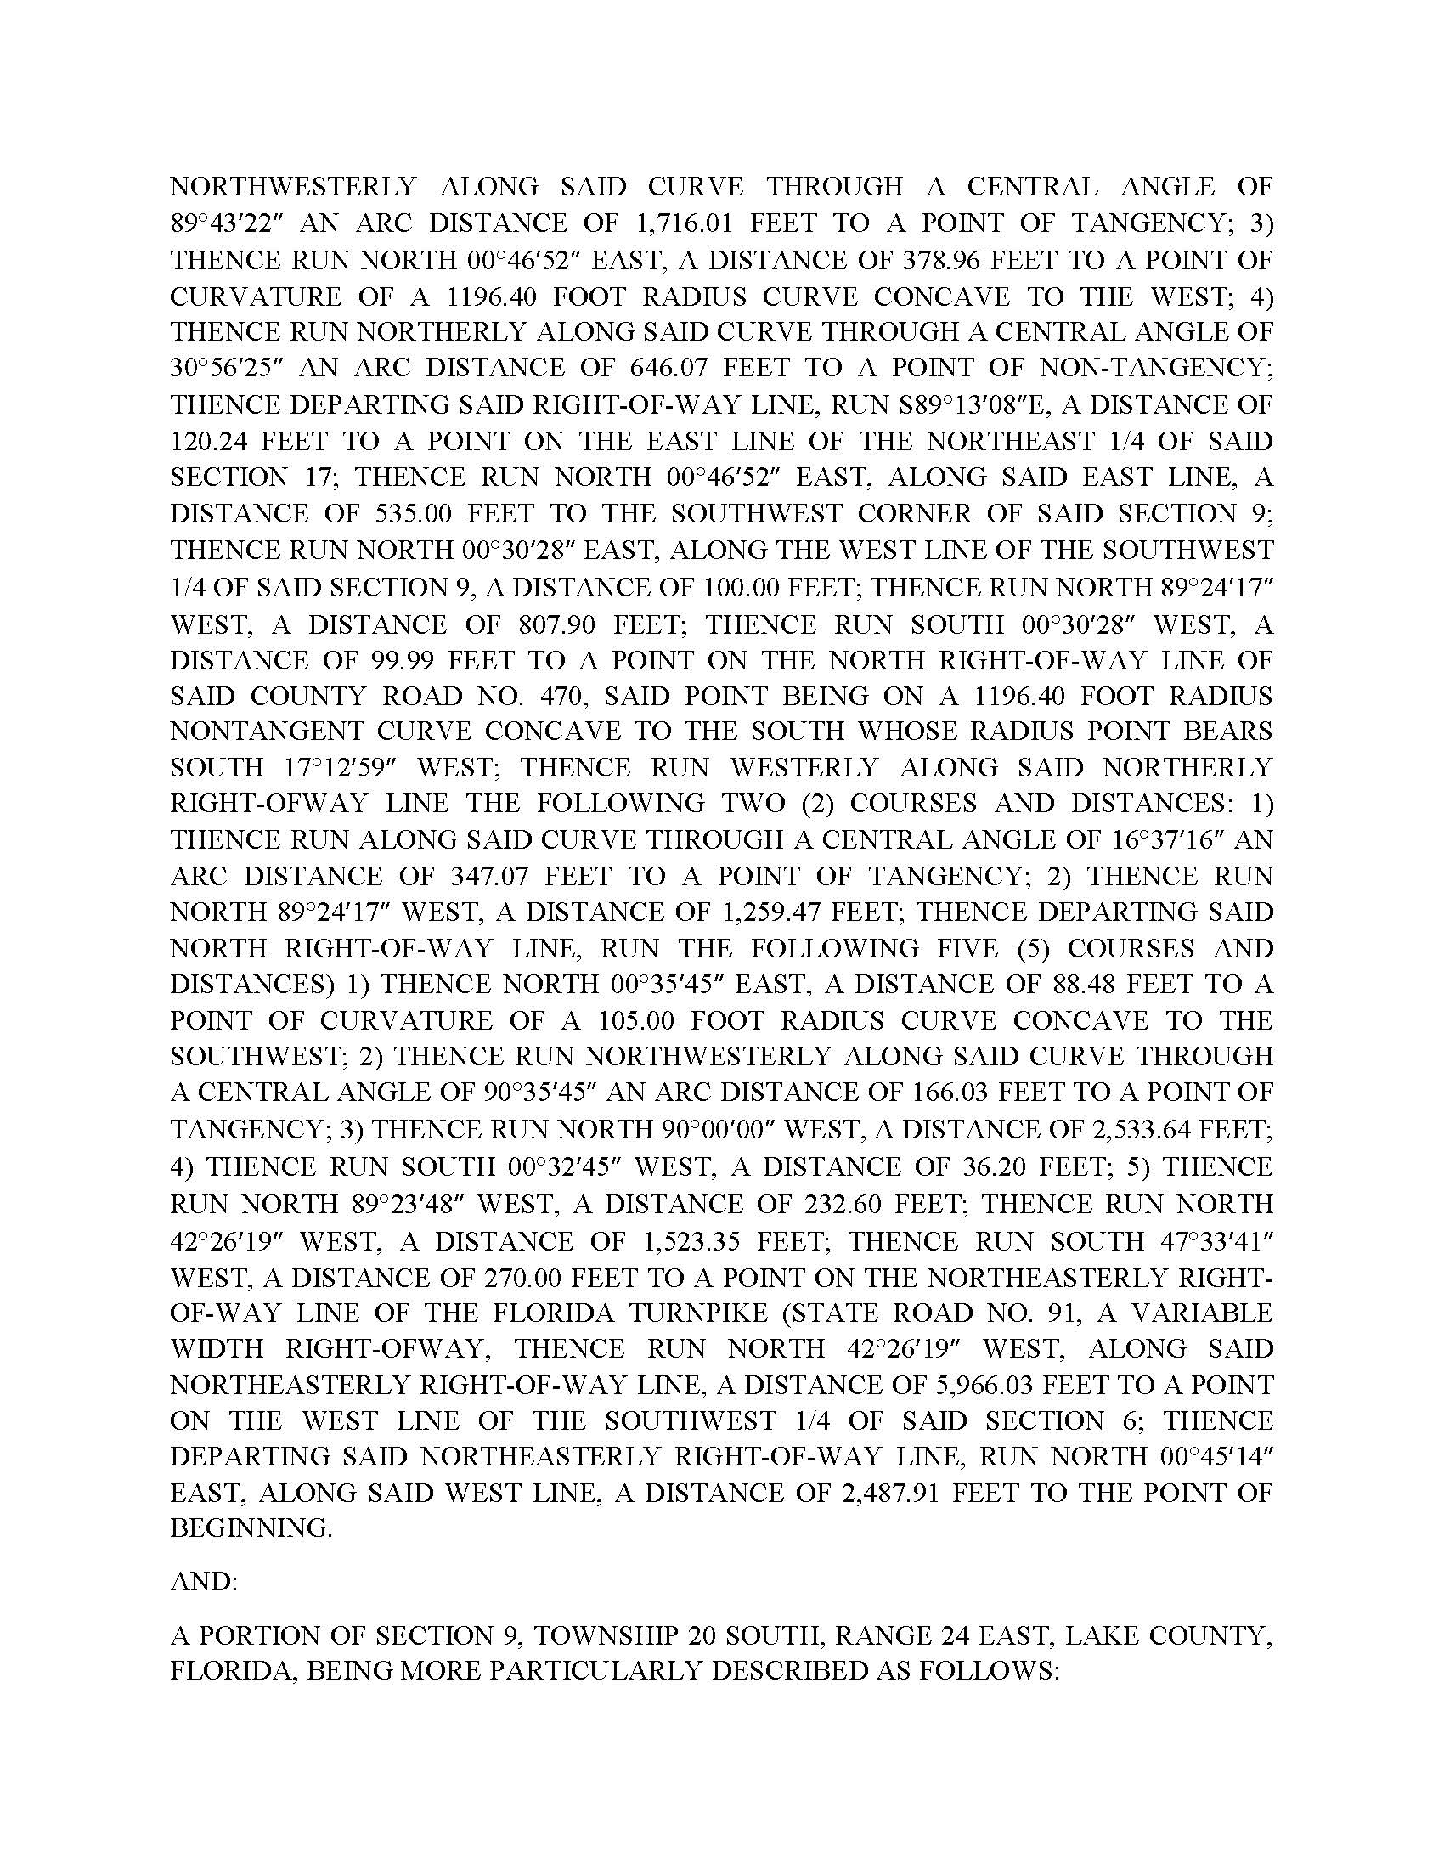

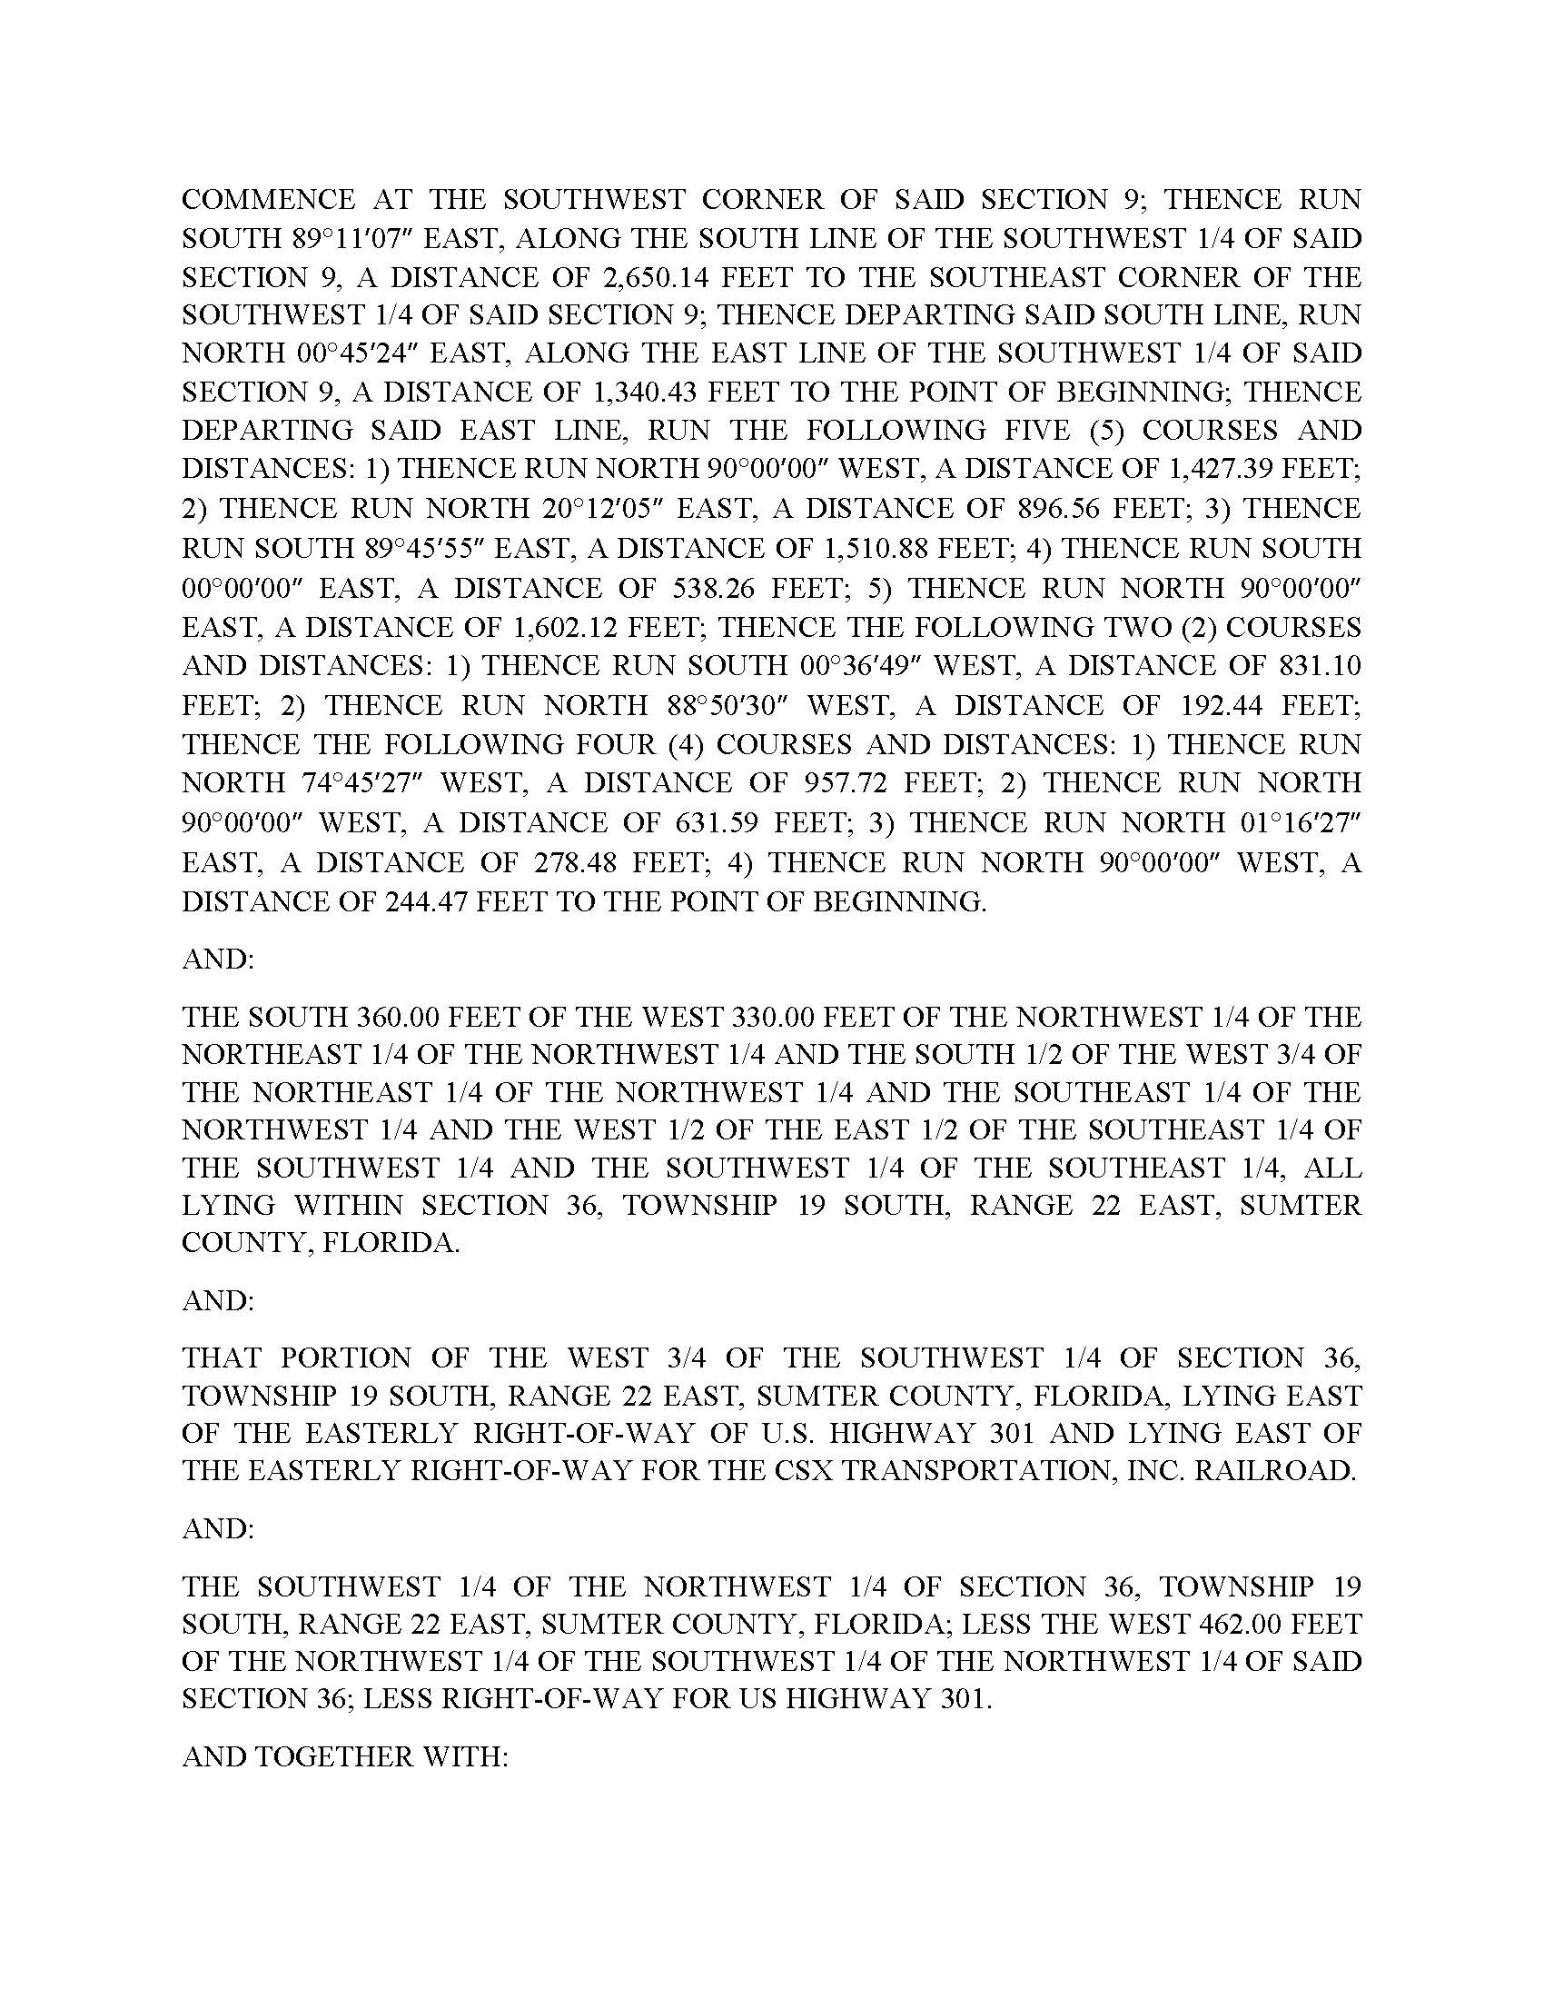

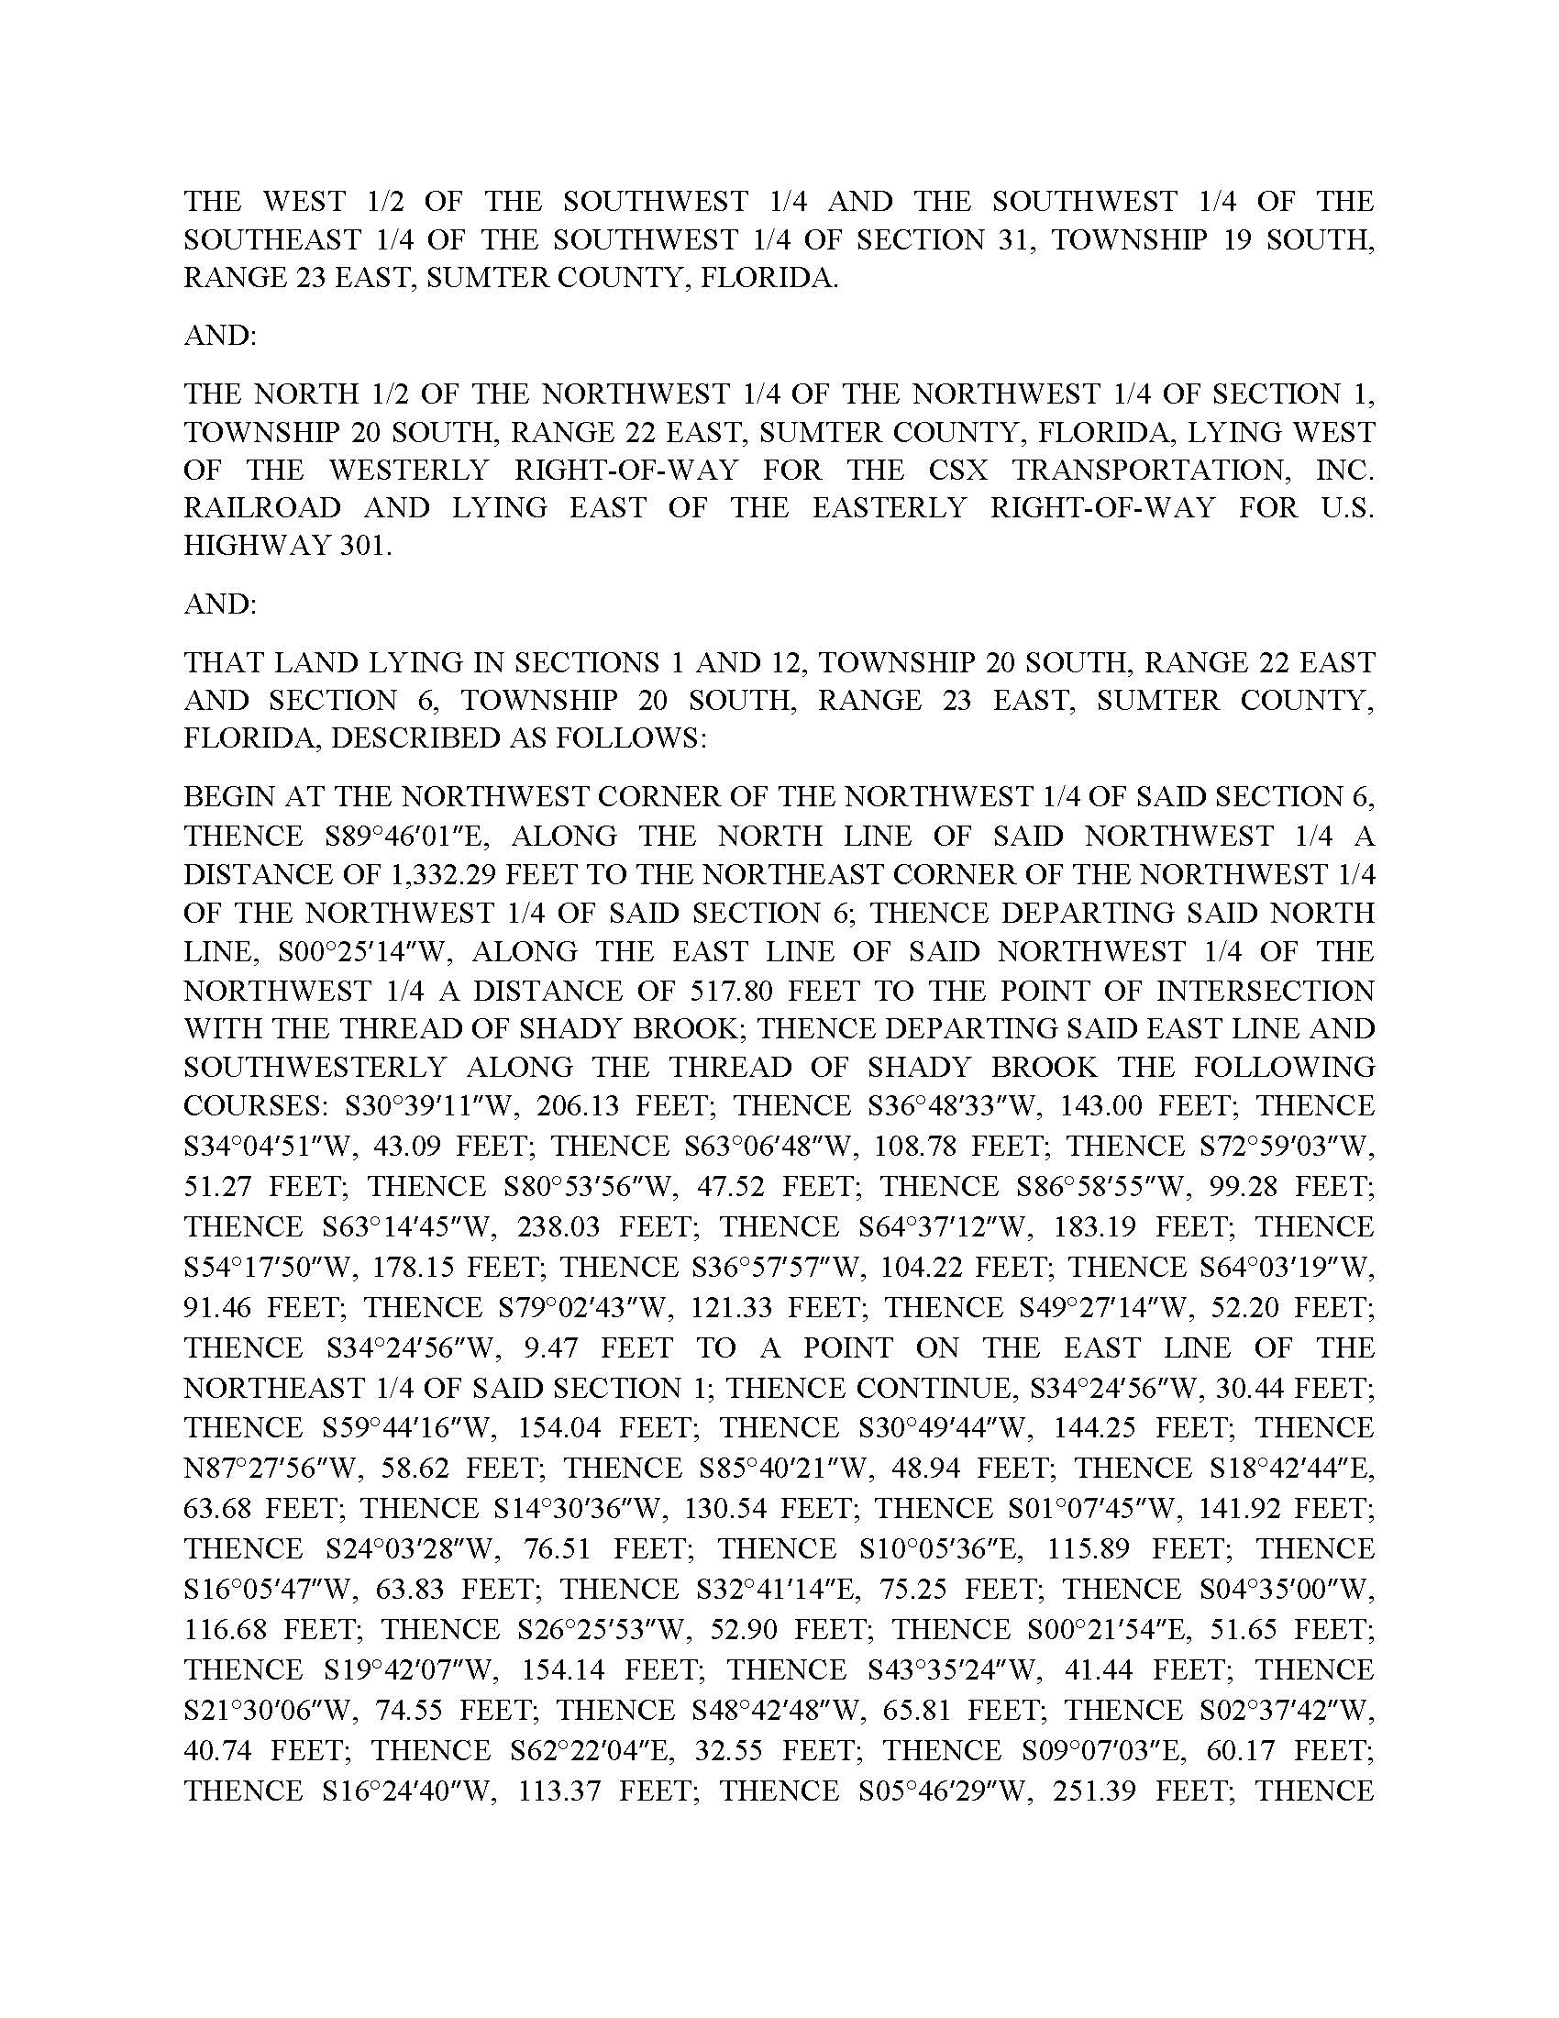

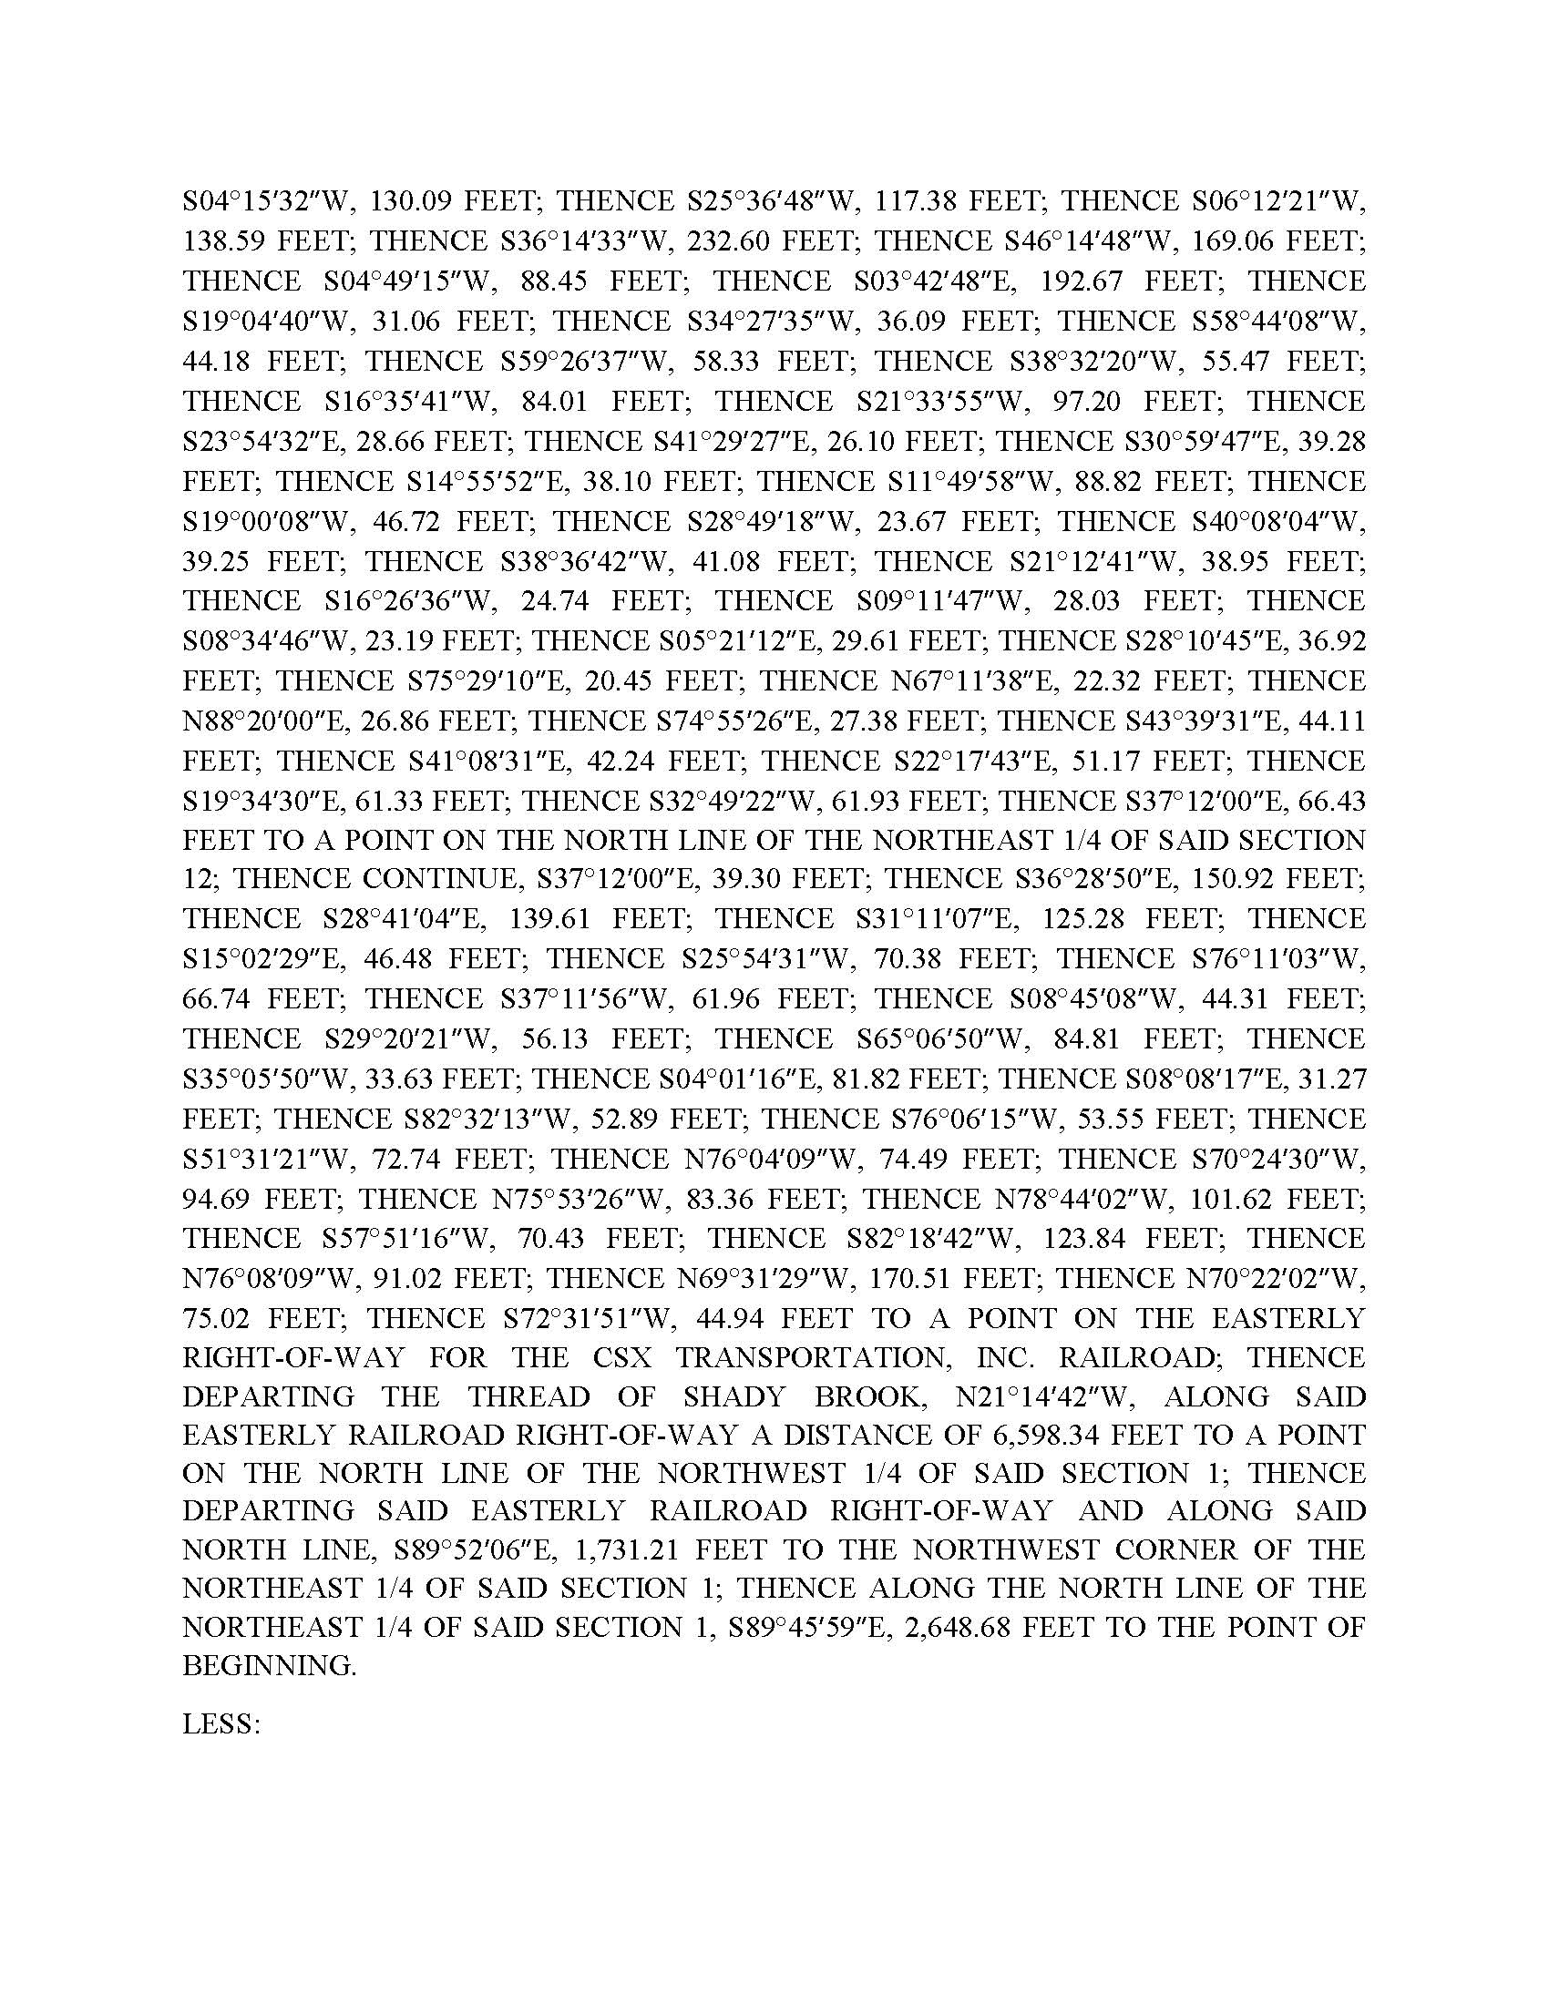

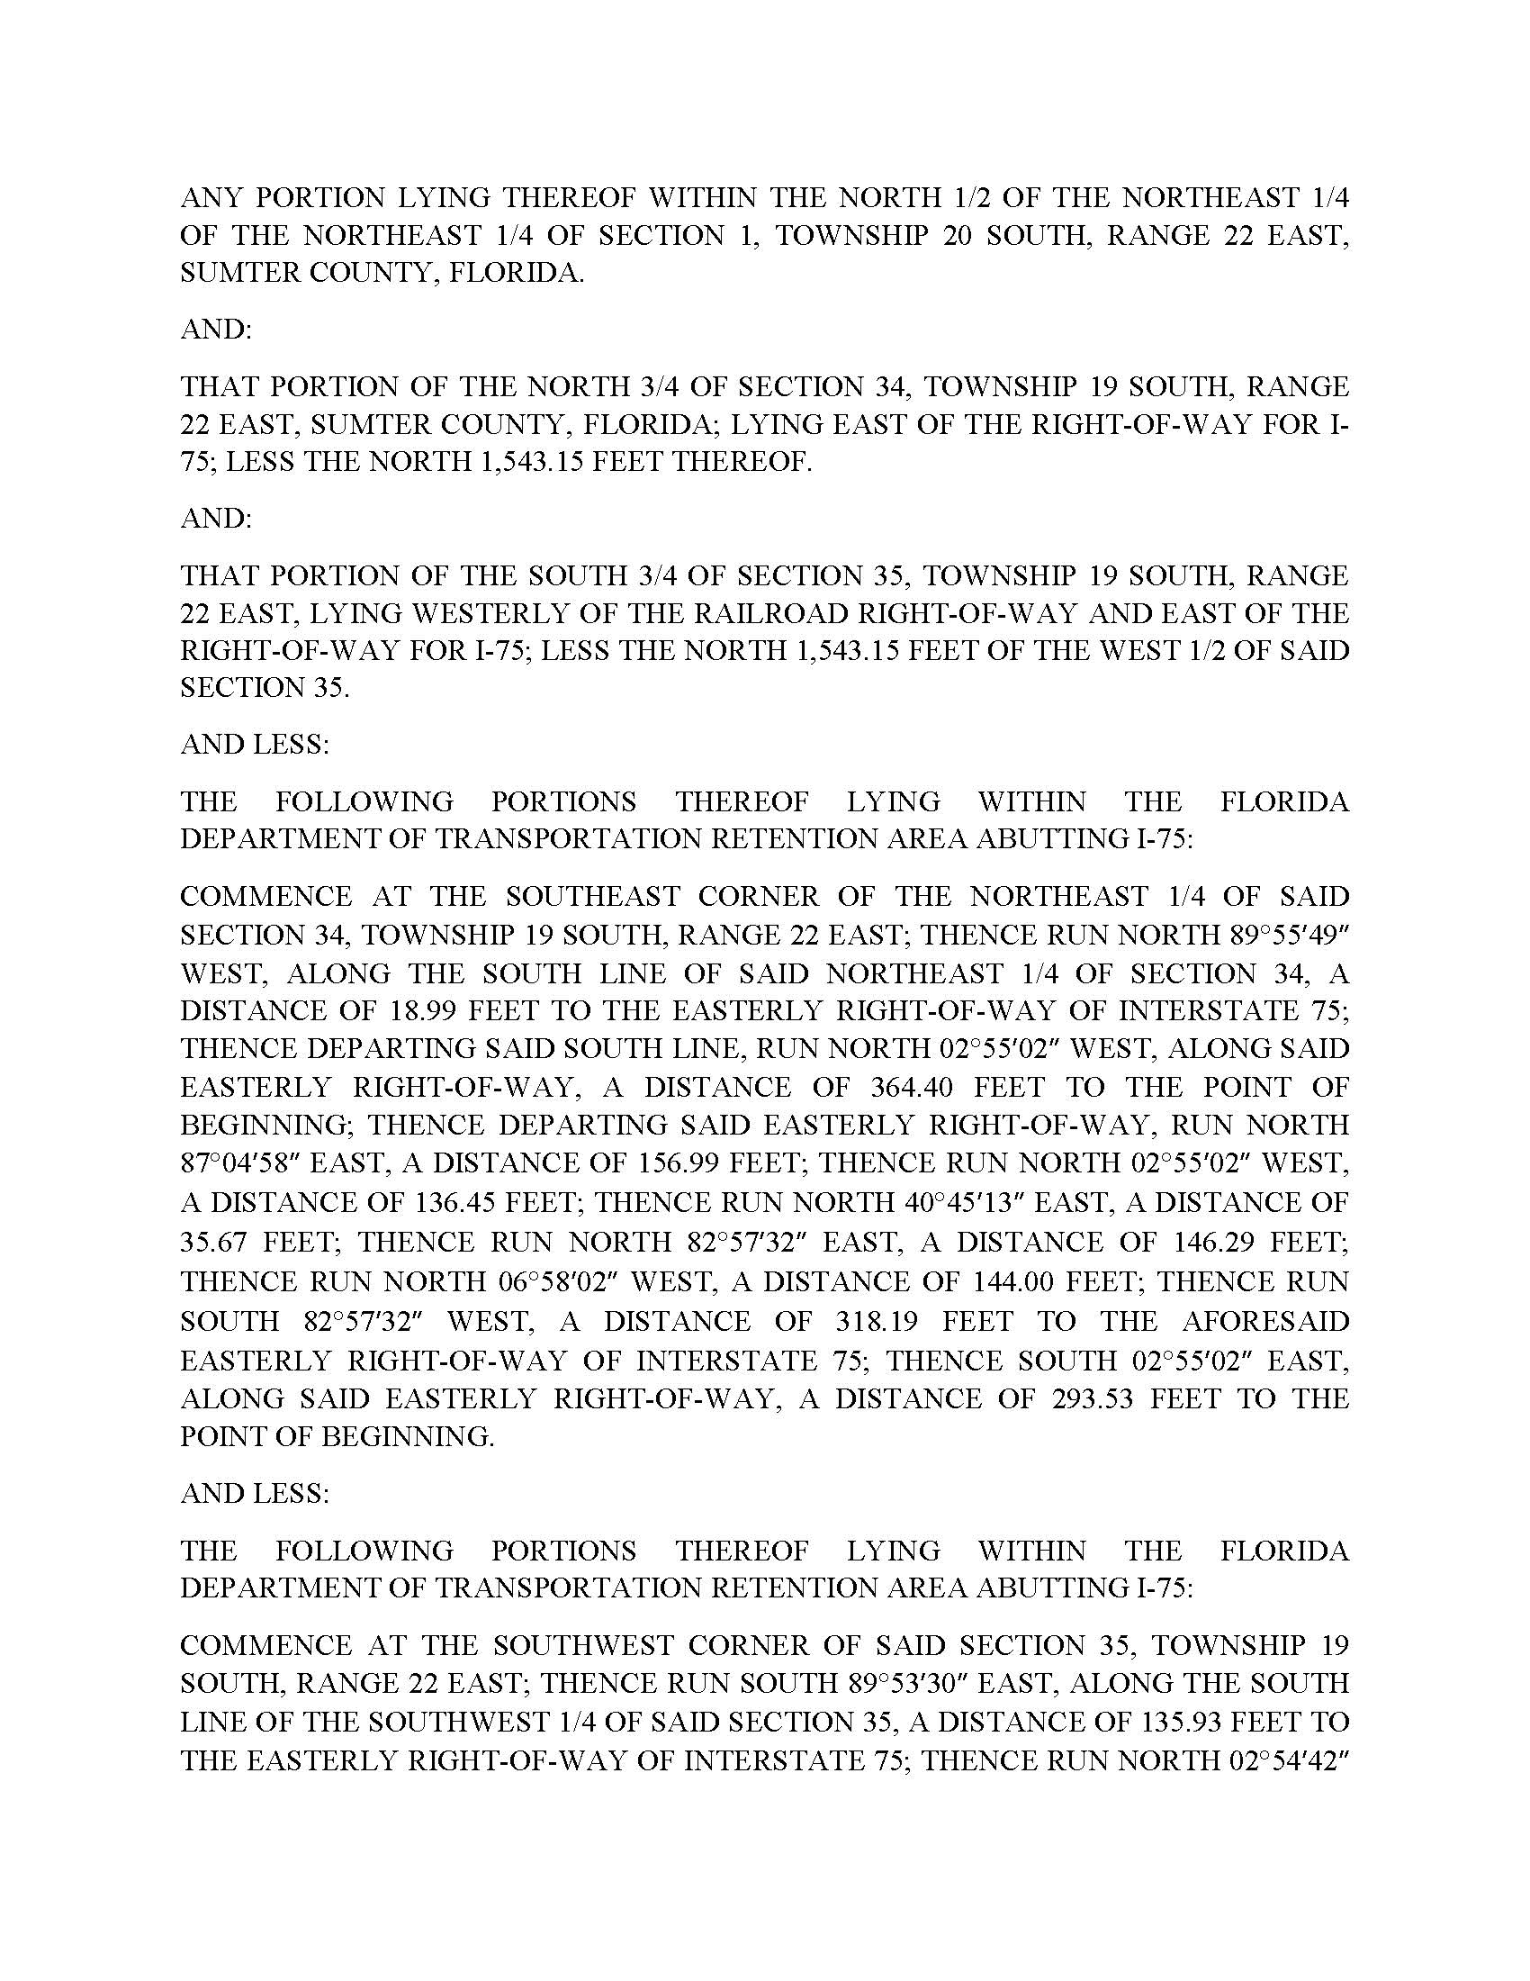

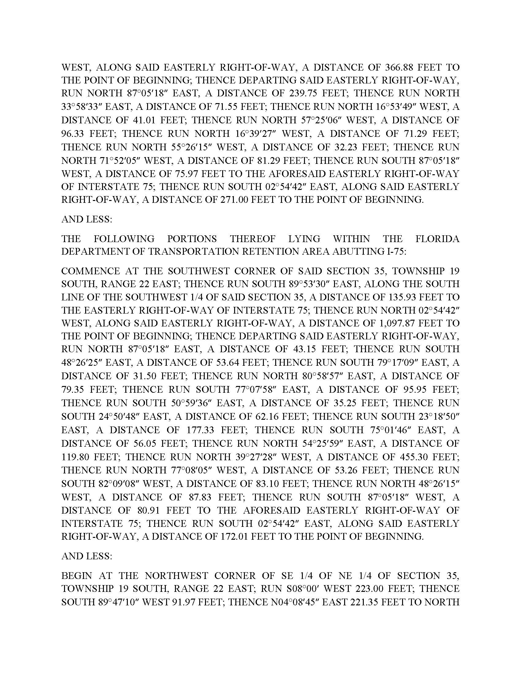

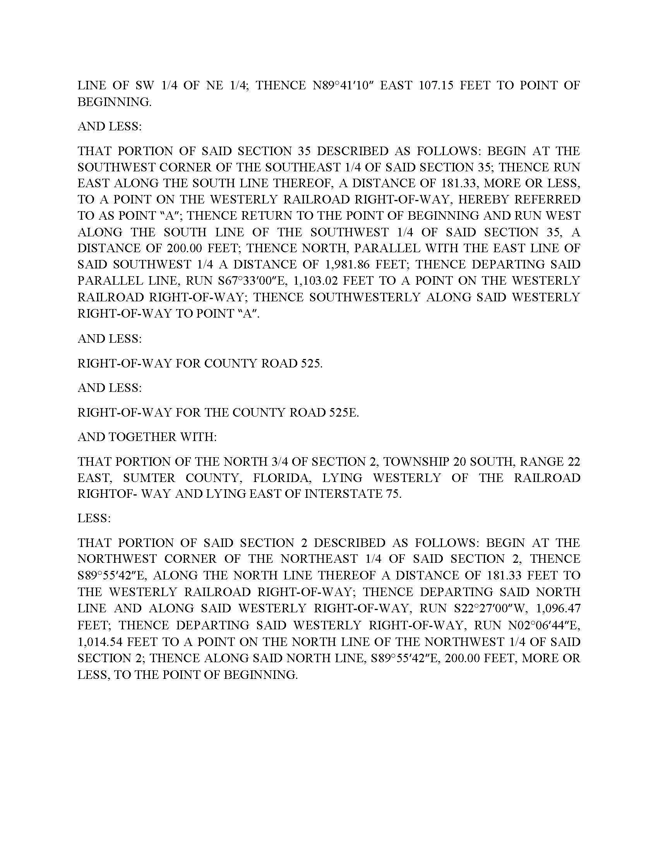

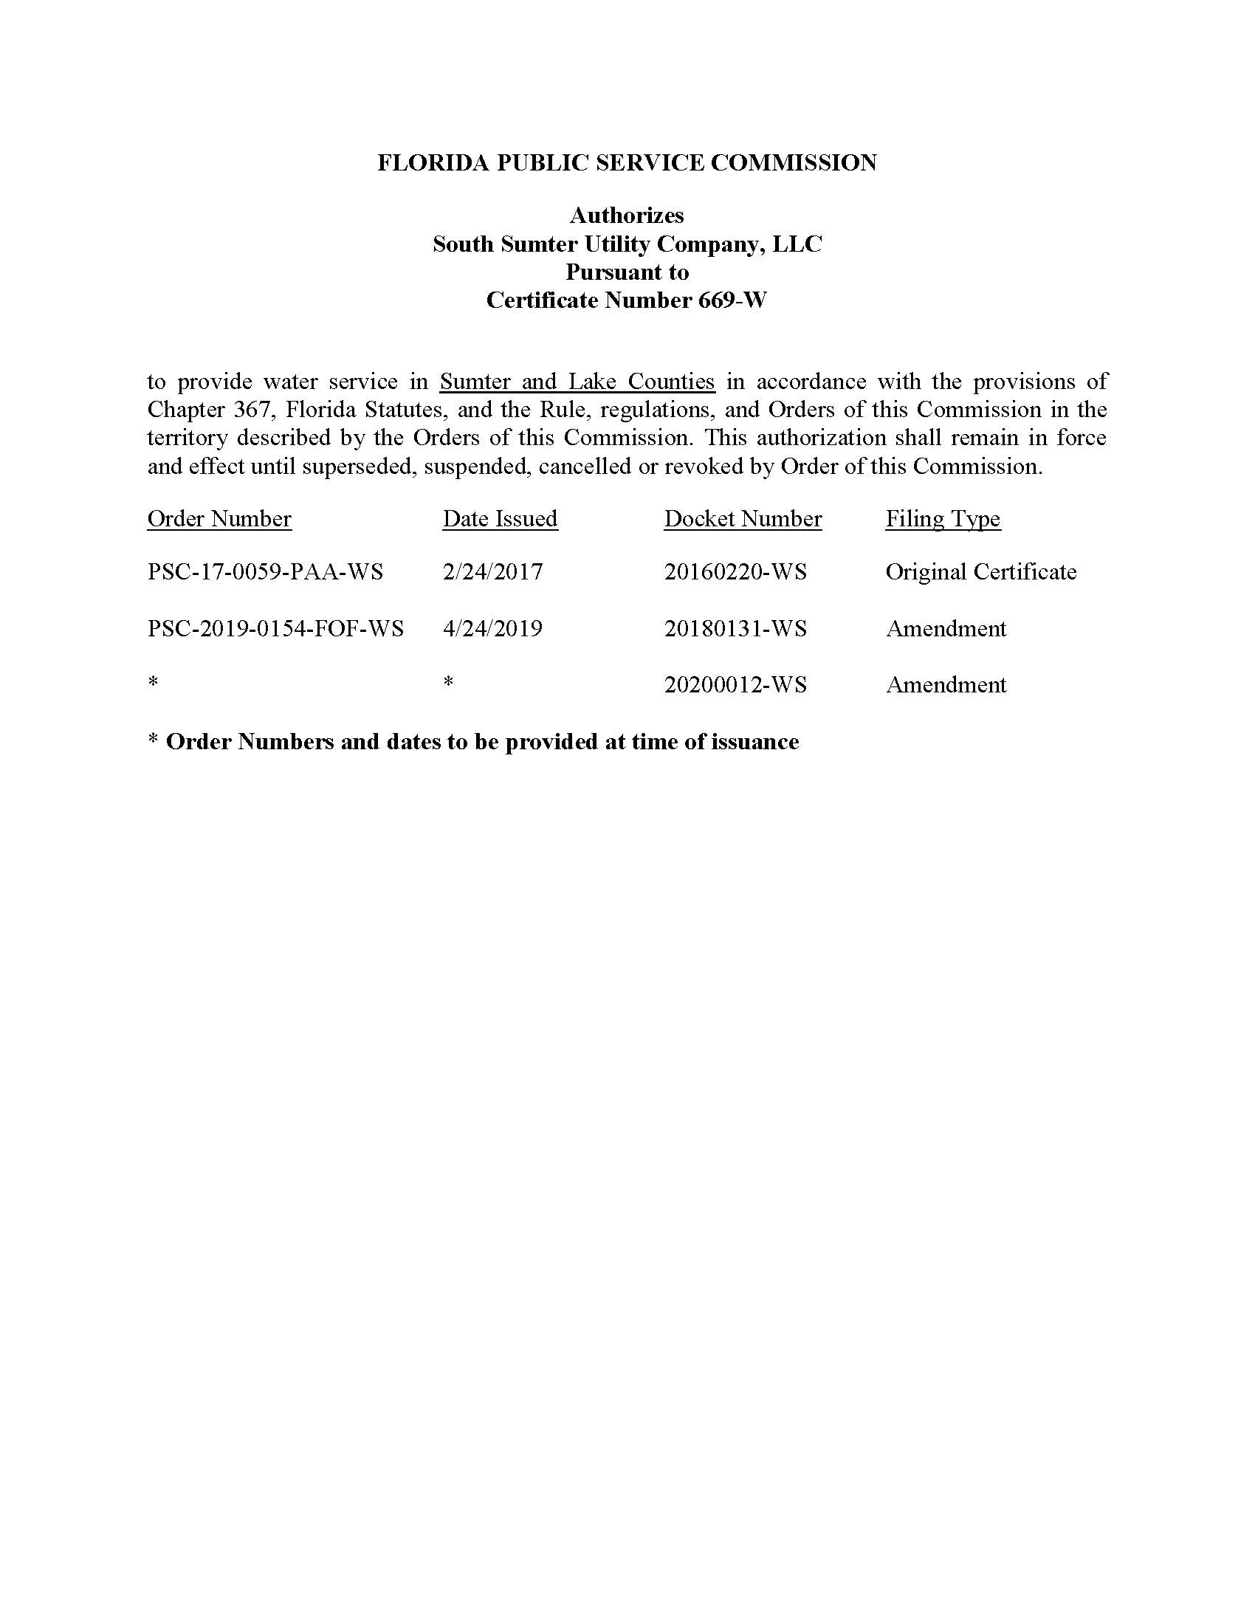

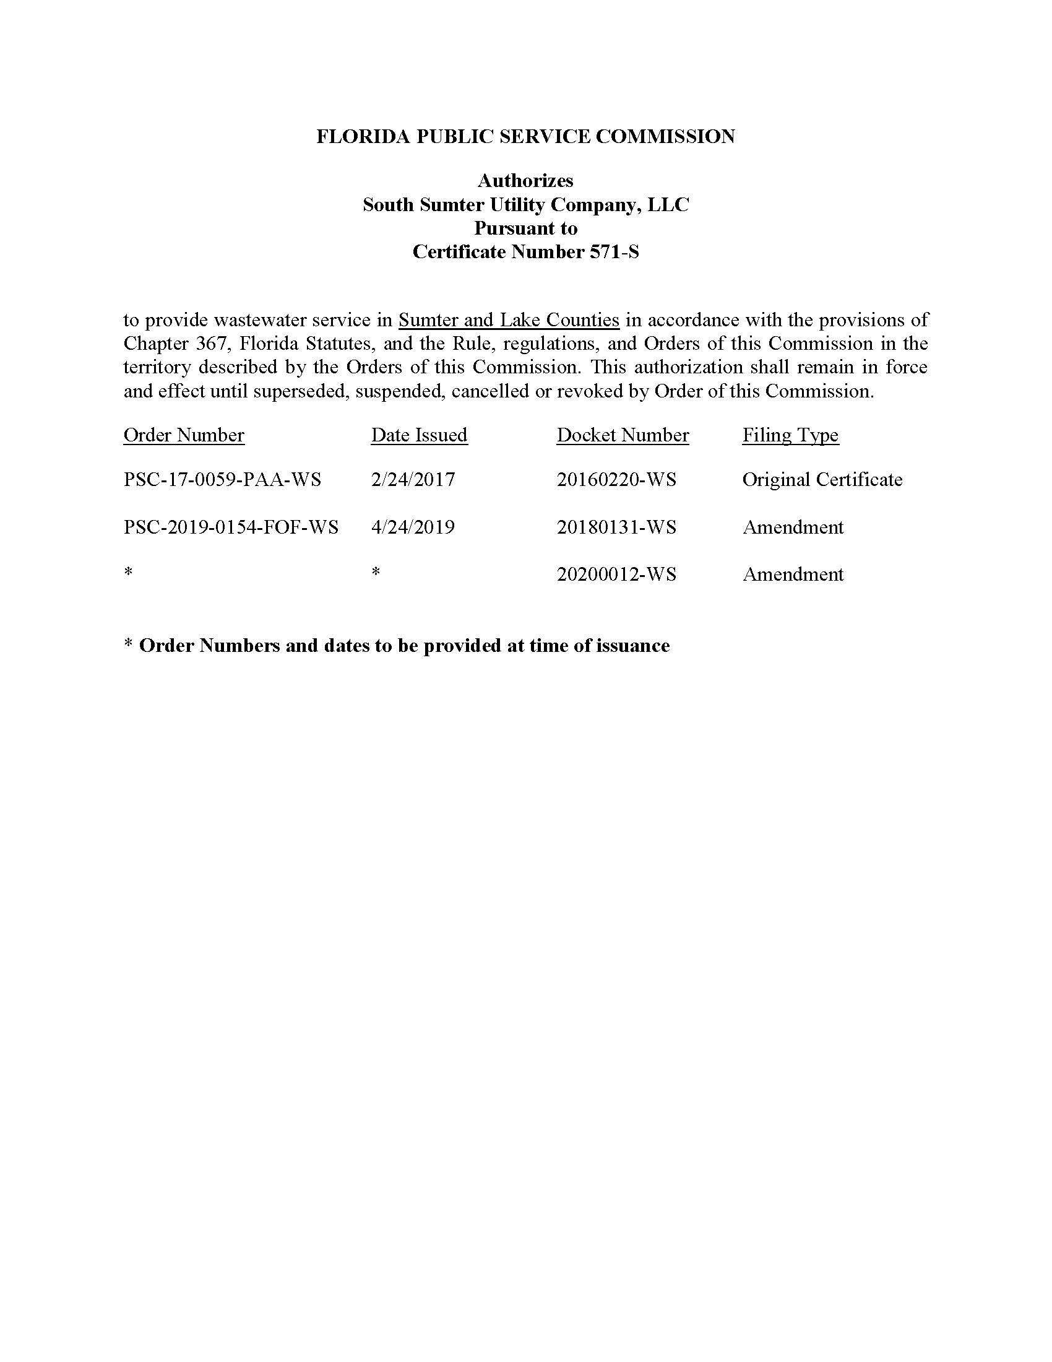

The Utility has requested an extension to file its 2019 Annual Report.
Document No. 00752-2020, filed February 3, 2020.

