State of Florida |  | Public Service Commission  Capital Circle Office Center ● 2540 Shumard Oak Boulevard  Tallahassee, Florida 32399-0850  -M-E-M-O-R-A-N-D-U-M-
DATE: | June 24, 2020
TO: | Office of Commission Clerk (Teitzman)
FROM: | Office of the General Counsel (Cowdery)  Division of Economics (Bruce, Guffey, Hudson, Sibley)
RE: | Docket No. 20200119-WS – Proposed amendment of Rule 25-30.335, F.A.C., Customer Billing.
AGENDA: | 07/07/20 – Regular Agenda – Rule Proposal – Interested Persons May Participate
COMMISSIONERS ASSIGNED: |  |  | All Commissioners
PREHEARING OFFICER: |  |  | Fay
RULE STATUS: |  |  | Proposal May Be Deferred
SPECIAL INSTRUCTIONS: |  |  | None

Case Background
Rule 25-30.335, Florida Administrative Code (F.A.C.), Customer Billing, addresses water and wastewater utility customer billing requirements. As part of its regular review of Commission rules, staff initiated rule development in order to update and clarify the requirements in the Customer Billing rule. The primary recommended amendments involve billing requirements for customers who temporarily discontinue service and are out of residence on a seasonal basis.

The Notice of Rule Development was published in the Florida Administrative Register on January 8, 2020. No request for a workshop was received, and no workshop was held. Staff received no written comments on the draft rule.

This recommendation addresses whether the Commission should propose the amendment of Rule 25-30.335, F.A.C. The Commission has jurisdiction under Sections 350.127(2), 367.121, and 120.54, Florida Statutes (F.S.).

Discussion of Issues

Issue 1:
Should the Commission propose the amendment of Rule 25-30.335, F.A.C., Customer Billing?

Recommendation:
Yes, the Commission should propose the amendment of Rule 25-30.335, F.A.C., as set forth in Attachment A. The Commission should also certify Rule 25-30.335, F.A.C., as a minor violation rule. (Hudson, Bruce, Sibley, Guffey, Cowdery)

Staff Analysis:
The purpose of this rulemaking is to update and clarify certain provisions in Rule 25-30.335, F.A.C., Customer Billing, for water and wastewater utilities. Overall, minor changes to the rule language have been made to update and clarify the rule. For example, section (1) was amended to delete the requirement that a bill show the applicable rate schedule because, unlike electric companies, water and wastewater utilities do not have multiple rate categories. However, the primary reason for amending this rule is to update and clarify rule requirements for billing seasonal customers when they are temporarily not in residence and to bill customers with different rate structures consistently.

Subsection (3): Consistency in prorating over a 30-day billing cycle
Under subsection (3) of the current rule, when service is rendered for less than 50 percent of the normal billing cycle, the utility must prorate the base facility charge as if the billing cycle were 30 days. That same subsection states that for service taken under flat rates, 50 percent of the normal charges may be applied. Subsection (3) does not address customers paying rates that include minimum usage. Customers paying rates that include minimum usage have a base facility charge and some amount (“minimum usage”) of gallons included in their bill. If the customer uses more than the minimum usage, they pay the gallonage rate on their tariff.

The draft amendments to subsection (3) clarify that customers who pay for service under flat rates or rates that include minimum usage will be treated the same as those who pay base facility charges when service is rendered for less than 50 percent of the billing cycle. In all cases, the utility must prorate the identified charges over a 30-day billing cycle. This recommended amendment gives consistency in treatment to all customers.

Subsection (4): Consistency in billing out of residence customers who pay base facility charges and flat or minimum tariff rates
New draft subsection (4) is also intended to treat customers consistently. This subsection requires all customers who request a temporary discontinuance of service or are out of residence to pay the base facility charge or, if applicable, 40 percent of the flat or minimum tariff rate. Out of residence customers with a flat or minimum tariff rate structure are required to pay 40 percent of that rate because 40 percent represents the utility’s fixed costs. It is the equivalent of a base facility charge. New draft subsection (4) replaces current subsection (8), which requires a utility to bill the customer the base facility charge regardless of whether there is any usage, unless the utility has an authorized vacation rate. The reference to vacation rates is obsolete because no Commission-regulated water or wastewater utility has “vacation rates.” In addition, unlike new draft subsection (4), current subsection (8) does not address customers who pay flat or minimum tariff rates.

Subsection (5): Consistency in billing customers who request temporary discontinuance of service and those who request permanent termination of service for six months or less
Over the years, staff has become aware that some of the Commission’s regulated water and wastewater utilities have seasonal customers who terminate or disconnect service during the months they are not in residence, as opposed to requesting a temporary discontinuance of service. Some of these customers expect that they should not have to pay the base facility charge or equivalent during the time they were temporarily not in residence. The current rule does not address these circumstances. Without clear guidance in the rule, utilities cannot point to a specific rule provision requiring payment when service is temporarily discontinued or the customer is out of residence. The recommended amendments are intended to provide this clarity. The utility incurs fixed costs in maintaining facilities and having water ready and available upon demand when the customers return. Paying the base facility charge or, if applicable, 40 percent of the flat or minimum tariff rate by customers who have temporarily discontinued service, or are out of residence, allows the utility to maintain revenue stability and the facilities necessary to provide service upon demand.

New draft subsection (5) is added to clarify that if a customer requests a permanent termination of service and subsequently requests service at the same location within six months of the termination, the utility must bill the customer the base facility charges or, if appropriate, 40 percent of the flat rate or rates that include minimum usage for the service termination period. Draft subsection (5) states that the customer must pay these rates and charges to restore service. Six months is an appropriate time to capture seasonal customers who might leave and return in a short period of time.

New draft subsection (5) recognizes that if a customer requests a permanent termination but reinstates service within six months, that customer is, in effect, the same as a customer who requests temporary discontinuance of service and is required to pay the base facility charge or equivalent rate when out of residence. The recommended amendments in subsection (5) would eliminate a false distinction between temporary discontinuance of service and permanent termination of service that is reinstated within six months of termination. In both cases, the utility will bill the base facility charge or 40 percent of the flat or minimum tariff rate.

Minor Violation Rules Certification
Pursuant to Section 120.695, F.S., the agency head must certify for each rule filed for adoption whether any part of the rule is designated as a rule the violation of which would be a minor violation. Rule 25-30.335, F.A.C., is currently listed on the Commission’s website as a rule for which a violation would be minor because violation of the rule would not result in economic or physical harm to a person or have an adverse effect on the public health, safety, or welfare or create a significant threat of such harm. The amendments to the rule would not change its status as minor violation rules. Thus, staff recommends that the Commission certify Rule 25-30.335, F.A.C., as a minor violation rule.

Statement of Estimated Regulatory Costs
Pursuant to Section 120.54(3)(b), F.S., agencies are encouraged to prepare a statement of estimated regulatory costs (SERC) before the adoption, amendment, or repeal of any rule. The SERC is appended as Attachment B to this recommendation.
The SERC concludes that the rule will not likely directly or indirectly increase regulatory costs in excess of $200,000 in the aggregate in Florida within one year after implementation. Further, the SERC economic analysis concludes that the rule will not likely have an adverse impact on economic growth, private sector job creation or employment, private sector investment, business competitiveness, productivity, or innovation in excess of $1 million in the aggregate within five years of implementation. Thus, the rule does not require legislative ratification pursuant to Section 120.541(3), F.S. In addition, the SERC states that the rule will not have an adverse impact on small business and will have no impact on small cities or counties. No regulatory alternatives were submitted pursuant to paragraph 120.541(1)(a), F.S. None of the impact/cost criteria established in paragraph 120.541(2)(a), F.S., will be exceeded as a result of the recommended amendments to Rule 25-30.335, F.A.C.

Conclusion
Based on the foregoing, staff recommends that the Commission should propose the amendment of Rule 25-30.335, F.A.C., as set forth in Attachment A. The Commission should also certify Rule 25-30.335, F.A.C., as a minor violation rule.

Issue 2:
Should this docket be closed?

Recommendation:
Yes. If no requests for hearing, information regarding the SERC, proposals for a lower cost regulatory alternative, or JAPC comments are filed, the rule should be filed with the Department of State, and the docket should be closed. (Cowdery)

Staff Analysis:
If no requests for hearing, information regarding the SERC, proposals for a lower cost regulatory alternative, or JAPC comments are filed, the rule may be filed with the Department of State and the docket should be closed.

25-30.335 Customer Billing.
(1) Except as provided in this rule, a utility must shall render bills to customers at regular intervals, and each bill must shall indicate: the billing period covered; the applicable rate schedule; beginning and ending meter reading; the amount of the bill; the delinquent date or the date after which the bill becomes past due; and any authorized late payment charge.
(2) When a utility is unable to obtain an actual meter read, estimated bills may be provided.
(a) If the utility estimates a bill, the bill statement shall prominently show the word “Estimated” must be prominently displayed on the face of the bill.
(b) The utility is obligated to timely correct any problems within the utility’s control causing the need to estimate bills. In no event may shall a utility provide an estimated bill to any one customer account more than four times in any 12-month period due to circumstances that are within the utility’s control and service obligations.
(c) Upon issuance of a second estimated bill in a 6-month period, the utility must shall provide the customer with an explicit written explanation for the estimation, along with the utility contact information and the Commission toll-free complaint number, 1(800) 342-3552.
(d) The utility must shall maintain records, for a minimum of two years, detailing the number, frequency, and causes of estimated bills, and those records must which shall be made available upon request to the Commission or to any party to a rate proceeding for the utility.
(3) When service is rendered for less than 50 percent of the normal billing cycle, the utility must shall prorate the base facility charges, flat rates, or rates that include minimum usage as though the normal billing cycle were 30 days., except that Tthe utility may elect not to not issue an initial bill for service if the service is rendered for during a time period which is less than 50 percent of the normal billing cycle. Instead, the utility may elect to issue a single bill combining combine the amount owed for the service rendered during the initial time period with the amount owed for the next billing cycle, and issue a single bill for the combined time period. For service taken under flat rate schedules, 50 percent of the normal charges may be applied.
(4) If a customer requests a temporary discontinuance of service or is out of residence:
(a) Utilities that have the base facility charge rate structure must continue to bill the base facility charge.
(b) Utilities that have a flat rate or a rate that includes minimum usage must bill the customer 40 percent of the flat or minimum rate contained on the applicable tariff.
(5) If a customer requests a permanent termination of service and the same customer subsequently requests service at the same location within 6 months of the termination, the utility must bill the customer the base facility charges or 40 percent of the flat rate or rates that include minimum usage for the service termination period. The customer is responsible for payment of all outstanding rates and charges for the termination period to restoration of service.
(6) (4) A utility may not consider a customer delinquent in paying his or her bill until the 21st day after the utility has mailed or presented the bill for payment.
(7) (5) A Each utility must shall establish each point of delivery as an independent customer account and must shall calculate the amount of the bill accordingly, except where physical conditions make it necessary to use additional meters or points of delivery for one class of service to a single customer on the same premises, or where such multiple meters or delivery points are used for the convenience of the utility.
(8) (6) A utility may not incorporate municipal or county franchise fees into the amount indicated as the cost for service on the customer’s bill. Rather, the utility must shall show any such franchise fee as a separate item.
(9) (7) The utility must shall maintain a record of each customer’s account for the most current 2 years so as to permit reproduction of the customer’s bills during the time that the utility provided service to that customer.
(8) If a utility utilizes the base facility and usage charge rate structure and does not have a Commission authorized vacation rate, the utility shall bill the customer the base facility charge regardless of whether there is any usage.
Rulemaking Authority 350.127(2), 367.121 FS. Law Implemented 367.091, 367.121 FS. History–New 9-14-74, Amended 6-21-79, Formerly 25-10.97, 25-10.097, Amended 11-10-86, 11-30-93, 6-17-13, ____________.

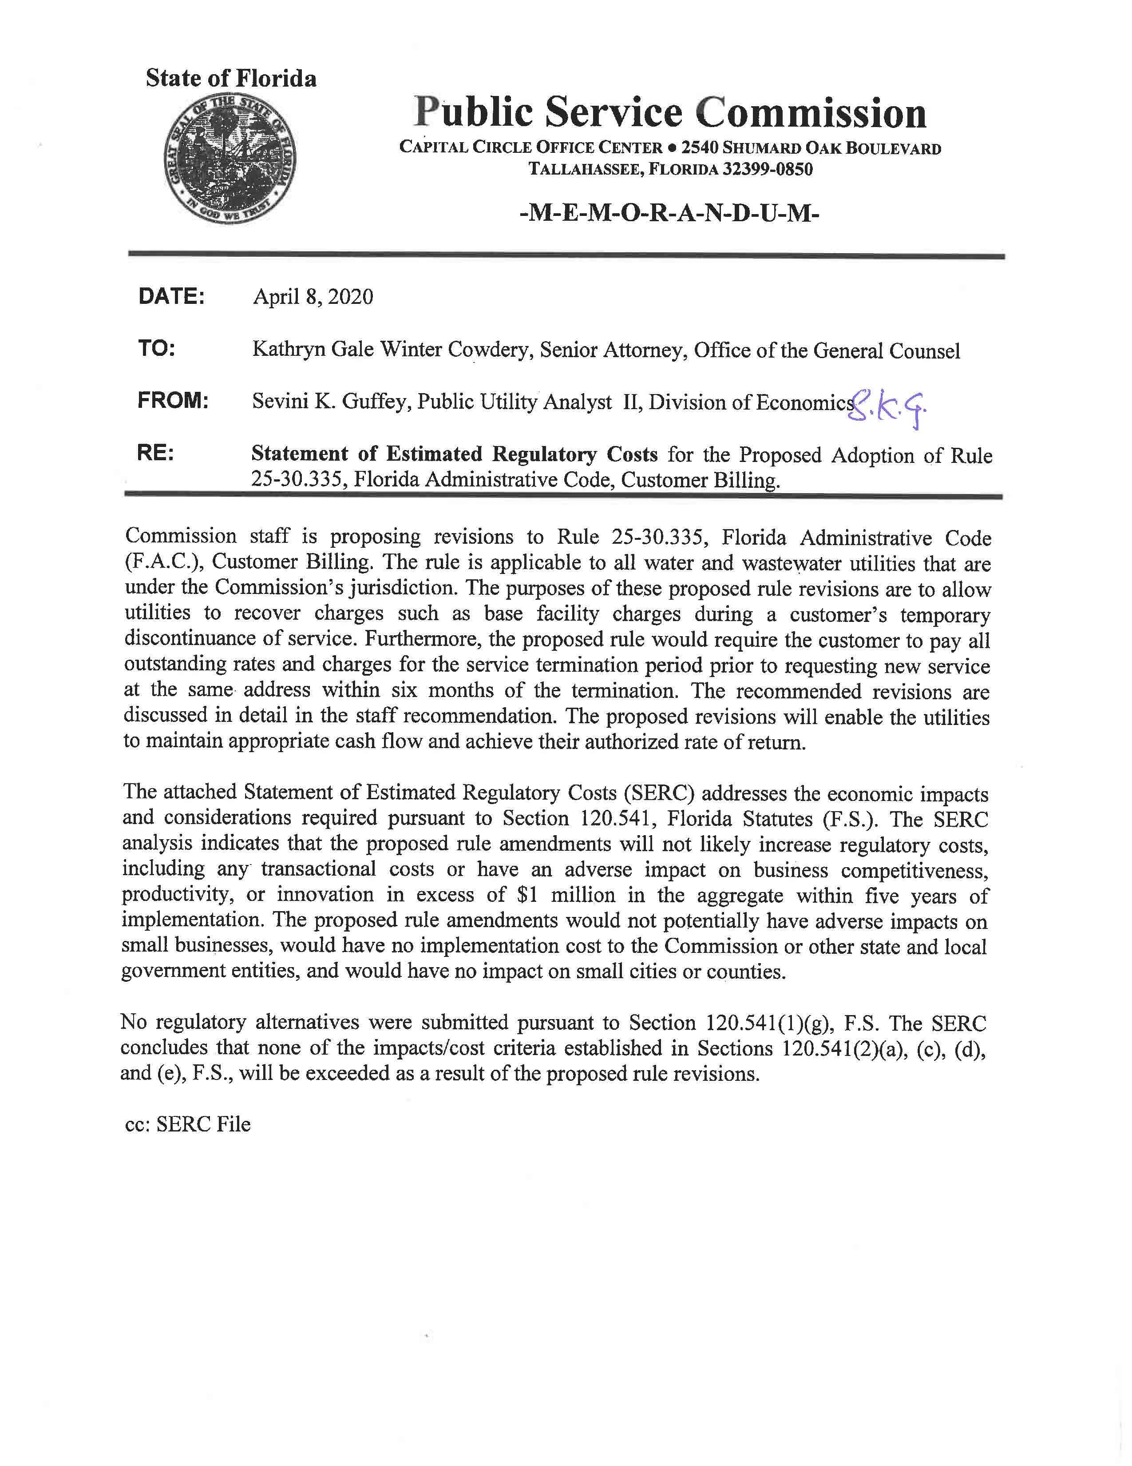

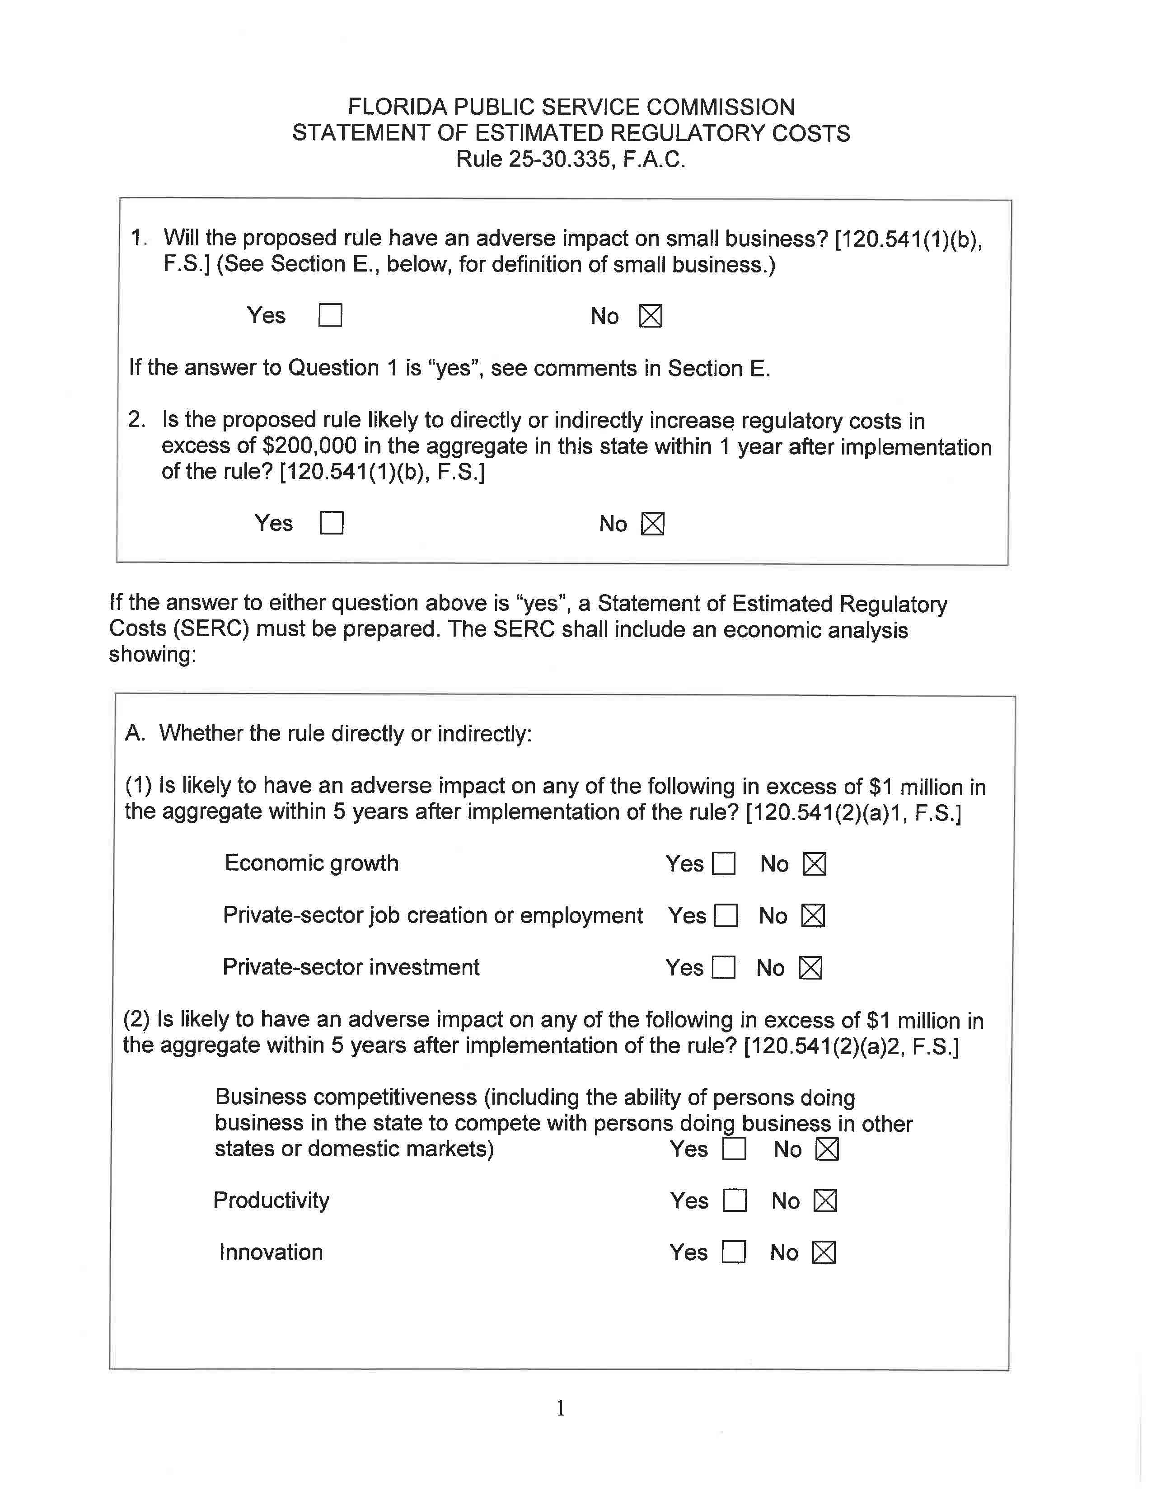

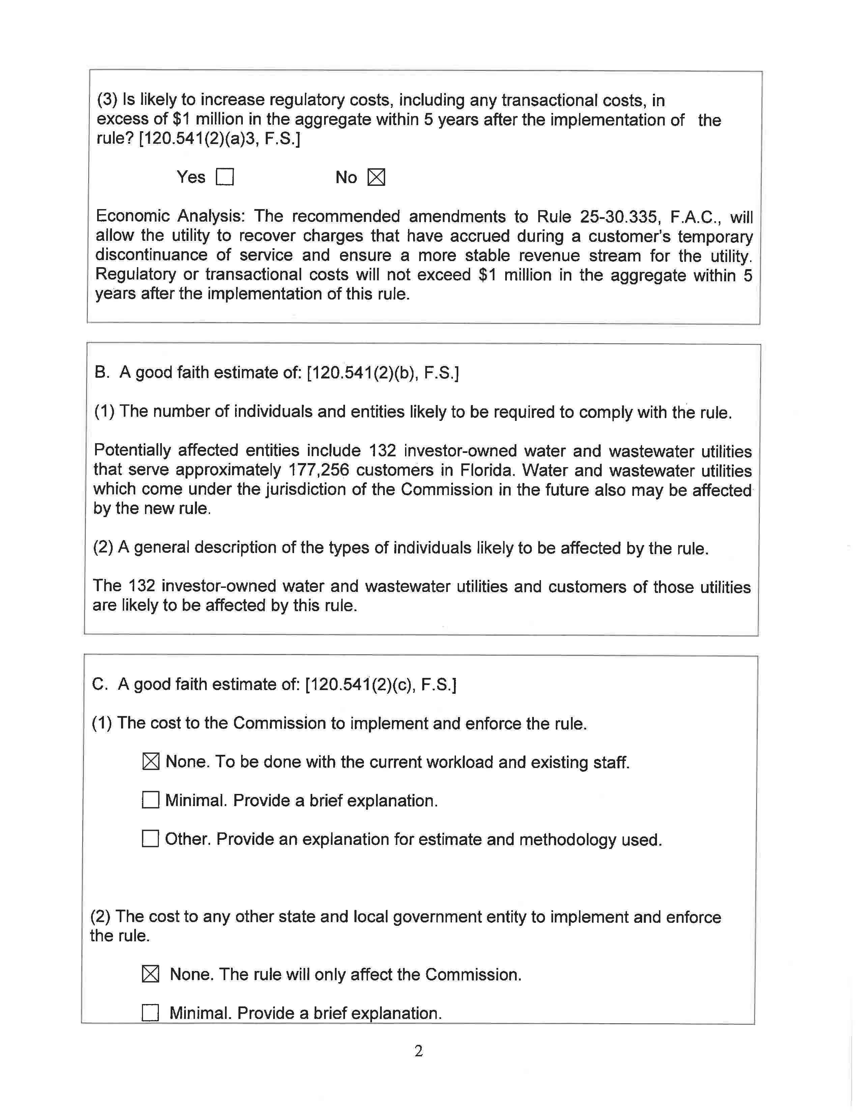

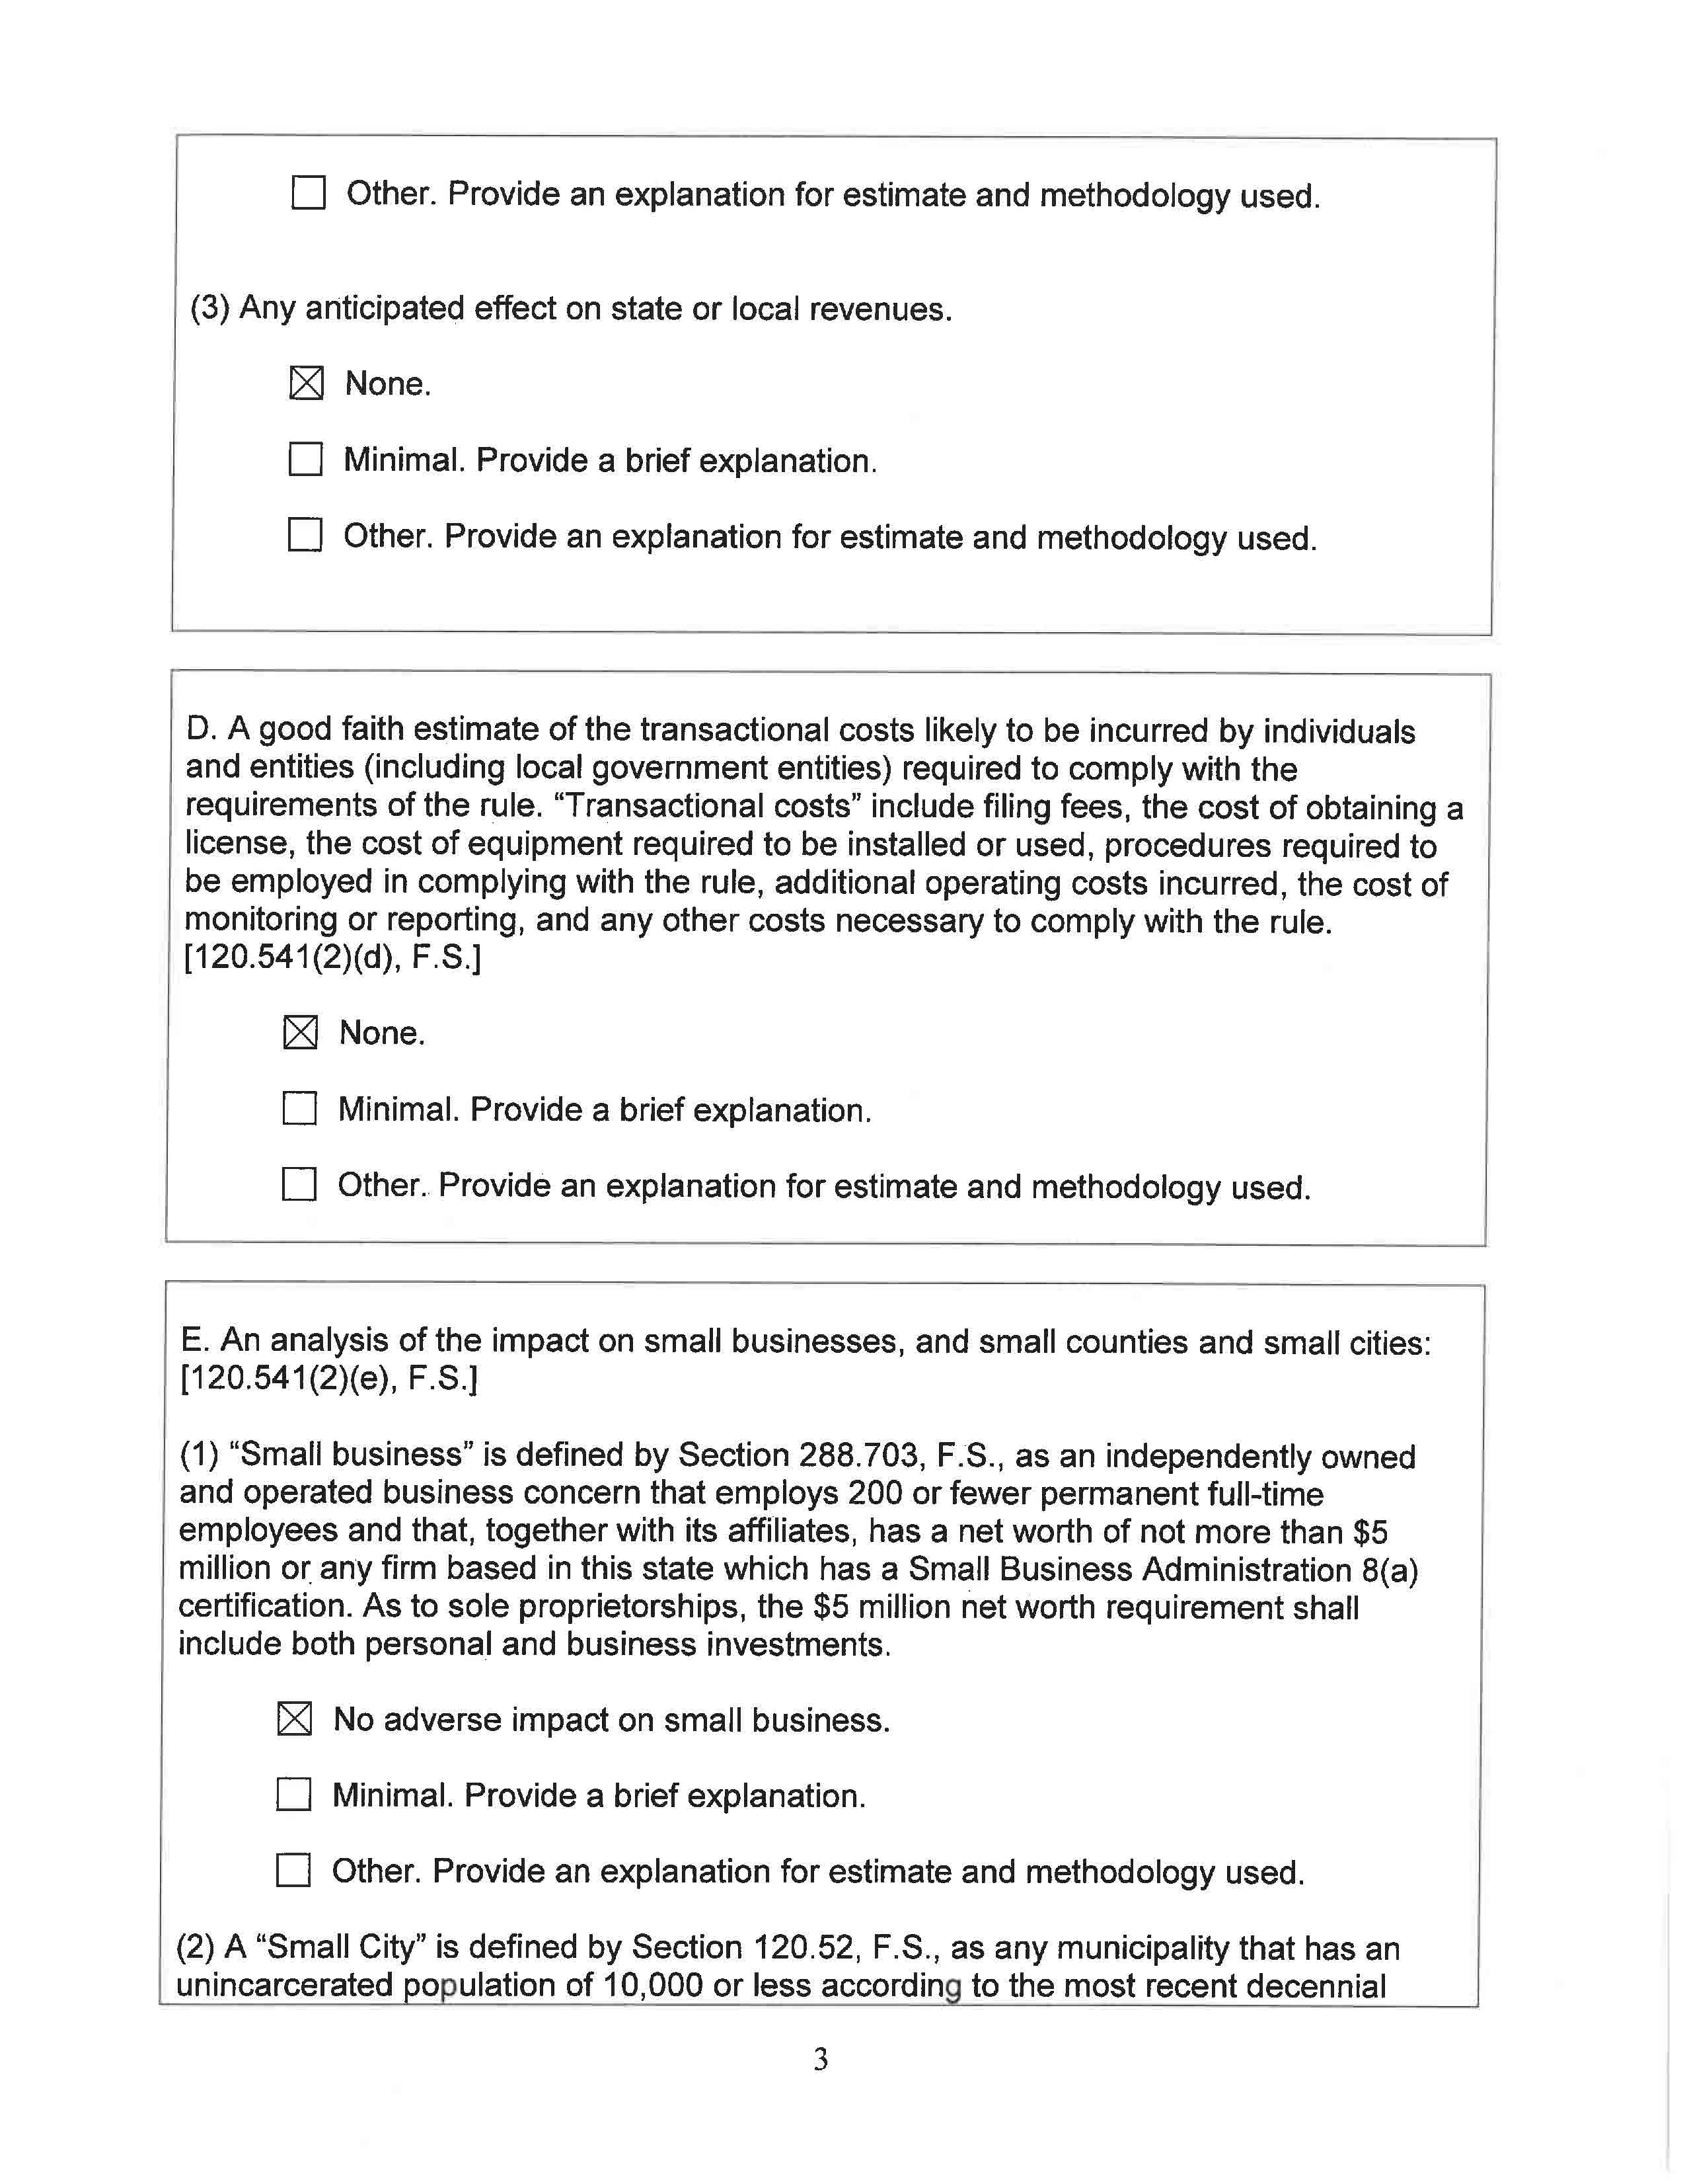

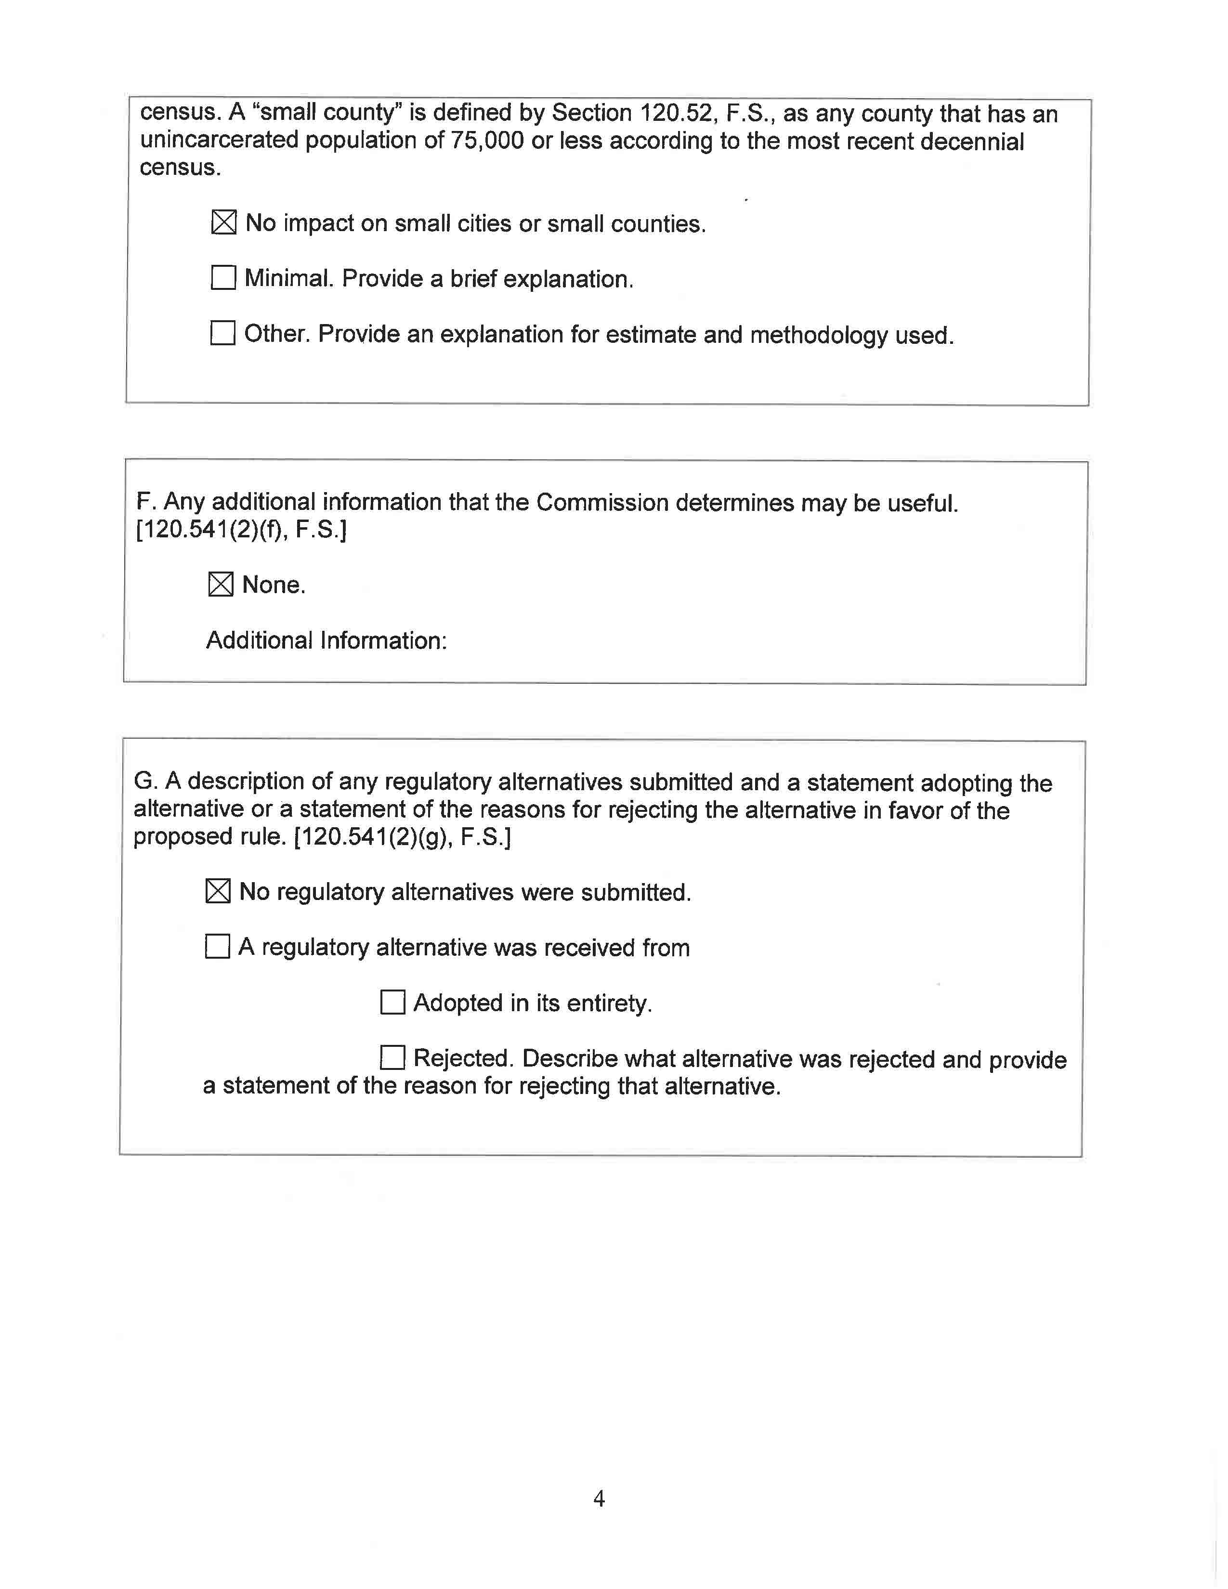

It is Commission practice to recover no more than 40 percent of revenues through the base facility charge. If a utility experiences high seasonal fluctuations in its customer base, the rate structure might allow recovery of more than 40 percent of revenues through the base facility charge.

