State of Florida |  | Public Service Commission  Capital Circle Office Center ● 2540 Shumard Oak Boulevard  Tallahassee, Florida 32399-0850  -M-E-M-O-R-A-N-D-U-M-
DATE: | June 24, 2020
TO: | Office of Commission Clerk (Teitzman)
FROM: | Division of Economics (Hampson, Guffey)  Office of the General Counsel (Brownless)
RE: | Docket No. 20200116-EU – Joint petition for approval of extension of territorial agreement and first amendment to territorial agreement, by Tampa Electric Company and Sumter Electric Cooperative, Inc.
AGENDA: | 07/07/20 – Regular Agenda – Proposed Agency Action – Interested Persons May Participate
COMMISSIONERS ASSIGNED: |  |  | All Commissioners
PREHEARING OFFICER: |  |  | Fay
CRITICAL DATES: |  |  | None
SPECIAL INSTRUCTIONS: |  |  | None

Case Background
On April 2, 2020, Tampa Electric Company (TECO) and Sumter Electric Cooperative, Inc. (SECO), collectively the joint petitioners, filed a petition seeking Commission approval of a 15-year extension of the parties’ current Commission-approved Territorial Agreement in Lake, Polk, and Sumter counties and approval of the First Amendment to the Territorial Agreement (First Amendment).

In 1994, the Commission approved the joint petitioners’ Territorial Agreement in Order No. PSC-1994-1397-FOF-EU (1994 Order). The current Territorial Agreement and map depicting the current service areas of TECO and SECO are provided in Attachment A to this recommendation. The proposed First Amendment to the Territorial Agreement seeks to modify certain limited provisions of the Territorial Agreement to comply with the 1994 Order, remove unnecessary language, and standardize depreciation rates for facility transfers. The Amendment is provided in Attachment B to this recommendation.

During the review of this joint petition, staff issued one data request to the joint petitioners on April 21, 2020, for which responses were received on May 4, 2020. The Commission has jurisdiction over this matter pursuant to Section 366.04, Florida Statutes (F.S.).

Discussion of Issues

Issue 1:
Should the Commission approve the extension of the Territorial Agreement between TECO and SECO and approve the proposed First Amendment to the Territorial Agreement?

Recommendation:
Yes, the Commission should approve the 15-year extension of the Territorial Agreement between TECO and SECO and approve the proposed First Amendment to the Territorial Agreement. The proposed extension and First Amendment to the Territorial Agreement are in the public interest and will avoid uneconomic duplication of facilities. (Hampson, Guffey)

Staff Analysis:
Pursuant to Section 366.04(2)(d), F.S., and Rule 25-6.0440, Florida Administrative Code (F.A.C.), the Commission has the jurisdiction to approve territorial agreements between and among rural electric cooperatives, municipal electric utilities, and other electric utilities. Unless the Commission determines that the agreement will cause a detriment to the public interest, the agreement should be approved.

Territorial Agreement Extension
Section 5.1 of the Territorial Agreement states it shall remain in effect for a period of 25 years, with the option to be renewed for periods of 15 years, unless either party gives written notice to terminate the agreement. Further, Section 5.1 and Article IV state that each renewal of the Territorial Agreement requires prerequisite approval of the Commission. The initial 25-year term of the Territorial Agreement ended in December 2019. The joint petitioners desire for the Territorial Agreement to extend for 15 years through December 2034, stating that the agreement has worked well for both TECO and SECO and their ability to provide safe and reliable electric service. The parties’ agreed upon desire to renew the Territorial agreement for an additional 15 years is provided for in the First Amendment.

The maps and legal descriptions defining the boundaries of the Territorial Agreement remain the same and no customers will be transferred or otherwise affected by the proposed extension of the Territorial Agreement. As such, there are no customers to notify regarding changes in service. Additionally, paragraph 7 of the petition states that there is no reasonable likelihood the extension will decrease electric service reliability.

First Amendment to the Territorial Agreement
The joint petitioners have proposed a First Amendment to the Territorial Agreement. The First Amendment consists of four modifications to the Territorial Agreement. Two of the modifications are results of the Commission’s decision in the 1994 Order. The first modification addresses the language of Section 2.2 of the Territorial Agreement. The current language required the filing of all interim service agreements with the Commission. However, in paragraph 4 of the 1994 Order, the Commission directed the joint petitioners to only file with the Commission interim service agreements expected to last for more than one year. Interim service could occur in an exceptional circumstance when a new customer due to economic or engineering constraints could not be immediately served by the utility in whose service territory the customer is located.

The second modification resulting from the 1994 Order addresses the filing of annual reports to the Commission. Currently, Section 4.1 of the Territorial Agreement states that the joint petitioners would file annual reports to the Commission on the status of the Territorial Agreement. However, in paragraph 5 of the 1994 Order, the Commission declined to require the filing of annual reports. As such, the joint petitioners removed this requirement in the proposed First Amendment.

The third modification removes Section 2.3 of the Territorial Agreement. Section 2.3 relates solely to SECO and was meant to preserve its 503(c)(12) tax status. Paragraph 9, Subsection b, of the petition states that SECO “does not have a significant concern that its non-profit status would be jeopardized by the circumstances described in Section 2.3.” Furthermore, SECO states that it has not included this language in more recent territorial agreements.

The fourth modification is to Section 2.4 of the Territorial Agreement which addresses depreciation rates to be used in the calculation for any potential facilities or asset transfers. This modification sets TECO’s depreciation rates as the standard to be used by the joint petitioners. Additionally, the modification clarifies that reintegration costs are to be included, where required by sound utility practice. The joint petitioners explained that SECO is required to use a 30-year depreciation schedule, while TECO’s Commission-approved depreciation rates vary depending on the specific assets. Therefore, using TECO’s rates ensures consistency with Commission Orders. The joint petitioners state that establishing a single standard for depreciation rates is a fair and reasonable approach.

Conclusion
After review of the joint petition and the joint petitioners’ responses to Commission staff’s data request, staff believes that the requested 15-year extension (December 2019 through December 2034) will enable TECO and SECO to avoid unnecessary duplication of facilities and to serve their customers in an efficient manner. The changes made in the First Amendment will bring the Territorial Agreement into compliance with the 1994 Order, remove obsolete language, and provide a fair and reasonable method for any future transfers of facilities.

As such, Commission staff recommends that the Commission should approve the extension of the Territorial Agreement between TECO and SECO and approve the proposed First Amendment to the Territorial Agreement. The proposed extension and First Amendment to the Territorial Agreement are in the public interest and will avoid uneconomic duplication of facilities.

Issue 2:
Should this docket be closed?

Recommendation:
If no protest is filed by a person whose substantial interests are affected within 21 days of the issuance of the Order, this docket should be closed upon the issuance of the Consummating Order. (Brownless)

Staff Analysis:
If no protest is filed by a person whose substantial interests are affected within 21 days of the issuance of the Order, this docket should be closed upon the issuance of the Consummating Order.
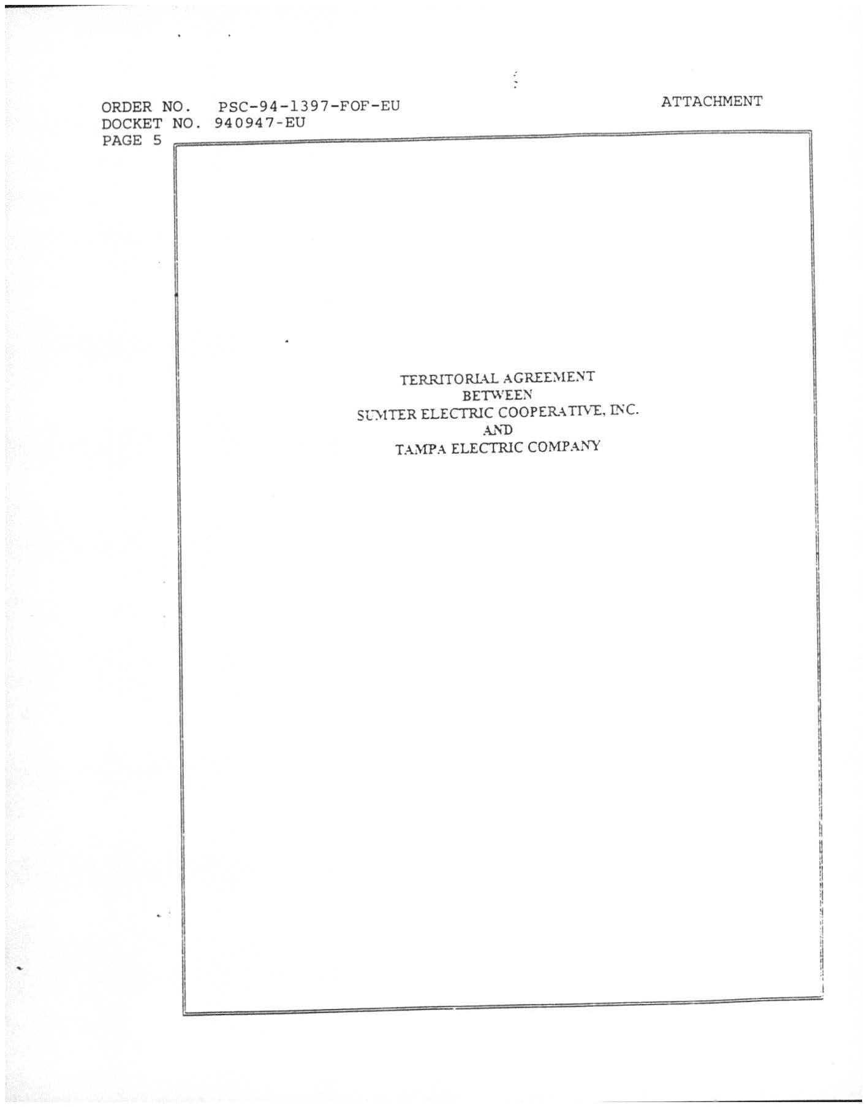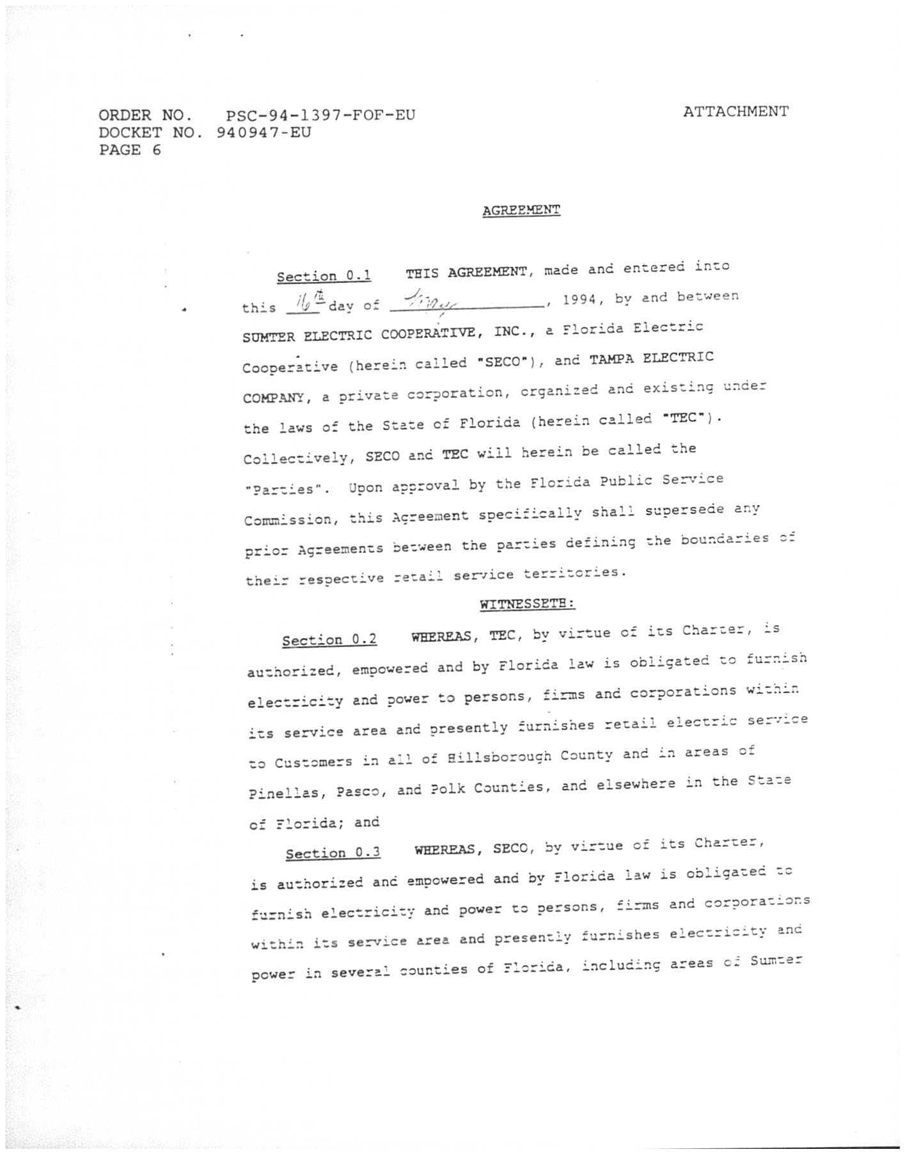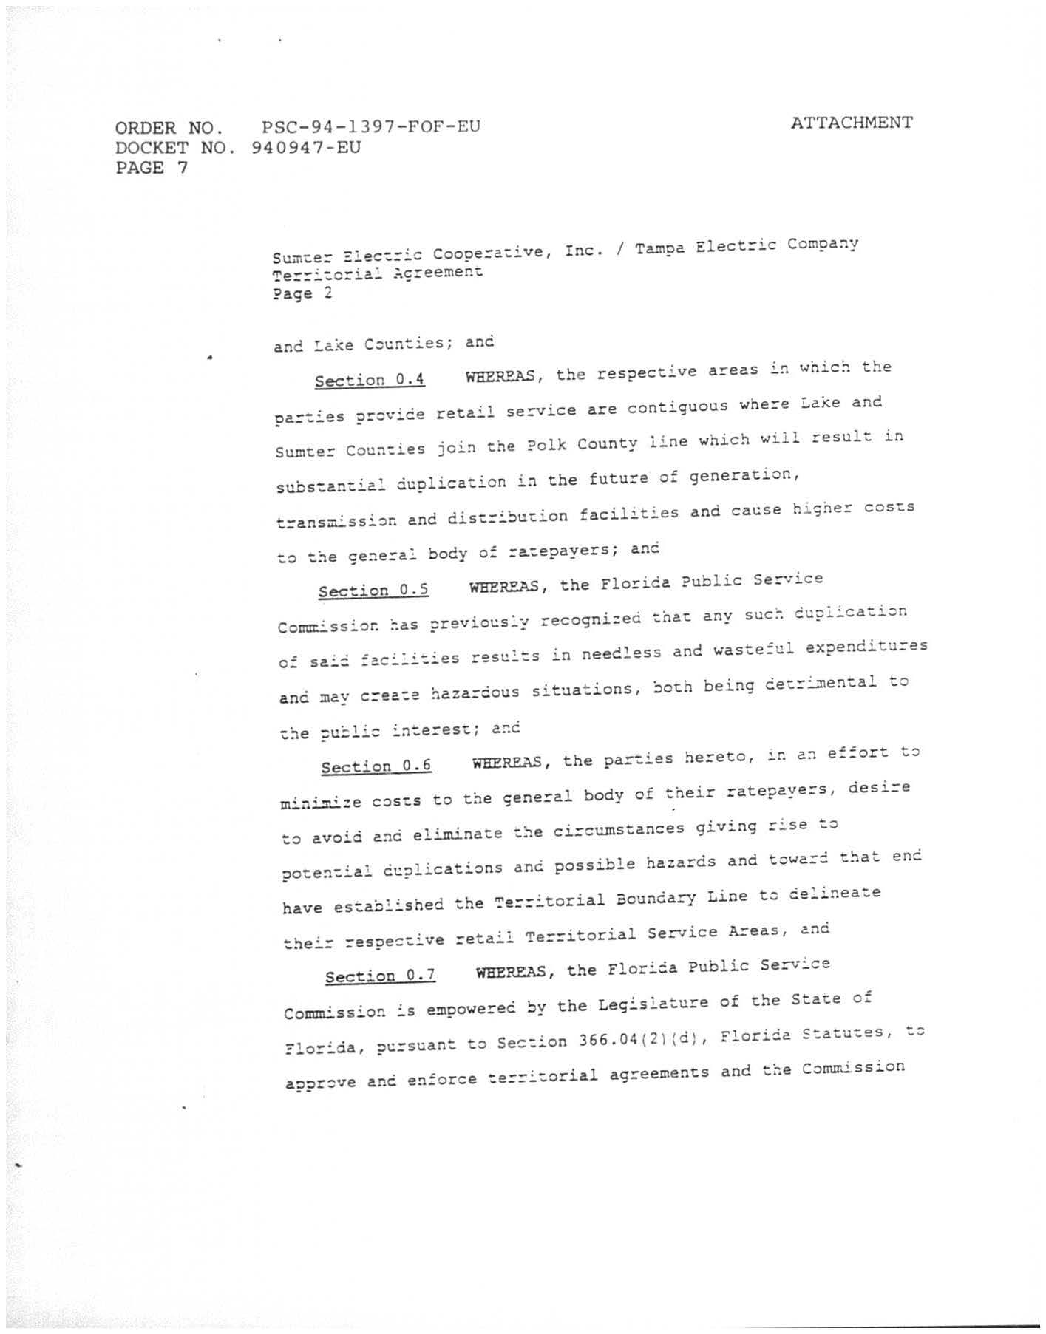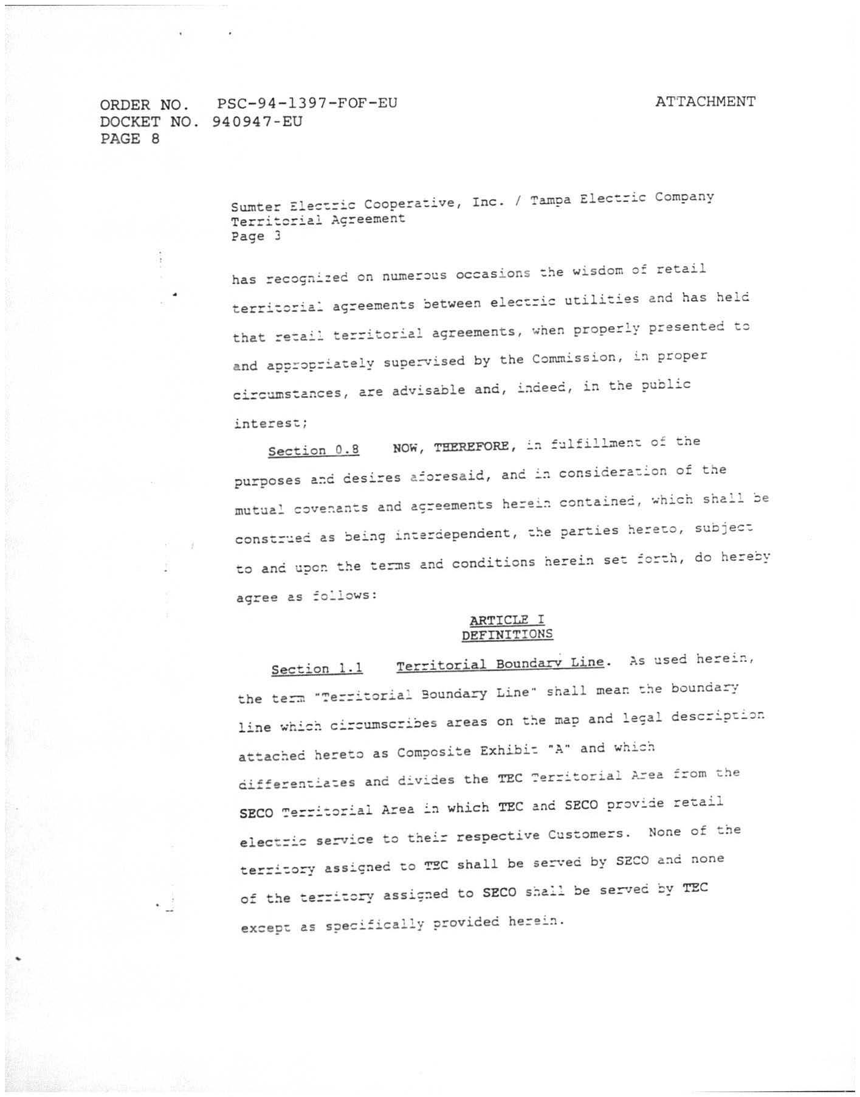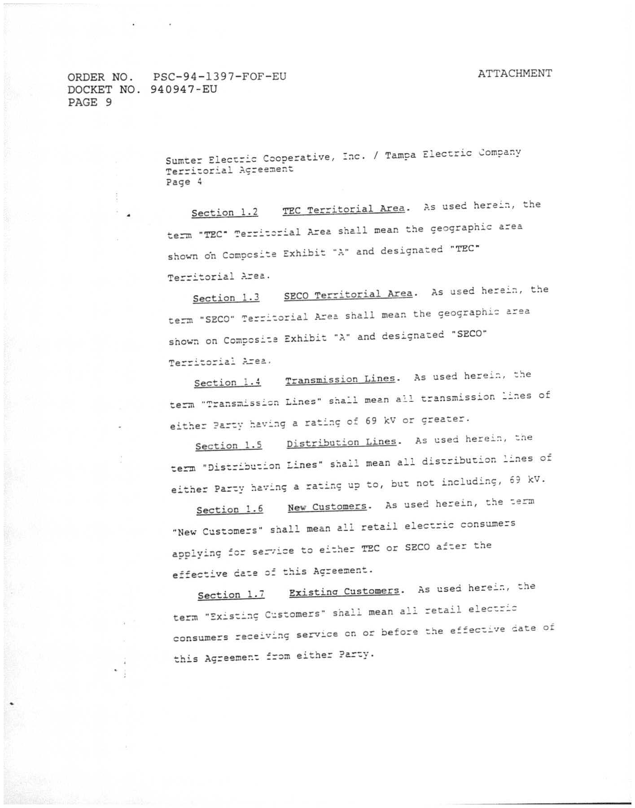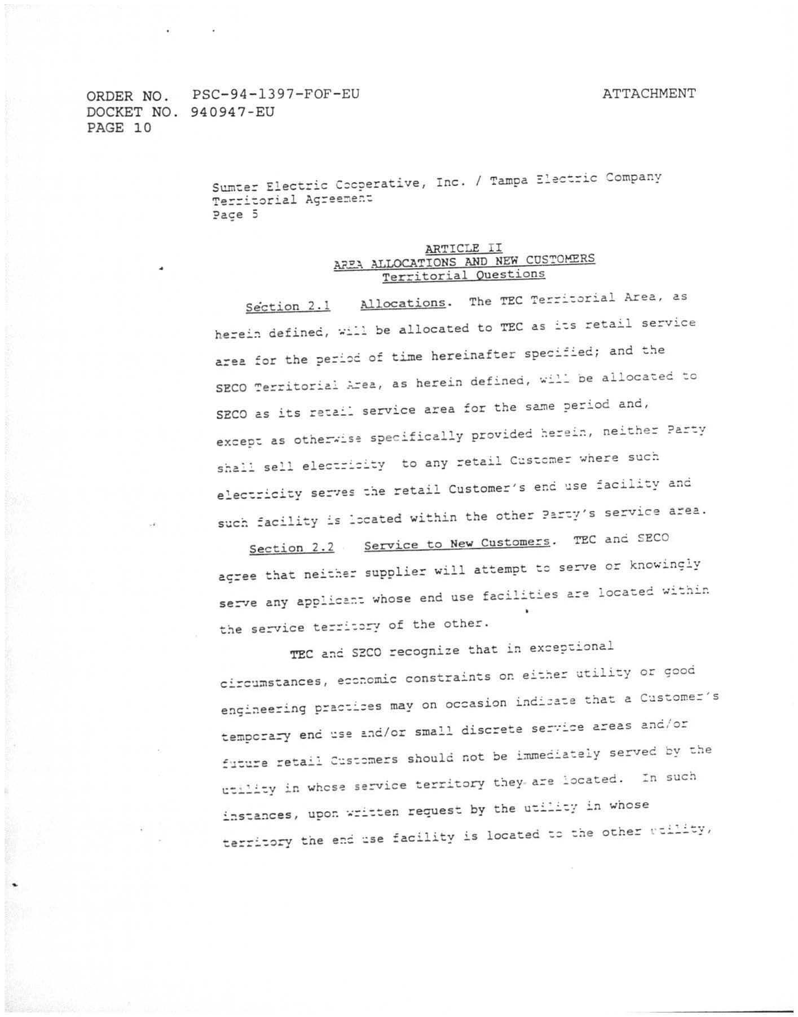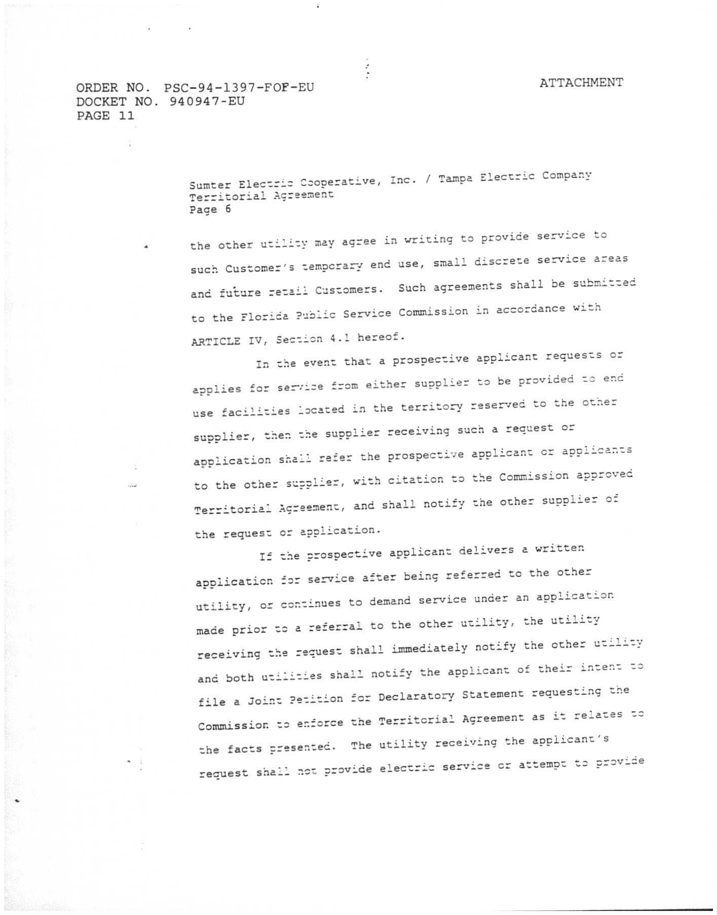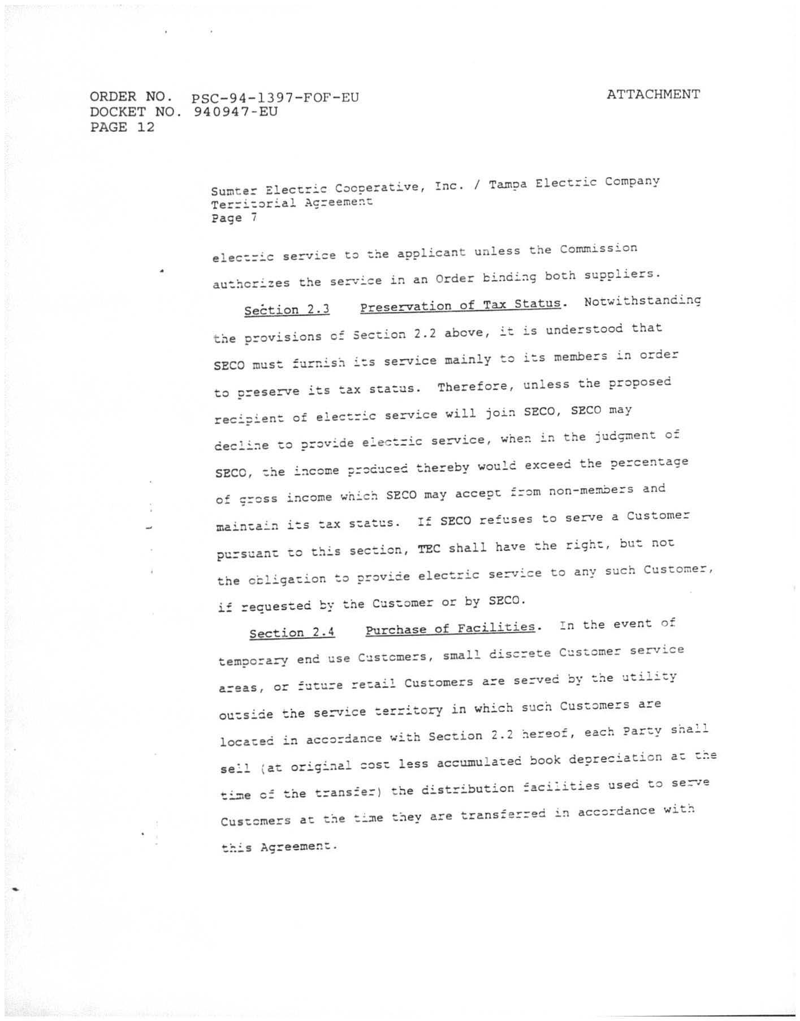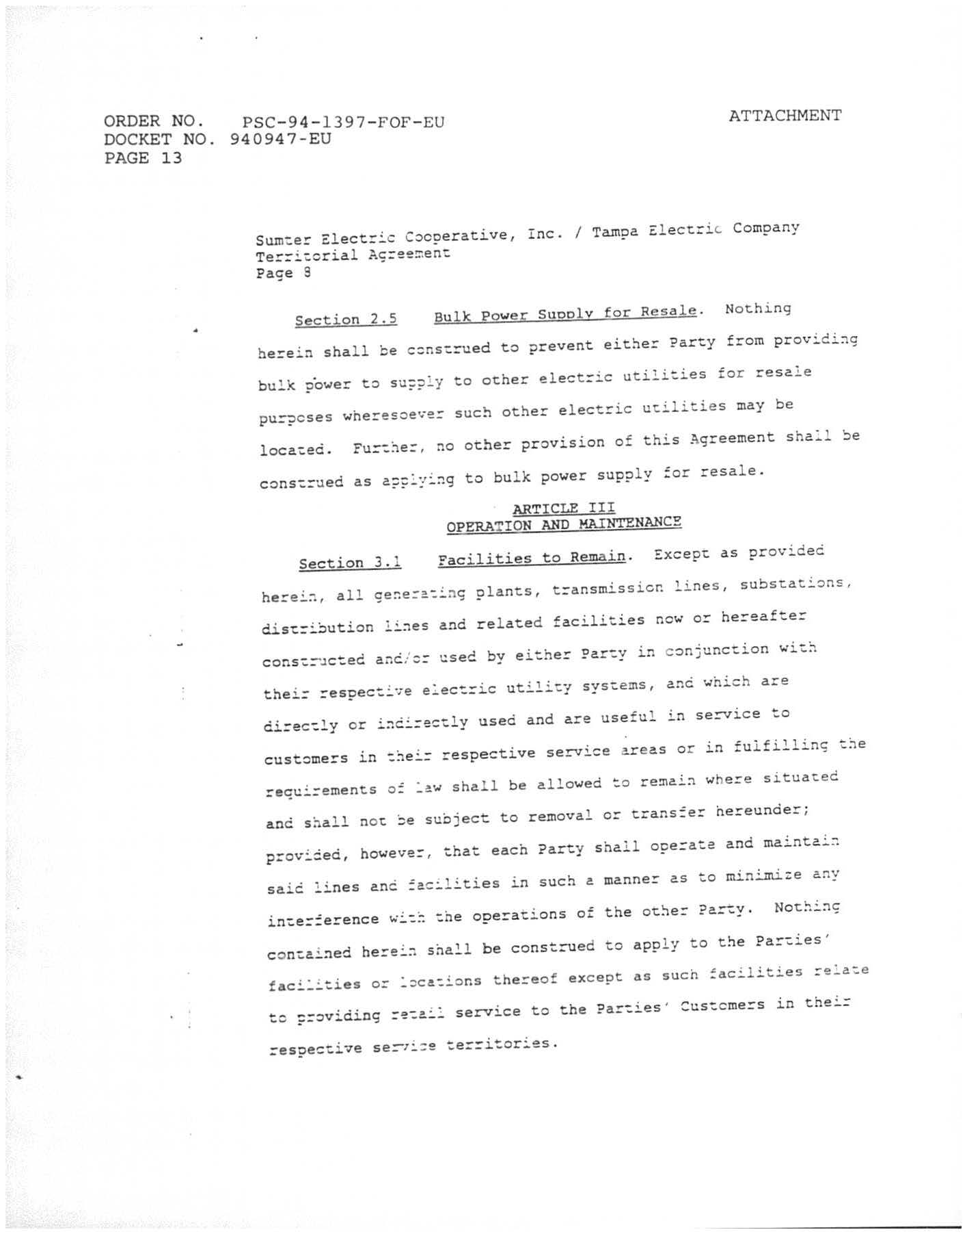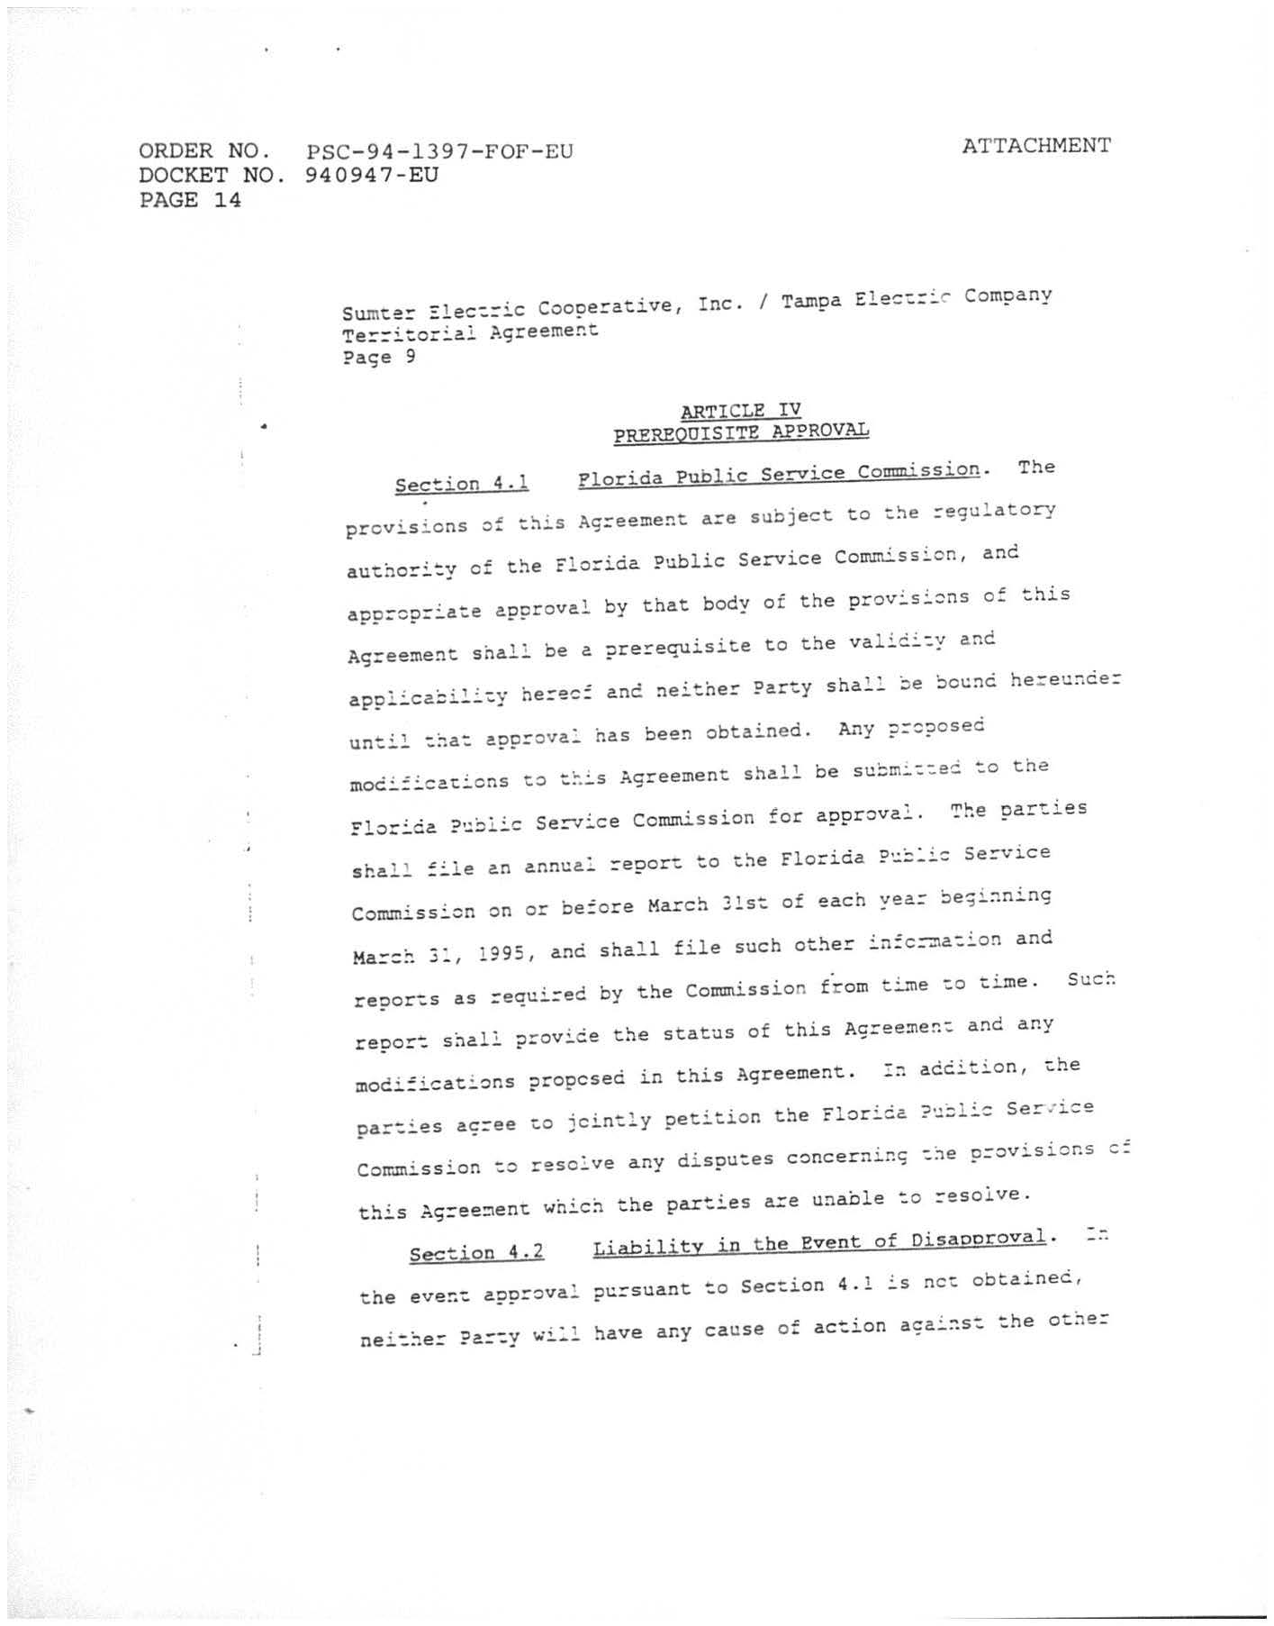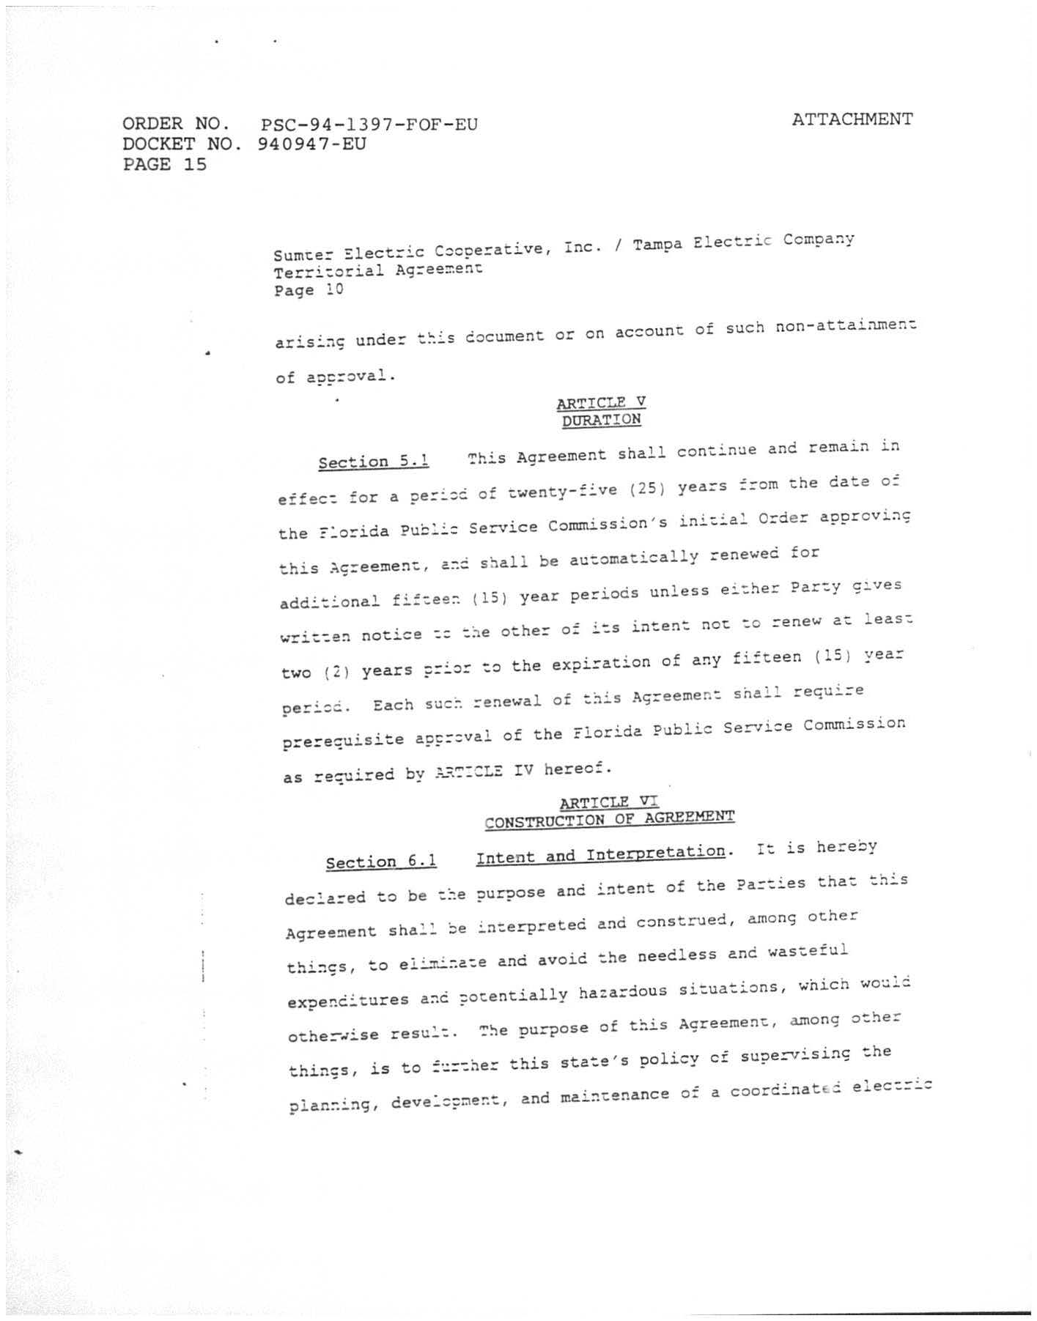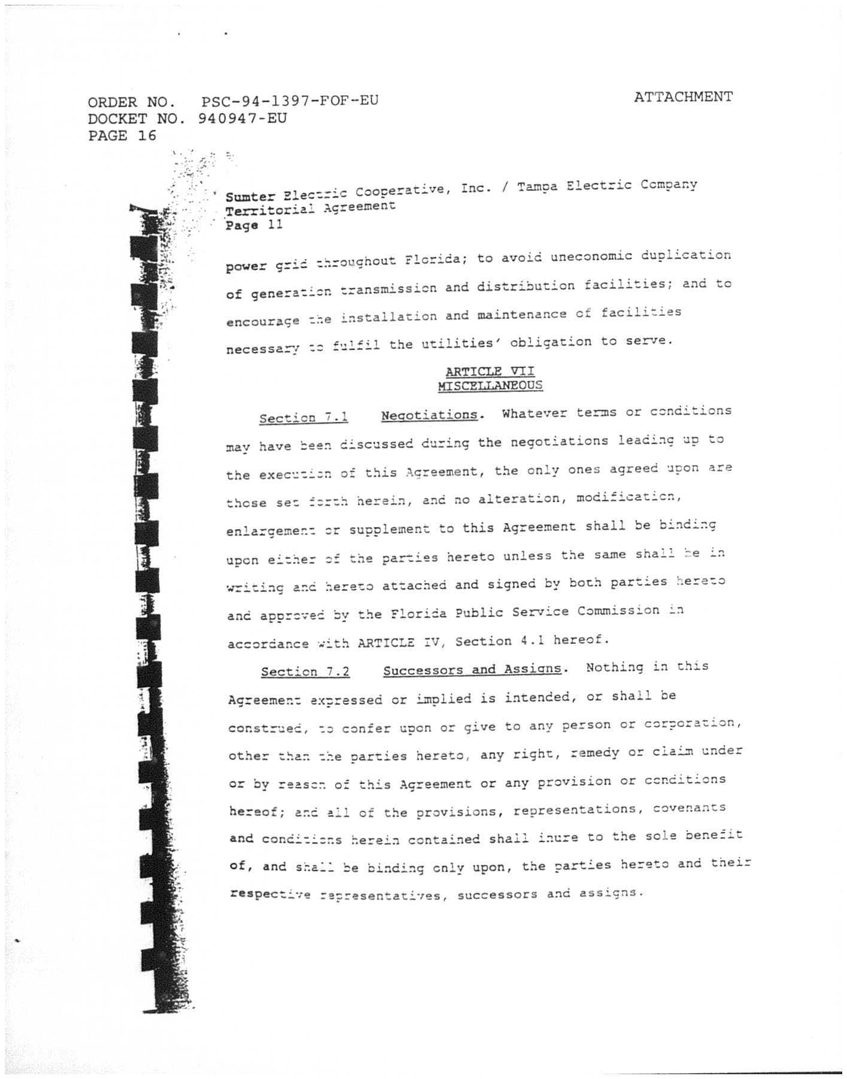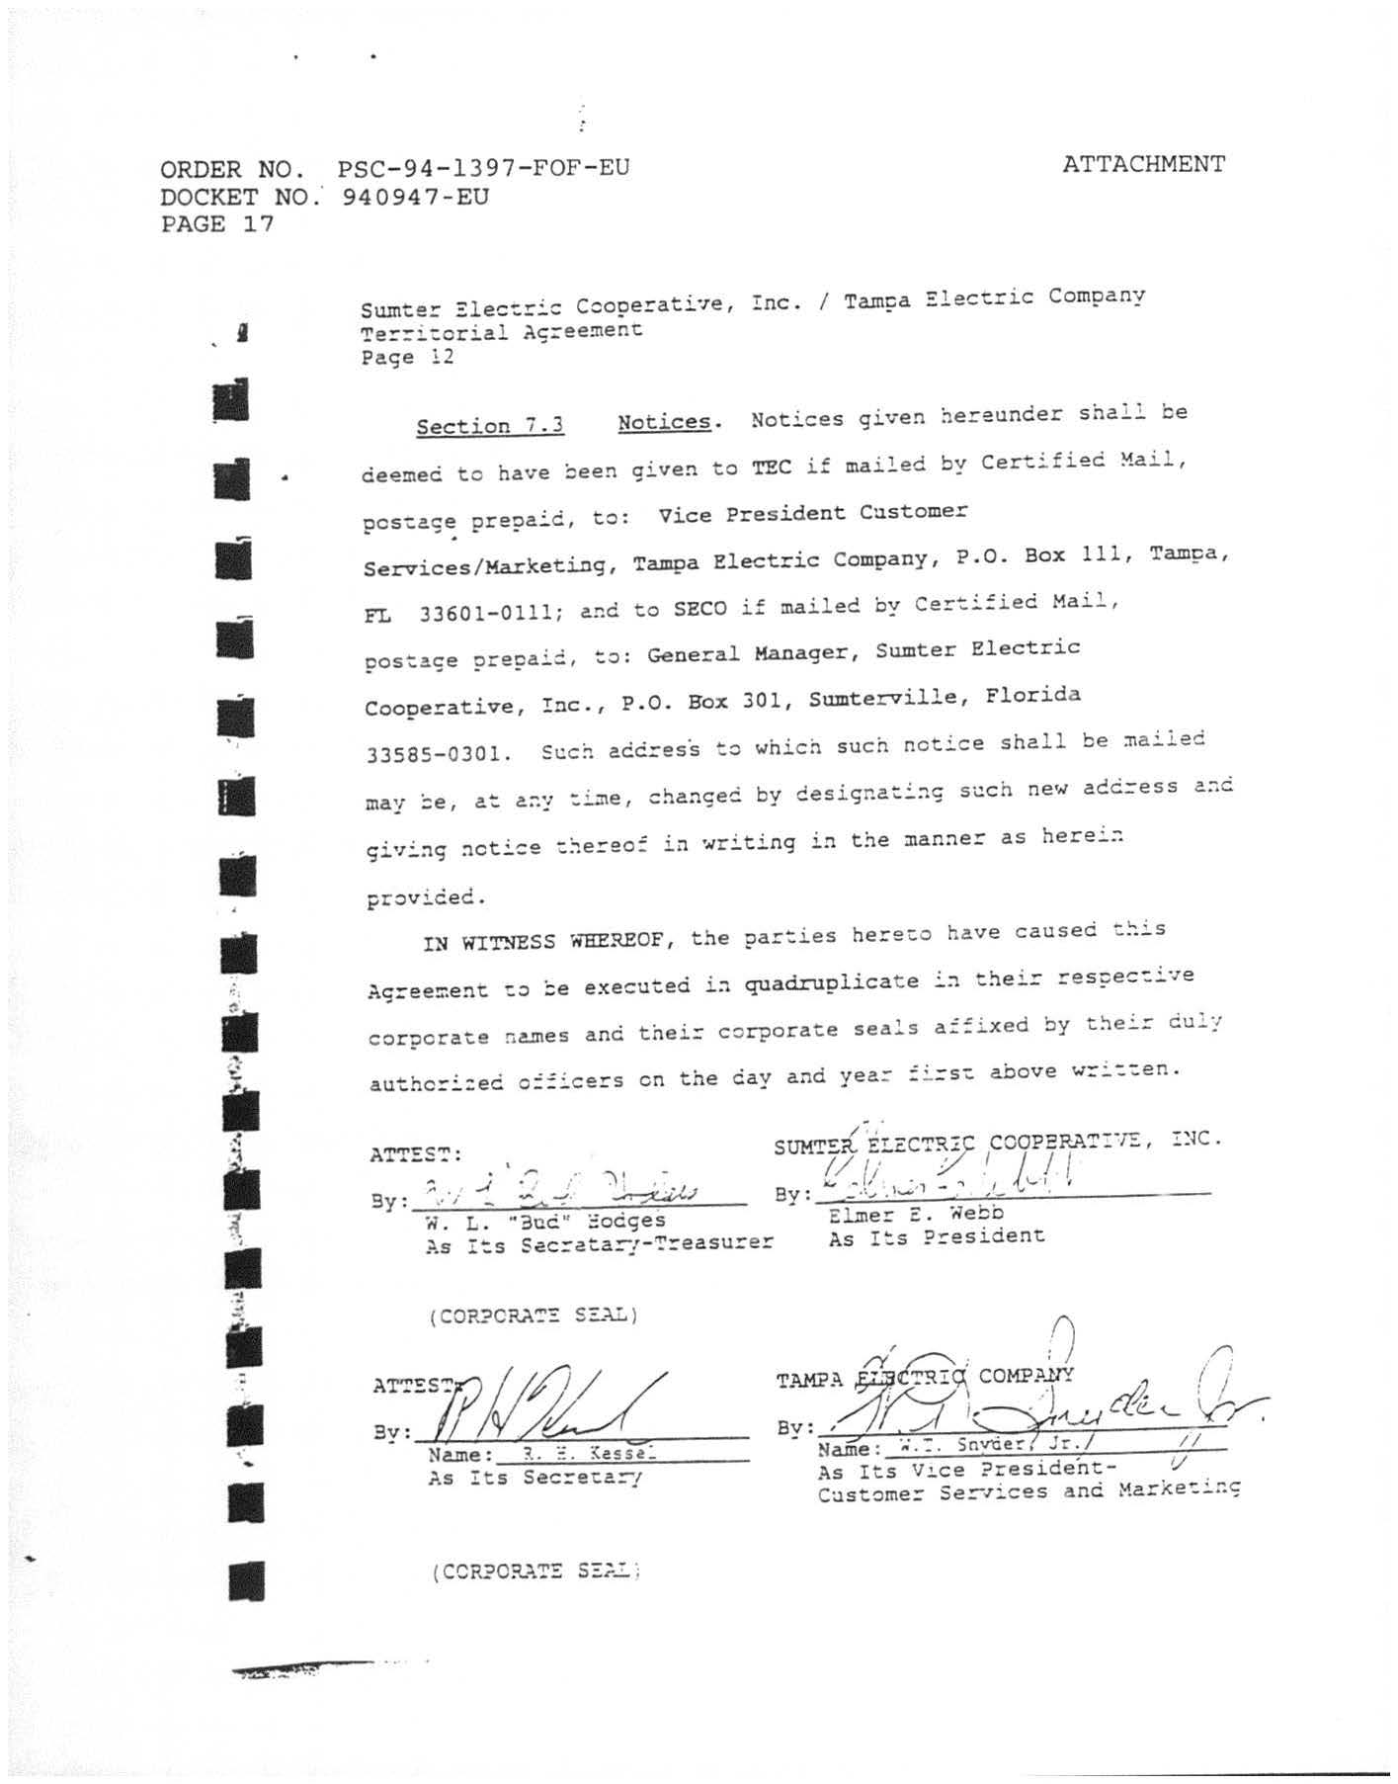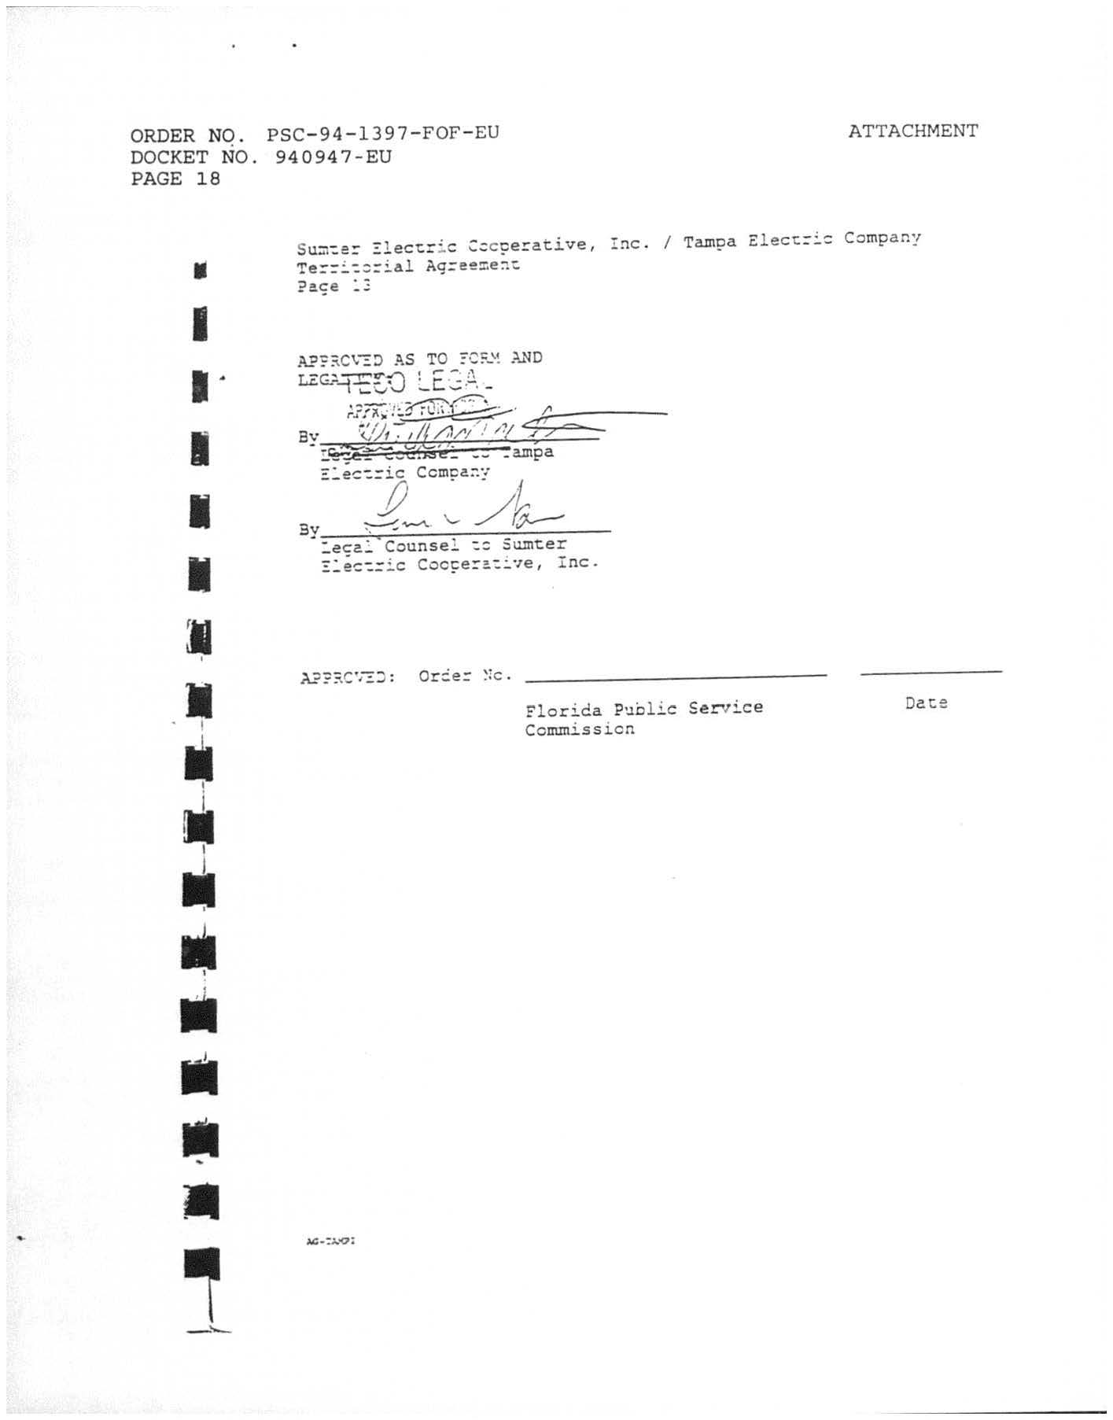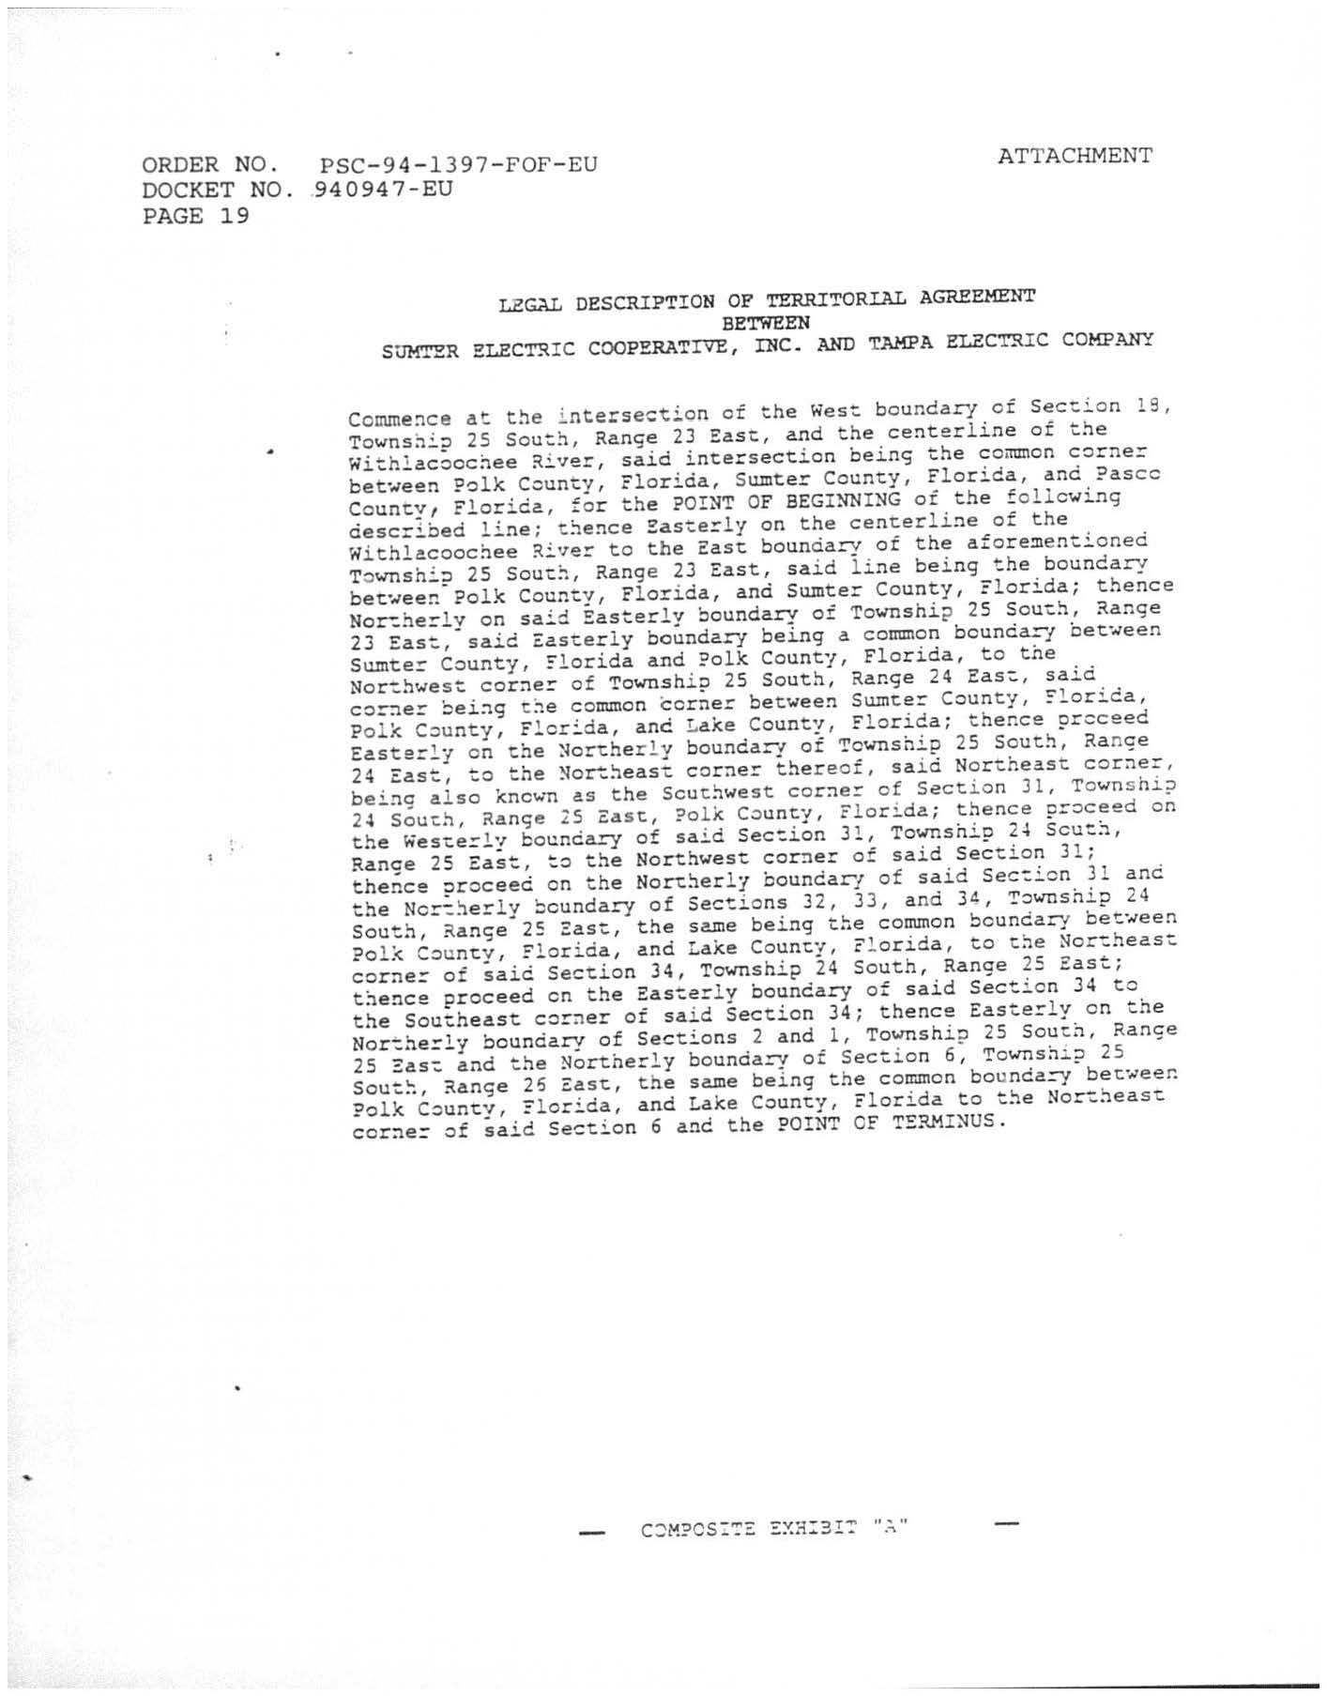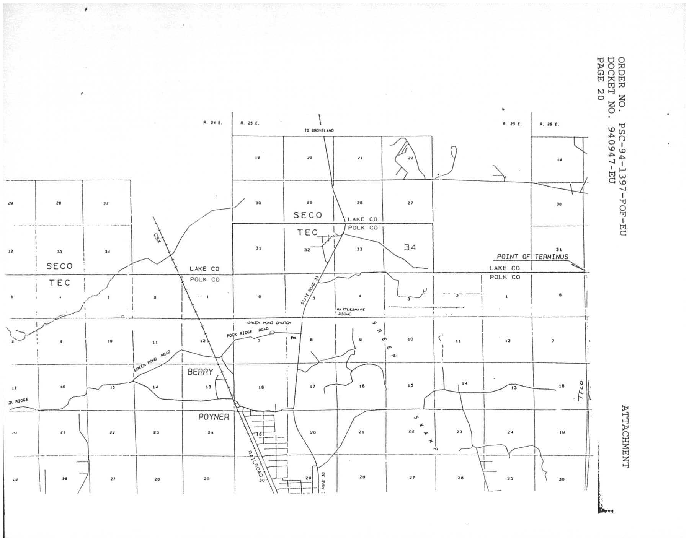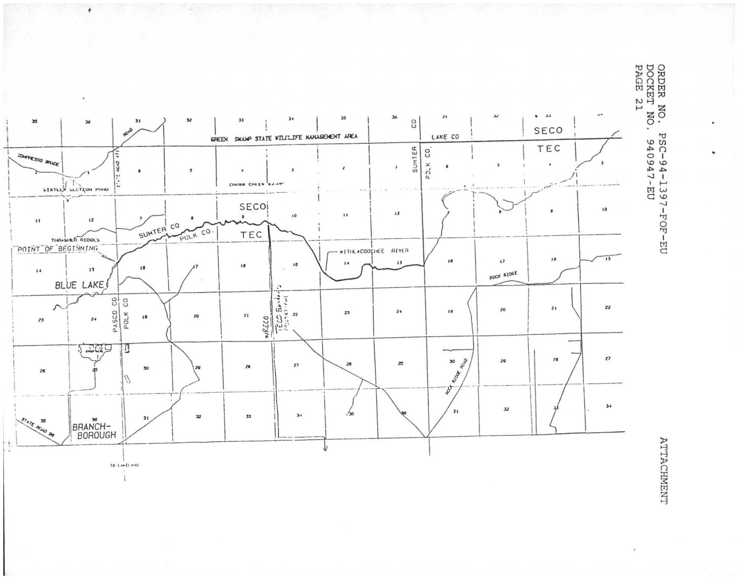
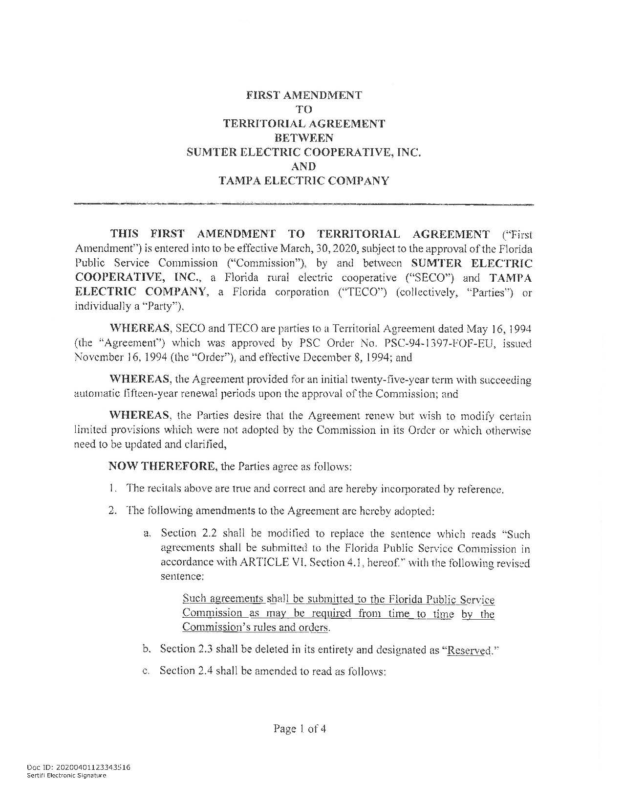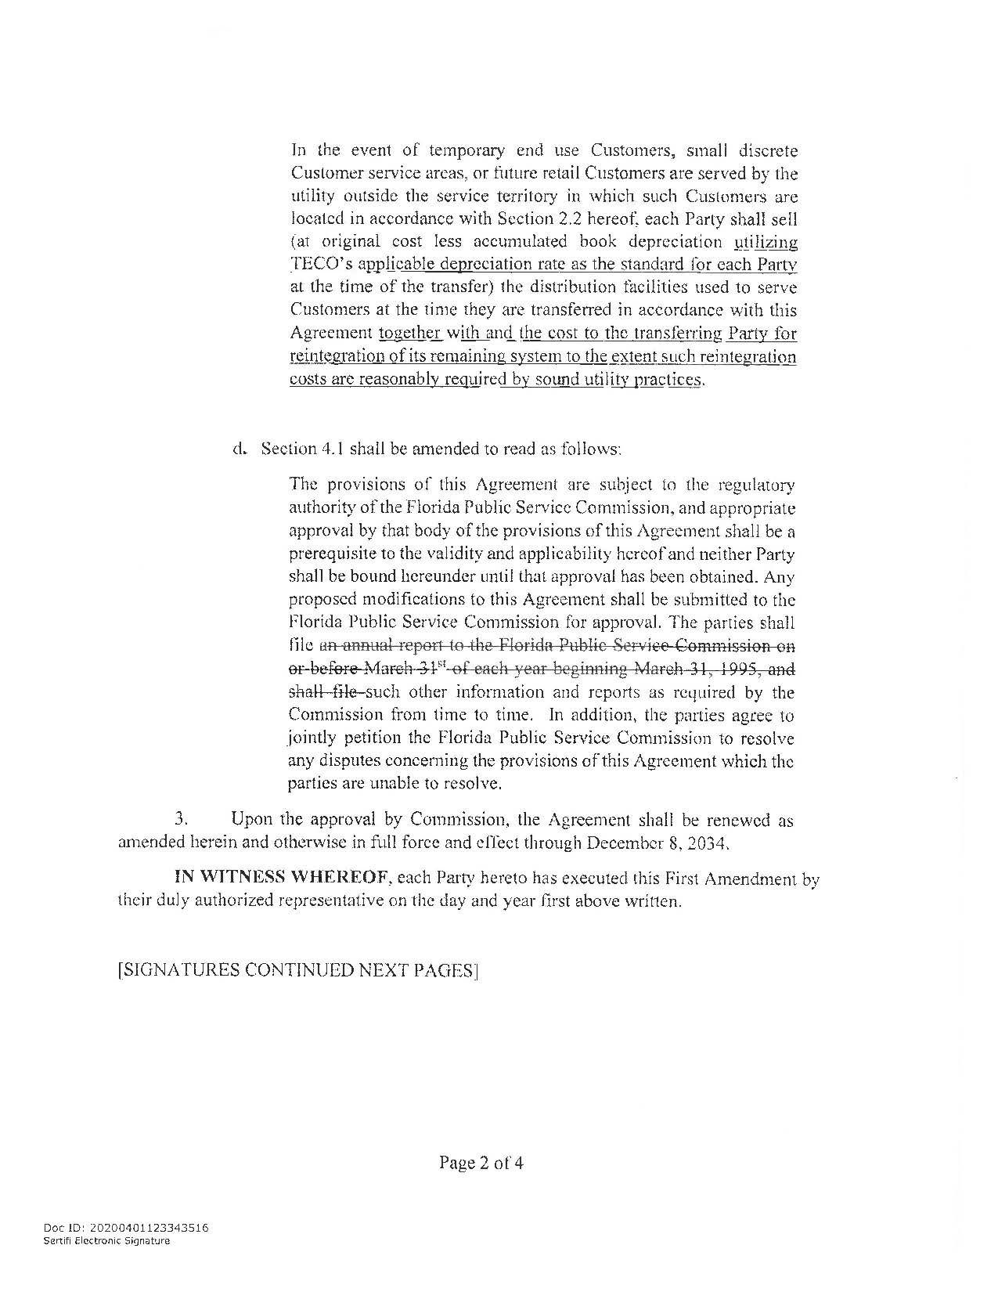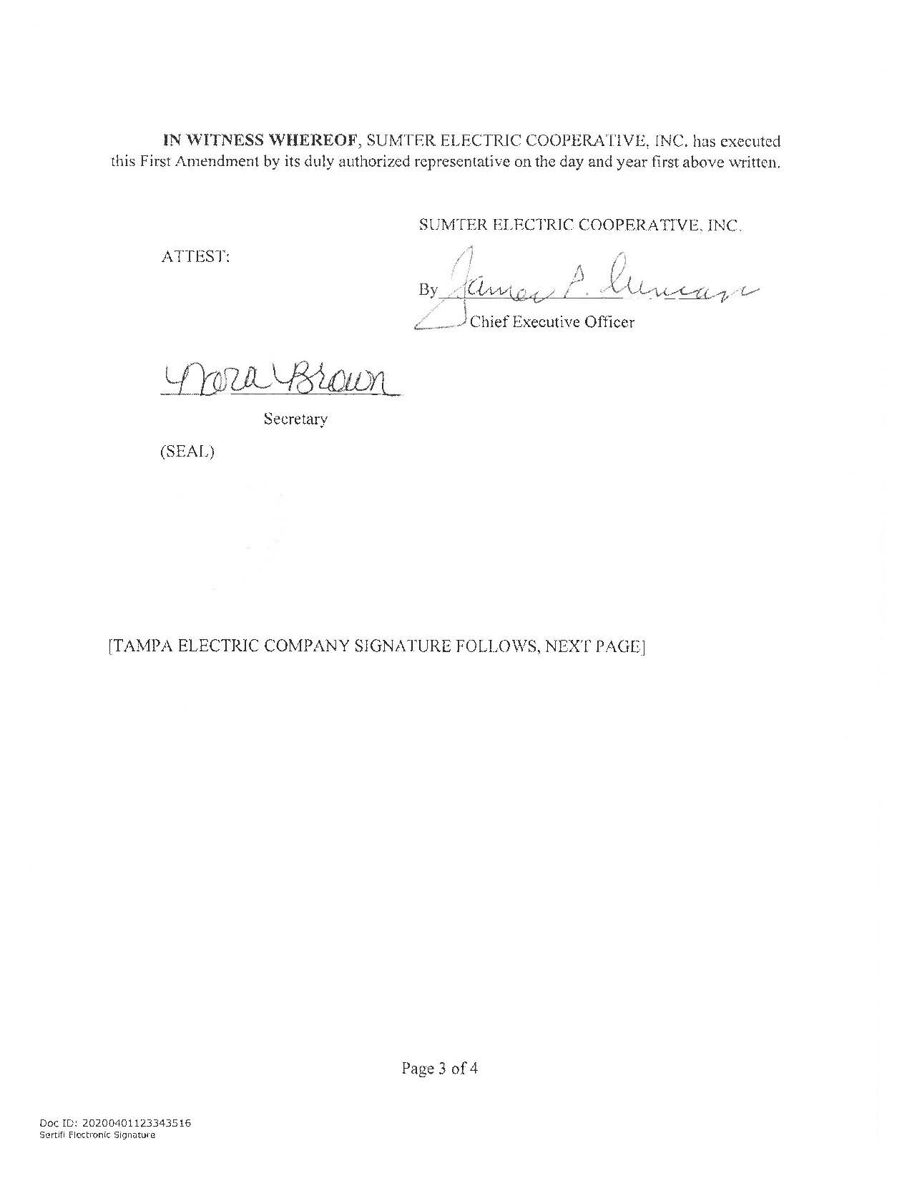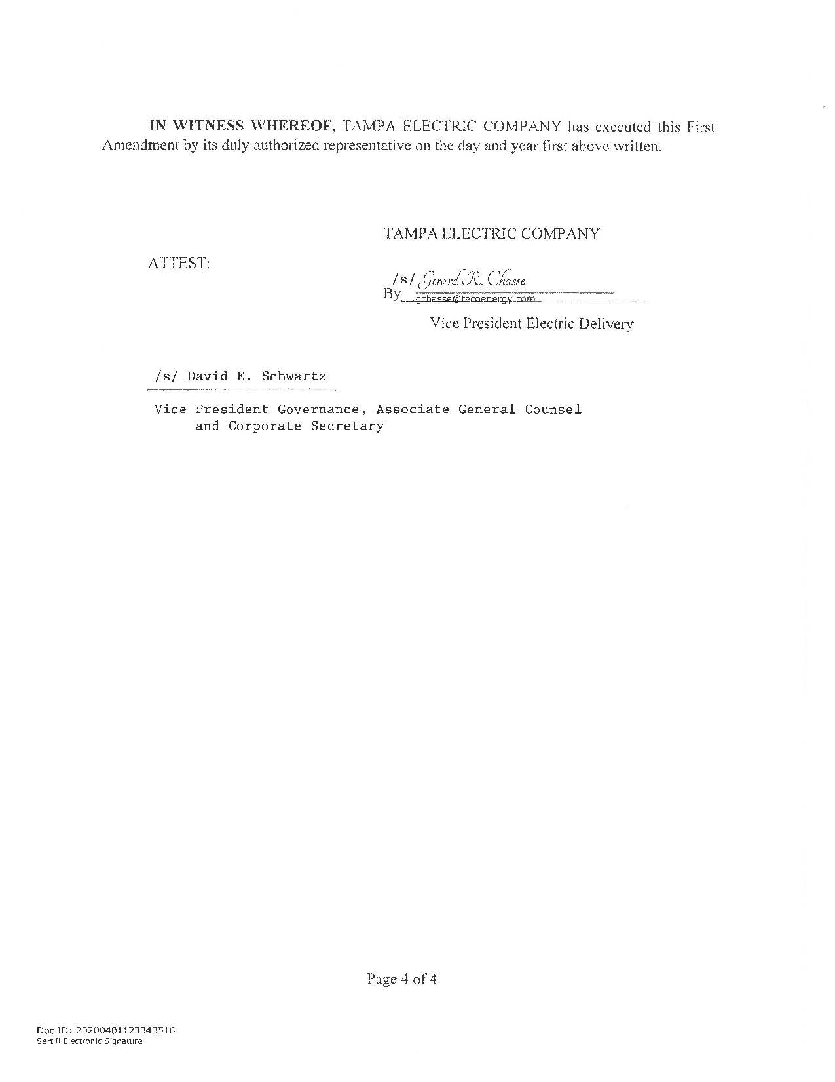

Order No. PSC-1994-1397-FOF-EU, issued November 16, 1994, in Docket No. 19940947-EU, In re: Joint petition for approval of territorial agreement between Tampa Electric Company and Sumter Electric Cooperative, Inc.
Utilities Commission of the City of New Smyrna Beach v. Florida Public Service Commission, 469 So. 2d 731 (Fla. 1985).
Response No. 1 to staff’s first data request (Document No. 02374-2020).

