BEFORE THE FLORIDA PUBLIC SERVICE COMMISSION

In re: Petition to approve the 2020 settlement agreement by Tampa Electric Company. | DOCKET NO. 20200145-EI
In re: Petition for a limited proceeding to approve fourth SoBRA, by Tampa Electric Company. | DOCKET NO. 20200064-EI
In re: Petition for a limited proceeding to eliminate accumulated amortization reserve surplus for intangible software assets, by Tampa Electric Company. | DOCKET NO. 20200065-EI
In re: Review of 2020-2029 Storm Protection Plan pursuant to Rule 25-6.030, F.A.C., Tampa Electric Company. | DOCKET NO. 20200067-EI
In re: Storm protection plan cost recovery clause. | DOCKET NO. 20200092-EI  ORDER NO. PSC-2020-0224-AS-EI  ISSUED: June 30, 2020

The following Commissioners participated in the disposition of this matter:

GARY F. CLARK, Chairman
ART GRAHAM
JULIE I. BROWN
DONALD J. POLMANN
ANDREW GILES FAY

APPEARANCES:

JEFFRY WAHLEN, JAMES D. BEASLEY and MALCOLM MEANS, ESQUIRES, Ausley Law Firm, P.O. Box 391, Tallahassee, Florida 32302-0391
On behalf of Tampa Electric Company

J.R. KELLY, PUBLIC COUNSEL, CHARLES REHWINKEL, DEPUTY PUBLIC COUNSEL, and MIREILLE FALL-FRY, ESQUIRES, Office of Public Counsel, c/o The Florida Legislature, 111 W. Madison Street, Room 812, Tallahassee, Florida 32399-1400
On behalf of the Citizen of the State of Florida

JON C. MOYLE, JR. and KAREN A. PUTNAL, ESQUIRES, Moyle Law Firm, P.A., 118 North Gadsden Street, Tallahassee, Florida 32301
On behalf of Florida Industrial Power Users Group

ROBERT SCHEFFEL WRIGHT, ESQUIRE, Gardner, Bist, Bowden, et al., 1300 Thomaswood Drive, Tallahassee, Florida 32308
On behalf of Florida Industrial Power Users Group

THOMAS “DREW” JERNIGAN, AFLOA/JACL-ULFSC, 139 Barnes Drive, Suite 1, Tyndall AFB, Florida 32403
On behalf of Federal Executive Agencies

MARK F. SUNDBACK and WILLIAM M. RAPPOLT, ESQUIRES, 2099 Pennsylvania Ave., Suite 100 Washington DC 20006
On behalf of West Central Florida Hospital Utility Alliance

STEPHANIE EATON, ESQUIRE, Spillman Thomas and Battle, PLLC, 100 Oakwood Drive, Suite 500, Winston-Salem, NC 27103
On behalf of Walmart

BIANCA LHERISSON and SHAW STILLER, ESQUIRES, Florida Public Service Commission General Counsel’s Office, 2540 Shumard Oak Boulevard, Tallahassee, Florida 32399-0850
On behalf of Florida Public Service Commission Staff

MARY ANNE HELTON, ESQUIRE, Deputy General Counsel, Florida Public Service Commission, 2540 Shumard Oak Boulevard, Tallahassee, Florida 32399-0850
Advisor to the Florida Public Service Commission.

KEITH C. HETRICK, ESQUIRE, General Counsel, Florida Public Service Commission, 2540 Shumard Oak Boulevard, Tallahassee, Florida 32399-0850
Florida Public Service Commission General Counsel.

FINAL ORDER APPROVING SETTLEMENT AGREEMENT

BY THE COMMISSION:

Background

On May 4, 2020, Tampa Electric Company (TECO) filed a Motion to Approve 2020 Agreement, attaching the 2020 Settlement Agreement (2020 Agreement). The 2020 Agreement, attached hereto, is signed and executed by TECO, the Office of Public Counsel (OPC), the Florida Industrial Power Users Group (FIPUG), the Florida Retail Federation (FRF), the Federal Executive Agencies (FEA), and the West Central Florida Hospital Utility Alliance (HUA) (collectively, the Signatories). The 2020 Agreement was filed in Docket Nos. 20200064-EI, 20200065-EI, 20200067-EI, and 20200092-EI because it impacts, in part, all of these dockets. Docket No. 20200145-EI was opened to have one central docket in which to address the 2020 Agreement. The Signatories are deemed parties for purposes of our consideration of the 2020 Agreement.

TECO contends that if the 2020 Agreement is approved, it will establish, as to TECO, a series of stipulations that will reduce the issues to be litigated in Docket Nos. 20200067-EI and 20200092-EI, thereby allowing the Signatories and us to focus on the merits of TECO’s Storm Protection Plan and the recovery of the costs associated with that Plan in 2020 and 2021 in Docket No. 20200092-EI. TECO states that if the 2020 Agreement is approved, it will resolve all issues currently pending in Docket No. 20200065-EI, and reduce the issues to be litigated in Docket No. 20200064-EI.

The 2020 Agreement also presents a base rate revenue reduction amount and reflects a determination of certain expenses for which TECO plans to seek cost recovery through the Storm Protection Plan Cost Recovery Clause, Docket No. 20200092-EI. TECO contends that approval of the 2020 Agreement promotes regulatory economy and administrative efficiency, and avoids the time and expense associated with litigating the settled issues in the various existing and continuing Commission dockets.

TECO, with the support of the Signatories, requested an administrative hearing for us to consider the 2020 Agreement. TECO stated that the Signatories to the 2020 Agreement believe that approval of the 2020 Agreement is in the best interests of the customers the Signatories represent, and that the 2020 Agreement in its totality is in the public interest. TECO stated that the Signatories agree that if the 2020 Agreement is approved, then the approval of the 2020 Agreement will resolve specified matters in Docket Nos. 20200064-EI, 20200065-EI, 20200067-EI, and 20200092-EI.

We held an administrative hearing on June 9, 2020. In addition to oral argument by the Signatories, we heard testimony from two TECO witnesses and admitted documentary exhibits into the record, all in support that approval of the 2020 Agreement is in the public interest. As part of this hearing, we provided notice that there was an opportunity for members of the public who wished to testify on this matter to do so either telephonically or by submitting written comments. No requests for public testimony were made, and no written comments were filed. At the conclusion of the evidentiary portion of the hearing, the parties indicated that they were willing to waive the filing of post-hearing briefs, and we approved the 2020 Agreement, as set forth herein, by bench vote.

The 2020 Settlement Agreement

The 2020 Agreement reduces the scope of potentially litigated issues in three dockets and fully resolves all matters in one docket.

Docket No. 20200064-EI: Petition for a Limited Proceeding to Approve Fourth SoBRA

Section I, paragraphs 1-4

In Docket No. 20200064-EI, a potential issue concerns whether TECO’s solar projects qualify for treatment under the Solar Base Rate Adjustment (SoBRA) provisions of its 2017 Amended and Restated Stipulation and Settlement Agreement (2017 Agreement). A requirement for eligibility of a 2021 SoBRA is that the calculation of the actual average installed cost value for the First and Second Solar Base Rate Adjustments (SoBRAs) is below a set threshold of $1,475 per KWac. The provisions of Section I of the 2020 Agreement will resolve how this calculation should occur, and the values to be input will be based on the outcome of pending Docket No. 20200144-EI, Petition to True-up First and Second SoBRAs. TECO’s petition and prefiled testimony in Docket No. 20200144-EI purportedly will show that its average cost of the SoBRA projects are at or below the threshold value. In this way, the Signatories assert that approval of the 2020 Agreement potentially simplifies the issues that will be litigated in Docket 2020064-EI.

Docket No. 20200065-EI: Petition to Eliminate Accumulated Amortization Reserve Surplus for Intangible Software Assets

Section II, paragraphs 5-9

TECO is required to record a credit of approximately $16.0 million to amortization expense over 12 months beginning retroactively in January 2020. This is the relief TECO has requested in its revised petition filed in Docket No. 20200065-EI. Furthermore, the Signatories agree that granting TECO’s revised petition will not violate the 2017 Agreement or require amendments to the 2017 Agreement. Approval of the 2020 Agreement would therefore grant the relief TECO is now requesting and Docket No. 20200065-EI can be closed.

Docket No. 20200067-EI: Review of TECO’s 2020-2029 Storm Protection Plan pursuant to Rule 25-6.030, F.A.C.

Section III of the 2020 Agreement discusses the Signatories’ agreements pertaining to TECO’s Storm Protection Plan (SPP) filings in Docket No. 20200067-EI and TECO’s anticipated filings in the Storm Protection Plan Cost Recovery Clause (SPPCRC) Docket No. 20200092-EI.

Section III, paragraph 10

The Signatories agree that TECO will provide project-level details in the SPP docket for years 2020 and 2021. Furthermore, the Vegetation Management Program, Infrastructure Inspection Program, and Legacy Storm Hardening Plan Initiatives Program do not have project components. Similarly, the Signatories agree that TECO’s Extreme Weather Hardening Study does not have project components during 2020 and 2021.

Section III, paragraph 15(a)

The Signatories agree that nothing in the 2020 Agreement shall be construed to prevent any party from challenging the reasonableness and/or prudence of all or part of any SPP program or project in any future proceeding, nor limit the amount of allowed discovery as specified in the Order Establishing Procedure for Docket Nos. 20200067-EI or 2020092-EI.

Section III, paragraph 15(c)

The Signatories will meet beginning October 1, 2020, and for a period of up to 60 days, to identify a method to modify the analytical framework TECO used in developing its SPP in Docket No. 20200067-EI. The good faith objective is to establish a unanimous and mutually agreed-upon method consistent with applicable statutes and rules that TECO will use thereafter unless the resulting framework is changed by agreement of the Signatories.

Docket No. 20200092-EI: Storm Protection Plan Cost Recovery Clause

Section III of the 2020 Agreement sets forth matters pertaining to TECO in Docket No. 20200092-EI and discusses a one-time reduction in base rates of approximately $15 million.

Section III, paragraph 10

Pursuant to the 2020 Agreement, TECO is required to provide project level details for projects it is planning for 2020 and 2021 when it files its petition for cost recovery.

Section III, paragraph 11

This section and its subparts describe the Signatories’ agreement to regulatory methods that allow TECO to recover through the SPPCRC its SPP operations and maintenance (O&M) expenses incurred during 2020 and 2021 that are incremental to its base rates. The O&M expenses are for six activities identified in TECO’s SPP: Planned Distribution Vegetation Management, Planned Transmission Vegetation Management, Transmission Vegetation Management-ROW Maintenance, Infrastructure Inspections, Distribution and Transmission Wood Pole Inspections, and Transmission Asset Upgrades.

TECO may seek recovery of its 2020 O&M expenses for the period May through December in excess of the total expenses of approximately $10.3 million shown on Exhibit 3 of the 2020 Agreement. Recovery of all of TECO’s 2021 SPP O&M expenses through the SPPCRC is contingent on a one-time base rate reduction of approximately $15 million shown on Exhibit 2 of the 2020 Agreement. The one-time base rate reduction is to be effective contemporaneous with the beginning of cost recovery via the SPPCRC.

Section III, paragraph 12

Concerning capital projects, the Signatories agree that cost recovery shall remain in base rates for projects initiated prior to April 10, 2020. The Signatories define the term “initiated” to mean when, in the normal and ordinary course of business, the first dollar is posted to the project work order as reflected in TECO’s accounting system in accordance with its standard procedures.

Project records and fixed asset records for SPP capital projects will be maintained in a manner that clearly distinguishes capital and assets recovered in retail rate base from capital and assets recovered through the SPPCRC. The return on investment and depreciation expense associated with capital projects initiated on or after April 10, 2020, shall be eligible for cost recovery through the SPPCRC, subject to a prudence review in the SPPCRC docket.

For assets being retired and replaced with new assets as part of an SPP program, TECO will not seek to recover the cost of removal net of salvage associated with the related assets to be retired through the SPPCRC. Rather, such net cost of removal will be debited to TECO’s accumulated depreciation reserve according to normal regulatory plant accounting procedures. Additionally, any depreciation expense from SPP asset additions will be reduced by the depreciation expense savings that results from the retirement of assets removed from service during the SPP project. Only the net of the two depreciation amounts will be recoverable through the SPPCRC.

TECO retains the option to seek to move prospective cost recovery from the SPPCRC to base rates for costs that have been determined prudently incurred through a final true-up in the SPPCRC. This request would be through a petition pursuant to Sections 366.06 and/or 366.07, Florida Statutes.

Section III, paragraph 13

The Signatories acknowledge that TECO’s Distribution Pole Replacement program is a legacy storm hardening activity that is included in TECO’s SPP. However, cost recovery for the plant additions and retirements associated with all distribution pole replacements will remain through base rates. This includes O&M expenses from asset transfers related to distribution pole replacements.

Section III, paragraph 14

The Signatories agree that TECO will not aggregate certain SPP capital projects as a means of demonstrating that it has met the threshold for accruing Allowance for Funds Used During Construction in Rule 25-6.0141, Florida Administrative Code. The 2020 Agreement includes guidance on this matter addressing factors such as geographic vicinity, same SPP program, contractor, or project manager.

Decision

The standard for approval of a settlement agreement is whether it is in the public interest. A determination of public interest requires a case-specific analysis based on consideration of the proposed settlement taken as a whole. By approving the 2020 Agreement, the 2020 Agreement promotes regulatory economy and administrative efficiency, and avoids the time and expense associated with litigating the settled issues in the various existing and continuing Commission dockets.

Based upon TECO’s motion, our review of the 2020 Agreement, and evidence and testimony on the record, we find that the 2020 Agreement is in the public interest and it is hereby approved. The 2020 Agreement resolves all of the issues in Docket Nos. 20200145-EI and 20200065-EI.

Based on the foregoing, it is

ORDERED by the Florida Public Service Commission that the stipulations, findings, and rulings herein are hereby approved. It is further

ORDERED that each utility that was a party to this docket shall abide by the stipulations, findings, and rulings herein which are applicable to it. It is further

ORDERED that the attached 2020 Settlement Agreement is approved. It is further

ORDERED that Docket Nos. 20200145-EI and 20200065-EI shall be closed.

By ORDER of the Florida Public Service Commission this 30th day of June, 2020.

/s/ Adam J. Teitzman
ADAM J. TEITZMAN
Commission Clerk
Florida Public Service Commission
2540 Shumard Oak Boulevard
Tallahassee, Florida 32399
(850) 413-6770
www.floridapsc.com

Copies furnished: A copy of this document is provided to the parties of record at the time of issuance and, if applicable, interested persons.

BYL

NOTICE OF FURTHER PROCEEDINGS OR JUDICIAL REVIEW

The Florida Public Service Commission is required by Section 120.569(1), Florida Statutes, to notify parties of any administrative hearing or judicial review of Commission orders that is available under Sections 120.57 or 120.68, Florida Statutes, as well as the procedures and time limits that apply. This notice should not be construed to mean all requests for an administrative hearing or judicial review will be granted or result in the relief sought.

Any party adversely affected by the Commission's final action in this matter may request: 1) reconsideration of the decision by filing a motion for reconsideration with the Office of Commission Clerk, 2540 Shumard Oak Boulevard, Tallahassee, Florida 32399-0850, within fifteen (15) days of the issuance of this order in the form prescribed by Rule 25-22.060, Florida Administrative Code; or 2) judicial review by the Florida Supreme Court in the case of an electric, gas or telephone utility or the First District Court of Appeal in the case of a water and/or wastewater utility by filing a notice of appeal with the Office of Commission Clerk, and filing a copy of the notice of appeal and the filing fee with the appropriate court. This filing must be completed within thirty (30) days after the issuance of this order, pursuant to Rule 9.110, Florida Rules of Appellate Procedure. The notice of appeal must be in the form specified in Rule 9.900(a), Florida Rules of Appellate Procedure.

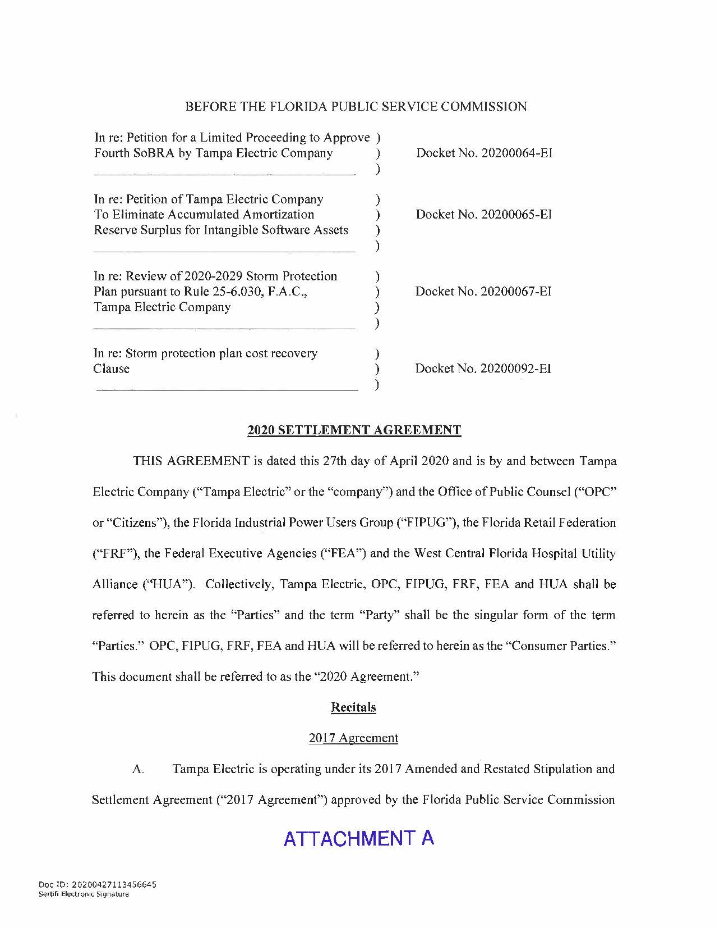
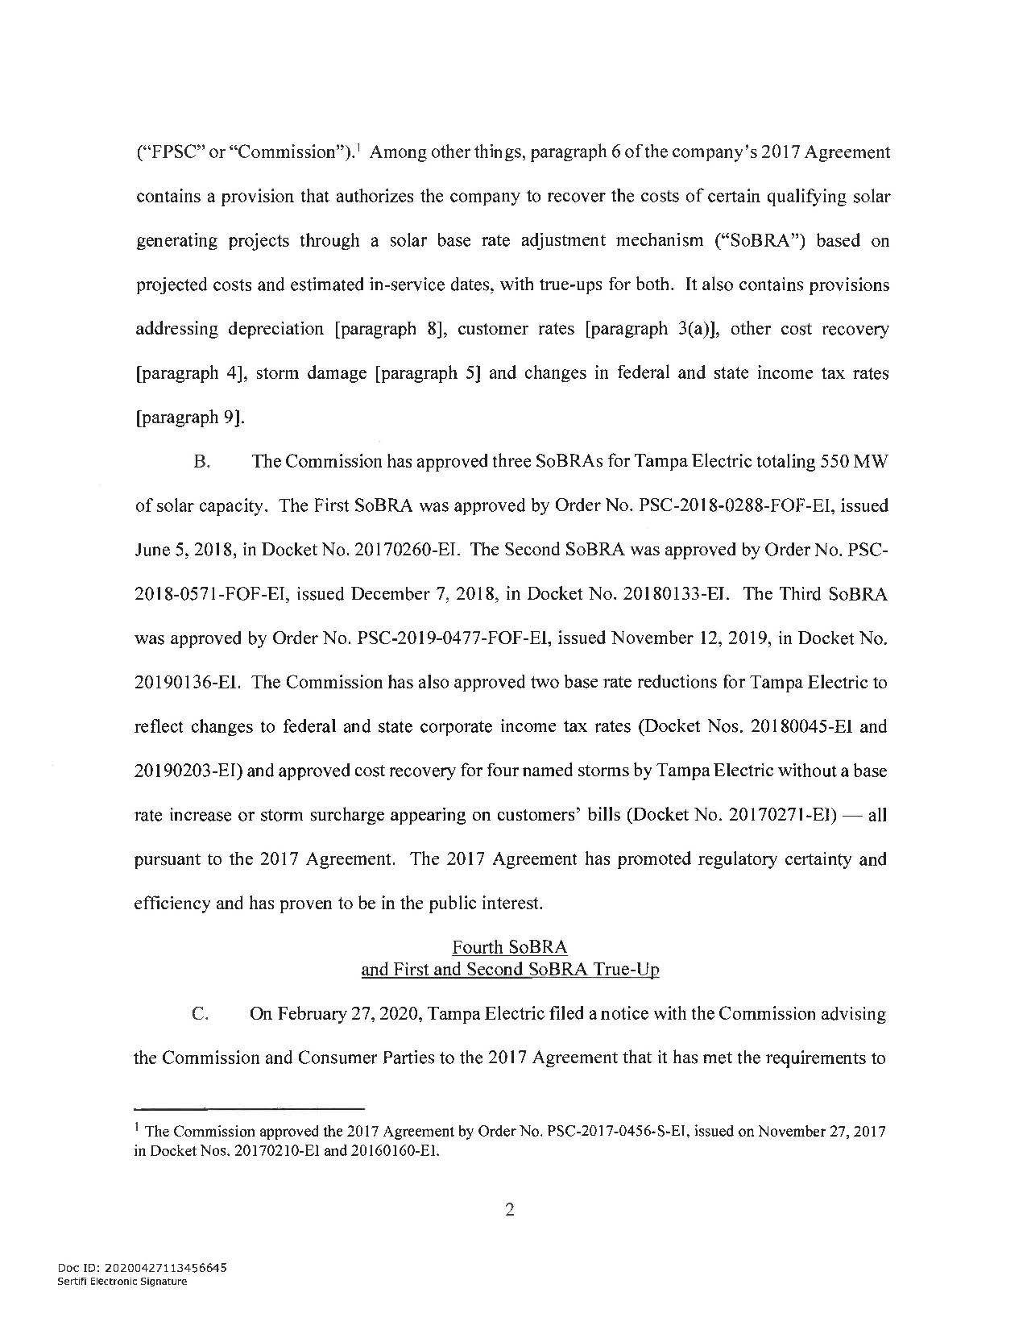
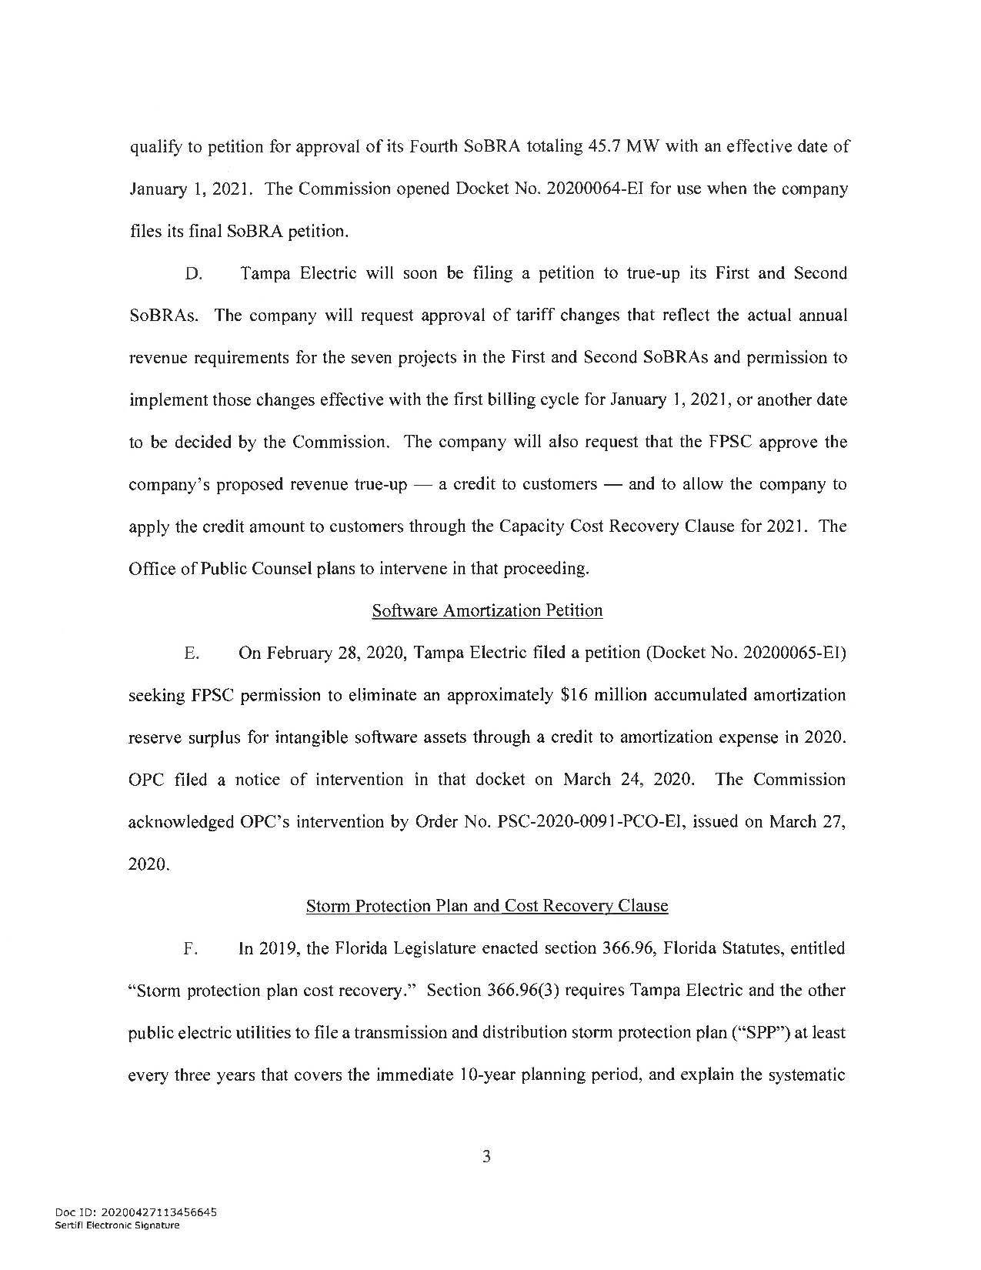
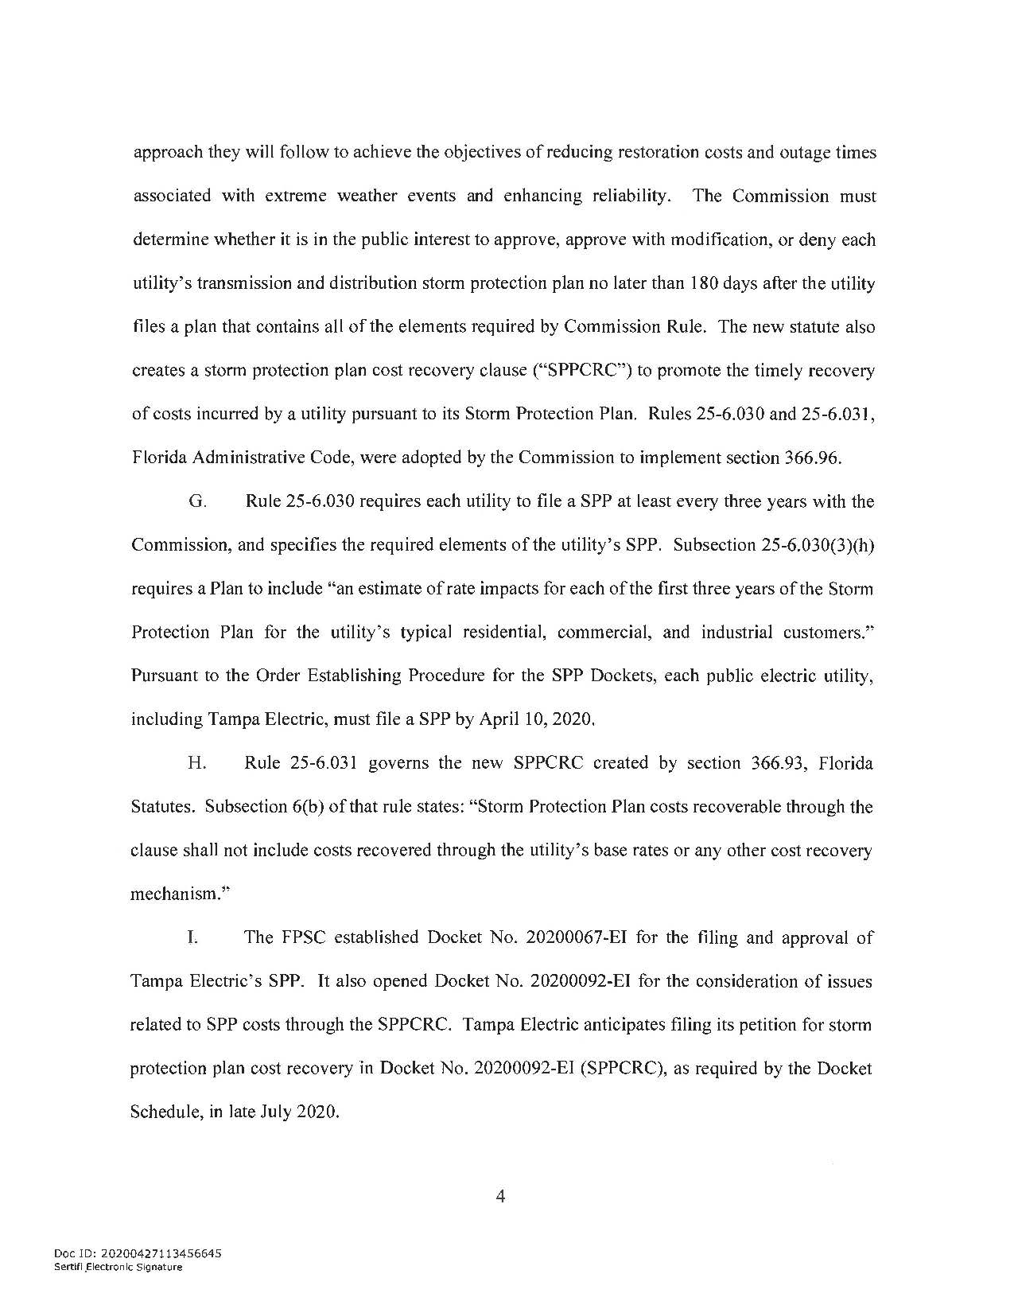
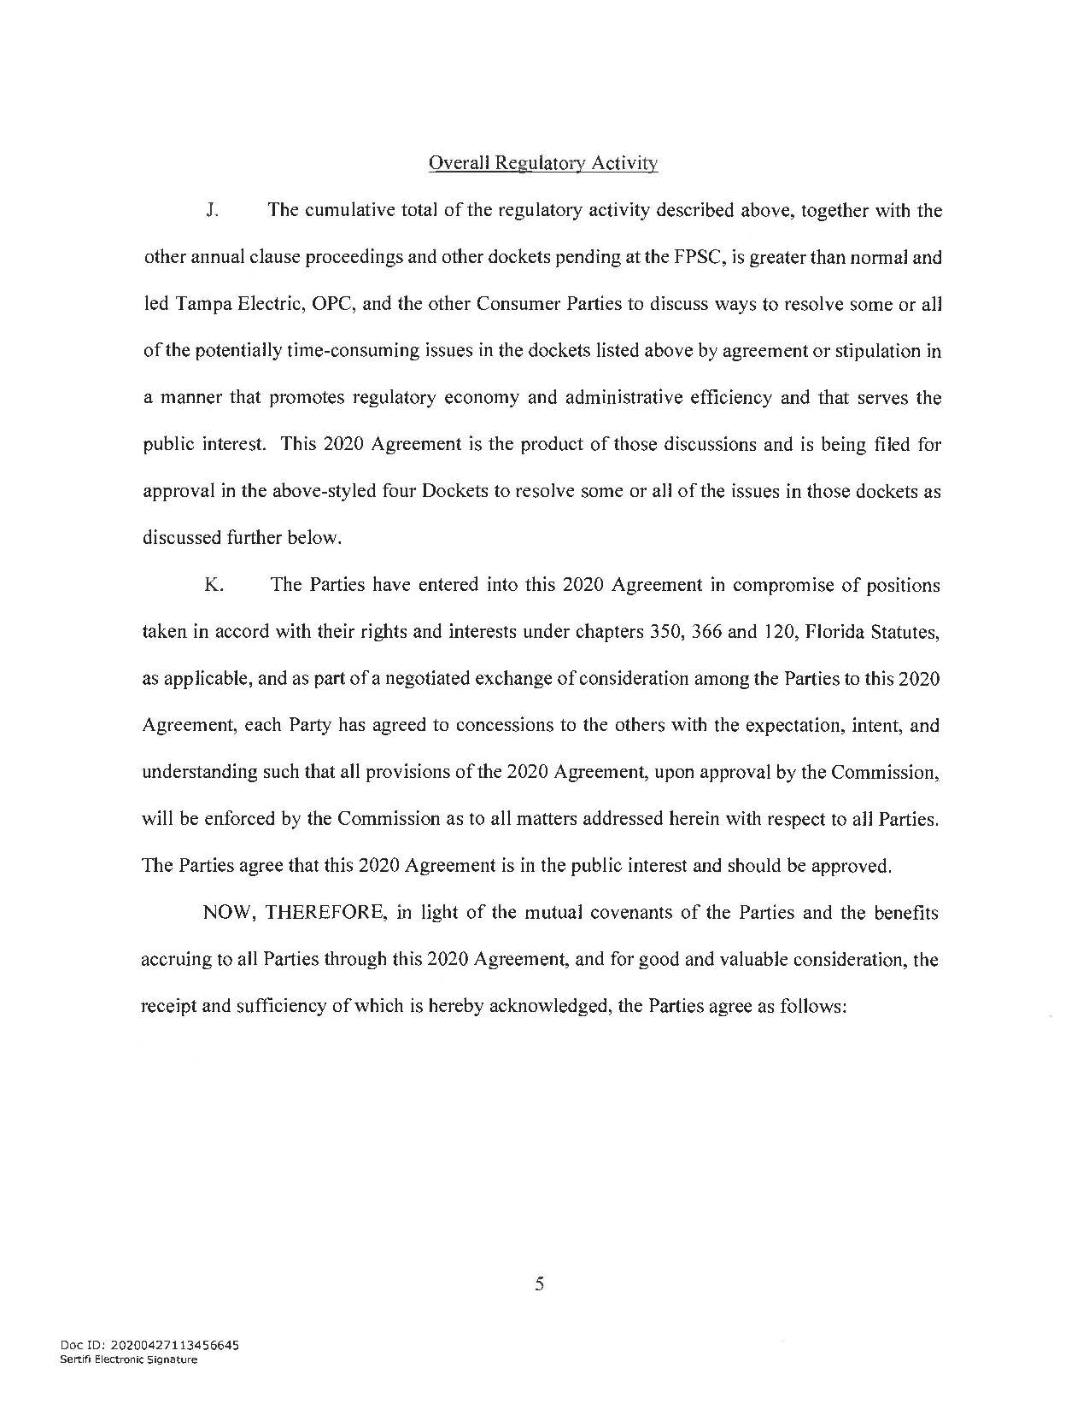
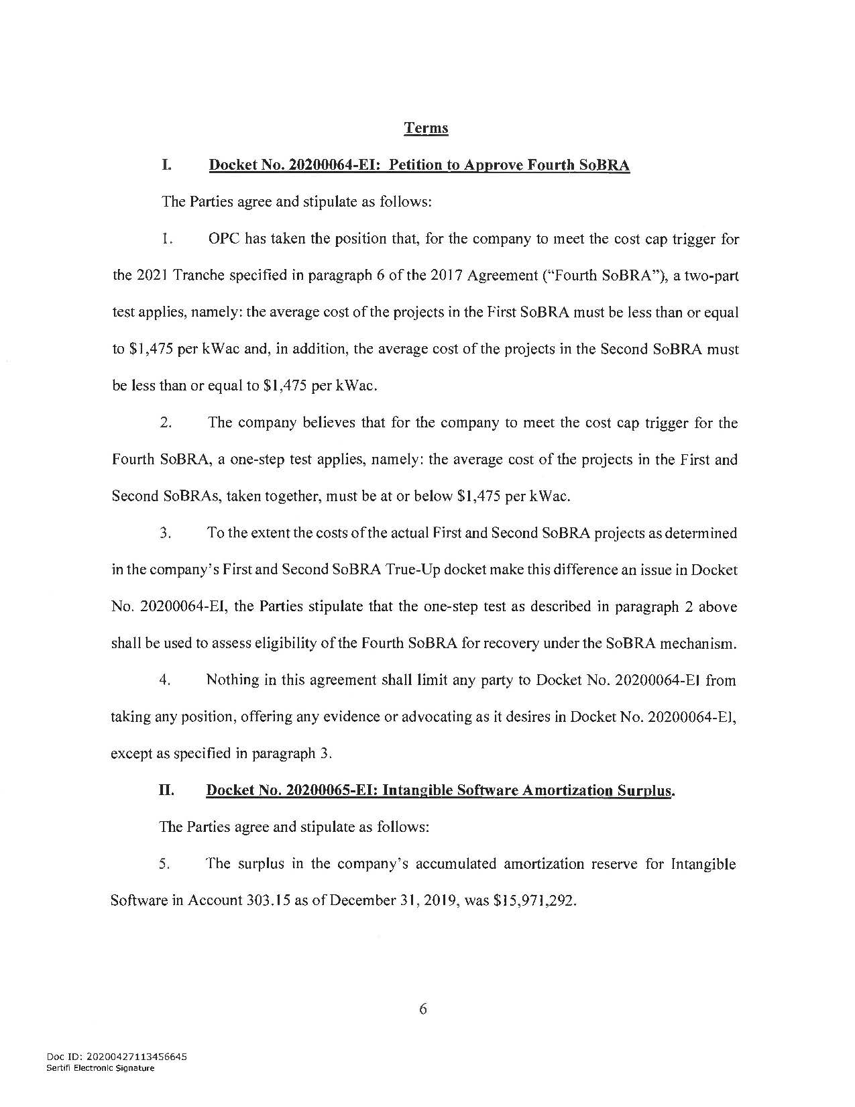
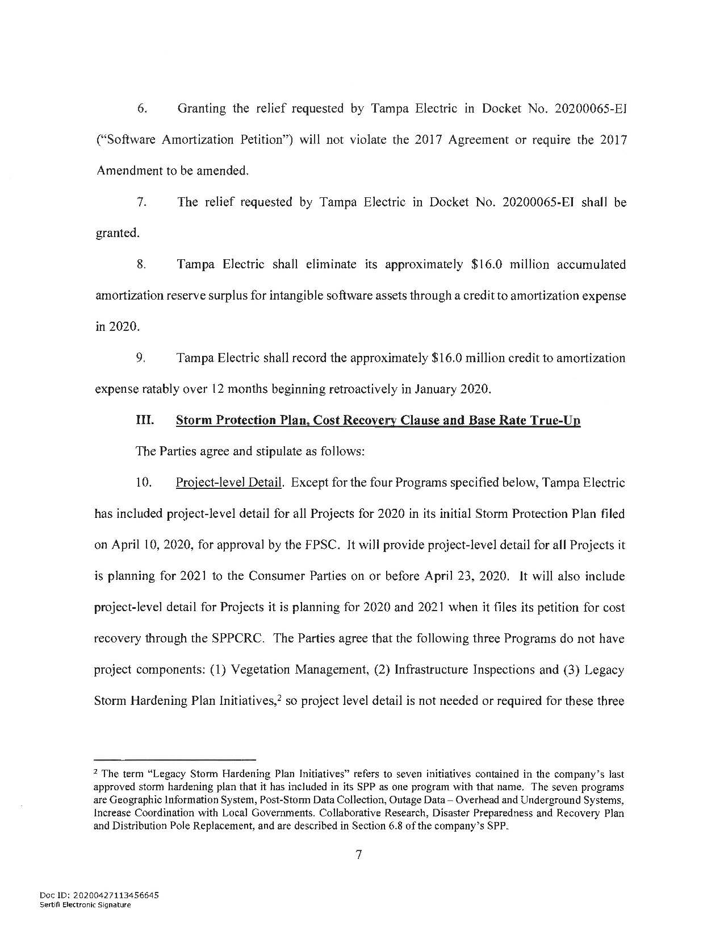
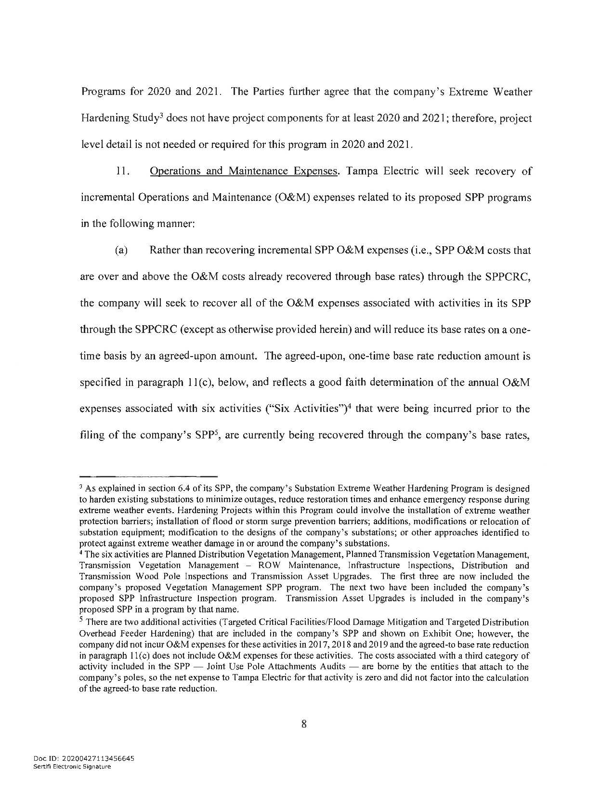
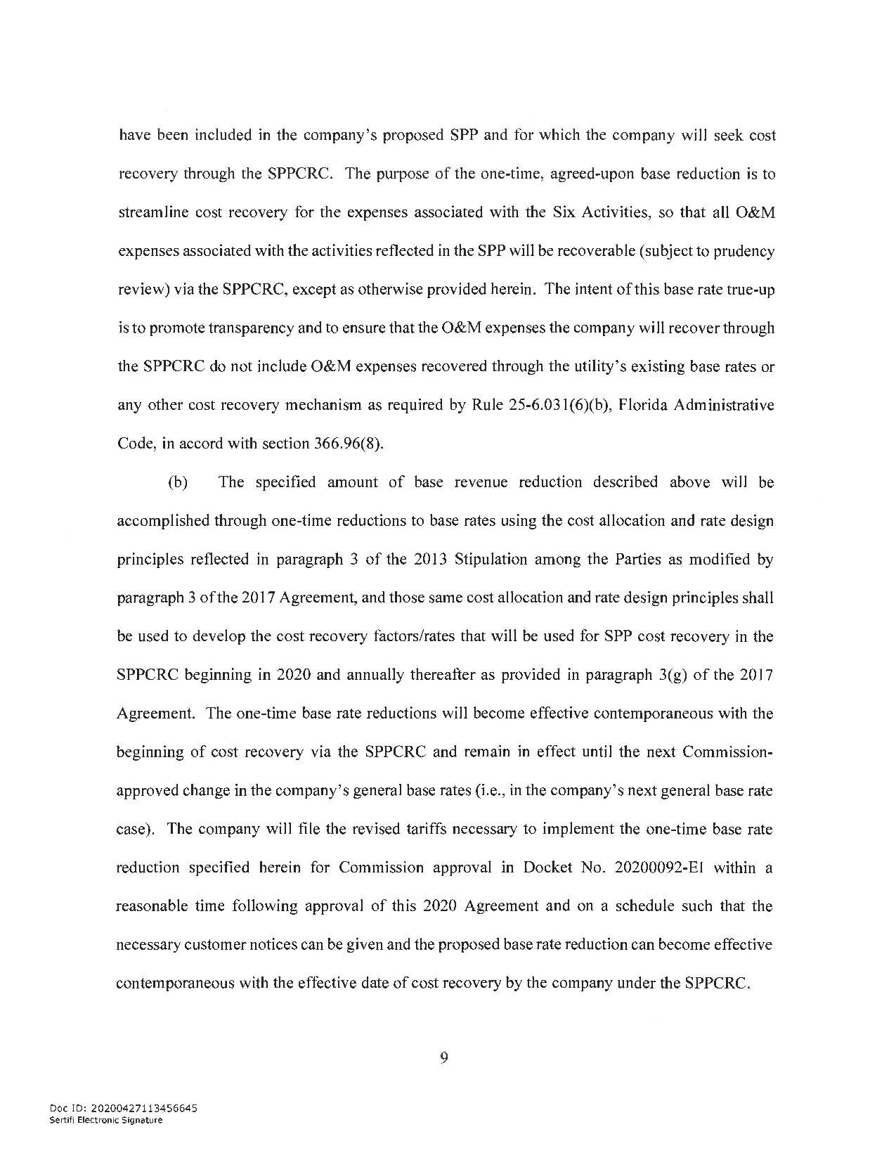
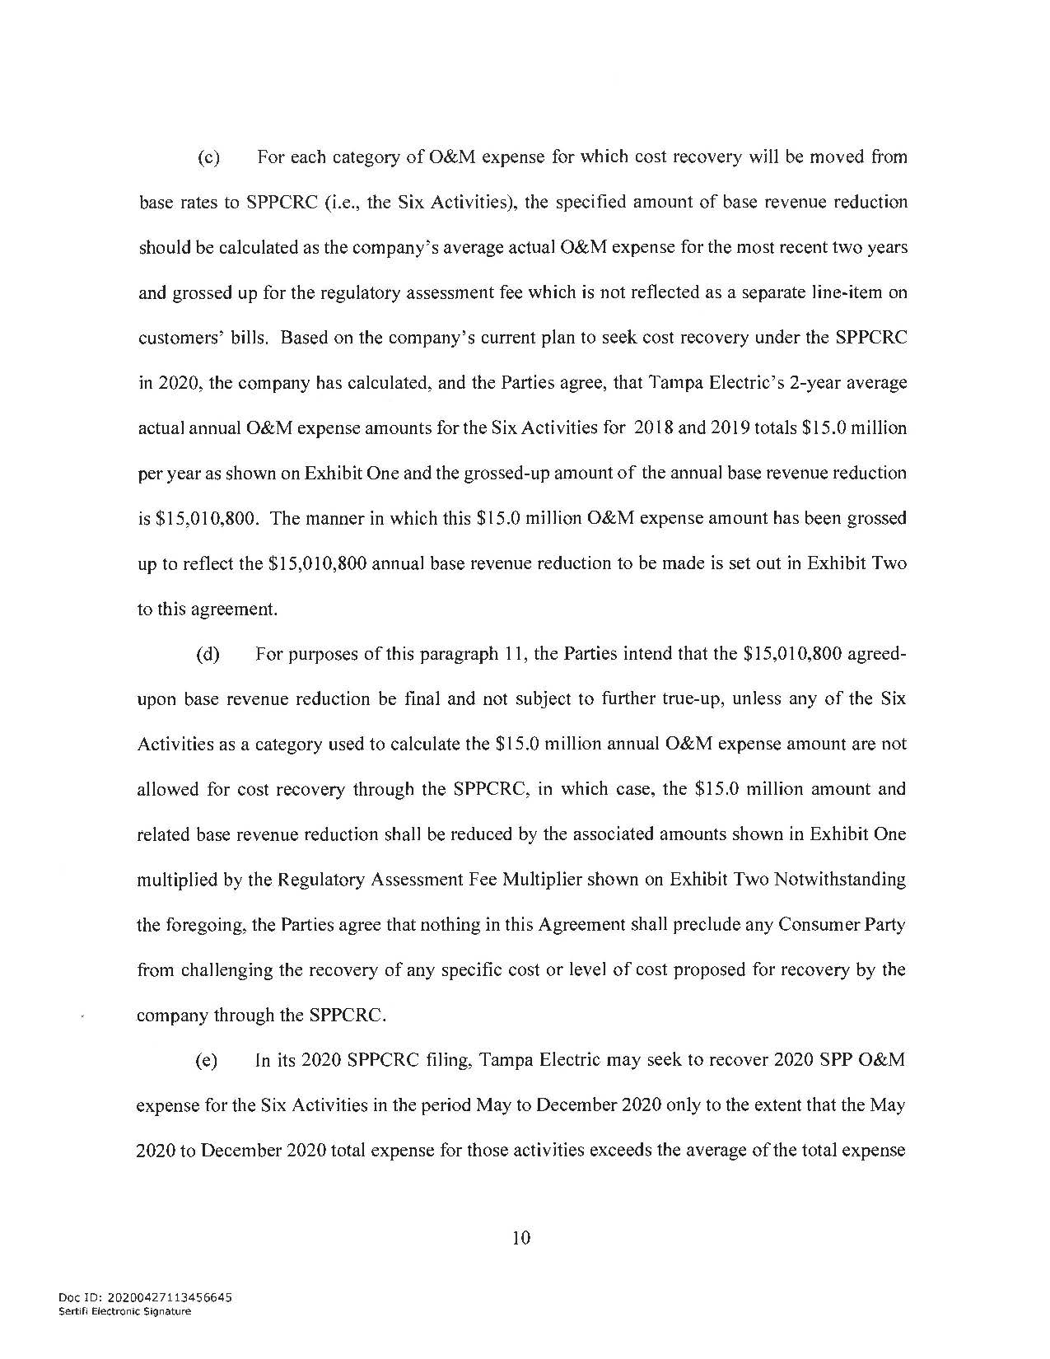
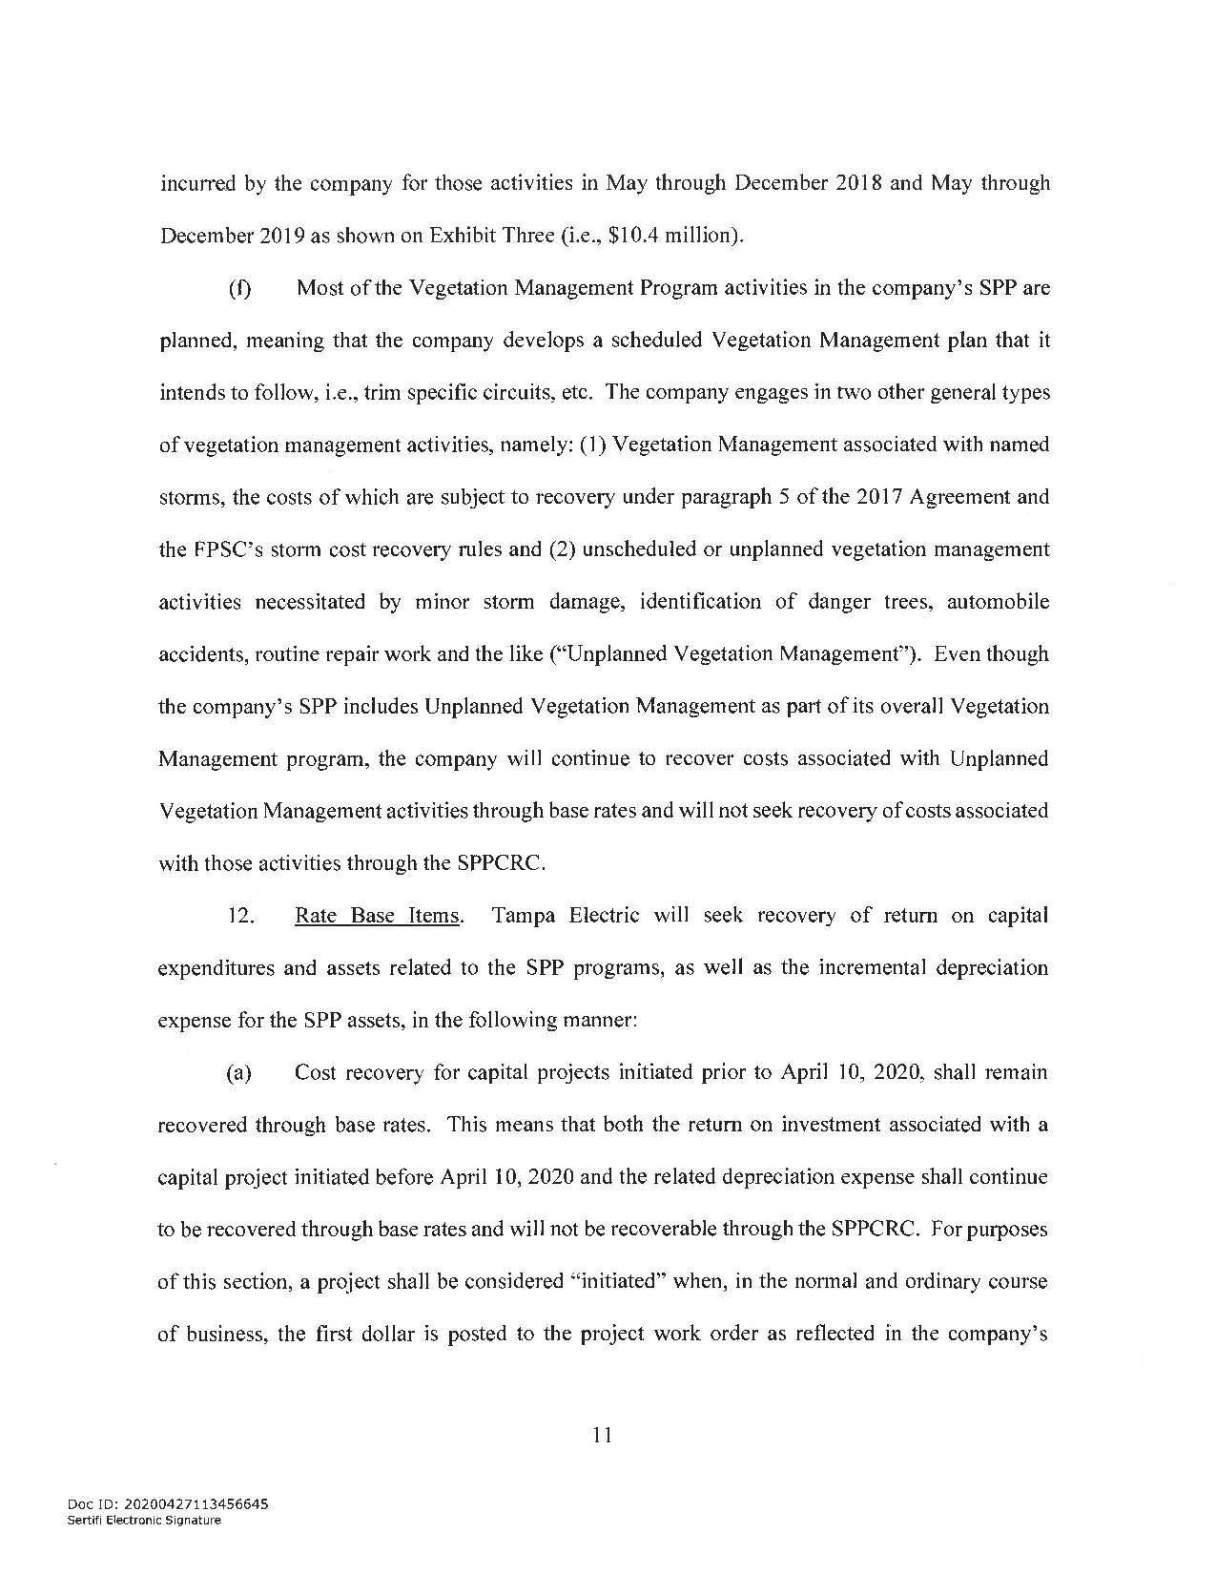
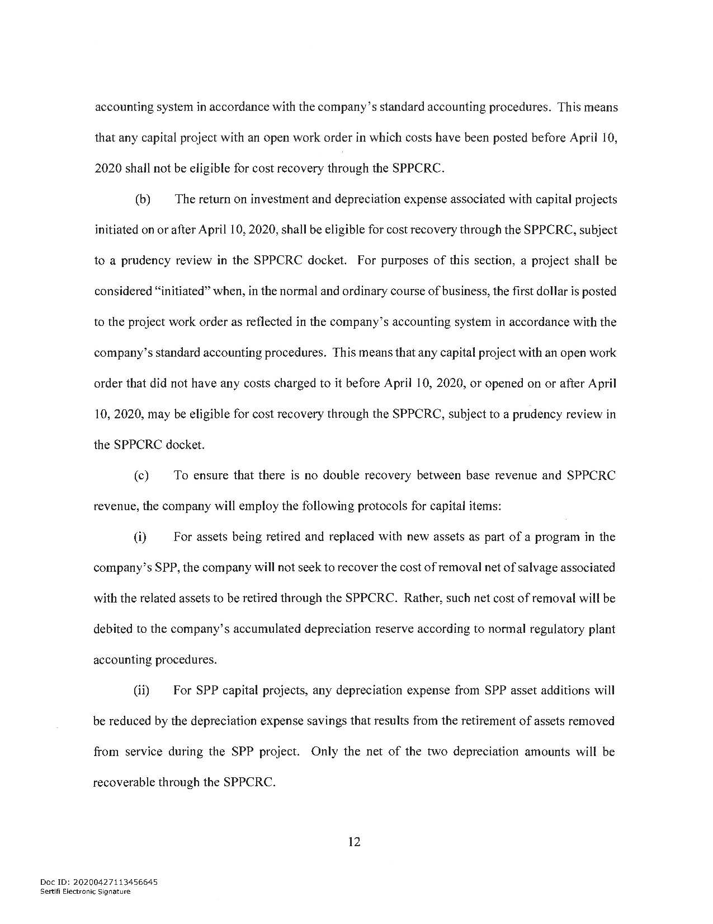
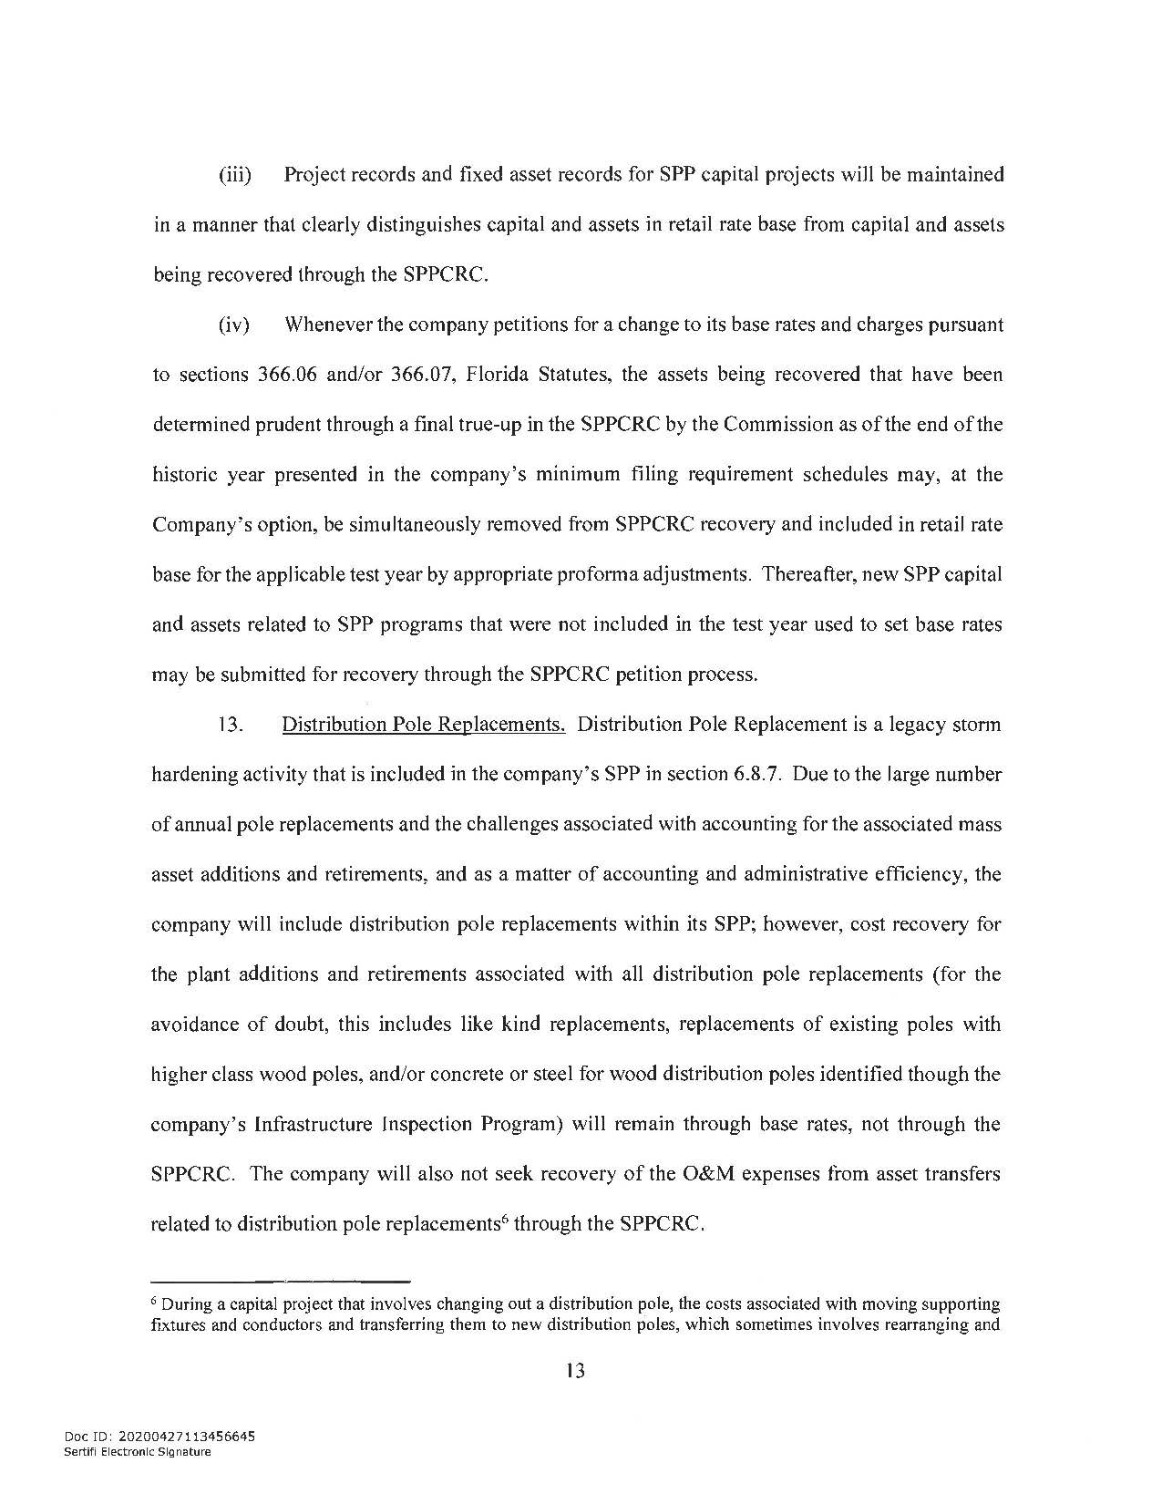
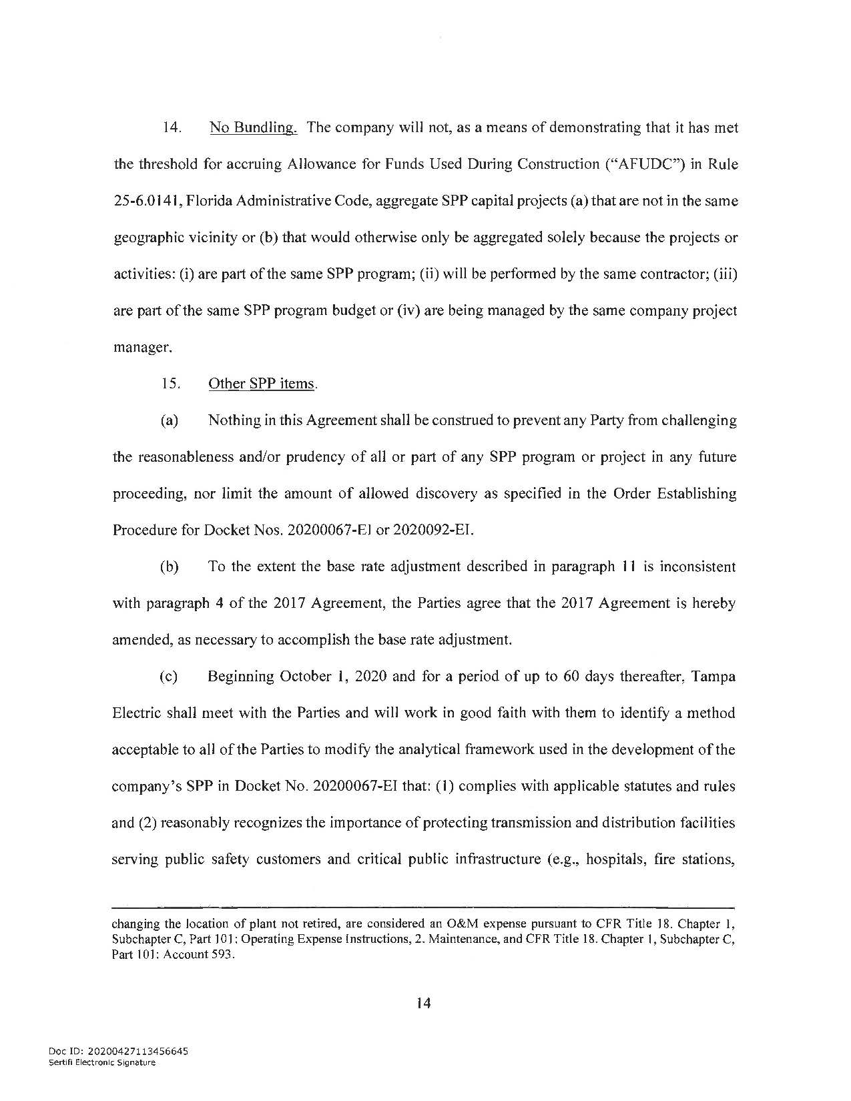
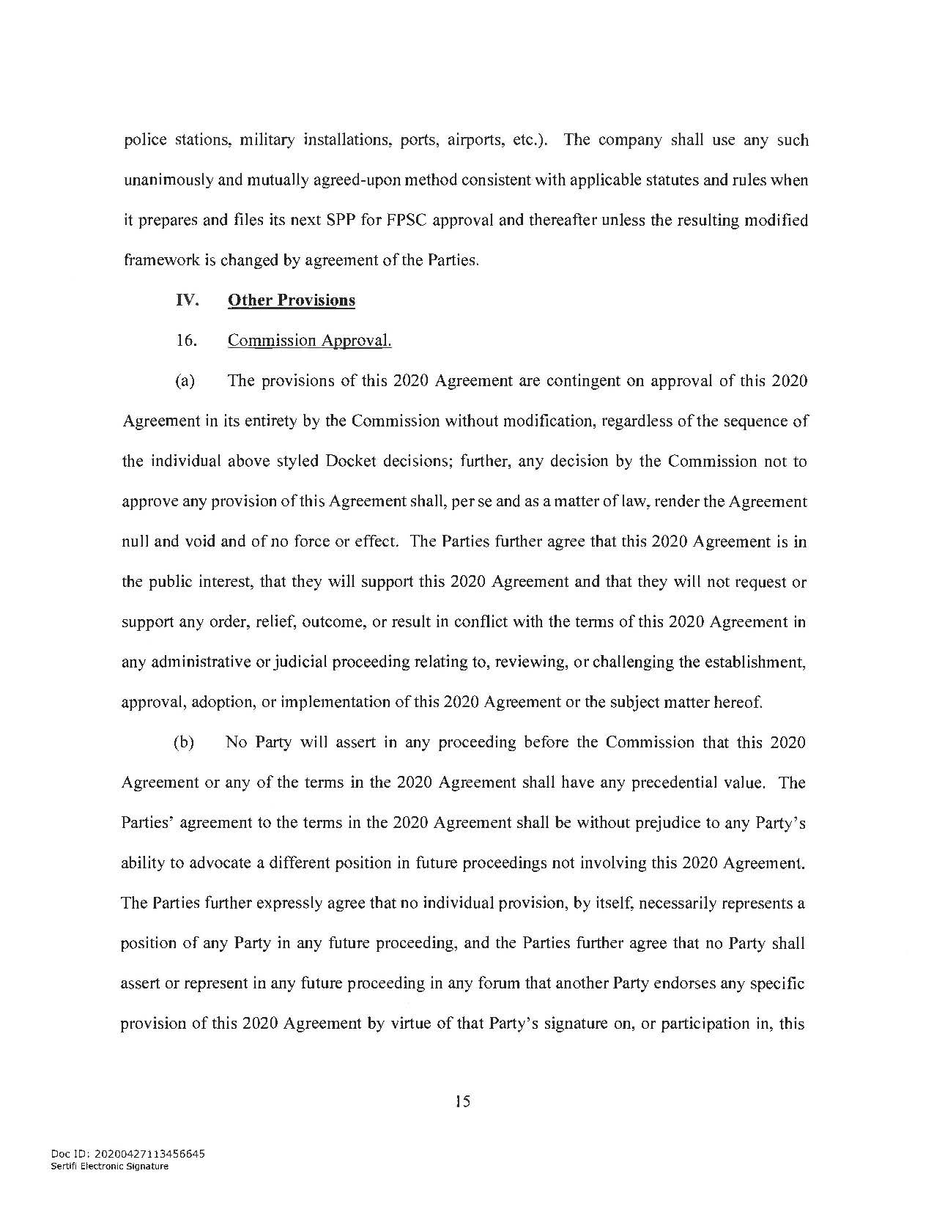
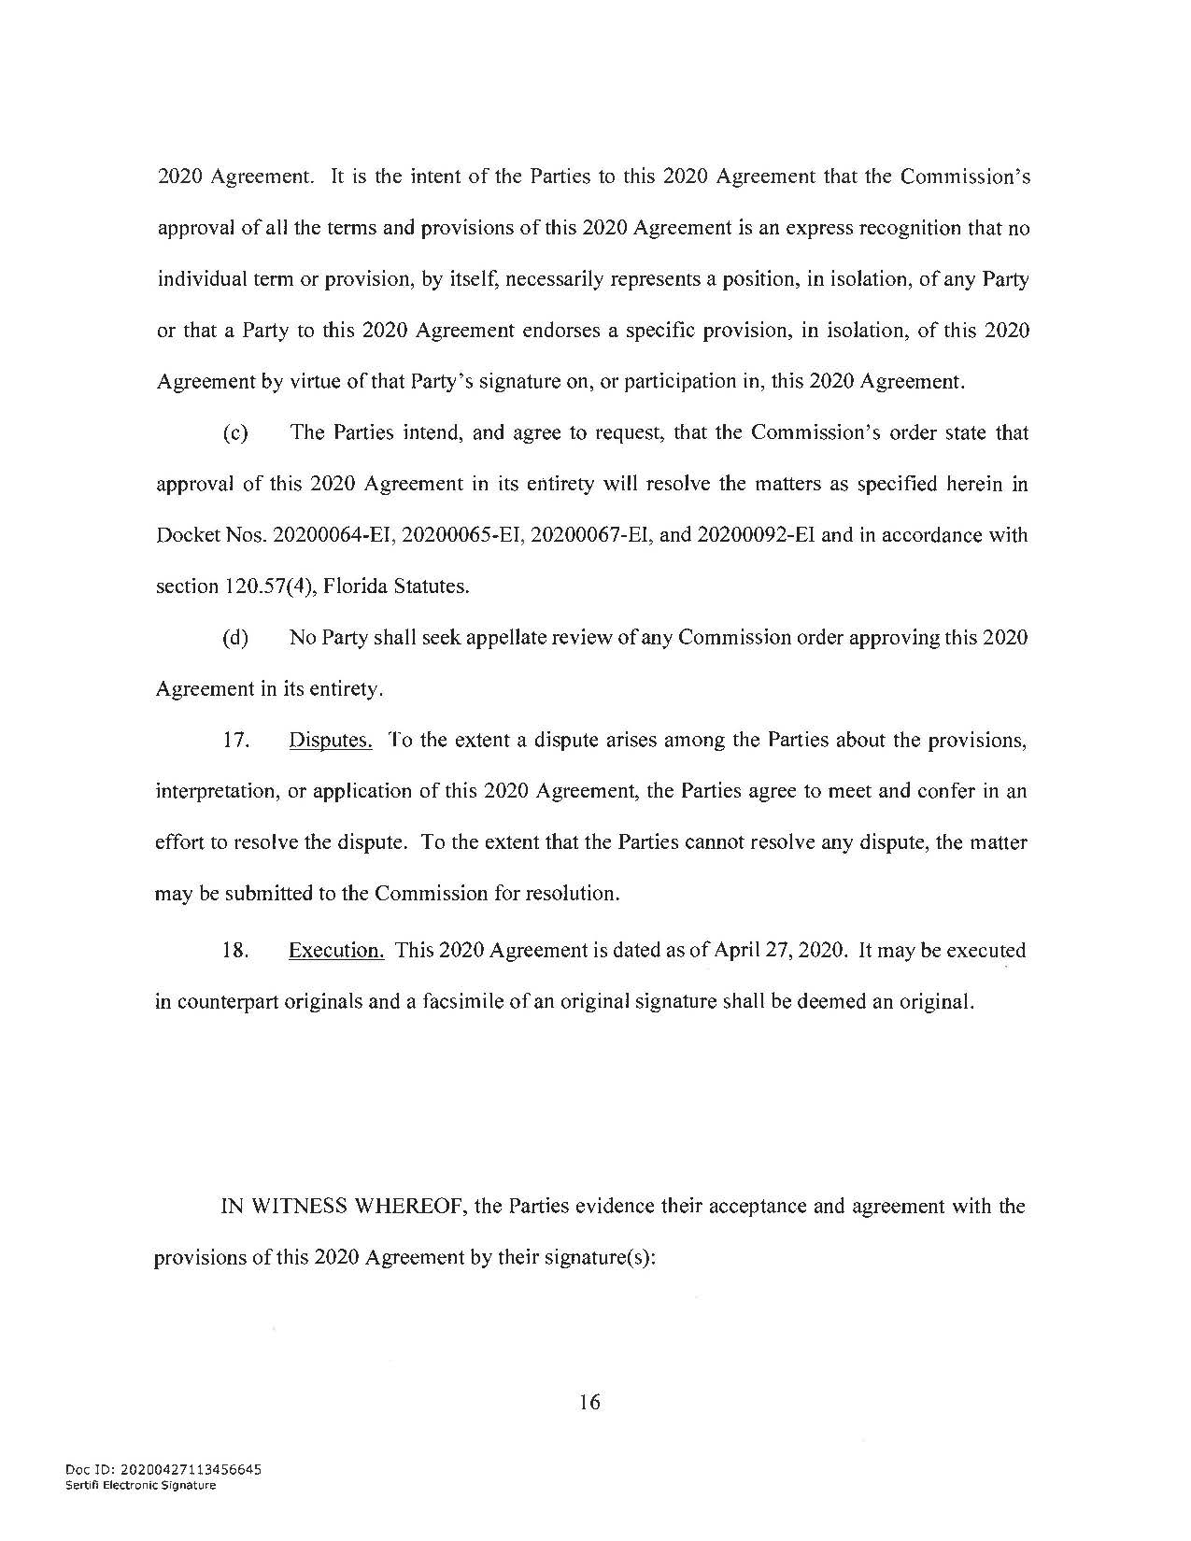
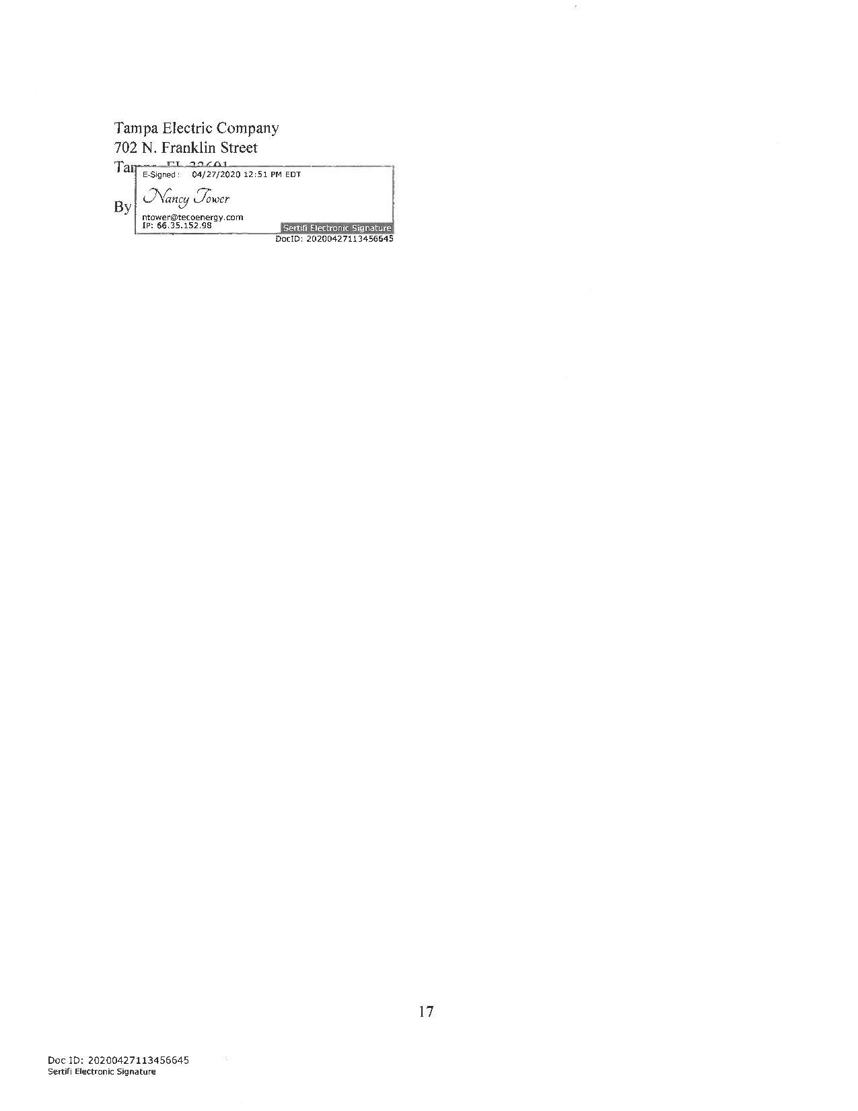
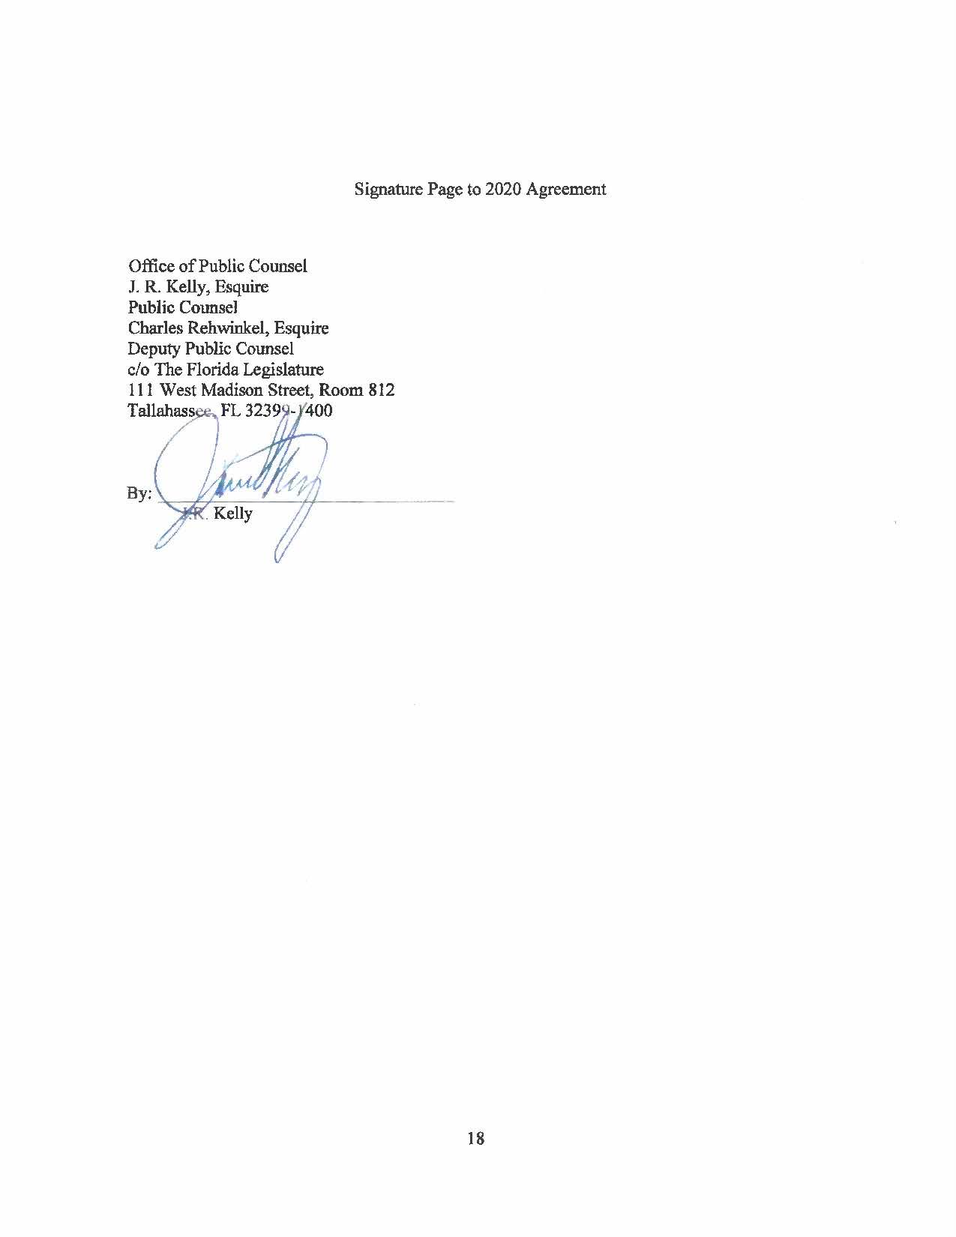
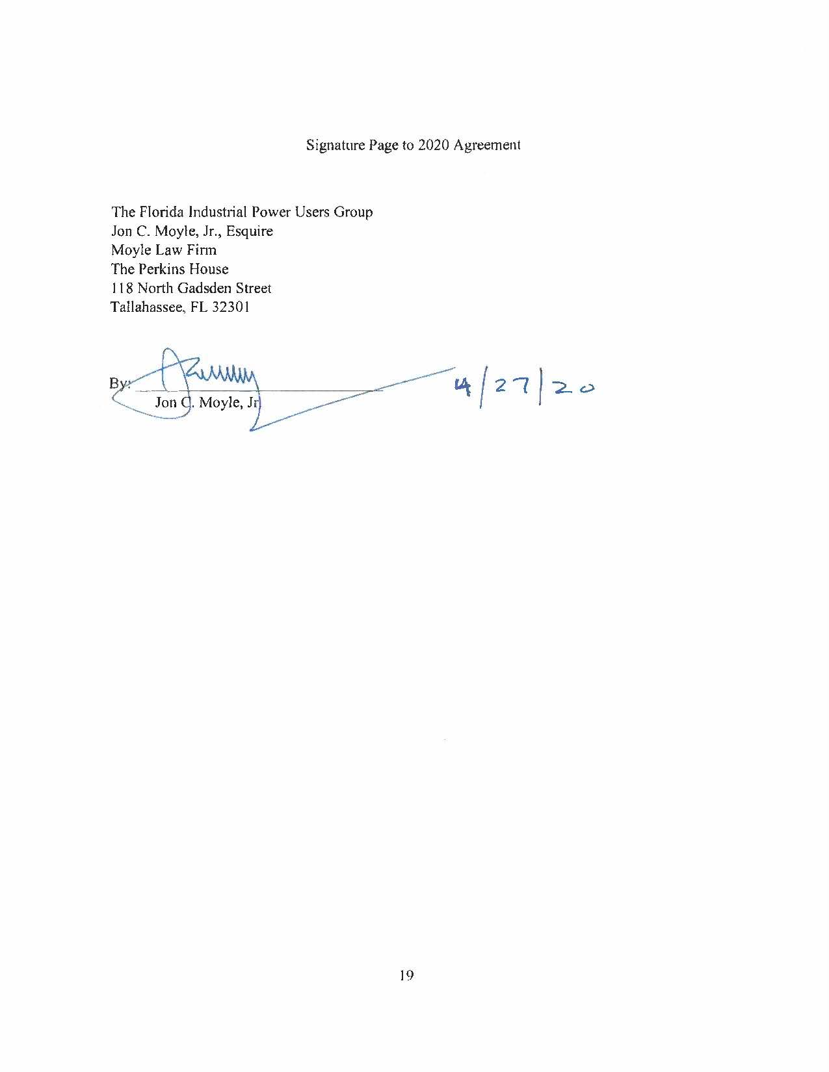
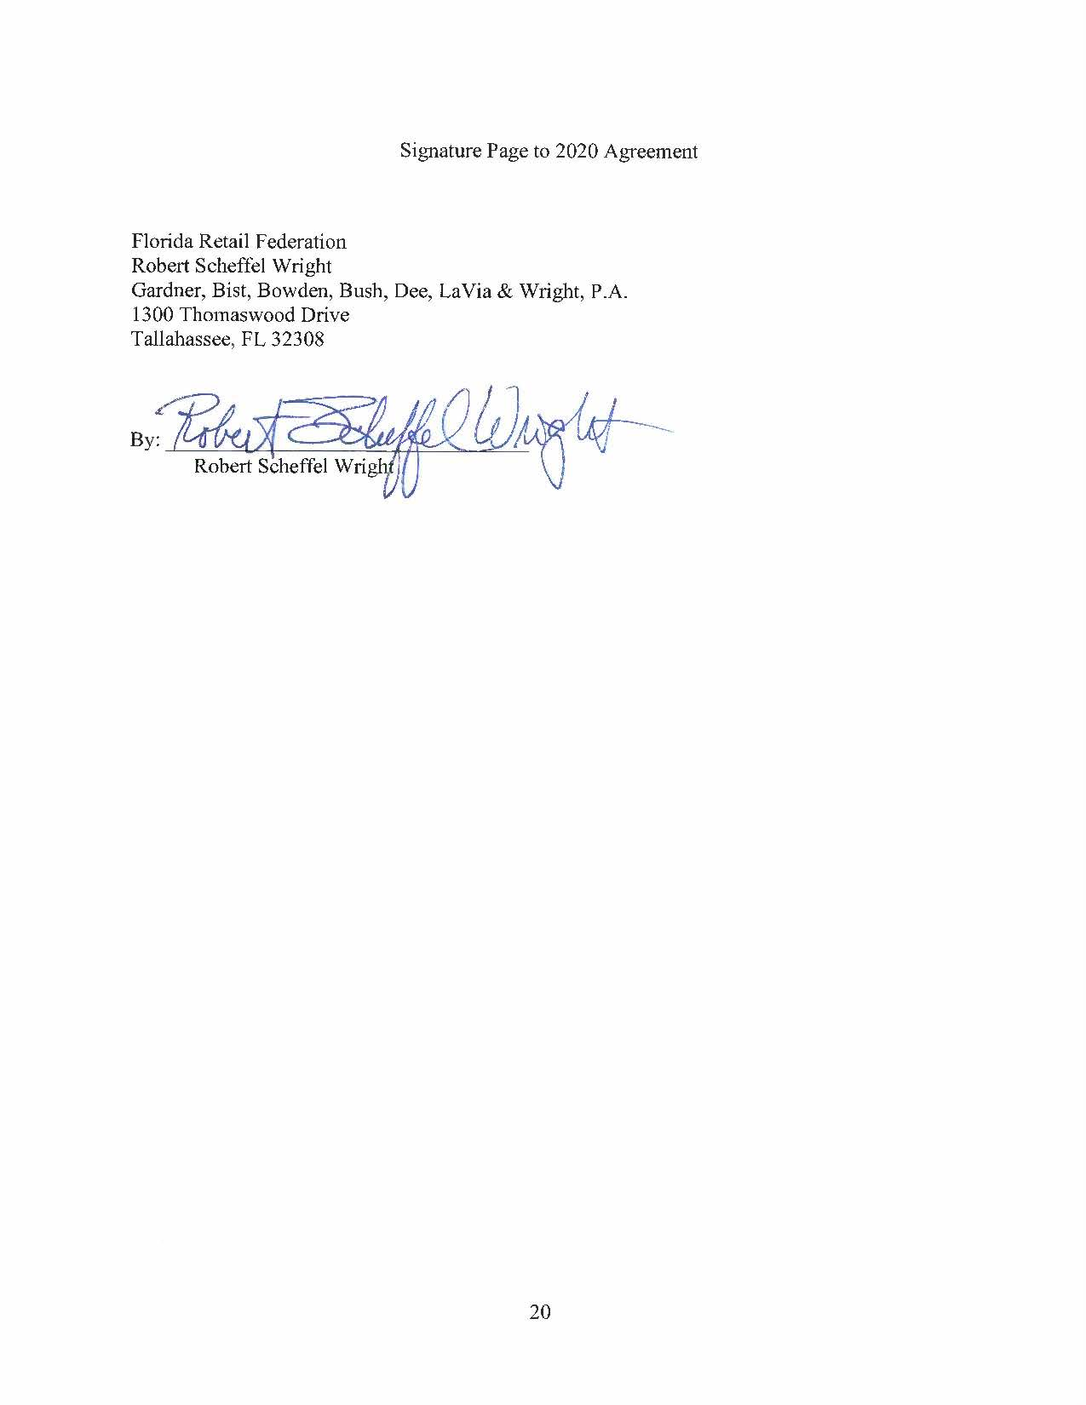
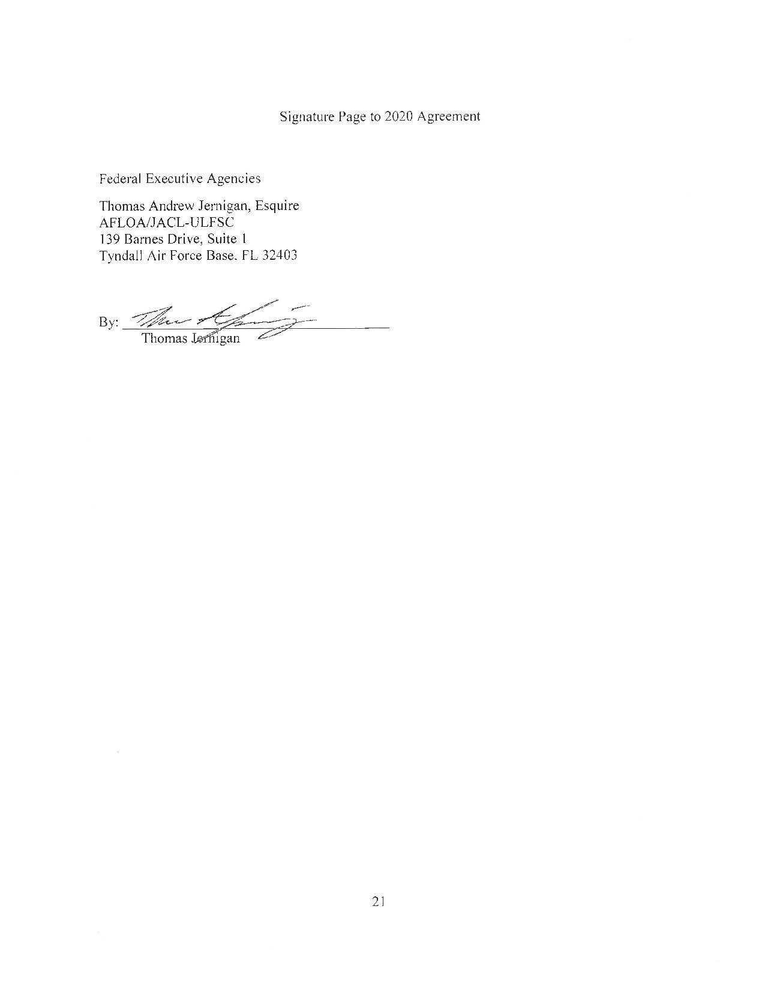
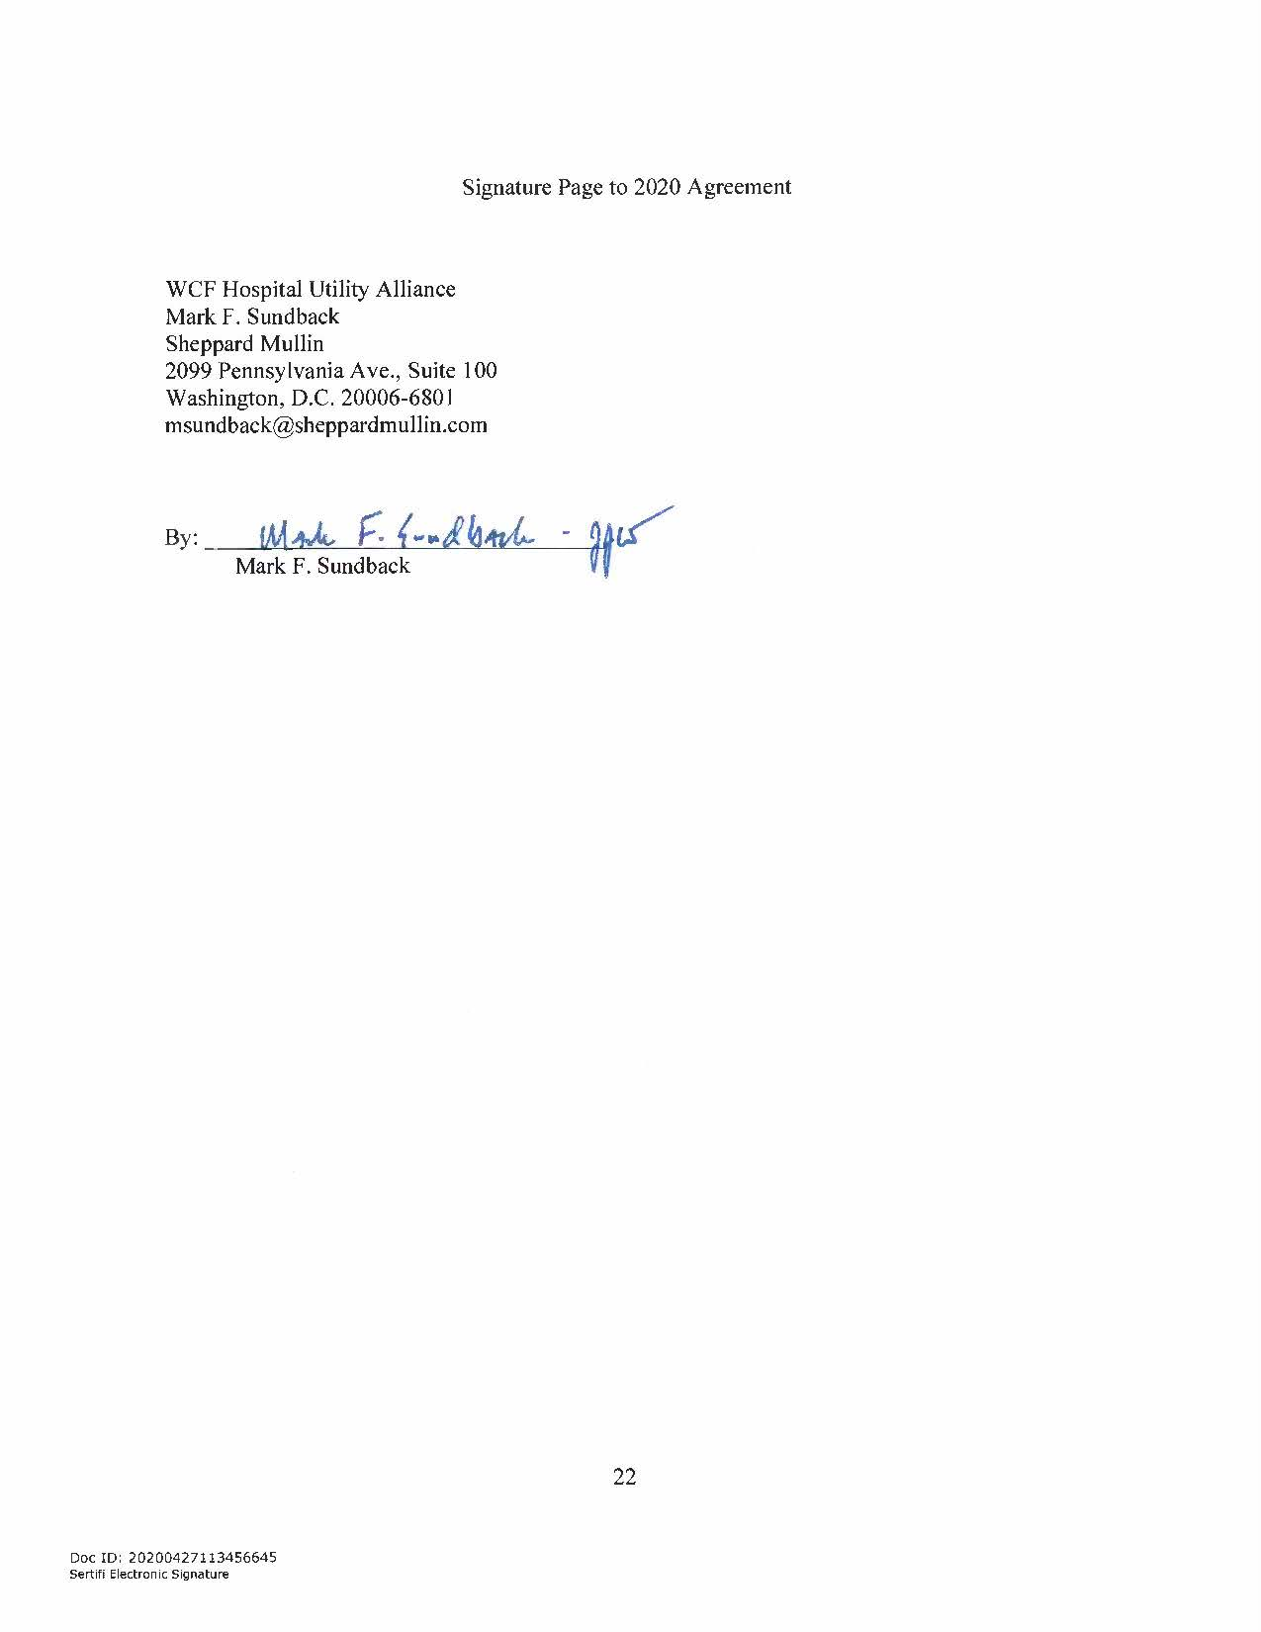
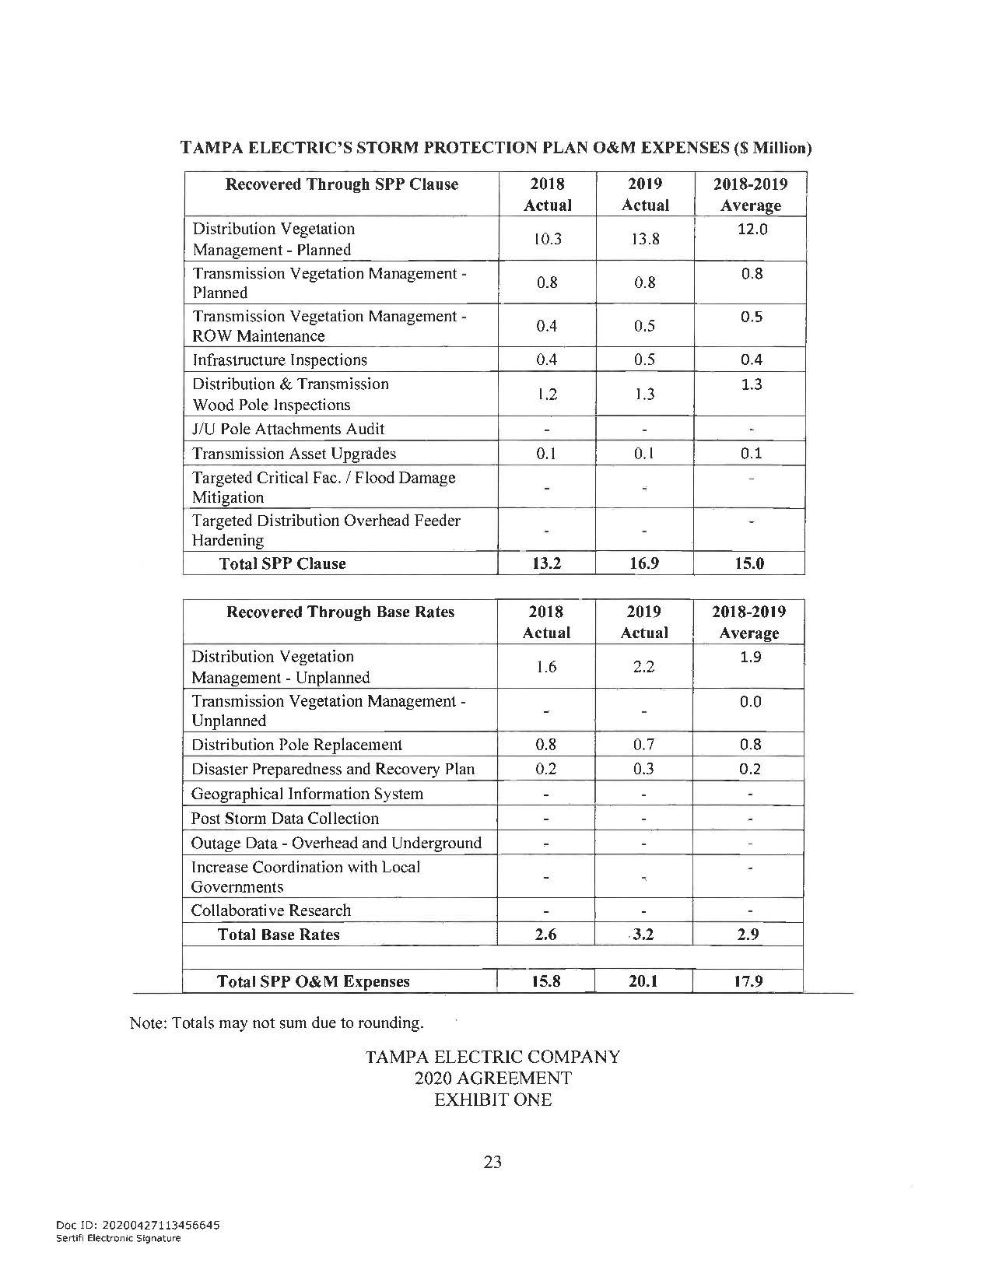
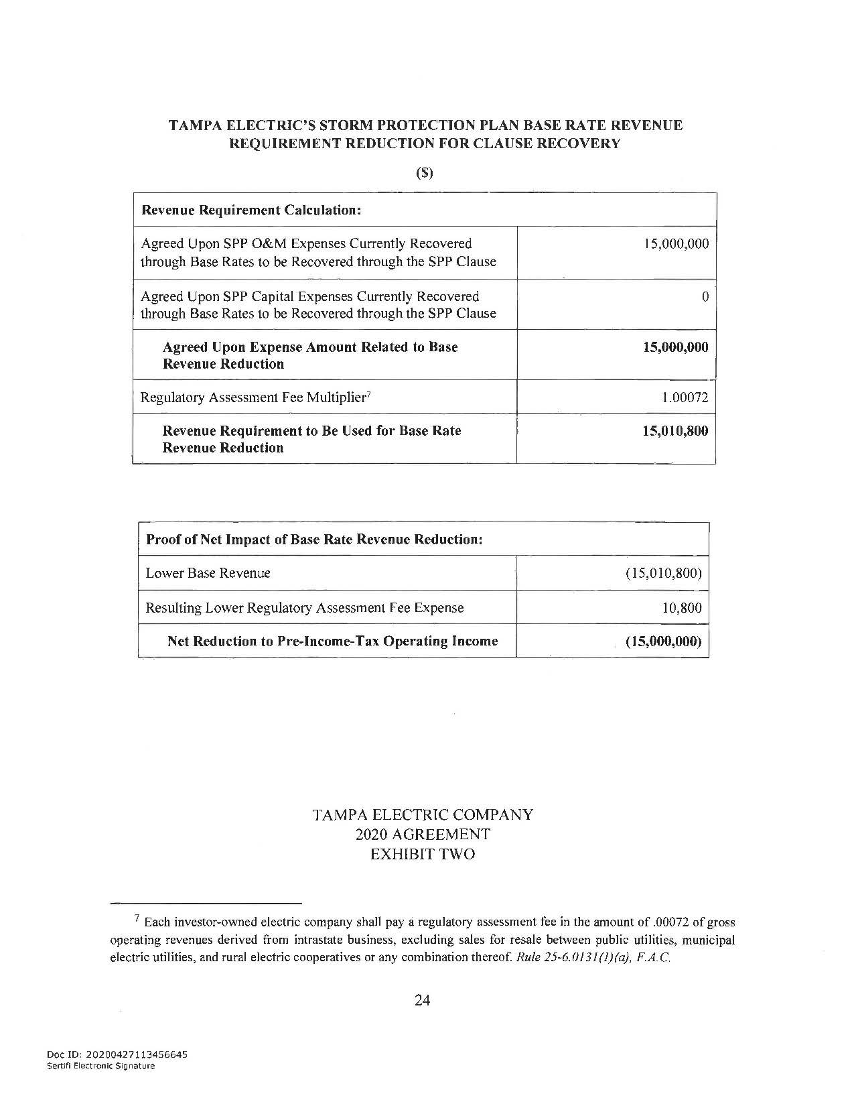
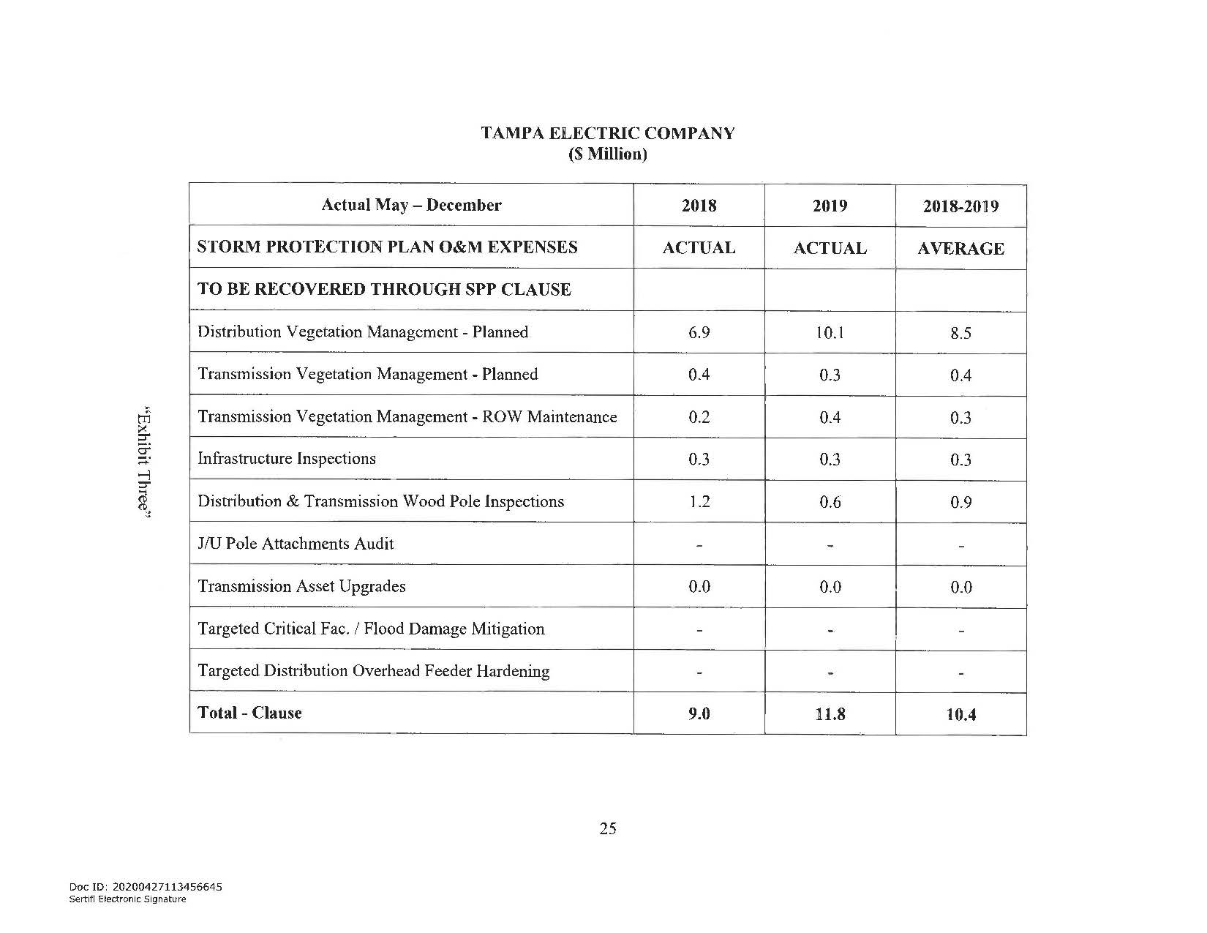
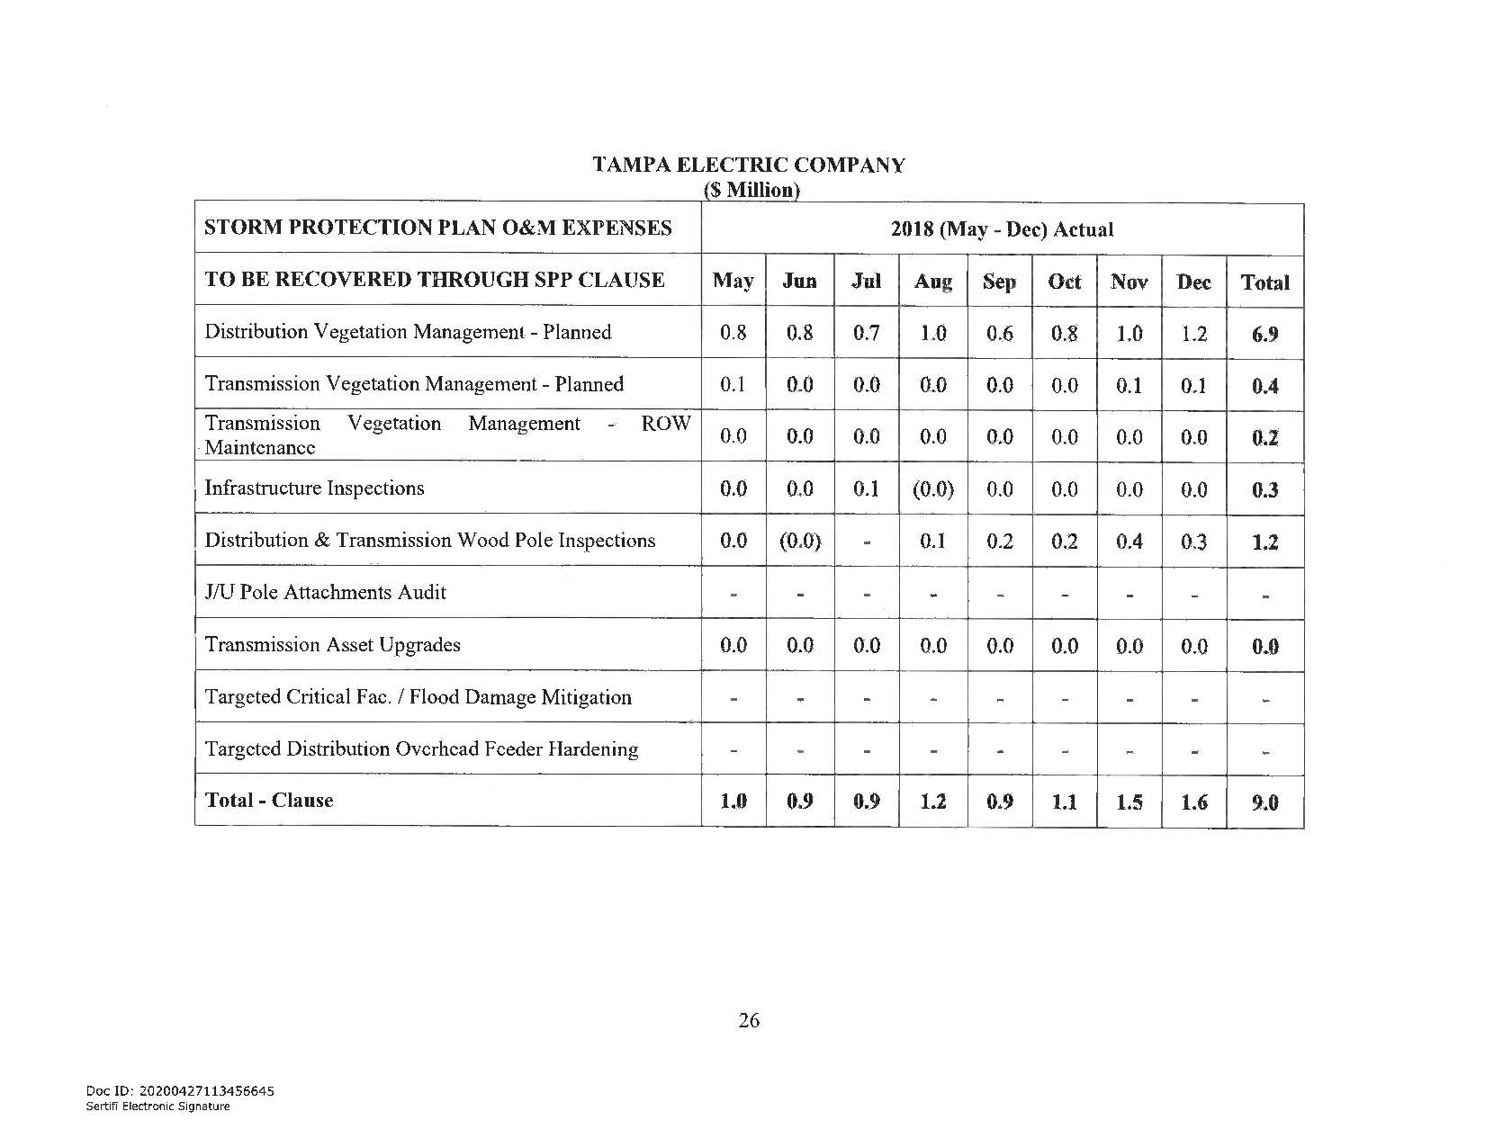
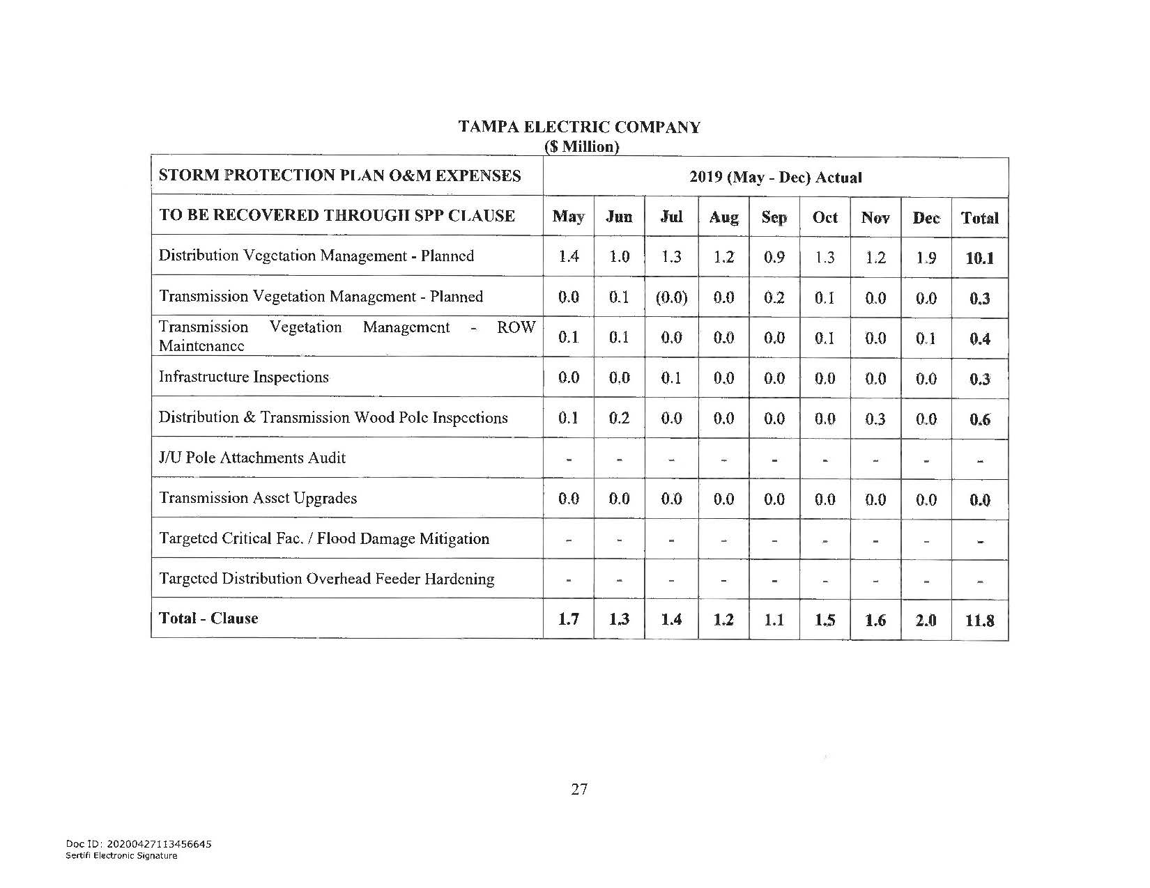

In re: Petition for a limited proceeding to approve fourth SoBRA, by Tampa Electric Company.
In re: Petition for a limited proceeding to eliminate accumulated amortization reserve surplus for intangible software assets, by Tampa Electric Company.
In re: Review of 2020-2029 Storm Protection Plan pursuant to Rule 25-6.030, F.A.C., Tampa Electric Company.
In re: Storm protection plan cost recovery clause.
Order No. PSC-2017-0456-S-EI, issued on November 27, 2017, in Docket Nos. 20170210-EI, In re: Petition for limited proceeding to approve 2017 amended and restated stipulation and settlement agreement, by Tampa Electric Company, and 20160160-EI, In re: Petition for approval of energy transaction optimization mechanism, by Tampa Electric Company, approving the 2017 Amended and Restated Stipulation and Settlement Agreement (2017 Agreement).
The term “Legacy Storm Hardening Plan Initiatives” refers to seven initiatives contained in TECO’s approved storm hardening plan pursuant to Order No. PSC-2019-0302-PAA-EI, issued July 29, 2019, in Docket No. 20180145-EI. The seven initiatives are now grouped as one program with that name.
Section III, paragraph 15(b) notes that to the extent the base rate adjustment is inconsistent with paragraph 4 of the 2017 Agreement, the Signatories agree that the 2017 Agreement is hereby amended, as necessary to accomplish the base rate adjustment.
Order No. PSC-13-0023-S-EI, issued on January 14, 2013, in Docket No. 120015-EI, In re: Petition for increase in rates by Florida Power & Light Company; Order No. PSC-11-0089-S-EI, issued February 1, 2011, in Docket Nos. 080677 and 090130, In re: Petition for increase in rates by Florida Power & Light Company and In re: 2009 depreciation and dismantlement study by Florida Power & Light Company; Order No. PSC-10-0398-S-EI, issued June 18, 2010, in Docket Nos. 090079-EI, 090144-EI, 090145-EI, 100136-EI, In re: Petition for increase in rates by Progress Energy Florida, Inc., In re: Petition for limited proceeding to include Bartow repowering project in base rates, by Progress Energy Florida, Inc., In re: Petition for expedited approval of the deferral of pension expenses, authorization to charge storm hardening expenses to the storm damage reserve, and variance from or waiver of Rule 25-6.0143(1)(c), (d), and (f), F.A.C., by Progress Energy Florida, Inc., and In re: Petition for approval of an accounting order to record a depreciation expense credit, by Progress Energy Florida, Inc.; Order No. PSC-05-0945-S-EI, issued September 28, 2005, in Docket No. 050078-EI, In re: Petition for rate increase by Progress Energy Florida, Inc.
Order No. PSC-13-0023-S-EI, at p. 7.

