BEFORE THE FLORIDA PUBLIC SERVICE COMMISSION

In re: Joint petition for approval of territorial agreement in Sumter County, by Sumter Electric Cooperative, Inc. and City of Bushnell. | DOCKET NO. 20200138-EU  ORDER NO. PSC-2020-0258-PAA-EU  ISSUED: July 24, 2020

The following Commissioners participated in the disposition of this matter:

GARY F. CLARK, Chairman
ART GRAHAM
JULIE I. BROWN
DONALD J. POLMANN
ANDREW GILES FAY

NOTICE OF PROPOSED AGENCY ACTION
ORDER APPROVING TERRITORIAL AGREEMENT
IN SUMTER COUNTY, BY SUMTER ELECTRIC
COOPERATIVE, INC. AND CITY OF BUSHNELL

BY THE COMMISSION:

NOTICE is hereby given by the Florida Public Service Commission that the action discussed herein is preliminary in nature and will become final unless a person whose interests are substantially affected files a petition for a formal proceeding, pursuant to Rule 25-22.029, Florida Administrative Code (F.A.C.).

Background
On April 17, 2020, Sumter Electric Cooperative, Inc. (SECO) and the City of Bushnell (City or Bushnell) filed a joint petition seeking approval of a territorial agreement in Sumter County (2020 Territorial Agreement). The 2020 Territorial Agreement implements the terms of a 1981 Franchise Agreement, a 2017 Arbitration Award, and a 2019 Transfer Agreement between the utilities which transferred 623 customers and associated facilities from SECO to Bushnell. The 2020 Territorial Agreement and map depicting the new territorial boundaries are contained in Attachment A to this Order.
In September 1981, the City and SECO entered into a Territorial Agreement (1981 Territorial Agreement) and an electric service franchise agreement (1981 Franchise Agreement) pursuant to which the City granted SECO an exclusive 30-year franchise to provide electric service to a portion of the City. The Commission approved the 1981 Territorial Agreement in 1982. In February 1999, the City and SECO amended the 1981 Territorial Agreement to establish new territorial boundary lines (1999 Territorial Agreement), which was approved by the Commission that same year. The 1999 Territorial Agreement expired on March 29, 2012. The termination of the 1981 Franchise Agreement coincided with the termination of the 1999 Territorial Agreement.
The 1981 Franchise Agreement contained an option for the City to purchase SECO’s electric utility assets located within the City limits at or after the expiration of the 30-year franchise. The parties explained that, prior to the expiration of the 1981 Franchise Agreement, they attempted to negotiate a new franchise agreement, a new territorial agreement, and Bushnell’s contractual right to purchase SECO facilities and customers per the 1981 Franchise Agreement. In early 2015, however, an impasse developed in the parties’ negotiations. In 2016, the City initiated arbitration before a panel of three retired Judges to determine the value of the electric assets within the City limits. The arbitrators rendered the final decision in 2017, which allowed the City to purchase the SECO system and transfer the customers, if it elected to do so. Subsequently, the parties negotiated and received City approval to transfer and purchase the SECO assets via the 2019 Transfer Agreement. As a result of the 2017 Arbitration Award, the 2019 Transfer Agreement, and the New Franchise Agreement, the joint petitioners negotiated the 2020 Territorial Agreement which delineates SECO’s and Bushnell’s respective service boundaries. Pursuant to Rule 25-6.0440(1)(f), F.A.C., the parties provided a map identifying the geographical areas to be served by SECO and Bushnell (see map in Attachment A).
The 2020 Territorial Agreement establishes the new territorial boundaries reflecting the assets and customers transferred from SECO to Bushnell. We have jurisdiction over this matter pursuant to Section 366.04, Florida Statutes (F.S.).

Decision
Pursuant to Section 366.04(2)(d), F.S., and Rule 25-6.0440(2), F.A.C., we have the jurisdiction to approve territorial agreements between and among rural electric cooperatives, municipal electric utilities, and other electric utilities. Unless we determine that the agreement will cause a detriment to the public interest, the agreement should be approved.

The 2020 Territorial Agreement

SECO and Bushnell executed the 2020 Territorial Agreement on September 24, 2019, to replace the 1999 Territorial Agreement, which expired in March 2012. Upon approval by this Commission, and pursuant to Section 5.3, the 2020 Territorial Agreement will supersede the 1999 Territorial Agreement and all other prior agreements between the parties. Through the 2020 Territorial Agreement, the joint petitioners seek to gain operational efficiencies and customer service improvements in their respective retail service territories in Sumter County and eliminate circumstances leading to uneconomic duplication of service facilities and hazardous situations.
The 2020 Territorial Agreement will remain in effect for 30 years from the date our order approving the agreement in its entirety is no longer subject to judicial review. Pursuant to Section 6.1 of the 2020 Territorial Agreement, upon the expiration of the initial 30-year term, the agreement will automatically renew for successive one-year terms. Either party may terminate this agreement after the initial 30-year term, by providing written notification no less than 12 months prior to the effective date of the termination in accordance with Section 8.3 of the 2020 Territorial Agreement. Pursuant to Article V of the 2020 Territorial Agreement, any modifications to this agreement will be submitted to this Commission for approval.

Customer and Facilities Transfer

The transfer of facilities and customers from SECO to Bushnell was completed in the fall of 2019. In response to Commission staff’s data request, the parties stated that 623 SECO customers and facilities were transferred to Bushnell at a cost of $5,874,030. According to the Arbitration Award, transfer value was based upon the new reproduction cost less depreciation method. The three-judge panel rejected the use of the income approach and the market approach, rejected the inclusion of stranded costs, and included a going concern value. Rule 25-6.0440(2)(a), F.A.C., provides that in approving territorial agreements, we may consider the reasonableness of the purchase price of any facilities being transferred. The determination of the transfer value through arbitration in this instance appears reasonable. The customer and facility transfers were finalized by the 2019 Transfer Agreement negotiated by the parties and approved by the Bushnell City Council. The Transfer Agreement provided timelines for Bushnell to construct facilities that were necessary to integrate SECO facilities, provided timelines for SECO to separate and integrate its system after the exchange/transfer, and provided for true-up amounts for any construction by SECO that would be subject to exchange but completed after the agreed valuation date of December 31, 2015.

We recognize that the joint petitioners completed the transfer of facilities and customers pursuant to the provisions contained in the 1981 Franchise Agreement and the 2019 Transfer Agreement prior to our consideration and approval of the 2020 Territorial Agreement. However, Section 366.04(2)(d), F.S., provides that in the exercise of our jurisdiction, we have power over electric utilities to approve territorial agreements between and among rural electric cooperatives, municipal electric utilities, and other electric utilities under our jurisdiction. We have the exclusive and superior statutory jurisdiction to determine electric utility service areas. Board of County Commissioners Indian River County v. Graham, 191 So. 3d 890, 892 (Fla. 2016). Without our active supervision over territorial agreements, such agreements between utilities run afoul of anticompetitive and antitrust law and “can have no validity without the approval of this Commission.” Order No. 3051, issued November 9, 1960, in Docket No. 6231-GU, In re. Territorial Agreement Between Peoples Gas Sys. and City Gas Co., at p. 1. As stated by the Florida Supreme Court in City of Homestead v. Beard, 600 So. 2d 450, 452 (Fla. 1992):
In City Gas Co. v. Peoples Gas System Inc., 182 So. 2d 429, 433 (Fla.1965), this Court held that territorial agreements between public utilities were not violative of antitrust law based on the premise that “the public welfare does not need Ch. 542 for protection against this kind of agreement....because the public interest is adequately protected by an alternative arrangement under F.S. Ch. 366, F.S.A.” We further concluded that the “agreement could result in monopolistic control over price, production, or quality of service only by the sufferance of the commission” and that its “statutory powers are more than sufficient to prevent any such outcome if properly employed.” Id. at 435. In Storey,[] which upheld the PSC's approval of the instant agreement, this Court “recognized the importance of the regulatory function as a substitute for unrestrained competition” and commented that “a regulated or measurably controlled monopoly is in the public interest.” 217 So. 2d at 307. Therefore, our decisions exempting territorial agreements from antitrust legislation have been premised on the existence of a statutory system of regulations governing the public utilities that is sufficient to prevent any abuses arising from the monopoly power created by the agreements.

SECO and Bushnell are put on notice that any modification or termination of their territorial boundaries, as addressed by our orders, must first be made by this Commission.

Customer Notification

Pursuant to Rule 25-6.0440(1)(d), F.A.C., in September 2019, SECO notified its 623 customers of their transfer to Bushnell. In August 2019, Bushnell informed the former SECO customers of the transfer and requirements. In response to Commission staff’s data request, the joint petitioners provided a copy of Bushnell’s customer notification which states that if the customer has an existing account with the City for water, wastewater, or garbage collection, the electric service will be added to the same account; no additional deposit is required of those customers. If the transferred customer did not have an existing account with Bushnell for water, wastewater, or garbage collection, those customers were required to open a new utility account with Bushnell, with a deposit of $150 or an amount equivalent to two months average electric bill. The City holds the deposit until final settlement of the customer account, at which time the deposit will be applied towards the bill and any remaining balance will be refunded to the customer and account closed pursuant to the utility’s Seventh Revised Tariff Sheet No. 4.0.

Conclusion

After review of the petition and the 2020 Territorial Agreement, and evaluation of responses to Commission staff’s data request, we find that the 2020 Territorial Agreement is in the public interest and will enable SECO and Bushnell to serve their current and future customers in an efficient manner. It appears that the agreement will eliminate any potential uneconomic duplication of facilities and will not cause a decrease in the reliability of electric service. As such, we find the 2020 Territorial Agreement between SECO and Bushnell will not cause a detriment to the public interest.
This agreement supersedes the prior territorial agreements between SECO and Bushnell. SECO and Bushnell are put on notice that any modification or termination of their territorial boundaries, as addressed by this or other Commission orders, must first be made by this Commission.
Based on the foregoing, it is

ORDERED by the Florida Public Service Commission that the 2020 Territorial Agreement between Sumter Electric Cooperative, Inc. and the City of Bushnell is approved. It is further

ORDERED that the provisions of this Order, issued as proposed agency action, shall become final and effective upon the issuance of a Consummating Order unless an appropriate petition, in the form provided by Rule 28-106.201, Florida Administrative Code, is received by the Commission Clerk, 2540 Shumard Oak Boulevard, Tallahassee, Florida 32399-0850, by the close of business on the date set forth in the “Notice of Further Proceedings” attached hereto. It is further

ORDERED that in the event this Order becomes final, this docket shall be closed.

By ORDER of the Florida Public Service Commission this 24th day of July, 2020.

/s/ Adam J. Teitzman
ADAM J. TEITZMAN
Commission Clerk
Florida Public Service Commission
2540 Shumard Oak Boulevard
Tallahassee, Florida 32399
(850) 413-6770
www.floridapsc.com

Copies furnished: A copy of this document is provided to the parties of record at the time of issuance and, if applicable, interested persons.
SPS

NOTICE OF FURTHER PROCEEDINGS OR JUDICIAL REVIEW

The Florida Public Service Commission is required by Section 120.569(1), Florida Statutes, to notify parties of any administrative hearing that is available under Section 120.57, Florida Statutes, as well as the procedures and time limits that apply. This notice should not be construed to mean all requests for an administrative hearing will be granted or result in the relief sought.

Mediation may be available on a case-by-case basis. If mediation is conducted, it does not affect a substantially interested person's right to a hearing.

The action proposed herein is preliminary in nature. Any person whose substantial interests are affected by the action proposed by this order may file a petition for a formal proceeding, in the form provided by Rule 28-106.201, Florida Administrative Code. This petition must be received by the Office of Commission Clerk, 2540 Shumard Oak Boulevard, Tallahassee, Florida 32399-0850, by the close of business on August 14, 2020.

In the absence of such a petition, this order shall become final and effective upon the issuance of a Consummating Order.

Any objection or protest filed in this/these docket(s) before the issuance date of this order is considered abandoned unless it satisfies the foregoing conditions and is renewed within the specified protest period.

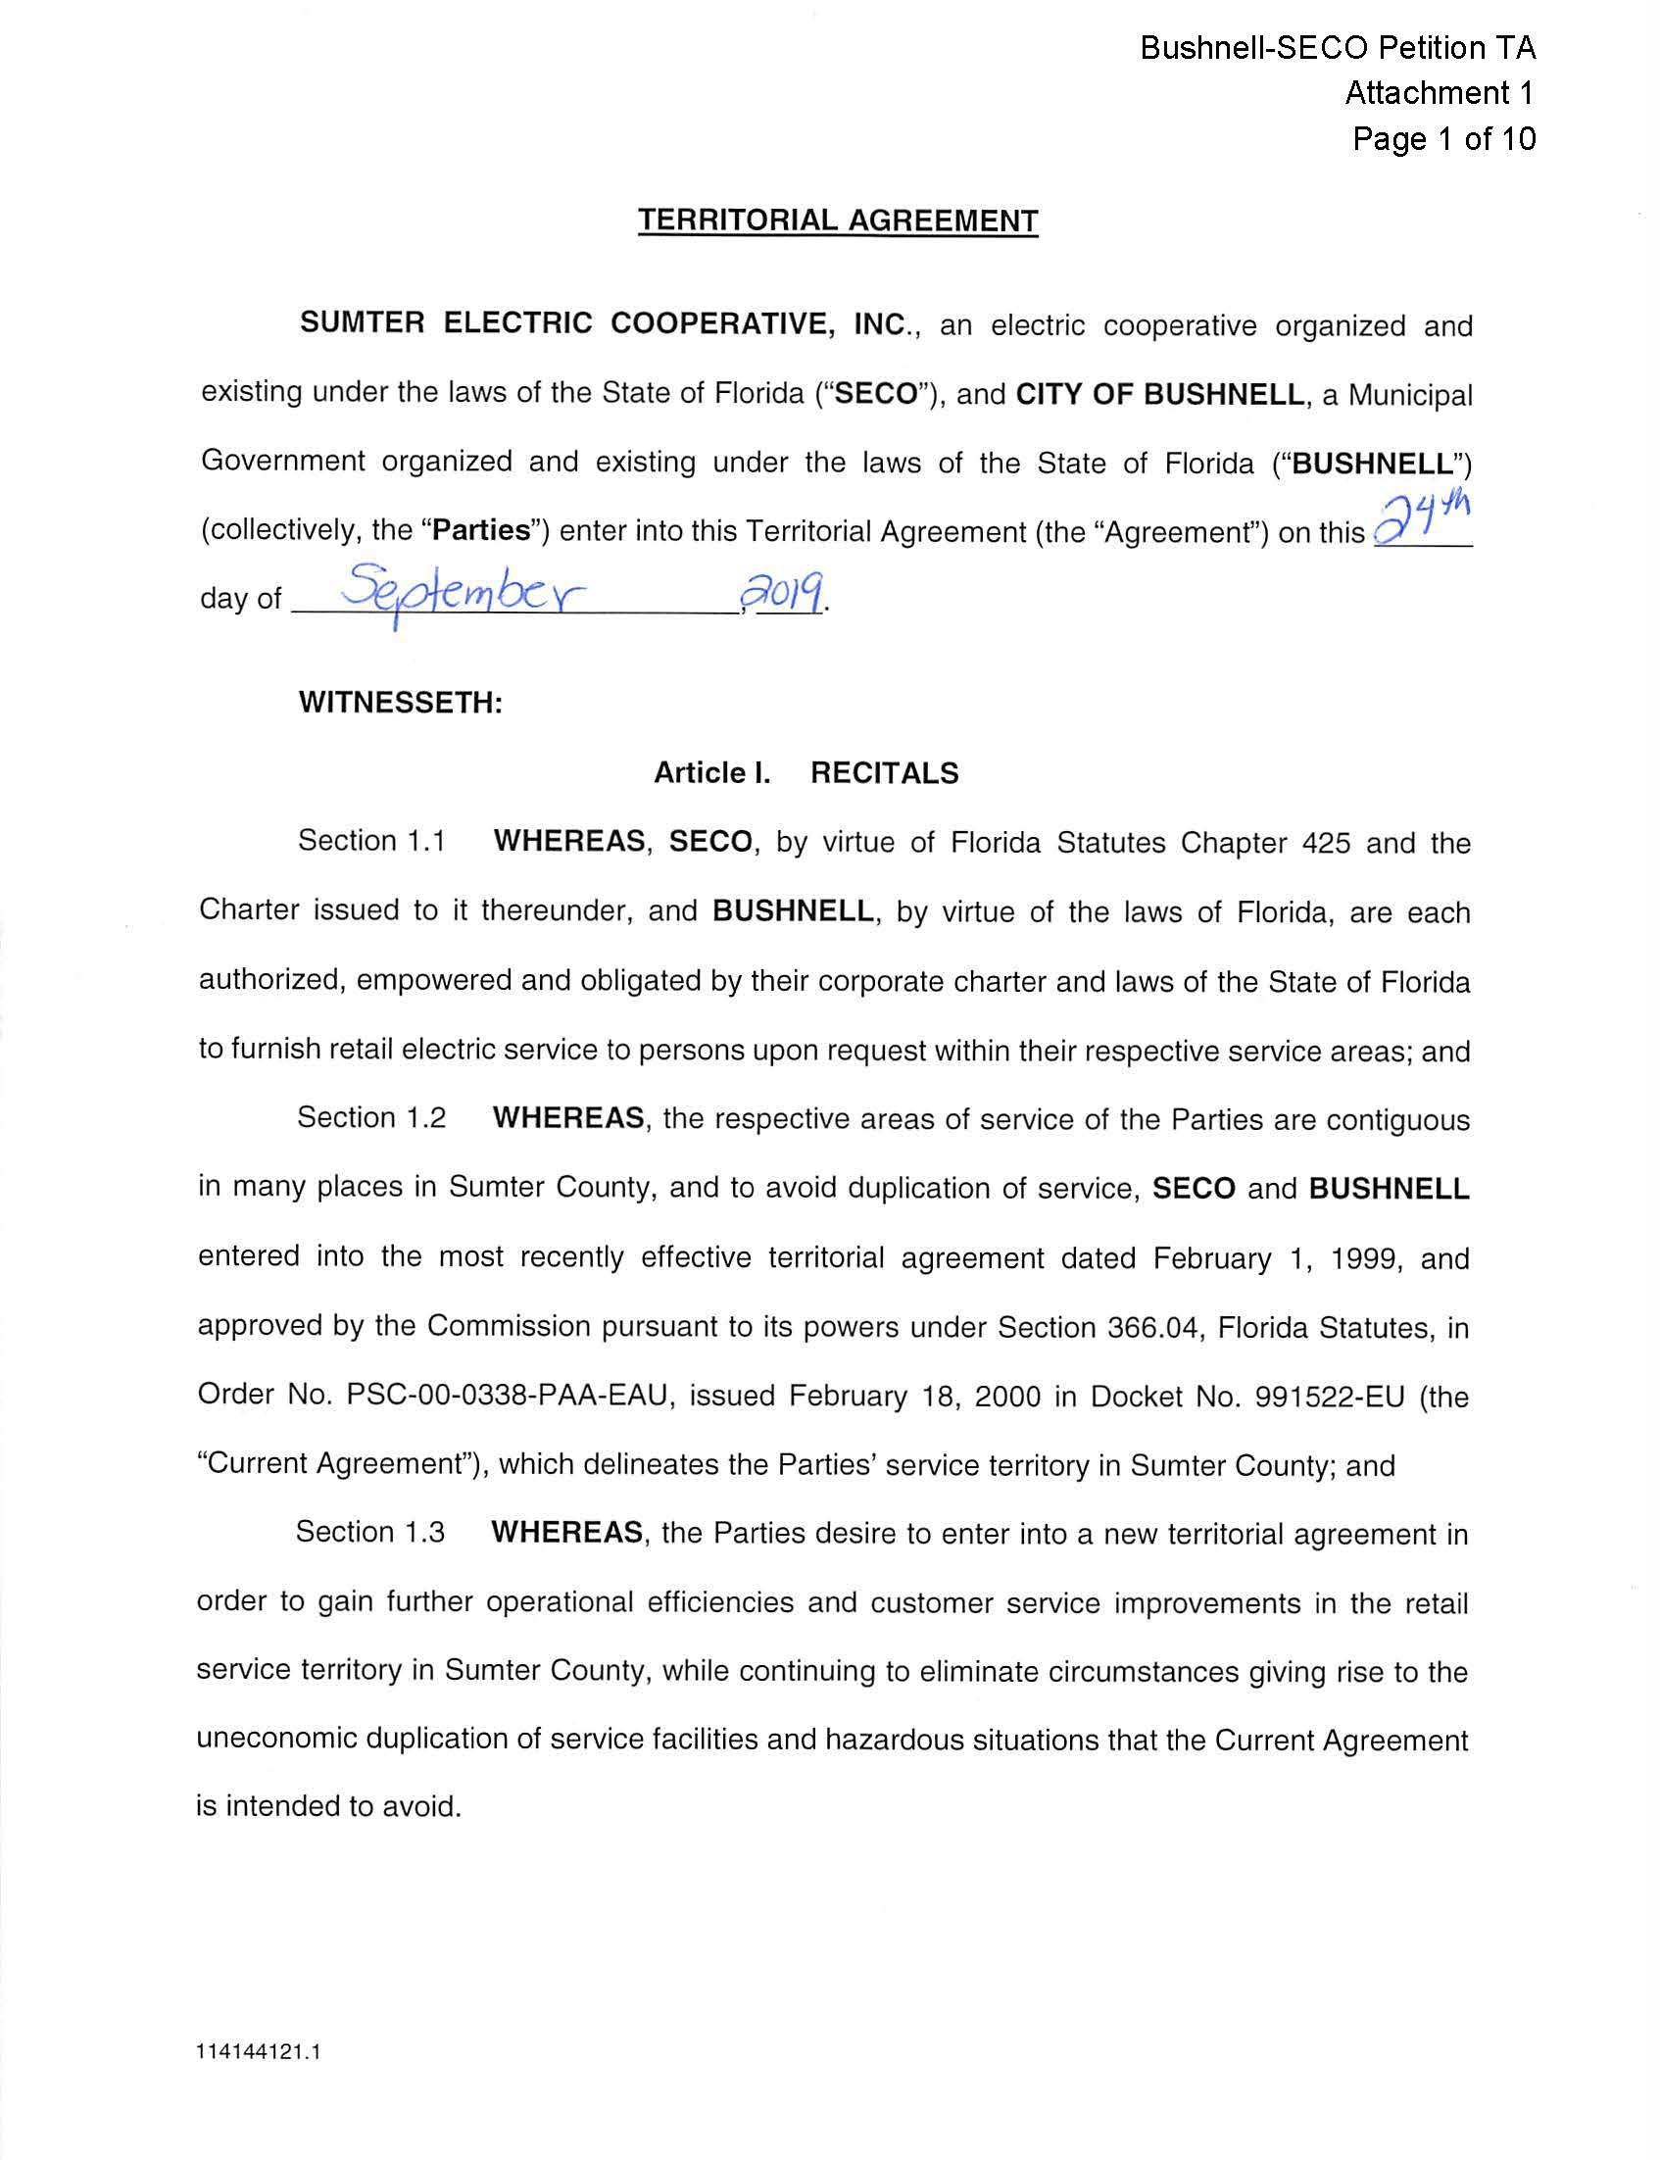

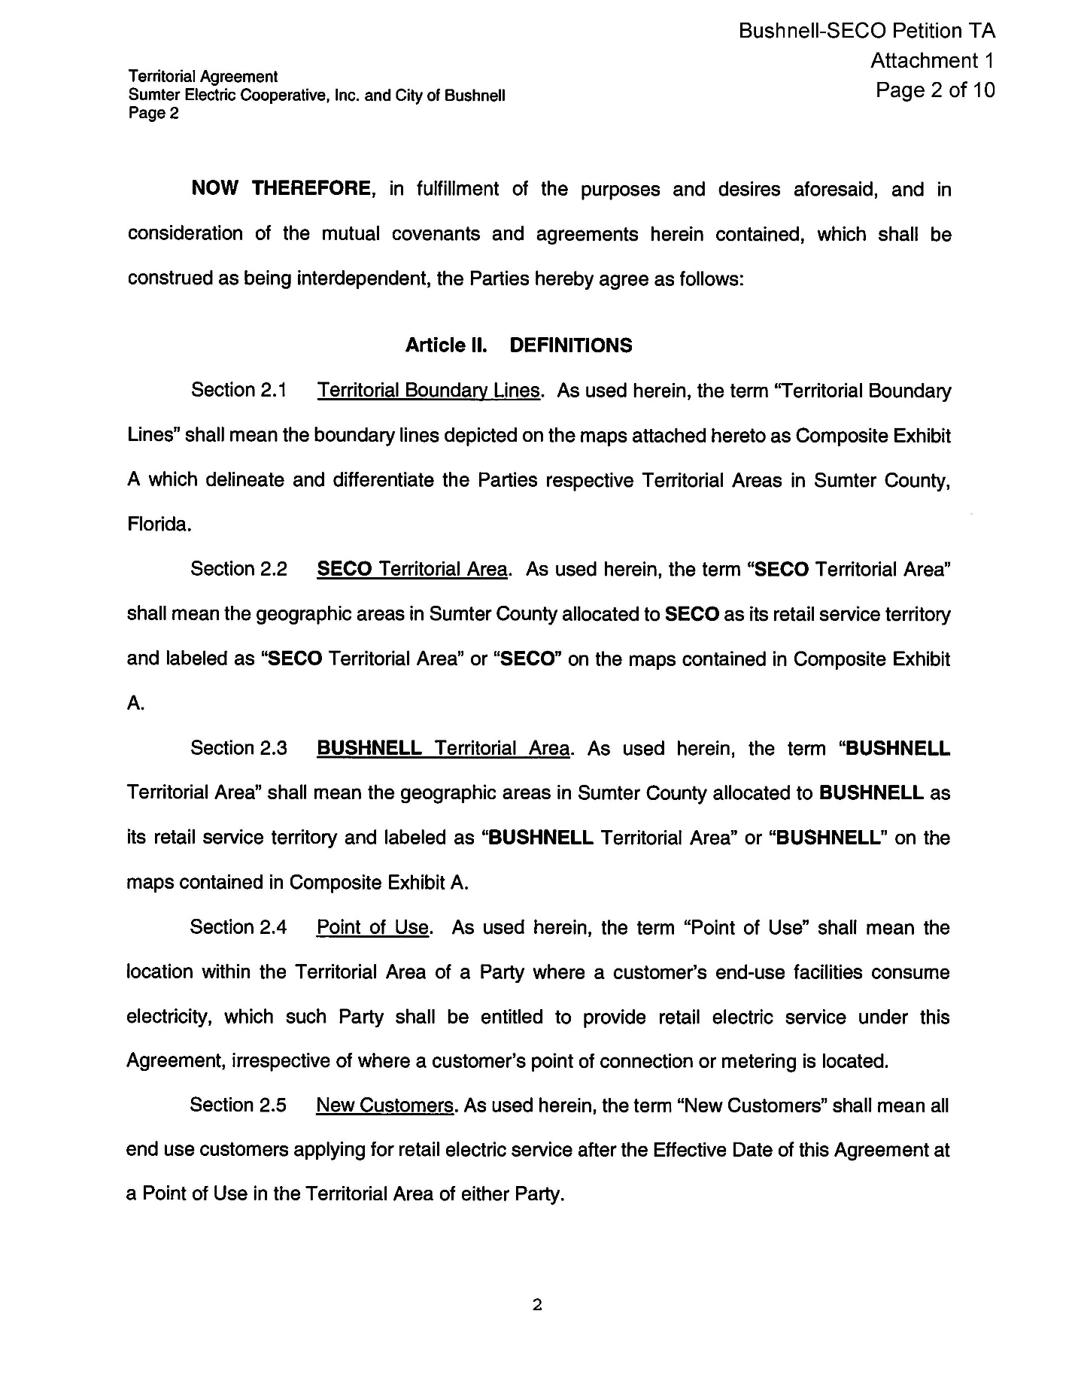

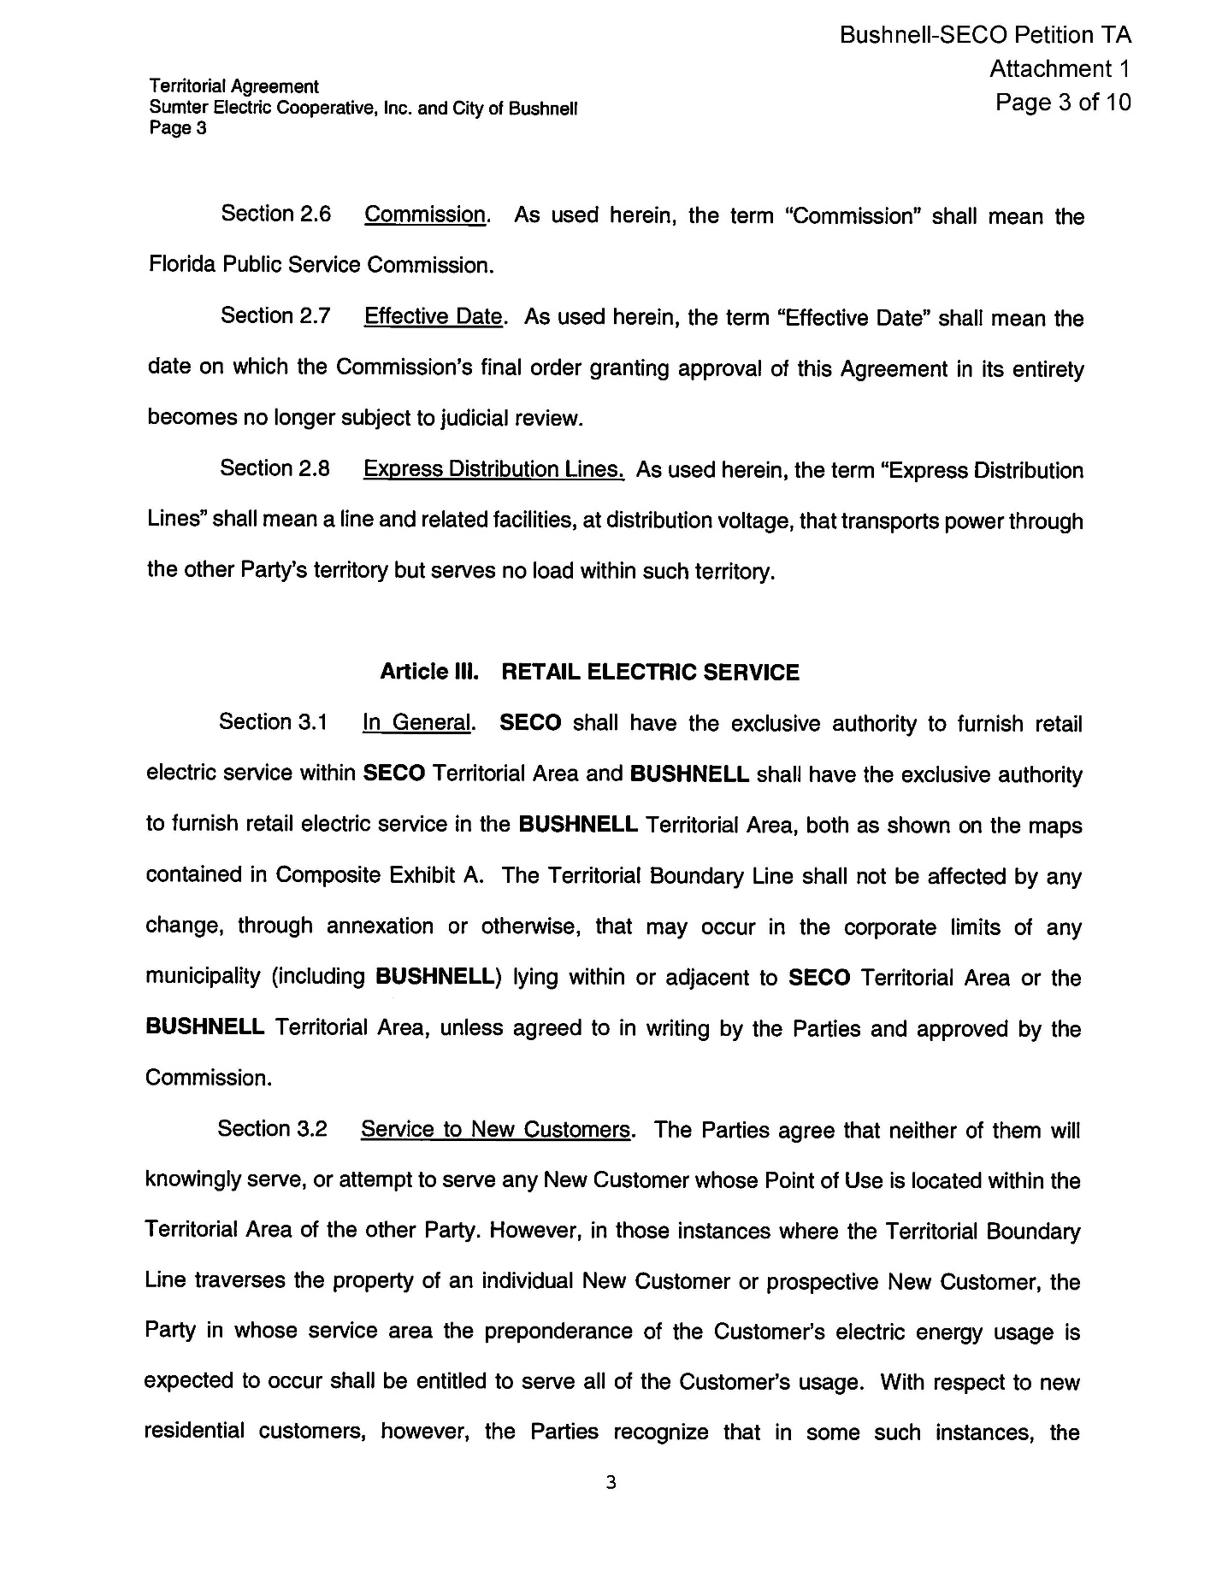

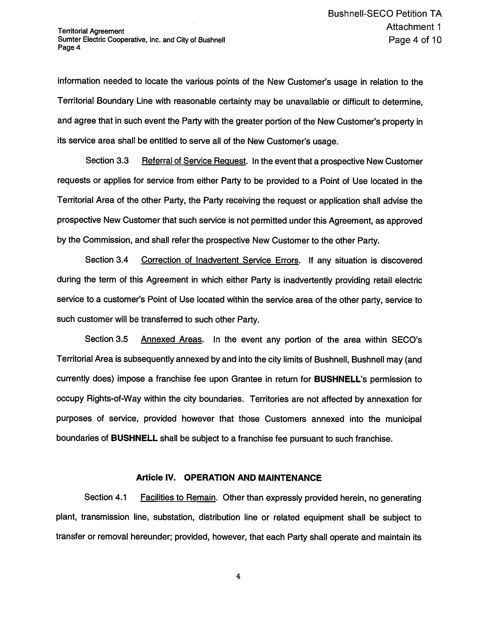

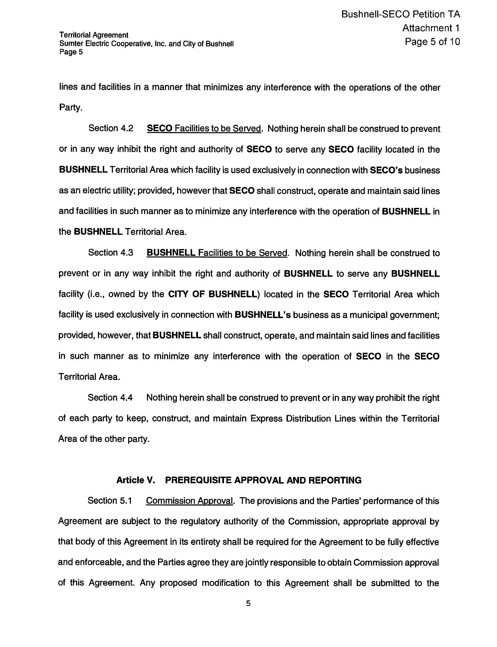

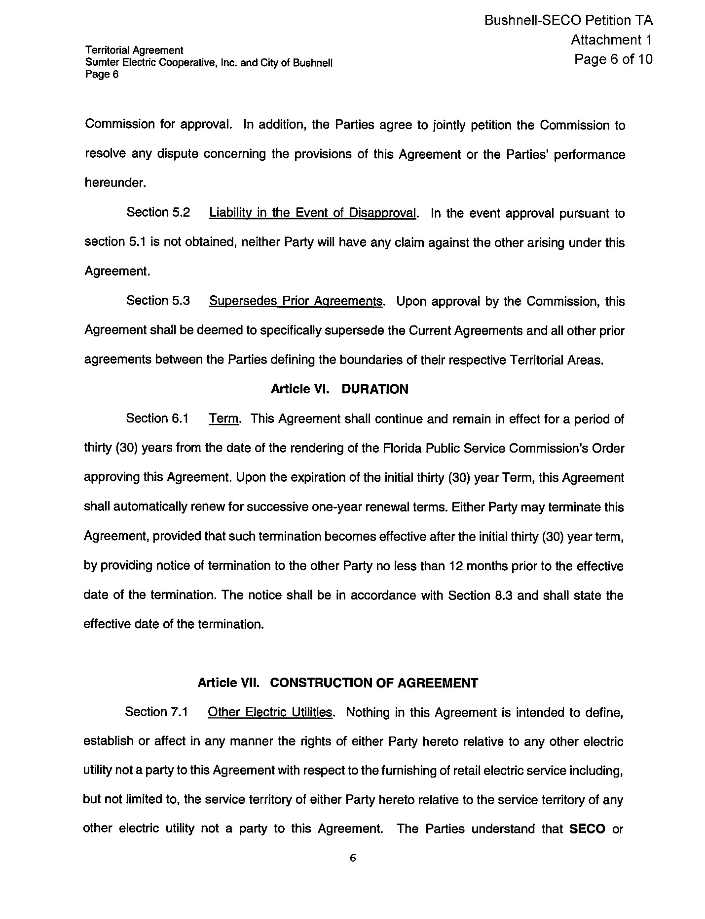

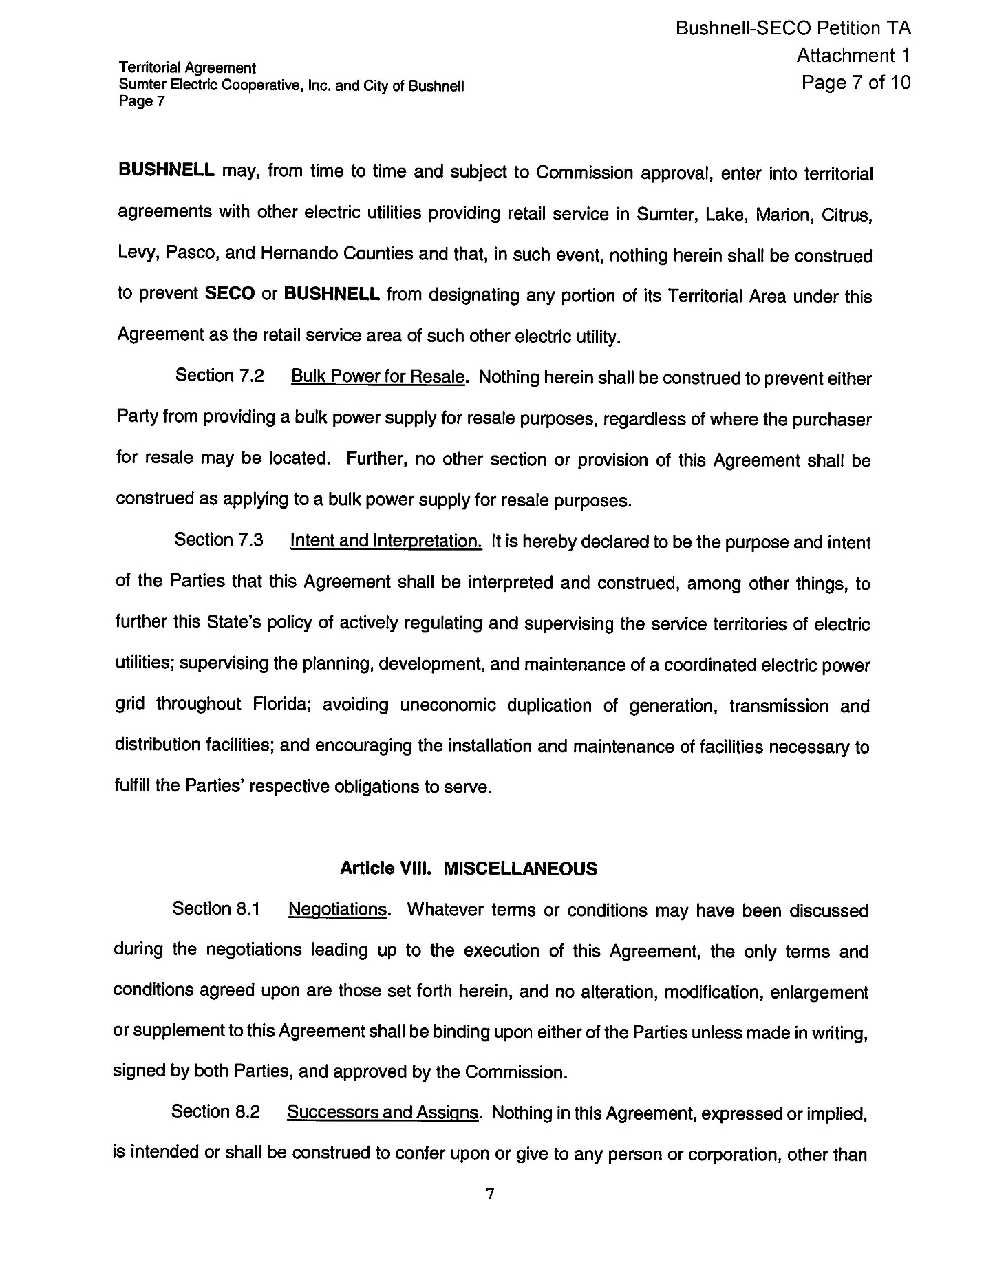

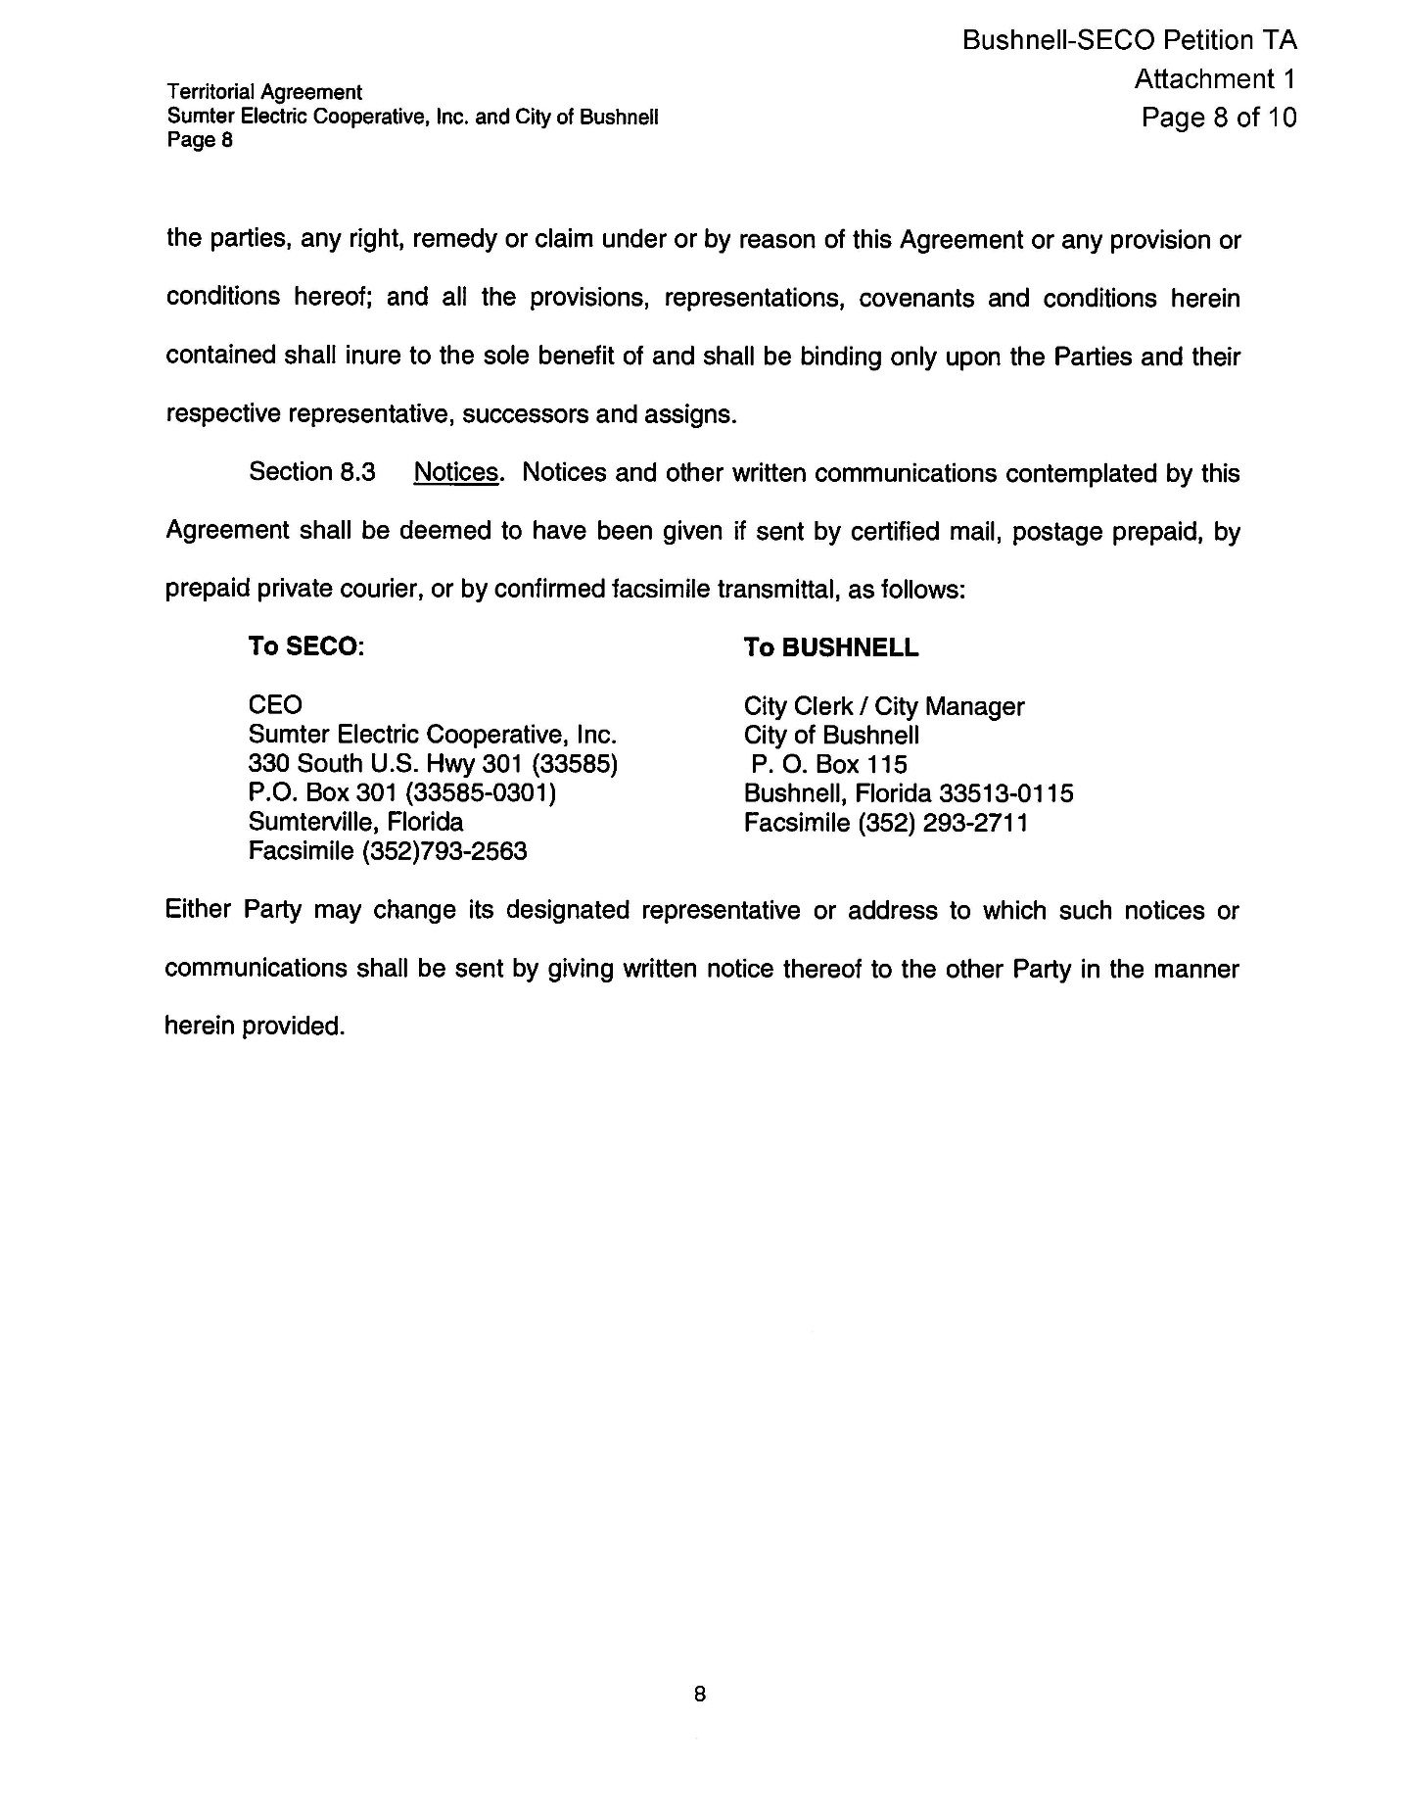

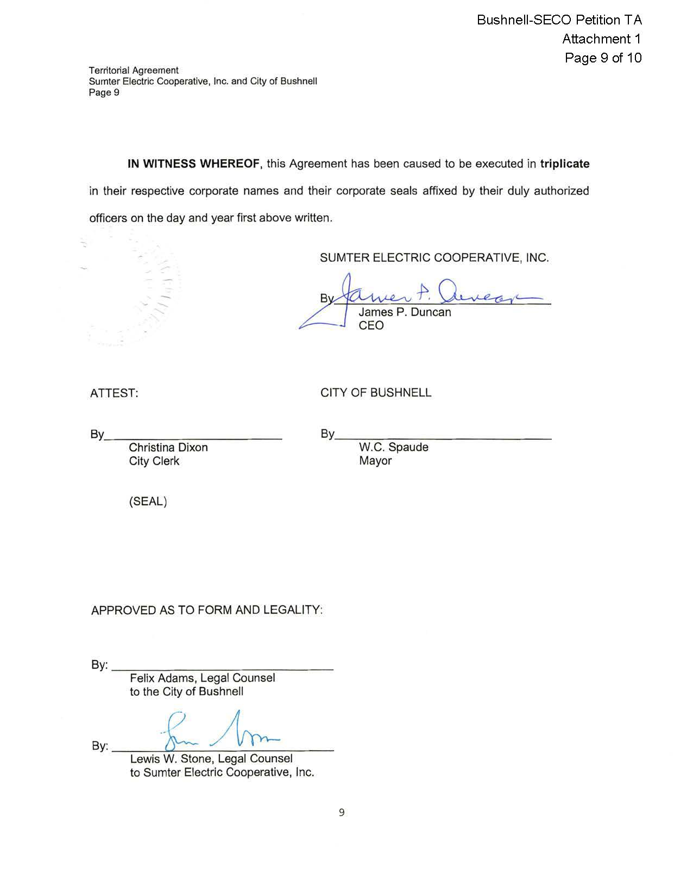

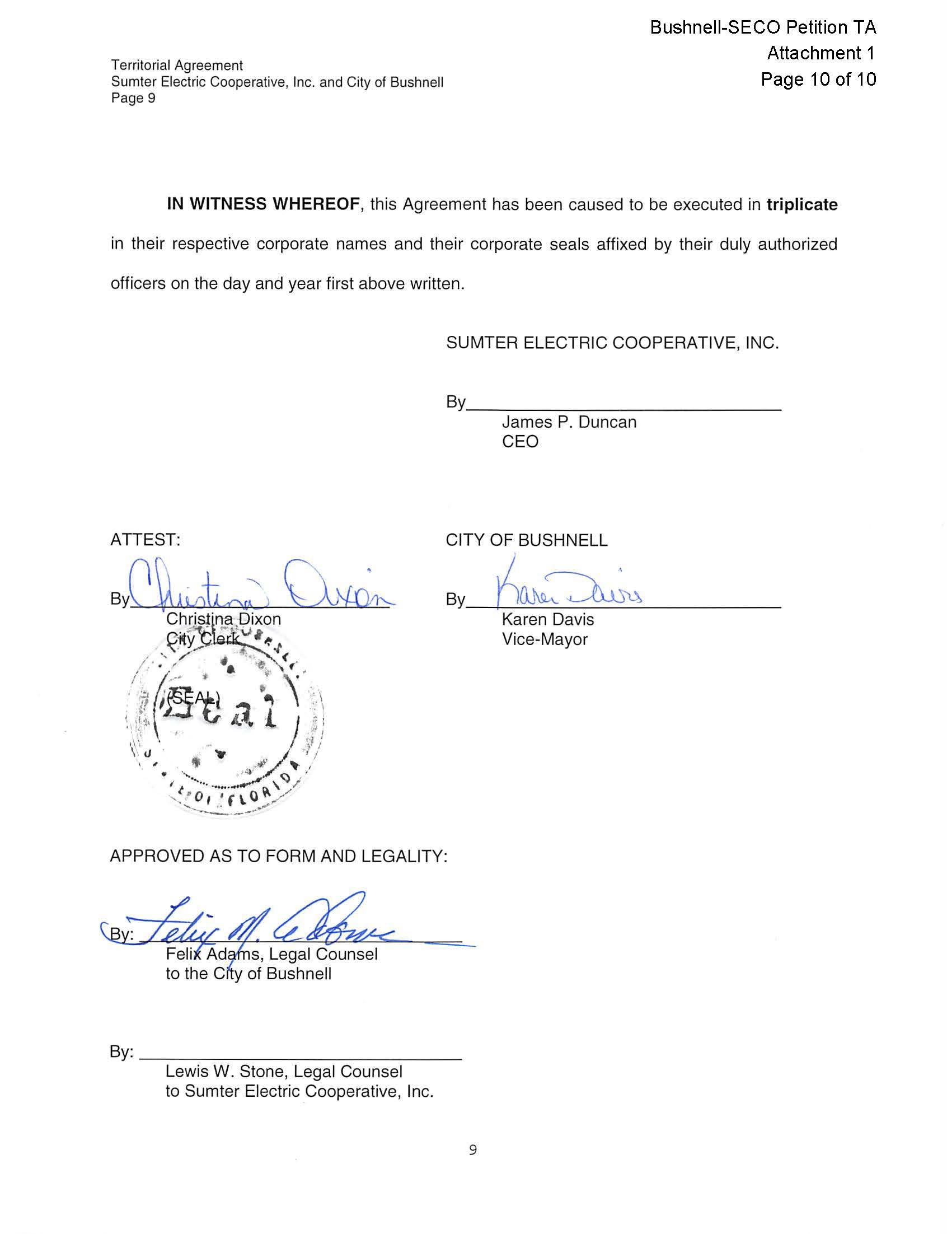

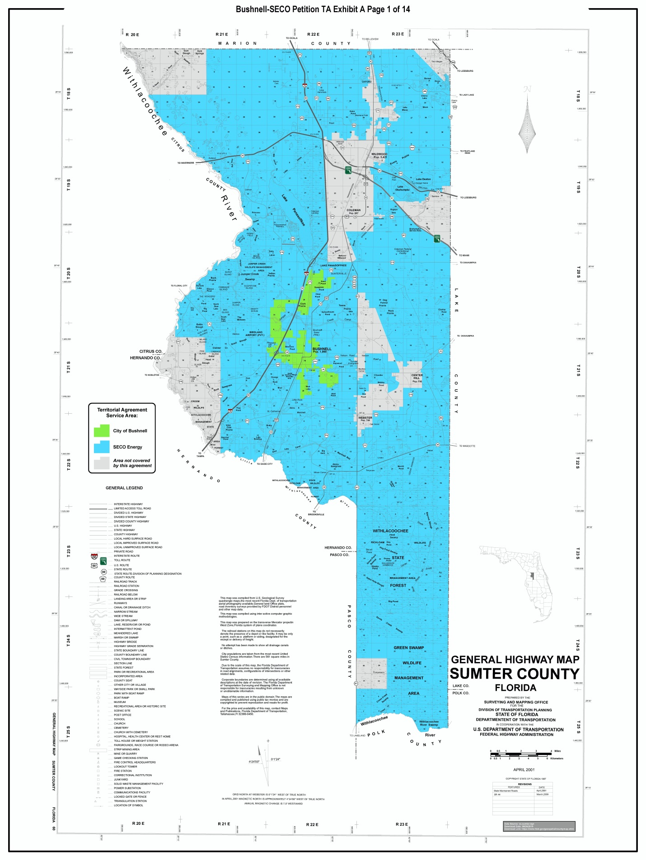

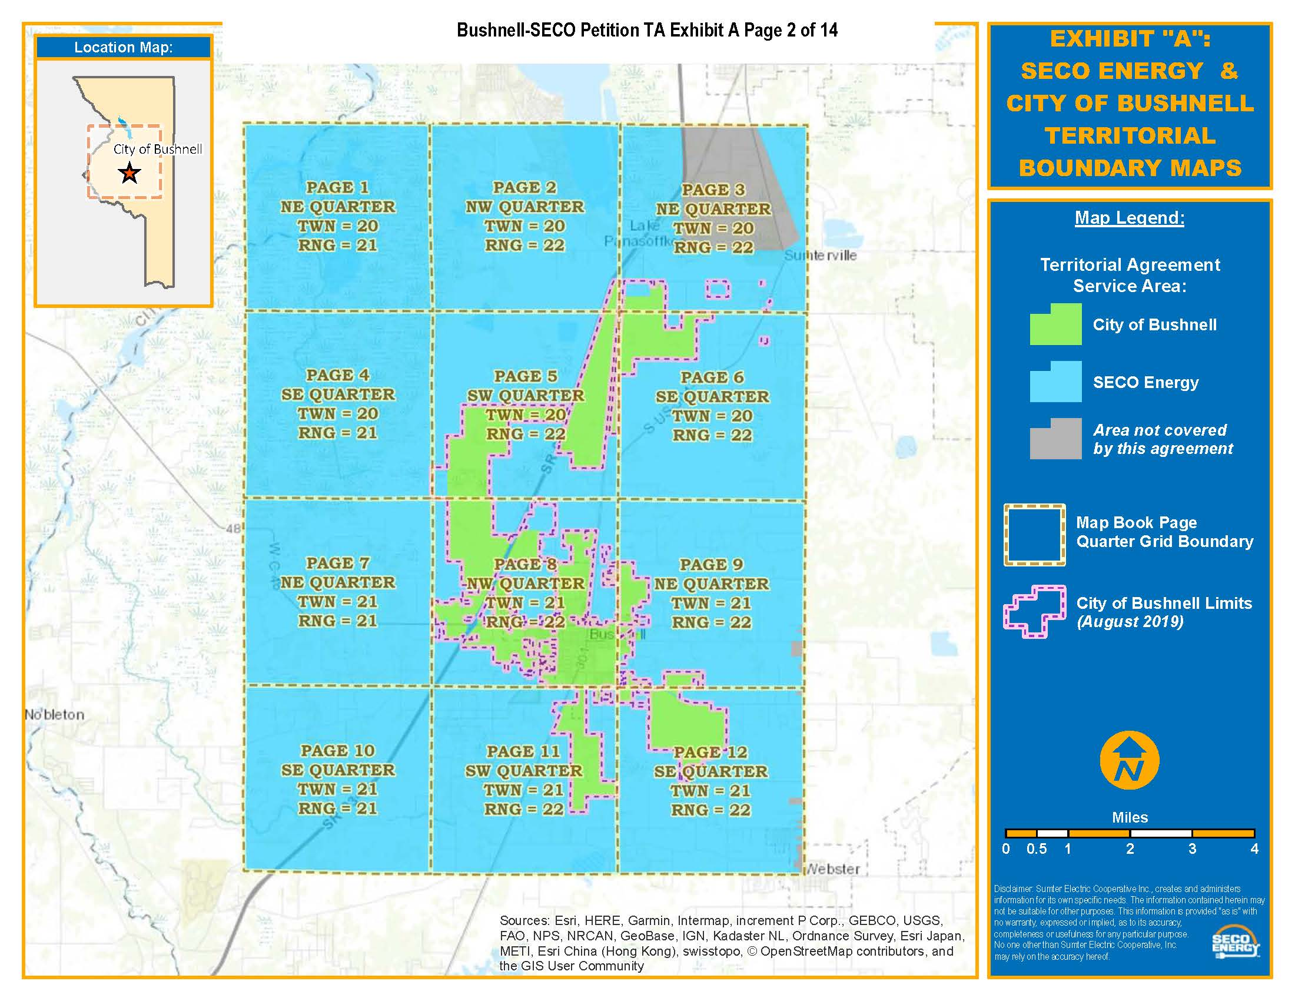

Order No. 10676, issued March 30, 1982, in Docket No. 810367-EU, In re: Joint Stipulation and Petition for Approval of Territorial Agreement between Sumter electric Cooperative, Inc. and the City of Bushnell.
Order No. PSC-00-0338-PAA-EU, issued February 18, 2000, in Docket No. 991522-EU, In re: Joint petition for approval of territorial agreement between City of Bushnell and Sumter Electric Cooperative, Inc.
Utilities Commission of the City of New Smyrna Beach v. Florida Public Service Commission, 469 So. 2d 731 (Fla. 1985).
See also Public Service Commission v. Fuller, 551 So. 2d 1210, 1212 (Fla. 1989); City Gas Co. v. Peoples Gas System, Inc., 182 So. 2d 429, 436 (Fla. 1965).
Storey v. Mayo, 217 So. 2d 304 (Fla.1968), cert. denied, 395 U.S. 909, 89 S.Ct. 1751, 23 L.Ed.2d 222 (1969).
Fuller, 551 So. 2d at 1212.

