BEFORE THE FLORIDA PUBLIC SERVICE COMMISSION

In re: Joint petition for approval of extension of territorial agreement and first amendment to territorial agreement, by Tampa Electric Company and Sumter Electric Cooperative, Inc. | DOCKET NO. 20200116-EU  ORDER NO. PSC-2020-0260-PAA-EU  ISSUED: July 24, 2020

The following Commissioners participated in the disposition of this matter:

GARY F. CLARK, Chairman
ART GRAHAM
JULIE I. BROWN
DONALD J. POLMANN
ANDREW GILES FAY

NOTICE OF PROPOSED AGENCY ACTION
ORDER APPROVING EXTENSION AND FIRST
AMENDMENT TO TERRITORIAL AGREEMENT

BY THE COMMISSION:

NOTICE is hereby given by the Florida Public Service Commission that the action discussed herein is preliminary in nature and will become final unless a person whose interests are substantially affected files a petition for a formal proceeding, pursuant to Rule 25-22.029, Florida Administrative Code (F.A.C.).

BACKGROUND

On April 2, 2020, Tampa Electric Company (TECO) and Sumter Electric Cooperative, Inc. (SECO), collectively the joint petitioners, filed a petition seeking Commission approval of a 15-year extension of the parties’ current Commission-approved Territorial Agreement in Lake, Polk, and Sumter counties and approval of the First Amendment to the Territorial Agreement (First Amendment).

In 1994, we approved the joint petitioners’ Territorial Agreement by Order No. PSC-1994-1397-FOF-EU (1994 Order). The current Territorial Agreement and map depicting the current service areas of TECO and SECO are provided in Attachment A. The proposed First Amendment to the Territorial Agreement seeks to modify certain limited provisions of the Territorial Agreement to comply with the 1994 Order, remove unnecessary language, and standardize depreciation rates for facility transfers. The Amendment is provided in Attachment B.

During the review of this joint petition, Commission staff issued one data request to the joint petitioners on April 21, 2020, for which responses were received on May 4, 2020. We have jurisdiction over this matter pursuant to Section 366.04, Florida Statutes (F.S.).

DECISION

Pursuant to Section 366.04(2)(d), F.S., and Rule 25-6.0440, F.A.C., we have the jurisdiction to approve territorial agreements between and among rural electric cooperatives, municipal electric utilities, and other electric utilities. Unless we determine that the agreement will cause a detriment to the public interest, the agreement should be approved.

Territorial Agreement Extension

Section 5.1 of the Territorial Agreement states it shall remain in effect for a period of 25 years, with the option to be renewed for periods of 15 years, unless either party gives written notice to terminate the agreement. Further, Section 5.1 and Article IV state that each renewal of the Territorial Agreement requires prerequisite approval of this Commission. The initial 25-year term of the Territorial Agreement ended in December 2019. The joint petitioners desire that the Territorial Agreement extend for 15 years through December 2034, stating that the agreement has worked well for both TECO and SECO and their ability to provide safe and reliable electric service. The parties’ agreed upon desire to renew the Territorial agreement for an additional 15 years is provided for in the First Amendment.

The maps and legal descriptions defining the boundaries of the Territorial Agreement remain the same and no customers will be transferred or otherwise affected by the proposed extension of the Territorial Agreement. As such, there are no customers to notify regarding changes in service. Additionally, paragraph 7 of the petition states that there is no reasonable likelihood the extension will decrease electric service reliability.

First Amendment to the Territorial Agreement

The joint petitioners have proposed a First Amendment to the Territorial Agreement. The First Amendment consists of four modifications to the Territorial Agreement. Two of the modifications are results of our decision in the 1994 Order. The first modification addresses the language of Section 2.2 of the Territorial Agreement. The current language required the filing of all interim service agreements with this Commission. However, in paragraph 4 of the 1994 Order, we directed the joint petitioners to only file interim service agreements expected to last for more than one year. Interim service could occur in an exceptional circumstance when a new customer due to economic or engineering constraints could not be immediately served by the utility in whose service territory the customer is located.

The second modification resulting from the 1994 Order addresses the filing of annual reports with this Commission. Currently, Section 4.1 of the Territorial Agreement states that the joint petitioners would file annual reports with this Commission on the status of the Territorial Agreement. However, in paragraph 5 of the 1994 Order, we declined to require the filing of annual reports. As such, the joint petitioners removed this requirement in the proposed First Amendment.

The third modification removes Section 2.3 of the Territorial Agreement. Section 2.3 relates solely to SECO and was meant to preserve its 503(c)(12) tax status. Paragraph 9, Subsection b, of the petition states that SECO “does not have a significant concern that its non-profit status would be jeopardized by the circumstances described in Section 2.3.” Furthermore, SECO states that it has not included this language in more recent territorial agreements.

The fourth modification is to Section 2.4 of the Territorial Agreement which addresses depreciation rates to be used in the calculation for any potential facilities or asset transfers. This modification sets TECO’s depreciation rates as the standard to be used by the joint petitioners. Additionally, the modification clarifies that reintegration costs are to be included, where required by sound utility practice. The joint petitioners explained that SECO is required to use a 30-year depreciation schedule, while TECO’s Commission-approved depreciation rates vary depending on the specific assets. Therefore, using TECO’s rates ensures consistency with our orders. The joint petitioners state that establishing a single standard for depreciation rates is a fair and reasonable approach.

After review of the joint petition and the joint petitioners’ responses to Commission staff’s data request, we find that the requested 15-year extension (December 2019 through December 2034) will enable TECO and SECO to avoid unnecessary duplication of facilities and to serve their customers in an efficient manner. The changes made in the First Amendment will bring the Territorial Agreement into compliance with the 1994 Order, remove obsolete language, and provide a fair and reasonable method for any future transfers of facilities.

For the reasons stated above, we find that the proposed extension and First Amendment to the Territorial Agreement are in the public interest and will avoid uneconomic duplication of facilities. Thus, we hereby approve the extension of the Territorial Agreement between TECO and SECO and approve the proposed First Amendment to the Territorial Agreement.

Based on the foregoing, it is

ORDERED by the Florida Public Service Commission that the Joint Petition for Approval of Extension of Territorial Agreement and First Amendment to Territorial Agreement by Tampa Electric Company and Sumter Electric Cooperative, Inc. is hereby granted. It is further

ORDERED that the provisions of this order, issued as proposed agency action, shall become final and effective upon the issuance of a consummating order unless an appropriate petition, in the form provided by Rule 28-106.201, F.A.C., is received by the Office of Commission Clerk, 2540 Shumard Oak Boulevard, Tallahassee, Florida 32399-0850, by the close of business on the date set forth in the “Notice of Further Proceedings” attached hereto. It is further

ORDERED that if a timely protest is filed within 21 days of the issuance of the order, the amendments to the territorial agreement shall remain in effect pending resolution of the protest. If no timely protest is filed, this docket shall be closed upon the issuance of a consummating order.

By ORDER of the Florida Public Service Commission this 24th day of July, 2020.

/s/ Adam J. Teitzman
ADAM J. TEITZMAN
Commission Clerk
Florida Public Service Commission
2540 Shumard Oak Boulevard
Tallahassee, Florida 32399
(850) 413-6770
www.floridapsc.com

Copies furnished: A copy of this document is provided to the parties of record at the time of issuance and, if applicable, interested persons.

SBr

NOTICE OF FURTHER PROCEEDINGS OR JUDICIAL REVIEW

The Florida Public Service Commission is required by Section 120.569(1), Florida Statutes, to notify parties of any administrative hearing that is available under Section 120.57, Florida Statutes, as well as the procedures and time limits that apply. This notice should not be construed to mean all requests for an administrative hearing will be granted or result in the relief sought.

Mediation may be available on a case-by-case basis. If mediation is conducted, it does not affect a substantially interested person's right to a hearing.

The action proposed herein is preliminary in nature. Any person whose substantial interests are affected by the action proposed by this order may file a petition for a formal proceeding, in the form provided by Rule 28-106.201, Florida Administrative Code. This petition must be received by the Office of Commission Clerk, 2540 Shumard Oak Boulevard, Tallahassee, Florida 32399-0850, by the close of business on August 14, 2020.

In the absence of such a petition, this order shall become final and effective upon the issuance of a Consummating Order.

Any objection or protest filed in this/these docket(s) before the issuance date of this order is considered abandoned unless it satisfies the foregoing conditions and is renewed within the specified protest period.

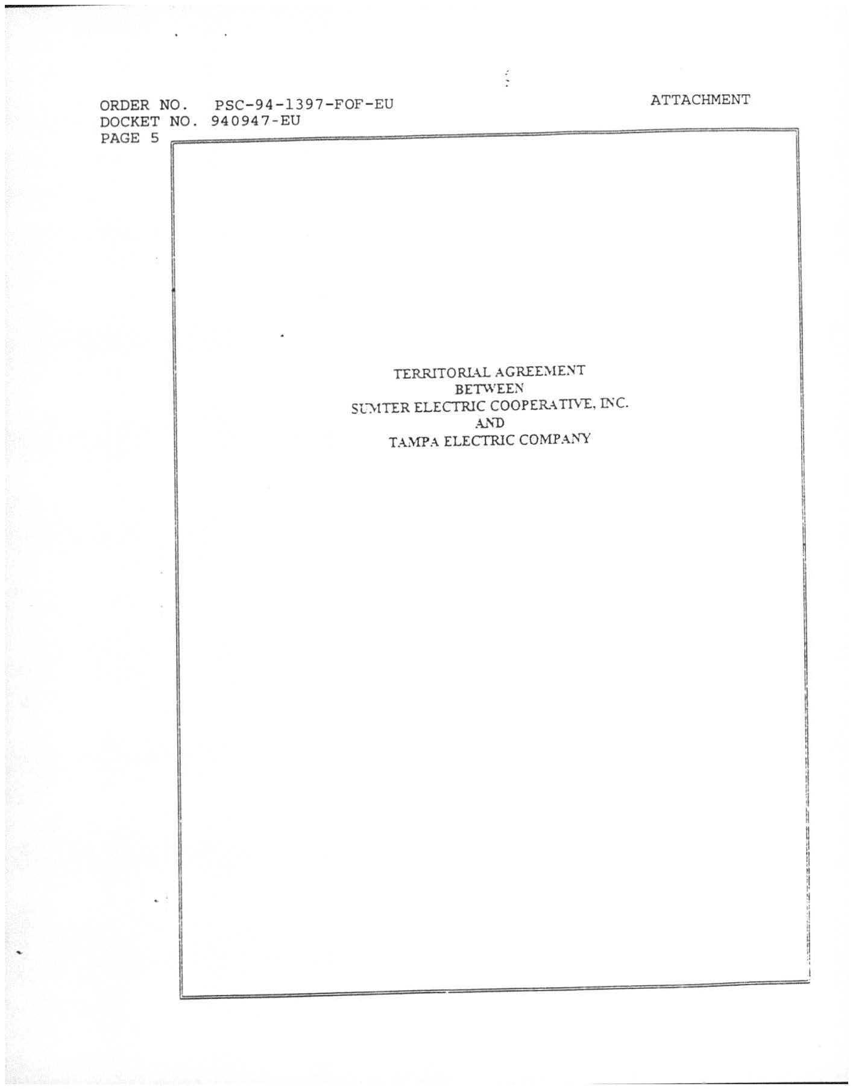

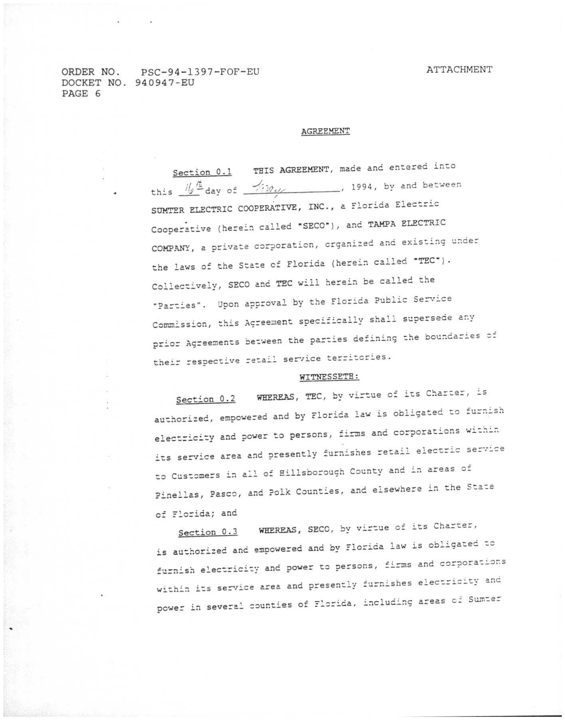

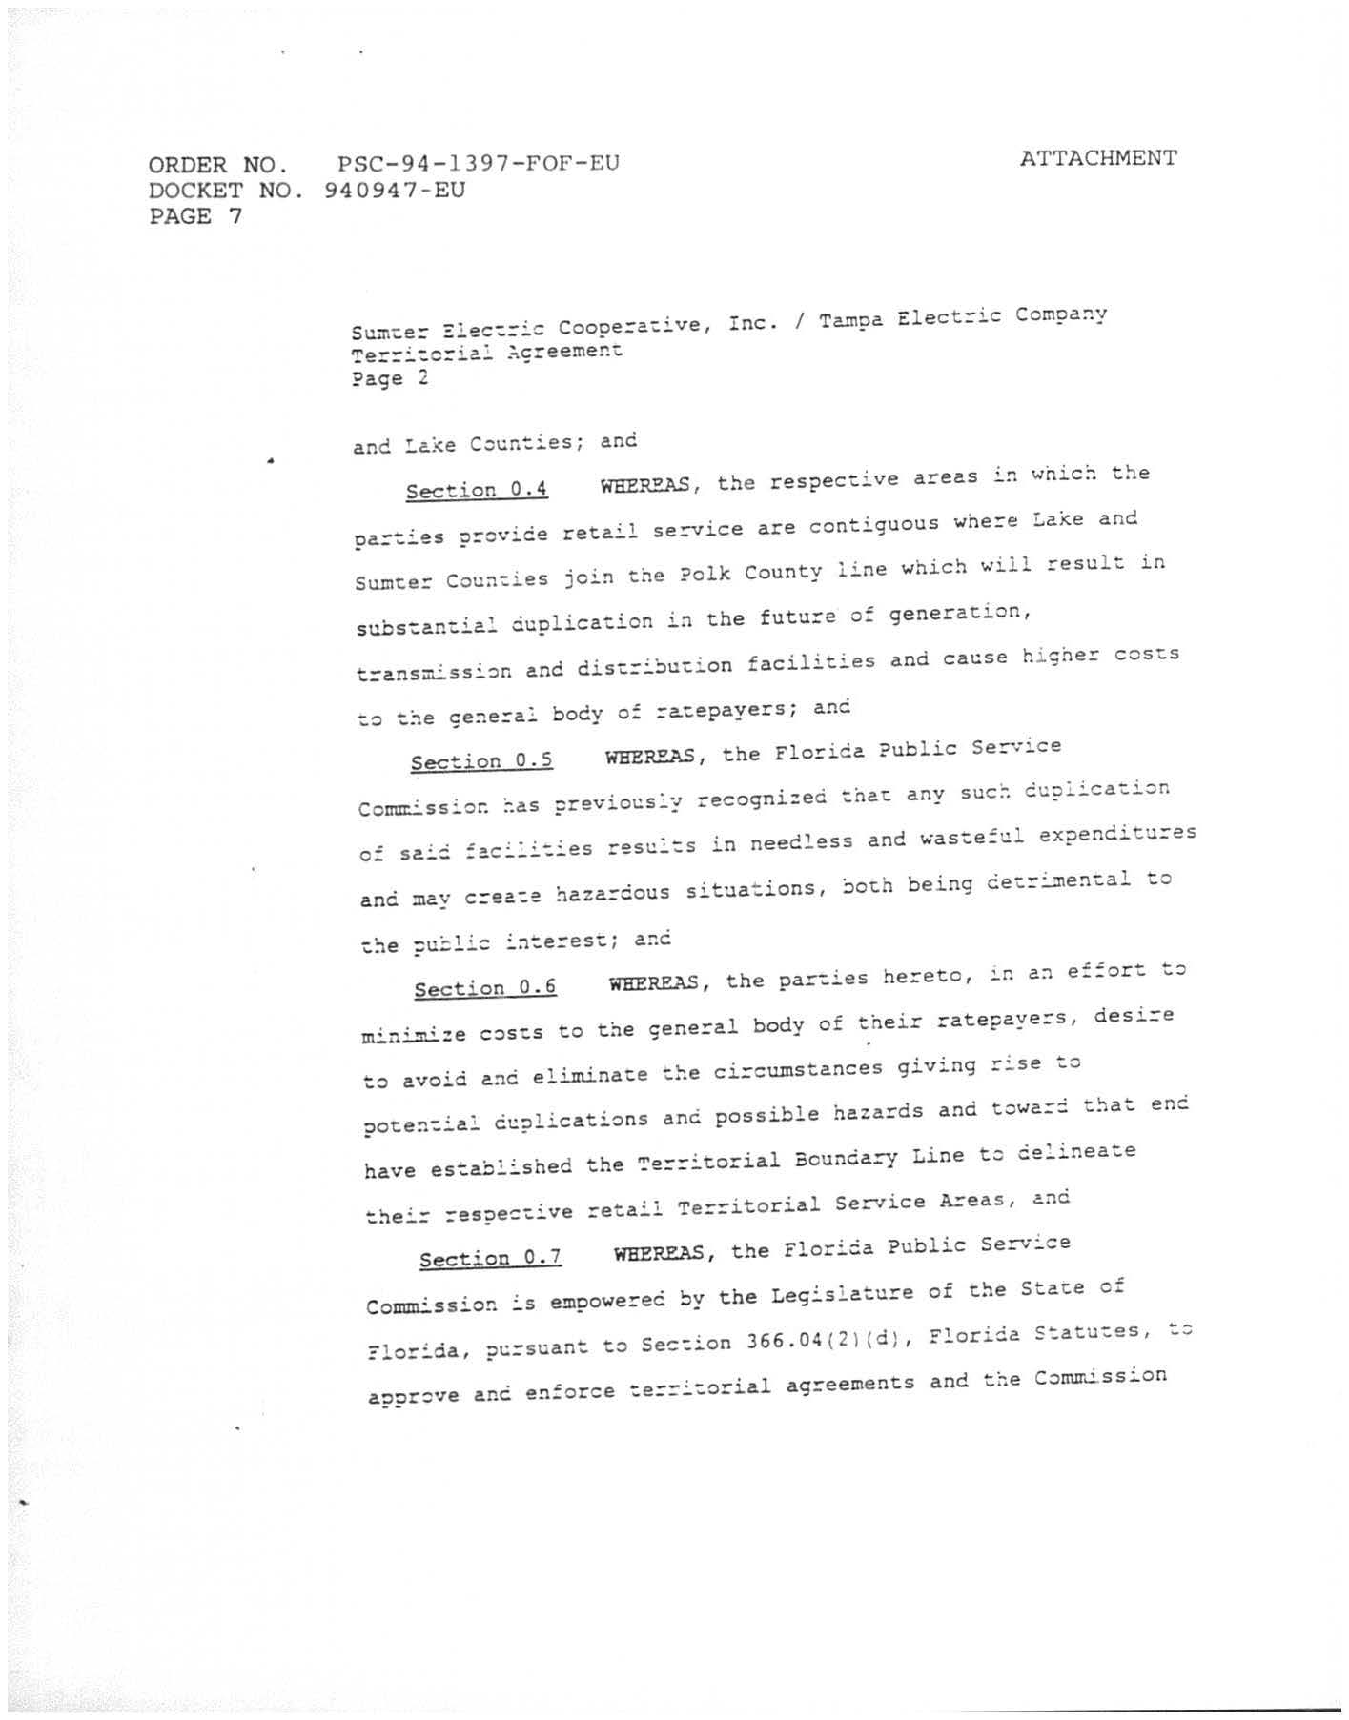

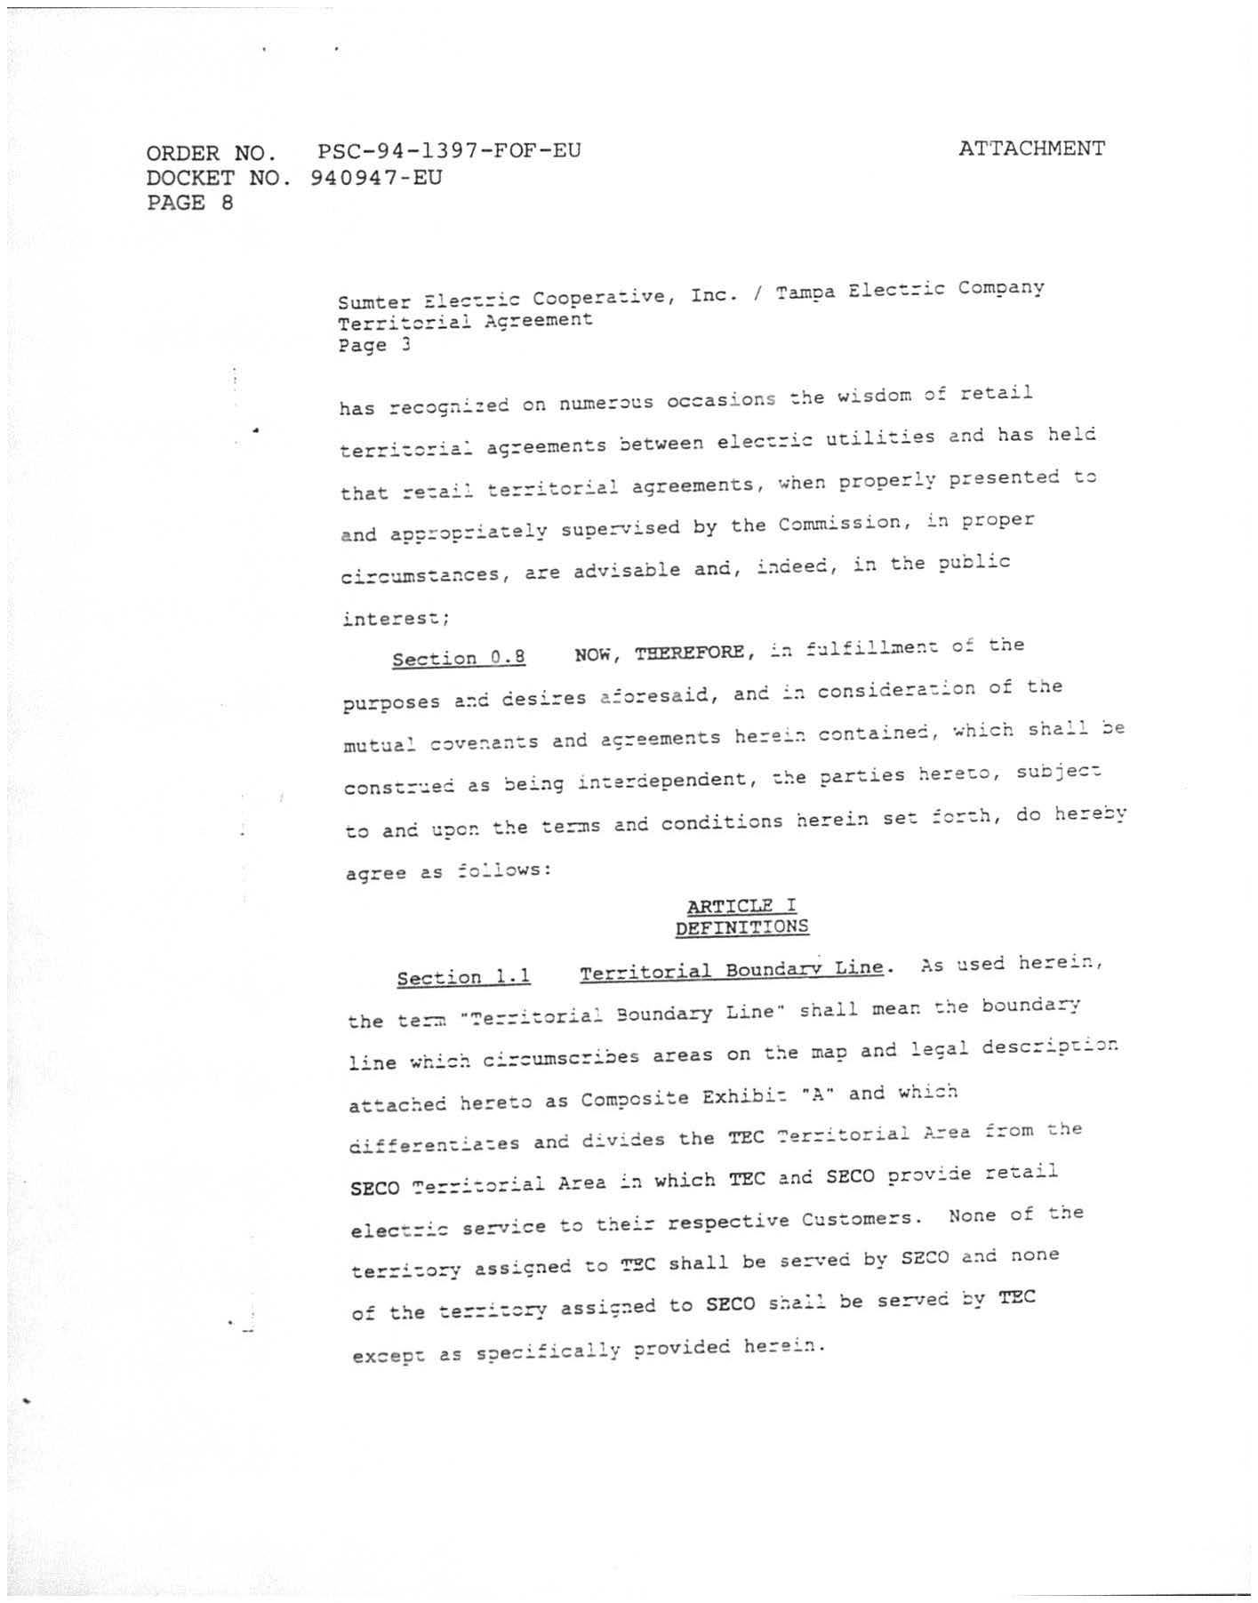

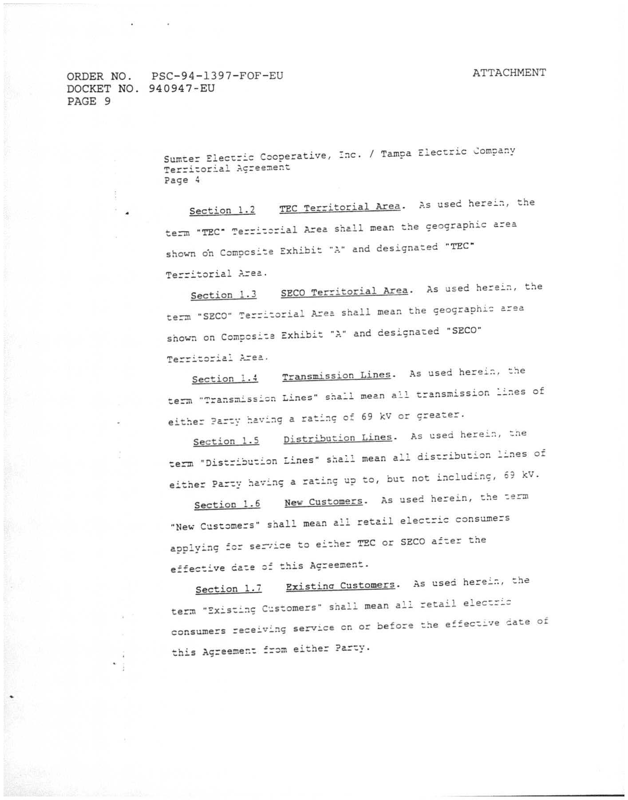

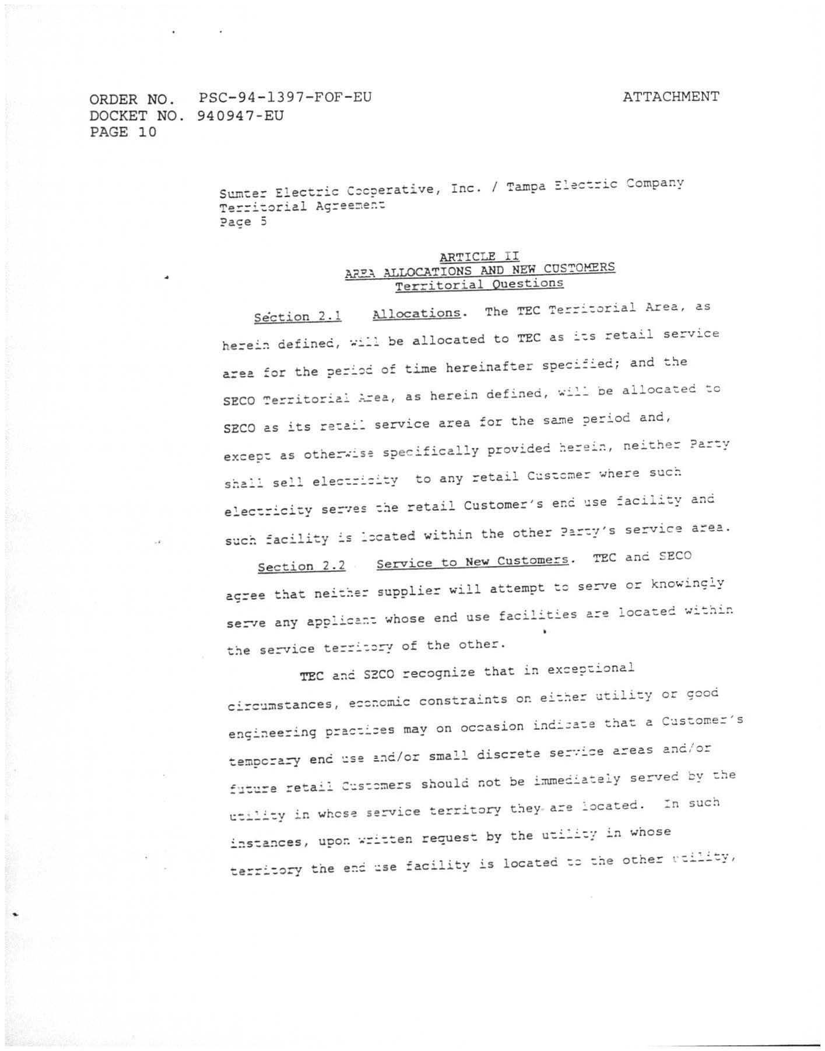

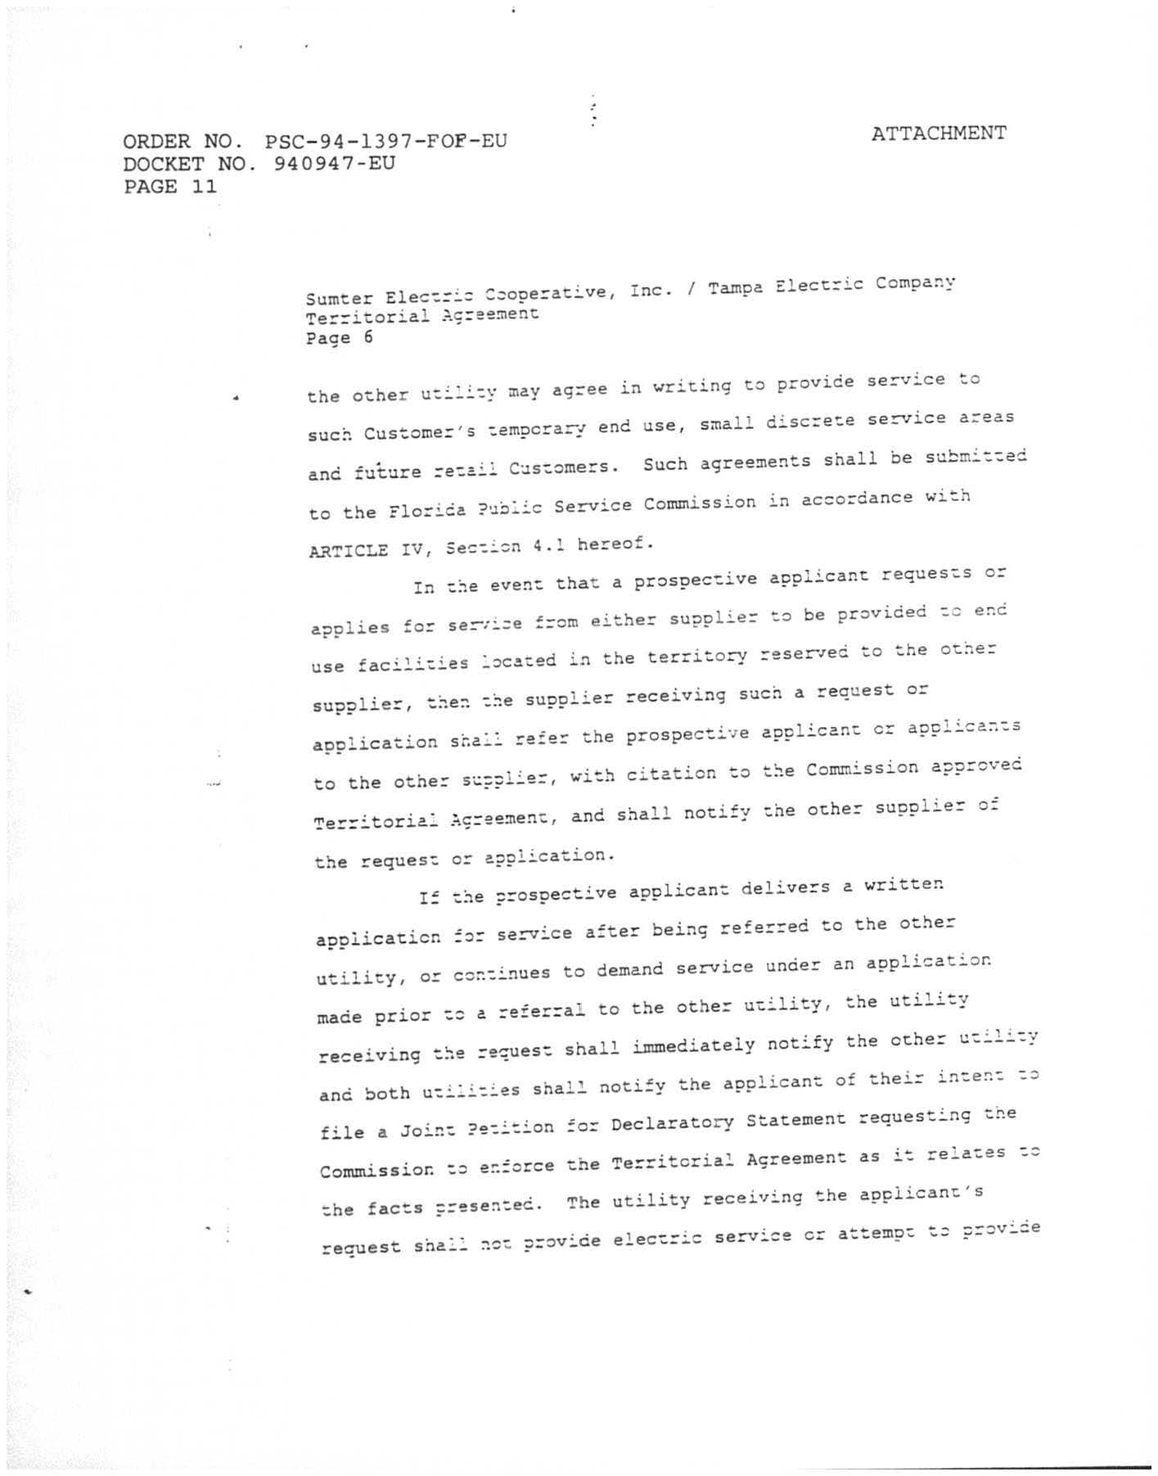

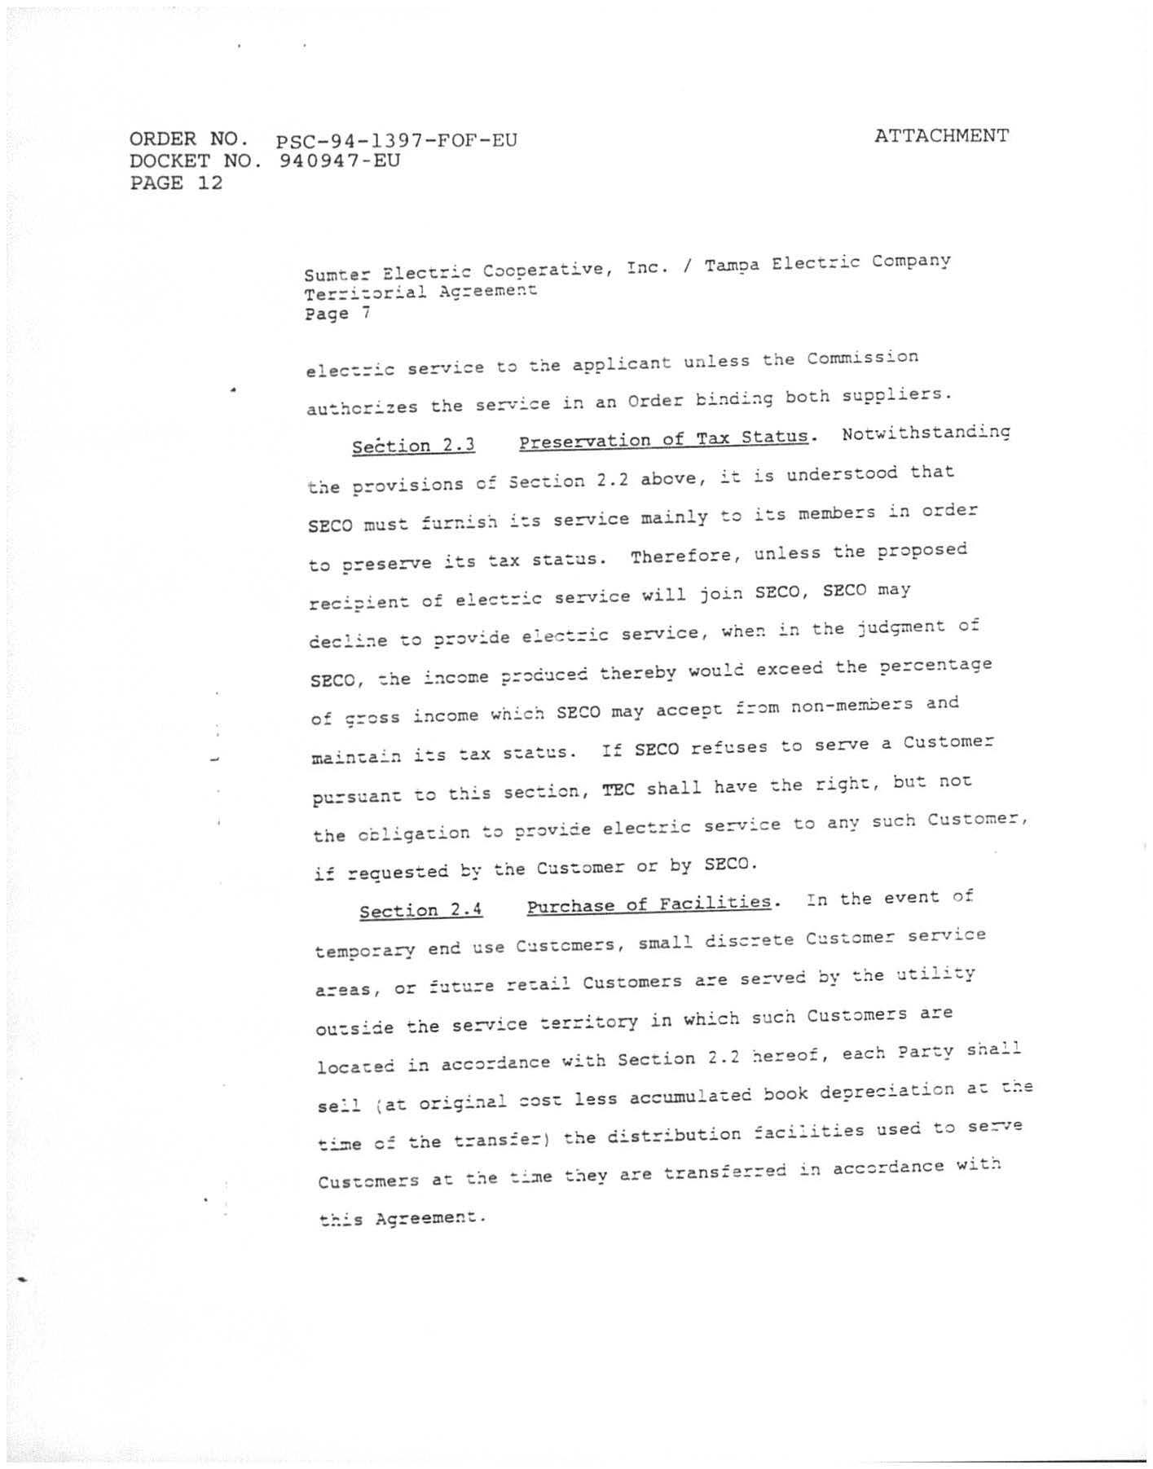

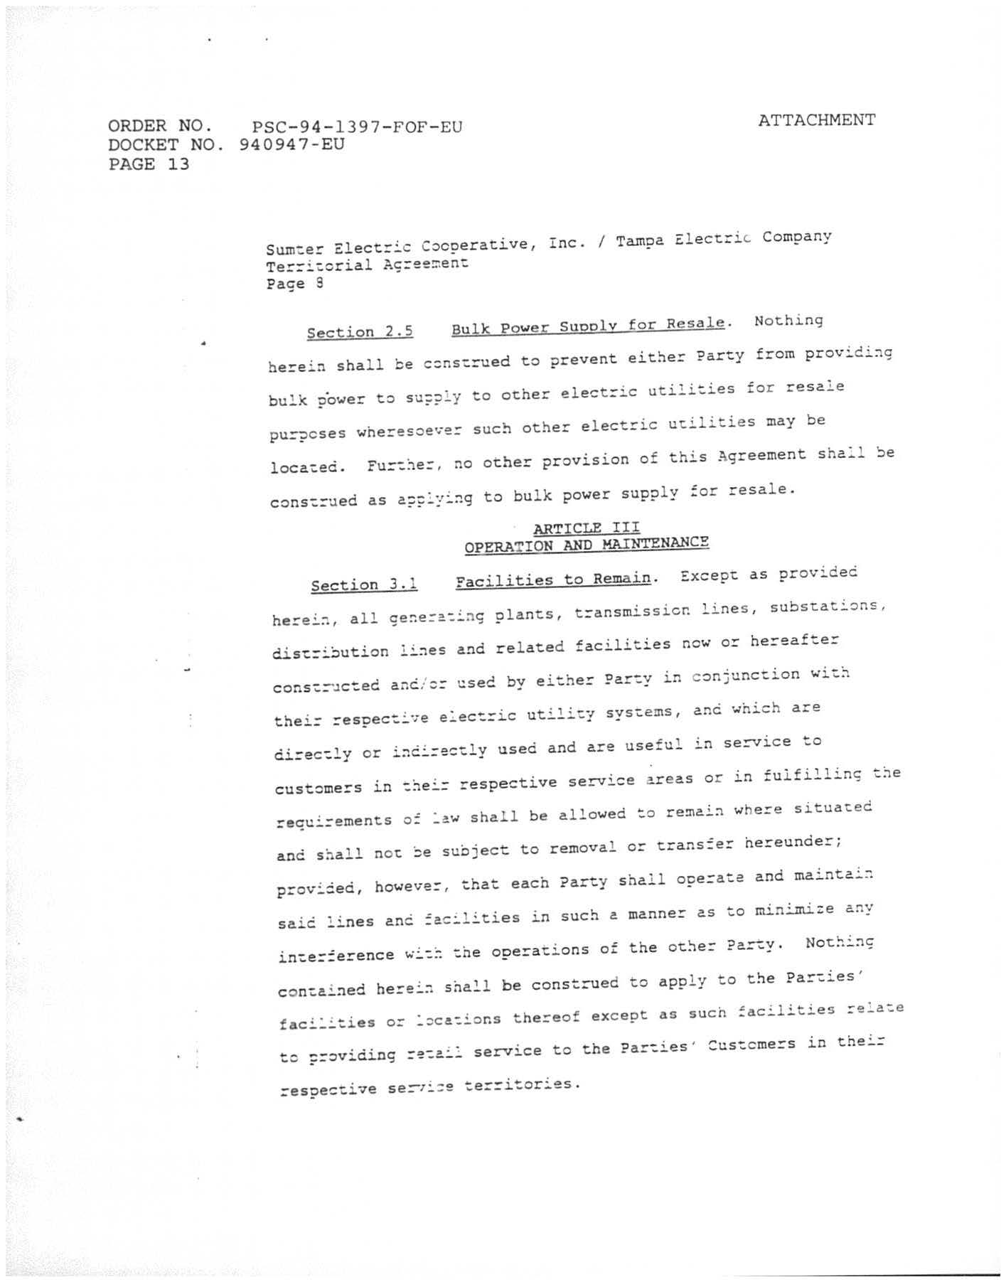

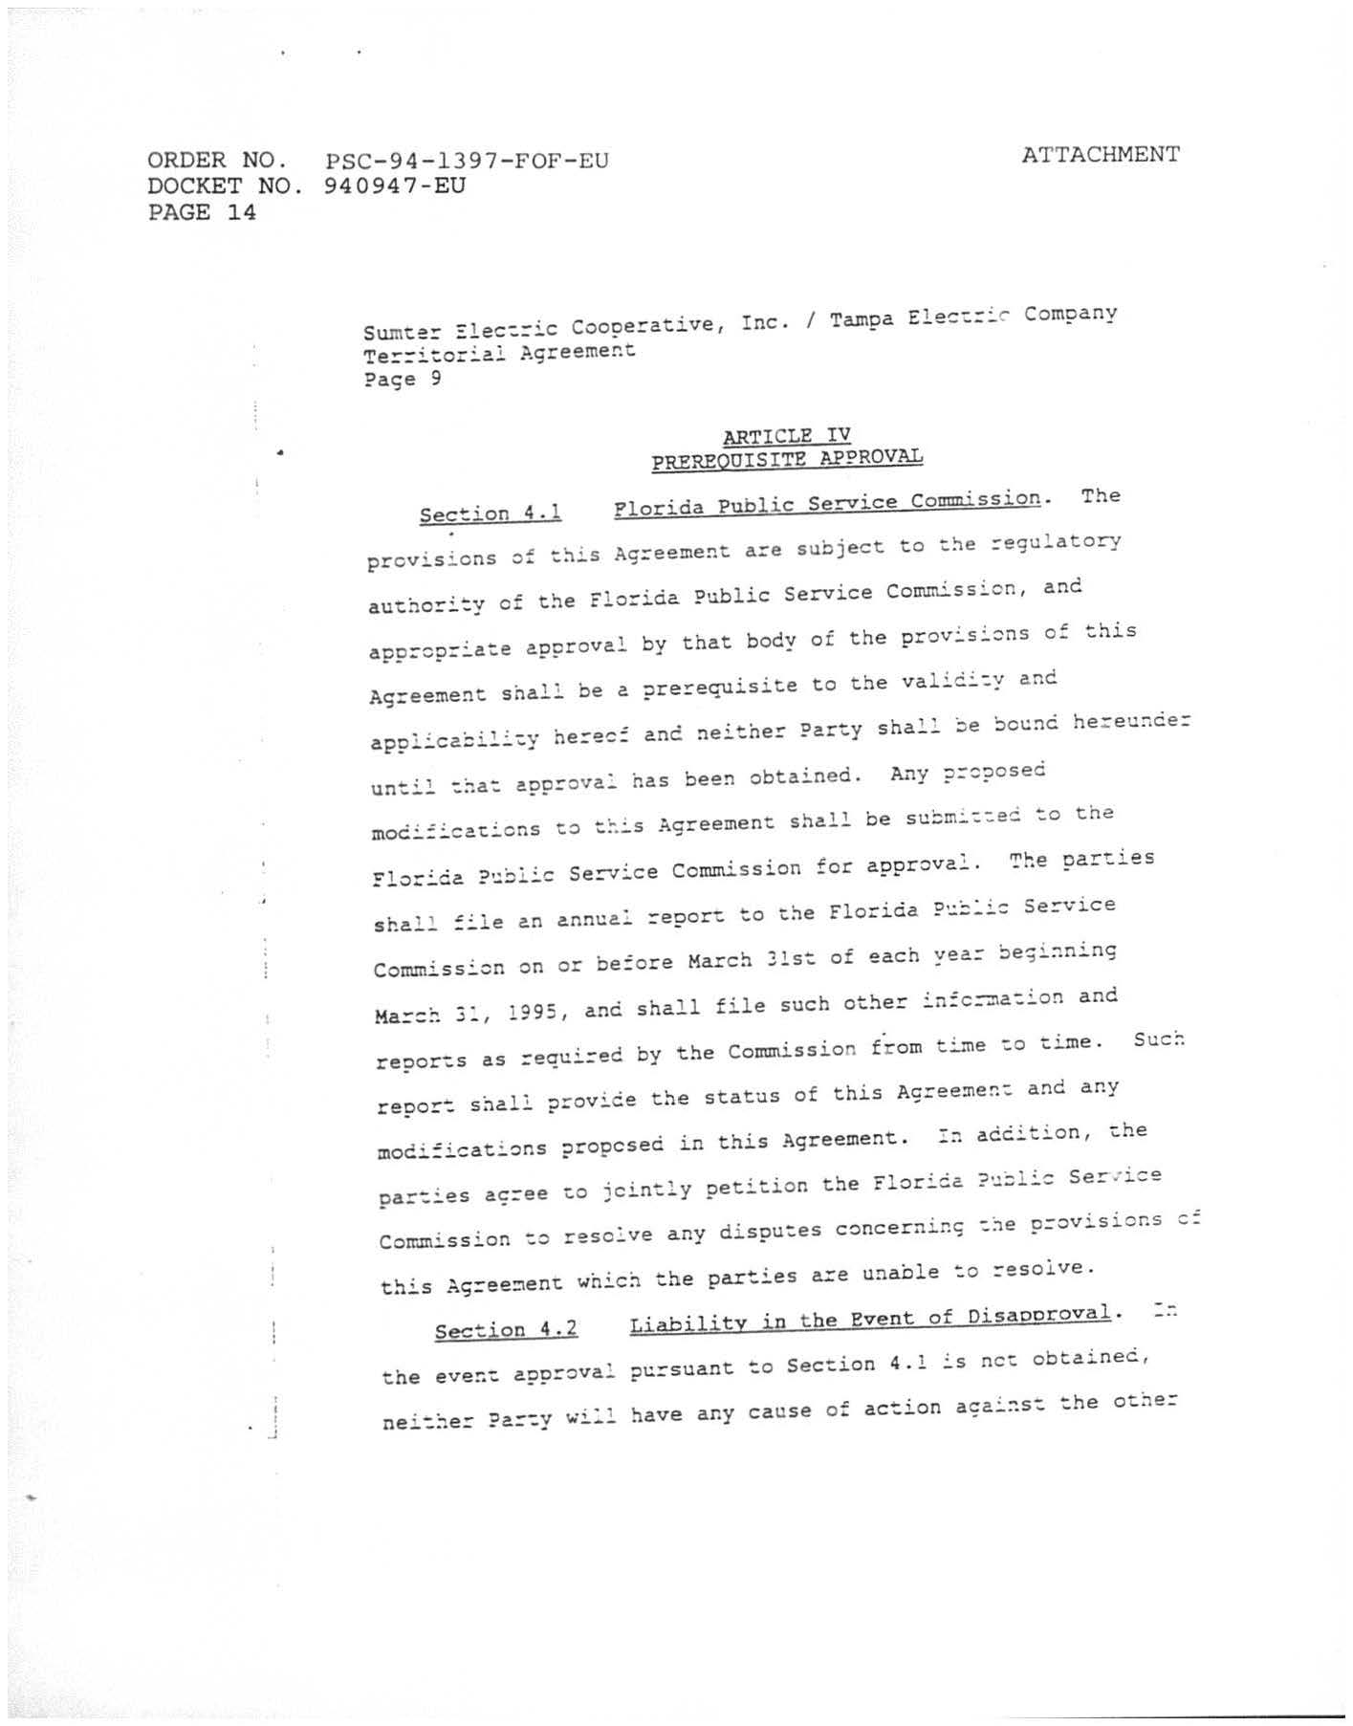

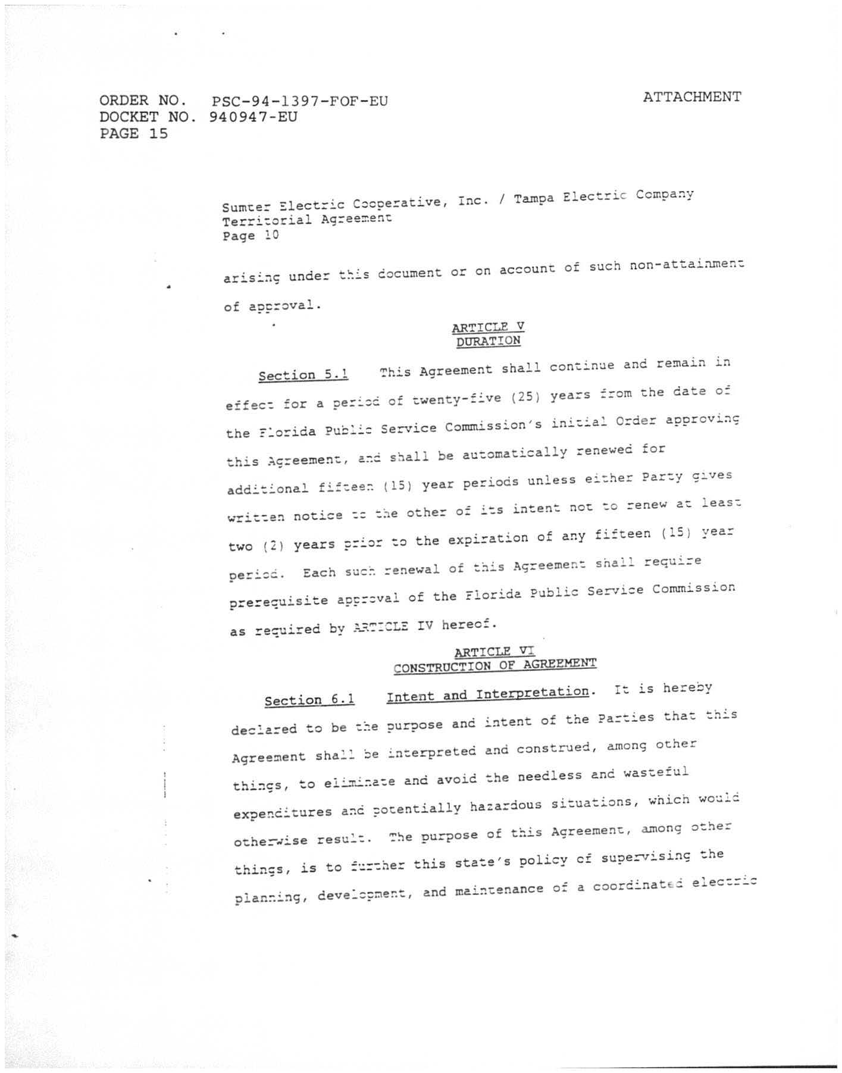

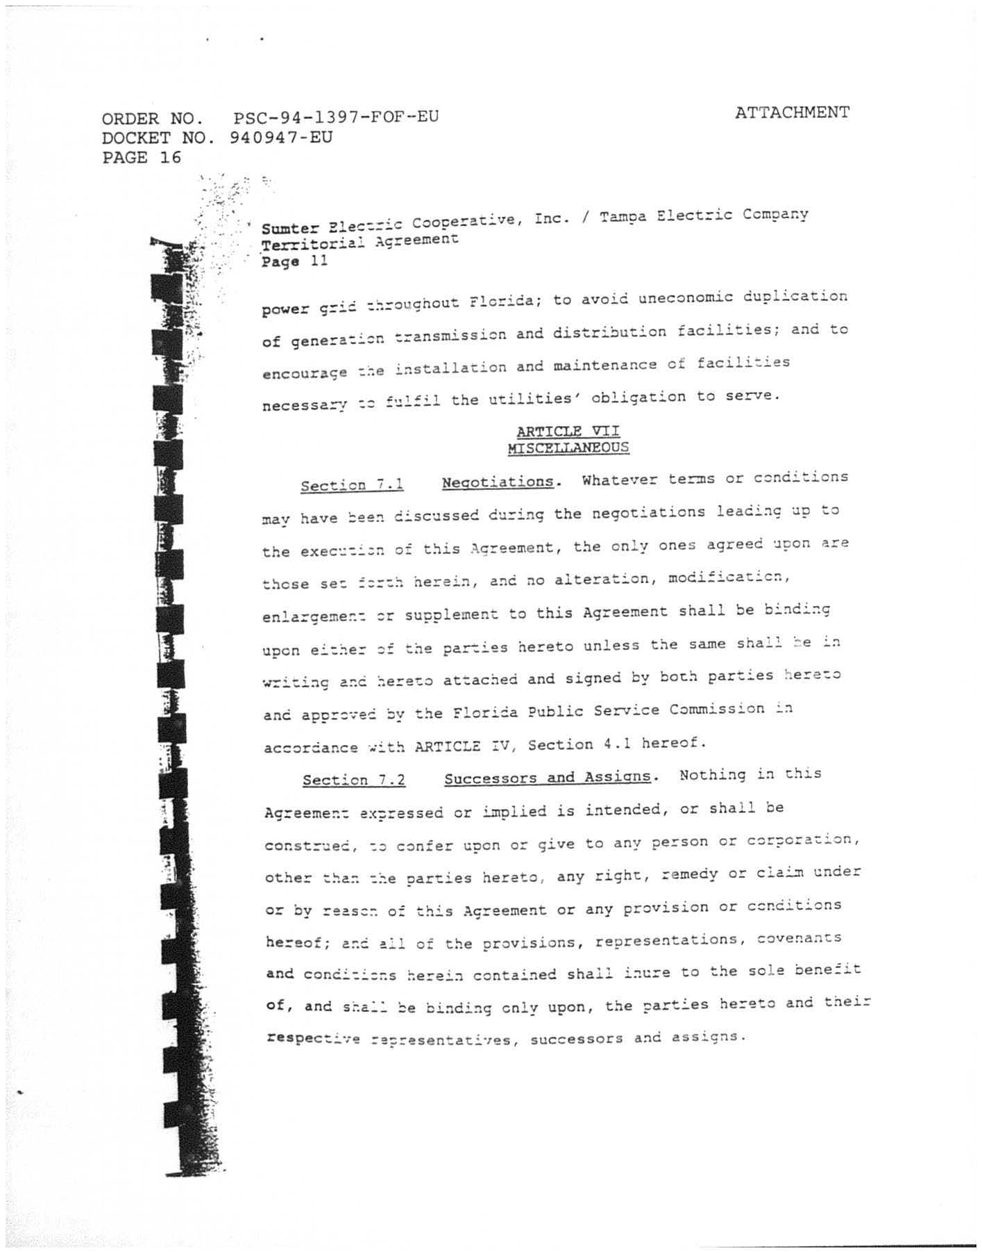

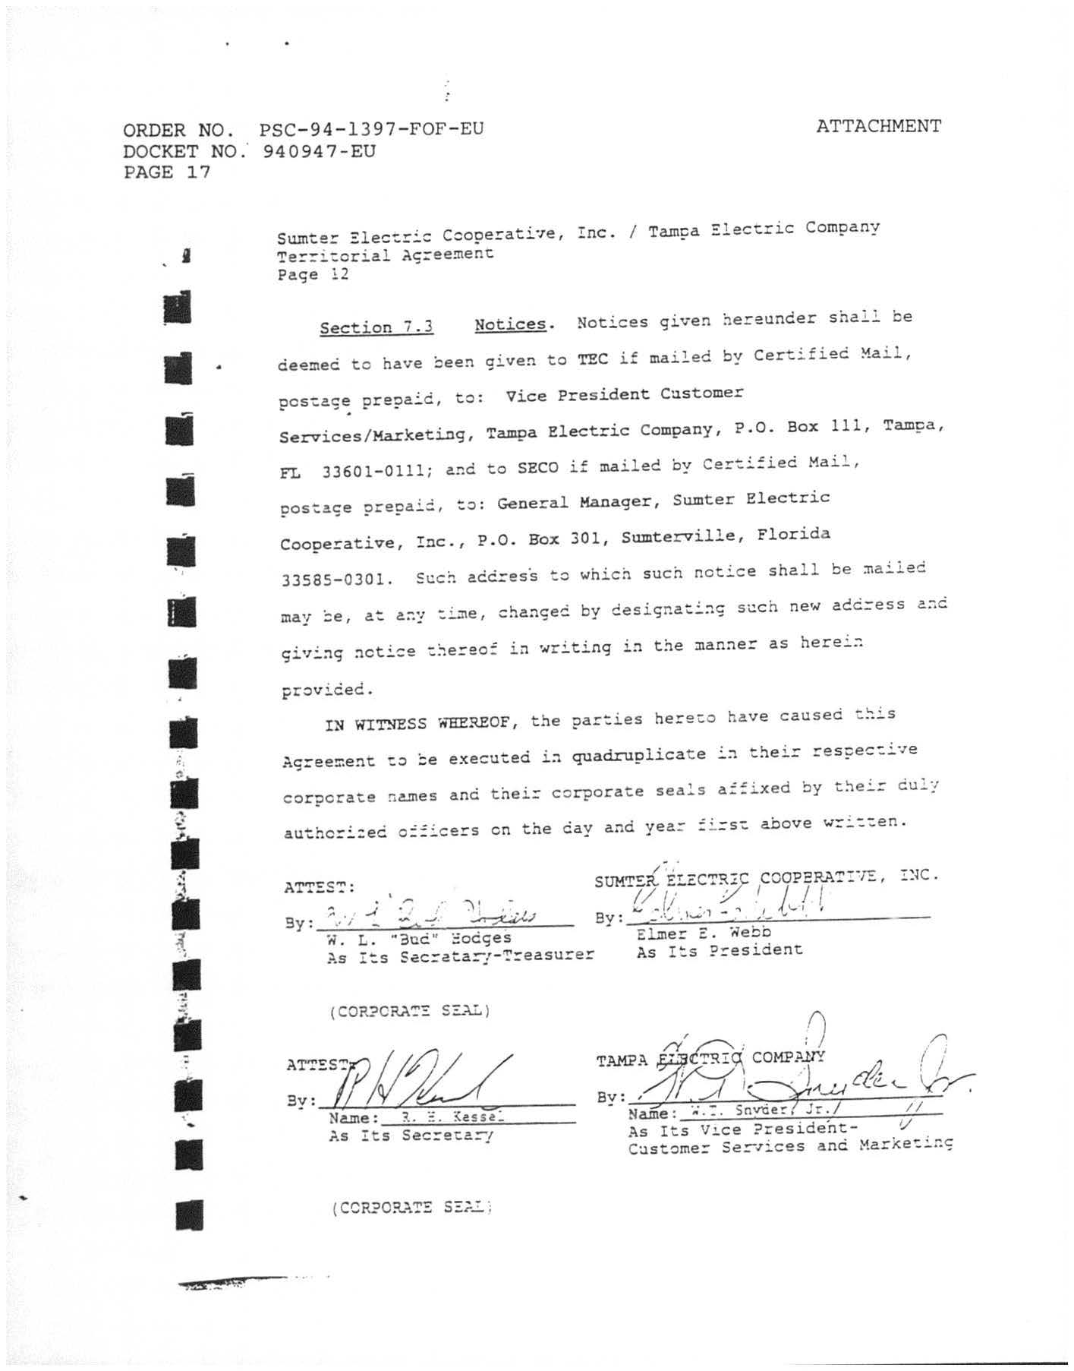

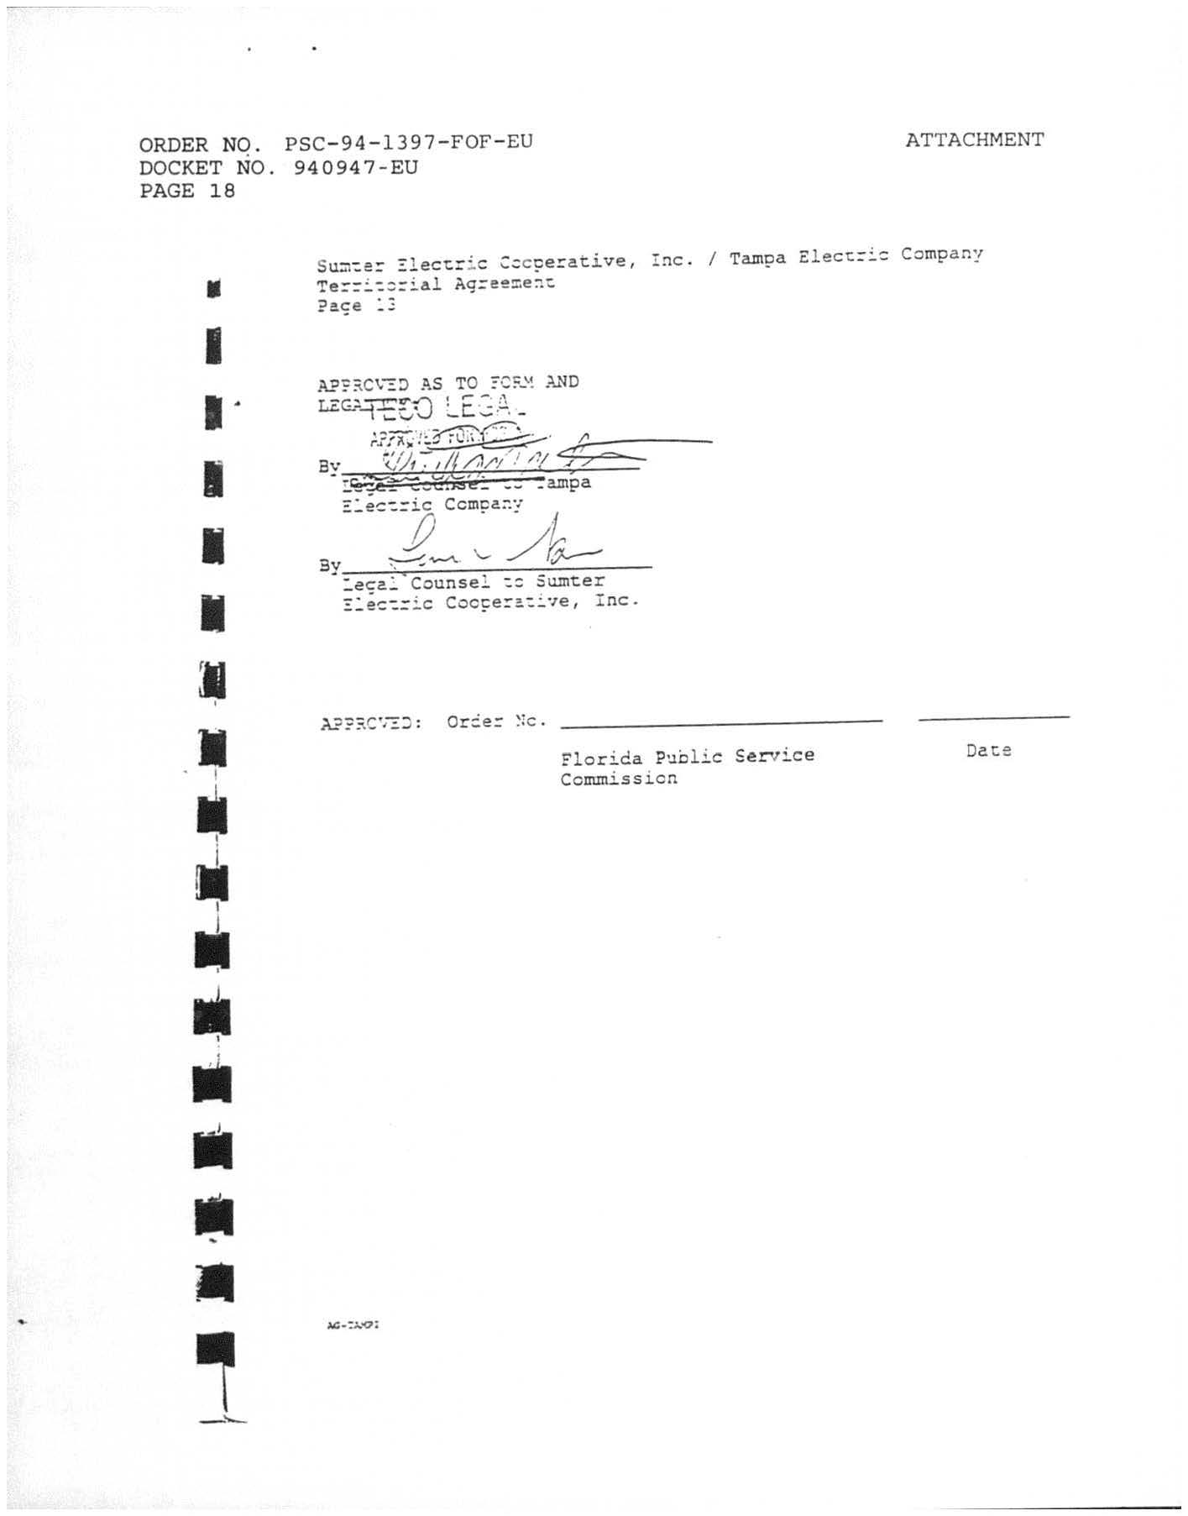

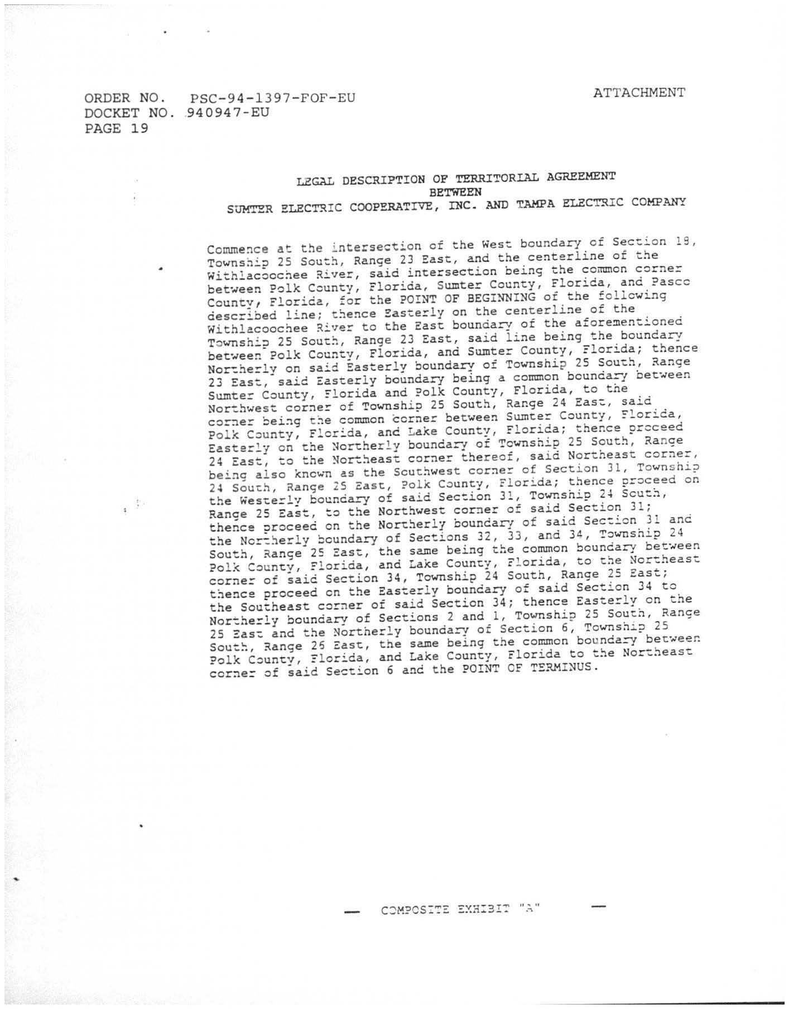

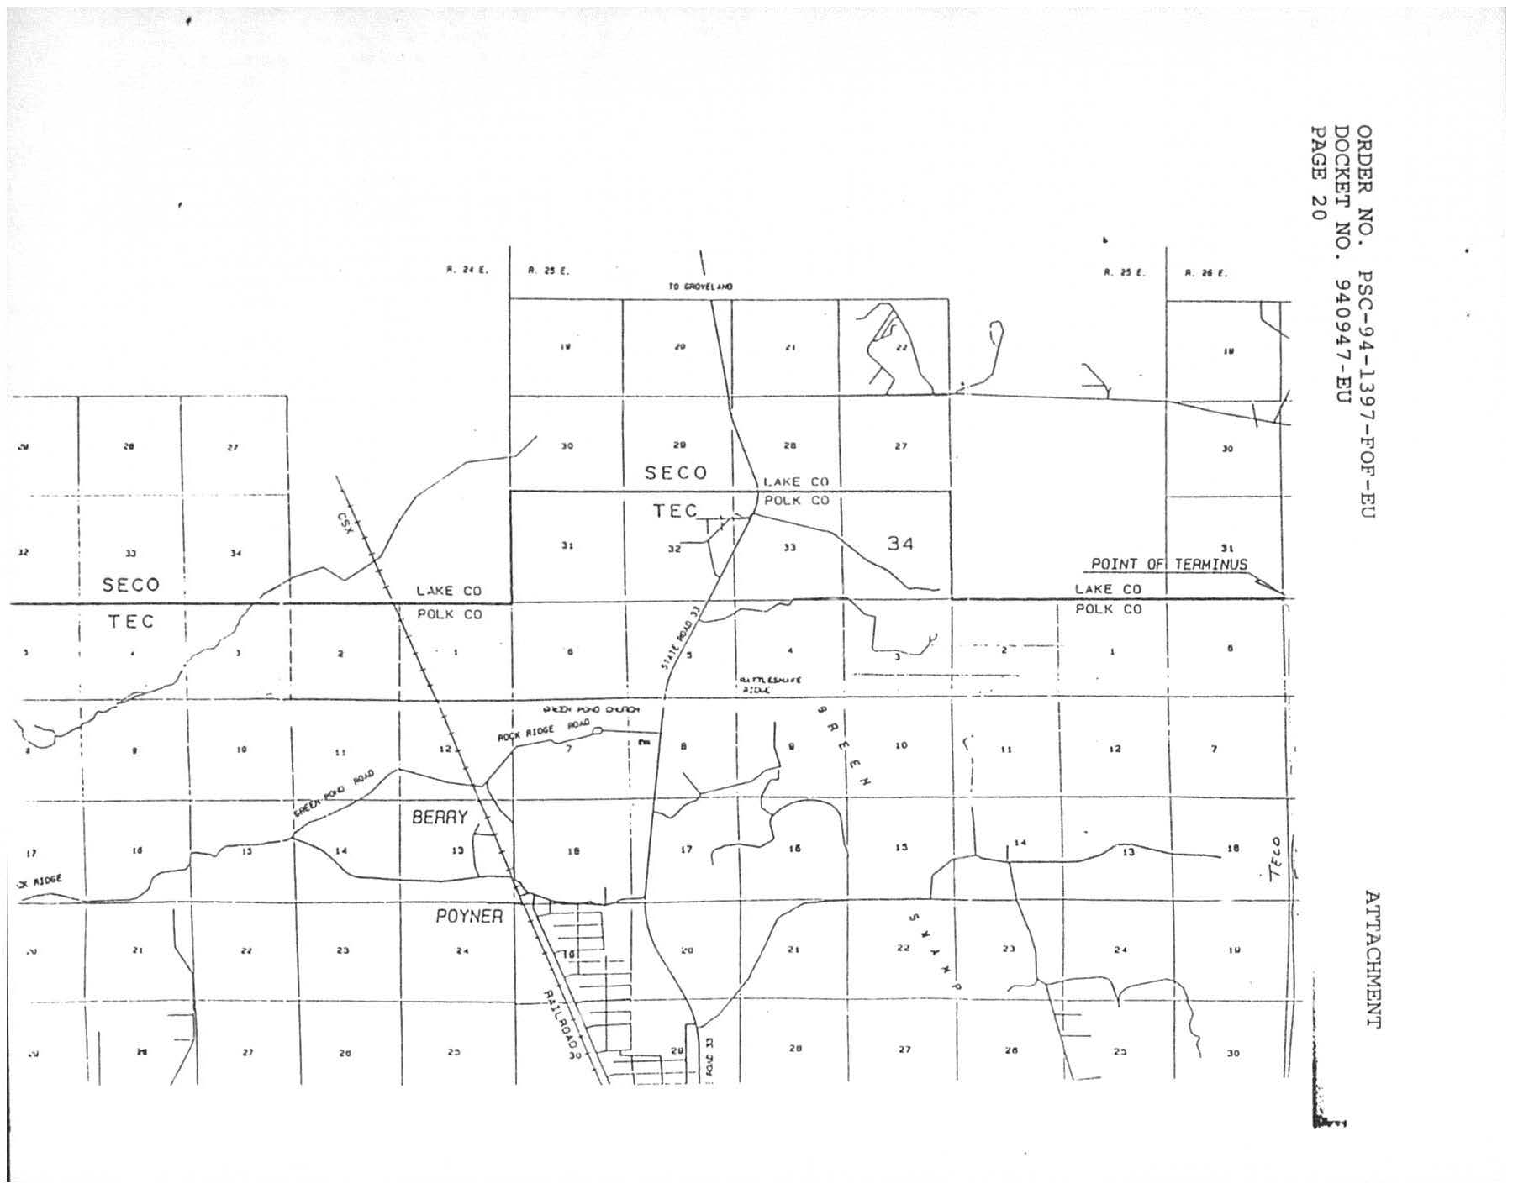

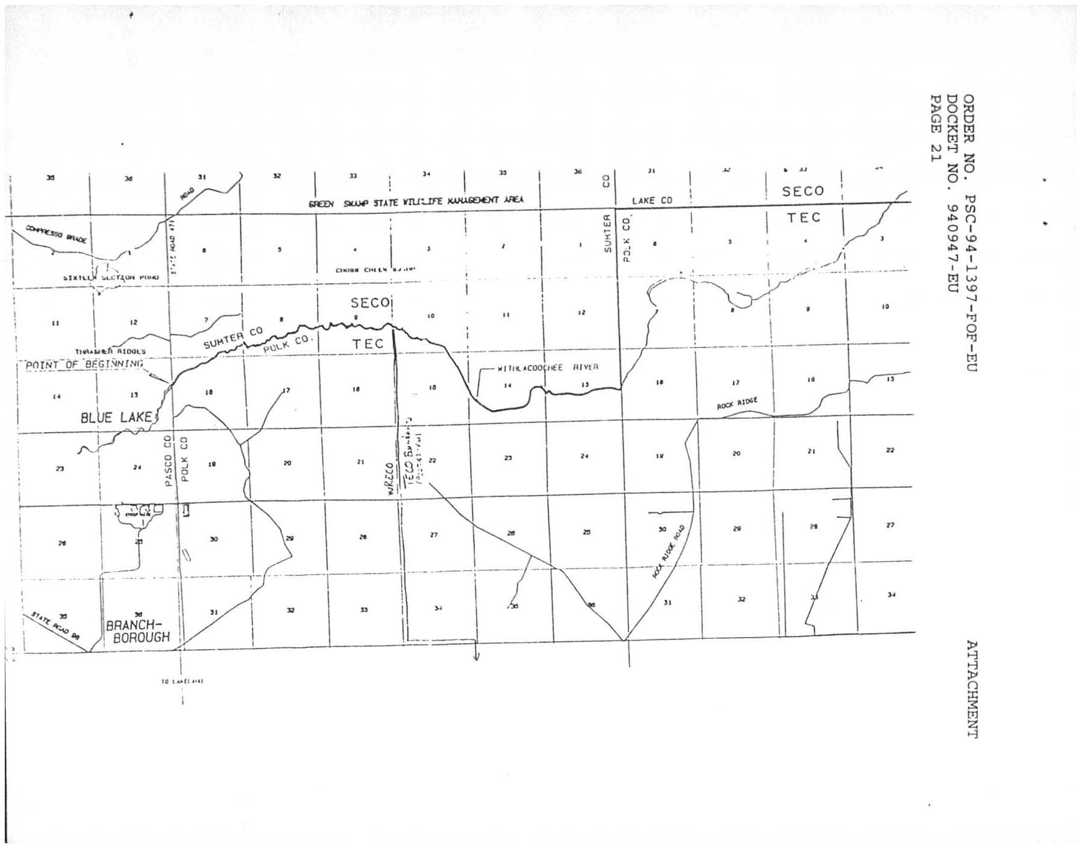

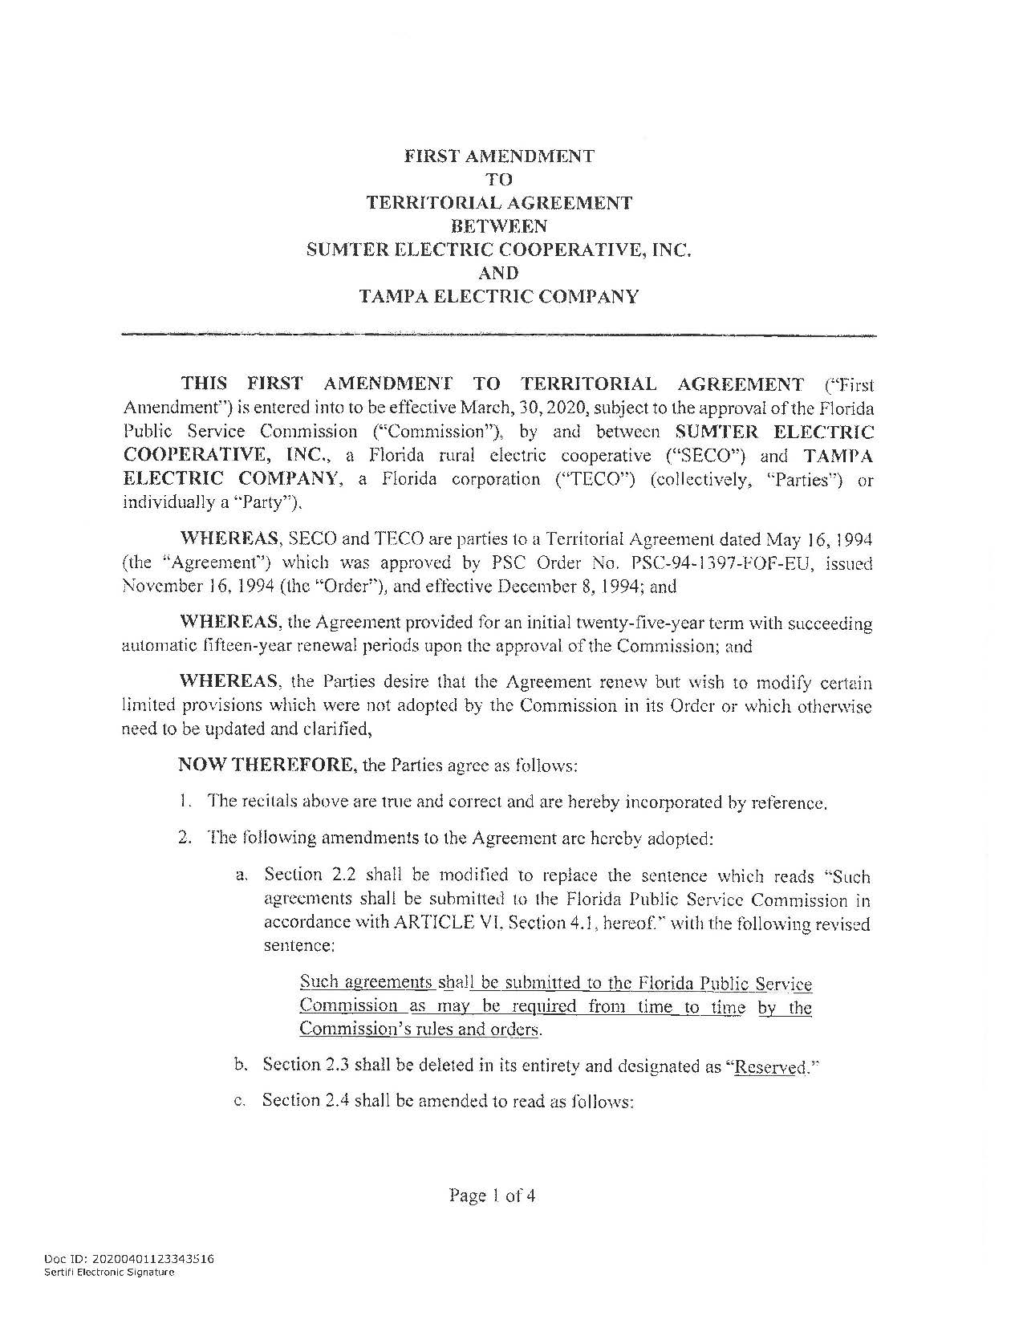

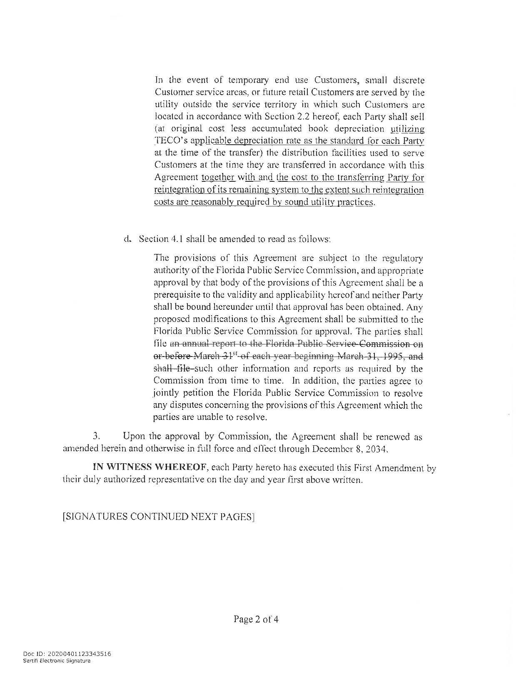

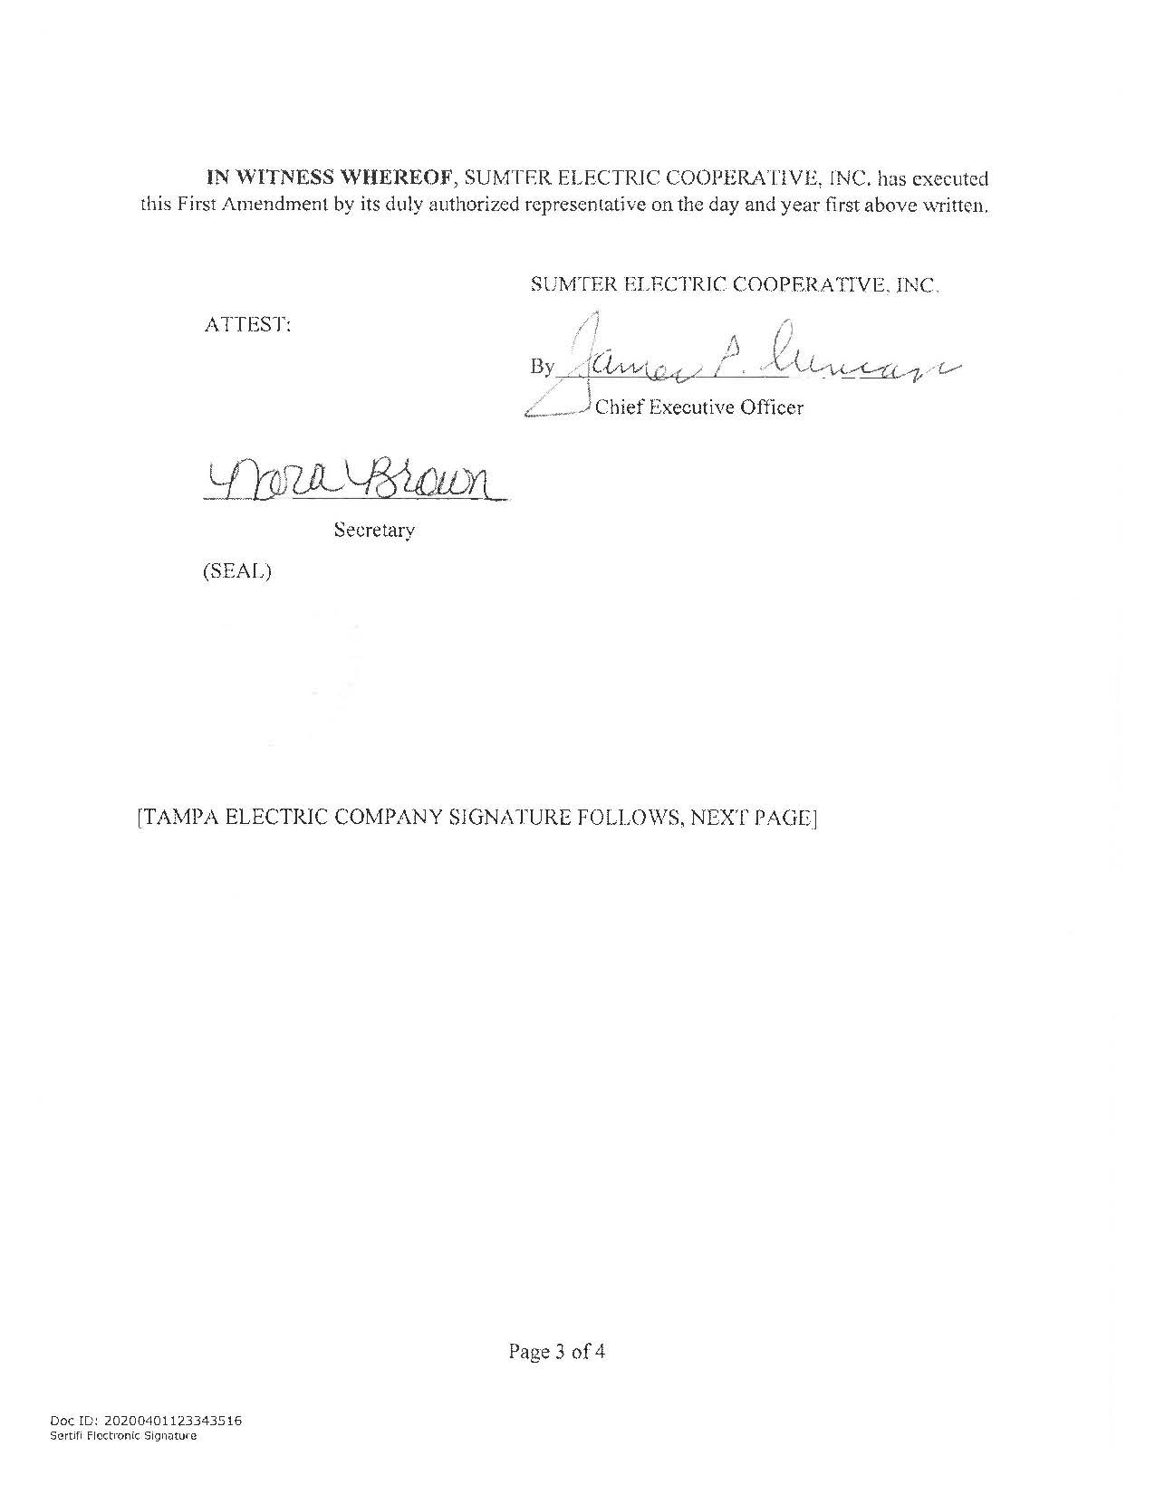

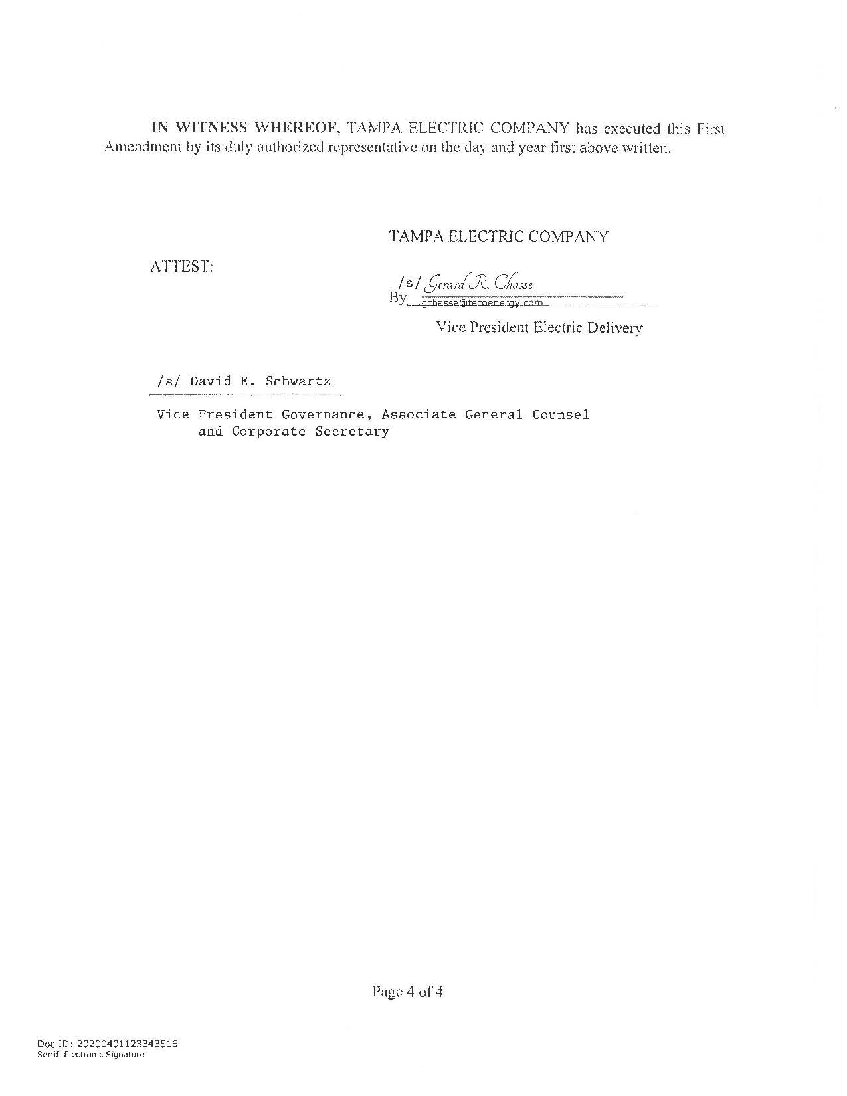

Order No. PSC-1994-1397-FOF-EU, issued November 16, 1994, in Docket No. 19940947-EU, In re: Joint petition for approval of territorial agreement between Tampa Electric Company and Sumter Electric Cooperative, Inc.
Utilities Commission of the City of New Smyrna Beach v. Florida Public Service Commission, 469 So. 2d 731 (Fla. 1985).
Response No. 1 to staff’s first data request (Document No. 02374-2020).

