BEFORE THE FLORIDA PUBLIC SERVICE COMMISSION

In re: Application for original water and wastewater certificates and approval of initial rates, charges and standard service agreements in Lee County, by CPI Citrus Park Utility TRS, L.L.C. | DOCKET NO. 20190194-WS  ORDER NO. PSC-2020-0263-PAA-WS  ISSUED: July 27, 2020

The following Commissioners participated in the disposition of this matter:

GARY F. CLARK, Chairman
ART GRAHAM
JULIE I. BROWN
DONALD J. POLMANN
ANDREW GILES FAY

NOTICE OF PROPOSED AGENCY ACTION
ORDER ESTABLISHING INITIAL RATES AND CHARGES
AND
ORDER GRANTING ORIGINAL WATER AND WASTEWATER
CERTIFICATE NOS. 675-W AND 576-S

BY THE COMMISSION:

NOTICE is hereby given by the Florida Public Service Commission that the action discussed herein, except for granting original water and wastewater certificates, is preliminary in nature and will become final unless a person whose interests are substantially affected files a petition for a formal proceeding, pursuant to Rule 25-22.029, Florida Administrative Code (F.A.C.).

Background
CPI Citrus Park Utility TRS, L.L.C. (CPI Citrus or Utility) is located in Lee County, Florida. Based on its application, the Utility provides water and wastewater service to the Citrus Park Mobile Home and RV Park (Citrus Park), which serves approximately 1,531 residential mobile home customers with associated common area buildings. The Utility also provides water service via master meter to the Bell Villa Property Owners Association, Inc., which serves approximately 127 residential lots in the Bell Villa Subdivision. According to documents from the Florida Department of Environmental Protection (DEP) and the Florida Department of Health in Lee County (DOH), the water system was built in 1989 and the wastewater system was built in 1988.
On June 10, 2019, an affiliate of the Utility, CPI Citrus Park Owner, L.L.C., acquired Citrus Park from the original developer, Citrus Park-Trost International, Inc. (CP Trost), including the provision of water and wastewater treatment service. CP Trost had provided water and wastewater service to Citrus Park, pursuant to the landlord/tenant exemption provided for by Section 367.022(5), Florida Statutes (F.S.). For this reason, CP Trost believed it was exempt from our jurisdiction. Upon conversations with Utility after the sale, Commission staff determined CPI Citrus did not meet the exemption, as the Utility’s customers are not its tenants.
On October 23, 2019, CPI Citrus filed its application for original certificates and for approval of initial rates and charges. Commission staff found the application to be deficient and issued a deficiency letter on November 21, 2019. CPI filed a response to the deficiencies on January 14, 2020. However, upon review Commission staff found the application to still be deficient and issued a second deficiency letter dated February 10, 2020. The Utility cured the deficiencies on February 28, 2020.
Pursuant to Section 367.031, F.S., we must grant or deny an application for a certificate of authorization within 90 days after the official filing date of the completed application. The application was deemed complete on February 28, 2020, which is considered the official filing date. CPI Citrus waived the 90-day statutory deadline through July 7, 2020.
This order addresses the application for original water and wastewater certificates and the appropriate rates and charges for the Utility. We have jurisdiction pursuant to Sections 367.031 and 367.045, F.S.

Decision
Original Water and Wastewater Certificates
On October 23, 2019, CPI Citrus filed its application for original water and wastewater certificates in Lee County, Florida. Upon review, Commission staff determined the original filing was deficient and sent two deficiency letters on November 21, 2019, and February 10, 2020, as well as a data request to the Utility seeking additional information. CPI Citrus corrected the deficiencies on February 28, 2020, which is considered the official filing date for the application. The Utility’s application is in compliance with the governing statutes, Sections 367.031 and 367.045, F.S.

Notice
On February 28, 2020, CPI Citrus filed proof of compliance with the noticing provisions set forth in Rule 25-30.030, F.A.C. No entity filed an objection during the protest period and the time for filing objections has expired.
Land Ownership and Service Territory
CPI Citrus provided adequate service territory and system maps and a territory description as required by Rule 25-30.034, F.A.C. The legal description of the service territory is appended to this order as Attachment A. The application contains a copy of a 99-year water and wastewater site lease agreement that was executed on October 22, 2019, as evidence that the Utility has access to the land upon which the water and wastewater treatment facilities are located pursuant to Rule 25-30.033(1)(m), F.A.C.
Financial and Technical Ability
Rule 25-30.033(1)(h) and (i), F.A.C., requires a statement providing the financial and technical ability of the applicant to provide service, a detailed financial statement, and a list of all entities upon which the applicant is relying to provide funding along with those entities’ financial statements. As a new business entity, CPI Citrus is relying upon the financial backing of its parent, CPI Citrus Park Owner, L.L.C. The existing water and wastewater infrastructure has been previously owned and operated by CP Trost. The parent company acquired the Utility on June 10, 2019. We have traditionally allowed reliance on the parent company’s financial ability in similar situations. Our reasoning has been that a parent company has a vested interest in the financial stability of its subsidiary. In response to Commission staff’s first deficiency letter, the Utility provided CPI Citrus Park Owner, L.L.C.’s most recent financial statements. We believe that CPI Citrus Park Owner, L.L.C’s financial statements demonstrate adequate and stable funding reserves for the Utility. Therefore, we find that CPI Citrus has demonstrated that it will have access to adequate financial resources to operate the Utility
Regarding technical ability, the Utility stated in its application that it has contracted with Florida Utility Solutions Inc. (FUSI) to operate the water and wastewater systems. CPI Citrus further stated that FUSI has extensive experience in the operation of such systems, and currently operates over 10 water and/or wastewater utility plants and maintains over 100 private lift stations for municipal and private utilities in South Florida. The Utility also engaged the law firm of Holland & Knight LLP and the utility consulting firm of Milian, Swain & Associates, Inc. to provide legal and regulatory advice to the Utility. CPI Citrus has no compliance issues on file with the DEP or the DOH and is current with its monitoring requirements.
Conclusion
We find that it is in the public interest to grant CPI Citrus Certificate Nos. 675-W and 576-S to serve the territory described in Attachment A, effective the date of our vote, July 7, 2020. This order shall serve as CPI Citrus’s water and wastewater certificates and it shall be retained by the Utility.
Water and Wastewater Rates and Return on Equity
In its application, the Utility provided the necessary information pursuant to Rule 25-30.033(1)(p), F.A.C., to support its proposed rates and charges. In the instant case, the Utility’s water and wastewater facilities are currently in operation. Therefore, the requested rates and charges in the application are based on reported operating costs of the existing systems in addition to some pro forma expenses. This is consistent with our policy for setting initial rates and charges.

Rate Base

Consistent with our practice in applications for original certificates, rate base is identified only as a tool to aid in setting initial rates and is not intended to formally establish rate base. The Utility’s proposed water and wastewater rate base calculations, as well as our adjustments, are described below.

The Utility proposed plant in service balances of $1,455,206 for water and $1,831,948 for wastewater in its filing. We have reviewed the provided documentation and make no adjustments to plant in service. As such, we approve a projected plant in service of $1,455,206 for water and $1,831,948 for wastewater.
CPI Citrus proposed an accumulated depreciation balance of $697,546 for water and $985,859 for wastewater. The Utility’s projection is based on the accumulated depreciation of existing plant, as well as the use of a half-year convention for the requested pro forma projects which will be completed in 2020. It has been our practice to include a full year’s depreciation for the treatment of pro forma projects.
Additionally, CPI Citrus miscalculated accumulated depreciation for several accounts. We reviewed plant additions since 1978 and recalculated accumulated depreciation for several accounts using group depreciation pursuant to Rule 25-30.140(5), F.A.C. Our recalculations result in increases of $93,602 and $92,731 for water and wastewater, respectively. As such, we find it appropriate to approve an accumulated depreciation balance of $791,148 for water and $1,078,590 for wastewater.
In its filing, CPI Citrus proposed contributions in aid of construction (CIAC) balances of $154,600 for water and $329,110 for wastewater. We reviewed the provided documentation and make no adjustments to CIAC. As such, we find it appropriate to approve CIAC balances of $154,600 for water and $329,110 for wastewater.
CPI Citrus proposed an accumulated amortization of CIAC balance of $138,062 for water and $278,863 for wastewater. We reviewed the provided documentation and make no adjustments to accumulated amortization of CIAC. As such, we find it appropriate to approve accumulated amortization of CIAC balances of $138,062 for water and $278,863 for wastewater.
The Utility calculated a working capital allowance of $16,583 for water and $17,782 for wastewater based on one-eighth of the estimated operation and maintenance (O&M) expense for each system. We find it appropriate to decrease $485 for water and $6,051 for wastewater, to reflect our adjustments to O&M expense discussed below. Our approved adjustments result in a working capital allowance of $16,098 for water and $11,731 for wastewater.
CPI Citrus proposed a rate base of $757,705 for water and $813,624 for wastewater. Based on the adjustments discussed above, rate base shall be decreased by $94,086 for water and decreased by $98,782 for wastewater. As such, we approve an adjusted rate base of $663,619 for water and $714,842 for wastewater. Rate base calculations for the water and wastewater systems are shown on Schedule Nos. 1-A and 1-B, respectively, which are appended to this order. Our adjustments are shown on Schedule No. 1-C.

Cost of Capital

The Utility’s application contained a schedule of the Utility’s capital structure. CPI Citrus projected common equity of $1,571,329. We find it appropriate to make a specific adjustment to increase common equity by $47,599 to match the Utility’s balance sheet amount for common equity. In order to reconcile proposed total capital to the approved rate base, we find it appropriate to make a pro rata adjustment to decrease common equity by $240,467.

CPI Citrus proposed a return on equity (ROE) of 7.85 percent, based on the current leverage formula. This is the appropriate ROE based on the current leverage formula. As such, we approve an overall cost of capital of 7.85 percent. The appropriate ROE for CPI Citrus is 7.85 percent, with a range of plus or minus 100 basis points, as shown on Schedule No. 2, which is appended to this order.

Net Operating Income

CPI Citrus calculated net operating income (NOI) of $59,508 for water and $63,899 for wastewater. Based on our adjustments below, we calculate an NOI of $52,094 for water and an NOI of $56,115 for wastewater. The calculated NOI for the water and wastewater systems are shown on Schedule Nos. 3-A and 3-B, respectively, which are appended to this order.

Operation and Maintenance Expense

The Utility proposed total O&M expenses of $132,666 for water and $142,256 for wastewater. We find that adjustments are necessary, as addressed below.

Salaries and Wages Expense – Employees

CPI Citrus projected salaries and wages – employees expense of $2,470 for water and $4,940 for wastewater. In response to the Office of Public Counsel’s (OPC) first request for production of documents (PODs), the Utility provided documentation indicating that this expense was related to landscaping at the water and wastewater plants. There was an additional amount included in contractual services expense – other related to landscaping. The Utility later indicated that all expenses related to landscaping should be included in contractual services expense – other. As such, we are decreasing salaries and wages expense – employees by $2,470 for water and $4,940 for wastewater to reclassify to contractual services expense – other expense.

Contractual Services Expense – Management Fees

The Utility proposed contractual services expense – management fees of $8,587 for the water system and $9,012 for the wastewater system. In response to OPC’s first PODs, CPI Citrus indicated that management fees should be 3.25 percent of gross charges collected. However, the Utility’s proposed expense did not match up to 3.25 percent of the requested revenues. As such, we find it appropriate to approve an increase of $114 for water and a decrease of $449 for contractual service expense – management fees.

Contractual Services Expense – Other

As discussed above, we find it appropriate to reclassify expense from salaries and wages expense – employees to contractual services expense – other. As such, we are increasing contractual services expense – other by $2,740 for water and $4,940 for wastewater.

Rent

CPI Citrus proposed rent expense $4,662 for water and $55,993 for wastewater. In response to OPC’s first PODs, the Utility indicated that rent expense was allocated based on the acreage for each plant, 0.9 acres for water and 10.81 acres for wastewater. CPI Citrus valued the land at $64,747 per acre, based on the average cost of four parcels of land recently sold in a neighboring residential community. The Utility divided that amount over 25 years and then doubled it to calculate rent expense. The Utility’s lease is with a related party. There is a 10.53-acre parcel of land adjacent to the Utility which is also owned by the same related party. The property tax appraiser valued this adjacent lot at $89,505, which is $8,500 per acre ($89,505 / 10.53). Without further documentation of the original cost of the land when it was first devoted to public use, we find it is more appropriate to value the land similar to the parcel adjacent to the Utility. Thus, the land for the water plant is valued at $7,650 ($8,500 x 0.9) and the land for the wastewater plant is valued at $91,885 ($8,500 x 10.81). In a prior case, we determined rent expense for land as the rate of return times the value of the land. Using the approved rate of return of 7.85 percent and the value of the land, rent expense for the land is $601 ($7,650 x 0.0785) for water and $7,213 ($91,885 x 0.0785) for wastewater. As such, we find it appropriate to decrease rent expense by $3,993 for water and $47,962 for wastewater.

O&M Expense Summary

Based on the above adjustments, projected O&M expense shall be decreased by $3,879 for water and $48,411 for wastewater, resulting in total O&M expense of $128,878 for water and $93,845 for wastewater.

Depreciation and CIAC Amortization Expense

CPI Citrus reflected depreciation expense, net of CIAC amortization, of $35,895 for water and $45,046 for wastewater. Based on our adjustments to rate base, corresponding adjustments shall be made to increase net depreciation by $12,520 for water and $28,712 for wastewater. These adjustments result in net depreciation expense of $48,415 for water and $73,758 for wastewater.

Taxes Other Than Income

In its filing, CPI Citrus included taxes other than income (TOTI) expense of $24,404 and $25,878 for water and wastewater, respectively. These total amounts included property tax expense of $11,134 and $12,433 for water and wastewater, respectively. The Utility’s calculation of proposed property tax expense for each system was based on net plant that included the balance of Account Nos. 301 and 351 – Organization. As this account is considered intangible plant, we removed these balances from the calculations. Based on this adjustment, as well as corresponding adjustments to reflect our adjustments to rate base and the proper millage rate, we find it appropriate to decrease property tax expense by $2,745 for water and $2,761 for wastewater.
In addition, as discussed below, we are approving an adjustment to the Utility’s projected revenues. As a result, TOTI shall be decreased by $226 for water and $1,588 for wastewater to reflect regulatory assessment fees of 4.5 percent on the change in revenues. Therefore, we approve TOTI of $21,433 ($24,404 - $2,745 - $226) for water and $21,529 ($25,878 - $2,761 - $1,588) for wastewater.

Income Taxes

CPI Citrus proposed income taxes of $20,203 for water and $21,694 for wastewater. Based on our adjustments to NOI, we find it is appropriate to decrease income taxes by $3,278 for water and $3,463 for wastewater. Therefore, we approve income taxes of $16,925 for water and $18,231 for wastewater.

Revenue Requirement

The Utility proposed revenue requirements for water and wastewater of $272,676 and $298,773, respectively. We approve revenue requirements of $267,654 for water and $263,479 for wastewater be used to set initial rates for service. The Utility’s projected revenue requirements include O&M expense, depreciation and amortization expense, TOTI, income tax expense, as well as a return on rate base investment. The approved revenue requirements will allow the Utility the opportunity to recover its expenses and earn a 7.85 percent return on its rate base investment, as shown on Schedule Nos. 3-A and 3-B, respectively. Our adjustments are shown on Schedule No. 3-C, attached hereto.

Rates and Rate Structure

The Utility provides master-metered water and wastewater service to the Citrus Park Mobile Home and RV Park (mobile home park). The mobile home park in turn provides the water and wastewater services to its approximately 1,531 tenants as part of their rent. In addition, the Utility provides master-metered water service to the Bell Villa Subdivision, which in turn provides water service to the approximately 127 residential lots within the subdivisions.

The Utility’s proposed water rates consist of a base facility charge (BFC) and two-tier gallonage charge rate structure for residential customers. General Service customers are billed a BFC by meter size and a uniform gallonage charge. For wastewater residential and general service customers, the Utility’s proposed rate structure and rates consist of a BFC and uniform gallonage charge, with a 10,000-gallon cap for residential service. The Utility’s proposed rates are designed to generate approximately 17 percent of revenues from the BFC and 83 percent from the gallonage charge for both water and wastewater.

We find that the Utility’s rate structure, consisting of base facility and gallonage charges, is reasonable. However, the Utility’s proposed BFC allocations shall be increased to 40 percent for water and 50 percent for wastewater consistent with our practice. Furthermore, we will not approve a residential tiered rate structure for water or a residential wastewater cap in this instant proceeding because the necessary consumption data in order to determine the tiered rates or an appropriate cap is not readily available. We will determine the appropriateness of a tiered rate structure for water and a residential wastewater cap in a subsequent rate proceeding in which a detailed billing analysis is audited and can be analyzed. We note that while the Utility currently has no residential customers, the BFCs will be included in the tariff for potential future customers.

Further, the Utility proposed to bill the mobile home park based on a three-inch master-meter, which is 62.5 equivalent residential connections (ERCs). There are approximately 1,531 mobile homes behind the master-meter. We find that billing by the meter size does not equally distribute the cost recovery among the customers. Rule 25-30.055(1)(a), F.A.C., states that unless we determine that valid local statistical data shall be used, ERCs for residential use for mobile homes shall be .8 ERCs per unit. As a result, the mobile home park shall be billed based on 1,224.8 ERCs (1,531 x .8 ERC). Increasing the number of ERCs used in designing the BFC mitigates the increase in the BFC allocation and results in the BFC approved herein being lower than the Utility requested. In addition, increasing the ERCs redistributes the cost recovery and avoids subsidization among the master-metered customers.

Conclusion

The approved monthly water and wastewater rates, on Schedule Nos. 4-A and 4-B attached hereto, are reasonable and are therefore approved. The Utility shall file revised tariff sheets and a proposed customer notice to reflect the Commission-approved rates. The approved rates shall be effective for service rendered on or after the stamped approval date on the tariff sheets pursuant to Rule 25-30.475(1), F.A.C. The approved rates shall not be implemented until Commission staff has approved the proposed customer notice and the notice has been received by customers. The Utility shall provide proof of the date notice was given within 10 days of the date of the notice. A return on equity of 7.85 percent, with a range of plus or minus 100 basis points, shall also be approved.
Miscellaneous Service Charges
Section 367.091, F.S., authorizes us to establish miscellaneous service charges. CPI’s request was accompanied by its reason for requesting the charges as well as the cost justification required by Section 367.091(6), F.S. The Utility requested initial connection, normal reconnection, violation reconnection, and premise visit charges of $30 during normal business hours. Additionally, the Utility requested that its violation reconnection charge for its wastewater system be actual cost pursuant to Rule 25-30.460(1)(c), F.A.C.
The purpose of these charges is to place the burden for requesting or causing these services on the cost causer rather than the general body of ratepayers. The Utility requested the recovery of $26.60 of field and supervisorial labor associated with processing miscellaneous services based on an hourly salary of $20 and the time it takes to perform all job functions, which is estimated to be 1.33 hours. Additionally, the Utility requested recovery of vehicle mileage of $3.48 based on a mileage rate of $0.58 per mile for 6 miles. The Utility’s cost justification for its requested miscellaneous service charges is shown in Table 1.

Table 1
Miscellaneous Service Charges Cost Justification
Labor ($20 x 1.33) | $26.60
Vehicle ($0.58 x 6) | $3.48
Total | $30.08
Source: Utility’s Cost Justification

We find the Utility’s requested charges are reasonable and shall be approved. A summary of the Utility’s approved miscellaneous service charges is shown in Table 2.

Table 2
Miscellaneous Service Charges
Initial Connection Charge | $30.00
Normal Reconnection Charge | $30.00
Violation Reconnection Charge (water) | $30.00
Violation Reconnection Charge (wastewater) | Actual Cost
Premise Visit Charge | $30.00
Source: Utility’s Cost Justification

Conclusion

Based on the above, the Utility’s requested miscellaneous service charges of $30, and wastewater violation reconnection charge of actual cost, are approved. The Utility shall file revised tariff sheets and a proposed customer notice to reflect the Commission-approved charges. The approved charges shall be effective for services rendered on or after the stamped approval date on the tariff sheet provided customers have received notice pursuant to Rule 25-30.475(1), F.A.C. The Utility shall provide proof of noticing within 10 days of rendering the approved notice.

Late Payment Charge
CPI Citrus requested a late payment charge of $7.50 to recover the cost of supplies and labor associated with processing late payment notices. CPI’s request for a late payment charge was accompanied by its reason for requesting the charge as well as the cost justification, as required by Section 367.091, F.S. The goal of allowing late payment charges is twofold: first, it encourages customers to pay their bills on time; and second, if payments are not made on time, it ensures that the costs associated with collecting late payments are not passed on to the customers who do pay on time.

Within its cost justification, the Utility included $5.00 for clerical labor associated with processing each late payment based on the clerical employee who is paid $20 per hour and the amount of time it takes the employee to process a single late payment charge of 15 minutes. This is consistent with Commission practice, in which the Commission has found that 10 to 15 minutes is an appropriate amount of time for a billing employee to process a single late payment. Furthermore, the Utility requested to recover supervisory labor of $2.00 based on the supervisor’s hourly salary of $25 per hour and the time it takes the supervisor to review a late payment charge of five minutes. The Utility is also requesting recovery of $0.10 for supplies and $0.50 for postage. While the Utility’s cost justification totals to $7.60, the Utility rounded down its requested late payment charge to $7.50.

We have previously approved late payment charges ranging from $4.90 to $7.15. However, in this case, we find that the supervisory labor would be an unnecessary duplication of the clerical work performed. The Utility’s cost justification for its requested late payment charge, and the late payment charge approved herein, is shown on Table 3.

Table 3

Proposed and Approved Late Payment Charge
Activity | Utility Requested | Comm. Approved
Clerical Labor | $5.00 | $5.00
Supervisor Labor | 2.00 | N/A
Supplies | 0.60 | 0.60
Total Cost (Rounded down) | $7.50 | $5.50
Source: Utility’s cost justification documentation

Conclusion

The appropriate late payment charge for CPI Citrus is $5.50. The Utility shall file the revised tariff sheet and a proposed customer notice to reflect the Commission-approved charge. The approved charge shall be effective for services rendered on or after the stamped approval date on the tariff sheet provided customers have received notice pursuant to Rule 25-30.475(1), F.A.C. The Utility shall provide proof of noticing within 10 days of rendering the approved notice.
Non-Sufficient Funds Charges
Section 367.091, F.S., authorizes us to approve NSF charges. We find that CPI Citrus shall be authorized to collect NSF charges consistent with Section 68.065, F.S., which allows for the assessment of charges for the collection of worthless checks, drafts, or orders of payment. As currently set forth in Section 68.065(2), F.S., the following NSF charges may be assessed:
(1) $25, if the face value does not exceed $50;
(2) $30, if the face value exceeds $50 but does not exceed $300;
(3) $40, if the face value exceeds $300; or
(4) 5 percent of the face amount of the payment instrument, whichever is greater.

Approval of NSF charges is consistent with our prior decisions. Furthermore, NSF charges place the cost on the cost-causer, rather than requiring that the costs associated with the return of the NSF checks be spread across the general body of ratepayers. As such, CPI Citrus shall be authorized to collect NSF charges. The Utility shall file revised tariff sheets and a proposed customer notice to reflect the Commission-approved NSF charges. The approved charges shall be effective for service rendered on or after the stamped approval date on the tariff sheets provided customers have received notice pursuant to Rule 25-30.475, F.A.C. The Utility shall provide proof of noticing within 10 days of rendering its approved notice.

Based on the foregoing, it is

ORDERED by the Florida Public Service Commission that CPI Citrus Park Utility TRS, L.L.C. is hereby granted Certificate Nos. 675-W and 576-S to serve the territory described in Attachment A, which is appended to this order, effective July 7, 2020. This order shall serve as CPI Citrus’s water and wastewater certificates and it shall be retained by the Utility. It is further

ORDERED that the approved monthly water and wastewater rates shown on Schedule Nos. 4-A and 4-B, which are appended to this order, are reasonable and shall be approved. The Utility shall file revised tariff sheets and a proposed customer notice to reflect the approved rates. The approved rates shall be effective for service rendered on or after the stamped approval date on the tariff sheets pursuant to Rule 25-30.475(1), F.A.C. The approved rates shall not be implemented until Commission staff has approved the proposed customer notice and the notice has been received by customers. The Utility shall provide proof of the date notice was given within 10 days of the date of the notice. A return on equity of 7.85 percent, with a range of plus or minus 100 basis points, shall also be approved. It is further
ORDERED that the Utility’s requested miscellaneous service charges of $30 and wastewater violation reconnection charge of actual cost shall be approved. The Utility shall file revised tariff sheets and a proposed customer notice to reflect the approved charges. The approved charges shall be effective for services rendered on or after the stamped approval date on the tariff sheet provided customers have received notice pursuant to Rule 25-30.475(1), F.A.C. The Utility shall provide proof of noticing within 10 days of rendering the approved notice. It is further
ORDERED that the Utility shall be authorized to collect NSF charges. The Utility shall file revised tariff sheets and a proposed customer notice to reflect the approved NSF charges. The approved charges shall be effective for service rendered on or after the stamped approval date on the tariff sheets provided customers have received notice pursuant to Rule 25-30.475, F.A.C. The Utility shall provide proof of noticing within 10 days of rendering its approved notice. It is further
ORDERED that the appropriate late payment charge for CPI Citrus is $5.50. The Utility shall file revised tariff sheets and a proposed customer notice to reflect the approved charge. The approved charge shall be effective for services rendered on or after the stamped approval date on the tariff sheet provided customers have received notice pursuant to Rule 25-30.475(1), F.A.C. The Utility shall provide proof of noticing within 10 days of rendering the approved notice. It is further
ORDERED that the provisions of this Order, issued as proposed agency action, shall become final and effective upon the issuance of a Consummating Order unless an appropriate petition, in the form provided by Rule 28-106.201, Florida Administrative Code, is received by the Commission Clerk, 2540 Shumard Oak Boulevard, Tallahassee, Florida 32399-0850, by the close of business on the date set forth in the “Notice of Further Proceedings” attached hereto. It is further

ORDERED that the docket shall remain open for Commission staff’s verification that the revised tariff sheets and customer notice have been filed by the Utility and approved by staff. Once these actions are complete, this docket shall be closed administratively.

By ORDER of the Florida Public Service Commission this 27th day of July, 2020.

/s/ Adam J. Teitzman
ADAM J. TEITZMAN
Commission Clerk
Florida Public Service Commission
2540 Shumard Oak Boulevard
Tallahassee, Florida 32399
(850) 413-6770
www.floridapsc.com

Copies furnished: A copy of this document is provided to the parties of record at the time of issuance and, if applicable, interested persons.

BYL

NOTICE OF FURTHER PROCEEDINGS OR JUDICIAL REVIEW

The Florida Public Service Commission is required by Section 120.569(1), Florida Statutes, to notify parties of any administrative hearing or judicial review of Commission orders that is available under Sections 120.57 or 120.68, Florida Statutes, as well as the procedures and time limits that apply. This notice should not be construed to mean all requests for an administrative hearing or judicial review will be granted or result in the relief sought.

As identified in the body of this order, our action herein, except for granting original water and wastewater certificates, is preliminary in nature. Any person whose substantial interests are affected by the action proposed by this order may file a petition for a formal proceeding, in the form provided by Rule 28-106.201, Florida Administrative Code. This petition must be received by the Office of Commission Clerk, at 2540 Shumard Oak Boulevard, Tallahassee, Florida 32399-0850, by the close of business on August 17, 2020. If such a petition is filed, mediation may be available on a case-by-case basis. If mediation is conducted, it does not affect a substantially interested person's right to a hearing. In the absence of such a petition, this order shall become effective and final upon the issuance of a Consummating Order.

Any objection or protest filed in this docket before the issuance date of this order is considered abandoned unless it satisfies the foregoing conditions and is renewed within the specified protest period.

Any party adversely affected by the Commission's final action in this matter may request: (1) reconsideration of the decision by filing a motion for reconsideration with the Office of Commission Clerk, within fifteen (15) days of the issuance of this order in the form prescribed by Rule 25-22.060, Florida Administrative Code; or (2) judicial review by the Florida Supreme Court in the case of an electric, gas or telephone utility or the First District Court of Appeal in the case of a water or wastewater utility by filing a notice of appeal with the Office of Commission Clerk and filing a copy of the notice of appeal and the filing fee with the appropriate court. This filing must be completed within thirty (30) days after the issuance of this order, pursuant to Rule 9.110, Florida Rules of Appellate Procedure. The notice of appeal must be in the form specified in Rule 9.900(a), Florida Rules of Appellate Procedure.

CPI Citrus Park Utility TRS, L.L.C.

Water Service Territory Legal Description

Lee County

THE EAST 150 FEET OF THE WEST 1,120 FEET OF THE NORTH 260 FEET OF SECTION 19, TOWNSHIP 47 SOUTH, RANGE 26 EAST, LEE COUNTY, FLORIDA, AND BEING MORE PARTICULARLY DESCRIBED AS FOLLOWS:

COMMENCING AT NORTHWEST CORNER OF SAID SECTION 19 RUN N89°16'57"E ALONG THE NORTH LINE OF SAID SECTION 19 FOR A DISTANCE OF 970.01 FEET TO THE POINT OF BEGINNING; THENCE CONTINUE N89°16'57"E ALONG SAID NORTH LINE FOR A DISTANCE OF 150.00 FEET; THENCE LEAVING SAID NORTH LINE RUN S0l°00'52"E ALONG A LINE 1,120 FEET EAST OF AND PARALLEL TO THE WEST LINE OF SAID SECTION 19 FOR A DISTANCE OF 260.00 FEET; THENCE RUN S89°16'57"W ALONG A LINE 260 FEET SOUTH OF AND PARALLEL TO THE NORTH LINE OF SAID SECTION 19 FOR A DISTANCE OF 150.00 FEET; THENCE RUN N0l°00'52"W ALONG A LINE 970 FEET EAST OF AND PARALLEL TO THE WEST LINE OF SAID SECTION 19 FOR A DISTANCE OF 260.00 FEET TO THE POINT OF BEGINNING.

SAID LAND CONTAINING 39,000.52 SQUARE FEET OR 0.90 ACRES MORE OR LESS.

Wastewater Service Territory Legal Description

Lee County

THE WEST 440 FEET OF THE SOUTH 1,070 FEET OF THE NORTH 1,310 FEET OF SECTION 19, TOWNSHIP 47 SOUTH, RANGE 26 EAST, LEE COUNTY, FLORIDA, AND BEING MORE PARTICULARLY DESCRIBED AS FOLLOWS:

COMMENCING AT NORTHWEST CORNER OF SAID SECTION 19 RUN S0l°00'52"E ALONG THE WEST LINE OF SAID SECTION 19 FOR A DISTANCE OF 240.00 FEET TO THE POINT OF BEGINNING; THENCE LEAVING SAID WEST LINE RUN N89°16'57"E ALONG A LINE 240 FEET SOUTH OF AND PARALLEL TO THE NORTH LINE OF SAID SECTION 19 FOR A DISTANCE OF 440.01 FEET; THENCE RUN S0l°00'52"E ALONG A LINE 440 FEET EAST OF AND PARALLEL TO THE SAID WEST LINE FOR A DISTANCE OF 1,070.01 FEET; THENCE RUN S89°16'57"W ALONG A LINE 1,370 FEET SOUTH OF AND PARALLEL TO THE NORTH LINE OF SAID SECTION 19 FOR A DISTANCE OF 440.01 FEET; THENCE RUN N0l°00'52"W ALONG SAID WEST LINE FOR A DISTANCE OF 1,070.01 FEET TO THE POINT OF BEGINNING.

SAID LAND CONTAINING 470,806.33 SQUARE FEET OR 10.81 ACRES MORE OR LESS.

FLORIDA PUBLIC SERVICE COMMISSION

Authorizes

CPI Citrus Park Utility TRS, L.L.C.

pursuant to

Certificate Number 675–W

to provide water service in Lee County in accordance with the provisions of Chapter 367, Florida Statutes, and the Rule, regulations, and Orders of this Commission in the territory described by the Orders of this Commission. This authorization shall remain in force and effect until superseded, suspended, cancelled or revoked by Order of this Commission.

Order Number Date Issued Docket Number Filing Type

* * 20190194-WS Original Certificate

* Order Number and date to be provided at time of issuance.

FLORIDA PUBLIC SERVICE COMMISSION

Authorizes

CPI Citrus Park Utility TRS, L.L.C.

pursuant to

Certificate Number 576–S

to provide wastewater service in Lee County in accordance with the provisions of Chapter 367, Florida Statutes, and the Rule, regulations, and Orders of this Commission in the territory described by the Orders of this Commission. This authorization shall remain in force and effect until superseded, suspended, cancelled or revoked by Order of this Commission.

Order Number Date Issued Docket Number Filing Type

* * 20190194-WS Original Certificate

* Order Number and date to be provided at time of issuance.

CPI Citrus Park Utility TRS, L.L.C. |  |  | Schedule No. 1-A
Schedule of Water Rate Base |  |  | 20190194-WS
 |  | Test Year | Comm. | Comm.
 | Description | Per | Adjust- | Adjusted
 |  | Utility | ments | Test Year
1 | Plant in Service | $1,455,206 | $0 | $1,455,206
2 | Accumulated Depreciation | (697,546) | (93,602) | (791,148)
3 | CIAC | (154,600) | 0 | (154,600)
4 | Amortization of CIAC | 138,062 | 0 | 138,062
5 | Working Capital Allowance | 16,583 | (485) | 16,098
6 | Rate Base | $757,705 | ($94,086) | $663,619

CPI Citrus Park Utility TRS, L.L.C. |  |  | Schedule No. 1-B
Schedule of Wastewater Rate Base |  |  | 20190194-WS
 |  | Test Year | Comm. | Comm.
 | Description | Per | Adjust- | Adjusted
 |  | Utility | ments | Test Year
1 | Plant in Service | $1,831,948 | $0 | $1,831,948
2 | Accumulated Depreciation | (985,859) | (92,731) | (1,078,590)
3 | CIAC | (329,110) | 0 | (329,110)
4 | Amortization of CIAC | 278,863 | 0 | 278,863
5 | Working Capital Allowance | 17,782 | (6,051) | 11,731
6 | Rate Base | $813,624 | ($98,782) | $714,842

CPI Citrus Park Utility TRS, L.L.C. |  | Schedule No. 1-C
Adjustments to Rate Base |  | 20190194-WS
 | Explanation | Water | Wastewater
 | Accumulated Depreciation
 | To reflect appropriate accumulated depreciation. | ($93,602) | ($92,731)
 | Working Capital
 | To reflect 1/8 of O&M expense. | ($485) | ($6,051)

CPI Citrus Park Utility TRS, L.L.C. |  |  |  |  |  |  | Schedule No. 2
Capital Structure |  |  |  |  |  |  | 20190194-WS
 |  |  | Specific | Subtotal | Prorata | Capital
 | Description | Total | Adjust- | Adjusted | Adjust- | Reconciled |  | Cost | Weighted
 |  | Capital | ments | Capital | ments | to Rate Base | Ratio | Rate | Cost
Per Utility
1 | Long-term Debt | $0 | $0 | $0 | $0 | $0 | 0.00% | 0.00% | 0.00%
2 | Short-term Debt | 0 | 0 | 0 | 0 | 0 | 0.00% | 0.00% | 0.00%
3 | Preferred Stock | 0 | 0 | 0 | 0 | 0 | 0.00% | 0.00% | 0.00%
4 | Common Equity | 1,571,329 | 0 | 1,571,329 | 0 | 1,571,329 | 100.00% | 7.85% | 7.85%
5 | Customer Deposits | 0 | 0 | 0 | 0 | 0 | 0.00% | 0.00% | 0.00%
6 | Deferred Income Taxes | 0 | 0 | 0 | 0 | 0 | 0.00% | 0.00% | 0.00%
7 | Total Capital | $1,571,329 | $0 | $1,571,329 | $0 | $1,571,329 | 100.00% |  | 7.85%
Per Commission
8 | Long-term Debt | $0 | $0 | $0 | $0 | $0 | 0.00% | 0.00% | 0.00%
9 | Short-term Debt | 0 | 0 | 0 | 0 | 0 | 0.00% | 0.00% | 0.00%
10 | Preferred Stock | 0 | 0 | 0 | 0 | 0 | 0.00% | 0.00% | 0.00%
11 | Common Equity | 1,571,329 | 47,599 | 1,618,928 | (240,467) | 1,378,461 | 100.00% | 7.85% | 7.85%
12 | Customer Deposits | 0 | 0 | 0 | 0 | 0 | 0.00% | 0.00% | 0.00%
13 | Deferred Income Taxes | 0 | 0 | 0 | 0 | 0 | 0.00% | 0.00% | 0.00%
14 | Total Capital | $1,571,329 | $47,599 | $1,618,928 | ($240,467) | $1,378,461 | 100.00% |  | 7.85%
 |  |  |  |  |  |  | LOW | HIGH
 |  |  |  | RETURN ON EQUITY |  |  | 6.85% | 8.85%
 |  |  |  | OVERALL RATE OF RETURN |  |  | 6.85% | 8.85%

CPI Citrus Park Utility TRS, L.L.C. |  |  |  |  | Schedule No. 3-A
Statement of Water Operations |  |  |  |  | 20190194-WS
 |  | Test Year | Comm. | Comm.
 | Description | Per | Adjust- | Adjusted | Revenue | Revenue
 |  | Utility | ments | Test Year | Increase | Requirement
1 | Operating Revenues: | $272,676 | $0 | $272,676 | ($5,022) | $267,654
 |  |  |  |  | (1.84%)
 | Operating Expenses
2 | Operation & Maintenance | $132,666 | ($3,879) | $128,787 |  | $128,787
3 | Depreciation | 35,895 | 12,520 | 48,415 |  | 48,415
4 | Amortization | 0 | 0 | 0 |  | 0
5 | Taxes Other Than Income | 24,404 | (2,745) | 21,659 | (226) | 21,433
6 | Income Taxes | 20,203 | (2,102) | 18,101 | (1,176) | 16,925
7 | Total Operating Expense | 213,168 | 3,794 | 216,962 | (1,402) | 215,560
8 | Operating Income | $59,508 | ($3,794) | $55,714 | ($3,620) | $52,094
9 | Rate Base | $757,705 |  | $663,619 |  | $663,619
10 | Rate of Return | 7.85% |  | 8.40% |  | 7.85%

CPI Citrus Park Utility TRS, L.L.C. |  |  |  |  | Schedule No. 3-B
Statement of Wastewater Operations |  |  |  |  | 20190194-WS
 |  | Test Year | Comm. | Comm.
 | Description | Per | Adjust- | Adjusted | Revenue | Revenue
 |  | Utility | ments | Test Year | Increase | Requirement
1 | Operating Revenues: | $298,773 | $0 | $298,773 | ($35,294) | $263,479
 |  |  |  |  | (11.81%)
 | Operating Expenses
2 | Operation & Maintenance | $142,256 | ($48,411) | $93,845 |  | $93,845
3 | Depreciation | 45,046 | 28,712 | 73,758 |  | 73,758
4 | Amortization | 0 | 0 | 0 |  | 0
5 | Taxes Other Than Income | 25,878 | (2,761) | 23,117 | (1,588) | 21,529
6 | Income Taxes | 21,694 | 4,802 | 26,496 | (8,265) | 18,231
7 | Total Operating Expense | 234,874 | (17,656) | 217,218 | (9,854) | 207,364
8 | Operating Income | $63,899 | $17,656 | $81,555 | ($25,440) | $56,115
9 | Rate Base | $813,624 |  | $714,842 |  | $714,842
10 | Rate of Return | 7.85% |  | 11.41% |  | 7.85%

CPI Citrus Park Utility TRS, L.L.C. |  | Schedule 3-C
Adjustments to Operating Income |  | 20190194-WS
 | Explanation | Water | Wastewater
 | Operation and Maintenance Expense
1 | To remove salaries expense to reclassify. | $(2,470) | ($4,940)
2 | To use 3.25 percent of revenue for contractual services - management. | 114 | (449)
3 | To reclassify salaries expense as contractual services - other. | 2,470 | 4,940
4 | To reflect appropriate rent expense. | (3,993) | (47,962)
 | Total | ($3,879) | ($48,411)
 | Depreciation Expense - Net
 | To reflect appropriate depreciation expense. | $12,520 | $28,712
 | Taxes Other Than Income
 | To reflect appropriate TOTI. | ($2,745) | ($2,761)

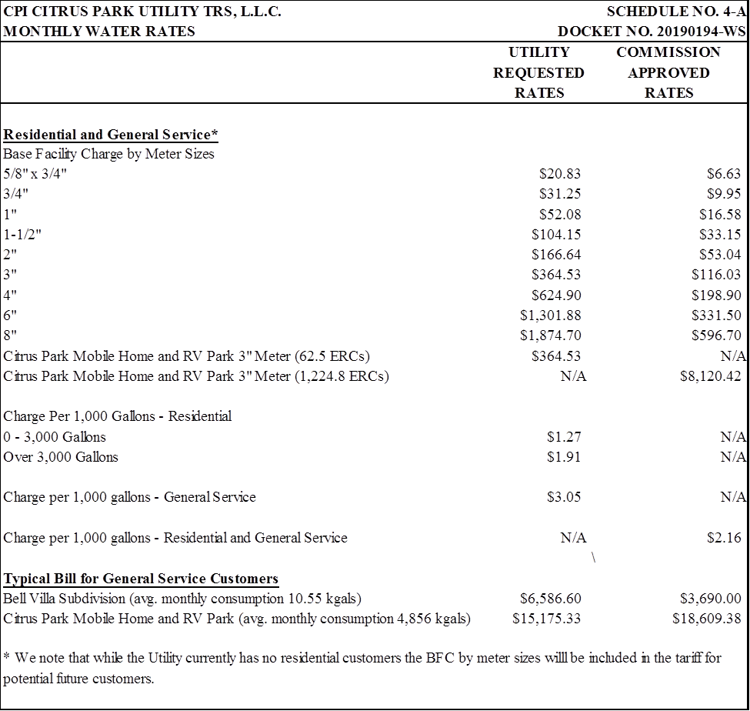
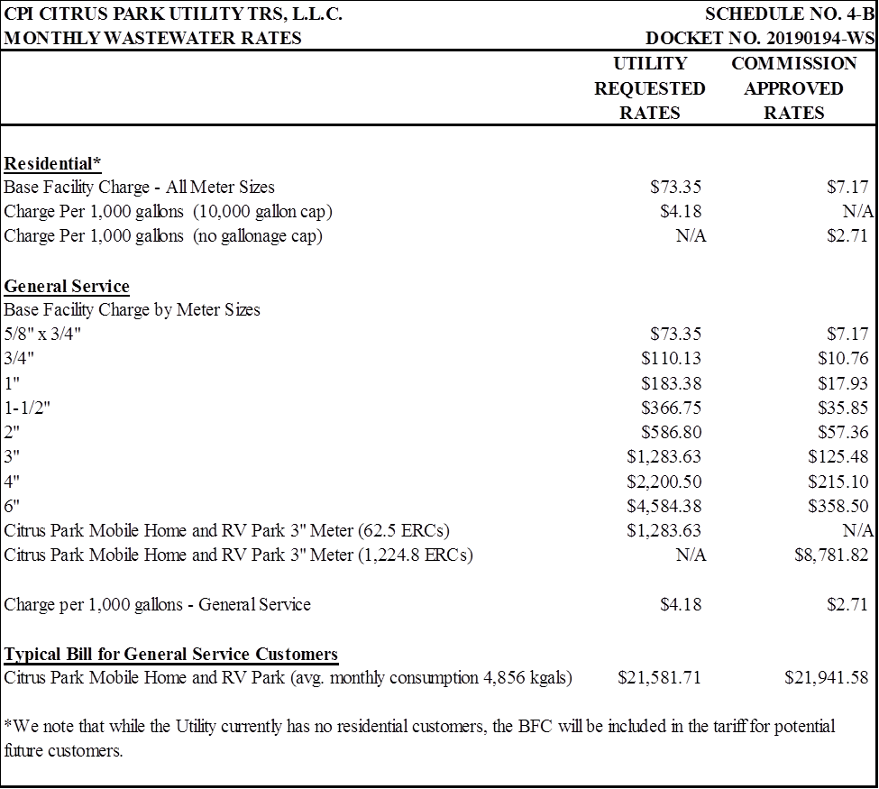

“Landlords providing service to their tenants without specific compensation for the service,” are not subject to regulation by the Commission as a utility nor are they subject to Chapter 367.
Document No. 09541-2019, filed October 23, 2019.
Document No. 11049-2019, filed November 21. 2019.
Document No. 00281-2020, filed January 14, 2020.
Document No. 00854-2020, filed February 10, 2020.
Document No. 01946-2020, filed April 14, 2020.
Order Nos. PSC-17-0059-PAA-WS, issued February 24, 2017, in Docket No. 20160220-WS, In re: Application for original water and wastewater certificates in Sumter County, by South Sumter Utility Company, LLC.; and PSC-2020-0059-PAA-WS, issued February 24, 2020, in Docket No. 20190147-WS, In re: Application for certificates to provide water and wastewater service in Brevard County by River Grove Utilities, Inc.
The Utility filed a Request for Confidential Classification for the financial statements of its parent, CPI Citrus Park Owner, L.L.C. The Utility’s request was approved by Order No. PSC-2020-0155-CFO-WS, issued May 15, 2020.
Order Nos. PSC-2018-0446-FOF-SU, issued September 4, 2018, in Docket No. 20170141-SU, In re: Application for increase in wastewater rates in Monroe County by K W Resort Utilities Corp.; and PSC-2018-0311-PAA-WS, issued June 13, 2018, in Docket No. 20170166-WS, In re: Application for limited proceeding rate increase in Orange County by Pluris Wedgefield, Inc.
Order No. PSC-2019-0267-PAA-WS, issued July 1, 2019, in Docket No. 20190006-WS, In re: Water and wastewater industry annual reestablishment of authorized range of return on common equity for water and wastewater utilities pursuant to Section 367.081(4)(f), F.S.
Order No. PSC-11-0345-PAA-WS, issued August 16, 2011, in Docket No. 20100359-WS, In re: Application for staff-assisted rate case in Volusia County by Tymber Creek Utilities, Incorporated.
Order No. PSC-01-0998-TRF-WU, issued April 23, 2001, in Docket No. 20010232-WU, In re: Request for approval of tariff filing to add "set rate" late fee to water tariff, by Lake Yale Treatment Associates, Inc. in Lake County.
Order Nos. PSC-2019-0047-PAA-WS, issued January 25, 2019, in Docket No. 20170249-WS, In re: Application for certificates to provide water and wastewater service in Orange County by RSPI MHC, LLC; PSC-2018-0334-PAA-WU, issued June 28, 2018, in Docket No. 2017-155-WU, In re: Application for grandfather water certificate in Leon County and application for pass through increase of regulatory fees, by Seminole Waterworks, Inc.; PSC-16-0041-TRF-WU, issued January 25, 2016, in Docket No. 20150215-WU, In re: Request for approval of tariff amendment to include miscellaneous service charges for the Earlene and Ray Keen Subdivisions, the Ellison Park Subdivision and the Lake Region Paradise Island Subdivision in Polk County, by Keen Sales, Rentals and Utilities, Inc.; PSC-15-0569-PAA-WS, issued December 16, 2015, in Docket No. 20140239-WS, In re: Application for staff-assisted rate case in Polk County by Orchid Springs Development Corporation; PSC-16-0523-TRF-WU, issued November 21, 2016, in Docket No. 20160023-WU, In re: Application for transfer of majority organizational control of Sunny Shores Water Company, Inc., holder of Certificate No. 578-W in Manatee County, from Jack E. Mason to Jack E. Mason, II and Debbie A. Mason.
Order Nos. PSC-14-0105-TRF-WS, issued February 20, 2014, in Docket No. 20130288-WS, In re: Request for approval of late payment charge in Brevard County by Aquarina Utilities, Inc.; PSC-15-0535-PAA-WU, issued November 19, 2015, in Docket No. 20140217-WU, In re: Application for staff-assisted rate case in Sumter County by Cedar Acres, Inc.; and PSC-15-0569-PAA-WS, issued December 16, 2015, in Docket No. 20140239-WS, In re: Application for staff-assisted rate case in Polk County by Orchid Springs Development Corporation.
Order No. PSC-2020-0086-PAA-WU, issued March 24, 2020, in Docket No. 20190114-WU, In re: Application for staff-assisted rate case in Alachua County, and request for interim rate increase by Gator Waterworks, Inc.

