BEFORE THE FLORIDA PUBLIC SERVICE COMMISSION

In re: Petition for approval of revised underground residential distribution tariffs, by Duke Energy Florida, Inc. | DOCKET NO. 20200110-EI  ORDER NO. PSC-2020-0266-TRF-EI  ISSUED: July 27, 2020

The following Commissioners participated in the disposition of this matter:

GARY F. CLARK, Chairman
ART GRAHAM
JULIE I. BROWN
DONALD J. POLMANN
ANDREW GILES FAY

ORDER APPROVING DUKE ENERGY FLORIDA, LLC’S PETITION

TO REVISE UNDERGROUND RESIDENTIAL TARIFFS
BY THE COMMISSION:

I. Background
On April 1, 2020, Duke Energy Florida, LLC (Duke or utility) filed a petition for approval of revisions to its underground residential distribution (URD) tariffs. The URD tariffs apply to new residential subdivisions and represent the additional costs, if any, Duke incurs to provide underground distribution service in place of overhead service. The proposed (legislative version) URD tariffs, approved herein, are contained in Attachment A.
Duke’s current URD charges were approved by Order No. PSC-2019-0443-TRF-EI. Duke waived the 60-day file and suspend provision pursuant to Section 366.06(3), Florida Statutes (F.S.), in an email dated April 8, 2020. We have jurisdiction over this matter pursuant to Sections 366.03, 366.04, 366.05, and 366.06, F.S.

II. Decision
Rule 25-6.078, Florida Administrative Code (F.A.C.), defines investor-owned utilities’ (IOU) responsibilities for filing updated URD tariffs. Duke has filed the instant petition pursuant to subsection (3) of the rule, which requires IOUs to file supporting data and analyses for updated URD tariffs if the cost differential, using current labor and material costs, varies from the Commission-approved differential by more than ten percent. On October 15, 2019, pursuant to Rule 25-6.078, F.A.C., Duke stated that its differential for the low density subdivision would change by more than 10 percent from the differential approved in the 2019 order, requiring Duke to file the instant petition.
The URD tariffs provide charges for underground service in new residential subdivisions and represent the additional costs, if any, the utility incurs to provide underground service in place of overhead service. The cost of standard overhead construction is recovered through base rates from all ratepayers. In lieu of overhead construction, customers have the option of requesting underground facilities. Any additional cost is paid by the customer as a contribution-in-aid-of-construction (CIAC). Typically, the URD customer is the developer of a subdivision.
Traditionally, three standard model subdivision designs have been the basis upon which each IOU submits URD tariff changes for our approval: low density, high density, and a high density subdivision where dwelling units take service at ganged meter pedestals (groups of meters at the same physical location). While actual construction may differ from the model subdivisions, the model subdivisions are designed to reflect average overhead and underground subdivisions.
Costs for underground construction have historically been higher than costs for standard overhead construction and the additional cost is paid by the customer as a CIAC. However, as shown on Table 1, Duke’s proposed URD differential charges remain $0 per lot for the low density and ganged meter subdivisions. For the high density subdivision, the proposed differential decreased from the current $34 to $0 per lot. The decrease in the differentials is primarily attributable to changes in Duke’s labor, material, and operational costs.
Table 1 shows the current and proposed URD differentials for the low density, high density, and ganged meter subdivisions. The charges shown are per-lot charges.
Table 1
Comparison of URD Differential per Lot
Types of Subdivision | Current URD Differential | Proposed URD Differential
Low Density | $0 | $0
High Density | $34 | $0
Ganged Meter | $0 | $0
Source: Order PSC-2019-0443-TRF-EI and Duke’s 2020 Petition
The calculations of the proposed URD charges include (1) updated labor and material costs along with the associated loading factors and (2) operational costs. The costs are discussed below.

Labor and Material Costs

The installation costs of both overhead and underground facilities include the labor and material costs to provide primary, secondary, and service distribution lines, as well as transformers. The costs of poles are specific to overhead service while the costs of trenching and backfilling are specific to underground service. The utilities are required by Rule 25-6.078(5), F.A.C., to use current labor and material costs.
Duke’s labor costs for overhead and underground construction are comprised of costs associated with work performed by both in-house employees and outside contractors. Duke’s in-house labor rates are based upon actual labor costs negotiated in bargaining unit contracts and labor rates with contractors are negotiated. Table 2 compares total 2019 and 2020 labor and material costs for the three subdivision models.
Table 2
Duke Trench and Install Conduit
Labor and Material Costs per Lot
 | 2019 Costs | 2020 Costs | Difference
Low Density
Underground Labor/Material costs | $1,620 | $2,263 | $643
Overhead Labor/Material costs | $1,323 | $2,343 | $1,020
Per lot Differential | $297 | $(80) | $(377)
High Density
Underground Labor/Material Costs | $1,484 | $1,978 | $494
Overhead Labor/Material Costs | $1,009 | $1,642 | $633
Per Lot Differential | $475 | $336 | $(139)
Ganged Meter
Underground Labor/Material Costs | $581 | $774 | $193
Overhead Labor/Material Costs | $750 | $1,295 | $545
Per lot Differential | $(169) | $(521) | $(352)
Source: 2019 Order and Duke’s 2020 Petition.
As Table 2 shows, the majority of overhead and underground total labor and material costs increased since the 2019 petition. The utility stated that it identified an error in its cost estimating tool which did not allow the system to sufficiently account for the actual costs paid for overhead contract labor, specifically in the area of setting poles and overhead transformers. As such, after adjusting for these changes, the cost of pole setting increased from $164 to $644 and single-phase transformers increased from $90 to $643. The correction of these costs contribute to the majority of increased labor costs in this petition. Duke stated that the utility will continue to monitor the labor cost data to ensure their accuracy and that material costs have fluctuated minimally since 2019.

Operational Costs

Rule 25-6.078(4), F.A.C., requires that the differences in net present value (NPV) of operational costs between overhead and underground systems, including average historical storm restoration costs over the life of the facilities, be included in the URD charge. The inclusion of the operational cost is intended to capture longer term costs and benefits of undergrounding.
Operational costs include operations and maintenance costs along with capital costs and represent the cost differential between maintaining and operating an underground versus an overhead system over the life of the facilities. The inclusion of the storm restoration cost in the URD calculations lowers the differential, since an underground distribution system generally incurs less damage than an overhead system as a result of a storm, and therefore, less restoration costs when compared to an overhead system.
The utility used a 5-year average of historical operational costs (2015-2019) for its calculations in this docket. The methodology used by Duke in this filing for calculating the NPV of operational costs was approved in Order No. PSC-12-0348-TRF-EI. We note that operational costs may vary among IOUs due to multiple factors, including differences in size of service territory, miles of coastline, regions subject to extreme winds, age of the distribution system, or construction standards.
Table 3
NPV of Operational Costs Differential per Lot
Type of Subdivision | Pre-Operational Costs  (A) | Non-Storm Operational  Costs  (B) | Avoided Storm Costs  (C) | Proposed URD Differentials  (A)+(B)+(C)
Low Density | $(80) | $60 | $(960) | $0
High Density | $336 | $64 | ($547) | $0
Ganged Meter | ($521) | ($69) | ($418) | $0
Source: 2020 Petition.
Table 3 presents the pre-operational, non-storm operational, and the avoided storm restoration cost differentials between overhead and underground systems. The proposed differential is $0 when the calculation results in a negative number.
According to Duke, the average non-storm operational costs did not change significantly from 2019 to 2020. The data shows that avoided storm restoration costs increased when compared to the 2019 petition. Duke’s 2019 petition included the 5-year average of historical operational costs for 2014 to 2018, while this petition includes operational costs for 2015 to 2019.

Additional Customer Options

In October 2019, the utility adopted a “cable in conduit” approach, similar to other utilities in Florida. This change required that all cable be included in conduit at installation, rather than cable being pulled through separately installed conduit. The utility asserted that this approach would reduce outages, as well as reduce repair and replacement times when failures occur. Under the “cable in conduit” approach, the utility removed certain costs associated with cable installation, splicing and pulling boxes. However, as a result of this change, the utility is proposing additional undergrounding construction options to developers in this petition, which could impact the overall cost of installing underground facilities. The two additional options are discussed below:
- Customer Mainline-Duke Services: Customer supply and install conduit for primary, secondary and street lights. This option allows the developer to purchase and install primary and secondary conduit in the subdivision; therefore, the material and labor costs associated with the installation of primary and secondary conduit, including trenching, have been excluded from the differential calculation. Duke continues to install services and transformers. The developer-purchased conduit will have to be installed meeting Duke guidelines.
- Customer Trench, Provide and Install Conduit: Customer supply and install conduit for primary, secondary and street lights. This option allows the developer to purchase and install services, primary, and secondary conduit. Therefore, the associated costs have been excluded from the differential calculation. Duke continues to install the transformers.
The utility noted that while the current NPV operational costs, including avoided storm restoration, result in a $0 URD differential for these new options, Duke recognized that a shift in the operational costs could allow the differential costs for these two new line costs to differ from the traditional Duke Trench and Install Conduit tariff, under which Duke performs the full installation.

III. Conclusion

After reviewing the entire record in this docket, we find the proposed URD tariffs and associated charges are reasonable. We hereby approve Duke’s proposed URD tariffs and associated charges as shown in Attachment A, effective July 7, 2020.
Based on the foregoing, it is

ORDERED by the Florida Public Service Commission that Duke Energy Florida, LLC’s proposed Underground Residential tariffs and associated charges as shown in Attachment A, are approved effective July 7, 2020. It is further
ORDERED that if a protest is filed within 21 days of issuance of the Order, the tariff shall remain in effect with any charges held subject to refund pending resolution of the protest. It is further

ORDERED that if no timely protest is filed, this docket shall be closed upon the issuance of a Consummating Order.

By ORDER of the Florida Public Service Commission this 27th day of July, 2020.

/s/ Adam J. Teitzman
ADAM J. TEITZMAN
Commission Clerk
Florida Public Service Commission
2540 Shumard Oak Boulevard
Tallahassee, Florida 32399
(850) 413-6770
www.floridapsc.com

Copies furnished: A copy of this document is provided to the parties of record at the time of issuance and, if applicable, interested persons.
WLT

NOTICE OF FURTHER PROCEEDINGS

The Florida Public Service Commission is required by Section 120.569(1), Florida Statutes, to notify parties of any administrative hearing or judicial review of Commission orders that is available under Sections 120.57 or 120.68, Florida Statutes, as well as the procedures and time limits that apply. This notice should not be construed to mean all requests for an administrative hearing or judicial review will be granted or result in the relief sought.

Mediation may be available on a case-by-case basis. If mediation is conducted, it does not affect a substantially interested person's right to a hearing.

The Commission's decision on this tariff is interim in nature and will become final, unless a person whose substantial interests are affected by the proposed action files a petition for a formal proceeding, in the form provided by Rule 28-106.201, Florida Administrative Code. This petition must be received by the Office of Commission Clerk, 2540 Shumard Oak Boulevard, Tallahassee, Florida 32399-0850, by the close of business on August 17, 2020.

In the absence of such a petition, this Order shall become final and effective upon the issuance of a Consummating Order.

Any objection or protest filed in this docket before the issuance date of this order is considered abandoned unless it satisfies the foregoing conditions and is renewed within the specified protest period.

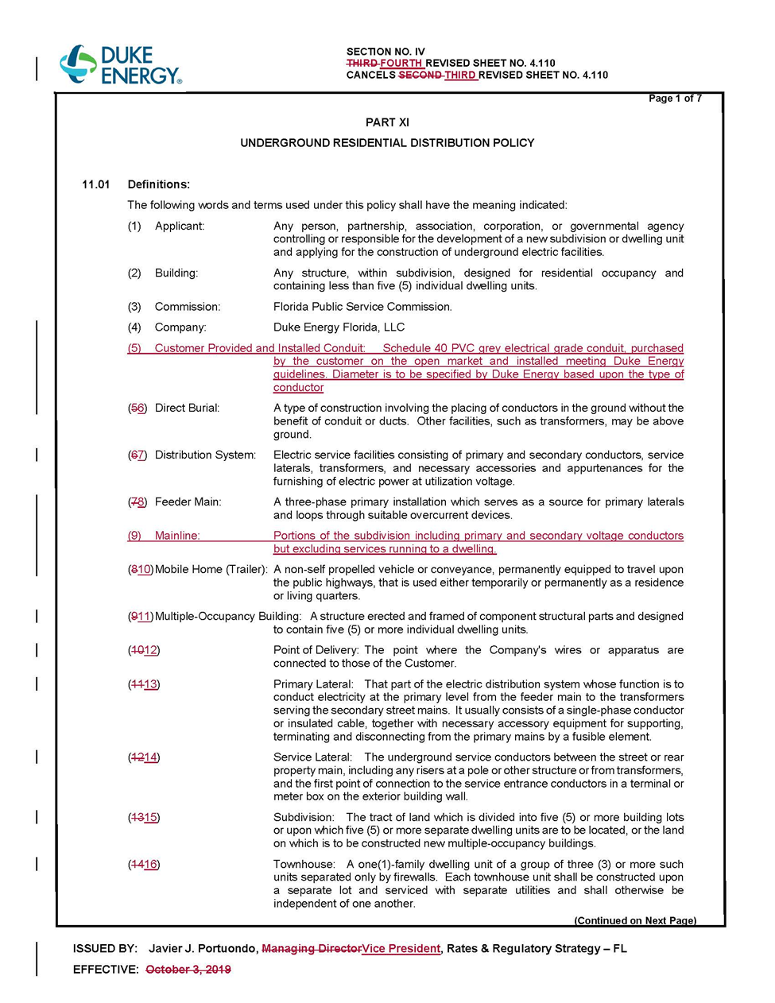

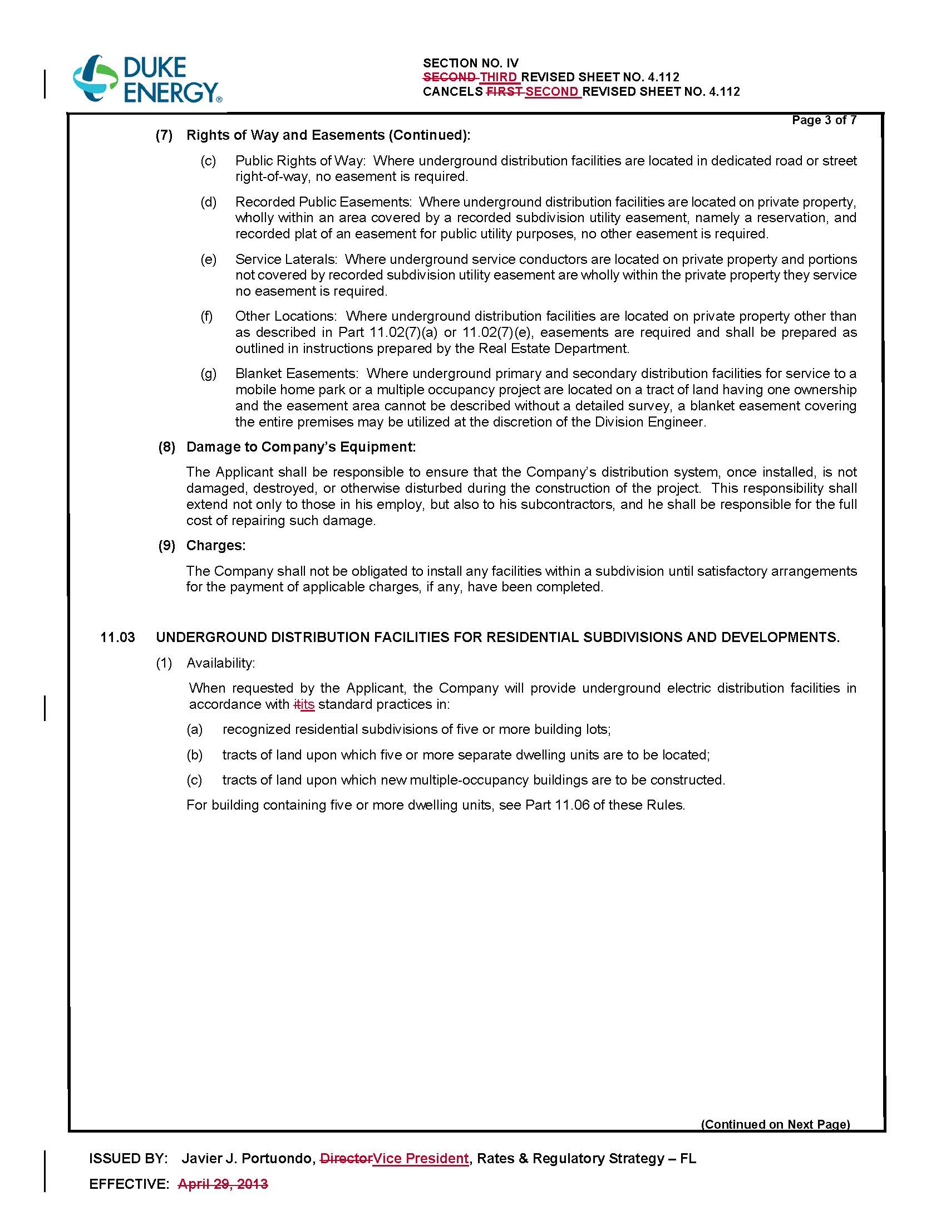

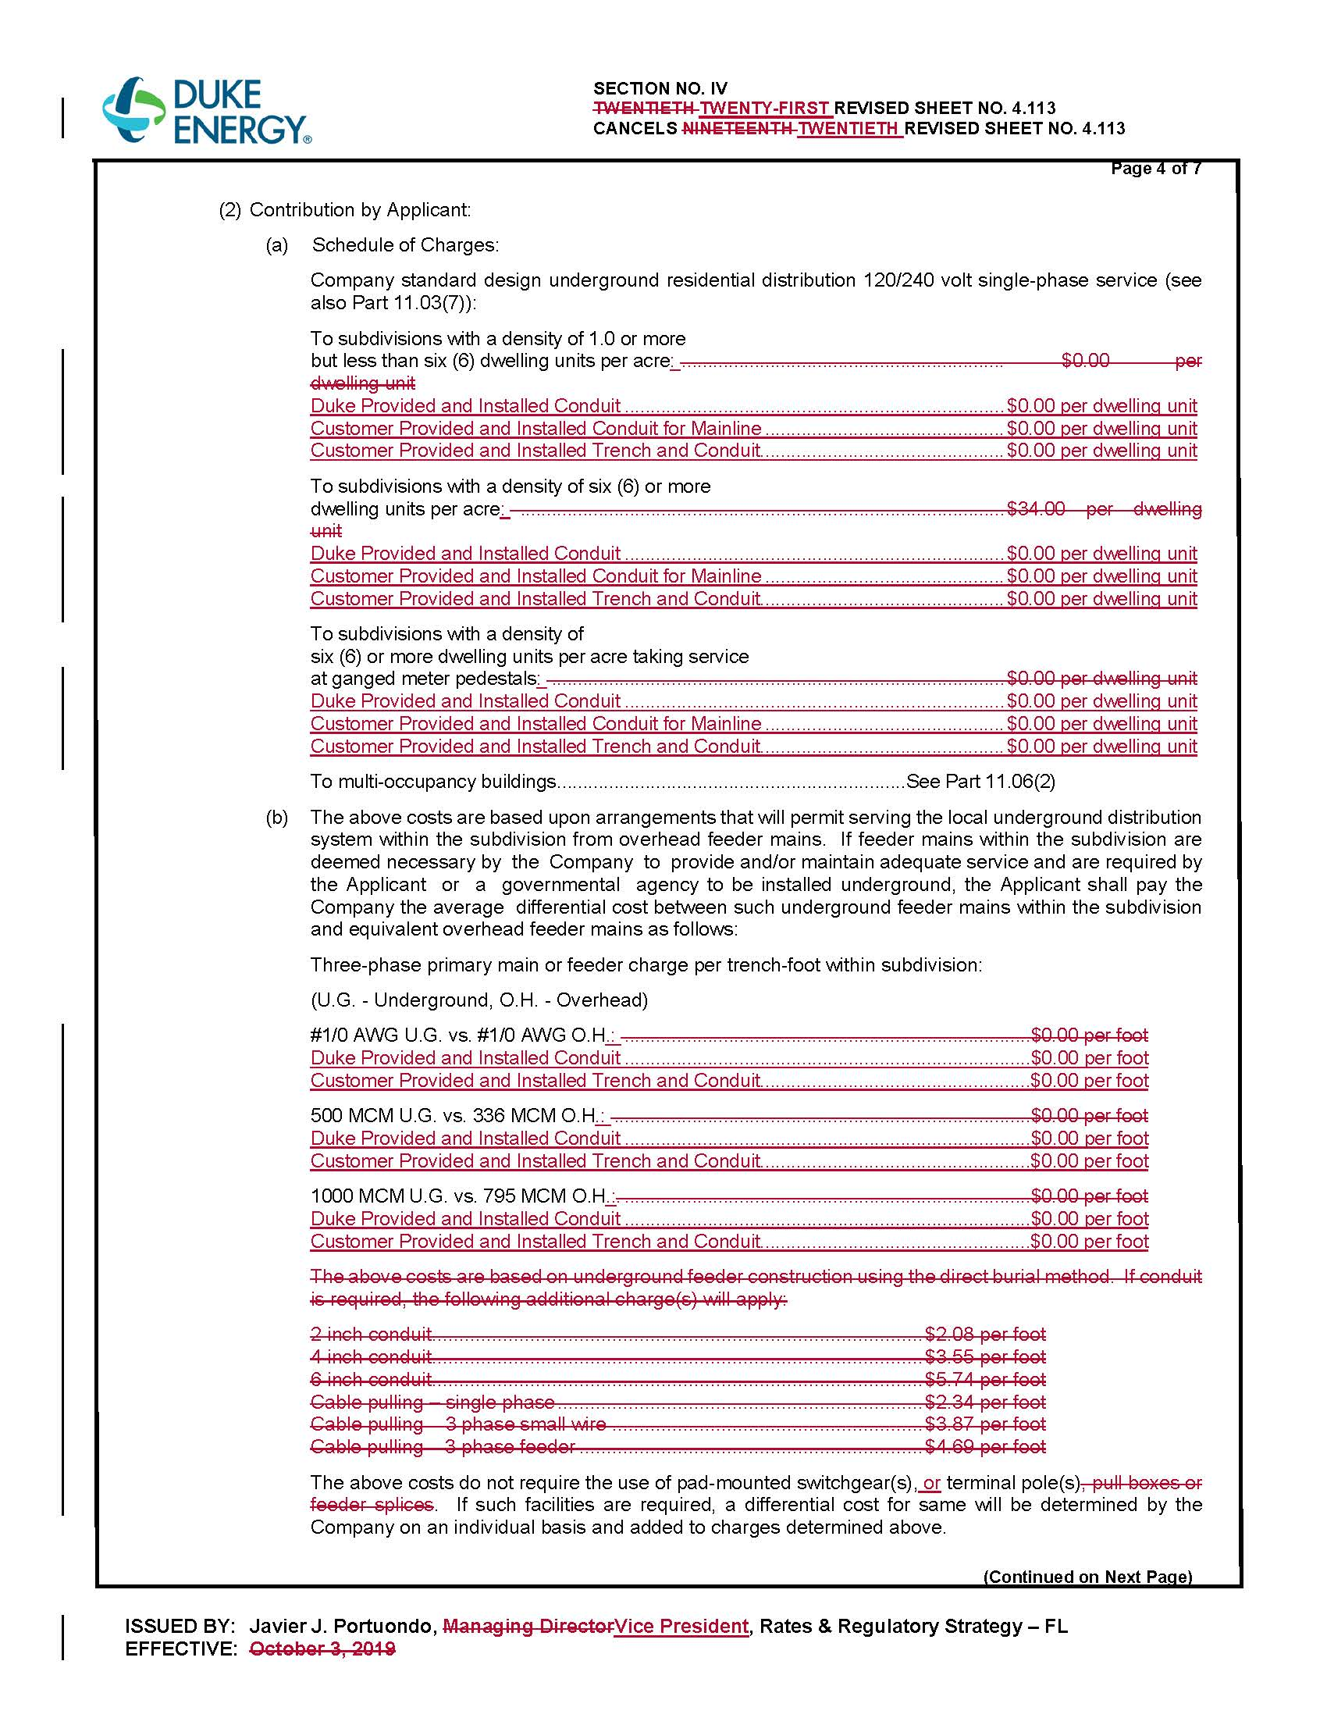

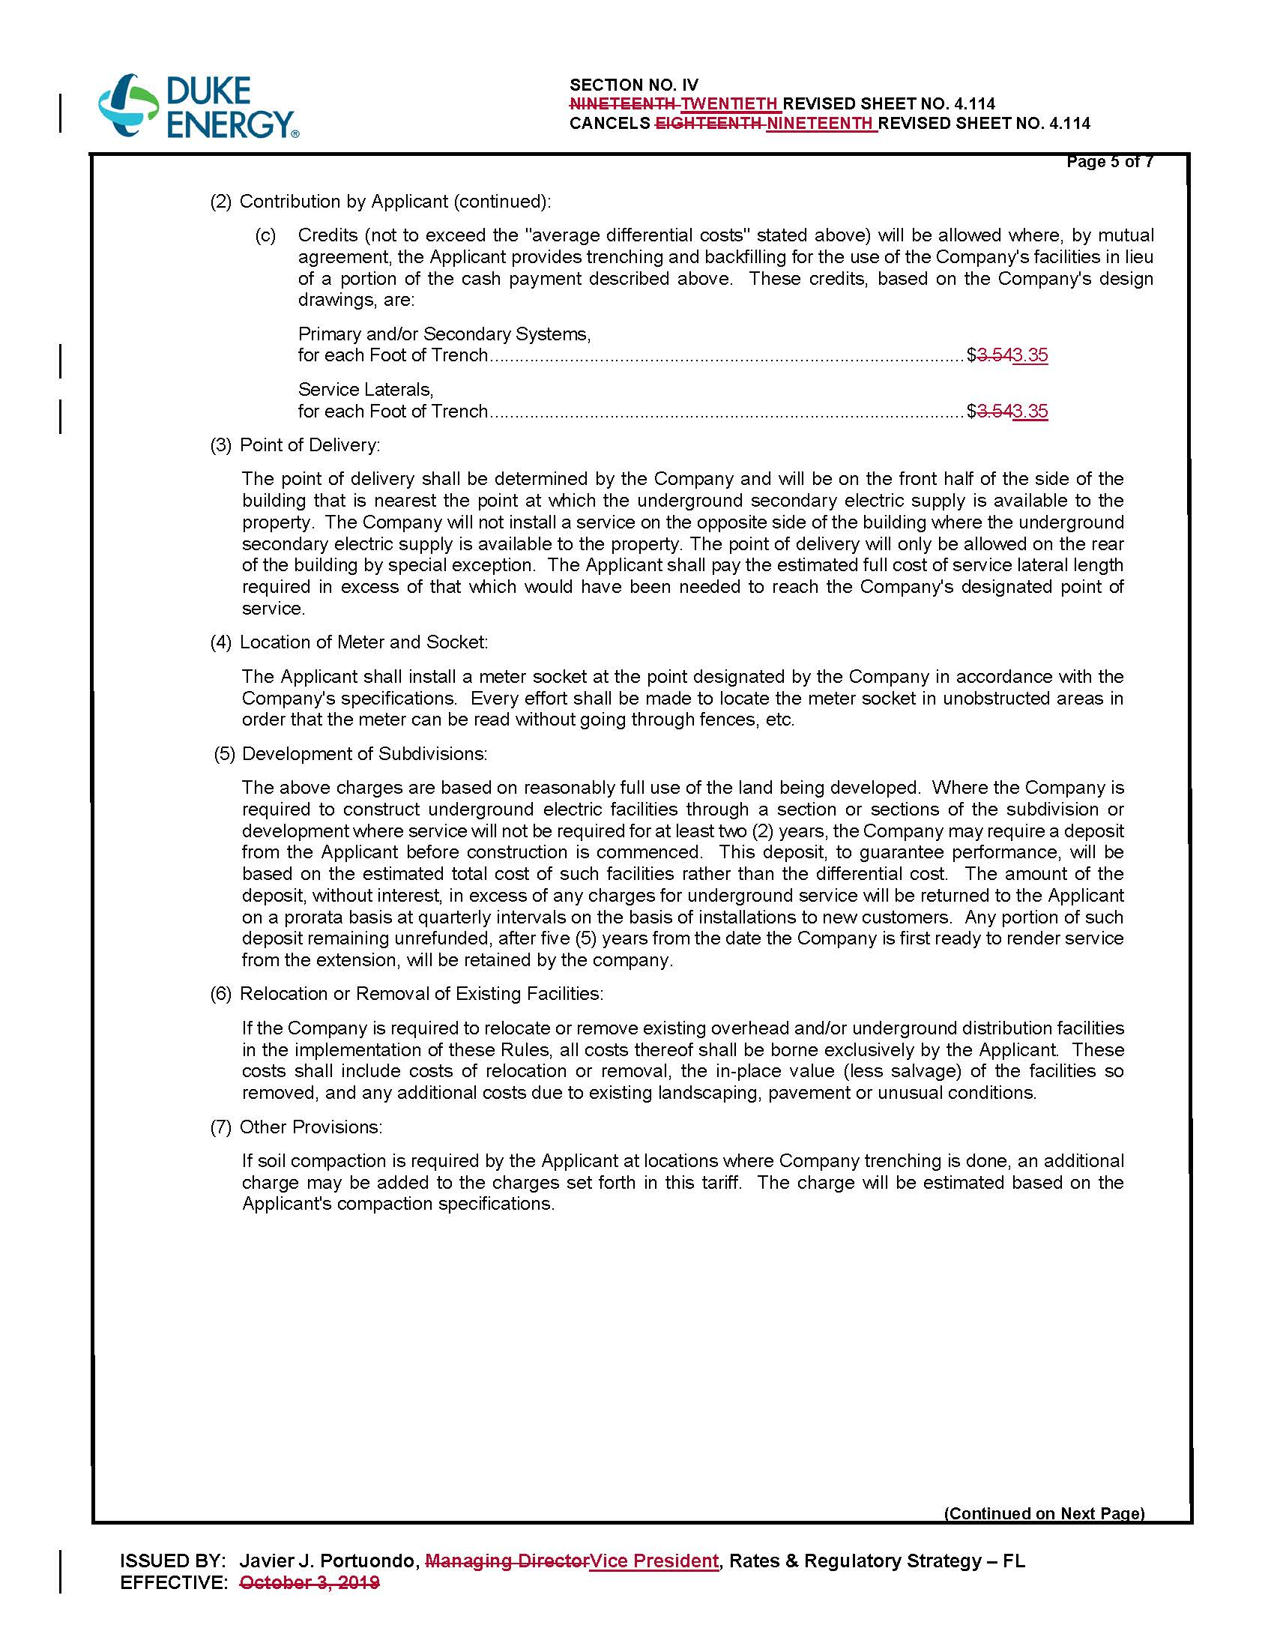

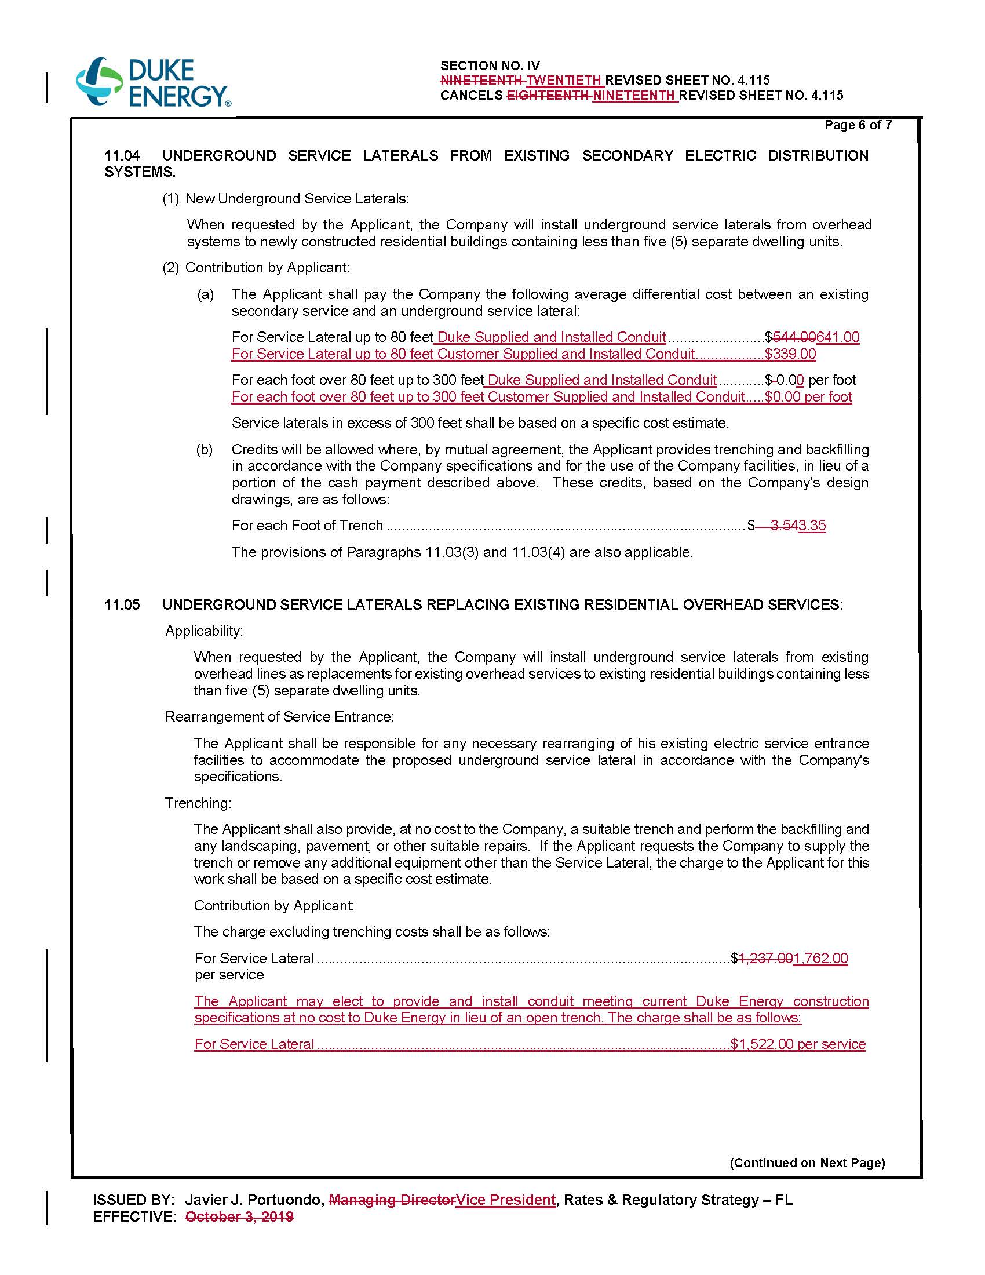

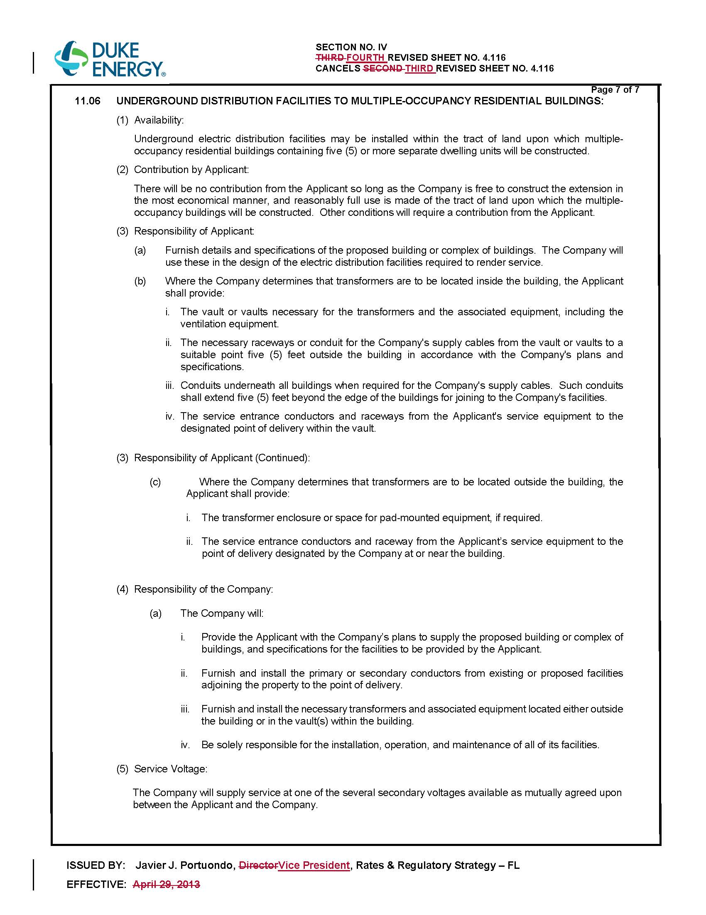

Order No. PSC-2019-0443-TRF-EI, issued November 19, 2019, in Docket 20190076-EI, In re: Petition for approval of revised underground residential distribution tariffs, by Duke Energy Florida, LLC.
Document No. 01824-2020.
Operational capital costs are the costs associated with replacement equipment needed during the lifespan of the facilities.
Order No. PSC-12-0348-TRF-EI, issued July 5, 2012, in Docket No. 110293-EI, In re: Petition for approval of revised underground residential distribution tariffs, by Progress Energy Florida, Inc.

