State of Florida |  | Public Service Commission  Capital Circle Office Center ● 2540 Shumard Oak Boulevard  Tallahassee, Florida 32399-0850  -M-E-M-O-R-A-N-D-U-M-
DATE: | August 20, 2020
TO: | Office of Commission Clerk (Teitzman)
FROM: | Office of the General Counsel (Cowdery)  Division of Economics (Coston, Draper, Guffey)  Division of Engineering (Buys)
RE: | Docket No. 20200186-EU – Proposed repeal of Rule 25-6.047, FAC, Constant Current Standards; Rule 25-6.081, FAC, Construction Practices; and Rule 25-6.082, FAC, Records and Reports, and amendment of Rule 25-6.054, FAC, Laboratory Standards; Rule 25-6.074, FAC, Applicability; and Rule 25-6.104, FAC, Unauthorized Use of Energy.
AGENDA: | 09/01/20 – Regular Agenda – Rule Proposal - Interested Persons May Participate
COMMISSIONERS ASSIGNED: |  |  | All Commissioners
PREHEARING OFFICER: |  |  | Polmann
CRITICAL DATES: |  |  | Proposal May Be Deferred
SPECIAL INSTRUCTIONS: |  |  | None

Case Background
By letter of March 12, 2019, staff of the Joint Administrative Procedures Committee (JAPC) requested that we review sixteen of our rules from Chapter 25-6, Florida Administrative Code (F.A.C.), Electric Service by Electric Public Utilities, to determine if any of the older rules needed to be updated, whether technical changes were needed, or whether the rules needed to be amended for clarity to ensure comprehension and compliance. Staff determined as a result of its review that three of the rules should be recommended for repeal as obsolete and that three of the rules should be amended. The three rules recommended for repeal are Rules 25-6.047, F.A.C., Constant Current Standards; 25-6.081, F.A.C., Construction Practices; and 25-6.082, F.A.C., Records and Reports. The three rules recommended for amendment are Rules 25-6.054, F.A.C., Laboratory Standards; 25-6.074, F.A.C., Applicability; and 25-6.104, F.A.C., Unauthorized Use of Energy.

A Notice of Rule Development for Rules 25-6.047, 25-6.082, 25-6.054, 25-6.074, and 25-6.104, F.A.C., appeared in the February 7, 2020 edition of the Florida Administrative Register (F.A.R.). There was no request for a rule development workshop, and a workshop was not held. Combined written comments were provided on Rule 25-6.104, F.A.C., Unauthorized Use of Energy, by Florida Power & Light Company, Tampa Electric Company, Duke Energy Florida, Inc., Gulf Power Company, and Florida Public Utilities Company.
A Notice of Rule Development for Rule 25-6.081, F.A.C., appeared in the June 7, 2019 edition of the F.A.R., along with twelve other rules that staff had determined might be affected by the adoption of Rules 25-6.030, F.A.C., Storm Protection Plan and 25-6.031, F.A.C., Storm Protection Cost Recovery Clause. Staff rule development workshops were held on all these rules on June 25, 2019, and on August 20, 2019. No comments were provided at the workshops or in post-workshop comments on Rule 25-6.081, F.A.C., and staff determined that Rule 25-6.081, F.A.C., did not need to be amended as a result of the new storm protection plan and cost recovery clause rules. However, JAPC’s March 12, 2019 comments raised concerns about Rule 25-6.081, F.A.C., so it was added to this docket.
This recommendation addresses whether the Commission should propose the repeal of Rules 25-6.047, 25-6.081, and 25-6.082, F.A.C., and the amendment of Rules 25-6.054, 25-6.074, and 25-6.104, F.A.C. The Commission has jurisdiction pursuant to Sections 350.127(2), 366.03, 366.04(2)(a),(c), (f) and (5), 366.05(1) and (3), and 120.54, Florida Statutes (F.S.).

Discussion of Issues

Issue 1:
Should the Commission propose the repeal of Rules 25-6.047, F.A.C., Constant Current Standards; 25-6.081, F.A.C., Construction Practices; and 25-6.082, F.A.C., Records and Reports, and the amendment of Rules 25-6.054, F.A.C., Laboratory Standards; 25-6.074 F.A.C., Applicability; and 25-6.104, F.A.C., Unauthorized Use of Energy?

Recommendation:
Yes, the Commission should propose the repeal of Rules 25-6.047, 25-6.081, and 25-6.082, F.A.C., and the amendment of Rules 25-6.054, 25-6.074, and 25-6.104, F.A.C., as set forth in Attachment A. The Commission should also certify Rules 25-6.054, 25-6.074, and 25-6.104, F.A.C., as minor violation rules. (Cowdery, P. Buys, Draper, Coston, Guffey)

Staff Analysis:
The purpose of this rulemaking is to repeal or update and clarify these Chapter 25-6, F.A.C., rules in response to concerns or questions raised by JAPC staff. Staff determined that three of the rules should be repealed as obsolete and unnecessary and that three of the rules should be amended. Staff’s recommendation for each rule is discussed below.

Rule 25-6.047, F.A.C., Constant Current Standards
JAPC staff asked that the Commission review and advise whether updates are needed to Rule 25-6.047, F.A.C., which has not been amended since adoption in 1969. This rule addresses equipment supplying constant current street lighting circuits. The rule has become obsolete and unnecessary because electric utilities no longer utilize this type of equipment. For this reason, staff recommends that the Commission should repeal Rule 25-6.047, F.A.C.

Rule 25-6.054, F.A.C., Laboratory Standards
The Laboratory Standards rule establishes reference standards for certain watthour meters. Section (4) of the rule requires each utility to maintain historical performance records for each watthour meter used as a basic reference standard for certain types of comparisons. This rule was last amended in 1997. JAPC staff raised a concern that the rule text did not identify a specific period of time that the historical performance records must be maintained by utilities. In order to address this concern, staff recommends that the Commission amend section (4) to state that the referenced historical performance records be maintained until the meter is no longer in use.

Rule 25-6.074, F.A.C., Applicability
Rules 25-6.074 through 25-6.082, F.A.C., are the Commission’s rules for residential electric underground extensions. The substance of Rule 25-6.074, F.A.C., requires that extensions of electric distribution lines necessary to furnish permanent electric service to certain new structures must be made underground when required by an applicant or required by a governmental authority. This rule has not been amended since it was adopted in 1971.

JAPC staff asked that it be advised as to the necessity of Rule 25-6.074, F.A.C., in light of the definition of a rule pursuant to section 120.52(16), F.S. In order to address this concern, staff recommends that the Commission delete certain provisions as obsolete and unnecessary. Staff recommends that the Commission delete as obsolete the language in Subsection (1) stating that the rule applies to extensions applied for after the 1971 effective date of the rule. Additionally, staff recommends that the Commission should delete Subsection (2) that provides that extensions must be made in accordance with the rules for residential electric underground extensions. Section (2) is unnecessary because other rules addressing residential electric underground extensions by their terms apply to the extensions identified in Rule 25-6.074, F.A.C.

Rule 25-6.081, F.A.C., Construction Practices
Rule 25-6.081, F.A.C. is another of the rules for residential electric underground extensions. JAPC staff raised the concern that Rule 25-6.081, F.A.C., which has not been amended since it was adopted in 1971, does not meet the Section 120.52(16), F.S., definition of “rule” and appears to contain undefined goals without definitions, standards, or how compliance is to be determined.
Subsections (1) and (2) of the Construction Practices rule are meant to encourage utilities to keep the cost of underground construction as low as possible. Subsection (3) encourages joint use of trenches by utilities “to the extent practicable” “where economies can be realized without impairment to safety or service” with “care being taken to conform to any applicable Code and utility specification,” and Subsection (4) encourages replacement of retired aerial facilities with underground construction “to the extent practicable” and “whenever economically feasible.”

Staff agrees with the concern raised by JAPC staff. Rule 25-6.081, F.A.C., contains what staff would characterize as aspirational goals. As pointed out by JAPC staff, the provisions of Rule 25-6.081, F.A.C., do not meet the current requirements of Chapter 120, F.S., because they do not impose specific standards for meeting the goals or determining compliance with the rule.

Staff does not believe that Rule 25-6.081, F.A.C., can be amended to impose specific standards for meeting the identified goals. There are more specific rules concerning residential electric underground extensions that impose standards or requirements. As explained above, Rule 25-6.074, F.A.C., requires that extensions of electric distribution lines necessary to furnish permanent electric service to certain new structures must be made underground when required by an applicant or required by a governmental authority. Rule 25-6.076, F.A.C., addresses rights of way and easements, and Rule 25-6.077, F.A.C., addresses installation of underground distribution systems within new subdivisions. For the reasons explained above, staff recommends that Rule 25-6.081, F.A.C., should be repealed as obsolete and unnecessary.

Rule 25-6.082, F.A.C., Records and Reports
Rule 25-6.082, F.A.C., also addresses residential electric underground extensions. The Records and Reports rule contains certain recordkeeping requirements for underground distribution construction, operation and maintenance costs, and the use of joint trenching. This rule was last amended in 1997.

JAPC raised the concern that this rule did not specify how long these records must be maintained and asked whether another relevant record retention rule applied. Staff believes that Rule 25-6.078, F.A.C., Schedule of Charges, supersedes Rule 25-6.082, F.A.C. The data required by Rule 25-6.082, F.A.C., is provided to the Commission pursuant to Rule 25-6.078, F.A.C. For this reason, staff recommends that Rule 25-6.082, F.A.C., be repealed as obsolete and unnecessary.

Rule 25-6.104, Unauthorized Use of Energy, F.A.C.
The Unauthorized Use of Energy rule states that in the event of unauthorized or fraudulent use or meter tampering, the utility may bill the customer on a reasonable estimate of the energy used. This rule was last amended in 1982. JAPC stated that it is unclear how the Commission would determine whether an estimated charge is “reasonable.”

In order to address this concern, and based on input from the investor-owned utilities in their written comments, staff is recommending that the Commission amend the unauthorized use of energy rule to allow the utility to bill the customer for the time period at issue using an estimate of the energy used, which may include factors such as historical usage, meter data, meter test data, approximate size of the residence or building, the types of appliances and equipment using electricity, use of air conditioning and electric heating, and the number of occupants. This language gives specificity and clarity to the rule and identifies factors currently used by utilities in determining estimates under this rule.

Minor Violation Rules Certification
Pursuant to Section 120.695, F.S., the agency head must certify for each rule filed for adoption whether any part of the rule is designated as a rule the violation of which would be a minor violation. Rules 25-6.047, 25-6.054, 25-6.074, 25-6.081, 25-6.082, and 25-6.104, F.A.C., are currently listed on the Commission’s website as rules for which a violation would be minor because violation of the rules would not result in economic or physical harm to a person or have an adverse effect on the public health, safety, or welfare or create a significant threat of such harm.
If Rules 25-6.047, 25-6.081, and 25-6.082, F.A.C., are repealed as recommended by staff, these rules will be deleted from the Commission’s website listing of minor violation rules after the repeals are certified by the Department of State. The amendments to Rules 25-6.054, 25-6.074, and 25-6.104, F.A.C., would not change their status as minor violation rules. Thus, staff recommends that the Commission certify Rules 25-6.054, 25-6.074, and 25-6.104, F.A.C., as minor violation rules.

Statement of Estimated Regulatory Costs
Pursuant to Section 120.54(3)(b), F.S., agencies are encouraged to prepare a statement of estimated regulatory costs (SERC) before the adoption, amendment, or repeal of any rule. The SERC is appended as Attachment B to this recommendation.
The SERC concludes that the rules will not likely directly or indirectly increase regulatory costs in excess of $200,000 in the aggregate in Florida within one year after implementation. Further, the SERC economic analysis concludes that the rules will not likely have an adverse impact on economic growth, private sector job creation or employment, private sector investment, business competitiveness, productivity, or innovation in excess of $1 million in the aggregate within five years of implementation. Thus, the rules do not require legislative ratification pursuant to Section 120.541(3), F.S. In addition, the SERC states that the rules will not have an adverse impact on small business and will have no impact on small cities or counties. No regulatory alternatives were submitted pursuant to paragraph 120.541(1)(a), F.S. None of the impact/cost criteria established in paragraph 120.541(2)(a), F.S., will be exceeded as a result of the recommended amendments to Rules 25-6.0440 and 25-6.0441, F.A.C.

Conclusion
Staff recommends that the Commission propose the repeal of Rules 25-6.047, 25-6.081, and 25-6.082, F.A.C., and the amendment of Rules 25-6.054, 25-6.074, and 25-6.104, F.A.C., as set forth in Attachment A. The Commission should also certify Rules 25-6.054, 25-6.074, and 25-6.104, F.A.C., as minor violation rules.

Issue 2:
Should this docket be closed?

Recommendation:
Yes. If no requests for hearing, information regarding the SERC, proposals for a lower cost regulatory alternative, or JAPC comments are filed, the rules should be filed with the Department of State, and the docket should be closed. (Cowdery)

Staff Analysis:
If no requests for hearing, information regarding the SERC, proposals for a lower cost regulatory alternative, or JAPC comments are filed, the rules should be filed with the Department of State, and the docket should be closed.

25-6.047 Constant Current Standards.
(1) Equipment supplying constant current street lighting circuits shall be so adjusted as to furnish as nearly as is practicable the rated current of the circuit supplied and, under normal operating conditions, the current shall not vary more than 4% above or below the rated current of the circuit.
(2) At least once a year the current output of the equipment supplying constant current circuits shall be checked and the equipment adjusted if necessary.
Rulemaking Authority 366.05(1) FS. Law Implemented 366.03, 366.04(2)(c), (5) FS. History–New 7-29-69, Formerly 25-6.47, Repealed___________.

25-6.054 Laboratory Standards.
(1) Each utility shall have available one or more watthour meters to be used as basic reference standards. The watthour meters must have an adequate capacity and voltage range to test all portable standards used by the utility and must meet the requirements described in subsection 25-6.055(1), F.A.C.
(a) Watthour meters used as basic reference standards shall not be in error by more than plus or minus 0.05 percent at 1.00 power factor or by more than 0.10 percent at 0.50 power factor. Watthour meters shall not be used to check or calibrate portable standard watthour meters unless the basic reference standard watthour meter has been checked and adjusted, if necessary, to the prescribed accuracy within the preceding twelve months.
(b) The percent registration of each basic reference standard watthour meter shall be compared with the percent registration of all other basic reference standard watthour meters used by the utility.
(2) Each utility shall establish traceability of its watthour standard to the national standards at least annually using one of the following methods:
(a) Through the Measurement Assurance Program (MAP) in which the National Institute of Standards and Technology (NIST) has provided a transport standard; or
(b) Through a transport standard which is of the same nominal value and of quality equal to the basic reference standards that are sent to NIST or to an independent laboratory approved by the Commission.
(3) If error exceeding that referenced in paragraph 25-6.054(1)(a), F.A.C., in the percent registration of a watthour meter used as a basic reference standard is observed in the comparisons in paragraph 25-6.054(2)(b), F.A.C., the utility shall investigate the source of the error. If the cause of the error cannot be corrected, use of the watthour meter as a basic reference standard shall be discontinued.
(4) Each utility shall maintain the following historical performance records for each watthour meter used as a basic reference standard until the meter is no longer in use for the following types of comparisons:
(a) Comparisons of basic reference standards with national standards; and
(b) Intercomparisons made with other basic reference standards.
Rulemaking Authority 350.127(2), 366.05(1) FS. Law Implemented 366.05(1),(3) FS. History–New 7-29-69, Amended 4-13-80, 5-13-85, Formerly 25-6.54, Amended 5-19-97, ___________.

25-6.074 Applicability.
(1) Extensions of electric distribution lines applied for after the effective date of these rules, and necessary to furnish permanent electric service to all structures within a new residential subdivision, or to new multiple-occupancy buildings, shall be made underground when requested by an applicant or required by governmental authority.
(2) Such extensions of service shall be made by the utility in accordance with the provisions in these rules.
Rulemaking Authority 350.127(2), 366.05(1) FS. Law Implemented 366.03 FS. History–New 4-10-71, Formerly 25-6.74, Amended ___________.

25-6.081 Construction Practices.
(1) The provisions in these rules are based on the premise that each applicant and utility will provide a cooperative effort to keep the cost of construction and installation of underground systems as low as possible.
(2) Each utility shall undertake to further improve underground construction proficiency toward the end that the downward trends in underground construction costs may be continued.
(3) To the extent practicable, joint use of trenches by all utilities shall be undertaken where economies can be realized without impairment to safety or service, care being taken to conform to any applicable Code and utility specification.
(4) To the extent practicable, where existing aerial facilities are being retired and removed from service, replacement will be made with underground construction whenever economically feasible.
Rulemaking Authority 366.05(1) FS. Law Implemented 366.03 FS. History–New 4-10-71, Formerly 25-6.81, Repealed__________.

25-6.082 Records and Reports.
(1) To insure the development and availability of appropriate data necessary to satisfy the reporting requirements of Rule 25-6.078, F.A.C., herein, each utility shall maintain separate records or sub-accounts for underground distribution construction, operation and maintenance costs.
(2) Records shall also be maintained of experienced results obtained in the use of joint trenching, in such manner and detail as will afford an opportunity to evaluate the economies available using this practice.
Rulemaking Authority 366.04(2)(f), 366.05(1) FS. Law Implemented 350.115, 366.03, 366.04(2)(a), (f) FS. History–New 4-10-71, Formerly 25-6-82, Amended 10-29-97, Repealed________.

25-6.104 Unauthorized Use of Energy.
In the event of unauthorized or fraudulent use, or meter tampering, the utility may bill the customer for the time period at issue using an on a reasonable estimate of the energy used, which may include factors such as historical usage, meter data, meter test data, approximate size of the residence or building, the types of appliances and equipment using electricity, use of air conditioning and electric heating, and the number of occupants.
Rulemaking Authority 350.127(2), 366.05(1) FS. Law Implemented 366.03, 366.05(1) FS. History–New 7-29-69, Amended 4-13-80, 5-3-82, 11-21-82, ___________.

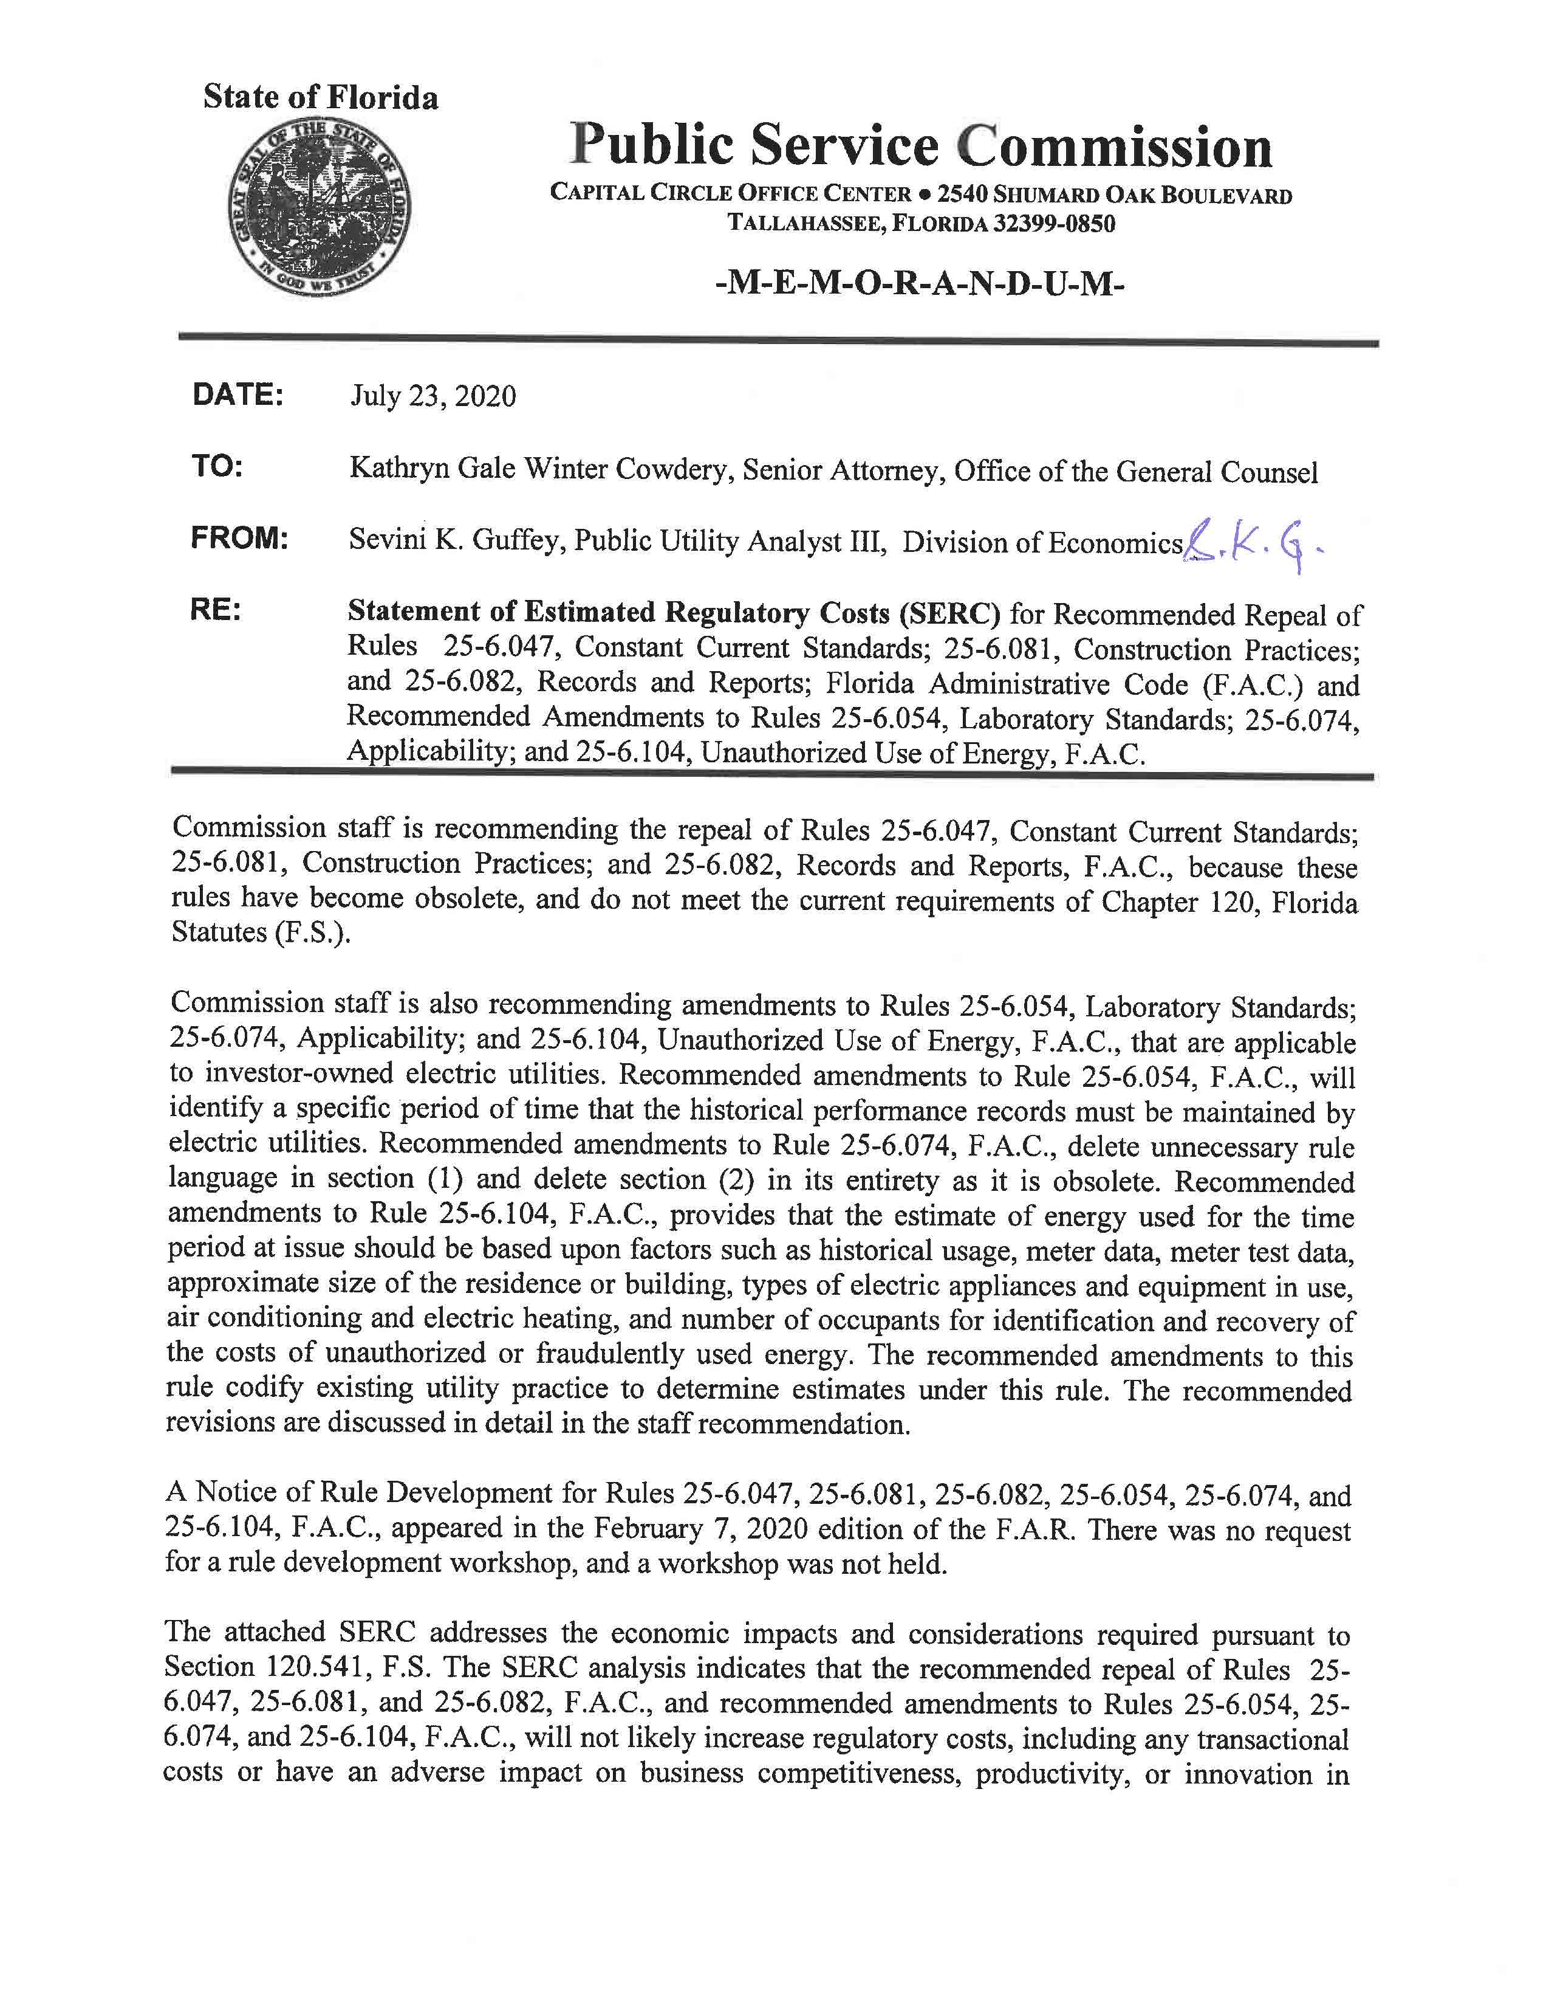

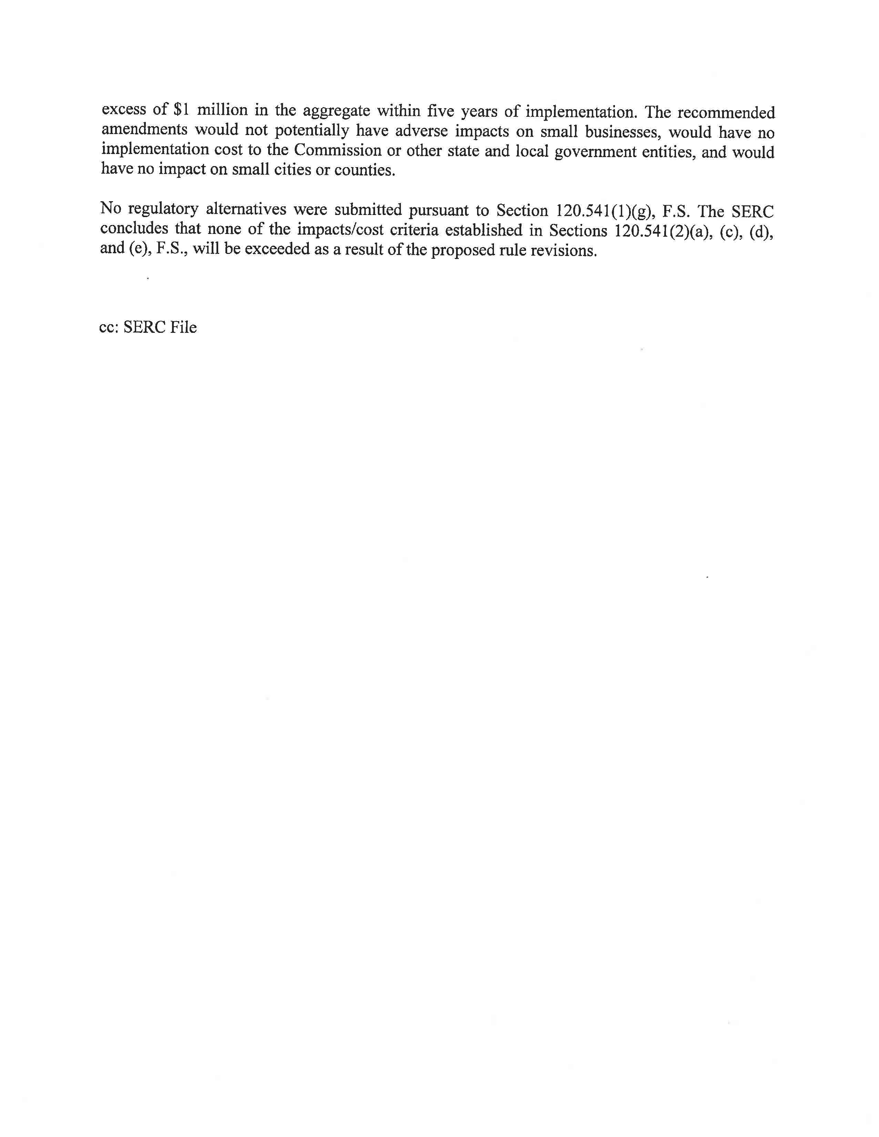

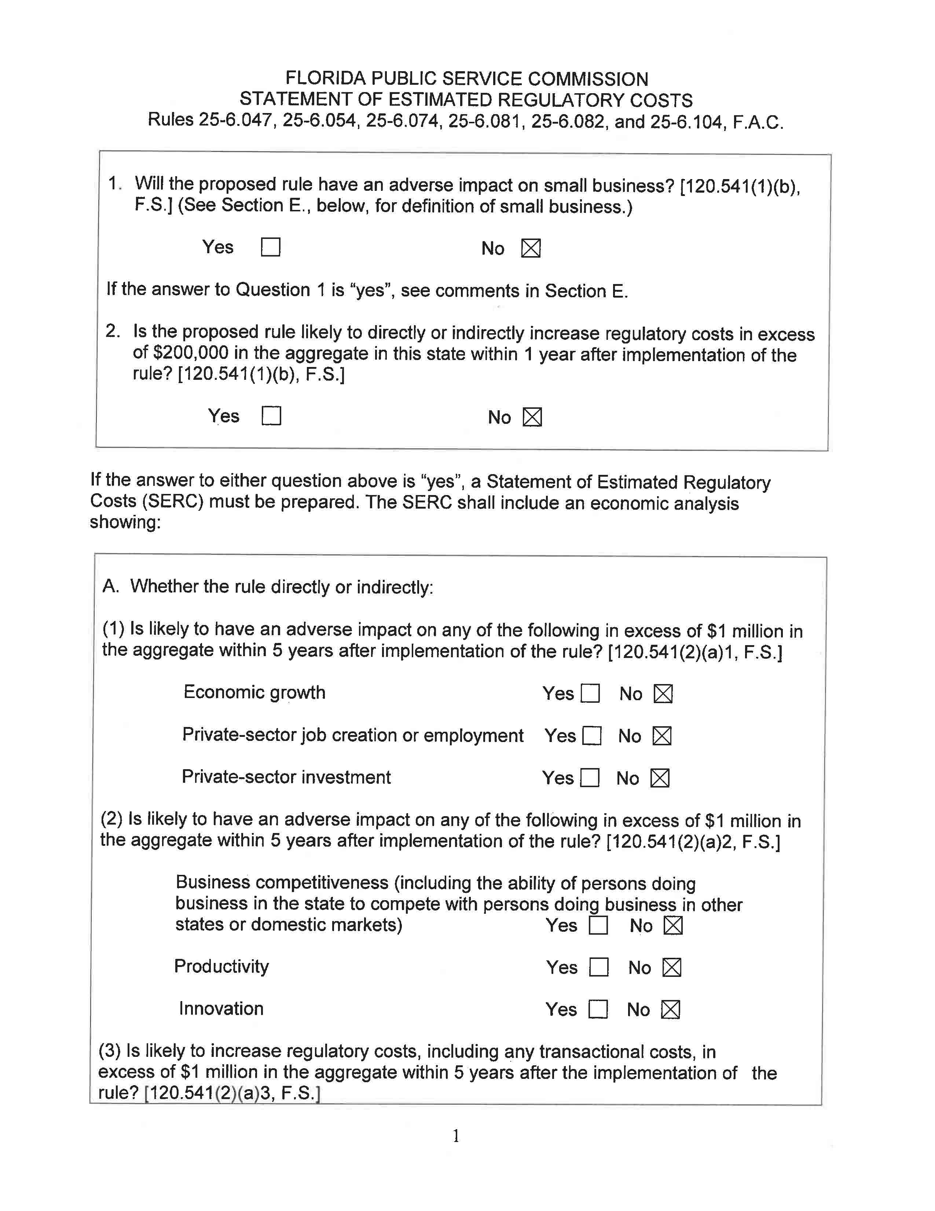

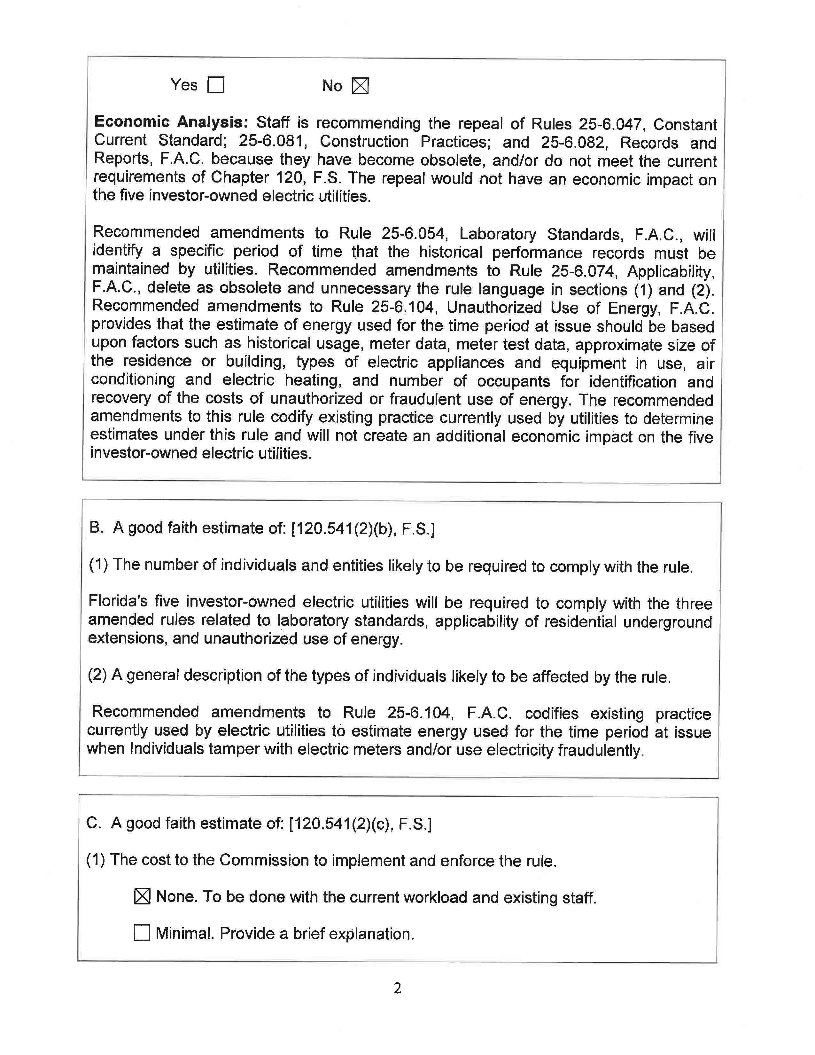

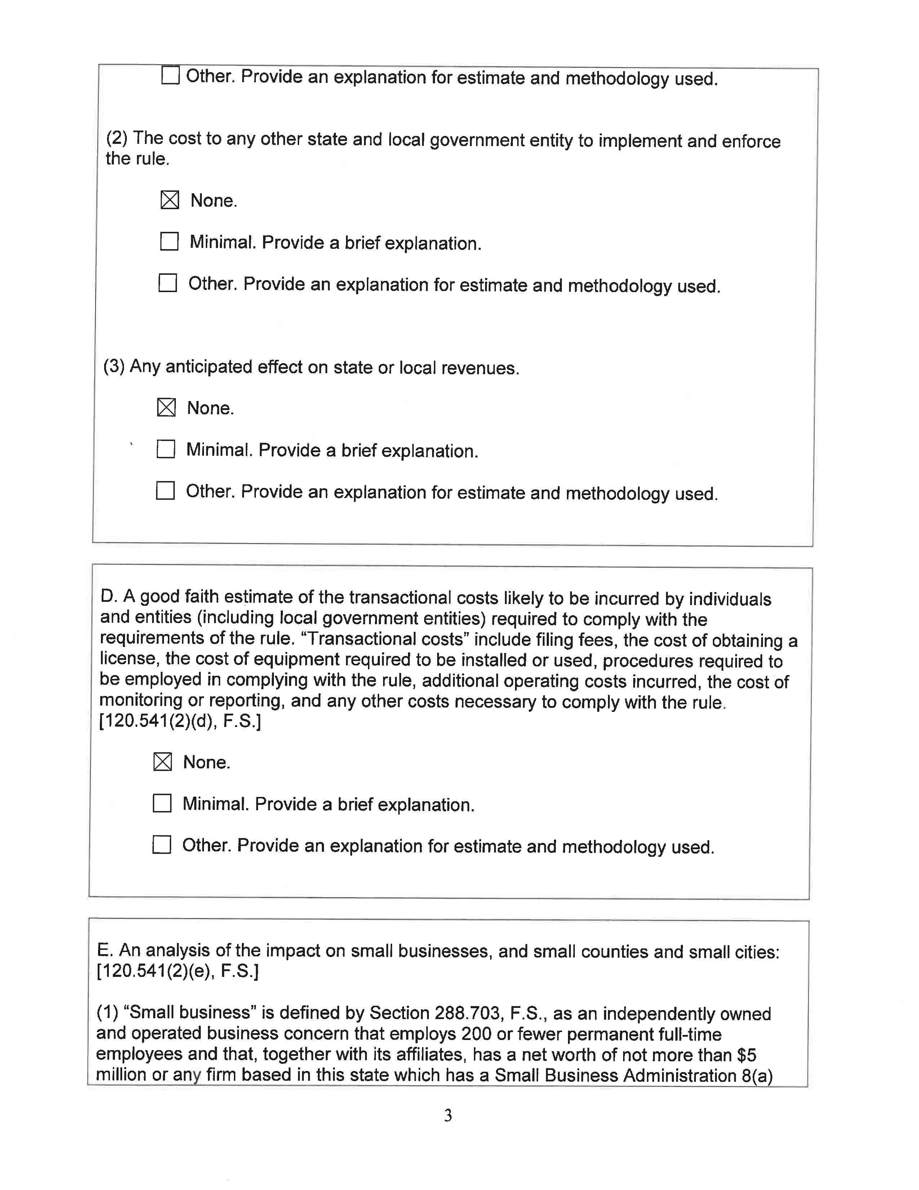

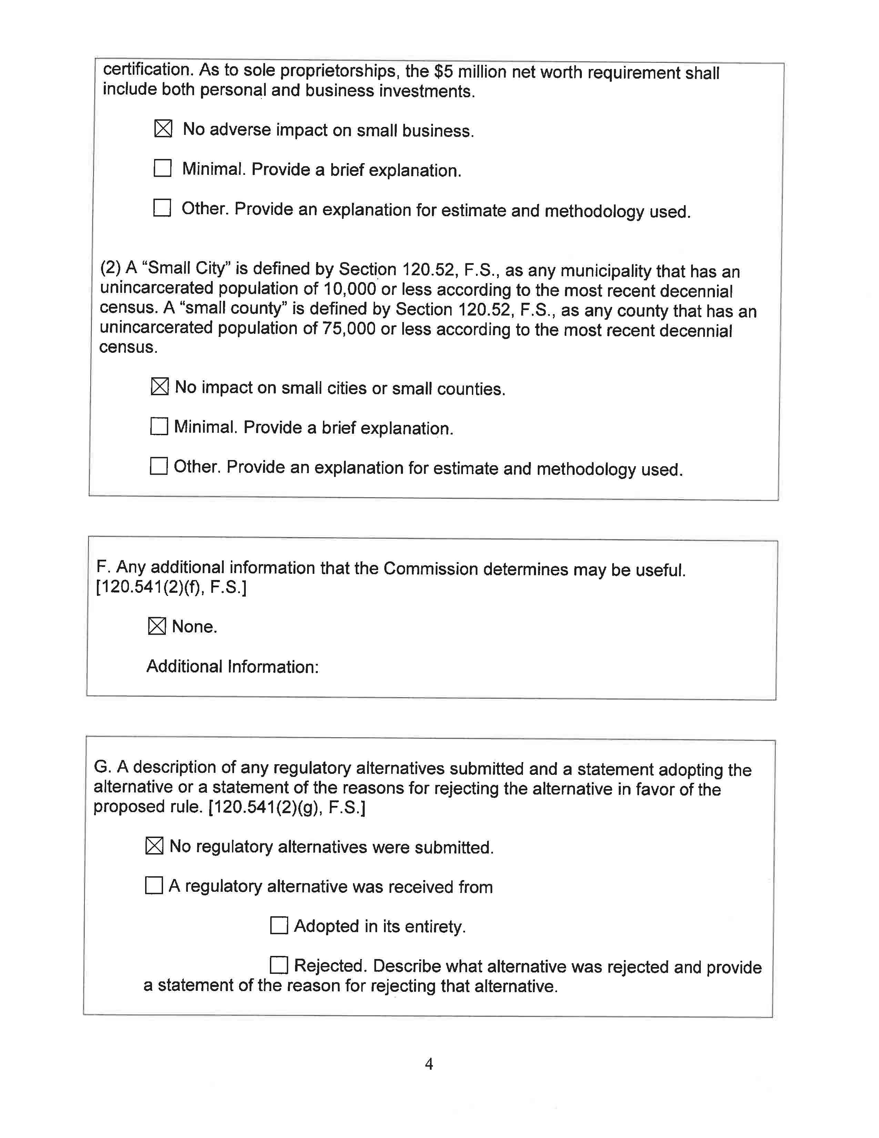

Docket No. 20190131-EU, In re: Proposed adoption of Rule 25-6.030, F.A.C., Storm Protection Plan and Rule 25-6.031, F.A.C., Storm Protection Plan Cost Recovery Clause.
Section 120.52(16), F.S., defines a rule as each agency statement of general applicability that implements, interprets, or prescribes law or policy or describes the procedure or practice requirements of an agency and includes any form which imposes any requirement or solicits any information not specifically required by statute or by an existing rule.

