State of Florida |  | Public Service Commission  Capital Circle Office Center ● 2540 Shumard Oak Boulevard  Tallahassee, Florida 32399-0850  -M-E-M-O-R-A-N-D-U-M-
DATE: | August 20, 2020
TO: | Office of Commission Clerk (Teitzman)
FROM: | Division of Economics (Hampson, Guffey)  Office of the General Counsel (Trierweiler)
RE: | Docket No. 20200164-EU – Joint petition for approval of amendment to territorial agreement in Lee County, by Florida Power & Light Company and Lee County Electric Cooperative.
AGENDA: | 09/01/20 – Regular Agenda – Proposed Agency Action – Interested Persons May Participate
COMMISSIONERS ASSIGNED: |  |  | All Commissioners
PREHEARING OFFICER: |  |  | Brown
CRITICAL DATES: |  |  | None
SPECIAL INSTRUCTIONS: |  |  | None

Case Background
On June 4, 2020, Florida Power & Light Company (FPL) and Lee County Electric Cooperative (LCEC), collectively the joint petitioners, filed a petition seeking Commission approval to amend their existing territorial agreement in Lee County. The proposed amendment (2020 Amendment) seeks to modify the territorial boundaries of their existing territorial agreement to allow both utilities to more efficiently serve a planned private development and to avoid the uneconomic duplication of facilities. On June 10, 2020, the joint petitioners filed an amendment to the petition to correct a typographical error in the 2020 Amendment.

In 1965, the Commission approved the joint petitioners’ original territorial agreement by Order No. 3799. In 1993, the Commission approved a new territorial agreement relating to the service areas in Charlotte, Collier, Hendry, and Lee Counties. In 1997, the Commission approved a minor modification to the boundary line between FPL and LCEC in Lee County to reflect development in the area. In 2015, the Commission approved an amendment to reflect service by FPL and LCEC to the Babcock Ranch Community Independent Special District.

The 2020 Amendment, legal descriptions and sketches of the parcels to be exchanged are provided in Attachment A of this recommendation. The Florida Department of Transportation General Highway County map and two more detailed maps depicting the proposed boundary lines are provided in Attachment B of this recommendation. The Commission has jurisdiction over this matter pursuant to Section 366.04, Florida Statutes (F.S.).

Discussion of Issues

Issue 1:
Should the Commission approve the proposed 2020 Amendment to the territorial agreement between FPL and LCEC?

Recommendation:
Yes, the Commission should approve the proposed 2020 Amendment to the territorial agreement between FPL and LCEC, dated June 3, 2020. The 2020 Amendment is in the public interest and will avoid uneconomic duplication of facilities. (Hampson, Guffey)

Staff Analysis:
Pursuant to Section 366.04(2)(d), F.S., and Rule 25-6.0440, Florida Administrative Code (F.A.C.), the Commission has the jurisdiction to approve territorial agreements between and among rural electric cooperatives, municipal electric utilities, and other electric utilities. Unless the Commission determines that the agreement will cause a detriment to the public interest, the agreement should be approved.

Amendment of Territorial Boundaries
The joint petitioners have proposed an exchange of two parcels, known as Exchange Parcel A and Exchange Parcel B, in order to achieve additional operational efficiencies and to avoid the uneconomic duplication of facilities. The joint petitioners have proposed this exchange as a result of a planned private development in Lee County. Both Exchange Parcels are currently undeveloped, with no existing customers or electric facilities. As such, there are no customers to notify regarding changes in service. Additionally, in Paragraph 14 of the petition, the joint petitioners state that approval of the 2020 Amendment will not cause a decrease in electric service reliability to existing or future customers of either utility.

Exchange Parcel A is approximately 160 acres large and will be transferred from LCEC to FPL, if approved by the Commission. Exchange Parcel A includes an area planned for 132 residential lots, which will be located in the aforementioned planned development. Exchange Parcel B is approximately 30 acres large and will be transferred from FPL to LCEC. Within Exchange Parcel B is approximately 26 acres of commercial land that is to be utilized for the planned development’s amenity center. Legal descriptions and sketches of the Exchange Parcels are included in Attachment A of this recommendation.

Conclusion
After review of the joint petition and amendment filed on June 10, 2020, staff believes that the 2020 Amendment to the territorial agreement will enable FPL and LCEC to avoid an unnecessary duplication of facilities and to serve their current and future customers in an efficient manner. As such, staff recommends that the Commission should approve the proposed 2020 Amendment to the territorial agreement between FPL and LCEC, dated June 3, 2020. The effective date of the 2020 Amendment will be the date on which the Commission’s final order granting approval of the amendment in its entirety is no longer subject to judicial review.

Issue 2:
Should this docket be closed?

Recommendation:
If no protest is filed by a person whose substantial interests are affected within 21 days of the issuance of the Order, this docket should be closed upon the issuance of the Consummating Order. (Trierweiler)

Staff Analysis:
If no protest is filed by a person whose substantial interests are affected within 21 days of the issuance of the Order, this docket should be closed upon the issuance of the Consummating Order.

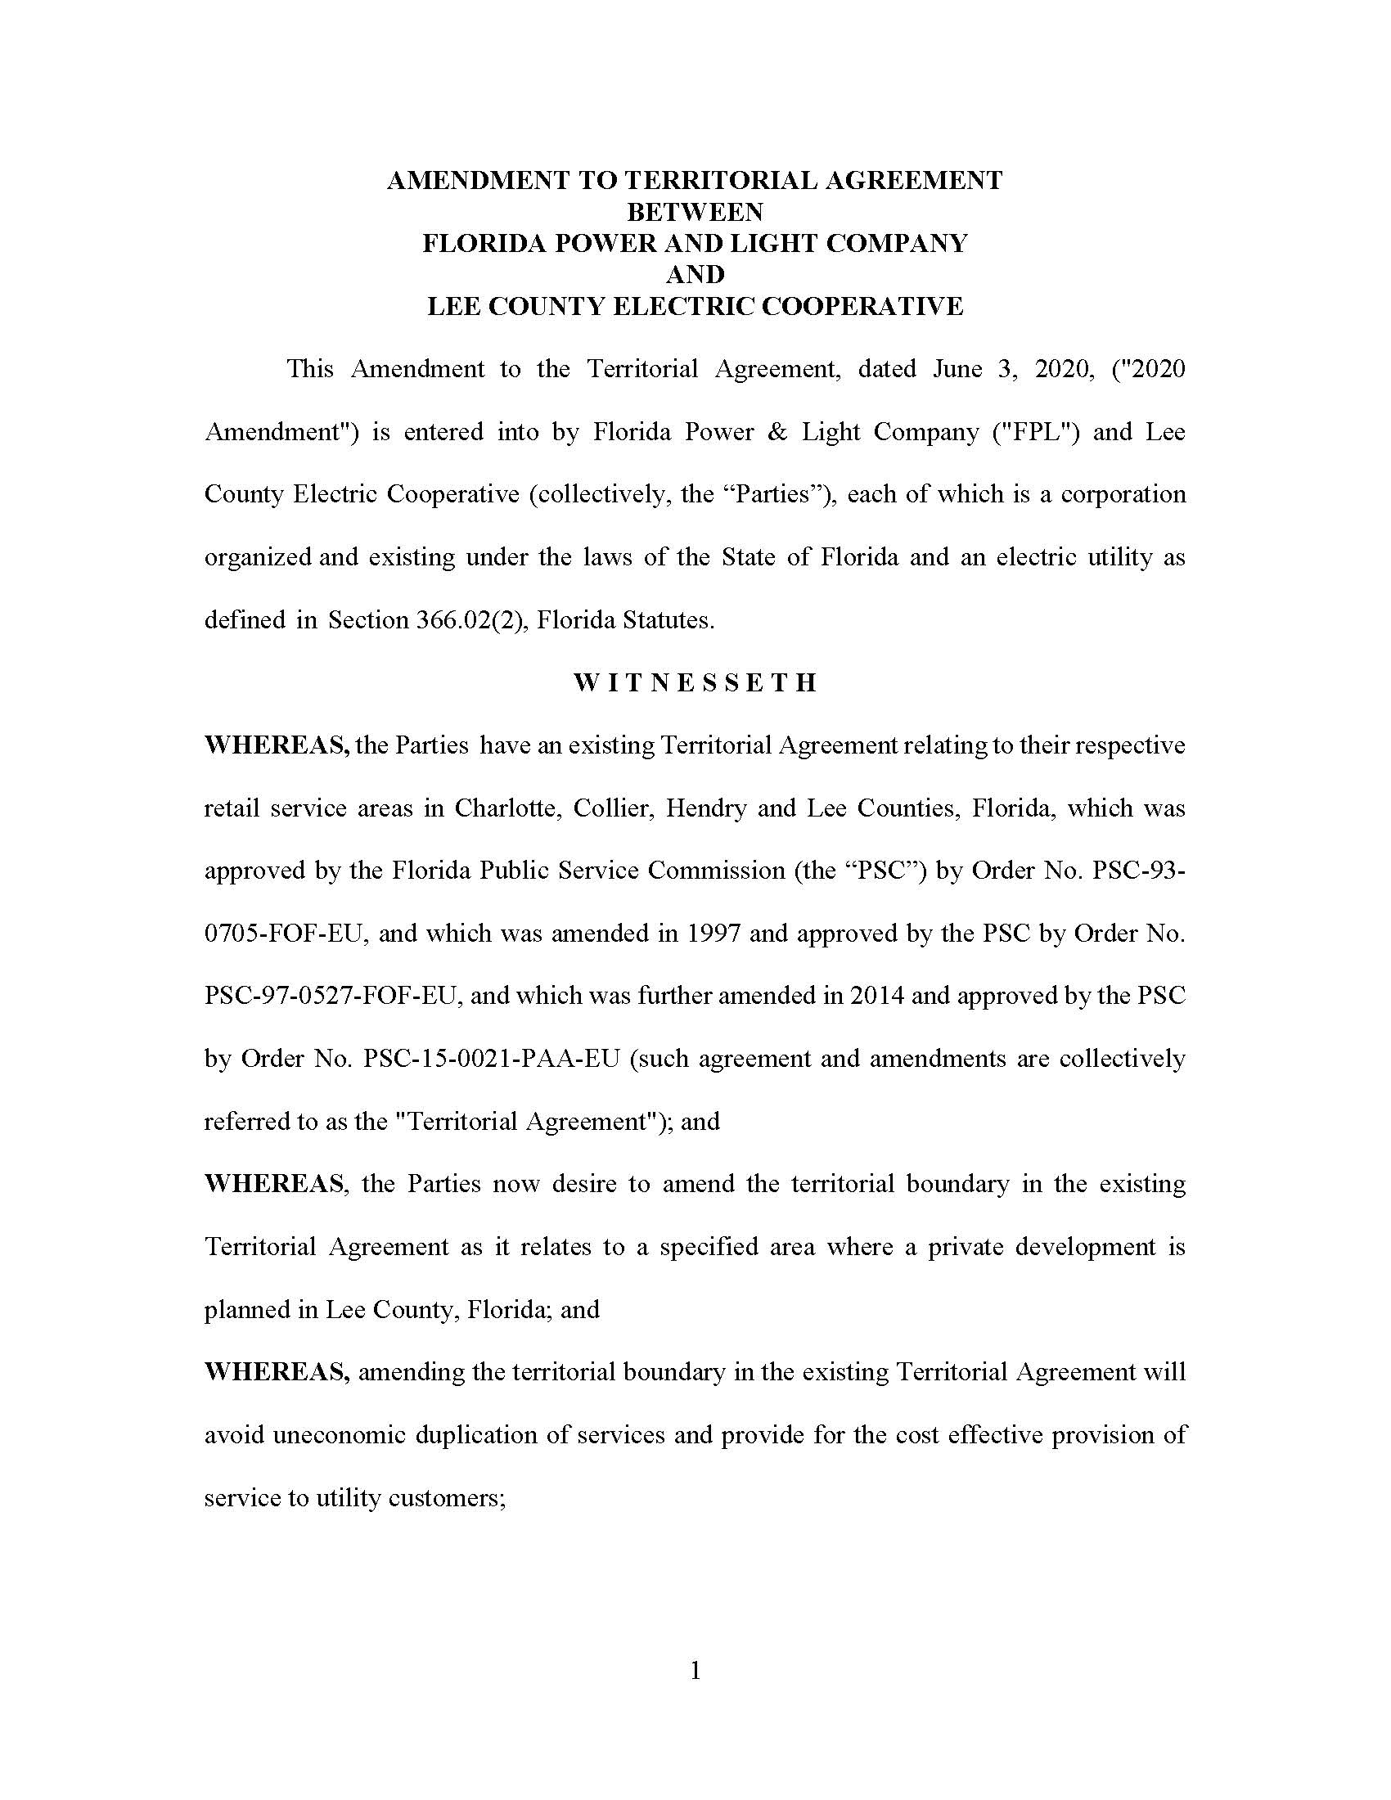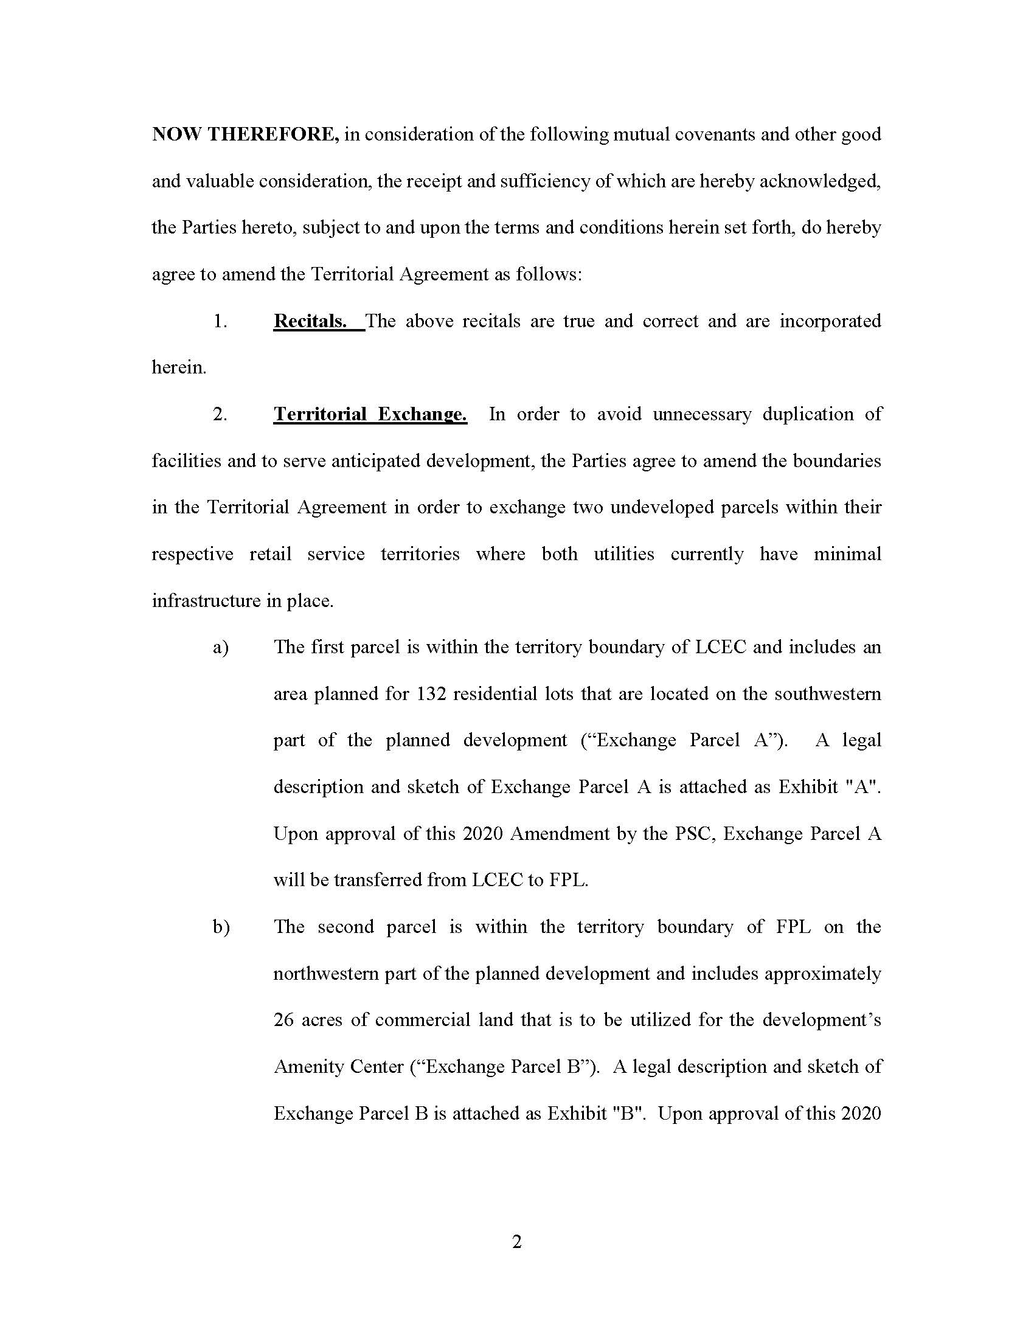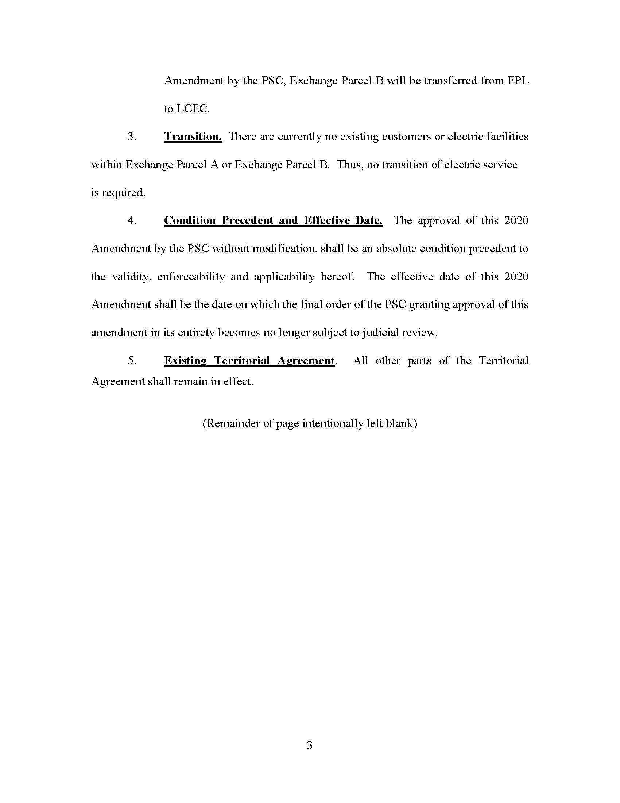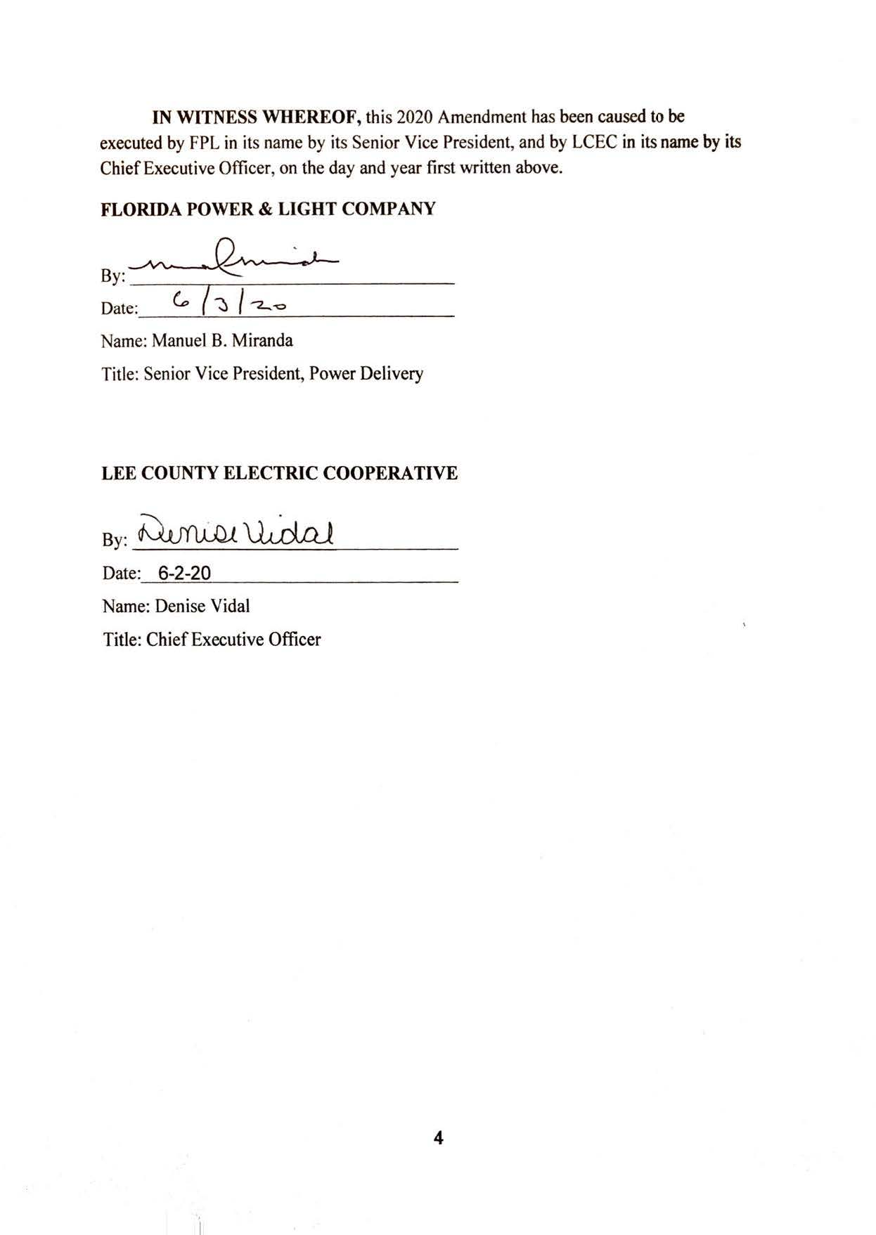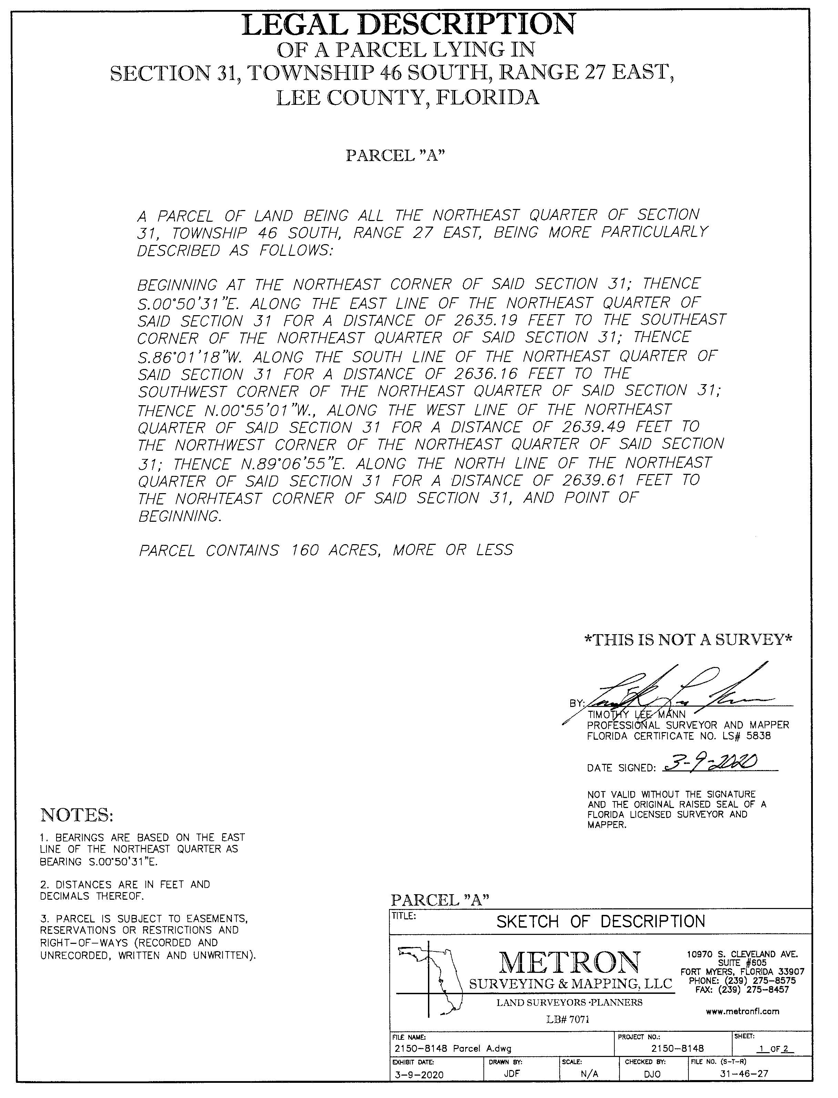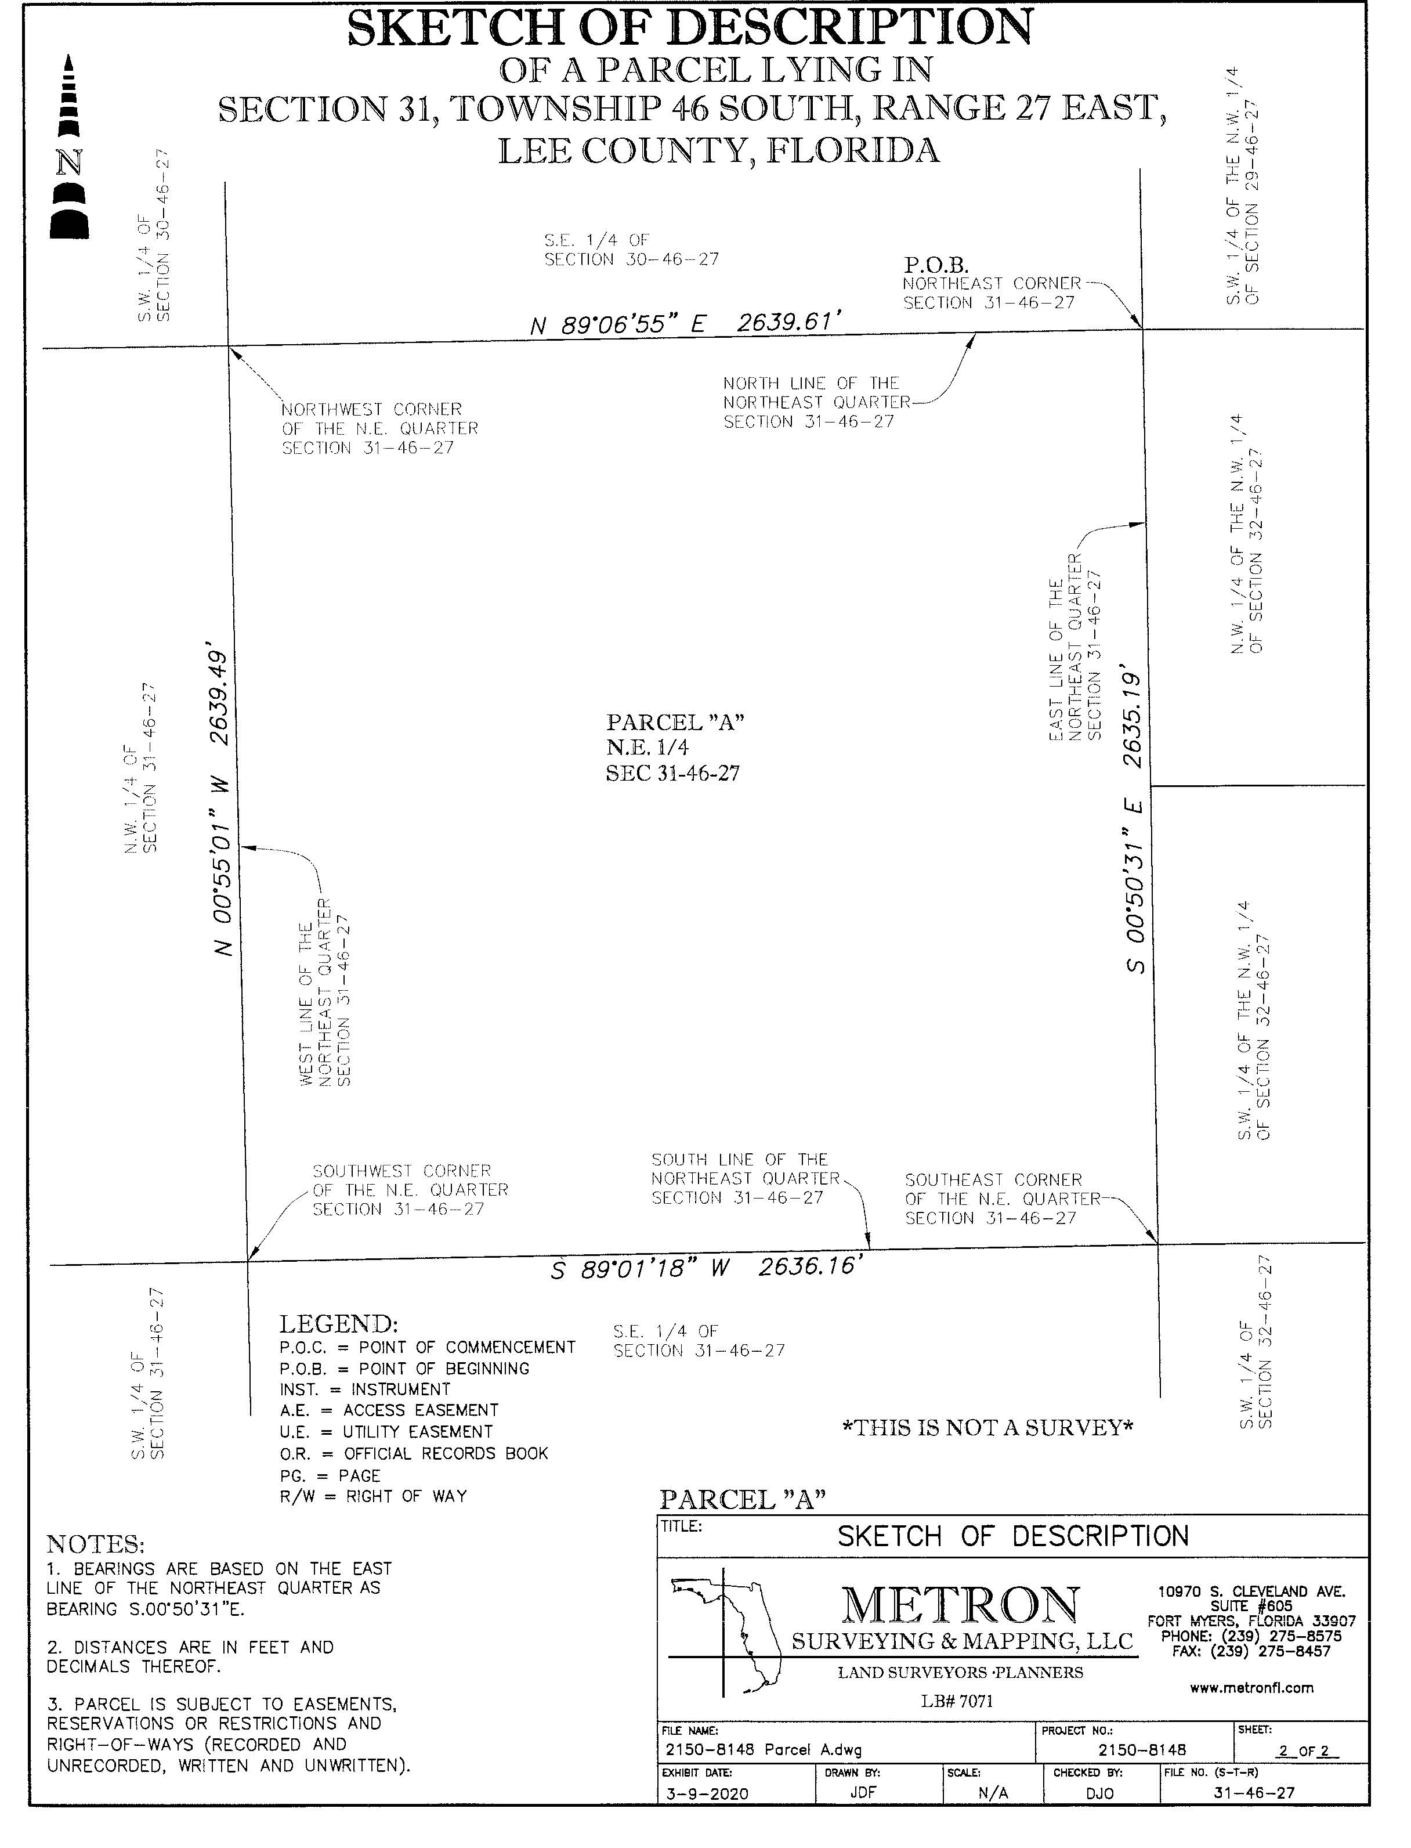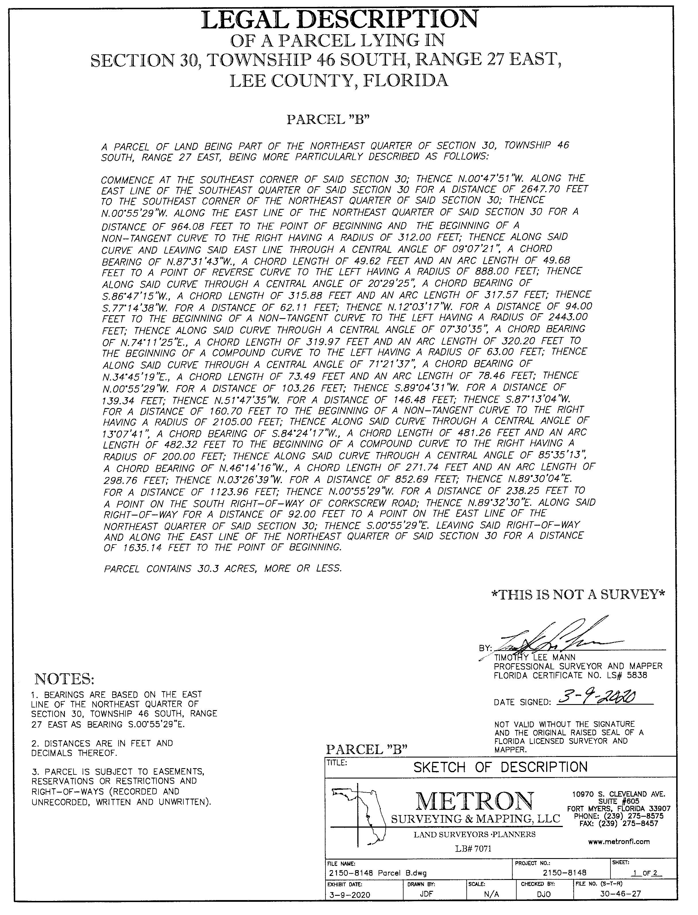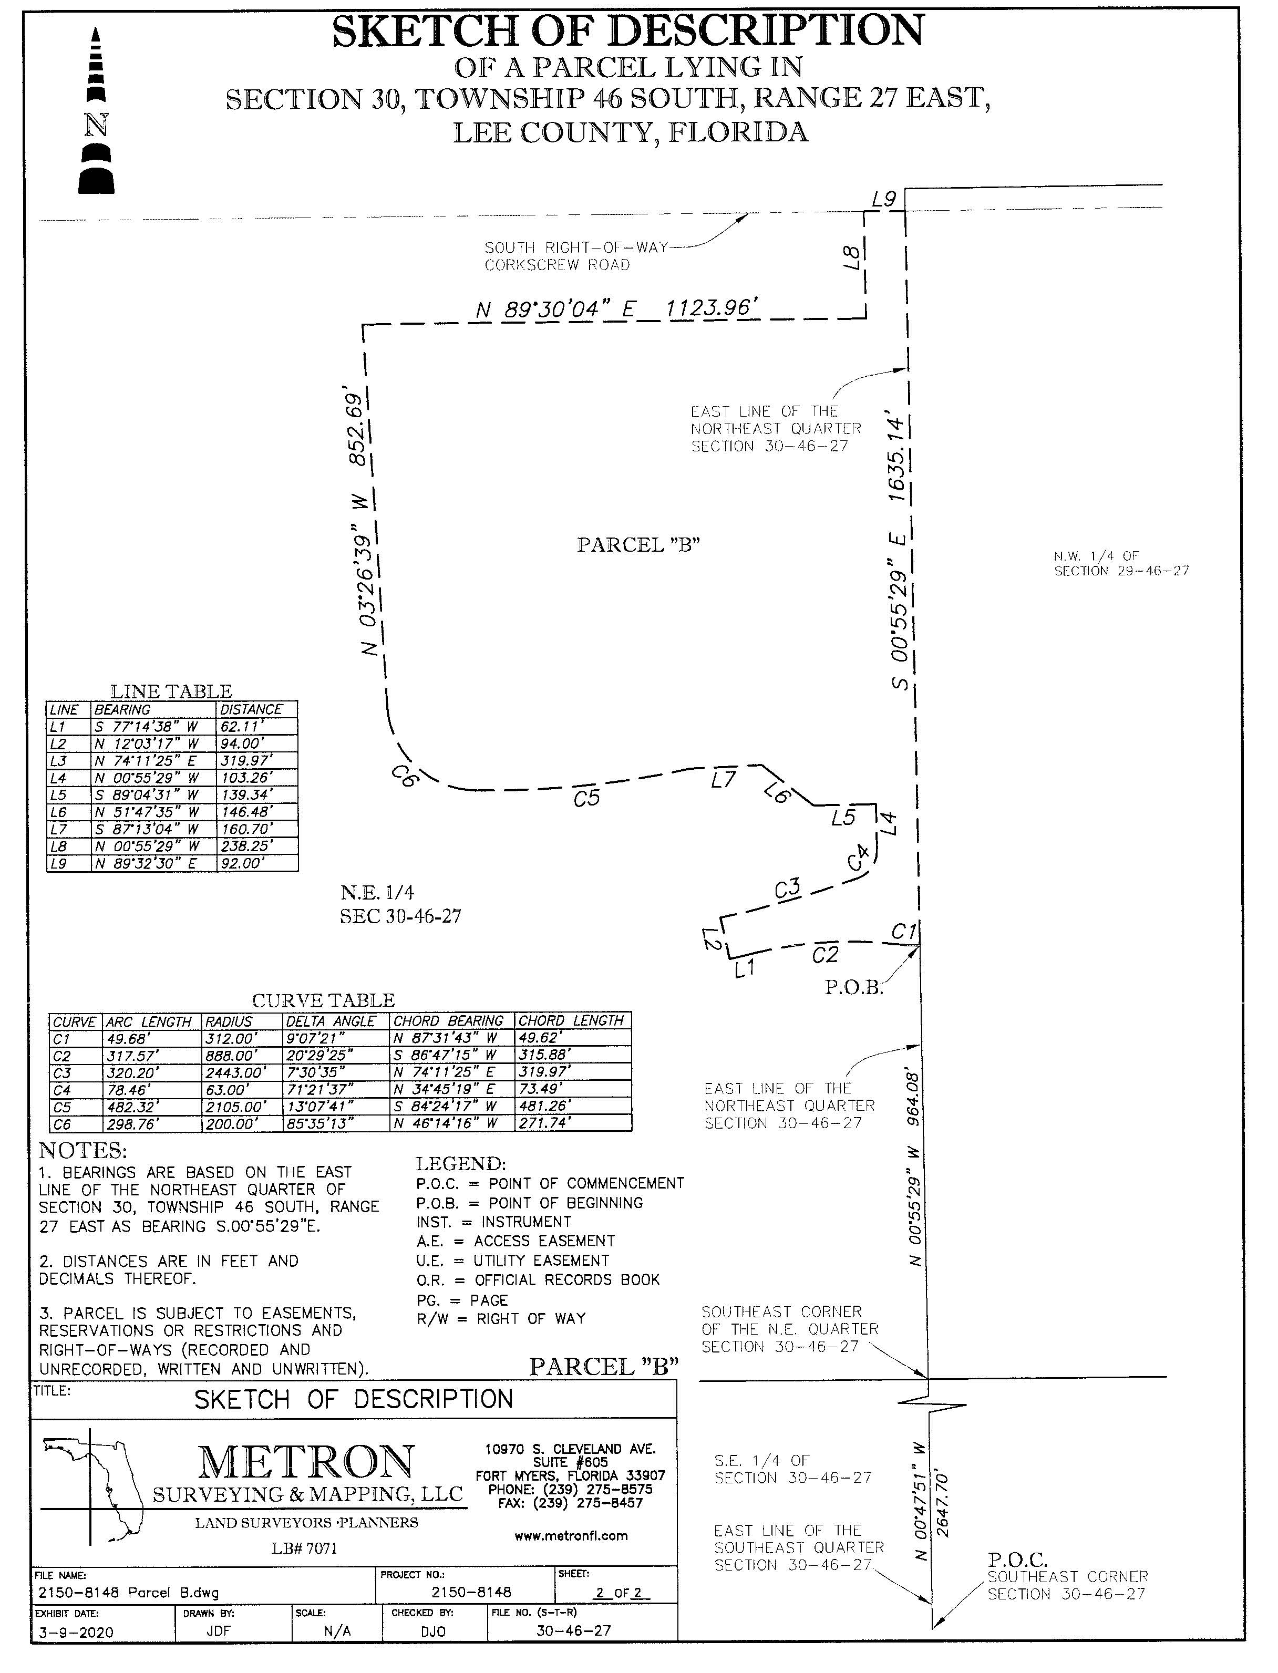

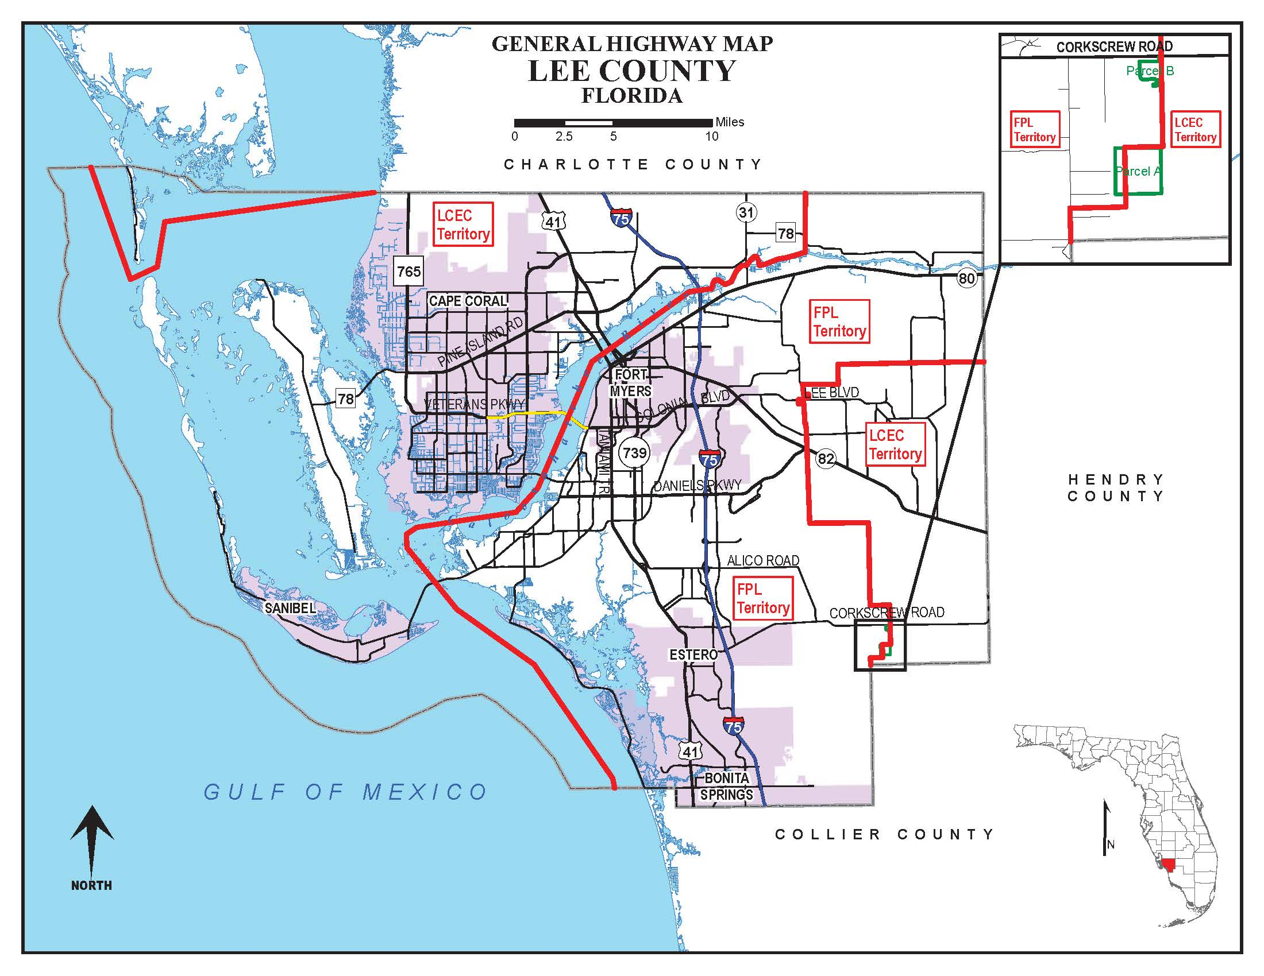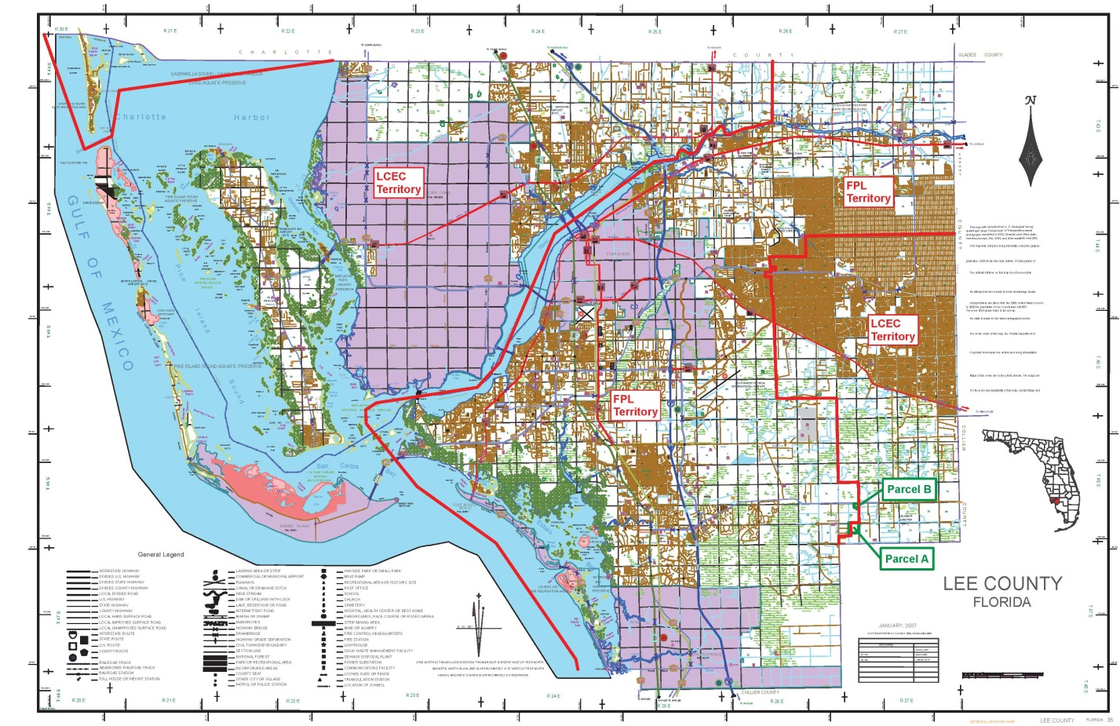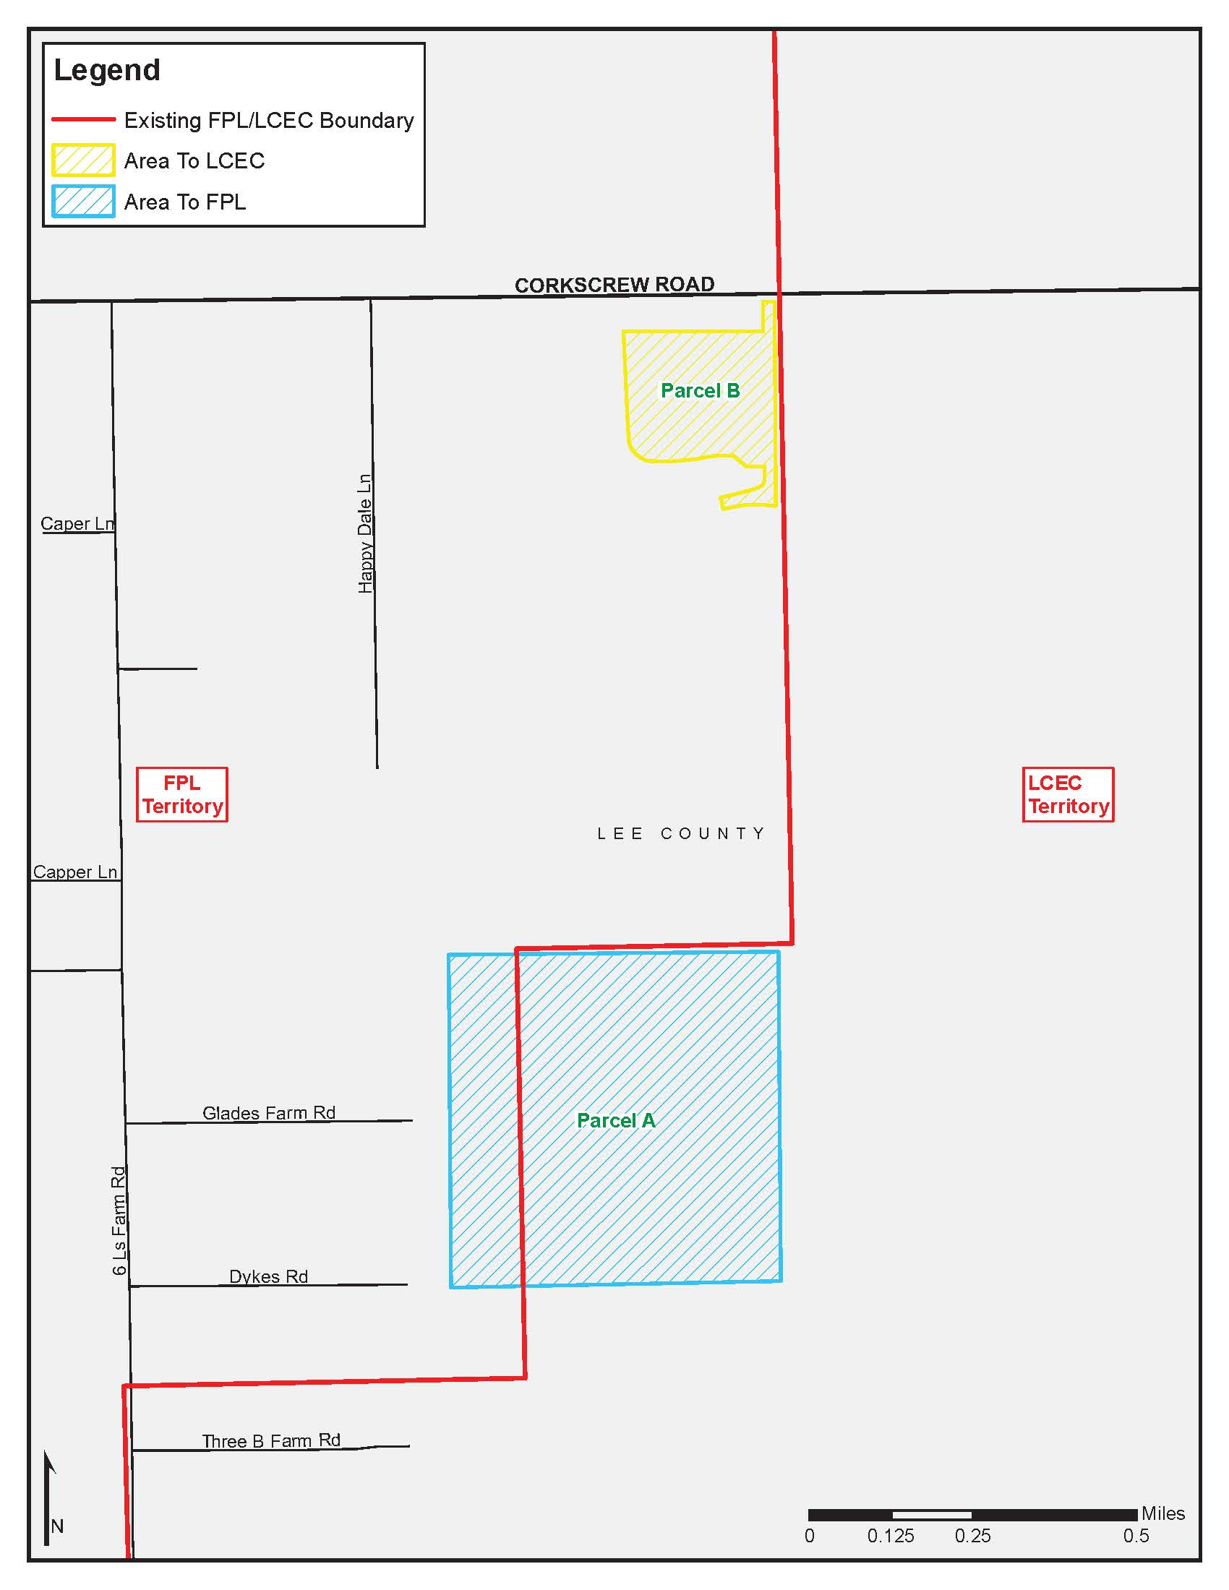

Document No. 03022-2020
Order No. 3799, issued April 28, 1965, in Docket No. 7421-EU.
Order No. PSC-93-0705-FOF-EU, issued May 10, 1993, in Docket No. 930092-EU, In re: Joint application for approval of territorial agreement between Florida Power & Light Company and Lee County Electric Cooperative, Inc.
Order No. PSC-97-0527-FOF-EU, issued May 7, 1997, in Docket No. 970105-EU, In re: Petition for approval of change in territorial boundary under territorial agreement with Lee County Electric Cooperative, Inc., by Florida Power & Light Company.
Order No. PSC-15-0021-PAA-EU, issued January 5, 2015, in Docket No. 20140210-EU, In re: Joint petition for approval of amendment to territorial agreement in Charlotte, Lee, and Collier counties, by Florida Power & Light Company and Lee County Electric Cooperative.
Utilities Commission of the City of New Smyrna Beach v. Florida Public Service Commission, 469 So. 2d 731 (Fla. 1985).

